THE IMPACT OF UNEMPLOYMENT ON ECONOMIC GROWTH IN NIGERIA

BY

NGWOKE-ABIA CHRISTIAN EBUKA
GOU/U22/ECO/443

BEING A RESEARCH PROPOSAL SUBMITTED TO THE DEPARTMENT OF ECONOMICS, GODFREY OKOYE UNIVERSITY, UGWUOMU-NIKE ENUGU STATE, IN PARTIAL FULFILMENT OF THE REQUIREMENT FOR THE AWARD OF BACHELOR OF SCIENCE (B.SC) DEGREE IN ECONOMICS

DEPARTMENT OF ECONOMICS
FACULTY OF SOCIAL SCIENCES
GODFREY OKOYE UNIVERSITY

JULY, 2026.
ABSTRACT
This paper examines the empirical effect of unemployment on economic growth in Nigeria using annual time-series data from 1991-2024. The study utilizes a quantitative research design and employs the Ordinary Least Squares (OLS) regression technique, and the Granger Causality test. The long-run regression analysis indicates that the rate of unemployment has a significant negative effect on economic growth, with a percent change in the rate of unemployment causing a negative percent change in Real GDP by 0.31%. The Error Correction Mechanism (ECM) of -0.233 indicate moderate speed of adjustment at which about percent of the economy’s disequilibrium are being corrected each year. The Granger Causality result show no significant causal relationship between unemployment and growth in either directions. In view of the above results, we concluded that unemployment constitute the core structural challenge of sustainable growth and development in Nigeria. We recommended that Government of Nigeria needs to focus on diversifying the Nigerian economy in labour intensive sector of the economy like agro processing, light manufacturing etc. There should also be more investment on skill acquisition and technical vocation centre to make Nigerian youths relevant in modern economy

CHAPTER ONE

INTRODUCTION

1.1 Background to the Study
Nigeria is a nation that the natural resource has always been rich and has many economic sections including manufacturing, agricultural, finance and tech. The World Bank declared Nigeria a large and fast growing economics nation in West Africa in 2021. Among Nigeria, people aged under 24 years old is over one third of total population (Virk, Nelson, & Dele-Adedeji, 2023). Thus Nigeria possesses significant of the future economic power.
The labor market of Nigeria has been identified as an area that will add approximately 66 million working age population by 2030. However, Nigerian economy development is severely hampered due to large scale employment, especially for the youth. Similar to other developing economies, The ILO warned that global economy facing high rate of inflation and many factors have led to an increase of world employment number by 190.8 million in the end of 2024. Young people is always be the first target for job market suffering; the employment of youth is four times more than adults (ILO, 2024).
According to the ILO's analysis, young people who are currently not employed is about one fourth of youth population in 2022.
According to the economic theory, unemployment deteriorates the growth rate of an economy. The longer term unemployment results in human capital deprecation that reduces the quality of labor supply. As a consequence the economy’s potential capacity to grow or Potential GDP decreases.
For a long period, the joblessness in Nigeria has been terrible, especially the unemployment rate in Q4 of 2020 which hit at 33.3 percent. In the last couple years, the measurement of employment in Nigeria has been changed due to the adoption of the International Labour Organization (ILO) methodology on reporting the job figures (Lain & Pape, 2023). Since then the number of employment in Nigeria has changed from 33.3 percent in 2020 Q4 to 5.3 percent in 2022 Q4, 4.1 percent in 2023 Q1 and 4.3 percent in 2024 Q2 (NBS, 2024). This change made many researchers and government figures skeptical of the statistic.
Figure 1: Nigeria’s Unemployment Status.

Former Presidential candidate Peter Obi voiced concern in 2024 that the reported employment rates do not reflect the real suffering and hunger in the Nigerian job market. Even ILO and UNDP has warned that Nigeria’s data may be unreliable (Obi, 2024). Nevertheless, even under the new statistics, unemployment, especially for educated youth, still remains high at 8.5 percent in 2024 Q2 (NBS, 2024). A large proportion of youth segment faces issues such as poverty (projected to affect 38.8 percent of the population by 2024, PwC) as well as instability and mismanagement (Virk et al., 2023).
The optimal path for Nigeria is utilizing its full youth potential and ensure this group is productive within its workforce. This means the economic growth rate should surpass its population growth rate (2.3% according to UNDESA, 2022) to create jobs and maintain a stable employment level. However, government's economic programs have failed to boost the country's growth rate sufficiently to achieve these goals (Virk et al., 2023). Contrary to common understanding, Nigeria’s real GDP has grown steadily from the 1990s to 2023, despite sluggish population growth (WDI). But this consistent economic expansion has not translated to corresponding job growth, a phenomenon often termed “jobless growth” (Figure 2).
Figure 2: RGDP
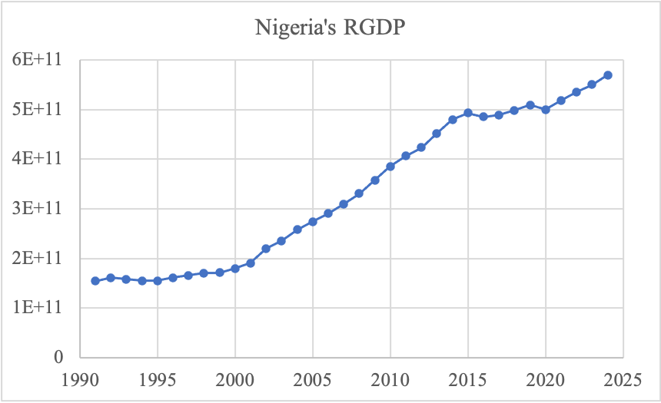
This study will analyze this gap between actual employment rate and what should be considered as optimum employment rate for Nigeria’s economic growth to determine the cost and losses Nigeria has been making due to unemployment or employment underutilization in general.

1.2 Statement of the Problem
Even with the 2023 new trend in the unemployment reporting, Nigeria job market has shown persistent growth and insufficient jobs created to match such growth. The NBS reported 4.3% unemployment rate in Q2 of 2024, but as discussed above this figure doesn't indicate the realistic rate due to the use of new measurement which considered someone working one hour a week as a job holder. And the number for youth unemployment, which shows at 8.5% for those with upper secondary education level, indicates the continuing structural challenge for Nigeria youth (NBS, 2024). The fact is that Nigeria's national economic expansion has not led to an equivalent increase in job creation, as highlighted by Nnachi and Ebubechima (2023).
Instead, the Nigerian economy has a tendency for jobless growth. This can be explained by reliance on a capital-intensive economy characterized by oil production, and information communication technology (ICT) where a limited labor force is needed. For a large population, and a substantial youth demographic that must be engaged to ensure productive development, this reliance on capital-intensive sectors is problematic. Abada et al. (2021) point out the slow development of labour-intensive industries, particularly the manufacturing sector, in absorbing new entrants to the labour market.
In Nigeria, literature on the economic impacts of unemployment has historically focused on social issues, causes, and overall effects on society. The significant empirical gap remains to measure how joblessness affects the rate of economic growth of Nigeria. This gap has led to diverse findings. For example, Idris (2021) finds that unemployment rate hinders the country’s economic development, whereas Olayemi et al. (2023) find a positive relationship.
Therefore, the specific impact of unemployment and labour underutilization on Nigeria’s Potential GDP remains empirically uncertain and unexplored. This research intends to bridge this empirical gap by quantifying the economic loss resulting from this underutilization.

1.3 Research Questions
- How does unemployment affect the economic growth in Nigeria?
- Is there a causality relationship between unemployment and economic growth in Nigeria?
1.4 Research Objectives
The overall purpose is to investigate the relationship between unemployment and economic growth in Nigeria. Specifically:
- To assess the effect of unemployment on economic growth in Nigeria. 2.
- To establish if a causality relationship exists between unemployment and economic growth in Nigeria.

1.5 Research Hypothesis
H01: Unemployment does not have a significant impact on the economic growth in Nigeria.
H02: A causality relationship between unemployment and economic growth in Nigeria does not exist significantly.

1.6 Significance of the Study
For the policy maker and government agency, the empirical results are crucial in quantifying the cost of mass unemployment to the Nigerian economy which will call for increased public expenditure in form of training programs and employment generation schemes for young Nigerians and job creation in labour-intensive industries. For Academics and Researchers, this research contributes to bridging the gap in Nigerian economic literature. It reoriented the focus from that of economic growth towards unemployment to one of unemployment toward growth. It fills the gaps left in prior researches on unemployment and growth, thereby provide empirical framework that will be referenced by any other scholars/researchers in their analysis. Again, it helps investors and private businesses in anticipating the direction of Nigeria’s economy on a long run.

1.7 Scope of the Study
Due to limitation of data in the area of study and use of Ordinary Least Squares method, data from 1991-2024 are used for this study.

CHAPTER TWO

LITERATURE REVIEW

2.1 Conceptual Framework
This articulate and organizes the main issues or concepts of interest. It may describe how each concept is measured and the relationships that are hypothesized to exist among the concepts.

2.1.1 Unemployment
Unemployment defined as the state or condition of not having employment. It should be stressed that Nigeria’s recent unemployment rate has been recalculated according to the International Labour Organization (ILO) benchmark which estimates unemployed persons as any person aged 15 to 64 years that worked for at least 1 hour for pay or profit in the seven days preceding the survey (Lain and Pape, 2023). The main independent variables of the study unemployment. However, there are many components of unemployment which have significant implications to the development of a nation such as, youth unemployment (the share of youth 15-35 in the workforce) constitutes a growing majority of new job market participants, youths are among the first to be hit when labor demand contracts, and high youth unemployment represents a considerable impediment to growth and an important factor in political instability in the developing world such as Nigerian (Almula-Dhanoon and Ali, 2021). Furthermore, the causes of unemployment could be insufficient labor demand, lack of matching job skill to job requirements etcetera (Mseleku, 2022).

2.1.2 Economic growth
Most frequently measured in economic growth is the annual increase of real Gross domestic product (GDP), which also represent the overall of growth and total product output by country annually (Doherty and Paul, 2018). Generally represented as per Real GDP (adjusting for Inflation) which also implies per GDP for a country. The general hypothesis will argue high rate of unemployment reduces the economic output thus, negatively affecting the rate of growth of the economy such as Nigerian.

2.2 Theoretical Literature

2.2.1 Okun’s Law
“Okun’s Law” is widely reported theory on the relationship between a nation’s growth and employment rate, it can be represented as a rule of thumb relating the two series in an inverted fashion as ‘an increase in the growth rate by X percent causes the unemployment rate to drop by Y percent (Doherty and Paul, 2018). That’s is the level of GDP and rate of unemployment were empirically proven to have negative relationship as identified by Okun (1962) that unemployment rate fell by 1 percentage point when the Gross Domestic Product increased by 3 percentage points from 1955 to 1964 in United States (Doherty and Paul, 2018). As this is one of the most common established relationship between unemployment and economic growth, and researchers found that for this coefficient X the value of Y varied between one to three percent and the coefficient has weakened for other developed countries (Durech et al., 2014) and also much weaker for developing countries.

2.2.2 Keynesianism
The theory of Keynesianism emphasized the significance of overall demand as the most important determinant of total economic output.
According to John Maynard Keynes’ theory, a lack of overall demand in an economy often leads to unemployment (Keynes, 1936; Dornbusch and Fischer, 1994). Firms produce goods and services based on expected consumer and business demand; if this demand declines, the firms reduce their production and eventually their workforce to prevent oversupply and minimize losses, since wages may not be quick to adjust downward. This phenomenon is called the sticky wage theory.

2.2.3 The Neoclassical Growth model (Solow-Swan)
Solow (1956) and Swan (1956) independently developed a theory which explain how the long run aggregate growth rates are determined.
In these neoclassical growth models, technology is exogenous and in steady-state growth is a function of technological change and population growth.
The model assumes that a flexible labor market quickly reaches a steady state with full employment. This includes friction between full time jobs such as temporary vacancies, lack of required skills or information of jobs (jobless). However, external forces can disrupt the process of self correction such as interference by government by using regulations that hinder the decrease of the wages (Dornbusch and Fischer, 1994).

2.2.4 The jobless growth
The phenomenon where a nation continues to generate impressive rate of growth in its GDP but it fails to expand job opportunities is referred to as joblessness growth. The jobless growth theory highlights an increase in a country’s GDP with little or no growth in the number of jobs it creates (Sen, 2021). Factors which drive this phenomenon include rapid technological advancement that leads to increasing automation of industries and businesses.
This implies that with enhanced efficiency, less manpower is required, thereby resulting in an overall economic growth rate which doesn’t translate into significant employment creation.
The emergence of jobless growth necessitates new avenues for policy discussion beyond conventional economic growth paradigms, especially on ways of how best a job should be provided to meet the expanding labor pool.

2.3 Empirical Literature
Aydin, Grbz and Ersan (2025) provided a more sophisticated approach, analyzing 13 European transition countries with a panel smooth transition regression (PSTR) model. Their study revealed an inflation threshold of 7.97% that delineates when Okun’s law holds firm – ie, economic growth successfully reduces unemployment. Once inflation rises above this threshold, however, Okun’s law ceases to function as the link between economic expansion and job creation is severed. This asymmetric Okun’s Law offers a unique contribution in that it suggests that price stability may not just be a desirable objective, but rather a prerequisite for labor market functionality, thereby potentially rendering growth policies ineffective in addressing unemployment in periods of high inflation.
Kumar (2024) presented a longitudinal study on Nepal’s economy. The research indicated a negative impact of inflation and unemployment on economic growth. In that way, one can conclude that the economy of Nepal experiences intermittent, inflation-driven economic surges which are ultimately tempered by fundamental weaknesses, resulting in reduced yields.
Mathibe and Oppong (2024) adopted a more holistic approach and considered a cross-section of 21 Anglophone and Francophone African countries employing a Generalized Method of Moments (GMM) regression analysis that considers a range of explanatory variables including language, history and sustainable entrepreneurship. From the results, sustainable entrepreneurship significantly negatively effects unemployment and a positive effect on economic growth, a correlation which appears to hold irrespective of language. Although history, and indeed culture, significantly influenced economic outcomes in Africa, language played no meaningful role in this phenomenon.
Akinola and Adekile (2024) shed light on the unique situation prevailing in Nigeria, arriving at the conclusion that insufficient remuneration in Nigeria represents the most dominant cause of brain drain, which, in turn, is detrimental to the nation's output. Additionally, the research identified unemployment as a factor that mediates the process by limiting the impact of brain drain, indicating that the brain drain contributes to a stagnation of the country's progress.
Uddin and Rahman (2023) carry out a general investigation and figured that negative forces to GDP per capita growth, corruption and unemployment significantly outweigh the positive effects.
Niken et al. (2023), using the VAR and ECM models together with an augmented ARDL regression analysis technique, the researchers' finding runs counter to the conventional wisdom suggesting a degree of growth exclusiveness that leaves the Ethiopian economy largely immune to such shocks as well-known labor market and price volatility.
Ayele et al. (2023) investigated the effects of unemployment in the presence of inflation, for the period 1991-2020. The study found that unemployment is negative both in the short and long run, whereas the impact of inflation changes from negative in the short run to positive in the long run.
The research by Ngubane et al. (2023) indicated that the impact of growth on poverty was positive and significant in the long run, but this was undermined by a consistently detrimental effect from unemployment. Their non-linear evidence revealed a poverty trap where poverty rises whether shocks to unemployment are positive or negative, signifying high sensitivity of the impoverished to changes in the labor market.
Olayemi et al. (2023) examine the role of unemployment in the growth of Nigeria's economy from 1980-2019, adopting the Autoregressive Distributed Lag (ARDL) methodology. Unlike several Nigerian scholars who have discussed the issue, their study indicates a significantly positive impact, which points towards a jobless growth pattern where the forces behind economic growth are intensive in terms of capital and are not associated with a broader labor force.
Nnachi and Ebubechima (2023) tested the relationships between inflation and unemployment, which are regarded as important determinants of RGDP. The authors found a long-run nexus between inflation and UPR on GDP, but in contrasting ways as unemployment exhibits an inverse correlation whereas inflation possesses a positive one. This means while the country's growth rate decreases unemployment; joblessness responds inversely, implying that the unemployment to growth elasticity of job is small.
Muhammad (2023)’s finding shows that inflation causes positive and significant economic growth, and while the cause-effect between unemployment and economic growth is positive and significant, thus, policy to improve economic growth must prioritises the management of inflation. It does not dispute the importance of employment as a measure of welfare and socio-economic development. The findings suggest that unemployment policies may not be effective to bring about an immediate and direct contribution to the Nigerian economy, at the moment, as the economy's ability to create jobs for the vast majority is limited.
Shah et al. (2022) examine the relationship between economic growth and unemployment in Pakistan between 1974 and 2020 using Autoregressive Distributed Lag (ARDL). The empirical evidence indicate that unemployment rate and inflation rate are both negatively and statistically significant in influencing economic growth, while population growth rate shows positive influence on economic growth.
Sinha (2022) employs tests to confirm up to 4 cointegrating equations in an equilibrium condition. The results suggest that while capital stock and human capital promote growth, inflation causes it to shrink, and unemployment fails to affect the growth rate in the long run.
Lubbock and Merin (2022) analyze the impacts of inflation, unemployment and population growth on economic development in the Philippines over the period 1991–2020, employing the Johansen Cointegration test and OLS analysis methods. The study reveals the long-run impact of these variables; finding that inflation is positive relative to the growth of economy, whereas UPR and PGR are harmful.
Hjazeen et al. (2021) demonstrate a long-run relation for economic growth and unemployment where higher economic growth rate lead to lower unemployment rates and also there are positive relationships between education and unemployment rate, thus a better strategy is needed to guide growth to accommodate the increasing educated and urban population into the labor force in Jordan.
Mujitapha et al. (2021) in Malaysia for the years 1980 to 2020 utilizing the ARDL bound test along with Granger Causality Test found that, there is a negative long run relation between unemployment rate and GDP, which mean the variation in economic growth causes the fluctuation in unemployment rate and vice-versa.
In this study Anyanwu et al. (2021) focused solely on youth unemployment and economic growth in Nigeria. The study indicated that the implication of youth unemployment is widespread throughout the country. This work showed that while youth literacy levels help with the acquisition of jobs, there is an ongoing lack of opportunity that serves as a drag on GDP.
The study of Anderu (2021) confirmed that both poverty and unemployment significantly affect economic growth. In another research, Abada et al. (2021) considered the nexus between inclusive growth and unemployment in Nigeria for 1970–2018 using the ARDL bounds test. They found that growth in agriculture and industry reduce unemployment significantly whereas the manufacturing sector and trade openness do not show significant results. Their findings show that to solve the problem of unemployment, an inclusive growth policy directed toward the sectors with the capacity for absorbing employment and for acquisition of skills will do.
Bala et al. (2020) indicated that population and FDI are positively related to real GDP, while poverty and unemployment are significant negatively related. This article moves the analysis away from the aggregate output expansion towards the quality dimension of growth.

2.4 Literature Gap
Majority of domestic and international works (Shah et al., Hjazeen et al., Lubbock & Merin, Ayele et al., Bala et al., Idris, Nnachi & Ebubechima) conclude that unemployment is a negative and significant determinant of economic growth in line with Okun’s law. But it is interesting to note the contradiction in the domestic literature: while few of the studies are in line with the international literature, a number of other studies found that unemployment insignificantly impacts and others found that it positively impacts economic growth. Thus, the solution should focus on the job creation process while if it has a positive impact, the government might be oblivious of the joblessness of growth process. With this discrepancy, this study will clarify the existing confusion whether the relationship is positive or negative using recent data, to test the robustness of previous findings and provide clear directions to policy formulation and implementation.
Furthermore, the causality does not receive much attention in the available domestic literature and among the few that have paid attention to causality, not all has utilized the Granger Causality test as in the case of Mujitapha et al. (2021). Therefore, to determine the direction of the relationship in Nigeria and confirm whether it aligns with Okun's Law or is there any relationship where the economy drives unemployment or vice versa, this study will utilize the Granger Causality Test based on the methodology by Mujitapha et al. (2021).
Finally, the studies reviewed on Nigeria cover periods up to 2016-2021, indicating that the unemployment statistics used are based on the outdated methodology. In 2023, NBS adopted a new definition of employment in line with the 19th International Conference of Labour Statisticians (ICLS). This is critical as it gives an internationally comparable measure. As such, this study will be unique as it will utilize this recent NBS data and capture the influence of post-Covid recovery, recent economic reforms, and the changes in macroeconomic policies under the current administration.

CHAPTER THREE

METHODOLOGY

3.1 Theoretical Framework
Our theoretical underpinning this research is Neoclassical growth theory, stating a constant rate of economic growth emanates from the combined force of labor, capital, and technology. Credit for the long-run economic growth model is given to Robert Solow and Trevor Swan, who separately put forth the argument in 1956. The Neoclassical model posits labor as a vital input that is being massively underutilized as a structural phenomenon. Such non utilization restricts the economy from reaching its peak capacity of output, thus lowering Nigeria’s GDP and curtailing its capacity to achieving a high growth path as predicted by the Neoclassical paradigm.

3.2 Research Design
A quantitative ex post facto research design is used in the research. The ex post facto method of research is adopted since it is based on historical non manipulaible data to investigate how a number of independent variable affects a dependent variable. Since we are concerned about tracing trends, causal relations over a period of time, we therefore employ a time-series longitudinal research design, the appropriateness of which relies on the application of econometrics techniques. The approach involves using official national and international databases to elicit numerical data so that an empirical analysis of the causal relationship between the variables, using objective and verifiable information is carried out. In addition, it allows for the use of a causal-comparative framework for analyzing and testing our hypothesis to confirm the extent of influence on Nigeria economic growth by fluctuations in labor market.

3.3 Model Specification
The specification of a model must necessarily rely on whatever is known about the real world relevant to the topic at hand. In other words, specification of an econometric model depends upon information we have about the phenomenon under study, information embedded within theory and in a wider range of literature. Specification is the process of moving from theory to the specification of a regression equation..
The model to actualize the objective is formulated thus;
The Functional Form:
GDP = F(UPR, INFR, FDI, OIL POP) ……………….………...…………… (3.3.1)
The Mathematical form:
LGDP_{𝑡} = 𝛼₀ + 𝛽₁UPR + 𝛽₂INFR_{𝑡} + 𝛽₃FDI𝑡 + 𝛽₄OIL𝑡 +𝛽₅LPOP𝑡 ……….. (3.3.2)
The Econometric Form:
LGDP_{𝑡} = 𝛼₀ + 𝛼₀ + 𝛽₁UPR + 𝛽₂INFR_{𝑡} + 𝛽₃FDI𝑡 + 𝛽₄OIL𝑡 +𝛽₅LPOP𝑡 + 𝜇_{𝑡} ........ (3.3.3)
GDP = Real Gross Domestic Product
UPR = Unemployment Rate
INFR = Inflation Rate
FDI = Foreign Direct Investment
OIL = Oil Rents (% of GDP)
POP = Population
𝛼₀ = Intercept.
𝜇_{𝑡} = The random term
L = Logarithm function
𝛽₁, 𝛽₂, 𝛽₃, 𝛽_{4,} 𝛽₅ = The slopes.

3.4 Variable Definition
3.4.1 Real Gross Domestic Product (RGDP)
The RGDP is a measure of the total value of all goods and services produced by an economy in a given period, and it’s adjusted for changes in price level. The real GDP is widely used in an attempt to compare different countries and regions over time. Real Gross domestic product are used by economist in order to determine how rich countries are, by how they are able to develop their economy and also its citizens, since the economy has the potential of developing. A growing Real GDP indicates that a nation’s production of goods and services is expanding in real terms. RGDP is the dependent variable in our regression model and is standard measure for economic growth in growth models. It serves this purpose in consistency with the Neoclassical Growth Theory (Solow-Swan Model) that attempts to explain long-run changes in total output and the RGDP will be used to assess the extent at which changes in the labor market (unemployment) hinder Nigeria’s capacity to expand economic growth.
3.4.2 Unemployment Rate (UPR)
The unemployment rate is the percentage of the labour force, i.e. All persons who are either employed or unemployed and who are available for and seeking to work in a country or a region, who are unemployed in an economy. In the context of the Nigerian situation, the measurement of unemployment in Nigeria currently uses the ILO standards which is a measure of labor under-utilization in Nigeria and can be used to ascertain whether there is labor force participation with out employment. It serves as our primary explanatory variable which is included to test our central hypothesis that the structural inability of the factor labor to absorb the population has impeded long term growth in the economy, a problem highlighted by Virk et al. (2023) to be major constraint on Nigerian’s ability to harness its potential dividend due to high unemployment rate especially amongst youths.
3.4.3 Inflation Rate (INFR)
The Inflation Rate is calculated as the percentage increase in a price index; the most commonly used is the consumer price index (CPI), a measure that represents the price of a basket of consumer goods and services. The Inflation Rate has been included as one of the control variables because macroeconomic stability, defined here by low and stable inflation, is often viewed as favourable for economic growth and this could have impact on our research by hampering economic growth (Fischer, 1993).
3.4.4 Foreign Direct Investment (FDI)
Foreign direct investment (FDI) refers to a lasting interest in an enterprise resident in a country different from that in which the FDI is made. The lasting interest is deemed to be of 10 percent or more of the voting power or equivalent in the direct investment enterprises (OECD, 2023). In the Nigerian Economy, it refers to an outward investment of funds to establish and develop assets in Nigeria.
The foreign direct investment has been included in the model to provide a proxy for the capital factor (K) as outlined by Neoclassical Growth theory since this inflow of FDI bring advanced technologies, skills and management expertise into the Nigerian Economy, thereby fostering innovative capacity and generating employment(Virk et al., 2023) It also helps the model to disentangle the impact of foreign capital on Nigerian output and to accurately attribute output growth to the use of domestically available factors, thus allowing us to better analyze the impact of the unemployment.
3.4.5 Oil Rents (OIL)
Oil rents are calculated as the difference between the value of production of crude oil at regional prices and the total cost of production, and expressed as a percentage of GDP (World Bank, 2023). As Nigeria’s economy is predominantly an oil dependent economy since its crude oil resources have historically constituted the primary source of government revenue and foreign exchange earnings, the trend in economic growth in Nigeria has shown sensitivity to oil price shocks in the international market. Hence,oil rents is included as a control variables to control for the ‘Dutch Disease’ effect on economic growth which typically shows the harmful impact on other sectors as a result of an upsurge in the petroleum sector. The introduction of this variable is to ascertain whether Nigeria’s earnings from oil resources contributes to the nation’s ability to accommodate a burgeoning population by absorbing excess labor force or hinders economic growth.
3.4.6 Population (POP)
Population is the number of people in a country, city, or any area at any given time (UNDESA, 2022). Population is included as a control variable to acknowledge its dual role in economic growth and in our Neoclassical growth model it serves to represent the growth rate of labor factor(L),and provides the supply of consumers, thus driving demand for products. Given Nigeria's rapidly growing population, it is essential to include the population as a control for the sheer size and influence of the population on our research. This also shows the scale impact of population in the total real output as produced by the Nigerian national bureau statistics.

3.5 Estimation Technique
In carrying out this study, the use of Ordinary least Squares (OLS) technique is generally adopted for the estimation in all instances. Its "blue" characteristic (best linear unbiased estimators) gives reasons why OLS techniques has become popular for macro-econometric models. This method (popularised by Carl Gauss) due to its desirable statistical properties of linearity, unbiasedness and efficiency was chosen for this work.

3.6 Pre-Estimation Tests
3.6.1 Unit Root Test
This test examines whether a variables average value, or mean, remains consistent over a period of time. More specifically, it tries to determine whether or not a variable is stationery. The Augmented Dickey-Fuller test (ADF test) shall be used for the unit root test in this analysis.
3.6.2 Co-integration
Co-integration is used to ascertain long-term relationships between variables in a model. It seeks to verify if two or more non-stationery time series variables move together in the long run or not. In other words, we want to check if the variables are linked in the long-run in a manner that prevents them from diverging from each other indefinitely (Engle and Granger, 1987). To investigate cointegration, the Johansen cointegration test will be performed.
3.6.3 Normality Test:
This test is conducted to test the assumption of normal distribution for error terms, ie t~ N(0,2) violation of which leads to biased standard error estimation. Biased estimation of standard error causes biased estimation for test statistic for variable, which is not in interest for this research, for we have to test for hypothesis, we need to know for sure whether or not error terms follows the normal distribution.
3.6.4 Granger Causality Test
The Granger causality test is based on the original paper written by Granger in 1969. Granger Causality Test aims at Testing whether any value for some variable, or combination of values of some variables, is useful in making the forecast for some other variable. From an econometric research point of view it is commonly established that although one variable regressed upon another does demonstrate a relationship, that relationship is not necessarily causal in nature. As Koop(2001), cited in Gujarati (2013) "time does not run backward, that is, if event A happened before event B, then event A may be the cause of event B". The Granger Causality Test premise is based on the idea that the information that is needed to forecast the variable(in this study unemployment rate) is to be contained in the history of the data for that variable. Thus, basically, current value of unemployment depends on past value of unemployment, real GDP per capita. Conversely, real GDP per capita is based on past value of itself and unemployment rate.

3.7 Method of Result Evaluation
The results obtained from the estimated model are evaluated based on the magnitude and signs of the estimates compared with economic theory. In other words, whether the estimates are in agreement with prior economic expectations or theory of economic relationships among variables under investigation. That is, the sign of the parameterestimates.
3.7.1 T-Test:
The t-Test is used to test whether individual independent variables are statistically significant relating to dependent variables. It indicates how two independent means are likely to be in the same population based on some condition.
3.7.2 F-Test:
This test is used to test the significance of the overall regression equation and joint significance of the whole set of independent variables of the overall regression.
3.7.3 Autocorrelation Test:
Autocorrelation exists if error terms associated with different observations are correlated with each other (e.g., if error in period 1 is related to error in period 2).
3.7.4 Heteroscedasticity Test:
Heteroskedasticity is a systematic increase or decrease in the variance of the residual term. We will check the existence of the heteroskedasticity using Breusch-Pagan-Godfrey Test. If heteroskedasticity is confirmed, we’ll address this issue with the help of the Newey-West HAC Test.
3.7.5 Multicollinearity Test:
Multicollinearity implies that one independent variable can be expressed as a linear function of some others. It leads to problems when attempting to interpret the coefficients as they represent partial effects, which become distorted. We will test for it using the pair wise correlation matrix, for which values greater than 0.8 denote significant multicollinearity problem.

3.8 Data Sources
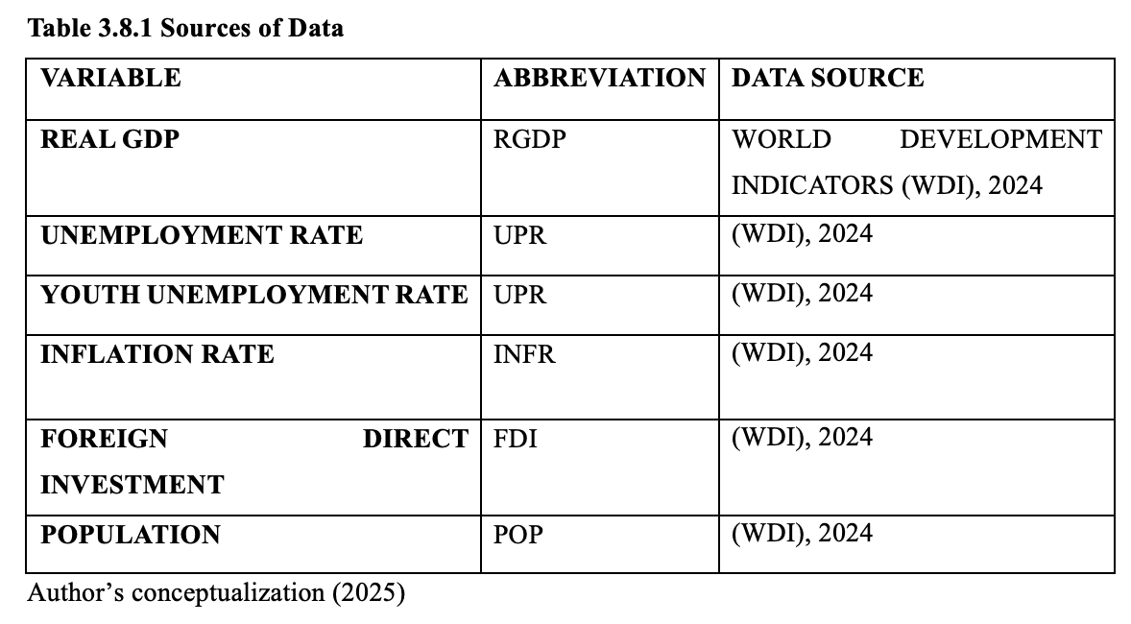

3.9 Software Packages:
This study utilized Microsoft Excel 20.0 for the computation and transformation of the data for statistical analysis and also E-views 12.0 econometrics software for the estimation and tests employed in this empirical study, due to their high quality user friendly interfaces, straightforward application and also most appropriate software for these estimation and test approaches.

CHAPTER FOUR

PRESENTATION AND ANALYSIS OF REGRESSION RESULTS

4.1 Descriptive Statistics
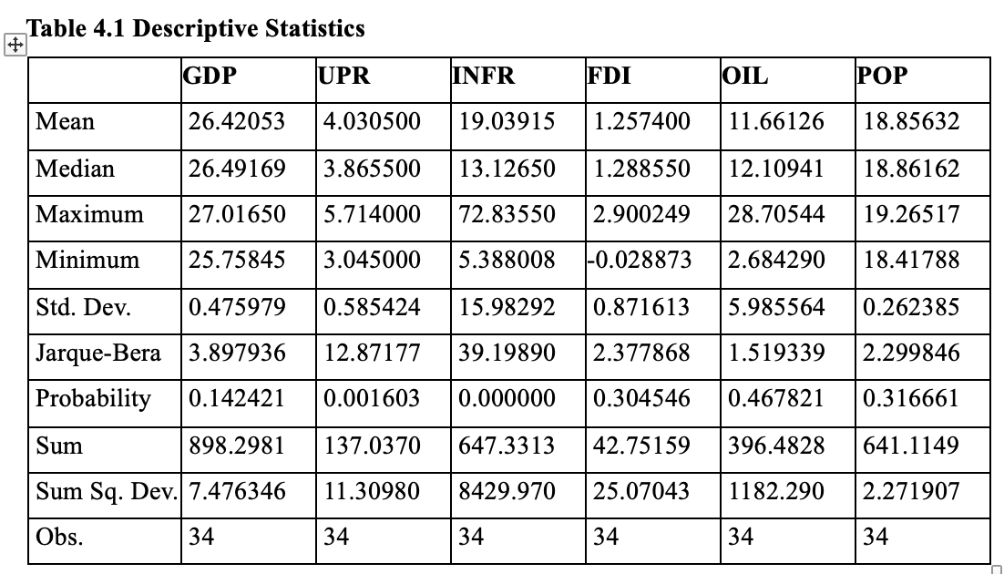
Table 4.1 contains the descriptive statistics summarizing the variables used in this study. The total number of observations is 34. With respect to the logged GDP, its average value is 26.42, and its relatively small standard deviation of 0.47 implies that Nigeria's economic growth has been upward over the period under study, with no signs of volatile shifts. In contrast, there is much fluctuation among labor variables. Its average rate of unemployment is 4.03%. INFR has the largest variability of all other variables, having average and standard deviations of 19.03% and 15.98%, respectively. There is a broad disparity between minimum and maximum values for inflation rate (5.38% vs. 72.83%). Oil revenue (OIL) has standard deviation of 5.98, implying an vulnerability in relation to world oil market volatilities. In terms of normality of variables, Jarque-Bera test statistics is utilized in analyzing whether the series follows a normal distribution. For GDP, FDI, OIL and LPOP, with p-values of greater than 0.05, we accept the null hypothesis of normality of these series. This has implication on validity of any economic estimate based on these variables. UPR and INFR series have p-values of 0.001 and 0.000 respectively, thus we reject the null hypothesis of normality for UPR and INFR.

4.2 Pre-Estimation Tests
Before running the models, it is necessary to check whether variables satisfy basic requirements of econometrics modeling. Thus this section presents: the test for stationarity and test for co-integration.

4.2.1 Stationarity Test
In any study concerning time series analysis, testing the stability of time series is very important since an observed time series is stable over time if the average, variance, and covariance are unchanged over time. Stationarity of the variable guarantees the validity and reliable forecasting; so this paper adopts the use of Augmented Dickey-Fuller (ADF) test to verify if the series are stationary over a specified linear trend or is stationary with or without a deterministic or linear trend around a specific value. In order to check whether variables conform with economic estimation and avoid using variables which can leads to a misleading regression analysis such as “spurious regression”, Augmented Dickey-Fuller (ADF) was conducted to confirm the stationarity properties of the variables.
Table 4.2: ADF Stationarity Test Result
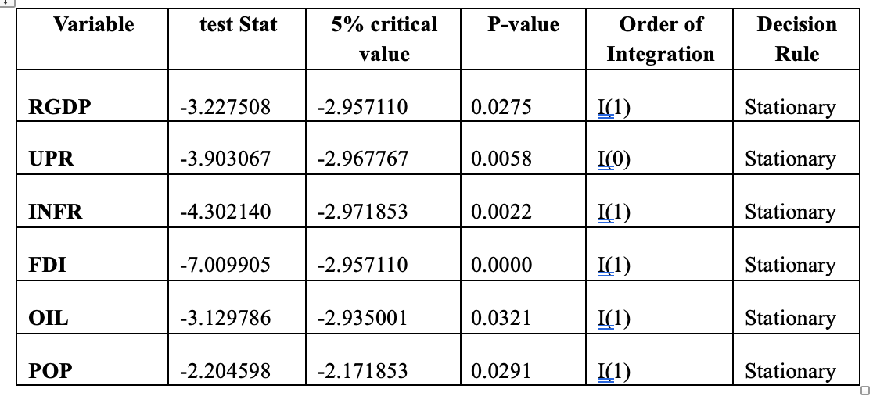
As seen in table 4.2, five of variables became stationary after first difference whereas only one variable UPR is stationary at level. This could give indications of possible relationship among variables in the long run, which is expected to confirm further in next sub-section.

4.2.3 Johansen Test for Co-Integration
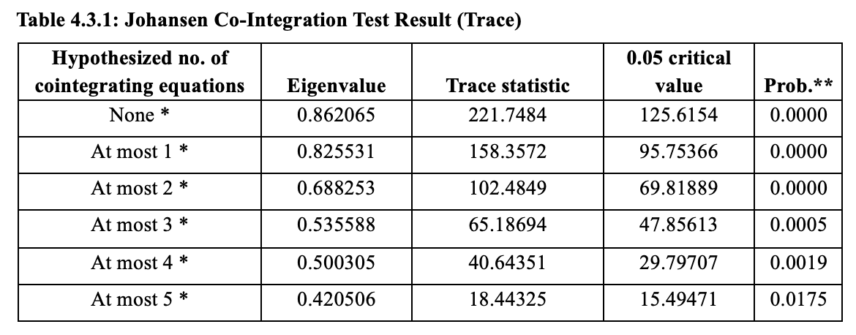
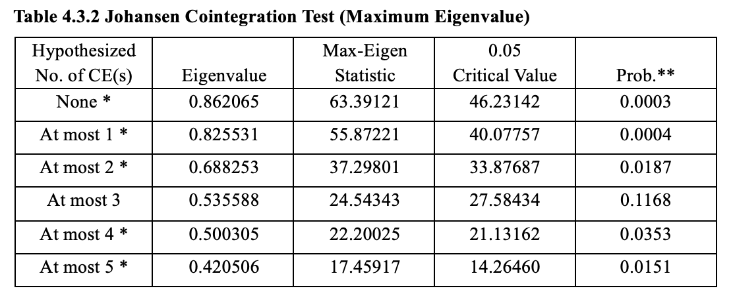
From Table 4.3.1 and 4.3.2 above, the result of the trace test suggests that there are six cointegrating vectors, as indicated by the asterisks (*). We therefore reject the null hypothesis of at most 0 cointegrating vectors. Thus, the result suggests the existence of cointegration among variables understudy.

4.3 Presentation of Estimation Results
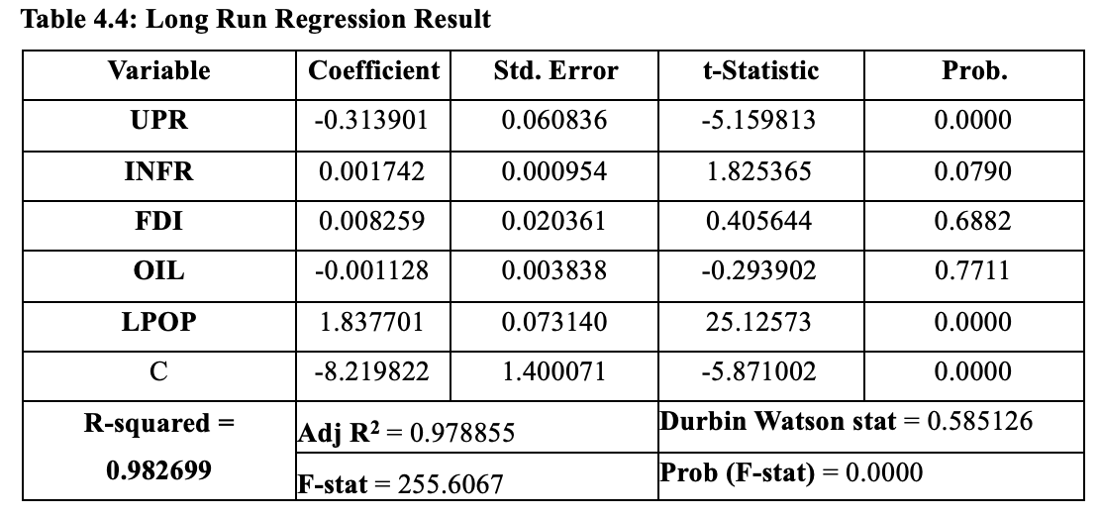
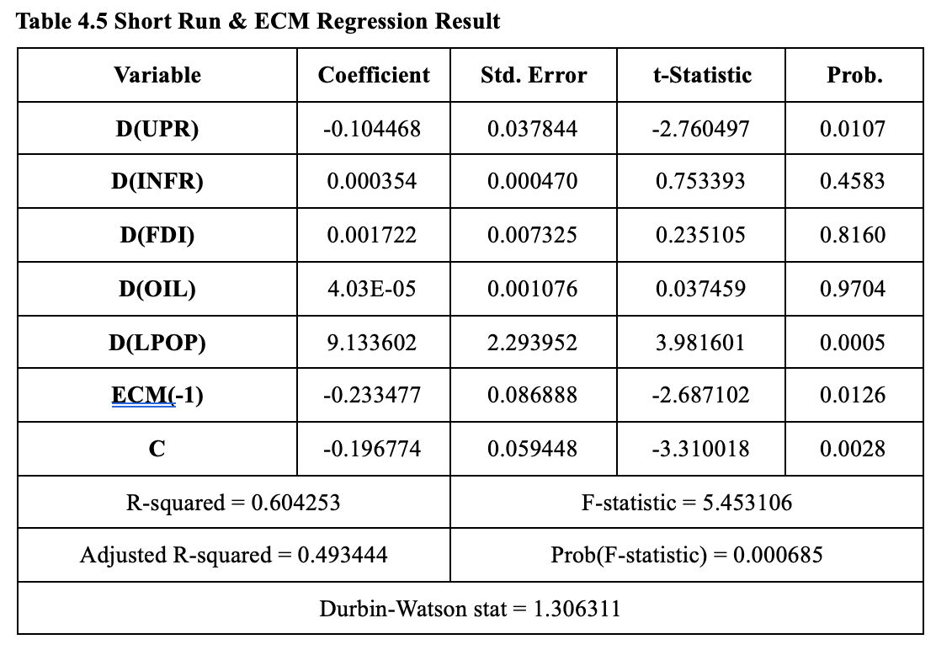

4.4 Evaluation of Estimation Results

4.4.1 Evaluation Based on Economic Criteria (Long-run model):
The coefficients of the unemployment rate variable (UPR) of -0.313901 are significant at 5 percent level, implying that a unit increase in the general unemployment rate of Nigeria causes the economic growth to decrease by 0.31% in the long-run, holding other factors at their current levels. The negative sign of UPR corroborates Okun’s Law (Okun, 1962), stating that a 1% rise in the general unemployment rate may cause a 2% reduction in the output level. The findings were found in the earlier literature of the Nigeria’s economic growth; for instance, Idris (2021) and Mujitapha et al. (2021). In relation to control variables, Population Growth (LPOP) has a positive and statistically significant coefficient (1.837701 with p=0.0000) which means that large size of population increases total output or GDP due to its role in boosting the total aggregate demand and total productive capacity of a country over the long run. Such result corroborates previous findings by Shah et al. (2022).
Foreign Direct Investment (FDI), Oil Revenue (OIL) and Inflation (INFR) variables are insignificant to contribute to economic growth over the long-run in Nigeria. The coefficient of Oil Revenue (OIL) is insignificant which might be related to the current state of Nigerian structural composition. A mono-product country as Nigeria should expect Oil revenue to be the major drive of the economic growth. However, our long run estimates imply that oil revenues do not contribute in the economic growth of the country even after considering population and labour variables. The theory of resource curse indicates that resource wealth leads to underdevelopment. It is possible for this in our Nigeria case based on earlier studies by Ajakaiye and Adeeye (2020). Our argument, from a statistical viewpoint is that as the government use oil revenue to fund expenditures and not to expand the base of productive resources that will expand economic growth over the long run, oil price volaltility contributes to unstable growth. This, it seems that this Nigeria's large population matters a lot for growth.
Furthermore, from Table 4.5, we now turn to examine the nature of relationship of variables in the short-run. Our result show that the coefficient of error correction term is negative and statistically significant at 5 percent level of significance with coefficient of -0.233477. This implies that there is a relationship between variables in the short-run as well as the long-run. Moreover, it suggests that it has ability to take care of time lags or short-run disturbances that would allow for faster and accurate long-run prediction to converge in 1 year to a speed of 23.3477 percent.
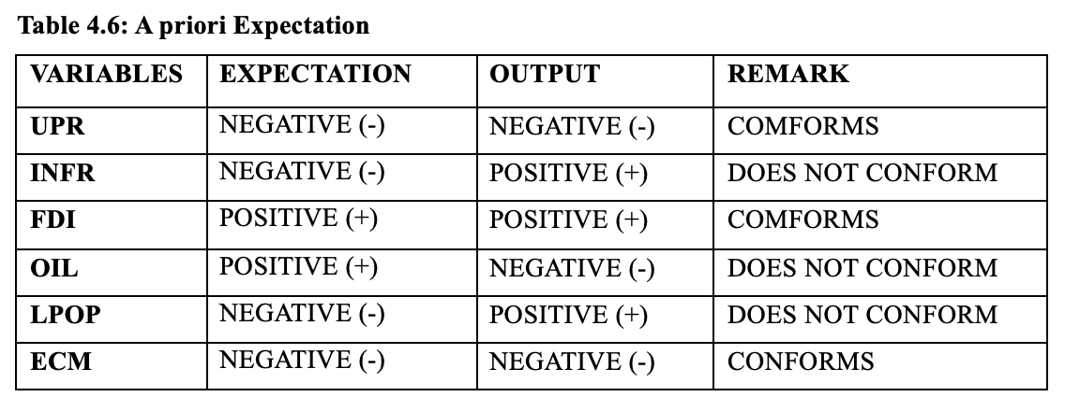4.4.2 Evaluation Based on Statistical Criteria (First-Order Test Results)
4.4.2.1: T-test: This is a two-tailed test to investigate the individual significance of each of the predictor variables that was employed in the model estimation. The test follows t-distribution. Based on t-statistic or the probability value, we make a decision for the test.
4.4.2.2: F-test: From Table 4.4 above, the probability value of the f-statistic is 0.0000, which is < 0.05 at a 5% level of significance. Thus, this study rejects H₀ and concludes that the variables of the model are jointly significant.
4.4.2.3: Multiple Coefficient of Determination (𝑹^{𝟐}): The result of table 4.4 above revealed that R2 is 0.982699. This mean the independent variables used in model contribute about 98.3% to explain the changes in the dependent variable. Hence the model is robust.
4.4.2.4: Adjusted Multiple Coefficient of Determination: Furthermore, from the result of table 4.4 above, adjusted R2 is 0.978855. The relative close proximity of the adjusted to multiple coefficient of determination implies that the model is parsimoniously selected. Therefore, we rely on Occam’s razor, implying robust model.

4.4.3 Evaluation Based on Econometric Criteria (Second-Order Test Results)/ Diagnostic Test Results:
4.4.3.1: Normality Test: This test is done to assess if the model conforms to the normal distribution, by doing the test on residuals.
Table 4.8: Output
Jarque-Bera | 1.321650
Probability | 0.516425
From 4.8 above the p-value of Jarque-Bera’s to be 0.516425 is >0.05, therefore, this study fail to reject the null hypotheses(0) hence we can concluded that the residual term of the model follows normal distribution.
4.4.3.2: Heteroscedasticity Test: To test for heteroscedasticity we used Breusch-Pagan-Godfrey (BPG) test, the test is known to follow the normal chi-square distribution.
Table 4.9: Result
Obs. R² | 8.081913
Prob. Chi-Square | 0.2322
In the table 4.9 above, at chi-squared (2) probability value of 0.2322 is > 0.05 at the 5% level of significance. Thus, we accept the null hypothesis(0) and we conclude that model of this study is homoscedastic.
4.4.3.3: Autocorrelation Test Result: We applied the Breusch-Godfrey (BG) Serial-Correlation LM test, it is known to follow normal chi-square distribution.
Probability value of chi-square (2) is 0.0004 which is <0.05 at the 5% level of significance. Therefore we reject null hypotheses (0) thus conclude that the residual term of the model has autocorrelation, which implies it is serially correlated across observation. Since autocorrelation has major issue in regression, it is resolved by using HAC (High-Autocorrelation Constant) method.
4.4.3.4: Multicollinearity Test Result:
To analyze the extent of the association among independent variables and check for multicollinearity we examine the correlation matrix of the variables used in the regression. A value of correlation coefficient above or equal to 0.8 suggests a significant level of collinearity among the variables.
Table 4.11: Correlation Matrix Result
 | LGDP | UPR | YUPR | INFR | FDI | OIL | LPOP
LGDP | 1 | 0.243381 | 0.26142 | -0.40022 | -0.29266 | -0.73156 | 0.97734
UPR | 0.243381 | 1 | 0.897738 | -0.06624 | -0.35937 | -0.29923 | 0.273661
YUPR | 0.26142 | 0.897738 | 1 | -0.22633 | -0.13175 | -0.22157 | 0.219252
INFR | -0.40022 | -0.06624 | -0.22633 | 1 | 0.009839 | 0.419126 | -0.38342
FDI | -0.29266 | -0.35937 | -0.13175 | 0.009839 | 1 | 0.584658 | -0.3814
OIL | -0.73156 | -0.29923 | -0.22157 | 0.419126 | 0.584658 | 1 | -0.76806
LPOP | 0.97734 | 0.273661 | 0.219252 | -0.38342 | -0.3814 | -0.76806 | 1
We have two cells in the matrix of correlations that contains values greater or equal to 0.8 (apart from values which are perfect collinear). Based on this finding, the model of study suffers from multicollinearity.
4.4.3.5: Specification Bias Test Results:
This test is performed to examine the functional specification of the model and to avoid model bias. This test follows the F- distribution and we use the probability value.
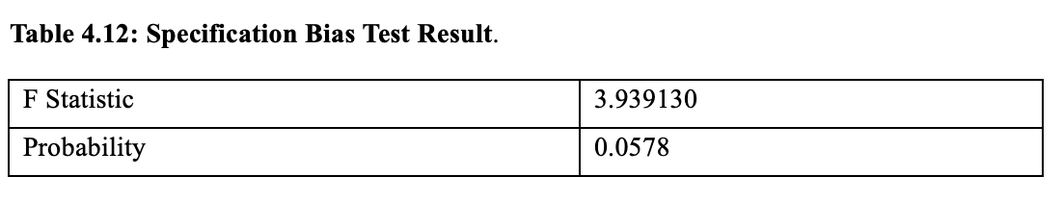The probability value (0.0578) for the F statistic, is above 0.05, at the 5% level of significance, according to Table 4.12. Thus, we fail to reject the null hypotheses and conclude that specification bias is absent in the model.

4.5 Granger Causality Test
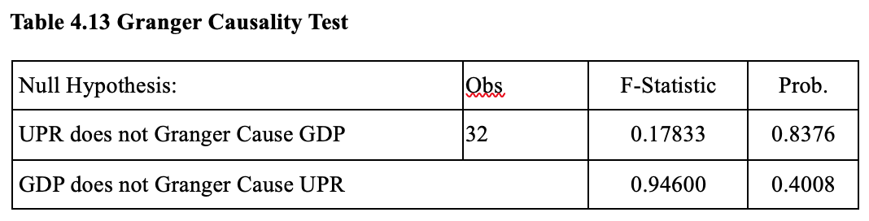
In Table 4.13, given that the p-value for this is significantly above the critical value of 0.05, we fail to reject the null hypotheses. Therefore, there is no Granger-Causality relationship between the rate of unemployment and gross domestic product. This imply that though unemployment and economic growth are associated in the long-run, there is no causal relationship. Consequently, growth of the Nigerian economy is not directly and explicitly induced by participation in the labor force, neither does the increase in Nigerian output lead automatically to increase employment. These results contrary to what the study by Mujitapha et al (2021) on Malaysia show one waycausality between labor market and economic growth where Okn’s law can be applied. However in the case of Nigeria, these two macro economic indices appear to run parallel. This implies for Nigerian policymakers, any attempt to trigger a reduction in the rate of unemployment through growth stimulating programmes may not be the answer, but may lead to growth which not translated to adequate and productive employment opportunities, hence need for specific, proactive labor market interventions to link unemployment with the growth of the economy.

4.6 Evaluation of Research Hypotheses
We evaluate the research hypothesis based on the estimation results of long-run OLS model and Granger causality test result as follows.
Hypothesis One (H01): Unemployment has no significant impact on economic growth in Nigeria.
The coefficient for general unemployment rate (UPR) is-0.313901 with the associated p-value of 0.0000, which is statistically less than the significance level of 0.05. Hence, we reject the null hypothesis that unemployment rate has no significant impact on economic growth.
Hypothesis Two (H02): There is no significant causal relationship between unemployment and economic growth in Nigeria.
From the Granger causality test, the p-values of both tests between UPR on LGDP (0.8376) and LGDP on UPR (0.4008) are greater than the 0.05 level of significance. Thus we fail to reject the null hypotheses.

CHAPTER FIVE

SUMMARY, POLICY RECOMMENDATIONS, AND CONCLUSION

5.1 Summary of Findings
This study investigated the influence of unemployment on economic growth in Nigeria through the application of time-series data that covers a period of 34 years using Ordinary Least Squares (OLS) regression analysis and Granger Causality test estimation techniques. In this regard, the result of the ADF test for stationarity revealed that the general rate of unemployment is stationary at level I(0) while the other variables (real GDP, oil rents, inflation and population) are stationarity after the first difference, i.e. I(1). Consequently, the study subjected these variables to Johansen cointegration test to assess if there exists any cointegrating relationship among them and the result confirmed that the variables are cointegrated. In the long run analysis of economic growth, general unemployment has a significant and negative relationship with the Real GDP. The study found that a one percentage (1%) change in unemployment causes Real GDP to decline by 0.31 percent (0.31%), which confirms the fact that the under-utilization of the labor force is an impediment to Nigeria's economic growth. Thus, the Nigerian economy is not at the level of making optimum use of its growing labor force. Meanwhile, the error correction term was found to be negative (-0.233) and significant, which implies that the economy corrects about 23% of its short-run disequilibrium within a year, before returning to its long-run equilibrium path. Finally, result of Granger Causality test did not reveal any significant relationship between the variables under study, which confirms that there is no causal link between these two variables and in other words, the economy may not use a decline in unemployment to signal future growth nor could unemployment’s rate growth automatically imply future fall in economic growth.

5.2 Conclusion
From empirical results and analysis above, it can be concluded that unemployment represents a significant structural problem that has hindered Nigeria from achieving her desired path for sustainable economic growth. Although Nigeria's economy has at some point in history recorded some positive growth rates, the economy has failed to make substantial investments to foster effective utilization of the enormous labor force that abounds in Nigeria. Consequently, as the share of unemployed population increases relative to the total population, Nigeria's economy will inevitably witness significant declines in its growth prospects.
In view of this, the evidence suggests that the Nigeria economy’s structure is largely disconnected from its labour force in such a way that the current economic growth neither induces nor is signaled by fluctuations in the rates of employment/unemployment.
Without a deliberate shift in economic policies away from the reliance on capital-intensive resources, toward investments that have larger absorptive capacities and promotes labor intensive productivity, Nigeria's demographic dividend is under the risk of slipping away due to sustained human capital erosion.

5.3 Policy Recommendations
The empirical findings of this research yield the following policy recommendations:
- Considering the adverse relationship between unemployment and the growth rate in Nigeria, government should consider shifting focus away from the reliance of capital-intensive investment to the employment of labor in the development of the country. Investment should be focused on the sector that possesses high labour absorption capacity relative to what obtained in the oil and telecommunication sector.
- Government shouldinstitutionalize and sustainably fund transition initiatives that would guarantee adequate absorption of young Nigerian professionals into job placements by diversifyingmulti-sector partnerships and supporting initiatives such as NJFP 2.0 to expand young people into jobs that lead to their professional careers development.
- On the issue of multi-sector partnership, the government, through the ministries of education and youth and sport, should collaborate with private firms and industries to scale up training centers that match required skills with existing vacancies in high-growing sectors like FinTech and agriculture.
- Given that inflation rate was found to be negative, thus hindering the overall economic growth in Nigeria, the CBN should pursue tight monetary policy to reduce the high level of inflation in the country.
- As evidence suggests, that population has the highest positive influence on the economy, for this demographic growth to be transformed into the country’s much sought demographic dividend and also help create jobs, Nigeria needs to invest more in human capital development that could convert such large population size into productive labor force that could spur job growth in the economy. And, for job creation, access to low cost and targeted credit facility provided by central bank of nigeria and bank of industry should be expand to encourage small medium enterprises, micro and cottage.

5.4 Limitations of the Study and Areas for Future Research Focus
This study is limited by recent shift in labour statistics methodology, this had made it difficult for proper consistent long time series unemployment rate to be obtained. Also, data at regional level have not been used in this study, but the study used an aggregate national data for Nigeria which will hide regional disparities in unemployment across states. Future research studies should investigate unemployment-economic growth relationship at state level in Nigeria and explore the impact of regional disparties in labour markets; the impact of Creative economy, Finance and FinTech sector to absorb more labours relative to traditional sectors.

REFERENCES
Abada, F. C., Manasseh, C. O., Nwakoby, I. C., Obidike, P. C., Okonkwo, O. N., & Alio, F. C. (2021). An assessment of inclusive growth policy as a determinant of unemployment reduction in Nigeria: An application of autoregressive distributed (ARDL) bound test approach. Montenegrin Journal of Economics, 17(4), 85-97.
Akinola, A. T., & Adekile, A. A. (2024). The impact of brain drain and unemployment on economic growth in Nigeria. African Journal of Social Sciences and Humanities Research, 7(2), 265-277.
Anderu, K. S. (2021). An empirical nexus between poverty and unemployment on economic growth. Jurnal Perspektif Pembiayaan Dan Pembangunan Daerah, 9(1), 85-94.
Anyanwu, U. N., Ojima, D., & Ajudua, E. I. (2021). Impact of youth unemployment on economic growth in Nigeria. Social Science Research, 7(1).
Aydin, C., Gürbüz, Y. E., & Ersan, S. (2025). Does the level of inflation matter in the relationship between unemployment and economic growth: a new approach to asymmetric Okun’s law. Labour and Industry, 1-17.
Ayele, A., Mitiku, F., & Bayissa, M. (2023). Impact of inflation and unemployment on economic growth in Ethiopia (1991-2020). Journal of Somali Studies: Research on Somalia and the Greater Horn of African Countries, 10(2), 97-116.
Bala, U., Ibrahim, A., & Hadith, N. B. (2020). Impact of population growth, poverty and unemployment on economic growth. Asian Business Research Journal, 5(1), 48-54.
Dornbusch, R., & Fischer, S. (1994). Macroeconomics. SPN and the Foundation of Economics, Prague.
Durech, M., Minea, A., Mustea, L., & Slusna, M. (2014). Regional evidence on Okun’s Law in Czech Republic and Slovakia. Economic Modelling. Elsevier, 42(c), 57-65.
Hjazeen, H., Seraj, M., & Ozdeser, H. (2021). The nexus between the economic growth and unemployment in Jordan. Future Business Journal, 7(1), 42.
Idris, M. I. F. T. A. H. U. (2021). Effect of unemployment and inflation on economic growth in Nigeria. Global Journal of Applied, Management and Social Sciences (GOJAMSS), 21(2021), 254-266.
Kumar, N. K. (2024). Effects of unemployment and inflation on the economy of Nepal. Rajarshi Janak University Research Journal, 2(1-2), 42-49.
Lain, J. & Pape, U. (2023). Nigeria’s dichotomy: low unemployment, high poverty rates. World Bank Blogs. Retrieved https://blogs.worldbank.org/en/opendata/nigerias-dichotomy-low-unemployment-high-poverty-rates
Lubbock, K. J., & Merin, M. (2022). The impact of inflation, unemployment, and population growth on philippine economic growth. Journal of Economics, Finance, and Accounting Studies, 4(2), 55.
Mathibe, M., & Oppong, C. (2024). Sustainable entrepreneurship: A catalyst for unemployment reduction and economic growth in Anglophone and Francophone countries. Business Strategy & Development, 7(2), e362.
Muhammad, A. A. (2023). Examining the relationship among unemployment, inflation, and economic growth. Journal of Business and Economic Options, 6(2), 23-31.
Mujitapha, D., Affendi, N. S. N. N., Othman, N., & Muda, R. (2021). Unemployment and Economic Growth: An Empirical Verification of Okun's Law in Malaysia. Global Business and Management Research, 13(4), 355-364.
Ngubane, M. Z., Mndebele, S., & Kaseeram, I. (2023). Economic growth, unemployment and poverty: Linear and non-linear evidence from South Africa. Heliyon, 9(10).
Niken, K., Haile, M. A., & Berecha, A. (2023). On the nexus of inflation, unemployment, and economic growth in Ethiopia. Heliyon, 9(4).
Nnachi, N., & Ebubechima, U. (2023). Unemployment, inflation and economic growth: evidence from Nigeria. African Journal of Politics and Administrative Studies, 16(2), 762-783.
Nwamuo, C. (2022). Monetary policy and unemployment rate in Nigeria: An empirical investigation. World Journal of Advanced Research and Reviews, 15(3), 248-255.
Okun, A. M. (1962). Potential Output: Its Measurement and Significance. Cowles Foundation
Olayemi, H. O., Maku, O. E., & Adelowokan, O. A. (2023). Impact of unemployment on economic growth in Nigeria: Bound test and ARDL approach. Acta Universitatis Danubius. Œconomica, 19(2), 159-171.
Organisation of Economic Cooperation and Development, OECD. (2023). Foreign Direct Investment. Retrieved from https://doi.org/10.1787/9a523b18-en
Sen, S. (2021). Jobless Growth in India during the 12th Five Year Plan (2012-2017). SSRN. https://dx.doi.org/10.2139/ssrn.3719969
Shah, S. Z. A., Shabbir, M. R., & Parveen, S. (2022). The impact of unemployment on economic growth in Pakistan: An empirical investigation. iRASD Journal of Economics, 4(1), 78-87.
Sinha, J. K. (2022). Impact of unemployment and inflation on the economic growth of India. Journal of Development Economics and Finance, 3(2), 397-417.
Uddin, I., & Rahman, K. U. (2023). Impact of corruption, unemployment and inflation on economic growth evidence from developing countries. Quality & Quantity, 57(3), 2759-2779.
Virk, A., Nelson, E.-U., & Dele-Adedeji, I. (2023). The challenge of youth unemployment in Nigeria. Journal of International and Comparative Social Policy, 39(3), 319–329. doi:10.1017/ics.2024.4

