ASSESSMENT OF HEAVY METAL CONCENTRATION IN SURFACE WATER AND SEDIMENT OF FRESHWATER ECOSYSTEMS WITHIN ENUGU METROPOLIS: IMPLICATIONS FOR ENVIRONMENTAL AND HUMAN HEALTH.

BY

EMMANUEL SMITH ADEBUSUYI
GOU/U21/BIO/008

PROGRAMME: APPLIED BIOLOGY
DEPARTMENT OF BIOLOGICAL SCIENCES
FACULTY OF NATURAL SCIENCE AND ENVIRONMENTAL STUDIES,
GODFREY OKOYE UNIVERSITY, THINKER’S CORNER, ENUGU.

JUNE, 2025

TITLE PAGE
ASSESSMENT OF HEAVY METAL CONCENTRATION IN SURFACE WATER AND SEDIMENT OF FRESHWATER ECOSYSTEMS WITHIN ENUGU METROPOLIS: IMPLICATIONS FOR ENVIRONMENTAL AND HUMAN HEALTH.

BY

EMMANUEL SMITH ADEBUSUYI
GOU/U21/BIO/008

PROGRAMME: APPLIED BIOLOGY
DEPARTMENT OF BIOLOGICAL SCIENCES
FACULTY OF NATURAL SCIENCE AND ENVIRONMENTAL STUDIES,
GODFREY OKOYE UNIVERSITY, THINKER’S CORNER, ENUGU.

A PROJECT SUBMITTED TO THE DEPARTMENT OF BIOLOGICAL SCIENCE,
IN PARTIAL FULFILLMENT OF THE REQUIREMENTS FOR THE DEGREE OF BACHELOR OF SCIENCE (B.Sc) IN APPLIED BIOLOGY

SUPERVISOR: DR. NNAMDI AMADI

JUNE, 2025
APPROVAL
This research titled “Assessment of Heavy Metal Concentration In Surface Water and Sediment of Freshwater Ecosystems Within Enugu Metropolis: Implications for Environmental and Human Health has been assessed and approved by the Committee of Department of Biological Sciences and Faculty of Natural Sciences and Environmental Studies, Godfrey Okoye University Enugu Nigeria.

____________________ __________________
Emmanuel Smith .A.
Student Date

____________________ __________________
Dr. Nnamdi Amadi Date
(Supervisor)

____________________ __________________
Dr. Olisaka Frances .N Date
Head of Department

____________________ __________________
External Examiner Date

DEDICATION
This research work is dedicated to my family and to God almighty the author and finisher of our Faith whom by his grace foreknew, predestined and made this work a success and for seeing me through my academic years.

ACKNOWLEDGEMENTS
My deepest appreciation to all those who contributed to the successful completion of this project.
Firstly, I am deeply thankful to my project supervisor Dr Nnamdi Amadi, for his exceptional guidance, insightful feedback, and consistent support throughout the course of this research. His mentorship greatly enriched the quality of this work and helped shape it into its final form.
My profound appreciation goes to my parents Mrs Cynthia Smith whose unwavering love, prayers, and encouragement have been the foundation of my academic journey. I am equally grateful to my siblings for their steadfast support and understanding throughout this process.
I also extend my sincere thanks to the members of the Press GOU Chapter, whose dedication and collaborative spirit served as a source of motivation and inspiration during my time as a student.
To my friends and colleagues in the Department of Biological Science, I am truly grateful for the knowledge shared, discussions held, and the collective drive that helped us all persevere. Your support and camaraderie made this journey both meaningful and memorable.
My appreciation goes to my lovely H.O.D., Dr. Frances N. Olisaka and Miss Paschaline for their help and care towards me. I also acknowledge Mrs. Ukwueze Maria the Lab Technician for her patience during my project work.
To everyone who contributed in one way or another — thank you.

ABSTRACT
Anthropogenic activity remains the single factor that remains of concern to the entire world with regards to the issue of water pollution, partly due to the threat of heavy metals present in it to the environment, the health of the animals and the human beings. In this study, the heavy metal toxicity load (HMTL) in surface water ecosystems and sediments was evaluated from six areas which includes Emene, Abapka ,Uguomu Nike 1 and 2, Trans – Ekulu within Enugu state Metropolis in Nigeria. The research took into account 6 water samples in terms of physicochemical parameters. Atomic absorption spectrophotometry was used to analyze the samples for heavy metal toxicity load and Metal Index (MI) results were computed to ascertain the Level of heavy metal toxicity load. The pH of sediment was 6.7-7.0 and the pH of water was 6.6- 7.3. Alkaline sign 0. The conductivity turned out to be 36.8-120.0 micro S/cm and 36.8-130.01 micro S/cm in water and sediment respectively but the total solids, turbidity, nitrate and sulfate parameters were found to be within the WHO guidelines. Cadmium (Cd), arsenic (As), and lead (Pb) were at negligible concentrations. More-so, the levels of mercury (Hg), Copper (cu) and Nickel (Ni) in the water were higher than 0.001 and 0.002 mg/L. In order to make water drinkable, the concentration of heavy metals should be eliminated in 88 percent as suggested by WHO cut-off level of 0.01% mg/L. HTML and MI values. Deemonstrate severe threat to drinking water security and the aquatic environment and severe seriousness of cleanup.

TABLE OF CONTENTS
TITLE PAGE
Title Page i
Approval ii
Dedication iii
Acknowledgements iv
Abstract v
List of Tables viii
List of Figures ix
List of appendix x

CHAPTER ONE: INTRODUCTION 1
1.1 Background of the Study 1
1.2 Statement of the Problem 2
1.3 Objective of the Study 3
1.4 Research Hypothesis 4
1.5 Significance of the Study 4

CHAPTER TWO: LITERATURE REVIEW 6
2.1 Heavy Metals in Aquatic Environments 6
2.2 Pollution of Heavy Metals in Surface Water and Sediments 8
2.3 Ecological and Health Impacts of Heavy Metals 10
2.4 Methods for Assessing Heavy Metals in Water and Sediments 11
2.5 Dissolved oxygen (DO) 12
  - National and International Standards for Heavy Metal Concentrations 17
2.7 Literature Gap 18

CHAPTER THREE: MATERIALS AND METHODS 20
3.1 Study Area 20
3.2 Sampling Techniques and Sample Collection 22
3.3 Lab Analysis 22
3.4. Sample Analysis 23
3.5 Quality Assurance 23
3.6 Data Analysis 24

CHAPTER FOUR: RESULT 25
4.1 Concentration of Heavy Metals from Water Samples Collected at Different Location 25
4.2 Concentration of Sediments from Water Samples Collected at Different Location 26
4.3 Physicochemical Parameters of Water Samples Collected 27
4.4 Physicochemical Parameters of Sediments from Water Samples Collected 28

CHAPTER FIVE: DISCUSSION, CONCLUSION AND RECOMMENDATIONS 29
5.1 Discussion 29
5.2 Conclusion 30
5.3 Recommendations 32

REFERENCES 33
APPENDIX 39

LIST OF TABLES
Table 2.1. WHO maximum point for drinking water 17
Table 4.1: Concentration of Heavy Metals 25
Table 4.2: Concentration of Sediments from Water Sample 26
Table 4.3: Physiochemical Parameters of Water Samples Collected 27
Table 4.4: Physiochemical Parameters of Sediments from Water Samples 28

LIST OF FIGURE
Figure 3.1: Sampling locations along Ugwuomu NIke Lake 1 Ugwuomu Nike Lake 2 Iva Valley River Trans Ekulu river Abakpa River 21

LIST OF APPENDIX

Appendix 1: Emene River 39
Appendix 2: Ugwuomu Nike Lake 1 39
Appendix 3: Ugwuomu Nike Lake 2 40
Appendix 4: Trans-Ekulu River 40
Appendix 5: Iva valley River 41
Appendix 6: Abakpa Nike River 41

CHAPTER ONE
INTRODUCTION
1.1 Background of the Study
One of the Sustainable Development Objectives (SDG) includes access to Clean Water and Sanitation. Access to clean water, enough food, and consistent sanitation and hygiene are all fundamental requirements for maintaining good health and well-being. (United Nations, 2023). Factors including the combination of urbanization, a rapidly expanding population, and the rising water demands of the energy, industrial, and agriculture sectors are driving up demand (Grönwall et al., 2020). According to the United Nations, billions of people will be deprived of these essential needs by 2030, access to these fundamental services will be limited if there isn’t a major effort to manage and preserve these resources. Water Resource Access Improvement Program, 2023). Although it is absolutely necessary for ensuring the safe finding of drinking possibilities for surface water, The importance is still unfinished at both the international and national levels; national standards. One of the essential elements for Earth's existence is water, it vital for the social and economic fabric of society as well as for growth and sustainable development (Okudo et al, 2023). Improper use of the water resources is threatening; there are several human activities, which worsen the situation. Surface water is an essential natural resource that supports human health as well as socioeconomic well-being development and ecosystems; recently it has come under increasing scrutiny for pollution (Reza et al., 2010). Rising to prominence on the global stage is the pollution of water resources by heavy metals originating from both natural sources and human activities (Egbueri et al., 2020). Therefore, a thorough grasp of surface water is imperative as its quality, development, and influencing variables enable long-term viability (Obasi et al., 2020). Because of their possible effects on the environment and human health, heavy metals are very polluting and constitute a major environmental concern (Kumar et al., 2021). These include lead (Pb), chromium (Cr), arsenic, cadmium (Cd), and mercury (Hg), which can bioaccumulate in the body and disrupt aquatic ecosystems as defined by their great atomic weights and densities at low concentrations persistence and cumulative effect in the environment (Kumar et al., 2021). Heavy metal pollution of bodies of water originates from a range of sources including industry, agricultural runoff, natural geology, and discharges (Sharma et al., 2009). This pollution has a negative impact on the environment stability and human well-being, which could eventually lead to neurological, muscular, and physical ailments (Ali et al., 2020). The food chain, which endangers both aquatic species and human beings (Lambert et al., 2000). Thus, determining the toxicity of heavy metals in, to minimize ecological harm, water quality is crucial. Even with the significance of heavy metal intoxication, a look at the Heavy Metal Toxicity Burden Measuring toxicity mostly the components of surface water in Nigeria using the (HMTL) model Enugu State still has demands not yet met. The HMTL technique offers an innovative way to assess poisonous elements based on levels as well as enhance surface water consumption usability (Proshad et al., 2021).
1.2 Statement of the Problem
Heavy metal contamination of freshwater ecosystem is a serious environmental concern that puts both aquatic life and humans at significant risk. Rivers and streams are essential resources in the Enugu Metropolis for household, agricultural, and industrial use. However, the growing rate of urbanization, unregulated industrial activity, inappropriate waste management, and coal mining have resulted in the indiscriminate dumping of harmful heavy metals into these water bodies. The chemicals accumulate in the surface water and sediments causing long term environmental threats. Freshwater systems are becoming increasingly harmful to human consumption and other useful purposes despite their high level of necessity in the process of sustaining lives.
The heavy metals are of special concern, and these will not disappear in the environment but may bio-accumulate in the aquatic life. Extended contact with these harmful chemicals through water, fish consumption among other ways, has been linked with life threatening conditions such as cancer, neural effects and organ damages. In addition, lack of routine watchdogging, ignorance of the people and ineffective enforcement of environmental regulations have also worsened the situation. To allay these fears, preserve the health of the populace and ensure the sustainability of the management of freshwater resources in the long term, the levels and the potential sources of the heavy metal contamination of the surface water bodies and the sediments in Enugu Metropolis must be assessed as an issue of great urgency.
1.3 Objective of the Study
The prime objective of the research would be to ascertain the concentrations, source and ecological risk of the heavy metals in the surface water and sediments of the fresh water ecosystem within Enugu Metropolis.
- To assess the levels of selected heavy metals (e.g., lead, cadmium, chromium, arsenic, and mercury) in surface water and sediments from freshwater habitats in Enugu Metropolis.
- To get access to the physicochemical parameter of water and sediment samples.
- To determine the environmental and human health risk due to the heavy metal pollution of the study site.

1.4 Research Hypothesis
To meet the study's objectives, the following tests and analysis will be performed:
1. Heavy metal concentration analysis is performed using Atomic Absorption Spectroscopy (AAS) and Inductively Coupled Plasma Mass Spectrometry (ICP-MS) to precisely quantify metals in water and sediment.
2. Physio-chemical Parameter Assessment will evaluate pH, dissolved oxygen (DO), electrical conductivity (EC), total dissolved solids (TDS), and turbidity to determine water quality.
3. Heavy metals will be traced back to their sources using the Geo-chemical Index and Principal Component Analysis (PCA). Sediment Quality Guidelines and risk indices will determine the possible effect on the environment and health.
1.5 Significance of the Study
Regarding local communities, the proposed study will be practical since the communities will be having vital information regarding the safety of freshwater resources in Enugu Metropolis. It will boost information exchange on the impacts of heavy metal contamination and how to use water safely thereby minimizing health risks. The findings will also help the stakeholders undertake the mitigation strategies of pollution in the troubled areas.
Locally, the study will improve the local understanding of the pollution of the heavy metals in the southeast of Nigeria by providing the information about the extent of pollution, its causes, and its threat. It will also serve as a guide to other states in the region having the same kind of environmental problems that favour the management of the fresh water resources and control of pollution in the region.
The potential health effect of the contact with the heavy metals through the contaminated water and the sediments will be focused on in the research. This will help the professional workers in public health to identify vulnerable people, formulate interventions, and awareness campaigns that would have minimal effect on health risk. It will minimize the spread of heavy metal related disorders in the locality in long run.
The study will provide recommendations that are viable and may be adopted by the policy makers and other environmental regulators in improving their pollution control mechanisms and in the formulation of environmental legislations, adoption of sustainable waste management methods and setting up regular monitoring programs. The result will also indicate the local government on the areas to focus on in protection of fresh water resources in addition to mitigation of environmental risks in Enugu Metropolis.

CHAPTER TWO
LITEARATURE REVIEW
2.1 Heavy Metals in Aquatic Environments
Heavy metals refer to elements that have atomic weight and density at least 5 times greater than that of water. They are naturally occurring in the crust of the earth but when introduced into the water ecosystem in large concentrations they act as contaminants. Common heavy metals of concern are arsenic (As), cadmium (Cd), chromium (Cr), copper (Cu), nickel (Ni), lead (Pb), and mercury (Hg). These metals are classed according to their toxicity, persistence, and bio-accumulative properties, all of which represent major hazards to aquatic creatures and human health (UNEP, 2023).
Heavy metals are major ecological contaminants and their toxicity is a problem of increasing significance for ecological, evolutionary, nutritional and environmental reasons (Jaishankar et al., 2013).Heavy metals are not biodegraded, and they imply long-term persistence in water bodies. They have a high propensity to bio-accumulation in aquatic life and bio-magnification up the food chain that lead to toxic effects on trophic levels. To give an example, mercury is methylated in water to form methyl-mercury which is a very toxic substance and accumulates in fishes thus affecting the predators, like human beings negatively. The environmental consequences of the heavy metals lie in their capacity to influence the aquatic systems, reduce the biodiversity and diminish the overall quality of water.
2.1.1 Sources of Heavy Metal Pollution in Freshwater Ecosystems
Rocks are considered to be the original source of heavy metals. The proportion of heavy metals in rocks differs depending on the rocks. Sometimes they get concentrated in soil, water or air and they are absorbed by plants and ingested by humans or animals. The level of heavy metals in water is highly associated with the level of our environment. Contaminations are picked up by streams and rivers through surface runoffs as well as through sewages and industrial discharge as well as agrochemical used in agricultural activities. Discharge from industries such as mining, smelting, electroplating, and manufacturing discharge cadmium, lead, and chromium into water bodies (Osuji and Onojake, 2020).
Heavy metal containing fertilizers and pesticides pollute rivers and lakes in Niger Delta (Nwankwoala, 2022). These are then moved to lakes or water reservoirs which provide drinking water. Mining activities such as coal mining produces waste that leaks heavy metals into nearby water bodies (Eze, 2023).
Hot water dissolves more salts of heavy metals than cold water and consequently there is change in the level of heavy metals during the wet and dry seasons (Hanaa et al., 2000). The levels increase with drop in pH value, below pH of 5.5 majority of metal ions dissolve in water and when the bed rock or aquifer rock contains high percentage of metal ions at low pH and high temperature levels of metal ions would increase (Skudi et al., 2011). A study carried out on water of River Kuywa found that the pH ranged from 4 to 8.5 (Omwoma, 2011).Baseline information regarding the occurrence of heavy metal contamination is needed in order to assess drinking water and agricultural soil. Several parameters such as distance to the source of pollution and the routes, natural variation in the background of pollution, and accumulation or deterioration of pollution with time, require that the data on environmental pollution should be prone to diversity of errors. Environmental variability indicates the actual variation in pollution level between population units (Guney et al., 2010).

2.2 Pollution of Heavy Metals in Surface Water and Sediments.
Heavy metals impact the aquatic environments in numerous ways most of which are as a result of human influence. Discharges associated with industrial activities like mining, smelting and manufacturing of products evict metals like cadmium, lead and chromium directly into the waterways. Agricultural activities also play a role by causing the emissions of pesticides and fertilizers with heavy metals to be emitted into rivers and lakes after heavy rains. Storm water runoff is also significant; metals may be mobilized by rain water on the roads, buildings and other facilities and carried into the water bodies. Moreover, deposition which comes as a result of emitting metals into the atmosphere as particulate matters leads to their deposition in the water bodies. Natural sources, including weathering of metal-rich rocks and volcanic actions, introduce heavy metals into the water environment, although in a lesser quantity compared with the anthropogenic sources. Sediment metal contamination poses serious environmental risks to the environment as it impacts directly and indirectly on various ecosystems. According to Praveen, (2007) it can negatively impact aquatic animals growth, reproduction, and species diversity. The metals build up in the water species and are consequently transferred to humans through the food chain.
2.2.1 Mechanisms of Heavy Metal Accumulation in Sediments
- Once in the aquatic systems, heavy metals are highly sensitive to particle matter whereby they accumulate in the bottom sediment. There are many processes that influence this process. Heavy metals stick to the surfaces of sediment particles, which is influenced by the particle's surface area and binding sites (Iodache and Nechita, 2022). The metals combine with the organic and inorganic compounds present in the water that gets deposited in the sediment. During formation, minimal matrix can absorb the heavy metals, thus removing them in the water column.
- Sediments rich in organic matter have a larger capacity for metal accumulation due to the availability of binding sites, which has a substantial impact on these mechanisms (Gierzskezki, 2022).
- Factors which affect the mobility and bio-availability of heavy metals in water and sediments.
- The mobility and bio-availability of heavy metals in the water environment depends on a number of related variables.
- pH level
- Acidic conditions can make heavy metals more soluble, thus more mobile and available to be taken up by biology.
- Redox Potential
- Oxidation-reduction conditions affect the solubility and interaction of metals with sediment because metals exist as chemical forms.
Organic Matter Content
Large inputs of organic matter may bind heavy metals reducing their mobility, but perhaps increasing bio-availability to species that feed upon organic particles.
Particle Size Distribution
Clays and silts are fine-grained sediments with a large surface area and the capacity to absorbed heavier amounts of metals compared to coarse-grained sediments.

Competing Ions
Mobility of heavy metals: Other ions present in water may have an effect on the adsorption and desorption of heavy metals and thus affect their mobility.
2.3 Ecological and Health Impacts of Heavy Metals
2.3.1 Effects of Heavy Metals on Aquatic Organisms and Ecosystems
Heavy metals such as arsenic, cadmium, chromium, copper, lead, nickel, molybdenum, vanadium and zinc, with a density higher than 5 mg mL -1. Aluminium, cobalt, strontium, and other rare metals attract interest (Khanna, 2011).
A heavy metal is not toxic although it becomes toxic in the plant and the animal only when its concentration supersedes a particular limit. There are other elements, the trace elements or micro-nutrients which play vital roles in plant and animal cells. This has been demonstrated in the case of Co, Cu, Fe, Mn, Mo, Ni and Zn. Only when the internal concentration exceeds a certain threshold do they demonstrate toxic effects, and then they are commonly termed “heavy metals” (Klaus-J, 2010).
Heavy metals such as lead (Pb), cadmium (Cd), mercury (Hg), and arsenic (As) are major environmental contaminants that affect aquatic life. Such metals may concentrate in water and sediments with toxicological effects to the aquatic organisms. An increase in heavy metals may lead to physiological stress, abnormal behavior, and even death of aquatic life. Heavy metals, for example, can damage DNA and produce genotoxicity in aquatic species, leading to abnormal gene expression, DNA strand breakage, and inappropriate DNA-protein interactions (Shah and Daverey, 2023). Additionally, heavy metals have the ability to disrupt microbial ecosystems decreasing both microbial diversity and activity which is imperative to nutrient cycling and the wellbeing of the ecosystem as a whole.
2.3.2 Heavy Metals Toxicity to Human Health
The heavy metals can enter into the body of human beings via several routes such as the ingestion of polluted water and aquatic organisms. A lot of adverse health effects have been attributed to chronic heavy metal exposure. An example will be given, lead may harm the growth of neurons in a child and cause cardiovascular issues in an adult. Cadmium is related to kidney damage and bone demineralization. Mercury and more so methyl-mercury is a potent neurotoxin which damages the central nervous system. With exposure, arsenic may result in skin blemishes, cancer and cardiovascular disease. These metals' bio-accumulation and bio magnification in the food chain heighten the health hazards, as higher trophic level creatures, including humans, are more likely to consume dangerous concentrations (Shah and Daverey, 2023).
2.4 Methods for Assessing Heavy Metals in Water and Sediments
Analytical Techniques for Detecting and Quantifying Heavy Metals
i. Atomic Absorption Spectroscopy (AAS)
The method is mainly because it is reliable and cheap. The AAS method is based on measuring the absorption of light by free atoms in gaseous form, the method provides quantitative information about the heavy metal concentration. It is appropriate for lead (Pb), cadmium (Cd), and mercury (Hg) at parts per million (ppm) levels (Welz and Sperling, 2020).
ii. Inductively coupled plasma mass spectrometry (ICP-MS)
ICP-MS is known for its excellent sensitivity, detecting trace amounts of metals as low as parts per billion (ppb). It is especially beneficial for simultaneous multi-element analysis of metals such as arsenic (As) and chromium (Cr). The capacity to handle complicated matrices makes it perfect for sediment investigation (Chen et al., 2021).

iii. X-ray Fluorescence Spectroscopy (XRF)
XRF is a quick non-destructive method of analysing metals in sediments. This approach is useful for in-field heavy metal pollution screening (Gupta and Tandon, 2022).
2.4 Water Quality to Cache Physicochemical Parameters
In the interactions of the heavy metals with water and sediment system, the physio-chemical parameters play a crucial role.
2.4.1 pH
This has been credited to the fact that acidity or alkalinity of water affects the solubility and nomenclature of heavy metals. Low pH tends to enhance metal Transportability.
2.5 Dissolved oxygen (DO)
This parameter affects the redox, and speciation of metals in water.
2.5.1 Electrical conductivity (EC) and total dissolved solids (TDS)
These parameters detect the presence of ions, especially, heavy metals, which indicates the condition of the water.
2.5.2 Turbidity
High turbidity is frequently associated with elevated levels of suspended particles, which can adsorb heavy metals and reduce their bio-availability (Wang et al., 2020).
Selected Heavy Metals
- Lead
Lead is a recognized toxic substance that is applied in batteries, paints and as fuel additives. It impacts negatively on aquatic environments mainly as a result of industrial effluents and air deposition. Lead is found naturally in the earth crust with an average content of approximately 13mg/kg. Its compounds are detected in each area of the environment. All lead isotopes but 204Pb could be observed in the end products of the radioactive decays of even heavier decay as in equation 2.1 to decay alpha particle and energy. Lead poisoning may result in brain damage especially in children and has been linked to heart disease in the adults. Lead in water may have numerous sources. These are, lead in ground water, urban water piping lead contamination. Nevertheless, lead can contaminate well water because of lead paints, dust and insignificant lead content due to lead in well pumps or faucet components. More so lead gets into the environment due to its utilization in various forms: metallic lead is utilized in storage batteries, solders, ammunition, shielding systems against X-rays and radiations and tank linings. Lead inorganic salts are employed in insecticides, pigments, paints, enamels, glazes, glass, plastics, rubber compound (Smoots, 2011). Chronic lead exposure results in its calcification in the bone from where it can be released following metabolic disruption (EPA, 2008). The particular organs that are sensitive to lead are: central peripheral nervous system, gastro intestinal structure and reproductive system. Lead may also operate as a cofactor in carcinogenesis (NTP, 2010). With chronic poisoning, it is 1000 mg/l of lead in blood in case of adults and 700 mg/l in case of children. A daily intake of 2.5 mg will acquire a dangerous level after 4 years whereas a daily ingestion of 3.5 mg achieves similar levels in just a few months (Sax and Lewis, 2007).
ii. Cadmium (Cd)
Cadmium is a soft metallic element that is bluish white in color and occurs naturally in earth crust. It is usually found in form of a mineral alongside other elements such as oxygen, chlorine and sulphur.
Mining, smelting and the use of phosphate fertilizers release the largest percentage of cadmium to the environment. It is bio-accumulative in aquatic life, toxic to kidneys, causes osteoporosis and cancer in humans. Its per Dead in sediments causes ecological long term threats.
Cadmium does not occur native as metal. The sole cadmium mineral is greenockite (CdS), found as a coating on zinc sulphide ore which is rare it also crystallizes in hexagonal system. Cadmium is found in very small quantities in zinc ores, copper and lead ores. It is typically created as a byproduct during the smelting of metals, especially zinc (Walakira, 2011).
Cadmium is mostly utilized for electroplating or alloying with other metals to provide fusible coatings, welding, and soldering processes (Schutte et al., 2008). Cadmium compounds also have some uses in printing, textiles, television phosphors, photography, lasers, semiconductors, solar cells, dental amalgams and as insecticides. Cadmium levels in food and drinking water can be reduced by reducing food contact, using low-Cadmium agrochemicals, and properly disposing of factory waste ( Nawrot et al., 2010).
- Mercury (Hg)
Traditional gold mining, coal burning and industrial waste are some ways that mercury impacts water bodies. In the organic form, methyl-mercury bio-accumulates in fish and propagates up the food chain, causing grievous neuro-toxicity and developmental disorders. Mercury occurs naturally in various forms, including metallic mercury, mercuric sulfide (cinnabar ore), mercuric chloride, and methyl-mercury. Both of them possess their toxicity profiles. Edible freshwater and salt water fish and marine mammals can contain high levels of methyl-mercury.
Inorganic and metallic mercury gets to the air through mining of deposits of ores containing mercury, through the emissions of coal-fired power plants, through burning of municipal and medical waste, through cement production and through uncontrolled releases in factories that use mercury. At room temperature metallic mercury is a liquid, although it can evaporate into the air and migrate over long distances. Mercury vapor in the air could be converted to various forms and could be transferred to water.
Mercury may get into the water or the ground during the weathering of rocks, during release into the environment by factories or water treatment plants, or during burning of municipal solid garbage that contains mercury, such as thermometers, electrical switches, or thrown away batteries. Mercury has the ability to get into and confer within the food chain. Mercury accumulates in the food chain as methyl-mercury (Balshaw et al., 2007).
The effects of mercury poisoning may be permanent brain and kidney damage, personality changes, tremors, vision changes, deafness, muscle in-coordination, sensory loss and memory problems.
- Zinc (Zn)
Zinc is a useful micro-element but it becomes poisonous when abundant. The possible sources are mining, galvanized metal and fertilizers. Overload of zinc disrupts aquatic life since it inhibits enzyme processes and disrupts reproduction in aquatic organisms. Zinc is a vital vitamin to both human and animal health, as it helps to catalyze a variety of metalloenzymes. These are enzymes such as alcohol dehydrogenase, alkaline phosphatase, carbonic anhydrase, leucine aminopeptidase, superoxide dismutase and DNA/RNA polymerase. Acute oral zinc exposure might result in symptoms like tachycardia, vascular shock, dyspeptic nausea, vomiting, diarrhea, pancreatitis, and liver damage (ATSDR, 2005).
A high intake of zinc does not allow copper absorption as it competes with metallothionein in the brush border of the intestinal lumen. Copper binds to metallothionein with greater avidity than zinc and displaces zinc on the protein. Metallothionein binds copper and this retention in the mucosal cell results in reduced availability of copper to be transferred to plasma.
Zinc deficiency has been associated with dermatitis, anorexia, growth retardation, poor wound healing, hypogonadism, impaired reproductive capacity, immune function, and depression, and with an enhanced danger of congenital malformations in infants.
iv. Copper (Cu)
Copper has many applications in electrical wiring, plumbing and agricultural herbicides. Though they are necessary in low concentrations, they can be lethal to aquatic organisms in large concentrations as they can stop metabolism and lead to gill destruction. Copper is a required nutrient that is a component of metalloenzymes used in the formation of hemoglobin, the metabolism of drugs/xenobiotics, carbohydrate metabolism, catecholamine synthesis, and crosslinking of collagen, elastin, and hair keratin, and antioxidant defense. Copper-dependent enzymes, including Cytochrome c Oxidase (CcO) (a terminal enzyme that reduces molecular oxygen to water), superoxide dismutase, ferroxidases, monoamine oxidase, and dopamine β-monooxygenase, decrease active oxygen species or molecular oxygen. Copper deficiency in humans can cause symptoms such as normocytic, hypochromic anaemia, leukopenia, and osteoporosis (ATSDR, 2004).
Homeostasis of copper averts harmful effects of copper, however, in excess quantities, it may induce liver and kidney toxicity, anaemia, immunotoxicity and developmental toxicity. The latter findings indicate oxidative membrane and macromolecular damage. Copper binds to the sulfhydryl groups of enzymes including glucose-6-phosphatase and glutathione reductase, reducing their ability to protect cells from free radicals (ATSDR, 2004).
v. Manganese (Mn)
Manganese is required in biology, but it is also harmful when it is in abundance. Mining and industrial emissions are some of the natural causes. An overdose of manganese may lead to neurological effects in human beings and alter the microbial populations in the sediments. Manganese plays a vital role in the health development and physiology of all mammals. In the body, Manganese combines with and controls a number of enzymes. It is a co-factors necessary in the action of arginase, which catalyzes the formation of urea in the liver, superoxide dismutase, which scavenges against cellular oxidative stress, and in the action of pyruvate carboxylase, an enzyme of gluconeogenesis. Manganese poisoning has more impact on the brain, which retains it longer than other tissues. Chronic manganese exposure can lead to a persistent neurological condition with limited treatment options and no cure (Crossgrove and Zheng, 2004).
2.5.2 Regulatory Standards and Guidelines
The regulatory standards and guidelines are necessary in the control of heavy metal pollution, protection, and sustainable use of aquatic ecosystems, and the health of the people. Both national and international organizations develop such standards and they are targeted towards particular environmental and health problems.
  - National and International Standards for Heavy Metal Concentrations
- The World Health Organization (WHO)
To protect human health, the WHO sets maximum allowed heavy metal concentrations in drinking water.
Table 2.1. WHO maximum point for drinking water.
Source: (Heavy metal standard points (WHO, 2021)
Heavy Metal | Standard Points
Lead(pb) | 0.01 mg/L
Cadmium (Cd) | 0.003 mg/L
Mercury (Hg) | 0.006 mg/L
Arsenic (As) | 0.01 mg/L
Copper (Cu) | 2.0 mg/L
Nickel (Ni) | 0.07 mg/L

These limitations are intended to reduce long-term exposure concerns, especially for vulnerable groups like children and pregnant women (WHO, 2021).
2.7 Literature Gap
Review of literature on heavy metal contamination in water ecosystem depicts that enormous progress has been made on the distribution of heavy metals, the sources of heavy metals and the effects of heavy metals in the water and sediments. However, these studies point to the fact that, there are issues, which present the requirement of the additional study, especially in the case of the Enugu Metropolis.
Previous research, such as studies on heavy metal contamination in the Ekulu and Ebonyi rivers by (Chukwu et al., 2020), has provided useful insights into heavy metal sources, distribution, and ecological concerns. These studies frequently use advanced analytical techniques such as Atomic Absorption Spectroscopy (AAS) and Inductively Coupled Plasma Mass Spectrometry (ICP-MS). Nevertheless, most of them are narrow, either in time (looking at isolated rivers) or in the heavy metals examined, and often they do not present a comprehensive risk assessment capable of taking into account ecological but also human health criteria. Moreover, majority of the research studies conducted over the past fail to consider the variation of seasons and how it affects the dynamics of heavy metals.
In addition, although global and national studies on heavy metals give general guidelines and procedure, they are not site specific (such as the Enugu Metropolis). This is because; the current study will close such gaps by filling an intensive survey of heavy metals in surface water and sediment of various fresh water ecosystems in Enugu Metropolis. Implementation of the presented project will present a detailed image of the pollution of heavy metals in the region since it includes the addition of sensitive analysis procedures, seasonal analysis, and models of hazard assessment. In addition to this, the study will present the most imperative information that may be integrated in the making of policies, fortification of environmental management practices and sustainable development of Enugu Metropolis. It is on this backdrop of information gap that ecological and health impacts of the heavy metals contamination must be alleviated and more so, the safety and sustainability of the freshwater supply to the locals.

CHAPTER THREE
MATERIALS AND METHODS
3.1 Study Area
The study was conducted at different locations of freshwater bodies within Enugu Metropolis as seen in fig. 1, which includes Ugwuomu Nike Lake 1(UNL1), Ugwuomu Nike Lake 2(UNL2), Iva Valley River(IVR), Trans-Ekulu River(TER), Abakpa River(AR) and Emene River (ER). These water bodies have a very great significance in domestic, industrial and agricultural uses but these are prone to be polluted by the anthropological activities like industrial effluents, mining activities, agricultural overspills and urban waste water discharges. The details of the map that indicates Enugu east local government area and several places where sample points will be placed are as follows.
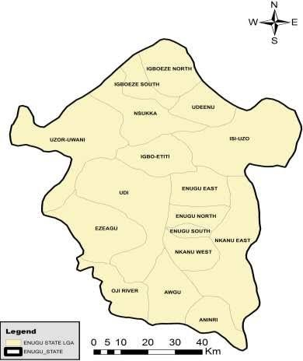
Iva valley River (F)
Trans Ekulu River (B)
Emene River (C)
Ugwuomu
Nike Lake 2 (E)
Ugwuomu
Nike Lake 1 (D)
Abapka River (A)

Figure 3.1 : sampling locations along Ugwuomu NIke Lake 1 Ugwuomu Nike Lake 2 Iva Valley River Trans ekulu river Abakpa river
Source : (Google Maps)
Coordinates of the six locations Abakpa River - (A) 6° 37° 52° N and 8° 49° 24° E Trans-Ekulu River - (B) 6° 25° 0° N and 7° 36° 0° E Emene River - (C) 6° 28° 33° N and 7° 35° 2° E Ugwuomu Nike Lake 1 - (D) 6° 27° 9° N and 7° 30° 37° E Ugwuomu Nike Lake 2 - (E) 6° 27° 9° N and 7° 68° 54° E Iva Valley River - (F) 7° 57° 0° N and 8° 4° 59° E
3.2 Sampling Techniques and Sample Collection
Stratified random sample of water and sediment samples were collected at various points along rivers. Dry season samples and the wet season samples were taken so as to determine the difference in concentration of the heavy metals in the dry season and the wet season. The process of collection include:
Sediment Samples: Sediment samples were collected on the river bed using the assistance of gravity sampler, acid-washed containers and kept at 4o C before analysis.
Accuracy and precision were determined out as part of quality control measures whereby; field blanks, triplicates and standard reference materials were utilized in the determination of accuracy and precision.
3.3 Lab Analysis
The advanced analytical techniques adopted in the examination of the concentration of heavy metal in water and sediment samples are:
Atomic absorption spectroscopy (AAS) was used to identify heavy metals like lead (Pb), cadmium (Cd), chromium (Cr), arsenic (As), and mercury (Hg).
Inductively Coupled Plasma Mass Spectrometry (ICP-MS) is an analytical technique used to determine the concentration of elements and their isotopes by ionizing elements with extremely high-temperature Argon (Ar) plasma, which is very precise and sensitivity.
Physicochemical parameters such as pH, electrical conductivity (EC), dissolved oxygen (DO), total dissolved solids (TDS), and turbidity was also measured according to established techniques.

Atomic absorption spectroscopy (AAS) analysis procedure
3.4. Sample Analysis
The samples were analyzed using the method of Nnorom et al., 2014 regarding the metals analysis. All samples were analyzed as purchased (collected) without any further pre-treatment. 1g sample was weighed and transferred quantitatively into a 250 ml conical flask and thereafter digested with 10 ml of the digestion acid mixture (ratio 1:2:2 of perchloric acid, nitric and sulphuric acids) with heating on a hot plate in a fume hood until evolution of white fumes. The digest was left to cool and 20 ml of distilled water was added to put the metals in solution; and filtered in ashless Whatman filter paper into a 100 ml calibrated volumetric flask and made up to mark with distilled water. Atomic adsorption spectrometer, Buck Scientific made, was then used to analyze the digests concerning the presence of heavy metals.
3.5 Quality Assurance
Sufficient quality assurance procedures and precautions were implemented in order to ensure reliability of results of the current study. All chemicals used were of analytical grade: HClO₄ (70%, Sigma-Aldrich, St. Louis, USA), H₂SO₄ (98%, BDH Laboratory Supplies, Poole, England); HNO₃ (69%, BDH Laboratory Supplies, Poole, England). Washing and rinsing All plastics and glassware were thoroughly cleaned by washing, rinsing severally with tap water and soaking in 5% HNO₃ solution at least 24h to avoid contamination during the experiments. They were washed severally with deionized water before use. The blanks were inserted at 10%. The accuracy of the analytical method was verified by analyzing a certified reference material (Accu Standards, New Haven Connecticut, USA). The limit of detection was described as the concentration that showed three standard deviations of seven blanks.

3.6 Data Analysis.
Statistical and risk assessment techniques (including the following) were applied to the data:
Descriptive statistics: The descriptive statistics of the data were expressed in terms of the mean, standard deviation, and coefficient of variation.
Geo-accumulation Index (Igeo): Used to assess sediment contamination levels.
The most famous geochemical index is Geo-accumulation Index which has helped in establishment of the degree of contamination of sediments. It was firstly suggested in 1969 and was utilized to determine the degree of metal pollution in sediments, through the comparison of current concentrations with the ones that were present in the pre-industrial background concentrations. A higher value indicates a greater degree of contamination (Müller, 1969).
Human Health Risk Assessment: The hazard quotient (HQ) and carcinogenic risk (CR) were used to quantify the potential health effects of heavy metal exposure Human Health Risk Assessment involves evaluating the potential adverse health effects that may result from exposure to environmental contaminants, in this case, heavy metals (Wang et al., 2010).
3.6.1 Ethical considerations
Such study will be Ethical, whereby all the activities in the samples will be based on the environmental regulations.

CHAPTER FOUR
RESULTS
4.1 Concentration of Heavy Metals from Water Samples Collected at Different Location
Table 4.1 shows that in all metals analyzed Copper (cu) and Nickel (Ni) where detected in water samples at all location. The water samples analyzed in table 2 shows negligible concentrations of other metals with levels below or comparable to world health organization guidelines lead was not detectable but found in Abapka River at the concentration of 0.001 ppm while arsenic was also below world health organization (WHO) standards. Mercury(Hg) was present at four location Iva Valley River(IVR), Emene River(ER), Abapka River(AR) and Trans Ekulu River(TER) at concentration ranging from 0.004 ppm, 0.006ppm,0.07ppm and 0.005ppm which where above acceptable limits of 0.006 set by world health organization (WHO). The general water sample seemed to be extensively polluted and the level of heavy metals was high reflecting much hazard to human health and environment.
Table 4.1: Concentration of Heavy Metals
Sample | Arsenic (Ar) (ppm) | Mercury (Hg) (ppm) | Lead (Pb) (ppm) | Cadmium (Cd) (ppm) | Nikel (Ni) (ppm) | Copper (Cu) (ppm)
Ugwuomu Nike Lake 1 (UNL1) | 0.00 | 0.00 | 0.00 | 0.00 | 0.006 | 0.006
Ugwuomu Nike Lake 2 (UNL2) | 0.00 | 0.00 | 0.00 | 0.00 | 0.006 | 0.008
Iva Valley (IV) | 0.00 | 0.004 | 0.00 | 0.00 | 0.003 | 0.042
Trans-Ekulu River (TER) | 0.00 | 0.006 | 0.00 | 0.00 | 0.007 | 0.012
Abakpa River (AR) | 0.00 | 0.007 | 0.001 | 0.00 | 0.00 | 0.066
Emene River (ER) | 0.00 | 0.005 | 0.00 | 0.00 | 0.005 | 0.006
WHO standard  (ppm) | 0.01 | 0.006 | 0.01 | 0.003 | 0.07 | 0.01
NESREA (ppm) | 1.0 | 1.0 | 0.01 | 0.003 | 1.0 | 1.2

4.2 Concentration of Sediments from Water Samples Collected at Different Location
Table 4.2 shows that out of the six heavy metals copper and nickel was detectable in the sediment only traces of Mercury(Hg), Copper (Cu), Arsenic(Ar), Nickel(Ni) and Lead (Pb) where found in sediments samples. Cadmium (Ca) was low or undetectable traces in the samples collected other concentrations of heavy metal in these samples were very low. Lead (Pb) showed an increased amount of contamination in Abapka River (AR), other metals indicated minimal amount of concentration, Which is a signal of growing rate of these heavy metal concentrations. In general the sediment samples indicate a growing rate of accumulation but do not show any major heavy metal contamination suggesting minimal risk to both human health and the environment.
Sample | Arsenic (Ar) (mg/L) | Mercury (Hg) (mg/L) | Lead (Pb) (mg/L) | Cadmium (Cd) (mg/L) | Nikel (Ni) (mg/L) | Copper (Cu) (mg/L)
Ugwuomu Nike Lake 1 (UNL1) | 0.00 | 0.00 | 0.00 | 0.00 | 0.003 | 0.006
Ugwuomu Nike Lake 2 (UNL2) | 0.00 | 0.00 | 0.00 | 0.00 | 0.001 | 0.00
Iva Valley (IV) | 0.003 | 0.007 | 0.006 | 0.00 | 0.008 | 0.002
Trans Ekulu River (TR) | 0.00 | 0.002 | 0.001 | 0.00 | 0.002 | 0.003
Abakpa River (AR) | 0.002 | 0.002 | 0.012 | 0.00 | 0.009 | 0.087
Emene River (ER) | 0.00 | 0.004 | 0.00 | 0.00 | 0.005 | 0.006
WHO standard  (mg/L) | 0.01 | 0.006 | 0.01 | 0.003 | 0.07 | 0.01
NESREA(ppm) | 0.01 | 0.001 | 0.01 | 0.003 | 0.001 | 1.2
Table 4.2: Concentration of Sediments from Water Sample

4.3 Physicochemical Parameters of Water Samples Collected
Table 4.3 indicates that the water is slightly alkaline for samples from Iva Valley River (IVR) and Ugwuomu Nike Lake 1 (UNL1) with the corresponding value of 7.3 and 7.0 respectively while other samples show levels of mild acidity the result indicate that water is of good drinking water standards set by World Health Organization(WHO) . Turbidity was above World Health Organization (WHO) standards in surface water bodies of Emene and Trans Ekulu, all other measured parameters such as Conductivity, Total Dissolved Solid Total Suspended Solids Nitrate and Sulphate are well within or below World Health Organization (WHO) limits. Overall the water sample appears to be suitable for aquatic life
Sample | pH | Conductivity  (µS/cm) | Turbidity  (NTU) | Total Solids(TS)  (mg/L) | Total Dissolved Solid  (TDS) (mg/L) | Total  Suspended Solids  (TSS)  (mg/L) | Nitrate  (mg/L) | Sulphate  (mg/L)
Ugwuomu Nike Lake 1 (UNL1) | 7.0 | 36.8 | 0.13 | 47.1 | 34.1 | 45.1 | 2.34 | 16.62
Ugwuomu Nike Lake 2 (UNL2) | 6.9 | 37.5 | 0.12 | 41.2 | 21.2 | 23.2 | 2.2 | 11.5
Iva Valley (IV) | 7.3 | 90.2 | 0.19 | 98.1 | 51.2 | 48.1 | 1.29 | 20.1
Trans Ekulu River (TR) | 6.7 | 86.5 | 6.9 | 76.1 | 59.2 | 46.2 | 1.10 | 43.2
Abakpa River (AR) | 6.6 | 88.9 | 1.83 | 93.6 | 43.3 | 41.2 | 0.9 | 41.0
Emene River (ER) | 6.7 | 120 | 10.5 | 71.6 | 61.4 | 41.1 | 0.81 | 32.0
WHO standard  (mg/L) | 6.5 - 8.5 | 400 | 5.00 | 1000 | 500 | 500 | 50 | 250
NESREA | 6.5 - 8.5 | 1000 | 5.0 | 1000 | 500 | 500 | 50 | 100
Table 4.3: Physiochemical Parameters of Water Samples Collected

4.4 Physicochemical Parameters of Sediments from Water Samples Collected
Table 4.4 shows that the sediment is slightly alkaline and contains both dissolved and suspended solids. The test results indicate that the physio-chemical properties of the sediments fall within acceptable levels in line with WHO guidelines. The average pH of 7.30 showing mild alkalinity in samples from Iva valley River(IVR) and Ugwuomu Nike Lake 1 (UNL1) ,other sediment parameters of total solids, total dissolved solids, and total suspended solid had an average of 61.3 , 60.2 and 50.0 respectively, furthermore samples show low levels of acidity other parameters remain well within safe limits of established WHO standards.
Table 4.4: Physiochemical Parameters of Sediments From Water Samples
Sample | pH | Conductivity  (µS/cm) | Turbidity  (NTU) | (TS)  (mg/L) | Total Dissolved Solid  (TDS) (mg/L) | Total  Suspended Solids  (TSS)  (mg/L) | Nitrate  (mg/L) | Sulphate  (mg/L)
Ugwuomu Nike Lake 1 (UNL1) | 7.0 | 36.8 | 0.13 | 61.3 | 43.1 | 45.1 | 2.34 | 7.62
Ugwuomu Nike Lake 2 (UNL2) | 6.9 | 37.5 | 0.12 | 52.1 | 44.2 | 23.2 | 2.2 | 6.2
Iva Valley (IV) | 7.3 | 90.2 | 0.19 | 20.3 | 60.2 | 48.1 | 1.29 | 103
Trans Ekulu River (TR) | 6.7 | 86.5 | 6.9 | 56.2 | 59.2 | 46.2 | 1.10 | 98.2
Abakpa River (AR) | 6.6 | 88.9 | 1.83 | 57.9 | 57.2 | 41.2 | 0.9 | 120
Emene River (ER) | 6.7 | 120 | 10.5 | 56.5 | 62.4 | 50.0 | 0.81 | 130
WHO standard  (mg/L) | 6.5 - 8.5 | 400 | 5.00 | 1000 | 500 | 500 | 50 | 250
NESREA (ppm) | 6.5 -  8.5 | 1000 | 5.0 | 1000 | 500 | 500 | 50 | 100

CHAPTER FIVE
DISCUSSION, CONCLUSION AND RECOMMENDATION
5.1 Discussion
A selection of heavy metals, including mercury (Hg), cadmium (Cd), arsenic (As), lead (Pb), nickel (Ni), and copper (Cu), were measured and distributed in surface water and sediments in six freshwater bodies in the Enugu Metropolis. Ugwuomu Nike Lake 1 (UNL1), Ugwuomu Nike Lake 2 (UNL2), Trans-Ekulu River (TER), Abapka River (AR), Iva valley River (IVR), and Emene River (ER). In order to collect structured data, measure heavy metal concentrations thoroughly, and evaluate them statistically, a quantitative research design was chosen. Water bodies were chosen using stratified random sampling according to how close they were to urban, semi-urban, and peri-urban areas. During several sessions in March, April, and May of 2025, samples were taken from specified coordinates.
Physio-chemical analyses was carried out on water samples, for the majority of metals, laboratory analysis was performed using Atomic Absorption Spectroscopy (AAS), whereas Microwave Plasma Atomic Emission Spectroscopy (MP-AES) was used to measure copper (Cu), with calibration based on a certified standard curve. Accredited labs such as Ahmadu Bello University's Central Laboratory and Godfrey Okoye University Chemistry Laboratory were used for the measurements.
Descriptive and comparative statistics were used to compile, clean, and analyze the data set. To ascertain the ecological and public health implications, values were compared to the guidelines set out by the National Environmental Standards and Regulations Enforcement Agency (NESREA) and the World Health Organization (WHO).
The results revealed:
• Mercury, Cadmium, Arsenic, and Lead were undetectable or below regulatory limits at most sites.
• Nickel and Copper were present in trace amounts across various locations.
• Surface water of Emene and Trans-Ekulu exceeded the WHO limit of Turbidity (5.00 ppm) in Pond Water (PW).
• Copper exceeded WHO’s permissible limit (0.01 ppm) in AR, IVR, and TER but remained below NESREA’s limit (1.0 ppm).
The spatial variation of heavy metals was influenced by urbanization, potential point-source discharges, hydrological dynamics, and possibly domestic and agricultural runoff. The findings are consistent with previous regional studies, supporting the need for continued environmental monitoring.
5.2 Conclusion
The outcome of this analysis has shown that there could be a chance where the water quality in the study site is not satisfactory. The concentration of mercury, copper, arsenic and nickel present in the water were above the maximum contained in WHO drinking water guideline. Such elevated concentrations of heavy metals may not be consumption suitable by humans as they may have an undesirable effect on the residents. The regulator authorities might need to put more efforts in monitoring the water bodies particularly the testing of drinking water in the area of study. It is also necessary to impose fines to those people or corporations who occasion a damage to the environment. This will greatly limit the exposure rate of the individuals within the study area to the pollutants such as the heavy metals. The heavy metals content in the sea foods and food crops ought to be tested on a periodic basis and find out the differences of the metals in different seasons. The total heavy metal toxicity load (HMTL) measurement shows that the amount of heavy metals present is higher than the permissible level. The pollution by the heavy metals should be removed to render the water drinkable. The research results indicate that 88 percent of the heavy metals should be removed before the water supplies are potable. This estimation is meant to help the planning authority in making decision on which method of treatment would be effective.
These differences highlight how susceptible freshwater systems are to environmental contamination in urban and peri-urban areas. Despite Enugu's low level of industrialization, the study demonstrates that even mild household, agricultural, or transportation activities can result in an increase of heavy metals, particularly in water systems that are poorly circulated or poorly managed.
The implications are significant for water quality, aquatic biodiversity, and public health. Although there is no immediate threat from the current levels, caution is necessary due to the possibility of bio-accumulation and long-term health effects.
The study also highlights how crucial it is to use a multi-parameter approach when monitoring the environment. A more comprehensive picture of contamination hot-spots and pollutant behavior was created by combining chemical analyses with site-specific sampling and regulatory comparisons. The increasing need for sustainable water resources in a rapidly urbanizing area like Enugu makes this strategy even more pertinent.
The results will equally be an excellent foundation of future evaluation, policy transformation, and plan of water resources. These studies will constitute valuable resources to community action, environmental advocacy and decision making as Nigeria approaches the realisation of its national development agenda and environmental conservation plans.
5.3 Recommendations
The research of the kind would recommend the following in view of the results and findings of the study:
1. Constant Monitoring: The environmental agencies and research institutions are also promoted to conduct constant monitoring of the water bodies within the Enugu Metropolis in order to detect any potential contamination on its initial phases.
2. Source Identification and Mitigation: thorough investigations should be carried out to pin-point the exact sources of pollution - especially in the high Cu and As areas. The suspects would include local farming activities, domestic waste, and rotten infrastructure.
3. Education of Population: The population surrounding the water bodies under consideration should be educated about the dangers of improper waste disposal, as well as the importance of better sanitation.
4. Policy Enforcement: Enforcement of the existing laws, which provide protection to the environment, needs to be done in a human thorough manner. The law should penalize the offenders who especially illegally dump or emit pollutants.
5. Improved Sanitation Facilities: Investments in waste management and drainage will be carried out so that the leachates are not allowed to flow into the water sources particularly in low lying populated areas and highly populated areas.

REFERENCES
Addisie, M. B. (2022). Evaluating drinking water quality using water quality parameters and esthetic attributes. Air, Soil and Water Research, 15(3), https://doi.org/10.1177/11786221221075005
Ali, M. M., Ali, M. L., Proshad, R., Islam, S., Rahman, Z., Tusher, T. R., Kormoker, T., and Al, M. A. (2020). Heavy metal concentrations in commercially valuable fishes with health hazard inference from Karnaphuli river, Bangladesh. Human and ecological risk assessment: an international journal, 26(10), 2646-2662
Alum, O. L., Akpomie, K. G., Ofomatah, A. C.,Chukwuemeka-Okorie, H. O., Ani, J. U., Agbo, S.C., Odewole, O., A., Ojo, F., K., and Abugu, H. O. (2023, May). Assessment of Pollution Status of River Ajali in Enugu State Using water quality index. IOP Conference Series: Earth and Environmental Science, Vol. 1178 (1). https://dx.doi.org/10.1088/1755-1315/1178/1/012024
American Public Health Association. (2017). Standard methods for the examination of water and wastewater (23rd ed.). APHA-AWWA-WEF.
Asuquo, F. E., and Ewa, E. E. (2021). Heavy metals concentrations in coal and sediments from River Ekulu in Enugu Coal City of Nigeria. International Journal of Environmental Research and Public Health, 18(6), 2894.
Atama, C. I., Onovo, C. J., Okeke, C. J., Nelson, O., and Nwani, C. D. (2020). Heavy metal analysis of three urban rivers in Enugu, Nigeria. Annu Res Rev Biol, 35(10), 14-19.
Ayejoto, D. A., Egbueri, J. C., Enyigwe, M. T., Chiaghanam, O. I., and Ameh, P. D. (2022). Application of HMTL and novel IWQI models in rural groundwater quality assessment: a case study in Nigeria. Toxin Reviews, 41(3), 918-932.Okudo, C. C., Ekere, N. R., and Okoye, C. O. (2023). Quality assessment of non-roof harvested rainwater in industrial layouts of Enugu, South East Nigeria. Applied Water Science, 13(5), 116.
Ayejoto, D. A., Egbueri, J. C., Enyigwe, M. T., Chiaghanam, O. I., and Ameh, P. D. (2022). Application of HMTL and novel IWQI models in rural groundwater quality assessment: a case study in Nigeria. Toxin Reviews, 41(3), 918-932.
Bellanger, M., Pichery, C., Aerts, D., Berglund, M., Castaño, A., Čejchanová, M., Crettaz, P., Davidson, F., Esteban, M., Fischer, M., E., Gurzau, A., E., Halzlova, K., Katsonouri, A., Knudsen, L., E., Kolossa-Gehring, M., Koppen, G., Ligoka, D., Miklavčič, A., Reis, M., C., … and DEMO/COPHES. (2013). Economic benefits of methylmercury exposure control in Europe: monetary value of neurotoxicity prevention. Environmental Health, 12, 1-10.
Chen, L., Wang, J., and Li, X. (2021). Analytical advancements in detecting heavy metals in aquatic environments. Journal of Environmental Chemistry, 18(3), 123–134.
Choy, C. M., Lam, C. W., Cheung, L. T., Briton Jones, C. M., Cheung, L. P., and Haines, C. J. (2003). Infertility, blood mercury concentrations and dietary seafood consumption: a case-control study. Obstetrical & Gynecological Survey, 58(5),325-326.
Chukwu, A., Nnaji, A., and Eze, J. (2020). Ecological pollution and health risk monitoring assessment of polycyclic aromatic hydrocarbons and heavy metals in surface water, Southeastern Nigeria. Heliyon, 6(11), e05380.
Damo, R., and Icka, P. (2013). Evaluation of Water Quality Index for Drinking Water. Polish Journal of Environmental Studies, 22(4). 1045-1051.
Egbueri, J. C. (2018). Assessment of the quality of groundwaters proximal to dumpsites in Awka and Nnewi metropolises: a comparative approach. International Journal of Energy and Water Resources, 2(1), 33-48.
European Commission. (2020). Environmental quality standards for priority substances under the EU Water Framework Directive. Official Journal of the European Union.
Ezeabasili, A. C. C., and Nnaji, A. O. (2021). Sediments and water column contamination by heavy metals in Ekulu River, Nigeria: Ecological and human health risk assessment. Scientific African, 13, e00928.
Fadaei, A., and Sadeghi, M. (2014). Evaluation and assessment of drinking water quality in Shahrekord, Iran. Resources and Environment, 4(3), 168- 172.Goher, M. E., Hassan, A. M., Abdel-Moniem, I. A., Fahmy, A. H., and El-Sayed, S. M. (2014). Evaluation of surface water quality and heavy metal indices of Ismailia Canal, Nile River, Egypt. Egyptian Journal of Aquatic Research, 40(3),225-233.
FAO. (2017). Water quality for agriculture. FAO Irrigation and Drainage Paper 29 Rev. 1.
Godfrey Okoye University Chemistry Lab. (2025). Heavy Metal Concentration Analysis Report for Water Samples in Enugu. [Internal Document].
Grönwall, J., and Danert, K. (2020). Regarding groundwater and drinking water access through a human rights lens: Self-supply as a norm. Water, 12(2), 419.
Gupta, R., and Tandon, S. (2022). X-ray fluorescence as a tool for heavy metal analysis in sediments. Applied Geochemistry, 67(5), 453–472.
Hakanson, L. (1980). An ecological risk index for aquatic pollution control. A sedimentological approach. Water Research, 14(8), 975–1003. https://doi.org/10.1016/0043-1354(80)90143-8
Hakanson, L. (2022). Ecological risk indices for sediment quality assessment. Environmental Monitoring and Assessment, 192(9), 532–547.
Ibe, F. C., and Okeke, F. N. (2019). Assessment of water quality status using heavy metal pollution indices: A case from Eha-Amufu catchment area of Ebonyi River, Nigeria. Journal of Environmental Science and Technology, 12(1), 40–52.
Ishaq, M., Jan, F. A., Khan, M. A., Ihsanullah, I., Ahmad, I., Shakirullah, M., and Roohullah. (2013).Effect of mercury and arsenic from industrial effluents on the drinking water and comparison of the water quality of polluted and non-polluted areas: a case study of Peshawar and Lower Dir. Environmental Monitoring and Assessment, 185, 1483-1494.
Islam, M. S., Ahmed, M. K., Habibullah-Al-Mamun, M., and Masunaga, S. (2015). Assessment of trace metals in fish species of urban rivers in Bangladesh and health implications. Environmental Toxicology and Pharmacology, 39(1), 347–357.
Jaishankar, M., Tseten, T., Anbalagan, N., Mathew, B. B., and Beeregowda, K. N. (2014). Toxicity, mechanism and health effects of some heavy metals. Interdisciplinary Toxicology, 7(2), 60-72. https://doi.org/10.2478/intox-2014-0009
Kalhor, K., and Emaminejad, N. (2019). Sustainable development in cities: Studying the relationship between groundwater level and urbanization using remote sensing data. Groundwater for Sustainable Development, 9, 100243. https://doi.org/10.1016/j.gsd.2019.100243
Ken-Onukuba, D. N., Okeke, O. C., Amadi, C. C.,Akaolisa, C. C. Z., Okonkwo, S. I., Offoh, J. I., and Nwachukwu, H. G. O. (2021). Water quality assessment of Ekulu and Asata Rivers in Enugu Area, Southeastern Nigeria, using physico-chemical and bacteriological parameters. Journal of Environment and Earth Science, 11(4), 70-92.
Kumar, D., and Khan, E. A. (2021). Remediation and detection techniques for heavy metals in the environment. In Heavy metals in the environment (pp. 205-222). Elsevier.
Kumar, V., Parihar, R. D., Sharma, A., Bakshi, P., Sidhu, G. P. S., Bali, A. S., Karaouzas, I., Bharwaj, R., Thukral, A. K., Gyasi-Agyei, Y., and RodrigoComino, J. (2019). Global evaluation of heavy metal content in surface water bodies: A meta-analysis using heavy metal pollution indices and multivariate statistical analyses. Chemosphere, 236, 124364. https://doi.org/10.1016/j.chemosphere.2019.124364
Lambert, M., Leven, B. A., and Green, R. M. (2000). New methods of cleaning up heavy metal in soils and water. Environmental Science and Technology Briefs for Citizens, 7(4), 133-163.
Li, J., & Xia, C. (2023). Drivers of spatial and temporal dynamics in water turbidity of China yangtze river basin. Water, 15(7), 1264.32. Mustapha, A. M., Ugya, A. Y., and Mu
Li, P., Zhang, Z., and Wang, X. (2023). Human health risk assessment of heavy metals in freshwater ecosystems. Environmental Risk Bulletin, 45(2), 123–145.
Montgomery, D. C., & Runger, G. C. (2014). Applied statistics and probability for engineers (6th ed.). John Wiley & Sons.
Müller, G. (1969). Index of geo-accumulation in sediments of the Rhine River. GeoJournal, 2(3), 108–118.
National Environmental Standards and Regulations Enforcement Agency (NESREA). (2011). National Environmental (Surface and Groundwater Quality Control) Regulations. Abuja: Federal Republic of Nigeria.
Nnaji, A. O., and Eze, A. C. (2019). Assessment of heavy metal pollution in Nigerian surface freshwaters and sediment: A meta-analysis using ecological and human health risk indices. Environmental Monitoring and Assessment, 191, 715.
Nwankwoala, H. O. (2018). Heavy metals and groundwater contamination in the Niger Delta region of Nigeria. Journal of Geoscience and Environment Protection, 6, 104–114.
Obasi, P. N., and Akudinobi, B. B. (2020). Potential health risk and levels of heavy metals in water resources of lead–zinc mining communities of Abakaliki, southeast Nigeria. Applied Water Science, 10(7), 1-23.
Ojo, O. A., and Adeniyi, I. F. (2012). The impacts of hospital effluent discharges on the physico-chemical water quality of a receiving stream at Ile-Ife, Southwestern Nigeria. Journal of Sustainable Development, 5(11), 82.
Okoye, C. O., and Eze, P. U. (2023). Evaluation of trace metal bioavailability in urban rivers in southeastern Nigeria. African Journal of Aquatic Science, 48(2), 112–125.
Okudo, C. C., Ekere, N. R., and Okoye, C. O. (2023). Quality assessment of non-roof harvested rainwater in industrial layouts of Enugu, South East Nigeria. Applied Water Science, 13(5), 116.
Onwukwe, O. (2012). Determination of Levels of Mercury (Hg) Contamination of Water Bodies in Enugu Metropolis and some Major Water Bodies in South-East Nigeria. Journal of Environmental Management and Safety, 3(4), 5-5.
Osuji, C., and Onojake. (2020). Nanostructured membranes for water harvesting: Advances in capillary condensation materials. University of Pennsylvania Engineering Blog.
Proshad, R., Islam, S., Tusher, T. R., Zhang, D.,Khadka, S., Gao, J., and Kundu, S. (2021). Appraisal of heavy metal toxicity in surface water with human health risk by a novel approach: a study on an urban river in vicinity to industrial areas of Bangladesh. Toxin Reviews, 40(4), 803-819
Rahman, M. M., Asaduzzaman, M., and Naidu, R. (2013). Consumption of arsenic and other elements from vegetables and drinking water from an arseniccontaminated area of Bangladesh. Journal of Hazardous Materials, 262, 1056-1063
Reza, R. and Singh, G. (2010) Heavy Metal Contamination and Its Indexing Approach for River Water. International Journal of Environmental Sciences Technology, 7, 785-792.
Sadiq, Q., Ezeamaka, C. K., Daful, M., Butu, A. W.,Adewuyi, T. O., Ajibuah, J., and Mustafa, I. A.(2022). Assessment of water quality in River Kaduna, Nigeria. Journal of Research in Forestry, Wildlife and Environment, 14(2), 154-165.
Saha, P., and Paul, B. (2019). Assessment of heavy metal toxicity related with human health risk in the surface water of an industrialized area by a novel technique. Human and Ecological Risk Assessment:An International Journal, 25(4), 966-987.
Salem, H. M., Eweida, A. E., and Farag, A. (2000, September 9–12). Heavy metals in drinking water and their environmental impact on human health. In Proceedings of the International Conference for Environmental Hazards Mitigation (pp. 542–556). Cairo University, Giza, Egypt.
Sharma D.K., Mudgal K.D. and Kumari M. (2009).Hydrochemical Analysis of Drinking Water Quality of Alwar District, Rajasthan, Nature and Science,7(2), http://www.sciencepub.net
U.S. Geological Survey. (2022). Dissolved solids in natural waters. https://www.usgs.govmission-areas/water-resources/science/dissolved-solids-natural-waters
Umeoduagu, C. M., and Nwachukwu, D. E. (2022). Pollution assessment of heavy metals in surface water and sediments of urban drainage systems. Journal of Water and Health, 20(4), 456–470.
United Nations Environment Programme. (2023). Freshwater challenge: Restoring rivers for people and nature. https://www.unep.org/resources/report/freshwater-challenge-restoring-rivers-people-and-nature
United Nations. (2023, July 10). The Sustainable Development Goals Report 2023.https://www.un.org/sustainabledevelopment/waterand-sanitation/
United States Environmental Protection Agency (USEPA). (2020). Water quality criteria for heavy metals. Environmental Protection Standards.
Varol, M. (2011). Assessment of heavy metal contamination in sediments of the Tigris River (Turkey) using pollution indices and multivariate statistical techniques. Journal of Hazardous Materials, 195, 355–364. https://doi.org/10.1016/j.jhazmat.2011.08.051
Vivien, C., Caleb, A. I., and Lekwot, V. E. (2012). Public health effects of effluent discharge of Kaduna Refinery into River Romi. Ereener Journal of Medical Sciences, 2(3): 64-69
Wang, S., Li, C., and Zhang, J. (2010). Heavy metals in soil and vegetables and health risk assessment in the Pearl River Delta, South China. Environmental Research, 110(2), 146–152. https://doi.org/10.1016/j.envres.2009.10.019
Wang, T., Zhao, Y., and Chen, X. (2020). Physicochemical influences on heavy metal mobility in aquatic systems. Aquatic Environmental Monitoring, 14(1), 67–78.
Welz, B., & Sperling, M. (1999). Atomic absorption spectrometry (3rd ed.). Wiley-VCH.
World Health Organization (WHO). (2021). Guidelines for drinking-water quality. Geneva: WHO Press.
World Health Organization. (2016, May 15). Protecting surface water for health: identifying,assessing and managing drinking-water quality risks in surface-water catchments.https://www.who.int/publications/i/item/978924151 0554
World Health Organization. (2017, April 24). Guidelines for Drinking-water Quality (4th ed.). https://www.who.int/water_sanitation_health/publications/drinking-water-quality-guidelines-4- including-1st-addendum/en/
World Health Organization. (2022, December 7).Arsenic https://www.who.int/newsroom/factsheets/detail/arsenic
Zabed, H., Suely, A., Faruq, G., and Sahu, J. N.(2014). Water quality assessment of an unusual ritual well in Bangladesh and impact of mass bathing on this quality. Science of the Total Environment, 472,363-369.
Zhao, J., Qin, M., and Li, W. (2021). Bioavailability assessments of heavy metals using sequential extraction techniques. Marine Pollution Journal, 33(7), 332–345.

APPENDICES
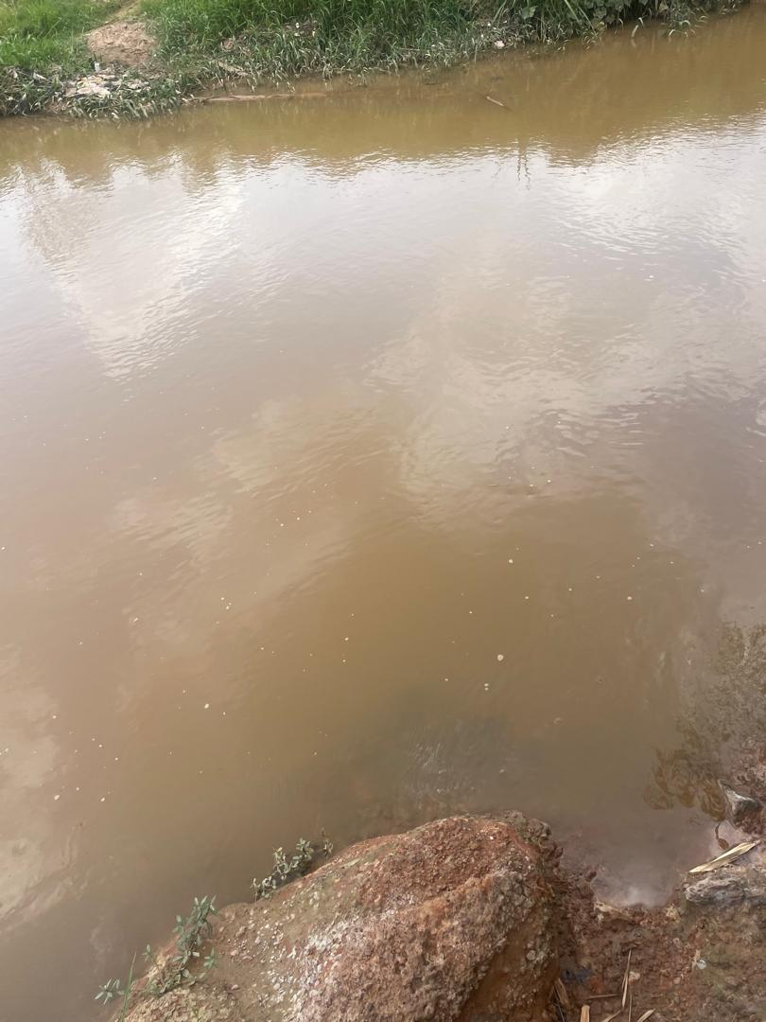
Appendix 1: Emene River
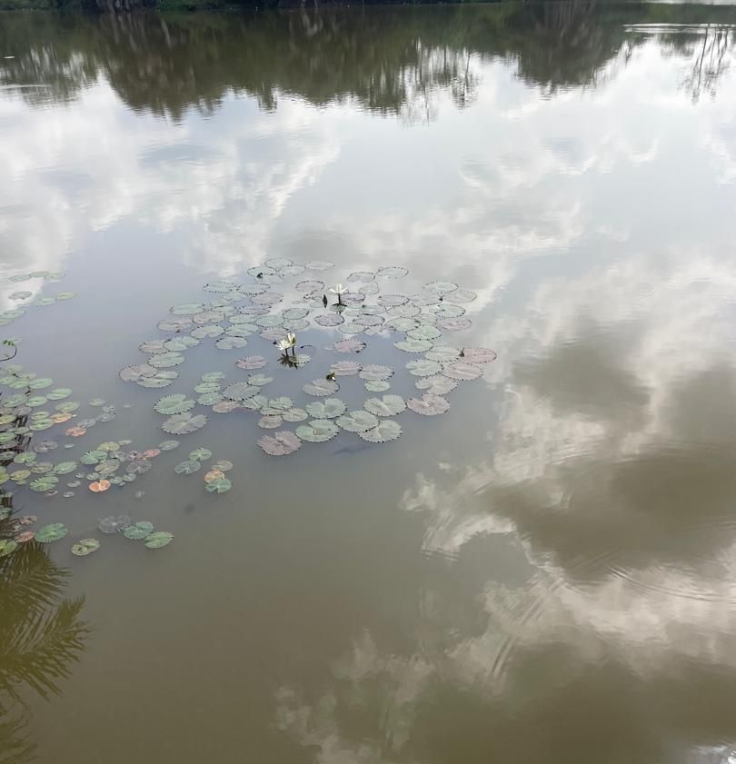
Appendix 2: Ugwuomu Nike Lake 1
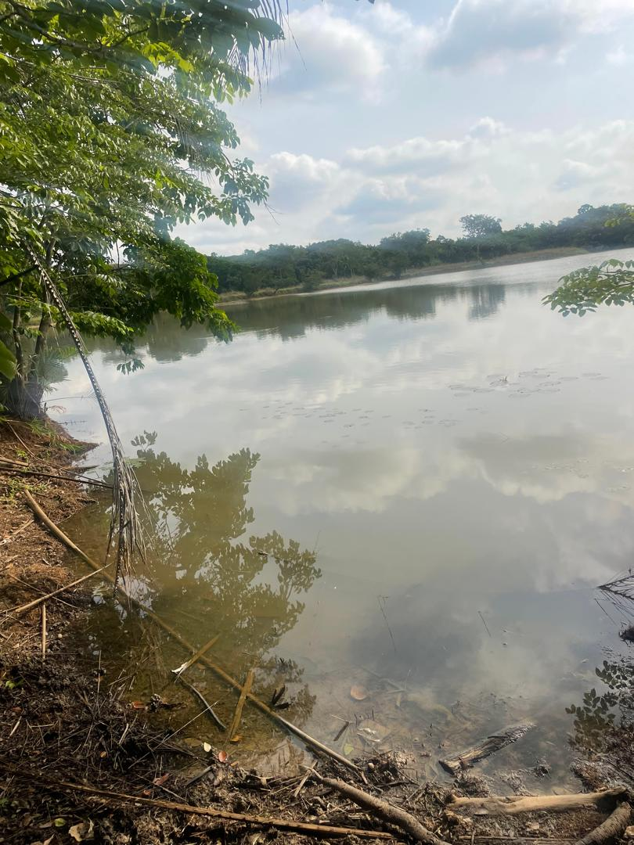
Appendix 3: Ugwuomu Nike Lake 2
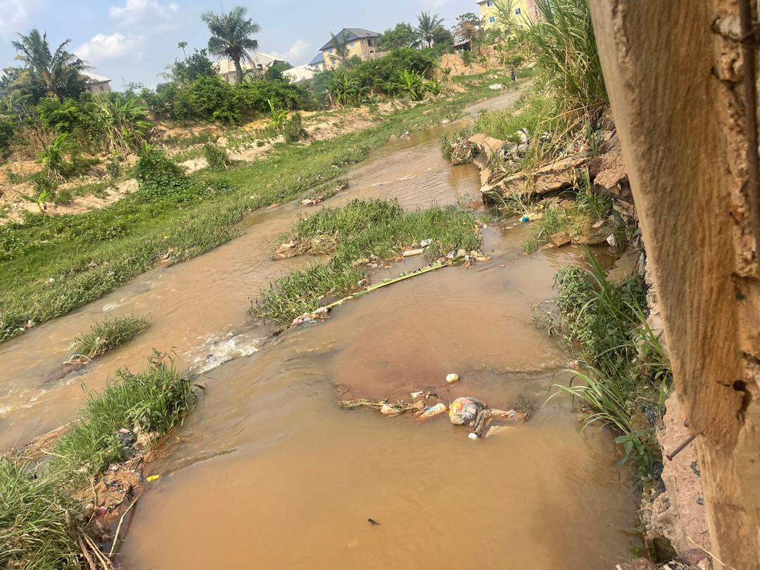
Appendix 4: Trans-Ekulu River
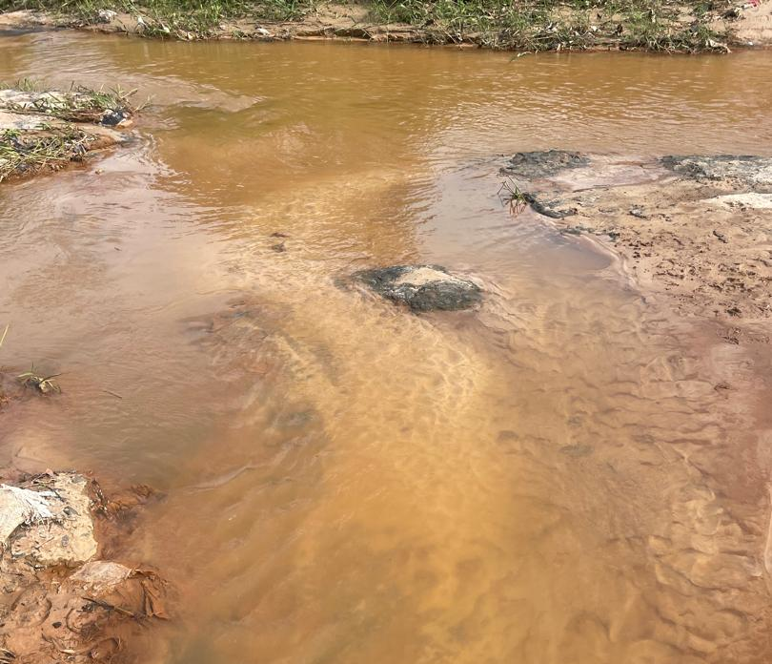
Appendix 5: Iva valley River
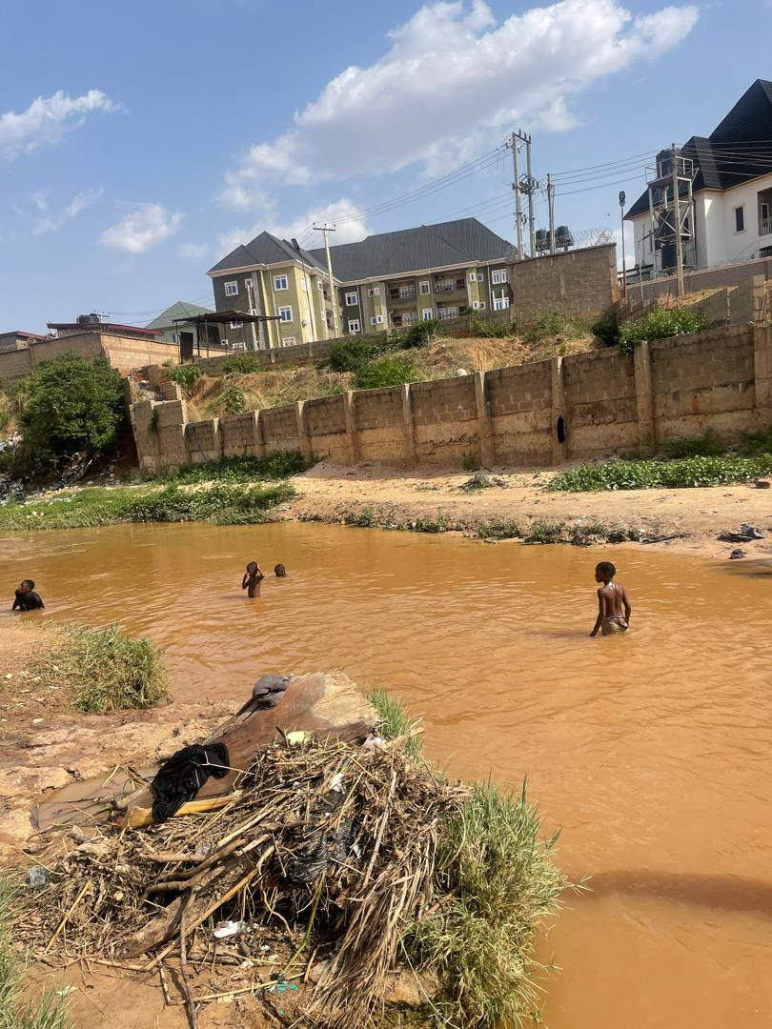
Appendix 6: Abakpa Nike River

