ANTIBIOTIC SUSCEPTIBILITY OF THE LUNG’S MICROBIOME IN CHRONIC OBSTRUCTIVE PULMONARY DISEASE PATIENTS

OLIKEZE, CHIBUZOR KELVIN
U19/NAS/MCB/254

MICROBIOLOGY
DEPARTMENT OF BIOLOGICAL SCIENCES
FACULTY OF NATURAL SCIENCES AND ENVIRONMENTAL STUDIES
GODFREY OKOYE UNIVERSITY, ENUGU
NIGERIA

A PROJECT RESEARCH SUBMITTED TO THE DEPARTMENT OF BIOLOGICAL SCIENCES IN PARTIAL FULFILMENT OF THE REQUIREMENTS FOR BACHELOR OF SCIENCE (B.Sc) DEGREE IN MICROBIOLOGY

SUPERVISOR: PROF. A. EZE & MISS OKOLI CHISOM.

JULY, 2023.

APPROVAL
This research titled “Antibiotic Susceptibility of the Lung’s Microbiome In Chronic Obstructive Pulmonary Disease Patients” has been assessed and approved by the committees and Department of Biological Sciences and Faculty of Natural Sciences and Environmental Studies, Godfrey Okoye University Enugu Nigeria.

……………………….. ……………………….
Prof. A. EZE
Miss Okoli Chisom Date
Project supervisor

…………………………. …………………….
Dr. Frances N. Olisaka Date
(HOD, Department of Biological Science)

CERTIFICATION
This is to certify that this research titled “Antibiotic Resistance of the Lung Microbome in Copd Patients” was carried out by Olikeze, Chibuzor Kelvin with Registration Number U19/NAS/MCB/254 under supervision in the Department of Biological Sciences Godfrey Okoye University, Enugu Nigeria.

………………………. ……………………..
Olikeze, Chibuzor Kelvin Date
Student

DEDICATION
I dedicate this project research to GOD for his guidance and protection throughout the course of my project research, and to my parents for their support in providing all I needed to successfully conduct this project research.

ACKNOWLEDGMENT
I would like to acknowledge Mr and Mrs Olikeze, my parents for their immense support in providing all I needed during my project research and extend my gratitude and immense appreciation for all their support.
I would like to acknowledge my H.O.D Dr. Ngozi Frances Olisaka who constantly provided guidance and wisdom that helped me successfully complete this project research.
I would like to give thanks to Prof. E. A. Eze and Miss Okoli Chisom who carefully guided me through all the steps of my work, Their remarks, corrections and guidance made this research a possibility and aided in its completion.
I would like to acknowledge Michael Okpala and Meremikwu Munachimsomy colleagues who greatly assisted me during certain procedures of my work of which i needed guidance.
I would like to acknowledge Mrs Maria for her eagle’s eye observational skills and exert guidance in the lab.
I would like to acknowledge Dr Ejike of UNTH who assisted me in receiving my ethical clearance to conduct this work as well assisted me in getting samples for my work
I am immensely appreciative of the patients of the Enugu State Teaching Hospital who trusted me enough to let me recruit them into the study.

ABSTRACT
Antibiotic susceptibility of the lung microbiome of Chronic Obstructive Pulmonary Disease patients is a research aimed at understanding the microbiome of COPD patients and determining the antibiotics best suited for treatment, To conduct this research sputum samples were obtained from patients at ESUT Teaching Hospital Park Lane, Enugu and inoculated into Nutrient, Blood and SDA agar plates, after which the observed microbial growth was subjected to various biochemical tests to identify the various species, Gram staining and microscopy in order to properly identify the microbes isolated, after identification the isolates were subjected to antibiotic susceptibility testing, Antibiotic sensitivity testing showed that majority of the isolated organisms were resistant to antibiotics which were previously deemed as treatment options, S. aureus for example which showed an intermediate response to ciproflaxin and resistance to all other antibiotics suggested it had become more resistant against the standard antibiotics used in laboratories, This research showed that antibiotics such as Ciproflaxin, Erythromycin, Penicillin e.t.c may no longer be effective in treating COPDs and emphasizes the need for an extensive research into antibiotics that would serve as proper treatment.

TABLE OF CONTENTS
Title page i
Approval ii
Certification iii
Dedication iv
Acknowledgment v
Abstract vi
List of Tables ix
List of Figures x
List of Appendices xi

CHAPTER ONE: INTRODUCTION 1
  - Background of The Study 1
1.2 Statement of the Problem 2
1.3 Aim and Objectives 3

CHAPTER TWO: LITERATURE REVIEW 4-16

CHAPTER THREE: MATERIAL AND METHOD 17
3.1 Study Area 17
3.2 Sample Collection 17
3.3 Culture Media Preparation 17
3.4 Sample Inoculation 17
3.5 Identification of Organisms 17
3.5.1 Gram Staining and Microscopy 18
3.6 Biochemical Tests 18
3.7 Antimicrobial Susceptibility Test 19

CHAPTER FOUR: RESULTS 20-34

CHAPTER FIVE: CONCLUSION 35
5.1 Limitations of the Study 36
5.2 Recommendations 37
REFERENCES 38
APPENDICES 41

LIST OF TABLES
Table 1: Morphological characteristics of the nutrient agar isolates 21
Table 2: Morphological characteristics of the blood agar isolates 23
Table 3: Morphological characteristics of the sda agar isolates 26
Table 4: Biochemical tests 28
Table 5: Antimicrobial sensitivity results: Gram positive isolates 30
Table 6: Antimicrobial sensitivity results: Gram negative isolates 32

LIST OF FIGURES
Figure 2.1: Ecological dynamics of the lung microbiome 6
Figure 2.2: Contribution of the Complement System to Host Immunity Against
Pneumococci 12

LIST OF APPENDICES
Appendix 1:Inoculation of samples into Nutrient, Blood and SDA agar plates 40
Appendix 2:Gram stain microscopy 41
Appendix 3:Antimicrobial Sensitivity test 42
Appendix 4:Biochemical Tests 42
Appendix 5:Staphylococcus Aureus showing intermediate response to CPX 44

CHAPTER ONE
INTRODUCTION
  - Background of The Study
According to the definition, the microbiome is composed of pathogenic and symbiotic organisms that inhibit the human body. Microbiome and host interactions in human have been studied almost exclusively in terms of bacteria, biotic factors and host. In addition to maintaining organ, tissue, and immune homeostatis, these complex communities of microbiota inhabiting lungs, skin and guts. (David et al.,20017). Medical texts refer to the lung’s environment as a sterile, This belief has remained in medicine science for a long time. As a result of inhalation or subclinical micro aspiration, the lung is constantly exposed to microbiota. Over the last decade, we have witnessed a revolution in our understanding of lung and microbiota interaction. It has been found that the lung isn’t sterile, infact, it harbors a large variety of microbes that interact with one another.
There is limited information concerning the role the lung’s microflora plays in immunity regulation as well as homeostasis, as indicated above by the gut microbiome modulating host mucosal defense. Upon the acceptance of the existence of microbial life in the lungs, a deep study has since been undertaken by various sections of health sciences in a bid to understand the microbiome of the lungs and so far we have been introduced to various species of microbes causing a vast number of infectious diseases in the lungs, these microbes are now being extensively researched to fully understand the way they have adapted to thrive in the lungs and result in highly detrimental illnesses such as COPDs despite the immunity of the body and the administration of antibiotics and medications that are considered deadly to the microbes, (Helen et al., 2022).
The idea that pulmonary microbiomes are involved in the physiology of chronic obstructive pulmonary disease (COPD) has been supported by a strong link between disruption of the microflora of the respiratory system, also called dysbiosis, and the emergence of numerous CRDs. New information on the respiratory ecology has been uncovered thanks to new sequencing techniques, which enable detailed research of respiratory microbial communities. An alternative to taxonomic micobiome characterisation is shotgun metagenomics sequencing (mNGS), which provides a greater level of information than taxonomic mapping. By identifying antibiotic resistant gene (ARG) on plasmids or chromosomes. This approach analyzes resistance markers in addition to virulence markers to provide information into a particular microenvironment. Atypical airway mucus clearance is the root cause of chronic obstructive pulmonary disease (COPD), which can lead to recurrent lung exacerbations and chronic infections. These may cause lungs to inflame, which could be harmful. Patients with these CRDs need several, lengthy courses of antibiotics as prophylaxis, chronic suppressive medication, or curative therapy to minimize inflammation, the frequency of pulmonary exacerbations, and disease development. In severe cases of asthma, continuous suppressive therapy may be administered. Asthma is also characterized by episodes of airflow obstruction and chronic inflammation of the lower respiratory tract. A repeated exposure to antibiotic therapies, however, may lead to antibiotic resistance as a result of increased selection pressure on the respiratory ecosystem.
1.2 Statement of the Problem
After over a decade of extensive study on the lung microbiome of COPD patients the ability of these harmful microbes to adapt and develop resistance to antibiotics and other treatment forms administered in a bid to reduce and eliminate their existence is still a broadly researched topic and an unanswered question.

1.3 Aim and Objectives
The aim of this study is to identify the microbes that thrive in the lungs and the antibiotics these organisms are susceptible to.
Objectives include:
- Ascertaining the forms of microbes that make up the lung microbiome of COPD patients.
- Ascertaining types of antibiotics best suited for treatment.

CHAPTER TWO
LITERATURE REVIEW
The refuted myth of lung sterility is the first step in the evaluation and revision of the fundamental concepts of respiratory microbiology. The respiratory ecosystem is different from other mucosal sites in terms of anatomy and physiology, and it alters significantly during disease when the balance between the host and microflora is disturbed. The role of phages, fungi, and viruses in the lung microbiome is not being fully comprehended by researchers. (Dickson et.al., 2015). Three elements must be balanced in order to define the makeup of the lung microbiome: firstly: microbial immigration to the airways, secondly: removal of microbes from the airways, and thirdly: the reproduction rates of its community members, which are due to regional growth conditions. Whether inside or between disease states, the microbiome must change if it does, (Dickson et al., 2015).
The altering of the natural flow of these factors is what brings about the change in the natural microbiome of the lungs, these changes are typically classified by an overabundance of microbes not commonly a part of the normal micro flora present in the lungs, this is typically the case in COPD patients.
Because the lung is a highly exposed organ due to its unique topography, the lung microbiome is inherently dynamic. Roughly equal cells exist in the human body. The human microbiome has been studied in more depth over the past decade, expanding from guts to bladders and lungs. Culture-independent methods have only recently been used to identify microbial communities in the healthy lung (Erbet.al.,2011). It is not a shock that the respiratory system is no longer considered to be sterile organ given its proximity to the upper respiratory system, which is a microbe-rich environment. However, compared to other systems in the body such as the stomach, skin, mouth, and vagina, the healthy lung has incredibly little microflora, and the lung microflora differs greatly in terms of both quantity and dynamics. Several respiratory illnesses that were not believed to be caused by microorganisms have now been linked to the lung microflora which is different from that of healthy persons, despite the fact that research has only recently begun to analyze causality and plausible pathways. In essence, "dysbiosis" refers to microbe homeostasis disruption from normal in a particular habitat, despite the fact that different studies interpret and apply the term differently. Dysbiosis in the lung is a departure from the microbiota found in healthy persons without lung disease, even if there may be ideal microbial communities in some disease states, such as cystic fibrosis (CF), they may still be different from health. Notably, dysbiosis entails modifications to both the overall microbial content and the relative abundances (proportions) of microbiome elements within a community. This is so because the microbial load in a healthy lung is so minimal. Researchers used rigorous sampling to identify bacterial sequences in the lung, which is contrary to traditional beliefs that lungs are sterile. (Dickson et.al., 2015). In contrast, lung bacteria have much lower densities than URT bacteria, and the community composition is similar, especially at the periglottic area. The most frequent phyla are Firmicutes and Bacteroidetes, whereas the most frequent genera are Prevotella, Streptococcus, and Veillonella. This means that the lung microbiome is largely transient and contains URT-derived immigrants that are cleared by mucociliary and innate immune mechanisms. (Dickson et.al., 2017). Uncertainty exists over the existence of actual long-term, self-sustaining bacterial inhabitants. As a result, the healthy lung microbiome is different from those in places with robust, self-sustaining microbial populations, like the gut, skin, and vaginal and oral cavities. As the URT (Upper Respiratory Tract) is where the lung microbiota first originates, dysbiosis in the URT microbiome may have an effect on the lung microbiome. The primary cause of lung disease is cigarette smoking, and healthy smokers and nonsmokers have somewhat different URT microbiomes. There has, however, been no significant difference in lung microbial communities between healthy smokers and nonsmokers in studies. Smoking could result in modest changes in the URT microbiome, and the effects of these changes would not be detectable after the URT-LRT gradient has been attenuated. As a result of the controlled nature of animal models, smoking may alter the lung microbiome in mice. Other environmental exposures may also alter the lung microbiome. Streptococcus and Neisseria are enriched in the lung microbiota of people exposed to indoor air pollution, for example. Moreover, as described recently in patients with end-stage lung disease and following lung transplantation, URT dysbiosis may be a driver of lung dysbiosis that is underappreciated (Simon-Soroet.al., 2019).

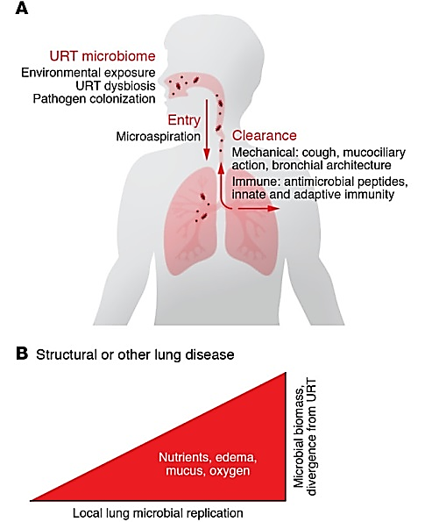
Fig 2.1: Ecological dynamics of the lung microbiome.

O'Dwyer, D. N., Dickson, R. P., Moore, B. B., The Lung Microbiome, Immunity, and the Pathogenesis of Chronic Lung Disease. J Immunol. 2016 Jun 15;196(12):4839-47. doi: 10.4049/jimmunol.1600279.
The balance of immigration from URT and removal by immunological and mechanical systems determines the lung microflora. Local microbial reproduction in the lung parenchyma and airways is constrained in healthy lungs. When a person has lung disease, structural changes and changes to the local environment encourage microbe growth, which primarily controls the makeup of the microbe community in the lung. An increased amount of aspiration may lead to greater entry of dysbiotic URT microflora, resulting in downstream lung impact. Dysbiotic URT microflora may disrupt entry, clearance, or local replication of the lung microflora. It is well known that pneumonia is often preceded by the colonization of the URT with respiratory pathogens such as Streptococcus pneumoniae or Gram-negative bacteria. As a result of immune dysfunction, sputum defects like those associated with cystic fibrosis, architectural distortion like those associated with bronchiectasis and fibrosis, cough defects, or physical barriers such as those associated with lung transplantation, clearance can be decreased. A greater bacterial population may be attributed to increased entry or poor clearance as well as increased nutrients from mucous or edema fluids. Several pulmonary diseases are associated with lung dysbiosis, but it is unclear whether it is a consequence and marker of disease, or whether it initiates or perpetuates inflammation and/or injury. In this section, insights are presented on selected lung diseases that aren't traditionally associated with microbial influences; advancements in other conditions have been discussed in recent disease-specific reviews (CF, lung transplantation, and ARDS) (Héry-Arnaud G, et al., 2019)
Over 300 million people have Chronic bronchitis, a mild airway blockage, inflammation, and an emphysematous loss of parenchyma are all symptoms of chronic obstructive pulmonary disease (COPD), which affects people all over the world. The biggest risk factor is smoking, although there are others as well, such as breathing in indoor smoke, pollution, respiratory illnesses in childhood, and inheritance. Prophylactic macrolide antibiotics reduce exacerbations in advanced disease, and bacteria can be found by culture from sputum and BALF during exacerbations, suggesting microbial origins. Studies using sequence-based approaches in COPD describe dysbiosis during both stable COPD episodes and acute exacerbations, however they vary in subject and specimen type. In compared to healthy smokers and nonsmokers, relative abundance of Pseudomonas was higher and Prevotella was lower in bronchial wash during stable illness. (Einarsson, G. G, et. al., 2016) .
COPDs are typically characterized by an inflammation of the bronchial tubes resulting in blockage of the respiratory system due to excessive mucus secretion as the body’s attempt at expelling the causative agents of the infection.
Most COPD cases can be attributed to bacterial, fungal and viral infections, they most commonly begin as a result of exposure to conditions unfavourable to the lungs, such as smoking, excessive dust and air pollution, exposure to these conditions typically trigger the lung’s immune system to attempt to expel the foreign particles which most times contain microbes that trigger immune mechanisms.
Organisms that trigger immune response resulting in COPD are grouped into;
Fungi: Certain fungi species are responsible for COPD exacerbations, Bacteria and viruses cause COPD exacerbations, the role of fungi is less understood. Most pulmonary fungal infections are caused by members of genus Aspergillus (Bulpa, P et al., 2007)
Invasive aspergillosis (IA), chronic pulmonary aspergillosis (CPA), aspergilloma, hypersensitivity pneumonitis, and allergic bronchopulmonary aspergillosis are only a few of the pulmonary disorders that can be brought on by aspergilli, which are common soil-dwelling fungi. If IA is not recognized and treated promptly, it is almost invariably fatal.
Viruses: A common virus seen in analysed sputum samples of patients is Rhinovirus. Bacteria: Common bacteria species found in analysed sputum samples of patients include; Gram negative bacteria are more uncommon, with Haemophilus influenzae (11% of all aggravating cases), Streptococcus pneumoniae (10%), Moraxella catarrhalis (10%), Haemophilus parainfluenzae (10%), and Pseudomonas aeruginosa (4%) being the most common.In cases caused by bacterial infections antibiotics are typically administered to terminate the bacteria causing the COPD exacerbation. Some of these antibiotics include: penicillin, ceftriaxone, cefotaxime, levofloxacin, and ciprofloxacin, due to excessive and continuous usage of these antibiotics these bacteria species have evolved over the years to develop resistance that makes them less susceptible to these antibiotics, A prospective analysis was done on the microbiologic screening of 531 COPD exacerbation patients hospitalized at National Scientific Medical Center between 2004 and 2013 with the following Results: 1210 isolates from patients are included in the study, Streptococcus pneumoniae (27.9%) and Moraxella catarrhalis (20.1%) were the two pathogens that were found most frequently. S. pneumoniae was more common overall from 18.1% in 2004 to 53.5% in 2013 (p 0.001). It is important to keep in mind that the detection rate for M. catarrhalis decreased from 26.7% to 10.7% (p0.001), respectively. Additionally, discovered were S. aureus (3,8%), P. aeruginosa (2,1%), and St. pyogenes (7,9%). 3,5% of all isolates belonged to the family Enterobacteriaceae. St. pneumoniae antibiotic susceptibility decreased from 89.4% in 2004 to 46.1% in 2013 (p0.001), from 96.4% to 69.5% (p0.01), from 90.6% to 55.5% (p0.02), from 100% to 64% (p0.001), and from 72% to 41.6% (p0.05). (Neyla, B 2016)
To circumvent the host's immune system and lessen their vulnerability to antibiotics, these bacteria species have evolved a variety of resistance mechanisms. Enzymes break down antibiotics, Bacterial proteins that are targets for antibiotics are modified, as is the permeability of the membrane to antibiotics.
These mechanisms have made susceptibility testing a crucial step in choosing the types of antibiotics that will benefit people with COPD caused by bacterial infections. Understanding how these microorganisms initially trick the body's immune system will help us better grasp their capacity to resist antibiotics. Complement plays a crucial role in immunity, the liver produces thirty proteins in soluble phase. Plasma and interstitial fluids include a collection of recognition molecules that become active to pathogens such as yeast, and viruses, (Dunkelberger and Song, 2010). thereby activating the complement. They then release peptides into the bloodstream that activate inflammation (Merle et al., 2015). Complement activation results in membrane attack complexes (MACs), which result in osmotic lysis of membranes, Before the need of antibiotic, the natural immune system is also expected to fight off these causative agents, the need for antibiotics arises when the patient’s immune system is weak or compromised, a situation that allows the causative agents to evade the immune system, For example: It is generally recognized that the bacteria S. pneumoniae, which causes COPD, can subvert the host's immune system. Otitis media, conjunctivitis, pneumonia, meningitis, and septicemia can all be brought on by Streptococcus pneumoniae infecting other niches in susceptible hosts. The human nasopharynx is regularly colonized by it, and it typically has no symptoms. Opsonization and the emergence of inflammatory responses are two complementary processes that significantly enhance the immune response. Pneumococcus has a vast number of virulence factors that stop activity of complement in an effort to resist the antibacterial effects of complement, which helps the bacteria evade the immune system. As a typical extracellular bacteria, pneumococcal clearance from the host depends on antibody-enhanced complement-mediated phagocytosis (Paterson and Orihuela, 2010). All three of the complement system's pathways are activated by S. pneumoniae infection.

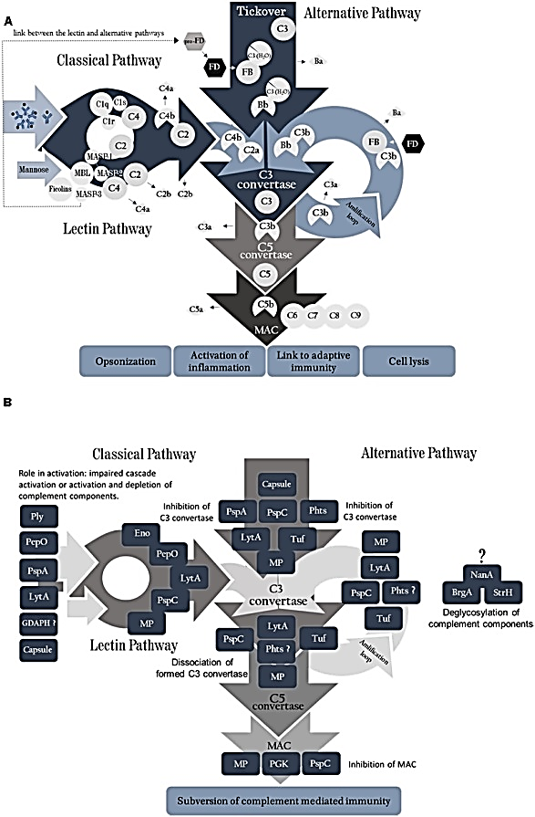
Fig 2.2: Contribution of the Complement System to Host Immunity against Pneumococci.

Rupprecht T. A., Angele B., Klein M., Heesemann J., Pfister H. W., Botto M., et al. (2007). Complement C1q and C3 are critical for the innate immune response to Streptococcus pneumoniae in the central nervous system. J. Immunol. 178 1861–1869. 10.4049/jimmunol.178.3.1861.
As pneumococcal virulence factor influences the complement cascade at several points. There is a relationship between each pneumococcal antigen and the complement components that interact with it. however, the mechanism underlying the inhibition is not known. By interfering with PLG and thereby degrading complement components, pneumococcal moonlighting proteins (MP) indirectly influence complement.
By recognizing phosphorylcholine on the cell wall and by natural IgM, specific antibodies activate the classical pathway. Macrophage-expressing SIGN-R1, a transmembrane C-type lectin that recognizes carbohydrates on pneumococcal surfaces and binds to C1q, activates the classical pathway in the absence of antibodies (Kang et al., 2006).
Once recognized, the C₁ complex breaks down C₄ into C₄a, which is released into the soluble phase, and C4b, which is left on the bacterial surface; C2 binds to C₄b and is split into C₂a and C₂b by C1s. Plasmatic C3 can be split into C3a (anaphylatoxin) and C3b by the C₄b₂a, a C₃ convertase of the classical pathway. When additional C3b binds to C3 convertase, it forms the C5 convertase complex; this is the main role of C₃b in the complement system. (Merle et al.,2015a). As MAC is assembled, complement activation reaches its final stage with the C5 convertase formation (Ehrnthaller et al., 2011). In addition to its Gram-positive status, pneumococci have thick peptidoglycan layers on their cell walls that help to limit MAC attack on them (Jarva et al., 2003); However, pneumococcal infections cannot be controlled without complement opsonic and proinflammatory functions (Paterson and Mitchell, 2006), This is due to C3b active on microbial surfaces acting as an opsonin, or as part of the amplification loop, where C3b connects with Bb, an alternative pathway protein, promoting the formation of more C3 convertases. (Merle et al., 2015a).
MBL deficiency appears to increase susceptibility to pneumococcal disease in the classical pathway. There is also evidence suggesting that MBL deficiency may increase susceptibility to invasive pneumococcal disease in human studies (Garcia-Laorden et al., 2013). Meningitis caused by S. pneumoniae is strongly associated with MBL deficiency (Brouwer et al.,2013).
As a result of spontaneous hydrolysis of C3, factor B (FB) recognizes C3 (H₂O), which is then cleaved into factors Ba and Bb by factor D (FD) to initiate the alternative pathway. Bb remains attached to C3 (H₂O), resulting in an alternative phase C3 convertase. As a result of the conversion of C3 to C3a and C3b, this convertase is capable of cleaving it in the blood. When C3b forms close to the cell membrane, it covalently attaches there, attracting FB and triggering a cascade on the activating surface because it is structurally similar to C3 (H₂O). An alternative pathway triggered an activation cascade based on the density of C3b deposited on the bacterial surface (Jarva et al., 2003), It can result in a greater ability to opsonize pneumococci. C-reactive protein (CRP) (Gang et al., 2015), surfactant protein A (S-PA) and other molecules are also involved (Madhukaran et al., 2015), serum amyloid P (SAP) (Yuste et al., 2007) and molecules of the coagulation cascade (Kim et al., 2015) A number of complement activating proteins recognize S. pneumoniae, particularly CRP and SAP, which activates complement. (Gang et al., 2015). CRP and PPS interact with polysaccharides (PS), lipopolysaccharides (LPS), and phosphocholine (PCh) on microbial surfaces by binding to collagen binding sites, which promote binding to C1q. In mice, CRP was shown to protect them from pneumococcal infection through binding to phosphocholine (PCh), but it may also function independently of PCh., Intriguingly, CRP modulates classical and alternative complement pathways by binding to regulators, C4BP and factor H. (Biro et al., 2007). Moreover, CRP increased binding to FH in pneumococci lacking PspC, suggesting that it has another role in complement activation. Additionally, SAP has been shown to increase complement deposition on pneumococci through the classical pathway, resulting in a more efficient bacterial clearance; mice lacking SAP were more likely to develop fatal pneumococcal infections; supplementation with human SAP partially alleviated the condition. (Yuste et al., 2007). In the presence of complement activation by S. pneumoniae, bacterial phagocytosis increases. As a result of the production of reactive nitrogen species, alveolar and monocyte-derived macrophages facilitate pneumococcal clearance in subclinical pulmonary infections. In addition to helping macrophages kill bacteria ingested, apoptosis has also been demonstrated to aid pneumococcal clearance by macrophages who have exhausted their ability to kill them (Aberdein et al., 2013). In most cases, this initial response eliminates the invading bacteria without causing clinical signs of infection. When macrophage clearance capacity exceeds, however, neutrophils and cells must be recruited. A bacterial clearance process is facilitated by the production of Th1 and Th17 CD4+ cytokines, which activate inflammation. Pneumococcal loads are controlled by neutrophils, which produce proteases (elastase and cathepsin G) for killing bacteria that are ingested at this stage. (Aberdein et al., 2013). It is highly dependent on complement activation for pneumococcal phagocytosis by this cell type. However, excessive inflammation can damage tissue and be deleterious to the host.
In the course of pneumococci otitis media, complement-mediated phagocytosis is another important mechanism for clearing bacteria; neutrophils from the circulatory system reach the middle ear, where they detect and kill bacteria that are coated with complement products. (Sabharwal et al., 2009). Moreover, capsule production is associated with variations in bacterial resistance to phagocytosis in this niche. In addition, complement's role in preventing pneumococci colonization of the nasopharynx is not determined by the bacterial load in the nasopharynx, but rather by the prevention of sepsis following mucosal colonization. (Bogaert et al., 2010).
In order to limit the disease caused by this pathogen, the complement system is extremely important because of the high number of pneumococcal proteins that interact with it. Since many of these proteins work in the same complement cascade, this suggests that they may be compensated for by another protein that performs similar functions when one antigen is lost.
Pneumococcal proteins have been evaluated as potential vaccine candidates with variable results. Protein-based pneumococcal vaccines (which have been extended to other pathogenic bacteria and protozoa) are emerging as a means of providing long-term, wide protection against pneumococcal diseases (which may not be sufficient with just one protein) (Darrieux et al.,2015). To prevent pneumococcal diseases, it has been emphasized that including different antigens in a multi-component vaccine formulation is a promising approach. Thus, combination of antigens that act on the same mechanism may be an effective method of blocking the pathogen's ability to evade the immune system, which allows bacteria to be cleared rapidly.It is therefore possible to provide strong protection against infections caused by S. pneumoniae by the combination of pneumococcal proteins that limit complement activation on this pathogen. Several combinations of PspA, PspC, Phts, and PLY have already been demonstrated to work in animal models and clinical trials (up to three proteins in one formulation). Protein interference and production limitations are also imposed by the inclusion of high numbers of antigens in a single formulation. In an alternative approach, protein chimeras can be used - protein fragments genetically fused with virulence factors - which are shown to preserve antigens and even to reveal previously cryptic epitopes, while increasing vaccine coverage while preserving individual antigenic properties. The moonlighting proteins can also be included in these vaccines to enhance their efficacy further.
It is essential to run proper susceptibility testing after identifying these organisms since one of these organisms is capable of evading a person's immune system and developing resistance to antibiotics. By exposing a standardized concentration of organisms to specific concentrations of antimicrobial drugs, susceptibility tests determine the microbe's ability to withstand antimicrobial drugs. This research will conduct a susceptibility test after cultivating and isolating bacteria or viruses from a COPD patient, in order to determine whether these organisms are susceptible to the research.
CHAPTER THREE
MATERIAL AND METHOD
3.1 Study Area
The present study was conducted at ESUTH and Godfrey Okoye University microbiology laboratory, Thinker’s corner Emene Enugu Nigeria. The study area is located in the South-Eastern part of the country and lies within longitude and latitude 7^0 31’ 59’’ E and longitude 6^031’59’’ N. It is bounded in the north by Isi Uzo and Igbo Etiti LGAs, south by Udi, East by Enugu north LGA and west by Nkanu LGA.
3.2 Sample Collection
With the help of a certified physician at ESUTH COPD patients were identified and their sputum samples were collected in a universal container in sterile conditions and kept tightly sealed to avoid contamination, The physician collected the samples in the early hours of the day to avoid contamination of the samples by food and did so by providing the patients with sterile universal containers into which the coughed up their sputum, the containers were then collected by the physician and tightly sealed after which they were transported to the lab for further testing.
3.3 Culture Media Preparation
Nutrient agar, Sabouraud Dextrose Agar and Blood Agar were prepared according to the manufacturer’s specifications
3.4 Sample Inoculation
Using a sterilized wire loop and appropriate lab gear, the samples were inoculated into the appropriate media and incubated a 35-37⁰C for 3-5 days and monitored daily for growth.
3.5 Identification of Organisms
After signs of growth have become visible, Gram staining and microscopy were carried out to identify the type, features and morphology of the organisms seen.
3.5.1 Gram Staining and Microscopy
This was done according to Cheesebrough (2006). A drop of suspended bacterial culture is introduced to a grease free slide, air dried and heat fixed over a flame, the slide was flooded with Crystal violet stain (primary stain) and left for 1minute, the slide was then rinsed wih running water and flooded with iodine solution and left for another 1minute, The slide was rinsed with running water and a few drops of acetone were added and rinsed after 5 seconds. The slide was counter stained with safranin (secondary stain) and left for 1minute then rinsed with running water, the slide was then dried and viewed under the microscope using oil immersion lens.
3.6 Biochemical Tests
Catalase Test
A wire loop is used to transfer a small amount of colony growth to the surface of a clean, dry, glass slide and about 3ml of hydrogen peroxide is dropped unto the slide via the use of a dropper pipette, the presence of bubbles indicates a positive reaction and none indicates a negative one.
Coagulase Test
A drop of distilled water is placed at each end of the slide, a loopful of the microbial growth is emulsified in each drop to make a thick suspension, clumping of the organism is looked out for within 10 seconds which indicates a positive reaction with the latter indicating a negative reaction.
Indole Test
A test tube containing 3ml of trytophton is used to inoculate the organism and incubated at 35-37 degrees for 48 hours, 0.5ml of Kovac’s reagent is added and gently shook. The presence of a cherry red ring color is observed on the layer which indicates positive and the latter indicating a negative reaction.
Oxidase Test
A small piece of filter paper is soaked in 1% Kovács oxidase reagent and dried, a sterile loop is used to pick a well-isolated colony from a fresh (18- to 24- hour culture) bacterial plate and rubbed onto the treated filter paper. Color changes indicate a positive reaction and the latter indicated a negative reaction.
3.7 Antimicrobial Susceptibility Test
Antibiotic discs are obtained, after which Nutrient agar is prepared, the organisms are inoculated unto the fresh nutrient agar using a sterile wire loop, after streaking the organisms on the agar, the antibiotic disc is also inoculated into the agar and then incubated, after incubation, inhibition zone were monitored for and the results were recorded.

CHAPTER FOUR
RESULTS
Sputum samples were collected from 5 individuals and cultured on 3 medias for growth, after which various Biochemical tests were carried out for identification purposes and finally antibiotic susceptibility.
These are the results gotten from the above mentioned tests:
CULTURE PLATE CHARACTERISTICS:

Table 1: MORPHOLOGICAL CHARACTERISTICS OF THE NUTRIENT AGAR ISOLATES.
Specimen | Shape | Size | Colour | Opacity | Elevation | Surface | Characteristics | Sus.  Organism
Plate 1 | Irregular | Large | White | Translucent | Converse | Smooth | Gram+, Rod in clusters | Bacillus spp
Plate 2 | Irregular | Tiny | Cream | Opaque | Raised | Smooth | Gram-, Rod in chains | Pseudomonas aeruginosa
Plate 3 | Irregular | Tiny | White | Translucent | Riased | Smooth | Gram+, Rod in clusters | Bacillus spp
Plate 4 | Irregular | Tiny | Cream | Opaque | Raised | Smooth | Gram+, Rod in clusters | Bacillus spp
Plate 5 | Irregular | Large | Cream | Opaque | Raised | Smooth | Gram+, Rod in clusters | Bacillus spp

The above table shows results viewed from the incubated nutrient agar plates, Plates 1-5 had an irregular shape, Plates 1&5 were tiny in size while plates 2,3&4 were large in size, Plates 1&3 had a white colour while plates 2,4&5 had a cream colour, Plates 1&3 were opaque while plates 2,4&5 were translucent, Plates 2-5 had a raised elevation while plate 1 had a converse elevation, Plates 1-5 had smooth surfaces, Plates 1,3,4&5 were Gram+ rods in clusters which made their suspected organisms bacillus spp while plate 2 was Gram- rod in chains which suggests Pseudomonas aeruginosa.
Pseudomonas aeruginosa: This organism is typically associated with a wide range of COPD exacerbations and is identified under the microscope as a Gram-ve rod typically seen in chains, it is synonymous with a couple of features when grown on media which include: an irregular shape, a small size, a cream colour with a smooth texture and opaque all which were synonymous with Plate 2 suggesting that the isolated organism was Pseudomonas Aeruginosa.
Bacillus spp: These are typically considered as normal flora in the lungs and are abundant in variety, they are typically characterized by their Gram+ve nature and are seen as rod in clusters, their morphological features are not exact as there are a vast amount of bacillus species but they are typically identified by their rod like structure when viewed under a microscope after gram staining.

Table 2: MORPHOLOGICAL CHARACTERISTICS OF THE BLOOD AGAR ISOLATES.
Specimen | Shape | Size | Colour | Opacity | Elevation | Surface | Characteristics | Sus.  Organism
Plate 1 | Round | Tiny | Whitish Precipitate | Translucent | Raised | Smooth and glistering | Gram+ Diplococci, | Strep. Pneumoniae
Plate 2 | Round | Tiny | Whitish | Clear | Raised Converse | Glistering and Rough | Gram- rod in chains | Pseudomonas aeruginosa
Plate 3 | Round | Tiny | Whitish | Opaque | Raised | Glistering and Smooth | Gram+ rods in Clusters. | Bacillus spp
Plate 4 | Irregular | Tiny | Creamy | Translucent | Raised | Smooth and Glistering | Gram+ rods in Clusters | Staphylococcus aureus
Plate 5 | Round | Tiny | Whitish | Transparent | Raised | Smooth and Glistering | Gram+ rods in Clusters | Bacillus spp

The above table shows results viewed from the incubated blood agar plates, Plate 4 had an irregular shape while plate 1,2,3&5 had round shapes, Plates 1-5 were tiny in size, Plates 1,2,3&5 had a white colour while plate 4 had a cream colour, Plate 3 was opaque while plates 1,2,4&5 were translucent, Plates 1,3,4&5 had a raised elevation while plate 2 had a converse and raised elevation, Plates 1-5 had smooth surfaces, Plates 3&5 were Gram+ rods in clusters which made their suspected organisms bacillus spp while plate 2 was Gram- rod in chains which suggests Pseudomonas aeruginosa, Plate 1 was Gram+ diplococci which suggests Steptococcus pneumonia, Plate 4 was Gram + rod in clusters, paired with features from the plate the suspected organism was deemed to be Staphylococcus aureus.
Pseudomonas aeruginosa: This organism is typically associated with a wide range of COPD exacerbations and is identified under the microscope as a Gram-ve rod typically seen in chains, it is synonymous with a couple of features when grown on media which include: an irregular shape, a small size, a cream colour with a smooth texture and opaque all which were synonymous with Plate 2 suggesting that the isolated organism was Pseudomonas Aeruginosa.
Bacillus spp: These are typically considered as normal flora in the lungs and are abundant in variety, they are typically characterized by their Gram+ve nature and are seen as rod in clusters, their morphological features are not exact as there are a vast amount of bacillus species but they are typically identified by their rod like structure when viewed under a microscope after gram staining.
Staphylococcus aureus: A common component of the body's microbiota, Staphylococcus aureus is a Gram-positive, spherically shaped bacterium that belongs to the Bacillota. It is frequently found in the upper respiratory tract and on the skin, it is typically characterized by it’s irregular shape, tiny size, cream colour, translucent opacity and smooth surface which are all synonymous with the organism seen on plate 4.
Streptococcus Pneumoniae: Also known as pneumococcus, this gram-positive, spherical member of the Streptococcus genus is an alpha-hemolytic bacteria, it is characterized by its round shape, tiny size, white colour, translucent opacity and raised elevation which are all synonymous with the organism seen on plate1.

Table 3: MORPHOLOGICAL CHARACTERISTICS OF THE SDA AGAR ISOLATES
Specimen | Shape | Size | Colour | Opacity | Elevation | Surface | Characteristics | Sus.  Organism
Plate 1 | Round and Filamentous | Medium and Tiny | White | Translucent | Raised | Rough and Dull | Gram+ rods in clusters. | Bacillus spp
Plate 2 | Round and Filamentous | Large | White | Opaque | Raised | Rough and Dull | Gram+ rods in clusters. | Bacillus spp
Plate 3 | Round and Filamentous | Large | White | Opaque | Raised | Rough and Dull | Gram+ rods in clusters. | Bacillus spp
Plate 4 | Round and Filamentous | Tiny | White | Translucent | Raised | Rough and Dull | Gram+ Thick rods in Clusters. | Bacillus spp
Plate 5 | Round and Filamentous | Large | White | Opaque | Raised | Rough and Dull | Gram+ rods in clusters. | Bacillus spp

The above table shows results viewed from the incubated SDA agar plates, The results all point to several bacillus spp.

Table 4: BIOCHEMICAL TESTS:
S/N | Catalase | Coagulase | Oxidase | Indole
N1 | -VE | -VE | -VE | -VE
N2 | +VE | -VE | +VE | -VE
N3 | -VE | +VE | -VE | +VE
N4 | +VE | +VE | +VE | -VE
N5 | +VE | +VE | +VE | -VE
B1 | -VE | -VE | -VE | -VE
B2 | +VE | -VE | +VE | -VE
B3 | +VE | +VE | -VE | +VE
B4 | +VE | +VE | -VE | -VE
B5 | +VE | +VE | +VE | -VE
S1 | +VE | -VE | -VE | -VE
S2 | +VE | +VE | +VE | +VE
S3 | +VE | +VE | +VE | +VE
S4 | +VE | +VE | +VE | -VE
S5 | +VE | +VE | +VE | +VE

The above table displays results from the biochemical tests used to test for validity of the suspected organisms, the tests included: Catalase test, Coagulase test, Oxidase test and Indole test.

Table 5: ANTIMICROBIAL SENSITIVITY RESULTS: GRAM POSITIVE ISOLATES
Antimicrobial Agents | Disk strength  [µg] | N1 | N3 | N4 | N5 | B1 | B3 | B4 | B5 | S1 | S2 | S3 | S4 | S5
Pefloxacin | 10 | I | I | I | I | R | I | R | I | I | I | I | I | I
Gentamycin | 10 | R | R | R | R | R | R | R | R | R | R | R | R | R
Ampiclox | 30 | R | R | R | R | R | R | R | R | R | R | R | R | R
Zinracef | 20 | R | R | R | R | R | R | R | R | R | R | R | R | R
Amoxacillin | 30 | R | R | R | R | R | R | R | R | R | R | R | R | R
Rocephin | 25 | R | R | R | R | R | R | R | R | R | R | R | R | R
Ciproflaxin | 10 | R | R | R | R | R | R | I | R | R | R | R | R | R
Streptomycin | 30 | R | R | R | R | R | R | R | R | R | R | R | R | R
Septrin | 30 | R | R | R | R | R | R | R | R | R | R | R | R | R
Erythromycin | 10 | I | I | I | I | R | I | R | R | I | I | I | I | I

Keys: S-Susceptible
R-Resistant
I-Intermediate
The above table displays results from the antibiotic susceptibility test done on the suspected organisms that fell under the gram+ branch, Streptococcus Pneumoniae was virtually resistant to all antibiotics used in the test, Staphylococcus Aureus was extremely resistant to all antibiotic discs with Ciproflaxin being the only disc to which it displayed an intermediate response, Bacillus sppall displayed similar results, they were resistant to most of the antibiotic discs and susceptible to Erythromycin with an intermedit response to Pefloxacin suggesting that an increased dosage of Pefloxacin could have a higher chance of treating it.

Table 6: ANTIMICROBIAL SENSITIVITY RESULTS: GRAM NEGATIVE ISOLATES
Antimicrobial Agents | Disk strength  [µg] | N2 | B2
Septrin | 30 | R | R
Chloranphenicol | 30 | R | R
Sparfloxacin | 10 | R | R
Ciprofloxacin | 10 | R | R
Amoxacillin | 30 | R | R
Augmentin | 30 | R | R
Gentamycin | 10 | R | R
Pefloxocin | 30 | I | I
TRA | 10 | R | R
Streptomycin | 20 | R | R

Keys: S-Susceptible
R-Resistant
I-Intermediate

The above table displays results from the antibiotic susceptibility test done on the suspected organisms that fell under the gram- branch, Pseudomonas Aeruginosa was resistant to nearly all antibiotics, there was a clear inhibition zone around the Streptomycin Disc which suggests that it would be susceptible to Streptomycin.
RESULT DISCUSSION:
The results of this research project reveal the reduction in effectiveness of antibiotics in treating these COPDs in contrast to the work done by (Dickson et al., 2015), these COPD causing organisms such as: Stapylococcus aureus, Bacillus spp and Streptococcus Pneumoniae.that were once resistant to antibitiotics like Gentamycin, Pefloxacin, Amoxacilline.t.c now show little to no resistance to them.
The only antibiotic that had an effect on the Staphylococcus aureus isolate was Ciproflaxin to which it displayed an intermediate response suggesting that even ciproflaxin had a very little effect on the isolate, The bacillus spp isolates were susceptible to erythromycin and showed an intermediate response to pefloxacin.
As compared to the result gotten from the antibiotic susceptibility tests done by (Neyla, B 2016), it can be seen that these organisms are now more resistant to the antibiotics being used in their treatment.
These results show:
The need for an extensive research into antibiotics that would be best suited for treating COPDs, The loss of effectiveness of these antibiotics that are currently in use and a need for their abandonment and the need to reduce use of the antibiotics listed above as they may have little to no effect on COPDs and could pose a threat to health if misused.

The aim of this research is to determine the effectiveness of antibiotic currently in use for treating COPDs and according to the results tabled and explained above it can be observed that these antibiotics may no longer be effective against COPD causing organisms.

CHAPTER FIVE
CONCLUSION
Determining the resistance/susceptibility of the lung microbiome in COPD (chronic obstructive pulmonary disease) patients is the goal of this research. Samples were obtained from [5] Patients exhibiting symptoms similar to those of COPD patients.
After carefully conducting appropriate lab procedures for isolation and identification the following organisms were isolated:
I] Pseudomonas aeruginosa is a gram-negative, aerobic, non-spore-forming rod that can infect both immunocompetent and immunocompromised hosts with a range of diseases.
II] Streptococcus Pneumoniae: Also known as pneumococcus, this gram-positive, spherical member of the Streptococcus genus is an alpha-hemolyticbacteria.
III] Staphylococcus aureus: A common component of the body's microbiota, Staphylococcus aureus is a Gram-positive, spherically shaped bacterium that belongs to the Bacillota. It is frequently found in the upper respiratory tract and on the skin.
IV] Bacillus spp: Bacillus is a genus of aerobic, sporulating, rod-shaped bacteria that is a part of the phylum Bacillota. It has 266 identified species and is widely distributed in the natural world.
After successfully identifying and isolating these organisms, Antibiotic susceptibility test was conducted to ascertain the proper method of treatment for these organisms.
I] Pseudomonas aeruginosa: This was resistant to nearly all antibiotics, there was a clear inhibition zone around the Streptomycin Disc which suggests that it would be susceptible to Streptomycin,
II] Streptococcus pneumoniae: This was virtually resistant to all antibiotics used in the test.
III] Staphylococcus aureus: This organism was extremely resistant to all antibiotic discs with Ciproflaxin being the only disc to which it displayed an intermediate response.
IV] Bacillus spp: These organisms consisted of various Bacillus spp. After the antibiotic susceptibility tests they all displayed similar results, they were resistant to most of the antibiotic discs and susceptible to Erythromycin with an intermedit response to Pefloxacin suggesting that an increased dosage of Pefloxacin could have a higher chance of treating it.
The aim of this study is to isolate organisms that are typically connected to COPDs and determine antibiotics to which they were susceptible to, this is due to the fact that bacteria and other disease causing microbes tend to develop resistance to antibiotics over time which emphasizes the need for current testing to determine the level of effectiveness of the antibiotics that are currently in use, When past reviews and research such as the antibiotic susceptibility testing of pneumococci and several other COPD related organisms done by (Neyla, B 2016) is compared to this research it can be seen that these microbe and bacterial species seem to have developed a higher level of resistance to these antibiotics and the need for a new research aimed at discovering new more effective antibiotics is highly emphasized.
5.1 Limitations of the Study
During the course of this work the following limitations were experienced:
-This research involved collecting samples from various patients at a specific time which posed a challenge as not all patients were available for sample collection.
-Due to the limited number of registered COPD patients at the hospital sample size number was greatly affected.
5.2 Recommendations
-Further research into antibiotic treatment options for COPD patients as the ones currently in use may no longer be effective.
-Public enlightenment on the dangers of antibiotic abuse to reduce to use and disbursement of in-effective antibiotics that may cause further health complications.
-Further research into the adaptability of these COPD causing organisms to understand how they develop resistance to the antibiotics used in their treatment.

REFERENCES
Aberdein J. D., Cole J., Bewley M. A., Marriott H. M., Dockrell D. H. (2013). Alveolar macrophages in pulmonary host defence the unrecognized role of apoptosis as a mechanism of intracellular bacterial killing. Clin. Exp. Immunol. 174 193–202. 10.1111/cei.12170
Ali Y. M., Lynch N. J., Haleem K. S., Fujita T., Endo Y., Hansen S., et al. (2012). The lectin pathway of complement activation is a critical component of the innate immune response to pneumococcal infection. PLoSPathog.8:e1002793 10.1371/journal.ppat.1002793
Biro A., Rovo Z., Papp D., Cervenak L., Varga L., Fust G., et al. (2007). Studies on the interactions between C-reactive protein and complement proteins. Immunology 121 40–50. 10.1111/j.1365-2567.2007.02535.x
Bogaert D., Thompson C. M., Trzcinski K., Malley R., Lipsitch M. (2010). The role of complement in innate and adaptive immunity to pneumococcal colonization and sepsis in a murine model. Vaccine 28 681–685. 10.1016/j.vaccine.2009.10.085
Brouwer M. C., Baas F., van der Ende A., van de Beek D. (2013). Genetic variation and cerebrospinal fluid levels of mannose binding lectin in pneumococcal meningitis patients. PLoS ONE8:e65151 10.1371/journal.pone.0065151
Bulpa P, Dive A, Sibille Y. (2007). Invasive pulmonary aspergillosis in patients with chronic obstructive pulmonary disease. EurRespir J. 30(4):782–800.
Darrieux M., Goulart C., Briles D., Leite L. C. (2015). Current status and perspectives on protein-based pneumococcal vaccines. Crit. Rev. Microbiol. 41 190–200. 10.3109/1040841X.2013.813902
Dever, L. A., Dermody, T. S., (1991). Mechanisms of Bacterial Resistance to Antibiotics. Arch Intern Med. 151(5):886–895. doi:10.1001/archinte.1991.00400050040010
Dickson RP, et al.(2017). Bacterial topography of the healthy human lower respiratory tract. mBio. 8(1):e02287-16.
Dickson RP, et al.(2015). Spatial variation in the healthy human lung microbiome and the adapted island model of lung biogeography. Ann Am Thorac Soc. 12(6):821–830. doi: 10.1513/AnnalsATS.201501-029OC.
Dickson, R. P., Huffnagle, G.B., (2015). The Lung Microbiome: New Principles for Respiratory Bacteriology in Health and Disease. PLoSPathog, 11(7): e1004923. https://doi.org/10.1371/journal.ppat.1004923
Dobo J., Pal G., Cervenak L., Gal P. (2016). The emerging roles of mannose-binding lectin-associated serine proteases (MASPs) in the lectin pathway of complement and beyond. Immunol. Rev. 274 98–111. 10.1111/imr.12460
Dunkelberger J. R., Song W. C. (2010). Complement and its role in innate and adaptive immune responses. Cell Res. 20 34–50. 10.1038/cr.2009.139
Ehrnthaller C., Ignatius A., Gebhard F., Huber-Lang M. (2011). New insights of an old defense system: structure, function, and clinical relevance of the complement system. Mol. Med. 17 317–329. 10.2119/molmed.2010.00149
Einarsson GG, et al. (2016). Community dynamics and the lower airway microbiota in stable chronic obstructive pulmonary disease, smokers and healthy non-smokers. Thorax. 71(9):795–803. doi: 10.1136/thoraxjnl-2015-207235.
Erb, D. JR., et al.(2011). Analysis of the lung microbiome in the ‘‘healthy’’ smoker and in COPD. PLoS One. 6(2):e16384. doi: 10.1371/journal.pone.0016384.
Gang T. B., Hanley G. A., Agrawal A. (2015). C-reactive protein protects mice against pneumococcal infection via both phosphocholine-dependent and phosphocholine-independent mechanisms. Infect. Immun. 83 1845–1852. 10.1128/IAI.03058-14
Garcia-Laorden M. I., Rodriguez, de Castro F., Sole-Violan J., Payeras A., Briones M. L., et al. (2013). The role of mannose-binding lectin in pneumococcal infection. Eur. Respir. J. 41 131–139. 10.1183/09031936.00174111
Hélène, P., Jean-Louis, H., Lourdes, V. S., Claudie, L., Clémence, B., Pierre, R. B., Geneviève, H. A., (2022). Antibiotic resistance in chronic respiratory diseases: from susceptibility testing to the resistome. European Respiratory Review 31 (164) 210259; doi: 10.1183/16000617.0259-2021
Héry-Arnaud G, et al.(2019). The lung and gut microbiome: what has to be taken into consideration for cystic fibrosis? J Cyst Fibros. 2019;18(1):13–21. doi: 10.1016/j.jcf.2018.11.003.
Jarva H., Jokiranta T. S., Wurzner R., Meri S. (2003). Complement resistance mechanisms of streptococci. Mol. Immunol. 40 95–107. 10.1016/S0161-5890(03)00108-1
Kadioglu A., Weiser J. N., Paton J. C., Andrew P. W. (2008). The role of Streptococcus pneumoniae virulence factors in host respiratory colonization and disease. Nat. Rev. Microbiol. 6 288–301. 10.1038/nrmicro1871
Kim H., Hawthorne W. J., Kang H. J., Lee Y. J., Hwang J. I., Hurh S., et al. (2015). Human thrombomodulin regulates complement activation as well as the coagulation cascade in xeno-immune response. Xenotransplantation 22 260–272. 10.1111/xen.12173
Kjaer T. R., Hansen A. G., Sorensen U. B., Holm A. T., Sorensen G. L., Jensenius J. C., et al. (2013). M-ficolin binds selectively to the capsular polysaccharides of Streptococcus pneumoniae serotypes 19B and 19C and of a Streptococcus mitis strain. Infect. Immun. 81 452–459. 10.1128/IAI.01148-12
Li Q., Li Y. X., Douthitt K., Stahl G. L., Thurman J. M., Tong H. H. (2012). Role of the alternative and classical complement activation pathway in complement mediated killing against Streptococcus pneumoniae colony opacity variants during acute pneumococcal otitis media in mice. Microbes Infect. 14 1308–1318. 10.1016/j.micinf.2012.08.002
Merle N. S., Church S. E., Fremeaux-Bacchi V., Roumenina L. T. (2015a). Complement system part I – molecular mechanisms of activation and regulation. Front. Immunol. 6:262 10.3389/fimmu.2015.00262
Merle N. S., Noe R., Halbwachs-Mecarelli L., Fremeaux-Bacchi V., Roumenina L. T. (2015b). Complement system part II: role in immunity. Front. Immunol. 6:257 10.3389/fimmu.2015.00257
Nelya, B., Aigerim, Y. (2016). European Respiratory Journal 48: PA2617; DOI: 10.1183/13993003.congress-2016.PA2617
O'Dwyer, D. N., Dickson, R. P., Moore, B. B., The Lung Microbiome, Immunity, and the Pathogenesis of Chronic Lung Disease. J Immunol. 2016 Jun 15;196(12):4839-47. doi: 10.4049/jimmunol.1600279.
Pailhoriès, H., Herrmann , J. L., Velo-Suarez L., Lamoureux, C., Beauruelle, C., Burgel, P. R., Héry-Arnaud G. (2022). Antibiotic resistance in chronic respiratory diseases: from susceptibility testing to the resistome. EurRespir Rev. 25;31(164):210259. doi: 10.1183/16000617.0259-2021. PMID: 35613743; PMCID: PMC9489181.
Rupprecht T. A., Angele B., Klein M., Heesemann J., Pfister H. W., Botto M., et al. (2007). Complement C1q and C3 are critical for the innate immune response to Streptococcus pneumoniae in the central nervous system. J. Immunol. 178 1861–1869. 10.4049/jimmunol.178.3.1861
Sabharwal V., Ram S., Figueira M., Park I. H., Pelton S. I. (2009). Role of complement in host defense against pneumococcal otitis media. Infect. Immun. 77 1121–1127. 10.1128/IAI.01148-08
Simon-Soro A, et al.(2019). Upper respiratory dysbiosis with a facultative-dominated ecotype in advanced lung disease and dynamic change after lung transplant. Ann Am Thorac Soc. 16(11):1383–1391. doi: 10.1513/AnnalsATS.201904-299OC.
Whiteside, S. A., McGinniss, J. E., Collman, R. G., (2021). The lung microbiome: progress and promise. J Clin Invest. 2;131(15):e150473. doi: 10.1172/JCI150473. PMID: 34338230; PMCID: PMC8321564.
Xie M, et al.(2020). Trends in prevalence and incidence of chronic respiratory diseases from 1990 to 2017. Respir Res. 21(1):49. doi: 10.1186/s12931-020-1291-8.
Xinzhu, Y., Jingyuan, G., Zhang, W (2022) The human lung microbiome—A hidden link between microbes and human health and diseases. iMETA,doi: 10.1002/imt2.33
Yuste J., Botto M., Bottoms S. E., Brown J. S. (2007). Serum amyloid P aids complement-mediated immunity to Streptococcus pneumoniae. PLoSPathog. 3:1208–1219. 10.1371/journal.ppat.0030120

APPENDICES
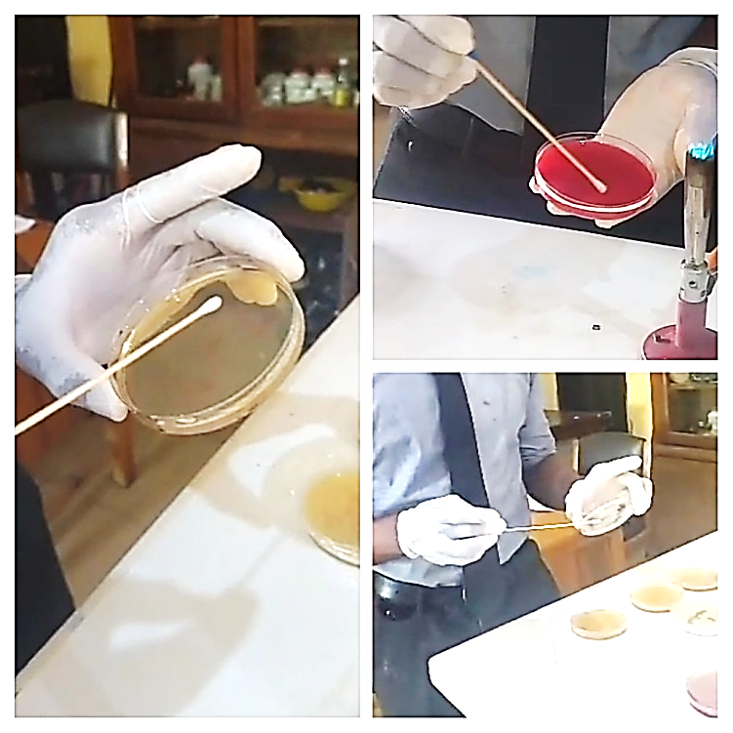
Appendix 1:Inoculation of samples into Nutrient, Blood and SDA agar plates.

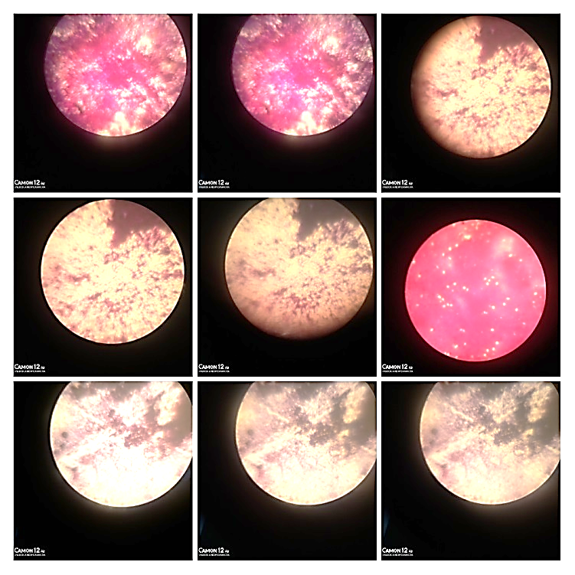

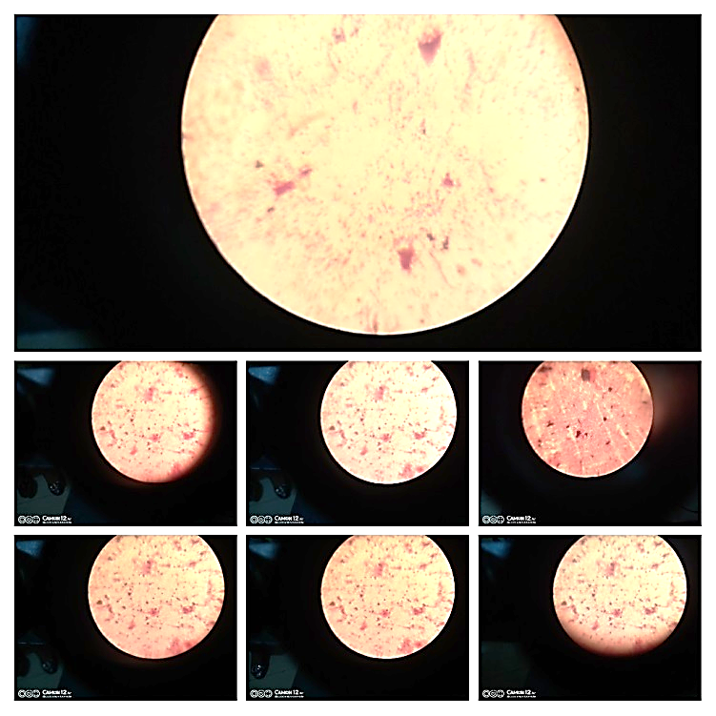
Appendix 2:Gram stain microscopy

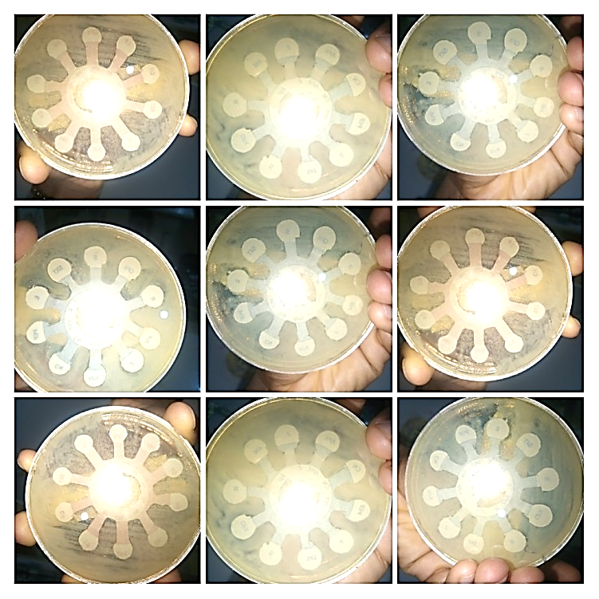
Appendix 3:Antimicrobial Sensitivity test.
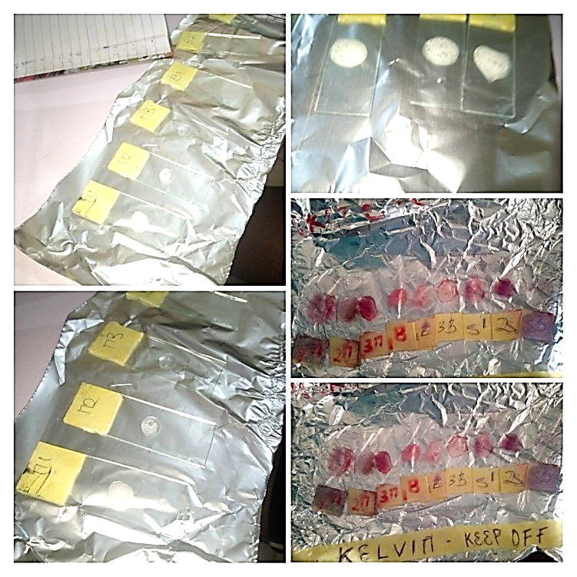
Appendix 4:Biochemical Tests
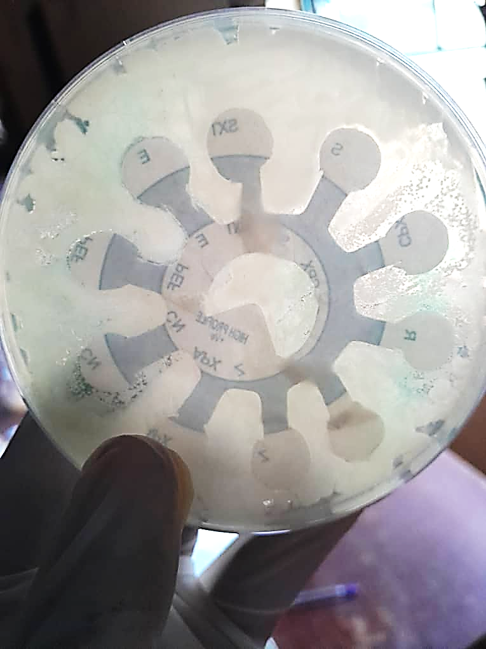
Appendix 5:Staphylococcus Aureus showing intermediate response to CPX.

