DESIGN AND IMPLEMENTATION OF A DOCTORED IMAGE DETECTION SYSTEM

BY

VICTOR CHIBUIKEM EMENIKE
U19/NAS/CSC/182

COMPUTER SCIENCE

DEPARTMENT OF COMPUTER SCIENCE AND MATHEMATICS
FACULTY OF NATURAL SCIENCES AND ENVIRONMENTAL STUDIES
GODFREY OKOYE UNIVERSITY,
ENUGU STATE, NIGERIA

JULY, 2023.

DESIGN AND IMPLEMENTATION OF A DOCTORED IMAGE DETECTION SYSTEM

BY

VICTOR CHIBUIKEM EMENIKE
U19/NAS/CSC/182

COMPUTER SCIENCE

DEPARTMENT OF COMPUTER SCIENCE AND MATHEMATICS
FACULTY OF NATURAL SCIENCES AND ENVIRONMENTAL STUDIES
GODFREY OKOYE UNIVERSITY,
ENUGU STATE, NIGERIA

A PROJECT RESEARCH SUBMITTED TO THE DEPARTMENT OF COMPUTER
SCIENCE AND MATHEMATICS IN PARTIAL FULFILMENT OF THE
REQUIREMENTS FOR THE AWARD OF BACHELOR OF SCIENCE (B.SC) DEGREE
IN COMPUTER SCIENCE

SUPERVISOR: MR. BENJAMIN NWAOGUGU

JULY, 2023.
CERTIFICATION
This is to certify that this research titled “DESIGN AND IMPLEMENTATION OF A DOCTORED IMAGE DETECTION SYSTEM” was carried out by VICTOR CHIBUIKEMEMENIKE with the Registration Number U19/NAS/CSC/182 under the supervision of Mr. Benjamin Nwaogwugwu in the Department of Computer Science, Godfrey Okoye University Enugu Nigeria.

___________________________ ________________________
VICTOR EMENIKE Date
U19/NAS/CSC/182
(Student)

APPROVAL
This research titled “DOCTORED IMAGE DETECTION SYSTEM” has been assessed and approved by the Committees of Department of Computer Science and Faculty of Natural Sciences and Environmental Studies, Godfrey Okoye University Enugu Nigeria.

___________________________ ________________________
Mr, Benjamin Nwaogwugwu Date
Supervisor

___________________________ ________________________
Dr. J. B Agbogun Date
HOD Department of Computer Science

___________________________ ________________________
Prof. Chidi C. Uhuegbu Date
Dean, FNSES

___________________________ ________________________
External Examiner Date

DEDICATION
This research is dedicated to God almighty for his grace and mercy, and for me leading me this far.

ACKNOWLEDGEMENTS
Without God, all these would not have been possible. I wish to start this page by thanking God for bringing me this far in the journey. To him alone be all glory.
I would like to express my deepest appreciation to all those who provided me the possible assistance to complete this project. A special gratitude I give to my project supervisor Mr. Benjamin Nwaogwugu whose contribution in stimulating suggestions and corrections, helped me to coordinate my project especially in writing this report. I will also like to acknowledge with much appreciation our HOD, Dr. J.B Agbogun, who played the role of a father to us and worked hard to see that we are coordinated in our work, and our lecturers who have invested their full effort in guiding the department to achieving the goal. A special appreciation in that regard to Mrs Chinenye and Mrs Ekene Okafor, lecturers who are always ready to assist me whenever I come knocking on theirdoors. I have to appreciate the guidance given by other supervisors as well as the panels, especially in our project presentation which has improved our presentation skills.
My appreciation extends to my family, for their earnest support and care. To my mother Mrs. Louisa Emenike for her motherly love, care and assistance, to my junior brother, Franklin Emenike, who will always turn up when he is called, and to my sisters, Amara, Ifunanya, Chidimma, and to my benefactor and sponsor, Mr. Chukwumee, I thank you all, and I pray for God’s continuos blessings on you all.
To extended family membersMrs. Ogechi, Sr. Jacinta, Mrs. Christiana, and my friends Paulinus, Edmond, Damilola, Stella, Judith, Vivian, Justice, Divine, to mention but a few, who have always provided me with both emotional support and encouragement to continue pushing, I say thank you, and I pray that the good God will bless us all. I also appreciate all who I could not mention, but have reached out in one way or another, may the good lord bless you all.

ABSTRACT
In our present generation, which has been dominated by the use of technologies, the use of digital images is a vital part of many application domains and software. With the steady upgrade and innovations in technology, software for doctoring images are being developed, and the speed at which digital images are being doctored is made easier, thereby increasing the rate of doctored images being spread online. Image doctoring is the process of manipulating a digital image, to either hide important information or to output false information for public consumption. The proposed system is aimed at detecting and highlighting the malpractices performed on modern-day digital images using the Python language and its libraries. The system is much different from the machine learning approach as it does not require the training of any dataset. For the design of the system, we adopted the Object-oriented model and the Object-Oriented analysis and Design. The software was implemented using the Python programming language and is dependent on some python libraries like Opencv, numpy, matplotlib and tkinter for smooth image processing and a user-friendly interface. It uses 4 different manipulation detection methods to assist the user in analysing a digital image in jpeg and png formats and producing an accurate output for the detection of manipulation in the uploaded image.

TABLE OF CONTENTS
Tittle Page i
Certification ii
Approval iii
Dedication iv
Acknowledgement v
Abstract vi
Table of contents vii
List of Figure ix

CHAPTER ONE: INTRODUCTION

BACKGROUND TO THE STUDY 1

STATEMENT OF THE PROBLEM 2

AIM AND OBJECTIVES 4

SIGNIFICANCE OF STUDY 5

SCOPE OF THE STUDY 6

CHAPTER TWO: THEORETICAL BACKGROUND AND REVIEW OF RELATED WORKS

2.1 INTRODUCTION 7

2.2 THEORETICAL BACKGROUND 7
2.2.1 IMAGE MANIPULATION TECHNIQUES 8
2.2.2 CHARACTERISTICS OF DOCTORED IMAGES 9
2.2.3 IMAGE FORENSICS TECHNIQUES 9
2.2. 4 MACHINE LEARNING APPROACHES 11

2.3 REVIEW OF RELATED WORKS 12

CHAPTER THREE: SYSTEM ANALYSIS AND DESIGN

3.1 PREAMBLE 15

3.2 SYSTEM ANALYSIS 15

3.2.1 ANALYSIS OF EXISTING SYSTEMS 16

3.2.2 ANALYSIS OF THE PROPOSED SYSTEM` 17

3.3 PROPOSED METHODOLOGY: OBJECT-ORIENTED MODEL 20

3.3.2 ANALYSIS AND DESIGN 23

3.3.3 UML DIAGRAMS 23

3.3.3.1 USE CASE DIAGRAM 24

3.3.3.2 ACTIVITY DIAGRAM 25

CHAPTER FOUR: SYSTEM IMPLEMENTATION

4.1 OVERVIEW 27

4.2 CHOICE OF DEVELOPMENT ENVIRONMENT 27

4.3 CHOICE OF PROGRAMMING LANGUAGE 29

4.4 LIBRARIES IMPORTED IN THE PROJECT IMPLEMENTATION 30

4.5 REQUIREMENTS 31

4.6 SYSTEM IMPLEMENTATION 32

4.6.1 USER INTERFACE 32

4.6.2 COPY-MOVE DETECTION 33

4.6.3 ERROR LEVEL ANALYSIS 34

4.6.4 METADATA ANALYSIS 34

4.6.5 DOUBLE COMPRESSION 35

CHAPTER FIVE: SUMMARY AND CONCLUSIONS

5.1 SUMMARY 36

5.2 CONCLUSION 37

5.3 RECOMMENDATIONS 37

REFERENCES 38
APPENDIX 41

LIST OF FIGURES
Figure 3.1: The Object-Oriented Model 22
Figure 3.2: The Use case diagram of the proposed system 25
Figure 3.3: Activity Diagram of the Proposed system 26

CHAPTER ONE
INTRODUCTION

1.1 BACKGROUND TO THE STUDY
The internet and the digital world are growing fast. With constant upgrades to devices; social media services expanding and new technologies being developed, there has been a huge increase in image sharing, so much so that saying that a large number of images are shared online each day is an understatement.
The Hootsuite (2020a) survey found that there are 3.8 billion active social media users and 4.54 billion internet users worldwide in 2020. More than half of Hungary's population uses social media, with 7.64 million internet users and 6.00 million social media users (out of a total population of 9.67 million) (Hootsuite, 2020b). The most popular social media platforms and sites in Hungary are Facebook (5.6 million), Messenger (5.35 million), and Instagram (2.1 million) based on the number of people that marketers can reach with advertisements (Hootsuite, 2020b). Also, so far in 2023, there are about 8,016,940,460 people in the world with a population increase of about 0.94% since 2022 (Jessica, 2023). This goes on to show from these studies that more than half of the world’s population uses the internet, and close to half of the population uses these social media platforms where images are exchanged daily.
Sequel to these developments, it is also worth knowing that with digital development, image doctoring has become a norm in the internet society. Doctored images are being released steadily for many purposes, which may be benign ideas such as impressing friends or deleterious intents like blackmails. With the advent and accessibility of powerful editing software, it has become very easy for images to be doctored even without skills or technical knowledge. And knowing how eager internet users are to swallow any available content, such images are readily shared online. Based on a study by Kasra (2018), individual responses and evaluations of images in online stories on various web channels were the subjects of a study based on groups of college students in the United States. The study came to the conclusion that the majority of people use web images without questioning their authenticity. This also crosses across other media types like videos and audio. A typical example will be the 2023 Nigeria Presidential election, where many images were released to taint the images of certain candidates. This further proves the significance of underlining the negative impact of doctored images.
Fake and doctored images are categorized differently. A fake image is an image created from scratch using high-end software or artificial intelligence, while a doctored image is a digital image or picture that has been altered using editing tools, after being taken with a digital camera and saved. The ease at which these doctored images are created using editing software by simply adding, removing, or replacing image data automatically has also made it quite difficult to detect those doctored images which most times will be used in misleading the public. This study focuses on the detection of doctored images using Python programming language and its libraries.

STATEMENT OF THE PROBLEM
“Detecting doctored images remains a constant problem nowadays in terms of identifying the significant factors along with achieving high classification accuracy” (Yasir et al., 2022).
The use of doctored images is becoming increasingly common in various fields, including journalism, social media, scientific research, politics, and even the legal system. This has proven to become a huge problem for the society as they are being used for the deception of both private and public factors. To worsen the issue, most journalistic companies do not even check the originality of the images they get before posting them, thereby ending up publishing fake news and images which leads to misinformation in the public. The researcher has once seen a fake image of Justin Bieber eating burritos wrongly, which went viral, and many believed them, till the original creators confessed to making those images.
Talking about the legal system, there have been many cases of people submitting doctored and fake images as evidence to the court, and in some of those cases, without proper investigation, the court ended up believing them. Take, for instance, the court case of Johnny Depp and his ex-wife, Amber Heard, where the latter at certain points of the court hearing was found to have presented a series of doctored images of her being molested and victimized as pieces of evidence to the court. In her case, the judge was intelligent enough to request verification and confirmation of the pictures before the evidence was accepted, and in the end, they were found to have been doctored images.
There have also been many cases of identity theft, cyber fraud, and a host of other cybercrimes relating to images, which are being committed daily on the internet.
The same can also be said of the political factor, which has in fact been the worst when it comes to this problem of doctoring images. A typical example of this is the events of the Nigeria 2023 presidential election, where supporters of different parties were busy releasing different doctored images to taint the integrity of the opposing party candidates. Some even went as far as releasing doctored audio files.
So, it is very essential to develop reliable methods for detecting these manipulated images. Traditional image manipulation detection methods often fail to identify doctored images due to the increasingly sophisticated manipulation techniques used by image forgers, and, most modern methods have proven to either be inaccurate or too complicated for users. Therefore, there is a need for a more accurate and effective method for detecting doctored images which will be free, easily accessible, and usable by the public.

AIM AND OBJECTIVES
The main aim of this project is to develop a system used for detecting doctored images of different types using different Python libraries and computer vision techniques available and accessible which the researcher can make use of. The primary challenge in this project lies in designing a system with the combination of those libraries and techniques which can tell the difference between real and doctored pictures by spotting even tiny differences in how the images look.
OBJECTIVES
The general Objectives of this project include:
- To design a doctored image detection system.
- To implement Image Loading and Preprocessing.
- To identify image processing techniques to extract the difference between a real and a manipulated image.
- To explore feature extraction methods such as texture analysis, edge detection, or other appropriate techniques for manipulation detection.
- To make use of suitable clustering methods to identify regions of an image that may have been manipulated.
- To Test and adjust the system to improve its accuracy at detecting a broader range of manipulated images.

SIGNIFICANCE OF STUDY
The proposed solution will leverage the powerful feature extraction capabilities of OpenCV and different Python libraries, to develop an accurate and reliable system with different techniques for doctored image detection.
The proposed project on Doctored Image Detection usingPython has significant implications for a wide range of fields, including journalism, social media, scientific research, and law enforcement.
First, the initiative can help journalists spot altered photographs, which are frequently used to spread false information and can influence the public's perception. Maintaining journalistic integrity and preventing the spread of misleading information require the identification of doctored photographs.
Second, by utilizing the created system for real-time picture manipulation detection using different Python libraries, social media platforms can also gain from this effort. It is crucial to create technologies that might lessen the damaging effects of distorted pictures on public perception given social media's explosive development and growing influence on society.
Thirdly, scientific research heavily relies on images, and doctored images can significantly impact research outcomes. By identifying and eliminating doctored photos from scientific papers, the project's suggested solution to the problem of establishing an effective and dependable system for detecting doctored photographs will assist enhance research integrity.

Lastly, law enforcement organizations may utilize this approach to find altered pictures used in a variety of crimes, such as identity theft, cyberbullying, and stalking. The initiative can aid in the battle against such crimes and offer a solid resource for identifying and prosecuting people who commit crimes using altered photos.
In summary, the project's significance lies in its potential to address a pressing issue of doctored image detection, which has far-reaching implications in various fields. This solution the study is proposing, which involves the of use libraries, algorithms, and computer vision techniquesto detect a doctored image accurately can contribute to the maintenance ofthe integrity of the journalism sector, it can also promote research ethics, help reduce crimes like identity theft, and also the reductionof the spread of false information.

SCOPE OF THE STUDY
The study will focus on developing a system that can accurately check whether a digital image has been manipulated or not.The scope of this work is limited to detecting doctored image file. The image files to be considered include JPEG and PNG files. Other forms of digital manipulation, such as video and audio manipulation, are outside the scope of this study.

CHAPTER TWO
LITERATURE REVIEW

2.1 INTRODUCTION
In this chapter, the study will mainly be taking a look at the different works already done by other researchers based on this topic.
With the widespread of image doctoringapplications, the ease at which these applications have been made accessible, and the harms which the uncontrolled use of these applicationshas caused, researchers have taken it upon themselves to develop tools and algorithms to detect these doctored images in response to those challenges. In this chapter, the research will be reviewing some of these inventions and consider how our system is an improvementof their work. To do this, this research will be looking atdifferentworks that have examined different approaches for detecting doctored images. The study will also explore the strengths, limitations, and applications of all these methods.

2.2 THEORETICAL BACKGROUND
This section will provide a better understanding of the concepts involved in the detection of doctored images. It involves the basics of digital image processing.
Before proceeding, the study will like to understand basically how an image works. An image is a combination of finite number of pixels which have different values and are stored in different locations. The values of these pixels are numbered depending on the type of image. E.g., a binary image is only numbered in 0 and 1, an 8-bit color-format image has 256 numberings with 0 being black and 255 as white, and a 16-bit color contains 65,536 different color values and is also referred to as the high color format.
Now, from the above explanation, the study can infer that the manipulation of an image implies an alteration to the pixel values of the image.
So, the project will be looking at the various methods commonly used in image manipulations, such as content-aware resizing, splicing, cloning, retouching, etc. Furthermore, the study will also look at the factors that can indicate that an image has been altered, such as inconsistencies in lighting, change in metadata, etc.
2.2.1 IMAGE MANIPULATION TECHNIQUES:
Understanding the various concepts used to manipulate images is very important for detecting a doctored image effectively. The researcher will be explaining different of such techniques sued in image manipulation, such as content-aware resizing, splicing, cloning, copy-move, and retouching.
Content-aware resizingis a technique used to adjust the size of an image without muchnoticeable loss of details in the image, by carefully removing pixels in the case of size reduction, or duplicating pixels in the case of size expansion.
“Image splicing involves a combination of different images to create one composite image. It involves cutting out an object from one image and pasting it onto another image to create a made-up scene. Detection of this manipulation technique can be very difficult, especially when it is done by a professional. Although it may be difficult, different factors can be used to identify errors and inconsistencies in the composite image, such as mismatched lighting and shadows, sharp edges, and a few other factors that will indicate the presence of manipulated regions within the image” (Bo Xu, 2014).
Cloning refers to creating duplicates of an imageand pasting those objects within the image. It can also be known as copy-move, where images are cut out and pasted onto the same image probably on a different area.
Retouching which quite is popular in our present age aimsat enhancingthe appearance of imagesthrough methods like airbrushing or smoothing. It is the method mostly used in the popular Snapchat application.
2.2.2 CHARACTERISTICS OF DOCTORED IMAGES
Doctored images often bearsome characteristics that indicate manipulations,some important factors to consider are inconsistencies in lighting, shadows, color gradients, and pixel-level anomalies. Unnatural highlights or shadows, sharp edges, irregular noise patterns, and compression artifacts are some examples of the characteristics to look out for. Detecting and analyzing these artifacts play a crucial role in differentiating doctored images from realimages.
2.2.3 IMAGE FORENSICS TECHNIQUES
Image forensics techniques serve as very important tools for pinpointingimages which has been manipulated in any way. To achieve this, several image forensics methods are commonly employed.
Onesuch method involves the analysis of the statistical properties of an image. By studying how pixel values are distributed in the image, researchers can identify anomalies that may indicate image manipulation. This could include identifying unexpected patterns or deviations from the expected statistical behavior.
Noise patterns within an image also provide valuable clues for detecting image manipulations. Every digital image has a certain level of noise inherent in its capture and processing which is spread evenly throughout the image. By analyzing the noise levels, researchers can determine if certain regions of an image have been modified or if additional elements have been introduced.
Duplicate regions within an image can also indicate image manipulation. By comparing different areas of an image and identifying identical regions, researchers can identify if the content has been copied and pasted within the same image.
In addition to traditional methods, advanced techniques can also be deployed to further enhance the detection capabilities of this project. One such technique is color filter array interpolation which examines how colors are reconstructed in digital images captured using a single sensor. By performing this analysis, researchers can identify potential image manipulations.
Compression analysis involves analyzing an image to detect whether it has been double compressed. When an image goes through a manipulation system, it is usually resaved after manipulation especially in JPEG format. That second compression causes the image to lose some of its features or pixels. Analyzing this factor by researchers has proven to show pieces of evidence of image manipulation.
Metadata analysis is also another technique, which involves analyzing and comparing the data details of the image, such as the camera settings, the date the image was taken, the location, etc. Some image file formats do not actually contain much information within, but the most popular lossy compression image file formats which are JPEG and PNG do contain the metadata information, though PNG does not contain much unless it has been converted from JPEG. There are many factors to consider when analyzing the metadata of an image. Those factors include camera information (make, model, and software), image size, timestamps, altered and missing metadata, description, and the type of metadata. Researchers have managed to use this information to detect if an image has been manipulated, by comparing the metadata of a real image and a manipulated image. Although metadata is not mostly reliable on its own as its content can be altered, it is mainly used as a backup for image manipulation detection (Casey, 2021).
Resampling detection is yet another technique that focuses on detecting whether an image has been resized or resampled. By analyzing the factors introduced during these processes, researchers can be able to predict potential manipulation.
Overall, this project involves an exploration of various image forensics techniques. These techniques range from traditional methods based on statistical properties, noise patterns, and duplicate regions, to more advanced techniques like sensor pattern, noise analysis, color filter, array interpolation, and resampling detection. By leveraging these techniques, this project aims to enhance the capabilities of image detection using Python.
2.2.4 MACHINE LEARNING APPROACHES
Machine learning has emerged as a powerful approach for computer-automated projects including doctored image detection. The project does not likely incorporate machine learning algorithms to train models on datasets of manipulated and authentic images, but it is worth considering this image detection technique. Convolutional neural networks (CNNs), support vector machines (SVMs), decision trees, or a combination of these methods are mostly employed when working with Machine learning. These models extract relevant features from images depending on how they have been trained, and learn to classify them based on their manipulated or real nature, thereby enabling automated doctored image detection. These machine-learning techniques are veryintelligent and flexible that they can also learn independently on depending on the situation(Shihao, 2018).

2.3 REVIEW OF RELATED WORKS
This project is not a novel innovation, but rather an improvement on the different doctored image detection systems which have been developed by different researchers. In this part of this research, the study will be taking a look at the doctored image detection system works done by those researchers, how effective their works are, and finally perform a comparison between their works and this study. In the end, from the comparison done, the researcher will highlight the gap that the proposed system will be covering which probably those other works did not consider.
Muhammed et al (2017) developed a system for fake image detection using Java programming language and machine learning to get an 83% success rate at fake image detection. The system was developed to detect manipulated images using 2 detection techniques which are Metadata analysis and Error Level Analysis. Upon upload, as written in their research paper, the system, using the Metadata-extractor java library, extracts the metadata information of the image. The metadata system uses a tag-searching algorithm to search for keywords like Photoshop, Corel, etc., which will indicate a possibility of manipulation. Asides from the metadata analysis, the system also uses trained data in the neural network to compare the Error Analysis Level (ELA) of the image and detect the compression ratio of the foreign object in the manipulated image. The abstract section of the research paper also mentioned that the neural network also recognizes the parts of the image that have been manipulated and reveals the segments of the original image. They made use of the Neuroph library for Java to implement the neural network, which means that the project was built using the Java programming language. One very important positive aspect of this project is that it was made available for Android phone users thereby making it available to almost everyone. The limitation I noticed in the project upon implementation is that the ELA is not fully reliable as it produces false results.
Weiqi et al (2007) built a Novel Method for Detecting Cropped and Recompressed Image Blocks. They used the regular symmetrical shape exhibited by the blocking artifact characteristics matrix (BACM) to determine whether an image is real or not. According to their research paper, the regular symmetrical shape is exhibited on a real image and destroyed on a cropped and recompressed image. Therefore, their method makes use of this property of BACM to detect a recompressed or cropped image. After the BACM introduction into the image, the representation feature derived is then fed into a support vector machine (SVM), and the machine is then trained to distinguish between a fake image and an original one. From the research paper study, because I have not actually implemented the work, I may infer that the research may have a high accuracy level, but based on the fact that it is still a novel innovation, it will still have its limitations.
Kapil et al (2022) worked on a novel multi-scale residual deep CNN for general-purpose image manipulation detection. The system was designed to learn the features of multiple image manipulation techniques for more accurate detection of manipulation. The work was done by training a deep CNN architecture in 3 stages comprising the preprocessing, hierarchical high-level feature extraction, and classification technique. The preprocessing stage extracts the noise features which are fed to the feature extraction network for the extraction of high-level manipulation features. Finally, the resulting feature map is provided to the CNN dense layer for the classification of the images. Though a novel work, this work has proven to be a great work, owing to the fact that it detects multiple manipulation techniques used on an image.

Lakshmanan et al (2021) under the funding of the DARPA, presented a novel method to detect image manipulation which the research paper was titled “Holistic Image Manipulation Detection using Pixel Cooccurrence Matrices”. Their method was proven to be holistic as it was not dependent on any type of manipulation technique and so can detect a host of many manipulation techniques. The method uses a pixel co-occurrence matrix to compute different color pixels of an image, this captures the neighboring pixels distribution. The matrices gotten from this method are then passed through a deep CNN to allow it to learn important features that can aid in the classification of the images into doctored or real images.
Yuri et al (2002) worked on a module “Detecting Forged Images” (though currently discontinued, is very vital for my research) which estimates how genuine an image is by calculating the probability of manipulations using different manipulation techniques. The module made use of different algorithms individually to determine the probability of an image being doctored before uploading them to a neural network to make the end decision. The algorithms employed were the JPEG format analysis, Double quantization effect, Copy-move forgery and clone detection, error level analysis, and inconsistent image quality.

CHAPTER THREE
SYSTEM ANALYSIS AND DESIGN

3.1 PREAMBLE
This section of this study involves a detailed outline of the methods and procedures used in designing and implementing the proposedsystem. Also, this chapter will take a look at the design requirements, the system architecture, and the development of the various components of the system.
A doctored image detection system is proposed, which makes use of the pre-defined algorithms and techniques in the python libraries to detect doctoring in the images. The system comprises of 4 different methods for doctored image detection which include Copy-move detection, metadata extraction, Error level analysis and Double compression detection. Python programming Language will be used to implement the different algorithms for the different detection methods in the system.

3.2 SYSTEM ANALYSIS
System analysis involves the breaking down of the system and studying the various component and their interactions. In this section, the researcher will also be discussing the complete analysis of the proposed system which would also involve the analysis of existing systems, identifying the limitations of the existing systems and ways of improving on them, as well as an analysis of the proposed system involving modelling of the system using use case diagrams, activity diagrams and class diagrams.

3.2.1 ANALYSIS OF EXISTING SYSTEMS
JPEGSnoop:
JPEGSnoop is a desktop/windows application that is used to analyze and detect whether an image has been manipulated or not. Besides image analysis and forensics, JPEGSnoop can also be used to check the quality of images, locate errors in an image, and determine what editing program was used to manipulate the photo. While JPEGSnoop may be a very good software for professionals as it is detailed in its analysis and gives a correct output, it also has its own limitations.
Limitations of JPEGSnoop and the proposed system Approach:
- The user interface is not very friendly, and such users who are not professionals may have a hard time navigating the software. To solve this, the proposed system is designed to have a very user-friendly interface which will make it easy for even inexperienced citizens to use.
- Although JPEGSnoop is really accurate, and divides analysis into 4 different classes, its result is only based on Class 1, which mostly detects any compressed image at all as manipulated. The proposed system on the other hand divides all the different analysis methods, to help a user know what exactly they are looking for and provide a clearer analysis.
OnlineExifViewer.com:
As shown in the name, this is a website for viewing the EXIF (Exchangeable Image File Format) data on an image. The EXIF is the recognized standard for any special information associated with an image or other media that was recorded by a digital camera. It has the ability to save crucial information like camera exposure, the date and time the image was taken, and even GPS position. So, the website OnlineExifViewer.com relies on the information provided by the EXIF data to know if an image has been tampered with or not.
Limitations and Approach:
As good as it is to detect image manipulation using the EXIF data, it is also important to note that there are some limitations to this.
- Some images do not usually have useful EXIF data, and the EXIF data of an image can also be removed in various ways. So, in that case, the images are usually assumed to be fake. To solve this, the proposed system does not rely solely on the use of EXIF data for manipulated image detection.
Fotoforensics.com:
FotoForensics.com just like OnlineExifViewer.com is a website for image forensics and analysis. Upon usage, I noticed that the website has a very good user interface but uses only the ELA and metadata as methods of detecting doctored images. To capture user’s interest, they have also included some games like puzzles to the website which users can play using the uploaded images. Their detection method of ELA and metadata be a very simple and clear method of doctored image detection, but it also limits the options of the website.
The system has approached this limitation by offering different methods of doctored image detection.

3.2.2 ANALYSIS OF THE PROPOSED SYSTEM
The proposed system, a Doctored Image Detection systemuses a rule-basedapproach, relying on predefined algorithms and procedures based on the imported libraries to make decisions,that will allow users to upload an image to the system for which the system will detect the image been doctored based on the detection techniques selected by the user. The system was built using about 4 different image detection methods, which will present the users with a variety of options to choose from when trying to detect the type of detection used in an image.
The system comprises different methods of image detection which will be highlighted below
COPY-MOVE DETECTION:
This detection method allows users to detect if certain areas of an image have been duplicated onto the same image. The copy-move forgery method involves duplicating a portion of the image in order to hide or manipulate certain content.
The copied region is usually moved to a different location within the same image, either to hide unwanted elements or to duplicate important elements for different purposes (Gulnawaz, 2021).
Steps involved in the copy-move detection
- The required image is uploaded, which is divided into the same block sizes, and analysed to extract blocks from the image.
- The blocks are then processed to identify similar parts in the image by checking for similarity based on color values.
- The identified similar parts are then grouped into clusters based on spatial relationships and similarities.
- The similar regions are then marked on to show that they have been copy-moved.
ERROR LEVEL ANALYSIS:
Image error level analysis is a technique for detecting changes to compressed (JPEG) images by detecting the distribution of errors introduced after the image is resaved at a specified compression rate. ELA works by re-saving the image at 95% compression and comparing the results to the original. Because of their distinctive characteristics in the ELA depiction, modified areas are immediately visible. ELA algorithm takes factors like shadows, eyes, and reflections into consideration to display hidden details of the input image (Ashay, 2022).
Steps involved in ELA
- When the composite image is uploaded, a temporal version of the image is created with reduced quality.
- The difference between the original and the created image is computed.
- The pixel difference values are scaled and the output is displayed.
METADATA EXTRACTION
Another method of doctored image detection is through metadata analysis. The proposed system is aimed at extracting the metadata for images which have the metadata in them. This involves showing the data and properties contained in the image, like the camera that took the picture, the File properties such as file size, file type, creation date, modification date, camera settings, date and time of capture, and other technical details and including the software used to modify the image. Experts or even inexperienced users will now look at the metadata extracted to discover patterns or data that may pin-point manipulation. Some metadata files as stated earlier do carry the software used to manipulate the image, like Adobe Lightroom, Photoshop, or CorelDraw. When these are indicated in the metadata, it is a clear sign that the image has been parsed in
It is also very important to note that not all images have metadata in them, as some may have lost their metadata due to compression or source of acquisition.

DOUBLE COMPRESSION DETECTION
Double compression refers to the process of reducing the image file size while trying to maintain image quality. It also refers to the act of compressing an already compressed image. Now, during manipulations using software like Adobe Photoshop or Corel Draw, the process of manipulating or editing the image itself does not involve compression, but when the image is saved in a lossy format like JPEG or JPG, it leads to compression. Now, the image is double-compressed if the original image was already saved in a lossy format (JPEG) before being resaved after manipulation. During compression, some details in the image which are considered unimportant are removed to achieve a higher compression ratio. (https://www.keycdn.com/support/what-is-image-compression)

3.3 PROPOSED METHODOLOGY: OBJECT-ORIENTED MODEL
The system is structured using the Object-Oriented model, and the Object-Oriented Analysis and Design will be used for the analysis and design phases of the software development.Also, notation symbols of the Unified Modeling Language (UML) will be used in the analysis and design.
The object-oriented model defers from the other models by its intensive reuse of software components. This methodology is characterised by its easy integration of existing software modules (called objects or components) into newly developed software systems. A software component library solves this purpose by supplying software components for reuse.The development process begins with a sequence of object-oriented analysis and design.
The design phase is followed by the acquisition of suitable components from the reusable software library when available. Regular development is carried out otherwise. Copies of newly developed software components are then stocked in the software library for future reuse. It is expected that the growing software components stocks in the reusable software library will allow substantial and increasing reuse of software(Agu, 2023).

Requirement definition
Object-oriented analysis
Object-oriented design
Reusability survey of component library
System construction
Availability of components in library
Customer evaluation
Operation and maintenance
Installation and conversion
System test
Reusable component library
Requirement definition
Analysis and design
Coding
Component test
Not accepted
Accepted
Reusable component available
Component not available
Development of a new component
Addition to the library

Figure 3.1: The Object-Oriented Model

In the above figure, the phases of the Object- orientedmodel are listed out sequentially, involving the different phases which one must conclude before proceeding to the next phase.

3.3.2 ANALYSIS AND DESIGN
The OOAD (Object Oriented Analysis and Design) will be used and notation symbols of the Unified Modeling Language (UML) will be used in the analysis and design.
A system is modelled as a collection of interdependent objects using the object-oriented analysis and design technique in software engineering. Every object is an instance of a class, which is a blueprint that specifies the characteristics and actions of the object(Mukherjee, 2016).
During the analysis stage, the researcher would examine the requirements using object-oriented methods to identify the key objects and the relationships between them. To represent the classes and their relationships, as well as to model the interactions between the system and its users, frequently demands creating UML diagrams. This often involves creating UML diagrams to model the interactions between thesystem and its users, to represent the classes and their relationships. The goal of this phase is to develop a clear understanding of the problem domain and to identify the key abstractions and concepts that will form the basis of the system’s design.

3.3.3 UML DIAGRAMS
A general-purpose modelling language is the Unified Modeling Language (UML). The primary goal of UML is to establish a uniform method for visualizing a system's design process. It resembles blueprints used in other engineering disciplines quite a bit. The UML language is more of a visual language than a programming language. To depict a system's behaviour and structure, we utilize UML diagrams.
Modelling, design, and analysis are made easier by UML for software engineers, businesspeople, and system architects. Unified Modelling Language became a standard in 1997 according to the Object Management Group (OMG). OMG has overseen its management ever since. In 2005, the International Organization for Standardization (ISO) released UML as a recognized standard. UML has undergone years of revision and is regularly examined.
The UML diagram consists of other different diagrams which include the: Use case diagram, Class Diagram, Activity Diagram, Sequence Diagram, Object Diagram, etcetera

3.3.3.1 USE CASE DIAGRAM
In the Unified Modeling Language (UML), a use case diagram can summarize the details of your system's users (also known as actors) and their interactions with the system. To build one, you'll use a set of specialized symbols and connectors. An effective use case diagram can help your team discuss and represent:
- Scenarios in which your system or application interacts with people, organizations, or external systems
- Goals that your system or application helps those entities (known as actors) achieve
- The scope of your system
(https://www.lucidchart.com/pages/uml-use-case-diagram)
During the development of a software program or system, use case analysis is a technique used to identify system requirements (typically connected to firmware architecture) as well as the specifics used to describe the processes and classes (which are collections of actors and processes) that would be used in both the use case diagram and the overall use case. The use case analysis will serve as the framework for the system's development (Waykar, 2015).
USER
SYSTEM
UPLOAD IMAGE (JPG, JPEG OR PNG)
SELECT A DETECTION METHOD
PROCESS IMAGE BASED ON D.M
VIEW RESULT

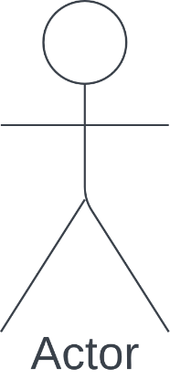

Figure 3.2: The Use case diagram of the proposed system.
In the above figure, the user is the main actor where they upload an image, selects a detection method, the system then scans the image and produces the result for the user to view.

3.3.3.2 ACTIVITY DIAGRAM
Activity Diagrams are used to show how a system's control flow operates. An activity diagram can also be used to describe the actions taken during the execution of a use case. Using activity diagrams, we model both sequential and concurrent activities. So, using an activity diagram, we simply visualize workflows. An activity diagram emphasizes the state of flow and the order in which it occurs. Using an activity diagram, we can explain or show what leads to a specific event.

USER INTERFACE
UPLOAD IMAGE FILE (JPEG OR PNG)
SELECT A DETECTION METHOD
Process Image based on selected detection method
DISPLAY RESULT

Figure 3.3: Activity Diagram of the Proposed system.

In figure 3.3 above, the diagram shows how the activities of the proposed system will run. When a user uploads an image, the system checks to know if the uploaded image is of a valid file format, if yes, when the user selects a detection method, the system runs the detection program on the image and displays the result for the user. If the user wants to perform another detection, they just upload another image and follow the same process.

CHAPTER FOUR:
SYSTEM IMPLEMENTATION

4.1 OVERVIEW
System implementation is the phase after the analysis and design phase. It entails converting the system's design into code, usually using a programming language, and then testing and debugging the code to make sure it complies with system requirements and works as planned. Following the design specifications created during the analysis and design phases, developers write the system's code during the implementation phase of a software development project. In order to guarantee that certain parts of the system are functioning properly, they could also develop test cases and carry out unit testing.
This chapter of the study will be looking at how the system is implemented, the tools and resources that were used to implement the design of the study’s proposed system.

4.2 CHOICE OF DEVELOPMENT ENVIRONMENT
An IDE (Integrated Development Environment) is a software application that offers a whole environment for software development, including tools like a source code editor, debugging tools, and build automation tools. Visual Studio Code, often referred to simply as VS Code, is a popular Integrated Development Environment (IDE) developed by Microsoft. It is a lightweight, cross-platform code editor that supports a wide range of programming languages and frameworks.
“VS Code provides a range of features and tools to help developers easily write, debug, and test their codes. These include:
- A powerful source code editor with syntax highlighting, code completion, and other features to help developers write code more efficiently.
- Implicit help for source control frameworks like Git, making it simple to manage and track changes to your code.
- A built-in terminal that lets you run scripts and tools from the command line from within the IDE.
- A large number of plugins and extensions that add features like support for particular programming languages or frameworks.
VS Code is designed to be highly customizable and extensible, allowing developers to tailor the IDE to their specific needs and preferences. It is available for Windows, macOS, and Linux, and is widely used by developers around the world”
(https://code.visualstudio.com/docs/editor/vscode-web).
Excluding the above-mentioned reasons, other reasons for choosing Visual Studio Code IDE include:
- Community and Support: The developer community around Visual Studio is sizable and vibrant, and it offers tools, discussion boards, and documentation for help. When utilizing Visual Studio to implement a project, the presence of tutorials, guides, and community forums can be helpful.
- Powerful Debugging Features: Visual Studio provides sophisticated debugging tools that make it easier to find and fix bugs in the code. For effective troubleshooting, it offers features like breakpoints, step-by-step execution, variable examination, and sophisticated debugging tools. Etcetera.

4.3CHOICE OF PROGRAMMING LANGUAGE: OBJECT-ORIENTED PROGRAMMING LANGUAGE
An object-oriented programming (OOP) language is a type of programming language that provides support for the concepts of objects and classes. In OOP, an object is an instance of a class, which is a blueprint that defines the attributes and behaviours of a group of similar objects.
OOP languages provide several features that support the development of modular and reusable software systems, including:
Inheritance: This allows you to define a new class that inherits the attributes and behaviours of an existing class. Inheritance enables you to create hierarchies of related classes, where each class builds upon the attributes and behaviours of its parent class.
Polymorphism: This refers to the ability of objects of different classes to be used interchangeably, as long as they share a common interface. Polymorphism enables you to write more flexible and reusable code, as you can define methods that work with objects of multiple types.
Some popular examples of object-oriented programming languages include Java, C++, Python, and Ruby. These languages provide support for OOP concepts such as objects, classes, encapsulation, inheritance, and polymorphism, making it easier for developers to create modular and reusable software systems.
For the proposed project, the Python programming language was used. Python is a popular, high-level programming Object Oriented programming language that is widely used for scientific computing, data analysis, and machine learning. It has a large and active community of users, and there are many libraries and frameworks available for tasks such as image processing, computer vision, and machine learning.
Python is a great choice for developing a doctored image detection system because it offers a high level of abstraction and expressiveness, making it easy to write code that is clear and concise. Its excellent support for numerical computing and data analysis makes working with image data useful.

4.4 LIBRARIES IMPORTED IN THE PROJECT IMPLEMENTATION
The proposed project's source code was implemented more smoothly by importing Cv2, NumPy, Matplotlib, and Tkinter. The doctored image detection systemwas made using a combination of some of these well-known Python libraries.
Cv2: This is the OpenCV (Open-Source Computer Vision) library, which offers several features and resources for computer vision and image processing. The 'cv2' is employed by the doctored image detection system to carry out operations on pictures, including reading and writing image files, resizing images, converting between colour spaces, and applying filters or transformations (Rosebrock, 2017).
Numpy: This is a library for numerical computing in Python, which provides support for large, multi-dimensional arrays and matrices, as well as a wide range of mathematical functions and operations. The 'numpy' program is used in the doctored image detection system to carry out operations on image data such as arrays, mathematical operations on pixel values, or to apply filters or adjustments to images.
Matplotlib is a Python visualization library that supports many different types of plots and charts, such as line plots, scatter plots, bar charts, and more. The results of the proposed project were visualized using Matplotlib, which included showing the original image next to the forgery regions that were identified (Roughier, 2021).
`Tkinter` is the standard Python interface to the Tk GUI toolkit. For building graphical user interfaces (GUIs) in Python, it offers a straightforward and user-friendly interface. The GUI that lets users communicate with the system was made using Tkinter. It was used to create windows, dialogue buttons, and other user interface elements that let users upload images, choose detection strategies, and see the detection result.
In summary, these are all powerful libraries that can provide useful functionality when implementing the proposed system. By using these libraries in conjunction with each other, developers can perform a wide range of tasks related to image processing, numerical computing, and data visualization.

4.5 REQUIREMENTS
These requirements define the features and functionality that the system needs to provide. The system requirements are categorized into 2; the functional and the non-functional requirements.
The functional requirements are those requirements that specify what the system must possess to properly function, while the non-functional requirements are those requirements that specify the attributes or abilities which the system must have.
Functional Requirements of the proposed System
The functional requirements of the proposed system include that:
- Users must be able to select an image of their choice for upload, and they can also change that choice when they want.
- The system must be able to detect doctored images using four different techniques: copy-move detection, metadata extraction, double compression detection, and Error Level Analysis (ELA).
- The system must provide a user interface that allows users to upload an image and select one of the four techniques to be used for detecting doctored images.
- The system must be implemented using the Python programming language
- The system should make should make use of the imported libraries for the implementation.
Non-Functional Requirements of the proposed system
The non-functional requirements of the system include that:
- The system does not have the ability to store images uploaded for detection by users.
- Currently, the system is only limited to desktop use, and as such cannot be assessed with a mobile phone.
- The system should be user-friendly and easy to use.
- The system should be reliable and provide accurate results.
- The system should be efficient and provide results in a timely manner.

4.6 SYSTEM IMPLEMENTATION
The doctored image detection system was implemented using the already mentioned IDE, programming language and libraries deployed on the programming language.
The system implementation is sub-divided into interface and detection with results.

4.6.1 USER INTERFACE
The user interface was implemented using the ‘Tkinter’ library. The activities in the system are all performed on the user interface which holds the function buttons. The user clicks the upload buttonto select an image from the drop-down option, then selects the detection method. The interface also has the instruction panel to guide the user.
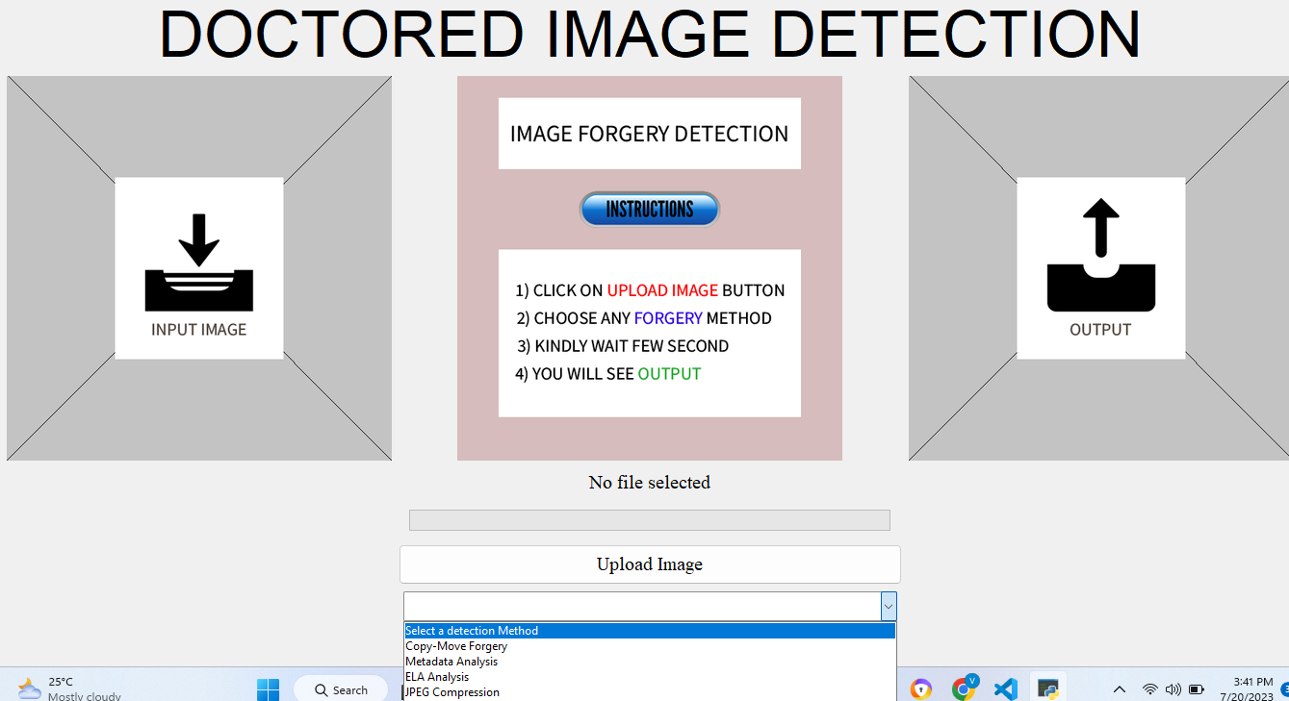

4.6.2 COPY-MOVE DETECTION
After the copy-move detection is selected, the system processes the image using the copy-move detection algorithm, and then outputs the result. The forged picture with markings drawn over the forged area is presented in a new window interface, while the detection result is shown on the output page.
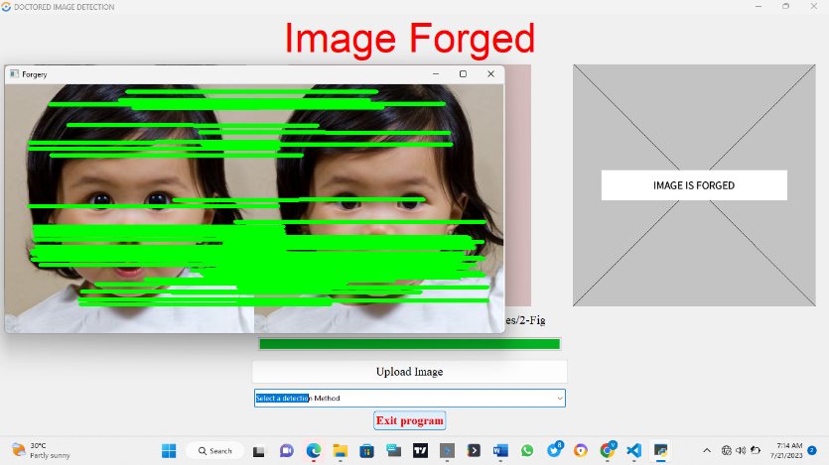

4.6.3 ERROR LEVEL ANALYSIS
The same process taken in the copy-move detection is used in all the other detection methods. For the ELA, the analyzed image is also shown in a new window.
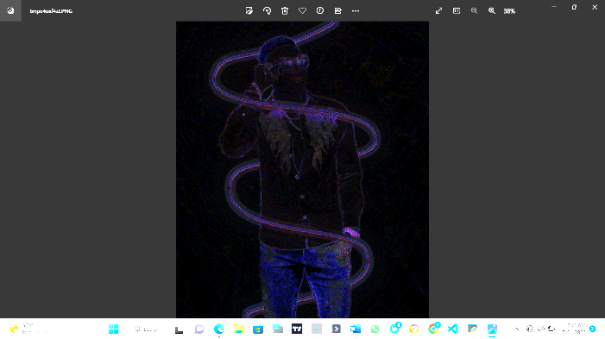

4.6.4 METADATA ANALYSIS
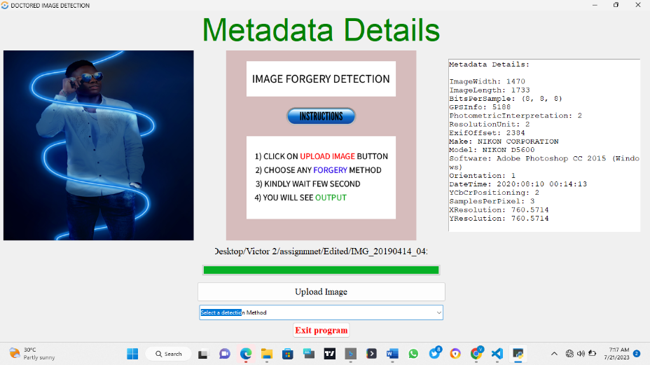

4.6.5 DOUBLE COMPRESSION
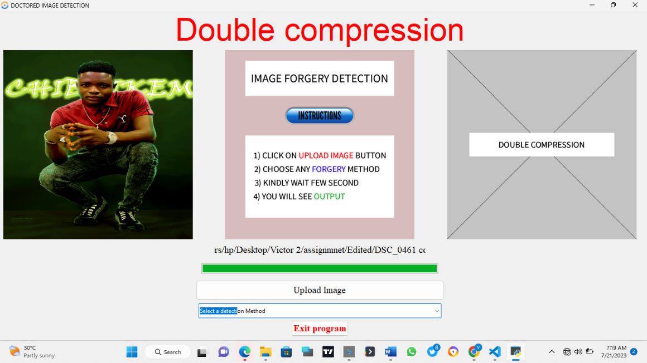

CHAPTER FIVE
SUMMARY AND CONCLUSIONS

5.1 SUMMARY
The design and implementation of the doctored image detection program will be summarized in this chapter. The aim of the project was to develop a system that can accurately analyze an image, and based on the desired input be able to detect manipulation in the image. To guarantee the system’s accuracy and effectiveness throughout the project, extensive research, design, and testing were carried out.
The doctored image detection system was programmed using Python language andOpenCV, numpy and matplotlib libraries for computer vision tasks, image processing, numerical computing and data visualization.
The system is functional in identifying and extracting Double JPEG Compression Detection, Copy-Move Detection, Error Level Analysis, Metadata Analysis out of an input image. The home page of the UI consists of an image displaying box and an output displaying box. The user is provided withdifferent interactive buttons and useful instructions at the center for the convenience of the user. The user needs to click on the “Upload Image” button which will open a pop-up file manager box allowing them to choose the input image out of local drive.The system allows the user to choose any of the techniques and produce suitable outputs through output window on the UI or pop-up windows or in the forms of images. The system works locally on the system without requiring network access.
The doctored image detection abilities of the system based on the selected method were tested using different images, and the system accurately detected that the images were doctored.

5.2 CONCLUSION
In conclusion, the project successfully achieved its objective of designing and implementing a doctored image detection system. The system assists users in accurately detecting if an image has been doctored.
In the proposed system, we have implemented 4 different concepts of doctored image detection algorithms. The system is capable of taking input image and give out suitable outputs to solve the obstacle of forged images.

5.3 RECOMMENDATIONS
From the development and running of the doctored image detection system, the following observations and recommendations were made:
  - The system can be used in law and enforcements and cyber security to help the user to differentiate between original and doctored images.
  - The device can be enhanced by adding other features and detection methods like image splicing detection and including an uncertainty factor label on the GUI to dispay the percentage and levels of certainty or and uncertainty of the image being doctored.
  - With the recommended improvement applied, the system is also recommended for use in the journalism sectors and social media software.

REFERENCES
Bonea, P. (2023, July 4). 7 tools to detect photoshopped & fake images (+ tutorials). Datasourse. https://www.datasourse.com/how-to-detect-photoshopped-fake-images/
Easow, S., & Manikandan, L. C. (2019, May 24). A study on image forgery detection techniques. International Journal of Computer (IJC). https://www.ijcjournal.org/index.php/InternationalJournalOfComputer/article/view/1411
Fisher, R., Perkins, S., Walker, A., & Wolfart, E. (2003). 8-bit color images. Glossary - 8-bit Color Images. https://homepages.inf.ed.ac.uk/rbf/HIPR2/8bitcol.htm
Fridrich, J., Soukal, D., & Lukáš, J. (2004). Detection of copy-move forgery in digital images. Detection of Copy-Move Forgery in Digital Images. https://ia.binghamton.edu/publication/FridrichPDF/copymove.pdf
Gani, G., & Qadir, F. (2021, July 27). Copy move forgery detection using DCT, patchmatch and cellular automata - multimedia tools and applications. SpringerLink. https://link.springer.com/article/10.1007/s11042-021-11174-7
Grigonis, H. K. (2019a, June 17). Adobe created an A.I.. that spots -- and reverses -- fake photos. Digital Trends. https://www.digitaltrends.com/photography/adobe-ai-research-fake-photos-faces/
Grigonis, H. K. (2019b, June 17). Adobe created an A.I.. that spots -- and reverses -- fake photos. Digital Trends. https://www.digitaltrends.com/photography/adobe-ai-research-fake-photos-faces/.
Hamid, Y., Elyassami, S., Gulzar, Y., Balasaraswathi, V. R., Habuza, T., & Wani, S. (2022, November 16). An improvised CNN model for fake image detection - international journal of information technology. SpringerLink. https://link.springer.com/article/10.1007/s41870-022-01130-5
Keycdn. (2023, February 10). What is image compression? - keycdn support. KeyCDN. https://www.keycdn.com/support/what-is-image-compression
Kumar, B. S., Karthi, S., Karthika, K., & Cristin, R. (2018). A systematic study of image forgery detection. Journal of Computational and Theoretical Nanoscience, 15(8), 2560–2564. https://doi.org/10.1166/jctn.2018.7498
Kuznetsov, A., Severyukhin, Y., Afonin, O., & Gubanov, Y. (n.d.). Detecting Altered Images. Detecting altered images. https://belkasoft.com/detecting-forged-images
Li, W., Yuan, Y., & Yu, N. (2009, April 1). Passive detection of doctored JPEG image via Block Artifact Grid Extraction. Signal Processing. https://www.sciencedirect.com/science/article/abs/pii/S0165168409001315
Luo, W., Zhenhua , Q., Huang, J., & Qiu, G. (2007). In 2007 IEEE International Conference on Acoustics, speech and Signal Processing Honolulu, HI, 16 - 20 April 2007 (p. II-217-II–220).
Piscataway, NJ; IEEE Service Center. Xu, B., Liu, G., & Dai, Y. (2014, January 16). Detecting image splicing using merged features in chroma space. The Scientific World Journal.https://doi.org/10.1155/2014/262356
McFadden, C. (2023, February 28). Here’s everything you really need to know about Java. Interesting Engineering. https://interestingengineering.com/how-to/what-is-java
Militante, T. J. (2022, October 7). It 20 - Systems Integration & Architecture module 10.DOCX - polytechnic institute of tabaco 100 Panal Tabaco City A.Y. 2021-2022 course code: Course hero. IT 20 - Systems Integration & Architecture Module 10.docx - Polytechnic Institute of Tabaco 100 Panal Tabaco City A.Y. 2021-2022 Course Code: | Course Hero. https://www.coursehero.com/file/158066991/IT-20-Systems-Integration-Architecture-Module-10docx/
Mukherjee, M. (2016, December 20). Object-oriented analysis and Design. Academia.edu. https://www.academia.edu/30780444/Object_Oriented_Analysis_and_Design
Nagi, J., Caro, G. A. D., Giusti, A., Nagi, F., & Gambardella, L. M. (1970, January 1). Convolutional neural support vector machines: Hybrid Visual Pattern Classifiers for multi-robot systems. 2012 11th International Conference on Machine Learning and Applications. https://scholar.archive.org/work/evog5zjocvah7ksqorfrp3imp4
Nataraj, L., Goebel, M., Mohammed, T. M., Chandrasekaran, S., & Manjunath, B. S. (2021, April 12). Holistic image manipulation detection using pixel co-occurrence matrices. arXiv.org. https://arxiv.org/abs/2104.05693
Obermayer, N., Kovari, E., Leinonen, J., Bak, G., & Valeri, M. (2021, August). How social media practices shape family business performance: The wine ... How social media practices shape family business performance: The wine industry case study. https://www.researchgate.net/publication/353923405_How_social_media_practices_shape_family_business_performance_the_wine_industry_case_study
Privat, M., & Warner, R. (2011). Beginning OS X lion apps development. SpringerLink. https://link.springer.com/book/10.1007/978-1-4302-3721-1
Rana, K., Singh, G., & Goyal, P. (2022, April). MSRD-CNN: Multi-Scale Residual Deep CNN for General-purpose Image Manipulation Detection. https://www.researchgate.net/publication/360032923_MSRD-CNN_Multi Scale_Residual_Deep_CNN_for_Generalpurpose_Image_Manipulation_Detection/fulltext/636c703e37878b3e8799899a/MSRD-CNN-Multi-Scale-Residual-Deep-CNN-for-General-purpose-Image-Manipulation-Detection.pdf
Rosebrock, A. (2017, September 11). Object detection with deep learning and opencv. PyImageSearch. https://pyimagesearch.com/2017/09/11/object-detection-with-deep-learning-and-opencv/
Rougier, N. p. (2021, November 13). Scientific visualization: Python + matplotlib. inria. https://hal.inria.fr/hal-03427242/
Rumpe, B., & France, R. (1999). In UML ’99: The unified modeling language: Beyond the standard: Second international conference: Fort Collins, CO, USA, October 28-30, 1999: Proceedings (1st ed., Vol. 1, Ser. 1611-3349, p. I–726). Berlin, Heidelberg; Springer.
Sager, J. (2023, February 17). Articles by Jessica Sager-Parade: Entertainment, recipes, health How Many People Are in the World in 2023? Everything to Know About the Current Global Population. https://parade.com/1370373/jessicasager/how-many-people-are-in-the-world-global-population/
Schmidt, C. (2021, February 16). A complete guide to metadata analysis. Canto. https://www.canto.com/blog/metadata-analysis/
Singh, V. (2019, February 9). Image forgery detection. Medium. https://towardsdatascience.com/image-forgery-detection-2ee6f1a65442
Slatkin, B. (2015). Effective python: 59 specific ways to write better python. Addison-Wesley.
Sonak, A., Sharma, A., Ramteke, R., Yadav, V., & Kolte, S. (2022, April 27). Image Tampering Detection System. https://journal.ijprse.com/index.php/ijprse/article/view/537/507
SULLIVAN, S. O. (2019, July 1). 5 strategies to identify doctored images. International Journalists’ Network. https://ijnet.org/en/story/5-strategies-identify-doctored-images
Wu, L., Cao, X., Zhang, W., & Wang, Y. (2010, September 16). Detecting image forgeries using metrology - machine vision and applications. SpringerLink. https://link.springer.com/article/10.1007/s00138-010-0296-6

APPENDIX

SOURCE CODE LISTING
Code for GUI with the ELA and METADATA class codes included inside the GUI class.

from importlib.resources import path
from tkinter import *
from tkinter import filedialog, ttk, messagebox
from tkinter import OptionMenu
from PIL import ImageTk, Image, ExifTags, ImageChops
from optparse import OptionParser
from datetime import datetime
from matplotlib import image
from prettytable import PrettyTable
import threading
import numpy as np
import random
import sys
import cv2
import re
import os
import time

from pyparsing import Opt

from ForgeryDetection import Detect
import double_jpeg_compression
import noise_variance
import copy_move_cfa

# Create the root window
root = Tk()
root.title("DOCTORED sIMAGE DETECTION")

# Set the fixed size of the window
root.state('zoomed')

# Global variables
IMG_WIDTH = 400
IMG_HEIGHT = 400
uploaded_image = None
uploaded_image

# copy-move parameters
cmd = OptionParser("usage: %prog image_file [options]")
cmd.add_option('', '--imauto',
help='Automatically search identical regions. (default: %default)', default=1)
cmd.add_option('', '--imblev',
help='Blur level for degrading image details. (default: %default)', default=8)
cmd.add_option('', '--impalred',
help='Image palette reduction factor. (default: %default)', default=15)
cmd.add_option(
'', '--rgsim', help='Region similarity threshold. (default: %default)', default=5)
cmd.add_option(
'', '--rgsize', help='Region size threshold. (default: %default)', default=1.5)
cmd.add_option(
'', '--blsim', help='Block similarity threshold. (default: %default)', default=200)
cmd.add_option('', '--blcoldev',
help='Block color deviation threshold. (default: %default)', default=0.2)
cmd.add_option(
'', '--blint', help='Block intersection threshold. (default: %default)', default=0.2)
opt, args = cmd.parse_args()
# if not args:
# cmd.print_help()
# sys.exit()

def getImage(path, width, height):
"""
Function to return an image as a PhotoImage object
"""
img = Image.open(path)
img = img.resize((width, height), Image.LANCZOS)

return ImageTk.PhotoImage(img)

# Create the outer frame with a black border
frame = Frame(root, bd=2, relief="solid")
frame.grid(row=1, column=1, pady=10)

# Create the inner frame with the desired background color
inner_frame = Frame(frame, bg="white")
inner_frame.grid(row=1, column=1)

# Create a label to display the uploaded image
image_label = Label(inner_frame)
image_label.grid(row=1, column=1)

# Create a label to display the result image
result_label = Label(inner_frame)
result_label.grid(row=2, column=1)

def browseFile():
"""
Function to open a browser for users to select an image
"""
# Only accept jpg and png files
filename = filedialog.askopenfilename(title="Select an image", filetypes=[("image", ".jpeg"),("image", ".png"),("image", ".jpg")])

# No file selected (User closes the browsing window)
if filename == "":
return

global uploaded_image

uploaded_image = filename

progressBar['value'] = 0 # Reset the progress bar
fileLabel.configure(text=filename) # Set the path name in the fileLabel

# Display the input image in imagePanel
img = getImage(filename, IMG_WIDTH, IMG_HEIGHT)
imagePanel.configure(image=img)
imagePanel.image = img

# Display blank image in resultPanel
blank_img = getImage("images/output.png", IMG_WIDTH, IMG_HEIGHT)
resultPanel.configure(image=blank_img)
resultPanel.image = blank_img

# Reset the resultLabel
resultLabel.configure(text="READY TO SCAN", foreground="green")

def copy_move_forgery():
# Retrieve the path of the image file
path = uploaded_image
eps = 60
min_samples = 2

# User has not selected an input image
if path is None:
# Show error message
messagebox.showerror('Error', "Please select image")
return

detect = Detect(path)
key_points, descriptors = detect.siftDetector()
forgery = detect.locateForgery(eps, min_samples)

# Set the progress bar to 100%
progressBar['value'] = 100

update_progress()

if forgery is None:
# Retrieve the thumbs up image and display in resultPanel
img = getImage("images/no_copy_move.png", IMG_WIDTH, IMG_HEIGHT)
resultPanel.configure(image=img)
resultPanel.image = img

# Display results in resultLabel
resultLabel.configure(text="ORIGINAL IMAGE", foreground="green")
else:
# Retrieve the output image and display in resultPanel
img = getImage("images/copy_move.png", IMG_WIDTH, IMG_HEIGHT)
resultPanel.configure(image=img)
resultPanel.image = img

# Display results in resultLabel
resultLabel.configure(text="Image Forged", foreground="red")
# cv2.imshow('Original image', detect.image)
cv2.imshow('Forgery', forgery)
wait_time = 1000
while(cv2.getWindowProperty('Forgery', 0) >= 0) or (cv2.getWindowProperty('Original image', 0) >= 0):
keyCode = cv2.waitKey(wait_time)
if (keyCode) == ord('q') or keyCode == ord('Q'):
cv2.destroyAllWindows()
break
elif keyCode == ord('s') or keyCode == ord('S'):
name = re.findall(r'(.+?)(\.[^.]*$|$)', path)
date = datetime.today().strftime('%Y_%m_%d_%H_%M_%S')
new_file_name = name[0][0]+'_'+str(eps)+'_'+str(min_samples)
new_file_name = new_file_name+'_'+date+name[0][1]

value = cv2.imwrite(new_file_name, forgery)
print('Image Saved as....', new_file_name)

def metadata_analysis():
# Retrieve the path of the image file
path = uploaded_image
# User has not selected an input image
if path is None:
# Show error message
messagebox.showerror('Error', "Please select image")
return

img = Image.open(path)
img_exif = img.getexif()

# Set the progress bar to 100%
progressBar['value'] = 100

update_progress()

if img_exif is None:
# Retrieve the output image and display in resultPanel
img = getImage("images/no_metadata.png", IMG_WIDTH, IMG_HEIGHT)
resultPanel.configure(image=img)
resultPanel.image = img

# Display results in resultLabel
resultLabel.configure(text="NO Data Found", foreground="red")
else:
# Clear the resultPanel
resultPanel.configure(image=None)
resultPanel.image = None

# Create a new text panel for displaying metadata details
metadataPanel = Text(root, font=("Courier New", 12), width=40, height=20)
metadataPanel.insert("1.0", "Metadata Details:\n\n")
for key, val in img_exif.items():
if key in ExifTags.TAGS:
metadataPanel.insert("end", f"{ExifTags.TAGS[key]}: {val}\n")

metadataPanel.configure(state="disabled")
metadataPanel.grid(row=1, column=2, padx=5)

# Display results in resultLabel
resultLabel.configure(text="Metadata Details", foreground="green")

def ela_analysis():
# Retrieve the path of the image file
path = uploaded_image

# User has not selected an input image
if path is None:
# Show error message
messagebox.showerror('Error', "Please select image")
return

# Set the progress bar to 100%
progressBar['value'] = 100

# Start the processing in a separate thread
thread = threading.Thread(target=ela_processing, args=(path,))

thread.start()

def ela_processing(path):
TEMP = 'temp.jpg' # Filename for the temporary image file
SCALE = 10 # Scaling factor for pixel differences

original = Image.open(path) # Open the original image using PIL's Image.open() and assign it to `original`
original.save(TEMP, quality=90) # Save the original image as a temporary file with reduced quality
temporary = Image.open(TEMP) # Open the temporary image

diff = ImageChops.difference(original, temporary) # Compute the difference between the original and temporary images
d = diff.load() # Load the pixel data of the difference image
WIDTH, HEIGHT = diff.size # Get the width and height of the difference image

update_progress()

for x in range(WIDTH):
for y in range(HEIGHT):
d[x, y] = tuple(k * SCALE for k in d[x, y]) # Scale the pixel difference values by `SCALE`

# Display the difference image
diff.show()
def jpeg_Compression():

# Retrieve the path of the image file
path = uploaded_image
# User has not selected an input image
if path is None:
# Show error message
messagebox.showerror('Error', "Please select image")
return

double_compressed = double_jpeg_compression.detect(path)

# Set the progress bar to 100%
progressBar['value'] = 100

update_progress()

if(double_compressed):
# print('\nDouble compression detected')
# Retrieve the output image and display in resultPanel
img = getImage("images/double_compression.png", IMG_WIDTH, IMG_HEIGHT)
resultPanel.configure(image=img)
resultPanel.image = img

# Display results in resultLabel
resultLabel.configure(text="Double compression", foreground="red")

else:
# print('\nSingle compressed')
# Retrieve the thumbs up image and display in resultPanel
img = getImage("images/single_compression.png", IMG_WIDTH, IMG_HEIGHT)
resultPanel.configure(image=img)
resultPanel.image = img

# Display results in resultLabel
resultLabel.configure(text="Single compression", foreground="green")

# Initialize the app window
# root = Tk()
# root.title("Copy-Move Detector")
root.iconbitmap('images/favicon.ico')

# Ensure the program closes when window is closed
root.protocol("WM_DELETE_WINDOW", root.quit)

# Maximize the size of the window
root.state("zoomed")

# Add the GUI into the Tkinter window
# GUI(parent=root)

# Label for the results of scan
resultLabel = Label(text="DOCTORED IMAGE DETECTION", font=("Times New Romans", 50))
resultLabel.grid(row=0, column=0, columnspan=3)
# resultLabel.grid(row=0, column=1, columnspan=2)

# Get the blank image
input_img = getImage("images/input.png", IMG_WIDTH, IMG_HEIGHT)
middle_img = getImage("images/middle.png", IMG_WIDTH, IMG_HEIGHT)
output_img = getImage("images/output.png", IMG_WIDTH, IMG_HEIGHT)

# Displays the input image
imagePanel = Label(image=input_img)
imagePanel.image = input_img
imagePanel.grid(row=1, column=0, padx=5)

# Label to display the middle image
middle = Label(image=middle_img)
middle.image = middle_img
middle.grid(row=1, column=1, padx=5)

# Label to display the output image
resultPanel = Label(image=output_img)
resultPanel.image = output_img
resultPanel.grid(row=1, column=2, padx=5)

# Label to display the path of the input image
fileLabel = Label(text="No file selected", fg="black", font=("Times", 15), width=40)
fileLabel.grid(row=2, column=1, pady=7)
# fileLabel.grid(row=2, column=0, columnspan=2)

# Progress bar
progressBar = ttk.Progressbar(length=500)

# Function to update the progress bar
def update_progress():
progress = 0
while progress <= 100:
progressBar['value'] = progress
progress += 1
progressBar.update()
time.sleep(0.05) # Adjust the sleep duration to control the speed of the progress bar

progressBar.grid(row=3, column=1, pady=7)
# progressBar.grid(row=3, column=0, columnspan=2)

# Configure the style of the buttons
s = ttk.Style()
s.configure('my.TButton', font=('Times', 15))

# Button to upload images
uploadButton = ttk.Button(
text="Upload Image", style="my.TButton", command=browseFile)
uploadButton.grid(row=4, column=1, sticky="nsew", pady=7, ipady=5)
# uploadButton.grid(row=4, column=0, columnspan=2, sticky="nsew", pady=5)

selected_option = StringVar()

def execute_function(event):
selected_function = selected_option.get()

if selected_function == "Select a detection Method":
# Placeholder selected, do nothing
return

# Reset the dropdown to the placeholder value
selected_option.set("Select a detection Method")

if selected_function == "Copy-Move Forgery":
copy_move_forgery()
elif selected_function == "Metadata Analysis":
metadata_analysis()
elif selected_function == "ELA Analysis":
ela_analysis()
elif selected_function == "JPEG Compression":
jpeg_Compression()

dropdown = ttk.Combobox(values=[
"Select a detection Method",
"Copy-Move Forgery",
"Metadata Analysis",
"ELA Analysis",
"JPEG Compression",
],
textvariable=selected_option)
dropdown.config(width=80)
dropdown.grid(row=6, column=1, sticky="w",ipadx=5, ipady=5, padx=5)
dropdown.bind("<<ComboboxSelected>>", execute_function)

# Button to exit the program
style = ttk.Style()
style.configure('W.TButton', font = ('Times', 15, 'bold'),foreground = 'red')

quitButton = ttk.Button(text="Exit program", style = 'W.TButton', command=root.quit)
quitButton.grid(row=8, column=1, pady=5)
# quitButton.grid(row=6, column=0, columnspan=2, sticky="e", pady=5)

# Open the GUI
root.mainloop()

