BIOPROSPECTING OF FUNGI FROM A COAL MINING SITE FOR THEIR HEAVY METAL TOLERANCE POTENTIALS

BY

UGOJI, EDITH CHINAZAEKPERE
GOU/U21/BTG/150

BIOTECHNOLOGY
DEPARTMENT OF BIOLOGICAL SCIENCES
FACULTY OF NATURAL SCIENCES AND ENVIRONMENTAL STUDIES
GODFREY OKOYE UNIVERSITY, ENUGU NIGERIA.

JUNE, 2025.

BIOPROSPECTING OF FUNGI FROM A COAL MINING SITE FOR THEIR HEAVY METAL TOLERANCE POTENTIALS

BY

UGOJI, EDITH CHINAZAEKPERE
GOU/U21/BTG/150

BIOTECHNOLOGY
DEPARTMENT OF BIOLOGICAL SCIENCES
FACULTY OF NATURAL SCIENCES AND ENVIRONMENTAL STUDIES
GODFREY OKOYE UNIVERSITY, ENUGU NIGERIA.

A RESEARCH PROJECT SUBMITTED TO THE DEPARTMENT OF BIOLOGICAL SCIENCES IN PARTIAL FUILFULMENT OF THE REQUIREMENTS FOR THE AWARD OF BACHELOR OF SCIENCE (B.Sc.) DEGREE IN BIOTECHNOLOGY.

SUPERVISOR: DR. LINDA OBI.

JUNE, 2025

APPROVAL
This research titled “bioprospecting of fungi from mining sites for their heavy metal tolerance potentials” has been assessed and approved by the Committee of Department of Biological Sciences and the Faculty of Natural Sciences and Environmental Studies, Godfrey Okoye University Enugu, Nigeria.

Dr. Linda Obi …………………. …………………
Supervisor Signature Date

Name of External Examiner …………………. …………………
Supervisor Signature Date

Dr. Frances N. Olisaka …………………. ……………….
HOD, Department of Signature Date
Biological Sciences

Prof. Chidi C. Uhuegbu …………………. …………………
Supervisor Signature Date

CERTIFICATION
This is to certify that this research titled (bioprospecting of fungi from a coal mining site for their heavy metal tolerance potentials) was carried out by UGOJI, EDITH CHINAZAEKPERE under the supervision of DR. LINDA OBI in the Department of Biological Sciences, Godfrey Okoye University Enugu, Nigeria.

UGOJI, EDITH CHINAZAEKPERE …………………. .....………….
Signature Date

DEDICATION
This project is dedicated to the society that has contributed to my intellectual growth and to my family, whose unwavering support has been instrumental in shaping my development.
I also dedicate it to Godfrey Okoye University for presenting challenges that have driven me to rise and grow stronger.

ACKNOWLEDGEMENT
My sincere gratitude goes to my supervisor Dr.Linda Obi, who made sure that this research work was a great success. In a special way I acknowledge my Head of Department, Dr. Frances N. Olisaka for her timeliness and word of advice during the preparations to kick-start the laboratory work, and of course, the Dean, Prof. Chidi Uchegbu of the Faculty of Natural Sciences and Environmental Studies, for his seamless efforts and also Miss Onyemaechi Paschaleen for her endless support. I would like to appreciate Prof. Ezeonu, Dr. Uba, Prof. Marire, Prof Onyia, Mr Okoro, Dr Okorie, and Dr Chidinma, and all the staff of the Department of Biological Sciences at Godfrey Okoye University for their massive support during the project. And to my fellow supervisees, I want to say thank you for your time, patience and hardworking spirit towards the course of these project.
From the bottom of my heart I appreciate my parents Mr. Kenneth Ugoji and Mrs. Edith Ugoji, for their financial support, unconditional love and words of wisdom during the course of my studies and I would also want to thank my siblings for their support during my course of study and to my friends….. I appreciate you all
Finally, my gratitude goes to all who I failed to mention, may God bless you all.

ABSTRACT
Heavy metal contamination of soil, particularly from mining activities, presents significant environmental challenges due to the persistence and toxicity of metals such as lead (Pb) and cadmium (Cd). This study aimed to isolate and characterize fungi from coal mine soils in Enugu, Nigeria, and evaluate their potential for heavy metal tolerance and bioremediation. Soil samples were collected and analyzed for heavy metal concentration using atomic absorption spectroscopy. Six fungi strains were isolated using Sabouraud Dextrose Agar and identified based on morphological and microscopic characteristics. Tolerance assays were conducted in three stages: exposure of fungal isolates to 200ppm concentrations of Pb and Cd respectively, testing of tolerant fungal isolates at higher concentrations (220ppm-400ppm), and non-tolerant fungal isolates at lower concentrations (20ppm-180ppm). Minimum inhibitory concentration (MIC) tests were performed in broth media across a dilution range (200-3.125ppm) to assess the lower concentration preventing fungal growth. MIC analysis revealed species-specific thresholds, with Aspergillus alternata and Aspergillus fumigatus also demonstrating resistance at lower concentration. Molecular identification of the most tolerant fungal isolates were carried out by sequencing the ITS gene region of the isolates, followed by BLAST analysis and phylogenetic tree construction. Result showed that Aspergillus aculeatus (M8), Aspergillus niger (M9), Rhizopus oryzae (M10) exhibited significant tolerance to both lead and cadmium, with growth observed even at 400ppm. Molecular identification confirmed the identity of the tolerant fungi and their phylogenetic relationship to reference strains. These findings highlight the ability of indigenous fungal isolates to survive in heavy metal-polluted environment and support their potential application in mycoremediation. This study concludes that A.niger, A.aculratus, R.oryzae are promising candidates for bioremediation strategies targeting lead and cadmium contamination.

TABLE OF CONTENT
Title Page
Approval
Certification
Dedication
Acknowledgments
Abstract
Table of content
List of tables
List of figures
List of Appendices

CHAPTER ONE: INTRODUCTION
  - Background of Study
1.2 Statement of Problem
1.3 Aim of the Study
1.4 Objectives of Study
CHAPTER TWO: LITERATURE REVIEW
2.1 Heavy Metals
2.2 Heavy Metal Contamination
2.3 Sources of Heavy Metal Contamination
2.4 Heavy Metals and their Effects on Humans
2.5 Microbes Involved in Bioremediation for Heavy Metal
2.6 Fungi as Bio-remediating Agent for Heavy Metals
2.7 Mechanism of Fungal-assisted Remediation for Heavy Metal
2.8 Factors Affecting Fungal-assisted remediation efficiency for Heavy Metal
2.9 Benefits and Drawbacks of Different Fungal Remediation for Heavy Metal
2.10 Challenges in Fungal Remediation
CHAPTER THREE: MATERIALS AND METHOD
3.1 Study Sites and Location
3.1.1 Sample collection
3.2 Heavy Metal Analysis
3.3 Isolation and Identification of Fungi through Morphological Characteristics
3.3.1 Preparation of media
3.3.2 Sample preparation and serial dilution
3.3.3 Isolation of fungi

3.3.4 Subculture of fungal isolates
3.3.5 Morphological identification of fungi
3.4 Fungal Tolerance Assay
3.5 Analysis of Minimum Inhibitory Concentration (MIC)
3.6 Molecular identification of fungal strains tolerant to heavy metals (lead and cadmium)
CHAPTER FOUR: RESULT
4.1 Heavy Metal Analysis of Soil Sample
4.2 Morphological Identification of Fungi
4.3 Fungal Tolerance Assay
4.4 Minimal Inhibitory Concentration
4.5 Molecular identification of fungal strains tolerant to heavy metals (lead and cadmium)
CHAPTER FIVE: DISCUSSION, CONCLUSION AND RECOMMENDATION
5.1 Discussion
5.2 Conclusion
5.3 Recommendation
REFERENCES

LIST OF TABLES
TABLE | TITLE | PAGES
TABLE 2.1 | Heavy metals and their impact on aquatic ecosystem, animals, and public health.
TABLE 2.2 | List of fungi capable of bio-remediating various heavy metals.
TABLE 4.1 | Heavy metal analysis of soil sample
TABLE 4.2 | Colony morphology of isolates from the subcultured plates
TABLE 4.3 | Fungi survival in 200ppm metals concentration (Section A)
TABLE 4.4 | Fungi tolerance in 220ppm to 400ppm lead &cadmium concentration (Section B)
TABLE 4.5 | Fungi tolerance in 20ppm to 180ppm lead (Section C)
TABLE 4.6 | Fungi survival in 20ppm to 180ppm cadmium (Section C)
TABLE 4.7 | Minimum inhibitory concentration for lead
TABLE 4.8 | Minimum inhibitory concentration for cadmium

LIST OF FIGURES
Figure 2.1: Sources of Heavy Metal Pollution
Figure 2.2: Harmful impact on humans and plants life and their sources
Figure 2.3: The primary mechanism involves in metal-fungal interaction which enables remediation of heavy metals
Figure 2.4: A range of techniques used for bioremediation of heavy metals applying bio-approaches and their benefits
Figure 4.1: Agarose gel electrophoresis result from the amplified isolates
Figure 4.2: Phylogenetic tree of the ITS gene sequences of heavy-metal tolerant fungal isolates obtained from mining and their relatives found by BLASTn search.

List of Appendices
Appendix 1: Primary isolation plate 1
Appendix 2: Primary isolation plate 2
Appendix 3: Primary isolation plate 3
Appendix 4: Primary isolation plate 4
Appendix 5: Subculture plate (sample A)
Appendix 6: Subculture plate (sample M8)
Appendix 7: Subculture plate (sample C)
Appendix 8: Subculture plate (sample M9)
Appendix 9: Subculture plate (sample E)
Appendix 10: Subculture plate (sample M10)
Appendix 11: Cadmium tolerance assay plate
Appendix 12: Lead tolerance assay plate
Appendix 13: Cadmium MIC test plate
Appendix 14: Lead MIC test plate

CHAPTER ONE
INTRODUCTION
  - Background to the Study
Heavy metals pollution remains a pressing concern in environmental studies. Accelerated industrialization and human activities have significantly contributed to release of heavy metals into the environment, posing severe risks to ecosystems and public health due to their toxicity, persistence, bio-accumulative nature, and resistance to degradation (Gururajan and Belur, 2018). The toxicity of hazardous metals has become a significant environmental threat, impacting vegetation and, in turn, posing serious risks to human and animal health. This widespread contamination primarily originates from manufacturing, crop production, drug production, and residential activities (Kumar et al., 2020). Among the more than 20 hazardous heavy metals, lead, arsenic, mercury, and cadmium are identified as top priorities by the Agency for Toxic Substances and Diseases Registry (a public health agency under the U.S. Department of Health and Human services) (Gururajan and Belur, 2018). Certain heavy metals, including as Co and Fe, are important nutritional elements, while others, like Ruthenium and silver, are generally harmless. However, these metals can become harmful in excessive amounts. In contrast, certain heavy metals, including lead (Ld), cadmium (Cd), and mercury (Hg), are highly hazardous even at minimal concentration (Kumar et al., 2020). Various traditional techniques, such as precipitation formation, microfiltration, electrochemical exchange, RO process, electrolytic recovery, solvent separation, and carbon-based adsorption, have been utilized to remove heavy metals. However, these conventional approaches are often deemed less efficient, costly, and environmentally problematic due to the production of toxic by-product and other associated drawbacks, increasing awareness of environmental concerns, combined with the implementation of stricter environmental regulations for industries, is driving a shift toward adopting more cost-effective and sustainable alternative solutions (Gururajan and Belur, 2018). The interactions between heavy metals, different group of species, and the ecosystem are highly intricate. As the surrounding has been highly contaminated in some areas (Kumar et al., 2020).
Mining operations are a key source of heavy metal release into the environment, making a substantial contribution to the contamination of lead, zinc, manganese, iron, and copper (Haghighizadeh et al., 2024). Anthropogenic activities, such as mining have led to increased concentration of these toxins in the environment. A heavy metal, by definition, is any toxic metal, regardless of its atomic weight or mass density. The classification encompasses metalloids, transition elements, basic metals, lanthanides, radioactive elements, and metals from the periodic table groups III to V. Example of heavy metals such as arsenic (As), lead (Ld), mercury (Hg), cadmium (Cd), chromium (Cr), cobalt (Co), nickel (Ni), copper (Cu), zinc (Zn), selenium, aluminum, cesium, manganese, molybdenum, strontium, uranium, beryllium, and bismuth (Kamunda et al., 2016). Mining and smelting have altered the geological landscape, resulting in the creation of mines, waste heaps, and sewage sludge ponds. However, their most significant impact has been the contamination of the surrounding environment (Angelovicova and Fazekasova, 2014). Mining activities have resulted in approximately 400km² of mine tailings, leaving behind a significant environmental legacy (Kamunda et al., 2016). Metal pollution in both water and soil are prevalent across many countries because of the mining and refining of the metal ores. During mining, which is often heavier and more voluminous than those in separation tanks, are constantly released directly into site-specific wetlands (Xu et al., 2024). The environmental consequences of mining, especially in terms of soil contamination, have become a significant and urgent concern (Haghighizadeh et al., 2024).
In recent years, metal remediation through microorganisms has gained significant attention and demonstrated effective progress. Notably, the fungal community is increasingly recognized for its potential as an adsorbent in remediation, due to the high content of cell wall material (Gururajan and Belur, 2018). Fungal bio-remediation offers the potential and lasting solution to environmental contamination by harnessing the natural metabolic abilities of fungi to break down as well as neutralize a diverse range of contaminants (Dinakarkumar et al., 2024). Metal tolerance is defined as an organism’s ability to withstand metal toxicity through some mechanisms specifically developed in direct response to metals involved (Oladipo et al., 2018). Fungi employ various mechanisms to tolerate and neutralize heavy metals, such as extracellular and intercellular precipitation, metal transformation, and biological absorption of cell wall (Mohammadian et al., 2017).
  - Statement of Problem
Environmental pollution, especially from the discharge of heavy metals due to mining activities, has become a major concern. The study directs to tackle several of these issues such as;
- A thorough understanding of heavy metals is essential to evaluate both the historical and current conditions of contaminated areas (Haghighizadeh et al., 2024).
- The drawbacks of conventional heavy metal removal method, such as their inefficiency, high expense, and associated environmental issues and environmentally friendly approaches to mitigate metal contamination.
- The capability of fungi from mining sites to transform and tolerate heavy metals, offering a promising alternative for bioremediation.
- The exploration of fungal bioremediation as an innovative approach to addressing heavy metal contamination.
- Soil pollution by heavy metal from mining sites is a major issue that alters soil properties and hinders its productive and environmental functions (Angelovicova and Fazekasova, 2014).
  - Aim and Objectives of Study
To characterize fungi from mining sites for their ability to tolerate heavy metals
- To isolate and identify fungal species from mining sites using morphological approach.
- To evaluate the tolerance potential of isolated fungi to different heavy metals under controlled conditions.
- To identify the isolated fungi that is tolerant to different heavy metals using molecular techniques.
  - Justification of the Study
Heavy metal pollution, especially from mining activities, poses a serious threat to soil health and ecosystem balance. Traditional remediation methods are often expensive, slow, and environmentally harmful. This study was justified by the need to explore eco-friendly, low-cost, and effective biological alternatives using indigenous fungal species. By evaluating the tolerance and bioremediation potential of fungi isolated from coal mine-polluted soil, the study provides valuable insight into how naturally occurring microorganism can be harnessed for heavy metal detoxification, particularly in developing region like Nigeria.
  - Scope of the Study
This study focused on the isolation and identification of fungi from coal mine-polluted soil Enugu, Nigeria, and their ability to tolerate heavy metals, specifically lead and cadmium. The work covered morphological and molecular identification of fungal isolates, assessment of metal tolerance using tolerance index and MIC, and molecular analysis of tolerant strains though ITS gene sequencing. The research was limited to in vitro laboratory experiments, and only six fungal isolates were evaluated for their bioremediation potential.

CHAPTER TWO
LITERATURE REVIEW
2.1 Heavy Metals
Heavy metals (HMs) are described as any chemical constituents that are metallic properties and has high density and are possibly harmful at low doses. Heavy metals are substance that exhibit naturally with a heavy atom and a density fivefold greater than that of water (Nnaji et al., 2023). Heavy metals are notable pollutants, originating from direct sources like mining waste, sludge management, and factory waste, as well as indirectly from surface runoff from highways, as a consequence of significant attention to metal-microbe interactions has emerged in recent years to scientists and industry professionals, who aim to recover, eliminate or immobilize heavy metals in land and wastewater (Kushwaha an Kashyap, 2021). Toxic metals occur as hydroxides, sulfates, silicates, sulfur compound, carbonates, phosphoric compound, oxides, and organic carbon species. Hazardous metals are non-decomposable when the level increased, accumulation linked with severe health conditions (Goutam et al., 2021). Heavy metals after being introduced into the environment can infiltrate the human body via the direct consumption of dust and water and indirectly through the ingestion of food. Heavy metals are highly dangerous owing to their hazardous, long-lasting, and bio accumulative characteristics. Between these heavy metals, some are very dangerous such as mercury, lead, arsenic, cadmium, nickel, and cobalt (Co) even in minimal quantities. However, the chromium, copper, zinc, manganese, and iron are vital to living organisms. Contact to higher doses of the vital metals may lead to negative health effects in humans, including kidney and liver disorders, abdominal pains, hypertension, cancer and circulatory issues (Ullah and Muhammad, 2020).
Heavy metals can build up in plant tissue to an extent that hinder its growth and advancement, since these metals disrupt metabolic processes in plants, comprising physiological and biochemical activities, suppression of photosynthesis and cellular respiration, deterioration of primary cell organelles, which encompasses restricted growth, yellowing of leaves, decreased crop yield, slowed sprouting, aging of plants, premature leaf drop, biochemical damage, loss of enzyme function, and ultimately result in plant death (Sivakumar et al., 2014).
Toxic metals have also been identified in aquatic environment; demonstrating high solubility within marine ecosystems, easily assimilated through biological species. They have been observed in the respiratory organs (gills), liver, and muscle fibers of various fish species in contaminated marine environment. Metals are found in industrial wastewater, from which they reach the soil, gradually accumulating in the soil along wastewater pathways and in the organism residing in those areas. Metals can accumulate in the human body once incorporated into the food chain. Interaction with metals may occur through inhalation of contaminated aerosols and dust, as well as through the ingestion of contaminated food water. There is a growing worldwide concern regarding their possible negative health impacts and lasting consequences on ecosystems. On the other hand, minimal quantity of these metals are commonly found in our environment, and when ingested at a very minimal levels by living organisms, they are harmless because some are vital for well-being, such as cobalt, copper, iron, and zinc but at increased amounts, they can turn harmful to both environment and humans (Nnaji et al., 2023).
2.2 Heavy Metal Contamination
Heavy metal contamination is the result of the accumulation of harmful hazardous metals in the soil due to human activities (Sherameti and Varma, 2015). The rising contamination from heavy has become a worldwide ecological issue because of its significant impacts on ecological, public, and financial Importance. They have altered the natural surrounding and ecological system. Thus, an affordable and environmental friendly approach is needed to address its harmful effect on the ecological system and to support their restoration. Heavy metals can be intensely harmful by mixing with various environment components. Humans and other living forms (organisms) may be subject to these toxins via the food chain rooted in contaminated soil. Disclosure to heavy metals can pose serious health risks. When humans are regularly exposed to these metals through inhalation and contact, certain heavy metals become toxic by disrupting or damaging important cells needed for proper organ function. In small amount, certain heavy metals are necessary for the metabolic functions in animals (Cu), plant and animal growth (Zn), red blood cells formation in human (Ni), humans and other organisms (Se). However, the heavy metals of primary public health concern include lead (Pb), cadmium (Cd), mercury (Hg), arsenic (As), and chromium (Cr). These metals are linked to various health risks, such as kidney dysfunction, cancer, hypertension, renal failure, liver cirrhosis, bone deterioration, damage nervous system, discomfort in the chest, breathing difficulty, immune problem, tremors, gingivitis, blood disorder, abortion, birth defects, nervous system disorder, anemia, intellectual disability, gastrointestinal diseases, respiratory and bladder diseases, blood vessel diseases, diabetes, tissue inflammation, lung congestion, nausea, cancer-causing and cell toxicity (Zheng et al., 2024).
2.3 Sources of heavy metal contamination
Metals naturally occur in the environment, human activities have significantly raised atmospheric metal concentration. Consequently, in recent decades, global annual emissions of heavy metals have reached approximately 22,000 tons of cadmium, 939,000 tons of copper, 783,000 tons of lead, and 1,350,000 tons of zinc (Yadav et al., 2017). In the environment, heavy metals originate from both natural and anthropogenic sources, leading to pollution in soil, sediments, and surface waters. Sources of heavy metals contamination includes fast-growing industrial regions, large-scale disposal of metal waste, mining waste, leaded fuel and coatings, fertilizer use, pesticides, sewage residues, animal manures, wastewater discharge, burning of coal by- products, airborne deposits, oil and chemical spills (Figure 2.1) (Nnaji et al., 2023).
Scientists have categorized heavy metal sources as either natural or anthropogenic:
Natural sources
In natural environments, increased heavy metal presence can also result from breakdown of primary metals (Panpatte and Jhala, 2021). Key natural source of heavy metals include mineral decomposition, land erosion and geological processes, natural fires, and particulate emissions from vegetation (Zheng et al., 2024).
Anthropogenic sources
Metal pollution arises when human activities disrupts natural chemical cycles or lead to the disposal of concentrated metal waste. Additionally, heavy metals are widely used in manufacturing pigments, alloys, and energy cells. Heavy usage and waste discharge of these metals contribute to metal pollution, adversely impacting plants, animal, and human health (Panpatte and Jhala, 2021).
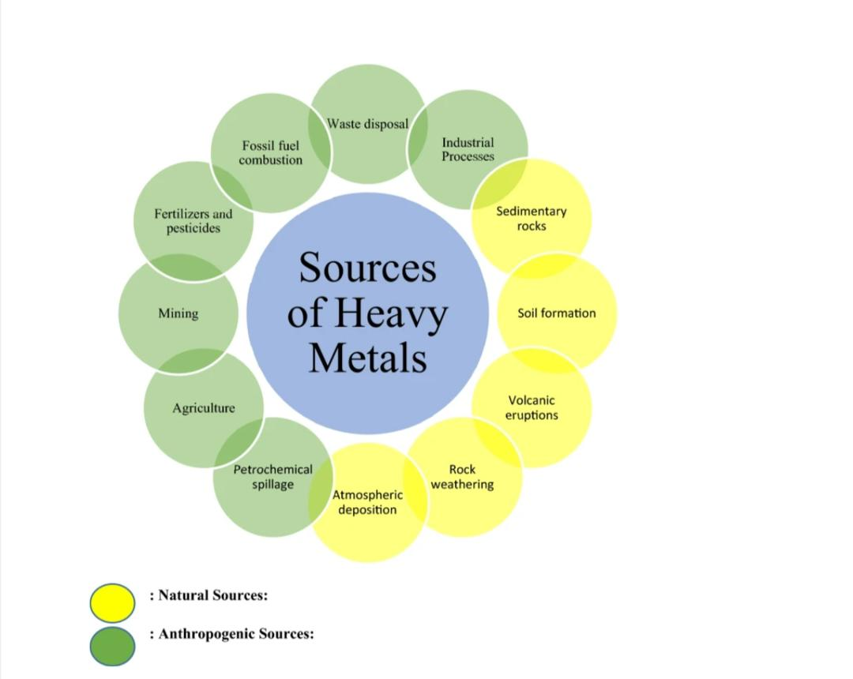

Figure 2.1: Sources of Heavy Metal Pollution
Source: Nnaji et al., 2023.

2.4 Heavy metals and their effects on humans
Environmental pollution due to heavy metals is a global issue, as these metals are persistent and often toxic to living organism at elevated concentration, human activities have significantly elevated the levels of various toxic metals, disrupt vital biological mechanisms and pose serious risks to the health of plant, animals, and humans. Plants and animals take in these metals from land, sediment, and water sources through interaction with outer surface, via intake, and breathing in metal particles and metal vapors, contaminated food chain with harmful metals represent a primary pathway for human exposure and can lead to multiple health hazards (Yadav et al., 2017). The WHO has identified arsenic (As), cadmium (Cd), lead (Pb), and mercury (Hg) as major public health concerns. Both the U.S. Environment Protection Agency (US EPA) and the International Agency for Research on Cancer (IARC) categorize these substances as “known” carcinogens for humans (Goutam et al., 2021), due to their toxicity, non-degradable in the environment, and tendency to bio accumulate in organisms (Khatun et al., 2024). They harm soil microbes, leading to substantial alterations in their metabolic activities, population numbers, and biodiversity, heavy metals are known to impact plant in multiple ways, including stunted growth and slowed development and disrupting germination. Surface water and acid rain can transport heavy metals from polluted environment to the ocean. In aquaculture, heavy metals are harmful, impacting aquatic organism especially fish. These metals dissolve and interact with natural water elements like organic compounds, sulfates, and carbonates, forming insoluble complexes and salts that are harmful to aquatic organisms (Khandakar et al., 2021).
Table 2.1: Heavy metals and their impact on aquatic ecosystem, animals, and public health.
Heavy metal | Impact on aquatic ecosystem | Impact on animals | Impact on public health | Reference
Arsenic (As) | Disturbs water bodies, lowers oxygen concentration, and builds up in fish. | Lowered maturation, reproductive capacity, and overall survival. | Carcinoma (skin cancer), nervous system disorder, cardiovascular disease. | Abd et al., 2023.
Cadmium (Cd) | Stunts growth in plant, interferes with the food chain. | Bone abnormalities, kidney dysfunction, lower fertility. | Kidney dysfunction, bone disorder, growth issues. | Gupta et al., 2023.
Chromium (Cr) | Enhances toxicity of other toxins, lower oxygen level. | Lungs problems, dermal irritation, genomic damage. | Respiratory cancer, digestion disorder, skin irritation. | Zeyad et al., 2020.
Copper (Cu) | Interferes with the life cycle of plants and animals, alters water pH. | Liver and renal dysfunction, stunted growth. | Digestion disorder, liver dysfunction, Wilson’s disease. | Ghosh, 2020.
Lead (Pb) | Lower species variety, and interrupts the food web. | Development issues, nerve damage, and stunted development. | Nervous system issue, behavioral changes, cognition challenges. | Abd et al., 2023.
Mercury (Hg) | Accumulates in aquatic species, impacting the nervous system. | Deformities, decreased fertility, and death. | Neurological harm, birth defects, mercury toxicity. | Abd et al., 2023.
Nickel (Ni) | Lowers oxygen availability, hinder fish breeding. | Dermal irritation, breathing issues, slowed growth. | Dermal allergies, pulmonary cancer, renal issues. | Sen et al., 2020.
Zinc (Zn) | Hinder with fish breeding, lowered oxygen concentration. | Stunted growth, reduced immune function. | Dermal discomfort, nausea, throwing up, coughing | Zeyad et al., 2020.
Source: Karnwal, 2024.
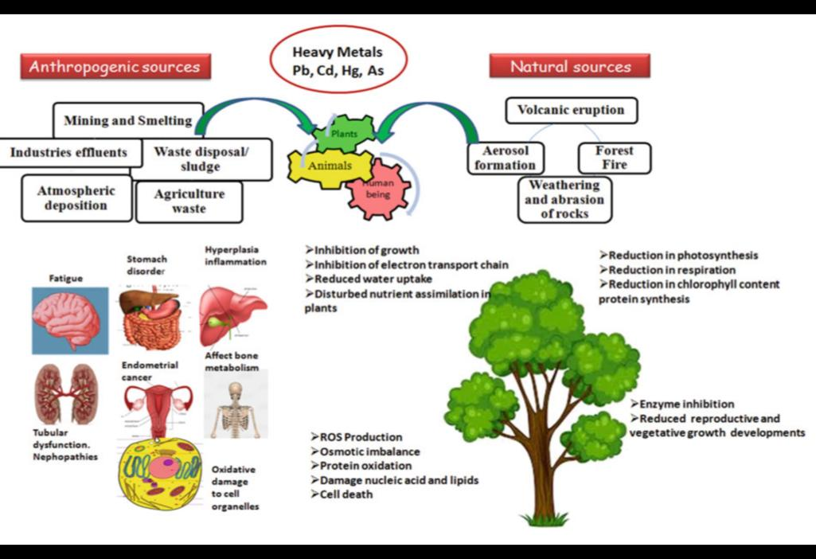
Figure 2.2: Harmful impact on humans and plants life and their sources
Source: Goutam et al., 2021.
2.5 Microbes involved in Bioremediation of Heavy Metals
Use of microbes involved in bioremediation of heavy metals is an efficient, cost-effective, environmental friendly technology that minimize the reliance on industrial chemical methods and promotes a pollution-free environment (Kushwaha and Kashyap, 2021). Microbes play a vital role in remediating heavy-metal-polluted environment due to their diverse mechanisms for withstanding metal toxicity (Ojuederie and Babalola, 2017). Microorganism detoxify heavy metals through mechanism such as oxidation state change, external chemical deposition, and evaporation. Microorganism engage with various heavy metals through diverse processes, with metal resistance serving as the primary mechanism for heavy metal remediation (Kushwaha and Kashyap, 2021).
Remediation of heavy metal by bacteria
Bacterial species are the most numerous and adaptable microorganisms, accounting for a significant portion of the Earth’s total terrestrial biomass, estimated at approximately 10¹⁸ grams (Yadav et al., 2017). Bacteria employ diverse pathways to resist or tolerate heavy metals (Panpatte and Jhala, 2021). Bacteria are utilized as bio-sorbents due to their tiny nature, widespread presence, ability to grow in controlled environments, and resilience to diverse environmental conditions. They can eliminate heavy metals from polluted sites through processes such as bio-accumulation, solid formation, biological adsorption(Yadav et al., 2017).
Remediation of heavy metal by fungi
Fungi are highly effective in remediating metals, semi-metals, radioactive isotopes, structural characteristic, environmental characteristic, and chemical attributes. Most fungi can carry out metal remediation at various stages of their life cycle through diverse mechanisms (Panpatte and Jhala, 2021). Microorganisms, including fungi, have been shown to remove heavy metals through bio-accumulation and bio-sorption in a cost-effective and environmentally friendly manner. Like bacteria, certain fungi offer a promising alternative for eliminating toxic heavy metals from the environment, particularly since fungi, as a group, are generally more tolerant to heavy metals than bacteria (Yadav et al., 2017). Fungi bioremediation plays a significant role in various applications for environmental protection (Khandakar et al., 2021).

Remediation of heavy metal by algae
Algae also possess significant capacity to absorb metals, offering considerable potential for their use in heavy metal removal. The mechanisms for heavy metal tolerance, storage, or uptake vary, depending on factors such as the anatomical characteristics conditions of the algal species,`````` environmental conditions, and growth media. In recent times, numerous researcher have utilized different algae species to remove heavy metal from polluted sites (Yadav et al., 2017).
2.6 Fungi as Bio-remediating Agent for Heavy Metals
Bioremediation is an innovative and promising technology for removing and reducing heavy metals from contaminated water and soil. It is widely regarded as a fundamental and dependable approach for removing contaminants (Dinakarkumar et al., 2024). Since the onset of 21st century, there has been a rise in the recognition of the importance of protecting the natural enviroment (Nnaji et al., 2023). Bioremediation involves environmental detoxification through natural agents, including plants, bacteria, algae, fungi, and similar organisms (Goutam et al., 2021). The fundamental concept of bioremediation include decreasing the solubility of environmental pollutants by altering pH levels and the adsorption of toxins from contaminated ecosystem (Ojuederie and Babalola, 2017).
Fungi are an optimal choice for bio-remediating heavy metals due to their rapid growth and strong binding capacity. Their short reproduction cycle allows for economical mass cultivation, and they can be readily modified by both physical and genetic alteration (Goutam et al., 2021). Members of the genus Aspergillus are renowned for their ability to break down a wide variety of hazardous substances like heavy metals, synthetic dyes, aromatic chemical, and pesticides (Deshmukh et al., 2016). Fungi like Aspergillus niger and Trichoderma harzianum are efficient in heavy metal bioremediation, as they release organic acids that bind with metals, aiding in their extraction and removal (Dinakarkumar et al., 2024).
The term “mycoremediation” first used by Paul Stamets, refers to the removal of toxic substances by fungi (Goutam et al., 2021). Mycoremediation is a process that uses fungal organism to remove toxins from various natural resources, whether living or non-living. This low-cost method does not produce waste, making it an eco-friendly option, the success of mycoremediation depends on selecting an appropriate fungi for the specific heavy metal or contaminant, offering a viable cost effective solution to the rising issue of soil and water pollution. Aspergillus niger generates citric acid, which solubilizes metals such as cadmium (Cd) and lead (Pb), transforming them into less harmful forms that could be stabilized or removed from the environment. In laboratory studies, Aspergillus niger has demonstrated the ability to reduce cadmium (Cd) concentration up to 87% between 14days (Dinakarkumar et al., 2024). The use of mycoremediation extend widely in safeguarding the environment (Abdullahi et al., 2021).This process not only lowers the metals bioavailability and toxicity but also inhibits their further spread within the environment (Dinakarkumar et al., 2024).
Table 2.2: List of fungi capable of bio-remediating various heavy metals.
S. NO | METAL | FUNGI
1 | Arsenic (As) | Aspergillus nidulans  Aspergillus niger
2 | Cadmium (Cd) | Aspergillus niger  Rhizopus stolonifer  Penicillium chrysogenum etc.
3 | Chromium (Cr) | Aspergillus flavus  Aspergillus niger  Trichosporon cutaneum etc.
4 | Copper (Cu) | Phanerochaete chrysosporium  Aspergillus awamori  Aspergillus ustus etc.
5 | Lead (Pb) | Aspergillus foetidus  Phanerochaete chrysosporium  Penicillium chrysogenum etc.
6 | Mercury (Hg) | Aspergillus flavus  Penicillium canescens  Aspergillus niger etc.
7 | Nickel (Ni) | Aspergillus flavus  Saccharomyces cerevisiae  Phanerochaete chrysosporium etc.
8 | Zinc (Zn) | Aspergillus niger  Rhizopus stolonifer

Source: Goutam et al., 2021.
2.7 Mechanism of Fungal-assisted Remediation for Heavy Metal
Bioremediation is a bio-decomposition mechanism using microbial potential to reduce the levels and harmfulness of various pollutants, the areas contaminated with toxic pollutant are remediated with the guide of fungal mechanism (Tomer et al., 2021). Microorganisms are important in the restoration of heavy metal polluted environments, having various ways by which they tolerate heavy metal toxicity. The use of microorganisms to isolate, crystallize, or change the ionic state of some toxic metals has been studied (Ojuederie and Babalola, 2017). They can degrade harmful substances and complex carbon compound into less harmful, eco-friendly forms to lead to ecological remediation. Numerous fungal species have high potential to interact with ionic metals, which includes metal discharge from the cell as the buildup and synthesis of metal compounds within the cell. They can also convert toxic ionic metals to a non-toxic state later. Several mechanism have arisen to stabilize, release, transform, neutralize, or endure the accumulation of metal contaminants (Dinakarkumar et al., 2024).
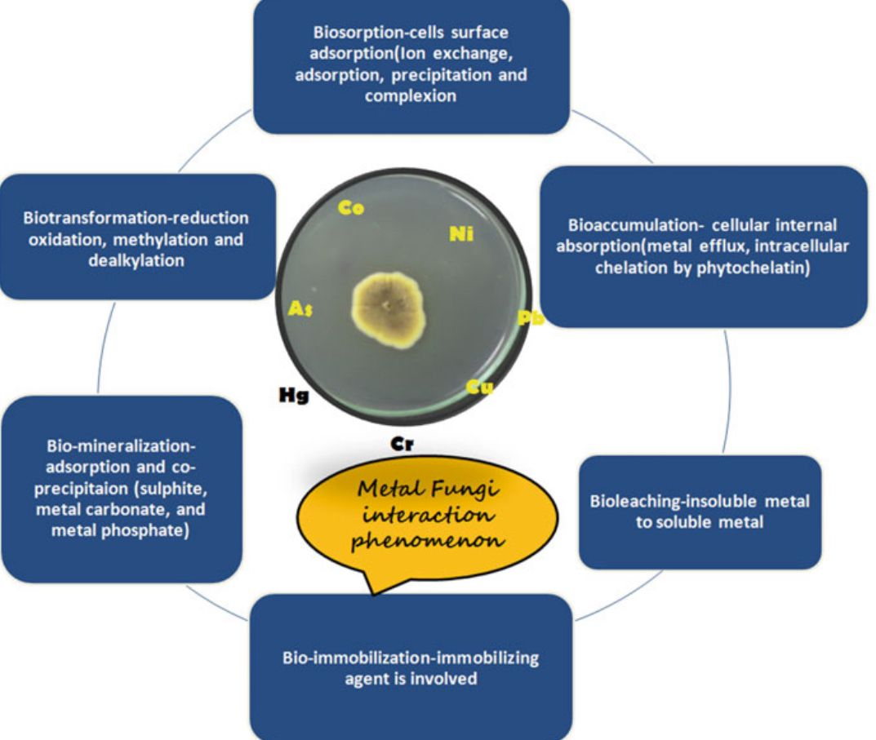
Figure 2.3: The primary mechanism involves in metal-fungal interaction which enables remediation of heavy metals
Source: Goutam et al., 2021.
2.7.1 Biosorption
Fungi carry out heavy metal detoxification which involve the attachment of the heavy metal to the cell wall known as biosorption. Biological sorption of metal ions usually occurs by ionic exchange process, surface attachment, and formation of complexes with functional groups such as present in cell membrane surface which are carboxylic group, amino group, hydroxyl group, phosphate group, and thiol group (Goutam et al., 2021). Example like, Aspergillus niger and Pencillium chrysogenum are seen for their high biosorption potential for heavy metals such as cadmium, mercury, and lead. These heavy metals are attached to the fungal cell wall, lowering their movement and biological availability in the environment (Dinakarkumar et al., 2024). The key advantages of biological adsorption over conventional remediation include budget-friendly, high effectiveness, reduction of chemical waste and biological sludge, reuse of biosorbents, and potential of metal recovery (Sivakumar et al., 2014).
2.7.2 Bioaccumulation
Generally a fungus also adopt a strategy for metal detoxification which involve intercellular assimilation of metals through cellular metabolism (Goutam et al., 2021). Biological accumulation of metals in fungal organisms relies on various factors such as metal levels, temperature, pH level, and other component (Priyadarshini et al., 2021). Bioaccumulation is the cell-based mechanism of fungi which involves attachment to sulfur-containing compound, acid-based organic molecules, polypeptides, phosphate polymers, and movement into intracellular spaces. Here internal absorption occurs through the increased permeability preceded by surface damage which leads to several activation of metal binding sites. Fungi have an intracellular detoxification system assisted by the production of antioxidant molecules (Goutam et al., 2021). Trichoderma harzianum can accumulate biologically considerable quantities of copper and zinc, successfully eliminating these heavy metals from their contaminants (Dinakarkumar et al., 2024). Some research indicate that biosorption is followed after bioaccumulation, where its buildup the non-metallic absorption of ionic metals in several cellular organelles. For example, Penicillium sp. utilizes both biological sorption and bioaccumulation to tolerate lead toxicity, where biological sorption follows both active uptake and passive uptake of lead (Priyadarshini et al., 2021).
2.7.3 Biotransformation
Biotransformation involves the chemical change of a specific structure to another, transforming their chemical characteristic and making them less toxic. It involves two processes: first is direct change in which catalytic proteins (enzymes) present in microorganism lowers the heavy metal cations, and second is indirect change where metal-reducing fungi decrease the heavy metal cations (Panpatte and Jhala, 2021).
2.7.4 Bio-immobilization
Bio-immobilization lowers the movement of metals, by changing water-soluble metal ions to non-dissolvable solids through microbes like fungi. It is generally carried out by biological sorption, bioaccumulation, biological precipitation, and microbial reduction/bio-oxidation, it is an improved biosorption method. The difference is that biological sorption is trapped by the different binding agents. Lewis indicated the elimination of Cd2+, Cu2+, Fe3+, Mn2+, Pb2+, and Zn2+ from remediation with immobilized biomass of the thread-like fungus R. arrhizus (Goutam et al., 2021). Pycnoporus sanguineus were trapped into calcium alginate gel. The trapped cells of Pycnoporus sanguineus were able to eliminate copper (II) ions from warer-based solutions (Panpatte and Jhala, 2021).

2.7.5 Bioleaching
In mining sectors, mining and refining processes release heavy metals in land and water, which leads to heavy metal pollution; such type of pollution are remediated by the biological leaching process. The biological leaching process is the removal of metals from low-quality ores and through the assistance of microbes like fungi. Fungal species are found useful in separating the metal from carbon-rich low-grade ore. Microorganisms convert metallic compound into aqueous forms and act as biological catalysts of bioleaching (Panpatte and Jhala, 2021). Several studies have recorded the bioleaching by fungi. It has been seen that fungal species from Aspergillus and Penicillium genera are included in the most efficient and crucial ones for bioleaching (Dusengemungu et al., 2021).
2.7.6 Bio-mineralization
Bio-mineralization is a biological process of removing toxicity metal along with biological recovery process. Microbes trap heavy metals and change into non-soluble minerals through biological processes to mineralize heavy metal cations, thereby lowering their movement and bioavailability (Panpatte and Jhala, 2021).
2.8 Factors Affecting Fungal-assisted Remediation efficiency for Heavy Metal
Bioremediation is a sophisticated biological pathway of the microbes. Microorganisms are able to lower the biological accessibility of heavy metals by the formation of organic acids and inorganic acids (example citric acid and sulfuric acid), electron gain, electron loss, and generation of binding agents ( cyanide compound) (Jacob et al., 2018). The capability of microbial pollution to eliminate contaminants from a contaminated area depends on the microbial count in that area and their degradative efficiency. The soil pathogen levels can be controlled by both natural and nutritional conditions (Tomer et al., 2021). Generally, microbes have their inherent tolerance to get adjusted to the unfavorable conditions; they have specific limitations. However, it is essential to understand the different limiting factors by the microbial degradation in order to implement an effective approach to enhance the process of toxic metal bioremediation (Jacob et al., 2018). Contaminant may engage with the environment to alter their accessibility to differs across organisms which the pollutants is able to enter organisms can be known as specified organisms (Tomer et al., 2021).
Factors influencing the remediation effectiveness of the microbes could be classified as; (i) biotic (living components) and (ii) abiotic factors (non-living)
Biotic factors
Biotic factors strongly influence the remediation effectiveness of the microbes by altering cell size and makeup, release of extracellular substances, etc. The microbial biomass level is one of the key biological aspects for microbial remediation, with studies suggesting that at lower biomass concentration, microbes has greater metal removal capacity when cellular spacing was more.
Abiotic factors
Abiotic factors also influence heavy metals remediation capacity of microbes such as fungi. The several abiotic factors describes in this view are physical and chemical parameters (thermal condition, pH, metal concentration, oxygen, redox potential, essential nutrient, carbon source, and atmospheric conditions (Jacob et al., 2018).

2.9 Benefits and Drawbacks of Fungal-assisted Remediation for Heavy Metal
Bioremediation is the highly effective method for detoxification of heavy metals contamination which have advantages over physical and chemical techniques because they maintain soil integrity and rely on sunlight. It require more time to remediate heavy metals contaminated soil. Therefore, the selection of suitable microorganisms can accelerate the remediation and heavy metal removal effectiveness (Zheng et al., 2024). Microbes like fungi are crucial in our everyday life, they decontaminate or metabolize the contaminant or residue, by using it as their primary carbon and energy source (Pratush et al., 2018).
Benefits of mycoremediation for heavy metals
- Is a naturally occurring process and is therefore recognized by the public (Pratush et al., 2018).
- Does not use any corrosives for remediation (Zheng et al., 2024).
- Can be lower in cost than other methods that are used for remediation of heavy metal (Pratush et al., 2018).
- Reduce the heavy metals to safe level (Zheng et al., 2024).
- Tolerance to severe conditions (eco-friendly).
- Enzyme-mediated variation and effectiveness.
- Flexibility in bioremediation methods.
- Beneficial interactions (Dinakarkumar et al., 2024).
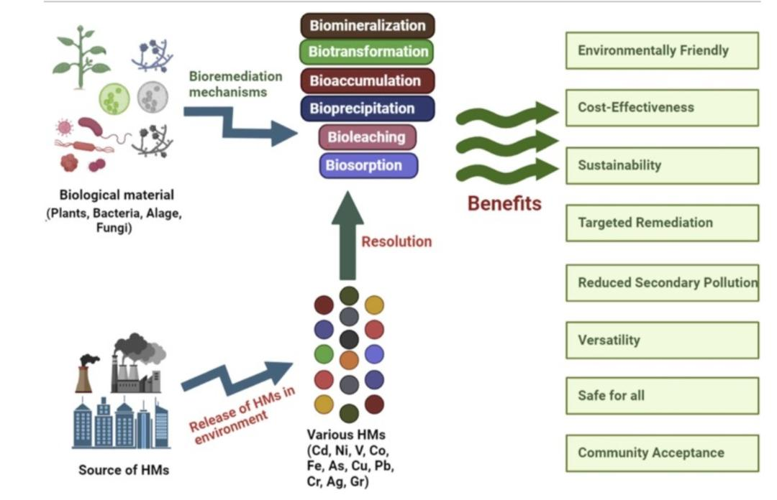
Figure 2.4: A range of techniques used for bioremediation of heavy metals applying bio-approaches and their benefits
Source: Karnwal, 2024.
Drawbacks of mycoremediation for heavy metals
- Limited performance.
- Currently under evaluation (Zheng et al., 2024).
- Delayed degradation speeds, particularly complicated contaminant or large-scale waste, can delay remediation process
- Poor containment protocols can cause escape of toxic byproducts, causing risks of secondary pollution (Thirumalaivasan et al., 2024).

2.10 Challenges in Fungal-assisted Remediation
The approaches for removing contaminants like heavy metals etc. by using unique fungi, one cost-effective and eco-friendly way to manage wastewater is through biological treatment. Fungi are seldom used in bio-wastewater remediation systems, whereas bacteria are dominant. Mycoremediation is an effective, eco-friendly, and low-cost process of remediating emerging contaminants (like medicinal residues) in ecosystems. It work by employing fungi or their metabolic byproduct. Fungi are favored over bacteria in biological remediation of polluted environment due to their specialized hyphal system, fungal mass, and long duration of life. This may also be achieved through bioremediation; therefore, the bio-approaches applied in this technology varied greatly with respect to their effectiveness and remediation time. The capabilities of mycoremediation are unique to a fungal species and a category of contaminant. The specific type of contaminant and growth-influencing factors, like temperature and nutritional levels, etc. To accomplish mycoremediation economically, there are some essential steps that should be carried out. First, the restricted variety of fungi that have been recognized as suitable for mycelial bio-pellets is the primary barrier to the technology's growth. Because of their remarkable growth, secure operation, low nutrient needs, and rapid production, fungi are important for developing, studying, and implementing mycoremediation (Dinakarkumar et al., 2024).

However, the implementation of these biological approaches faces multiple challenges that can reduce their efficacy. This section examines the challenges faced in microbial remediation, the drawbacks of current techniques, and the new approaches being developed to address these challenges.
Managing contaminant accessibility and ecological limitations (enhancement of bioremediation conditions)
One of the main challenges in microbial bioremediation is the contaminant accessibility. Many pollutants are strongly bound to soil or are present in water-insoluble liquids, making them challenging for microbes to utilize. Additionally, ecological conditions like pH, thermal conditions, and humidity levels can greatly influences the effectiveness of bioremediation processes.
Navigating the difficulties of fungal bioremediation
Fungal bioremediation, while offering special advantages in the breakdown of complex contaminant, encounter difficulties related to the particular growth needs and nutrient prerequisites of fungi. The innovation of customized bioreactors and co- growth approaches with bacteria have proven effective in creating more flexible and resilient fungal bioremediation systems. These development allow for the growing of fungi in regulated conditions, enhancing their viability and contaminant breakdown capabilities.
The way ahead: study and development
Despite the difficulties, continuous study and technological developments continue to improve the abilities and uses of microbial bioremediation. The combining of multidisciplinary strategies, extending from molecular biology to engineering, is essential for overcoming the limitations of existing bioremediation technologies (Thirumalaivasan et al., 2024).
CHAPTER THREE
MATERIALS AND METHODS
3.1 Study Sites and Location
The mine site soil analyzed in this research were collected from coal mining locations in Enugu Southeastern Nigeria, specifically coal camp (6⸰25`12”N, 7⸰27`40”E) and (6⸰25`06”N, 7⸰27`40”E) (Oladipo et al., 2018).
3.1.1 Sample collection
In this exploratory study, 2 soil samples were obtained from the location in Enugu metropolis. The soil samples were taken from the superficial soil layer, at a depth of no more than 5-10cm, using a soil Augar. Approximately 300-400g of soil were gathered into a sterile polyethylene bags and transported to the laboratory for further analysis (Pakshir et al., 2013).
3.2 Heavy Metal Analysis
For this evaluation, 0.5g of soil samples were weighed and transferred into beakers. To digest the samples overnight, 10ml of Aqua regia (HCL: HNO₃ 3:1 v/v) was added. The beakers were then gradually heated on hot plate until only 1ml of liquid remained. The resulting extracts were filtered using Whatman filter paper and diluted to the desired volume with deionized water in volumetric flasks. Following digestion, a multielemental analysis of the extracts was conducted using an atomic absorption spectrophotometer equipped with graphite furnace (Liaquat et al., 2020).

3.3 Isolation and Identification of Fungi through Morphological Characteristics
3.3.1 Preparation of media
Isolation and identification of fungi via morphological characteristics using the methods of (Liaquat et al., 2020). SDA (Sabouraud Dextrose Agar) used for total fungi counts was prepared with highly purified water, following the manufacturer’s guidelines (May and Baker). To inhibit fungal growth, 10% tartaric acid was incorporated into the medium, then, autoclaved to ensure sterility and was poured into petri dish and allowed to completely gel.
3.3.2 Sample preparation and serial dilution
The two soil sample was mixed together, 10g of soil sample was suspended in 100ml of peptone water and allowed to stand at room temperature for 18hours, and the suspension was filtered into sterile sample bottle. From the filtrate, 1ml was aseptically transferred into 9ml of sterile distilled water to achieve a 1:10 (10⁻¹) dilution. Serial dilution were performed up to 10⁻¹⁰ , with each tube thoroughly mixed using aseptic techniques.
3.3.3 Isolation of fungi
Exactly 1ml of each dilution was plated into labeled petri dishes in triplicates, molten SDA (cooled to ~25º C) was added to each dish, mixed gently, and left to solidify, plates were inverted and incubated at 30ºC for 72 hours. Colonies were counted using the standard plate count method (FOA, 1986). Colony counts were used to estimate the fungal load per gram of soil.

3.3.4 Subculture of fungal isolates
Based on distinct colony appearances from the pour plates, each representative fungal colonies were subcultured onto six (6) fresh SDA plates and slants using a sterile inoculation loop. The subculture plates were incubated at 30ºC for 48-72 hours to obtain pure isolate.
3.3.5 Morphological identification of fungi
The macroscopic characteristics of the fungal colonies were first assessed, focusing on the parameters such as colony color (both surface and reverse), texture (e.g. cottony, velvety, or granular), margin appearance, and growth rate. These features provided preliminary insights into the fungal genera.
For microscopic identification, Lacto phenol cotton blue (LPCB) staining was used. A drop of LPCB was placed on a clean glass slide, and a small portion of the fungal mycelium was carefully transferred from the agar slant using a sterile inoculation loop. The fungal specimen was smeared gently into the dye, and a coverslip was placed over the preparation by first touching one edge of the drop and then lowering it slowly to prevent the formation of air bubbles. The prepared slide was allowed to stand briefly to air-dry and then examined under a compound microscope.
3.4 Fungal Tolerance Assay
All the isolated and identified fungi was subjected to the tolerance of heavy metals such as lead, cadmium and chromium (the Cr at 200ppm couldn’t solidify with the agar so it was neglected). The tolerance tests were done in three sections;
Section A: Fungal isolates were subjected to lead and cadmium at the concentration of 200ppm. SDA was prepared and poured into separate petri dish. During media preparation, each heavy metal was individually incorporated into the agar at the specified concentration. The petri dishes were section based on the labeled isolates, and the fungal isolates were inoculated into designated segments. Each dish contained either lead or cadmium, not both. The plates were inverted and incubated at 25-30ºC for 72 hours. Fungal species that exhibited growth under metal exposure were recorded as tolerant, while those that showed no growth were identified as non-tolerant.
Section B: The fungal strains (tolerant to lead and cadmium at 200ppm) from section A that demonstrated tolerance to heavy metals at concentration of 200ppm were further challenged with elevated metal levels. SDA was prepared and dispensed into separate culture plates, each supplemented with increasing concentrations of metals at 220ppm, 240ppm, 260ppm, 280ppm, and 400ppm. The tolerant fungal isolates were inoculated into the different metal-enriched plates. These culture plates were then incubated at a temperature range of 25-30ºC for a duration of 72 hours.
Section C: Fungal isolates from section A that were unable to withstand or tolerate the heavy metal at 200ppm were subsequently exposed to lower concentration of the metals. SDA was prepared and poured into individual culture plates, each fortified with different concentration of the metals at 20ppm, 40ppm, 60ppm, 80ppm, up to 180ppm. The fungal strains were inoculated into respective metal-supplemented plates and incubated at 25-30ºC for 72 hours. The metal tolerance index of the fungal isolates was calculated using the equation below:
Metal tolerance index: $\frac{Fungal growth area in presence of metal}{Fungal growth area without metal exposure over the same time period}$ ( Liaquat et al., 2020).
3.5 Analysis of Minimum Inhibitory Concentration (MIC)
The minimum inhibitory concentration (MIC) of lead and cadmium was assessed for each fungal isolate using a range of metal concentration: 200, 100, 50, 25, 12.5, 6.25, 3.125mg/mL. One milliliter of nutrient broth was combined with 1mL of the fungal suspension, previously standardized to a 0.5 McFarland turbidity level. Each test tube received the metal containing broth at the specified concentration. A control tube, containing only nutrient broth and the fungal inoculum (without heavy metal), was prepared. All tubes were incubated at 25-30ºC for 48hours and monitored for visible growth based on turbidity changes.
3.6 Molecular identification of fungal strains tolerant to heavy metals (lead and cadmium)
Following the fungal tolerance assay, only three isolates (sample M8, M9, and M10) demonstrated significant tolerance to heavy metals (lead and cadmium) and were therefore selected for molecular identification. The isolates were previously characterized morphologically through colony observation and lactophenol cotton blue staining, and were now subjected to genetic analysis for precise identification.
For molecular identification, fungal DNA was extracted following a standard protocol (Zymo research protocol), the DNA quality was assessed with a Nano Drop ND-1000. DNA amplification was performed using universal primers (ITS1F, ITS4R) in a C-1000 thermal cycler. PCR was conducted with 20ng of genomic DNA and 10mM of each forward and reverse primer in master mix. The thermal cycling conditions included an initial denaturation at 94^{O}C for 4mins, followed by 34 cycles of 94^{O}C for 40secs, (annealing) 55^{O}C for 50secs, (extension) 72^{O}C for 45secs, and a final extension at 72^{O}C for 4mins and the PCR amplicons was analyzed using 0.8% agarose gel electrophoresis to confirm successful amplification.
The amplified ITS regions were sequenced using Sanger sequencing and BLAST search (http://www.ncbi.nlm.nih.gov) was conducted to determine closed related fungal species based on sequence homology (Liaquat et al., 2020). The amplified ITS gene sequences were aligned using the Bioedit and MUSCLE software. The Basic Local Alignment Search Tool (BLAST) program of the National Centre for Biotechnology Information (NCBI) was used to search and identify the closest species. Phylogenetic tree to show evolutionary relationship among organisms was generated using MEGA-11 software and Mucor circinelloides was used as an outgroup. An outgroup was used to root the tree i.e determine the ancestral lineage of the tree. This is essential in understanding the evolutionary history of the ingroup (fungal isolates in this study (Obi et al., 2020).

CHAPTER FOUR
RESULT
4.1 Heavy Metal Analysis of Soil Sample
The main purpose of the analysis was to quantify cases of lead (Pb), chromium (Cr), and cadmium (Cd) concentration to obtain assessment of soil contamination and fungal tolerance level. The result are presented in Table 3.1
Table 4.1 Heavy metal analysis of soil sample
Heavy metals | Concentration mg/kg
Lead (Pb) | 0.2415
Cadmium (Cd) | 0.6681
Chromium (Cr) | 0.0621

4.2 Morphological Identification of Fungi
A total of six isolates were obtained from the subcultured plates of the soil sample. These observations served as preliminary indicators for taxonomic identification of the fungal species (Table 4.2).
Table 4.2: Colony morphology of isolates from the subcultured plates
Sample | A | M8 | C | M9 | E | M10
Organism | cladosporium oxysporum | Aspergillus niger | Aspergillus flavus | Aspergillus fumigatus | Aspergillus terreus | Aspergillus alternate
Colony color | Olive brown mold | Black mold | Bright yellow mold | Blue-green | Cinnamon brown | Dark-brown
Colony morphology | Woolly at the center with velvet surface | Woolly or cottony appearance | Granular or velvety texture | Cotton appearance | Dense and compact | Dense texture
Conidiophores | straight | Long, smooth-walled | Rough and colorless | Short and smooth-walled | Smooth and shoot | Specialized hyphae
Hyphae | Vegetative | Septate | Septate and hyaline | Hyaline | Septate | Septate and hyaline

4.3 Fungal Tolerance Assay
Fungal tolerance assays plays a critical role in determining the capacity of fungal isolates to withstand and grow in environments contaminated with toxic heavy metals. At 200ppm (Section A) (Table 4.3), assessment at higher concentrations for the isolates that showed tolerance (Section B) (Table 4.4), and testing at lower concentration for the non-tolerant isolates (Section C) for lead (Table 4.5) and for cadmium (Table 4.6). Chromium (Cr) was excluded from the test due to its destabilizing effect on agar medium at 200ppm. This results offer valuable information on metal resistance capacity of the fungi, supporting their potential utility in myco-remediation strategies.
Table 4.3: Fungi survival in 200ppm metals concentration (Section A)
Metals | Cladosporium  Oxysporum | Aspergillus  Niger | Aspergillus  flavus | Aspergillus  fumigates | Aspergillus  terreus | Aspergillus  alternate
Lead | - | + | - | + | - | +
Cadmium | - | - | - | - | - | +

KEY; +………Fungi that grew in 200ppm metal concentration
-………..Fungi that failed to grow in 200ppm metal concentration

Table 4.4: Fungi tolerance in 220ppm to 400ppm lead &cadmium concentration (Section B)
S/N | Metal conc. (pp) | Lead (tolerance index) |  |  | Cadmium
S/N | Metal conc. (pp) | Aspergillus niger | Aspergillus  fumigates | Aspergillus  Alternate | Aspergillus  alternata
1 | 220 | 0.758 | 0.822 | 0.489 | 0.883
2 | 240 | 0.722 | 0.810 | 0.479 | 0.880
3 | 260 | 0.718 | 0.786 | 0.475 | 0.865
4 | 280 | 0.706 | 0.773 | 0.453 | 0.859
5 | 300 | 0.693 | 0.762 | 0.435 | 0.847
6 | 320 | 0.672 | 0.744 | 0.431 | 0.842
7 | 340 | 0.644 | 0.728 | 0.422 | 0.836
8 | 360 | 0.639 | 0.721 | 0.420 | 0.829
9 | 380 | 0.618 | 0.709 | 0.414 | 0.826
10 | 400 | 0.611 | 0.704 | 0.405 | 0.822

Table 4.5: Fungi tolerance in 20ppm to 180ppm lead (Section C)
S/N | Metal conc. (pp) | Lead (tolerance index)
S/N | Metal conc. (pp) | Cladosporium oxysporum | Aspergillus flavus | Aspergillus  terreus
1 | 20 | 0.588 | 0.296 | 0.512
2 | 40 | 0.561 | 0.288 | 0.501
3 | 60 | 0.549 | 0.283 | 0.495
4 | 80 | 0.543 | 0.269 | 0.472
5 | 100 | 0.531 | 0.267 | 0.461
6 | 120 | 0.516 | 0.261 | 0.457
7 | 140 | 0.511 | 0.255 | 0.454
8 | 160 | 0.503 | 0.253 | 0.441
9 | 180 | 0.492 | 0.250 | 0.437

Table 4.6: Fungi survival in 20ppm to 180ppm cadmium (Section C)
S/N | Metal conc. (pp) | Cadmium (tolerance index)
S/N | Metal conc. (pp) | Cladosporium oxysporum | Aspergillus niger | Aspergillus flavus | Aspergillus fumigates | Aspergillus terreus
1 | 20 | 0.283 | 0.139 | 0.412 | 0.325 | 0.377
2 | 40 | 0.279 | 0.132 | 0.403 | 0.318 | 0.365
3 | 60 | 0.274 | 0.108 | 0.392 | 0.311 | 0.360
4 | 80 | 0.271 | 0.072 | 0.376 | 0.306 | 0.349
5 | 100 | 0.265 | 0.061 | 0.361 | 0.302 | 0.337
6 | 120 | 0.253 | 0.055 | 0.349 | 0.297 | 0.332
7 | 140 | 0.250 | 0.051 | 0.342 | 0.285 | 0.325
8 | 160 | 0.247 | 0.048 | 0.336 | 0.283 | 0.320
9 | 180 | 0.241 | 0.035 | 0.331 | 0.266 | 0.317

4.4 Minimal Inhibitory Concentration
The minimum inhibitory concentration (MIC) assay was employed to identify the lowest concentration of lead (Table 4.7) and cadmium (Table 4.8) that could completely suppress visible growth of the fungal isolate. This method offers valuable information on the susceptibility or resistance profile of each strain under heavy exposure.
Table 4.7: Minimum inhibitory concentration for lead
S/N | Metal conc. (pp) | Lead
S/N | Metal conc. (pp) | Cladosporium  Oxysporum | Aspergillus  niger | Aspergillus  flavus | Aspergillus  fumigates | Aspergillus  terreus | Aspergillus  alternata
1 | 200 | - | - | - | - | - | -
2 | 100 | - | - | - | - | - | -
3 | 50 | - | - | - | - | - | -
4 | 25 | + | - | - | - | - | -
5 | 12.50 | + | + | + | + | + | +
6 | 6.25 | + | + | + | + | + | +
7 | 3.125 | + | + | + | + | + | +

Table 4.8: Minimum inhibitory concentration for cadmium
S/N | Metal conc. (ppm) | Cadmium
S/N | Metal conc. (ppm) | Cladosporium  Oxysporum | Aspergillus  niger | Aspergillus  flavus | Aspergillus  fumigates | Aspergillus  terreus | Aspergillus  alternata
1 | 200 | - | - | - | - | - | -
2 | 100 | - | - | - | - | - | -
3 | 50 | - | - | - | - | - | -
4 | 25 | - | - | - | - | - | -
5 | 12.50 | + | - | - | - | - | -
6 | 6.25 | + | - | - | + | + | +
7 | 3.125 | + | - | + | + | + | +

KEY; +………fungi that grew at the corresponding concentration
-………..fungi that failed to grow at the corresponding concentration
4.5 Molecular identification of fungal strains tolerant to heavy metals (lead and cadmium)
To achieve precise identification of the fungal isolates (sample M8, M9, M10) exhibiting notable tolerance to both lead and cadmium. Selection of isolates were chosen based on their strong resistance observed during prior metal tolerance assessments. Successful amplification of the ITS regions was confirmed through gel electrophoresis (Figure 4.1). To explore the evolutionary affiliations to the isolates, a phylogenetic tree was constructed (Figure 4.2). This molecular approach enabled accurate species-level classification and provided genetic validation of the isolates’ tolerance to heavy metals.
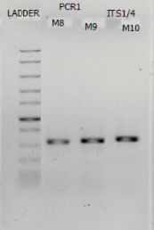
Figure 4.1: Agarose gel electrophoresis result from the amplified isolates
Figure 4.2: Phylogenetic tree of the ITS gene sequences of heavy-metal tolerant fungal isolates obtained from mining and their relatives found by BLASTn search.

CHAPTER FIVE
DISCUSSION, CONCLUSION AND RECOMMENDATION
5.1 Discussion
The result obtained from this research, showed the importance of fungal tolerance and bioremediation potential of the soil sample found at coal camp mining site located in Enugu, Nigeria. Heavy metal analysis of the soil samples showed varying levels of lead, chromium, and cadmium. Among the three, chromium was present at highest concentration (0.6684 mg/kg), followed by lead (0.2415 mg/kg), while cadmium had the lowest concentration (0.0621 mg/kg). These results indicate that chromium is the dominant pollutant in the investigated soil, likely due to human-related activities such as industrial discharge, or chemical effluents. Despite their relatively lower levels, the presence of lead and cadmium remains concerning due to their environmental persistence and toxicity, even at these concentrations, the metals may impose selective pressure on soil microbiota, particularly fungi, potentially affecting their composition, abundance, and metal tolerance capabilities (Liaquat et al., 2020). The isolation and morphological assessment of fungi from soil sample revealed a broad diversity of filamentous fungal species, with the Aspergillus genus appearing most frequently, which is also in agreement with Liaquat et al. 2020. Six fungal isolates were identified: Cladosporium oxysporum, Aspergillus niger, Aspergillus flavus, Aspergillus fumigatus, Aspergillus terreus, and Aspergillus alternate. Identification was based on colony morphology and microscopic characteristics visualized with Lactophenol cotton blue staining. Colony pigmentation varied significantly from olive brown (C. oxysporum) and black (A. niger) to bright yellow (A. flavus), blue-green (A. fumigatus), cinnamon brown (A. terreus), and dark brown (A. alternate), highlighting pigmentation as a useful taxonomic trait. Morphological features further distinguished the species: A. niger exhibited a woolly texture, A. flavus appeared granular, and A. terreus showed dense, compact growth, microscopic observation revealed septate hyphae in all isolates, predominantly hyaline, consistent with saprophytic soil fungi. Conidiophore morphology also varied from straight in cladosporium to smooth- or rough-walled types in Aspergillus species. The dominance of Aspergillus species likely reflects their ecological prevalence and adaptability to environment stressors such heavy metal exposure.
Variability in tolerance among fungi isolate: the fungi species demonstrated varying degrees of resistance, reflecting their differential ability to ensure elevated levels of heavy metal concentration in accordance with (Kutama et al., 2024). The specified heavy metal in this study are lead and cadmium, chromium was excluded from the experimental assays due to the inability of chromium-amended agar to solidify at a concentration of 200ppm, rendering it unsuitable for fungi inoculation and incubation procedure. In section A: tolerance at 200ppm, an initial evaluation was conducted at a metal concentration of 200ppm to determine the capacity of fungi isolates to withstand heavy metal exposure. Out of six isolates, only three exhibited visible colony development on SDA medium enriched with heavy metals, and were thus categorized as metal-tolerant. Specifically, Aspergillus niger (sample M8) and Aspergillus fumigates (sample M9) were resistant (tolerant) to lead, while Aspergillus alternata (sample M10) tolerated both lead and cadmium. The other strains which are Cladosporium oxysporum, Aspergillus flavus, and Aspergillus terreus failed to grow under these conditions, indicating sensitivity (non-tolerance) to the tested metal concentration. These observations suggest that lead resistance was more common than cadmium resistance among the isolates, with Aspergillus alternata showing the highest metal endurance in this phase. The identified fungal isolates (Aspergillus niger, Aspergillus fumigates, and Aspergillus alternata) tolerated metals at elevated/increasing concentrations of 220-400ppm , Their respective tolerance indices indicated their adaptability and survival capacity under intensified metal-induced stress. Result showed a gradual reduction in tolerance values as metal levels rose, aligning with the typical physiological stress response observed in fungi. Among the tested isolates, A. fumigatus demonstrated the highest level of resilience, sustaining a tolerance index above 0.70 even at the highest concentration. Aspergillus alternata showed particularly strong resistance to cadmium, reaching a tolerance index of 0.822 at 400pm, while Aspergillus niger also remained viable under lead (Pb) exposure, albeit with slightly lower performance. These outcomes underscore the potential of these fungal species for use in bioremediation, particularly in environments contaminated with lead and cadmium. The evaluation of fungal isolates (that could not tolerate metals at high concentrations of ≥200 ppm) at lower metal concentrations (20 – 180 ppm) revealed varying sensitivity levels among these species. Clasdosporium oxysporum displayed moderate yet stable resistance to both metals, with tolerance index decreasing only slightly as concentrations increased. Conversely, Aspergillus flavus and Aspergillus terreus were notably more sensitive, especially to cadmium, with their tolerance indices falling below 0.3 at the highest concentration tested. Surprisingly, even isolates previously deemed tolerant –such as A. niger and A. fumigatus- showed diminished tolerance indices at lower cadmium levels. This unexpected trend may reflect shifts in metabolic activity or cellular stress mechanisms under limited metal availability. Overall, the results of the fungal tolerance assay demonstrated that resistance to heavy metals varied across species and was influenced by metal concentration levels. Aspergillus alternata, Aspergillus fumigatus and Aspergillus niger exhibited the greatest capacity to withstand increased heavy metal exposure, highlighting their potentials as strong candidates for bioremediation approaches aimed at remediating metal-contaminated environments.
The MIC values indicated that the degree of tolerance to each specific heavy metal was dependent on the fungal strain involved. The minimum inhibitory concentration (MIC) test was performed to identify the lowest level of lead and cadmium capable of preventing visible growth in each of the fungal isolates. The result highlighted distinct variations in the sensitivity of the isolates to the metals. In case of lead exposure, none of the fungal isolates exhibited turbidity (an indicator of growth) at concentrations of 50ppm or above, demonstrating the potent inhibitory effect of the metal at these levels. At 25ppm, only Cladosporium oxysporum was able to grow, suggesting it possessed slightly greater tolerance than the other isolates. All strains showed visible growth at concentration of 12.5ppm and below (6.25, and 3.125 ppm), indicating that lead’s toxic impact diminished significantly at lower doses, these findings suggest that although most isolates were susceptible to elevated lead level, C. oxysporum had a relatively lower MIC value, indicating a higher degree of resistance. While in the case of cadmium exposure, it exhibited even stronger inhibitory activity compared to lead, none of the fungal isolates were able to survive at concentrations of 25ppm or above. Cladosporium oxysporum was the only strain that showed growth at 12.5ppm, while the remaining isolates required lower concentrations (specifically 6.25 ppm or 3.125) to display any visible growth. Among these, Aspergillus alternata, Aspergillus fumigatus, Aspergillus terreus demonstrated turbidity at 6.25ppm, whereas Aspergillus flavus and Aspergillus niger only exhibited growth at lowest concentration of 3.125ppm. These observations suggest that Aspergillus flavus and Aspergillus niger are more susceptible to cadmium stress compared to the other tested fungi. However, the MIC results were consistent with the earlier tolerance evaluations and underscored strain-specific variations in metal resistance. Cladosporium oxysporum exhibited relatively higher tolerance to both heavy metals at lower concentration. Among the fungal isolates, Aspergillus alternata and Aspergillus fumigatus displayed enhanced resistance to cadmium. These differences reinforce the potential use of particular fungal strains in bioremediation efforts. Moreover, the findings clearly demonstrate that cadmium presents a greater inhibitory threat to fungal growth than lead across all species assessed. On the other hand, the MIC values recorded in this research closely resemble those documented by Kutama et al. 2024.
However, following the fungal tolerance assays, three isolates (M8, M9, M10) demonstrated significant resistance to both lead and cadmium and were selected for molecular characterization through internal transcribed spacer (ITS) gene sequencing. Each of the three fungal isolates exhibited distinct and well-defined bands, indicating the presence of high-quality genomic DNA and successful amplification of the ITS region. This confirmed the readiness of the samples for sequencing and further molecular characterization. The amplified ITS sequence of isolates M8, M9, M10 were subsequently analyzed using BLAST searches against the NCBI nucleotide database. A phylogenetic tree was generated to determine their closest genetic relatives and elucidate their evolutionary relationship, the isolate M8 was identified to be Aspergillus aculeatus, aligning with known A. aculeatus strains within the tree. Although the isolates showed moderate metal tolerance in initial assays, its genetic identity suggests significant biotechnological potential for heavy metal detoxification. On the other hand, isolate M9 was conclusively identified as Asperglilus niger, clustering with high bootstrap support, this molecular confirmation supports its previously observed high tolerance to lead. While for isolate M10, it was definitively identified as Rhizopus oryzae, forming a distinct and highly supported clade with related R. oryzae strains, known for its rapid growth and metabolic versatility, this species is well-suited for application in metal-contaminated environment. Molecular identification verified that the three most metal-tolerant fungal isolates belonged to the species Aspergillus aculeatus, Aspergillus niger, Rhizopus oryzae. These genetic findings complement earlier morphological data and reinforce their applicability in bioremediation strategies targeting lead and cadmium contamination.
5.2 Conclusion
This research assessed the capacity of six fungal isolates to withstand exposure to the heavy metals (lead and cadmium). Utilizing a combination of tolerance assay minimum inhibition concentration (MIC) evaluations, and molecular identification techniques, three isolates (Aspergillus aculeatus (M8), Aspergillus niger (M9), Rhizopus oryzae (M10)) emerged as notably resistant. These fungi demonstrated robust growth even at elevated metal concentrations and maintained consistent performance across both agar-based and broth media systems. The identities of these metal-tolerant isolates were verified through PCR amplification and sequencing of the ITS region, followed by phylogenetic analysis which reinforced their taxonomic placement. The findings suggest that these fungal species possess distinct physiological adaptations and genetic mechanisms enabling them to persist in heavy metal-polluted environments. Consequently, they represent promising agents for future applications in bioremediation. This study emphasizes the ecological and practical significance of fungal diversity in advancing environment remediation efforts.
5.3 Recommendation
Based on the findings of this study, subsequent investigations could focus on assessing the bioremediation potential of Aspergillus aculeatus, Aspergillus niger, Rhizopus oryzae in natural settings, including contaminated soils and industrial wastewater. Advancing to pilot-scale studies or field experiments will enable evaluation of their effectiveness beyond controlled laboratory condition. Furthermore, exploring the metabolism pathways and genetic bases responsible for their heavy metal resistance could yield crucial knowledge to optimize their use in environment restoration. Integrating these fungal species into sustainable waste management frameworks presents a promising, environmentally friendly approach to mitigating heavy metal contamination.

REFERENCE
Abd Elnabi, M. K., Elkaliny, N. E., Elyazied, M. M., Azab, S. H., Elkhalifa, S. A., Elmasry, S., ... and Mahmoud, Y. A. G. (2023). Toxicity of heavy metals and recent advances in their removal: a review. Toxics, 11(7): 580.
Angelovičová, L., and Fazekašová, D. (2014). Contamination of the soil and water environment by heavy metals in the former mining area of Rudňany (Slovakia). Soil & water resolution, 1: 18-24
Deshmukh, R., Khardenavis, A. A., and Purohit, H. J. (2016). Diverse metabolic capacities of fungi for bioremediation. Indian journal of microbiology, 56: 247-264.
Dinakarkumar, Y., Gnanasekaran, R., Reddy, G. K., Vasu, V., Balamurugan, P., and Murali, G. (2024). Fungal bioremediation: An overview of the mechanisms, applications and future perspectives. Environmental Chemistry and Ecotoxicology, 6: 293-302.
Dusengemungu, L., Kasali, G., Gwanama, C., and Mubemba, B. (2021). Overview of fungal bioleaching of metals. Environmental Advances, 5: 100083.
Ghosh, S. (2021). Fungi-mediated detoxification of heavy metals. In Recent Advancements in Bioremediation of Metal Contaminants, 15: 205-219.
Goutam, J., Sharma, J., Singh, R., and Sharma, D. (2021). Fungal-mediated bioremediation of heavy metal–polluted environment. Microbial Rejuvenation of Polluted Environment, 2: 51-76.
Gupta, R., Khan, F., Alqahtani, F. M., Hashem, M., and Ahmad, F. (2024). Plant growth–promoting Rhizobacteria (PGPR) assisted bioremediation of Heavy Metal Toxicity. Applied Biochemistry and Biotechnology, 196(5): 2928-2956.
Gururajan, K., and Belur, P. D. (2018). Screening and selection of indigenous metal tolerant fungal isolates for heavy metal removal. Environmental Technology & Innovation, 9: 91-99.
Haghighizadeh, A., Rajabi, O., Nezarat, A., Hajyani, Z., Haghmohammadi, M., Hedayatikhah, S., and Beni, A. A. (2024). Comprehensive analysis of heavy metal soil contamination in mining Environments. Impacts, monitoring Techniques, and remediation strategies. Arabian Journal of Chemistry, 105777.
Jacob, J. M., Karthik, C., Saratale, R. G., Kumar, S. S., Prabakar, D., Kadirvelu, K., and Pugazhendhi, A. (2018). Biological approaches to tackle heavy metal pollution: a survey of literature. Journal of environmental management, 217: 56-70.
Kamunda, C., Mathuthu, M., and Madhuku, M. (2016). Health risk assessment of heavy metals in soils from Witwatersrand Gold Mining Basin, South Africa. International journal of environmental research and public health, 13(7): 663.
Karnwal, A. (2024). Unveiling the Promise of Biosorption for Heavy Metal Removal from Water Sources. Desalination and Water Treatment, 319: 100523.
Khandaker, M. M., Abdullahi, U. A., Elyni, N., and Alias, N. (2021). Biological processes of heavy metals-contaminated environmental remediation: a review. Journal of Environmental Treatment Techniques, 9(3): 601-608.
Khatun, M., Kobir, M. M., Miah, M. A. R., Sarkar, A. K., and Alam, M. A. (2024). Technologies for remediation of heavy metals in environment and ecosystem: A critical overview of comparison study. Asian Journal of Environment & Ecology, 23(4): 61-80.
Kumar, V., Sharma, A., and Cerda, A. (Eds.). (2020). Heavy metals in the environment. Impact, assessment, and remediation. Elsevier.
Kushwaha, P., and Kashyap, P. L. (2021). A review of advances in bioremediation of heavy metals by microbes and plants. Journal of Natural Resource Conservation and Management, 2(1): 65-80.
Kutama, A. S., Shukor, A., and Musa, H. (2024). Evaluation of Some Filamentous Fungi for Heavy Metal Tolerance. Biological and Environmental Sciences Journal for the Tropics, 21(2): 111-121.
Liaquat, F., Munis, M. F. H., Haroon, U., Arif, S., Saqib, S., Zaman, W., and Liu, Q. (2020). Evaluation of metal tolerance of fungal strains isolated from contaminated mining soil of Nanjing, China. Biology, 9(12): 469.
Mohammadian, E., Ahari, A. B., Arzanlou, M., Oustan, S., and Khazaei, S. H. (2017). Tolerance to heavy metals in filamentous fungi isolated from contaminated mining soils in the Zanjan Province, Iran. Chemosphere, 185: 290-296.
Nnaji, N. D., Onyeaka, H., Miri, T., and Ugwa, C. (2023). Bioaccumulation for heavy metal removal: a review. SN Applied Sciences, 5(5): 125.
Obi, L., Atagana, H., Adeleke, R., Maila, M., and Bamuza‐Pemu, E. (2020). Potential microbial drivers of biodegradation of polycyclic aromatic hydrocarbons in crude oil sludge using a composting technique. Journal of Chemical Technology & Biotechnology, 95(5): 1569-1579.
Ojuederie, O. B., and Babalola, O. O. (2017). Microbial and plant-assisted bioremediation of heavy metal polluted environments: a review. International journal of environmental research and public health, 14(12): 1504.
Oladipo, O. G., Awotoye, O. O., Olayinka, A., Bezuidenhout, C. C., and Maboeta, M. S. (2018). Heavy metal tolerance traits of filamentous fungi isolated from gold and gemstone mining sites. Brazilian journal of microbiology, 49(1): 29-37.
Pakshir, K., Rahimi Ghiasi, M., Zomorodian, K., and Gharavi, A. R. (2013). Isolation and molecular identification of keratinophilic fungi from public parks soil in Shiraz, Iran. BioMed research international, 1: 619576.
Panpatte, D. G., and Jhala, Y. K. (Eds.). (2021). Microbial rejuvenation of polluted environment. Springer, 2.
Pratush, A., Kumar, A., and Hu, Z. (2018). Adverse effect of heavy metals (As, Pb, Hg, and Cr) on health and their bioremediation strategies: a review. International Microbiology, 21: 97-106.
Priyadarshini, E., Priyadarshini, S. S., Cousins, B. G., and Pradhan, N. (2021). Metal-Fungus interaction: Review on cellular processes underlying heavy metal detoxification and synthesis of metal nanoparticles. Chemosphere, 274: 129976.
Sen, R., Jha, P., and Jobby, R. (2021). Immobilized fungal technology: a new perspective for bioremediation of heavy metals. In Bioremediation for Environmental Sustainability, 541-559.
Sherameti, I., and Varma, A. (2015). Heavy metal contamination of soils. Soil Biology; Springer: Berlin/Heidelberg, Germany, 44.
Sivakumar, D., Kandaswamy, A. N., Gomathi, V., Rajeshwaran, R., and Murugan, N. (2014). Bioremediation studies on reduction of heavy metals toxicity. Pollution Research, 33(3): 553-558.
Thirumalaivasan, N., Gnanasekaran, L., Kumar, S., Durvasulu, R., Sundaram, T., Rajendran, S., and Kanagaraj, K. (2024). Utilization of fungal and bacterial bioremediation techniques for the treatment of toxic waste and biowaste. Frontiers in Materials, 11: 1416445.
Tomer, A., Singh, R., Singh, S. K., Dwivedi, S. A., Reddy, C. U., Keloth, M. R. A., and Rachel, R. (2021). Role of fungi in bioremediation and environmental sustainability. Mycoremediation and Environmental Sustainability, 3: 187-200.
Ullah, R., and Muhammad, S. (2020). Heavy metals contamination in soils and plants along with the mafic–ultramafic complex (Ophiolites), Baluchistan, Pakistan: Evaluation for the risk and phytoremediation potential. Environmental Technology & Innovation, 19: 100931.
Xu, P., Liu, L., Zeng, G., Huang, D., Lai, C., Zhao, M., and He, Y. (2014). Heavy metal-induced glutathione accumulation and its role in heavy metal detoxification in Phanerochaete chrysosporium. Applied Microbiology and Biotechnology, 98: 6409-6418.
Xu, W., Jin, Y., and Zeng, G. (2024). Introduction of heavy metals contamination in the water and soil: A review on source, toxicity and remediation methods. Green Chemistry Letters and Reviews, 17(1): 2404235.
Yadav, K. K., Gupta, N., Kumar, V., and Singh, J. K. (2017). Bioremediation of heavy metals from contaminated sites using potential species: a review. Indian J. Environmental Protection, 37(1): 65.
Zafar, S., Aqil, F., and Ahmad, I. (2007). Metal tolerance and biosorption potential of filamentous fungi isolated from metal contaminated agricultural soil. Bioresource technology, 98(13): 2557-2561.
Zeyad, M. T., Ansari, W. A., Aamir, M., Krishna, R., Singh, S. K., Atri, N., and Malik, A. (2021). Heavy metals toxicity to food crops and application of microorganisms in bioremediation. In Microbe Mediated Remediation of Environmental Contaminants, 421-434.
Zheng, X., Lin, H., Du, D., Li, G., Alam, O., Cheng, Z., and Li, J. (2024). Remediation of heavy metals polluted soil environment: A critical review on biological approaches. Ecotoxicology and Environmental Safety, 284: 116883.

APPENDICES
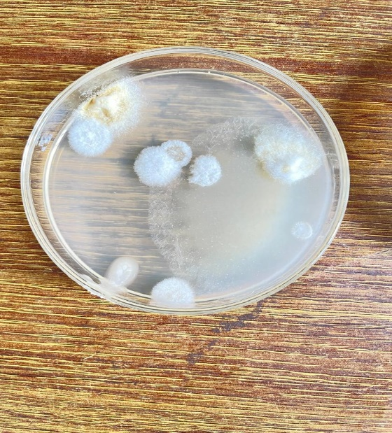
Appendix 1: Primary isolation plate 1
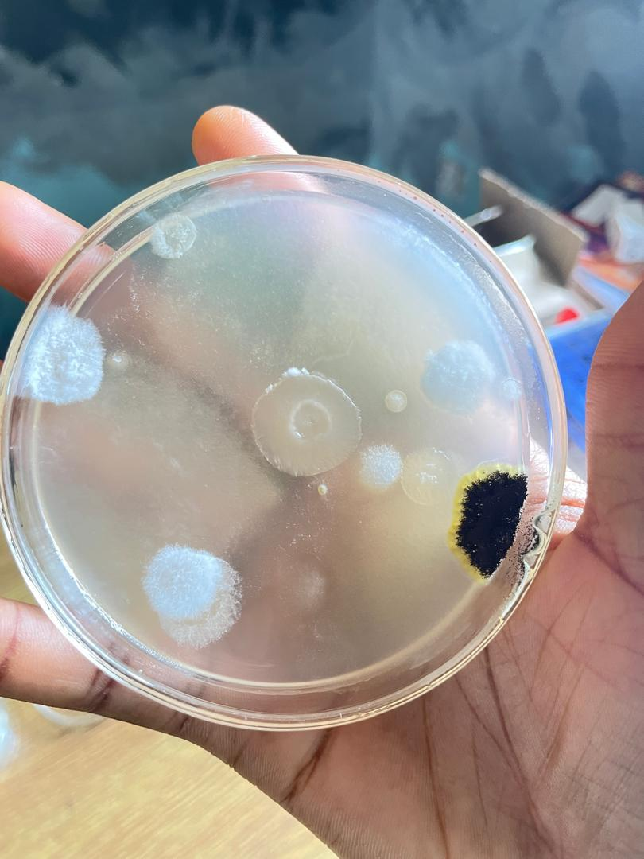
Appendix 2: Primary isolation plate 2

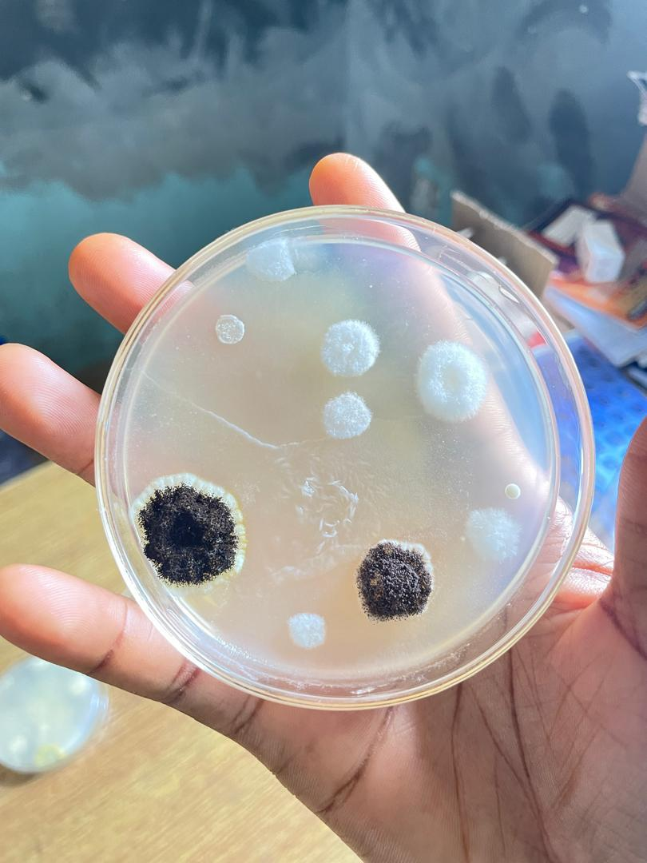
Appendix 3: Primary isolation plate 3
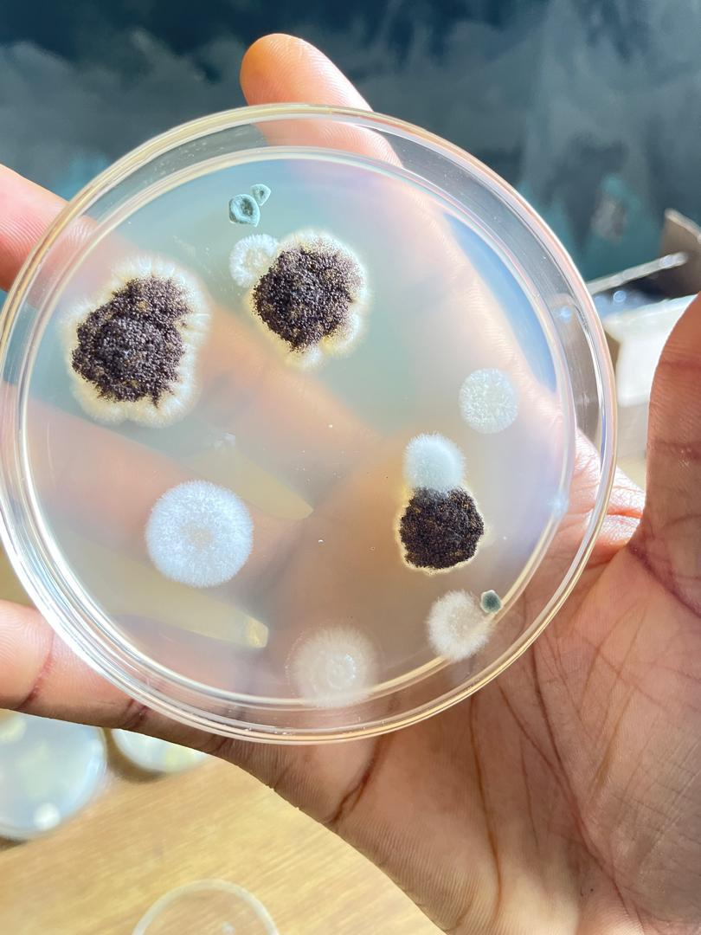
Appendix 4: Primary isolation plate 4
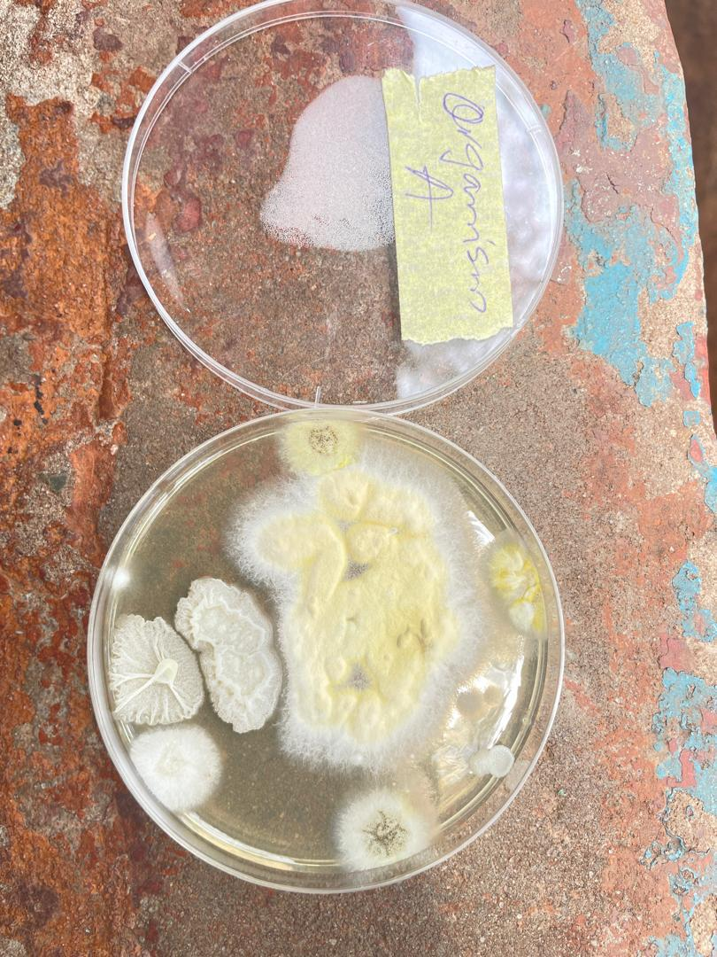
Appendix 5: Subculture plate (sample A)
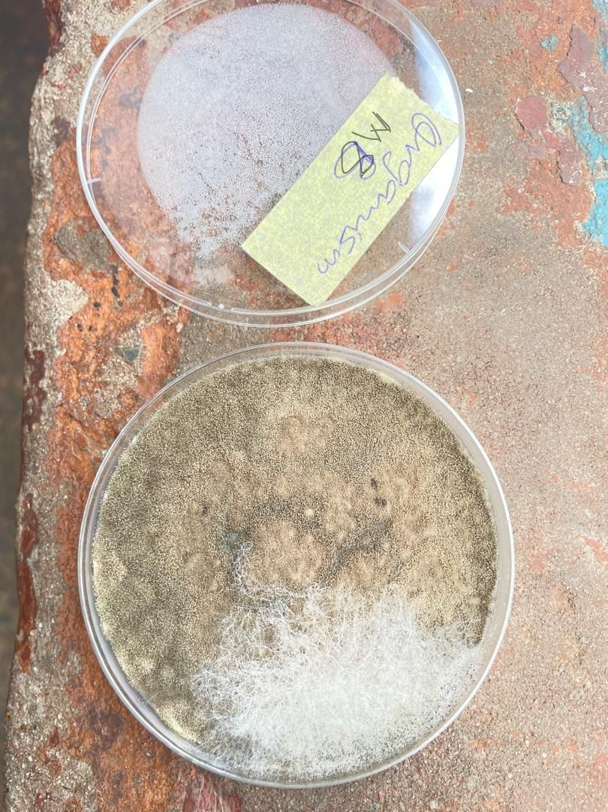
Appendix 6: Subculture plate (sample M8)
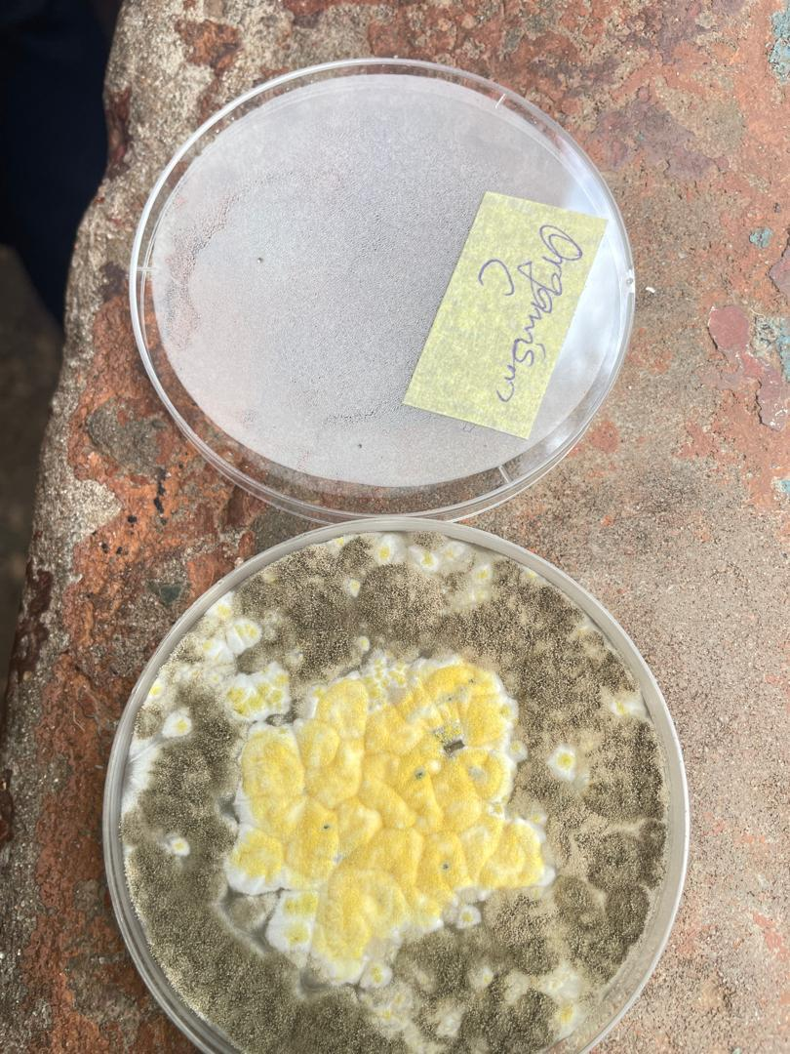
Appendix 7: Subculture plate (sample C)
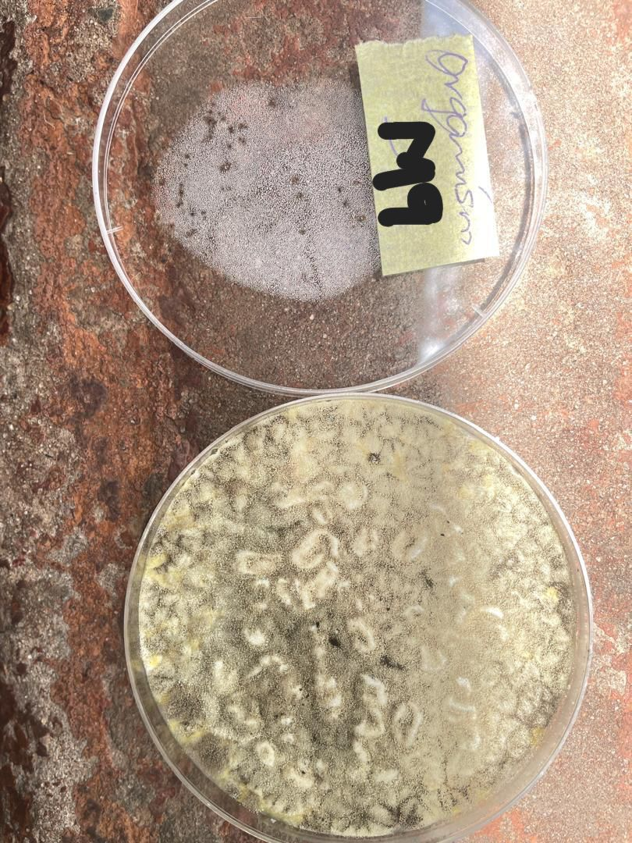
Appendix 8: Subculture plate (sample M9)
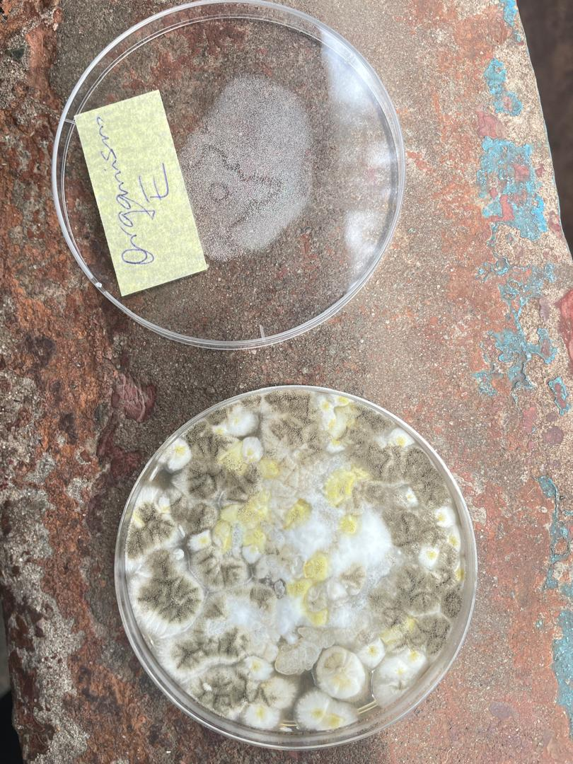
Appendix 9: Subculture plate (sample E)
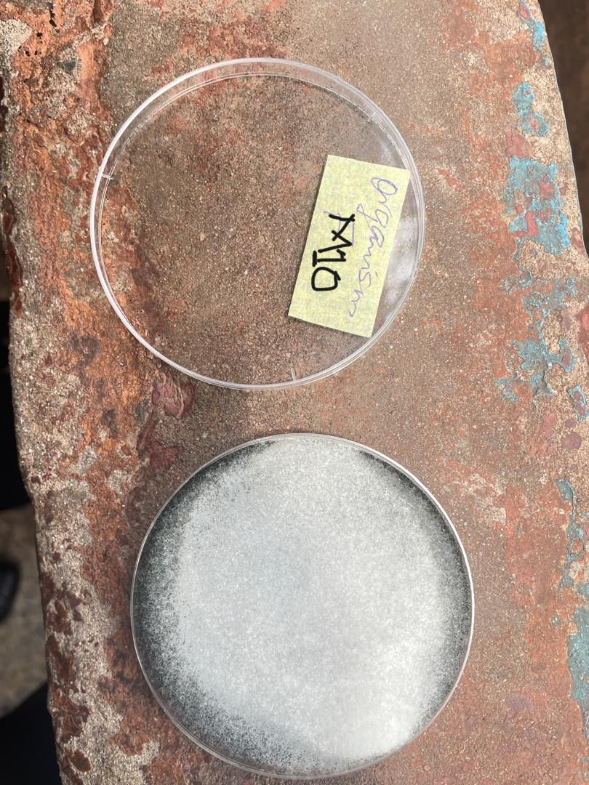
Appendix 10: Subculture plate (sample M10)
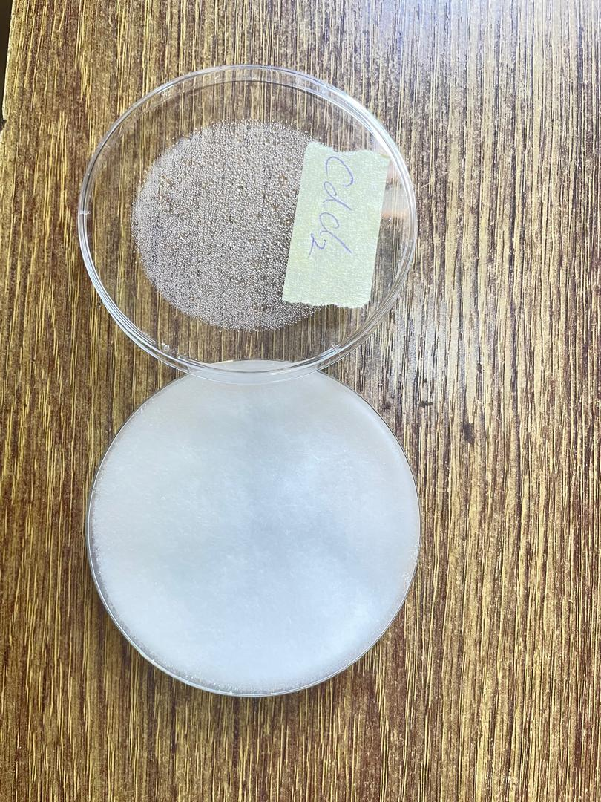
Appendix 11: Cadmium tolerance assay plate
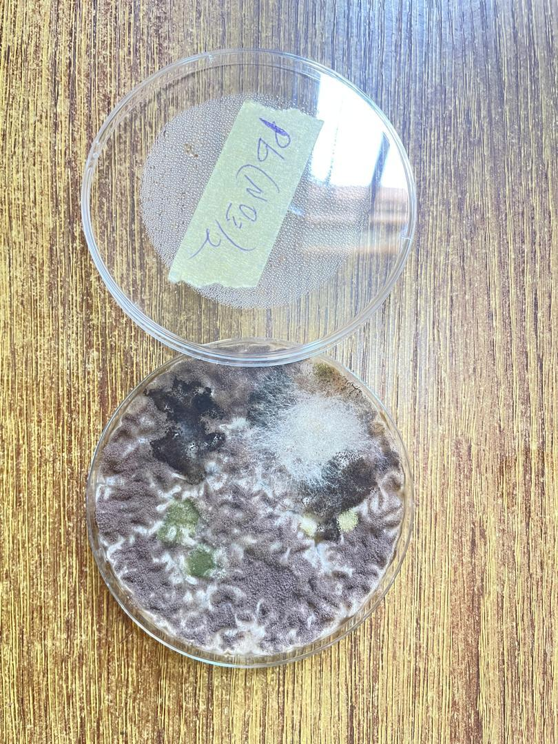
Appendix 12: Lead tolerance assay plate
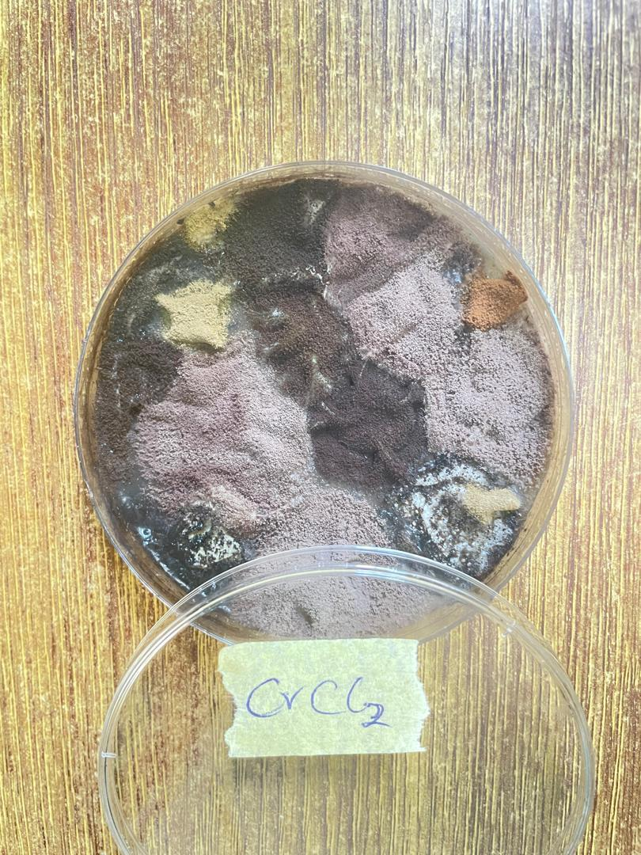
Appendix 13: Cadmium MIC test plate
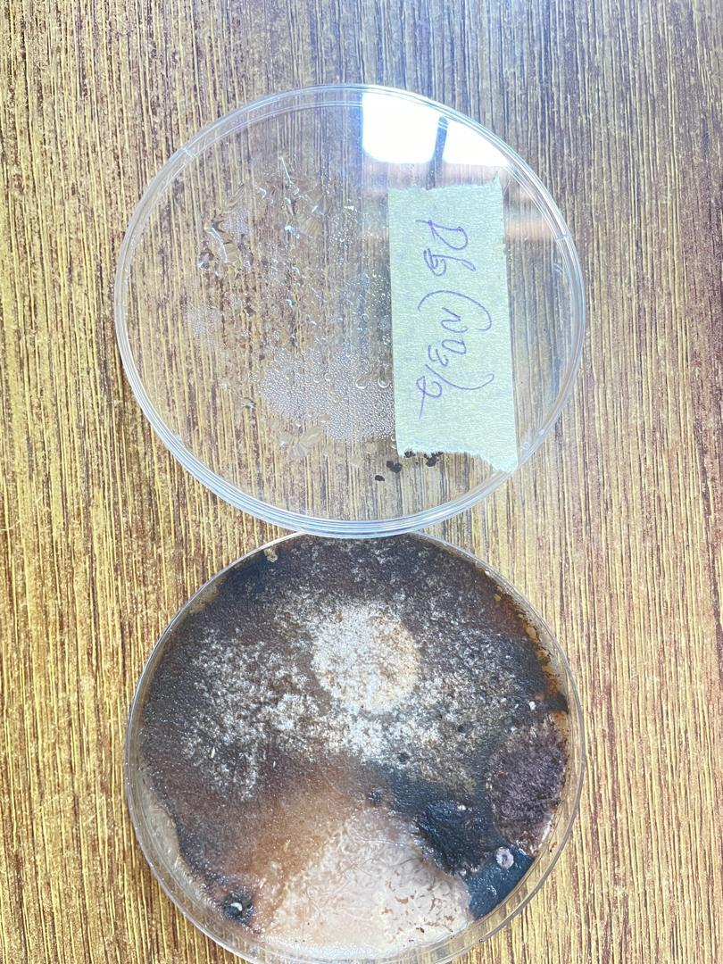
Appendix 14: Lead MIC test plate

