

(GO-UNI TIH)
GOU WEB-BASED TECHNOLOGY INNOVATION HUB
BY
IKE CHIDALU PROMISE
U20/NAS/CSC/281

DEPARTMENT OF COMPUTER SCIENCE AND MATHEMATICS, FACULTY OF NATURAL SCIENCES AND ENVIRONMENTAL STUDIES, GODFREY OKOYE UNIVERSITY, ENUGU.

(JUNE, 2025)
TITLE PAGE

(GO-UNI TIH)
GOU WEB-BASED TECHNOLOGY INNOVATION HUB
BY
IKE CHIDALU PROMISE
U20/NAS/CSC/281

DEPARTMENT OF COMPUTER SCIENCE AND MATHEMATICS, FACULTY OF NATURAL SCIENCES AND ENVIRONMENTAL STUDIES, GODFREY OKOYE UNIVERSITY, ENUGU. IN PARTIAL FULFILLMENT OF THE AWARD OF BACHELOR OF SCIENCE (B.SC), DEGREE IN COMPUTER SCIENCE.

SUPERVISED BY MR. N. V. UGWU

(JUNE, 2025)

CERTIFICATION
I hereby certify that the work included therein was completed by me and that it was mainly based on my own observations and research.

________________________
IKE CHIDALU PROMISE
U20/NAS/CSC/281

APPROVAL PAGE
This is to validate that this research work “GOU WEB-BASED TECHNOLOGY INNOVATION HUB” was embarked upon by “IKE CHIDALU PROMISE” with the matriculation number U20/NAS/CSC/281 in partial fulfillment of the requirements for the award of Bachelor Science(B.SC) in Computer Science, Faculty of Natural Sciences and Environmental Studies , Godfrey Okoye University, Enugu.

__________________________ ________________________

Mr. N. V. Ugwu DATE

(Project Supervisor)

_______________________________ _______________________

Dr. (Mr.) Frank Okebanama DATE

(Head of Department)

________________________________ _______________________

External Examiner DATE

DEDICATION
I dedicate this work project “GOU WEB-BASED TECHNOLOGY INNOVATION HUB based platform for Godfrey Okoye University student’s technology innovation hub” to my parents, Mr. and Mrs. Ike Kennise who have helped me in every way and I wish that God will keep them protected and cared for the rest of their lives. Amen.

ACKNOWLEDGMENTS
I would like to appreciate Our Lord God for his abundant mercies, inspiration and grace throughout this project. In a special way, I want to also acknowledge and appreciate my supervisor, Mr N, V. Ugwu for the time and patience he had set aside to make sure that this project is a success. I would love to appreciate my parents, Mr. & Mrs. Ike Kennise for their words of encouragement, support and prayers for me throughout my work in this project, my siblings also I will not forget to appreciate my lecturers for their support and lectures in class I pray that the good Lord will continue to bless them all.

ABSTRACT
This research explores how innovation and development are linked by looking at Technology and Innovation Hubs. By using the capability approach of Amartya Sen, it looks at the effects of tech hubs on development. In their opinion, tech hubs collaborate to support human development, and they do this without primarily paying attention to jobs or market sales. With this, development is guided by what is beneficial to people and helps them achieve important goals. According to this research, innovation for development may be explained as (often unbalanced) ways people and institutions act, provided that such actions are perceived as valuable by the people involved, with some of those values being about community, learning benefits , and growth. This study aims to provide the technology opportunities, community for computer science students at Godfrey Okoye University. Using the Object-Oriented Analysis (OOA), Structured System Analysis and Design Method (SSADM) and Business Process Modeling (BPM) I applied different UML diagrams such as the use case diagrams and activity diagrams to analyze this proposed system. This Innovation Technology hub website was developed using HTML programming language, CSS which is based on the styling of the website, JavaScript which is based on the front-end of the website and Python which is based on the back-end that was added to bring out the functionality embedded for the website. Godfrey Okoye University Technology Innovation Hub (GO-UNI TIH) is a highly recommended platform for Godfrey Okoye University students and other students from different institution, mentors as it renders distinctive features.

TABLE OF CONTENTS

COVER PAGE
TITLE PAGE i
CERTIFICATION ii
APPROVAL iii
DEDICATION iv
ACKNOWLEDGEMENTS v
ABSTRACT vi
TABLE OF CONTENTS vii
LIST OF FIGURES xi
LIST OF TABLES xii

CHAPTER 1: INTRODUCTION 1
1.1 BACKGROUND OF THE STUDY 1
1.2 STATEMENT OF PROBLEM 2
1.3 AIM AND OBJECTIVES OF THE STUDY 3
1.4 SIGNIFICANCE OF THE STUDY 4

1.5 SCOPE OF THE STUDY 4

1.6 LIMITATION OF THE STUDY 4

1.7 OPERATIONAL DEFINITION OF TERMS 5

CHAPTER 2: LITERATURE REVIEW 6
2.1 INTRODUCTION TO LITERATURE REVIEW 6
2.2 DESCRIPTION OF DIFFERENT CATEGORIES OF TECHNOLOGY HUBS 7
2.3 BRIEF HISTORY OF TECHNOLOGY 8
2.4 THE FUTURE OF TECHNOLOGY 9
2.5 REVIEW OF RELATED LITERATURE 10
2.6 SUMMARY OF REVIEW OF RELATED LITERATURE 11
2.7 RESEARCH GAP 14

CHAPTER 3: SYSTEM ANALYSIS AND DESIGN 15
3.1 OVERVIEW 15
3.2 SYSTEM ANALYSIS 15
3.3 ANALYSIS OF THE EXISTING SYSTEMS 15
3.4 LIMITATIONS OF THE EXISTING SYSTEMS 16
3.5 OBJECTIVES OF THE PROPOSED SYSTEM 17
3.6 SYSTEM REQUIREMENTS (SRS) 18
3.6.1 FUNCTIONAL REQUIREMENTS 18
3.6.2 USER MANAGEMENT 18
3.6.3 COURSE RESOURCES /SUBMISSION & MANAGEMENT 19
3.6.4 MENTORSHIP AND COLLABORATION 19
3.6.5 ANALYTICS DASHBOARD 19
3.6.6 NOTIFICATIONS SYSTEM 19
3.6.7 NON-FUNCTIONAL REQUIREMENTS 19
    - PERFORMANCE REQUIREMENTS 19
3.6.9 SCALABILITY 20
3.6.10 SECURITY 20
3.6.11 USABILITY 20
3.6.12 RELIABILITY AND AVAILABILITY 20
3.6.13 MAINTAINABILITY 20
3.7 PROPOSED SYSTEM METHODOLOGY 21
3.7.1 OBJECT ORIENTED ANALYSIS AND DESIGN 21
3.7.2 UNIFIED MODELLING LANGUAGE DIAGRAMS 21
3.7.3 USE CASE DIAGRAM OF PROPOSED SYSTEM 21
3.7.4 ACTIVITY DIAGRAM OF THE PROPOSED SYSTEM 23
3.7.5 CLASS DIAGRAM OF THE PROPOSED SYSTEM 24
3.7.6 UML SEQUENCE DIAGRAM 25
3.7.7 SYSTEM DESIGN 26
3.7.8 INPUT/OUTPUT DESIGN 27
3.7.9 INPUT AND OUTPUT DESIGNS OF THE PROPEOSED SYSTEM 27
3.7.10 DATABASE DESIGN 28

CHAPTER FOUR: SYSTEM IMPLEMENTATION 33
4.1 OVERVIEW 33
4.2 TOOLS USED FOR IMPLEMENTATION 33
4.2.1 HTML 33
4.2.2 CSS 33
4.2.3 JAVASCRIPT 34
4.2.4 PYTHON (DJANGO) 34
4.2.5 SYSTEM REQUIREMENTS 35
4.3 GO-UNI TIH USER INTERFACE 36
4.4 GO-UNI TIH SIGNUP AND SIGNIN SECTION 36
4.5 GO-UNI TIH ADMIN SECTION 37
4.6 GO-UNI TIH HOME SECTION 37
4.7 GO-UNI TIH RESEARCH SECTION 38
4.8 GO-UNI TIH COURSE SECTION 38
4.9 GO-UNI TIH COMMUNITY SECTION 39
4.10 GO-UNI TIH BUSINESS SECTION 39
4.11 GO-UNI TIH CONTACT SECTION 40

CHAPTER FIVE 41
5.0 OVERVIEW 41
5.1 SUMMARY 41
5.2 RECOMMENDATIONS 41
5.3 CONCLUSION 42
REFFERENCES 43
APPENDIX 44

LIST OF FIGURES
FIGURE 22
FIG. 1.1 USE CASE DIAGRAM 22
FIG. 1.2 ACTIVITY DIAGRAM 23
FIG. 1.3 CLASS DIAGRAM 24
FIG. 1.4 SEQUENCE DIAGRAM 26
FIG. 1.5 USERS AUTHENTICATION 27
FIG. 1.6 ADMIN AUTHENTICATION 27
FIG. 1.7 COUSRE PURCHASE 27
FIG. 1.8 COMMUNITY SOCIALS 27
FIG. 1.9 USER INTERFACE 36
FIG. 1.10 SIGN UP 36
FIG. 1.11 SIGN IN 36
FIG. 1.12 ADMIN DASHBOARD 37
FIG. 1.13 HOME PAGE 37
FIG. 1.14 RESEARCH PAGE 38
FIG. 1.15 SEARCH COURSES 38
FIG. 1.16 PURCHASE COURSE 38
FIG. 1.17 JOIN COMMUNITIES 39
FIG. 1.18 PERSONAL DATA 39
FIG. 1.19 BANKS PAGE 39
FIG. 1.20 ARTICLES 39
FIG. 1.21 CONTACT 40
LIST OF TABLES
TABLES 11
SUMMARY OF REVIEW OF RELATED LITERATURE 11
USER TABLE FOR GO-UNI TIH 28
COURSE TABLE FOR GO-UNI TIH 29
ADMIN TABLE FOR GO-UNI TIH 30
COMMUNITY TABLE FOR GO-UNI TIH 30
BUSINESS TABLE FOR GO-UNI TIH 31
CONTACT TABLE FOR GO-UNI TIH 32
CHAPTER ONE
INTRODUCTION

1.0 BACKGROUND OF THE STUDY
A technology and an innovation hub (sometimes referred to as a tech hub or an ICT Hub) which is a space where technologists, computer scientists, hackers, web developers and programmers congregate to network, share programs and design to bring their ideas to reality. In broad terms, they represent a form of co-working office space that can offer a variety of services like community building, learning materials, etc.
Recently, the number of tech hubs in Africa has kept increasing and reached over 100 (Kelly & Firestone, 2016). People tend to see tech hubs in Africa as offering great potential and positive progress. Many people are encouraged by international organizations, venture capitalists, and others to start start-ups and boost innovation and growth thanks to the spotlight on technology hubs. As a result of tech hubs, International Organizations expect “to boost business, stimulate more jobs, and find new mobile industry income sources […]” (GSMA Mobile for Development, 2014). This opinion matches what has been reported in the literature. Various authors believe that new developments and entrepreneurship play a key role in helping people out of poverty and increasing the economy in the long run (Fagerberg, 2009; Hall, Matos, Sheehan, & Silvestre, 2012). It means putting individuals in the role of entrepreneur or innovator first, viewing them with ideas from individualism and the market. In a second step, it regards individuals as participating in development, especially within the framework of individualism. It’s important to look closer at the concept of innovation when considering developing countries, since it fails to include the variety of true innovation processes (Srinivas & Sutz, 2008). We attempt in this paper to join discussions on innovation and development by widening the view of development so that it includes enhancing what Sen. (1999) terms “substantive freedoms” or the choices people have to live valuable lives (Chew, et al. 2015).
The overarching question we should ask based on that perspective is: what is the role in innovation that tech hubs may have in development? In a nutshell, this paper opposes the historical view of the relationship between innovation and development and asserts that we must bring in other dimensions than merely, competitive advantage and economic growth. The paper has been organized in the following manner. We are going to provide an introduction to the simple concepts that led to the emergence of numerous tech hubs, and showcase some significant papers on innovation and development. Next, we examine the question of development by presenting the capability approach (CA), which can also be another means of discussing the impacts of innovation. Under the instructions of teachers, the results are analyzed under various themes in the case study. We conclude with the effect of tech hubs on development and an alternative approach to the innovation.

1.1 STATEMENT OF PROBLEM
• Lack of Structured Innovation Framework: At the university, there is no well-outlined model or framework that is followed in driving innovation activities, collaboration, and development of projects.
• Insufficient Technical Infrastructure: the lack of or insufficiency of the stable internet connection, electricity, up-to-date computing hardware and development equipment restrains the inventiveness of students and researchers.
• Low Industry and Academic Collaboration: Poor access to industry partners, mentors and technology specialists inhibit knowledge transfer, mentor-ship and access to real world project opportunities.
• Poor Awareness and Participation: Most students and faculty are not even aware of the existence of the innovation hub, leave alone what it is and what it provides, which is the reason behind the low attendance and under-utilization of the center.
• Lack of Funding and Resource Support: Sustainable innovation involves finances to support prototypes, training, software licensing, and competitions, which are not steady or even available.
• Skill Gaps Among Students: Most students do not have the necessary technical, entrepreneurship, and problem-solving expertise that can help them to establish or maintain innovative projects within the hub.
1.2 AIM AND OBJECTIVES OF THE STUDY
This study titled “Gouni Technology Innovation Hub” aims at providing a platform that encourages innovative technology enhancement and productivity. To achieve the stated aim, the following specific objectives were pursued.
- The platform GO-UNI TIH will enable students to connect and exchange ideas for projects while working on innovations together with their field mates using technological resources available in the hub/ community.
- A foundation of knowledge exists in the GO-UNI TIH which offers students technological innovation guidance and research tools, providing course materials and physical meetings.
- The platform GO-UNI TIH consists of improved networking features that allow better interaction between students and industry experts and investors that could help in the development of an innovation or invention.

1.3 SIGNIFICANCE OF THE STUDY
The importance of this study lies primarily with Godfrey Okoye University, as it enables students to investigate learning materials through practical projects and collaboration, bridging the gap between theory and practice. The platform will provide research subjects along with technological article trends and innovation challenges to users based on their specific needs of field or specialty. Furthermore this research will provide substantial support to digital transformation efforts at Godfrey Okoye University Technology Innovation Hub. Students will receive platform empowerment and research productivity enhancement alongside the advancement of the university becoming known as an innovation and excellence center.

1.4 SCOPE OF THE STUDY
The scope of this project is devoted to the organization and work of the Godfrey Okoye University Technology Innovation Hub as a strategic measure to enhance technological improvement, entrepreneurship, and innovation among the university students. This project will cover the planning, design, functions and the expected impact of the innovation hub.

1.5 LIMITATION OF THE STUDY
Limitations to this study include as follows:
- Lack of Accessibility to Information: There was no access to all the information about the operations, financial model, and inner policies of the innovation hub. Part of the information was regarded as confidential that restricted the level of analysis.
- Time Constraints: The time that was devoted to complete the project will be quite limited which meant that it was not possible to carry out a significant fieldwork or a long-term observation or thick stakeholder interviews.
- Narrow Scope: The research was more of a case study of the Godfrey Okoye University Technology Innovation Hub and it was not expanded to a wider comparative research to other university innovation hubs in Nigeria or even outside the country. This little scope might restrict the finding generalization.
- Resource Limitations: The researcher was faced with financial and logistical setbacks, which influenced the capacity to conduct more rigorous forms of data collection and/or acquire some useful research materials and software packages.
- Technological Constraints: certain technical constraints were also experienced, mainly regarding the access and analysis of some digital tools or platforms adopted in the hub.

1.6 OPERATIONAL DEFINITION OF TERMS

- Student: Is a student, in a university or other institution of higher learning.
- University: Is a highly esteemed educational institution where scholars do research and students pursue degrees.
- Technology Innovation Hub: is a particular room or platform that is developed at an establishment to trigger creativity, research, development, and implementation of technological solutions.
- Digital Skills Development: The work of educating the students and staff in applicable technology skills like coding, app development, digital marketing, data analytic, and cyber security, frequently took place in the form of workshops and programs run by the Hub.
- Collaboration: Joint efforts of the students with industry associates and other stakeholders in the development and implementation of technological projects or research undertakings in an Innovation Hub.
- Entrepreneurship: It is the process of developing and operating a business enterprise in the technological environment with the aid of resources and preparation provided by the Innovation Hub.
CHAPTER TWO
LITERATURE REVIEW

2.1 INTRODUCTION
The 21st century universities are not teaching and research institutions only, but also innovation and entrepreneurship centers. In a world where technology is continually pushing the boundaries of what the economies and societies can achieve, the concept of Technology Innovation Hubs (TIHs) located in academic institutions has emerged as a smart way to fill the gap between theory and practice. This literature review covers the notion of technology innovation hubs at universities, especially their functions, influence, and adoption in the developing world, providing a background against which a specific facility the Godfrey Okoye University Technology Innovation Hub will be examined in detail.
The innovation hubs emerging in universities can be explained by the increased demand in commercializing the research output, developing startup ecosystems, and allowing students to have a hands-on experience in solving problems in realistic settings. These centers tend to act as innovation spaces that bring together students, researchers, industry players and entrepreneurs to work together and come up with technologically based solutions and help in socioeconomic growth and innovation culture. In this connection, university innovation hubs play a significant role in increasing the level of employ-ability, improving technology, and aiding in national development aims.
The topicality of the university innovation hubs is gaining more and more freedom of action in Nigeria in connection with the problems of youth unemployment and the need to find homegrown technological solutions to the problems of the country. Universities like Covenant University, the University of Lagos, and Obafemi Awolowo University have done remarkable work in creating such platforms. Nonetheless, little scholarly record and analysis exist of comparable programs in personal universities, including Godfrey Okoye University.
The proposed review will create a synthesis of the scholarly and policy-based literature available on the topic of technology innovation hubs in academic environments, specifically those pertaining to the Nigerian and African scenes. It will investigate the theoretical background of innovation hubs, evaluate implementation models, determine key success factors, and look into the common challenges. It is this context that will allow assessing the structure, aims, and possible effects of the Godfrey Okoye University Technology Innovation Hub and, thus, warrant its significance as a case study in the greater discussion of educational innovation ecosystems.
2.2 DESCRIPTION OF DIFFERENT CATEGORIES OF TECHNOLOGY HUBS
This section is centered on giving a brief description of some of the different categories that are present on technology hub platforms with examples. These categories include; Software and App Development, Artificial Intelligence (AI) and Data Science, Hardware and Embedded Systems, Entrepreneurship and Startup Incubation Hub, Cyber security and Digital Forensics, Smart Education and Ed Tech Hub.
- Software and App Development
This category offers a platform on which software solutions, mobile applications, and digital platforms are developed. It dwells on coding, user interface/user experience design, software engineering concepts, and agile methodologies.
- Artificial Intelligence (AI) and Data Science
This category is a machine learning and neural networks, data analytics and AI ethics hub. The students may take up projects on facial recognition, predictive analytics, and natural language processing (NLP).
- Hardware and Embedded Systems
This category allows students to do physical computing -combining hardware and software to create real-world devices.
- Entrepreneurship and Startup Incubation Hub
This category assists student entrepreneurs in getting idea to market. It offers coaching, business development services and access to funds.
- Cyber security and Digital Forensics
This category educates people to secure cyberspace and examine internet crimes.
- Smart Education and Ed Tech Hub
This category is devoted to the incorporation of technology in education to advance the learning experiences and availability.
2.3 BRIEF HISTORY OF TECHNOLOGY
History of technology is a history of human intelligence and the incessant desire to find solutions to challenges and better the living condition through innovation. It covers the first stone tools to the complex modern digital technologies.
Technology started during the pre-historic era when man made use of stones and bones to make crude tools. Ancient technology passed through milestones with the discovery of fire, invention of the wheel, as well as the development of agriculture. Such inventions formed the basis of human settlements, trade and civilization.
Technology grew swiftly during the Industrial Revolution in the 18th and 19th centuries, as inventions of machines, steam engines, and factories emerged. This period changed everything in manufacturing, transportation, communication, resulting in urbanization and the development of new industries.
The 20th century saw the emergence of modern technology particular in electricity, telecommunications, medicine and aviation. The development of computer in the mid twenty century was able to revolutionize data processing and lead to the digital age.
The Internet, mobile technology, artificial intelligence, and biotechnology have arrived in the late 20th early 21st century and made the world a global village where information and innovation travel at a speed never experienced before. All these developments have affected all spheres of life, education, health, business and governance.
To adapt to such changes in the world, educational systems such as Godfrey Okoye University have felt the necessity of technological inventions. The launching of the Technology Innovation Hub is a contemporary initiative- offering a platform on which students, researchers, and entrepreneurs can create innovative solutions involving the application of the emerging technologies.
Reference: Ceruzzi, P. E. (2003). A History of Modern Computing. MIT Press.
2.4 THE FUTURE OF TECHNOLOGY
What technology will bring in the future and its effect on our society?
Every part of life has changed because of the rapid evolution of technology in the last few decades. From when the wheel was created to modern times, technology has influenced the growth of the modern era.
Living has become easier as well as more productive due to technology. Lots of improvements worthwhile, such as cell phones, virtual reality, and artificial intelligence, which comes from technology to change our lives and the environment.
Still, using technology in society has had both good and bad impacts. Although there are several good results, but the industry has experienced some issues that needs to be managed. Among the negative impacts of technology on people are becoming too dependent on it, being bullied online, and being invaded when their privacy is concerned. Using more automation and AI technology has led people to fear that jobs will be lost and the gap between rich and poor will grow.
The future of technology looks especially exciting due to the continuous appearance of new technologies. Improvements introduced by these technologies must not stop us from considering the risks and controlling them. Some of the main technological changes that matter for our time will be explored, as well as the upsides and downsides of today’s technology.
2.5 REVIEW OF RELATED LITERATURE
This reviews fundamental ideas and structured research about machine learning implementations in technology done for Godfrey Okoye University Students and other known developments.
A web-based library information management system for the students of Godfrey Okoye University. The website aims at allowing students to access and borrow books from the library without having to visit the library physically it also allows library staff to manage student activity in the library and create digital catalogs without using the manual bulky file system. Designed by Onyeka Ifunanya Sylvia (2018).
A customized virtual classroom for Godfrey Okoye University. In the website a lecturer can create a virtual classroom for each course in the platform developed by the ICT Unit of Godfrey Okoye University. Students are given a short guideline on how to log in and use the beautiful platform. The guideline is also available on the university website. It enables lecturers to record each lecture; it allows multiple lectures to go on simultaneously without any technical hiccups. Designed and developed by Ag. Director, Mr. Chinedu Chibuzo (2025).
Technology Innovation Hubs in Nigerian Universities which presents the major difficulties in the establishment of innovation hubs in Nigerian institutions such as funding, infrastructure, and human capital. Built by Osunade, O.et al. (2017).
University Innovation Portal which details a university innovation portal case-study with simple features like project-submission, mentor-matching, and collaborations tools. Designed and implemented by Nwachukwu, A. (2021).
2.6 SUMMARY OF REVIEW OF RELATED LITERATURE
Author(s) Name/  Year | Name of research work/Journal Name | Contribution | Limitation
Onyeka, Ifunanya Sylvia (2018). | Web-based library information management system for the students of Godfrey Okoye University. | The website aims at allowing students to access and borrow books from the library without having to visit the library physically it also allows library staff to manage student activity in the library and create digital catalogs without using the manual bulky file system. | The system was web-based therefore limiting it to the web alone. And for students to borrow any library materials no method was mentioned on how it can be achieved online without visiting the library physically which may lead the records being unreal it is missing proper record of accountability.
Ag. Director, Mr. Chinedu Chibuzo (2025). | Development of a customized virtual classroom. | In the website a lecturer can create a virtual classroom for each course in the platform developed by the ICT Unit of Godfrey Okoye University. Students are given a short guideline on how to log in and use the beautiful platform. The guideline is also available on the university website. It enables lecturers to record each lecture; it allows multiple lectures to go on simultaneously without any technical hiccups. | The system development seems very bulk and it is set to consume 50% less data than zoom which is good but it could be slow in execution.
Osunade, O.et al. (2017). | Building Technology Innovation Hubs in Nigerian Universities. | Presents the major difficulties in the establishment of innovation hubs in Nigerian institutions such as funding, infrastructure, and human capital. | Does not outline technical requirements of system and steps to implement.
Uzochukwu, C. & Edeh, C. (2020). | ICT Infrastructure and Innovation in Nigerian Tertiary Institutions. | Gives outline to ICT based infrastructure that is required in innovation. | More concerned with policy and funding issues, than actual system components.
Nwachukwu, A. (2021). | Design and Implementation of University Innovation Portal. | Details a university innovation portal case-study with simple features like project-submission, mentor-matching, and collaborations tools. | Low scalability and lack of decent UI/UX stated in the review.
Okafor, J. & Ibrahim, M. (2022). | A Smart Innovation Ecosystem Framework for African Universities. | Presented a proposal of a smart ecosystem on the basis of cloud-based platforms to be used by startups, in collaboration and idea development. | The model is theoretical; has no implementation plan and case study testing.

2.7 RESEARCH GAP
There is a big knowledge gap here because firms do not have enough skill and knowledge in building and running a technology innovation learning based platform and this difference might occur because people do not know how ICT technology and related tools work and how to make them available for practical use, it may be necessary for participants in the project to learn more about technology innovations and the related technologies. My project helps one in buying online courses, join communities to work with experts, or investigate the subject by themselves to gain more knowledge and also my project provides a finance page that supports the development of innovative technologies.

CHAPTER THREE
SYSTEM ANALYSIS AND DESIGN

3.1 OVERVIEW
This research work discusses in detail the complete analysis and design of the proposed development on Gouni Innovation Technology Hub.
3.2 SYSTEM ANALYSIS
System analysis involves the step by step procedure of completely taking the system apart and also looking in detail at each of the components of the proposed system and also their interaction. The Godfrey Okoye University Technology Innovation Hub is expected to offer a platform where innovation, digital skills, entrepreneurship, and collaborative research can be supported by and among students, staff, and external stakeholders. System analysis is the process of understanding the existing environment and needs in order to develop a system that could respond to technological, educational, and administrative needs of the hub. As well as the comprehensive design of the proposed system, this involves modeling the system by means of class diagrams, activity diagrams and use case diagrams.
3.3 ANALYSIS OF THE EXISTING SYSTEMS
• Lack of Centralized Digital Platform: At present, such a centralized online system does not exist to facilitate innovation projects, collaboration, mentor-ship and sharing of resources between students and staff in the university.
• Manual or Informal Project Tracking: Documentation, monitoring and evaluation of student tech initiative are usually done manually or through informal means like WhatsApp groups or spreadsheets, which makes it challenging to keep track of student tech initiatives.
• Poor Visibility of Student Innovation: Innovations and research projects initiated and done by the students have limited exposure out of the classroom. Institutional infrastructure that can be used to present these works to prospective investors or industry partners is limited.
• Inadequate Collaboration Tools: Current systems do not have specific functionality that support collaborative development (e.g. code repositories, brainstorming boards, shared work spaces) which is essential to technology-based innovation.
• Absence of Integration with Mentors and Industry Experts: The existing system of linking students to outside experts, alumni and mentors is informal, and to a large extent, relies on personal relationships.
• Limited Access to Learning and Development Resources: They lack access to vetted resources, training documents, webinars, or workshops that get incorporated into a central platform that supports student innovators in the development of their skills.
• Lack of Performance Metrics and Evaluation: No KPIs or online systems are established to measure the growth, impact, and success rate of projects that exit the innovation hub.
3.4 LIMITATIONS OF THE EXISTING SYSTEMS
• Lack of Centralized Platform: A single digital platform does not exist, which allows uniting students, mentors, investors, and innovators to collaborate and share resources.
• Inadequate Digital Infrastructure: A significant number of systems being used currently are highly dependent on manual procedures or disjointed systems which restrict real-time based collaboration, innovation monitoring and progress reporting.
• Limited Student Engagement: current systems lack the proactive approach to engage students, particularly those without a technical background, because of unawareness, lack of motivation, or absence of academic integration.
• Poor Resource Management: The existing processes fail to effectively coordinate the Innovation hub resources such as labs, equipment, meeting rooms, etc., resulting in either under-utilization or schedule conflicts.
• Absence of Project Repository: The previous or current student innovation projects are not stored in some digital archive or searchable database so that they could be opened, examined, or further developed.
• Low Industry Integration: Poor partnership between hub and industry players limit access to mentors-hip, fundraising opportunities and real world validation.
• Insufficient Monitoring and Evaluation Tools: There exist no holistic instruments to monitor the development, influence, and indicators of student innovations over the time, which impacts the enhancement and scale.
• Limited Accessibility and Remote Support: Off-campus students or those in other faculties might not access the resources in the hub easily as a result of unavailability of systems that are remote friendly.
3.5 OBJECTIVES OF THE PROPOSED SYSTEM
The Godfrey Okoye University Technology Innovation Hub (GO-UNI TIH) is a proposed system to be established as a centralized digital and physical location within the university to facile innovation, entrepreneurship, and technological development by members of the university community. It also aims at bridging the academic-real world gap through providing services to students, researchers and faculty members to access resource such as course materials, physical mentor-ship program, funding of ideas and research collaborations means.
The system will have a section of uploading and purchasing course materials to the students who are willing to develop in their field of interest within the tech space, a section where the stakeholders can interact with each other easily, and students can also form communities where they can express and develop their innovative ideas. This system grants a medium to the performance monitoring, feedback, and reporting tool to keep a check on the progress and the impact of the innovation process in the admin section. Overall, the system will assist in enhancing the image of the university as the technologically advanced institution of learning and give students the tools, as well as the environment, which they need to transform their ideas into the feasible solutions.
3.6 SYSTEM REQUIREMENTS (SRS)
System requirements are the processes or the statements of what a system is supposed to be able to do. These system requirements can be divided into two; the functional requirements and the non-functional requirements.
3.6.1 Functional requirements:
The functional requirements refer to the requirements that specify what the system must have. Functional requirements of GO-UNI TIH include that:
These define the core functions and features the system must support:
3.6.2 User Management
- Sign up and log in of users (the students and admins).
- Role-based access control (Admin, Student, and Guest).
- User profile creation and management.
3.6.3 Course Resources /Submission and Management
- Post and administration of course materials (documents).
- Filter and search courses using category, tags or date.
- Buy to purchase course materials.
3.6.4 Mentorship and Collaboration
- Communication is handled through community social handles.
- Mentor assignments and matching students based on their desired field.
- Innovation-oriented discussion forums or message boards.
3.6.5 Analytics Dashboard
- See the statistics of courses sold, course registrations, number of active users, and so on.
3.6.6 Notifications System
- Notifications like; project status, event reminders through the email
3.6.7 Non-Functional requirements:
The non-functional requirement is employed in referring to those requirements, which define the characteristics or capabilities that the proposed system should possess. GO-UNI TIH non-functional requirements include that:
3.6.8 Performance Requirements
- It has to be able to sustain a minimum of 100 simultaneous users without compromising performance.
3.6.9 Scalability
- Should be scalable to allow future growth (increased users, data and functionality).
3.6.10 Security
- Secure log-in and password encryption.
- Data access limitation based on roles.
3.6.11 Usability
- Usability: easy to use interface that could be used by non-technical users.
- Mobile, tablet and desktop responsive design.
3.6.12 Reliability and Availability
- Automatic data backups (daily/weekly).
3.6.13 Maintainability
- Ease of maintenance and upgrades with well commented code and modular structure.

3.7 PROPOSED SYSTEM METHODOLOGY -
3.7.1 OBJECT ORIENTED ANALYSIS AND DESIGN
The Object Oriented Analysis and Design is the software development methodology which presupposes the utilization of the object-oriented concepts to develop and design software systems. Under this methodology the system requirements are established and the classes are identified and the relationships among these classes are also identified. This methodology has some techniques and practices which are being used and they are; UML diagrams, object-oriented programming and use cases. OOAD employs object- oriented programming to develop and implement this software, UML diagrams to design diagrams that depict various aspects of a software system and the relationship that exist between the various parts of the software system and finally, use cases to document the various interactions that users can have with a software system. This is the methodology that was intended to deal with intricate systems and hence, the rationale behind this methodology.
3.7.2 UNIFIED MODELLING LANGUAGE DIAGRAMS
The unified modeling language (UML) diagrams are utilized in the creation or design of a diagrammatic representation of the various aspects/components of the software system as well as the interaction of the software system. A use case diagram, activity diagram and class diagram are however modeled on this system.
3.7.3 USE CASE DIAGRAM OF PROPOSED SYSTEM
The use case diagrams can be divided into four categories; the actors that depict the external entities of the system, use cases that are the functional components of the system, the associations between the actors and the use cases and finally the system boundary that is the scope of the system the actor is interacting with.
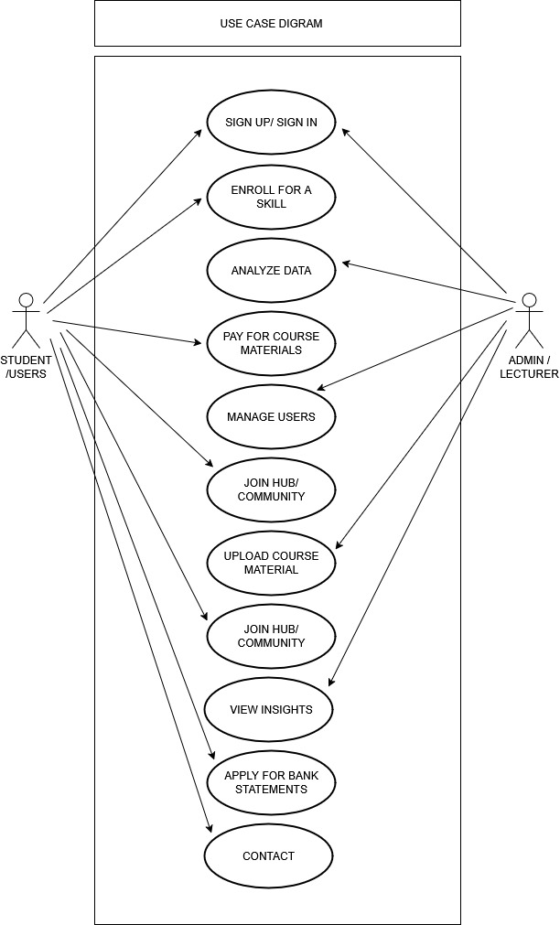
In the case of the proposed system, we have two (2) actors and they are as follows; the users/students, and the administrator/lecturer. In the use case diagram, the users are presented with 11 use cases that entails, sign in, enroll for a skill, pay for course materials, join available hub/community, apply for bank statements, and so on. The administrator/lecturer who is the super-admin can then do all that a user can do such as deleting or approving course materials and also resolves issues on the site.

JOIN HUB AND PITCH

Use case diagram of GO-UNI TIH:
Figure1.1 Use case diagram of the proposed system
The above diagram illustrates the use case of the proposed system in which the central user, can undertake a sequence of activities that lead towards the overall experience of the innovative technology experience on the platform.
3.7.4 ACTIVITY DIAGRAM OF THE PROPOSED SYSTEM
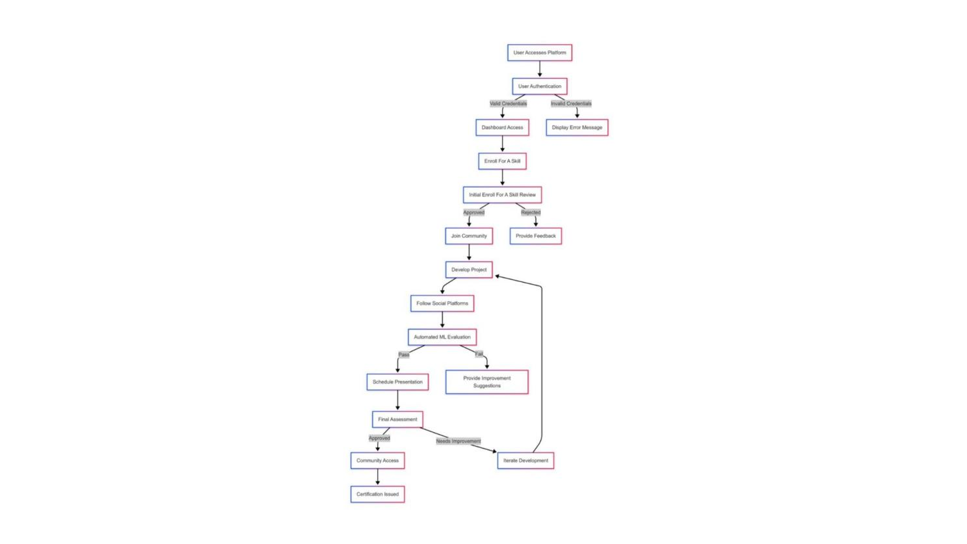
The other diagram that is of significance whenever using the Unified Modelling Language (UML) approach is the activity diagram. It is a chart that shows the dynamic features of the software system. An activity diagram however is simply a flowchart/flow-diagram that defines the flow of activities that occur within the system in a stepwise fashion. The figure below indicates the flow of the activities on GO-UNI TIH, which is the signing in, the access to the dashboard the logging out and so on.

Activity diagram for GO-UNI TIH.
Figure1.2 Activity diagram of the proposed system for the dashboard.
3.7.5 CLASS DIAGRAM OF THE PROPOSED SYSTEM
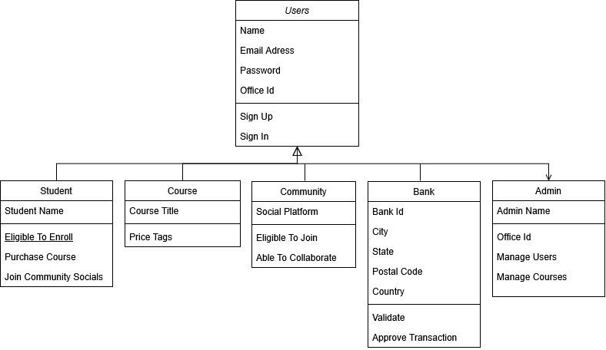
In this section we see the class diagrams that are diagrams in Unified Modelling language (UML) used to describe the structure of a software system by determining the classes, attributes, methods and the relationship between objects. The figure below shows the class diagram of GO-UNI TIH.

Figure1.3 Class diagram of the proposed system
The above class diagram indicates the various classes that would be incorporated in the proposed system and how they would be related to each other. It displays the various levels of the users which are held within the account class, the various activities which the users may carry out and various sub-classes which carry out these particular activities. The class diagram though is one of the standard prototypes of the proposed system since it will elaborate the various classes that will exist within the proposed system.

3.7.6 UML SEQUENCE DIAGRAM
The sequence diagrams in the unified Modeling Language (UML) are a dynamic pictorial model that illustrates the different interactions among the different objects that are present within a system throughout time. On the same note, these charts prove to be quite significant in the comprehension of the time sequence of the activities and messages that transpire when a specific use case or scenario is being implemented. But, fundamentally these sequence diagrams are visual representation of the sequence in which the interactions occur thus giving an explicit picture of how the different parts interoperate in a particular system to give the desired specified goal.
Nevertheless, the components of the UML sequence diagram are lifelines, message, activation's and objects where the lifelines indicate the entities that are interacting whereas, messages signify the communication among the various entities. In addition, activation's, which are depicted as vertical lines rising out of lifeline and hence stands to denote the period of time that an object has been engaged in interaction. In turn, this time dimension introduces an important level of interpretation hence enabling developers and stakeholders to not only comprehend what happens in the system, but also when it happens in the running of the system.
Additionally, UML sequence diagrams serve to aid the communication between the technical and non-technical members of a system and with the provision of a visual representation of system dynamics sequence diagrams are a formidable means of expressing complex technical information in a more comprehensible form. Nevertheless, the creation of these diagrams leads to better cooperation thus creating a common view of how the system behaves as well as assisting in revealing what can go wrong in the future to be improved.

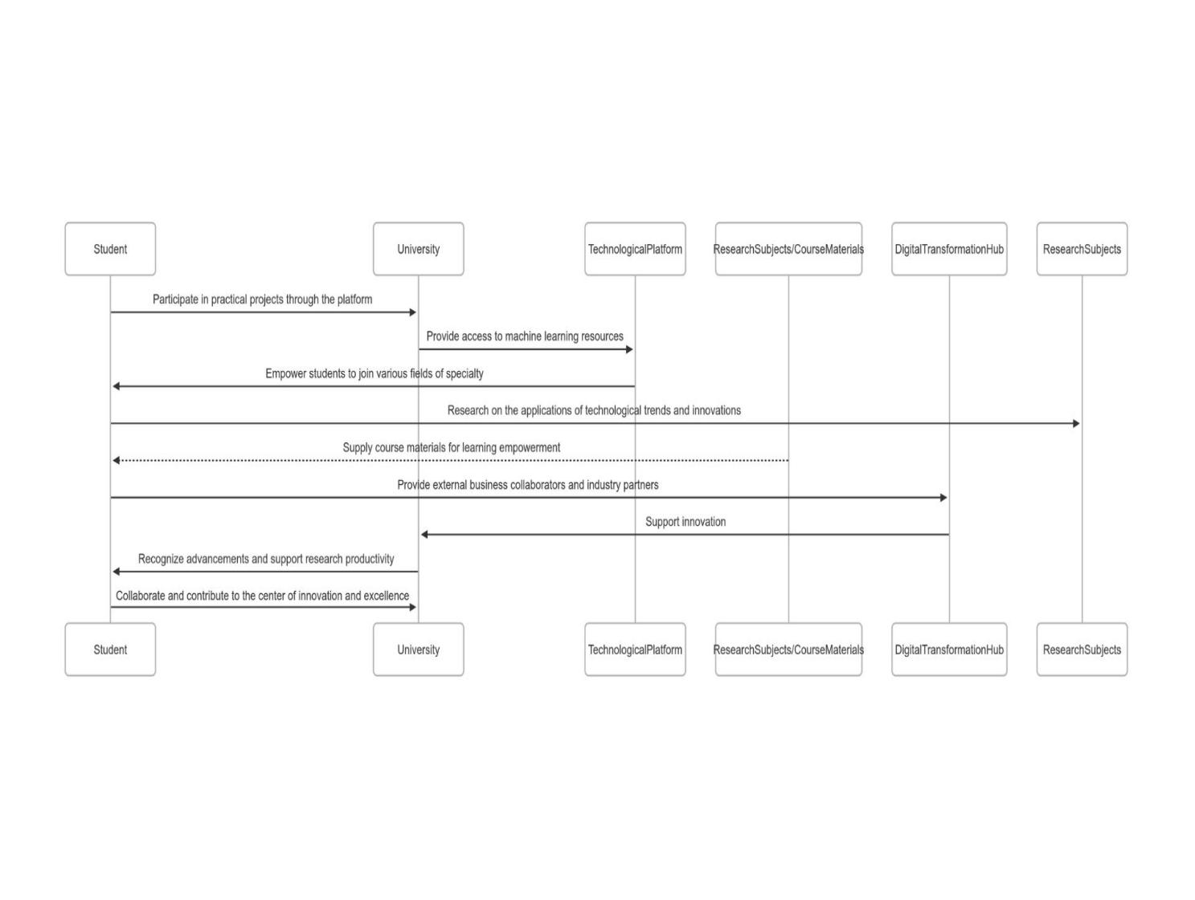

Figure1.4 Sequence diagram of GO-UNI TIH.
The above diagram is the sequence diagram of the proposed system; GO-UNI TIH, as it is to demonstrate in details the process of actions, which occurs during user registration process down to the how the proposed system functions. It is hereby employed in this respect to give a diagrammatic display of the action that takes place in the process of the proposed system which begins with the user providing his details, to the system verifying the user and redirecting the user successfully to the user interface of the system.
3.7.7 SYSTEM DESIGN
The system design of GO-UNI TIH, will explain how the system will address the requirements mentioned above. This system design will consist of input/output design of the proposed system and the database design of the system.

3.7.8 INPUT/OUTPUT DESIGN
The input/output design will include the mock-up design of all the areas through which inputs will be sent and received on the system and the illustrations of the output mock-up areas after the inputs. The diagram of the input/output design illustrations is shown below.
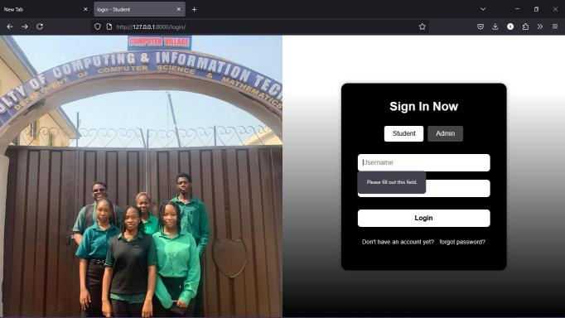
3.7.9 INPUT AND OUTPUT DESIGNS OF THE PROPEOSED SYSTEM:
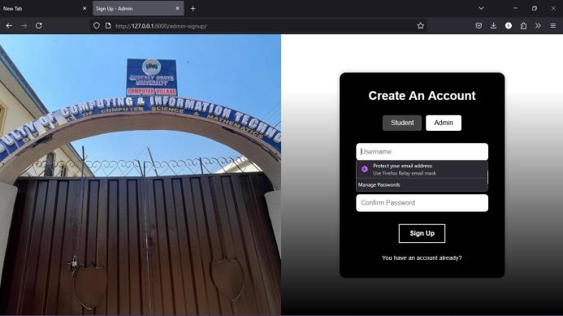


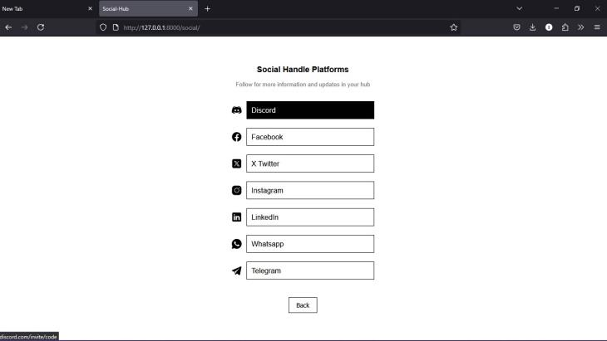
Figure1.5 Users Authentication Figure1.6 Admin Authentication

Figure1.7 Course purchase Figure1.8 Community Socials

Input and output designs for the proposed system

3.7.10 DATABASE DESIGN
The point of the database design is to present a modeled image of the GO-UNI TIH database. The database of GO-UNI TIH is a relational database that has been implemented and designed with python. The database was developed on python (django) to develop fast and more efficient database design.
3.7.11 DATABASE SCHEMA FOR GO-UNI TIH
User table
Table1.1 User table for GO-UNI TIH.
Field Name | Data Type | Constraints | Description
user_id | int | primary key, auto_  increment | Unique ID for each user
name | varchar | not null | Full name
email | varchar | unique, not null | User email address
password | varchar | not null | Hashed password
role | enum | ('student', 'admin') | Role of the user
profile_pic | text | null | Link to profile image

Course table
Table1.2 Course table for GO-UNI TIH.
Field Name | Data Type | Constraints | Description
course_id | int | primary key, auto_increment | Unique course ID
title | varchar | not null | Course title
description | text | not null | Course overview
price | decimal | not null | Course cost
category | varchar | not null | e.g.,Web Dev, Cybersecurity etc.

Purchase course table
Table1.3 Purchase course table for GO-UNI-TIH
Field Name | Data Type | Constraints | Description
purchase_id | int | primary key, auto_increment | Unique ID for each purchase
user_id | int | foreign key | Buyer user ID
course_id | int | foreign key | ID of purchased course
payment_status | enum | ('paid', 'pending', 'failed') | Status of payment
purchase_date | timestamp | default current_timestamp | When course was purchased

Admin table
Table1.4 Admin table for GO-UNI TIH.
Field Name | Data Type | Constraints | Description
admin_id | int | primary key, auto_increment | Admin user ID
user_id | int | foreign key | Links to user table
access_level | enum | ('super', 'moderator') | Admin privilege level
assigned_date | timestamp | default current_timestamp | Admin role assignment date

Hub(Community) table
Table1.5 Community table for GO-UNI TIH.
Field Name | Data Type | Constraints | Description
Social_id | int | primary key, join | Follow ID
user_id | int | foreign key | Who joined

Business table
Table1.5 Business table for GO-UNI TIH.
Field Name | Data Type | Constraints | Description
service_id | int | primary key, auto_increment | Unique business service ID
title | varchar | not null | Service name
description | text | not null | What the service is about
price | decimal | not null | Cost of the service
provider_id | int | foreign key (user_id) | Who offers the service (bank)’

Contact table
Table1.6 Contact table for GO-UNI TIH.
Field Name | Data Type | Constraints | Description
message_id | int | primary key, auto_increment | Unique message ID
name | varchar | not null | Sender's name
email | varchar | not null | Sender's email
subject | varchar | not null | Subject of the message
Skill | text | not null | Skill title
sent_at | timestamp | default current_timestamp | Message timestamp
message | text | not null | Actual message

CHAPTER FOUR
SYSTEM IMPLEMENTATION

4.1 Overview
The chapter is about the system implementation of the system GO-UNI TIH. Following an extensive procedure of system analysis of the current systems and also the definition of the system and all the system requirements, GO-UNI TIH is currently being implemented with the suitable tools that has been adopted and also put to test. This chapter will thus include user interfaces of various functional components of this system and also the tool that was used in implementation of this system.
4.2 Tools used for implementation
4.2.1 HTML:
The HTML (Hypertext Markup Language) is an open-standard, markup language that is created and supported by the World Wide Web Consortium (W3C), and which is basically devised to hierarchies and present web content. It is essential in web pages and web applications development since it offers a precise structure of text, images, links, multimedia, and interactive components. HTML introduces great importance to semantic clarity which enables developers to structure the content in understandable and accessible manner, cross-browser and cross-platform. Simplicity, readability, and ease of learning's are one of the significant benefits of HTML, which makes it very accessible to a beginner yet as powerful as it is in the hands of an advanced developer. Also, HTML is easily coupled with other fundamental technologies such as CSS and JavaScript to create visually eye-catching and dynamic websites.
4.2.2 CSS:
Cascading Style Sheets (CSS) is an open-standard, style sheet language, which is employed in describing the presentation of a document, which is written in HTML or XML. It was created and is supported by the World Wide Web Consortium (W3C) and is vastly created to manage the arrangement and aesthetic look of web pages on an array of gadgets and screen resolutions. CSS is an essential part of evolution of web applications nowadays as it allows developers to maintain the separation of content and design, improving flexibility and maintainability. Simplicity, re-usability, and easy to work with are the main characteristics associated with the language which makes it familiar even to novice developers and programmers. The cascading and inheritance model is one of the most impressive features of CSS, enabling the web developers to style and consistent web pages with a great level of efficiency and minimize repetition in the code to a great extent.
4.2.3 JAVASCRIPT:
JavaScript is an open source, high level, and interpreted programming language initially created by Netscape (now standardized as ECMAScript). Designed extensively to facilitate the interactive and dynamic contents on websites, it is regarded as one of the fundamental technologies of the World Wide Web along with HTML and CSS. JavaScript is highly focused on client-side web application development, but today is also used heavily on the server-side, due to environments such as Node.js. The language is mainly known to be flexible, dynamic, and has a wide ecosystem, thus being very approachable by developers of any level. Moreover, the event-driven non-blocking architecture of JavaScript is probably one of its most prominent aspects that enable the creation of responsive and fluid user interfaces, effective real-time data processing, and very interactive web apps.
4.2.4 PYTHON (Django):
Django is a Python-based high-level web framework which is free and open-source and was first published in 2005 by Adrian Holovaty and Simon Willison. It was created particularly to promote fast development and clean, pragmatic design, meaning that it eases the task of creating secure and scalable web applications. among the most popular features of Django is its “batteries-included” approach, which provides a great number of built-in capabilities, including authentication, an admin interface, and an ORM right out of the box. Django is one of the most effective frameworks of web development because it has a set of reliable components that can be reused and a big community of developers who contribute to the framework. Also, Django follows the Model-View-Template (MVT) architectural pattern and enforces the DRY (Don’t Repeat Yourself) principle, which raises the development speed and maintainability, so it can be used by beginners as well as by experienced developers.
4.2.5 SYSTEM REQUIREMENTS
These requirements are as follows:
- User Registration and Authentication: The users (students, Admin) have the capability to register, log in, and handle their profiles safely.
- Discussion Forum / Collaboration Space: Idea sharing can be done by users forming or joining discussion boards and chat groups through the provided social handles.
- Resource Library: access to research course materials.
- Admin Dashboard: Admins are supposed to create and manage users, courses, contents, and moderate the platform activity.
- Notification System: Inform users of update, events, project status and system activity via email.
- Analytics and Reporting: Present administrators with reports of user engagement, project statistics and system performance.

4.3 GO-UNI TIH USER INTERFACE
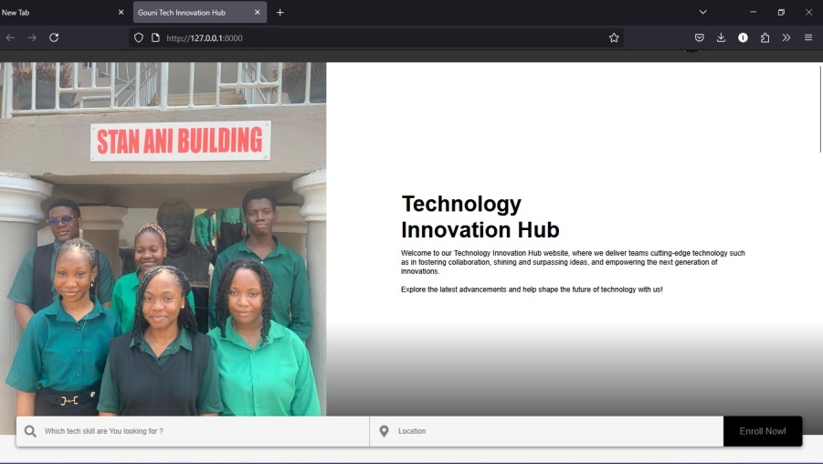
This part of this research work will include user interfaces of various parts of GO-UNI TIH which would comprise the home section, research section, bank section, contact section, profile section, the collaboration interface etc.

Figure 1.9 User interface
4.4 GO-UNI TIH SIGNUP AND SIGNIN SECTION
This section consists of the user’s personal data which includes: name, email. Password etc.
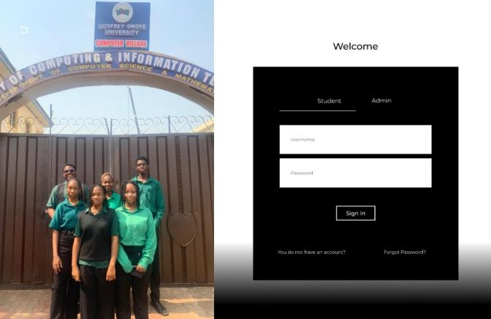
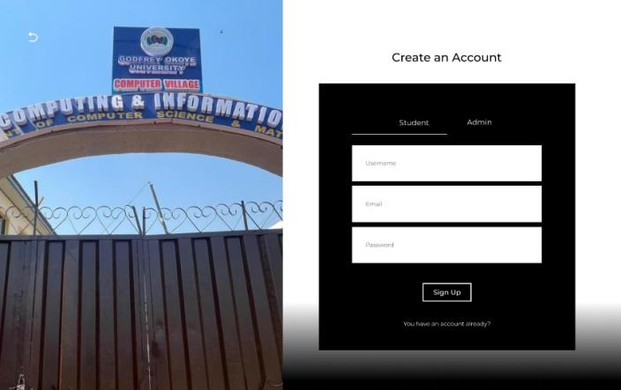

Figure 1.10 Signup Figure 1.11 Signin

4.5 GO-UNI TIH ADMIN SECTION
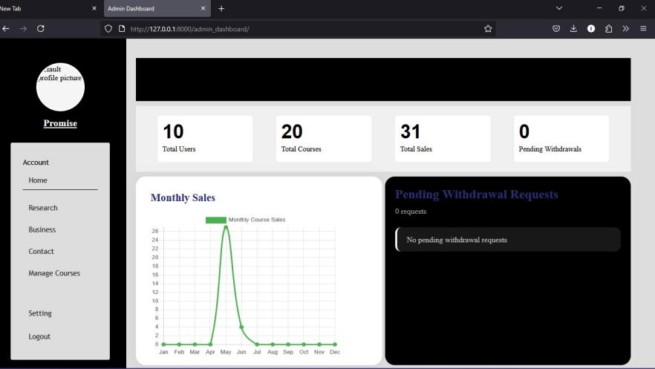
This section is to create and manage users, courses, contents, and moderate the platform activity.

Figure1.12 Admin Dashboard
4.6 GO-UNI TIH HOME SECTION
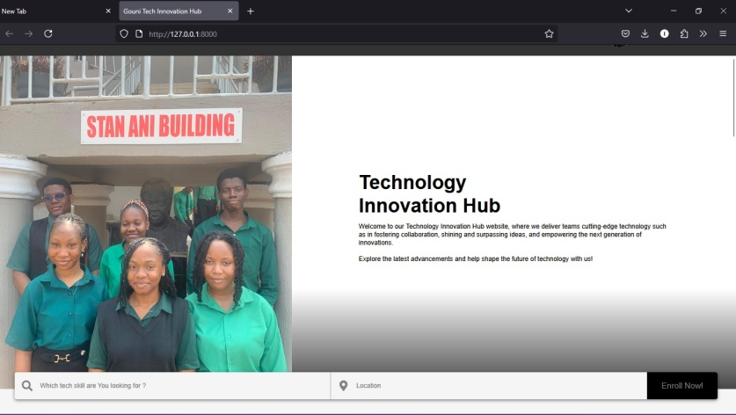
The homepage consists of GO-UNI TIH interface which is is made up of different sections, the header section that contains the user GO-UNI TIH text logo and other usability tools to make it accessible to the user easily, the section where the users can see where to search for a tech skill, location, learn more, view testimonials and enroll for a skill to get started. Once the user sign ups the user can edit his/her profiles.

Figure 1.13 Home

4.7 GO-UNI TIH RESEARCH SECTION
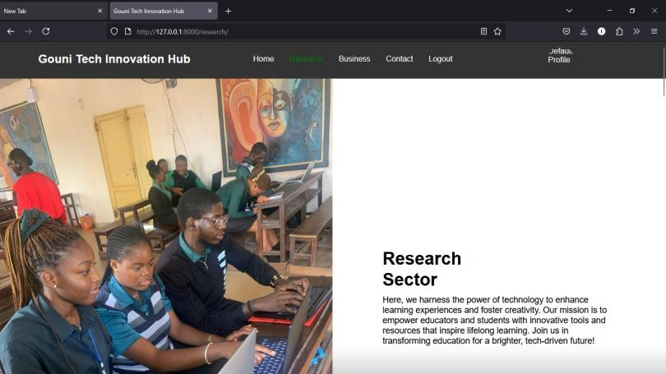
The GO-UNI TIH interface Research Section is meant to be accessible to the users. It has a simple header containing GO-UNI TIH logo and navigation tools, and contains specific sections, where one can find out available course material categories to purchase, join hubs(communities) to follow up projects.

Figure 1.14 Research
4.8 GO-UNI TIH COURSE SECTION
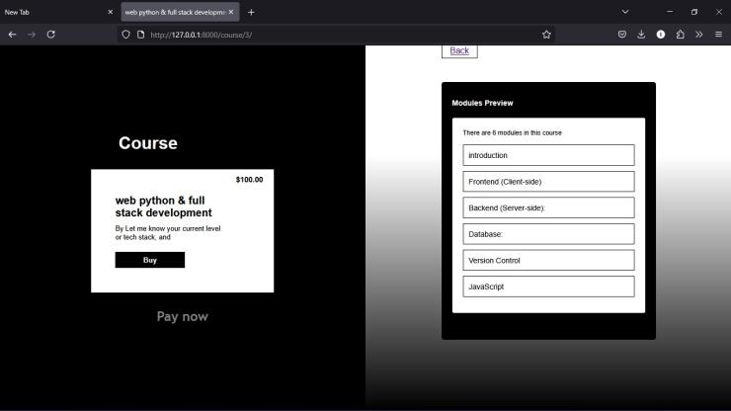
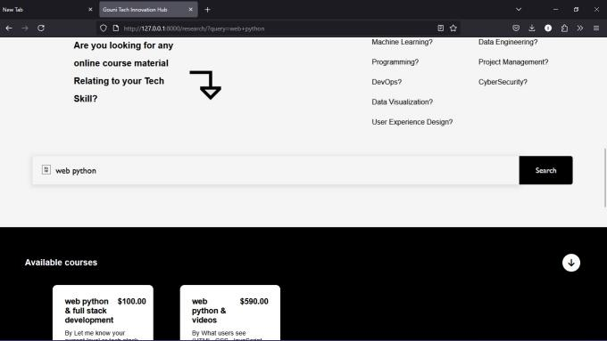
The Course Section of the GO-UNI TIH interface offers its users a convenient presentation of the existing tech courses. The user is able to navigate by categories, search by interest or expertise, see the course description and purchase in a course of his or her choice easily. On enrolment, the users will be able to monitor their course progress and access course materials without any hindrance.

Figure 1.15 Search courses Figure 1.16 Purchase course

4.9 GO-UNI TIH COMMUNITY SECTION
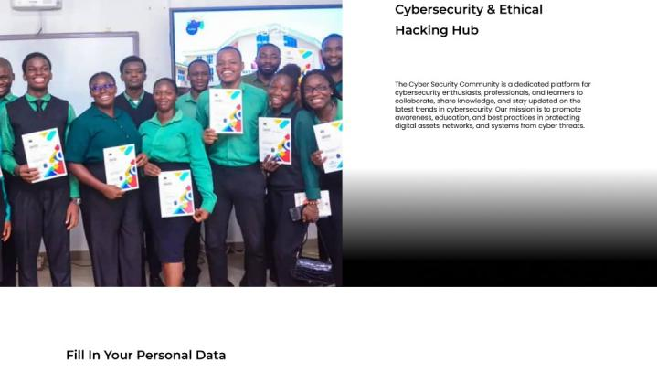

The Community area of GO-UNI TIH interface aims at establishing communication and cooperation between users. It has a header displaying the title Community and useful navigation tools to use. In this section, users will find communities based on their interest to join continuous discussions, meet new people, get ideas, pose questions and engage in technological conversations through the provided social handles.

Figure 1.17 Join communities Figure 1.18 Personal data
4.10 GO-UNI TIH BUSINESS SECTION

The Business section interface consists of several parts, where an area contains the logo of the bank and the main navigation and accessibility tools to facilitate easy usage. It also contains the blocks where a user can find a banking service. The registered users are in a position to access and request for financial assistance, and also a section to read articles of companies that applied technology and importance.
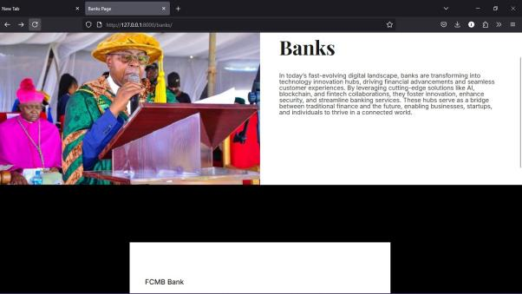

Figure 1.19 Banks Figure 1.20 Articles

4.11 GO-UNI TIH CONTACT SECTION
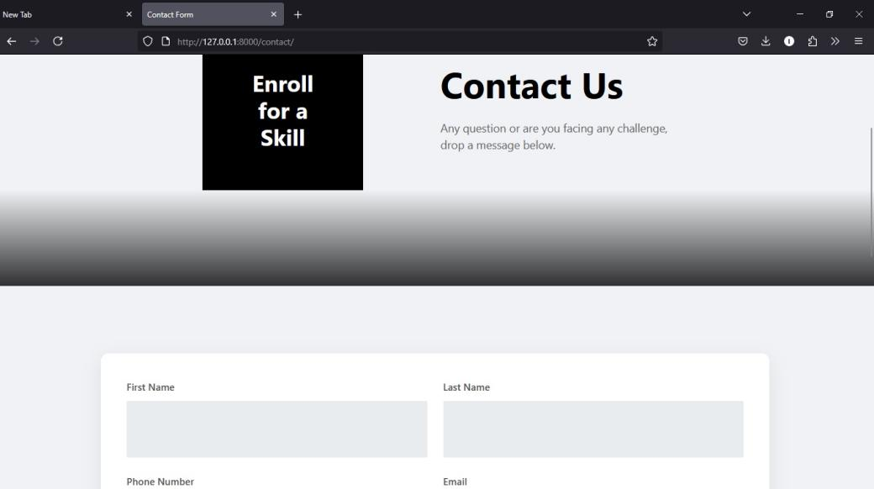
The Contact Section of the GO-UNI TIH interface gives the user a convenient place where they can easily get the contact information, submit a question, specify the tech skill to learn, get in touch with the support. It also has got a basic contact form, which makes it easy to users to contact or seek help whenever necessary.

Figure 1.21 Contact

CHAPTER FIVE
SUMMARY, RECOMMENDATIONS AND CONCLUSION

5.1 OVERVIEW
This chapter of this research work will give detailed summary of this project, future works recommendation and conclusion of this research work. This chapter however comes with a summary of all that has been said in all the chapters of this project.
5.2 SUMMARY
When this research work was first conceived, the background of the study was clearly discussed together with the problem statement with which this research work is associated. But in the subsequent chapters of this research work, the theoretical background of study of this research work was described and the available systems that are related with this work was also discussed. An analysis of existing systems was also clearly stated in this research work and so were the limitations of these existing systems hence this research work attempted to make the most of these existing issues and developed the system proposed in this research work keeping these existing issues in mind. In addition to this a detailed system analysis was performed on the third chapter of this research work using the UML diagrams; the use case diagrams, activity diagrams, the class diagrams and the class diagrams of the UML diagrams were particularly applied in the system analysis. Lastly, all the programming languages and frameworks in which this project was implemented were mentioned and the user interface description was mentioned as well.
5.3 RECOMMENDATIONS
This technology innovation platform is recommended to all students of Godfrey Okoye University specifically for computer science students as it stands to offer features that are unique to the specific needs and preferences of the Godfrey Okoye University student like the innovation improvements and recognition of the institution.
5.4 CONCLUSION
At last we have reached the final stages of this research because this part of this research work will serve to sum up the objectives that were set out in this research work. The system however managed to acquire a better user interface, user authentication was acquired through python(Django) which aided in enhancing the security of the users, good image and video compression was implemented which overall increased the speed of the application.

REFERENCES
History of technology is a history of human intelligence and the incessant desire to find solutions to challenges and better the living condition through innovation. It covers the first stone tools to the complex modern digital technologies. Ceruzzi, P. E. (2003). A History of Modern Computing. MIT Press.
A customized virtual classroom for Godfrey Okoye University. In the website a lecturer can create a virtual classroom for each course in the platform developed by the ICT Unit of Godfrey Okoye University. Students are given a short guideline on how to log in and use the beautiful platform. The guideline is also available on the university website. It enables lecturers to record each lecture; it allows multiple lectures to go on simultaneously without any technical hiccups. Designed and developed by Ag. Director, Mr. Chinedu Chibuzo (2025).
Technology Innovation Hubs in Nigerian Universities which presents the major difficulties in the establishment of innovation hubs in Nigerian institutions such as funding, infrastructure, and human capital. Built by Osunade, O.et al. (2017).
University Innovation Portal which details a university innovation portal case-study with simple features like project-submission, mentor-matching, and collaborations tools. Designed and implemented by Nwachukwu, A. (2021).

APPENDIX
<!DOCTYPE html>
<html lang="en">
<head>
<meta charset="UTF-8">
<meta name="viewport" content="width=device-width, initial-scale=1.0">
<title>Document</title>
<link rel="stylesheet" href="./index.css">
<script src="https://cdn.jsdelivr.net/npm/chart.js"></script>
</head>
<body>
<!DOCTYPE html>
<html lang="en">
<head>
<meta charset="UTF-8">
<meta name="viewport" content="width=device-width, initial-scale=1.0">
<title>Document</title>
<link rel="stylesheet" href="./index.css">

</head>
<body>
<button class="menu-toggle">Gouni Tech Innovation Hub ☰</button>
<div class="container">
<aside>
<div class="aside-container">
<div class="profileDiv">
<div class="imgDiv">
<img src="../cc29be2349daa9316aea48f777a443de49319266.jpg" alt="">
</div>
<p class="userName">King Jnrhhhdhdhdhh</p>
</div>

<div class="menu">
<ul>
<li>Account</li>
<li>Home</li>
<li>Research</li>
<li>Business</li>
<li>Contact</li>
<li>Setting</li>
<li>Logout</li>
</ul>
</div>
</div>
</aside>

