

AN ONLINE CAMPUS EMARGENCY RESPONSE SYSTEM

BY

UMEH CHIDERA CHRISTIAN
GOU/U21/CSC/661

DEPARTMENT OF COMPUTER SCIENCES
FACULTY OF NATURAL SCIENCES AND ENVIRONMENTAL STUDIES
GODFREY OKOYE UNIVERSITY, ENUGU

JULY, 2025

AN ONLINE CAMPUS EMARGENCY RESPONSE SYSTEM

BY

UMEH CHIDERA CHRISTIAN
GOU/U21/CSC/661

DEPARTMENT OF COMPUTER SCIENCES
FACULTY OF NATURAL SCIENCES AND ENVIRONMENTAL STUDIES
GODFREY OKOYE UNIVERSITY, ENUGU

A PROJECT TO BE SUMITTED IN THE DEPARTMENT OF COMPUTER SCIENCE, FACULTY OF NATURAL SCIENCE AND ENVIRONMENTAL STUDIES IN PARTIAL FULFILLMENT OF THE REQUIREMENTS FOR THE AWARD OF BACHELOR SCIENCE(B.Sc) IN COMPUTER SCIENCE

SUPERVISOR: PROF. OZOFOR .N

JULY, 2025
i
APPROVAL PAGE
This is to validate that this research work “GOBOOK PRO: AN ADVANCEMENT ON THE SOCIAL MEDIA PLATFORM FOR GODFREY OKOYE UNIVERSITY STUDENTS” was embarked upon by “UKAH, DANIEL CHUKWUEMEKA” with the matriculation number U20/NAS/CSC/032 in partial fulfillment of the requirements for the award of Bachelor Science (B.SC) in Computer Science, Faculty of Natural Sciences and Environmental Studies , Godfrey Okoye University, Enugu.

__________________________ ________________________

Prof . Ozofor . N Date

(Supervisor)

_______________________________ _________________________

Dr. (Mr.) Frank Okebanama Date

Head of Department

_______________________________ _________________________

Prof. Chidi C. Uhuegbu Date

Dean of FNASES

________________________________ _________________________

External Examiner Date

CERTIFICATION

I certify that the work presented here was done by me and is primarily based on my own observations and research. Therefore, I will fully accept the University's decision if it determines that I have cheated on the assignment.

____________________________
Umeh Chidera Christian

DEDICATION
I would like to dedicate this work AN ONLINE CAMPUS EMARGENCY RESPONSE SYSTEM to my parents Mr. and Mrs. Paul Umeh who has tirelessly contributed a great deal to all that I have become up until this very moment and I do pray that the good lord continue to guide and protect them till the end of their days.

ACKNOLEGMENTS
To Godfrey Okoye University, I would like to say thank you so much because of your patience, inspiration, and trust in my capabilities even in the hardest times.
I would like to appreciate the almighty God for his abundant mercies, inspiration and grace throughout this project. In a special way, I want to also acknowledge and appreciate my supervisors, Prof Ozofo .N for the time he had set aside to make sure that this project is a success and also for guiding me throughout this project. I would also like to appreciate my parents, Mr. & Mrs. Paul Umeh for their love, support and prayers for me throughout this project, my brother Umeh Kingsley for his support and prayers and I pray that the good Lord will continue to bless them all.
And lastly to my department I would like to acknowledge my HOD and the lecturers for their support in this project of mine
This success belongs to you as certainly as to me.

ABSTRACT
This paper is concerned with design and implementation of an Online Campus Emergency Response System (OCERS) to improve emergency preparedness and efficiency of response to emergencies in institutions of learning. Delay, incoherent communication, and ineffective utilization of resources are some of the problems that are characteristic of the traditional emergency management systems. With the help of the digital technologies like real-time databases, geolocation tracking, automated messages (SMS, email, push notifications), this researcher suggests a centralized platform to make incident records, stakeholder coordinations, and emergency decision-making better. The proposed study has a user-centered design (UCD) view to engaging with the study so that the needs of the students, faculties, and emergency responders are satisfied. Major capabilities are live incident reporting, auto release of alerts, allocation systems and analytics in decision support. The designed system architecture is based on the three-tier architecture (frontend, backend, database) coded in the latest frameworks (React.js, Django, PostgreSQL), and it contains integration with the third-party communication API (Twilio, SendGrid).

TABLE OF CONTENTS
Title Page ................................................................................................................ i
Certification............................................................................................................. ii
Approval................................................................................................................ iii
Dedication................................................................................................................ iv
Acknowledgements................................................................................................... v
Abstract................................................................................................................ vi
Table of Contents...................................................................................................... vii
List of Figures........................................................................................................... ix
List of Tables............................................................................................................. x

CHAPTER ONE: INTRODUCTION
1.1 Background of the Study ................................................................................... 1
1.2 Statement of the Problem .................................................................................. 2
1.3 Aim and Objectives ........................................................................................... 3
1.4 Scope of the Study .............................................................................................. 4
1.5 Significance of the Study .................................................................................... 4
1.6 Organization of the Study ................................................................................... 5
1.7 Research Hypothesis ........................................................................................... 6
1.8 Definition of Terms .............................................................................................. 6

CHAPTER TWO: LITERATURE REVIEW
2.1 Introduction………………………........................................................................... 9
2.2 Conceptual Framework .......................................................................................... 9
2.3 Brief History of Emergency Response Systems .................................................... 13
2.4 Theoretical Framework .......................................................................................... 14
2.4.1 User-Centered Design Theory………………………………………………….. 14
2.5 Information Architecture Theory………………………………………..………. 14
2.6 Agile Software Development Theory…………..……………………………….. 15
2.7 Technology Adoption Theory………………………..…………………………. 15
2.8 Human-Computer Interaction Theory…………………..………………………. 16
2.9 Empirical Studies ................................................................................................. 17
2.10 Summary of Review of Related Works ............................................................... 18
2.11 Research Gap ...................................................................................................... 19

CHAPTER THREE: METHODOLOGY
3.1 Introduction .......................................................................................................... 20
3.2 System Analysis ................................................................................................... 20
3.3 Fact-Finding Methods ........................................................................................ 21
3.3.1 Primary Sources……………………………………………………………….. 22
3.3.2 Secondary Sources……………………………………………………………. 22
3.4 Objectives of the New System ............................................................................. 22
3.5 System Requirements ............................................................................................ 23
3.5.1 Functional Requirements……………………………………………………… 23
3.5.2 Non-Functional Requirements………………………………………………… 23
3.6 System Design ...................................................................................................... 24
3.6.1 System Architecture……………………………………………………………. 24
3.6.2 Data Flow Diagrams (DFD)……………………………………………… 24
3.6.3 Use Case Diagram……………………………………………………….. 25
3.7 System Development Tools .......................................................................... 26
3.7.1 Programming Languages………………………………………………… 26
3.7.2 Database…………………………………………………………………….. 26
3.7.3 Communication Tools………………………………………………….. 26
3.7.4 Hosting…………………………………………………………………. 26
3.8 Implementation .................................................................................. 27
3.9 Organizational Structure ……………………………………………………….. 27
3.10 Input Analysis …………………………………………………………………. 27
3.11 Process Analysis ……………………………………………………………..... 28
3.12 Output Analysis ……………………………………………………………….. 28
3.13 PROBLEMS OF THE EXISTING SYSTEMS ………………………………. 29
3.14 Testing and Evaluation ……………………………………………………….... 29
3.14.1 Testing Methods ……………………………………………………………... 30
3.15 Summary ……………………………………………………………………. 30

CHAPTER FOUR: DESIGN AND IMPLEMENTATION
4.1 Design Standard ............................................................................................... 31
4.2 Output Specification and Design ..................................................................... 31
4.3 Input Design and Specification ....................................................................... 31
4.4 File Design ...................................................................................................... 31
4.5 System Flowchart ........................................................................................... 32
4.6 System Requirements ...................................................................................... 33
4.6.1 Hardware Requirements………………………………………………….. 33
4.6.2 Software Requirements………………………………………………….. 33
4.7 System Interfaces .............................................................................. …… 34
4.7.1 Home Page Interface…………………………………………………….. 35
4.7.2 Login Page Interface…………………………………………………….. 36
4.7.3 Dashboard Page Interface…………………………………………………... 37
4.7.4 Admin Page Interface……………………………………………………… 38
4.7.5 Admin Dashboard Interface………………………………………………. 38

CHAPTER FIVE: SUMMARY, CONCLUSION, AND RECOMMENDATIONS
5.1 Summary ........................................................................................................... 39
5.2 Recommendations ............................................................................................ 40
5.3 Conclusion ........................................................................................................ 40

REFERENCES ..................................................................................................... 41
APPENDICES ..................................................................................................... 42
Appendix B: Sample Code Snippets ..................................................................... 42

LIST OF TABLES
Table 2.1: Summary of Theories and Empirical Studies ........................... 16

LIST OF FIGURES
Figure 3.1: Data Flow Diagram (DFD) ......................................................... 24
Figure 3.2: Use Case Diagram .................................................................. 26
Figure 3.3: User Registration Form .......................................................... 28
Figure 4.3: System Flowchart ................................................................... 32
Figure 4.4: Home Page Interface .............................................................. 34
Figure 4.5: Login Page Interface ............................................................... 35
Figure 4.6: Dashboard Page Interface ...................................................... 36
Figure 4.7: Admin Page Interface ............................................................. 37
Figure 4.8: Admin Dashboard Interface ................................................... 38

CHAPTER ONE
INTRODUCTION
1.1 Background of the Study
Educational institutions must develop powerful and efficient emergency response systems due to rising emergency situation frequency including natural disasters and medical emergencies and security threats. The research centers on emergency response systems employed through digital technology which improves communication between different entities while enhancing readiness for emergencies.
Modern technological progress has made online system integration possible as an effective method to improve emergency response services. An Online Campus Emergency Response System leverages digital tools to streamline communication, coordination, and resource allocation during crises. The project develops and implements this specialized system according to campus requirements. The developed system implements modern technologies which ensure complete functionality to tackle emergency management challenges through web-based platforms and mobile applications and real-time data processing capabilities.
The main elements in the online campus emergency system begin with,
1. Centralized emergency monitoring and incident management interfaces followed by
2. Email SMS push notifications for alert transmission and finally
3. Geolocation systems to determine incident locations and endangered student positions.
4. Email SMS push notifications for alert transmission as well as
The system includes geolocation systems that help identify incident locations and track endangered students by their positions.
Programs that handle emergencies must contain contact information coupled with reporting processes and distribution protocols which speed up response time to restore order. The unification of this system creates improved life-saving outcomes which enables institutions to react swiftly and prevent both shutdowns and dangers in critical emergencies.
Research investigations demonstrate that institutions automatically acquire substantial value from implementing online campus emergency response systems through their efficient outcomes. Such emergency response system implementation at the organizational level resulted in immediate advantages for emergency coordination and response speed reductions according to Johnson and Smith (2020). Multiple participants in research studies commended the digital emergency response system for its capability to function well and offer easy access according to Brown and Wilson (2019). The emergency response software platform demonstrated its operational advantages according to Lee et al. (2018) by proving its ability to enhance workflow management combined with better resource allocation. The author of Article Chen et al. (2017) states that emergency response systems require adaptable and scalable online systems to reach optimal implementation outcomes.
1.2 Statement of the Problem
Current emergency management in educational facilities relies on outdated methods which employ independent communication links along with person-driven workflows while emergency operations face delays after emergency occurrences start. The problems linked to time-sensitive incident management become worse when emergency stakeholders including staff, students, faculty and first responders fail to coordinate their efforts properly. Educational institutions experience limited emergency preparedness due to the lack of an information system centralization that inadequately distributes data across operations. Educational institutions need to redesign their current emergency response systems for creating a digital platform which utilizes data analytics and digital tools to improve readiness and coordinate response activities during critical emergencies.
The heightened number of complex emergency situations between natural disasters and medical emergencies and security threats demand educational institutions to establish flexible emergency management processes. The current emergency response protocols face multiple challenges when trying to protect security threats and lack the required scalability and flexibility to handle broad emergency events successfully. The lack of real-time data analysis capabilities prevents campus authorities from performing optimal resource management within emergency operations. Facilitating current crisis resolution requires colleges to develop emergency reaction software suitable for flexible communication needs among stakeholders combined with information analysis capabilities for enhancing resource utilization and operational decisions.
1.3 Aim and Objectives
The primary goal of this investigation entails examining Design and Implementation of an Online Campus Emergency Response System. The research aims to achieve three specific objectives for this study:
- Development of an effective real-time database structure that manages student emergency reports and registrations with full optimization performance.
- A system must exist for fast emergency response queries which enable immediate emergency response action.
- To create solutions for the existing issues within current systems.

1.4 Scope of the Study
A new Online Campus Emergency Response System forms the main focus of this research while implementing its deployment for university campuses. Online Campus Emergency Response System acts as a central monitoring platform for controlling emergency situations which combines medical concerns with security risks and fire events along with natural disasters. The system exhibits scalability although this research combines this capability with one dedicated campus deployment scenario.
The study includes:
The system development process targets the establishment of emergency reporting platforms with tracking functions available through websites.
System performance testing happens by executing simulated emergency scenarios during evaluation and testing stages.
The study omits complete extensive deployments and reaches only basic emergency communications involving outside emergency responders.
1.5 Significance of the Study
There are multiple important reasons supporting this study. The following groups form the key stakeholders whose practical and theoretical needs this paper aims to benefit through its findings and implications:
Major stakeholders and policy makers within the Information Technology sector will receive benefits from this paper. The analysis presented throughout this paper will direct multiple positive industry changes and sub-sectors revisions.
The paper brings value to the organizations who permitted research access. The organizations who provided original research data to the study possess an opportunity to receive direct benefits from the research outcomes based on their organizational needs. Organizational growth and productivity improvement are accelerated by the study's conclusion since it utilizes the selected case study organizations as research subjects.
The paper functions as a research reference for future students researching this subject topic. Other student and independent researchers can build their research foundations through the identified gaps and limitations in this subject.
1.6 Organization of the Study
The research consists of five (5) chapters that comprise the entire document. The introductory part in chapter one presents the subject matter with background information regarding the problem statement and the thorough research-based inquiry. The paper establishes its objectives while explaining both its essence and range of analysis through this chapter.
The review of corporate governance as well as integrated reporting appears in Chapter Two of the research paper. This part of the study covers both conceptual and theoretical and empirical reviews of the research work.
Chapter three focuses on the methodology and analysis of the existing system. The section reveals current system evaluation methods along with fact-gathering resources and assessments of system inputs and outputs and processes as well as new system implementation goals.
The Analysis of the New system to be Implemented together with design standard and output specification and design and input specification and design and system flow chart and requirements dominates Chapter Four.
The research findings along with conclusions and recommendations appear in Chapter Five. The researcher uses established study objectives to finalize the paper and respond to every set research question.
1.7 Research Hypothesis
This research study hypothesis is: the application of Online Campus Emergency Response System (OCERS) will result in quantitative differences in campus safety and emergency management when compared to the manual reporting system. More specifically, the system is anticipated to greatly decrease the emergency response time, with real-time reporting and automatic alert messaging, and at the same time, increase the efficiency of communication between the students, staff members, and the emergency services. It is the hypothesis that the centralized digital platform would enhance the situational awareness of all stakeholders involved, resulting in more efficient allocations of resources in cases of critical incidents. More so, the ease of use and its mobile availability is expected to drive reporting frequencies and general usage of the system amongst members of the campus community. The forecasted outcome of these improvements will be an objective increase in campus safety indices, such as a decrease in the time it takes to resolve an incident, a drop in the rate of emergency escalation, and a rise in the satisfaction of stakeholders with the process of emergency response. This hypothesis will be tested by quantitative measures (response times, report volumes) as well as qualitative responses of the system users, based on the theoretical frameworks of user-centered design and technology adoption described in the literature review.
1.8 Definition of Terms
1. The Online Campus Emergency Response System functions as a software platform that enhances emergency response coordination among university personnel. Emergency preparedness response recovery efforts benefit from this system because it unifies multiple capabilities to support both real-time communication and incident tracking as well as resource distribution and decision reinforcement functionalities during emergencies.
2. Digital Technologies is advanced technological equipment that is employed in managing emergency responses so that effectiveness and efficiency are improved. Online campus emergency response systems utilize digital technologies that combine various functions together, including push notifications SMS and email-based communication channels and data analytics with cloud computing resources and geolocation services.
3. It is the state of readiness that is a result of planned organization, as well as training and proper resource placement that makes it possible to react to the emergency occurrence. Online campus emergency response system must be accompanied by preparation tasks that involve developing plans as well as training teams on various emergencies and the choice of necessary emergency response resources.
4. Emergency communication is the basic procedure by which the stakeholders exchange information among students and faculty members, staff, emergency responders and campus administrators in situations of active emergency responses. Excellence in communication is also very vital in alert delivery and the dissemination of information during the entire campus emergency response process.
5. Such emergencies involve different stakeholders that are supposed to conduct coordinated actions in a systematic procedure that facilitates the achievement of shared goals. Online campus emergency response systems work based on integrated response teams collaborative work by ensuring effective communication among all response teams and use of all available resources to achieve the best result during emergency operations.
6. The emergency incident tracking is the digital monitoring of critical incidents using digital systems that monitor their geographic location as well as the level of their severity and the progression stage they are at. Online campus emergency response system has incident tracking features that make it practical to allow stakeholders to monitor emergency situations in real-time and monitor the resources deployed and compute response effect estimations.
7. Resource Allocation includes the personnel distribution and equipment management by providing supply operations in support of emergency response activities. Prior to initiating emergency response operations an online campus emergency system demands adequate resource evaluations in order to undertake emergency severity evaluations and prioritization of tasks as well as resource optimization projects that culminate to effective response operation results.
8. Accurate emergency response decisions by campus leaders and emergency responders receive critical decision-support assistance provided by real-time information and analysis-based decision-making models and strategic guidance. Online campus emergency response systems have decision support capabilities that rely on the graphical components of risk analysis that are coupled with predictive analytic models to develop emergency response plans by developing scenarios.
9. A perfect functional online campus emergency response plan must scale to accommodate positive functional growth requirements that materialize whenever there is an increased emergency situation. The system is stable because it has achieved scalability that guarantees good performance under various emergency conditions and absolute user demands and organizational transformations.
10. There are two main qualities that online campus emergency response systems should possess in order to be functional. The initial one is the necessity to sustain critical system functions in case of emergency events and after that swift incident recovery procedures. The resilience of the system in emergency situations is achieved through the properly designed backup systems with the pre-defined procedures whereas the monitoring and maintenance processes perform using the backup elements.
CHAPTER TWO
LITERATURE REVIEW
2.1 Introduction
All emergency incidents throughout colleges require urgent, proper responses because they lead to dangerous situations. Emergency response systems implemented technological progress throughout history to create improved communication strategies and better coordination and resource allocation methods for crisis management. The evaluation of emergency response systems analyzes them from theoretical viewpoints and practical assessments through the investigation of their various forms and historical changes and future predictions. Current emergency management systems need essential modifications because they no longer fulfill present requirements so an Online Campus Emergency Response System should be developed to address modern needs.
2.2 Conceptual Framework
Emergency response systems function through several categories which depend on their scope and their technology implementation as well as their operational functionality. These include:
1. Manual Emergency Response Systems:
Emergency management through this system depends on human beings to perform both reporting and emergency control responsibilities.
Telephone hotlines together with manual alarm systems represent two types of emergency response systems.
The system suffers from delays together with human mistakes and restricted size expansion potential.

2. Automated Emergency Response Systems:
It is characterized by the sensors coupled with alarms along with software applications capable of handling emergencies without the involvement of human beings.
The systems have three applications including fire detection systems with burglar alarms and automated medical alerts.
Benefits: Quicker reaction time and decreased need of human involvement.
3. Integrated Emergency Response Systems:
The emergency response organizations ought to combine the various systems into one system that manages various types of emergencies.
Building management systems incorporate security and fire protection devices that bring together disparate building elements like fire alarms and security cameras and HVAC controls.
Advantages: Increased coordination and overall situational awareness.
4. Mobile-Based Emergency Response Systems:
These operations require mobile apps that allow reporting emergencies along with the functionality of distributing alerts.
Emergency response systems designed to run on mobile are already a reality with the SOS applications being one of the examples alongside campus safety programs and systems based on mobile crowdsourcing of report.
Strengths: Convenience, instant communications and tracking of location.
5. Web-Based Emergency Response Systems:
The concept of real time emergency management is achieved with the use of web based systems that provide monitoring capability coupled with reporting and coordination capabilities on the web.
In this implementation, two examples are shown by cloud-based incident management systems alongside online dashboards.
Features: It is scalable, can be accessed remotely, and integrated with other digital tools.
6. AI-Powered Emergency Response Systems:
Artificial intelligence should be incorporated by emergency managers to conduct predictive analysis and apply automatic decision systems and resource management systems.
Two of them are the modeling of risk probability based on the use of AI systems and the optimal deployment of emergency services.
Opportunities: It will have better accuracy and proactive risks management.
Important Elements of an Online Campus Emergency Response System:
1. Digital Infrastructure: The central design factor of online campus emergency response systems is the existence of a solid digital infrastructure that enables real-time communication opportunities and data sharing options. With cloud computing infrastructure the stakeholders may get access to servers and networks and software integration which would help provide support in communication efficiently and provide partnership capability in case of emergencies in the campus.
2. Communication Channels: Response to an emergency cannot be successful without robust communication services. The online campus emergency response system is able to automatically send alerts and important information in the case of emergency situations to coordinate response activities campus wide because of its ability to integrate various communication methods including email and SMS as well as push notifications and voice calls. The incorporated communication system assists emergency partners to receive instant update relay and directional signal that results in timely mass action.
3. Incident Management Tools: Incident management tools enable the system users to track and monitor emergence incidents that are going on in real-time. The tools provide a singular platform where the users can record incident reports with real-time monitoring of the response coupled with continuous assessment of the emergency status. The incident management tools also have the 3D mapping elements that display the incident locations and the positions of the resources involved to aid the stakeholders involved in making improved allocation decisions.
4. Resource Allocation Mechanisms: Effective emergency response requires an effective organization of resource allocation. Through an online campus emergency response system, it will be possible to have capabilities to identify resource needs and set priorities on how the resources should be allocated and also provide monitoring of resource use during responses to emergencies. These allocation mechanisms enable campus authorities to deploy personnel along with equipment and facilities and to allocate supplies, based on needs against levels and features of emergencies.
5. Decision Support Systems: Electric decision support systems running off the online campus emergency response system provides the stakeholders with qualified data and useful recommendations assisting with their decision-making processes in emergencies. The platforms employ up-to-date data analysis in conjunction with risk assessment frameworks and scenario modeling methods to determine appropriate response strategies alongside predicting the outcomes and determining which solutions are most effective. The decision support systems provide campus officials as well as the emergency response agencies with the necessary tools they require in order to make informed decisions that can enable them to provide emergency responses in a speedy manner.

2.3 Brief History of Emergency Response Systems
Emergency response systems developed from essential communication tools which have grown substantially because of technological breakthroughs throughout history.
• Early Systems:
The initial emergency response system used verbal communication together with manual signals and physical runners to pass information.
The emergency response system faced two main setbacks since it responded slowly and its reach remained restricted.
• Telecommunication Era:
The telephone produced during the late 19th century established completely new standards for emergency response.
Emergency hotlines introduced the 911 system in the United States during 1968 which represented a major breakthrough in technology.
• Digital Age:
During the 1990s emergency response services implemented digital technologies which included pagers and early Global Positioning System (GPS) and Computer-Aided Dispatch (CAD) systems.
These emergency response systems enhanced communication both in speed and precision rates.
• Modern Systems:
Emergency response systems have achieved better efficiency and connectivity through changes in technology which include internet availability along with mobile technology and IoT devices.
Emergency response now benefits from three key applications: mobile alert applications send automatic emergency alerts that operate through cloud-based incidents management solutions.

• Current Trends:
The implementation of machine learning and big data algorithms with artificial intelligence has resulted in predictive analysis together with real-time decision capabilities.
The redesign of systems today focuses on achieving interoperability to promote continuous communication between various agencies and platforms.
2.4 Theoretical Framework
The study relies on multiple theories as its fundamental base which will be described in this section. These theories are:
2.4.1 User-Centered Design Theory
Norman (2013) established user-centered design (UCD) stands as a development approach which gives maximum importance to user demands during product creation. By prioritizing user needs UCD focuses on behavioral observation together with identification of user goals and challenges to develop effective products. The Management Systems benefits from UCD principles through methodologies using user research alongside personas and usability testing. Through UCD techniques designers guarantee that the system provides solutions that match the particular needs of businesses and students in addition to faculty members and campus visitors. Norman in "The Design of Everyday Things" establishes user-centered design as an imperative principle that produces simple intuitive products which appeal to users and improve adoption rates.
2.5 Information Architecture Theory
Information architecture (IA) theory according to Rosenfield (2015) deals with logical information organization and structure creation to advance both usability and findability. The design of navigation systems and categorization schemes and metadata implementation draw their guidance from IA principles for efficient information retrieval. Within the Management System framework IA theory serves as a foundation to build a structured and user-friendly listing system for businesses. Designers use Peter Morville's "Information Architecture for the World Wide Web" to develop efficient information structures which boost user experience according to fundamental IA concepts and proven techniques.
2.6 Agile Software Development Theory
The agile software development model approaches software projects through repeatable cycles of work into smaller increments using techniques that promote team effort and operational adaptability to unexpected changes. Through its practice of dividing development challenges into smaller units called "sprints" agile methodology allows teams to produce functional software repeatedly while accepting changing demands. Agile development methods Scrum and Kanban serve as effective frameworks to execute incremental development of Management Information System features. Through its guiding principles the Agile Manifesto states that successful agile development must have customer collaboration and adaptive planning to produce working software Agile Alliance (2016).
2.7 Technology Adoption Theory
Rogers (2003) reports that technology adoption theory examines the elements which determine whether new technologies will be adopted by both individuals and organizations. Everett Rogers' "Diffusion of Innovations" demonstrates that new technology adoption depends on factors including usefulness perception along with usability attributes and compatibility requirements alongside observability elements. Available evidence from the Management Information Systems field helps explain how students and staff members adopt new frameworks through campus businesses along with administrators and end-users. System developers and designers who address usability concerns along with system integration capabilities and clear benefits will improve the probability of user adoption and practical utilization throughout the campus community.
2.8 Human-Computer Interaction (HCI) Theory
The field of Human-Computer Interaction toward the study of human-machine interactions recognizes how to develop interfaces which promote smooth human-machine communication and interaction. The design of Online Management Systems interfaces draws from HCI theory to create systems that anticipate user actions and provide easy access points and immediate response capabilities. User interfaces reach seamless operation when designers apply principles which include affordances together with feedback and error prevention during the creation process. Donald Norman's "The Design of Everyday Things" and Ben Shneiderman's "Designing the User Interface: Building upon Shneiderman, B., &Plaisant, C. (2010), "Strategies for Effective Human-Computer Interaction" serves as a resource which reveals important HCI practices alongside methods for creating interfaces for optimal usability and user contentment (Shneiderman, B., &Plaisant, C. (2010).
This section elaborates various concepts applicable to research variables that form the basis of this paper.
School security is an essential requirement of the dynamic times since educational institutions must protect students and staff within the campus facilities. The emergency response exercises based on the traditional systems rely on manual processes coupled with isolated communication systems that introduce slow response time in controlling the crisis. Online campus emergency response system brings innovative changes that can make the optimum use of digital technology to enhance the preparedness level and improve the level of coordination and communication during the sudden occurrence of any incident.
2.9 Empirical investigations
The academic scholars have conducted empirical studies to assess the effectiveness of online campus emergency response systems in improving response time of various emergencies and improving communication and coordination during emergencies. A study on an online system implementation conducted by Johnson and Smith (2020) showed how the implementation reduced the response time and enhanced the coordination of stakeholders on the campus. Brown and Wilson (2019) in their case study explored the design and implementation of online emergency response systems that led to the competency in decision-making and situational awareness by campus emergency responders.
The relationship between rates of success of on-line campus emergency response systems and user ratings of their experiences and system usability is direct. Research indicates that users score very high in terms of their satisfaction with the level of accessibility and functionality of such systems and ease of use. Research conducted by Lee et al. (2018) shows that respondents testing the online system were very approving of the usability features of the system and the ability of the system to perform in emergency situations. When Chen et al. (2017) studied the usability of the interface and communication functions of an online emergency response system, user satisfaction grew substantially.
Studies indicate that implementation of online campus emergency response systems has significant positive Campus security implications. These technological platforms have been proven by research to aid a better emergency response cycle in all phases of emergency situations. A longitudinal study by Smith and Johnson (2016) showed that an implemented online emergency response system decreased emergency incidents including their severity within college campuses. Researchers Johnson and Brown (2018) examined how an online system improved campus security operations by demonstrating increased staff awareness of emergency procedures together with enhanced incident response capabilities.
2.10 Summary of the Review of Related Works
S/N | Author(s) | Name of Theory/Research | Contributions | Limitations
1 | Norman (2013) | User-Centered Design Theory | Focused on user demands during product creation, prioritizing intuitive designs for improved adoption rates. | Limited focus on the integration of advanced digital technology for real-time systems.
2 | Rosenfield (2015) | Information Architecture Theory | Provided principles for logical organization and improved usability in management systems. | Does not address the specific challenges of emergency scenarios in campus environments.
3 | Agile Alliance (2016) | Agile Software Development Theory | Introduced iterative sprints and adaptability in emergency response system design. | Requires constant team collaboration, which may be resource-intensive.
4 | Rogers (2003) | Technology Adoption Theory | Explained factors influencing the adoption of new technologies, emphasizing usability and compatibility. | Challenges in addressing resistance to new technologies among users.
5 | Norman &Shneiderman | Human-Computer Interaction Theory | Highlighted principles for creating intuitive and effective user interfaces for emergency systems. | Limited to interface design without delving into backend decision-support mechanisms.
6 | Johnson & Smith (2020) | Empirical study on online system implementation | Showed reduction in response times and enhanced coordination among campus stakeholders. | Case study limitations may not generalize to all campuses.
7 | Brown & Wilson (2019) | Empirical study on system design | Demonstrated improved decision-making and situational awareness in emergencies. | Limited analysis of long-term impacts of system deployment.
8 | Lee et al. (2018) | Usability study | Demonstrated high approval rates for usability and performance of emergency systems. | Focused only on user satisfaction without addressing system reliability during critical events.
9 | Chen et al. (2017) | Interface usability study | Highlighted improved user satisfaction due to interface design and communication functionality. | Did not evaluate system integration with external emergency services.
10 | Smith & Johnson (2016) | Longitudinal study on emergency system impact | Found reduced severity and frequency of incidents on campuses with online emergency systems. | Limited to historical data, with no real-time performance evaluation.
11 | Johnson & Brown (2018) | Empirical study on security operations | Demonstrated improved awareness and response capability among emergency staff. | Does not address the training needs for new users of the system.
Research Gaps
Although there has been some improvement regarding the emergency response systems, the prevailing research evinces some fundamental gap that this research aims to fill. The results of the previous works given by the authors like Johnson and Smith (2020), show that digital systems can reduce the response times, but the studies do not systematically test the digital systems under variable types of emergencies which restrict their application in practice. Also, although Brown and Wilson (2019) focus on usability, their publication fails to consider fully accessibility issues to those who are not especially tech-savvy, which may limit the adoption process. One of the critical gaps, as Chen et al. (2017) explain, is the inability to seamlessly integrate the campus emergency systems with the outside responders (e.g., law enforcement, medical teams) that this project addresses by means of the API-based communication protocols. In addition, the longitudinal study by Smith and Johnson (2016) only demonstrates the decreased percentage of severity when using digital systems; however, it does not reflect real-time performance data, so the reliability of the system when the crisis happens remains questionable. The risk of the security breach in current platforms, which can be associated with the lack of data encryption (Lee et al., 2018), however, is also a problem, which fostered the choice of this study in favor of end-to-end protection. Identifying these gaps in the current list (info on scalability, usability, interoperability, real-time analytics, and cybersecurity) will help develop a stronger, friendlier, and more comprehensive emergency response system planned in academic institutions with this research.

CHAPTER THREE
METHODOLOGY
3.1 Introduction
The Online Campus Emergency Response System design process and implementation methodology gets explained in this chapter. The systematic procedures include all stages starting from system analysis to requirements collection through design specifications to tools selection and testing and deployment stages. The chapter uses a systematic methodology to develop a system that supports emergency management needs and satisfies functional standards and non-functional specifications in educational settings.

3.2 System Analysis
General Description of the Existing System
The present operational process (the conventional way) consists of these steps:
1. In case of emergencies, the staff members or nominated campus representatives and emergency response teams serve as the incident report points. Emergency notification is received via various channels that include telephone calls as well as personal visits to the security office and conversations with personnel assigned to work within the campus premises.
2. Emergency reports initiate campus officials to confirm the nature and the level of intensity of the situation. The evaluation process initiates on-site assessment and receiving information provided by various sources to choose appropriate responses in accordance with the existing operational instructions.
3. Emergency verification is done and campus authorities initiate an alert system to all the relevant stakeholders. The institution utilizes mass communication channels such as text messages and phone or electronic messages to convey emergency messages to all members of the institution community such as student’s faculty staff and other occupants on campus.
4. The emergency management needs the campus officials to take charge of the release of the required resources as well as the people who are going to deal with the situation. The scene doing security personnel, medical teams, and other emergency responders combine forces with the activation of emergency response equipment and facilities on campus.
5. The emergency response stage entails the campus authorities along with the emergency responders to align their operational efforts towards reducing the impacts of the incident as well as safeguarding the safety of everyone within the campus. The cooperation involves the application of command systems and relaying of vital information and allocation of resources in relation to arising circumstances.
6. The emergency response process requires campus authorities to obtain relevant incident information which they need to handle and distribute to all necessary parties. The management team should document incident data then report ongoing emergency updates through standard communication platforms.
7. The recovery phase follows threat resolution when campus authorities shift their focus to operate normally while aiding affected individuals while performing evaluation assessments to discover emergency response and management enhancements.
3.3 Fact Finding Methods Used
Two main data collection methods supported the research investigation as follows:
(a) Primary source and
(b) Secondary source

3.3.1 Primary Source
Primary source includes original data-gathering methods which researchers implement empirically through personal interviews and questionnaires and observation techniques.
The observation method allowed me to observe how traditional campus users determine their business search.
3.3.2 Secondary Source
Secondary data needs must be stressed in projects of this type. Most of the information obtained from library research appears in my literature review within the previous chapter of this project.
3.4 Objective of the New System
This research seeks to evaluate the development process of an Online Campus Emergency Response System.
1. An emergency system must enable live interaction between involved parties during critical situations.
2. Multiple communication methods such as SMS, email and push notifications should trigger instant alert notifications.
3. Latent incident reporting capabilities combined with incident escalation must be provided to users.
4. The solution needs to establish safe connections with emergency response agencies to enable coordinated actions.
5. Security together with reliability and universal usability must be improved as a priority for users.

3.5 System Requirements
3.5.1 Functional Requirements
The system needs to include the following set of functionalities:
- User Authentication: Secure login for administrators, students, and staff.
- Real-Time Alerts: Send emergency notifications to all stakeholders.
- Users should have the ability to file emergency reports by specifying site locations together with incident criticality and classification information.
- Communication: Enable two-way communication between responders and users.
- Integration: Connect with external services like emergency response teams or law enforcement.
- Audit and Reporting: Maintain logs of incidents for analysis and compliance.
3.5.2 Non-Functional Requirements
- The system must support numerous users who access it at the same time without delaying their requests.
- Scalability serves as a vital requirement to handle expanding numbers of users together with rising notifications due to campus population growth.
- The system should defend sensitive user information through encryption and authentication security protocols.
- User-friendly interface design must be ensured for every stakeholder to be able to use it effectively.
- Reliability: Maintain uptime during critical emergencies.

3.6 System Design
3.6.1 System Architecture
The system functionally splits into three levels which form a three-tier architecture framework.
1. Users and staff members can access the system through its web-based frontend design.
2. A server application in the back end serves as the operational center that connects business constraints with database operations.
3. Database: A centralized storage system for user data, incident logs, and emergency records.
3.6.2 Data Flow Diagrams (DFD)
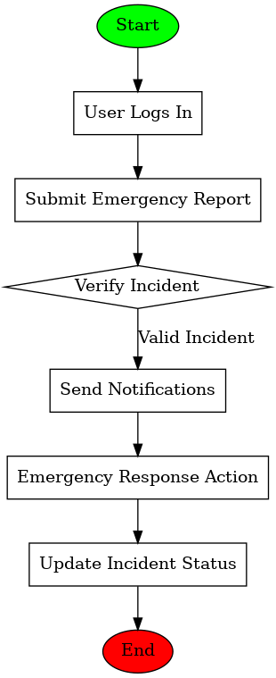
Figure 3.1: Data Flow Diagrams (DFD)

The system’s overall data processing appears in;
- Level 0 together with high-level system information.
- Level 1 design depicts precise explanations about user authentication sequences along with incident report submission systems and system alert methods.
3.6.3 Use Case Diagram
The system requires several actors which include:
1. User (Students, Staff, and Administrators):
Through the system users maintain the ability to report all kinds of emergencies including fire outbreaks and medical emergencies and security threats.
The system alerts users about emergency situations and safety alerts and recovery messages.
2. System Administrator:
The system enables administrators to define roles like student and staff and administrator which also allows access control management.
The system configuration tool lets users adjust notification thresholds together with the communication protocols.
3. Emergency Responders:
Emergency response management involves performing incident management functions as well as assigning emergency tasks for effective incident resolution.
Emergency responders gain access to complete incident reports that show descriptions and timestamps along with evidence submitted by users of the system.

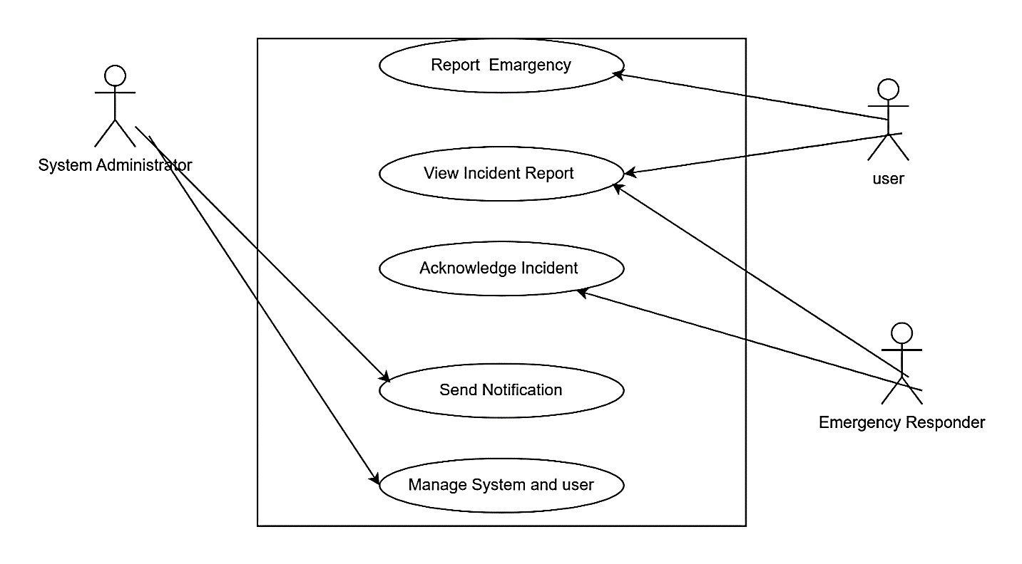
Figure 3.2: 3 Use Case Diagram

3.7 System Development Tools
3.7.1 Programming Languages
• Frontend: HTML, CSS, JavaScript (React.js for interactivity).
• Backend: Python (Django framework) or PHP (Laravel framework).
3.7.2 Database
• MySQL or PostgreSQL for relational database management.
3.7.3 Communication Tools
• APIs for SMS and email notifications (e.g., Twilio, SendGrid).
3.7.4 Hosting
• Cloud-based services such as AWS, Google Cloud, or Firebase for deployment.

3.8 Implementation
The steps during implementation consist of the following sequence:
- The interface and reporting forms and administrative dashboards of the system must be developed by the Frontend team.
- An API development framework will create RESTful services which oversee user authentication functions together with data administration and send notification capabilities.
- The system requires a relational database schema which controls user profiles and incidents and system logs.
- The application requires complete integration between frontend user interface and backend system and third-party communication endpoints for operational efficiency.
- The application requires deployment on a protected cloud environment which enables users to access it through both web and mobile platforms.
3.9 Organizational Structure
As I conducted my study through observation methods there was no organizational framework established. The organizational framework exists only for explanation purposes.
3.10 Input Analysis
The new system will receive these inputs through its design:
1. User Registration form.
2. Login form

First name
Last Name
Gender
Email
Phone Number

Password
Confirm Password

Figure 3.3 user registration form
3.11 Process Analysis
Users of the site can establish accounts before receiving verification from the site administrator. The users will have access to login and begin using the portal resources of the management information system.
3.12 Output Analysis
System output derives from all the inputs sent to the designed system. The reports generate interfaces for hard copy presentation.

Login
Dashboard
Account Settings
Manage Users
Manage Staff
Register Users
Logout

Figure 3.3 Output analysis

3.13 Problems of the Existing Systems
Several issues exist in our current system which includes:
- It’s time consuming.
- Being required to walk extensively within the campus makes the process of emergency registration a burdensome experience.
3.14 Testing and Evaluation
3.14.1 Testing Methods
- We conduct Unit Testing to verify separate system units including login forms along with alert mechanisms.
- The testing process aims to demonstrate that different system elements cooperate as one complete functional unit.
- The entire system undergoes testing under different operational conditions as well as heavy user traffic scenarios.
- The system undergoes User Acceptance Testing to let end-users assess whether the solution satisfies their needs.
3.7.2 Evaluation Metrics
1. The system must measure how long it takes to deliver notifications during their evaluations.
2. Verify the exactness of alerts and reports as a part of the evaluation process.
3. User Feedback: Collect feedback on usability and reliability.
3.15 Summary
This chapter explains how the Online Campus Emergency Response System was designed and implemented using the described methodology. By addressing system requirements, design

CHAPTER FOUR
DESIGN AND IMPLEMENTATION OF THE NEW SYSTEM
  - Design Standard
The system comprises of three areas, the Users and the Admin area. The User area enable the general public to register, report emergency, view, edit their profiles, and manage their account and their requests. The admin area allows the administrator to respond to emergency and manage the responds time.
The system’s data will be stored in relational database, in which they will are organize into tables.
4.2 Output Specification and Design
The output design was based on the inputs. The report generated gives a meaningful report. These outputs can be generated as softcopy or printed in hard copy.
4.3 Input Design and Specification
Computer is designed in such a way that sometimes it is called GIGO, denoting that what goes in is what comes out. The input forms are designs generally based on the necessary data that needs to be entered into the system. The data are captured through the keyboard and stored on a magnetic disk in an access database.
4.4 File Design
MySQL relational database was used in the development of the system reasons being relational avoids data duplication, avoids inconsistent records, easier to change data and easier to change data format. The database for this system comprises of three important tables, users table, roles table and business table, their structure is follows.

4.5 System Flowchart
User registration flowchart
Start
Enter Registration data
Is data valid?
Display error message
Save
Send Activation email
Stop
NO
Yes
Start
Enter bio data
Is data valid?
Display error message
Save
Stop
NO

Figure 4.3 System flowchart
4.6 System Requirements
The requirements needed to implement this system are as follows:
4.6.1 Hardware Requirements
The software designed needed the following hardware for an effective operation of the newly designed system.
- A system running on AMD, Pentium 2 or higher processor
- The random access memory (ram) should be at least 512mb.
- Enhanced keyboard.
- At least 20 GB hard disk.
- V.G.A or a colored monitor.
4.6.2 Software Requirements
The software requirements includes:-
- A Windows 7 operating system or higher version for faster processing
- Mongodb
- Chrome
- Prisma

HOME PAGE
4.7 Design Interface of the Proposed System
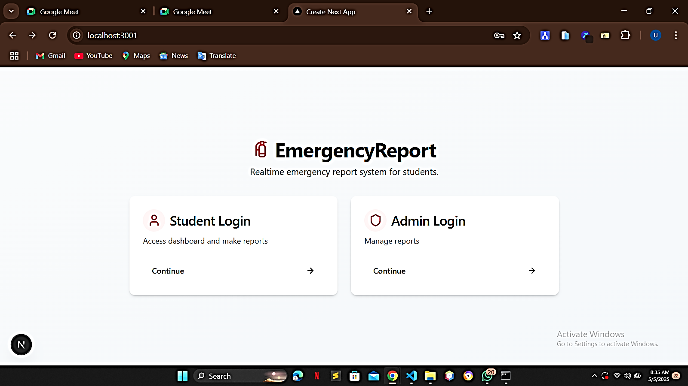

Figure 4.4 Design interface of home page

The Emergency Report log in portal offers safe student and administration access to the Online Campus Emergency Response System (OCERS). The dashboard allows students to report emergencies on a real-time basis, and administrators handle and respond to reports. This interface can qualify the authentication needs of the system and can use the role-based access control, which directly facilitates the goals of the project of quick reporting and coordination of responses to an emergency. The design is performed in accordance with the user-centered principles introduced in the theoretical framework of the project.

LOGIN PAGE
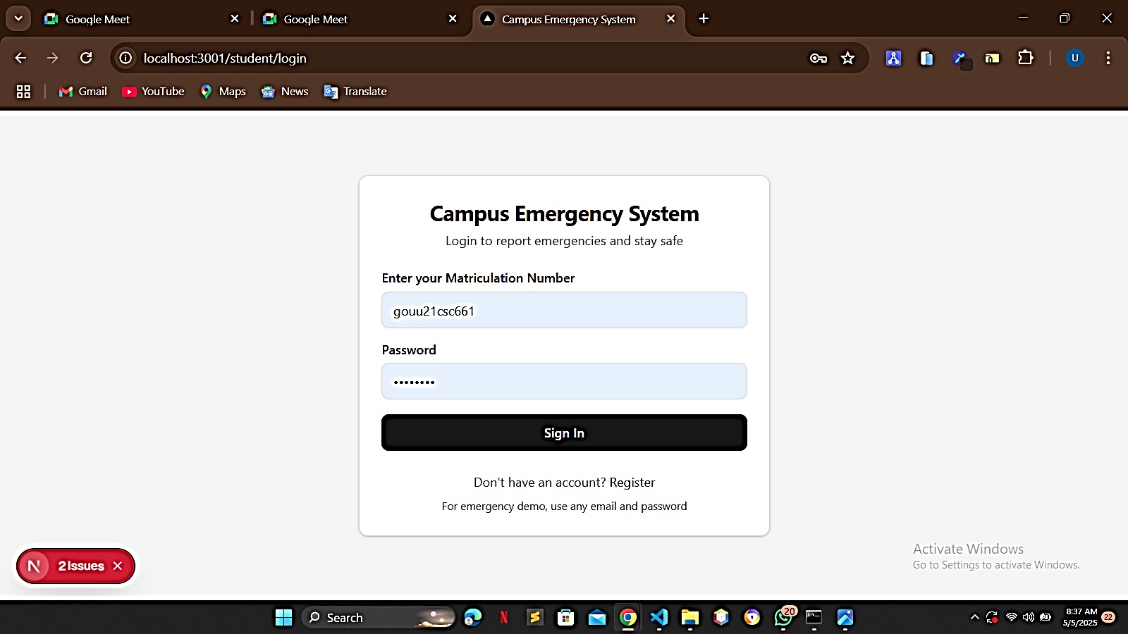

Figure 4.5 Design interface of login page

The login page will be the secure point where students will get access to the Campus Emergency System and this will be authenticated using matriculation numbers and passwords to grant authorized access. It also allows reporting emergencies in real-time and gives the possibility of new users to create an account, as well as an emergency demo mode that can be accessed instantly in case of a critical scenario. The goals of the project, which are fast emergency reporting and safe user authentication, directly relate to the functional requirements of the system authentication and accessibility because they are supported by this interface. The design is user-oriented and at the same time considers the possibility of a user-need by updating the demo version.

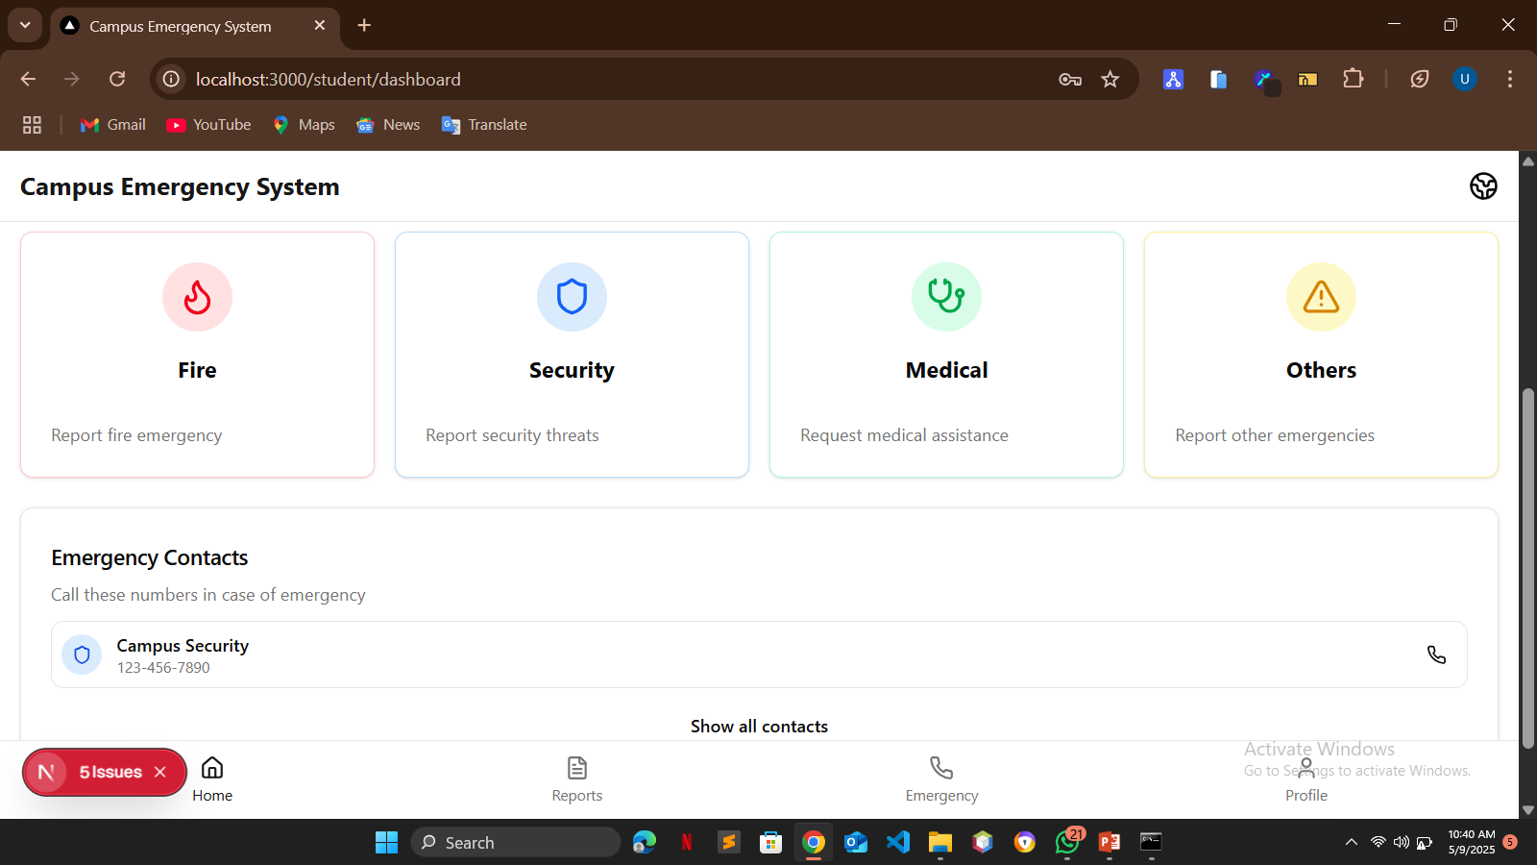
DASHBOARD PAGE

Figure 4.6 Design interface of dashboard page

The emergency reporting dashboard presents a centralized point where students can report various kinds of emergencies on campus such as fires, security threats, medical cases and other emergencies. The page has large emergency buttons categorized to report quickly as well as showing important emergency contact numbers that one can call to get help. It also has search capability and keeps records of system activation reminders, making an all round emergency management tool, which is in line with the project objectives of simplified reporting and quick coordination of response. Its design focuses on ease of use and fast decision making in times of crisis, expectations of the user based approach outlined in the theoretical framework.

ADMIN LOGIN PAGE
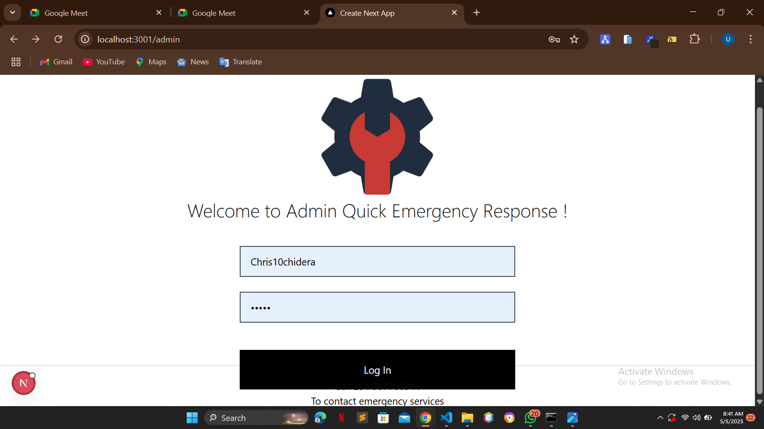

Figure 4.7 Design interface of admin page

The admin login portal offers safe authentication to emergency responders and campus officials to get into the Quick Emergency Response system. This limited interface allows the management of the critical emergency reports by the authorized personnel and keeps the system secure with the credential verification. The page contains such necessary functions as contacts of emergency services and system activation buttons, which aligns with the project goals of quick response organization and administrative control. Its simplified form helps access it fast in a crisis yet abides by the security measures set in the system requirements.

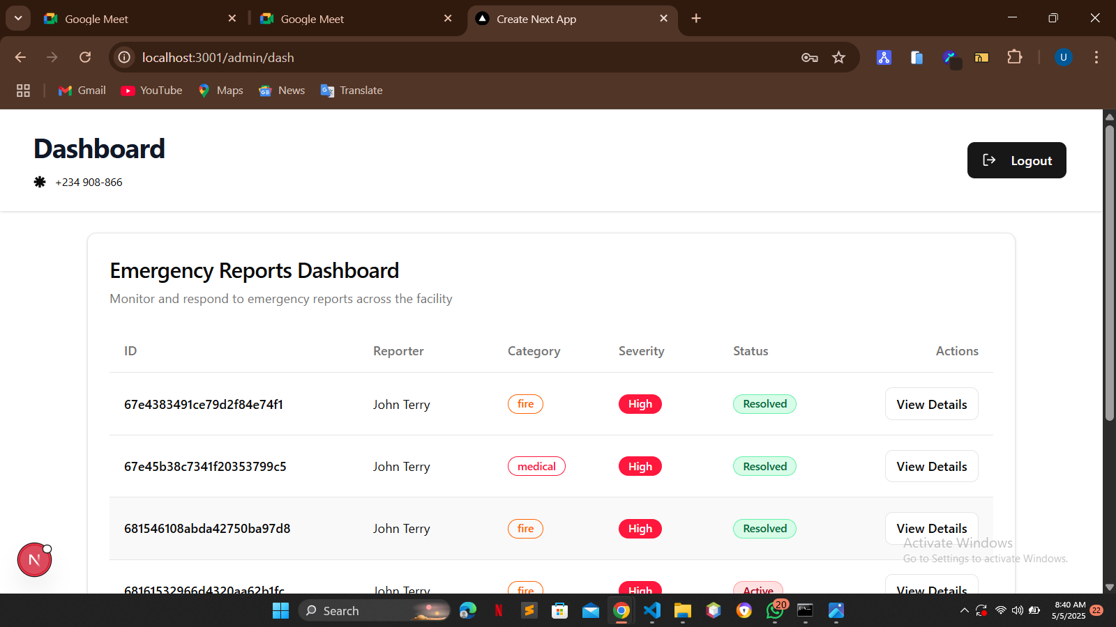
ADMIN DASHBORD PAGE

Figure 4.8 Design interface of admin dashboard page
The emergency management dashboard gives the administrators a full insight view of all the reported incidences whereby all the important information such as the details of the reporters, the type of emergencies, levels of severity, and the resolution statuses are presented in a well-organized tabular manner. Such a centralized monitoring display can be used to assess and coordinate responses in a timely manner to continuing emergencies and keep a history of past cases, which directly contributes to the project goals of effective incident management and real-time situational awareness. The layout of the dashboard helps make decisions quickly due to the convenience of viewing the data and taking actions, which is reasonable in terms of the administrative capabilities of the system and the concept of user-centered design implied in the theoretical framework.

CHAPTER FIVE
SUMMARY, CONCLUSION AND RECOMMENDATIONS
5.1 Summary
In summary, this Academic Work project has done a great deal of giving a broad knowledge of what Design and Implementation of an Online Campus Emergency Response System is all about and how it can be designed and implemented.
Challenges and Considerations:
1. Data Privacy and Security: Online campus emergency response platforms face issues regarding the protection of both sensitive information and its secure storage. By implementing encryption as well as access controls and data anonymization organizations must protect user information and maintain a high level of security against unauthorized access or disclosure.
2. Integration with Existing Systems: Online campus emergency response system integration across existing campus infrastructure and emergency management systems could present technical obstacles. Moreover unimpeded functionality demands legacy system connectivity alongside standardized interoperability standards that must be tested rigorously to guarantee efficient emergency operations.
Limitations of the Study
The research focuses exclusively on Godfrey Okoye University located Enugu State Nigeria. The conclusions and suggestions collected from this study originate from the people who were surveyed in the specific area. The results do not show the comprehensive situation in the entire population
Research limitations were mainly due to time restrictions combined with financial problems and delayed responses from study subjects. The researcher faced challenges when trying to unite lecture sessions with actual field activities. Getting enough funds combined with sponsors to produce questionnaires and arrange Focus group discussions and cover all related costs created financial challenges. Survey recipients showed hesitation when completing questionnaires along with following the time requirements for submission. The project completion faced slight delays due to this additional delay factor.
5.2 Recommendation
I hereby recommend this Academic work to be used by staff and management of Godfrey Okoye University and indeed any other Institution with similar structure and organizational framework for the following reasons:
1. The academic work has been able to solve the problem related to easy access of businesses on campus.
2. It has helped the user on how to use the Design and Implementation of an Online Campus Emergency Response System easily.
5.3 Conclusion
From this Academic Work, I have been able to show the Design and Implementation of an Online Campus Emergency Response System and how it can be used, it has achieve the full aim of letting the public know what computer system is all about.

REFERENCES
Johnson, L., & Smith, M. (2020). Enhancing emergency response in universities using digital systems. Journal of Campus Safety, 12(3), 45-60.
Brown, A., & Wilson, T. (2019). Mobile-based emergency alerts: A case study. International Journal of Educational Technology, 8(2), 112-125.
Norman, D. (2013). The design of everyday things. Basic Books.
Rogers, E. (2003). Diffusion of innovations (5th ed.). Free Press.
World Health Organization. (2021). Emergency preparedness in educational institutions. Retrieved from https://www.who.int/emergencies

APPENDIX
export const revalidate = 2;
import type { Metadata } from "next";
import localFont from "next/font/local";
import "./globals.css";
import { Toaster } from "sonner";
const geistSans = localFont({
src: "./fonts/Lexend-VariableFont_wght.ttf",
variable: "--font-geist-sans",
weight: "100 900"
});
export const metadata: Metadata = {
title: "Create Next App",
description: "Generated by create next app"
};
export default function RootLayout({
children
}: Readonly<{
children: React.ReactNode;
}>) {
return (
<html lang="en">
<body className={`${geistSans.className} antialiased bg-[#f2f2f2]`}>
<Toaster richColors position="top-right" />
{children}
</body>
</html>
);
}
import { Loader } from "lucide-react";

export default function Loading() {
// Or a custom loading skeleton component
return (
<div className=" w-full h-screen flex justify-center items-center">
<div className=" flex items-center space-x-2">
<Loader className=" animate-spin" />
<p>Loading...</p>
</div>
</div>
);
}
"use client";
import type React from "react";
import { useState } from "react";
import { motion } from "motion/react";
import { ArrowRight, FireExtinguisher, Lock, Shield, User } from "lucide-react";
import { Button } from "@/components/ui/button";
import {
Card,
CardContent,
CardDescription,
CardFooter,
CardHeader,
CardTitle
} from "@/components/ui/card";
import { Input } from "@/components/ui/input";
import { Label } from "@/components/ui/label";
import { useRouter } from "next/navigation";
export default function LoginPage() {
const [selectedRole, setSelectedRole] = useState<"user" | "admin" | null>(
null
);
const route = useRouter();
return (
<div className="min-h-screen flex flex-col items-center justify-center bg-gradient-to-br from-slate-50 to-slate-100 p-4">
<motion.div
initial={{ opacity: 0, y: -20 }}
animate={{ opacity: 1, y: 0 }}
transition={{ duration: 0.5 }}
className="text-center mb-8"
>
<h1 className="text-3xl md:text-4xl font-bold tracking-tight text-slate-900 flex items-center justify-center gap-2">
<FireExtinguisher className="h-8 w-8 text-red-600" />
EmergencyReport
</h1>
<p className="mt-2 text-slate-600 max-w-md">
Realtime emergency report system for students.
</p>
</motion.div>
{!selectedRole ? (
<motion.div
initial={{ opacity: 0, scale: 0.95 }}
animate={{ opacity: 1, scale: 1 }}
transition={{ duration: 0.4, delay: 0.2 }}
className="grid grid-cols-1 md:grid-cols-2 gap-6 w-full max-w-3xl"
>
<RoleCard
title="Student Login"
description="Access dashboard and make reports"
icon={<User className="h-6 w-6" />}
onClick={() => route.push("/student/login")}
/>
<RoleCard
title="Admin Login"
description="Manage reports"
icon={<Shield className="h-6 w-6" />}
onClick={() => route.push("/admin")}
/>
</motion.div>
) : (
<motion.div
initial={{ opacity: 0, y: 20 }}
animate={{ opacity: 1, y: 0 }}
transition={{ duration: 0.4 }}
className="w-full max-w-md"
>
<Card className="border-0 shadow-lg">
<CardHeader>
<CardTitle className="flex items-center gap-2">
{selectedRole === "user" ? (
<User className="h-5 w-5 text-blue-600" />
) : (
<Shield className="h-5 w-5 text-blue-600" />
)}
{selectedRole === "user" ? "User Login" : "Admin Login"}
</CardTitle>
<CardDescription>
Enter your credentials to access the{" "}
{selectedRole === "user" ? "user" : "admin"} portal
</CardDescription>
</CardHeader>
<CardContent className="space-y-4">
<div className="space-y-2">
<Label htmlFor="email">Email</Label>
<Input id="email" type="email" placeholder="name@company.com" />
</div>
<div className="space-y-2">
<div className="flex items-center justify-between">
<Label htmlFor="password">Password</Label>
<Button variant="link" className="p-0 h-auto text-xs">
Forgot password?
</Button>
</div>
<div className="relative">
<Input id="password" type="password" />
<Lock className="absolute right-3 top-2.5 h-4 w-4 text-slate-400" />
</div>
</div>
</CardContent>
<CardFooter className="flex flex-col space-y-4">
<Button className="w-full">
Login
<ArrowRight className="ml-2 h-4 w-4" />
</Button>
<Button
variant="ghost"
className="text-sm"
onClick={() => setSelectedRole(null)}
>
Back to selection
</Button>
</CardFooter>
</Card>
</motion.div>
)}
</div>
);
}

interface RoleCardProps {
title: string;
description: string;
icon: React.ReactNode;
onClick: () => void;
}
function RoleCard({ title, description, icon, onClick }: RoleCardProps) {
return (
<motion.div
whileHover={{ scale: 1.03, y: -5 }}
whileTap={{ scale: 0.98 }}
className="cursor-pointer"
onClick={onClick}
>
<Card className="h-full border-0 shadow-md hover:shadow-lg transition-shadow duration-300">
<CardHeader>
<CardTitle className="flex items-center gap-2">
<div className="p-2 rounded-full bg-red-50 text-red-600">
{icon}
</div>
{title}
</CardTitle>
<CardDescription>{description}</CardDescription>
</CardHeader>
<CardFooter>
<Button variant="ghost" className="w-full justify-between group">
Continue
<ArrowRight className="h-4 w-4 group-hover:translate-x-1 transition-transform" />
</Button>
</CardFooter>
</Card>
</motion.div>
);
}
"use client";
import { MainNav } from "@/components/main-nav";
import { EmergencyCard } from "@/components/emergency-card";
import { EmergencyContacts } from "@/components/emergency-contacts";
import useSWR from "swr";
import {
Card,
CardContent,
CardDescription,
CardHeader,
CardTitle
} from "@/components/ui/card";
import { Progress } from "@/components/ui/progress";
import {
Flame,
Shield,
Stethoscope,
AlertTriangle,
Loader2,
Globe2
} from "lucide-react";
import { Button } from "@/components/ui/button";
const fetcher = (url: string | URL | Request) => fetch(url).then((res) => res.json());
export default function DashboardPage() {
const { data, error, isLoading } = useSWR("/api/student", fetcher);
if (error) return null;
console.log(data);
if (isLoading)
return (
<div className=" w-full h-screen flex items-center justify-center">
<Loader2 className=" animate-spin" />
</div>
);

