CHARATERIZATION OF ENDOPHYTIC FUNGI FROM BITTER KOLA
WITH INFERRED MYCOTOXIGENIC POTENCIAL

BY

EMENOGU SAMUEL CHIDERA
GOU/U21/MCB/478

MICROBIOLOGY
DEPARTMENT OF BIOLOGICAL SCIENCE
FACULTY OF NATURAL SCIENCES AND ENVIRONMENT STUDIES
GODFREY OKOYE UNIVERSITY, ENUGU

AUGUST, 2025

CHARATERIZATION OF ENDOPHYTIC FUNGI FROM BITTER KOLA
WITH INFERRED MYCOTOXIGENIC POTENCIAL

BY

EMENOGU SAMUEL CHIDERA
GOU/U21/MCB/478

MICROBIOLOGY
DEPARTMENT OF BIOLOGICAL SCIENCE
FACULTY OF NATURAL SCIENCES AND ENVIRONMENT STUDIES

A PROJECT RESERCH REPORT SUBMITTED TO THE DEPARTMENT OF BIOLOGICAL SCIENCES IN PARTIAL FULFILMENT OF THE REQUIREMENTS FOE THE AWARD OF THE REQUIREMENTS FOR THEAWARD OF THE DEGREE BACHELOR IN SCIENCE (B.Sc.) DECIDE IN MICROBIPLOGY.

SUPERVISOR: DR LINDA OBI

AUGUST, 2025

CERTIFICATION
This is to certify that this research titled (Charaterization of Endophytic Fungi from Bitter Kola with Inferred Mycotoxigenic Potencial) was carried out by Emenogu Samuel Chidera under supervision of Dr Linda Obi in the Department of Biological Sciences, Godfrey Okoye University Enugu Nigeria.

Emenogu Samuel Chidera ………………. …………….
Student Signature Date

APPROVAL
This project has been read and approved by the Department of microbiology, Godfrey Okoye University, Thinker’s corner, Enugu.

…………………………………………. …………………………..
Dr. Linda Obi DATE
(Project supervisor)

……………………………………… …………………………
Dr. Francis N. Olisaka DATE
(Head of Department)

DEDICATION
I, dedicate this work to God almighty for his unwavering grace throughout the course of my research work.

ACKNOWLEDEGMENTS
My gratitude goes to my supervisor, Dr. Linda Obi., who made sure that this research work was a great success. In a special way I acknowledge my Head of Department, Dr. Francis N. olisaka for her timeliness and word of advice during the preparation to kick-start the laboratory work, and of course, the Dean, prof. Chidi Uchegbu of the Faculty of Natural Sciences and Environmental Studies, for his seamless efforts. I would like to appreciate all the staff of the Department of Biological Sciences at Godfrey Okoye University, for their massive support during project. I also acknowledge Prof. Ezeonu, Mr. Mike, Prof. Marire, Dr. Okafor, Dr. Charles, Dr. Nnamdi, Prof. Onyia and of course, the Dean, Prof. Chidi Uchegbu of the Faculty of Natural Sciences and Environmental Studies, for his seamless efforts.
My heart holds a million thanks to Mr and Mrs Ani Ugochukwu John, for their financial support, unconditional love and words of wisdom during the course of my studies. I cannot thank my mum through for her relentlessness, prayerfulness and hardworking spirit to see that I become a graduate since the demise of my Father, leaving her with 2(two) children to groom, I love you Mr and Mrs Emenogu. To my niece, nephew and cousins who added to my siblings for their immense love and encouragement. Thanks to friends like, Smith Emmanuel, Ogochukwu and Amaka, who always come through for me any time I need to do school work, I really cherish the relationship between us, and especially Okoli Mac Anthony Chidera, who in various ways inspired and helped me in the phase of the laboratory work and in writing, you have my special appreciation and a place in my heart.

ABSTRACT
Endophytic fungi are microorganisms that live symbiotically inside plant tissues. While some may be beneficial, others are known to produce secondary metabolites which produce mycotoxins that are harmful. Bitter kola (Gracinia kola), is a traditional medicine widely used in West Africa and it is known to harbour diverse microbes especially those concerned with toxin production. The bitter kola used for this research work underwent sterilization and afterwards they were plated on Potato Dextrose Agar (PDA) to isolate endophytic fungi that were present on it. Pure fungal cultures were gotten and identified based on their macroscopic and microscopic features. The findings showed several fungal genera including those known for mycotoxin production. This suggests that even medicinal substances such as bitter kola can host potential harmful fungi. These findings are important as they highlight the potential health risks associated with the consumption of untreated bitter kola. Isolation and identification of endophytic fungi from bitter kola (Garcinia kola) with inferred mycotoxiic potential

CHAPTER ONE
INTRODUCTION
1.1 Background of the Study
Researchers show significant interest in endophytic fungi because these fungi have diverse bioactive compounds which develop inside plant tissues yet induce minimal or no damage. Within particular fungal organisms a group of toxic substances known as mycotoxins develops. These endophytic organisms that produce mycotoxins represent dangerous resources that contain potentially hazardous bioactive compounds. Laboratory analysis of these organisms with their fungal host relationships must take place to lower the associated risks while using their anticipated useful properties. (Petrini, 1991; Rodriguez & Redman, 2008) Bitter kola represents Garcinia kola as a medicinal plant which spreads throughout West and Central Africa. Endophytic fungi grow from bitter kola seeds which are additionally used for their antioxidant properties and anti-inflammatory effects and bacterial culture medium according to Nwobodo et al., 2020. The fungi enhance plant defense responses and boost compound production benefits. Characterization of bitter kola is essential due to its potential mycotoxin-producing endophyte capability to ensure safe usage for both consumption and application. (Ndibukke et al., 2020). Public health professionals use the assessment method to determine which fungal strains produce mycotoxins in bitter kola. According to Eegbuta et al. (2017) the food items containing toxic levels of aflatoxins fumonisins and ochratoxins present two dangerous biological impacts because they function as both a carcinogenic agent and cause hepatotoxicity and immunosuppression. Through laboratory research scientists will be able to discover these fungi then create preventive measures against mycotoxin exposure in bitter kola food products and medicinal merchandise. The research community requires identification of all fungal life cycles occurring within bitter kola plants for long-term sustainable plant development. Arnold et al. (2000) explain that fungi behave as defensive protectors against stress or harmful toxin-producing pathogens during their plant associations. Fungi demonstrate environmental response behavior similar to plants when they encounter threats since these events shape their colony patterns according to Ndibukke et al. (2020). Scientific knowledge of plant-fungal relationships helps growers acquire financial success alongside minimized risks during agricultural operations. Got a double purpose there because this mycotoxin-producing endophytic fungi system functions as an industry advancement opportunity along with serving as an industry challenge.
Multiple studies show that pharmacologically and biotechnologically significant substances can be derived from mycotoxins despite their negative effects on food security and market trades (Schulz et al., 2002). Antibacterial and antioxidant extracts from endophytic fungi contain two chief compounds which are indole-3-acetic acid and p-hydroxybenzoic acid according to Nwobodo et al (2020). The industrial investigation of bitter kola fungi metabolites should undergo extensive complete examination. Assessments of metabolic fungi will uncover promising drug development compounds leading to commercial output.
Health agencies and farmers alongside industrial entities see extensive research of endophytic fungi producing mycotoxins in bitter kola as crucial for public health and agriculture and industrial needs. A wide investigative approach must study endophytic fungus for grasping its link to Garcinia kola while addressing international nutrition safety and enduring sustainability practices.
1.2 Statement of the Problem
The established medicinal and nutritional application of bitter kola (Garcinia kola) remains poorly understood regarding endophytic fungi production of mycotoxins inside this plant. The fungi play dual roles as they function as health improvement tools for plants but also cause harmful contamination to seeds and derived products which produce toxic mycotoxins. Financial value decreases for bitter kola and both food and public health protection decrease when toxic mycotoxins infect the plant.
Research lacks adequate knowledge about bitter kola endophytic fungus mycotoxin formation due to unclear identification of varieties and ecological distributions and genetic characteristics associated with their synthetic processes. Lack of sufficient understanding about this phenomenon hinders the development of efficient management strategies for fungi and their linked safety threats. The research aims to fill this knowledge gap through the identification of bitter kola endophytic fungi that produce mycotoxins and their evaluation of health risks for the public and farming and industrial sectors.
1.3 Aim of the Study
To character endophytic fungi isolated from bitter cola and inferred their mycotoxin producing ability (Garcinia kola).
Objectives of the Study:
- To isolate endophytic fungi from bitter kola
- To identify endophytic fungi isolated from bitter kola
- To infer the ability of identified endophytic fungi to produce mycotoxin based on literature
1.4 Research Question
1. Are there fungi resident in bitter kola as endophytes?
1.4 Significance of the study
Multiple vital factors support this following research project. Public health protection is achieved through this discovery because it prevents mycotoxin hazards in bitter kola material used for medicine and nutrition. The discovery of fungal endophytes that produce mycotoxins has become a leading scientific advancement which will help create guidelines to protect bitter kola consumers. Research knowledge derived from these findings creates practical usages for agricultural applications. The established relationship between bitter kola and fungal endophytes enables better cultivation practices to maintain healthy plants while avoiding potential mycotoxin problems. The research findings provide directions to sustainably yield and employ bitter kola (G. cola). Industrial implementation needs to be considered as the last element in this study. Endophytic fungi produce secondary metabolites including possible mycotoxins that researchers can use to create new pharmaceutical and biotechnological compounds. Research has characterized these fungi as part of a possible process to discover industrial and medical compounds.

CHAPTER TWO
LITERATURE REVIEW
2.1 Conceptual Review
2.1.1 History of Bitter Kola
The medicinal plant bitter kola grows naturally in the tropical rainforests spanning across West and Central African regions. Medicinal plant bitter kola has existed for hundreds of years to benefit human health through various benefits and cultural roles. Traditional medicine practices of Africa have historically used bitter kola under the Yoruba name “Orogbo” and the Igbo name “Aku ilu”. The traditional stimulation effects and energy-boosting properties of bitter kola seeds have been known through history for the same purpose as coffee (Usunomena, 2012). The bioactive compounds present in bitter kola bark along with leaves and seeds enable their use as medicine to treat throat infections and colds and inflammatory illnesses. Medically significant together with cultural and economic value define the standing of bitter kola. Traditional ceremonies and festivals use bitter kola as a symbol which expresses hospitality together with respect along with friendliness. The bitterness in kola seeds serves as an emblem of peace and friendliness when they are exchanged during Nigerian social events (Iwu, 1982). Bitter kola exists in domestic and international markets as a valuable commodity for trade purposes to support rural livelihoods. The scientific community recognizes this forest product as one of the major non timber forest resources that has economic and medicinal value (Usunomena, 2012). Contemporary scientific investigations validated numerous historical statements about bitter kola which resulted in an intensified interest regarding planet-based pharmacologic properties. Phytochemical characteristics in the seeds result in demonstrated antibacterial activity together with anti-inflammatory effects and antioxidant properties. Bitter kola attracts pharmaceutical developers because potential bioactive chemicals within its composition make it influential for product research in the fields of ethnobotany and pharmacology (Nwobodo et al., 2020). Uses of bitter kola
Bitter kola serves multiple applications which incorporate medical applications. According to Awards research from the year 1300 A.D. notarpoons already existed and treated three groups of medical conditions including respiratory infections and digestive problems and inflammatory conditions. People can bite bitter kola seeds to treat sore throat and cough and chest cold symptoms. Antibacterial components in bitter kola protect humans from bacterial and fungal diseases as well as antioxidants support overall health (Nwobodo et al., 2020). When consumed the bitter kola delivers a stimulant effect that raises focus levels while reducing fatigue in individuals.
Bitter kola stands as one of the most important products produced from non-timber forests. The trading activities involving these seeds allow rural African communities to earn income which sustain their existence. The seeds have two functions: preservation of food through natural preservatives and they appear in dietary supplements alongside herbal teas. Traditional therapeutic preparations built from seeds serve as treatments which combine bitter kola seeds with other medicinal plants to treat various medical conditions. Bitter kola functions as both foodware and nutrient-rich product leading to its appeal in modern international commerce beyond traditional usage.
2.1.1 Properties of Bitter Kola
The pharmacological properties of bitter kola exist due to the chemical compounds it contains. Other essential phytochemicals in bitter kola consist of flavonoids and tannins as well as saponins and alkaloids and phenolic acids. Chemicals in this substance possess antioxidant effects together with anti-inflammatory properties along with hepatoprotective benefits and antimicrobial ability. Scientists widely recognize Kolaviron as a biflavonoid compound found in seeds because it maintains protection against inflammatory responses and oxidative stress (Nwobodo et al. 2020). Seeds together with bark along with leaves from the plant provide substantial quantities of dietary fiber and critical elements in addition to vitamins and minerals. Research shows that the nutritional guidelines identify bitter kola seeds as both a dietary supplement and functional food. Notwithstanding the medicinal and nutritional properties of bitter kola; the medicinal plant of both African and global contexts.
2.1.2 Characteristics of Mycotoxin-Producing Endophytic Fungi
When fungi dwell inside plant tissues yet maintain complete plant health this it is known as endophytic fungi. Food safety experts regard mycotoxins as secondary metabolites which endophytic fungi produce as major threats to both food protection and human wellness. Higher organisms identify toxic fungi from their ability to produce poisonous substances including aflatoxins and fumonisins along with ochratoxins etc. Endophytic fungi select specific regions inside plant tissues to exchange carbon produced by the stem in order to grow and establish defense mechanisms by producing secondary metabolites in relation to the host plant (Schulz et al., 2002).
The investigation of bitter kola endophytic fungi including Aspergillus, Fusarium and Penicillium has already been performed by Ndibukke et al., 2020. The amounts of mycotoxins produced by these fungi depend on both environmental conditions and genetic factors from fungus and host plant species. These fungi generate mycotoxins that infect seeds together with their derivatives causing extensive public health threats. Scientists need to identify and characterize the fungi for better understanding their natural habitats because this leads to risk reduction and biotechnological discoveries (Arnold et al., 2000; Egbuta et al., 2017). Better molecular and biochemical techniques enable easier discovery and analysis of fungi which display elaborate interactions with plant hosts. The production of mycotoxin fungi occurs because of various effects from genotype, climate and agronomic practices on fungal ecological activities. The fungi establish complex interactions with their host by changing metabolic pathways based on external and internal environmental signals. Bitter kola offers stress adaptation through resident fungi that produce biochemical substances which prevent both herbivorous attacks and diseases impacting plant health. The manufacturing of hazardous mycotoxins presents an adverse effect during such biological processing according to food safety requirements (Rodriguez & Redman, 2008).
Scientists thoroughly researched mycotoxin genetic pathways resulting in the discovery of sequences that enable all toxins to develop. Researchers have established fum1 as the regulatory factor for fumonisins but aflR functions as the regulatory agent for aflatoxins. The analysis of these genetic pathways lets scientific groups create intentional treatments to reduce exposure risks to mycotoxins. Due to advances in molecular technology particularly polymerase chain reaction (PCR) and next generation sequencing scientists have developed better methods for finding gene clusters that yield essential biological and toxicological information about fungi (Schulz et al., 2002; Petrini, 1991).
2.1.3 Phytochemical Properties of Bitter Kola
People are well aware of the multiple phytochemical compounds in Bitter kola including alkaloids with tannins flavonoids and saponins among others. Scientific research has deeply explored the multiple advantages of Kolaviron biflavonoid compounds within seeds after identifying these compounds as effective against inflammation and cancer development and as hepatoprotective agents (Egbuta et al., 2017). Research indicates that phenolic compounds integrated within plant cell structures facilitate free radical elimination as an effective method of protecting cells from gradual harmful effects (Nwobodo et al., 2020).
Bitter kola demonstrates antimicrobial effects due to its high flavonoid and tannin content that interrupts microorganism cellular functions. Nwobodo et al. (2020) discovered that antimicrobial potency of Bitter Kola seed extracts with bark extracts effectively destroyed Staphylococcus aureus and Escherichia coli bacteria and pathogenic Candida albicans fungi. According to Egbuta et al. (2017) bitter kola exhibits antibacterial properties for therapeutic infections and functions as a natural antimicrobial alternative instead of traditional products. Bitter kola serves two functions by acting as medicinal treatment for health purposes while offering consumers vital nutrients suitable for dietary use. Apart from these vitamins A C and E the seed of bitter kola consists of potassium calcium and magnesium minerals. Nutrient properties found in bitter kola enhance both body immunity development and strengthen metabolic functions. According to the scientific research of Dalilial (1937) bitter kola seeds contain significant dietary fiber content that improves intestinal health to help digestive disorders. Anti-inflammatory phytochemicals exist within bitter kola seeds. Lab-based experimental research demonstrates that Kolaviron acts to reduce inflammation-focused indicators according to Nwobodo et al (2020). Medical experts classify bitter kola suitable for treatments aimed at inflammatory health problems such as arthritis and cardiovascular disease. Egbuta et al. (2017) state that the antioxidants in bitter kola work in synergy with the anti-inflammatory properties to create an effective method for treating oxidative stress and inflammation simultaneously.
Bitter kola possesses market potential as a phytochemical component for commercial applications. The extract known as Espresso derived from seeds leads to the development of natural food preservatives which extend perishable food stability through biflavonoids and phenolic components. These chemicals are under investigation for usage in cosmetic products to safeguard skin from oxidative harm at the same time boost skin health. Research by Schulz et al. (2002) demonstrates the plant flexibility which supports potential industrial development of its chemical compounds (refers to these chemicals have potential industrial innovation).
Further investigations of bitter notice phytochemicals provide both new phytochemicals and unexplained mechanisms of action. The study confirms its traditional medical functions and extends its usage potential through products for medicine and nutrition and industrial methods. Scientific analysis confirms bitter kola functions as a multi-purpose medicine and economic resource according to Arnold et al. (2000); Nwobodo et al. (2020).
2.1.4 Ecological Interactions between Bitter Kola and Endophytic Fungi
Bitter kola maintains survival capabilities when facing environmental threats due to its relationship with endophytic fungi. The plant benefits from a stronger resistance against infections through these interactions as well as improved overall health. Endophytic fungi enhance plant resistance by allowing drought and nutrient starvation according to Rodriguez and Redman (2008). The soils of tropical nature which are low in nutrients specifically benefit bitter kola as its natural habitat. The regulation of fungal host secondary metabolites exists as one of the abilities displayed by endophytic fungi. The study by Arnold et al. (2000) illustrates how fungally infected plants modify their bioactive substance levels to achieve better antibacterial and oxidation-defending properties. The combined effect of bitter kola plant along with its phytochemical components creates a possible key to understanding the medicinal properties it demonstrates. Ndibukke et al. (2020) determined seasonal variations in the bacteria colonization around bitter kola. Temperature and humidity, and soil environmental conditions together with other based factors determine the diversity and activity of endophytic fungi in bitter kola trees. The focus on this dynamic interaction points to the need for research on these fungi in the context of bitter kola ecological relevance.
Some of the bitter kola endophytic fungi produce antifungal compounds that act as a defense against pathogens by keeping them from growing by interacting with host pathogens and herbivores in the environment (Schulz et al. 2002).
Bitter kola releases volatile organic compounds through fungal species that work as herbivore insect repellents thereby protecting its seeds and plants. The beneficial relationship between endophytes and defence plants comes with an unwanted side effect of being able to create mycotoxins. Arnold et al. (2000) stated that there is an evolutionary advantage for the plant because the mycotoxins are harmful to animals and humans, where the mycotoxins act as natural insect repellent outside of herbivores. This role of interaction does so by interacting with the details of this event and from the correct description of this events. The methods of cultivation of bitter kola and its integrated resident fungi of symbiotic activities provide much in the development of sustainable agricultural practices that are an important aspect of having a sustainable agricultural system. Endophytes offer a host advantages such as participation in the uptake of nutrients and some environmental adaptations (Petrini, 1991). The presence of higher suberin levels enhances growth potential and durability of plants thrives in low fertile tropical regions. The natural symbiosis method decreases the requirement for chemical fertilizers and pesticides therefore protecting the environment.
2.1.5 Detection and Control of Mycotoxin-Producing Fungi
The advances in mycotoxin detection exist because of new analytical techniques such as high performance liquid chromatography (HPLC), Enzyme linked immunosorbent assay (ELISA), Polymerase chain reaction (PCR) along with others. These analytical methods permit precise fungal species recognition together with mycotoxin concentration determination in food products according to Egbuta et al. (2017). The identification of mycotoxin formation specific biosynthetic genes became possible through PCR which enabled scientists to detect genes like aflR and fum1 responsible for aflatoxin and fumonisin biosynthesis respectively. New scientific methods enhance monitoring programs by enabling fast detection of harmful substances present in bitter kola alongside other agricultural products which matter significantly for food security. The use of biocontrol substances as an alternative to mycotoxin-producing fungi provides a solid approach to minimize associated risks. Studies show that non-toxigenic strains of aspergillus successfully interfere with toxic strains in maize crops (Schulz et al., 2002). This bacterium displays the same environmentally safe characteristic as Bacillus subtilis by reducing fungal mycotoxin production which serves as a natural alternative to chemical fungicides (Arnold et al., 2000). Environmental control solutions should be implemented within bitter kola agricultural sites to replace fungal-based contamination issues. An effective reduction of mycotoxins occurs through proper post-harvest management strategies. Mycelial growth during storage is effectively prevented by following appropriate procedures for drying, storage and packaging (Rodriguez & Redman, 2008). Ndibukke et al. (2020) explained that maintaining appropriate low temperature and humidity conditions remains essential in stopping fungal proliferation inside stored bitter kola seeds. To ensure effective distribution of stored items manufacturers use both hermetic containers and natural plant extracts as preservatives to protect product safety.
Fundamental mycotoxin control needs regulations alongside awareness programs for the public and active management from producers and consumers. Laws regarding maximum mycotoxin content in food and feed products were developed by the Food and Agriculture Organization (FAO) along with World Health Organization (WHO) (Egbuta et al., 2017). During the recent month NAFDAC checked 110 Nigerian AgCargo shipments while establishing strict standards for regulation (The Nation Newspaper, 2018). The dissemination of propaganda toward farmers together with consumers resulted in effective teaching about proper storage methods which reduced risks from mycotoxins.
The development of an effective system to handle fungus threats depends on joining detection and control technologies. Stakeholders using innovative analysis with biocontrol agents and effective post-harvest procedures will decrease contamination hazards because they enhance the safety standards for bitter kola products as well as other agricultural goods. The science-based critical task needs continuous investigation for it to function effectively through coordinated actions between stakeholders including researchers and both politicians and farmers to maintain the safety standards.
2.2 Theoretical Framework
2.2.1 Theory of Symbiosis
According to the ecological model of symbiosis multiple inter-species relationships including mutualism and commensalism together with parasitism are examined. The researchers at Rodriguez and Redman (2008) demonstrate that symbiosis involves fungal-plant interactions at a fundamental level because fungi defend their hosts while producing hazardous mycotoxins. An understanding of bitter kola in its natural habitat stems from its mutualistic relationship structure with other species.
2.2.2 Resource Trade-off Hypothesis
Plants along with fungal endophytes use the "Resource Trade-off Hypothesis" to exchange resources that balance the mutual profits and risks for one another. Endophytic fungi advance their host organisms by producing defensive secondary compounds that protect against pathogens and predators says Schulz et al. (2002). The plant gives fungi vital nutrients while protecting them using favorable environmental conditions. The ecological connection between bitter kola and its fungal endophytes needs this exchange system as a method to sustain their beneficial relationship.
2.2.3 Gene-for-Gene Hypothesis
In 1971 Flor established the Gene-for-Gene Hypothesis to define chemical plant interactions with host microorganisms. Under this theory genetic factors operating independently in both endophytes and host plants control the development of suitable relationships as well as resistance features between them. Bitter kola endophytic interactions produce their results based on how two fungal biosynthetic genes fum1 and aflR express themselves. The identification of organismic genetic linkages remains essential so researchers can lessen formation risks of mycotoxins during development.
2.2.4 Theory of plant-microbe co-evolution
The ecological theory serves as a foundation for which Bitter kola together with its endophytic fungi continue to evolve through the process of co-evolution between plants and microorganisms. Plant fungal communities possess distinctive features because of their history of evolutionary development according to Petrini (1991). Microbes that live inside plant tissues adapt through co-evolution when they protect their hosts and this adaptive capability will benefit agricultural science while also benefiting medical and biotechnology fields.
2.3 Empirical Review
Scientific examinations of fungal endophytes which produce mycotoxins within plants provide essential information regarding these organisms from the perspective of diversity and safety risks in natural habitats. Ndibukke et al (2020) investigated in their investigations to ascertain mycoflora which proliferates in Garcinia kola samples sampled from Akamkpa and Obsan regions of Nigeria. The scientists were able to identify a large number of fungi species from their research that contained fungi usually known to produce recognized mycotoxin producing Penicillium, Aspergillus and Fusarium type. The mycotoxin contamination of bitter kola threatens human health, so that the introduction of systematic processes of monitoring the populations of fungal found in bitter kola was initiated in order to reduce the possible threats.. Egbuta et al. (2017) argued that as mycotoxin contaminated food products with animal nutritious contents are the basis of mycotoxin related health problems. If this environment is achieved in bitterness of kola management, in order to stop fungal infections, the researchers discovered that proper storage and handling protocols are set for such purpose. The research identifies that priority must be given to public knowledge about food safety and how to enforce this. As reported by Arnold et al (2000) in terms of biological research, fungi endophytes possess such compounds in which they act as bioactive in fighting fungal deterioration caused by fungi, ailments. Slime forming endophytic fungi were used for research into bitter kola benefits, because not only do they contribute in enhancing pathogen’s resilience to infection; slime forming endophytic fungi are also in the potential of producing mycotoxins that are generating mycotoxins. Results of the research indicate existence of It thus gives an idea of beneficial and detrimental effects of these fungus species, which can be investigated as useful fungus species.
In a vast, ecological and molecular study of plant/fungal symbiosis, Rodriguez and Redman (2008) did. The fungal endophytes helped protect the plants from a stress or disease defense. One of the potential means of work is the use of fungal endophyte to improve bitter kola value and minimize mycotoxin risks.
Molecular techniques such as PCR and next generation sequencing have been employed in evolving investigation for the organisms of fungal toxin producing. Schulz et al. (2002) state that precisely such techniques can be used to define biochemical pathways and gene clusters capable of making toxin. The process developed in this technological approach gives scientists to invent an invention that would help in reducing mycotoxins on bitter kola crops thus enabling a high level of food security and health outcome.

CHAPTER THREE
RESEARCH METHODOLOGY
3.1 Research Design
This research employed descriptive research as well as experimental design in order to produce results. Different fungal species were identified through the descriptive segment which characterized the distinctive features observed in bitter kola endophytes. Fungal production of mycotoxins will be established through biochemical tests and genetic research during the experimental stage of investigation.
3.2 Study Area
- The research site in Nigeria serves as the investigation area because bitter kola naturally grows there. Sample collection sites excel as the perfect environment due to their tropical climate and high humidity and extensive plant abundance in this region.
- The sample acquired good quality mature Garcinia kola seeds from Abakpa Market together with local plantations for scientific purposes. The study utilized specimen samples with exceptional physical state to prevent natural microorganisms from infecting their sample materials. Sterile polythene bags were used by the laboratory for sample transfer because of their established aseptic procedures.
3.3 Sample Collection
The appropriate locations allow scientists to obtain fresh bitter kola seeds from both local farms as well as market sources. Due to contamination hazards the laboratory will acquire samples through sterile containers. The seeds go through sterilization treatment by using 70% ethanol mixed with 2% sodium hypochlorite surface disinfectants followed by a wash with sterile distilled water. Endophytes must be separated from external pollutants during this method. The researchers will store the prepared seeds at 4 °C for additional research purposes. A part of the seeds will undergo sterile cutting techniques for producing isolated fungal cultures.
3.4 Isolation and identification of endophytic fungi
A standard technique described by Zhou et al. (2020) was utilized to surface sterilize Garcinia kola seeds in order to remove endophytic microorganisms from the seeds without affecting endophytes. The seed surface sterilization began with rinsing seeds under sterile distilled water to remove debris before proceeding with distilled water. A one-minute ethanol solution at 70% was applied to seeds at the beginning of decontamination before their processing. The stone specimen spent three minutes in a 2% sodium hypochlorite solution to destroy all external microbial contaminants. Seed rinsing was followed by three repetitions of water washes with sterile distilled water to remove all sterilizing agents per Zhou et al. (2020). The effectiveness of the process endpoint received verification through sterility testing procedures. After volume dilution of rinse water by ten it was used to obtain aliquots from which 0.01 volume solutions were placed onto nutrient agar before a 37°C incubation period of 24 hours. The process validation base was established through a condition that all incubated plated medium showed sterilized states. The sterilized seeds received placement in sterile segments using appropriate sterile techniques before being placed in sterile conditions. The samples were onto PDA and nutrient agar because they selected these media types to study both fungal and bacterial endophytes. The examination of the plates at 28°C prolonged up to seven days alongside daily observations for detecting microbial growth.
The identification of this endophytes were carried out using morphological methods and this involved, macroscopic examination and microscopic examination. So firstly the microscopic examination involve a small portion of mycelium from each isolate was mounted on a glass slide with a drop of lactophenol cotton blue stain and examination under a microscope. The shape, size, and arrangement of spore, conidiophores, and other reproductive structures were identified and compared and while the macroscopic examination which involve the colony characteristics such as color, texture, elevation, and growth rate were observed and documented from (PDA) potato dextrose agar
3.6 Data Analysis
The study will show fungal diversity while also displaying using means and percentages along with distribution frequencies.

CHAPTER FOUR
RESULT
Different fungal colonies emerged during the culturing and identification step because fungi were present in PDA. Various microorganisms were used for mycotoxin producing endophytic fungi identification among the bitter kola sample collections. Aspergillus niger, Aspergilus flavus, Aspergillus fumigatus, curvularia some of these fungi.

Aspergillus niger

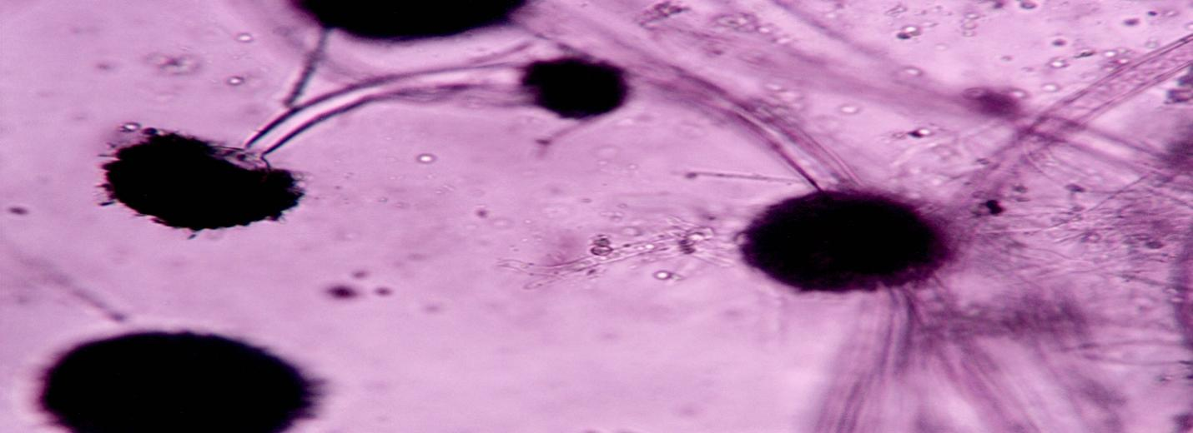
Figure 4.1: Microscopic view of Aspergillus niger

Role of Aspergillus niger in the Characterization of Mycotoxin-Producing Endophytic Fungi in Bitter Kola
Aspergillus niger, a common endophytic and environmental fungus, plays a crucial role in the characterization of mycotoxin-producing fungi in bitter kola in the following ways:
1. Indicator Species for Mycotoxin Contamination
OTA and fumonisins chemically are fungal toxins produced by A. niger; however, A. niger shows a skill to produce both mycotoxins when the environmental conditions meet certain requirements. Since the fungus leads to signs of the potential mycotoxin presence, laboratory tests should be done to investigate bitter kola for contamination.
2. Morphological & Molecular Identification Reference
1. Because A. niger shows black conidia and septate hyphae with biseriate phialides, it can be distinguished from other Aspergillus species. This organism is used as an identification reference point by microscopy together with molecular technique (ITS sequencing) in other mycotoxigenic fungi of bitter kola.
3. Aspergillus niger, a common endophytic and environmental fungus, plays a crucial role in the characterization of mycotoxin-producing fungi in bitter kola in the following ways:
1. Indicator Species for Mycotoxin Contamination
Conditions under which Aspergillus niger produces mycotoxins include OTA and fumonisins. Since the fungus shows apparent mycotoxin presence, bitter kola should be tested in the laboratory for contamination.
2. Morphological & Molecular Identification Reference
1. The scientific identification of Aspergillus niger depends on its dark spores together with segmented phialides and hyphal divisions that contain septa. The organism serves as reference material for all mycotoxigenic fungi present in bitter kola through microscopy and ITS sequencing tests.
4. Environmental & Storage Impact Assessment
Based on the storage conditions of bitter kola A. niger has the ability to create mycotoxins as temperature and moisture content levels affect this process. Laboratory detection of this fungus depends on analysis of storage environment and identification of methods which prevent fungal proliferation and reduce mycotoxicity.
5. Comparative Analysis with Other Fungi
Proof of identity between A.niger and other fungi such as Aspergillus flavus and Fusarium spp. and Penicillium spp. leads to an understanding of bitter kola fungal varieties and ecological position and certain A.niger strains establish dominance over competing fungi thereby influencing bitter kola mycotoxin chemical makeup.
On the reverse side of the colony one finds pale yellow to brown appearances.
The fungus develops quick growth on agar surfaces with defined border formation.

Aspergillus flavus

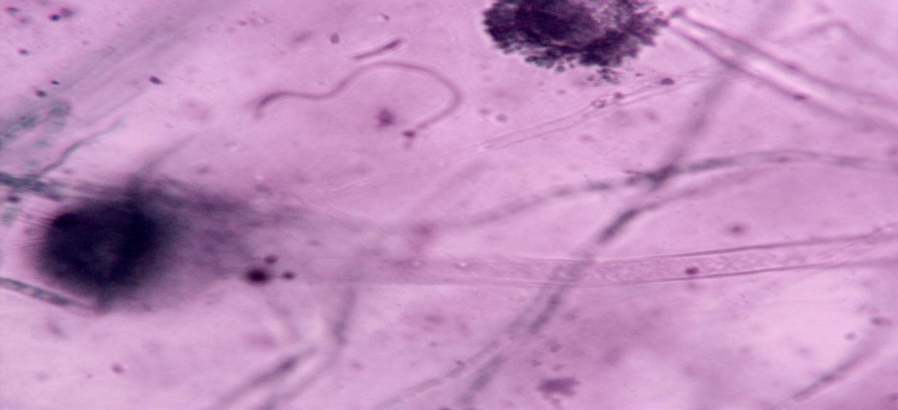
Figure 4.2: Microscopic view of Aspergillus flavus
2. Morphological & Molecular Identification Reference
1. The scientific identification of Aspergillus niger depends on its dark spores together with segmented phialides and hyphal divisions that contain septa. The organism serves as reference material for all mycotoxigenic fungi present in bitter kola through microscopy and ITS sequencing tests.
4. Environmental & Storage Impact Assessment
Based on the storage conditions of bitter kola A. niger has the ability to create mycotoxins as temperature and moisture content levels affect this process. Laboratory detection of this fungus depends on analysis of storage environment and identification of methods which prevent fungal proliferation and reduce mycotoxicity.
5. Comparative Analysis with Other Fungi
Proof of identity between A.niger and other fungi such as Aspergillus flavus and Fusarium spp. and Penicillium spp. leads to an understanding of bitter kola fungal varieties and ecological position and certain A.niger strains establish dominance over competing fungi thereby influencing bitter kola mycotoxin chemical makeup.
On the reverse side of the colony one finds pale yellow to brown appearances.
Agar surfaces allow quick fungal growth accompanied by well-defined boundary formation. The fungus develops rapid growth on agar surfaces that show defined border formation.
Key Indicator of Aflatoxin Contamination
A. flavus produces the highly controlled aflatoxin compounds AFB1, AFB2, AFG1 and AFG2 as its main toxic products. The substance needs further testing for aflatoxin because bitter kola is suspected to introduce contamination.
2. Morphological & Molecular Identification
A. flavus shows its distinctness through elemental phialides and rough conidia and yellow-green colonial growth because these characteristics differentiate it from other fungal species including A. niger DNA sequence of ITS combined with PCR-detected aflR gene for aflatoxin regulation confirm that this organism represents a specific fungal species through microsatellite marker analysis.
4. Environmental & Storage Risk Assessment
The optimal growth environment of A. flavus requires warm and humid conditions which indicates improper storage that makes mold production possible. By examining A. flavus in bitter kola storage areas researchers acquire knowledge about environmental conditions which maximize the prevention of fungal development.
5. Comparative Analysis with Other Fungi
The production of mycotoxins by Aspergillus flavus occurs together with other specialized fungal strains such as Aspergillus niger, Fusarium and Penicillium that create the bitter kola fungus community. Through this process both endophytes and fungal contaminants become distinguishable and various fungal groups can be recognized.

Studies conducted in laboratories on Aspergillus flavus found in bitter kola enable researchers to evaluate food supply risks and establish better food safety norms and create measures for fungal control.

Microscopic and Macroscopic Views of Aspergillus flavus

1. Microscopic View

The microscope reveals three main features of Aspergillus flavus at once through its glass.

The fungal diagnostic elements show colorless branched hypae together with septate structures.

Aspergillus fumigatus
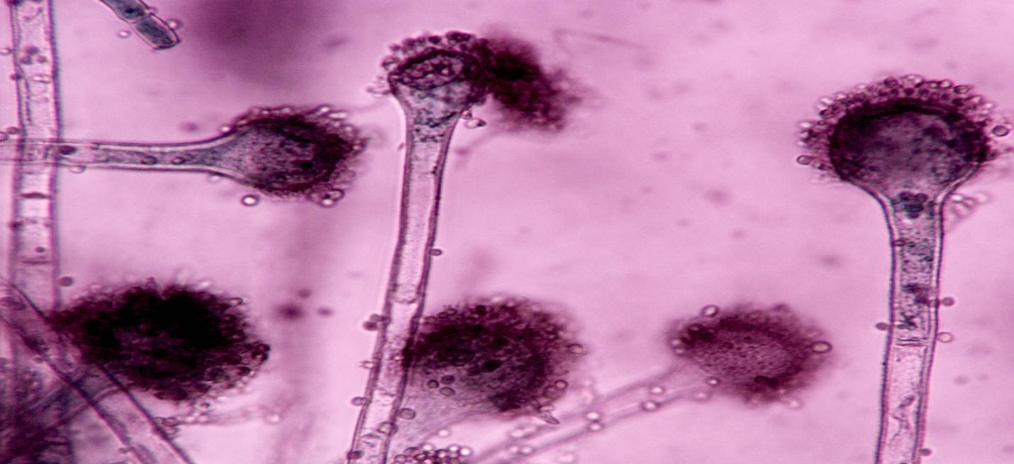
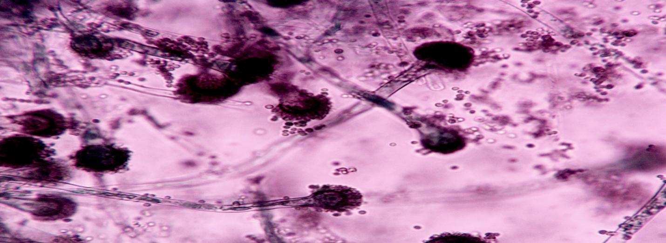
Figure 4.3: Microscopic view of Aspergillus fumigatus

- Role of Aspergillus fumigatus in the Characterization of Mycotoxin-Producing Endophytic Fungi in Bitter Kola
- The fungi show brown to yellowish thick-walled walls that present a rough texture.
- The basis for producing spores takes shape as spherical to slightly elongated vesicles.
- The spores are uniseriate (direct) or biseriate (joined by metulae) around the vesicle.
- The fungus displays small spherical to ellipsoidal structures with rough walls that show conidial arrangement in chains thus creating a powdery appearance.
- The spores extend from the vesicle in a radiant manner to create dandelion-like clusters under microscopic inspection.
- 2. Macroscopic View
- The distinct features of the Aspergillus flavus strain can be observed by culturing it on Potato Dextrose Agar (PDA) and Czapek Dox Agar (CZA).
- Yellow-green venation emerges first in the path of A. flavus colonial expansion until maturity brings dark green coloring.
- Texture: Powdery to granular due to dense spore production.
- The organism shows quick reproduction properties to completely fill a Petri dish within several days.
- The back of the colony exhibits color changes from golden yellow to reddish-brown.
- The growth conditions of particular microscopic strains cause the production of yellowish droplets that possibly contain aflatoxins.
- Does this laboratory or any other location want to learn microscopic observation methods and methods of staining to efficiently examine A. flavus?
1. The identification of toxic endophytic fungi matters strongly since A. fumigatus demonstrates potent biochemical toxin-generation capabilities. 4. Environmental & Storage Risk Assessment
Thus, storage of A. flavus is not suitable, as that is the worst known conditions for the optimal growth of A. flavus, and this suggests such favorably humid and warm conditions allow mold production. Knowledge regarding environmental conditions which prevent fungal development are obtained by researchers examining A. flavus in bitter cola storage areas.
5. Comparative Analysis with Other Fungi
Another diversity of such specialized fungal strains are those of Aspergillus niger and Fusarium and Penicillium that accomplice at creating bitter kola fungus community together with which mycotoxins are also produced by Aspergillus flavus. During this process both endophytes and fungal contaminants could be identified and several fungal groups separated.
The studies that have been done on Aspergillus flavus of bitter kola in the laboratory setting enable researchers to study food supply risks and set better food safety norms and take measures to control the fungal.
Microscopic and Macroscopic Views of Aspergillus flavus
1. Microscopic View
However, the glass of the microscope reveals three main features about Aspergillus flavus at once.
It is highlighted that the fungal diagnostic elements are comprised of branched colorless hypae and septate structures.

1. Indicator of Mycotoxin Contamination
Coming into contact with gliotoxin generated by A. fumigatus has a powerful immune system suppression on human health. Since scientists have confirmed the presence of segmented fungus A. fumigatus in these samples, the bitter kola has to be tested in laboratories for dangerous toxins.
4. Environmental & Storage Impact
Diverse environmental conditions in relatively warm and humid areas allow A.Fumigatus to survive; thus, bitter kola poses a problem of storage since this fungus detection in storage facilities provides researchers the opportunity to examine potential fungal infections throughout the post-harvest periods. Gliotoxin and Invasive Potential Gliotoxin and invasive potential for A. fumigatus are primarily studied, as A. fumigatus is not an aflatoxin or ochratoxin producer. Bitter kola fungal biodiversity assessment in broad terms is the result of studying how A. fumigatus grows accompanied by its growth pattern and toxins generating traits compared with other strains.
2. Macroscopic View
Aspergillus fumigatus develops its colonies on PDA or CZA agar media:
Colony Color: Bluish-green to gray-green.
Texture: Powdery to velvety, with dense conidial growth.
Growth Rate: Rapid, often covering the Petri dish within a few days.
Reverse Side: The underside of the colony appears white to pale yellow.
No Distinctive Ring Formation: Unlike A. niger or A. flavus, A. fumigatus colonies are uniform in color without concentric rings.

Curvularia

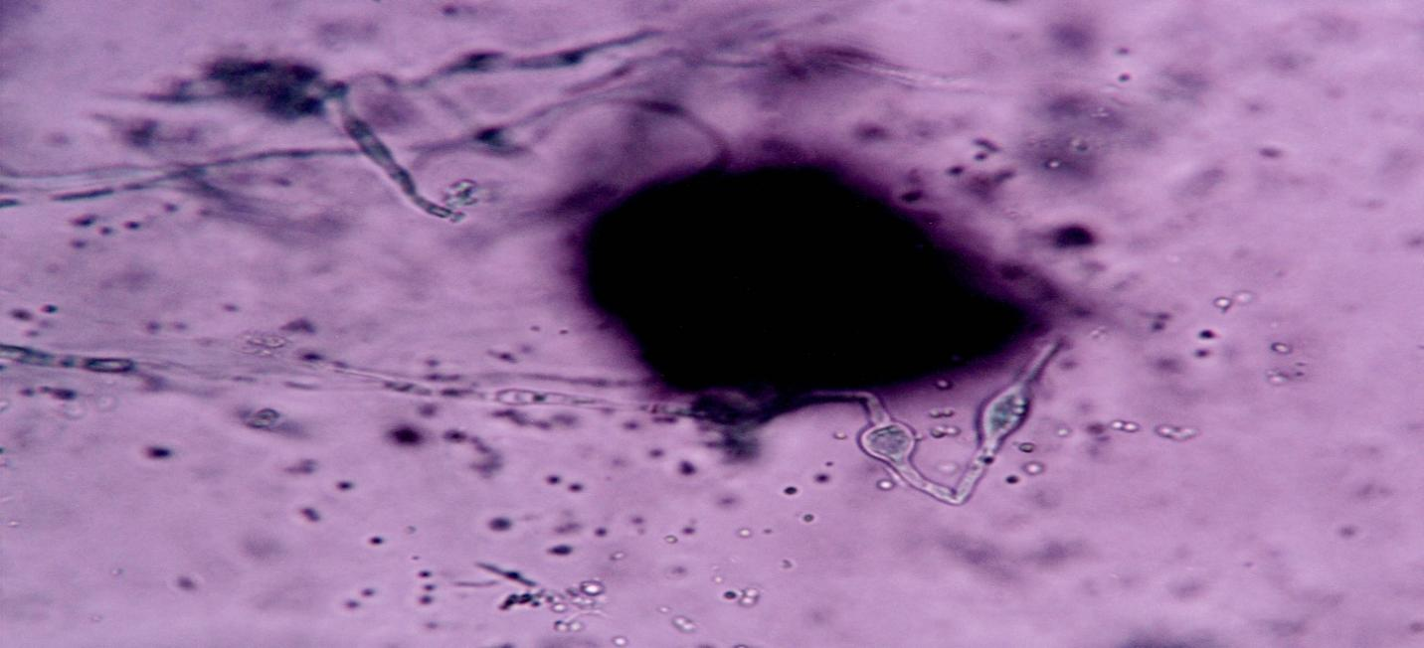
Figure 4.4: Microscopic view of Curvularia
- The fungus genus Curvularia exhibits well-known capabilities to generate both mycotoxins and additional metabolic compounds.
- Role of Curvularia in the Characterization of Mycotoxin-Producing Endophytic Fungi in Bitter Kola
- The tissues of bitter kola serve as natural environments for Curvularia spp which exist both within plants and take advantage of opportune conditions. Research data from Curvularia is important to evaluate both mycotoxin hazards and fungal species of bitter kola.
- Indicator of Mycotoxin Contamination
Mycotoxin production by Curvularia spp results in the formation of three harmful compounds including curvularin, tenuazonic acid and alternariol which threaten human health. A researcher must test for toxins when bitter kola exists on its own since it shows the need to screen for harmful compounds.
2. Morphological & Molecular Identification
The taxonomic group Curvularia presents dark pigment characteristics that join with curved multiple-celled conidia and hyphae composed of septa. The identification of molecules occurs through ITS sequencing and species-specific PCR markers. Mycotoxin Screening & Quantification
- Environmental & Storage Impact
Curvularia can thrive in humid storage conditions, making it a potential post-harvest contaminant of bitter kola. Detecting its presence helps assess storage safety and fungal control strategies.
- Comparison with Other Mycotoxigenic Fungi
Alongside Aspergillus flavus (aflatoxin producer) and A. niger (ochratoxin producer), Curvularia contributes to the overall mycotoxin risk profile of bitter kola. Its interaction with other endophytes may influence the fungal ecosystem and toxin production.
Characterizing Curvularia in bitter kola helps in identifying mycotoxin risks, optimizing fungal detection methods, and improving post-harvest handling to prevent contamination.
Research shows that Curvularia fungi genus possesses the ability to produce several fungal compounds among which mycotoxins and other metabolic products are included.
Role of Curvularia in the Characterization of Mycotoxin-Producing Endophytic Fungi in Bitter Kola
The Curvularia species lives inside bitter kola tissues by taking advantage of available ecological niches which exist within plant matter. Studies of Curvularia provide scientific evidence to identify dangerous mycotoxins together with the fungal species that inhabit bitter kola.

1. Indicator of Mycotoxin Contamination
Curvularia species generate three dangerous substances: curvularin and tenuazonic acid and alternariol which result in health effects that are not severe. Bitter kola needs a toxicological evaluation by the researcher since toxic elements have been detected that need to be identified.
2. Morphological & Molecular Identification
All members of the Curvularia taxonomic group use multiple-cell conidia and hyphal septa which remain curved while producing dark-colored pigments. PCR identification methods in conjunction with ITS sequencing provide meaningful molecule identification capabilities.

Microscopic and Macroscopic Views of Curvularia

1. Microscopic View
When observed under a microscope, Curvularia exhibits the following characteristics:
- Hyphae:
  - Dark brown to black.
  - Septate (divided into sections by cross-walls).
- Conidiophores:
  - Erect, dark brown, unbranched, or sparsely branched.
  - Slightly curved, supporting conidia.
- Conidia (Spores):
  - Curved or crescent-shaped, giving the fungus its characteristic name.
  - Typically 3-5 septa (divisions).
  - Central cells of the conidia are swollen, making the spores appear bent or boomerang-shaped.
  - Dark brown to black with thick walls.
- Arrangement: Conidia are produced in chains or clusters at the tips of conidiophores.

2. Macroscopic View
When grown on media like Potato Dextrose Agar (PDA) or Malt Extract Agar (MEA), Curvularia colonies show:
- Colony Color:
  - Dark brown, black, or gray, sometimes with an olive-green or reddish tint.
- Texture:
  - Woolly, cottony, or velvety due to dense mycelial growth.
- Growth Rate:
  - Moderate to fast-growing, covering the plate within a few days.
- Reverse Side:
  - The underside of the colony appears dark brown to black.
Recent studies demonstrate that Curvularia fungi genus generates multiple fungal compounds with mycotoxins and additional metabolic substances among these compounds.
Role of Curvularia in the Characterization of Mycotoxin-Producing Endophytic Fungi in Bitter Kola
The Curvularia species establishes itself inside bitter kola tissues by adopting the ecological niches that occur naturally within plant matter. Curvularia research serves as scientific proof for detecting dangerous mycotoxins and the fungal species which inhabit bitter kola.
1. Indicator of Mycotoxin Contamination
The Curvularia species produces three dangerous substances including curvularin and tenuazonic acid and alternariol that lead to health effects which are not serious. The researcher needs to conduct a toxicological evaluation on bitter kola because toxic elements have been discovered which require identification.
Isolate | Identified Fungi | Problem mycotoxin | Reference
AA1 | Aspergillus Niger | Ochratoxin and fumonisin | Samson et al 2014
BB2 | Aspergillus Flavus | aflatoxin | Cotty et al 2008
CC3 | Aspergillus Fumigatus | gliotoxin | (Ara’ujo et al 2017)
DD4 | Curvularia | Curvularin, tenuazonic acid and atternariol | Ribes et al 2000

Endophytes | Microscopic view | Macroscopic view
1.Aspergillus niger | - Hyphae: Septate, branched filament  - Conidiospores: Long, and smooth  - Vesicle: Large and spherical  - Conidia: Small, spherical, rough-walled and black dark color fungus | - Colony color: Initially white but quickly turns black due to conidia formation  - Texture: Powdery to velvety due to heavy spore production  - Reverse side: The underside of the colony often appear pale yellow to brown  - Growth Pattern: Rapid growth with well defined edges, spreading across the agar surface
- Aspergillus Flavus | - Hyphae: Septate, hyaline(colorless) and branched  - Conidiospores: Thick-walled, rough, and usally yellowish to brown in color  - Vesicle: Large, spherical to slightly enlongated, serving as the base spore  - Conidia: Small, spherical to ellipsoidal, rough-walled and arranged in chains | - S  - Texture: Powdery to granular due to dense spore production  - Growth Rate: Rapid, covering a petri dish within a few days
3.Asprgillus Fumigatus | - Hyphae: Septate, hyaline(transparent) and branced  - Conidiospores: Short,smooth-walled, and slightly swollen at the tip  - Vesicle:Small and dome-shaped, unlike A.flavus or A.niger which have large vesicles  - Conidia:Small, round, smooth to finely roughed, forming dense chains | - Colony color: Bluish-green to gray-green  - Texture: Powdery to velvety, with dense conidial growth  - Growth Rate: Rapid, often covering the petri dish within a few days
Curvularia | - Hyphae: Dark brown to black and divied into sections by cross walls  - Conidiospores: Erect, dark brown, unbranched and slightly curved supporting canidia  - Conidia:Curved or cresent-shaped | - Colony color: Dark brown, black or gray  - Texture: woolly, cottony or velvety due to dense mycelial growth  - Growth Rate: Moderate to fast-growing, covering the plate within a few days

CHAPTER FIVE
DISCUSSION, CONLUSION AND RECOMMENDATION
5.1 Discussion
This study characterizes endophytic fungi isolated from bitter with potential to produce mycotoxins. Obtained results indicate that bitter kola contains endophytic fungi such as Aspergillus niger, Aspergillus flavus, Aspergillus fumigatus and Curvularia, some of which are capable of producing mycotoxins. Species from the genus Aspergillus was recovered from bitter kola and among them Aspergillus niger found the most (40%). The study done by Samson et al. (2014) mentioned Aspergillus species as main contaminators of human health, as we also found in our study. Among other things, Aspergillus niger can create large amounts of helpful enzymes (Schuster et al., 2002). Investigations have linked bitter kola to this fungus and it’s thought this might lead to crop damage. Although Aspergillus niger is a member of the natural Aspergillus family, it is commonly spotted in soil, decaying plants and organic debris (Klich, 2002). Pedersen et al. (2009) have reported that the organism is able to form citric acid, gluconic acid and several types of industrial enzymes. Because diseases like aspergillosis can result from Aspergillus niger in both people and animals, it is classified as a pathogenic species (Latgé, 1999). Thanks to its use of conidia, the fungus is equipped to handle high levels of stress where it lives and to replicate quickly for a long span. In 20%, Aspergillus flavus was found because it produces aflatoxins that can endanger human health. Cotty et al. (2008) were right that Aspergillus flavus could be the possible reason for humans who consume bitter kola to become infected by aflatoxins. Aflatoxins are believed to be mainly responsible for causing liver cancer and many other difficulties in people and animals (Wild & Gong, 2010). Yellow-green Aspergillus or species Aspergillus flavus, is often present in soil, dead plant matter and decaying tissues (Klich, 2002). The fungus depends on wind and insects for transportation; it spreads when it releases justifiable conidia. Since bitter kola can have Aspergillus flavus, keeping and using it carefully is recommended by farmers to prevent health risk. Corn, peanuts, tree nuts and many more crops are where risks saflatoxin likes to form (Wu et al., 2014). Since it reduces aflatoxin production and lowers health, managing Aspergillus flavus in food crops is very important (Williams et al., 2004). A further look at plant surface microbes found that 13% contained Aspergillus fumigatus which converges with the findings of Paller et al. (2010). If bitter kola are improperly managed, the existence of Aspergillus fumigatus makes them dangerous to humans, since some species can be unsafe (Pfaller & Diekema, 2007). When the weather is hot and humid, Aspergillus fumigatus species know when to settle on parts of the plant (Araújo et al., 2017). Harmless skin problems in people with candidiasis can develop into serious infections and affect the entire body (Pfaller & Diekema, 2007). The 13% of samples that contained Curvularia reflect how frequently Curvularia can be found in plants or cause disease. Proteins produced by the Curvularia fungi can lead to Curvulariamycosis in situations where sinuses and the brain, as well as other organs, are infected (Ribes et al., 2000). Curvularia species can grow on things such as decomposing organic matter, plants and soil (Schipper, 1978).
5.2 Conclusion
According to this work, bitter kola contains several fungal species and some of these may produce mycotoxins. The large numbers of Aspergillus niger, Aspergillus flavus, Aspergillus fumigatus and Curvularia species found in grains show that storing them properly can help keep fungi and toxic products from forming. Controlling fungus in bitter kola and similar foods is necessary for making them safe for consumption. Because bitter kola may contain mycotoxigenic fungi, it might not be suitable for some consumers in countries with little food safety. It is important that more studies are done to help us lower the chances of mycotoxin exposure in the foods we eat. Researchers may assess the best way to handle, treat and store foods to restrict the growth of fungi and lower the use of harmful chemicals. Exploring the fungal ecology of bitter kola can help us control fungus in its production and secure safer food supplies. For these reasons, it is important that people from mycology, food science, agriculture and public health connect. The primary benefit is that research results provide guidance for actions that improve food safety and the health of the public. This information helps us reduce the risk of consumers ingesting mycotoxins because we understand the fungi in bitter kola. this helps us pay more attention to the fungi in bitter kola. The findings indicate that extra steps are necessary to protect public health and crops and efforts should be increased to reduce mycotoxin risk.
5.3 Recommendations
Proper management of bitter kola prevents fungi growth and prevents the formation of mycotoxins. Future studies could focus on employing advanced techniques to further study the endophytic fungi of bitter kola and their ability to produce mycotoxins as well as study the phytochemical properties of bitter kola that could be antimicrobial. Ideally, keep bitter kola away from sunshine, moisture, in a dry area and aired out.

REFERENCES
Aneja, K. R. (2003). Experiments in microbiology, plant pathology and biotechnology (4th ed.). New Age International Publishers.
Arnold, A. E., Mejía, L. C., Kyllo, D., Rojas, E. I., Maynard, Z., Robbins, N., & Herre, E. A. (2003). Fungal endophytes limit pathogen damage in a tropical tree. Proceedings of the National Academy of Sciences, 100(26), 15649–15654.
Barnett, H. L., & Hunter, B. B. (1998). Illustrated genera of imperfect fungi (4th ed.). APS Press.
Bennett, J. W., & Klich, M. (2003). Mycotoxins. Clinical Microbiology Reviews, 16(3), 497–516.
Bills, G. F., & Polishook, J. D. (1994). Abundance and diversity of endophytic fungi in leaf tissues of woody plants in the eastern United States. Canadian Journal of Botany, 72(S1), 7–17.
Braga, R. M., Dourado, M. N., & Araújo, W. L. (2016). Microbial interactions: Ecology in a molecular perspective. Brazilian Journal of Microbiology, 47(S1), 86–98.
Chandra, S. (2012). Endophytic fungi: Novel sources of anticancer lead molecules. Applied Microbiology and Biotechnology, 93(1), 1–9.
Choudhary, D. K., & Johri, B. N. (2009). Interactions of Bacillus spp. and plants – With special reference to induced systemic resistance (ISR). Microbiological Research, 164(5), 493–513.
Domsch, K. H., Gams, W., & Anderson, T. H. (2007). Compendium of soil fungi (2nd ed.). IHW-Verlag.
Dreyfuss, M. M., & Chapela, I. H. (1994). Potential of fungi in the discovery of novel, low-molecular weight pharmaceuticals. In V. P. Gullo (Ed.), The discovery of natural products with therapeutic potential (pp. 49–80). Butterworth-Heinemann.
Fisher, M. C., Hawkins, N. J., Sanglard, D., & Gurr, S. J. (2018). Worldwide emergence of resistance to antifungal drugs challenges human health and food security. Science, 360(6390), 739–742.
Frisvad, J. C., & Samson, R. A. (2004). Polyphasic taxonomy of Penicillium subgenus Penicillium. Studies in Mycology, 49, 1–173.
Gond, S. K., Verma, V. C., Kumar, A., Kumar, V., & Kharwar, R. N. (2007). Study of endophytic fungal community from different parts of Aegle marmelos Correa and their antimicrobial activity. Canadian Journal of Microbiology, 53(12), 1301–1309.
Hall, T. A. (1999). BioEdit: A user-friendly biological sequence alignment editor and analysis program for Windows 95/98/NT. Nucleic Acids Symposium Series, 41, 95–98.
Hoffman, M. T., & Arnold, A. E. (2010). Diverse bacteria inhabit living hyphae of phylogenetically diverse fungal endophytes. Applied and Environmental Microbiology, 76(12), 4063–4075.
Huang, W. Y., Cai, Y. Z., Hyde, K. D., Corke, H., & Sun, M. (2008). Biodiversity of endophytic fungi associated with 29 traditional Chinese medicinal plants. Fungal Diversity, 33, 61–75.
Jalgaonwala, R. E., Mahajan, R. T., & Mohan Karuppayil, S. (2011). A review: Endophytic fungi as a source of antimicrobial compounds. Journal of Applied Pharmaceutical Science, 1(6), 44–50.
Khan, A. L., Waqas, M., Kang, S. M., Al-Harrasi, A., & Lee, I. J. (2015). Endophytic fungi: Resource for gibberellins and crop abiotic stress resistance. Critical Reviews in Biotechnology, 35(1), 62–74.
Kharwar, R. N., Verma, V. C., Kumar, A., & Gond, S. K. (2010). A comparative study of endophytic and epiphytic fungal association with some medicinal plants. Mycosphere, 1(1), 65–71.
Klich, M. A. (2002). Identification of common Aspergillus species. Centraalbureau voor Schimmelcultures.
Kogel, K. H., Franken, P., & Hückelhoven, R. (2006). Endophyte or parasite—what decides? Current Opinion in Plant Biology, 9(4), 358–363.
Kumar, S., Stecher, G., & Tamura, K. (2016). MEGA7: Molecular evolutionary genetics analysis version 7.0 for bigger datasets. Molecular Biology and Evolution, 33(7), 1870–1874.
Lindow, S. E., & Brandl, M. T. (2003). Microbiology of the phyllosphere. Applied and Environmental Microbiology, 69(4), 1875–1883.
Lugtenberg, B., & Kamilova, F. (2009). Plant-growth-promoting rhizobacteria. Annual Review of Microbiology, 63, 541–556.
MycoBank. (2024). MycoBank Database. International Mycological Association. https://www.mycobank.org
Narmani, A., & Banihashemi, Z. (2017). Fungal endophytes: The unsung heroes of plants. Iranian Journal of Plant Pathology, 53(4), 1–18.
Nicoletti, R., & Fiorentino, A. (2015). Plant bioactive metabolites and drugs produced by endophytic fungi of spermatophyta. Agriculture, 5(4), 918–970.
Orole, O. O., & Adejumo, T. O. (2009). Activity of fungal endophytes against four maize wilt pathogens. African Journal of Microbiology Research, 3(12), 969–973.
Petrini, O. (1991). Fungal endophytes of tree leaves. In J. H. Andrews & S. S. Hirano (Eds.), Microbial ecology of leaves (pp. 179–197). Springer.
Pitt, J. I., & Hocking, A. D. (2009). Fungi and food spoilage (3rd ed.). Springer.
Raghunathan, V., Manasa, M., & Ravishankar, R. V. (2019). Endophytic fungi: Novel sources of anticancer compounds. Journal of Fungi, 5(3), 56.
Rodriguez, R. J., White Jr, J. F., Arnold, A. E., & Redman, R. S. (2009). Fungal endophytes: Diversity and functional roles. New Phytologist, 182(2), 314–330.
Schoch, C. L., Seifert, K. A., Huhndorf, S., Robert, V., Spouge, J. L., Levesque, C. A., ... & Fungal Barcoding Consortium. (2012). Nuclear ribosomal internal transcribed spacer (ITS) region as a universal DNA barcode marker for Fungi. Proceedings of the National Academy of Sciences, 109(16), 6241–6246.
Schulz, B., Boyle, C., Draeger, S., Römmert, A. K., & Krohn, K. (2002). Endophytic fungi: A source of novel biologically active secondary metabolites. Mycological Research, 106(9), 996–1004.
Strobel, G., & Daisy, B. (2003). Bioprospecting for microbial endophytes and their natural products. Microbiology and Molecular Biology Reviews, 67(4), 491–502.
Strobel, G. A., Miller, R. V., Martinez-Miller, C., Condron, M. M., Teplow, D. B., & Hess, W. M. (1999). Cryptocandin, a potent antimycotic from Cryptosporiopsis cf. quercina. Microbiology, 145(8), 1919–1926.
Tan, R. X., & Zou, W. X. (2001). Endophytes: A rich source of functional metabolites. Natural Product Reports, 18(4), 448–459.
Verma, V. C., Gond, S. K., Kumar, A., Mishra, A., & Kharwar, R. N. (2009). Endophytic actinomycetes from Azadirachta indica A. Juss: Isolation, diversity, and anti-microbial activity. Microbial Ecology, 57(4), 749–756.
White, T. J., Bruns, T., Lee, S., & Taylor, J. (1990). Amplification and direct sequencing of fungal ribosomal RNA genes for phylogenetics. In M. A. Innis et al. (Eds.), PCR protocols: A guide to methods and applications (pp. 315–322). Academic Press.
Yuan, Z. L., Lin, F. C., Zhang, C. L., & Kubicek, C. P. (2010). A new species of Trichoderma from estuarine mangrove forests in Southeast China. Mycologia, 102(5), 1086–1095.
Zhang, H. W., Song, Y. C., & Tan, R. X. (2006). Biology and chemistry of endophytes. Natural Product Reports, 23(5), 753–771.

