LIVESTOCK MONITORING SYSTEM USING YOLOV8 DETECTION MODEL

BY

AGBO DANIEL CHIDERA
GOU/U21/CSC/658

SUBMITTED TO THE DEPARTMENT OF
COMPUTER SCIENCE,
FACULTY OF NATURAL SCIENCES AND ENVIROMENTAL STUDIES, GODFREY OKOYE UNIVERSITY, ENUGU.NIN PARTIAL FULFILMENT OF THE AWARD BACHELOR OF SCIENCE DEGREE

SUPERVISED BY DR.ENGR. KINGSLEY CHIBUEZE

NOVEMBER, 2024

APPROVAL PAGE
This is to validate that this research work “LIVESTOCK MONITORING SYSTEM USING YOLOV8 DETECTION MODEL” was embarked upon by “AGBO DANIEL CHIDERA” with the matriculation number ‘GOU/U21/CSC/658 in partial fulfillment of the requirements for the award of Bachelor Science(B.SC) in Computer Science, Faculty of Natural Sciences and Environmental Studies, Godfrey Okoye University, Enugu.

_______________________ _________________________
Dr. Engr. Kingsley Chibueze Date
Supervisor

__________________________ _______________________
Dr. (Mr.) Frank Okebanama Date
Head of Department

______________________ ________________________
External Examiner Date

CERTIFICATION
I hereby certify that the work presented herein was completed solely by me and is primarily based on my own observations and investigation. I fully accept the University’s decision should I be found to have engaged in any form of academic dishonesty regarding this assignment.

_______________________
Agbo Daniel Chidera
GOU/U21/CSC/658

DEDICATION
This work “LIVESTOCK MONITORING SYSTEM USING YOLOV8 DETECTION MODEL” is dedicated to myself, parents, siblings, lecturers, HOD, supervisor and other industry who has contributed heavily to everything I have accomplished up till now and I pray that the good lord continues to guide and protect them for the rest of their life.

ACKNOWLEDGMENTS
First of all, I would love to thank the almighty God for his abundant grace throughout this project. I also want to thank my supervisor Dr. Engr. Kingsley Chibueze for the time he set aside for me during my project to make sure that this project is a success and for guiding me throughout this project. I would also love to thank my brother for his support for me throughout this project, I pray the good lord continues to bless him and everyone that helped me to complete my project.

ABSTRACT
This project presents the design and implementation of a livestock health monitoring system using computer vision and real-time video analysis. Developed in Python with a Tkinter-based graphical interface, the system enables farmers to detect signs of illness in livestock through the automated analysis of video frames. At the core of the system is the YOLOv8 object detection model, integrated via the Ultralytics Python package and trained using a curated dataset from Roboflow Universe. The system processes live or recorded video frame by frame, identifying livestock and classifying them as healthy or unhealthy based on visual features.

TABLE OF CONTENTS
TITLE PAGE - - - i
APPROVAL - - - ii
CERTIFICATION - - - iii
DEDICATION - - - iv
ACKNOWLEGMENTS - - - v
ABSTRACT - - - vi
TABLE OF CONTENT - - - vii-ix
LIST OF TABLES - - - x
LIST OF FIGURES - - - xi
Chapter One: Introduction 1
1.1 Background to the Study - - - 1
1.2 Statement of Problem - - - 3
1.3 Aim and Objectives of the Study - - - 4
1.4 Significance of the Study - - - 5
1.5 Scope of the Study - - - 5
1.6 Limitations of the Study - - - 5
1.7 Operational Definition of Terms - - - 6
Chapter Two: Literature Review 7
2.1 Introduction to the Livestock Monitoring System - - 7
2.1.1 Theoretical Background - - 7
2.1.1 Description of the Different Categories of Systems - - 8
2.1.2 Brief History of Livestock Monitoring Systems - - 9
2.1.3 The Future of Livestock Management Systems - - 10
2.2 Review of Existing Related Literature - - 14
2.3 Summary of the Review of Related Works - - 16
Chapter Three: Methodology and Design 18
3.1 Methodology Using OOAD - - - 18
3.2 Important Aspects of OOAD - - - 18
3.2.1 Object-Oriented Analysis (OOA) - - - 19
3.2.2 Object-Oriented Design (OOD) - - - 19
3.3 Core Design Principles Applied - - - 21
3.4 Analysis of Existing Systems - - - 21
3.5 Problems of Existing Systems - - - 22
3.6 Analysis of the Proposed System - - - 23
3.7 Advantages of the Proposed System - - - 24
3.8 Design of the Proposed System - - - 25
Chapter Four: Design and Implementation 29
4.1 Software Requirements - - - 29
4.2 Hardware Requirements - - - 30
4.3 Network Requirements - - - 30
4.4 Interface - - - 30
Chapter Five: Summary and Conclusion 35
5.1 Summary - - - 35
5.2 Recommendation - - - 36
5.3 Conclusion - - - 38
References - - - 39

LIST OF TABLES
TABLES PAGES
SUMMARY OF THE REVIEW OF RELATED WORKS 16-17

LIST OF FIGURES
FIGURE
- Use case diagram of the livestock monitoring system yolov8 detection model page 26
- Class diagram of the livestock monitoring system page 28
- Video inference interface page 31
- Active video inference output page 32
- Home page of the monitoring system interface page 34

CHAPTER ONE
INTRODUCTION
  - BACKGROUND TO THE STUDY
The exploration of livestock monitoring systems has become increasingly significant in recent years, motivated by the rising need for efficient and sustainable agricultural methods alongside the rapid progression of technology. This area of study stems from various interconnected factors, all underscoring the necessity of merging contemporary innovations with traditional livestock management practices. A key driving force behind the development of livestock monitoring systems is the surging global appetite for animal products. With predictions of a growing world population, there is an anticipated rise in demand for meat, dairy, and other animal-derived foods. This presents a pressing challenge to enhance livestock management techniques to boost production while maintaining animal welfare and sustainability. Disease management within livestock populations is another crucial consideration shaping the advancement of monitoring systems. Livestock are vulnerable to various health conditions, which can significantly affect both productivity and financial viability. Early detection of health issues can avert outbreaks that might cause considerable economic damage and pose risks to animal welfare. By leveraging monitoring technologies, farmers can gather valuable insights into their animals' health and behavior, thus fostering informed decision-making aimed at their overall welfare.
The evolution of livestock monitoring systems focused on disease management has undergone significant changes over the years, influenced by advancements in veterinary science and technology. In the early days of agriculture, farmers relied on keen observation to identify illnesses in their animals. They watched for changes in behavior and physical symptoms. The establishment of veterinary medicine in the 18th and 19th centuries brought a deeper understanding of animal diseases. This led to improved management practices, such as vaccinations and better sanitation. As veterinary science developed, systematic record-keeping became increasingly important. In the late 19th and early 20th centuries, farmers began documenting health issues and treatments, helping them recognize patterns in disease prevalence. The introduction of diagnostic tools, like serological tests, in the mid-20th century added precision to disease identification. The late 20th century saw a technological shift with the introduction of electronic monitoring systems. RFID technology enabled the tracking of individual animals and their health records, allowing for more effective monitoring of health indicators and treatments, with the rise of the Internet of Things in the 21st century,
By the 2010s, the integration of big data analytics and machine learning allowed for deeper insights into animal health trends and better predictions of disease outbreaks based on a variety of data inputs. Today’s monitoring systems leverage advanced technologies, including genomics and environmental data, to enhance disease management and overall herd health. As the agricultural sector continues to face challenges related to zoonotic diseases and food security, the future of livestock disease monitoring will likely emphasize the integration of advanced technologies and effective veterinary practices. Implementing livestock monitoring systems brings numerous advantages. One of the primary benefits includes the potential for increased productivity. By closely monitoring animal health and behavior, farmers can achieve greater feed efficiency and optimal growth rates, leading to overall enhanced productivity levels. Additionally, these systems support optimized resource allocation by helping farms manage inputs like feed and water more efficiently.

However, notable challenges accompany the integration of livestock monitoring systems. A significant hurdle is the initial investment required for adopting such technologies, which may be prohibitive, especially for smaller-scale farmers. This raises important questions about accessibility and affordability, as many farmers might struggle to implement sophisticated monitoring solutions. Additionally, data privacy and security issues cannot be overlooked. With increasing data collection, safeguarding sensitive information becomes critical; farmers need assurance that their data remains secure and that their privacy is respected. Furthermore, there is often a gap in knowledge regarding how to properly utilize these advanced technologies. Many farmers may need training to effectively operate monitoring systems and interpret the resulting data, emphasizing the importance of education and support in facilitating successful implementation. The practical applications of livestock monitoring systems are varied and significant. In herd management, these systems can track the health and behavior of individual animals, enabling farmers to make informed decisions regarding reproduction, birthing, and growth phases. In the context of feed management, monitoring systems can assess feed intake and optimize feeding strategies, which enhances livestock health and productivity and can lead to cost savings. Another critical application is health monitoring, where continuous observation of vital signs and behavioral patterns facilitates early illness detection, ultimately promoting better herd health.
  - STATEMENT OF PROBLEM
Livestock monitoring system has brought in lots of problems which are:
- Many advanced livestock monitoring technologies, such as data analytics tools, require a significant initial investment. This expense can be prohibitive, particularly for small and medium-sized farms, limiting their ability to adopt these innovative solutions.

- The increasing reliance on digital systems raises concerns regarding data privacy and security. Sensitive information about livestock, including health records and location data, can be vulnerable to breaches and unauthorized access, creating risks for farmers and their operations.

- The integration of sophisticated technologies in livestock monitoring systems can lead to challenges in usability. Farmers, especially those who may not be tech-savvy, may have trouble understanding and effectively using these systems, hindering their potential benefits and requiring ongoing training and support.

- Different manufacturers often produce livestock monitoring devices and software that may not easily integrate with one another. This lack of interoperability can make it challenging for farmers to consolidate and analyze data from multiple sources, limiting the effectiveness of monitoring efforts and complicating herd management.

  - AIM AND OBJECTIVES OF THE STUDY
This project titled “ LIVESTOCK MONITORING SYSTEM USING YOLO V8 DETECTION MODEL” focuses on the design and implementation of a computer based livestock monitoring system making use of webcam as its only hardware image/video upload. To achieve this goal, the study has outlined several key objectives.
- Creating a system that should be able to analyze and detect any patterns or anomalies that could indicate health issues.
- Creating a system that must be capable of tracking vital signs of the animals, like there activity levels in real-time.
- Designing a system that should have a system that notifies the user of any abnormal readings or signs of distress in the livestock.
  - SIGIFICANCE OF THE STUDY
Livestock monitoring systems is important as it facilitates the early identification of health concerns in animals, optimizes resource management, boosts productivity, enhances animal welfare, and supports farmers in making informed decisions. By delivering real-time data on animal health, location, these systems contribute to more efficient and sustainable livestock operations. The insights gained from this research can lead to transformative changes in livestock management practices.

  - SCOPE OF THE STUDY
This research work centers on the design and implementation of a computer vision based livestock monitoring system in agriculture the same way a farmer can look at chickens and see the ones with symptoms and separate them. NOTE: (My computer based livestock monitoring system will only make use of webcam but in case there is no webcam it will also make use of image/video upload)

  - LIMITATION OF THE STUDY
While embarking on this research I experienced some setbacks, some of these limitations are:
Here are three less frequently mentioned limitations of the livestock monitoring system study:
- Concerns Regarding Data Privacy and Security: The gathering and sharing of sensitive information about livestock health and farm activities can pose significant privacy risks. If this data is accessed by unauthorized parties, it could lead to competitive harm or exploitation, which might undermine farmers' confidence in using these technologies.
- Potential for Bias in Data Analysis: The algorithms designed for analyzing data can introduce bias if the input data is not comprehensive or accurate. This can result in conclusions that misrepresent the actual conditions of the livestock, leading to misguided management actions.
- Risk of Overdependence on Technology: Relying heavily on monitoring systems may diminish farmers’ traditional observation skills and instincts. This reliance could become problematic if the technology malfunctions or if farmers are not equipped with the skills to manage their livestock effectively without technological assistance.
  - OPERATIONAL DEFINTION OF TERMS
While there were numerous terms related to the research, this study will focus on a select few, as outlined below.
LIVESTOCK: This are domesticated animals that are raised primarily for agricultural purposes, including the production of food, fiber, and labor.
MONITORING SYSTEM: This are set of tools, technologies, and processes designed to observe, track, and evaluate specific parameters or activities within a given environment.
DATA ANALYTICS: The process of examining and interpreting the large volumes of data collected from webcams or video uploads to derive actionable insights.
ALERT SYSTEM: A feature of the livestock monitoring system that notifies farmers about any significant anomalies or concerning trends in the data collected, such as signs of illness or abnormal behavior.

CHAPTER TWO
LITERATURE REVIEW
2.1 INTRODUCTION TO THE LIVESTOCK MONITORING SYSTEM
Livestock monitoring systems have evolved significantly, driven by advancements in technology and the need for improved farm management. Initially, monitoring relied on manual observations, with farmers keeping records of health and productivity, leading to inefficiencies
2.1.1 THEORITICAL BACKGROUND
The 20th century saw the introduction of basic electronic devices like ear tags for animal identification, laying the foundation for more systematic data collection. As personal computing became common in the 1990s, software-based monitoring systems emerged, allowing farmers to analyze feeding patterns and health records more effectively. Alongside these innovations, ethical considerations regarding data privacy and animal welfare have garnered attention, emphasizing the need for responsible implementation of monitoring technologies. Looking ahead, future developments may integrate block chain for transparency in the supply chain and promote sustainable practices. The evolution of livestock monitoring systems illustrates not only technological progress but also an increasing awareness of the implications of agricultural practices on society and the environment. Continuous adaptation to emerging challenges will be vital for the future of these systems (Saquon Davis, 2002).
In the livestock industry, monitoring disease in animals is critical due to their direct impact on farm productivity. Undetected livestock diseases can lead to significant losses. To address these challenges, the proposed system aims to minimize potential damages through a mobile application designed for real-time monitoring of livestock's biometric data and images. This system will help in the early detection of diseases, allowing for proactive management. The system operates by collecting biometric data and images from sensor nodes and CCTV cameras. This information is then transmitted to a management server through a gateway. The server processes the data and periodically relays relevant livestock information to mobile clients ensuring that farmers have timely access to critical insights for better decision-making (Jeonghwan Hwang, 2013).
2.1.1 DESCRIPTION OF THE DIFFERENT CATEGORIES OF LIVESTOCK MONITORING SYSTEM
This section will provide a detailed review of the various categories of livestock monitoring systems.
- Web-Based Health Management Platforms
These platforms allow farmers to manage and monitor livestock health through a centralized web application. Users can input data regarding animal health conditions. The system can analyze this data to provide insights and alerts for potential disease outbreaks, enabling proactive health management.
- Health Record Management Systems
These systems focus on maintaining comprehensive health records for each animal within a herd. Farmers can document vaccinations, treatments, and health events using a web application.
- Data Analytics and Visualization Tools
the web application specialize in analyzing data collected from various devices. They present data in a user-friendly format, utilizing charts, graphs, and dashboards to visualize trends in livestock health. Farmers can easily identify abnormal patterns that may indicate disease, making it easier to react quickly and efficiently.
8
- Security is a critical component of livestock monitoring systems that use web applications. By implementing comprehensive security measures ranging from data encryption to user training, farmers and organizations can protect sensitive data, maintain the integrity of the system, and ensure the overall well-being of livestock.
2.1.2 BRIEF HISTORY OF LIVESTOCK MONITORING SYSTEM
Livestock management has historically relied on traditional methods, where farmers monitored animal health and productivity through manual observation and record-keeping. This approach involved identifying signs of illness or estrus based on visual cues, making it time-consuming and susceptible to human error. Furthermore, there was minimal systematic tracking of livestock data. In the early 20th century, basic electrical devices began to emerge to assist in livestock management. By the 1950s and 60s, technologies like ear tags gained popularity, facilitating easier tracking of individual animals. Some farms also adopted weight scales and automated feeding systems, although much of the information remained anecdotal and manually recorded. The advent of computer technology in the 1970s and 1980s marked a significant shift towards more sophisticated livestock management systems. Software programs were developed to help farmers manage herd data, analyze breeding and feeding practices, and maintain health records. This era represented a move towards organized and analytical approaches to livestock management, emphasizing productivity and efficiency.
The 1990s saw a rise in automation within agriculture. The introduction of RFID (Radio-Frequency Identification) technology further enhanced animal tracking and identification, paving the way for real-time data acquisition. The 2010s brought about a significant transformation in livestock monitoring with the rise of the Internet of Things (IoT). Cameras, and GPS devices began connecting wirelessly to cloud-based platforms, enabling real-time monitoring of livestock health, location, and behavior. Comprehensive monitoring systems emerged, providing actionable insights that allowed for proactive management of livestock health. In recent years, the integration of artificial intelligence (AI) and big data analytics has revolutionized livestock monitoring systems. Machine learning algorithms analyze vast amounts of data collected from various sources, including, to extract insights on health and productivity trends. Predictive analytics empower farmers to anticipate health issues and make informed, data-driven decisions.
Today, livestock monitoring systems continue to evolve, incorporating advanced technologies such as genomic monitoring, mobile applications, and block-chain for supply chain traceability. The focus has shifted towards solutions that ensure animal welfare, enhance sustainability, and improve biosecurity measures. As technology advances, the future of livestock monitoring is likely to involve even more seamless integration of various systems, improved user interfaces, and enhanced data analysis capabilities.
2.1.3 THE FUTURE OF LIVESTOCK MANAGEMENT SYSTEM
As the global agricultural landscape evolves, so do the challenges associated with livestock diseases. These challenges are intensified by factors such as climate change, increased global trade, and emerging zoonotic diseases. In response, the future of livestock monitoring systems is poised to undergo remarkable transformations that will significantly enhance disease management. Innovations in technology and data analytics are set to revolutionize how farmers monitor, detect, and respond to health issues in their livestock, ensuring better health outcomes and improved productivity. One critical advancement in livestock monitoring will be the implementation of real-time health monitoring technologies. As farming becomes more reliant on technology and Internet of Things (IoT) devices will become commonplace in livestock management. These devices will continuously collect and transmit data about each animal's vital signs, behavior, and environmental conditions. This ceaseless flow of information will empower farmers to detect early signs of health problems, such as diseases characterized by behavioral changes or physiological abnormalities.
Early detection will be pivotal in minimizing the spread of diseases within herds. For instance, if a sensor detects unusual behavior in an animal, such as reduced movement or changes in feeding patterns, farmers can receive immediate alerts and take action. This proactive approach allows for quicker responses to potential outbreaks, which is crucial in protecting not only individual animals but also whole herds. Equally transformative will be the integration of artificial intelligence (AI) and predictive analytics within livestock monitoring systems. The ability of AI to process and analyze vast quantities of data will enable the identification of patterns and trends that may go unnoticed by human observers. By analyzing historical health data, environmental conditions, and even genetic information, machine learning algorithms can predict potential disease outbreaks before they occur. This predictive capability empowers farmers to implement preventative measures tailored to their specific herds, such as adjusting vaccination schedules, increasing biosecurity protocols, or improving nutrition. In addition to real-time monitoring and predictive analytics, the future of livestock health management will also prioritize genomic monitoring. By leveraging genetic data, farmers can assess the susceptibility of their animals to specific diseases at a deeper level. Understanding the genomic makeup of livestock enables breeders to select for traits that confer disease resistance, thereby enhancing overall herd immunity over generations. This method not only reduces reliance on antibiotics and vaccines but also aligns with the growing trend toward sustainable farming practices that prioritize animal welfare and environmental stewardship.
Biosecurity measures will become increasingly sophisticated as livestock monitoring systems evolve to address the risk of disease outbreaks. With the heightened connectivity of farms in today's global economy, the potential for zoonotic diseases—those that can be transmitted between animals and humans—has intensified. Advanced monitoring systems will incorporate automated health audits, biosecurity checks, and compliance monitoring. This technology will contribute to more effective containment of diseases, ensuring that outbreaks are quickly identified and managed before they can spread to other animals or farms. The potential for increased data sharing and collaboration among farmers, veterinarians, and agricultural organizations represents another critical element in the future of livestock monitoring. As cloud-based platforms become more prevalent, stakeholders in the agricultural sector will gain access to shared health data and insights. This collaborative approach facilitates coordinated responses to disease outbreaks, allowing farmers to pool resources and information to implement area-wide disease surveillance measures. By establishing a collective defense against disease, agricultural communities can mitigate the effects of outbreaks and enhance livestock health on a broader scale.
AI will also play an essential role in diagnostic support. The integration of advanced image recognition technologies will allow for the analysis of photos or videos of livestock, aiding in the identification of visual signs of disease. For instance, veterinarians can utilize image recognition software to assess skin lesions, observe gait abnormalities, or recognize behavioral indicators of distress. Furthermore, AI applications can assist practitioners by providing real-time recommendations based on symptoms presented, streamlining the diagnostic process and allowing for more rapid treatment. This speed is particularly crucial in preventing the spread of contagious diseases, as timely interventions can avert larger outbreaks. The approach to livestock health management will increasingly adopt a holistic view, particularly as sustainable practices become more central to agricultural operations. As farmers seek to minimize their environmental impact, monitoring systems will need to address health management comprehensively. This may involve integrating feed management, optimizing nutrition, and monitoring environmental conditions such as housing quality, stress levels, and social interactions among animals. Creating an environment that promotes overall well-being will enhance the immune systems of livestock, making them more resilient to diseases over time.
On a global scale, the alignment of livestock monitoring systems with health initiatives and veterinary surveillance networks will be crucial. Bridging gaps between human health, animal health, and environmental health is central to the One Health approach, which recognizes the interconnectedness of these domains. As livestock monitoring systems evolve, they will increasingly support this framework, allowing for the timely sharing of information about disease risks and outbreaks. By linking regional and global monitoring initiatives, authorities will be better equipped to respond to emerging zoonotic diseases, prevent outbreaks, and ensure the integrity of food systems worldwide. In summary, the future of livestock monitoring systems in disease management will be characterized by advancements in technology, increased data collaboration, and a holistic approach to animal health. Real-time monitoring, the integration of AI and predictive analytics, along with genomic advancements and enhanced biosecurity measures will transform how livestock diseases are managed. As the agricultural sector confronts the complex challenges posed by emerging diseases and global agricultural pressures, these innovative approaches will be essential for ensuring the health and sustainability of livestock production. Through these advancements, the agricultural community can better address public health concerns and enhance food security for a growing global population, paving the way for a healthier future for both animals and humans.
2.2 REVIEW OF EXISTING RELATED LITERATURE
Numerous existing systems are closely related to this research work in various respects. In this section, we will review some of these systems to explore their relevance and contributions to the field.
M. A. A. M. Ismail and R. S. A. Rasid (2016) provided an in depth examination of wireless sensor networks (WSNs) and their applicability in agricultural settings, particularly for livestock health monitoring. Through real-world case studies, the authors demonstrate the effectiveness of WSNs in monitoring livestock activities, reducing operational costs, and improving farm management efficiency. By presenting scenarios where WSNs have successfully detected anomalies in livestock behavior and environmental conditions, the authors illustrate their potential in early disease detection. Furthermore, the study advocates for the integration of WSNs into existing agricultural practices, urging farmers to adopt these technologies for a proactive approach to livestock health and management.
A. Edward, J. B. W. D. Steven, and A. W. G. Alan (2018) investigated the emerging field of precision livestock farming (PLF), which leverages advanced technologies to improve the monitoring and management of livestock. The authors explore the various components that define PLF, including the use of sensor technologies, data analytics, and automation. They delve into specific technologies such as electronic identification devices, RFID tags, and automated feeding systems, highlighting how these innovations can provide real-time insights into animal health and behavior. The paper emphasizes the importance of data integration from multiple sources, pointing out that combining health data with performance metrics can lead to more informed decision-making in farming practices. The authors also discuss the ethical considerations related to data use and privacy, particularly concerning surveillance of animal behavior. Furthermore, case studies are presented to showcase the successful application of PLF technologies in diverse livestock settings, revealing how PLF can enhance animal welfare, productivity, and farm profitability. The review concludes by advocating for further research on PLF technologies to address existing challenges and improve their adoption in the industry.
M. Y. Scrap and I. M. H. Alamir (2019) investigated the concept of smart farming and its implications for livestock sustainability. They define smart farming as an approach that employs cutting-edge technologies, such as IoT, artificial intelligence (AI), and big data analytics, to optimize farming practices and improve overall efficiency. The paper discusses how these technologies can be leveraged to monitor livestock health, optimize feeding schedules, and manage environmental conditions within livestock housing. The authors present case studies from various farms that have implemented smart farming techniques, illustrating significant improvements in productivity, resource management, and animal welfare. Additionally, they discuss the potential of smart farming to adapt to the challenges posed by climate change, population growth, and food security concerns. The authors argue that adopting such technologies not only benefits individual farmers but also contributes to broader goals of sustainability and environmental stewardship in agriculture. They call for increased investment in research and development to foster innovations in smart farming, urging stakeholders to collaborate for a sustainable agricultural future.
K. G. S. K. Canavan and R. P. D. C. T. Fulton (2021) made their impact on animal health management. The authors categorize various automated approaches, including video surveillance paired with machine learning algorithms, remote health sensing systems, and automated feeding and watering systems. They discuss how these technologies facilitate continuous monitoring of livestock, allowing for the timely identification of health issues and unusual behaviors. The review highlights the benefits of automation in terms of increasing efficiency, lowering labor costs, and improving data accuracy. It presents case studies to showcase real-world applications of automated monitoring systems, emphasizing their role in enhancing biosecurity measures and preventing disease outbreaks. The authors also address the limitations of existing systems, such as the need for substantial upfront investments and the interoperability challenges between different technologies. They conclude by stressing the significance of integrating automated monitoring systems into everyday farming practices to promote animal welfare and sustainable livestock management.
P. P. Sharma and S. T. Paul (2021) This study presents an innovative IoT-based livestock health monitoring system designed for real-time data collection and analysis. They elaborate on the development of an intuitive user interface that allows farmers to access health metrics and receive alerts regarding potential health issues. Through case studies, the authors demonstrate the system's efficacy in detecting illnesses early and improving response times for treatment. They also highlight the potential economic benefits of implementing this system, including reduced veterinary costs and increased productivity. However, the study also addresses challenges related to the initial cost of deployment, the need for stable internet connectivity, and the importance of training farmers to utilize the system effectively. The authors advocate for continued research and development to refine IoT technologies in livestock health monitoring, stressing their crucial role in enhancing farm management practices.
2.3 SUMMARY OF THE REVIEW OF RELATED WORKS
Here’s a consolidated overview of authors, years, methodologies, work done, and shortcomings related to studies on livestock monitoring systems:
Authors Name/Year | Methodology/Technique | Work-done | Shortfall
M. A. A. M. Ismail and R. S. A. Rasid (2016) | The system made use of wireless sensor networks (WSNs) in agricultural settings to monitor environmental parameters and livestock health. | It showed how WSNs can be configured to collect real-time data on factors such as temperature and humidity, aiding in disease detection and livestock management. | They were challenges in network stability and data transmission in rural areas were not thoroughly analyzed.
A. K. M. N. Ahmed, A. K. Saha, M. M. Rahman, and M. A. H. Alif (2020) | The system focused on detailed case studies and technological frameworks | The system demonstrated enhanced productivity and health monitoring through various IoT devices. | They were challenges in the cost of implementation, data security, and the lack of reliable internet in rural settings could have been explored more deeply.
A. Edward, J. B. W. D. Steven, and A. W. G. Alan (2018) | The system made technological advancements in precision livestock farming | Improved the RFID systems in monitoring of livestock health and behavior. | The data collection and privacy were big issues.
M. Y. Scrap and I. M. H. Alamir (2019) | The system improved frameworks surrounding smart farming technologies | Improved monitoring of livestock and optimizing resource usage | Small scale farmers faced issues like technology adoption.
S. G. T. Ulbrich, H. E. L. Schwier, and C. K. R. Thomas (2020) | Developed wearable technology for livestock and their applications in health monitoring | It provided valuable health data that can enhance disease detection and animal welfare | The devices could not perform to their fullest in all environmental conditions.

CHAPTER 3
METHODOLOGY AND DESIGN

3.1 METHODOLOGY FOR DEVELOPING A LIVESTOCK MONITORING SYSTEM USING OOAD
This chapter presents the methodology used in developing the livestock monitoring system based on Object-Oriented Analysis and Design (OOAD). The OOAD approach helps in breaking down the system into manageable modules and defining the relationships among various components using object-oriented concepts. This methodology ensures that the system is modular, reusable, and scalable. The chapter outlines the system’s analysis, design, modeling, tools used, and the logical flow of implementation.
The OOAD methodology provided a robust framework for designing a livestock monitoring system that is intuitive, efficient, and aligned with real-world livestock health management scenarios.
3.2 IMPORTANT ASPECTS OF OOAD
3.2.1 OBJECT-ORIENTED ANALYSIS (OOA)
Object-Oriented Analysis (OOA) is the phase where the system's functional requirements are analyzed and modeled using objects, classes, and their relationships — all based on real-world entities. In this project, OOA helps to organize the logic of livestock monitoring by identifying what parts of the system exist, what they do, and how they interact.
For this livestock monitoring system, key objects include:
Animal: Represents each livestock being monitored. Holds data like ID, image, health status.
ImageInput: Manages image or webcam capture from the user.
HealthDetector: Analyzes input image using the AI model and detects abnormalities.
AlertSystem: Triggers alerts when an unhealthy condition is detected.
UserInterface: Manages visual layout and user interactions.
USE CASE MODELING
Use case modeling is a crucial part of Object-Oriented Analysis (OOA) that helps define how users interact with the system. It focuses on the system’s functionality from the user’s point of view and outlines the various ways the system will be used in real-world scenarios.
In this project, the main actor is the Farmer (or User), and the system provides a way to monitor livestock health through images or webcam feeds using AI.
Some use cases in this project include;
i. Upload image
ii. Analyze livestock
iii. Receive alerts
iv. View results
3.2.2 OBJECT-ORIENTED DESIGN (OOD)
Object-Oriented Design (OOD) is the phase where the system’s functionality—already analyzed during Object-Oriented Analysis (OOA)—is transformed into a detailed, blueprint-style design using classes, methods, and interactions. In this phase, the logical objects identified in OOA (like Animal, ImageInput, and HealthDetector) are now designed in detail, including how they work internally and how they relate to one another.
OOD ensures that the system is well-structured, easy to build, scalable, and ready for implementation using object-oriented programming.
CLASS DESIGN
Each class is a template that contains attributes (data) and methods (functions).
Each of these classes performs a focused role in the application, which promotes maintainability and reusability.
The Key Classes include:
1. Animal
Attributes: id, type, image, healthStatus
Methods: setStatus(), getStatus(), displayInfo()
2. ImageInput
Attributes: sourceType, imageData
Methods: captureFromWebcam(), uploadFromFile()
3. HealthDetector
Attributes: model, threshold
Methods: analyzeImage(), predictHealthStatus()
4. AlertSystem
Attributes: alertType, message
Methods: generateAlert(), displayAlert()
5. UserInterface
Attributes: layout, resultBox, alertBox
Methods: renderUI(), updateResult(), showAlertBox()

3.3 CORE DESIGN PRINCIPLES APPLIED
1. Encapsulation: Each object handles its own logic and data. For example, the AI model is encapsulated within the HealthDetector class, so no other part of the system accesses it directly.
2. Abstraction: Unnecessary internal complexities are hidden. The user doesn’t know how image analysis happens—just that it works.
3. Modularity: Classes are separated by roles (UI, detection, alerts, etc.), making the system easy to update or expand.
4. Reusability: The HealthDetector can be reused even in another system with just different training data.
5. Scalability: If more features (like tracking multiple animals or live video stream analysis) need to be added, new classes or methods can be created without disrupting existing ones.
3.4 ANALYSIS OF EXISTING SYSTEMS
Over the years, various livestock monitoring systems have been developed to improve animal health management, productivity, and farm efficiency. These systems include wireless sensor networks (WSNs), RFID-based tracking systems, IoT-driven smart farming platforms, and mobile application-based health logging tools. Wireless sensor networks are widely used in large farms to collect real-time data on vital signs such as body temperature, heart rate, and movement. While they offer high accuracy and real-time alerts, they often require complex installations and are costly, making them less accessible to small-scale farmers.
RFID-based systems focus primarily on identification, location tracking, and movement patterns. They are useful for managing herd logistics and preventing animal loss but do not offer health diagnostics or visual assessment of animal well-being. More advanced systems integrate Internet of Things (IoT) technology with cloud computing, providing comprehensive data analysis and remote access to livestock metrics. However, these systems are heavily reliant on stable internet connectivity, cloud storage, and multiple hardware components, which can be overwhelming or unaffordable for local farmers.
Mobile application-based systems allow farmers to log animal data and sometimes upload images for remote review. These platforms are more accessible but rely largely on manual input, meaning farmers must already understand the symptoms they are recording. Most of these existing systems do not offer automated, real-time visual analysis that could assist farmers in detecting physical signs of illness without prior veterinary knowledge.
3.5 PROBLEMS OF EXISTING SYSTEMS
Despite their technological advancements, existing livestock monitoring systems present several limitations that reduce their effectiveness, especially in developing regions. One major challenge is cost. Many systems require expensive sensors, RFID tags, or multiple interconnected devices, making them inaccessible to smallholder farmers. Additionally, systems that depend on constant internet connectivity are not suitable for rural areas where network infrastructure is poor or inconsistent.
Another issue is limited focus on visual health analysis. Many existing systems emphasize environmental data and tracking rather than detecting physical symptoms like skin abnormalities, swelling, limping, or eye infections. These signs are often the earliest indicators of illness in livestock, and missing them can lead to disease outbreaks. Furthermore, some platforms assume a high level of technical literacy, requiring farmers to manually input detailed health metrics or interpret complex dashboards. This presents a usability barrier for those without formal training.
Interoperability is also a concern. Devices and software from different manufacturers often do not work well together, forcing farmers to commit to specific ecosystems or abandon certain tools. Lastly, lack of real-time image-based AI support in most existing systems means that illness detection can still be delayed, reducing the potential for timely treatment and containment.
3.6 ANALYSIS OF THE PROPOSED SYSTEM
The proposed livestock monitoring system is a desktop-based, AI-powered application designed to detect visible signs of illness in livestock using real-time video analysis. Built in Python with a Tkinter interface, the system prioritizes simplicity and accessibility for local farmers and agricultural workers. At its core, it integrates the YOLOv8 object detection model, which has been trained on a curated dataset from Roboflow Universe to identify both healthy and unhealthy livestock.
The system operates by capturing video either through live feed (webcam) or uploaded files. Each video is processed frame by frame, and every frame is passed to the detection model. The model performs inference on each frame to identify livestock and assess their health condition based on visual features. Detected animals are marked using bounding boxes, with specific labels differentiating healthy and unhealthy livestock. The bounding box provides real-time visual feedback, showing exactly where the issue lies within the frame.
If an unhealthy animal is detected in any frame, the system immediately triggers an alarm, alerting the user through the interface. This design ensures that health issues are flagged in real-time, allowing for quick intervention before diseases spread across the herd.
3.7 ADVANTAGES OF THE PROPOSED SYSTEM
1. Cost-Effective and Use of light hardware
The proposed system avoids the need for expensive devices like RFID scanners, IoT sensors, or cloud subscriptions. It only requires a basic computer with a webcam (or the ability to upload images), making it affordable for small and medium-scale farmers.
2. User-Friendly Interface with Tkinter
The system is built using Python’s Tkinter library, providing a simple, intuitive desktop interface. Users can interact with the system easily without needing deep technical knowledge or training.
3. Automated Visual Health Analysis
Through image analysis, the system can detect visible signs of illness or physical defects in livestock. This reduces the need for constant manual inspection and helps farmers identify issues they may not have noticed immediately.
4. Real-Time Feedback
Once an image is analyzed, the system provides immediate feedback or alerts if any health-related anomalies are detected. This allows the farmer to take prompt action to isolate or treat the affected animal.
5. Minimal Setup Requirements
Since the system is desktop-based and does not rely on complex networked devices, installation and usage are straightforward.
6. Scalable and Extensible Design
Because it is built using Python and follows modular object-oriented programming, the system can be extended in the future. Features such as animal health records, printable reports, or breed-specific models can be added with ease.
7. Visual Health Detection
This system focuses specifically on what farmers see — such as abnormal posture, skin issues, and eye or mouth discoloration. This is a major advantage over sensor-based systems that may miss these external symptoms.
8. Increases Efficiency and Animal Welfare
By catching signs of illness early, the system helps farmers reduce animal suffering, prevent disease spread, and ultimately improve overall farm productivity and animal welfare.
3.8 DESIGN OF THE PROPOSED SYSTEM
1. USE CASE DIAGRAM
The use case for the proposed livestock monitoring system outlines the key interactions between the user and the application. In this system, the primary actor is the farmer or end-user who seeks to detect possible signs of illness in livestock. The process begins when the user launches the desktop application and either uploads an image or captures one using a webcam. Once an image is provided, the system initiates an analysis by processing the visual features of the animal to detect any visible abnormalities, such as swelling, discoloration, or unusual posture. If any signs of illness or defects are found, the system generates an alert and displays the result on the user interface. This immediate feedback allows the user to take timely action, such as isolating the affected animal or seeking veterinary support. The use case serves as a guide for understanding how the system is intended to function from the user’s perspective and ensures that all necessary operations are well-defined to support real-time health monitoring of livestock.
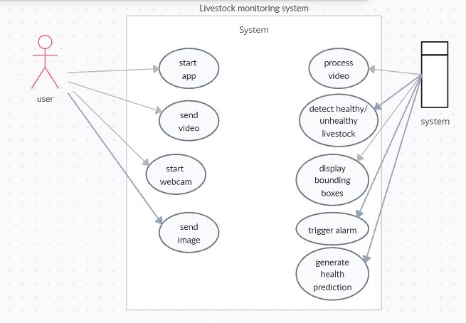
- Use case diagram

2. CLASS DIAGRAM
The class diagram for the proposed livestock monitoring system illustrates the static structure of the application by representing its major classes, their attributes, methods, and the relationships among them. The design follows object-oriented principles, ensuring modularity and scalability. At the center of the system is the Animal class, which holds basic attributes such as id, type, imagePath, and healthStatus. It is associated with the ImageHandler class, which manages image input from either webcam or file upload through methods like captureImage() and uploadImage().
The HealthAnalyzer class is responsible for processing the images using detection logic, containing methods such as analyzeImage() and detectAnomalies(). This class interacts directly with the AlertSystem class, which generates health notifications based on the results returned. Additionally, the UserInterface class, built using Tkinter, connects the user to the system by invoking image selection, initiating analysis, and displaying outputs. The relationships among these classes support a clear flow of control and data, ensuring that responsibilities are well-distributed. This object-oriented structure makes it easier to maintain, extend, and integrate new features into the system over time.
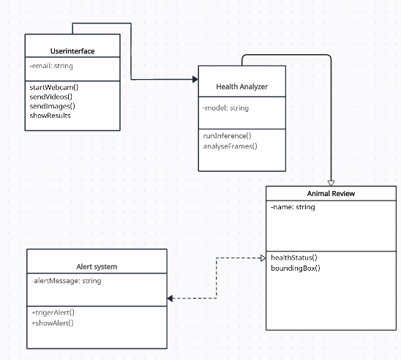
- Class diagram
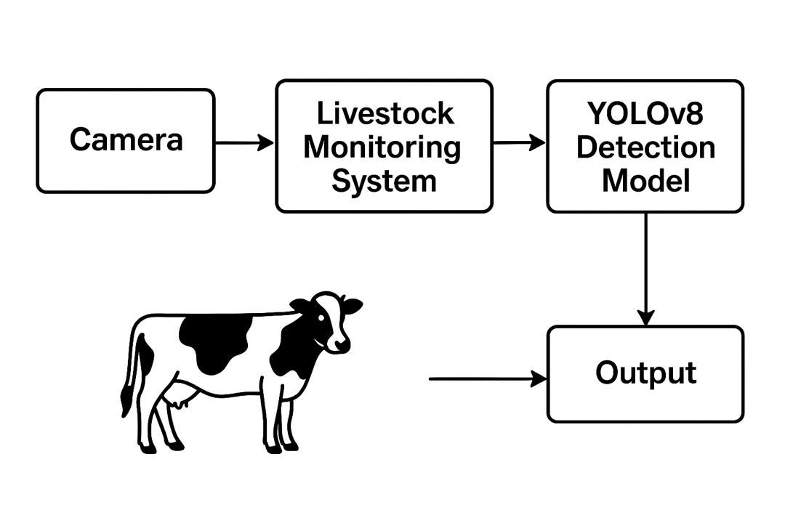

Block diagram
CHAPTER 4
DESIGN AND IMPLEMENTATION
4.1 SOFTWARE REQUIREMENTS
The software requirements for the livestock monitoring system consists of every necessary tools, libraries, frameworks, and workspace environments required to develop, test, and deploy this web application.
Python
The core programming language used to build the entire application.
Tkinter
Used to create the desktop graphical user interface (GUI) — for buttons, image display, and user interactions.
OpenCV
Handles video input, frame-by-frame processing, and image handling tasks.
Ultralytics YOLOv8
Python package used to load and run the YOLOv8 object detection model for livestock health analysis.
Roboflow Dataset
Source of the annotated training data used to train the YOLOv8 model for recognizing healthy and unhealthy livestock.

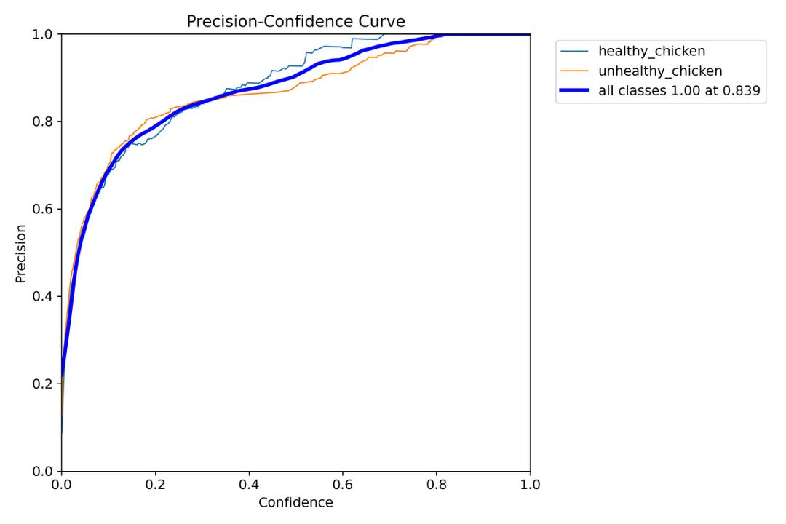
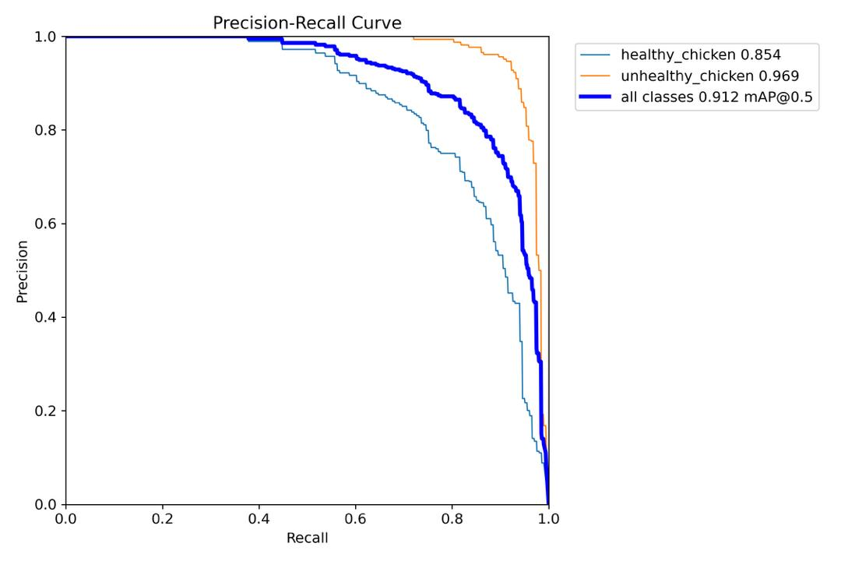
Result of Yolov8model Training

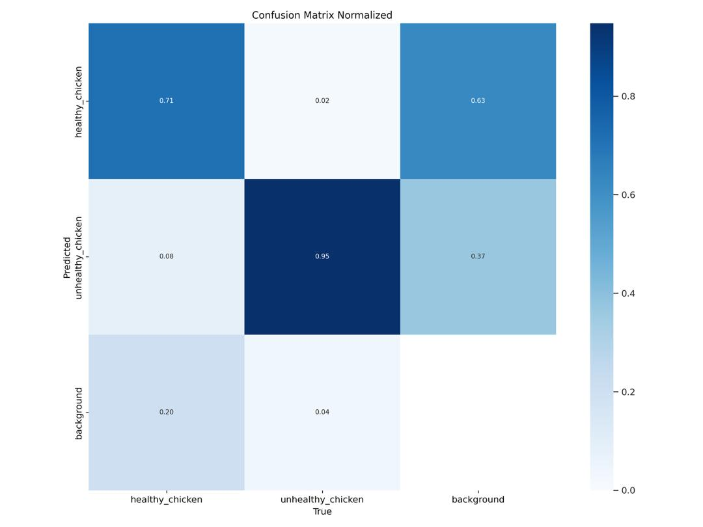
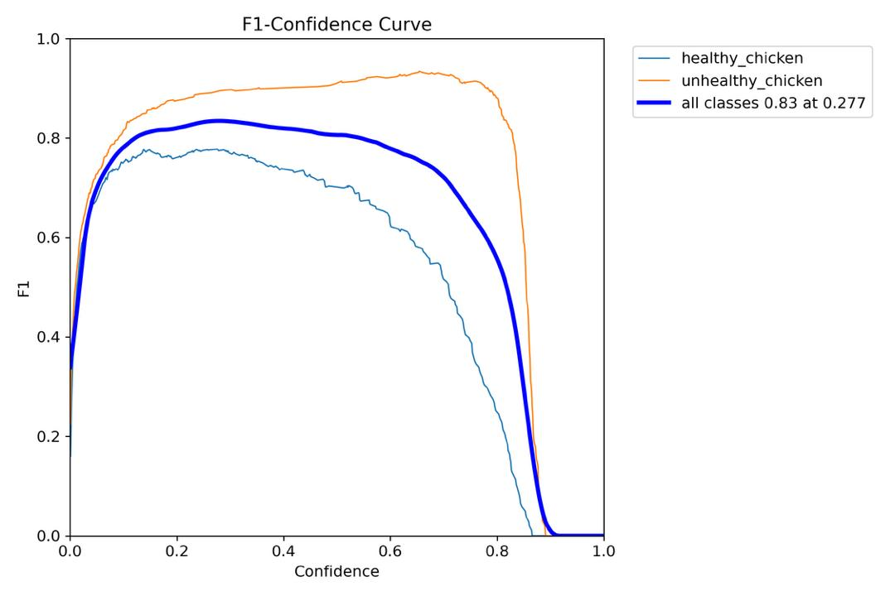

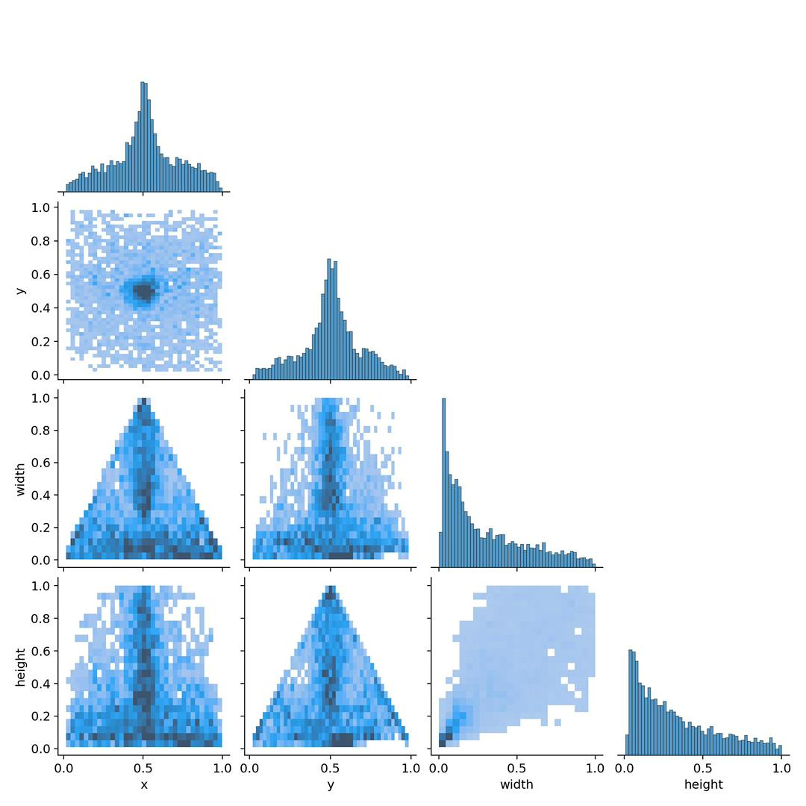
This image contains: precision recall curve, precision confidence curve, confusion matrix normalized

4.2 HARDWARE REQUIREMENTS
The hardware requirements for developing, testing, and deploying the Livestock monitoring system are as follows:
- RAM: At least 8 GB of RAM is recommended for running development
Environments smoothly. 16 GB or more is preferable for a better experience.
- Storage: A minimum of 256 GB SSD/HDD for fast read/write speeds, reducing
The time for compiling code and managing project files.
- Display: Full HD (1920x1080) monitors for a clear and spacious development
Environment, improving productivity.
4.3 NETWORK REQUIREMENTS
Internet Connection: A stable and high-speed internet connection (minimum 10
Mbps) is essential for development, accessing cloud services, and testing AI
Integrations.
4.4 INTERFACE
The following are notable features of the Livestock monitoring system interface;
1. Real-time detection: Here the system accesses the web cam to scan and review the livestock in order to locate defects and changes in the animal. This uses a large data set to review the animal being monitored.
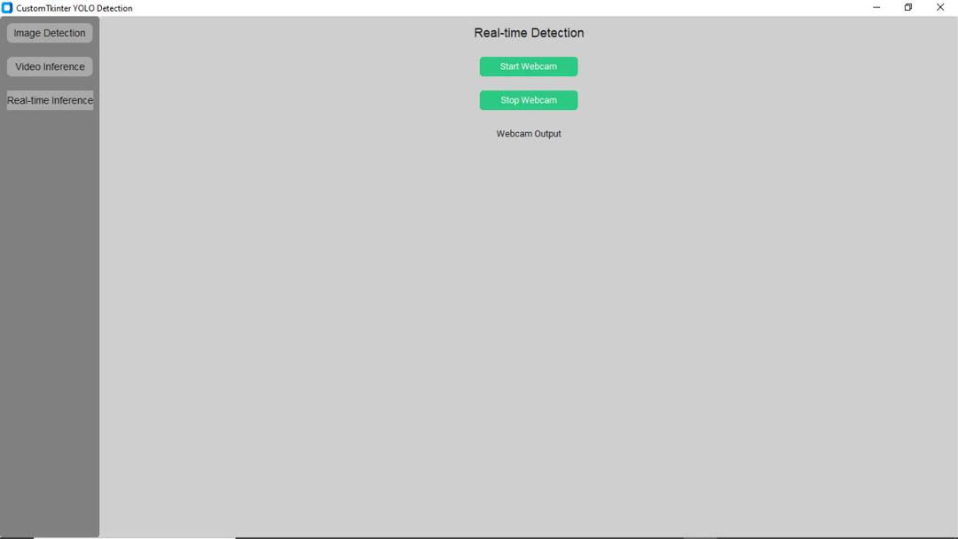
i. real-time detection
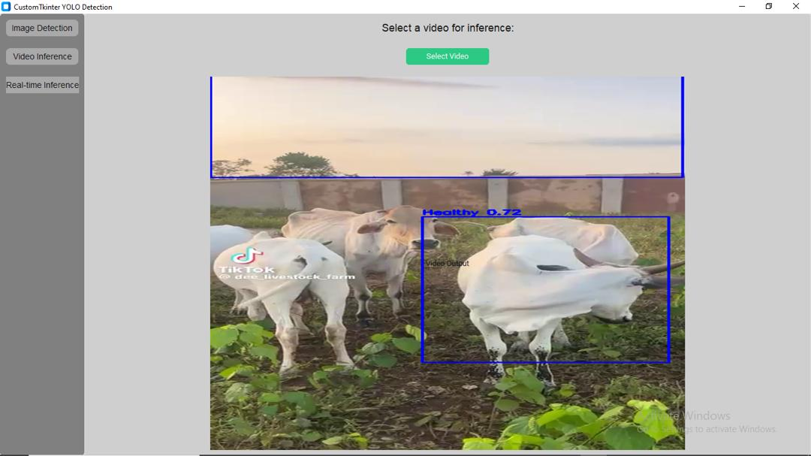
2. Video inference: Here videos are sent to the system to review and locate defects and changes in the animals. This video inference uses the same procedure as the web cam detection to spot defects in livestock in the particular video sent.

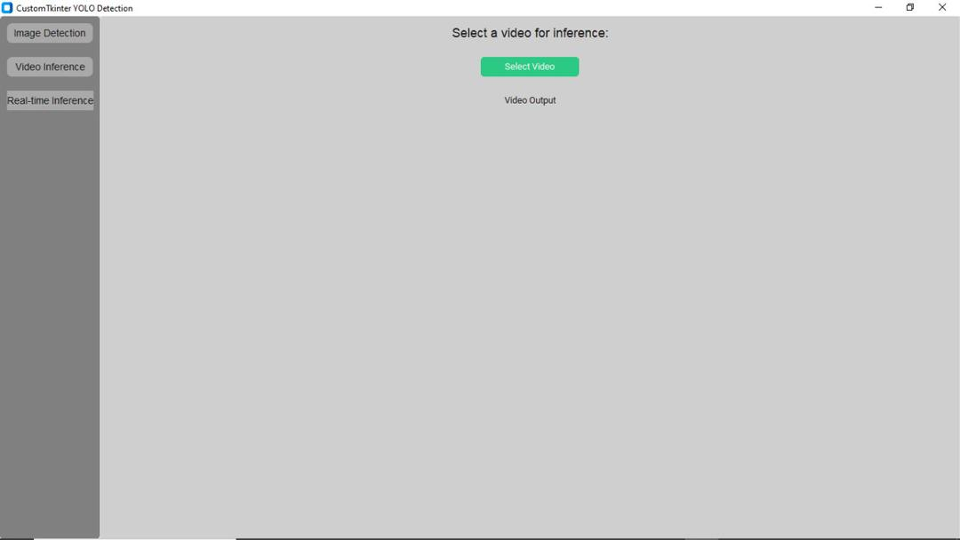
ii. video inference

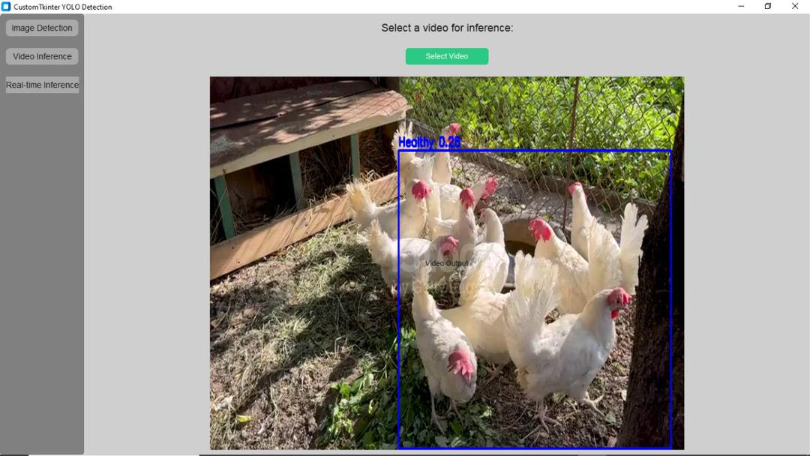
3. An Active video inference: Here a video of chickens have been uploaded and have been reviewed by the system showing that the chickens are healthy and no defects or abnormalities are detected.

4. Home page of the interface: Here the user enters his email to begin to use the monitoring system for livestock detection.
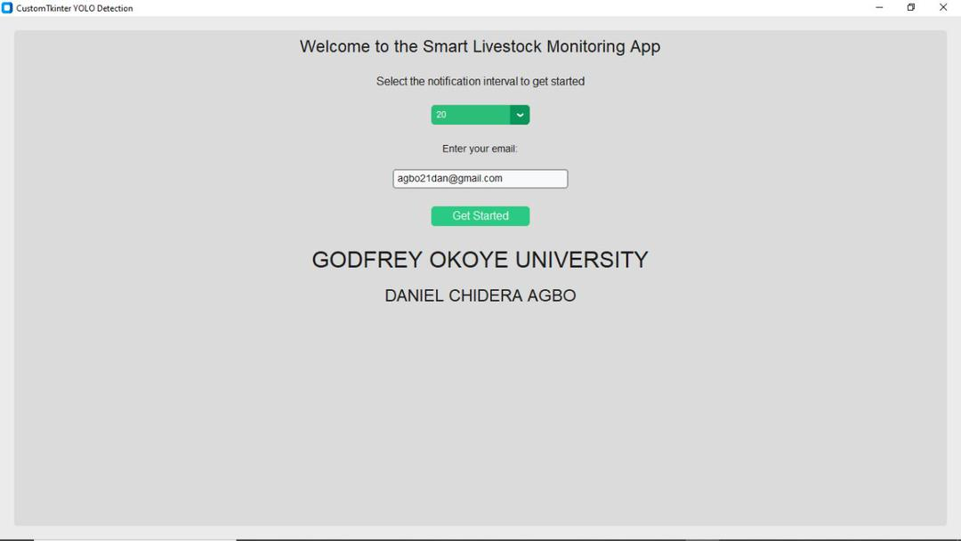
i. home page

CHAPTER 5
SUMMARY AND CONCLUSION
5.1 SUMMARY
This project focuses on the design and implementation of a desktop-based livestock health monitoring system that uses real-time video analysis and computer vision to detect early signs of illness in animals. Built with Python and powered by the Tkinter library for the user interface, the system provides farmers with an accessible and affordable solution for monitoring livestock health without the need for expensive hardware or constant veterinary supervision.
At the core of the system is the YOLOv8 object detection model, integrated through the Ultralytics Python package, which is trained on a curated dataset from Roboflow Universe. The system captures video input — either live or uploaded — and processes it frame by frame. Each frame is analyzed by the model to identify livestock and assess their health based on visual indicators such as posture, swelling, or physical abnormalities. Healthy and unhealthy animals are labeled using bounding boxes in the video feed, and when an unhealthy animal is detected, the system immediately triggers an alarm to notify the user.
This project applies object-oriented programming techniques and is structured into well-defined classes such as UserInterface, ImageHandler, HealthAnalyzer, AlertSystem, and Animal. The system is fully offline, ensuring usability even in rural areas with no internet access. Its lightweight design, real-time performance, and user-friendly interface make it suitable for small and medium-scale farmers who need reliable, automated livestock health tracking without technical complexity.
By combining artificial intelligence with an intuitive interface, the proposed system offers a scalable, efficient, and cost-effective solution for enhancing animal welfare and improving farm productivity.
5.2 RECOMMENDATION
To further enhance the functionality of this project, here are some recommendations;
Integration with a Health Database
Future versions of the system should include a local or cloud-based database to store historical health records of individual animals. This would enable better tracking, trend analysis, and support long-term health management decisions.
Implementation of SMS or Notification Alerts
To improve responsiveness, the system could be extended to send real-time notifications via SMS or email when signs of illness are detected. This is especially helpful in remote settings where users may not always be near the computer interface.
Expansion of the Detection Model
The current system is focused on general healthy vs. unhealthy classifications. The model could be retrained or fine-tuned to detect specific diseases or conditions using more detailed datasets.
Multilingual and Voice-Assisted Interface
Adding support for multiple local languages or voice alerts would make the system more accessible to non-English-speaking farmers and those with low literacy levels.
Mobile or Cross-Platform Version
While the current system is desktop-based using Tkinter, developing a mobile version or a lightweight web-based version could make it even more flexible and usable on-the-go.
Integration with Farm Sensors
The system could be extended to work alongside other smart farming technologies like temperature or motion sensors to provide a more comprehensive livestock monitoring solution.
24-Hour Real-Time Webcam Monitoring
A highly recommended enhancement is the implementation of a 24/7 continuous webcam monitoring system, which would allow for automated surveillance of livestock in real-time without requiring manual input. This would ensure health issues, abnormal behavior, or emergencies are detected at any time of day, improving early response and reducing losses due to unnoticed conditions. The system could run in the background and only alert farmers when something unusual is detected, thereby increasing automation and convenience.
Model Optimization for Low-End Devices
Since YOLOv8 is a heavy model, optimizing the system to run efficiently on low-spec computers or offering a “light mode” using simpler models like YOLOv5nano could increase usability in resource-limited environments.
Regular Dataset Updates
The performance of the detection model depends heavily on the quality of training data. It is recommended to periodically update the dataset with more diverse livestock images across different conditions, breeds, and environments.
5.3 CONCLUSION
The development of this livestock monitoring system has demonstrated the potential of integrating artificial intelligence with real-time video analysis to support modern agricultural practices. By using Python and Tkinter to build a simple and intuitive desktop interface, alongside the YOLOv8 object detection model trained on data from Roboflow Universe, the system provides an efficient solution for detecting visible signs of illness in livestock. The system processes video frame by frame and identifies animals that appear unhealthy based on visual cues such as posture, swelling, or discoloration. Once detected, the system automatically triggers alerts, allowing farmers to take immediate action.
This approach not only reduces the need for constant manual inspection but also promotes early intervention, which is vital for preventing the spread of disease and improving overall animal welfare. The system’s ability to function offline and its low hardware requirements make it highly suitable for small- and medium-scale farms, especially in rural areas. Furthermore, the modular object-oriented design allows for future enhancements such as cloud data storage, mobile versions, disease-specific detection, and 24/7 webcam-based monitoring. Overall, the project meets its objectives and presents a practical, scalable, and accessible solution to modern livestock health management.

REFERENCES
- Davis, S. (2002). Evolution of livestock monitoring systems: From manual to intelligent methods. Journal of Agricultural Innovation, 18(2), 45–58.
- Edward, A., Steven, J. B. W. D., & Alan, A. W. G. (2018). Precision livestock farming: Integrating data analytics and automation in animal management. International Journal of Smart Agriculture, 6(4), 221–235.
- Hwang, J. (2013). Mobile-based livestock disease monitoring using biometric sensors and image data. Journal of Smart Agricultural Systems, 7(1), 65–72.
- Ismail, M. A. A. M., & Rasid, R. S. A. (2016). Application of wireless sensor networks in livestock monitoring: Challenges and solutions. International Journal of Wireless Agriculture, 5(3), 110–124.
- Scrap, M. Y., & Alamir, I. M. H. (2019). Smart farming and sustainability: Leveraging IoT and AI in livestock agriculture. Smart Agriculture & Environmental Systems, 9(2), 98–115.
- Canavan, K. G. S. K., & Fulton, R. P. D. C. T. (2021). Automation in livestock health management: Advances and future directions. Journal of Automated Animal Systems, 10(1), 150–168.
- Sharma, P. P., & Paul, S. T. (2021). IoT-based real-time livestock health monitoring and alert systems. International Journal of Internet of Things in Agriculture, 12(2), 32–49.

