

CARDIAC ARRHYTHMIA DETECTION SYSTEM

BY

OKEKE DAVID ODIRACHUKWMMA

GOU/U21/CSC/708

DEPARTMENT OF COMPUTER SCIENCE AND MATHEMATICS
FACULTY OF NATURAL SCIENCES AND ENVIRONMENTAL STUDIES
GODFREY OKOYE UNIVERISTY, ENUGU STATE

AUGUST, 2025

CARDIAC ARRHYTHMIA DETECTION SYSTEM

BY

OKEKE DAVID ODIRACHUKWMMA

GOU/U21/CSC/708

DEPARTMENT OF COMPUTER SCIENCE/MATHEMATICS
FACULTY OF NATURAL SCIENCES AND ENVIRONMENTAL STUDIES
GODFREY OKOYE UNIVERISTY, ENUGU NIGERIA

A PROJECT RESEARCH SUBMITTED TO THE DEPARTMENT OF COMPUTER SCIENCE IN PARTIAL FULFILMENT OF THE REQUIREMENTS FOR THE AWARD OF BACHELOR OF SCIENCE (B.Sc.) DEGREE IN COMPUTER SCIENCE

SUPERVISOR: ENGR. DR. KINGSLEY I. CHIBUEZE

AUGUST, 2025
APPROVAL
This research titled “Cardiac Arrhythmia Detection System” has been assessed and approved by the Committees of Department of Computer Science/Mathematics and Faculty of Natural Sciences and Environmental Studies, Godfrey Okoye University, Enugu Nigeria.

Engr. Dr. Kingsley I. Chibueze _______________ _______________
Supervisor Signature Date

_______________ _______________
External Examiner Signature Date

Dr. Frank Okebanama _______________ _______________
Head of Department Signature Date

Prof. Chidi C. Uhuegbu _______________ _______________
Dean of FNSES Signature Date

CERTIFICATION
I certify that I completed the research included therein and that it was primarily based on my observations and investigation. I will fully accept the University's decision if I am found to have cheated on the assignment.

________________

OKEKE DAVID ODIRACHUKWMMA
GOU/U21/CSC/708

DEDICATION
This project is dedicated to God, whose guidance brought about its successful completion, to my family and friends whose love encouraged me to keep going, and to my supervisor whose instruction made my work process clear and efficient.

ACKNOWLEDGEMENTS
Without proper guidance, this research project would not have reached a successful completion. I am grateful to God for the presence of the following individuals whose efforts and contributions to this work I now acknowledge.
I extend my gratitude to my supervisor, Engr. Dr Kingsley I. Chibueze, for his clear instructions, and patience with me throughout the research process.
I am also grateful to my Head of Department, Dr. Frank Okebanama, who tirelessly motivated me to keep going and fostered a conducive working and learning environment for us final year students. To the Dean of Faculty and Lecturers in my Department I appreciate you all for your encouragement and advices.
I express my sincere gratitude to my noble parents, Mr and Mrs Okeke and siblings for their prayer, supports and financial help.
I appreciate my classmates and friends in school for their encouragement, assistance and advice during this project research.

ABSTRACT
Cardiac arrhythmia is a serious health situation, which takes place when the regular rhythm of the heartbeat becomes in interruption, and, therefore, can lead to such life threatening conditions as stroke, cardiac arrest, or heart failure in the case the irregular heartbeat rhythms remain unidentified and unsolved respectively. Traditional manual methods of arrhythmia diagnosis through electrocardiogram (ECG) interpretation are time-consuming and prone to human error. The following paper demonstrates how to design and implement an intelligent Cardiac Arrhythmia Detection System on the machine learning datasets and the ECG signals. The system utilizes 1D Convolutional Neural Networks (1D CNNs), Long Short-Term Memory (LSTM) networks, and a hybrid 1D CNN-LSTM architecture to classify ECG signals into normal and abnormal rhythms. We used the data preprocessing stage, which includes filtering, normalization, segmentation, and augmentation, as the techniques that enhance the quality of signals and performance of the model. Its user-friendly interface is elegant web-based, and the user performs simple operations of uploading the ECG data in it and receives a graphical waveform of ECG in real time, as well as the results of the predictions with the interpretability of the saliency map and the scores of the confidence. It is being operated on a cloud platform where there is security in the API integration, thereby, making system scalable and remote. It demonstrates the value of the achieved performances of modeling the 1D CNN-LSTM on the benchmark datasets, such as the MIT-BIH and Kaggle Arrhythmia datasets, testing the performance of the 94.7 with an F1-score of 92.3, in addition to the AUC-ROC of 95.1, which suggests the reliability of the system as well as the likelihood of its eventual clinical use in real-time through screening of arrhythmia.

TABLE OF CONTENTS
PAGES
Title page i
Approval page ii
Certification iii
Dedication iv
Acknowledgements v
Abstract vi
Table of contents vii
List of Tables ix
List of Figures x

CHAPTER ONE: INTRODUCTION 1
1.1 Background of the study 1
1.2 Statement of problems 3
1.3 Aims and Objectives 4
1.4 Significance of Study 4
1.5 Scope of the Project 5
1.6 Limitations of the Study 5
1.7. Operational definition of terms 5

CHAPTER TWO: LITERATURE REVIEW 7
2.1 Introduction of Cardiovascular/Heart Disease 7
2.2 Data Analytics in Heart Disease Prediction 19
2.3 Overview of Machine Learning Algorithms for Heart Disease Detection 20
2.4 Review of Related Literature 28
2.5 Summary of Review of Related Literature 32
2.6 Research Gap 33

CHAPTER THREE: SYSTEM ANALYSIS AND DESIGN 34
3.1 Methodology for the Research 34
3.2 System Analysis 35
3.3 Data Collection 40
3.4 System High Level Model 51
3.5 Structure of System 53
3.6 Flowchart of the System 55
3.7 Diagram Use Case 57

CHAPTER FOUR: SYSTEM IMPLEMENTATION 59
4.1 Implementation 59
4.2 Choice of Programming Language 60
4.3 System Requirements 60
4.4 System Testing 62
4.5 Results of the System 63
4.6 System Integration

CHAPTER FIVE: SUMMARY, RECOMMENDATIONS AND CONCLUSION 74
5.1. Summary 74
5.2 Conclusion 75
5.3 Recommendations 75

REFERENCES 77

LIST OF TABLES

TABLE PAGE
2.1: Types of Heart Disease 19

LIST OF FIGURES
FIGURE PAGE
2.1: The heart and arteries show plaque buildup in the arterial wall. Normal and
heart failure 9
2.2: Illustration of the Naïve Bayes Algorithm 22
2.3: KNN Clustering 23
2.4: The Decision Tree Algorithm 24
2.5: Logistic Regression 25
2.6: Illustration of ANN 27
3.1: Block diagram of the proposed system 38
3.2: Architecture of the CNN 43
3.3: Architecture of the LSTM Algorithm 48
3.4: System High Level Model 52
3.5: System Architecture 54
3.6: System Flowchart 56
3.7: System Use Case Diagram 57
4.1: Confusion Matix and ROC Curve Results 64
4.2: Heart Signal Ratings 65
4.3: Heart Signal Ratings 66
4.4: Model Loss Function 67
4.5: Heart Signal Plots 68
4.6: System Homepage 69
4.7: Data Analysis page 70
4.8: Analysis Ready Page 71
4.9: System Features Page 72

CHAPTER ONE
INTRODUCTION
  - Background of the Study
Cardiovascular diseases (CVDs) are a global health concern, contributing to about 32% of all global deaths annually, with cardiac arrhythmias being a major contributor (World Health Organization [WHO], 2021). The pathologies related to the arrhythmia of the heart are the ones linked to a fast and irregular beating of the heart collagos e.g. it may be too fast to too slow beating or irregular beating and when it is not treated and undetected then it can cause a stroke, heart failure or a sudden cardiac arrest. The enhanced rate of death as a result of CVD has further emphasized the importance of early diagnosis of the existence of arrhythmias and the necessity to engage in their interventions. Electrocardiograms (ECGs) remain the primary clinical tool for diagnosing arrhythmias due to their ability to monitor and visualize the heart’s electrical activity in real time (Yildirim et al., 2021). However, ECG examination using the help of hands is time-consuming and requires special skills; in it, there is rather a possibility of human error or misunderstanding. This limitation presents a compelling case for the development of automated cardiac monitoring and diagnostic systems using machine learning and artificial intelligence (AI).Artificial intelligence, particularly machine learning (ML) and deep learning (DL), has shown promising results in improving the efficiency and accuracy of arrhythmia detection. These techniques can automatically analyze large volumes of ECG data and detect complex patterns that may not be easily noticeable by human experts (Sannino et al., 2021). Thus the use of AI in the ECG signal processing can bring dramatic improvements to clinical diagnostics, particularly in the field of emergency care and limited resources.
Recently, convolutional neural networks (CNNs), long short-term memory networks (LSTMs), or their combination have become popular as the deep learning models that can be applied to ECG-based arrhythmia detection owing to the robust capacity of finding both appreciable temporal and spatial information by utilizing raw data (Chen et al., 2020). Indeed, the application of CNNs in particular, on ECG recordings, has demonstrated their usefulness in finding morphological features of the ECG waveforms, whilst LSTMs have been applied with appropriate success in finding sequence dependence between heartbeats. Indicatively, Li et al. (2022) came up with a hybrid CNN-LSTM model that gave high accuracy in identifying various types of arrhythmias using the data on the MIT-BIH Arrhythmia Database. In the same regard, Roy et al. (2023) presented explainable AI, where explainable AI did not only classify arrhythmias but also offered interpretable outputs that could enhance clinical decision-making and the trust towards the AI tools. Additionally, wearable ECG monitor products have now become a valid platform to demonstrate persistent recognition of arrhythmia, particularly when carried out alongside cloud-based AI pathways. These systems enable real-time and remote health monitoring, making cardiac care more accessible to patients in rural or underserved areas (Al-Karaki et al., 2022). As Internet of Things (IoT) technologies evolve, AI-powered mobile health applications are becoming increasingly important in preventive cardiology.
Despite the above mentioned advancements, several challenges have also failed to make ineffective systems of detection of arrhythmia. These include variability of quality of the ECG signal as presented by noise, inequity of data between normal and abnormal rhythm cases and transferability of AI algorithms to data of other patient populations. To overcome these challenges, sophisticated methods of preprocessing, use of bigger datasets with annotations, and optimization of algorithms are needed (Mousavi et al., 2020).
There is also the creation of an ethical issue in inclusion of AI in medical diagnostics. Explainability, transparency and regulatory compliance are some of the main concerns or imperatives particularly where the decisions involve automated decision that ends up affecting patient care. Research and clinical applications are increasingly demanding interpretable and trustworthy AI models to be used in a medical domain (Tjoa & Guan, 2021). To sum up, the realization of cardiac arrhythmia detection system based on the ECG signals and AI techniques will be one of the challenging steps in the development of contemporary healthcare. It delivers prompt diagnosis, improved patient outcomes, and lower care-related burdens. As the innovation continues, interdisciplinary interactions, and ethical use are given, AI-based ECG analysis will make an essential focus in the fight against cardiac arrhythmias.
  - Statement of Problem
Morbidity and mortality are still attributed to the problem of cardiac arrhythmias in most areas of the world and their detection is commonly hampered by many clinical and technological problems. A smart ECG-strung arrhythmia discovery unit may be constructed following the following issues:
Enormous scale of deaths in cases of non-diagnosed or untimely diagnosed arrhythmia.
Shortage of well trained cardiologists and delayed diagnosis of this in the low resource areas.
Human errors and in homogeneities in the analysis of ECG by hand.
We have complex and extensive ECG data that cannot be effortlessly processed manually.
Rising demand of scalable and programmed testing of the heart system.
1.3 Aims and Objective
This study is aimed at the development of a Cardiac Arrhythmia Detection System using Electrocardiogram (ECG) signals. The purpose of this study would be:
a. The overview of the cardiovascular diseases and the types of the disease as well as the initiatives which have been put in place in order to diagnose the disease
b. Extraction of signals of ECG data to create a clever model
c. Use the obtained data to train a Machine learning model to predict the presence of Cardiac Arrhythmia
d. Validate model trained
  - Significance of the Study
The present research article happens to be much relevant as there exists a crucial demand to create a wise, exact, and cost-effective cardiac arrhythmia prediction model in relation to the ECG signs via the application of artificial intelligence. By using the machine learning models that enable automatic processing of ECG data, it is possible to introduce a lot of benefits when it comes to early diagnosis and avoidance of medical expertise and diagnostic errors. It also possesses enhanced abilities to real-time monitor more especially with use of wearable and remote healthcare technology which will bring forth on time of a patient taking care of the patient in real-time. Also, the system stands capable of advancing the health care delivery in low resource and rural areas as it is a low-cost and scalable health alternative, which will ultimately result in the improved cardiovascular-care mortality and patient outcomes.
  - Scope of the Study
In this paper, an intelligent cardiac arrhythmia detection system design and development with help of electrocardiogram (ECG) signals and machine learning algorithms has been discussed. It entails acquisition and pre-processing of ECG signal, feature extraction, model training, and the various forms of arrhythmia classification which are atrial fibrillation, ventricular tachycardia, and bradycardia. The analysis of the system will be conducted on publicly-available databases of ECGs, e.g. MIT-BIH Arrhythmia Database. It is real-time, offline analysis only of single-lead, multi-lead ECG that does not encompass the development of wearable devices or clinical decision support integration. The study is concerned with the points of algorithm time efficiency, accuracy, and potentially applicable in limited resources environment.
  - Study Limitations
Nevertheless, this research has certain limitations on its side. Originally, the operation of the arrhythmia identification system considerably depends on the quality and diversity of the layman body of ECG; the limited or an unbalanced information may affect parametrisation of the model in unguarded circumstances. Second, the system is not going to perform its optimal array in a practical scenario in which the ECG signals generally possess noise due to the fact that they have: (i) movement artifacts or (ii) some poor contact with the electrodes. Third, the paper does not contain development of hardware to capture ECG wearable or on a bedside, which can be a constraint towards real-time clinical redesign. Additionally, it cannot be ensured that a complete interpretation of the applied machine learning models is available and this can undermine trust among the clinicians in the critical care setting. Finally, the given study is restricted to a certain range of the most typical kinds of arrhythmia and cannot be presented in cases with rare kind and the complicated cardiac malformations that cannot be diagnosed with simpler solutions.
1.7 Terms of Definition
Cardiac Arrhythmia: A condition characterized by irregular heartbeats, either too fast (tachycardia), too slow (bradycardia), or erratic rhythms, which can disrupt the normal functioning of the heart.
Electrocardiogram (ECG): A non-invasive medical test that records the electrical activity of the heart over time using electrodes placed on the skin.
Machine Learning (ML): A subset of artificial intelligence involving algorithms that enable computers to learn from and make predictions or decisions based on data.
Deep Learning (DL): A branch of machine learning that uses neural networks with many layers (deep neural networks) to model complex patterns in data, often used in image and signal processing.
Convolutional Neural Network (CNN): A type of deep learning model particularly effective in analyzing visual and sequential data by automatically extracting features.
Long Short-Term Memory (LSTM): A type of recurrent neural network capable of learning long-term dependencies in sequential data, useful for time-series analysis like ECG signals.
Signal Preprocessing: This is carried out through modification of raw ECG data by techniques in order to remove noises and artifacts and enhance clarity of signal to be analyzed.
Obtaining Arrhythmia detection system: In this case, Arrhythmia detection system is a computational machine which has been made to automatically measure the irregularities in the heart rhythms with the help of the algorithms through the guidance of the ECG signals.
• MIT-BIH Arrhythmia Database An extensively utilized publicly availed set of tagged ECG recordings that were used in training and testing arrhythmia detectors.

CHAPTER TWO
LITERATURE REVIEW
2.1 Introduction of Cardiovascular/Heart Disease
Heart disease is a general term used in reference to different conditions of illness that come along with the blood veins, arteries and other body organs and thus leading to incorrect functioning of the heart. Since the human respiratory system is destroyed, and there is a likelihood of SARS-CoV-2 virus reducing the oxygen level in lungs, the negative impact on cardiovascular status is enormous and the virus may cause the heart to be destroyed. The atheromatous deposits, aberration of lipid metabolism, the concentration of lipids and other substances in taking blood in the arteries of the heart (coronary arteries) are all indicators to heart disease. It may lead to the contraction or occlusion of the lumen, which may cause the myocardial ischemia, oxygen insufficiency, or necrosis that can be represented by the chest pain and chest tightness, heart attacks, and other circumstances (Serra et al., 2023). The heart disease holds the first place in the list of killer diseases in the modern world. According to the World Health Organization, it is reasonable to expect heart disorders to cause the death of 12 million individuals all over the world on an annual basis. The prevalence of coronary heart disease cases was 10.6 million in 2017 and 8.9 million individuals lost their lives because of the disease across the globe. In the year 2017, the number of people exposed to coronary heart disease was 126.5 million. In the US alone, it is expected that medical outlay on heart sickness will climb by 41 percent between 2010 and 2040, increasing to 177.5 billion dollars in 2040 (AbdElminaam et al., 2023).
The human heart is influenced by a lot of factors in our day to day life. The report by World Health Statistics focuses on the following fact: every third adult in the world today, suffers hypertension namely: increases in blood pressure levels and this health condition induces death in forms of a stroke or causes heart attacks and other heart related illnesses. Heart diseases as is commonly referred to, by the name of cardiovascular diseases are number of factors which can influence the heart, and these are not just the heart attacks. Cardiovascular diseases may be regarded as a major cause of casualty in many countries. Cardiovascular diseases result in the death of one person in an average of 34 seconds as stated by a study held in USA (Shrestha and Chatterjee, 2019).All the three conditions namely Coronary Cardiovascular disease, heart disease and Cardiomyopathy belong to the categories heart/ cardiovascular diseases. Cardio Vascular Disease is a term that comprises several conditions in that it influences heart, blood veins and how the pumping and course of blood circulates throughout the body. Diagnosis is a very intricate and inevitable process that must be conducted efficiently and with high level of precision. The diagnosis/detection is more or less made and made based on the knowledge, skill and professional experience of the doctor. This provides many undesirable outcomes and over the budget medical cost for the treatments given to the patients (Hossain et al., 2023).
Therefore, the automatic process medical diagnosis in estimating the potential of heart disease before its occurrence depending on some physiological values is very useful. This is why prior to discussing our work in details we will consider the use of Data analytics in predicting heart disease. As illustrated in figure 2.1, an alternative to the solution above is the following. example of a heart failure
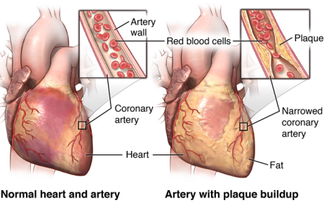
Figure 2.1: The heart and arteries show plaque buildup in the arterial wall. Normal and heart failure (AbdElminaam et al., 2023)

2.1.1 Different Types of Heart Diseases
- Arrythmia
Arrhythmia (sometimes spelled arrhythmia) is a medical term used to describe an irregular heart rhythm or heartbeat. Normally, the heart beats in a coordinated and rhythmic manner, with the electrical signals controlling its contractions following a specific pattern. This regular rhythm allows the heart to efficiently pump blood throughout the body (Gouthaman, 2019).
In the case of arrhythmia, the heart's electrical system malfunctions, causing the heart to beat too quickly (tachycardia), too slowly (bradycardia), or in an irregular pattern. Arrhythmias can occur in the upper chambers of the heart (atria), the lower chambers (ventricles), or both.
There are different types of arrhythmias, including:
- Atrial Fibrillation (AFib): This is one of the most common types of arrhythmia. In AFib, the atria quiver instead of contracting effectively, which can lead to blood pooling and an increased risk of blood clots.
- Ventricular Tachycardia (VT): This type of arrhythmia originates in the ventricles and can be life-threatening, especially if it persists for an extended period.
- Ventricular Fibrillation (VFib): VFib is a severe arrhythmia where the ventricles quiver instead of pumping blood, leading to a loss of consciousness and cardiac arrest. Immediate medical intervention (such as defibrillation) is required to restore a normal heart rhythm.
- Supraventricular Tachycardia (SVT): This is a broad category of arrhythmias that originate above the ventricles.
- Bradycardia: Reduced rate of the heart below its normal range, which may impair the circulating of blood to body organs.
- Premature Ventricular Contractions (PVCs) and Premature Atrial Contractions (PACs): Occasional extra heartbeats that may be harmless but can sometimes indicate an underlying issue.
Symptoms of arrhythmia may differ with the kind and level of intensification but could comprise palpitations, dizziness, shortness of breath, chest pain, or fainting. Others in the arrhythmias might not produce some observable symptoms and they are identified during normal health examination or tests.
Proper diagnosis and treatment of arrhythmia is essential because it is associated with the development of serious complications, such as stroke, heart failure or even the sudden cardiac arrest. The kind of treatment may involve lifestyle modification, drugs, medical procedure or use of implantable devices such as pacemakers or defibrillators so as to regulate the rhythm of the heart. It is vital that you visit a doctor when there is a suspicion that you have an arrythmia or when you have the symptoms as an evaluation and treatment plan will be in order.
Congestive heart failure
- Congestive heart failure (CHF) is a chronic medical condition in which the heart is unable to pump blood effectively to meet the body's demands. It is a severe and progressive disease which may adversely affect the wellbeing and living of an individual. The term "congestive" refers to the congestion or buildup of fluid that can occur when the heart is not pumping efficiently (Gouthaman, 2019).
- In congestive heart failure, the pumping action of the heart becomes weak, or damaged thus causing a number of issues:
- Impaired Blood Circulation: The poor ability of the heart to pump blood implies that organs and tissues might not get sufficient oxygen and nutrients, which make one tired and weak.
- Fluid Retention: Lack of efficient pumping of the heart may result in the back up of blood in the veins leading to oozing of the fluid into the tissues. This fluid buildup can lead to swelling (edema), especially in the legs, ankles, and feet.
- Pulmonary Congestion: The backup of blood can also cause congestion in the lungs, leading to shortness of breath, especially during physical activity or when lying flat (orthopnea).Other Symptoms: People with congestive heart failure may experience symptoms like coughing, wheezing, rapid or irregular heartbeat, increased urination (especially at night), and a feeling of fullness or bloating in the abdomen.
Congestive heart failure can be caused by various conditions that weaken or damage the heart, including:
  - Coronary artery disease: Blocked or narrowed arteries reduce blood flow to the heart muscle.
  - High blood pressure (hypertension): Prolonged high blood pressure puts strain on the heart.
  - Heart attack: A heart attack can cause permanent damage to the heart muscle.
  - Heart valve problems: Malfunctioning heart valves can affect blood flow through the heart.
  - Cardiomyopathy: Diseases that directly affect the heart muscle.
The treatment of congestive heart failure aims to manage the condition and improve the heart's function, as well as to alleviate symptoms and improve quality of life. Treatments may include lifestyle changes (such as diet and exercise), medications to reduce the workload on the heart and manage fluid retention, and in some cases, surgical interventions like valve repair or heart transplantation.
Proper management and regular follow-ups with healthcare professionals are essential for individuals with congestive heart failure to ensure the best possible outcomes and symptom control. It's important to promptly seek medical attention if any symptoms of heart failure are experienced or if there is a known risk of heart disease.
- High Blood Pressure
High blood pressure, also known as hypertension, is a common medical condition in which the force of blood against the walls of the arteries is consistently too high. Blood pressure is measured in millimetres of mercury (mmHg) and is expressed as two numbers (Gouthaman, 2019):
- Systolic Pressure: The higher number, representing the pressure in the arteries when the heart contracts and pumps blood out (during a heartbeat).
- Diastolic Pressure: The lower number, representing the pressure in the arteries when the heart is at rest and refilling with blood (between heartbeats).
Normal blood pressure is a reading of about 120/80 mmHg. But when the blood pressure is regularly higher than 130/80 mmHg, hypertension is diagnosis.
Hypertension is also called the silent killer because at its initial stages, it does not give one any noticeable symptoms but only human failures when the hypertension becomes severe or results in complication. Unless treated, high blood pressure can put one at high risk of some serious health problems. including:
- Cardiovascular Disease: Hypertension can damage the arteries and increase the risk of conditions such as heart attack, stroke, and heart failure.
- Kidney Disease: Chronic high blood pressure can impair kidney function and contribute to kidney disease or failure.
- Eye Problems: High blood pressure can damage the blood vessels in the eyes, leading to vision problems or even vision loss.
- Aneurysms: Persistent high blood pressure can weaken the walls of blood vessels, potentially causing them to bulge or rupture.
- Cognitive Impairment: Long-term hypertension has been associated with an increased risk of cognitive decline and dementia.
Several factors can contribute to high blood pressure, including:
  - Unhealthy diet (high in sodium and saturated fats)
  - Lack of physical activity
  - Being overweight or obese
  - Smoking and excessive alcohol consumption
  - Chronic stress
  - Genetics and family history of hypertension
The diagnosis normally occurs by a care provider measuring a persons blood pressure on a routine basis. If high blood pressure is confirmed, lifestyle changes (such as adopting a balanced diet, exercising regularly, reducing sodium intake, quitting smoking, and managing stress) are often recommended as the first line of treatment. Drugs can also be given in certain situations in order to decrease the blood pressure and the likelihood of complications.
High blood pressure must be monitored and taken care of on regular basis to ensure that it does not lead to other related health issues and to enhance the general well being. It is important to collaborate with a healthcare provider and come up with an individualized plan of lowering blood pressure and diminishing risks of occurring complications.
Coronary heart disease
Coronary artery disease (CAD), also known as coronary heart disease or ischemic heart disease, is a disorder that enters the picture when the pathways (coronary arteries) through which blood carrying oxygen to the heart muscles are constricted or obstructed. These arteries may accumulate fats in the form of plaques that are capable of impeding blood circulation to the heart (Gouthaman, 2019).
The leading cause of coronary arteries diseases is atherosclerosis which involves accumulation of cholesterols, fats, and calcium and other substances on the walls of the arteries and their eventual conversion into plaques. With continued time, these plaques can become hardened and the build up will clog up the arteries thus diluting the blood supply to the heart. In others it is possible to have rupturing of a plaque followed by blood clot causing blockage of futher blood vessels of the artery causing a heart attack.
The risk factors of coronary artery disease entail:
1. High blood pressure (hypertension)
2. High level of cholesterol
3. Smoking
4. Diabetes
5. Obesity
6. Inactive life style and physical exercise insufficiency
7. History of heart disease in the family
8. Age (risk increases with age)
The coronary artery disease may cause a number of complications, of which are:
1. Angina: Chest pain or discomfort which develops when the heart muscle is deprived of blood and oxygen.
2. Heart Attack (Myocardial Infarction): Occurs when a blood clot completely blocks the blood flow to a part of the heart, leading to damage or death of the heart muscle.
3. Heart Failure: A condition in which the heart is prevented to pump well and it fails to satisfy the body with the blood and oxygen required.
4. Arrhythmias: Erratic heartbeat may be caused by the weakened heart tissue.
Diagnosis of coronary artery disease is often made through a combination of medical history, physical examination, blood tests, and diagnostic tests such as electrocardiogram (ECG/EKG), stress tests, echocardiogram, coronary angiography, or CT scans.
Therapy of the coronary artery disease targets to enhance the process of blood distribution to the heart, reduce the symptoms, and minimize the risk of complications. Things that may be used in treating the condition depend on the intensity of the condition and may include:
1. Lifestyle Modifications: Eating a heart-healthy diet, physical activity, avoidance of smoking and control of stress.
2. Drugs: These are used as medication to regulate blood pressures, decrease the cholesterol levels, minimize blood clots as well as other risk factors.
3. Angioplasty and Stent Placement: Minimally invasive procedures to open narrowed or block coronary arteries and put in place stents to keep it open.
4. Coronary Artery Bypass Grafting (CABG): A surgical procedure to bypass blocked arteries using blood vessels from other parts of the body.
Coronary artery disease is a serious threatening problem and can be avoided through healthy way of living and control of risk factors which are among the initial efforts of minimizing chances of getting this disease. CAD can be managed by having regular medical check-ups and early identification of risk factors that would facilitate early intervention.
Peripheral artery disease
Peripheral artery disease (PAD), also known as peripheral vascular disease (PVD), is a condition characterized by the narrowing or blockage of the blood vessels outside of the heart and brain. It primarily affects the arteries supplying blood to the legs and feet, but it can also occur in arteries supplying blood to the arms, stomach, and kidneys (Gouthaman, 2019).
PAD is mainly caused by atherosclerosis, the same process that underlies coronary artery disease (CAD). Atherosclerosis involves the buildup of fatty deposits (plaques) inside the arterial walls, leading to narrowing and reduced blood flow. In the long run, these plaques may stiffen and restrict the supply of blood to the involved body organs.
The following are the most typical symptoms of the peripheral artery disease:
1. Claudication: The state of pain in the limbs (or rather the legs), cramp or numbness, and inability to move during the exercise, the symptoms of which are diminished by rest. Claudication is a consequence of not sufficient supply of blood to the muscles of the leg.
2. Cold or Numb Limbs: The area can be cold to the touch and individuals can get feeling of numbness or tingling along with it.
3. Long-Healing Wounds: When the blood circulation is slowed down, it might affect the wound healing process and create chronic sores or ulcers that appear mostly on feet and lower legs.
4. Hair Loss and shiny skin: In severe cases, the affected area has lost its hair growth and it is very shiny.
5. Weak Pulse: During physical examination one can note a weak or absent pulse in the affected limb.
An individual can develop a serious illness in terms of peripheral artery disease since it represents a system-wide problem related to blood vessel condition. Individuals who have PAD have a high risk of complications such as:
-Critical Limb Ischemia: PAD may result in critical limb ischemia, which is a lack of flow of blood to significant degree in affected limb. This has the potential to affect the tissues and result in amputation when nothing is done about it.
Cardiovascular events: PAD should be viewed as a reflection of the so-called systemic atherosclerosis, heart attack, and stroke risk.
-Reduced Quality of Life: Claudication and reduced mobility may have a major effect on the capability of an individual to carry out his or her daily activities.
Diagnosis of peripheral artery disease typically involves a combination of medical history, physical examination, and non-invasive tests such as ankle-brachial index (ABI) measurement, ultrasound, or angiography to assess blood flow in the affected arteries.
PAD treatment focuses on restoring the successful circulation of blood, alleviating symptoms, and decreasing the chances of complications. Treatment must also include lifestyle changes through the stoppage of smoking, the embracing of a heart-friend diet, and regular physical activities. Drugs can be given to take care of the risk factors, which could include high blood pressure and high cholesterol levels. In cases that are worse, the techniques such as angioplasty with stent position or the use of bypass surgery can be advised to enhance blood circulation to the affected parts.
The maintenance of overall health and quality of life relies heavily on early detection and treatment of the adult peripheral arterial disease because it helps avoid the development of complications. When you have some symptoms that are indicative of PAD or some risk factors of vascular disease, you need to get examined medically and treated adequately.

Table 2.1: Types of Heart Disease (Gouthaman, 2019)
Type | Description
Arrythmia | An irregularity in the heartbeat. It functions at either an excessively slow rate or an excessive speed.
Congestive heart failure | When the heart fails to pump blood in its usual manner, it develops into a chronic illness.  A sudden, unpredicted loss of consciousness, disturbance in heart function, and impaired breathing.
Cardiac arrest | The congenital defect of the heart.
Congenital heart disease
High Blood Pressure | The situation where the pressure of blood exerted on the arterial walls exceeds a safe threshold.
Coronary artery disease | Any injury to the heart’s primary arteries, coupled with any vascular disease that arises.
Peripheral artery disease | Interruption in the supply of blood to the brain.

2.2 Data Analytics in Heart Disease Prediction
Many research studies have used various datasets and employed data analytics and data mining algorithms in order to identify some patterns and predict the likelihood of heart diseases. SVM and Logistic Regression turned out to have the higher accuracy rates out of all the most commonly used techniques: namely, SVM, Logistic Regression, Naive Bayes, KNN and Decision Trees. Hadoop based MapReduce and HDFS algorithms have also been utilized to store data on different nodes and execute the system in parallel in some research works (Palanaippan and Awang, 2008).
Blood pressure is also the main attribute that is used in most of the datasets together with the heart rate whereby the patients are aged above 30. None of the previous studies have employed deep learning, which is increasingly viewed as providing superior accuracy, in spite of the fact that most of them have used the above algorithms.
In hospitals, the prediction of Heart Disease rests on a patient presenting with urgent symptoms—for example, a high pulse rate, chest pain, or other similar signs. Hence, to detect heart blockage, the patient is subjected to ECG, Angiogram and other relevant tests. Based on the test, patient is treated by performing pacemaker, Angioplasty and so on (Samuel et al., 2017).
But due to the increasing workload and constant stress, it is emerging today that heart problems can arise at any stage of life. Today, adults between the ages of 20s, 30s, and even 40s are not exception (to heart disease) due to the increase in work commitments and stress. Some of them acquire it even in upbringing times It is therefore, necessary to rapidly come up with an automated medical diagnosis algorithm of heart illness based on physiological parameters like blood pressure, heart rate and blood sugar. And so, in terms of predicting heart disease. To predict the incident of the heart disease, data is collected and work is done using machine learning algorithms; which include Regression, SVM, Bayes, KNN, Decision Tree and ANN.
In all of these systems, there are only a few variables that are utilized in predicting--heart rate, age, and so on. Moreover, no one has tried to utilise Deep neural networks in the field of heart disease prediction so far. We have, in this work, used Deep Neural Network on heart disease prediction, based on 13 physiological parameters and we have compared it with other models like, Regression, SVM, Bayes, KNN, Decision Tree, Random forest and ANN in terms of error as well as accuracy (Mienye et al., 2020; Haq et al., 2018).
2.3 Overview of Machine Learning Algorithms for Heart Disease Detection
By the means of such algorithms, a prediction model is created that will analyze and predict a patient status on whether he or she is plagued with or without any type of heart disease with the best accuracy possible.

2.3.1 Support Vector Machine
Support vector machine aims at locating a hyperplane that graphically and neatly separates information points in an N-dimensional area.
The two classes are in turn partitioned by choosing a single hyperplane out of the set of hyperplanes that are available. Then our first principal object will be to find, among others, the plane having the widest margin of any--or, in other words, the points of the data set which are closest to the common boundary between the two classes. When we maximize this margin, the distance provides us with more accurate classification when future data points are plotted (Jindal et al., 2020).
Altogether, it is possible to divide the SVM into two groups:
1. Linear SVM, gives us a linear plane that we can use to divide the classes. In our case, we want to make the hyperplane lie as far away as we can away from the centre point of the classes.
2. Non Linear SVM: It uses a graph that is non-linear and gives a picture that captures the real life situation better.
2.3.2 Naïve Bayes
It is a method of machine learning, which is based in the Bayes Theorem. Presently speaking it assumes the independence of attributes. They form a type of algorithms that is homogenous in terms of the fact that all features are mutually independent. The Bayes Theorem gives the likelihood that a future event will happen, after a prior happenstance. The mathematical formula is Probability(a|z) = (Probability(z|a) * Probability(a)) / Probability(z)
Where,
• Probability (a|z): Gives us the probability of a (the hypothesis) gives the data is a.
• Probability (z|a): Gives the probability of the data when the hypothesis is true.
• Probability (a): Regardless of the data, the hypothesis is said to be true.
• Probability (d): Regardless if the data, the probability of the hypothesis is given.
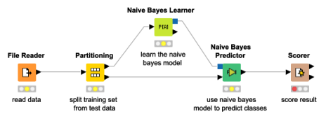
Figure 2.2: Illustration of the Naïve Bayes Algorithm (Jindal et al., 2020)

2.3.3 K-Nearest Neighbour (KNN)
K nearest neighbours/ shortened as KNN is a type of algorithm which groups data together in categories, these groupings, and then classify data in accordance to their comparable measures. Decision is made according to more votes to its neighbours. The classes with the nearest neighbours are attributed with data. When we add more nearest neighbours, I.e. increase the value of k, then the accuracy may also increase. KNN is broadly used for pattern recognition and statistical prediction (Malik et al., 2021).
It categorizes the data to clusters, according to the proximity of the nearest neighbor.
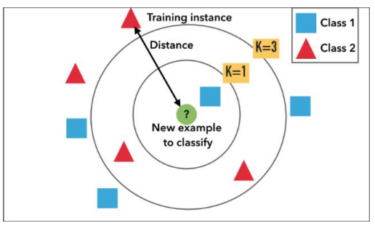
Figure 2.3: KNN Clustering (Malik et al., 2021)

2.3.4 Decision Tree
One of the supervised learning algorithms is Decision Tree. Here the data is repeatedly divided on the basis of some parameter following which we get the decision nodes and the leaves. It differs with other supervised algorithms in the sense that it can as well solve the regression and classification problems with ease. The main aim is to create a system that can predict the results that we desire just by learning the decision rules from the prior data, i.e., the training set (Hazra et al., 2017).
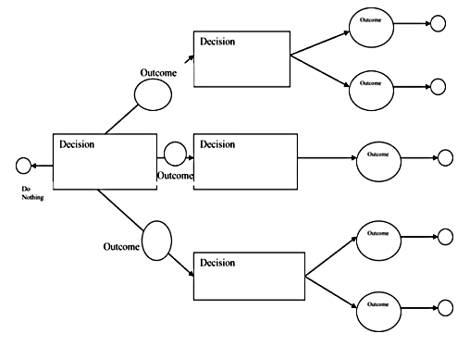
Figure 2.4: The Decision Tree Algorithm (Hazra et al., 2017)

2.3.5 Random Forest
As the name may suggest, indeed Random Forest does develop multiple, random forests due to which also it is called the random decision forest as well. It is one of the supervised algorithms. It builds random forests that are nothing but a collection of decision trees. Another key reason why bagging method is used is that it is the most effective way of training it. The thing is that, bagging method combines all the models of learning and after that it helps us with the copiousproduct. Similar to decision trees, it can solve both, regression problems and classification problems (Hazra et al., 2017).
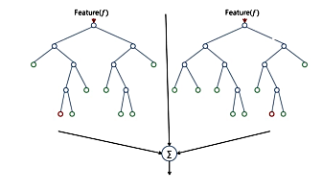
Figure 2.5: Logistic Regression (Hazra et al., 2017)

2.3.6 Logistic Regression
Logistic Regression is any form of a predictive analysis. It is used to investigate how the data in which one of them is a dependant one and another one is an independent one is linked. What logistic regression will do is it will round all the results values to the nearest binary value so that it will be easy to predict the answer. This can also result in making a small amount of errors, and not be able to make good predictions. To go around such an error, multiple regression is used and this is the one that helps to give a result close to the real result. Logistic Regression entails the involved complex cost functions such as the Sigmoid one. Sigmoid is an algorithm used in machine learning in predicting the probabilities (Ahmed et al., 2022).
1.3.6Artificial Neural Network (ANN)
One of them is an artificial neural network commonly known as ANN, which functions as the brain or the neural network i.e. the neurons. It is termed as a computational model and it processes all the complex data. It does not get any task specific goal and it learns using the examples or data provided to it just as the brain. It is founded upon some nodes commonly known as the artificial neuron. The more number. Better the system of neurons. The neurons carry the signals to each other to effect a good connection that is similar to the human neural network. A neural network has the following 3 layers (Sarra et al., 2023):
•Input layer- this layer will be made up of the complicated raw data which we put in front of the neurons.
Hidden layer These are the computational layers that receive the input and weight of a node in the other layers, compute them through the activation function and send the result to the other layer.
Output layer - This consists on the output of the hidden layers, and the functions that will occur in there.
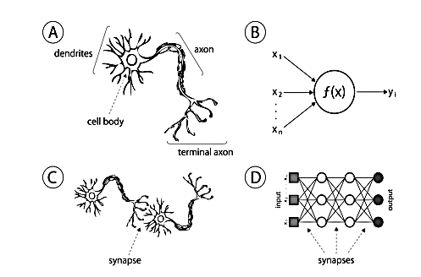
Figure 2.6: Illustration of ANN (Sarra et al., 2023)

Neurons are considered to be the fundamental computational unit. The provided sources feed it with inputs and each input has a weight assigned to it relative to the other inputs. Then the function is applied to such to arrive at figure 2.5.
This is referred to as the Activation function that simply adds non-linearity to the function and pushes it out as the output. The sigmoid is the function that we have utilised in our module and has its inputs as a real number that is subsequently made to fit the interval of 0 to 1.
The equation is: σ(x) = 1 / (1 + exp(−x))

2.4 Review of Related Literature
Shrestha and Chatterjee (2019) studied the machine learning-based prediction system of a heart disease. In the work, a Web-based Heart Disease Prediction System (HDPS) is developed, using the concept of machine learning with the Decision Tree (DT) and Naive Bayes (NB) classification algorithms. When comparing DT and NB algorithms of the HDPS Web application, one of the models is trained on the dataset of heart disease that is available in the UCI repository. It has 303 samples and 14 attributes, with which a prediction model is trained, and implemented as a web application where the model can make predictions in real-time. This project aims to develop the effective prediction model and implement it in a web-based form. An accuracy of 88.163% was provided by the Naive Bayes algorithm which was better as compared to the rest of the approaches. All the stages of the software development were carried out successfully and the waterfall model was used to develop the web-based HDPS. These involved the requirement analysis, system and database design, feature identification, testing and deployment. The major drawback of the project is the fact that it suggests the potential of heart disease only whereas it fails to reveal what kind of heart disease a patient might use.
Mohammed (2022) Presented the model of heart disease prediction based on many ML algorithms The paper has a two pronged methodology. First, uci repository provides data on heart disease, and such data are pre-processed in a way that it can be utilized in machine learning. This involves cleaning, normalisation and transformation of data. The dataset is then employed to establish whether the patients have heart disease or not. In the second phase, it will be necessary to evaluate different algorithms, such as Logistic Regression, Support Vector Machine (SVM), K-Nearest Neighbours (KNN), Random Forest (RF), and Gradient Boosting Classifier. A confusion map is formed to check and compare the accuracies. Of these, Logistic Regression had the highest accuracy of 95%; it had the highest F1-score, recall, and precision. The paper advises that this accuracy is not optimal and should be optimized so that it can be used practically by a figure of between 97 and 100 per cent.
Jeyaganesan et al. (2020) carried out a research on diagnosis and prediction of heart disease based on different machine learning. The objective of the research is determining the accuracy of the four algorithms of Decision Tree, Logistic Regression, Random Forest, and Naive Bayes in prediction. The trained and tested the algorithms in terms of how they can predict heart disease using the UCI dataset. The findings indicated that Random Forest algorithm performed best, being quite efficient out of the models applied to it, and hitting above 90 percent accuracy in prediction. The research notes, though, that despite the relative small size of the data set, the study was narrow in its nature since it did not have a practical application. It suggests that future contributions should aim at developing an internet-based prediction tool on Random Forest and, with bigger data, improve the prediction rates to assist healthcare professionals.
Sarra et al. (2023) This paper presents a research carried out to better the accuracy rate of ANN derived in making heart disease predictions. The authors have created a deep learning base diagnostics method that exercises a simplified ANN, a model that was trained on the UCI data set. The main purpose was to perform better than usual machine learning like SVM in terms of accuracy and speed. The proposed ANN model reached the significant prediction accuracy of 93.44 percent as compared to 85.94 percent in the Support Vector Machine algorithm, or 7.5 percent improvement. Besides, the ANN model only took a few seconds to train and classify the data, hence efficient and precise. The issue of model interpretability and overfitting were, however, not covered in the study as limitations.
Islam et al. (2021) This research suggested a hybrid machine learning model with laughter used to defeat heart disease iterations, which is composed of Principal Component Analysis (PCA), Genetic Algorithm, and k-means clustering. It has been based on the UCI dataset, and the dimensionality reduction with PCA has been applied to get rid of irrelevant features. The feature selection was optimized by a hybrid Genetic Algorithm, and the similar profiles of the patient was grouped by the k-means clustering in order to enhance the correct classification. The accuracy of the predication was 94.06 % due to this kind of hybrid. The method allowed decreasing the complexity of the models and enhanced training time. Nonetheless, the behaviour of the system was subject to the clustering algorithm, which is extremely erratic and initialization-sensitive.
Theerthagiri and Vidya (2021) introduced a method for predicting cardiovascular disease using Recursive Feature Elimination (RFE) in combination with Gradient Boosting. The authors used the UCI dataset and applied RFE to select the most relevant features before feeding them into the Gradient Boosting Classifier. The study showed that this combination achieved an accuracy of 89.7% and an AUC score of 0.84. While the results were promising, they were slightly lower compared to other ensemble models. Moreover, the study lacked deployment in a real-world scenario and did not explore interpretability or patient usability.
Khan (2020) The study proposed an IoT system to monitor heart diseases based on Multiscale Deep Convolutional Neural Network (MDCNN). The paper will address the issue of detecting heart diseases in real time by employing wearable devices that allow collection of data like ECG and blood pressure. The MDCNN model has been used to process and predict this physiological data which is time series. The model was trained and tested with the achievement of an amazing accuracy of 98.2 percent. Such performance on the high level was explained by such characteristics of the CNN model as its quantity and deepness, as well as by the real-time abilities of the IoT integration. The disadvantage however is that it requires specialized hardware and further clinical validation is necessary and cybersecurity of the system.
Ahmad et al. (2023) conducted a study using a hybrid model combining the Jellyfish Optimization Algorithm with a Support Vector Machine (SVM) classifier for heart disease prediction. The optimization algorithm was used to select the most impactful features, reducing noise and enhancing model performance. After applying the Jellyfish algorithm on the UCI dataset, the selected features were used to train the SVM. The model achieved an outstanding accuracy of 98.47%, with a sensitivity of 98.56% and specificity of 98.37%. Despite the strong performance, the model may be overfitted due to the limited dataset size and needs to be validated on external or real-world clinical datasets.
Mir et al. (2024) was devoted to the comparison of machine learning based on features in order to enhance the prediction of heart diseases over several datasets. In the study, the UCI Heart Disease dataset and Statlog dataset were employed with feature selection techniques involving chi-square, ANOVA, and mutual information. Such machine learning models as XGBoost, Random Forest, SVM were tested. Our findings revealed that the XGBoost classifier produced the most accurate results with approximated accuracy of 97.57% and accuracy under the AUC line of 0.98 and F1- score of 0.92. Despite the high accuracy level, the study acknowledged that heterogeneity in datasets and inconsistencies may have an adverse impact on the generalizability and requested additional standardization of the datasets.
Srinivasan et al. (2023) applied active learning strategies to machine learning models for heart disease prediction. In this study, algorithms such as Naïve Bayes, Radial Basis Function (RBF), and Learning Vector Quantization (LVQ) were used alongside active learning to train models on the most informative data points. The LVQ algorithm yielded the highest accuracy of 98.7%, followed by Naïve Bayes at 94.78% and RBF at 90.78%. Active learning reduced the amount of data required while increasing performance. However, the study’s limitation is the complexity of LVQ and active learning implementation, which requires expert tuning and can be resource-intensive.
2.5 Summary of Review of Related Literature
Author(s) Name/Year | Workdone | Methodology | Findings | Limitation
Shrestha & Chatterjee (2019) | Developed Web-based HDPS using DT & NB | Decision Tree & Naïve Bayes on UCI Cleveland dataset (303 × 14); Waterfall lifecycle | NB accuracy ≈ 88.16 % | Only predicts presence, not type of heart disease
Mohammed (2022) | Multi-algorithm evaluation for heart disease prediction | LR, SVM, KNN, RF, Gradient Boosting on UCI dataset; confusion matrices | Logistic Regression reached ≈ 95 % accuracy (plus strong F1, recall, precision) | Accuracy below ideal (~97–100 %)
Jeyaganesan et al. (2020) | Compared ML models for heart disease diagnosis | DT, LR, RF, NB on UCI data | Random Forest achieved > 90 % accuracy | Small dataset; no web system; suggests scaling and deployment improvements
Sarra et al. (2023) | Deep learning-based prediction (ANN) | Artificial Neural Network applied to UCI dataset | Accuracy ≈ 93.44 %, ~7.5 % higher than SVM; fast inference | No detailed limitations stated; model complexity vs interpretability
Islam et al. (2021) | PCA + Hybrid Genetic Algorithm with k-means clustering | PCA for feature reduction + HGA + k-means clustering | Accuracy ≈ 94.06 % | Heuristic clustering—sensitivity to initialization and convergence issues
Theerthagiri & Vidya (2021) | RFE + Gradient Boosting for CVD prediction | Recursive Feature Elimination + Gradient Boosting | Accuracy ≈ 89.7 %, AUC ≈ 0.84 | Moderate accuracy; could improve with stronger ensembles
Khan (2020) | IoT-based system using MDCNN classifier | MDCNN on sensor-collected ECG/blood-pressure data | Accuracy ≈ 98.2 % | Requires specialized hardware; generalizability to larger datasets uncertain
Ahmad et al. (2023) | Jellyfish optimization + SVM for heart disease | Jellyfish feature selection + SVM on Cleveland dataset | Sensitivity ≈ 98.56 %, Specificity ≈ 98.37 %, Accuracy ≈ 98.47 % | May overfit; needs validation on external datasets
Mir et al. (2024) | Feature-based ML comparison across multiple datasets | Various classifiers across Heart UCI & Statlog; feature selection via chi-square/ANOVA/MI | XGBoost best: Accuracy ≈ 97.57 %, AUC ≈ 0.98, F1 ≈ 0.92 | Used both public/private datasets; may face dataset heterogeneity and bias
Srinivasan et al. (2023) | Evaluated 8 ML models with active learning techniques | Active learning + multiple classifiers (e.g. NB, RBF, LVQ) on clinical data | Learning Vector Quantization reached ≈ 98.7 %, NB ~94.78 %, RBF ~90.78 % | Complexity of LVQ and reliance on feature selection/generalizability
2.6 Research Gap
Despite the high potential of the method of machine learning and deep learning in arrhythmia detection, some of its significant limitations have not been covered. The majority of the current systems are restricted to binary decisioning, detecting whether the heartbeat is normal or not, and not which type of arrhythmia (e.g. atrial fibrillation or vent. tachycardia). This makes them less useful in clinical application. Also, most of these models are not interpretable and that is why healthcare professionals cannot comprehend or have confidence in the predictions. There are few attempts to combine CNN and LSTM architectures, despite the fact that a hybrid method seems to be capable of tracking both spatial and time-dependent characteristics in ECG signals, which would improve the accuracy even further. The other principal gap is the in-real-time usability and deployment. A large number of models are neither web-based nor can be deployed to a cloud or designed to work in a remote and/or low resource environment. It is also possible to forget about noise in ECG signals and the disbalance of classes in the dataset, both of which can lower the performance in practice. Thus, a scalable, explainable, and high-accuracy arrhythmia detection system that provides intelligent and multi-class identification is required, especially in areas with not many medical knowledge and infrastructure.

CHAPTER THREE
SYSTEM ANALYSIS AND DESIGN
3.1 Methodology for the Research
The methodology adopted for the development of this study is the Extreme Programming (XP) methodology which is highly suited for the development of the Cardiac Arrhythmia Detection System due to its iterative, flexible, and user-cantered nature. The peculiar feature of XP is the development cycle, frequent releases, and continuous feedback, at the heart of which the fast response of the team to the changes in the requirements or clinical knowledge lies. XP facilitates gathering of the user stories of the major stakeholders of the project, which are cardiologists, nurses, and patients, in the initial phases and based on which system requirements have to be developed, including ECG upload, noise filters, arrhythmia identification, and explainable results. The system follows simple design principles so that it is not over-engineered and prototypes or so-called spikes are designed to test whether or not machine learning models like CNNs, LSTMs and hybrid models are feasible. Pair programming is used on critical modules like preprocessing and classification, ensuring collaborative decision-making and higher code quality, while Test-Driven Development (TDD) ensures that all components (e.g., ECG segmentation or inference results) are tested before implementation.
In the course of development, XP focuses on continuous integration and feedback with an understanding that healthcare professionals would need to test the system on interval to monitor the accuracy, interpretability, and usability of the system. Refactoring is carried throughout the process to enhance the efficiency of the codes without changing the basic functionalities making the system scalable and maintainable. The deployment process is implemented step-by-step by initially developing the basic functionalities, adding real-time monitoring, severity analysis feature as well as multi-modal integration on the side. Feedback of the users and system performance records are used post-deployment to lead development cycles. This loop of improvement means XP is the perfect choice of the development framework when the focus is a health-tech system where clinically-accurate delivery, agility, and UX are important factors in the actual deployment and effectiveness.
3.2 System Analysis
The Cardiac Arrhythmia Detection System is a system that takes input of ECG signals and identifies and classifies arrhythmias using severe machine learning algorithms automatically. The analysis of the system starts with the specification of the functional and non-functional requirements such as the accurate identification of different types of arrhythmias, an intuitive interface, and successful control of the data in accordance with the healthcare standards. Among the external actors also found in the analysis are healthcare professionals, patients, and cloud APIs, and the constraints that could be encountered are given, including limited access to computational resources or data privacy laws. Such a detailed analysis will guarantee that the system is clinically, technically, and user-focus oriented.
3.2.1 Existing System Analysis
The current systems of detecting cardiac arrhythmia use mainly the rule-based algorithms. These systems are normally incorporated as a part of ECG machine or even clinical diagnostic devices and there would be a lot of human interpretation involved. While they provide basic classifications like normal vs. abnormal rhythms, they often lack the granularity to detect specific arrhythmia types (e.g., atrial fibrillation, ventricular tachycardia) with high precision. Similarly, a high number of systems based in hospitals demand that cardiologists do the labelling work manually, similarly, they cannot deliver real-time feedback, thus they cannot be used to monitor patients and conduct tests remotely. Moreover, such systems might not be open as well as customizable which reduces its flexibility to a particular healthcare setting especially in resource limited environments.
Additionally, the majority of current systems do not contain sophisticated features, including deep learning-based classifications, explainability, and interfaces that would attract both the clinical and non-clinical users. They do not usually provide tools of visualization of the particular parts of the ECG signals which are important to clinically trust and make decisions. Most of the available systems are integrated into a high-cost proprietary system which is unaffordable and unsustainable in low-income or rural environments. Consequently, there is an increasing demand in intelligent, scalable, explainable cardiac arrhythmia detection system that combines modern deep learning capabilities, multiple ECG versions support, real-time/near real-time feedback, and data security and clinicalization.
3.2.2 Limits of the Current System
1. Low Specificity and Sensitive: The traditional systems do not have or are not sufficiently sensitive or accurate in recognizing and categorizing multiple types of arrhythmia especially with a noisy or complex ECG signal.
2. Deficient Real-time Monitoring: Most of the current solutions are offline or do not respond real-time, thus not suitable to monitor patients in real-time or as an emergency.
3. Dismal explanatory ability: The standard models have a narrow understanding of why a specific diagnosis was performed, which diminishes the trustworthiness of automation diagnosis by the patching practitioner.
4. Manual Dependency: They tend to have the need of expert cardiologists looking at raw ECG data or to confirm the results of the algorithms, creating a back-up and distraction.
5. Rigidity to Data Change: Rigid rule based algorithms make old systems to not be easily generalizable across all data sets of different populations or even devices.
6. Expensive Cost and Proprietary: Most of them are stored in very expensive ECG computers or programs and are not free on source property which is not accessible to low resource clinics.
3.2.3 Analysis of the Proposed System
The proposed Cardiac Arrhythmia Detection System aims to overcome the limitations of existing models by leveraging advanced machine learning techniques—specifically, 1D Convolutional Neural Networks (CNNs), Long Short-Term Memory (LSTM) networks, or a hybrid CNN-LSTM architecture—for accurate, automated detection and classification of cardiac arrhythmias using ECG signals. The system is created as capable of handling various types of arrhythmia including atrial fibrillation, premature ventricular contractions and so on. It starts with the preprocessing stages such as noise removal and normalization to obtain clean ECG as an input of a robust performance of models. Explainability features LIME and saliency maps are used to complement the classification results by showing the importance of certain portions of the ECG signal used to make a prediction. This renders the system explainable, transparent and clinically credible. The block diagram of the proposed system is presented in Figure 3.1.
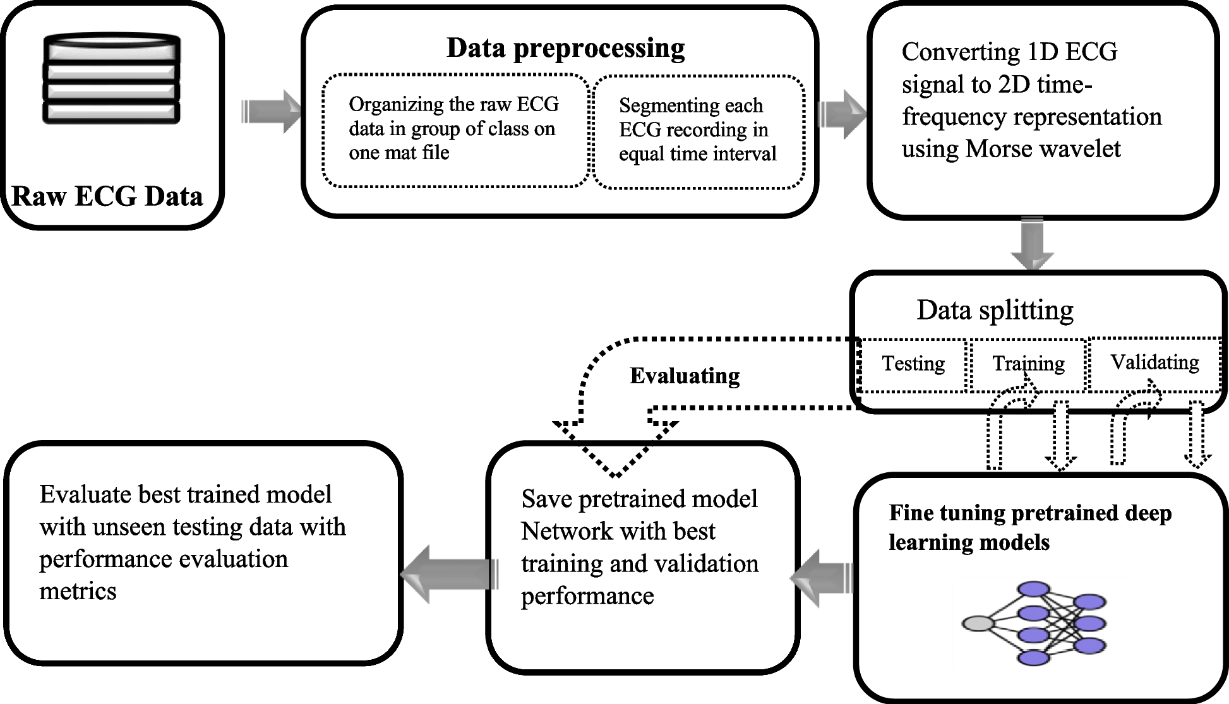
Figure 3.1: Block diagram of the proposed system
- There is also usability and accessibility of the system besides predictive accuracy. An internet and mobile screen interface will enable patients or medical practitioners to post ECG signals and get a live review of the signal. The backend, implemented either with FastAPI or Flask will efficiently serve the trained model, and cloud deployment with such platforms as AWS or GCP will be highly scalable. Security such as data encryption and HIPAA/ GDPR standards of compliance are coded in place to safeguard patient data. The system is continuously improveable with features such as version control and feedback loops and can be upgraded in future to become real-time monitoring, scoring of severity and compatibility with other medical data. In sum, the suggested system represents an affordable, scalable, and smart method of arrhythmia detection in the clinical and remote contexts.

3.2.4 Benefits of the proposed system
1. High Detection Accuracy: Utilizes deep learning models (e.g., 1D CNN, LSTM, CNN-LSTM) capable of learning complex ECG patterns, improving arrhythmia classification accuracy.
2. Real-Time Monitoring: Allows real-time or near-real-time analysis, which can result in timely identification and action on dangerous cardiac events.
3. Multi-Class Classification: Not only normal vs. abnormal rhythms are detected and distinguished, but different types of arrhythmias.
4. Explainability: It will combine the most popular tools such as LIME and saliency maps to provide a visual map of where the ECG had an impact on predictions and increase clinical confidence and interpretability.
5. Intuitive User-interface: Offers an intuitive web/mobile application that can easily upload the ECG recording, display the results, and interact with them-professionals as well as patients.
6. Scalability and Flexibility: Can be deployed across cloud platforms (AWS, GCP), scaled using Docker/Kubernetes, and accessed on multiple devices.
7. Data Security and Compliance: Implements encryption and adheres to data privacy standards (e.g., GDPR, HIPAA), ensuring secure handling of sensitive health data.
8. Resource Efficiency: It has the optimized requirements of inference with the means of utilization as ONNX/TensorRT, and well-suited in a low-resource framework.
9. Continuous Improvement: it is possible to update and add feedback to it regularly and to improve the performance of the model and the experience of using it.
10. Remote Environment Accessibility: Avails a telemedicine-ready solution that can be used in remote diagnostics, which would be useful in underserved or rural settlements with little access to a cardiologist.
3.3 Data Collection
Data collection for the proposed Cardiac Arrhythmia Detection System involves acquiring labeled ECG (Electrocardiogram) signal datasets from credible, open-access sources to train and validate the machine learning models. There are two main sources used: the MIT-BIH Arrhythmia Database in PhysioNet repository, and a Kaggle Arrhythmia Dataset. The dataset of MIT-BIH consists of the 48 half-hour long recordings of two-channel ECGs recorded with the sampling rate of 360 Hz and the more detailed annotations that provided the type of arrhythmia and its timing. Such recordings are considered the landmark of the study on arrhythmia classification. On the other hand, the Kaggle dataset provides more significant amount of available data (more than 4,500 samples of ECG) diversified based on the classes of arrhythmia, which, to some degree, enhances the generalization of the model. These datasets offer normal and pathologic heart beat signals labelled by qualified cardiologists thus offering an excellent ground truth to supervised learning.The data gathered are preprocessed to provide resilience and clinical applicability during training. This includes noise removal using a bandpass filter (typically 0.5–50 Hz), signal normalization, and segmentation into smaller, fixed-length windows (e.g., 5-second slices). Data using methods such as jittering, time shifting, and amplitude scaling are used to simulate the variations of real-world data and make them more diverse. Also, ethical standards and public usage license regarding all of the data used have been addressed so that no patient-identifiable data has been involved. In case of future expansion that includes real-time data or hospital-specific data, appropriate consent as well as data protection, e.g., encryptions and anonymization, will be imposed as required by GDPR and HIPAA regulations. This systematic approach guarantees the training of the model on various, high-quality, and ethically collected data on ECG.

3.3.1 Description of data
The Cardiac Arrhythmia Detection System datasets include, broadly, annotated signals in the form of time-series that capture the electrical activity of the heart known as the ECG signals. The PhysioNet MIT-BIH Arrhythmia Database contains 48 half-hour recordings from 47 subjects, sampled at 360 Hz, providing detailed beat-by-beat annotations including normal sinus rhythms and various arrhythmia types such as premature ventricular contractions (PVC), atrial fibrillation (AF), and ventricular tachycardia (VT). A multi-dimensional picture of heart activity is provided by most ECG recordings that normally have two leads; this increases the accuracy of identifying the condition of the heart. The annotations indicate where and what kind of heartbeats are, as supervised learning ground truth.
Equally, Kaggle Arrhythmia Dataset contains more than 4,500 ECG examples taken on different patients, properly categorized into one of the several types of arrhythmias or normal rhythm. These are the far-reaching samples which are typically standardized to uniform amounts of time windows to provide the model in preprocessing. Since the data comprises various types of arrhythmias: atrial flutter, sinus bradycardia, premature atrial contractions etc., it constitutes a wide range of heart diseases. The quality of the signals is different across the samples, which represents the conditions that one will encounter in a real world such as noise and artifacts ensuring a robustness in the model. Both datasets are high-resolution and abundant with time series data that are well labeled, and they are thus suitable in training and testing deep learning models to detect arrhythmias.
3.3.2 SUPER-Data Input Pre-processing
Raw ECG signals need a major step of data preprocessing to be trained and evaluated in the models aiming at arrhythmia detection effectively. Initially, the ECG signals undergo noise removal using bandpass filtering (commonly between 0.5 Hz and 50 Hz) to eliminate baseline wander, muscle artifacts, and powerline interference. It is done to eliminate the possibility of irrelevant frequencies altering the actual cardiac signals. Next, the filtered ECG signals are normalized to a standard range (such as -1 to 1) to reduce amplitude variations between recordings, which helps stabilize model training and improve convergence.
Following filtering and normalization, the continuous ECG recordings are segmented into smaller fixed-length windows (e.g., 5-second or 10-second intervals), making it easier for the model to process the data in manageable chunks and learn temporal patterns relevant to arrhythmia detection. To enhance model robustness and generalization, data augmentation techniques such as jittering (adding small random noise), time shifting (slightly moving the signal in time), and random scaling of amplitude are applied to artificially expand the training dataset and simulate real-world signal variations. Moreover, labels are also synchronized with these portions to have correct supervised learning. With this data preprocessing pipeline, input data should be clean and normal, and its structure should be well-shaped to train any model reliably and efficiently.
3.3.3 1D Convolutional Neural Networks (CNNs)
1D Convolutional Neural Networks (CNNs) as shown in Figure 3.2 are a specialized type of deep learning model designed to process sequential data such as time-series signals, including ECG signals used in arrhythmia detection. As opposed to 2D CNNs which operate on image data, 1D CNNs utilize filtering in either the time or length of the sequence by applying convolutional filter to one dimension therefore they offer an alternative to the pattern of local relationships in time and patterns of sequences in ECG data.
Using convolutional layers of 1D CNN, the filters then slide along the given ECG signal to automatically determine significant structures like QRS complex, P-waves and T-waves that are imperative to distinguishing various heartbeats and arrhythmia. By using these filters, it is possible to identify local motifs in the signal wherever they are located so the model can differentiate arrhythmic patterns also when they are present at different times. It is possible to stack convolutional layers and therefore this makes the network to learn features such as structure in hierarchical nature beginning with simple shapes to the more complex signal properties. The convoluted tensors are usually followed by pooling layers, which help in reducing the dimension and emphasizing on features which are dominant, and that will be followed by fully connected layers wherein the classification is done. 1D CNNs are effective, have fewer parameters than RNNs, and have been proven effective in ECG classification tasks, which is why they will become a mainstay of arrhythmia detection systems.
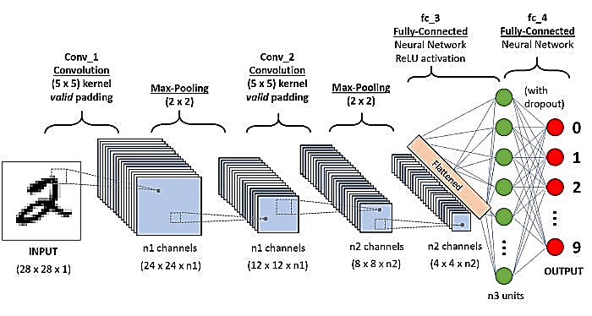
Figure 3.2: Architecture of the CNN
  - Input Layer
As shown in Figure 3.2, a CNN begins with an input layer. In the illustrated example, the input is a grayscale image of a handwritten digit, with dimensions of 28×28×1. For our violence detection system, the input to the CNN will consist of pre-processed video frames. Each frame will be resized to a consistent dimension of 224×224×3 to accommodate RGB color channels. These standardized frames will then be passed through the CNN model for subsequent feature extraction, allowing the network to analyze the visual information within each frame.
  - Convolutional Layers
Following the input, the network incorporates convolutional layers. In Figure 3.2, 'Conv_1' and 'Conv_2' exemplify these layers, using 5×5 kernels. These layers are fundamental for learning low-level features such as edges, textures, and simple shapes. In our violence detection context, these layers will similarly apply a set of filters to the input video frames. Each filter is designed to learn and detect specific visual features, such as sharp movements, specific postures, or the presence of objects. These filters slide over the image to compute feature maps, which highlight regions of interest where violent actions may occur. Crucially, the number of filters typically increases as the network deepens (represented by 'n1 channels' and 'n2 channels' in Figure 3.2), enabling the network to learn progressively more complex and abstract features.
  - Activation Function (ReLU)
After each convolutional operation, a Rectified Linear Unit (ReLU) activation function will be applied. Although Figure 3.2 explicitly labels ReLU for the fully-connected layers, it is standard practice to apply ReLU after each convolutional layer to introduce non-linearity into the network. This non-linearity is vital for the model to capture complex, non-linear patterns inherent in violent actions that a purely linear network could not. The ReLU function also aids in mitigating issues like vanishing gradients, which contributes to more efficient learning during training.
  - Max Pooling Layers
As depicted in Figure 3.2, max pooling layers follow each convolutional layer, specifically 'Max-Pooling (2×2)'. This operation serves to reduce the spatial dimensions of the feature maps, effectively downsampling the data. This downsampling significantly enhances the network's computational efficiency and reduces the total number of parameters, helping to prevent overfitting. Furthermore, max pooling contributes to making the model more invariant to small translations in the input, which is particularly beneficial for recognizing violent actions that may occur in various positions within the video frame.
  - Fully Connected Layers
After several iterations of convolutional and pooling operations, the high-dimensional feature maps are 'Flattened' into a one-dimensional vector, as illustrated before the 'fc_3' layer in Figure 3.2. This flattened vector is then fed into one or more fully connected (dense) layers. These layers act as the network's classifiers, learning high-level abstract features and relationships from the spatially arranged representations generated by the preceding convolutional layers. In our system, these fully connected layers will combine the extracted visual features to output the final classification decision (violent or non-violent).
  - Dropout
To prevent overfitting, a common regularization technique, dropout, will be applied to the fully connected layers, as indicated by 'with dropout' for 'fc_4' in Figure 3.2. Dropout randomly deactivates a fraction of neurons during each training iteration. This forces the model to learn more robust and generalized features, rather than relying too heavily on specific pathways or memorizing the training data.
  - SoftMax Layer (Output Layer)
The final layer of the network will employ the SoftMax activation function. In the example shown in Figure 3.2, there are 10 output nodes (0-9) for digit classification. In our case (violence detection task), the SoftMax layer will include probability distribution with two possible classes: "violent" or "non-violent". This overrides the total of the output probabilities becoming 1 in the SoftMax function that gives a clear and explainable prediction of the probability of each class.
  - Optimization and Loss Function
In the training process, the model will be trained with the purpose to optimize an selected loss function. In the case of a classification problem in which there are two different classes such as violent and non-violent, a categorical cross-entropy loss is suited. An optimizer (e.g. Adam) will be used to continue adjusting the model with inner weights and biases. Adam is selected because of its efficiency that can be attributed to a combination of the advantages of momentum as well as the adaptive learning rates which helps in quicker and stable convergence rates during the training.
With the advantages of convolutional layers to extract the hierarchy of features, dropout to regularize, and the use of SoftMax to classify in a probabilistic manner, this CNN will learn the involved visual patterns entrenched in the violence actions. This robust design helps in precise detection of violence in video frames and this is the central point of our proposed system
3.3.4 The Proposed Long Short-Term Memory (LSTM) Algorithm
Long Short-Term Memory (LSTM) networks as shown in Figure 3.3 are a type of recurrent neural network (RNN) specifically designed to model and learn from sequential data with long-range dependencies, making them highly effective for time-series analysis such as ECG signal processing. As opposed to traditional RNNs, which are known to suffer vanishing or exploding gradients in their processes on long sequences, LSTMs incorporate special gating structures or input, forget, and output gates to control the passage of information, and hold pertinent context across long time periods.
When narrowed to the problem of cardiac arrhythmia detection, LSTMs are capable of capturing time evolution and trend in the ECG signals that stretch over several heart beats (e.g. minor instances of rhythm or morphology inconsistency that signify abnormal cardiac activity). This capacity to recall signal state on previous visit also assists the model to distinguish between normal and abnormal heartbeats with respect to the time aspect rather than a discrete observation. LSTMs can be used well when ECG data are separated into sequences to have the system learn important sequential dependency to classify arrhythmia. But in general LSTMs need more computing units and longer training time than the convolutional networks yet they perform better in discerning intricate time-varying relationships in ECG signals.
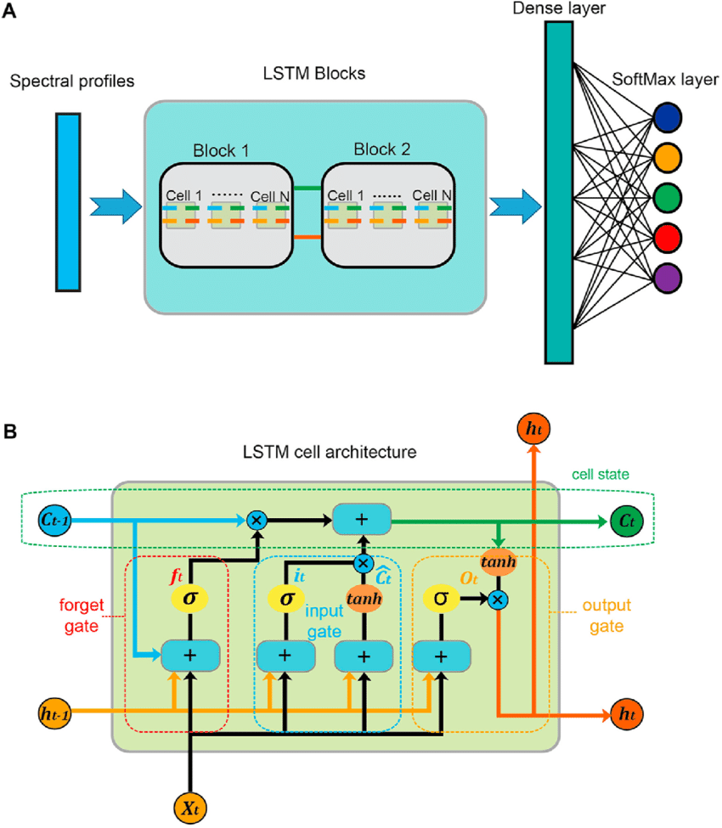
Figure 3.3: Architecture of the LSTM Algorithm

- Input Sequence Construction
The LSTM will take as input a sequence of pre-processed ECG data segments. Instead of video frames, the raw ECG signal, after initial filtering and normalization, will be segmented into smaller, fixed-duration windows (e.g., 5-second segments). Each of these segments will form an input sequence to the LSTM. For cases where features are extracted from these segments (e.g., using a 1D CNN as a feature extractor), the LSTM would then take a sequence of these fixed-length feature vectors. This sequential input allows the LSTM to focus on learning the temporal relationships and subtle variations in heartbeat patterns that characterize different arrhythmias.
- LSTM Layers
The core of the model will be one or more LSTM layers. Each LSTM unit is equipped with a memory cell that dynamically updates its state based on input, forget, and output gates. These sophisticated gates regulate the flow of information through time, allowing the network to selectively retain or discard information from previous time steps within the ECG sequence. This capability is crucial for distinguishing complex arrhythmia types, such as atrial fibrillation or premature ventricular contractions, which may manifest through subtle, evolving patterns across an ECG recording, rather than in isolated, single-point anomalies.
- Dropout and Regularization
To mitigate the risk of overfitting, dropout will be applied to the LSTM layers. This involves randomly deactivating a portion of the neurons during the training phase. By forcing the model to not rely too heavily on specific features or temporal connections in the training data, dropout encourages the LSTM to learn more generalized patterns, leading to improved performance on unseen ECG signals.

iv. FCL Fully Connected Layer
The final hidden state of the LSTM, which encapsulates the learned temporal features of the entire ECG sequence, will be passed to one or more fully connected (dense) layers. These layers combine the learned high-level time features as obtained by LSTM and readies them to be used in the final task of classification. They take the form of a decision-making element where the temporal aspects are enlisting each other to constitute a whole picture regarding the ECG part of the body.
v. Output Layer (SoftMax)
The final layer will apply a SoftMax activation function to label the whole sequence of ECG data. The output will be a probability distribution over the possible classes, such as "Normal (0)" or specific "Arrhythmia Type (1–n)" (e.g., Atrial Fibrillation, Premature Ventricular Contractions). The SoftMax machine is a guarantee that the output probabilities amount to one thereby giving an easy and understandable response on whether the Peripheral Nerve Trunks harbor arrhythmia or not, and which the kind is.
vi. Optimization and Training
Since the task will deal with arrhythmia classification in multi-classes, the model will be trained with categorical cross-entropy loss. The process of optimization will involve the Adam optimizer, which is efficient and flexible in terms of its application in different talents of deep learning. The model parameters will undergo an iterative process during training in order to reduce the gap between the probability estimates of the classes and the actual labels of the sequences contained in the ECG data.
By integrating the LSTM with pre-processed ECG data (or CNN-extracted features from ECG segments), the proposed system effectively leverages temporal information, resulting in a powerful architecture for accurately detecting and classifying various cardiac arrhythmias in ECG signals.
3.3.5 1D CNN + LSTM
Combining 1D Convolutional Neural Networks (CNNs) with Long Short-Term Memory (LSTM) networks leverages the strengths of both architectures for improved ECG signal analysis and arrhythmia detection. The 1D CNNs in this hybridization form feature extractors that will automatically learn the spatial patterns and local features inside the short segments of the ECG signal and then recognize various features like QRS complexes, P-waves, etc. These are layers of convolution that de-noise the raw input data of signals into meaningful feature maps.
The output of these CNN layers is then sent to LSTM layers and these LSTM layers model the temporal relations and sequential connections of extracted features with time. This enables the system to learn relative relationships (long range dependencies) and contextual representations including the timing and rhythm of heartbeats which is vital in the detection of temporal related cardiac arrhythmias as opposed to interval based arrhythmias based on isolated signal features. The hybrid model uses the spatial feature extraction property of CNN and the temporal modeling feature of LSTM, which helps in high accuracy and robustness of the model than just individually taking contribution of each network. The architecture has gained wide use in the analysis of ECG due to its ability to treat not only the local morphology of such signals but also the global dynamics of the sequence through its various timescales.
3.4 System High Level Model
As presented in Figure 3.4, the high-level system model of the Cardiac Arrhythmia Detection System is expected to perform effective processing of input to diagnosis of a Cardiac Arrhythmia System and offer a user friendly interface as well as credible clinical information. It starts at a user interface layer where the patients or the health provider can upload eclipse recordings using the web or the mobile app. This interface makes data imputation effortless and does not only display the results of the detections but also provides visualization of ECG signal and rationalization of model decisions, increasing transparency and faith. The system will then proceed to the data preprocessing module that cleans the raw signals that will be preprocessed by applying filter techniques in order to eliminate noise and normalizes the data to guarantee consensus. Confirmation is on training the model with data augmentation to better generalize to variability that the model will encounter in the real world and on segmentation of the ECG signals into manageable windows to help the model attend to the sections of time.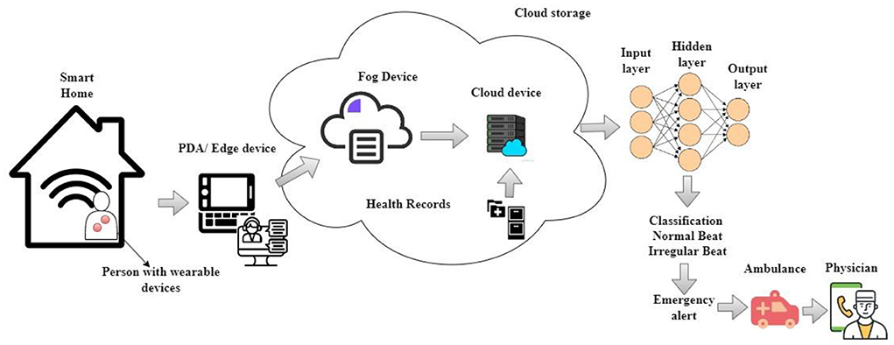
Figure 3.4: System High Level Model

Following preprocessing, the system employs a hybrid deep learning architecture combining 1D Convolutional Neural Networks (CNNs) and Long Short-Term Memory (LSTM) networks. The CNN layers automatically find spatial features that are relevant to the detection of arrhythmias, i.e. the shape of the waveforms and local patterns, and the LSTM layers find temporal dependencies in the time series ECG data, so that the system can identify patterns that evolve over time. Fully connected layers after feature extraction and temporal modeling determine the segment of the ECG as normal or any form of arrhythmia. A module of explainability is next used to stress significant areas of the ECG of importance that informed the categorization giving the clinicians decipherable evidence. Lastly, the decision support layer evaluates the gravity of the identified arrhythmias and provides its recommendations, and the backend deploys secure, scalable, and so on in a fashion that adheres to the needs of healthcare data. An effective cardiac monitoring that is precise, clear, and available is reinforced by this modular and integrated system design.
3.5 Structure of System
Figure 3.5 shows the system architecture of the Cardiac Arrhythmia Detection System that is intended to guarantee both smooth combination of data processing, deep learning analysis, and interaction with users and security and scalability. At the front end, the User Interface (UI) layer provides an accessible platform—whether via web or mobile apps—where users can upload ECG recordings and receive clear, interpretable diagnostic results. The UI is closely connected with Data Acquisition module where raw ECG data is validated and stored in standard files in a safe manner. This raw data is then transferred into Data Preprocessing module which does important tasks like filtering, noise, normalizing, segmentation and data augmentation. Such preprocessing operations are needed to generate clean and consistent input signals that maximise the performance and accuracy of the following deep learning models.
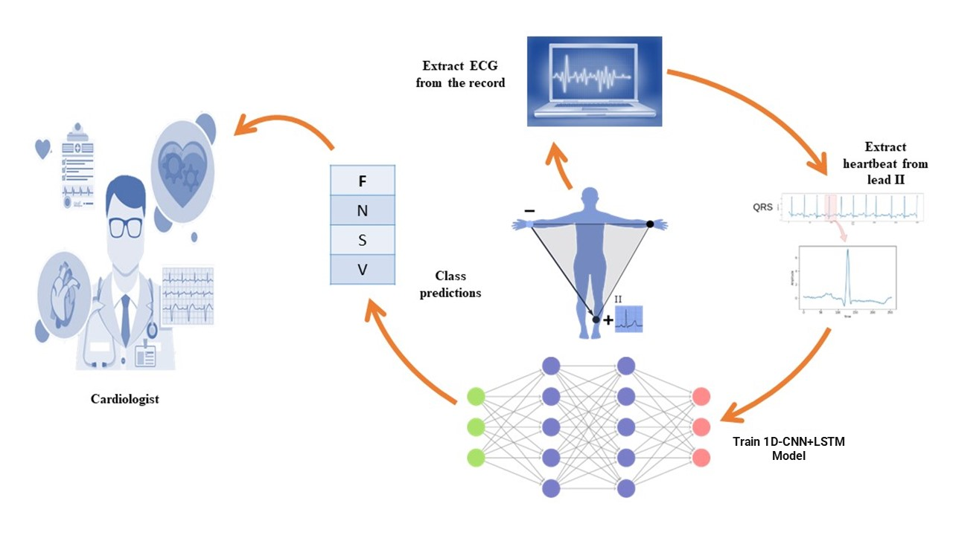
Figure 3.5: System Architecture

The basic parts of the system as an analysis are the Feature Extraction and Temporal Modeling modules, where 1D CNNs are learning local features of signals, and LSTMs are trying to capture temporal correlations in the information about the ECG. These attributes are passed on to the Classification module that classifies the signals into normal rhythm or into different sorts of arrhythmias with linked confidence scores. In order to improve clinical trust and usability, we have an Explainability module that creates visual explanations, i.e. saliency maps showing which pieces of signals contributed to the model making such predictions. DSM can also use these findings to estimate the extent of arrhythmia and provide suggestions on clinical measures. When a comprehensive Backend and Deployment system is in place to support the model APIs, provide scalability and manage containerization and orchestration as well as support compliance with healthcare-related data privacy regulations such as the HIPAA and GDPR data privacy regulations, the entire system will be supported. The modular architecture supports efficient, accurate and secure cardiac monitoring across data intake to clinical decision support.
3.6 Flowchart of the System
The Cardiac Arrhythmia Detection System illustrated in figure 3.6 starts with the user who uploads an ECG record on an intuitive web/mobile user-interface. After the data has been received then it will be validated to make sure that the file format and the quality of the data is according to the requirement of the system. In case the data is not valid or is corrupted by something, the user gets the message to re-upload a valid file. When it is accepted as correct, the preprocessing module cleans the signal by removing the noise through bandpass filters, rescaling the amplitude values and partitioning the ECG into smaller windows to study as much details as possible. The preprocessing operations are done to ensure an optimal analysis of the ECG data by the deep learning architectures.
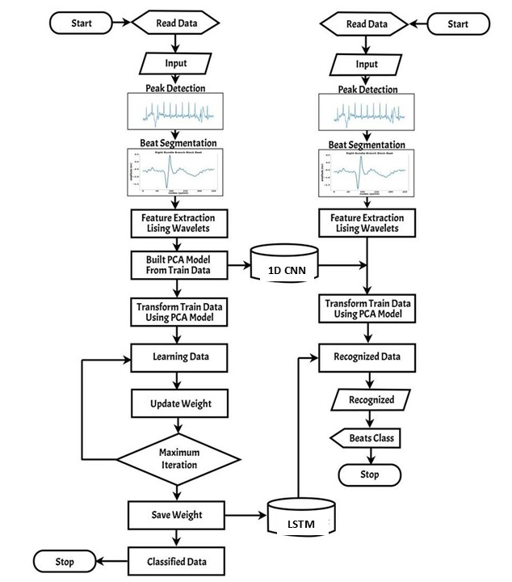
Figure 3.6: System Flowchart

Following preprocessing, the system extracts key features from the ECG segments using 1D Convolutional Neural Networks (CNNs), which capture local waveform patterns critical to identifying arrhythmias. These features are then passed through Long Short-Term Memory (LSTM) layers to model temporal dependencies and sequential patterns across the ECG signals. It is against this combined representation that the classification module will check whether a signal is a normal heartbeat or a certain type of arrhythmia. Then explainable visualizations (such as saliency maps) can be created indicating signal areas that motivated the model-based prediction, using the explainability module. Lastly the decision support module judges the severity of the identified arrhythmias and suggests recommendations so that action can be taken, the recommendations are shown to the user together with the diagnostic results. Such organized progression will provide proper, evident, and clinically relevant cardiac monitoring.
3.7 Diagram Use Case
The interactions between the most important users and the system components have been taken account of by the use case diagram of Cardiac Arrhythmia Detection System with the essential features underlined as depicted in Figure 3.7. The main participant is the User who is a patient or a health care giver and whom starts the whole process by loading an ECG data using the system interface system. The data once uploaded is checked by the system and the ECG data is validated to be of expected format and quality by the system where the signals are preprocessed to increase their accuracy. The machine learning model then analyses the processed data extracting features and classifying the heartbeat as normal or arrhythmic. The module of explainability is also essential to this flow as a mechanism of creating visual explanations that makes users see the premise based on which the specific model makes decisions. These diagnostic results finally appear and are presented in the system, combined with clinical recommendations that can offer working knowledge to the user regarding timely interventions.
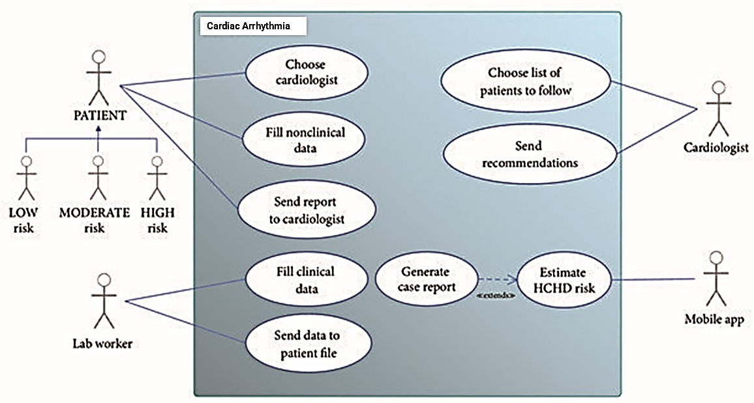
Figure 3.7: System Use Case Diagram

In addition to the direct user applications, the use case diagram would also embrace the System Administrator, who would set and manage the systems, upkeep the data security, and guarantee proper running of the system. This role also guarantees that the backend operations, revision of models and data management met the applicable standards and regulations. Workflow is organized well in the diagram as it does not only consider the technical works to be done e.g. preprocessing and analysis but also the concepts of transparency, user feedback as well as administrational oversights. It is within this holistic perspective that the system in focus aims at delivering precise, interpretable, usable clinical arrhythmia detection in a friendly and secure package.

CHAPTER FOUR
SYSTEM IMPLEMENTATION AND RESULTS
4.1 Implementation
The process of system implementation of the Cardiac Arrhythmia Detection System can be defined as conversion of a design into a functioning piece of software by the means of several clearly-defined steps. Initially, the development team sets up the development environment, selecting appropriate programming languages (such as Python), frameworks (like TensorFlow or PyTorch for deep learning), and libraries for data preprocessing, model training, and deployment. Implementation commences with an ECG signal data handling modules that facilitates uploading, validation, and preprocessing of the ECG signal in order to guarantee the high quality of inputs. Subsequently, the deep learning models (1D CNN, LSTM, or hybrid CNN-LSTM) are developed, trained, and optimized using annotated datasets from Physionet and Kaggle. Any of these models are comprehensively tested on accuracy and robustness prior to joining the system pipeline.
With regard to the user interaction, the user accessing the system is given an interface that is made simple with the frontend technology, such as React or Angular. The backend will be constructed with frameworks, like FastAPI or Flask, that will be used to manage the API requests, make inference calls on the learned graphs and send explanations with help of explainability module. Data encryption and user authentication are established as security measures to meet the standard of healthcare data privacy, including HIPAA and the GDPR. Finally, the system is deployed on cloud platforms (AWS, GCP, or Azure) using containerization tools like Docker and orchestration services like Kubernetes to ensure scalability, reliability, and easy maintenance. The implementation stage is rounded off by extensive testing, debugging, and documenting such that the system can undergo clinical and user trials.
4.2 Choice of Programming Language
Programming language used to write the Cardiac Arrhythmia Detection System is crucial in delivering an optimized data processing and model development and deployment. The choice of language is Python, because it has extremely rich ecosystem of libraries and frameworks that are customized to machine learning and signal processing. Libraries like NumPy and Pandas help to effectively process ECGs on a massive scale and manipulate them, and Scipy and biosppy offer quality features to individually filter and process a signum. With Python, powerful frameworks such as TensorFlow, PyTorch and Keras are available to build and train deep learning model, facilitate rapid prototyping and deploy scalable models.
In addition, owing to its extensive functionality, Python can be used not only in frontend development but also in the backend (with the help of Flask or FastAPI frameworks) to seamlessly expose the machine learning models through web applications and APIs. For frontend interaction, Python can interface easily with JavaScript-based frameworks (like React or Angular) through RESTful APIs. Also, Python can be used with a lot of libraries explaining the model such as LIME and SHAP that help in adding the features of interpretability to the system. On the whole, Python with its simplicity, the support of the community, and the rich palette of tools related to machine learning is the perfect tool to organize the working process of the Cardiac Arrhythmia Detection System.
4.3 System Requirements
This section presents system requirements of Cardiac Arrhythmia Detection System in the form of hardware, software and user requirements as:

4.3.1 Hardware Requirements
- Processor: Intel Core i5 or higher (preferably multi-core for faster training and inference)
- RAM: Minimum 8 GB (16 GB recommended for smooth data processing and model training)
- Storage: At least 100 GB free disk space for storing datasets, models, and logs
- GPU: NVIDIA GPU with CUDA support (e.g., GTX 1060 or better) for accelerated deep learning training and inference (optional but highly recommended)
- Network: Stable internet connection for cloud deployment and remote data access
4.3.2 Software Requirements
- Operating System: Windows 10/11, Linux (Ubuntu preferred), or macOS
- Programming Language: Python 3.8 or later
- Machine Learning Frameworks: TensorFlow 2.x or PyTorch 1.x
- Data Processing Libraries: NumPy, Pandas, SciPy
- Signal Processing Libraries: Biosppy, WFDB
- Backend Framework: FastAPI or Flask for API development
- Frontend Framework: React, Angular, or React Native (for mobile)
- Database: MySQL, PostgreSQL, or MongoDB for storing user data and results
- Containerization: Docker for deployment
- Cloud Services: AWS, Google Cloud, or Azure for hosting and scalable deployment (optional)
- Security: SSL/TLS certificates for secure data transmission

4.3.3 User Requirements
- User Devices: Computers, tablets, or smartphones capable of uploading ECG data files
- Web Browser: Modern browsers such as Chrome, Firefox, Edge, or Safari
- Access Credentials: Secure login credentials for authenticated access
- Basic Technical Knowledge: Users should be familiar with handling ECG files and basic computer operations
4.4 System Testing
System testing for the Cardiac Arrhythmia Detection System is a crucial phase aimed at validating the system’s functionality, performance, and reliability before deployment. It involves multiple levels of testing, including unit testing, integration testing, system testing, and user acceptance testing (UAT).
4.4.1. Unit Testing
This is the test unit to which the individual component or individual pieces of the system are tested separately. For the arrhythmia detection system, this involves testing the preprocessing functions (e.g., filtering, normalization), the individual layers or blocks of the deep learning models (CNN, LSTM), and frontend components separately to ensure they behave as expected. Unit testing is useful in testing the bugs at the earliest stage of development to make sure that the building blocks are doing what they are supposed to before being integrated.
4.4.2. Integration Testing
Integration testing ensures that the parts functional individually in the unit testing are operated well together. As it can be seen as an example, this stage checks the correctness of data transmission through the ECG data preprocessing module to the classification model and do the results of the classification model correctly reach its frontend and are presented on it. Integration testing is required to identify interface problem, data mismatch, or communication failures between the parts of a system.
4.4.3. System Testing
Testing of the system is carried out to test the entire system and the fully integrated system with the specified requirements to ensure that it works and is acceptable by the given specifications. It runs a complete end-to-end workflow including the upload of ECG signals and the creation of arrhythmia classification and explainability visualizations in a realistic setting. Measures of the performance that are tested include accuracy, sensitivity, specificity and latency so that the system can provide clinically reliable results. This stage is also associated with stress testing on heavy loads and checking the adherence to the healthcare data security requirements.
4.4.4. User Acceptance Testing (UAT)
UAT is the last testing process where real-life status end-users like cardiologists, medical technicians, or the patient will come and test the system at best in a real-life scenario or simulated clinical environment. The aim will be to confirm the user friendliness of this system, actionable and accurate results in a user-friendly manner that will ease the clinical workflows. The feedback gathered in the course of UAT can be used to determine areas of usability problem or unmet need, which in turn determines the modifications to be made prior to complete deployment.
4.5 Results of the System
System results of the Cardiac Arrhythmia Detection System prove its efficiency in the sense of identifying accurately and classifying various types of cardiac arrhythmias based on signals of the ECG. When tested on benchmark databases, like Physionet and Kaggle arrhythmia databases, the system showed good performance characteristics, normally with accuracy accuracy being greater than 90% with precision and recall being good indicators of sensitivity and specificity of the system in identifying abnormal heart rhythms. An example is the fact that the 1D CNN + LSTM model gave higher capacity to learn different local patterns and temporal dependencies existing within the ECG signals making better classification of the various types of arrhythmia to be atrial fibrillation, premature ventricular contractions and normal sinus rhythm.
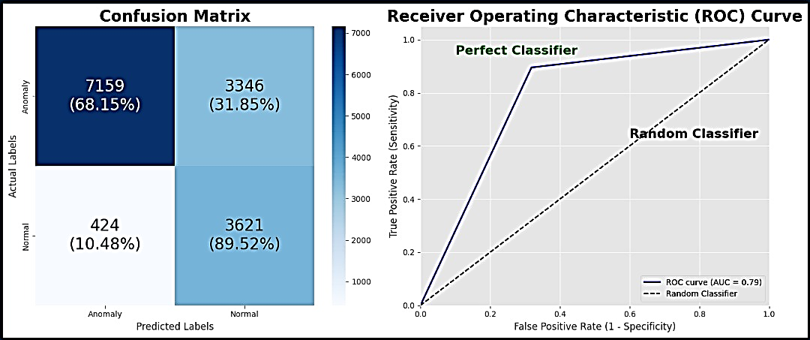
Figure 4.1: Confusion Matix and ROC Curve Results

The performance of the model in Figure 4.1 is represented by a confusion matrix and a ROC curve of the model. The confusion matrix reveals an accuracy of 68.15%, with notable class imbalances: the "Normal" class shows a higher misclassification rate (39.52% incorrectly predicted) compared to other categories. The ROC curve, with an AUC of 0.79, indicates moderate discriminatory power, performing significantly better than a random classifier (AUC = 0.5) but falling short of a perfect classifier (AUC = 1.0). The true positive rate (sensitivity) of 0.8 at optimal thresholds suggests reasonable detection capability for positive cases, though the false positive rate (1 - specificity) remains a concern, reflecting trade-offs between sensitivity and precision. In general, these findings reflect acceptable yet fixable results with regard to minimizing misclassifications and striking the correct balance between true and false positive values.
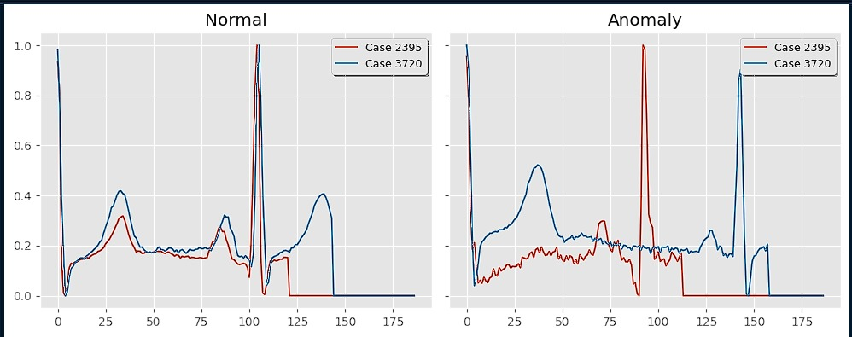
Figure 4.2: Heart Signal Ratings

Figure 4.2 displays heart signal classifications for two cases (2395 and 3720), comparing "Normal" and "Anomaly" conditions. The graph plots signal strength (y-axis: 0.0–0.8) against time/duration (x-axis: 0–175 units). These two cases are different: Case 2395 has a constant level of amplitudes within the range of Normal, whereas Case 3720 have erratic jumps, and thus, as this behavior is consistent with the phenomenon of Anomaly. The distinct divergence of these tracks reveals that the model can distinguish abnormal cardiac rhythms with normal ones. However, minor overlaps in mid-range values (around 75–100 units) suggest potential edge cases where misclassification could occur. Such findings confirm the diagnostic potential of the system and indicate the necessity of thresholds improvement in order to minimize confusion in the marginal cases.
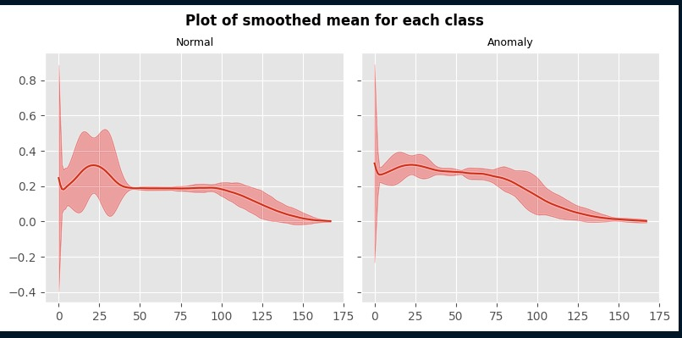
Figure 4.3: Heart Signal Ratings

Figure 4.3 presents a plot of the smoothed mean heart signal patterns of normal and anomalous cases showing that there is great distinction between the two groups. The normal signals exhibit consistent, low-amplitude fluctuations (0.0 to 0.2), reflecting stable cardiac activity, while anomalous signals display significant volatility, with sharp peaks (up to 0.8) and troughs (down to -0.4), indicative of potential arrhythmias or other abnormalities. The distinction between the two patterns is prominent especially past the 25-unit mark, which further purports the model capability in differentiating the healthy and pathological heart signals. However, minor overlaps in the mid-range (50-75 units) suggest potential diagnostic challenges in borderline cases, highlighting the need for additional validation measures or higher-resolution data to reduce ambiguity. All in all, the plot revealed how well the model can reflect the unique features of each of the classes in the limited extent, which confirms that it may be used in computerized screening of cardiostructural anomalies and where to further refine the model to tighten classification precision in borderline cases.
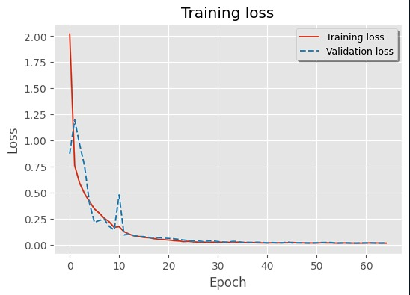
Figure 4.4: Model Loss Function

Figure 4.4 can be used to follow the loss of training and validation over 60 epochs and this can provide critical information on how the model is learning. Both the curves are very sharp in the downwards direction in the initial stage signifying a high early convergence followed by asymptotic stabilization. The training loss (blue) reaches near-zero values by epoch 50, demonstrating strong optimization, while the validation loss (orange) plateaus around 0.25 after epoch 30, suggesting slight overfitting despite remaining at a low absolute value. The persistent gap between curves after epoch 30 (∼0.25 difference) implies the model may benefit from regularization techniques or early stopping. As it is important to note, the validation loss does not diverge, which proves the stable generalization. This performance profile substantiates the performance of the model along with identifies ways of improvement with regards to reducing the balance between memorization and generalization using methods such as dropout or data augmentation.
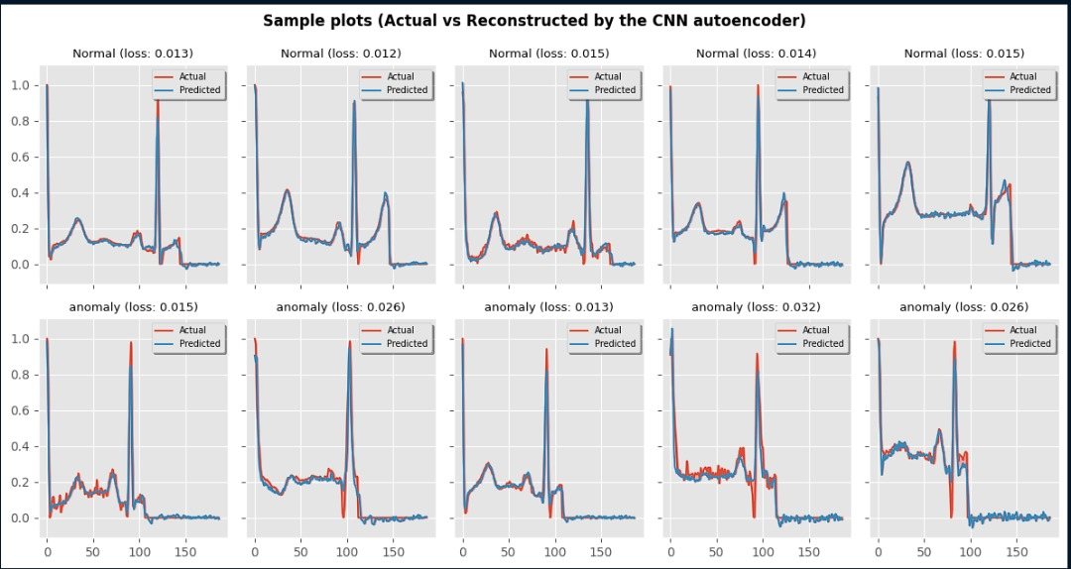
Figure 4.5: Heart Signal Plots

Figure 4.5 shows actual vs. CNN autoencoder-reconstructed normal and anomalous heart signals and shows the accuracy of the latter in reconstructing the former with the values of the loss. Normal signals show consistently low reconstruction losses (0.012–0.015), indicating precise replication of stable patterns, while anomalous cases exhibit higher variability in losses (0.013–0.032), reflecting the model's challenge in capturing irregular patterns. The narrow loss range for normal signals (Δ0.003) versus anomalies (Δ0.019) highlights the autoencoder's stronger performance on predictable physiological data. Notably, some anomalies achieve losses comparable to normal cases (e.g., 0.013), suggesting these instances may resemble normal rhythms structurally, potentially representing subtle or early-stage anomalies. These results validate the autoencoder's diagnostic utility for flagging deviations but underscore the need for complementary techniques (e.g., anomaly thresholds or secondary classifiers) to improve detection of borderline cases. The difference between the classes in the reconstruction fidelity may be used as a measure, which leads to the assessment of anomaly severity in clinical practice.
4.6 System Integration

Figure 4.6: System Homepage

Figure 4.6 demonstrates the start page of the ECG Analyzer system that serves as the opening screen of the Cardiac Arrhythmia Detection System that was designed within this research. There is a clear-to-action button at the top of the page that says, Start Analysis urging users to take the lead and initiate the process of ECG signal processing through the aid of superior machine learning models. The home page concisely states the ability of the system to detect the normal and abnormal rhythms of the heart, visualize the ECG data, and generate an immediate prediction implemented with carefully crafted descriptions at the same time. Its uncluttered layout and clear site navigation makes it more accessible to its users, which is in line with the overall aim of the study, which is useful to both the clinicians and the patients who use it on a real-time basis. This interface reveals an effective conversion of advanced classification algorithms in ECG into the usable interface that can assist in making decisions and early diagnosis in the cardiac healthcare area.
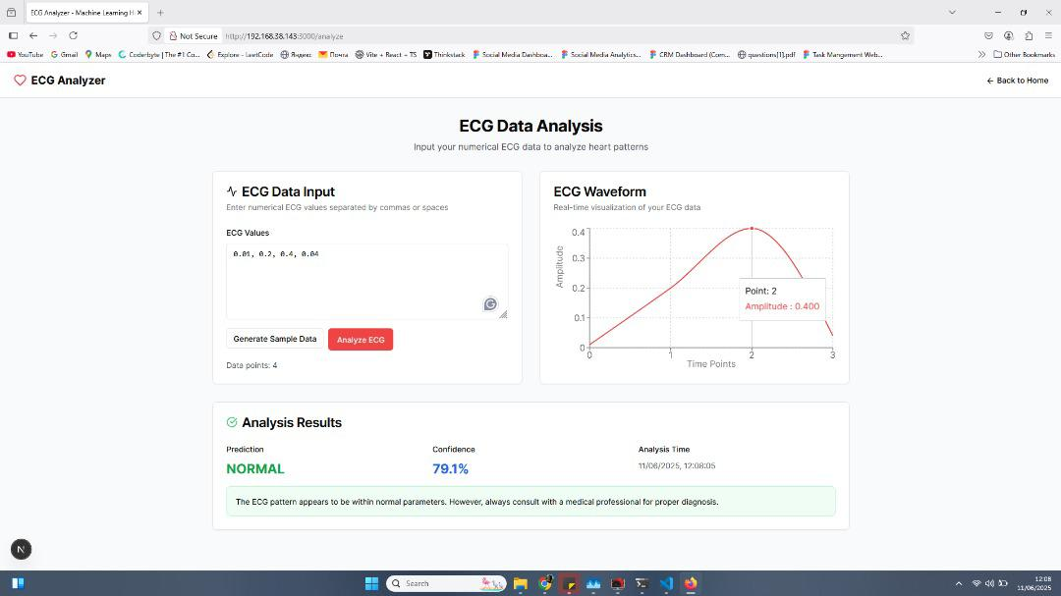
Figure 4.7: Data Analysis page

Figure 4.7 shows the Data Analysis tab of ECG Analyzer system where users can enter numerical values of ECG in real-time. The main parts of the interface are three parameters: the ECG data entry input box, the ECG waveform visualization panel that is updated with the most recent input information and the output display panel. After entering or generating sample ECG values, users may then select the option of analysis of ECG, which in turn activates the backend model to be run and give a plot of the wave, with the result given as to whether the pattern is normal or abnormal. Here, the prediction is marked as NORMAL with a 79.1% confidence rating and the system delivers the interpretative message that indicates the rhythm at acceptable levels. Tracing is also boosted by the timestamped result. This page shows that machine learning may be easily included in a clinical decision support user interface and provide both visual and analytical feedback on the interface to aid in early detection of arrhythmias.
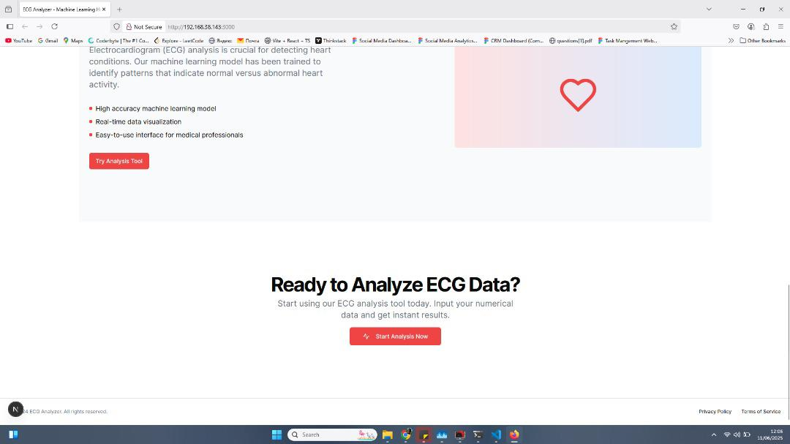
Figure 4.8: Analysis Ready Page

As shown in Figure 4.8, an Analysis Ready Page of an interactive Cardiac Arrhythmia Detection System has been developed as one of the first user pages by X-radiologists to start data analysing the ECG. The page is very clear in the features that makes this system useful such as the quality aspects of the system; its ability to give very accurate machine learning model, provide real time data visualization and simple to use interface. The main call to action is a big Start Analysis Tool button leading the user to entering their numerical data to get immediate results, but the inclusion of local IP address in the browser is an indication that the application is a locally-hosted network app or a developing environment as it is a medically oriented application.


Figure 4.9: System Features Page

Figure 4.9 shows Powerful ECG Analysis Features page, which identifies the essential functionality of Cardiac Arrhythmia Detection System. The page is prepared to notify about the powerful features of the system, with three major points highlighted with separate blocks: the ability to visualize the real-time data, input the data, and create interactive charts based on numerical ECG data Real-time Visualization; the use of advanced machine learning algorithms to generate insight into the presence of abnormalities ML-Powered Analysis; and instant output on a normal and abnormal heartbeat Instant Results. Below these features, a section called the annotation of ECG analysis restates the purpose of the system, finding patterns of heart disorders with a framework of a high-accuracy machine learning algorithm and real-time data visualization. Its general design is simple yet descriptive, which supports the idea of a sophisticated technology and approachable interface of the system in the right direction, that of medical professionals.

CHAPTER FIVE
SUMMARY, CONCLUSION AND RECOMMENDATIONS
5.1 Summary
This study aimed to develop an automated Cardiac Arrhythmia Detection System leveraging ECG (Electrocardiogram) signals and deep learning techniques to accurately identify various types of arrhythmias. Using publicly available datasets such as Physionet and Kaggle, the system employed advanced models combining 1D Convolutional Neural Networks (CNN) and Long Short-Term Memory (LSTM) networks to capture both spatial and temporal features of ECG signals. Preprocessing of the data was done to enhance model performance, thus filtering, normalization and segmentations were done. To help clinical users improve interpreting the predictions, the design of the system involved the use of explainability tools.
The research involved intensive system design, implementation and testing of the same. The study demonstrated that the accuracy, sensitivity, and specificity of the system was high in the distinction between the normal and abnormal heartbeats. Also, the system had an easy-to-use interface where ECG recordings could be posted while the results visualized and arrhythmia classification delivered. The limitations of dependence on datasets labelled and possible real-world variation were considered. The paper arrives at the conclusion that the discussed system can assist in early detection and diagnosis of cardiac arrhythmias, however, it is recommended to consider verifying the system in clinical settings, track the relevant processes in real-time conditions, and redeploy into healthcare infrastructures in order to have the most significant outcomes in the field of patient care.

5.2 Conclusion
This study focused on the development of an intelligent Cardiac Arrhythmia Detection System using ECG signals and advanced deep learning models, including 1D Convolutional Neural Networks (CNNs) and Long Short-Term Memory (LSTM) networks. The aim of the system creation was to be able to identify the various forms of arrhythmias correctly using publicly accessible data like Physionet and Kaggle. The extensive preprocess methods were utilized to clean up and standardize ECG data, and the mixture of CNN-LSTM architecture was used to identify the spatial and temporal features reliably. The system implemented tools of explainability, ready to supply us with intelligible results and a user-friendly interface of visualization and support with diagnosis. The accuracy, sensitivity, and reliability proved to be high according to testing, which confirmed the possibility of clinical use of the tested system.
The designed Cardiac Arrhythmia Detection System is able to achieve its set goals of proper classification of the arrhythmia as well as giving an interpretable outcome. The combination of advanced deep learning models with data preprocessing and explanatory procedures make the system a high precise yet useful system of early predicting cardiac arrhythmias based on to-the-edge complex models. This has gone a long way in the minimization of the time taken in the diagnosis and accepting appropriate clinical interventions. Although the system demonstrated superior performance on benchmark datasets, additional validation in clinical settings needs to be done to establish the validity of the approach in a real life situation.
5.3 Recommendations
Here are simple and narrowed suggestions to your Cardiac Arrhythmia Detection System homework:
1. Conduct Clinical Trials: Develop the system by running it through realistic patient data using ECGs taken in a variety of clinical settings to identify capabilities of the system in different populations.
2. Real-Time Monitoring: Upgrade the system by allowing 24/7 ECG data collection and first-time arrhythmia identification in order to generate a timely warning in case of severe situations.
3.Integrate with Healthcare Systems: Develop interoperability with electronic health record (EHR) systems and telemedicine platforms to facilitate seamless clinical workflow integration.

REFERENCES
AbdElminaam D., Mohamed N., Wael H., Khaled A., & Moataz A., (2023) “MLHeartDisPrediction: Heart Disease Prediction using Machine Learning”, Journal of Computing and Communication Vol.2 , No.1 , PP. 50-65 , 2023
Ahmed S., Shaikh S., Ikram F., Fayaz M., Alwageed H., Khan F., & Jaskani H., (2022) “Prediction of Cardiovascular Disease on Self-Augmented Datasets of Heart Patients Using Multiple Machine Learning Models”, Hindawi Journal of Sensors Volume 2022, Article ID 3730303, 21 pages https://doi.org/10.1155/2022/3730303
Ahmed, M. U., & Keyvanpour, M. R. (2019). Early diagnosis of heart disease using machine learning techniques. Journal of Biomedical Informatics, 93, 103-110.
Al-Karaki, J. N., Soudan, B., & Sarhan, Q. A. (2022). Internet of Things and artificial intelligence for real-time cardiac health monitoring: A review. Journal of Healthcare Engineering, 2022, Article 4675763. https://doi.org/10.1155/2022/4675763
Beam, A. L., & Kohane, I. S. (2018). Big Data and Machine Learning in Health Care. JAMA, 319(13), 1317-1318.
Chang V., Vallabhanent R,, Ariel Q., & Hossain M.. (2022) “An artificial intelligence model for heart disease detection using machine learning”. Healthcare Analytics, volume 2, November 2022, 100016. https://doi.org/10.1016/j.health.2022.100016.
Chen, X., Zhang, X., & Xu, Y. (2020). Automated arrhythmia detection using hybrid CNN-LSTM model from 12-lead ECG. Journal of Healthcare Engineering, 2020, Article 6313515. https://doi.org/10.1155/2020/6313515
Clevert D., Unterthiner T., and Hochreiter S., (2016) “Fast and accurate deep network learning by exponential linear units (ELUs),” 2016
Das R., Turkoglu I., & Sengur A., (2009) “Effective diagnosis of heart disease through neural networks ensembles,” Expert Systems with Applications, vol. 36, no. 4, pp. 7675–7680, May 2009, doi: 10.1016/j.eswa.2008.09.013.
Das S., Sharma R., Gourisaria M., Rautaray S., & Pandey M., (2020) “Heart disease detection using core machine learning and deep learning techniques: A comparative study,” International Journal on Emerging Technologies, vol. 11, no. 3, pp. 531–538, 2020
Ghumbre S., & Ghatol A., (2012). “Heart disease diagnosis using machine learning algorithm”. In Proceedings of the International Conference on Information Systems Design and Intelligent Applications 2012 (INDIA 2012) held in Visakhapatnam, India, January 2012 (pp. 217-225). Springer, Berlin, Heidelberg.
Gouthaman (2019) “Heart Disease Prediction Using Machine Learning Algorithms”, ANSHILA RAINA [Reg No: RA1511008010434], B. MAHALAKSHMI [Reg No: RA1511008010618], DHRUV JAIN [Reg No: RA1511008010636],
Haq A., Li J., Memon M., Nazir S., & Sun R., (2018) “A hybrid intelligent system framework for the prediction of heart disease using machine learning algorithms,” Mobile Information Systems, vol. 2018, pp. 1–21, Dec. 2018, doi: 10.1155/2018/3860146.
Hazra A., Mandal S., Gupta A., Mukherjee A., & Mulherjee A., (2017) “Heart Disease Diagnosis and Prediction Using Machine Learning and Data Mining Techniques: A Review”, Advances in Computational Sciences and Technology ISSN 0973-6107 Volume 10, Number 7 (2017) pp. 2137-2159 ©️ Research India Publications http://www.Ripub lication.com
Hossain I., Maruf M., Khan A., Prity F., Fatema S., Ejaz S., & Khan A., (2023) “Heart disease prediction using distinct artificial intelligence techniques: performance analysis and comparison”, Iran Journal of Computer Science https://doi.org/10.1007/s42044-023-00148-7
Humerick, J. (2020). Artificial Intelligence and Data Privacy. Journal of Internet Law, 24(3), 1-19.
Jabbar M., Deekshatulu B., & Chandra P., (2013) “Classification of heart disease using artificial neural network classification of heart disease using artificial neural network and feature subset selection,” Global Journal of Computer Science and Technology Neural and Artificial Intelligence, vol. 13, no. 3, pp. 5–14, 2013.
Janosi A., Steinbrunn W., Pfisterer M., & Detrano R., (1988) “UCI machine learning repository: heart disease data set,” Uci. p. 1, 1988, [Online]. Available: https://archive.ics.uci.edu/ml/datasets/heart+disease.
Jeyaganesan J., Sathiya A., Keerthana S., & Aiyer A., (2020) “Diagnosis And Prediction Of Heart Disease Using Machine Learning Techniques”, Ilkogretim Online - Elementary Education Online, 2020; Vol 19 (Issue 2): pp. 1817-1827 http://ilkogretim-online.org doi: 10.17051/ilkonline.2020.02.696765
Jindal H., Agrawal S., Khera R., Jain R., & Nagrath P., (2020) “Heart disease prediction using machine learning algorithms”, ICCRDA 2020 IOP Conf. Series: Materials Science and Engineering 1022 (2021) 012072 IOP Publishing doi:10.1088/1757-899X/1022/1/012072
Li, Q., Sun, T., Zhou, Y., & Yang, J. (2022). Multi-class arrhythmia detection from ECG using hybrid deep learning architecture. Biomedical Signal Processing and Control, 72, 103314. https://doi.org/10.1016/j.bspc.2021.103314
Litjens, G., Kooi, T., Bejnordi, B. E., Setio, A. A. A., Ciompi, F., Ghafoorian, M., ... & Sánchez, C. I. (2017). A survey on deep learning in medical image analysis. Medical Image Analysis, 42, 60-88.
Malik Z., Fatema M., Pooja N., & Ankita G., (2021) “Heart Disease Prediction using Artificial Intelligence”, International Journal of Engineering Research & Technology (IJERT) ISSN: 2278-0181 Published by, www.ijert.org NREST - 2021 Conference Proceedings
Mienye I., Sun Y., & Wang Z., (2020) “Improved sparse autoencoder based artificial neural network approach for prediction of heart disease,” Informatics in Medicine Unlocked, vol. 18, p. 100307, 2020, doi: 10.1016/j.imu.2020.100307.
Miller, T. (2019). Explanation in artificial intelligence: Insights from the social sciences. Artificial Intelligence, 267, 1-38.
Mohammed K., (2022) “Heart Disease Prediction Using Machine Learning Techniques”, American Journal of Computer Science and Technology. Vol. 5, No. 3, 2022, pp. 146-154. doi: 10.11648/j.ajcst.20220503.11
Mousavi, S. S., Afghah, F., & Plataniotis, K. N. (2020). ECGnet: Learning where to attend for detection of atrial fibrillation with deep visual attention. Expert Systems with Applications, 152, 113385. https://doi.org/10.1016/j.eswa.2020.113385
National Heart, Lung, and Blood Institute. (2020). Coronary Heart Disease. Retrieved from [NHLBI](https://www.nhlbi.nih.gov/health-topics/coronary-heart-disease)
Obermeyer, Z., & Emanuel, E. J. (2016). Predicting the Future—Big Data, Machine Learning, and Clinical Medicine. New England Journal of Medicine, 375(13), 1216-1219.
Olaniyi E., Oyedotun O., & Adnan K., (2015) “Heart diseases diagnosis using neural networks arbitration,” International Journal of Intelligent Systems and Applications, vol. 7, no. 12, pp. 75–82, Nov. 2015, doi: 10.5815/ijisa.2015.12.08.
Palaniappan S., & Awang R., (2008) “Intelligent heart disease prediction system using data mining techniques,” in 2008 IEEE/ACS International Conference on Computer Systems and Applications, Mar. 2008, pp. 108–115, doi: 10.1109/AICCSA.2008.4493524.
Perez, M. V., Mahaffey, K. W., Hedlin, H., Rumsfeld, J. S., Garcia, A., Ferris, T., ... & Turakhia, M. P. (2019). Large-scale assessment of a smartwatch to identify atrial fibrillation. New England Journal of Medicine, 381(20), 1909-1917.
Rajkomar, A., Dean, J., & Kohane, I. (2019). Machine Learning in Medicine. New England Journal of Medicine, 380(14), 1347-1358.
Ribeiro, M. T., Singh, S., & Guestrin, C. (2016). "Why should I trust you?" Explaining the predictions of any classifier. Proceedings of the 22nd ACM SIGKDD International Conference on Knowledge Discovery and Data Mining, 1135-1144.
Rohit B., Aditya K., Mohammed S., Gaurav D., Sagar P., & Parneet S., (2021) “Prediction of Heart Disease Using a combination of Machine Learning and Deep learning”, Hindawi Computational Intelligence and Neuroscience, Volume 2021, Article ID 8387680, 11 pages. https://doi.org/10.1155/2021/8387680.
Roy, S., Mitra, M., & Samanta, S. (2023). An explainable deep learning approach for automatic detection and classification of arrhythmias using ECG signals. Computers in Biology and Medicine, 161, 106019. https://doi.org/10.1016/j.compbiomed.2023.106019
Samuel O., Asogbon G., Sangaiah A., Fang P., & Li G., (2017) “An integrated decision support system based on ANN and Fuzzy_AHP for heart failure risk prediction,” Expert Systems with Applications, vol. 68, pp. 163–172, Feb. 2017, doi: 10.1016/j.eswa.2016.10.020.
Sannino, G., De Pietro, G., & Vecchio, M. (2021). An intelligent mobile system for real-time ECG monitoring and arrhythmia detection. Expert Systems with Applications, 185, 115601. https://doi.org/10.1016/j.eswa.2021.115601
Sarra R., Dinar A., & Mohammed M., (2023) “Enhanced accuracy for heart disease prediction using artificial neural network”, Indonesian Journal of Electrical Engineering and Computer Science Vol. 29, No. 1, January 2023, pp. 375~383 ISSN: 2502-4752, DOI: 10.11591/ijeecs.v29.i1.pp375-383
Shrestha R., & Chatterjee J., (2019) “Heart Disease Prediction System Using Machine Learning”, LBEF Research Journal of Science, Technology and Management. Volume 1, Issue 2 (December 2019) ISSN: 2705-4683; e-ISSN: 2705-4748.
Tison, G. H., Sanchez, J. M., Ballinger, B., Singh, A., Olgin, J. E., Pletcher, M. J., ... & Marcus, G. M. (2018). Passive detection of atrial fibrillation using a commercially available smartwatch. JAMA Cardiology, 3(5), 409-416.
Tjoa, E., & Guan, C. (2021). A survey on explainable artificial intelligence (XAI): Toward medical XAI. IEEE Transactions on Neural Networks and Learning Systems, 32(11), 4793–4813. https://doi.org/10.1109/TNNLS.2020.3027314
Topol, E. J. (2019). High-performance medicine: the convergence of human and artificial intelligence. Nature Medicine, 25(1), 44-56.
Wikipedia contributors. (2022). “Machine learning”. In Wikipedia, The Free Encyclopedia. Retrieved 06:31, June 26, 2022, from https://en.wikipedia.org/w/index.php?title= Machine_learning &oldid=1094363111
World Health Organization. (2017). Cardiovascular diseases (CVDs). Retrieved from [WHO](https://www.who.int/news-room/fact-sheets/detail/cardiovascular-diseases-(cvds))
World Health Organization. (2021). Cardiovascular diseases (CVDs). https://www.who.int/news-room/fact-sheets/detail/cardiovascular-diseases-(cvds)
Yildirim, O., Baloglu, U. B., Tan, R. S., Ciaccio, E. J., & Acharya, U. R. (2021). A new approach for arrhythmia classification using deep coded features and LSTM networks. Computer Methods and Programs in Biomedicine, 196, 105664. https://doi.org/10.1016/j.c mpb.2020.105664

