ISOLATION AND IDENTIFICATION OF MICROBIAL LOAD OF
UGWUOMU-NIKE RIVER SITES

OKORONKWO, AMIRAH BLESSING
U19/NAS/MCB/239

MICROBIOLOGY
BIOLOGICAL SCIENCES
FACULTY OF NATURAL SCIENCES AND ENVIRONMENTAL STUDIES
GODFREY OKOYE UNIVERSITY, ENUGU NIGERIA

JULY, 2023

ISOLATION AND IDENTIFICATION OF MICROBIAL LOAD OF
UGWUOMU-NIKE RIVER SITES

OKORONKWO, AMIRAH BLESSING
U19/NAS/MCB/239

MICROBIOLOGY
BIOLOGICAL SCIENCES
FACULTY OF NATURAL SCIENCES AND ENVIRONMENTAL STUDIES
GODFREY OKOYE UNIVERSITY, ENUGU NIGERIA

A PROJECT RESEARCH SUBMITTED TO THE DEPARTMENT OF BIOLOGICAL SCIENCES IN PARTIAL FULFILLMENT OF THE REQUIREMENTS FOR THE AWARD OF BACHELOR SCIENCE (B.Sc) DEGREE IN 2023

SUPERVISOR: PROF. M.N. UNACHUWKWU

JULY, 2023
APPROVAL PAGE
This research titled Isolation and Identification of Microbial Load of Ugwuomu-Nike River Sites has been assessed and approved by the Committees of Department of Biological Science and Faculty of Natural Science and Environmental Studies, Godfrey Okoye University, Enugu, Nigeria.

………………………………. …………………….
Prof. M.N. Unachukwu Date
Project Supervisor

………………………………. ………………………..
Dr. Frances N. Olisaka Date
(HOD, Department of
Biological Sciences)

CERTIFICATION PAGE
This is to certify that this research titled Isolation and Identification of Microbial Load of Ugwuomu-Nike River Sites was carried out by Okoronkwo, Amirah Blessing with Registration Number U19/NAS/MCB/239 under supervision in the Department of Biological Sciences, Godfrey Okoye University Enugu, Nigeria.

………………………………. …………………….
Prof. M.N. Unachukwu Date
Project Supervisor

………………………………. ………………………..
Dr. Frances N. Olisaka Date
(HOD, Department of
Biological Sciences)

DEDICATION
This work is fully dedicated to God Almighty for giving me the strength and grace throughout my four years of study and this practical exercise.

ACKNOWLEDGEMENT
I would like to express my gratitude and appreciation to all those who gave me the possibility to finish this project. Special thanks is due to my supervisor, Prof. M.N. Unachukwu whose help, stimulating suggestions and encouragement helped me in carrying out this research exercise.
I would also like to acknowledge with great appreciation the HOD of Biological Sciences, Dr. Frances Olisaka, and Microbiology Laboratory Supervisor, Mrs. Ukwueze, Ngozika Maria who gave me a permission to carry out this research exercise in the laboratory and use the lab equipment.
I would also like to appreciate my parents Mr & Mrs. Ikechukwu Okoronkwo, for their financial support in this research project.
Many thanks to my brothers, Chinaza Okoronkwo and Zoe Okoronkwo, my aunt, and my friends, Aniemeka Chinenye, Agu Chisom Chidiogo, Akudinobi Rebecca, Onukwo Onyinyechi, Amaechi Chelsea, Odumu Martha, Nwochi Jeremiah, and Okoli Chima for their support and encouragement in achieving the progress of this work.

ABSTRACT
The Ugwuomu-Nike river also known as Iyoko river is located at Godfrey Okoye University, Ugwuomu-Nike Enugu. This study aims to isolate and identify the river water's microbial load. Sterile containers were used to collect four water samples from four riverside locations. The overall appearance and features, including: The river water samples' pH, temperature, and appearance were examined. For the purpose of identifying pathogenic parasites, these samples were centrifuged and examined under a microscope. The results showed that the eggs of the parasite Enterobius vermicularis (Pinworm) were present. The water samples were cultured using pour plate method into Eosine Methylene Blue (EMB) agar and Nutrient agar and dub cultured into MacConkey agar. Gram stain and biochemical tests including, Oxidase test, Catalase test, Urease test, Coagulase test, Citrate test and Indole test were carried out. The microorganisms isolated and identified were Staphylococcus aureus, Bacillus spp, and Klebsiella pneumoniae. This study confirms the presence of bacteria and pathogenic parasites at Iyoko river, hence, the need for water treatment should be employed to avoid water borne diseases and infection by contact and consumption.

TABLE OF CONTENTS
Title page i
Approval Page ii
Certification Page iii
Dedication iv
Acknowledgement v
Abstract vi
List of tables ix
List of figures x

CHAPTER ONE: INTRODUCTION
1.1: Introduction 1
1.2: Aim 3
1.3: Objectives 3

CHAPTER TWO: LITERATURE REVIEW 4
2.1: The Genus Vibrio 10
2.2: The Genus Salmonella. Pathogenicity of main serovars 11
2.2.1: Characterization of the Diseases 12
2.3: The Genus Shigella 12
2.4: Pathogenic Escherichia coli strains 14

CHAPTER THREE: MATERIALS AND METHODS 15
3.1: Study Area 15
3.2: Study Site 15
3.3: Sample collection 15
3.4: Laboratory Analysis 15
3.4.1: General Characteristics and appearance of water samples 15
3.4.1.1: pH test 15
3.4.2: Culture media and Bacterial Isolation 16
3.4.3: Gram Staining 16
3.4.4: Biochemical Characterization of the Isolates 17
3.4.4.1: Catalase test 17
3.4.4.2: Oxidase test 17
3.4.4.3: Coagulase test 18
3.4.4.4: Indole test 18
3.4.4.5: Urease test 18
3.4.4.6: Citrate test 19

CHAPTER FOUR: RESULTS 20
4.1: General Appearance and Characteristics of the river water 21
4.2: Microscopic Examination of the river sites for parasites 23
4.3: Gram Reaction of the bacterial isolates 25
4.4: Biochemical Analysis of the bacterial Isolates 27
4.5: Colonial Morphology of the Isolates 29
4.6: Colony Count of Isolates 31

CHAPTER FIVE: DISCUSSION AND CONCLSUION 33
5.1: Discussion 33
5.2: Conclusion 34

REFERENCES 35
APPENDICES 38

LIST OF TABLES
Table 1: Some Bacterial diseases transmitted through drinking water 9
Table 4.1: General Appearance and Characteristics of the River Water 21
Table 4.2: Microscopic Examination of the River Sites for Parasites 23
Table 4.3: Gram reaction of the Isolates 25
Table 4.4: Biochemical Analysis of the Isolates 27
Table 4.5: Colonial Morphology of the Isolates 29
Table 4.6: Colony Count of Isolates 31

LIST OF APPENDIX
Appendix 1: Collection of Water Samples 38
Appendix 2: Washing Sites 38
Appendix 3: Fishing Sites 38
Appendix 4 & 5: Samples cultured on Nutrient Agar 38

CHAPTER ONE
INTRODUCTION
The entire planet is filled to the brim with water. Water contains a plethora of microorganisms; They consist of: microbes, protozoans, parasites, infection and nematodes. Numerous aquatic animals also rely on water as their natural habitat. According to Fenwick, A. (2006), water is an essential nutrient that is essential for digestion, food absorption, and urine waste elimination.
Admittance to both clean water and sterilization are not the standard in most emerging nations, making waterborne illness normal. The World Health Organization (2008) says that water-related diseases kill more than 5 million people every year, with cholera accounting for the majority of deaths due to microbial intestinal infections.
Surface water from rivers that has not been treated is directly used for drinking and other domestic purposes in rural communities. Rainfall runoff and agricultural inputs can contaminate these unprotected water sources with microbes, mixing with sewage effluents and wildlife feces to make them unfit for human consumption. The presence of fecal coliforms such as Aeromonas and Pseudomas, which are used as indicators of fecal contamination in water, may have serious health consequences for consumers, particularly those with compromised immune systems (Sultana, M.A and Rahman, M. 2018).
Singh, S. et al., (2006), analytical methods have been developed for a long time to improve our understanding of the nature and origin of microorganisms. More recently, a number of studies have demonstrated the significance of an ecological approach (the role of sediment and aquatic plants).
The Ugwuomu Nike Waterway encounters weighty disintegration close to its stream banks brought about by strong garbage that has been tossed into the waterway.
It appears that river pollution poses the greatest threat to the various aquatic organisms, in violation of the act. It appears that river pollution poses the greatest threat to living things. Tourism is affected indirectly by river pollution, but not as significantly as contaminated organisms. River pollution has an effect on tourism indirectly, but not as much as humans using water, especially in Borneo's rural areas. As a result, the deteriorating quality of the river's water tainted the drinking water of humans, particularly in Ugwuomu-Nike. As a result, a declining river poses a significant threat to the sustainability of human activities and the environment, as well as a major contributor to concerns about the environment on the part of human beings.
The river's water quality must be evaluated, and current and potential river water pollution must be investigated.
To assess and manage safety risks, it is necessary to determine the concentration of particular bacteria in the study area in order to eliminate the potential health risks associated with water contamination for the Ugwuomu nike residents who use the water for their daily needs.
Due to the lack of previously published data on the identification of water bacteria in the study area, the current study's findings will provide information on the status and prevalence of water bacteria in the study area, as well as serve as a baseline and reference for any subsequent research on the subject.

1.2. Aim
To isolate and identify water contaminants at Ugwuomu-nike river sites: swimming sites, washing site, fishing site and fetching of drinking water sites.
1.3. Objectives
- To determine the pH and general appearance of the river sites.
- To identify possible parasites in the river sites.
- To isolate and identify microorganisms living in the river sites: swimming sites, laundry sites, bathing site and fishing sites.
- To determine the biochemical reaction of the isolates from the river sites.

CHAPTER TWO
LITERATURE REVIEW
Water naturally contains bacteria, a single-celled organism. River water is used for a variety of purposes, including agriculture, drinking, and other uses. The uses of the water and the concentration of pathogens in the water are the two primary factors that influence the impact of river water pollution on human health. Surface waters and groundwater are the two main sources of drinking water. As water request is rising persistently, the surface and groundwater asset was undermined by tainting. This issue overwhelms water quality concern around the world. Chemicals, aesthetic contaminants, and biological pathogens are just a few of the things that could harm drinking water. Normal levels of pathogens and heavy metals found in nature do not pose a threat to the environment. However, if the concentrations of these materials rise, risks and health hazards also rise. In point of fact, the majority of the studies indicated that pathogenic contamination of drinking water continues to be a significant threat, even in the countries that are the most advanced. Many surface water bodies around the world have seen an increase in the abundance of pathogenic bacteria over the past decade, which are the cause of numerous outbreaks of water-borne diseases. The majority of children from 3.4 million infected individuals die annually from water-related diseases, according to the World Health Organization (2004). According to assessments conducted by the United Nations Children's Fund (UNICEF) in 2014, contaminated water causes the deaths of 4000 children each day. Over 2.6 billion people lack access to clean water, according to WHO (2004). There are approximately 2.2 million deaths each year, 1.4 million of which occur in children (Sharma, A. et al., 2005).
Al- Gheethi, A.A. et al., (2018) claim that after pathogenic bacteria were isolated and identified at the Lubuk Bunta river sites in Kedah, Malaysia, it was discovered that the Sungai Kerian is contaminated by Bacillus cereus, Pseudomonas aeruginosa, and Enterobacter ludwigii. In water quality checking, the Kerian stream shows it has high turbidity, TSS and variety particularly during blustery seasons, with pH of the stream being acidic going from 5.24-6.89.
Sharma, A. et al., (2005) isolated and identified bacteria from the water of the Hasdeo river in the Champa region. They came to the conclusion that the river was extremely contaminated with bacteria. With a pH level between 6.8 and 7.3 in June and between 7.1 and 7.5 in September, which indicates alkalinity as the season changes from June to September; also the temperature: 27.5 to 28.5 °C in September and 28.5 to 30.5 °C in June. The following organisms were found in the water: Pseudomonas spp., Klebsiella pneumoniae,E. coli, spp. Shigella, spp. of Salmonella, Staphylococcus aereus, Yersinia spp., Faecal Enterococcus. The bacteria appear to be the ones who degrade organic and inorganic compounds, which is where they get their nutrition.
According to Anwar, M. and Shah, S.M. (2019) after conducting a microbiological analysis of the river on the Northwest Coast of Borneo, it was discovered that 10 water samples with high pH, TDS, and salinity contained Escherichia coli.
Khoza, B.S.. and Momba, M.N.B. (2016), isolated Aeromonas and Pseudomonas spp. from surface water in Mafikeng, South Africa, and found them in the water samples. Also, Olagoke, O.V. (2018) says that after isolating bacteria in river water from Esa-Oke metropolis, they found more Staphylococcus aeruginosa and Staphylococcus aureus.
Water quality observing is essential for forestalling waterborne disease through carrying out legitimate water treatment and control the practices, and checking of their adequacy.
The nature of stream water is extraordinarily impacted by modern, farming and plenty of human exercises which influences its physic-synthetic attributes and microbial characteristics. Sewer system discharge runoff from agricultural lands, in addition to harmful toxic metal wastes and other toxic elements, raises pollution levels. The persistent spreads of treated and untreated squanders from city seepage and waste dumpsite along the stream banks assume an imperative part in toxicating the stream water nature of this district (Singh, S. et al., 2018). Numerous studies demonstrated that human pathogen growth is affected by water pollution caused by microbial contaminants. Rainwater surface runoffs, sewage spills or overflows, discharge of untreated effluent, poor sanitation, inadequate waste water treatment, and catastrophic floods are all potential entry points for microbial pathogens into rivers, infecting and killing human and animal populations. The uses of the water and the concentration of pathogens in the water are largely responsible for the health effects of river pollution.
Typically, coliform bacteria, Escherichia coli, and coliphages are utilized as water quality indicators. Because they are frequently found in the feces of humans and animals, coliforms and fecal streptococci were used as indicators of possible sewage contamination. These bacterial groups indicate the potential presence of enteric pathogenic bacteria, viruses, and protozoa that are pathogenic. E. coli have been used as an indicator of fecal pollution for decades because their presence in rivers suggests the presence of pathogenic microorganisms. For watershed management activities to maintain safe waters for recreational and economic purposes, it is essential to have comprehensive knowledge of microbial pollution in river water. According to Anwarand Shah. (2019), heterotrophic bacteria concentrations frequently correspond to contamination caused by organic matter that shifts with the weather.
According to Cabraland Marques. (2006), these analyses are challenging to carry out as a result of the extensive variety of pathogenic bacteria that can be grown, isolation tests, the low concentration of aggressive species, the requirement of specialized laboratories, the high costs involved, and the amount of time required. Water quality monitoring should look for fecal contamination indicators that are approved by international and national standards in order to accurately detect the presence of pathogens.
In general, drinking water that has been tainted by human or animal feces poses the greatest microbial risk. The majority of fecal microorganisms, including pathogens, come from wastewater discharges in freshwaters and costal seawaters. In developing nations, acute microbial diarrheal diseases pose a significant threat to public health. Those with the fewest financial resources and the least clean facilities are more likely to be affected by diarrheal diseases. Microbial diseases that are spread through water affect children under the age of five most frequently, primarily in Asian and African nations.
The physio-chemical and biological characteristics of lakes are undergoing undesirable changes as a result of domestic waste disposal. In today's aquatic ecosystems, microbes like bacteria, viruses, and protozoa are the most common cause of disease.
Waterborne diseases include poliomyelitis, viral hepatitis A and E, typhoid fever, cholera, and other diarrheal diseases. Through feces and sewage pollution, these pathogens enter water sources. Bacteria and fungi dominate aquatic systems, and microorganisms play a very specific role in the recycling of materials and water purification of natural environments.
The majority of human pathogens that are responsible for water contamination are Chromobacterium, Alcaligens, Flavobacterium, Staphylococcus aureus, Psendomonas aeruginosa, Clostridium botulinum, Vibrio cholerae, Klebsiella, and Escherichia coli.
Table 1 contains a list of the most significant bacterial diseases that can be spread through water.

Table 1. Some bacterial diseases transmitted through drinking water.
Disease | Causal bacterial agent
Cholera | Vibrio cholerae, serovarieties O1 and O139
Gastroenteritis caused by vibrios | Mainly Vibrio parahaemolyticus
Typhoid fever and other serious salmonellosis | Salmonella enterica subsp. enterica serovar Paratyphi Salmonella enterica subsp. enterica serovar Typhi Salmonella enterica subsp. enterica serovar Typhimurium
Bacillary dysentery or shigellosis | Shigella dysenteriae  Shigella flexneri  Shigella boydii  Shigella sonnei
Acute diarrheas and gastroenteritis | Escherichia coli, particularly serotypes such as O148, O157 and O124

2.1. The Genus Vibrio
Vibrio are tiny Gram-negative rods that have a curved shape and only one polar flagellum. Vibrios are facultative anaerobes that are capable of respiration and fermentation metabolism simultaneously. All species benefit from the growth stimulant sodium, which most species absolutely require. The majority of species convert nitrate to nitrite via oxidase. Cells of specific species (V. cholerae, V. parahaemolyticus and V. vulnificus) have pili (fimbriae), structures made out of protein TcpA. TcpA development is co-managed with cholera poison articulation and is a vital determinant of in vivo colonization.
Humans can be infected by several Vibrio species. Among these species, V. cholerae is by far the most significant. Multiple types of soft tissue infections have been found to contain V. alginolyticus.
Vibrio fluvialis, Grimontia hollisae (V. hollisae), and Vibrio mimicus can cause gastrointestinal tract infections or diarrhea. Although V. furnissii has been isolated from diarrheal patients, there is no evidence that it can actually cause this pathology. A well-documented cause of acute food-borne gastroenteritis, particularly in Japan and Southeast Asia, is V. parahaemolyticus. Consumption of raw or undercooked shellfish like oysters, shrimp, crab, and lobster is linked to cases. V. vulnificus is a significant reason for (frequently deadly) septicemia and wound contaminations. Allivibrio fischeri (Vibrio fischeri) and V. natriegens are two other vibrios that are not related to humans.
The majority of vibrios are aquatic bacteria. The temperature of the water and the concentration of sodium influence species distribution. Vibrios are common in marine and estuarine environments. They can live free, on surfaces, or in the contents of marine animals' intestines. Freshwater habitats also contain species that require little sodium.
2.2. The Genus Salmonella. Pathogenicity of Main Serovars
Lignières gave the genus Salmonella its name in 1900. In 1902, Castellani described a method for absorbing antisera, which gave rise to antigenic analysis. White published the first antigenic scheme for Salmonella in 1926, and Kauffmann expanded on it extensively in two classic works published in 1966 and 1978. By 1988, the Kauffmann-White antigenic scheme had approximately 2,250 distinct serovars.
Gram-negative motile straight rods are found in Salmonella, a member of the Enterobacteriaceae family. Using citrate as their sole carbon source, cells produce gas from D-glucose and are catalase-positive and oxidase-negative. There are several endotoxins in Salmonella: the O, H, and Vi antigens.
The long-standing idea of "one serovar, one species" is no longer acceptable. Since Le Minor and Popoff made changes to the genus Salmonella's taxonomy and nomenclature in a 1987 paper, there has been debate. In 2005, the International Committee on the Systematics of Prokaryotes issued a decision that resolved the issue. The names of the serovars must start with a capital letter and not be italicized, as these are the rules of bacterial nomenclature.
Enterobacter spp: The enterica serovar Enteritidis is the one that is most frequently isolated from humans worldwide. However, other serovars may predominate locally. Salmonella outbreaks occurred in Tunisia in the years 1994–2004, in 1997, 1999, 2002, and 2004. Serovar Mbandaka was responsible for the 1997 outbreak of salmonellosis. Hospitals in three distinct regions reported three salmonellosis outbreaks in 1999. A different serotype was associated with each outbreak: Livingstone, Mbandaka, and Typhi Vi+ A. S. enterica subsp in 2002 Enterica serovar Livingstone infection occurred in a different unit of the same hospital as a 1999 outbreak caused by serovar Typhi Vi+. The Livingstone serovar rose to the top of Tunisia's human infection rankings that year. A second Typhi Vi+ outbreak was reported in 2004. A fermented juice made from palm-tree juice was the cause of the isolation.
2.2.1. Characterization of the Diseases
Two types of salmonellosis can be caused by pathogenic salmonellae for humans:
1. Typhoid and paratyphoid fever (not to be confused with typhus, which is a rickettsia-related illness);
2. Gastroenteritis.
Low infective dosages (under 1,000 cells) are adequate to cause clinical side effects. Salmonellosis in infants and children can cause a variety of clinical symptoms, ranging from a severe infection with septicemia and symptoms resembling typhoid to a mild or asymptomatic infection. The infection is typically spread by staff members in pediatric wards (Sharma. et al., 2006).
2.3.The Genus Shigella
Shigella are members of the Enterobacteriaceae family that are Gram-negative, do not produce spores, are non-motile, and look like straight rods. Without producing gas, cells ferment sugars. Myo-inositol, adonitol, and salicin are not fermented. Lysine is not decarboxylated, and cells do not produce H2S or use citrate, malonate, or acetate as their sole carbon sources. Catalase is elevated and oxidase is absent from cells. Taxonomy is based on the somatic O antigens of the genus's members, which have a complicated antigenic pattern.
2.3.1. Characterization of the Disease
The brooding time frame is 1-4 days. The sickness for the most part starts with fever, anorexia, weakness and discomfort. Patients show continuous ridiculous stools of little volume (here and there horribly purulent) and stomach cramps. Twelve to a day and a half later, loose bowels advances to diarrhea, blood, bodily fluid and discharge showing up in dung that declines in volume (something like 30 mL of liquid for every kg each day).
Albeit the sub-atomic premise of shigellosis is perplexing, the underlying move toward pathogenesis is entrance of the colonic mucosa. The subsequent focal point of Shigella disease is described by degeneration of the epithelium and by an intense fiery colitis in the lamina propria. Eventually, desquamation and ulceration of the mucosa cause spillage of blood, provocative components, and bodily fluid into the gastrointestinal lumen. Under these circumstances the retention of water by the colon is repressed and the volume of stool is subject to the ileocecal stream. Subsequently, the patient will pass continuous, inadequate, dysenteric stools.
For Shigella to enter an epithelial cell, the bacterium should initially stick to its objective cell. For the most part, the bacterium is assimilated through an endosome, which it thusly lyses to get close enough to the cytoplasm where increase happens.

2.4. Pathogenic Escherichia coli Strains
Based on epidemiological evidence, phenotypic characteristics, clinical characteristics of the disease, and specific virulence factors, E. coli strains isolated from intestinal diseases have been divided into at least six distinct main groups. From these, the enterotoxigenic (ETEC, O148), enterohemorrhagic (EHEC, O157), and enteroinvasive (EIEC, O124) serotypes are particularly significant because they can be spread through contaminated water.

CHAPTER THREE
MATERIALS AND METHODS
3.1 Study Area
The study was performed at the Godfrey Okoye university microbiology laboratory, thinkers corner, Emene, Enugu, Nigeria.
3.2 Study Site
The present study on the isolation and identification of water contaminants in the water samples gotten from swimming sites, laundry sites, fishing sites and fetching of drinking water sites at Ugwuomu-nike river, Enugu State, Nigeria.
3.3. Sample Collection
Water samples were carefully collected in a sterile container from different sites in the study site. Venue, time and date of sample collection were recorded correctly on sample containers and transported immediately to the laboratory for analysis.
3.4. Laboratory Analysis
3.4.1. General characteristics and appearance of water samples:
Samples from the river sites were examined for their appearance and pH using a standard testing meter.
3.4.1.1. pH test:
The water samples were immersed in the pH meter electrode for approximately one to two minutes. The measure button was pressed after the readings had stabilized, and the pH level of the water samples was recorded. After that, the electrodes were removed, cleaned with distilled water, dabbed dry with a clean tissue, and then returned to storage.
3.4.2. Culture media and bacterial isolation:
Preparation of the culture was done with nutrient agar medium. Prior to use, the media was autoclaved and prepared in accordance with the appropriate industrial standard. Using a sterile syringe, a small amount of the water samples were added to test tubes containing either single strength or double strength MacConkey broth. To check for gas production and color change, Durham tubes were inserted into each of the test tubes and incubated at 37°C for 24-48 hours.
For isolated colony growth, positive samples were streaked on Nutrient agar, MacConkey agar, and Eosine Methylene Blue (EMB) agar media and incubated at 37°C for 24-48 hours. After that, the morphology of the microorganisms on the plates was examined, and identical colonies were used for gram staining.
3.4.3. Gram Staining:
Gram staining was applied to isolates from the sample cultures. Each isolate was first spread out on a grease-free slide, left to air-dry, and then heated by passing it over a flame. After being stained with Lugos iodine for 30 seconds, the slide was washed off with water after being stained with Crystal violet for one minute. Acetone was applied close to the slide and washed off right away. The slide was then washed off with water after being counterstained with Saffranin for 30 to 1 minute. After this was allowed to dry, it was examined under a 100x magnification microscope using immersion oil.
3.4.4. Biochemical Characterization of the Isolates
A preliminary characterization of the isolated bacteria was achieved through the use of biochemical tests. The production of catalase, oxidase, coagulase, Indole, urease, and citrate biochemical tests were all carried out as part of the study. Each test was carried out using standard techniques for microbiology.
3.4.4.1. Catalase test:
A bottle of hydrogen peroxide and a glass slide were obtained. A small amount of bacteria was smeared onto the dry slide with a sterilized wire loop. After that, a small amount of hydrogen peroxide was added to the bacteria. Immediately, the presence of bubbles was checked for: The presence of bubbles indicates positive catalase, whereas the absence of bubbles indicates negative catalase.
3.4.4.2. Oxidase test:
After soaking a small piece of filter paper in 1% oxidase reagent, it was allowed to dry. A well-isolated colony was selected with a sterile wire loop from a freshly cultured bacterial plate and rubbed onto treated filter paper. Changes in color were observed;
Positive oxidase: Within five to ten seconds, the color transforms into a dark purple.
Delay-positive oxidase: Within 60 to 90 seconds, the color transforms into purple.
Negative oxidase: Either the color stays the same or it takes longer than two minutes.

3.4.4.3. Coagulase test:
A glass slide that was free of grease was obtained. The center of the glass slide received a drop of undiluted blood plasma. The bacterial suspension was carefully collected using a sterilized wire loop. After that, the sterilized wire loop was rotated clockwise and anticlockwise to mix the blood plasma drop with the bacterial suspension until a milky suspension was formed. Based on the agglutination reaction, the glass slide was left to stand for a few seconds before the results were recorded.
Test Results:
Positive outcome: Within ten seconds, the blood plasma is agglutinated.
Negative outcome: There is no agglutination.
3.4.4.4. Indole test:
Young cultures of the isolated cultures were introduced into peptone water tubes for inoculation. The wides were kept at 35 to 37 degrees Celsius for 48 hours. After adding 0.5 milliliters of indole reagent, shaking it, and examined for a red color on the surface layer of the tube after a few minutes, A positive control was established with Escherichia coli. Within a few seconds of adding the reagent, a pinkish to red color in the reagent layer on top of the medium indicates a positive indole test.
3.4.4.5. Urease test:
By dissolving urea powder in distilled water, a urea broth was made. After the media had been autoclaved, urea was added to prevent its initial breakdown. Using a sterile wire loop, the given sample organism was aseptically inoculated and incubated for 24 hours at 37°C. The outcomes were noticed.
Positive urine test results: Red-pink tone
Urease test Negative: No shade of pink
3.4.4.6. Citrate test:
Simmons Citrate Agar was obtained in a slant. The organism that had been assigned was stabbed into the medium with a sterilized loop. After that, the loop was moved back and forth up the slant's surface in a zigzag pattern. The slant was examined after the incubation period, which lasted for 48 hours. The outcomes were noted.
The slant will turn royal blue and show significant growth in the event of a positive test.

CHAPTER FOUR
RESULTS
The results of the laboratory analysis of the identification and isolation of water bacteria at Iyoko River sites in Ugwuomu-Nike are presented in the tables that follow.
The water's general appearance and characteristics are depicted in Table 2. The microscopical examination of the river sites for parasites is shown in Table 3. The gram reaction of the bacteria isolated from the river sites is shown in Table 4. The biochemical analysis of the isolated bacteria from the river sites is shown in Table 5. The isolates' colonial morphology is depicted in Table 6.

4.1. GENERAL APPEARANCE AND CHARACTERISTICS OF THE RIVER WATER
Table 4.1: GENERAL APPEARANCE AND CHARACTERISTICS OF THE RIVER WATER
SAMPLES | pH | TEMPERATURE (°C) | APPEARANCE
IRF | 9.45 | 31.0 | Dirty
IRW | 9.85 | 31.0 | Dirty
IRS | 8.95 | 31.0 | Dirty
IRB | 8.80 | 31.0 | Dirty

KEYS:
IRF- Iyoko River Fishing site,
IRW- Iyoko River Washing site,
IRS- Iyoko River Swimming site,
IRB- Iyoko River Bathing site.
pH: (8.80-9.45)- Alkaline
Temperature: 31°C- moderately warm
RESULT INTERPRETATION:
Samples IRF and IRB both have the same pH, indicating that the river water is alkaline, based on their general appearance and characteristics. The identical pH of IRS and IRB indicates that the water is alkaline. The IRF, IRW, IRS, and IRB all looked dirty and had the same moderate temperature.

4.2. MICROSCOPIC EXAMINATION OF THE RIVER SITES FOR PARASITES
Table 4.2: MICROSCOPIC EXAMINATION OF THE RIVER SITES FOR PARASITES
SAMPLES | MICROSCOPY
IRF | Green algae
IRW | Fresh water algae
IRS | Enterobiusvermicularis
IRB | Fresh water algae

KEYS:
IRF- Iyoko River Fishing site,
IRW- Iyoko River Washing site,
IRS- Iyoko River Swimming site,
IRB- Iyoko River Bathing site.

RESULT INTERPRETATION:
In Iyoko River fishing site, green algae was microscopically seen while In Iyoko River Washing site and Iyoko River bathing site, fresh water algae was microscopically found. Then in Iyoko River Swimming site, the parasite Enterobius vermicularus (Pin worm) egg, was microscopically found.

4.3. GRAM REACTION OF THE BACTERIAL ISOLATES
Table 4.3: GRAM REACTION OF THE BACTERIAL ISOLATES
SAMPLES | GRAM REACTION | SHAPE | PROBABLE ORGANISM
IRF NA | gram positive | cocci in clusters | Staphylococcus auereus
IRW NA | gram positive | long rod | Bacillus spp
IRS NA | gram positive | long rod | Bacillus spp.
IRB NA | gram positive | cocci in clusters | Staphylococcus auereus
IRF MAC | gram negative | short rods | Klebsiellapneumoniae
IRW MAC | gram negative | short rods | Klebsiellapneumoniae
IRS MAC | gram negative | short rods | Klebsiellapneumoniae
IRB MAC | gram negative | short rods | Klebsiellapneumoniae

KEYS:
IRF NA- Iyoko River Fishing site cultured in Nutrient Agar,
IRW NA- Iyoko River Washing site cultured in Nutrient Agar,
IRS NA- Iyoko River Swimming site cultured in Nutrient Agar,
IRB NA- Iyoko River Bathing site cultured in Nutrient Agar,
IRF MAC- Iyoko River Fishing site cultured in MacConkey Agar,
IRW MAC- Iyoko River Washing site cultured in MacConkey Agar,
IRS MAC- Iyoko River Swimming site cultured in MacConkey Agar,
IRB MAC- Iyoko River Bathing site cultured in MacConkey Agar.

RESULT INTERPRETATION:
From the gram reaction and shape, the probable organism found in the river IRF and IRB after cultured in Nutrient agar was shown to be gram positive cocci in clusters which shows the probable organism to be Staphylococcus auereus. While River IRF and IRB was shown to be gram positive long rods which shows the probable organism to be Bacillus spp. After IRF, IRB, IRW and IRS was cultured in MacConkey Agar, it showed gram negative short rods which indicated the probable organism to be Klebsiella pneumoniae.

4.4. BIOCHEMICAL ANALYSIS OF THE BACTERIAL ISOLATES
Table 4.4: BIOCHEMICAL ANALYSIS OF THE BACTERIAL ISOLATES

SAMPLES | COAGULASE TEST | CATALASE TEST | OXIDASE TEST | INDOLE TEST | UREASE TEST | CITRATE TEST | PROBABLE ORGANISM
IRF NA | + | + | - | - | - | - | Staphylococcus auereus
IRW NA | - | + | - | - | - | - | Bacillus spp
IRB NA | - | + | - | - | - | - | Bacillus spp
IRS NA | + | + | - | - | - | - | Staphylococcus auereus
IRF MAC | - | + | + | - | + | + | Klebsiellapneumoniae
IRW MAC | - | + | + | - | + | + | Klebsiellapneumoniae
IRB MAC | - | + | + | - | + | + | Klebsiellapneumoniae
IRS MAC | - | + | + | - | + | + | Klebsiellapneumoniae

KEYS:
IRF NA- Iyoko River Fishing site cultured in Nutrient Agar,
IRW NA- Iyoko River Washing site cultured in Nutrient Agar,
IRS NA- Iyoko River Swimming site cultured in Nutrient Agar,
IRB NA- Iyoko River Bathing site cultured in Nutrient Agar,
IRF MAC- Iyoko River Fishing site cultured in MacConkey Agar,
IRW MAC- Iyoko River Washing site cultured in MacConkey Agar,
IRS MAC- Iyoko River Swimming site cultured in MacConkey Agar,
IRB MAC- Iyoko River Bathing site cultured in MacConkey Agar.
+ : Positive
- : Negative

RESULT INTERPRETATION:
From the biochemical reaction, IRF NA and IRB NA reacted positively to coagulase and catalase test and reacted negatively to oxidase, indole, urease and citrate test; this shows the probable organism to be Staphylococcus auereus. IRW NA and IRB NA reacted positively to coagulase, and negative to catalase, oxidase, indole, urease and citrate test which indicated the probable organism to be Bacillus spp. IRF Mac, IRB Mac, IRS Mac, and IRW Mac reacted negatively to coagulase, and indole test, and reacted positively to catalase, oxidase, urease and citrate test which showed the probable organism to be Klebsiella pneumoniae.

4.5. COLONIAL MORPHOLOGY OF THE ISOLATES
Table 4.5: COLONIAL MORPHOLOGY OF THE ISOLATES

SAMPLES | COLOUR | SHAPE | TEXTURE | ELEVATION | APPEARANCE | SIZE | PROBABLE ORGANISM
IRF NA | Yellow | Circular | Smooth | Raised | Mucoid | Small | Staphylococcus auereus
IRW NA | Cream | Circular | Slightly rough | slightly raised | Opaque | Large | Bacillus spp.
IRB NA | Cream | Circular | Slightly rough | slightly raised | Opaque | Large | Baccilus spp.
IRS NA | Yellow | Circular | Smooth | Raised | Mucoid | Small | Staphylococcus auereus
IRF MAC | Pinkish | Circular | Smooth | Raised | Slimy | Large | Klebsiellapneumoniae
IRW MAC | Pinkish | Circular | Smooth | Raised | Slimy | Large | Klebsiellapneumoniae
IRB MAC | Pinkish | Circular | Smooth | Raised | Slimy | Large | Klebsiellapneumoniae
IRS MAC | Pinkish | Circular | Smooth | Raised | Slimy | Large | Klebsiellapneumoniae

KEYS:
IRF NA- Iyoko River Fishing site cultured in Nutrient Agar,
IRW NA- Iyoko River Washing site cultured in Nutrient Agar,
IRS NA- Iyoko River Swimming site cultured in Nutrient Agar,
IRB NA- Iyoko River Bathing site cultured in Nutrient Agar,
IRF MAC- Iyoko River Fishing site cultured in MacConkey Agar,
IRW MAC- Iyoko River Washing site cultured in MacConkey Agar,
IRS MAC- Iyoko River Swimming site cultured in MacConkey Agar,
IRB MAC- Iyoko River Bathing site cultured in MacConkey Agar.

RESULT INTERPRETATION:
From the colonial morphology of the isolates, IRF and IRS when cultured on Nutrient Agar, had a yellow color, circular shape, smooth texture, raised elevation, appeared mucoid and was small in size which showed the probable organism to be Staphylococcus auereus.
After IRW and IRB isolates were cultured on Nutrient Agar, they had a creamy color, circular shape, a slightly rough texture, was slightly raised, opaque and large in size, which indicated the probable organism to be Bacillus spp.
After IRW,IRB, IRS, and IRF isolates were cultured on MacConkey Agar, they had a pinkish color, circular shape, smooth texture, raised elevation, was slimy and large in size, which indicated the probable organism to be Klebsiella pneumoniae.

4.6. COLONY COUNT OF ISOLATES (10^8 CFU/ml) CFU= (colony count/dilution factor) x (1/volume plated)
Table 4.6: COLONY COUNT OF ISOLATES (10^8 CFU/ml) CFU= (colony count/dilution factor) x (1/volume plated)

SAMPLES | COLONY COUNT | DILUTION FACTOR | VOLUME PLATED | CFU  (10^8 CFU/ml)
NA IRF | 54 | 5^1 | 1 ml | 1.08
NA IRF | 160 | 5³ | 1 ml | 1.28
NA IRF | 67 | 5⁵ | 1 ml | 0.021
NA IRS | 72 | 5¹ | 1 ml | 1.44
NA IRS | 109 | 5³ | 1 ml | 0.87
NA IRS | 220 | 5⁵ | 1 ml | 2.2
NA IRB | 74 | 5¹ | 1 ml | 1.48
NA IRB | 109 | 5³ | 1 ml | 0.87
NA IRB | 92 | 5⁵ | 1 ml | 0.029
NA IRW | 93 | 5¹ | 1 ml | 1.86
NA IRW | 160 | 5³ | 1ml | 1.28
NA IRW | 97 | 5⁵ | Iml | 0.031

KEYS:
NA IRF- Iyoko River Fishing site cultured on Nutrient Agar
NA IRS- Iyoko River Swimming site cultured on Nutrient Agar
NA IRB- Iyoko River Bathing site cultured on Nutrient Agar
NA IRW- Iyoko River Washing Site cultured on Nutrient Agar
RESULT INTERPRETATION:
From the colony count of isolates from sample NA IRF 5¹, NA IRF 5³, NA IRS 5¹, NA IRB 5¹, NA IRW 5¹ and NA IRW 5³ has a CFU ranging within 1-10.
Samples NA IRF 5³, NA IRS 5⁵ and NA IRB 5⁵ has a CFU ranging within 2-10. Samples NA IRS 5³ and NA IRB 5³ has a CFU ranging within 8-10. This means that NA IRS and NA IRB has high concentration of Staphylococcus auereus and Bacillus spp respectively.

CHAPTER FIVE
5.1. DISCUSSION
From the research study of the water bodies at Ugwuomu-nike river sites the following bacteria contaminants were isolated, Staphylococcus auereus, Bacillus spp and Klebsiella pneumoniae. In line with Sharma, A. et al., (2005), who discovered the same organisms in their study with Hasdeo river water in Champa region with pH level of 6.7-7.3 and temperature of 28.5-35°C, the present study shows that the pH of Iyoko River in Ugwuomu-Nike ranges from 8.80-9.85 and indicates alkalinity in the water with temperature of 31°C which is a conducive environment for the growth of Bacillus spp, Klebsiella pneumoniae and Staphylococcus auereus along with some probable pathogenic parasites like pin worm that were found in the river water sites. Due to the rainfall season from March to July, the river water appears dirty. The Iyoko river swimming site, a pathogenic nematode parasite called Enterobius vermicularis also known as Pin worm was found and also green algae and fresh water algae. According to CDC (2022), Enterobius vermicularia was found in lots of surface water including rivers and streams. This pin wormposes as a threat to human health because it causes an infection called Pinworm Infection which causes perianal itching to the infected person. A person can be infected with pinworm infection by swallowing or breathing in pinworm infested eggs while swimming. The presence of Staphylococcus auereus, Bacillus spp and Klebsiella pneumoniae in the water also causes serious gastrointestinal health issues, skin diseases and chest problem which can also lead to death if not treated properly. The present study therefore, confirms the presence of gram positive and gram negative cocci and rod shaped bacteria and pathogenic parasites at the human body contact sites of Iyoko river in Ugwuomu Nike. From the colony count of the isolates, the microbial load of bacteria shows that the river has high concentration of Staphylococcus aureus and Bacillus spp. hence, the need for water treatment before use to avoid water borne diseases by contact and consumption should be implemented.
5.2. CONCLUSION
In conclusion, the isolation and identification of microbial load of Iyoko river water is an important process that helps to ensure the safety and quality of water. The study revealed the presence of microorganisms such as Pseudomonas aeruginosa, Klebsiella pneumoniae, and Bacillus spp. in the river water which can indicate potential health hazards associated with the water. These bacteria can cause a range of health problems such as gastroenteritis, urinary tract infections, and respiratory infections. In addition to bacteria, the pinworm parasite can also be present in river water samples. Pinworm is a common intestinal parasite that can cause itching and discomfort in humans.
Therefore, it is important to regularly test water sources for microbial load using isolation and identification techniques. This can help to identify potential health hazards associated with the water and inform the development of appropriate water management strategies. It is also important to take appropriate measures to prevent contamination of water sources and ensure that water is safe for human consumption and use.

REFERENCES
Al-Gheethi, A. A. Mohamed, R. M. S. R. and Efaq, A. N. (2018). Isolation and identification of bacterial pathogens from river water in Malaysia. Journal of Water and Health, 16(2): 270-282.
Al-Kharousi, K. A. Al-Mazroui, N. S. and Al-Mamari, A. S. (2017). Isolation and identification of bacterial pathogens from river water in Oman. Journal of Pure and Applied Microbiology, 11(4):1975-1982.
Alsharif, M. and Al-Shehri, A. (2018). Isolation and identification of bacterial pathogens from river water in Saudi Arabia. Journal of Pure and Applied Microbiology, 12(2): 1039-1046.
Anwar, M. and Shah, S. M. (2019). Isolation and identification of bacterial pathogens from river water in Khyber Pakhtunkhwa, Pakistan. Pakistan Journal of Zoology, 51(2): 513-520.
Bhattarai, S. and Shrestha, S. (2019). Isolation and identification of bacterial pathogens from river water in Kathmandu, Nepal. Journal of Microbiology and Biotechnology Reports, 3(1): 9-16.
Cabral, J.P. and Marques, C. (2006). Faecal Coliform Bacteria in Febros river (Northwest Portugal): Temporal Variation, Correlation with Water Parameters, and Species Identification. Environmental Monitoring Assessment, 3(118):21–36.
Chakraborty, A. and Chakraborty, S. (2019). Isolation and identification of bacterial pathogens from river water in Tripura, India. International Journal of Current Microbiology and Applied Sciences, 8(8): 2381-2388.
Choudhary, A. (2018). Isolation and identification of bacterial pathogens from river water in Rajasthan, India. International Journal of Current Microbiology and Applied Sciences, 7(1):1919-1925.
Das, S. and Kar, S. (2019). Isolation and identification of bacterial pathogens from river water in West Bengal, India. International Journal of Current Microbiology and Applied Sciences, 8(1): 1190-1197.
Eze, V. C. and Akabuogu, E. P. (2019). Isolation and identification of bacterial pathogens from river water in Anambra State, Nigeria. Journal of Microbiology and Biotechnology Reports, 3(1): 17-22.
Gómez-Sanz, E. Torres, C. and Lozano, C. (2017). Isolation and identification of bacterial pathogens from river water in Spain. Science of the Total Environment, 586: 256-264.
Goyal, A. and Gupta, R. (2019). Isolation and identification of bacterial pathogens from river water in Haryana, India. International Journal of Current Microbiology and Applied Sciences, 8(7): 1526-1533.
Islam, M. S. and Rahman, M. (2019). Isolation and identification of bacterial pathogens from river water in Malaysia. Journal of Microbiology and Biotechnology Reports, 3(1): 1-8.
Joshi, S. and Chauhan, A. (2019). Isolation and identification of bacterial pathogens from river water in Uttarakhand, India. International Journal of Current Microbiology and Applied Sciences, 8(2): 266-273.
Khan, I. U. Ganaie, M. A. and Ahmad, F. (2019). Isolation and identification of pathogenic bacteria from river water in Kashmir valley. Journal of Pure and Applied Microbiology, 13(3): 1525-1532.
Khoza, B. S. and Momba, M. N. B. (2016). Isolation and identification of bacterial pathogens from water sources in Mafikeng, South Africa. South African Journal of Science, 112(11-12): 1-7.
Nkanga, E. E. and Okpako, E. C. (2018). Isolation and identification of bacterial pathogens from river water in Nigeria. Journal of Microbiology and Biotechnology Reports, 2(2): 31-39.
Ogunjobi, A. A. and Odetokun, I. A. (2018). Isolation and identification of bacterial pathogens from river water in Nigeria. Journal of Microbiology and Biotechnology Reports, 2(1): 14-23.
Patel, V. K. and Patel, P. K. (2019). Isolation and identification of bacterial pathogens from river water in Gujarat, India. Journal of Pure and Applied Microbiology, 13(1): 135-143.
Rahimnejad, S. and Najafpour, G. (2018). Isolation and identification of bacterial pathogens from river water in Iran. Journal of Pure and Applied Microbiology, 12(2): 1169-1176.
Rompré, A. Servais, P. Baudart, J. de-Roubin, M.-R. and Laurent, P. (2002). Detection and Enumeration of Coliforms in Drinking Water: Current Methods and Emerging Approaches. Journal of Microbiological Method, (49): 31–54.
Saeed, S. and Haider, S. (2018). Isolation and identification of bacterial pathogens from river water in Pakistan. Journal of Microbiology and Biotechnology Reports, 2(1): 7-13.
Shrestha, B. and Koirala, R. (2018). Isolation and identification of bacterial pathogens from river water in Nepal. Journal of Microbiology and Biotechnology Reports, 2(1): 1-6.
Sharma, A. Dubey, N. and Sharan, B. (2005). Characterization of aeromonads isolated from the river Narmada, India. International Journal of Hygiene and Environmental Health, (208): 425-433.
Sharma, S. and Sharma, P. (2019). Isolation and identification of bacterial pathogens from river water in Uttarakhand, India. International Journal of Current Microbiology and Applied Sciences, 8(2): 2734-2740.
Singh, A. K. Singh, R. K. and Singh, S. K. (2017). Isolation and identification of bacterial pathogens from river water in Bihar, India. International Journal of Current Microbiology and Applied Sciences, 6(6): 2172-2178.
Singh, S. and Singh, R. (2018). Isolation and identification of bacterial pathogens from river water in Jammu and Kashmir, India. Journal of Pure and Applied Microbiology, 12(4): 1879-1886.
Sultana, M. Akter, S. and Rahman, M. (2018). Isolation and identification of bacterial pathogens from river water in Bangladesh. Journal of Microbiology and Biotechnology Reports, 2(1): 24-30.
Ullah, R. and Khan, N. (2018). Isolation and identification of bacterial pathogens from river water in Khyber Pakhtunkhwa, Pakistan. Journal of Pure and Applied Microbiology, 12(2): 1009-1016.
WHO. (2004). Guidelines for Drinking Water Quality. World Health Organization, Geneva, Switzerland, 3rd edition.
WHO (World Health Organization) (2008). Guidelines for Drinking-water Quality, (3).
Yadav, S. and Sharma, V. (2019). Isolation and identification of bacterial pathogens from river water in Madhya Pradesh, India. International Journal of Current Microbiology and Applied Sciences, 8(1): 2247-2255.
Zhang, Y. and Liu, Y. (2018). Isolation and identification of bacterial pathogens from river water in China. Environmental Science and Pollution Research, 25(13): 12510-12518.

APPENDICES
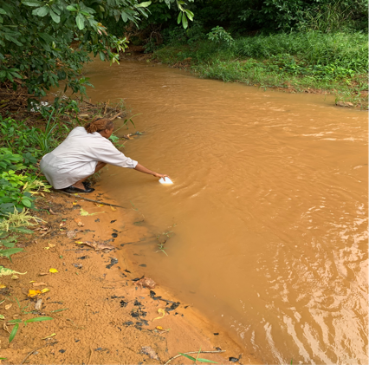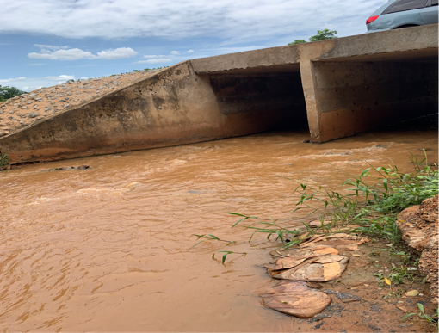
Appendix 1: Collection of water samples. Appendix 2: Washing site
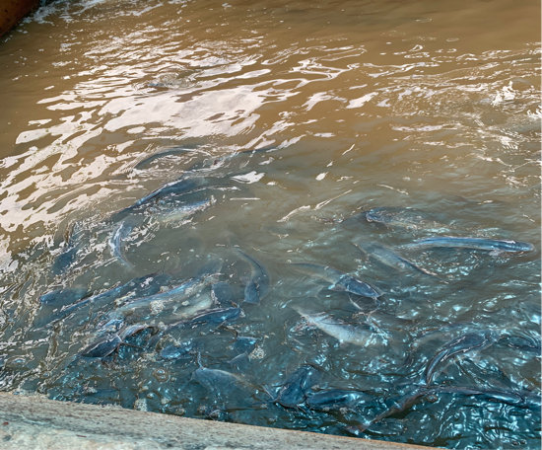.
Appendix 3: Fishing site
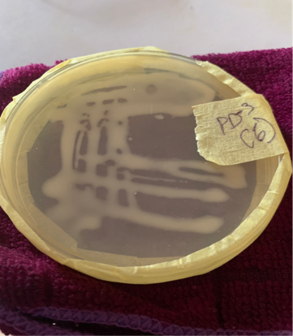. 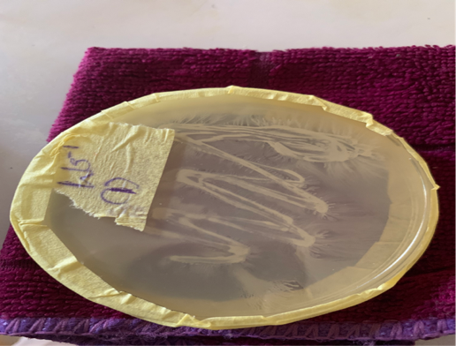
Appendix 4 & 5: Sample cultured on nutrient Agar.
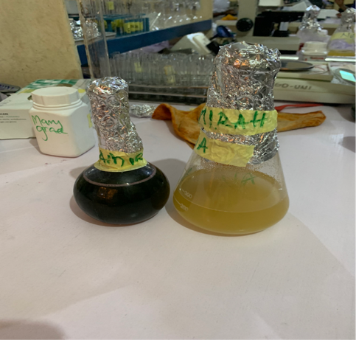. 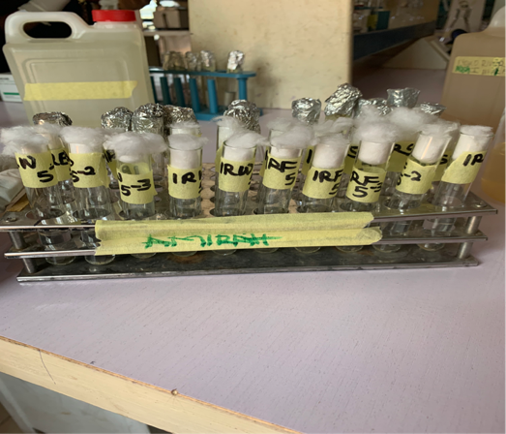
Fig 6: Nutrient Agar and EMB agar. Fig 7: Serial dilution of water samples
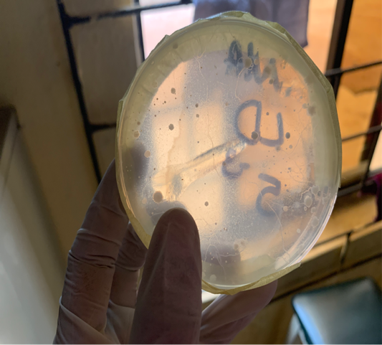. 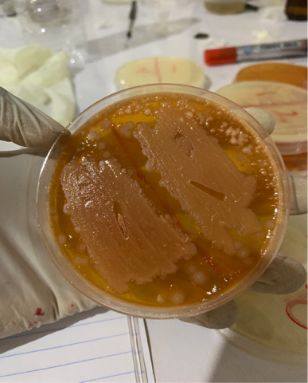
fig 8: Colonies on nutrient Agar. Fig 9: Culture in MacConkey Agar
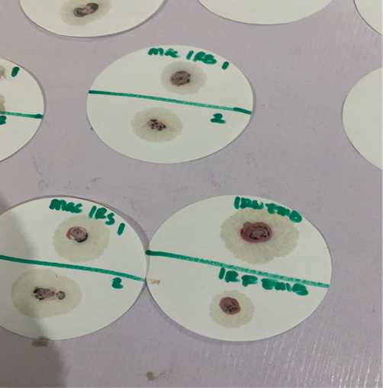. 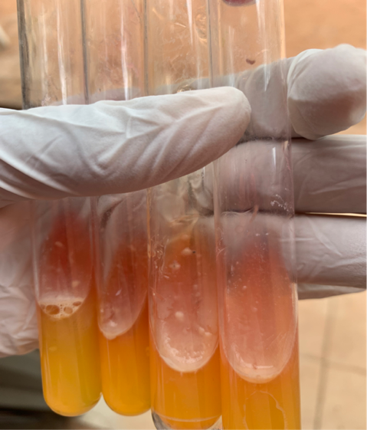
Fig 10: Oxidase test. Fig 11: Positive Urease test
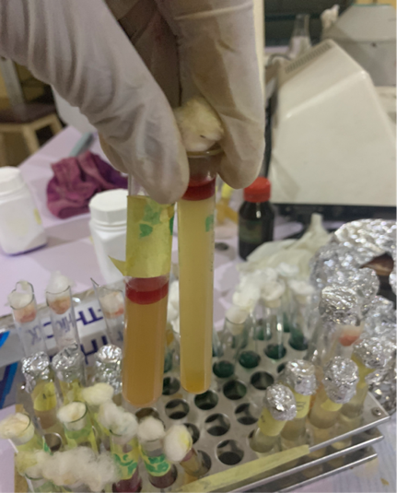
fig 12: positive indole test
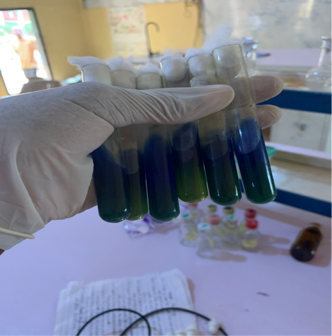
Fig 13: Citrate test
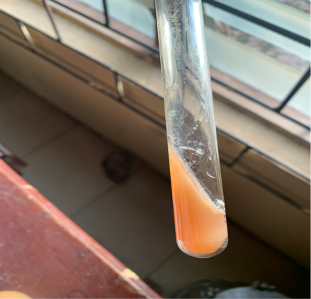. 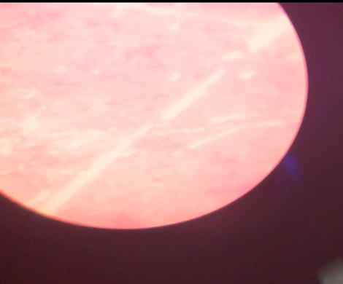
Fig 14: Negative Urease test. Fig 15: Microscopic view of Klebsiella
Pneumoniae on MacConkey Agar

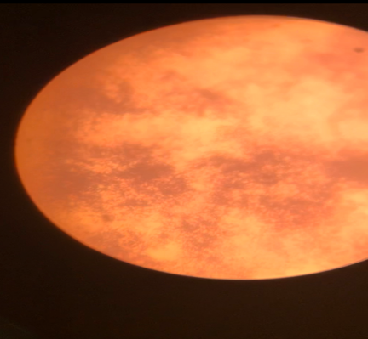. 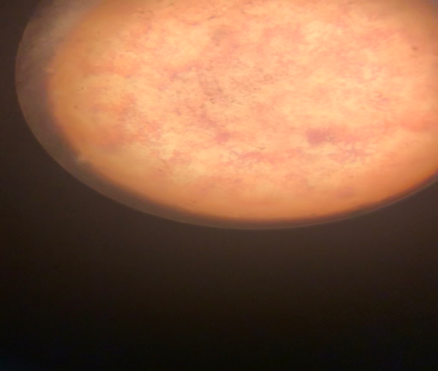
Fig 16: Microscopic view of Fig 17: Microscopic view of S.
Bacillus spp on Nutrient Agar. aureus on Nutrient Agar
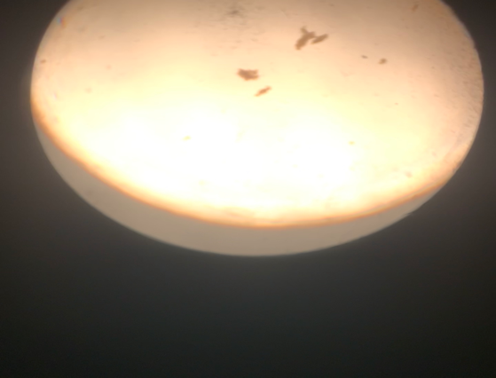
fig 18: Microscopic view of Green algae microscopically water sample
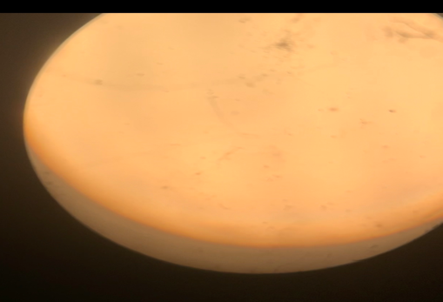
Fig 19: Microscope view of Pinworm egg in water

