IMPACT OF MONETARY POLICY ON ECONOMIC GROWTH IN NIGERIA

BY

CONFIDENCE BARTHOLOMEW
GOU/U22/ECO/440

DEPARTMENT OF ECONOMICS
FACULTY OF MANAGEMENT AND SOCIAL SCIENCES
GODFREY OKOYE UNIVERSITY, ENUGU

JULY, 2026

IMPACT OF MONETARY POLICY ON ECONOMIC GROWTH IN NIGERIA

BY

CONFIDENCE BARTHOLOMEW
GOU/U22/ECO/440

A PROJECT PRESENTED TO THE DEPARTMENT OF ECONOMICS FACULTY OF MANAGEMENT AND SOCIAL SCIENCES, GODFREY OKOYE UNNIVERSITY, ENUGU STATE

IN PARTIAL FULFILLMENT OF THE REQUIREMENT FOR THE AWARD OF BACHELOR OF SCIENCE (B.Sc), DEGREE IN ECONOMICS.

SUPERVISOR: DR QUEENDALINE UWAKWE

JULY, 2026
DECLARATION
I, Bartholomew Confidence Chinecherem, a student in the Department of Economics, Faculty of Management and Social Sciences, Godfrey Okoye University, hereby declare that “The Impact of Monetary Policy on Economic Growth in Nigeria.” presented by me in partial fulfillment of the requirement for the award of bachelor of science (Bsc) degree in Economics is my original work and has not been submitted either in part or full for any other degree or diploma either in this or any tertiary institution.

_______________________ ____________________
Bartholomew Confidence C. Date
GOU/ U22/ECO/440

APPROVAL
This is to certify that this project titled “The Impact of Monetary Policy on economic growth in Nigeria” was undertaken by Bartholomew Confidence Chinecherem with registration GOU/U22/ECO/440 and the department of Economics, Faculty of Management and Social Sciences, Godfrey Okoye University, Enugu state has been assessed and approved for oral examination defense by the Department of Economics, Godfrey Okoye University, Enugu.

____________________ __________________
Dr. Queendaline Uwakwe Date
Project Supervisor

____________________ __________________
Dr. Iduma C. Modesta Date
Head of Department

____________________ __________________
Prof. John Odoh Date
Dean of the FMSS

____________________ __________________
External Examiner Date

DEDICATION
I dedicate this project work to Almighty God who made it possible for me to carry out this project research and also for seeing me through from the beginning to the end of the project, who also gave me knowledge and understanding.

ACKNOWLEDGEMENTS
I wish to express my profound gratitude to God Almighty for his strength, wisdom and grace to successfully complete this research work and who sustained me throughout my academic journey.
I extend my sincere gratitude to my project supervisor Dr. Queendaline Uwakwe for her devotion, consistency and encouragement to ensure that this research work is a success. My appreciation also goes to my HOD and lecturer Dr. Modesta Iduma, to my lecturers, Prof Nwafor, Mrs Chikwendu, Mr. Ikechukwu, Mr. Odo, Mrs. Chioma and the entire staff of economic department. I would also like to appreciate the efforts of a non-academic staff, Mrs. Stella, the secretary Rev. Sr. Nkechinyere Chime of the economic department for providing a solid academic foundation and an environment conducive to learning and research.
I will be forever grateful to my beloved parents Mr and Mrs Okafor, and my adorable siblings, for their love, patience, support, encouragement, prayers and financial support.
My deep felt appreciation goes to my friends Chiagozie and Adanaya, and my course mates whose insights, feedback, and companionship contributed one way or the other to this research work. May God bless you all, thank you.

TABLE OF CONTENTS
Title Page i
Declaration page ii
Approval Page iii
Dedication iv
Acknowledgements v
List of Tables viii
Abstract ix

CHAPTER ONE – INTRODUCTION 1
1.1 Background to the Study 1
1.2 Statement of the Problem 2
1.3 Objectives of the Study 3
1.4 Research Questions 3
1.5 Research Hypotheses 3
1.6 Significance of the Study 3
1.7 Scope of the Study 4

CHAPTER TWO – LITERATURE REVIEW 5
2.1 Conceptual Literature 5
2.2 Theoretical Literature 13
2.3 Empirical Literature 15
2.4 Gap in literature 23

CHAPTER THREE – METHODOLOGY 24
3.1 Design of the Study 24
3.2 Theoretical framework 24
3.3 Model specification 25
3.4 Method of evaluation 26
3.4.1 Preliminary Tests 26
3.4.2 Economic (A priori) Criteria 27
3.5 Data Required and Sources 31

CHAPTER FOUR – DATA PRESENTATION, ANALYSIS AND INTERPRETATION
4.1 Presentation of Results 32
4.2 Bounds testing for co-integration with ARDL 35
4.3 Empirical Findings 36
4.4 Evaluation of Estimated Results 38
4.5 Test for Statistical Significance 39
4.6 Evaluation of estimated results based on Econometrics Criteria (Diagnostic tests) 40
4.6 Discussion of findings 44

CHAPTER FIVE- SUMMARY OF FINDINGS, CONCLUSION AND
RECOMMENDATIONS 47
5.1 Summary of Findings 47
5.2 Conclusion 47
5.3 Recommendations 47

REFERENCES 49
APPENDICES 51

LIST OF TABLES
Table 4.1: Descriptive statistics of the Model 32
Table 4.2: Unit Root Analysis 34
Table 4.3: Bound testing 35
Table 4.4: Long-run ARDL coefficients 36
Table 4.5 Short-run dynamic coefficients 37
Table 4.6: Summary of the coefficients 39
Table 4.7 Heteroscedasticity test 41
Table 4.8 Multicollinearity Test 42
Table 4.9 Serial Correlation 43

ABSTRACT
The current research project focused on assessing the impacts of Monetary Policy on the economic growth of Nigeria using time series data between 1994 and 2024. This current research assessed the impacts of Money supply, exchange rate, monetary policy rate, and cash reserve ratio on economic growth in Nigeria. The approach adopted in analyzing data in this current research study is Auto-regressive Distrributed Lag Model (ARDL) through E-Views 14. Findings from the current research project indicate that while all other variables have a positive impact on economic growth,cash reserve ratio exchange rate has a negative impact on economic growth. Furthermore, the analysis utilized the Zivot & Andrews Unit Root Test to check the stationarity, and it was found out that the explanatory variables are stationary at first differencing. From the results obtained, it can be seen that The Federal Government and Central Bank of Nigeria need to make efforts towards ensuring that financial inclusion is increased by making the credit accessible and the monetary policies like the Monetary Policy Rate (MPR) and Cash Reserve Ratio (CRR) help in making investments and economic growth. It is recommended that the Central Bank of Nigeria keeps the money supply growing steadily in order to increase investments, consumptions, and productions without the increase in inflation rate.

CHAPTER ONE

INTRODUCTION

Background to the Study
Monetary policy is one of the major policies used in macroeconomic policies for influencing economic activities in order to ensure sustainable economic growth. In Nigeria, CBN utilizes different monetary policies such as Monetary Policy Rate (MPR), open market operations, reserve requirements, liquidity ratio, and money supply control to regulate inflation, ensure price stability, generate jobs, and develop the economy. Economic growth refers to the process of growth in the production of goods and services and is always measured through GDP growth rate.
Monetary Policy and Economic Growth has received substantial attention from many scholars, economists, and policy makers in the recent past. Despite the belief of classical economists in the neutrality of money and the notion that monetary policy does not influence the economy in any way, Keynesians have maintained that monetary policy is important in influencing investments, consumption, production, and employment through the use of interest rate and money supply (Chuku, 2009). Under these circumstances, the adoption of sound monetary policy has become a very crucial ingredient for economic growth and development, particularly in countries such as Nigeria.
There have been many economic challenges in Nigeria from the 1980s, which include inflation, instability in the value of the currency, unemployment, inefficiencies in industries, and economic recession. These economic challenges have led Nigeria to formulate different monetary policies to stabilize its economy. After adopting the SAP policy in 1986, there has been an increase in the adoption of market-oriented approaches in managing money (Ani, 2021). However, in spite of all this, there have been fluctuations in the growth rates of the Nigerian economy.
There are empirical studies carried out regarding the effects of monetary policy on economic growth in Nigeria, and the outcomes are not consistent. For instance, Chuku (2009) showed that innovations of monetary policy have significant effects on output growth through several transmission channels. In addition, Fasanya et al. (2013) indicated that monetary policy has positive effects on economic growth in Nigeria through money supply and credit creation. Lastly, Adigwe et al. (2015) showed that monetary policy has a significant contribution to economic growth, even though there are differences in its effectiveness at different times.
Additionally, inflation has been revealed to be another important issue that can negatively impact the efficiency of monetary policies in Nigeria. According to the research findings by Aminu and Zubairu (2012), Bawa (2012), Olarunji (2013), Gatawa et al. (2017), and Enejo and Tsauni (2017), high levels of inflation can pose a threat to the country's economy since it can decrease the purchasing power of the population, reduce investments, and increase uncertainty. Consequently, the maintenance of price stability has become one of the primary goals of the monetary policy in Nigeria.
However, despite the numerous changes brought about by the Central Bank of Nigeria through its monetary policies, there is still skepticism concerning the contribution of monetary policies to the economic development of the country. Taking into account the constant issues with inflation, exchange rates, and GDP growth in the country, more research into the efficiency of the monetary policy seems to be necessary. Therefore, the aim of the present paper is to evaluate the impact of the monetary policy on economic development in Nigeria.
  - Statement of the Problem
Although there are several monetary policies proposed by the Central Bank of Nigeria that promote economic growth, there is slow economic growth, high inflation rates, unstable exchange rate and economic crises in Nigeria. There have been several scholarly studies on the relationship between monetary policy and economic growth, although the findings from the research are inconsistent, some show positive influence, others show negative influence while others show insignificant influence. There is therefore an ambiguity about whether monetary policies can positively influence economic growth in Nigeria.

Also, due to the new economic circumstances in which monetary policy operates, there is need for empirical evidence on this matter. This study will make a comprehensive and empirical evaluation of the effect of the monetary policy framework, interest rate and credit ceilings on macroeconomic stability in Nigeria which created concerns about the appropriateness and effectiveness of the monetary policy framework in Nigeria to achieve price stability and sustainable economic growth.

1.3 Research Questions
1. To what extent does monetary policy rate impact on economic growth in Nigeria?
2. Does cash reserve ratio have a significant influence on Nigeria's economic growth?

1.4 Objectives of the study
This study aims at analyzing the effect of monetary policy on economic growth in Nigeria. In order to meet the above-stated objective, the study is directed towards the following specific objectives:
- To analyze the impact of monetary policy rate on the economic growth of Nigeria
- To examine the influence of cash reserve ratio on Nigeria's economic growth.

1.5 Research Hypotheses
H₀₁: monetary policy rate has no significant impact on economic growth in Nigeria
H₀₂: cash reserve ratio has no significant influence on Nigeria's economic growth.
1.6 Significance of the Study
This research is considered very important to;
To Policy makers: This paper offers policy recommendations to guide decision makers specifically the CBN and the Government with respect to use of monetary policy instruments towards attaining and sustaining of economic growth. Since the policy instrument helps to influence the Nigerian economic growth, thus enabling them to achieve and attain their targets of having stability.
To the investors and the financial institutions, the research provides information about the appropriate times and the desired conditions to expect an appreciable returns for investments. Since financial sector has the potential to direct flow of funds that leads to growth, so any information that affects economic growth directly or indirectly is valuable.
To Academicians and students, the study fills up the research gap and can be used as reference material for the courses related to monetary policy, economics development and for the students to guide their research works, case studies and write-up.
To the future Researchers, the research work may be considered a starting point or a base upon which further research on monetary policy and economic growth in other developing economies can be undertaken or expanded.

1.7 Scope of the Study
The effect of monetary tools and on economic growth in Nigeria, is being conducted by this study, using data for the period 1994–2024. To effectively evaluate the long run and short run effect of monetary policy in Nigeria, annual time series data were used for both effects. Nigeria is chosen as the case study to provide detailed insight into how monetary policies influence economic growth in a developing economy.
The data which were obtained mostly from CBN Statistical Bulletin, were based on annual time series secondary data.
Among the policy instruments of monetary policies chosen are cash reserve ratio, monetary policy rate, money supply and exchange rates. economic growth (Real Gross domestic Product, indicated as GDP at constant price) treated as a dependent variable. It limited the analysis to monetary policy tools only, excluding the fiscal and other macro-economic factors.

CHAPTER TWO

LITERATURE REVIEW

2.1 Conceptual Literature
2.1.1 Concept of monetary policy
Monetary Policy can therefore be explained as conscious efforts by the central bank of any nation to control money supply, credit, and interest rate with an aim of achieving some set objectives in the macroeconomic environment such as price stability, full employment, balance of payments equilibrium and most importantly economic growth. Formulation and conduct of monetary policy in Nigeria is undertaken by the Central Bank of Nigeria (CBN) through some monetary instruments such as Monetary Policy Rate, Open Market Operations, Cash Reserve Ratio, liquidity ratio and selective credit control.
It cannot be over emphasized the importance of monetary policy in managing economic activity since money supply and interest rate have effects on consumption, investments, savings, and aggregate demand. As explained by Chuku (2009), there are many ways through which monetary policy affects the economic performance including interest rate, credit, exchange rate and asset prices.
Monetary policy has been discussed based on the monetarist concept in which money supply is considered as having significant influence on economic activities. The monetarists particularly Friedman believe that the increase in money supply needs to be controlled in order to ensure stable economic growth and keep the inflation under control (Fasanya, Onakoya & Agboluaje, 2013). Unlike the monetarist approach, the Keynesian economists have focused on the use of interest rate as the instrument for influencing investment and output via monetary policy.
The history of development of monetary policy in Nigeria has been observed in the process of time. Prior to 1986 when Structural Adjustment Program was adopted in the country, the CBN had been using the direct monetary policy instruments such as credit ceiling and administered interest rate. With the adoption of SAP in Nigeria, the country has been able to use market-oriented monetary policy tools in order to enhance market efficiency (Ani, 2021).
Monetary policies can be classified into two types, which include expansionary and contractionary monetary policies. The expansionary monetary policy involves increasing the amount of money in circulation while decreasing the interest rate to facilitate investments and boost economic growth. However, the contractionary monetary policy involves decreasing the amount of money while increasing the interest rate to control inflation and balance the economy (Ufoeze et al., 2018).
The effective monetary policy as indicated by Adigwe, Echekoba, and Onyeagba (2015) stimulates economic growth by creating an environment that is favorable for investment and production. According to Anowor and Okorie (2016), good monetary policy enhances economic performance by facilitating the allocation of financial resources.
Therefore, monetary policy can be considered an instrument used by the Central Bank to manage the condition of the monetary system to achieve sustainable economic development and stability. The efficiency of the monetary policy is determined not only by the correct selection and application of the instruments of the monetary policy but also by the responsiveness of the economy to these changes in the policy.
2.1.2 The Concept of Monetary Policy Frameworks
In general terms, the phrase "monetary policy framework" refers to the instruments used by the central bank in achieving the monetary policy objectives. It refers to the systematic application of monetary policies aimed at influencing economic activities, attaining stable price levels, and ensuring economic growth. In Nigeria, the CBN applies a monetary policy framework with different instruments for controlling liquidity, inflation, exchange rate, and economic growth (Adesanya, 2021).
Notably, monetary policy frameworks have undergone various transformations with time as functions of changes in the economy and developments in the financial market. Typically, frameworks for monetary policies are concerned with controlling monetary aggregates, targeting inflation or exchange rates, or both. It is crucial for monetary framework to apply appropriate instruments to achieve macroeconomic objectives effectively (Fasanya, Onakoya, & Agboluaje, 2013).The monetary policy tools to be discussed in this study by the CBN are the following:
The Reserve ratio: It refers to the portion of the deposit liabilities of the banks that each deposit bank has to retain in cash in their deposit account with the central bank. This procedure which is called fractional reserve reduces the quantity of loan that deposit banks can lend to individuals, firms, and organizations in an economy. Thus, the money supply will be reduced through this measure with a contractionary influence. When the CBN increases the reserve ratio, the banks will lose more of their money that they would have lent out in reserves. On the other hand, when the reserve ratio is decreased by the CBN, the amount of money to lend out increases relative to the amount of the money lost in the reserves, which can be used to stimulate investments in the economy. In Nigeria, the Cash Reserve Ratio (CRR) is the method used by the CBN to measure the reserve ratio.
Money supply. Money supply is the amount of money in the economy. There are different monetary supply aggregates (M0, M1, M2, M3 in most countries and even M4 in others like United States).
The M0 is referred to as the base money and refers to physical currency held by individuals or institutions and liquid assets stored by the bank or in banks and money markets funds. M1 represents narrow money and defines money in terms of their ability as the medium of exchange and defines it as currency held by the individuals plus money held as deposits in banks; thus, M1=C+DD where C is money in circulation and DD is demand deposit. M2 is defined as broader money or less liquid cash or savings and also defines the total amount of money in cash held by the banks, and includes time and saving deposit (as well as currency in circulation). This definition can be expanded as M2=M1+SD+TD+money markets, where SD is Savings deposits and TD is Time deposits. For example, in the CBN’s operational activities of monetary management, the definition of M2, as broadly defined by any reasonable perspective, remains a guide and the broad money used by the CBN, captures all money supply and includes cash, which is liquid money that can be easily used for transaction within the economy, whether such cash is held in bank account or in physical form. However, we believe that inclusion of savings and time deposit with commercial bank would give the right result because these are readily convertibility into cash when a depositor needs the money and will also be available to carry out financial transaction within a short span of time (Nwankwanwoeze, 2012).
M3 defines all the money defined under broad money as well as cash held in other institutions, such as financial house and merchant bank (i.e. M1+M2+Dx).M4 is the sum total of all other classifications of money supply plus time deposit held in the bank including call money and government securities.
These above classification of money supply are common but CBN use only M2 to represent Money Stock.
Exchange rate : Exchange rate is defined as the price of one country's currency in relation to another country's currency. This is an important aspect of monetary policy. The rate can be as the result of how much it cost one currency in relation to the other country's currency. It effects not only foreign direct investment and the flow of capitals but also the total trade between countries, the inflation and economic growth of an economy. In a Nigerian economy, managing the exchange rate is essential, due to heavy reliance on imported goods (machineries and raw materials). The stability of exchange rate leads to the reduction in economic risks that encourage domestic and foreign investors and thus, help in fostering economic growth. On the other hand excessive depreciation leads to increase cost of imports; increase in production cost; rise in inflationary pressures; decline in aggregate investment etc which leads to slow down in growth performance.
In our analysis the average of the official ( nominal) exchange rate of Naira per US dollars is the variable published by CBN. This indicates the relative value of the two currency in the market. It reflects, however, not only the price of one currency relative to another country’s currency, but also the differences in the price levels between two countries, in this case the trade relationship between The United Sate and Nigeria, therefore reflecting the real purchasing power of the currencies of these two countries.
The other studies investigated have used the real effective exchange rate (REEL) which takes the exchange rate value of domestic country into consideration of the countries that it is dealing with.
Monetary policy Rate
The Monetary Policy Rate (MPR) is the indicator interest rate that is used by the Central Bank of Nigeria (CBN) to determine the trend or direction of the monetary policy. It is the interest rate at which the CBN lends to Deposit Money Banks and is also the reference interest rate for other interest rates in the economy. The MPR influences the cost of borrowing, savings, investments, inflation rate and economic growth among others.
Before the year 2006, the Central Bank of Nigeria used the Minimum Rediscount Rate (MRR) as its major monetary policy interest rate. Nevertheless, the MRR did not prove to be an effective means of communication of monetary policies by the central bank as it had little effect on the short-term interest rates in the market. Liquidity excess in the banking sector and volatile money market rates were the challenges faced by the MRR as the monetary policy tool. This led to the MPC making the decision to change its monetary policy strategy by introducing the MPR on December 11, 2006 to replace the MRR. The introduction of the MPR was expected to improve the effectiveness of the monetary policy transmission process, liquidity increase interbank market operations, and provide an improved benchmark for interest rates in the economy. Initially, the MPR rate was set at 10% with an interest rate corridor of ±300 basis points around the MPR.
According to the Central Bank of Nigeria, the role of MPR was to serve as a nominal anchor for interest rates and ensure stability of interest rates in the short-run money markets. Unlike MMR that only served as an administrative rate, the MPR serves as a transactional interest rate that affects the cost of fund in the banks. This makes the transmission of the monetary policy to the banking industry and the entire economy more effective.
It is important to note how significant MPR is in addressing the economic imbalances in the country. For example, if the level of inflation rate is high in the country, then the CBN would increase the MPR so as to reduce the amount of money in the economy. The increased interest rates will helping in reducing borrowing and high expenditures, hence reducing aggregate demand and inflationary pressures. On the contrary, during periods of economic recession, the CBN can decrease the MPR in order to increase borrowing and expenditure as well as economic activities (Okeyovat, 2022).
Additionally, the MPR is very important in stabilizing exchange rates since the high MPR will lead to attracting investments in the country both from domestic and foreign investors, hence increasing the naira value. The MPR plays a role in ensuring the financial stability of the country through regulating how banks lend money. According to Chuku (2009), the MPR is among the key mechanisms through which the interest rate policy influences the output growth and performance of the economy.
MPR is a monetary policy variable whose change influences economic growth.(Adesanya (2021), Shaibu and Enofe (2021), Aliu (2022), and Adu and Musa (2024) found that the changes in the policy rate influence
Investments, credits, inflation, and economic growth. Conclusion: Monetary Policy Rate (MPR) is one of the important instruments used by the Central Bank of Nigeria to attain price stability and national growth.

2.1.3 The concept of Economic growth

The concept Economic Growth involves constant growth in a county’s productive capacity over time, which results in growth in the economy's aggregate output of goods and services within a specified period of time. It is generally measured by growth in the GDP or real GDP, where real GDP measures GDP after adjusting for inflation. Economic growth is how much an economy can grow in terms of income generation, creation of employment, investments, and improving the standard of living of the citizens.

Economic growth is an important component of the development process of countries because it is the indicator of economic performance and welfare improvement. This results ih in the creation of employment opportunities, growth in industries, reduction of poverty, advancement of technology, and increased government revenue. This ensures that there is an improvement in the supply of essential public goods and services, including education, health, transport, and infrastructure services. Therefore, various macroeconomic policies such as monetary policy try to ensure continued economic growth.
Growth of the economy is not only limited to the increase in the output of the economy. Rather it entails improvements in productivity, efficiency of resource usage, creation of capital, innovation, among other factors. As per Aminu and Zubairu (2012), economic growth takes place when there is a continuous increase in the production of goods and services, and an improvement in the standard of living. Economic growth as per Bawa (2012) is a state where the economy has expanded its capacity of production without experiencing inflation.
Development in the Nigerian economy has been characterized by considerable volatility in nature over the years. This is because there have been significant growth rates averaging 6 percent in the period between 2001 and 2014, attributed to the country’s oil revenues, banking reformations, and investments. However, there has been a significant decline in the growth rate, which led to an economic contraction of −1.6 percent in 2016, but the economy managed to recover with growth rates of 0.8 percent in 2017, 1.9 percent in 2018, and 2.2 percent in 2019. In addition, there has been volatility in economic growth due to the COVID-19 pandemic, leading to an economic contraction of −1.8 percent in 2020, but with growth rates of 3.4 percent in 2021, 3.3 percent in 2022, and 2.7 percent in 2023 (NBS, 2024; World Bank, 2024).According to the existing economic trends in the country, it can be concluded that Nigeria has recorded positive economic growth; however, the growth rate is less than the required rate to solve the problem of unemployment, poverty, and population in the country. Even though there have been moderate GDP growth records in Nigeria from 2021 until now, the existence of factors such as inflation, exchange rate fluctuations, insecurity, and lack of infrastructure has affected the growth in the country (Adu & Musa, 2024).
Many researches have been carried out to investigate the relationship between monetary policy and economic growth. Chuku (2009), for example, claimed that monetary policy influences the growth in output through interest rate, credit policies, and money supply. The researchers (Fasanya et al., 2013) stated that the implementation of monetary policy plays a significant role in economic growth through liquidity and productivity. According to the researchers (Adigwe et al., 2015), the proper implementation of monetary policies results in economic growth due to creating favorable environment for business and investment.
It is for this reason that economic growth becomes a key indicator of the degree of development and economic success of any country. The realization of economic growth is subject to many factors including sound monetary policy, macroeconomic stability, investment, technological innovation, and efficient use of resources. It therefore becomes very crucial for any developing economy, especially Nigeria.

2.2 Theoretical Literature

This study is built upon three major theories, the Keynesian liquidity preference, Monetarist theory, Quantity theory of money

Keynesian liquidity preference.

The theory was enunciated by John Meynard Keynes (1936) in his book The General Theory of Employment Interest and Money. As a matter of fact, Keynes observed that the tool of monetary policy is so powerful, yet it is so subtle. Money policy affects interest rate, liquidity, credit; hence it influences economic activity indirectly.

Firms, Households, financial institutions are affected in ways that may not be anticipated by monetary authorities.

Also Keynes’s theory is the one that pointed to the inefficiency of money policy when in what is called the liquidity trap. Keynes in this context advocated the use of fiscal policy to address the situation in a bid to increase Aggregate demand for to reduce unemployment and control prices (Ufoeze, Odimgbe, Ezeabalisi, & Alajekwu, 2018).

Monetarist Theory (Milton Friedman)
This study is based on the monetarist theory, which puts an accent on Friedman's ideas that the functioning of an Economy is predominantly determined by the increase in money supply. The monetarists believe that the main reason for than economy's inflation is the excessive growth of money supply. Friedman argued that alteration of the money supply has a significant effect on the overall level of output as well as price stability. He said inflation can be nothing but monetary in nature.
In this perspective, excessive growth of money supply causes high inflation and uncertainty in the economy, causing the saving and investment rates to fall, and it may even prevent the economy from growing. Friedman suggests a more stable monetary policy since the k-percent rule, which suggests that the money supply should grow at a fixed rate every year. This rate of growth should match that of real GDP, he suggested, to preserve the general level of prices over time.
Hence the Monetarist theory suggests a policy of monetary authorities to ensure stability of prices through steady and predictable growth of the money supply. This is better than making quick, short-term or drastic changes in monetary policy, which can have a destabilizing effect on the economy.
Quantity Theory of money (Irving Fisher)
The Quantity Theory of Money by Irving Fisher, describes how the amount of money in an economy relates to the price level. Fisher has this relationship represented by the equation of exchange:
"MV=PT
" Where:
Money supply is represented by the letter M, the velocity of money (the number of times money circulates in the economy) is represented by the letter V, the general price level is represented by the letter P, and the number of transactions (or the amount of output) in the economy is represented by the letter T.
The theory is based on the assumption that the velocity of money (V) and the volume of transactions/output (T) remain fairly constant in the short run. Based on this assumption, an increase in the money supply (M) will lead to a proportional increase in the price level (P). This means that an increase in money supply can lead to inflation as more money will be chasing fewer goods and services.

On the subject of economic growth, Quantity Theory implies that an average growth in money supply can back up the production and economic activities by providing more liquidity and facilitating more transactions. When money supply grows too fast in relation to economic activity, however, it does not generally lead to an expansion of output but to an increase in prices. Monetary policy thus affects economic growth by affecting money supply which in turn affects the output and price stability in the economy, hence the theory goes.

2.3 Empirical Literature
To understand the relationship between monetary policy instruments and economic growth in Nigeria, several empirical studies have been reviewed.
Ayorinde (2025) ,, in his research investigated the influence of monetary policy on Nigeria's economic development between 1986 and 2023 utilizing Auto-regressive Distributed Lag (ARDL) model, Gross fixed capital formation (GFCF) as growth's prox, and money supply, exchange rate, private sector credit, inflation rate, and GDP as explanatory variables. Monetary policy variables and GDP were found to not have a statistically significant long-term effect on economic growth, and it is recommended that policymakers prioritize an attractive and stable exchange rate, efficient monetary policy implementation, and control of money supply to promote sustainable economic development by curbing inflation.
In a similar vein, Gini and Obode (2025) observed a favorable long-term relationship between monetary policy and economic growth in Nigeria using 1982-2023 time-series data and the Autoregressive Distributed Lag (ARDL) model. They employed an ex-post facto research design for identifying a causal and effect relationship between the dependent variable and regressors.
From their study utilizing time-series data from 1982-2022, Amadi, Ewubare, and George (2025) found that monetary policy tools positively influence real GDP in Nigeria through unit root, bound cointegration, and Autoregressive Distributed Lag analyses.
Likewise, Musa and Ahmad (2024) analyzed the impact of monetary policy on Nigerian economic growth from 1990 to 2022 through a bounds cointegration approach of the autoregressive distributed lag model (ARDL) using data from the Central Bank of Nigeria (CBN). The study considered broad money supply, interest rate, inflation rate, and exchange rate as variables, with the real GDP growth rate as a proxy for economic growth. The findings revealed significant long-term impacts of money supply, inflation rate, and exchange rate on economic growth. In the short run, money supply positively affected growth, while interest rate and exchange rate showed negative significant impacts. To foster a stable investment environment, both domestic and foreign direct investment, the study recommends specific monetary policies.
Nwikpo (2022) analyzed analysed the influence of exchange rate, interest rate, and liquidity ratio as monetary policy variables on Nigeria's economic growth, highlighting the long-term positive and significant correlation of liquidity ratio with economic growth and the negative relationship of interest and exchange rates with economic growth. Recommendations from the study include maintaining adequate liquidity in deposit money banks, low and stable interest rates to boost investment, and a favorable exchange rate to encourage foreign investment and economic growth.
Examining the effect of monetary policy instruments on Nigerian economic development from 1986 to 2021, Ohwofasa and Obukohwo used data from the CBN's annual report and account, employing Co-integration and error correction models. They found that there is a long-run equilibrium relationship between the dependent and explanatory variables, with cash reserve ratio and money supply significantly positively influencing human development in the long run. Their study recommended the application of MPR for interest rate policy to keep interest rates low and avoid stunting private and public sector investment growth in Nigeria.
Aliu (2022) assessed the effectiveness of monetary policy on Nigeria's economic growth from 1990 to 2019 using CBN data. Their empirical analysis, incorporating Augumented Dickey Fuller unit root test, ARDL bounds test, and Error Correction Mechanism (ECM), indicated that all variables except monetary policy rate were stationary at first difference levels. The researcher suggested the use of non-monetary policies by the monetary authorities to have a positive impact on economic growth in both the short and long runs.A lot of developing countries are paying keen interest in economic growth in general.
Sulaimon (2022), based on this the research aims to evaluate the impact of monetary policy on the Nigerian economy using time series data for 1990 to 2021, stationary was tested using Augument Dickey fuller test and the ARDL bond test to test long-run relation, from the result obtained Monetary Policy has statistically significant on the Nigerian Economic Growth. This implies that the Nigerian monetary authority needs to consider its policy formulation and implementation for better Nigerian economy growth.
Effectiveness of Monetary Policy Rate on the Nigerian Economic Growth. (A review of empirical study from 2006-2020 data by Okey, 2022) Okey (2022), examined the impact of monetary policy rate on Nigerian economy through empirical review from 2006-2020 with data gotten from the central bank of Nigeria for time series analysis. Time series of annual frequency from 2006-2020 annual time-series were use, a two-stage least square (2SLS) approach to investigate the impact of the monetary policy rate on the Nigeria economy.
Variables under consideration in the analysis before estimating are tested for stationary on the broad money supply, liquidity ratio and cash reserve ratio, and were all tested to be stationary at first round view. From the empiricial analyses, monetary policy rate and real exchange rate impact on Nigeria Economy Growth positively and negatively respectively and both were statistically significant.
Analyzing the influence of monetary policy on Nigeria’s economy by Timothy (2022) adopted the Keynesian Transmission Mechanism using the data sourced from the publication of the Central Bank of Nigeria (CBN) from 1990-2019 and econometrics methods such as Augumented Dickey fuller unit root test, ARDL Bound Test and ECM were applied. Results of the empirical analysis revealed that all the variable are stationary at first difference while the monetary policy rate is stationary at level; and as the unit root tests have shown that all the variables are stationery in their first differenced, this further confirms the use of ARDL Bound test and ECM to check for cointegrating relationship.
Monetary Policy and Economic Growth in Nigeria: an Assessment (1989-2019 by Adesanya & Ogakwu, 2021) The researchers carried out an assessment of the impact of monetary policy on the Nigerian economic growth based on data and information gotten from central bank of Nigeria statistical bulletins from 1989-2019, The researchers identified the use of Vector Error Correction Model (VECM) as the estimation technique for their variables of interest. Results reviewed shows no bidirectional granger causality level amongst any of the identified variables, a one standard deviation rise in the broadest money supply (M2) will lead to a positive response initially, however, a further positive impact can also been seen over long run period but will lead to a fall in output, a one standard deviation shock in bank credit to private sector (BCP) has negative effect on output, a one standard deviation shock in Interest rate (INT) and Exchange rate (EXC) have positive, but smaller effects on GDP.
Study on Effect of Monetary Policy Tools on Nigerian economy between 1986 to 2018, Shaibu & Enofe (2021) have explored the impact of different tools of monetary policy on Nigerian economy over the period 1986 to 2018 using annual time series data on the impact of policy on output; it was found that only interest rate had a statistically significant positive impact on the economy in short run. The results of the research however reveal that M2 and the output levels are inversely related, which shows negative relationship in long run in Nigeria economy. It therefore recommends for the Nigerian Monetary Authorities to pursue expansionary monetary policy, designed to generate a quick and significant increase in the supply of money in the Nigerian economy, that will in turn cause the aggregate investment to increase due to reduced rate of interest, thereby causing economic growth in the long-run to surge.
The Eggon and Adjidani (2020) studied the influence of monetary policy management on inflation in Nigeria using time series data of the Nigerian economy between 1985 and 2019, and Autoregressive Distributed lag (ARDL) model approach for time series analysis. They observed that Monetary Policy had a negative impact on the Inflation, whilst Broad Money Supply showed a positive impact on the Inflation rate. Based on the study findings monetary authorities should introduce exchange rate mechanism where the value of naira becomes strengthened, and government should increase its investment on productive areas so that production of goods and services will rise leading to reduction in rate of inflation and enhancement in the economic growth of the country.
According to the Ismail, Adegbemi and Agboluaje (2018), monetary policy as regards economic growth in Nigerian Economy over the period of 1975-2010, employed time series analysis of Nigeria economy and Error Correction Model (ECM) was used to analyze the effects of the stochastic shock of each of the endogenous variable on each of other. The outcome of the research indicated that among the monetary policy indicators Inflation, Exchange rate and External Reserve have significantly impacted the Nigerian economy growth, while there was long-run relationships amongst all the variables in the model.
The monetary authorities should focus on the cash reserve ratio as one of the instruments of Monetary policy that are used to stabilize the economy, Anowor and Okorie (2016). The study also applied the Error correction model technique to check on the impact of monetary policy on the economic growth by the use of data on Nigeria Economy for period 1982 to 2013. The result shows that a one unit increase in cash reserve ratio (CRR) in Nigeria will cause to increase to increase in economic growth by 0. Units.
Similarly, Onwachukwu (2014) also examined the impact of Monetary Policy on Inflation in Nigerian Economy, the problem of Nigeria Economy being inflated over the years as inflation is the major cause to growth of Nigeria Economy. By applying Ordinary least squares OLS method on Nigerian data over the period of 1970 to 2010, it shows that Bank rate, Liquidity ratio, and broad money supply has significant relation with the inflation, but Exchange rate does not have any significant effect on inflation of Nigerian Economy.
Also Chipote and Makhetha (2014) studied on role of Monetary Policy in the growth of South Africa Economy using data for the period 2000-2010. The research employs Augumented Dicky-Fuller (ADF) and Phillips Perron (PP) unit roots test for stationarity and cointegration analysis using Johansen co-integration approach and ECM to determine the short run and long run interaction among variables. The study concludes that there is long-run interaction among variables, and money supply, repo rate and exchange rate did not have significant impact on South Africa economy but the inflation rate significantly impact the South African economy growth.
As indicated in the research done by Emereni and Eke (2014) which examine the determinants of inflation in Nigeria within the monthly data from January 2007 to August 2014 using the ordinary least squares regression method for the model on grounds of its linearity Unbiased estimator property in this study. The analysis concluded that Exchange Rate and Money Supply had influence on Inflation over the sample period, and that Expected Inflation had impact on Inflation in Nigeria. Also the result from the co-integration test shows a long-run relationship between variables and proved that all variables are stationary of order one.
Using the Ordinary least squares (OLS) technique of multiple regression modelsimoisi, Olatunji and Ekpenyong (2013) examined the effectiveness of monetary policy in achieving the objectives of balance of payment stability in Nigeria for the period 1980 – 2010. Based on the estimation result, we conclude that there is positive correlation between the dependent variable (Balance of payment) and the explanatory variable (Money supply, Interest rate, and Exchange rate). However, government should improve on export of other products other than oil to enable balance of payment improves in the country through increases in the country’s production and consumption of products in general.
Onyeiwu (2012) in his research used Ordinary least squares Method (OLS) to analyze data from 1981-2008 with the aim of finding the influence of monetary policy on the economic growth of Nigeria. The analytical results shows that monetary policy, using money supply has a positive impact on a GDP growth and balance of payment but has a negative impact on inflation rate.
The effect of money supply on the growth of the economy in Nigeria was studied by Nwankwooeze (2012) and obtained data on money supply from CBN statistical bulletin for the period of 1981-2021. The statistical techniques used includes the ordinary least square (OLS) alongside Stata 10 software, which show that there is no influence of real interest rate and exchange rate on real gross domestic product (GDP) in Nigeria, but broad money supply has significant influence on real GDP for the period under study.
Based on the aforementioned study, it was observed that money supply is positively related to growth but this is not the case with GDP growth rates in the choice between contractionary and expansionary money supply, Ogunmuyiwa and Ekone (2010).
This is in line with Akujuobi (2010) who found cash reserve ratio significant in affecting the economic development of Nigeria both at the 1% and 5% level of significance in his study, the effect of monetary policy instruments on the economic development of Nigeria, using multiple regression technique.
Adefeso and Mobolaji (2010) were interested in re-estimating and re-examining the relative effectiveness of fiscal and monetary policy on economic growth in Nigeria with annual data for the period 1970-2007. The data was analyzed using Error Correction Mechanism and Cointegration technique. The empirical result confirmed the strong effect of the monetary policy as compared with the fiscal policy and exclusion of the degree of openness did not significantly reduce this result. The implication of this for the policy maker is that there should be more emphasis and reliance on monetary policy for the purpose economic stabilization in Nigeria.
In this paper, Chuku (2009) looked at monetary policy innovation and its significance to policy making. Monetary policy shocks effect on output and prices in Nigeria were analyzed using the Structural Vector autoregression (SVAR) model. It was found that monetary shocks have profound effects on both output and prices. The study showed that the central bank needs to emphasize use of the quantity-based nominal anchor as opposed to the price-based nominal anchor in monetary policy.
However, the relative effectiveness of monetary and fiscal policy on economic activity in Nigeria was established using the cointegration and error correction modelling techniques. To examine the properties of the time series of the variables, a unit root test was carried out on the annual series data covering the period 1970-1998, primarily from CBN Statistical Bulletin. From the result of our analysis, it can be seen that monetary policy, not fiscal policy has a great influence on economic activity in Nigeria. (Ajisafe and Folorunso, 2002).
Gylfason (1987) studied the correlation between money supply and economic growth. The results suggested that the credit expansion reduced considerably in some of the non-oil developing countries, while a significant improvement in the overall balance of payments was observed.
From this literature review of empirical evidence on the role of monetary policy on economic growth of Nigeria, some weaknesses are noticeable. Most of the literature in Nigeria has been conducted using one single measure of monetary policy, either money supply, interest rate etc., hence unable to assess impact of interaction among combinations of these monetary policies; like the impact of money supply and interest rate, or the impact of inflation and exchange rates. It limits the level of understanding in interaction of variables on economic growth.
2.4 Gap in Study
Upon extensive study of literature published by others on the topic, divergent results emerged regarding the impact of monetary policy instruments on the economy in Nigeria. On basis of empirical work undertaken on the issue, few result positive and significant on monetary policy instruments’ impacts on the growth of economy while others reveal the negative impacts and no impact at all on the economy. Furthermore the main gap existing in the former studies is the utilization of other classical unit roots tests, such as ADF, Phillip-perron unit root test, that do not capture the structural breakpoints within the data. Therefore in order to address this limitation this paper will use the Zivot-Andrews unit root tests which allow for the inclusion of structural break.

CHAPTER THREE

RESEARCH METHODOLOGY

3.1 Research Design

The research design of this study is the ex post facto research design because it allows the researcher to assess cause and effect relations of monetary policy variables on Nigeria's GDP using already collected secondary data on the monetary policy instruments and impact on GDP without any interference or manipulations of the variables studied. Pesaran et al. (2001) developed the ARDL Bounds Tests and is used for tests on long-run relations between variables; especially in small-sample data rather than most other econometric approaches. The reason is it allows for unit root test and testing for stationarity which enables determine the order of integration such as whether it is I(0) or I(1).

3.2 Theoretical Frame work

The study adheres to the monetarist theory which is presented in Friedman and Schwartz seminal work A Monetary History of the United States, 1867-1960, where they argue that the quantity of money determines the growth rate of aggregate demand, the rate of inflation, and even the growth rate of the economy itself. This monetarist school believes inflation slows economic growth and they insist that an increase in money supply and central banks’ activities, through prudent manipulation can affect price level, regulate economy activity, and control inflation. Therefore in monetarist model money supply impacts on the growth of the economy, In compliance with the suggestions of the monetarist approach, the model is framed where Real Gross Domestic Product (proxy of economic growth) is a function of Money supply, policy rate (as an interest rate), cash reserve ratio and exchange rate.

3.3 Model Specification

Guided by the monerist theoretical underpinning, it is proposed to adopt the multiple regressions modeling technique, which has several econometric methods to explain relation between the dependant and independant variable. It shows the relationships between the variables, and the relationship have been giving by following equation: For the purpose of estimation, this model can be represented in following equation format

i)Functional form of model: Here real gross domestic product has been modeled as a function of money supply, money policy rate, Cash reserve ratio and Exchange Rate.

RGDP = f(MPR,CRR,EXR,MS) …. …. …. ….. …. (1)

ii )Mathematical equation of the model

lnRGDPt = β₀ + β₁MPR_{t} + β₂CRR_{t} + β₃MS_{t} + β₄ lnEXR_{t} …. …. …. ….. …. (2)

Econometrics form of the model

LnRGDPt = β₀ + β₁MPR_{t} + β₂ CRR_{t} + β₃ MS_{t} + β₄ lnEXR_{t} + ε_{t} …. …. …. ….. …. (3)

Where

Ln=Natural logarithm

RGDP = Real Gross Domestic Product

MS=Broad Money Supply

MPR=Money policy Rate

CRR = cash reserve ratio

EXR=Exchange Rate

β = Parameter constant

β_{1,} β_{2,} and β₃ are parameter estimates

ε = Error Term

t=Time period

The Generalized ARDL(P,Q) model is represented as:

$$Y_{t}= \sum_{i=1}^{p}{α_{0j}}+π_{2i}Y_{t−1}+\sum_{i=1}^{q}{π_{21}}X_{t−1}+ε_{t}……………………….……….(4)$$
Where: provided that p and q do not necessarily suggest symmetry of lag-lengths,
p = optimum lag length for the predicted parameter.
q = optimum lag length for the predictors.
The ARDL model for this study is specified as follows:

$$∆{LNRGDP}_{t}= α_{0}+\sum_{i=1}^{n}{β_{1}}∆{MPR}_{t−i}+\sum_{i=1}^{n}{β_{2}}∆{CRR}_{t−i}+\sum_{i=1}^{n}{β_{3}}∆{LNM2}_{t−i}+\sum_{i=1}^{n}{β_{4}}∆{LNEXR}_{t−i}+γ_{1}{LMPR}_{t−1}+γ_{2 }{CRR}_{t−1}+γ_{3}{LNM2}_{t−1}+γ_{4}{LNEXR}_{t−1}+ε_{t}$$
Where, Δ is the first difference operator, and $α_{0}$ is the drift component. The expressions with the summation sign ($β_{1}$-$β_{3}$) represent the short-run dynamics of the model, while the coefficients ($γ_{1}$-$γ_{3}$) represents long-run relationship and $ε_{t}$ IS the serially uncorrelated disturbance with zero mean and constant variance. All other variables remain as earlier defined. From equation above, it can be observed that RGDP is dependent Variable (endogenous variable) while MS, INF, EXR, and MPR are Independent variable(s), with MPR and CRR treated as the study’s focus variables and MS and EXR Natural logarithm was employed to both RGDP and EXR to enable the model fit better with reasonable regression results, to help overcome the potential problem of heteroskedasticity since RGDP and EXR have values greater than one.

3.4 Method of Evaluation

The result evaluation techniques are divided into three sub-sections, which are;

Preliminary Test

The economic test (a priori criteria)

The statistical Test (first-order criteria)

The econometrics Test (Second order criteria)

3.4.1 Preliminary Test

3.4.1.1 Unit root test

The unit root test is used to determine whether a time series is stationary. Macroeconomic data often show non-stationarity; therefore, using unit root tests helps avoid spurious regression results in which variables appear statistically related, but no real relationship exists between them. The Zivot-Andrews unit root test was employed in the study to assess potential structural breaks in the time series data.

∆Y_{t}=µ+β_{t}+θDU_{t}+_{ϒ}DT_{t}+αY_{t-1}+Ʃ^{k}_{i-1}c_{i}∆Y_{t-i}+ε_{t}

Where ∆ is the first difference operator

Y_{t =} variable under study

µ = constant term (intercept)

t = time trend

DUt = Dummy variable capturing the change in the intercept due to a structural break.

DT_{t} = Dummy variable capturing the change in trend due to a cultural break

Y_{t-1} = lagged value of variable.

c_{i} = coefficients of lagged difference terms

ε_{t} = Error term

Decision rule

If the test statistic has an absolute value greater than the critical value at a 0.05 level of significance, reject the null hypothesis, and do not reject the null hypothesis otherwise.

3.4.1.2 ARDL Bounds cointegration Test

This ARDL Bounds cointegration test is also suggested by Pesaran, Shin and Smith (2001), a technique used to find out whether the series is cointegrated or not (i.e. There is a long-run relation between the series). Series can be either integrated of order zero I(0) or order one I(1) or mixture. However, one should note that ARDL Bound Test cannot be applied when a series is of order of integration 1(2) and above.

Decision Rule

Reject the null hypothesis if the ARDL bounds test f-statistic is greater than the I(1) upper critical value which proves the presence of long run relation or co-integration between variables. Failure to reject the null hypothesis otherwise. When computed F- statistic lie between the I(1) and I(0) upper and lower critical values, it is an inconclusive result.

3.4.2 Economic (A priori) Criteria

The economic criteria examine the signs and size of the estimated model. Here, we confirm whether the signs of the estimated parameters and coefficients are consistent with the theoretical relationship between the independent and dependent variables.
Parameters | Variables | Expected Signs
β₁ | M2 | positive
β₂ | MPR | Negative
β₃ | CRR | Negative
β₄ | EXR | Negative

3.4.2 Statistical Criteria

3.4.2.1The coefficient of determination, also known as R-squared, determines how well dependent variables are explained by the explanatory variables. This value is not an indicator of how independent variable leads to changes in dependent variable; it gives values from 0 to 1, and also determines statistical data in percent. Higher the R2 value is the higher percent of economic growth is explained by independent variable.

3.4.2.2 Adjusted R-square Is a regression statistic that is a modification of R-squared for the regression model because it is a better fit than R-squared by considering changes due to regressors added to the ordinary R2. The adjusted R2 indicates whether adding additional regressors can improve the explanatory power of the models such as: models with multiple regressors and lag structure (ARDL).

3.4.2.3 The T-test Is used in this research in to determine how individually statistically significant of each independent variable on the model is. Test the impact on the money supply, cash reserve ratio, monetary policy rate and exchange rate towards real gross domestic product on our regression model. This is the test to know how significant the parameters to our research which H₀: parameters are not statistically significant.

Decision rule:

If Probability value (P- value) is < 0. 05, reject H 0 otherwise fail to reject H 0.

3.4.2.4 The F-test is a statistical method used to examine the variance between two samples and to evaluate the significance of regression models. It is used to determine whether all independent variables influence economic growth. To determine the significance, the calculated F-value is compared to a critical value from the F-distribution table based on the degree of freedom (number of samples-1) and significance level (α =0.5 mostly used significant level).

Decision Rule

When F-calculated > F-critical, reject the null hypothesis. The null hypothesis can also be rejected if p value of the F statistic < 0.05, in that case otherwise null hypothesis should not be rejected.

3.4.3 Econometric Criteria

The econometric criteria are to make judgment as to the assumption which supports estimated model and these include test of heteroskedasticity and autocorrelation. They also measure of stability and validity of the model estimated in this research, The following tests were used in this study; the Error Correction Model (ECM), the Heteroskedasticity test, the Normality test, the Multicollinearity test, the Serial correlation test and stability test.

3.4.3.1 Heteroskedasticity tests

Homoscedasticity (and heteroskedasticity) test determines if there exists any link or relationship between the error term and the independent variables or their squared term. To detect whether the error term of this regression model is a linear function of one or more of explanatory variables, the Breusch-Pagan-Godfrey test was used in this study.

The decision rule

To interpret these results. If p-value<0.05 (at the 5% significance level), then we reject the null hypothesis H₀, that is we have detected the presence of heteroskedasticity. However, if p-value>0.05, then we fail to reject the null hypothesis H₀, that is the assumption of homoscedasticity holds for our model.

3.4.3.2 Normality tests

The Jarque-Bera test is performed for checking the normality of the disturbance term.
Decision rule:

Reject the null hypothesis if probability value of the Jarque-Bera statistic is below 0.05. In other case fail to reject.

3.4.3.3 Multicollinearity Test

The Multicollinearity Test was conducted using the correlation matrix to assess the degree of multicollinearity among the explanatory variables.

Decision Rule:

A correlation coefficient above 0.80 indicates multicollinearity among the explanatory variables.

3.4.3.4 Serial Correlation Test

The Serial Correlation Test was conducted using the Breusch-Godfrey Serial Correlation LM Test to determine whether autocorrelation exists among the residuals.

Decision Rule:

Accept the null hypothesis of no serial correlation if the probability value is greater than 0.05. Otherwise, reject the null hypothesis.

3.4.3.5 Stability Test

CUSUM and CUSUMSQ tests have been used to evaluate the stability of the fitted model during the entire period of the study to carry out the Stability Test.

Decision rule

The model will be declared to be stable if plots of CUSUM and CUSUMSQ pass between critical bounds at 5 per cent level of significance.

3.5 Data required and resources

Data. The study utilizes secondary time-series data for the period 1993 to 2024 on the real Gross Domestic Product, Money supply, exchange rate, cash reserve ratio and money policy rate as the explanatory variables. All data used were collected from the World Bank, Central Bank of Nigeria statistical bulletin.

The econometric software used for estimation is EViews (version 9).

CHAPTER FOUR
DATA PRESENTATION, ANALYSIS, AND INTERPRETATION
4.1 Presentation of Results
4.1.1 Descriptive Analysis
Table 4.1 Descriptive statistics of the Model
 | RGDP | MPR | CRR | M2 | EXR
Mean | 49338.12 | 13.62097 | 14.60645 | 1833042 | 222.6786
Median | 50042.36 | 13.50000 | 10.00000 | 10918.67 | 148.8800
Maximum | 79289.39 | 27.50000 | 50.00000 | 113337.7 | 1478.965
Minimum | 21660.49 | 6.000000 | 1.000000 | 266.9400 | 21.88443
Std. Dev | 20262.16 | 4.035195 | 11.14322 | 25321.40 | 271.3913
Jarque-Bera | 3.171000 | 19.83098 | 10.48530 | 61.00580 | 282.3613
Probability | 0.204845 | 0.000049 | 0.005286 | 0.000000 | 0.000000
Obs | 31 | 31 | 31 | 31 | 31
Source: Author’s computation using E-Views 14(2026)
It can be noted from the above table that the means of the variables, real gross domestic product, monetary policy rate, cash reserve ratio, broad money supply, and exchange rate are 49338.12, 13.62097, 14.60645, 18330.42, and 222.6786 respectively. As far as their standard deviation is concerned, the one which has the highest spread is broad money supply with a standard deviation of 25321.40 while monetary policy rate has the lowest spread of 4.035195. The standard deviations of real gross domestic product, cash reserve ratio, and exchange rate are 20262.16, 11.14322, and 271.3913 respectively. With respect to Jarque-Bera statistics, it can be seen from the table that real gross domestic product is normally distributed because its Jarque-Bera probability value (0.204845) is higher than the 5% level of significance while monetary policy rate, cash reserve ratio, broad money supply, and exchange rate are not normally distributed because their Jarque-Bera probability values (0.000049, 0.005286, 0.000000,In addition, the Jarque-Bera (JB) test is used to see how closely our data's skewness and kurtosis approximate the values of a normal distribution. If p-value is greater than 0.05 then variable is normally distributed. Our findings indicated that LNRGDP (0.180486), LNM2 (0.339461) and LNEXR (0.744327) have p-value greater than 0.05 and it implies they are normally distributed.
However, for MPR (0.000049) and CRR (0.005286) the JB test shows p-value less than 0.05 and implies they are not normally distributed.
4.1.2 Unit Root Analysis
Table 4.2
Variable | ZA statistics  (level) | lag | ZA staistics  (1st diff) | lag | Remark
LNRGDP | -3.270325 | 2 | -4.543609 | 0 | I(1)
MPR | -2.492587 | 0 | -7.427243 | 0 | I(1)
CRR | -2.767298 | 0 | -5.339930 | 0 | I(1)
LNM2 | -3.374341 | 1 | -4.416654 | 0 | I(1)
LNEXR | -3.262905 | 0 | -7.322394 | 0 | I(1)
Source: Author’s computation using E-Views 14 (2026)
Table 4.2 shows the outcomes of the Zivot-Andrews unit root test performed on the five variables. From Table 4.2 above, it is clear that all the variables are non-stationary at level because their t-statistics are not as negative as the critical values at 1%, 5%, and 10%. In the Zivot-Andrews unit root test, the decision rule shows that if the t-statistic is more negative than the critical value, then we will reject the null hypothesis of unit root existence, otherwise accept the null (non-stationary).
For example, the t-statistics of MPR, CRR, and LNEXR at first difference are -7.427243, -5.339930, and -7.322394 respectively, and they are more negative than the critical values hence their stationarity (I(1)). Also, LNRGDP and LNM2 at first difference have t-statistics of -4.543609 and -4.416654 respectively and are marginally short of 10% critical value (-4.893950). Such a result is common in small-sample macroeconomic time series due to a relatively small number of observations (31) and low power of the Zivot-Andrews test in small samples. Neither RGDP nor M2 can economically be considered as integrated of order two and therefore taken as I(1) just like in other similar studies using ARDL models in Nigeria.
A structural break was established for each series in the estimation process. A structural break occurred in LNRGDP in the year 2016, which corresponds to Nigeria's economic recession after the fall in international oil prices and the subsequent floatation of the Naira. Structural break in MPR was observed in the year 2021, capturing the Central Bank of Nigeria's tight monetary policy regime established to tackle the increased inflationary pressures in the post-pandemic era. There is a structural break in CRR in the year 2010, capturing the banking sector reforms and recapitalization policies that were put in place after the 2008/2009 global financial crisis. Structural break in LNM2 was observed in the year 2008, coinciding with the global financial crisis and its impacts on the money supply in Nigeria. Structural break in LNEXR was established in the year 1999, coinciding with the establishment of civilian democracy in Nigeria.
The Zivot-Andrews test of unit root suggests that all the five variables, LNRGDP, MPR, CRR, LNM2 and LNEXR, are integrated of order one (I(1)) after first difference, fulfilling the necessary condition of applying ARDL bounds testing procedure for cointegration.
4.2 Bounds testing for co-integration with ARDL
Using this specific approach we applied the ARDL cointegration bounds test to investigate whether there is any long run relationship among RGDP and all the selected independent variables, that are MPR, CRR, EXR, M2. Table 4.4 has confirmed that the value of the f statistic (22.77365) is superior to all the values of the lower and upper bound of the critical values for the significant level 1%, which is 5.840. According to the guideline of Pesaran (2001) it should be noted that we reject the null hypothesis that there is no cointegrating relation between variables when our F statistic computed is higher than the higher bound of critical values for the I(1) case, and conclude that we should accept the alternative hypothesis that there is cointegrating relation among the chosen variables in the period of 1994-2024.
Table 4.3: Bound testing
F- statistics | K | Critical values | Lower Bound  I (0) | upper bound  I (1)
22.77365 | 4 | 10%  5%  1% | 2.525  3.058  4.280 | 3.560  4.223  5.840
Source: Author’s computation (202) using E-Views 14
4.3 Empirical Findings
Once cointegration relationship among variables have been confirmed through the use of ARDL bounds test then the estimated long run and short run coefficients which are dynamic in nature, can be derived to estimate the effect of monetary policies tool in economic growth of Nigeria.
4.3.1 Long-run ARDL coefficients
Table 4.4: Long-run ARDL coefficients
Variables | Coefficients | Std. Error | t-statistics | Prob.
MPR | 0.019759 | 0.01033 | 1.912235 | 0.0679
CRR | -0.012202 | 0.004475 | -2.726764 | 0.0118
LNM2 | 0.289540 | 0.037040 | 7.817013 | 0.0000
LNEXR | 0.016538 | 0.056173 | 0.294408 | 0.7710
C | 8.240740 | 0.204785 | 40.24100 | 0.0000
Source: Author’s computation using E-Views 14 (2026)
As evident from Table 4.4 below, there are some positive and negative relationships between the dependent variable and the explanatory variables in the long run. With a coefficient of LNM2 of 0.289540, this shows that there will be an increase in real output of 0.289540% due to a change in money supply by 1%. This provides empirical evidence in support of the monetarist theory that the money stock positively affects economic growth in the long run. This is because an increase in money stock results in an increase in the amount of credit in the economy. This is because the increased money stock puts more money in the hands of the spenders to purchase more goods and services, which significantly affects prices and output.
CRR has a negative and significant effect on growth, where the coefficient is -0.012202, and the significance level is 5%. This is in line with the theoretical expectation that a one-unit rise in the CRR will reduce the amount of loanable funds from the deposit money banks to create credit, hence limiting the growth of the economy's output.
The MPR has a positive coefficient of 0.019759, which does not quite meet the theoretical expectations since the results are only marginally significant, at a 10% level, contrary to the theoretical expectation, which is a negative relationship. According to the theory, an increase in the monetary policy rate increases the cost of borrowing, and hence, discourages investment in the economy. However, the positive and weakly significant result indicates that for the review period, any changes in the monetary policy rate might have been concurrent with investors' confidence or complementary changes in the output. Nonetheless, this result cannot be taken too seriously due to its insignificance.
An exchange rate has a coefficient of 0.016538, indicating that a 1% depreciation in the exchange rate results to a 0.016538% increase in economic growth, but this result is statistically insignificant (p = 0.7710).

Table 4.5 Short-run dynamic coefficients
Variable | Coefficient | Std. Error | t-sattistics | prob
D(MPR) | -0.000182 | 0.001921 | -0.094524 | 0.9257
D(CRR) | -0.001089 | 0.001328 | -0.820019 | 0.4229
D(LNM2)  D(LNEXR) | -0.057373  -0.020067 | 0.030385  0.015001 | -1.888196  -1.337741 | 0.0752  0.1976
CointEq(-1) | 0.020109 | 0.013280 | 1.514256 | 0.1473
Source: Author’s computation using E-Views 14 (2026)
R-squared=0.852571, Adjusted R-squared=0.770667, F-Statistics=10.40930, prob(F-statistics)=0.000013, Durbin-Watson=2.016787
From Table 4.5 above, we have the short-run dynamic effects of the independent variables on economic growth. It was found out that the money supply has an inverse relationship with economic growth in the short run, which is equal to -0.057373 and has a probability of 0.0752, which is significant at 10%. For every 1% increase in the money supply in the short run, there is a corresponding 0.057373% decrease in the real GDP of the economy, and this is significant at the 10% level. The monetary policy rate, cash reserve ratio, and exchange rate have no statistically significant effects on economic growth in the short run, with probabilities of 0.9257, 0.4229, and 0.1976 respectively.
4.4 Evaluation of the Estimated Results based on the Economic Criteria
The above results show the relationship between the variables in the short and long run. From the results, we note that there was a positive and significant relationship between the money supply variable and economic growth in the long run, showing that there exists an increase in growth due to an increase in money supply; that is, for every 1% increase in money supply, real GDP will increase by 0.289540%.

The coefficient result of the exchange rate implies that a 1% fall of the value of the naira currency against other currencies leads to an increase in real GDP by 0.016538% in the long run. However, this result was not statistically significant.
In contrast, the cash reserve ratio coefficient shows that there is a negative and significant relationship between cash reserve ratio and economic growth in the long run; that is, there exists a decrease in economic growth due to every 1% increase in cash reserve ratio.
Monetary policy rate had a positive effect on economic growth in the long run, although it was insignificantly significant at the 10% level; a 1% change in monetary policy rate was associated with an increase in real GDP by 0.019759%. The money supply negatively affected economic growth in the short run, meaning that 1% change in money supply was associated with a decrease in real GDP by 0.057373% in the short run, significantly at the 10% level. The monetary policy rate, cash reserve ratio, and exchange rate did not have any statistically significant effects on economic growth in the short run, indicating that they had their effects in the long run, as shown in the cointegration equation.
The adjustment factor had a highly significant negative coefficient of -0.284997 (p = 0.0002), meaning that about 28.50% of the disequilibrium is corrected in one year.
Table 4.6: Summary of the coefficients.
Variable | Expected Sign | Long-run sign | Short-run sign | Conformity
LNM2 | positive | positive | Negative | Long-run-confirmed  short-run-not confirmed
MPR | Negative | positive | Negative | Not conformed
CRR | Negative | Negative | Negative | conformed
EXR | Negative | Positive | Negative | Long-run-not confirmed  short-run-confirmed

4.5 Tests for statistical significance (1st order test)
4.5.1 The coefficient of determination (R²)
Summary of Results(continued) R-squared of the study was 0.852571 showing that over 85% (85.26%) of variation in Nigeria’s Real GDP growth rate is attributed to short-run monetary policy measures included in the model. With an Adjusted R2 of 0.770667 (considering number of regressors), the explanatory capacity of the model is still considered good and fit as shown by these values.
4.5.2 Student t-statistics
4.5.2.1 Long-Run t-statistics
Money supply and cash reserve ratio exhibit high p-values. The t-statistics for the two variables have p-values of 0.0000 and 0.0118 respectively. Both values are less than 0.05. Therefore, money supply and cash reserve ratio are statistically significant in the long run. The monetary policy rate has a p-value of 0.0679, which is above 0.05 but below 0.10. Consequently, the variable is only marginally statistically significant at 0.10. Exchange rate is statistically insignificant at the 5% level of significance because its p-value is 0.7710.
4.5.2.2 Short-run t-statistics
In the short-run, the probability value for money supply is 0.0752, which is greater than the 5% significance level but less than the 10% significance level, meaning that the variable is marginally significant at the 10% significance level only. The probability values for monetary policy rate, cash reserve ratio, and exchange rate were 0.9257, 0.4229, and 0.1976 respectively, all above the 5% significance level, hence not statistically significant.
4.5.3 F- Statistics
From the result obtained from the estimated regression, it can be observed that the F-statistic value is 10.40930, with a probability value of 0.000013 for the short-run model. The probability value obtained is below the 5% significance level, and hence the hypothesis of the joint equality of the coefficient values of the explanatory variables is rejected.
4.5.3 Test for Hypothesis
Hypothesis 1
H_{O1}: Monetary policy rate has no significant impact on economic growth in Nigeria.
According to Table 4.4, the p-value of the coefficient of monetary policy rate is 0.0679, which is greater than the 5% level of significance (although significant at 10% level of significance). This indicates that the monetary policy rate is not significantly associated with economic growth in Nigeria at 5% level of significance. Thus, the above-stated null hypothesis cannot be rejected.
Hypothesis 2
H_{O2}: Cash reserve ratio has no significant influence on Nigeria's economic growth.
The p-value of the cash reserve ratio coefficient, according to Table 4.4, is 0.0118 and is below the 5% level of significance. This means that cash reserve ratio does influence economic growth in Nigeria significantly. The null hypothesis postulated earlier is therefore rejected.
4.6 Evaluation of estimated results based on Econometrics Criteria (Diagnostic tests)
4.6.1 Heteroskedasticity
To study the whether the variance of the error term is constant for the various sizes of sample, a test is carried out for the purpose of detecting the heteroskedasticity for which the following hypothesis is considered;
H_{o}: the presence of homoskedasticity i.e. The absence of heteroskedasticity.
The variance of the error term remains constant with values of the dependent variables.
H₁: presence of heteroskedasticity i.e. Variance of error term is not constant. If the p value of the test is below the 5% significance level, then the H₀ is rejected; otherwise fail to reject.
Table 4.8 presents the Heteroskedasticity test's probability values and results
Table 4.8.1 Heteroscedasticity test
 | F-statistics | Obs* R-squared | Scaled Explained SS
Value | 0.558186 | 6.864341 | 2.468873
Probability | 0.8262 | 0.7382 | 0.9913
Source: Authors computation using E-Views 14(2026)
Breusch-Pagan-Godfrey was used to check for heteroscedasticity in the study. F statistics, 0bs*R-squared and Scaled Explained SS in the table above, that are 0.558186, 6.864341, 2.468873 and have probability value that are greater than 0.005 as shown below 0.9697, 0.9466, 0.9933 are greater than 0.005 so there is no rejection of H0 that means residuals are homoscedastic.
4.6.2 Normality Test
In this study this test was conducted to check the normal distribution of sample data. The condition for the test is as: Ho: The residuals have normal distribution. H1: The residuals have no normal distribution.
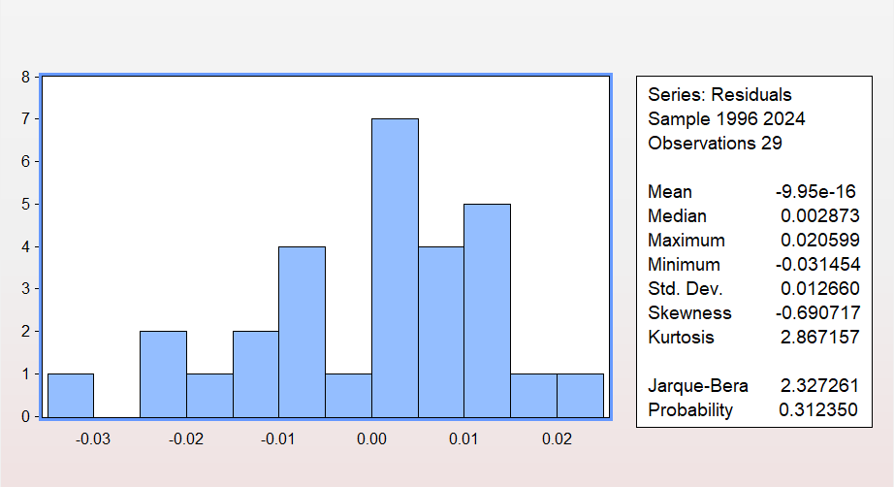
Given that the Expectation of the Jarque-Bera probability is 0.312350>0.05, we don’t reject the null hypothesis. In conclusion, the residuals exhibit a normal distribution behavior.
4.6.3 Multicollinearity Test
 | MPR | CRR | LNM2 | LNEXR
MPR | 1.000000 | 0.628 | 0.048 | 0.294
CRR | 0.628 | 1.000000 | 0.675 | 0.726
LNM2 | 0.048 | 0.675 | 1.000000 | 0
LNEXR | 0.294 | 0.726 | 0.921 | 1.00000
Source: Author’s computation using E-Views 14 (2026)
The presence of multicollinearity in the independent variables was examined through correlation matrix, which is presented in Table 4.4. As per the findings, the correlation coefficients of MPR and CRR (0.628), MPR and LNM2 (0.048), MPR and LNEXR (0.294), and CRR and LNM2 (0.675) are all less than the 0.80 level, meaning that there is no problem of multicollinearity among these pairs. However, the correlation coefficient of LNM2 and LNEXR (0.921) is greater than the 0.80 level, and therefore, there is multicollinearity between broad money supply and exchange rate. This is not surprising given the relationship between money supply increase and naira depreciation in the past over the time span of the analysis. Although this will impact on the efficiency of the coefficient estimates of LNM2 and LNEXR, it will not undermine the validity of the model because the ARDL method is fairly resilient to the problem of multicollinearity.

4.6.4 Serial Correlation
 | Values | DF | Prob
F-Statistics | 0.055126 | prob. F(2,16) | 0.9465
Chi-Square | 0.198465 | Prob.Chi-Square(2) | 0.9055

The serial correlation in the residuals of the estimated ARDL model is testing using the Breusch-Godfrey Serial Correlation LM test. The null hypothesis of the test assumes that there is no serial correlation in the residuals to the second order. In the output given above, the probability value of F-statistic as 0.055126, P-value = 0.9465 and Chi-Square statistic = 0.198465, P-value =0.9055. As the P-values are above the critical value 0.05, we fail to reject the null hypothesis and thus concluded that there is no serial correlation.
4.6.5 Stability test
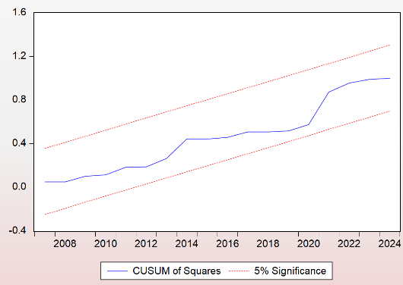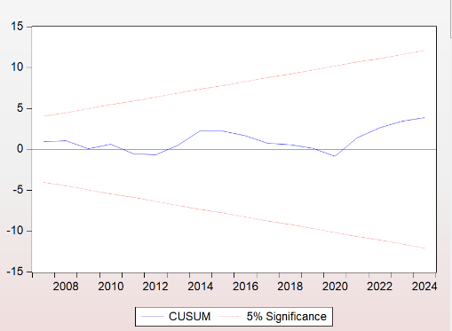

Then, CUSUM stability test were performed for the time frame studied to assess the stability of the estimated model. The figure below show that blue line for the study period from 2007 to 2024 do not cross the lines for the significance level of 5% (marked by red dotted lines). Therefore, the estimated model is stable, there is no statistical support for rejection the null hypothesis of structural stability at 5% level of significance.
In addition to applying CUSUM test to investigate the stability of model parameters, we also applied CUSUM of Squares test to examine if the variance is stable. The graph indicates that the blue curve doesn’t exceed 5% critical values. The above test clearly shows structural stability of the ARDL model that has been fitted.
4.7 Discussion of Findings
In this study, the Autoregressive Distributed Lag (ARDL) bounds testing technique has been used empirically to determine the effect of selected monetary policy instruments on the economic growth of Nigeria between 1994 and 2024. The results of unit root test, cointegration test, short and long run estimators and diagnostics have been given along with the interpretation of the results with respect to empirical literature.
The results of Zivot-Andrews unit root tests reveal that all the variables; LNRGDP, LNM2, MPR, LNEXR, and CRR are I(1), that is, they are integrated of order one. The structural break points identified relate to some major economic shocks faced by the Nigerian economy, namely the global financial crisis of 2008, the banking reform in 2010, the fall in oil prices and recession of 2016 and monetary tightening post COVID-19 in 2021.
The F-statistics for the ARDL bounds test came out to be 22.77365, which is higher than the critical values at the significance levels of 10%, 5%, and 1%. Thus, the long-run cointegrating relationship exists between money supply, monetary policy rate, exchange rate, cash reserve ratio, and economic growth in Nigeria. The finding is in line with the findings by Obafemi & Ifere (2013), Udude (2014), and Adebayo et al. (2019) on the presence of long-run relationship between money supply and real output. Money supply (LNM2) is the most significant economically and statistically variable for Nigeria’s real GDP growth in the long run, having a positive coefficient of 0.289540 at the 1% significance level in support of the theory by Friedman & Schwartz (1963) forming the base of this study and aligning with Musa & Ahmad (2024), Eggon & Adjidani (2020), and Nwankwoeze (2012).
The Cash Reserve Ratio (CRR) had an adverse influence on real GDP growth (-0.012202) at a 5% significance level due to its ability to decrease credit within the banking sector. Exchange rate (LNEXR) had a positive but insignificant coefficient value (0.016538; p = 0.7710) in the long term, meaning that the depreciation of the naira had no credible influence on economic growth within the study period, unlike that reported by Onwachukwu (2014). The Monetary Policy Rate (MPR) had an adverse influence on the real GDP growth, albeit statistically significant (0.019759; 10%) despite the expectation of an adverse influence.
However, the influence of monetary policy on real gross domestic product was not significant for short-run estimates. The money supply had a negative coefficient (-0.057373), compared to the positive long-run estimate and was significant at 10%. This was due to its influence on real gross domestic product in the short run, in terms of short-run adjustments before credit-based growth takes place. MPR, CRR, and LNEXR were not significant at the short run.
The error correction variable, CointEq(-1), has a negative value and is significant at 1%. This implies that there exists cointegration among the variables. The value of the coefficient is -0.284997, meaning 28.50% of the deviation from the long-run equilibrium is corrected in one year.
Diagnostic tests validate the robustness of the model: the LM test does not detect serial correlation (p = 0.9465); the Breusch-Pagan-Godfrey test supports homoscedasticity (p = 0.8262); and the Jarque-Bera test supports the normal distribution of errors (p = 0.312350). According to the correlation matrix, there is a positive correlation between the money supply and exchange rate of 0.921250, which is higher than the 0.80 threshold of multicollinearity, while other pairs of regressors do not exceed this threshold. Multicollinearity makes the estimates of the coefficients of LNM2 and LNEXR imprecise but still valid to predict the result variable. CUSUM and CUSUM of squares tests do not reveal any instability, as their values did not exceed critical levels at the 5% level of significance.

CHAPTER FIVE

SUMMARY OF THE FINDINGS, CONCLUSIONS, AND RECOMMENDATIONS
5.1 Summary of the Results
This research investigation explored the Influence of Monetary policy on economic growth in Nigeria using the following Monetary policy Instruments of the study: the monetary policy rate, the Cash Reserve Ratio while controlling for Money Supply and exchange rate.
The findings were summarized as follows: in the Nigerian Economy,
The monetary policy rate shows a positive impact on economic growth, in the long run however, this had marginal significance at the 10% level and no statistically significant impact in the short run. The money supply was also found to have a positive relation with economic growth which impacts significantly on economic growth in the Nigerian economy.
The cash reserve ratio had a negative and statistically significant relationship with economic growth in the long run and no statistically significant impact in the short run. The exchange rate had a positive but statistically insignificant impact on economic growth in the long run
.5.2 Conclusions
This study scrutinized the effect of monetary policy tools on the economy growth of Nigeria’s using ARDL bounds test to capture the relationship that exist between economic growth and four monetary policy variables of the cash reserve ratio, Monetary policy rate Exchange rate, and money supply on economic growth. Based on the estimation results obtained, money supply and cash reserve ratio were found to have statistically significant long-run effects on Nigeria's economic growth, while the monetary policy rate showed only a marginally significant effect, and the exchange rate showed no statistically significant long-run effect on growth.

5.3 Study Recommendation
The recommendations founded on the basis of the above conclusion and findings of the study are stated as follows;
      - The access to credit should be an increased focus for the Federal Government and the CBN. Targeted policies should focus on credit to individuals, SMEs and start-up businesses that do not presently have access to credit via the banking sector. In turn, such broader access to financial inclusion should help in broadening the impact of monetary policy transmission channels. The CBN also need a more deliberate targeting of both the Cash Reserve Ratio and Monetary Policy Rate so that reductions in MPR can translate into cheaper borrowing costs and thus a boost to investment; and moderate shifts in the CRR could make more funds available to the private sector to lend to customers without undermining price stability.
      - The importance of money supply to the economy and its development can be assessed by the extent to which it influences investment, consumption and production activity. The CBN should keep the growth in the money stock stable and modest to fuel growth and investment in the economy, but avoid it from translating into higher inflation.
      - Given the conclusion from this study, that exchange rate depreciation in Nigeria has negative consequences for economic stability, therefore it is important that the Federal Government to take measures to reduce reliance on imports by focusing efforts at the real economy such as investing in local manufacturing and agriculture, export value chains and developing the export orientation of non-oil sectors. This will also help moderate the demand for foreign exchange and minimize exchange rate vulnerability from growing at home in the longer run to external monetary conditions.

REFERENCES
Adesanya, B. M. (2021). Impact of Monetary Policy on Economic Growth in Nigeria. SSRN Working Paper.
Adibola, A., & Oluwole, A. (2018). Monetary Policy and Economic Growth in Nigeria (1981–2016). Open Access Library Journal.
Adigwe, P. K., Echekoba, F. N., & Onyeagba, B. C. (2015). Monetary Policy and Economic Growth
Adu, K., & Musa, I. (2024). Empirical Analysis of Monetary Policy and Economic Growth in Nigeria (1990–2022). Integrated Journal of Business and Economics.
Aliu, T. I. (2022). Effectiveness of Monetary Policy in Stimulating Economic Growth in Nigeria. International Journal of Research in Social Science and Humanities.
Aminu, U. and Zubairu,A.A.(2012). Effect of Inflation on the growth and development of the Nigerian economy( an empirical analysis). International journal of business and social science, 3(10), 183-191.
Ani, K. J. (2021). Effect of Monetary Policy on Economic Growth during Post Structural Adjustment Programme in Nigeria. IJMP.
Anowor, O. F., & Okorie, G. C. (2016). A Reassessment of the Impact of Monetary Policy on Economic Growth: Evidence from Nigeria. International Journal of Developing and Emerging Economies.
Ayorinde, B. F. (2025). Impact of Monetary Policy on Economic Development in Nigeria. Journal of Business Management and Economic Development.
Bawa, S. (2012). Threshold effect of inflation on economic growth in Nigeria. CBN Journal of Applied Statistics, Volume 3(1).
Chinedu, C. J., Nwikpo, C. N., & Others. (2024). Monetary Policy Variables and Economic Growth in Nigeria. Journal of Economics and Business Aseanomics.
Chuku A. Chuku (2009) Measuring the effects of monetary policy innovations in nigeria: A Structural Vector Autoregressive (SVAR) Approach. African Journal of Accounting, Economics, Finance and Banking Research Vol. 5. No. 5. 2009
Chukwu, J., Magaji, S., & Musa, I. (2021). Empirical Analysis of the Role of Money Market Instruments on Economic Growth in Nigeria (1994–2018). Lapai Journal of Economics.
Enejo, S.Y. and Tsauni, A. M. (2017). An Analytical study of the impact of inflation on economic growth in Nigeria (1970-2016). International Journal of Academic Research in Accounting, Finance and Management Sciences,7(4), 110-120
Fasanya, Ismail O., Onakoya, Adegbemi B.O and Agboluaje, Mariam A. (2013). Does monetary policy influence economic growth in Nigeria? Asian Economic and Financial Review, 3 (5): 635-646 [Leave space here]
Gatawa, N. M. et al, (2017). Impact of money supply and Inflation on economic growth in Nigeria (1973-2013). IOSR Journal of Economics and Finance, 8(3, ver.IV,)26-37.
Global Scientific Journal. (2025). Empirical Analysis of Monetary Policy and Economic Growth in Nigeria. Global Scientific Journal.
Ibrahim, M., & Idris, A. (2024). Empirical Analysis of Monetary Policy on Economic Growth in Nigeria. ResearchGate publication.
IIARD Journals. (2025). Effects of Monetary Policy on Economic Growth in Nigeria. Journal of Business and Economic Studies.
Ijalbs. (2025). Broad Money Supply and Economic Growth of Nigeria. International Journal of Advanced Legal and Business Studies.
Ikechukwu, N. (2010). The Impact of Money Supply on Economic Growth in Nigeria (1981–2010). ABUAD Research Project.
JournalAJEB. (2023). Impact of Monetary Policy on Economic Growth in Nigeria (1985–2022). African Journal of Economics and Business Analysis.
1Muhammed, M. N., Babawulle, D. H., & Tahir, H. M. (2021). Impact of Monetary Policy on Economic Growth in Nigeria: Vector Error Correction Mechanism Approach. Asian Journal of Economics, Finance and Management.
Okeyovat, O. (2022). Monetary Policy Rate and Economic Growth in Nigeria. International Journal of Economics and Financial Issues.
Olarunji, L.A. (2013). Analysis of inflation and its effects on economic growth in Nigeria(1980-2012). Undergraduate project, Department of Economics, University of Abuja.
Olawale, H., & Agbada, I. C. (2024). The Impact of Monetary Policies on the Economic Growth of Nigeria. International Journal of Financial Research and Business Development.
Ree, J.(2020). Nigeria Strategy for a monetary policy Reset. IMF, Nigeria selected issues, Country Report no.20221/034.
RisestPress. (2025). Impact of Monetary Policy on Economic Development in Nigeria. RisetPress Journal of Business.
RSIsInternational.org. (2025). Analysis of Monetary Policy and Economic Growth in Nigeria (1990–2022). RSI International Journal.
SCIRP. (2023). Monetary Policy, Inflation, and Economic Growth in Nigeria. Scientific Research Publishing.
Shaibu, I., & Enofe, E. E. (2021). Monetary Policy Instruments and Economic Growth in Nigeria: An Empirical Evaluation. International Journal of Academic Research in Business and Social Sciences
Sulaimon, T. T. (2025). Effect of Monetary Policy on Economic Growth in Nigeria (1990–2021). International Journal of Advanced Research in Multidisciplinary Studies.
Timothy, I. A. (2022). Effectiveness of Monetary Policy in Stimulating Economic Growth in Nigeria. International Journal of Research in Social Science and Humanities (IJRSS), 3(2),43-33.
Ufoeze, L. O., Odimgbe, J. C., Ezeabalisi, V. N., & Alajekwu, U. B. (2018). Effect of Monetary Policy on Economic Growth in Nigeria. Annals of Spiru Haret University Economic Series.)
APPENDIX
Year | RGDP | M2 | MPR | CRR | EXR
1994 | 21,676.85 | 266.94 | 13.5 | 8 | 21.996
1995 | 21,660.49 | 318.76 | 13.5 | 8 | 21.89526
1996 | 22,568.87 | 370.3 | 13.5 | 8 | 21.88443
1997 | 23,231.12 | 429.73 | 13.5 | 8 | 21.88605
1998 | 23,829.76 | 525.64 | 13.5 | 10 | 21.886
1999 | 23,967.59 | 699.73 | 18 | 10 | 92.3381
2000 | 25,169.54 | 1036.08 | 14 | 10 | 101.6973
2001 | 26,658.62 | 1315.87 | 20.5 | 9.5 | 111.2313
2002 | 30,745.19 | 1599.49 | 16.5 | 9.5 | 120.5782
2003 | 33,004.80 | 1985.19 | 15 | 9.5 | 129.2224
2004 | 36,057.74 | 2263.59 | 15 | 9.5 | 132.888
2005 | 38,378.80 | 2814.85 | 13 | 9.5 | 131.2743
2006 | 40,703.68 | 4027.9 | 10 | 3 | 128.6517
2007 | 43,385.88 | 5875.76 | 9.5 | 3 | 125.8081
2008 | 46,320.01 | 9315.11 | 9.75 | 3 | 118.5667
2009 | 50,042.36 | 10918.67 | 6 | 1.3 | 148.88
2010 | 54,612.26 | 11662.91 | 6.25 | 1 | 150.2975
2011 | 57,511.04 | 13179 | 12 | 8 | 153.8625
2012 | 59,929.89 | 15391.22 | 12 | 12 | 157.5
2013 | 63,218.72 | 17307.37 | 12 | 12 | 157.3117
2014 | 67,152.79 | 18654.27 | 13 | 20 | 158.5526
2015 | 69,023.93 | 19599.13 | 11 | 20 | 192.4403
2016 | 67,931.24 | 23173.26 | 14 | 22.5 | 253.492
2017 | 68,490.98 | 23944.66 | 14 | 22.5 | 305.7901
2018 | 69,799.94 | 26455.41 | 14 | 22.5 | 306.0837
2019 | 71,387.83 | 28877.94 | 13.5 | 22.5 | 306.921
2020 | 70,014.37 | 37828.88 | 11.5 | 27.5 | 358.8108
2021 | 72,393.67 | 44443.07 | 11.5 | 27.5 | 401.152
2022 | 74,639.47 | 51793.63 | 16.5 | 32.5 | 425.9792
2023 | 76,684.94 | 78831.12 | 18.75 | 32.5 | 645.1941
2024 | 79,289.39 | 113337.69 | 27.5 | 50 | 1478.965

UNIT ROOT AT LEVEL
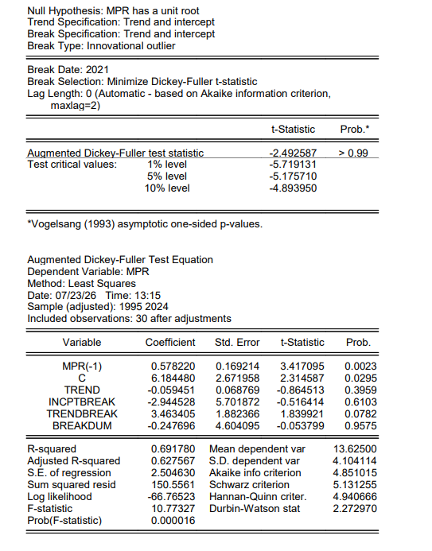
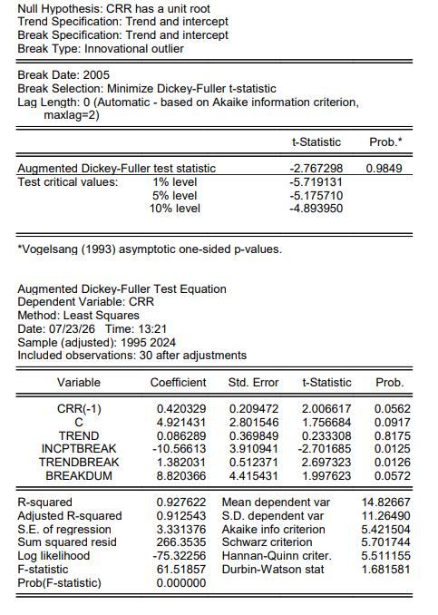
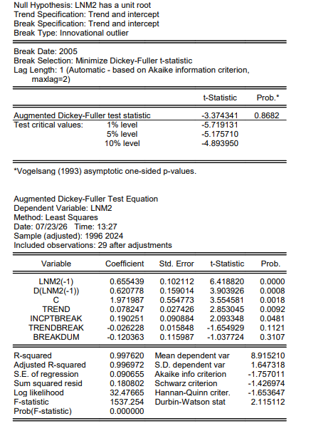
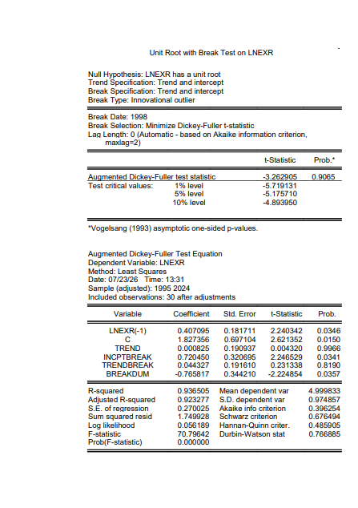

UNIT ROOT AT FIRST DIFFERENCING
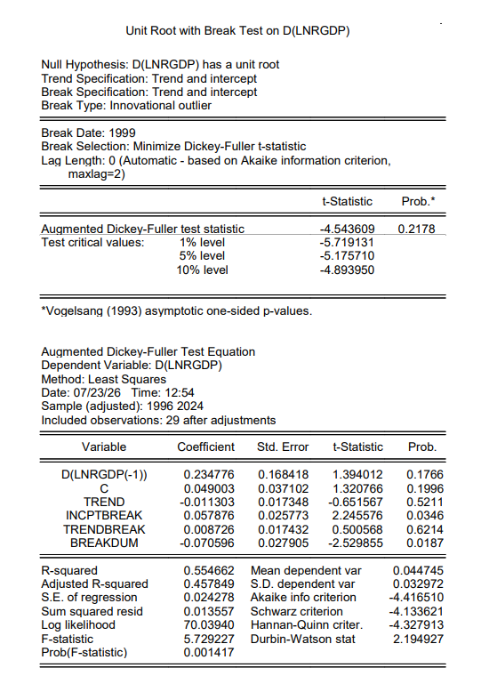
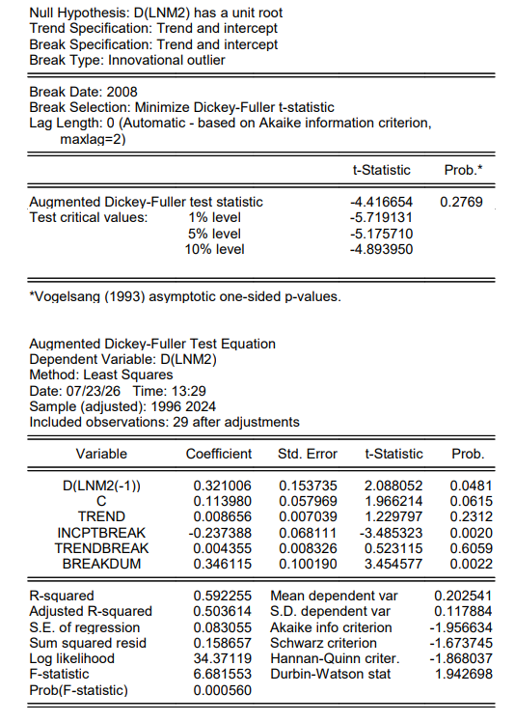
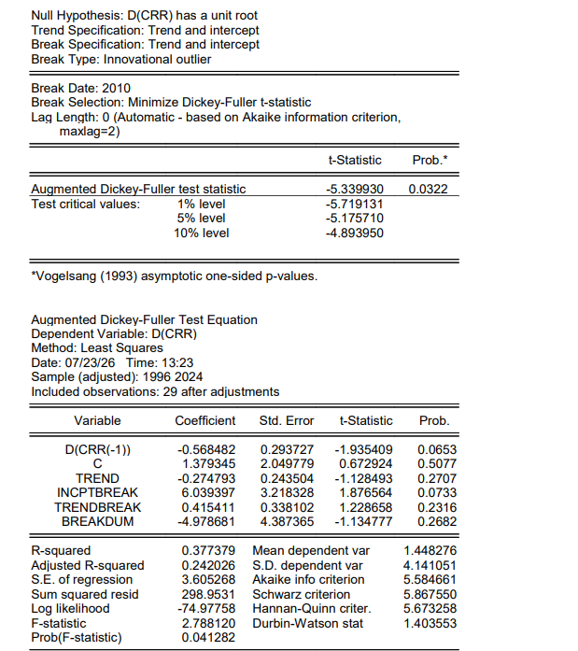

ARDL BOUNDS TESTING
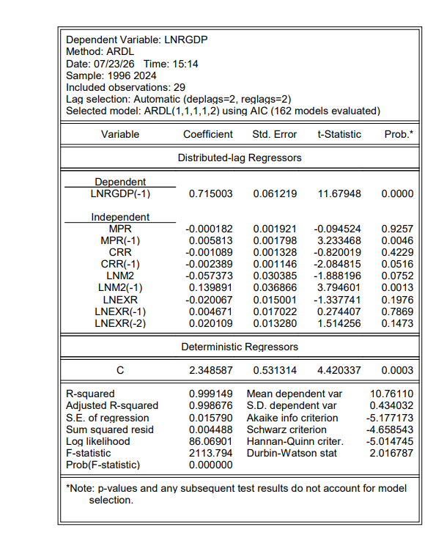

SERIAL CORRELATION
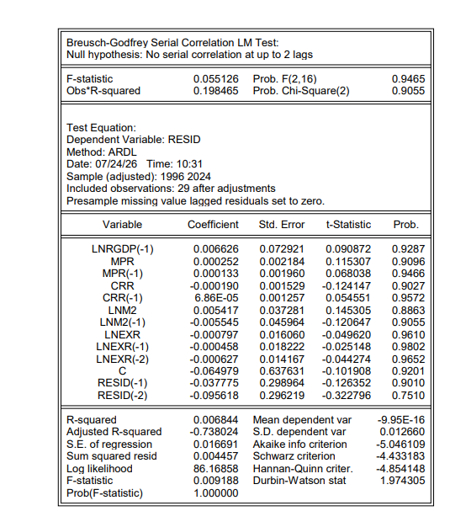

HETEROSKEDASCITY
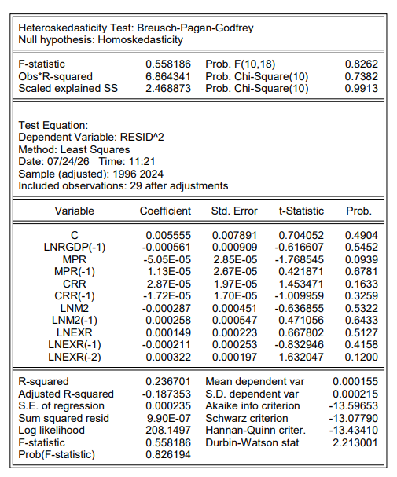

JARQUE- BERA TEST
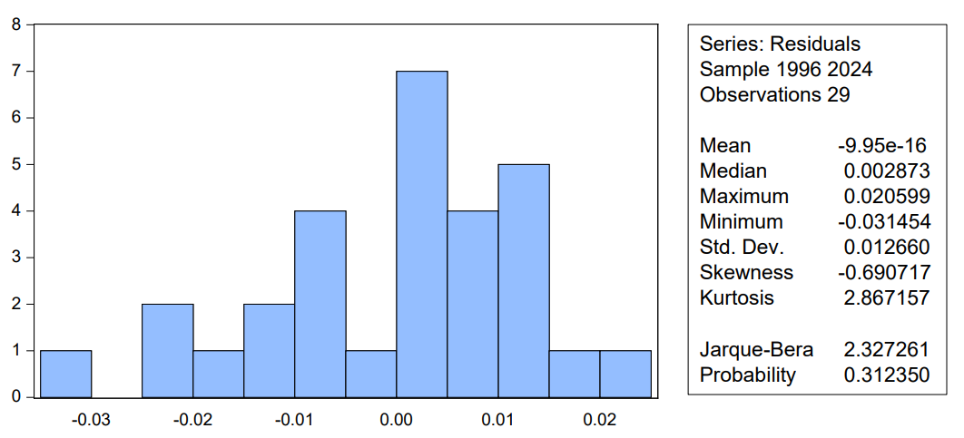
MULTICOLLINEARITY TEST
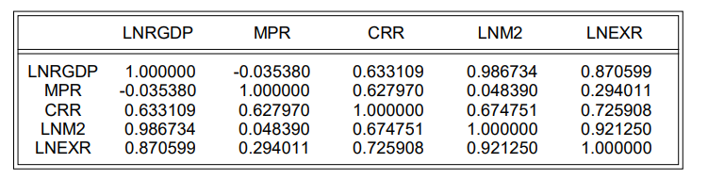

STABILITY TEST
