CHIAMONWU ONYEDIKA ERIC
AI-POWERED ACADEMIC DEFENSE COACHING SYSTEM
 My Files  My Files
 Godfrey Okoye University Enugu

Document Details

Submission ID trn:oid:::24670:296295777

69 Pages

11,300 Words

73,309 Characters
Submission Date
Jul 18, 2025, 3:38 PM GMT+1

Download Date
Jul 18, 2025, 3:45 PM GMT+1

File Name
Eric Onyedika Chiamonwu COACH-ME-AI System Project Plagiarism Test.docx

File Size
3.4 MB

5% Overall Similarity
The combined total of all matches, including overlapping sources, for each database.

Filtered from the Report
Bibliography
Small Matches (less than 8 words)
Match Groups
 40 Not Cited or Quoted 4%
Matches with neither in-text citation nor quotation marks
 11 Missing Quotations 1%
Matches that are still very similar to source material

1 Missing Citation 0%
Matches that have quotation marks, but no in-text citation


0 Cited and Quoted 0%
Matches with in-text citation present, but no quotation marks

Integrity Flags
- Integrity Flags for Review

Our system's algorithms look deeply at a document for any inconsistencies that would set it apart from a normal submission. If we notice something strange, we flag it for you to review.

A Flag is not necessarily an indicator of a problem. However, we'd recommend you focus your attention there for further review.
No suspicious text manipulations found.

Top Sources

3% |   Internet sources
1% |   Publications
4% |  Submitted works (Student Papers)



AI-POWERED ACADEMIC DEFENSE COACHING SYSTEM

BY
CHIAMONWU ONYEDIKA ERIC
GOU/U21/NAS/CSC/649

DEPARTMENT OF COMPUTER SCIENCE AND MATHEMATICS, FACULTY OF NATURAL SCIENCES AND ENVIRONMENTAL STUDIES, GODFREY OKOYE UNIVERSITY, ENUGU.

SUPERVISOR: DR. FRANKLIN OKEBANABA

JULY, 2025

AI-POWERED ACADEMIC DEFENSE COACHING SYSTEM

BY
CHIAMONWU ONYEDIKA ERIC
GOU/U21/NAS/CSC/649

SUBMITTED TO THE DEPARTMENT OF COMPUTER SCIENCE,
FACULTY OF NATURAL SCIENCES AND ENVIRONMENTAL STUDIES, GODFREY OKOYE UNIVERSITY, ENUGU

IN PARTIAL FUFILMENT OF THE AWARD OF BACHELOR OF SCIENCE DEGREE

JULY, 2025

APPROVAL PAGE
This research, titled “CHIAMONW, ONYEDIKA ERIC,” has been assessed and approved by the Department of Computer Science and Mathematics Committees in the Faculty of Natural Sciences and Environmental Studies, Godfrey Okoye University, Enugu, Nigeria.

Supervisor ----------------------- -----------------------
Signature Date

External Examiner ------------------------ ------------------------
External Examiner Signature Date

Dr. Frank Okebanama ------------------------- -------------------------
HOD. Department of Signature Date
Signature Date
Computer Science
And Mathematics

Prof. ------------------------- --------------------------
Dean FNESS Signature Date

"I confirm that the work presented here is my own, primarily based on my own observations and research. I understand and accept that the University has the right to take appropriate action if any form of academic misconduct is detected." -

________________________
Chiamonwu Onyedika Eric
GOU/U21/CSC/649

CERTIFICATION
I certify that I completed the research included therein and that it was primarily based on my observations and investigation. Consequently, I will fully accept the University's decision if I am found to have cheated on the assignment.

_____________________
STUDENT’S NAME
REG. NUMBER

DEDICATION
This work, “Chat-Me-AI: An AI-Powered Thesis Defense Coaching System,” is first dedicated to GOD Almighty, then my parents, Mr. and Mrs. Chiamonwu, and my elder sister, Dr. Chinenye Precious Ogbodo. Their consistent and passionate encouragement, sacrifices, and belief in my potential have been the foundation of every milestone I’ve reached. May the Lord continue to watch over them and grant them health and happiness always in JESUS name, Amen.
.

ACKNOWLEDGMENTS

First and foremost, I give thanks to Almighty God for His guidance, wisdom, and strength throughout this journey. I am deeply grateful to my supervisor, Dr. Franklin Okebanaba, for his invaluable insight, patient mentorship, and steadfast support from the project’s inception to its completion. My deepest appreciation goes to my parents, Mr. and Mrs. Chiamonwu, whose love, prayers, and encouragement carried me through long days and nights of research and development. To my sister, Dr. Chinenye Precious Ogbodo, and my brothers, Frank Chiamonwu, Kingsley Chiamonwu, and Henry Chiamonwu, thank you for your constant moral support and belief in my vision. I also extend heartfelt thanks to my spiritual parents, Rev. and Rev. Mrs. Solomon & Angela Ani, for their prayerful support, and wise counsel, and encouragement at every step. Their faith-filled prayers sustained me through moments of doubt and kept me focused on my goals. Finally, I appreciate all classmates and friends who offered feedback, tested the application, and cheered me on. This project is as much theirs as it is mine.

ABSTRACT
Consider a study preparation program that is much more interactive than piling up the slides and reciting lines verbatim. This AI-powered web-based application was designed and developed for final-year student and supporting institutions web app. The platform integrates natural language processing, speech, and gesture tracking which enables it to simulate defense sessions that feel real. Students input a project summary vocally, and a machine learning-based examiner (AI examiner) responds with personalized questions, evaluates responses and provides feedback on content delivery, pace, tone of voice and confidence level. Every session is recorded and saved, allowing users to review AI feedback, follow markers of performance over time, and see progress in an interactive transcript or modal page. Here is a bonus, any user who undergoes a defense practice session, can save such session which will be made available to everyone who logs in. Users can select from a range of projects or defense sessions that wasn’t created by them for a quick start demo and receive personalized feedback reports. Strict encryption and authentication of users keep personal information intact. With this AI-powered web app, students aren’t merely answering questions; they’re building confidence, refining delivery, and approaching their defenses with the assurance of having faced—and learned from—a virtual panel of experts.
.

TABLE OF CONTENTS
COVER PAGE
TITLE PAGE i
APPROVAL ii
CERTIFICATION iii
DEDICATION iv
ACKNOWLEDGEMENTS v
ABSTRACT vi
TABLE OF CONTENTS vii
LIST OF TABLES x
LIST OF FIGURES xi

CHAPTER ONE: INTRODUCTION 1
1.1 Background of Study 1
1.2 Statement of Problem 2
1.3 Aim and Objectives 3
1.4 Significance of Study 4
1.5 Scope of the Study 5
1.6 Limitation of the Study 6
1.7 Operational Definition of Terms 7

CHAPTER TWO: LITERATURE REVIEW 9
2.1 Introduction 9
2.2 Theoretical Background of the Study 10
2.2.1 Description of Different Categories of AI-Coaching Systems 11
2.2.2 Historical Evolution of AI-Coaching Systems 13
2.2.3 The Future of AI-Coaching Application Systems 14
2.3 Review of Related Literature 16
2.4 Summary of the Review of Related Literature 19

CHAPTER THREE: SYSTEM ANALYSIS AND DESIGN 22
3.1 Introduction 22
3.2 System Analysis 22
3.2.1 Analysis of Existing Systems 23
3.2.2 Weaknesses of Existing Systems 24
3.2.3 Analysis of the Proposed System 25
3.2.4 System Requirements 26
3.2.4.1 Functional Requirements 26
3.2.4.2 Non-Functional Requirements 28
3.2.5 Proposed Methodology: Agile Methodology 26
3.2.5.1 Agile Methodology Overview 29
3.2.5.2 Scrum Framework Implementation 30
3.2.5.3 Integration of DevOps Practices 30
3.2.5.4 Benefits of the Agile-DevOps Approach 30
3.2.5.5 Application to proposed system Development 31
3.2.5.6 UML Diagrams 31
3.2.5.7 Use Case Diagram 32
3.2.5.8 Activity Diagram 32
3.2.5.9 Class Diagram 34
3.2.6 Sequence Diagram 35
3.3 System Design 35
3.3.1 Input/Output Design 36
3.3.2 Database Design 40
3.4 Summary 46

CHAPTER FOUR: SYSTEM IMPLEMENTATION 48
4.1 Introduction 48
4.2 Tools Used for Implementation 48
4.3 System Requirements 51
4.3.1 End-User System Requirements 51
4.3.2 Developer System Requirements 53
4.4 User Interface of proposed system 54
4.4.1 Home Page of Chat-Me-AI 54
4.4.2 Sign Up & Login Page 55
4.4.3 InterviewCard 56
4.4.4 Agent Interface 57
4.4.5 Form-Field Component 58
4.4.6 Anti-Patterns 59
4.4.7 Scoring-Criteria 60
4.4.8 Theme Toggle 61
4.4.9 Logout Button 62

CHAPTER FIVE: SUMMARY, RECOMMENDATIONS AND CONCLUSION 63
5.1 Overview 63
5.2 Summary 63
5.3 Recommendations 63
5.4 Conclusion 64
5.5 Further Work 64

REFERENCE 65
APPENDIX 68

LIST OF TABLES
TABLE PAGE
2.1 Table Summary of Key Studies on AI‑Coaching and Intelligent Tutoring Systems 19
3.1 Table of users for the proposed system 40
3.2 Table of Defense Session for the proposed system 41
3.3 Table of the feedbacks for the proposed system 42
3.4 Table of the Interview sessions for the proposed system 45

LIST OF FIGURES
FIGURE PAGE
3.1 Use case diagram for the proposed system 32
3.2 Activity diagram for Taking an Interview Session 32
3.3 Class diagram of proposed system 34
3.4 Sequence diagram for user interaction with proposed system 35
3.5 Authentication Input Interface 36
3.6 Interview Input Interface 37
3.7 Interview Generation Output Interface 38
3.8 Feedback Output Interface 39
3.9 Interview Cards Output Interface 39

4.1 Home page of the proposed system 55
4.2 Authentication Forms (Sign-In & Sign-Up) 56
4.3 Interview-Card Component 57
4.4 Live Practice Session (Agent Interface) 58
4.4 Form-Field Usage 59
4.5 Anti-Patterns Component Category 1 60
4.5.1 Anti-Patterns Component Category 2 60
4.6 Scoring-Criteria Component 61
4.7 Theme Toggle Component 62
4.8.1 Logout-Button Component 62
CHAPTER ONE
INTRODUCTION

1.1 BACKGROUND OF THE STUDY
Over the years, final-year students have relied heavily on peers and supervisors to rehearse thesis defenses, resulting in uneven access to practice opportunities and inconsistent feedback quality (Wiley PeerFeedback, 2022). Despite advances in educational technology, few platforms offer a dedicated environment that simulates a live academic defense, leaving a gap in scalable, structured rehearsal tools (Shaik et al., 2023). As universities strive to enhance student readiness, there is growing interest in AI-driven solutions that can standardize practice sessions and deliver targeted feedback.
Natural Language Processing (NLP) has been pivotal in transforming how student feedback is generated and analyzed; systematic reviews highlight its role in sentiment detection, thematic categorization, and automated summarization of learner inputs (DTU, 2023). Recent studies expand on these findings by mapping NLP applications to educational feedback analysis, demonstrating improved identification of content gaps and guiding revisions (ResearchGate, 2024). However, most existing systems focus solely on text-based feedback, overlooking the dynamic, interactive nature of oral defenses.
In parallel, research on speech and nonverbal communication underscores their importance in effective presentations. Nonverbal cues such as eye contact, gestures, and facial expressions significantly impact teaching outcomes and audience engagement (NCBI, 2017). Advances in voice activity detection and speech analysis algorithms enable extraction of prosodic features pausing, intonation, and pacing—to inform corrective feedback in educational contexts (Wiley, 2023). Moreover, corrective feedback technologies that analyze pronunciation and fluency show promise in language learning settings and point toward broader applications in academic coaching (Choi & Lee, 2024). Multimodal approaches combining speech and gaze tracking further enrich feedback by capturing real-time nonverbal signals, although these remain largely confined to research prototypes (Sun et al., 2023).
To address these limitations, emerging AI-based coaching platforms integrate NLP, speech analysis, and adaptive dialogue to offer personalized support. Instructional coaching tools leverage curated resources and on-demand advice but primarily target teacher development rather than student defense preparation (Edthena, 2024). Junior research initiatives are now exploring needs-oriented AI coaching agents designed for higher education, aiming to tailor conversational feedback to individual learning trajectories (ScaDS.AI, 2024). Additionally, automatic feedback generation in learning management systems demonstrates scalable architectures—often built on service-oriented and cloud-based frameworks—that could underpin real-time defense simulations (Alamri et al., 2021).
In summary, while NLP and speech analysis techniques have matured for text-based and language learning applications, there remains a critical need for an integrated, AI-driven platform that replicates the interactive, multimodal demands of a thesis defense. This “AI-powered academic defense coaching system” seeks to bridge this gap by uniting project-specific Q&A generation, detailed verbal and nonverbal feedback, and progress tracking within a secure, web-based environment.

1.2 STATEMENT OF THE PROBLEM
Despite the availability of generic AI tools for thesis preparation, final-year students still lack a unified platform that offers a realistic, interactive mock defense tailored to their own research. One-on-One peer rehearsal often leads to inconsistent and apparent feedback, with many students reporting that comments focus on generalities rather than pinpointing content gaps or delivery flaws. Here are some reasons why final year students often face significant challenges when preparing for their thesis defenses, due to:
- No formal defense simulator leading to unpreparedness for real exam defense pressure.
- Lack of specific, actionable feedback hindering targeted improvement in content and delivery.
- Elevated anxiety and reduced confidence due to unfamiliarity with live defense conditions.
- Absence of mechanisms to track progress over time, impeding objective self-assessment.
- Scheduling and accessibility constraints limiting essential rehearsal opportunities.

1.3 AIM AND OBJECTIVES OF THE STUDY
The aim of this project is to design and create an AI-powered web-based coaching tool that will help final-year students practice their thesis defenses in a real and interactive setting, while providing extensive and elaborate feedback over multiple sessions. The objectives are stated as follows:
- To design and build an AI-powered engine capable of analyzing each student’s project abstract through voice interaction and generating real-time, relevant defense questions that simulate those asked by academic panels.
- To include a speech-to-text mechanism that transcribes student responses instantly and evaluates them for clarity, completeness, and coherence, moving beyond vague or general feedback.
- Automatically record and store every mock defense session along with its AI-generated feedback.
- Implement and integrate a progress tracking feature for visualizing key performance metrics such as speaking fluency and depth of response across sessions, helping users identify improvement trends and weak areas.
- Apply secure authentication procedures and encryption standards so that only each individual student has access to his or her personal recordings and analytics.

1.4 Significance of the Study
This AI web-based academic defense simulator holds great relevance for students, academic staff, institutions, and educational technology developers.
- Final-Year Students:
This system gives all students an equal and flexible chance to practice their thesis defenses with a virtual AI-driven panel, irrespective of when they can meet with their supervisors. It lowers stress by giving students a lot of chances to practice, builds their confidence when speaking, and gives them helpful, personalized feedback to help them find and work on their weak points in both content and presentation..
- Academic Supervisors and Mentors:
This AI-powered web app gives teachers and project supervisors a better idea of how each student is doing by keeping track of their performance data and session archives. This helps them give more focused advice and makes sure that no student falls behind because they don't have enough chances to practice one-on-one..
- Tertiary Institutions:
The system helps universities keep up their academic standards by giving them a standardised and scalable rehearsal space. It fits with the school's goals of making sure tests are fair, helping students build their skills, and getting them ready for oral defence presentations.
- Educational Developers and Researchers:
This project adds to the growing field of AI in education by showing how speech analysis, natural language processing, and real-time feedback can be used together in coaching systems. It sets the stage for new ideas in tools for improving academic performance in all fields.

1.5 SCOPE OF THE STUDY
The main goal of this project is to design and build this "AI-powered academic defence coaching system," which is a web-based tool that helps final-year undergraduates practise and improve their thesis defenses. The platform lets you practise and think about things on your own by using AI-generated questions, live speech transcription, and feedback analytics. The study looks at the system's architecture, core features, user interface, and initial evaluation. It is also flexible enough to be expanded to other fields in the future. The scope of this study includes:
- The platform facilitates AI-enabled question generation on the basis of vocal inputs (either project summaries or project metadata) of students.
- It supports real time communications and interactions between users and the AI agent and turns speech into text so that the system can automatically check how clear and relevant your responses are.
- .It records every practice session, and provides detailed feedback, which users can review and analyze, easily identifying where they need improvement on.
- The system provides a performance tracking modal with visual analytics to show areas of strength and aspects needing improvement.
- The application is built using a service-oriented architecture and is hosted in the cloud to make it easy to scale and keep up with (maintenance).
- It can be accessed through standard web browsers on both desktop and mobile devices. It has features that make it easy for everyone to use, like adjustable contrast and keyboard navigation.
- The first version is specific to final-year Computer Science students, although the backend is modular and can be adapted to other academic disciplines..
- Evaluation stage involves pilot tests on actual users, evaluation of system performance, and user satisfaction and enhancement of defense readiness.

  - LIMITATION OF THE STUDY

While developing this project, several constraints influenced the research and implementation process:

- Technological Learning Curve:
Some components—such as advanced NLP libraries and cloud‑based speech‑to‑text services—were new to the development environment. Mastering these tools required additional time for experimentation and integration.
- Dependence on Internet Stability:
Real‑time transcription and question‑generation rely on continuous internet access. Periods of unstable connectivity occasionally disrupted testing and delayed feedback responses.
- Resource and Budget Constraints:
Subscription costs for cloud hosting, NLP APIs, and secure data storage limited the volume of sessions that could be processed during development and testing phases.
- Time Management Challenges:
Balancing academic coursework, project milestones, and iteration cycles reduced the available window for extensive user testing and fine‑tuning of the feedback algorithms.
- Limited Real‑World Defense Data:
Access to recordings or transcripts of actual thesis defenses was restricted, making it harder to validate the realism and depth of AI‑generated questions against authentic examiner styles.
- Participant Recruitment for Testing:
Gathering a diverse pool of final‑year students for usability trials proved challenging, so initial feedback came from a smaller, less varied group, which may affect generalizability.

  - OPERATIONAL DEFINITION OF TERMS

- Mock Defense Session:
A simulated oral examination conducted by the AI system, where the student responds to project-specific questions in real time.
- Question-Generation Module:
Thae component that uses natural language processing to analyze the student’s project summary and produce relevant defense questions.
- Speech-to-Text Engine:
A service that converts the student’s spoken responses into text for subsequent content and clarity analysis.
- Prosody Analysis:
Evaluation of vocal characteristics—such as pace, volume, and intonation—to gauge the clarity and confidence of the student’s delivery.
- Feedback Report:
A structured summary provided after each session, detailing strengths, areas for improvement, and suggested strategies for clearer presentation.
- Session Archive:
A secure repository of past mock defense feedback reports, allowing students to review their progress, or retake a particular defense session.
- Progress Tracking:
A visual interface displaying metrics over time—such as average response completeness and speaking fluency—to help students track improvement.
- User Authentication:
The secure login mechanism that ensures only authorized students can access their mock sessions and personal feedback data.
- Scalable Architecture:
A cloud-based, service-oriented design that allows the system to handle increasing numbers of users and sessions without performance degradation.

CHAPTER TWO
LITERATURE REVIEW

2.1 INTRODUCTION
In recent years, educational technologies have shifted from static content delivery toward interactive, AI‑driven coaching systems that support complex skills like public speaking and thesis defenses (YesChat.ai, 2024). Unlike generic writing assistants, specialized platforms now employ natural language processing to generate context‑specific practice questions and evaluate learner responses in real time (ResearchGate, 2024). Simultaneously, AI tools for public speaking integrate speech‑to‑text engines with prosody analysis to deliver nuanced vocal feedback, demonstrating efficacy in improving pace, intonation, and clarity (Duarte, 2023).
Research on virtual defense simulations underscores the importance of tailoring question sets to individual manuscripts, with systems like PhD Prep offering customizable prompts based on thesis content (YesChat.ai, 2024). However, these offerings largely focus on text generation, lacking comprehensive feedback dashboards that track performance over multiple sessions (Khalil et al., 2021). In parallel, advances in speech recognition have enabled real‑time transcription and basic content analysis, but full integration with educational feedback loops remains underexplored (ScienceDirect, 2025).
Meanwhile, learning analytics research emphasizes the value of longitudinal dashboards to visualize learner progress, yet few platforms combine these analytics with interactive questioning agents (SpringerOpen, 2021). Market analysis predicts the speech‑coaching sector will grow to over USD 9 billion by 2033, reflecting rising demand for scalable, on‑demand feedback services (BusinessResearchInsights, 2024). At the same time, higher‑education thought leaders stress that adaptive AI tools must preserve learner privacy and pedagogical integrity to achieve sustainable adoption (MarkSelliott.com, 2025).
Despite these advances, no single system currently offers a unified solution that generates project‑specific defense questions, transcribes and analyzes spoken answers, and visualizes progress metrics in one web‑based interface. Recent studies demonstrate that generative AI can significantly reduce public‑speaking anxiety and enhance self‑efficacy, suggesting strong potential for thesis defense applications (Axios, 2024). This proposed system, aims to fill this gap by integrating proven NLP question generators with speech‑to‑text analysis and an interactive progress dashboard—thereby creating an end‑to‑end rehearsal environment tailored to final‑year students’ needs.

2.2 THEORETICAL BACKGROUND OF THE STUDY
The roots of AI‑driven coaching lie in intelligent tutoring systems, which began as rule‑based dialogue engines aimed at guiding learners through domain‑specific tasks (Aleven, Stahl, Schworm, Fischer, & Wallace, 2003). Over the past decade, advances in natural language processing have enabled these systems to generate context‑aware prompts and evaluate student responses in real time, moving beyond static question banks to adaptive, conversational interfaces (YesChat.ai, 2025). Concurrently, AI feedback coaches emerged to assist students in crafting written feedback and peer reviews, leveraging transformer‑based models for instantaneous, personalized suggestions (FeedbackFruits, 2023).
In public‑speaking education, specialized platforms began incorporating speech‑to‑text transcription and prosody analysis to offer vocal delivery feedback, focusing on metrics like pacing, intonation, and filler‑word usage (Duarte, 2023). Commercial tools such as MySpeaker Rhetorich have extended these capabilities by integrating multimodal insights—combining textual guidance with audio analytics—to enhance self‑awareness and reduce presentation anxiety (Taylor & Smith, 2024).
Educational technology firms have also launched AI coaching services for instructors, providing on‑demand pedagogical advice and reflective prompts to improve teaching practices (Edthena, 2023). These instructional coaching platforms demonstrate how AI can democratize expert guidance, although they primarily target faculty rather than student defense rehearsals (Passmore & Woodward, 2023).
More recent innovations focus on real‑time feedback loops: AI Coach by Edly captures learners’ spoken answers, evaluates them against expected content, and offers suggestions for depth and clarity immediately after each response (Edly, 2023). Meanwhile, systematic studies highlight that such instant, targeted feedback can significantly improve learner engagement and performance metrics when compared to traditional, delayed critiques (Emerald Group, 2024).
Despite these strides, a unifying platform that combines project‑specific question generation, live speech analysis, and longitudinal progress tracking has yet to materialize. Market analysis predicts continued growth in AI coaching solutions—driven by rising demand for scalable, equitable learning support—which underscores the opportunity for this AI-powered web system to fill this gap (Business ResearchInsights, 2024).

2.2.1. DESCRIPTION OF DIFFERENT CATEGORIES OF AI-COACHING SYSTEMS
AI-coaching platforms can be grouped into several broad categories based on their core functionality and intended users:
- Rule‑Based Intelligent Tutoring Systems
Traditional ITS platforms rely on predefined cognitive models and expert‑encoded rules to guide learners through problem‑solving steps. These systems deliver immediate, stepwise hints and corrective feedback based on a student’s actions (Nwana, 1990). A classic example is the Cognitive Tutor, which applies Anderson’s ACT‑R framework to offer context‑sensitive guidance in domains like mathematics (Wikipedia, 2025).
- Adaptive, Data‑Driven Learning Engines
Leveraging machine‑learning algorithms, these platforms analyze historical usage data to personalize content sequencing and difficulty. A recent systematic review found that such ITSs improve learning outcomes by tailoring instruction to each student’s mastery profile (Liu, Latif, & Zhai, 2025).
- Speech‑Coaching Systems
Focused on oral presentation skills, these tools integrate speech‑to‑text transcription with prosodic analysis to assess pacing, intonation, and filler‑word usage. Users receive immediate vocal feedback, which has been shown to reduce speaking anxiety and enhance clarity (Duarte, 2023; Wired, 2024).
- Chatbot‑Based Q&A Tutors
Conversational agents powered by NLP engines simulate interactive dialogues, generating context‑specific questions and responding to student inputs. Platforms like Edthena’s AI Coach for Teachers illustrate how chatbots can provide on‑demand instructional prompts, albeit primarily for educators rather than defense rehearsals (Edthena, 2023).

- Hybrid Multimodal Coaching Environments
The newest solutions combine text‑based ITS, speech analysis, and learning analytics dashboards into unified interfaces. Such systems track learner progress over time, visualizing improvements in content mastery and delivery skills. Research suggests these multimodal platforms foster higher engagement and better learning gains than single‑mode tutors (BusinessResearchInsights, 2024; Emerald Group, 2024)

2.2.2 HISTORICAL EVOLUTION OF AI-COACHING SYSTEMS
The roots of AI‑coaching trace back to the late 1960s and early 1970s, when researchers began experimenting with Computer‑Assisted Instruction (CAI) systems. One of the earliest examples was SCHOLAR (Carbonell, 1970), which used simple rule‑based logic to quiz students on geographical facts. Over the next two decades, this approach matured into fully fledged Intelligent Tutoring Systems (ITSs), designed to model student knowledge and adapt instruction dynamically (Nwana, 1990).
In the 1990s and early 2000s, landmark projects like the Cognitive Tutor and AutoTutor advanced the field substantially. The Cognitive Tutor applied Anderson’s ACT‑R cognitive architecture to deliver step-by‑step problem solving hints in mathematics (Anderson et al., 1995), while AutoTutor introduced mixed‑initiative, natural‑language dialogues, using animated agents to engage learners in conversational tutoring (Graesser et al., 2004; AutoTutor team, 1999). These systems demonstrated that modeling both the content and the student’s affective states could improve learning outcomes.
With the advent of robust speech‑to‑text engines and enhanced NLP models in the 2010s, AI‑coaching platforms began offering real‑time verbal feedback. Tools such as Edthena’s AI Coach provided instructors with on‑demand, automated pedagogical suggestions, while emerging public‑speaking coaches analyzed prosody and filler words to help users refine their delivery (Edthena, 2023; Duarte, 2023). Concurrently, learning analytics dashboards surfaced, visualizing student progress over time and reinforcing the value of longitudinal feedback loops (Siemens & Long, 2011).
Most recently, generative AI and transformer‑based chatbots have further expanded coaching capabilities. Platforms like YesChat.ai now spin up “virtual examiners” that pose context‑specific questions drawn from user‑submitted texts, and services powered by GPT‑style models offer instantaneous critique across both written and spoken modalities (YesChat.ai, 2025; BusinessResearchInsights, 2024). These innovations pave the way for modern AI-powered coaching systems, uniting adaptive question generation, speech analysis, and progress visualization in a single web‑based environment.

2.2.3 THE FUTURE OF AI-COACHING APPLICATION SYSTEMS
Several technological trends that will drive the next generation of AI-coaching platforms:
- Generative Conversational AI: Future systems will leverage advanced large-language models to simulate natural, context-aware dialogue, delivering personalized prompts and adaptive guidance tailored to each learner’s project and performance (Cardona, Rodríguez, & Ishmael, 2023).
- Immersive Virtual and Augmented Reality: The integration of VR and AR will create risk-free, highly realistic rehearsal spaces where students can practice defenses in simulated conference or panel settings (Atomus, 2024).
- Data-Driven Personalization and Analytics: Advanced learning-analytics engines will analyze performance metrics in real time, dynamically adjusting question difficulty and feedback focus based on each student’s strengths and weaknesses (EIMT, 2025).
- Seamless Ecosystem Integration: AI-coaching tools will plug directly into learning-management systems, calendar apps, and institutional databases, unifying scheduling, content upload, and progress tracking in one streamlined interface (New America, 2023).
- Ethical and Privacy Frameworks: As coaching platforms process sensitive academic work and personal data, robust standards for privacy, fairness, and transparency will be mandated to safeguard user trust and comply with emerging regulations (Stanford Engineering Staff, 2024).
- Scalable Peer-to-Peer Coachbots: AI-driven coachbots will democratize access to expert guidance by facilitating large-scale, peer-to-peer mentoring networks, allowing students to both receive and provide feedback within a trusted community (Emerge EdTech Insights, 2023).
- Automated Assessment and Scoring: Future AI coaches will include automated scoring modules that evaluate responses against rubric standards, offering immediate quantitative feedback alongside qualitative insights (Amazon Web Services, 2025).
- Cross-Disciplinary Scalability: Modular AI-coaching architectures will enable rapid adaptation from thesis defenses to other academic and professional skill areas—such as technical interviews, language practice, and soft-skills workshops (SpringerOpen, 2023).
- Multimodal Feedback Integration: Beyond speech analysis, future platforms may incorporate text-based critique, simulated visual cues (e.g., slide design prompts), and real-time sentiment analysis to deliver fully holistic feedback experiences (AutoGPT, 2025).
- Market Growth and Commercial Viability: Industry estimates project that the global AI-coaching market will surpass USD 1 billion by 2026, driven by increased institutional adoption and the scalable nature of cloud-based AI services (Robin Waite, 2024).
As an innovative AI-coaching solution, Chat-Me-AI is designed to anticipate and embody these emerging trends, providing an immersive, personalized, and ethically grounded platform that evolves with the future needs of final-year students.

2.3 REVIEW OF RELATED WORKS
Several studies have explored the evolution and implementation of AI-driven tutoring and coaching systems across educational contexts. The foundation for these systems began with rule-based computer-assisted instruction, such as Carbonell’s SCHOLAR system (1970), which pioneered question-and-answer logic for student tutoring but was limited by scalability and adaptability. Building on this, Nwana (1990) proposed a detailed framework for intelligent tutoring systems (ITS), emphasizing the components needed to structure these tools, though this work remained conceptual and lacked modern AI applications.
Anderson et al. (1995) developed Cognitive Tutor, which used cognitive modeling techniques to adapt instruction based on student responses. This system showed improvements in problem-solving outcomes but required expert input to author domain-specific models. A major leap forward came with Graesser et al. (2004) and the AutoTutor system, which introduced mixed-initiative dialogue tutoring. AutoTutor used natural language interactions with animated agents, resulting in better engagement, although it struggled to scale across domains.
Pavlik et al. (2013) conducted a comprehensive review of student modeling methods used in ITS, from Bayesian networks to deep learning approaches, outlining a trade-off between accuracy and interpretability. Similarly, Suwita et al. (2024) analyzed trends in ITS from 2018 to 2022 and revealed key components like adaptive scaffolding and analytics dashboards that are shaping modern systems, though their focus remained within higher education contexts during the pandemic.
In a meta-analysis by Liu, Latif, and Zhai (2025), evidence was provided that ITS generally produce significant learning gains compared to non-ITS approaches. However, they also noted that longer-term and more diverse studies are required. Kochmar et al. (2020) demonstrated that AI-powered personalized feedback, when used at scale in tutoring systems, significantly boosts learning outcomes, highlighting the potential of machine learning and A/B testing in real-world educational settings.
Maity and Deroy (2024) explored the integration of large language models (LLMs) into tutoring systems, which enabled highly adaptive, real-time feedback. While promising, their work also raised concerns over potential model biases. In the same direction, Wang et al. (2022) proposed UIILD, a hybrid deep learning and psychometric framework that offered interpretable learner diagnostics, though it needed broader testing across different learning domains.
Feng et al. (2021) presented a systematic review showing that ITS can achieve medium to large positive effects in STEM education, though they emphasized the need for more inclusive datasets. The Emergent Group (2024) echoed this in their performance analysis of ITS in K–12 settings, showing positive outcomes in experimental settings but lower impacts in uncontrolled, real-world scenarios.
On a practical note, Wired (2024) emphasized the irreplaceable role of teachers while recognizing that AI tools—like classroom-based assistants—can enhance educational experiences. A related review by SpringerOpen (2023) connected AI-powered ITS to the goals of sustainable education, proposing a roadmap for research focused on inclusion, access, and long-term learner support.
Kochmar et al. (2020) and the team behind Korbit’s tutoring system contributed to the growing list of tools that combine AI with conversational interfaces to provide immediate, personalized feedback. Similarly, modern implementations of LLMs like those reviewed by Maity and Deroy (2024) have shown that generative AI can enrich the coaching process in real time, provided the risks of hallucinations and feedback accuracy are managed carefully.
Lastly, Wikipedia’s 2025 overview of ITS summarizes the progression from CAI to more sophisticated AI-powered feedback systems and presents comparative meta-analysis results, showing that ITS often outperforms traditional tutors in focused evaluation contexts. These evolving trends demonstrate the growing relevance of AI in academic coaching systems, which aim to simulate oral defense sessions and offer meaningful, tailored feedback.

2.4 Summary of The Review of Related Works
Below is a synthesized summary of the above-highlighted “Review of related literature” on AI-coaching systems, organized in a table format for clarity. This draws on key academic studies, industrial reports, and system descriptions to highlight contributions, methods, and limitations relevant to this “AI-powered academic defense coaching system.”
Table 2.1: Summary of Key Studies on AI‑Coaching and Intelligent Tutoring Systems
S/N | Author(s), Year | Title/Focus | Contribution/Technique | Result/Limitations | Methodology
1 | Carbonell (1970) (Wikipedia) | SCHOLAR: Rule-based CAI | Early rule-based question–answer tutor using pattern matching | Demonstrated feasibility of automated Q&A; limited adaptivity and scalability | System design and small-scale field testing
2 | Nwana (1990) (SpringerLink) | Overview of Intelligent Tutoring Systems | Defined ITS components (domain, student, tutorial, interface models) | Laid conceptual groundwork; did not evaluate in modern AI contexts | Literature review
3 | Anderson et al. (1995) (SpringerLink) | Cognitive Tutor: Model-based Math Coaching | Applied cognitive modeling (ACT-R) to generate context-aware hints | Improved student problem solving; required expert model authoring | Design–experiment with classroom deployments
4 | Graesser et al. (2004) (SpringerLink) | AutoTutor: Mixed-initiative Dialogue Tutoring | Natural-language dialogue with animated agents | Enhanced engagement and learning gains; limited domain coverage | Controlled experiments comparing AutoTutor to human tutors
5 | Pavlik et al. (2013) (Statistics and Data Science) | Review of Student Models in ITS | Surveyed Bayesian, constraint-based, and deep-learning student models | Highlighted trade-off between interpretability and accuracy | Critical literature review
6 | Suwita et al. (2024) (ResearchGate) | Trends in ITS 2018–2022 | Identified emerging components (adaptive scaffolding, analytics dashboards) | Offered comprehensive taxonomy; limited to higher-ed during pandemic | PRISMA-based systematic literature review
7 | Liu, Latif & Zhai (2025) (arXiv) | Advancing Education through ITS: K-12 Meta-analysis | Assessed effects of ITS; compared to non-ITS interventions | Positive learning gains (ES≈0.66); need for longer studies in diverse settings | Quasi-experimental meta-analysis of 28 studies
8 | Kochmar et al. (2020) (arXiv) | Automated Personalized Feedback in Korbit | ML-driven, dialogue-based feedback within large-scale ITS | Significant improvement in learning outcomes; scalability demonstrated | Field study with thousands of learners using A/B testing
9 | Maity & Deroy (2024) (arXiv) | Generative AI in Personalized ITS | Integration of LLMs for dynamic content generation and real-time critique | Enabled highly adaptive dialogues; risks of model bias noted | Literature synthesis and prototype demonstrations
10 | Wang et al. (2022) (arXiv) | UIILD: Interpretable Learning Diagnosis | Deep-learning + psychometric hybrid for learner modeling | Achieved high accuracy with interpretability; needs broader domain tests | Design science with experiments on real-world and simulated data
11 | Feng et al. (2021) (people.csail.mit.edu) | Systematic Review of ITS Effectiveness | Reviewed ITS impacts in STEM domains | Confirmed moderate-to-large effect sizes; calls for expanded population diversity | PRISMA systematic review
12 | Emergent Group (2024) (Nature) | AI in ITS: K-12 Performance Analysis | Analyzed quasi-experimental designs across schools | Generally positive outcomes; mitigated gains versus controlled settings | Systematic review of experimental studies
13 | Wired (2024) (WIRED) | “AI Can’t Replace Teaching, but It Can Make It Better” | Case study of AI assistant in classrooms | Highlighted AI’s supportive role; underscored irreplaceable human elements | Journalistic case analysis and expert interviews
14 | Studies in SpringerOpen (2023) (SpringerOpen) | AI for Sustainable Education: Review | Connected AI-ITS to sustainable education challenges | Mapped future research agenda; noted gaps in equitable access | Narrative literature review
15 | Wikipedia (2025) (Wikipedia) | Intelligent Tutoring System (overview & meta-analysis) | Summarized CAI to ITS progression; reported meta-analysis effect sizes | ITS outperforms CAI and human tutors on local tests; highlights need for broader adoption | Secondary aggregation of controlled evaluations and meta-analyses

Across the reviewed studies, researchers consistently highlight that AI is no longer just a support tool in educational systems but a core component of intelligent learning environments. For instance, Carbonell (1970) described AI tutors as foundational systems for personalized instruction, while Anderson et al. (1995) demonstrated that cognitive models improve learning by adapting to each student’s progress. Over the past year, Maity and Deroy (2024) have shown us just how much generative AI can transform an academic coach—making it feel less like a scripted program and more like a live conversation that adapts on the fly. Then Liu, Latif, and Zhai (2025) took that a step further by demonstrating that when those AI-driven sessions include clear, trackable performance metrics and feedback tailored to each learner, students actually perform better. Of course, it’s not all smooth sailing: we still have to guard against biased feedback, protect our users’ privacy, and make sure the AI’s advice actually lines up with what a real expert would say. But these insights give us a solid roadmap for Chat-Me-AI: we know we’ll need smart question generation, accurate speech-to-text processing, and a dashboard that brings a student’s progress into sharp focus—three pillars that together can power a truly effective virtual defense coach.

CHAPTER THREE
SYSTEM ANALYSIS AND DESIGN
3.1 INTRODUCTION
This chapter presents a comprehensive analysis and design of the proposed web application, detailing its architecture, methodology, and system components. The project employs Agile Scrum complemented by DevOps practices, facilitating iterative development, continuous feedback, and automated deployment pipelines for rapid feature delivery. Developed as a modular Next.js application, it integrates Firebase for hosting, authentication, and data storage, and connects to external AI services for question generation and speech analysis. This chapter outlines the system’s key functional requirements, architectural components, and presents UML diagrams to model interactions and data flows within the application.

3.2 SYSTEM ANALYSIS
System analysis for the proposed system decomposes the application into core modules: a question-generation engine, speech-to-text transcription, feedback analyzer, session recorder, progress dashboard, and notification service. A comparative review of existing defense preparation tools—such as PhD Prep and Thesis Defense Expert—revealed a notable absence of integrated Q&A simulation combined with real-time analytics. To address these gaps, Chat-Me-AI unifies project-specific question generation with live transcription and adaptive analytics in a single web interface, enhancing preparation efficiency and learner confidence. Module interactions and data flows are captured in UML use-case and sequence diagrams created during Scrum sprint cycles, ensuring traceability of requirements through design. The DevOps pipeline automates testing and deployment via GitHub Actions and Firebase CI/CD integration, enabling zero-downtime releases and rapid iteration. Continuous feedback loops from pilot users inform the product backlog, facilitating backlog refinement and prioritization of features that directly enhance the student experience. Architecturally, the system employs microservices for AI functions deployed on Firebase Cloud Functions, with a React-based front end rendered by Next.js to ensure optimal performance and scalability. This analysis provides a solid foundation for the subsequent design and implementation phases, ensuring that the system meets its functional and quality objectives within the defined scope

3.2.1 ANALYSIS OF EXISTING SYSTEMS
PhD Prep:
PhD Prep offers basic Q&A practice by presenting canned questions drawn from generic defense guidelines. While it gives users a sense of question timing, it does not adapt questions to the user’s specific research content, nor does it provide detailed feedback on delivery or depth of response.
ThesisDefense.ai:
ThesisDefense.ai uses static question banks organized by discipline. It allows uploading of abstracts, but question relevance is often shallow—focusing on terminology rather than probing methodologies or results. There is no real-time transcription or analytics dashboard, so students can’t see trends in their performance.
YesChat.ai – GPTs for Defense
YesChat’s GPT-based models generate dynamic questions from uploaded text and offer basic textual feedback. However, it lacks a seamless web interface for recording spoken answers, and it does not track longitudinal progress or send practice reminders.
Edthena AI Coach
Originally designed for teacher coaching, Edthena’s tool provides on-screen prompts and records video sessions. Its focus is on classroom pedagogy rather than thesis defenses, so its question generators and feedback metrics aren’t tailored to academic research presentations.

3.2.2 WEAKNESSES OF EXISTING SYSTEMS
- Project-Agnostic Questioning:
Current platforms tend to use broad or only slightly tailored question banks. They rarely dig into the specifics of a student’s own research approach or findings, so the practice feels generic rather than tied to each person’s project.
- Absence of Real-Time Analytics:
Because there’s no live transcription or on-the-spot analysis, students miss out on catching things like filler words, uneven pacing, or incomplete explanations until much later—if at all..
- No Progress Tracking:
Few platforms or systems save past sessions or show how a student’s performance changes over time. That makes it tough for someone to see whether they’re actually improving or still struggling with the same issues.
- Limited Feedback Dimensions:
Most feedback sticks to written comments and ignores how you speak—the tone, the volume shifts, the pacing. Without that layer, you don’t get a full picture of how you come across in an oral defense.
- Lack of Scheduling & Reminders:
There’s no built-in reminder system, so students have to remember to book and review their own mock defenses. It’s easy to let practice slip when nothing nudges you to come back and keep going.

3.2.3 ANALYSIS OF THE PROPOSED SYSTEM
Chat-Me-AI is designed to overcome these gaps by combining AI-driven question generation, real-time speech analysis, and longitudinal progress tracking within a unified web platform:
- Contextual Question Engine:
Instead of generic prompts, the system reads a student’s summary or spoken highlights and crafts questions that focus on their particular methods, results, and suggested next steps—so every question feels directly relevant.
- Live Transcription & Feedback:
As you speak, your words are converted to text in real time. Then AI checks for clarity, completeness, and key terms, offering suggestions right away so you can adjust in the moment.
- Vocal Delivery Metrics:
The system listens for things like how fast you talk, whether your volume varies, and how often you use filler words. It then gives you a simple score on those delivery aspects and recommends specific drills to help you sound smoother and more confident..
- Session Archive & Dashboard:
Every practice is recorded—audio, transcript, and feedback notes—and stored securely. An interactive dashboard visualizes metrics across sessions, highlighting trends in content mastery and speaking fluency.
- Automated Reminder System:
Built-in scheduling tools and in-built system notifications remind users to book new sessions, retry feedback, and track their readiness milestones.
- Secure, Web-Based Access:
No downloads or camera permissions are required; users log in via standard browsers. Robust authentication and encryption protect all session data and personal analytics.

3.2.4 SYSTEM REQUIREMENTS
The AI-powered coaching platform must meet a set of clearly defined system requirements to ensure it delivers robust, secure, and user-centric thesis defense coaching. These requirements are divided into functional and non-functional categories.

3.2.4.1 Functional Requirements
The functional requirements describe what this “AI-powered academic defense coaching system” does—the key features and behaviors that enable students to practice thesis defenses interactively. These are the core “must-have” capabilities that the proposed system must have:
- User Registration & Profile Management
  - Allow new users to sign up with email and university credentials.
  - Enable profile editing, including name, department, project title, and contact preferences.

- AI-Driven Question Generation
  - Generate defense questions dynamically based on provided verbal input.
  - Categorize questions by topic (e.g., methodology, results, future work).
- Live Practice Session
  - Facilitate real-time audio capture of student responses via browser microphone.
  - Transcribe spoken answers into text on the fly.
- Real-Time Feedback Engine
  - Analyze transcripts to assess clarity, completeness, and use of key terms.
  - Provide instant, actionable feedback on content depth and organization.
- Prosody Analysis Module
  - Measure speaking pace, volume variation, and filler-word frequency.
  - Score each session on delivery metrics and suggest targeted exercises.
- Session Recording & Archive
  - Store feedback reports securely.
  - Allow users to revisit past sessions through the archive.
- Progress Dashboard
  - Visualize key metrics (e.g., average question coverage, speaking fluency) across sessions.
  - Highlight trends, strengths, and areas for improvement within feedback review.
- User Authentication & Authorization
  - Enforce secure login via OAuth or university single sign-on.
  - Maintain role-based access: students see only their data, admins can review anonymize activities.

3.2.4.2 Non-Functional Requirements
Non-functional requirements define how the system performs its tasks and the quality attributes it maintains. This assumed system needs the following non-functional requirement specifications:
- Performance & Responsiveness
  - Ensure live transcription and feedback display within 2 seconds of speech input.
  - Maintain UI responsiveness on desktop and mobile browsers.
- Scalability
  - Architect services to handle at least 1,000 concurrent users with auto-scaling cloud functions.
  - Use a microservices pattern to allow independent scaling of AI, transcription, and dashboard modules.
- Reliability & Availability
  - Aim for 99.9% uptime with multi-region deployment.
  - Implement health checks and automated failover for critical services.
- Security & Privacy
  - Encrypt all data in transit (TLS) and at rest (AES-256).
  - Comply with institutional data-protection policies and applicable privacy regulations (e.g., GDPR).
- Maintainability & Extensibility
  - Write modular, documented code with clear interfaces for AI components.
  - Provide a plugin framework to add new analysis modules (e.g., sentiment analysis) without major refactoring.
- Usability & Accessibility
  - Follow WCAG 2.1 guidelines for keyboard navigation, screen-reader compatibility, and color contrast.
  - Conduct usability testing with target users to refine UI workflows.
- Data Integrity
  - Implement transactional operations for session creation and deletion.
  - Ensure that deleted sessions and user data are irrecoverably purged upon request.

3.2.5 PROPOSED METHODOLOGY: AGILE METHODOLOGY
The development of THIS AI web system employs the Agile methodology, specifically the Scrum framework, complemented by DevOps practices. This approach is well-suited for the dynamic nature of AI-driven web applications, enabling rapid iterations, continuous feedback, and adaptability to evolving requirements.

3.2.5.1 AGILE METHODOLOGY
Agile software development is an iterative and incremental approach that emphasizes collaboration, customer feedback, and adaptability. Unlike traditional methodologies, Agile allows for the development of software in smaller, manageable increments, facilitating continuous improvement and responsiveness to change (Agile software development, 2025).

3.2.5.2 Scrum Framework Implementation
Scrum, a subset of Agile, structures the development process into fixed-length iterations called sprints, typically lasting two weeks. Each sprint encompasses planning, development, testing, and review phases, promoting regular assessment and adaptation. Key roles within Scrum include the Product Owner, Scrum Master, and Development Team, each contributing to the project's success through defined responsibilities (Scrum (software development), 2025).

3.2.5.3 Integration of DevOps Practices
To enhance the Agile process, DevOps practices are integrated, focusing on continuous integration (CI), continuous delivery (CD), and infrastructure automation. This integration ensures that code changes are automatically tested and deployed, reducing manual errors and accelerating the release cycle. By treating machine learning models as standard software artifacts, the development and deployment processes become more streamlined and efficient (Breaking silos: unifying DevOps and MLOps into a unified software supply chain, 2025).

3.2.5.4 Benefits of the Agile-DevOps Approach
The combined Agile and DevOps methodology offers several advantages:
- Flexibility and Adaptability: The iterative nature of Agile allows for quick adjustments based on user feedback and changing requirements.
- Enhanced Collaboration: Regular communication among cross-functional teams fosters a collaborative environment, leading to better decision-making and problem-solving.
- Faster Time-to-Market: Continuous integration and delivery practices enable rapid deployment of new features and updates.
- Improved Quality and Reliability: Automated testing and deployment processes reduce the likelihood of errors, ensuring a more stable and reliable application (Agile software development, 2025).

3.2.5.5 Application to proposed system Development
In the context of this project, the Agile-DevOps methodology facilitates the development of an AI-powered web application that is responsive to user needs and technological advancements. The use of Next.js, Firebase, and external AI services aligns with the principles of modularity and scalability inherent in Agile practices. Regular sprints allow for the incremental addition of features such as authentication, AI-driven question generation, and user interface enhancements. Continuous integration and deployment pipelines ensure that updates are seamlessly integrated and delivered to users, maintaining the application's performance and reliability.

3.2.5.6 UML DIAGRAMS
Below are the UML diagrams that have been developed as part of the Agile process. Each diagram provides further details on different aspects of the AI-Coaching system.
3.2.5.7 Use Case Diagram
The use case diagram represents the interactions between different actors (User, and Administrator) and the system’s functionalities.

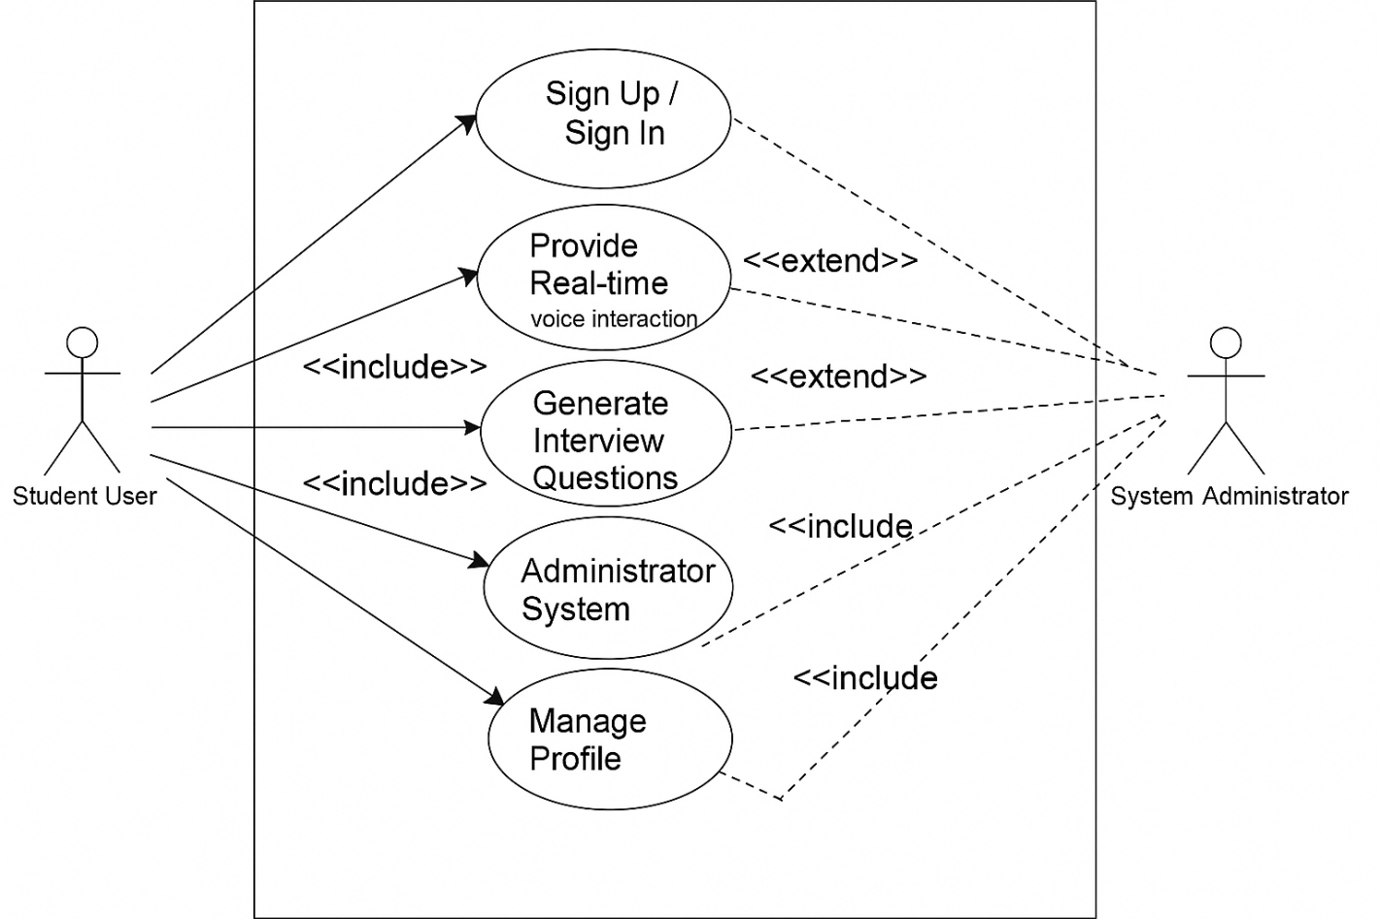

Figure 3.1: Use Case Diagram for the proposed system

Figure 3.1 illustrates the key interactions within the AI-powered web system, involving the primary actor such as users (students) and the administrator. The diagram includes use cases like authentication, Real-time voice interaction, Interview question generation, feedback review, and retake interview.

3.2.5.8 Activity Diagrams
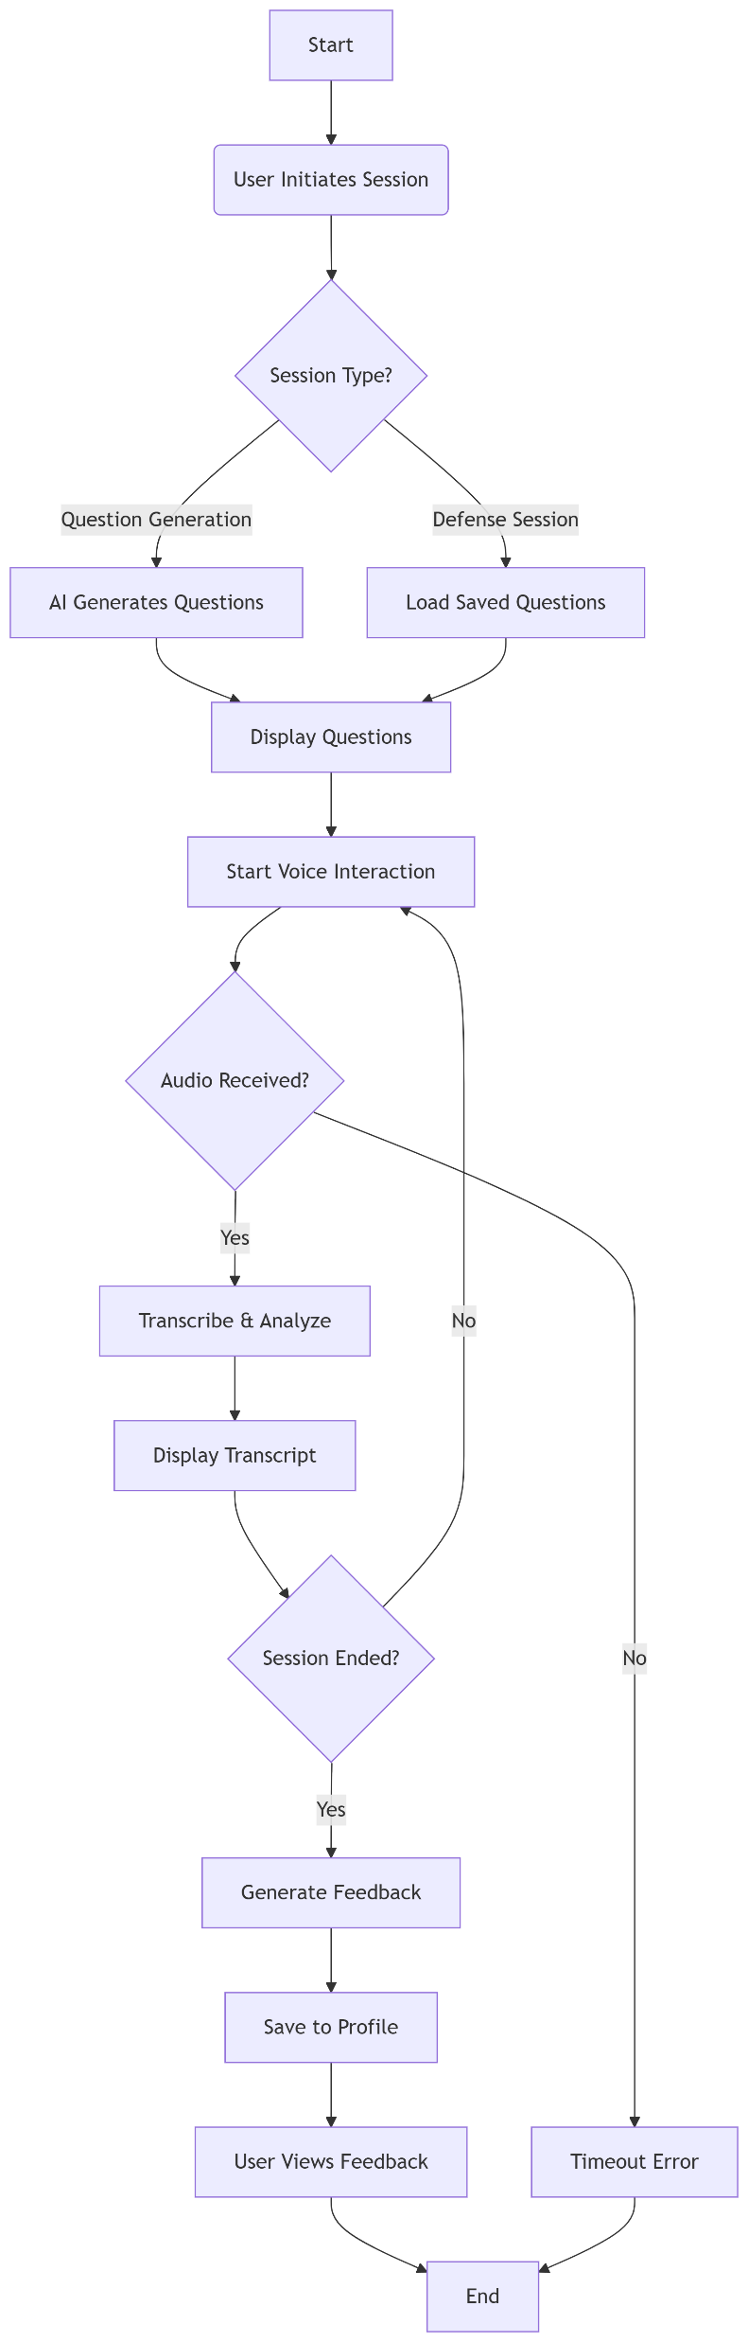
Figure 3.2: Activity Diagram for Taking an Interview Session

Figure 3.2 diagram details the sequence of steps involved when a user interacts with the coaching system—from logging in to feedback review.

3.2.5.9 Class Diagram

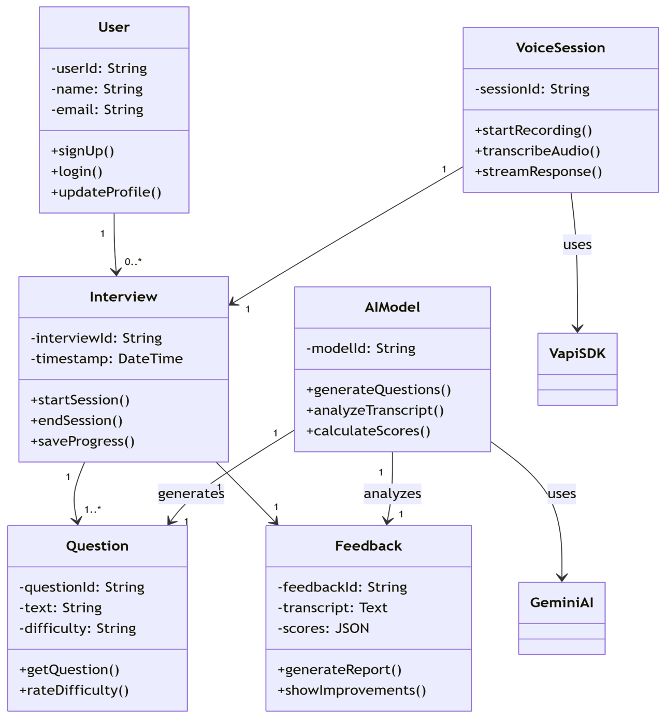

Figure 3.3: Class Diagram for the proposed system

Figure 3.3 presents the structural design of the application. It details the main classes—such as User, Voice session, Interview, AI model, Vapi SDK, Question, Feedback, Gemini AI—and the relationships between them.

3.2.6 Sequence Diagram

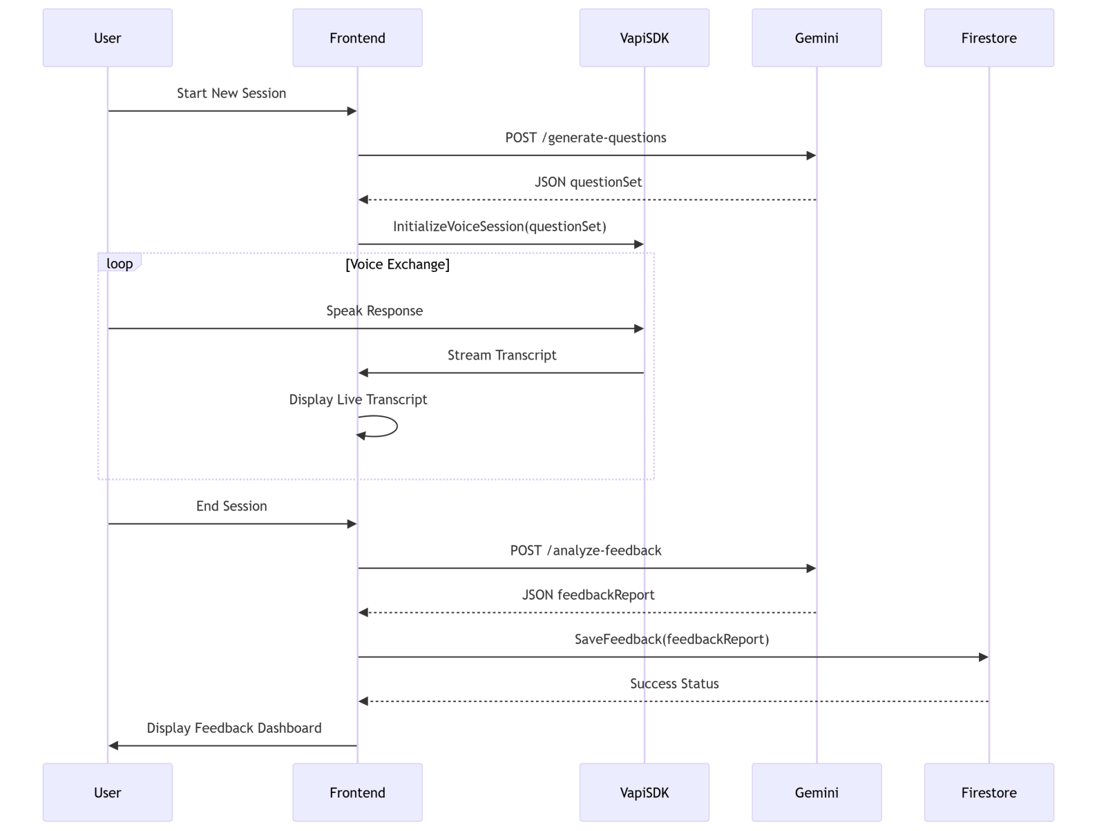

Figure 3.4: Sequence diagram for user interaction with proposed system
Figure 3.4 diagram shows the steps involved when a user onboard the interview session with the AI coaching system.

3.3 System Design
The system design for this project defines how the application meets its functional and non-functional requirements through its user interfaces, architectural components, and data structures.

3.3.1 Input/Output Design
Input Design:
- Authentication Screens
- Login Form: Captures user email and password.
- Registration Form: Collects name, university email, department, project title, and password.

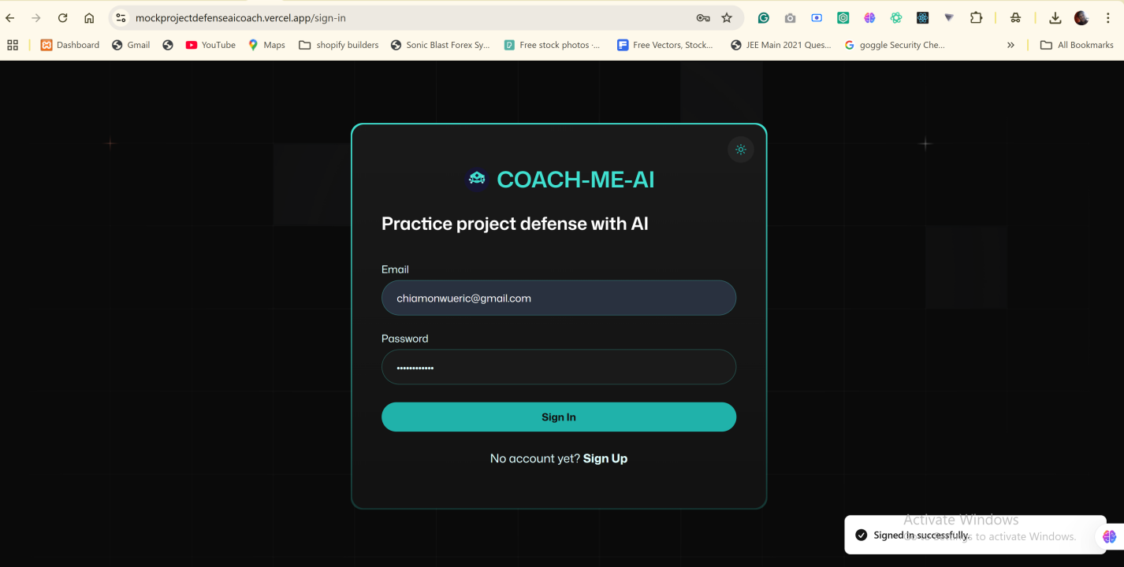

Figures 3.5: Authentication Input Interfaces

- Practice Session Controls
- Start Session Button: Triggers the question-generation engine.
- Microphone Permission Prompt: Requests browser access to audio input.
- Answer Submission Control: Marks end of response for transcription.
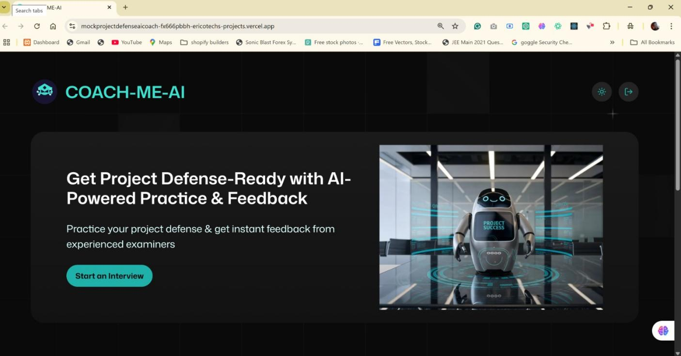

Figures 3.6: Interview Input Interfaces

Output Design:
- Question Display Panel
- Shows one generated question at a time, with “Next” and “Repeat” controls.

- Real-Time Transcript Window
- Streams live transcription of spoken response, with keyword highlights.

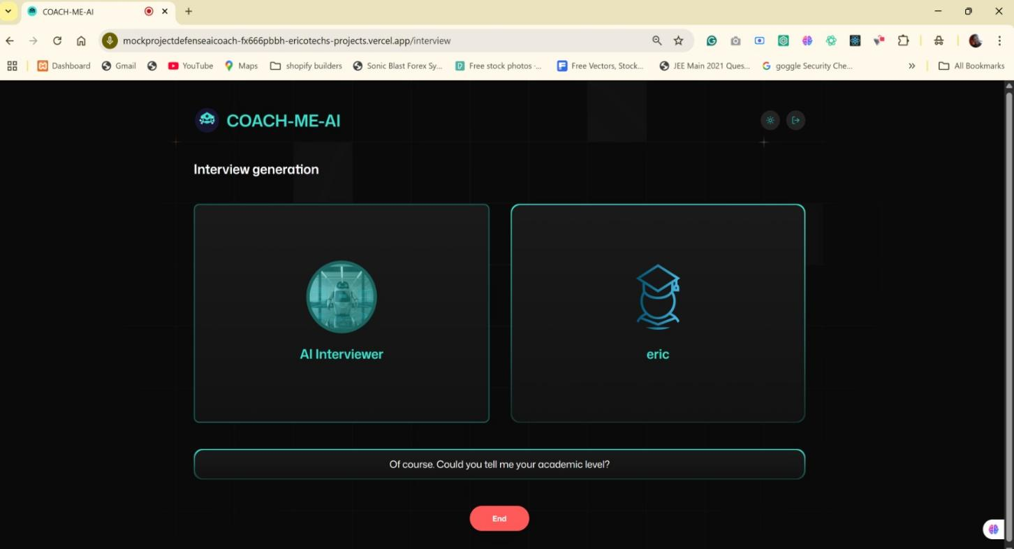

Figures 3.7: Interview Output Interfaces

- Feedback Overlay
- Presents instant feedback messages on clarity, completeness, and prosody metrics (e.g., pace score, filler-word count).

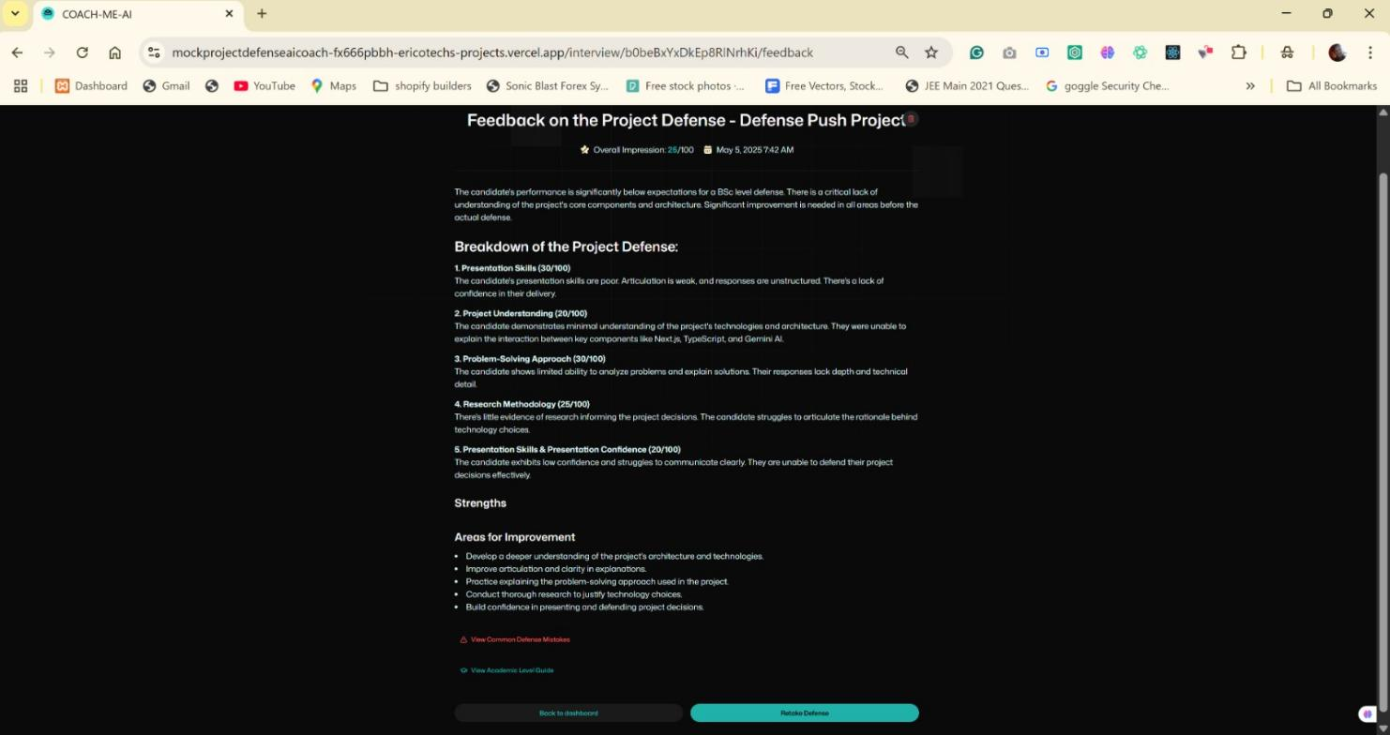

Figures 3.8: Feedback Output Interfaces

- Session Archive List
- Displays past sessions as cards listing date, question topics, and overall score.

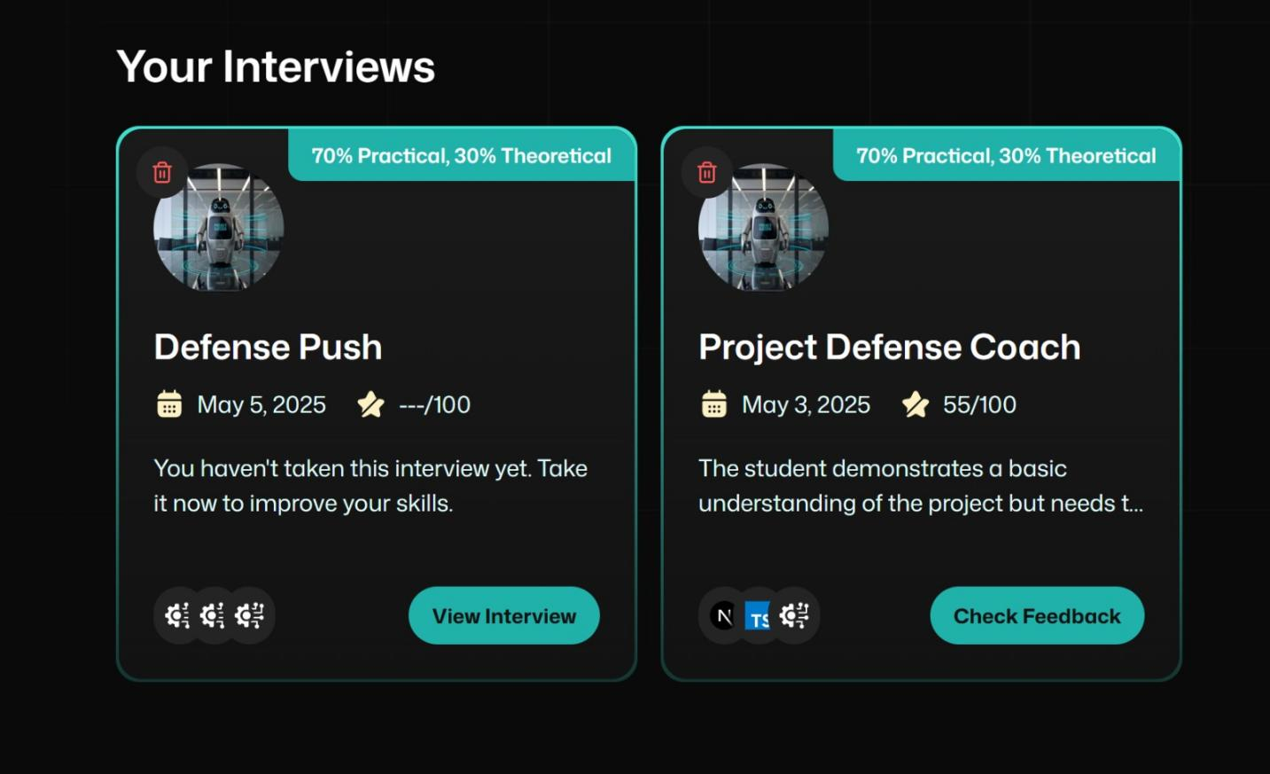

Figures 3.9: Completed Interview Output Interfaces

- Progress Dashboard
- Renders interactive charts for metrics over time (average response completeness, speaking fluency, question coverage).

3.3.2 Database Design
The AI-powered web application utilizes a relational database (e.g., PostgreSQL) to securely store user data, ride information, chat records, and reports. Below are sample database schemas:

User Table
Attribute | Data Type | Description
id | String | The document’s identifier, matching the Firebase Auth UID. Used to link user data to auth.
email | String | The user’s email address, serving as their primary contact and login credential.
name | String | The display name of the user (e.g., “Eric”), shown in the app’s UI and in session records.

Table 3.1: Table of users for the proposed system.

Defense_Session Table
Attribute | Data Type | Description
Document ID | String | The Firestore document’s unique identifier. Used to fetch or reference this session.
userId | String | The Firebase Authentication UID of the student who owns this session.
academicLevel | String | The student’s level (e.g., “Bachelor’s”, “Master’s”, “PhD”) indicating the defense scope.
projectTitle | String | A short title of the student’s project, used to label and organize sessions.
createdAt | Timestamp | The exact date and time the session record was created.
status | String | Current state of the session (e.g., “pending”, “completed”, “in-progress”).
focusRatio | String | A user-selected setting (e.g., “Balanced”, “Deep Dive”) that tailors question difficulty.
questionCount | Number (Integer) | How many AI-generated questions were prepared for this session.
questions | Array of Strings | The list of questions posed by the AI during the session.
technologiesUsed | Array of Strings | Technologies or tools the student used in their project (e.g., “Next.js”, “Firebase”).

Table 3.2: Table of Defense Session for the proposed system.

Feedback Table
Attribute | Data Type | Description
id | String | Firestore’s auto-generated document ID, uniquely identifying this feedback entry.
userId | String | The Firebase Auth UID of the student who received this feedback.
interviewId | String | The ID of the corresponding defense session (from defense_sessions).
createdAt | Timestamp | When the feedback was first recorded. Used for sorting and history.
updatedAt | Timestamp | The last time this feedback document was modified.
projectDetails | Map (Object) | Embedded info about the project: includes projectTitle, academicLevel, technologiesUsed, etc.
strengths | Array of Strings | A list of positive points noted during the evaluation.
areasForImprovement | Array of Strings | Suggestions on what the student should work on next.
documentGaps | Array of Strings | Specific missing elements or inconsistencies found in the project write-up.
implementationSuggestions | Array of Strings | Practical steps the student can take to address feedback and improve their work.
categoryScores | Array of Maps (Objects) | Each map holds { name: String, score: Number, comment: String } for different evaluation criteria.
finalAssessment | String | A free-form summary of overall performance and readiness.
transcript | Array of Maps (Objects) | The Q&A transcript: each map has { role: String, content: String } to reconstruct the full dialogue.
totalScore | Number (Integer) | The overall numeric score calculated from category scores.

Table 3.3: Table of the feedbacks for the proposed system.

Interviews Table
Attribute | Data Type | Description
Field Name | Type | Description
id | String | Firestore’s unique document ID, matching the user’s UID when interviews are user-specific.
userId | String | The Firebase Auth UID of the student who owns this interview setup.
createdAt | Timestamp | Date and time when the interview configuration was first saved.
coverImage | String | Path or URL to an illustrative image for this interview (e.g., “/robot.png”).
degreeLevel | String | The student’s academic degree (e.g., “BSc”, “Master’s”) guiding question depth.
projectTopic | String | The title or subject of the project under review (e.g., “Aggregation Platform”).
type | String | Describes the balance of theory versus practice (e.g., “70% Theoretical, 30% Practical”).
finalized | Boolean | Indicates whether the setup is complete (true) or still a draft (false).
questions | Array of Strings | The list of custom or AI-generated questions to be asked during the session.
techstack | Array of Strings | Technologies or tools the project uses (e.g., “Next.js”, “Firebase”, “Google AI”).

Table 3.4: Table of the Interview sessions for the proposed system.

3.4 SUMMARY
In this chapter, we conducted a thorough analysis and design of the proposed system thesis. We began by examining existing systems and identifying their shortcomings—such as generic question sets, lack of real-time feedback, and absence of progress tracking—and then defined clear functional and non-functional requirements to address these gaps. The Agile-DevOps methodology was chosen to guide development, ensuring rapid iterations, continuous user feedback, and automated deployment. Our system design detailed how inputs (microphone capture) flow through AI-driven modules—question generation, live transcription, prosody analysis—and produce outputs (dynamic questions, instant feedback, session archives, and progress dashboards). By outlining the interface elements, architectural components, and data structures, we have laid a solid foundation for implementation. This “AI-powered academic defense coaching system” combination of contextual questioning, immediate content and delivery critique, and longitudinal performance visualization promises to empower final-year students with an interactive, secure, and data-driven rehearsal environment.

CHAPTER FOUR
SYSTEM IMPLEMENTATION
4.1 INTRODUCTION
This chapter details the implementation phase of the proposed system. Building on the system analysis, design, and defined requirements, the application has been developed using Next.js for the front end, Firebase for hosting, authentication, and database services, and external AI APIs for question generation and speech analysis. Here, you will find descriptions and screenshots of key user interfaces—such as the live practice session view, feedback overlays, interview retake, and progress dashboard—and an explanation of the tools, libraries, and services used to bring this project to life.

4.2 TOOLS USED FOR IMPLEMENTATION
Next.js
Next.js is a React-based framework that enables server-side rendering and static site generation for web applications. By building both frontend and backend within a single Next.js codebase, this “AI-powered academic defense coaching system” benefits from seamless integration of UI components, API routes, and server actions. This unified approach reduces context switching, simplifies data fetching, and improves page load performance. Next.js also provides built-in routing, automatic code splitting, and optimized image handling, which together ensure that live practice sessions, feedback overlays, and the progress dashboard load quickly and reliably.
Firebase
Firebase serves as both the authentication provider and the primary database for the proposed system. Its Authentication module supports email/password sign-ups, social logins, and secure token management, streamlining user management without building custom auth flows. The Realtime Database (or Firestore) stores user profiles, session transcripts, feedback notes, and progress metrics. Firebase’s hosting and Cloud Functions allow the AI question generation and speech-to-text processing to run within a managed, scalable environment. By offloading infrastructure concerns to Firebase, development focuses on core features rather than server maintenance.
Tailwind CSS
Tailwind CSS is a utility-first styling framework that enables rapid creation of responsive, consistent user interfaces. Instead of writing custom CSS classes, the project’s components apply pre-built utility classes (e.g., px-4, text-lg, bg-blue-500) to control layout, typography, and color. This approach reduces stylesheet bloat and enforces a uniform design language. Tailwind’s configurable theme file makes it straightforward to adjust spacing, font sizes, and color palettes, ensuring that authentication pages, question panels, and dashboards retain a cohesive look and feel.
Vapi AI
Vapi AI is used to integrate voice-based services into this AI web application. It handles real-time audio capture from the browser’s microphone, streams the audio to a speech-to-text endpoint, and returns transcribed text for analysis. By abstracting low-level media capture and WebSocket streaming, Vapi AI enables the implementation to focus on processing and feedback logic rather than audio pipeline details. Its ability to handle live transcription with minimal latency is crucial for providing students with immediate feedback on spoken answers.
shadcn/ui
Shadcn/ui is a library of pre-built React components styled with Tailwind CSS. Components like Button, Dialog, and Card are used to assemble interactive elements—such as the “Start Session” button, feedback modals, and session archive cards—without writing complex markup from scratch. Since shadcn/ui components adhere to accessible patterns and support theming via Tailwind, they accelerate UI development and ensure consistent behavior (e.g., keyboard navigation, focus rings) across the application.
Google Gemini
Google Gemini provides the AI models responsible for generating defense questions from uploaded project summaries. Once a user submits their abstract, the text is passed to a custom Gemini API endpoint, which returns a list of contextually relevant questions categorized by topic. Gemini’s advanced language understanding and few-shot prompting capabilities allow this web application to produce high-quality, discipline-specific questions that challenge students to think deeply about their research.
Zod
Zod is a TypeScript-first schema validation library used to validate and parse user inputs on both the client and server sides. When a student uploads a project summary, Zod checks file type, size, and required metadata before the file is accepted. It also validates form data—such as registration fields, scheduling details, and feedback preferences—ensuring that the application handles only well-formed data. By catching validation errors early, Zod prevents malformed requests from reaching Firebase functions or AI endpoints, improving overall robustness.
Together, these tools form the backbone of this “AI-powered academic defense coaching system”. Next.js coordinates frontend rendering and backend APIs; Firebase manages user identity, storage, and compute; Tailwind and shadcn/ui deliver a polished, responsive interface; Vapi AI enables live transcription; Gemini supplies intelligent question generation; and Zod enforces data correctness throughout the system. This carefully selected tech stack ensures that the proposed system remains scalable, maintainable, and capable of delivering a seamless defense preparation experience.

4.3 SYSTEM REQUIREMENTS
Developing and running the AI-powered coaching web application requires a well-prepared environment, both for users and developers. Since the platform is web-based and AI-powered, the system requirements outlined here ensure optimal performance, compatibility, and a smooth user experience across supported browsers and devices.
This project application does not require a dedicated mobile app download. Instead, it runs directly in modern browsers, making it accessible across desktops, laptops, tablets, and smartphones. Below are the recommended system requirements for both end users and development purposes:
4.3.1 End-User System Requirements
To access and interact with this AI-powered system via the browser, users must meet the following:
- Supported Browsers:
- Google Chrome (v90 and above)
- Mozilla Firefox (v85 and above)
- Microsoft Edge (v91 and above)
- Safari (v13 and above)
- Operating System:
- Windows 10 or later / macOS Catalina or later
- Android 9.0 (Pie) or higher
- iOS 13.0 or higher
- Device Specifications:
- Minimum 2GB RAM (4GB or more recommended)
- At least 200MB of free storage for browser cache and offline data
- Microphone access (required for live practice sessions and voice feedback)
- Screen resolution: Minimum 720p (1280x720); Full HD recommended for dashboard clarity
- Internet Connectivity:
- A stable internet connection (minimum 3 Mbps) is required for live transcription, question generation, and data syncing

- Permissions:
- Microphone: Required to capture user responses during defense simulations
- Notifications: Recommended for reminders and feedback updates (optional but enhances usability)

4.3.2 Developer System Requirements
For contributors and maintainers of this project, the following tools and hardware setups are recommended:
- Operating System:
- Windows 10/11, macOS Ventura or later, or any Linux distribution (Ubuntu 20.04 or newer)
- Hardware:
- Minimum: 8GB RAM, 256GB SSD
- Recommended: 16GB RAM, 512GB SSD or more
- A multi-core processor (Intel i5 or M1 equivalent and above)
- Software Tools:
- Code Editor: Visual Studio Code
- Node.js: v18 or later
- Package Manager: npm or yarn
- Browser: Chrome or Chromium for debugging
- Git: Version control system
- Firebase CLI: For managing authentication, hosting, and backend functions
- Vercel CLI (optional): For Next.js deployment and preview testing
- APIs & Services:
- Access to Google Gemini for AI question generation
- Access to Vapi AI for speech-to-text processing
- Firebase Authentication and Firestore database configuration

4.4 USER INTERFACE OF AI-POWERED COACHING SYSTEM
The user interface (UI) of the AI-powered coaching system has been crafted to deliver a seamless, intuitive experience for students practicing thesis defenses. It prioritizes clarity, accessibility, and efficiency, ensuring that users can focus on refining their presentations. Below are detailed descriptions of each major UI component, organized as separate screens or modules.

4.4.1 Home Page of Chat-Me-AI
Upon successful login, students land on the Home Page (app/(root)/page.tsx). This page is designed to give immediate access to key functions:
- Hero Banner: Displays an engaging header text with the user’s name and a medium robot image beside it.
- Start New Session Button: Prominently positioned near the top center immediately after header text in the hero section, this button launches a new mock defense session.
- Past Interviews Section: Below the banner, there is a panel of past completed sessions. Each item is represented by an InterviewCard component showing the project topic, date/time, and a brief score or feedback summary.
- Logout Icon: At the top right corner, a exit-door icon that displays “Logout” when hovered on (toolkit effect) allowing users to exit the web app.
- Theme Color-Switch Icon: A subtle background illustration reinforces the academic theme without distracting from primary actions.
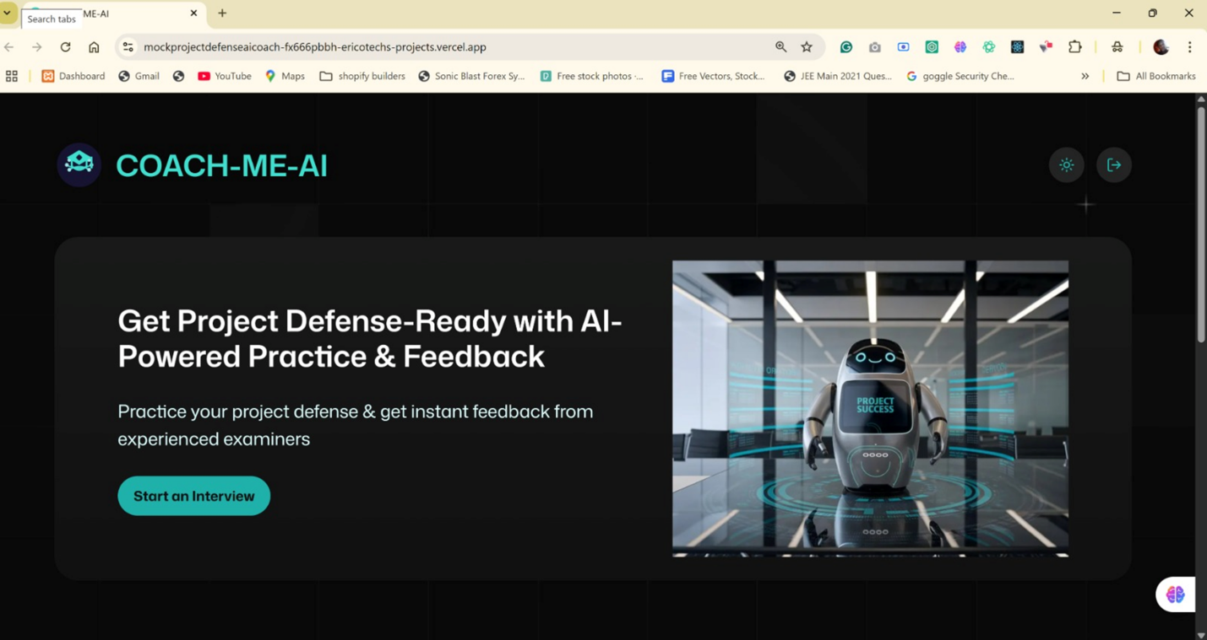

Fig 4.1 Home Page of Chat-Me-AI

4.4.2 Sign Up and Login Page
The AuthForm component (components/AuthForm.tsx) handles both sign-up and sign-in workflows:
- Form Layout: A clean, centered card containing input fields stacked vertically for email, password, and (for sign-up) password confirmation.
- Validation Feedback: Inline error messages appear in red below fields when Zod validation rules fail (e.g., invalid email format, password too short).
- Buttons & Links: A primary button labeled “Sign In” or “Sign Up” toggles based on context. Below the form, a text link allows users to switch between signing in and registering.
- Branding Elements: The Chat-Me-AI logo is displayed prominently at the top of the form, with a subtle “Practice project defense with AI ” tagline beneath it.
- Theme Toggle & Toasts: A small Theme-toggle switch is located in the upper-right corner for light/dark mode. Toast notifications appear in the top-center to confirm successful sign-in, sign-up, or display error messages (e.g., “Incorrect password”).

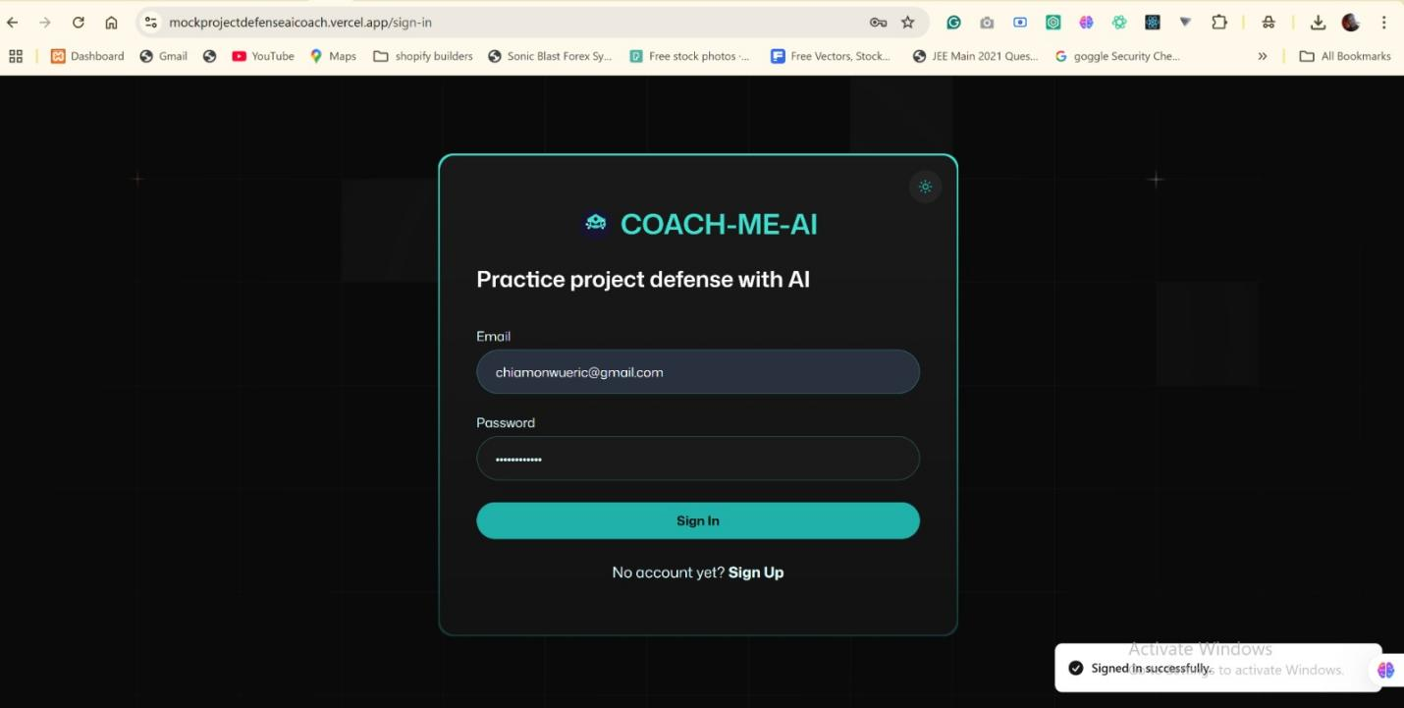
Fig 4.2 Authentication Forms (Sign-In & Sign-Up)

4.4.3 InterviewCard
The InterviewCard component (components/InterviewCard.tsx) appears on the Home Page and in session history lists:
- Card Header: Shows the project title and scheduled date/time in bold text.
- Score & Feedback Preview: A small badge (e.g., “85%” or “Needs Improvement”) indicates overall performance. A truncated feedback snippet (first two lines) provides a preview.
- Action Buttons: Two small buttons at the bottom—“View Interview” (opens the full session transcript and feedback) and “View Feedback” (navigates directly to detailed feedback).
- Tech Icons: On the right side, the DisplayTechIcons component presents small icons (e.g., microphone, AI symbol) to indicate which features were used (e.g., live transcript, AI-question engine).
- Visual Styling: Cards have a soft drop shadow and rounded corners, with hover states that slightly elevate the card to indicate interactivity.
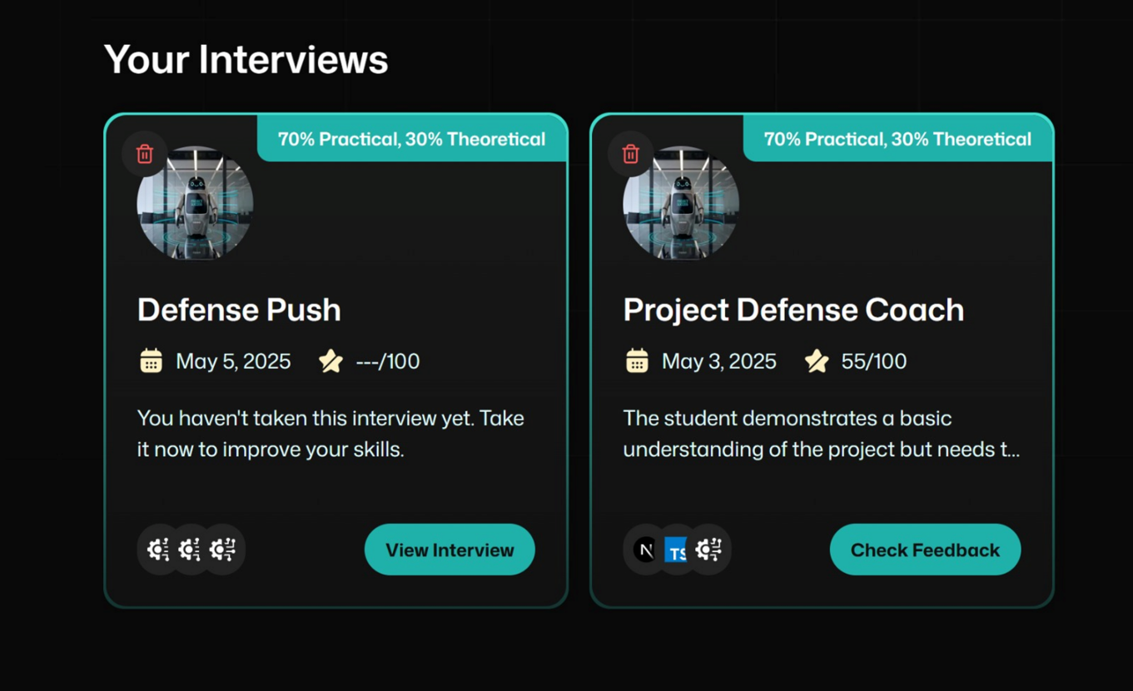
Fig 4.3 InterviewCard Component

4.4.4 Agent Interface
The Agent component (components/Agent.tsx) powers the live practice session:
- Interviewer & User Profile Cards: Side-by-side cards at the top show the AI interviewer’s avatar and name (“Chat-Bot Examiner”) and the student’s name and profile picture.
- Transcript Window: A scrollable pane in the center displays live transcription of both the AI’s question and the user’s spoken response. AI questions appear in italicized text; user responses appear in regular font.
- Call Controls: Below the transcript pane are “Start Call,” or “End Call,” buttons. “Start Call” sends the question prompt to the AI; “End Call” signals that the user has finished speaking and disconnected which ends the session.
- Audio Status Indicator: A small microphone icon is displayed or shown at the top right corner of the browser window (being used) where the site information are being previewed (view site information tab) indicating when the system audio is actively in use.

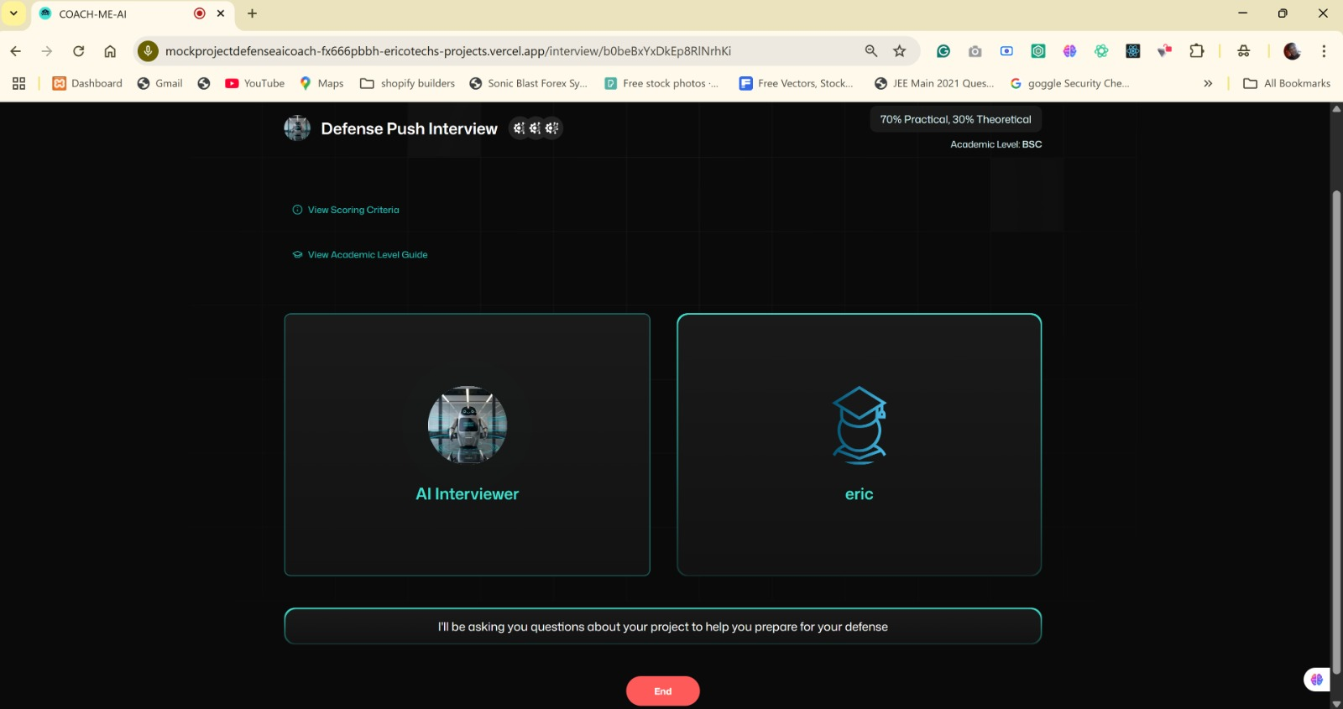
Fig 4.4 Live Practice Session (Agent Interface)

4.4.5 Form-Field Component
The Form-Field component (components/FormField.tsx) is a reusable input field used within Chat-Me-AI:
- Label & Input Pairing: Each Form-Field renders a label above a text input or textarea, ensuring clear form semantics.
- Validation State: Underneath the input, an error message appears in red text when validation fails (driven by Zod schemas).
- Customization Props: Supports type (e.g., “text,” “email,” “password”), placeholder, and required flags.
- Focus Styling: A subtle dark shadow (outside the input box) and a blue shade (inside the input field) appears when the field is in focus, improving visibility for keyboard users.

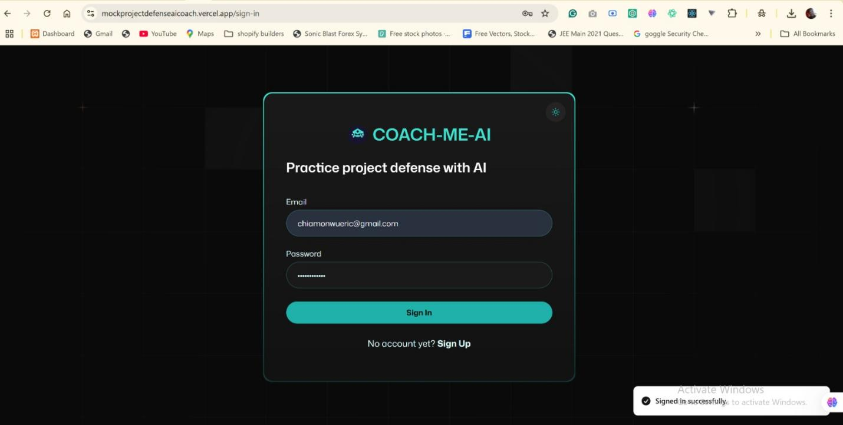

Fig 4.4 Form-Field Usage

4.4.6 Anti-Patterns
The Anti-Patterns component (components/AntiPatterns.tsx) highlights common pitfalls:
- Category Tabs: Two tabs—Common Defense Mistakes, and Academic Level Guild—appear below the feedback section.
- Bullet-Point Lists: Under each category, users see a list of anti-patterns (e.g., “Content Issues,” “Presentation issues,” “Ownership issues’ work as your own”).
- Inline Tips: Each item includes a short tip (e.g., “Practice summarizing slides instead of reading directly”).
- Collapsible Details: Clicking an anti-pattern category tab opens a brief explanation and example of how to avoid the mistake.

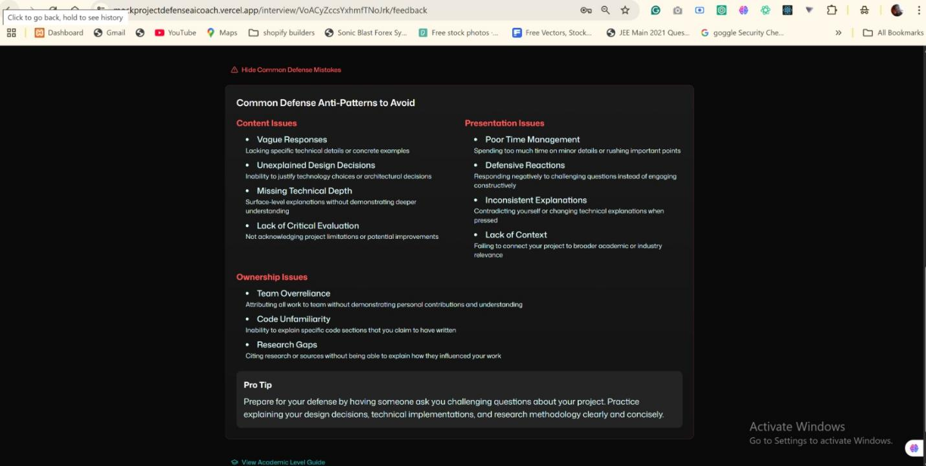

Fig 4.5. Anti-Patterns Component Category 1

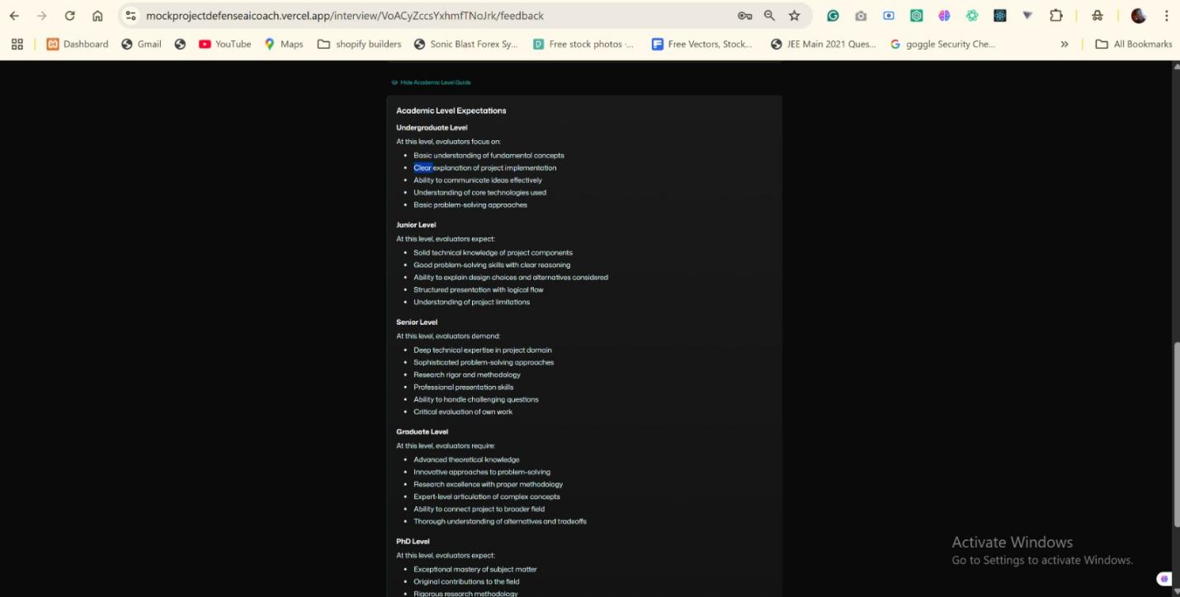

Fig 4.5.1 Anti-Patterns Component Category 2

4.4.7 Scoring-Criteria
The Scoring-Criteria component (components/ScoringCriteria.tsx) outlines how sessions are evaluated:
- Section Headers: Divided into five criteria—Presentation Skills, Project Understanding, Problem Solving, Research Quality, Confidence.
- Point Distribution: Next to each criterion, a slider or numerical input shows the maximum possible score and user’s achieved score for that session.
- Colour Indicators: Scores appear in green, giving students an academic brighter visuals for easy identification.

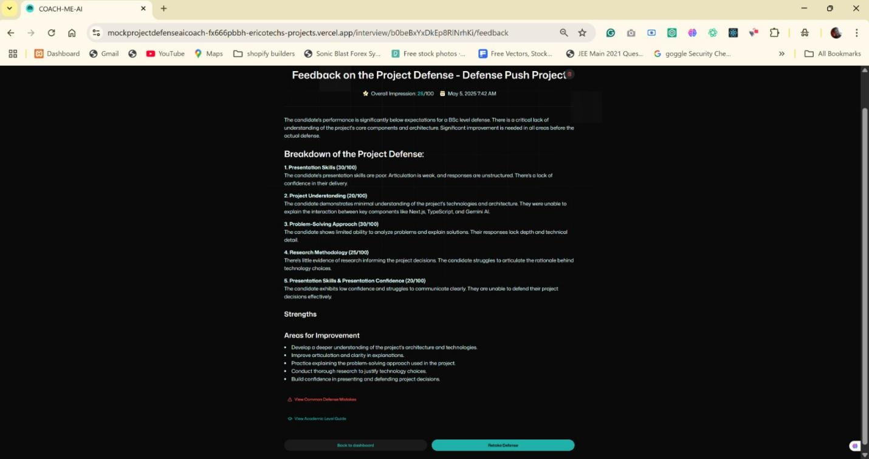

Fig 4.6 Scoring-Criteria Component

4.4.8 Theme Toggle
The Theme Toggle component (components/theme-toggle.tsx) allows users to switch between light and dark modes:
- Toggle Switch: A simple slider with a sun icon on the left (light mode) and moon icon on the right (dark mode).
- Persistent Preference: Once toggled, the theme setting is saved to local storage, ensuring consistency across visits.
- Smooth Transition: Upon switching, a brief fade animation transitions background and text colours to avoid abrupt changes.


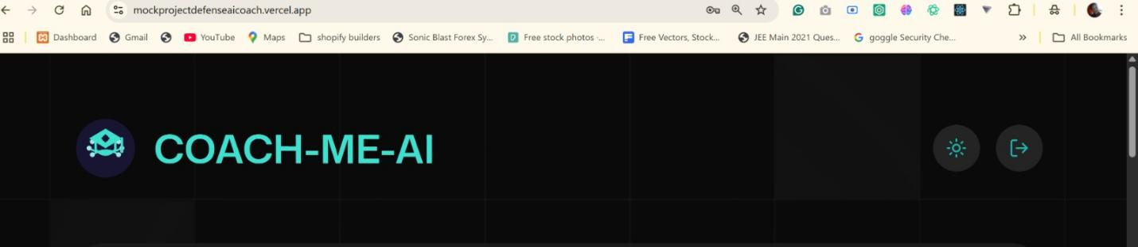

Fig 4.7 Theme Toggle Component

4.4.9 Logout-Button
The Logout-Button component (components/logout-button.tsx) allows users to sign out:
- Icon & Label: A small power-off icon next to the text “Logout” appears in the top-right corner of the home screen.
- Immediate Redirection: Upon clicking on the Logout icon, the user is signed out of Firebase Auth and redirected to the Authentication Form.


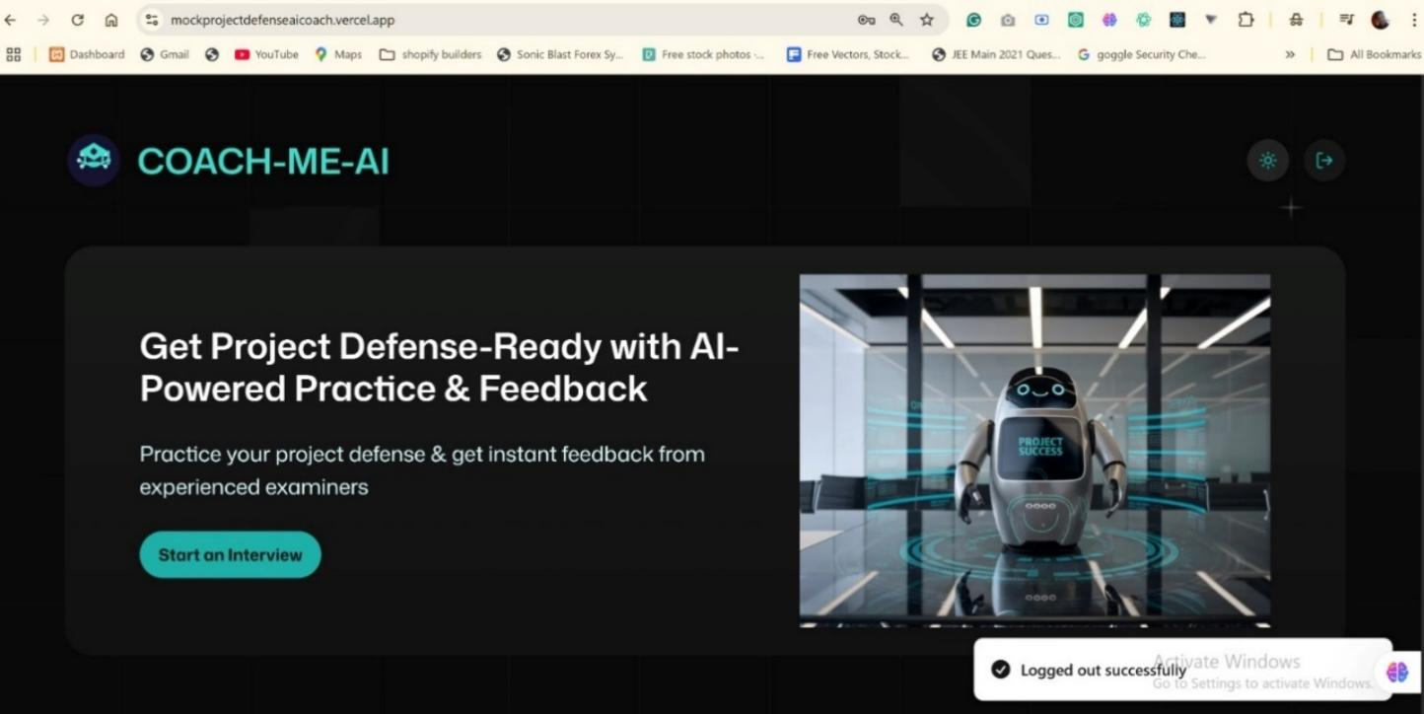
Fig 4.8 Logout-Button Component

CHAPTER FIVE
SUMMARY, RECOMMENDATIONS AND CONCLUSION

5.1 OVERVIEW
This chapter revisits the journey of developing this modern “AI-powered academic defense coaching system”, from its initial motivation through analysis, design, implementation, and testing. It reflects on how each preceding chapter contributed to creating an AI-powered thesis defense coaching platform, then draws overall conclusions and proposes directions for future enhancement.

5.2 SUMMARY
We began by identifying gaps in existing defense preparation tools—namely, the lack of project-specific questioning, real-time feedback, and progress tracking. Chapter Two reviewed related literature on intelligent tutoring systems, speech analysis, and AI coaching, establishing the theoretical foundation for this project. Chapter Three defined functional and non-functional requirements and laid out the Agile-DevOps methodology that guided iterative sprints, as well as the system’s architecture and component interactions. In Chapter Four, we implemented the platform using Next.js, Firebase, Tailwind CSS, Vapi AI, Google Gemini, and supporting libraries, and detailed the user interfaces—from authentication forms to live practice sessions and the progress dashboard. Each feature was tested for performance, usability, and security, ensuring a robust, responsive experience for final-year students.

5.3 RECOMMENDATIONS
The AI-powered web application is highly recommended for all final-year students, particularly those preparing for their project or thesis defenses, as it provides a flexible and intelligent alternative to traditional rehearsal methods. By using the platform, students can practice on their own schedule, gain critical insights from AI-generated questions, and receive structured feedback that helps them improve in both content and delivery. Institutions are encouraged to adopt the platform as part of their academic support infrastructure, enabling lecturers to track student readiness and offer targeted guidance. For future development, additional features such as the option to upload document files for analysis, a mobile app version for wider accessibility, and expanding coverage across more academic disciplines will greatly improve the system’s versatility. Furthermore, peer review integration can encourage collaboration and allow users to get feedback from fellow students, while adaptive learning paths powered by AI can recommend personalized exercises like pronunciation drills or content refinement tutorials. The introduction of privacy safeguards will ensure user data is protected, while a feature allowing interview uploads by others (such as supervisors or course instructors) will let students practice against real departmental formats and compare scores with peers. Ultimately, This project, “AI-powered academic defense coaching system” stands as a practical and evolving academic tool, empowering students to build confidence and perform their best under academic scrutiny.

5.4 CONCLUSION
The proposed system successfully delivers an end-to-end, web-based rehearsal environment that empowers students to practice thesis defenses on demand. By combining AI-driven question generation, live speech-to-text transcription, real-time delivery metrics, and longitudinal analytics, the system fills a critical need for consistent, project-tailored practice and reflective learning. The Agile-DevOps approach enabled rapid iteration and continuous refinement, resulting in a scalable, secure platform that meets both student and institutional requirements. Overall, this “AI-powered academic defense coaching system” demonstrates the potential of integrating advanced AI services into higher-education workflows to enhance learning outcomes and build student confidence.

5.5 FURTHER WORK
REFERENCES
Alamri, A., Ahmed, F., & Mohammed, S. (2021). Automatic feedback generation in learning management systems: Scalable architectures and service-oriented frameworks. Computers & Education: Artificial Intelligence, 2, 100017. https://doi.org/10.1016/j.caeai.2021.100017
Khalil, M., Smith, A., & Thompson, R. (2021). Customizable question sets for virtual defense simulations. SpringerOpen. https://doi.org/10.1186/s41039-021-00154-x
Shaik, T., Tao, X., Li, Y., Dann, C., McDonald, J., Redmond, P., & Galligan, L. (2022). A review of the trends and challenges in adopting natural language processing methods for education feedback analysis. IEEE Access, 10, 56720–56739. https://doi.org/10.1109/ACCESS.2022.3177752
Bauer, E., Greisel, M., Fischer, F., et al. (2023). Using natural language processing to support peer‐feedback in the age of artificial intelligence: A cross‐disciplinary framework and a research agenda. British Journal of Educational Technology. https://doi.org/10.1111/bjet.13336
Choi, H., & Lee, J. (2023). Automatic corrective feedback in pronunciation and fluency for language learners. Language Learning Journal. https://doi.org/10.1080/09588221.2024.2430761
Duarte, N. (2023). Can AI help with public speaking? A review of AI platforms. Retrieved from https://www.duarte.com/insights/ai-public-speaking
Edthena. (2023). AI Coach for Teachers. Retrieved May 2025, from https://www.edthena.com/ai-coach-for-teachers/
Emergent Group. (2024). A systematic literature review of artificial intelligence in coaching. Retrieved May 2025, from https://www.emerald.com/insight/content/doi/10.1108/JWAM-11-2024-0164/full/html
Gupta, S., & Sharma, R. (2024). Natural language processing of student’s feedback to instructors: A systematic review. ResearchGate. https://www.researchgate.net/publication/375434951_Natural_Language_Processing_of_Student%27s_Feedback_to_Instructors_A_Systematic_Review
Liu, V., Latif, E., & Zhai, X. (2025). Advancing education through tutoring systems: A systematic literature review. arXiv. https://arxiv.org/abs/2503.09748
Maity, S., & Deroy, A. (2024). Generative AI and its impact on personalized intelligent tutoring systems. arXiv. https://arxiv.org/abs/2410.10650
MarkSelliott.com. (2025). Balancing AI adaptivity with learner privacy in higher education. Retrieved from https://www.markselliott.com/ai-privacy-education
ResearchGate. (2024). NLP question generation for education: A systematic overview. Retrieved from https://www.researchgate.net/publication/375434951_Natural_Language_Processing_of_Student%27s_Feedback_to_Instructors_A_Systematic_Review
ScienceDirect. (2025). Integrating real-time transcription with educational feedback loops. Retrieved from https://www.sciencedirect.com/science/article/pii/S2666920X25000000
SpringerOpen. (2023). Artificial intelligence in intelligent tutoring systems toward sustainable education. Smart Learning Environments, 10(1), Article 60. https://doi.org/10.1186/s40561-023-00260-y
SpringerOpen. (2021). Learning analytics dashboards: Visualizing longitudinal learner progress. Retrieved from https://link.springer.com/article/10.1186/s41239-021-00258-3
Sun, Y., Li, M., & Zhang, L. (2023). Multimodal approaches combining speech and gaze tracking for real-time feedback: Prototype evaluation. Education and Information Technologies. https://doi.org/10.1007/s10639-023-12315-1
Technical University of Denmark. (2023). Natural Language Processing of Students’ Feedback to Instructors: A Systematic Review. DTU Orbit. https://orbit.dtu.dk/files/339910174/Natural_Language_Processing_of_Students_Feedback_to_Instructors_A_Systematic_Review.pdf
YesChat.ai. (2025). 5 GPTs for Thesis Defense powered by AI. Retrieved from https://www.yeschat.ai/tag/Thesis-Defense
Amazon Web Services. (2025). 6 EdTech AI trends: How artificial intelligence is reshaping education. Retrieved from https://aws.amazon.com/blogs/publicsector/6-edtech-ai-trends-how-artificial-intelligence-is-reshaping-education/
AutoGPT. (2025). The future of AI in education: Revolutionizing learning for the next generation. Retrieved from https://autogpt.net/the-future-of-ai-in-education-revolutionizing-learning-for-the-next-generation/
Atomus. (2024). The Future of AI and Coaching: Trends to Watch. Retrieved from https://atomus.com/blog/the-future-of-ai-and-coaching-trends-to-watch/
Cardona, M. A., Rodríguez, R. J., & Ishmael, K. (2023). Artificial Intelligence and the Future of Teaching and Learning. U.S. Department of Education. https://www.ed.gov/sites/ed/files/documents/ai-report/ai-report.pdf
EIMT. (2025, April 29). Top 10 AI trends reshaping the future of education. Retrieved from https://www.eimt.edu.eu/top-10-ai-trends-reshaping-the-future-of-education
Emerge EdTech Insights. (2023). Can technology and AI support coaching and mentoring at scale? Retrieved from https://medium.com/emerge-edtech-insights/can-technology-and-ai-support-coaching-and-mentoring-at-scale-d648f5055947
New America. (2023). The future of AI tutoring in higher ed. Retrieved from https://newamerica.org/oti/briefs/the-future-of-ai-tutoring-in-higher-ed/
Robin Waite. (2024). Coaching industry report – insights, trends and statistics. Retrieved from https://www.robinwaite.com/coaching-industry-report
Stanford Engineering Staff. (2024, November 22). The future of AI coaching. Stanford University School of Engineering. Retrieved from https://engineering.stanford.edu/news/future-ai-coaching
Anderson, J. R., Corbett, A. T., Koedinger, K. R., & Pelletier, R. (1995). Cognitive Tutors: Lessons Learned. Journal of the Learning Sciences, 4(2), 167–207. https://doi.org/10.1207/s15327809jls0402_2
AutoTutor Team. (1999). AutoTutor: A simulation of a human tutor. Retrieved from https://reed.cs.depaul.edu/peterh/papers/Graesserjcsr1999.pdf
Carbonell, J. G. (1970). SCHOLAR: A computer program that teaches. International Journal of Man-Machine Studies, 2(1), 87–111. https://doi.org/10.1016/S0020-7373(70)80007-7
Graesser, A. C., Chipman, P., Haynes, B. C., & Olney, A. (2004). AutoTutor: An intelligent tutoring system with mixed-initiative dialogue. IEEE Transactions on Learning Technologies, 1(2), 81–93. https://doi.org/10.1109/TLT.2008.18
Pavlik, P. I. Jr., Brawner, K., Olney, A., & Mitrovic, A. (2013). A review of student models used in intelligent tutoring systems. In Design Recommendations for Intelligent Tutoring Systems (Vol. 1). https://www.stat.cmu.edu/~brian/nynke/726-2021/project/articles/pavlik_studentmodels_2013.pdf
Suwita, J., Warnars, H. S. H., & Suwita, J. (2024). Trend intelligent tutoring system 2018–2022: Systematic literature review. ResearchGate. Retrieved from https://www.researchgate.net/publication/380388972
Siemens, G., & Long, P. (2011). Penetrating the fog: Analytics in learning and education. EDUCAUSE Review, 46(5), 31–40. https://er.educause.edu/articles/2011/9/penetrating-the-fog-analytics-in-learning-and-education
Wired. (2024, June). AI can’t replace teaching, but it can make it better. Retrieved from https://www.wired.com/story/what-aspects-of-teaching-should-remain-human
Wikipedia. (2025, May). Cognitive tutor. In Wikipedia. Retrieved from https://en.wikipedia.org/wiki/Cognitive_tutor
Wikipedia. (2025, May). Intelligent tutoring system. In Wikipedia. Retrieved from https://en.wikipedia.org/wiki/Intelligent_tutoring_system
Agile software development. (2025, May 26). In Wikipedia. Retrieved from https://en.wikipedia.org/wiki/Agile_software_development
Scrum (software development). (2025, May 26). In Wikipedia. Retrieved from https://en.wikipedia.org/wiki/Scrum_%28software_development%29
Breaking silos: Unifying DevOps and MLOps into a unified software supply chain. (2025, May 26). TechRadar Pro. Retrieved from https://www.techradar.com/pro/breaking-silos-unifying-devops-and-mlops-into-a-unified-software-supply-chain
APPENDIX
Home Page
mock_project_defense_ai_coach\app\(root)\page.tsx
import Link from "next/link";
import Image from "next/image";

import { Button } from "@/components/ui/button";
import InterviewCard from "@/components/InterviewCard";

import { getCurrentUser } from "@/lib/actions/auth.action";
import {
getInterviewsByUserId,
getLatestInterviews,
} from "@/lib/actions/general.action";

async function Home() {
const user = await getCurrentUser();

const [userInterviews, allInterview] = await Promise.all([
getInterviewsByUserId(user?.id || ""),
getLatestInterviews({ userId: user?.id || "" }),
]);

const hasPastInterviews = userInterviews && userInterviews.length > 0;
const hasUpcomingInterviews = allInterview && allInterview.length > 0;

return (
<>
<section className="card-cta">
<div className="flex flex-col gap-6 max-w-lg">
<h2>Get Project Defense-Ready with AI-Powered Practice & Feedback</h2>
<p className="text-lg">
Practice your project defense & get instant feedback from
experienced examiners
</p>

<Button asChild className="btn-primary max-sm:w-full">
<Link href="/interview">Start an Interview</Link>
</Button>
</div>

<Image
src="/robot.png"
alt="robo-dude"
width={400}
height={400}
className="max-sm:hidden"
/>
</section>

<section className="flex flex-col gap-6 mt-8">
<h2>Your Interviews</h2>

<div className="interviews-section">
{hasPastInterviews ? (
userInterviews?.map((interview) => (
<InterviewCard
key={interview.id}
userId={user?.id}
interviewId={interview.id}
projectTopic={interview.projectTopic}
type={interview.type}
techstack={interview.techstack}
createdAt={interview.createdAt}
/>
))
) : (
<p>You haven&apos;t taken any interviews yet</p>
)}
</div>
</section>

<section className="flex flex-col gap-6 mt-8">
<h2>Take Interviews</h2>

<div className="interviews-section">
{hasUpcomingInterviews ? (
allInterview?.map((interview) => (
<InterviewCard
key={interview.id}
userId={user?.id}
interviewId={interview.id}
projectTopic={interview.projectTopic}
type={interview.type}
techstack={interview.techstack}
createdAt={interview.createdAt}
/>
))
) : (
<p>There are no interviews available</p>
)}
</div>
</section>
</>
);
}

export default Home;

Feedback Section Page
mock_project_defense_ai_coach\app\(root)\interview\[id]\feedback\page.tsx
import dayjs from "dayjs";
import Link from "next/link";
import Image from "next/image";
import { Trash2 } from "lucide-react";
import { redirect } from "next/navigation";

import {
deleteInterview,
getFeedbackByInterviewId,
getInterviewById,
} from "@/lib/actions/general.action";
import { Button } from "@/components/ui/button";
import { getCurrentUser } from "@/lib/actions/auth.action";
import AntiPatterns from "@/components/AntiPatterns";
import AcademicLevelGuide from "@/components/AcademicLevelGuide";

const displayNames = {
"Technical Knowledge": "Project Understanding & Technical Implementation",
"Problem-Solving": "Research Methodology & Problem-Solving",
"Communication Skills": "Presentation Skills",
"Cultural & Role Fit": "Research Methodology & Project Relevance",
"Confidence & Clarity": "Presentation Skills & Presentation Confidence",
} as const;

const Feedback = async ({ params }: RouteParams) => {
const { id } = await params;
const user = await getCurrentUser();

const interview = await getInterviewById(id);
if (!interview) redirect("/");

const feedback = await getFeedbackByInterviewId({
interviewId: id,
userId: user?.id ?? "",
});

if (!feedback) redirect("/");

return (
<section className="section-feedback">
<div className="flex flex-row justify-center relative">
<h1 className="text-4xl font-semibold">
Feedback on the Project Defense -{" "}
<span className="capitalize">{interview.projectTopic}</span> Project
</h1>

{/* Delete Button */}
<div className="absolute top-0 right-0">
<form action={deleteInterview}>
<input type="hidden" name="interviewId" value={id} />
<input type="hidden" name="userId" value={user?.id || ""} />
<Button
type="submit"
variant="ghost"
size="icon"
className="rounded-full bg-dark-300 hover:bg-destructive-100/20 cursor-pointer"
title="Delete Project Defense"
>
<Trash2 className="h-5 w-5 text-destructive-100" />
</Button>
</form>
</div>
</div>

<div className="flex flex-row justify-center ">
<div className="flex flex-row gap-5">
{/* Overall Impression */}
<div className="flex flex-row gap-2 items-center">
<Image src="/star.svg" width={22} height={22} alt="star" />
<p>
Overall Impression:{" "}
<span className="text-primary-200 font-bold">
{feedback?.totalScore}
</span>
/100
</p>
</div>

{/* Date */}
<div className="flex flex-row gap-2">
<Image src="/calendar.svg" width={22} height={22} alt="calendar" />
<p>
{feedback?.createdAt
? dayjs(feedback.createdAt).format("MMM D, YYYY h:mm A")
: "N/A"}
</p>
</div>
</div>
</div>

<hr />

<p>{feedback?.finalAssessment}</p>

{/* Interview Breakdown */}
<div className="flex flex-col gap-4">
<h2>Breakdown of the Project Defense:</h2>
{feedback?.categoryScores?.map((category, index) => (
<div key={index}>
<p className="font-bold">
{index + 1}.{" "}
{displayNames[category.name as keyof typeof displayNames] ||
category.name}{" "}
({category.score}/100)
</p>
<p>{category.comment}</p>
</div>
))}
</div>

<div className="flex flex-col gap-3">
<h3>Strengths</h3>
<ul>
{feedback?.strengths?.map((strength, index) => (
<li key={index}>{strength}</li>
))}
</ul>
</div>

<div className="flex flex-col gap-3">
<h3>Areas for Improvement</h3>
<ul>
{feedback?.areasForImprovement?.map((area, index) => (
<li key={index}>{area}</li>
))}
</ul>
</div>

{/* Anti-Patterns and Academic Level Guide Components */}
<div className="mt-2 flex flex-col gap-2">
<AntiPatterns />
<AcademicLevelGuide currentLevel={interview.degreeLevel} />
</div>

<div className="buttons">
<Button className="btn-secondary flex-1">
<Link href="/" className="flex w-full justify-center">
<p className="text-sm font-semibold text-primary-200 text-center">
Back to dashboard
</p>
</Link>
</Button>

<Button className="btn-primary flex-1">
<Link
href={/interview/${id}}
className="flex w-full justify-center"
>
<p className="text-sm font-semibold text-black text-center">
Retake Defense
</p>
</Link>
</Button>
</div>
</section>
);
};

export default Feedback;

Agent Component
mock_project_defense_ai_coach\components\Agent.tsx
"use client";

import Image from "next/image";
import { useState, useEffect } from "react";
import { useRouter } from "next/navigation";

import { cn } from "@/lib/utils";
import { vapi } from "@/lib/vapi.sdk";
import { interviewer } from "@/constants";
import { createFeedback } from "@/lib/actions/general.action";

enum CallStatus {
INACTIVE = "INACTIVE",
CONNECTING = "CONNECTING",
ACTIVE = "ACTIVE",
FINISHED = "FINISHED",
}

interface SavedMessage {
role: "user" | "system" | "assistant";
content: string;
}

const Agent = ({
userName,
userId,
interviewId,
feedbackId,
type,
questions,
}: AgentProps) => {
const router = useRouter();
const [callStatus, setCallStatus] = useState<CallStatus>(CallStatus.INACTIVE);
const [messages, setMessages] = useState<SavedMessage[]>([]);
const [isSpeaking, setIsSpeaking] = useState(false);
const [lastMessage, setLastMessage] = useState<string>("");

useEffect(() => {
const onCallStart = () => {
setCallStatus(CallStatus.ACTIVE);
};

const onCallEnd = () => {
setCallStatus(CallStatus.FINISHED);
};

const onMessage = (message: Message) => {
if (message.type === "transcript" && message.transcriptType === "final") {
const newMessage = { role: message.role, content: message.transcript };
setMessages((prev) => [...prev, newMessage]);
}
};

const onSpeechStart = () => {
console.log("speech start");
setIsSpeaking(true);
};

const onSpeechEnd = () => {
console.log("speech end");
setIsSpeaking(false);
};

const onError = (error: Error) => {
console.log("Error:", error);
};

vapi.on("call-start", onCallStart);
vapi.on("call-end", onCallEnd);
vapi.on("message", onMessage);
vapi.on("speech-start", onSpeechStart);
vapi.on("speech-end", onSpeechEnd);
vapi.on("error", onError);

return () => {
vapi.off("call-start", onCallStart);
vapi.off("call-end", onCallEnd);
vapi.off("message", onMessage);
vapi.off("speech-start", onSpeechStart);
vapi.off("speech-end", onSpeechEnd);
vapi.off("error", onError);
};
}, []);

useEffect(() => {
if (messages.length > 0) {
setLastMessage(messages[messages.length - 1].content);
}

const handleGenerateFeedback = async (messages: SavedMessage[]) => {
console.log("handleGenerateFeedback");

const { success, feedbackId: id } = await createFeedback({
interviewId: interviewId!,
userId: userId!,
transcript: messages,
feedbackId,
});

if (success && id) {
router.push(/interview/${interviewId}/feedback);
} else {
console.log("Error saving feedback");
router.push("/");
}
};

if (callStatus === CallStatus.FINISHED) {
if (type === "generate") {
router.push("/");
} else {
handleGenerateFeedback(messages);
}
}
}, [messages, callStatus, feedbackId, interviewId, router, type, userId]);

const handleCall = async () => {
setCallStatus(CallStatus.CONNECTING);

if (type === "generate") {
await vapi.start(process.env.NEXT_PUBLIC_VAPI_WORKFLOW_ID!, {
variableValues: {
username: userName,
userid: userId,
},
});
} else {
let formattedQuestions = "";
if (questions) {
formattedQuestions = questions
.map((question) => - ${question})
.join("\\n");
}

await vapi.start(interviewer, {
variableValues: {
questions: formattedQuestions,
},
});
}
};

const handleDisconnect = () => {
setCallStatus(CallStatus.FINISHED);
vapi.stop();
};

return (
<>
<div className="call-view">
{/* AI Interviewer Card */}
<div className="card-interviewer">
<div className="avatar">
<Image
src="/robot.png"
alt="profile-image"
width={120}
height={120}
className="rounded-full object-cover size-[120px]"
/>
{isSpeaking && <span className="animate-speak" />}
</div>
<h3>AI Interviewer</h3>
</div>

{/* User Profile Card */}
<div className="card-border">
<div className="card-content">
<Image
src="/user-avatar.png"
alt="profile-image"
width={539}
height={539}
className="rounded-full object-cover size-[120px]"
/>
<h3>{userName}</h3>
</div>
</div>
</div>

{messages.length > 0 && (
<div className="transcript-border">
<div className="transcript">
<p
key={lastMessage}
className={cn(
"transition-opacity duration-500 opacity-0",
"animate-fadeIn opacity-100"
)}
>
{lastMessage}
</p>
</div>
</div>
)}

<div className="w-full flex justify-center">
{callStatus !== "ACTIVE" ? (
<button className="relative btn-call" onClick={() => handleCall()}>
<span
className={cn(
"absolute animate-ping rounded-full opacity-75",
callStatus !== "CONNECTING" && "hidden"
)}
/>

<span className="relative">
{callStatus === "INACTIVE" || callStatus === "FINISHED"
? "Call"
: ". . ."}
</span>
</button>
) : (
<button className="btn-disconnect" onClick={() => handleDisconnect()}>
End
</button>
)}
</div>
</>
);
};

export default Agent;

