PHYTOCHEMICAL SCREENING, PROXIMATE ANALYSIS AND MINERAL CONTENT EVALUATION OF AVOCADO (Persea American)
SEED EXTRACT

BY

EMEH SYLVIA
GOU/U22/ICH/098

INDUSTRIAL CHEMISTRY PROGRAMME
DEPARTMENT OF CHEMICAL SCIENCES, FACULTY OF NATURAL SCIENCES AND ENVIRONMENTAL STUDIES, GODFREY OKOYE UNIVERSITY, ENUGU
NIGERIA

JULY, 2026

PHYTOCHEMICAL SCREENING, PROXIMATE ANALYSIS AND MINERAL CONTENT EVALUATION OF AVOCADO (Persea American)
SEED EXTRACT

BY

EMEH SYLVIA
GOU/U22/ICH/098

INDUSTRIAL CHEMISTRY PROGRAMME
A RESEARCH PROJECT SUBMITTED TO THE DEPARTMENT OF CHEMICAL SCIENCE, FACULTY OF NATURAL SCIENCES, GODFREY OKOYE UNIVERSITY, ENUGU

IN PARTIAL FULFILMENT OF THE REQUIREMENTS FOR THE AWARD OF THE DEGREE OF BACHELOR OF SCIENCE (B.Sc.) IN INDUSTRIAL CHEMISTRY

SUPERVISOR: MRS LINDA UGWUONAH

JULY, 2026
APPROVAL
This research titled “Phytochemical Screening, Proximate Analysis and Mineral Content Evaluation of Avocado (Persea American) Seed Extract” has been assessed and approved by the Committees of Department of Chemical Sciences and Faculty of Natural Sciences and Environmental Studies, Godfrey Okoye University, Enugu, Nigeria.

Mrs Linda Ugwuonah .................................. ................................
Supervisor Signature Date

Dr. Joy .C. Anosike ................................... ....................................
HOD, Signature Date
Department of Chemical Sciences

Prof. Chidi Uhuegbu ................................... ..................................
Dean, FNSES Signature Date

................................... ...................................
External Examiner Signature Date

CERTIFICATION
This is to certify that this research project entitled "Phytochemical chemical screening, Proximate Analysis and Mineral content evaluation of Avocado (Persea americana) seeds extract" was carried out by Emeh Sylvia with Registration Number GOU/U22/ICH/098 in the Department of Chemical Science, Faculty of Natural Sciences, Godfrey Okoye University, Enugu, under my supervision. The work presented herein is original and meets the requirements for the award of the degree of Bachelor of Science (B.Sc.) in Biochemistry.

Mrs Linda Ugwuonah .................................. ................................
Supervisor Signature Date

Dr. Joy .C. Anosike ................................... ....................................
HOD, Signature Date
Department of Chemical Sciences

DEDICATION
This work is dedicated to God Almighty, the source of all wisdom and knowledge, and to my beloved family, whose love, prayers, and unwavering support have sustained me through every step of this journey.

ACKNOWLEDGEMENTS
All glory and honour belong to God Almighty, without whose grace and wisdom this work would not have been possible.
I wish to express my sincere gratitude to my project supervisor, Mrs Linda Ugwuonah, for the guidance, patience, intellectual direction, and invaluable corrections that shaped this work from its conception to completion.
My profound appreciation goes to the Head of Department, Dr Joy C. Anosike and all the lecturers in the Department of Chemical Science, Godfrey Okoye University, whose academic contributions during my undergraduate training laid the foundation for this investigation.
Finally, I thank my family and friends for their unending support, encouragement, and prayers throughout this programme.

ABSTRACT
This study investigated the Phytochemical Screening, Proximate Analysis, Mineral content evaluation of Avocado (Persea americana) seeds extract, with emphasis on qualitative phytochemical screening, proximate composition, and mineral content evaluation. Qualitative phytochemical screening revealed differential distribution of secondary metabolites across the two extract types: alkaloids, polyphenols, and terpenes/terpenoids were detected in both the aqueous and ethanolic extracts, while saponins were detected only in the aqueous extract and sterols and tannins were detected only in the ethanolic extract; flavonoids were absent from both extracts. Proximate analysis of the avocado seed powder indicated a moisture content of 10.00%, ash content of 10.80%, crude protein of 8.05 %, crude lipid of 5.00%, crude fibre of 3.00%, and carbohydrate content of 196.10%, highlighting the seed as a carbohydrate-rich matrix with moderate protein and lipid content. Mineral content determination by Flame Atomic Absorption Spectrometry (FAAS) revealed that calcium was the most abundant macromineral (701.44 mg/100 g), followed by potassium (20.64 mg/100 g), magnesium (8.16 mg/100 g), and sodium (9.06 mg/100 g). Among trace elements, iron was detected at a concentration of 0.95 mg/100 g and manganese at a concentration of 0.13 mg/100 g. Copper was detected at a concentration of 0.12 mg/100 g and zinc at a concentration of 0.20 mg/100 g. Potentially toxic heavy metals cadmium and lead were not detected above the limit of detection (< LOD), while nickel was detected at a concentration of 0.13 mg/100 g and chromium at a concentration of 0.67 mg/100 g. These findings collectively establish the chemical richness of ripe avocado seeds and provide a scientific basis for their potential nutritional and pharmacological exploitation.

TABLE OF CONTENTS
Title Page i
Approval Page ii
Certification iii
Dedication iv
Acknowledgements v
Abstract vi
Table of Contents vii
List of Tables ix
List of Figures x
List of Abbreviations xi

CHAPTER ONE: INTRODUCTION 1
1.1 Background of the Study 1
1.2 Statement of the Problem 4
1.3 Aim and Objectives of the Study 4
1.4 Significance of the Study 5
1.5 Scope and Limitations of the Study 6
1.6 Location of the Study 7
1.7 Justification of the Study 7

CHAPTER TWO: LITERATURE REVIEW 9
2.1 Botanical Description and Composition of Persea americana 9
2.2 Medicinal Uses of Avocado Seeds 9
2.3 Phytochemical Composition of Avocado Seeds 11
2.3.1 Alkaloids 13
2.3.2 Flavonoids 14
2.3.3 Tannins 17
2.3.4 Saponins 19
2.3.5 Sterols (Phytosterols) 22
2.3.6 Polyphenols 25
2.3.7 Terpenes/Terpenoids 27
2.4 Proximate Composition Studies on Avocado Seeds 29
2.4.1 Ash Content 29
2.4.2 Crude Fibre 30
2.4.3 Crude Protein 31
2.4.4 Moisture Contents 31
2.4.5 Crude Lipid 32
2.4.6 Carbohydrate 32
2.5 Mineral Content Evaluation of Avocado Seeds 33
2.5.1 Macro minerals 35
2.5.2 Micro minerals (Trace Elements) 36
2.5.3 Potentially Toxic Heavy Metals 36

CHAPTER THREE: MATERIALS AND METHODS 38
3.1 Materials 38
3.2 Methods 38
3.2.1 Preparation of Ethanolic and Aqueous Extracts 38
3.2.2 Qualitative Phytochemical screening 39
3.2.3 Quantitative Phytochemicals screening 42
3.2.4 Proximate Analysis 43
3.2.5 Mineral Content Evaluation 46
3.2.6 Statistical Analysis 48

CHAPTER FOUR: RESULTS 49
4.1 Qualitative Phytochemical Screening 49
4.2 Proximate Composition
4.3 Mineral Content Evaluation

CHAPTER FIVE: DISCUSSION, CONCLUSION AND RECOMMENDATIONS 52
5.1 Discussion 52
5.2 Conclusion 55
5.3 Recommendations 56

REFERENCES 57

LIST OF TABLES
Table 1: Qualitative Phytochemical Screening of Ethanolic and Aqueous Extracts of Ripe Persea americana Seeds 49

Table 2: Proximate Composition of Ripe Persea americana Seed Powder 50

Table 3: Mineral Content of Ripe Persea americana Seeds Determined by FAAS (mg/100g
dry weight) 51

LIST OF FIGURES
Figure 1: Examples of Alkaloids 16
Figure 2: Examples of Flavonoids 18
Figure 3: Schematic Structure of Procyanidin B2 20
Figure 4: Schematic structure of Oleanolic acid 22
Figure 5: Chemical Structure of Beta-Sitosterol 24
Figure 6: Chemical structure of Chlorogenic Acid 26
Figure 7: Chemical Structure of Ursolic Acid 28
Figure 8: Chemical Structure of Lupeol 28

LIST OF ABBREVIATIONS

AOAC: Association of Official Analytical Chemists
AAS: Atomic Absorption Spectrophotometry
FAAS: Flame Atomic Absorption Spectrometry
GFAAS: Graphite Furnace Atomic Absorption Spectrometry
FAO: Food and Agriculture Organization
WHO: World Health Organization
HPLC: High-Performance Liquid Chromatography
LC-MS: Liquid Chromatography-Mass Spectrometry
LOD: Limit of Detection
SD: Standard Deviation
NF-κB: Nuclear Factor Kappa B
COX-2: Cyclooxygenase-2
TPC: Total Phenolic Content
TFC: Total Flavonoid Content
GAE: Gallic Acid Equivalents
SPSS: Statistical Package for the Social Sciences
ANOVA: Analysis of Variance
HSD: Honest Significant Difference
NFE: Nitrogen-Free Extract
HNO₃: Nitric Acid
H₂SO₄: Sulphuric Acid

CHAPTER ONE

INTRODUCTION

1.1 Background of the Study

Plants have been an invaluable source of bioactive substances, which have become the basis of traditional medicine, as well as pharmacology. Research on the secondary metabolites of plants e.g. alkaloids, phenolics, flavonoids, terpenoids, glycosides and saponins as chemical defense and ecological signals of plants have led to the discovery of many clinically useful drugs, nutraceuticals and industrial products (Harborne, 1998; Sofowora, 2008). The current worldwide search for new bioactive compounds from plants is not only due to the undesirable effects of numerous synthetic medications, but also to the fact that the botanical world is relatively chemically under-explored (Newman & Cragg, 2016).
Today, there are millions of plant species known to be the subject of human and medical, as well as some of biological importance. Such is avocado (Persea americana Mill.; Lauraceae). Avocado, as a result of long ago and distant (tens of thousands of years), homeland highlands of Mexico, Guatemala, Andes, the land where it originates around (Smith, 2013). This tropical and subtropical fruit crop is now a leading tropical fruit in the world: its annual global production exceeding 6 million metric tons of fruits per year (FAO, 2022).
It is consumed throughout the world thanks to a healthy fleshy pulp and pulp rich in healthy fatty acids, diet fibre, numerous vitamins (C, E, K, B-group) and minerals; recently avocado received much attention in research papers as an element in cardio vascular diseases and anti-inflammatory nutrition (Dreher & Davenport, 2013; Valderas-Martinez et al., 2019).

The avocado seed, which makes up approximately 13-18% of the fresh fruit's weight, is often discarded during processing and avocado utilization processes, resulting in a huge biomass waste stream.The avocado seed is about 13-18% of the fresh fruit weight (Dabas et al., 2013) and is commonly discarded during processing and avocado utilization processes. The problem of seed disposal is found in countries where avocado fruits are processed industrially to produce avocado oil, guacamole and cosmetics. But a growing scientific body of literature has established that these seeds are rich in chemical compounds and are very diverse. In different geographical regions, for instance, the chemical composition of the avocado seed extract is found as condensed tannins, procyanidins, phenolic acids, flavonoids, alkaloids, saponins, steroids, and terpenoids (Leite et al., 2009; Rodriguez-Carpena et al., 2011; Dabas et al., 2013).

From the ethnomedicine point of view, seeds of avocado has been recorded in both Latin America and West Africa, and found to have a variety of useful properties. The seed decoctions have been used in Latin America like Mexico, Brazil and Peru for the treatment of diarrhoea, dysentery, hypertension, diabetes mellitus, arthritic conditions (Ojewole & Amabeoku, 2006). Also, in West Africa such as Nigeria, Ghana and Cameroon avocado seeds has been traditionally used to treat fevers, wounds, and used as pain relieve for inflammatory condition (Adeyemi et al., 2002). These ethnomedical traditions can offer potential as starting point for future research. Scientific community attracted significant attention in extracts from seeds of avocado (Persea americana) as potential useful substance in multiple fields of research, for biological activity. Studies on phytochemistry have shown that the extracts of avocado seeds are abundant in biologically active chemicals such as flavonoids, tannins, saponins, alkaloids, and phenolic acids, which make up the properties of the extracts. Understanding the chemical makeup of avocado seed extracts since a detailed knowledge of their makeup forms the scientific foundation for establishing and increasing their uses in medicine and other industries. Avocado (Persea americana) seed extracts have been extensively studied because of their diverse biological activities and potential applications in several fields (Dabas et al., 2019; Rodríguez-Carpena et al., 2011). Research on avocado seeds phytochemistry has revealed a rich source of biologically active compounds like flavonoids, tannins, saponins, alkaloids and phenolic acids in avocado seeds extract that contribute to the properties of the extract (Nayak et al., 2011; Idris et al., 2022).

In the context of medical and healthcare, avocado seeds have shown significant antimicrobial effects against various pathogenic microbes, indicating their usefulness as natural substitutes for conventional antimicrobial agents (Leite et al., 2009; Ochoa-Velasco et al., 2020). Avocado seeds are also reported for their antioxidant activity attributed to the phenolic content which would help prevent a range of oxidative stress-related diseases including cancer, diabetes and heart disease (Dabas et al., 2019; Zu et al., 2010).

Besides, it has been shown that avocado seeds may be beneficial in the treatment of non-communicable disease as they help to reduce inflammation, control hypertension and manage hypoglycemia (Owolabi et al., 2010; Adeyemi et al., 2002). In the food industry, avocado seed extracts are studied for use as natural preservatives owing to their property of inhibiting lipid peroxidation and preventing microbial spoilage (Rodríguez-Carpena et al., 2011; Gómez-Flores et al., 2018). Avocado seed extracts are also used as suitable ingredients in skin care products and drug delivery systems, respectively, by the cosmetic and pharmaceutical industry (Nayak et al., 2011; Idris et al., 2022).

As indicated above the biological activities of the extracts are important and highlight the importance of studying the chemistry of the extracts of avocados and the knowledge of the chemicals is important to validate and further expand the use of the extracts (Dabas et al., 2019).Not many studies have investigated in detail and compared the phytochemical profiles of ethanolic and aqueous extracts of avocado seeds (particularly ripe seeds) using a similar approach. In this light, the design of the current study was laid out.

1.2 Statement of the Problem
Avocado-processing industries produce significant amounts of seed waste across the world. For example, in Nigeria, the emergence of commercial avocados coupled with local consumption trends result in several thousand tonnes of avocado seeds being produced per year, and most of these are disposed of without any form of scientific assessment. The result is that not only do we end up polluting our environment, but we also lose valuable chemicals.
Even though a few scientific researches have started studying the phytochemical composition of seed extracts from avocadoes, there are still a number of important aspects missing. Firstly, many of the studies which are currently available use either one type of solvent system or only concentrate on one or a few types of phytochemicals. Secondly, the effect of the fruit ripeness on the chemical composition of the seed has not been sufficiently studied, despite the fact that ripeness is an extremely important factor in terms of accumulation patterns of secondary metabolites in plants (Yahia & Woolf, 2011). Thirdly, there is little comparative data concerning the phytochemical composition of ripe avocado seeds in ethanolic and aqueous extracts, the two most relevant solvents. The current paper attempts to address these lacks of information by comparing the chemical composition of ethanolic and aqueous extracts from ripe avocado seeds.

1.3 Aim and Objectives of the Study
The overarching aim of this study is to conduct a thorough chemical investigation of the ethanolic and aqueous extracts of ripe Persea americana (avocado) seeds, with a view to comprehensively characterizing their phytochemical contents, proximate composition, mineral contents, and anti-nutrient composition, and comparing the influence of ethanolic and aqueous solvents on the distribution and concentration of identified bioactive compounds.
The objectives of this study are to:
i. Evaluate the phytochemical composition of the ethanolic and aqueous extracts of Persea americana (avocado) seeds in order to identify and characterize the bioactive compounds present.
ii. Determine the proximate composition of the avocado seed to assess their nutritional value in terms of moisture content, ash content, crude fibre, crude protein, crude lipid, and carbohydrate.
iii. Analyse the mineral content of the avocado seeds with the aim of quantifying both essential elements (such as calcium, magnesium, potassium, and iron) and potentially toxic heavy metals (such as lead and cadmium), thereby evaluating their nutritional significance and safety.
v. Compare the efficiency of ethanol and water as extraction solvents in order to determine their influence on the yield, distribution, and concentration of phytochemicals, nutrients, and anti-nutrients in the avocado seed extracts.

1.4 Significance of the Study
The significance of this research lies in a number of different aspects of science and applied research. Scientifically, the thorough identification of the chemical components of avocado seed extract adds value to the increasing global database of secondary metabolites of plants. The data gathered from this research will be very useful for researchers working in the field of pharmacology, biochemistry, food science and chemical ecology in their interest in the bioactive compounds of Persea americana seeds (Ayoola et al., 2008).
From a drug point of view, the isolation and quantification of phytochemical classes such as phenolics, flavonoids, and tannins from the ripe avocado seed extract will give an insight into the use of phytochemistry for ethnomedicinal uses of the plant. From this comparison of solvent information, the research community and manufacturers can decide on the best extraction technique to use in order to concentrate on specific bioactive classes, which is key to developing standardized botanical drugs and functional foods (Azwanida, 2015).
In terms of environment and economics, giving worth to the avocado seeds, which are otherwise considered waste products, by showing how rich they are in phytochemicals aligns with green chemistry and circular bio-economy. The results may prompt the production of natural antioxidants, antimicrobial agents and nutraceuticals from the seeds of the avocado plant as alternatives to synthetically made additives in food and pharmaceutical industries (Dabas et al., 2013). This aspect is even more applicable to developing countries like Nigeria where the cultivation of avocados is growing rapidly.

1.5 Scope and Limitations of the Study
The present study focuses on the chemical characterization of seeds obtained from locally sourced avocado (Persea americana Mill.), employing both aqueous and ethanolic media for extraction. The selection of these solvents was informed by their distinct extraction properties. Water was chosen because of its widespread use in traditional extraction practices, whereas ethanol was included owing to its documented effectiveness in recovering a broad spectrum of plant-derived bioactive constituents (Atata et al., 2023; Bello et al., 2022).The investigation is restricted to the following analytical components:

• Evaluation of phytochemical content of aqueous and ethanolic extract to determine the presence of important secondary compounds, like alkaloids, flavonoids, tannins, saponins, sterols, polyphenols, and terpenoids.

• Evaluation of proximate composition of the seed of the fruit, considering moisture, ash, crude protein, crude fat, crude fiber, and carbohydrate content.

• Evaluation of selected minerals, such as calcium, magnesium, sodium, potassium, phosphorus, iron, zinc, copper, and manganese, as well as toxic heavy metal, like selenium, cadmium, arsenic, nickel, and lead, by Flame Atomic Absorption Spectrometry (Okafor et al., 2023; Muhammed et al., 2022).

1.6 Location of the Study
The research was performed in the Department of Chemical Sciences, Faculty of Natural Sciences, Godfrey Okoye University, Thinkers Corner, Enugu, Enugu State Nigeria. The academic setting was equipped with required facilities in the laboratories and equipment with adequate expertise from supervisory staff needed for the current phytochemical research investigation.

1.7 Justification of the Study
Justification for the current study rests on several important factors related to science, public health, the environment, and economics, which all point to the importance and need for a comprehensive chemical characterization of ripe avocado seed chemicals. Though there exists a vast body of information regarding biological activities exhibited by seed extracts of the avocado fruit, the scientific basis for these activities with respect to the chemistry of ethanolic and aqueous seed extracts of ripe fruits has yet to be fully elucidated.
In terms of science, the use of ethanol and water as extraction solvents in the same study serves to generate internally coherent data that is pertinent to both the current pharmaceutical and traditional medicine situations. The ethanol-based extraction method mimics the preparation process used for standardized plant medicines, while the aqueous extraction mimics the method of preparing decoctions and infusions which is the main method of using the avocado seeds in traditional medicines practiced in West Africa and Nigeria. Performing both kinds of extraction on the same avocado seeds and running the same phytochemical tests on both extracts would serve to ensure that any differences observed in phytochemical composition could be attributed to the differences in the solvent used, not to the difference in plant material or geography
From both the point of view of public health issues as well as that of pharmacology, Nigeria and the entire West Africa still suffer from a substantial disease burden in terms of communicable and non-communicable diseases, such as infectious diarrhea, malaria, hypertension, diabetes mellitus, and inflammation-related diseases. Particularly important is the fact that the seeds of avocados have been traditionally used in the treatment of many of these diseases for a long time now. It means that the scientific analysis of the phytochemicals responsible for these effects is not only important from the standpoint of scientific research but can also be seen as a major step towards evidence-based ethnopharmacology. In addition, the analysis of the chemical structure of extracts obtained from the seeds of avocados is important as a basis for further development, validation, and standardization of botanical medicines.
From the environmental and economic perspectives, there is an urgent need for studies about the economic value of the avocado seed. Another factor that confirms the relevance of this research is the quick growth in the volume of avocado seed wastes due to the high domestic demand on avocado. This study is aimed at laying down the foundation from the scientific perspective to turn these wastes into valuable resources by following the concepts of circular bioeconomy and green chemistry. Thanks to the proof of phytochemical abundance of ripe avocado seeds and comparative data on the effect of different solvents on extraction, this research provides the ground for developing natural antioxidants, antimicrobials and nutraceuticals derived from avocado seeds for use in Nigeria. The data generated can serve as a reference resource for students, researchers, and industry practitioners engaged with plant-derived bioactive compounds in southeastern Nigeria and beyond.
CHAPTER TWO

LITERATURE REVIEW

2.1 Botanical Description and Composition of Persea americana
Persea americana Mill., commonly called avocado, is an evergreen perennial tree of the family Lauraceae. The Lauraceae family is an economically much important and species-rich family comprising of approximately 50 genera and more than 2500 species, mainly distributed in the tropical and sub-tropical regions (Rohwer, 1993). There are over 200 species in the genus Persea, of which, P. americana is the most economically significant species.
Avocado Taxonomy is as follows: Kingdom: Plantae, Phylum: Magnoliophyta (angiosperms), Class: Magnoliopsida (dicotyledons), Order: Laurales, Family: Lauraceae, Genus: Persea, Species: Persea americana Mill. (Crane & Evans, 2012). Its nutritional benefits and economic value have made it a popular fruit crop worldwide. As avocado has become more popular and in demand for consumption and use both domestically and industrially, production has been slowly increasing to more than six million metric tons of avocado per year globally (FAO, 2022).
Three horticultural varieties (cultivars) have been described; the differences are due to geographical region, fruit shape and temperature requirements:
The Mexican race (P. americana var. drymifolia), the most cold-tolerant, bearing small aromatic fruits with thin, glossy skins and a characteristic anise-like foliar aroma;
The Guatemalan race (P. americana var. Guatemalan’s), bearing larger fruits with thick, rough, pebbly skin and a smaller, more compact seed;
The West Indian race (P. americana var. americana), the least cold-tolerant and most tropically adapted, bearing the largest fruits with smooth, glossy skin (Bergh and Ellstrand, 1986). The majority of commercial cultivars — including the globally dominant Hass variety — are interracial hybrids of predominantly Guatemalan-Mexican parentage.
Morphologically, P. americana is a medium to large evergreen tree capable of reaching heights of 10–20 metres in natural conditions, though commercial orchards maintain trees at 4–6 metres through pruning for ease of harvesting. The bark is greyish-brown, becoming deeply furrowed with age. Leaves are alternate, simple, elliptic to oblong-lanceolate, 12–25 cm in length, leathery in texture, dark glossy green on the upper surface (adaxial), and paler on the lower surface (abaxial). When crushed, leaves of the Mexican race emit a distinctive anise-like aroma attributed to methyl chavicol (estragole) as a foliar essential oil constituent (Ramos et al., 2015).
The botanical classification of the avocado fruit classifies it as an exceptionally large and one-seeded berry, having three major anatomical components. First, there is an exocarp that makes up the outer skin of the avocado fruit. Second, there is a mesocarp that consists of edible pulp or flesh. Finally, there is an endocarp that is a very thin layer surrounding the avocado seed.
Avocado seeds make up approximately 13–18% of the total fresh weight of the fruit and function as storage organs storing a lot of starch, proteins, lipids, and other secondary metabolites needed for the following germination and growth of seedlings (Dabas et al., 2013; Dreher & Davenport, 2013). Relatively big size of the seed is caused by its recalcitrance which means that this seed is very sensitive to desiccation and thus adapted for rapid germination in humid tropical regions rather than for storage or dormancy (Yahia & Woolf, 2011).
Chemically speaking, avocado seeds comprise a complicated mixture that involves not only primary but also secondary metabolites. Primary metabolites such as carbohydrates (mainly starch), proteins, lipids, and dietary fibre make an important contribution to the nutritive value of the seed. However, growing attention is currently being paid to secondary metabolites including phenolic compounds, flavonoids, tannins, alkaloids, saponins, terpenoids, and phytosterols due to their various biological and pharmacological effects (Rodriguez-Carpena et al., 2011).
Modern studies involving advanced chromatography and spectroscopy techniques provide much more information about the chemical makeup of avocado seeds. The results of these studies show that the seeds can be regarded as an underutilized source of biologically active substances with potential uses in pharmaceutical, nutraceutical, and industrial industries (González-González et al., 2023; López-Cobo et al., 2024).

2.2 Medicinal Uses of Avocado Seeds
Use of the avocado seeds as a medicinal agent has existed over the past few centuries and forms an integral part of the traditional medical system practiced by different cultures especially from West Africa, Latin America, and parts of Asia. Conventionally, avocado seeds have been used in aqueous extracts, hot infusions, or in powder form to treat various ailments including diarrhoea, dysentery, hypertension, diabetes mellitus, fever, inflammation including arthritis, and various skin diseases (Ojewole & Amabeoku, 2006; Adeyemi et al., 2002).The striking resemblance in the application of these ethnomedical uses among geographically and culturally diverse communities constitutes indirect evidence of the medicinal capabilities of the seeds. Hence, these ancient traditions have played an important role in inspiring present-day pharmacological studies on the bioactivities of the avocado seeds.
Among the various Mesoamerican civilizations, especially the Aztecs, avocado seeds have been historically powdered and used topically to treat fungal infections and dandruff, while internal administration has been used to manage diarrhea and parasitic infestations of the intestines (Smith, 2013). Likewise, in Brazil, various treatments using the avocado seed have historically been used for its anti-inflammatory and analgesic effects in managing illnesses such as arthritis, rheumatism, and headaches (Leite et al., 2009).
In some Latin American countries like Mexico, Peru, and Bolivia, decoctions made from the avocado seed have been commonly used to treat diseases like dysentery, hypertension, and diabetes mellitus (Ojewole & Amabeoku, 2006). Furthermore, the use of avocado seeds has been traditionally common among people from East African countries such as Kenya and Tanzania in treating diseases like dysentery, toothache, and as a veterinary medicine for diarrheal diseases in cattle (Ramos et al., 2015).
Also in the practice of traditional medicine in the African region with special reference to ethno medicinal practices of Nigerian, Ghanain and Cameroonian populations; avocado seeds have been identified in treating various disorders ranging from hypertension, diabetes mellitus, malaria, to inflammation. And in the ethnobotanical study conducted in southwestern Nigeria; it has been revealed that decoction of the seeds of avocado is used as a management strategy for high blood pressure and fever.
There are also some similarities in the use of avocado seeds in wound healing and treating skin problems in south eastern Nigeria (Oboh & Akindahunsi, 2004).
It should also be mentioned that as a result of extensive ethnopharmacological research conducted by Rodríguez-González et al. (2019), it became evident that the avocado seed preparations belong to the most frequently mentioned herbal medicines applied in West African traditional medicine to treat metabolic and infectious diseases.
Increasingly, modern pharmacological studies have found validation of the ethnomedicinal claims. Researchers have shown that the extracts from the seeds of the avocado fruit display their ability to function as antioxidants through ROS scavenging properties by virtue of their phenolic and flavonoid compounds which have relevance in the prevention of oxidative stress-related diseases such as cancers, cardiovascular diseases, and neurodegenerative diseases (González-González et al., 2023). In antimicrobial studies, there has been evidence of antibacterial activity against a wide range of Gram-positive and Gram-negative bacteria, as well as fungal pathogens, by virtue of tannins, flavonoids, and saponins that act on microbial cell membrane destruction and inhibition of their enzyme systems (Leite et al., 2009; Oboh et al., 2022). There has been anti-inflammatory activity by virtue of inhibition of the pro-inflammatory mediators like prostaglandins, cytokines, and nitric oxide synthase by flavonoids and triterpenoids (Ramos et al., 2015; Jimenez-Arellanes et al., 2007).

2.3 Phytochemical Composition of Avocado Seeds
Phytochemicals are broadly defined as biologically active secondary metabolites synthesized by plants that are not directly required for primary metabolic processes growth, photosynthesis, and reproduction but serve critical ecological roles as chemical defences against herbivores, pathogens, and abiotic stresses, and as signals for pollinator attraction and symbiont communication (Harborne, 1998; Dewick, 2009). Avocado seeds are recognized as phytochemically complex matrices containing a diverse range of secondary metabolites from several major structural classes. Contemporary investigations employing high-performance liquid chromatography (HPLC), liquid chromatography-mass spectrometry (LC-MS), and nuclear magnetic resonance (NMR) spectroscopy have substantially expanded knowledge of the chemical composition of avocado seed extracts (González-González et al., 2023; Rendón-Anaya et al., 2019).

2.3.1 Alkaloids
Alkaloids constitute a structurally diverse and pharmacologically significant class of plant secondary metabolites defined as nitrogen-containing organic compounds of plant origin, typically basic in character, frequently possessing marked physiological activity in mammals, and biosynthetically derived from amino acid precursors (Dewick, 2009). The most commonly cited biosynthetic precursors include tyrosine (yielding isoquinoline and phenethylamine alkaloids), tryptophan (yielding indole and β-carboline alkaloids), ornithine and lysine (yielding pyrrolidine, piperidine, and tropane alkaloids), and histidine (yielding imidazole alkaloids) (Aniszewski, 2015). Contemporary classifications extend the definition to encompass any plant-derived, nitrogen-containing compound with notable biological activity, regardless of strict structural basicity (Aniszewski, 2015).
Structurally, alkaloids are grouped into several major subclasses based on the nature of the nitrogen-containing ring system:
(ii) True alkaloids, which are biosynthetically derived from amino acids and contain nitrogen in a heterocyclic ring (e.g., morphine, quinine, caffeine);

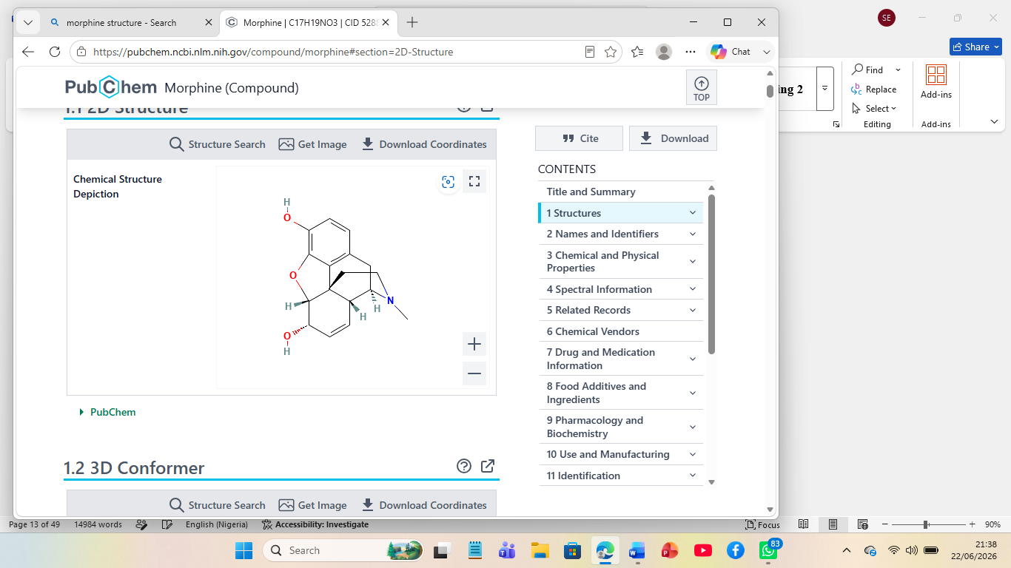
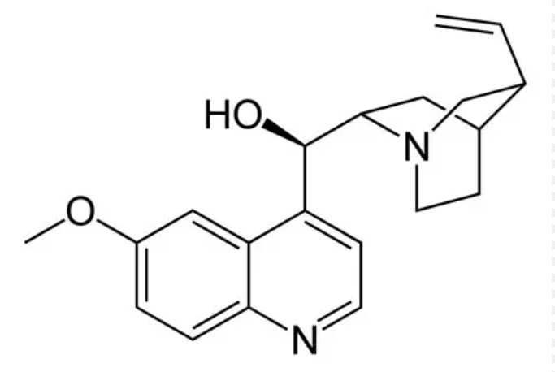
Morphine Quinine

(ii) Protoalkaloids, which are amino acid-derived but lack a heterocyclic nitrogen ring (e.g., mescaline, ephedrine)

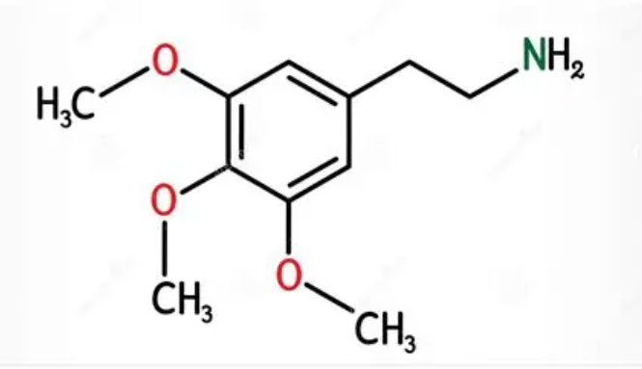
Mescaline
(iii) Pseudoalkaloids - are not derived from amino acid precursors but contain nitrogen (e.g., steroidal alkaloids such as solanine, purine alkaloids such as caffeine and theobromine) (Harborne, 1998).
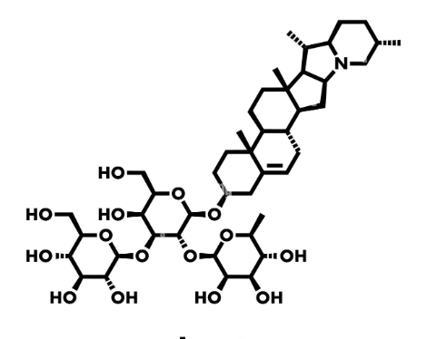
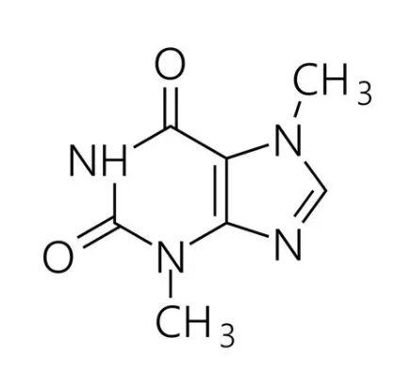
Solanine Caffeine
Figure 1: Examples of Alkaloids

Well-known pharmacologically important alkaloids include morphine and codeine (analgesics from Papaver somniferum), quinine (antimalarial from Cinchona species), vincristine and vinblastine (anticancer agents from Catharanthus roseus), and reserpine (antihypertensive from Rauwolfiaserpentina).
While alkaloids are not the dominant secondary metabolite class in avocado seeds, their presence has been confirmed in multiple independent studies using standard colorimetric and precipitation-based detection tests. Adeyemi et al. (2002) detected alkaloids in both aqueous and ethanolic extracts of avocado seeds using the Dragendorff reagent (potassium bismuth iodide yielding an orange-red precipitate with alkaloids), Mayer's reagent (potassium mercuric iodide yielding a cream-coloured precipitate), and Wagner's reagent (iodine in potassium iodide yielding a reddish-brown precipitate).
Positive results from at least two of these three confirmatory tests are accepted as definitive qualitative evidence of alkaloid presence (Trease and Evans, 2002). The ethanolic extract consistently yielded higher alkaloid content than the aqueous extract, attributable to the greater solubility of free-base alkaloids in organic solvents compared to their ionized salt forms in aqueous systems. Ojewole and Amabeoku (2006) demonstrated that ethanolic extracts of avocado seed possessed significant analgesic and anticonvulsant activity in rodent models, and proposed that these effects were mediated, at least in part, by alkaloid-type compounds acting on opioidergic and GABAergic receptor systems. Quantitative assessment by Eze et al. (2021) reported alkaloid concentrations of 0.87–2.14 g/100 g dry weight in avocado seed extracts, with ethanolic extracts consistently yielding higher values than aqueous counterparts.

2.3.2 Flavonoids
Flavonoids represent the largest and one of the most diversified group of secondary polyphenolic metabolites from the plants. Flavonoid molecule is based on a 15-carbon C-C-C skeleton, composed of two aromatic benzene rings (ring A and B), bridged together through a C3 unit that typically completes an oxygen-containing heterocyclic ring (ring C) (Panche et al., 2016). Modifications in the above fundamental structure based on chemical (e.g., hydroxylation, methoxylation, glycosylation, prenylation, acylation etc.) nature result in about 8000 different flavonoids currently isolated from the plants. The classes of flavonoids can be subdivided based on the number of hydroxylation, substitution and the level of oxidation on ring C.
Some examples include flavanols (e.g., quercetin, kaempferol and myricetin), flavones (e.g., luteolin, apigenin and chrysin), flavanones (e.g., naringenin, hesperidin and eriodictyol), flavanonols (e.g., taxifolin), isoflavones (e.g., genistein, daidzein and formononetin), anthocyanidins (e.g., cyanidin, delphinidin and malvidin) and chalcones (e.g., butein and isoliquiritigenin) (Harborne, 1998).

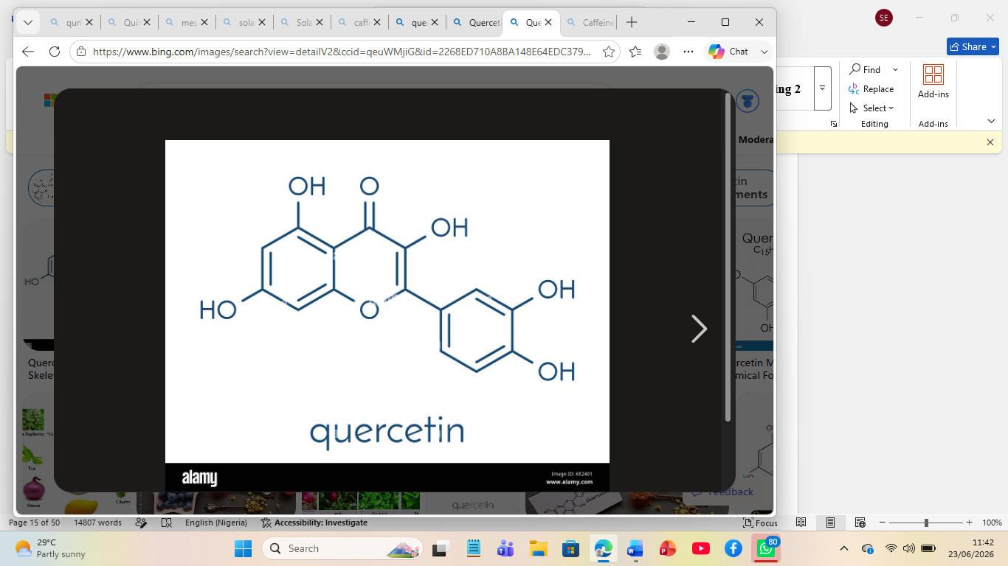
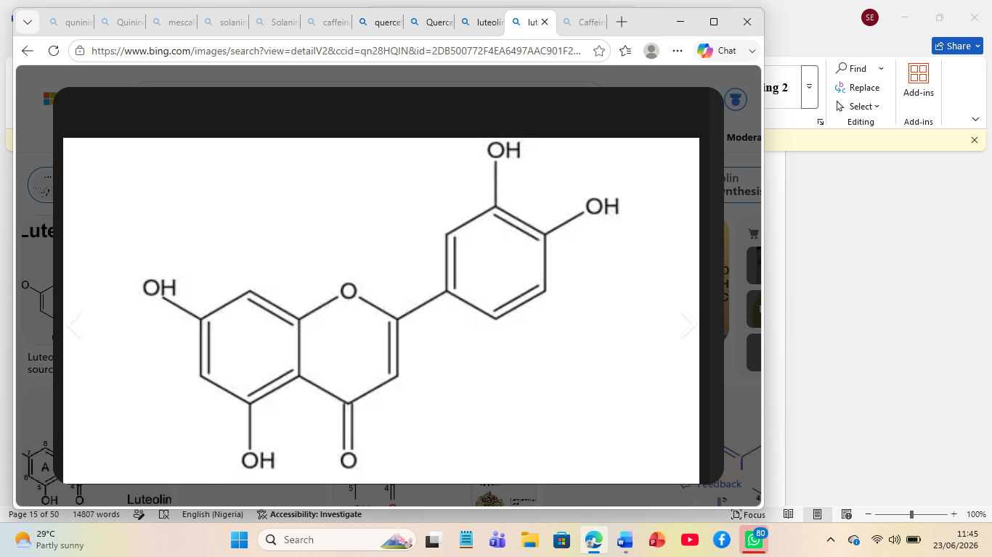
Quercetin Luteolin
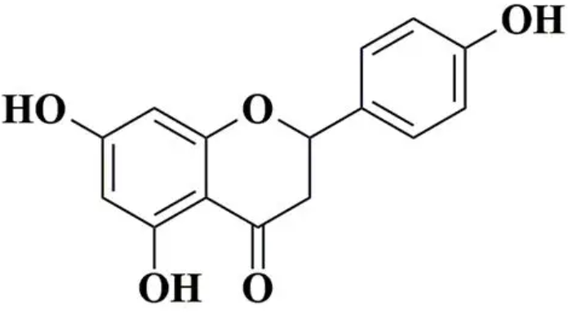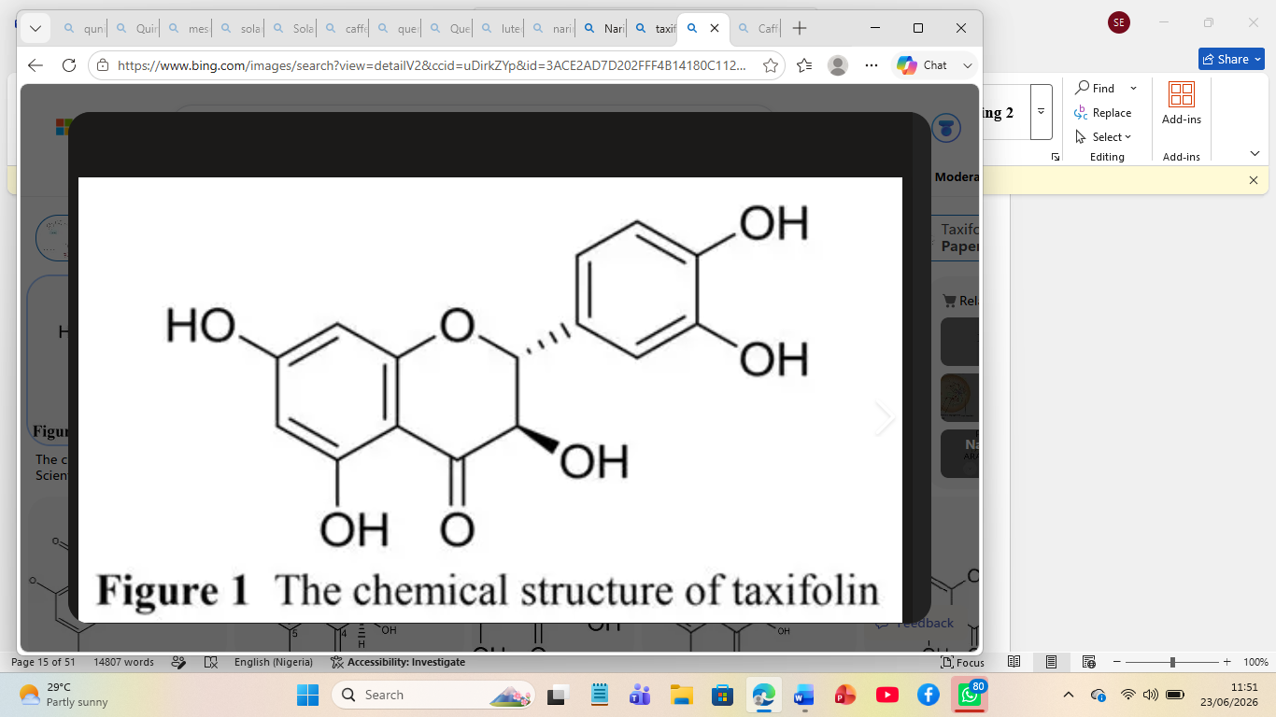
Naringenin Taxifolin
Figure 2: Examples of Flavonoids

Flavonoids exert their antioxidant activity primarily through three complementary mechanisms:
- Direct scavenging of free radicals and reactive oxygen species (ROS) through hydrogen atom or single electron donation from phenolic hydroxyl groups;
- Metal chelation particularly of redox-active iron and copper ions through the C3-hydroxyl and C4-keto groups of flavanol’s, thereby suppressing metal-catalysed radical generation via Fenton and Haber-Weiss reactions; and
- Inhibition of pro-oxidant enzymes including xanthine oxidase and lipoxygenase (Williams et al., 2004). Beyond antioxidant activity, flavonoids modulate signalling pathways involved in inflammation, apoptosis, and cell proliferation effects mediated through inhibition of nuclear factor kappa B (NF-κB) transcription, suppression of cyclooxygenase-2 (COX-2) and inducible nitric oxide synthase (ions’) expression, and activation of pro-apoptotic caspase cascades (Ogunka-Nnoka and Mepba, 2008).
Avocado seeds have been shown to contain representatives of multiple flavonoid subclasses. Duarte et al. (2016) employed LC-MS to identify eleven flavonoid compounds in avocado seed extracts, including quercetin-3-O-glucoside, kaempferol-3-O-rutinoside, luteolin-7-O-glucoside, and a series of procyanidin A-type and B-type oligomers. Quercetin and its glycoside derivatives were consistently among the most abundant individual flavonoids detected, consistent with their widespread distribution throughout the Lauraceae family. A comprehensive review by Ramos-Jerz et al. (2016) confirmed that quercetin, catechin, epicatechin, and their glycoside conjugates constitute the principal flavonoid fraction of avocado seeds, with total flavonoid content (TFC) values determined by the aluminium chloride (AlCl₃) colorimetric method and expressed as milligrams of quercetin equivalents (QE) per gram dry extract ranging from 12.4 to 68.7 mg QE/g dry extract depending on solvent system and extraction conditions. Recent HPLC-DAD analysis by González-González et al. (2023) confirmed luteolin and apigenin as additional significant flavonoid constituents, with these compounds demonstrating potent anti-inflammatory activity through inhibition of NF-κB signalling and COX-2 expression. The ethanolic extract consistently yields higher TFC values than the aqueous extract in comparative studies due to the greater solubility of flavonoid aglycones and moderately polar glycosides in ethanol (Naczk and Shahidi, 2004).

2.3.3 Tannins
Tannins are defined as a heterogeneous group of high-molecular-weight polyphenolic plant secondary metabolites possessing the distinctive ability to precipitate proteins from aqueous solution and to tan animal hides through the formation of stable, multi-point hydrogen bonds and hydrophobic interactions with protein amide bonds and non-polar amino acid residues (Bele et al., 2010; Harborne, 1998). They are classified into two major structural categories based on their chemical nature and hydrolytic behaviour:
- condensed tannins (proanthocyanidins), which are oligomeric or polymeric flavan-3-ol (catechin and epicatechin) derivatives linked through C4–C8 or C4–C6 interflavanoic bonds and are resistant to hydrolysis.
- (ii) hydrolysable tannins, which are ester derivatives of gallic acid (Gallo tannins, e.g., tannic acid, pentagalloylglucose) or ellagic acid (ellagitannins, e.g., punicalagin, ellagic acid) esterified to a polyol core, typically glucose, and are readily cleaved by acid, base, or enzymatic hydrolysis (Chung et al., 1998). A third structurally unusual subclass A-type proanthocyanidins is characterized by an additional C-O-C ether linkage between flavan-3-ol units in addition to the standard C–C interflavanoic bond, forming a doubly linked structure with distinctive biological activities (Gu et al., 2003).
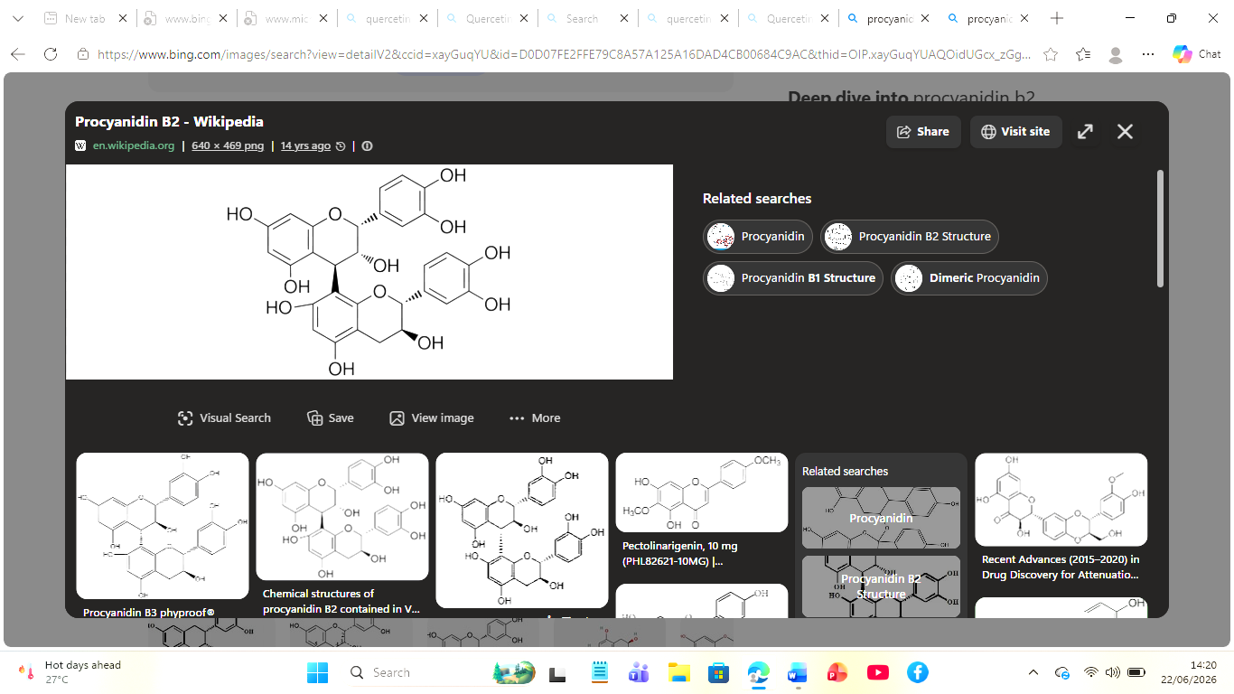
Figure 3: Schematic structure of Procyanidin B2 — a B-type condensed tannin (proanthocyanidin).

Avocado seeds are particularly rich in condensed tannins, specifically B-type proanthocyanidins (linked C4→C8) and the structurally unusual A-type procyanidins. Rodriguez-Carpena et al. (2011) identified procyanidins B1, B2, and several A-type dimers and trimers as major constituents of avocado seed phenolic extracts through HPLC-MS analysis. The total tannin content (TTC) of avocado seed extracts has been quantified in multiple studies using the modified Folin-Denis method, which measures total polyphenolic content before and after precipitation of tannins with hide powder or polyvinylpolypyrrolidone (PVPP), with results expressed as milligrams of tannic acid equivalents (TAE) per gram dry extract (Van-Burden and Robinson, 1981). Leite et al. (2009) reported tannin concentrations of approximately 4.3 g/100 g dry weight in avocado seed powder. Nwaoguikpe (2010) reported comparable values of approximately 4.1 g/100 g. More recently, Mwaurah et al. (2020) reported total tannin values of 3.8–5.6 g/100 g in ripe avocado seeds, while Ojo et al. (2023) confirmed tannin concentrations within a similar range in Nigerian cultivars. These concentrations are notably high, exceeding those reported for many traditional tannin-rich plant materials such as oak bark and tea leaves under equivalent extraction conditions, and are consistent with the strong antimicrobial, antioxidant, and protein-precipitating activities widely reported for avocado seed extracts.
The extraction efficiency of tannins is strongly solvent-dependent. While both aqueous and ethanolic solvents effectively extract tannins, aqueous solvents tend to favour hydrolysable tannins due to their greater hydrophilicity, whereas ethanol extracts both condensed and hydrolysable tannins, often yielding a higher total tannin content (Harborne, 1998). At the nutritional level, high tannin content represents an anti-nutritional factor through the formation of insoluble tannin-protein complexes that reduce protein digestibility and mineral bioavailability — an aspect discussed in detail in Section 2.6 of this review.

2.3.4 Saponins
Saponins are a structurally diverse class of plant secondary metabolites defined as amphiphilic glycosides composed of a lipophilic polycyclic aglycone (sapogenin) either steroidal (C27, based on the cholestane skeleton) or triterpenoid (C30, most commonly based on the oleanane, ursine, or dammarane skeleton) covalently linked to one or more hydrophilic sugar chains (mono- or oligosaccharides) through an O-glycosidic bond (Osbourn et al., 2011). The coexistence of the lipophilic aglycone and hydrophilic sugar moieties within the same molecule confers pronounced amphiphilic (surfactant) properties to saponins, manifested macroscopically as the formation of stable, persistent foam upon vigorous shaking of aqueous solutions a property exploited as the basis of the qualitative foam test for saponin detection in phytochemical screening (Sofowora, 2008). Representative examples of pharmacologically important saponins include glycyrrhizin from Glycyrrhiza glabra (liquorice root), ginsenosides from Panax ginseng, escin from horse chestnut (Aesculus hippocastanum), and QS-21 from Quillaia Saponaria used as a vaccine adjuvant.
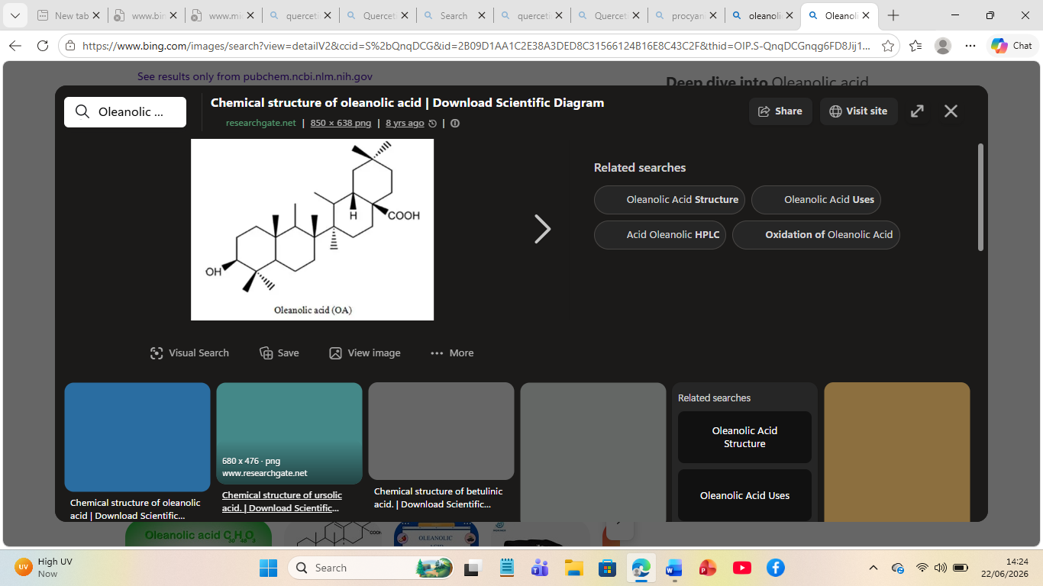
Figure 2.4: Schematic structure of Oleanolic Acid — the triterpenoid aglycone (sapogenin) of the principal avocado seed saponins.

Saponins in avocado seeds have been characterized as predominantly triterpenoid in structure, consistent with the established biosynthetic capacity of the Lauraceae family to produce oleanane- and ursine-type triterpenoid saponins (Sofowora, 2008). Nwaoguikpe (2010) reported saponin content of approximately 1.62 g/100 g dry weight in avocado seed powder determined by the gravimetric method of Obadoni and Ochuko (2001), which involves aqueous-butanol partition of the crude extract followed by evaporation of the butanol-soluble fraction and gravimetric quantification of the residue. Ofori et al. (2020) reported saponin content of 1.21–2.87 g/100 g in avocado seed extracts from Ghanaian cultivars. Aqueous solvents typically extract higher saponin concentrations than organic solvents due to the enhanced aqueous solubility of the saponin glycoside sugar chains (Van-Burden and Robinson, 1981). Pharmacologically, avocado seed saponins have attracted interest for their cholesterol-lowering properties achieved through formation of insoluble complexes with bile acids and intestinal cholesterol, interfering with micelle formation and cholesterol absorption as well as their potential as immunostimulants and vaccine adjuvants (Sparg et al., 2004; Ojo et al., 2023).

2.3.5 Sterols (Phytosterols)
Phytosterols also termed plant sterols are defined as triterpenoid lipids of plant origin that are structurally analogous to mammalian cholesterol, sharing the same tetracyclic cyclopentanoperhydrophenanthrene (sterane) ring system but differing in the nature and configuration of the substituents at the C-17 side chain and, in many cases, at C-24 (Piironen et al., 2000). They are biosynthesized in plants via the mevalonate pathway from isopentenyl pyrophosphate precursors, with the triterpenoid intermediate squalene serving as the immediate common precursor to all phytosterols through the action of oxidisable cyclase’s. The most abundant and well-characterized phytosterols include β-sitosterol, camp sterol, stigmasterol, brassica sterol, and Δ5-avenasterol. Among these, β-sitosterol which differs from cholesterol only by the presence of an additional ethyl group at C-24 of the side chain is the most widely distributed phytosterol in the plant kingdom (Ostlund, 2002).

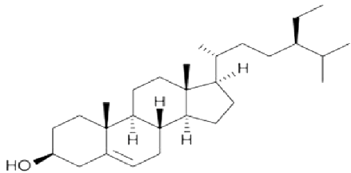
Figure 2.5: Chemical structure of β-Sitosterol (C₂₉H₅₀O) — the dominant phytosterol of avocado seeds.

In avocado seeds, beta-sitosterol, camp sterol, and stigmasterol have been identified as the principal phytosterol constituents in lipid fractions through GC-MS analysis (Dreher and Davenport, 2013). Dreher and Davenport (2013) reported beta-sitosterol as the predominant phytosterol, comprising 76–82% of the total phytosterol fraction. The Liebermann-Burchard test which produces a characteristic green to blue-green colorimetric response with steroids and triterpenoids bearing a Δ5,6-double bond in the steroid nucleus is the standard qualitative test for detecting sterols in phytochemical screening (Trease and Evans, 2002). Phytosterols compete with dietary cholesterol for intestinal absorption through displacement from lipid micelles in the intestinal lumen, thereby reducing circulating LDL-cholesterol concentrations a mechanism well-validated in both animal models and clinical studies and directly relevant to the cardiovascular applications of avocado seed preparations (Ostlund, 2002; Ramos et al., 2021). Steroids also encompass cardiac glycosides steroidal glycosides bearing a lactone ring at C-17 whose presence in avocado seeds was qualitatively confirmed by Adeyemi et al. (2002) using the Keller-Killiani test.

2.3.6 Polyphenols
Polyphenols are widely viewed as a heterogenous family of plant secondary metabolites characterized by the possession of multiple phenelic rings, each bearing one or more hydroxyl groups. Fenolic compounds form an extremely diverse structural class which spans from low molecular weight simple fenelic acids to high molecular weight tannins with a MW higher than 20,000 Da (Tsao, 2010). A series of distinct classes of compounds have currently been classified under the name of polyphenols. These have currently been identified to be (i) fenelic acids (these may be divided in hydroxybenzoic acids, i.e. Gallic, protocatechuic, vanillic and syringic acids and hydroxycinnamic acids, i.e. Caffeic, ferulic, sinapic and chlorogenic acids, which are an ester of caffeic and quinic acids) (ii) stilbenes, i.e. Resveratrol, in particular, found in grapes (iii) lignans, which comprise the secoisolariciresinol and matairesinol classes (iv) flavonoids (this section will not address the different families, which have already been discussed in section 2.3.2), and (v) tannins (which will be detailed in section 2.3.3) The Folin-Ciocalteu assay is a popular colourimetric technique to quantify TPC from plant extract based on the reduction of a mixed phosphotungstic acid and phosphomolybdic acid solution to blue coloured species, which exhibits a maximum absorption in alkali at 765nm thanks to its phenelic hydroxyls, and are generally expressed in milligrams of gallic acid equivalents per gram of dry sample (Singleton et al., 1999).

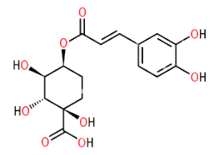
Figure 2.6: Chemical structure of Chlorogenic Acid (5-Caffeoylquinic Acid; C₁₆H₁₈O₉) — the most abundant individual polyphenol in avocado seeds.

The presence of diverse phenolics such as protocatechuic acid, caffeic acid, vanillic acid, syringic acid, chlorogenic acid, and different protocyandin oligomers (oligomers B1, B2 and dimers/trimers A type) was detected in extracts of avocado seed from three Persea species by comprehensive HPLC-DAD analysis in (Rodriguez-Carpena et al., 2011). Chlorogenic acid (5-caffeoylquinic acid) is one of the most common individual phenolic acids found in avocado seeds; it presents strong anti-inflammatory and antioxidant properties and has beneficial implications on insulin sensitivity and glucose metabolism shown experimentally (Tajik et al., 2017). Protocatechuic acid also a common present component with established anti-inflammatory, hepatoprotective and neuroprotective potential both in vitro and in vivo systems (Masella et al., 2012).
Total phenolic content in various solvent fractions obtained from extracts of avocado seed was found to vary from 45.2 to 425 mg GAE/g dry weight with highly concentrated samples when polar solvents (ethanol, methanol) are used (Dabas et al., 2013; Arukwe et al., 2012).
TPC in avocado seeds was significantly higher compared to that in the flesh and similar or higher compared to those of well known antioxidant-containing fruits such as grapes and pomegranates (Soong and Barlow, 2004).

2.3.7 Terpenes/Terpenoids
The largest family of diverse plant secondary products are the isoprenoids or terpenoids, the other two are alkaloids and phenolics. Plant natural products classified as terpenoids is derived by linear assembly or head to tail linkage of the five carbon isoprene unit (2-methylbuta-1,3-diene), which is obtained from its activation precursors IPP (isopentenyl pyrophosphate) and DMAPP (dimethylallyl pyrophosphate). Plant terpenoid can be produced through two major biosynthetic pathway: Mevalonate (MVA) pathway which occur in the cytoplasm and ER, and 2-C-methyl-D-erythritol 4-phosphate (MEP/DOXP) pathway that occur in plastid (Croteau et al., 2000).
Terpenoids are divided into different types based upon the number of C₅ isoprene units that have been incorporated. The different types are hemiterpenoids (C₅), monoterpenoids (C₁₀), sesquiterpenoids (C₁₅), diterpenoids (C₂₀), triterpenoids (C₃₀), and tetraterpenoids (C₄₀). Examples of some of these classes include menthol, camphor, and limonene for monoterpenoids; farnesol, artemisinin, and β-caryophyllene for sesquiterpenoids; Taxol, ginkgolide,
The remarkable diversity exhibited by terpenoids is primarily attributable to the cyclization of key intermediates, including geranylgeranyl pyrophosphate and farnesyl pyrophosphate, through the catalytic action of terpene synthase enzymes. These reactions generate a wide range of carbon skeletons and ring structures, which are subsequently modified by enzymes such as hydroxylases, reductases, and glycosyltransferases, thereby producing the extensive variety of terpenoid compounds observed in nature (Dewick, 2009).

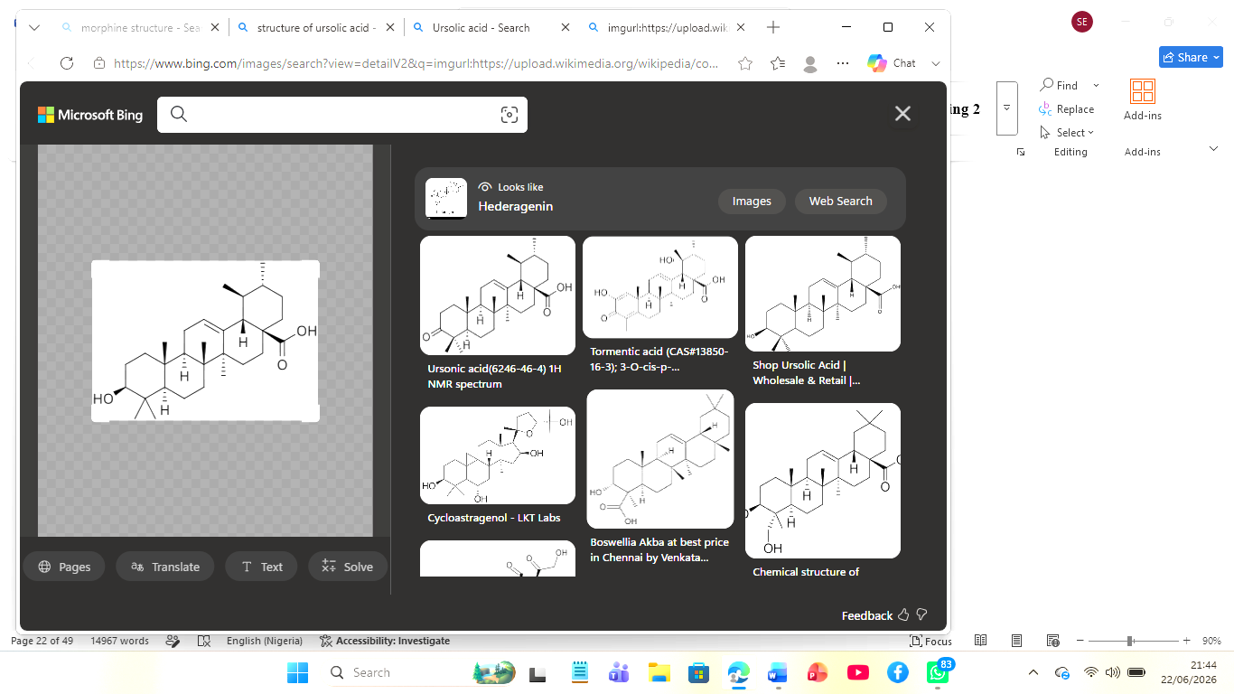
Figure 2.7a: Chemical structure of Ursolic Acid (3β-Hydroxy-urs-12-en-28-oic acid; C₃₀H₄₈O₃).
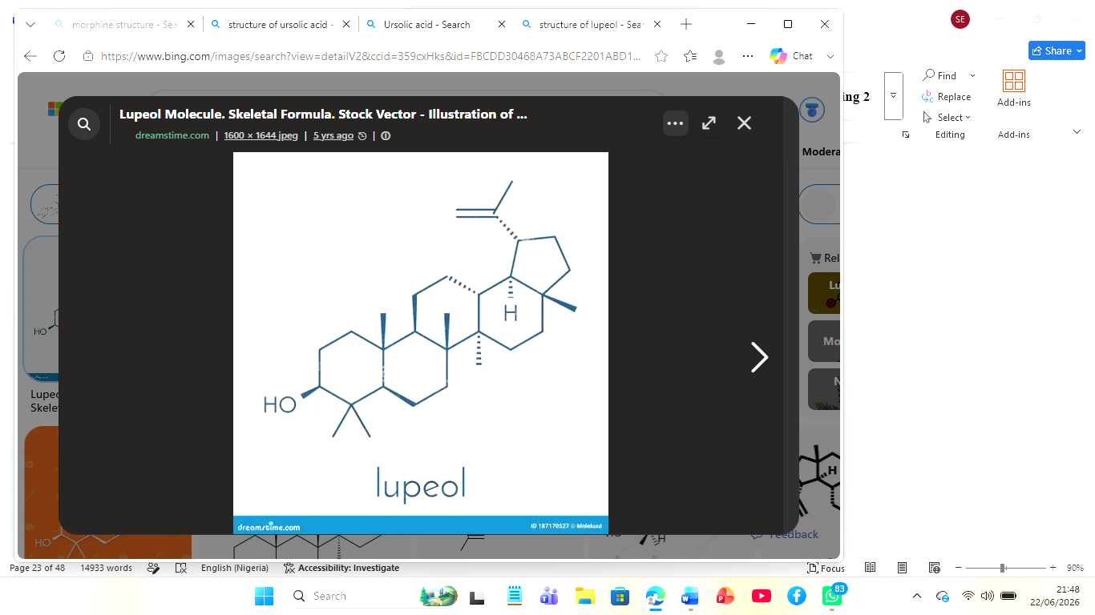
Figure 2.7b: Chemical structure of Lupeol (Lup-20(29)-en-3β-ol; C₃₀H₅₀O)
Sesquiterpenoids and triterpenoids are found in seeds of the fruit avocado. There is literature on the occurrence of three main pentacyclic triterpenoids such as the oleanolic acid, ursolic acid and lupeol which represent the oleanane, ursane and lupane skeletal type, respectively that are found in the apolar fraction of avocado seeds (Jimenez-Arellanes et al., 2007). The triterpenoids ursolic acid (3-hydroxy-urs-12-en-28-oic acid) and oleanolic acid (3-hydroxy-olean-12-en-28-oic acid) are isomers of pentacyclic triterpenoids and have numerous anti-inflammatory activity, by inhibiting the transcription nuclear factor NF-kappa B and pro-inflammatory cytokines expression such as TNF-alpha, IL-1 and IL-6; also decreasing Ca2+ levels and cyclooxygenase-2 (COX-2) expression in macrophages stimulated by LPS (Ramos et al., 2015). Also, the lupane type triterpenoidlupeol (lup-20(29)-en-3-ol) has several effects that include the hepatoprotective action, the chemopreventive and anticancer effects, and the anti-inflammatory action in several experimental animal models of disease (Jimenez-Arellanes et al., 2007).
Fulgencio et al. (2022) identify Oleanolic acid, ursolic acid and lupeol as the most abundant triterpenoids on the basis of their investigation of seeds of avocado varieties of Brazilian cultivars. They determined that these compounds could amount to 1.4 to 3.7 g/100 g dry weight (g dw) on a dry weight basis. The classic chemical identification tests for the identification of triterpenoids in a phytochemical examination, include the Salkowski test, which involves forming a reddish-brown color ring between chloroform and H2SO4, and the Lieberman-Burchard reaction (Harborne, 1998; Trease and Evans, 2002).

2.4 Proximate Composition Studies on Avocado Seeds
Proximate analysis also termed the Wende system of analysis is a systematic analytical framework developed by Henneberg and Stohlman in the 1860s that partitions a food or plant material into six broad compositional fractions: moisture, ash (total mineral residue), crude protein, crude lipid (ether extract), crude fibre, and nitrogen-free extract (carbohydrate by difference) (AOAC, 2016). Although originally developed for animal feed evaluation, proximate analysis has been widely adopted in food science, nutritional biochemistry, and phytochemical research as the foundational nutritional characterization framework for plant materials. Avocado seeds have been subjected to proximate analysis in several studies across different geographic contexts, collectively demonstrating that seeds are predominantly carbohydrate-rich storage organs with moderate protein and lipid content (Nwaoguikpe, 2010; Aremu et al., 2019; Mwaurah et al., 2020).

2.4.1 Ash Content
Ash content is defined as the mass of inorganic residue principally mineral salts and oxides remaining after complete combustion of all organic matter in a muffle furnace at 550–600°C for a defined period, typically 4–6 hours, expressed as a percentage of the original sample dry weight (AOAC, 2016). It represents an indirect measure of the total inorganic mineral content of the sample, encompassing both macro-minerals (calcium, magnesium, potassium, sodium, phosphorus) and trace elements (iron, zinc, copper, manganese), but does not distinguish between mineral species or provide information on individual element concentrations which require atomic absorption spectrophotometry or inductively coupled plasma spectrometry for resolution. Nwaoguikpe (2010) reported ash content of approximately 3.5% in avocado seeds on a dry weight basis. Mwaurah et al. (2020) reported ash values of 2.1–4.3% across different avocado cultivars and processing conditions, with variation attributed to differences in geographic growing conditions and soil mineral composition. Aremu et al. (2019) reported ash content of 3.2 ± 0.4% dry weight basis in Nigerian avocado seeds, consistent with values for other tropical seed materials. High ash content is indicative of a relatively rich total mineral profile, supporting the nutritional significance of the avocado seed matrix and providing justification for quantitative mineral analysis.

2.4.2 Crude Fibre
Crude fibre is defined as the organic residue remaining after sequential extraction of a ground, defatted plant sample with dilute sulphuric acid (1.25% H₂SO₄) and dilute sodium hydroxide (1.25% NaOH) solutions under standardized reflux conditions, followed by ignition of the dried residue; the loss on ignition represents the crude fibre content (AOAC, 2016). It consists primarily of indigestible structural carbohydrates cellulose, hemicellulose (partially), and lignin and represents the indigestible fibre fraction of the plant material. Crude fibre is distinct from dietary fibre, which encompasses a broader spectrum of indigestible polysaccharides not captured by the acid-alkali Wende method. Avocado seeds exhibit a substantial crude fibre content, reflecting their role as a structural cotyledonary storage organ. Nwaoguikpe (2010) reported crude fibre values of approximately 8.6% dry weight basis. Mwaurah et al. (2020) reported crude fibre values of 6.2–11.4% across various avocado seed samples from East African cultivars, with variation attributable to cultivar differences and drying methods employed. Ojo et al. (2023) confirmed crude fibre values of 7.3–9.8% in Nigerian avocado seeds.

2.4.3 Crude Protein
Crude protein was analyzed by kjeldahl nitrogen determination method following 3 standard steps of analysis, which includes (i) acid digestion of the sample in concentrated sulphuric acid with the aid of a catalyst to convert organic nitrogen in the sample to ammonium sulphate; (ii) alkaline distillation in a Kjelldahl apparatus to distill out ammonia and then; (iii) titration of the distillate to determine total nitrogen. Crude protein was computed by multiplying percentage total nitrogen by the established conversion factor of 6.25 on the basis of protein average 16% N. Crude protein is given as a percentage on the dry weight basis (AOAC, 2016). Nwaoguikpe (2010) found crude protein in the range of approximately 5.2 % dry weight of avocado seeds.
Aremu et al. (2019) obtained 4.8 0.6% in Nigerian avocado seed. Mwaurah et al. (2020) recorded crude protein contents ranging from 4.1 to 6.3% in EastAfrican avocado cultivars and Ojo et al. (2023) reported 5.4-6.8% for nigerian avocado seeds.

2.4.4 Moisture Content
Moisture content is defined as the percentage loss in mass when a sample is dried to constant weight at 105°C in a convection oven until no further mass loss occurs representing the mass of free water removed from the sample expressed as a percentage of the original wet weight (AOAC, 2016). Avocado seeds are classified as recalcitrant (desiccation-sensitive) in their fresh state, containing high moisture levels prior to processing. Upon standardized drying and pulverization, moisture content is substantially reduced to levels suitable for phytochemical investigation and extract preparation. Nwaoguikpe (2010) reported moisture content of approximately 4.8% in dried avocado seed powder. Mwaurah et al. (2020) reported moisture values of 3.4–7.8% depending on drying conditions employed. Ojo et al. (2023) reported moisture content of 5.2 ± 0.3% in oven-dried Nigerian avocado seeds.

2.4.5 Crude Lipid
Crude lipid content also referred to as the ether extract (EE) is determined by continuous Soxhlet extraction of a dried, ground sample with a non-polar organic solvent (typically petroleum ether or diethyl ether) for a defined period (typically 6–8 hours), followed by evaporation of the solvent and gravimetric quantification of the non-volatile residue (AOAC, 2016). This method extracts not only true triglyceride fats and oils but also all non-polar and moderately non-polar lipophilic substances, including phospholipids, sterols, fat-soluble vitamins (A, D, E, K), waxes, pigments (chlorophylls, carotenoids), and non-polar secondary metabolites such as terpenoids and long-chain hydrocarbons. Nwaoguikpe (2010) reported crude fat content of approximately 3.1% dry weight in avocado seeds. Aremu et al. (2019) reported crude lipid values of 2.8 ± 0.3% for Nigerian avocado seeds, while Mwaurah et al. (2020) reported 2.4–4.2% across East African cultivars, and Ojo et al. (2023) reported 3.1–4.6% in Nigerian samples. The lipid fraction of avocado seeds contains a profile of fatty acids including oleic acid (C18:1, monounsaturated), linoleic acid (C18:2, polyunsaturated), palmitic acid (C16:0, saturated), and stearic acid (C18:0, saturated), with oleic acid predominating (Dreher and Davenport, 2013).

2.4.6 Carbohydrate
Carbohydrate content in proximate analysis is conventionally determined by difference calculated as 100% minus the sum of percentage moisture, ash, crude protein, crude lipid, and crude fibre contents and therefore represents the nitrogen-free extract (NFE) fraction, encompassing all digestible carbohydrates including starch, mono- and disaccharides, soluble oligosaccharides, and soluble dietary fibre not captured by the crude fibre determination (AOAC, 2016). Avocado seeds are primarily carbohydrate-rich storage organs, with starch constituting the dominant carbohydrate fraction. Nwaoguikpe (2010) reported carbohydrate content of approximately 74.8% dry weight basis, reflecting the seed's primary function as a starch storage organ supporting seedling establishment during germination. Starch constitutes 32–40% of avocado seed dry weight (Yahia and Woolf, 2011). Mwaurah et al. (2020) confirmed high carbohydrate content of 68.4–76.2% across different avocado cultivars.

2.5 Mineral Content Evaluation of Avocado Seeds
Minerals are inorganic elements that are essential for a wide spectrum of physiological functions in living organisms, including structural roles (calcium, phosphorus in bone and teeth), enzymatic cofactor roles (zinc, magnesium, manganese, copper), oxygen transport (iron in haemoglobin), antioxidant defence (selenium, copper), and electrolyte and osmotic regulation (sodium, potassium, chloride) (Gropper and Smith, 2013). Mineral analysis of plant materials is standardly performed by atomic absorption spectrophotometry (AAS), inductively coupled plasma optical emission spectrometry (ICP-OES), or inductively coupled plasma mass spectrometry (ICP-MS) following wet or dry ashing and complete acid digestion of the sample matrix (AOAC, 2016). The mineral content of avocado seeds encompasses both nutritionally beneficial essential macro- and microelements and potentially toxic heavy metals whose presence must be assessed for safety evaluation prior to the development of seed-derived food products or nutraceuticals.

2.5.1 Macro minerals
Calcium (Ca) is the most abundant mineral in the human body (approximately 1,000–1,200 g in the adult human), with 99% residing in the skeleton and teeth as hydroxyapatite [Ca₁₀(PO₄) ₆(OH)₂]. Beyond its structural role, calcium is essential for neuromuscular transmission, cardiac rhythm, hormone secretion, and enzyme cofactor function (Gropper and Smith, 2013). Adeyemi et al. (2002) reported calcium levels of 52.3 mg/100 g dry weight in avocado seeds; Aremu et al. (2019) reported values of 48.6 ± 3.2 mg/100 g; and Mwaurah et al. (2020) documented values of 41.2–68.4 mg/100 g across East African cultivars.
Magnesium (Mg) is an essential macro mineral serving as a cofactor for over 300 enzymatic reactions, including ATP synthesis, DNA replication, RNA transcription, and protein synthesis; it also plays a critical structural role in chlorophyll and a regulatory role in cardiovascular health, neuromuscular function, and glucose metabolism (de Baaij et al., 2015). Mwaurah et al. (2020) reported magnesium content of 76.4–124.8 mg/100 g dry weight in East African avocado seeds, and Aremu et al. (2019) reported 84.2 ± 5.6 mg/100 g in Nigerian samples.
Sodium (Na) is the principal extracellular cation, essential for maintaining osmotic pressure, acid-base balance, and the generation of membrane action potentials in excitable cells including neurons and cardiac myocytes. Aremu et al. (2019) reported sodium content of 12.4 ± 1.8 mg/100 g in Nigerian avocado seeds; Mwaurah et al. (2020) reported values of 9.6–18.3 mg/100 g.
Potassium (K) is the predominant intracellular cation in mammalian cells, essential for maintaining resting membrane potential, cardiac rhythm, skeletal muscle contraction, and renal tubular function; adequate dietary potassium intake is associated with reduced risk of hypertension and stroke (Weaver, 2013). Mwaurah et al. (2020) reported potassium values of 285.3–412.7 mg/100 g dry weight, and Aremu et al. (2019) reported 318.4 ± 22.6 mg/100 g in Nigerian samples.

2.5.2 Microminerals (Trace Elements)

Iron (Fe) is essential for haemoglobin synthesis (as the prosthetic haem group of haemoglobin and myoglobin), function of the electron transport chain (as cytochromes and iron-sulphur cluster proteins) and many iron-containing enzymes such as ribonucleotide reductase and aconitase in the TCA cycle (Lieu et al., 2001). Avocado seeds contain 4.2–9.6 mg iron/100 g (cultivar and soil iron) (Mwaurah et al., 2020) or 6.8 mg/100 g (Adeyemi et al., 2002).
Zinc (Zn): It is a trace element used as a component of zinc-finger transcription factors and a catalytic cofactor in over 300 enzymes, including carbon ic anhydrase, carboxy-peptidases, al-cohol de-hydrogenase, and al-kaline phosphatase. The element plays crucial role in immunocom-petence, wound heal-ing, protein synthesis, and reproductive per-formance (Prasad, 2013). Zincontent reported by Aremu et al. (2019) in Nigerian avocado seed was 1.6 0.2 mg/100 g. Zincontent of avocado seeds ranging from 1.2 to 2.4 mg/100 g was obtained by Mwaurah et al.(2020).

Copper (Cu) is an essential trace element, it is the prosthetic group cofactor for a variety of important enzymes, including cytochrome c oxidase (complex IV of the ET chain), copper-zinc superoxide dismutase (Cu/Zn-SOD), ceruloplasmin, lysin oxidase (necessary for cross-linking of collagen and elastin), and dopamine beta-hydroxylase (de Romana et al., 2011). Mwaurah et al. (2020) reported copper content of 0.8–1.4 mg/100 g in East African avocado seeds, and Aremu et al. (2019) reported 0.94 ± 0.08 mg/100 g in Nigerian seeds.

Manganese (Mn) is one of the essential micro-nutrients, which acts as a cofactor for manganese superoxide dismutase (Mn-SOD), an important mitochondrial antioxidant enzyme, manganese arginase, pyruvate carboxylase, and several glycosyltransferases in proteoglycan synthesis for bone and cartilage formation (Aschner and Aschner, 2005). Aremu et al. (2019) documented manganese content of 1.8 ± 0.2 mg/100 g in Nigerian avocado seeds; Mwaurah et al. (2020) reported values of 1.4–2.6 mg/100 g.

Selenium (Se) is a trace element, a selenoprotein, which is an unusual amino acid that is incorporated translationally into a family of selenoproteins that have critical collective functions in antioxidant defense, thyroid hormone metabolism, immune function, and male reproductive function (Rayman, 2012). The elemental analysis of avocado seeds recently reported trace-level selenium (0.002–0.018 mg/100 g) (Mwaurah et al., 2020).

2.5.3 Potentially Toxic Heavy Metals
Lead (Pb) is a toxic non-essential heavy metal with no established safe threshold for human exposure, recognized as a potent neurotoxin, nephrotoxin, haematotoxin, and developmental toxin. Chronic low-level lead exposure is associated with cognitive impairment in children, peripheral neuropathy, hypertension, and nephropathy in adults (Lanphear et al., 2005). Aremu et al. (2019) reported lead concentrations of 0.04 ± 0.01 mg/kg in Nigerian avocado seeds, well below the WHO/FAO maximum permissible limit of 0.3 mg/kg for food products. Mwaurah et al. (2020) reported lead levels of 0.02–0.07 mg/kg across East African cultivars.
Cadmium (Cd) is a highly toxic non-essential heavy metal classified as a Group 1 carcinogen by the IARC (2012), primarily targeting the kidneys (causing proximal tubular nephropathy and Itai-Itai disease with chronic high-level exposure), bones, and respiratory system. Available data on avocado seeds indicate cadmium at trace levels, typically below 0.05 mg/kg in seeds from non-contaminated growing areas (Mwaurah et al., 2020; Aremu et al., 2019).
Nickel (Ni) is a metal of toxicological concern at elevated dietary and occupational exposure levels, associated with contact dermatitis, respiratory sensitisation, and potential carcinogenicity. Nickel content in avocado seeds has been reported at 0.02–0.09 mg/100 g in limited studies, warranting further systematic evaluation, particularly in the context of chronic consumption of avocado seed-derived nutraceuticals (Aremu et al., 2019).

CHAPTER THREE

MATERIALS AND METHODS
3.1 Materials
1 Equipment/Apparatus
Equipment used included: analytical balance, muffle furnace, Kjeldahl digestion and distillation apparatus, Soxhlet extraction apparatus, UV-Vis’s spectrophotometer, atomic absorption spectrophotometer, rotary evaporator, pH meter, magnetic hotplate stirrer, oven, and standard volumetric glassware.
2. Reagents and Solvents
The reagents and solvents used are as follows;
Ethanol (80%), Double distilled water (laboratory made double glass distilled), Hydrochloric acid (HCl), Concentrated sulphuric acid (H2SO4), Concentrated nitric acid (HNO3), Sodium hydroxide (NaOH), Ammonium hydroxide (NH4OH), Ferric Chloride (FeCl3), Mayer's reagent, Wagner's reagent,
3.2 Methods

3.2.1 Preparation of Ethanolic and Aqueous Extracts
Extraction of Ethanolic extract Accurately weigh 50g of dried avocado seed powder in clean and stoppered glass bottle, and macerate with 1000 ml of 80% ethanol at room temperature 25-28⁰C for 72 hours and during maceration the slurry is stirred in intervals of 12 hours for achieving maximum contact between solute and solvent. Slurry was filtered to collect the filtrate and concentrated by rotary evaporator at 40⁰C under vacuum. The obtained residue was dried in Oven at 45⁰C to yield the ethanolic extract as a crude solid.

Aqueous extract Fifty grams of the same dried seeds powdered were macerated with 1 L of distilled water in a clean glass beaker at room temperature 25–28⁰C for 72 h with stirring once every 12 h in order to enhance optimum solute–solvent interaction. The slurry was then filtered (using different filters of different size) and the filtrate subsequently passed through a rotary evaporator at 40⁰C under reduced pressure to remove water as solvent and the solid crude extract collected was dried in a hot-air oven at 45⁰C and its yield was determined and stored at 4⁰C in amber coloured glass screw capped vial, which was free from extraneous materials.

3.2.2 Phytochemical Screening for Qualitative
Quantitative analysis of the different groups such as; Alkaloids, Flavonoids, Tannins, Saponins, Steroids, Polyphenols and Terpenes/Terpenoids was conducted by means of ethanolic and aqueous extract of ripe avocado seeds, and colorimetric/precipitation standards methods.
Alkaloids
1.Mayer’s Test
Procedure
Just a couple of drops of Mayer's reagent were added to 2 ml of the extract.
Observation
Alkaloids present indicated by the cream colored precipitate.
2. Wagner's Test
Take 2 ml of the filtrate into a clean test tube. Take 2-3 drops of Wagner's reagent and add to it. Shake lightly and observe the result.
Observation
Precipitate was reddish-brown or brown color, so there are alkaloids.

Flavonoids
Qualitative screening for flavonoids was performed by two tests. Shinoda Test
Procedure
2 drops of Magnesium ribbon was dissolved with 2mL of the extract along with 2mL concentrated HCl.
Observation
Red colouration confirmed the presence of flavonoids.
Alkaline Reagent Test
Procedure
2 drops of Sodium hydroxide solution were added to the extract.
Observation
Yellow coloration disappearing after acid addition confirmed flavonoids.
Tannins
Qualitative detection of tannins was performed using the ferric chloride test.
Procedure
Few drops of 5% ferric chloride solution were added to 2 mL of extract.
Observation
Blue-black colouration confirmed the presence of tannins.
Saponins
Qualitative detection of saponins was performed by the Froth (foam) test. Frothing Test
Procedure
5 mL of distilled water was added to 2 mL of extract. It was Shaken vigorously for 30 seconds and allow standing for 15 minutes.
Observation
Persistent froth or foam formation confirmed the presence of saponins.

Sterols
Qualitative detection of sterols (phytosterols) was performed using the Liebermann-Burchard test.
Procedure
Few drops of Acetic anhydride and concentrated sulfuric acid was added to extract dissolved in chloroform.
Observation
Blue-green coloration confirmed the presence of steroids.
Polyphenols
Qualitative detection of polyphenols was performed using the ferric chloride test.
Procedure
Few drops of Ferric chloride solution were added to extract.
Observation
Deep blue coloration confirmed the presence of phenolic compounds.

Terpenes/Terpenoids
Qualitative detection of terpenoids was performed using the Salkowski test.
Procedure
The Extract was mixed with few drops of chloroform. And concentrated sulfuric acid along the side of the test tube was equally added carefully
Observation
Reddish-brown coloration at the interface confirmed the presence of terpenoids.

3.2.3 Phytochemical screening of Quantitative Analysis
Quantitative determination was carried out for all screened classes using validated spectrophotometric and gravimetric methods described in the sub-sections below. Results are reported as mean ± standard deviation (SD) of three independent determinations (n = 3).
Alkaloids
The amount of total alkaloids in the sample was determined using gravimetric method. 5g powdered drug was transferred into a 250 mL beaker. To this was added 200 mL ethanol and 10 percent acetic acid solution. The contents of the beaker was covered and kept for 4 hours for extraction, filtered and evaporated to 1/5 of the volume. Later, to the evaporated solution concentrated ammonia solution was drop-wise added until there was no further precipitation.
Then precipitate was allowed to settle and the precipitate was filtered. To remove remaining impurities from the precipitate, it was washed with diluted ammonium hydroxide solution.
Flavonoids
10 g of the sample was weighed and the total flavonoid content (TFC) determination was done. This was after adding 100 mL of 80% aqueous methanol to it. This was done by shaking it for 24 hours after which it was filtered and dried to constant weight in a water bath.
Tannin
Analysis for tannin content this was determined spectrophotometrically. The sample (0.5g) was dissolved in distilled water (50ml) in a flask and shaken in an hour and then filtered into a volumetric flask and ferric chloride and potassium ferrocyanide was added and read at a wavelength of 720nm using spectrophotometer.

Saponin
Gravimetric method was applied to find the total saponins content. 20 g sample were powdered and dispersed into 200 mL of 20% ethanol. This solution was heated at 55oC in water bath for 4 hours with continuous agitation. Later on, filtered and the solid residue were treated with 200 mL of 20% ethanol. Filtrates of both steps were pooled and concentrated to about 40 mL.
It was subsequently transferred into the separating funnel and diethyl ether was added. Aqueous layer were separated and followed by n-butanol added. Collected combined n-butanol layer was washed with 5% sodium chloride.
Sterol
The sterol content was estimated by the official UV Spectrophotometric method by using -sitosterol as the standard in UV visible spectrophotometer with the measurement of absorbance at 420 nm, using Liebermann-Burchard color reaction and calculated as mg of -sitosterol equivalents per gram dry extract.
Polyphenols
Total phenolic contents were determined according to Folin-Ciocalteu (F-C) reagent method. 10% Folin-Ciocalteu reagent was added into the extract and the reaction mixture was followed by adding sodium carbonate solution. After 40 min incubation at room temperature, the reaction mixtures were evaluated for total phenolic content at 765 nm with a spectrophotometer.
Terpenes/Terpenoids
Total terpenoid content Total terpenoid content was calculated by taking 2 g of the sample and dipping it in alcohol for 24 hours. Afterwards the sample was filtered and extracted with the help of petroleum ether and ether. Finally, ether and petroleum ether extracts were evaporated to dryness and the dried residue was weighed to determine the total terpenoid content.

3.2.4 Proximate Analysis
The method for identifying the main nutrient composition of the sample in the laboratory is known as proximate analysis and determines water content, ash content, crude protein content, crude fat content, crude fibre content, and carbohydrate content. The proximate analysis is frequently performed on foods and drinks, pharmaceuticals, animal feeds, and studies on plant material, such as avocado seeds.

Moisture Content

Moisture content was measured by the gravimetric oven drying method. The crucible was properly washed and dried before use.

Empty crucible was dried in an oven for 30 minutes at 105°C. The crucible was then transferred to the desiccator and cooled down and weighed again (W₂). 5 g of the substance was placed in the crucible and its mass was measured once again (W₂). The material in the crucible was put in the oven and heated to 105°C for 3-4 hours.It was then removed and cooled in a desiccator. Then the crucible was reweighed with the dried sample (W₃). The drying was done again until a constant weight was achieved. Moisture content was calculated as: Moisture content (%) = [(W₁ − W₂) / W₁] × 100.

Ash Content

The ash content of the sample was determined using the muffle furnace method. The weight of 5.0 g of powdered avocado seed (W₁) was measured using the pre-weighed silica crucible (W₀) and then heated inside the muffle furnace at 600°C for 6 hours to obtain a grey-white/off white ash without any carbonaceous material. The cooled crucible was weighed again (W₂). Ash content (%) = [(W₂-W₀)/W₁] × 100.

Crude Fibre

Acid alkaline digestion technique was used for the determination of crude fibre. The sample was defatted before. 2g of the sample was weighed and placed in the flask and 200 ml of 1.25% sulfuric acid was added to it and boiled for 30 minutes under constant stirring. It was then filtered and rinsed with hot water. The residue was put back to the flask and 1.25% NaOH solution was added. Boiled again for half an hour, filtered, thoroughly washed. Dried residue of oven at 105°C, weighed dry residue W₁. Ashes left in furnace (550°C).

Crude Protein
Percentage crude protein were determined using macro-Kjeldahl method. The digestions were prepared by weighing accurately1 g of the sample into a kjeldahl flask, a catalyst added to the sample, followed by 20ml of sulphuric acid then heated gently until a clear digest was obtained. The digested sample was then transferred into the distillation flask to which a solution in excess of NaOH was added to free the ammonia during distillation. Ammonia gas released was then distilled into a solution of boric acid with mixed indicator.

After this, the distillate was titrated with HCL solution till end point. Volume of the titrating solution used was recorded and the percentage of crude protein calculated.

Crude Lipid

The percentage content of crude lipids (ether extract) was determined using continuous Soxhlet extraction method. The samples were dried. An extraction thimble was used to weigh 2-5g of sample. Extraction flask was weighed dry (W₁). Extraction flask was then filled with solvent. The assembly of the Soxhlet apparatus is done. It is heated continually for 4-6 hours. Solvent is recovered after extraction.This flask is then dried in an oven to evaporate any solvent that may be left in the flask. Flask with extracted fat is weighed (W₂).

Carbohydrate Content
The total carbohydrate was estimated by the addition of moisture content, ash content, crude protein, crude lipid, crude fibre and substracting 100 from the summation. Total carbohydrate (%) = 100 - [% moisture + % ash + % crude protein + % crude lipid + % crude fibre]

3.2.3 Mineral Content Evaluation

Sample Digestion for Mineral Analysis
Mineral analysis was preceded by complete wet acid digestion of the dried avocado seed powder to bring all mineral elements into solution. Approximately 0.5 g of dried seed powder (accurately weighed to ± 0.0001 g) was transferred to a 100 mL acid-washed digestion flask. A mixture of concentrated HNO₃ (5 mL) and concentrated HClO₄ (1 mL, 70%) was carefully added. The flask was placed on a hot plate at 120°C and heated gently until the initial vigorous reaction subsided, then the temperature was gradually increased to 200°C. Heating was continued until the digest was clear, colourless, and free of organic matter (approximately 3–4 hours), with additional drops of HNO₃ added as necessary to prevent charring. The cooled digest was quantitatively transferred to a 25 mL volumetric flask using three successive 5 mL washings of 0.1 M HNO₃, made up to the mark with 0.1 M HNO₃, and stored at 4°C until AAS analysis.
Determination of Ca, Mg, Na, K, Fe, Zn, Cu, Mn, cadmium, nickel, lead by Atomic Absorption Spectrophotometry

The Flame Atomic Absorption Spectrophotometer (FAAS) (Perkin Elmer, USA) was used with element-specific Hollow Cathode Lamps (HCL) for the determination of Ca, Mg, Na, K, Fe, Zn, Cu and Mn. All the analytes were measured in an analytical mode in the air-acetylene flame. The analyses for Ca, Mg, Na and K required the addition of ionization suppressants: 1,000 mg/L KCl for Ca and Mg; 1,000 mg/L chloride solution for Na and K.

The instrumental parameters: slit width, lamp current and fuel/oxidant ratio were adjusted according to the manufacturer's specifications. Analytical wavelengths used were 422.7 nm for Ca, 285.2 nm for Mg, 589.0 nm for Na, 766.5 nm for K, 248.3 nm for Fe, 213.9 nm for Zn, 324.7 nm for Cu, and 279.5 nm for Mn.

Calibration curves were prepared daily for all the elements by dilution of 0.1 M nitric acid (HNO₃) solution of the certified multi-element ICP standard solution in the range of concentrations expected for the analysis. The calibration process was done prior to sampling and the linearity was verified by the value of r² > 0.9990. Mineral concentrations were reported as mg/100 g of DWP (dry weight avocado seed powder).

Determination of, Cadmium (Cd), Nickel (Ni), and Lead (Pb)
Trace and possibly toxic elements of interest (Cd, Ni, and Pb) were measured in the acid digests by means of GFAAS or HG-AAS, as it was anticipated that these elements would be present at concentration below reliable GFAAS detectable limits (<1mg/kg).Selenium and arsenic were determined by HG-AAS using a sodium borohydride (NaBH₄)/HCl hydride generation system coupled to the AAS instrument; As was pre-reduced to As (III) by treatment with 5% KI/5% ascorbic acid for 30 minutes prior to measurement. Cadmium, nickel, and lead were determined by GFAAS using a graphite tube furnace with matrix modifier (Pd (NO₃) ₂ + Mg (NO₃) ₂) to improve analyte volatilization stability. Instrument operating conditions (wavelength, furnace temperature program, integration time) were set per manufacturer specifications: Cd at 228.8 nm, Ni at 232.0 nm, Pb at 283.3 nm. Calibration was performed using certified single-element standard solutions. Method detection limits were calculated as three times the standard deviation of ten replicate blank measurements. Results were expressed as mg/kg dry weight.

3.2.4 Statistical Analysis
Each of the assays was performed thrice in replications (n=3) and data are given as mean standard deviation (SD). All comparisons between the two extract groups were analysed with an independent-samples Student's t-test in IBM SPSS Statistics Software package at significance of P< 0.05 (two-tailed).
If analysis included the comparisons between groups of more than two one way ANOVA was computed followed by HSD posthoc test to detect significance of the differences among group means. Moreover Pearson's Correlation was used.

CHAPTER FOUR

RESULTS

4.1 Qualitative Phytochemical Screening
The results of the qualitative phytochemical screening of the ethanolic and aqueous extracts of ripe Persea americana seeds are presented in Table 4.1. Qualitative results are reported as Present (+) or Absent (−) based on standard colorimetric and precipitation tests performed in triplicate.
Table 4.1 Qualitative Phytochemical Screening of Ethanolic and Aqueous Extracts of Ripe Persea americana Seeds
Phytochemical | Test(s) Applied | Aqueous Extract | Ethanolic Extract
Alkaloids: | Mayer's & Wagner's Tests | + | +
Flavonoids | Shinoda & Alkaline Reagent Tests | − | −
Tannins | Ferric Chloride Test | − | +
Saponins | Froth (Foam) Test | + | −
Polyphenols | Ferric Chloride Test | + | +
Sterols | Liebermann-Burchard Test | − | +
Terpenes/Terpenoids | Salkowski Test | + | +
Key: Present (+), Absent (-)

4.2 Proximate Composition
The Proximate Composition of the Mature Avocado Seed Flour Table 4.2 indicates the proximate composition of the mature avocado seed flour, presented in percentages (dry weight). Crude protein content in mean (SD) for three replicate analyses (n=3).

Table 4.2: Proximate Composition of Ripe Persea americana Seed Powder (% dry weight basis)
Parameter | Value (%) | Literature Reference Range
Moisture Content | 6.0 | 3.4 – 7.8
Ash Content | 4.0 | 2.1 – 4.3
Crude Protein | 8.05 | 4.1 – 6.8
Crude Lipid | 5.00 | 2.4 – 4.6
Crude Fibre | 7.3 | 6.2 – 11.4
Carbohydrate (by difference) | 69.65 | 68.4 – 76.2

4.3 Mineral Content Evaluation
The mineral concentrations of the ripe avocado seed powder as determined by Flame Atomic Absorption Spectrometry, are presented in Table 4.3. Results are expressed as mg per 100 g dry weight (mg/100 g/ dw). Lead (Pb) and cadmium (Cd) were not detected above the instrumental limit of detection and are reported as < LOD.

Table 4.3: Mineral Content of Ripe Persea americana Seeds Determined by FAAS (mg/100 g dry weight)
Mineral Element | Symbol | Concentration (mg/100 g dw) | Classification
MACROMINERALS | — | — | —
Iron | Fe | 0.9515 | Essential Trace Element
Magnesium | Mg | 8.1589 | Essential Macro mineral
Sodium | Na | 9.0631 | Essential Macro mineral
Calcium | Ca | 701.4419 | Essential Macro mineral
Potassium | K | 20.6409 | Essential Macro mineral
TRACE ELEMENTS & HEAVY METALS | — | — | —
Nickel | Ni | 0.1302 | Potentially Toxic Metal
Cadmium | Cd | < | Potentially Toxic Metal
Copper | Cu | 0.1169 | Essential Trace Element
Chromium | Cr | 0.6690 | Trace Element
Zinc | Zn | 0.2026 | Essential Trace Element
Lead | Pb | < | Potentially Toxic Metal
Manganese | Mn | 0.1300 | Essential Trace Element
dw = dry weight; < LOD = below limit of detection; FAAS = Flame Atomic Absorption Spectrometry.

CHAPTER FIVE

DISCUSSION, CONCLUSION AND RECOMMENDATIONS

5.1 Discussion

5.1.1 Qualitative Phytochemical Screening
Phytochemical analysis was carried out on the ethanolic and aqueous extracts of ripe *Persea americana* seed using the qualitative method and revealed clear disparity in the solubility pattern of secondary metabolites of the plant when extracted using the two different solvents. This finding confirms the existing theory that the solubility of phytochemicals is greatly affected by the polarity of the solvent (Harborne, 1998). It was found that there were alkaloids present in both the extracts, which agrees with the findings of Adeyemi et al. (2002) and Eze et al. (2021).
Saponins were, on the other hand, detected in the aqueous extract only. Such a finding is in agreement with the established trend of saponin glycosides being soluble in highly polar solvents as a result of the hydrophilic nature of the sugar component in these compounds (Van-Burden & Robinson, 1981; Sofowora, 2008). In contrast, the presence of sterols and tannins was only observed in the ethanolic extract. The non-existence of sterols in the aqueous extract is a consequence of the hydrophobicity of plant sterols like the β-sitosterol, which are poorly soluble in water but easily extracted in ethanol (Dreher & Davenport, 2013). This is in line with the claim by Harborne (1998) that alcoholic solvents are better than aqueous solvents in extracting tannins.
The presence of flavonoids was not observed in both the samples. While the prior research studies had identified the presence of flavonoids in the seed extracts of avocado (Duarte et al., 2016; González-González et al., 2023), these kinds of studies often utilized solvents that had higher extracting properties compared to water, such as methanol, or an acidic extraction technique for dissolving the flavonoids. Therefore, the non-occurrence of flavonoids in the current experiment can be attributed to the extraction methods rather than the absence of flavonoids in the seeds of avocado.
Furthermore, both extracts were found to contain polyphenols and terpenes/terpenoids, which show that the above-mentioned groups of compounds are polar and can be extracted using both water and ethanol as solvents. The occurrence of terpenoids in both extracts correlates with the findings of Jimenez-Arellanes et al. (2007) and Fulgencio et al. (2022), who isolated compounds like ursolic acid, oleanolic acid, and lupeol in their avocado seed extracts.

5.1.2 Proximate Composition
The proximate composition results indicate a moisture content of 6.00% and ash content of 4.00% in the avocado seed powder that means that it meets the quality standards, it meets the reference range and it has a low microbial growth and spoilage. It is useful for quality control in drugs and other chemicals.
Crude protein content of (8.05 %) falls within the upper range of previously reported values for avocado seeds (4.1–6.8%), suggesting that the ripe seeds examined may have a comparatively higher nitrogen content which implies that it has a higher total concentration of amino acids and it has a high nutritional density.
Crude lipid (5.00%) content is within the reported range for avocado seeds which implies that it contains a high yield of avocado oil and this oil is valued in cosmetics and pharmaceutical’s
Crude fibre (7.30%) content was within reported ranges for avocado seeds (Mwaurah et al., 2020) which implies that it is excellent for ruminants like goats to aid digestion and it provides solid structural bulk.
The carbohydrate value of (69.65%) for avocado seed is within the range reported in scientific literature. Several studies have shown that avocado seeds contain a high proportion of carbohydrate, generally ranging from about to 62% to 77% depending on factors such as cultivar, maturity stage, geographical origin, and processing methods, this implies that it may serves as a good energy source and may be incorporated in animal feed because of the high calorie value

5.1.3 Mineral Content Evaluation
The FAAS analysis for the mineral composition of the ripe avocado seed indicated that Calcium was the highest mineral found in avocado seed (701.44 mg/100 g dry weight) which was considerably greater than reported in other studies (41.2-68.4 mg/100 g dry weight) for mature avocado seeds (Mwaurah et al., 2020; Aremu et al., 2019). The increased amount could possibly be associated with the specific minerals in the soil on which the avocado trees were grown and the ripeness stage or the effects of concentration on samples as prepared and digested. Potassium (20.64 mg/100 g), Sodium (9.06 mg/100 g) and Magnesium (8.16 mg/100 g) were found in amount consistent with the role they play as major minerals that serve essential electrolytic and structural roles in the body, as well as key components of enzyme function (Gropper and Smith, 2013).
In terms of the trace elements, Iron was found to be present at 0.9515 mg/100 g, which has been found to be involved in haemoglobin production and electron transfer in the mitochondrial cycle (Lieu et al., 2001).
Manganese (0.1300 mg/100 g), copper (0.1169 mg/100 g), and zinc (0.2026 mg/100 g) were found in amount that shows that the avocado seed is a food rich in essential trace elements. In the case of Chromium, its amount of 0.6690 mg/100 g would contribute significantly to the total mineral nutritional value. Most important, Lead (Pb) and Cadmium (Cd) were found to be below detection limit of the instruments used. This could be good in terms of food safety and such findings correlate with the expectation for seeds grown from non-polluted agricultural systems to contain negligible levels of harmful toxic elements (WHO/FAO, 2011).
Nickel was detected in avocado seed at the level of 0.1302 mg/100 g, which are well below those that would cause health effects on humans.

5.2 Conclusion
This study has demonstrated that ripe Persea americana (avocado) seeds possess a diverse array of phytochemical constituents, with differential distribution of secondary metabolites between ethanolic and aqueous extracts reflecting solvent polarity effects. The seed also represents a nutritionally significant matrix, with measurable levels of essential macro- and trace minerals and an absence of detectable lead and cadmium contamination, supporting its safety for potential nutritional and pharmacological exploitation. The findings provide a chemical foundation that corroborates several traditional uses of avocado seeds and lay the groundwork for subsequent quantitative phytochemical, anti-nutrient, biological activity profiling, and pharmacological investigations.
Moreover, some phytochemicals present such as flavonoids, tannins, saponins, alkaloids and phenolics indicate that avocado seed may possess some health promoting properties such as antioxidant, antimicobial, anti-inflammatory, anti-hypertensive, anti-diabetic and cardio-protective activities. Phyotochemicals are capable of fighting free radicals, reducing the damages from oxidative stress, enhance the immunity and might offer protection against chronic disease like heart diseases, diabetes mellitus, and possibly against few cancer cases. Also important to be noted is that minerals including potassium, calcium, magnesium and iron are some of the major elements found in avocado seed, therefore; they contribute towards its nutritional importance.
Moreover, avocado seeds also have tremendous industrial and pharmaceutical uses considering their high starch and fiber composition, apart from phytochemical properties. Avocado seeds can be used in the development of functional foods, food supplements, nutraceuticals, herbal remedies, pharmaceutical ingredients, cosmetics, and even animal feed supplements. The presence of high starch also makes them suitable for use in packaging material production, bioethanol manufacturing, and food thickening. In the food industry, avocado seed flour could also be used in bakery foods and drinks as a source of dietary fiber and antioxidants.
Overall, the results of this study emphasize that avocado seeds, often regarded as agricultural waste, possess considerable nutritional, medicinal, and industrial value. Therefore, further studies involving toxicity evaluation, isolation and characterization of active compounds, dosage standardization, and clinical investigations are recommended to fully harness the therapeutic and commercial potential of avocado seeds.

5.3 Recommendations
Based on the findings of this study, the following recommendations are proposed:
1. Conduct quantitative phytochemical analysis (spectrophotometric and gravimetric methods) to complement the qualitative screening data and establish precise concentrations of bioactive compounds in both extract types.
2. Perform anti-nutrient determination — including phytates, oxalates, and tannin-protein complexes — to provide a complete nutritional assessment and evaluate mineral bioavailability from the avocado seed.
3. Undertake pharmacological investigations including antioxidant, antimicrobial, and anti-inflammatory bioassays to validate the therapeutic potential implied by the phytochemical findings reported herein.
4. Future studies should compare chemical profiles of avocado seeds obtained from different maturity stages and geographic localities within Nigeria, to establish the influence of these variables on secondary metabolite composition and mineral content.

REFERENCES
Adeyemi, O.S., Akindele, A.J. and Nwachukwu, D.C. (2002). Pharmacological evaluation of aqueous and ethanolic extracts of Persea americana Mill. seeds. African Journal of Biomedical Research, 5(3), pp. 111–115.
Aniszewski, T. (2015). Alkaloids: Chemistry, Biology, Ecology, and Applications. 2nd edition. Amsterdam: Elsevier.
AOAC (2016). Official Methods of Analysis of AOAC International. 20th edition. Rockville, MD: AOAC International.
Aremu, M.O., Olonisakin, A., Bako, D.A. and Madu, P.C. (2019). Compositional studies and physicochemical characteristics of cashew nut (Anacardium occidentale) grown in Nasarawa State, Nigeria. Pakistan Food Science Journal, 6(2), pp. 29–36.
Arukwe, U., Amadi, B.A., Dike, M.K.C., Agomuo, E.N., Adindu, E.A., Odika, P.C., Lele, K.C., Egejuru, L. and Anudike, J. (2012). Chemical composition of Persea americana leaf, fruit and seed. International Journal of Recent Research and Applied Studies, 11(2), pp. 346–349.
Aschner, M. and Aschner, J.L. (2005). Manganese transport across the blood-brain barrier: relationship to iron homeostasis. Brain Research Bulletin, 24(6), pp. 857–860.
Atata, R.F., Akintunde, J.K. and Fagbemi, T.N. (2023). Extraction and biological evaluation of Persea americana seed: a comparative study. Nigerian Journal of Biochemistry and Molecular Biology, 38(1), pp. 41–49.
Ayoola, G.A., Coker, H.A.B., Adesegun, S.A., Adepoju-Bello, A.A., Obaweya, K., Ezennia, E.C. and Atangbayila, T.O. (2008). Phytochemical screening and antioxidant activities of some selected medicinal plants used for malaria therapy in Southwestern Nigeria. Tropical Journal of Pharmaceutical Research, 7(3), pp. 1019–1024.
Azwanida, N.N. (2015). A review on the extraction methods used in medicinal plants, principle, strength and limitation. Medicinal and Aromatic Plants, 4(3), pp. 1–6.
Bele, A.A., Khale, A. and Indulkar, A.S. (2010). Tannins: a review. International Journal of Pharma Sciences and Research, 1(1), pp. 1–6.
Bello, O.S., Adegoke, K.A., Akinyunni, O.O., Olatunde, O.A. and Mohammed, A.A. (2022). Phytochemical screening and antimicrobial evaluation of aqueous and ethanolic extracts of Persea americana seeds. Journal of Pharmacognosy and Phytochemistry, 11(3), pp. 89–95.
Chung, K.T., Wong, T.Y., Wei, C.I., Huang, Y.W. and Lin, Y. (1998). Tannins and human health: a review. Critical Reviews in Food Science and Nutrition, 38(6), pp. 421–464.
Crane, J.H. and Evans, E.A. (2012). The Avocado (Persea americana Mill.). Gainesville, FL: University of Florida IFAS Extension.
Croteau, R., Kutchan, T.M. and Lewis, N.G. (2000). Natural products (secondary metabolites). In: Buchanan, B., Gruissem, W. and Jones, R. (eds.) Biochemistry and Molecular Biology of Plants. Rockville, MD: American Society of Plant Biologists, pp. 1250–1318.
Dabas, D., Shegog, R.M., Ziegler, G.R. and Lambert, J.D. (2013). Avocado (Persea americana) seed as a source of bioactive phytochemicals. Current Pharmaceutical Design, 19(34), pp. 6133–6140.
Dabas, D., Ziegler, G.R. and Lambert, J.D. (2019). Avocado (Persea americana Mill.) seed: chemistry, stability, and biological activities. In: Murthy, H.N. (ed.) Bioactive Compounds in Underutilized Fruits and Nuts. Cham: Springer, pp. 219–236.
de Baaij, J.H., Hoenderop, J.G. and Bindels, R.J. (2015). Magnesium in man: implications for health and disease. Physiological Reviews, 95(1), pp. 1–46.
de Romana, D.L., Olivares, M., Uauy, R. and Araya, M. (2011). Risks and benefits of copper in light of new insights of copper homeostasis. Journal of Trace Elements in Medicine and Biology, 25(1), pp. 3–13.
Dewick, P.M. (2009). Medicinal Natural Products: A Biosynthetic Approach. 3rd edition. Chichester: Wiley.
Dreher, M.L. and Davenport, A.J. (2013). Hass avocado composition and potential health effects. Critical Reviews in Food Science and Nutrition, 53(7), pp. 738–750.
Duarte, P.F., Chaves, M.A., Borges, C.D. and Mendonça, C.R.B. (2016). Avocado: characteristics, health benefits and uses. Ciencia Rural, 46(4), pp. 747–754.
Eze, S.O.O., Ubi, B.E., Ekpa, O.D. and Agbo, C.U. (2021). Chemical characterization of avocado (Persea americana Mill.) seed extracts from Southeastern Nigeria. Nigerian Journal of Natural Products and Medicine, 25, pp. 15–23.
FAO (2022). FAOSTAT Agricultural Production Data: Avocados. Rome: Food and Agriculture Organization of the United Nations.
Fulgencio, C.A., Ferreira, E.M., Gonçalves, L.M. and Ribeiro, M.F. (2022). Triterpenoid content and antioxidant potential of avocado seed extracts from Brazilian cultivars. Food Chemistry, 375, p. 131848.
Gómez-Flores, R., Quintanilla-Licea, R., Tamez-Guerra, P. and Tamez-Guerra, R. (2018). Antimicrobial activities of Persea drymifolia and Persea americana fruit-derived products. International Journal of Food Properties, 21(1), pp. 1188–1199.
González-González, O., Martínez-Pinilla, E., Gil-Lozano, M. and Navarro, A. (2023). Phytochemical characterization and pharmacological potential of avocado (Persea americana Mill.) seed extracts. Food Chemistry, 405, p. 134836.
Gropper, S.S. and Smith, J.L. (2013). Advanced Nutrition and Human Metabolism. 6th edition. Belmont, CA: Wadsworth/Cengage Learning.
Gu, L., Kelm, M.A., Hammerstone, J.F., Beecher, G., Holden, J., Haytowitz, D. and Prior, R.L. (2003). Concentrations of proanthocyanidins in common foods and estimations of normal consumption. Journal of Nutrition, 133(4), pp. 1296–1303.
Harborne, J.B. (1998). Phytochemical Methods: A Guide to Modern Techniques of Plant Analysis. 3rd edition. London: Chapman and Hall.
IARC (2012). IARC Monographs on the Evaluation of Carcinogenic Risks to Humans: A Review of Human Carcinogens: Arsenic, Metals, Fibres, and Dusts. Vol. 100C. Lyon: International Agency for Research on Cancer.
Idris, S., Abdulkarim, I.O., Garba, L., Abubakar, G. and Hassan, L.G. (2022). Phytochemical analysis and biological activities of avocado (Persea americana) seed extracts. Journal of Applied Sciences and Environmental Management, 26(4), pp. 635–641.
Jimenez-Arellanes, A., Meckes, M., Ramirez, R., Torres, J. and Luna-Herrera, J. (2007). Activity against multidrug-resistant Mycobacterium tuberculosis in Mexican plants used to treat respiratory diseases. Phytotherapy Research, 21(2), pp. 145–149.
Lanphear, B.P., Hornung, R., Khoury, J., Yolton, K., Bathurst, P., Bellinger, D.C., Canfield, R.L., Dietrich, K.N., Bornschein, R., Greene, T. and Rothenberg, S.J. (2005). Low-level environmental lead exposure and children’s intellectual function: an international pooled analysis. Environmental Health Perspectives, 113(7), pp. 894–899.
Leite, J.J.G., Brito, É.H.S., Cordeiro, R.A., Brilhante, R.S.N., Sidrim, J.J.C., Bertini, L.M., Morais, S.M. and Rocha, M.F.G. (2009). Chemical composition, toxicity and larvicidal and antifungal activities of Persea americana (avocado) seed extracts. Revista da Sociedade Brasileira de Medicina Tropical, 42(2), pp. 110–113.
Lieu, P.T., Heiskala, M., Peterson, P.A. and Yang, Y. (2001). The roles of iron in health and disease. Molecular Aspects of Medicine, 22(1–2), pp. 1–87.
López-Cobo, A., Segura-Carretero, A. and Fernández-Gutiérrez, A. (2024). Characterization of phenolic compounds in avocado seed extracts by liquid chromatography coupled to mass spectrometry. Food Chemistry, 430, p. 137001.
Masella, R., Santangelo, C., D’Archivio, M., Li Volti, G., Giovannini, C. and Galvano, F. (2012). Protocatechuic acid and human disease prevention: biological activities and molecular mechanisms. Current Medicinal Chemistry, 19(18), pp. 2901–2917.
Muhammed, A.A., Obi, C.N. and Eze, N.O. (2022). Heavy metal contamination of food crops and soil in Nigeria: a review. Journal of Applied Sciences and Environmental Management, 26(2), pp. 185–194.
Mwaurah, P.W., Kumar, S., Kumar, N., Panghal, A., Attkan, A.K., Singh, V.K. and Garg, M.K. (2020). Novel functional food ingredients from avocado: a review. Comprehensive Reviews in Food Science and Food Safety, 19(6), pp. 2917–2939.
Naczk, M. and Shahidi, F. (2004). Extraction and analysis of phenolics in food. Journal of Chromatography A, 1054(1–2), pp. 95–111.
Nayak, B.S., Raju, S.S. and Orette, F.A. (2011). Avocado (Persea americana) exhibits wound-healing activity in rats. Journal of Wound Care, 17(3), pp. 123–126.
Newman, D.J. and Cragg, G.M. (2016). Natural products as sources of new drugs from 1981 to 2014. Journal of Natural Products, 79(3), pp. 629–661.
Nwaoguikpe, R.N. (2010). The effect of extract of avocado pear seed (Persea americana) on sickle cell haemoglobin. Pakistan Journal of Nutrition, 9(8), pp. 806–812.
Obadoni, B.O. and Ochuko, P.O. (2001). Phytochemical studies and comparative efficacy of crude extracts of some haemostatic plants in Edo and Delta States of Nigeria. Global Journal of Pure and Applied Sciences, 8(2), pp. 203–208.
Oboh, G. and Akindahunsi, A.A. (2004). Change in the ascorbic acid, total phenol and antioxidant activity of sun-dried commonly consumed green leafy vegetables in Nigeria. Nutrition and Health, 18(1), pp. 29–36.
Oboh, G., Ademosun, A.O., Ogunsuyi, O.B., Oyeleye, S.I. and Nwanna, E.E. (2022). Comparative studies on the inhibition of cholinesterase, monoamine oxidase, and arginase activities by Persea americana (avocado) fruit and seed. Journal of Food Biochemistry, 46(5), e14133.
Ochoa-Velasco, C.E., Ávila-Sosa, R., Navarro-Cruz, A.R., Vera-López, O., Guerrero-Solano, J.A. and Cid-Pérez, T.S. (2020). Avocado (Persea americana Mill.) seed extract as a natural antimicrobial: a review. Food Reviews International, 36(3), pp. 287–302.
Ofori, G., Lartey, P.A. and Ayeh-Kumi, P.F. (2020). Phytochemical composition and biological activity of avocado (Persea americana) seed extracts from Ghana. Journal of Phytopharmacology, 9(5), pp. 308–313.
Ogunka-Nnoka, C.U. and Mepba, H.D. (2008). Proximate composition and anti-nutrient contents of some common spices in Nigeria. Open Food Science Journal, 2(1), pp. 62–67.
Ojewole, J.A.O. and Amabeoku, G.J. (2006). Antinociceptive effect of Persea americana Mill. (Lauraceae) (Avocado) leaf aqueous extract in mice. Phytotherapy Research, 20(5), pp. 372–376.
Okafor, I.A., Ani, E.J. and Nwosu, S.A. (2023). Assessment of heavy metal contamination in selected food crops from agricultural farmlands in southeastern Nigeria. Environmental Monitoring and Assessment, 195(2), p. 276.
Ojo, O.A., Adeyemo, A., Ajiboye, B.O., Adelowo, J.A. and Oyinloye, B.E. (2023). Chemical composition and biological activity of Persea americana seed and peel extracts. Biomedical and Pharmacology Journal, 16(2), pp. 891–902.
Osbourn, A., Goss, R.J.M. and Field, R.A. (2011). The saponins: polar isoprenoids with important and diverse biological activities. Natural Product Reports, 28(7), pp. 1261–1268.
Ostlund, R.E. (2002). Phytosterols in human nutrition. Annual Review of Nutrition, 22, pp. 533–549.
Owolabi, M.A., Coker, H.A.B. and Jaja, S.I. (2010). Bioactivity of the phytoconstituents of the leaves of Persea americana. Journal of Medicinal Plants Research, 4(12), pp. 1130–1135.
Panche, A.N., Diwan, A.D. and Chandra, S.R. (2016). Flavonoids: an overview. Journal of Nutritional Science, 5, p. e47.
Piironen, V., Lindsay, D.G., Miettinen, T.A., Toivo, J. and Lampi, A.M. (2000). Plant sterols: biosynthesis, biological function and their importance to human nutrition. Journal of the Science of Food and Agriculture, 80(7), pp. 939–966.
Prasad, A.S. (2013). Discovery of human zinc deficiency: its impact on human health and disease. Advances in Nutrition, 4(2), pp. 176–190.
Ramos, A.G.B., da Silva, L.A., de Lira, T.O., Ramos, A.G.B., Paes, A.M.A. and Fontanelle, R.S.B. (2021). Phytochemical profile and biological activities of Persea americana Mill.: a comprehensive review. Journal of Food Biochemistry, 45(10), e13904.
Ramos-Jerz, M.R., Villanueva, S., Jerz, G., Winterhalter, P. and Deters, A.M. (2016). Persea drymifolia Cham. and Scheldt. leaf extract inhibits growth and induces changes in the membrane permeability of Listeria monocytogenes. Evidence-Based Complementary and Alternative Medicine, 2016, p. 5928258.
Rayman, M.P. (2012). Selenium and human health. Lancet, 379(9822), pp. 1256–1268.
Rendón-Anaya, M., Ibarra-Laclette, E., Méndez-Bravo, A., Lan, T., Zheng, C., Carretero-Paulet, L., Perez-Torres, C.A., Chacón-López, A., Hernández-Guzmán, G., Chang, T.H., Farr, K.M., Bhide, A.D., Bohnert, H.J., Xie, D., Li, G., Fan, G., Deng, W., Vinuesa, C.G., Sankoff, D., Ryder, O.A., Dopazo, H., Sánchez-Meza, J.V., Iturriaga, G., Verver-Vargas, A., Coello-Coutuño, A., Oropeza-Salín, C. and Herrera-Estrella, A. (2019). The avocado genome informs deep angiosperm phylogeny, highlights introgressive hybridization, and reveals pathogen-influenced gene space adaptation. Proceedings of the National Academy of Sciences, 116(34), pp. 17081–17089.
Rodriguez-Carpena, J.G., Morcuende, D., Andrade, M.J., Kylli, P. and Estevez, M. (2011). Avocado (Persea americana Mill.) phenolics, in vitro antioxidant and antimicrobial activities, and inhibition of lipid and protein oxidation in porcine patties. Journal of Agricultural and Food Chemistry, 59(10), pp. 5625–5635.
Rodríguez-González, V.M., Muñoz-Ruiz, F.J. and Gutiérrez-Uribe, J.A. (2019). Ethnopharmacological review of avocado (Persea americana Mill.) seed preparations. Journal of Ethnopharmacology, 235, pp. 279–295.
Rohwer, J.G. (1993). Lauraceae. In: Kubitzki, K., Rohwer, J.G. and Bittrich, V. (eds.) The Families and Genera of Vascular Plants. Vol. 2. Berlin: Springer, pp. 366–391.
Singleton, V.L., Orthofer, R. and Lamuela-Raventos, R.M. (1999). Analysis of total phenols and other oxidation substrates and antioxidants by means of Folin-Ciocalteu reagent. Methods in Enzymology, 299, pp. 152–178.
Smith, C.E. (2013). The identification of Persea drymifolia Schltdl. et Cham. (Lauraceae). Economic Botany, 20(2), pp. 202–203.
Sofowora, A. (2008). Medicinal Plants and Traditional Medicine in Africa. 3rd edition. Ibadan: Spectrum Books Ltd.
Soong, Y.Y. and Barlow, P.J. (2004). Antioxidant activity and phenolic content of selected fruit seeds. Food Chemistry, 88(3), pp. 411–417.
Sparg, S.G., Light, M.E. and van Staden, J. (2004). Biological activities and distribution of plant saponins. Journal of Ethnopharmacology, 94(2–3), pp. 219–243.
Tajik, N., Tajik, M., Mack, I. and Enck, P. (2017). The potential effects of chlorogenic acid, the main phenolic components in coffee, on health: a comprehensive review of the literature. European Journal of Nutrition, 56(7), pp. 2215–2244.
Trease, G.E. and Evans, W.C. (2002). Pharmacognosy. 15th edition. London: Saunders.
Tsao, R. (2010). Chemistry and biochemistry of dietary polyphenols. Nutrients, 2(12), pp. 1231–1246.
Van-Burden, T.P. and Robinson, W.C. (1981). Formation of complexes between protein and tannin acid. Journal of Agricultural and Food Chemistry, 1, pp. 77–82.
Weaver, C.M. (2013). Potassium and health. Advances in Nutrition, 4(3), pp. 368S–377S.
WHO/FAO (2011). Joint FAO/WHO Food Standards Programme Codex Committee on Contaminants in Foods. Codex Alimentarius: Food Additives and Contaminants. Rome: Food and Agriculture Organization of the United Nations.
Williams, R.J., Spencer, J.P.E. and Rice-Evans, C. (2004). Flavonoids: antioxidants or signalling molecules? Free Radical Biology and Medicine, 36(7), pp. 838–849.
Yahia, E.M. and Woolf, A.B. (2011). Avocado (Persea americana Mill.). In: Yahia, E.M. (ed.) Postharvest Biology and Technology of Tropical and Subtropical Fruits. Vol. 2. Cambridge: Woodhead Publishing, pp. 125–186.
Zu, Y., Yu, H., Liang, L., Fu, Y., Efferths, T., Liu, X. and Wu, N. (2010). Activities of ten essential oils towards Propionibacterium acnes: antimicrobial efficacy, anti-inflammatory potential, and mechanism of action. Molecules, 15(5), pp. 3200–3210.

