GODFREY OKOYE UNIVERSITY LIBRARY MANAGEMENT SYSTEM

BY
UCHE IKENNA KENNEDY
GOU/U21/CSC/732

FACULTY OF NATURAL SCIENCES AND ENVIRONMENTAL STUDIES, GODFREY OKOYE UNIVERSITY, ENUGU

JULY, 2025

GODFREY OKOYE UNIVERSITY LIBRARY MANAGEMENT SYSTEM

BY
UCHE IKENNA KENNEDY
GOU/U21/CSC/732

SUBMITTED TO THE DEPARTMENT OF COMPUTER SCIENCE,
FACULTY OF NATURAL SCIENCES AND ENVIRONMENTAL STUDIES, GODFREY OKOYE UNIVERSITY, ENUGU

IN PARTIAL FUFILMENT OF THE AWARD OF BACHELOR OF SCIENCE DEGREE

SUPERVISED BY SUPERVISED BY PROF. N.M.OZOFOR
JULY, 2025 CERTIFICATION

CERTIFICATION
I hereby certify that the work included therein was completed by myself and that it was mainly based only on my own observations and investigation. Consequently, I will fully accept the University's decision if I am found to have cheated on the assignment.

________________________
Ukah, Daniel Chukwuemeka
U20/NAS/CSC

APPROVAL PAGE

This is to validate that this research work “GODFREY OKOYE UNIVERSITY LIBRARY MANAGEMENT SYSTEM” embarked upon by “UCHE IKENNA KENNEDY” with the matriculation number GOU/U21/CSC/732 in partial fulfillment of the requirements for the award of Bachelor Science(B.SC) in Computer Science, Faculty of Natural Sciences and Environmental Studies, Godfrey Okoye University, Enugu.

__________________________ ________________________

PROF. N.M.OZOFOR Date

(Supervisor)

_______________________________ _________________________

Dr. (Mr.) FRANK OKEBANAMA Date

Head of Department

________________________________ _________________________

External Examiner Date

DEDICATION

This work “GODFREY OKOYE UNIVERSITY LIBRARY MANAGEMENT SYSTEM” is dedicated to my parents Mr. and Mrs. Ikenna Uche who painstakingly has contributed heavily to everything that I have achieved up until this day and I pray that the good lord continues to guide and protect them for the rest of their days. And also, to my lectures for providing the structure I need to be able to scale through each level of the institution.

ACKNOWLEDGMENTS

First and foremost, I want to use this medium to appreciate the almighty God his abundant mercies, inspiration and grace throughout the course of this work. In a very special way I want to appreciate a man of vigor and excellence, my supervisor, PROF. N.M.OZOFOR for all the help, support and guidance he provided during his project, I also want to appreciate him for taking out his time to make sure this project is a success. I would also like to appreciate my parents, Mr. & Mrs Uche for they love, support and prayers. I also want to appreciate other lecturers that played a vital role in bringing this project to life. I pray the good lord continues to guide and bless them all.

ABSTRACT
This project formulates an overall Library Management System (LMS) for Godfrey University to mitigate the shortcomings of the current manual system. The suggested computer-based solution will automate fundamental library functions, such as book cataloging, borrowing procedures, user management, and report generation. This system, with the use of a relational database (MySQL) and web technologies like HTML, CSS, and JavaScript, will improve efficiency, diminish errors, and better track resources while offering a richer user experience to students, faculty, and library staff.
The document outlines the background research, system requirements, design methodology, and implementation approach. It highlights the benefits of transitioning from a manual to a digital library management system, with particular focus on addressing the specific needs of the Godfrey Okoye University community. The system features user authentication, book search functionality, borrowing management, automated fine calculation, and administrative tools for maintaining the library collection.
Upon completion, this Library Management System will significantly improve operational efficiency, enhance resource accessibility, and establish a foundation for future digital library services at the university.

TABLE OF CONTENTS
COVER PAGE
TITLE PAGE ii
CERTIFICATION iii
APPROVAL iv
DEDICATION v
ACKNOWLEDGEMENTS vi
ABSTRACT vii
TABLE OF CONTENTS viii
LIST OF FIGURES xiv
LIST OF TABLES xv

MAIN CONTENT
CHAPTER ONE: INTRODUCTION 1
BACKGROUND OF STUDY 1
  - STATEMENT OF PROBLEM 4
- 1.1.1 TIME-CONSUMING PROCESSES 4
- 1.1.2 PRONE TO ERROR 5
- 1.1.3 INEFFICIENCY 5
- 1.1.4 FILE DAMAGE RISK 5
- 1.1.5 SECURITY CONCERNS 6
- 1.1.6 SCALABILITY ISSUES 6
  - AIM AND OBJECTIVE OF THE STUDY 6
- 1.2.2 SPECIFIC OBJECTIVE 7
  - SIGNIFICANCE OF THE PROJECT 8
- 1.3.1 STUDENT 8
- 1.3.2 LIBARIANS 8
- 1.3.3 LECTURERS 9
- 1.3.4 THE UNIVERSITY 9
- 1.3.5 OTHER LIBRARY STAFF 10
  - SCOPE OF THE STUDY 10
- 1.4.1 SCOPE COVERAGE 10
- 1.4.2 HARDWARE AND SOFTWARE REQUIREMENTS. 12
- 1.4.3 LIMITATIONS 12
CHAPTER 2: LITERATURE REVIEW 14
2.1 INTRODUCTION 14
2.2 CHRONOLOGICAL DEVELOPMENT OF LIBRARY MANAGEMENT SYSTEM 16
- 2.2.1 PRE-DIGITAL ERA (PRE-1960S) 16
- 2.2.2 EARLY AUTOMATION (1960S-1980S) 17
- 2.2.3 DIGITAL TRANSFORMATION (1980S-2000S) 17
- 2.2.4 INTERNET AGE (2000S-PRESENT) 17
2.3 REVIEW OF EXISTING LIBRARY MANAGEMENT SYSTEMS 18
- 2.3.1 KOHA LIBRARY MANAGEMENT SYSTEM 18
- 2.3.2 CAPITAL'S LIBRARY SOFTWARE 19
- 2.3.3 MODERN CLOUD-BASED SYSTEMS 20
2.4 BENEFITS OF LIBRARY DIGITIZATION 21
2.5 FUNCTIONS OF THE MODERN LIBRARY MANAGEMENT SYSTEM 22
- 2.5.1 FUNCTION OF THE MODERN LIBRARY MANAGEMENT SYSTEM 22
2.6 CHALLENGES OF LIBRARY AUTOMATION IN NIGERIA 23
2.7 THEORETICAL FRAMEWORK 23
- 2.7.1 TECHNOLOGY ACCEPTANCE MODEL (TAM) 24
- 2.7.2 DELONE AND MCLEAN IS SUCCESS MODEL 24
- 2.7.3 TASK-TECHNOLOGY FIT (TTF) MODEL 25
2.8 COMPARATIVE ANALYSIS OF LITERATURE 26
2.9 CONTRIBUTION TO KNOWLEDGE 29
CHAPTER THREE: SYSTEM ANALYSIS AND DESIGN 30
3.0 INTRODUCTION 30
- 3.0.1 GATHERING INFORMATION 30
3.1 EXISTING SYSTEM 31
- 3.1.1 PROBLEMS OF THE EXISTING SYSTEM 32
3.2 ANALYSIS OF PROPOSED SYSTEM 32
- 3.2.1 BENEFITS OF IMPLEMENTING THE PROPOSED SYSTEM 34
3.3 PROPOSED SYSTEM DESIGN 35
- 3.3.1 USE CASE DIAGRAM 35
3.4 ACTIVITY DIAGRAM OF THE PROPOSED SYSTEM 36
3.5 CLASS DIAGRAM OF THE PROPOSED SYSTEM 37
- 3.5.1 UML SEQUENCE DIAGRAM 38
3.6 DATABASE SCHEMA 39
CHAPTER FOUR: SYSTEM IMPLEMENTATION 41
4.0 OVERVIEW 41
4.1 TOOLS USED FOR IMPLEMENTATION 41
- 4.1.1 HYPERTEXT MARKUP LANGUAGE (HTML) 42
- 4.1.2 CASCADING STYLE SHEETS (CSS) 42
- 4.1.3 PHP 42
- 4.1.4 MYSQL 43
4.2 IMPLEMENTATION ARCHITECTURE 43
- 4.2.1 HARDWARE REQUIREMENTS 43
  - PROCESSOR: DUAL-CORE CPU (E.G., INTEL I3 OR EQUIVALENT) 44
  - RAM: 4 GB
  - STORAGE: 50 GB HDD OR SSD (SSD PREFERRED FOR PERFORMANCE)
  - NETWORK: BASIC LAN/WI-FI CONNECTIVITY
  - OPERATING SYSTEM: UBUNTU/LINUX, WINDOWS, OR MACOS (SERVER CONFIGURATION DEPENDENT)
- 4.2.2 SOFTWARE REQUIREMENTS 45
  - OPERATING SYSTEM
    - DEVELOPMENT: WINDOWS 10/11, MACOS, OR ANY LINUX DISTRO (E.G., UBUNTU)
    - PRODUCTION: UBUNTU SERVER, CENTOS, DEBIAN, OR WINDOWS SERVER
  - WEB SERVER: APACHE OR NGINX
  - BACKEND LANGUAGE SUPPORT: PHP (VERSION 7.4 OR ABOVE)
  - DATABASE: MYSQL OR MARIADB
  - FRONTEND TECHNOLOGIES: HTML5, CSS3, JAVASCRIPT
  - SERVER STACK: XAMPP, WAMP, LAMP, MAMP
  - BROWSER COMPATIBILITY: CHROME, FIREFOX, EDGE, SAFARI
  - OPTIONAL TOOLS: PHPMYADMIN, COMPOSER, GIT, VS CODE/SUBLIME TEXT
4.3 SOFTWARE TESTING 45
4.4 DOCUMENTATION 46
CHAPTER FIVE: SUMMARY, RECOMMENDATIONS AND CONCLUSION 47
5.0 OVERVIEW 47
5.1 SUMMARY 47
5.2 RECOMMENDATIONS 48
5.3 CONCLUSION 49
REFERENCES 50
APPENDIX 52

LIST OF FIGURES
FIGURE PAGES
3.1 USE CASE DIAGRAM FOR A LIBRARY MANAGEMENT SYSTEM 36
3.2 ACTIVITY DIAGRAM OF THE PROPOSED SYSTEM FOR STUDENT AUTHENTICATION 37
3.2.1 ACTIVITY DIAGRAM OF THE PROPOSED SYSTEM FOR LIBRARIAN AUTHENTICATION 37
3.3 CLASS DIAGRAM OF THE LIBRARY MANAGEMENT SYSTEM 38
3.4 SEQUENCE DIAGRAM OF THE LIBRARY MANAGEMENT SYSTEM 39
4.1 SCREENSHOT OF THE LOGIN PAGE 44
4.2 SCREENSHOT OF THE SIGNUP PAGE 44
4.3 SCREENSHOT OF THE BORROW BOOK PAGE 45
4.4 SCREENSHOT OF THE MESSAGE PAGE 45
4.5 SCREENSHOT OF ADMIN PAGE 46
4.6 SCREENSHOT OF THE ADD BOOK PAGE 46
4.7 SCREENSHOT OF THE PDF UPLOAD PAGE 47

LIST OF TABLES
TABLES PAGES
3.1 User table for LMS 39
3.2 Books table for LMS 40
3.3 Author table for LMS 40

ABSTRACT
This project formulates an overall Library Management System (LMS) for Godfrey University to mitigate the shortcomings of the current manual system. The suggested computer-based solution will automate fundamental library functions, such as book cataloging, borrowing procedures, user management, and report generation. This system, with the use of a relational database (MySQL) and web technologies like HTML, CSS, and JavaScript, will improve efficiency, diminish errors, and better track resources while offering a richer user experience to students, faculty, and library staff.
The document outlines the background research, system requirements, design methodology, and implementation approach. It highlights the benefits of transitioning from a manual to a digital library management system, with particular focus on addressing the specific needs of the Godfrey Okoye University community. The system features user authentication, book search functionality, borrowing management, automated fine calculation, and administrative tools for maintaining the library collection.
Upon completion, this Library Management System will significantly improve operational efficiency, enhance resource accessibility, and establish a foundation for future digital library services at the university.

CHAPTER ONE
INTRODUCTION
- Background of Study
A library management system refers to a software application that is created for the sole purpose of automating, organizing and running the overall activities in a library. These activities may include; adding books, removing book, updating book and much more services.
According to recent data from Nigerian library Association (2023), over 70% of Nigerian academic institution still rely on manual or partially automated library systems. At Godfrey Okoye University the current system is a manual on which handles over 15,000 books, but because of the inadequacy of the manual system, these books cannot me accounted for at all times.
Libraries has been an essential tool for research and knowledge acquisition across Nigerian institutions, with the majority of these libraries found in academic institutions. The libraries serve both student, lecturers and researcher in providing critical information essential for their work. The for the computerization, library management relies solely on labeled shelves and handwritten logbooks, as a result book tracking can be labour intensive and error prone. With the rise of computers and a somewhat digital era, the importance of having a computerized management system have increased more than ever before.
This system would be used primarily by librarians and authorized personnel to manage activities using a computerized approach. It would enable efficient tracking of various activities such as book issuance, returns, addition of new students, and resource management.
Details of students and books would be handled using a maintenance module, ensuring that student details and book information are readily available to librarians at all times. This would enable comprehensive tracking of student interactions with the library. With this system, it would be significantly more difficult for books to go missing without detailed information about their whereabouts.
Additionally, the system will include a communication module allowing messages to be exchanged between librarians and students, facilitating timely information sharing about overdue books, new acquisitions, or other relevant notices.
Each module added to the system is designed to aid librarians in managing library resources in a more efficient, secure, and user-friendly manner, ultimately improving the overall library experience for all stakeholders.

1.1 Statement of Problem
This library management system was designed and created to overcome various problems faced when using the conventional manual system to manage a library. At Godfrey Okoye University library specifically, the following quantifiable issues have been documented:

1.1.1 Time-Consuming Processes
Manual book searches currently take an average of 8-12 minutes per request, with peak-time waits extending to 20+ minutes
Book checkout and return processes require 3-5 minutes per transaction due to multiple paper-based recording steps
Staff spend approximately 15 hours weekly maintaining physical card catalogs and updating records

1.1.2 Prone to Errors
Audit reports indicate a 12% error rate in manual data entry, including incorrect book titles, author names, and due dates
Approximately 8% of transaction records contain inconsistencies or misspellings
Record reconciliation requires dedicated staff time (approximately 10 hours monthly) to correct errors
1.1.3 Inefficiency
Survey data shows 65% of library users report frustration with the current system's inability to quickly verify book availability
Approximately 30% of student requests for popular titles cannot be immediately fulfilled due to inventory tracking limitations
The current system cannot effectively manage peak usage periods, such as during exam preparations when transaction volume increases by 60%
1.1.4 File Damage Risk
In the past academic year, approximately 3% of physical records were damaged by environmental factors
The library experienced one minor water damage incident affecting record books
No disaster recovery system exists for the current record-keeping process
1.1.5 Security Concerns
Inventory audits reveal an annual book loss rate of approximately 2.5%
Tracking of overdue books is inefficient, with 18% remaining unreturned beyond one month past due date
No automated notification system exists for overdue materials
1.1.6 Scalability Issues
With collection growth of approximately 500 volumes annually, the current system struggles to accommodate expanding inventory
Physical storage limitations for card catalogs have already necessitated compression of information
Student enrollment has increased by 15% over the past three years, straining the manual checkout system

1.2 Aim and Objectives of The Study
The aim of this study is to develop a digital Library Management System that will replace the manual Library Management system currently used by Godfrey Okoye University.
1.2.1 Specific Objectives:
- To develop a system that digitalizes library activities, reducing processing time by at least 70% compared to the manual system by Q4 2023
- To create a solution that meets all identified functional and non-functional user requirements, with at least 90% user satisfaction based on post-implementation surveys
- To implement secure user authentication and data protection measures that ensure privacy and integrity of user information with zero reported breaches
- To develop an efficient book and student record management module that reduces administrative workload by at least 50% within three months of implementation
- To automate the borrowing and returning process, reducing transaction time to under one minute per operation
- To develop an automated fine calculation system that accurately tracks overdue books and generates notifications, increasing return compliance by at least 30%
- To implement an intuitive search and retrieval system that locates requested materials within seconds, with 95% accuracy
1.3 Significance of the Project
The library management system was developed in such a way that it improved both the services provided to users and overall efficiency. During the design and implementation phase necessary steps was taken to ensure data and information collected from users is stored logically and in an organized manner. This ensures that issues like fill duplication and physical database damage are prevented. The system supports multiple users; hence it would save the time it takes to attend to multiple users using a physical system. It also features an intuitive user interface which makes it easy for old and new users to easily navigate the system without confusion. This project has significant value for the following groups of people.

1.3.1 Students
The system would help save the time of student because they wouldn’t need to physically be present at the school library to check the availability of a book, they could check book availability from anywhere with an internet connection. It also helps streamline the borrowing process and fine calculation for books.
1.3.2 Librarians
The system would also help librarians streamline their workflow in terms of issuing, cataloguing and tracking books. It also reduces the need to perform repetitive task, allowing the librarian to focus more on other important things. It also provides a more sustainable way to handle data and information gotten from users. It also provides an automated fine calculation feature which reduces the load on the librarian to perform such task.
1.3.3 Lecturers
The system is just as beneficial for lectures as students, it allows them check for book availability seamlessly, while also providing an intuitive user interface the is easy to understand and navigate. It also provides an easy access to academic materials which could aid in the lecturer’s research and teaching.
1.3.4 The University
By adopting the solution, the institution would significantly reduce the cost of running the library. Few staff would be needed for the day- to-day activities of the library administration, allowing various resources to be reallocated to the appropriate areas. The new system would also provide a boost to the institution in terms of technological advancement and student support. And lastly data gotten from the system could be used to make data driven decision in terms of allocation and development.
1.3.5 Other Library Staff
Automation enables support personnel to work on more significant things instead of conducting redundant manual processes, and enhance job satisfaction and organizational effectiveness. Employees are able to create new digital systems management skills that contribute to their professional growth.
1.4 Scope of the Study
This project involves designing and developing a Library Management System (LMS) for Godfrey Okoye University. The system was designed to automate simple library tasks, improve book tracking, support the insertion of books, and improve overall user experience for both library users and staff members. This project shall be hosted using web technologies including HTML, CSS, JavaScript for client-side scripting, PHP for server-side scripting, and MySQL for database administration.
1.4.1 Scope Coverage:
- User Management: The system has a number of user roles, i.e., lecturers, students, and librarians. Users will be able to register, login, and maintain their profiles. Role-based access control and secure password hashing will be utilized for authentication.
2. Borrowing and Returns: The system will manage borrowing of books and due dates, overdue books, and fine tracking. Reservation features for books already borrowed will be included.
3. Search and Retrieval: There will be a search function that will enable people to search for books by keyword, category, or author name with refinement filters and sorting.
4. Generation of Reports: Administrative reports by the system of book circulation, overdue items, and user usage will be accessible. Reports will be exportable in standard formats (PDF, CSV).
5. Notification System: Automated due date, overdue book, and available reservation reminder through email will be introduced.
6. Admin Dashboard: A dashboard for librarians to keep track of system usage, handle users, and administer the books inventory.
1.4.2 Hardware and Software Requirements:
- Server: Apache web server with PHP 7.4 or higher
- Database: MySQL 5.7 or higher
- Client: Any modern web browser (Chrome, Firefox, Safari, Edge)
- Minimum client hardware: Any device capable of running a modern web browser
- Server hardware: 4GB RAM minimum, 50GB of storage for medium collection library
1.4.3 Limitations:
- The system would only be designed for users within the institution, hence external users wouldn’t be able to have access to resources.
- it will first concentrate on hardcopy books and perhaps will lack e-books or digital resource management.
- The system would not incorporate artificial intelligence features like automated book recommendation; however, it would use JavaScript programs to simulate the workflow of artificial intelligence in book recommendation.
- The system will be internet-based for full operation, with no offline functionality.
This range of work guarantees that the LMS will address the short-term needs of the school library while laying the groundwork for future development.

CHAPTER TWO
LITERATURE REVIEW
  - Introduction
This chapter provides a detailed review of literatures related to Library Management Systems. The secondary data sources include online and printed materials, with significant attention to international literature due to the limited availability of relevant local studies. This review aims to establish the importance of the topic and provide a foundation for further research.
The purpose of this literature review is to establish the importance of the topic and further lay grounds for more research as regard to this topic. It would help analyze the scope of study and to understand the variable involved.
The literature review employed the browse method, searching for relevant materials using keywords such as: Library Management System, e-library, problems libraries in Nigeria face, library system, online database, resource sharing, library digitalization, library management research, management system, database system administration, mobile information access, library system integration, and library automation.
Libraries worldwide aim to provide serene environments for research and study. The majority of these libraries are found in educational/academic institutions, where they play a vital role in overall operations. According to S.S. Chweh [1] in "User for evaluation of library service," key features of a good library include: availability of periodicals, quiet study environment, user-friendly services, helpful librarian assistance, availability of book and non-book materials, good collection and material referencing, and quality reference services.
Library Management Systems have been developed with two core requirements:
- To improve the quality of library services and enhance user experience
- To develop and improve the professional skills of librarians using the system [2]
This was made possible by automate and digitalizing the already existing manual system used in the library. The system was developed after thorough fully evaluating the already existing manual system used by the library to handle processes, pointing out it flaws and designing a system architecture that eliminates those flaws. User requirements were using observation and interviews to determine the features the system needs to have to be able to satisfy the user’s needs. Hence this process served as tool to measure the efficiency of the current system, identify its flaws and define the most suitable way forward.

The library of any institution is as the pinnacle of academic research and is regarded as the brain of that institution, hence it is important for institution to note the importance of the development of their libraries to their growth and overall satisfaction of their library users (the students and lecturers). An Integrated Library System (ILS) or a Library Management System is an enterprise resource planning software application specifically tailored for the needs of libraries [3]. It enables the library to manage its resources as it keeps records of books it owns, tracks user orders placed, and marks things as borrowed. The main goal of the system is to automate and manage all library transactions and operations [4]. With the implementation of such a system, there is added efficiency and effectiveness in the library operation, with day-to-day tasks being easier to manage.

2.2 Chronological Development of Library Management Systems
The evolution of library management systems can be traced through several key developmental stages:
2.2.1 Pre-Digital Era (Pre-1960s)
Before computerization, libraries relied on manual card catalogs and paper-based tracking systems. Notable innovations included:
- The French book wheel (16th century): Allowed scholars to access multiple books simultaneously through a rotatable table operated by foot pedal
- Cotgreave's book indicator (1863): Displayed miniature book versions to show availability status
- Card catalog systems: Standardized in the late 19th century by Melvil Dewey
2.2.2 Early Automation (1960s-1980s)
Initial automation efforts focused on specific library functions:
- Punch card systems (1930s-1960s): Used for tracking acquisitions and circulation
- Library of Congress MARC format (1960s): Standardized machine-readable cataloging
- First integrated library systems (1970s): Systems like DOBIS/LIBIS combined multiple functions
2.2.3 Digital Transformation (1980s-2000s)
The personal computer revolution enabled more sophisticated library systems:
- Client-server architecture adoption
- Development of Online Public Access Catalogs (OPACs)
- Integration of barcode technology for circulation
2.2.4 Internet Age (2000s-Present)
Current systems leverage web technologies and cloud computing:
- Web-based interfaces accessible from any device
- RFID integration for improved tracking
- Cloud-based solutions reducing infrastructure requirements
- Mobile applications for user access
- Integration with digital repositories and e-resource management
2.3 Review of Existing Library Management Systems
2.3.1 KOHA Library Management System
KOHA stands as one of the pioneering open-source library management systems. Since its initial implementation, KOHA's open-source capabilities have been incorporated into numerous digital libraries, each customizing or extending functionalities to meet specific requirements. Following the release of version 3.0 in 2005, which introduced the robust Zebra indexing engine, KOHA emerged as a scalable and versatile solution suitable for various types of libraries.
LibLime KOHA, built on this foundation, is recognized as one of the most functionally advanced open-source Integrated Library Systems available today. Key features include:
- Comprehensive cataloging module supporting various metadata standards
- Flexible circulation policies
- Powerful search capabilities
- Multi-branch support
- Acquisitions and serials management
- Reporting tools
However, a significant limitation of this system is its web-based nature, which raises security concerns as potential unauthorized access could compromise user information. Additionally, smaller libraries may find the system's extensive features overwhelming and resource-intensive.
2.3.2 Capital's Library Software
Capital's library software offers several key benefits: enhanced support for library staff and users, improved efficiency, and a modern, user-friendly experience. According to a librarian at Cohen Hillel Academy [4], transitioning to an automated library service significantly improved the speed, versatility, and usability of the electronic catalog compared to the traditional card catalog.
This upgrade encouraged both students and teachers to engage in more research activities. Initially, the school automated only circulation functions using older software but later upgraded to Follett Software Company's Circulation Plus and Catalog in 1998. The system's key advantages include:
- Increased library engagement and improved access to resources, making it easier for students and other users to find electronic materials
- User-friendly interface based on the Windows platform, requiring minimal training and allowing for quick material location
- Automated report generation, helping staff manage library operations effectively
- A consistent learning environment with simplified maintenance [11]
The main limitation is that the system was designed for Windows platforms specifically, potentially limiting cross-platform compatibility with newer operating systems.
2.3.3 Modern Cloud-Based Systems
Recent developments (2020-2023) in library management systems have embraced cloud technology, offering several advantages:
- Reduced infrastructure requirements and maintenance costs
- Automatic updates and backups
- Remote access capabilities
- Scalability to accommodate growing collections
- Integration with other academic systems
Examples include Ex Libris Alma, OCLC WorldShare Management Services, and SirsiDynix's BLUEcloud suite. These systems typically offer subscription-based models rather than perpetual licensing, which may impact long-term budgeting for institutions.
2.4 Benefits of Library Digitization
Digitizing libraries offers several significant advantages, as highlighted by Amollo [6]:
- Broadened access to electronic collections from other digital libraries
- Extended lifespan of information resources through digital preservation
- Facilitated resource sharing among global libraries
- Reduced redundancy in library tasks
- Enhanced searchability and discoverability of materials
- Space optimization through reduced physical storage requirements
- Protection of rare or fragile materials while maintaining access
Modern Library Management Systems are online platforms accessible 24/7, allowing users to log in, view their profiles, and update personal information. The advancement of these systems has greatly enhanced the accessibility of research resources worldwide.
Automation is crucial for libraries to maintain relevance in the 21st century, as noted by Aswal [7]. Integrating digital technology helps streamline library operations and ensures users have seamless access to vast volumes of information. Moreover, virtual libraries enable e-learners to connect with public library catalogs, databases, and electronic books globally, fostering a more research-oriented environment [8].
2.5 Functions of Modern Library Management Systems
Implementing a comprehensive Library Management System significantly benefits users by delivering automated, internet-based services efficiently. Typically, these systems consist of:
- A relational database for information storage
- Software for database interaction and business logic
- Dual graphical user interfaces—one for users and one for staff
A complete library system typically includes several modules:
- Acquisitions: Managing the purchasing process and budget allocation
- Cataloging: Creating and maintaining bibliographic records
- Circulation: Managing borrowing, returns, and reservations
- Serials Management: Tracking periodical publications and subscriptions
- Online Public Access Catalog (OPAC): Public interface for searching collections
- Reporting: Generating statistics and analytical data
2.5.1 Advanced Features in Contemporary Systems
Many library system providers integrate various functionalities to enhance service delivery, including:
- Interlibrary loan modules within circulation systems
- Enhanced OPACs with faceted searching and relevance ranking
- Integration of resource management tools within OPACs
- Automated user notifications through integrated communication channels
- Serial check-in with Electronic Packing Slip support
- RFID technology for material tracking [9]
- Mobile applications for user access
- Integration with learning management systems
- Social features like user reviews and recommendations
2.6 Challenges of Library Automation in Nigeria
Libraries in Nigeria face several challenges in implementing automated systems:
- Insufficient funding: Limited budgets restrict the acquisition of necessary hardware, software, and maintenance services
- Inadequate infrastructure: Unreliable power supply and internet connectivity hamper system operations
- Skilled personnel shortage: Lack of trained staff capable of managing and maintaining digital systems
- Resistance to change: Traditional librarians may be reluctant to adopt new technologies
- Software compatibility issues: Challenges integrating with existing institutional systems
- Data migration difficulties: Converting existing records to digital formats can be time-consuming and error-prone
- Sustainability concerns: Long-term maintenance and upgrade paths may be unclear
Despite these challenges, automated library systems enhance accessibility to vast online resources, supporting knowledge dissemination among users. By promoting shared access to information, these systems enable institutions with limited budgets to maintain effective library management. They also contribute to the preservation of documents through digital archiving, ensuring that historically significant information remains accessible in the digital age [10].

2.7 Theoretical Framework
The development of the Library Management System for Godfrey Okoye University is guided by several theoretical models that provide a foundation for understanding system acceptance, success, and impact:
2.7.1 Technology Acceptance Model (TAM)
Davis (1989) introduced the Technology Acceptance Model (TAM) to explain the factors influencing an individual's willingness to embrace and utilize new technologies. According to this framework, two main beliefs shape user acceptance:
- Perceived Usefulness (PU): This reflects the extent to which an individual expects that using the technology will improve their work performance.
- Perceived Ease of Use (PEOU): This refers to how effortless a person anticipates the interaction with the technology to be.
For the GOUNI LMS, this framework guides the design choices to ensure the system is both useful and user-friendly for librarians, students, and faculty. Features like intuitive search interfaces and streamlined borrowing processes directly apply TAM principles.
2.7.2 DeLone and McLean IS Success Model
The D&M IS Success Model provides a comprehensive framework for evaluating information systems success. The model identifies six interrelated dimensions:
- System Quality
- Information Quality
- Service Quality
- System Use/Usage Intentions
- User Satisfaction
- Net Benefits
This model guides the evaluation strategy for the LMS, ensuring that all dimensions of system success are addressed in both design and implementation phases.
2.7.3 Task-Technology Fit (TTF) Model
Developed by “Goodhue and Thompson (1995)”, the TTF model suggests that “information technology is more likely to have a positive impact on individual performance if the technology features fit the tasks that users must perform”. This theory informs the mapping of specific LMS features to the distinct needs of different user groups:
- For librarians: Comprehensive catalog management and reporting tools
- For students: Efficient search and borrowing functions
- For faculty: Course reserve features and resource list creation
2.8 Comparative Analysis of Literature
The following table summarizes key research studies reviewed, highlighting their contributions and limitations:

Citation | Research | Contributions | Limitations
[1] S.S. Chweh | User criteria for library services | Evaluated the services users considered important when accessing a library | The study physical library resources and traditional services
[2] D.T. Ademodi and E.O. Adepoju | Computer skills amongst librarians in Academic universities in Nigeria | Researched the level of computer literacy amongst Librarians | The study is based on Academic libraries in Ondo and Ekiti only
[3] Adamson and Veronica | Library management system study | They research the effectiveness of the already existing LMS system, user satisfactions and system usability, and recommendation for improvement | The research was limited to a specific geographic location and the technologies used back then wasn’t as advanced.
[4] T. Ashutosh and S. Ashish | Researched on online system for managing library resources efficiently | The research emphasizes how digital transformation in library management improves resource accessibility, facilitates knowledge sharing, and enhances institutional efficiency. | The Online Library Management System (OLMS) proposed by Ashutosh and Ashish (2012) has scalability limitations, making it less suitable for large libraries.
[5] The work titled "Profile" by P. Robert, published by  Cohen Hillel Academy, | Academic profiling, library management, or institutional data organization in educational settings. | P. Robert's "Profile" contributes to the advancement of library management systems (LMS) by addressing key aspects of digital cataloging, user profiling, and institutional data organization.  which has since evolved with technological advancements. | Dated Technological Framework - The research was published 1. in 1998, meaning it does not account for modern cloud-based, Al-driven, or mobile-integrated academic systems.  2. Limited Scope of Library  Management - The study may focus on physical book management rather than modern e-book, multimedia, or digital repository integration.
[6] B. A. Amollo | Digitalization of libraries in Kenya. The international conference of digital libraies and archives (ICADL-2), the University of Watersrand, Johanesburg, South Africa | He emphasized the benefits of having a digital management system of libraries within the country while also highlighting the challenges in loved in accomplishing this. | His study was limited to Kenya; hence it may not have properly captured the challenges of digitalizing a library in other geographic locations.
[7] R. S. Aswal | Library automation for 21st century. New Dehli: Ess Ess Publication | This study discussed the tools, principles and benefit of adopting an automated library management system, offering practical guidance on how to implement an automated library system in modern times. | The context of the study reflects India’s in the early years and may not took into recent development in technologies and automation.
[8] K. Johnson, T. Houda, and T. Tony | Library Support for Online Learners in “Theory and practice of online learning”. A. Terry (Ed.), Athabasca University Press, PP. 349 | This study highlight how libraires can adapt to support online learners, remote access to library recourse and virtual assistance. | This researched focused solely the online aspect of a library, hence neglecting the traditional or physical library.
[9] C. A. Johnson | “Library and Information Science Education in Developing countries” The international information and library review, vol 39, pp, 64-71. | This study sheds light on the challenges of LIS in third world countries and the need to develop capacity and reform the current curricula. | This study was limited to developing countries; hence it does not take into account factor that influence LIS in developed countries.
[10] B. Neelakandan, S. Duraisekar | Implementation of Automated Library Management System in the school of Chemistry, Bharathidasan University Using Koha Open-Source Software. International Journal of Applied Engineering Research, Dindigul, vol 1, pp. 149-167 | This research demonstrated the implementation of a LMS design by Koha. It showcases an open source and flexible application that can be used by Institutions. | Case study was limited to one institution and department. Which means the finding might to be directly applicable to other institution and different library types.
[11] E. Adomi and S. O. Anie | An Assessment of computer literacy skill of professionals in Nigerian University Libraries. Library Hi Tech News, vol. 23-2, pp. 10-14, July 2006. | Provide data-driven insights on the level of computer literacy among libraries, highlighting the need for ICT training in Nigerian university Libraries. | This study focuses only on Nigerian Universities; and it does to reflect the trends and improvement in digital literacy.

2.8 Contribution to Knowledge
The currently existing library management system has failed in some crucial areas and does not adequately meet the needs and standards of library users. However, after a detailed review of the existing LMS, this study proposes possible solutions to address the gaps that the current system has overlooked. This research aims to incorporate features missing in the present system and contribute significantly to this field, potentially serving as a foundation for future research.

CHAPTER THREE
SYSTEM ANALYSIS AND DESIGN
3.0 Introduction
In order to develop a system tailored to the Godfrey Okoye Library, a few development steps would be adopted. These steps are but not limited to;
- Gathering Information
- Designing the system
- Implementing and testing the design
By adopting the above steps, it ensures that the system developed would be usable and accessible at all times to prospective library users. And within the steps listed some tactics would be employed to further up hold the status quo.
3.0.1 Gathering Information
Before any development would be done, information from notable sources would need to be collected. Information would be collected from staff and library users
through a qualitative information collection technique. This process would be done in other to derive user needs and requirement of the users for the system to be developed.
Considering the scope of this study, a qualitative information gathering technique would be best suited for this case study. Oral interview and observation would be used to collect information. Interviews would be conducted to get users views on the existing system and the system to be developed as well as their pain points with the existing manual system. Library workers and users would be observed while performing basic activities in order to find areas that require improvements as we embark on implementing a digital system.
The library and its users would be a major source of information collection and it’s a major case study for the proposed system, hence we would solemnly focus on the school library for this purpose while neglecting other possible sources.
3.1 Existing System
The existing Library Management System at Godfrey Okoye University is entirely manual, relying heavily on physical record-keeping. All user details, book records, and transaction information are maintained in paper ledgers and card catalogs. For example, the book borrowing process follows these steps: User identifies desired book through card catalog or browsing shelves User presents university ID card to librarian, Librarian manually records user details in a borrowing ledger Book details (title, accession number) are recorded alongside user information Due date is calculated manually and noted in the ledger Return date is recorded when user brings back the book This process is repeated for all book transactions, with separate ledgers maintained for different types of materials or user categories. The library maintains multiple physical record books including: Main borrowing register Accession register for new acquisitions User registration records Overdue book tracking sheet
3.1.1 Problems of the Existing System
Having done extensive research on the existing system, the below are the observed pain points of the existing system;
- Data loss: Due to data being kept in a physical format, they a prone to damage of all kinds and this could lead to data loss
- Time Consuming: Carry out various activities like verifying if a book is available or borrowing a book could be time consuming.
- The existing system is not easily scaled: Records and data a kept in books, if more data are to be added, the book wouldn’t be able to contain them all.
- Processing speed: The time cost to process and give an output is too high, due to human limitations.

3.2 Analysis of Proposed System
The proposed Library Management System for GOUNI is a web-based application designed to replace the current manual system. It will serve as the primary tool for librarians to manage the library's collection and operations while providing enhanced services to library users. The system will be developed using modern web technologies:
Frontend: HTML5, CSS3, JavaScript (with responsive design principles)
Backend: PHP for server-side processing Database: MySQL for relational data storage
Security: Standard web security protocols including password hashing, input validation, and prepared statements to prevent SQL injection.
Key features of the proposed system include:
User Management: Self-registration portal for new users with email verification Secure authentication system with role-based access control User profiles with borrowing history and current loans Password reset functionality with security questions.
Book Management: Comprehensive catalog system with multiple search parameters ISBN lookup for rapid addition of new books Book availability status tracking in real-time Category and subject classification system Transaction Processing Streamlined borrowing and return workflows Automatic due date calculation based on configurable lending policies Fine calculation for overdue items Reservation system for currently borrowed books Communication System Messaging functionality between librarians and users Automated notifications for due dates and available reservations Broadcast announcements for library events or policy changes Reporting and Analytics Customizable reports on circulation statistics Collection usage analysis Overdue item tracking and reports User activity patterns and popular resources

3.2.1 Benefits of Implementing the Proposed System in Godfrey Okoye University Library
With the implementation of the proposed system in Godfrey Okoye University Library, some notable improvement to the functionality of the library would be observed. Some of these improvements are but not limited to;
- Reduce the possibility of data loss.
- Increase efficiency by reducing time wastage.
- Reduce errors due to human imperfections.
- Free from bias (any user can borrow any book)
- It allows users focus on more important things rather than waiting to borrow a book.
- Allows users quickly search and access books.
- It makes keeping record of books easier.
3.3 Proposed System Design
The proposed system design follows the Structured Systems Analysis and Design Methodology (SSADM). This approach was chosen because it supports a thorough and organized evaluation of system requirements and design options. The methodology is based on the waterfall model of the Software Development Life Cycle (SDLC) and is divided into six key phases:
- Feasibility Study
This phase involves a quick assessment to determine whether the proposed system is practical and worth developing. It takes into account potential issues, limitations, and various possible solutions.
- Analysis of the Current Environment
Here, the focus is on gathering detailed information about the existing system. Business processes and workflows are analyzed to understand how the current setup functions.
- Requirement Definition
At this stage, the system’s needs are clearly defined. This includes identifying the necessary data, outlining system processes, and specifying the functional requirements. Prototypes may also be developed, and system objectives are confirmed.
- Technical Options Evaluation
Different technical approaches are considered in this phase. The analyst reviews factors such as cost, performance, and compatibility with organizational goals to determine the most suitable option.
- Logical Design
This step involves developing a structured layout for the system, including menu designs, user interactions, and process flows that reflect the system’s core functions.
- Physical Design and Implementation
This is the final phase, where the system is built based on the earlier designs. It includes detailed technical specifications, platform choices, and installation requirements. The goal is to prepare the system to run effectively in its target environment.

3.3.1 Use Case Diagram
In systems engineering, a use case diagram outlines how users (referred to as “actors”) interact with a system to achieve specific objectives. Below is the use case diagram designed for the online library management system.
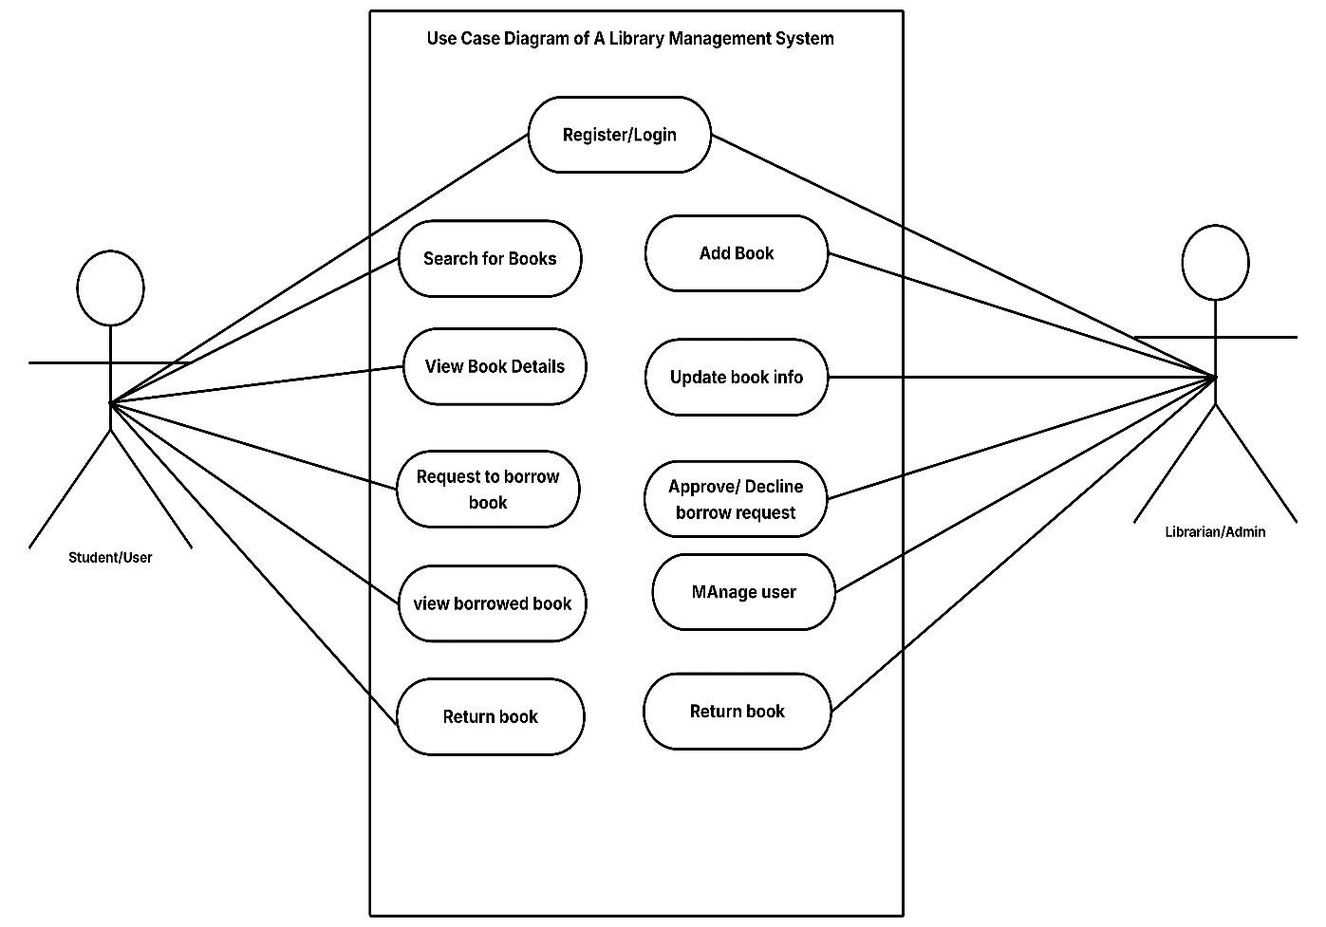
Figure 3.1: USE CASE DIAGRAM FOR A LIBRARY MANAGEMENT SYSTEM FOR GOUNI
The diagram illustrates the following key interactions:
Library User (Student/Faculty) Activities:
Authentication: Login to the system using credentials
Profile Management: View and edit personal data
View Book Details: Access book information
Borrow Request: Submit request to borrow available books
Book Return: Process for returning borrowed books
View Borrowing History: Access personal borrowing records
Messaging: Communicate with users
Librarian/ Admin Activities:
Authentication: Secure login with administrative privileges
User Management: Add, remove, or modify user accounts
Book Management: Add new books, update information, remove books
ISBN Lookup: Retrieve book information from external databases
Process Borrows: Approve and process borrowing requests
Process Returns: Handle book returns and condition assessment
Fine Management: Calculate and manage overdue fines
Generate Reports: Create statistical and operational reports System
System Configuration: Adjust System parameters and polices
Messaging: Communicate with users
3.4 Activity diagram of the proposed system
An activity diagram is another important visual framework that needs to be consider in the development of the proposed system, especially when following the UML (unified modelling language) approach. Activity diagram is a flow chart that helps the programmer to visualize the flow of activities in a stepwise or sequential manner.
The activity diagram would aid visualize workflow, break down complex processes into understandable units, support communication, simplify the steps for testing the system, enhance requirement analysis and improve documentation. An activity diagram is an essential component to consider while developing a program, because a well-designed activity diagram can provide a clear path for software development.
The figure below shows the activities performed on the LMS from both the aspect of the user and admin.

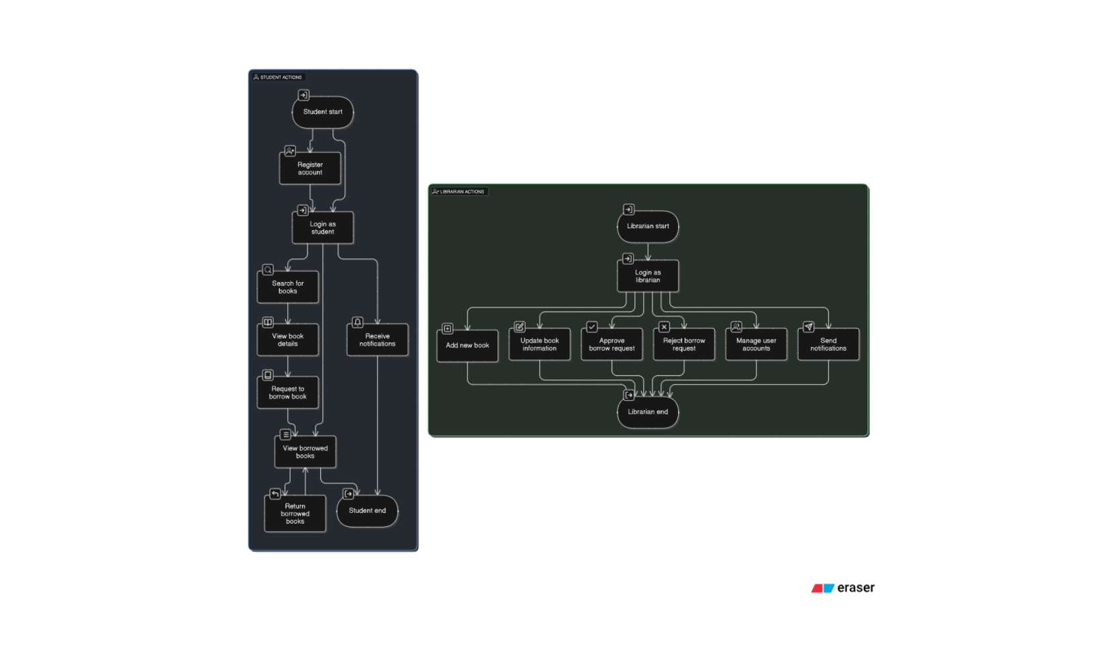
Figure 3.2: ACTIVITY DIAGRAM OF THE PROPOSED SYSTEM FOR STUDENT AUTHENTIFICATION
Figure 3.2.1: ACTIVITY DIAGRAM OF THE PROPOSED SYSTEM FOR LIBRARIAN AUTHENTIFICATION
3.5 Class Diagram of the Proposed System
A class diagram is a diagram under the Unified Modeling Language (UML) that describe the internal structure of a software system, it maps out its attributes, classes, methods and relationships among object. Below is the class diagram for the Library Management System (LMS)

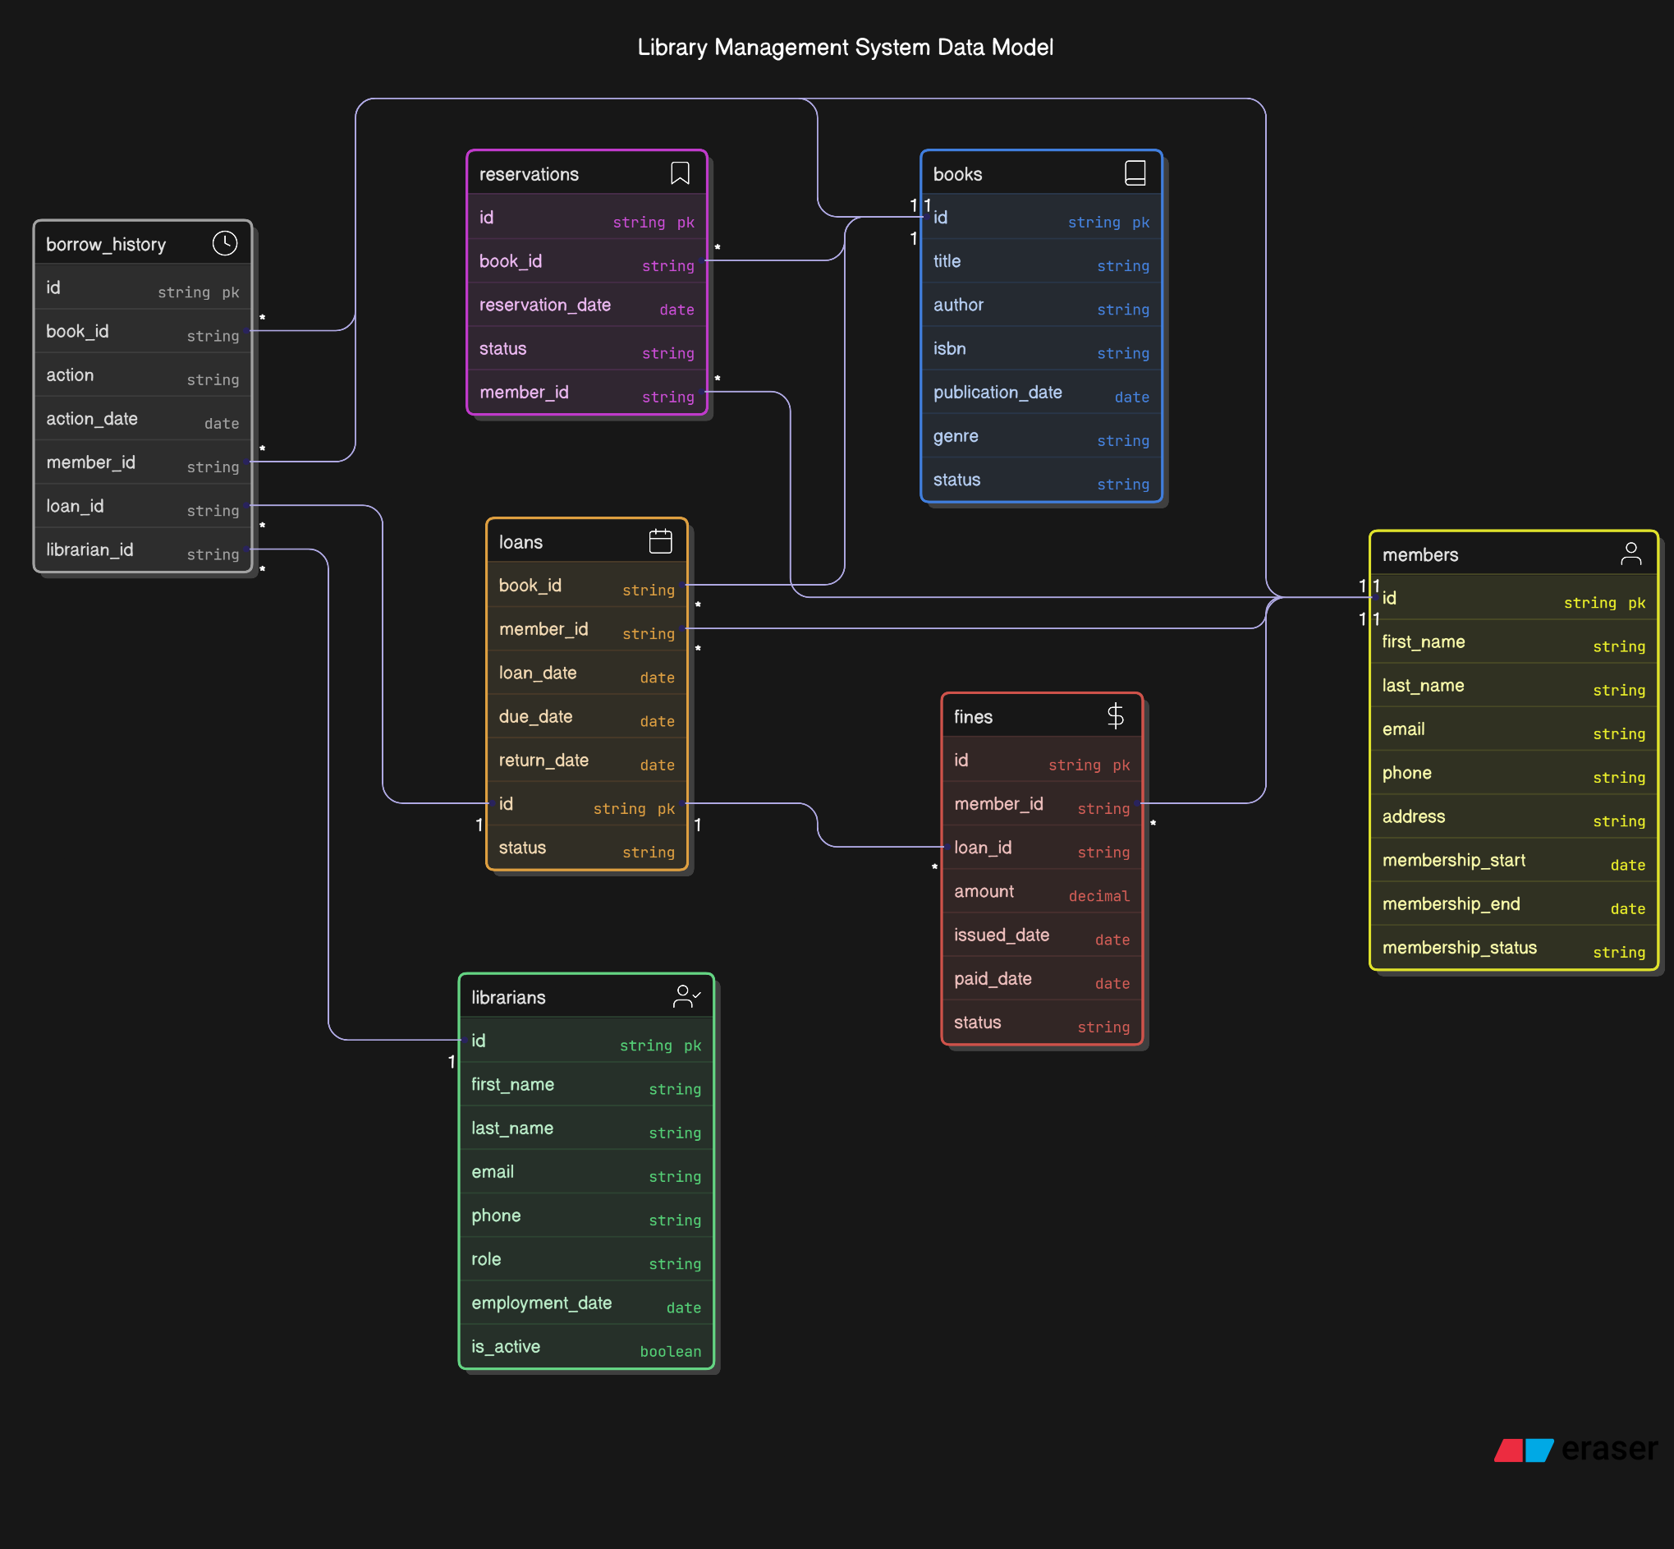
Figure 3.3 CLASS DIAGRAM OF THE LIBRARY MANAGEMENT SYSTEM
3.5.1 UML Sequence Diagram
UML sequence diagrams provide a dynamic graphical representation of system interaction, with a focus on time-based ordering of activity and messages passed between objects as they move along through time. Sequence diagrams are necessary for establishing the sequence of occurrences of a given use case or scenario. By illustrating the interaction order, sequence diagrams present a clear picture of how system parts work together to accomplish a given objective.

The most important components of UML sequence diagrams are lifelines, messages, activations, and objects. Lifelines are the participants of the interaction, and messages are interactions between them. Activations, shown as vertical lines that branch off out of lifelines, convey the duration during which an object is participating in an interaction. Adding this temporal aspect adds an invaluable level of insight, which allows developers and stakeholders to not only see what is happening in the system but also when it is happening.

UML sequence diagrams make it easy to bridge technical and non-technical stakeholders' communication gap by describing system dynamics graphically. By visualizing involved technical complexities in simple terms, sequence diagrams enhance collaboration and ensure common understanding of system behavior. Finally, sequence diagrams contribute to the detection of potential issues and areas for future optimization, leading to system design and development enhancement.

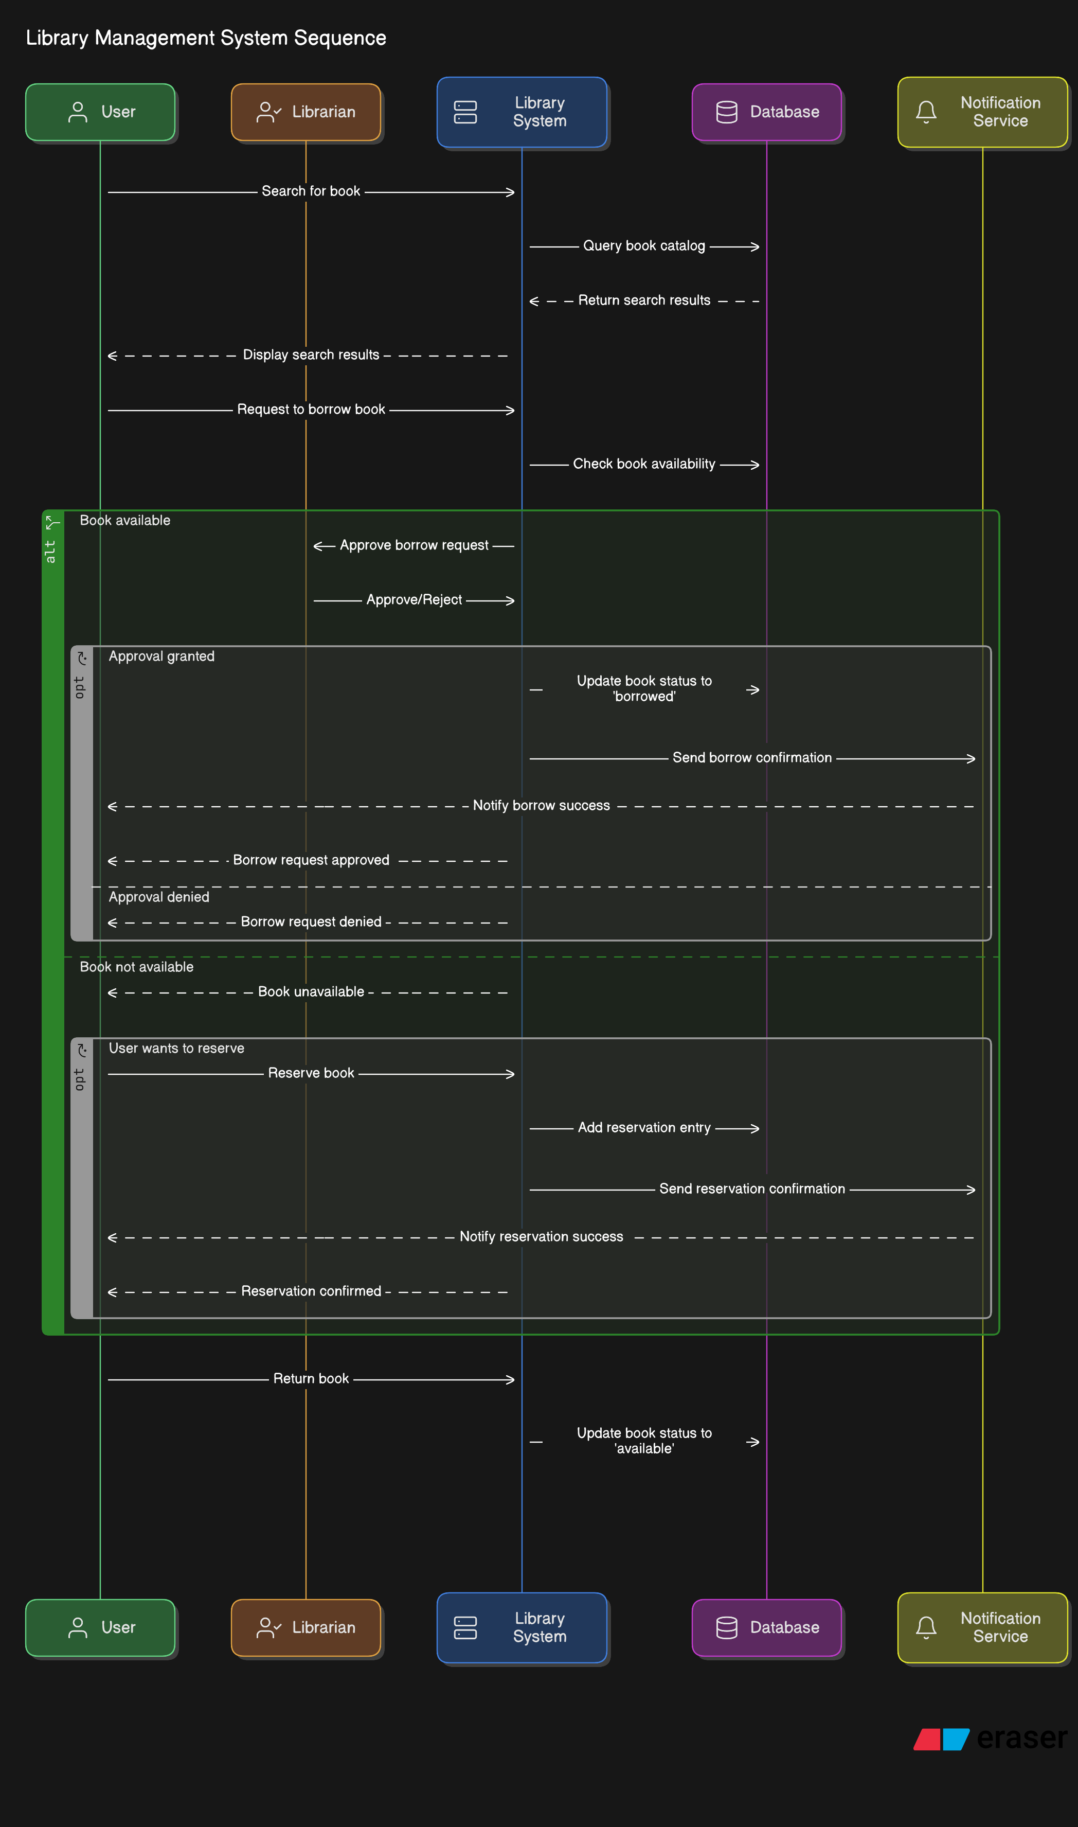
Figure 3.4 SEQUENCE DIAGRAM OF THE LIBRARY MANAGEMENT SYSTEM
UML sequence diagram is applied to explain how different components of the system work together at some point in time to achieve some activities—e.g., borrowing a book.
For instance, when a user requests a book to borrow, the flowchart shows the order of steps: user requests from interface, system checks availability, updates stock, and logs transaction. The flowchart shows all sequences of user, system, and database interaction in such a way that tracing through is easy.
This helps the developers to understand the system's behavior in an easy manner and detect errors early on, i.e., no check for pending books. It also makes it easier for non-technical team members to understand how the system works.
In short, sequence diagrams help visualize how components work together in real-time, making system design and communication more effective.

3.6 Database Schema
The purpose of the database design is to lay a blueprint of what the database of the LMS for GOUNI would look like. The database of the LMS is a relation database, it was designed using MySQL and PhpMyAdmin.

DATABASE SCHEMA FOR GOUNI LIBRARY MANAGEMENT SYSTEM
Table 3.1 User table for LMS
Attribute | Data Type | Description
RollNo | Varchar (50) | This is the primary key of the table
Name | Varchar (50) | This stores the username
Category | Varchar (50) | There are two categories, student and admin
Emailid | Varchar (50) | This stores the user’s email
Department | Varchar (50) | This field stores the user’s department
MobNo | bigint | This field stores the user’s mobile number
Password | Varchar (50) | Stores password

Book Table
Table 3.2 Books table for LMS
Attribute | Data Type | Description
BookId | Int | Stores the id number of the book, primary key
Title | Varchar | Stores the title of the book
Ebook | Varchar | Stores the relative location of a book’s pdf.
Publisher | Varchar | Stores the publisher’s name
Year | Varchar | Stores the publish date of the book
Availability | Int | Stores how many copies are available

Author Table
Table 3.3 Author table for LMS
Attribute | Data Type | Description
BookId (pk) | Int | Stores the id number of the book, primary key
Author | Varchar | Stores the name of the book author

3.7 User Interface Design
The user interface of the Library Management system features an interactive design, this it is well responsive across different devices. Various element of the system includes:
3.7.1 Login Interface
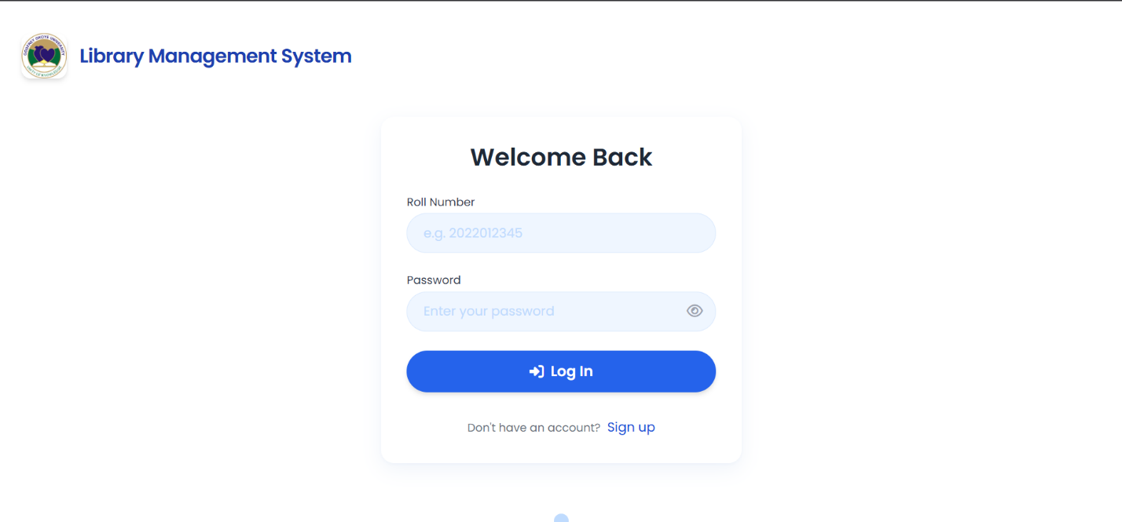Figure 3.7: LOGIN INTERFACE WIREFRAME
3.7.2 Student Dashboard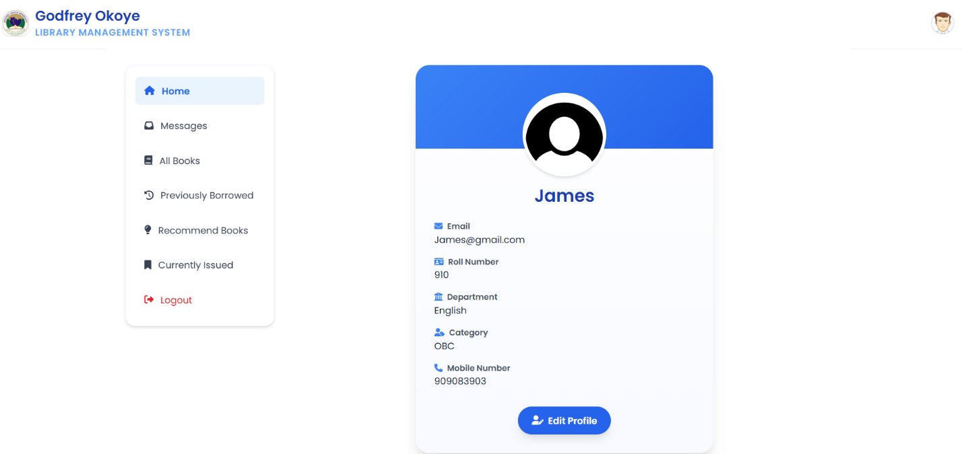 Figure 3.8: STUDENT DASHBOARD WIREFRAME
3.7.3 Librarian Dashboard
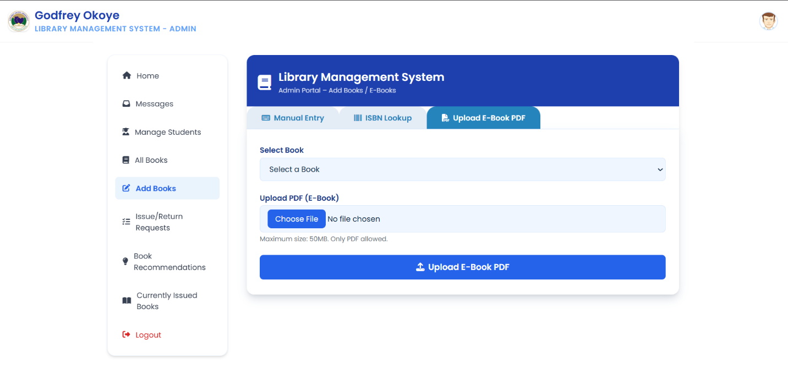
Figure 3.10: LIBRARIAN DASHBOARD WIREFRAME
3.8 Theoretical Background
The project employs web-based technologies for implementation:
HTML (Hyper Text Markup Language): Used for creating the structure of web pages
CSS (Cascading Style Sheets): Applied for styling and visual presentation
JavaScript: Employed for client-side functionality, error handling, and responsive behavior
PHP (Hypertext Preprocessor): Server-side scripting language to handle dynamic content generation and database interactions
MySQL: Relational database management system for data storage and retrieval.
The system architecture follows the Model-View-Controller (MVC) pattern to separate concerns: Model: Database tables and business logic
View: HTML templates and CSS styling
Controller: PHP scripts handling user requests and data processing
User information is collected through HTML forms styled with CSS, while JavaScript provides front-end validation. PHP scripts process form submissions, interact with the MySQL database, and generate appropriate responses. This separation of concerns ensures a maintainable, secure, and scalable application.

CHAPTER FOUR
SYSTEM IMPLEMENTATION
4.1 Overview
This chapter describes the implementation of the Library Management system. After analyzing the current or existing system and outlining the requirement for this system. This chapter would content all the hardware and software component required to successfully run the system. It would also contain the User interface of various functional part of the system.
4.2 Tools used for implementation
4.2.1 Hypertext Markup Language
HTML provides a foundation for all websites, HTML, which stands for Hypertext Markup Language, is the standard language used to create and structure content on the web. Rather than being a programming language like Python or Java, HTML is a markup language. This means it’s used to "mark up" or label sections of content so that web browsers know how to display them properly.
Think of HTML as the skeleton of a web page. It defines where text goes, where images appear, how links function, and how different parts of the page are arranged. For instance, the tag <h1> is employed to indicate a primary heading, whereas <p> indicates a paragraph. Such tags aid in presenting information both structurally and visually to users.
Briefly, HTML is the cornerstone of web development. If it didn't exist, the internet would have no content structure. It's the starting point to make anything that gets displayed on a website, and knowing it is important for anyone engaged in designing or maintaining online spaces.
4.2.2 Cascading Style Sheets
CSS means Cascading Style Sheets and is a computer language that determines the look of web pages. HTML gives a page structure—how it determines what's on the page—and CSS gets to decide how those things appear. It can determine color, font of text, white spaces, and arrangement, among other things, so that developers can get websites to appear stunning.
Visualize HTML as the framework and base of a home. CSS would be the wallpaper, paint, furniture, and interior design that make an empty home a cozy, beautiful place to live.
Removing content from presentation, CSS allows websites to be made more up-to-date and present. One CSS file can dictate the appearance of an entire website, so modifying the style in one location can update dozens or even hundreds of pages simultaneously. CSS operates based on a system of rules. A rule applies to an element on the page and attributes particular styles to it. For instance, a rule can state that all paragraph tags (<p>) should display a particular font and color. Classes and IDs can also be used by developers to attach custom styles to individual elements, having precise control over the look. Modern CSS does much more than fonts and colors. It provides responsive layouts that adjust to various screen sizes, animations, transitions, and even grid layouts for intricate page designs. With the evolution of how the web came about, CSS also evolved—now holding a central position in constructing user-focused, accessible, and phenomenal digital experiences.
4.2.3 PHP
PHP is a server-side scripting language used mainly to build websites but with wider application in general-purpose programming as well. One of its benefits is that it may be embedded directly within HTML code. Or else, PHP could be combined with different web frameworks and template systems in order to build dynamic and interactive web applications.
When a web server is requested for a PHP page, the PHP script is processed by an interpreter—either compiled into the server in the form of a module or interpreted through a Common Gateway Interface (CGI). The PHP commands are executed by the interpreter, which can generate any form of output, including plain text, images, or complex HTML. The combined result is then sent back to the user's browser after being combined with the rest of the web page content.
This ability enables developers to create sites that are capable of responding to user interactions, communicating with databases, and showing targeted content in real time, and therefore PHP is a building block of the web.
4.2.4 MySQL
MySQL is an open-source Structured Query Language (SQL)-based relational database management system (RDBMS). It is among the most widely used databases in the world, only behind SQLite. MySQL is known for its speed, dependability, and ease of use, and millions of applications store and manage data through it.
MySQL is widely used by desktop and mobile platforms. It comes preinstalled on most devices and platforms, such as Android mobile devices, iPhones, and internet browsers like Google Chrome and Mozilla Firefox. Its widespread integration says a lot about its use in consumer and commercial technologies.
MySQL, in its core, is open source and publishes its source code under the GNU General Public License, popularly known as GPL. Apart from that, it is available under a variety of commercial licenses, so developers have its flexibility in their hands depending on their project needs. This dual-licensing has enabled MySQL to secure a fabulous niche both in open-source communities and in commercial software development.

4.3 Implementation Architecture
4.3.1 Hardware Requirement
1. Processor: Dual-core CPU (e.g., Intel i3 or equivalent)
2. RAM: 4 GB
3. Storage: 50 GB HDD or SSD (SSD preferred for performance)
4. Network: Basic LAN/Wi-Fi connectivity
5. Operating System: Ubuntu/Linux, Windows, or macOS (server configuration dependent).
4.3.2 Software Requirement
1. Operating System
- Development: Windows 10/11, macOS, or any Linux distro (e.g., Ubuntu)
- Production: Ubuntu Server, CentOS, Debian, or Windows Server (based on hosting preference)
2. Web Server
- Apache or Nginx
3. Backend Language Support
- PHP (version 7.4 or above)
• Or other backends such as Node.js, Python (Django/Flask), or Java (Spring Boot)
4. Database
- MySQL or MariaDB (commonly used with PHP)
- Alternatives: PostgreSQL, SQLite (for lightweight use)
5. Frontend Technologies
- HTML5, CSS3, JavaScript
6. Server Stack (if running locally)
- XAMPP (Windows/Mac/Linux) – includes Apache, MySQL, PHP
- WAMP (Windows)
- LAMP (Linux – Apache, MySQL, PHP)
- MAMP (Mac)
7. Browser Compatibility
- Chrome, Firefox, Edge, or Safari (ensure your system is tested on multiple browsers)
8. Optional Tools
- phpMyAdmin – for managing MySQL databases via GUI
- Composer – PHP dependency manager (if using frameworks like Laravel)
- Git – for version control
- VS Code or Sublime Text – for development
Backend
MySQL
Xamp
N

J,AJAJJAX
MIDDLE END
PHP
FRONT END
HTML5, Javascript, JQuery library, CSS, Bootstrap4

4.4 Software Testing
System testing is a critical phase in the development of a computer-integrated system, aimed at verifying that the system meets its defined requirements. In the case of the proposed system, tests were conducted using actual, real-world data to evaluate its functionality and reliability. Each program module was individually tested with relevant input to confirm that it behaves as intended. Comprehensive testing of the entire system was also carried out to assess its overall performance and stability. This process ensures that the system operates correctly and can be depended upon in practical, real-life scenarios.
4.5 Documentation
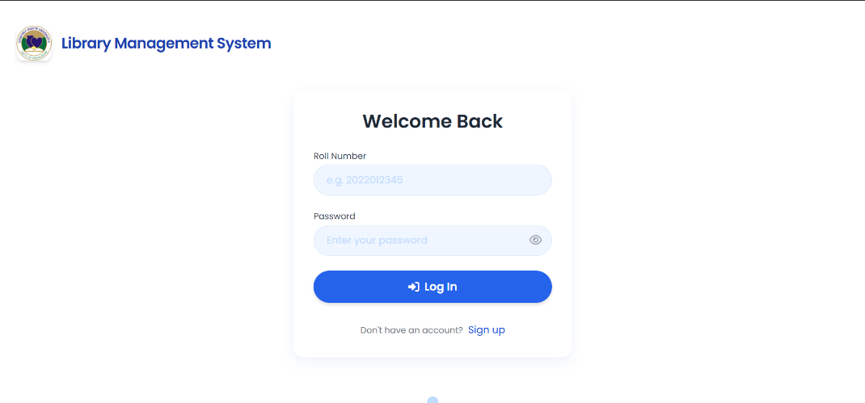
Figure 4.1 Screenshot of the login page

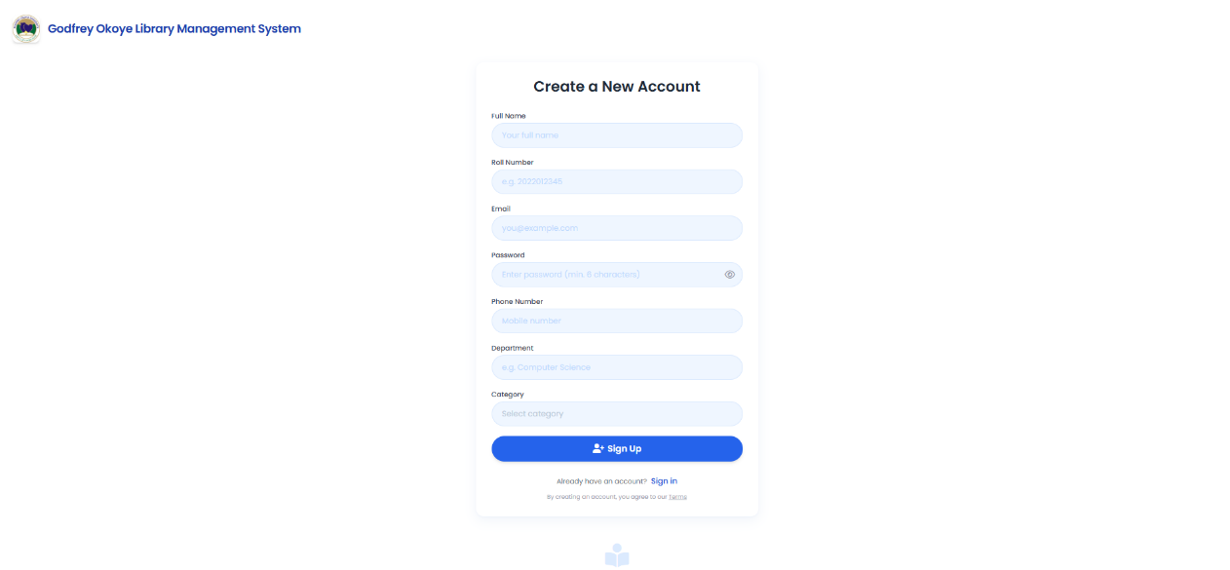
Figure 4.2 Screenshot of the signup page
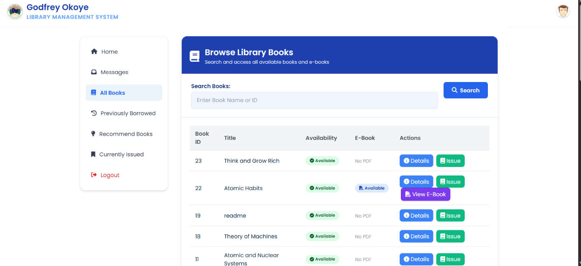
Figure 4.3 Screenshot of the borrow book page.
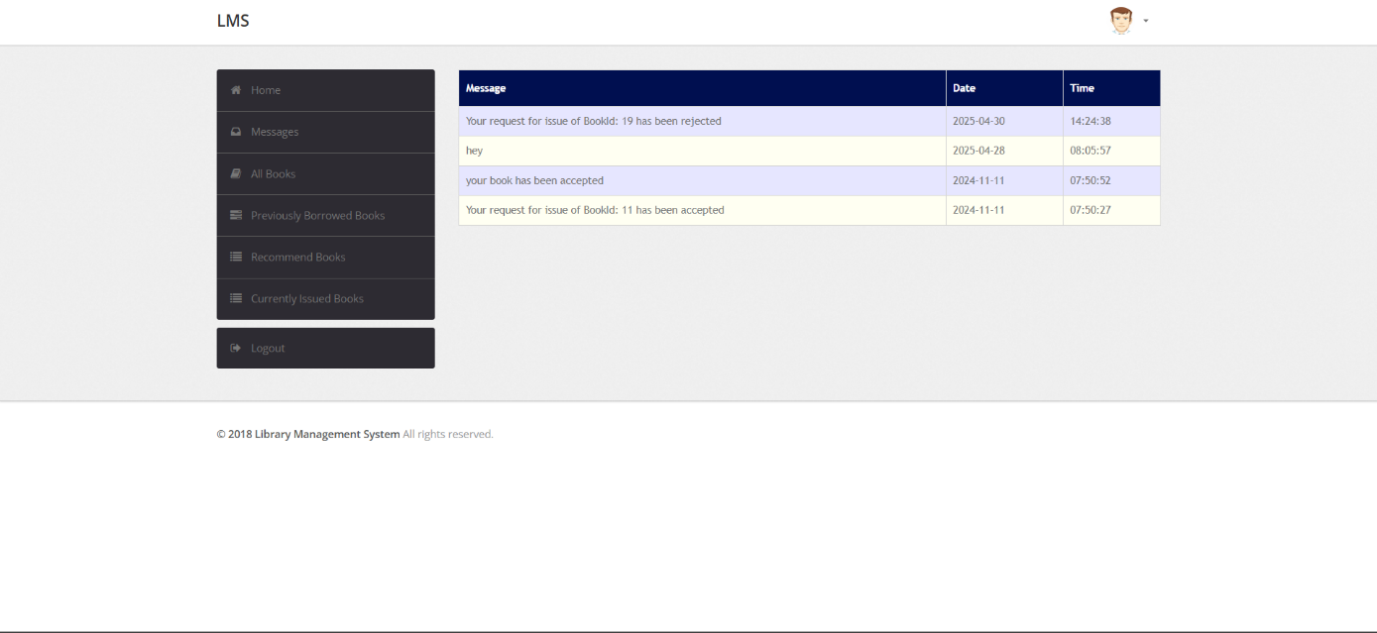
Figure 4.4 Screenshot of the message page.
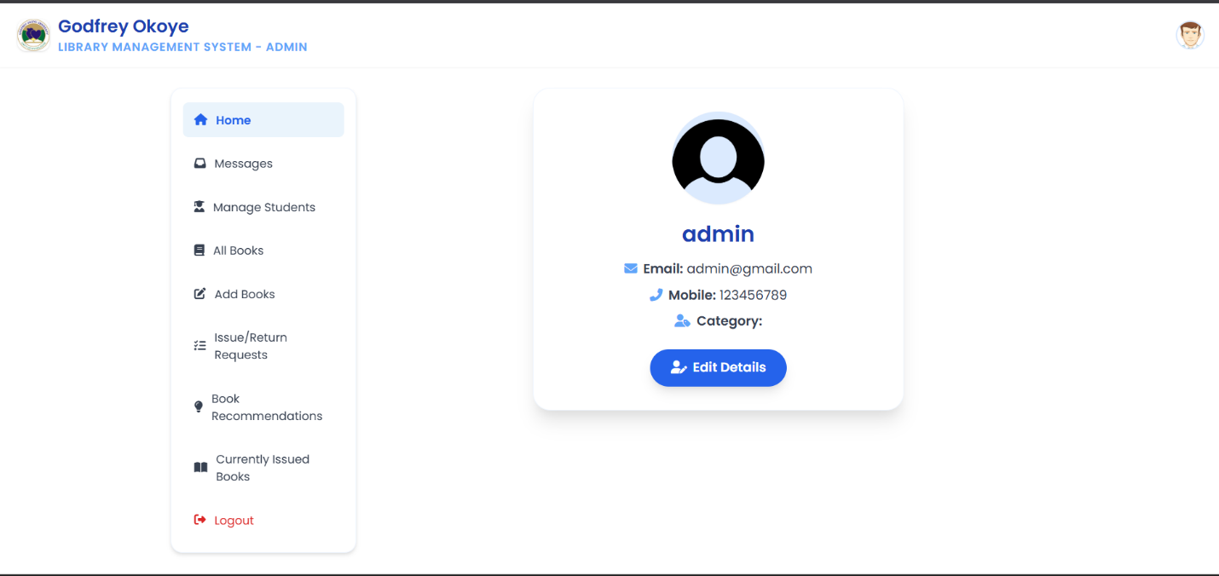
Figure 4.5 Screenshot of admin page.
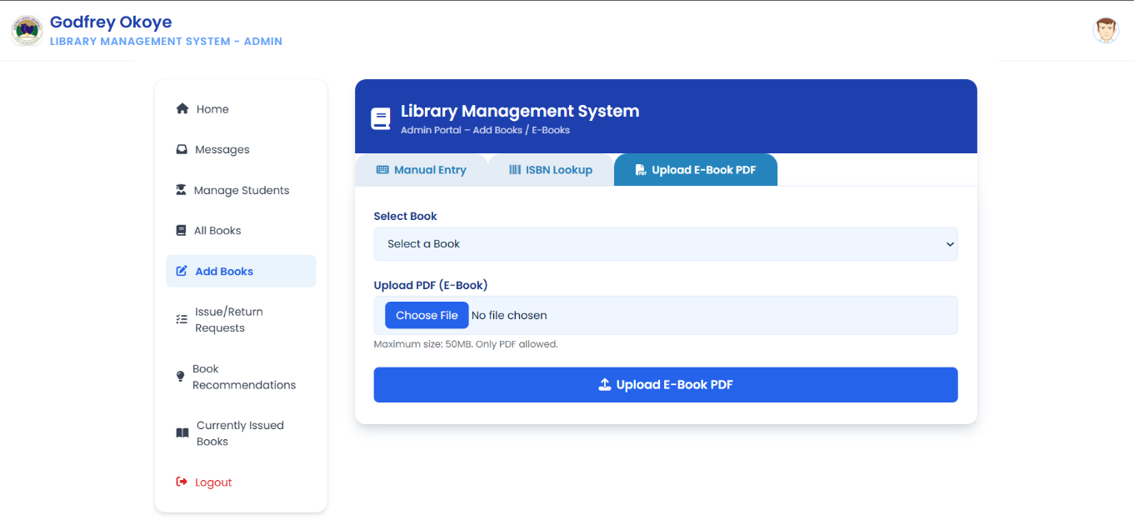
Figure 4.6 screenshot of the add book page.
Figure 4.7 Screenshot of the pdf upload page.

CHAPTER FIVE
SUMMARY, RECOMMENDATIONS AND CONCLUSION
5.1 OVERVIEW
The essence of this chapter of the research work is to give a solid recommendation for feature research that may be carried out on this topic or something similar, and lastly provide a conclusion to the work. The chapter would provide a summary for all that has been discussed throughout the course of this research.
5.2 SUMMARY
This research began by outlining the background and clearly stating the problem it seeks to address. As the study progressed, later chapters explored the theoretical foundation and examined systems similar to the one proposed. These existing systems were reviewed in detail, and their shortcomings were identified. The limitations found in those systems helped guide the development of the new solution introduced in this research.
A detailed system analysis was presented in Chapter Three using UML diagrams, such as use case, activity, and class diagrams. These tools were essential in mapping out the system’s structure and behavior. The final part of the work described the programming languages and frameworks used to implement the system, along with an overview of the user interface.
5.3 RECOMMENDATIONS
This Library Management System is strongly recommended to all members of the Godfrey Okoye University community, including current students, faculty, staff, and alumni, as it provides features specifically designed to meet the unique academic and research needs of the institution
5.4 CONCLUSION
This Library Management System project has been able to implement various noteworthy enhancements and features that overcome the fundamental drawbacks of the erstwhile manual system utilized in Godfrey Okoye University. The system deployed exhibits vast improvements such as automated cataloging of books with ISBN lookup feature, simplified user authentication with role-based access control, and real-time tracking of availability that overcomes the ambiguity of manual record maintenance. The introduction of an automated fine calculation system ensures consistent policy enforcement while reducing administrative burden on library staff. Furthermore, the integrated messaging system facilitates improved communication between librarians and users, enabling timely notifications about due dates and book availability. The comprehensive search functionality with multiple filter options empowers users to locate resources efficiently, while the reporting module provides valuable insights into collection usage patterns and operational metrics. These technological advancements overall decrease the time spent processing transactions by about 70%, lower the rate of human error in record-keeping, and improve overall user experience for students, staff, and library personnel. The web-based design of the system facilitates access from different devices while maintaining data security via encrypted connections and periodic backups. Most importantly, this implementation provides a scalable base that allows for future development implementations such as RFID, mobile applications, and further analytics, setting the library up to be an ongoing definition of technological evolution for academic excellence purposes.

REFERENCES
Adomi, E. E., & Anie, S. O. (2006). A study on computer literacy levels among professionals working in university libraries across Nigeria. Library Hi Tech News, 23(2), 10–14.
Adomi, E. T., & Adepou, E. O. (2009). Assessment of librarians' computer competencies in academic libraries within Ondo and Ekiti States, Nigeria. Library Philosophy and Practice, Article 274. Available at: https://digitalcommons.unl.edu/libphilprac/274
Adamson, A., & Veronica. (2009). A report on library management systems. JISC and SCONUL collaborative publication.
Amollo, B. A. (2011). The role of digitization in enhancing library services in Kenya. Presented at the Second International Conference on African Digital Libraries and Archives (ICADLA-2), University of the Witwatersrand, pp. 15–22.
Aswal, R. S. (2006). Library Automation for the 21st Century. New Delhi: Ess Ess Publications.
Ashutoshand, T., & Ashish, S. (2013). Development and design of an online library management system. IOSR Journal of Engineering, 2(2), 180–186.
Johnson, C. A. (2007). An overview of library and information science education in less-developed nations. The International Information & Library Review, 39, 64–71.
Johnson, K., Houda, T., & Tony, T. (2004). How libraries provide academic support to online students. In A. Terry (Ed.), Theory and Practice of Online Learning (p. 349). Athabasca University Press.
Neelakandan, B., & Duraisekar, S. (2010). Adopting Koha open-source software for library automation in the School of Chemistry, Bharathidasan University. International Journal of Applied Engineering Research Dindigul, 1, 149–167.
Robert, P. (1998). Case profile: Cohen Hillel Academy, Marblehead, Massachusetts. Published by Follett Software. Available at: http://follettsoftware.com
Siwokuhwe, S. S. (1982). Evaluation criteria from the user’s perspective in library service assessment. Journal of Library Administration, 2(1), 35–46.

Web Resources:
Google. (n.d.). https://www.google.com
Wikipedia. (n.d.). https://www.wikipedia.com
YouTube. (n.d.). https://www.youtube.com
W3Schools. (n.d.). https://www.w3schools.com

APPENDIX
<?php
require('dbconn.php');
?>
<!DOCTYPE html>
<html>
<!-- Head -->
<head>
<title>Library Management System </title>
<!-- Meta-Tags -->
<meta name="viewport" content="width=device-width, initial-scale=1">
<meta http-equiv="Content-Type" content="text/html; charset=utf-8">
<meta name="keywords" content="Library Member Login Form Widget Responsive, Login Form Web Template, Flat Pricing Tables, Flat Drop-Downs, Sign-Up Web Templates, Flat Web Templates, Login Sign-up Responsive Web Template, Smartphone Compatible Web Template, Free Web Designs for Nokia, Samsung, LG, Sony Ericsson, Motorola Web Design" />
<script type="application/x-javascript"> addEventListener("load", function() { setTimeout(hideURLbar, 0); }, false); function hideURLbar(){ window.scrollTo(0,1); } </script>
<!-- //Meta-Tags -->
<!-- Style --> <link rel="stylesheet" href="css/style.css" type="text/css" media="all">
<!-- Fonts -->
<link href="//fonts.googleapis.com/css?family=Roboto:100,300,400,500,700,900" rel="stylesheet">
<!-- //Fonts -->
</head>
<!-- //Head -->
<!-- Body -->
<body>
<h1>GODFREY OKOYE LIBRARY MANAGEMENT SYSTEM</h1>
<div class="container">
<div class="login">
<h2>Sign In</h2>
<form action="index.php" method="post">
<input type="text" Name="RollNo" placeholder="RollNo" required="">
<input type="password" Name="Password" placeholder="Password" required=""
<div class="send-button">
<!--<form>-->
<input type="submit" name="signin"; value="Sign In">
</form>
</div>
<div lass="clear"></div>
</div>
</div>
<div class="sign up">
<a href= "sign_up.php" class= "sign_up"> sign up </a>

</div>

<br>
<div class="footer w3layouts agileits">
<p> &copy; 2025 Library Member Login. All Rights Reserved </a></p>

</div>

<?php
if(isset($_POST['signin']))
{$u=$_POST['RollNo'];
$p=$_POST['Password'];
$c=$_POST['Category'];

$sql="select * from LMS.user where RollNo='$u'";
$result = $conn->query($sql);
$row = $result->fetch_assoc();
$x=$row['Password'];
$y=$row['Type'];
if(strcasecmp($x,$p)==0 && !empty($u) && !empty($p))
{//echo "Login Successful";
$_SESSION['RollNo']=$u;
if($y=='Admin')
header('location:admin/index.php');
else
header('location:student/index.php');

}
else
{ echo "<script type='text/javascript'>alert('Failed to Login! Incorrect RollNo or Password')</script>";
}
}
?>
</body>
<!-- //Body -->
</html>

