
EFFECTIVE CIRCULATION IN THE DESIGN OF A LOGISTICS TERMINAL

BY

UFOMADU DICKSON UCHENNA
GOU/U21/ARC/154

DEPARTMENT OF ARCHITECTURE
FACULTY OF NATURAL SCIENCE AND ENVIRONMENTAL STUDIES GODFREY OKOYE UNIVERSITY

A RESEARCH REPORT SUBMITTED TO THE DEPARTMENT OF ARCHITECTURE, FACULTY OF NATURAL SCIENCE AND ENVIRONMENTAL STUDIES, GODFREY OKOYE UNIVERSITY, IN PARTIAL FULFILLMENT OF THE REQUIREMENTS FOR THE AWARD OF BACHELOR OF SCIENCE (B.Sc.) DEGREE IN ARCHITECTURE

SUPERVISOR: ARC DR BSA OKOYE

AUGUST, 2025

ABSTRACT

This research focuses on Effective Circulation in Logistics Terminals, highlighting how architectural planning and spatial organization influence efficiency in logistics operations. This research aims to use architectural design in achieving effective circulation in logistics terminals for vehicular and pedestrian movement in the study area. The objectives include: To examine the circulation types used in logistics terminals (personnel, vehicles, and goods). To identify the critical determinants of circulation efficiency. To evaluate real-life examples and case studies wherein circulation upgrades have contributed to improved performance. The research methodology adopted involves an aggregate of qualitative and quantitative processes, which include literature evaluation, case studies of each neighborhood and worldwide logistics terminals (e.g., GIGM and GUO in Enugu), on-web page commentary, and architectural analysis. Data had been synthesized to extract key circulation techniques and spatial zoning requirements applicable to terminal performance. Findings monitor that ineffective circulation remains a main constraint in many Nigerian terminals, frequently due to bad layout, insufficient zoning, and a shortage of integration with transportation networks. International case studies confirmed that strategic format planning, clear signage, integrated traffic management, and automation appreciably enhance terminal efficiency and decrease congestion. Based on those findings, the hints consist of designing terminals with virtually defined zones (loading, unloading, storage, admin), ensuring one-way vehicular motion where feasible, integrating inexperienced buffers, and adopting clever technology for monitoring and routing. The final layout proposal displays those techniques, contributing to a version logistics terminal appropriate for urban and local transport structures.

CHAPTER ONE
INTRODUCTION
1.1 Background to the Study
In architectural and planning terms, circulation is used to describe the systematic movement of individuals, commodities, and vehicles within and outside of a built space. Circulation in an architectural context, according to Ching (2014), involves spatial organization and systems of circulation that enable passage through, in, and out of buildings or sites. Proper circulation is not merely about movement – it involves optimized paths, reduced congestion, uncluttered zoning, and unbroken links among functional zones. Effective circulation is described as safe, productive, and purposeful movement of individuals and goods, aiming to achieve high productivity and minimize holds (Neufert & Neufert, 2012). In architectural terms, good circulation is used to ensure spatial organization enhances operational efficiency and security without causing physical and functional bottlenecks.
A logistics terminal is an allocated node in the supply chain for transferring goods among various modes of transportation, temporary storage, sortation, and processing. Such examples include seaport container terminals, airport cargo terminals, and inland freight distribution centres (Notteboom & Rodrigue, 2005). Optimized circulation in a terminal, this is all about conscious planning of architectural and operational space organization in such a manner as to ensure free and unencumbered movement of goods, vehicles, and people through different zones of process—unloading docks, storing areas, inspection stations, and dispatch zones. Optimized circulation is truly an essential idea in terminal planning and design, for non-optimal circulation can contribute to bottlenecks, increased turnaround time, accidents, and waste (Rushton, Croucher & Baker, 2017).
In today's interdependent economy, terminal operations in the field of logistics play an essential role in the supply chain, enabling goods transportation, storage, and switching among road, rail, air, and sea transportation modes. These terminals at ports, airports, and inland delivery hubs have to deal daily with a large volume of cargo and truck movements (Notteboom & Rodrigue, 2005). Efficiency in in-terminal circulation influences operational quality, delivery speed, cost savings, and customer service (Rushton, Croucher & Baker, 2017).
Effective terminal circulation involves the uninterrupted movement of cargo, vehicles, and staff. Ineffective circulation can cause congestion, bottlenecks, hazards, and escalated operational expenses (Lowe, 2002). Technologies include automation, real-time tracking, and computerized traffic control systems, which are increasingly used in terminal operations (Higgins, Ferguson & Kanaroglou, 2011). Physical design, planning of operations, and human factors, nevertheless, remain key to obtaining optimal circulation.
1.2 Statement of Problem
Even with advances in terminal management systems and logistics technologies, most of the terminal operations still suffer from problems of inefficient circulation. Some of those problems include congestion in vehicles, slow cargo handling, wasted space, and site hazards for workers. In other instances, those problems arise because of out-of-date terminal configurations, ineffective planning, the absence of synchronization among operational systems, or poor infrastructure. The implications of poor circulation are serious, frequently leading to bottlenecks in operations, extended turnaround cycles, and increased expenses.

1.3 Aim and Objective of the Study
1.3.1 Aim
The aim of this research is to use architectural design in achieve effective circulation in logistics terminals for vehicular and pedestrian movement in the study area
1.3.2 Objectives of the Study
1. To examine the circulation types used in logistics terminals (personnel, vehicles, and goods).
2. To identify the critical determinants of circulation efficiency.
3. To evaluate real-life examples and case studies wherein circulation upgrades have contributed to improved performance.
1.4 Research Questions
1. What major circulation types are found in logistics terminals?
2. What are the factors affecting the efficiency of circulation at these terminals?
3. How can the logistics terminal reduce congestion and improve circulation efficiency?
1.5 Significance of the Study
This research can be of particular interest for terminal operators, infrastructure planners, policymakers, and cargo and contract carriers. It can offer practical knowledge for achieving better circulation to those who work in the planning process. In today's fast-paced and competitive logistics industry, maximizing terminal circulation can prove to be an operational success factor.
1.6 Scope of the Study
This includes planning for loading and unloading sites, warehousing space, sort areas, administrative offices, and parking. Integration of circulation routes for different types of traffic (automated systems, vehicular, pedestrian). Integration of vehicular and walking circulation routes. Architectural features used to increase safety and efficiency (e.g., lighting, barriers, signage).
Delimitation
The research does not include external transportation networks (e.g., national water shipping lanes) outside of the terminal's boundaries.
Doesn’t include the cost factors of the design
1.7 Organization of the report
Chapter 1: Introduction
Chapter 2: literature review and case studies
Chapter 3: The Study Area
Chapter 4: Research Methodology
Chapter 5: design synthesis and development
Chapter 6: Conclusion and Recommendation
1.8 Definition of Special Terms
Turnaround Time: The overall time spent by an automobile or shipment at the terminal from arrival to departure, comprising unloading, processing, and reloading operations.
Flow Optimization: The process for enhancing facility movement speed, reliability, and safety, usually through data-driven decision support or automation.
Circulation: Refers to the movement of passengers, vehicles, and goods within a logistic terminal or transportation facility.
Congestion: Occurs when the volume of passengers or vehicles exceeds the capacity of the terminal, resulting in overcrowding, delays, and reduced efficiency.
Terminal Layout: The spatial arrangement and organization of infrastructure within the bus terminal, including platforms, waiting areas, ticket counters, signage, and access points.
Logistics terminal: is where goods are received, sorted, and shipped. They're important for moving products efficiently and are often found near ports, airports, and major highways.

CHAPTER TWO
LITERATURE REVIEW AND CASE STUDIES
2.1 Conceptual Framework
The conceptual approach informing this study integrates spatial planning philosophy with logistics efficiency, with an emphasis on circulation flow as an aspect of design. Efficient circulation entails unambiguous delineation of access paths, functional separation, and integration of technology to optimize flow. This approach is developed from architectural design philosophy, systems theory, and principles of transport planning to achieve optimized flow of people, vehicles, and goods in terminals (Neufert & Neufert, 2012).
2.2 Theoretical Framework
Two main theories lay the groundwork for this research:
Systems Theory views terminals as complex, interconnected systems in terms of which disruption in one aspect, for example, circulation, impacts on the efficiency of the system as a whole (Bertalanffy, 1968). Space Syntax Theory examines the spatial configuration's impact on movement by stating that more connected areas allow for more fluid circulation and fewer friction points in logistics spaces (Hillier & Hanson, 1984).
2.3 Literature Review
2.3.1 Definition of Circulation Terminal & Logistic Terminal
Circulation in architecture is the flow of people or products, usually horizontal (roads, corridors) or vertical (stairs, lifts) (Ching, 2014). Efficient circulation in logistics means that there is an organized system of corridors that enables unobstructed, conflict-free flow between operational areas such as loading docks, warehouses, and areas for dispatch (Neufert & Neufert, 2012).
Logistics terminals are centres in which goods arrive, are sorted, warehousing is done, and dispatched, commonly including intermodality operations (Rodrigue et al., 2013). The success in such terminals is critically dependent on defining and managing circulation paths (Zhang & Lam, 2019).
2.3.2 Layout planning and spatial zoning
Optimal terminal design is driven by functional zoning, which keeps vehicular traffic, pedestrian paths, loading spaces, and administrative areas segregated to prevent operational interference (Neufert & Neufert, 2012). Good zoning also minimizes internal travel distances, enhancing travel time and resource use efficiency (Zhang & Lam, 2019).
2.3.3 Traffic Flow and Safety
Circulation becomes problematic due to inadequate separation between trucks, forklifts, and people. Dedicated lanes and visual markings increase safety and decrease operational downtime (Higgins et al., 2011). The use of tactile paving, stepped walkways, and signage facilitates safer conditions for both personnel and cargo transfer (Ching, 2014). 2.3.4 Role of Technology in Terminal Circulation Technological integration, including RFID tags, automatic scheduling, and Digital Twins, assists in tracking and simulating circulation routes to discover and address congestion spots ahead of time (Winkenbach et al., 2016). Intelligent terminals use data in real-time to dynamically modify traffic flow to sustain optimized performance (Zhang & Lam, 2019).

2.3.4 Role of Technology in Terminal Circulation
Technological integration, such as RFID tags, automated scheduling, and Digital Twins, helps monitor and simulate circulation paths to detect and solve congestion points before they occur (Winkenbach et al., 2016). Smart terminals utilize real-time data to adjust traffic flow dynamically and maintain optimal performance (Zhang & Lam, 2019).
2.4 Case Studies
Nigerian Logistics Terminal Case Studies
2.4.1 GIGM Logistics Terminal, Enugu
Address: 1A Ziks Avenue, opposite Osisatech Polytechnic, Ogui Road, Enugu, Nigeria
Type: Intercity passenger and cargo logistics terminal
Brief history
This terminal combines passenger and logistics operations within a linear layout. Entry and exit points are marked, and parking zones are available, which contribute to basic circulation effectiveness. However, drop-off and loading areas are undefined, creating vehicular congestion, particularly during peak hours (Field Observation, 2024).

This image indicates the front view of a GIGM Logistics terminal. The construction is a modern-day, single-story structure with an outstanding sign that reads "GIG LOGISTICS" on the left side and "GIGM" in huge red letters at the right, with "ENUGU TERMINAL" written below it.

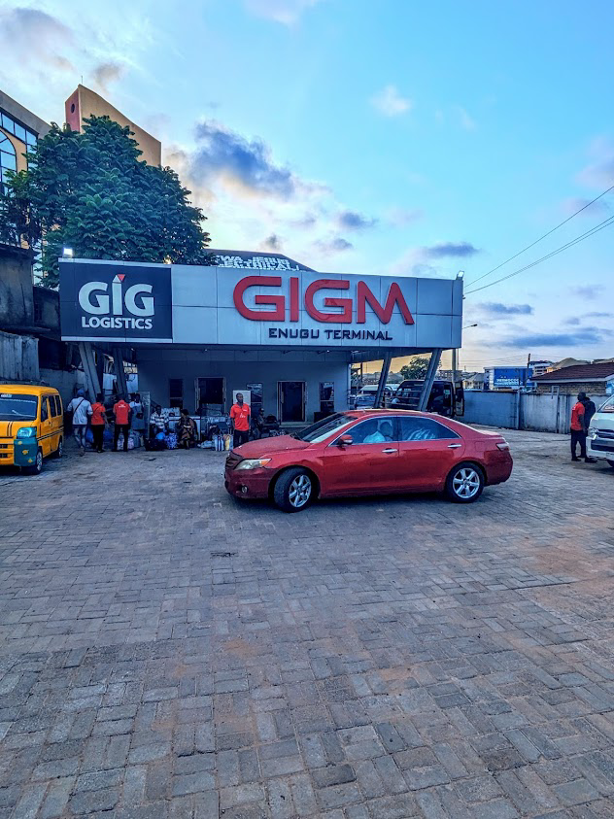
Plate 2.1 GIGM logistics terminal Front view
Source: Field Study (2025)
The image shows the side view of a GIGM Logistics terminal. The building has a modern-day design with a gray facade and a prominent red and white sign that reads "GIGM ENUGU TERMINAL". To the left, some other sign identifies the business enterprise as "GIG LOGISTICS".
The terminal entrance is sheltered by a grey cover supported using diagonal metal pillars. A dark-coloured sedan is parked immediately beneath this cover. The ground in front of the building is paved with what seems to be concrete or asphalt. The vicinity is extraordinarily tidy, with a couple of black plastic chairs and a waste bin seen near the parked car.
In the heritage, a multi-story building with a specific, rounded glass facade is visible, suggesting an urban or semi-city setting. The sky is slightly overcast.
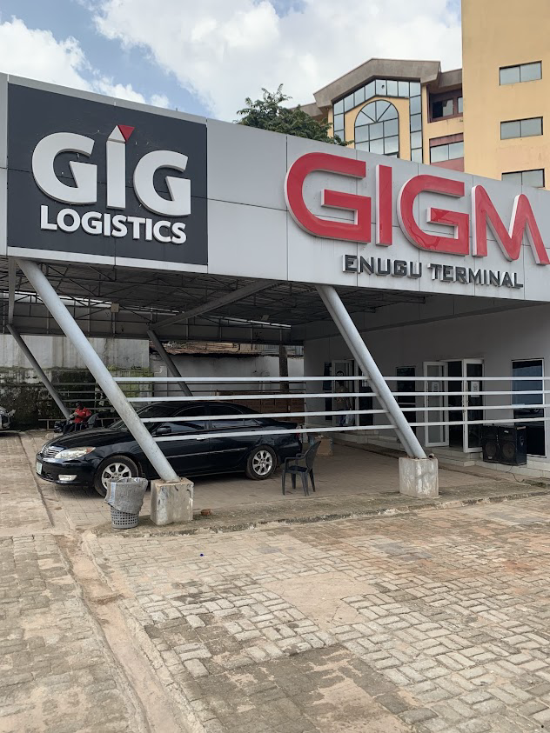

Plate 2.2 GIGM logistics terminal Side view

Source : Field Study (2025)
This image suggests a drop-off region, at the entrance area of the GIGM Logistics terminal. A dark-coloured van with "GIGM LOGISTICS" branding is parked to offload goods

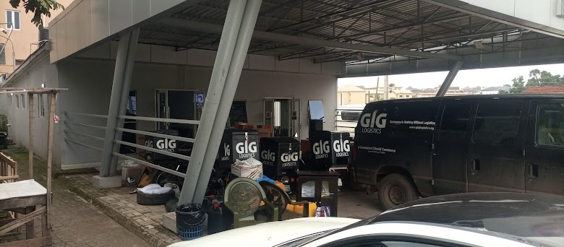
Plate2:3 drop-off at entrance
Source :Field Study( 2025)
Merits:
Central location ensures easy access.
Dedicated vehicular access points improve circulation.
Demerits:
Lack of designated drop-off/loading areas leads to congestion.
Overlapping pedestrian and vehicle paths raise safety concerns.
2.4.2 GUO Logistics Terminal, Enugu
Location: 34 Okpara Avenue, beside Polaris Bank, Enugu, Nigeria
Type: Urban logistics hub for parcels and passengers
Brief history
GUO Terminal incorporates segregated entry and exit gates, with more clearly defined logistics and passenger areas compared to GIGM. However, the terminal suffers from poor walkway infrastructure and insufficient turning space for large vehicles (Site Assessment, 2024).

This photograph shows the entry gate to the GUO Logistics terminal. The setting seems to be a typical, purposeful access point to factor for a transport and logistics company in a city or semi-city environment.
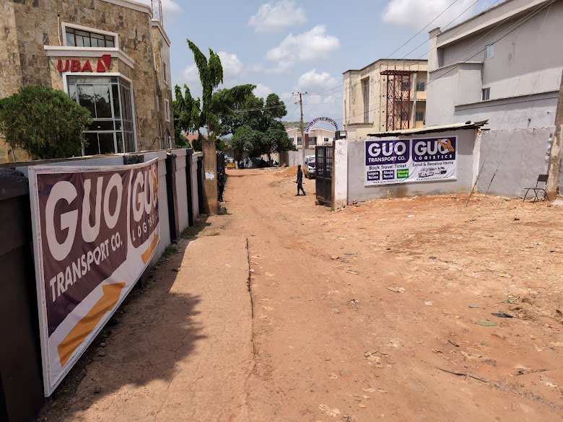
Plate 2.4 GUO logistics terminal access gate
Source : Field Study (2025)
This photograph suggests the entrance to a GUO Logistics terminal. The front is protected via a low-placing roof shape, with red metallic trusses and a blue tarp-like cloth supplying colour. A crimson guide pillar is prominently positioned in the center of the body.The entrance itself is a simple doorway.
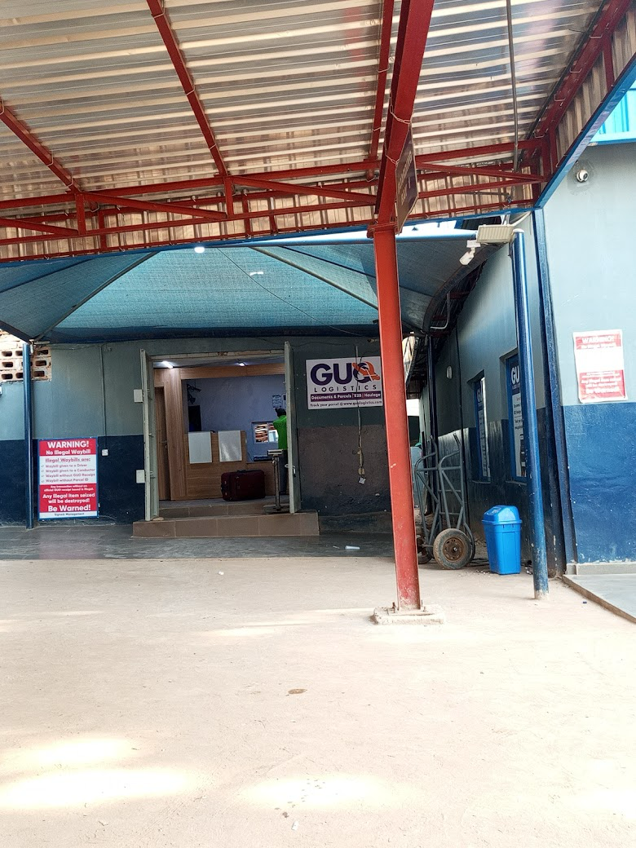
Plate 2.5 GUO logistics terminal entrance
Source : Field Study (2025)
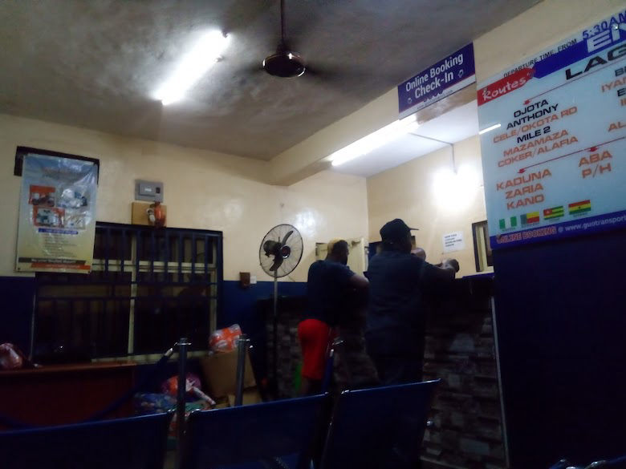
Plate 2.6 GUO reception area
Source : Field Study (2025)

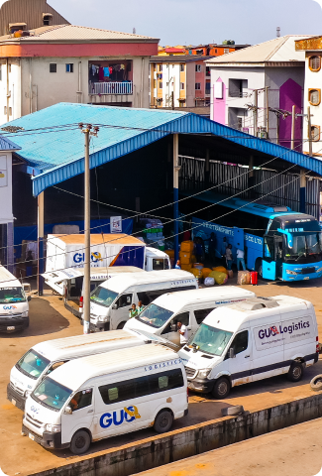
This picture shows the parking and loading area of the GUO Logistics terminal. The foreground is packed with delivery vehicles. The universal scene is a busy hub of logistics operations, with numerous vehicles and a group of workers engaged in transport-associated responsibilities. Residential or business buildings with exclusive hues are seen throughout history, finishing the urban landscape.
Plate 2.7 GUO parking area
Source : Field Study (2025)

Architectural Merits:
Separate logistics and passenger zones enhance operational clarity.
Controlled access gates reduce entry delays.
Architectural Demerits:
Walkways are poorly sheltered and lack signage.
Limited maneuvering space for trucks leads to delays
The interior space is too small for customers
Young Shall Grow Terminal – Enugu, Nigeria
Location
2 Market Road, Achara, Nkwo-Nike, Enugu, Enugu State, Nigeria
Type
An intercity bus and logistics terminal, handling both passenger travel and parcel/cargo dispatch within Nigeria and West Africa.
Brief History
Young Shall Grow Motors (YSG) was founded in 1972 by Chief Vincent Obianodo, starting with two mini-buses servicing the Enugu to Onitsha route. By 1973, the operational base moved to Lagos, expanding its fleet to over 40 buses within seven years. Today, YSG runs over 1,500 vehicles, serving more than 10,000 passengers daily and transporting around 20 tons of cargo across Nigeria and West Africa Hotels.ng+11YSG Transport+11Machinep+11.
The Enugu terminal, located at Market Road, Achara, serves as a key regional hub, integrating e-ticketing, vehicle tracking, and cargo-handling alongside passenger operations
Architectural Merits:
- Clear vehicle staging zones, enabling efficient circular traffic flow and reducing congestion.
- Integrated passenger and logistics facilities, allowing simultaneous handling of travelers and cargo under one roof.
- Canopy and shade structures contribute to pedestrian comfort and shelter during boarding.
Architectural Demerits:
- Pedestrian pathways are not well-defined, causing potential conflicts with vehicular movement.
- Limited waiting area capacity relative to passenger volume, which may lead to overcrowding during peak times.
4. Amazon Fulfillment Centre – Tilbury, UK
Location: Windrush Road, Tilbury RM18 7AN, UK
Type: E-commerce warehouse terminal
Brief History:
Opened in 2017, Amazon’s Tilbury fulfillment centre spans over 2 million square feet and was designed for robotic integration and high-volume processing. It is part of Amazon’s push for faster delivery in the UK (The Guardian, 2017; Amazon UK, 2023).

This photograph shows the outside of the Amazon Fulfillment Centre, likely taken from the access street main to its main gate. The construction is a massive, multi-tale business warehouse with a present-day layout, offering a facade of horizontal gray panels. The Amazon emblem is visible in several locations on the building, inclusive of the front and the side. The basic effect is a huge-scale, properly secured, and noticeably prepared logistics facility.

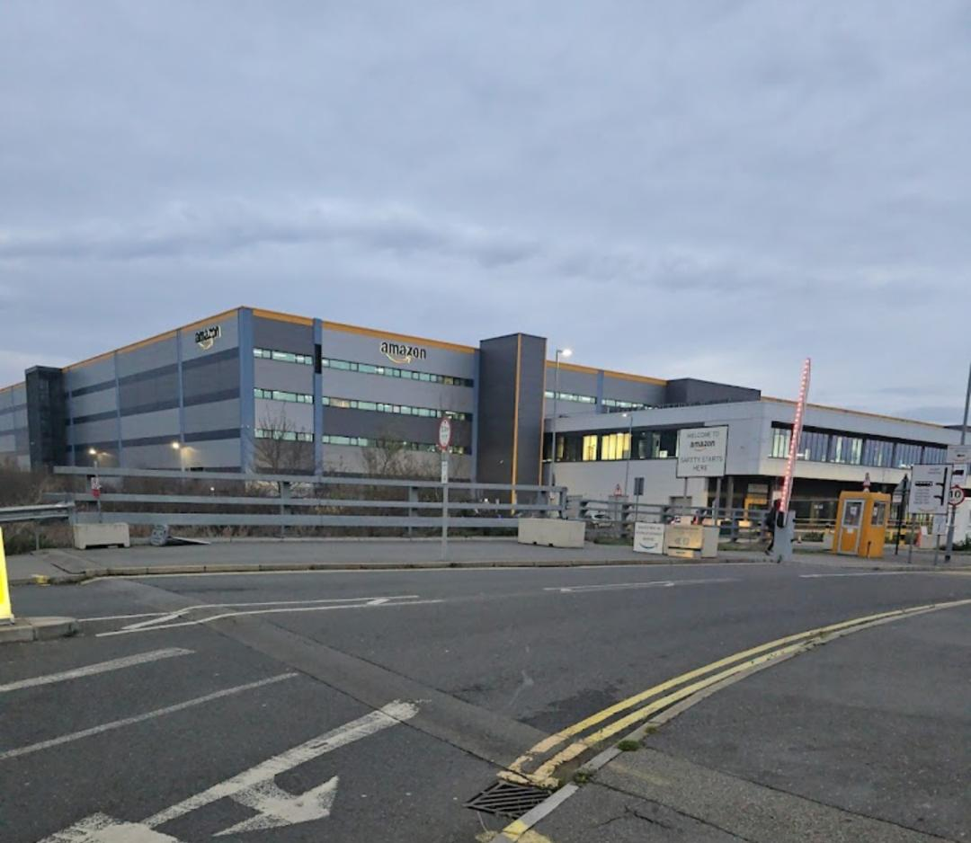
Figure 2. 8 Amazon Fulfillment Centre access gate

Source: Google Images (2023)

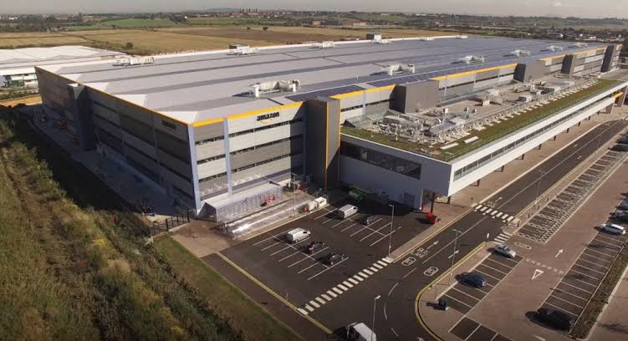
The photo indicates an Amazon Fulfillment center, a huge commercial building with solar panels on the roof, providing an Amazon brand, a parking region with a couple of vehicles, and surrounding greenery.

Figure 2. 9 Amazon Fulfillment Centre 3D view

Source: Google Images (2023)

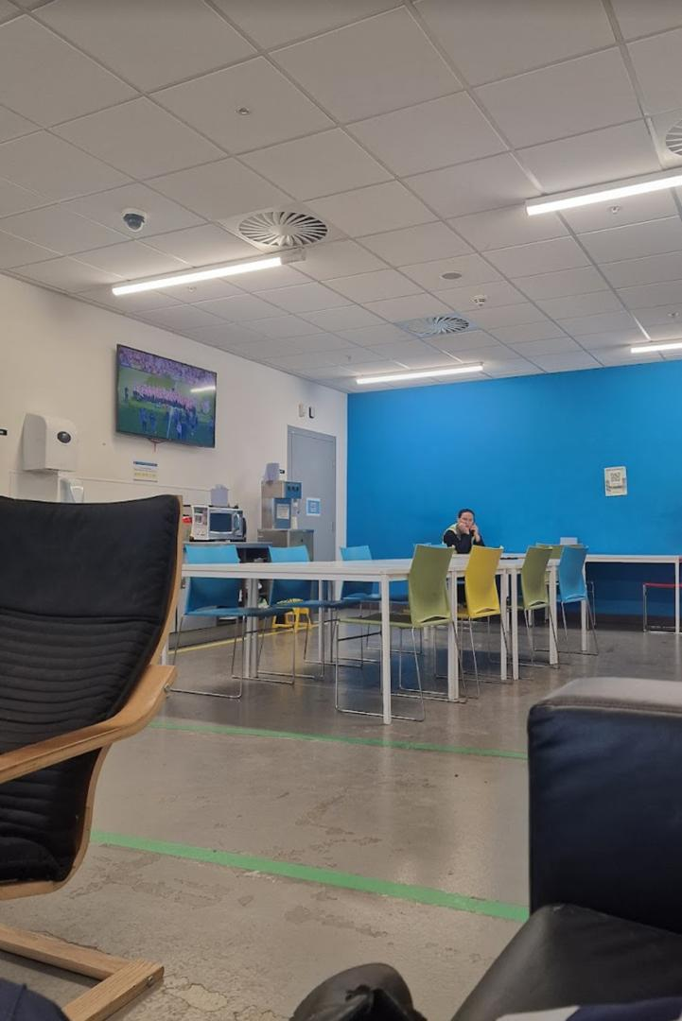

Figure 2. 10 Amazon Fulfillment Centre conference room

Source: Google Images (2023)

Architectural Merits:
1. High-bay storage design: Maximizes vertical space efficiency.
2. Dedicated inbound/outbound docks: Reduce internal congestion.
3. Clear circulation spine: With optimized cross-aisles for robotic systems.
Architectural Demerits:
1. Monolithic block form: Provides little user orientation inside.
2. Minimal natural lighting: Fully dependent on artificial systems.

UPS Smart Hub – Atlanta, USA
Location: 1100 Fulton Industrial Blvd NW, Atlanta, GA
Type: Ground parcel processing and logistics terminal
Brief History:
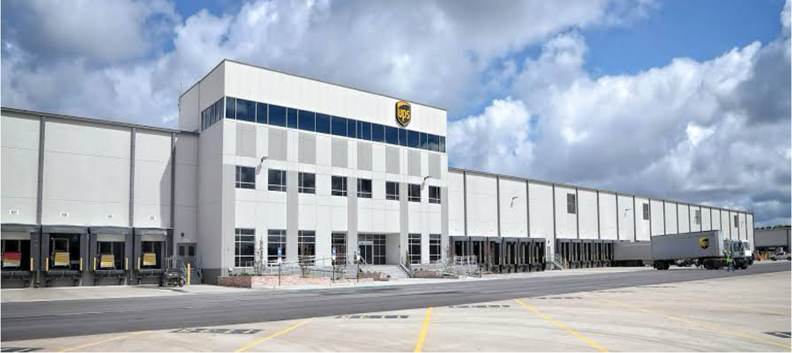
Opened in 2018, the $400 million UPS Smart Hub in Atlanta processes over 100,000 parcels per hour using advanced scanning and automated systems. It was designed to optimize internal circulation and scale operations (UPS Newsroom, 2018).
Figure 2.11 UPS Smart Hub logistics terminal Front view
Source: http://randallpaulson.com(2018)
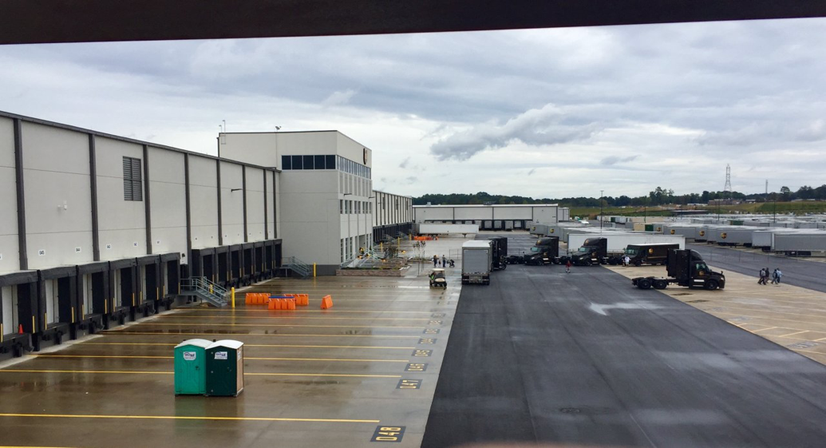

Figure 2.12 UPS Smart Hub logistics terminal Side view
Source: http://randallpaulson.com(2018)

Architectural Merits:
1. Modular building form: Supports future expansion.
2. Segmented bays for traffic types: Minimizes intersection conflicts.
3. Advanced signage and wayfinding: Aids internal navigation.
Architectural Demerits:
1. Very large floor plate: May increase walking distances inside.
2. Extensive hardscape: Limits environmental permeability.
FedEx Ground Hub – Chicago, USA
Location: 7000 W 59th Street, Bedford Park, Chicago
Type: Regional logistics distribution terminal
Brief History:
FedEx’s Ground facility in Chicago is a LEED-certified structure with integrated sustainability features and automated logistics infrastructure. It facilitates large-volume cargo flows and is a central point for Midwestern distribution (FedEx, 2021).
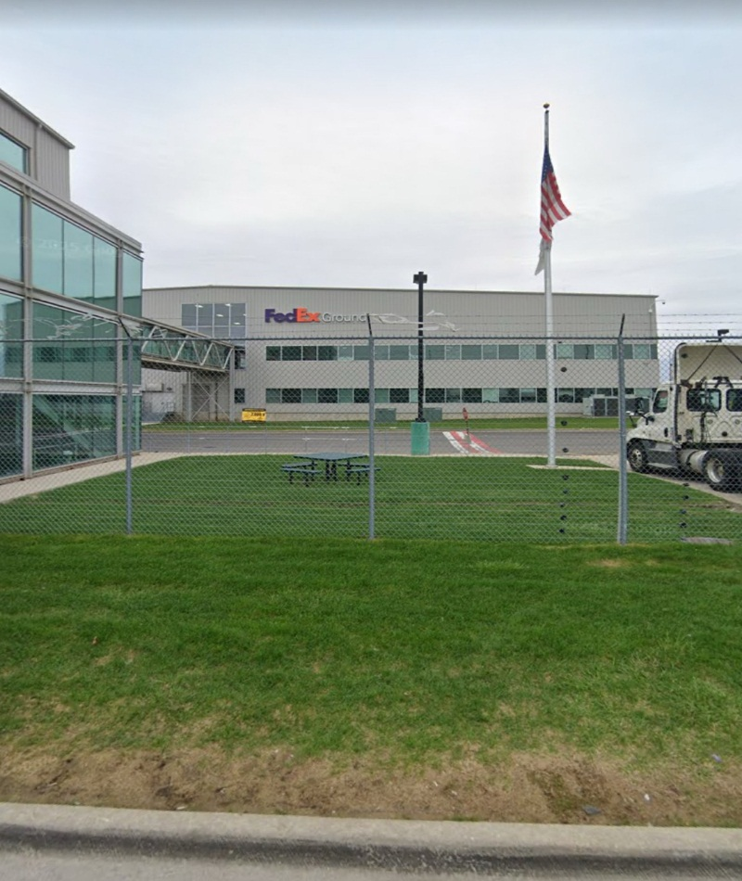

Figure 2.13 FedEx logistics terminal Front view
Source: Google image(2021)

This photograph indicates a FedEx Ground logistics terminal from a side view. In the foreground, there is a large, paved parking and drop-off area. The lot has yellow painted lines marking numerous parking bays and "DROP ZONE" areas. Several large semi-vehicles are parked alongside the side of the building, at loading docks, with their trailers visible. The universal scene depicts a considerable, industrial-scale logistics facility designed for the efficient management of an excessive quantity of packages.
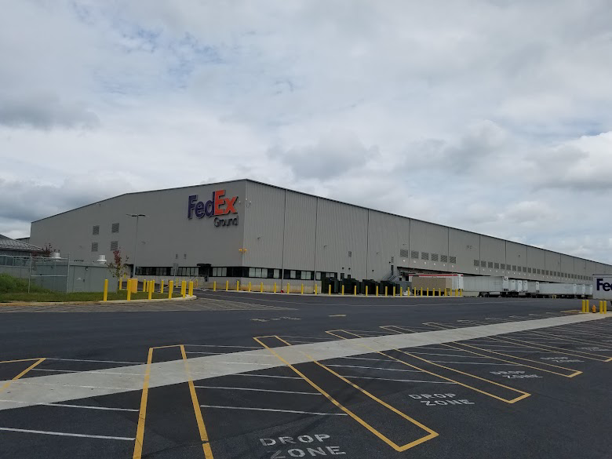
Figure 2.14 FedEx logistics terminal Side view
Source: Google image(2021)

This photograph shows the parking lot filled with FedEx Express transport trucks. The cars are current, small, electric-powered-looking vans. They are arranged in neat rows on a paved lot. The basic scene conveys a sense of a large, nicely prepared, and present-day logistics operation.

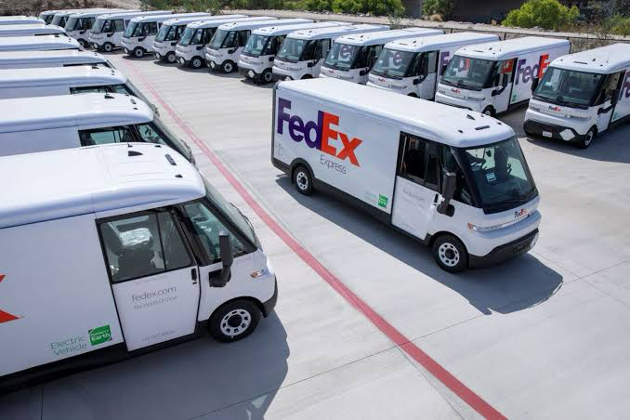
Figure 2.15 FedEx logistics delivery vehicle parking area
Source: Google image(2021)

Architectural Merits:
- Green roof design: Reduces heat gain and blends into surroundings.
- Flexible dock areas: Accommodate diverse shipping sizes.
- Passive daylighting in office sections: Improves energy efficiency.
Architectural Demerits:
- Operational areas dominate architecture: Minimal aesthetic articulation.
- Low public interface: Uninviting facade for non-logistics users.

This is a summary table that outlines the important characteristics of numerous logistics terminals. The table has four columns: "Terminal," "Address," "Merits," and "Demerits." It provides a concise case observe for each facility indexed.

Summary Table

Table 2. 1 SUMMARY TABLE OF CASE STUDIES
Terminal | Address | Merits | Demerits
GIGM Enugu | 1A Ziks Ave, Naira Triangle, Enugu | Tech integration, zoned areas | Peak congestion, tight space
GUO Enugu | 34 Okpara Ave, Enugu | Flow separation, tracking system | Poor pedestrian access
NIPOST Lagos | Mobolaji Bank Anthony Way, Ikeja | Network reach, zoned sorting area | Old layout, signage gaps
Amazon UK | Tilbury, RM18 7AN, UK | Automation, dock separation | Scale disorientation, tech dependency
UPS Atlanta | 1100 Fulton Industrial Blvd NW, GA, USA | Fast throughput, advanced tracking | High maintenance, routing complexity
FedEx Chicago | 7000 W 59th St, IL 60638, USA | LEED design, dock automation | Surface coordination, specialized docks

Summary of Literature Review and Case Studies
The literature reviewed highlights that productive circulation in terminal logistics is a result of prudent space planning, route separation, and intelligent system integration. Nigerian terminals like GIGM and GUO have potential but require architectural development in terms of pedestrian-friendly areas as well as more transparent zoning. International terminals like

CHAPTER THREE
STUDY AREA
3.0 Introduction
This chapter presents an overview of the selected study area, Naira Triangle in Enugu, Nigeria. The chapter discusses the geographical setting, selection criteria, historical context, physical environment, and socio-economic characteristics relevant to effective circulation in logistics terminals.

3.1 Geographical Location and Setting

This is a political map of Nigeria showing its 36 states and the Federal Capital Territory (FCT). The map is targeted on the United States, with longitude lines from 2° E to 14° E and latitude lines from 4° N to twelve° N.

The states are outlined and classified with their names. A key within the backside right nook suggests that Enugu State is highlighted in red, and water bodies are shown in blue. The map additionally indicates the main rivers flowing through the USA.

The scale of the map is furnished at the lowest, indicating a ratio of 1:7,500,000, with a corresponding bar scale showing distances in kilometers. The map offers a clear geographical evaluation of Nigeria's inner political divisions.

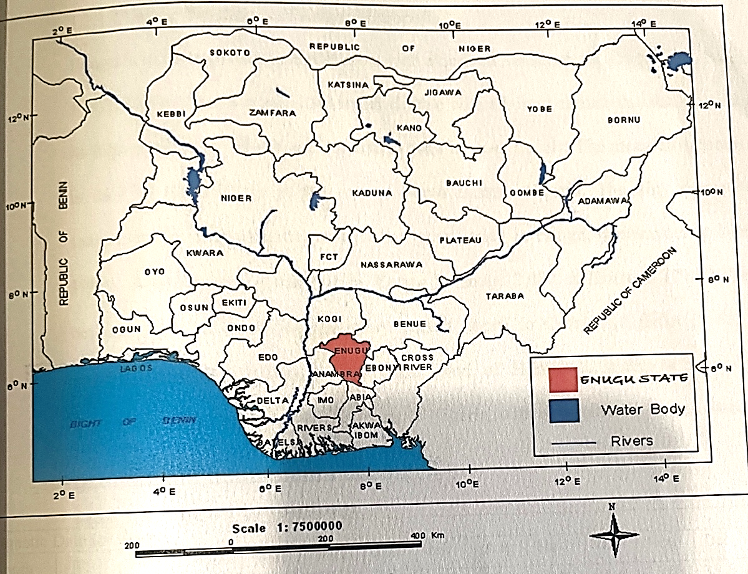
Figure 3.1: Map of Nigeria showing Enugu State with the 36 States of Nigeria and the Federal Capital Territory

Source: Nationsonline (2016).

Nigeria, officially referred to as the Federal Republic of Nigeria, is positioned in West Africa, among latitudes 4°N and 14°N and longitudes three°E and 15°E. It shares borders with the Benin Republic to the west, Niger to the north, Chad to the northeast, and Cameroon to the east, with its southern boundary being the Atlantic Ocean alongside the Gulf of Guinea. Nigeria is split into 36 states and a Federal Capital Territory (FCT) and operates a federal system of presidency. It is the most populous country in Africa and has a rapidly expanding economic system, making it an enormous hub for commerce and logistics in the West African sub-region (National Bureau of Statistics, 2022).

Based on the map furnished, here is a description:

This is a geopolitical map of Enugu State, Nigeria. The map is overlaid with a grid that indicates range and longitude coordinates.

Key Features:

* Geographical Area: The map outlines the boundaries of Enugu State and its diverse Local Government Areas (LGAs).

* Coordinate System: The map uses a grid with lines of longitude ranging from approximately 7°0'0"E to 8°0'0"E and lines of latitude from about 6°0'0"N to 7°0'0" N.

* LGAs Labeled: Numerous LGAs are labeled on the map, together with:

* Uzo-Uwani

* Nsukka

* Igbo-Etiti (labeled "Osbebe")

* Udi

* Ezeagu

* Oji River

* Agwu (Agwu)

* Nkanu East

* Nkanu West

* Enugu East

* Enugu North

* Enugu South

* and others within the northern part of the country.

* Highlighted Regions: The significant part of the nation is highlighted to show the three key LGAs that constitute the middle of Enugu city:

* Enugu East: Colored brown, positioned to the east of Enugu North.

* Enugu North: Colored orange, positioned within a significant part of the highlighted location.

* Enugu South: Colored darkish blue, positioned to the south of Enugu North.

* Surrounding LGAs: The map indicates the relationships between those LGAs. For instance, Enugu East, North, and South are bordered by other LGAs inclusive of Nkanu West (coloured light blue) to the southwest and Nkanu East to the southeast. Oji River and Udi are to the west, even as Igbo-Etiti is to the north.

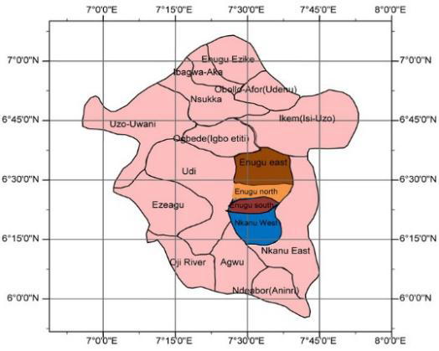

Figure 3.2: Map of Enugu state showing Enugu East, North, and South regions

Source: Nationsonline (2016).

One of the outstanding southeastern states in Nigeria is Enugu State, regularly referred to as the “Coal City” because of its rich coal mining records. It is bounded using Kogi State to the northwest, Benue State to the northeast, Ebonyi State to the east, Anambra State to the west, and Abia State to the south. The country capital, Enugu town, lies kind of among latitude 6°30'N to 7°30'N and a longitude 7°00'E to 8°00'E, occupying a strategic vicinity within the southeast geopolitical zone. Enugu is on the market by using the avenue, rail, and air, making it a critical node for nearby delivery and commercial freight.

Within Enugu town, the examination area called the Naira Triangle is located within the Enugu North Local Government Area. This region bureaucracy has a triangular form defined by 3 foremost roads: Ogui Road, Market Road, and Okpara Avenue. The triangle is less than 1 kilometer in radius but incorporates a number of the busiest city features in the metropolis. It is bordered by Holy Ghost Park to the east, Ogbete Main Market to the south, and the railway corridor to the west. This principal positioning gives the website a strategic advantage in terms of accessibility, visibility, and integration with surrounding urban systems.

From a land use attitude, the Naira Triangle is a blended-use city region that combines transport, retail, warehousing, public infrastructure, and casual trading. This high-density city material reflects the dynamics of a growing metropolis that serves both local and interstate functions. Transport corporations along with GIGM, GUO, and Young Shall Grow Motors operate inside or close to this place, helping daily passenger movement and freight services throughout the country. These activities create extreme move styles—each pedestrian and vehicular—making the place ideal for a redesigned logistics terminal with the purpose to decongest site visitors, improve operational performance, and enhance the person experience.

Geographically, the terrain is commonly flat to softly undulating, which is suitable for construction and permits flexibility in layout design. The location is properly related through the most important arterial roads, while secondary roads and footpaths assist the internal stream. The web page benefits from the present city infrastructure such as strength, public water supply, drainage structures, and public transportation hubs.

The surrounding neighborhoods are in the main commercial and institutional, but also include a mix of residential uses. This urban setting offers each opportunity and demanding situations: even as it guarantees human visitors and market proximity, it additionally suffers from congestion, disorderly parking, and inadequate loading/unloading spaces. These constraints make the vicinity not handiest suitable but additionally in need of architectural intervention via powerful spatial planning and circulation layout

3.2 Site Selection Criteria
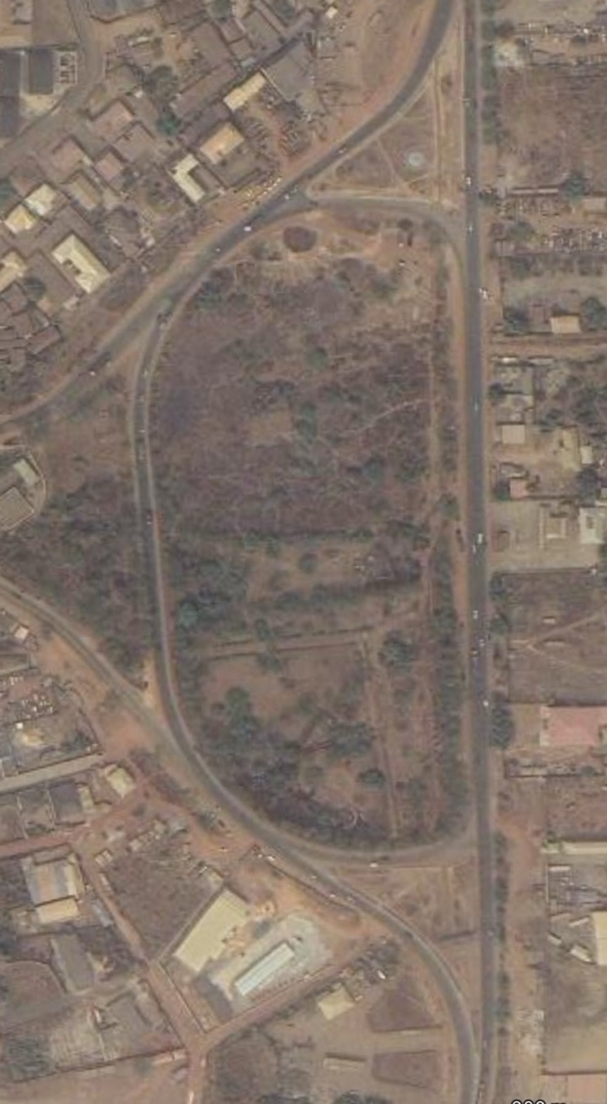

Figure 3.3: Site Map of Naira Triangle

Source: Google Earth

The selection of the Naira Triangle in Enugu because the web site for the logistics terminal is knowledgeable by way on numerous strategic, physical, and functional criteria. These encompass accessibility, connectivity, land use compatibility, population density, monetary affordability, and infrastructure availability. Proximity to the Ogbete Main Market and principal transport routes complements its suitability. The region's existing industrial feature aligns with the desires of a logistics terminal, that is to aid goods movement, warehousing, and mobility. Furthermore, the website's topography, availability of buildable land, and surrounding avenue community make it ideal for designing an efficient circulation system.

3.3 Brief History of the Study Area

Enugu metropolis has a deep-rooted historical significance dating back to the early twentieth century, while coal was discovered in the Udi hills by British colonists in 1909. This discovery brought about the establishment of the railway line from Port Harcourt to Enugu in 1916, making the metropolis the executive and commercial center of Eastern Nigeria. The Naira Triangle itself developed as a principal trading and shipping node because of its proximity to the railway station and the Ogbete Main Market. Over time, the region transformed into a logistics hub wherein multiple bus and freight corporations set up terminals. This transformation was driven by financial and population growth, creating a need for powerful visitors and logistics control (Eze, 2019).

3.4 Physiography, Climate, and Vegetation

Based on the weather graph provided for Enugu, Nigeria (Altitude: 142 m), here is an in-depth description:

The graph displays a year-long evaluation of numerous climate variables, with months on the x-axis and specific scales on the y-axis.

Key Features:

* Temperature:

* Maximum Temperature (red line): The maximum temperatures are determined from January to April, peaking in March at around 35°C. Temperatures progressively lower at some stage in the rainy season after which they begin to rise again in the direction of the quit of the 12 months, reaching approximately 33°C in November and December.

* Minimum Temperature (blue line): The minimum temperatures observed were comparable to the maximum, with the lowest points occurring at some point in the center of the 12 months, around July and August, at approximately 22°C to 23°C. The highest minimum temperatures are around March and April, reaching about 24°C.

* Average Temperature (pink line): The common temperature is highest in March and April, around 29°C, and slightly decreases at some stage in the mid-year rainy season, dropping to about 26°C.

* Precipitation (inexperienced bars):

* Rainy Season: The graph truly suggests an awesome rainy season from April to October. Precipitation levels are very low from November to March.

* Peak Rainfall: The wettest months are August and September, with precipitation exceeding 250 mm.

* Dry Season: The driest months are December, January, and February, with very little rainfall, typically less than 5 mm.

* Daylight (gray line):

* Daylength (Hours): The daylength stays notably consistent in the year, as expected for a region near the equator. It hovers simply above 12 hours, with a moderate version of about an hour among the longest and shortest days.

Summary of Climate:

The graph illustrates a regular tropical wet and dry climate.

* Dry Season: From November to March, characterised with the aid of excessive temperatures, low rainfall, and minimal cloud cover.

* Wet Season: From April to October, characterised by a aid of decrease in most temperatures and very high ranges of precipitation, peaking in late summer. The minimal temperatures are also barely cooler for the duration of this period. The climate is possibly to be warm and humid throughout the wet season.
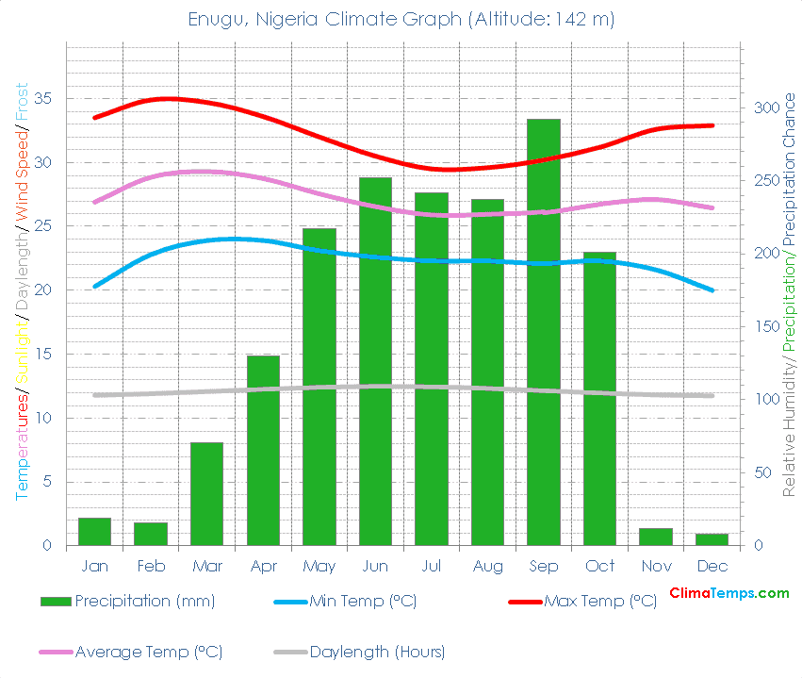

Figure 3.4: Climate Graph Of Enugu, Nigeria

Source: Google image

The terrain of the Naira Triangle and Enugu metropolis is characterised by lightly undulating plains and low hills. The elevation averages around 2 hundred to 300 meters above sea level, imparting suitable drainage conditions appropriate for terminal improvement. The soil composition includes sandy loam and laterite, which assist in creation activities.

Enugu falls under the tropical savanna weather area with wonderful wet and dry seasons. The rainy season typically spans from April to October, even as the dry season runs from November to March. Average annual rainfall levels between 1,2 hundred mm and 2,000 mm, and temperatures vary between 22°C and 34°C. The weather affects building orientation, drainage making plans, and the selection of substances for weather durability (NIMET, 2022).

Vegetation in the location is a combination of derived savanna and concrete green patches, primarily inclusive of shrubs, grasses, decorative bushes, and a few remnant wooded area species in less advanced plots. Vegetation should be incorporated into the logistics terminal design for ecological balance and urban aesthetics.

3.5 Population, Culture, and Economic Development

Enugu town has a population of approximately 800,000 residents, with the Enugu North LGA hosting a considerable component due to its centrality and industrial vibrancy. The Naira Triangle places studies in very excessive daylight hours population density because of consumers, traders, shipping customers, and logistics operators (NPC, 2023). This density reinforces the need for green pedestrian and vehicular flow within the proposed terminal.

The dominant ethnic organization in Enugu is the Igbo people, known for their entrepreneurial spirit, strong network ties, and colourful lifestyle. The language spoken is more often than not Igbo, alongside English for enterprise and respectable communication. The local tradition embraces trade, innovation, and variation, which supports the integration of cutting-edge logistics solutions into conventional systems.

Economically, the vicinity flourishes on retail alternatives, shipping services, warehousing, and small-scale manufacturing. Ogbete Main Market, which lies adjacent to the website, is one of the biggest markets in southeastern Nigeria and attracts buyers from more than one state. This creates opportunities for nearby monetary growth via logistics optimization, city regeneration, and employment technology.

CHAPTER FOUR
RESEARCH METHODOLOGY
4.0 Introduction
This chapter outlines the methodology used to investigate effective circulation in logistics terminals. It details the research design, data sources, sampling techniques, methods of data collection, and techniques for data analysis.
4.1 Research Design
The study adopted a case study and descriptive survey design, integrating observational methods and qualitative review of existing logistics terminals. This combination was used to understand the spatial, operational, and architectural principles influencing effective circulation in logistics hubs. Case studies enabled in-depth analysis of selected logistics terminals, while surveys provided broader user perspectives on terminal design and efficiency.
4.2 Data Needs and Sources
To address the research objectives, the following data types were identified:
Primary Data: Site observations, interviews with staff and users, photographs, and physical measurements.
Secondary Data: Literature from journals, books, government reports, terminal layout plans, and online resources.
Sources include:
Terminal operators and users (primary)
Published academic research and government logistics data (secondary)
Online repositories and architectural documentation
4.3 Population of Study and Sampling Procedure
The population consists of users, operators, and staff of logistics terminals, particularly those at the Naira Triangle (Enugu), GIGM, and GUO terminals. Other international case study terminals also provide comparative insights.
Sampling Technique: Purposive sampling was used to select terminals with varying levels of design and operational efficiency.
Sample Size: For surveys, a minimum of 20 respondents per local terminal was targeted, while observational studies covered 6 terminals in total (3 local, 3 international).
4.4 Methods and Instruments for Data Collection
Observation Sheets: Used to record pedestrian and vehicular circulation patterns, signage clarity, congestion points, etc.
Interviews & Questionnaires: Administered to users and staff to gather insights on functionality and user experience.
Photography & Video Recordings: Captured live circulation conditions and spatial organization of case study terminals.
Sketches and Floor Plans: Acquired from terminal managers and used for spatial analysis.
4.5 Methods of Data Analysis
Qualitative Analysis: Thematic content analysis was employed to interpret responses from interviews and observations.
Comparative Case Study Analysis: Used to highlight similarities and differences between terminals.
Descriptive Statistics: Frequencies and percentages from questionnaire responses were compiled using spreadsheet tools for visual representation (e.g., charts or tables).
Spatial Mapping: Manual sketching and digital drawing tools were used to analyze layout effectiveness and circulation flow.

CHAPTER FIVE
5.0 Introduction
This chapter uses findings from previous studies to create a practical layout for an advanced logistics terminal at Naira Triangle, Enugu. The design addresses stream inefficiencies and aligns with architectural, operational, and contextual criteria.
5.1 The Design Brief
Objective:
Design a terminal to accommodate passengers, cargo, and administrative features with green flow for pedestrians and automobiles.
Key Requirements:
Clear public, carrier, and staff zones
Well-described drop-off/select-up and loading/unloading areas
Comfortable waiting centres, price ticket counters, restrooms, and offices
Seamless car ingress/egress and parking for buses, automobiles, and bikes
5.2 Design Requirements & Planning Data
Standards & Spatial Provisions
Parking: 3 × 6 m in step with vehicle; 3.5 × 7 m for buses
Walkways: ≥1.5 minutes for both the public and staff
Turning Radii: ≥12.5 m for bus maneuvers
Counter Heights: Ticket windows at 0.9–1.0 m; 1.1 × 0.8 m space in step with the counter
Waiting Area: 1.2 m² according to the number of persons seated
Anthropometrics
Comfortable walking velocity: 1.2–1.5 m/s
Eye degree at 1.5 m for signage
Door clearances for house wheelchairs and cargo trolleys
5.3 Schedule of Accommodation
Functional Area Quantity Size each (m²) Total m²
Ticketing Counters four 2.5×3 30
Waiting Lounge 1 60 60
Admin Offices three 15 45
Loading/Unloading Bays 6 30 a hundred and eighty
Driver Rest Rooms 2 10 20
Toilets (M/F) 2 15 30
Passenger Car Parking 15 bays 3×6 every hundred and fifty
Bus Parking three bays 3.5 ×9 each 126
Motorbike Parking Varied 1 × 1 each 25

5.4 Special Considerations
Circulation: One-way loop avenue gadget, pedestrian segregation via bollards
Accessibility: Ramps and tactile tiles for users with disabilities
Safety: Fire exits, CCTV insurance, lighting fixtures
Environmental: Solar shading, permeable paving, passive air flow
Wayfinding: Color-coded zones, overhead signage at 1.5m

5.5 Site Inventory And Analysis
Inventory:
Mixed-use urban area with regular traffic
Utilities: Water, electricity at street degree
Vegetation: Sparse arms near the belongings edges
Topography: Slight slope (~1–2%)
Analysis:
Unsheltered movement corridors
Vegetation underutilized
Clear vehicular-pedestrian conflicts
Good possibilities for daylighting and ventilation

5.6 Data Analysis & Presentation
Findings:
Stakeholders highlight signage and warfare zones as top issues
Bottlenecks at access gates, shared zones
Preference for shading and clear orientation
Design Response:
Central spine for movement with color systems
Segregated zones with a clear visual hierarchy
Digital wayfinding kiosks and real-time traffic display
5.7 Design Concept & Proposal
Concept: “Flow & Clarity”
A linear form with a principal backbone performing as a site visitor's artery
Courtyards introduce herbal mildness, reduce warmth, and serve as orientation anchors
Buffer inexperienced zones separate shipment and public regions
Proposal Highlights:
Public quarter at central backbone; cargo bays at rear
Drop-off/pick-up forecourts with canopies
Landing lounges facing courtyards with passive cooling
Admin places of work overlooking operations for supervision
5.8 Presentation Drawings & 3-D Visuals
(These may be developed graphically; the draft includes a description of every drawing.)
Site Plan: Zones, access points, panorama
Floor Plan: Internal zoning, carrier regions
Elevations: Entry façades with shading and signage
Sections: Cross-sectional view showing stream backbone
Isometric renders: Pedestrian and vehicular motion
Circulation Diagram: Pedestrian vs. Automobile drift arrows
5.9 Detailed Drawings & Physical Model
Details at 1:20: Entrance canopy, standard bay, shading device
Sections: Load bay go-segment detailing awnings
Roof Structure Details: Drainage and PV integration
Physical Model: Massing, drift sample, and sunlight hours

REFERENCES

Akindare Okunola. (2018, November 16). GIGM is Nigeria’s most technologically advanced road transport company. TechCabal. Businessday NG+7TechCabal+7Wikipedia+7

AnaedoOnline. (2019, June 18). How GUO Transport started – Chief G.U. Okeke.Wikipedia+9anaedoonline.ng+9Connectnigeria Articles+9

Bertalanffy, L. von. (1968). General System Theory. George Braziller.

Ching, F. D. K. (2014). Architecture: Form, Space, and Order (4th ed.). Wiley.

ConnectNigeria. (2022, March 25). Brands We Love: GUO Transport. Connectnigeria Articles

GIG Mobility. (n.d.). About us [Wikipedia article]. Retrieved 2025. Wikipedia

GMPOSTS. (n.d.). GUO Transport: online booking process and terminals in Nigeria.anaedoonline.ng+8GMPOSTS+8thenigerianinfo.com+8

GMPOSTS. (n.d.). Young Shall Grow Motors Parks in Nigeria and West African Countries.GMPOSTS+1TechCabal+1

GUO Transport Company Ltd. (n.d.). About [Official website].Wikipedia+10guotran sport.com+10anaedoonline.ng+10

Higgins, L., Ferguson, M., & Kanaroglou, P. (2011). Modeling the effects of terminal gate appointment systems. Transportation Research Part E, 47(2).

Hillier, B., & Hanson, J. (1984). The Social Logic of Space. Cambridge University Press.

Neufert, E. & Neufert, P. (2012). Architects’ Data (4th ed.). Wiley-Blackwell.

Notteboom, T., & Rodrigue, J.-P. (2005). Port regionalization and flow continuity. Maritime Policy & Management, 32(3).

Rodrigue, J.-P., Comtois, C., & Slack, B. (2013). The Geography of Transport Systems. Routledge.

TechPoint Africa. (2018, May 8). How GIGM became the most technology-driven bus transportation company in Nigeria. Wikipedia+2Techpoint Africa+2Techpoint Africa+2

Wikipedia contributors. (2025). Enugu (city). Retrieved 2025. Reddit+4Wikipedia+4Reddit+4

Winkenbach, M., Clausen, U., & Holch, P. (2016). Designing Urban Logistics Systems. Springer.

Zhang, M., & Lam, J. S. L. (2019). Port digitalization and smart logistics. Journal of Transport and Supply Chain Management, 13.

