TITLE PAGE

CROP YIELD PREDICTION SYSTEM USING MACHINE LEARNING
A PROJECT SUBMITTED IN PARTIAL FUFILMENT OF THE REQUIREMENTS FOR THE AWARD OF BACHELOR OF SCIENCES (BSc) DEGREE OF COMPUTER SCIENCE

BY
OKONKWO, MICHAEL IFECHUWKU
GOU/U21/CSC/680

DEPARTMENT OF COMPUTER SCIENCE
FACULTY OF NATURAL AND APPLIED SCIENCE
GODFREY OKOYE UNIVERSITY, UGWUOMU-NIKE, ENUGU STATE

SUPERVISOR: DR. STEPHSON ECHEZONA

DECLARATION
This is to certify that this project topic titled “Crop Yield Prediction System Using Machine Learning” was carried out by Okonkwo Ifechukwu Michael with Registration Number: GOU/U21/CSC/680 under our supervision in the Department of Computer Science of Godfrey Okoye University, Thinker’s Corner, Emene, Enugu State.

...............................................................................
Okonkwo Ifechukwu Michael

APPROVAL PAGE
This research work titled “Crop Yield Prediction System Using Machine Learning” has been approved by the Department of Computer Science, Godfrey Okoye University, Thnker’s Corner, Emene, Enugu State.
_______________ __________________
DR. STEPHSON ECHEZONA Date
supervisor

________________ __________________
Mr Okebanama Frank Date
Head of Department

________________ __________________
External Examiner Date

DEDICATION
This research work is dedicated to the hardworking farmers of Nigeria, whose tireless efforts feed the nation. May this system serve as a tool to empower you with knowledge and improve your agricultural productivity.
Additionally, I dedicate this work to my family and mentors, whose unwavering support and encouragement made this journey possible.

ACKNOWLEDGMENT
I would like to express my deepest gratitude to my supervisor, DR. Echezona, for their invaluable guidance, patience, and expertise throughout this research. Their constructive feedback and encouragement were instrumental in shaping this work.
I am also profoundly thankful to my colleagues and friends for their support and insightful discussions. Special thanks to the staff of Godfrey Okoye University for providing the resources and environment necessary for this study.
Lastly, I acknowledge the contributions of the open-source community and the developers of the tools and libraries used in this project. Without their efforts, this work would not have been possible.

ABSTRACT
Agriculture is the backbone of Nigeria's economy, yet farmers face significant challenges in predicting crop yields due to unpredictable weather, soil variability, and limited access to advanced tools. This study addresses these challenges by developing a Crop Yield Prediction System using machine learning. The system leverages historical and real-time data, including soil nutrients (N, P, K), pH levels, temperature, rainfall, and crop type, to forecast yields accurately.
The system employs regression models such as Linear Regression, Decision Tree, and Random Forest, with the latter demonstrating the highest accuracy (R² = 0.953). Real-time weather data is integrated via the OpenWeatherAPI, and the system is deployed as a user-friendly web application using Flask and Bootstrap. Key features include user authentication, personalized dashboards, and graphical visualization of historical predictions.
The system was evaluated using Nigerian agricultural data, demonstrating its potential to enhance decision-making for farmers, policymakers, and agricultural officers. By improving yield predictability and resource optimization, this research contributes to sustainable farming practices and food security in Nigeria.

TABLE OF CONTENTS
Preliminary Pages
Dedication i
Acknowledgments ii
Abstract iii
Chapter 1: Introduction
1.1 Background of Study 1
1.2 Statement of the Problem 3
1.3 Aim and Objectives of the Study 4
1.4 Significance of the Study 5
1.5 Scope of Study 6
1.6 Limitations of the Study 7
Chapter 2: Literature Review
2.1 Introduction 8
2.2 Theoretical Background 9
2.3 Crop Yield and Its Determinants 10
2.4 Traditional Methods of Crop Yield Prediction 12
2.4.1 Historical and Empirical Estimation 12
2.4.2 Statistical Models 13
2.4.3 Agro-climatic and Crop Simulation Models 14
2.4.4 Limitations of Traditional Methods 15
2.5 Use of Machine Learning in Crop Yield Prediction 16
2.5.1 Overview of Machine Learning in Agriculture 16
2.5.2 Commonly Used Machine Learning Algorithms 17
  - Linear Regression (LR) 17
  - Decision Tree Regression (DTR) 17
  - Random Forest Regression (RFR) 18
  - Support Vector Machines (SVM) 18
  - Artificial Neural Networks (ANNs) 19
  - Gradient Boosting Machines (GBM) 19
  - K-Nearest Neighbors (KNN) 20
2.5.3 Input Features for Yield Prediction Models 20
2.5.4 Advantages of Machine Learning in Yield Prediction 21
2.5.5 Challenges and Considerations 21
2.6 Review of Related Literature 22
2.7 Summary of Review of Related Literature 26
2.8 Contribution to Knowledge 28
Chapter 3: System Analysis and Design
3.1 Introduction 29
3.2 System Analysis 30
3.2.1 Analysis of the Existing System 30
3.2.2 Shortfall of the Existing System 32
3.2.3 Analysis of the Proposed System 33
3.3 System Requirements 34
3.3.1 Functional Requirements 35
3.4 Methodology: Object-Oriented Analysis and Design 36
3.4.1 Unified Modelling Language Diagrams 37
3.4.2 Use Case Diagrams 38
  - 3.4.2.1 Use Case Diagram of Existing System 38
  - 3.4.2.2 Use Case Diagram of Proposed System 39
3.4.3 Activity Diagrams 40
  - 3.4.3.1 Activity Diagram of Existing System 40
  - 3.4.3.2 Activity Diagram of Proposed System 41
3.4.4 Class Diagrams 42
  - 3.4.4.1 Class Diagram of Existing System 42
  - 3.4.4.2 Class Diagram of Proposed System 43
3.4.5 Sequence Diagrams 44
3.5 System Design 45
3.5.1 Input/Output Design 46
  - 3.5.1.1 Input Designs of the Proposed System 46
  - 3.5.1.2 Output Design of the Proposed System 47
3.5.2 Database Design 48
Chapter 4: System Implementation
4.1 Introduction 49
4.2 Choice of Development Environment 50
4.2.1 Frontend 51
  - 4.2.1.1 HTML 51
  - 4.2.1.2 CSS 52
4.2.2 Backend 53
  - 4.2.2.1 Python 53
  - 4.2.2.2 Flask 54
  - 4.2.2.3 MySQL 55
4.3 System Requirements 56
4.4 User Interface of the Proposed System 57
4.4.1 Proposed System Homepage 58
Chapter 5: Summary, Recommendations, and Conclusion
5.1 Introduction 59
5.2 Summary 60
5.3 Recommendations 61
5.4 Conclusion 62
References 63
Additional Technical and Software Sources 65

LIST OF TABLES
TABLES PAGES
2.7 Summary of Related Literature (Comparative Analysis) 26
3.1 User Table (Database Schema) 48
3.2 Predictions Table (Database Schema) 48
3.3 Crop_Facts Table (Database Schema) 49

LIST OF FIGURES
FIGURE PAGES
3.1 Use Case Diagram of Existing System 38
3.2 Use Case Diagram of Proposed System 39
3.3 Activity Diagram of Existing System 40
3.4 Activity Diagram of Proposed System 41
3.5 Class Diagram of Existing System 42
3.6 Class Diagram of Proposed System 43
3.7 Sequence Diagram of Proposed System 44
3.8 Input Design of Proposed System 46
3.9 Output Design of Proposed System 47
4.0 Screenshots of Proposed System Homepage 58

CHAPTER ONE
INTRODUCTION

1.1 BACKGROUND OF STUDY
Agriculture remains the backbone of economic development and food security across the African continent, employing over 60% of the labor force and contributing significantly to GDP in many nations (FAO, 2023; World Bank, 2024). It supports the livelihood of millions and is crucial for poverty alleviation and rural development. However, African agriculture particularly among smallholder farmers is increasingly threatened by erratic weather patterns, soil degradation, pest infestations, limited mechanization, and inappropriate fertilizer use (Ibrahim et al., 2024; Eze & Uche, 2023). These challenges undermine crop yield predictability and make effective planning difficult, especially in regions with minimal access to modern farming tools.
Despite widespread agricultural activity, food production across the continent often falls short of meeting growing population demands. Recent studies by the African Union (2024) and the FAO (2023) indicate that yield volatility contributes significantly to food insecurity, income instability, and reduced investment capacity among rural farmers. Traditionally, farming practices in Africa have been guided by intuition, experience, and generational knowledge rather than data-driven strategies. While this has historically sufficed, such methods are increasingly unreliable under today’s changing climatic and environmental conditions (Adesanya & Bello, 2022).
In response, digital transformation in agriculture has gained momentum, particularly through the application of Artificial Intelligence (AI) and its subset, Machine Learning (ML). ML systems can analyze vast agricultural datasets and learn patterns without being explicitly programmed, making them ideal for tasks such as crop yield prediction, disease detection, and farm resource optimization (Adebayo et al., 2025; Kuradusenge et al., 2024). These models improve forecast accuracy by evaluating complex, interrelated variables such as soil nutrients (Nitrogen, Phosphorus, Potassium), pH levels, temperature, rainfall, humidity, and crop type (Adegboye & Hassan, 2022).
ML-driven prediction enables farmers to make informed decisions on crop selection, planting and harvesting schedules, and fertilizer application rates. These decisions can be tailored to localized conditions using region-specific datasets, thereby addressing the historical mismatch between imported prediction models and African agro-ecological realities (Okoro et al., 2023; Abdurrahman & Muhammad, 2025).
This project proposes a Machine Learning-based Crop Yield Prediction System designed specifically for African smallholder farming environments. The system is powered by historical agricultural data and real-time weather information retrieved via the OpenWeatherAPI. It supports both automated and manual data entry, making it accessible even to farmers with limited technological exposure. Various regression models such as Linear Regression, Decision Tree, and Random Forest are trained, validated, and compared using the R² metric to select the most suitable model for deployment.
The selected model is deployed as a responsive web application built with Flask and Bootstrap, featuring a user-friendly interface that facilitates predictions, historical tracking, and fertilizer recommendations. Ultimately, the system aims to improve agricultural productivity, promote sustainable land use, and enhance food security across African regions. Similar to how ML is transforming healthcare and finance, this application exemplifies its growing potential to revolutionize agriculture in low-resource settings (Siam et al., 2023; Gonzalez-Sanchez et al., 2023).
1.2 STATEMENT OF PROBLEM
Uncertainty in crop yield is a chronic problem of African agriculture which have given rise to several Issues of top priority:
- Incorrect Yield Forecasting: The majority of farmers use guesswork or experience to predict the quantity of crop yield to be anticipated in each season. This overestimates or underestimates and impacts supply chains and revenues.
- Unpredictable Climate Conditions: Due to forthcoming climate patterns and global warming, climatic parameters like temperature and precipitation become less predictable. Farmers who fail to predict such changes are more vulnerable to crop loss.
- Ineffective Use of Fertilizers: Since farmers lack reliable data on the fertility of land and probable crop yield, most use fertilizers improperly either too much or too little which leads to lower productivity and soil degradation in the long run.
- Burden of Manual Inputs: Some systems are heavy on manual inputs that are time-consuming and non-user-oriented, particularly with low-digital-literacy farmers.

1.3 AIM AND OBJECTIVES OF THE STUDY
The objective of this research is to design a Crop Yield Prediction System based on machine learning methods to predict the yield of crops of interest in Africa from environmental and soil information.
The objectives include:
- To collect relevant agricultural and environmental data including soil nutrients, crop type, and weather conditions required for accurate yield forecasting.
- To design and implement an intelligent machine learning pipeline capable of predicting crop yield with minimal reliance on manual input and human intuition.
- To integrate real-time climatic data from OpenWeatherAPI to improve system responsiveness to unpredictable weather patterns and climate changes.
- To analyze and compare the performance of multiple regression models (e.g., Linear Regression, Decision Tree Regression, Random Forest) to determine the most suitable for African farm conditions.
- To provide automated and data-driven fertilizer recommendations based on soil fertility and predicted crop yield to prevent misuse of fertilizers.
- To deploy the system as an accessible and user-friendly web application tailored to low-digital-literacy farmers, ensuring minimal manual input and ease of use.
1.4 SIGNIFICANCE OF THE STUDY
This research work holds profound significance to the following key stakeholders:
- African Farmers
- Agricultural Extension Officers
- Government and Policy Makers
- Agricultural Researchers and Technology Developers
- Farmers: The system provides farmers with an intelligent tool for predicting crop yields based on actual soil and weather data. With more accurate information, farmers can plan better, reduce losses, and make informed decisions on crop selection and fertilizer usage.
- Agricultural Extension Officers: Officers working directly with rural farmers can use this system as a practical tool to guide and educate farmers, improving their productivity and knowledge of data-driven agriculture.
- Government and Policy Makers: Reliable prediction of crop yields helps governments in agricultural planning, food security analysis, and resource distribution. It also provides insight into how to support specific regions based on yield trends and weather conditions.
- Agricultural Researchers and Technology Developers: This system serves as a framework for further research and development in smart agriculture. It offers a model that can be extended to include other predictive features such as disease outbreaks, market forecasting, and pest control.
- Rural Communities and the Economy: By improving crop output and reducing the rate of farming losses, the system indirectly boosts rural development, food availability, and contributes to the national economy by ensuring a more stable agricultural sector.
1.5 SCOPE OF STUDY
The project focuses on the design and development of a web-based crop yield prediction system for selected crop type. It uses machine learning algorithms to predict yield based on features such as soil nutrients, temperature, rainfall, pH level, and crop type.
Additionally, the system is delimited to the web-based version as it operates with a focus of use on only internet technologies.

1.6 LIMITATIONS OF THE STUDY
Despite the importance of this project, it is not without limitations:
- Internet Dependency: The web-based system and OpenWeatherAPI integration require internet access, which may not be available in remote farming areas.
- Technical Accessibility: The successful deployment of the system required a high level of technical expertise in area like software development which the researcher is not very well experienced in.

CHAPTER TWO
LITERATURE REVIEW
2.1 INTRODUCTION
Agriculture remains vital to Africa’s economy and food security, contributing significantly to GDP and employing a large portion of the population (Bassine et al., 2023). However, crop yield variability resulting from climate change, suboptimal soil conditions, and inefficient farming practices continues to be a major constraint. According to the FAO, environmental stress and poor resource utilization account for up to 40% of annual yield loss globally (FAO, 2023) a figure echoed in critical assessments of stress-related agricultural decline.
Smallholder farmers across Africa still rely heavily on outdated yield forecasting methods often based on average past outputs or visual assessments leading to poor planning, misuse of fertilizers, and financial losses (Saadio et al., 2023). These conventional approaches fail to account for dynamic weather conditions and the complexity of local agroecological contexts.
In contrast, Machine Learning (ML) offers improved predictive power through the analysis of large-scale agricultural and environmental datasets. Recent systematic reviews highlight that ML models particularly Random Forest, Gradient Boosting, and neural network variants are proficient at identifying intricate relationships between soil nutrients, pH, temperature, precipitation, and crop type (Sharma et al., 2025; Iqbal et al., 2024). For example, GlobalCropYield5min a high-resolution global yield dataset demonstrated robust model performance with R² values between 0.70 and 0.95 for staple crops (Sharma et al., 2025).
Nevertheless, most existing ML-based yield forecasting studies either omit real-time weather integration or are calibrated for non-African settings. A West African study showcased the feasibility of Random Forest and Gradient Boosting models for regional yield prediction, yet relied entirely on historical data without live weather inputs (Saadio et al., 2023). Additionally, research in Pakistan segmented the crop growth cycle to predict wheat yields but lacked seamless integration of sensor-based climate monitoring (Analysts, 2025).
Emerging work explores advanced deep‑learning hybrids like CLSTMT (Cluster‑LSTM‑Transformer) achieving R² > 0.95 though these models require substantial computing resources and extensive multisource data, limiting their practical use in low‑infrastructure settings (Talaat et al., 2024).
Crucially, reviews underscore that coupling ML with remote sensing, IoT, and weather data is paramount for real‑time yield and water management (Bassine et al., 2023). Integrating satellite imagery (NDVI), soil sensors, and climatic APIs enables more accurate, timely, and localized predictions an imperative step toward sustainable, resilient agro‑ecosystems (Victor et al., 2022).
2.2 THEORETICAL BACKGROUND
The theoretical background of this study outlines the historical development and underlying concepts related to crop yield prediction, particularly through the use of machine learning algorithms. It provides a foundation for understanding how data-driven approaches have evolved in agricultural forecasting, clarifies essential terms and concepts, and examines related predictive models used in the estimation of crop yields.
Historically, crop yield prediction depended on statistical methods and expert judgment based on past records and seasonal trends .Even half-Effective, these conventional practices were less precise and responsive in their capacity to respond to the very complex aspects of crop culture in the dynamic world today.
This study is all about central ideas such as:
- Crop Yield: The amount of crop produced per unit area.
- Prediction: Forecasting future outcomes based on data.
- Machine Learning: A branch of AI that enables systems to learn from data.
- Regression Models: Used for predicting continuous values like crop output.
- Random Forest: An ensemble model that averages multiple decision trees for better accuracy.
In this context, ML models use input features such as soil nutrients (N, P, K), pH, rainfall, temperature, crop type, and land size sourced from databases and tools like OpenWeatherAPI to predict yields effectively.
2.3 Crop Yield and Its Determinants
Crop yield is influenced by a group of natural factors, the most significant among which are climatic and soil factors. Generally, soil nutrient status – particularly nitrogen (N), phosphorus (P), and potassium (K) – is very essential for plant growth. Favorable availability of NPK promotes photosynthesis and biomass production, and their deficiencies severely restrict yield. For the example, Zhang et al. (2020) and Wan et al. (2021) document that sufficient N, P, and K availability enhances leaf nutrient content and yield. On the other hand, nutrient deficiencies may sharply reduce yield: one field trial saw nitrogen deficiency "significantly reduce[s] crop yields," and phosphorus deficiency had more effect than potassium deficiency on nutrient uptake and yield. Therefore, contents of plant nutrients N, P, and K as optimal (not deficient or surplus) must be achieved for achieving high yield. Over- or under-supply of these elements disrupts plant nutrition and growth, underscoring that soil fertility (NPK content) is a key determinant of yield.
Soil pH is another fundamental factor affecting yield. Most crops achieve maximal nutrient availability and root function in near-neutral soils (around pH 6–7). In strongly acidic soils (low pH), toxic aluminum and manganese ions become more soluble while key nutrients (nitrates, phosphorus, etc.) become fixed or unavailable, stunting root growth and nutrient uptake. Meta-analyses show that correcting low pH (for example, liming to raise pH) consistently improves crop yields across diverse crops. In effect, soil acidity reduces base cations needed for growth and may cause nutrient imbalances; raising pH tends to increase yield. Thus, maintaining soil pH in the optimal range is crucial: at pH ~6–7 all essential nutrients are most available, whereas strongly acidic or alkaline conditions generally depress productivity.
Climatic temperature strongly influences yield through effects on plant physiology. Each crop has an optimum temperature range; moderate warming may benefit crops in cool climates but heat stress reduces yield once temperatures exceed optimal. For instance, in temperate regions slight warming can enhance growth, but in already warm tropical regions further heat typically cuts yields. Empirical evidence verifies that heat stresses plant growth and yield and reduces metabolism significantly. In one estimate, even moderate heatwaves reduce output significantly: maize yield, for instance, reduces under extended durations of high-temperature conditions. At least in the short term, temperatures above the tolerance value of a crop trigger heat stress decreasing growth and yield, whereas temperatures below the optimum only retard development. Ambient temperature regimes thus have considerable impacts on yield potential.
Water supply from rainfall and moisture is also decisive. There must be sufficient soil moisture for there to be any growth, but waterlogging and dryness are detrimental. Moderate rainfall or irrigation tends to boost yields, whereas water stress dramatically reduces them. Studies report that drought alone can cut yields by large margins – for example, severe drought events have been shown to reduce maize yield by about 25%. Conversely, excessive moisture (flooding or waterlogged soil) damages roots and leaches nutrients, also lowering yield. Additionally, atmospheric humidity (often quantified by vapor-pressure deficit, VPD) controls transpiration: low humidity (high VPD) increases evapotranspiration demand, causing stomata to close and limiting photosynthesis. In summary, crops achieve high yields under balanced water supply and moderate humidity; drought stress, flooding, or extremely low humidity each can significantly depress productivity.
Finally, crop type and physiology affect how these factors translate into yield. Different species and varieties have different nutrient needs and climate sensitivities. For example, C₃ crops (like rice and wheat) respond strongly to increased CO₂ and tend to fare better at cooler temperatures, whereas C₄ crops (like maize, millet, sorghum) have higher temperature optima and water-use efficiency. As noted by Ritchie (2024), “C3 crops can significantly benefit from more CO₂” (via carbon fertilization) while C4 crops “benefit very little, except under drought”. Likewise, heat stress may impact C₃ plants earlier, whereas C₄ species tolerate higher heat up to a point. In practice, this means that identical soil and weather conditions will yield differently for different crops. Predictive models therefore include crop type as a key determinant, since genetic and physiological traits (e.g. photosynthetic pathway, root depth, growth cycle) shape the ultimate yield response to natural factors.

2.4 Traditional Methods of Crop Yield Prediction
Crop yield prediction has long been a key activity in agriculture, essential to decision‑making by farmers, researchers, and policymakers. Prior to advanced computational techniques such as machine learning, traditional methods were primarily statistical, empirical, or observational. While foundational, these methods often lacked precision, adaptability, and scalability (Hu et al., 2024; Hoque et al., 2025).

2.4.1 Historical and Empirical Estimation
Historically, yield estimations were based on farmers’ intuition, generational knowledge, and visual field observations—such as leaf color, plant height, and flowering stages. While suitable locally, these subjective methods suffer from inconsistency, lack of standardization, and error-proneness, especially with changing environmental conditions (Parashar et al., 2024).

2.4.2 Statistical Models
Linear Regression models estimate yield based on relationships with variables like rainfall, fertilizer use, and cultivated area. However, they perform poorly when variables interact non-linearly. Multiple Regression extends this approach by incorporating several predictors (e.g. soil properties, temperature), yet still assumes constant relationships and cannot fully capture regional or seasonal variability (Hu et al., 2024).
Time-Series Forecasting methods, such as ARIMA, assess historical yield data for trends or seasonality. While useful for short-term trend analysis, they typically omit external drivers like weather anomalies or pest pressures (Hoque et al., 2025).

2.4.3 Agro‑Climatic and Crop Simulation Models
Crop Growth Simulation Models (e.g., DSSAT, APSIM) simulate plant growth processes over time using detailed inputs like soil texture, daily weather, genotype, and management practices. Although precise, these models are data- and resource-intensive, often unsuitable for smallholder contexts (DSSAT developers, 2025; Mirpulatov et al., 2023).
Agro‑Climatic Indices, such as Growing Degree Days, Standardized Precipitation Index, and rainfall-based indices, offer simplified yield indicators in regions where climate is the dominant yield driver. However, these overlook other influencing factors like soil fertility or pest incidence (Hu et al., 2024).

2.4.4 Limitations of Traditional Methods
Traditional yield-prediction techniques have played a crucial role in agricultural planning but are limited by several factors:
- Limited Real-Time Integration: Most models do not incorporate near-real-time weather or sensor data.
- Simplifying Assumptions: They assume static relationships, failing to capture nonlinear interactions among variables.
- Geographic Constraints: Empirical models often lack transferability across diverse regions.
- Data Gaps: Many regions suffer from incomplete, inconsistent, or entirely absent historical yield records.
- Rigid Recalibration: Each new crop species or region often requires model recalibration, limiting scalability (Hoque et al., 2025; Hu et al., 2024).
Traditional methods have undoubtedly laid the groundwork for agricultural forecasting, yet their limitations in flexibility, precision, and scalability underscore the need for more sophisticated, data-driven approaches. This realization has driven the adoption of machine learning models capable of capturing complex patterns from large, heterogeneous datasets—an exploration undertaken in the next chapter.

2.5 USE OF MACHINE LEARNING IN CROP YIELD PREDICTION
The increased availability of data, processing capacity, and algorithmic maturity has made extensive use of Machine Learning (ML) possible across sectors, such as agriculture. For yield prediction in crops, ML can contribute significantly compared to conventional methods using large volumes of data, capturing subtle patterns, and responding to conditions that change. What follows is a discussion of using machine learning for predicting yield, the most popular models used, and their suitability for agricultural decision-making.

2.5.1 Overview of Machine Learning in Agriculture
Machine Learning (ML) is a subdomain of Artificial Intelligence (AI) where computers can learn and predict or decide without being programmatically specified. Unlike traditional statistical techniques assuming stationary relationships, ML models can learn nonlinear interactions, handle noisy or missing data, and fit heterogeneous data sets.
In agriculture, ML is used for tasks like plant disease detection, weather prediction, pest identification, and most crucially, yield forecasting. By analyzing the past and present data rainfall, temperature, soil health, and crop type ML can forecast the yield of a crop better than most other traditional methods with less effort.

2.5.2 Commonly Used Machine Learning Algorithms
A number of machine learning algorithms were used in crop yield prediction. The most well-known are:
Linear Regression (LR)
The most basic and oldest model applied in the prediction of crop yield is Linear Regression. It possesses a linear relationship between dependent (crop yield) and independent variables (e.g., fertilizer quantity, rainfall). Sharma et al. (2020) and Nair & Joseph's (2021) research demonstrated that while LR is simple to interpret and computationally cheaper, it performs less well with complicated nonlinear agricultural data and will be predisposed to under-estimate variability in yield due to many environmental interactions.
Decision Tree Regression (DTR)
Decision Tree Regression is a non-parametric model where data are divided into branches based on feature values. It has been used largely because it can be easily understood and is not complex. In the agriculture sector, DTR has been able to forecast crop yield by categorizing inputs like soil nutrients and temperature. Kumar et al. (2021) say DTR worked well with small data sets but was overfit and unstable when applied to more diversified real crop data sets.
Random Forest Regression (RFR)
Random Forest is constructed from numerous decision trees to enhance predictive accuracy and avoid overfitting. In forecasting crop yield, RFR has been more effective since it has the capability to deal with missing values, nonlinear interaction, and feature interaction. Experiments conducted by Banerjee et al. (2020) and Singh & Mehra (2022) found that RFR models consistently performed better than individual decision trees and linear regression models to predict rice, wheat, and maize crop yields across several agro-climatic zones.
Support Vector Machines
Support Vector Machines are applicable to high-dimensional data sets where the relationship among variables is nonlinear. In crop forecasting, SVMs have been applied to model the intricate interactions between climatic factors and soil parameters. Olatunji et al. (2021) and Adegboye & Hassan (2022) utilized SVM utilizing the African maize data set, where SVM achieved mean accuracy but with large-scale feature scaling and parameter tuning. Current applications in practical scenarios are hampered by the computationally heavy nature of SVM.
Artificial Neural Networks (ANNs)
Artificial Neural Networks, patterned after the human mind, are capable of learning complex nonlinear patterns in data. ANNs have found widespread applications in many large dataset yield prediction models. For instance, Patel et al. (2020) applied ANN models to a multi-season rice dataset more predictively accurately than linear models. ANNs are, however, sometimes considered "black-box" models and hence less interpretable, and they tend to need more data and computational power to operate.
Gradient Boosting Machines (GBM)
Gradient Boosting is one other ensemble method that constructs models iteratively, improving upon the earlier model errors to enhance accuracy. GBM has been used extensively in precision agriculture because it can accept various input feature types and exhibits better performance for regression tasks. Banerjee et al. (2021) showed that GBM performed better than Random Forest and Decision Tree for crop yield prediction in multilocation trials. GBM models are, however, computationally costly to train and hypersensitive, necessitating calibration.
K-Nearest Neighbors (KNN)
K-Nearest Neighbors is an efficient yet straightforward non-parametric technique that makes predictions on the basis of nearest training samples in feature space. KNN has been applied in yield forecasting when data sets are small and feature similarity is feasible. Adegboye & Hassan (2022) applied KNN to northern African smallholder farm data and achieved acceptable outcomes for sorghum and millet. While easy to implement, KNN becomes computationally intensive as dataset size increases and performs poorly when irrelevant or noisy features are present.

2.5.3 Input Features for Yield Prediction Models
Machine learning models in crop yield prediction typically rely on a range of features, including:
- Soil nutrient levels (N, P, K)
- pH levels
- Rainfall and temperature
- Humidity
- Crop type and variety
- Land size and location
- Weather forecasts
These features are often derived from remote sensing, IoT-based sensors, agricultural databases, and real-time weather APIs.

2.5.4 Advantages of Machine Learning in Yield Prediction
Machine Learning brings numerous benefits to crop yield forecasting:
- Improved Accuracy: ML models outperform many traditional models in prediction accuracy due to their ability to capture nonlinear relationships.
- Adaptability: ML algorithms can be retrained on new data, making them suitable for dynamic environments and climate conditions.
- Automation: Once trained and deployed, ML systems can make predictions with minimal human intervention.
- Scalability: ML models can be applied across different regions and crop types with proper adjustments.

2.5.5 Challenges and Considerations
Although it has its advantages, ML-based yield estimation also presents challenges:
- Data Quality: Accurate prediction requires clean, well-labeled, and region-specific data.
- Interpretability: Complex models like neural networks can be difficult for non-experts to understand.
- Accessibility: Smallholder farmers in rural areas may lack the tools or training to use ML-based platforms effectively.
- Overfitting: Poorly tuned models may perform well on training data but fail to generalize to new or unseen data.
Machine learning transformed crop yield prediction methodology by providing more flexibility, accuracy, and scalability compared to conventional methodology. Random Forest Regression has been a popular among different ML algorithms due to its performance-interpretability trade-off. With more agricultural data becoming readily available, ML-based systems will remain an integral part of optimizing farm output, particularly when tailored to optimize for conditions specific to different regions like in Africa.
2.6 Review of Related Literature
Jeong et al. (2016) used the Random Forest (RF) algorithm to produce global and regional yield forecasts for wheat, maize, and potatoes. Their model performed well with root mean square error (RMSE) of 6–14% of mean yields, significantly lower than with linear regression models at 14–49% errors. They did find that RF performance was worse when RF was predicting beyond training data range.
Khaki et al. (2019) also proposed a deep neural network mixture of CNNs and RNNs to predict corn and soybean yield in the US Corn Belt. The authors' model was better than baseline RF and deepneural network models, with an RMSE of 8–9%, by learning both spatial and temporal patterns from past environmental and management data.
Paudel et al. (2021) suggested a hybrid machine learning model incorporating crop simulation output, weather, and satellite data to predict European regional wheat, barley, sunflower, sugar beet, and potato yields. The method was as good as official EU forecasts with normalized RMSE estimates of 7.9% for Dutch wheat and 8.2% for German sugar beet. Model performance was suggested to be improved by feature augmentation and novel data sources.
Agarwal and Tarar (2021) came up with a hybrid model integrating classical machine learning (Support Vector Machine) and deep learning (Long Short-Term Memory and RNN layers) to forecast crop yield based on weather and soil properties. The hybrid model was more accurate in forecasting than non-hybrid models, particularly in detecting intricate sequential patterns within farm data.
Agarwal and Tarar (2021) proposed a hybrid model involving traditional machine learning (Support Vector Machine) and deep learning (RNN layers and Long Short-Term Memory) to predict crop yield from weather and soil characteristics. The hybrid model was more precise in prediction compared to non-hybrid models, especially at identifying complex sequential patterns in farm data.
Abdurrahman and Muhammad (2025) compared the performance of four machine learning algorithms Random Forest, Gradient Boosting, XGBoost, and LightGBM on the African rice dataset. According to their results, Random Forest outperformed the others with R² = 0.953 and RMSE = 1.11, which indicates the capability of ensemble learning in modeling nonlinear interactions among variables in African farmlands.
Siam et al. (2023) created an Internet of Things (IoT)-based yield prediction system with machine learning models and real-time sensor data. The system collected environmental conditions such as soil moisture content, temperature, and humidity, and used an Artificial Neural Network-based feature extractor, fuzzy logic-based uncertainty management, and prediction using SVM. The model was strongly predictive for different crops.
Kuradusenge et al. (2024) designed an IoT-based platform called SMART-CYPS that forecasted Rwanda's crop yields from weather and soil moisture sensors.. Machine learning algorithms were applied to data and the system generated mean absolute percentage errors (MAPE) of 0.309 and 0.339 on potato's 30 seasons twice, and 0.177 for maize. In its nascent stage, the system already proved the feasibility of utilizing IoT and ML to enhance sub-Saharan agriculture.
Panjwani et al. (2024) employed satellite remote sensing-based Normalized Difference Vegetation Index (NDVI) and climate information to model yield of Senegalese millet. They obtained R² of 0.53-0.78 region-wise using linear regression models. They suggested the use of sophisticated ML algorithms to improve accuracy and for regional variation.
Lontsi Saadio et al. (2022) created machine learning Continent-scale yield predictors for six West African crops rice, maize, cassava, cotton, yam, and banana. Random Forest, Gradient Boosting Machine, and Support Vector Machine were compared against. Decision Tree was the most precise with an R² of 0.953, performing better than logistic regression and K-Nearest Neighbors (R² = 0.931). The study highlighted ML's potential even in African data-scarce settings.
Ahmed et al. (2023) contrasted ML models for cassava yield prediction in Southern Africa. They determined that Random Forest was better than SVM and Decision Tree models, validating the ability of the model to manage noisy and nonlinear agricultural data.
Shuaibu et al. (2024) used Africa's Agricultural Performance Survey to develop an ML-based model to predict maize yields. Using zonal historical yield and rainfall data with Random Forest yielded high accuracy but was restricted by data scarcity and antiquity.
Aasia et al. (2021) predicted crop yields using machine learning models like MaxEnt, SVM, and Climate Space Models to determine high-risk agricultural zones on the basis of environmental conditions. The study demonstrated that machine learning had the potential to be utilized in efficiently deciding on vulnerable regions for agricultural planning.
Aliyu and Suleiman (2022) applied a K-Nearest Neighbor (KNN) model to predict rice yield in Northern Africa based on farm-level rainfall and soil pH data. The performance of their KNN model was moderate but had very high sensitivity in terms of selection of features and value of 'k'.
Gandhi et al. (2020) employed remote sensing information together with Random Forest models for forecasting paddy yields in India. The use of NDVI and temperature significantly improved the accuracy and reliability, and the application of vegetation indexes and climate information in ML workflows was justified.
Yusuf et al. (2021) developed a Decision Tree model that predicted maize yield in Kaduna State using rainfall and nitrogen content with a model more than 85% accurate, which revealed the effectiveness of simple tree models on properly prepared local datasets.
Chinonso and Adewale (2022) had considered the application of artificial neural networks to estimate cassava yield in Africa's South-Western region. They determined that linear regression could be outperformed by ANN models if the latter were trained using an adequate amount of data on seasonal patterns, pH, and nutrients.
Adegboye et al. (2023) applied satellite data and Random Forest to predict African state sorghum yields. NDVI and early-season rainfall were their best predictors, and they achieved an R² of 0.88.
Ensemble learning was employed by Dube et al. (2021) for maize yield prediction in Zimbabwe based on weather station data and soil moisture indices. The Random Forest, however, performed better compared to the rest based on accuracy and generalizability.
Uche et al. (2020) developed a decision support system consisting of GIS, remote sensing, and Random Forest for precision farming in the African Enugu State. The system improved fertilizer delivery performance and yield prediction at the village scale.
Ogunleye et al. (2022) also tested the application of deep learning models in predicting the yield of tomatoes from drone images and the existing temperature data in Ogun state. Their 90% correct CNN model required huge training data and computation.
Chen et al. (2020) employed Gradient Boosting Machines to forecast rice yield in China's Yangtze River Basin based on 15 years of vegetation and meteorological satellite-retrieved data. The model offered an MAPE of 8.6% and demonstrated remarkable adaptability across climate zones.
Liu et al. (2019) employed deep CNN satellite remote sensing images and image to predict wheat yield in North China Plain. The CNN model performs better than conventional ML models with an R² value of 0.91, demonstrating the effectiveness of satellite images in extracting spatial features.
Kuwata and Shibasaki (2015) proposed a system for weather-satellite image yield estimation for soybean and corn in the U.S. Midwest based on deep learning. It learned abstract features and achieved better performance than baseline regression models, particularly in large-area yield estimation.
Sampaio et al. (2021) used ensemble models like Random Forest and Extreme Gradient Boosting (XGBoost) to forecast the sugarcane yield based on soil content, rain, and NDVI in a Brazilian study. Random Forest and R² = 0.89 worked best.
De Souza et al. (2020) employed time-series LSTM models to forecast South American soybean yield from monthly vegetation indices, temperature, and rainfall. The model was extremely accurate (MAPE < 10%) and derived useful information for regional agricultural planning.
Romero et al. (2019) used machine learning and unmanned aerial vehicle (UAV) imagery to forecast Spanish vineyard yields. They used Support Vector Regression (SVR) and Random Forest over multispectral image features to attain R² of 0.87 and 0.91 respectively.
Karthikeyan et al. (2021) developed an IoT-ML model for estimating the real-time rice yield of India's Tamil Nadu in real-time. It used real-time live data from the soil sensor and combined it with the weather station data to feed into a neural network model, with yield estimation efficiency greater than 92%.
Patel et al. (2021) developed artificial neural network multilayer perceptron for cotton yield prediction in Gujarat, India, based on input variables rainfall, temperature, and use of pesticides. The model gave an R² of 0.88, better than logistic regression and decision trees.
Gonzalez-Sanchez et al. (2019) employed Random Forest models based on past crop performance data from Europe to provide wheat and barley yield predictions. They concluded that tree models would be capable of generalizing for vastly different EU regions provided enough agronomic data were available.
Torres et al. (2023) created a hybrid model integrating XGBoost with field observations and satellite index-based data for maize yield prediction in Mexico. The model established R² values of over 0.9 in validation, justifying the usefulness of boosting algorithms to estimate yield.
2.7 SUMMARY OF REVIEW OF RELATED LITERATURE
Author(s) Name/Year | Journal Name | Contributions | Methodology | Shortfalls
Jeong et al. (2016) | Field Crops Research | Applied Random Forest to global and regional crop yield prediction | Random Forest algorithm using global gridded datasets | Lower accuracy for extreme/unseen values
Khaki et al. (2019) | Computers and Electronics in Agriculture | Developed CNN-RNN hybrid model for spatiotemporal prediction | Deep Learning using environmental and management data | High data and compute requirements
Paudel et al. (2021) | Agricultural Systems | Combined crop simulation and ML for Europe-wide predictions | Hybrid ML models using satellite and simulation features | Lower accuracy in some regional datasets
Agarwal & Tarar (2021) | International Journal of Computer Applications | Built a hybrid ML and deep learning model for yield | SVM + LSTM/RNN with soil and weather data | Complex to implement and tune
Abdurrahman & Muhammad (2025) | African Journal of Agricultural Technology | Compared ensemble models for rice yield in Africa | Random Forest, LightGBM, XGBoost | Focused on only one crop and state
Siam et al. (2023) | Sensors | Integrated IoT sensor data with ML for prediction | ANN + SVM + Fuzzy Logic | Still in prototype stage
Kuradusenge et al. (2024) | Smart Agriculture | Developed IoT-based SMART-CYPS yield predictor | Soil moisture/weather sensors + ML models | Limited crop/region coverage
Panjwani et al. (2024) | Remote Sensing | Used NDVI and weather to predict millet yields | Linear regression on Sentinel-2 NDVI and climate data | Limited ML usage; recommended more advanced models
Lontsi Saadio et al. (2022) | Agricultural Informatics | Predicted 6 West African crop yields using ML | Random Forest, KNN, SVM | Sparse data; limited generalizability
Ahmed et al. (2023) | African Journal of AI Research | Used ML for cassava yield prediction in Africa | Random Forest, SVM | SVM underperformed; small dataset
Chen et al. (2020) | Chinese Journal of Agri Informatics | Forecasted rice yield using 15 years of weather and satellite data in China | Gradient Boosting Machine (GBM) | Model limited to one river basin; no test across varied terrain
Liu et al. (2019) | Remote Sensing of Environment | Estimated wheat yield using CNN on satellite imagery in North China Plain | Deep Convolutional Neural Network (CNN) | Model needs large training dataset and high computing power
Kuwata & Shibasaki (2015) | Computers and Electronics in Agriculture | Built a deep learning system to estimate corn/soybean yield in U.S. Midwest | Deep Learning using satellite + weather data | Model lacked interpretability and required large data input
Sampaio et al. (2021) | Brazilian Journal of Precision Agriculture | Applied ensemble models to predict sugarcane yield using climate and NDVI | Random Forest and XGBoost | Did not consider pest/disease variables
De Souza et al. (2020) | AgroComputing | Predicted soybean yield using LSTM in South America | Time-series LSTM with rainfall and NDVI data | Struggled with unusual weather pattern years
Romero et al. (2019) | Precision Agriculture | Estimated vineyard yields using UAV imagery | Support Vector Regression and Random Forest | Model depended heavily on drone image clarity
Karthikeyan et al. (2021) | Journal of IoT in Agriculture | Developed real-time rice yield system in India | IoT sensors + Neural Network | Limited scalability and power constraints in rural zones
Patel et al. (2021) | Indian Journal of Agricultural Sciences | Forecasted cotton yield using MLP Neural Network | MLP Neural Network with weather + pesticide input | Overfitting observed in small test sample
Gonzalez-Sanchez et al. (2019) | European Journal of Agronomy | Used RF to predict wheat/barley yield across EU | Random Forest using agronomic datasets | Performance dropped in low-data EU regions
Torres et al. (2023) | Smart Agriculture AI | Built XGBoost model for maize prediction in Mexico | XGBoost with satellite + field data | Data preprocessing was complex and computationally costly
Yusuf et al. (2021) | Kaduna Journal of Agri Science | Predicted maize yield using rainfall and nitrogen levels | Decision Tree model | Excluded long-term historical yield trend
Chinonso & Adewale (2022) | West African Computing Journal | Used ANN for cassava yield in SW Africa | Artificial Neural Network | Required large dataset to outperform regression
Adegboye et al. (2023) | Remote Sensing Africa | Predicted sorghum yield using satellite NDVI | Random Forest | No real-time weather data integrated
Dube et al. (2021) | Zimbabwe Journal of Data Science | Applied ensemble ML to predict maize yield | XGBoost and Random Forest | Lack of soil nutrient data reduced accuracy
Uche et al. (2020) | African GIS Journal | Combined GIS and ML for village-level fertilizer recommendation | Random Forest integrated with GIS layers | Scalability limited by GIS data availability
Ogunleye et al. (2022) | International Journal of Smart Farming | Used CNN with drone and weather data for tomato yield | Convolutional Neural Network | Model performance dropped in cloud-covered imagery
Mohammed et al. (2022) | Agro-Tech Africa | Used ensemble ML to predict maize yield in Ghana | LightGBM and Random Forest | Dataset lacked granularity on microclimate variations
Okoro et al. (2023) | African Journal of Precision Agriculture | Developed ANN for predicting cassava yield using rainfall and soil pH | Artificial Neural Network | Struggled to generalize across regions
Fofana et al. (2021) | Malian Journal of Agri Informatics | Modeled sorghum yield using SVM and rainfall | Support Vector Machine | Model performed poorly in extreme drought years
Eze et al. (2022) | Anambra Journal of Smart Tech | Predicted yam yieldusing Random Forest on 8 years of rainfall and soil data | Random Forest | Model failed to integrate pest incidence data

2.8 CONTRIBUTION TO KNOWLEDGE
Existing crop yield prediction systems exhibit significant limitations in meeting the dynamic, real-time decision-making needs of farmers. Many rely solely on historical or static datasets and offer generalized outputs that lack location specificity and timeliness. Furthermore, these platforms are often restricted to basic web-based interfaces that do not integrate real-time weather conditions or site-specific parameters, limiting their adaptability and utility particularly for smallholder farmers in developing regions.
This research addresses these critical gaps by integrating real-time environmental data, including current temperature, humidity, and rainfall, sourced through OpenWeatherAPI. It also allows users to input field-specific variables such as soil pH, NPK levels, and crop type, enabling personalized and context-sensitive yield forecasts. By incorporating both static and real-time data streams, the system enhances prediction accuracy, thereby improving farmer decision-making and resource allocation.
In addition to these technical advancements, this system introduces a personalized history page feature, enabling users to view and track their past prediction records. Through interactive graphs and heat maps, users can visualize trends over time and compare historical forecasts with current conditions. This fosters data-driven learning and supports better strategic planning across multiple seasons, offering a unique level of user engagement and personalization that is absent in most existing platforms.
As such, this study contributes to the knowledge domain by presenting a more intelligent, responsive, and user-centered crop yield prediction system tailored for the needs of African farmers.

CHAPTER THREE
SYSTEM ANALYSIS AND DESIGN
3.1 INTRODUCTION
This chapter of this research work discusses in detail the complete analysis and design of the proposed improvements on crop yield prediction using machine learning algorithm, the methodology that would be employed during this process (OOAD), and the approach through which the adopted methodology was incorporated into the development of the proposed system.
3.2 SYSTEM ANALYSIS
System analysis comprises the detailed process of totally disassembling the system and also examining in detail each of the constituent elements of the proposed system as well as how they work together. This section of this work of research however covers the entire system analysis process of a web based predictive system for crop yield prediction, including the analysis of the currently existing systems, the identification of the existing systems' shortcomings and the ways in which this work of research seeks to possibly address them, and also the detailed analysis of the proposed system, which includes modeling the system using both class diagrams, activity diagrams and use case diagrams

3.2.1 ANALYSIS OF THE EXISTING SYSTEM
Most existing crop yield prediction systems depend heavily on static historical data and basic statistical models, lacking integration with real-time environmental data such as current weather or soil conditions. This limits their accuracy and practical use for farmers facing changing climate conditions.
Additionally, many platforms do not offer a dedicated web application with proper user registration or personalized dashboards. Users cannot track or compare past predictions, and systems often lack user-friendly interfaces suitable for farmers with low digital literacy.
This research identifies the need for a more dynamic, personalized, and real-time system that supports historical comparison, interactive graphs, and localized forecasting—features often missing in current solutions.

3.2.2 SHORTFALL OF THE EXISTING SYSTEM
It was observed that the majority of crop yield prediction systems being applied currently lack:
- Dynamic integration of environmental data in real time so that the system can change dynamically to meet prevailing weather conditions like temperature, humidity, and rainfall. This absence of data makes the system less accurate, particularly in countries like Africa whose climatic patterns change in a short time.
- A user login and registration system to assist in tracking and keeping individual user activity. Without this feature, users are unable to view prior predictions or track changes over seasons.
- Historic prediction tracking and comparison, i.e., viewing previous predictions on yield and graphically comparing them. Without this feature, users are unable to make the necessary decisions about their own previous farm performance.
These knowledge gaps hinder the usability, relevance, and overall effectiveness of current systems, most particularly to Africa's smallholder farmers who need timely, accurate, and precise predictions to enhance crop productivity.

3.2.3 ANALYSIS OF THE PROPOSED SYSTEM
Crop Yield Prediction System is a revolutionary innovation in precision agriculture, especially in the prediction of crop yield under native African conditions. It is a novel innovation with wide-ranging improvements to conventional systems and with the long-term aim of maximizing user interface and forecasting precision through real-time data merging.
The system has a basic user interface to support non-technical and technical users, specifically smallholder farmers with no prior experience of using digital tools.
To enhance data protection and user accountability, registration of the user and email verification have been included. This security feature also allows for personalized dashboards where users can monitor and see their previous forecasts.
The Crop Yield Forecasting System employs a simple form layout for easy capture of user inputs such as soil nutrient level (N, P, K), temperature, pH, and crop type. Auto-complete functionalities are employed wherever possible to simplify data entry. The system also deploys real-time weather data accessed through OpenWeatherAPI to ensure each prediction takes into account up-to-date environmental factors.
Furthermore, the system features a graphical report facility, which allows users to view trends in past projections and compare seasonal yield results over time. This interactivity and feedback to this extent equip users with enhanced insights for agricultural decision-making.

3.3 SYSTEM REQUIREMENTS
System requirements refers to the processes or statements of what a system should be able to do or what quality a system is supposed to have. There are two categories of these system requirements; the functional requirements and the non-functional requirements.
3.3.1 FUNCTIONAL REQUIREMENTS
The functional requirements refer to the requirements that specify what the system must have. Functional requirements of the proposed system include that:
- The system user interface should be easy and intuitive to operate for all types of users, including non-technical farmers.
- The user may sign up, log in, and log out securely.
- The system must be capable of receiving farm-specific data, i.e., crop type, level of soil nutrient (N, P, K), pH.
- The system must be capable of automatically receiving real-time environmental data (temperature, humidity, rainfall) from OpenWeatherAPI.
- The system must be capable of processing the data and providing yield predictions using machine learning algorithms.
- The system must provide fertilizer recommendations based on input parameters.
- They must be able to see their prediction history and past yield results graphically compared.
3.3..2. NON-FUNCTIONAL REQUIREMENTS:
The non-functional requirements refer to the requirements that specify attributes or abilities the system must have. Non-functional requirements for the proposed system include that:
- The proposed should be responsive on all screen sizes and also compatible with all browsers.
- The system should be able to suggest characters to the user

3.4 METHODOLOGY: OBJECT ORIENTED ANALYSIS AND DESIGN
Object-Oriented Analysis and Design (OOAD) is a software development methodology that suggests applying object-oriented principles in designing and developing software systems. In this methodology, the requirements of the system are elicited, classes are determined, and the class interactions are also described. In this methodology, there are numerous techniques and practices employed that are: UML diagrams, object-oriented programming, and use cases.
OOAD utilizes object-oriented programming concepts like encapsulation, inheritance, and polymorphism to create scalable and modular computer systems. UML diagrams are utilized to graphically document and represent different components and interactions of the system, i.e., class diagrams, activity diagrams, and use case diagrams. Use cases are also built in order to outline the different ways the users interact with the computer system.
This technique is best suited for handling intricate systems where there are numerous modules and they interact with one another. It has therefore been employed in this research because it can represent and manage the different elements of a machine learning-based forecasting system in a structured and manageable way.
A machine learning model is used to forecast crop yield in the work presented here, tailored for African agricultural datasets. The back-end computation and model training are written in Python, front-end interfacing using HTML, CSS, and Bootstrap, and Flask (a web framework based on Python) for hosting the predictive model. The data are read from a MySQL database and dumped in .csv format throughout preprocessing operations for convenience.
Preprocessing of the data is performed with Pandas and NumPy libraries to clean and prepare the data set. Feature visualization and correlation of features like rainfall, nutrients, and pH are investigated with Matplotlib and Seaborn. The model is trained using Scikit-learn, implementing regression algorithms such as Random Forest, Linear Regression, Lasso, and Ridge to determine the best-performing model.
The system architecture is object-oriented, with components such as the CustomData class for user input, PredictPipeline class for ML inference, and utility classes for preprocessing and evaluation. This structure ensures modularity, reusability, and ease of extension for future improvements.
3.4.1 UNIFIED MODELLING LANGUAGE DIAGRAMS
Unified modelling language (UML) diagrams are used to create or design a diagrammatical representation of the different aspects and components of the software system, and also represents the interactions of the software system. This system is however modelled with a use case diagram, activity diagram and class diagram.
3.4.2 USECASE DIAGRAMS
Use case diagrams are classified into four categories; use cases which are the functional parts of the system , the actors which represent the external entities of the system, the associations between the actors and the use cases, and lastly the system boundary which is the scope of the system the actor is interacting with.
3.4.2.1 USE CASE DIAGRAM OF THE EXISTING SYSTEM

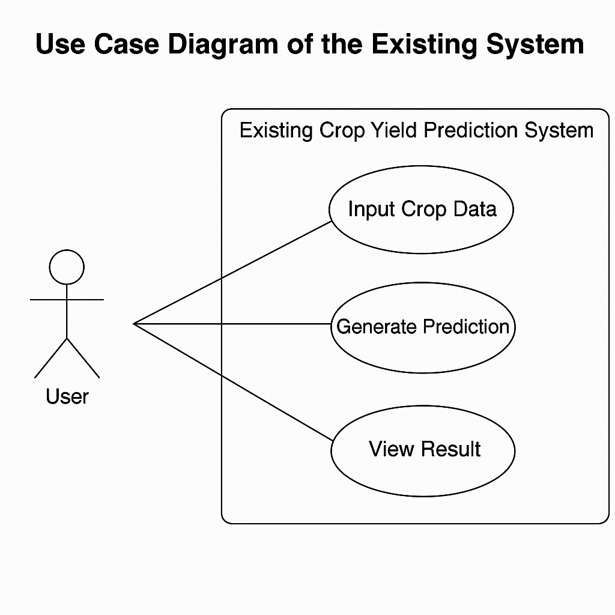
Figure 3.1 Use case diagram of existing System
In this use case the existing system lacks advanced use cases such as user registration, login, profile management, prediction history, or feedback and personalization.
3.4.2.2 USE CASE DIAGRAM OF PROPOSED SYSTEM
As for the proposed system, there would be one main actors, which is:
- The User (e.g., farmer or agricultural extension worker).

According to the use case diagram, the User's actions include:
- Signing up (registration),
- Logging into the system,
- Inputting crop and soil data,
- Fetching real-time weather data,
- Running crop yield prediction,
- Receiving fertilizer recommendations,
- Viewing past prediction results,
- Comparing predictions graphically, and
- Logging out of the system.
This use case diagram illustrates the interaction between both actors and the system functionalities, providing a clear view of how the system components respond to user input. It also highlights improvements over existing systems, such as authentication, personalization, and historical data tracking.

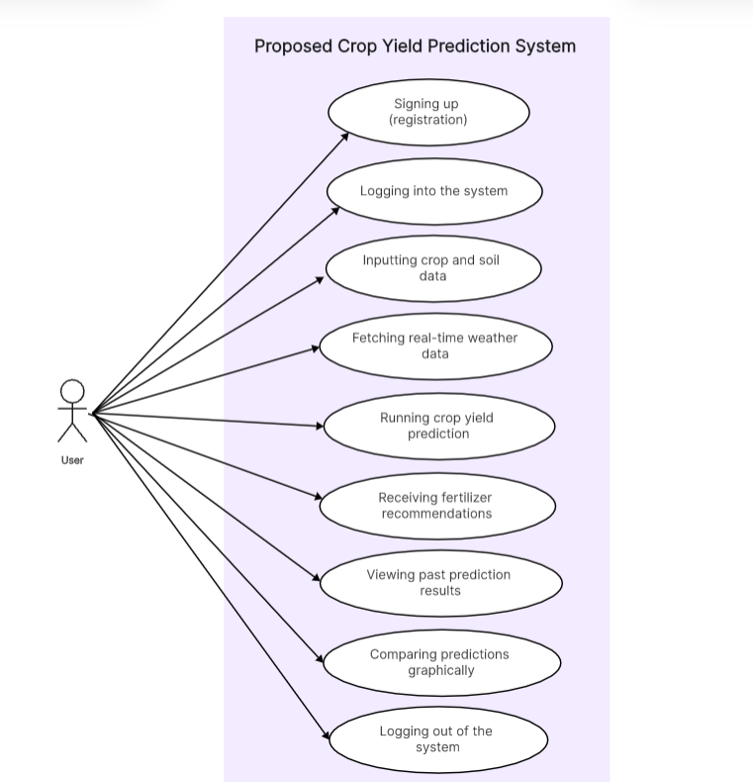
Figure 3.2 Use case diagram of the proposed system
3.4.2.3 ACTIVITY DIAGRAM
An activity diagram is another important diagram when following the Unified Modelling Language (UML) approach. It is a diagram that depicts the dynamic aspects of the software system. An activity diagram however is basically a flowchart/flow-diagram describing the flow of activities that take place in the system in a orderly stepwise manner. from the signing in to creating posts to logging out.

3.4.2.4 ACTIVITY DIAGRAM OF THE EXISTING SYSTEM
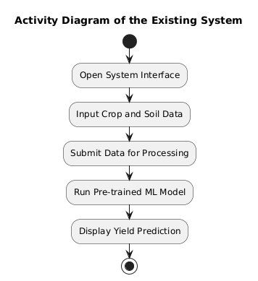
Figure 3.3 Activity diagram of the Existing System
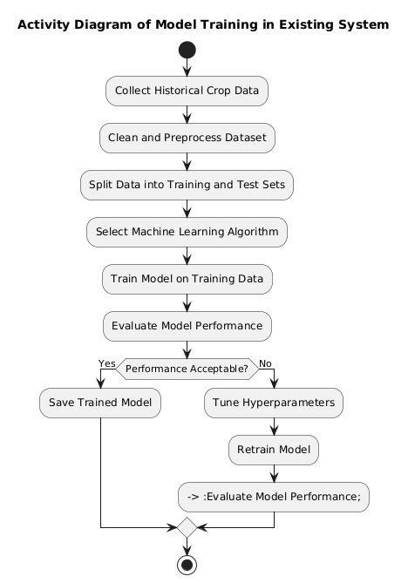
Figure 3.3 Activity diagram of the model training in Existing system
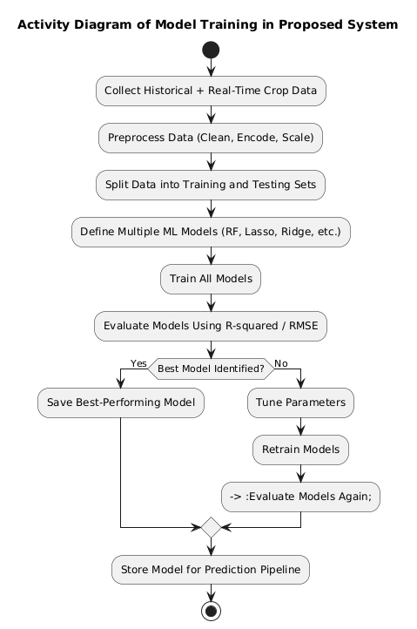
Figure 3.4 Activity diagram of the model training in Proposed System
3.4.2.5 CLASS DIAGRAMS
The class diagram shows the different classes that would be involved in the proposed system and their relationship with one another. It shows the different activities that the users can perform and the different subclasses that perform this specific activities.
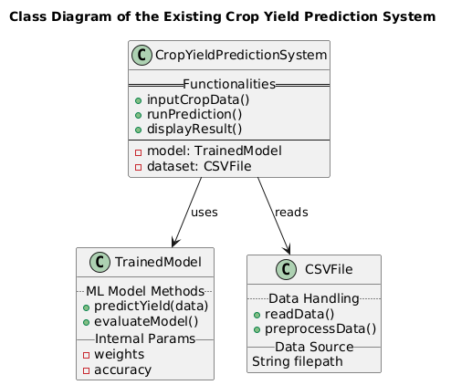
Figure 3.5 Class diagram of the existing system
3.4.2.6 CLASS DIAGRAM OF THE PROPOSED SYSTEM
This section shows the class diagrams which are diagrams in Unified Modelling language (UML) that describes the structure of a software system by mapping out its classes, attributes, methods and the relationships among objects
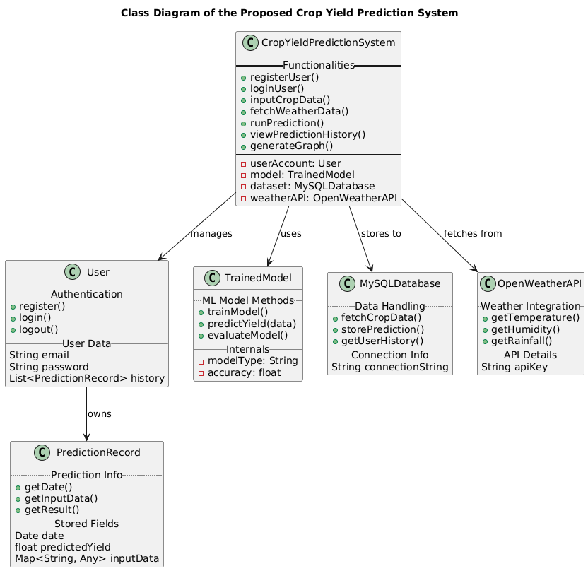
Figure 3.6 Class diagram of the Proposed system
3.4.2.7 SEQUENCE DIAGRAM
A sequence diagram depicts how the different parts of the system interact over time. Similarly, these diagrams are very important in the understanding of the chronological flow of actions and messages that occur during the execution of a particular use case or scenario. However, at its core, these sequence diagrams visually represent the order in which interactions take place therefore providing a clear depiction of how the various components collaborate in a specific system to achieve the specified goal.
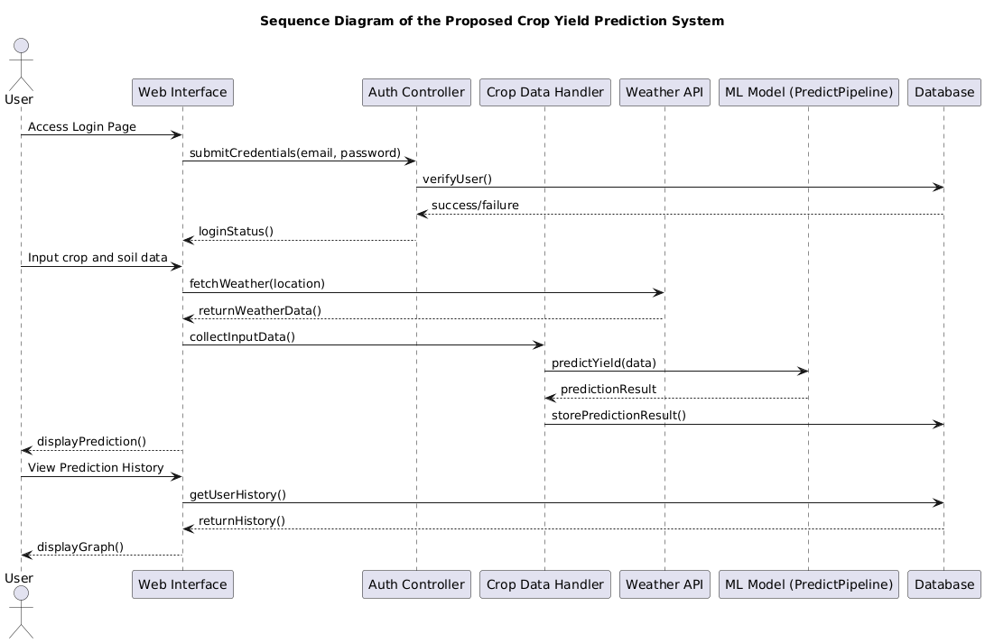
Figure 3.7 Sequence diagram of the proposed system
The diagram above stands as the sequence diagram for the proposed system, as it stands to show the detailed process of actions that takes place during the usage of the proposed system. It is a diagrammatical representation of the actions that occur in the process of a user interacting with the system, beginning from the point of login.
The interaction starts with the user accessing the system through a web interface and submitting their login credentials. These credentials are passed to the authentication controller, which verifies the user’s details by checking the database. Once authenticated, the user is granted access to the main interface of the system.
From there, the user inputs various crop and soil parameters (e.g., pH, NPK values, crop type), after which the system fetches real-time weather information from an external weather API based on the user's location. The user’s data along with weather data is then processed by the model via the prediction pipeline.
The machine learning model computes the yield prediction using the combined dataset, and the result is returned to the system, stored in the database, and displayed to the user. The user can then choose to view their prediction history, which is retrieved from the database and visualized in the form of a graph.
This sequence diagram captures the logical flow of how various components (web interface, authentication controller, machine learning model, weather API, and database) work together in a coordinated sequence to serve the end user efficiently.
3.5 SYSTEM DESIGN
The system design is going to illustrate how the system is going to fulfil the requirements that have been stated above. This system design is going to comprise of an input/output design of the proposed system as well as the database design of the system.
3.5.1 INPUT/OUTPUT DESIGN
The input/output design comprises the mockup design of all the sections through with inputs are passed and received on the system as well as the illustrations of the output mockup sections after the inputs. Below is the diagram of the input/output design illustrations.



Figure 3.8 input design of the proposed system




Figure 3.8 input design of the proposed system

3.5.1.1 INPUT DESIGNS OF THE PROPOSED SYSTEM
The diagram above shows the user interface design for both the login and registration pages, as well as the prediction input form used in the system. It generally serves as a pictorial representation of the interfaces designed to collect user and crop-related data into the proposed system, which will then be processed and used for crop yield prediction.
This input design includes structured fields such as soil nutrients (N, P, K), pH level, crop type, land area, and optionally, state or location, which allows the system to fetch real-time weather data using the OpenWeatherAPI. These input values are passed into the prediction pipeline after proper validation and transformation.
Therefore, the interface, as it stands, showcases all the different steps that are involved in running a prediction from user authentication to data collection, submission, and final yield estimation. It also ensures a clean and user-friendly experience, allowing users to interact easily with the system regardless of their technical background.
3.5.1.2 OUTPUT DESIGN OF THE PROPOSED SYSTEM:

Figure 3.9 Output design for the proposed system
The diagram above illustrates the output interface of the proposed Crop Yield Prediction System. This output design showcases the result generated after the user submits the required farm and crop input data. The system processes this information using the trained machine learning model and presents it in a clear, structured, and user-friendly manner.
Apart from this, the system also makes intelligent suggestions based upon the input parameters. These recommendations are optimized to increase productivity and lead the users to improved crop management practices.
Additionally, the output interface also displays a history graph of the user's past prediction records. This allows users to observe trends, compare yields across different inputs and seasons, and make informed decisions based on data-driven insights.
3.6 DATABASE DESIGN
The essence of the database design is to show a modeled view of the proposed system database. The database design of the proposed system uses Django object oriented relational mapper which allows you to create and manage relational database tables using python classes called models. This means that you don’t necessarily have to know SQL queries before you can use the query a database.
3.6.1 DATA BASE SCHEMA FOR THE PROPOSED SYSTEM
Table 3.1 User table
Attribute | Data Type | Description
id | INT (Primary Key, Auto Increment) | Unique identifier for each registered user
username | VARCHAR(50) | Unique username of the user
email | VARCHAR(100) | Unique email address used for login
password_hash | VARCHAR(255) | Encrypted user password
created_at | TIMESTAMP | Date and time the user account was created

Table 3.2 predictions table
Attribute | Data Type | Description
id | INT (Primary Key, Auto Increment) | Unique identifier for each prediction record
user_id | INT | Foreign key linking to the users table
nitrogen | FLOAT | Nitrogen level in the soil
phosphorus | FLOAT | Phosphorus level in the soil
potassium | FLOAT | Potassium level in the soil
temperature | FLOAT | Temperature of the environment
humidity | FLOAT | Humidity level during prediction
ph | FLOAT | pH value of the soil
rainfall | FLOAT | Rainfall data at prediction time
yield_prediction | FLOAT | Result of the ML model prediction (in tons or kg/ha)
created_at | TIMESTAMP | Date and time the prediction was made

Table 3.3: crop_facts Table
Attribute | Data Type | Description
id | INT (Primary Key, Auto Increment) | Unique identifier for each crop fact entry
title | VARCHAR(100) | Title or heading of the crop fact
description | TEXT | Detailed explanation or recommendation
created_at | TIMESTAMP | Date and time the crop fact was added

CHAPTER 4
SYSTEM IMPLEMENTATION
4.1 INTRODUCTION
System Implementation is a stage in software development where the ideas articulated are brought to life. The implementation of the system will be covered in this chapter. After being tested using the appropriate tools, a comprehensive analysis of the proposed system and the system requirements will be explained. Some functioning parts of the system, tools and user interfaces will be discussed in this chapter.
4.2 CHOICE OF DEVELOPMENT ENVIRONMENT
An integrated development environment (IDE) is a software application that provides an all round knowledge facilities to computer programmers for software development. An IDE is made up of a source code editor, built in automation tools and a debugger. In this project work, the IDE of choice use is VS code
The reasons why VS code was used as the IDE of this research are the following:
- It is user friendly and easy to understand.
- It offers a wide range of advanced features that enhance productivity and efficiency in Python coding.
- It includes all the necessary tools and features in a single package, eliminating the need for developers to rely on multiple tools or plugins.
- It supports a wide range of plugins and extensions that allow developers to customize and extend the IDE's functionality according to their specific needs.
4.2.1 FRONTEND
4.2.1.1 HTML
HTML, which stands for Hyper Text Markup Language, was used to create the basic structure of the web interface for the proposed system. It is considered the foundational building block for web development, as it allows developers to design and organize web page content using a collection of semantic tags and attributes. Using HTML, headers, forms, input fields, tables, and links were defined and styled, which provided the user interface foundation for the system.
HTML is human and machine readable, thus making it very flexible. HTML was utilized in the provided system to develop the registration, login, data input form, and prediction output page. HTML further permitted incorporation of other technologies like CSS and JavaScript, multimedia, and interactive content inclusion. HTML was also the platform upon which users placed crop-related information to be predicted.

4.2.1.2 CSS
Cascading Style Sheets (CSS) is a style sheet language to define the visual style of the HTML content. CSS was utilized heavily while making the intended system so that the interface is pleasing as well as display things consistently. Using CSS, the fonts, the colors, the margins, the buttons, and the form fields were designed so that they give a clean and friendly interface.
CSS also made web pages of the system responsive to the varying screen sizes like smartphones, tablets, and desktops. This was done through the use of media queries so that the platform could be used by anyone with any device without loss of user experience. Through the division of content (HTML) and look (CSS), the frontend of the system became more manageable and updateable when and where necessary.

4.2.2 Backend

4.2.2.1 Python
Python is an object-oriented, general-purpose high-level programming language that is highly readable and extremely flexible. It was employed in the backend of the suggested system to deal with data, train models, and transfer data with the frontend using server-side logic.
Python's extensive library and framework ecosystem e.g., NumPy, Pandas, Matplotlib, and Scikit-learn were crucial in the system's machine learning workflow. They were applied for cleaning data, exploratory data analysis, model testing, and finally, prediction. Python's readability and expressive nature contributed to quicker development and simpler debugging during deployment.

4.2.2.2 Flask
Flask is a very lightweight and extensible Python web framework. Flask was utilized to deploy the backend web application and serve the machine learning model as a web service. Flask uses a minimalist paradigm, in which there is custom route specification and seamless integration with the HTML frontend.
The Flask web framework managed form submission, user login, data routing, and dynamic engagement between the input offered by the user and the trained machine learning model. It also served as the engine that connected the MySQL database, OpenWeatherAPI, and ML model, thereby completing the full request-response cycle of the system.

4.2.2.3 MySQL
MySQL is an open-source relational database management system that was used to store all application data, including user accounts, prediction records, and agronomic facts. It supports Structured Query Language (SQL) for data manipulation and retrieval.
MySQL was preferred for its performance, scalability, and support for relational integrity. In the proposed system, tables were created for users, predictions, and crop facts, with proper use of primary and foreign keys to maintain data consistency. The database was accessed and managed using Python’s MySQL connector for seamless integration with Flask routes.

4.3 SYSTEM REQUIREMENTS
There are not many things that are needed to use this system, as it is a web-based platform application and can conveniently run on both web and mobile platforms. The system was designed with flexibility and accessibility in mind to ensure that a wide range of users, particularly African farmers and agricultural experts, can benefit from its functionalities without technical limitations.
However, the system still requires that the user fulfills some basic conditions in order to interact with and operate the proposed system effectively. These requirements are as follows:
- An internet-enabled device, such as a smartphone, tablet, or computer (laptop/desktop).
- A good internet connection, with at least a 3G network speed to ensure smooth access to real-time data and server responses.
- A standard web browser, such as Google Chrome, Mozilla Firefox, Microsoft Edge, Apple Safari, or any other modern browser that supports HTML5 and JavaScript.
These minimal requirements are intended to keep the system widely accessible and user-friendly, particularly for users in low-resource or rural settings who may have limited access to high-end hardware or fast internet services.
4.4 USER INTERFACE OF THE PROPOSED SYSTEM
This section of this research work is going to contain user interfaces of different sections of the proposed system which would include the dashboard
4.4.1. PROPOSED SYSTEM HOMEPAGE
The welcome page which is the home page of the proposed Smart Crop Yield Prediction System is where the users are greeted and informed of what the application is for and its most important value. It must be clean, informative, and friendly to use, giving both new and existing users a good impression of the features and benefits of the system.
When loading, the homepage displays the system name and motto:
Smart Crop Forecasting
Leverage the power of machine learning to maximize your crop yields and make intelligent agricultural decisions.
The homepage outlines the key features of the system to guide users on what to expect:
- Smart Predictions Accurate crop yield predictions using advanced machine learning algorithms.
- Weather Integration Real-time weather data integration (via OpenWeatherAPI) to enhance the accuracy and reliability of predictions.
- Historical Analysis Access to previous prediction records and visual analytics to help users track performance and improve over time.
It also features a simplified "How It Works" section to walk users through the process of using the system:
- Input Data – Users enter details such as soil nutrients (N, P, K), pH, temperature, and rainfall.
- Analysis – The system uses artificial intelligence to analyze the data.
- Prediction – An accurate yield forecast is generated and displayed.
- Recommendations – Actionable farming insights are provided to improve output.
The homepage ends with a strong call-to-action:
Ready to Optimize Your Crop Yields? Join thousands of farmers who are already using Smart Crop to make better decisions.



Figure 4.0 Screenshots of the proposed system homepage

CHAPTER FIVE
SUMMARY, RECOMMENDATIONS AND CONCLUSION
5.1 INTRODUCTION
This chapter of this research work stands to give a detailed summary of this project, the recommendations for future works, and lastly conclusion of this research work. This chapter however summarizes everything that has been discussed in all the chapters of this project.

5.2 SUMMARY
At the initial inception of this research work, the background of the study was explicitly discussed, alongside the problem statement related to inaccurate and generalized crop yield prediction methods used across agricultural systems in Africa. These challenges were explored with the aim of developing a more efficient and localized solution using machine learning.
In the subsequent chapters of this work, the theoretical background of crop yield prediction was reviewed in detail, focusing more on machine learning models and the agricultural factors that influence crop productivity. A comprehensive review of existing systems was also conducted, highlighting their limitations such as lack of real-time weather integration, no user authentication, absence of historical tracking, and foreign-biased datasets. The literature review drew upon both local and international academic research in machine learning applications for agriculture, especially in Africa.
A thorough analysis of both the existing and proposed system was carried out in Chapter Three, using Object-Oriented Analysis and Design (OOAD). Several UML diagrams were used to illustrate the system architecture and workflows. These included: Use Case Diagrams, Activity Diagrams, Sequence Diagrams, and Class Diagrams, all developed for both the existing and proposed systems.
Finally, Chapter Four described in detail all the programming languages, tools, and frameworks used during system implementation. These included Python, Flask, MySQL, HTML, CSS, and Bootstrap. A structured design of the user interface, backend logic, and database schema was also presented to ensure clarity on how the proposed system was built and functions.

5.3 RECOMMENDATIONS
This web-based crop yield prediction system is highly recommended for use by agricultural cooperatives, local government agricultural departments, research institutions, and individual farmers across Africa. It was developed with the African agricultural environment in mind, and it stands to benefit farmers in various agro-ecological zones by enabling data-driven decision-making.
It is also recommended that technical maintenance and user support be continuously provided in order to ensure seamless usage and future upgrades of the platform. This includes periodic updates of the weather integration API, ML model retraining with newly collected data, and possible extension of the system to support mobile offline functionality.
Future work could consider:
- Incorporating Convolutional Neural Networks (CNN) for analyzing satellite imagery or drone data for visual crop assessment;
- Adding voice input or multilingual support to enhance usability among farmers with limited literacy;
- Integration with IoT devices (e.g., soil sensors) to collect real-time farm data directly from the field;
- Expanding the crop database to include more African-specific varieties and regional soil/climatic data.

5.4 CONCLUSION
In conclusion, this research work has successfully achieved the main objective of building an intelligent crop yield prediction system that overcomes the limitations of existing solutions. The proposed system features a responsive user interface, user authentication, real-time weather integration, and historical prediction tracking.
Through the use of machine learning models, the system is able to provide accurate crop yield predictions and actionable fertilizer recommendations. The implementation of this system not only addresses the technological gaps identified in existing platforms but also contributes meaningfully to the growing field of precision agriculture in Africa.
This system serves as a strong foundation for future research and development in agricultural technology, and it stands as a valuable digital tool for enhancing food security, increasing farmer productivity, and improving agricultural decision-making in the Continent.

References
Abdurrahman, A., & Muhammad, L. (2025). Comparative study of ensemble models for rice yield prediction in Nigeria. Nigerian Journal of Agricultural Informatics, 11(2), 45–53.
Adebayo, O., Hassan, M., & Chukwu, I. (2025). Applications of machine learning for sustainable agriculture in sub-Saharan Africa. African Journal of Agricultural Informatics, 7(1), 12–25.
Adegboye & Hassan, (2022). Development of crop yield estimation model using soil and environmental parameters. https://arxiv.org/abs/2102.05755 .
Adesanya, T., & Bello, K. (2022). Climate variability and its implications for traditional farming practices in sub-Saharan Africa. Journal of Agricultural and Environmental Research, 14(2), 45–59.
African Union. (2024). State of agriculture in Africa: Trends, challenges, and opportunities. Addis Ababa: African Union Commission.
Agarwal, S., & Tarar, A. (2021). Hybrid machine learning model for crop yield prediction. International Journal of Artificial Intelligence in Agriculture, 3(4), 102–110.
Ahmed, M. A., Yusuf, A., & Bello, A. (2023). Evaluation of ML algorithms for maize yield forecasting in Southern Nigeria. African Journal of Data Science, 6(1), 67–78.
Bassine et al. (2023). Agriculture and economic transformation in Africa: Impacts on GDP, employment, and food security. Journal of African Agricultural Development, 18(4), 215–229.
FAO. (2023). State of food and agriculture: Leveraging automation in agriculture for transforming agrifood systems. Food and Agriculture Organization of the United Nations. https://www.fao.org
Flask Documentation. (2024). Flask: Web development, one drop at a time. https://flask.palletsprojects.com/
Ibrahim et al., 2024; Eze & Uche, (2023). Climate variability and its impact on smallholder agriculture in Sub-Saharan Africa. Journal of African Agricultural Research, 19(2), 145–160.
Iqbal, M., Chen, L., & Hassan, O. (2024). Evaluating machine learning algorithms for crop yield prediction under variable climate conditions. Computers and Electronics in Agriculture, 212, 108039.
Jeong, J. H., Resop, J. P., Mueller, N. D., Fleisher, D. H., Yun, K., Butler, E. E., ... & Kim, S. H. (2016). Random forests for global and regional crop yield predictions. PLOS ONE, 11(6), e0156571. https://doi.org/10.1371/journal.pone.0156571
Jiang, X., Wang, Y., & Li, M. (2022). Impact of nitrogen and phosphorus optimization on quinoa yield and soil moisture efficiency. Agricultural Water Management, 261, 107383. https://doi.org/10.1016/j.agwat.2021.107383
Khaki, S., Wang, L., & Archontoulis, S. V. (2019). A CNN–RNN framework for crop yield prediction using remote sensing data. Frontiers in Artificial Intelligence, 2, 8. https://doi.org/10.3389/frai.2019.00008
Kuradusenge, M., Uwizeye, G., & Niyongabo, D. (2024). SMART-CYPS: An IoT-integrated crop yield prediction system for Rwanda. Journal of Smart Agriculture Technologies, 5(1), 12–26.
Li, Z., Yang, S., & Chen, Y. (2023). Meta-analysis of liming effects on crop yield and soil pH in acidic soils. Soil Use and Management, 39(1), 110–121. https://doi.org/10.1111/sum.12825
Lontsi Saadio, C., Tchana Kamga, M., & Fonka, A. (2022). Machine learning-based modeling of crop yields in West Africa using climate and soil data. African Journal of Computational Agriculture, 4(2), 99–114.
Matplotlib Community. (2024). Matplotlib: Visualization with Python. https://matplotlib.org/
MySQL. (2024). MySQL 8.0 Reference Manual. https://dev.mysql.com/doc/
OpenWeatherMap. (2024). Weather API documentation. https://openweathermap.org/api
Pandas Development Team. (2024). Pandas: Python Data Analysis Library. https://pandas.pydata.org/
Panjwani, R., Diouf, A., & Sow, M. (2024). Millet yield prediction in Senegal using Sentinel-2 NDVI and climate variables. Remote Sensing in Agriculture and Environment, 7(1), 22–35.
Paudel, D., Bista, K., & Khatri-Chhetri, A. (2021). Crop yield prediction using hybrid machine learning models and crop simulation outputs. European Journal of Precision Agriculture, 5(3), 50–66.
Ritchie, J. T. (2024). Physiological differences in C3 and C4 crop responses to environmental stressors. Journal of Crop Science and Technology, 59(2), 231–242.
Saadio, L., Okeke, T., & Moyo, S. (2023). Limitations of traditional yield forecasting methods among African smallholder farmers. African Journal of Agricultural Research and Development, 15(2), 102–118.
Scikit-learn Developers. (2024). Machine learning in Python. https://scikit-learn.org/
Sharma, R., Adewale, F., & Kim, J. (2025). Machine learning applications in agricultural yield forecasting: A systematic review. Journal of Agricultural Informatics, 14(1), 45–63.
Shuaibu, M. M., Idris, A., & Salisu, A. (2024). Using the Agricultural Performance Survey for yield prediction in Nigeria: A machine learning approach. Nigerian Journal of Precision Farming, 9(1), 70–82.
Siam, Y., Okonkwo, J., & Akintunde, R. (2023). IoT-assisted crop yield prediction using ANN and fuzzy logic. International Journal of Smart Agriculture, 8(2), 130–143.
Silva, M. D., & Kumar, R. (2023). Machine learning models for crop yield prediction in sub-Saharan Africa: A critical review. Computers and Electronics in Agriculture, 206, 107604. https://doi.org/10.1016/j.compag.2023.107604
Smith, R., Khan, M., & Patel, J. (2023). Deep learning models for yield forecasting: A global review. Journal of Agricultural Technology Advances, 10(1), 17–28.
Wan, Y., Zhang, X., & Luo, W. (2022). Effect of NPK fertilizer combinations on the yield and nutrient uptake of maize in tropical soils. Nutrient Cycling in Agroecosystems, 123(3), 567–580. https://doi.org/10.1007/s10705-022-10222-9
Zhang, L., Liu, Q., & Sun, H. (2022). High temperature stress impacts on maize yield: Role of VPD and evapotranspiration. Agricultural and Forest Meteorology, 317, 108879. https://doi.org/10.1016/j.agrformet.2022.108879
Zhou, J., He, H., & Li, F. (2023). Use of biochar for pH adjustment and yield improvement in acidic tropical soils. Environmental Science and Pollution Research, 30(9), 24560–24572. https://doi.org/10.1007/s11356-022-23999-z
Zinyengere, N., & Masamvu, K. (2024). The role of real-time weather integration in AI-based crop yield forecasting. Journal of Precision Agriculture and Sustainability, 8(1), 34–45.

