

THE DEVELOPMENT OF A BLOCKCHAIN-BASED VOTING SYSTEM

BY

OSUJI CHINEMEREM CHIJIOKE
GOU/U21/CSC/652

COMPUTER SCIENCE
COMPUTER SCIENCE AND MATHEMATICS
FACULTY OF NATURAL SCIENCES AND ENVIRONMENTAL STUDIES
GODFREY OKOYE UNIVERSITY, ENUGU NIGERIA

JULY, 2025

THE DEVELOPMENT OF A BLOCKCHAIN-BASED VOTING SYSTEM

BY

OSUJI CHINEMEREM CHIJIOKE
GOU/U21/CSC/652

A PROJECT RESEARCH SUBMITTED TO THE DEPARTMENT OF COMPUTER SCIENCE AND MATHEMATICS, FACULTY OF NATURAL SCIENCE AND ENVIRONMENTAL STUDIES, GODFREY OKOYE UNIVERSITY, ENUGU

IN PARTIAL FULFILMENT FOR THE AWARD OF BACHELOR OF SCIENCE (B.Sc) DEGREE IN COMPUTER SCIENCE

SUPERVISOR: DR G. E. OKEREKE

JULY, 2025

APPROVAL
The Development of a Blockchain-based Voting System has been assessed and approved by the Committees of the Department of Computer Science, Faculty of Natural Sciences and Environmental Sciences, Godfrey Okoye University Enugu State, Nigeria


Dr G. E. Okereke (P.hD) …………………. 10th June, 2025
Supervisor Signature Date

Dr. U. F Okebanama (PhD) …………………. ……..………….
HOD of Computer Science Signature Date

Prof Chidi Uhuegbu ..………………. ……..………….
Dean of FNSES Signature Date

External Examiner: ………………… …….………….
Signature Date

CERTIFICATION
This is to certify that this research the development of a blockchain-based voting system was carried out by Osuji Chinemerem Chijioke with the registration number GOU/U21/CSC/652 under the supervision of DR G. E. Okereke in the Department of Computer Science Godfrey Okoye University, Enugu Nigeria.

________________________
OSUJI CHINEMEREM CHIJIOKE
GOU/U21/CSC/652

DEDICATION
This project is dedicated to Almighty God for the abundant grace, wisdom, knowledge, and ability given to me all through my life, especially during my stay in Godfrey Okoye University.

ACKNOWLEDGEMENTS
I would like to acknowledge my supervisor, Dr. G. E. Okereke who assisted me to put these ideas well above the level of simplicity and into something presentable.
I also want to express my special thanks and immeasurable gratitude to my parents for their able guidance and support in my academics and in completing this project. I also want to thank my friends who helped me in one way or the other in finalizing this work within the limited time frame.

ABSTRACT
This project will focus on the development of a secure transparent voting system using blockchain technology, current voting systems(traditional paper-based systems or electronic) often encounter various issues like tampering, lack of transparency and over centralization which affects the integrity of elections and its outcome. With blockchain as the foundation, I implemented the key voting features using smart contracts written in Solidity. These contracts take care of processes such as voter registration, casting votes, and vote counting. During development, I used tools like Ganache a local blockchain network for testing and MetaMask, a browser-based wallet used for authenticating users and verifying voter eligibility, such as age. The user interface was created with basic web technologies including; HTML, CSS, and JavaScript, while Web3.js helped connect the front end to the blockchain. The expected result is a working prototype of a voting system that is secure, transparent, and easy to use. Its aim is to ensure that each person can vote only once and without fear of interference. This project has the potentials to end electoral fraud in the not-so distant future.

TABLE OF CONTENTS
TITLE PAGE i
APPROVAL ii
CERTIFICATION iii
DEDICATION iv
ACKNOWLEDGEMENTS v
ABSTRACT vi
TABLE OF CONTENTS vii
LIST OF TABLES ix
LIST OF FIGURES x

CHAPTER ONE: INTRODUCTION

1.1 Background of the Study 1

1.2 Statement of the Problem 3

1.3 Aim and Objectives of the Study 4

1.4 Scope of Study 5

1.5 Significance of the Study 5

1.6 Limitations of Study 6

1.7 Definition of Terms. 7

CHAPTER TWO: LITERATURE REVIEW 8

2.1 INTRODUCTION 8

2.2 Background of Electronic Voting Systems 8

2.3 Blockchain Technology in Voting 9

2.4 Comparative Analysis of Blockchain Voting Models 11

2.4 Key Studies on Blockchain Voting 14

CHAPTER THREE: SYSTEM DESIGN AND METHODOLOGY

3.1 System Architecture 18

3.2 Methodology 18

3.3 Technologies Used 21

3.4 Functional and Non-Functional Requirements 21

CHAPTER FOUR: SYSTEM IMPLEMENTATION

4.1 Preamble 31

4.2. HARDWARE AND SOFTWARE REQUIREMENT 31

● Hardware Requirements: 31

● CPU: Quad-core (development), 8+ cores (production) 31

● RAM: 8-16 GB (dev), 32-128 GB (prod) 31

● Storage: 500 GB - 2TB SSD 31

● Network: 1-10 Gbps internet/LAN 31

● Client devices(PCs, tabs and smartphones with internet connection and a browser application) 31

● Software Requirements: 31

● Blockchain platform(MetaMask) 31

● Frontend: HTML, CSS, Javascript, Bootsrap 31

● Backend Framework: Laravel (PHP) 31

● Database: MySQL 31

4.3 Testing 35

CHAPTER FIVE: DISCUSSION, CONCLUSION AND RECOMMENDATION

5.3 Conclusion 38

5.4 Recommendations 38
40

REFERENCES
APPENDIX
41

LIST OF TABLES
TABLE PAGE
2.1: Comparison: Permissioned vs. Permissionless Blockchains in Voting 13
2.2: Literature Review Summary 16
3.1: Database design of the proposed system (Voter table) 29
3.2: Database design of the proposed system (Admin table) 30

LIST OF FIGURES
FIGURE PAGE
3.1 User interaction diagram 18
3.2 Agile SDLC diagram 20
1.3 Use case diagram for the voter and admin 24
3.4 Class Diagram of the Blockchain 25
3.5 Sequence Diagram of the Blockchain voting system 26
3.6 Flowchart Diagram for a voter 27
3.7 Flowchart Diagram for an admin 28
3.8 Input design of the proposed system 28
3.9 output design of the proposed system 29

CHAPTER ONE

INTRODUCTION

1.1 Background of the Study
Casting ballots/ voting has stayed a principle of democratic government as this shapes how leadership and policy direction develop. While the problems of voter fraud, ballot tampering, low transparency, and inefficiencies plague traditional voting systems whether paper or electronic ones there are newer innovations available to sidestep these. Especially in the history of voting systems, they have evolved from simple hand written ballots to more sophisticated electronic voting machines. Reliable as some aspects of paper based voting, however, the counting and result tabulation of paper based voting is labour intensive and prone to errors (Clark et al., 2017). Electronic voting systems provide speed and convenience, but are frequently criticized because they are sensitive to hacker attacks, glitchy software, and not verifiable (Mitchell & Krimmer, 2020). These systems' difficulty raises a question mark regarding paradigm shift to more secure and transparent voting mechanisms.
Block chain technology, introduced in 2008 and first popularized with Bitcoin, is a system that is decentralized and relies on multiple nodes to record transactions and make sure the activity is transparent, immutable and secure (Nakamoto, 2008). It is decentralized, so it doesn’t have a central authority and hence is tamper resistant and is no more fraud susceptible. Each block in a blockchain records a transaction in chronologically linked, cryptographic algorithm secured chain (Zheng et al., 2017) and then remain immutable until the election process is finished (Hjalmarsson et al., 2018).

An important characteristic of blockchain voting is in the use of smart contracts, i.e. self-executing code that allows for automating electoral processes, e.g. voter registration and result tabulation (Buterin, 2013), is integrated in blockchain voting. These capabilities reduce or eliminate human error or manipulation and also increase efficiency. Traditional voting systems are plagued with disenfranchisement of voters, ballot box stuffing and delayed result announcement. Moreover, the rising threat of cyberattacks on electronic voting systems have brought the question of election integrity to the fore round the globe (Rivest & Wack, 2006).
Systems that exist today have been highlighted as unsatisfactory in the 2020 U.S. presidential election with regards to both claims of fraud in election and lack of transparency in vote counting (Gellman & Sides, 2021). They remind us of the need for innovative solutions that will rebuild public confidence in electoral processes. There are many advantages of employing a blockchain based voting system in place of conventional systems. Its decentralized architecture guarantees none of the parties involved can control, or corrupt, the voting process (Noizat, 2015). The second, and probably the most pertinent, advantage of the blockchain is its immutability, which would ensure that votes can’t not be altered or deleted after casting, preventing any tampering. Third, blockchain's transparency and its openness to all race to affirm the complete integrity of the election (Zyskind et al., 2015). Additionally blockchain voting systems can increase accessibility of voting through secure digital platforms that enable remote voting. In situations where physical polling stations cannot be accessed (geographically, politically or due to health related factors) for example during the COVID 19 pandemic (Treiblmaier, 2020), this is very advantageous.
A number of countries and organizations have experimented with implementing blockchain based voting systems with varying amounts of success. Estonia, as a forerunner of e-governance, used blockchain for improving the level of security and transparency within e-Voting system (Priisalu and Ottis, 2017). In the 2018 U.S. midterm elections, West Virginia attempted a blockchain voting 'proof of concept' for their overseas military personnel, showing how this technology as applicable to real world elections, as discussed by McCorry et al. (2017). In another instance, the Swiss city of Zug tried a blockchain-based voting system for a public referendum, and the experiment immersed voters in a small scale electoral context (Schulz et al., 2018). The ability of blockchain voting systems to deal with these challenges and their benefits are explored through these case studies.
However, a blockchain based voting system has a huge potential, even though it’s fraught with challenges. Scalability and energy consumption, however, still work against widespread adoption. For example, security of blockchain networks, specifically based on proof of work type and consensus mechanism, requires an astronomical amount of computational power (Bonneau et al., 2015). Additionally, voter anonymity and privacy of data have to be discussed carefully because of related ethical concerns. The transparency afforded by blockchain is a strength, but it also gives rise to harm to voter privacy if sensitive voter information is not adequately protected (Ben Sasson et al., 2014). Consequently, the design of a blockchain voting system requires a balance between transparency and confidentiality. Such solution using a blockchain based voting system represents a pioneering solution to the long standing problems of electoral process.

1.2 Statement of the Problem
Voting is one of the most basic but important component of the democratic governance; however today many traditional voting systems have inefficiencies and security threat. The problems of ballot tampering, voter fraud, and a lack of transparency go on undermining trust in electoral processes. To overcome some of these challenges, electronic voting systems have been introduced, but remain tainted by a history of susceptibility to hacking, system failure and lack of voter verifiability. This project aims to address the problem of building a secure, efficient and transparent voting system on the basis of blockchain technology. Specifically, the study seeks to solve the following sub-problems:
- Lack of Transparency: Election results can be difficult to verify in traditional voting systems because we lack transparency.
- Voter Fraud and Security Breaches: Hacking, double voting, unlawful access, all of which can occur with current voting systems, particularly electronic ones, have made voting unreliable.
- Inefficient Vote Counting: All of these methods for count of vote are time consuming and prone to error and may cause delays and election outcome dispute.
- Accessibility and Scalability: But many voting systems are inadequate for handling large scale elections or remote voting, especially for diaspora voters or citizens in underserved areas.
- Trust in the System: Yet traditional and electronic voting methods often do not inspire public confidence when immutability and auditable verifiable audits are absent.
In a bid to addressing these issues, this study proposes a voting system that is blockchain based; designed and implemented to provide a decentralized, tamper proof, and scalable solution for electoral processes.

1.3 Aim and Objectives of the Study
The aim of this study is to design and implement a blockchain based voting system that improves voting security, transparency, and efficiency.

Objectives include:
- To build a decentralized vote system using blockchain, that would allow tamper proof immutable records of a vote paradigm.
- To create a transparent voting framework where everyone involved in the vote — including voters and stakeholders — can independently verify the integrity of election results without compromising security.
- To implement a secure voter authentication system to prevent double voting, unauthorized access and other kinds of voter fraud.
- To design a Scalable Blockchain based System for handling large scale elections in efficient manors, performance, and reliability.
- To develop user friendly interfaces and detailed documentation for voters and election administrators.

1.4 Scope of Study
In this research, we focus on the design and implementation of a blockchain based voting system. This study encompasses a holistic review of the theoretical, technical and practical elements of blockchain technology for use in secure transparent electoral processes. A decentralized voting system based on blockchain technology is designed in this study to better secure and track the process. It focuses on defining system architecture, developing smart contract and building user interface.

1.5 Significance of the Study
This work is poised to offer substantial benefits to a wide range of benefirs including the voters, electoral body, and even technology developers and researchers.

The key beneficiaries include;
- Voters: They gain increased trust and confidence in election results due to enhanced transparency leading to higher participation in general elections.
- Electoral Body: They stand in line to achieve public credibility by streamlining vote counting and reducing malpractice drastically.
- Technology Developers: This study could inspire futher innovation in secure voting systems and digital governance in general.
- Researchers: This study could inspire researchers to look into the detailed examination of how decentralized ledger technology can address the critical challenges involved in electoral transparency.

1.6 Limitations of Study
With all the potential the study holds in store, it encountered certain limitations that may impact its outcomes and generalizability:
- Technical Challenges: The system reliability during testing and simulations may be affected by network latency, the congestion on the blockchain, or system downtimes.
- Adoption Barriers: Although the system may be impossible to implement in certain regions due to lack of infrastructure or in some case, due to resistance to new technology by stakeholders.
- Scalability Constraints: Blockchain system can provide higher security, but the computational and storage challenges to scale blockchain system for national or global elections will be great.
- Data Privacy Concerns: System design had to ensure voter anonymity, yet maintain transparency.

1.7 Definition of Terms
The following terms are defined for clarity within the context of this study:
- Blockchain: Digital ledger with no central or single point of control, and is secured, tamper resistant.
- Smart Contract: An autonomic digital agreement on a blockchain that automates processes without intermediaries.
- Decentralization: Data and decision making in separated multiple nodes to reduce a single point of control.
- Cryptography: The process of information security using mathematical algorithms to prevent unauthorized access to information.
- Consensus Mechanism: A mechanism in a blockchain network for having distributed nodes reach agreement on a single data value or on a transaction order.

CHAPTER TWO

LITERATURE REVIEW

2.1 INTRODUCTION
In this chapter, I will carry out a review of some available existing literature on blockchain-based voting systems, covering the historical evolution of e-voting, the adoption of blockchain technology in voting, key theoretical frameworks, and the challenges addressed by prior studies. The review also explores methodologies, applications, and case studies to identify gaps and opportunities for further research.

2.2 Background of Electronic Voting Systems

2.2.1 Evolution of Electronic Voting
Electronic voting (e-voting) has undergone significant transformation over the years, moving from traditional paper-based systems to modern digital platforms. The emergence and deployment of electronic voting happened in the 1960s with punch card systems which automated vote counting process but was prone to various mistakes one in particular was the misaligned punch cards leading to ambiguous votes. During the early 1990s, direct recording electronic (DRE) machines began replacing punch cards and optical scanners offering touch screen interfaces and automated tallying.
Despite the advancement of electronic voting it has continued to face roadblocks in relation to scalability and public trust.
An analysis on technological advancement shows that each step taking aimed at addressing past shortcomings, may lead to new problems that require innovative solutions.

2.2.2 Challenges in Traditional E-Voting Systems
Electronic voting systems has faced limitations sometimes that can undermine their reliability, security, and effectiveness. These systems are often vulnerable to cyberattacks opening room for dangerous malware to alter vote counts, compromise voter data, or disrupt the voting process entirely.
Many electronic voting systems lack transparency.
The internal processes of vote recording are hidden from the voters. This lack of auditability undermines the public’s trust as there is no straightforward way to independently verify that votes are accurately recorded and counted.
The traditional voting systems sometimes fail to deploy mechanisms for securing voter identity while also enabling the verifiability of the votes. The problem of scalability is another major limitation especially during large-scale or national elections. As voter turnout increases traditional e-voting infrastructures can become overwhelmed leading to system delays or even failures. High traffic on centralized servers can slow down vote processing causing frustration among voters and raising questions about system.

2.3 Blockchain Technology in Voting

2.3.1 Blockchain
Blockchain technology can be defined as a decentralized ledger that allows data to be recorded and shared across a network without relying on a central authority. Gained most of its public attention in 2008 when it was used to create Bitcoin a digital currency introduced by Satoshi Nakamoto (2008). Rather than storing information in one place blockchain connects data in blocks that are linked together in a secure and time-ordered chain.
The key innovation of blockchain lies in its consensus mechanism. Rather than relying on a central authority to validate transactions the blockchains network can achieve consensus through algorithms such as Proof of Work (PoW), Proof of Stake (PoS), or Delegated Proof of Stake (DPoS). This decentralization reduces the risks of single points of failure and makes the system resilient to malicious attacks.
All transactions recorded on the blockchain are visible to participants in the network, ensuring accountability. At the same time, blockchain leverages cryptographic methods such as public and private keys to maintain user anonymity, a feature that is particularly relevant in voting applications.
Blockchain's immutability is another significant advantage. Once a block is added to the chain it cannot be altered or deleted without consensus from the network. This characteristic makes blockchain an ideal platform for systems requiring secure and tamper-proof record-keeping such as voting systems where the integrity of votes is paramount. Given these properties blockchain has been increasingly explored as a solution to traditional voting challenges including security vulnerabilities, lack of transparency, and voter trust issues.
By providing a distributed and immutable ledger, blockchain offers a foundation for secure, transparent, and auditable voting systems that can strengthen electoral processes.

2.3.2 Blockchain for Decentralized Voting
Blockchain technology has proved instrumental in solving the problem of decentralized voting systems that limit the process of electronic voting systems. The blockchain can offer a solution to holding secure and auditable elections by using its fundamental characteristics that are security, transparency, immutability, and decentralization. Increased security is among the major strengths of blockchain in voting. Voting systems used in the past are, in most cases, centralized, thus susceptible to cyberattacks and vulnerable to single point of failure. Blockchain, on the contrary, operates on distributed nodes, where each node has access to the copy of the ledger. Moreover, cryptographic tools like digital signatures and hashing are also used to make voting tamper-resistant and any tampering with votes to be impossible after the voter has cast her/his vote. Another important characteristic of blockchain-based voting systems is transparency. An important aspect of blockchain technology is immutability which is required in voting applications. When a vote has been cast and placed on the blockchain it has been fixed into an irreversible chain of blocks of data. This aspect eliminates the fear of the votes being manipulated after the fixtures of the elections giving the interested parties confidence in the authenticity of the elections. Decentralization also increases the confidence of the blockchain-based voting system as opposed to the centralized systems where the election process is centrally run, the blockchain decentralizes control of the system. Such a decentralized procedure prevents the manipulation or bias lowering chances of the publics belief.
Despite its advantages blockchain for decentralized voting is not without challenges. Scalability remains a concern particularly in large-scale elections where high voter turnout can stress the network. Additionally the need for internet access and technical literacy may limit adoption in certain regions. Nonetheless blockchain's potential to revolutionize voting systems makes it a valuable area of exploration for researchers and policymakers.

2.4 Comparative Analysis of Blockchain Voting Models

2.4.1 Permissioned vs. Permissionless Blockchain
Blockchain technology has been widely adopted across various sectors due to its decentralized nature and ability to offer safe and immutable record keeping. One of the primary distinctions within blockchain implementations lies in whether the system operates as a permissioned or permissionless blockchain.
Some key features of permissioned blockchain are as follows:
- Access Control.
- Customizable Governance.
- High Throughput.
- Data Confidentiality.
- Efficient Consensus Mechanisms.
Some advantages of Permissioned Blockchains in voting Systems are as follows:
- Enhanced Security.
- Controlled Transparency.
- Security.

Some disadvantages of permissioned blockchains in voting system are as follows:
- Centralization Risks.
- Reduced Trust.
- Limited Transparency.
- Access is restricted to the general public.
Some use cases for Permissioned Blockchains in Voting include:
- Corporate Elections.
- Government Referendums.
- University and Institutional Elections.
Some key features of permissionless blockchains are as follows:
- Open Participation.
- Transparency.
- Decentralized Governance.
- Robust Security.
- Immutability.
Some advantages of permissionless blockchains in voting systems are as follows:
- Trustworthy Environment.
- Global Accessibility.
- Transparency and Auditability.
Disadvantages of permissionless blockchains in voting systems include:
- Scalability problem.
- Privacy issues.
- Energy Consumption.
- Environmental concerns.
- Susceptibility to attacks.
Use Cases for Permissionless Blockchains in Voting:
- National Elections.
- Decentralized Autonomous Organizations (DAOs).
- Global Referendums.
Table 2.1: Comparison: Permissioned vs. Permissionless Blockchains in Voting
Feature | Permissioned Blockchain | Permissionless Blockchain
Access Control | Only authorized participants have access | Open to all
Governance | Centralized or consortium-based | Decentralized and participant-driven
Transparency | Limited to authorized participants | Fully transparent and publicly accessible
Security | High due to restricted access | High but dependent on network size
Scalability | High due to fewer nodes | Lower due to high computational demands
Energy Efficiency | Energy-efficient due to lightweight consensus | Often energy-intensive (e.g., PoW)
Suitability for Voting | Small-scale or controlled elections | Large-scale or global elections

Suitability for Voting Systems.
The option between the permissioned blockchain and permissionless blockchain in the voting system depend on some specific requirements of the election which are as follows;
- Small Scale Elections: For small scale elections it is better to implement the permissioned blockchain because for small scale control over participants is necessary. Example is a corporate election or institutional elections.
- Large Scale Public Elections: For large scale public national or global elections permissionless is more appropriate because transparency, trust and confidentiality are more than essential.

2.4.2 Key Studies on Blockchain Voting

Case Studies and Pilot Projects
Some case studies and pilot projects are as follows;
- West Virginia’s Blockchain Voting pilot.
- Swiss Blockchain voting trials.
- The Moscow active citizenship Platform.
- Estonia’s E-residency Voting.
- University of Melbourne’s Blockchain election for student representatives.

2.5 Empirical Literature
This section refers to relevant and similar research studies that are based on data and various case studies.
In a study carried out in 2021, Alashoor and Williams deployed a prototype model of a blockchain-based voting system for students in a university in the United Arab Emirates. These researchers invited one hundred and fifty students to come and participate in the testing of the system so as to gather data and feedback on their experience.
The Result was able to show that most of the students of about 87% felt the system was trustworthy, and over 90% were convinced it made voting procedure more transparent and reliable than the paper based method. The system ran with minimal errors and the researchers concluded that the blockchain technology could play a decisive and powerful part in imporoving the quality of elections, the fairness of elections and the reliability of elections, especially in smaller or controlled organizations or setups like schools or organizations.

2.6 Literature Review

Table 2.2: Literature Review
Author(s) Name/Year | Journal Name | Contribution | Shortfall
Bhise et al. (2021) | Journal of Emerging Technology | Developed a blockchain framework leveraging CNN for transaction validation and RFE for data feature selection. Compared consensus algorithms for voting systems. | Limited focus on scalability and practical implementation in large-scale voting scenarios.
Tahmooresi et al. (2018) | International Journal of Computing | Proposed a hybrid blockchain model integrating cryptographic techniques and smart contracts for secure, versatile voting systems. | Did not address challenges in voter authentication across diverse geographical regions.
Sharma et al. (2018) | Blockchain and Cryptography | Implemented Ethereum-based DApp for e-voting, utilizing smart contracts for automated vote tallying and result publication. | Lacked performance testing for large voter populations under high network load.
Allugunti (2022) | Advances in Computing Research | Designed a permissioned blockchain voting system with cryptographic hash functions to ensure voter anonymity and data integrity. | Did not explore the adaptability of the system for cross-border or multi-jurisdictional elections.
Vyas et al. (2022) | Applied Blockchain Review | Investigated blockchain performance using Byzantine Fault Tolerance (BFT) and Raft algorithms, improving system reliability and latency. | Overlooked privacy concerns associated with public blockchain systems.
Basker et al. (2021) | Journal of Distributed Systems | Examined private blockchain efficiency using PBFT and DPoS algorithms, emphasizing hybrid blockchain benefits for scalability and security. | Limited focus on the cost-effectiveness of implementing hybrid solutions.
Nallamala et al. (2019) | AI and Security Innovations | Introduced an adaptive voting scheme combining cryptographic protocols and machine learning for fraud detection in blockchain systems. | Did not explore the real-world feasibility of integrating AI in election environments.
Omondiagbe et al. (2019) | Journal of Blockchain Research | Conducted a comparative analysis using feature extraction and cryptographic techniques to improve accuracy and privacy in voting systems. | Limited validation of their approach in practical and diverse election scenarios.
Shravya et al. (2019) | Blockchain Usability Studies | Compared usability and operational efficiency of permissioned and permissionless blockchain networks in voting systems. | Focused more on usability, with less emphasis on network performance metrics in large-scale contexts.

2.7 Gap in Literature

While existing studies highlight the potential of blockchain-based voting systems, they often fail to address the challenge of scalability in large-scale elections. Many proposed systems struggle with handling high transaction volumes without significant delays or compromises in security. The present study aims to close this gap by developing an optimized blockchain framework that ensures seamless scalability and maintains performance integrity in high-turnout electoral contexts. This contribution is critical for enabling the practical application of blockchain technology in national and international elections.

CHAPTER THREE

SYSTEM DESIGN AND METHODOLOGY

3.1 Research
They are numerous methodologies used for the development of online systems such as this. This section discussed the methods and materials for the implementation of the proposed blockchain voting system. The methodology used in this system is the agile methodology. Agile is a method for project management and product development that is organized and iterative. Flexible project management techniques such as Scrum, Kanban and XP are developed on top this set of approaches. Agile methodologies are an alternative to waterfall technique which is a popular paradigm for creating a system using linear and sequential approach throughout the system development life cycle. In the model for agile development methodology. Firstly, we determine the customer’s needs and requirements and analyzing them, this phase which is the first phase is called brainstorming. Then it is followed by creating the system design and prototyping, this is where the developers create structures like wireframes for the voting system to get a schema and an overview of how the system should be developed using the requirements given by the user/customer. This is then followed by the development of a functional web application. In this phase there would be multiple iterations and demo testing due to the feedback given by user testers during review of demo. After identifying and resolving errors or bugs seen during review of the demo project also known as the MVP (minimum viable product) it will then be deployed via a third party hosting software then the project would be delivered to the client. The fundamental of this methodology is to give the developers flexibility and to satisfy the client by delivering valuable software early and frequently as it gets reviewed by users and testers, it makes development faster, efficient and easier to collaborate with other developers.
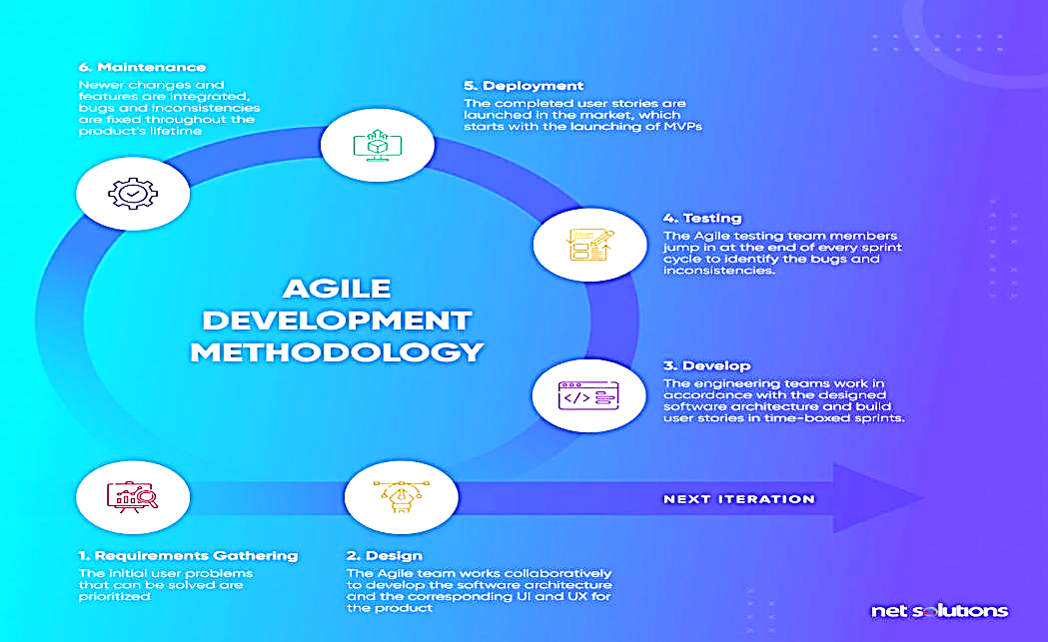
Figure 3.1 Agile SDLC diagram

3.2 Analysis of Existing Systems
Traditional voting systems suffer from various vulnerabilities that threaten the integrity of electoral processes. Instances of tampering, fraud, and a lack of transparency have been recurrent issues in elections worldwide. By examining these problems, we underscore the pressing need for an alternative that addresses these critical challenges.

3.2.1 Limitations of Traditional Voting Systems
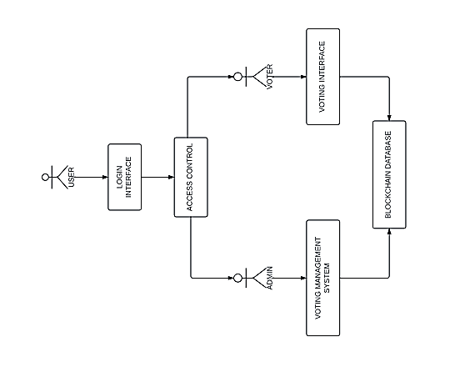
Traditional voting systems exhibit shortcomings that extend to security, accessibility, and trust. Security vulnerabilities open the door to manipulation, limiting the system's ability to guarantee the accuracy of results. Additionally, accessibility issues may disenfranchise certain demographics, impacting the inclusivity of the democratic process. These limitations erode public trust in the electoral system, emphasizing the urgency for a more robust solution.

Figure 3.2 User interaction diagram

3.3 Analysis of the Purposed System

The proposed system architecture consists of three main parts, the blockchain server (Hardhat), the web application backend (PHP), and the front-end (Bootstrap, CSS and HTML). The implementation of a public blockchain by the suggested solution is highlighted as anyone can be a node and no trust is required among the participants (nodes) in the blockchain. In the proposed system, not every registered voter has to be part of the blockchain and not every node has to be used as a device for voting. There is a distinction between nodes and the devices of the participants.

3.3.1 Technologies Used

3.3.1.1 Hardware Requirements
I. Computer System
II. Web Browser.
III. Hosting infrastructure (WAMP Server)

3.3.1.2 Software Requirements
I. MYSQL: Database editor
III. PHP: Server scripting technology.
IV. JavaScript: JavaScript (JS) is a versatile, high-level programming language primarily used for web development. It enables dynamic content on websites and can be used for both front-end (browser) and back-end (server-side) development.

3.3.2 Functional and Non-Functional Requirements
3.3.2.1 Functional Requirements
These are what the system should be able to do the features and tasks it must support to serve its users.
For Users:
- Voters should register and Login securely.
- Voters should be able to cast their vote once.
- When voting ends users can see the pools.
- Voters should be able to log out after voting.

For Admins (Electoral Commission Staff):
- Admins should be able to create and manage elections within the system.
- The system should automatically count and collate votes.
- Admins should be able to add candidates to any election.
3.3.2.2 Non-Functional Requirements
These requirements focus on how the system performs its tasks. They are more concerned with qualities like speed, reliability, security, and ease of use.
Key Points:
- The system must ensure that voter identities remain private. Votes should not be traceable to individual users.
- Security measures must be in place to prevent tampering or unauthorized access.
- The system should be reliable and able to function smoothly during all stages of voting.
- It should be scalable, allowing more users and elections without performance issues.
- The design must be easy to understand and use for both voters and administrators.
- Election activities should be auditable without compromising voter anonymity.
The person that casts a vote should not be known. It is the principle of voter confidentiality and anonymity.
. The system must ensure there is no way for the voter to prove he voted for any particular candidate. It would reduce voter buying or coercion.
. The system must not allow votes to be changed or manipulated after they have been cast. The records must be immutable.
. It should be impossible for an organization (even the electoral commission) or individual to have control over the system. In other words, there should be no single point of failure, and the system records would be distributed among the participating nodes based on consensus.
.Elections must be specific both in the period to be conducted and the candidates contesting. Once an election is initiated, it cannot be discontinued or the candidates edited mid-way by the administrators (electoral officers)
3.4 UML Diagrams
UML diagram (Unified Modelling Language) is modelled to describe pictorially a system with its primary actors, roles, actions, and artifacts.
3.4.1 Use case diagram
Use case diagram A use case diagram representation represents how a user might use a system. It illustrates how a user will behave with a system, whether it is an app or a web page. Use case diagrams are also able to depict the various kind of users that a system possess, the most important components are referred to as actors and the use cases as processes. It indicates the actors who communicate with one another in every use case.

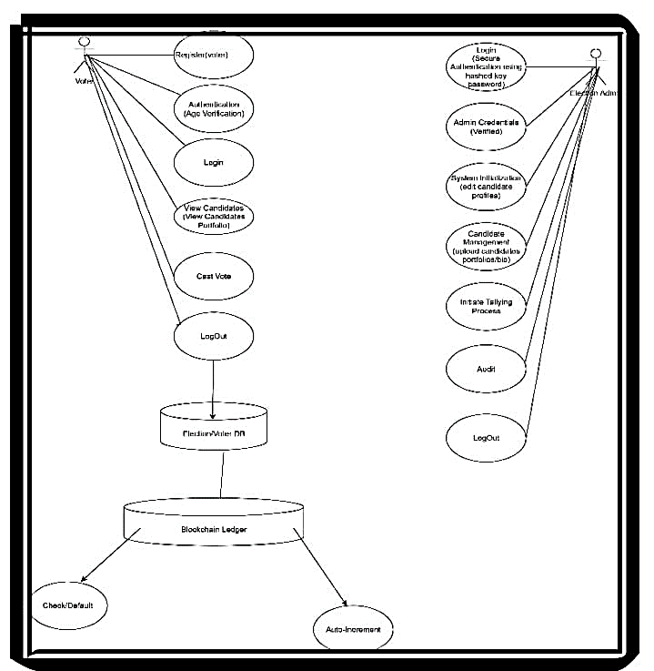
Figure 3.3 Use case diagram for the voter and admin.

3.4.2 Actors, Use Cases Actor: Voter Use cases:
I. Enrolment for Election
II. See the current applicants
III. Cast Votes
IV. View results Actor: Admin It controls the running module of the system of voting
Use cases:
- Create Elections
- Authenticate/Add Candidates
- View results
3.4.3 Class Diagram
A class diagram is a diagram in the unified modeling language (UML) that shows the arrangement of classes in a system plus the relationships among them. UML is a common modeling language that is applicable in software engineering application and it is used to visualize, specify, construct, and document the artifacts of software system.

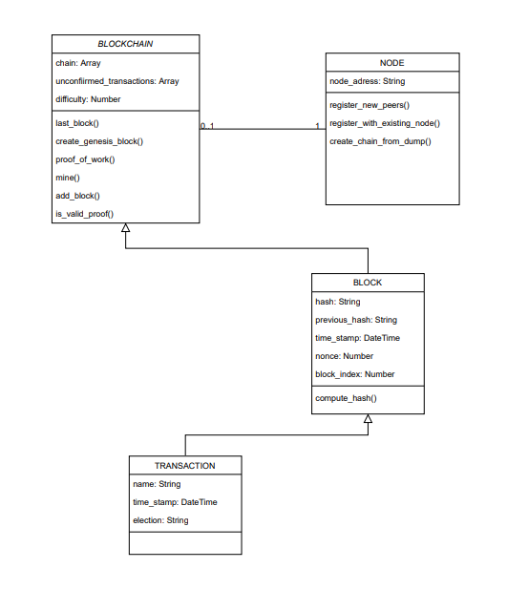
Figure 3.4 Class Diagram of the Blockchain

3.4 Sequence Diagrams
Sequence diagrams show how layers or sub-systems in a system interact with each other and the user. The sequence diagrams for the system as shown below in Figure 3.5.
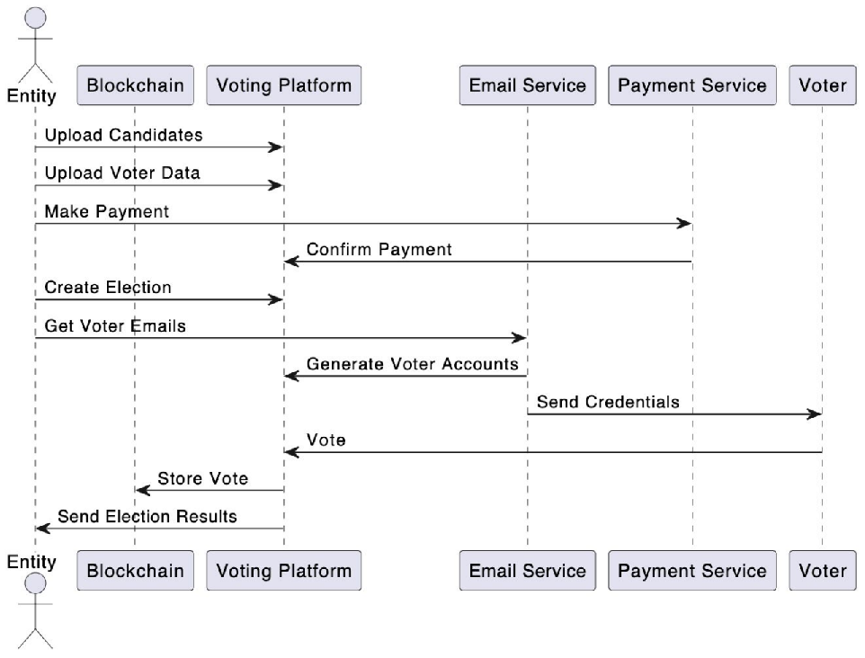
Figure 3.5 Sequence Diagram of the Blockchain voting system.

3.4.5 Flowchart
These diagrams represent the algorithm used in the system for both voters and administrators. The flowchart for voters and admins of this system as shown in Figure 3.6 and Figure 3.7, respectively.
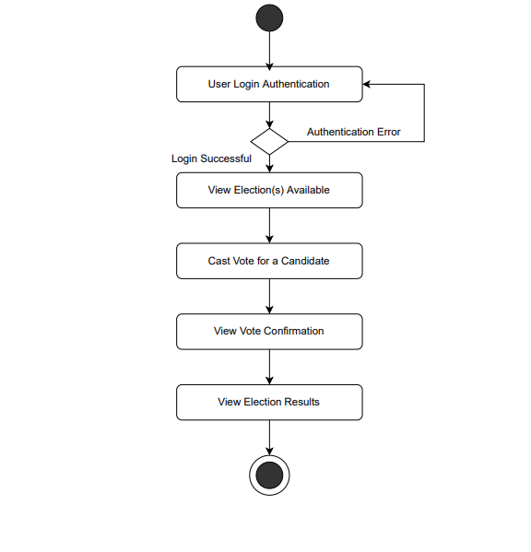
Figure 3.6 Flowchart Diagram for a voter

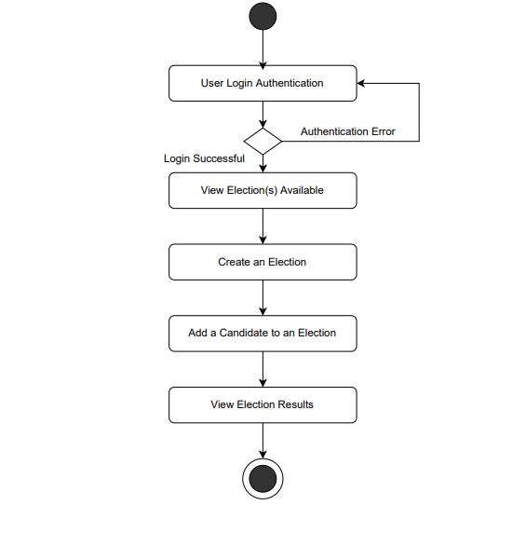
Figure 3.7 Flowchart Diagram for an admin
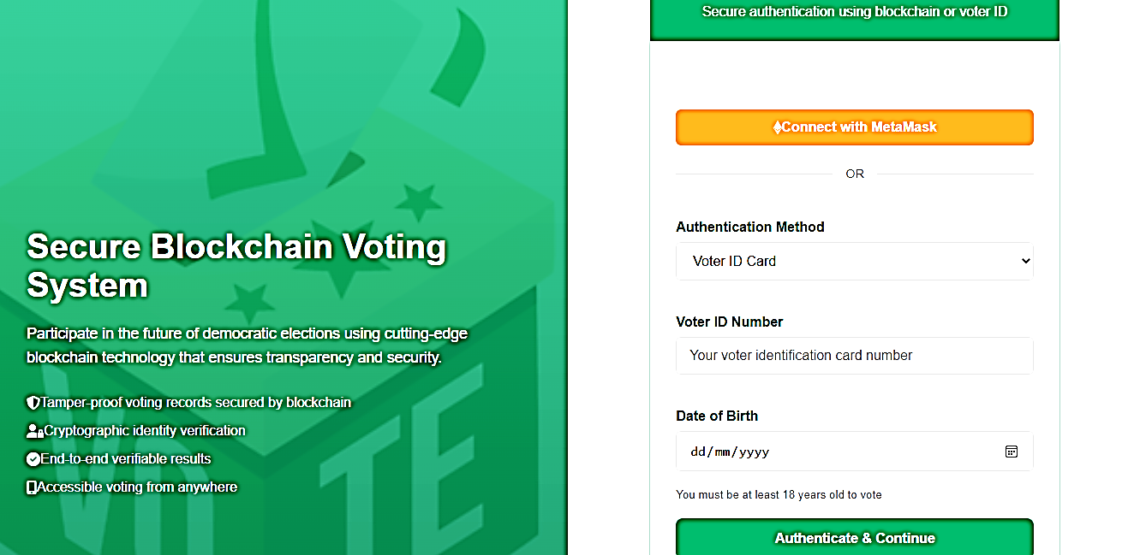
Figure 3.8 Input design of the proposed system
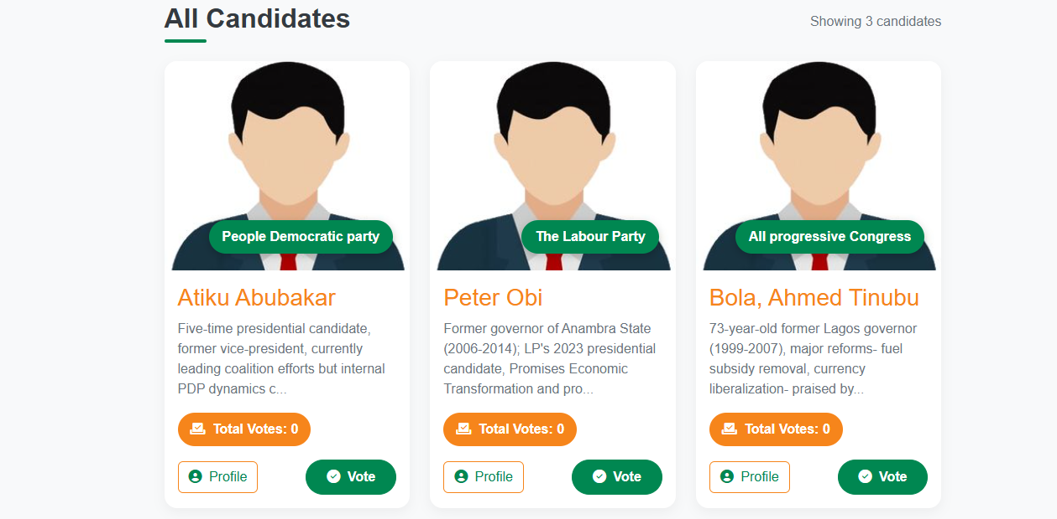Figure 3.9 Output design of the proposed system

3.5 Database design of the proposed system
Table 3.1 Voter
Column Name | DataType | Constraints | Description
voter_id | VARCHAR(255) | PRIMARY KEY | Unique identifier for each voter.
national_id _number | VARCHAR(20) | UNIQUE | Unique national identification number
first_name | VARCHAR(100) | NOT NULL | Voter’s first name.
last_name | VARCHAR(100) | NOT NULL | Voter’s last name.
date_of_birth | DATE | NOT NULL | Voter’s date of birth.
Wallet_address | VARCHAR(255) | UNIQUE, NOT NULL | The public address of the voter’s blockchain wallet.
registration_status | ENUM | NOT NULL | Status of voter registration.
registration_timestamp | DATETIME | NOT NULL | Timestamp when the voter registered
last_login_timestamp | DATETIME | NULLABLE | Last time the voter logged into the system

Table 3.2 Admin
Column Name | DataType | Constraints | Description
admin_id | VARCHAR(255) | PRIMARYKEY , UNIQUE | Unique identifier for the admin.
Username | VARCHAR(50) | UNIQUE, NOT NULL | Admins login username
Password | VARCHAR(255) | NOT NULL | Hashed password of the admin.
full_name | VARCHAR(200) | NOT NULL | Admins full name
Role | ENUM | NOT NULL | Role of the admin(election officer)
creation _timestamp | DATETIME | NOT NULL | Timestamp when the admin account was created.
last_login_timestamp | DATETIME | NULLABLE | Last time the admin logged in.
is_active | BOOLEAN | NOT NULL | Indicates if the admin account is active or not.

CHAPTER FOUR

SYSTEM IMPLEMENTATION

4.1 Preamble
This chapter shows the implementation details, test procedures, and results of the Blockchain-Based Voting System built using Laravel (php framework) and MetaMask. The system was designed to enhance the transparency, security, and integrity of electoral processes in Nigeria by leveraging blockchain technology.
The chapter discusses the system's deployment environment, key functionalities, testing methodologies, and performance evaluation. Additionally, it presents the results obtained from various test cases to validate the system's efficiency and reliability.

4.2. Hardware and Software Requirement

Hardware Requirements:

CPU: Quad-core (development), 8+ cores (production)

RAM: 8-16 GB (dev), 32-128 GB (prod)

Storage: 500 GB - 2TB SSD

Network: 1-10 Gbps internet/LAN

Client devices (PCs, tabs and smartphones with internet connection and a browser application)

Software Requirements:

Blockchain platform (MetaMask)

Frontend: HTML, CSS, Javascript, Bootsrap

Backend Framework: Laravel (PHP)

Database: MySQL

4.2.1 Development Environment
The system was developed using the following technologies:
- Backend Framework: Laravel (PHP)
- Frontend: HTML, CSS, JavaScript, Bootstrap
- Blockchain Integration:MetaMask Wallet
- Database: MySQL
- Web3 Library: Web3.js for interacting with the Ethereum blockchain
- Server: Apache (XAMPP for local development)

4.2.2 Key Functionalities Implemented
The following core features were successfully implemented:
- User Authentication
- Voters and administrators pages.
- MetaMask wallet integration for secure identity verification.



- Voting Process
- Voters connect their MetaMask wallets to the system.
- Once verified, they can cast their votes, which are recorded on the database.

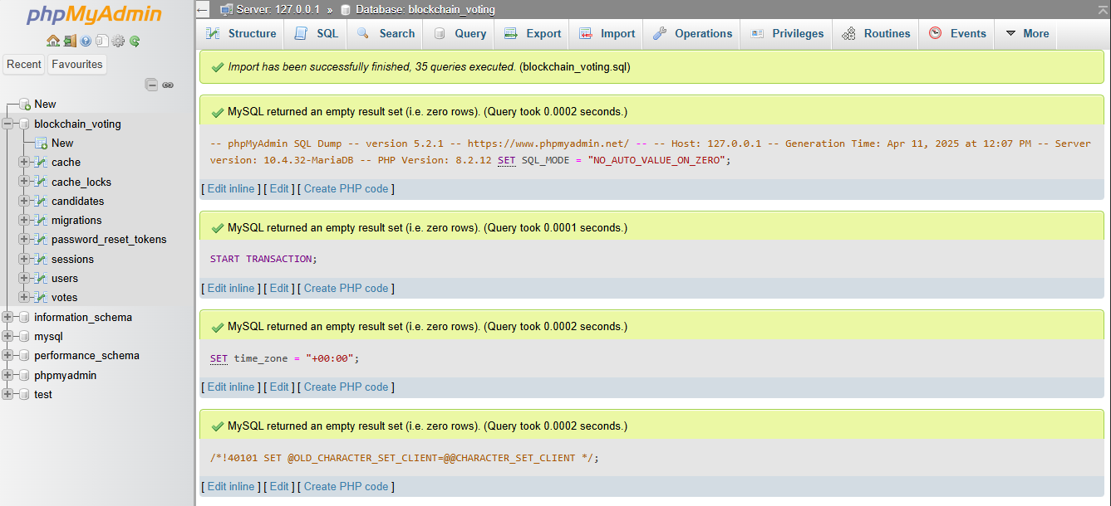

- Results Tallying & Display
- The system automatically tallies votes and displays results in real-time.

- Admin Dashboard
Administrators can:
- Register candidates.
- Monitor voting progress.

- Validate voter eligibility.
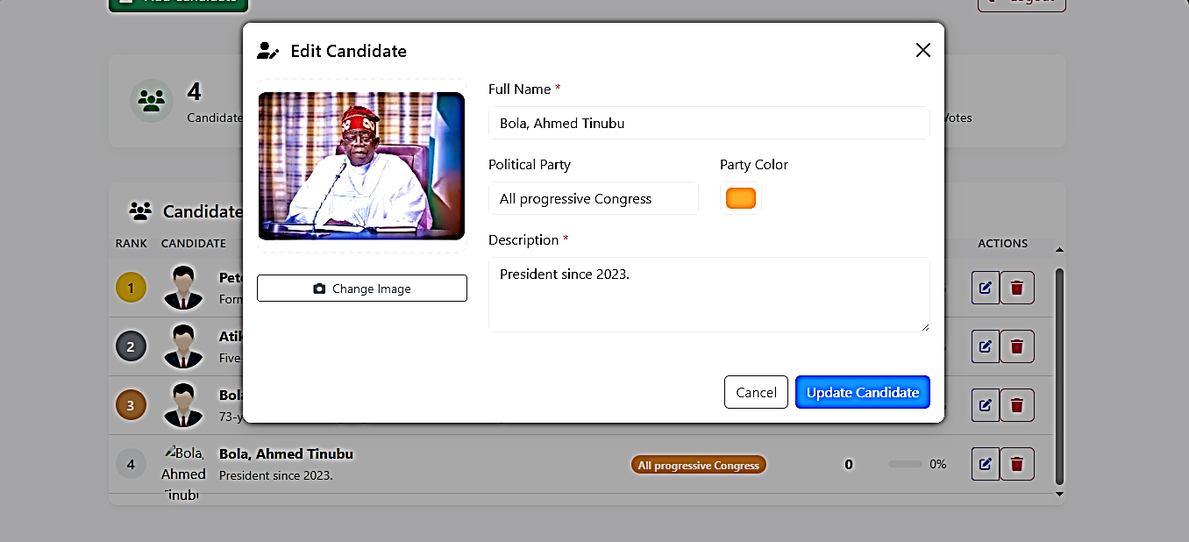

4.3 Testing
Testing was conducted to ensure the system's functionality, security, and performance. The following testing methods were applied:

4.3.1 Unit Tests
Individual components (e.g., user authentication, smart contract functions) were tested in isolation.
Laravel PHP Unit was used for backend testing.
Truffle Suite was used to test smart contract functionalities.
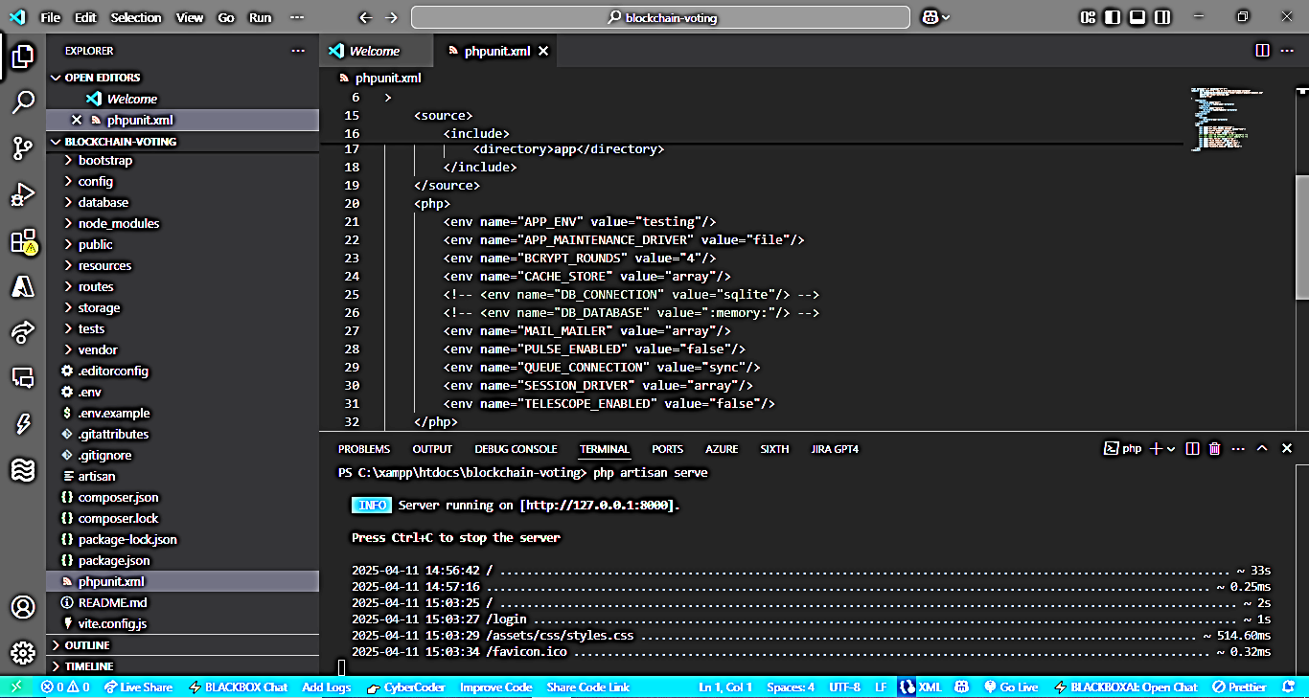

4.3.2 Integration Testing
Verified seamless interaction between:
Laravel backend and MySQL database.
Frontend and MetaMask wallet.
Web3.js and Ethereum blockchain.

4.3.3 Security Testing
Conducted penetration testing to identify vulnerabilities.
Ensured that:
Only registered voters can participate.
Votes cannot be altered once recorded.
Private keys and wallet access remain secure.
This chapter presented the implementation, testing, and results of the Blockchain Voting System. The system successfully integrated Laravel and MetaMask to create a secure, transparent, and efficient voting mechanism.
Testing confirmed that the system:
- Prevents vote manipulation
- Ensures only eligible voters participate
- Provides real time verifiable results

CHAPTER FIVE

DISCUSSION, CONCLUSION AND RECOMMENDATION
5.1 Preamble
The conclusions about the voting system project are outlined in the given chapter, several contributions are identified, and the difficulties during development are discussed. It also presents limited suggestions to be done in the future so as to make systems efficient and adoptable in real electoral processes.
5.2 Project summary
The idea exploited in this project was how this decentralized technology using blockchain can be utilized to design a reliable, transparent and tamper free method of voting by riding on the blockchain.

5.3 Conclusion
The implementation of this work shows how blockchain technology can significantly improve the integrity of e-voting offering transparency, security and real-time verifiability of votes.

5.4 Recommendations
To improve the system, the following enhancements are suggested:
1. Adoption of a More Scalable Blockchain
Explore Ethereum Layer-2 solutions (Polygon, Arbitrum) or low-fee blockchains (Binance Smart Chain, Solana) to reduce costs.
2. Biometric Voter Authentication
3. Mobile Application Development
4. Government and Electoral Body Collaboration
5.5 Future Work
- The integration of biometric or a form of digital ID verification will help to secure voter authentication.
- Regular conducting of real-world testing refines usability and lack of error.

REFERENCES
Aggelos K., Alexander P., and Alexander R. (2010) Examined Proof-of-Stake blockchain protocols with near-optimal resilience in the Proceedings of the 29th International Symposium on Distributed Computing (DISC). 1–15.
Aggelos K., Alexander P., and Alexander R., (2021). Returned with “Efficient Byzantine Agreement without a Trusted Setup” in IEEE Transactions on Dependable and Secure Computing, 18(1), 1–14.
Barin E., (2025). “Blockchain in Voting Systems Statistics 2025: Enhancing Security and Accessibility” on CoinLaw (Feb. 25, 2025), summarizing the latest adoption figures and trends.
Chan-Ho R., and In-Young L., (2020). Surveyed private-blockchain e-voting systems in the Journal of Information Processing Systems, 16(2), 421–434.
Feng H., Peter R., and Piotr Z., (2010). Explored voter anonymity in “Anonymous Voting by Two-Round Public Discussion,” published in IET Information Security 4(2), 62–67.
Gavin W., (2014). Laid out the architecture for Ethereum in the Yellow Paper titled “Ethereum: A Secure Decentralised Generalised Transaction Ledger.”
Jörn M., Rainer B., and Dominik B., (2013). Investigated illicit uses of cryptocurrencies in “An Inquiry into Money Laundering Tools in the Bitcoin Ecosystem,” presented at the 2013 APWG eCrime Researchers Summit 1–14.
Konstantinos K., Peter J., Nicolas G., Ismail K., Luke G., and Bryan F. (2016). Enhanced Bitcoin’s security and performance via collective signing in the 25th USENIX Security Symposium. 279–296.
Maryam H. B., Hossein R. B., Noureddine E., and Christoph P., (2024). Offered a comprehensive review of blockchain-based e-voting in Electronics, 13(1), 17.
Mohammad N., and Douglas S., (2015) Presented efficient sealed-bid auction protocols using verifiable secret sharing at the 8th International Conference on Information Theoretic Security (ICITS), 140–155.
Peter M., Siamak F., Shahandashti, and Feng H., (2017). Proposed “A Smart Contract for Boardroom Voting with Maximum Voter Privacy” at the 19th International Conference on Financial Cryptography and Data Security (FC), 357–375.
Satoshi N. (2008). Landmark technical report “Bitcoin: A Peer-to-Peer Electronic Cash System” introduced the world to the foundational ideas of a decentralized digital currency.
Siamak F. Shahandashti and Feng H. (2013). Introduced DRE-ip, a verifiable e-voting scheme without tallying authorities, at the 21st European Symposium on Research in Computer Security (ESORICS), 223–240.

APPENDIX

1.0 Code Snippet: Admin Login API

<!DOCTYPE html>

<html lang="en">

<head>

<meta charset="UTF-8">

<meta name="viewport" content="width=device-width, initial-scale=1.0">

<meta name="csrf-token" content="{{ csrf_token() }}">

<title>Admin Login | Nigeria Voting System</title>

<link href="https://cdn.jsdelivr.net/npm/bootstrap@5.3.0/dist/css/bootstrap.min.css" rel="stylesheet">

<link href="https://cdnjs.cloudflare.com/ajax/libs/font-awesome/6.0.0/css/all.min.css" rel="stylesheet">

<style>

:root {

--nigerian-green: #008751;

--nigerian-white: #ffffff;

--nigerian-dark-green: #005738;

}

body {

background-color: #f8f9fa;

font-family: 'Segoe UI', Tahoma, Geneva, Verdana, sans-serif;

}

.login-container {

display: flex;

justify-content: center;

align-items: center;

min-height: 100vh;

background: linear-gradient(135deg, rgba(0, 135, 81, 0.1) 0%, rgba(255, 255, 255, 1) 100%);

}

.login-card {

width: 100%;

max-width: 420px;

border: none;

border-radius: 12px;

overflow: hidden;

box-shadow: 0 10px 30px rgba(0, 0, 0, 0.1);

transition: transform 0.3s ease;

}

.login-card:hover {

transform: translateY(-5px)

