DEVELOPMENT OF A YOLOv11-BASED VEHICLE LICENSE PLATE DETECTION AND RECOGNITION SYSTEM

BY

GEORGE, DAVID NSEABASI
GOU/U21/CSC/675

DEPARTMENT OF COMPUTER SCIENCE AND MATHEMATICS, FACULTY OF NATURAL SCIENCES AND ENVIRONMENTAL STUDIES,
GODFREY OKOYE UNIVERSITY, ENUGU STATE. IN PARTIAL FULFILLMENT OF THE AWARD OF BACHELOR OF
SCIENCE (B.SC), DEGREE IN COMPUTER SCIENCE.

SUPERVISOR: Dr. FRANK OKEBANAMA

JUNE, 2025.

ABSTRACT
This study seeks to address several challenges affecting Nigerian roads, especially for travelers who encounter unnecessary queues in different checking points and toll booths as a result of the use of the manual method of vehicle inspection. It also identifies the problems affecting the use of ML and DL techniques in automating vehicle license plate recognition systems. The study employed a public dataset to train and developed a YOLOv11-based vehicle license plate detection and recognition system that solves the identified problems. Additionally, OCR was employed to recognize and extract the characters. The performance was evaluated considering some metrics such as F1-score and accuracy. The model achieved a high accuracy of 97.4%, an F1-score of 96%, and demonstrated fast computational capabilities. Python’s tkinter to design a user-friendly software application to test how efficient the model is on live capture image and video data. The study encountered some limitations that hindered the achievement of some of the original goals. This led to a 5% misclassification rate, caused by lighting issues and broken or faded plates. However, the results offer a way forward for practical applications in Nigeria, with the model proving reliable for traffic monitoring and enforcement, thereby addressing the initial challenge of manual recognition inefficiencies.

CHAPTER ONE
INTRODUCTION
1.1 Background of the Study
In recent years, governments and corporate entities have been adopting artificial intelligence (AI) technology for urban management (Lin et al. 2022). As a result of the high numbers of cars on the roads, there is a growing need for automated license plate recognition (ALPR) systems that combine AI models and computer vision techniques that automatically detect and read vehicle license plates from images or videos. These ALPR systems will utilize information technology capabilities such as speed tracking (Shashirangana et al., 2021), unmanned parking lot management, and roadside enforcement of illegal traffic (Han et al., 2020) in urban environments. Currently, automatic license plate recognition (ALPR) plays a crucial role in smart transportation systems and continues to present challenges in the field of computer vision and image processing (Raza et al., 2020).
The current vehicle registration plates in Nigeria were introduced in 1992 and updated in 2011. Nigeria uses various types of license plates to manage its increasing vehicle population, where the privately owned vehicles display blue text on a white background, commercial vehicles show black on yellow for easier identification, and the plates for government, diplomatic, military, and paramilitary vehicles have unique colors and codes to indicate their official roles or privileges. Additional categories include custom-designed plates for personal branding, temporary plates for newly purchased vehicles, dealer plates for unregistered transit vehicles, and special plates for trailers and trucks. This categorization enables the maintenance of organized regulation and control. Furthermore, the National Bureau of Statistics (NBS) had in its records an approximate number of 11.8 million registered vehicles on Nigerian roads in 2018 (as cited in International Trade Administration, 2023). Assuming an average annual growth rate of 2–3%, the national vehicle population is projected to increase by 15–23% over seven years. Following this steady growth tendency, it suggests that by 2025, the total number of vehicles on Nigerian roads could reach around 13 million, reflecting increased urbanization, vehicle imports, and transportation demand. Therefore, there is a need to adopt and integrate APLR systems effectively across the Nigerian transport sector, as it is an effective way to monitor vehicles leveraging on their unique plate number. Adoption of ALPR will enable the efficient and effective management of traffic, and also faster identification and recovery of stolen vehicles.
Automatic License Plate Recognition has been a frequent research topic as the number of cameras available in cities increases, with most of them connected to the Internet. Because of that, many studies have examined various approaches that will improve Automatic License Plate Recognition (ALPR) systems within intelligent transportation environments. One such work was the use of an Optical Character Recognition (OCR) and Wireless Sensor Networks (WSN) to develop a real-time Automatic License Plate Recognition (ALPR) system by Dalarmelina et al. (2020). Results after testing indicate an accuracy of 83% for the proposed method, while having the best average processing time of 0.26 seconds. In a related work, Lin et al. (2022) developed an Edge AI-based system that performs real-time local license plate recognition through a streamlined pipeline of data preprocessing, frame detection, virtual judgment gating, modified-YOLOv4 character recognition, and logic-based result validation. The developed model reported a recognition accuracy of 97% during daytime with sustained high FPS (frames per second).
Buleu et al. (2025) proposed an automated license plate recognition system using the latest version of the YOLO algorithm, namely YOLOv12, along with a PaddleOCR library. The YOLOv12 is tasked to automatically detect license plates in images with vehicles, while the OCR provides the recognition functionality of identifying the type of vehicle bearing the license plate along with the county of registration. Experimental results show that the YOLOv12 had an improvement of 2.3% in precision and 1.1% in the F1score. Similarly, a study by Al-Batat et al. (2022) proposed a three-phase architecture that utilizes YOLOv2 for vehicle detection and YOLOv4-tiny for both license plate detection and character recognition. In addition, a ResNet-50 was integrated for vehicle type classification, to distinguish between different vehicle categories such as trucks and emergency vehicles. The model was evaluated using five publicly available datasets and achieved an average license plate recognition accuracy of 90.3%. Going forward, Saha et al. (2024) addressed the problems challenging ALPR through the adoption of a two-stage detection pipeline, where one stage is tasked with license plate detection, and the other recognizes characters using the same YOLOv10 model. The model was evaluated using standard object detection metrics, as reported results indicate an F1 score of 94.36% and mAP50 of 96.25.
Despite the recent technological development and progress, continuous innovative research is required to address challenges such as models missing or mismatch of characters and overlapping recognition frames under extreme conditions (Lin et al., 2022), as highlighted also in (Dalarmelina et al., 2020), who mentioned challenges like sensitivity to lighting conditions. In addition, Al-Batat et al. (2022) pointed out detection challenges from faded or broken plates as well as the drop in recognition with visual similarity and struggles with complex data. The proposed study, a YOLOv11-Based Real-Time Vehicle Plate Detection and OCR for Nigerian Toll Booth Automation, will consider these challenges as a focal point by designing a robust and efficient system that solves these problems.
Overall, this research will contribute to society academically and also practically with the adoption of an improved YOLOv11 model along with an OCR channeled towards improving the challenges in Nigeria's toll booth system. The study seeks to address the problem identified from the characterization of the existing system and the literature review, such as faded or broken license plates, poor lighting, visual obstructions, and a lack of local data integration on existing models. In terms of practical contribution, the proposed system will improve toll collection efficiency, reduce queue times, and enhance enforcement of traffic laws, thereby aligning with Nigerian smart city initiatives. The system is also flexible enough to be applied in other transport settings, including parking areas and Nigerian road checkpoint stations. Finally, the study illustrates how artificial intelligence as a whole can effectively tackle transportation challenges in developing countries like Nigeria.
1.2 Statement of the Problem
This study is motivated by several challenges affecting the Nigerian roads, especially for travelers who encounter unnecessary queues in different checking points and toll booths, all as a result of using the manual method to inspect vehicles. This process is very slow, time-consuming, inefficient, and prone to human error. Another case to point out is bribery and corruption affecting this manual method of toll booth collections. These challenges lead to unnecessary delays, revenue collection leakages, and, most time, biased and inaccurate vehicle tracking for security purposes.
Nevertheless, the existing ALPR systems are also faced with enormous problems, making it difficult to directly adopt them into Nigerian toll booth or check point stations. The challenges identified from the existing system includes limited dataset, non-localized dataset for Nigeria, accuracy problems especially in poor lighting conditions and faded or broken plates and then character mismatch. This results to poor detection performance making it unreliable for operation. Therefore, there is an urgent need for a robust, intelligent, efficient, and real-time system that can accurately detect and recognize Nigerian vehicle license plates in diverse environmental conditions, while improving toll booth efficiency, vehicle theft apprehension, and contributing to traffic automation.
1.3 Aim and Objectives of the Study
The study aims to develop a YOLOv11-based vehicle License Plate Detection and Recognition for Nigerian Toll Booth Automation. The specific objectives are to:
1. Characterize the existing system of vehicle license plate detection and recognition.
2. Gather and preprocess a dataset of Nigerian vehicle license plates to train and test the model.
3. Develop a YOLOv11-based model for real-time detection of vehicle plates
4. Integrate an OCR module capable of accurately recognizing alphanumeric characters from detected plates.
5. Evaluate the performance of the proposed system and integrate it into a software application.
1.4 Significance of the Study
This project work is of academic and practical importance. It explores a critical intersection between advanced computer vision technologies and transportation infrastructure in Nigeria. By designing and implementing a YOLOv11-based system for real-time vehicle license plate detection and OCR, the research aims to improve toll both automation and drive forward intelligent transport system initiatives in Nigeria.
Academically, it is significant in the following areas:
- Contributes to ongoing research in deep learning-driven vehicle plate recognition systems.
- Demonstrates the application of the YOLOv11 model, with adaptations for Nigerian license plate character structure and road infrastructure.
- Evaluates the performance and suitability of cutting-edge object detection in real-world conditions specific to Nigeria.
While the Practical Implications include:
- Enhances the efficiency of toll collection processes across Nigerian highways.
- Minimizes human errors associated with manual toll operations.
- Strengthens vehicle monitoring and identification capabilities, especially for crime prevention.
In summary, the study lays the groundwork for integrating advanced technology into Nigeria’s transport ecosystem. It supports smarter mobility solutions, enhances tools for law enforcement, and provides data-driven urban planning, contributing to the advancement of intelligent transportation systems in Nigeria.
1.5 Scope of the Study
The study focuses on the design, implementation, and evaluation of a real-time vehicle license plate detection and recognition system using YOLOv11 and OCR. The scope is limited to Nigerian license plates, particularly those encountered at Enugu city toll booths. The research covers data collection, training, and enhancement of the model, testing under different lighting and weather conditions, and simulation of toll booth operations. It does not cover hardware installation or real-world deployment apart from experimental validation using or still image data.
1.6 Limitations of the Study
This research encounters some challenges in the area of real-time deployment of the system at locations such as the Enugu Toll Booth was not conducted, which limits practical assessment under real-world traffic conditions. Additionally, hardware constraints such as camera resolution and processing speed may affect system performance during live operation. The study also focuses exclusively on the detection and recognition of number plates, without integration into broader systems such as automated toll payment or vehicle access control.
1.7 Operational Definition of Terms
YOLOv11: The 11th version of the "You Only Look Once" deep learning algorithm, optimized for fast and accurate object detection.
OCR (Optical Character Recognition): A technology used to convert images of text (such as vehicle number plates) into machine-encoded text.
Real-Time Detection: The ability of the system to process and analyze video frames instantly as they are captured, with minimal delay.
Toll Booth: This is an enclosure placed along a toll road that is used for the purpose of collecting a toll from passing traffic.
License Plate Recognition (LPR): It the use object detection models or system to read or extract vehicle license plate numbers from images or video.
Image Processing: This can be defined as the use of computers and mathematical model to process and analyze a digital image. Examples are resizing, filtering, and edge detection
Computer Vision: It is a field of AI where a machine is tasked with acquiring, processing, analyzing and understanding digital images from cameras or sensors to interpret and make decisions based on them.
Machine Learning: It is defined as a branch of AI that focuses on developing models and algorithms that let computers learn from data to make predictions or decisions.
Neural Network: In machine learning, A neural network is a layered network architecture consisting of connected units or nodes called artificial neurons, that is used to detect patterns and perform tasks like classification, regression, and segmentation in image data.
Deep Learning: DL is a subset of machine learning that focuses on utilizing multilayered neural networks to perform tasks such as classification, regression, and representation learning from large amount of data. It has high performance in tasks such as image recognition.
CHAPTER TWO
LITERATURE REVIEW

2.1 Introduction
This chapter presents a holistic review of relevant literature to my research topic, A YOLOv11-Based Vehicle License Plate Detection and Recognition for Nigerian Toll Booth Automation. As vehicular traffic in Nigeria continues to grow, especially around toll booths where congestion and verification issues persist, the need for a robust and automated vehicle license identification system becomes more needed than ever. This section analyzes theories related to the field of vehicle license plate automation and deep learning models, especially the CNN algorithm YOLO. Through a critical analysis of research papers and articles, along with previous project reports, this section identifies the strengths and shortcomings of existing solutions for vehicle license plate detection and recognition.
2.2 Theoretical Background
The concept of automated license plate detection combines computer vision, deep learning, and intelligent transportation systems (ITS), as well as the Internet of Things (IoT). The mentioned disciplines provide the technical foundational theories, frameworks, and theoretical models that support the development and deployment of innovative visual recognition systems for transportation infrastructure.
2.2.1 Object Detection
Recently, the concept of object detection has become a key focus within the broader field of AI-driven information technology. Object detection is a computer vision and image processing approach that involves identifying patterns or features from images or videos. From their functions, the object detection process is classified into two categories: first is localization, which pinpoints the object's position using bounding boxes, and second, classification, which is tasked with assigning object labels.
Object detection (OD) system is the process of finding objects in the real world by using object models known as a priori (Sharma and Thakur, 2017). This task is difficult to perform for machines compared to Humans, who perform OD instantaneously with little effort. Figure 2.1 illustrates the components of an OD system. It shows the stages that are involved in the process of the OD system. The basic input to the OD system can be an image or a scene, in the case of videos. The objective of the system is to detect objects that are present in the image or scene, or simply to categorize the various objects into respective object classes.
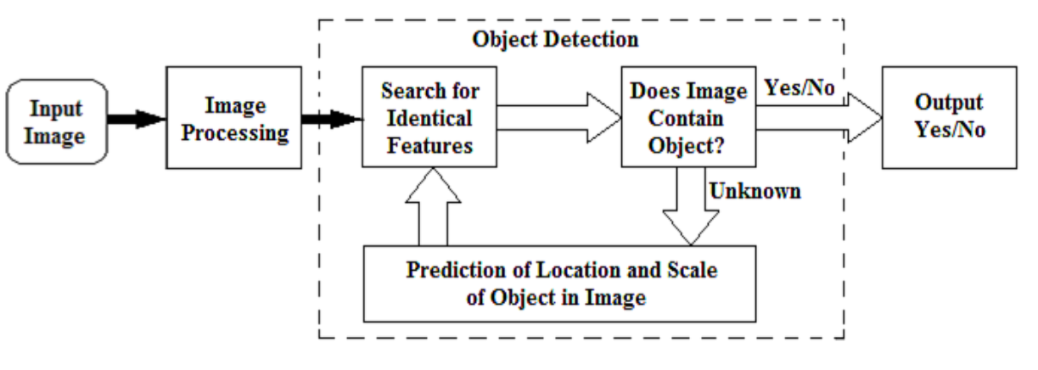
Figure 2.1 Basic Object Detection Framework (Sharma and Thakur, 2017)
A. Traditional object detection methods
Before the introduction and widespread adoption of DL methods, object detection algorithms were mainly based on geometric techniques, focusing on the arrangement of elements of specific objects, and the models were relatively simple. “Based on the traditional object detection algorithm with manually designed features, the steps and processes of detection mainly include pre-processing, region selection, feature extraction, and feature classification processes (Abeywardhana et al., 2023).” Pre-processing in object detection is the redundant denoising of the detected image. According to Abeywardhana et al. (2023), the common pre-processing methods used in OD are histogram equalization, median filtering, mean filtering, Gaussian filtering, and other spatial domain image denoising methods, high pass filtering, low pass filtering, and other image denoising methods.

B. Object Detection in Deep Learning Model
Object detection is one of the most important computer vision tasks that deals with the detection of visual instances of objects of a certain class in a disorderly but realistic scene or input likely of images or videos (Sharma and Mir, 2020). Object detection techniques aim to develop computational models that provide much-needed information needed by applications based on computer vision. As a result of the wide range of applications and recent advancements, object detection has attracted large amounts of research interest in recent years. The task of object detection in both real-world applications and academia is currently undergoing continuous investigation. However, there are many challenges affecting the efficiency of object detection models, such as occlusion, computational demands, class imbalance, and data limitations. Zou et al. (2025) in their research said that over the past two decades, there has been a great rise in the area of object detection for deep learning, focusing on the impact and ways to reduce these highlighted challenges. In a similar manner, Jamali et al. (2025) state that the term “context” plays a big role in object detection for deep learning and computer vision, as it helps systems understand and be specific in analyzing visual data more accurately. The context referred to here consists of a wide range of areas, including environmental information, lighting conditions, position and orientation of the object, the associations between objects, location, and time.
According to research conducted by Jamali et al. (2025) he said that the introduction of Convolutional Neural Networks in 2012 sparked a great rise in the field of object detection in deep learning. Additionally, Object detection joined with active learning has emerged as a strong approach that harnesses the capabilities of machine learning to identify and perform image-based object detection automatically (Garcia et al., 2023). Object detection has continuously advanced into real-time detection where objects are instantaneously identified in a video or image (Rathore et al., 2024). Deep learning models are also more efficient and scalable, with architectures such as YOLO detecting objects in a single step.
2.2.2 Deep Learning
Deep learning, a branch of machine learning, uses multi-layered neural networks that mimic cognitive processes through interconnected layers of artificial neurons. In VLPR systems, deep learning allows for automatic learning of hierarchical features such as edges, shapes, and characters from raw images, reducing dependence on manual feature engineering. Deep learning has advanced significantly, transforming many fields by its capacity to learn and represent complex patterns. Classic models like CNNs and RNNs laid the foundation for current AI developments: CNNs, initially designed for image tasks, employ convolutional layers to identify spatial relationships in visual data, enabling major progress in image and video recognition, with key contributions from LeCun's digit recognition and Krizhevsky's AlexNet (Mienye and Swart, 2024). Meanwhile, RNNs focus on sequence data, driving breakthroughs in speech and language processing; LSTM units helped overcome previous limitations by enhancing the learning of long-term dependencies. A fundamental theoretical insight underpinning neural networks is their universal approximation property. The universal approximation theorem states that, given a nonlinear activation function, a neural network with a single hidden layer containing enough neurons can approximate any continuous function on a compact subset of ℝ𝑛 to any desired degree of accuracy (Mienye and Swart, 2024). This idea shows the flexibility and adaptability of neural networks, which makes them capable of learning complex patterns from data. Also, simple networks can exhibit these functions if they have enough power or size.
Unlike older methods that first search for possible object areas and then identify them, YOLO skips that by directly predicting where objects are and what they are in a single action. As explained by Terven and Cordova-Esparza (2024), YOLO combines the task of drawing boxes around objects and identifying them into one neural network, making it very fast and efficient for real-time use, like in surveillance or self-driving cars.
2.2.3 YOLO Architecture
YOLO stands for “You Only Look Once,” and the framework has created a fast and modern method for detecting objects by projecting a unified architecture that performs object detection in a single shot instead of breaking the process into several steps like the R-CNN. YOLO is based on convolutional neural networks (CNNs), unlike region-based models like R-CNN variants, YOLO treats detection as a regression problem by mapping directly from image pixels to bounding boxes and class probabilities. The research conducted by Terven and Cordova-Esparza in 2024 explained how the YOLO model combines the task of drawing bounding boxes around objects and identifying them into one neural network. This enables real-time object detection at a remarkable speed and efficiency. Based on their research, the YOLO algorithm unified method or approach removes the need for region proposals commonly used in other two-stage detector algorithms like R-CNN. Additionally, the YOLO algorithm has continued to progress significantly from the first phase of YOLOv1 to the latest phase being YOLOv11, with continuous improvement in performance in terms of frames per second and mAP across successive versions (Khanam et al., 2025). Figure 2.2 presents the evolution of YOLO, starting from the initial release to the most recent version.
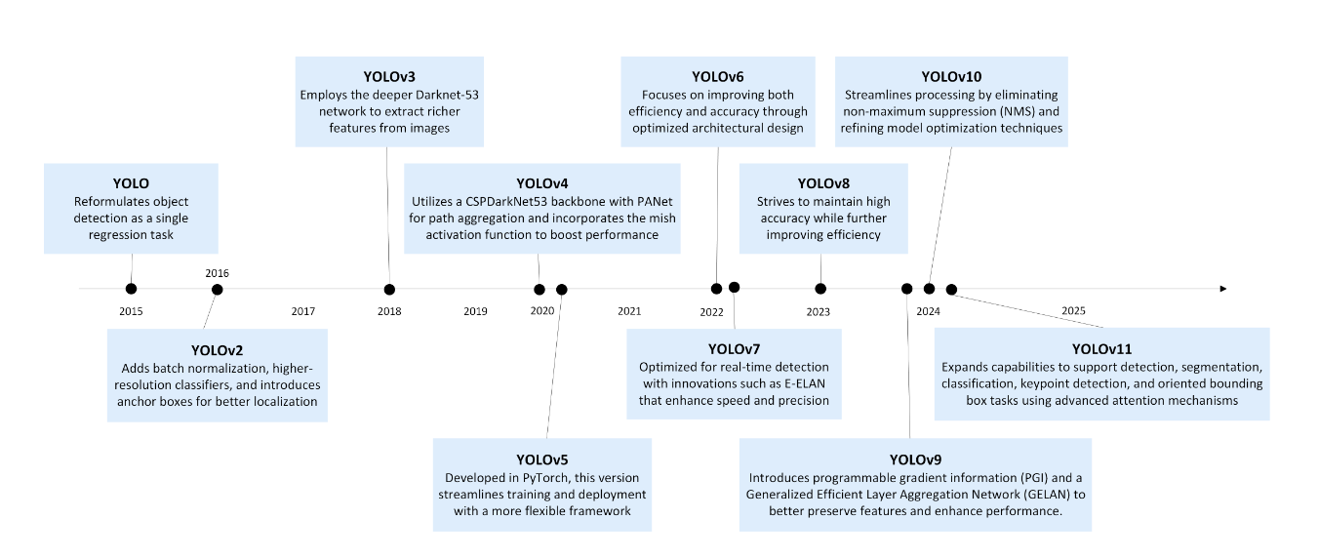
Figure 2.2 YOLO model evolution (Khanam et al., 2025)
Since its inception, the YOLO series has continually improved. The YOLOv2, also known as YOLO9000, significantly improved in the area of image resolution and detection capabilities to over 9000 object categories, as reported by (Khanam et al., 2025), making the version more powerful and adaptable in the areas of detection and recognition. The YOLOv3 continued on the same path of progress by adding a more layered network structure that uses prediction at multiple scales to detect smaller objects with higher accuracy. This progression continued with the release of the YOLOv4 and YOLOv5. YOLOv4 incorporated features such as Cross-stage Partial (CSP) connections and a mosaic-style for augmenting data to boost accuracy and speed. Likewise, YOLOv5 simplified the user experience and delivered impressive efficiency, making it popular in the area of computer vision. From YOLOv6 through the latest YOLOv11, each version has aimed to improve scalability, reduce computational demands, and support faster real-time processing. In conclusion, each version has added one improvement feature to enhance the primary function of object detection. This has created positive impacts on applications such as smart traffic systems, automated vehicle license plate recognition, autonomous vehicles, healthcare imaging, and industrial automation (Sapkota et al., 2025). The YOLOv8 is among many YOLO versions is another powerful phase that easily handles object detection, classification, and segmentation within a single architecture, as illustrated in Figure 2.3
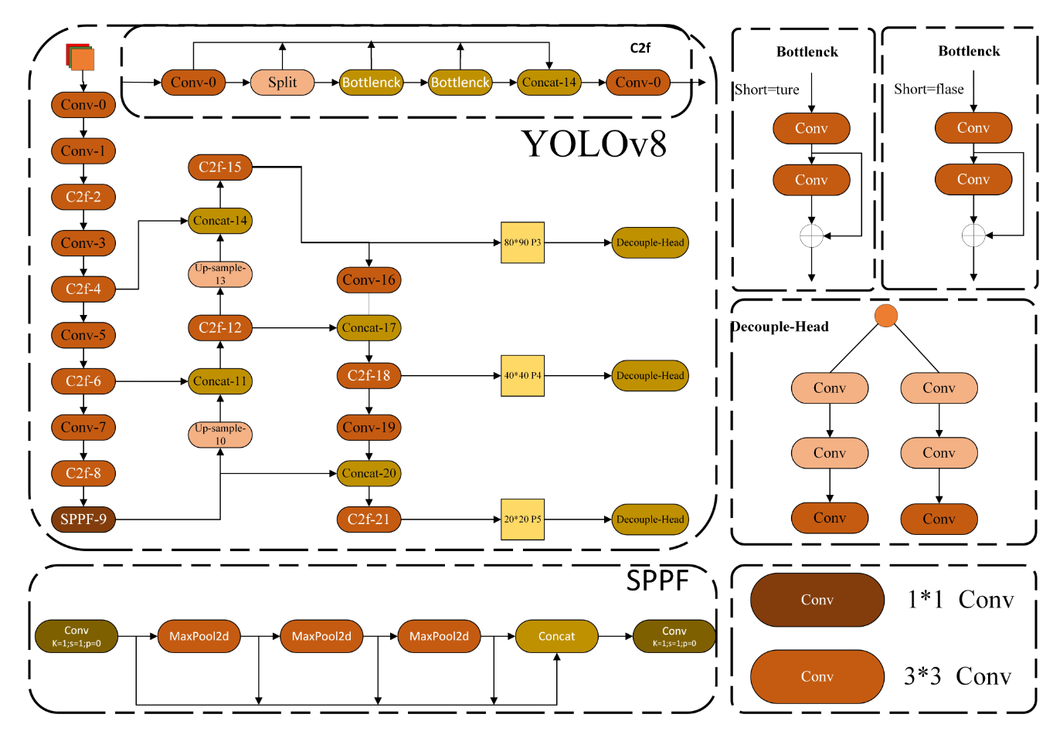
Figure 2.3 YOLOv8 framework diagram (Pan et al., 2025).
According to figure 2.3, the YOLOv8’s architecture is made up of three core components: the backbone, which is responsible for extracting rich visual features using advanced C2f modules which is faster and more efficient variant of the CSP (Cross Stage Partial) Bottleneck possessing two convolutions for efficiency and depth, the neck is responsible for enhancing these features by merging multi-scale information through modules like Spatial Pyramid Pooling Fast (SPPF), Probabilistic Anchor Assignment (PAA), and the Path Aggregation Network (PAN) for better object representation and finally the head component splits into two specialized paths, one for accurate object detection using convolutional layers, and the other for robust classification using global average pooling (Pan et al., 2025).
The YOLO’s architecture stands out because it can process entire spatial regions at once. This design choice of the YOLO helps it work much faster than older methods that use two stages to detect objects. Diwan et al. (2023) explain that this single-shot detection approach gives YOLO a big speed advantage over traditional two-stage detectors. While early versions traded accuracy for speed, recent iterations have improved performance without sacrificing speed. YOLO focuses on fast detection, which makes it well-suited for applications where timing is crucial, such as autonomous driving, surveillance systems, or real-time analytics. Hasan et al. (2023) describe YOLO as a compact and adaptable model, capable of handling both classification and localization in a single pass. According to his findings, its lightweight framework makes it the model of choice for devices with inadequate computational power. In another related work, Rathore et al. (2024) highlighted the end-to-end differential structure of the YOLO, which is a special design that allows the model to learn where objects are and how they are shaped all at once, thereby enabling it to detect objects effectively in real-time with high speed. More recently, YOLO’s design of building a fast and smart model has influenced emerging models like YOLO-NAS and transformer-based variants, which attempt to keep the balance of high detection speed and contextual depth.
2.2.4 Intelligent Transportation System
Milosavljevic and Simicevic (2019) defined Intelligent transportation systems (ITS) as systems or services that improve the efficient movement of people and goods through the use of new technologies. Building on their study, the systems made use of various physical components and communication technologies to improve safety, reduce congestion, and minimize environmental impacts across different transportation modes. The concept of Intelligent Transportation System (ITS) explains how modern societies manage transportation, safety, and other components of the transport sector, such as infrastructure. From the research, ITS adds modern technologies like AI, Cloud computing, along with sensors and wireless communication into the transportation network for the easy flow of traffic, minimizing congestion, and enhancing road safety. These systems go beyond traditional traffic control by enabling the exchange of data and information between vehicles, transport infrastructures, and the central coordinating system, all in real-time. ITS applications are enormous, ranging from traffic signals and electronic toll collection to vehicle-to-vehicle (V2V) and vehicle-to-infrastructure (V2I) communication (Zemmouchi-Ghomari, 2025). If we take into account the rapid growth of Nigerian cities and the increasing number of vehicles, adopting ITS will offer a flexible and sustainable solution to urban mobility challenges, thereby creating accountable systems, preventing accidents, and optimizing travel time. ITS improves traffic efficiency, safety and infrastructural reliability through its processes of analyzing data, automating tasks and real-time processing. Susanty et al. (2023) in their study, observed that ITS research has increased globally, with over 17,000 publications indexed in Scopus between 1960 and 2020. They explained that more research papers about ITS are being published because it is multidisciplinary, connecting many fields like engineering, data science, urban planning, and government policy. This shows that ITS plays an important role in building smart cities where people can live happily.
Overall, the idea behind the creation of ITS was to reduce travel times, increase traffic safety, increase mobility, utilize the capacities of existing roads efficiently, and reduce possible environmental damage through real-time data exchange between users, vehicles, infrastructure, and the environment. Additionally, the control mechanism, central measurement, and data analysis of the communication-based information system were integrated into the ITS goal of minimizing human-induced errors (Avci and Koca, 2024). In addition, ITS can be used to prevent negative situations such as fatal and injury accidents, traffic-related time loss, financial losses, air pollution, and many others. Figure 2.4 presents a view of ITS and its urban applications.
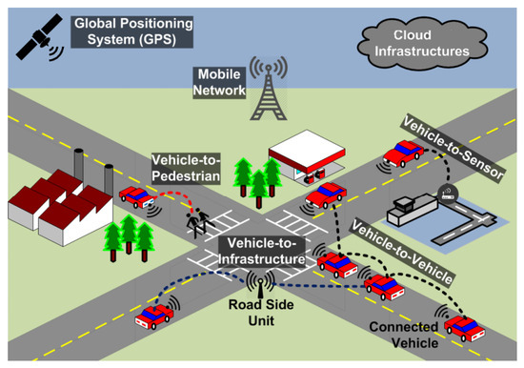
Figure 2.4 Intelligent Transport System (Javed et al., 2018)
ITS is summarized as a system comprising information and communication technology, supported and integrated into the transportation framework. ITS incorporates sustainable, safe, and interconnected transport systems, including cars, bicycles, buses, trams, subways, sea and air transport, and pedestrians. Avci and Koca (2024) state that the goal of Intelligent transportation is to provide a different and smart approach in the transport network, which includes traffic management, the safety of our roads, and many other aspects. The adoption of ITS makes transport services safe and more environmentally friendly, focusing on freight and passenger transport. In like manner, ITS applications are currently being developed to increase the efficiency and safety of road access systems. The aim is to develop computer, electronic, and communication technology applications that provide passenger information, especially for the users of this system (Kiela et al., 2020). To summarize, the YOLOv11 application within this framework aligns with modern ITS algorithms whose goal is to reduce human interaction, eliminate traffic congestion, and enable flexible toll booth operations in Nigeria.
2.2.5 Conceptual Framework of the Study
This is centered on the integration of DL models and features along with smart transportation technologies in automating vehicle license plate recognition (VLPR) within Nigerian toll booth infrastructure. This topic will explain the relationship among system components, starting from input acquisition, intelligent decision-making, and highlighting how YOLOv11 functions as the core detection engine. Essentially, the framework is based on these key concepts:
Input Layer: The Input layer refers to the first layer of nodes in an artificial neural network. This layer receives input data from the outside world. In the context of ALPR, it is also known as the Vehicle and Plate Capture, which is the process of extracting data using the surveillance cameras mounted at the toll booths or highways, especially here in Enugu, Nigeria. This particular function is most often affected by environmental factors such as poor lighting, damaged plates and the position of the vehicles.
Processing Layer: At this stage, it is where the feature extraction and the encoding of prediction confidence are done by the internal layers of the model, including backbone, neck, and head modules.
Decision Layer: The decision layer is responsible for recognition & integration functions. Recognized plate data are matched with databases for toll authentication, payment routing, or access control. The decision layer is responsible for automating decision-making based on detection results.
Deployment Layer: The model is deployed within cloud or edge computing environments to ensure scalability, low-latency response, and data storage. Tools like Amazon Web Services (AWS) Lambda, S3, and Textract support real-time data flow and OCR validation.
Feedback Loop (Performance Monitoring): Detection accuracy, system latency, false positives/negatives, and environmental robustness are evaluated to refine the model and deployment strategy.
By linking these layers together, the system demonstrates how combining the YOLOv11 model with OCR technology can influence smart license plate detection in toll booths, highlighting accuracy, speed, automation, and flexibility as essential factors for its success.
2.2.6 Nigerian License Plate Format
Nigeria uses different types of license plates for its vehicle organization to enable easy identification. Private vehicles have blue text on a white background, while commercial vehicles display black on yellow for quick recognition. Plates for government, diplomatic, military, and paramilitary vehicles feature distinctive colors and codes to signify their official roles or privileges. Other categories include custom-designed plates for personal branding, temporary plates for newly purchased vehicles, dealer plates for unregistered transit vehicles, and special plates for trailers and trucks, all aiming to maintain organized regulation and control. The standard Nigerian license plate format is ‘ABC-123DE’. The first three letters (ABC) indicate the Local Government Area (LGA) where the vehicle was registered, keeping in mind that Nigerian vehicle registration numbers were revised in 2011. Therefore, vehicles registered from 2011 onward use the letter ‘D’. This means a vehicle registered in 2011 bears an A, in 2012 B, in 2013 C, in 2014 D, and so forth. The last letter ‘E’ represents a batch of 1,000 vehicles registered at the same time, while the numbers ‘123’ denote the exact number within that batch.


Figure 2.5 Nigeria License Plate Format
For instance, a license plate with the following inscription, ‘APP-456CV (Lagos)’. In this license plate, APP indicates the Local Government Area (LGA), in this case, Apapa. ‘C’ signifies that the vehicle was registered in 2013, and ‘V’ indicates that this vehicle belongs to the 22nd batch of 1,000 vehicles registered for that year. We know that this vehicle belongs to the 22nd batch because ‘V’ is the 22nd letter of the alphabet. Additionally, ‘456’ means that this vehicle is the 456th out of 1,000 vehicles registered. Furthermore, the plate features the words ‘Centre of Excellence,” which represents the slogan of the state, in this case, Lagos. Another example is a Nigerian license plate labeled “ENU-400HL,” which, when decoded, shows that the plate belongs to a private vehicle registered in Enugu North Local Government Area, as indicated by the “ENU” prefix. The number “400” signifies it’s the 400th car in a batch of 1,000 for that LGA. The letter “H” marks the year of registration as 2018, based on a coding system where “A” starts at 2011. Finally, the “L” at the end shows this vehicle is part of the 12th batch for that year. Overall, Nigeria’s license plate format is a smart and purposeful system. Each element gives a hint of where and when a vehicle was registered to its type and intended use. This careful categorization of the characters or element in the license plates helps law enforcement track vehicles, supports better record-keeping for authorities, and even promote regional pride. Example of such is seen in state mottos like “Coal City State.” Additionally, the use of different color for its background facilitates easy identification of private, commercial, and official vehicles, ensuring proper regulation and generating vital revenue.
2.3 Review of Related Works
Buleu et al. (2025) proposed an automated license plate recognition system using the latest version of the YOLO algorithm, namely YOLOv12, a deep learning technique. The study claims the current version has not been applied to ALPR studies. The research made use of a dataset containing 744 images of vehicles registered in Romania, which was expanded through augmentation to train the YOLOv12 model along with a PaddleOCR library. The YOLOv12 is tasked to automatically detect license plates in images with vehicles, while the OCR provides the recognition functionality of identifying the type of vehicle bearing the license plate along with the county of registration. Experimental results show that the YOLOv12 achieved superior performance when compared with the YOLOv11, with a 2.3% increase in precision and 1.1% improvement in the F1score. Despite the novel nature and high accuracy, the study was not deployed on edge devices or tested in real-time to evaluate whether the high accuracy will be maintained.
Imtiaz et al. (2025) proposed an automatic number plate detection and recognition system for Category L vehicles (L-ANPR) that will address the environmental challenges affecting traditional models such as low lighting, small objects, and cluttered backgrounds. The study was motivated by the need for a fast, reliable, and accurate object detection for real-time applications. The research utilized a modified version of YOLO named YOLO-T, by combining depth-wise separable convolutions and squeeze-and-excitation blocks to enhance performance. Training and test data were sourced from a public dataset repository named Paschal VOC and MS COCO. The result obtained shows that the proposed YOLO-T was lighter, possesses high speed, good accuracy, and a precision of 90% when compared to the YOLOv5 model. The system, however, had lower accuracy than larger models and might require further fine-tuning.
Al-Yaman et al. (2021) aim to improve the performance of an automatic license plate recognition system for Jordanian license plates through the adoption of a two-stage ANN (Artificial Neural Network) for character classification and recognition, as well as enhancement in the detection and segmentation stages by the addition of a vertical-edge histogram analysis and size estimation to filter candidate regions efficiently in the detection stage while image de-rotation process was added to correct tilt in plates at the segmentation stage. Furthermore, the study utilized a custom dataset of 500 high-resolution images of Jordanian license plates for model development and evaluation. Performance was measured in terms of detection, segmentation, and recognition accuracy, with results showing improvements from 82% to 94.4%, 74.4% to 91.9% and 68.5% to 91.5% respectively. The use of a custom dataset limits reproducibility and benchmarking, and there is no end-to-end learning, unlike modern deep learning-based systems.
Dalarmelina et al. (2020) developed an intelligent vehicle identification system based on optical character recognition (OCR) for use in smart transportation systems. The study utilized an intelligent parking system called Smart Parking Service (SPANS), which manages public and private parking spaces. The research employs the same computer vision technique used in SPANS to detect whether parking slots are available. The proposed system uses the SPANS framework to capture images of parking spaces with the goal of identifying license plates of parked or moving vehicles within the slots. The dataset was collected from live images from cameras positioned around a parking lot containing about 30 vehicles. The development process involved several steps: detecting license plates, preprocessing images, recognizing characters with OCR enhanced by LSTM models, and linking the results to the SPANS infrastructure. The system’s performance was evaluated in real-time, showing an accuracy of 83% while maintaining a processing time of 0.26 seconds. Overall, the study succeeded in creating an efficient and cost-effective license plate recognition solution. However, challenges remain with poor lighting and difficult-to-read characters, which still hinder real-world deployment.
Lin et al. (2022) collected image data of 2800 license plates to train a deep learning algorithm, YOLOv4-Tiny, for automating license plate recognition in real-time. The proposed Edge AI-based system performs real-time local license plate recognition through a streamlined pipeline of data preprocessing, frame detection, virtual judgment gating, modified-YOLOv4 character recognition, and logic-based result validation. The developed model had reported recognition accuracy of 97% daytime with sustained high FPS (frames per second). The system lacked room for international plate styles, and the model may miss characters or produce overlapping recognition frames under extreme conditions.
Khan et al. (2022) utilized deep learning techniques to design a strong, mobile and efficient ALPR system that is capable of executing its functions freely and accurately in traffic environments. In their study, they used a custom video dataset consisting of 5500 augmented frames and 12,000-character samples for the training and evaluation of a two-stage deep learning model that involves a transfer learning algorithm called YOLOv5 for detection and a custom CNN for recognition. The performance of the proposed model was evaluated using metrics like mean Average Precision (mAP), precision, recall, and accuracy. Results show 95% detection accuracy and 92.8% recognition accuracy on the custom dataset. However, the system only supports English characters, as Arabic characters are excluded, and the dataset is relatively small, not publicly available, which limits reproducibility.
Al-Batat et al. (2022) proposed developing a fully automated, end-to-end license plate recognition system using YOLO-based detectors and a vehicle classifier. The research designed a three-stage pipeline consisting of vehicle detection with YOLOv2, license plate detection with YOLOv4-tiny, and license plate recognition also using YOLOv4-tiny. Additionally, ResNet50 was used as a vehicle type classifier to differentiate between trucks, emergency vehicles, and other types. The study employed five publicly available datasets: Caltech Cars, English LP, OpenALPR, AOLP, and UFPR ALPR, totaling 7,290 samples. The evaluation results show an average recognition accuracy of 90.3% across datasets. Despite their success, some characters (e.g., “O,” “Q,” “K,” “M”) had lower recognition accuracy due to visual similarity, and performance declined on more complex datasets.
Saha et al. (2024) proposed the use of YOLOv10 to enhance the robustness and accuracy of Automatic License Plate Recognition (ALPR) under adverse weather conditions. Furthermore, an expanded dataset of 125,914 images from the Bangladeshi license plate dataset was employed to train the YOLOv10 object detection models, considering a two-stage detection pipeline, where one stage is tasked with license plate detection, and the other recognizes characters using the same YOLOv10 model. The model was evaluated using standard object detection metrics, as reported results indicate an F1 score of 94.36% and mAP50 of 96.25%. The weather augmentation in this case improved model robustness under foggy, rainy, and noisy conditions. However, there is no real-world deployment as the results evaluation is dataset-based.
Batra et al. (2022) utilized a custom dataset of 4,786 images created from real-world traffic camera footage under varied conditions. The datasets were manually annotated, and transfer learning and fine-tuning were employed in training five object detection algorithms: YOLOv4, YOLOv5, YOLOx, Faster R-CNN, and EfficientDet for automatic license plate detection (ALPD) under diverse environmental conditions. The goal is to compare the performance of these multiple deep learning-based models and identify the most robust and efficient model for real-time deployment in intelligent transport systems. The new models were evaluated, and results obtained reveal YOLOv5 as having the best overall performance with an F1 score of 98.8%, as well as the fastest processing time among accurate models. Despite the comprehensive comparison using multiple DL models, the evaluation is restricted to static images, not live video or streaming, and the focus is only on detection with no mention of license plate recognition.
Padmasiri et al. (2022) developed an energy-effective, cost-effective, and hardware-optimized automated license plate recognition system for constrained environments employing differentiable neural architecture search (NAS) and Raspberry Pi technique. The study made use of a Chinese City Parking dataset to train a model for license plate detection and recognition. In evaluating the performance of the model, latency, accuracy, energy efficiency, and model size were considered. In addition, the developed model was tested under different hardware setups and real-world scenarios. The results from the model evaluation indicate an accuracy of 99.87% for daytime, 94.76% for synthetic, and 98.73% for nighttime. Overall, the model performed very well across varied camera angles and lighting conditions and was robust to environmental challenges, but real data collection was limited.
A study by Alam et al. (2021) developed a reliable automatic vehicle license plate recognition system using image processing and machine learning techniques to improve intelligent transportation systems. The study utilized the Caltech Cars dataset, containing images with different vehicle types, angles, and plate styles. The Optimal K-Means clustering algorithm for license plate localization and a Convolutional Neural Network (CNN) for character recognition were trained using the Caltech Cars dataset. Reported results show that the CNN achieved high accuracy in character recognition, and the Optimal K-Means achieved high localization accuracy. The processing time of the system was efficient, and it performs well under noisy and variable real-world conditions. However, the processing efficiency could be improved further for very large-scale datasets.
Analysis and comparison of the performance of different YOLO versions for cloud-based license plate recognition (LPR) presented by Asaju et al. (2025), employed a DL technique to train four YOLO models (YOLOv5, YOLOv7, YOLOv8, and YOLOv9) for vehicle license plate recognition by collecting 433 annotated images from the Kaggle car plate dataset. Evaluation was done using metrics like Precision, Recall, F1-score, and mAP, considering validation accuracy and cloud testing accuracy. Results indicate that YOLOv8 with 83% validation accuracy and 78% testing accuracy outperformed others in cloud deployment, thereby striking a balance between speed, accuracy, and adaptability. The model encounters detection challenges from faded or broken plates and poor lighting.
Tsai et al. (2025) developed a real-time automatic license plate recognition (ALPR) system that uses three datasets, including the openALPR and UFPR ALPR datasets, to train a YOLOv4 model combined with CNN-based OCR and custom real-time video feeds for practical testing. The study aims to enhance intelligent transport systems through fast, accurate, and efficient detection using advanced deep learning techniques. The evaluation results, primarily measured by accuracy, show 95% recognition accuracy and high precision in detecting multiple vehicles and plates within a single frame, along with efficient processing speed. However, performance may decrease in extremely poor lighting conditions or when plates are damaged.
2.4 Summary of Literature Review
This section summarizes the key findings from the reviewed literature.
S/N | AUTHOR(S) | CONTRIBUTION | TECHNIQUE | LIMITATIONS
1. | Buleu et al. (2025) | Proposed an automated license plate recognition system using the latest version of the YOLO algorithm, namely YOLOv12. The research made use of a dataset containing 744 images to train the YOLOv12 model along with a PaddleOCR library. Experimental results show that the YOLOv12 achieved superior performance when compared with the YOLOv11, with a 2.3% increase in precision and 1.1% improvement in the F1score. | Deep Learning and OCR technique. | The study was not deployed on edge devices or tested in real-time to evaluate whether the high accuracy will be maintained.
2. | Dalarmelina et al. (2020) | Develop a real-time Automatic License Plate Recognition (ALPR) system integrated into an intelligent parking framework named Smart Parking Services (SPANS) to automate vehicle identification in open environments, particularly in Intelligent Transportation Systems (ITS), despite variations in lighting conditions. The results obtained show that the proposed algorithm achieved 83%, compared to 80% for Gaussian Blur and 72% for 2D filters, with an overall average processing time of 0.26 seconds. | Computer vision | Recognition accuracy is still sensitive to lighting conditions, and ambiguous characters pose a challenge to the system.
3. | Raza et al. (2020) | Developed a system that addresses the variations in license plate styles, colors, fonts, and lighting conditions across different regions. From the data collected, 21,717 extracted characters were used to train the AlexNet-based CNN architecture for recognition, and 84,058 characters were used for training the SVM classifier. The results were classified as segmentation accuracy 96.88% and recognition accuracy using improved CNN and layer aggregation as 98.62% while using AlexNet only had 96.87%. | Deep learning and machine learning | The system struggles with multi-color license plates and may fail on non-standard plates or highly damaged plates.
4 | Lin et al. (2022) | Utilized image data of 2800 license plates to train a YOLOv4-Tiny for automating license plate recognition in real-time. The developed model had reported recognition accuracy of 97% daytime with sustained high FPS (frames per second). | Deep learning and Agile methodology | The model may miss characters or produce overlapping recognition frames under extreme conditions.
5 | Al-Yaman et al. (2021) | The improved performance of an automatic license plate recognition system for Jordanian license plates for character classification and recognition, as well as an enhancement in the detection and segmentation stages. The study utilized a custom dataset and performance was measured in terms of detection, segmentation, and recognition accuracy, with results showing improvements from 82% to 94.4%, 74.4% to 91.9% and 68.5% to 91.5% respectively. | Two-stage Artificial Neural Network | The use of a custom dataset limits reproducibility and benchmarking.
6 | Khan et al. (2022) | Develop a robust, mobile, and efficient ALPR system capable of functioning accurately in unconstrained traffic environments. The study employed a custom video dataset consisting of 5500 augmented frames and 12,000-character samples to train a YOLOv5 for detection and a custom Convolutional Neural Network (CNN) for recognition. Results show 95% detection accuracy and 92.8% recognition accuracy on the custom dataset. | Deep learning technique | The dataset is relatively small, not publicly available, which limits reproducibility.
7 | Al-Batat et al. (2022) | Designed a fully automated, end-to-end license plate recognition system using YOLO-based detectors and a vehicle classifier. The study employed five publicly available datasets: Caltech Cars, English LP, OpenALPR, AOLP, and UFPR ALPR, totaling 7,290 samples. The evaluation results show an average recognition accuracy of 90.3% across datasets. | Deep Learning including YOLO and ResNet50 | Some characters had lower recognition accuracy due to visual similarity, and performance declined on more complex datasets.
8 | Saha et al. (2024) | Enhanced the robustness and accuracy of Automatic License Plate Recognition (ALPR) under adverse weather conditions. The study made use of an expanded dataset of 125,914 images to train the YOLOv10 object detection models, considering a two-stage detection pipeline, where one stage is tasked with license plate detection, and the other recognizes characters using the same YOLOv10 model. Reported results indicate an F1 score of 94.36% and mAP50 of 96.25%. | Deep Learning technique | There is no real-world deployment as the results evaluation is dataset-based.
9 | Asaju et al. (2025) | Presents a study that evaluates and compares the performance of different YOLO versions for cloud-based license plate recognition (LPR). The research collected 433 annotated images from the Kaggle car plate dataset to train the YOLO versions for License plate recognition. The results reported indicate that YOLOv8, with 83% validation accuracy and 78% testing accuracy, outperformed others. | Deep Learning technique (YOLOv5, YOLOv7, YOLOv8, and YOLOv9) | Model encounters detection challenges from faded or broken plates and poor lighting.
10 | Batra et al. (2022) | A custom dataset of 4,786 images was employed in training five object detection algorithms: YOLOv4, YOLOv5, YOLOx, Faster R-CNN, and EfficientDet for automatic license plate detection (ALPD) under diverse environmental conditions. The new models were evaluated, and results obtained reveal YOLOv5 as having the best overall performance with an F1 score of 98.8%, as well as the fastest processing time among accurate models. | Transfer Learning and Fine-Tuning | The evaluation is restricted to static images, not live video or streaming, and the focus is only on detection with no mention of license plate recognition.
11 | Tsai et al. (2025) | Designed a real-time automatic license plate recognition (ALPR) system utilizing three datasets for training a YOLOv4 model along with CNN-based OCR and custom real-time video feeds for practical evaluation. The results show 95% recognition accuracy and high precision in detecting multiple vehicles and plates in a single frame, as well as efficient processing speed. | Deep learning and OCR technique | The performance drops in extremely poor lighting or with damaged plates.

2.5 Research Gap
Having reviewed many related literatures on the subject of interest, the automated vehicle license plates recognition system, many studies have demonstrated great success, especially in accuracy, processing speed, and robustness under varying illumination and noise. However, there are still challenges with dataset availability, poor recognition of broken or faded plates, character mismatch, and the fact that most reviewed works did not consider Nigerian license plates. The study proposes a YOLOv11-based real-time Vehicle Plate Detection and OCR system for Nigerian Toll Booth Automation, which addresses these challenges by designing a robust and efficient system that overcomes these issues.

CHAPTER THREE
SYSTEM ANALYSIS AND DESIGN
3.0 Introduction
Chapter three provides a detailed overview of the system analysis and design stages for the research topic titled YOLOv11-based automatic license plate recognition (ALPR) system for Nigerian toll booth automation. In addition, the section will discuss the functional and non-functional requirements and present a detailed breakdown of the existing and proposed system for vehicle license plate recognition. A research methodology of choice will be adopted and discussed while describing the architecture of the system.
3.1 System Analysis
3.1.1 Analysis of the Existing System
In Nigeria today, traditional methods of toll collection and checkpoint inspection are still operational. These consist of a manual approach that relies on human toll collectors and individual checking of license plates and driver's licenses in the aspect of checking points, especially when there is a case of car theft, overspeeding, traffic violations, and many other transport-related hurdles. This system depends on attendants, paper-based logs, and direct interaction with drivers.
However, some existing systems have adopted ALPR in intelligent transport systems. An earlier work done by Padmasiri et al. in (2022) developed an energy-effective, cost-effective, and hardware-optimized automated license plate recognition system for constrained environments employing differentiable neural architecture search (NAS) and Raspberry Pi technique. Overall, the model performed very well across varied camera angles and lighting conditions and was robust to environmental challenges, but real data collection was limited. Similarly, an ALPR system was developed using a YOLOv4 model combined with CNN-based OCR and custom real-time video feeds for practical testing by Tsai et al. (2025). It had high recognition accuracy and high precision in detecting multiple vehicles and plates within a single frame, along with efficient processing speed. The performance decreases in extremely poor lighting conditions or when plates are damaged. In recent work conducted by Buleu et al. (2025), they proposed an automated license plate recognition system using the latest version of the YOLO algorithm, namely YOLOv12, which achieved superior performance. Despite the novel nature and high accuracy, the study was not deployed on edge devices or tested in real-time to evaluate whether the high accuracy will be maintained.
3.1.2 Limitations of the Existing System
The manual method is associated with a lot of problems, such as long queues and delays at toll booths and checking points, inaccurate recording of license plates as a result of human error, and cases of fraudulent omissions and missed entries. This manual method lacks real-time vehicle identification, automated recording, and integration into a central management system.
Secondly, the existing automated systems are faced with a lot of limitations, as observed from the analysis of relevant literature, which include:
1. Data availability has been a major challenge for most deep learning models, with either limited data or poor quality of data. DL models need enough data for efficient detection and classification.
2. The performance of most existing models decreases in extremely poor lighting conditions or when plates are damaged.
3. Some existing automated systems were not tested or evaluated in real-time, and there was no deployment on edge devices to justify high accuracies and processing speed.
These limitations justify the need for an automated solution evaluated in real-time that maintains high accuracy and low latency.
3.1.3 Analysis of the Proposed System
The proposed system aims to replace manual plate entry with an automated method that will leverage the YOLOv11 model combined with OCR to detect and recognize license plates in images and video feeds, as well as in real time. The proposed system will build upon the challenges of the work conducted by Buleu et al. (2025), who developed an automated license plate recognition system using the latest version of the YOLO algorithm, namely YOLOv12, which achieved superior performance compared to the proposed YOLOv11 but had no practical application or real-time deployment and evaluation. Figure 3.1 illustrates the stages of the proposed system in a block diagram.
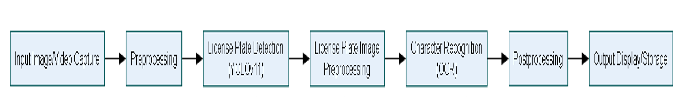
Figure 3.1 Block diagram of the Proposed Model
The new model will automatically capture images of incoming vehicles at toll booths and checkpoints on Nigerian roads to detect license plates using YOLOv11 and extract characters (alphanumeric) with OCR. When the surveillance camera detects a vehicle, the proposed algorithm begins the plate localization function to extract license plate frames from the vehicle image by recognizing rectangular objects. Once the license plate is identified from the vehicle image, extraction creates a new image. Preprocessing of this image is performed to eliminate environmental variations, such as illumination, texture, cracks, and background, thereby reducing noise. After preprocessing, OCR technology is used to recognize characters on the plate image. Overall, the proposed system offers a technological solution to address weaknesses in the current system by providing sufficient data for model training and testing, thereby enhancing accuracy, speed, and throughput. Additionally, it integrates with toll booths and road safety agency systems for real-time operation.
3.1.4 Proposed YOLOv11 model
The YOLOv11 is an advanced version of the YOLOv8 developed by Ultralytics. It is a modern generational target detection model that has been improved significantly in many aspects. Innovative changes were made to the backbone network by replacing the C2f module in the previous version, especially YOLOv8, with a better-performing C3k2 structure in the network architecture of the model (Zhang et al., 2025).
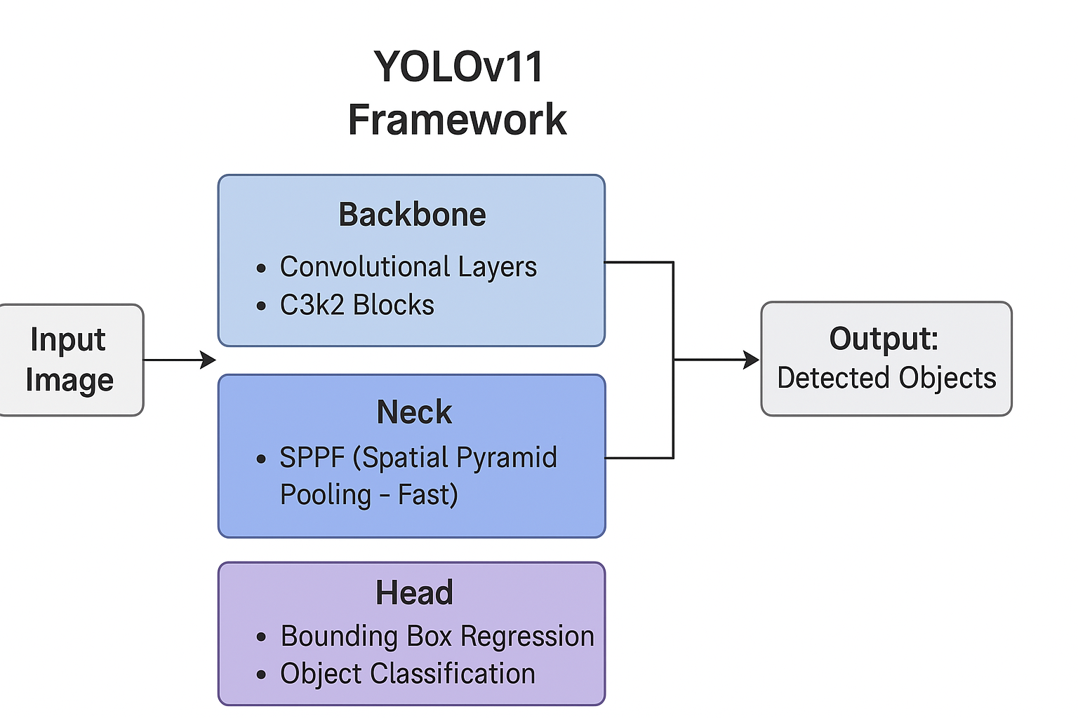
Figure 3.2 Framework of the YOLOv11
According to Zhang et al. (2025), the YOLOv11 presents a groundbreaking C2PSA feature-enhancement module. This module that was introduced new will combine the efficiency of the C2 structure with the strengths of the Position Self-Attention mechanism. The integration will strongly improve the ability of the model to precisely capture and detect target position information and spatial dependencies.
The YOLov11 enhances the classification component by incorporating two depth-separable convolutional layers (DWConv), which ensure continuous growth from the initial original design of the decoupled detector. This modification lowers both the model’s parameter counts and the computational overhead of the model, preserving its effectiveness, thereby making it suitable for real-world deployment scenarios.
Finally, a balanced increase in the depth and width of each version of the network model and maintenance of processing speed is introduced by the YOLOv11. This structural expansion strengthens the model’s feature extraction capacity, enabling it to deal with more complex detection incidents as presented by Zhang et al. (2025). The network structure of YOLOv11 is provided in Figure 3.3. According to research conducted by Khanam and Hussain (2024), the original YOLOv11 model struggles a bit to perform effectively in modern traffic scenarios due to occlusion of vehicles and changing light conditions, it however used as a reference for further improvement.
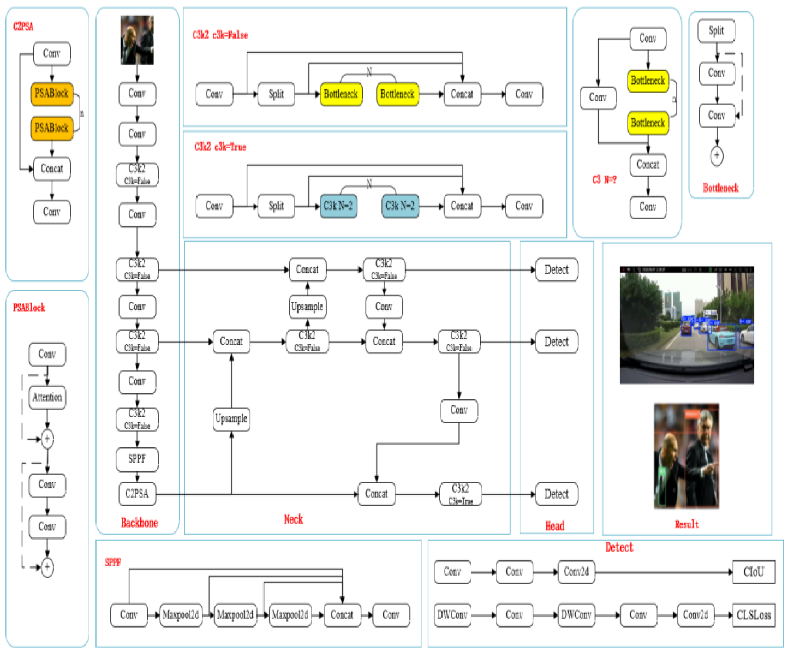
Figure 3.3 network structure diagram of the YOLOv11(Zhang et al., 2025)
3.1.5 System Flowchart
The flowchart of the YOLOv11-based automatic license plate recognition (ALPR) system for Nigerian toll booth and checking point automation, shown in Figure 3.4, depicts the flow of activities and functions in the proposed intelligent system. The ALPR system first sets the virtual license plate judgment line; secondly, images are collected from the camera, followed by license plate recognition after image processing in each frame.
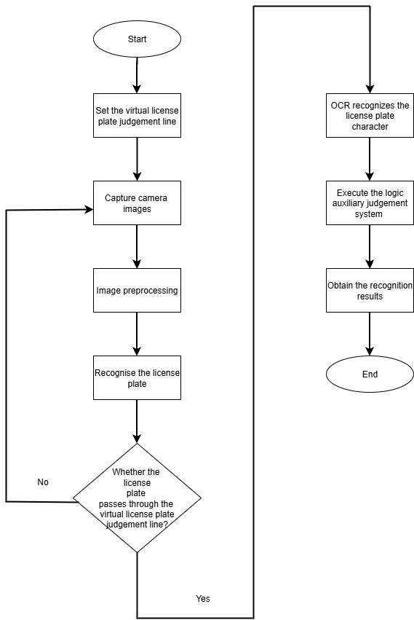
Figure 3.4: Flowchart of the proposed system
Figure 3.4 depicts the visual step-by-step process of how the system works by setting a surveillance camera on the road to detect passing vehicles. When a car crosses the invisible line, a camera captures the image, and preprocessing takes place to enhance the image for a clearer view of the license plate. Next, the YOLOv11 algorithm identifies the plate and verifies that it crossed the judgement line before the OCR is deployed to extract the characters on it. An auxiliary logic module carries out additional checks, like comparison of vehicle types and timestamps, before displaying the recognized license plate number. Overall, the flowchart combines smart detection with logical verification to ensure effective and accurate license plate recognition.
3.2 System Requirements Specification (SRS)
3.2.1 Functional Requirements
The system must perform the following functions:
- Capture live video or still images at toll booth and checking point entries through integration on existing surveillance systems.
- Detection and localization of license plate frames using YOLOv11 improved for Nigerian plates
- Perform OCR on the detected license plate regions to convert image text to an alphanumeric string.
- Possess the capability to document recognized license plate data, timestamp, and position ID in a local database.
- Provide a web-based interface/dashboard for operators to monitor system status, manual correction, and exception handling.
3.2.2 Non-Functional Requirements
- Performance: The model should achieve a high detection and OCR accuracy in Nigerian license plate formats.
- Speed: The new system must have a fast-processing time, enabling real-time throughput.
- Usability: Provide a clean, intuitive operator interface with the ability for manual correction and audit.
- Reliability: The system will operate under harsh environmental conditions such as dust, lighting variations, and high vehicle speeds on Nigerian roads and at toll booths.
- Robustness: The system should be robust to variations in input data characteristics, handling noise, outliers, and missing values effectively to maintain model performance across varying scenes.
- The system will be scalable in deploying to different scenes and have security features to encrypt vital information.
3.3 Proposed Methodology
Object-oriented analysis and design, often abbreviated as OOAD, is a well-established methodology in the field of software development, as it leverages the principles of object-oriented programming to create and implement comprehensive software systems. In OOAD, it is important that the researcher understands what the system needs to do, then identifies key objects, and finally decides how these objects will work together. This approach helps make software easier to manage, reuse, and grow. The process of object-oriented analysis and design is itemized below:
a. System Requirements: The process of OOAD begins with a thorough analysis of the requirements needed in designing the proposed system to ensure that the final product aligns with the needs and expectations of its end users.
b. Classes and System Relationship: This step is critical in creating a system that is both efficient and effective; it succeeds the system requirement phase. After the system requirement has been defined, the next step in the OOAD process involves identifying the classes and their relationships within the system, with each class representing a distinct component of the system, and the relationships between these classes dictate how they interact with one another.
3.3.1 Justification for Methodology
The choice of OOAD is because it offers numerous benefits compared to traditional procedural approaches to software development. In OOAD, objects and classes can be reused across different projects, thereby reducing time and effort in development. Also, the modular design of object-oriented systems allows us to properly organize our code, making it easier to manage and extend, minimize errors, speed up development, and improve time-to-market.
In OOAD, changes to one part of the system can be localized, minimizing the impact on other components, thus enhancing maintainability. They possess scalability functions enabling systems to easily accommodate changes in requirements and scale to meet evolving needs. Despite the numerous advantages, there are a few bottlenecks, such as complexity. Object-oriented systems can become complex, especially as the number of classes and their interactions increases. Managing the complexity of large-scale object-oriented projects requires careful design and planning.
3.3.2 Method of Data Collection
In this project, titled YOLOv11-based automatic license plate recognition (ALPR) system for Nigerian toll booth automation data for model training, was collected from a public dataset.
Public datasets: A Public or open dataset means anyone can access it. The are collections of data that are freely available for anyone to access, use, and redistribute, often subject to minimal restrictions. The dataset for my work was obtained from Roboflow.
3.4 System Modeling Using UML
Unified Modeling Language (UML) diagrams are an important component in the field of software engineering. It offers a standard visual representation of a software system's features and components. These diagrams serve as an important tool for software architects, developers, and stakeholders to collectively design and communicate the various facets of a software system. Among the UMI diagrams, the use case diagram is deemed critical as it delineates the possible interactions between users or external entities and the system, thereby acting as a guide for understanding the functional requirements and scenarios within the software application.
However, following the use case diagrams is the activity diagram, which enhances the dynamic aspects of system development processes by depicting the overall flow of activities within the system. This captures the sequential and concurrent processes that occur during the system operation, as this dynamic viewpoint assists in visualizing the overall workflow occurring in the system, thereby aiding in identifying potential bottlenecks, decision points, and opportunities for
optimization in the software system.
3.4.1 Use Case Diagram of Proposed System
The use case diagram of the proposed system is classified into four categories: the actors, which are used to show the external entities of the system; the use cases, which are used to show the functional parts of the system. This relationship exists between the actors and the use cases, and lastly, the system demarcation, which is the scope of the system within which the actors are interacting.
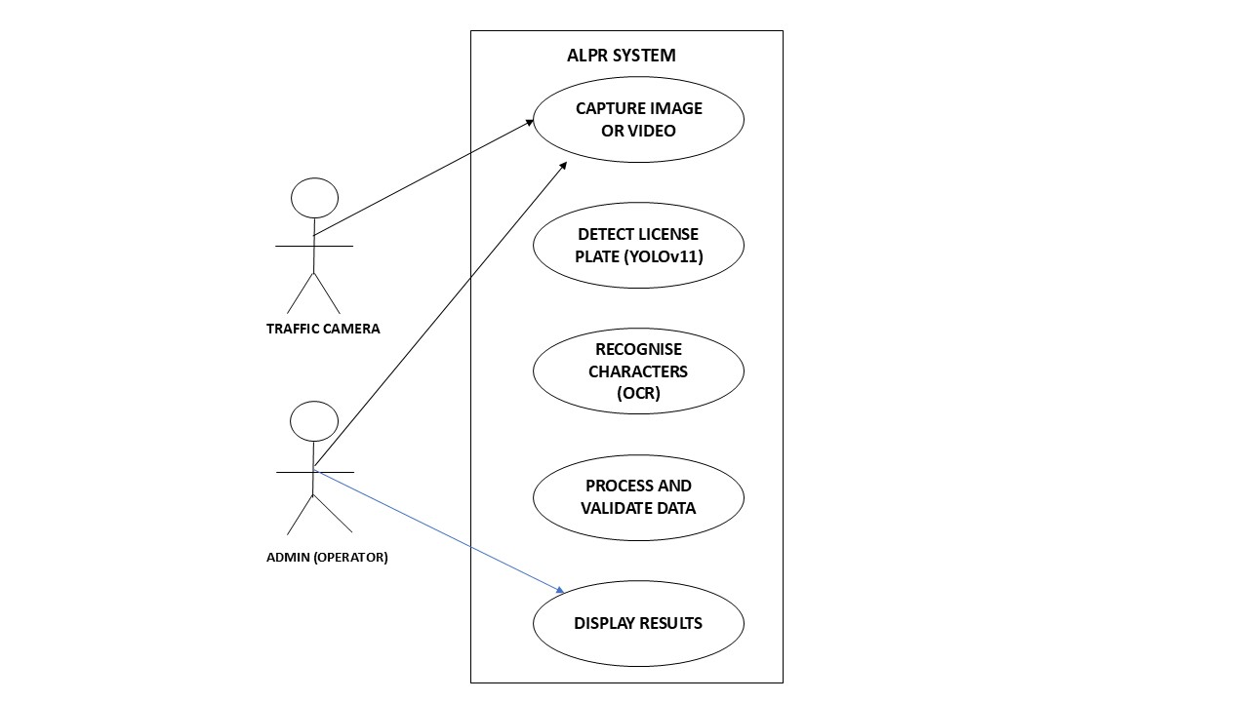
Figure 3.5: Use case diagram of the proposed system.
Figure 3.5 illustrates the use case diagram featuring two actors: the traffic camera and the admin (operator). In the image, the traffic camera performs the task of capturing vehicles with license plates, which have the model integrated into their control system for detection and recognition. The operator, who also serves as the admin, can interact with the displayed results and oversee the traffic camera's image-capturing process. The admin ensures all settings are accurate to guarantee the proper functioning of the system.
3.4.2 Activity Diagram of the Proposed System

Activity diagrams are a unified modelling tool that is used to describe the flow of activities or processes within a system in a visual or graphic representation format. Here is an activity diagram outlining the steps that are involved in implementing a YOLOv11-based automatic license plate recognition (ALPR) system, as illustrated in Figure 3.6.
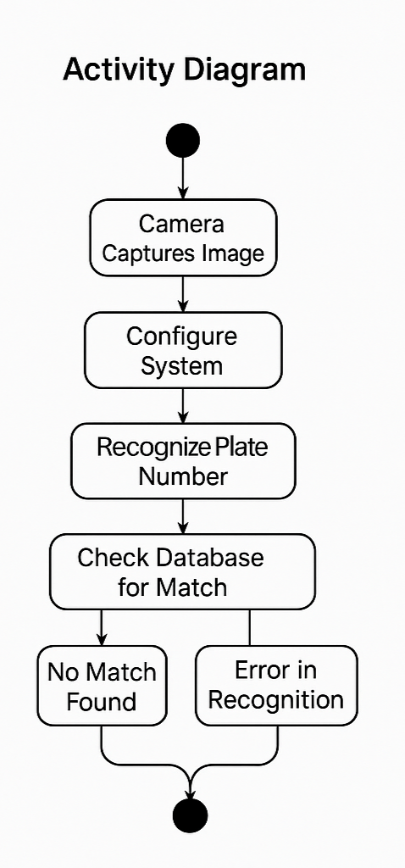
Figure 3.6. Activity diagram of the proposed system

3.4.3 Class Diagram of the Proposed System
This section of this work of research holds the class diagram of the proposed system. The class diagram in Unified Modelling Language (UML) is one of the Unified Modelling Language diagrams that describes the architectural design of a software system by defining and laying out its classes, the attributes of the laid-out classes, the methods, and the relationships among these different objects that make up a system. Below is the illustration of the class diagram for the proposed system.
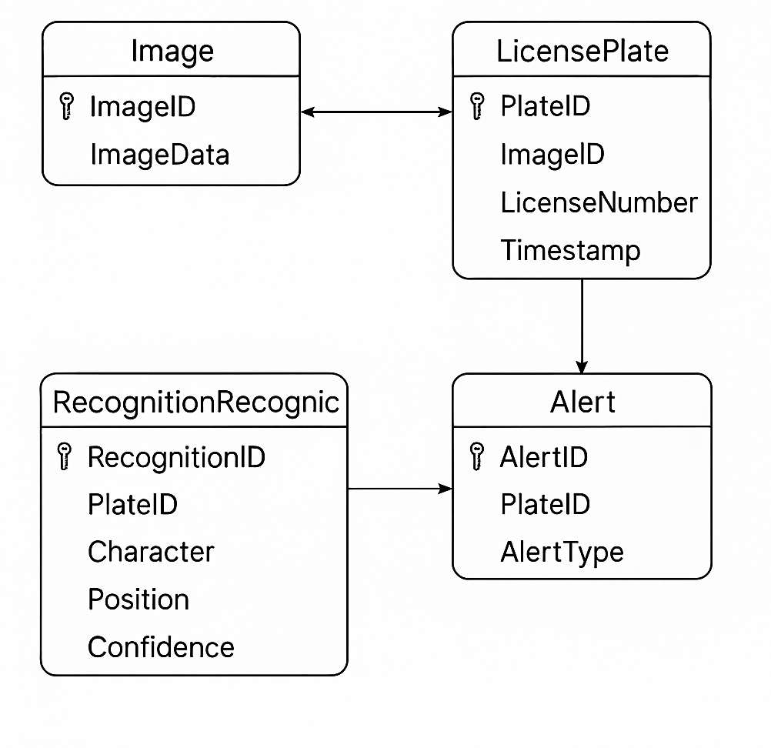
Figure 3.7 Class diagram of the proposed system
The class diagram above shows the different classes that would be involved in the proposed system and their relationship with one another. It shows the way in which the system functions by outlining the specific attributes and methods that are present in the classes that are available in the system that is proposed in this work of research.

3.5 System Design
The basic study of system design is the understanding of parts and their subsequent interaction with one another. The process of designing the components, architecture, and interfaces for a system so that it meets the end-user requirements is defined as system design. This section of my research study will stand to typically show how the proposed system is going to fulfil all the requirements that have been stated above. This design of the proposed system will consist of the design of the interface of the input/output sections of the proposed system, as well as the database design of the system.
3.5.1 Input/Output Design
The input/output design comprises the mockup design of all the sections through which inputs (data) are passed and received on the system, as well as the illustrations of the output mockup sections after the inputs. Below is the diagram of the input/output design illustrations.
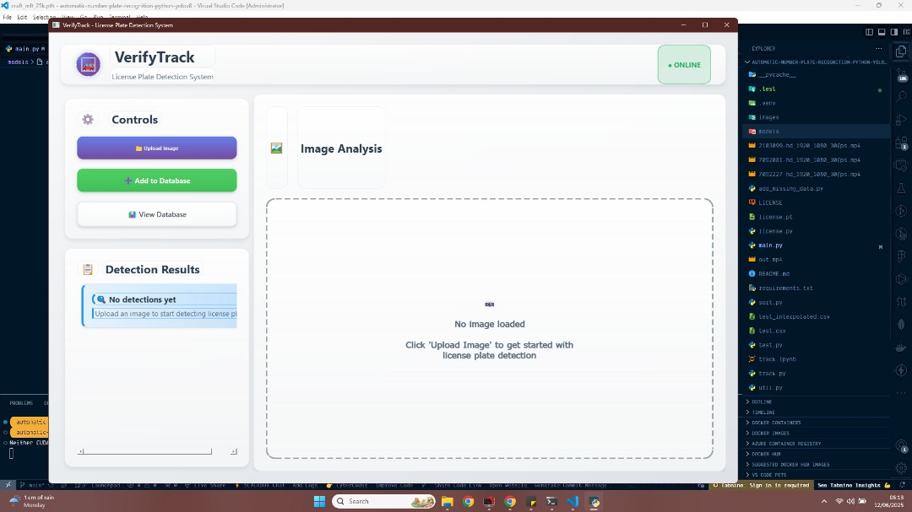
Figure 3.8 Input designs for the proposed system
The diagram above shows the user interface design for the proposed system, through which the user gets to select an image or a video for the detection and recognition analysis. This interface was designed to prototype and simulate how the developed model works using test data before real-time implementation
3.5.2 Database Design
Table 3.1 User table for The Automated Vehicle License Plate Recognition System.
Attribute | Data Type | Description
Id | Int | Unique identifier for each user.
Vehicle Name | Varchar | Retains the captured vehicle name
License plate number | Varchar | Retains the plate name that the user puts in.
Country | Varchar | Retains the vehicle's country of registration
State | Varchar | Retains the vehicle state of registration
Plate status | Varchar | Whether the vehicle is an offender or not in any particular crime

CHAPTER FOUR
SYSTEM IMPLEMENTATION, RESULTS, AND DISCUSSION

4.0 Introduction
System Implementation can be defined as the executing phase of the system development lifecycle, consisting of concept to function by coding, testing, and deployment (GeeksforGeeks, 2025). This chapter describes how the Automatic License Plate Recognition (ALPR) system was built, the tools and frameworks selected, the dataset and preprocessing steps, model training and calibration, the architecture of key modules, testing procedures, and an analysis of results. Each section ties back to the requirements and design artifacts from Chapter Three to ensure traceability and validate that the implementation meets the stated objectives.
4.1 Development Environment and Tools
A development environment is defined as a structured setup of tools and processes that support the development, testing, and debugging of an application, program, or website. Most times, commonly known to programmers as an IDE, an Integrated Development Environment (IDE), however, is a software application that provides comprehensive facilities for software development. They contain at least a source-code editor, build automation tools, and a debugger. This section will discuss the development environment, tools, programming language, library, and hardware configurations utilized in training the model and developing software for its integration and testing.
4.1.1 Programming Language and Libraries
A high-level programming language is a programming language with strong abstraction from the details of the computer. They are designed to allow humans to write computer programs and interact with a computer system. I utilized Python in the development of my ALPR system, which is a common high-level language. Python is a programming language that is very powerful and versatile. And it is a popular language for machine learning due to its simple syntax, flexibility, and powerful libraries like Scikit-Learn. It supports collaboration, runs on multiple OSes, and is beginner-friendly, making it ideal for building and experimenting with machine learning and deep learning models.
It supports many different paradigms and also supports a large ecosystem of third-party packages that allow for rapid development across various domains, such as web development, data analysis, artificial intelligence, and automation. It also offers dynamic typing to improve productivity and allow for integration with other languages, tools, and frameworks like Django to enable and ensure a more efficient modern software development process. Python was used as the scripting language, and Figma for the UI design.
Key libraries used include:
- OpenCV: For image preprocessing, contour detection, and real-time video processing.
- TensorFlow/Keras: For loading and deploying the trained deep learning model for license plate recognition.
- YOLOv11: Used for detecting vehicles and license plates in real-time from CCTV feeds or image frames.
- Tkinter: A standard graphic user interface library in Python used to create a simple, user-friendly desktop application for interacting with the model.
- NumPy: For handling numerical operations and array manipulations.
- Matplotlib: Used for visualizing image samples during testing and debugging phases.
These Libraries altogether assisted in making the design a success by providing the needed functionalities for efficient model interference, image processing and UI integration.
4.1.2 Development Platform and Hardware Requirements
The Integrated Development Environments (IDEs) and Platforms used for this system are:
- Visual Studio Code (VS Code): Primary IDE for code development, debugging, and integration of the graphical user interface with the model.
- Jupyter Notebook: Employed in earlier stages for model experimentation and visualization of image datasets.
Hardware Specifications:
The hardware demands for the ALPR system are:
- Processor: Intel Core i7, 10th Generation, 2.6 GHz
- RAM: 16 GB DDR4
- GPU: NVIDIA GeForce GTX 1650 (4 GB VRAM), used for accelerating model inference and image processing tasks.
- Operating System: Windows 10 (64-bit)
The above hardware specification was adequate for training on medium-sized datasets and for real-time detection during model deployment. GPU acceleration helped significantly in reducing model prediction time during video stream analysis.
4.2 Model Architecture and Training
The YOLOv11 model architecture has been presented earlier in the previous chapter. YOLOv11 is a pretrained CNN algorithm that was trained through transfer learning using the ALPR dataset to detect and extract vehicle license plate frames from videos and images.
A confusion matrix is a simple table used to evaluate the performance of a classification model. It compares the predictions made by the model with the actual results and shows where the model was right or wrong. To use a confusion matrix, the actual values must already be known. Figure 4.1 presents a normalized confusion matrix for the YOLOv11 ALPR model training and testing.
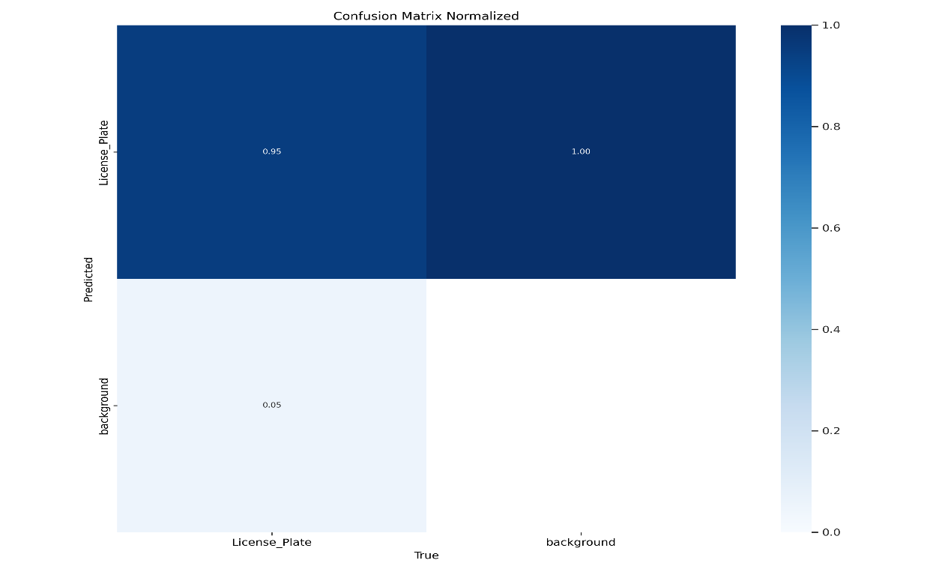
Fig 4.1 Normalized Confusion Matrix of the new YOLOv11 ALPR model
Figure 4.1 depicts the confusion matrix with two classes, titled license plate and background, which are normalized, and the heatmap uses darker blue colors to show higher values. Readings observed the matrix graph, when the true label is license plate, it has a 95% prediction accuracy, and 100% when the true label is background. The missing 5% can be attributed to variation in lighting and faded or cracked plates. Overall, the model has a tendency to achieve an average accuracy of 97.5%.
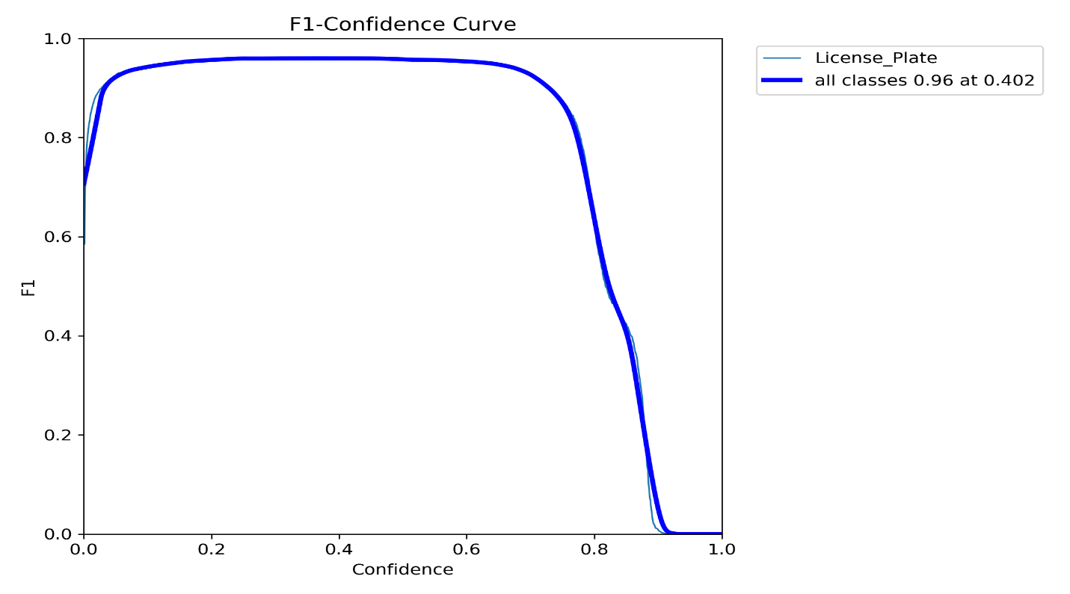
Figure 4.2 F1-Confidence curve
The F1 confidence curve shows how confidence threshold changes affect the F1 score. Detections with scores below the confidence level are filtered out. F1-score combines precision and recall into a single metric to balance their trade-off.
According to Figure 4.2, the model attained a high F1-score of 0.96 for all classes at a confidence threshold of 0.42. F1-score provides a better sense of a model’s overall performance, particularly for imbalanced datasets. The 0.96 F1-score of the model shows there is a balance between precision and recall for this threshold. However, if the threshold increases beyond 0.4, the F1 score drops quickly, falling to around 0.4 at a threshold of 1.0. This suggests the model becomes too strict at higher confidence levels, missing more true positives.
Overall, the ALPR system is performing at an impressive level, with a total 97.5% accuracy and an F1 score of 0.96, making it well-suited for application in the Nigerian road traffic system for toll booth automation and checking point usage. The positives far outweigh the occasional errors, which are in the region of 5% misdetection due to environmental variations and faded or broken plates. The study adopted a confidence threshold of 0.4 to maintain optimal detection performance.
4.3 Result Presentation and Discussion
The user interface for testing the developed model using Python tkinter is presented below. It forms the results of the developed YOLOv11-based Vehicle License Plate Detection System.
A. Home page
The home page of the proposed system is made up of vital information about the system. It is a very important part of the system because it shows the users how to upload an image or video feeds for analysis and detection, it also shows the detection result section, and another added feature of storing the detected license plate into a database.
Figure 4.3 Homepage of ALPR system

B. Upload Page
This page is known as the upload and detection page. The AI Model analyzes the image that was uploaded and then sends back a detection result in seconds. Here, the OCR-extracted characters are highlighted and presented in text-like format for further database queries.
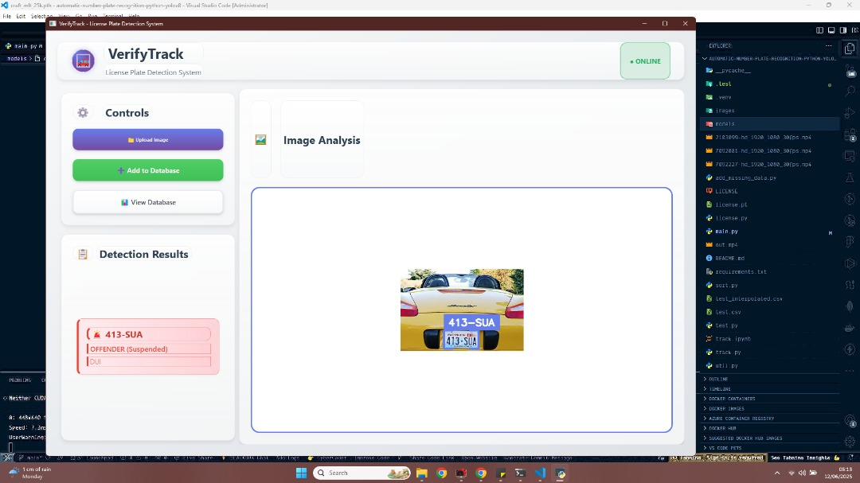
Figure 4.4 Detection page

Classification Result Page: This is the result page where the response obtained from the AI model after analysis and prediction, along with a database query to determine if the plate number is an offender or not, is displayed for the use of the traffic officers.
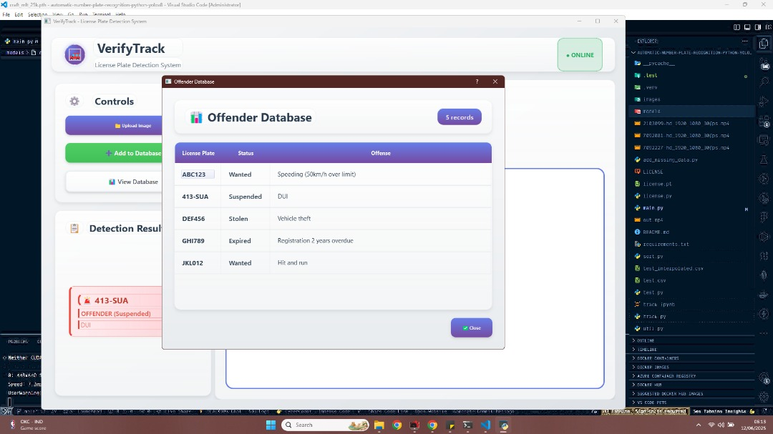
Figure 4.6 Classification Result page

CHAPTER FIVE
SUMMARY, RECOMMENDATIONS, AND CONCLUSION
5.1 Introduction
This chapter of this research work gives a detailed summary of this project, the recommendations for future reference, and a conclusion of this research project. This chapter basically summarizes everything that has been detailed in all other chapters of this project.
5.2 Summary
The research focuses on the development of a YOLOv11-based automated license plate recognition system that eliminates the rampant traditional method of toll collection and vehicle inspections at checkpoints manually in Nigeria, and also improves on the flaws of existing automated systems. The first chapter presented a background to the subject matter and discussed the importance of study in solving this problem, as well as laying out concrete objectives to achieve this aim, with a focus on Nigerian toll booths and checking points. Subsequently, a review was conducted in the second section to analyze related literature, and a research gap was established. This is in accordance with the first step of the laid-out objectives.
Building on that, system analysis and design were carried out in the third chapter to critically analyze the existing and proposed systems. The proposed YOLOv11 model architectural network and block diagram were discussed, and the OOAD research methodology was adopted for the system design approach. In addition, the dataset for model training was discussed along with the Unified Modeling Language that describes the system processes, entities, and actors. The fourth section presents the implementation of the proposed system by the identified procedures in Section 3. The results of the model training were evaluated and then tested through integration of the model in a user interface, Python software named tkinter.
Finally, the aim of the study and its specific objectives were achieved by developing an effective and efficient automated license plate recognition system with outstanding accuracy and processing time.
5.3 Conclusion
This project successfully developed a YOLOv11-based vehicle license plate detection and recognition system, which can be applied across various road transport sectors, especially for Nigerian Toll Booth Automation. The study used a public dataset to train a pretrained CNN algorithm called YOLOv11 for license plate frame detection. Additionally, OCR was employed to recognize and extract the characters. I then evaluated its performance considering some metrics such as F1-score and accuracy. The model achieved a high accuracy of 97.4%, an F1-score of 96%, and demonstrated fast computational capabilities. Additionally, I utilized Python’s tkinter to design a user-friendly software application to test how efficient the model is on live capture image and video data. The study encountered some limitations that hindered the achievement of some of the original goals. This led to a 5% misclassification rate, caused by lighting issues and broken or faded plates.
Despite these challenges, the results offer a way forward for practical applications in Nigeria, with the model proving reliable for traffic monitoring and enforcement, thereby addressing the initial challenge of manual recognition inefficiencies.
5.4 Recommendation
Having completed the research, tested and evaluated considering real-time data in a mini scale, the following are recommended to improve the usage of this model and its efficiency.
i. Expansion of the training dataset with more varieties of images capturing multiple lighting conditions or different weather seasons in Nigeria. This act could reduce the 5% misclassification rate experienced in our model.
ii. Integration of the system into the Nigerian traffic surveillance system to enable real-time detection and sharing of data. This will facilitate the reduction in unaccountability with regard to revenue collection and criminal activities on the road, such as vehicle theft and tax avoidance.

REFERENCES
Abeywardhana, D. K. Y., Alameen, A. A., Hussain, A., & Zhang, D. (2023). A survey of deep learning-based object detection methods in crop counting. Computers and Electronics in Agriculture, 210, 108425. https://doi.org/10.1016/j.compag.2023.108425
Alam, N.‑A.; Ahsan, M.; Based, M.A.; Haider, J. Intelligent System for Vehicles Number Plate Detection and Recognition Using Convolutional Neural Networks. Technologies 2021, 9, 9. https://doi.org/10.3390/technologies9010009
Al-Batat, R., Angelopoulou, A., Premkumar, S., Hemanth, J., & Kapetanios, E. (2022). An end-to-end automated license plate recognition system using YOLO-based vehicle and license plate detection with vehicle classification. Sensors, 22(23), 9477. https://doi.org/10.3390/s22239477
Al-Yaman, M., Alhaj Mustafa, H., Hassanain, S., Abd AlRaheem, A., Alsharkawi, A., & Al-Taee, M. (2021). Improved automatic license plate recognition in Jordan based on ceiling analysis. Applied Sciences, 11(22), 10614. https://doi.org/10.3390/app112210614
Asaju, C.B.; Owolawi, P.A.; Tu, C.; Wyk, E.V. Cloud-Based License Plate Recognition: A Comparative Approach Using You Only Look Once Versions 5, 7, 8, and 9 Object Detection. Information 2025, 16, 57. https://doi.org/10.3390/info16010057
Avcı, İ., & Koca, M. (2024). Intelligent Transportation System Technologies, Challenges, and Security. Applied Sciences, 14(11), 4646. https://doi.org/10.3390/app14114646
Batra, P.; Hussain, I.; Ahad, M.A.; Casalino, G.; Alam, M.A.; Khalique, A.; Hassan, S.I. A Novel Memory and Time-Efficient ALPR System Based on YOLOv5. Sensors 2022, 22, 5283. https://doi.org/10.3390/s22145283
Buleu, B., Robu, R., & Filip, I. (2025). A Deep Learning-Based System for Automatic License Plate Recognition Using YOLOv12 and PaddleOCR. Applied Sciences, 15(14), 7833. https://doi.org/10.3390/app15147833
Dalarmelina, N. D. V., Teixeira, M. A., & Meneguette, R. I. (2020). A real-time automatic plate recognition system based on optical character recognition and wireless sensor networks for ITS. Sensors, 20(1), 55. https://doi.org/10.3390/s20010055
Diwan, T., Anirudh, G., & Tembhurne, J. V. (2023). Object detection using YOLO: Challenges, architectural successors, datasets and applications. Multimedia Tools and Applications, 82, 9243–9275. https://doi.org/10.1007/s11042-022-13644-y
Garcia, D., Carias, J., Adão, T., Jesus, R., Cunha, A., & Magalhães, L. G. (2023). Ten years of active learning techniques and object detection: A systematic review. Applied Sciences, 13(19), Article 10667. https://doi.org/10.3390/app131910667
GeeksforGeeks. (2025, July 23). What is software implementation? https://www.geeksforgeeks.org/software-engineering/what-is-software-implementation/
Han, B. G., Lee, J. T., Lim, K. T., & Choi, D. H. (2020). License plate image generation using generative adversarial networks for end-to-end license plate character recognition from a small set of real images. Applied Sciences, 10(8), 2780. https://doi.org/10.3390/app10082780
Hasan, R. H., Hassoo, R. M., & Aboud, I. S. (2023). YOLO versions architecture: Review. International Journal of Advances in Scientific Research and Engineering, 9(6), 1–8. https://doi.org/10.31695/IJASRE.2023.9.6.1
Imtiaz, H. H., Schaffer, P., Hesse, P., Kupper, M., & Bergmann, A. (2025). Automatic Number Plate Detection and Recognition System for Small-Sized Number Plates of Category L-Vehicles for Remote Emission Sensing Applications. Sensors, 25(11), 3499. https://doi.org/10.3390/s25113499
International Trade Administration. (2023). Nigeria's automotive sector. U.S. Department of Commerce. https://www.trade.gov/country-commercial-guides/nigeria-automotive-sector
Jamali, M., Davidsson, P., Khoshkangini, R., Ljungqvist, M. G., & Mihailescu, R. C. (2025). Context in object detection: A systematic literature review. Artificial Intelligence Review, 58(6), Article 175. https://doi.org/10.1007/s10462-025-11186-x
Javed, M. A., Ben Hamida, E., Al-Fuqaha, A., & Bhargava, B. (2018). Adaptive security for intelligent transport system applications. IEEE Intelligent Transportation Systems Magazine, 10(4), 110–120. https://doi.org/10.1109/MITS.2018.2865993
Khan, M. M., Ilyas, M. U., Alshomrani, S., & Rahardja, S. (2022). Automatic license plate recognition in real-world traffic videos captured in an unconstrained environment by a mobile camera. Electronics, 11(9), 1408. https://doi.org/10.3390/electronics11091408
Khanam, R., & Hussain, M. (2024). Yolov11: An overview of the key architectural enhancements (arXiv:2410.17725). arXiv. https://arxiv.org/abs/2410.17725
Khanam, R., Asghar, T., & Hussain, M. (2025). Comparative performance evaluation of YOLOv5, YOLOv8, and YOLOv11 for solar panel defect detection. Solar, 5(1), 6. https://doi.org/10.3390/solar5010006
Kiela, K., Barzdenas, V., Jurgo, M., Macaitis, V., Rafanavicius, J., Vasjanov, A., Kladovscikov, L., & Navickas, R. (2020). Review of V2X–IoT standards and frameworks for ITS applications. Applied Sciences, 10(12), 4314. https://doi.org/10.3390/app10124314
Lin, C.-J., Chuang, C.-C., & Lin, H.-Y. (2022). Edge-AI-based real-time automated license plate recognition system. Applied Sciences, 12(3), 1445. https://doi.org/10.3390/app12031445
Mienye, I. D., & Jere, N. (2024). Deep learning for credit card fraud detection: A review of algorithms, challenges, and solutions. IEEE Access, 12, 96893–96910. https://doi.org/10.1109/ACCESS.2024.3384567
Mienye, I. D., & Swart, T. G. (2024). A comprehensive review of deep learning: Architectures, recent advances, and applications. Information, 15(12), 755. https://doi.org/10.3390/info15120755
Milosavljevic, N., & Simicevic, J. (2019). Chapter 11- Parking guidance and information system. In N. Milosavljevic & J. Simicevic (Eds.), Sustainable parking management (pp. 249–270). Elsevier. https://doi.org/10.1016/B978-0-12-815800-5.00011-2
Nepal, U., & Eslamiat, H. (2022). Comparing YOLOv3, YOLOv4 and YOLOv5 for autonomous landing spot detection in faulty UAVs. Sensors, 22(464). https://doi.org/10.3390/s22020464
Padmasiri, H.; Shashirangana, J.; Meedeniya, D.; Rana, O.; Perera, C. Automated License Plate Recognition for Resource-Constrained Environments. Sensors 2022, 22, 1434. https://doi.org/10.3390/s22041434
Pan, L., Xue, Z., & Zhang, K. (2025). GAML-YOLO: A precise detection algorithm for extracting key features from complex environments. Electronics, 14(13), 2523. https://doi.org/10.3390/electronics14132523
Rathore, N., Chaudhary, S., Sharma, P., & Nehra, R. (2024). Comparative analysis of real-time object detection methods using machine learning. Journal of Emerging Technologies and Innovative Research, 11(4), 1–8. https://doi.org/10.6084/m9.figshare.25432145
Raza, M. A., Qi, C., Asif, M. R., & Khan, M. A. (2020). An adaptive approach for multi-national vehicle license plate recognition using multi-level deep features and a foreground polarity detection model. Applied Sciences, 10(6), 2165. https://doi.org/10.3390/app10062165
Saha, U.; Saha, B.; Imran, M.A. A Weather-Adaptive Convolutional Neural Network Framework for Better License Plate Detection. Sensors 2024, 24, 7841. https://doi.org/10.3390/s24237841
Sapkota, R., Qureshi, R., Flores-Calero, M., Badgujar, C., Nepal, U., Poulose, A., Zeno, P., Vaddevolu, U. B. P., Yan, P., & Karkee, M. (2024). YOLOv10 to its genesis: A decadal and comprehensive review of the You Only Look Once series. Artificial Intelligence Review, 58(274). https://doi.org/10.1007/s10462-025-11253-3
Sharma, K. U., & Thakur, N. V. (2017). A review and an approach for object detection in images. International Journal of Computational Vision and Robotics, 7(1/2), 196–207. https://doi.org/10.1504/IJCVR.2017.081234
Sharma, V. K., & Mir, R. N. (2020). A comprehensive and systematic look into deep learning-based object detection techniques: A review. Computer Science Review, 38, 100301. https://doi.org/10.1016/j.cosrev.2020.100301
Shashirangana, J., Padmasiri, H., Meedeniya, D., & Perera, C. (2021). Automated license plate recognition: A survey on methods and techniques. IEEE Access, 9, 11203–11225. https://doi.org/10.1109/ACCESS.2021.3050792
Susanty, A., Purwanggono, B., & Putri, V. A. (2023). Bibliometric analysis for an intelligent transportation system. AIP Conference Proceedings, 2683(1), 050004. https://doi.org/10.1063/5.0125399
Terven, J. R., & Cordova-Esparza, D. M. (2024). A comprehensive review of YOLO architectures in computer vision: From YOLOv1 to YOLOv8 and YOLO-NAS. Machine Learning and Knowledge Extraction, 5(4), 1680–1716. https://doi.org/10.3390/make5040083
Tsai, P.F., Shiu, J.Y., & Yuan, S.M. (2025). A deep learning framework of super resolution for license plate recognition in surveillance systems. Mathematics, 13(10), 1673. https://doi.org/10.3390/math13101673
Zemmouchi-Ghomari, L. (2025). Artificial intelligence in intelligent transportation systems. Journal of Intelligent Manufacturing and Special Equipment, 6(1), 26–42. https://doi.org/10.1108/JIMSE-11-2024-0035
Zhang, Z., Zhang, Z., Li, G., & Xia, C. (2025). ZZ-YOLOv11: A Lightweight Vehicle Detection Model Based on Improved YOLOv11. Sensors, 25(11), 3399. https://doi.org/10.3390/s25113399
Zou, Z., Chen, K., Shi, Z., Guo, Y., & Ye, J. (2023). Object detection in 20 years: A survey. Proceedings of the IEEE, 111(3), 257–276. https://doi.org/10.1109/JPROC.2023.3238524

