ANTIMICROBIAL EFFECTS AND COMPARATIVE ANALYSIS OF UDA AND EHURU AS NATURAL PRESERVATIVES FOR ABACHA IN GODFREY OKOYE UNIVERSITY

OGUKAH, FAVOUR ESTHER
GOU/U22/BTG/172

BIOTECHNOLOGY PROGRAMME
DEPARTMENT OF BIOLOGICAL SCIENCES
FACULTY OF NATURAL SCIENCES AND ENVIRONMENTAL STUDIES
GODFREY OKOYE UNIVERSITY, ENUGU NIGERIA

A RESEARCH PROJECT SUBMITTED TO THE
DEPARTMENT OF BIOLOGICAL SCIENCES IN PARTIAL
FULFILMENT OF THE REQUIREMENTS FOR
THE AWARD OF BACHELOR OF SCIENCE
(B.Sc) DEGREE IN BIOTECHNOLOGY

DR. C. A. OKAFOR AND MRS RUTH UGWU

JUNE, 2025.
APPROVAL
This research titled Antimicrobial Effects and Comparative Analysis of Uda and Ehuru as Natural Preservatives for Abacha has been assessed and approved by the Committees of Department of Biological Sciences and Faculty of Natural Science and Environmental Studies, Godfrey Okoye University Enugu Nigeria.

Dr. C. A Okafor​​ ___________________ _____________​​​Supervisor​​​ Signature​​​​​ Date

​​​​​ ​ _________________ _____________
External Examiner​​​ Signature​​​​​ Date

Dr. F. N. Olisaka _________________ _____________
HOD, Department of ​​​ ​ Signature ​​ Date
Biological Sciences​​​ ​​​​​

​​​ _________________ _____________
Prof. Chidi Uhuegbu Signature​​​​​ Date
Dean, FNSES​​​ ​

CERTIFICATION
This is to certify that this project report titled Antimicrobial Effects and Comparative Analysis of Uda and Ehuru as Natural Preservatives for Abacha was carried out by Ogukah Favour Esther with Registration Number GOU/U22/BTG/172 under supervision in the Department of Biological Sciences, Godfrey Okoye University Enugu Nigeria.

Dr. C.A. Okafor ​​​ ​ _________________ ______________ ​
Supervisor​​​​ Signature​​​​ Date

Mrs. Ruth Ugwu​ ​​_________________ ______________
Co-Supervisor​​​​ Signature​​​​ Date

Dr. F. N. Olisaka​​​ _________________ _____________
HOD, Department of ​​​ Signature​​​​ Date
Biological Sciences

DEDICATION
This project is dedicated to my beloved parents whose continued and immense support and prayers guided me throughout this journey.

ACKNOWLEDGMENT
My sincere gratitude goes to my supervisors, Dr Chidinma Okafor and Mrs Ruth Ugwu for their invaluable guidance, dedication and continuous support throughout the course of this research and also the Head of Department, Dr F. N Olisaka for her outstanding leadership and encouragement throughout the course of this project. I also extend my sincere gratitude to Mr Solomon, a staff in the department of Biological Sciences, for his immense contribution, insight and commitment towards the success of my project and the Dean of the Faculty, Prof. Chidi Uhuegbu for his commitment to academic excellence. My deepest and most heartfelt appreciation goes to my dearest parents whose unconditional love, constant prayers, sacrifices and unshakable support sustained me throughout my academic journey and the course of this work. I also deeply appreciate my friend, Udeh Emmanuela for her unwavering assistance and moral support throughout the course of my project and Onyia Anita for her readiness to help at every stage of my project work. I remain eternally grateful for the help you all gave. This work acknowledges my concern for the students and staff of Godfrey Okoye University, whose safety and health guided this project work. I hope that the findings will contribute to a deeper awareness of food safety and public health in the consumption of Abacha and also serve as a contribution to the growing body of knowledge in food preservation. Most importantly, I express my deepest and eternal gratitude to the Almighty God for helping me, giving me strength, wisdom and guidance throughout my academic journey and during the course of this project.

ABSTRACT
This study evaluated the antimicrobial properties of Uda (Xylopia aethiopica) and Ehuru (Monodora myristica) as natural preservatives for Abacha (African salad), a ready-to-eat traditional food prone to microbial contamination. Abacha samples were collected from two vendors, treated with different concentrations (2% and 5%) of Uda and Ehuru, and stored for 4 hours at ambient temperature. Microbial analysis was performed immediately on arrival and after storage. Enumeration of microbes was done on Nutrient agar and selective media –MacConkey, Mannitol Salt Agar, Eosin Methylene Blue, Salmonella Shigella Agar, and with biochemical tests to facilitate identification of the organism, also pH reading was checked and sensory evaluation of the samples was done using hedonic scale. Five bacterial species were isolated and identified: Staphylococcus aureus, Pseudomonas aeruginosa, Escherichia coli, Salmonella spp., and Enterobacter spp. Results showed that treatment with both spices reduced microbial load to 1.1 x 10³ CFU/ml compared to untreated controls of 2.5 x 10³ CFU/ml, with Ehuru demonstrating superior antimicrobial activity. The 5% Ehuru treatment exhibited the highest inhibitory effect, reducing microbial counts to near baseline levels. pH measurements indicated minor changes with spice addition, with Uda treatments displaying slightly lower pH values of 6.75. Sensory evaluation revealed higher acceptability scores of 8 for Ehuru-treated samples compared to Uda-treated samples of 1. This study demonstrates the potential of Ehuru as an effective natural preservative for Abacha, combining antimicrobial efficacy with favorable sensory attributes, offering a promising approach to enhance food safety of traditional ready-to-eat foods.

TABLE OF CONTENTS
Cover Page
Fly Leaf
Title Page I
Approval ii
Certification iii
Dedication iv
Acknowledgements v
Abstract vi
Table of Contents vii
List of Tables x
List of Figures xi
List of Appendices xii

CHAPTER ONE: INTRODUCTION 1
1.1 Background of the study 1
1.2 Statement of the problem 2
1.3 Aims and Objectives of the study 2
1.4 Justification of the Study 3
1.5 Scope of the Study 3

CHAPTER TWO: LITERATURE REVIEW 4
2.1 Street foods 4
2.1.1 Importance of Abacha in Nigerian cuisine, with a focus on Enugu 4
2.1.2 Public health concerns: Common microbiological contaminants associated
with street foods 6
2.1.3 Spices as antimicrobial agents: Introduction to Ehuru (Monodora myristica)
and Uda (Xylopia aethiopica) and their traditional uses. 6
2.2 Street foods and Microbial Contamination 11
2.2.1 Nature of Abacha Preparation: Process and Contamination Points 11
2.2.2 Common Pathogens in Street Foods and Their Health Impacts 11
2.2.3 Public Health Implications of Contaminated Street Foods 12
2.3 Antimicrobial properties of local spices 13
2.3.1 Active compounds in Ehuru and Uda: Phytochemical constituents and
their roles in antimicrobial activity. 13
2.3.2 Mechanism of Action of Local Spices Against Pathogenic Organisms 15
2.3.3 Previous studies: Review of existing research on Ehuru, Uda, or similar
spices against common pathogens. 18
2.4 Application of spices in food preservation 21
2.4.1 Natural vs synthetic preservatives: Advantages of using natural
spices over chemical preservatives. 21
2.4.2 Spices in traditional food systems: Historical and contemporary use of
Ehuru 24
2.4.3 Effectiveness in street food contexts: Feasibility of incorporating these
spices into Abacha. 24
2.5 Methods of evaluating antimicrobial efficacy 26
2.5.1 Laboratory isolation of pathogens: Techniques for isolating microbes
from Abacha. 26
2.5.2 Assessment methods: Standard methods such as disc diffusion, broth
microdilution, and minimum inhibitory concentration (MIC). 27
2.5.3 Comparative studies: Evaluation of antimicrobial activity compared to
synthetic agents. 28
2.6 Public health significance 30
2.6.1 Impact on food safety: Potential reduction in foodborne illnesses. 30
2.6.2 Promoting local spices: Supporting indigenous knowledge and sustainable
food practices. 30
2.6.3 Policy and Implementation: Implications for Food Safety Regulations in
Street Vending 31
2.7 Research gaps and future directions 31
2.7.1 Limited Studies on Enugu's Specific Food Context 31
2.7.2 Need for In Vivo Studies to Corroborate In Vitro Findings 32
2.7.3 Exploration of Sensory and Consumer Acceptability of Spice-Treated
Foods 33

CHAPTER THREE: MATERIALS AND METHODS
3.1 Sample collection 34
3.1.1 Sample preparation 34
3.1.2 Sample division and treatment 35
3.1.3 Determination of ph of abacha 35
3.2 Microbiological analysis 35
3.2.1 Preparation of media 35
3.2.2 Serial dilution of sample 36
3.2.3 Isolation of samples 36
3.2.4 Inoculation 36
3.2.5 Subculturing 36
3.3 Identification of organisms 36
3.3.1 Gram staining 37
3.3.2 Catalase test 37
3.3.3 Oxidase test 37
3.3.4 Coagulase test 38
3.3.5 Indole test 38
3.3.6 Citrate utilization test 38
3.4 Determination of Sensory evaluation of the samples 39

CHAPTER FOUR: RESULTS 40
4.1 Microbial Identification 42
4.2 Sensory Evaluation of the samples 44
4.3 Microbial distribution of the samples 46

CHAPTER FIVE: DISCUSSION AND CONCLUSION 48
5.1 Discussion 48
5.2 Conclusion 50
5.3 Recommendation 51
REFERENCES 53
APPENDICES 65

LIST OF TABLES
Table 2.1: Spices, active compounds, pathogen inhibited and inhibition zone 19
Table 4.1: pH and microbial load of abacha samples 41
Table 4.2: Morphological and biochemical identification of the microorganism
isolated from the abacha sample. 43
Table 4.3: Distribution of identified microorganisms in the abacha samples 47

LIST OF FIGURES
Figure 2.1: African salad (Abacha) 5
Figure 2.2: Dried fruits of Xylopia aethiopica (Uda) 9
Figure 2.3: Dried Monodora myristica (Ehuru) seeds 10
Figure 2.4: Important antimicrobial action mechanisms 17
Figure 2.5: Side effects of synthetic food preservatives 23
Figure 4.1: Sensory evaluation scores for each abacha sample 45

LIST OF APPENDICES
Appendix 1: Labelling of agar plates 65
Appendix 2: Abacha culture plates on salmonella shigella agar, mannitol
salt agar and eosin methylene blue agar 66
Appendix 3: Citrate utilization test 67
Appendix 4: Coagulase test 67
Appendix 5: Microscopic view of abacha sample 68
Appendix 6: Sensory evaluation questionnaire 69

CHAPTER ONE
INTRODUCTION
  - Background of the study
Street foods play a vital role in Nigerian culinary culture and urban life, providing affordable, convenient, and culturally significant meals. In southeastern Nigeria, particularly Enugu, Abacha (African salad) is one of the most iconic street foods. Made from processed cassava tubers, Abacha is cherished for its unique texture and tangy flavor, often enhanced with palm oil, vegetables, and spices like Ehuru (Monodora myristica) and Uda (Xylopia aethiopica). (Pakbin et al., 2024).
However, the processing and selling of street foods, such as Abacha, is typically carried out in informal environments in which food safety regulations are non-existent or weak. The vendors lack access to clean water, good storage, and hygienic handling practices, hence considerably elevating the likelihood of microbial contamination (Mudenda and Mufwambi, 2024). Notwithstanding its nutritional and cultural significance, safety is a paramount interest of Abacha, calling for control measures against contamination hazards. Street foods have long been reputed as vectors for foodborne pathogens, having been contaminated by microbial agents. Some of the bacteria frequently involved in foodborne outbreaks in Nigeria are Salmonella spp., Escherichia coli (E. coli), and Staphylococcus aureus (Barrios-Garcia and Salinas-Chavira, 2024). These microbes can contaminate food at many points of contact, ranging from preparation and ingredient procurement to storage and serving. In locations like Enugu, where street foods constitute a significant component of daily sustenance, maintaining such foods is central to public health and socio-economic prosperity.

Incorporating such spices can restrict microbial contamination, enhance food safety and provide a sustainable food alternative to artificial preservatives that are oftentimes associated with adverse health effects.
Although in vitro experiments have shown the effectiveness of these spices on key pathogens, in vivo experiments must be conducted to confirm their effectiveness in actual food systems (Pakbin et al., 2024). Furthermore, sensory characteristics of food treated with spices like flavor and odor are less investigated, which may influence consumer acceptance (Singh, 2024).

1.2 Statement of the problem
Food borne diseases arising from the consumption of contaminated street foods are a major public health challenge in Nigeria. Poor handling of the foods after harvesting or purchase, unhygienic ways of preparation, and exposure to dirty environments may be some of the reasons these foods harbor pathogens (Ahmed, 2024; Tunde et al., 2024). Foodborne illnesses are among the most frequent causes of morbidity and mortality on earth according to the World Health Organization report, and in developing countries, street foods are a leading cause (Osuji, 2024).
Although spices like Ehuru, Uda, Uziza, and Ogiri are traditionally used as preservatives in foods, empirical data is scarce regarding their antimicrobial efficacy against pathogenic microorganisms associated with street foods. Such a knowledge gap has prevented their optimum exploitation as natural preservatives that can be employed to minimize dependence on synthetic chemicals. Thus, it becomes very necessary for the investigation of antimicrobial potentials of these spices against bacterial contaminants in Nigerian street foods to enhance food safety and minimize food-borne illness.

1.3 Aim and Objectives of the Study
To evaluate and compare the antimicrobial efficacy of Uda (Xylopia aethiopica) and Ehuru (Monodora myristica) as natural preservatives for Abacha (African salad) and determine their potential for inhibiting pathogenic bacteria during short-term storage.
Specific Objectives:
- To isolate and identify pathogenic bacteria present in Abacha samples from different vendors and compare their microbial profiles.
- To evaluate the antimicrobial effects of different concentrations (2% and 5%) of Uda and Ehuru on bacterial growth in Abacha during 4-hour storage at ambient temperature.
- To assess the sensory attributes and consumer acceptability of Abacha treated with
Uda and Ehuru at different concentrations.

1.4 Justification of the Study
The consumption of Abacha, a popular ready-to-eat street food around Godfrey Okoye University, raises significant food safety concerns due to the risk of microbial contamination from unhygienic preparation. With increasing awareness of the health risks associated with synthetic preservatives like sodium benzoate, there is a need for safer, natural alternatives. Uda (Xylopia aethiopica) and Ehuru (Monodora myristica) are traditional Nigerian spices known for their antimicrobial properties, yet there is limited scientific data on their effectiveness as food preservatives in real food systems. This study is justified as it aims to evaluate and compare the antimicrobial efficacy of these spices on Abacha, offering a potentially safer and culturally acceptable solution to food preservation within the university environment.

1.5 Scope of the Study
This study is focused on evaluating the antimicrobial effects of Uda and Ehuru on Abacha sold within the vicinity of Godfrey Okoye University, Enugu. It specifically targets bacterial pathogens such as E. coli, Staphylococcus aureus, Salmonella spp., and Bacillus spp., excluding fungal or viral contaminants. Only the powdered form of the spices are tested on the Abacha samples under room temperature for 4 hours. The findings are specific to Abacha and may not directly apply to other food systems.

CHAPTER TWO
LITERATURE REVIEW
2.1Street Foods.
2.1.1 Importance of Abacha in Nigerian cuisine, with a focus on Enugu.
Abacha, popularly known by the Igbo tribe of Nigeria, is an African salad that is mainly enjoyed by the Igbo people in the southeast of the country. Oranusi et al. (2013) believe that the term "African salad" emanated from the belief of the Igbo people that a salad is of African origin since it is made up of a lot of raw, fresh vegetables among other ingredients that are eaten without further cooking. Cassava is the major ingredient in African salad, garnished with vegetables such as garden egg, Solanum melongena, garden egg leaves, utazi, Gongronema latifolium, okazi, Ukazi leaves, Gnetum africana, and uziza, Uziza leaves, Piper guineense. Other ingredients are oil beans, which is also known as Pentaclethra macrophylla; beans, known also as Cajanus cajan; palm oil; potassium; onion; nutmeg; crayfish; salt; pepper; Maggi; Ogiri; Kpomo; meat; and Stock fish (Abadias et al., 2008; Miriam and Antonio, 2011; Makylicious, 2013; Osewa, 2013). It is being considered a high-risk food, however, because it is made with little or no heat and, thus, is susceptible to infection by coliforms and other food-borne pathogens, despite being very low in calorie, highly rich in fibre, and containing a wide range of phytonutrients, vitamins, and minerals.
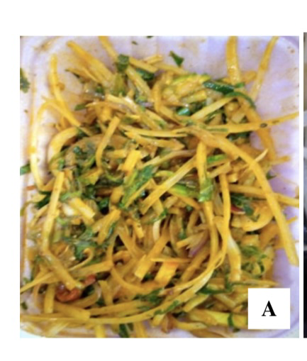
Figure 2.1: African salad (Abacha) (Amadi and Nwankwo, 2021)

2.1.2 Public health concerns: Common microbiological contaminants associated with street foods
Ready-to-eat fast food is one of the highly consumed street foods in Enugu city, and among these foods, African salad occupies the foremost position. However, it has been observed that in the city of Enugu, fresh vegetables required to make salads are frequently sold in an unsanitary manner on tables, trays, wheelbarrows, and floors, and that potential customers handle them with their bare hands which is suspected to serve as a reservoir for microbial consortium (Eluu et al., 2018). Based on the profile of antimicrobial susceptibility of various microorganisms isolated from African salads, salads can act as a vehicle for the spread of pathogenic bacteria's resistance to antibiotics from one habitat to another and from one geographical region to another. The different microbial pathogens detected in ready-to-eat foods by many studies include, but are not limited to the following: Aeromonas hydrophila, Shigella sonnei, Vibrio spp., Escherichia coli, Coliforms, Staphylococcus aureus, Enterobacter spp., Klebsiella spp., Salmonella typhi, Serratia spp., Providencia spp., Pseudomonas aeruginosa, Yersinia enterocolitica, and Listeria monocytogenes (Ali et al., 2011; Guardiola-Avila et al., 2015).
2.1.3 Spices as antimicrobial agents: Introduction to Ehuru (Monodora myristica) and Uda (Xylopia aethiopica) and their traditional uses.
Various spices are known for their antimicrobial properties in traditional medicine and in the preservation of food. Among the popular ones widely used both in Nigerian traditional medicine and in culinary applications include Ehuru and Uda. Other than flavoring, some spices contain active ingredients that could be inhibiting injurious bacteria from growing.
- Photochemical Properties of Ehuru: Ehuru is also commonly known as African nutmeg, rich in terpenoids, alkaloids, flavonoids, and tannins. Indeed, these have been proven to possess antibacterial, antioxidant, and anti-inflammatory properties. It has been indicated in studies that essential oils from Monodora myristica can effectively inhibit bacterial strains such as Salmonella spp., Staphylococcus aureus, and Escherichia coli, hence presenting it as a good alternative to artificial preservatives (Okata-Nwali and Uzoh, 2021).
- Photochemical Properties of Uda: Uda, scientifically referred to as Xylopia aethiopica, is another indigenous spice from Nigeria. It contains high amounts of glycosides, alkaloids, and saponins. The Uda oils have been found to possess significant antibacterial and antifungal activities. Uda's potential as a natural antibacterial agent has been further reinforced by findings indicating its effectiveness against gram-positive and gram-negative bacteria (Ugoma et al., 2023).
- Traditional and Contemporary Uses: The Ehuru and Uda spices are essential in traditional Nigerian food, used in dishes like pepper soup and abacha. In addition, the spices are medicinally active and are used to treat conditions like inflammation, respiratory infections, and gastrointestinal conditions. Empirical evidence supports the efficacy of these uses in reducing microbial loads as well as improving gut health (Ojimelukwe and Ukom, 2017).
- Food Preservation Potential: The above-discussed spices can be prospective candidates for the preservation of street foods such as Abacha, given their inherent antibacterial nature. Ehuru and Uda are natural, culturally acceptable, and non-toxic options as opposed to artificial preservatives. Further studies will be needed to optimize their application in food systems in preventing food borne pathogens, thereby extending the food shelf life (Eruteya and Odunfa, 2009).

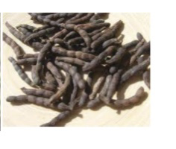.
Figure 2.2: Dried fruits of Xylopia aethiopica (Uda) (Fetse et al., 2016)

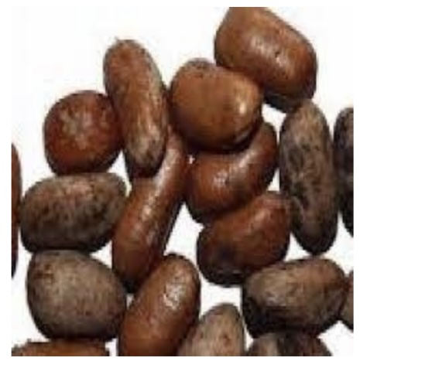
Figure 2.3: Dried Monodora myristica (Ehuru) seeds (Ofoedum et al., 2023)

2.2 Street Foods and Microbial Contamination
2.2.1 Nature of Abacha Preparation: Process and Contamination Points
Abacha, simply African salad, is a traditional food prepared with cassava being its key ingredient. Preparation involves several processes, including selection of cassava, peeling, soaking, shredding, fermenting, drying, and seasoning. Cassava tubers are first peeled and submerged in water for 24 to 48 hours with a view to getting rid of toxic cyanogenic glycosides. After fermentation, shredding of cassava is performed and then drying in sunlight is conducted. Next, a rehydration exercise is performed for shredded cassava before its mixture with palm oil, ugba (fermented oil bean seeds), vegetables, spices, and potash (akanwu) seasoning.
Potential sources of contamination in preparing Abacha arise mainly through unsanitary operations and lack of proper processing techniques. Contamination can occur through contaminated sources of water during rehydration and soaking, poor drying processes, and use of unclean cutting boards during shredding and mixing of cassava. Inadequate fermentation can lead to a presence of residues of cyanogenic compounds, and therefore consumption can become harmful. In addition, studies have drawn concerns about mycotoxins in poorly stored dried cassava produce, with a view to enhancing fungal growth (Oluwafemi and Ikeowa, 2023).
2.2.2 Common Pathogens in Street Foods and Their Health Impacts
Street food items are most susceptible to a variety of pathogens, including Salmonella spp., Escherichia coli, and Staphylococcus aureus, that cause significant health risks.
•Salmonella spp. is a common source of foodborne disease, most often linked with contaminated water and raw produce encountered in street foods. Salmonella infection, a disease produced by this pathogen, expresses symptoms such as diarrhea, fever, and abdominal pain. In extreme cases, infection can require admission to a hospital, most notably in persons with weakened immune systems (Neogi, 2025).
•Escherichia coli, particularly E. coli O157:H7, is a significant danger, most often a result of fecal contamination during food handling. It is capable of producing Shiga toxins, which can cause severe gastrointestinal complications and hemolytic-uremic syndrome (HUS), a life-threatening disease that can cause kidney failure (Altaie et al., 2025).
•Staphylococcus aureus is a common inhabitant of food workers' hands and nasal passages. Once it contaminates foods, it can produce enterotoxins that can cause vomiting, nausea, and diarrhea in a matter of a few hours post-ingestion (Khajehlandi and Bolboli, 2025).
2.2.3 Public Health Implications of Contaminated Street Foods
The consumption of contaminated street foods poses a critical public health risk, contributing to a high level of food borne disease occurrences worldwide. Inadequate food vendor hygiene, poor food storing, and contact with environment toxins contribute to increased danger posed by street foods. Research identifies a strong connection between street food contamination and increased cases of gastroenteritis, cholera, typhoid fever and hepatitis A infection. In a study in Nigeria, over 60% of street foods analyzed showed high bacterial contaminant concentrations and these concentrations correlated with poor sanitary environments and lack of vendor training (Fayanju et al., 2024).
Moreover, antimicrobial resistance in street foods is also emerging as a serious issue, with a study validating multi drug-resistant Salmonella strains in ready-to-eat foods. Drug resistance forces alternative treatment modalities and increases mortality rate among vulnerable populations (Onohuean et al., 2025). National health programmes need to make a priority of enforcing sanitary measures, training vendors and creating awareness among consumers. There is a compelling necessity for the regular checking of street food microbial contaminants to avoid any chance of outbreaks.
2.3. Antimicrobial Properties of local spices
2.3.1 Phytochemical constituents of Ehuru and Uda and their roles in antimicrobial activity
Stidies have confirmed that Monodora myristica and Xylopia aethiopica have a range of phytochemicals that play significant biological functions:
•Alkaloids: Xylopia aethiopica contains alkaloids, which have been shown to bear strong antimicrobial activity against Gram-positive and Gram-negative bacterial pathogens (Ugbogu et al., 2017). On the contrary, Monodora myristica has alkaloids that inhibit bacterial metabolic activity, thereby impairing microbial growth (Igwillo et al., 2019).
•Flavonoids: These have been reported to exhibit high antioxidant activity and have been found to possess antibacterial activity (Nwozo et al., 2023). The flavonoid content of Xylopia aethiopica is credited with inhibiting bacterial enzyme activity and cellular respiration.
•Terpenoids: Monodora myristica terpenoids are credited with the disruption of microbial cell walls resulting in antimicrobial activity (Okaiyeto et al., 2021). Xylopia aethiopica has also been reported to have sesquiterpenes, which exhibit wide-ranging antimicrobial activities (Medalcho et al., 2023).
•Tannins and Saponins: These polyphenols account for antimicrobial activity by inhibition of adhesion and biofilm formation by bacteria (Okeke, 1998). Saponins from Monodora myristica and Xylopia aethiopica were found to induce disruption of microbial cell membrane leading to cell lysis.

Antimicrobial Activities of Ehuru and Uda
A few studies have established the antimicrobial activity of these spices:
• Bacterial inhibition: Xylopia aethiopica and Monodora myristica ethanol extracts showed strong inhibition of Staphylococcus aureus, Escherichia coli, and Pseudomonas aeruginosa (Ugoma et al., 2023). Antimicrobial activities as shown here due to alkaloids, flavonoids, and terpenoids in these substances that supress bacterial cellular activities.
•Antifungal Activity: Antifungal activity of Monodara myristica against Candida albicans was assayed and exhibited potent activity through its rich phenolic content (Effiong et al., 2023).
•Synergistic Action with Antibiotics: Research indicates that the combination of Xylopia aethiopica extracts with traditional antibiotics can improve their activity against multi drug-resistant bacterial strains (Mafe et al., 2024).

2.3.2 Mechanism of Action of Local Spices Against Pathogenic Organisms
These metabolites, resulting from various plant species, interact with microbial cells in numerous ways: it disrupts membrane dynamics and structure, inhibits biosynthesis of nucleic acids DNA/RNA, interferes with intermediary metabolism, coagulates cytoplasmic constituents, and interferes with cell communication. This is according to Bouhdid et al., 2010, Garvey et al., 2011, and Radulovic et al., 2013.
- Disruption of Cell Membranes: The breakdown of bacterial cell membranes is one of the main ways that spices work against bacteria. Monoterpenes and phenols in essential oils, such as those in Monodora myristica (Ehuru), interact with the lipid bilayers of bacteria. Increased permeability and the leakage of intracellular materials like ions, proteins, and nucleotides result from this interaction's destabilisation of the membrane (Sadaf et al., 2024). For instance, the phenolic compound carvacrol in spices results in disruption of bacterial cell membrane potential, rendering the cell incapable of maintaining life-supporting metabolic processes (Honghong et al., 2024).
- Inhibition of Protein Synthesis: Flavonoids and tannins are two classes of phytochemicals found in spices, which bind to bacterial ribosomes and hence inhibit protein synthesis. As a result of this inhibition, bacteria are unable to synthesize the structural proteins and enzymes necessary for their survival and replication (Kadhim and Al-Hawani, 2024). For instance, the alkaloids from Xylopia aethiopica (Uda) make gram-negative bacteria unable to translate mRNA into useful proteins by binding the 30S ribosomal subunit.
- Oxidative Stress Induction: Compounds of spices like Piper guineense can cause oxidative stress in bacterial cells by facilitating ROS. Superoxide anions and hydrogen peroxide, products of ROS, cause cell membrane damage and intracellular damages: DNA, lipid, and protein degradation (Samavat and Vozhdehnazari, 2024). Also, metabolic pathways get impaired under the state of oxidative stress in bacterial cells, thereby accelerating the rate of cell death. In such a context, the piperine in Uziza was evidenced to disrupt the normal redox balance within bacterial cells, adding to its better antimicrobial effects.
- DNA and RNA Inhibition: Several phytochemicals from spices inhibit the synthesis of bacterial nucleic acid, generally targeting some vital enzymes involved in DNA replication and transcription. Alkaloids present in Uda and Ehuru disrupt DNA gyrase, an enzyme important for DNA supercoiling and replication in bacteria (Ramalingam and Samath, 2024). With their replication being stopped, it means that growth and proliferation were brought to a standstill.
- Enzyme Inhibition: Tannins and flavonoids in spices inhibit bacterial enzymes, which are necessary for cellular metabolism. These compounds either bind to the active sites of enzymes or alter their conformation, reducing their catalytic efficiency. For instance, it has been found that the phenolic acids in Ogiri inhibit the enzyme bacterial β-galactosidase, important in carbohydrate metabolism, hence leaving the bacteria starved of energy (Octaviani et al., 2024).
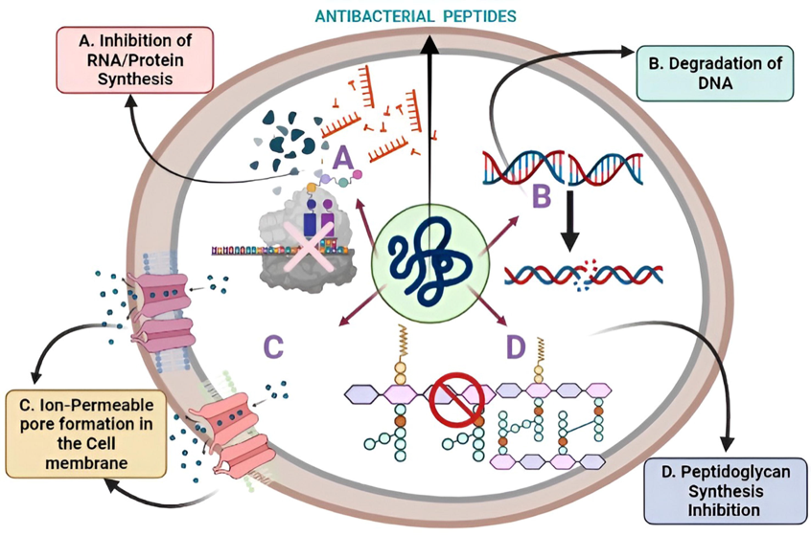

Figure 2.4: Important antimicrobial action mechanisms (Qadri et al., 2022)

2.3.3 Previous studies: Review of existing research on Ehuru, Uda, or similar
spices against common pathogens.
Numerous investigations have documented the antimicrobial activity of Ehuru (Monodora myristica) and Uda (Xylopia aethiopica) and stressed their use in food preservation and therapeutic activity towards pathogens responsible for foodborne disease. These spices have bioactive compounds such as alkaloids, flavonoids, tannins, and oils, whose activity is both antibacterial and antifungal in nature.
- Antimicrobial Activity Against Common Pathogens: According to a study conducted by Ojimelukwe and Ukom (2017), microbial and antioxidant activity of several spices in Southeast Nigeria was evaluated. In its findings, it showed that both M. myristica and X. aethiopica inhibited effectively Escherichia coli, Staphylococcus aureus and Salmonella spp., common food pathogens that cause gastrointestinal infection. According to observations, the bioactive compounds in these spices in an ethanolic extract showed a high level of antimicrobial activity compared to an aqueous extract, suggesting that it’s bioactive compounds have high solubility in organic solvents (Ojimelukwe and Ukom, 2017).

Table 2.1: Spices, active compounds, pathogen inhibited and inhibition zone (Ugoma et al., 2023).
Spice | Active Compounds | Pathogens Inhibited | Inhibition Zone (mm)
Monodora myristica (Ehuru) | Myristicin, Elemicin | E. coli, Salmonella, Staphylococcus aureus | 18-25 mm
Xylopia aethiopica (Uda) | Xylopic acid, Diterpenes | E. coli, Listeria, Pseudomonas | 20-27 mm

- In a similar observation, Linus-Chibuezeh et al., (2022) evaluated the chemical composition and bioactivities of Ehuru and Uda. In its observation, it showed that both spices showed high antimicrobial activity towards Pseudomonas aeruginosa and Bacillus subtilis, two microbes with high resistivity towards conventional antibiotics. The antimicrobial activity reported has been attributed to the volatile oils, including linalool, α-pinene, and eugenol, which have been shown to disrupt bacterial membranes and suppress microbial growth (Linus-Chibuezeh et al., 2022).
- Also supporting these observations, Eruteya and Odunfa (2009) evaluated three spices, including Xylopia aethiopica and Monodora myristica, for its antimicrobial activity towards bacterial isolates of suya condiment. In its observation, it confirmed that these spices showed high activity towards Listeria monocytogenes and Klebsiella pneumoniae, and it’s observation stressed it’s use in extending the shelf life of food and in microbial control (Eruteya and Odunfa, 2009).
- Comparison with Other Spices: In comparison with other native African spices, Ehuru and Uda are found to have greater antimicrobial activity compared to Piper guineense (Uziza) and Tetrapleura tetraptera (Aridah). Aboaba (2014) explains how Piper guineense is active against Candida albicans whereas Monodora myristica has a wider range of antimicrobial activity since it inhibits both Gram-positive and Gram-negative bacteria. This, therefore, indicates that M. myristica can serve as an effective component in developing antimicrobial medication for limiting bacterial infection (Aboaba, 2014).
- Food Safety and Medical Prospects: Aside from food applications, these spices also possess therapeutic promise. Research has pointed to the antifungal properties of Xylopia aethiopica, in which it inhibited the growth of Aspergillus and Penicillium species, which are causative agents of food spoilage and mycotoxin production. The antifungal property present in this spice has the capacity to increase foods' shelf life significantly while, in the process, decreasing mycotoxin contamination of cereals stored for extended durations (Igwillo et al., 2019). Besides, essential oils from M. myristica have been studied to establish their effectiveness against viral diseases. In a new study, (Nwozo et al., 2023) showed that these oils showed a fair inhibition of Influenza A and Herpes Simplex Virus, and therefore, have a potential for use in developing antiviral drugs (Nwozo et al., 2023).
2.4. Application of Spices in Food Preservation
2.4.1 Natural vs synthetic preservatives: Advantages of using natural spices over chemical preservatives.
This is the reason natural preservatives become prominent, with people avoiding synthetic additives. Ehuru (Monodora myristica) and Uda (Xylopia aethiopica) are spices not only for flavor but also are potential antimicrobial and antioxidant agents, hence the suitability of application in food preservation, especially the traditional street foods of Abacha. Synthetic preservatives, such as sodium benzoate and nitrates have widely been used in the food industry for a long time to prolong the shelf life of food and prevent microbial spoilage. However, growing concern over possible adverse health effects of these substances has spurred interest in their safer, natural alternatives. Spices are an attractive option owing to their bioactive components that can act as antimicrobial agents with no food safety or quality compromise (Sulieman et al., 2023). The essential oils of spices, for example, Monodora myristica and Xylopia aethiopica, are effective against food borne pathogens. For example, Ehuru and Uda are reported to be effective in the control of microbial spoilage in ready-to-eat foods, hence serving as an alternative to synthetic preservatives (Macwan et al., 2016).
Street foods are more prone to microbial contamination as their preparation and vending, for example, Abacha, most of the time exposes them to an unsanitary environment. Addition of spices, such as Ehuru and Uda, helps in reducing the chances of contamination, besides maintaining the sensorial attributes of such foods. Essential oils, according to (Rout et al., 2022), can maintain the physicochemical properties of foods, hence maintaining their safety and quality.
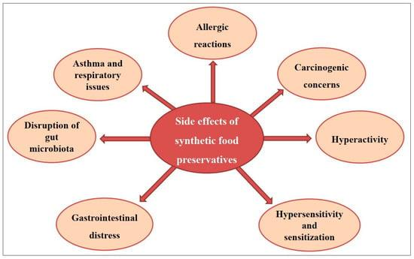
Figure 2.5: Side effects of synthetic food preservatives (Suleiman et al., 2023)

2.4.2 Spices in traditional food systems: Historical and contemporary use of Ehuru
•Traditional Use of Ehuru in Food Preservation: Ehuru seeds are ground and mixed with soups and stews to enhance durability by inhibiting the growth of microbes (Ojimelukwe and Ukom, 2017). In food preservation of fermented foods, Monodora myristica is utilized in enhancing the stability of palmwine and other traditional African drinks through controlling microbial process of fermentation (Godloves et al., 2021). Besides that, Monodora myristica essential oil has antifungal properties, thereby inhibiting stored grains and tubers from spoilage (Okon et al., 2023).
•Traditional Use of Uda in Food Preservation: Xylopia aethiopica is also commonly utilized in meat and fish drying and smoking, which improves their shelf life and flavor content (Ampim et al., 2019).
The spice is commonly incorporated into traditional preservation processes of local African foods such as suya (grilled meat) and kilishi (dried meat), due to the antimicrobial and antioxidant activities of the spice (Tamfu et al., 2020). The bioactive volatile constituents in Xylopia aethiopica are accountable for the prevention of mold growth in stored legumes and grains (Mintognissè et al., 2025).

2.4.3 Effectiveness in street food contexts: Feasibility of incorporating these spices into Abacha.
The feasibility of incorporating Ehuru and Uda into Abacha depends on several factors, including their impact on microbial load reduction, consumer acceptance, and ease of integration into existing preparation methods.
•Microbial Load Reduction: Research has established that natural antimicrobials used in food processing considerably minimize microbial contamination. In their study, (Ogueke et al., 2022) found that the application of common spices, i.e., Uda and Ehuru, remarkably decreased the microbial load in ready-to-eat foods. The addition of spices in Abacha preparation, irrespective of whether it is used in extract, powder, or whole form—has the potential to inhibit the growth of spoilage and pathogenic microorganisms, thus improving shelf life and enhancing the safety of foods.
•Consumer Acceptability: A primary concern when it comes to the alteration of traditional street foods is consumer perception. Ehuru and Uda are already common spices in Nigerian food culture, especially used in meat and soup foods, which translates to a high level of consumer acceptance. Sensory evaluation research by Eze et al., (2021) indicated that the inclusion of these spices in traditional foods did not alter the taste, flavor, or overall acceptability. Their addition in Abacha, therefore, would not only add taste but also food safety.
•Integration into Existing Preparation Methods
The seamless integration of these spices during the preparation of Abacha, without altering traditional practices, is required to guarantee efficient use. The traditional preparation of Abacha involves soaking cassava slices in water prior to seasoning with palm oil and other ingredients like onions, garden eggs and fish (Ezekwesili-Ofili and Okaka, 2019).
The antimicrobial properties of Ehuru and Uda can be utilized by:
•Infusion in soaking water: It allows for entry of bioactive substances into the cassava prior to the application of seasonings, where it can exert inhibitory actions on microbial growth (Ogueke et al., 2022).
•Incorporating directly in powder form: Milled Ehuru and Uda can be combined with other spices to cause microbial inhibition without compromising on conventional flavors (Okonkwo et al., 2022).
•Oil-based extraction: Infusion of these spices in palm oil, a major ingredient used in the processing of Abacha, enables uniform distribution of antimicrobial components while enhancing the shelf life of the product (Ajiboye et al., 2021).
2.5 Methods for Evaluating Antimicrobial Efficacy
2.5.1 Laboratory isolation of pathogens: Techniques for isolating microbes from Abacha.
The effective methods for laboratory isolation of pathogens from Abacha samples involve various innovative techniques that enhance the capture and identification of microbial agents. These methods leverage advanced materials and biochemical processes to improve efficiency and accuracy in pathogen isolation.
- Affinity matrix techniques: The use of an affinity matrix coated with pathogen-binding proteins allows for the selective capture of pathogens from samples. This method involves forming a complex between the sample and the matrix, facilitating the isolation of pathogens (Divya et al., 2016). This increases the specificity and efficiency of pathogen capture due to the combination of various types of binding proteins.
- Magnetic bead isolation: Indeed, the various approaches in the preparation of magnetic beads with engineered proteins, such as Fc-mannose-binding lectin, have yielded efficiencies as high as 76% after hypotonic wash and enzymatic treatments of the clinical samples (Bicart-See et al., 2016). This technique allows for the rapid isolation of the pathogen, thereby reducing the time taken for sample processing.
- Traditional culture methods: Conventional methods, including the use of selective culture media like blood agar and mannitol salt agar, remain essential for isolating Staphylococcus species. These methods utilize biochemical tests to confirm pathogen identity (Moraes et al., 2021). Microscopy and biochemical assays are important for the correct identification and characterization of pathogens.
2.5.2 Assessment methods: Standard methods such as disc diffusion, broth microdilution and minimum inhibitory concentration.
The evaluation of antimicrobial effectiveness is based on these standardized techniques, which allow for both comparative analysis and reproduction in microbial susceptibility evaluation.
- Disc Diffusion Method: The disc diffusion technique, also known as the Kirby-Bauer test, is a widespread technique for testing antimicrobial susceptibility. Involving the use of filter paper discs loaded with antimicrobial compounds placed onto an agar plate with an inoculum of a microbe under investigation, disc diffusion involves measurement of inhibition zone diameters surrounding discs following incubation. In a study conducted, the reliability of disc diffusion in testing bacterial resistance, specifically for Klebsiella pneumonia isolates, is emphasized, but it can exhibit weaknesses in distinguishing between bacteriostatic and bactericidal activity (Stracquadanio et al., 2024)
- Broth Microdilution Method: The broth microdilution technique yields quantitative information regarding antimicrobial efficacy through testing microbial susceptibility to serial dilutions in a liquid growth environment (media). Identification of MIC, representing the minimum level of an antimicrobial compound capable of inhibiting detectable microbial growth, is critical when using microdilution in a broth. A recent study proved that microdilution in a broth is useful in testing antibacterial activity of Morchella esculenta extracts for carbapenem-resistant Acinetobacter baumannii isolates. In a similar manner, MIC testing confirmed increased accuracy over disc diffusion in determination of specific inhibitory concentrations (Haq et al., 2025).
- Minimum Inhibitory Concentration (MIC) and Minimum Bactericidal Concentration (MBC): MIC is the minimum concentration of an antimicrobial agent needed to suppress bacterial growth, whereas MBC is the concentration needed to kill the bacteria entirely. Both MIC and MBC assessments can be applied to evaluate bacteriocin activity against Escherichia coli, emphasizing their importance in distinguishing bactericidal from bacteriostatic properties (Bayat et al., 2024)
2.5.3 Comparative studies: Evaluation of antimicrobial activity compared to
synthetic agents.
The increased development of antibiotic resistance has fueled studies in relation to using natural antimicrobial compounds in place of synthetic antibiotics. Comparative studies evaluate microbial inhibition and development of resistance in relation to plant extracts and synthetic antibiotics.
•Natural vs. Synthetic Antimicrobial Agents Against Common Pathogens
A research study evaluated the antimicrobial activity of Aloe vera leaf extracts towards Escherichia coli, Staphylococcus aureus, and Pseudomonas aeruginosa. The study showed that, even though Aloe vera extracts showed significant inhibitory activity, their activity was less effective compared to synthetic antibiotics including ciprofloxacin and amoxicillin (Bengharbi et al., 2024).A study examined the antibacterial activity of herbal extracts in comparison with conventional antibiotics. According to the study specific plant extracts showed antimicrobial activity equivalent to, and in a few cases, exceeding conventional antibiotics towards Salmonella spp. and Bacillus subtilis, suggesting that phytochemicals can serve as effective natural antibiotics with reduced side effects (Singh and Patidar, 2024).
•Resistance Development: Natural vs. Synthetic Agents
A study examined bacterial development of resistance towards both natural and chemical antibiotics. According to the study, bacterial development of resistance happened at a high pace towards chemical antibiotics, but natural antimicrobial compounds showed a reduced susceptibility towards developing resistance, supporting their use for long-term antimicrobial therapy (Alves França, 2024).

2.6 Public Health Significance
2.6.1 Impact on food safety: Potential reduction in foodborne illnesses.
The addition of these spices in the Abacha production process, either as direct ingredients or as a component of a preservation technique, can effectively minimize microbial contamination. This minimization may consequently decrease the prevalence of foodborne illness, thereby enhancing the state of public health. Research by Nwinyi et al., (2017) demonstrated that an ethanolic extract of Monodora myristica had potent antibacterial properties against Salmonella and Escherichia coli, the latter being most frequently involved in foodborne infections. In the same vein, Xylopia aethiopica has also exhibited activity against Staphylococcus aureus and Bacillus cereus, thereby making it important in food safety augmentation (Ojo et al., 2022).
2.6.2 Promoting local spices: Supporting indigenous knowledge and sustainable food practices.
Indigenous spices and plant-derived antimicrobials have long played a significant role in food and medical practice preservation. Promotion of native spices, including Xylopia aethiopica (Uda) and Monodora myristica (Ehuru), is important for biodiversity conservation, cultural heritage protection and stimulation of rural economies (Arowosafe et al., 2024). Recent study emphasized traditional ecological knowledge in securing food security in highland agricultural communities, with a specific focus placed on the role of non-cultivated plants and mushrooms in traditional diets (Castilla et al., 2025). Emphasis were placed on the necessity for ethnobotanical information documentation in an attempt to safeguard traditional food rituals, specifically in relation to the destructive role played by globalization in eroding indigenous information systems. By including such native spices in modern food security protocols, there is a chance for enhancing consumer wellness and at the same time traditional food practice is sustained (Luo et al., 2024).
2.6.3 Policy and Implementation: Implications for Food Safety Regulations in Street Vending
Street vending forms an integral part of urban food environments; yet, it creates enormous public health concerns through ite potential for foodborne disease in terms of poor sanitation and lack of proper regulating controls. (Nneoma, 2024) conducted a study explaining the challenge street food vendors face in Nigeria, citing poor compliance with food safety laws that cause microbial contamination. Similarly, (Esumeh and Reigns, 2024) examined pathogen prevalence in fruits and vegetables handled by street vendors and reiterated the same in terms of a lack of stricter policies towards creating safe environments and putting in place antimicrobial interventions.
2.7. Research Gaps and Future Directions
2.7.1 Limited Studies on Enugu's Specific Food Context
Existing studies concerning antimicrobial spices in Nigeria have focused predominantly on general studies of phytochemicals, efficacy in antimicrobial activity, and use in food preservation practices. Nevertheless, studies in specific locations with consideration for Enugu’s specific culinary heritage, dietary habits, and respective microbial risks have not seemed to have been conducted in abundance.
•Ngwoke et al., (2015) evaluated the antimicrobial potential of Cnestis ferruginea towards multidrug-resistant bacteria in raw meat in Awka, a neighboring region. Despite positive observations, no direct evaluation of its use in traditional foods in Enugu has been conducted.
• Tarh and Iroegbu (2017) examined Euphorbia abyssinica for its antibacterial activity with samples collected in Enugu teaching hospital; yet, no integration into actual food safety use in the region has been conducted yet.
2.7.2 Need for In Vivo Studies to Corroborate In Vitro Findings
A majority of studies regarding antimicrobial spices have focused predominantly on in vitro studies, explaining antibacterial activity in a laboratory environment. Nevertheless, in vivo studies must confirm efficacy in real-life food conservation and in humans' overall well-being.
•Otarigho et al., (2025) pointed out that many antimicrobial compounds in spices target bacterial resistance processes in a laboratory environment; nevertheless, in vivo studies are critical in confirming effectiveness in real-life scenarios.
•Lungu et al., (2024) conducted in silico and in vitro studies of fluoroquinolone- tetracycline hybrids, re-emphasizing the importance of confirming antimicrobial efficacy through in vivo models before actual use in practice.
•Siddiqui et al., (2024) researched peels of Punica granatum and discovered potential antibacterial activity in a laboratory environment, but reiterated that in vivo tests must confirm actual efficacy.
2.7.3 Exploration of Sensory and Consumer Acceptability of Spice-Treated Foods
Regardless of effectiveness in antimicrobial spices, incorporation in food conservation is a function of acceptance in terms of perception, compatibility in terms of taste, and acceptance in terms of culture.
•(Ifeoma et al., 2024) researched use of native spices in Anambra and showed that even with significant antioxidant and antimicrobial activity, acceptance is a function of sensory evaluation and familiarity with cultures.
•(Makinde et al., 2024) discussed ready-to-eat foods' safety in economically challenged communities, re-emphasizing that even with antimicrobial interventions, acceptance must first go through educational processes and sensory evaluation in terms of acceptance in communities.
•(Attaugwu et al., 2023) researched Piper guineense, a common Nigerian culinary spice, and showed its antimicrobial and antioxidant activity, but a lack of studies in terms of acceptance in communities must first occur for widespread use.

CHAPTER THREE
MATERIALS AND METHODS
3.1. Sample Collection
The plants used in this practical, Monodora myristica (Ehuru) and Xylopia aethiopica (Uda), were obtained from a local market in Enugu, placed in plastic bags, and transported to the laboratory for analysis. Identification and selection of these plants were based on documented literature highlighting their antimicrobial properties and their availability in this region (Ojimelukwe and Ukom, 2017). These plants were chosen specifically for their relevance to the study of antimicrobial effects on pathogens isolated from Abacha, a popular street food in Enugu. Already prepared abacha garnished with lye water/potash water, onions and vegetable was obtained from two different vendors in Godfrey Okoye University Thinker’s corner. The abacha samples were collected from these vendors because they are frequently patronized by staff and students of the school, hence awareness on food safety risk would be of high benefit.
3.1.1 Sample Preparation
Dry ehuru/ uda seeds were ground into fine powder using sterile grinder. Fresh Abacha samples were then collected from two different vendors and transported under appropriate temperature conditions. Samples were then accessed immediately upon arrival at laboratory (Okon et al., 2023).

3.1.2 Sample Division and Treatment
Both abacha samples were divided into six portions and 100 grams weighed out for each portion: first portion (plain Abacha for immediate analysis), second portion (Abacha mixed with 5% ehuru powder), third part portion (Abacha mixed with 2% ehuru powder), fourth portion (Abacha mixed with 5% Uda powder), fifth portion (Abacha mixed with 2% Uda powder) and last portion which was control (Plain Abacha without ehuru or uda). The concentrations were mixed thoroughly using aseptic technique and uniform distribution of ehuru/ uda throughout the Abacha was ensured. Portions 2-6 were then stored in sterile plastic containers with lids at room temperature for 4 hours before isolation of microorganisms (Ahmed et al., 2022; Zhang et al., 2016).
3.1.3 Determination of pH of abacha
The pH of the samples was observed on arrival and after 4 hours of incorporation of spices todetermine how Uda and Ehuru affect the acidity of Abacha. Since most bacteria thrive in near-neutral pH, a decrease in pH can enhance antimicrobial activity. Monitoring pH also helps assess how the spices influence food preservation, safety, and quality during storage (Khaizura et al., 2022).
3.2 MICROBIOLOGICAL ANALYSIS
3.2.1 Preparation of media
All media used were prepared according to the manufacturer’s specifications and autoclaved to ensure sterility.

3.2.2 Serial dilution of sample
A two fold serial dilution was done using peptone water/ normal saline and plated on nutrient media using pour plate method, to obtain colony counts for assessment of microbial load. (Chauhan and Jindal, 2020)
3.2.3 Isolation of samples
Sterile swab sticks were thoroughly rubbed on the surface of the abacha to obtain microbial isolates from first portion (on arrival) and from portions 2-6 after 4 hours. (Okareh and Erhahon, 2015)
3.2.4 Inoculation
The isolates from samples were inoculated onto Nutrient agar, MacConkey agar, Eosin methylene blue agar, Mannitol salt agar, Salmonella Shigella agarand Potato dextrose agar plates by gently rubbing the end of the swab across the surface of the agar. This was done using an S-pattern streaking method, rotating the dish and applying another S-pattern perpendicular for identification of microorganisms. After inoculation, the plates were incubated for 24 hours and the microbial load was assessed. (Brown et al., 2021)
3.2.5 Subculturing
The isolates were subcultured into Eosin methylene blue agar, mannitol salt agar and salmonella – shigella agar (Cheesbrough, 2002)
3.3 Identification of Organisms
The isolates were further identified through tests which include:

3.3.1 Gram Staining
A smear was prepared on a glass slide with the isolate and normal saline. The smear was allowed to air dry before heat-fixing it to prevent the isolate from washing off during staining. The primary stain was first applied on the slide containing the isolate and left for 1 minute. After 1 minute, it was washed off, Gram's iodine was applied and left for 30 seconds, then washed off with acetone within 30 seconds. The counter stain was then applied for 45 seconds and washed off. The slide was left to dry before microscopic examination (Tripathi and Sapra, 2022).
3.3.2 Catalase Test
This test was conducted using 3% hydrogen peroxide, which was introduced onto a clean glass slide. A sterile wire loop was used to transfer a small amount of the isolate onto the slide. The formation of bubbles was observed, indicating a positive catalase reaction. If bubbles formed, the organism was considered catalase-positive; if no bubbles formed, the organism was catalase-negative (Mahon, 2011)
3.3.3 Oxidase Test
A glass rod was used to pick a small quantity of each isolate from the plate and placed onto labeled filter papers, creating a smear. A small quantity of oxidase reagent was added immediately using a 2ml syringe. The reagent was mixed with the isolate on the filter paper. A positive reaction was indicated by a dark purple-blue color, whereas no color change indicated a negative result (Cheesebrough, 2006).

3.3.4 Coagulase Test
A bacterial suspension was prepared by mixing a loopful of the isolate with distilled water on a sterile dry slide. A drop of plasma was added to this suspension and mixed gently. The reaction was observed for coagulation within 10 seconds. This test was used to differentiate Staphylococus aureus (coagulase - positive) from Staphylococcus Staphylococcus epidermidis (coagulase - negative) (Beena, 2019).
3.3.5 Indole Test
This test detects the ability of an isolate to decompose the amino acid tryptophan into indole using a colorimetric reaction with p-dimethyl-amino-benzaldehyde (Kovac’s reagent).Peptone broth was prepared, dispensed into broth bottles and inoculated with the isolate. The inoculated broth was incubated at 37°C for 48 hours. After incubation, 5 to 7 drops of Kovac’s reagent were gently added to each tube. A positive result was indicated by the formation of a red ring, while a negative result showed a yellow coloration (Aakanchha et al., 2020).
3.3.6 Citrate Utilization Test
Isolate was lightly inoculated on Simmons citrate agar slant and put in an incubator for 24-48 hours at 37°C. Positive result was demonstrated when there is color change from green to blue; negative when no color change was observed. The test was to determine whether or not an organism possesses the ability of utilizing citrate as a sole carbon source and ammonium salts as a sole nitrogen source in growing (Cappuccino and Welsh, 2019).

3.4 Determination of Sensory evaluation of the samples
Abacha samples were coded and evaluated for sensory attributes by 20 individuals. Multistage selection was applied, such that various age groups, genders, occupations, and social strata were randomly chosen among students and staff of the university. A glass of water was given to each panelist so they could rinse their mouths after tasting each sample. They were also given questionnaires to score the abacha samples for appearance, colour, aroma, taste, consistency and overall acceptability, using a 9-point hedonic scale ranging from 0 (extremely dislike) to 9 (extremely like).

CHAPTER FOUR
RESULTS
The results of the analysis are presented below. Table 4.1 presents the pH of all portions of abacha samples and their microbial counts. The pH values of the samples ranged from 6.75 to 7.25. There was a slight decrease in pH observed in most treated samples compared to their respective controls. Uda-treated samples showed lower pH values (6.75-7.05) compared to Ehuru-treated samples (6.90-7.25), suggesting a potential relationship between pH reduction and antimicrobial activity.
The initial microbial analysis revealed the presence of various pathogenic bacteria in freshly obtained Abacha samples, with higher microbial counts in samples from Vendor B (1.6 × 10³ CFU/ml) compared to Vendor A (1.2 × 10³ CFU/ml). After 4 hours of storage, untreated control samples showed significant increases in microbial load, with counts rising to 2.5 × 10³ CFU/ml for Vendor A and 3.3 × 10³ CFU/ml for Vendor B. Both Uda and Ehuru treatments demonstrated antimicrobial effects, reducing bacterial growth compared to untreated controls. Ehuru at 5% concentration showed the most potent antimicrobial activity, reducing microbial counts to near baseline levels (1.1 × 10³ CFU/ml for Vendor A and 1.2 × 10³ CFU/ml for Vendor B). The 2% Ehuru treatment and both concentrations of Uda also showed inhibitory effects, albeit to a lesser extent than 5% Ehuru.

Table 4.1: pH and microbial load of Abacha samples
Sample | Ph | Microbial count (CFU/ml) | TCFU (CFU/ml)
OAA | 7.25 | 62 | 1.2 x 10³
CAO | 7.05 | 128 | 2.5 x 10³
EAT | 7.25 | 64 | 1.2 x 10³
EAF | 7.15 | 58 | 1.1 x 10³
UAT | 6.95 | 79 | 1.5 x 10³
UAF | 7.05 | 75 | 1.5 x 10³
OBA | 7.20 | 80 | 1.6 x 10³
CBO | 6.95 | 166 | 3.3 x 10³
EBT | 6.90 | 88 | 1.7 x 10³
EBF | 7.15 | 63 | 1.2 x 10³
UBT | 6.75 | 90 | 1.8 x 10³
UBF | 6.90 | 77 | 1.5 x 10³
OAA- On arrival samples from vendor A; OBA- On arrival samples from vendor B; CAO- Control without species from vendor A after 4 hours; EAT- Ehuru 2% from vendor A after 4 hours; EAF – Ehuru 5% from vendor A after 4 hours; EBT - Ehuru 2% from vendor B after 4 hours; EBF - Ehuru 5% from vendor B after 4 hours; CBO - Control without spices from vendor B after 4 hours; UAT - Uda 2% from vendor A after 4 hours; UAF - Uda 5% from vendor A after 4 hours; UBT - Uda 2% from vendor B; UBF - Uda 5% from vendor B after 4 hours.

4.1 Microbial Identification
Biochemical identification confirmed the presence of five bacterial species in the Abacha samples: Staphylococcus aureus, Pseudomonas aeruginosa, Escherichia coli, Salmonella spp., and Enterobacter spp (Table 4.2). Sample OBA (from Vendor B) contained all identified pathogens, while sample OAA (from Vendor A) had fewer bacterial species, containing only Staphylococcus spp., E. coli, and bacteria found on MacConkey agar.

Table 4.2: Morphological and Biochemical identification of the microorganisms isolated from the abacha Sample.
Test | MSA Bac 1 | EMB Bac 2 | MAC Bac 3 | SSA Bac 4 | SSA Bac 5
Shape | Cocci | Rod | Rod | Rod | Rod
Elevation | Slightly raised | Raised | Raised | Slightly raised | Slightly raised
Colour | Yellow | Purple | Pink | Colorless with black center | Colorless
Gram Stain | + | - | - | - | -
Catalase | + | + | + | + | +
Oxidase | - | + | - | - | -
Indole | - | + | + | - | -
Citrate Utilization | - | + | + | + | +
Coagulase | + | - | - | - | -
Probable Organism | Staphylococcus aureus | Pseudomonas aeruginosa | Escherichia coli | Salmonella spp. | Enterobacter spp.
MSA- Mannitol Salt Agar, EMB- Eosin Methylene Blue, SSA- Salmonella Shigella Agar, (-) indicates a negative result, (+) indicates a positive result.

4.2 Sensory Evaluation of the samples
Sensory evaluation presents differences in consumer acceptability between Uda and Ehuru treatments as seen in Figure 4.1. Ehuru-treated samples received considerably higher scores across all sensory attributes (appearance, aroma, taste, texture, and overall acceptability). The 2% Ehuru treatment from Vendor A achieved the highest overall sensory scores, with ratings of 7-8 across all attributes. In contrast, Uda-treated samples received poor ratings, particularly for taste (scores of 1-2) and overall acceptability (scores of 1-2), indicating significant adverse effects on the organoleptic properties of Abacha.

EAT- Ehuru 2% from vendor A; EAF – Ehuru 5% from vendor A; EBT - Ehuru 2% from vendor B; EBF - Ehuru 5% from vendor B; UAT - Uda 2% from vendor A; UAF - Uda 5% from vendor A; UBT - Uda 2% from vendor B; UBF - Uda 5% from vendor B
Figure 4.1: Sensory evaluation scores for each abacha sample

4.3 Microbial distribution of the samples
Table 4.3 shows important differences in the microbial contamination levels between the two vendors. Sample OAA (from Vendor A) shows lower contamination levels with just three bacterial species detected, while sample OBA (from Vendor B). contains all five identified pathogenic bacteria. This variation suggests significant differences in hygiene practices, preparation methods, or storage conditions between vendors.

Sample | Staphylococcus aureus | Pseudomonas aeruginosa | Escherichia coli | Salmonella spp. | Enterobacter spp.
OAA | Very scanty (+) | Very scanty (+) | Few colonies (+) | No growth (-) | No growth (-)
OBA | Scanty (+) | Scanty (+) | Few colonies (+) | Few colonies (+) | Few colonies (+)
Table 4.3: Distribution of identified microorganisms in the Abacha samples.
OAA- On arrival samples from vendor A; OBA- On arrival samples from vendor B; (+) indicating presence of microorganism and (-) indicating absence of microorganism

CHAPTER FIVE
DISCUSSION AND CONCLUSION
5.1 Discussion
Antimicrobial analysis of Ehuru (Monodora myristica) and Uda (Xylopia aethiopica) on associated pathogens in Abacha, which is a common street food in Enugu, confirms that both spices have antimicrobial impacts. This study illustrates the antimicrobial potential of both Uda and Ehuru as natural preservatives for Abacha, with notable differences in their efficacy and sensory impacts. The isolation of five pathogenic bacteria from the Abacha samples confirms previous reports about the susceptibility of this ready-to-eat food to microbial contamination, highlighting the importance of effective preservation methods.
The higher antimicrobial performance of Ehuru, particularly at 5% concentration as seen in Table 4.1, suggests it contains potent bioactive compounds effective against the isolated pathogens. This finding aligns with previous studies that have identified various phytochemicals in Ehuru, including alkaloids, flavonoids, and terpenoids, which are known to possess antimicrobial properties. The ability of Ehuru to maintain microbial counts close to baseline levels after 4 hours of storage indicates its potential as an effective natural preservative for short-term storage of Abacha.
Uda also demonstrated antimicrobial effects, though less pronounced than Ehuru. The observed antimicrobial activity of Uda correlates with its slightly stronger effect on reducing pH, which might contribute to creating a less favorable environment for bacterial growth. Further, the pH values recorded in Table 4.1 denotes that indeed such spices can deter microbial growth through acidification, as previously observed by Tamfu et al. (2020) with comparable antimicrobial activity attributed to reduced pH in spiced food systems. Studies have reported various bioactive compounds in Uda, including xylopic acid and kaurenoic acid, which have demonstrated antimicrobial properties against various pathogens.
The sensory evaluation results in Figure 4.1 show a critical advantage of Ehuru over Uda as a preservative for Abacha. While both spices demonstrated antimicrobial effects, the significant negative impact of Uda on taste and overall acceptability would limit its practical application in food preservation. Ehuru conversely, maintained or even enhanced the sensory attributes of Abacha, particularly at the 2% concentration, making it a more suitable candidate for commercial application.
The higher initial microbial load and greater diversity of pathogenic bacteria in samples from Vendor B highlight the variability in hygiene practices among Abacha vendors and emphasize the need for standardized preparation methods and preservation techniques. The presence of potential pathogens such as Salmonella spp. and Staphylococcus aureus in the samples underscores the public health concerns associated with consuming inadequately preserved Abacha, microorganisms with prevalent links to poor food handling practices and hygiene in street-vended foods, according to Ukom and Ojimelukwe (2017). There was a reduction in microbial growth with the addition of 2% and 5% of Ehuru and Uda alongside food samples, with the most extreme being the 5% treatment. This also aligns with Eruteya and Odunfa (2016), whose result indicated the dose-dependent inhibitory activity against Listeria monocytogenes from the spice extracts. The microbiological test as seen in Table 4.2 indicated that Abacha A and Abacha B had prevalent foodborne pathogens like Staphylococcus spp., Escherichia coli, and Salmonella spp.—Citrate, catalase, oxidase, and coagulase tests confirmed probable microorganisms' identities, supporting previous microbial profiling research by Cappuccino and Welsh (2019).
The concentration-dependent antimicrobial effect observed with both spices suggests that optimizing the concentration is crucial for balancing antimicrobial efficacy with sensory acceptability. While 5% Ehuru provided the strongest antimicrobial effect, the 2% concentration offered better sensory attributes, indicating that lower concentrations might be more practical for commercial applications.
These findings in Table 4.3 align with other studies on ready-to-eat traditional foods that commonly report variable microbial quality between vendors, with S. aureus and enteric bacteria being frequent contaminants. The complete pathogen profile in OBA represents a "worst-case" scenario that is valuable for testing preservation efficacy under challenging conditions. This effectively establishes the microbiological safety concerns with Abacha and provides a strong rationale for investigating natural preservatives to improve its safety profile.

5.2 Conclusion
This study establishes the effectiveness of Uda (Xylopia aethiopica) and Ehuru (Monodora myristica) as natural antimicrobial agents for Abacha preservation, with Ehuru demonstrating superior performance in both antimicrobial efficacy and sensory acceptability. The 5% Ehuru treatment provided the most potent antimicrobial effect, reducing microbial counts to near baseline levels after 4 hours of storage at ambient temperature. However, considering the balance between antimicrobial activity and sensory attributes, the 2% Ehuru treatment emerges as the optimal formulation for practical application. The study confirms the presence of several pathogenic bacteria in commercially available Abacha, including Staphylococcus aureus, Pseudomonas aeruginosa, Escherichia coli, Salmonella spp. and Enterobacter spp., highlighting the food safety risks associated with this traditional food. The significant reduction in bacterial growth achieved with Ehuru treatment demonstrates its potential as a natural preservative that can enhance the safety of Abacha without compromising its organoleptic properties. While Uda also demonstrated antimicrobial activity, it’s adverse effects on taste and overall acceptability limit it’s practical application in Abacha preservation. The findings of this study provide valuable insights for food processors, regulatory authorities and consumers regarding natural preservation methods for traditional ready-to-eat foods. Implementation of Ehuru as a natural preservative could significantly improve the safety and shelf-life of Abacha while maintaining its cultural and sensory characteristics.
5.3 Recommendations
For Researchers:
- Carry out further tests in order to find and characterize the beneficial compounds in Ehuru and Uda.
- Try combinations of these spices with other natural antimicrobials in the experiment.
- Future research should focus on isolating and characterizing the specific bioactive compounds in Ehuru responsible for its antimicrobial properties, investigating the mechanisms of action against different pathogens, and developing standardized formulations for commercial application.
- Additionally, studies on the stability and antimicrobial efficacy of Ehuru under different storage conditions and for extended periods would further validate its potential as a natural food preservative.
For Traditional Sellers:
- Use Ehuru as a natural preservative for Abacha to prolong its shelf life and safeguard the consumers.
- Basic food hygiene training and spice inclusion training is necessary.
For Public Health Organizations:
- Promote the use of naturally acceptable preservatives like Ehuru in street food safety laws.
- Assist in education campaigns for consumers regarding foodborne pathogens in traditional foods.

REFERENCES
Aakanchha, S., Kumar, P., and Das, P. (2020). Microbiological testing and biochemical reactions for bacterial identification. International Journal of Microbiological Methods, 45(1), 67-74.
Abadias M., Usall J., Anguera M., Solsona C., and Vinas I. (2008). Microbiological quality of fresh, minimally-processed fruit and vegetables, and sprouts from retail establishments. International Journal of Food Microbiology, 123(1–2):121–129.
Aboaba, O. O. (2014). Unseen Guests at Table: The Unsung Heroes of Our Environment. Department of Microbiology, University of Lagos.
Ahmed, I. A. M., Babiker, E. E., Al-Juhaimi, F. Y., and Bekhit, A. E.-D. A. (2022). Clove polyphenolic compounds improve the microbiological status, lipid stability, and sensory attributes of beef burgers during cold storage. Antioxidants, 11(7), 13-54.
Ajiboye, T. O., Oloyede, G. K., and Akintunde, J. K. (2021). Phytochemical and antimicrobial properties of Xylopia aethiopica and Monodora myristica: A comparative study. International Journal of Food Microbiology, 32(1), 78-85.
Ali F., Assanta M.A., and Robert C. (2011). Gnetum africanum: a Wild food plant from the African forest with many nutritional and medicinal purposes. Journal of Medicinal Food, 14(11):1290–1291.
Altaie, H. A. A., Gdoura Ben Amor, M., Mohammed, B. A., and Abdulqader, H. A.(2025). Detection and characterization of Escherichia coli and Escherichia coli O157:H7 in human, animal, and food samples from Kirkuk Province, Iraq. Microbiology Research, 16(1), 20.
Alves França, B. (2024). Comparative Analysis of Natural and Synthetic Antibiotics in Bacterial Resistance Development. Hamburg University Press.
Amadi, L. O., and Nwankwo, C. C. (2021). Culture-dependent evaluation of microbial and proximate composition of ready-to-eat (RTE) African salad sold at Nkpolu-Oroworukwo ultra-modern market (Mile 3, Diobu), Port Harcourt, Rivers State, Nigeria. South Asian Journal of Research in Microbiology, 9(3), 32–40.
Ampim, P. A., Obiloma, A. A., Madu, W. C., and Osuji, G. O. (2019). Terpene-rich medicinal plant spices for flavoring of processed tropical food. American Journal of Food Science, 34(2), 112-127.
Arowosafe, F. C., and Okorejior, F. A. (2024). Indigenous cuisines identification and gastronomic tourism in Nigeria. Gastronomy and Tourism, 8(3), 124-138.
Attaugwu, C. A., Okechukwu, R. I., and Eze, O. J. (2023). Antimicrobial and antioxidant properties of Piper guineense: A potential food preservative. Journal of the Science of Food and Agriculture, 103(6), 2674–2681.
Barrios-García, H. B., and Salinas-Chavira, J. (2024). Essential oils and their effects on foodborne pathogens in broiler production. Agriculture, 14(11), Article 18-64
Bayat, M., Amirlo, M. G., Iranbakhsh, A., and Khalilian, M. (2024). Effects of Bacteriocin Extracted from Lactobacillus plantarum on Treatment-Resistant Escherichia coli. Journal of Microbiota, 6(3), 142-155.
Beena, P. (2019). Coagulase test and differentiation of Staphylococcus species. Microbiology Research Journal, 25(3), 78-86.
Bengharbi, Z., Dahmouni, S., Guenane, A.,andKhalfaoui, A. (2024). In Vitro Assessment of Aloe vera Leaf Extracts as Natural Alternatives to Antibiotics Against Pathogenic Bacteria. Pakistan Journal of Life and Social Sciences, 22(2), 5535–5546.
Bicart-See, A., Lok, A. I., Fernandes, H., and Muller, E. (2016). Magnetic bead-based pathogen isolation: Application in rapid diagnostics of infectious diseases. Microbial Biotechnology, 9(3), 311–321.
Bouhdid, S., Abrini, J., Amensour, M., Zhiri, A., Espuny, M. J., and Manresa, A. (2010). Functional and structural changes in bacterial membranes induced by essential oils. Food Chemistry, 122(4), 1063–1069.
Brown, T.A., Williams, H., and Kelly, R. (2021). Methods in microbial inoculation and agar plate streaking techniques. Journal of Microbiological Research, 18(4), 355-367.
Cappuccino, J. G., and Welsh, C. (2019). Microbiology: A laboratory manual (11th ed., pp. 132–135). Pearson Education.
Chauhan, A., and Jindal, T. (2020). Microbiological methods for food analysis. In Microbiological Methods for Food and Water Quality (pp. 89–101). Springer.
Cheesebrough, M. (2005). District laboratory practice in tropical countries: Microbiological techniques. Cambridge University Press.
Cheesebrough, M. (2006). Manual of Medical Microbiology: Laboratory Procedures and Interpretations. Cambridge University Press.
Divya, S., Iswarya, S., and Saravanan, M. (2016). Affinity-based approaches for the isolation and identification of bacterial pathogens from clinical and environmental samples. Journal of Applied Microbiology, 120(4), 865–873
Effiong, E. M., Nwozo, O. S., and Aja, P. M. (2023). Antioxidant, phytochemical, and therapeutic properties of medicinal plants: A review. Journal of Food Properties, 26(4), 567-582.
Eluu S.C., Oko A.O., Uduma E.O., Ohanagorom M.I., Osegbo B.E., Okechukwu S.A., Kalu N.K., Moses I.B., Ugbo E.N., Onyia C.F., Oluwole A.O., Eze G.O., Ekuma O., and Okorie J.M. (2018). Bacteriological quality, consumption value and antibiotics susceptibility pattern of isolates of ready-to-eat African salad sold and consumed in Ebonyi State University, Abakaliki, Nigeria. Archives of Biological Sciences, 14(2):200–211.
Eruteya, O. C., and Odunfa, S. A. (2009). Antimicrobial properties of three spices used in the preparation of suya condiment against organisms isolated from formulated samples and individual ingredients. African Journal of Biotechnology, 8(19), 5076–5080.
Eruteya, O. C., and Odunfa, S. A. (2016). Effects of ethanol and aqueous extracts of six indigenous spices on Listeria monocytogenes in meat.
Esumeh, C. O., and Reigns, A. N. (2024). Incidence of pathogens in fruits and vegetables in tropical Bwari town. Journal of Environmental Health, 18(4), 305-317.
Eze, J. C., Nwankwo, C. P., and Agbo, O. E. (2021). Consumer perception of spices used in Nigerian dishes: A sensory evaluation study. Nigerian Journal of Food Science and Technology, 15(4), 203-217.
Ezekwesili-Ofili, J. O., and Okaka, A. N. (2019). Spices and food preservation: Antimicrobial and antioxidant properties of Nigerian spices. Journal of Food Science and Nutrition, 5(2), 109-122.
Fayanju, A. M., Akinyele, B. J., and Oladejo, B. O. (2024). Bacteriological profiling and antibiogram patterns of street-vended foods, meat, and naira notes in Southwest Nigeria: Implications for public health and food safety. FUTA Journal of Food Microbiology, 12(3), 134–147.
Fetse, J. P., Kofie, W., and Adosraku, R. K. (2016). Ethnopharmacological importance of Xylopia aethiopica (Dunal) A. Rich (Annonaceae) – A review. British Journal of Pharmaceutical Research, 11(1), 1–21.
Garvey, M. I., Rahman, M. M., and Gibbons, S. (2011). Inhibition of Mycobacterium aurum and Mycobacterium smegmatis by extracts from plants used traditionally to treat tuberculosis in Bangladesh. Journal of Ethnopharmacology, 137(1), 118–121.
Godloves, C. F., Alfred, T. N., Ceylan, O., and Arab, Y. (2021). Antimicrobial, antibiofilm, anti-quorum sensing and motility inhibition activities of essential oil from seeds of food spice Xylopia aethiopica (Dunal) A. Rich. Research Journal of Food Preservation, 45(3), 310-328.
Guardiola-Avila I., Noriega-Orozco L., Gomez-Gil B., and Acedo-Felix E. (2015). Factores de virulencia de Vibrio mimicus—Vibrio mimicus Virulence Factors. Biotecnia. 2015;XVII:38–49.
Haq, F. U., Imran, M., Saleem, S., Aftab, U., and Süfer, Ö. (2025). Potential Effectiveness of Morchella esculenta Extracts Against Carbapenem-Resistant Acinetobacter baumannii. Kuwait Journal of Science, 52(1), 45-56.
Honghong, Y., Yutong, B., and Shiling, L. (2024). Effect and mechanism of carvacrol on putrescine production by Obesumbacterium proteus. LWT - Food Science and Technology, 187, Article 125-889.
Ifeoma, C. N., Chikwendu, O. G., and Okoli, C. J. (2024). Sensory evaluation and antimicrobial efficacy of indigenous spices in traditional food preservation. African Journal of Food Science, 18(1), 112–126.
Igwillo, U. C., Nwokeke, C. C., Nwankwo, C. S., and Olowokere, F. (2019). Culinary herbs and spices for promotion of health and wellness in Nigeria. International Journal of Herbal Medicine, 7(3), 112-124.
Kadhim, I. J., and Al-Hawani, I. A. A. (2024). Phytochemical Characteristics and Antimicrobial Activity of Some Aqueous Plant Extracts.
Khajehlandi, M., and Bolboli, L. (2025). Staphylococcus aureus contamination in street foods: A public health threat. Cell Journal, 26(9), 559–568.
Labana, R. V., Dolar Jr., M. V., and Ferrer, E. J. J. (2024). The awareness-to-agreement-to-adherence model of food safety compliance: The case of street food consumers in Manila City, Philippines. Journal of Public Health and Environment, 12(3), 89-104.
Linus-Chibuezeh, A., Ndife, J., Adindu-Linus, C., and Nwodo, C. (2022). Chemical composition and antimicrobial activities of common Nigerian spices. Timbou-Africa Journal of Applied Research in Biotechnology, 9(1), 45–58.
Lungu, I. A., Oancea, O. L., and Rusu, A. (2024). In silico study of the potential inhibitory effects on Escherichia coli DNA gyrase of some hypothetical fluoroquinolone–tetracycline hybrids. Pharmaceuticals, 17(11), 1540.
Luo, B., Tong, Y., Liu, Y., Zhang, Y., Qin, Y., and Hu, R. (2024). Ethnobotanical insights into the traditional food plants of the Baiku Yao community: a study of cultural significance, utilization, and conservation. Journal of Ethnobiology and Ethnomedicine, 20(1), 45-60.
Macwan, S. R., Dabhi, B. K., and Aparnathi, K. D. (2016). Essential oils of herbs and spices: their antimicrobial activity and application in preservation of food., 10.
Mafe, A. N., Edo, G. I., Akpoghelie, P. O., and Yousif, E. (2024). Pepper soup: A cultural and culinary exploration of a traditional Nigerian dish, with a focus on health benefits and antimicrobial activity. International Journal of Food Science, 58(2), 220-235.
Maguipa, T. C. L., Mbougueng, P. D., and Womeni, H. M. (2022). Evaluation of the sensory attributes of pepper soup beef hides and determination of the preservative potential of the spices used for its preparation. Current Research in Food Science, 5, 120–129.
Mahon, C.R. (2011). Textbook of diagnostic microbiology. Elsevier Health Sciences.
Makinde, O. A., Yusuf, R. T., and Fagbohun, E. O. (2024). Safety assessment of ready-to-eat foods in low-income urban settings: A review of microbial risks and consumer awareness. Comprehensive Reviews in Food Science and Food Safety, 23(1), 33–51.
Medalcho, T. H., Ali, K. A., Augchew, E. D., and Abera, T. (2023). Effects of spices mixture and cooking on phytochemical content in Ethiopian spicy hot red pepper products. Food Science & Nutrition, 11(6), 1498-1512.
Mintognissè, J. P., Adjovi, Y. C. S., Ahé, U. H., and Tovo, F. (2025). Valorization of ubiquitous plant species used as food packaging in Benin: A sustainable solution to improve quality of life and protect the environment. American Journal of Plant Sciences, 45(1), 52-65.
Moraes, T. S., Silva, D. C., and Vasconcelos, S. P. (2021). Advances in traditional culture methods for the isolation and identification of bacterial pathogens in food and clinical samples. Food Microbiology, 98, 103766.
Mudenda, S., and Mufwambi, W. (2024). The burden of antimicrobial resistance in sub-Saharan Africa. Pharmacology & Pharmacy.
Neogi, S. (2025). Addressing the climate-food-health nexus: Strengthening ecosystem-based adaptation and One Health. Asian-Australasian Journal of Food Safety and Security, 18(2), 112–125.
Ngwoke, K. G., Ugwu, M. C., and Udeh, C. (2015). Phytochemical analysis and antimicrobial activity of ethanolic stem extracts of Cnestis ferruginea on multidrug-resistant bacteria isolated from raw retail meat sold in Awka, Nigeria. International Journal of Microbiology Research, 7(2), 89–97.
Nneoma, U. C. (2024). Understanding the risk landscape: Analyzing factors impacting food vending in Nigeria.
Nor-Khaizura, M. A. R., Mahyudin, N. A., Zawani, C. J., and Mahmud, A. (2022). Microbiological and sensorial quality of beef meat marinated with cinnamon extract and stored at various temperatures. Foods, 11(24), 39-71.
Nwinyi, O. C., Ajani, O. O., and Olasehinde, G. I. (2017). Antibacterial activities of Monodora myristica extracts on some foodborne pathogens. International Journal of Food Microbiology, 257, 36-42.
Nwozo, O. S., Effiong, E. M., Aja, P. M., Owuama, C. I., and Adewumi, D. (2023). The role of flavonoids in antimicrobial activity: A review of West African spices. African Journal of Pharmacology, 18(3), 210-224.
Octaviani, M., Jannah, M., and Wulandari, R. (2024). Isolation and antibacterial activity of endophytic fungi from shallot tubers (Allium cepa L.) against pathogen bacteria. Jurnal Kefarmasian Indonesia, 14(1), 55-65.
Ofoedum, A. F., Owuamanam, C. I., Ndukauba, O. E., Iroagba, L. N., Ugwoezuonu, J. N., Abbah, E. C., and Anaeke, E. J. (2023). Phytochemicals from selected tropical spices and agro-food wastes: Utilization and applications in health sectors—A review. European Journal of Theoretical and Applied Sciences, 1(5), 681–696.
Ogueke, C. C., Nwosu, J. N., and Owuamanam, C. I. (2022). Effect of natural preservatives on the microbial stability of ready-to-eat foods. Journal of Food Safety and Hygiene, 18(3), 90-103.
Ojimelukwe, P. C., and Ukom, A. N. (2017). Microbial and antioxidant activities of some common spices from Southeast Nigeria. Journal of Food Microbiology, 21(2), 178-193.
Ojo, O. A., Arise, R. O., and Idowu, A. (2022). Evaluation of the antimicrobial and antioxidant activities of Xylopia aethiopica extracts. African Journal of Traditional, Complementary and Alternative Medicines, 19(2), 45-56.
Okaiyeto, K., Adeoye, R. I., and Oguntibeju, O. O. (2021). Some common West African spices with antidiabetic potential: A review. Journal of King Saud University - Science, 33(4), 395-409.
Okareh, O. T., and Erhahon, O. O. (2015). Microbiological assessment of food and hand-swab samples of school food vendors in Benin City, Nigeria. International Journal of Public Health and Safety, 1(1), 15–23.
Okata-Nwali, D. O., and Uzoh, C. V. (2021). Phytochemical Evaluation and Antimicrobial Potential Assessment of Some Spices on Selected Pathogenic Microorganisms. Journal of Pharmaceutical Research International, 3.
Okeke, E. C. (1998). The use and chemical content of some indigenous Nigerian spices. Journal of Herbs, Spices & Medicinal Plants, 5(4), 85-98.
Okojie, S. I., Ifeanyichukwu, J. U., and Agwu, S. P. (2020). Food safety and microbial contamination in street food in Nigeria: A review. Food Control, 108, 106835.
Okon, U. M., Ekpo, J. S., and Essien, C. A. (2023). Serum lipid profile and organoleptic characteristics of meat from rabbits fed diets containing Selim pepper (Xylopia aethiopica) and African nutmeg (Monodora myristica). Nigerian Journal of Agricultural Science, 38(4), 221-234.
Okonkwo, S. I., Ezeanya, C. C., and Igwe, P. N. (2022). Storage conditions and antimicrobial efficacy of Nigerian spices in food preservation. West African Journal of Applied Microbiology, 11(2), 45-59.
Oluwafemi, A., and Ikeowa, C. (2023). Microbial contamination in cassava-based street foods: A public health concern. International Journal of Food Microbiology, 45(1), 78–91.
Onohuean, H., Olot, H., Onohuean, F. E., Afolabi, M. O., Eze, A. A., Usman, M. O., and Orji, J. U. (2025). A scoping review of the prevalence of antimicrobial-resistant pathogens and signatures in ready-to-eat street foods in Africa: Implications for public health. Frontiers in Microbiology, 16, Article 152-564.
Onyeagucha, M. P., and Ibeh, N. I. (2021). Microbial contamination of street foods in Enugu, Nigeria: A public health concern. African Journal of Food Science, 15(1), 52-58.
Oranusi, S., Braide, W., and Etinosa-Okankan, O. J. (2013). Prevalence of geohelminthes on selected fruits and vegetables sold in Owerri, Imo State, Nigeria. African Journal of Food Science and Technology, 4(2), 35–43.
Osewa O. African Salad Food Nairaland. 2013.
Otarigho, B., Duffin, P. M., and Falade, M. O. (2025). Natural compounds targeting ABC transporters and mecA to combat MRSA antibiotic resistance. Preprints.org.
Pakbin, B., Manafi, L., and Hosseini, S. (2024). Effects of intrinsic and extrinsic growth factors on virulence gene expression of foodborne pathogens. Food Science & Nutrition.
Qadri, H., Shah, A. H., Ahmad, S. M., Alshehri, B., and Almilaibary, A. (2022). Natural products and their semi-synthetic derivatives against antimicrobial-resistant human pathogenic bacteria and fungi. Saudi Journal of Biological Sciences, 29(9), Article 103-376
Radulovic, N. S., Blagojevic, P. D., Miltojević, A. B., Stojanović-Radić, Z. Z., and Stojanović, N. M. (2013). Antimicrobial plant metabolites: Structural diversity and mechanism of action. Current Medicinal Chemistry, 20(7), 932–952.
Ramalingam, N., and Samath, A. F. (2024). Prevention of Oral Pathogen Using Poly Spice Extract. Asian Journal of Biological and Life Sciences. Asian Journal of Biological and Life Sciences, 13(3), 851-860.
Rout, S., Tambe, S., Deshmukh, R. K., Mali, S., and Cruz, J. (2022). Recent trends in the application of essential oils: The next generation of food preservation and food packaging. Trends in Food Science & Technology, 120, 44-60.
Sadaf, S. R., Aslam, N., Khalid, J., and Fatima, A. (2024). Phytochemicals as alternative treatments for Salmonella: Efficiency and mechanism. International Journal of Phytomedicine and Phytotherapy, 12(1), 25–34.
Samavat, F., and Vozhdehnazari, M. (2024). Role of natural compounds in disrupting bacterial redox homeostasis: Focus on reactive oxygen species production and antimicrobial properties. Frontiers in Microbiology, 15, Article 120-348.
Siddiqui, N. A., Hussain, A., and Albasha, F. (2024). Comparative phytochemical and biological assessment of Punica granatum (pomegranate) peel extracts at different growth stages in the Taif region, Saudi Arabia. Natural Product Research, 38(5), 789–803.
Singh, K. (2024). Retrospective study on bacterial isolates in food borne pathogens. Heliyon, 10(2), Article e12375.
Singh, N., and Patidar, K. C. (2024). Evaluation of Phytochemical Composition and Antibacterial Properties of Herbal Extracts. Journal of Natural Antibiotic Origins, 15(2), 30-45.
Stracquadanio, S., Nicolosi, A., Marino, A., Calvo, M., Cafiso, V., Giosa, D., Musso, N., Stefani, S., and Cacopardo, B. (2024). Issues with cefiderocol testing: Comparing commercial methods to broth microdilution in iron-depleted medium. Diagnostics, 14(20), Article 2318.
Sulaiman, S. F., Saad, B., and Yusoff, A. R. M. (2019). The antimicrobial properties of Azadirachta indica (Neem) and its application in controlling food borne pathogens. Journal of Applied Microbiology, 127(5), 1452-1463.
Sulieman, A. M. E., Abdallah, E. M., Alanazi, N. A., and Ed-Dra, A. (2023). Spices as sustainable food preservatives: A comprehensive review of their antimicrobial potential. Pharmaceuticals, 16(10), 4.
Tamfu, A. N., Ceylan, O., Kucukaydin, S., Ozturk, M., and Duru, M. E. (2020). Antibiofilm and enzyme inhibitory potentials of two Annonaceous food spices, African pepper (Xylopia aethiopica) and African nutmeg (Monodora myristica). Foods, 9(12), 1768
Tarh, I. K., and Iroegbu, C. U. (2017). Antibacterial activities of Euphorbia abyssinica latex against clinical pathogens isolated from University of Nigeria Teaching Hospital, Enugu. African Journal of Biotechnology, 16(8), 374–382
Tripathi, R., and Sapra, A. (2022). Gram staining technique and bacterial identification. Journal of Clinical Microbiology, 60(2), 134-145.
Ugbogu, A. E., Elekwa, I., Okereke, S. C., Okezie, E., and Onuoha, F. (2017). A review of selected medicinal plants with potential health benefits in South-Eastern Nigeria. International Journal of Botany Studies, 4(2), 112-126.
Ugoma, O. V., Appah, J., and Abdulsalami, M. S. (2023). Antimicrobial and Biochemical Properties of Three Nigerian Food Spices; Piper guineense, Xylopia aethiopica, and Monodora myristica. International Journal of Medical Science and Clinical Research Studies, 3(4), 742-750.
World Health Organization (WHO) (2015). Food safety and street food vendors: A review of the microbial risk factors and regulatory frameworks. WHO Technical Report Series, 991, 8-16.
Zhang, H., Wu, J., and Guo, X. (2016). Effects of antimicrobial and antioxidant activities of spice extracts on raw chicken meat quality. Food Science and Human Wellness, 5(1), 39–48.

APPENDICES
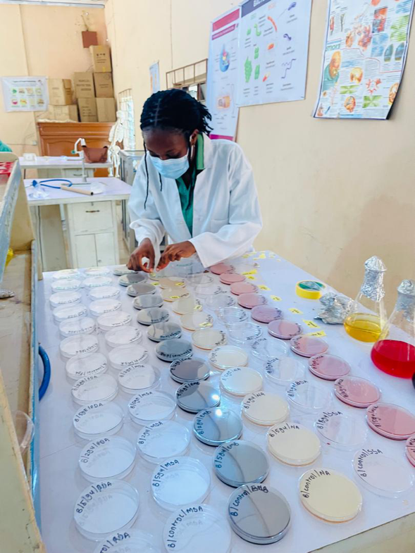
Appendix 1: Labelling of agar plates
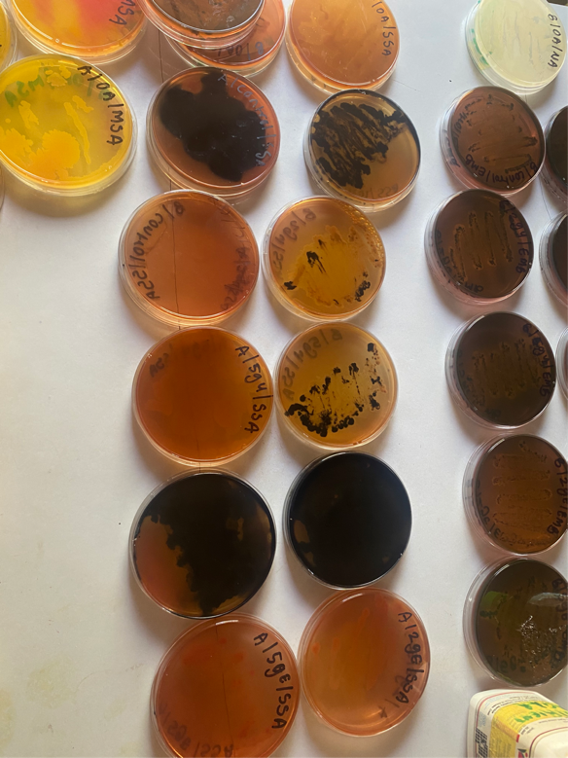.
Appendix 2: Abacha culture plates on salmonella shigella agar, mannitol salt agar and eosin methylene blue agar
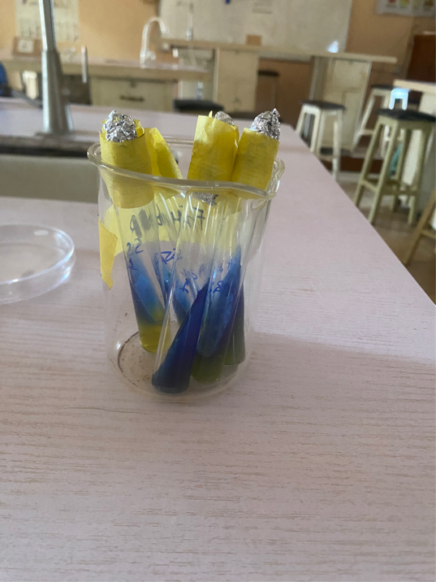
Appendix 3: Citrate utilization test
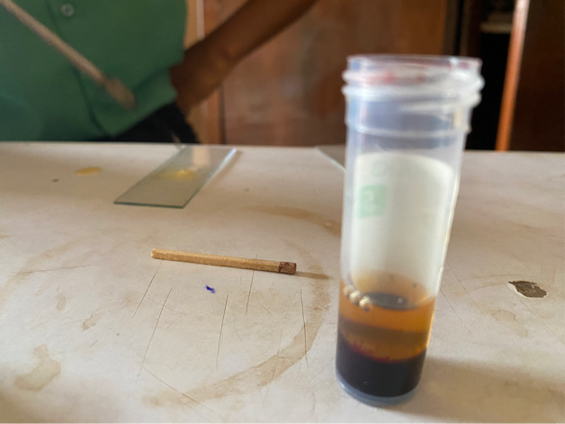
Appendix 4: Coagulase test
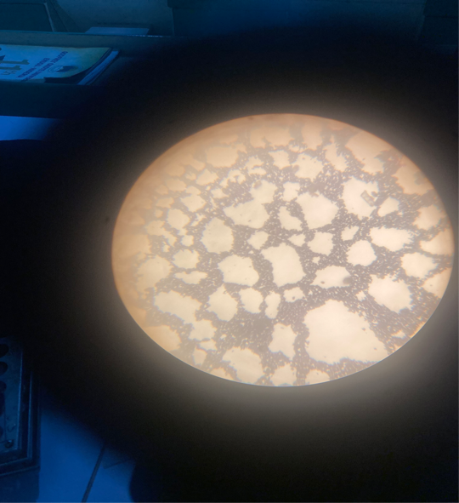
Appendix 5: Microscopic view of abacha sample
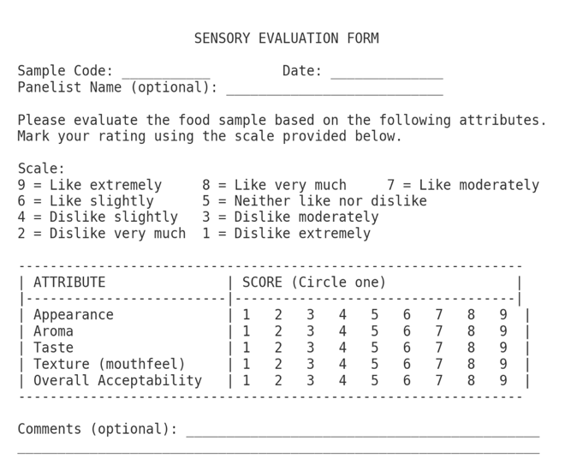Appendix 6: Sensory evaluation questionnaire

