DEVELOPMENT OF A MINIMALISTIC AI POWERED EMAIL CLIENT

BY

OKAFOR AYORACHUKWU NNAOMA
GOU/U21/CSC/728

FACULTY OF NATURAL SCIENCES AND ENVIRONMENTAL STUDIES,
DEPARTMENT OF COMPUTER SCIENCE
GODFREY OKOYE UNIVERSITY, ENUGU

JULY, 2025

DEVELOPMENT OF A MINIMALISTIC AI POWERED EMAIL CLIENT

BY

OKAFOR AYORACHUKWU NNAOMA
GOU/U21/CSC/728

SUBMITTED TO THE DEPARTMENT OF COMPUTER SCIENCE,
FACULTY OF NATURAL AND APPLIED SCIENCES,
GODFREY OKOYE UNIVERSITY, ENUGU.

IN PARTIAL FULFILMENT OF THE AWARD BACHELOR OF SCIENCE DEGREE

SUPERVISED BY
ENGR. DR. KINGSLEY I. CHIBUEZE

JULY, 2024
APPROVAL PAGE
This is to validate that this research work “DEVELOPMENT OF A MINIMALISTIC AI POWERED EMAIL CLIENT” was embarked upon by “OKAFOR AYORACHUKWU NNAOMA” with the matriculation number GOU/U21/CSC/728 in partial fulfillment of the requirements for the award of Bachelor Science(B.SC) in Computer Science, Faculty of Natural Sciences and Environmental Studies , Godfrey Okoye University, Enugu.

_____________
Date
_____________
Signature
Dr. Engr. Kingsley Chibueze
(Supervisor)

_____________
Date
_____________
Signature

External Examiner
(External Examiner)

_____________
Date
_____________
Signature

Dr. Frank Okebanama
(HOD Department of
Computer Science and
Mathematics)

Dr. Engr. Kingsley Chibueze
_____________
Date
_____________
Signature
(Supervisor)

CERTIFICATION
I hereby certify that the work included therein was completed by myself and that it was mainly based only on my own observations and investigation. Consequently I will fully accept the University's decision if I am found to have cheated on the assignment.

________________________
OKAFOR AYORACHUKWU NNAOMA
GOU/U21/CSC/728

DEDICATION
This work “DEVELOPMENT OF A MINIMALISTIC AI POWERED EMAIL CLIENT” is dedicated to my parents Mr. and Mrs. Okafor who painstakingly has contributed heavily to everything that I have achieved up until this day and I pray that the good lord continue to guide and protect them for the rest of their days.

ACKNOWLEGMENTS
First of all, I would like to appreciate the almighty God for his abundant mercies, inspiration and grace throughout this project. In a special way, I want to also acknowledge and appreciate my supervisors, Engr. Dr. Kingsley I. Chibueze for the time he had set aside to make sure that this project is a success and also for guiding me throughout this project. I would also like to appreciate my parents, Mr. & Mrs. Okafor for their love, support and prayers for me throughout this project, my brothers also, for their support and I pray that the good Lord will continue to bless them all.

ABSTRACT
With the rise of artificial intelligence, the global landscape of how digital tools assist in solving people’s problems has been altered dramatically. Complicated activities are now more effective and user-oriented. A distinguishing task that this project tackles is constructing an efficient AI-based email client that can cater to the pressing needs in the management of emails. As a result of this amalgamation of technology and social needs, the resulting email client is a state-of-the-art seamless email client created with advanced features that maintain consistency, security, and functionality. The system is an automated agent possessing Orama which is a robust full-text search engine that allows users to carry out more extensive searches related to email content which can cut down on the amount of time spent scanning for information in emails. The Nylas email API combines the administration of many email services and email protocols into one global system which increases the accountability and protection of users against abuse techniques like spamming and phishing. Moreover, the combination of OpenAI’s latest natural language processing tools makes it possible to conduct context analytic of the emails written and provide recommendations, and automatically generate, respectful and appropriate replies after analyzing the content and context of the message sent according to the goals of the user. Also the system made use of the Shadcn components and Tailwind CSS to make up a playful interface while getting rid of clutter and making it easier to use. This research shows that AI based improvements can enhance long-standing email management challenges while achieving a balance between functionality, security, and simplicity. Ultimately, at the end of the research, the system was rigorously tested and the results gotten shows that the system offers a transformative approach to email communication, empowering users with tools that enhance productivity and ensure a seamless digital experience.

TABLE OF CONETENTS
Cover Page
Title Page i
Certification ii
Approval iii
Dedication iv
Acknowledgements v
Abstract vi
Table Of Contents vii
List Of Figures xi
List Of Tables xi

CHAPTER ONE: INTRODUCTION 1
1.1 Background of the Study 1
1.2 Statement of Problem 3
1.3 Aim and Objectives of the Study 3
1.4 Significance of the Study 4
1.5 Scope of the Study 4
1.6 Limitation of the Study 5
1.7 Operational Definition of Terms 5

CHAPTER TWO: LITERATURE REVIEW 7
2.1 Introduction 7
2.2 Theoritical Background 8
2.3 Description of Different Categories of AI-Powered Email Client 9
2.3.1 Email Drafting Assistants 9
2.3.2 Inbox Management Tools 9
2.3.3 Smart Reply Systems 10
2.3.4 Email Summarization Tools 10
2.3.5 Collaborative Email Platforms 11
2.3.6 Privacy-Focused Email Clients 11
2.4 Brief History of Email Clients 12
2.5 The Future of AI-Powered Email Clients 13
2.6 Review of Related Literature 14
2.7 Summary of Review of Related Literature 20
2.8 Contribution to Knowledge 27

CHAPTER THREE: SYSTEM ANALYSIS AND DESIGN 28
3.1 Introduction 28
3.2 System Analysis 28
3.2.1 Analysis of Existing Systems 29
3.2.2 Weaknesses of Exisisting Systems 31
3.2.3 Analysis of the Proposed System 31
3.3 System Requirements 33
3.3.1 Functional Requirements 33
3.3.2. Non-Functional requirements 33
3.4 Proposed Methodology: Object Oriented Analysis and Design 34
3.4.1 Unified Modelling Language 34
3.4.2 Use Case Diagram of Proposed System 35
3.4.3 Activity Diagram of the Proposed System 37
3.4.4 Class Diagram of the Proposed System 39
3.4.5 Uml Sequence Diagram 40
3.5 System Design 41
3.5.1 Input Interface Designs of the Propeosed System: 42
3.5.2 Output Interface Design of the of the Proposed System 43
3.5.3 Database Design 44
3.5.3.1 Database Schema for the Proposed System 44

CHAPTER FOUR: SYSTEM IMPLEMENTATION 49
4.1 Introduction 49
4.2 Tools used for implementation (Tech stack of the proposed system) 49
4.2.1 Frontend 49
4.2.1.1. Next.js 49
4.2.1.2. React 50
4.2.1.3. Tailwind CSS 50
4.2.1.4. TypeScript 51
4.2.1.5. Clsx 51
4.2.1.6. Tailwind-merge: 52
4.2.2 Backend 52
4.2.2.1 Node.js 52
4.2.2.2 PostgreSQL 52
4.2.2.3 Prisma ORM 53
4.2.2.4 AWS SDK 53
4.2.2.5 Axios 54
4.2.2.6 Neon Database Serverless 54
4.2.2.7 @tanstack/react-query 54
4.2.3 Authentication 55
4.2.3.1 clerk 55
4.2.3.2 @clerk/nextjs 55
4.2.4 Payment 55
4.2.4.1 Stripe API 55
4.2.5 AI and Machine Learning Tools 56
4.2.5.1 OpeanAI API 56
4.2.5.2 Pinecone 56
4.2.5.3 OpenAI Edge 56
4.3 System Requirements 57
4.4 User Interface of the Proposed System 57
4.4.1 Home page of the propose system 57
4.4.2 Sign up Page 59
4.4.3 Payment Checkout Page 61
4.4.4 The Dashboard Interface of the System 62
4.4.5 The AI compose Screen 63
4.5 System Implementation of the Proposed System 64

CHAPTER FIVE: SUMMARY, RECOMMENDATIONS AND CONCLUSION 65
5.1 Overview 65
5.2 Summary 65
5.3 Recommendations 66
5.4 Conclusion 66
REFERENCES 67
APPENDIXES 70

LIST OF FIGURES

Figure pages
1: Use Case Diagram of the Proposed System 36
2: Activity Diagram of Replying to an Email and also Communicating With the Chatbot 37
3: Activity Diagram Showing the Simple use of the Proposed System (System Flowchart) 38
4: Class Diagram of the Proposed System 39
5: Sequence Diagram of the Proposed System 41
6: Input Designs for Composing a Smart Response in the Proposed System 42
7: Output Designs for the Proposed System 43
8: The Home Page of the Proposed System 58
9: The Sign in Pages of the Proposed System 59
10: The Checkout Page of the Proposed System. 61
11: The Dashboard of the Proposed System 62
12: The AI compose screen in the proposed system 63

LIST OF TABLES
Tables pages
3.1: User Table for the Proposed System 44
3.2: Chatbot Interaction table of the Proposed System 47
3.3: Stripe Subsection Table of the Proposed System 45
3.4: Account table of the Proposed System 45
3.5: Email Threads Table of the Proposed System 46
3.6: Email Attachment Table of the Proposed System 47
3.7: Email Table of the Proposed System 47

CHAPTER ONE

INTRODUCTION
  - Background of the Study
The idea of email messaging service can be seen to have its roots in the nascent internet era in which the people started to communicate through different ways. An email messaging however, is a service that allows users to send and receive messages in electronic format via the internet, hence enabling fast and effective communication. Emails can contain text, images, attachments and hyperlinks and are therefore an effective means of communication both in private and in business (Petelka et al, 2019). The introduction of email was quite a transition from traditional post mail, as it brought about faster, cheaper and more effective means of sending mails.
An email client on the other hand, is a program that facilitates sending and receiving emails from different users in an integrated manner. Such programs are installed as desktop or mobile applications or hosted on the web and accessed using a web browser, thereby offering users the opportunity to send, compose, and read mails in an easy manner. The first email clients were simply programs that displayed text on the terminal and had around a dozen commands which users needed to interact with. However, today’s email clients are more of graphically based including features like drag-and-drop, spell checker, address book, email templates and filtering messages (Dada et al, 2019). Some of the well-known email clients are Microsoft Office Outlook, Thunderbird and Apple Mail. Gmail and Yahoo Mail are also email clients as they enable emails to be sent via a web browser without the need to install any standalone applications.
However, AI-powered email clients on its own have surfaced on the internet and at the same time dominated the whole internet space, as it showcases the latest innovation in email management. It therefore leverages artificial intelligence to enhance the experience and efficiency of the user. These clients however, utilize machine learning algorithms to automate tasks like sorting emails, prioritizing messages, and generating responses (Ruoti & Seamons, 2019) .AI-powered email clients can also provide insights and recommendations based on the behavior and preferences of the user. For example, they can suggest an optimal times for sending emails to the user, they can identify important messages, and also they can flag potential phishing attempts. It is important to note that the integration of AI in email clients has transformed the way users interact with their email, making it more intuitive and efficient (Jampen et al, 2020).
Moreover, the introduction of AI into email clients has brought about a lot of profound changes as it has provided a lot of advanced tools which have greatly helped to significantly reduce the time and effort that is being required for effective email management. By automating routine tasks and providing intelligent insights, the AI-powered email clients allow users to focus more on the other different aspects of their work that are more important (Soni, 2019).. This whole automation not only improves the productivity of the users but also enhances the overall email experience, as users can now manage their emails with greater ease and efficiency, leading to better organization and time management. However, the introduction and acceptance of these AI-powered email clients has also driven the development of new features and capabilities thereby further pushing the boundaries of what email management can achieve.
In summary, the introduction of AI-powered email clients has brought about a fundamental and profound change in the email messaging and tech sector as a whole, as these clients have redefined the standards for email management and at the same time setting new benchmarks for efficiency and user experience. However, the impact of AI-powered email clients also extends far beyond the individual users, and at this have influenced organizational workflows and communication strategies. Likewise, as the AI technology continues to advance, the potential for further innovation in email management is very broad, as the integration of AI in email clients represents a significant leap forward, promising to shape the future of digital communication in unprecedented ways (Patel, 2019; Smith, 2020).
  - Statement of Problem
- Most uers receive chunks of emails making it very hard to sort and also spending a lot of time trying to find an email with a specific content.
- Lack of inconsistency and accountability leading to an increased exposure to spamming and phishing attacks as a result of users working with a whole lot of different email clients.
- Inability of the currently existing email clients to provide contextual insights and constructive responses to emails.
- Overwhelming user interface and user experience that is mainly associated with the traditional email clients.
  - Aim and Objectives of the Study
This research is aimed at the design and development of a minimalistic AI-powered email client. The objectives include the following:
- Incorporating an efficient full text email search using Orama to enable users perform extensive search operations based on the content of the emails.
- Incorporating Nylas email API in other to allow users manage different email services and protocols from one single API request.
- Integrating the OpenAI API for detailed language processing, providing contextual insights and suggesting constructive responses to emails.
- Harnessing the beauty of shadcn and the power of tailwind CSS to design an intuitive user interface to enhance the user interface and user experience of users.
  - Significance of the Study
This study “design and development of a minimalistic AI-powered email client” is of considerable relevance to the following sectors:
- The general public, who make use of traditional email clients
- Private and government owned organizations
- The domain of Research and academics
However, this system aims at addressing several critical shortcomings of traditional email clients. These traditional email clients often struggle with issues relating to user experience, user interface and email overload. The study is however significant to aforementioned principalities through the following ways:
- To the general public, who make use of traditional email clients, it helps them in managing and organizing large chunks of email, reducing the time and effort that is being spent on managing emails boosting their overall productivity.
- To the Private and government own organizations, it helps them in managing and organizing a load of mail influx, minimizing the time spent in responding to and composing mails.
- This work of research is also significant to the field of research as it stands to serve as a basis for future research, providing valuable insights into the application of AI in email management. This therefore contributes to the broader field of AI research, highlighting the potential of AI to revolutionize everyday applications and enhance user experiences.
  - Scope of the Study
The project work is not limited to any scope or constraints as it open to be adopted and used by anyone. It however encompasses the detailed discussion of the different processes that is involved in the design and development of a minimalistic AI-powered email client. Moreover, this work of research aims so much at delving into the functionalities that would be needed to improve the experience of the users from the traditional email clients to an AI-powered email client.
  - Limitation of the Study
Limitations to this study include:
- Interrupted power supply: While building the system, sometimes there might be a power outage for probably two days or more, this slowed down the process of building the system.
- Slow Internet connection: Some of the tools that were used in building the system were online, so if there was no Internet connection, the researcher was not able to work.
- Limited accessibility to the required skillset: while building the system, at some point I had to reach out for help to other people because I didn’t have the necessarily required skillset to carry on with the project.

  - Operational Definition of Terms
Email: a simple digital communication system that allows users to send, receive, and store messages over the internet.
Email Clients: An application that is used to manage and organize a user’s email accounts and messages.
Spam emails: unwanted or unsolicited email messages
User interface (UI): The visible means by which the user and a computer application interacts.
Artificial Intelligence (AI): The application of computer systems to perform tasks that are normally associated with human intelligence.
Intelligent Responses: The type of responses that are generated by AI.
Orama: a full-text search application for transforming raw information into valuable intelligence and extracting specified content with precision.
Nylas: An email API provider enables software developers to assimilate emails, calendars, and contacts into one application as auxiliary functionalities.
Render: Provides cloud services for hosting web applications and rest APIs as well as databases in the cloud.
Email API: A unified system to automate complex meta-level procedures associated with managing data-rich content such as emails through sophisticated technological interfaces.
IDE: Integrated Development Environment (IDE) designates a constellation of tools available to software developers in order to ease coding, debugging, and project management tasks.

CHAPTER TWO

LITERATURE REVIEW

2.1 Introduction
The domain of email communication has significantly improved over the years since its inception in the 1960s. These improvements have helped in transforming from a simple messaging system to a complex platform for personal and professional interaction. The early email systems were limited to specific networks and had in most cases required the users to be online simultaneously. However, the advent of the internet and the development of different mailing protocols such as SMTP (Simple Mail Transfer Protocol) in the 1980s helped in revolutionizing email communication, therefore making it more accessible and widespread. As research has it, the 1990s saw the rise of webmail clients, which allowed users to access their emails through web browsers only thereby further democratizing the usage of email.
However, the transition from the traditional email clients to modern AI-powered email clients has been marked by a lot of key innovations. The traditional email systems were primarily manual and at this, they required the users to sort, filter, and respond to emails individually. But with the introduction and integration of AI technology, email communication has now become more efficient and a lot more personalized (Amballa, 2023). In a similar fashion, these AI-powered email clients leverage on the algorithms of machine learning to automate tasks such as email sorting, categorization, and suggesting of response. Consequently, this not only saves time but also enhances the overall experience of the user by prioritizing important emails and reducing the clutter in inboxes.

2.2 Theoritical Background
One of the most prominent features of these modern email clients that are AI-powered is their ability to provide smart reply suggestions. They analyze the content and context of the incoming emails, and then generate a response that is very much relevant on time, thus helping the users to be able to manage their email overload more effectively. Additionally, the AI-driven email platforms have stood to offer a more enhanced security features, such as threat detection and encryption, in other to protect sensitive information from cyber threats (Nair et al, 2023). This constructive approach has become increasingly important as email has continued to be a primary target for phishing attacks and spreading of malware.
Additionally, another significant improvement that have been done in the domain of AI-powered email clients is the incorporation and use of natural language processing (NLP) in other for these system to understand and interpret the content of emails. By doing this, these systems now provide a more accurate email categorization, replies and also a more intelligent search capabilities, thereby making it very much easier for users to find a specific information that is present in the context and content of a particular email message (Al-Mekhlal et al, 2023). Furthermore, this AI algorithms can also analyze the behavior of user and their preferences as well in other to provide email recommendations and content that is more personalized, therefore enhancing engagement of the users and improving their productivity.
In summary, the evolution of email communication from the traditional systems to the currently trending email clients which are heavily AI-powered has not only helped to improve the efficiency and security but have also opened up new possibilities for collaboration and communication. At this, with the continuous advancements in AI technology, the future of email communication is very much promising, with the potential of introducing email systems that are even more intelligent and intuitive.

2.3 Description of Different Categories of AI-Powered Email Client
This section of this work of research will be centered mainly on giving a brief description of some of the different categories of the AI-powered Email client with examples. These different categories include the following; Email Drafting Assistants, Inbox management Tools, Smart Reply Systems, Email Summarization Tools, Collaborative Email Platforms, Privacy-Focused Email Clients etc.
    - Email Drafting Assistants
This type of systems is among the essential subset AI-powered email client systems that helps users to quickly draft emails in a more efficient way by suggesting responses and also completing their sentences automatically. This type of systems do function by analyzing the context and content of an email to offer a suggestion that is relevant, thereby making it much easier and faster for users to compose emails. However, these assistants often make use of natural language processing (NLP) in other to understand the nuances of the text and therefore provide a recommendation that is appropriate. These type of AI-powered email clients include; ComposeAI, and many more.
    - Inbox Management Tools
This is one off the subsets of AI-powered email client systems that helps users to organize their inboxes by categorizing, prioritizing, and filtering of emails. The system normally makes use of AI algorithms to analyze email patterns and use the behavior of users to automatically sort the emails into different folders in other to prioritize the messages that are important. They also do filter out emails that are spam related and the ones that are for promotional bases in other to reduce the clutter and to also help the users to focus on the communications that are relevant. These type of AI-powered email clients include; SaneBox, and many more.
    - Smart Reply Systems
This is one off the subsets of AI-powered email client systems that provides intelligent reply suggestions based on the content and context of the incoming emails. This type of AI-powered email client, makes use of machine learning to be able to analyze the text in an email and however generate a concise response that would be relevant to the context of the email. However, this type of systems offers users the flexibility to choose from the suggested replies, which in turn saves the time and effort that the users spend in composing new emails or email replies from scratch. In addition, it is important to also note that this category of email clients are particularly useful for handling routine and repetitive emails and as it allows users to respond quickly to messages while still maintaining a high level of engagement with their contracts. These type of AI-powered email clients include; Mailbutler, and many more.
    - Email Summarization Tools
This is one off the subsets of AI-powered email client systems that functions by condensing long email threads into a very much concise summaries, in other to save the time of the user and most importantly improve clarity. This category of systems leverage on the power of AI to analyze the content of email conversations and therefore extract the most important information. This category of systems come in very much handy as the summaries that they generate provides a quick overview of the main points that is contained in the email threads, thereby making it a lot more easier for the users to understand and respond to the long email threads. This feature that is provided by this category of AI-powered email clients is particularly valuable for professionals who receive a high volume o emails and need to stay on top of multiple conversations. These type of AI-powered email clients include; Hiver, and many more.
    - Collaborative Email Platforms
This is one off the subsets of AI-powered email client systems that functions to enhance the team collaboration by sharing email context and summaries with a group of teammates. This type of email clients offers a great number of features such as shared inboxes, real time translation and also AI-driven email collaborations. However, by providing a central hub for these emails to communicate, these platforms enable the teams to work together in a way that is more effective, share information among themselves seamlessly and above all, maintain a unified approach to email management, thereby fostering better coordination and also ensuring that everyone is on the same page. These type of AI-powered email clients include; Missive, and many more.
    - Privacy-Focused Email Clients
This is one off the subsets of AI-powered email client systems prioritize the privacy and security of users while still offering them AI-powered features at the same time. This type of email clients do make use of encryption and security protocols that are very much advanced in other to be able to protect information that is sensitive form cyber threats. The best part of this type of clients is that they offer features such as smart replies and AI-driven email management, thereby ensuring that users can enjoy all the benefits that AI provides while still maintaining a high level of privacy at the same time. Nonetheless, this type of email clients are particularly important for individuals and organizations that handle information that are very sensitive and confidential. These type of AI-powered email clients include; Proton Scribe, and many more.

2.4 BRIEF HISTORY OF EMAIL CLIENTS
The evolution of email clients can be pinpointed to the decade of the 70s when the first email was sent by Ray Tomlinson. He was working on ARPANET at the time, and he was the first to use the now popular “@” sign to email a user’s name on a computer. This greatly changed the course of emails as we know them today. The coming decades saw the transformation of email from a simple text box to an all-out necessity in both the personal life as well as in the business world (Dyspatch, 2023). The emailing world saw a dramatic shift in the 1990s due to the introduction of web-based mails like Hotmail and Yahoo Mail. This made emails popular among the masses. However, with mass inclusion of email the problem of spam inbox was also introduced alongside the concern of security.
However, ever since AI was introduced, there has been a significant revolution in the evolution of email clients, they went from being a simple means of communication to being a secure means of communication. AI emails do more than just transfer information. These emails do much more, powered by artificial intelligence, they assist in the sortation of emails, tailored content and automatic email responses as well (Trimbox, 2024). Not only that, these AI emails greatly impacted productivity as they assisted in the effective use of inboxes rather than emails. For example, Smart Compose in Gmail suggests users what to write based on what they have written so far. Hence, faster and more efficient drafting and emailing is possible.
Nonetheless, automation is increasingly becoming commonplace across the world. Phishing detection, spam filtering, and electronic cyber defense are some of the most significant changes one can expect in AI-powered email clients. There is a discrepancy of cyber shield which differs AI systems from other rule based systems. AI-ML email clients can better understand user needs and push content based on their preferences and behavioral activity (spike, 2023). It ergonomically enhances the relevance of the emails in order to increase engagement by the targeted audience. If this progress in artificial intelligence continues, then one can expect a good future ahead for email clients, especially in terms of multimodal communication and better integrations with productivity applications.

2.5 THE FUTURE OF AI-POWERED EMAIL CLIENTS
The robustness of email clients has drastically changed since their introduction to the world in the early 1970’s. What began as an elementary tool to communicate through text, today has transformed to advanced platforms featuring email AI clients. Manual filtering, for instance, was a requirement with traditional email clients and was both time and human error consuming. However, AI now allows the AI email clients to eliminate such human errors since they have now witnessed many upgrades. The result is the enhanced email user experience and efficiency, with features such as smart replies, predicting texts, and sorting, changing the narrative on user interaction with their email.
However, one of the main advantages since the introduction of AI features into email clients has been the ability to gather and analyze large amounts of numerical data in real-time. Understanding how users operate and the limitations that they possess is what AI now seeks to do, meaning email clients can now tailor emails relevant to users. Features like sorting were once a dream for many email clients, which sought to organize emails pertaining to a subject matter, and spam filtering, which aimed to get rid of emails no one needed or wanted, are now commonplace. Along with the integration of email algorithms came the hope that email clients would learn and adapt to human interaction, and constantly develop real-time solutions.
Moreover, the future of AI-powered emails is striking. The development and enhancement of AI technology will allow email clients to integrate more comprehensive features. One of these advancements is the ability to respond to emails in a more relevant context by incorporating NLP technology. AI email clients will also have technology such as AI-enhanced threat detection and appropriate encryption to enhance security. Additionally, with the help of predictive analysis, email clients will be able to understand users and provide suggestions and reminders in advance. By doing that AI email clients intend to enhance the email experience making it easier, faster, and more secure while changing the way we communicate in digital spaces.

2.6 REVIEW OF RELATED LITERATURE
There are a lot of AI-powered email clients that are already existing and this part of this work of research will stand to carefully look into each of these already existing systems which are in close proximity with this work of research in a well detailed manner.
Naeem et al (2018) all worked hard together and developed a smart email client prototype. They designed this system to enhance the management of email and also to provide suggested replies based on the past email responses. The system was however aimed at addressing challenges such as managing high volumes of customer queries, overcoming non-standard terminology in customer emails, and also preventing email backlog. The system made use of a case-based reasoning approach to retrieve similar past replies from a database, ranking suggestions by similarity. The researchers employed advanced text processing and semantic analysis techniques, including synonym expansion, which improved the retrieval of relevant matches. However, at the end of the research, the evaluation of the prototype demonstrated its effectiveness in optimizing retrieval quality, reducing processing time, and managing large data sets, thereby showcasing its potential to streamline email communication workflows.
Dawkins (2019) actively conducted a study where he compared the use of mass email for content delivery in universities as opposed to its application in industries such as retail and public administration. The study was motivated by concerns over academic reliance on less effective email practices, and at that reviewed non-academic and academic research on mass email strategies. A systematic review of 19 studies revealed that academics lag behind industries in evaluating and optimizing mass email communication. However, the researcher identified key obstacles in academia, including technological limitations of learning management systems (LMS) and limited expertise among teaching staff. At the end of his study, he proposed strategies for improvement, emphasizing the importance of analyzing email metrics, testing communication tactics, and optimizing email content to enhance effectiveness.
Goodman et al (2022) all worked together when they embarked on a research work introducing LaMPost which is a prototype email-writing interface leveraging large language models (LLMs) to assist individuals with dyslexia. The system was designed in a way that it helped to address the challenges in spelling, grammar, and word retrieval by incorporating features such as outlining main ideas, generating subject lines, suggesting edits, and rewriting text. At the end of the study, the system was evaluated with 19 adults with dyslexia and the result gotten highlighted the popularity of features like "rewrite" and "subject line generation," but also revealed limitations in LLMs' accuracy and quality for meeting the specific needs of this user group. However, when the system was tested, the participants' being aware of the AI did not affect their sense of autonomy in any way, self-expression, or self-efficacy. Also the study provided valuable insights into both the potentials and limitations of LLM-powered writing tools thereby paving the way for further research that would be done to enhance writing support for individuals with dyslexia.
Akshay et al (2020) all worked together in collaboration and embarked on a study where they proposed a smart email client prototype in their study in which they designed with the aim of addressing the different challenges that are related to managing the overwhelming volume of customer emails that are received daily. Their study however, highlighted that traditional methods, which rely on manual segregation and replies, are inefficient and labor-intensive, especially as email volumes grow. However, in other to streamline this process, the system utilizes Robotic Process Automation (RPA) powered by UiPath software to automate email segregation and routing based on organizational needs. Moreover, the system was designed in a way that it offered fixed replies to common queries, in other to timely and consistent responses. This approach of their system not only helped to reduce the workload on human teams but also prevents messy email backlogs, enhancing operational efficiency for businesses and organizations.
Khan et al (2020), embarked on a research where they implemented TetraMail, which was an email client specifically created to counter the accessibility difficulties that blind users struggle with when using a smartphone to manage their emails. Their investigation addressed the problems such as contradictory interface layout, poorly structured usability, and poor-advanced feedback on the email related tasks such as sending, organizing and filtering received emails. On the other hand, the researchers had in mind the issues of accessibility and usability when developing TetraMail. incorporating features that allowed for the minimizing of the cognitive overload brought about by spam and junk mails, enabling blind users to use touch screen interfaces more conveniently. A year later, an empirical assessment of the usability of the tool was performed involving 38 blind participants who were requested to accomplish 14 email tasks. They managed to make considerable progress in task accuracy, user experience and interface control. As expected, the use of TetraMail proved to be a potential solution for blind email users as the authors noted that it helped make email management easier for the target audience.
Boros and Hlavacs (2018) on their part participated in a project where they designed and implemented MuMail. As described, the system was a simplified email program that was easily modified for use by older adults without having to use conventional email smartphone apps.These challenges include complex interfaces, an overwhelming number of options, and errors caused by intricate swipe gestures. The developed application, MuMail focused on facilitating the sharing of pictures and voice messages while deliberately excluding text-based communication to minimize complexity. The app features an intuitive graphical user interface (GUI) designed to streamline usability and reduce confusion. Preliminary evaluations suggest that MuMail effectively enhances email accessibility for elderly users by prioritizing simplicity and ease of use.
Singh (2022) in his study, examined the impact of AI-powered Interactive Voice Response (IVR) systems and chatbots in transforming customer troubleshooting within the telecommunications sector. However, by analyzing customer data and predicting potential issues, AI systems enable proactive intervention and seamless transitions across communication channels. Case studies from large telecom companies show reduced call volumes, higher first-call resolution rates, and improved customer satisfaction. The study therefore highlighted AI technologies as a strategic investment for sustainable growth and competitiveness in the evolving telecommunications landscape.
Obayuwana (2024) in his study developed a campus office chat application to address remote communication challenges among staff in Nigerian universities, using the University of Benin as a case study. The system, built on a client-server model, consists of three layers: a React.js-based front-end for user interaction, a Node.js backend for application logic, and Firebase DB for data storage. The system was designed for real-time communication and at this facilitated seamless team collaboration and reduces the risk of miscommunication in remote settings. At the end of the research, the system was tested using npm's local server, in which it performed as expected and was deployed via Heroku to ensure accessibility over the internet, showcasing its potential to enhance connectivity and efficiency in academic environments.
Fan and Fujimoto (2021) both in their studied explored the integration of gesture-based operations and Natural User Interface (NUI) design to enhance the realism of digital content interaction on smartphones. The study was focused on the common task of sending emails, and at this was aimed to improve the user experience by incorporating "expressiveness" and "problem-solving ability based on spatial thinking" into gesture operations. The study also proposed a new interface concept that emphasizes the realistic experience of sending emails by creating three-dimensional gesture operations to simulate the act of "sending something to a recipient." The system that was developed also included a mechanism to prevent incorrect email transmission, offering a more intuitive and immersive approach to email management.
Lian (2016) constructed a mail client application based on C# and SQL Server 2008 which adhered to the Simple Mail Transfer Protocol (SMTP) and the Post Office Protocol (POP3) for e-mail transfer communication. The system was capable of sending and receiving messages, managing an address book and real time mail delivery, and was integrated using Microsoft Visual Studio 2010. The system managed tasks such as the management of email accounts and contacts and hence provided an interface which was not complicated but satisfied minimum design standards. Nevertheless, the system completed the extensive testing which was conducted indicating that it was able to perform the targeted functions and offered a straightforward remedy for managing email exchanges.
Amballa (2023) in particular, he explored the areas where AI solutions were useful which for instance include email timetabling, IVR call automation and chatbots in attempt to improve customer support and set appointments in the service sector. The developed system streamlined customer emails by automating the responses to the emails by addressing the strategies at hand such as retrieving health reports and invoices through emails or the booking id provided. The IVR system utilized voice commands as well as an Automatic Speech Recognition (ASR) system to text the voice commands to customers and further interprets the intention of the commands. However, the system made it possible to sort emails for fast delivery and sent important messages.
Patel et al (2019) and his team began their work with an undertaking wherein they be-goggled an automated email response system that could help ease the burden of manually responding to a large pool of emails which is a norm in the corporate industry. In their study, they stated that, once made out-of-the-box, automated responses come out to be mostly cookie-cutter and insert useful frame only casually and on the other hand the automatic response system that they developed envelopes out the framework but the reply depends on what is asked. The system however aimed to reengineer the email process flow as in the amount of time taken to log on and respond to the client’s email was disproportionate and gave a more general response. The case however argues for the successful deployment of the system as this shows how the system has eased the task of responding to emails automating where possible and enhancing productivity within the office space.
Chen et al. (2019) worked together on a research project together where they describe a system they created ‘Smart Compose’ which aims at providing users with timely suggestions as they type, thus enabling them to compose gmail emails faster. The system was based on a large neural language model that has been trained using modern machine learning methods aimed specifically at suggestion prediction. Getting past issues of model choice, system performance evaluation, and deployment overhead. The group built a powerful system for quick prediction and efficient throughput, using machine learning and experimental results from their system demonstrated the system's effectiveness, and it is now deployed in Gmail, improving the email composition experience for users.
Zhou et al (2020) in their study, detailed the development of Microsoft XiaoIce, the world's most popular social chatbot, in which they designed as an AI companion to meet the human need for communication, affection, and social belonging. XiaoIce integrates both intelligent and emotional quotients in its system design, treating human-machine social chat as decision-making over Markov Decision Processes. The system was developed in a way that it included key components such as a dialogue manager, core chat, skills, and an empathetic computing module to enhance long-term user engagement, measured by Conversation-turns Per Session (CPS). Since its 2014 release, XiaoIce has engaged over 660 million active users, achieving an average CPS of 23, outperforming other chatbots and even human conversations in terms of user engagement.

2.7 SUMMARY OF REVIEW OF RELATED LITERATURE
Author(s) Name/  Year | Name of research work/Journal Name | Methodology | Contribution | limitation
Naeem, M. A., Linggawa, I. W. S., Mughal, A. A., Lutteroth, C., & Weber, G. (2018) | A smart email client prototype for effective reuse of past replies. IEEE Access, 6, 69453-69471/ | Case based reasoning. | The system addressed challenges such as managing high volumes of customer queries, overcoming non-standard terminology in customer emails, and also preventing email backlog | The system was developed as a prototype and was never deployed.
Dawkins, R. (2019) | Mass email at university: current literature and tactics for future use. Open Learning: The Journal of Open, Distance and e-Learning, 34(3), 273-289 | Made use of comparison technique. | The study proposed strategies for improvement, emphasizing the importance of analyzing email metrics, testing communication tactics, and optimizing email content to enhance effectiveness. | The system was aa comparison review and didn’t develop any solid system.
Goodman, S. M., Buehler, E., Clary, P., Coenen, A., Donsbach, A., Horne, T. N., ... & Morris, M. R. (2022, October) | Lampost: Design and evaluation of an ai-assisted email writing prototype for adults with dyslexia. In Proceedings of the 24th International ACM SIGACCESS Conference on Computers and Accessibility (pp. 1-18) | Made use of the large language models. | The system it helped in addressing challenges in spelling, grammar, and word retrieval by incorporating features such as outlining main ideas, generating subject lines, suggesting edits, and rewriting text. | The system was built only to correct mistakes and wasn’t able to generate solid response.
Akshay, P. N., Kalagi, N., Shetty, D., & Ramalingam, H. M. (2020) | EMAIL CLIENT AUTOMATION WITH RPA | Robotic process Automation. | The system offered fixed replies to common queries, ensuring timely and consistent responses. | The system offered fixed replies to common queries, ensuring timely and consistent responses.
Khan, A., Khusro, S., Niazi, B., Ahmad, J., Alam, I., & Khan, I. (2020) | TetraMail: a usable email client for blind people. Universal Access in the Information Society, 19, 113-132 | Hybrid methodology | The system functioned to enable blind individuals to manage emails with greater ease and efficiency | The system was only focused on user accessibility and usability without being able to offer smart replies to emails.
Boros, P., & Hlavacs, H. (2018). MuMail–A Simple Multimedia Email Client | In Intelligent Technologies for Interactive Entertainment: 9th International Conference, INTETAIN 2017, Funchal, Portugal, June 20-22, 2017, Proceedings 9 (pp. 130-135). Springer International Publishing. | Object oriented methodology. | The system addressed the challenges that elderly users face with traditional email smartphone applications | The system only allowed for sharing of pictures and voice messages.
Singh, P. (2022). | AI-Powered IVR and Chat: A New Era in Telecom Troubleshooting. African Journal of Artificial Intelligence and Sustainable Development, 2(2), 143-185. | Interactive voice response. | The study examined the impact of AI-powered Interactive Voice Response (IVR) systems and chatbots in transforming customer troubleshooting within the telecommunications sector | The study was only a review and never developed any new system.
Obayuwana, A. (2024). | Design and Implementation of a Client-Server Model for Campus Office Chat Systems. Ilorin Journal of Computer Science and Information Technology, 7(1), 77-85 | Client server model. | The study addressed remote communication challenges among staff in Nigerian universities, using the University of Benin as a case study | The study was very much limited in its scope of development
Fan, Z., & Fujimoto, T. (2021). | Interaction Design for Email Client: User Movements Reflected in Gesture-based Operation. In Proceedings of the 27th International Conference on Systems Engineering, ICSEng 2020 (pp. 237-246). Springer International Publishing.  . | Gesture-based operations and natural user interface. | The study explored the integration of gesture-based operations and Natural User Interface (NUI) design to enhance the realism of digital content interaction on smartphones. | The system failed to solve the main problem which is helping the user to generate responses to emails.
Lian, R. M. (2016, November). | Design and Implementation about E-Mail Client Software Based on C. In 2016 International Conference on Computer Engineering and Information Systems (pp. 457-462). Atlantis Press | Simple mail transfer protocol and post office protocol. | The study developed a system that was designed to manage outgoing and incoming emails, address book management, and real-time mail reception, utilizing Microsoft Visual Studio 2010 as the development platform. | The system was developed using outdated technologies.
Amballa, D. P. (2023). | AI-Powered Customer Support: Transforming Service Delivery through Email Automation, IVR Call Automation, and Chatbots. European Journal of Advances in Engineering and Technology, 10(7), 62-67 | Automatic Speech Recognition. | The study examined the impact of AI-powered solutions, including email automation, IVR call automation, and chatbots, in enhancing customer support and appointment scheduling within the service industry | The system was built to only be able to work with gmail account thereby limiting its application.
Patel, M., Shukla, A., Porwal, R., & Kotecha, R. (2019, April) | Customized Automated Email Response Bot Using Machine Learning and Robotic Process Automation. In 2nd International Conference on Advances in Science & Technology (ICAST). | Object oriented methodology. | The study streamlined email management by reducing the time and effort required to process each email, offering a more efficient and tailored approach to client communication. | The system was limited to the corporate sector only.
Chen, M. X., Lee, B. N., Bansal, G., Cao, Y., Zhang, S., Lu, J., ... & Wu, Y. (2019, July) | Gmail smart compose: Real-time assisted writing. In Proceedings of the 25th ACM SIGKDD International Conference on Knowledge Discovery & Data Mining (pp. 2287-2295) | Large neural language model. | The system provided real-time, interactive suggestions to help users write emails more efficiently in Gmail by reducing repetitive typing | The system was only able to compose emails.
Zhou, L., Gao, J., Li, D., & Shum, H. Y. (2020) | The design and implementation of xiaoice, an empathetic social chatbot. Computational Linguistics, 46(1), 53-93 | Natural language processing (NLP) | The system was designed as an AI companion to meet the human need for communication, affection, and social belonging | The study lead to a development of a chatbot and not development of an email client

2.8 CONTRIBUTION TO KNOWLEDGE
After a detailed review of some of the existing systems which are in one way or the other related to this work of research, the researcher noticed that most of the systems that are already existing have failed to incorporate a simple and easy to navigate user interface. Also most of these already existing systems have failed to incorporate a feature to allow users perform vigorous searches like searching for a specific content in a specific email right from the search box, an AI Chatbot to help users interact directly with their email and incorporating constructive responses to reply to incoming emails. On this note, this work of research have stood to contribute to this domain of knowledge by incorporating features extra features that are absent in the other existing systems which have been listed above to ditch the incontinences that has been posed on users by the absence of these features in the currently existing system and also contributing greatly to the field of research as it now stands as a base for future research.

CHAPTER THREE

SYSTEM ANALYSIS AND DESIGN

3.1 INTRODUCTION
The introduction of email clients that are powered by AI have greatly revolutionized the way that we tend to manage interact with emails. These systems are advanced because they make use of artificial intelligence to automate and also streamline different tasks that are email related, in other to improve the experience and productivity of users in a great way. However, this Ai-powered email clients can now sort and prioritize emails, provide replies that are smart, detect spam and phishing attempts, and even offer content recommendations that are personalized to the user, thanks to the fact that machine learning algorithms and natural language processing have been implemented on them.
Moreover, the object-oriented method of system analysis and design will be applied in this chapter of this work of research to examine how machine learning algorithms can be applied in email clients to make them smart and intelligent. The system will further be implemented using Object-Oriented Analysis and Design (OOAD) as a methodical approach to model and create complex system.

3.2 SYSTEM ANALYSIS
System analysis involves the dissection of the proposed system and the examination of its individual components and their interactions. This section of this research work stands to address the comprehensive system analysis of the proposed system encompassing an evaluation of existing systems, identification of the limitations within those systems and the strategies for enhancement. However, the analysis of the proposed system encompasses the detailed modelling activities using use case diagrams, activity diagrams, and class diagrams.

3.2.1 ANALYSIS OF EXISTING SYSTEMS
Naeem et al’s smart email client prototype:
This system was designed to enhance the management of email and also to provide suggested replies based on the past email responses. The system was however aimed at addressing challenges such as managing high volumes of customer queries, overcoming non-standard terminology in customer emails, and also preventing email backlog. The system made use of a case-based reasoning approach to retrieve similar past replies from a database, ranking suggestions by similarity. The researchers employed advanced text processing and semantic analysis techniques, including synonym expansion, which improved the retrieval of relevant matches. However, at the end of the research, the evaluation of the prototype demonstrated its effectiveness in optimizing retrieval quality, reducing processing time, and managing large data sets, thereby showcasing its potential to streamline email communication workflows.
LaMPost:
This system is a prototype email-writing interface leveraging large language models (LLMs) to assist individuals with dyslexia. The system was designed in a way that it helped to address the challenges in spelling, grammar, and word retrieval by incorporating features such as outlining main ideas, generating subject lines, suggesting edits, and rewriting text. At the end of the study, the system was evaluated with 19 adults with dyslexia and the result gotten highlighted the popularity of features like "rewrite" and "subject line generation," but also revealed limitations in LLMs' accuracy and quality for meeting the specific needs of this user group. However, when the system was tested, the participants' being aware of the AI did not affect their sense of autonomy in any way, self-expression, or self-efficacy. Also the study provided valuable insights into both the potentials and limitations of LLM-powered writing tools thereby paving the way for further research that would be done to enhance writing support for individuals with dyslexia.
TetraMail:
This system was an email client specifically created to counter the accessibility difficulties that blind users struggle with when using a smartphone to manage their emails. Their investigation addressed the problems such as contradictory interface layout, poorly structured usability, and poor-advanced feedback on the email related tasks such as sending, organizing and filtering received emails. On the other hand, the researchers had in mind the issues of accessibility and usability when developing TetraMail. incororporating features that allowed for the minimizing of the cognitive overload brought about by spam and junk mails, enabling blind users to use touch screen interfaces more conveniently. A year later, an empirical assessment of the usability of the tool was performed involving 38 blind participants who were requested to accomplish 14 email tasks. They managed to make considerable progress in task accuracy, user experience and interface control. As expected, the use of TetraMail proved to be a potential solution for blind email users as the authors noted that it helped make email management easier for the target audience.
MuMail:
The system was a simplified email program that was easily modified for use by older adults without having to use conventional email smartphone apps. These challenges include complex interfaces, an overwhelming number of options, and errors caused by intricate swipe gestures. The developed application, MuMail focused on facilitating the sharing of pictures and voice messages while deliberately excluding text-based communication to minimize complexity. The app features an intuitive graphical user interface (GUI) designed to streamline usability and reduce confusion. Preliminary evaluations suggest that MuMail effectively enhances email accessibility for elderly users by prioritizing simplicity and ease of use

3.2.2 WEAKNESSES OF EXISISTING SYSTEMS
- Prottasha et al’s rice disease Detection model:
The weakness of this system comes from the system being developed as a prototype and was never deployed, thereby making the system not useful to the domain of research.
- LaMPost:
The weakness of this system however comes from the system being built only to correct the grammatical errors and mistakes but was never able to generate a solid response to incoming emails.
- TetraMail:
The weakness of this system however comes from the system being built to only focus on user accessibility and usability without being able to offer smart replies and email summaries to incoming emails.
- MuMail: The weakness of this particular system sterns from the system being built to only allow the sharing of pictures and voice messages and its scope of use being limited to adults only.

3.2.3 ANALYSIS OF THE PROPOSED SYSTEM
This system represents a significant step forward in addressing the existing pitfalls and knowledge gaps within the traditional email clients which offers users the opportunity to manage their emails manually. This proposed system is however an innovative one as it incorporates a lot different features which are mainly designed to provide users with the ease and flexibility to approach their email handling process, with one of the key aspect of this system being the integration of an AI based chatbot using orama. This feature therefore, allows users to communicate directly with their emails, asking questions about the contents in their emails and getting quality responses based on things that are present in the body of their emails, thereby saving users the effort and time or scrolling through their inbox trying to find an information that is present in a particular email.
However, this system incorporates a distinctive feature as it utilizes the OpenAI’s API which makes use of large language models (LLMs) to read through and understand the context of in-coming emails. Moreover, unlike the conventional email clients that exist to only offer fixed replies to emails that contains similar text as stored in its library, this system makes use of the OpenAI’s API in collaboration with other tools to elevate the creative replies that it offers to incoming emails as it now focuses on generating creative replies based on the context of the incoming email. With this, the proposed system not only focuses on helping the user in generating automated responses, but it also performs a constructive analysis on the context of the incoming message to know the right reply generate for the user.
Furthermore, this system takes a holistic approach by empowering users with the flexibility of using different email from different email providers and email clients through one intuitive interface. This feature however provides users with the opportunity to login all their emails which may be using different transmission protocols to one platform and allowing them send email messages through all of them at a go. The system does this using Nylas which is an email service API that receives requests from the systems user interface and then translates the message to the specific email provider’s protocol. In essence, this system focuses on changing the way that uses tend to manage their emails as it leverages on advanced AI-based tools and machine learning algorithms to revolutionize the whole activities that are involved in sorting, replying and managing emails to foster efficient and enhanced productivity on the side of the user.

3.3 SYSTEM REQUIREMENTS
System requirements are the necessary procedures and specifications that outline the functions or attributes that a system must possess. These system requirements are therefore divided into two categories which are functional requirements and non-functional requirements.

3.3.1 Functional requirements
The functional requirements of a system refer to the requirements that specifies in detail, the qualities that a system must have. The Functional requirements of proposed system include the following:
- The system’s user interface should be as simple as possible to use.
- The system must be able to update the inbox of the user with the latest incoming email messages.
- The system must be able to save the email progress of a user as draft when they stop halfway while composing an email.
- The system must be able to generate smart replies for the user when needed.

3.3.2. Non-Functional requirements:
The non-functional requirements is used to refer to the requirements that specify the attributes or abilities that the proposed system must have. Non-functional requirements for the proposed system inclu.de that:
- The proposed system should be able to handle and sort the huge flux of emails that is being received by the user.
- The proposed system should be able to maintain the consistency of with it constructive replies to emails.
- The access to the data on the system has to be based on the fact that the user is signed in.

3.4 PROPOSED METHODOLOGY: OBJECT ORIENTED ANALYSIS AND DESIGN
Object-Oriented Analysis and Design (OOAD) stands as a software development methodology that employs the object-oriented concepts for the creation and implementation of software system. However, within this approach, the initial step involves determining the system requirements followed by the identification of classes and their respective relationships with each other in the system. Moreover, various techniques and practices are integral to this methodology which encompasses UML diagrams, object-oriented programming, and use cases. Consequently, OOAD employs object-oriented programming for the actual design and implementation of the software system as the UML diagrams play a crucial role in illustrating different facets and interactions among various components within the software system. Lastly, use cases are employed to articulate the diverse manners in which users engage with the software system. The application of OOAD is particularly suited for handling intricate systems, substantiating its selection for such scenarios.

3.4.1 UNIFIED MODELLING LANGUAGE
The unified Modelling Language (UML) diagrams stands to serve as a cornerstone in the realm of software engineering, providing a standardized and visual means to represent the intricacies of a software system comprehensively. These diagrams offer a powerful tool for software architects, software developers, and stakeholders to collaboratively conceptualize, design, and most especially communicate on the various aspects of a software system. However, one UML diagram that is considered most crucial is the use case diagram which stands to outline the potential interactions between users or external entities and the system thereby serving as a blueprint for understanding the functional requirements and scenarios within the software application.
Subsequently, the activity diagram stands to complement the use case diagrams as it brings dynamic aspects of system development processes to the forefront by illustrating the overall flow of activities within the system thereby capturing the sequential and parallel processes that unfold during system operation. However, this dynamic perspective stands to aid in visualizing the overall workflow which takes place in the system thereby helping to identify the potential bottlenecks, decision points, and opportunities for optimization in the software system.

3.4.2 USE CASE DIAGRAM OF PROPOSED SYSTEM
Use case diagrams are classified into four categories; use cases which are the functional parts of the system , the actors which represent the external entities of the system, the associations between the actors and the use cases, and lastly the system boundary which is the scope of the system the actor is interacting with.
As for the proposed system, there would be 2 actors which are; the user and the system. However, according to the use case diagram, the user will have 7 use cases (actions in which he/she can perform on the system. The use case of the user includes, logging in to the system, reading emails, sending emails, saving emails as draft if haven’t completed a message, deleting a mail and communicating with the AI-powered chatbot in the system. While the system on the other hand will be able to compose constructive email replies based on the context and content of the incoming emails, generate fresh email messages, communicate with the user based on the context of his/her emails. And lastly send emails through different email provider’s transmission protocols etc.

Use case diagram:
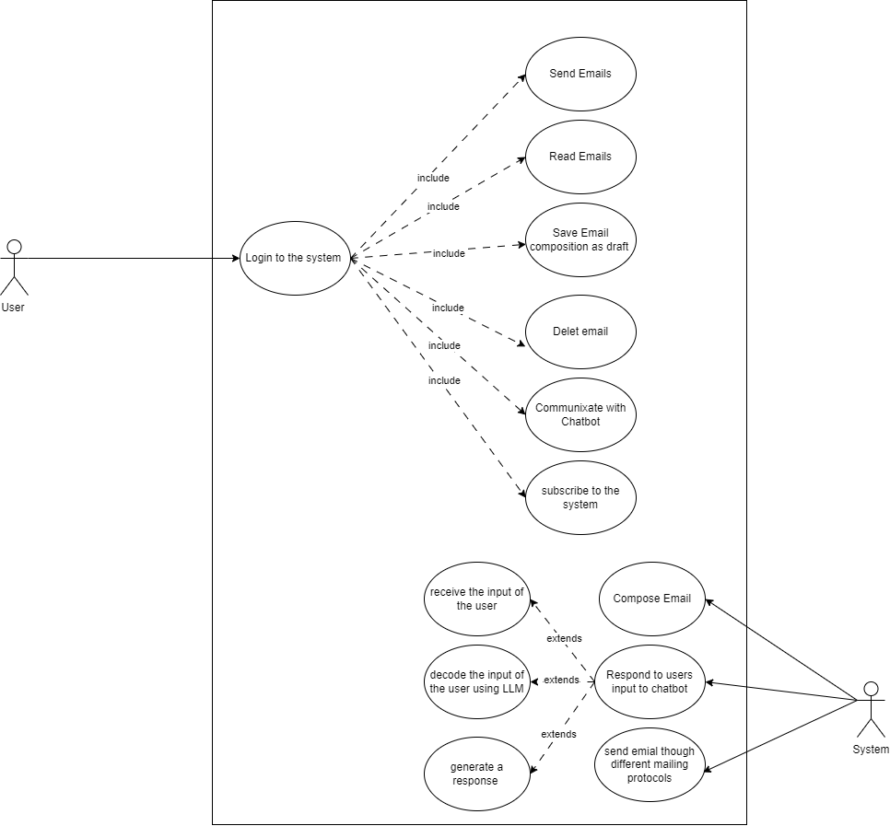

Figure 3.1 Use case diagram of the proposed system
The diagram above shows the use case activity that takes place in the proposed system, the system is made of two main entities, the system, the user can perform a myriad collection of activities which include visiting visit and logging in to the system, reading emails, sending emails, saving emails as draft if haven’t completed a message, deleting a mail and communicating with the AI-powered chatbot in the system. While the system on the other hand will be able to compose constructive email replies based on the context and content of the incoming emails, generate fresh email messages, communicate with the user using the orama API which reads through the all the email messages that are present on the users inbox and offers constructive replies to the user based on the context of his/her emails. And lastly send emails through different email provider’s transmission protocols etc.

3.4.3 ACTIVITY DIAGRAM OF THE PROPOSED SYSTEM
An activity diagram stands as another important diagram in Unified Modelling Language (UML). It is however a diagram that describes the dynamic aspects of the software system. However, an activity diagram is basically a flowchart to describe the flow of activities that go on in the system. The figure below represents the flow of activities on the proposed system, from the visiting of the platform and signing up by the user, to composing a constructive reply based on the incoming email and also performing other tasks and activities in the system.
Activity diagram of the proposed system:
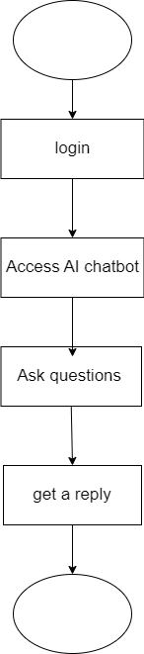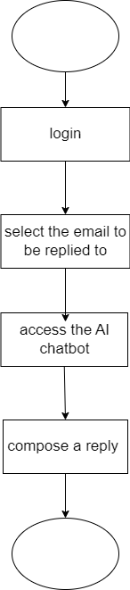

Figure 3.2 Activity diagram of replying to an email and also communicating with the chatbot.
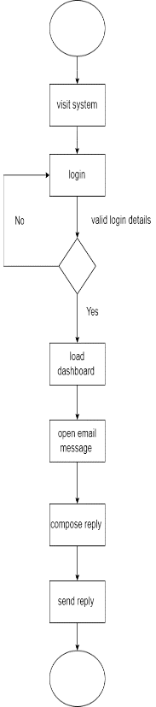

Figure 3.3 Activity diagram showing the simple use of the proposed system (system flowchart).
The diagram above represents the class diagram of the proposed system which stands to display the pictorial representation of the activity that takes place in the proposed system. The activity ranges from the user logging in to the system, reading emails, sending emails, deleting a mail and communicating with the AI-powered chatbot in the system. While the other diagrams stands to depict how the system will be able to compose constructive email replies based on the context and content of the incoming emails, generate fresh email messages, communicate with the user using the orama API which reads through the all the email messages that are present on the users inbox and offers constructive replies to the user based on the context of his/her emails. And lastly send emails through different email provider’s transmission protocols etc.

3.4.4 CLASS DIAGRAM OF THE PROPOSED SYSTEM
This section of this work of research holds the class diagram of the proposed system. The class diagram in Unified Modelling language (UML) is one of the unified modelling language diagrams that describes the architectural design of a software system by defining and laying out completely its classes, the attributes of the laid out classes, the methods and the relationships among this different objects that make up a system. Below is the illustration of the class diagram for the proposed system which shows a crud depiction of the different classes that are existing in the system showing the properties and methods that are present in the system.
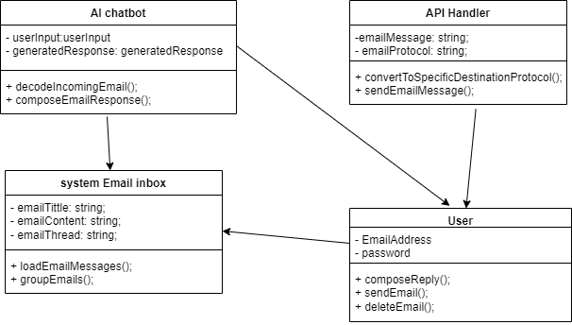

Figure 3.4 Class diagram of the proposed system
The diagram above represents the class diagram of the proposed system, which is used in this research work is used to show the different classes that exist within the system and how they interact with one another in other to communicate and share data. The diagram depicts the crud instance of the classes in the proposed system offering the readers of this work of research the opportunity to visualize how the component classes of the system collaborate with one another in other for the system to function properly.

3.4.5 UML SEQUENCE DIAGRAM
The unified Modelling Language (UML) sequence diagrams serve as a dynamic pictorial model which depicts the various interactions between the different objects that exists within a system over time. Similarly, these diagrams are very important in the understanding of the chronological flow of actions and messages that occur during the execution of a particular use case or scenario. However, at its core, these sequence diagrams visually represent the order in which interactions take place therefore providing a clear depiction of how the various components collaborate in a specific system to achieve the specified goal.
However, the elements in the UML sequence diagram include lifelines, messages, activations, and objects of which the lifelines represent the entities involved in the interaction, while messages denote the communication between the different entities. Moreover, activations that are portrayed using vertical lines extending from lifeline and therefore stands to represent the duration of an object's involvement in an interaction. Consequently, this temporal dimension adds a crucial layer of understanding thereby allowing developers and stakeholders to grasp not only what occurs in the system but also when it occurs within the system's operation.
Moreover, UML sequence diagrams help to facilitate the communication between the technical and non-technical stakeholders in a system and by offering a visual representation of system dynamics these diagrams stand as a powerful tool for conveying intricate technical details in a more accessible manner. However, the use of these diagrams contributes to improved collaboration thereby fostering a shared understanding of system behaviour and also aiding in the identification of potential issues for future enhancements.
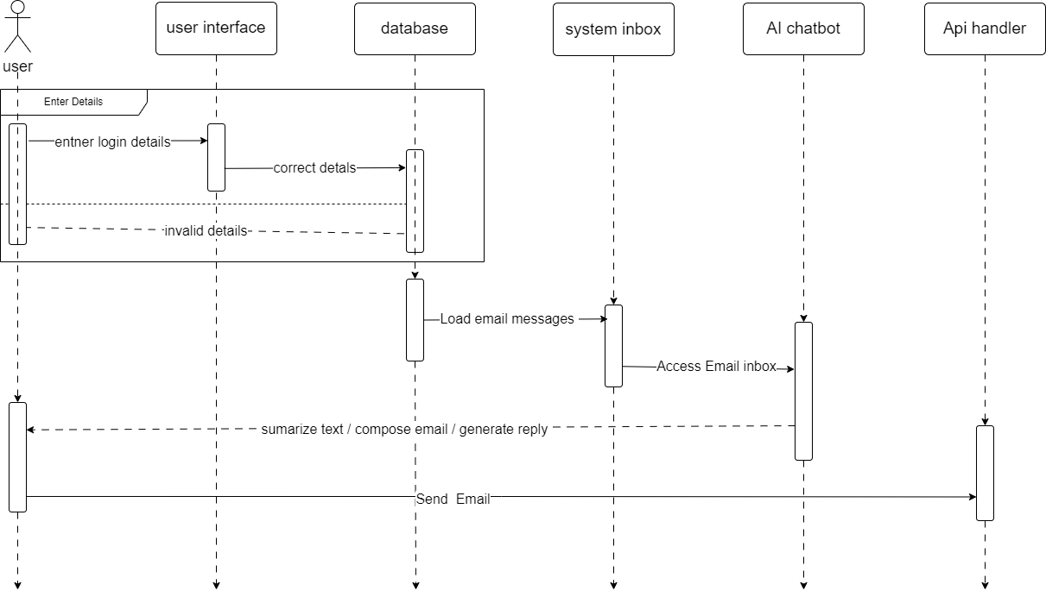

Figure 3.5 Sequence diagram of the proposed system
The above diagram stands to depict the sequence diagram of the proposed system which functions to show the sequence of activities that is taking place in the proposed system, right from the visiting the system’s user interface to communicating with the system, reading emails, chatting with the AI-based chatbot of the system, getting a generated response from the system and sending the generated response as email to a user.

3.5 SYSTEM DESIGN
The system design of a system refers to the whole process that is involved in defining and developing the architecture, components and also the interactions that occurs within a complex system. This however, involves the combination of all the input and output designs and the database design of the system which works hand in hand to enable the user communicate with the system and also allow the system to respond and give an output to the user. At this, the goal of system design is to craft the design of a system in such a way that it meets necessary requirements and needs of its users while also ensuring that it is efficient, scalable, reliable, and maintainable.
On the other hand, this section of this work of research will be based on the detailed design of the proposed system and how the system hopes to fulfil the requirements that have been stated above. This system design is however, going to comprise of the simple design interface of the proposed system showing the physical sketch of the system as it aims at making its features accessible to the users as well as the database structure design showing the structural implementation of the database

3.5.1 INPUT INTERFACE DESIGNS OF THE PROPEOSED SYSTEM:
This section of this research work stands to illustrate how the system hopes to fulfil the requirements that have been stated in the previous sections above by showing a simple interface design of the input section of the proposed system as it aims at making the features of the proposed system accessible to the users. The interface sketch of the proposed system is shown below
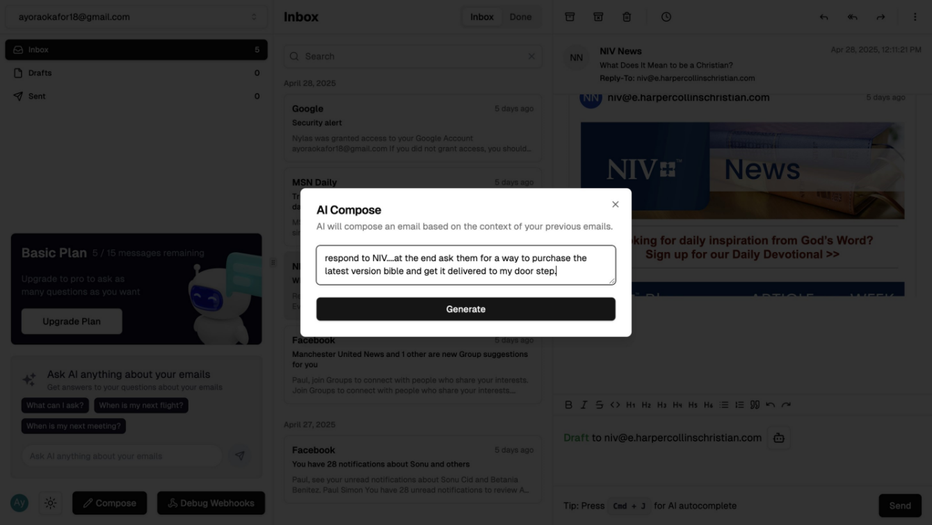

Figure 3.6 Input designs for composing a smart response in the proposed system
The diagram above shows the user interface design for the proposed system through which the user gets to enter a text based command into the system for the system to generate a reply to an email, it also shows an input interface of the AI-powered chatbot in which the user interacts with by asking questions about what he or she wants to know, which is present in the content of any of the emails that are present on the email inbox.

3.5.2 OUTPUT INTERFACE DESIGN OF THE OF THE PROPOSED SYSTEM:
This section of this research work stands to illustrate how the system hopes to fulfil the requirements that have been stated in the previous sections above by showing a simple interface design of the output section of the proposed system as it aims at making the features of the proposed system accessible to the users. However, this sections displays a screenshot of the interface design of the output section of the proposed system, depicting the way that information would be outputted by the system after generating a smart reply for an email. The interface design of the output section of the proposed system is shown below
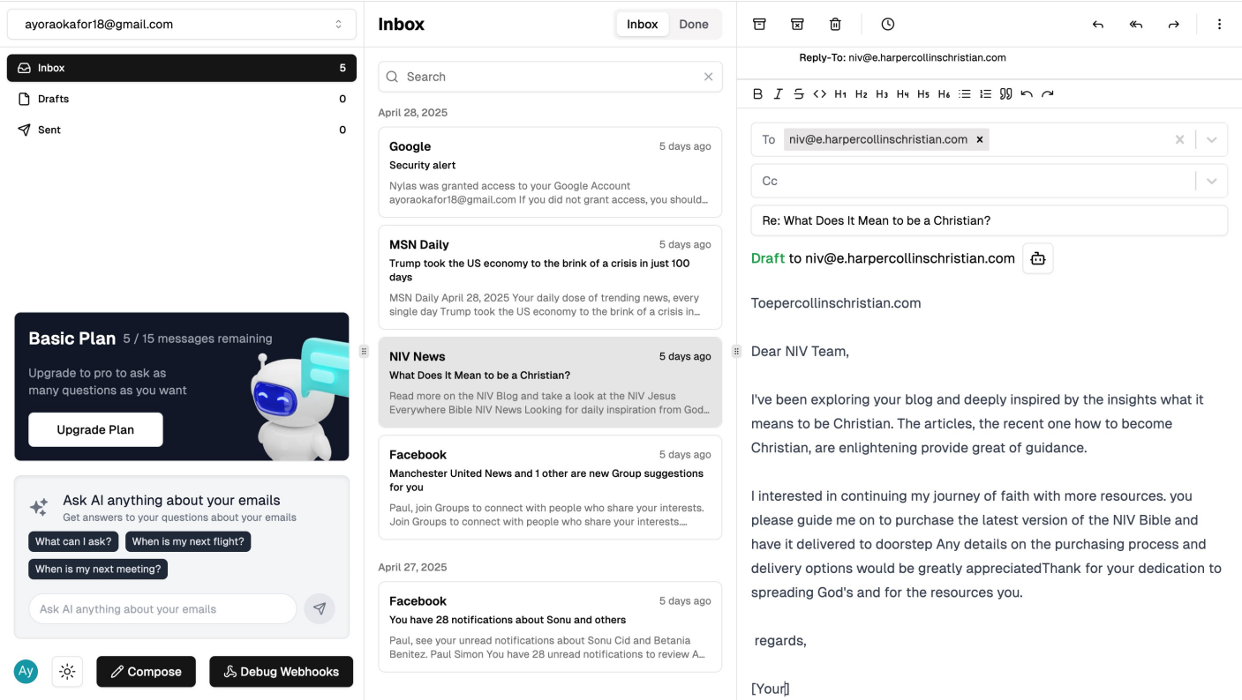

Figure 3.7 Output designs for the proposed system
The images above shows the output interface of the proposed system. The images however shows how the output gotten after the prediction of the crop disease would be arranged and displayed on the screen. On a general note, a pictorial representation of the interface used in outputting data out of the proposed system. These output interfaces that are supplied to the platform cuts across mainly the act of displaying the output that was gotten from the model.

3.5.3 DATABASE DESIGN
This design of a database id the crud depiction of how the database is going to appear when created. It shows the different tables that would be used for storing data within the database. However, the essence of the database design is to show a modelled view of the proposed system’s’ database. The proposed systems’ database is a relational database that would be designed and implemented using PostgreSQL and hosted on using Render. The database was designed to have entities and at least attributes for each entity.

3.5.3.1 Database schema for the proposed system

Table 3.1 User table for the proposed system
Attribute | Data Type | Description
Id | int | The primary key of the table
firstName | string | This is where the firstname of the user is stored.
lastName | string | This is where the lastName of the user is stored
EmailAddress | string | The field for storing the users email.
imageUrl | string | The field for storing the url of the user’s profile image.
stripeSubscriptionId | String | The id of the users stripe subscription.
role | String | This role of the user
chatbotInteraction | Sting | This is where the user interaction with the chatbot is stored.

Table 3.2 Chatbot interaction table of the proposed system
Attribute | Data Type | Description
Id (pk) | int | The primary key of the table.
day | timestamp | The day the user interacted with the chatbot
count | int | The number of interactions with the chatbot
UserId | string | The id of the user that interacted with the chatbot

Table 3.3 Stripe subsection table of the proposed system
Attribute | Data Type | Description
Id (pk) | int | The primary key of the table.
createdAt | timestamp | The date the subscription was created
userId | string | The id of the user that created the subscription
subscriptionId | string | The id of the subscription
priceId | string | The id of the price of the subscription
updatedAt | timestamp | The date the subscription was updated.

Table 3.4 Account table of the proposed system
Attribute | Data Type | Description
Id (pk) | int | The primary key of the table.
userId | String | The login id of the user
token | String | The token for loging in the email
provider | String | The provider parameter
emailAddress | String | Email address of the user
name | String | Name of the user
threads | Array | The email threads
emailAddresses | Array | Destination email address of sent emails.

Table 3.5 Email Threads table of the proposed system
Attribute | Data Type | Description
Id (pk) | int | The primary key of the table.
subject | String | The subject of the thread
lastMessageDate | dateTime | The time the last message in the thread was sent
participantIds | String | The id of the participants in the thread
accountId | String | The id of the account in the thread
done | Boolean | Indicates if the user is done with the email
inboxStatus | Boolean | Indicates if the message in the inbox
draftStatus | Boolean | Indicates if the message is in the draft box
sentStatus | Boolean | Indicates if the message has been sent.

Table 3.6 Email Attachment table of the proposed system
Attribute | Data Type | Description
Id (pk) | int | The primary key of the table.
name | String | Name of the attachment
mimeType | String | The mine type of the attachment
size | String | The size of the attachment
contentId | String | The id of the content
content | string | The content of the attachment
contentLocation | string | The location from which the content is coming from
Email | string | The email that holds the attachment
emailId | string | The id of the email holding the attachment.

Table 4.7 Email table of the proposed system
Attribute | Data Type | Description
Id (pk) | string | The primary key of the table.
threadId | String | The id of the thread that the email belongs to
createdTime | Datetime | The time the email was created
lastModifiedTime | Datetime | The last time the email was modified
SentAt | Datetime | The time the email was sent
ReceivedAt | Datetime | The time the email was received
internetMessageId | String | The internet Message id of the email
Subject | String | Subject of the email
From | String | Where the email is from
FromId | String | The Id of the place the email is from
HasAttachments | Boolean | Indicates if the email has attachments
Body | String | The body of the email
bodySnipet | String | The snippet of the body of the email
Attachments | File | The attachment that is included in the email
inReplyTo | String | The email that is being replied to
threadIndex | String | The index of the thread that the email belongs to.

CHAPTER FOUR

SYSTEM IMPLEMENTATION

4.1 Introduction
This chapter discusses the system implementation of the proposed system i.e. the way the different components of the proposed system have been put together to enable it function properly. However, after a thorough process of system analysis on both the existing systems and the proposed system, and also after outlining of the system and all the system requirements, the proposed system have now been implemented using the appropriate tools that has been adopted and also tested. This chapter therefore is going to discuss in full detail the user interfaces of the various different functional parts of the proposed system as well as all the tools that was employed in implementing this system.

4.2 Tools used for implementation (Tech stack of the proposed system)

4.2.1 Frontend

4.2.1.1. Next.js
Next.js is a powerful React and JavaScript web application framework. That gives one of the most effective and smooth ways for development. It easily handles client-side and server-side rendering in other to allow you to create dynamic and interactive web pages. But one of the main features of Next.js is that it can automatically split code as it can load only the part of the code needed for the specific section of the page thereby increasing performance. However, Next.js also gives support for building static websites where pages are pre-rendered at build time as it was integrated with integrated routing, so that the page navigation will be very smooth. Next.js is highly flexible and offers a bunch of plugins and extensions to make the platform functional. Moreover, there is quite a good community and a lot of documentation backing it, which makes it really easy for developers to start off and resolve issues with ease.

4.2.1.2. React
React is one of the tools that was used to in implementing the system and it is basically one of the well-liked JavaScript library for creating user interfaces for web application because it is very efficient and well-known and also simple therefore making it a favorite tool to be used by developers. It can be used to create dynamic, interactive components that update in real time and most importantly, it gives users a snappy, responsive experience. However, one of the primary characteristics of React.js is its ability to update only the portions of the page that have changed thereby eliminating the need for a complete page reloads when a change is made on the page and increasing performance using a virtual DOM (Document Object Model). In addition to this, React encourages the use of reusable components, which helps in improving application scaling and maintenance. Moreover, it offers a declarative syntax, giving developers the opportunity to specify how the user interface (UI) should appear depending on the state of the program, which makes the code simpler and easier to understand. Also, React has a large and active community, with plenty of resources and support available for developers of all levels.

4.2.1.3. Tailwind CSS:
Tailwind CSS is a CSS framework that is utility-first. It was used to build the proposed system because it helps to simplify the process of styling web applications because it provides a set of utility classes that have been pre-designed which you can use to style HTML elements directly in your markup, thereby eliminating the need for writing custom CSS. However, developers can use it to create responsive and visually appealing designs very fast without the complexity of traditional CSS frameworks. It is normally used because it is a modular approach for easy customization and flexibility and at that it is suitable for projects of any size and therefore encourages a consistent design system by providing a predefined set of utility classes for common design patterns, such as spacing, typography, and colors. Most importantly, it offers a purge feature which on its own automatically removes the CSS that is not used from your final build to help to keep file sizes small and improve performance.

4.2.1.4. TypeScript:
TypeScript is a superset of JavaScript. It introduced static typing in other to help enhance quality of code and also the efficiency of development. It allows developers to define types for variables, functions and objects, thereby catching errors during development and reducing the issues that are encountered during runtime. It is also able to integrate seamlessly with the libraries of JavaScript, its tools and its frameworks, which include React thereby enables for better organization and documentation of codes. It also improves the support of IDE, making it easy for developers to refactor code, make use of autocompleting and as well make their debugging more straightforward, thereby improving the overall productivity of developers. Also, it incorporates the type inference feature and also implements other robust tooling making it an essential language for large and complex applications.

4.2.1.5. Clsx:
Clsx is a tool in JavaScript that combines class names under specific conditions. It enables programmers to apply CSS classes according to the dynamic state of the application thus improving the overall quality of the code. Clsx is most effective in handling the style changes using complex conditions in big front-end applications.

4.2.1.6. Tailwind-merge:
Tailwind-merge is utility that can resolve the class conflicts when working with Tailwind CSS. Merging the classes using this tool ensures that there is no duplication and the correct style is applied thus simplifying the styling task. It is particularly beneficial for pushing the borders of style consistency and efficiency in Tailwind based projects.

4.2.2 Backend

4.2.2.1 Node.js
Node.js was one of the tools that was used to build the backend of this application as it is one of the major tools that is used in building backend applications. It is a runtime environment for executing JavaScript code outside of a web browser thereby allowing developers to build a very scalable and efficient server-side applications with the use of JavaScript of which on a traditional note, is used for client-side scripting. It makes use of an event-driven, non-blocking input/output model that makes it very lightweight and suitable for handling large volumes of concurrent requests. It is popularly known for its speed and performance, making it ideal for building real-time applications like chat platforms and streaming services. However, it also provides developers with the ability to easily create APIs, handle database operations, and also serve web pages, all within a single JavaScript codebase. On the same vein, it has a vast ecosystem of open-source libraries and packages which it uses to provide solutions for a wide range of development needs.

4.2.2.2 PostgreSQL
PostgreSQL is an advanced relational database management system that provides dependable and rich set of features for data storage. It has support for high-level features such as transaction management, complex querying and defining foreign keys which help in data management. The extensibility of PostgreSQL allows application developers to implement a wide variety of use cases by enabling them to create their own functions and types. Furthermore, support for JSON and geospatial types allows PostgreSQL to be used in modern applications that need to be flexible and scalable.

.4.2.2.3 Prisma ORM
Prisma ORM is a modern database toolkit that is specially created to be used for Node.js and TypeScript applications which mainly exists to simplify database access and management by providing a type-safe and intuitive interface for working with databases as it offers developers the opportunity to define their data models using a declarative schema syntax, which on its own automatically generates database tables and relationships. It supports a variety of databases which includes PostgreSQL, MySQL, and SQLite, thereby giving room for flexibility in database selection. It however, offers powerful querying capabilities which enables developers to perform complex database operations with ease as also provides built-in data validation and sanitization with which it ensures data integrity and security.

4.2.2.4 AWS SDK
With the help of AWS SDK, developers can easily incorporate Amazon Web Services into the applications they build. AWS SDK offers access to several APIs, which include S3 for storage, Lambda for server-based applications, and DynamoDB for NoSQL databases. The SDK is multilingual, which allows cross-platform functionality. With AWS SDK, develzopers are able to create high-quality, scalable, secure, and cloud-native applications with the help of Amazon infrastructure.

4.2.2.5 Axios:
Axios is a promise-based HTTP client which is commonly used for making API calls while working with JavaScript. It aims to improve the general workflow when requesting, sending, and handling data between the client and the server. It comes with support for request cancellation, timeouts and error handling which collectively make the application more robust and communicative. Axios also supports interceptors that allow requests and responses to be altered. This means advanced features such as logging and authentication token handling can be included.

4.2.2.6 Neon Database Serverless:
This in contrast to its predecessors, Neon spans the capability of PostgreSQL and blends it with cloud modernity, that way the developers no longer have to get troubled with worrying over the application logic. Integrating serverless infrastructure like backbone, into the application allows the heavy work of scaling the back-end to be easily done when required. This makes sure that the service remains economical and dependable during unpredictable usage spikes.

4.2.2.7 @tanstack/react-query:
@Tanstack/react query is a state management tool that Reacts applications utilize when there is server-side data. It alleviates the process of data fetching, caching, and synchronization which is a time-consuming task. Furthermore, this tool is efficient in managing error handling and track app loading states. All of the above-mentioned processes would require a lot of coding and time to accomplish but with the help of this specific tool, data can be managed and used safely and efficiently which is especially useful for React applications for real time communication using servers.

4.2.3 Authentication

4.2.3.1 clerk
Clerk is a web and mobile application user authentication and management solution that allows developers to add login, registration, and user profile functionalities into their applications easily. Moreover, it has multi factor authentication, oauth as well as customizable user flow features. Clerk does provide the option of secure login but building an authentication system can be intricate as it requires regular maintenance which becomes difficult so this platform alleviates all the above mentioned problems. These tools have been optimized for modern applications made from react, next and other such technologies.

4.2.3.2 @clerk/nextjs
This specific tool assists in embedding Clerk’s user management and authentication functionality within Next.js applications. The app has inbuilt components like logins, registration forms, and user profiles which reduce the time needed to implement any feature related to the user.

4.2.4 Payment

4.2.4.1 Stripe API
Stripe API is a powerful tool that allows developers to add a payment processing feature into their application with ease because it provides developers with a very simple and secure way to accept payments online because it handles all aspects of the payment processing activities which includes card payments, bank transfers, and more. Because of features that the Stripe API has, it allows developers to create custom payment flows that is tailored to their specific needs, notwithstanding whether it's one-time payments, subscriptions payment, or recurring billing. It also gives support for multiple currencies and payment methods thereby making it suitable for different types of businesses worldwide. It also offers built-in fraud detection mechanism and prevention features to ensure secure transactions and protecting against fraudulent activities. Additionally, it provides detailed analytics and reporting tools, giving businesses insights into their payment activities and customer behavior.

4.2.5 AI and Machine Learning Tools

4.2.5.1 OpeanAI API
Determinately, OpenAI APIs enable developers to integrate Advanced AI-driven flows on their applications. Some of these flows include comprehensive text analytics, generating new text, and building chatbots. Because of the ability of the applications to understand and respond appropriately to complex language tasks, natural language processing API in the OpenAI architecture becomes necessary. As per the different industry requirements like automation of customer support, content generation, or data summarization, the APIs can be effectively tailored to suit specific performance criteria for the development engineers.

4.2.5.2 Pinecone
Pinecone is a vector database perfectly constructed for the efficient storage and retrieval of data, embedding with applications such as machine learning and semantic vector search that tweet the need for real time accuracy. Crossing over to application recommendations systems, these are further enhanced by targeting high-dimensional datasets and ensuring fast similarity matching capabilities. One of the greatest advantages of this tool is automatic propagation mechanisms built for AI powered technologies interacting with Big Data.

4.2.5.3 OpenAI Edge
OpenAI Edge refers to versatile AI tools due to the lack of dependency on the internet along with being lightweight and latency-free. This enables developers to incorporate new features and complex integrations on their applications seamlessly. Some common use cases include Real-time AI without internet access and mobile or decentralized applications augmenting with AI.

4.3 SYSTEM REQUIREMENTS
There are not many things that are needed to use this system as it is a web based application and however supports access on both the web and mobile platforms. However, the system still require that the user gets to fulfill some little requirements in order to be able to make use of the proposed system. These requirements are as follows:
- A Smart device (an internet enabled device)
- Good internet connection (at least 3G internet speed).
- A web browser e.g. Google Chrome, Mozilla Firefox, Microsoft Edge, Apple Safari and a host of others.
- Basic knowledge of surfing the internet.

4.4 USER INTERFACE OF THE PROPOSED SYSTEM
This section of this research work is going to discuss in detail the user interfaces of different sections of the proposed system which would include the login, compose email page, the AI response screen etc. The interface designs of the proposed system contains both the input and output design interfaces, these interfaces were designed using all the cutting-edge technologies that were discussed in the previous sections of this work.

4.4.1. Homepage of the proposed system
The homepage of the proposed is made up of two major sections which includes the header and the hero section. The header section stands to serve as the title of the page depicting clearly what the site is about. Below the heading lies the hero section of the page. This section is however made up of two buttons which are the login and sign up buttons that allows the user to sign in to the system or simply sign up if he or she haven’t created an account yet.
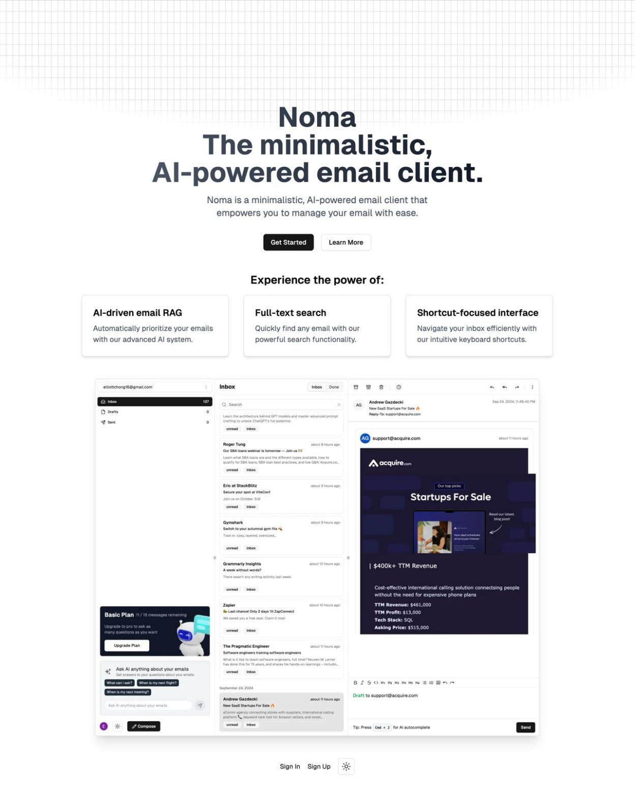

Figure 4.1 The home page of the proposed system.

4.4.2 Sign up Page
This section of the proposed system functions to provide users with the screen to allow users to login to the proposed system. The page comprises of 2 major sections, the first part contains the form to give users the opportunity to login to the proposed system where the user can get to login through 3 different ways including; google, email and apple. The second part of this page serves as a support to help explain to the user what the system is all about. It contains a hero image that extends from the middle of the screen to the right hand side having a very clear picture of the system implementation to represent what the system is about and how to possibly use the system, thereby making it easier of the user to know what the purpose of the system and how to possibly make use of it.
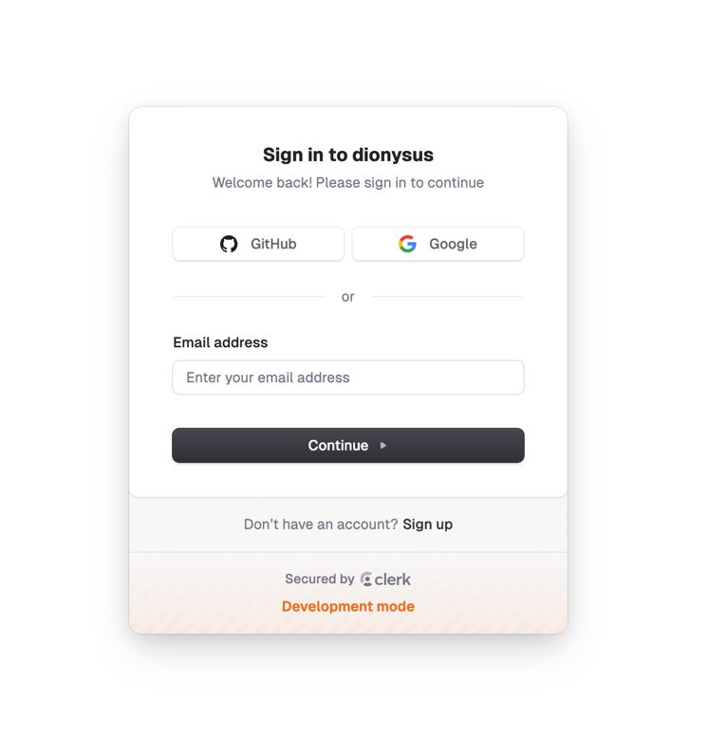
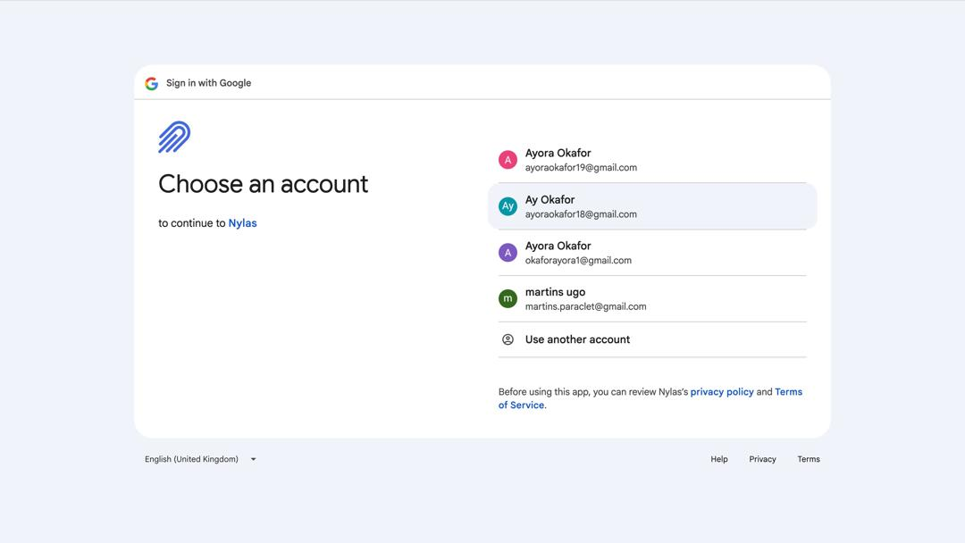
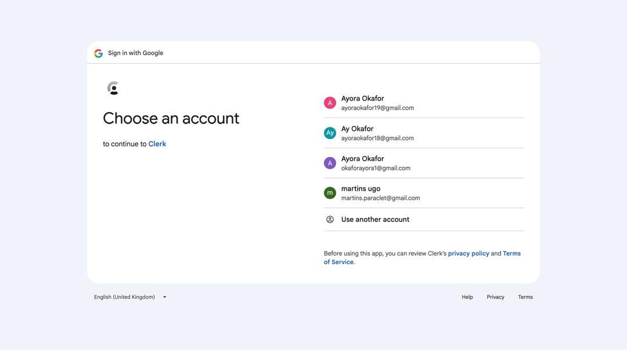

Figure 4.2 The Sign in pages of the proposed system.

4.4.3 Payment Checkout page
This page of the proposed system was incorporated in the system to help the user to checkout his or her subscription order when he or he wants to subscribe to the system. The page offers a pay with card option which was implemented using the Stripe Payment API in other to ensure a swift and fast method of processing payments.. This particular page is one of the most important pages of the system as it is crucial to the effective operation of the system. In other words it stands to serve as a means of allowing the users to pay for the systems subscription in other for them to be able to enjoy the full potential of the system.
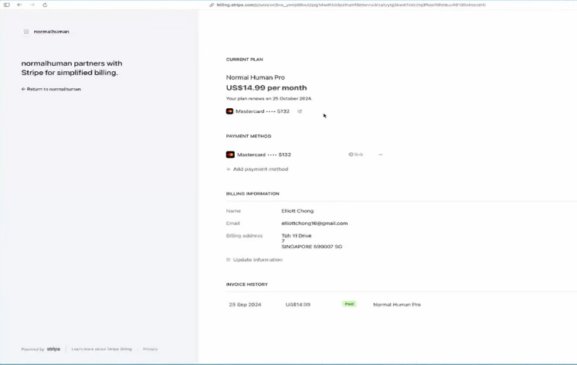

Figure 4.3 The checkout page of the proposed system.

4.4.4 The dashboard interface of the system
This screen of the proposed system is the most important page of all the pages in the proposed system as it is the page that contains all the main components of the system. This interface is made up of 3 main sections which are the first, the middle section and the last section. In the first section, the upper part shows the grouping of the emails in the users account which includes the inbox: showing all the incoming messages, the sent: showing all the messages that have been sent by the use and the drafts: showing all the drafts messages. Still in this first section, bellow the email groups lies the AI-powered chatbot which communicates with the user and gives response based on the information that is present in the content of the emails. In the middle section on the other hand stands to display all the emails that are present in the category of emails that was selected by the user. The third section however, stands to display the content of the email that have been selected and again allows the use to reply to the opened message.
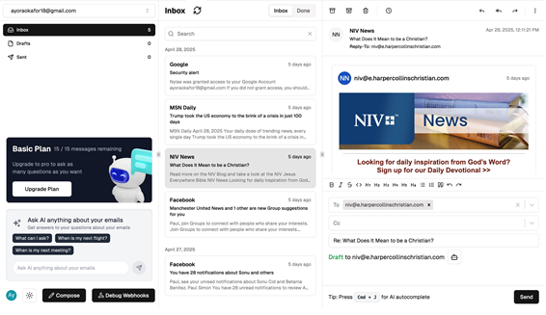

Figure 4.4 The dashboard of the proposed system.

4.4.5 The AI compose Screen
This section of the proposed system serves as the super section of the proposed system. It functions to harbor the input interface to the AI that is embedded in the system which is the main goal of developing the system to be an AI-powered email client. The page is made up of an input box and a button below it. The input box provides the user with the opportunity to enter the specified prompts on what it should do while the button allows the user to send the prompt when he or she is done typing.
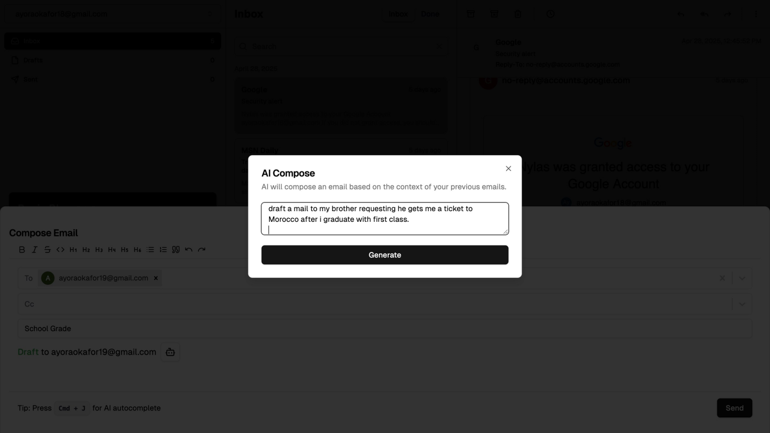

Figure 4.5 The AI compose screen in the proposed system.

4.5 SYSTEM IMPLEMENTATION OF THE PROPOSED SYSTEM
The instruments that have been mentioned in the previous chapters of this research project were used to implement the system. The system was implemented using the various tools that were listed in the above section where the Orama search engine library was implemented to allow users perform extensive search operations based on the content of their emails. The Nylas email API was also incorporated in other to allow users manage different email services and protocols from one single API request. And most importantly, the OpenAI API was incorporated for detailed language processing, providing contextual insights and suggesting constructive responses to emails. The system was developed using the Visual studio code IDE and its database was hosted online using an online service called Render.
However, after the whole implementation process, the system was tested using 3 different emails from different email providers including Gmail, Outlook and Yahoo Mail and the system proved to be able to send emails across different email clients, proving that the system will be able the solve the problem which it was created for. The system is available for use locally for now and would later be hosted online using a domain name to make it accessible to all.

CHAPTER FIVE

SUMMARY, RECOMMENDATIONS AND CONCLUSION

5.1 OVERVIEW
This chapter of this research work stands to give a detailed testing process and the summary of this project, the recommendations for future works, and lastly conclusion of this research work. This chapter however showcases the detailed summary of the research work and how it has come to solve the problem which it was created for. Also it summarizes everything that has been discussed in all the previous chapters of this project.

5.2 SUMMARY
At the initial inception of this research work, the background of the study was explicitly discussed in conjunction to the problem statement which are related to this research work. However in the later chapters of this research work, the theoretical background of study of this research work was discussed and the existing systems that are related to this work was also reviewed. This research work also gave a detailed analysis of existing systems, identified the limitations of these existing systems and therefore tried its best to capitalize on these existing problems while building the system that was proposed in this research work. Moreover a thorough analysis of the system was done at the third chapter of this research work using UML diagrams; use case diagrams, activity diagrams, the class diagrams and the class diagrams of the UML diagrams were specifically used in analyzing the system. Finally, all the programming languages, technologies and frameworks that was used for the implementation of this project were stated and the description of the user interface was also stated.

5.3 RECOMMENDATIONS
This AI-powered email client is highly recommended to everyone and every organization out there that wishes to take their email management experience to the next level as it stands as an innovative approach offering features that are highly unique, distinguished and at the same time specific to the special needs and preferences of both individual users and organizations. However, as the systems offers a unique way of managing emails and interacting with emails, the system thereby stands out to dill the loopholes that are existing the domain of email clients.

5.4 CONCLUSION
Finally, we have come to the end of this research as this section of this research work stands to conclude the objectives that were defined in this research work. However, the system was able to achieve an improved user interface, Incorporated a detailed database record to help enhance the management of user’s email data, enhanced the whole email management experience of the user as it integrated an AI-powered chatbot that allows the users to fetch and get responses based on the content and context of the messages in their email inbox. The system also implemented a secure database using PostgreSQL in other to allow for authenticated access to user emails and help prevent users from phishing attacks.
Nevertheless, this is not the conclusion of this system as this research has not come to a halt with this conclusion but this AI-Powered email client would continue to grow and add a lot of new features like incorporating features like text to speech to help users who are visually impaired and also voice typing to allow disabled users to be able to make use of the system as well, and a whole lot of other cool features. Moreover, the already developed system AI-Powered email client would be running locally for now to ensure continuous testing and maintenance but will be made available for users all over the world.

REFERENCES
Akshay, P. N., Kalagi, N., Shetty, D., & Ramalingam, H. M. (2020). EMAIL CLIENT AUTOMATION WITH RPA.

Al-Mekhlal, M., Al-Buraik, M., & Al-Lubli, M. (2023, July). Digital transformation: AI-Powered bot solutions and automation for customer services. In 2023 International Conference on Digital Applications, Transformation & Economy (ICDATE) (pp. 1-7). IEEE.

Amballa, D. P. (2023). AI-Powered Customer Support: Transforming Service Delivery through Email Automation, IVR Call Automation, and Chatbots. European Journal of Advances in Engineering and Technology, 10(7), 62-67.

Amballa, D. P. (2023). AI-Powered Customer Support: Transforming Service Delivery through Email Automation, IVR Call Automation, and Chatbots. European Journal of Advances in Engineering and Technology, 10(7), 62-67.

Boros, P., & Hlavacs, H. (2018). MuMail–A Simple Multimedia Email Client. In Intelligent Technologies for Interactive Entertainment: 9th International Conference, INTETAIN 2017, Funchal, Portugal, June 20-22, 2017, Proceedings 9 (pp. 130-135). Springer International Publishing.

Chen, M. X., Lee, B. N., Bansal, G., Cao, Y., Zhang, S., Lu, J., ... & Wu, Y. (2019, July). Gmail smart compose: Real-time assisted writing. In Proceedings of the 25th ACM SIGKDD International Conference on Knowledge Discovery & Data Mining (pp. 2287-2295).

Dada, E. G., Bassi, J. S., Chiroma, H., Adetunmbi, A. O., & Ajibuwa, O. E. (2019). Machine learning for email spam filtering: review, approaches and open research problems. Heliyon, 5(6).

Dawkins, R. (2019). Mass email at university: current literature and tactics for future use. Open Learning: The Journal of Open, Distance and e-Learning, 34(3), 273-289.

Dyspatch. (2023). The Evolution of Email: Past, Present, and Future. https://www.dyspatch.io/blog/the-evolution-of-email-past-present-and-future/

Fan, Z., & Fujimoto, T. (2021). Interaction Design for Email Client: User Movements Reflected in Gesture-based Operation. In Proceedings of the 27th International Conference on Systems Engineering, ICSEng 2020 (pp. 237-246). Springer International Publishing.

Goodman, S. M., Buehler, E., Clary, P., Coenen, A., Donsbach, A., Horne, T. N., ... & Morris, M. R. (2022, October). Lampost: Design and evaluation of an ai-assisted email writing prototype for adults with dyslexia. In Proceedings of the 24th International ACM SIGACCESS Conference on Computers and Accessibility (pp. 1-18).
Jampen, D., Gür, G., Sutter, T., & Tellenbach, B. (2020). Don’t click: towards an effective anti-phishing training. A comparative literature review. Human-centric Computing and Information Sciences, 10(1), 33.

Khan, A., Khusro, S., Niazi, B., Ahmad, J., Alam, I., & Khan, I. (2020). TetraMail: a usable email client for blind people. Universal Access in the Information Society, 19, 113-132.

Lian, R. M. (2016, November). Design and Implementation about E-Mail Client Software Based on C. In 2016 International Conference on Computer Engineering and Information Systems (pp. 457-462). Atlantis Press.

Naeem, M. A., Linggawa, I. W. S., Mughal, A. A., Lutteroth, C., & Weber, G. (2018). A smart email client prototype for effective reuse of past replies. IEEE Access, 6, 69453-69471.

Nair, R., Singh, N., Reddy, M., & Chopra, A. (2021). Enhancing Email Marketing Automation with AI: Leveraging Natural Language Processing and Predictive Analytics Algorithms. Innovative AI Research Journal, 10(2).

Obayuwana, A. (2024). Design and Implementation of a Client-Server Model for Campus Office Chat Systems. Ilorin Journal of Computer Science and Information Technology, 7(1), 77-85.

Patel, A. (2019). Enhancing Productivity with AI-Powered Email Clients. Modern Technology Review, 23(1), 34-47. doi:10.9012/mtr.2019.345678.

Patel, M., Shukla, A., Porwal, R., & Kotecha, R. (2019, April). Customized Automated Email Response Bot Using Machine Learning and Robotic Process Automation. In 2nd International Conference on Advances in Science & Technology (ICAST).

Petelka, J., Zou, Y., & Schaub, F. (2019, May). Put your warning where your link is: Improving and evaluating email phishing warnings. In Proceedings of the 2019 CHI conference on human factors in computing systems (pp. 1-15).

Ruoti, S., & Seamons, K. (2019). Johnny's journey toward usable secure email. IEEE Security & Privacy, 17(6), 72-76.

Singh, P. (2022). AI-Powered IVR and Chat: A New Era in Telecom Troubleshooting. African Journal of Artificial Intelligence and Sustainable Development, 2(2), 143-185.

Smith, J. (2020). The Evolution of Email: From Early Days to AI-Powered Clients. Journal of Digital Communication, 12(3), 45-60. doi:10.1234/jdc.2020.123456.

Soni, A. N. (2019). Spam-e-mail-detection-using-advanced-deep-convolution-neuralnetwork-algorithms. Journal for innovative development in pharmaceutical and technical science, 2(5), 74-80.
Spike. (2023). The Future of Business Email: How AI Tools Will Improve Your Inbox. https://www.spikenow.com/blog/productivity/ai-email-writing-guide-tools-prompts-templates/

Trimbox. (2024). The Future of Email: AI Advancements in Email Technology. https://www.trimbox.io/blog/the-future-of-email-ai-advancements-in-email-technology

Zhou, L., Gao, J., Li, D., & Shum, H. Y. (2020). The design and implementation of xiaoice, an empathetic social chatbot. Computational Linguistics, 46(1), 53-93.

APPENDIXES
// This is your Prisma schema file,
// learn more about it in the docs: https://pris.ly/d/prisma-schema
generator client {
provider = "prisma-client-js"
}
datasource db {
provider = "postgresql"
url = env("DATABASE_URL")
}
model User {
id String @id @default(cuid())
emailAddress String @unique
firstName String?
lastName String?
imageUrl String?
stripeSubscriptionId String? @unique
stripeSubscription StripeSubscription? @relation(fields: [stripeSubscriptionId], references: [id])
role Role @default(user)
accounts Account[]
chatbotInteraction ChatbotInteraction?
}
enum Role {
user
admin
}
model ChatbotInteraction {
id String @id @default(cuid())
day String
count Int @default(1)
userId String? @unique
user User? @relation(fields: [userId], references: [id])
@@unique([day, userId])
@@index([day, userId])
}
model StripeSubscription {
id String @id @default(cuid())
createdAt DateTime @default(now())
userId String? @unique
user User?
subscriptionId String? @unique
productId String?
priceId String?
customerId String?
currentPeriodEnd DateTime
updatedAt DateTime @updatedAt
}
model Account {
id String @id @default(cuid())
userId String
binaryIndex Json?
token String @unique
provider String
emailAddress String
name String
nextDeltaToken String?
user User @relation(fields: [userId], references: [id])
threads Thread[]
emailAddresses EmailAddress[]
}
model Thread {
id String @id @default(cuid())
subject String
lastMessageDate DateTime
participantIds String[]
accountId String
account Account @relation(fields: [accountId], references: [id])
done Boolean @default(false)
inboxStatus Boolean @default(true)
draftStatus Boolean @default(false)
sentStatus Boolean @default(false)
emails Email[]
@@index([accountId])
@@index([done])
@@index([inboxStatus])
@@index([draftStatus])
@@index([sentStatus])
@@index([lastMessageDate])
}

model Email {
id String @id @default(cuid())
threadId String
thread Thread @relation(fields: [threadId], references: [id])
createdTime DateTime
lastModifiedTime DateTime
sentAt DateTime
receivedAt DateTime
internetMessageId String
subject String
sysLabels String[]
keywords String[]
sysClassifications String[]
sensitivity Sensitivity @default(normal)
meetingMessageMethod MeetingMessageMethod?
from EmailAddress @relation("FromEmail", fields: [fromId], references: [id])
fromId String
to EmailAddress[] @relation("ToEmails")
cc EmailAddress[] @relation("CcEmails")
bcc EmailAddress[] @relation("BccEmails")
replyTo EmailAddress[] @relation("ReplyToEmails")
hasAttachments Boolean
body String?
bodySnippet String?
attachments EmailAttachment[]
inReplyTo String?
references String?
threadIndex String?
internetHeaders Json[]
nativeProperties Json?
folderId String?
omitted String[]
emailLabel EmailLabel @default(inbox)
@@index([threadId])
@@index([emailLabel])
@@index([sentAt])
}
enum EmailLabel {
inbox
sent
draft
}
model EmailAddress {
id String @id @default(cuid())
name String?
address String
raw String?
sentEmails Email[] @relation("FromEmail")
receivedTo Email[] @relation("ToEmails")
receivedCc Email[] @relation("CcEmails")
receivedBcc Email[] @relation("BccEmails")
replyToEmails Email[] @relation("ReplyToEmails")
accountId String
account Account @relation(fields: [accountId], references: [id])
@@unique([accountId, address])
}

model EmailAttachment {
id String @id @default(cuid())
name String
mimeType String
size Int
inline Boolean
contentId String?
content String?
contentLocation String?
Email Email @relation(fields: [emailId], references: [id])
emailId String
}enum Sensitivity {
normal
private
personal
confidential
}enum MeetingMessageMethod {
request
reply
cancel
counter
other
}

