DEVELOP A WEB-BASED PHARMACEUTICAL SUPPLY CHAIN AND DIRECT ORDER MANAGEMENT SYSTEM FOR FIRST VADIS PHARMACEUTICAL INDUSTRIES LIMITED.

BY

TOBENNA UDEZE CHIDUMEBI
GOU/U22/CSC/898

SUBMITTED TO THE DEPARTMENT OF COMPUTER SCIENCE,
FACULTY OF NATURAL SCIENCES AND ENVIRONMENTAL STUDIES, GODFREY OKOYE UNIVERSITY, ENUGU IN PARTIAL FULFILLMENT OF THE AWARD OF BACHELOR OF SCIENCE DEGREE

SUPERVISED BY DR. K. M. OKORIE

JULY, 2025

CERTIFICATION
I hereby certify that the work included therein was completed by me and that it was mainly based on my observations and investigation. Consequently, I will fully accept the University's decision if I am found to have cheated on the assignment.

________________________
TOBENNA UDEZE CHIDUMEBI
GOU/U22/CSC/898

APPROVAL PAGE
This is to validate that this research work “A WEB-BASED PHARMACEUTICAL SUPPLY CHAIN AND DIRECT ORDER MANAGEMENT SYSTEM FOR FIRST VADIS PHARMACEUTICAL INDUSTRIES LIMITED.” was embarked upon by “TOBENNA UDEZE CHIDUMEBI” with the matriculation number U22/NAS/CSC/898 in partial fulfillment of the requirements for the award of Bachelor Science(B.SC) in Computer Science, Faculty of Natural Sciences and Environmental Studies, Godfrey Okoye University, Enugu.

__________________________ ________________________
Dr. K. M. Okorie Date
(Supervisor)

_______________________________ _________________________
Dr. (Mr.) Frank Okebanama Date
Head of Department
Computer Science and
Mathematics

________________________________ _________________________
External Examiner Date

_______________________________ _________________________
Prof. Chidi C. Uhuegbu Date
Dean, FNESS
DEDICATION

This work “A WEB-BASED PHARMACEUTICAL SUPPLY CHAIN AND DIRECT ORDER MANAGEMENT SYSTEM FOR FIRST VADIS PHARMACEUTICAL INDUSTRIES LIMITED.” is dedicated to my parents Pharm. and Mrs. Emeka Udeze who painstakingly has contributed heavily to everything that I have achieved up until this day and I pray that the good lord continues to guide and protect them for the rest of their days.

ACKNOWLEDGMENTS
First of all, I would like to appreciate the almighty God for his abundant mercies, inspiration, and grace throughout this project. Specifically, I want to also acknowledge and appreciate my supervisors, Dr. K. M. Okorie and Mr. Camillus Njoku, for the time they set aside to make sure that this project was a success and also for guiding me throughout this project. I would also like to appreciate my parents, Pharm. & Mrs. Emeka Udeze, for their love, support, and prayers for me throughout this project; my brother, Somto Udeze; and my sister, for their support, and I pray that the good Lord will continue to bless them all.

ABSTRACT
The study focuses on the development of a web-based pharmaceutical supply chain and direct order management system to tackle key challenges faced by First Vadis Pharmaceutical Industries Limited and similar companies. These challenges include high implementation and maintenance costs, a lack of real-time communication, and scalability issues due to system complexities. For a structured approach, the waterfall model was employed as the research methodology, allowing steady progress through well-defined phases. Additionally, the system was designed using object-oriented analysis and design, enabling a well-structured and efficient system design. The evaluation of the developed system indicates its effectiveness, with integrated chat support enhancing real-time communication between pharmaceutical companies and suppliers. This feature allows continuous exchange of order details, delivery updates, formal documents, and product specifications, improving transparency, collaboration, and quicker decision-making. Ultimately, the system strengthens supply chain management by providing more efficient responses to disruptions, ensuring reliability, and ensuring effective operations.

TABLE OF CONTENTS
Table of Contents
Title page i
Approval ii
Certification iii
Dedication iv
Acknowledgments v
Abstract vi
Table of contents vii
List of figures ix
List of tables x
CHAPTER ONE: INTRODUCTION 1
1.1 Background of Study 1
1.2 Statement of the Problem 3
1.3 Aim and Objectives of the Study 4
1.4 Significance of Study 4
1.5 Scope of Study 5
1.6 Limitations of Study 5
1.7 Operational Definition of Terms 5
CHAPTER TWO: LITERATURE REVIEW 7
2.1 Introduction to Supply Chain Management System 7
2.1.1 Different Categories of Pharmaceutical Supply Chain Management System 7
2.1.2 Brief History of Supply Chain Management System 8
2.2 Inventory Management System for Pharmacy 10
2.3 Review of Existing Related Works 11
2.4 Summary of the Review of Related Works 14
2.5 Research Gap 16
CHAPTER THREE: SYSTEM ANALYSIS AND DESIGN 18
3.1 Overview 18
3.2 Research Methodology 18
3.2.1 Requirement Analysis 18
3.2.2 System Design 18
3.2.3 Implementation 19
3.2.4 Testing 19
3.2.5 Deployment 19
3.2.6 Maintenance 20
3.3 System Analysis 20
3.3.1 Analysis of Existing Systems 20
3.3.2 Weaknesses of Existing Systems 21
3.3.3 Analysis of the Proposed System 21
3.3.4 System Requirements 22
3.4 System Design Methodology 23
3.4.1 Unified Modelling Language 24
3.4.2 Use Case Diagram of Proposed System 24
3.4.3 Activity Diagram of the Proposed System 26
3.4.4 Class Diagram of the Proposed System 26
3.4.5 UML Sequence Diagram 27
3.4.6 Database Design 29
CHAPTER FOUR: SYSTEM IMPLEMENTATION 31
4.1 Introduction 31
4.2 Choice of Development Environment 31
4.2.1 Integrated Development Environment 31
4.2.2 Programming Languages 31
4.3 System Requirements 32
4.4 User Interfaces of the System 32
4.4.1 User Registration Page 32
4.4.2 User Login Page 33
4.4.3 Dashboard 33
4.4.4 Track Order 34
4.4.5 Chat Feature 35
4.4.6 Super Admin Dashboard 35
4.4.7 Chat with Support 36
4.4.8 Report Analytics 37
CHAPTER FIVE: SUMMARY, CONCLUSION, AND RECOMMENDATIONS 38
5.1 Summary 38
5.2 Conclusion 39
5.3 Recommendations 39
References 40

LIST OF FIGURES
3.1 Use case diagram of the proposed system 25
3.2 Activity diagram of the proposed system 26
3.3 Class diagram of my system 27
3.4 Sequence diagram of my system 29
4.1 User Registration 32
4.2 User Login Page 33
4.3 User Dashboard 33
4.4 Order Tracking 34
4.5 Chat Feature 34
4.6 Super Admin Dashboard 35
4.7 Chat with Support 35
4.8 Report Analytics 36

LIST OF TABLES
4.1 User table for the proposed system 29

CHAPTER ONE
INTRODUCTION

1.1 Background of Study
In every pharmaceutical company, it is very crucial to have up-to-date information about everything that happens, as it is directly affiliated with one’s health. A supply chain management system in a pharmacy is a digital system that is used to coordinate all activities involved in the sourcing, production, and delivery of drugs (Uğrak et al., 2025). It is a life cycle of processes comprising physical, information, financial, and knowledge flows whose purpose is to satisfy end-user requirements with products and services from multiple linked suppliers (Felea et al., 2016).
Mu et al. (2025) describe a supply chain as a set of three or more entities (organizations or individuals) directly involved in the upstream and downstream flows of products, services, finances, and/or information from a source to a customer (Mentzer et al., 2001). In addition, their study indicates three degrees of supply chain complexity: a direct supply chain, an extended supply chain, and an ultimate supply chain. The direct supply chain consists of a central organization, its suppliers, and its customers. Furthermore, the extended supply chain includes suppliers of the immediate supplier and customers of the immediate customer. The ultimate supply chain will include all organizations that are involved in all flows of products, services, finance, and information from the ultimate suppliers to the ultimate customers. Also, the ultimate supply chain encompasses functional intermediaries such as market research firms and financial and logistics service providers (Mu et al., 2025).
Before the advent of this system, pharmacies employed the traditional method of local sourcing of raw materials. Suppliers’ information was stored using paper, which posed a lot of risk, as primary information could be destroyed by a fire outbreak or any unforeseen natural disaster. Suppliers were being called one by one to check the availability of goods, and most times they didn’t get responses until days later, and they placed an order only to find out that it was out of stock. Other times, most stocks arrived late or all at once due to poor tracking, and this led to overstocking, expired drugs, and, worse, wasted money. There were also times when life-saving drugs could not be administered as no one knew they were out of stock, and this led to the loss of lives. The use of a supply chain management system has helped to curb these issues by providing a modernized and stress-free approach to solving these problems.
Lately, supply chain problems have caused serious disruptions across various industries, with the pharmaceutical sector being heavily affected. According to Medical Packaging (n.d.), eliminating these challenges is crucial, as a smooth pharmaceutical supply chain is vital for patient care. Any setbacks in this system could put patient safety at risk and create broader problems for the healthcare industry. Let me know if you'd like any further adjustments. Therefore, the study will consider and implement computerization of the pharmaceutical supply chain and direct order management.
The rise in the use of electronic equipment and computer systems has enhanced innovation in the management of medicine. The use of computers is becoming common in our daily life due to its versatility and the ability it possesses to perform complicated tasks with minimal effort (Onuiri et al., 2016). They perform tasks that can be completed in days and hours within seconds and milliseconds. The Internet and the new search engines like Google have transformed the way we access information in such a way that inaccessible information is accessed as well. The mobility of current devices also gives us access to information in an easier way compared to the past, altering the way of working with information as well as interaction with it.
Pharmaceutical control is experiencing tremendous changes with the use of information and communication technology in the health industry (Okeke et al., 2016). There is extensive research that has drawn attention to control of drug dispensing as well as the enforcement of pharmacy laws to prevent sales of fake drugs. This is predominantly in developing countries such as those in Sub-Saharan Africa. According to Okeke et al. (2016), there is minimal regulation in community pharmacies with the end-result being indiscriminate dispensing of drugs as well as self-medication by patients. Non-enforcement is the cause of an increased public health problem in that it promotes dispensing of sub-standard drugs. My research proposes the use of an efficient high-tech web-based Pharmaceutical Supply Chain and Direct Order Management System for First Vadis Pharmaceuticals.
Besides that, the supplier chat for pharmacy supply chain management will be implemented in the system with its feature of live communication that allows pharmaceutical companies and suppliers to message each other regarding their order, delivery status, official documents, product information, and other associated data in order to offer transparency. The integration of supply chat functionality in existing drug manufacturing company "First Vadis" will assist in interaction speed along with productivity enhancement. It will monitor stock quantity, regulate orders from suppliers, monitor delivery, and chat live with suppliers using the chat facility. It will also enhance collaboration, quicker decision-making, and better responses to supply chain disruptions.

1.2 Statement of the Problem
First Vadis Pharmaceuticals is currently facing issues with their supply chain system, which include
- The traditional pharmaceutical distribution model relies heavily on third-party distributors.
- Customers face delays, increased costs, and limited access to verified drug sources.
- First, Vadis lacks a direct communication and ordering system for its customers.
- There is no platform for customers to view available drugs or place orders directly with the company.
- Tracking orders and receiving timely updates is currently difficult or non-existent.

1.3 Aim and Objectives of the Study
This study aims to develop a web-based Pharmaceutical Supply Chain and Direct Order Management System for First Vadis Pharmaceutical Industries Limited. The specific objectives are to:
- Perform a comprehensive analysis of the existing pharmaceutical supply chain and direct order management systems.
- Develop a web-based platform for customers to place pharmaceutical orders online.
- Automate product and inventory management, as well as the ordering and tracking system.
- Integrate a customer support and communication interface that facilitates real-time access between users and the admin.
- Integrate modules for the generation of reports on sales, inventory, and supplier performance, to facilitate effective decision making.

1.4 Significance of Study
Implementing the pharmaceutical supply chain supplier chat function in First Vadis Pharmaceutical will enable communication, efficiency, and transparency within the supply chain. Product safety and quality, as well as regulatory compliance, will be ensured by the system. The system will also provide real-time monitoring, reducing supply chain risks like counterfeited drugs and stock-outs. An effective utilization of maximum resources and decision-making will help the firm remain competitive as well as improve healthcare product delivery.

1.5 Scope of Study
This research is on the development of a pharmaceutical supply chain management supplier chat feature for First Vadis Pharmaceutical. The system will cover inventory, order processing, and real-time tracking in addition to regulatory compliance and data accuracy.
The supplier chat function will facilitate communication in real time between suppliers and supply chain managers, encouraging problem-solving and cooperation. The research is aimed at supply chain managers, suppliers, and logistics personnel at First Vadis Pharmaceutical for potential future scaling.

1.6 Limitations of Study
- Data Availability and Accuracy: Getting data from the company before advancing was a little difficult, as they had to be sure that it was not an attempt to ruin their business and steal private data.
- Interrupted power supply: While building the system, sometimes there might be a power outage for probably two days or more, this slowed down the process of building the system.
- Slow Internet connection: Some of the tools that were used in building the system were online, so if there was no Internet connection, the researcher was not able to work.
- Language and communication barriers: Suppliers in different regions may find it difficult to communicate because of language barriers, hence becoming less efficient in using the chat feature.

1.7 Operational Definition of Terms
1. Pharmaceutical Supply Chain system: a digital system that is used to coordinate all activities involved in the sourcing, production, and delivery of drugs.
2. Supply Chain Management System (SCMS): an application software that enables visibility, control, and optimization of processes over a supply chain, including inventory levels, orders, logistics, and supplier relationships.
3. Supplier Chat Feature: a communication link between the pharmaceutical company and the supplier
4. Information Technology (IT): It refers to the use of computers, networks, software, and other digital systems to create, store, process, and manage information. IT plays a crucial role in businesses, education, healthcare, and nearly every aspect of modern life, enabling communication, data analysis, automation, and innovation.
Management system: It is a structured framework of policies, processes, and procedures used by organizations to achieve their objectives very fast and effectively. It helps streamline operations, improve performance, and ensure compliance with industry standards
5. Supply chain: A supply chain encompasses all the activities, processes, and organizations involved in the creation and delivery of a product or service from its origin to the end customer. It's essentially the entire journey a product takes, from sourcing raw materials to its final delivery, including manufacturing, warehousing, and distribution

CHAPTER TWO
LITERATURE REVIEW

2.1 Introduction to Supply Chain Management System
It is an aspect that has existed in business processes because it has become better with the passage of time as an outcome of shifting needs and technological advancements.
Pharmaceutical supply chain is an important infrastructure that helps ensure delivery of life-saving drugs and healthcare products from producers to users (Buseri et al., 2023). In recent years, the utilization of SCM strategies and the adaptation of technology has played an important role in managing inherent PSC challenges (Buseri et al., 2023). This chapter reviews current literature on pharmaceutical supply chain management systems (PSCMS) and supply chain integration, through which information on how they are designed, implemented, and influence the industries is obtained.

2.1.1 Description of Different Categories of Pharmaceutical Supply Chain Management System
This section gives a brief description of some of the different categories of supply chain systems.
1. Safety Stock Optimization Systems:
These are properly designed instruments to provide an optimal quantity of safety stock in supply chains. Safety stock when it comes to such category or optimization systems is the quantity of inventory set aside in order to avoid stock-out caused by uncertainty in demand, supply disruptions, or lead time fluctuation. The systems also need to create a balance, therefore creating an appropriate quantity of safety stock in order to meet unforeseen variations while incurring minimal inventory excess cost of holdings.

2. Procurement Systems
This is where the supply chain starts. These systems help businesses buy the materials or products they need from the right suppliers. It’s not just about finding the cheapest option but also ensuring the materials are high quality, delivered on time, and meet all requirements. Procurement systems also manage contracts and keep track of supplier performance to ensure smooth operations.
3. Inventory Management Systems
They help companies know what’s available, what’s running low, and what’s about to expire or go out of demand. By doing this, it prevents overstocking, which ties up money and space, or running out of essential products.
4. Transportation and Logistics Systems
These systems handle the section of moving goods to customers as well as delivering raw goods to factories.
5. Warehouse Management Systems
They are responsible for the organization and storage in a warehouse. They ensure proper space management and movement within the warehouse.
6. Demand Planning Systems
They are required for data analysis to know the right steps to take in the business. It helps in overproduction and underproduction issues.

2.1.2 Brief History of Supply Chain Management System
The history of this system can be traced back to ancient civilizations, in the early stages of commerce, where supply management was essential for trade and large-scale projects. For example, ancient Egyptians used rudimentary systems to organize materials and labor for the construction of pyramids. These early efforts involved basic methods of coordination and transportation, laying the groundwork for modern SCM practices (Althabatah, 2023).
A revolution in the 18th and 19th centuries brought about significant changes to supply chain systems. With the advent of mechanized production, factories required efficient processes to manage raw materials, labor, and finished goods. Railways and steamships expanded transportation capabilities, enabling businesses to reach broader markets (Chen, 2025). This period marked the rise of supply chains as structured systems, focusing on cost reduction and production efficiency (Chopra & Meindl, 2019).
Subsequently, in the 20th century, global conflicts necessitated the development of advanced logistics strategies. Concepts such as inventory control, warehousing, and efficient transportation were refined to ensure supplies reached soldiers on time. These wartime innovations later influenced civilian industries, fostering the integration of logistics into supply chain management systems (Waller & Fawcett, 2013).
Supply chain management began to gain recognition in the 1980s as companies moved toward integrating procurement, manufacturing, and distribution into unified systems. The introduction of just-in-time production by Toyota in Japan revolutionized this field, emphasizing waste reduction and efficiency. By aligning production schedules with demand, businesses minimized inventory holding costs and improved responsiveness (Toyota Motor Corporation, 2020).
The late 20th century saw the rise of computing technologies that transformed SCM systems. Enterprise Resource Planning (ERP) software allowed businesses to automate and streamline supply chain processes. Globalization further complicated supply chains, requiring more sophisticated systems to manage international trade, compliance, and logistics. Technologies like radio frequency identification and electronic data interchange became standard tools in managing supply chain operations (Christopher, 2016).
Currently, the evolution of AI alongside machine learning (ML) has completely revolutionized supply chain management. These technologies enable effective data analysis, demand prediction, optimized routes, and enhanced decision-making. Additionally, there has been a growing emphasis on sustainability, with companies striving to create eco-friendly supply chains to reduce environmental impact and meet regulatory requirements (Wang et al., 2021).
Supply chain management has evolved from basic methods of coordination in ancient times to sophisticated systems driven by technology and data. This continuous innovation ensures businesses can adapt to the challenges of a dynamic global market while meeting customer needs efficiently.

2.2 Inventory Management System for Pharmacy
The rise of computers and digital gadgets has fueled innovation in pharmaceutical management. Today, computers are deeply integrated into daily life, thanks to their versatility and ability to handle complex tasks with minimal effort (Onuiri et al., 2016). Performing tasks that would have taken hours and maybe days in the past has become possible in seconds. The Internet, along with powerful search engines like Google, has revolutionized how we access information, making even the most obscure details instantly available. Additionally, the portability of modern devices has made information more accessible and mobile than ever before, reshaping the way we work and interact with knowledge. In the same vein, the management of inventory and taking stock of goods and services in different organizations has become so much easier with the growth of the computer system (Onuiri et al., 2016). Currently, phones and tablets have faster processing power than early-generation computers, making it easier to perform tasks. Our economy has been referred to as the “learning economy” because of the rate at which innovations come to light (Abbas, Alhasan, & Hamza, 2015).
In China, a text messaging system was developed to enhance pharmaceutical care for patients and support mobile healthcare solutions (Mao et al., 2008). Over time, inventory management has evolved in various ways, one of which is the Vendor-Managed Inventory (VMI) system. With VMI, suppliers have full control over delivering goods and services, provided the customer can utilize them efficiently. Within this system, the maximum Level approach allows suppliers to supply products as needed, ensuring optimal use. Another approach, known as the order-up-to policy, enables suppliers to replenish customer inventory to its maximum capacity with each delivery (Coelho & Laporte, 2015). Various computerized management systems have been valuable in saving lives around the world. The earthquake in Haiti in 2010 created a need for medicines for the injured and for additional aid. Due to the significant influx of medicines into the country at that time, an inventory management system was developed to facilitate this effort. The hospitals in the country lacked the means to provide medicines to those in need while keeping track of what had been distributed and what had not. Furthermore, the proposed management systems that were later implemented addressed shortage issues, thus saving countless lives. The Pharmacy Computerized Inventory Program (PCIP) consisted of four processes: needs assessment, development of the PCIP, implementation of the PCIP, and outcomes and data analysis. The program proved successful and significantly alleviated the turmoil in the country during the time of the earthquake (Holm, Rudis, & Wilson, 2015).

2.3 Review of Existing Related Works
There are a lot of existing systems that are related to this research work in one way or the other; however, in this section, some of these systems will be reviewed.
Kritchanchai and Meesamut (2015) contributed together in developing an inventory management system for medicines that have a very high consumption rate at a public hospital in Thailand to help minimize the total costs of inventory that are involved in maintaining patients’ safety levels. The system proposed the most suitable policies for each drug category and also obtained their best performance. The system also classified the historical demand of drugs by their characteristics, clinical importance, and consumption value, as well as the characteristics of the demand. However, the system operated by comparing each drug’s current inventory policy to the inventory policy of the previous studies to allow the system to investigate the inventory policy and characteristics that are most suitable for each drug category.
Luo et al. (2020) developed a drug inventory management system for a hospital to improve the efficiency of drug management. The system was developed based on a genetic algorithm and BP neural network; it also combined the actual situation of hospital drug inventory forecast to develop a system model based on the hospital drug management mode. The developers of the system, however, collected experimental data and input the data for a successful data analysis simulation. Also, they brought about a simulation model to verify the model’s validity. In addition, the system also analyzed the sensitivity and accuracy of model predictions.
Ahmed et al. (2020) collectively designed and developed a drug inventory management information system (DIMIS) to manage all the information, allowing pharmacists to do their jobs faster and more effectively in real time. The system was built to help with the dispensing of drugs, sales of drugs, and the regulation of these drugs. The system, however, adopted the iterative methodology in its implementation stage of the system development life cycle, which produces an early-stage model. The system was, nevertheless, implemented using ASP.NET MVC 5, AJAX, CSS, HTML, and Bootstrap in an attempt to provide the user interface with an interactive nature. The system further made use of the usage of C#.NET as the server language and Microsoft SQL Server 2012 as the server. The system was able to check an immense amount of drugs' expiry dates based on the purchase history as well as delivery history. Sukasih et al. (2020) implemented designing an inventory management system for drugs using a finance basis for the ABC pharmacy installation. The system made use of observation interview and documentary data gathering methods because it was establishing its interest in getting access to the pharmacy installation as its case study. Accounting, inpatient pharmacy, outpatient pharmacy, pharmacy warehouse were covered under the case study. Linda et al. (2016) all together developed a standalone inventory management system to ensure quality control in businesses that are responsible for handling transactions that are revolving around consumer goods. The system is, however, a software application developed to facilitate the automated processing of all the drugs in the inventory of a business. The system was built with the use of Visual Basic .NET, and it also depended on Microsoft Access for the design of its database. However, upon testing of the system, it was discovered that the system was designed to help in the minimization of the risk of possible errors. The system, however, provided the users the opportunity to generate the price of any item that has been selected and, however, calculate the total price of purchased goods whenever the purchased quantity is entered.
Salih et al. (2023) cooperatively developed and implemented an automated inventory management system in Alfa Company, a medium-sized Iraqi distributor of laboratory equipment and supplies. The system, however, solved the challenges encountered by medium-sized businesses by improving their inventory tracking, reducing their storage fees, and generally ensuring the happiness of customers.
Abisoye et al. (2013) all together designed a computer-based inventory management system to help proffer solutions to all the present challenges that are faced by the manual inventory management system of supermarkets in order to update the stocks of the supermarkets. The system, however, employed the use of the interview method of data collection and, however, made use of the acquired data in the creation and implementation of the system.
Seidenberg et al. (2008) conducted a review of a web-based stock management system developed by Partners in Health and Zanmi Lasante to streamline medication supply chains across nine rural clinics in Haiti. Designed based on WHO stock cards, the system enabled pharmacy staff to input inventory data, request medications, and monitor shipments across multiple locations. The study demonstrates that the system operated based on an existing electronic medical records system for TB and AIDS therapy that had minimized tracking of patients as well as communication significantly in spite of infrastructure problems. Regular data sharing was made possible with satellite internet that bridged road as well as electricity availability gaps. The system worked remarkably well within two years: stockouts decreased from 2.6% to 1.1%, and 97% of prescriptions arrived within one day. Given its scalability, the model was later expanded to rural Rwanda, demonstrating its potential to enhance healthcare efficiency in resource-limited settings.

2.4 Summary of the Review of Related Works
Author(s) | Contribution | Techniques adopted | Shortfall
Kritchanchai, D., & Meesamut, W. (2015). | The system also classified the historical demand of drugs by their characteristics, clinical importance, and consumption value, as well as the characteristics of the drug’s demand | Data-driven inventory and classification approach | The work was limited to reducing the total cost of inventory.
Du, M., Luo, J., Wang, S., & Liu, S. (2020) | The system improved the effectiveness of the hospital's drug inventory management system. | Hybrid Artificial Intelligence methodology | The system failed to incorporate proper inventory management techniques.
Ahmed, S. K., Naji, Z. H., Hatif, Y. N., & Hussam, M. (2020). | The system was built to help with the dispensing of drugs, sales of drugs, and the regulation of these drugs | Iterative methodology | The system failed to incorporate features to keep track of the expiry date of drugs.
Seidenberg et al. (2008) | Conducted a review of a web-based stock management system developed by Partners in Health and Zanmi Lasante to streamline medication supply chains across nine rural clinics in Haiti. The study emphasizes how the system was built upon a previously successful electronic medical record (EMR) system for HIV and TB care, the system showed impressive results stockouts decreased from 2.6% to 1.1%, and 97% of drug orders were processed within a day. | Customized web-based system development approach | No user and administrator communication interface.
Sukasih, E., Apriyanto, G., & Firdiansjah, A. (2020). | The system developed a drug inventory management in a financial perspective on the ABC hospital pharmacy installation | Case study approach and Qualitative data collection method | The study was never implemented on a full scale, as it was only implemented as a case study.
Linda, D. M., Iheanyi, N. R., Chika, O., & Yaya, A. | The system that was developed in this study ensured quality control in businesses that are responsible for handling transactions that are revolving around consumer goods | Object-Oriented Design (OOD) principles to develop a standalone inventory management system | The system developed was only able to take care of the sales of drugs and was never able to manage other details of the inventory.
Salih, H. S., Ghazi, M., & Aljanabi, M. (2023). | The system however solved the challenges encountered by medium sized business by improving their inventory tracking, reducing their storage fees and generally ensuring the happiness of customers. | System analysis and design methodology | The system only handled the goods that was in stock and the goods that was pushed out of stock only.
Abisoye, O. A., Boboye, F., & Abisoye, B. O. (2013). | This study helped to proffer solutions to all the present challenges that are faced by the manual inventory management system of supermarkets to update the stocks of the supermarkets | System analysis and design methodology | The system was only an electronic system that managed transactions and was robust.

2.5 Research Gap
Among many works that have been reviewed in the previous section, existing pharmaceutical systems show critical gaps, mainly due to their narrow focus on the reduction of inventory costs, thereby neglecting essential management techniques. Some of the reviewed works lack features for monitoring drug expiration dates, real-time stock control, and enabling communication between users and administrators. Additionally, most reviewed existing systems operate on a limited scope due to the case study approach, as well as their functionality being confined to basic sales tracking and stock movement. These shortcomings highlight the need for a more versatile and scalable solution that will integrate advanced features to improve the pharmaceutical supply chain and direct order management. Therefore, this study proposes a web-based Pharmaceutical Supply Chain and Direct Order Management System that will automate product and inventory management and ordering and tracking systems, as well as integrate a customer support and communication interface that facilitates real-time access between users and administrators. Also, the proposed system will blend in modules for the generation of reports on sales, inventory, and supplier performance to facilitate effective decision-making.

CHAPTER THREE
SYSTEM ANALYSIS AND DESIGN

3.1 Overview
This chapter covers research methodology and the design and analysis approach adopted for the development of the Pharmaceutical Supply Chain Management System, specifically designed for First Vadis Pharmaceutical.

3.2 Research Methodology
This study adopts a waterfall model of software development methodology to design and implement a web-based pharmaceutical supply chain and direct order management system for First Vadis Pharmaceutical. The waterfall model consists of a sequential design process in which progress flows steadily through well-defined phases, making it a suitable methodology for this project, coupled with its simplicity.

3.2.1 Requirement Analysis
In this phase, both functional and non-functional requirements were gathered through discussions with stakeholders in pharmaceutical distribution, including pharmacists, supply managers, and end users. Additionally, observations of current operations and a review of existing supply chain management practices provided further insights. The identified requirements, such as inventory tracking, order placement, delivery monitoring, and user role management, served as the foundation for designing the system architecture for First Vadis Pharmaceutical.

3.2.2 System Design
This stage deals with the design of the system architecture. It includes both the high-level architectural design (the client-server model) and the low-level design involving the database module, user interface layout, and data flow diagrams. The design also specified the technologies to be used, such as HTML, CSS, and JavaScript for front-end, PHP for server-side logic, MySQL for database management, and VS Code for the integrated development environment. The design phase ensured that the structure of the system supported all user and system requirements identified in the previous phase.

3.2.3 Implementation
The implementation phase describes how the system was developed in modules based on the design documents. Each module, such as user authentication, inventory control, order processing, and reporting, was coded and integrated. PHP was used as the primary programming language for the back-end, while HTML, CSS, and JavaScript were used for the front-end. The MySQL database was used to store and manage pharmaceutical data, order records, and user information. Version control was maintained using Git to manage code changes and collaboration.

3.2.4 Testing
Once the system was installed, it was tested in detail for normal use, dependability, and performance. Each unit was tested individually, then integration testing was conducted to ensure proper interfacing of the units. The final process of system testing was then conducted to ensure that the entire application met the specified requirements. User acceptance test is the final phase of the test cycle, but it marks readiness for release.

3.2.5 Deployment
After all the tests had been successfully conducted, the system was implemented to a web server and released to end-users through a domain. Tuning of configuration was also done to ensure optimal accessibility, security, and dependability. User manuals and trainings were conducted to assist end-users to smoothenly shift from past manual operations to the newly created automated system.

3.2.6 Maintenance
After it is deployed, the system is in maintenance mode. It relies on continual surveillance for potential issues such as bugs and inefficiency in performance. It will be periodically released with updates and patches to improve functionality as well as keeping in mind evolving regulation in the pharma supply chain. Maintenance is an integral aspect of continued utilization of the system as well as its longevity.

3.3 System Analysis
It entails the breakdown of the suggested system and the analysis of its elements and the way in which these components interact with each other. This section of this research work discusses the overall analysis of the suggested system with regards to the evaluation of the current systems, analysis of the shortcomings of the current systems, and how the upgrading is to be realized.

3.3.1 Analysis of Existing Systems
A majority of pharmacy supply chain management systems remain highly reliant on traditional, manual processes that make efficiency as well as scalability challenging. New systems such as Multi-Med Chain and AI+VMI have implemented new technologies to efficiently govern supply chain processes. While they provide high-level functionality, these systems are generally neither scalable, cost-effective, nor based on real-time communication that is high-priority incentives to deal with the contemporary pharmacy distribution requirements. Existing supply chain management systems like Multi-Med Chain and AI+VMI have previously been compared based on developing their strengths and weaknesses. The systems provide high-level functionality but are largely neither scalable, cost-efficient, nor based on real-time communication that is high-priority incentives which First Vadis Pharmaceutical demands. AI+VMI system of managing drug supply chains that is based on Artificial Intelligence and Vendor Managed Inventory streamlines drug supply chain management by enhancing inventory levels, future forecasting of demand, and obtaining optimization in terms of cost minimization. Despite these advantages, the system is inflexible and fixed in nature in real-time that can undermine its performance in dynamic drug environments. In short, an affordable, rapid, and efficient solution is to be introduced to bridge these gaps in order to ensure seamless inventory management and communication through the supply chain.

3.3.2 Weaknesses of Existing Systems
High Cost: The cost of installation and maintenance make these systems less viable for small pharma companies.
They Lack Real-Time Communication: They do not offer real-time communications and easy coordination of the involved parties.
Multi-MedChain: it is founded on blockchain characteristics that create complexities that reduce its scalability.
AI+VMI System: AI-powered AI+VMI system maximizes the performance of operations while addressing data believability issues and accuracy of AI estimations. The system is best optimized on the assumption that healthcare providers ensure data quality levels in the proper manner and create proper predicted demand in sometimes inescapable health delivery systems.

3.3.3 Analysis of the Proposed System
The system targeted is an online First Vadis Pharmaceutical Industries Limited Pharmaceutical Supply Chain and Direct Order Management System. It was designed to resolve challenges caused by third-party distributors in Nigeria's drug supply chain such as high prices of drugs, delayed delivery, opaqueness, and counterfeiting of products. By cutting out the middleman, the system gives the pharmacy the ability to register, log in, view products in stock, order, make payment, and monitor their delivery directly with the manufacturing company. The system has a customer support real-time chat facility and order history as well as transaction record display dashboard. To manage operations internally, the platform has different admin roles: the Inventory Management Admin oversees product listings and stock updates; the Customer Care Admin handles support requests and user messages, and also approves or rejects incoming orders; and the Super Admin monitors system analytics and generates reports. This centralized system enhances transparency, ensures faster order processing, and improves communication between the manufacturer and pharmacies while maintaining accountability and efficiency
The suggested system has an integrated, centralized database to store supplier and inventory data. In addition, there will be an email trigger facility to notify the First Vadis Pharmaceutical staff about level changes so that prompt remarks on supply chain problems can be made.

3.3.4 System Requirements
System requirements are the processes or statements of what a system should be able to do or what quality a system is supposed to have. It is made up of the functional and the non-functional requirements.
A. Functional requirements:
These requirements define what the system must have. Functional requirements of my system include:
- The system's user interface should be as simple as possible to use.
- Pharmacists should be able to edit the details of drugs after creation.
- The system should allow different user roles (Admin, Supplier, Pharmacist) to log in securely.
- It should be able to maintain stock levels, expiration dates, and reorder notifications.
- It should be able to maintain supplier information, purchase orders, and delivery tracking.

B. Non-Functional requirements:
These define attributes or abilities the system must have. Non-functional requirements for my system include:
- The proposed design should be responsive on all screen sizes and also compatible with all browsers.
- The system should ensure secure authentication and data encryption.
- The system should be scalable by supporting multiple branches and suppliers.

3.4 System Design Methodology
The system design methodology adopted for this software is object-oriented analysis and design, which employs the object-oriented method for the creation and implementation of software systems. However, within this approach, the initial step involves determining the system requirements, followed by the identification of classes and their respective relationships with each other in the system. Moreover, various techniques and practices are integral to this methodology, which encompasses UML diagrams, object-oriented programming, and use cases. Consequently, OOAD employs object-oriented programming for the actual design of the software system, as the UML diagrams play a crucial role in illustrating different facets and interactions among various components within the software system. Lastly, use cases are employed to articulate the diverse ways in which users engage with the software system. The application of OOAD is particularly suited for handling intricate systems, substantiating its selection for such scenarios.

3.4.1 Unified Modelling Language
UML diagrams are used to create or design a diagrammatical view of the different aspects and components of the software and also represents the interactions of the system. This system is modelled with a use case, activity and class diagram to therefore depict the individual classes that are available in the system, the different entities and key players that are involved in the system operations and the overall method of operation in the system.

3.4.2 Use Case Diagram of Proposed System
These are classified into four categories: the functional parts of the system known as use cases, the actors that show the external entities of the system, the associations between the actors and the use cases, and lastly, the system boundary, which is the expectation of the system that the actor is interacting with. For my system, there would be 4 actors, which are the user, the super admin, the inventory management admin, and the customer-care admin. However, according to the use case diagram, the user is going to have 8 use cases, which include register account, login in, place order, track orders etc. Figure 3.1 presents a well-detailed use-case diagram.
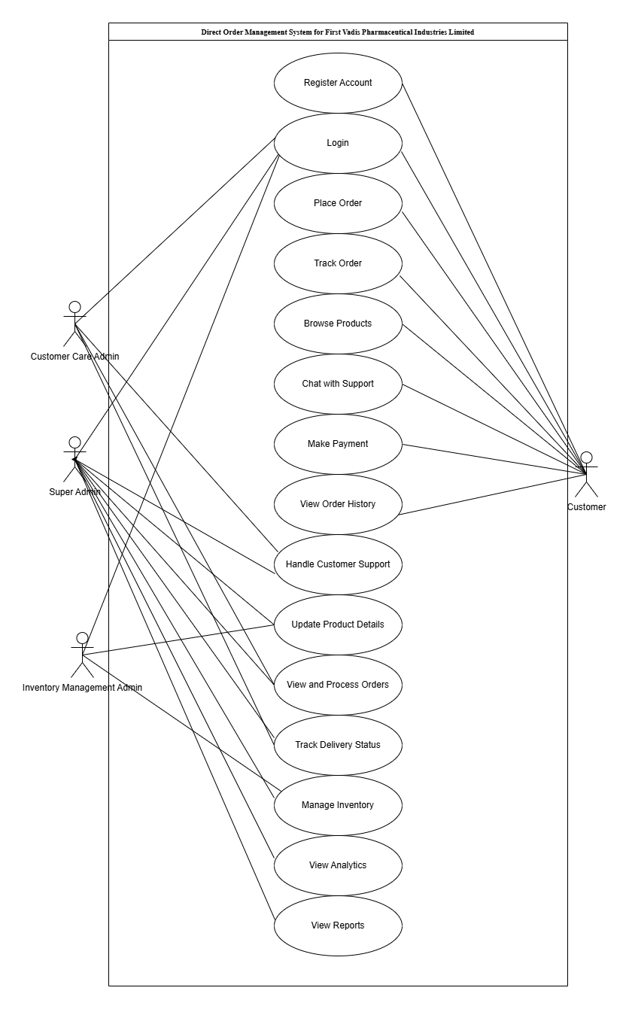
Figure 3.1 Use case diagram of the proposed system
The diagram illustrates the use case activity for the system, which consists of four main entities: the super admin, the inventory management admin, customer-care admin and the user. The user has various functionalities, such as logging into the platform and placing orders. The super admin, serving as the central authority, not only has access to all user functions but also plays a crucial role in sending email notifications regarding system updates.

3.4.3 Activity Diagram of the Proposed System
This is a diagram that describes the dynamic aspects of the software system. However, this diagram is basically a flowchart to describe the activity flow in the system. Figure 3.2 represents the flow of activities on the system, from registering account and login in, down to browsing product and placing order.
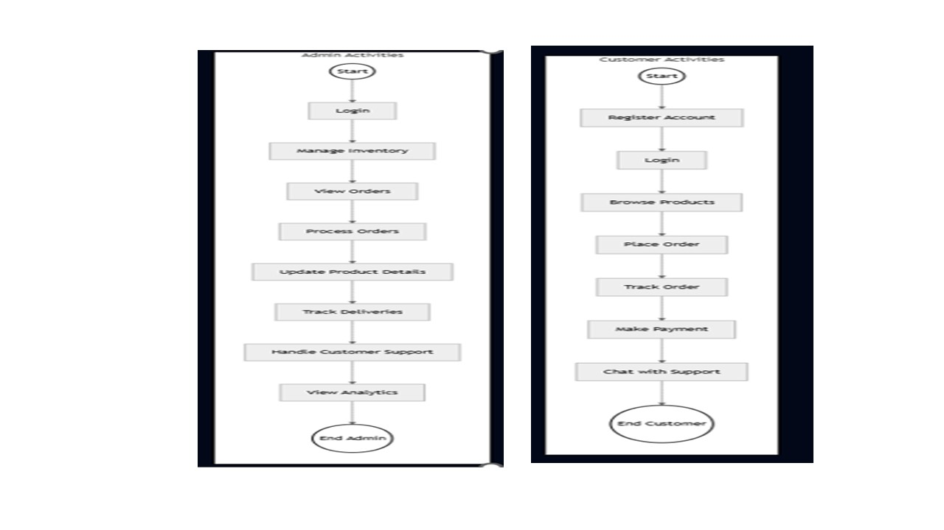
Figure 3.2 Activity diagram of the proposed system.

3.4.4 Class Diagram of the Proposed System
These describe the structure of a system software by mapping out its classes, attributes, methods, and object relationships. Figure 3.3 presents an illustration of the class diagram for the system.
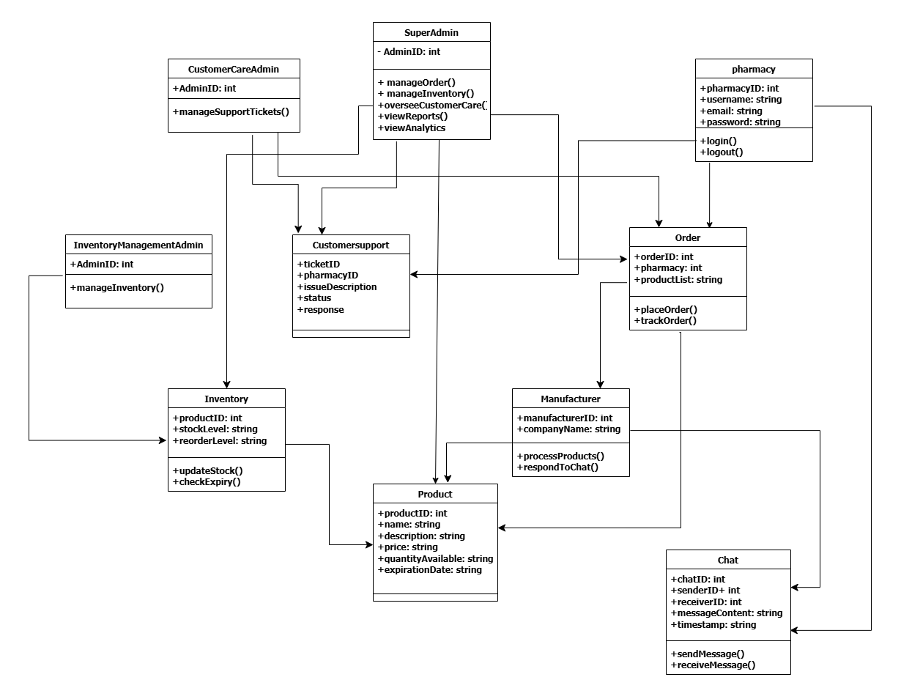
Figure 3.3 Class diagram of my system
Figure 3.3 illustrates the class diagram of the system, which is used in this research to represent the various activities within the system. The diagram outlines the different classes that interact to ensure the system operates efficiently.

3.4.5 UML Sequence Diagram
The UML diagram serves as a dynamic pictorial model that depicts the various interactions between the different objects that exist within a system over time. Similarly, these diagrams are very important in the understanding of the organized flow of actions and messages that occur during the execution of a particular use case or scenario. However, at its core, these sequence diagrams visually represent the order in which interactions take place, therefore providing a clear depiction of how the various components collaborate in a specific system to achieve the specified goal.
However, the elements in the UML sequence diagram include lifelines, messages, activations, and objects, of which the lifelines represent the entities involved in the interaction, while messages denote the communication between the different entities. Moreover, activations are portrayed using vertical lines extending from the lifeline and therefore stand to represent the duration of an object's involvement in an interaction. Consequently, this temporal dimension adds a crucial layer of understanding, thereby allowing developers and stakeholders to grasp not only what occurs in the system but also when it occurs within the system's operation.
Moreover, UML sequence diagrams help to facilitate the communication between the technical and non-technical stakeholders in a system, and by offering a visual representation of system dynamics, these diagrams stand as a powerful tool for conveying intricate technical details in a more accessible manner. However, the use of these diagrams contributes to improved collaboration, thereby fostering a shared understanding of system behavior, and also helps in identifying potential issues for future enhancements.
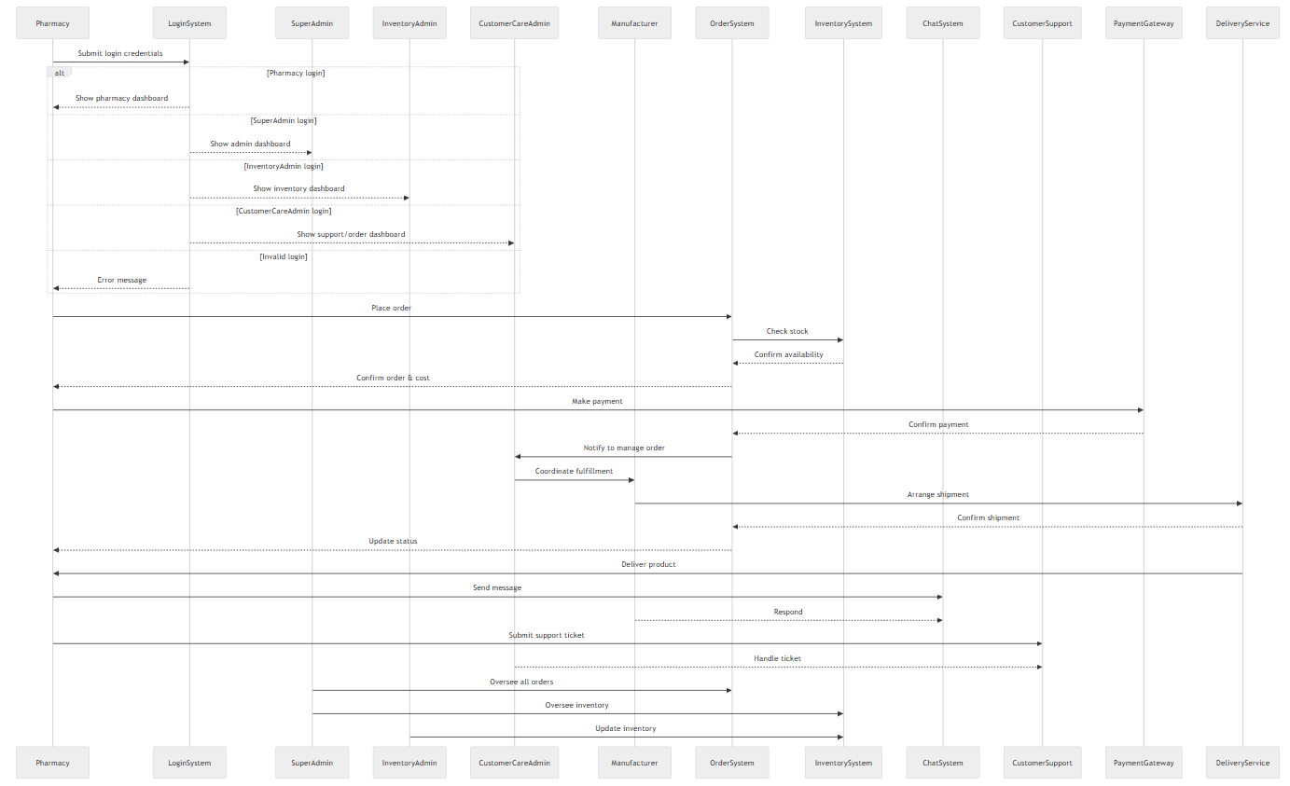
Figure 3.4 Sequence diagram of my system
Figure 3.4 illustrates the sequence diagram for the proposed system. The sequence diagram explains the sequence of activities that take place in the proposed system, starting from the instance the user signs up to the web-based platform to updating his or her profile.

3.4.6 Database Design
The essence of the database design is to portray a modeled view of the system’s database. The system’s database is a relational database that was designed and implemented with MySQL. The database was designed to have more than 6 entities and at least three attributes for each entity.
A. USER TABLE
Table 4.1 User table for the proposed system
Attribute | Data Type | Description
Id | Int | The primary key of the table
Username | Varchar | This is where the username of the user is stored.
Email | Varchar | The field for storing the user's email.
Phone_no. | Varchar | The field for storing the user's email.
Dob | Date | The field for storing the date of birth of the user.
Password | Varchar | The field for storing the user's email.
Level | String | The field stores the level of each user which determines the action they can perform
Date_joined | Timestamp | The field shows the date of when the user joined the team.

CHAPTER FOUR
SYSTEM IMPLEMENTATION

4.1 Introduction
This chapter provides step-by-step details regarding the development and installation of the Pharmaceutical Supply Chain and Direct Order Management System for First Vadis Pharmaceutical Industries Limited. Each section of the system is explained with screenshots as well as understanding notes about the user interface.

4.2 Choice of Development Environment
The technologies that were used in the development of the proposed system are described in this section.

4.2.1 Integrated Development Environment
The development environment for this system is Visual Studio Code (VS Code) because it is flexible, very extensible, has far-reaching support for extensions, and has an intuitive interface. VS Code has native integration of Git, terminal, debugging, and IntelliSense support, which enables it to be very responsive to front-end and back-end development.

4.2.2 Programming Languages
The system is designed using a combination of frontend and server-side technologies with a relational database to store structured data. The technologies used are:
- Frontend user interface: HTML, CSS, and JavaScript (Plain Code)
- Python Fast API framework to be used in backend work and API development
- MySQL to manage relational data about users, orders, and products
- JSON Web Token (JWT) authentication and secured API access

4.3 System Requirements
To effectively implement the application, the user should have:
- Current web browser (Chrome, Firefox, Safari)
- Internet access (preferably 3G and above)
- A minimum of an Android 8.0 or Windows 10 phone for desktop connectivity

4.4 User Interfaces of the System
This part illustrates user interfaces for different system modules like the dashboard, inventory control, order module, and the functionalities of chatting.

4.4.1 User Registration Page
Users (Pharmacies) are registered with information such as email, phone number and password. Input validation prohibits duplicate or invalid input.
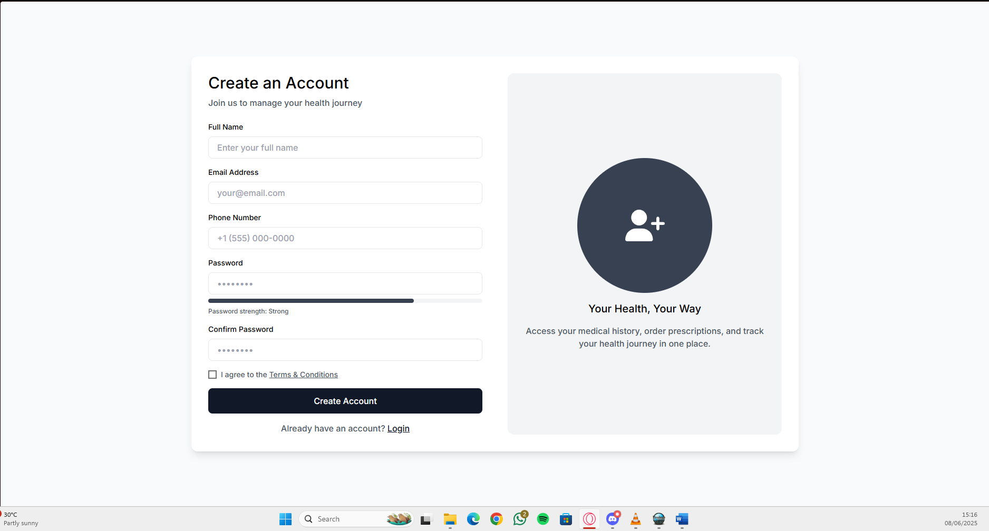
Figure 4.1: User Registration

4.4.2 User Login Page
Users log in using their credentials. Credentials are checked by the backend and return a secure JWT token that is used to validate subsequent requests.
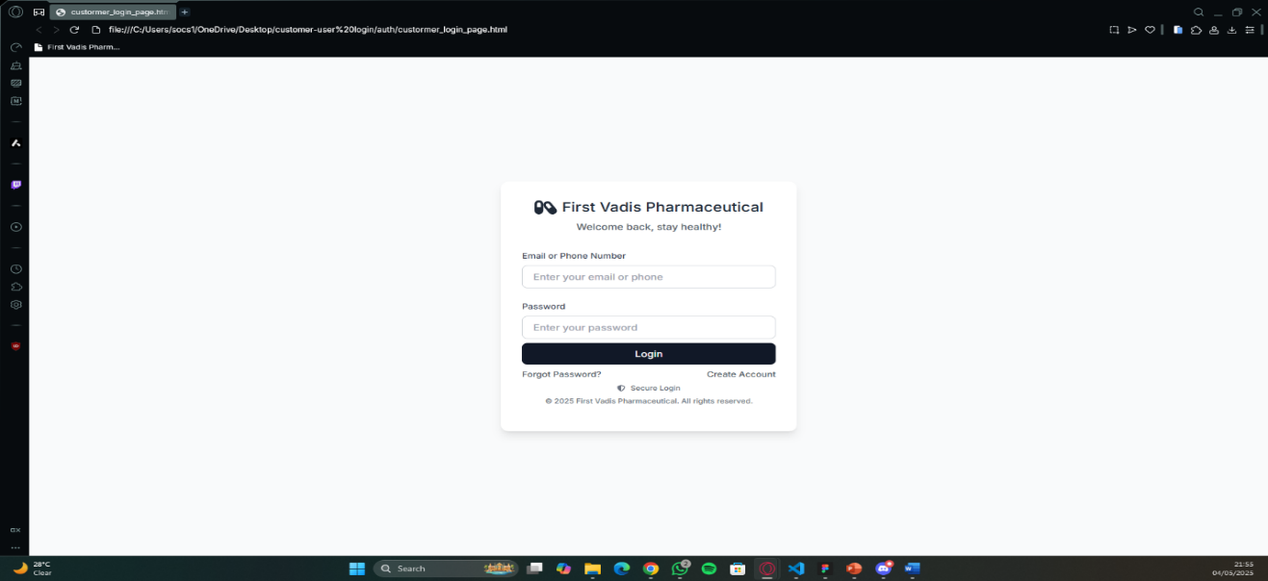
Figure 4.2: User Login Page

4.4.3 Dashboard
Dashboards vary by user types. Pharmacy users are able to order and monitor delivery status, whereas manufacturers are able to manage orders and inventory.
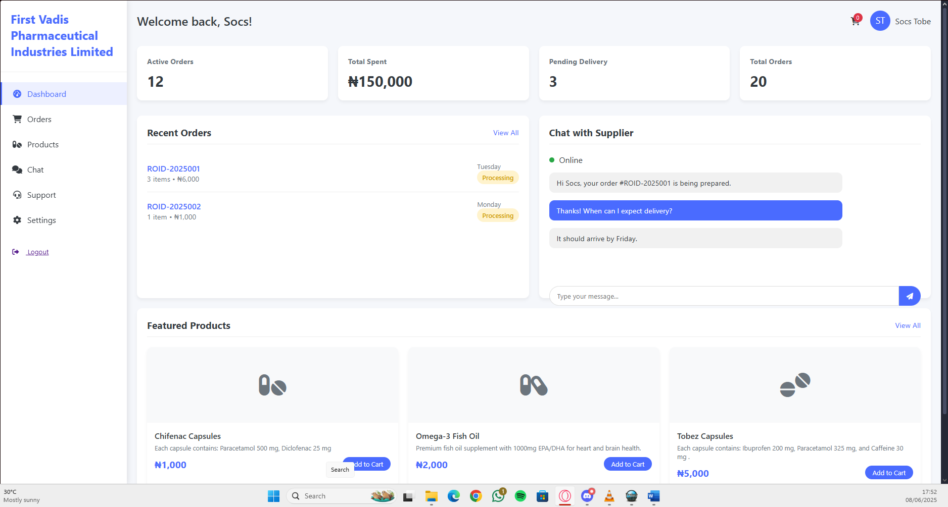
Figure 4.3: User Dashboard

4.4.4 Track Order
Customers receive information on the status of orders placed, like processing, shipping, and delivery.
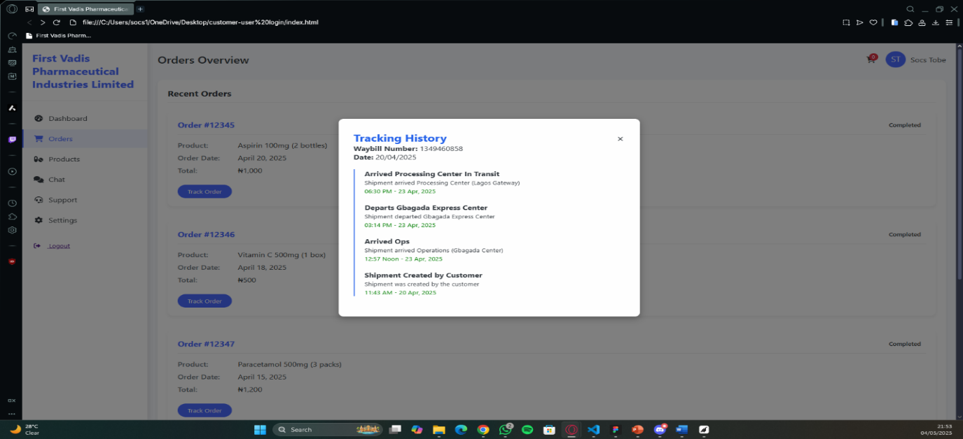
Figure 4.4: Order Tracking

4.4.5 Chat Feature
An in-app messaging feature allows the manufacturer and pharmacies to communicate in real-time to request clarification of supplies or delivery.
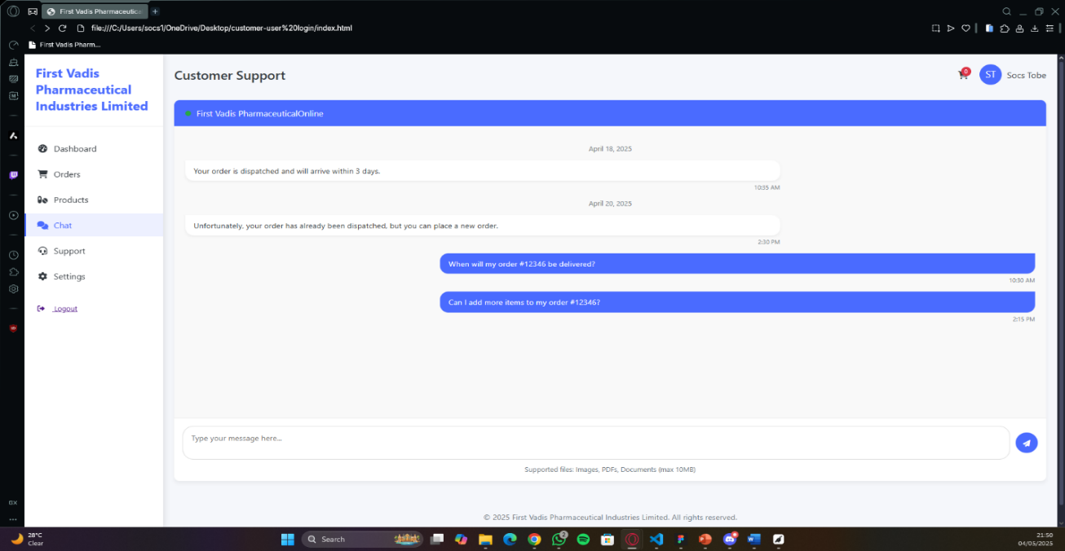
Figure 4.5: Chat Feature

4.4.6 Super Admin Dashboard
This is where the super admin can view their total revenue, total orders, inventory items, recent orders, inventory status, and recent messages
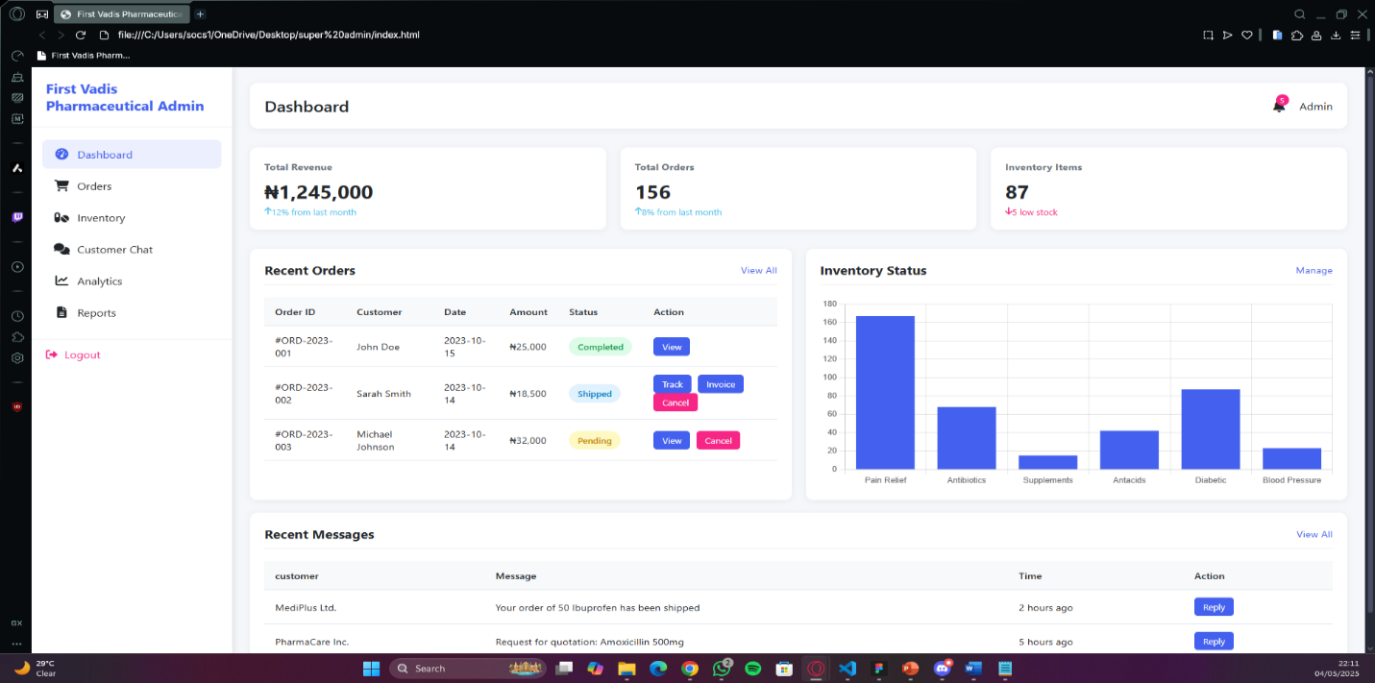
Figure 4.6: Super Admin Dashboard

4.4.7 Chat with Support
Admins handle incoming messages from users through the chat interface.
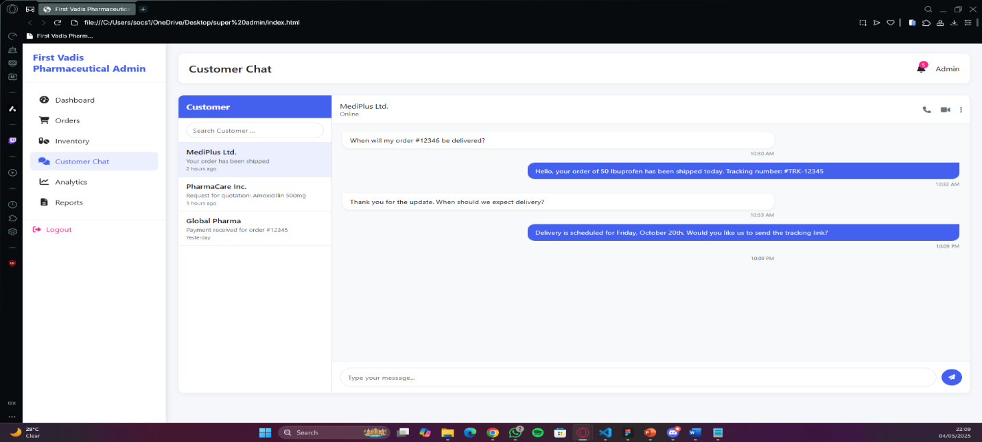
Figure 4.7 Chat with Support

4.4.8 Report Analytics
This is where the manufacturing company can view their sales analytics, inventory distribution, revenue by category, and products that are about to expire
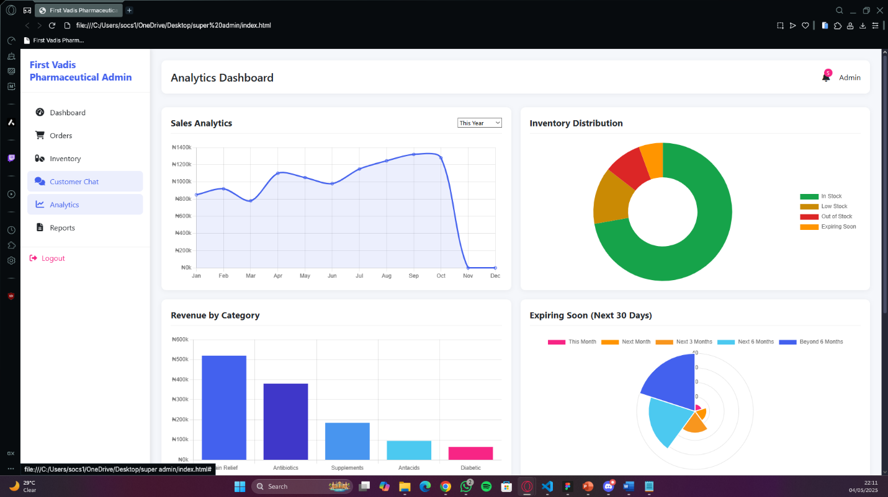

Figure 4.8 Report Analytics

CHAPTER FIVE
SUMMARY, CONCLUSION, AND RECOMMENDATIONS

5.1 Summary
The project sought to revolutionize the pharmaceutical supply chain by providing a direct and transparent ordering system between pharmacies and First Vadis Pharmaceutical Industries Limited. By eliminating intermediaries like distributors, the system ensures faster order processing, immediate stock updates, and seamless communication between suppliers and pharmacies. Built using the MERN stack, the platform features secure user login, streamlined order placement, and efficient stock management, minimizing delivery delays and reducing the risk of fake drugs.
To achieve this, the research proposes a series of main goals: to research literature on the existing supply chain models and recognize what inefficiencies and gaps are in current practice in terms of the use of third-party distributors with an emphasis laid on enhancing supply chain operation for First Vadis Pharmaceutical Industries Limited. Subsequently, an online platform for direct ordering of drugs and automated stock as well as order tracking processes was established, presenting an interface by which customers are able to deal directly with First Vadis Pharmaceutical Industries Limited, check what drugs are available in stock, and order without the need to go through any distributor. The system is further equipped with real-time customer support that provides easy communication between users and administrators. The system further comprises a reporting module with relevant information regarding sales, stock, as well as the performance of the suppliers in order to facilitate informed decisions and maximize supply chain management.
It is built with the MERN stack, and its features involve secure login of users, ordering, and inventory tracking. It provides increased transparency, avoids delivery delay, and avoids forgery risk.

5.2 Conclusion
In summary, the research has designed a sophisticated web-based First Vadis Pharmaceuticals Pharmaceutical Supply Chain and Direct Order Management System that will solve the issues of the pharma supply chain, for example, high cost of maintenance and implementation that renders it unaffordable to small companies. Also, issues such as there is no real-time communication that leads to challenges in efficient coordination of the players in addition to scalability issues of some systems because of complexity
Moreover, the new system included an integrated chat between suppliers of a Pharmacy supply chain management system to provide an active communication feature that allows pharma companies and suppliers to exchange messages among themselves regarding their orders, delivery status, official reports, products, and other requisite details in making it transparent in nature. It will additionally facilitate cooperation, decision-making with improved speed, and better response to supply chain disruptions.

5.3 Recommendations
- Add support for mobile application on iOS and Android
- Integrate a secure payment gateway to enable instant payments
- Include enhanced analytics to facilitate better supply chain decision-making
- Adopt multilingual rural accessibility facilitation
- Offer role-based access control to enhance data privacy

References
Abbas, M., Alhasan, A., & Hamza, U. M. (2015). Perceived ease of use and utilization of e-learning technologies by academic staff in Federal College of Education, Zaria.
Abisoye, O. A., Boboye, F., & Abisoye, B. O. (2013). Design of a computer-based inventory system for supermarkets. International Journal of Computing and Technology, 2(2), 45–50. https://www.ijctjournal.org/Volume2/Issue2/IJCT-V2I2P6.pdf
Ahmed, S. K., Naji, Z. H., Hatif, Y. N., & Hussam, M. (2020). Design and implementation of a drug inventory system. Diyala Journal of Engineering Sciences, 13(2), 80–90. https://www.iasj.net/iasj/article/192207
Althabatah, A., Yaqot, M., Menezes, B., & Kerbache, L. (2023). Transformative Procurement Trends: Integrating Industry 4.0 Technologies for Enhanced Procurement Processes. Logistics, 7(3), 63. https://doi.org/10.3390/logistics7030063
Buseri, T. F., Aremu, T. O., & Suleiman, I. A. (2023). Knowledge and practice of supply chain management of pharmaceuticals by health professionals in four states of South-South, Nigeria. African Journal of Research and Pharmaceutical Development, 15(2), 91–100.
Chen, J. (2025, May 31). Industrial Revolution: Definition, history, pros, and cons. Investopedia. https://www.investopedia.com/terms/i/industrial-revolution.asp
Chopra, S., & Meindl, P. (2019). Supply chain management: Strategy, planning, and operation (7th ed.). Pearson. https://www.pearson.com/store/p/supply-chain-management-strategy-planning-and-operation/P100001039313
Christopher, M. (2016). Logistics & supply chain management (5th ed.). Pearson Education. https://www.pearson.com/store/p/logistics-and-supply-chain-management/P100001006753
Coelho, L. C., & Laporte, G. (2015). An overview of vendor managed inventory: Coordination and inventory management. International Journal of Production Research, 53(17), 5223–5246. https://doi.org/10.1080/00207543.2015.1033032
Du, M., Luo, J., Wang, S., & Liu, S. (2020). Inventory control optimization with genetic algorithm and BP neural network. Neural Computing and Applications, 32, 1981–1994. https://doi.org/10.1007/s00521-018-3687-1
Felea, M., & Albăstroiu, I. (2013). Defining the concept of supply chain management and its relevance to Romanian academics and practitioners. Amfiteatru Economic Journal, 15(33), 74–88. https://www.amfiteatrueconomic.ro/RevistaDetalii_EN.aspx?Cod=240
Holm, M. R., Rudis, M. I., & Wilson, J. W. (2015). Medication supply chain management through the implementation of a hospital pharmacy computerized inventory program in Haiti. American Journal of Health-System Pharmacy, 72(17), 1450–1453. https://doi.org/10.2146/ajhp140671
Kritchanchai, D., & Meesamut, W. (2015). Inventory management in a hospital using demand categorization and resource allocation. International Journal of Supply Chain Management, 4(2), 11–19. https://ojs.excelingtech.co.uk/index.php/IJSCM/article/view/1355
Linda, D. M., Iheanyi, N. R., Chika, O., & Yaya, A. (2016). Development of standalone inventory management system for consumer goods. Unpublished manuscript, Federal College of Forestry, Jos, Plateau State, Nigeria.
Mao, Y., Zhang, Y., & Zhai, S. (2008). Mobile text messaging for pharmaceutical care in a hospital in China. Telemedicine and e-Health, 14(4), 412–417. https://doi.org/10.1089/tmj.2007.0081
Medical Packaging. (n.d.). Pharmaceutical supply chain management: Key steps & challenges. Retrieved June 12, 2025, from https://medpak.com/pharmaceutical-supply-chain-management/
Mu, Y., Boussemart, J.-P., Shen, Z., & Vardanyan, M. (2025). Sustainable supply chains with socially undesirable and intermediate outputs: Evidence from Chinese agricultural cities. Annals of Operations Research. Advance online publication. https://doi.org/10.1007/s10479-025-06658-w
Okeke, C. O., Uzochukwu, I. C., & Okoye, M. I. (2016). Online pharmaceutical management system. European Scientific Journal, 12(12), 139–150. https://doi.org/10.19044/esj.2016.v12n12p139
Onuiri, E. E., Oyebanji, I. G., Fayehun, S. A., & Chukwujioke, S.-D. (2016). Online pharmaceutical management system. European Scientific Journal, 12(12), 139–150. https://doi.org/10.19044/esj.2016.v12n12p139
Salih, H. S., Ghazi, M., & Aljanabi, M. (2023). An automated inventory management system for SMEs. Iraqi Journal for Computer Science and Mathematics, 4(2), 238–244. https://journal.ijcsm.org/index.php/ijcsm/article/view/219
Sukasih, E., Apriyanto, G., & Firdiansjah, A. (2020). Drug inventory management from a financial perspective in the ABC hospital pharmacy. IOSR Journal of Business and Management, 22(8), 54–61. https://www.iosrjournals.org/iosr-jbm/papers/Vol22-issue8/Series-5/H2208055461.pdf
Toyota Motor Corporation. (2020). Toyota production system overview. Toyota Global. https://global.toyota/en/company/vision-and-philosophy/production-system/
Uğrak, U., Çınar, Ş., Seyhan, F., & Kavak, D. (2025). Evaluation of the supply process in public hospitals: A qualitative study. Verimlilik Dergisi, 59(1), 101–114. https://doi.org/10.51551/verimlilik.1495743
Waller, M. A., & Fawcett, S. E. (2013). Data science, predictive analytics, and big data: A revolution that will transform supply chain design and management. Journal of Business Logistics, 34(2), 77–84. https://doi.org/10.1111/jbl.12010
Winters, B. H., & Hernandez, L. (1972). Automated drug inventory control system. American Journal of Health-System Pharmacy, 29(9), 780–785. https://doi.org/10.1093/ajhp/29.9.780

APPENDIX
Index page code of the user
<!DOCTYPE html>

<html lang="en">
<head>
<meta charset="utf-8"/>
<meta name="viewport" content="width=device-width, initial-scale=1.0"/>
<title>First Vadis Pharmaceutical Industries Limited</title>
<link href="https://cdnjs.cloudflare.com/ajax/libs/font-awesome/6.4.0/css/all.min.css" rel="stylesheet"/>
<style>
:root {
--primary-color: #4a6bff;
--secondary-color: #f8f9fa;
--dark-color: #343a40;
--light-color: #ffffff;
--success-color: #28a745;
--warning-color: #ffc107;
--danger-color: #dc3545;
--sidebar-width: 250px;
--transition: all 0.3s ease;
}

* {
margin: 0;
padding: 0;
box-sizing: border-box;
font-family: 'Segoe UI', Tahoma, Geneva, Verdana, sans-serif;
}

body {
display: flex;
min-height: 100vh;
background-color: #f5f7fb;
color: var(--dark-color);
}

/* Sidebar Styles */
.sidebar {
width: var(--sidebar-width);
background-color: var(--light-color);
box-shadow: 2px 0 10px rgba(0, 0, 0, 0.1);
padding: 20px 0;
transition: var(--transition);
position: fixed;
height: 100vh;
z-index: 100;
}

Index page code of the super admin
<!DOCTYPE html>
<html lang="en">
<head>
<meta charset="UTF-8">
<meta name="viewport" content="width=device-width, initial-scale=1.0">
<title>First Vadis Pharmaceutical Admin - Dashboard</title>
<link href="https://cdnjs.cloudflare.com/ajax/libs/font-awesome/6.4.0/css/all.min.css" rel="stylesheet">
<script src="https://cdn.jsdelivr.net/npm/chart.js"></script>
<style>
:root {
--primary: #4361ee;
--secondary: #3f37c9;
--accent: #4895ef;
--danger: #f72585;
--success: #4cc9f0;
--warning: #f8961e;
--light: #f8f9fa;
--dark: #212529;
--sidebar-width: 280px;
--expiring: #ff9500;
}

* {
margin: 0;
padding: 0;
box-sizing: border-box;
font-family: 'Segoe UI', Tahoma, Geneva, Verdana, sans-serif;
}

body {
display: flex;
min-height: 100vh;
background-color: #f5f7fb;
color: var(--dark);
}

.sidebar {
width: var(--sidebar-width);
background: white;
box-shadow: 2px 0 10px rgba(0, 0, 0, 0.1);
padding: 20px 0;
position: fixed;
height: 100vh;
z-index: 1000;
transition: transform 0.3s ease;
}

