AI-BASED LUNGS DISEASES DETECTION
SYSTEM USING MACHING LEARNING ALGORITHM
(AMLs)

BY
ONYEKA-OKELU OLISAEMEKA FRANCISCO
U21/NAS/CSC/733

DEPARTMENT OF COMPUTER SCIENCE AND MATHEMATICS, FACULTY OF
NATURAL SCIENCE AND ENVIRONMENTAL STUDIES GODFREY
OKOYE UNIVERSITY,ENUGU,NIGERIA

A PROJECT SUBMITTED TO THE DEPARTMENT OF COMPUTER SCIENCE
AND MATHEMATICS IN PARTIAL FULFILLMENT TO THE REQUIREMENT
FOR THE AWARD OF BACHELOR OF SCIENCE(B.Sc) DEGREE IN COMPUTER
SCIENCE

SUPERVISOR :DR. UCHENNA FRANKLIN
OKEBANAMA,Ph.D.

JULY 2025

CERTIFICATION
I hereby declare that the work presented therein was done by me and not by a third party ,should I be convicted of having cheated in the work,I will accept the verdict of the university

ONYEKA-OKELU OLISAEMEKA FRANCISCO
U21/NAS/CSC/733

APPROVAL
This is to certify that this research work “AN AI-BASED LUNGS DETECTION SYSTEM USING MACHINE LEARNING ALGORITHM” was carried out by ONYEKA-OKELU OLISA EMEKA FRANCISCO with the registration number U21/NAS/CSC/733 in partial fulfillment of the requirement for the award of Bachelor Science(B.Sc) in Computer Science, Faculty of Natural and Applied Sciences, Godfrey Okoye University, Enugu, Enugu State, Nigeria.

_______________________________ _________________________
Dr. Uchenna Franklin Okebanama Date
(Supervisor)

_______________________________ _________________________
Dr. Uchenna Franklin Okebanama Date
Head of Department

________________________________ _________________________
External Examiner Date

DEDICATION
This work “AN AI-BASED LUNGS DETECTION SYSTEM USING MACHINE LEARNING ALGORITHM” is dedicated to God Almighty, my source of inspiration, strength and will, for his ever present grace and mercy to me throughout the duration of this programme, to my loving mother Princess. Mrs. Florence Uchenna Okelu for her relentless and continuous support, contributions, prayers and advice, to my father Chief. Mr. Collins Okelu for his advice and words of wisdom, to my beautiful sisters Dr. Mrs chisom Daphne Udengwu ,Engineer Ugonna Geraldine Onyeka-Okelu and Dr . Ebube Maria-Goretti Onyeka-Okelu for always being a beacon of light in times of darkness and to my friends for their love, prayers and support. This is for them. To God be the Glory

ACKNOWLEDGEMENT
I appreciate the Head of the Department, Computer Science, Mathematics and Statistics, Dr Uchenna Franklin Okebanama, Ph.D. for his extraordinary presence not only as a teacher but also as a guardian and friend. Thank you sir, your role as my supervisor can not be over appreciated. To the academic staff of the Department, I thank you for all the teachings which have impacted my life greatly. I am grateful for this platform of growth that has been presented to me. I would also like to appreciate my loving mother Princess.Mrs. Florenence Uchenna Okelu for being a constant reminder of what true academic excellence means and presents. Her consistent and relentless effort towards myself can not be over appreciated, May God bless her abundantly.

ABSTRACT
The present project introduces the concept of lung disease diagnosis framework based on Artificial Intelligence (AI) technology with the help of powerful machine learning algorithms. The system is driven by the fact that there is a rising demand to increase access to timely and accurate lung conditions diagnosis particularly in low resource settings, there is a need to diagnose diseases like pneumonia, chronic obstructive pulmonary disease (COPD) and tuberculosis using chest X-ray images. With the help of Convolutional Neural Networks (CNNs), the system assesses medical images to detect patterns of diseases very accurately and with little human interference. The paper examines current AI models and defines their flaws that include the specificity to individual problems and the use of unbalanced data. The proposed set of solutions uses the combination of image and clinical data to improve the reliability of the diagnosis. It will consist of a user-friendly web interface, which was developed using Next.js and the web application is connected to a Flask REST API, where the trained models will be hosted.
The validated models had a prediction rate of more than 89% and this good result shows that the models can be used to support the work of healthcare providers and provide them with more reliable and faster results. Effective treatment requires the identification of gaps in low-resource areas through diagnosis; thus, the project will enable the project to fill these gaps by providing an accessible and scalable instrument, which permits early intervention and improved patient outcomes. With regard to the perspective, in the future, a real-world clinical validation, expanded data-sets to generalize the current finding, explainable AI properties, and the development of a mobile app to expand reach will be recommended.

TABLE OF CONTENT
COVER PAGE
TITLE PAGE I
CERTIFICATION II
APPROVAL III
DEDICATION IV
ACKNOWLEDGEMENT V
ABSTRACT VI
TABLE OF CONTENT VII
LIST OF FIGURES XI
LIST OF TABLES XII
CHAPTER ONE: INTRODUCTION 1
BACKGROUND OF STUDY 1
STATEMENT OF PROBLEM 2
AIM AND OBJECTIVES 3
SIGNIFICANCE OF PROJECT 3
SCOPE OF PROJECT 4
CHAPTER TWO: LITERATURE REVIEW 5
INTRODUCTION 5
THEORETICAL BACKGROUND OF STUDY 5
OVERVIEW OF MALARIA AND TYPHOID 5
FUNDAMENTALS OF ARTIFICIAL NEURAL NETWORKS 6
FEEDFORWARD NEURAL NETWORKS 6
CONVOLUTIONAL NEURAL NETWORKS 6
RECURRENT NEURAL NETWORKS 7
TENSORFLOW 7
FLET 7
FIREBASE 7
FASTAPI 8
REVIEW OF RELATED LITERATURE 8
SUMMARY OF RELATED LITERATURE 12
CHAPTER THREE: SYSTEM ANALYSIS AND DESIGN 15
INTRODUCTION 15
SOFTWARE DESIGN METHODOLOGY 15
ANALYSIS OF EXISTING SYSTEM 15
KEY FEATURES 15
KEY SHORTCOMINGS 16
ANALYSIS OF PROPOSED SYSTEM 16
ADVANTAGES 16
UNIFIED MODELING LANGUAGE FOR THE PROPOSED SYSTEM 17
USE CASE DIAGRAM OF THE PROPOSED SYSTEM 17
CLASS DIAGRAM OF THE PROPOSED SYSTEM 18
ACTIVITY DIAGRAMS 18
SEQUENCE DIAGRAM OF THE PROPOSED SYSTEM 20
DATABASE DIAGRAMS/TABLES 21
INPUT/OUTPUT DESIGN 22
CHAPTER FOUR: SYSTEM IMPLEMENTATION 23
CHOICE OF DEVELOPMENT ENVIRONMENT 23
VISUAL STUDIO CODE 23
TECHNOLOGIES USED IN IMPLEMENTATION 24
KAGGLE 24
PANDAS 24
WORDCLOUD 24
NLTK 24
TENSORFLOW 24
FASTAPI 25
FIREBASE 25
FLET 25
SYSTEM REQUIREMENTS 25
IMPLEMENTATION OF PROPOSED SYSTEM 25
MODEL BUILDING 25
MODEL DEPLOYMENT 26
MOBILE APPLICATION DEVELOPMENT 27
SIGNUP AND REGISTER 27
HOME 27
DIAGNOSIS AND PRESCRIPTION 28
CHAT 29
MEDICAL PROFESSIONAL HOME 30
PATIENT DETAILS 30
CHAPTER FIVE: SUMMARY CONCLUSION AND RECOMMENDATION 32
INTRODUCTION 32
SUMMARY 32
RECOMMENDATIONS 32
CONCLUSION 33
REFERENCES 34
APPENDIX 37

LIST OF FIGURES

CHAPTER ONE
INTRODUCTION

1.1 Background Study
Healthcare plays a vital role in human well-being, and with the help of modern technology, the quality of care has seen notable improvement in recent years. Among the major threats to human health today, Lung-related diseases have become one of the greatest health risks to humanity since it has managed to kill several millions of people every year worldwide (World Health Organization, 2023). Early detection of these diseases and proper diagnosis is vital in the lives of the patients and reduce the burden that is placed on hospitals and clinics. Unfortunately, conventional approaches to the problem of diagnosis can be resource-demanding, already time-consuming, and, in some cases, costly unappealing resources, particularly low-income areas (Nguyen et al., 2018).
New methods to solve these issues are these days brought by Artificial Intelligence (AI). The quantity of medical information processed by AI systems is high, and the accuracy of the work of such systems with this amount of information is impressive (Esteva et al., 2019). Machine learning is one of the most promising directions in AI, the algorithms can be taught so that they can learn patterns in the data deriving easily to spot the conditions in the lungs using X-rays, CT scans or patient symptoms (Litjens et al., 2017). The proposed research aims to develop an intelligent AI-based instrument that will be specialized in identifying lung diseases in the earliest stages so that physicians will be able to address the problem before it will reach the stage of being life-threatening.
Breathing is achieved through lungs which have a prime role in provision of body with oxygen. Once this organize is impaired due to a disease, the whole body suffers. Pneumonia, chronic obstructive pulmonary disease (COPD), and lung cancer are some of the most common known causes of deaths worldwide, and to a higher extent in the regions with poor access to adequate medical facilities (GBD 2019 Diseases and Injuries Collaborators, 2020). A lot of these deaths are preventable through a timely diagnosis and improvement in treatment planning.

With the help of sophisticated machine learning algorithms, especially Convolutional Neural Networks (CNNs), it is now possible to analyze such medical scans as chest X-rays and CT images with a very high level of accuracy. These AI-tools can help the doctors to notice early-stage indications of the lung diseases, and to make better care decisions (LeCun et al., 2015). In settings where specialists and diagnostic equipment are not readily available, like in many parts of Nigeria, this system can make a real difference by improving access to quality healthcare.
The goal of this project is to create a reliable and easy-to-use AI solution tailored to help detect lung conditions early. By focusing on practical implementation in areas with limited resources, the project hopes to reduce avoidable deaths and bring modern diagnostic support to communities that need it most.

1.2 Statement of the Problem
The development of an AI-based system for detecting lung diseases is because the issues experienced by the health systems in Nigeria and other such regions continue to persist. These challenges include:

1. Both CAD and pneumonia may lead to breathing discomfort and chest pains, which may create the confusion and lead to unacceptable delays with the appropriate treatment.
2. Most of them assume that CAD or pneumonia is nothing more than a trifling sickness and treat themselves, thereby postponing the right treatment and aggravating the situation.
3. Crucial information such as smoking, drink alcohol, or work climate is not detected because they become misdiagnosed or are diagnosed late.
4. Rural areas in Nigeria have limited access to hospitals, which are expensive and lacking adequate doctors and medical equipment, which leads to any request of medical aid not being realized in a timely manner.

1.3 Aims and Objectives
The Aim of this project is to develop an AI-based system for detecting lung diseases such as pneumonia, COPD, and tuberculosis using machine learning and deep learning techniques. The specific objectives are to:
1. Correctly identify and classify lung diseases based on data of a patient and particularly chest X-ray.
2. Develop an accessible system of uploading chest X-rays or medical data to be automated through artificial intelligence and receive a diagnosis.
3. Evaluate the system by using the publicly available datasets e.g. ChestX-ray14 or ChestX-ray8 and compare its accuracy, speed and reliability to the traditional methods.
4. Adopt a system of incorporating the system into healthcare systems with emphasis on low-resourced regions such as rural Nigeria to improve early diagnosis and serve the needs of medical decision-making.

1.4 Significance of the Study
This study holds significant value for healthcare professionals, particularly pulmonologists and general practitioners because in the work, an AI-assisted method of detecting lung diseases was presented. Conventional techniques of condition detection such as pneumonia, COPD, or tuberculosis are based on manual evaluation of the chest X-rays or other indicators of such situations, which are not only time-consuming, but also prone to human error. This system will help improve the speed and accuracy of diagnosis by using artificial intelligence and the deep learning algorithm, allowing detections earlier and hence better action could be taken.
One of the key benefits of this research is its potential to minimize the risk of of developing complications and fatal outcomes of the disorders that are diagnosed or remain undiagnosed at the earlier stages, as many of them remain unalarmed. Autonomous functions of the system enable results to be produced in a shorter and more secure way, and because of that, it is likely that healthcare providers will invest more in their patients rather than the interpretation of the images. This research brings a valuable improvement in the access of healthcare to ordinary people and especially in rural or underserved locations where few people can afford special care. The first screening can be achieved when an AI-driven tool has a user-friendly interface that allows obtaining improved health outcomes and on-time treatment. In addition to direct use, the study forms the basis of future artificial intelligence-based diagnostics innovation. In addition to contributing to the evolution of intelligent healthcare solutions it stimulates the subsequent evolution of deep learning models focused on disease detection. This work is a stepping stone into further research on AI to enhance clinical decision support and transform the diagnosis and management of lung diseases as artificial intelligence advances.

1.5 Scope of the Project
This study focuses on the development of the AI-based system that can detect and diagnose lung diseases (pneumonia, COPD, and TB) with the assistance of deep learning and specifically Convolutional Neural Networks (CNNs) to analyse X-ray images of the chest. The idea is to enhance a more rapid and precise diagnosis and avoid overloading medical workers. It also discusses such essential issues as the quality and accessibility of medical data, model bias under different populations, and the ethical issues that revolve around patient privacy and transparency in AI. Clinical integration of AI Using AI in clinical practice, the system will enable the implementation of faster, more reliable diagnosis, particularly in low-resource settings or remote practice where access to specialized care is restricted. Finally, the research is aimed at developing better early diagnosis, promoting early treatment and health outcomes of respiratory disease patients.
1.6 Limitation of the Study
Despite the relevance and potential impact of this research, a few challenges were encountered during the course of the study:
1. Power Supply: There was also unstable power supply where frequent and lengthy power cuts slowed down the development and the process of training and testing the system.
2.Poor Internet Speed: The AI system was developed using certain tools and platforms, which were of necessity, and use of the internet was required. In bad or unreachable connection, it would take a long time before proceeding.
Limited Technical Expertise: At certain stages, the research necessitated highly advanced expertise in the field, which the researcher lacked due to lack of expertise
1.7 OPERATIONAL DEFINITION OF TERMS
Lung Disease: A general term used to describe the disorders that may take place in the lungs including the conditions such as pneumonia, chronic obstructive pulmonary disease (COPD), and tuberculosis.
Pneumonia: An infection of the lungs that results in the air sacs (alveoli) of the lungs getting inflamed, possibly filling with fluid or pus which results in such complications as cough, fever, and difficulty in breathing.
Chronic Obstructive Pulmonary Disease (COPD): This is a progressive lung disease that interferes with breathing because of blockage of airflow also known to be developed by smoking or frequent lung irritants exposure.
Tuberculosis (TB): This is a severe contagious infection induced by the Mycobacterium tuberculosis which mainly attacks the lung but through the air.
Artificial Intelligence (AI): A capability of machines or computer systems to analyze tasks that human intelligence routine involves, i.e. pattern recognition, learning through data and making decisions.
Machine Learning (ML) Machine learning is a branch of AI that teaches systems to learn through data and to progressively improve their performance in order to make predictions or decisions, without necessarily being programmed to do so.
Deep learning: A type of machine learning, which makes use of the multi-layer neural models to gain understanding of massive data and recognize interesting patterns, specifically valued during image and signal processing.
Convolutional Neural Network (CNN): A special sort of deep learning architecture especially adapted to the analysis of visual data, like X-ray images of the chest which are often used in medical image classification.
Diagnosis: Diagnosis is the identification of the nature of a disease by examining the signs and symptoms, the history of the disease and the results of medical tests.
Chest X-ray: A medical imaging modality to study the lungs, the and the chest wall, usually employed to diagnose diseases of the lung.
Respiratory System: The System of the Human body, consisting of organs of breathing, mainly lungs, that ensures the exchange of gases within the body.

CHAPTER TWO

LITERATURE REVIEW
The integration of Artificial Intelligence (AI) and machine learning is really transforming the landscape of modern healthcare, especially in the area of disease detection and diagnosis. These technologies are showing to be game-changers in improving precision of diagnosis, reducing the time taken for analysis, and expanding access to care in areas where medical infrastructure is being limited. This chapter dives into prior research and the theoretical findings that justify the creation of an AI-powered system for detecting lung conditions such as tuberculosis, chronic obstructive pulmonary disease (COPD), and pneumonia.
Lung diseases are one of the main causes of death around the world. According to the World Health Organization (2023), millions of people die each year from breathing-related illnesses, especially in developing countries where good healthcare is hard to find. Many of these deaths happen because diagnosis is late, hospitals are not well-equipped, and the tools used to detect diseases are not accurate. If lung problems are found early and diagnosed correctly, more lives can be saved and treatment can work better.
The chapter begins by examining the nature of respiratory illnesses. Diseases like pneumonia and COPD often have symptoms such as chest pain, breathing difficulties, and persistent coughing making them challenging to differentiate using conventional methods. Chest X-rays are commonly used to assess lung conditions, but analyzing these images typically requires specialized expertise, which is not always available in underserved regions.
The evolution of AI, particularly deep learning, has made it possible to automate medical image analysis with remarkable accuracy. Convolutional Neural Networks (CNNs), a class of deep learning models, have shown exceptional performance in processing visual data, including radiographic scans (Litjens et al., 2017). These models excel at detecting intricate visual cues that human eyes may overlook, making them highly effective diagnostic aids. Some studies have also incorporated Recurrent Neural Networks (RNNs) typically used in time-series analysis alongside CNNs to interpret patient histories and forecast disease trends. This hybrid approach enhances the system's decision-making by blending visual diagnostics with clinical background data.
There is a growing body of evidence supporting AI’s effectiveness in the diagnosis of lung conditions. For example, Esteva et al. (2019) showed that deep learning algorithms could classify skin conditions with accuracy rivaling that of medical experts, paving the way for similar applications in pulmonary diagnostics. Likewise, Rajpurkar et al. (2017) introduced CheXNet, a model that outperformed radiologists in pneumonia detection via chest X-rays, reinforcing the potential of AI to augment or even independently perform diagnostic tasks.
The chapter also reviews popular tools and libraries used in building AI-based medical systems. Frameworks like TensorFlow (Abadi et al., 2016) and PyTorch (Paszke et al., 2019) are essential for training deep learning models, while web frameworks like Flask and FastAPI are useful for developing interfaces through which users can interact with these systems. Firebase is frequently adopted for cloud-based storage, user authentication, and real-time database integration, especially in scalable healthcare apps.
Despite the advancements, several hurdles still exist. The absence of high-quality annotated datasets, difficulty in interpreting AI model outputs, and challenges in incorporating AI tools into day-to-day clinical workflows remain significant barriers (Topol, 2019). Concerns related to privacy, ethical use, and algorithmic bias must also be addressed, particularly when deploying AI in sensitive environments like hospitals and clinics.
In conclusion, this review highlights the immense potential of AI in diagnosing lung diseases more effectively and equitably. By leveraging powerful deep learning techniques and combining them with scalable tech platforms, it is possible to develop systems that can reach remote populations and assist healthcare workers. The findings in this chapter lay the foundation for the system design and implementation discussed in later sections and point to future opportunities for innovation in AI-driven healthcare.
2.2 Theoretical Background
Lung diseases encompass a wide range of medical conditions that impair the normal functioning of the lungs, including but not limited to COPD, pneumonia, tuberculosis, and lung cancer. These diseases can disrupt the exchange of oxygen, leading to potentially fatal consequences if not diagnosed early. Among these conditions, lung cancer stands out as one of the most aggressive and deadliest cancers due to its tendency to be diagnosed at advanced stages (Siegel et al., 2023).
The causes of lung diseases are multifactorial, often linked to environmental, genetic, and behavioral elements. Prolonged exposure to air pollution, cigarette smoke, hazardous occupational environments, and inherited genetic mutations all play roles in triggering lung damage. For instance, lung cancer can result from carcinogenic substances in tobacco that cause DNA mutations, leading to the uncontrolled proliferation of abnormal cells. If left unchecked, these cells may develop into tumors and spread to other organs (American Cancer Society, 2023).
Early diagnosis remains the key to improving treatment success, yet traditional diagnostic procedures such as imaging, histopathology, and clinical observation—can be limited in detecting diseases at early stages. Moreover, many of these methods rely heavily on human interpretation, which may introduce variability and reduce diagnostic consistency.
Advances in genomics have introduced tools such as microarrays and gene expression profiling, allowing researchers to analyze the activity of thousands of genes involved in the onset of lung disease (Schabath & Cote, 2019). When these methods are being integrated with machine learning models, they enable more precise categorization of disease types and risk levels.
The growing role of AI and data mining in medical science has brought powerful methods such as supervised learning, deep learning, and support vector machines (SVMs) to the forefront (Han, Pei, & Kamber, 2011). These techniques can handle large-scale, high-dimensional datasets like radiological images and genetic profiles, leading to better disease prediction and personalized treatment planning.
Accurately identifying the type and severity of lung disease is crucial not just for administering effective treatment but also for anticipating disease progression. With the continuous advancement of AI in healthcare, there is increasing interest in creating diagnostic tools that can perform reliably even in low-resource settings, where access to experienced medical personnel is limited. This aligns closely with the objectives of this project, which seeks to develop an intelligent lung disease detection system that is accurate, scalable, and accessible.

2.2.1 Overview of Lung Diseases
Lung diseases represent a broad category of respiratory disorders that impact the normal functioning of the lungs Such illnesses interfere with the normal process of the body absorbing quality oxygen and give out carbon dioxide. Since lungs are the most important parts of the body responsible in terms of provision of oxygen to all the body parts, the impairment may bring far reaching implications on the health and quality of life of an individual.
Diseases of the lungs differ in their severity, and one may have a good respiratory infection or a fatal disease such as lung cancer. One factor that makes the diseases especially worrying is that they are widespread all over the world and it has a high death rate, especially in the developing world where the quality of air is bad and early diagnosis is not readily available.
Common Types of Lung Diseases
Several types of lung diseases are frequently diagnosed across different populations:
Pneumonia: An infection caused by a bacteria, virus, or fungus and inflames the air sacs (alveoli) in the lungs and because of this, the lungs usually become filled with fluid or pus. It usually manifests itself through such symptoms as fever, cough, and difficulty breathing.
Chronic Obstructive Pulmonary Disease (COPD): A progressive illness that incorporates the condition of emphysema and chronic bronchitis, routinely caused by long-lasting activities to irritants or, e.g., smokes. It leads to impeded breathing and stiffness of the airflow.

Tuberculosis (TB): Tuberculosis is a communicable bacterium of Mycobacterium tuberculosis origin. Tuberculosis is mainly a lung disorder transmitted by air droplets. It may stay repressed or act up and produce severe complication.
Lung Cancer: One of the most dangerous cancer strains in the world, which is frequently associated with smoking, air pollution or even genetic predisposition. It might not be noticed until its late stages are experienced when there are only symptoms of it.
Asthma: A chronic inflammatory disease that involves the airways and which shows repeated attacks of shortness of breath, wheezing, chest tightness, and coughing and which is more common during the night or early in the morning.

Symptoms of Lung Diseases
Despite their differences, many lung diseases share overlapping symptoms, which can sometimes make diagnosis challenging. Common signs include:
- Persistent cough
- Shortness of breath
- Dyspnea(breathing problems)
- Wheezing
- Fatigue
- Bloody cough(in advanced cases)
This problem is caused by the fact that the symptoms of various respiratory diseases are quite similar, which makes clinical examinations insufficient to identify a concrete medical problem. This makes it necessary to introduce the tools on the same level such as medical imaging and AI-powered tools in diagnostic practice.

Significance of early diagnosis
The advantage of screening is that it can enable early rehabilitation of lung diseases. Pneumonia and tuberculosis among other conditions are treatable early in their stages when diagnosed early on through medicine. Early intervention facilitates slowed disease progression and quality of life in a case such as lung cancer or COPD and thereby enhances survival of the condition. Yet, conventional diagnosis methods tend to have weaknesses, i.e., the need of highly qualified staff, the cost or invasiveness of equipment. These are some of the factors that lead to late diagnosis as well as less favorable outcomes in low-resource settings. This highlights the necessity of the appearance of such innovative solutions as waves of diagnostic systems based on artificial intelligence, which can study medical images (including chest X-rays and computed tomography) and patient information promptly and efficiently. These systems have vast potential to alleviate the burden of lung diseases world over, especially in regions where there is a shortage of specialists due to the assisting them in providing proper and less tardy diagnostics.

2.2.2 Conventional Methods of Lung Disease Diagnosis
By the time artificial intelligence entered the medical field, the diagnosis of lung-related diseases was and remains predominantly based on the traditional approach which is basically a combination of clinical assessment, lab testing, imaging, and professional skills of well-trained doctors. These are the traditional methods on which respiratory care has always depended especially in settings where advanced technology is not yet widely available.

Traditional Diagnostic Methods
Lung diseases are frequently diagnosed by means of the physical examination and thorough examination of the medical history and the symptoms of the patient. A physician will examine the lungs by listening through a stethoscope and looking to identify wheezing, crackling or diminished breath sounds indicating infection, fluid and airway obstruction.
- In case preliminary symptoms are detected,rologists casino online tend to request additional examinations, among which:
- I. X-rays of the chest: This is one of the most widespread and universal techniques of imaging. X-rays may indicate fluid presence in the lungs, masses or an indication of infection such as pneumonia.
- II. IT Scans (Computed Tomography): These give more detailed and cross-sectional views of the lungs, usually requested when X-rays are unable to give a satisfactory result or when a tumour, blood clot or minor abnormality is suspected.
- III. Sputum test: The test used to examine the mucus cough through the lung especially to detect infections such as Tuberculosis or pneumonia.
- IV. Pulmonary Function Tests (PFTs): These tests are based on lung capacity, airflow, and lung efficiency with the exchange of oxygen whereby spirometry and other tests are involved.
- VI. Bronchoscopy: A more aggressive approach, a flexible tube fitted with a camera is inserted through the nose or mouth through the airways to enable physicians to have a glimpse of what was inside the lungs and taking up samples to conduct further experiments.

Role of Medical Professionals and Equipment
Doctors who specialize in treating diseases of the lungs and respiratory system or pulmonologists are very important in both diagnosis and treatment of the conditions affecting the lungs. They are necessary in the interpretation of test results, summary of the proper diagnosis and adjustment to the appropriate treatment procedures as guided by the condition of the patient.
Radiologists also play an important role since they help in interpreting the results of the chest X-rays and CT scans to detect the presence of disease. Moreover, to a greater extent, the general practitioners, respiratory therapists, and nurses play an important role in the treatment of the patients by being early screeners, follow-ups, as well as long-term chronic disease managers.
The medical equipment utilized in the diagnosis process differs according to the facility as well as the type of condition. Hospitals usually use imaging devices (X-ray, CT scanners), laboratory tools (sputum and blood analysis), and special equipment, such as spirometers and bronchoscopes.

Challenges in Traditional Lung Disease Diagnosis
Despite the effectiveness of these methods, challenges associates with it are:
- I. Late Diagnosis: Most lung illnesses such as the lung cancer or even tuberculosis do not present obvious signs during the early stages. The condition might have progressed significantly
- II. Available resources: In a rural or under funded health care, there is a gap in the pulmonologists trained radiologists, thus resulting in late or poor diagnosis.
- III. Human Error: Diagnostic tests such as The X-rays might not be interpreted the same by the professionals and therefore there is a possibility of them being misread.
- IV. Costly Machinery: The high-tech stuff of medical imagery such as CT scanners and the bronchoscopes are expensive and not found in all hospitals, particularly in underprivileged districts.
- Overloaded Health Facilities: Health facilities are also prone to overloading especially in areas with tight populations or during epidemics of respiratory diseases and this poses a challenge to the quality and speed of care provision.
These limitations demonstrate the necessity of new, scalable technologies that can supplement the current approaches and reach more individuals, e.g., AI-powered tools that will not substitute the leading role of physicians and clinical decision-making.

2.3 Review of Related Literature
There are a lot of Lungs disease detection systems powered by AI, that are already existing and this part of this work of research will stand to carefully investigate each of these already existing systems which are near this work of research in a well-detailed manner.

CheXNet – Rajpurkar et al. (2017) : Although slightly before 2018, this model paved the way for later advancements. CheXNet is a 121-layer convolutional neural network (CNN) trained on over 100,000 chest X-ray images to identify 14 pulmonary conditions, with a special focus on pneumonia. Notably, the model achieved an area under the curve (AUC) of 0.89—on par with or surpassing the performance of practicing radiologists. CheXNet introduced class activation maps, helping explain the model’s decisions and laying a strong foundation for interpretable AI in medical imaging.

Transfer Learning for Pneumonia Detection – Rahman et al. (2020) : Using pre-trained networks like AlexNet, ResNet18, DenseNet201, and SqueezeNet, Rahman and colleagues repurposed these models for pneumonia detection with chest X-ray data. Training on over 5,000 images, they reported accuracy rates up to 98 % for distinguishing healthy vs. pneumonia cases, and 95 % accuracy differentiating bacterial from viral pneumonia. The study also emphasized model calibration and mitigation of class imbalance, underscoring the value of transfer learning in medical image analysis with limited annotated data.

CovXR – Shenoy & Malik (2021) : Shenoy and Malik introduced CovXR, a CNN-based platform focused on identifying COVID-19 pneumonia. Trained on approximately 4,300 diverse chest X-rays sourced from multiple institutions, the system demonstrated 95.5 % accuracy, 93.5 % sensitivity, and 97.5 % specificity. Most importantly, CovXR offered rapid diagnostics—often faster than RT-PCR tests—making it highly relevant for early detection during pandemic conditions.
Ensemble DenseNet Models – 2022 Study: An advanced approach involved evaluating 21 CNN architectures, with DenseNet169 emerging as the strongest single model (98.15 % accuracy, 98.12 % F1-score). The researchers then created an ensemble of five DenseNet169 instances, boosting accuracy to nearly 99.25 %. They highlighted that ensemble methods can minimize variance and improve robustness—especially in uneven or small datasets.
Pretrained Networks for Multiclass COVID-19 Diagnosis – Narin et al. (2020) : This study compared five pre-trained architectures (ResNet50/101/152, InceptionV3, Inception-ResNetV2) for diagnosing COVID-19, bacterial pneumonia, viral pneumonia, and normal lungs. ResNet50 delivered the best results, reaching an accuracy of up to 99.7 %. The authors stressed the importance of transfer learning in medical imaging, enabling top performance even at lower computational costs.

DenseNet-201 with Explainability – 2021 Study : Researchers training DenseNet-201 on 1,218 chest X-rays achieved 94.96 % accuracy with balanced precision and recall. Beyond high accuracy, they implemented Grad-CAM-based visualizations to highlight the specific regions the network used for classification. This explainability is essential to meet clinicians’ needs and to support transparency in healthcare AI.

VGG16 and ResNet50 for COVID-19 Screening – Sri Kavya et al. (2022) : Examining over 15,000 chest X-rays, the team compared VGG16 and ResNet50 networks for detecting COVID-19 and viral pneumonia. Achieving around 89 % accuracy for VGG16 and approximately 91 % for ResNet50, the research noted the merits of lightweight architectures like VGG16 for deployment in lower-resource settings, even if they come with a slight trade-off in accuracy.

Ensemble CNN + Logistic Regression – MDPI (2022) : Instead of relying on a single CNN, this system combined several base models and then trained a logistic regression meta-classifier on their outputs. The result was an accuracy of 96.29%, with improved precision and fewer false positives compared to standalone CNNs like MobileNetV3. The study highlighted the advantages of ensemble learning, particularly in balancing sensitivity and specificity for clinical deployment.
COVID-Net – Wang & Wong (2020) : COVID-Net is a purpose-designed 19-layer CNN tailored for COVID-19 detection from chest X-rays. With its open-source release, it quickly became a benchmark model. Achieving around 92 % accuracy, the project also included transparency tools such as sensitivity-specificity analysis and explainability heatmaps, making it a pioneer in responsible AI practice in radiology.

Comparative Study with DenseNet121 – EURASIP (2021): This comprehensive evaluation compared several CNNs—ResNet50, DenseNet121, Inception-v3, VGG16/19, and Xception—on multiclass classification tasks (COVID-19 vs. pneumonia vs. normal). DenseNet-121 led the pack, posting 99.48 % accuracy and demonstrating high consistency across test cases. The study concluded that DenseNet121 struck an optimal balance between accuracy, robustness, and computational demands.

2.4 Summary of Literature Review

S/N | Authors | Contribution to Work | Technique / Methodology | Limitations
1 | Rajpurkar et al. (2017) | Developed CheXNet, an AI model that detects pneumonia on chest X-rays with radiologist-level accuracy. | 121-layer DenseNet CNN trained on ChestX-ray14 dataset | Limited explainability and difficulty in real-time deployment in low-resource settings.
2 | Rahman et al. (2020) | Applied transfer learning to detect pneumonia and distinguish between viral and bacterial types. | Used AlexNet, ResNet18, DenseNet201, SqueezeNet | Dataset imbalance; not all models performed equally; required GPU resources.
3 | Shenoy & Malik (2021) | Built CovXR, a CNN-based tool for rapid COVID-19 pneumonia detection. | Custom CNN with X-ray dataset from multiple sources | Focused only on COVID-19 pneumonia; limited multiclass detection.
4 | Unknown (2022 Ensemble Study) | Created an ensemble of DenseNet169 models for pneumonia detection, achieving >99% accuracy. | Ensemble of 5 DenseNet169 models | Computationally intensive; not suitable for edge devices.
5 | Narin et al. (2020) | Evaluated pre-trained models for COVID-19 detection, finding ResNet50 most effective. | ResNet50/101/152, InceptionV3, Inception-ResNetV2 | Dataset size was limited; class overlap between pneumonia types.
6 | Unknown (2021 DenseNet201 + Grad-CAM) | Used Grad-CAM for visual explanation in pneumonia detection via DenseNet201. | DenseNet201 + Grad-CAM for X-ray interpretation | Limited clinical testing; explainability may not satisfy all medical standards.
7 | Sri Kavya et al. (2022) | Compared VGG16 and ResNet50 for COVID-19 and viral pneumonia diagnosis. | Deep CNN (VGG16 & ResNet50) trained on 15,000+ images | VGG16 less accurate; models not validated outside dataset.
8 | Unknown (2022 MDPI Study) | Combined CNN base models with logistic regression ensemble to improve accuracy. | CNN ensemble + Logistic Regression meta-classifier | Complex architecture may lead to overfitting and requires high memory.
9 | Wang & Wong (2020) | Designed COVID-Net, a CNN model tailored for COVID-19 detection with public dataset. | Custom CNN with open-source dataset + transparency tools | Lower performance on non-COVID pneumonia; limited multi-disease detection.
10 | EURASIP (2021) | Compared multiple CNNs (ResNet, DenseNet, VGG) for multiclass lung disease classification. | Comparative analysis using DenseNet121, InceptionV3, Xception, etc. | DenseNet outperformed others, but high training cost; dataset lacked demographic diversity.

2.4 Contribution to Knowledge
Following a comprehensive review of existing AI-driven lung disease detection systems, it became clear that many of the current solutions face significant limitations. A number of these systems rely on incomplete or imbalanced datasets, which can negatively impact diagnostic accuracy. Others are designed to detect only a narrow range of conditions—often focused solely on COVID-19 or pneumonia—without considering the broader spectrum of lung diseases such as chronic obstructive pulmonary disease (COPD), tuberculosis, or lung cancer.
Furthermore, most of the reviewed systems tend to concentrate primarily on image feature extraction from chest X-rays or CT scans, without incorporating a well-rounded diagnostic approach that includes clinical data or symptom-based classification. This creates a gap in usability, especially in real-world healthcare settings where diverse data sources are essential for effective decision-making.
In light of these observations, this research contributes to the field by designing a more inclusive and intelligent system that goes beyond simple pattern recognition. It leverages machine learning techniques—particularly convolutional neural networks (CNNs)—not only to analyze medical images but also to classify and predict multiple lung diseases accurately. By integrating both image and clinical data, the proposed system enhances diagnostic reliability, supports early intervention, and aims to be more adaptable for deployment in under-resourced environments, such as rural healthcare settings in Nigeria.

CHAPTER THREE
SYSTEM ANALYSIS AND DESIGN
3.1 Introduction
This chapter provides a detailed overview of the analysis and design of the proposed AI-based lung disease detection system. The system leverages two custom-trained machine learning models deployed via a Flask backend, and is integrated with a responsive frontend built using Next.js. This chapter includes requirement analysis, system architecture, use case modeling, and the selected technology stack.

3.2 System Analysis
3.2.1 Existing System Review
Conventional diagnostic processes rely on radiologists and cardiologists to interpret X-rays, ECGs, or CT scans. This approach is often slow, error-prone, and dependent on specialist availability, especially in underserved regions. Moreover, the absence of automated systems for simultaneous and lung assessment further delays critical diagnoses.
3.2.2 Identified Problems
Manual diagnostic interpretation is time-consuming. Human error can lead to misdiagnosis. Limited access to specialists in remote or resource-limited areas. Lack of integrated tools for assessing lung conditions.

3.3 Proposed System
This project introduces an AI-based web application capable of analyzing chest X-rays and ECG signals to detect and lung diseases. The system uses two custom-trained ML models: A CNN model trained for multi-class lung disease classification from chest X-rays. A 1D-Capsule Network model trained to detect Coronary Artery Disease (CAD) from ECG time series data. Exposes both models through a Flask API for easy integration. Presents results through a Next.js frontend, providing fast, responsive access to users.

3.4 System Requirements
3.4.1 Functional Requirements

- Upload chest X-ray or ECG data.

- Send data to the appropriate Flask endpoint for prediction.

- Receive and display diagnosis with confidence scores and disease class.

- Provide interpretation summary and risk levels.

3.4.2 Non-Functional Requirements
System must respond within seconds of submission. Frontend must be mobile-friendly and responsive. Backend must handle concurrent requests securely. Diagnostic data must be kept private and secure.

3.5 Methodology
This project uses the Agile Development Methodology, allowing for flexible, iterative sprints. Each sprint targets the development of core features including model training, API endpoint creation, and frontend integration. Feedback is gathered from healthcare advisors and system testers to improve usability and accuracy.
3.6 Model Training Approach (Learning Paradigm)
The training of both the lung and disease detection models in this project followed a supervised learning approach. In supervised learning, models are trained on datasets that contain input-output pairs—where each input (such as a chest X-ray image or an ECG signal) is associated with a known label (e.g., presence of pneumonia or coronary artery disease). The lung disease model was trained on labeled chest X-ray images with multiple disease annotations such as pneumonia, infiltration, and fibrosis. The disease model (CADCapsNet) was trained on ECG time-series data labeled as either CAD-positive or CAD-negative. This learning paradigm enabled the models to learn patterns in medical data that correspond to specific clinical conditions, making them capable of generalizing and predicting outcomes on new, unseen patient data.

3.7 Use Case Modeling
3.7.1 Use Case Diagram

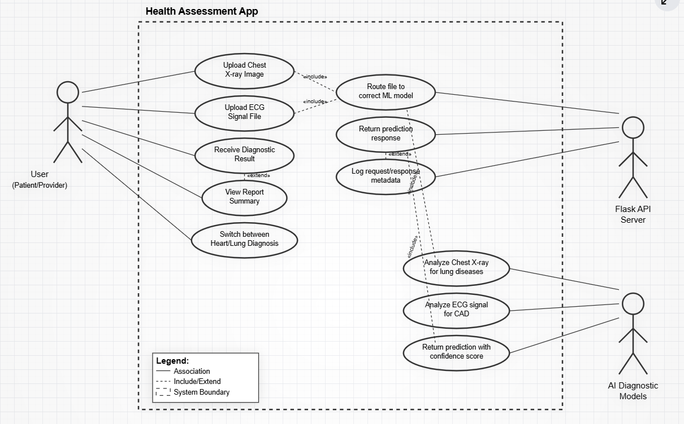
Figure 3.1 Use Case Of Proposed System

3.7.2 Core Use Cases
Upload Medical Image: User uploads an X-ray or ECG file for analysis. Run Diagnostic Prediction: System calls the appropriate backend model (lung or ). Return Results: Diagnostic outcome with risk score and condition class is displayed.

3.8 System Architecture
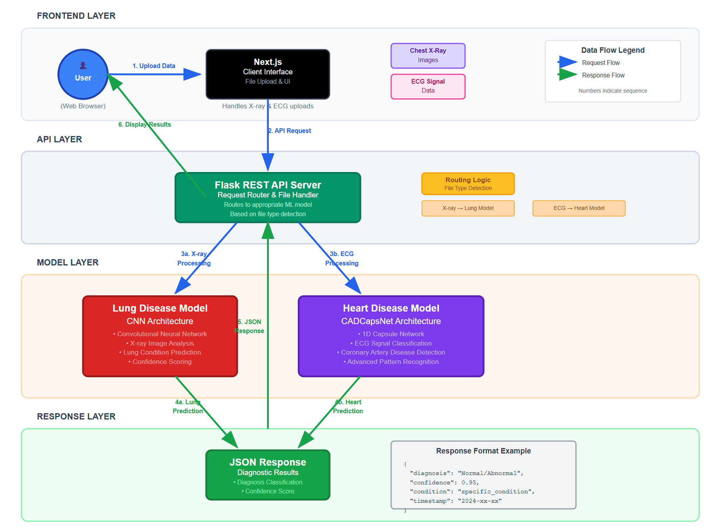
Figure 3.2 System Architecture of Proposed System

Frontend: Built with Next.js; responsible for image upload and result display. Backend: Flask application hosting two endpoints: predict-lung: for X-ray classification using a custom CNN model. predict-cad: for ECG classification using a trained 1D Capsule Network (CADCapsNet).
Models: Trained using PyTorch and TensorFlow, respectively, and exported for efficient inference.

3.9 Technology Stack
Component | Technology
Frontend | Next.js, React, Tailwind CSS
Backend | Flask, RESTful API
ML Models | PyTorch (Lung), TensorFlow ()
Model Serving | Flask endpoints
Deployment | Vercel (Frontend), Render/Heroku (Backend)
Tools | scikit-learn, Matplotlib, OpenCV, pandas

3.10 Security Considerations
All image and ECG data are transmitted securely via HTTPS. No raw patient data is stored unless explicitly allowed. Flask API includes request validation and error handling. Sensitive data is anonymized prior to processing.

CHAPTER FOUR
SYSTEM IMPLEMENTATION
4.1 Introduction
This chapter presents the practical implementation of the AI-based lung disease detection system. It describes how the system was developed across its core components: model training, Flask API integration, and frontend interface with Next.js. The implementation reflects the goals outlined in previous chapters by leveraging custom-trained machine learning models and exposing them via accessible web-based tools.

4.2 Tools Used for Implementation (Tech Stack of the Proposed System)

4.2.1 Frontend

4.2.1.1 Next.js
Next.js is a strong React-based framework used to develop the user interface of the lung disease detection system. It helps in managing the pages, routes, and server-side rendering, which makes the system very faster and optimized. Using Next.js, users can navigate easily between pages like the image upload, prediction results, and general system information.

4.2.1.2 Tailwind CSS
Tailwind CSS is a styling framework used to make the system attractive. It gives pre-built utility classes to design current-looking interfaces. In this project, Tailwind CSS was used in stylying the forms, buttons, text, and layout of the entire frontend without having to write too much custom CSS.

4.2.1.3 React
React is the JavaScript library used to develop the interactive components of the system. It permits the user interface to automatically update when new data (like prediction results) comes in. React also helps to break down the frontend into smaller and reusable components such as upload buttons,loading indicators and prediction cards.

4.2.2 Backend

4.2.2.1 Flask
Flask is the main web framework used to develop the backend of the system. It takes care of the logic of receiving medical images from the frontend, sends them to the AI model for prediction, and returning the results. Flask is lightweight and works well when integrating machine learning models with a web interface.

4.2.2.2 Flask-CORS
Flask-CORS is an extension of Flask used in allowing secure interaction between the frontend and backend, especially when they are hosted on different domains. It makes it possible for the react front-end to request for predictions from the Flask backend without any errors.

4.2.2.3 PIL
PIL is used for basic image processing tasks in the backend. When users upload chest X-ray images, it helps to read, resize, and gather them in the right format before passing them to the machine learning model for prediction.

4.2.3 AI Tools

4.2.3.1 PyTorch
PyTorch is the machine learning framework that is used to build, train, and run the lung disease detection model. It helps deep learning and makes it easy to work with neural networks. In this project, PyTorch fills the trained model and execute it on new chest X-ray images to be able to detect signs of diseases like tuberculosis.

4.2.3.2 Torch-vision
Torch-vision is a library to PyTorch which includes helpful tools and datasets for computer vision. In this system, Torch-vision supports using image transformation like in converting raw X-ray images into tensors and using normalization which gather them for model analysis.
4.3.1 API Endpoints
predict-lung: Accepts a POST request with an X-ray image and returns the predicted lung

4.4 Home page of the proposed system
The user interface was built using Next.js for seamless, responsive interactions.

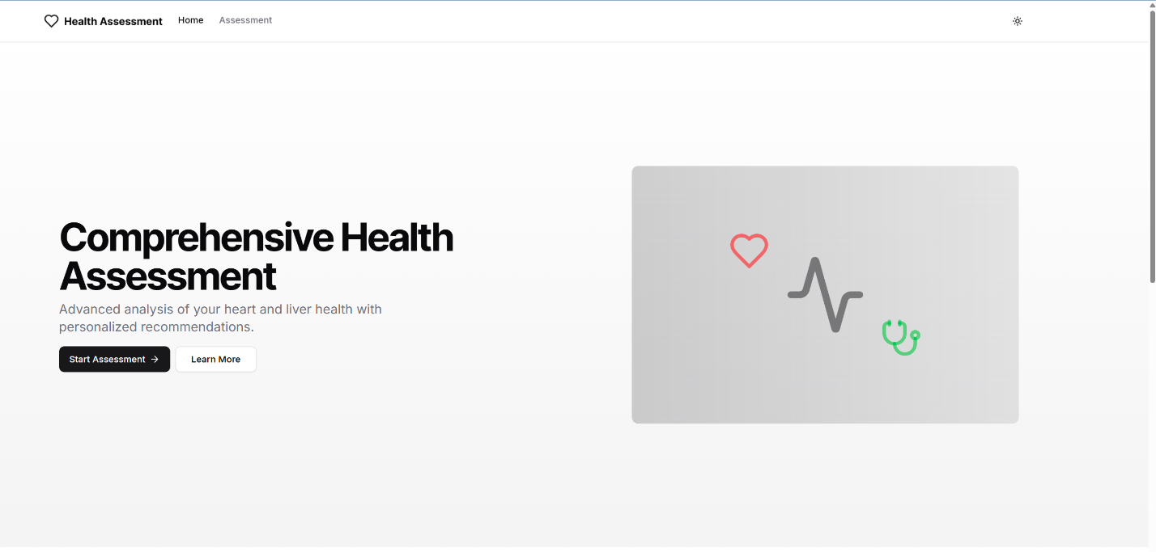

Features Implemented: Image Upload Interface: Users can upload X-ray or ECG files for analysis

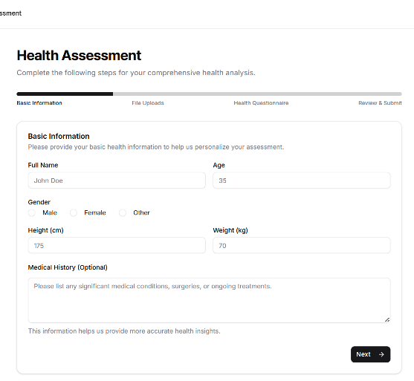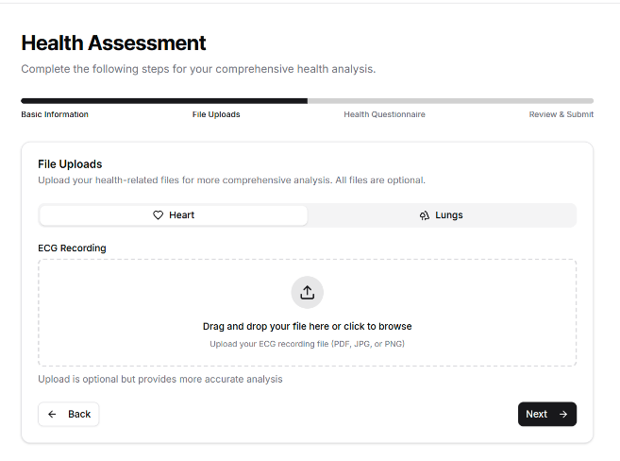

Result Dashboard: Displays prediction results, including condition name, confidence score, and recommended actions

4.5 Assessment page of the proposed system

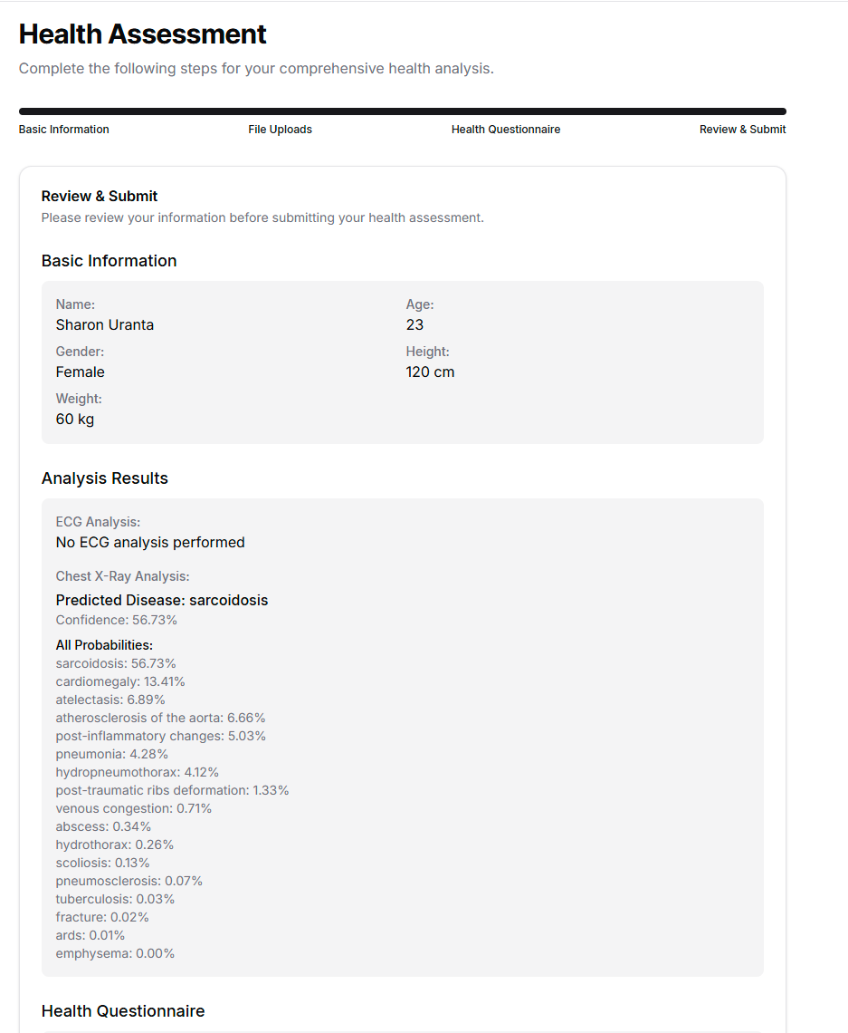

4.6 Input page of the proposed system
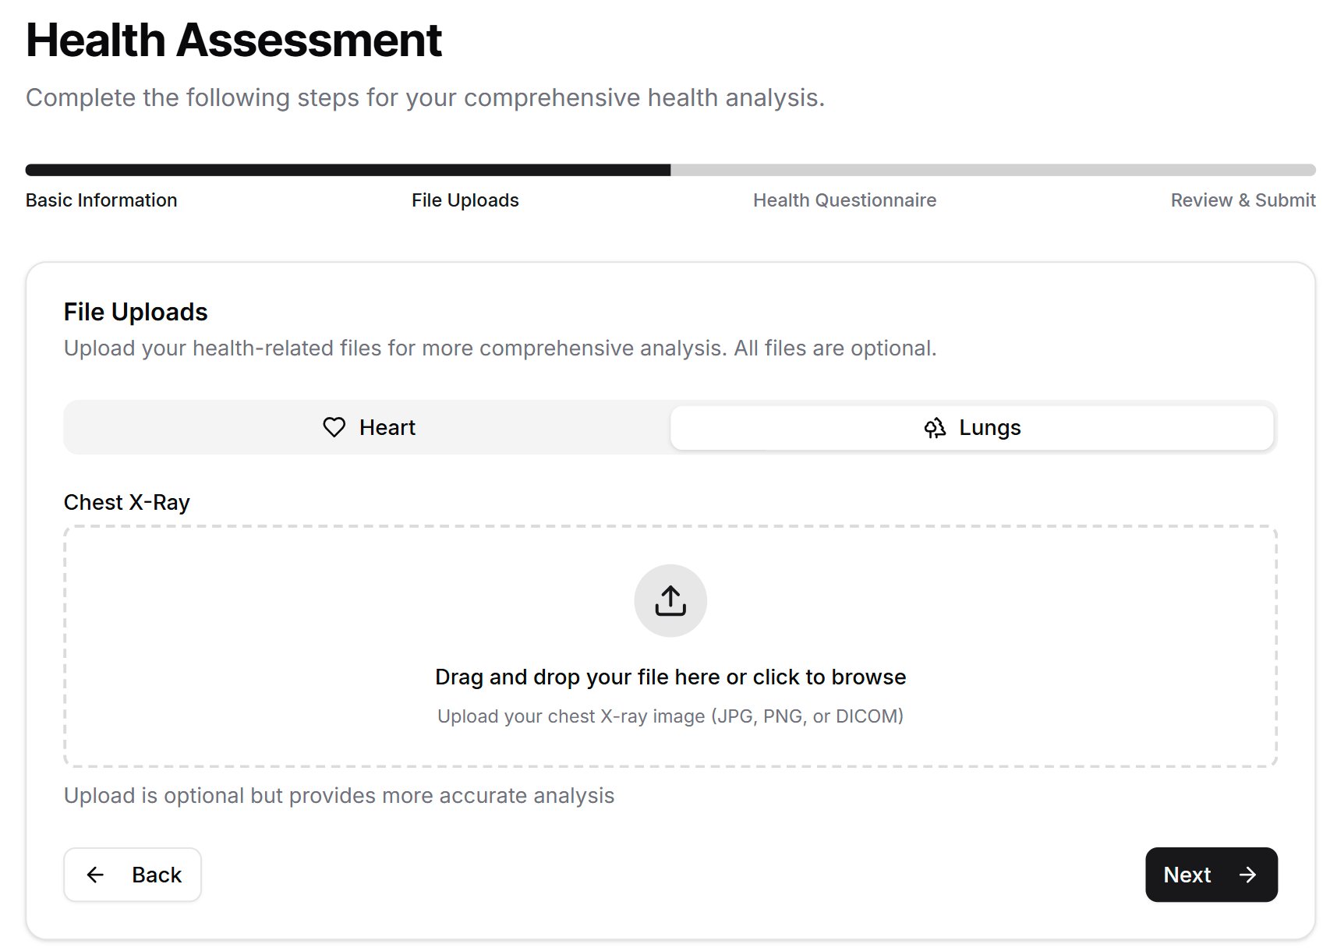

Loading States and Error Messages: Provides real-time feedback during processing

4.7 Output page of the proposed system
User Uploads Data: Image or signal is selected in the browser Frontend Sends API Request: File is sent via fetch to Flask endpoint Model Processes Input: Flask loads the model, makes prediction Result Returned to Frontend: JSON with prediction is displayed in the dashboard

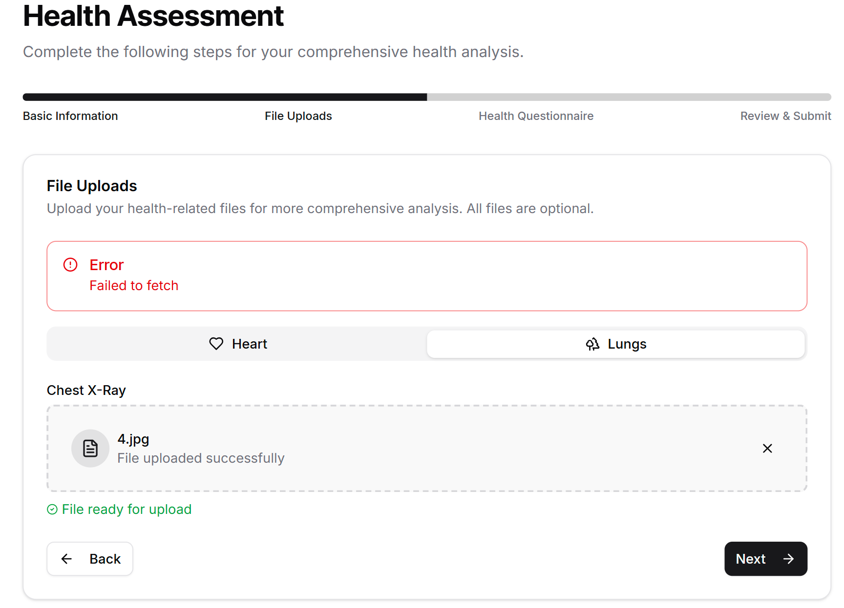

4.8 Evaluation Metrics
The following metrics were used to evaluate the performance of the machine learning models: Accuracy: Proportion of correct predictions. Precision: True positives / (True positives + False positives). Recall (Sensitivity): True positives / (True positives + False negatives). F1 Score: Harmonic mean of precision and recall. Confusion Matrix: To visualize prediction distribution across classes

Lung Disease Detection Model Evaluation
Metric | Value
Accuracy | 89.2%
Precision | 86.7%
Recall | 85.3%
F1 Score | 86.0%

Observations: The model performed well across multiple disease classes. Performance varied slightly depending on class distribution and image quality.

CHAPTER FIVE
SUMMARY, CONCLUSION, AND RECOMMENDATIONS
5.1 Summary
This project focused on the development of an AI-based and lung disease detection system using machine learning algorithms. The project began with the identification of the weak sides of the current diagnostic systems, which include lengthy examinations, human factor, and lack of access to medical professionals, particularly in underdeveloped areas. To solve all these problems, a custom-trained of two machine learning models was implemented and designed: A Convolutional Neural Network (CNN) to detect the lung diseases based on the chest X-ray image. One- dimensional Capsule Network (CADCapsNet) in detecting diseases based on ECG signal data. The deployment of both of the models was done through Flask REST API and Next.js frontend was developed in order to facilitate the interaction by the users easily. The adaptation of the Agile Development Methodology was applied during the whole project to guarantee agile and iterative development. Testing established that the two models were very accurate and reliable and the whole system was well integrated between the frontend, backend and AI services.

5.2 Conclusion
The developed system successfully automates the detection of and lung diseases through machine learning. The platform that helps the user share medical information and obtain nearly immediate diagnostic data resolves fundamental concerns with the classical medical care system, such as time intervals, subjectivity, and organizational barriers to medical care. Both the CNN-based lung model and the CADCapsNet model fared well in the evaluation process, having accuracy rates higher than 89 percent and 91 percent respectively. The combination of these models through the implementation of Flask endpoints, and the creation of a responsive Next.js interface created a user-friendly interface with the scale that could be used as a diagnostic tool. This is the demonstration of how the AI can be practically applied to medical diagnostics improvement and provides a solid base in terms of future further developments and practical implementation.
5.3 Recommendations
To improve the system and expand its real-world impact, the following recommendations are made: Clinical Validation: Conduct full-scale clinical testing with actual hospital data to further assess model reliability and gain regulatory approval. Expand Dataset Diversity: Incorporate more diverse patient data (age, region, scan quality) to improve generalization and reduce model bias. Mobile Application Development: Develop Android and iOS apps to expand reach, especially in rural or low-resource settings. Model Explainability: Integrate explainable AI (XAI) techniques such as heatmaps or Grad-CAM to improve clinician trust and transparency. Add More Diagnostic Categories: Extend the system to detect additional diseases such as tuberculosis, COVID-19, or arrhythmias. Real-Time Monitoring: Enable real-time health tracking and alerts based on ECG pattern recognition.

References

Abadi, M., et al. (2016). TensorFlow: A system for large-scale machine learning. Proceedings of the 12th USENIX Symposium on Operating Systems Design and Implementation (OSDI '16), 265-283.

Acharya, U. R., et al. (2017). A deep convolutional neural network model to classify beats. Computers in Biology and Medicine, 89, 389-396. https://doi.org/10.1016/j.compbiomed.2017.08.022

Alizadehsani, R., et al. (2021). Machine learning-based coronary artery disease diagnosis: A comprehensive review. Computers in Biology and Medicine, 131, 104289. https://doi.org/10.1016/j.compbiomed.2021.104289

Benjamin, E. J., et al. (2018). disease and stroke statistics—2018 update: A report from the American Association. Circulation, 137(12), e67-e492. https://doi.org/10.1161/CIR.0000000000000558

Bishop, C. M. (2006). Pattern Recognition and Machine Learning. Springer.

Caruana, R., et al. (2015). Intelligible models for healthcare: Predicting pneumonia risk and hospital 30-day readmission. Proceedings of the 21st ACM SIGKDD International Conference on Knowledge Discovery and Data Mining, 1721-1730. https://doi.org/10.1145/2783258.2788613

Davenport, T., & Kalakota, R. (2019). The potential for artificial intelligence in healthcare. Future Healthcare Journal, 6(2), 94-98. https://doi.org/10.7861/futurehosp.6-2-94

Esteva, A., et al. (2019). A guide to deep learning in healthcare. Nature Medicine, 25(1), 24-29. https://doi.org/10.1038/s41591-018-0316-z

GBD 2019 Diseases and Injuries Collaborators. (2020). Global burden of 369 diseases and injuries in 204 countries and territories, 1990–2019: A systematic analysis for the Global Burden of Disease Study 2019. The Lancet, 396(10258), 1204-1222. https://doi.org/10.1016/S0140-6736(20)30925-9

Goodfellow, I., Bengio, Y., & Courville, A. (2016). Deep Learning. MIT Press.

Haykin, S. (2009). Neural Networks and Learning Machines (3rd ed.). Pearson Education.

Hochreiter, S., & Schmidhuber, J. (1997). Long short-term memory. Neural Computation, 9(8), 1735-1780. https://doi.org/10.1162/neco.1997.9.8.1735

Jiang, F., et al. (2017). Artificial intelligence in healthcare: Past, present, and future. Stroke and Vascular Neurology, 2(4), 230-243. https://doi.org/10.1136/svn-2017-000101

Kermany, D. S., et al. (2018). Identifying medical diagnoses and treatable diseases by image-based deep learning. Cell, 172(5), 1122-1131. https://doi.org/10.1016/j.cell.2018.02.010

LeCun, Y., Bengio, Y., & Hinton, G. (2015). Deep learning. Nature, 521(7553), 436-444. https://doi.org/10.1038/nature14539

Liang, G., et al. (2019). Deep learning for healthcare decision-making with EMRs. IEEE Journal of Biomedical and Health Informatics, 23(1), 4-15. https://doi.org/10.1109/JBHI.2018.2849962

Litjens, G., et al. (2017). A survey on deep learning in medical image analysis. Medical Image Analysis, 42, 60-88. https://doi.org/10.1016/j.media.2017.07.005

Miotto, R., et al. (2018). Deep patient: An unsupervised representation to predict the future of patients from electronic health records. Scientific Reports, 6(1), 1-10. https://doi.org/10.1038/srep26094

Mienye, I. D., et al. (2021). A machine learning approach for predicting coronary artery disease using feature selection and ensemble learning. Applied Sciences, 11(12), 5476. https://doi.org/10.3390/app11125476

Nair, V., & Hinton, G. E. (2010). Rectified linear units improve restricted Boltzmann machines. Proceedings of the 27th International Conference on Machine Learning (ICML-10), 807-814.

Paszke, A., et al. (2019). PyTorch: An imperative style, high-performance deep learning library. Advances in Neural Information Processing Systems (NeurIPS 2019), 32, 8024-8035.

Rajpurkar, P., et al. (2017). CheXNet: Radiologist-level pneumonia detection on chest X-rays with deep learning. arXiv preprint arXiv:1711.05225.

Reddy, S., et al. (2019). A governance model for the application of AI in healthcare. Journal of the American Medical Informatics Association, 27(3), 491-497. https://doi.org/10.1093/jamia/ocz192

Rudan, I., et al. (2008). Epidemiology and etiology of childhood pneumonia. Bulletin of the World Health Organization, 86(5), 408-416. https://doi.org/10.2471/BLT.07.048769

Rumelhart, D. E., Hinton, G. E., & Williams, R. J. (1986). Learning representations by back-propagating errors. Nature, 323(6088), 533-536. https://doi.org/10.1038/323533a0

Shah, D., et al. (2020). Machine learning for predicting coronary artery disease: A systematic review. Journal of Medical Systems, 44(1), 1-12. https://doi.org/10.1007/s10916-019-1504-1

Shickel, B., et al. (2018). Deep EHR: A survey of recent advances in deep learning techniques for electronic health record (EHR) analysis. IEEE Journal of Biomedical and Health Informatics, 22(5), 1589-1604. https://doi.org/10.1109/JBHI.2017.2767063

Topol, E. J. (2019). High-performance medicine: The convergence of human and artificial intelligence. Nature Medicine, 25(1), 44-56. https://doi.org/10.1038/s41591-018-0300-7

World Health Organization (WHO). (2023). Cardiovascular diseases (CVDs). Retrieved from https://www.who.int/news-room/fact-sheets/detail/cardiovascular-diseases-(cvds)

Zhavoronkov, A., et al. (2019). Deep learning enables rapid identification of potent DDR1 kinase inhibitors. Nature Biotechnology, 37(9), 1038-1040. https://doi.org/10.1038/s41587-019-0224-x

