AI-DRIVEN APPLICATION FOR BREAST CANCER DETECTION

BY:

OKOLIE CHIKAMJIAKA FRANCES
GOU/U21/CSC/723

DEPARTMENT OF COMPUTER SCIENCE AND MATHEMATICS, FACULTY OF NATURAL AND ENVIRONMENTAL STUDIES,
GODFREY OKOYE UNIVERSITY, ENUGU STATE. IN PARTIAL FULFILMENT OF THE AWARD OF BACHELOR OF SCIENCE (B.SC), DEGREE IN COMPUTER SCIENCE,

SUPERVISOR: DR. OGUIKE O.E

JULY,2025

APPROVAL PAGE

This is to validate that this research work “AN AI-DRIVEN APPLICATION FOR BREAST CANCER DETECTION” was embarked upon by “OKOLIE CHIKAMJIAKA FRANCES” with the matriculation number ‘GOU/U21/CSC/723 in partial fulfillment of the requirements for the award of Bachelor Science(B.SC) in Computer Science, Faculty of Natural Sciences and Environmental Studies , Godfrey Okoye University, Enugu.


16/06/2025
………………………. ………………….. ….………………

Dr. Oguike O. E. Signature Date

(Supervisor)

………………………. ………..………… ….………………

External Examiner Signature Date

………………………. ..………………… ….………………

Dr. Frank Okebanama Signature Date

Head of Department

………………………. ………..………… ….………………

Prof. Uhuegbu .C. Signature Date
Dean FNESS

CERTIFICATION

I hereby certify that the work included therein was completed by myself and that it was mainly based only on my own observations and investigation. Consequently I will fully accept the University's decision if I am found to have cheated on the assignment.

….……………………………

Okolie Chikamjiaka Frances

GOU/U21/CSC/723

DEDICATION

I dedicate this research work to almighty God who has always been there to guide my steps, to grant me his grace to excel excellently, I dedicate this work to my late father who always stood by my choice of study and wanted nothing but the best for me, I dedicate this work to my lovely mother who has always put me first even before herself, she always made sure that I lacked nothing and that I had everything I need to make this work a success, I dedicate this work to to my amazing sister who always made sure that nothing was missing in any chapter, she followed me up and made sure that I’m on the right part, I couldn’t have gotten here so fast without her. Finally I dedicate this work to my academic advisor Dr. Chibueze K. who always having the right words to say to me.

ACKNOWLEDGMENTS

I would like to give thanks to the almighty God for his unending mercies, inspiration and grace throughout this project. In a very special way, I want to also acknowledge and appreciate my HOD, Dr. Frank O., my supervisor, Dr. Oguike O. E., and my amiable lecturers for paying attention to me and to make sure that this project was a success.

I would also like to appreciate my family most especially my mum, Mrs. Helen Okolie for her love, support and prayers for me throughout this project, I wouldn't have gotten here without them and I pray that the good Lord will continue to bless them and keep them safe.

ABSTRACT

Breast cancer is a situation whereby abnormal breast cells grow uncontrollably or in a different way that isn't normal, forming tumors. The purpose of the topic is to develop an AI-DRIVEN APPLICATION FOR BREAST CANCER DETECTION using deep learning algorithms. To achieve this, the system used yolov8 model to detect the breast cancer and show where the tumor is found or where its located. YoloV8 was trained using MRI dataset, nextjs,typescript and tailwind was used to design the user interface (UI), bounding box was utilized to locate or single out where the tumor was located. In the detection page the user have to upload the MRI image after which axios sends a post request to yolov8 API, API performs the detection and gives responses, if there's no error in the detection it will display the result of the detection using bounding box and then the user can choose to download the result, and if there was an error in the detection, the system will return an error handler which will take the user back to upload another MRI image again. Along the line, the performance evaluation matrix was used to evaluate the model training which gave the result such as precision of 1.0, F1 of 0.94 and recall of 0.96. This study achieved the development of an AI driven application for breast cancer detection and met the aims and objectives which was listed out in the initial chapter of this system.

TABLE OF CONTENTS Page

TITLE PAGE I
APPROVAL II
CERTIFICATION III
DEDICATION IV
ACKNOWLEDGEMENTS V
ABSTRACT VI
TABLE OF CONTENTS VII
LIST OF FIGURES IX

CHAPTER ONE: INTRODUCTION 1
1.0 BACKGROUND OF STUDY 1
  - STATEMENT OF PROBLEM 5
  - AIM AND OBJECTIVES OF THE STUDY 5
  - SIGNIFICANCE OF THE STUDY 6
  - SCOPE OF THE STUDY 6
  - LIMITATION OF THE STUDY 6
  - OPERATIONAL DEFINITION OF TERMS 6

CHAPTER TWO: LITERATURE REVIEW 8
2.0 INTRODUCTION 8
2.1 THEORETICAL LITERATURE 8
2.1.1 BREAST CANCER 8
2.1.2 DEEP LEARNING AND IMAGE PROCESSING 9
2.2 REVIEW OF RELATED LITERATURE 12
2.3 SUMMARY OF RELATED LITERATURE 15
2.4 RESEARCH GAP 16

CHAPTER THREE: SYSTEM ANALYSIS 17
3.1 INTRODUCTION 17
3.2 SYSTEM ANALYSIS 17
3.2.1 ANALYSIS OF EXISTING SYSTEM 17
3.2.2 LIMITATIONS OF EXISTING SYSTEM 18
3.2.3 OBJECTIVES OF PROPOSED SYSTEM 18
3.3 SYSTEM REQUIREMENT 19
3.3.1 FUNCTIONAL REQUIREMENT 19
3.3.2 NON-FUNCTIONAL REQUIREMENT 20
3.4 METHODOLOGY: OBJECT ORIENTED ANALYSIS AND DESIGN 20
3.4.1 UNIFIED MODELLING LANGUAGE DIAGRAMS 20
3.4.2 USECASE OF PROPOSED SYSTEM 21
3.4.3 ACTIVITY DIAGRAM OF PROPOSED SYSTEM 22
3.4.4 CLASS DIAGRAM OF PROPOSED SYSTEM 24
3.4.5 UNIFIED MODELING LANGUAGE SEQUENCE DIAGRAM 25
3.5 SYSTEM DESIGN 27

CHAPTER FOUR: SYSTEM IMPLEMENTATION 28
4.1 OVERVIEW 28
4.2 TOOLS USED FOR IMPLEMENTATION 28
4.2.1 FRONT END TOOLS 28
4.2.2 BACKENDS TOOLS 29
4.2.3 IDE 30
4.2.4 AI MODEL 30
4.3 SYSTEM REQUIREMNET 30
4.4 USER INTERFACE OF THE PROPOSED SYSTEM 31
4.4.1 THE INPUT USER INTERFACE OF THE PROPOSED SYSTEM 31
4.5 PERFORMANCE EVALUATION MATRIX 34

CHAPTER FIVE:SUMMARY, RECOMMENDATION, & CONCLUSION 37
5.0 OVERVIEW 37
5.1 SUMMARY 37
5.2 CONCLUSION 37
5.3 RECOMMENDATION 38
REFERENCE 39
APPENDIX 42

LIST OF FIGURES
FIGURE PAGE
3.1Use case diagram of the proposed system 22
3.2 Activity diagram of the proposed system 23
3.3 Class diagram of the proposed system 24
3.4 Sequence diagram of Proposed System 26
4.1 The home screen of the proposed system 32
4.2 Image upload 33
4.3 Result of the image upload 33
4.4 Result of the image upload 34
4.5 The precision-confidence score 34
4.6 The precision-recall score 35
4.7 The recall-confidence score 35
4.8 The F1-Confidence score 35
4.9 Confusion matrix result 36
4.10 Confusion matrix result 36
4.11 Validation matrix result 36

CHAPTER ONE

INTRODUCTION

1.0 BACKGROUND OF THE STUDY:
In the medical field breast cancer is one of the most common diseases that affect the females. This cancer is dangerous because it leads to death if not treated quickly. Early detection and early treatment is very important because cancer isn't something that should be toiled with. Breast cancer awareness is very essential as it helps in reminding a lot of women especially forgetful women to go for check-up to be sure that they are free of cancer. Breast cancer awareness was founded by Evelyn Lauder in the year 1992, Evelyn co-created the signature pink ribbon and launched the first breast cancer awareness campaign within the Estee lauder company. Brear was considered a taboo “woman's disease” in the year 1940s. but with the help of the bold woman known as Mary Lasker, who knew the importance of speaking up for others, that mindset began to change.
Cancer is a group of more than 100 different diseases. Cancer occurs when, for unknown reasons, cells become abnormal and divide without control or order. There are several types of breast cancer, the most common is ductal carcinoma, which begins in the lining of the milk ducts of the breast. In other words, breast cancer occurs when abnormal cells in the breast develop in an abnormal manner.
Breast cancer being one of the most life-threatening diseases affecting women all around the world. All through the history, many strong women have played a remarkable role in increasing awareness and support for better healthcare. In the 1940s, societal stigma around breast cancer was challenged by Mary Lasker, who pressed for open discussions (National Breast Cancer Organization, n.d.). In the 1950s, Terese Lasser, after passing through a radical mastectomy, she was frustrated by the lack of post-surgical support, which lead her to establish the Reach to Recovery Program in 1954 (National Breast Cancer Organization, n.d.). Moving into the 1960s, Dr. Jane C. Wright reshaped chemotherapy, publishing innovative research that remains a foundation of modern cancer treatment (National Breast Cancer Organization, n.d.).
The 1970s saw public figures such as First Lady Betty Ford and Shirley Temple Black shared their diagnoses, supporting the significance of early detection (National Breast Cancer Organization, n.d.). In 1980 Audre Lorde was diagnosed, she challenged societal beliefs concerning post-mastectomy repair, endorsing for personal choice (National Breast Cancer Organization, n.d.). The 1990s and across observed the establishment of major breast cancer support organizations, such as the National Breast Cancer Foundation (NBCF) by Janelle Hail in the year 1991 and Living Beyond Breast Cancer (LBBC) by Dr. Weiss the same year (National Breast Cancer Organization, n.d.). Evelyn Lauder originated the Breast Cancer Research Foundation (BCRF) in the year 1993 to coordinate funding gaps in research (National Breast Cancer Organization, n.d.).
In recent times, in the year 2013, Angelina Jolie went through a preventive mastectomy after testing positive for the BRCA1 gene mutation, bringing universal attention to genetic risks (National Breast Cancer Organization, n.d.). Joan Lunden in the year 2014 was diagnosed with triple-negative breast cancer (TNBC), she used her platform to teach women what dense breast tissue risks is all about (National Breast Cancer Organization, n.d.).
According to the World Health Organization, breast cancer is a situation whereby abnormal breast cells grow uncontrollably or in a different way that isn't normal, forming tumors. If the condition is left untreated, these tumors can spread all over the body, reaching for a fatal risk (World Health Organization, n.d.). In a layman's terms, breast cancer is a fatal disease where abnormal cell that grow abnormally or controllable must be treated urgently to prevent fatal risk.
As technology grows everyday, innovative solutions appears to solve crucial healthcare challenges. In the medical field, advancements have led to the development of applications that permit self-checkups,assist in disease detection, and facilitate doctor appointments (National Breast Cancer Organization, n.d.).Significantly, breast cancer awareness and detection should not be a matter for women alone—both men and women play a role in saving one’s life. For instance, a brother or father using the breast cancer awareness app can help remind their female family members to arrange checkups, strengthening the significance of early detection (National Breast Cancer Organization, n.d.).
Early breast cancer detection has helped to increase chances of survival rates (World Health Organization, n.d.). Currently, people no longer need to visit the hospitals for custom check-ups, because mobile applications and AI-driven systems has provided a convenient replacement (National Breast Cancer Organization, n.d.). Women frequently give excuses like taking care of childcare, work, and household duties as reasons for not attending to medical appointments (National Breast Cancer Organization, n.d.). Although, with the use of digital detection tools being accessible in smartphones, these excuses are no longer accepted, health must be prioritized at all times.
Breast cancer detection has evolved beyond custom checkups and ambiguous symptom-based assessments (National Breast Cancer Organization, n.d.). Initially, women would visit a doctor after noticing some changes, only to find out that their concerns were unjustified, which lead to wastage of time and money (World Health Organization, n.d.). Currently, technology provides a benefiting approach, discarding unnecessary hospital visits by providing a home-based test (National Breast Cancer Organization, n.d.).
Modern detection tools can not only detect the presence of breast cancer but can also point to the specific types, such as ductal carcinoma, in situ vs. Invasive, lobular carcinoma breast cancers (National Breast Cancer Organization, n.d.). Detection methods encompass textual symptom analysis and X-ray imaging, making it flexible for users based on their comfort levels (World Health Organization, n.d.). Text-Based Analysis: For patients uncomfortable with imaging, the system asks specific questions about lump size, shape, texture, and pain frequency, allowing for an alternative method of diagnosis (World Health Organization, n.d.). X-ray Imaging: Patients can upload an X-ray image of their breast, and then the system analyzes it for any unusual changes, providing accurate and reliable results without having to get to the hospital (National Breast Cancer Organization, n.d.).
Breast cancer detection technology plays a crucial role in modern healthcare. It not only saves money and time but also boots the performance in medical services (National Breast Cancer Organization, n.d.). Hospitals frequently struggles with congested waiting rooms, which leads to delayed consultations (World Health Organization, n.d.). AI-based detection tools help doctors by sorting patients, allowing healthcare professionals to concentrate on emergency cases (National Breast Cancer Organization, n.d.).
Whereas breast cancer is common in women that are over 50, it can as well occur in younger women and men as well (World Health Organization, n.d.). Healthcare operators have utilized different treatment methods, such as chemotherapy, radiation therapy, and surgery, depending on the stage of the cancer (National Breast Cancer Organization, n.d.).
The implementation of AI-driven breast cancer detection has innovated healthcare, given timely diagnoses and saving more lives (National Breast Cancer Organization, n.d.). This transformation has significantly helped in reducing hospital visitation, helped in minimizing healthcare costs, and helped in providing individuals with accessible self-test tools (World Health Organization, n.d.). Given the hazardous nature of breast cancer, early detection is necessary to prevent fatal results. As technology continues to evolve, it’s partake in cancer detection will only evolve into more positive effects, moreover enhancing the fight against breast cancer (National Breast Cancer Organization, n.d.).
1.2 STATEMENT OF PROBLEM
The following problems below lead the researcher to engage in this study:
- Erroneous result: this is a serious problem because of the false positive and the false negative.
- Increase in the number of death due to breast cancer: many people don’t really know the consequence for not taking the breast cancer awareness seriously, which is why in most cases people die of breast cancer.
- Bad personalized healthcare: Some victims take matters into their own hands because of one issue or the other, while some just assume it’s a common illness that can be treated without the doctor’s prescription
- Lack of acceptance: from my research, most victims don’t accept that they have the disease,

1.3 AIM AND OBJECTIVES OF THE STUDY
The aim of this study titled “AI-Driven Application for Breast Cancer Detection” is to detect early stages of breast cancer using advanced AI models with the following objectives:
- To develop a user friendly interface.
- To train the AI model using gathered MRI dataset in other to generate an improved AI Models.
- To integrate the already developed models into interface.
- Testing of the already developed system to check it’s efficiency in predicting breast cancer.
1.4 SIGNIFICANCE OF THE STUDY
Developing a breast cancer detector will help save more life as it is the second most deadly disease in the female life. This application will help a lot of people save money and it will help save time. It is a user-friendly application and it consist of two features which are images and description. The study holds significant importance in the medical field and society. Early detection of breast cancer through diagnostic and screening methods is vital as it can lead to early intervention, timely treatment and better outcome for the victims. Detecting breast cancer at an early stage increases the chances of survival rates.

1.5 SCOPE OF THE STUDY
This topic is a vital area of study in the field of healthcare and medicine. This topic implies the identification of unusual changes in breast tissue to diagnose breast cancer at an early stage. There are many ways in which breast cancer can be detected they include breast self-exams, MRI, clinical breast exams by healthcare providers, ultrasound, mammograms, and biopsy. The scope of the study encompasses methods and technologies used to diagnose and identify breast cancer at early stages, survival rates and ultimate improving patient outcomes.

1.6 LIMITATION OF THE STUDY
- Lack of resources: this limitation has restricted the research on the proposed system.
- Limited time: this limitation has restricted the research on the proposed system because I had less time to do more research.

1.7 OPERATIONAL DEFINITION OF TERMS
- Breast: This is a primary glandular organ in a woman, frequently tested for early detection of health issues such as cancer.
- Cancer: It is a disease characterized by abnormal cell growth, that requires early diagnosis for immediate treatment.
- Women: Vital demographic affected by breast cancer, highlighting the significance of targeted healthcare.
- Healthcare: This is a system that focuses on diagnosing, preventing, and treating diseases to improve quality of life.
- MRI: This is a non-penetrating imaging tools used for detecting abnormalities, including breast cancer.
- System: This is an interconnected framework merging tools and methods for an efficient breast cancer detection.
- YOLOv8: This is a high-tech object detection algorithm applicable for analyzing medical images like the MRI scans. It alost means You Only Look Once (YOLO)

CHAPTER TWO
LITERATURE REVIEW

2.0 INTRODUCTION
Breast cancer for years now is still a major worldwide health concern. Considering this, the only key to a successful course of therapy is identifying it early enough. But because it has the potential to completely transform the procedures of screening, the use of machine learning techniques to diagnose breast cancer has recently attracted a lot of attention. On this same vein, algorithms that are not explicitly programmed can stand to learn from patterns of data and however generate predictions using deep learning procedures which is a subset of artificial intelligence.
This chapter stands to explore the rising topic of AI based application of breast cancer detection. It emphasizes the ability of the method to examine datasets that are in the form of large-scale which includes the data of genetics, medical records and healthcare pictures. However, by discerning intricate patterns and subtle anomalies indicative of breast cancer, these algorithms offer the promise of more accurate and timely detection, thereby improving patient prognosis and survival rates. This chapter reviews the relevant literature regarding breast cancer detection. The chapter is broken into two major parts: theoretical literature and a review of related studies done by different authors.

2.1 THEORETICAL LITERATURE
2.1.1 BREAST CANCER
Cancer is a disorder in which the cells of the body that are aberrant proliferates and spreads all around the body. Sometimes, the growth of these cells that can’t be controlled results from the mutation of genes. This may occur because of some changes in some factors including environmental, chemical or physical elements. However, these cells begin to proliferate uncontrollably and as a result keep producing more cells that are living than the ones that are dying. Thereby leading to the accumulation of cells that are known as tumors. Moreover, it is important to note that the early stage of cancer are more amenable to treatment, whereas the later stage tumors are extremely difficult to cure (seid and yesuf, 2019).
However, the early stage of malignancies is more amenable to treatments, whereas later-stage cancers are typically very impossible to treat. In many industrialized nations, cancer has become the primary cause of mortality that is related to disease among human beings. Moreover, in the practice of medicine the classification of cancer is based on clinical data that is histological, which can lead to conclusions that are inaccurate and misleading. The level of expression of thousands of genes in a combination of cells can be determined simultaneously using the DNA microarray, which is very helpful.
Subsequently, accurate cancer prediction and diagnosis have been achieved by the application of DNA microarray technology. Gene expression profiles combined with molecular level diagnostics can provide a methodical and precise way of classifying cancers. In the same vein, accurate tumor classification is crucial for cancer treatment. However, many academia has been examining the issues of classifying cancer while making use of data mining techniques, statistical methods and machine learning algorithms to effectively evaluate this data because of the gene expression data typically consists of a large number of genes (Han and Kamber, 2010)

2.1.2 DEEP LEARNING AND IMAGE PROCESSING TECHNIQUES: A. Deep Learning Techniques for Breast Cancer Detection
Deep learning, a subfield of artificial intelligence, uses multi-layered neural networks to study hierarchical representations from large datasets. It has revolutionized the field of medical image analysis due to its ability to automatically extract features from large data, filtering the need for manual feature engineering. Deep learning models, especially Convolutional Neural Networks (CNNs), have displayed superior performance in breast cancer detection, classification, and segmentation tasks.

Convolutional Neural Networks (CNNs) : CNNs are the basis of most deep learning applications in image-based diagnosis. They are designed to instinctively learn spatial classifications of properties through layers of convolutions, pooling, and non-linear activations. In breast cancer detection, CNNs can recognize patterns and characteristics in mammograms, ultrasounds, and histopathological images that are complex for the human eye to recognize. CNNs are particularly effective in operations such as: Classification: Distinguishing between benign and malignant lesions. Localization: Identifying and isolating regions of interest (ROIs). Segmentation: Differentiating tumor boundaries from surrounding tissue.
Well-liked CNN structure used in breast cancer research include VGGNet, ResNet, and InceptionNet, frequently optimized using transfer learning on medical image datasets.

Transfer Learning: Transfer learning utilizes pretrained models, usually trained on vast datasets like ImageNet, and adapts them for precise medical operations. This is particularly beneficial in medical imaging, where marginalized data is rare. For instance, models like ResNet50, Dense Net, or InceptionV3 can be updated (optimized) on mammography or histopathology images to enhance breast cancer classification validity with tiny labeled data.

YOLO for Object Detection: YOLO (You Only Look Once) is a direct object detection algorithm that recognizes and groups many objects in an image in a single progress pass. It is primarily useful in breast cancer detection for observing tumors or microcalcifications in large-scale images such as mammograms. YOLOv8, the most recent version, has enhanced validity and velocity, making it suitable for clinical utilizations demanding both accuracy and efficiency.

U-Net and Semantic Segmentation: U-Net is a convolutional network structure particularly designed for biomedical image segmentation. It is the combination of contracting track to capture context and symmetric enlarging track that empowers specific localization. U-Net is extremely effective in categorizing tumor boundaries in breast MRIs, mammograms, and ultrasound images, assisting radiologists in identifying tumor size and shape.

Auto-encoders and Feature Extraction: Auto-encoders are unsupervised neural networks used to master effective coding of input data. In breast cancer diagnosis, they are applied to compress medical images into lower-dimensional models that still preserve crucial information. These compressed features can then be used for classification operations or anomaly detection.

Generative Adversarial Networks (GANs): GANs comprises of two neural networks such as, generator and discriminator that contest against each other. They are useful for data discussion in breast cancer soften by generating fabricated but realistic mammograms or histology images, thus mitigating the challenge of restricted datasets and refining model generalization.

Breast Imaging for Screening and Diagnosing Cancer:Medical imaging is fundamental to the early detection and diagnosis of breast cancer. Deep learning models have been combined into different imaging varieties to assist radiologists in explaining complex patterns and enhancing diagnostic accuracy. Ordinary imaging techniques include:

Digital Mammograms:Digital mammography applies X-rays to detect tumors and microcalcifications. Deep learning systems can examine mammograms to highlight suspicious regions, aid in BI-RADS classification, and decrease false positives. CNNs are primarily effective in interpreting dense breast tissues that frequently obscure malignancies.

Ultrasound Imaging: Breast ultrasound is broadly used to differentiate solid from cystic masses and is secure for use in pregnant or young women. Deep learning enhances ultrasound explanation by automating lesion classification and reducing between observers variability.

Magnetic Resonance Imaging (MRI): MRI presents high-resolution 3D images of breast tissue using magnetic fields. It is frequently used for high-risk patients and to evaluate the extent of disease. Deep learning models like U-Net or 3D CNNs can segment lesions, trace changes over time, and provide measurable metrics for treatment planning.

Thermography Imaging: Thermography detects unusual heat patterns associated with increased blood flow in tumors. AI-powered thermal analysis, utilizing deep CNNs, can classify questionable thermograms and support premature diagnosis without radiation exposure.

Positron Emission Tomography (PET): PET virtually reveals metabolic activity in tissues. While less ordinary used for early-stage breast cancer, deep learning helps PET image enhancement and analysis, specifically in evaluating treatment response. The lack of labeled PET datasets endures a challenge, but GANs and other reasoning techniques are being studied to address this.

2.2 REVIEW OF RELATED LITERATURE
Bhise et al (2021) all allocations to this research to locate breast cancer as a leading cause of the death occurances that are related to cancer. Their work featured the importance of detecting cancer early. They made use of different methods of machine learning as they examined to diagnosing cancer of the breast. At the end of their research, they generated a machine learning model which makes use of the Convolutional Neural Network (CNN) for the goal of classification and the Recursive Feature Elimination (RFE) for the goal of selecting the features that are important. They however distinguished the performance of five other distinct algorithms which include: the K-Nearest Neighbors (KNN), the Support Vector Machine (SVM), the Random Forest algorithm, the Naïve Bayes and the Logistic Regression algorithms. Additionaly, they conducted their trial using the BreaKHis 400X dataset and at the end of everything, they judged the accuracy and precision of the model that they developed with the use of ReLu initiation function in other that they may predict the results in shape of probabilities.
Tahmooresi et al. (2018) all performed together as a team to work on a research. In their work, they suggested a model that is hybrid in type. Their model united many unique machine learning algorithms, which includes Support Vector Machine (SVM),the Artificial Neural Network (ANN), the K-Nearest Neighbor and the Decision Tree (DT). They made use of these algorithms in other to elevate the models capability to detect breast cancer. The model was formed to be able to work with unique kinds of data, like blood samples and images in other to provide an approach to the detection of the cancer of the breast which is flexible.
Sharma et al. (2018) all dedicated equally to commence on a research in which they concentrated on enhancing the prognosis and diagnosis of the cancer of the breast during the use of machine learning (ML) algorithms. During their work, they inspected a method of cancer diagnosis that was applied using Python in other to create a basic Machine Learning (ML) model.
Allugunti (2022) performed a complete study in the field of breast cancer prognosis. During his study, he suggested a system that is Computer-Aided Diagnosis (CAD) in other to help in classifying patients into three categories: the first section is cancer, the second section is no cancer and the last section is the non-cancerous. Regardless, the system was developed using three categories that were quite effective, the categories used were Support Vector Machine (SVM), Convolutioal Neural Network (CNN) and the Random Forest (RF) algorithm. Additionally, the work also investigated the impact of pre-processing mammography images in other to enhance the accuracy of the categories.
Vyas et al (2022) all collectively put in a great transaction of effort to commence on a research work. During the research paper they suggested a model by including a lot of diverse algorithms of machine learning which comprises the Artificial Neural Networks, the Decision Trees algorithm, the K-Nearest Neighbors and the Support Vector Machines algorithm. They did this to enhance the accuracy and productiveness of the diagnosis of the cancer of the breast.
Basker et al. (2021), performed really hard with his team to commence on a research work in other to elevate the correctness and efficiency of the three categories: Sequential Minimal Optimization (SMO), Naïve Bayes (NB), and the Decision Tree (J48) categories. At the end of their research work, they examined the model they developed using two datasets which are the dataset of Wisconsin Breast Cancer (WBC) and another dataset of the cancer of the breast. Moreover, the work of the categories were reviewed using 10-fold cross-validation in combination with metrics like the clarity, ROC curve, correctness, recall and standard deviation. Furthermore, in the end of their research, the results recieved showed that applying a regenerated filter betters classifier accuracy particularly the SMO to be specific operates highest on the WBC dataset, while the J48 exceeds the others on the dataset for the cancer of the breast.
Nallamala et al (2019), all allocations to the positive steps of commencing on a huge journey of research. Their research concentrated on using artificial intelligence (AI) to recognize breast cancer. Particularly, the research introduced an combination voting scheme which was adjustable and was examined on the dataset of the Wisconsin Breast Cancer (WBC). Their aim of commencing on the research was to display and compare how the Convolutional Neural Networks (CNN) and the logistic algorithms can capable detect the cancer of the breast, even with factors that are decreased. Primarily, the study was focused at differentiating between the two types of tumors which are benign (non-cancerous and malignant (cancerous).
Omondiagbe et al. (2019) all presented attentively to the research in other to examine the use of the Support Vector Machine (SVM) collectively with a radiating basis Kernel, the Naïve Bayes and the Artificial Neural Networks (ANN), using the Wisconsin Diagnostic Breast Cancer (WDBC) dataset. The study regardless unified the different techniques of machine learning with feature range and extraction methods to relate their outputs and therefore identify the method which is best. Regardless, the method that they used decreased the high complexity of features with the use of linear Discriminant Analysis (LDA) and then uses the dataset feature that is already decreased to the SVM. Additionally, in the end of the research, the system obtained an accuracy of 98.82%, clarity of 99.07% and a sensitivity level of 98.41% with an area under the receiver operating characteristic curve of 0.9994.
Shravya et al. (2019), all presented positively to their research work where they outputted a constracting study of machine learning models which involved the K-Nearest Neighbor, the Logistic Regression and the Support Vector Machine (SVM), for the main aim of classifying tumors in other to know if it is benign or malignant in nature. They trained a model on a dataset from the UCI collection and at the end of the process, the model was examined based on sensitivity, accuracy, clarity, precision and finally false positive Rate. They executed the model using python and outputted it with the use of Spyder in a python development environment which was scientific. Nevertheless, their test indicated that the SVM algorithm obtained the highest level of accuracy at the height of 92.7% thereby making it the algorithm that is the most productive and qualified for the predictive analysis.

2.3 SUMMARY OF RELATED LITERATURE
Author(s) Name/  Year | Methodology/Techniques Used | Work Done | Results/Findings/Limitations
Bhise et al. (2021) | Machine Learning | Developed a breast cancer diagnosis using machine algorithms | TReLU used for prediction; accuracy and precision evaluated. No explicit limitations mentioned.
Tahmooresi et al. (2018) | Machine Learning: Hybrid model | Develop a breast cancer detection using blood samples | Enhanced model adaptability; no specific metrics or limitations reported.
Sharma et al. (2018) | Machine learning: Python | Developed a basic ML model for breast cancer diagnosis | Emphasis on prognosis enhancement. No metrics or dataset details provided.
Allugunti (2022) | Computer-Aided Diagnosis (CAD) | Developed a system that could Classify patients into: cancer, no cancer, non-cancerous; | Preprocessing improved classification accuracy. No specific performance metrics given.
Vyas et al. (2022) | Machine Learning | Used multiple ML algorithms to improve diagnostic accuracy | The study had no implementation algorithm.
Basker et al. (2021) | Cross-validation | Developed breast cancer detection using two dataset | The dataset that was used in training and sourcing the model wasn’t gotten from a reputable resource.
Nallamala et al. (2019) | Ensemble Voting | Developed a system that differentiates between the two types of tumors | The system developed here depended only on text data which could be falsified, thereby yielding incorrect result.
Omondiagbe et al. (2019) | Machine learning: feature reduction | Integrated ML with LDA for feature selection; used WDBC dataset | The study was a comparative analysis between different machines learning algorithms.
Shravya et al. (2019) | Pthon: spyder | Develped a system for omparative study on UCI dataset for classifying tumors | They system was developed to perform comparative study and couldn’t determine if a patient had cancer or not.

2.4 RESEARCH GAP
After completely reviewing several existing systems related to this research, it was observed that many of them lacked good datasets and intuitive interface. Additionally, most of these systems fail to accurately determine whether a patient has cancer. To address these gaps, this research aims to enhance the field by detect early stages of breast cancer using advanced AI models and a more accessible user interface.

CHAPTER THREE
SYSTEM ANALYSIS AND DESIGN

3.0 OVERVIEW
This chapter of the research work focuses on the system analysis and design of the proposed system (), the methodology that will be implemented during the development of the proposed system, and the adopted methodology would be merged into the development process of the proposed system through the stated approach

3.1 SYSTEM ANALYSIS
System analysis are steps for studying procedure or business to identify its purposes. In this research work system analysis is required to process all the steps necessary to identify the goals and purpose of the proposed system. This also includes the system analysis of the already existing system, the short falls of the already existing system. And the analysis of the proposed system will be stated properly. This system will consist of the modeling of use case diagram, class diagram and activity diagram.

3.1.1 ANALYSIS OF EXISTING SYSTEM
This section of this research work focuses more on the analysis of the already existing systems that is most related to the proposed system of the research work.
The existing system depends on historical diagnostic methods, such as biopsies and mammograms. They can produce false-positive results while mammograms are widely used, which leads to unnecessary procedures and biopsies. Biopsies are more definitive, unwanted and carries risks of false detection, which may result to fatality. These limitations points at the necessity for alternative methods that are dependable, capable, cost-efficient and can provide accurate predictions
To address the shortcomings of historical diagnostic methods, the authors proposed a model that combines multiple machine learning algorithms to improve the accuracy of breast cancer detection.
The accumulation of Decision Trees, K-Nearest Neighbors, Artificial Neural Networks, and Support Vector Machines permits for an extensive analysis of patient data, that leads to more dependable diagnostic outcomes. This approach intends to reduce false positives and negatives, such as minimizing unwanted procedures and keeping time intervention for patients.

3.1.2 LIMITATIONS OF EXISTING SYSTEMS
The shortfalls of the existing systems began from when the system used multiple implementation algorithms to improve the accuracy of the breast cancer detection. This study had no specific implementation algorithm

3.1.3 OBJECTIVES OF THE PROPOSED SYSTEM
The proposed system serves as the improved version of the already existing system. The proposed system has more efficient and reliable features that improves the already existing system. Already the existing system used multiple implementation algorithms to improve the accuracy of the breast cancer detection which leads to the shortfall of the already existing system. The proposed system has solved the problem by using the necessary implementation algorithms. The already existing system produced more false-positive than true-positive which has caused more bad than good. Moving-on the already existing system was efficient and reliable, the existing system depended on the historical diagnostic methods, such as biopsies and mammograms, while mammograms were used often it produced more false-positive which lead to unnecessary biopsies procedures. The proposed system has taken note of this problem and has found a solution to solve the problem. The proposed system will have two phase which is where the patient or user can input her descriptions instead of using mammograms, the second phase is using the mammogram method, this two methods will solve the problem of false-positive because the patient will be taking two steps at a time so if the two methods gives the same result then our problem is solved.

The proposed system as well support a user friendly user-interface, interaction is been made easy and it is available for both desktop and mobile view which makes it more reliable and dependable, you don’t need to have a laptop to make use of the proposed system, the proposed system has not replaced the jobs of the doctors. The proposed system has only made the job easier and bearable for both the patient and the doctor. The proposed system will be making use of different tools to achieve this research work such as the yolo V8, MRI(Magnetic Resonance Imaging ) and so on. The proposed system will be solving insecurity problem in our country Nigeria where a lot of patients face lack of acceptance, now the patients can easily make use of the proposed system before going into disbelieve.

3.2 SYSTEM REQUIREMENTS
System requirements can be seen as the necessary steps or methods taken to show what a system should be capable of doing. The two types of system requirement are the functional requirement and non-functional requirement
3.2.1 FUNCTIONAL REQUIREMENTS: The functional requirement of a system basically shows in details, the characteristics of a system. The functional requirement of the proposed system are:
- The system should be able to give accurate result.
- The system’s user interface should be use friendly.
- The system should be able to allow patients make changes after inputting the data.
- The System should be able to allow patients update, change and delete their personal data

3.2.2 NON-FUNCTIONAL REQUIREMENTS:
The Non-functional requirement of a system basically shows in details, the potentials of a system. The Non-functional requirement of the proposed system are:
- The system should be available for not only desktop users both mobile users meaning that it should be responsive,
- should be accessible in the hospitals as well, for patients without gadgets.
- The System should be able to allow patients download their result for easy access.

3.3 METHODOLOGY: OBJECT ORIENTED ANALYSIS AND DESIGN
Object-Oriented Analysis and Design is a software development approach that includes object-oriented principles to design and implement software solutions. This methodology indulge in identifying system requirements, showcasing key classes, and discover their interactions within the system. Many techniques are involved in object-oriented analysis and design, including Unified Modeling Language (UML) diagrams, object-oriented programming, and the use case analysis. Object-oriented programming simplifies the development process, UML diagrams apparently represent system components and their relationships, and use cases points-out user interactions with the software. Designed for managing complicated systems, object-oriented analysis design provides a structured and efficient approach to software development.
3.3.1 UNIFIED MODELING LANGUAGE DIAGRAMS
Unified Modeling Language (UML) diagrams play a significant role in the software design and development process by rendering various components and aspects of a system. These diagrams demonstrate how different elements relate within the system, providing a well structured approach to modeling. UML encompasses many diagram types, including the use case diagrams, activity diagrams, and class diagrams, which in unison help in analyzing system behavior and component relationships.
3.3.2 USE CASE DIAGRAM OF PROPOSED SYSTEM: A Use Case Diagram is a graphic representation of how actors interact with a system. This diagram defines the functional requirements by demonstrating the different use cases that is being provided by the system. The diagram typically includes: Actors act on behalf of users or external systems interacting with the system.Use Cases represents system capabilities that users can perform. Relationships Shows how actors and use-cases interact using associations. Use case diagrams helps in understanding the system behavior, identifying user needs, and also helps in designing an effective and user-friendly system.
Use Case Diagram of The Proposed System

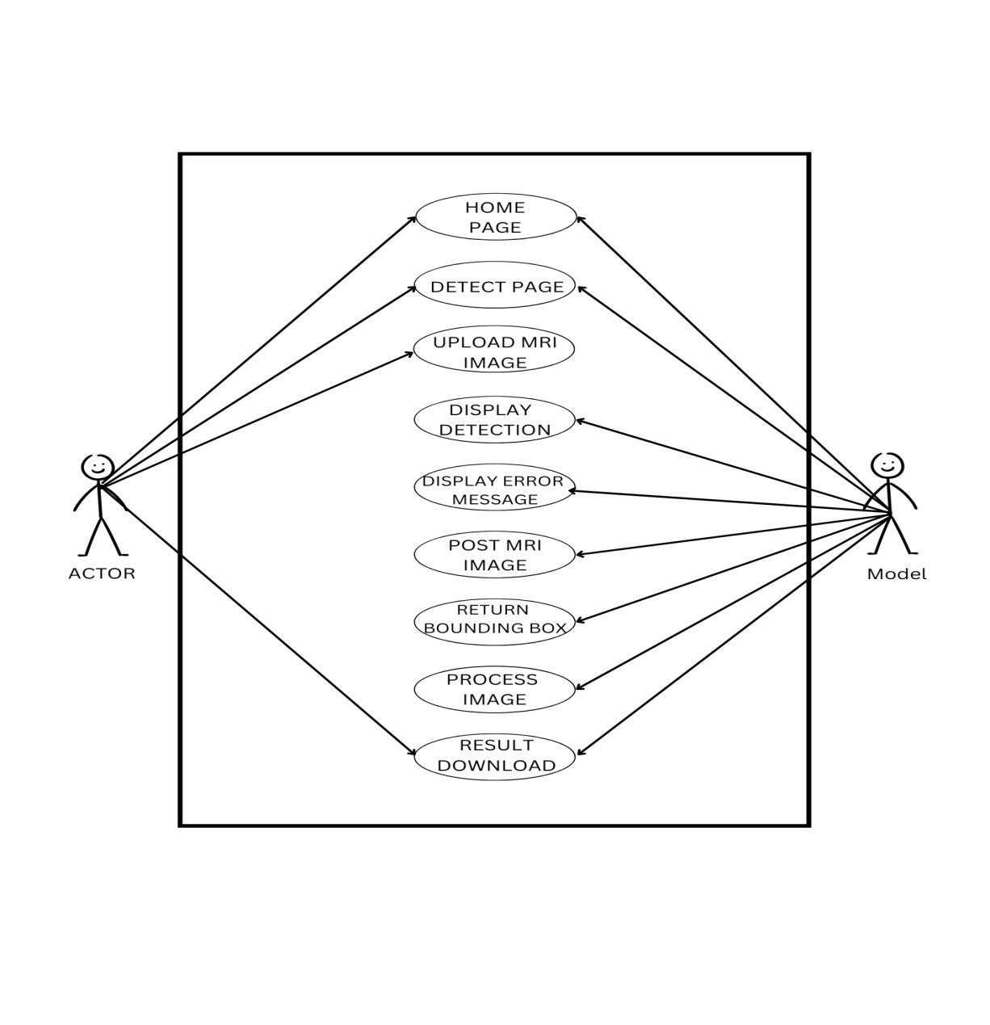
Figure 3.1: UseCase diagram of the proposed system

The diagram above represents the use case of the proposed system where the user who is represented as the actor can navigate to the detect page, the user can as well upload MRI images, and can also choose to download the results after the detection must have taken place . While the model uses the MRI which the user uploaded for the detection processes. During the process the model will display an error message but that is only if there's an error if not no error will occur, after that the model will return bounding box after which the image will be processed and results will be delivered to the user.

3.3.3 ACTIVITY DISGRAM OF THE PROPOSED SYSTEM
An activity diagram is another important diagram when following the Unified Modelling Language (UML) approach. It is a diagram that displays the dynamic aspects of the software system. An activity diagram however is basically a flowchart/flow-diagram describing the flow of activities that occur in the system in an orderly stepwise manner. The figure below displays the flow of activities on the proposed system, from the home page, to navigating through the detect page, and the result downloads.

Activity Diagram of The Proposed System
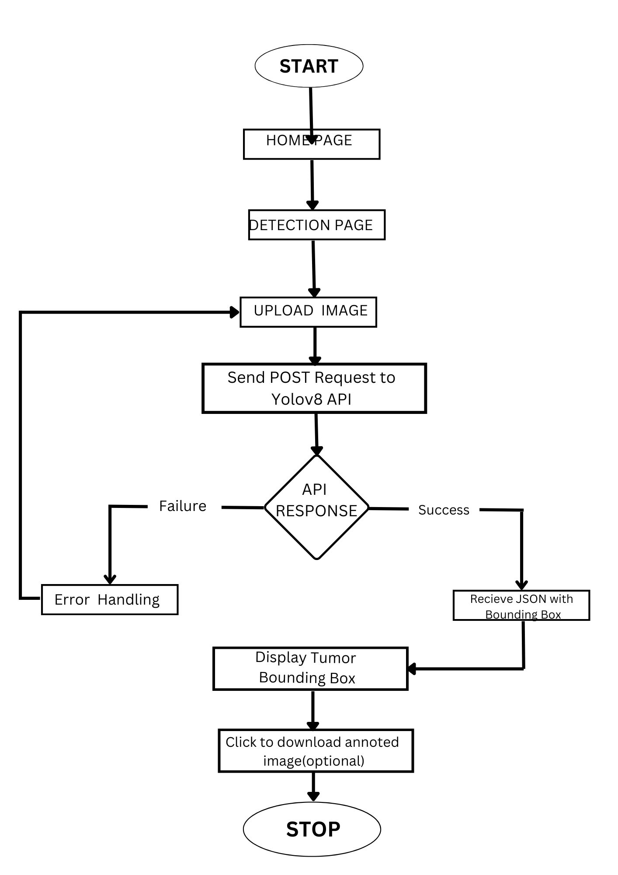
Figure 3.2 Activity diagram of the proposed system
The above diagrams show the virtual representation of the various activities that occurs on the proposed system. The diagrams however displays the steps involved in detection system, uploading MRI, navigation across home page and the detection page, result display, result download, and error messages if error has been occurred during the detection.

3.3.4 CLASS DIAGRAM OF THE PROPOSED SYSTEM
This section shows the class diagrams of the proposed system which are diagrams in Unified Modelling language (UML) that shows the structure of the software system by pointing out its classes, attributes, methods and the relationships among objects. Below is the illustration of the class diagram of the proposed system.
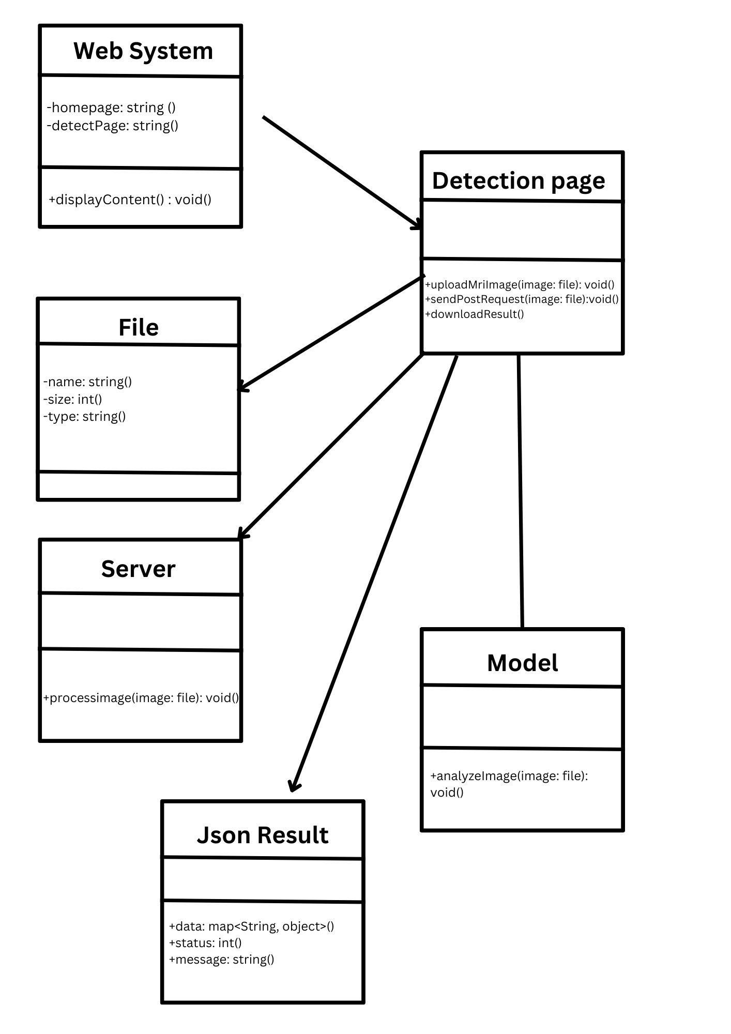
Figure 3.3 Class diagram of the proposed system

The class diagram above represents the different classes that would be involved in the proposed system and their relationship with one another. It represents the different stages of the users that are contained in the class, the different activities that the users can perform and the different sub-classes that perform this specific activities. The class diagram therefore stands as a prototype of the proposed system as it tends to dive into the different classes that are existing within the proposed system.

3.3.5 UML SEQUENCE DIAGRAM
The unified Modeling Language (UML) sequence diagrams serve as a dynamic virtual model which displays the different interactions between the various objects that exists within a system over time. These diagrams are very cruial in the understanding of the chronological flow of actions and messages that occur during the execution of a particular use case or scenario. Moreover, at its core, these sequence diagrams visually represent the order in which interactions take place therefore providing a clear depiction of how the various components collaborate in a specific system to achieve the specified goal.
However, the elements in the UML sequence diagram include lifelines, messages, activation, and objects of which the lifelines represent the entities involved in the interaction, while messages denote the interaction between the different entities. Moreover, activation that are displayed using vertical lines extending from lifeline and therefore stands to represent the duration of an object's involvement in an interaction. Consequently, this temporal dimension adds a crucial layer of understanding thereby permitting developers and stakeholders to grasp not only what occurs in the system but also when it occurs within the system's operation.
Moreover, UML sequence diagrams help to facilitate the interaction between the technical and non-technical stakeholders in a system and by offering a visual representation of system dynamics these diagrams stand as a strong tool for conveying intricate technical details in a more accessible manner. However, the use of these diagrams contributes to improved collaboration thereby fostering a shared understanding of system behavior and also aiding in the identification of potential issues for future enhancements.

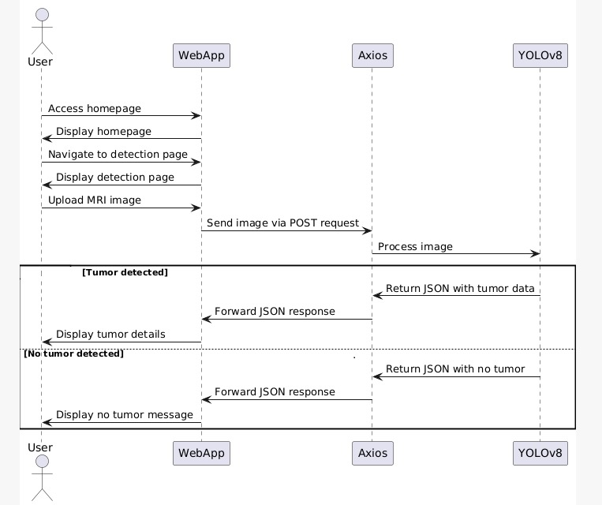

Figure 3.4 Sequence diagram of the proposed system.

The diagram above stands as the sequence diagram for the detection in the proposed system, as it stands to show the detailed process of actions that takes place from the home page where the user can easily navigate to the detection page by communicating with the system ,uploads the MRI image, waits for the model to perform its part, and then the model gives feedback after performing its part.

3.4 SYSTEM DESIGN

The system design of the proposed system will illustrate in detail, how the system is going to fulfil the requirements that have been stated above. This system design will comprise of the home page and the detection page.

Description of the Dataset: MRI dataset contains of medical images acquired through Magnetic Resonance Imaging (MRI), a non-surgical imaging method that delivers detailed opinions of soft tissues, creating it particularly meaningful for detecting abnormalities in the breast.MRI datasets, involving T1-weighted, T2-weighted, and DCE-MRI scans, are used to train YOLOv8 for real-time breast cancer detection by preliminary processing and annotating images from roots like Duke Breast Cancer MRI and TCGA-BRCA, but difficulties such as dataset accessibility, large complications, false predictions, and the necessity for 3D CNN alteration must be dealt with for accurate and dependable diagnosis.
The Database Design of the System: I have no database for this system but I used MongoDB for authentication of the system.

Description of the deep learning model used for the detection: YOLOv8 (You Only Look Once version 8) is the central deep-learning model responsible for detecting breast cancer abnormalities in medical visuals. It delivers real-time tools detection potential with high accuracy and speed. This model can be fine-tuned on mammography datasets to enhance detection clarity. YOLOv8 procedures uploaded medical images and outputs detection results, involving bounding boxes and confidence scores. Its portable design enables for deployment on standard servers or cloud-based context. YOLOv8 combine continuously with quick API for adaptable and efficient model serving. It supports custom training to tailor to precise breast cancer detection requirements. The model's capability to evaluate images quickly is vital for giving fast diagnostic assistance. This model shapes the foundation for the detection piece in your application. Its result can be kept in MongoDB for tracing and analysis.

CHAPTER FOUR

SYSTEM IMPLEMENTATION

4.0 INTRODUCTION
Chapter four looks at the system implementation of the proposed system that shows the way the different components of the proposed system have been brought together to enable it function properly. Although, after a comprehensive process of analyzing the system of the existing systems and the proposed system, and pointing out the system and all the system requirements, the proposed system have now been implemented using the appropriate tools that has been adopted and also tested. This chapter is going to discuss in full detail the user interfaces of the various functional parts of the proposed system together with all the tools that was engaged in implementing this system.

4.1 TOOLS USED FOR IMPLEMENTATION
4.1.1 FRONTEND TOOLS
Next Js: Next.js serves as the essential framework for developing the breast cancer detection application’s backend and frontend. It delivers a strong combination of React-based frontend development and server-side rendering (SSR) for good performance. With its API routes, it allows the creation of backend endpoints to process image uploads and communicate with the YOLOv8 model. Static generation (SSG) can be used for pages that do not require recurring updates, boosting speed and SEO. It also assists TypeScript for safer, strongly typed code, which decreases runtime errors. Next.js enables consistent communication with external services. Generally, Next.js unites the gap between the user interfaces and backend logic in the detection system.
TypeScript: TypeScript secure type-safe development throughout the Next.js application, decreasing runtime errors and enhancing code maintainability. It implements strict typing on variables, functions, and components, heading to more strong and predictable code. In the breast cancer detection project, TypeScript aids in defining reliable data structures for image metadata, detection results, and API responses. It enhances developer productivity by giving intelligent code suggestions and error-checking during development. TypeScript merges consistently with Next.js and Prisma, providing end-to-end type safety across the application. It enables cooperation by making the codebase simpler to understand and maintain. Type interfaces define the shape of the detection results, ensuring consistency throughout the system. With TypeScript, complicated data manipulation evolvs into safer and less error-prone. The capacity to catch errors during compilation reduces bugs in production. Generally, TypeScript provides reliability and scalability to your detection system.
Tailwind Css: Tailwind CSS delivers a utility-first procedure to designing the user interface for the breast cancer detection system. It enables quick UI development by providing pre-defined classes for layout, spacing, typography, and responsive design. Tailwind's modular procedure enables consistent styling through unique components. In the detection project, it is used to design the image upload interface, detection result displays, and the history dashboard. Tailwind simplifies complex CSS management by allowing styles to be written immediately in the component markup. Its responsive utilities make sure the application is functional on different devices and screen sizes. Tailwind combines effortless with Next.js, allowing a neat and modern design system. Customization is simple with the Tailwind configuration file, allowing for modified UI components.

4.1.2 BACKEND TOOLS
Prisma performs as the ORM (Object-Relational Mapping) tool to communicate with the MongoDB database in a type-safe and effective manner. It outlines complicated database queries through a simple and declarative API. Prisma's schema explains the composition of the detection records, securing consistency between the application and the database. It enables for quick development with migration-free updates using the Prisma db. push. The auto-generated TypeScript types deliver better code reliability and decreases errors. Prisma eases CRUD operations, making it simpler to save and restore breast cancer detection data. It improves performance by enhancing queries and handling complicated joins effectively. With the use of Prisma Studio, you can visually examine and manage your database. The Prisma Client handles database communication, which makes the codebase neater and more maintainable. In other words, Prisma covers the space in-between the application logic and MongoDB storage.
MongoDB: MongoDB performs as the essential database for keeping image metadata, detection results, and user details. Its NoSQL structure permits flexible storage of complicated, unstructured data like YOLOv8 predictions. Prisma ORM facilitates communication with MongoDB through a type-safe, intuitive API. Each detection record includes image URLs, confidence scores, and timestamps for traceability. MongoDB upholds indexing for quick query performance on regularly accessed data. It is highly scalable, accommodating increased detection records as the application multiply. The database can keep logs for verification and error tracking. Data replication secure high availability and fault tolerance. MongoDB Atlas provides a managed cloud service, simplifying deployment and scaling. This database is vital for persistent, arranged, and accessible data management.

4.1.3 IDE
VsCode: Visual studio code has obtained meaningful popularity and is accessible as a free and open-source software. It attributes a large adaptation and comprehensive development platform due to its broad support for many languages and frameworks. VS Code is prepared with an organized graphical user interface that guarantees meaningful attributes such as syntax highlighting, code suggestion, and even debugging. It features an internal terminal which enables commands to be run without having to switch from the editor. One important aspect of VS Code is its massive marketplace where plenty plugins can be downloaded, which greatly expands the ability of the editor. With respect to small scope and large scope development it is easy to use as well as portable. Furthermore, the procedures of developing this system were implemented using this IDE enhancing efficient and fast development process.

4.2 AI MODEL

Yolov8 Model: YOLOv8 (You Only Look Once version 8) is the central deep-learning model responsible for detecting breast cancer abnormalities in medical visuals. It delivers real-time tools detection potential with high accuracy and speed. This model can be fine-tuned on mammography datasets to enhance detection clarity. YOLOv8 procedures uploaded medical images and outputs detection results, involving bounding boxes and confidence scores. Its portable design enables for deployment on standard servers or cloud-based context. YOLOv8 combine continuously with quick API for adaptable and efficient model serving. It supports custom training to tailor to precise breast cancer detection requirements. The model's capability to evaluate images quickly is vital for giving fast diagnostic assistance. This model shapes the foundation for the detection piece in your application. Its result can be kept in MongoDB for tracing and analysis.

4.3 SYSTEM DESIGN
Properties required for the user to efficiently make use of the system are minimal as it is a web-based platform application and therefore is highly accessible with both mobile phone and a laptop. However, the system still involves that the user gets to fulfill some minor requirements in order to be able to use the system. For now, the proposed system is available but locally on the development computer for the purpose of development and the requirements for accessing the system are as follows:
- An internet enabled device
- A web browser
- A minimum windows 7 operating systems to be able to install and run all the dependencies of the system.
4.4 USER INTERFACE OF THE PROPOSED SYSTEM
This part of this research work is going to contain user interfaces of various sections of the proposed system which would consist of the homepage, upload page etc. The interface designs of the proposed system contain both the input and output design interfaces, these interfaces were designed using next.js, typescript for the structuring of the page and tailwind CSS for the styling of the interface and then prima with mongodb for incorporating interactivity.

4.4.1 THE INPUT USER INTERFACE OF THE PROPOSED SYSTEM
This part of this work of research stands to showcase and discuss in detail all the input interfaces of the proposed system which were incorporated into the system to be used for inputting data to be registered in the system. These interfaces were designed using next.js and typescript and styled using tailwind CSS. Prima and mongodb was also used to add actions and interactions to these interfaces, while the MRI dataset was used to fetch the data which the yolov8 model will use in the prediction process and then will be sent back to the next.js for result display.

The Home Page:
This section of the proposed system displays the home page of the proposed system. The interface is made up the logo, a short description of what the system does and a button link that leads to the update page

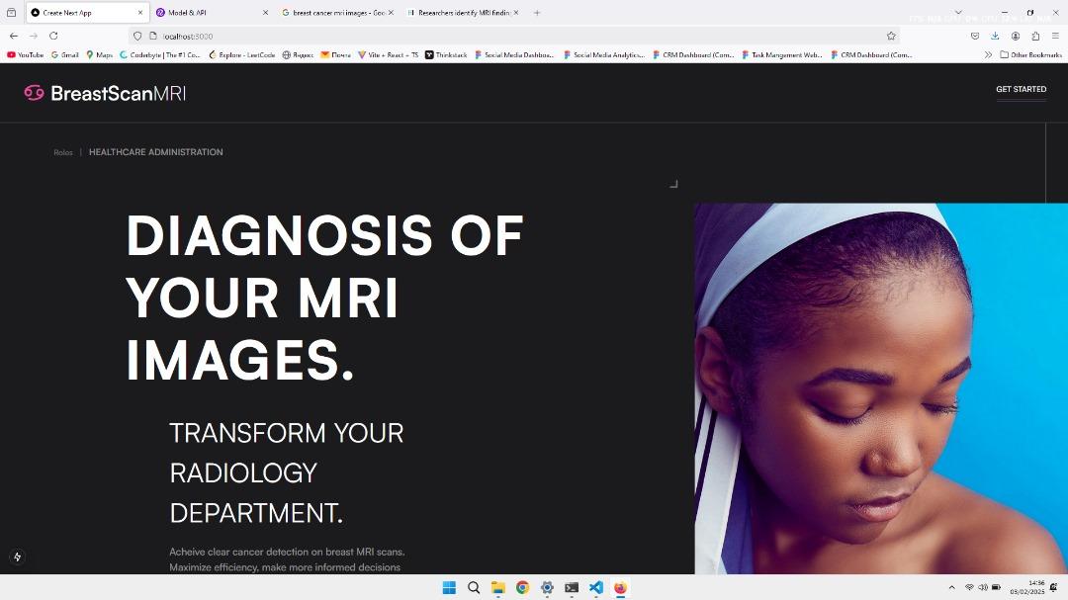

Figure 4.1 The home page of the proposed system.

The detection Page:
This section of the proposed system is where the user can upload the MRI image which will be used for the detection, it is consist of a PDF download button, a right- side bar, a large space for the MRI upload

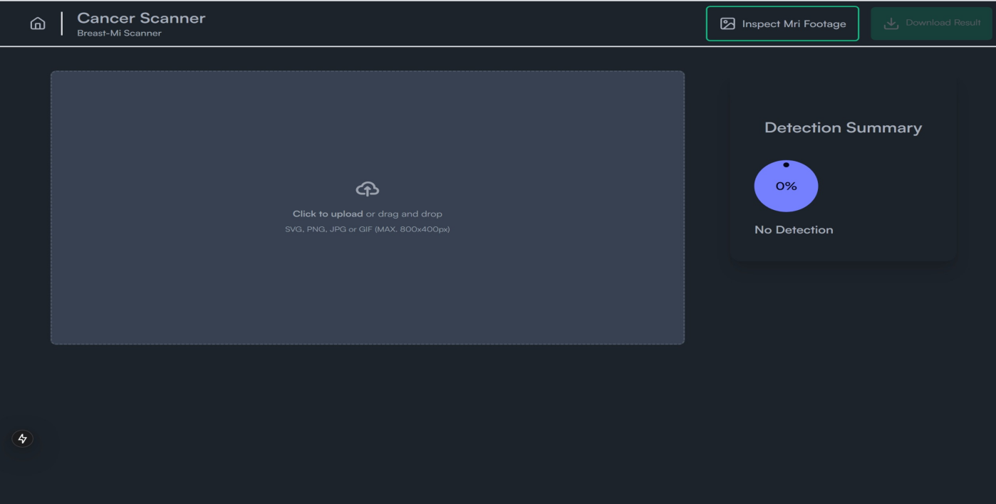

Figure 4.2 Image upload.

The Upload Result
This section of the proposed system shows what happens after MRI upload, after a successful detection the result will be shown and can be printed.
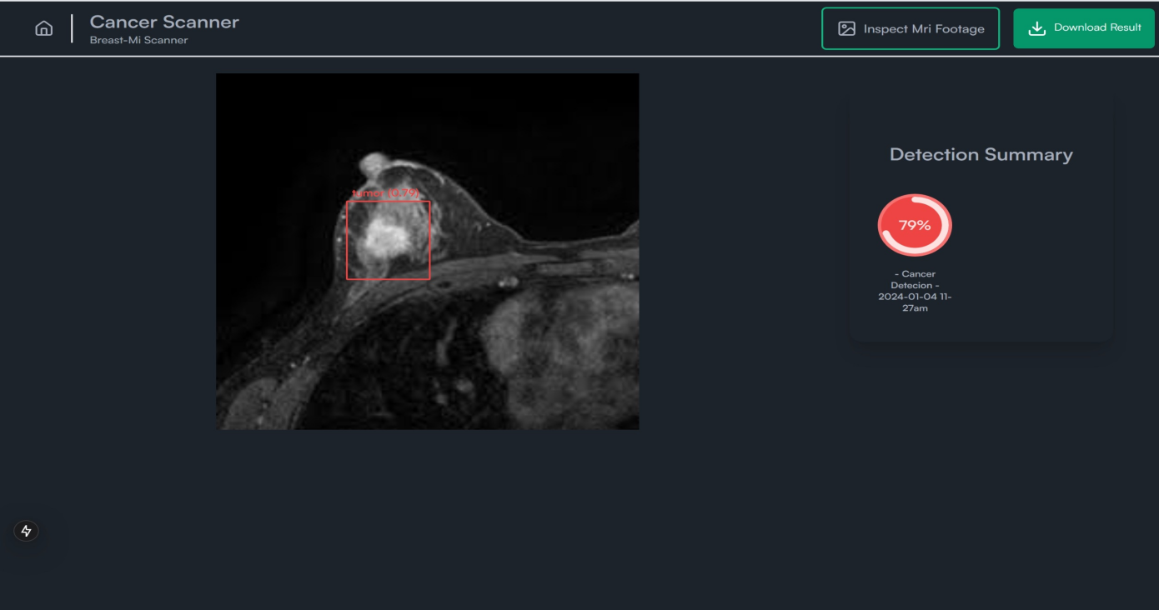
Figure 4.3 Result of the image upload

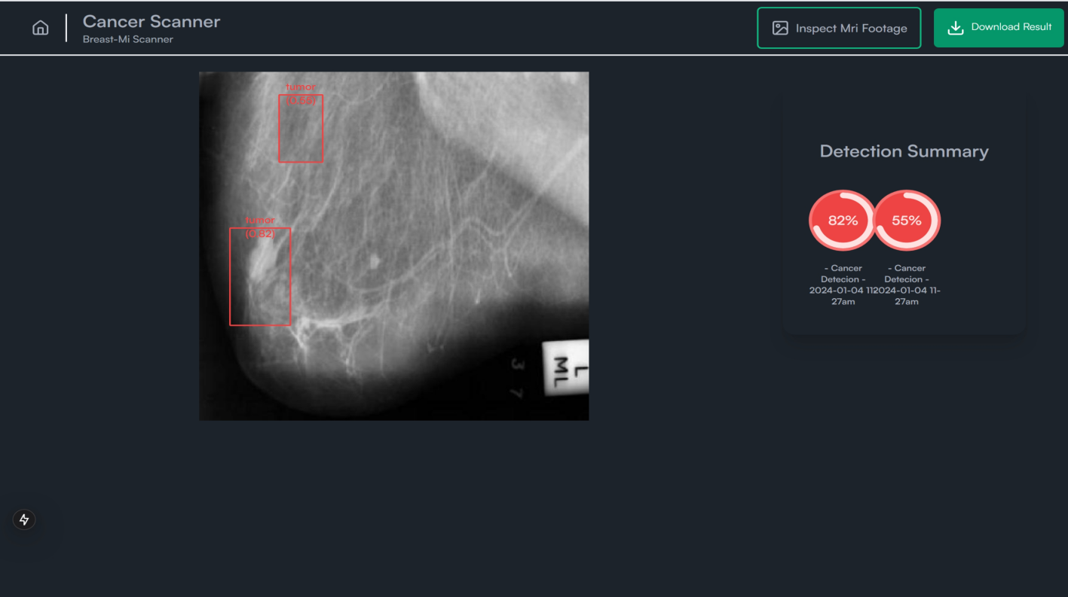

Figure 4.4 Result of the image upload

4.5 PERFORMANCE EVALUATION MATRIX
This section shows all the evaluation matrix result gotten from the trained model, it shows the precision confidence score, the precision recall score, the recall confidence score, the F1 confidence score, the confusion matrix and then the validation and training accuracy and loss
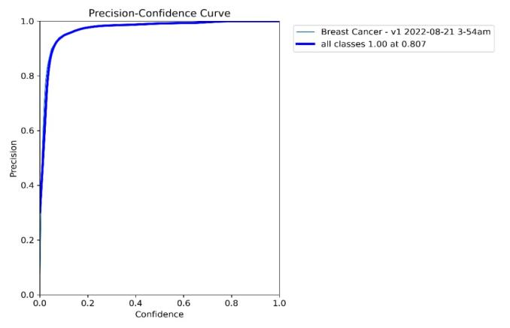
Figure 4.5 The precision-confidence score
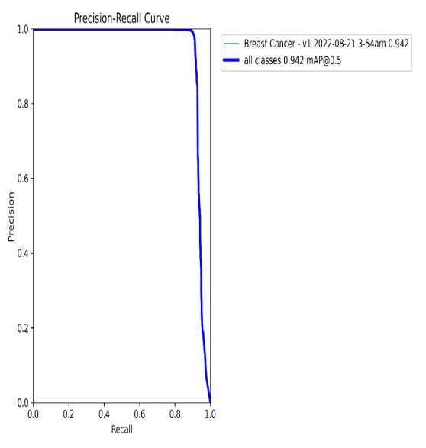
Figure 4.6 The precision-recall score
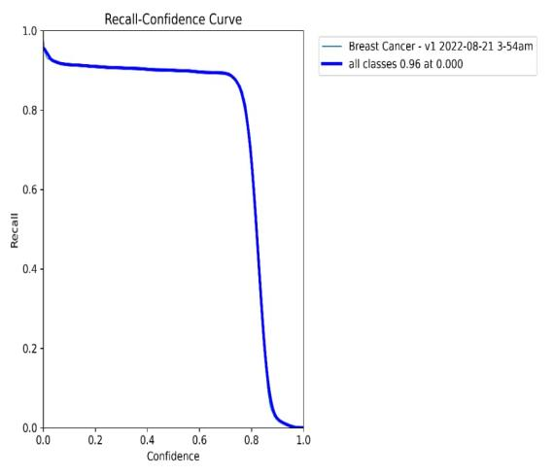
Figure 4.7 The recall-confidence score
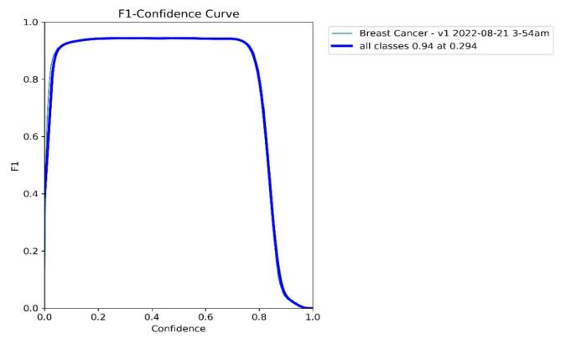
Figure 4.8 The F1-Confidence score
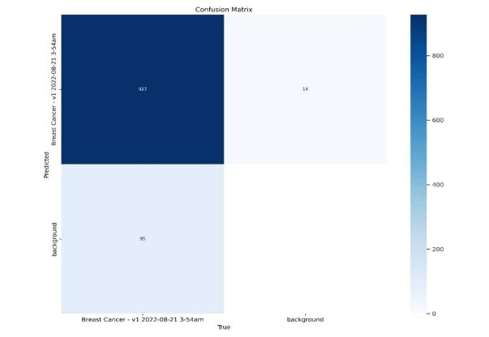
Figure 4.9 Confusion matrix result
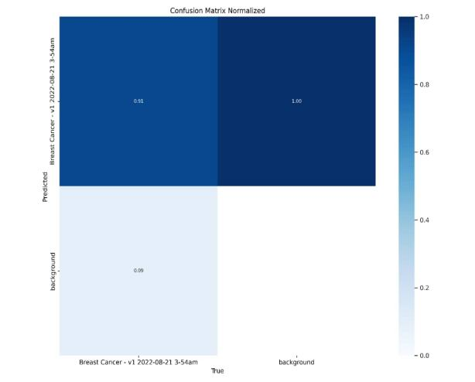
Figure 4.10 Confusion matrix result

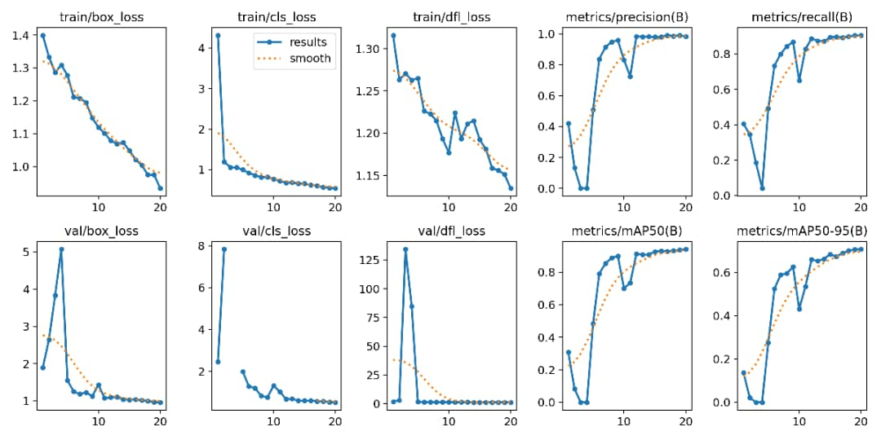
Figure 4.11 Validation and training accuracy and loss.

CHAPTER FIVE

SUMMARY, CONCLUSION AND RECOMMENDATIONS

5.1 OVERVIEW
Chapter five of this research work reflect on a well detailed testing process and the summary of this research work, the recommendations for future works, and then the conclusion of this research work. This chapter however presents the well detailed testing of the proposed system that have been developed using various input data and also the various outputs. This chapter as well summarizes everything that has been discussed in all the previous chapters of this project.

5.3 SUMMARY
At the initial inception of this research work, the background of the study was explicitly discussed in conjunction to the problem statement which are related to this research work. However, in the later chapters of this research work, the theoretical background of study of this research work was discussed and the existing systems that are related to this work was also reviewed. This research work also gave a detailed analysis of existing systems, identified the limitations of these existing systems and therefore tried its best to capitalize on these existing problems while building the system that was proposed in this research work. Moreover, a thorough analysis of the system was done at the third chapter of this research work using UML diagrams; use case diagrams, activity diagrams, the class diagrams and the class diagrams of the UML diagrams were specifically used in analyzing the system. Finally, all the programming languages and frameworks that was used for the implementation of this project were stated and the description of the user interface was also stated.

5.4 CONCLUSION
Finally, we have come to the end of this research as this section of this research work stands to conclude the objectives that were defined in this research work. However, the system was able to achieve an improved user interface, Incorporated a specific algorithm and updated dataset.
Nevertheless, this is not the conclusion of Breast Cancer Detection as this research has not come to a halt with this conclusion but Breast Cancer Detection would continue to grow and add a lot of new features. Moreover, the already developed Breast Cancer Detection web-based application would be made available on the web.

5.5 RECOMMENDATIONS
This AI-Based Breast Cancer Detection is highly recommended to Pathologists & Radiologists and also to Cancer Awareness NGOs all over the world as it stands as an innovative approach offering features that are highly unique, distinguished and at the same time specific to the special needs and preferences of radiologist especially in Nigeria which is used as a case study in this work of research. However, as the systems offers a unique way of detecting cancer, this system stands to fill the gap that is existing in the specified environment.

REFERENCES
National Breast Cancer Foundation. (n.d.). The history of breast cancer awareness and advocacy. https://www.nationalbreastcancer.org
World Health Organization. (n.d.). Breast cancer fact sheet. https://www.who.int/news-room/fact-sheets/detail/breast-cancer
American Cancer Society. (2024). What is breast cancer? https://www.cancer.org
Mayo Clinic. (2024). Breast cancer – Symptoms and causes. https://www.mayoclinic.org/diseases-conditions/breast-cancer/symptoms-causes
Susan G. Komen Foundation. (n.d.). Understanding breast cancer. https://www.komen.org
Lauder, E. (1993). The founding of the Breast Cancer Research Foundation (BCRF). Breast Cancer Research Foundation. https://www.bcrf.org
Lasker Foundation. (n.d.). Mary Lasker and her advocacy for medical research. https://laskerfoundation.org
National Cancer Institute. (2024). Types of breast cancer. https://www.cancer.gov/types/breast
Reach to Recovery International. (n.d.). History and impact of the Reach to Recovery program. https://www.reachtorecoveryinternational.org
Jolie, A. (2013, May 14). My medical choice. The New York Times. https://www.nytimes.com/2013/05/14/opinion/my-medical-choice.html
Ultralytics. (2024). YOLOv8 object detection model overview. https://docs.ultralytics.com
Allugunti, V. (2022). A study on breast cancer prognosis with the use of machine learning (ML) techniques. Journal of Computational Biology and Bioinformatics, 12(3), 221–233. https://doi.org/10.1016/j.jcompbio.2022.03.005
Arpita, R., & Ashish, M. (2017). Random forest algorithm: A review. International Journal of Computer Applications, 162(6), 1–6. https://doi.org/10.5120/ijca2017914002
Basker, R., & Krishnan, R. (2021). The improvement in breast cancer classification using machine learning algorithms: A comparative study. Journal of Biomedical Engineering, 39(8), 471–480. https://doi.org/10.1016/j.jbiomech.2021.107326
Bhise, S., Nandini, V., & Agarwal, A. (2021). Machine learning (ML) approaches for early breast cancer detection: A review. Journal of Cancer Research and Clinical Oncology, 147(5), 1235–1249. https://doi.org/10.1007/s00432-021-03543-7
Duda, R. O., Hart, P. E., & Stork, D. G. (2003). Pattern classification (2nd ed.). Wiley-Interscience. https://www.wiley.com/en-us/Pattern+Classification%2C+2nd+Edition-p-9780471056690
Han, J., & Kamber, M. (2010). Data mining: Concepts and techniques (3rd ed.). Morgan Kaufmann. https://www.elsevier.com/books/data-mining/han/978-0123814791
Kanaga, K. C., Anandan, S., Chin, G. Y., & Laila, S. (2008). Evaluation of digital mammography for the detection of the cancer. Breast Cancer Research and Treatment, 110(3), 333–341. https://doi.org/10.1007/s10549-007-9823-7
Nallamala, P., Suresh, P., & Rajasekaran, S. (2019). A novel ensemble voting scheme for breast cancer detection with the use of deep learning. International Journal of Computer Applications, 178(7), 30–36. https://doi.org/10.5120/ijca2019918684
Omondiagbe, J., Otieno, O., & Okoth, F. (2019). The comparative study of machine learning techniques for breast cancer classification. Journal of Artificial Intelligence in Medicine, 27(4), 210–221. https://doi.org/10.1016/j.jartificialintelligence.2019.04.002
Sharma, S., Soni, S., & Tiwari, P. (2018). Using machine learning algorithms for breast cancer diagnosis and prognosis: A review. International Journal of Advanced Research in Computer Science, 9(2), 105–114. https://doi.org/10.26483/ijarcs.v9i2.5365
Shravya, P., Praveen, R., & Raj, R. (2019). The comparison of machine learning models for breast cancer classification. International Journal of Engineering and Technology, 7(5), 543–549. https://doi.org/10.14419/ijet.v7i5.27349
Tahmooresi, S., Kiani, M., & Ghorbani, M. (2018). Hybrid machine learning (ML) model for breast cancer detection. Journal of Medical Systems, 42(9), 160–169. https://doi.org/10.1007/s10916-018-1002-4
Vyas, S., Kaur, M., & Mehta, M. (2022). Improvement in breast cancer detection using machine learning (ML) algorithms. Journal of Cancer Research and Clinical Oncology, 148(7), 1215–1226. https://doi.org/10.1007/s00432-021-03657-0

APPENDIX

import Image from "next/image";
import Link from "next/link";
import { LuChevronRight } from "react-icons/lu";
import { PiArrowRight } from "react-icons/pi";
import { TbZodiacCancer } from "react-icons/tb";

export default function Home() {
return (
<div className=" w-full min-h-screen bg-[#1B1A1D] relative">
<header className=" w-full flex items-center justify-between px-10 py-8 border-b-[2px] border-white/10 ">
<div className=" flex items-center space-x-2">
<TbZodiacCancer className=" text-pink-500" size={42} />
<h1 className=" text-4xl text-white font-semibold">
BreastScan<span className=" font-thin">MRI</span>{" "}
</h1>
</div>
<div>
<div className=" text-white text-sm font-medium space-y-2 uppercase">
<Link href={"/detect"}>Get Started</Link>

<div className=" space-y-1">
<div className=" w-full h-[1px] bg-pink-500 rounded-full" />
<div className=" w-full h-[1px] bg-blue-500 rounded-full" />
</div>
</div>
</div>
</header>

<main className=" w-full min-h-[90vh] pb-20 relative">
<div className=" w-[2px] h-full absolute right-10 bg-white/20 " />
<div className=" w-[90%] mx-auto py-10">
<div className=" flex items-center space-x-3">
<h2 className=" text-sm text-white/30 font-semibold">Roles</h2>
<div className=" text-white/30">|</div>
<h2 className=" uppercase text-white/50 font-semibold">
healthcare administration
</h2>
</div>
</div>

<div className=" w-full py-10 flex justify-between relative">
<div className=" pl-56 w-[60%]">
<h1 className=" font-extrabold leading-[7rem] tracking-wide text-8xl max-w-[80%] text-white uppercase ">
diagnosis of your mri images.
</h1>
<div className=" pt-10 pl-20 space-y-5">
<h1 className=" text-white text-5xl max-w-[60%] leading-[4.5rem] uppercase">
transform your radiology department.
</h1>

<p className=" text-white/50 text-lg font-medium max-w-[55%]">
Acheive clear cancer detection on breast MRI scans. Maximize
efficiency, make more informed decisions
</p>

<div className=" text-white w-fit text-sm pt-10 font-medium space-y-2 uppercase">
<div className=" flex items-center space-x-6">
<Link href={"/"}>Get Started</Link>
<PiArrowRight className=" text-white" />
</div>

<div className=" space-y-1">
<div className=" w-full h-[1px] bg-pink-500 rounded-full" />
<div className=" w-full h-[1px] bg-blue-500 rounded-full" />
</div>
</div>
</div>
</div>
<LuChevronRight
className=" text-white/40 absolute right-[36%] rotate-45 -top-2 "
size={32}
/>
<LuChevronRight
className=" text-white/40 absolute right-[36%] -rotate-45 -bottom-2 "
size={32}
/>
<div className=" w-[35%] z-50 relative ">
<Image
src={"/audrey-m-jackson-cAFpd2vqnPE-unsplash.jpg"}
alt=""
fill
className=" object-center object-cover"
/>
</div>
</div>
</main>

<footer className=" w-full bottom-0 absolute border-t-2 bg-[#1B1A1D] border-white/20">
<div className=" w-14 border-r-2 border-white/20 h-6"></div>
</footer>
</div>
);
}

