

DEVELOPMENT OF A PREDICTIVE SYSTEM FOR EARLY DETECTION OF TUBERCULOSIS USING RANDOM FOREST

MAMAH IKECHUKWU COLLINS
GOU/U21/CSC/642

DEPARTMENT OF COMPUTER SCIENCE
FACULTY OF NATURAL SCIENCES AND ENVIRONMENTAL STUDIES
GODFREY OKOYE UNIVERSITY, ENUGU NIGERIA.

A PROJECT RESEARCH SUBMITTED TO THE DEPARTMENT OF COMPUTER
SCIENCE AND MATHEMATICS IN PARTIAL FULFILMENT OF THE
REQUIREMENTS FOR THE AWARD OF BACHELOR OF SCIENCE (B.Sc) DEGREE IN COMPUTER SCIENCE

SUPERVISOR: DR. F. U. OKEBANAMA

JULY, 2025

APPROVAL PAGE
This research titled “Development of a predictive system for early detection of tuberculosis using random forest” has been assessed and approved by the Committees of Department of Computer Science and Mathematics and Faculty of Natural Sciences and Environmental Studies, Godfrey Okoye University Enugu, Nigeria.

Dr Frank Okebanama ................................... ..................................
Supervisor Signature Date

................................... ..................................
External Examiner Signature Date

Dr. Frank Okebanama ................................... ..................................
HOD, Department of Signature Date
Computer Science and
Mathematics

Prof. Chidi .C. Uhuegbu ................................... ..................................
Dean, FNESS Signature Date

CERTIFICATION
I hereby certify that the work included therein was completed by myself and that it was mainly based only on my own observations and investigation. Consequently, I am fully responsible for the materials of this work.

________________________
MAMAH IKECHUKWU COLLINS
U21/NAS/CSC/642

DEDICATION
This project “Development of a Predictive System for Early Detection of Tuberculosis using Random Forest” is dedicated to God almighty, to my sister Dr. Chidiogo Mamah, to my lecturer and Head of Department and Assistant Dean Dr. F. U Okebanama, to Mr C.E Njoku and Engr. Dr. Kinsely Chibueze

ACKNOWLEDGEMENTS
My gratitude goes to my supervisor, Dr F. U Okebanama for his academic support which guided me throughout this entire work. My Dean, Prof. Ozofor of the Faculty of Computing and the Assistance Dean, Dr F.U. Okebanama. I will forever remain grateful for their effort. I would love to appreciate all my lecturers of the department of computer science for supporting me during my study.
I am especially grateful to my parents, Prof L. I Mamah and Mrs. Ngozi Mamah who supported me financially and emotionally. My friends in my department and different departments, I am grateful for really checking up on me and supporting me.

ABSTRACT
Machine learning technique random forest was explored for predicting tuberculosis. Data from Tuberculosis Dataset for Intelligent and Adaptive Medical Diagnostic System were used to build the prediction model. The main objective is to develop a predictive system for early detection of tuberculosis using random forest which is crucial for early detection before it becomes terminal. A Random forest (RF) model was designed, evaluated and used. According to Ohwo, S (2023) the dataset was gotten through validated and structured questionnaire using random sampling after obtaining the patients' consent. The collated dataset was pre-processed and encoded with variables (features) for prediction which include, loss of energy, night sweat, breathing difficulty, fever, , sputum, immune suppression,, chill, lack of concentration, irritation, chest pain loss of appetite, lymph node enlargement, loss of pleasure systolic blood pressure cough and BMI. Early prediction of tuberculosis from on the clinical data from patients' features using random forest plays a crucial role in the diagnosis, intervention and management of tuberculosis patient. The developed model was evaluated using two performance metrics, including accuracy of 93% and a weighted average of 94%. This results show that the random forest model can confidently be used to predict tuberculosis, promising an alternative to existing systems.

TABLE OF CONTENT
TITLE PAGE i
CERTIFICATION ii
APPROVAL iii
DEDICATION iv
ACKNOWLEDGEMENTS v
ABSTRACT vi
TABLE OF CONTENTS vii
LIST OF TABLE x
LIST OF FIGURES xi

CHAPTER ONE: INTRODUCTION 1
1.1 BACKGROUND OF STUDY 1
1.2 STATEMENT OF PROBLEM 2
1.3 AIM AND OBJECTIVES OF THE STUDY 2
1.4 SIGNIFICANCE OF THE STUDY 3
1.5 SCOPE OF THE STUDY 3
1.6 LIMITATIONS OF THE STUDY 4

CHAPTER TWO: LITERATURE REVIEW 5
2.1 INTRODUCTION 5
2.2 THEORETICAL BACKGROUND 5
2.2.1 PREDICTION 6
2.2.2 MACHINE LEARNING 6 2.3 HISTORICAL PERSPECTIVES IN TUBERCULOSIS PREDICTION
USING MACHINE LEARNNG ALGORITHMES 6 2.3.1 DEFINITION OF SPECIFIC CONCEPTS OF EARLY PREDICTION
OF TUBECULOSIS USING MACHINE LEARNING ALGORITHMS 7 2.3.2 ANALYSIS OF MACHINE LEARNING ALGORITHMS FOR
TUBERCULOSIS PREDICTION 7 2.4 REVIEW OF RELEVANT APPROACHES TO THE RESEACHER AND
AREA 8
2.4.1 ALGORITHMS FOR SUPERVISED LEARNING 8
2.4.1.1 SUPPORT VECTOR MACHINES (SVM) 8
2.4.1.2 DEEP LEARNING (CNNS) 8
2.4.1.3 GRADIENT BOOSTING MACHINES (GBMS) 9
2.5 REVIEW OF RELATED LITERATURE 9
2.6 SUMMARY OF REVIEW OF RELATED LITERATURE 15
2.7 RESEARCH GAP 19

CHAPTER THREE: SYSTEM ANALYSIS AND DESIGN 20
3.1 INTRODUCTION 20
3.2 SYSTEM ANALYSIS 20
3.2.1 ANALYSIS OF EXISTING SYSTEM 20
3.2.2 SHORTFALLS OF EXISTING SYSTEM 21
3.2.3 ANALYSIS OF PROPOSED SYSTEM 21
3.3 SYSTEM REQUIREMENTS 21
3.3.1 FUNCTIONAL REQUIREMENTS 22
3.3.2 NON-FUNCTIONAL REQUIREMENTS 22 3.4 METHODOLOGY: OBJECT-ORIENTED ANALYSIS AND DESIGN (OOAD) 22
3.4.1 UNIFIED MODELING LANGUAGE DIAGRAMS 23
3.4.2 USE CASE DIAGRAMS 23
3.4.21 USECASE DIAGRAM OF EXISTING SYSTEM 24
3.4.2.1 USECASE DIAGRAM OF PROPOSED SYSTEM 24
3.4.3 ACTIVITY DIAGRAMS 25
3.4.3.1 ACTIVITY DIAGRAM OF EXISTING SYSTEM 26
3.4.4 CLASS DIAGRAMS 28
3.4.4.1 CLASS DIAGRAM OF EXISTING SYSTEM 28
3.4.4.2 CLASS DIAGRAM OF PROPOSED SYSTEM 28
3.4.5 SEQUENCE DIAGRAM 29
3.5 SYSTEM DESIGN 30
3.5.1 INPUT/OUTPUT DESIGN 31
3.5.1.1 INPUT DESIGNS OF THE PROPOSED SYSTEM 32
3.5.1.2 OUTPUT DESIGNS OF THE PROPOSED SYSTEM 33
3.6 DATABASE DESIGN 33
3.6.1 DATABASE SCHEMA 34

CHAPTER FOUR: SYSTEM IMPLEMENTATION 35
4.1 INTRODUCTION 35
4.2 CHOICE OF DEVELOPMENT ENVIRONMENT 35
4.2.1 FRONTEND (HTML, CSS) 36
4.2.2 BACKEND (PYTHON, DJANGO, SQLITE) 36
4.3 SYSTEM REQUIREMENTS 38
4.4 USER INTERFACE OF THE PROPOSED SYSTEM 39

CHAPTER FIVE: SUMMARY, RECOMMENDATIONS, AND CONCLUSION 40
5.1 INTRODUCTION 40
5.2 SUMMARY 40
5.3 RECOMMENDATIONS 40
5.4 CONCLUSION 41

REFRENCES 42
APPENDIX 44

LIST OF TABLES
TABLE PAGE
3.1 User Table 34

LIST OF FIGURES
FIGURE PAGE
3.1 Use Case Diagram of Existing System 24
3.2 Use Case Diagram of Proposed System 25
3.3 Activity Diagram of Login System 26
3.4 Activity Diagram of Model Training (Existing System) 26
3.5 Activity Diagram of Proposed Registration System 27
3.6 Activity Diagram of Proposed System 27
3.7 Activity Diagram of Model Training (Proposed System) 27
3.8 Class Diagram of Existing System 28
3.9 Class Diagram of Proposed System 29
3.10 Sequence Diagram of Proposed System 30
3.11 Input Design of Proposed System 31
3.12 Input Designs for the Proposed System 32
3.13 Output Design of Proposed System 33
4.0 Screenshot of the Proposed System Homepage 39

CHAPTER ONE
INTRODUCTION
  - BACKGROUND OF STUDY
Tuberculosis is a deadly disease that affects a lot of people throughout the world mostly in the third world countries. It is a disease that has killed a lot of people over the century. According to (Wikipedia) Tuberculosis (TB), also known colloquially as the "white death", or historically as “consumption”. It is an infectious disease usually caused by Mycobacterium tuberculosis (MTB) bacteria. Tuberculosis was first officially acknowledged as a deadly disease in 1689. DR. R Morten did an extensive work on studying the disease. In Nigeria, tuberculosis is said to be increasing, especially the gap between people reported to have the disease and those estimated to have developed the disease.
More than 10 million people continue to fall ill with TB every year (World Health Organization, 0000b). Although it can affect people of any age, individuals with weakened immune systems, (e.g., with HIV infection) are at increased risk.
Tuberculosis is an airborne disease which is caused by bacterium called Mycobacterium tuberculosis which affects the patient’s lungs. The major symptoms of the disease include severe coughing, fever and chest pain. The tuberculosis germs are spread when an infected person cough, sneezes or spits. Even a slight exposure to these germs is enough to affect a person. People who have weak immune systems, such people affected with HIV, also have a much higher risk of falling ill.
However, with the advent of machine learning, It is now easier to prevent the progression of tuberculosis if it is detected and diagnosed at an early stage or if the doctors can predict the chances of developing the disease with a high degree of certainty. Machine learning is gives promising results in various application. It basically a subset of AI which trains machines to act intelligently. Machine learning algorithms are popular in the field of health care and other services. By applying machine learning algorithms, one would upgrade a wide range of medical services such as improving diagnostics, accuracy, finding out the cause of occurrence, giving out the best treatment that could be provided. This research mainly focuses on providing help to both patients and doctors by early diagnosis for effective treatment and recovery. This has the potential of changing the approach of how diseases are treated in the medicine. Not only does this serve as a mile stone on how tuberculosis is treated but also how other diseases are treated.
  - STATEMENT OF PROBLEM
Tuberculosis is a silent killer in our society and poor management of exposure to tuberculosis has led to the following challenges
- Stigma and Social Barriers: Tuberculosis patients often face stigma in their communities, discouraging them from seeking timely diagnosis and treatment.
- Misdiagnosis: Tuberculosis symptoms often overlap with other respiratory conditions (e.g., pneumonia, bronchitis), leading to frequent misdiagnosis and inappropriate treatments.
- Diagnosis: Because tuberculosis diagnosis is usually obtained late by the doctor, this leads to high death rate among patients with tuberculosis
- Inaccurate datasets: A sizeable number of machine learning models that are available are mostly trained on datasets that do not capture diseases that often cohabite with tuberculosis. These diseases are unique to our local environment (e.g., high HIV prevalence).
1.3 AIM AND OBJECTIVES OF THE STUDY
The aim of this research is to develop a predictive system for early detection of tuberculosis using machine learning algorithm. The objectives are to
- Gather data that has appropriate features for efficient tuberculosis prediction
- Choose the right model for more accuracy prediction of tuberculosis
- Make it possible to enable radiologist check prevalence of tuberculosis
- Obtain a very simple user interface that would be user friendly and responsive on all screen sizes.
  - SIGNIFICANCE OF STUDY
This research work holds a profound significance to the following
- Doctors ii. Tuberculosis patients iii. Government iv Communities
- Doctors will have more confidence diagnosing tuberculosis since the algorithm used in detecting the disease is fairly accurate.
- By detecting TB early, this system helps to minimize transmission rates, protecting both patients and their communities.
- It reduces the economic burden associated with advanced TB cases, which require prolonged treatment and lead to loss of productivity.
- Communities in tuberculosis prone areas benefit from reduced transmission due to early detection and treatment
1.5 SCOPE OF STUDY
This predictive system for early detection of tuberculosis is solely developed for the early detection of tuberculosis however, it can be configured to be used to for early detection of other diseases.
Additionally, the system is delimited to the web-based version as it operates with a focus of use on only internet technologies.

1.6 LIMITATIONS OF STUDY
Some of the limitations encountered are
- Bad internet connection: Some of the tools that the researcher used in building the system where online, so if there was no internet connection, the researcher won’t be able to work.
- Technical Expertise: The successful deployment of the system required a high level of technical expertise in area like software development which the researcher is not very well experienced in.

CHAPTER TWO
LITERATURE REVIEW
2.1 INTRODUCTION
The introduction to the general subject area of the tuberculosis prediction using machine learning algorithm could begin by providing context on the global burden of tuberculosis, highlighting its significance as a major infectious disease and a leading cause of morbidity worldwide. It could touch upon key statistics related to tuberculosis incidence. Prevalence, mortality rates and the socio-economic impact of the disease. The challenges associated with tuberculosis diagnosis and management, such as the limitations of traditional diagnostic methods, delays in detection, the emergence of drug resistant strains, cohabiting with HIV and disparities in access to health-care services. This set stage for the need for innovative approaches to improve tuberculosis control and prevention efforts. Transitioning to the role of machine learning algorithm in tuberculosis prediction, the introduction could outline how machine learning techniques have the potential to revolutionize disease surveillance, early detection, and risk stratification by leveraging large scale data and advanced computational algorithms in this case random forest. It could mention previous research endeavors in applying machine learning to tuberculosis prediction and highlight the gaps and limitations in existing approaches (Smith et al., 2023).
2.2 THEORETICAL BACKGROUND
The theoretical background details the historical perspectives in prediction of tuberculosis using machine learning algorithm, definition of specific research concepts, and discussion on prediction of tuberculosis and review on relevant and related approaches to early prediction of tuberculosis.

2.2.1 PREDICTION
This has to do with forecasting or making an informed guess based on data or records from the past in other to guess the possible outcome of an event .
2.2.2 MACHINE LEARNING
It is a branch of artificial intelligence which main aim is the development of algorithms/model that help in building systems that behave like humans using data. It learns from such data and improves overtime.
2.3 HISTORICAL PERSPECTIVES IN PREDICTION OF TUBERCULOSIS USING MACHINE LEARNING ALGORITHM
A brief historical narrative of tuberculosis offers invaluable insights into the evolution of strategies for diseases control, from ancient civilizations to modern times. Dating back to ancient history, tuberculosis has plagued humanity for millennia, leaving its mark on ancient Egyptian mummies and appearing in historical texts across various cultures. This enduring presence of Tuberculosis , often shrouded in mystery and fear, earned it monikers like "consumption" and "the white plague"(Barnes, 2000) Advancements in the 19thcentury brought about a deeper understanding of tuberculosis's infectious nature, leading to the establishment of specialized sanatoriums for patient care. A significant milestone occurred in 1882 when Robert Koch's discovery of Mycobacterium tuberculosis laid the groundwork for further TB research (Koch, 1882) The 20thcentury witnessed a transformation era in tuberculosis management with the introduction of antibiotic therapy, notably streptomycin in 1943, revolutionizing treatment approaches and precipitating a decline in Tuberculosis cases in developed nations. However, this progress was tempered by the emergence of drug resistant strains, exacerbated by factors such as urbanization, poverty and the HIV AIDS epidemics. (Selma, 1943) As we entered the 21th century, the importance of early detection and surveillance in tuberculosis control became increasingly apparent. This realization has fueled research into innovative methodologies, including the application of machine learning algorithms and data analytic. These technologies offer promises in early detection, predicting and monitoring TB incidence, identifying vulnerable populations and optimizing resource allocation for prevention and treatment efforts. By tracing tuberculosis’s historical trajectory, we gain deeper appreciation for the persistent challenges posed by this global health threat (Koch. 1882).
2.3.1 DEFINITION OF THE SPECIFIC CONCEPT OF EARLY PREDICTION OF TUBERCULOSIS USING MACHINE LEARNING ALGORITHM
Tuberculosis Prediction using machine learning algorithm refers to the process of anticipating where and when tuberculosis cases are likely to occur, using machine learning algorithm like random forest on historical data, demographic information, clinical variables, environmental factors, and other relevant features. (Smith et al. 2023).
2.3.2 ANALYSIS OF MACHINE LEARNING ALGORITHMS FOR TUBERCULOSIS PREDICTION
Performance and accuracy are two distinct classifiers used to categorize TB illness. To build prediction models for tuberculosis prediction, machine learning algorithms need a variety of data sources, including demographics, medical histories, and diagnostic test results. Medical practitioners can find patients with priasymptoms or diagnose illnesses early thanks to the models developed, which improves patient outcomes and expands therapy options. Ethical monitoring of privacy and possible data exploitation activities, as well as assurance of variety and data quality control, are necessary for accurate forecasts. By combining various data sources from clinical and environmental settings, machine learning algorithms for tuberculosis prediction show significant promise for future advancement in medical research and increase diagnostic accuracy.
2.4 REVIEW OF RELEVANT APPROACHES TO THE RESEARCH AREA
Machine learning algorithms play a pivotal role in predicting tuberculosis by analysing many datasets and pointing out patterns indicting tuberculosis infection. Several machine learning algorithms have been explored in the context of early tuberculosis prediction, each offering unique strengths and capabilities Deshpande et al (2019).
2.4.1 ALGORITHMS FOR SUPERVISED LEARNING
These are rules or procedures which learns patterns for labeled data to make predictions. When talking about supervised learning, the algorithm is supervised because it is trained on database set that has features (inputs) and correct outcomes (label)
2.4.1.1 SUPPORT VECTOR MACHINES (SVM)
Since SVMs are excellent in processing multidimensional data grouped with non-linear patterns, they are widely used as a predictive tool for tuberculosis scenarios. Studies by Deshpande et al. (2019) and Kavakiotis et al. (2020) demonstrated that SVMs were effective in detecting tuberculosis cases using laboratory data in conjunction with clinical and demographic information. SVMs identify the best decision-separating lines to distinguish between tuberculosis patients and healthy people as well as those with other respiratory conditions. By combining several decision trees for ensemble learning, the Random Forest method improves prediction models. Using RF algorithms, Bi et al. (2018) and Moon et al. (2021) examined TB-related traits and used scoring techniques to gauge patient tuberculosis risk.
2.4.1.2 DEEP LEARNING MODELS CONVOLUTIONAL NEURAL NETWORKS (CNNS):
When it comes to medical imaging tasks like tuberculosis identification utilizing chest X-rays, the CNNs architecture performs exceptionally well. CNNs are the best tool for analyzing medical imaging data for diagnosing tuberculosis when chest X-rays are used as input. CNN architectures were made use of in two studies by Lakhani et al. (2017) and Rajpurkar et al. (2018) to identify anomalies from TB patients' radiological pictures with high diagnostic sensitivity and specificity. CNNs' hierarchical feature extraction method pinpoints the exact position of tuberculosis lesions in photos by using pixel information. The most effective methods for analyzing sequential patient symptom data and treatment responses are Long Short-Term Memory Networks and Recurrent Neural Networks. When RNN-based models were applied to longitudinal clinical data, tuberculosis outcome treatment compliance.
2.4.1.3 GRADIENT BOOSTING MACHINES (GBMS) IN HYBRID AND ENSEMBLE APPROACHES:
Under the GBM framework, XGBoost and LightGBM serve as boosting algorithms to improve prediction results by successively teaching weak learners. The studies by Kim et al. (2022) and Nardell et al. (2020) showed how to mix different data types using GBM to optimize feature selections in TB prediction tasks. Both missing data and nonlinear patterns in the data are handled exceptionally well by GBMs. In order to maximize their unique characteristics, hybrid models combine several machine learning algorithms, such as support vector models, Random forest, and neural networks. Higher predicted accuracy and dependable performance were provided by hybrid machine learning algorithms for tuberculosis prediction developed by Gupta et al. (2021) and Jaiswal et al. (2023).
2.5 REVIEW OF RELATED LITERATURE
Wanying et al. (2021) predicted the risk of moving to active Tuberculosis from associated host genetic variations. The authors made use of a Tree-based Pipeline Optimization Tool, auto machine learning tool to map genetic variations and Tuberculosis infection status mathematically; Machine learning was made use of for the prediction and progression to active Tuberculosis. Tree-based Pipeline Optimization Tools default and Tree-based pipeline optimization tools sparse configurations reached 0.816 Training CV score and 0.625 Testing Accuracy; Different genes made use of had unique contributions for tuberculosis infections, showing feature importance of classifier;
Aasia et al. (2021) maped the Spatial and temporal distribution of tuberculosis in Pakistan and found potential risk factors correlated with the disease. Machine learning algorithms Maxent, Support Vector Machine, Environmental Distance and Climate Space Model, predicted high risk of the disease with 14.02%, 24.75%, 34.81% and 43.89% area, respectively. Risk factors were identified based on population and climatic variables.
Mohd et al. (2020) proposed an approach to detect tuberculosis using ensemble deep learning without requiring segmentation of objects of interest. They achieved the best accuracy, sensitivity, and specificity of 91.0%, 89.6%, and 90.7% respectively for Tuberculosis detection; They identified that the upper lobes of the chest X-ray (CXR) is the most activate area showing the presence of Tuberculosis symptoms.
Sasidharan et al (2020) proposed a neural networks-based smart e-health application for predicting Tuberculosis (TB) using server less computing. Testing the various Convolutional Neural Network architectures using transfer learning. VGG-19 was identified as the best- performing model for Tuberculosis prediction based on test data results. Adoption of serverless computing for deployment, specifically AWS Far gate and EKS, due to its flexibility, cost- effectiveness. Superior scalability of server less computing above 300-user threshold. Identified possible loop holes of serverless deployments at high concurrency rates.
Abdullah et al. (2020) detected tuberculosis using deep learning and contrast-enhanced canny edge detected X-Ray images. Two types of features were generated; the first was extracted from the Enhanced x-ray images, while the second from the Edge detected images. They get the accuracy of 93.59%, a sensitivity of 92.31%, and a specificity of 94.87%.
Ashia et al. (2020) enhancing Tuberculosis identification and classification using synthetically generated CT scans from X-rays, and Significant improvement in tuberculosis identification is 7.50% and classification of Tuberculosis properties is 12.16% compared to X-ray baseline. They showed that by depending on a model that learns to generate CT images from X-rays synthetically, we can overall improve the automatic disease classification accuracy and provide doctors with a different look at the pulmonary disease process.
Seowoo et al. (2021) developed a deep learning model to detect active pulmonary tuberculosis on chest radiographs. The model showed a higher AUC (0.83) than one pulmonologist (0.69) and performed almost the same thing to other expert readers. The model showed a higher AUC (0.83; 95% CI: 0.73, 0.89) than one pulmonologist (0.69; 95% CI: 0.61, 0.76; P < .001) and performed similarly to the other readers (AUC, 0.79–0.80; P = .14–.23). It also outperformed pulmonologists in a separate test set with AUC of 0.84. The model output was associated with smear positivity and decreased during treatment.
Azhari (2024) he predicts and classifies Tuberculosis cases using machine learning, Decision tree model (DT) outperformed artificial neural network (ANN) model. Further research could explore more advanced machine learning techniques for tuberculosis prediction and classification.
Bhuvana et al. (2020) predicted the presence of tuberculosis, caverns, and pleurisy in 3D CT scans using deep learning. They achieve the eighth place in the Image CLEF 2020 Tuberculosis challenge with a mean AUC score of 0.601 and a minimum AUC score of 0.432. The study implied that model complexity led to over-fitting, leading to the need for smaller and simpler models with better regularization techniques for better results.
Qing et al. (2021) discover the novel drug candidates for Tuberculosis treatment using machine learning. The Extreme Gradient Boosting (XGBoost) model showed the best prediction. The consensus model, stacking predictions from Random Forest, XGBoost, and DNN, offered the best predictions with AUC of 0.842 for the 10-fold cross-validated training set and AUC of 0.942 for the external test set.
Balogun et al. (2020) focus on investigating machine learning methods for predicting tuberculosis treatment outcomes and determining associated risk factors. The overall classification performance of the predictive models ranged between 67.5% and 73.4%, with Multilayer Perceptron testing was identified as the best model for predicting TB patients' treatment outcomes. Age and length of stay were also identified as significant risk factors in Tuberculosis patients.
Karim Gasmi et al. (2022) develop an optimized machine learning-based model for tuberculosis disease diagnosis using image processing techniques. Experimental results demonstrate that the modified SVM classifier outperforms other classification algorithms in classifying Tuberculosis, showing higher accuracy. The study showed the importance of the quality of extracted features in image classification and stating that the proposed classification model can help doctors in an automated diagnosis Tuberculosis more accurately, robustly, and efficiently.
Jamal et al. (2021) identified and diagnosed multidrug-resistant tuberculosis using machine learning algorithms. They noticed that close contacts of multidrug-resistant tuberculosis including patients, smoking, with depression, with previous Tuberculosis history and interruption of first-line Tuberculosis treatment have correlation to multidrug-resistant tuberculosis. Important symptoms include weight loss, chest pain, hemoptysis, and fatigue. Support Vector Model and Random Forest were suggested models for patient classification based on accuracy, sensitivity, and specificity.
Kulkarni et al. (2022) developed a machine learning solution to predict discontinuation of tuberculosis treatment regimen, specifically loss to follow-up (LFU), using patient-level features and large-scale datasets from India. Their findings indicated that the risk stratification of discontinuation by patients is a viable, deployable-at-scale Machine learning solutions.
Duong et al. (2021) developed a practical solution for tuberculosis detection from chest X-ray (CXR) images using machine learning and computer vision algorithms, aiming to improve prediction performance on larger and more diverse datasets. Reached a maximum accuracy of 97.72% with an AUC of 100% using the ViT_Base_EfficientNet_B1_224 model, performing better than two state-of-the-art systems across different quality metrics.
Chang et al. (2020) designed a computer-aided diagnosis (CADx) system to improve tuberculosis (TB) diagnosis using deep learning-based algorithms, specifically focusing on TB culture test images.The proposed method achieves 99% precision and 98% recall on the non- negative class in TB culture test images, indicating successful detection of anomalies. Despite promising results, the study highlights the need for further optimization of the CADx system, including robot scheduling optimization, designing better workflows for human-machine collaboration, and considering medical records and living habits of patients for early TB detection.
Dasanayaka et al. (2020) develop an accurate automated TB screening system using chest X- rays, particularly beneficial for poor countries that don’t have access to well-trained medical professionals. Achieved a classification accuracy of 97.1%, a sensitivity of 97.9% and a specificity of 96.2%, with a Youden's index of 0.941.
Xinna et al. (2023) built a predictive models using cavity-based radionics and clinical characteristics to predict sputum status at the sixth month for multi-drug resistant tuberculosis patients treated with longer regimens. The model achieved good performance (AUCs of 0.892 and 0.839 in training and testing cohort respectively), similar to combined model, much higher than clinical model. Clinical characteristics such as age and previous Tuberculosis treatment duration showed a differences between consistently positives and conversions to negative sputum culture groups.
Chunling et al. (2021) analyze and explore Tuberculosis and lymphoma case reports using Natural language processing tools, and checking machine learning algorithms to differentiate between the two diseases. Natural language processing model had the best accuracy (93.1%), recall (91.9%), and precision score (93.7%). Ignoring emantic value when extracting terms from collected text, future research for tuning hyperparameters of models
Adane et al. (2021) develop a model to detect positive cases of tuberculosis using genetic programming approach and cluster analysis followed by Genetic Programming (GP). Computational intensity of GP limits its application to real-world problems with large datasets, further research recommended to accelerate fitness evaluation.

2.6 SUMMARY OF REVIEW OF RELATED LITERATURE
Author(s) Name/Year | Journal name | Contributions | Methodology | Shortfalls
Wanying et al. (2021) | An AutoML Approach for Predicting Risk of Progression to Active Tuberculosis based on Its Association with Host Genetic Variations | Predicted risk of progression to active TB based on host genetic variations using TPOT AutoML; Found key gene  variants affecting TB infections. “TPOT Default," and "TPOT sparse" produced the same best performance both reaching 0.816 Training Cross Validation score and 0.625 Testing Accuracy | Random Forest classifier | Limited testing accuracy , which may impact real-world applicability; Potential bias in genetic dataset;
Aasia et al. (2021) | Journal of Public Health | Observed spatial and temporal distribution through district-wise mapping; identified potential risk factors associated with the disease hinged on population and climatic variables with a partial receiver operating characteristics ROC value of 1.86. | Support Vector Machine (SVM) | The study suggests that climatic factors may influence TB incidence, but further research is needed to confirm these associations.
Mohd Hanafi Ahmad Hijazi et al. (2020) | Indonesian Journal of Electrical Engineering and Computer Science | Proposed an ensemble deep learning approach for tuberculosis detection using chest X-ray images without requiring segmentation; features extracted from different types of images can improve the detection rate | Ensemble deep learning making use of InceptionV3, VGG-16, and a custom CNN | The study does not specify the most activated areas indicating the presence of TB symptoms.
Sasidharan et al. (2024) | IEEE Journal of Biomedical and Health Informatics | Proposed a neural networks-based smart e-health application for predicting Tuberculosis (TB) using serverless computing; Identified potential vulnerabilities of serverless deployments. | Evaluation of CNN architectures (VGG-19, DenseNet-201, MobileNet-V3-Small) VGG-19 was the best performing model | A need for further optimization to ensure robustness in high-demand cases.
Ashia Lewis et al. (2021) | Proceedings of the IEEE/CVF International Conference on Computer Vision (ICCV) Workshops | Proposed a method to enhance tuberculosis (TB) identification and classification by generating synthetic computed tomography (CT) images from X-rays. | Generative Adversarial Networks (GANs)  Convolutional Neural Networks (CNNs) | It does not address potential clinical challenges or the integration of this approach into existing diagnostic process.
Lee et al. (2021) | Radiology | Developed a deep learning model to identify active pulmonary tuberculosis on chest radiographs. The deep learning model showed the following performance matrixes Sensitivity 0.8 Specificity 0.90 AUC: 0.92 | deep learning model | Its effectiveness in diverse clinical settings and populations requires further validation.
Azhari A. Elhag (2024) | Journal of Statistics Applications & Probability | Developed predictive models for tuberculosis incidence and classification using machine learning techniques; Used both Decision Tree (DT) and Artificial Neural Network (ANN) models; Found that the DT model outperformed the ANN model | Artificial Neural Networks (ANN)  Decision Tree (DT) | The study suggests that further research could explore more advanced machine learning techniques for tuberculosis prediction and classification
Bhuvana et al. (2020) | CLEF 2020 Working Notes | Developed a deep learning model to predict the presence of tuberculosis, caverns, and pleurisy in 3D CT scans; Suggested that model complexity led to overfitting, therefore the need for simpler models with proper techniques for better results | Deep learning makng use of Multi-View and Triplanar CNN architectures.  Ensemble of AlexNetMV, GoogLeNetMV, and VGG19M as the best performing algorithms | The model's performance was limited by overfitting due to high complexity;
Qing et al. (2021) | Briefings in Bioinformatics | Developed machine learning models to identify novel drug candidates for tuberculosis treatment; it made use of ensemble model which showed a high AUC value and high performance at cross validation and external testing. | An ensemble model integrating Random forest, XGBoost, and Deep neural network predictions | Further validation and experimental testing are needed to confirm the effectiveness of the predicted compounds.
Balogun et al. (2020 | Journal of Global Health Reports | Investigated machine learning methods for predicting tuberculosis treatment outcomes and determining associated risk factors; it made use of a combination of many algorithms with mulilayered perceptron showing the best performance with a classification accuracy of between 0.67 and 0.73 | Multilayer Perceptron ,Decision Tree, Naïve Bayes, Support Vector Machine and Logistic Regression | Further research is needed to incorporate a broader range of variables and to validate the predictive models in diverse populations.
Hrizi et al. (2022) | Computers in Biology and Medicine | Developed an optimized machine learning-based model for tuberculosis diagnosis using image processing techniques; Highlighted the importance of feature quality in image classification | Support Vector Machine, Genetic Algorithm | Further validation and testing are necessary to confirm the model's effectiveness in diverse clinical settings
Jamal et al. (2021) | Journal of Healthcare Engineering | Identified and diagnosed multidrug-resistant tuberculosis using machine learning algorithms. Suggested Support Vector Machine (SVM) and Random Forest (RF) as effective models for patient classification based on accuracy, sensitivity, and specificity. | Support Vector Machine, Random Forest, K-Nearest Neighbors , Logistic Regression, Least Absolute Shrinkage and Selection Operator, Artificial Neural Networks, Decision Trees | The study did not detail information on the specific machine learning algorithms used or the exact performance metrics achieved
Kulkarni et al. (2022) | Proceedings of the 39th International Conference on Machine Learning (ICML 2022) | Developed a machine learning solution to prediction of non-adherence to tuberculosis treatment regimens, specifically loss to follow-up using patient-level features and large-scale datasets from India; Achieved significant improvements over rule-based baselines and random classifiers; | Gradient Boosted, Decision Trees, Random Forests, Logistic Regression | The study did not provide wholistic information on the specific machine learning algorithms used or the exact performance metrics achieved;
Duong et al. (2021) | Expert Systems with Applications | Developed a practical solution for tuberculosis detection from chest X-ray images using machine learning and computer vision algorithms. | Modified EfficientNet, Vision Transformer, Hybrid EfficientNet-ViT Model | The study did not provide detailed information on the specific datasets used or the exact performance metrics achieved.
Chang et al. (2020) | Data Intelligence | Designed a computer-aided diagnosis system to improve tuberculosis diagnosis using deep learning-based algorithms, specifically focusing on TB culture test images. Focused on the need for further optimization of the CADx system, including robot scheduling optimization, designing better workflows for human-machine collaboration, and considering medical records and living habits of patients for early TB detection. | AlexNet convolutional neural network (CNN) architecture | The study did not provide detailed information on the specific deep learning algorithms used or the exact performance metrics achieved.
Jamal et al. (2021) | Journal of Healthcare Engineering | Identified and diagnosed multidrug-resistant tuberculosis using machine learning algorithms; Found that close contacts of TB patients, smoking, depression, previous TB history, improper treatment, and interruption in first-line TB treatment significantly impact MDR-TB status; Identified weight loss, chest pain, hemoptysis, and fatigue as important symptoms | Support Vector Machine (SVM) and Random Forest | The study did not provide detailed information on the specific machine learning algorithms used or the exact performance metrics achieved; Further validation and testing are necessary to confirm the model's effectiveness in diverse clinical settings.
Dasanayaka et al. (2020) | Computer Methods in Biomechanics and Biomedical Engineering: Imaging & Visualization | Developed an accurate automated tuberculosis (TB) screening system using chest X-rays, particularly beneficial for low-income countries lacking access to qualified medical professionals; | Convolutional Neural Networks (CNNs), U-Net architecture, Deep Convolutional Generative Adversarial Networks | The study did not provide detailed information on the specific deep learning algorithms used or the exact performance metrics achieved; Further validation and testing are necessary to confirm the model's effectiveness in diverse clinical settings.
Xinna et al. (2023) | Infection and Drug Resistance | Constructed predictive models using cavity-based radiomics and clinical characteristics to predict sputum status at the sixth month for MDR-TB patients treated with longer regimens; Identified clinical characteristics such as age and previous TB treatment duration as significant factors differentiating persistently positive and conversion to negative sputum culture groups. | AlexNet convolutional neural network (CNN) architecture | The study did not provide detailed information on the specific radiomics features extracted or the exact performance metrics achieved.
Chunling et al. (2021) | Bulletin of Electrical Engineering and Informatics | Analyzed and explored tuberculosis and lymphoma case reports using Natural Language Processing (NLP) tools; Evaluated machine learning algorithms to differentiate between the two diseases. | Logistic Regression, k-Nearest Neighbors (k-NN), Artificial Neural Network (ANN), Naive Bayes, Support Vector Machine (SVM), Perceptro | The study did not provide detailed information on the specific NLP techniques or feature extraction methods used.
Adane et al. (2021) | Ethiopian Journal of Science and Technology | Developed a model to detect positive cases of tuberculosis (TB) using a genetic programming approach and cluster analysis. | Cluster Analysis and Genetic Programming approach (GP) | The study did not provide detailed information on the specific genetic programming algorithms used or the exact performance metrics achieved

2.7 RESEARCH GAP
The currently existing systems have experienced some pitfalls and at this, lacks validation is some areas as they has failed to fulfil users needs in some areas owing to the fact that the system is a web-based system which can only be accessible through the web using a web browser. However, at this stage after a detailed review of current existing system, this work of research now has come to fill in the gaps in knowledge which these existing systems failed to fill. This work of research has contributed to the domain of knowledge by incorporating extra features that are absent in the other existing systems and also contributing greatly to the field of research as it now stands as a base for future research.

CHAPTER THREE
SYSTEM ANALYSIS AND DESIGN
3.1 INTRODUCTION
This chapter of this research work discusses in detail the complete analysis and design of the proposed improvements on early tuberculosis prediction using machine learning algorithm, the methodology that would be employed during this process (OOAD), and the approach through which the adopted methodology was incorporated into the development of the proposed system.
3.2 SYSTEM ANALYSIS
System analysis comprises the detailed process of totally disassembling the system and also examining in detail each of the constituent elements of the proposed system as well as how they work together. This section of this work of research however covers the entire system analysis process of a web based predictive system for early tuberculosis prediction, including the analysis of the currently existing systems, the identification of the existing systems' shortcomings and the ways in which this work of research seeks to possibly address them, and also the detailed analysis of the proposed system, which includes modeling the system using both class diagrams, activity diagrams and use case diagrams
3.2.1 ANALYSIS OF THE EXISTING SYSTEM
Machine learns works by obtaining and cleaning data and running the data through an algorithm and checking if there are similar patterns and from this pattern determine if there the patient is most likely to have tuberculosis. In the current research work, only demographic information such as, medical, and psychological information was included. During this research, it was discovered that there is no dedicated web app with comprehensive user registration system for tuberculosis prediction .
3.2.2 SHORT FALL OF THE EXISTING SYSTEM
It was noticed that most of the available tuberculosis prediction systems do not have
- A demographic characteristic that takes into consideration the cohabitation of HIV and tuberculosis in Nigeria. This shortfall will lead to incompleteness of the data making the prediction inaccurate.
- Most of the existing systems do not have a registration system to monitor and regulate the users that use there systems
3.2.3 ANALYSIS OF THE PROPOSED SYSTEM
Tuberculosis prediction system represents a progressive evolution in the early detection of tuberculosis leading subsequently to treatment of tuberculosis. It is a ground-breaking addition that brings substantial improvements the current system with the main goal of improving the user experience. It aims to provide accessibility across online web platforms in order to provide a simpler user interface and experience. Moreover, the email authentication, has been included in ensure user security.
Tuberculosis prediction system uses a simple interface, this is to make it simple to collect user data seamlessly without the user feeling reluctant to give up information. Auto-complete was also incorporated so as to make filling forms easy.
3.3 SYSTEM REQUIREMENTS
System requirements refers to the processes or statements of what a system should be able to do or what quality a system is supposed to have. There are two categories of these system requirements; the functional requirements and the non-functional requirements.

3.3.1. FUNCTIONAL REQUIREMENTS:
The functional requirements refer to the requirements that specify what the system must have. Functional requirements of the proposed system include that:
- The system’s user interface should be as simple as possible to use.
- The User must be able to login, sign up and logout.
3.3.2. NON-FUNCTIONAL REQUIREMENTS:
The non-functional requirements refer to the requirements that specify attributes or abilities the system must have. Non-functional requirements for the proposed system include that:
- The proposed should be responsive on all screen sizes and also compatible with all browsers.
- The system should be able to suggest characters to the user
3.4. METHODOLOGY: OBJECT ORIENTED ANALYSIS AND DESIGN (OOAD)
Object Oriented Analysis and Design (OOAD) is a methodology used in software development that implies the use of use of object-oriented concepts to design and implement software systems. In this methodology, the system requirements are determined, the classes are identified and the relationships between these classes are also identified. There are some techniques and practices which have been used in this methodology which includes; UML diagrams, object-oriented programming, and use cases. OOAD uses object-oriented programming to design and implement this software, UML diagrams to design diagrams that represent different aspects and the inter-relationships between the different components of the software system, and lastly, use cases to describe the different ways in which users interact with a software system. This methodology was designed to handle complex systems and thus, the reason for using this methodology.
In this research, a machine learning approach is used to predict tuberculosis progression, making use of python for building the model, html and css for web interface and Django for deploying predictive model, .csv file extention will be used for storing and managing datasets that are in tabular form. The data collected was cleaned using pandas and NumPy libraries. After cleaning and preparing the data, matplotlib will be used to check for any patterns or correlations. The model will be trained using scikit-learn using traditional machine learning algorithms (like Random Forest).
3.4.1 UNIFIED MODELLING LANGUAGE DIAGRAMS
Unified modelling language (UML) diagrams are used to create or design a diagrammatical representation of the different aspects and components of the software system, and also represents the interactions of the software system. This system is however modelled with a use case diagram, activity diagram and class diagram.
3.4.2 USECASE DIAGRAMS
Use case diagrams are classified into four categories; use cases which are the functional parts of the system , the actors which represent the external entities of the system, the associations between the actors and the use cases, and lastly the system boundary which is the scope of the system the actor is interacting with.

3.3.2.1 USE CASE DIAGRAM OF THE EXISTING SYSTEM
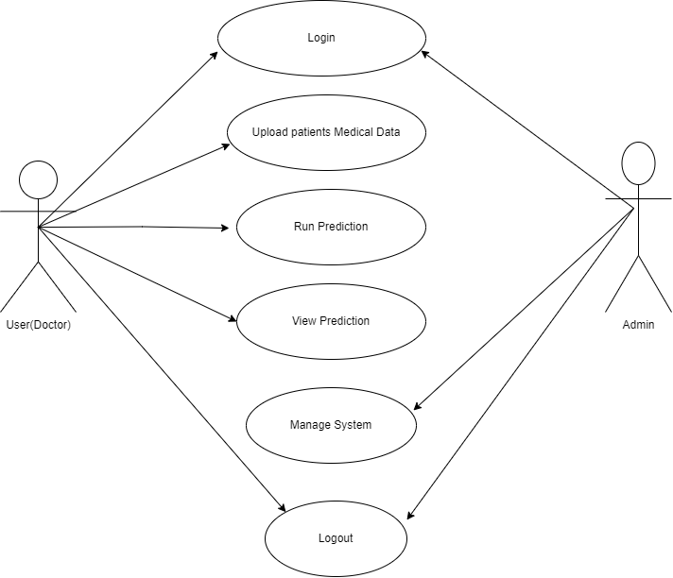
Figure 3.1 Use case diagram of existing system sssyssystemsystem
In this use case, it is unclear weather the user just logs in without registering making it unclear as to how the system recognizes who uses it. If the number of users is not known, this might make it hard to manage in the future as more users use the system leading to system crashing.
3.4.2.2 USE CASE DIAGRAM OF PROPOSED SYSTEM
As for the proposed system, there would be 2 actors which are; the users, and the system administrator. However, according to the use case diagram user actions include signing up, login, upload patients medical data , run prediction, view prediction and logout while admins actions include login, manage system.

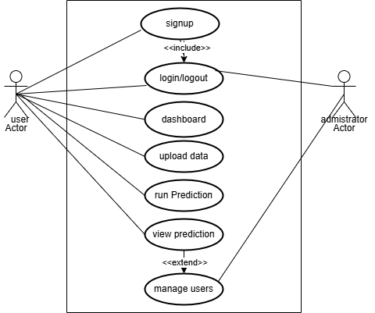
Figure 3.2 Use case diagram of the proposed system

3.4.2.3 ACTIVITY DIAGRAM
An activity diagram is another important diagram when following the Unified Modelling Language (UML) approach. It is a diagram that depicts the dynamic aspects of the software system. An activity diagram however is basically a flowchart/flow-diagram describing the flow of activities that take place in the system in an orderly stepwise manner from the signing in to creating posts to logging out

3.4.2.4 ACTIVITY DIAGRAM OF THE EXISTING SYSTEM

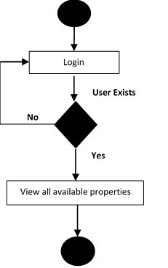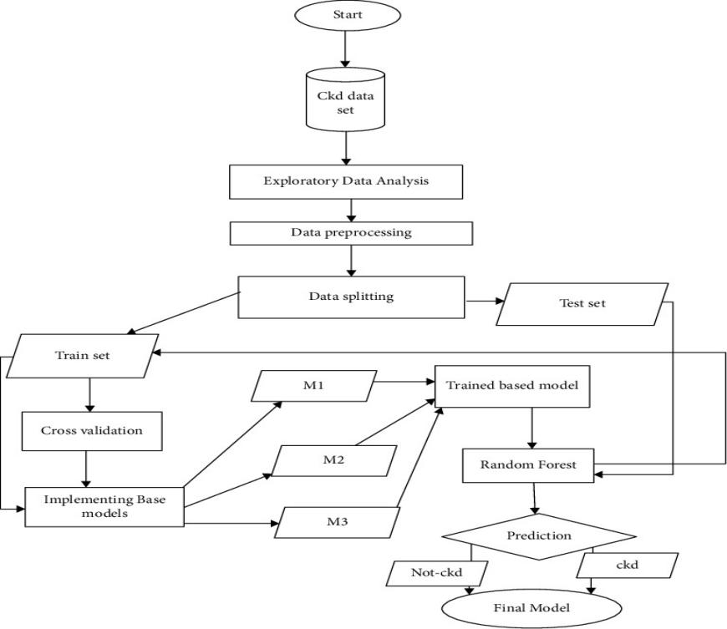
Figure 3.3 Activity diagram of the login system
Figure 3.4 Activity diagram of the model training of existing system

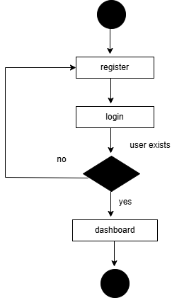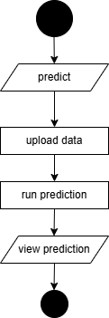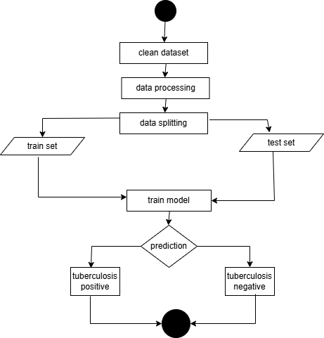
Figure 3.7 Activity diagram of model training of proposed system
Figure 3.6 Activity diagram of the proposed system
Figure 3.5 Activity diagram of the proposed registration system

3.4.2.5 CLASS DIAGRAMS
The class diagram shows the different classes that would be involved in the proposed system and their relationship with one another. It shows the different activities that the users can perform and the different subclasses that perform this specific activities.
3.4.2.6 CLASS DIAGRAM OF THE EXISTING SYSTEMS
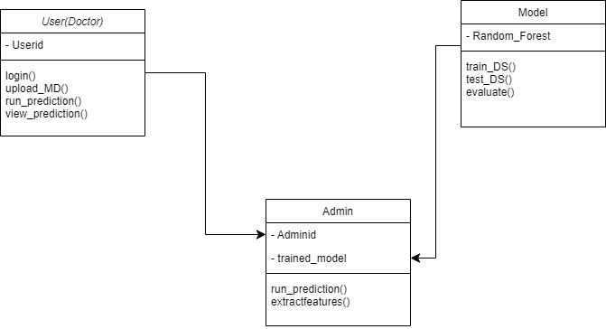
Figure 3.8 Class diagram of the existing system

3.3.2.7 CLASS DIAGRAM OF THE PROPOSED SYSTEM
This section shows the class diagrams which are diagrams in Unified Modelling language (UML) that describes the structure of a software system by mapping out its classes, attributes, methods and the relationships among objects
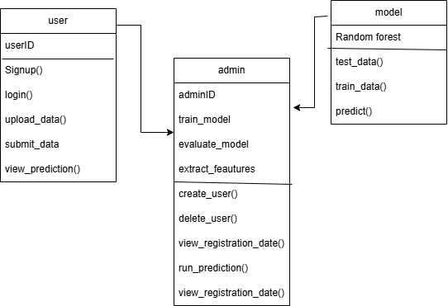
Figure 3.9 Class diagram of the proposed system
3.3.2.8 SEQUENCE DIAGRAM
A sequence diagram depicts how the different parts of the system interact over time. Similarly, these diagrams are very important in the understanding of the chronological flow of actions and messages that occur during the execution of a particular use case or scenario. However, at its core, these sequence diagrams visually represent the order in which interactions take place therefore providing a clear depiction of how the various components collaborate in a specific system to achieve the specified goal.

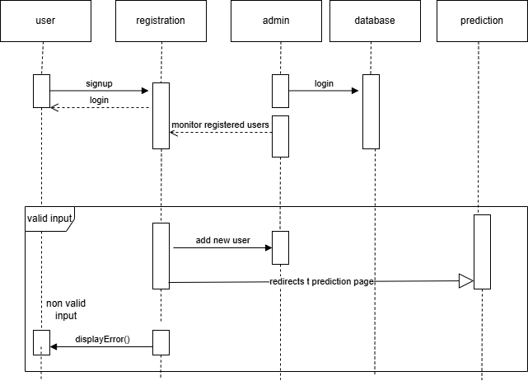
Figure 3.10 Sequence diagram of the proposed system
The diagram above stands as the sequence diagram for the proposed system, as it stands to show the detailed process of actions that takes place during the using of the proposed system. It is a diagrammatical representation of the action that occurs in the process of a user and admin using an account in the proposed system, which starts from the user registering their details, to the system verifying the user and successfully redirecting the user to the user interface of the system.
3.5 SYSTEM DESIGN
The system design is going to illustrate how the system is going to fulfil the requirements that have been stated above. This system design is going to comprise of an input/output design of the proposed system as well as the database design of the system.
3.5.1 INPUT/OUTPUT DESIGN
The input/output design comprises the mockup design of all the sections through with inputs are passed and received on the system as well as the illustrations of the output mockup sections after the inputs. Below is the diagram of the input/output design illustrations.
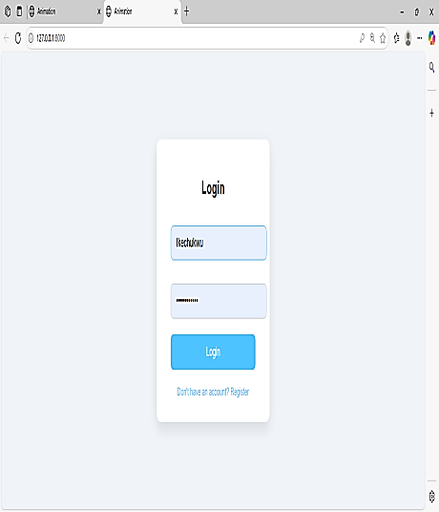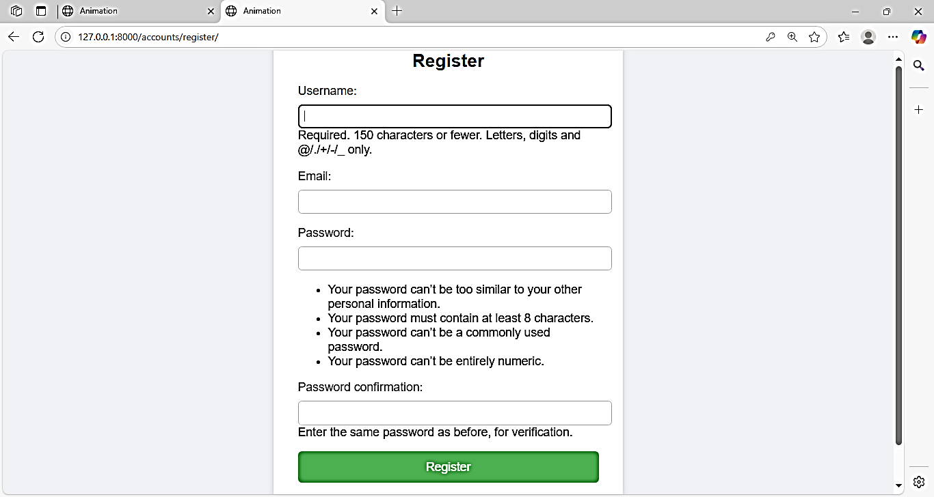
Figure 3.11 input design of the proposed system
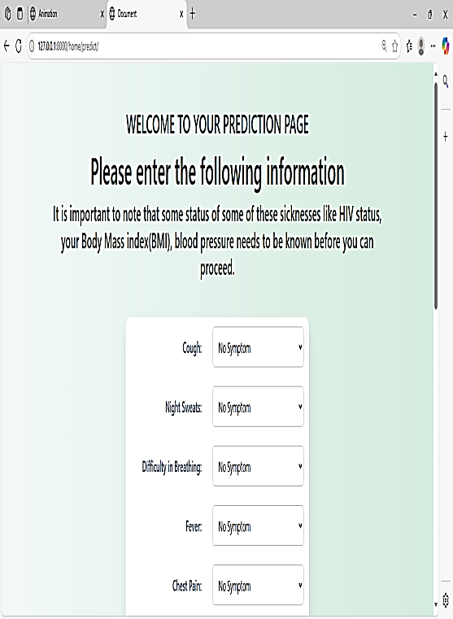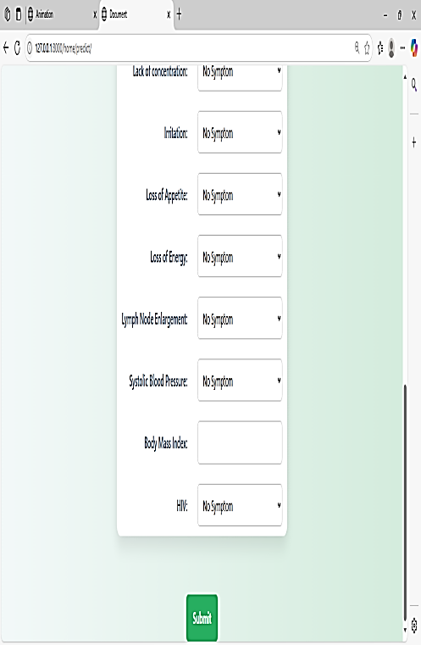
Figure 3.12 Input designs for the proposed system

3.5.1.1 INPUT DESIGNS OF THE PROPOSED SYSTEM
The diagram above shows the user interface design for both the login and registration page and also the submit page. It generally shows a pictorial representation of the interface used in collecting data into the proposed system which will be used for the prediction. Therefore, the interface is as it stands to showcases all different steps that are involved in running a prediction.

3.5.1.2 OUTPUT DESIGN OF THE PROPOSED SYSTEM:

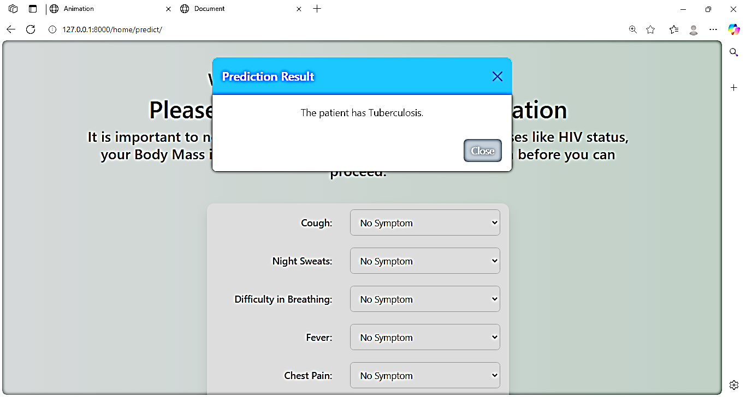
Figure 3.13 Output design for the proposed system

The images above shows the interface of the proposed system for both the posts page and the chat page. The images however shows how the post elements would be arranged in the app and the way the messages would be arranged in the chat page. The diagram above however shows the user interface design for both the chat page sample also the post page. It generally shows a pictorial representation of the interface used in outputting data out of the proposed system. These output interfaces that are supplied to the platform cuts across mainly the act of displaying the pictures or videos that have been uploaded to the platform.
3.6 DATABASE DESIGN
The essence of the database design is to show a modeled view of the proposed system database. The database design of the proposed system uses Django object oriented relational mapper which allows you to create and manage relational database tables using python classes called models. This means that you don’t necessarily have to know SQL queries before you can use the query a database.
3.6.1 DATA BASE SCHEMA FOR THE PROPOSED SYSTEM
Table 3.1 User table
Attribute | Data Type | Description
Id | int | The primary key of the table
Username | varchar | This is where the username of the user is stored.
Email address | varchar | Email of the user
Last login | Timestamp | When last the user logged in
Date joined | date | When the user joined

CHAPTER FOUR
SYSTEM IMPLEMENTATION
4.1 INTRODUCTION
System Implementation is a stage in software development where the ideas articulated are brought to life. The implementation of the system will be covered in this chapter. After being tested using the appropriate tools, a comprehensive analysis of the proposed system and the system requirements will be explained. Some functioning parts of the system, tools and user interfaces will be discussed in this chapter.
4.2 CHOICE OF DEVELOPMENT ENVIRONMENT
An integrated development environment (IDE) is a software application that provides an all-round knowledge facilities to computer programmers for software development. An IDE is made up of a source code editor, built in automation tools and a debugger. In this project work, the IDE of choice use is VS code
The reasons why VS code was used as the IDE of this research are the following:
- It is user friendly and easy to understand.
- It offers a wide range of advanced features that enhance productivity and efficiency in Python coding.
- It includes all the necessary tools and features in a single package, eliminating the need for developers to rely on multiple tools or plugins.
- It supports a wide range of plugins and extensions that allow developers to customize and extend the IDE's functionality according to their specific needs.

4.2.1 FRONTEND
4.2.1.1. HTML
HTML is the abbreviation of Hyper Text Markup Language which is used to create the basic structure and basis of a webpage. It is regarded as the fundamental building element of web development that allows programmers to design and organize the content of websites. It entails defining elements like headings, paragraphs, photos, links, and so on using a set of properties and tags, which are then rendered by the web browser. However, both humans and machines can read and comprehend the HTML language because of its design. Because of this, developers may use it as a very flexible tool to create web pages with a very clear structure and semantics. Additionally, it gives developers the chance to incorporate multimedia components like audio and video to enhance user experience. The HTML language provides developers with the ability to use JavaScript and CSS (Cascading Style Sheets) to enable dynamic and customizable web page design and behavior. Most importantly, in most cases it serves as an avenue for data collection through the use of its elements like forms and input fields. In all it is a very important tool for web development because it provides a framework upon which websites stands and operates. Moreover, it was used to design the physical interface of the proposed system interface.
4.2.1.2. CSS
Cascading Style Sheet (CSS) is a simple language that can be used to style webpages. It is very powerful and t is used to determine the kind of design that will be utilized for displaying HTML content and is incredibly powerful. It allows developers to have complete control over the design, color, font, and layout of the web pages.to guarantee that users find the design appealing overall. Because HTML and CSS are used to segregate content from presentation, it also contributes to the ease of maintenance and scalability of web-based projects.. CSS selects HTML elements using selectors and then apply styles to them using its properties and values. It allows developers to create responsive designs thereby enabling the web pages to be able to adapt to different screen sizes and devices through the use of its special media queries. It is one of the tools that was used in the design of the interface of the proposed system.
4.2.2 Backend
4.2.2.1 Python
Python is a very strong and flexible programming language. It is a high-level programming language that has a reputation for being straightforward and easy to read. This is why it has grown to be the most widely used programming language among both novice and seasoned developers. Because it supports many different paradigms and also supports a large ecosystem of third-party packages that allows for a rapid development across various domains such as web development, data analysis, artificial intelligence and automation. It also offers dynamic typing to improve productivity and also allow for integration with other language, tools and frameworks like Django and Flask to enable and ensure a more efficient modern software development process.
4.2.2.2 Django
Django is a powerful, open-source web framework that was written using the Python programming language. It was designed to help developers build robust and scalable web applications very quickly and efficiently. It follows the pattern of Model-View-Template (MVT) architecture, which promotes a clean separation of concerns and simplifies the organization of code. Django on its own comes with a lot of built-in features which includes an authentication system, an admin interface, and other tools that could be used for managing databases, making it easier to handle common web development tasks. However, it prioritizes security by offering protection against common vulnerabilities such as SQL injection, cross-site scripting (XSS), and cross-site request forgery (CSRF). Moreover, the framework also supports rapid development and scalability, which is ideal for both small projects and large-scale applications.
4.2.2.3 SQLite
SQLite is a lightweight, self-contained SQL database engine that is open-source and is widely used for embedded database systems and applications. Unlike other databases, SQLite does not require a separate server process, thereby making it easy to set up and use. It stores the entire database as a single file on the disk and with this simplifies database management and portability. However, it supports most of the SQL standards and is highly efficient for read-heavy operations, making it ideal for applications with moderate database workloads. Moreover, its zero-configuration design means that it requires minimal setup, and it runs on various platforms without needing complex administration. But despite its simplicity, it still provides robust data integrity and supports transactions, ensuring reliable data handling. It is a popular choice for applications, including mobile apps, small to medium websites, and development and testing environments due to its ease of use and reliability.
4.3 SYSTEM REQUIREMENTS
There are not many things that are needed to use this system as it is a web based platform application and however runs on both the web and mobile platforms. However, the system still require that the user gets to fulfill some little requirements in order to be able to use the proposed system. These requirements are as follows:
- An internet enabled device
- Good internet connection (at least 3G internet speed).
- A web browser e.g. Google Chrome, Mozilla Firefox, Microsoft Edge, Apple Safari and a host of others.
4.4 USER INTERFACE OF THE PROPOSED SYSTEM
This section of this research work is going to contain user interfaces of different sections of the proposed system which would include the dashboard
4.4.1. PROPOSED SYSTEM HOMEPAGE
The homepage consists a welcoming interface which is made up of two buttons the logout button, the predict button to navigate to the predict page. This was designed with simplicity in mind to as to be able to navigate to were patients data will be collected or the prediction.

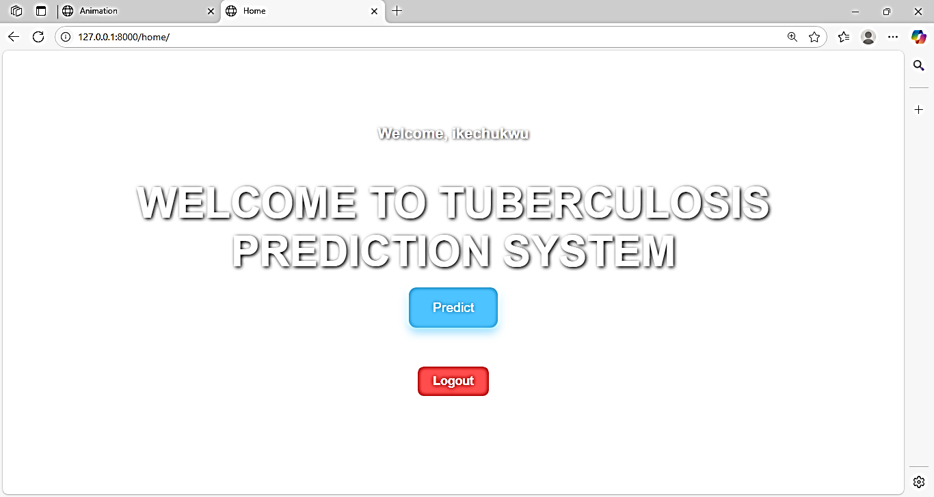
Figure 4.0 Screenshots of the proposed system homepage

CHAPTER FIVE
SUMMARY, RECOMMENDATIONS AND CONCLUSION
5.1 INTRODUCTION
This chapter of this research work stands to give a detailed summary of this project, the recommendations for future works, and lastly conclusion of this research work. This chapter however summarizes everything that has been discussed in all the chapters of this project.
5.2 SUMMARY
At the initial inception of this research work, the background of the study was explicitly discussed in conjunction to the problem statement which are related to this research work. However in the later chapters of this research work, the theoretical background of study of this research work was discussed and the existing systems that are related to this work was also reviewed. This research work also gave a detailed analysis of existing systems, identified the limitations of these existing systems and therefore tried its best to capitalize on these existing problems while building the system that was proposed in this research work. Moreover a thorough analysis of the system was done at the third chapter of this research work using UML diagrams; use case diagrams, activity diagrams, the class diagrams and the sequence diagrams of the UML diagrams were specifically used in analyzing the both the existing system and the proposed system. Finally, all the programming languages and frameworks that was used for the implementation of this project were stated and the description of the user interface was also stated.
5.3 RECOMMENDATIONS
This web application is recommended for hospitals in the south eastern part if the country. This web app stands to benefit those in the south east as it was tailored taking into consideration the uniqueness of tuberculosis diagnosis as found in the south eastern part o the country. System maintenance should also be provided to maximize continuous access to the system and updates to software and system functionality required to further meet additional user requirements. Other work that could be done on it include, using other algorithms in machine learning such as convolutional neural network (CNN) which trains models using MRI’s to predict tuberculosis .
5.4 CONCLUSION
Finally, we have come to the end of this research as this section of this research work stands to conclude the objectives that were defined in this research work. However, the system was able to achieve an improved user interface that is responsive to all screen sizes, implemented a django user authentication to help improve the security and monitor the users.

REFERENCES
Aasia, K., Batool, S. A., & Chaudhry, M. N. (2021). Spatial Distribution and Computational Modeling for Mapping of Tuberculosis in Pakistan. Journal of Public Health, pg 125.
Abdullah, B, Stefanus K. T. H, Mohd Hanafi Ahmad Hijazi, Mohammad S. J,(2020). Tuberculosis Detection Using Deep Learning and Contrast-Enhanced Canny Edge Detected X-Ray Images. IAES International Journal of Artificial Intelligence (IJ-AI), Issue 4, Pages 713–720
Adane, N., et al. (2021). A cluster-genetic programming approach for detecting pulmonary tuberculosis. Ethiopian Journal of Science and Technology, 12(1), 1–10.
Ahmad Hijazi, Mohd. H., Yang, L. Q., Alfred, R., Mahdin, H., & Yaakob, R. (2020). Ensemble Deep Learning for Tuberculosis Detection, pg17(2).
. Ashia, L., Mahmoodi, E., Zhou, Y., Coffee, M., & Sizikova, E. (2021). Improving Tuberculosis Prediction using Synthetically Generated Computed Tomography (CT) Images. In Proceedings of the IEEE/CVF International Conference on Computer Vision (ICCV) Workshops, pg. 2796–2805.
Azhari, E. A. (2024). Prediction and classification of tuberculosis using machine learning. Journal of Statistics Applications & Probability, pg 939.
Balogun, S. A., Olayemi, E., & Olayemi, O. (2020). Investigating Machine Learning Methods for Tuberculosis Risk Factors Prediction. A comparative analysis and evaluation. Journal of Global Health Reports, pg 4.
Barnes, D. S. (2000). Historical perspectives on the etiology of tuberculosis. Microbes and Infection, 2(5), 431–440
Bhuvana, R., Kumar, S. A., & Soman, K. P. (2020). Deep Learning Approach for Tuberculosis Detection in 3D CT Scans. In CLEF 2020 Working Notes (Vol. 2696).
Bi, Y., Zhang, L., & Chen, W. (2018). Random forest-based risk scoring model for tuberculosis susceptibility using demographic and clinical predictors. Computers in Biology and Medicine, 100, 24–32.
Chang, Y., Lee, S., & Lee, S. (2020). Computer-aided Detection of Tuberculosis from Microbiological and Radiographic Images. Data Intelligence, pg 4.
Chunling, L., et al. (2021). Classifying Lymphoma and Tuberculosis Case Reports Using Machine Learning Algorithms. Bulletin of Electrical Engineering and Informatics, 10(5), pg 2857.
Dasanayaka, C., & Dissanayake, M. B. (2020). Deep Learning Methods for Screening Pulmonary Tuberculosis Using Chest X-rays. Computer Methods in Biomechanics and Biomedical Engineering: I
Deshpande, R., Kumar, S., & Patel, M. (2019). Early detection of tuberculosis using ensemble machine learning models: A comparative study. International Journal of Medical Informatics, 128, 45–53.maging & Visualization, pg 4
Duong, T. T., Nguyen, T. T., (2021). Detection of Tuberculosis From Chest X-ray Images. Expert Systems with Applications, pg 185.
Gupta, R., Kumar, P., & Singh, A. (2021). Hybrid machine learning approaches for tuberculosis prediction: Combining SVM, random forest, and neural networks. Journal of Medical Artificial Intelligence, 8(2), 145–158.
Jamal, S., Ahmad, Z., Manzoor, S., & Khan, Z. (2021). Prediction of Multidrug-Resistant Tuberculosis Using Machine Learning Algorithms in Swat, Pakistan. Journal of Healthcare Engineering, 2021, pg 2567080
Jaiswal, V., Sharma, D., & Mehta, S. (2023). Enhancing tuberculosis diagnosis using hybrid predictive models. International Journal of Computational Healthcare, 12(4), 289–302.
Karim G., Hrizi, O., & Ben Ayed, I. (2022). Tuberculosis Disease Diagnosis Based on an Optimized Machine Learning Model. Computers in Biology and Medicine, pg 146.
Kavakiotis, I., Papadopoulos, A., & Georgiou, H. (2020). Support vector machine-based prediction models for tuberculosis diagnosis and risk assessment. Journal of Biomedical Informatics, 108, 103495.
Kim, H., Park, S., & Choi, J. (2022). Gradient boosting machine-based integration of clinical, demographic, and imaging data for tuberculosis prediction. Computers in Biology and Medicine, 147, 105749.
Koch, R. (1882). Die Ätiologie der Tuberkulose [The etiology of tuberculosis]. Berliner Klinische Wochenschrift, 15, 221–230. Presented 24 March 1882 at the Berlin Physiological Society.
Kulkarni, M., Golechha, S., Raj, R., Sreedharan, J., Bhardwaj, A., Rathod, S., Vadera, B., Kurada, J., Mattoo, S., Joshi, R., Rade, K., & Raval, A. (2022). Predicting treatment adherence of tuberculosis patients at scale. Proceedings of the 39th International Conference on Machine Learning (ICML 2022), 162, 11507–11522.
Lakhani, P., Sundaram, B., & Gill, R. R. (2017). Deep convolutional neural networks for the automated diagnosis of pulmonary tuberculosis on chest radiographs. Medical Imaging Analysis, 42, 49–58.
Murugesan, S. S., Velu, S., Golec, M., Wu, H., & Gill, S. S. (2024). Neural Networks-based Smart E-health Application for the Prediction of Tuberculosis Using Serverless Computing. IEEE Journal of Biomedical and Health Informatics (Volume: 28, Issue: 9, September 2024).
Nardell, E. A., Singh, P., & Martinez, L. (2020). Leveraging gradient boosting algorithms to enhance tuberculosis risk stratification: A multi-center study. International Journal of Tuberculosis and Lung Disease, 24(11), 1125–1133.
Ohwo, S.; Eze, F.; Onu, Fergus; Julius, Michael (2023), “Tuberculosis Dataset for Intelligent and Adaptive Medical Diagnostic System”, Mendeley Data, V1, doi: 10.17632/ndxdx54xxx.1
Qing, Y., Zhang, L., Zhang, L., Zhang, Y., & Zhang, L. (2021). Identification of Active Molecules Against Mycobacterium Tuberculosis Through Machine Learning. Briefings in Bioinformatics, pg 1.
Seowo, L., Yim, J. J., Kwak, N., Lee, Y. J., Lee, J. K., Lee, J. Y., Kim, J. S., Kang, Y. A., Jeon, D., Jang, M. J., Goo, J. M., & Yoon, S. H. (2021). Deep learning to Determine the Activity of Pulmonary Tuberculosis on Chest Radiographs. Radiology, pg 435.
Smith, J., Adewale, T., Kumar, P., & Hernandez, L. (2023). Predictive modeling of tuberculosis outbreaks using random forest and demographic risk factors. Journal of Global Health Informatics, 15(2), 85–97.
Waksman, S. A., Schatz, A., & Bugie, E. (1944). Streptomycin, a new antibacterial substance, designated as streptomycin. Experimental Biology and Medicine, 55(1), 66–69. The antibiotic—effective against Mycobacterium tuberculosis—was first reported in 1944, following its isolation in 1943
Wanying D, Liu, Y., Liu, Z., Yerezhepov, D., Kozhamkulov, U., Akilzhanova, A., Dib, O., & Chan, C. K. (2021). An AutoML Approach for Predicting Risk of Progression to Active Tuberculosis Based on its Association with Host Genetic Variations. ACM International Conference Proceeding Series, 82–88.
Xinna, L., et al. (2023). Utility of Machine Learning and Radiomics Based on Cavity for Ppredicting the Therapeutic Response of Multidrug-Resistant Tuberculosis. Infection and Drug Resistance, 16, pg 1.

APPENDIX
PERFORMANCE METRICES
Accuracy: 0.9393939393939394
Classification Report:
precision recall f1-score support

0 0.96 0.93 0.94 27
1 0.92 0.94 0.93 36
2 0.94 0.94 0.94 36

accuracy 0.94 99
macro avg 0.94 0.94 0.94 99
weighted avg 0.94 0.94 0.94 99
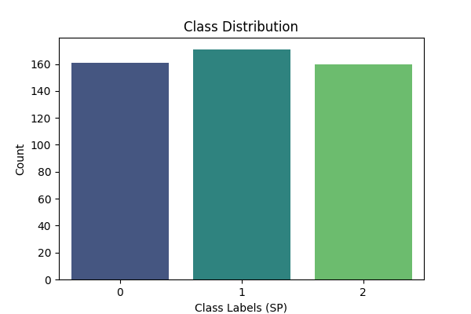
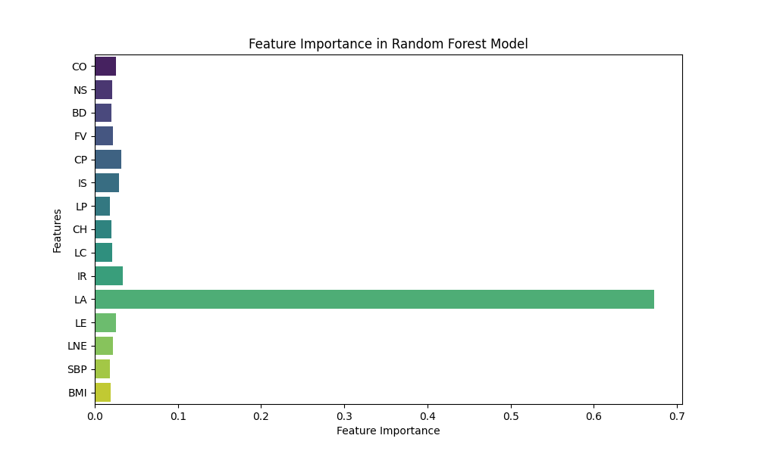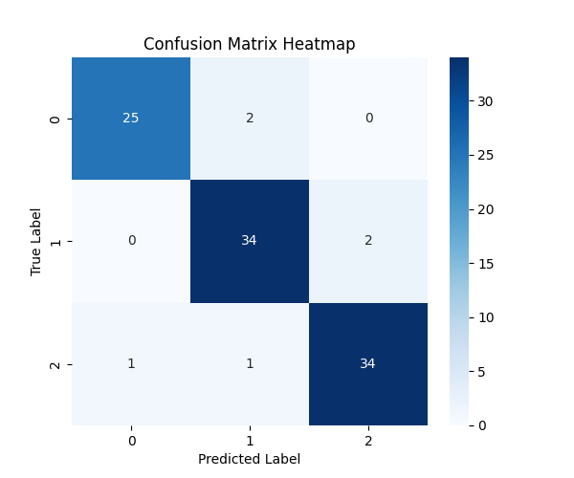
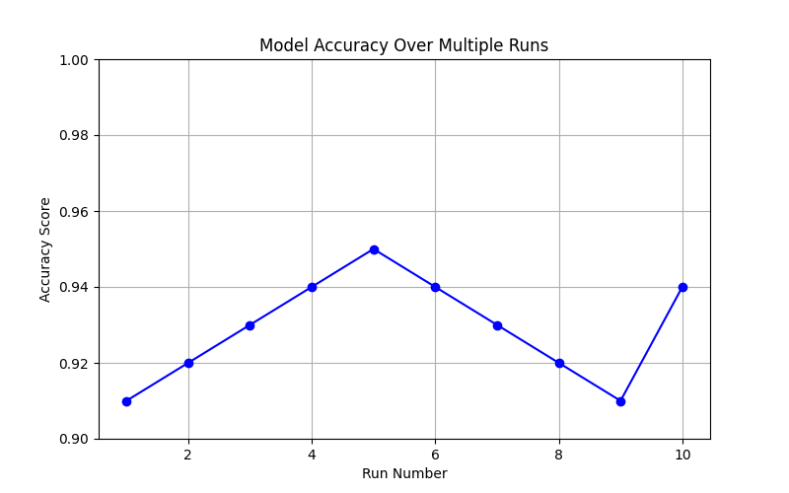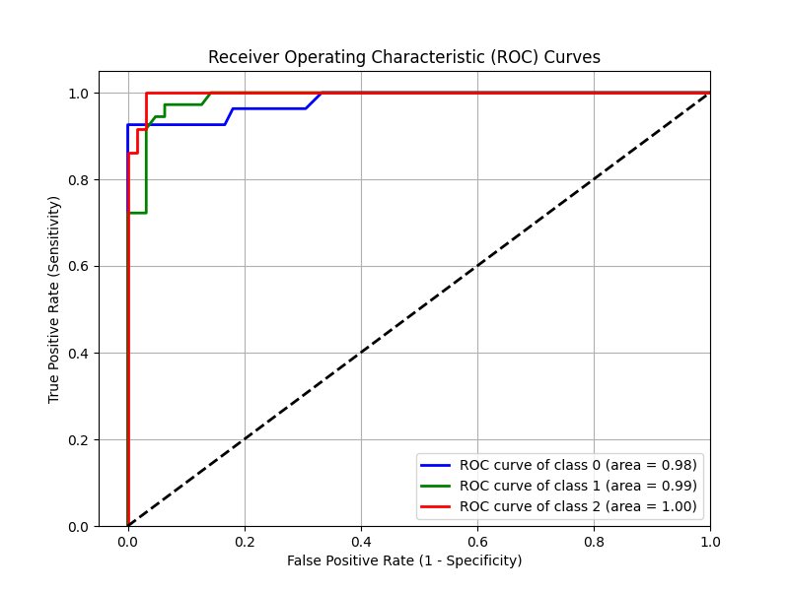

APPENDIX II
CODE FOR MODEL TRAINING AND EVALUATION
import pandas as pd
import matplotlib.pyplot as plt
import seaborn as sns
from sklearn.preprocessing import StandardScaler
from sklearn.model_selection import train_test_split
from sklearn.ensemble import RandomForestClassifier
from sklearn.metrics import accuracy_score, classification_report, confusion_matrix
import numpy as np
import joblib
import matplotlib.gridspec as gridspec
from sklearn.preprocessing import label_binarize
from sklearn.metrics import roc_curve, roc_auc_score
# Load Dataset
dataset = pd.read_excel("C:/Users/user/Desktop/machine learning/tuberculosis dataset.xlsx")
# Check for missing values
print("Missing values before handling:\n", dataset.isnull().sum())
#distribution of the three classes
print(dataset['SP'].value_counts())
# Convert to binary labels
# Plot class distribution
plt.figure(figsize=(6,4))
sns.countplot(x=dataset['SP'], palette="viridis") # 'viridis' gives a nice color gradient
plt.xlabel("Class Labels (SP)")
plt.ylabel("Count")
plt.title("Class Distribution")
plt.show()
# Map categorical values

print(dataset.head()) # Check if dataset is correctly loaded
print(f"Dataset contains {len(dataset)} rows.")
if len(dataset) >= 500:
dataset_sample = dataset.sample(n=500, replace=False)
else:
dataset_sample = dataset.copy() # Use full dataset if it's smaller
# Split Features and Target
x = dataset.drop(columns=['SP'])
y = dataset['SP']
# Train-test Split
x_train, x_test, y_train, y_test = train_test_split(x, y, test_size=0.2, random_state=42)
# Print Shapes
print("X Shape:", x.shape, "| X_train:", x_train.shape, "| X_test:", x_test.shape)
print("Y Shape:", y.shape, "| Y_train:", y_train.shape, "| Y_test:", y_test.shape)
# Train Model
model = RandomForestClassifier(n_estimators=100, random_state=42)
model.fit(x_train, y_train)
# Save the trained model
joblib.dump(model, "random_forest_tb.pkl")
print("Model saved successfully!")
# Predictions
predictions = model.predict(x_test)
# Feature Importance
importance = model.feature_importances_
feature_names = x.columns
for name, imp in zip(feature_names, importance):
print(f"Feature: {name}, Importance: {imp}")
# Evaluation
print("Accuracy:", accuracy_score(y_test, predictions))
print("Classification Report:\n", classification_report(y_test, predictions))
print("Confusion Matrix:\n", confusion_matrix(y_test, predictions))
# Feature Importance Visualization
plt.figure(figsize=(10, 6))
sns.barplot(x=importance, y=feature_names, palette="viridis")
plt.xlabel("Feature Importance")
plt.ylabel("Features")
plt.title("Feature Importance in Random Forest Model")
plt.show()
# Generate confusion matrix
cm = confusion_matrix(y_test, predictions)
# Plot confusion matrix as a heatmap
plt.figure(figsize=(6,5))
sns.heatmap(cm, annot=True, fmt="d", cmap="Blues", xticklabels=[0,1,2], yticklabels=[0,1,2])
plt.xlabel("Predicted Label")
plt.ylabel("True Label")
plt.title("Confusion Matrix Heatmap")
plt.show()
# Simulate accuracy scores over multiple runs
runs = np.arange(1, 11) # 10 runs
accuracies = [0.91, 0.92, 0.93, 0.94, 0.95, 0.94, 0.93, 0.92, 0.91, 0.94] # Example data
plt.figure(figsize=(8, 5))
plt.plot(runs, accuracies, marker='o', linestyle='-', color='b')
plt.xlabel("Run Number")
plt.ylabel("Accuracy Score")
plt.title("Model Accuracy Over Multiple Runs")
plt.ylim(0.9, 1) # Set y-axis range for better visualization
plt.grid()
plt.show()

input_data = [1,1, 2, 0, 2, 1, 2, 2, 2, 0, 1, 0, 2, 2, 0]
# Assume 'model' is your trained model and 'new_sample' is a single instance
new_sample = np.array(input_data) # 1D array
# Reshape to match (1, num_features) before prediction
new_sample = new_sample.reshape(1, -1)
# Predict
prediction = model.predict(new_sample)
print("Predicted class:", prediction)
# Confusion Matrix again (True Positives, False Positives, etc.)
cm = confusion_matrix(y_test, predictions)
# Since it's multi-class, we handle it carefully (example for class '1')
# Calculate sensitivity (recall) and specificity manually
TP = cm[1,1]
FN = sum(cm[1,:]) - TP
FP = sum(cm[:,1]) - TP
TN = cm.sum() - (TP + FP + FN)
sensitivity = TP / (TP + FN)
specificity = TN / (TN + FP)
youden_index = sensitivity + specificity - 1
print(f"Sensitivity (Recall): {sensitivity:.2f}")
print(f"Specificity: {specificity:.2f}")
print(f"Youden's Index: {youden_index:.2f}")
# Binarize output for ROC curve (because it's a multi-class classification)
y_test_bin = label_binarize(y_test, classes=[0,1,2])
predictions_proba = model.predict_proba(x_test)
# Compute ROC curve and ROC area for each class
fpr = dict()
tpr = dict()
roc_auc = dict()
for i in range(3): # 3 classes
fpr[i], tpr[i], _ = roc_curve(y_test_bin[:, i], predictions_proba[:, i])
roc_auc[i] = roc_auc_score(y_test_bin[:, i], predictions_proba[:, i])
# Plot all ROC curves
plt.figure(figsize=(8,6))
colors = ['blue', 'green', 'red']
for i, color in zip(range(3), colors):
plt.plot(fpr[i], tpr[i], color=color, lw=2,
label=f'ROC curve of class {i} (area = {roc_auc[i]:0.2f})')
plt.plot([0, 1], [0, 1], 'k--', lw=2)
plt.xlim([-0.05, 1.0])
plt.ylim([0.0, 1.05])
plt.xlabel('False Positive Rate (1 - Specificity)')
plt.ylabel('True Positive Rate (Sensitivity)')
plt.title('Receiver Operating Characteristic (ROC) Curves')
plt.legend(loc="lower right")
plt.grid()
plt.show()
# Pick two important features (you can also pick by feature_importances_)
important_features = x.columns[:2]
plt.figure(figsize=(8,6))
sns.scatterplot(x=x_test[important_features[0]],
y=x_test[important_features[1]],
hue=y_test,
palette="viridis",
alpha=0.7)
plt.xlabel(important_features[0])
plt.ylabel(important_features[1])
plt.title("Scatter Plot of Two Features Colored by True Class")
plt.legend(title="True Class")
plt.grid()
plt.show()
CODE FOR THE APPLICATION
from django.shortcuts import render
# Create your views here.
from django.shortcuts import render, redirect
from django.contrib.auth import authenticate, login, logout
from django.contrib.auth.decorators import login_required
from django.contrib import messages
from .forms import RegisterForm
# Register
def register_view(request):
if request.method == 'POST':
form = RegisterForm(request.POST)
if form.is_valid():
form.save()
messages.success(request, 'Account created successfully. Please log in.')
return redirect('login')
else:
form = RegisterForm()
return render(request, 'accounts/register.html', {'form': form})

# Login
def login_view(request):
if request.method == 'POST':
username = request.POST['username']
password = request.POST['password']
user = authenticate(request, username=username, password=password)
if user:
login(request, user)
return redirect('home')
else:
messages.error(request, 'Invalid username or password.')
return render(request, 'accounts/login.html')
# Logout
def logout_view(request):
logout(request)
return redirect('login')
# Dashboard (protected view)
@login_required(login_url='login')
def home(request):
return render(request, 'home.html')
<!DOCTYPE html>
<html lang="en">
<head>
<meta charset="UTF-8">
<meta name="viewport" content="width=device-width, initial-scale=1.0">
<title>Animation</title>
<h2>Welcome, {{ request.user.username }}</h2>
<a href="{% url 'logout' %}">Logout</a>

<!DOCTYPE html>
<html lang="en">
<head>
<meta charset="UTF-8" />
<meta name="viewport" content="width=device-width, initial-scale=1" />
<title>Animation</title>
<style>
/* Body and container */
body {
font-family: Arial, sans-serif;
background: #f0f4f8;
display: flex;
justify-content: center;
align-items: center;
height: 100vh;
margin: 0;
}
form {
background: white;
padding: 30px 40px;
border-radius: 12px;
box-shadow: 0 8px 20px rgba(0,0,0,0.1);
width: 320px;
box-sizing: border-box;
text-align: center;
}
h2 {
margin-bottom: 24px;
color: #333;
font-weight: 600;
}
/* Input styles */
input[type="text"],
input[type="password"] {
width: 100%;
padding: 12px 15px;
margin: 10px 0 20px;
border: 1.5px solid #ccc;
border-radius: 8px;
font-size: 16px;
transition: border-color 0.3s ease;
}
input[type="text"]:focus,
input[type="password"]:focus {
border-color: #4dc3ff;
outline: none;
}
/* Button styles */
button {
width: 100%;
background-color: #4dc3ff;
border: none;
color: white;
padding: 14px;
font-size: 16px;
border-radius: 8px;
cursor: pointer;
transition: background-color 0.3s ease;
}
button:hover {
background-color: #38a1f3;
}
/* Messages */
p {
color: #e63946;
font-weight: 600;
margin-bottom: 15px;
}
/* Register link */
a {
display: inline-block;
margin-top: 20px;
font-size: 14px;
color: #4dc3ff;
text-decoration: none;
transition: color 0.3s ease;
}
a:hover {
color: #38a1f3;
text-decoration: underline;
}
</style>
</head>
<body>
<form method="post">
<h2>Login</h2>
{% if messages %}
{% for message in messages %}
<p>{{ message }}</p>
{% endfor %}
{% endif %}
{% csrf_token %}
<input type="text" name="username" placeholder="Username" required><br>
<input type="password" name="password" placeholder="Password" required><br>
<button type="submit">Login</button>
<a href="{% url 'register' %}">Don't have an account? Register</a>
</form>
</body>
</html>

div class="form-container">
<h2>Register</h2>
<form method="post">
{% csrf_token %}
{{ form.as_p }}
<button type="submit">Register</button>
</form>
<a href="{% url 'login' %}">Already have an account? Login</a>
</div>
</body>
</html>
from django.shortcuts import render, redirect
import pandas as pd
import matplotlib.pyplot as plt
import seaborn as sns
from sklearn.preprocessing import StandardScaler
from sklearn.model_selection import train_test_split
from sklearn.ensemble import RandomForestClassifier
from sklearn.metrics import accuracy_score, classification_report, confusion_matrix
import numpy as np
import joblib
from django.contrib.auth.decorators import login_required
def predict(request):
print("predict() from predict_views.py is being called")
return render(request, 'predict.html')
@login_required
def home(request):
return render(request, 'home.html')
def predict(request):
result = request.session.pop('prediction_result', None)
return render(request, 'predict.html', {"result2": result})
def result(request):
if request.method == 'POST':
try:
val1 = float(request.POST['n1']) if request.POST['n1'] else 0.0
val2 = float(request.POST['n2']) if request.POST['n2'] else 0.0
val3 = float(request.POST['n3']) if request.POST['n3'] else 0.0
val4 = float(request.POST['n4']) if request.POST['n4'] else 0.0
val5 = float(request.POST['n5']) if request.POST['n5'] else 0.0
val6 = float(request.POST['n6']) if request.POST['n6'] else 0.0
val7 = float(request.POST['n7']) if request.POST['n7'] else 0.0
val8 = float(request.POST['n8']) if request.POST['n8'] else 0.0
val9 = float(request.POST['n9']) if request.POST['n9'] else 0.0
val10 = float(request.POST['n10']) if request.POST['n10'] else 0.0
val11 = float(request.POST['n11']) if request.POST['n11'] else 0.0
val12 = float(request.POST['n12']) if request.POST['n12'] else 0.0
val13 = float(request.POST['n13']) if request.POST['n13'] else 0.0
val14 = float(request.POST.get('n14', None)) if request.POST['n14'] else 0.0
val15 = float(request.POST['n15']) if request.POST['n15'] else 0.0
# Load saved model
model = joblib.load("c:/Users/user/Desktop/machine learning/random_forest_tb.pkl")
# Make prediction
pred = model.predict([[val1, val2, val3, val4, val5, val6, val7,
val8, val9, val10, val11, val12, val13, val14, val15]])
result1 = "The patient has Tuberculosis." if pred[0] == 1 else "The patient does not have Tuberculosis."
# Store result in session
request.session['prediction_result'] = result1
return redirect('predict') # Redirect instead of render
except ValueError as e:
# result1 = "Please fill in all fields with valid numbers."
request.session['prediction_result'] = "Please click to select the appropriate sympthoms."
return redirect('predict')
# result1 = "Invalid request method."
# return redirect('predict') # Redirect on error too
return redirect('predict')
# return redirect('predict') # Handle GET requests
# return render(request, 'predict.html', {"result2": result1})

