A LIVESTOCK MANAGEMENT SYSTEM

BY

OHENMEN LAWRENCE USOUNHBUN
U17/NAS/CSC/181

COMPUTR SCIENCE
COMPUTER SCIENCE/MATHEMATICS
FACULTY OF NATURAL SCIENCES AND ENVIRONMENTAL STUDIES
GODFREY OKOYE UNIVERSITY, ENUGU NIGERIA.

SEPTEMBER, 2020.

A LIVESTOCK MANAGEMENT SYSTEM

BY

OHENMEN LAWRENCE USOUNHBUN
U17/NAS/CSC/181

COMPUTER SCIENCE
COMPUTER SCIENCE/ MATHEMATICS
FACULTY OF NATURAL SCIENCES AND ENVIRONMENTAL STUDIES
GODFREY OKOYE UNIVERSITY, ENUGU NIGERIA

A PROJECT RESEARCH SUBMITTED TO THE DEPARTMENT OF COMPUTER SCIENCE/ MATHEMATICS IN PARTIAL FULFILLMENT OF THE REQUIREMENTS FOR THE AWARD OF BACHELOR OF SCIENCE (B.Sc.) DEGREE IN COMPUTER SCIENCE

SUPERVISOR: MR. BENSON IKENNA

SEPTEMBER, 2020.

APPROVAL

This research titled “A LIVESTOCK MANAGEMENT SYSTEM” has been assessed and approved by the Committee of Department of Computer Science and Faculty of Natural and Environmental Studies, Godfrey Okoye University Enugu Nigeria.

Mr. Benson Ikenna .D. __________________ ______________

Supervisor Signature Date

Dr. Okereke G.E. (PhD) ____________________ ____________

Head of Department Signature Date

Asso. Prof. Mirian U. _________________ _____________

Dean, FNSES Signature Date

External Examiner ________________ ______________
Signature Date

CERTIFICATION

I hereby declare that the work presented therein was done by me, and not by a third party. Should I be convicted of having cheating in the work, I will accept the verdict of the University.

__________________________________________ _______________________

Ohenmen Lawrence Usounhbun U17/NAS/CSC/181 Signature & Date

DEDICATION
This project work is dedicated to God Almighty, for his love and faithfulness to me throughout the duration of this program. I dedicate this project work also to my lovely Parents, Mr. and Mrs. Ohenmen who have encouraged and supported me all the way.

ACKNOWLEDGMENTS
My deepest gratitude goes to my supervisor Mr. Benson I.D, Head of Department of this department, Dr. Okereke G.E and I also appreciate my lecturers for nurturing the vision of great institution.
I also appreciate my departmental, Peter John, Obey Abraham and every other person in the department, my time in this school was a wonderful one, because of you all.

ABSTRACT
This project implements a desktop application which give livestock farmers an easy and more efficient computerized method for managing their farm record. With this desktop application, the livestock farmer can keep record of several types of livestock’s like Goat, Cow, and pig. The livestock farmer is capable of keeping record of information like sex, date of birth, health status, and gestating status. The system was designed using the Structured System Analysis and Design Methodology (SSADM). The author implemented the system using electron, vuejs, JavaScript, quasar, HTML, and CSS on a windows operating system using visual studio code Integrated Development Environment (IDE)

TABLE OF CONTENTS
Title Page i
Approval ii
Certification iii
Dedication iv
Acknowledgement v
Abstract vi
Table of Contents vii
List of Tables ix
List of Figures x

CHAPTER ONE: INTRODUCTION
1.1 Background of the study 1
1.2 Statement of the problem 2
1.3 Aim and Objectives 2
1.4 Significance of the study 3
1.5 Scope of the study 3
CHAPTER TWO: LITERATURE REVIEW
Overview 4
2.1 Theoretical background 4
2.2 Review of literature 12
CHAPTER THREE: MATERIALS AND METHODS
Overview 15
3.1 Description of existing system 18
3.2 Analysis of proposed system 19
3.3 Design of proposed system 24
CHAPTER FOUR: IMPLEMENTATION
Overview 28
4.1 Implementation Technologies 28
4.2 Software Testing 29
4.4 Documentation 33
CHAPTER FIVE: SUMMARY AND CONCLUSION
5.1 Summary 35
5.2 Conclusion 35
5.3 Recommendation 36
References 37
Appendices 38

LIST OF TABLES

Table 3.1 Livestock Table 24
Table 3.2 Animal Table 24

LIST OF FIGURES
Figure 3.1: Phases of the waterfall model. 17
Figure 3.2: Functional decomposition of the farm management system. 20
Figure 3.3: data flow diagram of farm management system. 22
Figure 3.4: Entity relationship diagram of farm management system. 23
Figure 3.5: “Add Animal” input screen. 25
Figure 3.6: “Add Livestock” input screen 26
Figure 3.7: “Animal detail” output screen. 27
Figure 3.8: “Animal list” output screen. 27
Figure 4.1: Animal List Screenshot 30
Figure 4.2: Menu items screenshot. 31

Figure 4.3: Add Animal Dialogue screenshot. 31
Figure 4.4: Add Livestock Dialogue screenshot. 32
Figure 4.5: Animal Detail dialogue screenshot. 32

CHAPTER ONE
INTRODUCTION
1.1 Background of study
Livestock is commonly defined as domesticated animals raised in an agricultural setting to produce labor and commodities such as meat, eggs, milk, fur, leather, and wool. Livestock management refers to the activities carried out by a farmer in his effort to raise farm animals from day old to the point of marketing or disposing the animals. It involves the provision and maintenance of adequate housing, good feeding, sanitation and Medicare. Record keeping is a necessary element of good livestock management. With no written records, farmers have to depend on their memory while making decisions regarding their farm practices. But, memories can become unreliable after a few days, months or years. Thus, recording of the performances of the animals can be done easily if animals have some identifications / numberings. Thus, both animal recording and identification are always required. There are several useful records such as production and financial transactions in the dairy enterprise. If we know what is happening on the dairy farm we need to maintain some useful farm records. Farm records are like the progress report cards students get at school. If farmers have farm records, they can tell how well they are managing their farm in comparison to other farmers. They can also see the strengths and weaknesses in their farm operations. It is also important to have accurate facts and figures when borrowing money, seeking government loans and tax returns. Although some farmers have made some effort by keeping records of their farm in books, physical record keeping still poses its challenges. This project illustrates the development of a simple desktop application that helps keep track of an elaborate livestock record, tracking of dates and tracking of events.
1.2 Statement of the Problem
- Livestock farmers are unable to keep mental record of farm animals and farming activities.
- Livestock farmers are unable to readily provide a report about the farm animals.
- Physical record of farm animals on paper can easily be misplaced or damaged.
1.3 Aim and Objectives
The aim of the study is to develop a livestock management system that will enable livestock farmer to keep track of sales, death and sick animals.
The specific objectives are:
- Analyze the record keeping challenges to see which of them could be stored and automated on a computer.
- Develop a desktop application to enable farmers manage these records.
1.4 Significance of the Project
This project will be beneficial to commercial farmers as it will enable easily keep record of sick, death, sold and gestating animals. The livestock framer will be able get a detailed report on the number and state of all the animals in the farm without having to manually count of all the animals in the farm.
Records provide basis for evaluation of animals from past records hence helps in selection and culling animals.

1.5 Scope of Study
This project is aimed at attending to the need of commercial livestock farmers. It is capable of keeping record of livestock like goat, cow, and poultry.

CHAPTER TWO
LITERATURE REVIEW
Overview
This chapter shows, explain and outlines the various technologies used during the development of my software. It presents the technologies used in my work and how I used them.
2.1 Theoretical Background
The software is a desktop application built using web technologies (HTML, CSS, JavaScript, Vue.js, Quasar, and Electron). Although Using web technologies has its fuss, I decided to go with this stack because of its development speed and great UI/UX. HTML and CSS was used for building the user interface, Vue.js an open-source Model–view–viewmodel JavaScript framework was also used in building the user interfaces. Electron is an open source library for building cross-platform desktop applications by combining Chromium and Node.js into a single runtime and apps can be packaged for Mac, Windows, and Linux.
HTML is short for Hypertext Markup Language. HTML is used to create electronic documents. HTML code ensures the proper formatting of text and images so that your Internet browser may display them as they are intended to look. HTML also provides a basic structure of the page, upon which Cascading Style Sheets are overlaid to change its appearance. One could think of HTML as the bones (structure) of a web page, and CSS as its skin (appearance).
When working with HTML, we use simple code structures (tags and attributes) to mark up a website page. For example, we can create a paragraph by placing the enclosed text within a starting <p> and closing </p> tag.
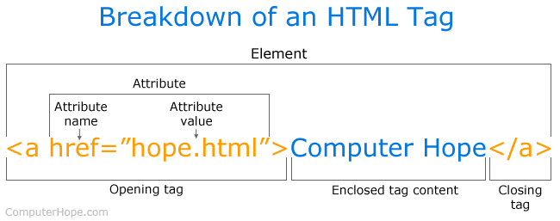
As can be seen in the HTML tag example above, there are not many components. Most HTML tags have an opening tag containing the tag name, tag attributes, a closing tag containing a forward slash, and the tag name being closed. For tags that do not have a closing tag like <img>, it is best practice to end the tag with a forward slash.
Each tag is contained within a less than and greater than angle brackets, and everything between the opening and closing tag is displayed or affected by the tag. In the example above, the <a> tag is creating a link called "Computer Hope" that is pointing to the hope.html file.
I will use the code snippet below to demonstrate how some of the technologies used work. In the desktop application, this snipped is shown by a dialogue that lets the farmer add a new animal to the system.

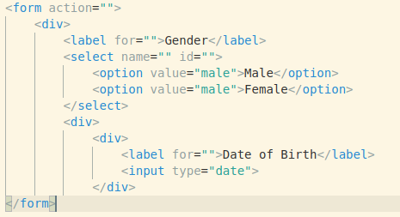
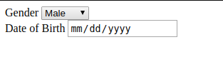

The image above shows a code snippet of a HTML form (left) and its output (right).
To create a html form, you use the <form></form> html tag, some of the <form> attributes include action and method. Within the content area of the tag, we add the fields of the form. Our form has only two fields - Gender and Date of Birth. HTML form fields can be any of the following, input, textarea, select field, ect. The select field is used to choose between multiple choices, the textarea is used to write a large body of text, and the input field has an attribute type which lets you specify the type of the input you are expecting, some of the input field type recognized by HTML5 include date, number, email, password, text, etc. In our case we needed a select field for the farmer to choose between ‘Male’ and ‘Female’ as the gender of the farm animal, we also used an input field of type ‘date’ for the farmer to input the date of birth of the farm animals. The <label></label> tag is used to display the title of the HTML fields.
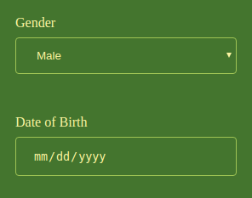
One can see a great difference in the look of our form above and the complete application, this is because we used only HTML for the form above. HTML capability are very limited in terms of design, as an alternative we use CSS (Cascading Style Sheets). Cascading Style Sheets is a style sheet language used for describing the presentation of a document written in a markup language like HTML. CSS can be added to HTML elements in three ways, inline - by using the style attribute in HTML elements, internal - by using the <style> element in the <head> section of the HTML document or external - by using an external CSS file. For our demo we will use the internal method to show a little of the power of CSS.
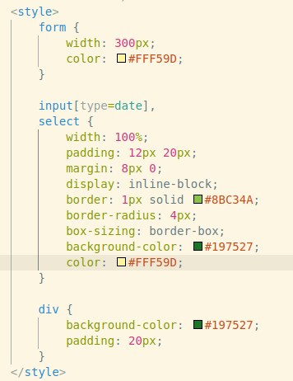

The image shows an internal CSS code on the left and the output of our HTML form on the right. The render engine was able to modify the default display of the HTML form using the CSS rule set. The CSS rule set consists of a selector and its declarations. The selector is an HTML tag at which a style will be applied. This could be any tag like <h1> or <table> etc. The declarations is a set of properties and values to be applied to the HTML tag.
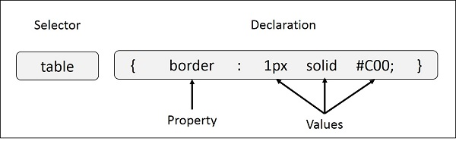
In the image above, table is a selector and border is a property and given value 1px solid #C00 is the value of that property. You can define selectors in various simple ways based on your comfort.
With just HTML and CSS, we can’t get the seamless experience of a native desktop application. A fix will be to use JavaScript - a programming language for HTML and the web. With plane JavaScript we can be able to get something close to the experience of a native desktop application using techniques like Ajax. To build an application like this with several parts/components, we will want each to this components to be reactive to each other, this can be handled by us using JavaScript, but it can also easily get bulky, messy and difficult to maintain, luckily there are a couple of JavaScript frameworks out there which fix this problem so there was no need to reinvent the wheel. Our JavaScript framework of choice was Vue.js by Evan You. Vue.js is an open source Model-view-viewmodel JavaScript framework for building user interfaces and single page applications, Vue.js offer features such as components, templates, reactivity, transition and routing. Vue.js lets you extend HTML and HTML attributes called directives, these directives offer functionalities to HTML applications. Vue.js provides built in directive and permits user-defined directives.
To demonstrate the reactivity of Vue.js, I will modify our form a little bit to show different message depending on gender for the farm animal selected.
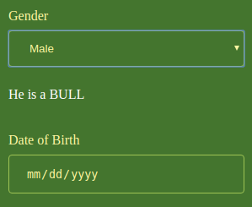
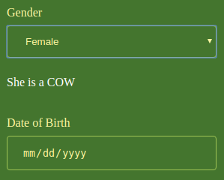
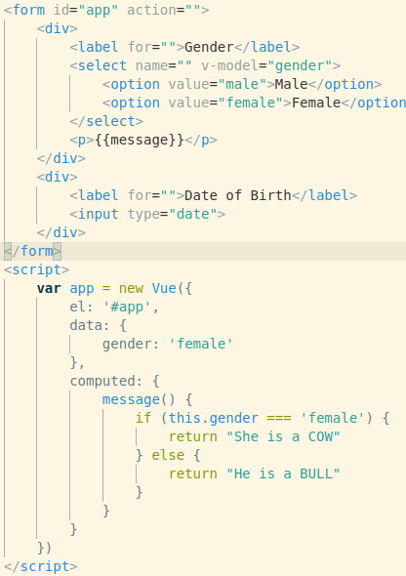
From the figure above we seed that the message below the gender field changes dynamically when the value of the gender field changes. This level of reactivity was achieved using a Vue.js concept known as “Data Binding”. Data binding in Vue.js can be unidirectional or bi-directional, unidirectional data binding can be achieved using the v-bind directive while the bi-directional data binding can be achieved using v-model directive. In the demo above, we see that the gender attribute of the Vue instance is bound to the gender input field of the HTML form, a change in either of them - the input field or the gender attribute, will be reflected on the other. To show this reactivity, we displayed the value of computed attribute message which is reactive to any change to the value of gender.
Vue.js on its own doesn’t provide actual UI elements, or components, or consistent designs we can use. Another Framework which was very useful in the development of the application is Quasar. Quasar is a high performance, Material Design 2, full front-end stack for Vue.js. It comes with simple-to-use but powerful UI kit that supplements Vue.js to provide a full-featured toolset for building responsive front-end apps without having to delve too deep into the scaffolding and configuration. It comes with a lot of UI components, and layout elements and helpers.
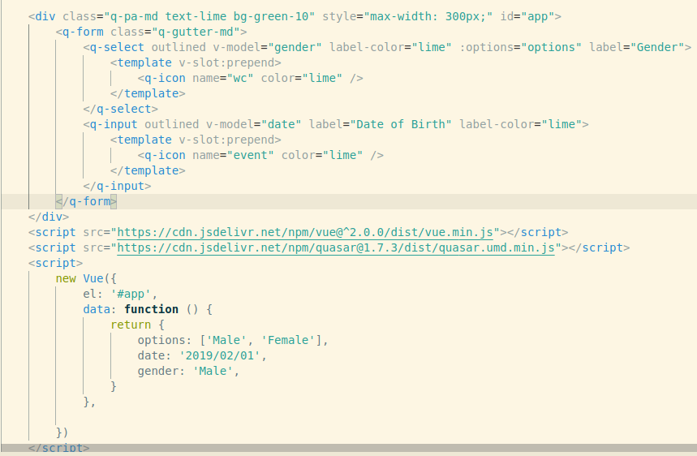
To demonstrate how Quasar works, I will replace most of the HTML tags in our forms with Quasar’s Vue components.
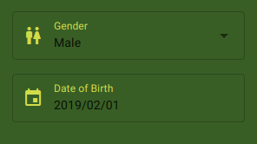
From the code snipped above you can see that i have replaced the HTML <form></form> tag with Quasar’s <q-form></q-form> component tag. <q-form></q-form> is provided by Quasar QForm Component, The QForm component renders a <form> DOM element and allows you to easily validate child form components (like QInput, QSelect or your QField wrapped components) that have the internal validation (NOT the external one) through rules associated with them.<select></select> was replaced with <q-select></q-select> which is provided by QSelect. The QSelect component has two types of selection: single or multiple. This component opens up a menu for the selection list and action. A filter can also be used for longer lists. I also replaced <input/> HTML tag with <q-input></q-input> which is provided by QInput component. The QInput component is used to capture text input from the user. It uses v-model, similar to a regular input. It has support for errors and validation, and comes in a variety of styles, colors, and types [QInput]. In case you didn’t notice there is a change in the styling, I removed my custom CSS style and leveraged the UI property that comes with Quasar.
2.2 Review of Related Literature
Glaubos. C (2012) designed a web system for farming management that implements a conceptual framework for modeling the production system at a farm scale. The web system supports the design of the production system, which is logically split in three parts: the decision support sub-system the technical sub-system, and the bio-physical sub-system. Additionally, they design the web system using interdisciplinary research project management (IRPM) concepts, with an architecture known as Model-View-Controller (MVC), that is, it was developed applying the MVC Evolutionary Acquisition IRPM.
Christoph. H (2014) developed a “Farm Management Information System” using German multifunctional farm as a case study. He aimed at the deduction of a concrete FMIS from a general FMIS. His research focus on the needs of medium-sized and multifunctional farms .This means that the farmer has to be empowered to allocate the scarce resources of the farm. The case study farm helps to identify and to analyze relevant material and information flows, production processes, and their interconnections and synergies.
Alexandros Kaloxylos (2012) conducted a research on famer management system in the era of internet. He was able to describe a FMS functional architecture that utilizes advanced Future Internet characteristics. Its main characteristics include apart from the support of the typical farming procedures, the seamless support and integration of different stakeholders and services, interworking with the networked infrastructures and the introduction of autonomic and cognitive elements in the overall management process. This architecture was the result of an extensive analysis of a significant number of use cases by researchers from diverse fields of expertise. With this work they attempt to enable a farmer to step into a new reality, where he becomes an actual ‘‘node in an agricultural worldwide web’’. Optimized methods for managing all tasks inside a farm as well as pioneered Future Internet services for entering the global markets are also provided. Easy access to information and advices, convenient communication among all stakeholders along the food chain, efficient combination.
Terry Griffin (2017) carried out a case study on Farm Experiments and Farm Management Decision Making to better understand farmers’ use of on-farm trials and how localized on-farm data influences their decision making process. Case studies were chosen to evaluate the behavior, perceptions, and opinions of farmers because 1) surveys would have very small sample size, 2) the research investigators already were working very closely with the case study subjects, and 3) lack of general background information on the research topic. Case study methodology provides in-depth information suitable to apply local information to the general theory answering “how” and “why” questions.
Sonam1, O.P (2014) developed an integrated application for farm management which works, on first building decision tree for recommendation of agricultural solutions that a research student (user) is looking for, and the recommended solution include application of some fertilizer, pesticide etc. For further allotment of inventory, which is required in order to complete any task on the research farm, the user can browse and open the requesting module for requisition of resources required on research farm. Inventory related to farming such as various machines, fertilizers, chemicals is maintained and all task involved can be e-mailed as report by the student to the irrespective advisor. Advisors can post the daily tasks list for each supervised student and the current status of that job will be visible to the advisor, helping to maintain better communication channel and easy record maintenance. Finally the system was evaluated against the ground truth, and we found the recall and precision values for our system.
Lazzari and Mazzetto (1996) introduced a model called Computed Farm Machinery System (ComFARMS). It was developed to analyze mechanization problems of Italian arable farms (<250 ha) from strategic and management standpoints. It mainly focused on the strategic approach to select farm machinery for multicropping. Once a given crop rotation pattern and a list of operations per crop are put in, the selection offers the user a machinery set (tractors and implements) where each machine is defined in terms of type, number and size. It is being incorporated in a more general decision support system to improve its use by farmers and advisors at farm level as well.

CHAPTER THREE
SYSTEM ANALYSIS AND DESIGN
Overview
The System Development Life Cycle, "SDLC" for short, is a multistep, iterative process, structured in a methodical way. This process is used to model or provide a framework for technical and non-technical activities to deliver a quality system which meets or exceeds a business’s expectations or manage decision-making progression.
Traditionally, the systems-development life cycle consisted of five stages. That has now increased to seven phases. Increasing the number of steps helped systems analysts to define clearer actions to achieve specific goals.
Similar to a project life cycle (PLC), the SDLC uses a systems approach to describe a process. It is often used and followed when there is an IT or IS project under development.
The SDLC highlights different stages (phrases or steps) of the development process. The life cycle approach is used so users can see and understand what activities are involved within a given step. It is also used to let them know that at any time, steps can be repeated or a previous step can be reworked when needing to modify or improve the system.
There are seven phases in software development life cycle:
i. Planning
ii. Define Requirements
iii. Design and prototyping
iv. Software development
v. Testing
vi. Deployment
vii. Operation and maintenance
There are different SDLC models in the industry, each of them offering their own approaches to the development process. No matter which model you choose, phases of SDLC will remain the same. The most common methodologies are agile methodology and waterfall model.
Agile software development refers to software development methodologies centered round the idea of iterative development, where requirements and solutions evolve through collaboration between self-organizing cross-functional teams. The ultimate value in agile development is that it enables teams to deliver value faster, with greater quality and predictability, and greater aptitude to respond to change. Scrum and Kanban are two of the most widely used agile methodologies.
Waterfall approach was first SDLC Model to be used widely in Software Engineering to ensure success of the project. In "The Waterfall" approach, the whole process of software development is divided into separate phases. In this Waterfall model, typically, the outcome of one phase acts as the input for the next phase sequentially.

Illustration is a representation of the different phases of the Waterfall Model.
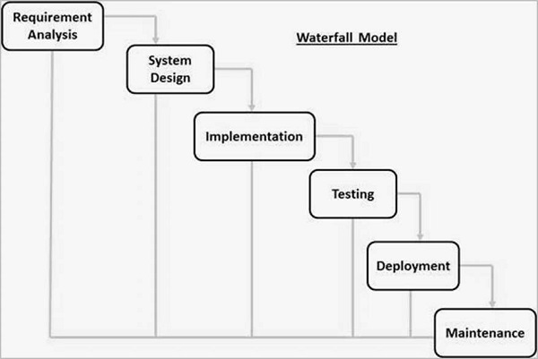
Figure 3.1: Phases of the waterfall model.
Structured System Analysis and Design Methodology (SSADM) is a waterfall method by which an Information System design can be arrived at. SSADM methodology was used during the analysis and design of this system.
The three most important techniques that are used in SSADM are as follows:
Logical data modeling: The process of identifying, modeling and documenting the data requirements of the system being designed. The result is a data model containing entities (things about which a business needs to record information), attributes (facts about the entities) and relationships (associations between the entities).
Data Flow Modeling: The process of identifying, modeling and documenting how data moves around an information system. Data Flow Modeling examines processes (activities that transform data from one form to another), data stores (the holding areas for data), external entities (what sends data into a system or receives data from a system), and data flows (routes by which data can flow).
Entity Event Modeling: A two-stranded process; Entity Behavior Modeling, identifying, modeling and documenting the events that affect each entity and the sequence (or life history) in which these events occur, and Event Modeling, designing for each event the process to coordinate entity life histories.
3.1 Description of existing system
An average commercial farmer in Nigeria does not record of their livestock, those that manage to do, do it manually. Obviously, farmers are faced with constraints which cause their inability to keep farm records. The lack of keeping farm records is more pronounced due to the high levels of illiteracy and low numeracy levels in most low resource African farming communities. Another constraint faced by farmers is that, most of them engage in several enterprises and mixed farming systems, and thus farm record keeping requires much of their time. They are therefore faced with time constraints which hinder them from keeping farm records. That the subsistence nature of farming does not produce any incentive for keeping the farm records. Farmers therefore cannot engage separately trained accountants for helping them in farm accounting. The small farmers know that because of the small size of their farm holdings they will not be able to effect economies of scale hence do not show interest in farm record keeping. Lack of sensitization on the importance of farm record keeping on the performance of farm businesses by extension agents or enumerators is a constraint.
3.2 Analysis of Proposed System
3.2.1 Functional Requirement
The farmer should be able to add and remove a new type of livestock to the system.
The farmer should be able to add all the individual animals in the farm to the system.
The farmer should be able to see a report on all his animals like:
- Number of sick animals.
- Number of death animals.
- Number of gestating animals.
- Number of sold animals.
The farmer should be able to view a report on individual animals.
The farmer should be able to change status of animals like:
- From sick to healthy and otherwise
- From living to death
- From gestating to not on gestation
- From available to sold

The functional decomposition of the proposed system.
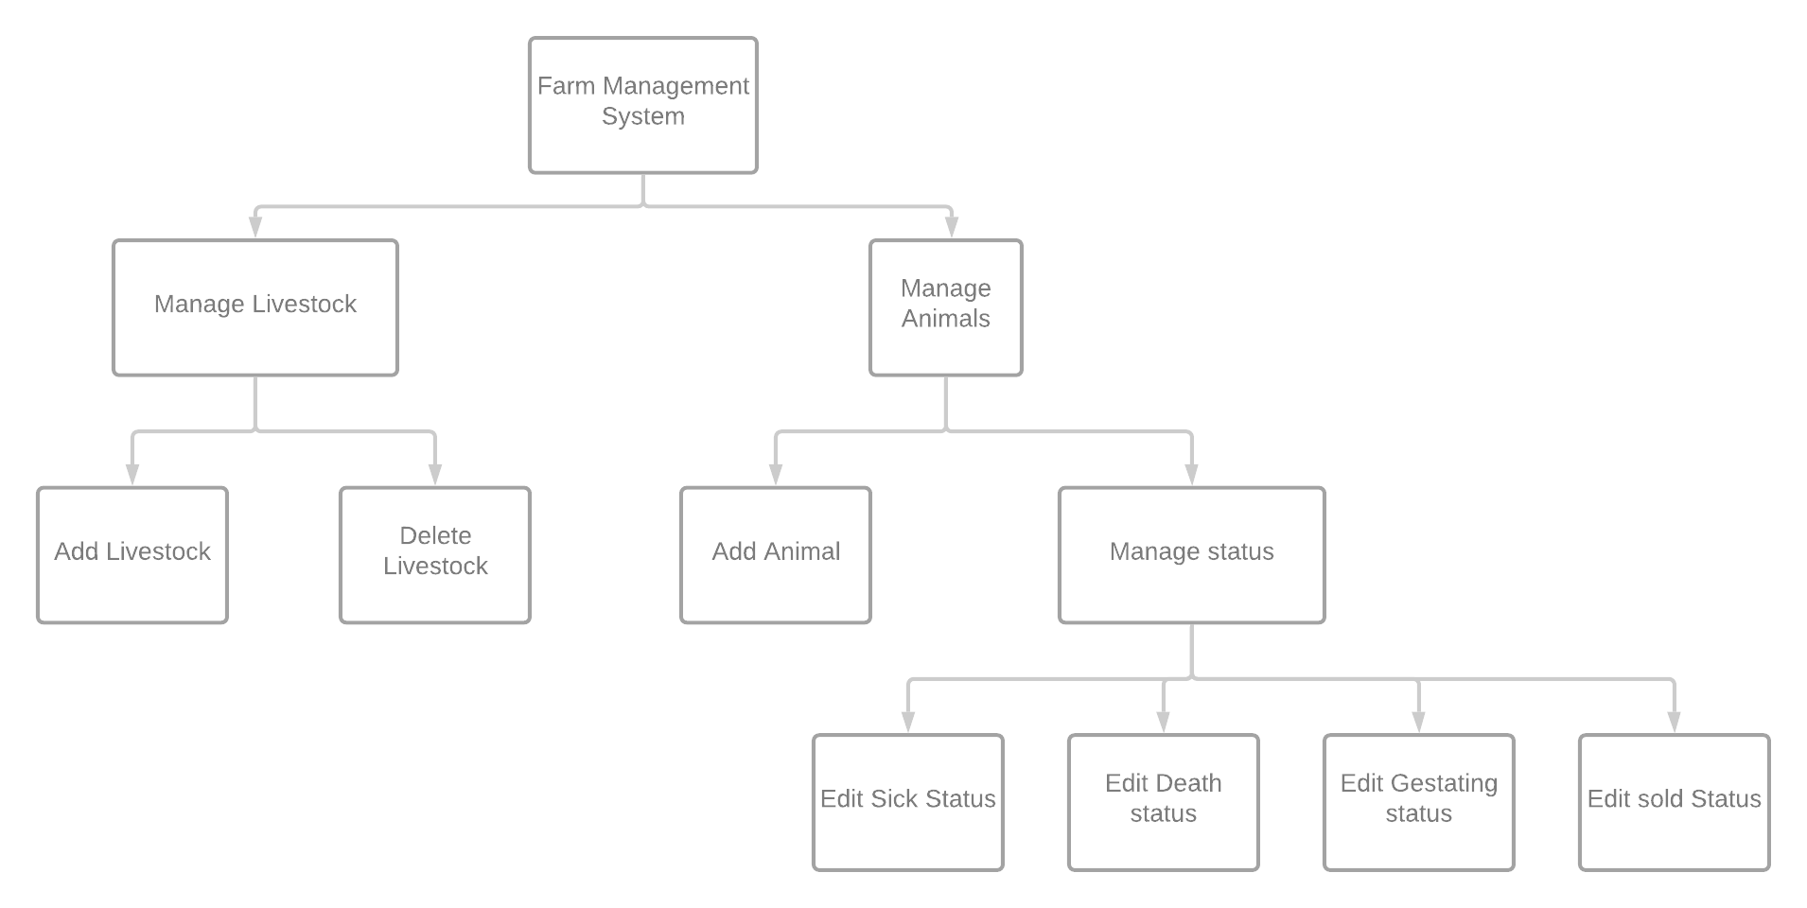

Figure 3.2: Functional decomposition of the farm management system.

3.2.2 Non-functional requirement
Operational:
The system should be a desktop application.
The system should be able to run on a low-end PC.
The system should be easy to use, even to someone not familiar with computers.

3.2.3 Process modeling
A data flow diagramming which is one of the most commonly used process modeling techniques will be used to describe the business process of the proposed system.
A data flow model is diagrammatic representation of the flow and exchange of information within a system. Data flow models are used to graphically represent the flow of data in an information system by describing the processes involved in transferring data from input to file storage and reports generation.
A data flow diagram takes business processes and activities and uses them to create a clear illustration of how data flows through a system. DFDs represent the flow of data from external entities into a single system by moving and storing data from one process to another.

The figure below shows the data flow diagram of the proposed system.
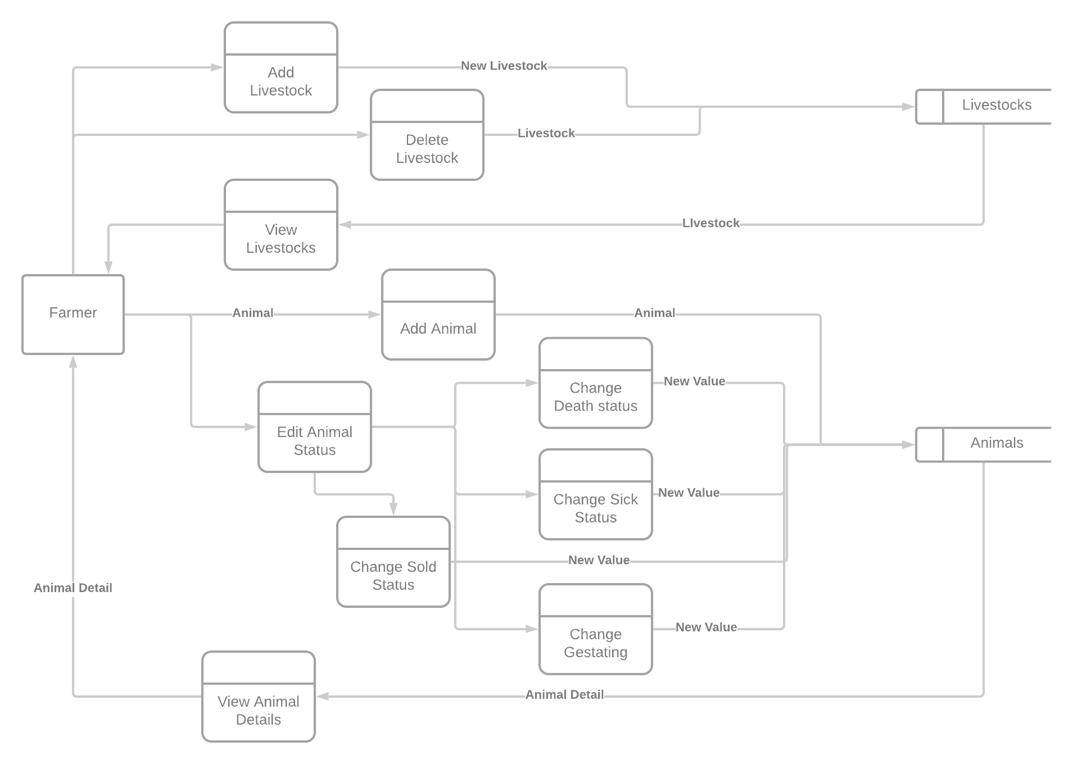
Figure 3.3: data flow diagram of farm management system.
3.2.4 Entity Relationship Model
Entity Relationship Model(ER Modeling) is a graphical approach to database design. It is a high-level data model that defines data elements and their relationship for a specified software system. An ER model is used to represent real-world objects.
An Entity is a thing or object in real world that is distinguishable from surrounding environment. For example, each employee of an organization is a separate entity.
This Figure below Show the entity relationship diagram of the proposed system.

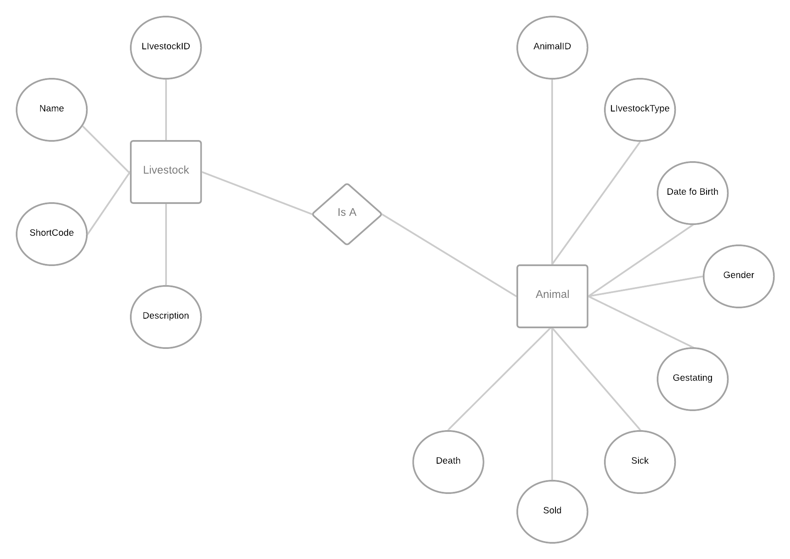
Figure 3.4: Entity relationship diagram of farm management system.

3.3 Design of Proposed System
3.3.1 Database Design
Table 3.1: Livestock Table
Field | Data Type | Size | description | NULL | Action | Extra
LivestockID | Int | 11 | Livestock Identification number | No | PK | AUTO_INCREAMENT
ShortCode | Varchar | 5 | Animal code | No
Description | Text |  | Breed | Yes

Table 3.2: Animal Table
Field | Data Type | Size | Description | NULL | Action | Extra
AnimalID | Int | 11 | Animal identification number | No | PK | AUTO_INCREAMENT
Gender | Varchar | 10 | Animal sex | No
DOB | Datetime |  | Date of birth | Yes
LivestockID | Int | 11 | Livestock identification number | No | FK
Gestating | Varchar | 25 | Pregnant | Yes
Sick | Varchar | 25 | Sick | Yes
Death | Varchar | 25 | Death | Yes
Sold | Varchar | 25 | Sold | Yes

3.3.2 Input Design
Input design is the process of converting a user oriented description of the outputs to a computer-based business system into a programmer-oriented specification. Figure 3.5 and 3.6 shows some of the input screens of the proposed system.

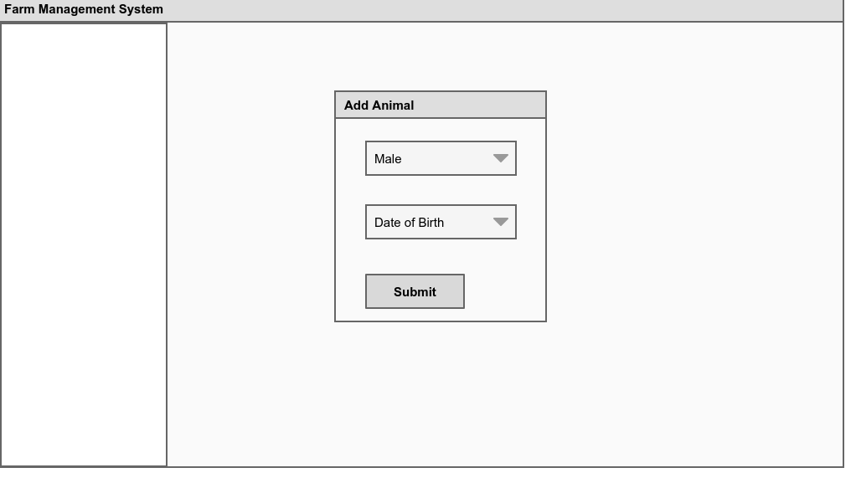
Figure 3.5: “Add Animal” input screen.

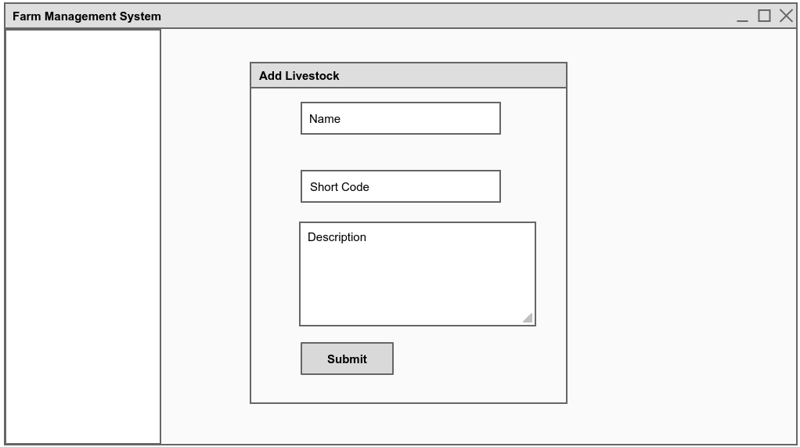
Figure 3.6: “Add Livestock” input screen
3.3.3 Output design
During output design the developer is expected the types of outputs needed and consider the necessary controls and prototype report layouts.

Figures below shows some of the output screens of the proposed system.
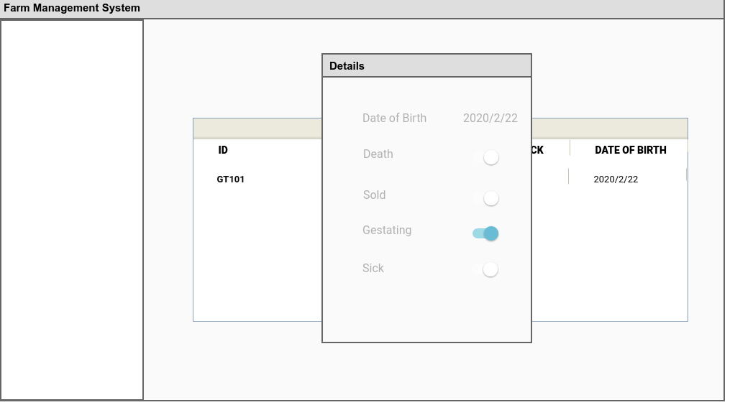
Figure 3.7: “Animal detail” output screen.
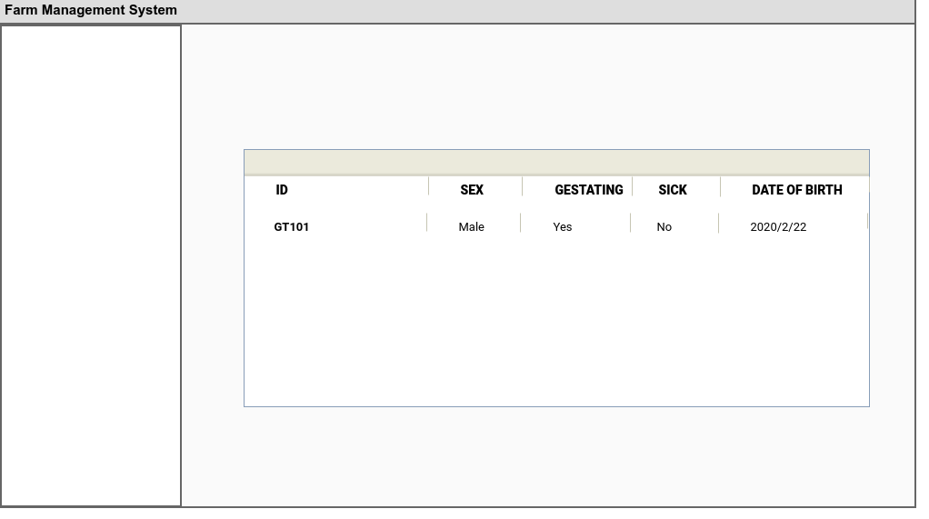
Figure 3.8: “Animal list” output screen.

CHAPTER FOUR
SYSTEM IMPLEMENTATION
Overview
In this chapter I discuss the implementation of the system, development stack and how to use the system. I also talk about the testing methodology i used during development of the system.
  - Implementation Technologies
This system was developed on a window 8.1 operating system using visual studio code Integrated Development Environment (IDE) and the window command prompt terminal.
4.1.1 Operating System - This system and its architecture can be implemented on macOS or Linux; my reasons for using windows for the development include my familiarity with the operating system; ease of use; market share and community support; and most importantly because it was the operating I was already using before I started development of this project. The code for this project can be successfully compiled on a Mac or Linux system with need for modification.
4.1.2 Integrated Development Environment (IDE) - my IDE of choice is Microsoft’s visual studio code editor. I had a large pool of IDEs to choose from; my reasons for choosing visual studio code editor other than it being the already installed IDE on my system was it nice and friendly user interface; it is very lightweight; it’s easy of use; code linting; and it is very extensible. Because of the ease of extension of visual studio code, there are already existing extensions of linting and debugging my HTML, CSS, JavaScript and Vuejs Code.

4.1.3 Choice of programming language
I used web technologies - HTML and CSS - and JavaScript programming language for the development of the system. The web is growing very fast and getting lots of attention in terms of user interface. Creating of user interface with HTML and CSS is faster, easier and prettier than other options so I took advantage of “Electron” - a web framework for developing desktop app using web technologies. Electron is a cross platform desktop application development framework that gives developers access to some of the native features of the operating system like camera, battery, and so on. Electron wraps the developer coder using web technologies with a chromium web engine which renders the code.
4.2 Software testing
During development, I carried out unit testing, component testing and general system testing.
Unit testing - during development I was able to test individual units of my code using the debugger that come with visual studio code and visual studio code extension called veutr.
Component testing - I was able to test components and modules of the system using the IDE debug console and my laptop.
System tests - during and after development, I made sure to test the system as a whole to make sure all the modules integrated successfully and worked as expected.

Screenshot
Figure 4.1, 4.2, 4.3, 4.4 and 4.5 shows some of the screenshot of the livestock management system
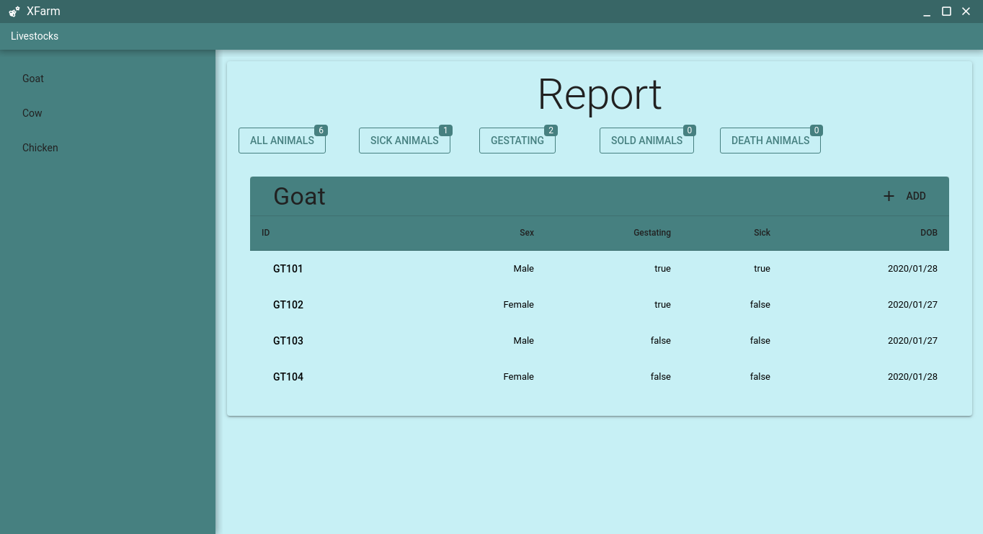
Figure 4.1: Animal List Screenshot

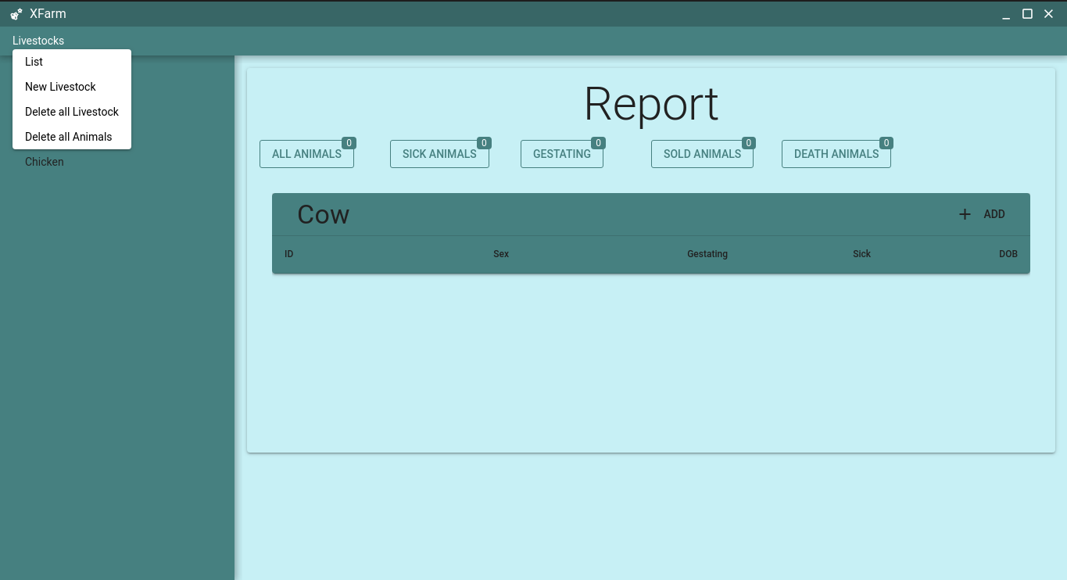
Figure 4.2: Menu items screenshot.

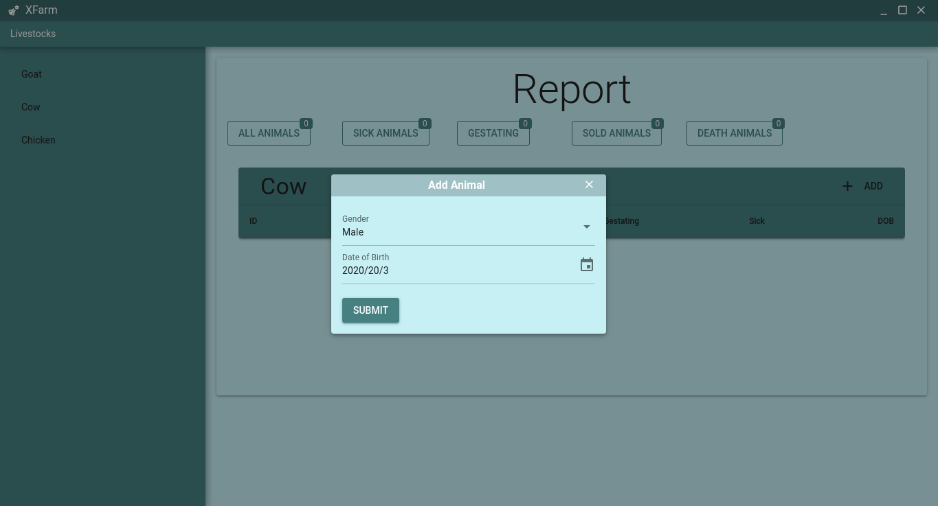
Figure 4.3: Add Animal Dialogue screenshot.

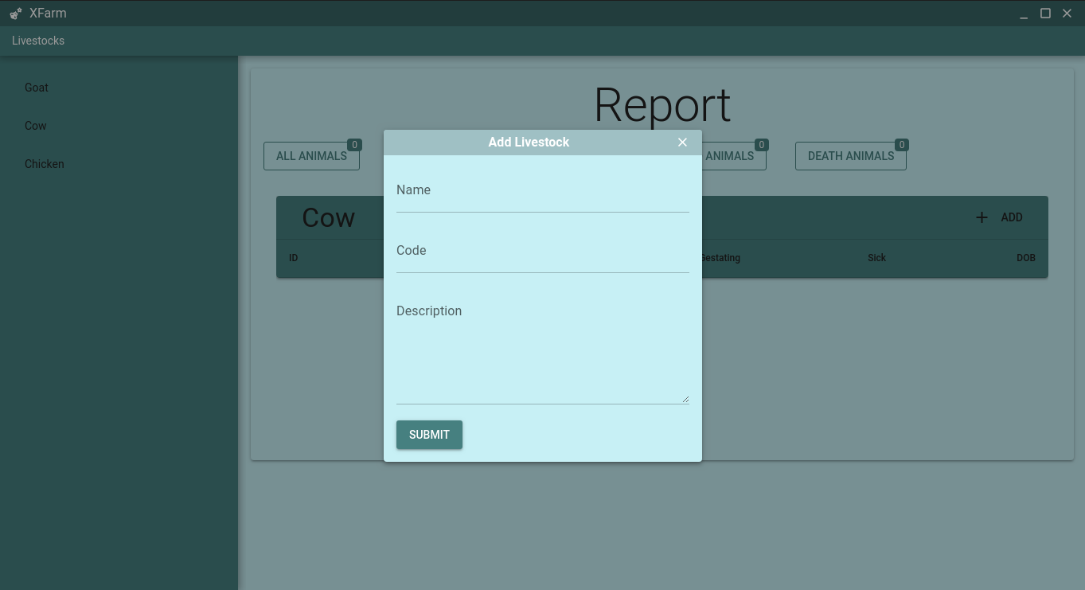
Figure 4.4: Add Livestock Dialogue screenshot.
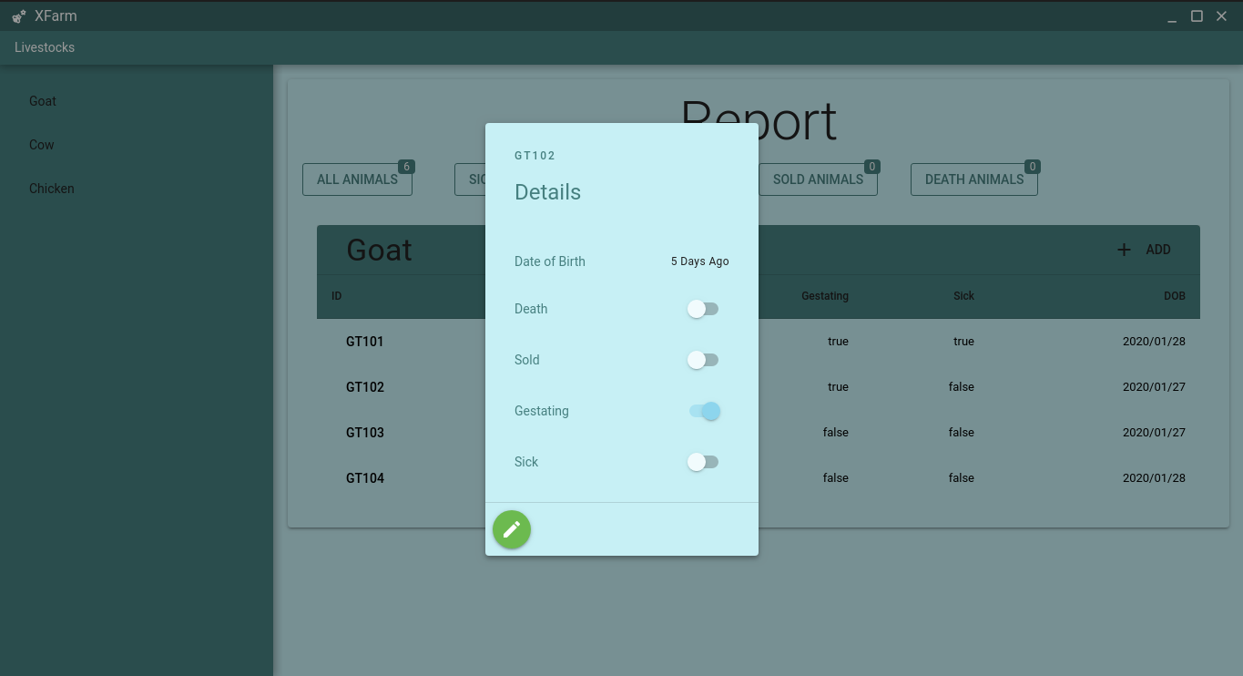
Figure 4.5: Animal Detail dialogue screenshot.

4.3 Documentation
The software is a desktop application that has been designed to help commercial livestock farmers to manage and keep record of some of their farming activities. With this application, livestock farmers can keep record of data like, birth date of livestock, number of livestock in the farm, sick animals, death count and pregnant animals. Usage of the system requires no form of authentication and the system is not connected to an online database.
4.3.1 User Manual
4.3.1.1 Adding livestock
To add a new livestock to the system, the steps below should be followed.
- Click on “Livestock” menu item
- Click on “New Livestock”
- A dialog will show for you to enter detail of the new livestock
- Click on “submit” after entering lives details
4.3.1.2 Adding Animal
To add a new animal to the system, follow the steps outlined below.
- Select the type of animal you wish to add to the system at the left navigation bar.
- On the top of the animal list table, you will find a button named “+ Add”.
- Click on “+ Add” button
- A dialog will show for you to enter the details of the animal.
- Click on “Submit” to save the details entered.
4.3.1.3 Viewing/Editing animal record
To view/edit animal details, follow the steps outlined below
- Select the type of the animal from the left navigation bar.
- A table showing all the animals of the selected type will display, Click on the animal you wish to view or edit its detail.
- A dialog will show with animal details.
- To start edit an animal detail, click on the pencil icon to enable edit mode.
- Toggle the animal status as need.
- You can click on the pencil icon again leave edit mode.
4.3.2 Source Code Listing
- Animals List Page (Appendix A)
- Application store getter (Appendix B)
- Application Layout (Appendix C)

CHAPTER FIVE
SUMMARY AND CONCLUSION
5.1 Summary
Livestock management refers to the activities carried out by a farmer in his effort to raise farm animals from day old to the point of marketing or disposing the animals. It involves the provision and maintenance of adequate housing, good feeding, sanitation and Medicare.
Most Livestock farmers still keep a mental record of their livestock; some use exercise books while some don’t at all.
Record keeping is very important in livestock management as it helps the livestock farmer make better decision leading to better yield and growth of the farm.
The aim of the study is to develop a livestock management system that will enable livestock farmer to keep track sales, death, and sick animals.
5.2 Conclusion
This system is developed to assist farmers in managing their livestock and improving productivity. The development of the livestock management system is aimed as a simpler, user-friendly system for the farmers to be able to manage their livestock for productivity and monitoring purposes, however, there are many improvements and enhancements that can be made in order to improve the livestock management system as a whole for future work.

5.3 Recommendation
- Agriculture is a major source of income for the Nigeria economy; computer scientist should put more effort in computerizing the sector as much as they do other sectors of the economy.
- Whether entrepreneurial or research purpose, I strongly recommend that researchers and fellow computer scientist consider this topic and the Agricultural sector as a whole as an area of interest.
- User interface could be designed to become more user-friendly especially for new users to the system.
- New functionalities should be added to add variety to the system.
- System should be improved to accommodate more users.

REFERENCES
Climaco, G. and Chagas, F, (2012) “A Web System for Farming Management,” DOI no: 10.7763/JOEBM.2013.V1.36.
Electron. Agric., vol. 89, pp. 130–144, 2012, doi: 10.1016/j.compag.2012.09.002.
Griffin, T, Dobbins, C. and Lowenberg-deboer, J. (2012) “Selected Paper prepared for Presentation at the American Agricultural Economics Association Annual Meeting, Portland, Oregon”.
http://vikaspedia.in/agriculture/livestock/cattle-buffalo/importance-of-record-keeping-at-livestock-farm Importance of record keeping at livestock farm,
https://www.computerhope.com/jargon/h/html.htm, HTML, 11/13/2018
Husemann, C. and Novković N., (2014) “Farm Management Information Systems : A Case Study,” Vol. 2, No. 8, pp. 441–453.
Kaloxylos, (2017) “Farm management systems and the Future Internet era,” Computer.
Lazzari, M. and Mazzetto, F. (1996) A PC model for selecting multicropping farm machinery systems. Computer and Electronics in Agriculture 14(1): 43-59.
Sonam, O.P Gupta, and Sawhney, B.K. (2014) Development of Software for Research Farm Management System Available online https://ijarcce.com/wp- content/uploads/2012/03/IJARCCE3G__s_sonam_Development.pdf

APPENDICES
Appendix A: Animals List Page
<template>
<! -- 6A645A E3C28D 5D7052 C18845 -->
<q-page>
<div class="q-pa-md items-start">
<q-card class="my-card bg-secondary">
<q-card-section>
<div class="text-h2 text-center">Report</div>
</q-card-section>
<q-card-section>
<div class="row">
<div class="col-2">
<q-btn
outline
text-color="primary"
label="All Animals"
size="md"
@click="filter='all'"
>
<q-badge
color="primary"
floating
>{{animalsCount(livestockID)}}</q-badge>
</q-btn>
</div>
<div class="col-2">
<q-btn
outline
text-color="primary"
label="Sick Animals"
size="md"
@click="filter='sick'"
>
<q-badge
Color="primary"
floating
>{{sickCount(livestockID)}}</q-badge>
</q-btn>
</div>
<div class="col-2">
<q-btn
outline
text-color="primary"
label="Gestating"
size="md"
@click="filter='gestating'"
>
<q-badge
color="primary"
floating
>{{gestationCount(livestockID)}}</q-badge>
</q-btn>
</div>
<div class="col-2">
<q-btn
outline
text-color="primary"
label="Sold Animals"
size="md"
@click="filter='sold'"
>
<q-badge
color="primary"
floating
>{{soldCount(livestockID)}}</q-badge>
</q-btn>
</div>
<div class="col-3">
<q-btn
outline
text-color="primary"
label="Death Animals"
size="md"
@click="filter='death'"
>
<q-badge
color="primary"
floating
>{{deathCount(livestockID)}}</q-badge>
</q-btn>
</div>
</div>
</q-card-section>
<q-card-section>
<list-animals :filter="filter" />
</q-card-section>
</q-card>
</div>
</q-page>
</template>

<style lang="sass">

</style>

<script>
import { mapGetters } from 'vuex'
export default {
name: 'PageAnimal',
data () {
return {
filter: 'all'
}
},
computed: {
...mapGetters('farmAnimals', ['animalsCount', 'sickCount', 'deathCount', 'gestationCount', 'soldCount']),
livestockID () {
return this.$route.params.id
}
}

}
</script>

Appendix B: Application store Getter Source Code
export function livestockName (state) {
return (code) => state.livestocks.find(livestock => livestock.code === code).name
}

export function getAnimals (state) {
return (param) => {
if (param.filter === 'sick') {
return state.animals.filter(animal => animal.type === param.livestockID && animal.sick === true && animal.death === false && animal.sold === false)
} else if (param.filter === 'gestating') {
return state.animals.filter(animal => animal.type === param.livestockID && animal.gestating === true && animal.death === false && animal.sold === false)
} else if (param.filter === 'sold') {
return state.animals.filter(animal => animal.type === param.livestockID && animal.sold === true)
} else if (param.filter === 'death') {
return state.animals.filter(animal => animal.type === param.livestockID && animal.death === true)
} else {
return state.animals.filter(animal => animal.type === param.livestockID && animal.death === false && animal.sold === false)
}
}
}

export function getAnimal (state) {
return (livestockID, animalID) => state.animals.find(animal => animal.type === livestockID && animal.id === animalID)
}

export function nextAnimalID (state) {
return (livestockID) => Math.max(...state.animals.filter(animal => animal.type === livestockID).map(anim => anim.id), 100) + 1
}

export function animalsCount (state) {
return (livestockID) => state.animals.filter(animal => animal.type === livestockID && animal.death === false && animal.sold === false).length
}

export function sickCount (state) {
return (livestockID) => state.animals.filter(animal => animal.type === livestockID && animal.sick === true && animal.death === false && animal.sold === false).length
}

export function gestationCount (state) {
return (livestockID) => state.animals.filter(animal => animal.type === livestockID && animal.gestating === true && animal.death === false && animal.sold === false).length
}

export function deathCount (state) {
return (livestockID) => state.animals.filter(animal => animal.type === livestockID && animal.death === true).length
}

export function soldCount (state) {
return (livestockID) => state.animals.filter(animal => animal.type === livestockID && animal.sold === true).length
}
Appendix C Application Layout
<template>
<q-layout view="hHh LpR lff">

<app-menu />

<q-drawer
show-if-above
v-model="left"
side="left"
behavior="desktop"
elevated
content-class="bg-primary text-accent"
>
<div
class="q-pa-md"
style="max-width: 250px"
>
<q-list
class="text-accent"
v-for="livestock in livestocks"
:key="livestock.code"
>
<q-item
clickable
v-ripple
active-class="my-menu-link"
:to="livestock.code"
>
<q-item-section>{{livestock.name}}</q-item-section>
</q-item>

</q-list>
</div>
</q-drawer>

<q-page-container class="bg-secondary text-accent">
<router-view />
</q-page-container>

</q-layout>
</template>

<script>
import { mapState } from 'vuex'
export default {
data () {
return {
left: false,
selected: null
}
},
computed: {
...mapState('farmAnimals', ['livestocks'])
},
methods: {
navigateClickHandler (node) {
console.log(node)
}
}
}
</script>

