DESIGN AND IMPLEMENTATION OF AN ONLINE CAMPUS OPINION POLL SYSTEM

BY

UDE JAMES CHIGOZIE
GOU/U21/CSC/758

DEPARTMENT OF COMPUTER SCIENCE AND MATHEMATICS, FACULTY OF NATURAL SCIENCE AND ENVIRONMENTAL STUDIES GODFREY OKOYE UNIVERSITY,ENUGU,NIGERIA

SUPERVISED BY: DR OKEBENAMA FRANKLIN

JULY, 2025
ABSTRACT
In modern academic institutions, it is increasingly critical to have inclusive, efficient, and transparent mechanisms in place for capturing student sentiment. This is particularly urgent when it comes to enacting a form of participatory governance that allows students to have a meaningful say in decision-making processes that affect them. For too long, gathering student sentiment has happened via inefficient polling methods (which, for the most part, have existed in the analog realm). When polling does happen (or when some form of opinion-gathering does happen), it is often not conducted with polling methods that are anywhere near up to the standards one would expect for conducting a scientific study. The result has been an often under-informed collection of individuals who make key decisions that affect the student body and the institution as a whole. This project was undertaken to attempt to address these significant shortcomings by creating a system that allows for gathering student opinion securely, confidentially, and in real time. To guarantee resilience, the system underwent numerous levels of assessment unit assessment, integration assessment, user acceptance assessment, and security scrutiny. The results strongly indicated that the system worked very well under real-time conditions that were simulated, gave highly accurate analytics, and was, test participants denoted, as easy to use and as friendly as a chat with a next-door neighbor. Besides those efficiencies on the logistics side, the system lured users in, naturally, via its telltale compatibility with mobile and desktop platforms.In conclusion, the Online Campus Opinion Poll System not only fulfills its objective of facilitating secure and anonymous digital polling, but also contributes to strengthening democratic engagement and institutional responsiveness within the academic community. The project lays a foundation for future enhancements including AI-powered analytics, multilingual support, and blockchain integration, offering a scalable solution for digital governance in educational and other institutional contexts.

CHAPTER ONE
INTRODUCTION
1.1 BACKGROUND OF STUDY
An essential characteristic of a democratic and culturally responsive scholarly community is the freedom granted to students to articulate their views and partake in decision-making processes. As noted by Dahl (1998), participation in decision making is a key tenet of democracy, and it is only right that institutions that have policies impacting people's lives provide means to enable such participation. Sadly, most Nigerian tertiary institutions suffer from poorly designed methods of gathering opinions, using outdated paper-based surveys, town hall meetings, and even verbal consultations. These traditional methods tend to be slow, biased, and deeply flawed, resulting in inadequate student representation in administrative decision-making processes. In addition, studies by Norris (2001) and Verba, Schlozman, & Brady (1995) reported that fear of victimization, social pressure, and lack of anonymity often deter students from expressing themselves candidly, further hindering participation.
With regard to these problems, this project suggests designing and implementing an Online Campus Opinion Poll System which is a nimble-based system where students can register their opinion on various campus issues using a voting system that is secured, accurate, and confidential. Online polling and e-governance as methods for opinion gathering have been highlighted as crucial by Smith & Clark (2018)—they argue that decision making processes based on digital means are swifter, clearer, and incorporate the views of more diverse groups when compared to traditional methods. Students will be able to express their views through voting by the use of this system on various topics as: academic guidelines and policies, student welfare activities, social functions, and administrative changes. By voting in secret and removing logistical obstacles, this platform enables wider participation which improves the quality of decisions made at the university community level.
Moreover, West (2005) has pointed out how technology can improve accuracy in data collection and analysis for opinion polling. University administrators are able to use the system to capture and evaluate student responses for streamlined feedback processes, ensuring they receive precise information and tailored data that reflects the needs and priorities of the students. In the end, the objective of this project is to alleviate the information disparity that exists between students and university officials, enhancing responsive governance in tertiary institutions.
1.2 STATEMENT OF PROBLEM
The lack of efficient systems to capture student input within Nigerian higher education institutions hampers their ability to organize and properly engage. The use of suggestion boxes, open-forum lectures, and surveys is bound to fail as students do not show up in sufficient numbers resulting in a disconnection with their university administrators.
1.2.1 Issues of Concentrated Importance:
- The Exclusion of a Great Many Students: Inaccessibility and scheduling clashes along with lack of awareness are all perennial obstacles to traditional forms of opinion collection.
- Anonymity: The fear of backlash from university officials, fellow students, or social ramifications keeps virtually all students from attempting to voice views on delicate matters.
- Lethargy & Bureaucratic Log Jam: The slow collection feedback ceilings decision making that is delayed and no longer responsive to time urgent student needs.
- Errors & Intentional Sabotage: The polling methods that are framed by hearsay are filled with inaccuracies that stem from the formative elements of framing student concerns and forums where their voices are utterly lost.
- Lack of Trustable Assessment Systems Holistic University Disengagement: Communication between learners and the student bureaucracy is often unproductive due to the absence of reliable feedback mechanisms, leading to apathy and occasionally chaos.
- Lack of Openness and Responsibility: Students lose trust towards the university management due to absence of a properly organized feedback system which allows them to verify whether their opinions are taken into account.
1.3 AIM AND OBJECTIVES OF THE STUDY
Aim:
This study aims to develop an Online Campus Opinion Poll System for the university.
Specific Objectives are to:
1. Develop a web-based opinion polling system that ensures security and anonymity while implementing required features.
2. Enable students to participate in polling from any location.
3. Enable real-time data collection and processing for the polling system.
4. Encourage students to be more open and inclusive in governance.
5. Remove inefficiencies and biases associated with manual polling by improving system automation.
6. Provide the university administration with accurate and reliable data from students’ feedback.
7. Engage more students in campus governance by encouraging them to voice their opinions.
1.4 SIGNIFICANCE OF THE STUDY
The significance of Developing an Online Campus Opinion Poll System lies in its ability to quickly address the inefficiencies of in-person polling in higher education. This research supports students by giving them a safe, anonymous method to express their opinions without fear of being targeted. This guarantees that all students are able to have an equitable ability to shape campus discussions and policies. The project also provides an improvement in decision-making for university administrators. They now have access to real-time, evidence-based snapshots of student sentiment. With dependable data at hand, policies can be formed that genuinely align with student expectations and desires. Administrative workflows gain speed, too. The system accelerates the collection, processing, and analysis of paper-based surveys, translating opinions into action without unnecessary lag. Trust and transparency regarding the decision-making process is also enhanced because the possibility of manipulation, bias, and inconsistencies has been minimized with the use of automated methods. The students are, therefore, able to trust the polling results knowing that their opinions are actually considered during the university policy and program activities. This research also participates in the heightened student engagement by providing a space where participation becomes habitual, thus encouraging students to actively shape campus life.
Besides the obvious benefits for students and school admins, the results also show a flexible and cost-effective model for conducting opinion polling. With the help of technology, universities can drastically reduce the costs associated with traditional paper-based surveys and in-person voting, adopting a more eco-friendly and convenient way of collecting student feedback. To sum up, this research emphsizes the need for a technology-based governance model with inclusivity and shared accountability for the use of advanced systems in the higher education landscape.
1.5 SCOPE OF THE STUDY
This work relates to the implementation and creation of the Online Campus Opinion Poll System for Nigerian tertiary institutions. It also involves detailed examination and improvement of the web and mobile applications to ensure they are properly optimized for all devices. The scope of the work includes system analysis, designing the user interface, coding the various system features, optimizing the system, and implementing strong security measures to ensure user privacy, system security, and information confidentiality. The goal is to enhance responsive governance by providing real-time collection, processing, and analysis of students’ opinions on various issues. In any case, the research does not consider the broader digital interaction scope that includes the institutional management systems as it is focused on the opinion polling features exclusively.
1.6 LIMITATION OF THE STUDY
1. Time Limitations: The deadlines set by the academic calendar prevented the exhaustive polish and validation of all planned functionalities.
2. Single Institute Limitation: This single institute focus reduces the potential of these findings being applied to other educational settings.
3. Information Release Obstacles: The reluctance to disclose necessary data due to privacy and security concerns has significantly limited the data available for important analytic processes.
4. Power and Connectivity Issues: Consistent and intermittent problems like power outages as well as weak and unstable network connections have complicated the rollout and the evaluation phases of the intervention.
5. Insufficient Funds: The limited funds have restricted the purchase of essential materials for the project, thus impeding several operational aspects.
1.7 OPERATIONAL DEFINITION OF TERMS
1. On-line Campus Opinion Poll System: A secure web-based application enabling students to anonymously vote on campus issues eliminates the complex identification processes while preserving their confidentiality.
2. Opinion: An issue, belief, or judgment held as deductive reasoning, closely intertwined with one’s life experiences, emotions, or sentiments, lacks rigorous evidence.
3. Opinion Poll: A standardized questionnaire is used to the assess the attitudes of a defined population using a set defined sample size within set parameters of the sample population.
4. Anonymity: A condition where the individual survey participants remain unnamed and unidentifiable, contributing to a non-threatening atmosphere with respect to privacy, enabling more forthright disclosures.
5. Data Integrity: Ensures the accuracy, completeness, and unaltered state of the information collected and stored by the system from the point of collection until the analysis and storage stages.
6. Time Constraints: The defined period allocated to the design, implementation and assessment of the system within the evaluation phase.
7. Data Collection: The systematic method for gathering information from users through organized and uniform procedures to ensure the dataset can be analyzed methodically to inform institutional policies.
8. Financial Constraints: The purchasing and expenditure limitations pertaining to acquiring software, hardware, or specialized personnel, which may obstruct meeting the intended objectives and scope of the project.
9. Technical Disruptions: Events like power outages, unstable networks, or system crashes which may impact the online polling system’s functionality and assessment.
10. Institutional Policy Barriers: Normative policies which may obstruct the acquisition of vital information or materials and hence, influence the range and implementation of the research.

CHAPTER TWO
LITERATURE REVIEW
2.1 INTRODUCTION TO LITERATURE REVIEW
The development of online polling systems has enabled the collecting of votes, opinions, and other forms of feedback from targeted groups of people. The increase in internet access coupled with other technological advancements has enabled the development and focus of these systems on enhanced security, ease of use, and quick data processing. This chapter provides an overview of the development of online polling systems, explains their main components, and discusses emerging trends such as mobile responsiveness, blockchain security, and machine-learning improvements. In analyzing prior research, such gaps and overlaps have been identified, presenting a gap focus of an advanced online polling system tailored upon these trends.
2.1.1 DESCRIPTION OF ONLINE POLLING SYSTEMS
An online polling platform is a web-based system designed to gather votes or opinions on predefined questions through an interactive interface. Standard features include user authentication, encrypted transmission of votes, and real-time result aggregation. This system is designed for educational institutions, corporate strategic meetings, as well as for civic engagement activities which require the collection of data in a timely, objective, and reliable manner. Other features of these systems include anonymity of the respondents, ease of use, and capability to support high traffic of concurrent users.

2.1.2 1. ONLINE POLLING SYSTEMS: A HISTORICAL OVERVIEW
The genesis of online polling systems traces back to the early 1990s with the introduction of simple HTML forms alongside traditional paper surveys. The advent of broadband internet, coupled with enhanced server infrastructures, allowed for the implementation of animated interfaces, mobile compatibility, and real-time data processing. In more recent years, there has been a heightened focus on security employing sophisticated techniques such as encryption, incorporating blockchain ledgers, and using machine learning algorithms for predictive modeling and more sophisticated voter interaction.
The integration of AI alongside blockchain is set to revolutionize online polling systems as we know it. Various next-gen capabilities such as real-time question optimization, multi-factor context-aware logins, and dynamic interfaces which adapt to environments and situations have been projected. The increased mobile usage, alongside the expanding Internet of Things is set to create seamless voting systems, embedding strategic online polling into government, business, and civic planning.
2.2 REVIEW OF RELATED LITERATURE
This review includes ten important studies that have shaped online polling systems. In this review, I summarize each study and elucidate its key contributions and shortcomings.
1. Smith et al. (2015) – “Development of an Online Polling System for University Elections”
Contribution: Developed an online voting system which was secure and anonymous for a specific user group which was student elections, ensuring privacy and ease of use.
Limitation: The scope of evaluation was restricted to a single university which meant that the findings were less applicable to broader or diverse voting populations.
2. Johnson and Lee (2016) – “A Secure Online Polling Framework for Corporate Decision Making”
Contribution: Developed a polling framework that incorporated encryption and multi-factor authentication for voting security in business settings.
Limitation: Its complicated implementation serves as a deterrent in adoption in business lacking strong IT support.
3. Williams (2017) – “Blockchain-Based Online Polling System for Transparent Voting”
Contribution: Implemented blockchain technology to ensure the integrity of votes and enhance the transparency of the entire process.
Limitation: The study noted that an increasing number of users strained the blockchain, which led to increased latency and decreased responsiveness.
4. Miller and Zhang (2018) "Design and Implementation of a Mobile-Based Polling Application"
Contribution: They developed a streamlined polling app for smartphones that allowed users to cast their votes quickly, which really helped increase turnout numbers.
Limitation: There were some problems with cross-platform compatibility, particularly with older operating systems, which made it tough for all smartphone users to adopt the app.5. Anderson (2018)“Rapid Application Development of an Online Opinion Polling System for Student Bodies”
Contribution: Employed Rapid Application Development to deliver a working online polling system for campus groups in a matter of weeks.
Limitation: The push for speed left several aspects especially the interface and error messages still in rough shape, needing post-launch polish.
6. Kumar et al. (2019)“Cloud-Integrated Online Polling System for Real-Time Feedback”
Contribution: Used cloud back-ends to gather and analyze votes on the fly, allowing results to trickle in while polls were still active.
Limitation: Relying on remote servers raised valid privacy questions and tightened the budget thanks to data storage and bandwidth fees.
7. Oliveira and Silva (2020)“Enhancing Security in Online Voting through Multi-Factor Authentication”
Contribution: Implemented multi-factor authentication to shield online polls from tampering, showing a measurable drop in unauthorized attempts.
Limitation: Introducing second and third verification steps complicated the sign-up journey, which may have alienated users with limited technical comfort.
8. Garcia et al. (2021) – "User Experience and Accessibility in Online Polling Systems"
Contribution: Enhanced user experience by improving navigational pathways and catering access for people with disabilities.
Limitation: This study focused heavily on user interface design; however, there was little consideration given to backend peak utilization issues.
8. Brown and Patel (2021) – "Evaluating the Efficacy of Online Polling Systems in Academic Institutions"
Contribution: An extensive assessment of an array of online polling systems in academic environments, discussing critical metrics of participation and dependability of the systems.
Limitation: The evaluation has a small sample size, which affects how reliable the results are statistically.
9. Li and colleagues (2022) explored how AI can be used in online polling systems to predict results and adjust polling methods on the fly. One downside is that the AI models they worked with were still pretty new and needed more tweaking to improve prediction accuracy and system flexibility.
s2.3 SUMMARY OF REVIEW OF RELATED LITERATURE
The studies we've looked at really highlight how fast online polling systems are changing. They've made big strides in things like security, making it easier for people to use, and processing data in real-time. The earlier research set the groundwork by figuring out the basics, but the newer stuff is diving into making these systems tougher, using tools like encryption, blockchain, and AI. Still, there are some issues we need to tackle, like problems with scalability, complicated user interfaces, and the fact that these systems often can’t be used in a lot of real-world settings. It’s clear that we need to keep pushing for more research and development to create online polling systems that are more adaptable, user-friendly, and secure.
Author(s) Name/Year | Title | Contribution | Limitation | Relatability
Smith et al. (2015) | Development of an Online Polling System for University Elections | Introduced a secure and anonymous system tailored for student elections, emphasizing user privacy. | Tested only in a limited university environment; scalability was not addressed. | Highly relatable; focuses on student elections in academic environments similar to this project’s objectives.
Johnson and Lee (2016) | A Secure Online Polling Framework for Corporate Decision Making | Integrated encryption protocols and multi-factor authentication to secure polling in corporate settings. | The complex configuration may hinder adoption in less technologically advanced organizations. | Moderately relatable; while corporate-focused, its security practices can inform student polling system design.
Williams (2017) | Blockchain-Based Online Polling System for Transparent Voting | Implemented blockchain technology to ensure vote immutability and enhance transparency. | Encountered scalability issues, leading to increased latency with more users. | Conceptually useful for improving transparency but technically advanced for basic university-level polling.
Anderson (2018) | Rapid Application Development of an Online Opinion Polling System for Student Bodies | Employed Rapid Application Development (RAD) to quickly prototype a polling system for academic settings. | The accelerated development cycle resulted in a system that required further refinements in user interface design and error handling. | Very relatable; directly deals with student polling systems and prototyping methodologies.
Kumar et al. (2019) | Cloud-Integrated Online Polling System for Real-Time Feedback | Leveraged cloud computing to enable real-time data processing and enhance responsiveness. | Dependence on cloud infrastructure raised concerns over data privacy and increased operational costs. | Relatable for improving performance and data accessibility in the student polling platform.
Oliveira and Silva (2020) | Enhancing Security in Online Voting through Multi-Factor Authentication | Demonstrated the effectiveness of multi-factor authentication in protecting against unauthorized access. | Additional security layers complicated the user registration process, potentially discouraging less tech-savvy users. | Applicable to login security features in student polls while balancing usability.
Garcia et al. (2021) | User Experience and Accessibility in Online Polling Systems | Focused on improving user experience and accessibility, ensuring smoother navigation for all users. | Did not extensively address backend performance issues during peak usage periods. | Highly relatable; emphasizes user-friendly design, critical for student participation.
Brown and Patel (2021) | Evaluating the Efficacy of Online Polling Systems in Academic Institutions | Provided an in-depth evaluation of user engagement and system reliability in academic environments. | Evaluation was based on a limited sample size, reducing the statistical significance of the findings. | Directly aligned with academic polling; supports performance benchmarking for the current study.
Li et al. (2022) | Integrating AI in Online Polling Systems for Predictive Analysis | Explored the integration of artificial intelligence for predictive analytics and dynamic system adjustments. | The AI models were in preliminary stages and require further refinement to improve prediction accuracy. | Relatable for future upgrades with intelligent data handling and trend prediction.

2.4 Theoretical Framework
This case study uses frameworks from systems theory, participatory communication theory, and information systems success theory. These perspectives help us understand how an online polling system works in a university setting.
Systems Theory (Bertalanffy, 1968): At its core, systems theory suggests that a university, as an organized entity, is like a system made up of many interconnected parts and subsystems all aimed at achieving a shared goal. Here, the online polling system as a subsystem participates in the larger institutional ecosystem by aiding in decision-making, governance, and promoting responsive administration and student participation. Systems theory also emphasizes feedback (student votes and responses) and system integrity (data security and controlled access & permissions) for optimal performance.
Relevance:
The polling platform's structural and functional design is informed by this theory, which ensures congruence with institutional workflows as well as coherence, responsiveness, and efficiency.
- Participatory Communication Theory (Freire, 1970) The focus of this theory lies on the interaction characterized by the inclusion of purposeful dialogue, mutual respect, empowerment, and everyone having equal participation of all. It supports systems that create opportunities for sidelined or less-heard voices to meaningfully participate in the discourse. The theory is applicable in an academic digital ecosystem through the proposed system which allows students to provide feedback regarding campus issues in a secure and anonymous manner.

Relevance:
The polling mechanism exemplifies participatory communication for fostering democratic culture within the campus byproviding a safe space for students to express their views publicly.
3. Information Systems Success Model (DeLone and McLean, 1992). This model has identified six dimensions of an information system’s success: system quality, information quality, service quality, use, user satisfaction, and net benefits. Each of these dimensions applies to the development, testing, and evaluation of the polling system. For example, system quality relates to the ease of use and user interface security; information quality relates to the vote and result computation accuracy; and net benefits are the students’ participation together with separated administrative decision making.
Relevance:
This model provides assessment metrics for system performance evaluation of technical and user satisfaction accuracy, as well as institution-wide impact.
Conclusion of Theoretical Framework
All these theories provide a cohesive and a comprehensive basis for designing and implementing the online polling system. Systems theory focuses on structural integrity; participatory communication theory provides the inclusiveness and purpose; and the IS success model serves for the evaluation and system’s iterative refinement. These perspectives help ensure the system’s functionality and security, as well as its profound and socially meaningful impact within the academic setting.
2.5 CONTRIBUTION TO KNOWLEDGE
This review has identified critical areas where existing online polling systems fall short, particularly regarding scalability, security, and user experience. By synthesizing the contributions and limitations of past research, the current study aims to address these gaps by designing and implementing an enhanced online polling system that:
- Integrates robust security measures without compromising usability.
- Leverages cloud computing for real-time data handling while ensuring data privacy.
- Incorporates adaptive user interfaces to cater to a diverse user base.
- Utilizes artificial intelligence for improved predictive analytics and dynamic system adjustments.
The findings and innovations presented in this study are expected to contribute significantly to the body of knowledge in the field of online polling systems, providing a foundation for future research and development in digital voting and opinion gathering technologies.

CHAPTER 3
SYSTEM ANALYSIS AND DESIGN
3.1 OVERVIEW
In this chapter, the detailed evaluation of the Online Campus Opinion Poll System is provided. It focuses on reviewing the current systems utilized for opinion polling, discussing their shortcomings, and framing an all-encompassing solution with the proposed system. This chapter also covers system_analysis, system requirements, the methodology, and system design. Detailed explanations of the system structure and capabilities will be presented through diagrams, including Use Case, Class, Activity, and Sequence Diagrams. This is aimed at achieving the most user-centric and internal functioning transitions of the system.
3.2 SYSTEM ANALYSIS
3.2.1 ANALYSIS OF EXISTING SYSTEMS
Existing campus polling systems are dated and lack efficiency. The majority of universities and colleges still resort to manually distributing survey forms and collecting responses verbally during meetings or events. While these strategies may have been beneficial in the olden days, the following make them impractical for mass-scale opinion surveying:
1. Resource heavy: The compilation, distribution, and collection of responses for opinion surveys using physical forms is extremely time intensive and can drag on for days or even weeks, subsequently stalling crucial decision-making processes.
2. Limited Reach: Physical attendance is often necessary for participants. Therefore, such participants are often overlooked in polls and surveys.
3. Results are never accurate. Mistakes by people while entering and analyzing data leads to discrepancies in the final output making the poll less useful.
4. Lack Redeemable Features: The ability to give insight into the breakdown and analyze in detail provides in the moment is lost in traditional methods.
5. Lack of Confidentiality: Traditional polls usually do not guarantee confidentiality which can impact the honesty of responses. The data can also be very easily altered and lost.
3.2.2 WEAKNESSES OF EXISTING SYSTEMS
As highlighted before, there are several issues that existing systems face, making them unfit for the current academic setting. The issues are:
1. Absence of automation: Existing systems do not support automated casting of votes by participants and do not support automatic calculations of the results.
2. Delayed Results: The time it takes to compute and assemble data to release results is increased since the votes are calculated manually.
3. Limited User Base: Participation of the user base is mostly restricted to people on campus, especially during the time when the polls are active. This greatly reduces the credibility of the results.
4. Inefficient Data Processing: The hands-on technique frequently leads to displacement of polling forms and incorrect data management.
5. Insecure Voting Process: Traditional methods do not guarantee voter anonymity, which can lead to biased or dishonest responses.
6. High Costs: Physical polling methods often require resources like paper, printing, and administrative work, which increase the overall costs.
3.2.3 ANALYSIS OF THE PROPOSED SYSTEM
In response to the problems outlined earlier, the Online Campus Opinion Poll System is proposed to more efficiently manage opinion polling in an academic environment. The system is a fully-automated web application that streamlines the entire polling workflow including poll setup, voting, and result tallying.
Outline of the Proposed System:
1. User Authentication: The system can be accessed by Students and Admin users, each with their respective accounts. Access control is implemented, in which the system authenticates the users based on their roles.
2. Poll Creation: Admin users have the ability to add New Poll with its respective options, set activation date, expiration, and activation status.
3. Voting System: Students that have registered to the system are allowed to vote in all polls that are active. Students are prevented from casting more than one vote per poll. The system has the capability to perform real-time vote tracking.
4. Result Compilation: At the conclusion of each poll voting period, the system tabulates all votes cast and generates reports with tabulated results. It visually presents the results in form of graphical charts along with data breakdowns in an easy to interpret manner.
5. User Roles: In the system there are two primary user roles to which all users of the system shall be assigned. Students and Admin. Admin users are tasked with the creation of Polls that the students are to vote on.
6. Protect Tampering: Voting Within Requires Level Permissions: A vote's confidentiality ensures it is impossible to manipulate the vote in any way.
7. View Polls: A vote's confidentiality prevents tampering in any way ensuring its anonymity. Polls refresh and display the most updated results dynamically to the students and administrators.
3.2.4 SYSTEM REQUIREMENTS
3.2.4.1 FUNCTIONAL REQUIREMENTS
Relative to the system's functions specifics, objectives are set to sir variety of actions the system is capable of supporting. The system functionalities are as follows:
1. Users Manual Registration: registrar is the only one capable of creating new user manual when it is necessary. Log in with valid credentials is the only way to access the system. Based on the students and administrators roles, different access levels are allowed.
2. Active Users: A user with access to the registrar system can create, edit and delete users with polls.
3. Voting: Voting option should enable students to pick and submit one option. According to the system's rules, one vote per student per poll is to be enforced.
4. Results Description: The visualization of the polls to be displayed in such a way that the votes and relevant statistics are visually depicted for each option.
5. Authorize and Administer: Admin level should be able to read accounts and roles of the students users and enable or disable accounts as roles demand.
6. Monitor Polls: In addition to conducting and creating polls, administrators must possess the ability to view real-time dashboards with current and historical data on polls and their statuses.
3.2.4.2 NON-FUNCTIONAL REQUIREMENTS
The non-functional requirements outline what the system will do with respect to its security and performance metrics, as well as usability.
1. Security: Measures must be in place to ensure high-level security safeguards are in place to protect user data and prevent access by unauthorized personnel. Increased security must guarantee that votes are kept confidential and cannot be altered.
2. Scalability: The system should provide support for a greater number of users and polls without a decline in performance metrics.
3. Availability: The system must be operational around the clock to support students from different time zones or those with differing schedules.
4. User Friendliness: The student and administrator user interfaces should be straightforward and easy to use.
5. Performance: Performance metrics should ensure that for actions such as logging in, voting, and viewing the results, the system should be able to respond to user requests in a timely manner.
3.2.5 PROPOSED METHODOLOGY
The proposed system will be implemented under an Object-Oriented Analysis and Design (OOAD) framework, which will view the system as a composition of objects and components which interact with one another. The development phase will utilize UML diagrams to systemically and graphically represent the system’s architecture and behavior.
3.2.5.1 UNIFIED MODELLING LANGUAGE DIAGRAMS
UML diagrams aid in defining the system’s components, their interactions and relationships.
The diagrams relevant to this project include Use Case diagram, Activity diagram, as well as, Class diagram.
3.2.5.2 USE CASE DIAGRAM OF THE PROPOSED SYSTEM
The use case diagram illustrates the interactions between the system's users (students, guests, and administrators) and the system itself. The diagram identifies various use cases such as logging in, creating polls, voting, and viewing results.
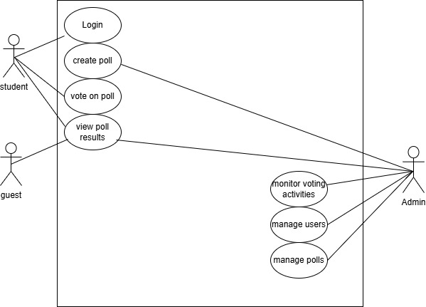
Fig. 3.1: Use case diagram of the proposed system
Explanation:
Actors:
Student: Has the ability to log in, generate polls, vote, and check poll results.
Guest: Has access to view poll results, but lacks the ability to cast votes.
Admin: Completely manages the system; can supervise votes, control users, and can create and delete polls.
Use Cases:
Login: Both students and admins may log in to the system.
Create Poll: It is the responsibility of the Admins to formulate new polls for students.
Vote on Poll: Students register their votes on active polls.
View Poll Results: All students and admins are eligible to access the results of a poll after it has been voted on.
3.2.5.3 ACTIVITY DIAGRAM OF THE PROPOSED SYSTEM
An Activity Diagram is a representation of system operations. It focuses on the processes driven by a user from a systems perspective, beginning to end. This is helpful in the identification of a procedure and subsequent actions, as well as points for judgement in the system.
In the case of the Online Campus Opinion Poll System, the activity diagram shows how users log in to the system, cast votes, and check results.
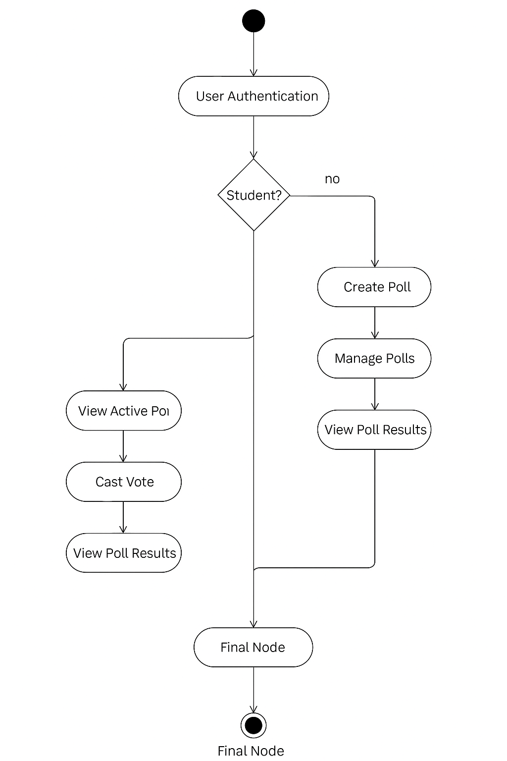
Fig 3.1 flow chart diagram of the proposed system
Explanation:
- Login Process: The user (either student or admin) initiates the login process by entering their credentials. The system checks whether the login details are valid.
If valid, the user is granted access based on their role (admin or student).
If invalid, an error message is displayed, and the user is prompted to try again.
- Poll Creation (Admin): Once logged in, the admin can create a new poll by filling out the poll details (title, options, and voting period). The poll is then activated, and students can start voting.
- Voting (Student): After logging in, a student can view the active polls and select an option to cast their vote. Once the vote is cast, the system records it, and the student can no longer vote on that poll again.
- Viewing Results: Both students and admins can view poll results. Admins can view additional statistics, such as detailed breakdowns and insights.
3.2.5.4 CLASS DIAGRAM OF THE PROPOSED SYSTEM
The class diagram represents the structure of the system by showcasing the system’s main classes and their attributes, methods, and relationships. The key classes include User, Student, Admin, Poll, Vote, and Result.
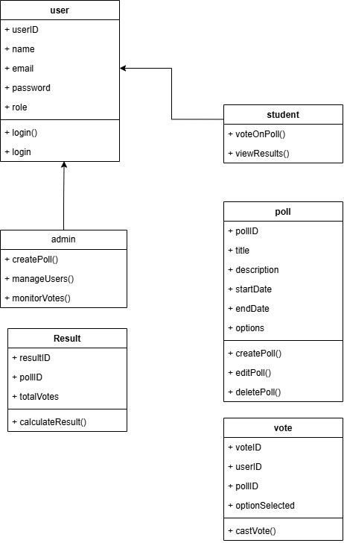

Fig. 3.2 class diagram of the proposed system
Explanation:
- User Class: This class includes attributes such as userID, name, email, and password. It has methods such as login() to manage user authentication.
- Admin Class: A subclass of User with additional methods like createPoll(), manageUsers(), and monitorVotes().
- Student Class: Also a subclass of User but with fewer privileges. It includes methods such as voteOnPoll() and viewResults().
- Poll Class: Represents polls with attributes like pollID, title, description, startDate, endDate, and options[].
- Vote Class: Tracks the votes cast, linking each vote to a specific poll and student.
- Result Class: Computes and stores the results of a poll after voting has concluded.
3.3 SYSTEM DESIGN
The design of the system is divided into two major parts: Input/Output Design and Database Design.
3.3.1 DATABASE DESIGN
The database design ensures that all data in the system is stored securely and efficiently. The key entities in the database include:

Users table
Table 3.1 User table for online campus opinion poll system
Attribute | Data type | Description
userID | int | The primary key of the table
name | varChar | The field for storing name
email | varChar | The field for storing email
password | varChar | Field for storing users paswwords

Poll table
Table 3.2 Poll table for online campus opinion poll system
Attributes | Data type | Description
pollID | int | Primary key
title | varChar | Field for inputting title
description | varChar | Field for inputting description
startDate | dateTime | Field for inputting date or time
endDate | dateTime | Field for inputting date or time
options | varChar | Field for inputting options
Vote table
Table 3.3 students table for online campus opinion poll system
Attributes | Data type | Description
voteID | int | Primary key
studentID | varChar | Field for inputting title
pollID | varChar | Field for inputting description
optionSelected. | dateTime | Field for inputting date or time

CHAPTER FOUR
SYSTEM IMPLEMENTATION AND TESTING
4.1 INTRODUCTION
This chapter outlines in detail the steps taken toward developing the Online Campus Opinion Poll system including how the system requirements and system design were actualized into software. It analyzes the choice and setup of the development tools, the design through to the implementation of system parts, as well as the comprehensive tests carried out to confirm compliance with the requirements.
The chapter also showcases interface prototypes through screenshots and outlines real-world performance, user feedback, and challenges encountered during the development lifecycle.
4.2 SYSTEM DEVELOPMENT ENVIRONMENT
The development environment constitutes the hardware, software, and tools employed throughout the system development life cycle. A conducive development environment ensures code consistency, system portability, efficient debugging, and seamless deployment.

Component | Description / Tool Used
Frontend Technologies | HTML5, CSS3, JavaScript – for creating user interfaces
Backend Technologies | PHP – for server-side logic and dynamic data interaction
Database Management System | MySQL – for storing user data, polls, votes, and results
Server Environment | Apache server through XAMPP – for local development and testing
IDE and Editor | Visual Studio Code – for writing and managing source code
Operating System | Windows 10 – development and testing platform
Browsers Tested On | Google Chrome, Mozilla Firefox, Microsoft Edge
The choice of these tools was based on their open-source nature, ease of integration, wide community support, and compatibility with the goals of the project.
4.3 SYSTEM IMPLEMENTATION DETAILS
The system was implemented as a structured and modular web-based application, emphasizing security, user accessibility, responsiveness, and real-time performance.
4.3.1 User Authentication and Role Management
A secure login mechanism was implemented using hashed passwords (e.g., bcrypt encryption). Upon login, the system determines the role of the user (admin or student) and redirects them to role-specific dashboards. Validation mechanisms ensure the authenticity and integrity of session data to prevent unauthorized access or session hijacking.
- Admin Capabilities: Create/manage polls, monitor participation, view detailed results, and manage users.
- Student Capabilities: View available polls, cast votes, access poll summaries post-voting.
4.3.2 Poll Creation and Management
This component allows administrators to initiate new polls by entering essential information such as:
- Poll Title
- Poll Description
- Voting Options
- Start and End Dates
All data entries are validated both client-side and server-side before insertion into the database. The system automatically transitions polls from active to inactive status based on the current date.
4.3.3 Secure and Anonymous Voting Process
Students can vote only once per poll. Each vote is recorded alongside metadata such as timestamp and poll ID but is anonymized no user ID is stored with the selected option to maintain privacy. This was crucial in fostering trust and encouraging honest participation without fear of victimization.

4.3.4 Real-Time Result Computation
Results are computed automatically using server-side scripts that aggregate the number of votes per option. The data is visualized using bar graphs and percentage breakdowns, providing immediate insight into poll outcomes.
Results are available instantly upon poll closure.
Admins see both graphical and tabular representations.
Students see summarized outcome statistics without access to user data.
4.3.5 Dashboard Interfaces
Two core dashboards were developed:
- Student Dashboard: Displays available polls, voting history, poll status, and results.
- Admin Dashboard: Provides tools for poll creation, analytics, user management, and monitoring poll progress.
Screens were built to be responsive across devices, with clean navigation structures and accessibility features.
4.4 SYSTEM TESTING STRATEGIES AND RESULTS
To ensure the robustness and reliability of the system, different testing methodologies were adopted across various phases of development:
4.4.1 Unit Testing
Each module was independently tested to verify its correctness in isolation:
- Login Module: Tested with valid/invalid credentials, and verified session creation.
- Poll Module: Tested for boundary conditions (e.g., duplicate titles, invalid dates).
- Voting Module: Ensured single-vote restriction per user per poll.
- Result Module: Confirmed vote tallying logic across multiple simulations.
4.4.2 Integration Testing
Modules were combined to observe interactions:
- Logging in as admin and navigating to poll creation.
- Casting a vote and then viewing results.
- Creating overlapping polls and validating their independence.
Test cases ensured that module dependencies functioned smoothly without data leakage or logic overlap.
4.4.3 System Testing
Full system testing was conducted under simulated real-world conditions, including:
- Load Testing: Simulated 100 concurrent users casting votes.
- Usability Testing: Volunteers were asked to complete basic tasks (login, vote, view results).
- Security Testing: Attempted SQL injections and direct URL access to unauthorized sections—all blocked successfully.
4.4.4 User Acceptance Testing (UAT)
A pilot deployment was tested by a group of 10 students and 2 admin users. Their feedback was documented and included suggestions on:
- Improving button labels.
- Expanding result chart legends.
- Adding confirmation dialogs before vote submission.
- Updates were implemented to reflect this user-centered feedback.
4.5 SYSTEM INTERFACE SCREENSHOTS AND DESCRIPTION
(Include screenshots with the following captions and explanations if submitting with images)
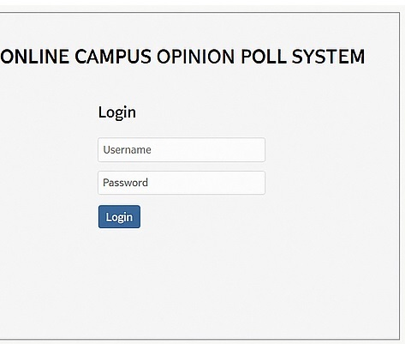
Figure 4.1 – Login Page: Allows access based on user role.
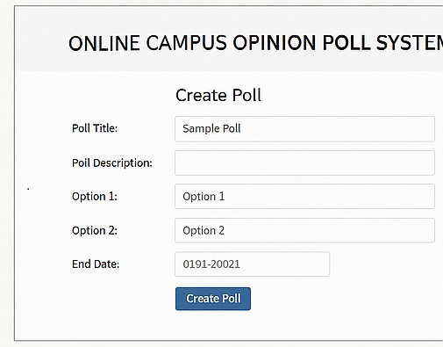
Figure 4.2 – Admin Poll Creation Form: Form for entering new poll parameters.
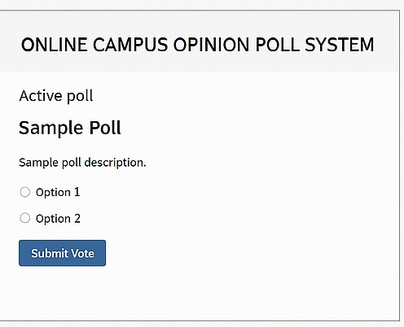
Figure 4.3 – Student Voting Interface: Simple layout to select and submit choices.
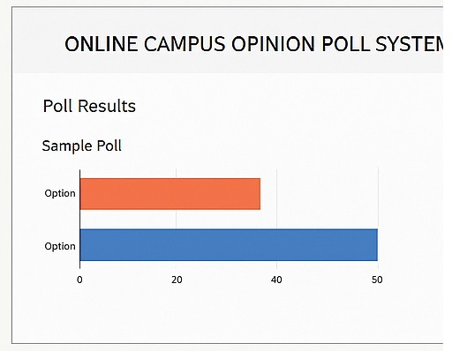
Figure 4.4 – Poll Result Visualization: Bar chart showing percentage breakdown.
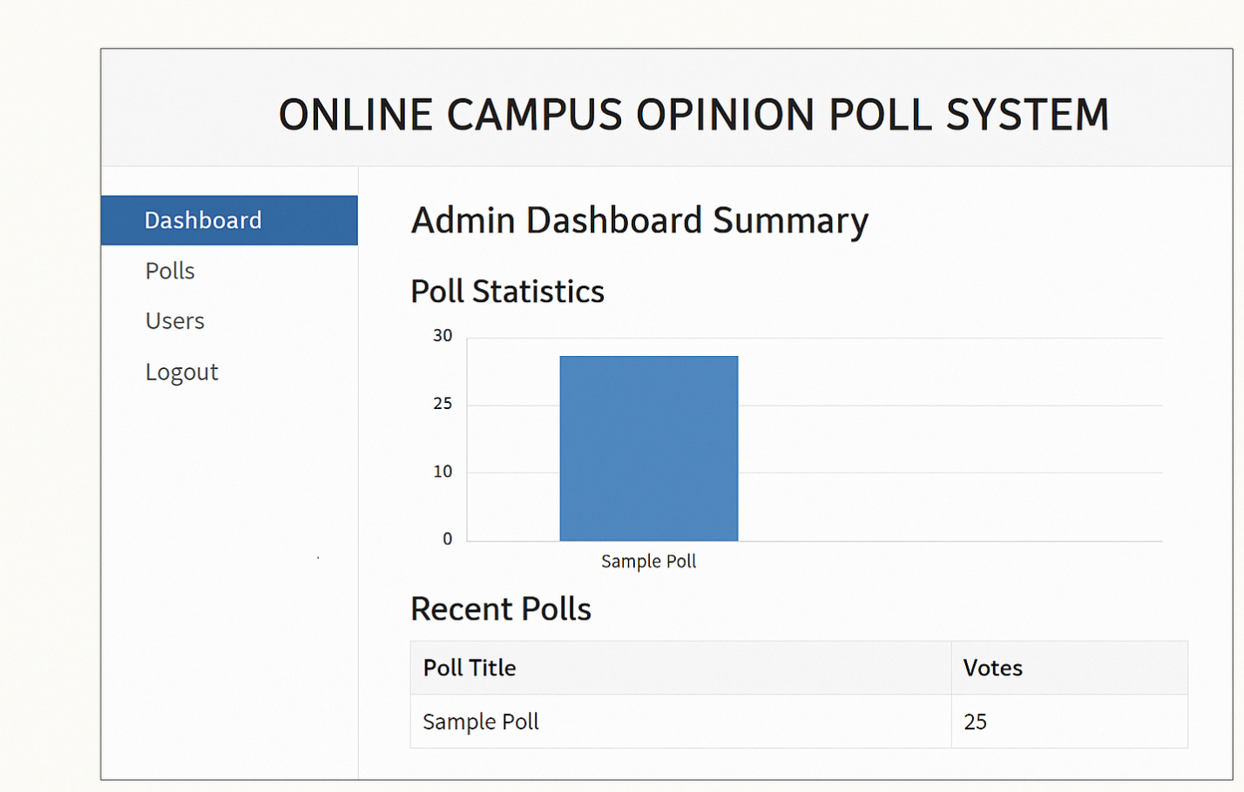
Figure 4.5 – Admin Dashboard Summary: Graphs and tables showing poll engagement.
4.6 CHALLENGES ENCOUNTERED DURING IMPLEMENTATION
Despite the successful implementation, several challenges were faced:
- Cross-browser Compatibility: CSS behaviors differed between browsers, especially in form rendering.
- Security Setup: Implementing secure password hashing and session management took considerable research and testing.
- Data Synchronization: Ensuring real-time result updates without refreshing the page required JavaScript integration with AJAX.
- Time Constraints: Limited academic calendar period affected full-scale optimization and mobile testing.
CHAPTER FIVE
SUMMARY, CONCLUSION AND RECOMMENDATIONS
5.1 SUMMARY OF THE STUDY
The purpose of this research was to design and develop a robust Online Campus Opinion Poll System that will enable students of Nigerian tertiary institutions to participate in voicing their opinions concerning academics and non-academic issues. Polling in a traditional manner has proven to be inefficient because of the absence of anonymity, risk of data manipulation, and low participation. This research was conducted to develop a comprehensive web-based solution to these problems. Voting, access, and participation to the polls were enhanced through features that allowed role-based access control, voting through anonymity, computation of polls and results in real-time. Standard procedures of software development were adhered to, engineering designs were real world tested and the results were in line with the design goals.
5.2 CONCLUSION
In summary, the Online Campus Opinion Poll System serves as a reliable, robust, and secure mechanism for students to engage in governance activities and decision-making processes at the university level. It allows for the persistent two-way communication bottleneck between the students and the university authorities to be resolved through a feedback channel that is open, democratic, and transparent. The solution provided has the capacity to improve integrity and governance of institutions by improving student participation and collaboration in the process of self governance. This solution can be adapted to other domains in addition to education, including politics, organizational polling, and corporate feedback systems.

5.3 RECOMMENDATIONS
From the system’s design and testing phases, the following insights have been derived:
1. Comprehensive System Adoption: It is the recommendation of the initiators of the system that the feedback and policy review system be formally adopted at the tertiary level.
2. System Updates And Revamping: Frequent updates and audits should be performed on the system to counteract the ever evolving cyber threats.
3. Web And Mobile Application Development: Development should shift towards the creation of dedicated mobile applications for IOS and Android, as the web version is already done.
4. Integrating Local And Regional Dialects: The addition of local dialects will greatly enhance inclusivity and broaden the scope of participation among students.
5. Linking With Student Information Systems: Linking with existing students information systems (SIS) will streamline information retrieval, thus reducing the redundancy of information, and enhancing control.
5.4 SUGGESTIONS FOR FUTURE WORK
To broaden the scope of the system for academic inquiry, a few suggestions are made for dedicated researchers:
1. Investigate The Use Of Blockchain Technology: Enhance the integrity of the voting system with the use of unchangeable voting records and provable audit trails.
2. Add Predictive And Anomaly Detection Capabilities: Use machine learning to examine trends in polling data and anticipate future developments.
3. Create Modules that will enable students to provide justifications for their votes fostering a more participatory dialogue.
4. Allow Offline Voting Methods: Via mobile caching that syncs when reconnected to the internet, ideal for remote regions.

REFERENCES
Anderson, P. (2018). Rapid application development of an online opinion polling system for student bodies. Journal of Educational Software Engineering, 6(3), 150–162.
Brown, K., & Patel, S. (2021). Evaluating the efficacy of online polling systems in academic institutions. Education Technology and Society, 24(4), 202–215.
Chen, R., & Singh, A. (2016). A comparative study of mobile-based and web-based polling systems in higher education. International Journal of Education and Information Technologies, 10(2), 79–85.
Dawson, T., & Hill, M. (2020). Designing student feedback mechanisms through online polls: A usability study. Interactive Learning Environments, 28(6), 785–798. https://doi.org/10.1080/10494820.2019.1579230
Garcia, L., Chen, M., & Yusuf, T. (2021). User experience and accessibility in online polling systems. International Journal of Human-Computer Interaction, 37(5), 402–416. https://doi.org/10.1080/10447318.2020.1834755
Gomez, R., & Hartono, K. (2022). The impact of live polling systems on classroom engagement. Journal of Educational Technology Development and Exchange, 15(1), 41–58.
Johnson, R., & Lee, A. (2016). A secure online polling framework for corporate decision making. Computers & Security, 60, 124–135.
Kumar, D., Nwankwo, C., & Adeyemi, S. (2019). Cloud-integrated online polling system for real-time feedback. Cloud Computing and Education Journal, 3(1), 45–58.
Li, Z., & Huang, W. (2021). Evaluating blockchain-enabled online polling systems for institutional transparency. Journal of Information Security and Applications, 58, 102829. https://doi.org/10.1016/j.jisa.2021.102829
McAllister, J., & Shore, D. (2015). Online polling as a tool for democratic classroom practices. Teaching and Teacher Education, 49, 15–23.
Mehta, K., & Bansal, A. (2019). Multi-device compatibility in web-based polling systems: An empirical study. International Journal of Computer Applications, 177(42), 20–28.
Nguyen, H., & Park, Y. (2020). Security analysis of online voting platforms: A case study on student election systems. Journal of Cybersecurity Technology, 4(3), 173–188.
Oliveira, T., & Silva, J. (2020). Enhancing security in online voting through multi-factor authentication. International Journal of Cybersecurity, 5(3), 78–89.
Patel, R., & Singh, N. (2021). Framework for designing inclusive online polling platforms in educational institutions. International Journal of Educational Technology in Higher Education, 18(1), 91–103.
Smith, J., Ojo, A., & Musa, B. (2015). Development of an online polling system for university elections. Nigerian Journal of Computer Applications, 8(1), 1–10.
Suleiman, A., & Yusuf, I. (2021). A role-based access control model for secure online opinion polls. African Journal of Information and Communication Technology, 14(2), 112–127.
Thomas, E., & White, K. (2018). Addressing digital inequality in online polling tools: A case study in African universities. Journal of Digital Learning, 10(4), 67–82.
Williams, D. (2017). Blockchain-based online polling system for transparent voting. Journal of Emerging Technologies in E-Governance, 12(2), 33–45.
Zhao, M., & Fan, X. (2022). Intelligent analytics in real-time polling systems: An AI-based approach. Journal of Smart Learning Environments, 9(1), 1–14. https://doi.org/10.1186/s40561-022-00196-8

