KERATINOPHILIC POTENTIALS OF SOME SOIL FUNGI
AROUND GODFREY OKOYE UNIVERSITY TEMPORALLY SITE

MADUEKOBO, MICHAEL CHIEMEZIE
GOU/U21/MCB/493

MICROBIOLOGY
BIOLOGICAL SCIENCE
FACULTY OF NATURAL SCIENCE AND ENVIRONMENTAL STUDIES
GODFREY OKOYE UNIVERSITY, ENUGU, NIGERIA

JUNE, 2025

KERATINOPHILIC POTENTIALS OF SOME SOIL FUNGI
AROUND GODFREY OKOYE UNIVERSITY TEMPORALLY SITE

MADUEKOBO, MICHAEL CHIEMEZIE
GOU/U21/MCB/493

MICROBIOLOGY
BIOLOGICAL SCIENCE
FACULTY OF NATURAL SCIENCE AND ENVIRONMENTAL STUDIES
GODFREY OKOYE UNIVERSITY, ENUGU, NIGERIA

A PROJECT RESEARCH WORK OF BIOLOGICAL SCIENCES IN PARTIAL FULFILMENT OF THE REQUIREMENTS FOR THE AWARD OF BACHELOR OF SCIENCE (B.Sc.) DEGREE IN MICROBIOLOGY

SUPERVISOR: EMERITA. PROF. C.A OYEKA

JUNE, 2025

APPROVAL
This research, titled "Keratinophilic Potentials of Some Soil Fungi around Godfrey Okoye University Temporally Site," has been assessed and approved by the committees of the Department of Biological Sciences and Faculty of Natural Sciences and Environmental Studies, Godfrey Okoye University, Enugu, Nigeria.

Emerita. Professor C.A. Oyeka ...…………………….. ………………
Supervisor Signature Date

………………… …………………
External Examiner Signature Date

Dr. F.N. Olisaaka ………………… ………………….
HOD,
Department of Biological Sciences Signature Date

Prof. Chidi C. Uhuegbu …………………… …………………
Dean, FNSES Signature Date

CERTIFICATION
This is to certify that this research, titled "Keratinophilic Potentials of Some Soil Fungi around Godfrey Okoye University Temporally Site," was carried out by Maduekobo Michael Chiemezie, Registration Number GOU/U21/MCB/493, under the supervision of Emerita Prof. C. A. Oyeka in the Department of Biological Sciences, Godfrey Okoye University, Enugu.

Maduekobo Michael Chiemezie ………………………. ……………………
Student Sig/nature Date

DEDICATION
I dedicate this work to almighty God who by his grace and fatherly care I was able to carry this research work, and also to my loving parents Late Dr. Christopher Maduekobo and the first woman in my life Mrs. Maduekobo and to you Mrs. Christa Lay who by your motherly care for sees that I was able to attend a higher education even after the bereaved of your husband Late Mr. Lay who with you started this journey of success, you continued in your motherly love to the last God bless you all.

ACKNOWLEDGMENT
I want to express my sincere gratitude to God, for everything seems impossible, he (God) made all possible. My gratitude also extends to the head of the department, Dr. F.N. Olisaka, my Supervisor Emeritus, Prof. C.A. Oyeka, and both tutorial and non-tutorial staff in the department for their invaluable guidance, support, and expertise throughout this project. Their insightful feedback and encouragement have been instrumental in shaping this work.
I also extend my appreciation to all my friends and family in Germany, especially Aunty Meggy Kantert, Late Mr. Lay and Mrs. Lay, and the German foundation that took care of my fess when the going became tough, and also to Rev. Sis Madeleine Nechi for their contributions, support and their prayers throughout my stay in Godfrey Okoye University, God bless you all.
I acknowledge the support of my own family, especially my twin, for providing the necessary resources and environment that facilitated the completion of this project. You all are the best.
Finally, I thank my friends Philip, Sonia, and Genevieve; I can’t mention all for their unwavering support and understanding throughout our academic journey. I pray we will not forget so easily how everything used to be when we go our separate ways. God bless us all, amen.

ABSTRACT
Keratin is found in soil areas rich in keratinous materials like feathers, hair, animal, insects, etc. Twelve soil samples were collected randomly from different sites around Godfrey Okoye University, thinker’s corner Emene Enugu, for this study. This study deals with the isolation, identification, and evaluation of those soil fungi that have the potential to degrade keratin from keratinous materials. These soil samples are rich in pathogenic keratinophilic fungi, including dermatophytes. For isolation, these samples were screened for keratinophilic fungi using the ‘‘Hair baiting and Nail baiting technique.’’ Fungal growth appeared after 1-2 weeks of incubation at room temperature. Isolates were cultured on mycological media and identified based on colonial, macroscopic, and microscopic features. The keratinophilic isolates were Aspergillus niger (10), Aspergillus flavus (10), Penicillium (10), Aureobasidium pullulans (30), Aspergillus fumigatus(40).These isolates were able to grow on hair and nail samples because they possess the enzyme keratinase. The result concluded that these isolated fungi are pathogenic for animals and human beings. And people leaving within these study sites are advice to prioritize good hygiene by regularly washing and drying skin, especially between toes and in skin folds.

TABLE OF CONTENTS
Cover page
Title page i
Approval page ii
Certification page iii
Dedication iv
Acknowledgment v
Abstract vi
Table of contents vii
List of tables ix
List of Figures x

CHAPTER ONE: INTRODUCTION 1
  - Background of the Study 1
  - Keratinase 3
  - Statement of Problem 4
  - Aim and Objective 5
    - Aim 5
    - Objectives 5

CHAPTER TWO: LITERATURE REVIEW 6
2.1Overview of Keratinophilic Fungi 6
2.2Keratin and Its Importance 7
2.3 Keratin: Structure, Classification, and Properties 12
2.4 Extraction Methods of Keratin 20

CHAPTER THREE: MATERIALS AND METHODS 21
3.1 Study Site and Location 21
3.2 Collection of Samples 21
3.3 Materials 21
3.4 Sterilization of Materials 22
3.5 Keratinophilic Fungi Isolation from the Soil 22
3.6 Preparation of Soil Samples 22
3.7 Hair Fragments 22
3.8 Incubation 22
3.9 Culturing and Storage of the Fungal Isolates 23
3.10 Characterization of Isolates 23
3. 11Inoculation into Bijou Bottles 23
3.12 Slide Culture Technique 23
3.13 Microscopic Examination of the Slide Culture 24

CHAPTER FOUR: RESULT 25
4.1 Cultural and Morphological Characteristics of Each Isolate 32

CHAPTER FIVE: DISCUSSION, CONCLUSION, AND
RECOMMENDATION 35
5.1 Discussion 35
5.2 Conclusion 38
5.3 Recommendation 39
REFERENCES 40

LIST OF TABLES
Table 2.1: Keratin Sources in Various Applications 10
Table 2.2: List of Some Genres of Keratinophilic Fungi 18
Table 4.1: Distribution of Keratinophilic Fungi at Godfrey Okoye University,
Temporal site 30
Table 4.2: Frequency of Occurrence of Keratinophilic Fungi at Godfrey Okoye University Temporal Site. 34

LIST OF FIGURES
Figure 2.1: Major Source of Keratin 9
Figure 2.2: The possible Chemical Modification of Proteins, including Keratin 14
Figure 2.3: Molecular Structure of Keratin Protein; α-Keratin and ẞ-Keratin 16
Figure 2.4: Chemical Structure of Amino Acids 19
Figure 4.1: The Macroscopic and Microscopic view of Aspergillus niger 26
Figure 4.2: The Microscopic and Macroscopic view of Aspergillus flavus 27
Figure 4.3: The Microscopic and Macroscopic View of Penicillium Spp 28
Figure 4.4: The Microscopic and Macroscopic view of Aureobasidium pullulans 29
Figure 4.5: The Microscopic and Macroscopic view of Aspergillus fumigatus 30
Figure 4.6: Hair Baiting Culture and Nail Baiting Culture 31

CHAPTER ONE
INTRODUCTION
1.1 Background of the Study
The primary fungal reservoir is the soil. Certain soil fungi may put humans and animals at risk. Associated geophilic dermatophytic species and potentially harmful keratinophilic fungi are found worldwide (Ajello et al., 1965). The greatest places for keratinolytic and saprophytic fungi to thrive include soils found in forests, farms, and parks, as well as sediments found in rivers and oceans that contain humus and organic matter (Mohamed et al., 2000).
Thus, to better understand the distribution and occurrence of dermatophytes and other keratinophilic fungi, as well as the risk of human dermatophytosis in those areas, we have investigated the keratinophilic mycoflora of farm yards and forests, where farmers, tourists, and animals spend a significant amount of time and may be exposed to pathogenic fungi (Mahdavi, 1991). From an industrial perspective, this could contribute to the breakdown of keratinous material (Nasery, 1992).
Dermatophytes are fungi that induce infections of the skin, hair, and nails, classified into three genera: Microsporum, Trichophyton, and Epidermophyton. Keratin substances are important natural materials that are found in nature primarily in the form of hairs, wools, feathers, horns, hooves, nails, skin, and other cornfield appendages and act as natural baits for these fungi (Khanam and Jain, 2002). Soil is the main source of many fungi, some of which are dangerous to people and animals. It is also a major source of keratinophilic fungi, and the more keratinous materials there are in the soil, the more likely it is that these fungi will be found.(Marchisio, 2000).
Saprotrophic living is also possible for keratinophilic fungi, usually referred to as dermatophytes, which cause mostly human and animal infections. All keratinophilic fungi can invade tissues and induce infection (Simpanya, 2000).
Skin, nails, and hair can be colonized and invaded by dermatophytes and non-dermatophytes (Deshmukh et al., 2008). These fungi were discovered for the first time using the hair baiting technique, which is the most commonly used technique for the qualitative and quantitative isolation of keratinophilic fungi from soil.
Keratin compounds are naturally colonized by these fungi. A-keratins, the insoluble fibrous protein, are broken down by some keratinolytic organisms, which are crucial to the environment. Hair polypeptide chains are tightly packed in a-helix configurations and are joined by disulfide bonds, which makes them poorly biodegradable (Kunert et al., 2000).
Rich in keratinous material, soil is a dynamic habitat for the survival of microorganisms and is ideal for the development and occurrence of keratinophilic fungi (Mercantini et al., 1980, 1986). After conducting a survey, Dixit et al. (1991) and Sarangi et al. (1991) found a correlation between keratinophilia and a few common Indian birds. According to a review of the literature, keratinophilic fungi have been recorded from all over the world (Ajello et al., 1965; Filipello Marchisio et al., 1991). According to some reports, India is home to keratinophilic fungi (Nigam et al., 1985; Singh et al., 1990). The presence of keratinophilic fungi on various substrates has provided important insights into their natural distribution.
The diversity of keratinophilic fungi in various habitats and their widespread presence in men's environments were deemed to be of epidemiological significance because it is thought that differences in natural habitat and host preferences significantly contribute to the global distribution of these fungi and related dermatophytes. When cultivated on keratin-containing media, keratinophilic fungi can break down keratin and use it as a basic source of carbon and nitrogen.
Both the medium's alkalization and the elevated activity of proteolytic enzymes accompany degradation. Kunert (1972) discovered that the culture filtrate's products had characteristics of proteins, peptides, and amino acids. According to Ziegler (1967) and Nickerson et al. (1963), these dermatophytes are well-equipped with enzymes that can give them organic nutrients that are extremely resistant to keratinous substrates.

1.2 Keratinase
The enzyme keratinase hydrolyzes keratin, an insoluble protein present in wool, animal horns, human hair, and chicken feathers (Onifade et al., 1998). Bacteria (Williams et al., 1990), actinomyces (Bockle et al., 1995; Bressollier et al., 1999), and fungi (Friedrich et al., 1999) that break down keratin create it as a protease. To increase the nutritional content of feather meal in the feed industry, this enzyme may be used in the poultry industry to remove hair and feathers (Lee et al., 1991; Williams et al., 1990). The characteristics of keratinase are dependent on its manufacturer.
According to Grassiar et al., (2000) and Riessen and Antranikian (2001), it is typically a serine protease. According to Sangali and Brandelli (2000), it has occasionally been discovered to be a serine protease with a cysteine protease. According to reports, its ideal pH range is between 6 and 10, and its ideal temperature range is between 40°C and 80°C (Lin et al., 1992; Cheng et al., 1995; Friedrich and Antranikian, 1996).
Because dermatophytic fungi are known to be harmful, keratinase from these fungi has long been popular (Sohnle and Wagner, 2000). Only recently have these enzyme groups attracted biotechnological attention. Their ability to break down the tough, insoluble keratin of feathers and turn it into economically useful feather meal (Lin et al., 1999; Riffel et al., 2003), nitrogenous fertilizers, biodegradable films, glues, and foils (Schrooyen et al., 2001; De Toni et al., 2002) is the primary factor contributing to their increasing significance.
Keratinolytic enzyme-mediated feather degradation has been regarded as a crucial technique for effective bioconversion, nutritional improvement, and environmental friendliness. This process is very appealing and might be used to create glues, slow-release nitrogen fertilizers, biodegradable films, and uncommon amino acids like proline, cysteine, and serine. Numerous microbes, including bacteria like Bacillus sp., generate keratinolytic enzymes, which are found in nature (Korkmaz et al., 2004).
According to Awasthi and Kushwaha (2011), keratinolytic fungi from a variety of sources were isolated using a medium that contained feather powder. For developing chicks, the crude keratinase enzyme may substitute up to 7% of the dietary protein and improve the digestibility of commercial feather meal (Odetallah et al., 2003).
Adetunji et al. (2018) assessed the impact of keratinase enzyme and immobilized keratinase enzyme on tomato plant development and compared their efficacy in biodegrading chicken feather waste. Bacillus cereus isolated from a halophilic environment produced more keratinase when fermentation conditions were optimized, according to Arokiyaraj et al. (2019).
This study is conducted because the region is suited for the prudent distribution of these fungi due to its subtropical climate and geographic diversity. The keratinophilic potentials of several soil fungi in the vicinity of Godfrey Okoye University will be reported in this paper.
1.3 Statement of Problem
Keratin is found in soil in areas rich in keratinous materials like feathers, hair, animal, insects, etc. Some keratinophilic fungi degrade the keratin-rich materials, making keratin available to plants. The study emphasizes the isolation, identification, and evaluation of those soil fungi that have the potential to degrade keratin from keratinous materials using the hair-baiting technique.

1.4 Aim and Objective
1.4.1 Aim
This study aims to identify some Soil Fungi that can digest or assimilate Keratin around the Godfrey Okoye University temporary site.

1.4.2 Objectives includes to:
- isolate and identify fungi from soil in the Godfrey Okoye University campus, one.
- study the keratinophilic potentials of these fungi using the hair baiting technique and morphological method.
- evaluate the level of fungal contamination of the soil in Godfrey Okoye University.

CHAPTER TWO
LITERATURE REVIEW
2.1 Overview of Keratinophilic Fungi
One important ecological group of fungi that lives in soil is keratinophilic fungi. Many researchers throughout the world have reported and isolated keratinophilic fungi in recent years (Jangid and Begum, 2018). Degradation of keratinaceous substrates is facilitated by keratinophilic fungi, which are present in settings worldwide. Keratinophilic fungi are capable of degrading keratin. Keratin is the cornified part of the epidermis of vertebrates, which comprises their wool, horns, feathers, hair, nails, and other tissues etc. (Kumar et al., 2017).
After an animal or insect dies, its remains are added to the soil. Additionally, a significant amount of keratin-rich substrate is added to the soil. Keratin can be categorized as soft or hard based on the amount of cystine it contains. Molds that can attack keratinized tissues are known as keratinophilic fungi. In addition to dermatophytic fungus and a variety of non-dermatophytic keratinophilic fungi in other taxonomic groups, these are categorized as hyphomycetes. Some dermatophyte species, such as Microsporum gypseum and Trichophyton terrestre, are known as geophilic because they live in the soil as saprophytes, although the majority are anthropophilic or zoophilic in their native habitat (Weitzman and Summerbell, 1995).
The presence of saprobes in soil by non-dermatophytic keratinophilic fungi, including species of Chrysosporium and other fungal genera, is well recognized. Some keratinophilic fungi are called dermatophytes because of their capacity to parasitize keratin tissues in both humans and animals. Dermatophytosis is caused by fungi called dermatophytes that parasitize keratinized tissues in both humans and animals. Dermatophytosis, sometimes known as cutaneous mycosis, is an infection that can affect human keratinized epidermal tissues. All dermatophytes are keratinophilic by nature. Dermatophytes are among the most prevalent skin disorders that impact humans, pets, and animals. The disorder, which is common to varying degrees worldwide, is more prevalent in men than in women.
Based on clinical rather than mycological data, the order Eurotiales identified three genera of dermatophytes in the Ascomycotina: Microsporum, Trichophyton, and Epidermophyton. Arthroderma and Hannizza, two closely related genera in the Gymnoascaceae family, are sexually compatiblewith dermatophytes. One of the most prevalent skin disorders affecting humans, pets, and animals is dermatophytosis. Despite the isolation of numerous dermatophyte species from animals, only a few zoophilic species—namely Microsporum canis, Trichophyton mentagrophytes, Trichophyton equinum, Trichophyton verrucosum, and the geophilic species Microsporum gypseum—account for the majority of cases (Chen et al., 2018).
2.2 Keratin and Its Importance
Keratin belongs to the family of fibrous structural proteins known as scleroproteins. It is the most common structural protein in animals' hair, nails, feathers, horns, and claws, and together with collagen, the most important biopolymer in mammals. It is differentiated by having a greater concentration of cysteine than other fibrous proteins such as collagen, elastin, and myofibrillar protein (Feroz et al., 2020).
Numerous investigations into the different methods of keratin protein extraction, purification, characterisation, and application have been carried out. Human hair, toes, horns, hooves, beaks, feathers, and claws have all been used to extract keratin over the years. Wool is another important source of keratin. Intermediate filament proteins are thought to be pure in wool, which contains up to 95% keratin by weight.
Human hair and wool are used to make keratin biomaterials, which include cell-binding motifs with hemostatic and cell-binding properties. The ability of keratin to self-assemble and create polymers is inherent. These biomaterials are excellent candidates for tissue engineering and drug delivery systems because of their remarkable biocompatibility and capacity for cellular proliferation (Idrees et al., 2020). Additionally, they have identified potential opportunities in the energy, agricultural, cosmetic, pharmaceutical, textile, and leather industries (Donato and Mija 2020). Figure 1 describes the major sources of keratin, and Table 1 lists the uses for each.

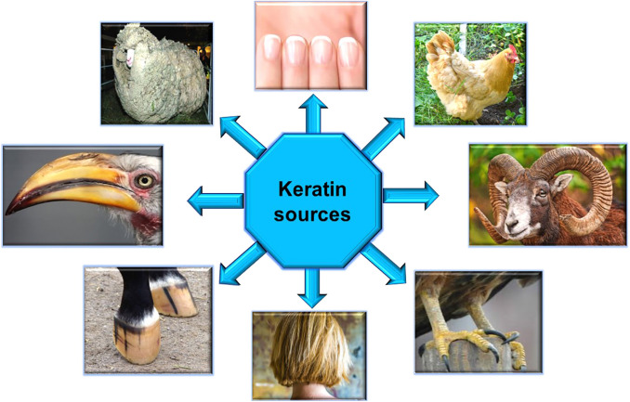
Fig 2.1 Major source of keratin
Source from Springer (2021)

Table 2.1: Keratin sources in various applications are described below
Source from Springer (2021)
S. No. Keratin Sources Application Reference
1 | Chicken feather | Composites in cars and airplanes, bioplastic films, biofertilizers, and bio-composite cosmetics  Hydrogels are food packaging films made of thermoplastic. Diet aids in the production of leather and textiles. Management of waste. | Mija and Donato (2020)
2 | Chicken feather | They are employed in the development of dielectric materials, printed circuit boards (PCBs), and films made of thermoplastic for food packaging. | Mija and Donato(2020)
3 | Chicken feather | Utilized in the manufacturing of paper. | Tesfaye et al. (2017)
4 | Chicken feather | A non-woven insulator made of polypropylene and chicken feathers is utilized. | Soekoco et al. (2018)
5 | Human Hair | Drug permeation, biomaterials, films as a substrate, tissue engineering, and medication use. | De Masi et al. (2019)
6 | Wool | Nanofibers,antipilling, processesbiopolymers, porous foams,sponges, andhydrogel in medical science. | De Masi et al. (2019)
7 | Sheep wool | Concrete slab flooring and external walls with thermal insulation | Porto and Parlato (2020)
8 | Sheep wool | Wool fiber serves as a forerunner to carbon fiber and reinforcement in concrete.
9 | Sheep wool | Carpet and clothing industries. | Gong et al. (2016)
10 | Sheep wool | Coatings, bioplastics, packaging, or regenerative medications. | Fernandez-d’Arlas (2019)
11 | Bovine hoof | A suitable substance for encouraging cellular attachment is hoof bovine, used in tissue engineering and biomedicine as a result. | Kakkar et al. (2014)
12 | Bovine hoof, horn | Engineering composites and aerospace applications. | Baisllie et al. (2000)

The food industry, especially the meat, slaughter, and wool sectors, releases millions of keratin-containing biomass into the environment as a result of the fast urbanization trend (Sharma and Gupta 2016). Worldwide, a lot of keratinous waste is disposed of, landfilled, and burned, polluting the environment. Therefore, it is imperative to identify effective methods for treating these waste materials. According to studies, the biological breakdown of keratin debris is thought to be more effective than the physical and chemical processes, producing valuable by-products with a wide range of economic uses.

2.3 Keratin: structure, classifications, and properties
Keratin, a prominent structural protein found in certain vertebrate epithelial cells, belongs to the class of intermediate filament proteins. Keratin proteins are fibrous and comprise long polypeptide chains and cross-linking fibers (Murray et al., 2017). Polypeptide chains comprise the basic macromolecular structure of keratin. These chains can coil into helices (generating α-conformation) or join side by side to form pleated sheets (producing ẞ-conformation). As a result, keratins can be categorized structurally as either α- or ẞ-keratins, with the latter being more resilient than the former. The main component of wool, hair, claws, hooves, horns, and stratum corneum, the α-form is present in animals. The ẞ-form, on the other hand, is mostly found in hard tissues of birds and reptiles, including feathers, bird beaks and claws, and scales and claws.
Keratins are structurally strong, extremely stable, and insoluble in the majority of organic solvents. Proteolytic enzymes cannot break them down enzymatically either. Keratin's high cysteine concentration provides both chemical and mechanical resilience. Takahashi et al. claim that keratin protein can denature at temperatures above 100 °C, demonstrating its excellent thermal resistance.
Certain amino acids, such as glycine, alanine, serine, and valine, are abundant in keratin proteins. There are also trace quantities of tryptophan, lysine, and methionine (Strnad et al., 2011). Covalent linkages are formed by cysteine and cysteine, have sulphide and disulphide bonds, and affect the physicochemical characteristics of keratin.The chemical modification is presented in Fig.2.2.

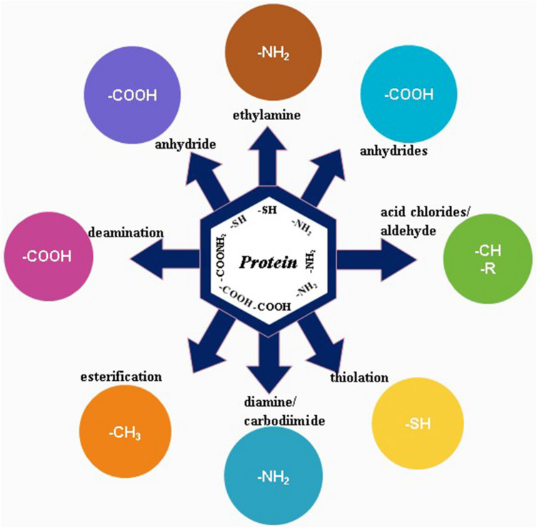
Fig 2.2: The potential chemical changes that proteins, including keratin, can undergo
Source by Springer (2021).

About half of a protein's secondary structure is made up of α-helices and ẞ-sheets. Non-covalent interactions—primarily hydrogen bonds—form and stabilize them. When amino acids tightly coil into a right-handed helical configuration, the α-helix is created. Each turn of the α-helix contains 3.6 residues. The creation of hydrogen bonds between the amino and carbonyl groups of every fourth peptide bond. K stabilizes and holds together the side chains of amino acids that are three or four residues apart.
On the other hand, the ẞ-sheets are made up of polypeptide chains that are pleated and twisted by folding back and forth. The hydrogen atom of the amino group forms a hydrogen bond with the carbonyl oxygen atom of the backbone, which holds these sheets in place. As a result, the lengthy keratin chains may be compact and rod-like, resulting in a conformation, or they may extend out into twisted and flattened ẞ-sheets.As shown in Fig.2.3 (Murr, 2015).

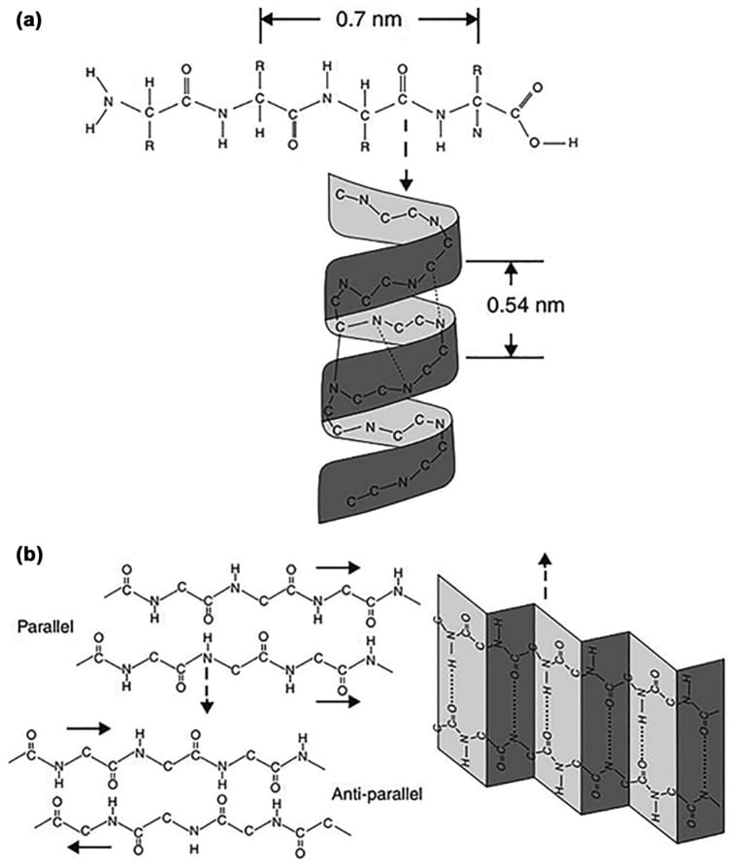
Fig 2.3 Molecular structure of keratin protein; α-keratin (α-helix) and ẞ-keratin (ẞ-pleated sheet).
Source by Sabarunisha Begum S (May 2021)

Research on the molecular weight of α-keratins and ẞ-keratins has revealed that the former has a molecular weight of about 40 kDa, while the latter has a molecular weight of 10–22 kDa.
Based on their isoelectric points, also known as pI, or the pH at which the proteins are neutral, keratins can be classified as basic or acidic. Post-translational changes of the amino acids in keratins can alter their function. Ionic bonds depend on pH to exist. At the pH 4.9 isoelectric point, where the protein is in zwitterion form (+H3N-CHR-COO-), it is greater. Since keratin is normally neutrally charged, excessively basic or acidic environments weaken the ionic interactions. Ammonium cations and carboxylic anions are joined by an ionic connection. At high pH, the amine group deprotonates these bonds, while at low pH, the carboxylic groups protonate them (Feroz et al., 2020).
A variety of methods, including oxidation, reduction, sulfitolysis, and superheated hydrolysis, have been used to remove keratin over the years. Amino acid analysis and molecular weight measurement are used to characterize various extracted keratin samples. (Rajabinejad et al., 2019) examined the amino acid composition of extracted samples and original wool in one investigation.The list of some genres of keratinophilic fungi is shown in Table 2.2, and the chemical structures of an amino acid are presented in Fig.2.4

Table 2.2 list of some genre of keratinophilic fungi.
1 | Geomyces | 11 | Alternaria
2 | Penicillin | 12 | Microsporium
3 | Trichophyton | 13 | Epidermophyton
4 | Curvularia | 14 | Chrysosporium
5 | Malbranchea | 15 | Aspergillius
6 | Myceliophthora | 16 | Fusarium
7 | Geotricum | 17 | Arthroderma
8 | Cladosporuim | 18 | Chaetomium
9 | Ctenomyces | 19 | Aphanoascus
10 | Gymascella | 20 | Gibberella

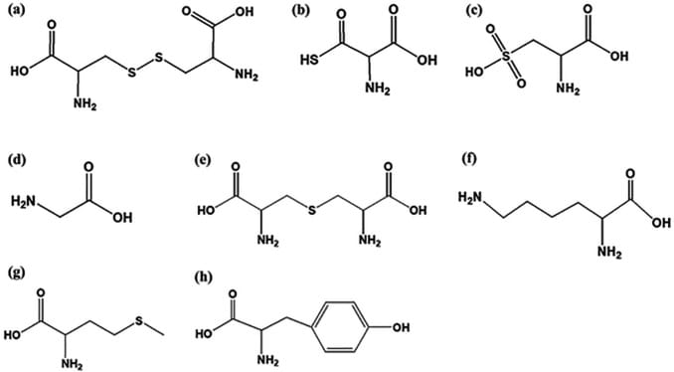
Fig 2.4 Chemical structure of amino acids. A Cystine. B Cysteine. C Cysteic acid. D Glycine. E Lanthionine. F Lysine. G Methionine. H Tyrosine.
Source by Sabarunisha Begum .S (May 2021).

Hydrolysing keratin results in the breakdown and modification of amino acids. For instance, tryptophan is removed. Other amino acids like cystine, cysteine, methionine, and tyrosine undergo partial breakdown, whereas asparagine and glutamine are converted into aspartic and glutamic acid, respectively. Breaking cystine disulfide bonds during various extraction methods results in the creation of new residues in low molecular weight proteins and peptides. The amino acid composition of cysteic acid is significantly altered from that of cytosine and cysteine.
2.4 Extraction methods of keratin
Keratin extraction and dissolution are challenging procedures. Finding a cost-effective, environmentally responsible, and efficient approach is crucial. More keratin-based products are being produced as a result of developments in keratin extraction and characterization in recent years. The leather, pharmaceutical, cosmetic, and agricultural sectors all make substantial use of these products.
A variety of techniques, including chemical hydrolysis, enzymatic and microbiological treatment, dissolution in ionic liquids, microwave, steam explosion, thermal hydrolysis or superheated process, nail baiting,and hair baiting, can be used to extract keratin. The research is conducted using hair and nail baiting technique.

CHAPTER THREE
MATERIALS AND METHODS
3.1 Study Site and Location
This research was conducted at Godfrey Okoye University's temporary location between January and March 2025. Godfrey Okoye University's temporary site is at Thinkers Corner and Ugwuomu Nike (Permanent site) in Emene Enugu, in Enugu East Local Government Area of Enugu State. Emene is at 6° 28ʾ9. 64” N7°31ʾ3538W.
3.2 Collection of samples:
Twelve soil samples were collected randomly from different locations at Godfrey Okoye University. Before the soil samples were collected, superficial debris was removed from the surface. Loosened soil (approximately 500g) was removed from the surface layer of each site to a depth of 2-5cm. Soils were collected in sterile plastic bags and sealed on the spot. Samples were brought to the laboratory and stored overnight.
3.3 MATERIALS
- Soil samples
- Hair samples
- Sterile petri dishes
- Agar media
- Distilled water
- Scalpel
- Microscope
- Gloves and autoclave.

3.4 Sterilization of Materials
All equipment needed for the experiment underwent sterilization in the laboratory. After being cleaned with soap, the glassware was sterilized for an hour at 120°C in the oven. In order to minimize contamination, 70% ethanol was used to sanitize the remaining equipment and the workspace (Agrios, 2005).Inoculating loops and scalpels were sterilized by immersion for 20 seconds in 70% ethanol, followed by heating until they were red hot.The manufacturer's instructions were followed to prepare the medium, Potato Dextrose Agar.

3.5 Keratinophilic fungi isolation from the soil
Hair was collected from a salon in a sterile zip-lock bag and was taken to the laboratory immediately to avoid further contamination. The hair samples were sterilized in an autoclave and were allowed to cool for some time before processing.
The nails:
Fingernails were collected randomly from students in a sterile zip-lock bag with their informed consent. The nails were then taken to the laboratory, where they were sterilized in an autoclave.
3.6 Preparation of soil sample: Five (5) grams of soil samples were weighed into a petri dish and placed on the working bench, and each sample was labeled appropriately.
3.7 Hair fragments: The sterilized hair fragments were scattered on the surface of the soil in petri dishes and were moistened by sprinkling sterile distilled water.
3.8 Incubate: The petri dishes were covered, and samples were incubated at room temperature at 25-30°C for 1-2 weeks. During this period, sterile water was sprinkled on the soil daily, which enabled the moisture content of the environment to be at a normal level for the expected growth of the desired organism.
3.9 Culturing and storage of the fungal isolates
Distinct colonies were cultured on a freshly prepared potato dextrose agar based on their color, shape, and arrangement to obtain a pure culture. This was incubated at room temperature for 3-4 days.
3.10 Characterization of isolates
Each plate was observed for fungal growth, and the characteristics, texture, colors, and shapes were observed and recorded.
3.11 Inoculation into Bijou Bottles
Exactly 26.16 grams of Potato Dextrose Agar (PDA) was dissolved in 300 mL of distilled water and was autoclaved at 121°C for 15 minutes. And about 5ml were dispersed into bijou bottles. After autoclaving, it was placed slantingly to gel before inoculating the organisms. The inoculated bottles were incubated at room temperature for 3-4 days and served as a stock culture for the study.
3.12 SLIDE CULTURE TECHNIQUE
Slide culture technique was carried out according to Keiss et al. (2021) with some modifications. The modification was the use of two sterile slides to serve as a base for the support of a third slide on which the culture is carried out. There was no bent grass rod to support the slide culture. Plates of Potatoes Dextrose Agar (PDA) were prepared for the slide culture technique. Using a sterile scalpel, the medium was cut into small squares. In another sterile petri dish containing filter paper, two sterile slides were placed. A third slide was placed across. A sterilized scalpel was then used to place an agar block on the slide. A cover slip was put on the agar block after the slides were inoculated with the isolate using a wire loop. To make the filter paper moist, drops of distilled water were added to it. Before growth appeared, the setup was incubated for four to five days at room temperature.
3.13 Microscopic Examination of the slide culture
After four to five days, the coverslip was carefully removed using sterile forceps, and the growth-containing slides were oriented with their faces up. The Agar block was carefully removed using a sterile inoculating needle so as not to disturb the growth on the slide, and it was disposed of in a disinfectant jar to prevent the spread of spores. After removing any water bubbles from the slide and coverslip around the fungal growth, 70% ethanol was dropped on them. The growth was then mounted on a fresh, clean slide and coverslip before being stained with lactophenol cotton blue. Using blotting paper, the extra stain was eliminated. To acquire microscopic features of the isolates, the growth of the slide and the coverslip were examined using a microscope with x10 and x40 objective lenses.

CHAPTER FOUR
RESULTS
A total of 12 soil samples were collected from different sites at Godfrey Okoye University, Thinkers Corner. Soil samples rich in organic matter were more suitable for keratinophilic fungi. All of the samples except sample eleven (11) exhibited positive fungal colonies; data on the distribution of these isolated keratinophilic fungi are given in Table 4.1. Five species of keratinophilic fungi were isolated from various soil habitats out of the twelve soil samples that were gathered, according to the data. The majority of keratinophilic fungi in this investigation are Aspergillus flavus, with a percentage distribution of 40%, and Aurebasidium pullulans, with a percentage distribution of 30%. The macroscopic and microscopic features of the fungal isolates are shown in Figures 1, 2, 3, 4, and 5.
Figure 1: Showed Aspergillus niger, which initially appeared white-green and later turned black. Under microscopic examination, it exhibited phialides with chains of conidia. Figure 2: Aspergillus flavus showed dark green colonies surrounded by a white circle, eventually covered by conidia. It is often velvety or powdery, woolly center. Figure 3: Penicillium spp displayed a white surface that later turned powdery and bluish green, with a distinct color border. Microscopically, the hyphae were septate and either branched or unbranched, with conidiospores that had secondary branches called metulae. Figure 4: showed Aureobasidium pullulans, which appeared slimy pink and later turned black. The colonies were smooth, and they grew very fast. Figure 5: showed Aspergillus fumigatus, which displayed a characteristic grey-green color with a slight yellow reverse. It had a woolly to cottony texture, and microscopic observation revealed septate hyphae, phialides, and chains of conidia.

4.1 Cultural and Morphological Characteristics of Each Isolate
Microscopic characteristics of Aspergillus niger showed White-green black coloration (spores) vetty to cottony microscopically and showed flask shaped, cylindrical phaialides and chains of conidia which are one called microscopically. Aspergillus flavus showed Yellow-green colonies with a velvety structure macroscopically and septate hyphae, conidiospores that bear conidia and are globose (smooch walled) microscopically. Penicillium spp showed a white surface that turns into a powdery texture with a bluish green and defined colour, bonder macroscopically and septate hyphae, and possesses either branched or unbranched conidiospores microscopically. Aureobasidium pullulans showed black slimy masses of conidia, the colonies are smooth, and they grew very fast macroscopically which appeared pink and later turned black microscopically. Aspergillus fumigatus showed smoky grey-green with slight yellow reverse, woolly to cotton texture macroscopically, and septate hyphae, conidiospores, and conidia that are typically smooth-walled and spherical microscopically.
One isolate each of Aspergillus niger and Aspergillus flavus were isolated from Omnium sanctorum site while other sites yielded one isolate each except Godfrey Okoye University secondary school area, philosophers garden area, and university back gate area yielded no isolate
Table 4.1: Distribution of Keratinophilic fungi at Godfrey Okoye University, Temporal Site

S/No | Name of fungus | Sampling site
 |  | A  Omnium sanctorum Chaplaincy (Parish house garden area) | B  Uwaebuka Biological Garden (Ostrich Cage) | C  AD-Gentes Hostel  (flower area) | D  Back-gate (Farm) | E  GOUni  Secondary School  (Ringing Zone area) | F  Philosopher’s Garden (in front of the sculpture) | G  GOUni. Secondary School (Guetta) | H  Philosopher’s Garden (Relaxation Area) | I  Volley-ball court | J  Our Savour Hostel  (Before the field) | K  Back-gate (Towards the fens) | L  Love Garden  (Behind the sit out) | Total
1. | Aspergillus niger | + | - | - | - | - | - | - | - | - | - | - | - | 1
2. | Aspergillus flavus | + | + | + | - | - | - | - | - | + | _ | _ | _ | 4
3. | Penicillum | - | - | - | + | - | - | - | - | - | - | - | - | 1
4. | Aurebasidium pullulans | - | - | - | - | - | - | + | - | - | + | - | + | 3
5. | Aspergillus funigatus | - | - | - | - | - | - | - | + | - | - | - | - | 1
 | Total | 2 | 1 | 1 | 1 | 0 | 0 | 1 | 1 | 1 | 1 | 0 | 1 | 10

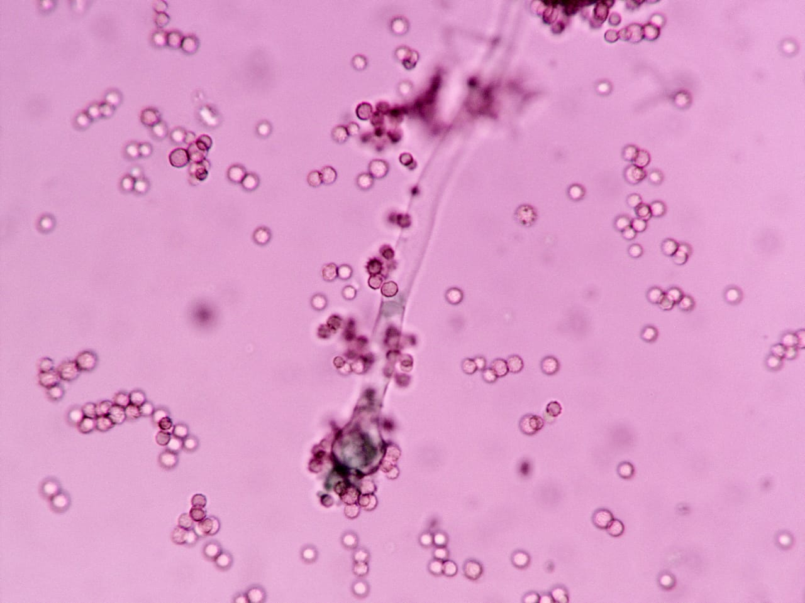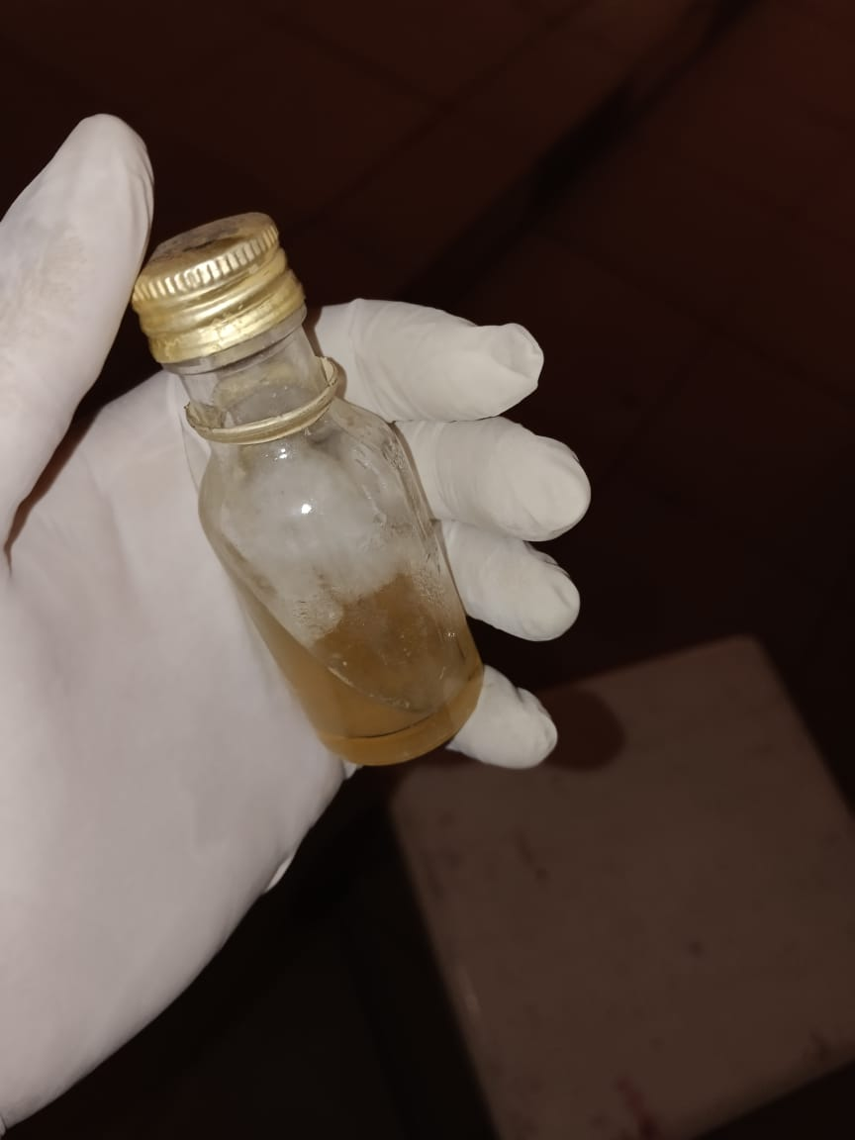
Fig 4.1: The macroscopic and microscopic view of Aspergillus niger

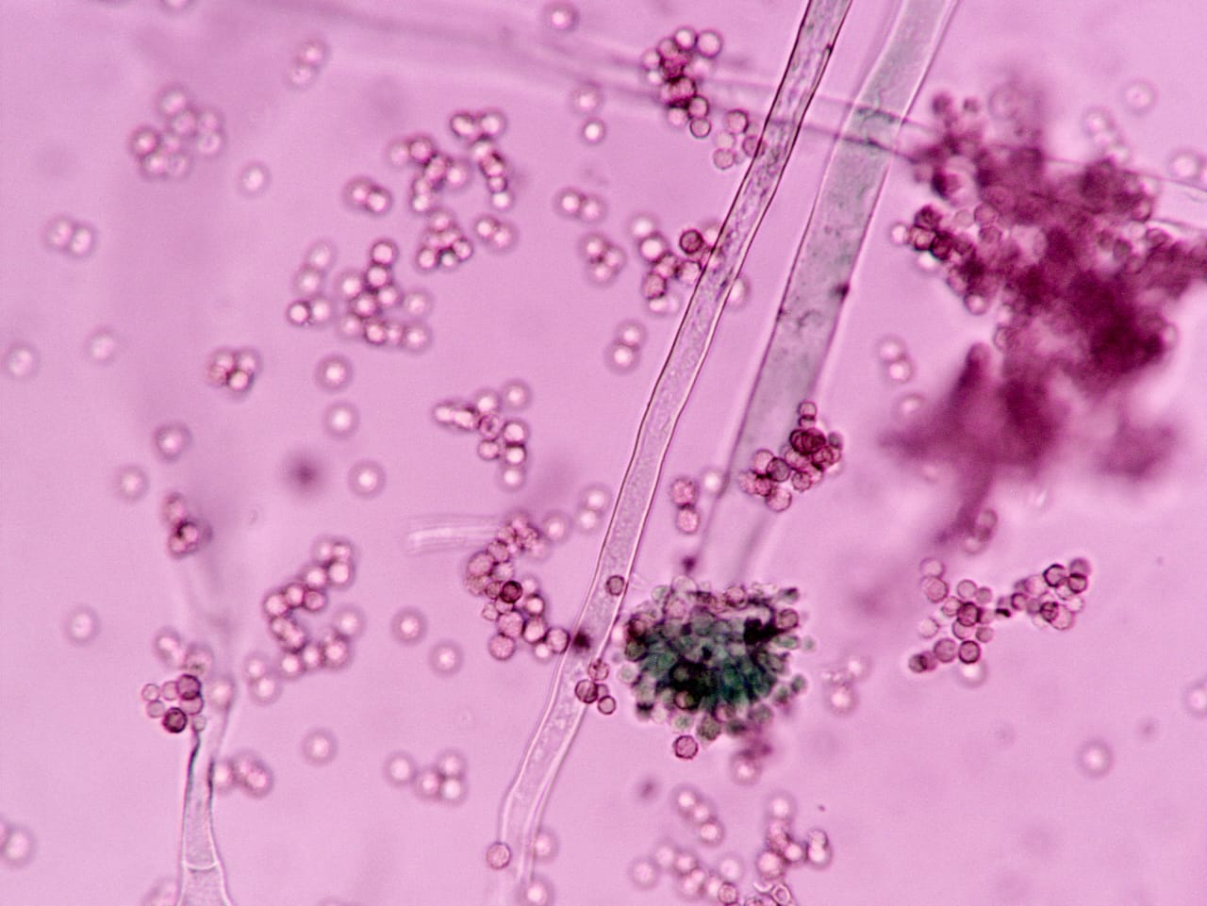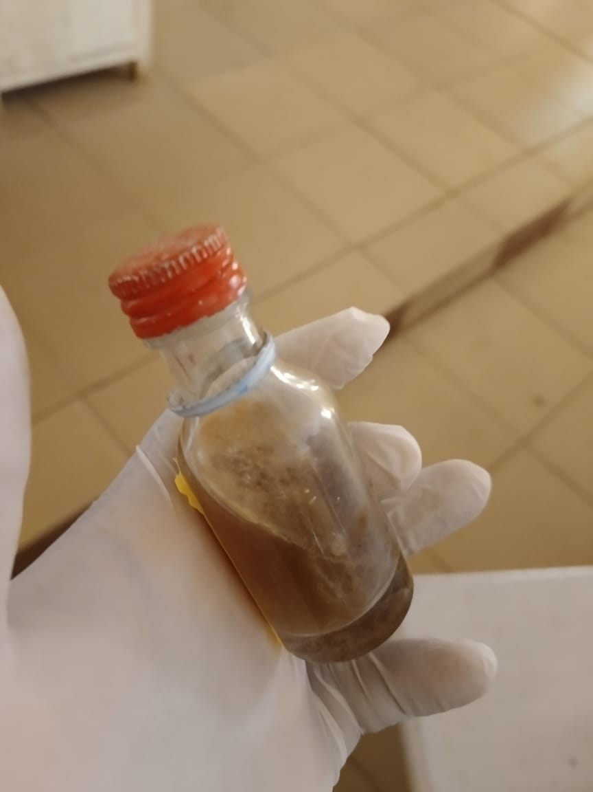
Fig 4.2: The microscopic and macroscopic view of aspergillus flavus

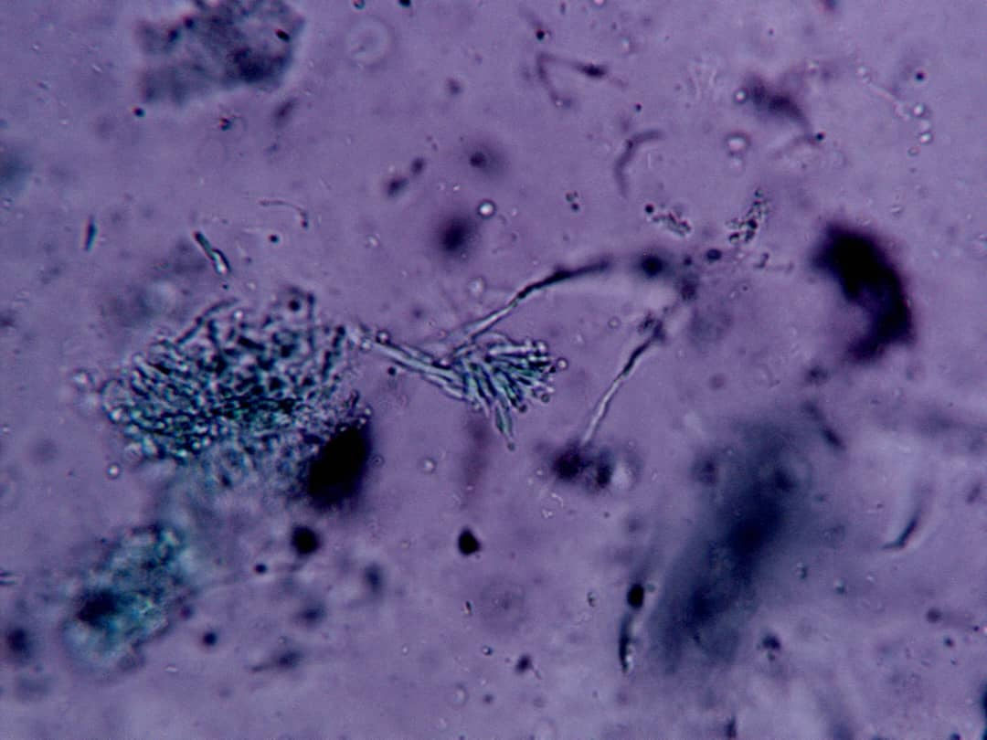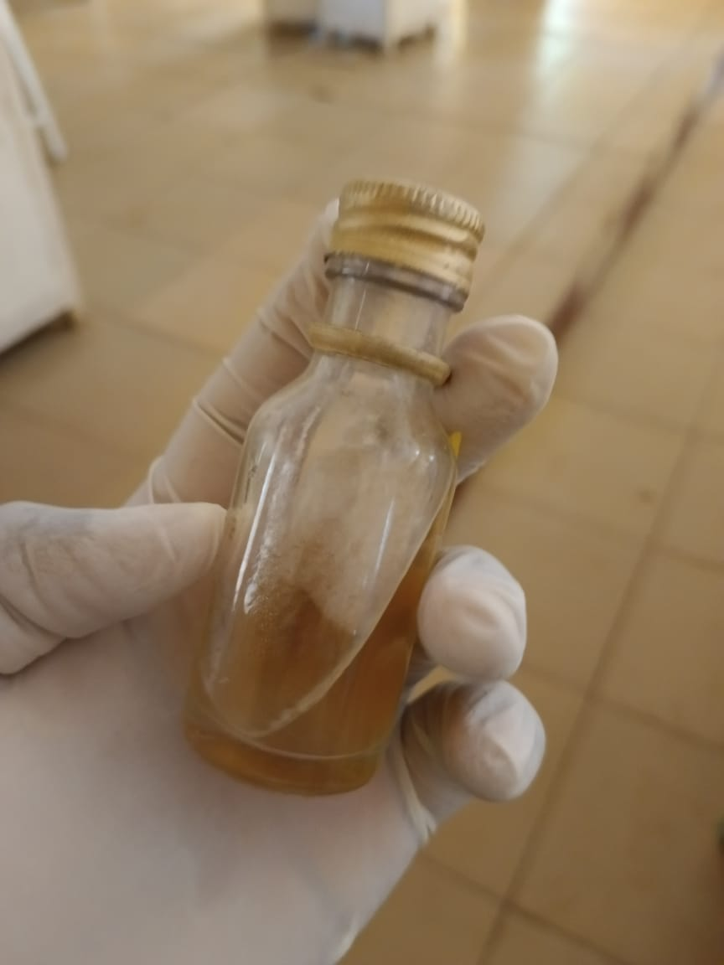
Fig 4.3: The microscopic and macroscopic view of penicillium spp

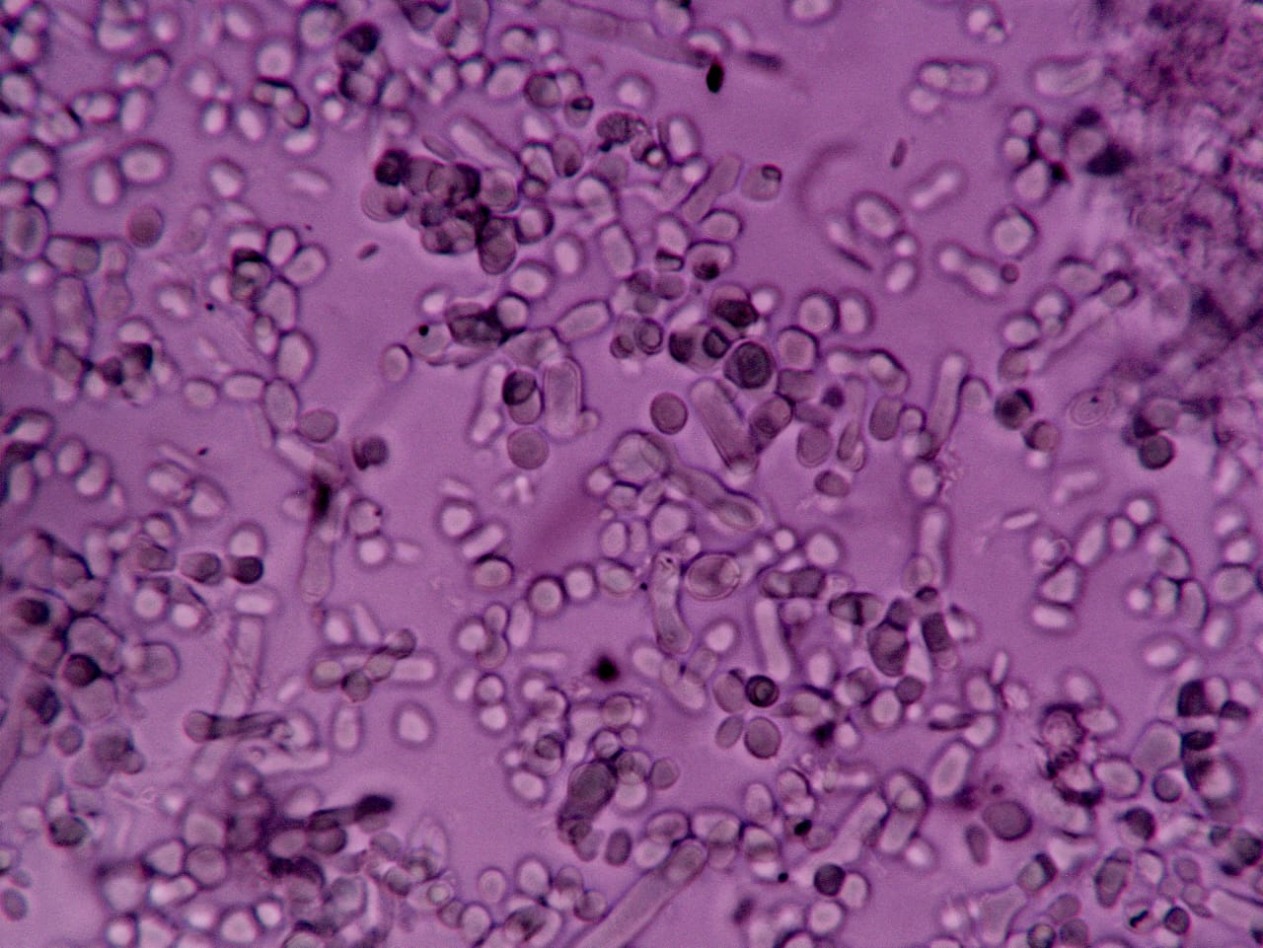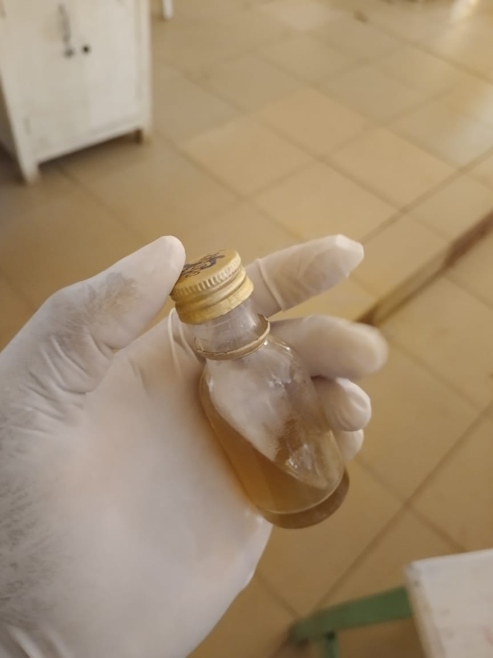
Fig 4.4: The microscopic and macroscopic view of Aureobasidium pullulans

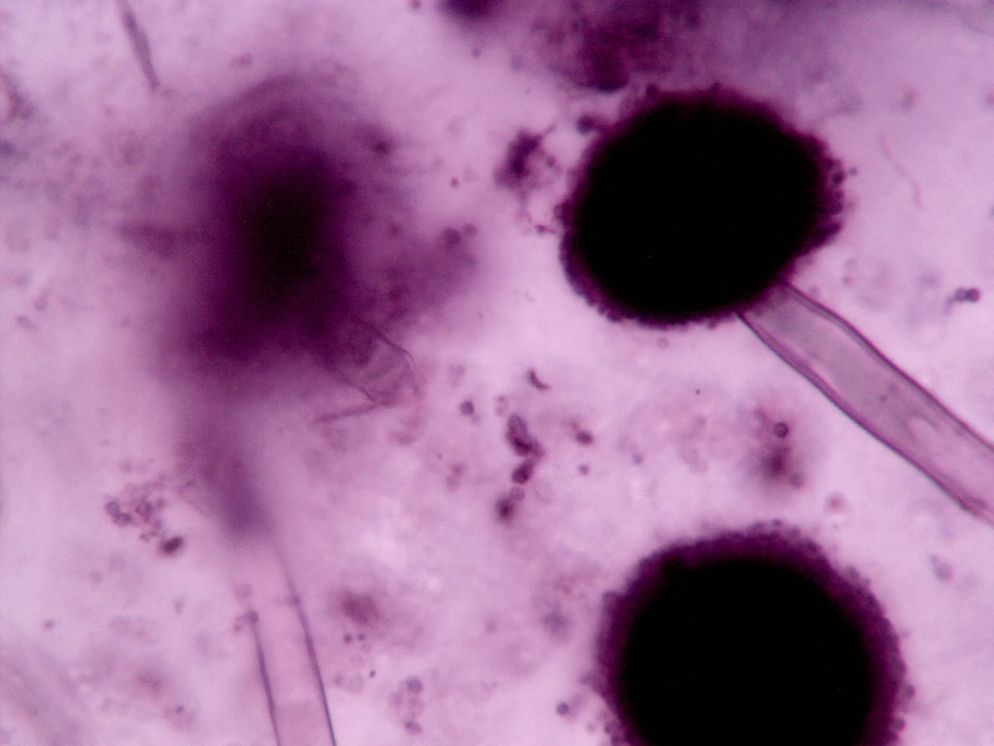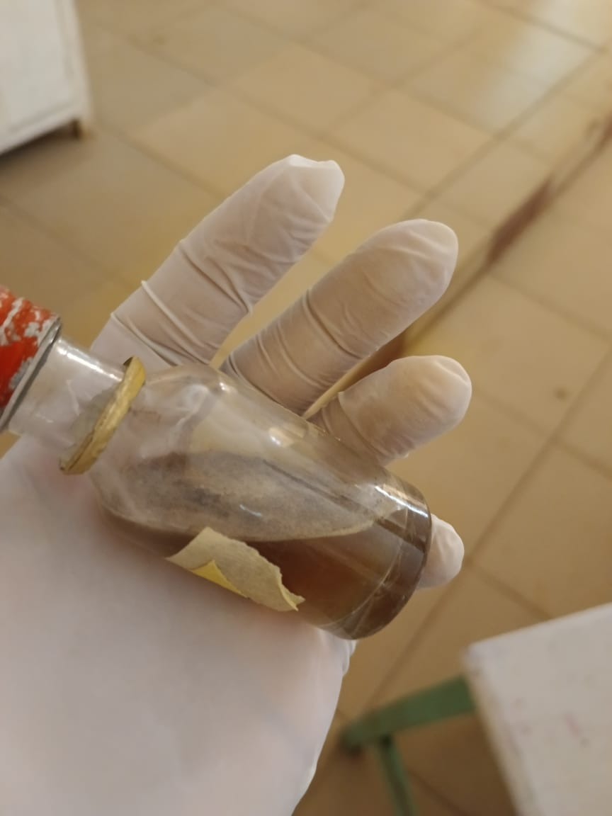
Fig 4.5: The microscopic and macroscopic view of Aspergillus fumigatus

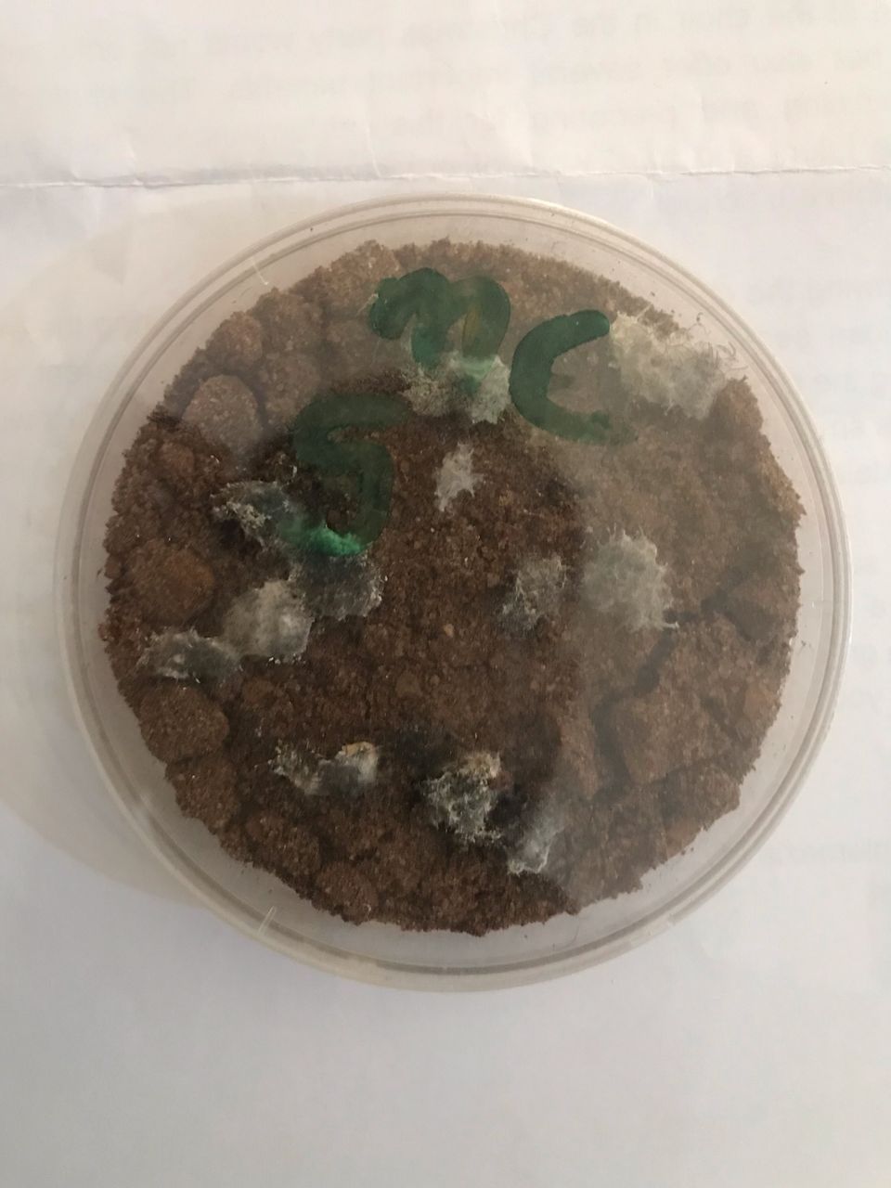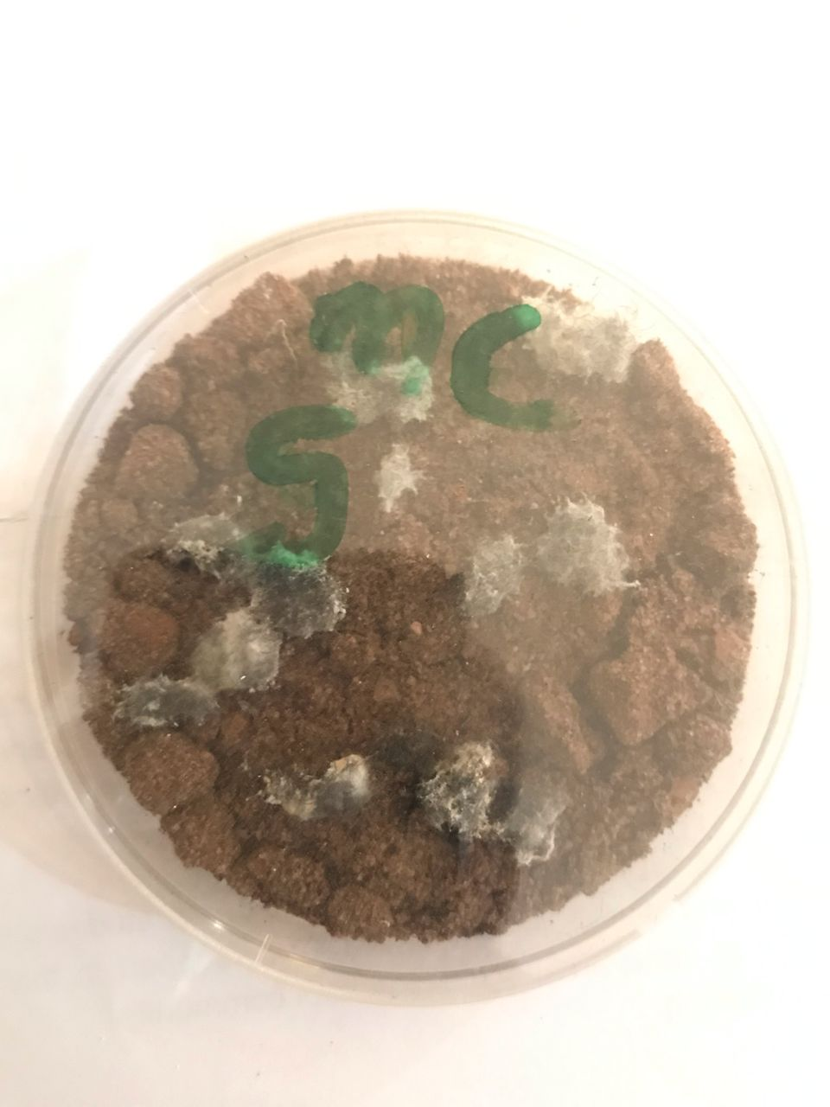
Hair baiting culture.
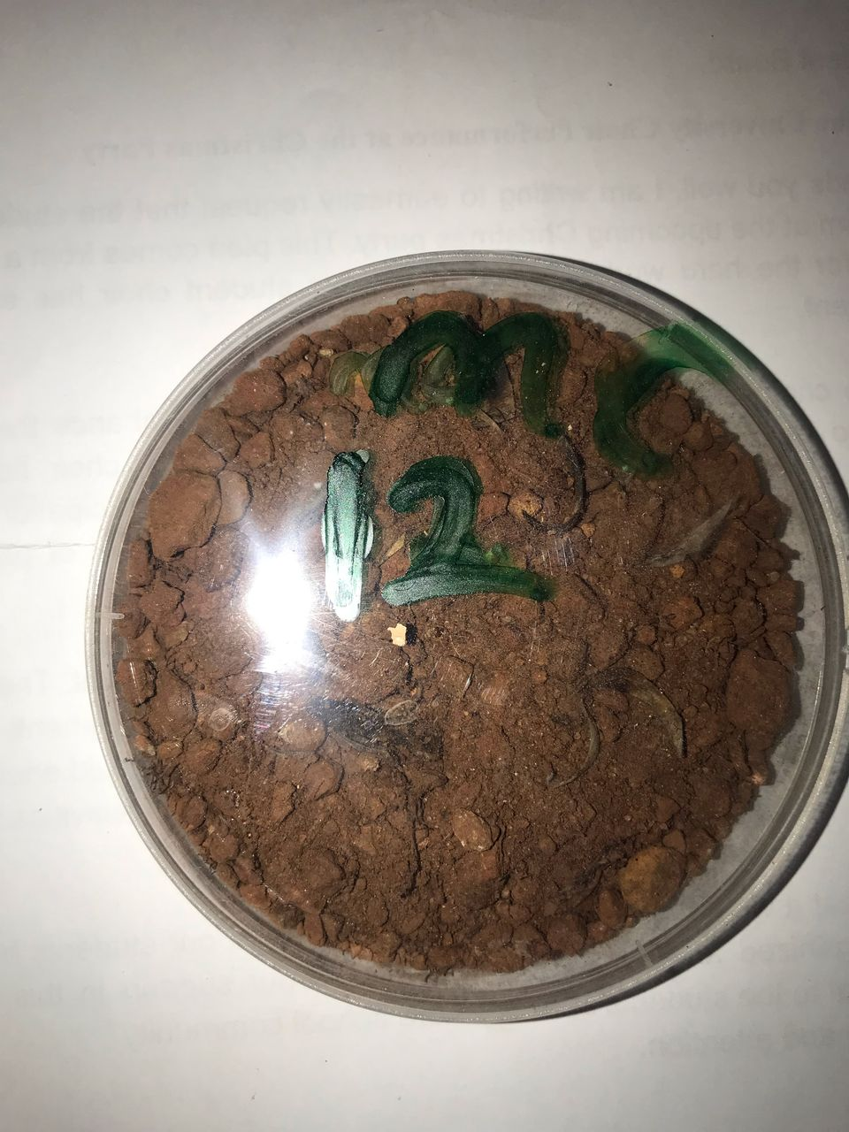
Nail-baitingculture.
Fig 4.6: Keratinophilic fungi were isolated using the "hair and nail baiting technique" from several soil samples.

The frequency of occurrence of the keratinophilic fungi (Table 2.) is in the order Aspergillus flavous 40% and Aurebasidium pullulans 30% being the most dominant and in minimum Aspergillus niger, penicillum, and Aspergillus fumigates having a percentage value of 10%.

Table 4.2: Frequency of occurrence of keratinophilic fungi at Godfrey Okoye University temporal site.
S.No | Name of fungus | Number | % value
1. | Aspergillus niger | 1 | 10
2. | Aspergillus flavus | 4 | 40
3. | Penicillium | 1 | 10
4. | Aurebasidium pullulans | 3 | 30
5. | Aspergillus fumigates | 1 | 10
 | Total Isolates | 10

CHAPTER FIVE
DISCUSSION, CONCLUSION, AND RECOMMENDATION
5.1 Discussion
According to the study's results, some soil fungi at Godfrey Okoye University have the ability to break down keratin, a protein found in skin, hair, and nails. This property is known as keratinophilic, and it is significant in several ecological and medical contexts.
They are crucial for decomposing keratin-containing objects and releasing nutrients into the soil, which enhances soil fertility, promotes plant growth, and emphasizes the role these fungi play in preserving ecological equilibrium.
Numerous studies conducted in different regions of India in recent years have demonstrated that soils contain a wide range of keratinophilic fungus flora (Simpanya and Baxter, 1996). According to this study, keratinophilic fungi were more prevalent in home and agricultural settings, which act as reservoirs.
Aspergillus flavus had the greatest frequency percentage of 40% among the isolated fungi, followed by Aurebasidium pullulans with 30%, Aspergillus niger with 10%, Penicillium 10%, and Aspergillus fumigates 10% with the lowest frequencies respectively.

Additionally, these fungi can decompose waste materials that are high in keratin, such as hair and feathers, offering a novel approach to waste management. These fungi generate proteolytic enzymes that could be useful in a few industries, including the textile and pharmaceutical sectors. From a medical and veterinary standpoint, Godfrey Okoye University's study of keratinophilic fungi can provide insight into the biology of dermatophytes, which cause illnesses of the skin and nails.
Perfect et al. (2001) and Marr et al. (2002) state that Aspergillus fumigatus, Aspergillus niger, and Aspergillus flavus are the three main species that are known to cause disease in people. Aspergillus flavus appears to have shown more frequently, with four appearances in this study. The researchers can aid in directing the creation of antifungal drugs by clarifying the keratin-degrading mechanism of these fungi, which would ultimately improve the health of both people and animals.
The high frequency of these fungi in these soils explains why animal and human hair, as well as bird feathers that have been dropped or come from dead animals, act as substrates for microbial decomposition. The natural breakdown of keratinized leftovers is significantly aided by keratinophilic fungi. Sharma and Rajak (2003) found that the park was a rich source of many keratinophilic fungi, obtaining 641 isolates from 125 soil samples.
However, because of environmental elements like heat and humidity, keratinous soil is prevalent in India and other tropical nations. All of these elements, along with good personal cleanliness, contribute to the growth of fungal infections and the development of fungal diseases. The current study can educate the general public, who are either directly or indirectly connected to these habitats, on the importance of adhering to health rules to avoid and control fungal disease.
The predominant keratinophilic fungus; Aspergillus flavus, is isolated 36.4% of the time. This suggests that keratin, a protein present in skin, hair, and nails, is easily broken down by Aspergillus flavus.
Other keratinophilic fungi include; Aurebasidium pullulans (30%),Aspergillus fumigatus (10%), Penicillium (10%), and Aspergillus niger (10%) are further keratinophilic fungi that were isolated from soil samples.

The presence of these keratinophilic fungi in the soil shows that:
- The soil can support the development of fungi that can break down keratin materials.
- The fungus can play a role in decomposing organic materials and recycling nutrients in the soil.
- The presence of Aspergillus flavus, in particular, may have implications for managing keratin-containing waste materials.
Humans can have a variety of symptoms, including respiratory ones like a runny nose, sneezing, coughing, itching, etc., depending on the species of fungus, exposure degree, and individual sensitivity.

5.2 Conclusion
The results of this study provide insight into the keratinophilic potential of soil fungi from Godfrey Okoye University. Aspergillus flavus conspicuous presence suggests that it plays a critical role in the decomposition of soil detritus that contains keratin.
It is clear from the current study that these soils offer the ideal conditions for keratinophilic fungi. This could be due to the high concentrations of organic waste and keratinous substrates in some soils. However, the fungi isolation was inconsistent due to its reliance on organic components. The amount of organic matter in soils is one of the primary factors affecting the presence of keratinophilic fungi. (Doe, 2020).
These animal infections and human fungi may therefore be considered bioindicators of environmental contamination and may be a risk factor for mycosis in both humans and animals due to their keratinous substrate. Keratinophilic fungi include both dermatophytic and non-dermatophytic types. Anamorphic hyphomycetes, another name for dermatophytes, are keratinophilic fungi that parasitize keratinized tissue, such as skin, hair, and nails, in both humans and animals and cause dermatophytoses. These are the most prevalent fungal diseases in the world.
Determining the role of keratinophilic fungi in these circumstances requires an understanding of the presence of both dermatophytes and non-dermatophytic fungi in soil. The current study makes it abundantly evident that the keratinophilic fungi thrive in the soils of Godfrey Okoye University's temporary sites. The high levels of keratinous substrates and organic detritus in certain soils may be the cause of this. However, because it depends on organic matter, the isolation of fungi was not consistent.
With their keratinous substrate, these human and animal infections may be regarded as bio-indicators of environmental contamination and may be a risk factor for both human and animal mycoses.
5.3 RECOMMENDATIONS
One of the main variables influencing the keratinophilic fungi in soils is the amount of organic matter present. According to the current study, Aurebasidium pullulans and Aspergillus flavus are quite common in soils of Godfrey Okoye University's temporally site, and further taxonomic and ecological research is required to completely comprehend these species. People living within these study sites are advised to prioritize good hygiene by regularly washing and drying their skin, especially between their toes and in skin folds.

REFERENCE
Abarca, M.L., Castella, G., Martorell, J., Cabanes, F.J., (2010). Chrysosporiumguarroi specie. nov. A new emerging pathogen of pet green iguanas (Iguana iguana). Medical Mycology. 48(2): 365-72
Abarca, M.L., Martorell, J., Castella, G., Ramis, A., Cabanes, F.J., (2009). Dermatomycosis in a pet inland bearded dragon (Pogona vitticeps) caused by a Chrysosporium species related to Nannizziopsis vriesii. Vet Dermatol. 20: 295-9.54.
Ajello Libero, Elliot m. Alpert (1972). Survey of Easter Island Soils for Keratinophilic Fungi. Mycologia 64 (1), 161-166.
Aleer, Rose, M.C., (1980). Investigation of Keratinophilic Fungi from soils in Western Australia, preliminary survey. Mycopathologia. 72: 155-165
Anane, S., Al-Yasiri, M.H., Normand, A.C., Ranque, S. (2015). Distribution of keratinophilic fungi in soil across Tunisia: a descriptive study and review of the literature. Mycopathologia. 180: 61-8 .
Anbu, P., Gopinath, S.C., Hilda, A., Mathivanan, N., Annadurai, G., Can. J. (2006) Microbiol., 52: 1060-9.
Anbu, P., Hilda, A., Gopinath, S.C., (2004). Keratinophilic fungi of poultry farm and feather dumping soil in Tamil Nadu, India. Mycopathologia, 158(3): 303 9.
Avasn, Y.M., Hossain, K., Priya, D.H., Tejaswi, B. (2012) Ad., In Applied Sciences. Research., 3(1): 605-610..
Ayatollahei, Mousavy, A., (1992). The survey and identification of soil fungi in Kerman. MSc thesis in Medical Mycology. School of Public Health, Tehran University of Medical Sciences, Iran..

Cano J, Gurrao J. (1990). The genus Aphanoascus. Mycology Research., 94: 355-77.
DeHoog, G.S., Guarro, J., Gene J and Figueras MJ (2000). Atlas of clinical fungi (second edition)
Deshmukh S.K., (2004). Isolation of dermatophytes and other keratinophilic fungi from the vicinity of salt pan soils of Mumbai (India). Mycopathologia. 157(3): 265-7.
Deshmukh, S.K., Mandeel, Q.A., Verekar, S.A. (2008). Keratinophilic fungi from selected soils of Bahrain, Mycopathol., 165(3): 143-147.
Deshmukh, S.K., Verekar, S.A., Shrivastav, A., (2010). Natural Science, 2: 1247-1252.
Deshmukh, SK., Verekar, SA, (2014). Isolation of keratinophilic fungi from selected Sanjay Gandhi National Park, Mumbai (India) soils. Journal de Mycologie Me 'dicale. 24(4): 319-27.
Fillipello, M.V., Fusconi, A., Rigo, S.,(1994). Keratinolysis, and its morphological expression in hair digestion by airborne fungi. Mycopathologia, 127: 103-15.
Fillipello, M.V., (2000). Keratinophilic fungi: Their role in nature and degradation of keratinic substrates. In: Biology of dermatophytes and other keratinophilic fungi. Eds Kushawaha RKS, Guarro J, RevistaIberoamericana de Micologia. Spain, pp.77-85.
Ganaie, M.A., Sood, S., Rizvi, G., Khan, T.A., (2010) Plant Pathology. Journal., 9: 194-197.
Gugnani, H.C., (2010) Non-dermatophytic filamentous keratinophilic fungi and their role in human infections. In: Kushwaha R.K., Guarro J, editors. Biology of dermatophytes and other keratinophilic fungi. Bilbao: Berekintza; 109-14. 2.
Hedayati, M.H., Mohseni-Bandpi, A., Moradi, S., (2005). A survey on the pathogenic fungi in soil samples of potted plants from Sari hospitals. Journal of Hospital Infection, 58: 59-62.
Itisha, S. and Kushwaha, R.K.S., (2010). Dermatophytes and Related Keratinophilic Fungi in Soil of Parks and Agricultural Fields of Uttar Pradesh, India. Indian Journal of Dermatol, 55(3): 306-308.
Jain, N., Sharma, M. (2011). Mycosis, 54: 52-8.
Khanam, S.J.P., Jain, P.C. (2002). Isolation of keratin-degrading fungi from soil of Damoh, India. Asian Journal of Microbiology, Biotechnology, Environmental Sciences. 4: 251-254.
Kumar, R., Mishra, R., Maurya, S., and Sahu, HB. (2013). Isolation and identification of keratinophilic fungi from garbage waste soils of Jharkhand region of India. European Journal of Experimental Biology, 3(3): 600-604.
Kunert, J.R.K.S., Kushwaha, Guarro, J. (2000). RevistaIberoamericana de Micologia, 9: 77-85.
Lee, S.B., Taylor, J.W., (1990). Isolation of DNA from fungal mycelium single cells. In: Innis MA, Gelfand DH, Sninsky JJ, White TJ, editors. PCR protocols: a guide to methods and applications. San Diego, California: Academic Press; publication 282-7.
Mahdavi, S., (1991). The epidemiological survey of cutaneous-superficial infections of children in Amol, Iran. MSc thesis in Medical Mycology. School of Public Health, Tehran University of Medical Sciences, Iran.
Mancianti, F., Nardoni, S., Corazza, M., D'achille, P., Ponticelli, C., (2003). Environmental detection of Microsporum canisarthrospores in the households of infected cats and dogs. Journal Feline Medical Surgery. Dec 5(6): 323-8. 4.
Marchisio, V.F. (2000). Keratinophilic fungi: their role in nature and degradation of keratinic substrate. In: Kushwaha, R.K.S., Guarro, J. (Eds.) Biology of dermatophytes, keratinophilic and other fungi. RevistaIberoamericana de Micologia, Spain, Bilbao. publication 86-92.
Maruthi, Y.A., Hossain, K., Chaitanya, D.A., Asian, J.,(2012). Plant Science Research., 2(4): 534-538 (2012).
Maruthi, Y.A., Hossain, K., Priya, D.H., Tejaswi, B., (2012). Advanced Applied. Science. Research., 3(1): 605-610.
Migahed, F., (2003). Distribution of fungi in sandy soil of Egyptian Beaches. Pak J Boil Sci, 6(10): 860-66.
Mini, K.D., Paul, M.K., and Mathew, J., (2012). Advanced Applied Science. Research., 3(4): 2073-2077.
Moallaei, H., Zaini, F., Pihet, M., Mahmoudi, M., Hashemi, J.,(2006). Isolation of keratinophilic fungi from soil samples of forests and farm yards. Iran Journal Public Health. 35(4): 62-9.
Mohamed, S., Ali-Shtayeh, Rana, M.F., Jamous, (2000). Keratinophilic fungi and related dermatophytes in polluted soil and water habitats. In: Kushawaha, R.K.S., Guarro. J. (Eds). Biology of dermatophytes and other keratinophilic fungi. RevistaIberoamericana de Micologia, Spain. publication. 51 59.
Nasery Bande Gharaey, A. (1992). The survey and study of cutaneous-superficial infections in patients referred to dermatology clinics in Mashhad, Iran. MSc thesis in medical mycology. Faculty of Medicine, University of Tarbiat Modares
Ogbonna, C.I., Pugh, G.J. (1987). Mycopathologia, 99: 115-8.
Pare, J.A., Jacobson, E., (2007). Mycotic diseases of reptiles. In: Jacobson E, editor. Infectious diseases and pathology of reptiles: a color atlas and text. Boca Raton: CRC Press; publication. 527-70.
Rajeev, S., Sutton, D.A., Wickes, B.L., Miller, D.L., Giri, D., Van, Mete, M., Thompson, Ε.Η., Rinaldi, MG., Romanelli, A.M., Cano, J.F., Guarro, J.,(2009). Isolation, and characterization of a new fungal species, Chrysosporiumo phiodiicola, from a mycotic granuloma of a black rat snake (Elapheobsoletaobsoleta). J ClinMicrobiol. 47(4): 1264-8 (2009).
Ramesh, V.M., Hilda, A. (2003). Mycopathologia, 143: 139-45. 1999. Sharma, R., Rajak R.C. 2003. Keratinophilic fungi: Nature's keratin-degrading machines! Their isolation, identification, and ecological role. Resonance, page. 28-40.
Reiss, E, Shadomy, H.J., and Lyon, G.M. (2012). Fundamental Medical Mycology, John Wiley and Sons, Inc., Publications, Page 47-49.
Roilides, E., Sigler, L., Bibashi, E., Katsifa, H., Flaris, N., Panteliadis, C., J (1999) Clin Microbiol., 37: 18-25.
Sharma, R. and Rajak, R.C.,(2003). Keratinophilic Fungi: Nature's Keratin Degrading Machines! Their Isolation, Identification, and Ecological Role. Resonance, 8 (9): 28-40.
Shokohi, T., Hedayati, M.T., Bakhshi, H.J., (2005). Kermanshah Uni. Med. Sci., 8: 25-32 .
Simpanya, M.F. (2000). Dermatophytes: their taxonomy, ecology and pathogenicity. In: Kushwaha, R.K.S., Guarro, J. (Eds.) Biology of Dermatophytes and Other Keratinophilic Fungi. RevistaIberoamericana de Micologia, Spain, Bilbao. Page. 1-10.
Singh, C.J., Singh, B.G., Singh, B.S.,(1994). Keratinophilic fungi of Ghana birds Sanctuary Bharatpur (Rajasthan). Ad Plant Sci., 7: 280-91.
Stchigel, A.M., Sutton, D.A., Cano-Lira, J.F., Cabanes, F.J., Abarca, L., Tintelnot, K., Wickes, B.L., Garcia, D., Guarro, J., (2013). Phylogeny of chrysosporia infecting reptiles: proposal of the new family Nannizziopsiaceae and five new species. Persoonia. 31: 86-100.
Sundaram, B.M., Subramanian, S. (1986). Indian Journal Microbiology., 26: 138-140.
Sunil, K., Deshmukh, Shilpa, Amit, Verekar, Yashwant, G. Chavan. (2017). Incidence of keratinophilic Fungi from the selected soils of Kaziranga National Park, Assam (India). Mycopathologia 182: 371-377.
Sutton, D.A., Marı 'n Y, Thompson, E.H, Wickes, B.L, Fu, J., Garcı 'a D., Swinford, A., de Maar, T., Guarro, J.,(2013). Isolation and characterization of a new fungal genus and species, Aphanoascellagalapagosensis, from carapace keratitis of a Galapagos tortoise (Chelonoidisnigramicrophyes). Medical Mycology. 51(2): 113-20.
Tamura, K., Stecher, G., Peterson, D., Filipski, A., Kumar, S., (2013). MEGA6: molecular evolutionary genetics analysis version 6.0. MolBiolEvol. 30: 2725-9.
Vanbreuseghem, R. (1952). Technique biologique pour l'isolement des dermatophytes du sol. Ann. Soc. Belge. Med. Trop., 32: 173-178.
Vidyasagar, Shivkumar, G.M., D., Hosmani, Ν, (2005). Keratinophilic fungi isolated from hospital dust and soils of public places at Gulbarga, India. Mycopathologia. 159(1): 13-21.
Zarrin, M., Haghgoo, R., (2011). Jundishapur Journal Microbiology., 4(3): 191-194.

