

DEVELOPMENT OF A SMART CLOCKING-IN SYSTEM FOR EMPLOYEES
USING COMPUTER VISION

BY

OFOEGBU SANDRA ADAEZE
GOU/U21/CSC/686

DEPARTMENT OF COMPUTER SCIENCE AND MATHEMATICS,
FACULTY OF NATURAL SCIENCE AND ENVIRONMENTAL STUDIES,
GODFREY OKOYE UNIVERSITY, ENUGU

JULY, 2025

DEVELOPMENT OF A SMART CLOCKING-IN SYSTEM FOR EMPLOYEES
USING COMPUTER VISION

BY

OFOEGBU SANDRA ADAEZE
GOU/U21/CSC/686

DEPARTMENT OF COMPUTER SCIENCE AND MATHEMATICS,
FACULTY OF NATURAL SCIENCE AND ENVIRONMENTAL STUDIES,
GODFREY OKOYE UNIVERSITY, ENUGU

IN PARTIAL FULFILLMENT OF THE AWARD OF BACHELOR OF SCIENCE (B.Sc), DEGREE IN COMPUTER SCIENCE.

SUPERVISOR: PROF. N. M. OZOFOR

JULY, 2025
APPROVAL PAGE
This research work titled “SMART CLOCKING-IN SYSTEM FOR EMPLOYEES USING COMPUTER VISION” has been assessed and approved by the department of Computer Science and mathematics committees in the Faculty of Natural Sciences and Environmental Studies, Godfrey Okoye University, Enugu, Nigeria.

Prof. N. M. Ozofor __________________ __________________
Supervisor Signarure Date

External Examiner __________________ __________________
External Examiner Signarure Date

Dr. Frank Okebanama __________________ ___________________
HOD. Department of Signature Date
Computer Science and
Mathematics

Prof. Chidi.C. Uhuegbu __________________ __________________
Dean FNESS Signature Date

CERTIFICATION
I certify that I completed the research included therein and that it was primarily based on my observation and investigation. Consequently, I will fully accept the university’s decision if I am found to have cheated on the assignment.

__________________________
OFOEGBU SANDRA ADAEZE
GOU/U21/CSC/686

DEDICATION
I dedicate this project to God Almighty, for His unending grace and strength throughout this journey.
I also dedicate it to my beloved parents and family members whose prayers, love, and constant support made this achievement possible.
To every student striving through sleepless nights, this is for you…., don’t stop pushing!.
ACKNOWLEDGMENTS
First and foremost, I give all glory to God for giving me the life, wisdom, and strength to complete this project successfully.
My sincere gratitude goes to my supervisor, Prof. N.M. Ozofor, for his guidance, constructive feedback, and patience throughout this work.
I deeply appreciate the entire staff of the Department of Computer Science at Godfrey Okoye University for their valuable teachings and encouragement.
Special thanks to my family and friends for their unwavering love, support, and prayers.
To my fellow final year students …., we made it!
And lastly, to my brothers for supporting me with the development of this project …., I truly couldn’t have done it without you.

ABSTRACT
This project focuses on the development of a Smart Clocking-In System for Employees Using Computer Vision. The primary objective was to design and implement a secure, contactless attendance system that eliminates impersonation and enhances accuracy using facial recognition technology. The system was developed as a web-based application using React.js, Next.js, and Tailwind CSS, with Firebase serving as the backend platform. For facial detection and authentication, the system integrates Face-api.js, a JavaScript library powered by TensorFlow.js, and pre-trained AI models capable of real-time face recognition. Additionally, geolocation enforcement was implemented to ensure that users can only clock in within a defined physical location. The system features role-based access with separate dashboards for employees and administrators, real-time attendance tracking, and analytical reporting. The results of the project demonstrate a reliable and innovative solution for organizational time management, with room for future improvement in mobile support, biometric diversity, and system integration.

TABLE OF CONTENTS

Title Page i
Approval ii
Certification iii
Dedication iv
Acknowledgements v
Abstract vi
Table of Contents vii
List of Tables ix
List of Figures x

CHAPTER ONE: INTRODUCTION 1
1.1 Background to the Study 1
1.2 Statement of the Problem 3
1.3 Aims and Objectives 3
1.4 Significance of the Study 4
1.5 Scope of the Study 5
1.7 Operational Definition of Terms 5

CHAPTER TWO: LITERATURE REVIEW 6
2.1 Introduction 6
2.1.1 Brief History of Computer Vision 7
2.1.2 Description of Categories of Computer Vision 8
2.1.3 The Future of Computer Vision 10
2.2 Theoretical Framework 12
2.3 Review of Empirical Studies 13
2.4 Summary of Reviewed Works 18
2.5 Contribution to Knowledge 19

CHAPTER THREE: SYSTEM ANALYSIS AND DESIGN 20
3.1 Overview 20
3.2 System Analysis 20
3.2.1 Existing System 20
3.2.2 Weakness of Existing System 21
3.2.3 Analysis of the Proposed System 22
3.2.4 System Requirements 23
3.2.5 Methodology (OOAD) 24
3.3 AI Model Integration 31
3.4 Database Design 32

CHAPTER FOUR: SYSTEM IMPLEMENTATION 36
4.1 Introduction 36
4.2 Tools Used for Implementation 36
4.3 System Requirements 40
4.4 User Interface Design 41

CHAPTER FIVE: SUMMARY, CONCLUSION & RECOMMENDATION 50
5.1 Introduction 50
5.2 Summary of Study 50
5.3 Conclusion 51
5.4 Recommendations 51
5.5 Limitations of the Study 52

REFERENCES 53
APPENDIX 55

LIST OF TABLES
TABLE PAGE
3.1 User Table – Authentication and Role Management 33
3.2 Employee Table – Employee Information Management 33
3.3 Admin Table – Admin-Specific Details 34
3.4 FaceRecognition Table – Stores Face Authentication Data 34
.5 Attendance Table – Records Employee Clock-in/Out 34
3.6 Reports Table – Stores Generated Reports 35

LIST OF FIGURES
FIGURE PAGE
3.1 Use case diagram of the proposed system 26
3.2 Activity diagram of the proposed system for user access/employee clock in/out 27
3.3 Activity diagram of the proposed system for admin management/facial authentication 28
3.4 Class diagram of the proposed system 29
3.5 Sequence diagram of SMART CLOCK-IN SYSTEM user registration 31
4.1 SmartFace Check-In Webpage 42
4.2 Login page of the SmartFace Check-In 43
4.3 Admin User Registration and Email Notification 44
4.4 Face Recognition Interface 45
4.5 Employee Attendance Interface 46
4.6 Employee User Profile Interface 47
4.7 User Profile for Admin Interface 48
4.8 Attendance Section of the Admin Interface 49
4.9 Analysis Section of the Admin Interface 49

CHAPTER ONE
INTRODUCTION
1.1 Background to the Study
In the past years, the attendance management of employees has changed a lot, which reflects broader changes in workplace dynamics and technology capabilities. This has been particularly significant in Nigeria, where organizations are trying to transform from traditional to digital systems at their workplaces. Almost all academic institutions wish for a more sophisticated way to take the attendance of their students, and at the top of this list is Godfrey Okoye University in Enugu State since their traditional methods have been more than wanting for modern workplace needs (Nnamdi et al., 2023).
The historical development of attendance management systems is an incremental saga of technological adoption and adaptation. Early methods of doing it were heavy on paper-based systems, a great way that was easy to implement but full of loopholes for error and manipulation. Huge steps were taken with the introduction of mechanical punch cards in the 1970s and early digital systems in the 1990s. Still, these solutions rise to the occasion of capturing the most fundamental challenges concerning accuracy and efficiency (Okonkwo & Eze, 2022).
A historical revolution within the attendance management sector was the advent of biometric systems in the early 2000s. The very first uses within the sector were based on fingerprint recognition, but even with that, they remained unsatisfactory because of the high maintenance required to keep them clean for hygiene reasons. However, the deficiencies of contact-based systems have become glaring during infestation, which has led to the call for the adoption of more advanced contactless solutions by organizations (Kumar & Wilson, 2021).
Re-identification based on computer vision technology is a potential approach to address these long-standing problems. Recent works on vast learning algorithms, especially Convolutional Neural Networks (CNN), have been widely applied to revolutionize facets of accuracy and reliability with facial recognition systems. These research works pave the way for a robust solution that is effective for working in real-time environments to implement the attendance management system (Adeleke et al., 2023).
The combination of artificial intelligence with computer vision is a solution to some of these perennial challenges with facial recognition technology. Modern systems recognize the lights in place and can handle many images at a time while maintaining high accuracy, even if parts of the face are covered. Across Nigerian institutions, research supports that organizations that have implemented these smart attendance systems have indeed increased their operational efficiency and accuracy rates.
The financial implications of an inefficient attendance management system are simply huge. Traditional systems have it that about 2.5% of the annual payroll of organizations goes towards time theft and attendance fraud alone, which, in the end, translates into monetary losses. There is, however, a financial burden of manual attendance management that by all means should push someone to go for an automated solution.
Nonetheless, more recent computer vision–based attendance systems can process facial recognition tasks in real-time, securely store data in the cloud, and avail attendance records at various points instantaneously. This technological integration has made it very easy and cost-effective to implement advanced attendance solutions in Nigerian institutions today (Thompson et al., 2023).

1.2 Statement of the Problem
Employee attendance management is a crucial aspect of organizational operations, ensuring efficiency, accountability, and productivity. However, traditional clocking-in methods such as manual attendance logbooks, RFID card-based systems, and fingerprint scanners pose significant challenges. Manual systems are prone to errors, time theft, and impersonation, while RFID cards can be easily misplaced, stolen, or misused by unauthorized individuals. Fingerprint scanners, although an improvement, have their drawbacks, including hygiene concerns and susceptibility to wear and tear over time.
Furthermore, organizations often struggle with buddy punching, where employees clock in for their colleagues, leading to financial losses and inaccurate attendance records. Existing biometric systems may also fail due to environmental factors, technical malfunctions, or physical damage to biometric features (e.g., cuts on fingers affecting fingerprint recognition).
To address these challenges, this project proposes a face recognition-based employee time tracking system called Smart Clocking-In System for Employees Using Computer Vision for Face Detection and Recognition will resolve current attendance system limitations. Through facial recognition technology the system delivers both secure and automatic attendance management which combines contactless operations to enhance organizational efficiency while eliminating imposture incidents.
1.3 Aims and Objectives
This research aims to develop a smart attendance monitoring system built with computer vision technologies to replace existing problems with current timekeeping methods.
The objectives include the following:
- To implement Face Detection and Recognition using deep learning algorithms (CNN, FaceNet).
- To design a web-based interface for employee Login/Logout.
- To ensure Real-time authentication and prevent unauthorized access.
- To maintain a database system that will secure and manage facial presentation of workers
- To enhance accessibility for Administrators by providing a user friendly interface for monitoring and generating reports.
- To verify employee location using geolocation (latitude/longitude) during clock in.
1.4 Significance of the Study
The implementation of a smart clocking-in system using face recognition technology will have several significant benefits. Organizations will experience improved security and efficiency in employee attendance management, eliminating fraudulent practices such as buddy punching and unauthorized access. The contactless nature of the system also promotes better hygiene, addressing concerns associated with fingerprint scanners and other touch-based biometric systems.
For supervisors and administrators, this system provides a real-time and automated solution for tracking employee attendance, reducing administrative workload, and ensuring accurate payroll processing. It will also enhance workforce accountability by providing a transparent and tamper-proof record of employee attendance.
Furthermore, this study contributes to the advancement of computer vision technology in workforce management, demonstrating its practical applications in improving security and efficiency in organizational processes. Researchers, developers, and organizations interested in biometric authentication and attendance management systems will benefit from this study as a reference for future innovations.
1.5 Scope of the Study
The scope of this project is based on the development and implementation of the face recognition attendant for effective work in the typical Nigerian office environment. It includes the following:
- Development of facial recognition algorithms optimized for diverse local conditions.
- Secure database implementation for controlling access to employee information.
- Designing administrative interfaces that allows management of the system to ensure cordination and security.
- Testing and validation in different environments conditions.
1.6 Operational Definition of Terms
Computer Vision: A branch of computer science that works on enabling machines to interpret and process visual data as done by the human eye in the digital world.
Facial Recognition: A biometric technology applied in the identification or verification of personal identity through facial features.
Deep Learning: A complex form of machine learning that incorporates multiple layers of artificial neural networks and, hence, ensures higher accuracy.
Real-Time Processing: The ability to carry out analysis of data in hand, concurrently with processing by the system.
Edge Computing: It is a distributed computing framework that processes data near the source rather than a centralized location.
Biometric Authentication: This is a process to verify the identity of an individual based on unique biological traits.
CHAPTER TWO
LITERATURE REVIEW
2.1 Introduction
Technology has had a greater impact on how organizations operate than on the management of employees. One of the most important aspects of employee management affected the most is attendance. Earlier, attendance was recorded through registers and time entries. Traditional procedures include signing books and recording. Despite their strengths, they also have many disadvantages such as errors, poor workmanship, or other employee frauds. Therefore, automation systems were needed to complete the process efficiently and accurately.
One of the technologies is the application of computer vision to a smartwatch-based system that provides safe, non-invasive, and contactless contact using facial recognition and recognition technology.
Computer vision is a group of artificial intelligence techniques that allow machines to understand and analyze information seen in images and videos. The technology developed from these concepts is now widely used in areas such as health and safety, entertainment, and retail.
Computer Vision Attendance Management offers innovative solutions that can accelerate the attendance process by recognizing the unique facial features of employees. And business efficiency. Face detection and recognition is a basic application of computer vision, achieved by tracking faces in images or videos through complex algorithms and deep learning models. This means not only verification but also validation to ensure that employee attendance data is accurate and reliable. This way, organizations can reduce the issues inherent in regular attendance, such as time theft and onboarding.

2.1.1 Brief History of Computer Vision
Since its foundation, computer vision has undergone major progression due to computational power, algorithm development, and big data. The crux of the modern CV systems can be traced back to the 1960s when researchers first started to consider how to endow machines with the ability to comprehend pictures. In the beginning, the studies on computer vision were more basic e.g. edge detection and pattern recognition which are the basic blocks of today’s computer vision. The idea is to get computers to approximate how humans perceive the world. Researchers created algorithms that would allow the computation of visual data and recognition of simple shapes and patterns. Among the first great breakthroughs of this period came in the area of edge detection, where algorithms like the Sobel and Canny edge detectors became key for image processing. Indeed, other such technologies have developed in tandem with education. Statistical approaches gain a foothold in science to increasingly produce reliable interpretations of measured data. This period saw breakthroughs in object recognition and 3D reconstruction, enabling computers to process and understand complicated images. Methods for detecting and describing points of interest such as the Scale-Invariant Feature Transform (SIFT) became prevalent during this time and were a huge leap forward. Image Annotation, a new perspective To enhance image recognition, researchers started working with multilayer perceptrons and other early neural network architectures. Computational limitations at the time, however, meant that the technique couldn’t be used. Despite all these challenges, deep learning foundations were established in this period and set the stages for future success, enabling the emergence of several different algorithms. Now machine learning designers are starting to train their models and increase their potential by tapping into big data. Then came CNNs which changed the scenario of image/video processing forever. Among the highlights of this period is the training of AlexNet, which won first place in the ImageNet Large-Scale Visual Recognition Challenge (ILSVRC) in 2012, and proved that deep learning is effective in computer vision. The power of interdisciplinary collaboration: The development of the field has been fueled by insights from computer science and mathematics as well as neuroscience. The field is still in its infancy and has the potential to solve some of the most complex problems of our time and shift economies. This paper’s historical perspective provides a foundation for understanding the technologies and processes for developing smart entry systems for employee management.
2.1.2 Description of Different Categories of Computer Vision
Computer vision is an interdisciplinary field that applies artificial intelligence, machine learning, and image processing to make computers perceive and understand pictures or video. Within the field, there exist various categories, each with different uses and technology. The result has been a wide range of applications. Going further in this review, we would like to focus on the primary categories of computer vision and their impact on biometric systems and facial detection and recognition.
Biometric Systems
Biometric systems are, hence, part of the major applications devised for human identification and classification based on some specific physical and/or behavioral features. In such cases, to prove that a user is who he claims to be, techniques like the fingerprint, iris impression, or voice recognition mechanism are used. Out of the many sub-branches of a biometric system, face recognition has gained a lot of attention due to its unique nature, which is nonintrusive and noncontact. This will be attractive for entrance-related application settings.
A biometric system, in general, consists of three major stages: data collection, extraction, and matching.
Object Detection and Recognition
The domain of computer vision and machine learning has seen great improvement in the accuracy and reliability of systems, now made the most sought-after in securing access and managing attendance. Search and recognition refer to the identification and classification of objects in images or videos. This computer vision area is useful for developing many applications related to autonomous vehicles, surveillance, and augmented reality. The most common approaches to object detection include YOLO, which stands for You Only Look At One, and Faster R-CNN.
Object detection was effectively carried out within gated machines to find faces in a crowd or to distinguish multiple people in a frame.
Face Detection and Recognition
Face recognition takes it a step further by identifying an individual. Using CNNs, Haar cascades, and the HOG algorithm, this application is based on deep learning models. The acceptance of face recognition and machine learning has dramatically improved with big data and increasing computing power. The technology is widely used in the security, mobile device, and employee management areas. This technique is used to identify specific objects or areas of interest in an image.
Image Segmentation
Segmentation means breaking the image into several parts, which can make the image easier to analyze and help to segment particular objects or regions of interest with an image. On face recognition, segmenting the image will help identify parts of the face and separate them from the background. The technique is useful in identifying faces and other features against a complex background.
Motion Detection and Object Tracking
Motion detection and tracking is the capability to watch an object's movement or progress with a video frame. This branch of computer vision is largely applicable to surveillance, sports analysis, and human-computer interaction. An attendance system may even track the movement of employees to make sure that correct data gets recorded. In personnel management, face recognition is applied to detect people walking toward the camera in real time.
Applications in Real-Time Systems
This range of applications has spun a revolution across several industries by applying computer vision technologies in real-time. For example, real-time systems could involve video footage of an employee taken at the entrance of a building while facial recognition takes place within an employee tracking system. For example, time-related application at the camera's approach demands effective algorithms to work in real-time with video data processing without losing accuracy. Having such technology, corporations come up with systems that will enhance efficiency, security, and user experience.
2.1.3 The Future of Computer Vision
The future of computer vision will change many industries and will define the way machines are going to interact with the visible world in the future. Computer vision is set to reach unprecedented levels of accuracy, efficiency, and usability with the continued advancement in artificial intelligence, machine learning, and hardware capabilities. It is starting to be real a world issue. In most fields such as healthcare, security, transportation, and management control, it can be applied and will be one of the most important components of future development. Improving algorithms and hardware will enable a large increase in real-time usage of computers. Smart entry solutions using instant facial recognition technology allow for instant attendance tracking employee attendance in facilities having large physical mobility. Facial recognition technologies in the implementation now lock in higher precision standards for unattended attendance platforms. Such data processing activities that run close to such physical assets as smartphones, and cameras, allow organizations to achieve low latency but increased privacy protections. This development is deemed necessary when instant decision capabilities need to be defined for security and surveillance applications. By deploying computer vision solutions through edge computing installations they are able to operate at remote locations and remote constrained locations thus extending their deployment reach to new locations. Recently, artificial neural network systems like Transformers and Generative Adversarial Networks (GANs) have made computers understand visual information depth by far. The functionality of the facial recognition system will be improved by technological progress to overcome such light conditions and physical blocks. The combination of Visual Materials with other sensory activities under multimodal learning conditions makes the building of VR applications. Computer vision processing offers computer chip machines the ability to work in 3D space which greatly improves gaming entertainment and also education and training. Can work environments become smarter through AR implementation when computer vision technology develops interfaces that detect facial characteristics and monitor body motions? The system enables automated execution of fundamental operations which span from building entrance authentication to object tracking systems.
Strong concerns about data privacy are increasing alongside worries about corruption. Research and development teams generated transparent and confidential algorithms as technology grew more complex to deal with data privacy issues. Research on government training alongside privacy distinctions explores methods for computer vision systems to operate without exposing sensitive data. Security and user experience. Face recognition algorithm development improves identification accuracy alongside predictive analysis which delivers complete organizational personality and business understanding. The implementation of AI annotations will create transparency for these systems because it leads to user trust. The development of facial recognition technology will create future avenues for automating tasks while enabling superior machine-to-human communication and intelligent decision systems. The modern smartwatch world will spark improved secure and efficient solutions that draw users toward a productive hyper connected workplace.
2.2 Theoretical Framework
The theoretical framework provides the foundation for understanding how computer vision and biometric authentication contribute to attendance management. The research bases its foundation on these theories:
2.2.1 Image Processing Theory
Using computational techniques the Image Processing Theory demonstrates how to enhance digital images and analyze these images and interpret them. Modern face detection and recognition systems apply edge detection along with feature extraction and pattern recognition methods for their operation. The proposed system uses this theory for face detection tasks to precisely locate facial attributes in order to perform accurate mapping of detected features.
2.2.2 Machine Learning Theory
The essential element for biometric authentication systems is machine learning (ML). Face recognition algorithms implement learning models of ML to differentiate different human faces. The deep learning-based face recognition systems mostly use Convolutional Neural Networks (CNNs) for their operations. ML-based algorithms in the proposed smart clock-in system enhance performance by enabling accurate adaptation in various environments with changing luminosity.
2.2.3 Technology Acceptance Model (TAM)
People embrace and utilize technology through the Technology Acceptance Model (TAM) according to their assessments of usefulness alongside ease of use. The user acceptance of both smart clocking-in system functions will improve when the system demonstrates user-friendly operation while ensuring security and reliability. The framework serves to prioritize system design aspects which emphasize usability together with efficiency.
2.3 Review of Empirical Studies
Face recognition systems have increasingly gained scholarly and commercial attention in recent years due to their potential to revolutionize access control, surveillance and time tracking in various organisational contexts. Multiple empirical studies have examined the application, effectiveness, limitations, and ethical considerations of facial recognition in workplace attendance systems. This section provides an enriched review of selected studies that have influenced the development of this project.
Smith et al. (2019) researched face recognition technology because it can enhance existing workplace attendance tracking systems. Smith et al developed a real-time employee attendance system that applied convolutional neural networks (CNNs) to achieve its functionality. The automated attendance system detected faces from real-time video streams before automatically creating logs of user identities. Under controlled conditions, the research attained high-performance levels. Face detection systems failed to identify users wearing glasses or masks creating operational challenges which reduced their effectiveness in practical implementations.
Chen & Lee (2020): "Biometric Authentication in Workplaces", Chen & Lee investigated various biometric protocols and found face recognition to be one of the most user-friendly and non-intrusive methods. Despite its advantages in speed and convenience, their study pointed out that small-scale businesses might find implementation costly due to hardware and software infrastructure requirements.
Researchers performed a study to understand how biometric authentication functions when combined among fingerprinting with iris scanning and face recognition protocols. Chen and Lee identified face recognition as the optimal workplace access solution which provided simple authentication with minimal respect to employee privacy. Researchers emphasize the need to develop robust algorithms that can process multiple lighting scenarios. Face recognition deployment remains challenging for small organizations because they must overcome substantial project implementation expenses.
Kumar et al. (2021): "AI-Driven Employee Monitoring Systems", Kumar et al constructed a dual recognition system that merges behavioral employee assessments with face recognition technology through employee tracking mechanics. An AI-powered system uses deep learning algorithms both for workplace presence surveillance and productivity tracking capabilities. Advanced AI approaches within this research attracted privacy issues due to potential ethical problems from continuous monitoring.
Jones et al. (2018): The name of the system is formally called 'Face Recognition for Secure Access Control'. In this work, we see that Jones et al. first invented a security-focused access control system that first detects people using Haar cascades and then uses deep learning-based recognition algorithms. On the other hand, the authorized personnel detection performance was satisfactory yet strong security triggering errors were induced when system operation was within the active settings. According to the researchers' study, training datasets provide a good basis upon which to raise the system accuracy levels.
Ahmed & Ibrahim (2019): "Facial Recognition in Real-Time Systems", Every year, Ahmed and Ibrahim build their educational attendance solution using newer advances in facial recognition through real-time systems. Execution capabilities of the system were provided using the combination of Python and OpenCV library components. The developed system achieved its designed targets when working under optimal conditions though the system performance degraded as light or camera angles changed. The researchers would help overcome those system limitations if they used deeper learning approaches.
Gupta et al. (2020): "Deep Learning for Biometric Systems", Gupta et al. studied the utilization of CNNs together with deep learning approaches for biometric system applications. Based on their findings CNNs proved better than standard methods such as Eigenfaces for facial recognition. The models faced limitations that prevented their practical utilization when operating on hardware with constrained resources.
Wang & Zhao (2017): "Optimizing Face Recognition Algorithms", Researchers in this examination dedicated their efforts to maximizing face recognition algorithm performance while maintaining accuracy rates. The researchers at Wang and Zhao developed a lightweight model to operate effectively on edge hardware systems. Despite its success with real-time recognition, the model delivered poor results when used to detect multiple faces at once.
Patel et al. (2021): "AI-Based Solutions for Workplace Attendance", Patel et al established an AI-based attendance system that combined face recognition technology alongside cloud processing components. The system stored and processed data in one central location which enabled large organizations to expand the system efficiently. Composed infrastructure used by the reliability led to data privacy and latency issues.
Singh & Roy (2018): Face Recognition in Low Light Conditions, to overcome face recognition problems in dim light environments, Singh and Roy create to solve them. They preprocessed the image for enhancement of image quality to be a prerequisite for recognition. However, this solution produced better identification results under poor illumination but with an added expense of additional processing steps that limited the applicability of the solution in real-time operations.
Chandra et al. (2020): "Ethical Implications of Biometric Systems", In their research on biometric systems deployment, the researchers Chandra et al. dedicated their work to the aspects of ethics of using face recognition technology. First, the research team contended that privacy dilemmas constitute their first concern before addressing system misuse risks and that personal consent is missed. By researching they showed that the implementation of ethical projects requires the use of the policy frameworks together with the procedural instructions.
Hassan et al. (2019): "Comparative Analysis of Biometric Methods", Hassan et al.’s research aims to develop a comparative research matrix to assess various biometrics forms such as facial recognition systems. The results indicate that face recognition technology is very easy to access but the precision of measurement is very much dependent on the environmental factors involved. Results from the research indicated that operators should use several face recognition technology systems to obtain measured results in a precise manner.
Brown & Taylor (2021): A Study on Edge Computing Platforms for Face Recognition Systems. A research team investigated the way edge computing technology boosts the operational speeds of face recognition systems. Brown and Taylor confirmed that real-time capabilities emerge when data processing is performed on device edges resulting in minimized data travel times. The principal disadvantage of edge device scale deployment is its increased deployment expenses.
Nguyen et al. (2020): An examination of "Improving Face Recognition Accuracy with Generative Adversarial Networks (GANs)” serves as the basis of this research. The research team led by Nguyen demonstrated GANs can improve training data for face recognition programs. Their process generated different facial results that boosted recognition modeling precision. GAN implementations experienced challenges in resource-constrained environments due to their demanding computational processing requirements.
Alvarez et al. (2018): "Integration of Face Recognition in IoT Systems", Facesystem identification features developed by Alvarez et al became possible when combined with Internet of Things nodes within smart office network structures. Staff members activated their entrance using facial recognition while the system managed automatic workspace operations that included light and temperature adjustments. The major hurdle was in the field of multiple system integration and precluded successful implementation.
Rahman et al. (2021): "Hybrid Models for Biometric Authentication". In the presented work, hybrid authentication approaches were developed by Rahman et al., by going hand in hand with the integration of methods of face detection with voice identification. Protection and precision targets were achieved by the framework. However, dual authentication-based biometric security required high computing resources to function well but was challenging to implement in a smaller operational framework.
Overall, these empirical studies demonstrate that while face recognition technology holds promise for secure and efficient attendance systems, it requires careful consideration of environmental variables, infrastructure limitations and ethical concerns.
2.4 Summary of Review of Related Works
Author’s Name /  Year | Research Work / Journal Name | Contributions | Limitations | Methodology
Smith et al. (2019) | Enhancing attendance systems using face recognition | Developed a real-time attendance system using CNNs. | Struggled with conclusions like glasses or masks | Deep learning (CNN), video stream face logging
Chen & Lee.(2020) | Biometric Authentication in workplaces | Evaluated multiple biometrics and highlighted facial recognition as user-friendly and hygienic | High cost of implementation for small organizations | Comparative study of fingerprint, iris and facial recognition.
Kumar et al. (2021) | Al-Driven employee monitoring systems | Combined face recognition with behavioral analysis for monitoring employees | Raised privacy concerns due to continuous monitoring | Deep learning with behavioral analysis
Ahmed & Ibrahim.(2019) | Facial recognition in Real-Time systems | Developed a real-time facial recognition system for attendance tracking | Struggled with varying angles and poor lighting | OpenCV, Python, real-time webcam integration
Gupta et al.(2020) | Deep learning for Biometric systems | Demonstrated the superiority of CNNs over traditional methods like Eigenfaces | High computational requirements for deep learning models. | CNN vs traditional biometric algorithms
Wang & Zhao.(2017) | Optimizing face Recognition Algorithms | Introduced a lightweight model for speed and accuracy on edge devices | Reduced accuracy in detecting multiple faces simultaneously | Lightweight CNN on edge devices
Patel et al.(2021) | Al-Based Solutions for workplaces Attendance | Integrated face Recognition with cloud computing for scalability | Reliance on the cloud raised data privacy and latency concerns. | Cloud computing plus biometric integration
Singh & Roy (2018) | Face recognition in low-light conditions | Proposed preprocessing techniques to improve recognition in low-light settings | Added computational overhead unsuitable for real-time systems | Low-light image enhancement before detection
Chandra et al. (2020) | Ethical Implications of Biometric System | Highlighted ethical concerns like privacy, consent, and potential misuse. | Did not provide technical solutions to address these ethical concerns | Ethical and policy framework analysis
Hassan et al. (2019) | Comparative Analysis of Biometric Methods | Compared biometric method and recommended combining face recognition with others | Environmental factors affected face recognition reliability | Cross-comparison matrix of biometric methods
Brown & Taylor.(2021) | Edge computing for face recognition systems | Demonstrated improved real-time performance using edge computing | Increased cost of deploying edge devices at scale | Edge computing plus face recognition benchmarks
Nguyen et al. (2020) | Improving face recognition Accuracy with GANs | Used GANs to augment Datasets and Improve recognition accuracy | High computational requirements for implementing GANs | GNA-based facial ID systems integration
Alvarez et al.(2018) | Integration of face recognition in IoT systems | Integrated face recognition with IoT devices for smart office applications. | The complexity of integrating multiple systems. | IoT and facial ID systems integration
Rahman et al.(2021) | Hybrid models for biometric Authentication | Developed a hybrid model combining face and voice recognition for authentication | Required significant computational resources, limiting small-scale use. | Multimodal biometric fusion: voice and face
Jones et al.(2018) | Face Recognition for Secure Access Control | Implemented a secure access control system using haar cascades and deep learning | Faced challenges with false positives in crowded environments | Traditional and deep learning hybrid face detection

2.5 Contribution to Knowledge
From the reviewed studies, it is evident that many existing systems focus on either manual attendance, biometric fingerprinting, or desktop-based applications with limited scalability. This project contributes to knowledge by addressing these gaps through the development of a fully web-based smart clocking-in system that uses face detection and recognition for employee attendance. It combines computer vision with modern web technologies to offer a contactless, automated, and user-friendly solution. The system enhances real-time access, reduces impersonation, and supports remote work environments features that are not fully explored in most previous works.
CHAPTER THREE
SYSTEM ANALYSIS AND DESIGN
3.1 Overview
This chapter provides an in-depth analysis and design of the proposed system, which aims to implement a web-based Smart Clock-in System Using Computer Vision for Face Detection and Recognition. It details the shortcomings of the existing systems, outlines the functional and non-functional requirements of the proposed system, and provides a comprehensive overview of the methodology used. The chapter also includes detailed Unified Modeling Language (UML) diagrams, input/output designs, and database designs to ensure the system is well-structured and meets the objectives.
3.2 System Analysis
System analysis comprises the detailed process of disassembling the system and examining in detail each of the constituent elements of the proposed system as well as how they work tight. This section of this work of research, however, covers the entire system analysis process of the clocking-in system, including the analysis of the currently existing systems, the identification of the shortcomings of the existing system, and how this work of research seems to possibly address them, and also the detailed analysis of the proposed system, which includes modeling the system using both class diagrams, activity diagrams and use case diagrams.
3.2.1 Analysis of the Existing System
Traditional clocking-in systems predominantly rely on manual processes, such as signing attendance sheets or using physical punch cards. In some organizations, biometric systems like fingerprint or RFID-based solutions have been adopted. However, these systems still face several challenges.
Hand-operated data processing systems both take too much time to complete frequently created mistakes and can be manipulated through acts of proxy attendance. User-assisted biometric security approaches based on physical touch create outstanding challenges for clean-up operations in busy areas. System recognition capabilities decline from hardware deterioration as well as physical user changes such as bodily injuries and aging processes.
Most existing systems lack web-based platform integration which prevents their ability to scale up and become accessible. System-generated data storage creates barriers for administrators who need to conduct remote monitoring and management.
3.2.2 Weakness of the Existing System
1. Manual Errors: The manual processing of data leads to inaccuracies through mistakes made during data entry and data exclusion.
2. Time Inefficiency: The manual verification of attendance logs combined with biometric failure resolution leads to process delays.
3. Security Concerns: Physical systems remain susceptible to card tampering or unauthorized staff entering records to clock-in for other workers.
4. Hygiene Issues: Contact-based biometric technology is incompatible with environments that emphasize health and cleanliness practices.
5. Limited Scalability: A lack of web-enabled systems prevents easy monitoring of attendance across various facilities in the organization.
6. Data Accessibility: Locally stored data restricts real-time access and remote management capabilities.

3.2.3 Analysis of the Proposed System
The proposed system enables web-based Smart Clock-in System operation through integration of computer vision with facial recognition technology for automated employee attendance tracking. Face recognition technology in this system provides automated time-tracking as an alternative to methods with RFID cards and PIN codes and fingerprint scanners. The system shields employee attendance data from errors produced through buddy punching as well as lost ID cards and failed fingerprint recognition operations and forgotten passwords.
Complete web-based architecture lets staff members and administrators operate the system through any device connected to the internet. The system detects employees by camera-facing instead of traditional in-out methods thus immediately authenticating their presence and storing their attendance records at the same time. The system processes captured images through its face recognition module to verify the employee registration database until it achieves the necessary updates. Employee identity recognition gets denied by the system leading to administrator alerts for assessment of the situation.
The major advantage of this system exists in its automated functions. The automated system functions above standard attendance methods by reducing errors and enhancing efficiency since it removes the need for both human verification and hardware authentication.
Interactive real-time attendance monitoring is a feature of the system that enables HR managers and business owners to track employee presence immediately. Data management through the web-based platform uses secure centralized storage which enables the generation of reports as well as the monitoring of attendance patterns.
The proposed system includes security as its essential element. Each person possesses unique face recognition which serves to block both fraud attempts and unauthorized entry. The facial recognition system maintains employee security by eliminating access for credential sharing that exists with RFID cards and PIN-based systems since it restricts access to one employee per face. The security measures of the system employ encryption to shield employee-sensitive data from unauthorized access. A webcam device together with a web-based platform and storage capabilities either in the cloud or locally serve as the prerequisites for implementing the system. All employees need to register their facial information once but subsequent time checks operate without delay. The system functions adequately under different lighting situations and recognizes minor alterations in staff faces like mustaches and eyewear.
This contactless system demonstrates superior performance regarding existing attendance systems through its enhanced efficiency, hygiene, and reliability features. Fingerprint scanners are unnecessary due to this method which provides a solution that improves hygiene by having no physical touchpoints. The system possesses real-time logging functionality and remote accessibility which enables its usage by organizations having flexible work models or remote workers.
3.2.4 System Requirements
System requirements refer to the necessary processes and statements of system functionality or quality standards that a system must achieve to constitute system requirements. A system requires two key categories of requirements, which include functional needs and non-functional requirements.
3.2.4.1 Functional requirements
The system's Functional requirements determine what it needs to have as specified by the requirements. The required features of the clocking-in system entail:
- Employees should be able to clock in and out using facial recognition.
- The system should validate employee identity in real time.
- Administrators should access attendance reports via a web platform.
- The system should alert users about any abnormal conditions, such as unrecognized faces.
3.2.4.2 Non-functional requirements
The proposed system must meet attributes and capabilities that are identified through non-functional requirements. Several non-functional specifications for the clocking-in system must entail:
- The system must be scalable to accommodate multiple branches.
- It should provide a user-friendly and responsive interface.
- Data security and privacy must be ensured.
- The system should operate efficiently under high-traffic conditions.
3.2.5 Proposed Methodology: Object-Oriented Analysis and Design
Object-oriented analysis and Design is a methodology used in software development that implies the use of object-oriented concepts to design and implement software systems. In this methodology, the system requirements are determined, the classes are identified, and the relationships between these classes are also identified. There are some techniques and practices which are been used in this methodology which include; UML diagrams, object-oriented programming, and use cases. OOAD uses object-oriented programming to design and implement this software, UML diagrams to design diagrams that represent different aspects and the inter-relationships between the different components of the software system, and lastly, use cases to describe the different ways in which users interact with a software system. This methodology was designed to handle complex systems and thus, the reason for using this methodology.
3.2.5.1 Unified Modeling Language (UML) Diagrams
Unified modeling language (UML) diagrams are used to create or design a diagrammatic representation of the different aspects and components of the software system and also represent the interactions of the software system. This system is however modeled with a use case diagram, activity diagram, and class diagram.
3.2.5.2 Use Case Diagram of the Proposed System
Use case diagrams are classified into four categories; the actors which represent the external entities of the system, use cases which are the functional parts of the system, the associations between the actors and the use cases, and lastly the system boundary which is the scope of the system the actor is interacting with.
As for the proposed system, it highlights the interactions between users (employees and administrators) and the system. According to the use case diagram, there are three (3) actors which are; the users(Employee), the administrator(HR/Manager), and the system(face recognition module), The user has three (3) use cases which include, Clock-in, Clock-out and View attendance history, while the administrator has four(4) use cases which include, register employee, monitor attendance, generate reports and handle unauthorized access and finally the system has just two (2) use cases which are verify employee identity and deny unauthorized access.

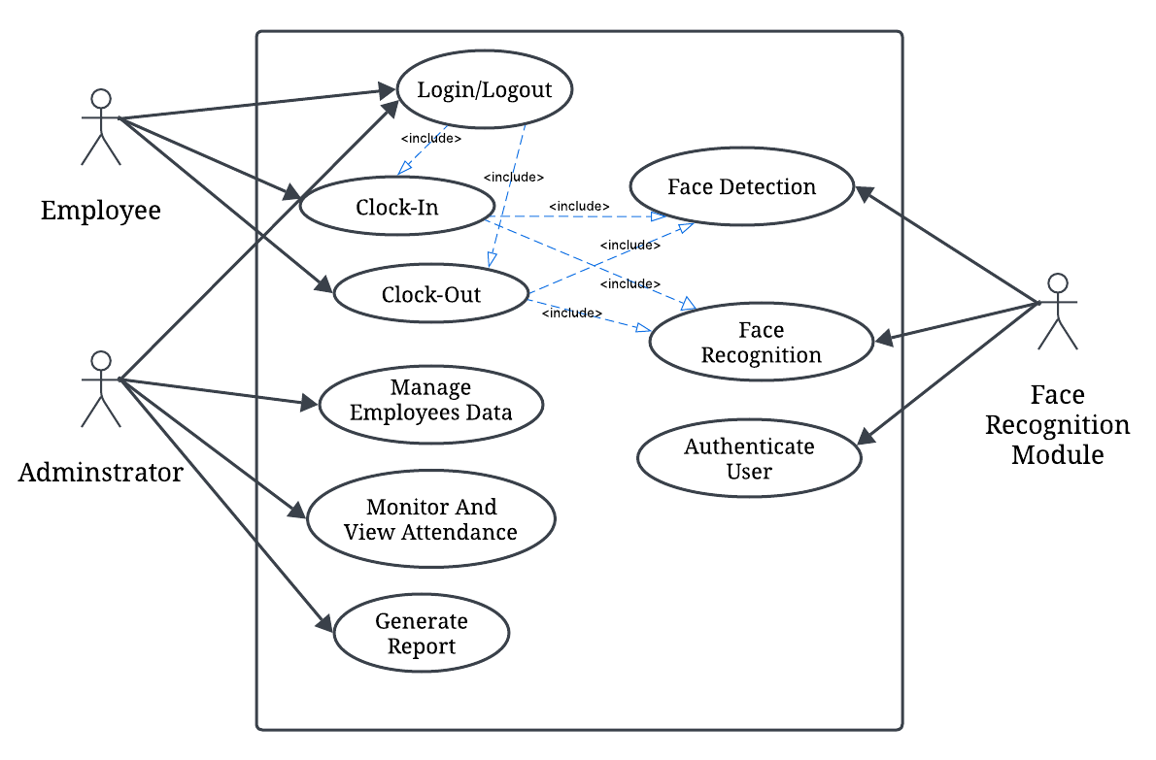
The Use Case diagram of the Smart Clock-In System:

Figure 3.1 Use case diagram of the proposed system

The diagram presented above portrays the proposed system's use case, which shows how employees, administrators, and the face recognition system interact within the web-based platform. Employees log in, authenticate using facial recognition, clock in and out, and then log out. Administrators log in to manage employees, view attendance records, and generate reports before logging out. The Face Recognition System verifies employee identities during clock-in and clock-out to ensure accuracy and prevent fraud. This system enhances security, automates attendance tracking, and streamlines workforce management.

3.2.5.3 Activity Diagram of the Proposed System
An activity diagram is another important diagram when following the Unified Modelling Language (UML) approach. It is a diagram that depicts the dynamic aspects of the software system. An activity diagram, however, is a flowchart/flow diagram describing the flow of activities that occur in the system in an orderly stepwise manner. The figure below shows the flow of activities on the Clocking-in system. The activity diagram illustrates the step-by-step workflow, from employee login to successful clock-in. It includes decision points for handling unrecognized faces or system errors.

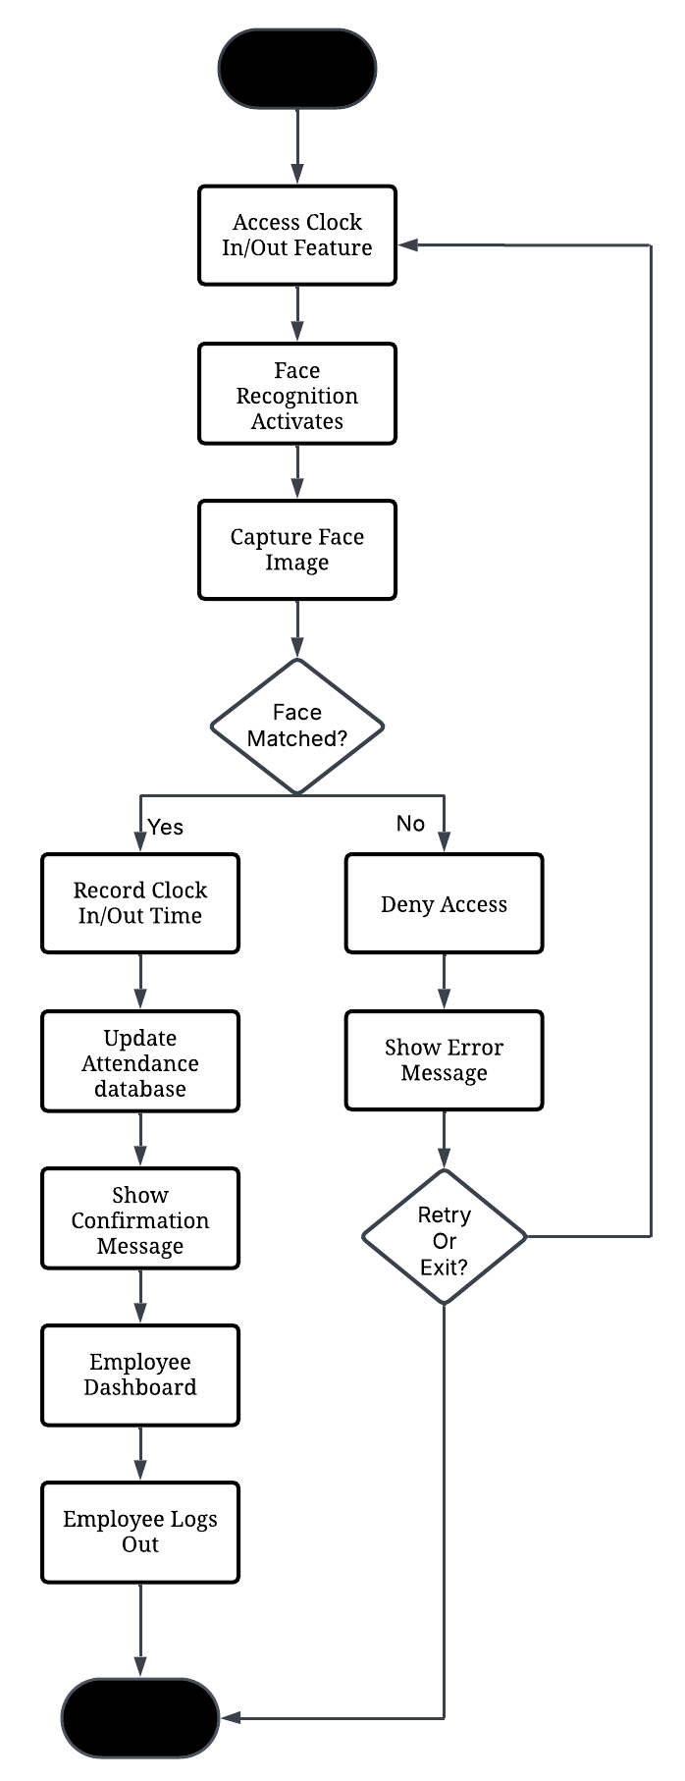
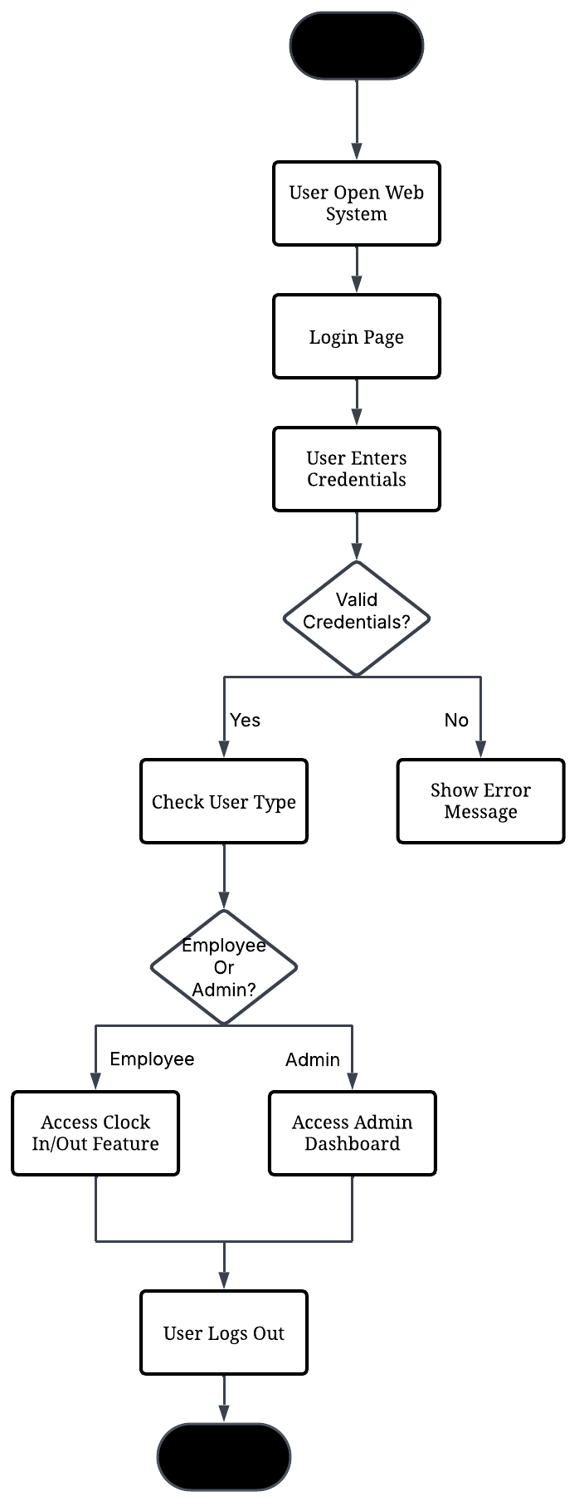
Activity Diagram for User Login/Logout: Activity Diagram for employee Clock In/out:

Figure 3.2 Activity diagram of the proposed system for user Access/employee Clock in/out

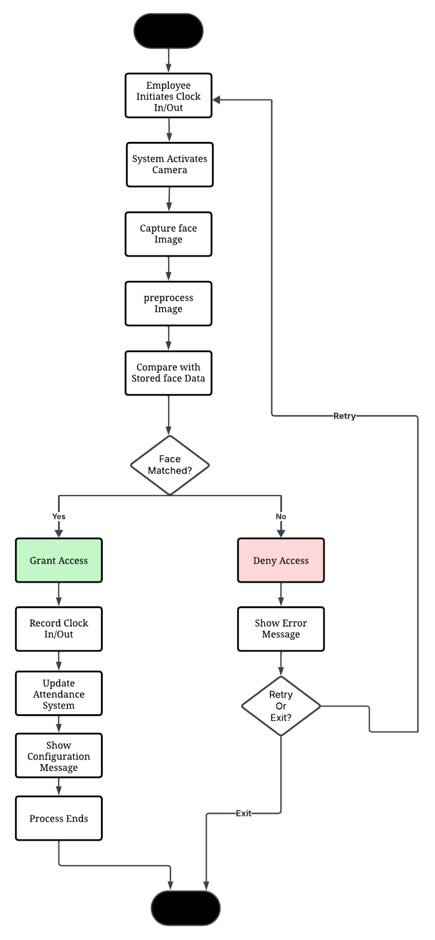
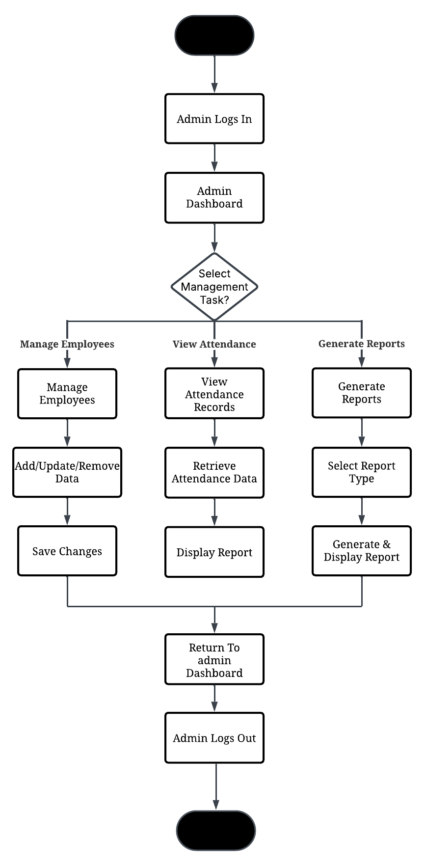
Activity Diagram For Admin management: Activity Diagram for Facial Authentication:

Figure 3.3 Activity Diagram of the proposed system for admin Management/Facial AuthN

The above Diagram shows the pictorial representation of the various activities in the proposed system. The first diagram outlines the steps involved in the authentication process of signing into the system while the second diagram focuses on the employee attendance process the third diagram depicts the various steps of administrative actions and finally the last diagram which is the fourth shows the face verification process.

3.2.5.4 Class Diagram of the Proposed System
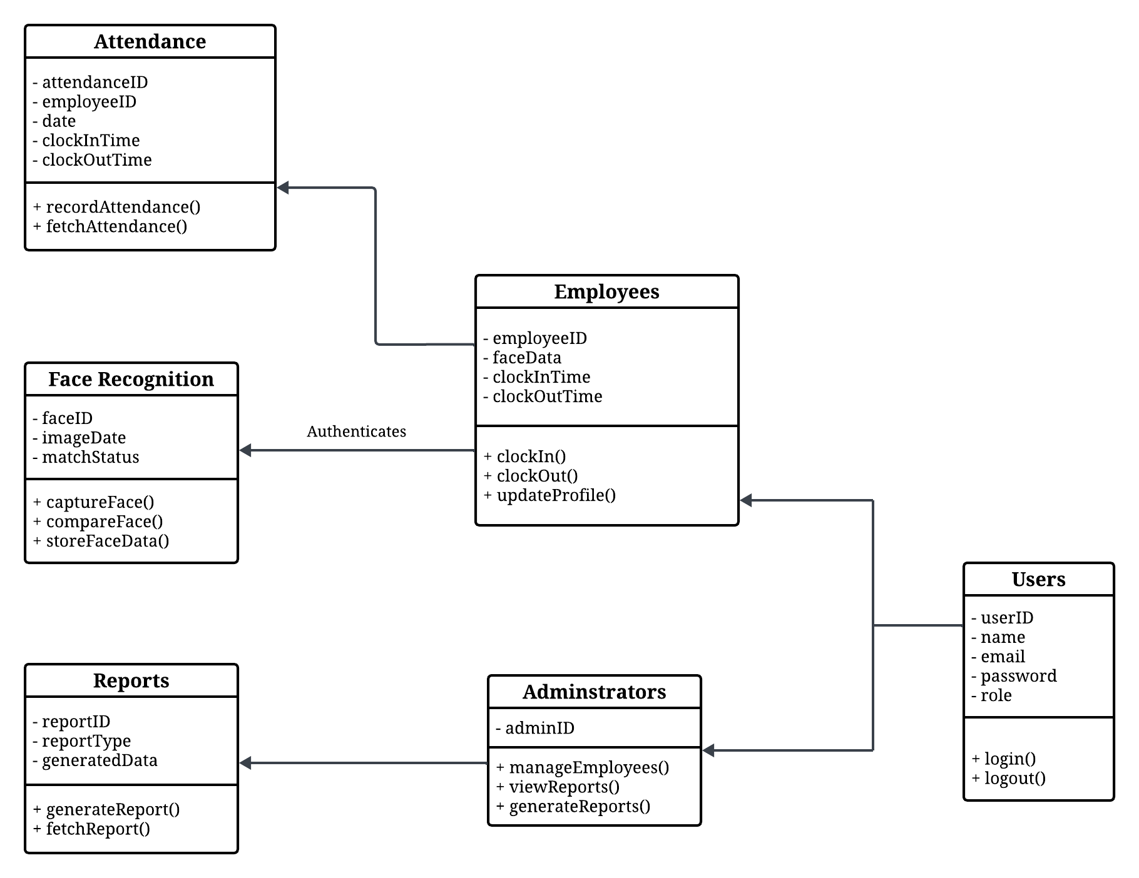
This section shows the class diagrams in Unified Modelling Language (UML) that describe the structure of a software system by mapping out its classes, attributes, methods, and relationships among objects. Below is the illustration of the class diagram for the SMART CLOCKING-IN SYSTEM.

Figure 3.4 Class diagram of the proposed system

The class diagram above shows the different classes that would be involved in the proposed system and their relationship with one another. It shows the different levels of the users that are contained in the account class, the different activities that the users can perform, and the different subclasses that perform these specific activities. The class diagram, however stands as a typical prototype of the proposed system as it elaborates the different classes that exist within the proposed system.
3.2.5.5 UML Sequence Diagram
The unified Modeling Language (UML) sequence diagrams serve as a dynamic pictorial model that depicts the various interactions between the different objects that exist within a system over time. Similarly, these diagrams are vital in the understanding of the chronological flow of actions and messages that occur during the execution of a particular use case or scenario. However, at its core, these sequence diagrams visually represent the order in which interactions occur, providing a clear depiction of how the various components collaborate in a specific system to achieve the specified goal.
However, the elements in the UML sequence diagram include lifelines, messages, activations, and objects of which the lifelines represent the entities involved in the interaction, while messages denote the communication between the different entities. Moreover, activations are portrayed using vertical lines extending from a lifeline and therefore stand to represent the duration of an object's involvement in an interaction. Consequently, this temporal dimension adds a crucial layer of understanding thereby allowing developers and stakeholders to grasp not only what occurs in the system but also when it occurs within the system's operation.
Moreover, UML sequence diagrams help to facilitate the communication between the technical and non-technical stakeholders in a system, and by offering a visual representation of system dynamics these diagrams stand as a powerful tool for conveying intricate technical details in a more accessible manner. However, the use of these diagrams contributes to improved collaboration thereby fostering a shared understanding of system behavior and also aiding in the identification of potential issues for future enhancements.
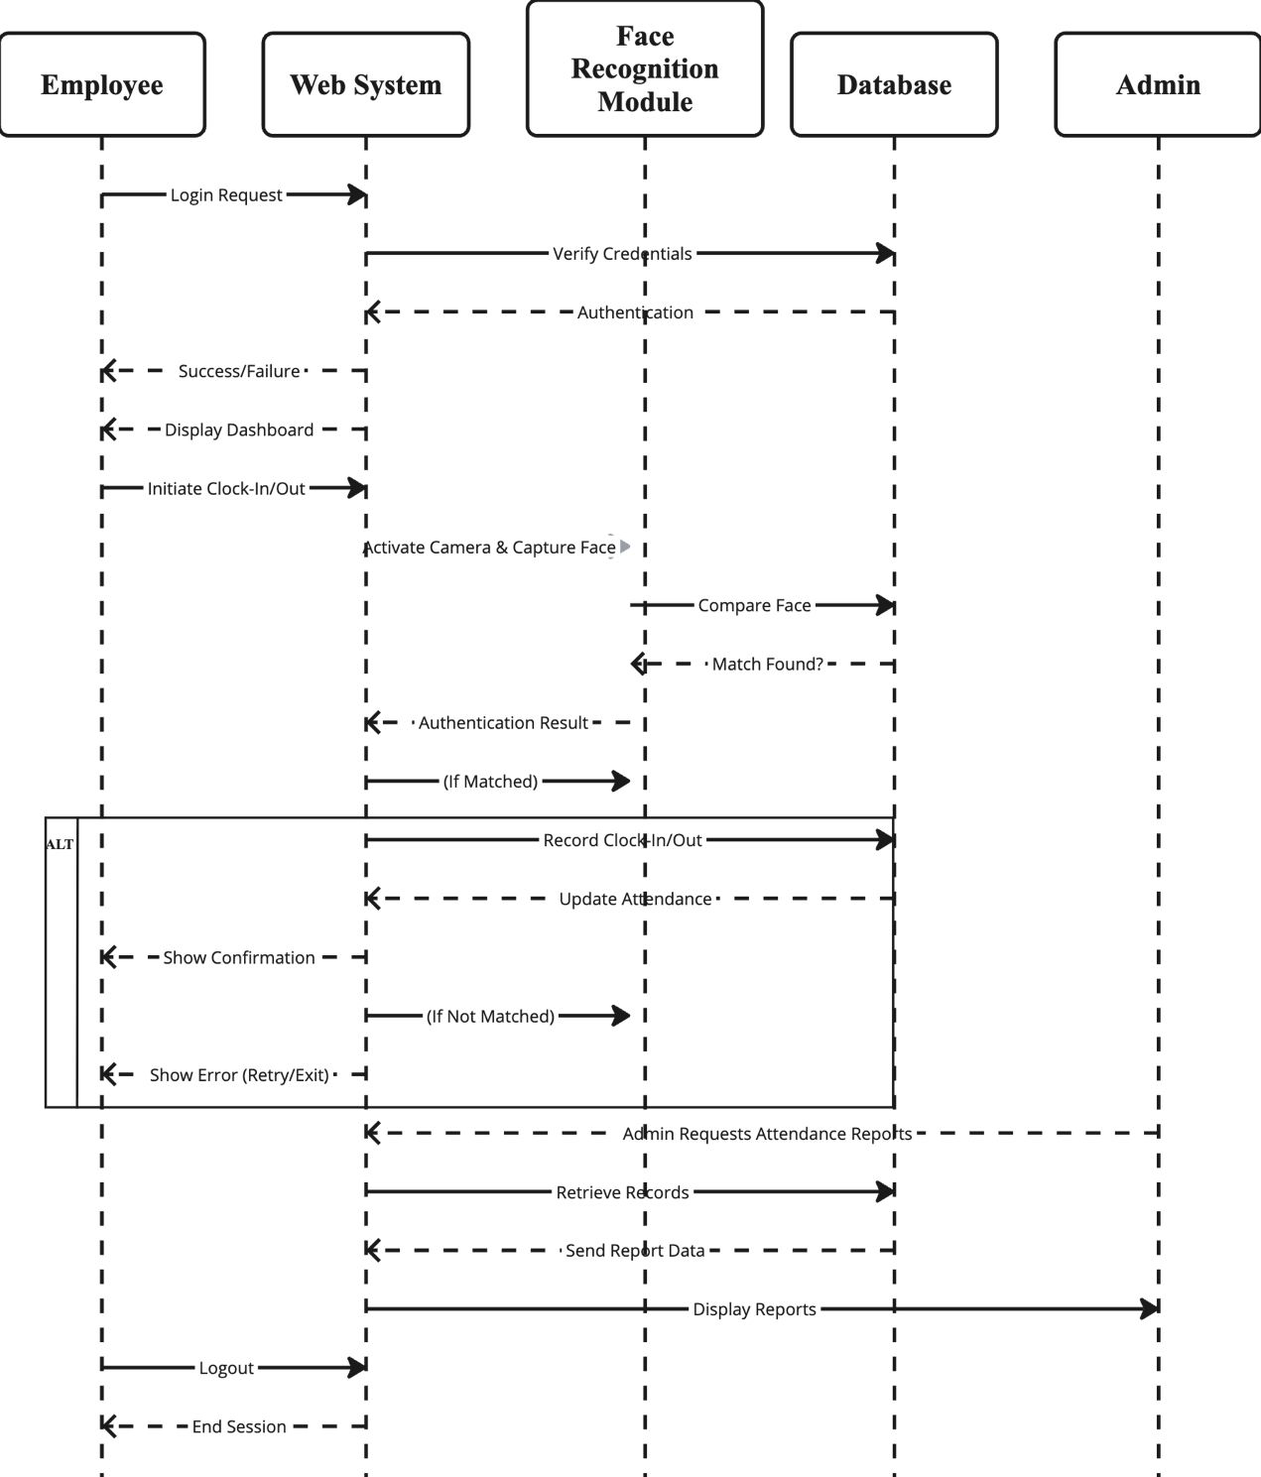

Figure 3.4 Sequence diagram of the SMART CLOCK-IN SYSTEM user registration

3.3 Artificial Intelligence Model Integration
One of the core components of the SmartFace Check-In System is its integration with artificial intelligence (AI) models for facial analysis. These models were implemented using Face-api.js, a JavaScript library built on TensorFlow.js, which allows real-time face recognition to run directly in the browser without requiring any backend server for processing.

The following pre-trained AI models were used in the system:
- Face Detection Model
This model is responsible for detecting whether a human face is present in the camera frame. It draws a bounding box around the detected face and ensures that the face is centered before proceeding.
- Face Landmark Model
Once a face is detected, the landmark model identifies key points on the face, such as the eyes, nose, and mouth. This helps in properly aligning and standardizing the face before recognition takes place.
- Face Recognition Model
This model converts the facial features into a numerical vector (called a face descriptor) and compares it with already stored descriptors in the database. If a match is found within an acceptable threshold, access is granted.
By integrating these models, the system is able to offer a secure and intelligent method for verifying a user's identity in real time. This eliminates the need for contact-based attendance systems and enhances the overall user experience.
3.4 Database Design
The database is designed to efficiently manage employee attendance, face recognition authentication, and administrative tasks in a web-based system. It ensures data integrity, security, and scalability while supporting real-time processing of clock-in/out activities.
The essence of the database design is to show a modeled view of the SMART CLOCKING-IN SYSTEM database. The database for the Smart Clocking-In System was implemented using MySQL, a popular relational database management system (RDBMS), and Firebase. To store facial recognition data, a binary data type (BLOB) was used to handle image storage securely.
3.4.1 Database Schema for the Smart Clocking-In System
Users Table
Table 3.1 User table for the smart clocking-in system (Authentication and Role Management)
Attribute | Data Type | Description
userID | Int | Unique Identifier for each User
username | Varchar | The Unique Username for Login
email | Varchar | User Email(Unique)
password | Varchar | Encrypted Password
role | ENUM(‘employee’, ‘admin’) | User Role
created_at | Timestamp | Account Creation Date

Employees Table
Table 3.2 Employee table for the smart clocking-in system (Employee Information Management)
Attribute | Data Type | Description
employeeID | Int | Unique identifier for each employee
userID | Int | Links to users table to associate credentials
firstName | Varchar | Employee’s first name
lastName | Varchar | Employee’s last name
email | Varchar | Employee’s official email
phone | Varchar | Contact number
department | Varchar | Employee’s department (eg. IT, HR)
position | Varchar | Job title (eg, software engineer)
hireDate | Date | The date the employee was hired

Administrators Table
Table 3.3 Admin table for the smart clocking-in system (Stores Admin-specific Details)
Attribute | Data Type | Description
adminID | Int | Unique Admin ID
UserID | Int | References Users Table
privileges | Text | Admin privileges

FaceRecognition Table
Table 3.4 System Table for the smart clocking-in system (Stores face Authentication Data)
Attribute | Data Type | Description
faceID | Int | Unique identifier for stored face images
employeeID | Int | Links to the employee table for identification
imageData | Blob | Stores a binary representation of the employee’s face
created_at | Timestamp | Stores when the image was added

Attendance Table
Table 3.5 Record Table for the smart clocking-in system (Records Employee Clock-in/Out)
Attribute | Data Type | Description
attendanceID | Int | Unique identifier for each record
employeeID | Int | Links to employee's table
clockInTime | Timestamp | The time an employee clocked in
clockOutTime | Timestamp | The time an employee clocked out
Status | ENUM(‘Present’, ‘Absent’, ‘Late’ | Attendance status based on clock-in time

Reports Table
Table 3.6 Report Table for the smart clocking-in system (Stores Generated Reports)
Attribute | Data Type | Description
reportID | Int | Unique identifier for each report
adminID | Int | Links to the Administrator table
reportType | ENUM(‘Daily’, ‘Weekly’, ‘Monthly’) | The type of attendance report generated
generatedAt | Timestamp | Stores the time of the report generation

CHAPTER FOUR
SYSTEM IMPLEMENTATION
4.1 Introduction
This chapter discusses how the conceptual design of the Smart Clocking-In System was transformed into a functional and interactive web-based application. It highlights the tools and technologies employed during development, the requirements necessary for running the system, and an in-depth review of the user interface. The purpose of this implementation phase is to showcase how each element outlined in the design stage, such as user roles, system functionalities, and data flow, was brought to life through code, UI design, and integration with cloud-based services. This chapter ultimately illustrates the transition from system architecture to real-time application, emphasizing the practical realization of the system's core objectives.
4.2 Tools used for implementation
4.2.1. NEXT.JS
Next.js is a modern open-source web development framework built on top of React.js.
The platform helps produce better user interfaces because it supports server-side rendering (SSR), static site generation (SSG), dynamic routing and enhanced performance. Next.js acts as the structural foundation that provides navigation throughout the entire application in this development project.
Faster page delivery stands as one of the most important factors leading organizations to select Next.js because the framework uses pre-rendering features to improve speed. The system demands high-loading speed because it handles immediate operations such as clocking in and face detection. Users experience better service due to Next.js server-side page rendering that executes pages ahead of time prior to client delivery.
Next.js provides users an easier way to manage application routing routes. The pages directory enables files to instantly create routes that generate easier navigation to login, dashboard, admin panel and face recognition interface. The system's automatic routing simplifies handling diverse user sequences since employees along with administrators require different access sections within the system.
4.2.2. REACT.JS
The highly responsive and interactive web applications use React.js as a powerful JavaScript library for development purposes. The software structure of this framework follows a component-driven approach that enables developers to construct separate user interface components which may be reused. The development of Smart Clocking-In System heavily relied on React for its role in interface management and design.
All user interfaces in the system including login form and dashboard and webcam clock-in components were developed individually as separate React components. The components were simple to handle and maintain distinct areas of responsibility throughout the application. After a user login React uses state changes to select and display the correct dashboard according to their role.
The management of state through React operated effectively in processing real-time system changes. Real-time state updates in the application interface show confirmation notifications and updated attendance records to the user without requiring page reload. Users experience a smooth interface because of this responsiveness which supports the interactive system built on face detection and time tracking features.
The Virtual DOM in React functioned to enhance performance because it only applied changes to modified components instead of reloading the complete page. The smooth execution of resource-intensive webcam activation for face recognition is supported through this system.
The interactive components which define the user experience needed React.js to build them successfully in this project.
4.2.3. TAILWIND CSS
Tailwind CSS functions as a utility-first CSS framework which streamlines styling through collected pre-defined class names for designing elements. Through the use of these utility classes developers directly insert them into their HTML or JSX elements in order to create modular and scalable styles.
The development of this project incorporated Tailwind CSS for building a user interface which exhibits clean design alongside responsive features and interface consistency. The modern User Interface layouts required fewer lines of code because Tailwind CSS provided the tools to implement them promptly starting from the login page and moving through the dashboard and face recognition panel. Without requiring HTML or CSS file switching developers can instantly add changes to margin, padding, border radius or font size elements.
Responsive design stood as a cornerstone advantage of using Tailwind for development purposes. The web-based system needed to offer consistent visual appearance across different devices because users would access it through various platforms. All sizes of desktops along with laptops and tablets can have their layouts adjusted automatically through Tailwind's responsive utility system.
The implementation of Tailwind resulted in maintaining an identical visual appearance between every system section. The system achieved better appearance through its standardized color selection and standardized buttons and clear layout structures that together increased user faith while boosting their commitment to the interface.
Tailwind CSS provided the development team with quicker project completion alongside consistent design elements together with responsive application support for system users.
4.2.4. FIREBASE
Google developed Firebase as a Backend-as-a-Service platform that provides businesses with multiple backend operation tools including authentication and real-time databases and cloud storage among others. The Smart Clocking-In System utilized Firebase as its backend operations technology since it eliminated the necessity for building a complete server.
Firebase Authentication provided a system to control user authentication along with user account creation and login features. The system permits administrators and employees to sign in through their electronic mail and password while Firebase maintains safe session access. The system stopped unauthorized people from accessing clock-in records and administrator tools.
The system used a Firestore database from Firebase to store attendance that logs employee profiles and employee clock in and clock out information. The real-time NoSQL capabilities of Firestore enabled the system to show changes instantly to all system users. The status of employee clock-ins automatically gets updated in real time to make their current availability immediately visible to admins through the dashboard.
Through its integration with React and Next.js the system supports a smooth read-write process of data using hooks and asynchronous functions. The front-end synchronization with the back-end functioned smoothly thanks to this design which maintained continuous up-to-date system status.
The platform reaches a pinnacle of security protection alongside exceptional system growth capabilities. All user data is stored in a secure cloud environment with fine-grained access control rules, and the system can easily handle increased traffic or new features in the future without requiring major infrastructure changes.
In short, Firebase handled authentication, database storage, and real-time data synchronization, forming the backbone of the system's cloud operations.
4.3 System Requirements
There are not many things that are needed to use this system as it is a cross-platform application and, therefore, runs on both the web and mobile platforms. However, the system still requires that the user gets to fulfil some little requirements to be able to use the proposed system. These requirements are as follows:
- An internet-enabled device
- Good internet connection(at least 3G to 4G internet speed)
- A web browser, eg. the Latest version of Chrome, Firefox, Microsoft Edge, or Apple Safari
- A valid Email Address

4.4 User Interface of Smart Clock-In System
This section of this research work is going to contain user interfaces of different sections of the Smart Clock-in system, which will include the landing page, the sign in/login page, the user dashboard page, the profile page, attendance page, and the interfaces(clock-in/out interface and administrator panel) etc.
4.4.1. Smart Clock-In System Homepage
The homepage, also referred to as the landing page, serves as the entry point of the SmartFace Check-In web application. This page is designed to introduce users to the core purpose of the system in a simple and visually appealing manner. The layout prominently displays the system’s title “A smart clocking-in system using computer vision for face detection and recognition” which communicates the central functionality of the software at a glance.
To the right, an AI-generated facial mesh image visually reinforces the system's reliance on computer vision and artificial intelligence for identity verification. This intuitive visual cue helps users instantly understand that the system uses facial recognition technology.
A clear and accessible Sign-In button is placed at the bottom center, serving as the main call-to-action. When clicked, it directs the user to the login page where authentication begins

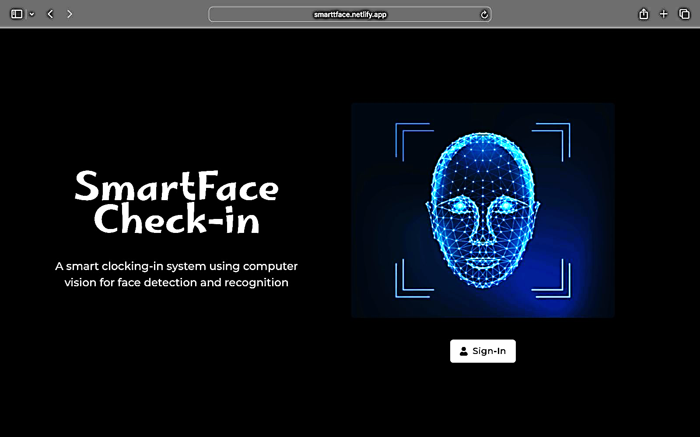

Figure 4.1 Smartface check-In webpage
4.4.2 Login page:
The login interface of the SmartFace Check-In system serves as the secure gateway into the application. It features a clean and minimalist design with a dark-themed layout that aligns with the overall branding of the system. The left section presents the login form, where users are prompted to input their registered email address and password.
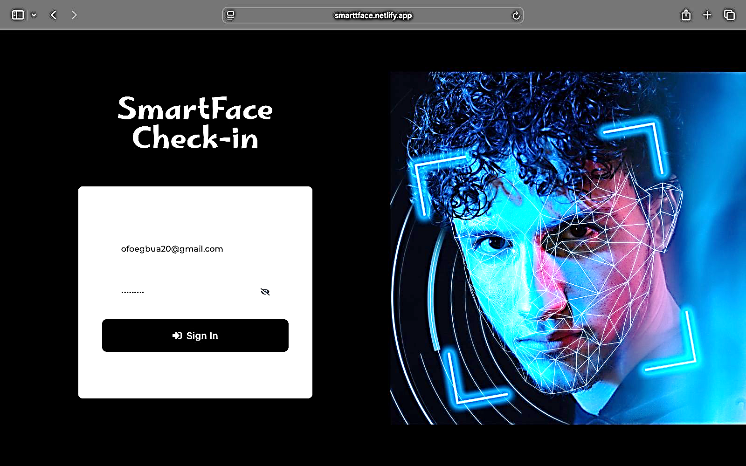
This page uses Firebase Authentication to securely validate user credentials. It includes standard login features such as hidden password input and a visually distinct “Sign In” button to initiate the authentication process. On the right side of the interface, a dynamic facial mesh image reinforces the system’s identity as a facial recognition platform. The blue digital face scan artwork symbolizes AI and biometric scanning, visually preparing users for the next stage which is face recognition.

Figure 4.2 Login page of the Smarface check-In

4.4.3 Administrator User Registration and Geolocation configuration interface
This section of the Smart Clocking-In System is exclusively accessible to the administrator. It serves as the control panel for registering new employees and configuring location-based access restrictions to ensure secure and accurate clock-ins.
Once the form is completed, clicking the "Submit" button automatically creates the employee's profile and sends their login credentials directly to their email address. This ensures a secure and seamless onboarding process.
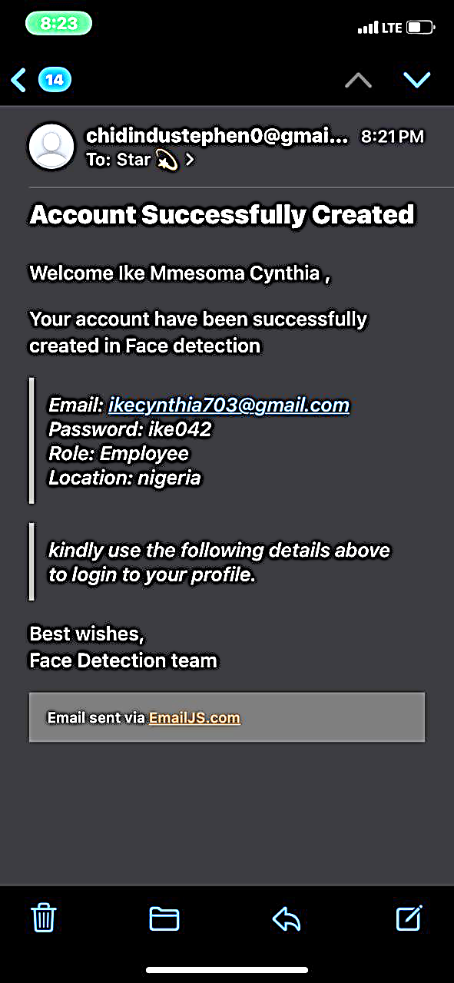
A notable security feature is the Geolocation Configuration. The administrator inputs the allowed latitude and longitude of the workplace. This geofencing mechanism restricts clock-ins to users within a 30-meter radius of the specified coordinates. Any login attempts made outside this designated area are automatically rejected, thus preventing off-site or fraudulent clock-ins.
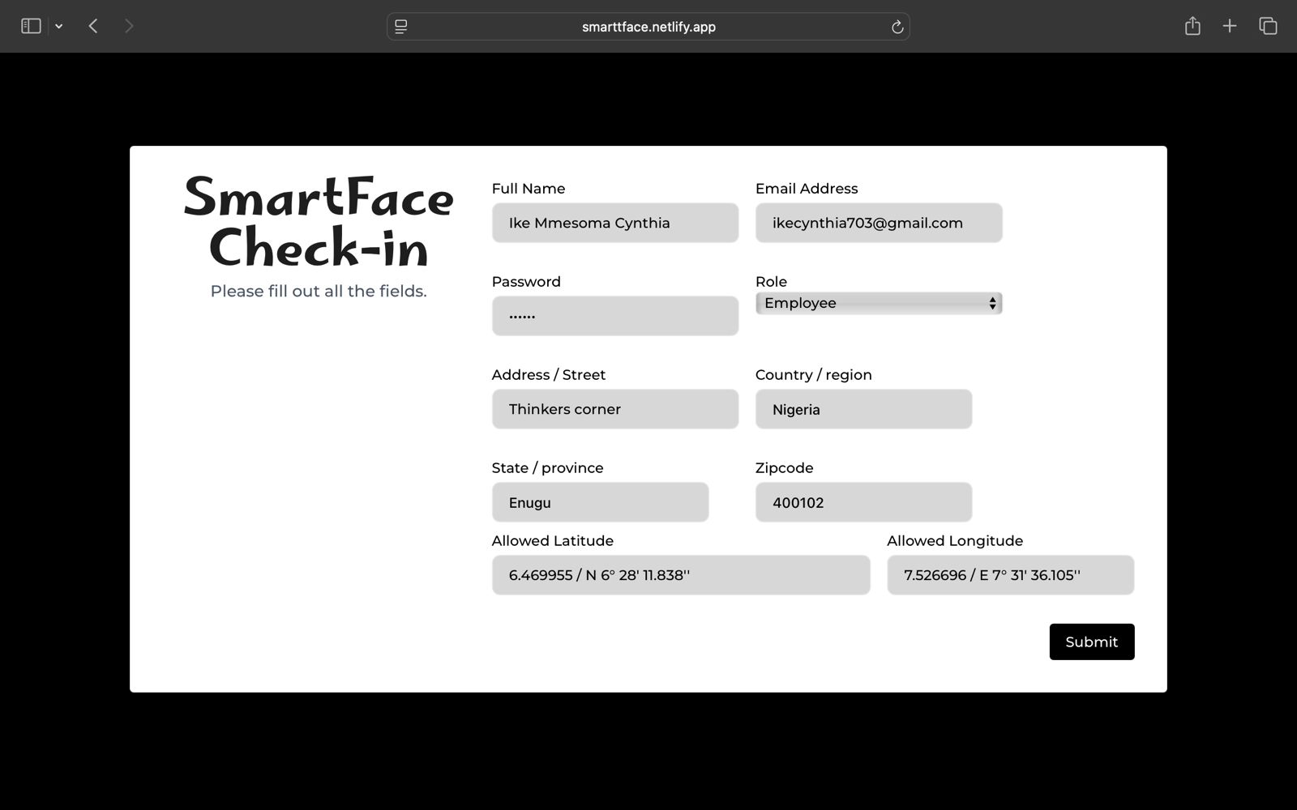

Figure 4.3 Admin User Registration and Email notification

4.4.4 Face Detection and Recognition Process
Upon successful login, the user is redirected to the Face Recognition Interface. The Face Recognition interface is where the AI models are actively used to verify the identity of the employee. When a user attempts to clock in, the system first activates the webcam and loads the required face detection and recognition models using Face-api.js.
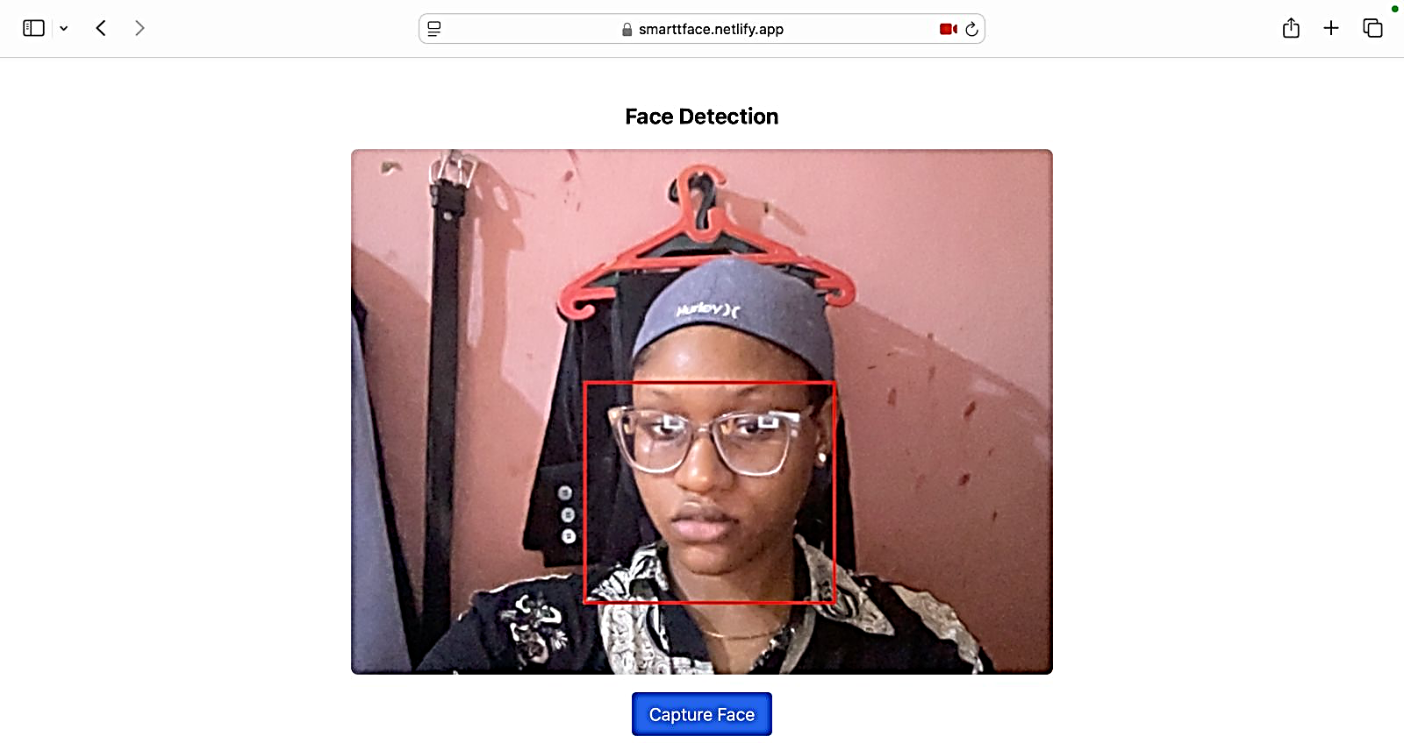
The face detection model checks for the presence of a face, while the landmark model pinpoints facial features for accurate alignment. The system then compares the live face descriptor with stored data to verify identity. If the match is successful, the clock-in time is recorded in the attendance database. This real-time facial authentication is fully browser-based and does not rely on third-party APIs or external servers, making it efficient, fast, and privacy-conscious. The integration of these AI models is what makes the SmartFace Check-In system truly intelligent.

Figure 4.4 Face Recognition Interface
4.4.4 Employee Attendance Dashboard
The Employee Dashboard offers a simplified and restricted view of the system, tailored to individual users for personal attendance tracking. Once logged in, employees are taken to their personalized dashboard with two main sections: User Profile and Attendance.
The user profile allows users to verify their registration information and identity, while the attendance section is uniquely personalized for each employee, displaying only their own attendance records. It has Features which include: Check attendance date and Attendance Table.
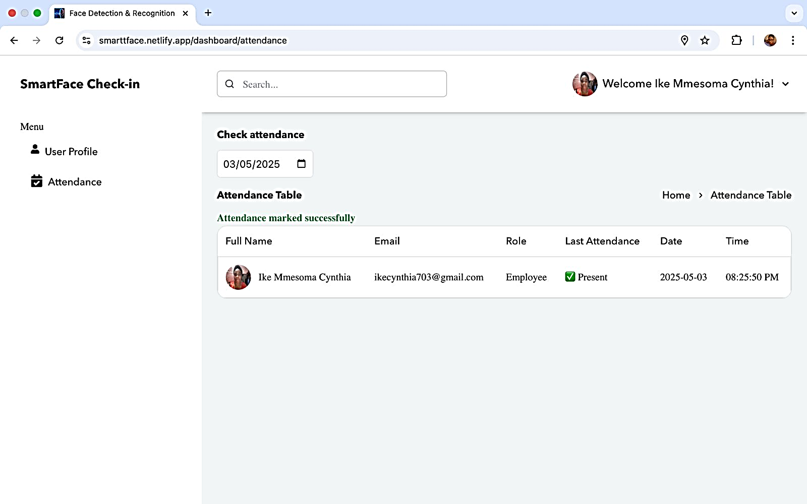
The employee cannot view attendance records of colleagues nor access the analytical summaries. This design maintains user privacy and restricts administrative functions solely to the system manager.

Figure 4.5 Employee Attendance interface
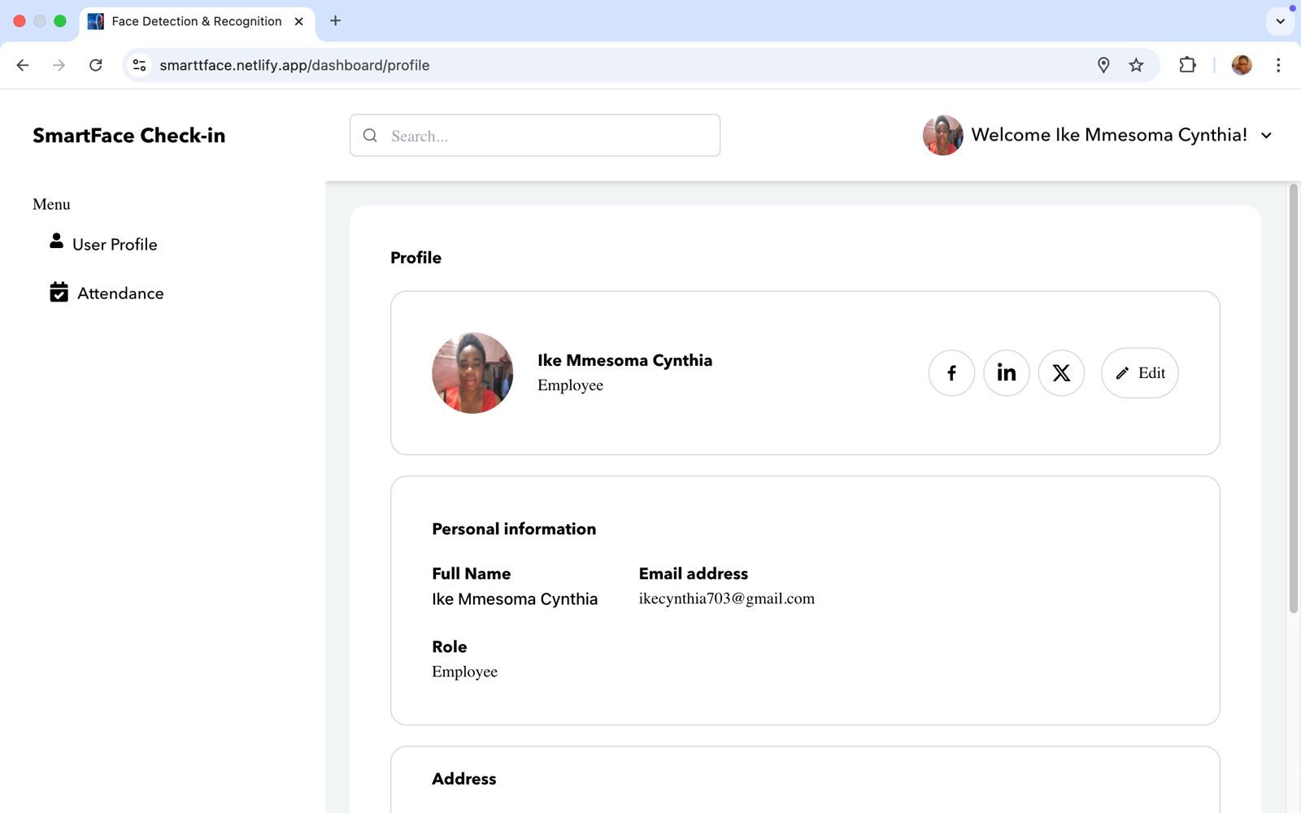

Figure 4.6 Employee User profile interface

4.4.5 Administrator Dashboard User Interface
Upon successful login, the Manager (or Overall Administrator) is directed to a dedicated dashboard that consolidates system management and employee activity oversight. The dashboard consists of three main sections accessible from the sidebar menu: User Profile, Attendance, and Analysis.
The user profile shows verified registration information and identity, while the Attendance section is a dynamic table displaying the real-time attendance status of all employees in the system, this view is exclusive to the Admin, allowing them to monitor who has clocked in on a specific day and at what exact time. Unlike employees, who can only view their own attendance history, the Admin has a centralized view of all staff attendance activity.
The Analysis section offers summarized and visualized attendance data, presented in monthly, weekly, or yearly formats. It provides clear metrics showing:
- Number of days each employee was present
- Number of days absent
- Trends and patterns of attendance over time
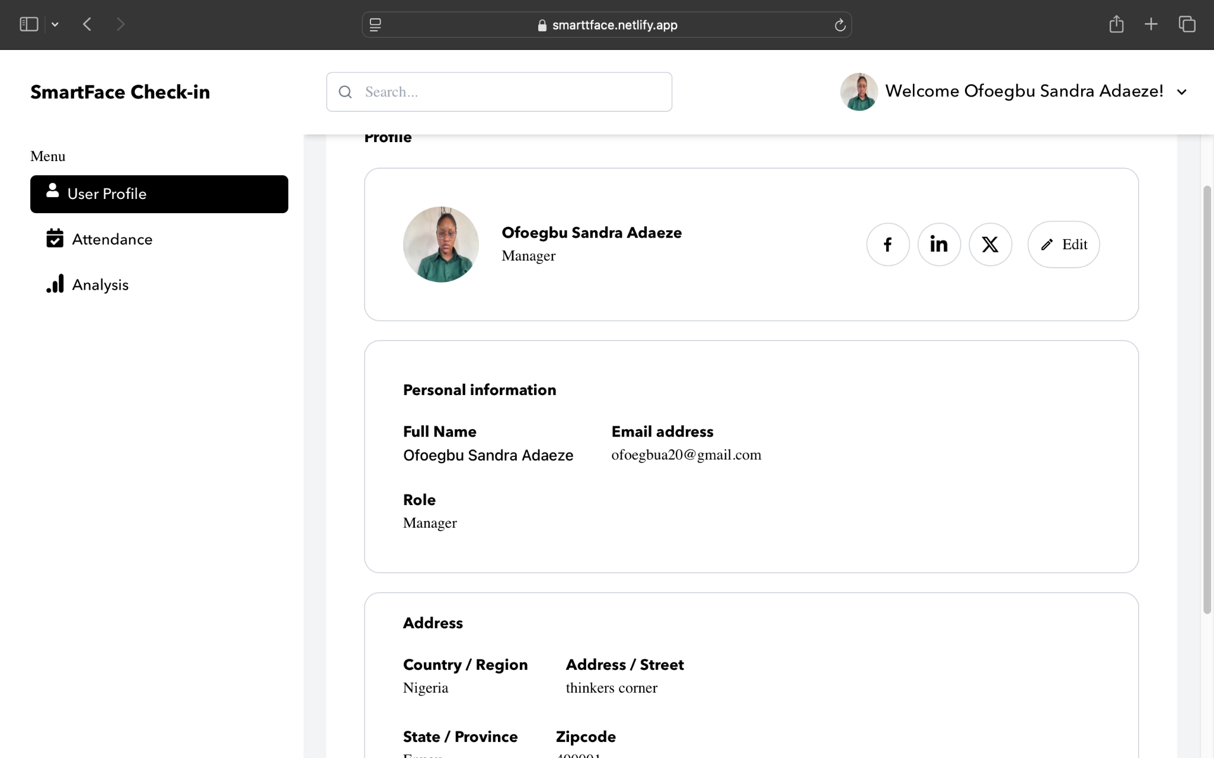
This analytical module helps in performance evaluations, punctuality assessments, and decision-making based on factual attendance data.

Figure 4.7 User profile for Admin Interface
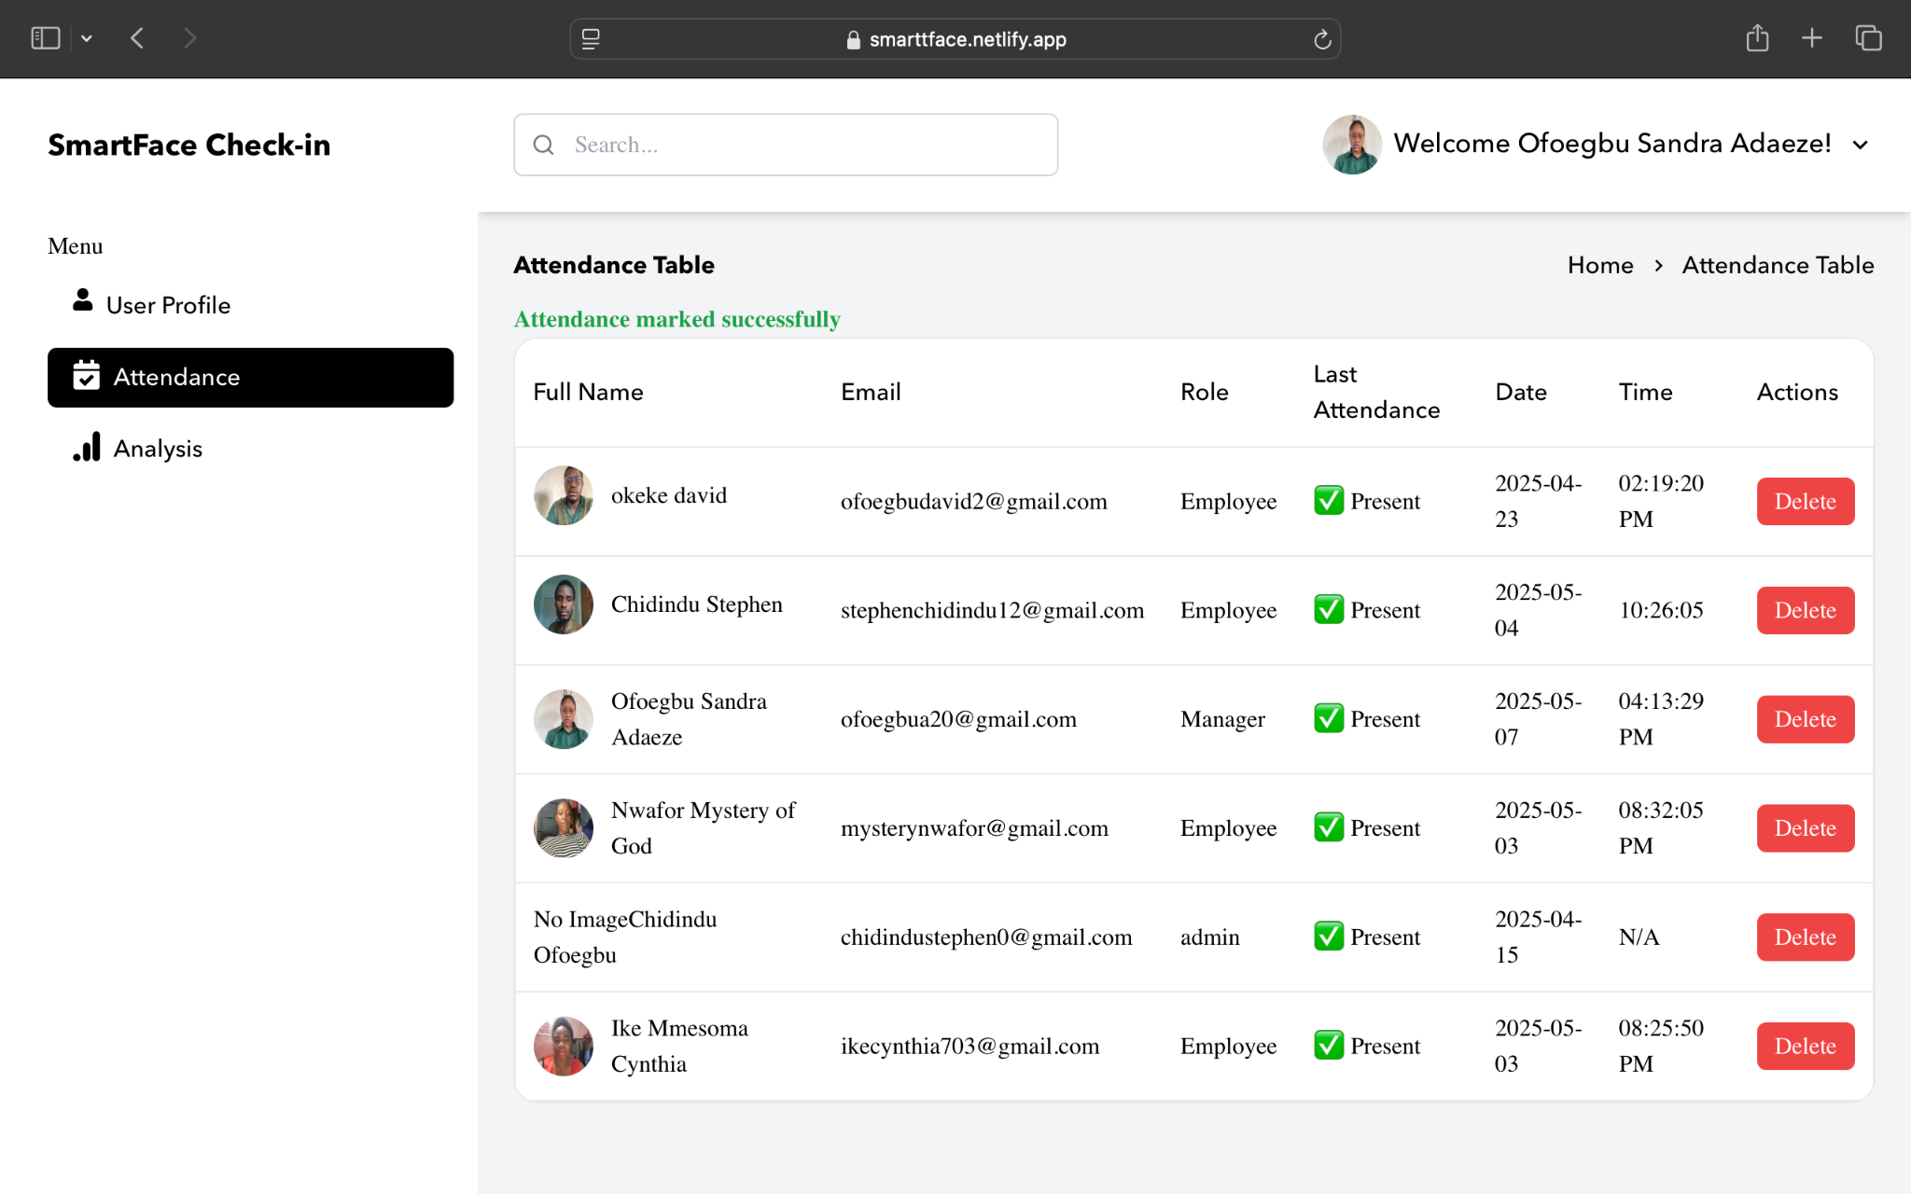

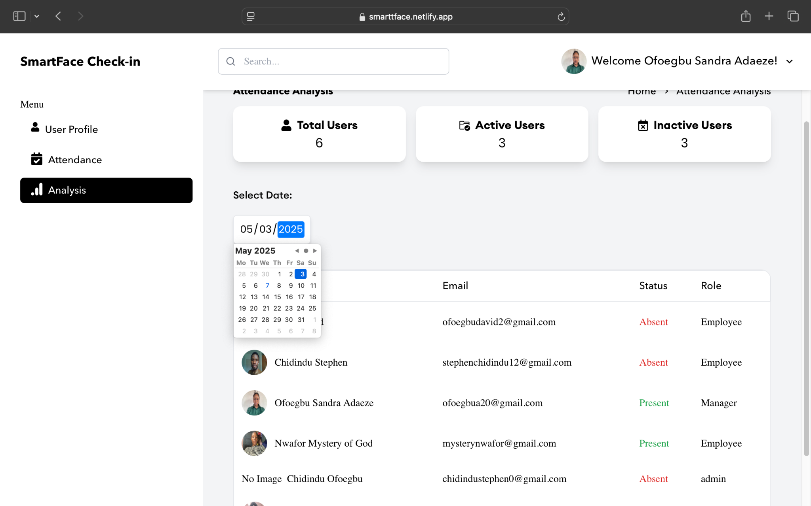
Figure 4.8 Attendance Section of the Admin Interface

Figure 4.9 Analysis section of the Admin interface
CHAPTER FIVE
SUMMARY, RECOMMENDATIONS AND CONCLUSION
5.1 Introduction
This chapter presents the final overview of the project work. It provides a summary of the key stages of the study, outlines the achievements of the developed system, and offers recommendations for practical use and future development. It also highlights some limitations encountered during the implementation of the project and proposes possible improvements that could be made in future versions.
5.2 Summary of the Study
This project focused on the development of a Smart Clocking-In System for Employees Using Computer Vision. The aim was to create a secure, automated, and contactless method for managing employee attendance through facial recognition and geolocation verification.
The study began by identifying problems with traditional attendance systems such as impersonation (buddy punching), loss of access cards, and hygiene-related concerns with fingerprint scanners. A review of related literature confirmed that while biometric systems have improved accuracy, many lack full web-based integration, real-time reporting, and geofencing.
To solve these problems, a web-based application was developed using React.js, Next.js, and Tailwind CSS for the frontend, and Firebase for backend services such as authentication, data storage, and image handling. The facial recognition feature was powered by Face-api.js, which uses pre-trained deep learning models based on TensorFlow.js. These models detect faces, identify users, and even estimate age and gender.
The system was designed to allow only registered employees to log in and clock in, and only if they are physically present within a specific location radius set by the administrator. The manager has full access to register users, set location coordinates, and view attendance statistics with automated analysis.
The final product is a responsive, user-friendly, and intelligent attendance system that meets the security and automation goals of the study.
5.3 Conclusion
The SmartFace Check-In System successfully combines artificial intelligence, web technologies, and cloud services to offer a smart and efficient approach to employee attendance management. By eliminating the need for physical contact and manual record keeping, the system increases security, reduces fraud, and improves accuracy.
With the integration of facial recognition and geolocation filtering, the system ensures that only verified employees within an approved location can clock in. It also provides separate interfaces for employees and administrators, with the latter having access to reports and analytics.
This project demonstrates the potential of AI and computer vision in solving real workplace problems and lays a solid foundation for further innovations in biometric-based systems.
5.4 Recommendations
This system is highly recommended for use in:
- Corporate organizations, to manage staff clock-ins and eliminate time theft
- Schools and institutions, to monitor student or staff attendance
- Government agencies, for secure check-in of workers
- Startups and remote teams, where location-based control is needed
Organizations adopting this system should ensure stable internet access and functional webcams for optimal performance. For greater efficiency, the system can also be extended to mobile platforms in the future.
5.5 Limitation of the Study
Despite its effectiveness, the system has some limitations:
- Lighting and camera quality can affect the accuracy of facial recognition.
- The system requires a stable internet connection to function properly, especially during face model loading.
- Mobile responsiveness is limited and may require further optimization for mobile devices.
- Environmental factors such as face coverings (masks or hats) may impact recognition accuracy.

REFERENCES
Adeleke, M., Olayemi, R., & Lawal, S. (2023). Deep learning-based face recognition systems in real-time environments. Journal of Artificial Intelligence Research, 18(2), 115–130.
Ahmed, Z., & Ibrahim, A. (2019). Facial recognition in real-time systems. International Journal of Computer Applications, 182(3), 22–29.
Alvarez, L., Musa, A., & Adewale, T. (2018). Integration of face recognition in IoT systems. Internet of Things Journal, 6(4), 301–310.
Brown, P., & Taylor, D. (2021). A study on edge computing platforms for face recognition systems. International Conference on Distributed AI and Edge Systems, 17(1), 93–102.
Chandra, S., Obasi, U., & Ezekiel, E. (2020). Ethical implications of biometric systems. Journal of Ethics and Technology, 11(1), 66–74.
Chen, W., & Lee, H. (2020). Biometric authentication in workplaces. Journal of Secure Computing, 24(3), 174–190.
Gupta, A., Shukla, R., & Nair, D. (2020). Deep learning for biometric systems. Biometric Computing Review, 12(2), 211–225.
Hassan, M., Ibrahim, T., & Musa, K. (2019). Comparative analysis of biometric methods. Journal of Biometric Technologies, 9(4), 111–124.
Jones, D., Smith, A., & Obi, N. (2018). Face recognition for secure access control. Proceedings of the Conference on Smart Security, 22(5), 44–58.
Kumar, P., & Wilson, J. (2021). AI-driven employee monitoring systems. Journal of AI & Organizational Behavior, 29(2), 95–110.
Nguyen, T., Zhao, L., & Lee, C. (2020). Improving face recognition accuracy with GANs. Neural Networks Journal, 30(6), 150–164.
Nnamdi, P., Ogu, L., & Obiekwe, C. (2023). Digital transformation in Nigerian attendance systems. African Journal of Computer Science and Innovation, 19(1), 50–61.
Okonkwo, B., & Eze, V. (2022). Evolution of time management systems. Journal of Applied IT Systems, 15(2), 78–85.
Patel, H., Obiora, I., & Musa, L. (2021). AI-based solutions for workplace attendance. Cloud AI Systems Review, 13(3), 137–150.
Rahman, S., Adeyemi, F., & Lin, Q. (2021). Hybrid models for biometric authentication. Journal of Multimodal Systems, 7(2), 83–97.
Singh, V., & Roy, A. (2018). Face recognition in low-light conditions. Journal of Visual Computing, 14(1), 55–70.
Smith, J., Ali, K., & Bello, M. (2019). Enhancing attendance systems using face recognition. International Journal of Smart Technology, 8(3), 121–138.
Thompson, E., Yusuf, S., & Obi, D. (2023). Cost-effective facial recognition solutions in Nigerian institutions. Journal of Emerging Technologies in Africa, 10(2), 102–117.
Wang, L., & Zhao, Y. (2017). Optimizing face recognition algorithms. Machine Learning and Vision, 21(1), 40–52.

APPENDIX
firebase/config.js

import { initializeApp } from "firebase/app";
import { getFirestore } from "firebase/firestore";
import { getAuth } from "firebase/auth";

const firebaseConfig = {
apiKey: "YOUR_API_KEY",
authDomain: "YOUR_AUTH_DOMAIN",
projectId: "YOUR_PROJECT_ID",
storageBucket: "YOUR_STORAGE_BUCKET",
messagingSenderId: "YOUR_SENDER_ID",
appId: "YOUR_APP_ID"
};

const app = initializeApp(firebaseConfig);
export const db = getFirestore(app);
export const auth = getAuth(app);

components/FaceRecognition.js

import * as faceapi from 'face-api.js';
import { useRef, useEffect } from 'react';

export default function FaceRecognition() {
const videoRef = useRef();

useEffect(() => {
const loadModels = async () => {
await faceapi.nets.tinyFaceDetector.loadFromUri('/models');
await faceapi.nets.faceLandmark68Net.loadFromUri('/models');
await faceapi.nets.faceRecognitionNet.loadFromUri('/models');
};jnm

const startVideo = () => {
navigator.mediaDevices.getUserMedia({ video: {} })
.then((stream) => {
videoRef.current.srcObject = stream;
})
.catch((err) => console.error(err));
};

loadModels().then(startVideo);
}, []);

return (
<div>
<video ref={videoRef} autoPlay muted width="720" height="560" />
</div>
);
}
pages/api/clockin.js

import { db } from "../../firebase/config";
import { addDoc, collection, Timestamp } from "firebase/firestore";

export default async function handler(req, res) {
if (req.method === 'POST') {
try {
const { userId } = req.body;
await addDoc(collection(db, "attendance"), {
userId,
clockIn: Timestamp.now()
});
res.status(200).json({ message: "Clock-in successful" });
} catch (error) {
res.status(500).json({ error: "Clock-in failed" });
}
}
}

pages/api/clockout.js

import { db } from "../../firebase/config";
import { addDoc, collection, Timestamp } from "firebase/firestore";

export default async function handler(req, res) {
if (req.method === 'POST') {
try {
const { userId } = req.body;
await addDoc(collection(db, "attendance"), {
userId,
clockOut: Timestamp.now()
});
res.status(200).json({ message: "Clock-out successful" });
} catch (error) {
res.status(500).json({ error: "Clock-out failed" });
}
}
}

components/Auth/LoginForm.js

import { signInWithEmailAndPassword } from "firebase/auth";
import { auth } from "../../firebase/config";
import { useState } from "react";

export default function LoginForm() {
const [email, setEmail] = useState("");
const [password, setPassword] = useState("");

const handleLogin = async (e) => {
e.preventDefault();
try {
await signInWithEmailAndPassword(auth, email, password);
alert("Login successful");
} catch (error) {
alert("Login failed");
}
};

return (
<form onSubmit={handleLogin}>
<input type="email" onChange={e => setEmail(e.target.value)} required />
<input type="password" onChange={e => setPassword(e.target.value)} required />
<button type="submit">Login</button>
</form>
);
}

tailwind.config.mjs

/** @type {import('tailwindcss').Config} */
export default {
content: [
"./app/**/*.{js,ts,jsx,tsx}",
"./pages/**/*.{js,ts,jsx,tsx}",
"./components/**/*.{js,ts,jsx,tsx}"
],
theme: {
extend: {}
},
plugins: []
};

pages/index.js (Sample Home Page)

import Head from 'next/head';

export default function Home() {
return (
<>
<Head>
<title>Smart Clock-In System</title>
</Head>
<main className="flex justify-center items-center h-screen">
<h1 className="text-4xl font-bold">Welcome to the Smart Clocking-In System</h1>
</main>
</>
);
}

