DEVELOPMENT OF A SMART LAND PRICE PREDICTION SYSTEM

BY

OGUELINA OLIVIA CHINAZA
GOU/U21/CSC/688

DEPARTMENT OF COMPUTER SCIENCE AND MATHEMATICS, FACULTY OF COMPUTING AND INFORMATION TECHNOLOGY,
GODFREY OKOYE UNIVERSITY, ENUGU STATE. IN PARTIAL FULFILLMENT OF THE AWARD OF BACHELOR OF
SCIENCE (B.SC), DEGREE IN COMPUTER SCIENCE.

SUPERVISOR: MR. Camillus Njoku

JULY, 2025.

APPROVAL PAGE
This research, titled “Development of a Smart Land Price Prediction System,” has been assessed and approved by the Committees of the Department of Computer Science and Mathematics and the Faculty of Natural Sciences and Environmental Studies, Godfrey Okoye University, Enugu, Nigeria.

Mr. Camillus Njoku ................................... ..................................
Supervisor Signature Date

External Examiner ................................... ..................................
External Examiner Signature Date

Dr. Frank Okebanama ................................... ..................................
HOD, Department of Signature Date
Computer Science and
Mathematics

Prof. Chidi.C.Uhuegbu ................................... ..................................
Dean, FNESS Signature Date

CERTIFICATION
I hereby certify that the research included therein and that it was primarily based on my observations and investigations. Consequently, I will fully accept the University's decision if I am found to have cheated on the assignment.

________________________
OGUELINA OLIVIA CHINAZA
GOU/U21/CSC/688

DEDICATION
This project “Development of a smart Land Price Prediction System,” is dedicated to God Almighty and my parents, Mr. and Mrs. Chukwudi Oguelina, for their immense support and sacrifice to ensure I completed this project.

ACKNOWLEDGEMENT
My gratitude goes to my supervisor, Mr Camillus Njoku, for his academic support and encouragement, which guided me throughout this research. The head of the department, Dr Frank Okebanama. I will forever remain grateful for his effort to ensure that this project was a success. I would like to express my appreciation to all my lecturers in the Department of Computer Science for their support during my research.
I am especially grateful to my parents, Mr. and Mrs. Chukwudi Oguelina, who supported me financially and emotionally. My friends in my department, my roommates, and, most importantly, my closest friend, Amadi Jesscia, I am grateful for her constant support and encouragement.

ABSTRACT
Land is one of the most owned properties by humans. In Nigeria, there is a lot of power in the ownership of land because it symbolizes wealth. However, in recent times, land acquisition has become very difficult and expensive due to several factors, including inflation of prices and deceptive practices by land agents that lead buyers into overpaying. This research project aims to develop a Smart AI Land Price Prediction System that will make use of machine learning (ML) algorithms, image analysis, and geospatial data for accurate, real-time land valuation in the Nigerian market. The methodology applied is Object-Oriented Analysis and Design (OOAD). The proposed system addresses this limitation by using diverse data comprising structured property attributes, geospatial data, and visual inputs. After the research on the shortcomings of the traditional methods, such as the lack of usage of structural and visual data, leads to inaccuracy in price prediction. The model was trained using XGBoost for the price prediction, and CNN was used for the visual data analysis. The result of the model after evaluation of the XGBoost had an R² score of 96%. MobileNetV2, a pretrained CNN model, had an R² score of 56%. The developed model will be integrated into a user-friendly mobile application for an easier understanding of the prediction of land prices.

TABLE OF CONTENTS

Title page i
Approval ii
Certification iii
Dedication iv
Acknowledgments v
Abstract vi
Table of content vii
List of tables ix
List of figures x

Chapter one: Introduction 1
  - Background of the Study 1
  - Statement of the Problem 3
  - Aim and Objectives 3
  - Significance of the Study 4
  - Scope of the Study 4
  - Limitations of the Study 4
  - Operational Definition of Terms 5

Chapter Two: Literature Review 6
  - Introduction 6
  - Theoretical background 6
  - Review of Related works 7
  - Summary of Review of Related Works 13
  - Knowledge gap 17

Chapter Three: System Analysis and Design 18
  - Overview 18
  - Analysis of the Existing System 18
  - Analysis of the proposed system 19
  - Design of the proposed system 29

Chapter Four: System implementation 33
  - Introduction 33
  - Choice of Programming Languages 33
  - Choice for Model Development 34
  - System Requirements 37
  - User interface 37
Chapter five: Summary, recommendation and conclusion 41
  - Summary 41
  - Recommendation 42
  - Conclusion 42

References 44
Appendix 45

LIST OF TABLES
Table Pages
Table 3.1 User table for Smart Land Price Predictor 30
Table 3.2 Predictions table for Smart Land Price Predictor 31

LIST OF FIGURES
Figures Pages
3.1 Use case diagram of the Smart Land Price Predictor 26
3.2 Class diagram of Smart Land Price Predictor 27
3.3 Activity diagram of Smart Land Price Predictor for Authentication 28
3.4 Activity diagram of Smart Land Price Predictor for Prediction 29
3.5 Input/Output Design of the proposed system 30
4.1 Graph of the accuracy of MobileNetV2 34
4.2 Graph of the accuracy of EfficientNetB0 35
4.3 Graph showing the accuracy of ResNet50 35
4.4 Graph of the accuracy of XGBoost 36
4.5 Sign-up page 37
4.6 Sign-in page 38
4.7 Home page 38
4.8 Prediction page 39
4.9 Prediction Result page 39
4.10 Profile page 40
CHAPTER ONE
INTRODUCTION
  - Background of the Study
Land plays an essential role not only in economic development but also in the development of population distribution and investment behaviors, mostly in developing urban centers (Bimali et al. 2021). This made us understand that effective land management, such as accurate valuation, is important for decision-making, enabling equitable taxation, and supporting private investments. In the olden days, lands were valued on the resources they possessed, but as civilization in the world increased, when you owned land, you were seen to be rich because land was seen as a sign of wealth, power, and status.
Price prediction is a very challenging task in most developing countries. In Nigeria, traditional valuation methods like Comparative Market Analysis (CMA), expert opinion, or field surveys are still broadly used. These strategies are time-consuming, inconsistent, inaccurate, and subjective, mostly in informal markets. These methods have been observed to fail in capturing dynamic market trends and fail to respond effectively to rapid change in urban conditions (Ho et al. 2021 and Özgür et al. 2021). It depends on various factors, such as the recent sale prices of the properties, along with various features of the property, for the property price to be determined by human experts and comparative market analysis (CMA) (Alomari et al., 2022; Ho et al., 2021). In decision-making in real estate, investment analysis, and sustainable urban planning, accurate price prediction is a very important factor. The stakeholders, from buyers and sellers to government authorities and developers, are supported with the reduction of the uncertainty in the market sales, support fair pricing, and facilitate smarter city infrastructure (Alomari et al., 2022; Ho et al., 2021;).
In Nigeria, the absence of reliable digital land records, combined with the complexity of local market dynamics, undermines the effectiveness and precision of conventional pricing methods (Mulher et al., 2024). The inaccurate land valuation leads to flawed investment strategies, ownership disputes, and planning inefficiencies in land use. To address these challenges, this research introduces a Smart AI Land Price Prediction System specifically tailored to the distinct characteristics of Nigeria’s land market. The systems seek to deliver real-time, data-informed land valuation insights through the integration of structured property datasets, geospatial information, and advanced image analysis. This research mainly extends the research work of Bimali et al. (2021), who proposed an E-Valuer system designed to predict current and future land prices using machine learning models such as LSTM, Multiple Linear Regression (MLR), Random Forest, and ARIMA. Although the E-Valuer system showcased the potential of AI in land price forecasting, it was developed specifically for Sri Lanka, relying on region-specific data and omitting key components such as image-based analysis, user accessibility, and contextual adaptation. Furthermore, its emphasis was more on long-term projections rather than real-time valuation. Unlike the E-Valuer, the system introduced in this study is built for real-time valuation, leverages CNNs to process land and satellite images, and incorporates geospatial data specific to Nigeria to better align with local market dynamics. Furthermore, the system offers a web and mobile interface to enhance accessibility, along with model interpretability tools that enable users to understand the underlying factors influencing price predictions. These enhancements are intended to provide a valuation tool that is more applicable in practice, transparent in operation, and aligned with local market realities.
The real estate industry used different methods in the past to predict land prices but the accuracy so low and as time pasted machine learning approaches were introduced. The introduction of machine learning (ML) into the real estate industry brought about an evolution by providing effective solutions to the house and land pricing estimation through the provision of a data-based approach to prediction. Machine learning algorithms use past data, for instance, past land prices, location, size, etc., to develop accurate predictive models to be able to perform estimation of future prices of land prices.
A real estate price estimation system has been built. It combined tabular property data with features obtained from images using Convolutional Neural Networks (CNNs). The output from the CNN was fused with an extreme Gradient Boosting (XGBoost) regressor, therefore creating a robust real estate valuation system (Ho et al., 2021). In conclusion, by integrating diverse data sources into a unified prediction engine, our proposed system offers a more comprehensive and advanced approach to land valuation in Nigeria. With the addition of a user-friendly mobile application that has map representation, this bridges various existing gaps, therefore, setting a new standard beyond existing methods.
  - Statement of the Problem
Predicting land prices in Nigeria is fraught with challenges due to a variety of factors, making existing solutions either ineffective or not tailored to local needs. The main issues include:
- Many current valuation systems overlook the distinct characteristics of Nigeria’s informal and unstructured land economy.
- Traditional land valuation methods tend to be slow, manual, and subjective, leading to inconsistent and inaccurate pricing.
- Current models make limited use of visual data, which hinders the accurate assessment of land features, such as terrain and development potential.
- The lack of integrated GIS data restricts models from considering key location-based factors, such as infrastructure, roads, and zoning.
- No accessible, intelligent platform offers real-time land valuation with transparency and ease for the average Nigerian landowner, investor, or policymaker.
1.3 Aims and Objectives of the Study
This study aims to develop a Smart AI Land Price Prediction System using machine learning, image analysis, and geospatial data for accurate, real-time land valuation in the Nigerian market. The specific objectives are to:
- Develop a localized AI valuation model that incorporates local datasets and informal pricing patterns to reflect Nigeria's unique land market
- Use XGBoost to automate valuation, improving accuracy and reducing reliance on slow, manual, error-prone methods
- Integrate CNNs to analyze land and satellite images, extracting visual features that impact value.
- Incorporate GIS data, such as proximity to roads, markets, schools, and land-use zones, to improve spatial accuracy.
- Deploy a user-friendly platform for users to input land details, upload images, and receive transparent, real-time price predictions.

  - Significance Of the Study
Creating a Smart AI Land Prediction System for Nigeria has significant value across multiple sectors and stakeholders. By providing a reliable, transparent, and data-driven method for land valuation, this project makes a meaningful contribution to informed decision-making and sustainable land management.
- Landowners and Sellers: The landowners and sellers will need this system to access precise, real-time land valuations without the expense or delays of traditional manual appraisals.
- Property Buyers and Investors: The investors need this system to help them make purchase decisions based on objective pricing, surrounding infrastructure, and future development potential.
- Government and Urban Planners: The government needs this system to promote land taxation, zoning, and infrastructure development with accurate, location-aware valuation data.
- Real Estate Developers and Agencies: Real estate developers need this system to access development sites and market opportunities using integrated AI and geospatial insights.
  - Scope Of the Study
This study focuses on developing a smart AI-driven system that predicts land prices in Nigeria based on some essential factors. It is designed to use machine learning models, XGBoost for the structure data analysis, and CNN for the image analysis. It considers GIS data to evaluate current land values. The proposed system focuses mainly on land properties. Training will be carried out using Nigerian-specific data. The dataset will be obtained from different websites that specify land prices through scraping. The final output will be in a mobile application to ensure a user-friendly experience.
  - Limitations of Study
- Geographic Limitation: The study is limited due to the availability of datasets in rural areas in Nigeria. In the urban and pre-urban areas, the data is readily available.
- Image Limitations: The accuracy of the CNN model is based on the quality and consistency of the images provided. The user's images may vary.
- Internet and Technology Access: Poor internet connection and low digital literacy in some areas will limit the usability of the mobile application.
- Data Availability: Land price datasets focused on Nigeria are not easy to come across, therefore leading to missing historical land price data, and this may affect the accuracy of the model.
1.7 Operational Definition of Terms
- Artificial Intelligence (AI): “is the science and engineering of making smart computer machines that can perform tasks that require human intelligence” (John McCarthy, 1955)
- Machine Learning: Machine learning can be defined as the subset of artificial intelligence that is focused on the development of systems that learn and improve as they consume more data (Michael Chan, 2024).
- Land Valuation: It can be defined as the process of evaluating the current market value of land based on several factors such as location, topography, etc.
- XGBoost: It is a machine learning algorithm that is efficient and also used for regression, classification, mainly effective with structured data.
- Convolutional Neural Network (CNN): This is a deep learning algorithm used in image visual analysis. It is useful for extracting the insights from the land image in this study.
- Geospatial Data (GIS): This is defined as the information associated with geographic locations. It is used to analyze the spatial distribution of land prices in this study.
- Structured Data: This can be defined as organized data in a database format, which includes the numerical and categorical information that is needed when training models
- Real-time Prediction: The proposed system can instantly process users' input and give the estimated prices without any form of delay.
- E-Valuer System: This is defined as the electronic valuation system that automates the process of predicting property prices using an AI-powered model

CHAPTER TWO
LITERATURE REVIEW
2.1 Introduction
This chapter is about the project's detailed review of existing studies related to the land price prediction system, including the theoretical background, review of similar literature, and summary.
2.2 Theoretical background
Land price prediction is the process of estimating the future value of land by analyzing various factors such as its geographic location, specific property characteristics, market trends, and external influences like economic conditions and infrastructure development. The theoretical foundation of this study is established with several theories that enhance the design and development of an AI-driven land price prediction system. The first primary theory is the Hedonic Pricing Theory, which was proposed by Rosen in 1974. The theory describes that the value of a land is determined by the sum of its attributes. Theory also brings to light that factors like location, land size, zoning, and proximity to resources all affect the valuation of land. This theory describes that in predictive models, they rely on diverse land characteristics to get more accurate and detailed results (Sharma et al., 2024; Bimali et al., 2021; and Kim et al., 2021).
Supervised learning algorithms have been employed to pinpoint a function that can deliver precise forecasts (Ho et al., 2021). The system we’re proposing will harness supervised learning along with a variety of machine learning algorithms, particularly eXtreme Gradient Boosting (XGBoost) and Convolutional Neural Networks (CNNs), like ResNet18, for developing the model. XGBoost has shown to outperform many traditional regression algorithms when it comes to structured data tasks, thanks to its knack for capturing complex nonlinear relationships (Özgür et al., 2021; Alomari et al., 2022). On the other hand, Convolutional Neural Networks (CNNs) excel at pulling out spatial and contextual details from images. When it comes to land valuation, CNNs can sift through satellite and ground-level images to spot visual indicators like terrain, road access, vegetation cover, and nearby developments—elements that are crucial in assessing land value (Alomari et al., 2022). The system will also integrate Geographic Information System (GIS) data, which includes factors like proximity to essential infrastructure and land-use zoning regulations as suggested by Lee (2021) and Dharmaseelan et al. (2021).
However, Machine Learning Theory is also one of the key theories. This theory focuses on the fact that computers learn complex and non-linear relationships from different data to achieve an accurate result without being explicitly programmed (Mora-Garcia et al., 2022). It has been proven that modelling both structured and unstructured data for prediction with machine learning models like XGBoost, Random Forest, LSTM, and CNNs is very effective and accurate (Bimali et al.,2021; Sharma et al.,2024; and Chenbo Zhao et al.,2023). The hybrid learning approach is been promoted by the study because it supports the combination of structured input data and image data enhances land valuation accuracy.
Spatial Economic Theory is also another key theory. This theory makes it clear that geographic factors, spatial relationships, and access to infrastructure and resources are very crucial when determining land values (Kim et al., 2021; Lee, 2021). The theory explains that factors like distance to transport networks, zoning categories, and local land use practices affect the pricing (Kim et al. 2021). The theory describes the whole perception of spatial quality, derived from street view images, and correlates strongly with land prices (Chenbo Zhao et al.,2023). GIS integration in the model ensures the spatial dependencies are fully captured, reflecting real-world valuation dynamics.
Lastly, Decision Support Systems (DSS) Theory. The theory describes intelligent systems' aid uses in making informed and data-based decisions (Bimali et al., 2021; Mora-Garcia et al., 2022). The theory describes that predictive models can serve as a crucial decision-making tool for investors and developers Bimali et al., 2021). The proposed study builds on the theories by creating a user-friendly, real-time, smart AI land prediction system platform that does not only predicts land prices but also provides detailed information on the land, including the visual map representation. Altogether, these theories form a robust framework that justifies the use of machine learning, spatial data analysis, and decision support mechanisms to promote the evolution of land price prediction in Nigeria.
2.3 Review of Related Works
- Sharma et al (2024): They aimed to improve the machine learning algorithms that were used in the prediction of house prices. Understanding that prices of houses were been affected by several factors that could be physical, economic, and social. They aimed to compare and evaluate several models and determine which of them would give the most accurate result. The models were XGBoost, Support Vector Regression, Random Forest, Multilayer Perceptron, and Multiple Linear Regression to conduct a detailed test and evaluation. After the evaluation, XGBoost demonstrated superior performance compared to the other models, therefore indicating its potential as a reliable choice for prediction model training. This study was limited to structured tabular data, with no visual data or GIS spatial was integrated. The proposed system made use of visual data using CNN to extract the features, and then uses GIS spatial and then there is a map representation showing the distance from the land to the necessary facilities.
- Kim et al (2021): They aimed to use Random Forest and XGBoost machine learning algorithms for land price prediction, considering various factors zoning, geographical features, and land use. The dataset contained the land details of Seoul. After test and evaluation, XGBoost was proven to be the most accurate result, therefore making it a good option to use in prediction models. The limitation of this research is that there is no visual data that will help in getting a better result, focused on one region, and GIS spatial integration. The proposed system used structured data but also made use of CNN for image data analysis, and GIS spatial data was also integrated, and this is for the whole of Nigeria.
- Bimali et al. (2021): They aimed at developing an AI-driven system for the prediction of both current and future prices of land in Sri Lanka. They gathered data from real estate agents, government sources, and public records after considering factors like location, land type, and accessibility. There was a comparison testing and evaluation of various machine learning models such as LSTM, Random Forest, KNN, and ARIMA. The LSTM model outperformed the other models with 75% accuracy. The research was limited due to its limited dataset, and no visual data was used. The proposed system has a wider dataset
The proposed system is working with a larger dataset and has integrated GIS spatial data, Map visualizations, and CNN-based image data analysis around Nigeria to gain a more accurate and detailed prediction.
- Chenbo Zhao et al. (2023): They focused on the prediction of land prices while using deep learning models, which were applied to street view images. The research also collected over 800,000 images from Kochi, Japan, and then linked them to an official land price record. Models such as ConvNeXt and Swin Transformer were trained to predict the prices of lands depending on the visual streetscape features. They also found and used human judgment scores, like how “safe” or “wealthy” the place looks, to improve the predictions. ConvNeXt-B was proven to be the best-performing model, which achieved about 78% classification accuracy. This research also explains that human judgment has more influence on land prices than physical factors such as soil type. The study was limited to only one city and only the available street view images. The performance of the research was limited because there was no future price forecasting and GIS data. This research proved that CNNs' analysis of images can be very effective and accurate in predictions without relying on traditional tabular data. The proposed system builds on this by using CNNs with land view images, GIS spatial data, and covers the whole of Nigeria.
- Mora-Garcia et al (2022): They researched on how machine learning can predict the prices of houses in Alicante, Spain, before and after the COVID-19 pandemic. The research was done using structured data from about 40,000 property listings and testing and training models like Random Forest, Gradient Boosting, XGBoost, and LightGBM. The Boosting models, Gradient Boosting and XGBoost, gave the best result in predicting accuracy, achieving R² values above 0.90. The study was able to prove that machine learning can collect complex, non-linear patterns in real estate data. The study is limited to one city and only asks for prices instead of the final transaction prices, and there is no use of visual data. This study also proves that boosting models are very effective and efficient for property valuation actions. The proposed system uses XGBoost and extends it by adding GIS and CNN-based image data for land price prediction, along with map visualization.
Changro Lee (2021): He focused on introducing an approach for the prediction of land prices and evaluating the risk of predictions. A Neural Network was used for supervised price prediction, and Principal Component Analysis (PCA) for detecting rare cases. The research made use of the land transaction data from the Seocho-gu district in Seoul, which achieved about a 12% average prediction error. PCA helps in identifying properties where the model predictions are not reliable. The research was directed only to a single region and did not make use of GIS and visual data. The method highlights that the understanding of prediction risk is critical for better property valuation. The proposed system model was developed with a CNN for image analysis and integration of GIS spatial data, and covers the whole of Nigeria.
- Prof. Smita Mulhar et al. (2024): They aimed to develop a system for the prediction of land price using Support Vector Machine (SVM) and Random Forest (RF) algorithms. They gathered the dataset from the government and real estate agents. The study was limited due to the limited use of real-time data and the absence of visual data and GIS spatial data for a better and accurate result. The proposed system was built using XGBoost for structural data and CNN for image analysis. There was also integration of GIS spatial data along with a map visual representation to show the distance of the land to various facilities.
- Winky K.O. et al (2020): They aimed at testing and evaluating the prediction of property prices using machine learning algorithms like Support Vector Machine (SVM), Random Forest (RF), and Gradient Boosting Machine (GBM). The dataset used was over 39,000 values in Hong Kong. Supervised learning and feature selection were used in the process of training the model. The Random Forest and Gradient Boosting Machine had the highest performance metrics, but the Gradient Boosting Machine outperformed the Random Forest model a little. The research was bottlenecked due to the fact that the result would be a lot more accurate if visual data and GIS spatial data were used. The proposed system bridged the gap to ensure accurate prediction is provided by using XGBoost for structural data and CNN for image analysis. There was also integration of GIS spatial data along with a map visual representation to show the distance of the land to various facilities.
- Aditi Shahasane et al (2024): They aimed to develop a house prediction using machine learning in Bangalore, India. They experimented to determine the machine learning regression algorithms like Linear Regression, Decision Tree Regression, and Lasso Regression. The Linear Regression outperformed the other models by getting an accuracy of 85%. The study was limited to one region, and it had no integration of visual data or GIS spatial data in order to gain a better result. The proposed system bridged the gap by making use of XGBoost for structural data and CNN for image analysis. There was also integration of GIS spatial data along with a map visual representation to show the distance of the land to various essential facilities. It was not limited to one city but the whole of Nigeria.
- M. Balakumaran et al. (2025): They focused on the prediction of house prices by evaluating Random Forest-based algorithms. This study was able to use the combination of complex data preprocessing and sentiment analysis to solve the problem that is been encountered when there is a wide range of datasets needed for training a model. They retrieved the data used from various sources, such as Kaggle, and handled the missing values to avoid null values. This model was bottlenecked because of its strong dependence on only the Random Forest Model; it also had no GIS or image usage for more accurate values. The proposed system solves this problem by combining XGBoost and CNN machine learning algorithms and using them in the training of the model. The CNN extracts features from the images, and the XGBoost focuses on the structured data, and there is also integration of GIS, to achieve a better performance and better accuracy, and it is not limited to one state but the whole of Nigeria.
- Sri Attada Rajesh et al. (2023): They aimed to develop a model that predicts the house price using Linear Regression. The USA Housing Dataset played the role of the data, having several features of a house, such as house age, number of rooms, area income, facilities availability, and population in mind. Supervised learning was used in model training, which gave a result of the R² evaluation to be 92.08% accuracy. The study was able to prove that linear regression is one of the high-performing models. The limitation of this study is the fact that there was no use of visual data, which increases the chances of getting an accurate result after training. The proposed system was able to bridge this gap by using CNN for visual data features extraction and also integrating GIS.
- Alzain et al. (2022): They focused on the prediction of real estate prices in Saudi Arabia by bringing about an Artificial Neural Network (ANN)-based model. They retrieved the data for the training from major cities like Riyadh. The Levenberg–Marquardt algorithm played a role in the training of the ANN model, and after training and evaluation, the model had an R² value that was close to 100%, meaning that the accuracy was quite high. It outperformed the other algorithms that were used, like Random Forest and SVM. The system was still bottlenecked due to its lack of use of images and GIS integration for a better prediction. The proposed system bridges this gap by providing a user-friendly system that integrates XGBoost, CNNs with land view images, GIS spatial data, map visualization, and covers the whole of Nigeria.
- Hemlata Sharma et al (2024): They focuses on accurately predicting house prices using machine learning techniques. The authors compared Linear Regression, Random Forest, Support Vector Regression, Multi-Layer Perceptron, and XGBoost using the Ames Housing Dataset. They identified XGBoost as the best-performing model with an R² of 0.93 and the lowest MSE of 0.001. Key influential features included overall quality, ground floor area, garage capacity, and basement area. Hyperparameter tuning through GridSearchCV significantly improved model performance. A major limitation noted was the relatively small dataset and the lack of spatial/geographic feature consideration. The proposed system integrates CNN, XGBoost, and GIS, which not only leverages XGBoost’s power but also addresses the spatial limitations by including geographic and visual data. The use of CNN allows automatic feature extraction from land images, while GIS provides crucial spatial analysis, strengthening prediction accuracy.
- Ali Nouriani and Lance Lemke (2022): They proposed a method to predict house prices by combining textual attributes and visual features. They use CNNs to extract features from interior, exterior, and satellite images. They first classify images by room type, then by luxury level, and finally merge these visual features with text data for price prediction using a regression model. VGG16, DenseNet, and GoogLeNet were evaluated for image classification, with VGG16 achieving the best performance. Their method achieves a median error rate of 4.98%. A key limitation is the need for comprehensive image data (interior, exterior, satellite), which may not be accessible. The proposed system further addresses the limitation by integrating GIS spatial analytics directly, enhancing location-based precision. It extends the idea of visual and location-aware price estimation to a broader and more flexible domain.
- N. Ragapriya et al. (2023): They suggested a model that uses a modified XGBoost algorithm to forecast home prices. The study compared the performance of several algorithms, including Linear Regression, Random Forest, and Gradient Boosting, with the primary goal of increasing prediction accuracy with optimized model parameters. Using characteristics like location, area type, and number of BHKs, the model's accuracy reached its maximum of 82.9. It performed better than conventional techniques. Despite its effectiveness, the system only works with structured data and lacks deep learning and geospatial (GIS) features. By combining CNN, XGBoost, and GIS, the suggested system not only makes use of XGBoost's capabilities but also overcomes the spatial constraints by incorporating visual and geographic data. CNN makes it possible to automatically extract features from land images, and GIS offers essential spatial analysis that improves prediction accuracy. By addressing some of the main issues found, the suggested system expands and builds upon their work.
- Doğan et al. (2025): They aimed at comparing the traditional and machine learning principles which is used in carrying out agricultural land price prediction. They used the data obtained from Canakkle and Turkey, they used daily economic indicators such as gold to evaluate the Multiple Linear Regression (MLR) and XGBoost. After the training, they realized that XGBoost outperformed the MLR by achieving an R² of 0,667 versus. They evaluated the effectiveness of traditional and machine learning approaches in predicting agricultural land prices. Python’s Scrapy library was used for the tabular data collected, which was preprocessed to filter out anomalies and synchronize with economic indicators. While it provides valuable insights into the utility of ML in land valuation, it was limited by its lack of use of visual data and also GIS spatial data. However, the proposed system makes use of visual data and spatial data for a more accurate result.
2.4 Summary of Review of Literature
Author(s) Name/Year | Contribution/Work Done | Techniques Used | Limitations/Research Gap
Heleta Sharma et al (2024) | Compared multiple machine learning models for house price prediction and identified XGBoost as the best performing. | Ames Housing Dataset; trained XGBoost, SVR, Random Forest, MLP, and MLR; evaluated with R² and RMSE. | Did not use GIS or images; limited to structured tabular data.
Bimali et al. (2021) | Developed an AI system (E-Valuer) for predicting current and future land prices. | LSTM, Random Forest, KNN, MLR, and ARIMA on manually collected land data. | Only tabular land-use data; limited external validation; sensitive to outliers.
Kim et al (2021) | Applied ML models to separate land value prediction from property value. | Used Random Forest and XGBoost; features included zoning, area, location, and land use. | Only tabular land-use data; limited external validation; sensitive to outliers.
Chenbo Zhao et al. (2023) | Predicted land prices directly from street view images using deep learning. |  | Focused on one city (Kōchi, Japan); no use of satellite GIS data or future forecasting.
  Trained images using deep learning.
  Trained ConvNeXt and Swin Transformer models on 800,000 street view images.
Mora-Garcia et al (2022) | Predicted house prices using boosting models pre/post COVID-19. | Used Gradient Boosting, XGBoost, LightGBM on 39,943 property listings; cross-validated. | Focused only on tabular GIS data; no images; sensitivity to outliers.
Changro Lee (2021) | Combined Neural Networks and PCA to predict prices and measure prediction uncertainty | Neural Network trained on land transactions; PCA used for detecting rare cases | Focused on one city (Kōchi); no satellite imagery; no future forecasting.
Prof. Smita Mulhar et al (2024) | Developed an ML-based land price prediction system using SVM and Random Forest to automate traditional manual appraisals. | Data preprocessing, feature engineering, SVM and RF modeling, hyperparameter tuning, deployment via API | No use of real-time or GIS data; limited to traditional ML models; no deep learning techniques explored.
Winky K.O. et al (2020) | Applied SVM, Random Forest, and Gradient Boosting Machine to a large Hong Kong property dataset; compared model performances. | Supervised learning, feature selection, error metrics (MSE, RMSE, MAPE), and large-scale dataset analysis. | Limited model interpretability, computational cost; did not integrate spatial GIS features.
Aditi Shahasane et al (2024) | Predicted real estate prices in Bangalore using Linear Regression, Lasso, and Decision Trees, with a focus on accessible ML pipelines | Data cleaning, outlier removal, k-fold cross-validation, feature engineering, hyperparameter tuning (GridSearchCV) | It focused only on basic models, lacked GIS integration, and had limited spatial variability handling.
M. Balakumaran et al. (2025) | Proposed a Random Forest model for house price prediction using structured data and text sentiment analysis. | Data cleaning, feature extraction, and Random Forest regression. | Relied only on Random Forest; lacked geospatial data and dynamic updating.
Sri Attada Rajesh et al. (2023) | Developed a linear regression model to predict house prices based on housing features. | Supervised learning (Linear Regression) on structured housing data. | Used only Linear Regression; ignored complex models and spatial data.
Alzain et al. (2022) | Built an ANN model for house price prediction across four Saudi cities. | ANN modeling with Levenberg–Marquardt algorithm and normalization. | No GIS, image, or real-time data was considered; static structured attributes only.
Ali Nouriani & Lance Lemke (2022) | Developed a deep learning model that combines interior, exterior, and satellite images with house metadata. Introduced a luxury level classification system using CNNs and regression for price prediction | Used VGG16 CNN for image classification, crowd-sourced luxury labeling, and Gradient Boosting regression using combined metadata + visual features. | Requires extensive image data (not always available), focused on single-story houses; limited regional scope (Midwest US only).
N. Ragapriya et al. (2023) | Optimized XGBoost for housing price prediction and compared it with other ML models. | Feature engineering + XGBoost + comparative analysis. | No GIS or deep learning, limited to structured features.
Doğan et al. (2025) | Validates the effectiveness of XGBoost for land price prediction over traditional regression methods. | Data scraping (Scrapy), preprocessing, and integration of daily gold, dollar, and euro data. Models used: MLR, XGBoost. Evaluation: R², RMSE, MAE. | Focused on one region (Çanakkale), only used tabular data, and excluded images and textual descriptions.

2.4 Knowledge Gap
After reviewing the research work closely related to the proposed system, the limitations include that most models were not trained with visual data and GIS spatial data. Visual data is one of the most important things that should be considered in predictions to get accurate results. Land and houses act differently in terms of marketing, which is why it has been noticed that the majority of existing studies are on house price prediction (Sharma et al., 2024; Mora-Garcia et al., 2022). After reviewing most articles, XGBoost was seen to have been used to achieve accurate prediction. There is also a lack of solutions tailored for regions like Nigeria, where informal land markets are common. The smart land price prediction system addresses these gaps by providing a user-friendly mobile application that integrates structured, GIS spatial, and visual data along with a map representation for smarter, real-time land valuation.

CHAPTER THREE
SYSTEM ANALYSIS AND DESIGN
3.1 OVERVIEW
This chapter describes the system analysis and design of the proposed Smart AI Land Price Prediction System. It reviews the existing vision-based house valuation system and identifies challenges affecting accuracy, speed, and client convenience. The chapter also presents the methodology, system requirements, and design implementation used in the development of the proposed system.
3.2 SYSTEM ANALYSIS
3.2.1 Analysis of the Existing System
The vision-based house valuation system was proposed by Ali Nouriani & Lance Lemke in the year 2022. It proposed the use of convolutional neural networks (CNNs) to extract features from images and join structured metadata to them for an effective price prediction using Gradient Boosting. The model encountered a low rate of error and describes the importance of visual data in real estate forecasting. The system worked with interior images to get the aesthetic and design of indoor spaces, exterior images provide the architectural condition and features, and satellite images indicate the neighborhood contents and buildings. These images were transformed from raw image data to feature vectors using a CNN. The metadata was fed to the regression model trained to estimate the prices of houses.
Problems with the existing system:
After reviewing the vision-based house valuation system, the following limitations and bottlenecks were identified:
- The system lacks the integration of GIS (e.g., road proximity), which is important in determining an accurate land price.
- The model used older CNN architectures (e.g., AlexNet), which may not give optimal performance.
- The system relies solely on images and forgets the other data, such as area in square meters and coordinates.
- There is no provision for a map for the visualization of other properties nearby
- No interactive interface to assist buyers, investors, or sellers with price forecasting.
3.3 Analysis of the Proposed System
The proposed Smart Land Price Prediction System was designed to bridge the gap in the existing systems, such as the fact that the existing system is user-friendly, does not make use of both visual data, GIS spatial data, and structural data in the training of models, and it is mostly restricted to one city. The proposed system promotes the valuation of both developed lands and undeveloped landed properties by combining structural land attributes, visual data, and geospatial intelligence. It brought about a hybrid AI-driven model that uses XGBoost for structural data prediction, CNN for visual data analysis, and a GIS tool for spatial features extraction. Evaluation will be conducted using metrics such as accuracy, RMSE, MAE, precision, recall, and F1-score. The system is focused on the whole country, Nigeria, not a specific state.
The proposed system supports real-time prediction of land prices using the user's input, like state, town, address, land size, a very descriptive description, and land type, or image. A Convolutional Neural Network (CNN) model, a deep learning algorithm that focuses on the analysis of images, was used in the extraction of the features of images in order to be able to determine the land type. The GIS data is for the calculation of the proximity to infrastructures such as hospitals, schools, and markets from the land, and then the map visualization is been provided.
A Gradient Boosting Regression model (XGBoost) would be trained on a structured dataset, which will contain information about the land, soil composition, and the average market prices for the actual land price prediction. Cross-validation, feature selection, and hyperparameter tuning using Bayesian optimization are carried out for optimization and to reduce overfitting.
An interactive map interface was generated using Google Maps API, which visualizes the location of land and the distance from the land to the various infrastructures close by. this, therefore, improves predictive accuracy and streamlines land valuation processes across Nigeria.

3.3.1 System Requirements
System requirements highlight the specifications necessary for the system to function effectively and meet user needs. These are categorized into functional and non-functional requirements.
Functional Requirements
- Users should be able to input property details such as town, state, address, land size(sqm), and land type.
- The user should be able to upload land images for the prediction of land type
- The system uses machine learning models like XGBoost and CNNs to predict land price and type based on user input and uploaded images, ensuring accurate and data-rich insights.
- GIS integration should provide location-based insights and recommendations.
- The system should fetch and analyze geospatial information (e.g., distance to roads, clinics, and other landmarks).
- The user should be able to view a GIS-based map of the input location and surrounding land values.
- The system should return real-time, readable, and interpretable predictions to the user.
Nonfunctional Requirements
- The system must ensure high prediction accuracy and maintain a low error margin.
- The system should deliver responses in real-time for user inputs and requests.
- The system must be scalable and capable of supporting multiple concurrent users.
- User data must be securely stored and protected using standard encryption methods
- The system must provide a responsive user interface compatible with mobile and desktop devices.
- The system should ensure high availability and minimal downtime.

3.3.2 XGBoost Algorithm
XGBoost is a machine learning algorithm renowned for its high performance in training on structured data. it is used mostly for classification tasks, and it outperforms many machine learning algorithms in predictive training. Based on this research, XGBoost was utilized in land price prediction, leveraging various features from the structured data, including location, price, land type, and land size.
How XGBoost Works
1. Initial Prediction
XGBoost starts with basic guesses for simple prediction, for example, it uses the average land price, which is the target variable.
2. Calculate Residuals
Residuals are the distinction between the actual prices and the current predictions, which shows the model's error.
3. Train a New Tree on Residuals
For the prediction of the residuals, a decision tree is trained, which is used to fix the errors made previously.
4. Update Predictions with a Learning Rate
To ensure gradual learning and lack of overfitting, each output of the decision tree is scaled by learning_rate
5. Repeat
Stages 2 to 4 are repeated for over 300 boosting rounds, which slowly improve the accuracy of the model.
6. Final Prediction
The final prediction is determined by the sum of the initial prediction and all the adjustments made by the various decision trees.
Input:
- D_train: Training dataset (features X_train, target y_train)
  - X_train: Matrix of independent variables including:
    - One-hot encoded categorical features (e.g., Land Type, State)
    - TF-IDF vectorized textual data from Description + Address
    - Scaled numerical features (e.g., Size_sqm, Town_encoded, desc_length)
  - y_train: Log-transformed vector of land prices
- D_test: Testing dataset (features X_test, target y_test)
  - X_test: Same preprocessing as X_train
  - y_test: Log-transformed vector of land prices
- hyperparameters:
  - n_estimators: 300
  - learning_rate: 0.05
  - max_depth: 7
  - subsample: 0.8
  - colsample_bytree: 0.8
  - objective: 'reg:squarederror'
  - eval_metric: 'rmse'
  - random_state: 42
Output:
- y_predicted: Predicted land prices for the test set (converted back from log-scale using np.expm1)
- model_performance_metrics:
  - RMSE (Root Mean Squared Error)
  - R² Score
- feature_importance_scores: Top 30 important features based on the trained model

3.3.3 Proposed Methodology: Object-Oriented Analysis and Design
The Object-Oriented Analysis and Design (OOAD) methodology is adopted for the development of the Smart Land and House Price Prediction System. This approach uses real-world objects and their interactions to model the structure and behavior of the system. OOAD enhances modularity, scalability, and code reusability qualities essential for developing complex, data-driven, AI-integrated systems.
To ensure a clear, structured, and user-centered system, the development process applies Unified Modeling Language (UML) for illustration and Object-Oriented Programming (OOP) principles for implementation. This methodology also enables the efficient management of dynamic property attributes, image data, and GIS-based interactions.
The OOAD methodology consists of the following major phases:
• Requirement Analysis
In this phase, the system features are collected from end users such as landowners, investors, surveyors, and developers. The identified requirements stemmed from the analysis of the gaps in the existing system as well as the expectations from intelligent land valuation aids.
• Design of System Architecture
During this phase, UML diagrams such as use case diagrams, class diagrams, activity diagrams, and sequence diagrams are created in order to capture the static and dynamic aspects of the system. These diagrams contain interactions between the users and the prediction engine along with external data sources (GIS).
• System Implementation
The design is executed in OOP languages and respective frameworks. The backend is written in Python (Flask), where XGBoost and CNN models will be integrated, while the responsive user interface is designed in React Native for the frontend. GIS database and image processor APIs are interconnected.
• Testing
Each of the system modules is put through separate and collective tests. Each function undergoes validation through unit testing and module validation through integration testing. The model accuracy and system speed are validated using performance metrics like RMSE, MAE, and response time.
• Deployment:
Following the testing phase, the system is set up on a live server and is accessible to users through web or mobile applications. This step also involves the deployment of the models and the services of the databases onto the secure cloud infrastructure.
• Maintenance:
About the previous step, supplementary maintenance guarantees that the system is continuously refreshed with new information, updates to the model, and the latest security measures. The prediction accuracy can be kept at optimal levels by retraining the models regularly.
3.3.4 Method of Data Collection
The land price prediction system relies on a lot of data sources that help in the enhancement of the accuracy of the model. These were the methods used in gathering the data:
- Scraped Property Listings: Using python packages like Scrapy and Sellium, was able to obtain the title, prices, locations, land size in sqm, land descriptions, and URLs from real estate platforms like Property Pro, Jiji.ng.
  - Image Data Collection: Using python packages like beautiful soupwas used to scrape, the land images were scraped from various platforms like Jiji.ng. The images were saved in a folder after scraping.
  - Geolocation Coordinates: Geopy, a Python library, played an essential role in the geocoding of locations in order to achieve the longitude and latitude of different locations using the OpenStreetMap Nominatim API.
  - Environmental & GIS Data: Humanitarian Data Exchange (HOTOSM Nigeria) provided data for health facilities and road lines, which were used for spatial analysis.
  - Soil Quality Dataset: The soil dataset contained all the necessary information to ensure the accuracy of the model, including the coordinates and density values.
  - Structured Data Storage: All datasets were stored in structured formats (CSV, JSON) for preprocessing and machine learning training.

3.3.5 Unified Modelling Language (UML) diagrams
UML diagrams are employed to conceptualize, document, and plan the architecture and the interaction of the system’s components. Using these diagrams, developers and other stakeholders are able to grasp the communicational structure and the entire flow of the processes within the system. The Smart Land and House Price Prediction System is modeled with the following components:
A. Use Case Diagram for the Proposed System
The use case diagram represents the system’s functional requirements and the interactions between actors and system processes. The major actors are the Users, the AI Model,
and the Administrator. There are 8 use cases in this system, which include signing in, logging in, input of land details, uploading image, viewing the predicted price and map representation for the user, predict the price and map visualization by the AI model and then the admin manages the user and the predictions to make sure the model is working properly.
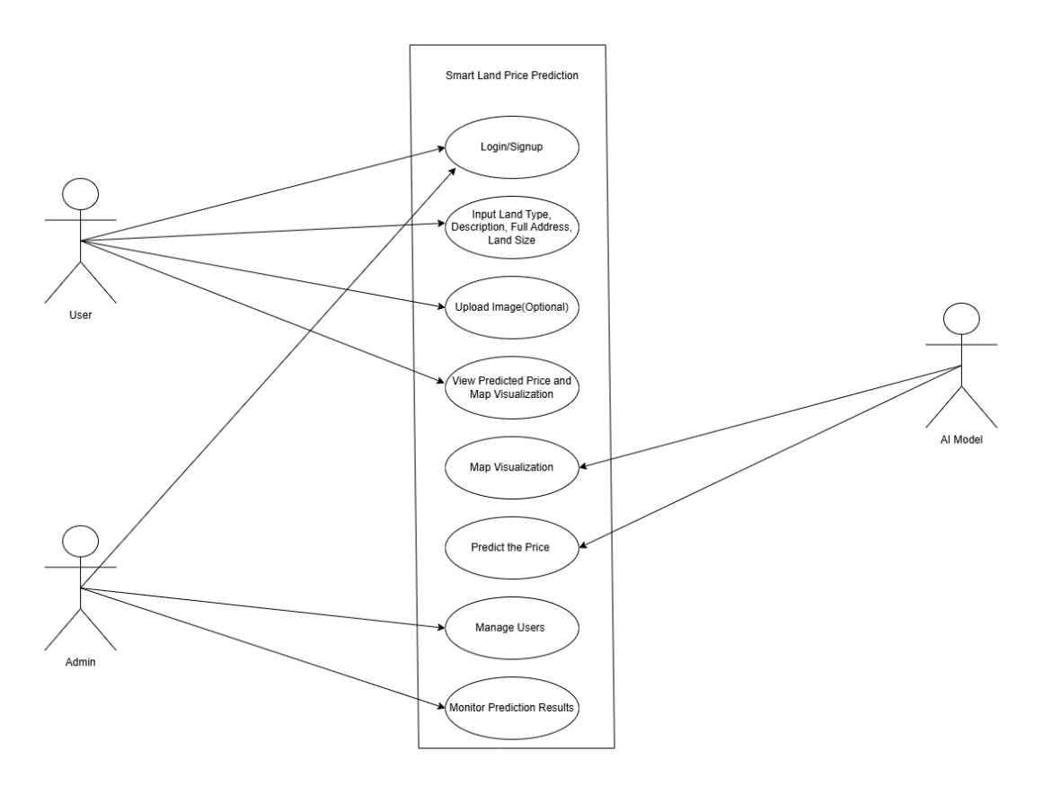
Figure 3.1 Use case diagram of the Smart Land Price Predictor
The Illustration above shows the proposed system's use case, where the user can engage in several activities that contribute to achieving the goal of the prediction system. The user can perform all the actions in the app, apart from the activities being carried out by the AI model and the admin. The user logs in or signs up, then fills in the land details that are required for the AI model to carry out the action of predicting the price of the land and providing a map representation. The admin ensures that the app prediction is been done properly and monitors the user's actions in the app.

B. Class Diagram
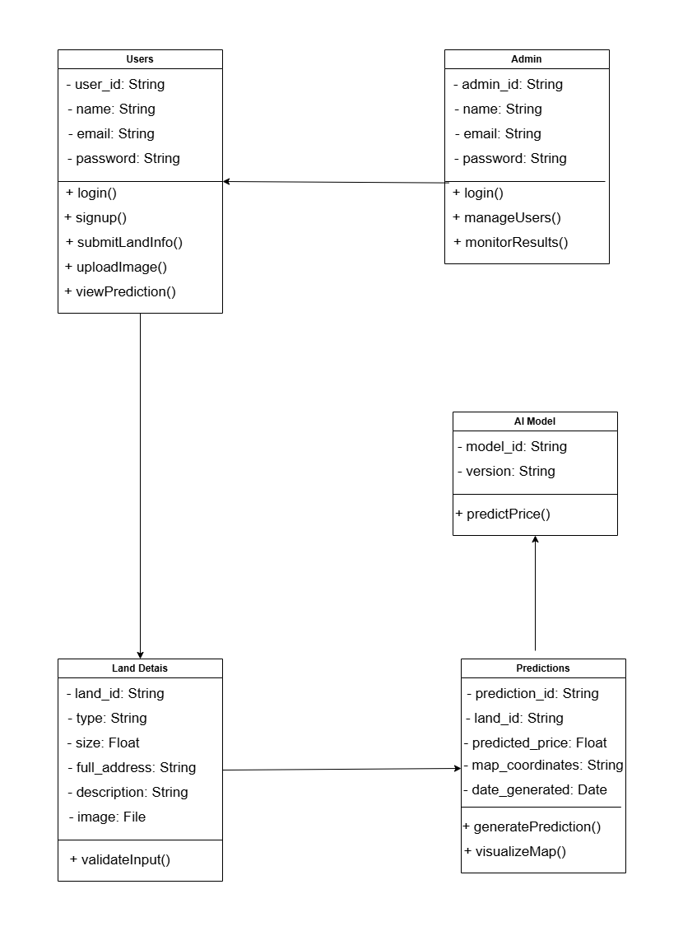
The class diagram includes various classes with attributes and methods. This system is made up of 5 classes. The users, admin, land information, predictions, and the AI Model. The User class has several attributes such as user ID, Name, Email, and Password. It also allows users to log in or sign up, submit land details, upload images, and check the results of predictions along with map representations. The Admin Class, representing system administrators, has similar attributes but can also manage users and check the results from the system for prediction, and monitor the AI model’s performance. The Land Details class provides an account of all relevant information related to a particular piece of land after prediction, which includes: type, size, full address, description, predicted price, and images, alongside a method to check the validity of input data. The Prediction class is responsible for keeping track of prediction results and relating them to specific land details while also having attributes like predicted price, map coordinates, and the date the prediction was made. It also has methods to generate predictions and display them on a map. Finally, the AI Model class contains information about the machine learning model designed for predicting land prices and holds data like model ID and version. It also provides price estimation functionality based on the provided land data.
C. Activity Diagram of Smart Land Price Predictor
An activity diagram shows the flow and the actions, activities, and decisions in an orderly step-by-step manner within a particular process that occurs in the Smart Land Price Predictor by using a simple flow diagram. This diagram helps with communication and process modelling, but the Illustration below shows how the user signs up or logs in to the system and how the user can predict the price of land.
Activity Diagram for User Authentication of Smart Land Price Predictor:
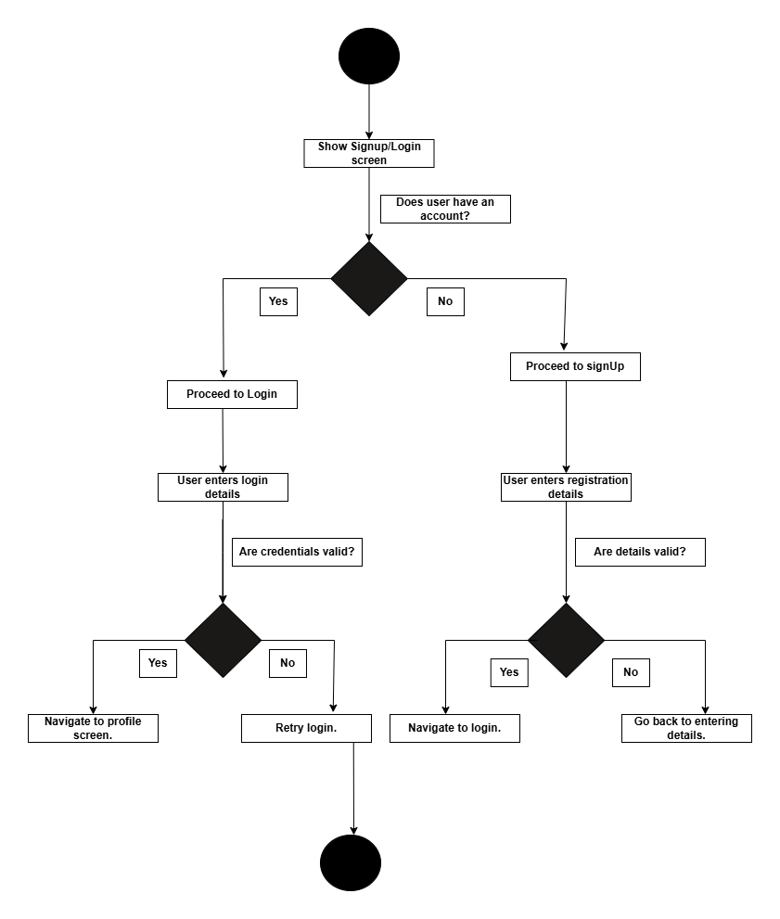
Figure 3.3 Activity diagram of Smart Land Price Predictor for user authentication
Activity diagram for predicting land prices:
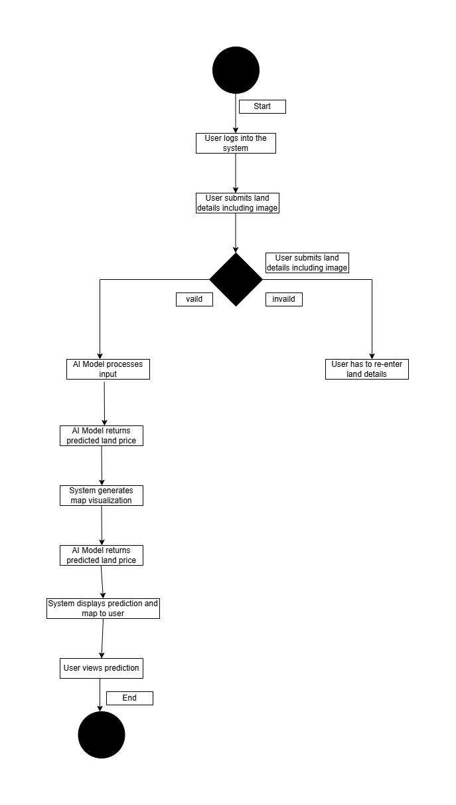
Figure 3.4 Activity diagram of Smart Land Price Predictor for user authentication
  - Design of the proposed system
Systems design involves explaining the entire components of a system, which include the modules, architecture, interfaces, and data, according to specific requirements. This section of this chapter will show the proposed system's input/output design and database design.

3.41. Input/Output design

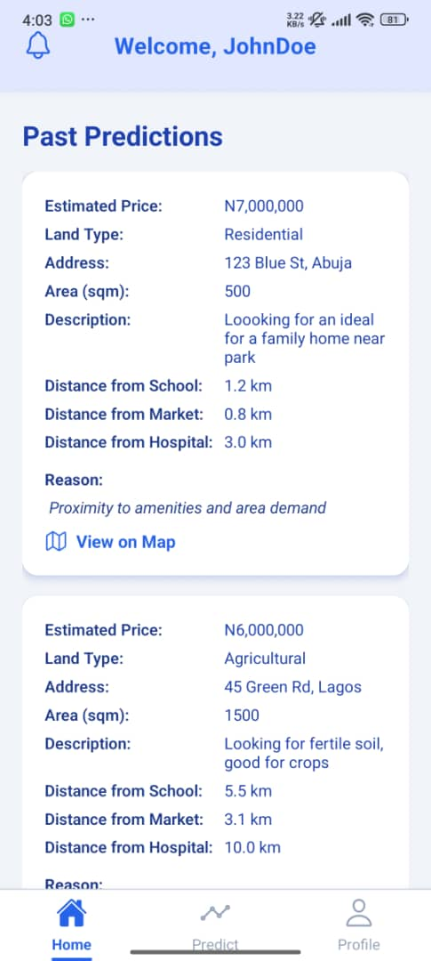
Fig 3.5 Input/Output Design of the proposed system
3.4.2 Database Design
User Table
Table 3.1 User table for Smart Land Price Predictor
Attribute | Data Type | Description
Id | Int | Unique identifier for each user.
Name | Varchar | Retains the full name of the user.
Username | Varchar | Retains the username that the user chose.
Email | Varchar | Retains the user's email.
Password | Varchar | Retains the hashed password for security.
profile_image | Varchar | Retains the profile image file path.
is_verified | Boolean | Indicates if the user is verified (true or false).
Predictions | Text | Retains a list of predictions that have been made by the user
Role | Enum | Indicates the function of the user in the system, which controls the permissions and features available to them.
Address | Varchar | This refers to the user's current location.
date_joined | Timestamp | Retains the account creation timestamp.
updated_at | Timestamp | Retains the last update timestamp.
reset_password_otp | Varchar | Retains the OTP for password reset.
reset_password_expiry | Timestamp | Expiration time for OTP reset.

Predictions table
Table 3.2 Predictions table for Smart Land Price Predictor.
Attribute | Data Type | Description
Id | Int | Unique identifier for each prediction.
Name | Varchar | Unique name to identify the prediction (e.g., my_first, dream_land)
Address | Varchar | This refers to the location of the land that the user inputs.
land_type | Varchar | This refers to the type of land the user requests.
land_size | Varchar | This refers to the size of the land (sqm, ft) that the user inputs
land_price | Varchar | This refers to the estimated price of the land
Description | Varchar | This refers to the description provided by the user for the land.
land_image | Varchar | Retains the uploaded land image file path.
Reason | Varchar | This refers to the details of the various reasons why the land amounted to the predicted amount.
nearest_amenties | Varchar | This refers to the resources close by and the distance from the land to those places (e.g., the Market, School).
map_representation | Varchar | This refers to the link provided to the user to view the map representation showing the nearest resources to the land.

CHAPTER FOUR
SYSTEM IMPLEMENTATION
4.1 Introduction
System Implementation refers to the part where the software is been brought to life. This chapter describes the implementation of the system, along with the user interface and tools used in the system. This focuses on showing how the implementation was done in the development of the system following the system analysis that was carried out.
4.2 Choice of Programming Languages
4.2.1 Backend
Flask
Flask was developed by Armin Ronacher and released in the year 2010 among Pallets projects. Flask is a Python-based web framework. Python and Flask packages must be installed on the system to be able to use Flask for building and running web applications. "Micro but extensible” is a simple principle in Flask, which implies that it supports the crucial things needed for web development, while the developers can still add their functionalities through extensions. Handling web requests and routing, making it easy to build dynamic APIs, is what Flask is aimed at doing.
4.2.1 Frontend
React Native
React Native was developed by Facebook and was released in the year 2015. It is an open-source JavaScript framework for mobile application development. Node.js and Expo must be set up on the system in the system to be able to develop using React native. Node.js provides a package manager, Node Package Manager (NPM), which helps in the installation of various packages that will help in the development of the application. React native provides built-in tools for building applications for both Android and IOS with the same code. This is the main reason why it was my choice because it means that the app will be able to work on both Android and IOS seamlessly. It supports the use of reusable components, which helps in making the development process easy.

4.2.3 Database
MongoDB
MongoDB was developed by a company called MongoDB Inc., formerly known as 10gen, and was launched in the year 2009. MongoDB is a NOSQL database that supports the storage and management of data in a JSON-like format known as BSON. It is mostly used as a database system for mobile and web applications because it is scalable and has high performance. The information can be saved in collections to be able to separate the data to avoid confusion. MongoDB Atlas is the web app that u use to open a MongoDB account, and from there, you can create a project then a database then you get database URL which will have a unique username and password attached to it along with the project name that you use in your code to connect to it.
4.3 Choice for Model Development
Image-Based Analysis: After researches were carried out, Convolutional Neural Network (CNN) was chosen for the image analysis because it was developed for training grid-like structures, such as images. CNN is a deep learning model that has different pre-trained models, which have been trained with millions of images. By using any of these pre-trained models, features can be extracted from the images and then customized to perform the desired task, a process known as image classification. An experiment was carried out between three pre-trained CNN models, EfficientNetB0, ResNet50, and MobileNetV2. The MobileNetV2 outperformed the other models.
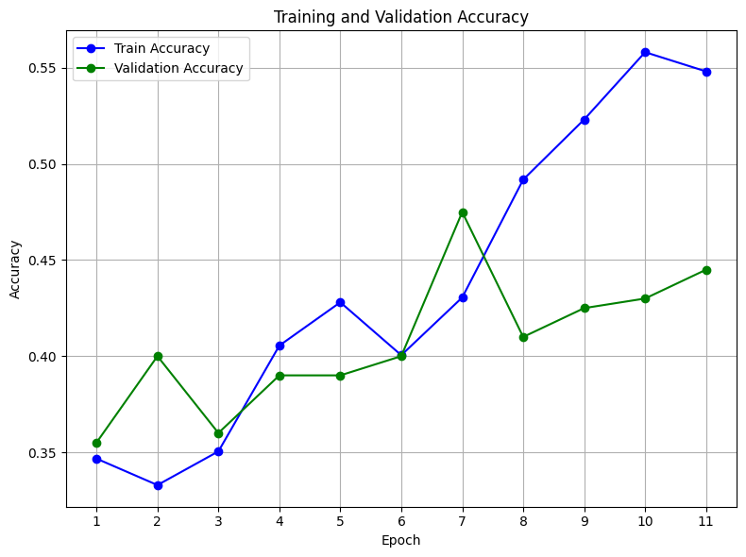
Figure 4.1 Graph of the accuracy of MobileNetV2
MobileNetV2 is a lightweight CNN model that is used in mobile which makes it very compatible with our project, considering we are building a mobile application. In the graph above, Figure 4.3.1, it is clearly showing the training and validation accuracy obtained from the CNN model, MobileNetV2. The graph shows that after 11 epochs, the model achieved an accuracy of about 56%, which was the best that was achieved after training over 4 other different CNN models. 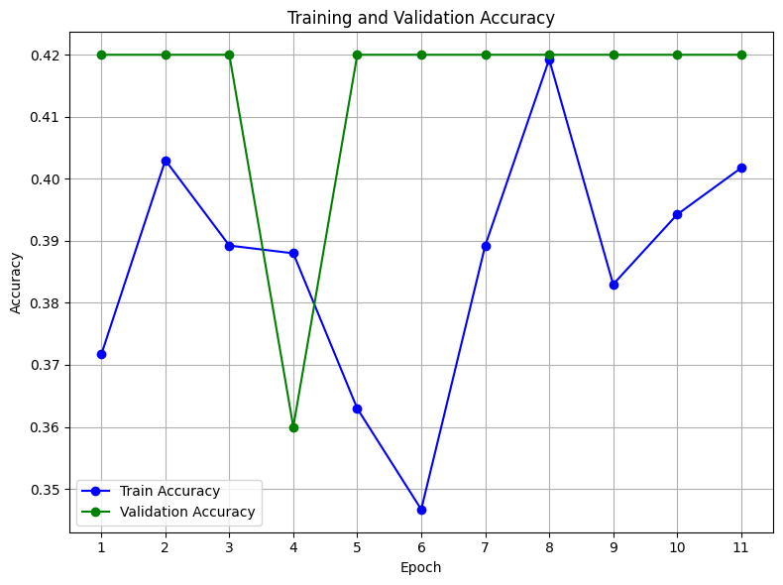
Figure 4.2 Graph of the accuracy of EfficientNetB0
The graph above, in Figure 4.3.2, shows that the validation accuracy of EfficientNetB0 is approximately 42%, achieved with around 11 epochs. And it was noticed that there was a little fluctuation in the training accuracy between 35% and 42%, which signifies the possibility of difficulty in fitting the training data effectively. The validation accuracy curve remained mostly flat across epochs, suggesting poor generalization and potential underfitting.

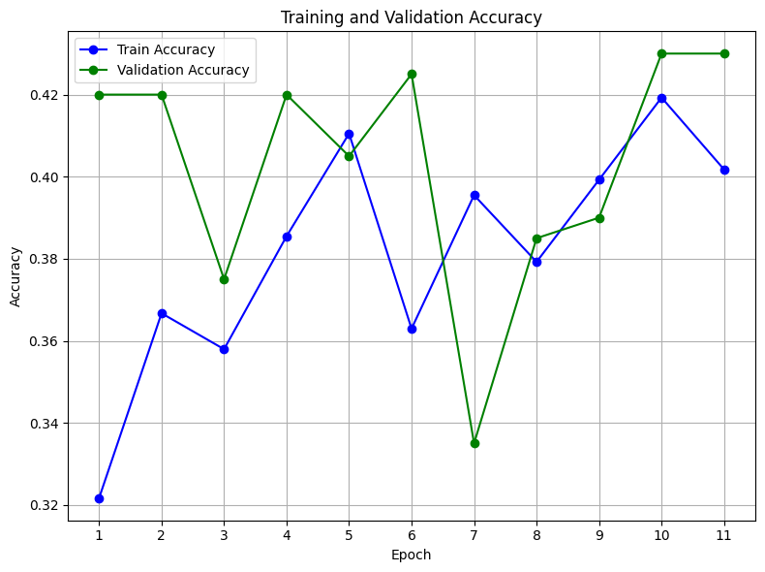
Figure 4.3 Graph showing the accuracy of ResNet50
The graph above in Figure 4.3.3 shows the training and validation accuracy graph for ResNet50, which shows that the model steadily improved its ability to learn from the training data, with training accuracy rising from around 32% to about 42% over 11 epochs. However, the validation accuracy tells a different story—it bounced up and down between 33% and 42%, showing that while the model sometimes performed well on unseen data, it wasn’t consistent.
Structural-Data Analysis: Most of the works that were reviewed showed that XGBoost is one of the best machine learning models for prediction, and after carrying out the training, the accuracy was 96%. It was proven to be true, therefore, XGBoost was used in this system to train structural data.
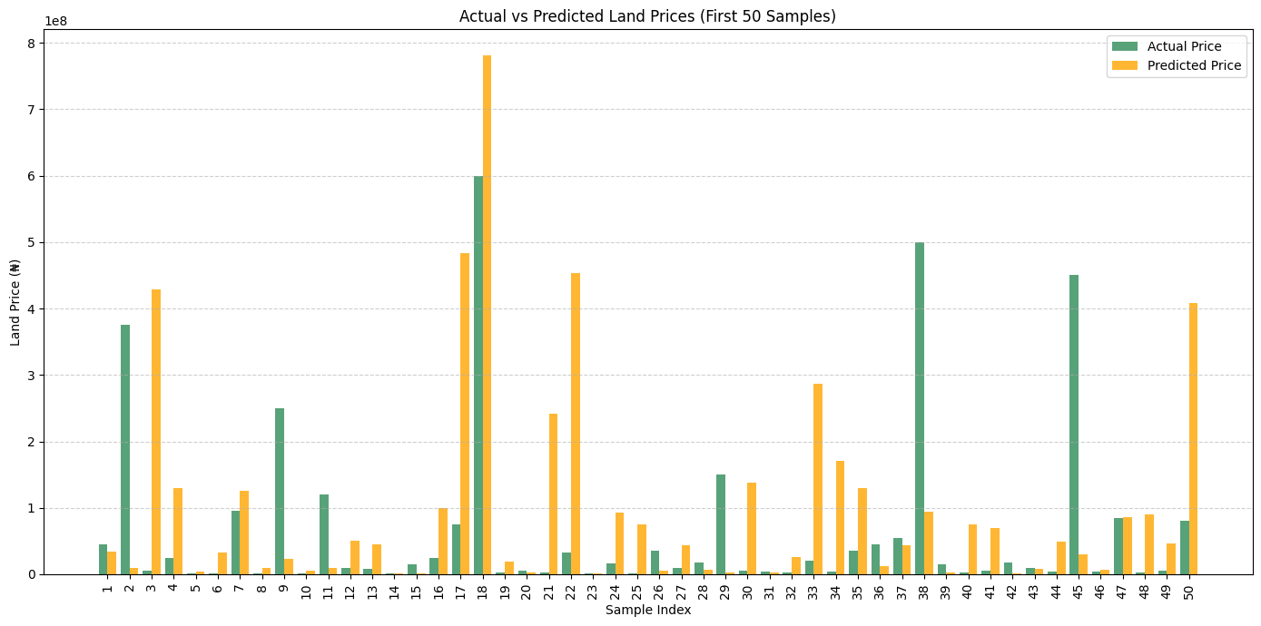
Figure 4.4 Graph of the accuracy of XGBoost
The graph in Figure 4.3.4 compares actual land prices to the ones predicted by the XGBoost model for the first 50 samples. The green bars show the real prices, while the orange bars represent what the model predicted. As seen in the chart, the model does a fairly good job for many samples, especially for lands with lower or moderate prices, where the predicted values are quite close to the actual ones. This suggests that the model is generally good at capturing price patterns in those ranges.

  - SYSTEM REQUIREMENTS
There are a few requirements that the proposed system needs from the user for seamless usage of the system. They include:
- Stable internet connection on their device
- A very good Android or IOS mobile phone so that they can access the application on their device
- 4.5 USER INTERFACE
- This section of this research work is going to contain the user interfaces of different sections of
- PREGO, which would include the sign-in page, sign-up, homepage, profile page, etc.


- LANDIVIA’s Sign-up page:
- A Sign-up page is a form designed to accept a name, username, email, and password for new users so that they can be registered into the app, and their details will be saved.

- Figure 4.5 Sign-up page

- LANDIVIA’s Sign-in page:
- A Sign-in page is a form designed to accept an email and password from existing users, allowing administrators to authenticate access to the system.

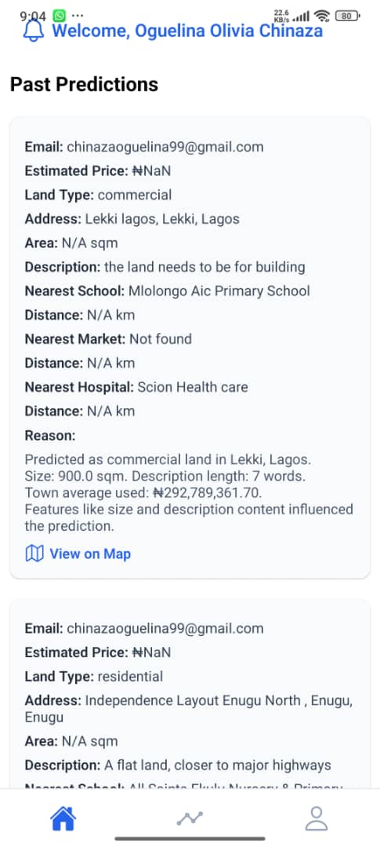
- Figure 4.6 Sign-in page
- LANDIVIA’s Homepage
- A home page contains the main details of the app, viewing notifications, and viewing the past predictions the user has made. From the home, you can navigate to other screens like the home, predict, and profile.

- Figure 4.7 Home page

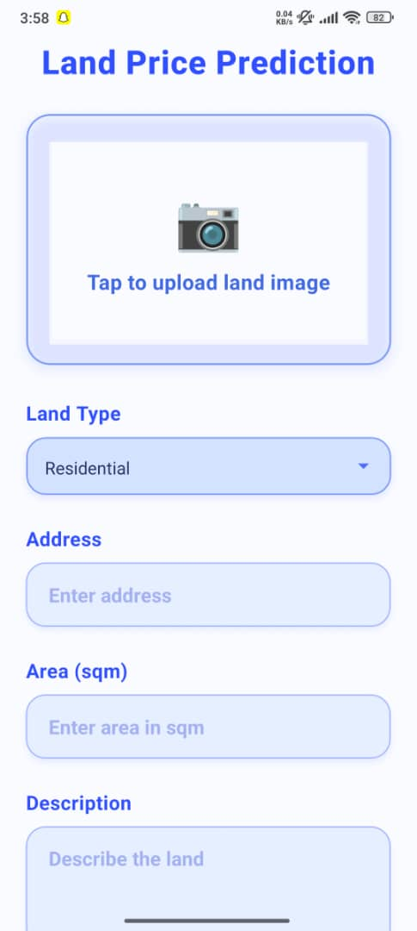
- LANDIVIA’s Prediction Page
- The prediction page is primarily a form where the user inputs the details needed, which include fields like uploading an image, land type, land size(sqm), address, and description for the prediction to be carried out efficiently, and then they are immediately navigated to a result page where they can see the result from the prediction.

- Figure 4.8 Prediction page
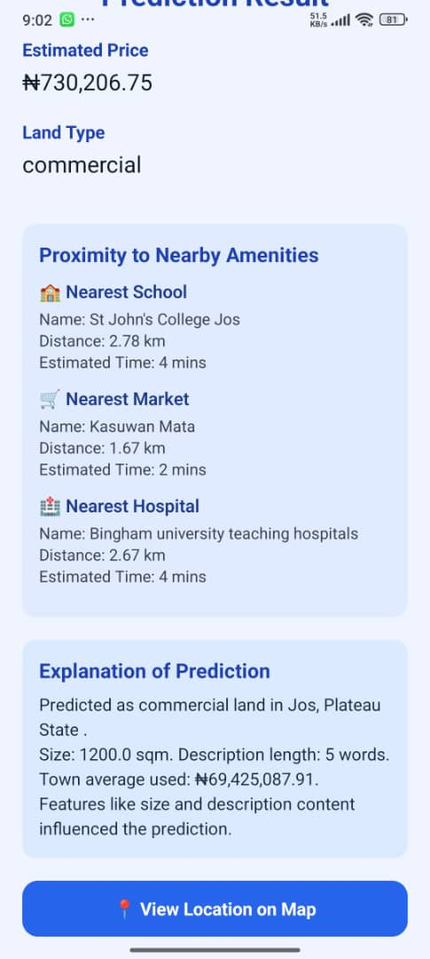
- LANDIVIA’s Prediction Result Page
- This page shows the result of the predictions. It contains information such as the estimated price of the land, land type, land size, description, address, distances to necessary amenities (schools, hospital, and market), the reason for the result of the prediction, and a link to view the land on the map.

- Figure 4.9 Prediction result page

LANDIVIA’s Profile Page
This page shows the information of the user, such as the user’s name, username, profile picture, email, and address, and this information can also be edited.

Figure 4.10 Profile Page

CHAPTER FIVE
SUMMARY, CONCLUSION, AND RECOMMENDATION
  - Summary
This project aims to provide a smart land price prediction system using machine learning algorithms. In the first chapter, the background of the study was discussed, highlighting the purpose of using machine learning algorithms for this system. The problem statements were also listed to provide an overview of the limitations that the project addresses. The aim and objective of the study which was solely adhered to, and it was achieved. The scope of the study, along with the significance and limitations of the study, was also discussed. In the next chapter, a review of related literature took place, therefore making us understand the best approach to take when handling the training of the models to achieve better accuracy. It was proven in almost all the literature work that the Gradient Boosting Model and the Regression Models were very accurate in prediction training, and the knowledge gap was that models were trained without using visual data, and visual data helps in giving better and accurate results. In chapter three, the system analysis of the system was carried out using Object Oriented Analysis and Design (OOAD). The UML diagrams of the research were also visualized along with the database design. The method of data collection was through scraping of various land selling platforms in Nigeria, such as Property Pro.ng, Jiji. In chapter four, the implementation of the system was discussed, thereby giving a visual representation of the user interface of the system. The backend of the system was built with Flask, while the frontend was built using React Native. The database used is MongoDB. XGBoost and CNN were the algorithms that were used in this system to train the model. XGBoost is a gradient boost model that was used to train the structural data of the system, and after evaluation, the accuracy was 96%, which is definitely a good accuracy score. For the image analysis and feature extraction, there was a comparison between three CNN pretrained models, EfficientNetB0, ResNet50, and MobileNetV2, to determine the one with higher training and validation accuracy. After the evaluation, the MobileNetV2 outperformed all other models with an accuracy of 56%. There is a graph representation showing the training and validation accuracy of all the models.

  - Conclusion
The research is aimed at enhancing the accuracy of the price prediction of the lands using machine learning algorithms. Thes main objective was to develop localized AI valuation model that incorporates local datasets and informal pricing patterns to reflect Nigeria's unique land market integrated into user-friendly mobile application that was designed for easy accessibility. The research began with a deep review of related literature work, which saw able to revealed the gaps in the quality and scalability of real estate price prediction systems. The developed system addresses this limitation by using diverse data comprising structured property attributes, geospatial data, and visual inputs to train an XGBoost for the price prediction, and CNN(MobileNetV2) for the visual data analysis. The result of the model after evaluation showed that the R² Score of 96% for XGBoost and R² Score of 56% for MobileNetV2. Over all, the research work contributes to the growing application of machine learning to agricultural and finance sector by providing an efficient and intelligent solution to land pricing in Nigeria.

  - Recommendations
The smart Land prediction (Landivia) still has a room for improvement and addition of new features. These are the areas that are recommended for future exploration:
- Fine-Tuning and Optimization Models: More work could be done in terms of fine-tuning the hyperparameters of XGBoost and CNN models to help in increase of predictive accuracy.
- Inclusion of Market Trends and Economic Indicators: For future research, there could be integration of the app to use broader economic data, such as interest rates, neighborhood development indices, that can enhance the market trend analysis.
- User-Centric Price Adjustment Features: This considers the user preference by providing options for users to input their budget and get the possible lands around that price with their details.

REFERENCES
Alzain, E., Alshebami, A. S., Aldhyani, T. H. H., & Alsubari, S. N. (2022). Application of artificial intelligence for predicting real estate prices: The case of Saudi Arabia. Electronics, 11, 3448. https://doi.org/10.3390/electronics11213448
Attada Rajesh, S., Likhitha, D., Janardhanarao, K., Vasu, B., & Sahitya, K. (2023). House price prediction using machine learning. International Research Journal of Modernization in Engineering Technology and Science, Impact Factor – 7.868. Retrieved from https://www.irjmets.com
Bimali, Y. M. Y., Rodrigo, U. S. D., Dharmaseelan, T., Thayalini, K., Gamage, M. P. A. W., & Rathnayaka, P. B. (2021). A machine learning-based solution for predicting land values: E-Valuer Land Value Predictor.
Doğan, S., Genç, L., Yücebaş, S. C., & Uşakli, M. (2025). Analyzing agricultural land price prediction using linear regression and XGBoost machine learning algorithms: A case study of Çanakkale. Turkish Journal of Agriculture - Food Science and Technology, 13(5), 1109–1116. https://doi.org/10.24925/turjaf.v13i5.1109-1116.7379
Ho, W. K. O., Tang, B. S., & Wong, S. W. (2021). Predicting property prices with machine learning algorithms. Journal of Property Research, 38(1), 48–70. https://doi.org/10.1080/09599916.2020.1832558
Kim, J., Won, J., Kim, H., & Heo, J. (2021). Machine-learning-based prediction of land prices in Seoul, South Korea. Sustainability, 13, 13088. https://doi.org/10.3390/su132313088
Lee, C. (2020). Predicting land prices and measuring uncertainty by combining supervised and unsupervised learning. International Journal of Strategic Property Management, 25(2), 169–178. https://doi.org/10.3846/ijspm.2021.14293
Mora-Garcia, R. T., Cespedes-Lopez, M. F., & Perez-Sanchez, V. R. (2022). Housing price prediction using machine learning algorithms in COVID-19 times. Land, 11, 2100. https://doi.org/10.3390/land11112100
Mulhar, S., Dhage, A., Deshmukh, R., Deshmukh, V., & Barhate, B. (2024). Land property price prediction using machine learning algorithms. International Open-Access, Double-Blind, Peer-Reviewed, Refereed, Multidisciplinary Online Journal, 4(3).
Nouriani, A., & Lemke, L. (2022). Vision-based housing price estimation using interior, exterior, and satellite images. Intelligent Systems with Applications, 14, 200081. https://doi.org/10.1016/j.iswa.2022.200081
Ragapriya, N., Kumar, T. A., Parthiban, R., Divya, P., Jayalakshmi, S., & Raman, D. R. (2022). Machine learning-based house price prediction using modified extreme boosting. Asian Journal of Applied Science and Technology, 7(1), 41–54.
Shahasane, A., Gosavi, M., Bhagat, A., Mishra, N., & Nerurkar, A. (2023). House price prediction using machine learning. International Research Journal of Engineering and Technology (IRJET).
Sharma, H., Harsora, H., & Ogunleye, B. (2023). An optimal house price prediction algorithm: XGBoost. Analytics, 3, 30–45. https://doi.org/10.3390/analytics3010003
Sobana, P., Balakumaran, M., Bharathkumar, S., Boopathi, P., & Harish, J. (2025). House price prediction using machine learning. Taylor & Francis Open Access. https://www.taylorandfrancis.com
Zhao, C., Ogawa, Y., Chen, S., Oki, T., & Sekimoto, Y. (2023). Quantitative land price analysis via computer vision from street view images. Engineering Applications of Artificial Intelligence, 120, 105040. https://doi.org/10.1016/j.engappai.2023.105040

APPENDIX A
Code for the Price Prediction
import numpy as np
import joblib
from scipy.sparse import hstack
# --- Load trained components ---
model = joblib.load("./models/xgb_land_price_model.pkl")
tfidf = joblib.load("./models/tfidf_vectorizer.pkl")
encoder = joblib.load("./models/onehot_encoder.pkl")
scaler = joblib.load("./models/scaler.pkl")
town_avg = joblib.load("./models/town_avg_encoder.pkl")

def predict_price(input_data):
"""
Predict land price using trained XGBoost model.
input_data: dict with keys:
- 'Description' (str)
- 'Address' (str)
- 'Land Type' (str)
- 'State' (str)
- 'Town' (str)
- 'Size_sqm' (float or str)

Returns:
- predicted_price (float)
- reason (str): explanation of prediction factors
"""

# --- 1. Combine text and vectorize with TF-IDF ---
full_text = input_data['Description'] + ' ' + input_data['Address']
tfidf_text = tfidf.transform([full_text])

# --- 2. One-hot encode low-cardinality categorical variables ---
cat_data = [[input_data['Land Type'], input_data['State']]]
encoded_cats = encoder.transform(cat_data)
# --- 3. Target encode town (fallback if town not seen before) ---
town = input_data['Town']
town_encoded = town_avg.get(town, town_avg.mean())
# --- 4. Engineered numerical features ---
size = float(input_data['Size_sqm'])
price_per_sqm = 0 # No actual price known yet
desc_length = len(input_data['Description'])
desc_word_count = len(input_data['Description'].split())
numeric_features = np.array([[size, town_encoded, price_per_sqm, desc_length, desc_word_count]])
scaled_numeric = scaler.transform(numeric_features)

# --- 5. Combine all features ---
final_features = hstack([encoded_cats, tfidf_text, scaled_numeric])

# --- 6. Predict ---
log_price = model.predict(final_features)[0]
predicted_price = np.expm1(log_price) # reverse log1p

# --- 7. Human-readable reason ---
reason = (
f"Predicted as {input_data['Land Type']} land in {input_data['Town']}, {input_data['State']}.\n"
f"Size: {size} sqm. Description length: {desc_word_count} words.\n"
f"Town average used: ₦{town_avg.get(town, town_avg.mean()):,.2f}.\n"
f"Features like size and description content influenced the prediction."
)
return round(predicted_price, 2), reason

APPENDIX B
Code Environment for the Prediction Result Screen
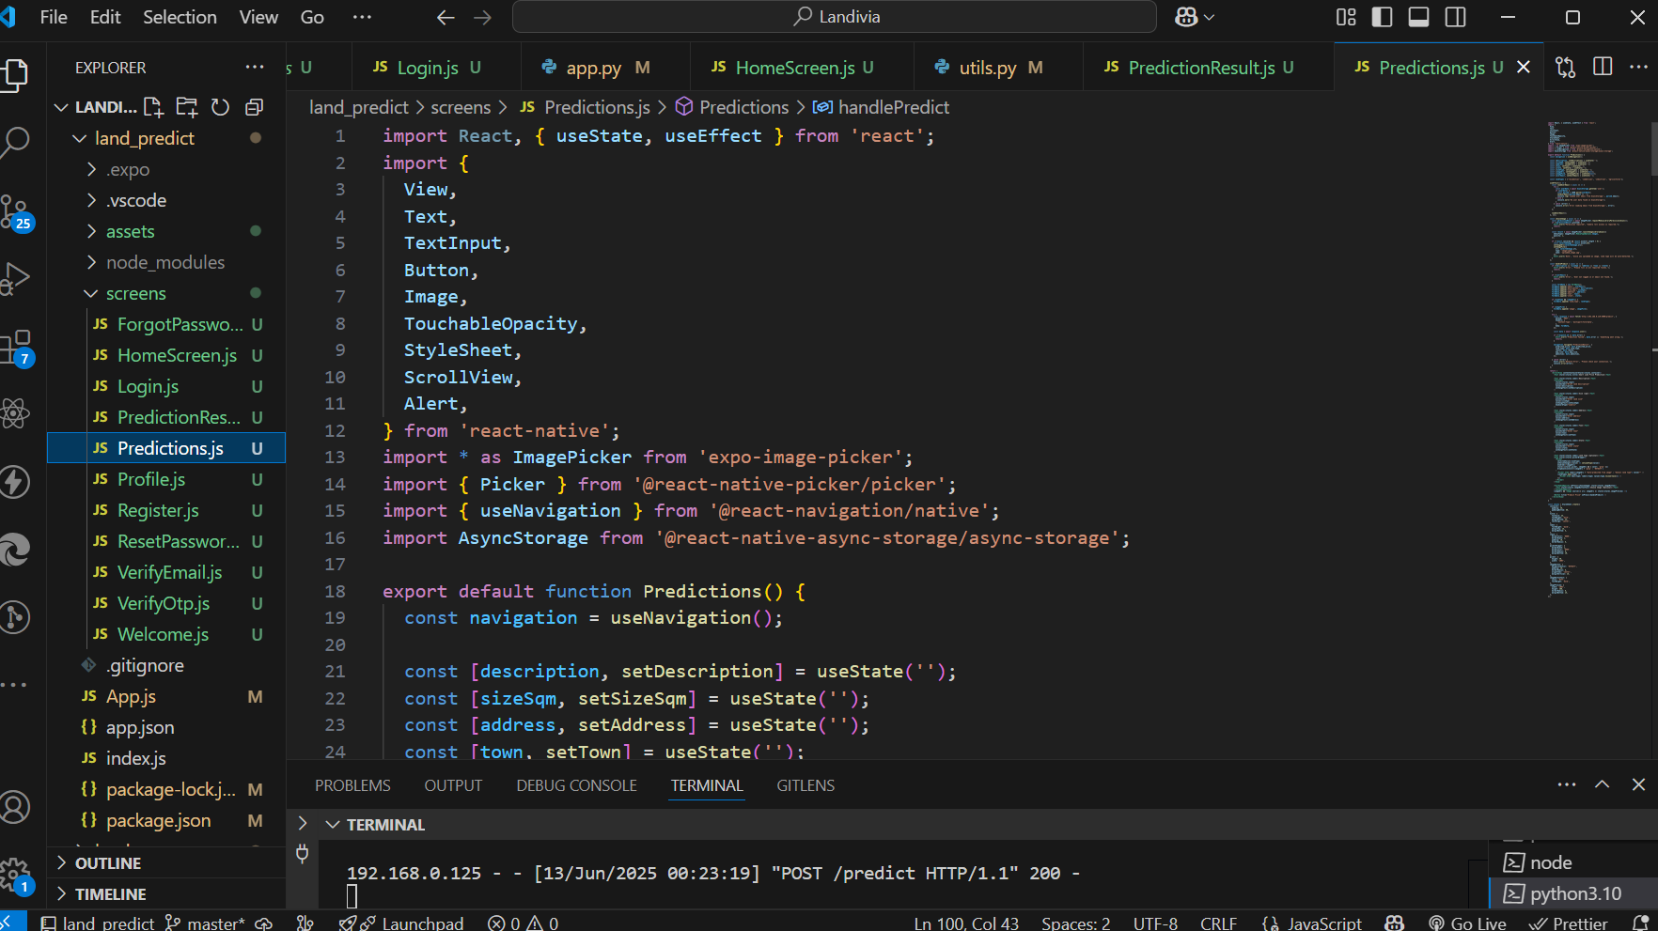
Code Environment for Prediction Result
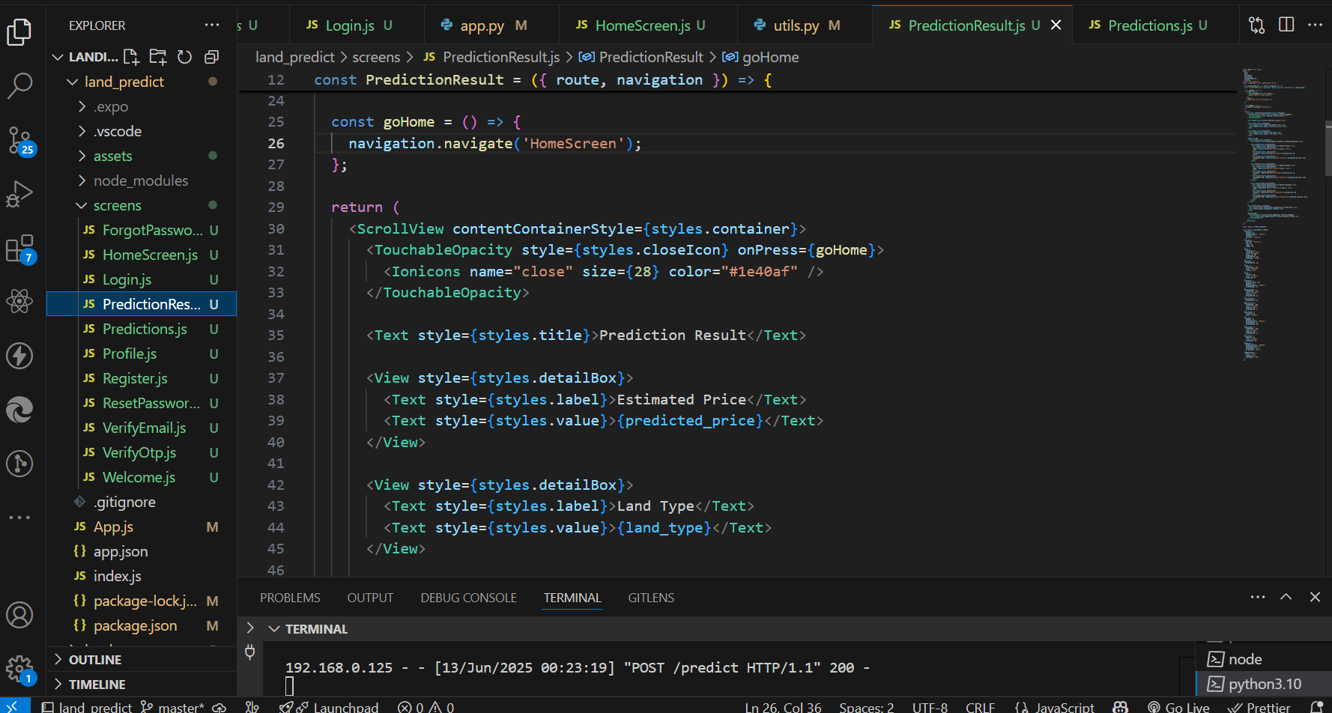

The Prediction Form and the Result, along with the Map Representation
