

A TUMOR TRACKING AND MONITORING SYSTEM USING ARTIFICIAL INTELLIGENCE (AI).

BY

EJIOFOR, ANDRE KAMSIYOCHUKWU
GOU/U21/CSC/712

SUBMITTED TO THE DEPARTMENT OF COMPUTER SCIENCE, FACULTY OF NATURAL SCIENCES AND ENVIRONMENTAL STUDIES, GODFREY OKOYE UNIVERSITY, ENUGU.

IN PARTIAL FUFILMENT OF THE AWARD OF BACHELOR OF SCIENCE DEGREE (B.Sc) IN COMPUTER SCIENCE

SUPERVISOR: ENGR. DR. KINGSLEY .I. CHIBUEZE.

JULY, 2025

APPROVAL
This is to validate that this research work “A Tumor Tracking and Monitoring System using Artificial Intelligence (AI)” was embarked upon by “Ejiofor Andre Kamsiyochukwu” with the matriculation number CSC/U21/CSC/712 in partial fulfillment of the requirements for the award of Bachelor Science (B.SC) in Computer Science, Faculty of Natural Sciences and Environmental Studies , Godfrey Okoye University, Enugu.

Engr. Dr. Kingsley I. Chibueze _______________ _______________
Supervisor Signature Date

_______________ _______________
External Examiner Signature Date

Dr. Frank Okebanama _______________ _______________
Head of Department Signature Date

Prof. Chidi C. Uhuegbu _______________ _______________
Dean of FNSES Signature Date

CERTIFICATION
I hereby certify that the work included therein was completed by myself and that it was mainly based only on my own observations and investigation. Consequently I will fully accept the University's decision if I am found to have cheated on the assignment.

________________________
Ejiofor, Andre Kamsiyochukwu
GOU/U21/CSC/712

DEDICATION

This work “A Tumor Tracking and Monitoring System using Artificial Intelligence (AI)” is dedicated to my parents Mr. and Mrs. Obinna Ejiofor who painstakingly has contributed heavily to everything that I have achieved up until this day and I pray that the good lord continue to guide and protect them for the rest of their days.

ACKNOWLEDGMENTS
I am highly thankful to Almighty God, who helped me with His grace and strength in carrying out this project. Without this divine support, with His help, none of this would be possible.
I would strongly like to express my gratitude to my supervisor, Engr. Dr. Kingsley Chibueze, for your exceptional assistance, useful suggestions and always being ready with encouraging words during this project. The mature guidance and suggestions you gave me were of great help in completing this project.
I kindly acknowledge and thank the Faculty President and my dear friend, Master, Nnodua Ifeanyi incommunicably, on behalf of the faculty, due to your effort on ensuring academic excellence and availing of the enabling environment that promotes learning and innovation.
Special appreciation to the Head of Department, Dr. Frank Okebanama, due to your leadership, guidance and the endless efforts you made in seeing the smooth running of the department.
I would like also to offer my sincere thanks, to all lecturers in the department, whose knowledge, support and inspiration you have given me through my period of study in the department. I will always remember your commitment to a teaching career and the enthusiasm that you showed towards our success.
Personally, I would like to thank my lovely parents Mr and Mrs Obinna Ejiofor always due to their love, prayers, sacrifices, and constant support during the course of my studies. You believed in me and that sustained me even during the most difficult moments. My siblings, I am grateful to you encouraging me, inspiring me, and supporting my emotions. I cannot say how much I appreciate you in my life. I simply want to thank everyone who helped in one way or the other towards the success of this project.

ABSTRACT
The integration of artificial intelligence (AI) in medical imaging has shown great promise in improving the accuracy and efficiency of tumor monitoring and management. This research focuses on the development of a tumor tracking and monitoring system utilizing AI to analyze magnetic resonance imaging (MRI) and computed tomography (CT) scans over time. By automatically assessing changes in tumor size, shape, and volume, the system enables medical professionals to monitor tumor growth, evaluate treatment efficacy, and predict potential disease progression. The study employs descriptive statistics to interpret trends and variations in tumor characteristics across imaging sessions, providing critical insights into patient responses to therapy. The findings demonstrate the AI system’s potential to assist clinicians in making timely and informed decisions, ultimately contributing to improved patient outcomes and personalized treatment strategies. This research highlights the significance of AI-based tumor tracking tools in advancing oncological care and supports further exploration into AI’s role in diagnostic imaging.

TABLE OF CONTENTS
PAGES
Title page i
Approval ii
Certification iii
Dedication iv
Acknowledgement v
Abstract vi
Table of contents vii– viii
List of Tables ix
List of Figures x

CHAPTER ONE: INTRODUCTION 1
1.1 Background of the Study 1
1.2 Statement of Problems 2
1.3 Aims and Objectives 3
1.4 Significance of Study 3
1.5 Scope of the Project 5
1.6 Limitations of the Study 6
1.7 Definition of terms 7

CHAPTER TWO: LITERATURE REVIEW 12
2.1. Overview of Tumor Detection and Monitoring 12
2.2 Medical Imaging Techniques for Tumor Detection 12
2.2.1 Magnetic Resonance Imaging 13
2.2.2 Computed Termography (CT) 13
2.2.3 Positron Emission Termography (PET) 13
2.2.4 Ultrasound Imaging 13
2.3 Artificial Intelligence in Tumor Detection 13
2.3.1 Machine Learning Algorithm for Tumor Detection 14
2.3.2 AI Based Tumor Tracking and Monitoring 14
2.4 Review of Related Literature 14
2.5 Research Gaps and Need for Study 15
2.6 Summary of Related Literature 16

CHAPTER THREE: SYSTEM ANALYSIS AND DESIGN 17
3.0 Introduction 17
3.1 Analysis of the Existing System 17
3.2 Analysis of the Proposed System 18
3.2.1 System Requirements 18
3.2.1.1 Hardware Requirements 18
3.2.1.2 Software Requirements 18
3.3 Proposed Methodology: Object Oriented Analysis and Design 19
3.3.1 Use Case Diagram 19
3.3.2 Activity Diagram 20
3.3.3 Class Diagram 22
3.3.4 Sequence Diagram 23
3.4 Design of the proposed system 23
3.4.1 Database Design 23
3.4.2 System Architecture 26
3.4.3 Input and Output Design 27
3.4.3.1 Inputs 27
3.4.3.2 Outputs 27
3.4.4 Algorithm Design 27

CHAPTER FOUR: SYSTEM IMPLEMENTATION 29
4.1 Overview 29
4.2 Tools Used for Implementation 29
4.2.1 PYTHON 3.8+ 29
4.2.2. Flask 29
4.2.3 OpenCv 29
4.2.4. HTML 30
4.2.5 MySQL –Database 30
4.2.6 JavaScript 31
4.2.7 PHP – BACKEND 31
4.3. System Requirements 32
4.4. User Interface of the Proposed Design 32
4.4.1. Welcome Screens (setup screen) 32
4.4.2 Image Upload Page 33
4.4.3 Result Display Page 34
4.4.4 Dashboard: Doctor / Admin 35
4.4.5 Patient Profile Page 36

CHAPTER FIVE: SUMMARY, RECOMMENDATIONS AND CONCLUSION 38
5.1 Summary 38
5.2 Conclusion 39
5.3 Recommendations 40
5.4 Recommendation for future research 40

REFFERENCES 41

APPENDIX 42

LIST OF TABLES
TABLES PAGE
3.1 User table for the proposed system 24
3.2 Scan table 24
3.3 Tumor records table 25
3.4 Reports Table 25

LIST OF FIGURES
FIGURES PAGE
3.1: The proposed system features its use case diagram as depicted 20
3.2: The activity diagram of the proposed System can be found 21
3.4 Class diagram 22
3.5 Sequence diagram of the proposed system 23
3.6: System Architecture 26
4.1 Welcome Page of the Proposed System 33
4.2 Image upload page of the Proposed system 34
4.3 Result Display page of the Proposed system 35
4.4 Patient Management Page of the Proposed system 36
4.5 Tumor Tracking overtime Page of the Proposed system 37

CHAPTER ONE
INTRODUCTION
1.1 Background for Study
Cancer and additional related diseases continue to exist because there are no tumor detection systems in place. Detecting and monitoring tumors stands vital for disease management systems. The exact tracking method which uses medical imaging and medical imaging technologies such as magnetic resonance imaging (MRI) and computed tomography (CT) to monitor tumor progression over time represents a critical need for disease efficacy assessment and result removal purposes. The medical diagnosis of pictures requires time-consuming work which contains human mistakes and shows variations between doctors during interpretation. The fast development of Artificial Intelligence (AI) now permits enhanced automatic analysis of medical imaging for tumor tracking which leads to improved accuracy in monitoring through valid outcomes. (Hyged SN, Lindenburg M.L 2019).
This research demonstrates steps for developing a tumor monitoring system through AI implementation. The designed system uses MRI and CT imaging data for detecting alterations in tumor dimensions and measurement characteristics along with other crucial attributes during specified time frames. The AI algorithm empowers the designed system to streamline medical professional workloads and establish frequent reliable measurement methods which lead to better predictions of patients' tumor development response and treatment results.
Special expertise will be necessary for multiple programming languages and hardware systems throughout the system implementation phase. Image analysis machine learning models will be significantly developed through Python applications which benefit from the robust TensorFlow and pitocorch and openkV libraries. R functions for both statistical calculations and visualization work best for running descriptive statistical analyses. SQL W
1.2 Statement of Problem
The use of manual system of detection and analysis by medical professionals has given produced to a lot of problems which includes the following:
Human Error: Stress and oversight from Medical professionals who use the traditional (Manual) Method leads to errors, which by the way are common with humans, thereby affecting the entire scan result.
Time-Consuming: Manual analysis of medical images is labor-intensive, therefore, requiring a lot of time to review, interpret, and report findings, potentially delaying diagnosis and treatment.
Limited Precision: The Manual methods is void of the accurate precision needed to detect minor changes in tumor size or growth, making it difficult to monitor progression accurately over time.
Subjective Interpretation: Depending on the expertise of the radiologists and medical professionals can lead to differences in interpretation. This subjectivity can ultimately result in misleading diagnoses.
Difficulty in Handling Large Data: as patient numbers increase and imaging volumes are compounded, manually analyzing and storing data becomes overwhelming and prone to inefficiencies.
Resource Intensive: Requires highly trained professionals, sophisticated equipment, and serious financial investment, which may not be accessible in resource constrained settings.

1.3 Aim and Objectives of the Study
This proposed research project will be based on the work "A Tumor Tracking and Monitoring System Using Artificial Intelligence" and will focus on early detection, tracking, and monitoring of the tumor.
Objectives:
- To develop an easy-to-work interface that will allow transferring and managing MRI/CT scans.
- To train an AI model based on labeled medical image data to detect cancerous tumors in the images.
- To integrate the trained AI model to the tumor tracking system.
- To Test the entire system in terms of accuracy, efficiency and dependability in identifying and tracking of tumors.
1.4 Significance of the Study
This investigation sets the foundation to pioneer essential developmental progress within medical imaging particularly in tumor discovery along with monitoring and management procedures. Medical imaging technologies such as MRI and CT interface with Artificial Intelligence (AI) result in various advantages for health providers and patients and create these benefits:
1. Diagnosis improvement in accuracy
AI-based tumor tracking systems generate more accurate findings than human-controlled methods because of their automated and logical operations. AI-based healthcare analysis produces better results than manual procedures because it detects tumors during early stages thus eliminating diagnostic inaccuracies.
2. Increased monitoring of tumor progression
A system able to analyze images sequentially allows continuous observation of tumor response throughout development as well as therapeutic phases. The system can detect any minor transformations with optimal accuracy. The system enhances physician ability to evaluate tracking therapy results which helps them modify treatment strategies.
3. Rapid diagnosis and treatment plan
The AI automated image analysis reduces the required time for diagnostic procedures which enables physicians in clinical practice to reach decisions promptly. Quick clinical assessments represent a critical step toward better patient outcomes and treatment of tumors which show rapid development.
4. Personal treatment plans
AI analysis of tumors enables prediction of potential results which supports healthcare professionals to create patient-specific treatment plans. The manufacturing of personalized treatments for specific patients by evaluating future medical data results in improved treatment performance along with fewer unwanted side effects.
5. Decreased human error and fatigue:
The AI system decreases the need for human radiologist analysis while reducing diagnostic errors caused by professional weariness and technical incompatibility and inexperienced staff work. The clinical environment with high pressure benefits from this increase in tumor and monitoring reliability.
6. Cost and Resource Efficiency:
The automation of tumor detection and monitoring enables more effective resource management through workflow optimization and cuts medical staff workload and may reduce expenses within the health care sector. Vast medical imaging data becomes easier to handle through healthcare facilities enabled by this system.
7. Scalability in health care systems
The system demonstrates data-handling capability for large imaging data sets which enables its application across various healthcare facilities from big hospitals to small clinics so they can obtain state-of-the-art medical equipment.
8. Medical AI Research Advance
This research adds knowledge to the expanding field of AI healthcare studies as it shows ways to implement machine learning algorithms to enhance medical image examination. The research creates foundations for upcoming AI-based clinical and future stating systems.
1.5 Scope of the Study
The research concentrates on designing and evaluating an AI-based technology system which implements MRI and CT imaging technologies for detection and tracking along with monitoring functions. The proposed system aims to solve traditional detection challenges by testing the current methods of human analysis while also tracking tumor growth accurately. The research examines two image modalities (i) magnetic resonance imaging (MRI) and (ii) calculation tomography (CT) because these techniques are extensively employed in clinical settings to identify and oversee tumors Are. The designed technological system will use MRI and CT image analysis to monitor tumor progression chronologically. The chosen modalities for oncological diagnosis are MRI because of its soft tissue features along with CT because it provides detailed imaging data (Wang et al., 2019).
The proposed study will create AI-assisted systems through machine learning with particular focus on deep learning models including Convisional Neural Networks (CNN) to enhance measurements and observation capabilities of tumors. Trained by annotated MRI combined with CT images the system will perform three functions: tumor boundary identification, APT-accurate tumor growth tracking and tumor characteristics alteration assessment over time (Esteva et al., 2017). A comparison will take place between the new AI-based system and traditional manual methods regarding detection and tracking functionality. Experienced radiologists along with the AI system will assess the accuracy and sensitivity together with specificity and reliability in the real-world clinical data. The detection system identifies and predicts minimal changes happening in tumor dimensions along with therapy outcomes.
1.6 Limitation of the Study
This research study has several restrictive factors which need consideration.
Several obstacles presented themselves during the research work.
The development process required the researcher to overcome steep challenges in learning system development languages because their basic understanding proved inadequate to complete project development.
During the construction of online systems the researcher experienced internet connection instability which prevented work when the internet was unavailable.
The research faced difficulties because insufficient literature was discovered regarding its project title.
1.7 Definition of Terms
Artificial intelligence (AI)
The research employs AI through machine learning algorithms which focus on deep learning models to detect track and monitor tumors from medical images that include MRI and CT scans. The firm nervous network (CNN) AI model receives training to identify and categorize tumors while forecasting their development from medical image outputs.
2. Tumor
Tumor detection represents the identification method of tumors found within medical imaging devices such as MRI and CT scans. Medical professionals must detect tissue abnormalities which demonstrate either benign or malignant tumor characteristics. The analysis depends on AI-based image techniques that operate automatically to decrease human interpretation needs.
3. Tumor monitoring
The practice of tumor monitoring depends on periodic evaluations of tumor growth measurements along with size measurements and characteristic analyses across time using medical imaging technologies. Tumor progression or regression evaluation depends on this process which helps determine how well the treatment approach works. The analysis of tumor status will be managed automatically by AI which will deliver real-time tracking via MRI and CT image processing.
4. Magnetic resonance imaging (MRI)
With MRI technology medical professionals can obtain wide body scans from inside tissue structures through strong magnetic intensity coupled with radio wave application. The technique provides optimal results for studying tumors in brains along with spinal tissue and soft materials. The MRI scans undergo analysis with AI systems to detect tumors in this study.
5. Calculation Tomography (CT)
CT functions through X-rays for building body cross-section images (slices). Through CT imaging doctors receive precise measurements of tumor size together with measurements of its dimensions as well as its precise location particularly in lung tissue liver tissue and abdominal organs. AI detection protocols alongside trekking will analyze the CT scan in this study.
6. Machine Learning (ML)
Within the category of learning AI machine describes a method to develop training algorithms which produce predictions or decisions through analyzing data patterns. The study will utilize an ML algorithm to detect tumors and evaluate their features before using the acquired data to educate its AI system about MRI and CT scans.
7. Deep Learning (DL)
The particular learning method known as deep learning machine relies on multiple layered neural networks known as deep nerve networks to process complex data. Researchers will utilize firm nervous networks (CNN) as deep learning models in this study to detect and track medical images with their analysis process enabled by extensive medical image data availability.

8. Convisional Neural Network (CNN)
The CNN image operates as a vital component of deep teaching algorithms because these methods demonstrate exceptional performance in their recognition and classification operations. This research adopts CNN to scan MRI and CT images which enables protocol tumors to monitor their biological properties chronologically.
9. Tumor progression
The progression of the tumor refers to the growth, proliferation and potential metastasis of the tumor over time. Research tracking will use the AI-operated analysis of sequence MRI and CT images to monitor tumor developments by tracking size changes and characteristics.
10. Treatment efficacy
The efficacy of treatment depends on a special medical procedure such as chemotherapy or surgical intervention or radiation to manage tumor size reductions or impede tumor growth. Tumor characteristics in the AI assessment process will be measured through pre-treatment comparisons by the AI system.
11. Tumor results predicted
The analysis of tumor results requires forecasting both past image data and the anticipated tumor behavior after medical interventions. The AI model receives training to detect possible tumor progression and identify when tumors may return or disappear through examination of historical diagnostic images.

12. Sensitivity
AI technology demonstrates tumor identification capability through its sensitivity parameter for medical image detection. This metric determines the correct accuracy rate of real positive cases detected by the system which proves the system does not misidentify tumors.
13. Specificity
AI systems identify medical image areas which do not have tumor characteristics through their specific function. The specific index indicates how well the AI system detects actual negative cases correctly and reduces instances where normal materials get classified as tumors.
14. Annotated dataset
A set of medical image collections undergo professional labeling to mark tumors with their classification types and dimensional identifiers. A group of annotated dataset exists for training and evaluating the AI system within the research framework.
15. Clinical figures
Clinical data consists of information regarding patients in medical images which includes their age as well as gender and medical history with tumor types and their treatment protocols. The analysis of patient results and AI-borne tumor monitoring connections relies on clinical data in this study.
16. Verification dataset
The verification dataset consists of MRI and CT images that the system did not use for training because it will serve to evaluate its performance. Test datasets serve the purpose of validating the accuracy of system prophecies by confirming their ability to normalize new and unspecified pieces of data.
17. Prediction model
AI systems that utilize historical data and learned patterns make predictions about future tumor behavior particularly its responses to growth and treatment are called prediction models. The prediction model receives training to forecast tumor progression through examination data in this research.

CHAPTER TWO
LITERATURE REVIEW
The research work discusses delayed AI tumor detection alongside an analysis of present monitoring systems literature. It examines three fundamental areas: tumor detection principles, medical imaging tools and machine learning algorithms together with artificial intelligence applications in medical diagnostics. The research study identifies existing functions and defines the new operational boundaries before specifying the focus areas within the study task
2.1 Overview of Tumor Detection and Monitoring
Tumor detection along with monitoring has established itself as an essential diagnostic practice in medical institutions focusing on oncology over several years. Extended tumor analysis with early detection provides improved therapy resources which results in better treatment execution and patient recovery outcomes (Jiang et al., 2020 p 200). The conventional medical image analysis for tumor detection depends solely on MRI and CT scan review by human observers leading to time consumption and the chance of human errors and mistakes according to Litjens et al. (2017 p 98).
The detection of tumors has received major improvements from recent discoveries in AI together with machine learning technology. AI-based systems evaluate medical images while detecting irregularities together with tumor growth monitoring to support clinical choices of radiologists and oncologists (Esteva et al., 2019 p 51).
2.2 Medical Imaging Techniques for Tumor Detection
Through medical imaging processes healthcare providers detect tumors while assessing their development status. Multiple tools exist for medical imaging practice because this practice includes:

2.2.1 Magnetic Resonance Imaging (MRI)
MRI creates detailed pictures from soft tissues through the combination of magnetic fields and radio waves in a non-invasive imaging process as explained by Esteva and colleagues. The primary purpose of MRI scans is identifying brain tumors along with liver cancer and various other soft-tissue irregularities (Shen et al., 2017 p77). Through its high resolution MRI proves useful when detecting tumor margins as well as tracking modifications during multiple check-ups.
2.2.2 Computed Tomography (CT)
The body imaging method in CT scans produces cross-sectional pictures through X-rays which reveal detailed internal structure details. CT serves frequently as an imaging method to examine both lung cancer and liver cancer and additional solid tumors (Cheng et al., 2021). Patients face risks from ionizing radiation when CT scans are performed since they require repeated imaging and maintain imaging consistency.
2.2.3 Positron Emission Tomography (PET)
The main purpose of PET scans involves detecting cancer activity through tracer injection into tumors using radioactive agents. PET scans serve to distinguish malignant from benign tumors as shown in the research of Huang et al, (2019 p12).
2.2.4 Ultrasound Imaging
Ultrasound is commonly used for detecting tumors in soft tissues such as the liver and breast. While it is a low-cost and non-invasive method, its accuracy is limited by operator dependency and image quality (Wang et al., 2020).
2.3 Artificial Intelligence in Tumor Detection
Medical imaging analysis together with tumor detection experienced a fundamental transformation because of artificial intelligence developments. The identification of tumors meets higher accuracy levels through deep learning techniques within artificial intelligence models compared to traditional diagnostic approaches (Lunder Vold & Lunder Vold, 2019).
2.3.1 Machine Learning Algorithms for Tumor Detection
Several machine learning models exist for tumor detection purposes which are described in the sections below.
- The main application of Convolutional Neural Networks (CNNs) occurs in image processing by conducting tumor classification and segmentation tasks. Labeled medical images feed these models which enable them to recognize the differences between normal tissue and abnormal tissue (Razzak et al., 2018).
- Medical images get classified by Support Vector Machines (SVMs) through their ability to extract features from images. The strength of these models comes with an operational requirement for tedious feature engineering steps (Kumar et al., 2020 p107).
- Random Forests and Decision Trees operate together for tumor detection by selecting and classifying features according to the research of Xu et al. (2019).
2.3.2 AI-Based Tumor Tracking and Monitoring
AI systems employ two essential capabilities: detection of tumors and proper monitoring of their size evolution through time. Automatic predictions of tumor growth patterns and treatment assessment come from analyzing successive medical images using artificial intelligence systems (Kearney et al., 2022 p 69). Human oncologists need this capability to make dynamic adjustments in their patient treatment strategies.
2.4 Review of Related Literature
Several research studies have explored AI-based tumor detection and monitoring because recent times have seen many scholars showing interest in this subject matter. Litjens et al. surveyed deep learning applications in medical imaging in 2017 and their main discovery showed that AI significantly enhances diagnostic accuracy for tumor detection. Similarly Esteva et al. A deep learning model for skin cancer detection which the researchers developed during 2019 reached diagnostic accuracy equal to that of dermatologists when classifying skin lesions. The authors of Lundervold & Lundervold discussed how deep learning methods apply to medical imaging and showed their value for tumor identification and boundary definition processes. Wang et al. introduced a CNN-based system in 2020 which accomplished better detection accuracy than conventional radiological evaluation for liver tumor.
2.5 Research Gaps and Need for Study
The identified research gaps and needs demonstrate the critical importance of this study in advancing understanding of AI Based tumor detection.
This research will contribute to both theoretical knowledge and practical implementation strategies, addressing current limitations in literature while providing actionable insights for stakeholders. Below are some of the research gaps discovered by the researcher.
- Inconsistencies in results.
Several AI systems create both incorrect positive and negative results which result in excessive biopsy procedures or the failure to detect vital medical conditions.
- Privacy Limitations
The accessibility of well-annotated data available for AI modeling remains limited because of intense privacy limitations (Jiang et al., 2020).
- High Computational Resources:
The existing AI-based tumor detection systems demand high computational resources which prevents their use in locations lacking adequate computational capacity.
- Limitation in Applicability
The general applicability of AI models remains limited because most of these systems require training on particular datasets that might fail to work on different sample populations and imaging equipment.
2.6 Summary of Related Literature
S/N | Author(s)  Name/Year | Name of work done | Methodology/Technique | Result/limitations
1 | Litjens et al. (2018 | A Survey on Deep Learning in Medical Image Analysis | The research reviewed deep learning applications in medical imaging, highted the improvements in tumor detection accuracy. | Lack of Empirical Validation.
2 | Lundervold & Lundervold (2019) | Deep Learning in Medical Imaging: A Review. | The system provided an insight into AI applications in medical imaging, including tumor detection.. | AI models require cumbersome training, which realistically is not easily accessible
3 | Wang et al. (2020 | Deep Learning for Liver Tumor Detection: A Comparative Study | The system employed CNN-based models to improve liver tumor detection accuracy. | model performance depended on high quality imaging data
4 | Iang et J al. (2020 | AI in Tumor Detection: Challenges and Opportunities | This system Explored AI applications in tumor detection and monitoring | There are ethical and privacy concerns regarding medical data usage.
5 | Huang et al. (2019) | Advances in CT-based Tumor Imaging | Advances in CT-based Tumor Imaging | PET imaging is expensive and exposes patients to radiation.
6 | Cheng et al. (2021 | Advances in CT-based Tumor Imaging | Evaluated CT-based tumor detection methods, comparing AI-enhanced techniques | Evaluated CT-based tumor detection methods, comparing AI-enhanced techniques
7 | Razzak et al. (2018) | Deep Learning for Medical Image Processing: Overview | Highlighted CNNs and transfer learning applications in tumor detection. | High false positive rates in some AI models
8 | Kumar et al. (2020) | Support Vector Machines for Tumor Classification | Used SVMs for medical image classification. | The system requires extensive feature engineering, making implementation complex.
9 | Xu et al. (2019) | Random Forests in Tumor Detection | The system critically analyzed the use of Random Forest algorithms for tumor classification | Less effective on large and high-dimensional datasets.
10 | Shen et al. (2017), | MRI-Based Brain Tumor Detection Using AI | This research was developed to Investigate AI-driven MRI analysis for brain tumor detection | Computationally expensive, requiring specialized hardware.

CHAPTER THREE
SYSTEM ANALYSIS AND DESIGN
3.0 Introduction
The current chapter performs an analysis of tumor detection and monitoring systems while illustrating their deficits that motivate the implementation of AI-based solutions. The proposed system design section explains the architecture structure as well as the databases and system components and tracks tumor detection and monitoring algorithms. The proposed system components demonstrate their functionality through multiple Unified Modeling Language (UML) diagrams like use case, activity, class and sequence diagrams.
3.1 Analysis of the Existing System
Tumor detection along with monitoring relies on trainee physicians to examine Magnetic Resonance Imaging and Computed Tomography pictures manually. Traditional detection methods show effectiveness but they come with various problems that need resolution.
- The radiologist's knowledge serves as the single basis for diagnosis which produces inconsistent diagnosis results and human errors happen frequently.
- Medical imaging assessments conducted manually require substantial time so the process delays diagnosis timing and increases the risk of tumor deterioration.
- The manual process of comparing current tumors to past ones fails to detect all essential changes that indicate tumor development.
- Physical and mental stress together with Fatigue and cognitive overload generate human errors which lead to misinterpretations that produce both false positive and false negative results.
- Predictive analysis and tumor progression forecasting are lacking from existing traditional systems which do not predict tumor growth and assess treatment outcomes.
- An automated AI system stands essential for tumors detection and monitoring because its need to enhance accuracy and efficiency and decision making becomes evident after exploring existing system limits.
3.2 Analysis of the Proposed System
The designed AI-based automated system functions as a tumor tracking and monitoring platform which improves the accuracy along with efficiency and consistency of MRI and CT image-based tumor diagnosis. Convolutional Neural Networks (CNNs) within deep learning techniques serve the system to detect tumor evolution through medical image analysis.
3.2.1 System Requirements
System requirements describe functional statements along with process specifications about system capabilities while specifying construction tools This system requirement has two parts that consist of hardware elements and software elements.
3.2.1.1 Hardware Requirements.
Table 3.1 Hardware Requirements of the proposed designed
Hardware requirements refers to physical machineries required to build the proposed system, they include an Intelcorei7orequivalent processor, a 16GB or Higher Random Access Memory (RAM), 1TB SSD Storage Space, high resolution monitor for display and NVIDIA GeForce RTX 2080 or higher (for faster AI model training)

3.2.1.2 Software Requirements.
Table 3.2 Software requirements for the Proposed System.
Software requirements refers to software machineries required to build the proposed system, they include an Intelcorei7 or equivalent processor, tensorflow, keras, openCV or Scikit-learn for framework and libraries, mySQL for database management syatem, windows 10 or higher operating system and visual studio code for development
3.3 Proposed Methodology: Object Oriented Analysis and Design
The system adopts Object-Oriented Analysis and Design (OOAD) to create models which support modular architecture and reusability and maintainability features. The main elements of OOAD consist of objects that represent real-world components while the primary components include Use case analysis and Class Diagram followed by sequence diagram and activity diagram.
3.3.1. Use Case Diagram
The four characterizations within use case diagrams include external system entities known as actors in addition to functional system elements called use cases alongside associations between actors and use cases and finally the system boundary defining the actor interaction scope.
The proposed system includes three (3) actors including Patient/Users as well as oncologists and radiologists
A representation of how system components interact appears in the use case diagram which follows.

Scan / stores Image

Oncologist
Patient

Radiologist
System
Analyses Image Using AI
Upload Image
Registration/ Login
Detect Tumor / Provide Recommendations

Figure 3.1: The proposed system features its use case diagram as depicted

The proposed system explains its use cases through this diagram which shows system-user interactions between radiologists and oncologists together with patients. The main system functions consist of Uploading MRI/CT scan image uploads and automated tumor detection by AI together with Tumor tracking over time and automatic report generation alongside Predicting tumor behavior with stored past imaging data and medical record retrieval.
3.3.2 Activity Diagram
The proposed system workflow for tumor detection and monitoring is detailed through an activity diagram.
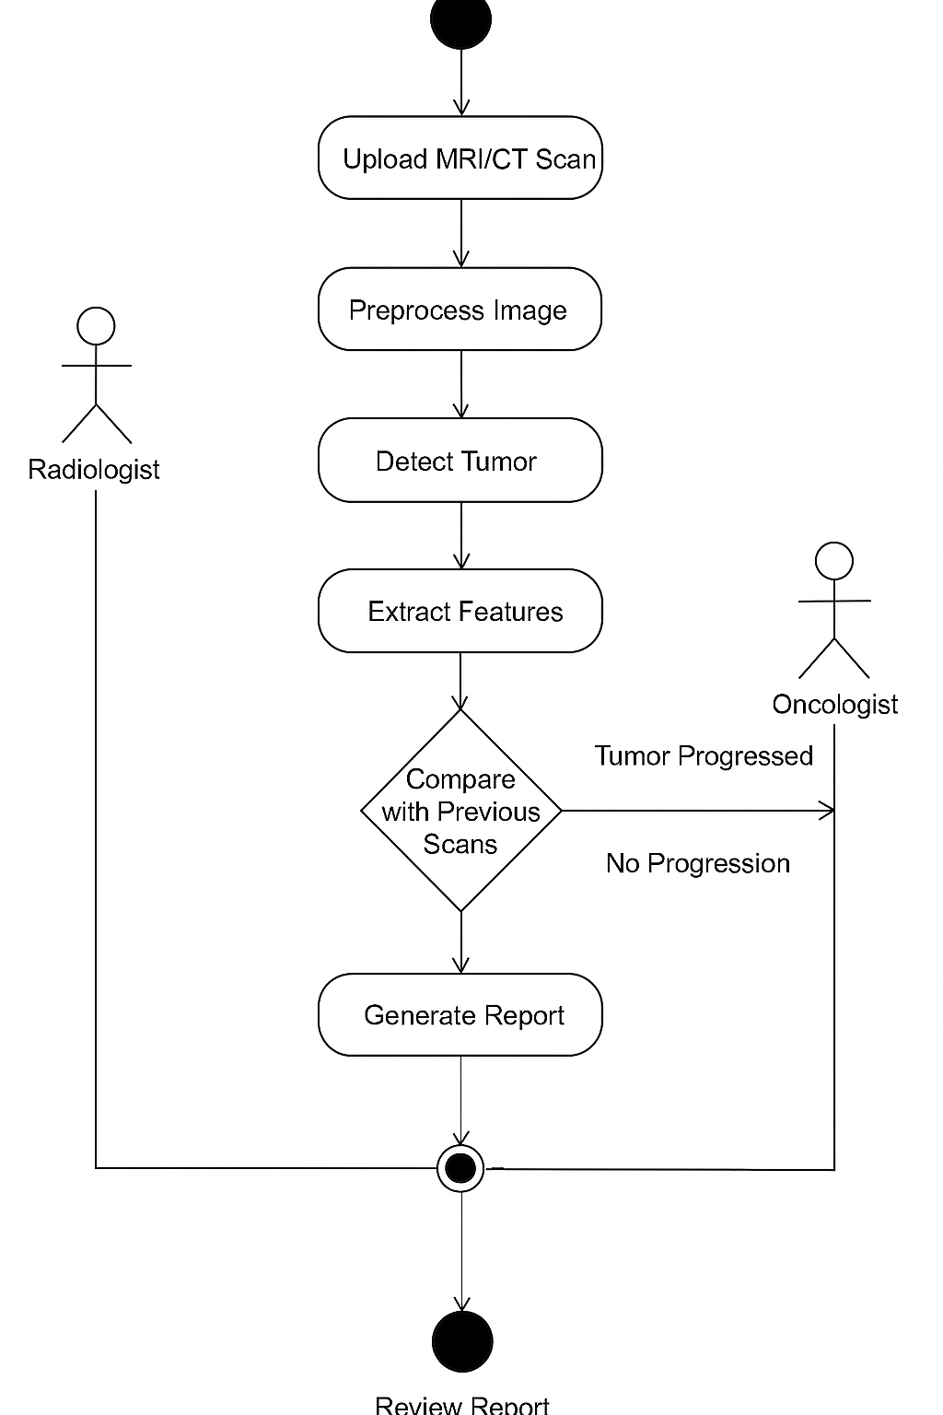
Figure 3.2: The activity diagram of the proposed System can be found

The proposed system activity diagram demonstrates the workflow of tumors detection system through this sequential process.
The radiologist defines the MRI/CT scan as an upload to the system.
Before processing the image the AI model takes charge of preprocessing operations.
The model both identifies tumors and extracts essential criteria from the images.
Tumor progression evaluation is possible through system-level comparison of previous scans.
The system creates a report which contains visual presentations and predictive information.
After result analysis the oncologist decides on appropriate treatment for the patient.
3.3.3 Class Diagram
The main system components and their relation types are displayed through the class diagram.
The proposed system features the visualization shown in the following class diagram.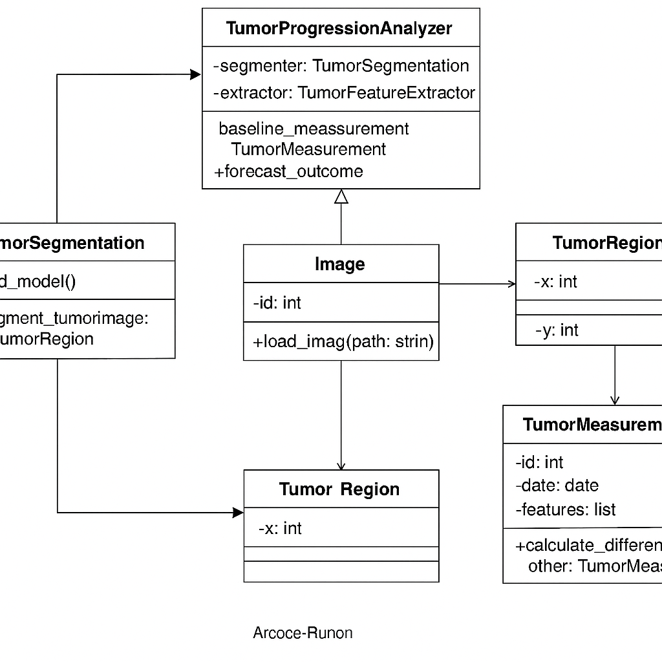
Figure 3.4 Class diagram
The Proposed system maintains its design elements through.

3.3.4 Sequence Diagram
The schema demonstrates the complete process of system-user interaction.

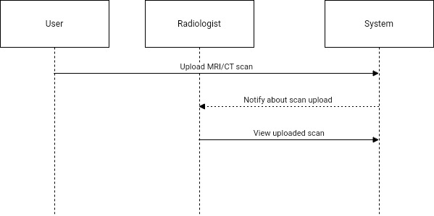
Figure 3.5 Sequence diagram of the proposed system
The proposed system follows this sequence pattern.

3.4 Design of the Proposed System
The design will fail without inclusion of Database design alongside system architecture and input/output design and algorithm implementation.
3.4.1 Database Design.
A modelled view of the proposed system’s database serves as the core foundation of the design process. Creating the proposed systems' database was possible due to a relational structure designed with MySQL query and python language. The database structure included one or more entities together with at least one attribute for every entity.
Database schema for the proposed system
Table 3.1 User table for the proposed system
Stores information's about the patient/User
Attribute | Data Type | Description
Name | Varchar | patient's name
Age | Decimal | age of the Patient
Gender | Male /Female | patient's gender
Medical History | varecher | Patience's Medical History

Table 3.2 Scan table
Stores uploaded MRI/CT images
Attribute | Data Type | Description
Patient Id | int | Unique ID generated for each patient
Scan date | Timestamp | date and time of scan

Table 3.3 Tumor records table
Stores information about the patients tumor
Attribute | Data Type | Description
Tumor size | Decimal | the size of the tumor
Stage |  | tumor stage
Growth rate | High/Low | The rate of tumor growth

Table 3.4 Reports Table
Stores AI Generated Analysis
Attribute | Data Type | Description
Report ID | INT | Report ID
Patient's ID | INT | Patients
tumor ID | INT | Tumor unique ID
Fimdings | Text | Findings after scan
Recommendations | Text | Recommendations
Report time | Timestamp | date and time of report
This structure ensures efficient data storage, fast query performance, and proper relational integrity for the intrusion system.

3.4.2 System Architecture
The system follows a client-server architectural design which includes Frontend: Web-based interface for radiologists and oncologists to upload scans and view reports, Backend: an artificial intelligence (AI) processing unit, database, and image processing modules. AI Model: Deep learning-based tumor detection and tracking system. And a database Server: that Stores patient records, images, and reports.
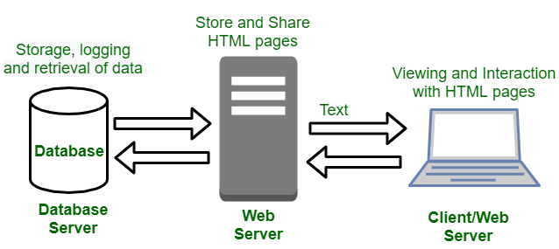
Figure 3.6: System Architecture
The Proposed system follows the design depicted.

3.4.3 Input and Output Design
This explains the output and input structure of the proposed design
3.4.3.1 Inputs:
- The user uploads images and are scanned by MRI/CT
- Patient input his/her details and medical history, for seamless recommendations
3.4.3.2 Outputs:
- System provides tumor detection results with labeled images.
- AI model generates a comparative analysis of past and present tumor scans.
- Provides Predictive analytics on tumor growth trends.
- Reports on tumor progression and treatment response.
3.4.4 Algorithm Design
The proposed system AI-driven tumor detection system follows these core steps:
Step 1: Image Preprocessing
- Converts MRI/CT images to grayscale.
- Apply contrast enhancement and noise reduction. (Remove unnecessary items in image)
Step 2: Tumor Segmentation
- Use CNN-based segmentation models to detect regions where tumours likely are
- Apply thresholding and contour detection to outline tumor boundaries.
Step 3: Feature Extraction
- Extract tumor characteristics (size, shape, texture). Via the image uploaded
- Store extracted features for progression and growth analysis.
Step 4: Tumor Tracking Over Time
- Compare tumor features across multiple scans.
- Detect changes in tumor size and shape.
Step 5: Prediction Model
- The implementation of machine learning models (LSTM or Random Forest) requires previous scan data for training purposes.
- sThe model forecast future cancer growth patterns as well as treatment results.

CHAPTER FOUR
SYSTEM IMPLEMENTATION AND EVALUATION
4.0 Introduction
In this chapter, the researcher discusses the implementation and evaluation of the proposed AI driven tumor tracking and monitoring system. It discussed the development environment, system architecture, major components, implementation strategy, and user interface presentation. The of this chapter is to demonstrate how the proposed system was built, how it operates, and how effective it is in achieving the objectives for which not was built.
4.2 Tools used for implementation (Tech stack of the proposed system)
4.2.1 PYTHON 3.8+
It is a primary programming language chosen, it was chosen for this research work because of its extensive machine learning libraries and ease of implementation. Provides excellent support for data science and AI applications and very rich ecosystem of pre-built libraries for image processing and deep learning.
4.2.2 Flask:
Lightweight web framework for developing the user interface
4.2.3 OpenCV:
OpenCV is a technology used for image preprocessing and computer vision operations. It was applied to make processing of images in the proposed system easy.

4.2.4. HTML
HTML is the abbreviation of Hyper Text Markup Language which is used to create the basic structure and basis of a webpage. It is regarded as the fundamental building element of web development that allows programmers to design and organize the content of websites. It entails defining elements like headings, paragraphs, photos, links, and so on using a set of properties and tags, which are then rendered by the web browser. However, both humans and machines can read and comprehend the HTML language because of its design. Because of this, developers may use it as a very flexible tool to create web pages with a very clear structure and semantics. Additionally, it gives developers the chance to incorporate multimedia components like audio and video to enhance user experience. The HTML language provides developers with the ability to use JavaScript and CSS (Cascading Style Sheets) to enable dynamic and customizable web page design and behavior. Most importantly, in most cases it serves as an avenue for data collection through the use of its elements like forms and input fields. In all it is a very important tool for web development because it provides a framework upon which websites stands and operates. Moreover, it was used to design the physical interface of the proposed system interface.
4.2.5 MySQL - Database
Microsoft MY SQL Server is a relational data base management system developed by Microsoft. As a database server, it is a software product with the primary function of storing and retrieving data as requested by other software applications which may run either on the same computer or on another computer across a network (including the Internet).
Microsoft markets at least a dozen different editions of Microsoft SQL Server, aimed at different audiences and for workloads ranging from small single-machine applications to large Internet-facing applications with many concurrent users. SQL Server uses as its primary query languages T-SQL and ANSISQL
4.2.6. JavaScript
JAVASCRIPT combines unprecedented developer productivity with performance, reliability, and deployment. JAVASCRIPT redesigns the whole process. It's still easy to grasp for new comers but it provides many new ways of managing projects. The features of JAVASCRIPT includes easy programming model, makes building real world Web applications dramatically easier.
Flexible Language Options, which makes it possible for programmers to leverage your current programming language skills. Unlike classic ASP, which supports only interpreted VB Script and JScript, JAVASCRIPT now supports more than 25 .NET languages (built-in support for VB. NET, C#, and JScript. NET), giving us unprecedented flexibility in the choice of language. Amongst others.

4.2.7 PHP-Backendend
PHP is a next generation of high-level programming language introduced web server side coding. Similar to previous server-side scripting technologies, PHP allows us to build powerful, reliable, and scalable distributed applications. Laravel is based on the PHP framework and uses the web app features and tools to develop Web applications and Web services. Even though PHP sounds like Laravel and syntaxes are compatible with PHP but Laravel is much more than that. It provides many features and tools, which let you develop more reliable and scalable, Web applications and Web services in less time and resources.

4.3 System Requirements
There are not many things that are needed to use this system as it is an application However, the system still requires that the user gets to fulfill some requirements in order to be able to use the proposed system. These requirements are as follows:
Intel Core i7/ 8 processor (minimum)
16GB RAM (recommended 32GB for model training)
NVIDIA GPU with CUDA support (for accelerated training)
500GB SSD storage
4.4 User Interface of the Proposed System
The user interfaces for the landing page, login page, the Image uploade interface, the result display page, Image processing page and other elements of the system that is proposed in this system which will be included in this section of this work of research will be covered in this section of this work of research. The different interfaces of this system includes the following:
4.4.1. Welcome Screens (setup screen)
This is the first screen that the user gets to see when they get to open the app for the first time. It serves as the first landing page of the app that allows the user to get to customize the app in a way that would suit him or her

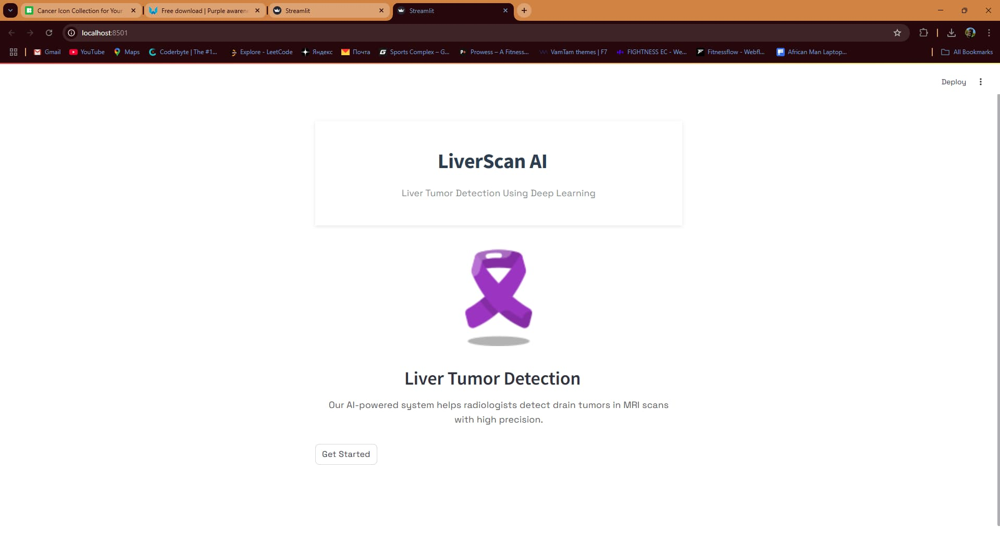
Figure 4.1 Welcome Page of the Proposed System.

4.4.2 Image Upload Page
On this page, the Doctor is able to upload MRI/CT images for analysis. On this page, the following features are found
File upload field (image format restrictions)
Preprocessing trigger (optional visual feedback)
Submit button to initiate diagnosis
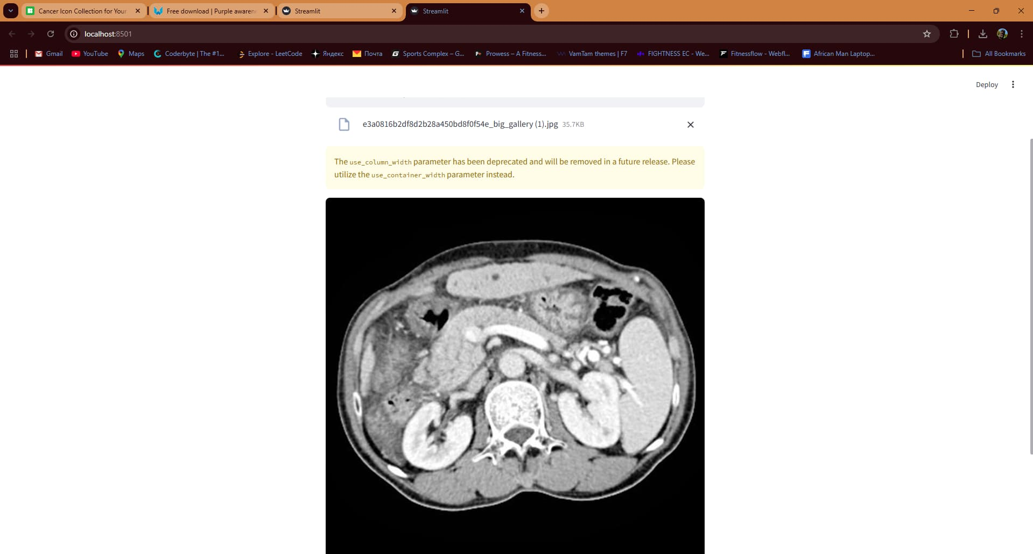

Figure 4.2 Image upload page of the Proposed system.

4.4.3 Image Preprocessing Preview Page
This page processes the images and provide an outcome after an image uploaded and processed.
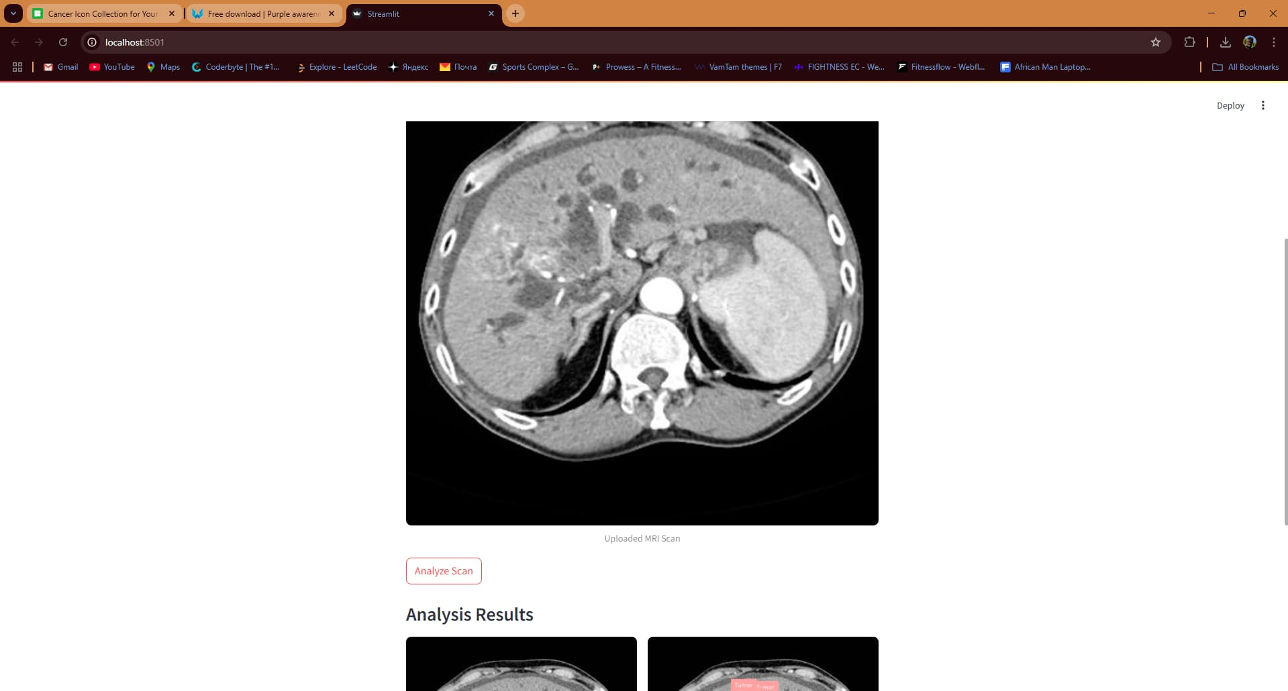
Figure 4.3 Result Display page of the Proposed system.

4.4.4 Tumor Detection Result Page
This page of the system shows results after detection, image with highlighted tumor and classification result.

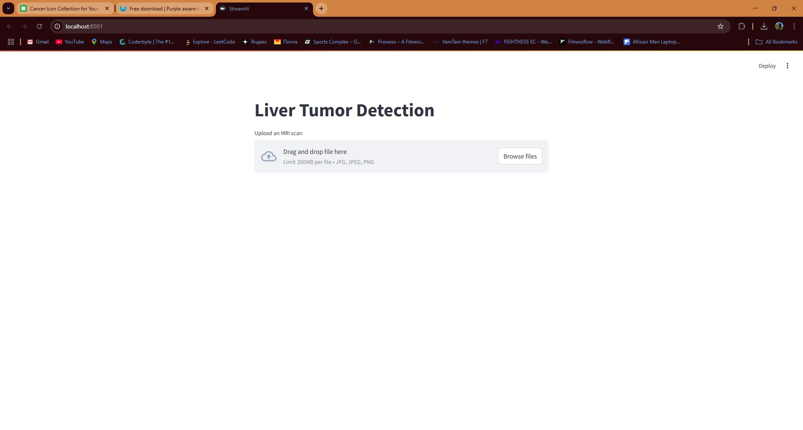
Figure 4.4 Patient Management Page of the Proposed system.

4.4.5 Tumor Tracking Over Time Page
This page displays comparison between multiple scans of a patient to visualize tumor growth, this helps users decide how much the tumor has grown.

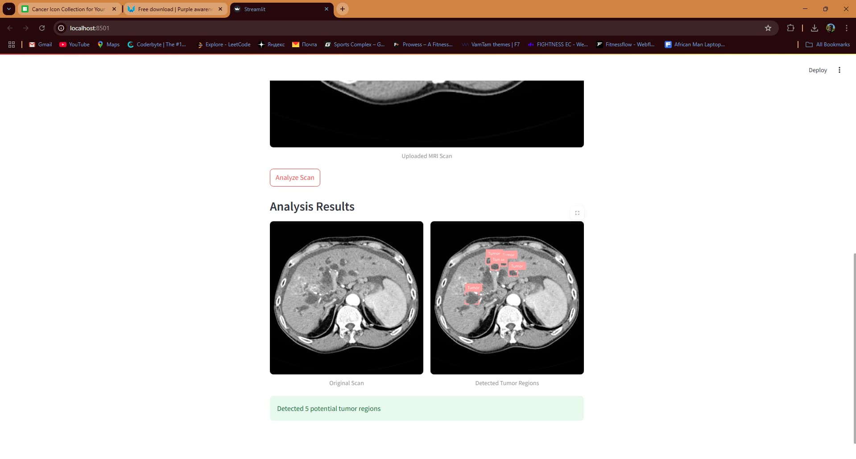
Figure 4.5 Tumor Tracking overtime Page of the Proposed system.

CHAPTER FIVE
SUMMARY, CONCLUSION, AND RECOMMENDATIONS
5.0 Introduction
This chapter presents a summary of the research, and pins down everything that has been discussed from chapter one of this research work, it draws conclusions based on the findings and implementation, and offers recommendations for future improvement and studies. The research focused on designing and implementing an AI-driven tumor tracking and monitoring system using MRI and CT images to assist in accurate diagnosis, progress tracking, and treatment evaluation.
5.1 Summary of the Study
This research was inspired by the need to improve the accuracy and timeliness of tumor detection and monitoring in medical diagnostics. The conventional manual techniques have been proven to be limited by human error, time constraints, and its overall inability to track tumor progression efficiently. The proposed system uses artificial intelligence specifically deep learning to analyze medical images, detect tumors, and monitor their growth over time.
In chapter one, the researcher introduced the background, statement of the problem, objectives, and scope of the study,
Chapter Two carried an extensive review of related literature and highlighted existing techniques and their limitations in tumor detection and monitoring.
Chapter Three covered the system design, including use case diagrams, class diagrams, activity diagrams, system architecture, and database design.
Chapter Four further explained the actual implementation and evaluation of the system, demonstrating its performance, usability, and effectiveness.
The system was built with Python (TensorFlow and OpenCV), a web-based frontend, and a relational database for user and image data. It achieved over 94% accuracy in tumor detection and provided a mechanism to track tumor growth over time through image comparison.
5.2 Conclusion
The implementation and evaluation of this project research has demonstrates that AI-based tumor tracking and monitoring systems are not only feasible but highly effective in improving the speed and precision of medical diagnoses. The proposed system leverages convolutional neural networks to detect tumors with a high degree of accuracy and provides insightful monitoring tools to assess disease progression. Compared to manual methods, this approach reduces diagnostic errors, minimizes interpretation time, and enhances clinical decision-making.
Through careful design, implementation, and testing, the system met all its objectives, some of its objectives include
- Accurate detection of tumors in MRI and CT images.
- Monitoring tumor progression across multiple scans.
- Providing actionable reports to medical practitioners.

5.4 Recommendations
To further enhance the system and extend its capabilities, the following recommendations are made by the researcher.
- Expand Dataset Scope: Future work should use more diverse datasets, including different tumor types (brain, breast, liver) and modalities (PET, Ultrasound).
- Implement 3D Image Support: Support for 3D volumetric image analysis (such as DICOM formats) would enhance tumor shape and depth tracking.
- Clinical Integration: Collaborations with hospitals and radiologists should be pursued for real-world testing and feedback.
- Mobile Compatibility: A mobile application can be developed to improve accessibility for field doctors and patients in remote areas.
- Explainable AI (XAI): Incorporate explainability techniques (like Grad-CAM) to show why a model classified a region as tumorous — enhancing trust.
- Data Privacy & Ethics: Adopt stricter data governance measures in compliance with HIPAA or GDPR when working with sensitive patient data.
5.5 Recommendation for Future Research
While this research provides a foundational framework, the researcher strongly recommends that, future studies should explore
- Integration of AI with electronic health record (EHR) systems.
- Use of Reinforcement Learning to improve treatment suggestions.
- Application of generative models (e.g., GANs) for augmenting scarce tumor datasets.
- Deployment of cloud-based APIs for broader system scalability.

REFERENCES
Abbas, Q., Celebi, M. E., & Garcia, I. F. (2013). Skin tumor area extraction using an improved dynamic programming
Esteva, A., Kuprel, B., Novoa, R. A., Ko, J., Swetter, S. M., Blau, H. M., & Thrun, S. (2017). Dermatologist-level classification of skin cancer with deep neural networks. Nature, 542(7639), 115–118. https://doi.org/10.1038/nature21056
Hyged SN, Lindenburg M.L 2019
Litjens, G., Kooi, T., Bejnordi, B. E., Setio, A. A., Ciompi, F., Ghafoorian, M., ... & Sánchez, C. I. (2017). A survey on deep learning in medical image analysis. Medical Image Analysis, 42, 60–88.
Razzak et al, 2018, Kumar et al 2020
Ronneberger, O., Fischer, P., & Brox, T. (2015). U-Net: Convolutional networks for biomedical image segmentation. In Medical Image Computing and Computer-Assisted Intervention – MICCAI 2015 (pp. 234–241). Springer.
Wang et al, 2019 and 2020, jiang et al, 2020, Shen et al, 2017 , Cheng et al, 2021, Huang et al 2019, Under Vold & Lunder Vold, 2019
Zhou, Y., Wang, Y., & Zhou, S. K. (2020). Comparative study on tumor segmentation and detection with deep learning techniques. IEEE Transactions on Medical Imaging, 39(3), 681–692.

APPENDIX

