A PREDICTIVE MODEL FOR EARLY DETECTION AND SPREAD OF CROP DISEASE USING A CONVOLUTIONAL NEURAL NETWORK ALGORITHM

BY

ALUM BOB OKWUDILI
GOU/U22/CSC/886

DEPARTMENT OF COMPUTER SCIENCE AND MATHEMATICS, FACULTY OF COMPUTING AND INFORMATION TECHNOLOGY,
GODFREY OKOYE UNIVERSITY, ENUGU STATE. IN PARTIAL FULFILLMENT OF THE AWARD OF BACHELOR OF
SCIENCE (B.SC), DEGREE IN COMPUTER SCIENCE.

SUPERVISED BY: MR CAMILLUS NJOKU

JULY, 2025

CERTIFICATION

I hereby certify that the work included therein was completed by me and that it was mainly based on my own observations and investigation. Consequently, I will fully accept the University's decision if I am found to have cheated on the assignment.

________________________
Alum Bob Okwudili
GOU/U22/CSC/886

APPROVAL PAGE
This is to validate that this research work, “A PREDICTIVE MODEL FOR EARLY DETECTION AND SPREAD OF CROP DISEASE USING A CONVOLUTIONAL NEURAL NETWORK ALGORITHM” was embarked upon by “ALUM BOB OKWUDILI” with the matriculation number ‘GOU/U22/CSC/886’ in partial fulfillment of the requirements for the award of Bachelor of Science (B.SC) in Computer Science, Faculty of Natural Sciences and Environmental Studies, Godfrey Okoye University, Enugu.

Mr. Camillus Njoku ................................... ..................................
Supervisor Signature Date

External Examiner ................................... ..................................
External Examiner Signature Date

Dr. Frank Okebanama ................................... ..................................
HOD, Department of Signature Date
Computer Science and
Mathematics

Prof. Chidi.C. Uhuegbu ................................... ..................................
Dean, FNESS Signature Date

DEDICATION

This work, “A PREDICTIVE MODEL FOR EARLY DETECTION AND SPREAD OF CROP DISEASE USING A CONVOLUTIONAL NEURAL NETWORK ALGORITHM,” is dedicated to God Almighty, who has been there all through the way of my project work, and I give glory to him
ACKNOWLEDGMENTS
First and foremost, I express my deepest gratitude to the Almighty God for His abundant mercy, divine inspiration, and unending grace throughout this project.
My sincere appreciation also goes to My Supervisor, Mr. Camillus Ekene Njoku for the time and dedication he invested to ensure the success of this work, and for his unwavering mentorship throughout the process.
I am deeply thankful to my Head of Department, Dr. Frank Okebanama, for his inspirational leadership and unwavering support which created an enabling environment for academic progress and research excellence.
I would like to acknowledge the Department of Computer Science and Mathematics, along with its lecturers, for their academic guidance and commitment to our learning during our time in the program.

ABSTRACT
This study presents the development of a deep learning-based predictive model for the early detection of tomato crop diseases. The model is designed as a decision-support tool for smallholder farmers, and it utilizes a Convolutional Neural Network (CNN), which was enhanced with transfer learning (VGG16) to effectively analyze and classify diseases from tomato leaf images. Image data augmentation techniques were employed to improve the detection accuracy of the proposed model under diverse conditions, and the training dataset was compiled from active farms in the Sub-Saharan region of Africa and reputable online sources like the PlantVillage dataset, enabling the system to combine localized and standardized data. The system includes a user-friendly Graphical User Interface (GUI) to ensure easy accessibility and usability for farmers with limited tech skills. The system addresses common issues in traditional disease management, such as misdiagnosis and excessive pesticide use, by providing timely and precise disease identification, which has led to reduced input costs, decreased chemical usage, and improved crop yields for farmers. Evaluation results from the test dataset show an accuracy of 94%, precision of 94%, recall of 93%, and an F1 score of 93%, underscoring the model's effectiveness in enhancing agricultural disease detection and supporting sustainable farming.

TABLE OF CONTENTS
TITLE PAGE i
CERTIFICATION ii
APPROVAL iii
DEDICATION iv
ACKNOWLEDGEMENTS v
ABSTRACT vi
TABLE OF CONTENTS vii
LIST OF FIGURES xi
LIST OF TABLES xii

CHAPTER 1: INTRODUCTION 1
1.1 BACKGROUND OF STUDY 1
1.2 STATEMENT OF THE PROBLEM 3
1.3 AIM AND OBJECTIVES OF THE STUDY 3
1.4 SIGNIFICANCE OF THE STUDY 3
1.5 SCOPE OF THE STUDY 4
1.6 LIMITATION OF THE STUDY 4
1.7 OPERATIONAL DEFINITION OF TERMS 5

CHAPTER 2: LITERATURE REVIEW 6
2.1 INTRODUCTION TO THE CONCEPT OF CROP DISEASE PREDICTION 6
2.2 REVIEW OF EXISTING RELATED WORK 10
2.3 SUMMARY OF REVIEW OF RELATED WORKS 17
2.4 KNOWLEDGE GAP 18

CHAPTER 3: SYSTEM ANALYSIS AND DESIGN 27
3.0 OVERVIEW 19
3.1 RESEARCH METHODOLOGY 19 3.2 SYSTEM ANALYSIS 20
3.3 DATA COLLECTION 24
3.4 UNIFIED MODELLING LANGUAGE 32
3.5 USE CASE DIAGRAM OF THE PROPOSED SYSTEM 34
3.6 ACTIVITY DIAGRAM OF THE PROPOSED SYSTEM 35
3.7 SYSTEM DESIGN 37
3.8 DATABASE DESIGN 40
3.9 TOOLS USED FOR IMPLEMENTATION 41

CHAPTER FOUR: SYSTEM IMPLEMENTATION 43
4.0 OVERVIEW 43
4.1 USER INTERFACE OF THE PROPOSED SYSTEM 43
4.2. IMPLEMENTATION AND RESULTS OF THE PROPOSED SYSTEM 45
4.3 SYSTEM TESTING 49

CHAPTER FIVE: SUMMARY, RECOMMENDATIONS, AND CONCLUSION 51
5.1 SUMMARY 51
5.2 CONCLUSION 51
5.3 RECOMMENDATIONS 52
REFERENCES 53
APPENDIX 58

LIST OF FIGURES
FIGURE
3.1 Image of training and test datasets 25
3.2 Architecture of the CNN Algorithm 27
3.3 Architecture of the Plant Disease Prediction 29
3.4 System High-Level Model 31
3.5 Sequence diagram of Proposed System 33
3.6 Use case diagram of the proposed system 34
3.7 Activity diagram of the system and the analysis process of the system 36
3.8 Class diagram of the proposed system 37
3.9 Input design of the proposed system 38
3.10 Output design of the proposed system 39
4.1 The Input screen of the proposed system 44
4.2 The output screen of the proposed system 45
4.4 Validation and training accuracy and loss for the initial complete 30 epochs 46
4.5 Validation and training accuracy and loss for the 9 more epochs before being halted 47
4.6 Full Validation and training accuracy for both the 30 and 9 epochs 47
4.7 Full Validation and training loss for both 30 and 9 epochs 48
4.8 Classification report showing precision, recall, and F1 score Performance 48

LIST OF TABLES
TABLE
3.1 User table for the proposed system 40
3.2 Prediction table of the proposed system 40
3.3 Suggestion table of the proposed system 41

CHAPTER ONE
INTRODUCTION
1.1 Background to the Study
Disease can be defined as a condition in which an organism’s structure or functioning is abnormal and is specifically associated with a set of signs or symptoms (World Health Organization, 2020). And in agriculture, plant diseases include diseases caused by pathogens, including plants, fungi, bacteria, viruses, and nematodes. The impact of these diseases is large in that they can result in great losses in yield, which may affect food supply and farmers’ output. Farmers have traditionally observed and intervened manually to detect and manage crop diseases. However, these methods are in most cases of great concern since they are slow, labour-intensive, and susceptible to errors of human nature.
However, diseases of crops have, over time, been of great concern to agricultural output and growth. For example, the Irish potato famine in the 1840s was attributed to the late blight disease, and it was associated with a great movement of people and starvation. More recently, instances such as the wheat rust invasions in Eastern Africa and the banana wilt disease in Central Africa had debilitating growth impacts on economies and food security (Singh et al., 2016; Ploetz, 2015). Moreover, to tackle these crop diseases, some methods have been employed in the past to help manage these diseases, including the alteration of crop sequence planting, the utilization of replacement varieties, and the use of pesticides. But in many instances, these methodologies proved to be unfeasible and led to a whole lot of environmental problems, including pollution (Van Bruggen et al., 2015).
Nevertheless, advances in the past, especially in data analysis, have led to the development of predictive models and algorithms, which have effectively helped and assisted in analyzing possible future occurrences and events. However, in agriculture, one of the prominent applications has been in forecasting crop diseases based on the analysis of weather parameters, soil properties, and previous outbreaks of the diseases (Shmueli & Koppius, 2011). This forecasting allows farmers to act preemptively to prevent the further spread of the disease, thus avoiding the potential massive losses that come with an outbreak (Chlingaryan et al., 2018). Also, predictive systems have been seen to be advantageous for use in crop disease detection because they provide timely responses to outbreaks and lessen the use of agrochemicals while enhancing overall agricultural crop management practices (Mahlein, 2016).
In recent times, the use of machine learning and deep learning algorithms in predictive systems has significantly enhanced the accuracy and reliability of crop disease detection and management, and machine learning algorithms such as decision trees, support vector machines, and neural networks have proven effective in facilitating pattern recognition and making predictions based on the analysis of large datasets related to historical crop diseases (Kamilaris and Prenafeta-Boldú, 2018). Similarly, deep learning, a subfield of machine learning, has shown great promise, as its models can process complex and high-dimensional input data, such as images of diseased crops, enabling accurate disease identification and classification, which in turn helps to reduce the severity and spread of infections (Li et al., 2020).
Recently, both the usage and application of machine learning and deep learning algorithms in predictive systems have improved the accuracy and reliability of detecting and managing crop diseases. These machine learning algorithms, which include the decision tree, support vector machine, and neural networks, have stood to help facilitate pattern recognition and make predictions based on the analysis of large datasets on past crop diseases (Kamilaris and Prenafeta-Boldú, 2018). In the same vein, deep learning, which is a subfield of machine learning, and its models can work on quite complex and high-dimensional input data like pictures of sick crops to enable accurate identification and classification of diseases, and this helps to decrease the degree of influence (Li et al., 2020).
Furthermore, in my own opinion, the change that crop recommendation systems have brought to the agricultural sector as a whole is quite important, as through the integration of predictive models and machine learning algorithms, these systems have enabled agriculture to advance from traditional farming methods to more data- and technology-driven approaches (Wolfert et al., 2017). Farmers are now able to use real-time data and predictive analysis to make such decisions, which they hope will improve crop yield, minimize losses, and promote sustainability, as these systems can also counter climate change effects on agriculture by offering responsive options to new threats (Rial-Lovera et al., 2017).
In summary, the creation and use of predictive models that combine machine learning and multilayered algorithms to predict and track the spread of crop diseases is part of the solution to the problems being faced by the agricultural sector. The system enables farmers to easily diagnose crop diseases and manage them effectively, increasing crop yield, minimizing damage to the ecosystem, and improving availability of food. The use of such technologies and systems marks a positive partnership towards an eco-friendly and robust agricultural system.
1.2 Statement of the Problem
The manual process of detecting crop diseases and making informed decisions on appropriate countermeasures has introduced numerous challenges, including but not limited to the following:
- Inability of farmers to accurately detect and diagnose crop diseases using traditional methods, often leading to misidentification and inappropriate interventions.
- Inefficiency in traditional data collection methods, resulting in the acquisition of unreliable or insufficient data.
- Poor quality and inefficiency of available data, which often leads to the improper application of pesticides. This not only reduces crop yield but also increases the overall cost of crop management.
- Significant time spent by farmers on manual farm monitoring, thereby reducing labor efficiency and productivity.
1.3 Aim and Objectives of the Study
This study aims to develop a predictive model for early crop disease detection and spread using machine learning algorithms. However, this study hopes to achieve this aim through the following objectives, which are to:
- Analyse and characterize the limitations of existing traditional crop disease detection methods.
- Collect and preprocess relevant crop disease data for training and testing machine learning models.
- Develop a machine learning-based model for the early detection and prediction of crop diseases.
- Design and implement a mobile application for deploying and testing the developed model.
- Evaluate the model's effectiveness in improving diagnosis accuracy, reducing pesticide misuse, and saving time in farm monitoring.
1.4 Significance of the Study
The work of research holds paramount significance in the domain of agriculture as it stands to address the critical challenges that have been faced by both local traditional and large-scale farmers. Therefore, this work of research significantly stands to reduce crop losses, improve yields, and enhance the quality of crops, as it provides a reliable predictive model tool for the early detection of diseases. Also, on the side of the farmer, this research work directly benefits the stability of the income of farmers and, most especially, contributes to food security.
Additionally, this work of research is also significant to the domain of education as it serves as a foundation for future research and innovation in agricultural technology, because by applying deep learning algorithms to predict crop diseases, this work of research paves the way for further advancements in detection and prevention methodologies of disease. However, researchers can further be able to build upon the findings of this study to develop more models that are sophisticated and, most especially, extend the application to other crops, ultimately leading to a more productive, sustainable, and resilient agricultural sector.
1.5 Scope of the Study
This research work centers on the development of a predictive model for early crop disease detection and spread using machine learning algorithms, with a specific focus on addressing the challenges that are being faced by farmers when making informed decisions on the detection of diseases that are affecting their crops. The scope of this study is not only limited to the landscape of farmers, but its domain is also extended to individuals and organizations who venture into the field of tomato, potato, and corn cultivation and trading, both for personal and research purposes.
1.6 Limitation of the Study
The researcher experienced some setbacks while embarking on this research. Some of these limitations are as follows:
1. Inefficiency in data Precision: The inaccuracies or gaps in climate, soil, or yield data may compromise the reliability of the output of this study, as the accuracy of the crop disease detection system is highly contingent on the quality and precision of available datasets.
2. Applicability Constraints: This study may not fully address socio-economic factors influencing farmers' decisions, such as market dynamics, resource access, and socio-cultural considerations, as the changes in use, technological advancements, and evolving market demands are beyond the study's scope and may affect the applicability of recommendations.
3. Technical Expertise: The successful deployment of the system required a high level of technical expertise in areas like software development, in which the researcher experienced a shortage of professional skills in this area.
1.6 Operational Definition of Terms
There are lots of terms associated with this research work, but for the purpose of this study, we will only consider a few, which are listed below.
- Crop Disease: It refers to an abnormal condition of crops resulting from infection by some pathogen, which conceivably interferes with growth and yield.
- Pathogen: Any disease-causing organism, such as bacteria, viruses, or fungi.
- Predictive Model: A statistical or computerized tool used to vet or look ahead at what has not yet occurred through consideration of what has taken place in the past.
- Deep Learning: Involves the use of multiple layers of neural networks for the processing of data in constrained dimensions; this is a subset of machine learning.
- Algorithm: This entails a precise step-by-step method for solving a given problem or for performing a specific task.
- Neural Network: A model for computation and a subtype of machine learning that is based on the principles of the design of the brain.
- Convolutional Neural Network (CNN): A class of neural networks used for recognizing patterns in images as well.
- Image Analysis: It is defined as the act of examining images to find useful information.
- Machine Learning: This is a sub-discipline of artificial intelligence that utilizes brittle systems platforms to make predictions and sometimes decide based on previous datasets.
- Artificial Intelligence (AI): It is the capacity to reason and resolve issues via programmed machines' behavior that would typically require a person.
- Data Set: This is a group of connected data that is often used for the purpose of analysis or for training machine learning models.

CHAPTER TWO
LITERATURE REVIEW
2.1 Introduction to The Concept of Crop Disease Prediction Systems
The advent of predictive systems in agriculture has marked a significant milestone in the pursuit of sustainable farming practices. Historically, farmers relied heavily on personal experience and rudimentary tools to assess the health of their crops and estimate potential yields. In contrast, the integration of advanced technologies into agriculture has revolutionized these processes. Early predictive systems were primarily based on statistical models and simple algorithms derived from farmers' experiences, relying on historical weather data and crop performance metrics to forecast future outcomes (Nourali and Shortridge, 2024). These foundational systems have since evolved, paving the way for more sophisticated, data-driven solutions.
However, the movement from these traditional methods of disease prediction to the modern methods of disease prediction, which are technologically driven, has been very transformative and productive. On the same note, the incorporation of machine learning (ML) and deep learning (DL) algorithms has helped to enable the development of predictive models that are more accurate and dynamic, as these advanced models can analyze a vast amount of data that is gotten from various sources, including satellite imagery, soil sensors, and weather forecasts, to provide insights into crop health in real-time. As a result, this shift has not only improved the accuracy of predictions but has also allowed for proactive measures to mitigate potential threats.
Moreover, the recent improvements in the field of agriculture, particularly with the integration of predictive models, have now been able to bring several prominent features to life, with one of the notable advancements being its ability to now detect diseases at their very early stages, as it is crucial for preventing widespread outbreaks and minimizing overall crop losses. For example, convolutional neural networks (CNNs) have been successfully employed to analyze the images of tomato leaves and also identify signs of diseases such as early blight and late blight with a very high accuracy (Sakkarvarthi et al., 2022). In essence, the early detection capability of CNN has ensured a timely intervention, therefore reducing the need for the extensive use of pesticides and also promoting a sustainable farming practice.
Finally, the transition from traditional disease prediction systems to modern, AI-driven predictive models has significantly enhanced the management of tomato crop diseases, and these advancements have not only improved the accuracy of disease detection but have also greatly contributed to the overall sustainability and productivity of agricultural practices (Abbas et al., 2024). Furthermore, as technology continues to evolve, there is vast potential for further advancements in predictive agriculture, thereby promising a future of farming systems that are more resilient, efficient, and adaptive.
2.1.1 Description of The Different Categories of Crop Disease Prediction System
There are different categories and types of crop disease prediction systems; some of these categories will be discussed below with their specific examples.
- Image-Based Systems:
These categories of crop disease prediction systems rely heavily on data that are presented in visual format to detect and classify diseases in crops, and the models, however, make use of advanced computer vision techniques, particularly convolutional neural networks (CNNs), to analyze images of tomato leaves and identify the different symptoms of diseases. For example, the TomatoDet model employs CNNs to analyze leaf images and identify diseases such as early blight and late blight, and these models have, however, helped to revolutionize disease detection by providing rapid, accurate, and non-invasive methods to monitor crop health (Sakkarvarthi et al., 2022).
- Environmental Data-Based Models:
These categories of crop disease prediction systems make use of information that is sourced from sensors of the environment, such as temperature, humidity, and the moisture of the soil, to predict the likelihood of disease outbreaks. However, these models stand to analyze how the different environmental conditions stand to influence the development and the spread of diseases. A typical example of this environmental data-based model is the model that was proposed by Lee and Yun (2023).
- Hybrid Models:
This category of crop disease prediction systems functions by combining multiple data sources, such as images, environmental data, and historical data obtained from disease records, to enhance the accuracy of predictions. This type of model usually leverages the strengths of the different machine learning and deep learning algorithms to provide a disease detection system that is more comprehensive and reliable. A typical example of a crop disease prediction system that falls under this category of crop disease prediction systems is the hybrid model that was developed by Sanida et al. (2023).
  - Genomic Data-Based Models:
This category of crop disease prediction systems utilizes information on the genetics and form of tomato plants to be able to predict disease susceptibility and resistance. However, by analyzing the genetic makeup of the different tomato varieties, this type of system can identify the specific genes that are associated with resisting disease. For now, there is no notable example of this type of model, but researchers and developers are steadily exploring the integration of genomic data into the domain of predictive models to provide deeper insights into disease resistance (Thangaraj et al., 2022).
2.1.2 Brief History of Crop Disease Prediction System in The Field of Agriculture:
The history of crop disease prediction systems in agriculture, particularly for the cultivation of crops, has evolved significantly in detail over the years, as compared to the initial moments when farmers relied on traditional methods such as visual inspections of crops and manual sampling to detect crops that had been affected by diseases. In the same vein, those methods over time proved to be labor-intensive, time-consuming, and often inaccurate (Gent et al., 2013). However, the advent of predictive systems started with the development of disease forecasting models that made use of historical data and environmental factors to predict the outbreak of diseases (Jafar et al., 2024). These early models, therefore, provided a foundation for understanding the complex interactions that practically exist between pathogens, crops, and environmental conditions (Basavant et al., 2024).
However, as advancements in technology kept on expanding, so did the methods for disease prediction. On this note, the successful integration of machine learning (ML) and deep learning (DL) algorithms, therefore, marked a significant shift in tide in the field, as these modern predictive systems have been seen to make use of a vast array of datasets, which range from the historical behavior of crops to the images of diseased plants, to train models that can accurately identify and classify diseases (Wang and Liu, 2024). A notable example is the convolutional neural networks (CNNs), which have been widely used for image-based disease detection and have since then propelled the achievement of high accuracy in identifying diseases such as gray leaf spot and brown rot in tomato crops, late blight and potato blackleg in potatoes, and also tar spot and southern rust in corn. Therefore, these advancements have not only improved the accuracy of disease detection but have also reduced the time and resources required for monitoring crops (Thangaraj et al., 2021).
Moreover, judging from how far the field of crop disease prediction has come, some notable advancements in these systems have been noticed, especially in their application in the domain of tomato, potato, and corn cultivation. Some of these advancements include the development of models like TomatoDet, which incorporates advanced feature extraction and multi-scale feature fusion techniques to enhance detection accuracy. In addition, the use of Internet of Things (IoT) sensors and drones for real-time monitoring and data collection has also further improved the efficiency of these disease prediction systems (Delfani et al., 2024). Most importantly, these innovations have enabled farmers to take proactive measures to manage diseases, thereby ultimately leading to a very drastic increase in the yield of crops, and most importantly, they have reduced the overall economic losses.
2.1.3 The Future of Crop Disease Prediction Systems in the Field of Agriculture
The journey since the introduction of disease prediction systems in the domain of agricultural crop cultivation has been seen to be remarkable, as it has successfully led to the transition from rudimentary methods to sophisticated technologies that are heavily driven and backed up by data. On the other hand, in the past, farmers relied on their visual inspection abilities and traditional agricultural knowledge to be able to identify and manage the diseases of crops, which were, in most cases, reactive and therefore less effective. However, the introduction of machine learning and deep learning models defined a significant turning point in history, as it has consequently allowed for a more precise and proactive management of crop diseases. At this, systems like the convolutional neural networks (CNNs) have been particularly transformative, as they have provided room for the accurate detection of diseases such as gray leaf spot and brown rot in tomato crops, late blight and potato blackleg in potatoes, and also tar spot and southern rust in corn through image analysis. These advancements have significantly reduced crop losses and improved the overall yield and quality of crops.
Fast-forward to today, there have been a lot of notable upgrades to these predictive systems, and heck, the integration of internet of things (IoT) devices has over the years helped to enhance the collection of data in real-time and has also given room for continuous monitoring of the health of crops and also the environmental conditions. This, when combined with advancements in artificial intelligence, has led to the development of predictive models that are more robust and that can analyze a vast number of datasets with a greater amount of accuracy and at a very high speed. Also, innovations such as hybrid models that work by combining the strengths of different machine learning algorithms have further improved the efficiency and reliability of these disease detection systems. However, these notable upgrades have not only increased the accuracy of predictions but have also made it possible to implement timely interventions, which have helped in mitigating the impact of diseases on crops.
Moreover, when looking into the future, the field of disease prediction systems, especially in the domain of crop cultivation, can be seen to be poised for a greater number of advancements, as technologies that are currently emerging, such as edge computing and blockchain, are expected to play a very huge role in improving the security and efficiency of data processing and storage. Additionally, the continuous development of AI models that are more sophisticated could be viewed as being capable of learning from a minimal amount of data and moving forward to updating themselves to adapt to various conditions, therefore further revolutionizing the whole process of disease management in agriculture.
Also, researchers are constantly exploring the potential of integrating genomic data into predictive models, which in turn could provide a lot of deeper insights into disease resistance and crop health. However, the future of disease prediction systems in the cultivation of crops will most likely see an increased head-to-head collaboration between technology developers, agricultural scientists, and farmers to ensure that these proposed innovations are practical and accessible. At this, it is important to note that, by embracing these advancements, the agricultural sector will most probably be looking forward to more sustainable and resilient farming practices, ultimately securing food production for future generations.
2.2 Review of Existing Related Works
There are a lot of existing systems that are related to this research work in one way or the other; however, in this section some of these systems will be reviewed.
Prottasha et al. (2021) all contributed to developing a lightweight CNN architecture that is lightweight. The system was used to identify various diseases that affect rice plants in Bangladesh. During their study, they collected and augmented images of 12 different types of diseases that affect the rice plant. They used the images of these diseases to develop their model based on the CNN architecture. However, when this system was tested with live data, the experimental results revealed that the developed model achieved an impressive mean validation accuracy of 95.4%. On the other hand, the system’s scope was limited as there was not much available data to be used in testing the system.
Shoaib et al. (2022) collaborated to develop a predictive system based on deep learning. The system was developed to be able to use tomato leaf images to identify and classify the diseases that are suffered by tomato plants. The researchers made use of over 18,000 images, which were both segmented and non-segmented, and also models like the InceptionNet alongside models of semantic segmentation such as U-Net and Modified U-Net during the development stage of their model. At the end, the Modified U-Net was able to achieve an accuracy of 98.66% for segmentation, while the InceptionNet was at the forefront, achieving a whopping accuracy of 99.95% for binary classification and an accuracy of 99.12% for six-class segmentation.
Gottemukkala et al. (2024) all embarked on research, during which they presented an advanced algorithmic framework to be used for the early prediction of tomato leaf diseases to improve the management of the crop and its productivity. Their research made use of image processing techniques to extract essential features, such as green, red, and blue mean values; leaf width and height; and the color channels of defects from high-resolution tomato leaf images. These features, however, helped in the detection of diseases like early blight, leaf mold, bacterial spot, two-spotted spider mite infestations, and Septoria leaf spot. However, their study combined the Principal Component Analysis (PCA) and Ant Colony Optimization (ACO) to optimize its feature selection, and at this, they were able to reduce the computational complexity while still being able to retain key indicators of diseases. Moreover, at the end of their study, experimental results demonstrate that their hybrid approach surpasses conventional models in efficiency and accuracy level, thereby offering a method for detecting diseases at an early stage that will be reliable and scalable in agricultural systems.
Khan et al. (2024) all put their experiences together in their study, during which they proposed a hybrid model that combined both deep learning and machine learning for the classification of ten tomato leaf types, which included nine diseased and one healthy type. The study made use of a customized convolutional neural network (CNN) for the extraction of features automatically. The study made use of the PlantVillage dataset for evaluation, and the best-performing CNN-stacking model achieved an accuracy of 98.27% and an F1-score of 98.53%. The model also proved to be time efficient by accurately identifying noisy and blurry images in 0.174 seconds but failed to incorporate a simple user interface to enable access for the common farmer.
Liu and Wang (2020) both embarked on research where they explored deep learning-based object detection models such as the YOLO V3, which processes raw images directly through an end-to-end framework, to address the issue of errors that emanate from traditional methods, which involve the manual extraction of features and image pre-processing. At the end of the study, which was a comparative review between the traditional method of crop disease detection that relied on the manual feature of extraction and the modern methods that ran on the YOLO V3’s feature layer with image pyramids for multi-scale detection, the study concluded that these advancements have enabled precise identification of disease types and locations in natural environments, thereby making models that are based on deep learning more valuable for intelligent agricultural disease management systems.
Manchanda et al. (2024) all worked tirelessly to propose a Tomato Plant Disease Predictor using a Convolutional Neural Network (CNN) that is fine-tuned for classification and analysis in real-time to address the urgent need for advanced tomato plant disease detection methods, most particularly in regions that are dependent on agriculture, like India. The system that they proposed helped to enhance precision, applicability, and generalization as it automated the detection of disease, thereby reducing the manual workload and promoting a very sustainable farming practice. The model they developed, however, offered a promising step toward efficient and proactive management of crop disease with the use of cutting-edge AI technologies, but on the other hand, the system's proficiency wasn't determined, as it wasn’t tested rigorously with different types of data.
Kaushik et al. (2023) all worked together on their research, where they proposed TomFusioNet. The system was designed to be a mobile-based tomato crop analysis framework that was poised to tackle the tomato disease detection challenges in real-time. Their system integrated the late-fusion extraction feature by combining a modified cross-domain transfer learning model and a multilayer perceptron meta-learner. The framework was designed in a way that it consisted of two modules: DeepRec, which was adopted for initial disease detection, and DeepPred, which was adopted for precise classification. However, for them to optimize the performance of the system, they employed the NSGA-II algorithm and also introduced an HSV-based background elimination technique to enhance feature selection. Moreover, when the system was tested, the system demonstrated accuracy rates of 99.93% for DeepRec and 98.32% for DeepPred, with a convergence loss of 0.021 and an AUC of 99.10%. On the other hand, while TomFusioNet showed promise for remote crop monitoring through mobile apps, its performance in diverse environmental conditions remains untested, leaving room for further evaluation.
Aishwarya et al. (2023) all contributed to their study, during which they developed a custom model based on the convolutional neural network (CCNN) to detect and classify the diseases of tomato plants to address the global need for accurate management of crop disease. Their model featured three convolutional layers followed by three fully connected layers, and it was able to reduce the processing time and computational power compared to state-of-the-art models like AlexNet and VGG-16. The developed model was tested using 10 classes of tomato leaf images, and the result demonstrated a competitive accuracy with lower computational costs. Additionally, they proposed deploying the CCNN model in a mobile-based system, enabling global smartphone-assisted crop disease diagnosis; however, the model’s real-world applicability under diverse environmental conditions remains to be further explored.
YILDIZ et al. (2024) all contributed to developing an automatic tomato leaf detection system to enhance tomato crop productivity by enabling the early diagnosis and management of diseases. Their study made use of computer vision and deep learning technologies and also leveraged the CNN-based architectures to enable a very high accuracy in classification and detection of objects. The researchers sourced datasets from Kaggle and applied machine learning algorithms such as Random Forest (RF), K-Nearest Neighbors (KNN), Logistic Regression (LR), Neural Networks (NN), and Support Vector Machine (SVM) through Orange software. However, at the end of their research, a custom Python algorithm achieved the highest classification accuracy of 96%, which surpassed the 95.6% accuracy that was obtained when using the traditional machine learning models. The detection system was deployed using Amazon Web Services (AWS) Lambda and was integrated into a mobile application that was built using Flutter and Dart to ensure a seamless cloud-based operation. Moreover, while their model demonstrated a robust performance when tested with dummy data, the researchers failed to test its applicability in the real world.
Jha et al. (2024) all worked together in their study, where they proposed an ensemble machine learning model for the precise detection of plant disease. Their study was focused on tomato, potato, and bell pepper crops to address the food security challenges that are evident in India. They applied transfer learning using MobileNet and Inception models, which were pre-trained and fine-tuned on a dataset of 10,403 images of diseased and healthy plant leaves. At the end of the day, their system was able to achieve a remarkable accuracy of 98.95%, which outperformed the individual models and, most importantly, ensured precise and early identification of disease. The innovative approach of their work supported farmers by enabling timely interventions, thus contributing to improved crop management and food security, but on the other hand, the researchers failed to deploy the system using an intuitive user interface to make it accessible to farmers all over the world.
Tan et al. (2021) conducted a comparative study on machine learning (ML) and deep learning (DL) models for the classification of tomato leaf disease using the PlantVillage dataset. They extracted 157 features, including texture features from local binary pattern (LBP) and gray-level co-occurrence matrix (GLCM), and color features from color moments and histograms. However, after performing their tests, the COLOR+GLCM feature combination provided the best results for ML models like SVM, kNN, and RF. Moreover, the deep learning models, such as AlexNet, VGG16, ResNet34, EfficientNet-b0, and MobileNetV2, outperformed the machine learning algorithms in all evaluation metrics. ResNet34 achieved the highest accuracy (99.7%), precision (99.6%), recall (99.7%), and F1 score (99.7%), making it the most effective model for tomato disease detection in their study. This comparison highlights the superior performance of DL models for plant disease classification tasks.
Badiger and Mathew (2023) all worked on the development of DbneAlexNet, a deep learning-based model for the detection of tomato leaf disease using a customized deep batch-normalized eLu AlexNet (DbneAlexNet) model. Their system was built to process tomato leaf images through several stages, including anisotropic filtering for distortion removal, U-Net-based segmentation enhanced by Gradient-Golden Search Optimization (Gradient-GSO), and image augmentation for improved data diversity. The DBNEAlexNet model, trained using the proposed Gradient Jaya-Golden Search Optimization (GJ-GSO) algorithm, classified leaf diseases with an accuracy of 92.4%, a true positive rate (TPR) of 91.9%, and a true negative rate (TNR) of 92.2%. However, the unified segmentation and classification framework demonstrated superior disease detection, highlighting the potential of combining advanced optimization techniques with deep learning for precision agriculture. However, it failed to focus on the acceptability of the model by local farmers.
Ullah et al. (2023) all embarked on a research work together, proposing the Deep Tomato Detection Network (DTomatoDNet), a deep learning model that was lightweight and was created for detecting tomato leaf diseases with minimal computational resources. The model was designed to use 19 learnable layers and a convolutional kernel to reduce the parameters while enhancing the extraction of features. The DTomatoDNet was trained from scratch using a dataset of 10,000 tomato leaf images, which covered nine different disease categories and one healthy class. They proved to be able to effectively identify diseases such as early blight, late blight, leaf mold, and tomato mosaic virus, as it provided an accuracy of 99.34%. However, its lightweight design makes it suitable for mobile applications, allowing farmers to detect tomato diseases quickly and efficiently through smartphone-based solutions. But the system therefore experienced some downsides, as it was not deployed to an accessible repository to enable farmers to have access to it freely.
Zhou et al. (2021) all embarked on research in which they worked on a restructured Residual Dense Network (RDN) for the identification of tomato leaf disease. Their system was created by combining the different features of the deep residual dense networks. The system was a hybrid model, which helped to enhance the flow of information, reduce the training parameters, and improve the accuracy of classification. However, the experimental evaluation of the system using the Tomato Test Dataset from the AI Challenger 2018 dataset demonstrated a top-1 average identification accuracy of 95%. The model was seen to have achieved superior performance compared to state-of-the-art methods while requiring fewer computational resources, thereby making it highly suitable for real-time crop monitoring and disease management.
Verma et al. (2019) all worked together to develop a model based on the Convolutional Neural Network (CNN) to support farmers in improving crop yield through early detection of disease. During their study, they made use of a dataset of 3,000 tomato leaf images representing nine different groups of diseases and healthy groups. Their study was conducted on Google Colab with a multi-step process that includes image preprocessing, segmentation of targeted areas, and feature extraction based on color, texture, and edges using CNN. However, the proposed model achieved a classification accuracy of 98.49% by optimizing the CNN’s hyperparameters, but was limited as the system was hosted using Google Colab, therefore making it only available for tech-inclined users.
Tarek et al. (2022) worked on exploring various deep learning models for detecting tomato leaf disease. The study focused on pre-trained architectures such as ResNet50, InceptionV3, AlexNet, and MobileNet versions V1, V2, and V3. Among these pre-trained architectures, MobileNetV3, when tested for the first time on tomato leaf diseases, outperformed other models. The MobileNetV3 Small achieved an accuracy of 98.99%, while MobileNetV3 Large reached 99.81%. However, the deployment evaluations on both a workstation and a Raspberry Pi 4 demonstrated the models’ efficiency. The MobileNetV3 Small, on the other hand, recorded latencies of 66 ms on the workstation and 251 ms on the Raspberry Pi 4, while MobileNetV3 Large achieved latencies of 50 ms and 348 ms, respectively. The deployment of the model, therefore, highlighted the potential for building Internet of Things (IoT) devices for real-time agricultural disease detection.
Alzahrani and Alsaade (2023) explored the use of computer vision and deep learning for the early detection of tomato leaf diseases. Their study emphasized its potential to reduce economic losses that are caused by plant diseases, and during their study, they applied transfer learning to enhance model efficiency and reduce costs. The study compared three deep learning models: DenseNet169, ResNet50V2, and Vision Transformer (ViT). However, they found that DenseNet121 outperformed the other models with a training accuracy of 99.88% and testing accuracy of 99.00% using a dataset containing healthy and diseased tomato leaf images. At the end of the study, the ResNet50V2 and ViT achieved testing accuracies of 95.60% and 98.00%, respectively. The study also highlighted the models' fast training and testing times, making them practical for real-world agricultural applications.
Agarwal et al. (2020) worked to investigate a convolutional neural network (CNN) model that is lightweight for identifying tomato leaf diseases to reduce the computational demands while maintaining high accuracy, and the study compared their CNN model, which was made up of eight layers, with the traditional machine learning (ML) methods like the k-nearest neighbors (k-NN) and decision trees, as well as the pretrained CNN models like VGG16. However, their model achieved a classification accuracy of 98.4%, outperforming k-NN’s 94.9% and VGG16’s 93.5% using the PlantVillage dataset containing 10 classes of tomato diseases. Moreover, they were able to enhance the performance of their model through image pre-processing, adjusting brightness, and performing image augmentation. At the end of their study, their model also demonstrated strong generalizability, achieving 98.7% accuracy on datasets beyond PlantVillage. This study highlights the potential of simplified CNN architectures for practical, efficient tomato leaf disease detection, but it failed to test the system using live data.
Singh et al. (2024) worked to explore the deep learning techniques for detecting tomato leaf diseases. The model compared several classifiers, including Random Forest (RF), Inception V3, DenseNet, ResNet50, Xception, and MobileNet. Their findings showed that Inception V3 performed best with a 97% accuracy, precision of 98%, recall of 96%, and an F1-score of 97.5%. However, the DenseNet and ResNet50 followed closely with accuracies of 94% and 93.3%, respectively, demonstrating strong prediction capabilities. On the other hand, Xception achieved a balanced performance with 95% accuracy, while MobileNet performed moderately with 76% accuracy. The random forest lagged it with only 68% accuracy. The results demonstrated the potential of advanced deep learning models for accurately diagnosing tomato leaf diseases, thereby supporting improved agricultural productivity through early disease detection.
Jasim (2021) worked on using deep learning for plant disease detection through convolutional neural networks (CNNs). He eventually developed models in which he trained using a public dataset of 18,000 images, featuring healthy and diseased plants from ten different species. The models were designed in a way that they will be able to classify plant health using multi-layer neural network architectures. However, when the model was tested, their best-performing CNN model achieved an accuracy score of 97% in detecting plant diseases based on image analysis. It therefore made its contribution by demonstrating deep learning’s potential for enhancing agricultural productivity through precise and scalable plant health diagnostics.
2.3 Summary of Review of Related Works
Author(s) | Work Done | Technique Used | Result / Research Gap
Prottasha et al. (2021) | Developed a lightweight CNN for detecting 12 rice diseases in Bangladesh. | Custom CNN with data augmentation. | Achieved 95.4% accuracy; limited scope due to lack of diverse live data.
Shoaib et al. (2022) | Developed a deep learning system to classify tomato diseases. | InceptionNet, Modified U-Net, U-Net on 18,000+ images. | InceptionNet achieved 99.95% (binary), 99.12% (multi-class), with high accuracy, but segmentation accuracy varies.
Gottemukkala et al. (2024) | Created a feature extraction framework for early tomato disease detection. | Image processing + PCA + Ant Colony Optimization (ACO). | Improved accuracy and efficiency; scalable model, but dependent on high-res images.
Khan et al. (2024) | Proposed a hybrid DL-ML model for classifying 10 tomato leaf types. | Customized CNN + CNN-stacking. | Achieved 98.27% accuracy, 98.53% F1-score; no user interface for farmer accessibility.
Liu & Wang (2020) | Compared traditional and DL-based object detection for plant diseases. | YOLO V3 with image pyramids. | Highlighted YOLO V3’s precision; traditional methods prone to manual errors.
Manchanda et al. (2024) | Designed a real-time CNN-based tomato disease prediction model. | Fine-tuned CNN model. | Promising for sustainable farming, but not tested with diverse data.
Kaushik et al. (2023) | Proposed TomFusioNet mobile tomato disease detection system. | Transfer learning + MLP + NSGA-II + HSV elimination. | DeepRec: 99.93%, DeepPred: 98.32%, AUC: 99.10%; not tested in varied conditions.
Aishwarya et al. (2023) | Developed a custom CNN (CCNN) for tomato disease detection. | CNN with 3 conv + 3 FC layers. | Competitive accuracy, low computational cost; real-world application untested.
YILDIZ et al. (2024) | Developed a CNN-based automatic tomato disease detection system. | CNN + ML (RF, KNN, LR, SVM, NN) via Orange + AWS + Flutter. | Python algorithm achieved 96%; deployment success, but real-world testing absent.

2.4 Knowledge Gap
In the part of the world where this work of research was conducted, specifically the sub-Saharan region of Africa. Most of the farmers in this area make use of the traditional methods of disease detection, which involve the manual approach of inspecting the crops one after the other to check for crops that have been affected by diseases. At this, the currently existing systems have faced a lot of pitfalls, and as a result, they lack validation in some areas. These pitfalls, however, stem from the systems being built using datasets of data that were captured from other regions, thereby limiting their application to the sub-Saharan regions, as the weather conditions are quite different from those in other parts of the world.
However, after the detailed review of these existing works and successful identification of the pitfalls, the proposed system is now poised to develop a model that will fill the existing lacuna and also contribute to the domain of knowledge by training its model using a combination of both localized datasets and datasets from public repositories to incorporate extra features that were absent in the other existing systems and also contribute greatly to the field of research as it now stands as a base for future research.

CHAPTER THREE
SYSTEM ANALYSIS AND DESIGN
3.0 Overview
Crop diseases have, for a long time now, proven to be the major factor that affects the output of crops globally. Therefore, improving the outcome and output of crops and lowering the high rate of losses that are incurred by farmers depends heavily on the early identification of these crop diseases. However, the object-oriented method of system analysis and design will be used in this chapter, as this chapter examines how machine learning algorithms can be used for crop disease diagnosis and how they can also be implemented using Object-Oriented Analysis and Design (OOAD) as a methodical approach to model and create complex systems.
3.1 Research Methodology
Object-Oriented Analysis and Design (OOAD) stands as a software development methodology that employs object-oriented concepts for the creation and implementation of software systems. However, within this approach, the initial step involves determining the system requirements, followed by the identification of classes and their respective relationships with each other in the system. Moreover, various techniques and practices are integral to this methodology, which encompasses UML diagrams, object-oriented programming, and use cases. Consequently, OOAD employs object-oriented programming for the actual design and implementation of the software system, as the UML diagrams play a crucial role in illustrating different facets and interactions among various components within the software system. Lastly, use cases are employed to articulate the diverse ways in which users engage with the software system. The application of OOAD is particularly suited for handling intricate systems, substantiating its selection for such scenarios.
3.2 System Analysis
System analysis involves the dissection of the proposed system and examining its components and their interactions. This section of this research work addresses the comprehensive system analysis of the proposed system, encompassing an evaluation of existing systems, identification of the limitations within those systems, and the strategies for enhancement. However, the analysis of the proposed system encompasses detailed modelling activities using use case diagrams, activity diagrams, and class diagrams.
3.2.1 Analysis of Existing Systems
There are some of these systems that already exist and are being used by farmers both within and outside the sub-Saharan region of the world. One of these already existing systems is the traditional system, which involves the farmer manually navigating through the farm to simultaneously check for diseases in the plants one after the other. This traditional system, however, is very tedious and most time results in excruciating stress on the farmer, making them unsuitable for large-scale commercial farming. However, Prottasha and his teammates designed a lightweight model based on the CNN architecture to be used in the identification of various diseases that affect rice plants in Bangladesh. The system was created using images of 12 different types of diseases that affect the rice plant.
Another example of these existing systems is the Deep Tomato Detection Network (DTomatoDNet), which is a lightweight deep learning model that was created for detecting tomato leaf diseases with minimal computational resources. The model was designed to use 19 learnable layers and convolutional kernels of 1x1 in order to reduce the parameters while enhancing the extraction of features. It was trained from scratch using a dataset of 10,000 tomato leaf images, which covered nine different disease categories and one healthy class.
Also, Verma and his colleagues have built a system off the Convolutional Neural Network (CNN) to support farmers in improving crop yield through early detection of disease. Their system was built using a dataset of 3,000 tomato leaf images, representing nine different groups of diseases and healthy groups. The system was developed to function by using a multi-step process that includes image processing, segmentation of targeted areas, and feature extraction based on the color, texture, and edges using CNN.
3.2.2 Weaknesses of Existing Systems
Although different systems currently exist in the area of this study, these existing systems have fallen short in some areas, which, on the other hand, have affected the farmer in one way or the other. However, some of these shortfalls include the fact that the traditional methods of disease detection are tedious and error-prone, thereby resulting in a biased prognosis and diagnosis. Also, some of these already existing systems were built using incomplete data, as the data that was used in developing the models was taken from non-sub-Saharan regions, making them unsuitable to be used by farmers in those areas.
However, some of the weaknesses that stem from other existing systems include the following:
  - Susceptibility to Overfitting: Due to their simplicity, most of the existing systems are prone to overfitting, especially when faced with high-dimensional or noisy datasets, as models that fail to generalize well to unseen data might end up resulting in overfitting, compromising their reliability and predictive accuracy.
  - Lack of Adaptability to Imbalanced Data: Datasets on plant diseases frequently show an imbalance in class, and simple algorithms may struggle to effectively handle imbalanced data, leading to biased predictions and reduced sensitivity to minority classes.
  - Vulnerability to Missing Data: Some of the existing systems do not possess robust mechanisms to handle missing or incomplete data, which are common challenges in real-world datasets. Inadequate handling of missing data can introduce bias and reduce the reliability of model predictions.
3.2.3 Analysis of the Proposed System
This system represents a significant step forward in addressing the existing pitfalls and knowledge gaps within the traditional agricultural decision-making process, which primarily focused on the eastern part of the country, Nigeria, as a case study. This innovative system incorporates a myriad of features, which is mainly designed to provide farmers with a comprehensive and intelligent approach to crop disease detection, as one key aspect of this system is the integration of a climate dataset sourced from reputable online repositories, which this system uses to offer a robust analysis of the conditions specific to the region where plants are to be cultivated to determine the type of disease that is affecting the crop.
However, this system incorporates a distinctive feature as it utilizes the deep learning algorithm (VGG16) as the trained model that can predict the diseases that are suffered by crops, with its focus being on tomatoes, potatoes, and corn. Moreover, unlike the conventional systems that often rely on simplistic approaches, this system incorporates the VGG16 algorithm to elevate the precision and contextual relevance of crop disease detection. At this, the system not only focuses on factors in climatic conditions but also considers the nuanced geographical location and soil variations within the region by taking into consideration the different factors that affect these crops over here in the eastern region of the country and, with that, contributes to more accurate and localized suggestions.
Furthermore, this system takes a holistic approach by empowering farmers to make informed decisions not only based on experiences and their intuitions but also on the visible physical signs that are backed up by data as it integrates a predictive analytic feature, thereby helping farmers to gain the capability to anticipate the environmental effect on their crop, thus aligning their reactions with the right crop health deficiency. In the same vein, this forward-thinking feature of this system bridges a crucial gap in the existing systems that typically overlook the climatic and locational aspects of farming. In essence, this system focuses on the detection of tomato, potato, and corn crop diseases as a case study and how the eastern weather conditions affect them, however, offering a comprehensive solution by leveraging advanced climate data analysis and machine learning algorithm predictions to revolutionize all the activities that are involved in making agricultural decisions and, however, fostering sustainable practices in the region.
3.2.4 Advantages of the Proposed System
- Improved Accuracy of Disease Detection
The use of deep learning models, particularly Convolutional Neural Networks (CNNs), significantly enhances the precision of detecting and classifying crop diseases based on leaf images and environmental data.
- Localization and Contextual Relevance
By incorporating climate and geographical data specific to the eastern region of Nigeria, the system provides tailored and context-aware disease predictions, ensuring more relevant and actionable insights for farmers.
- Multi-Crop Support
The system is designed to detect diseases in multiple staple crops such as tomatoes, potatoes and corn, increasing its applicability and value to a broader range of farmers.
- Real-Time and Early Detection
The integration of predictive analytics enables early detection of diseases, allowing for timely intervention and significantly reducing crop losses due to delayed responses.
- User-Friendly Interface
A simple graphical user interface (GUI) makes the system accessible even to farmers with limited technical skills, promoting widespread adoption among smallholder farmers.
- Data-Driven Decision Making
The system reduces reliance on guesswork and farmer intuition by enabling decisions to be made based on data, visible crop symptoms, and predictive analytics, leading to more effective disease management strategies.
- Efficient Resource Utilization
Accurate disease identification helps in the proper use of pesticides and fertilizers, minimizing chemical waste, lowering costs, and protecting the environment.
- Support for Sustainable Agriculture
Through precise monitoring and forecasting, the system promotes sustainability by optimizing inputs, reducing unnecessary treatments, and ensuring long-term soil and crop health.
- Bridges Technological Gaps
The system addresses key shortcomings of traditional disease management tools, particularly the lack of climate awareness and inability to scale with local agricultural challenges.
- Scalability and Flexibility
The modular design of the system allows for easy adaptation to additional crops, regions and evolving datasets, making it scalable and future-ready.
3.3 Data Collection
Gathering data is perhaps one of the most important elements in creating a predictive model aimed at early diagnosis of crop diseases, owing to its impact on model performance. This work will collect image data from two key centers: the agricultural institutions in the sub-Saharan region of Africa and external sources such as PlantVillage. The traditional field data collection from agricultural institutions entails working with farmers and agricultural specialists to obtain actual images of crop leaves that are either diseased or healthy. These images will be taken under different climatic conditions to ensure that the dataset captures regional differences in the manifestation of diseases. Accompanying the images with the metadata, such as crop type and extent of the disease, will be necessary for providing context. Some of the images of crop diseases that were gathered to be used in training the model are shown below.
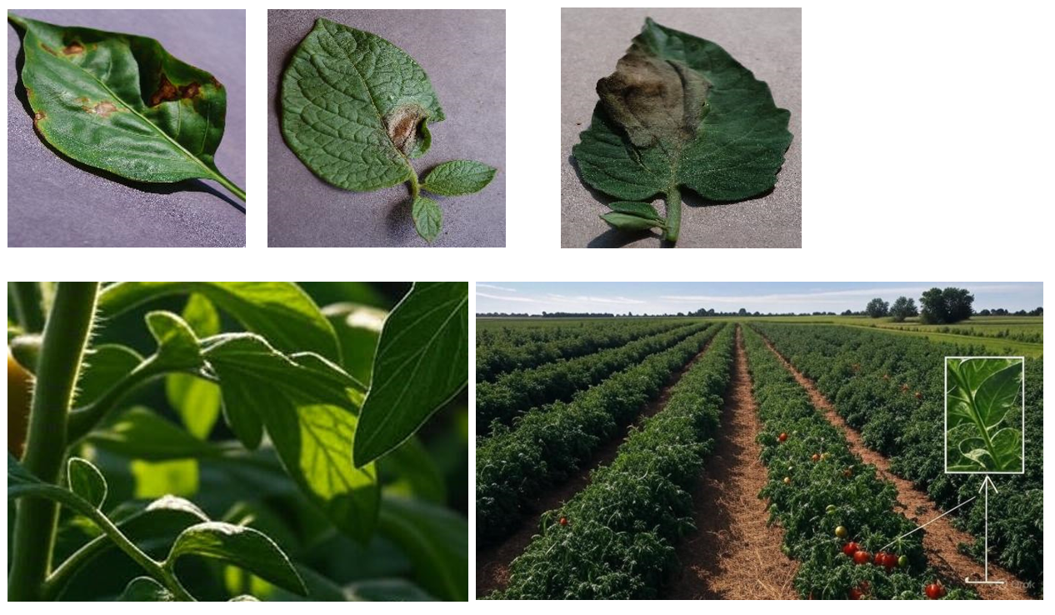
Figure 3.1: Image of test training and test dataset
3.3.1 Sample Dataset
Figure 3.1 images come from two main sources: agricultural institutions across sub-Saharan Africa and external datasets like PlantVillage. We’re focusing on high-quality pictures of crop leaves such as maize, cassava, and tomatoes, which are staples in the region. The leaves are labeled as either healthy or diseased, showing what they look like when things are going well or when they’re under attack by diseases. Here’s what we include with each one:
- Crop Type: What kind of crop it is, like maize, cassava, or tomato.
- Disease Status: Whether the leaf is healthy or dealing with a specific disease, like maize streak virus or cassava mosaic disease.
- Extent of Disease: If it’s diseased, how bad it is: mild, moderate, or severe.
- Location: Where the image came from, like a specific region or agricultural institute in Africa.
- Climatic Conditions: Things like the temperature, humidity, and light levels when the photo was snapped.
3.4 System Requirements
System requirements are the necessary procedures or specifications that outline the functions or attributes that a system must possess. These system requirements are therefore divided into two categories, which are functional requirements and non-functional requirements.
3.4.1 Functional requirements
- Feature Extraction and Selection: The system should perform feature extraction techniques to identify relevant characteristics and biomarkers indicative of crop diseases from the input data. It should support feature selection methods to reduce dimensionality and enhance model interpretability while preserving predictive accuracy.
- Machine Learning Model Development: The technology that is proposed by this system ought to make it easier to create and train deep learning models with a variety of algorithms, including random forests, logistic regression, support vector machines, and deep learning architectures.
- Real-time Inference and Prediction: The system should support real-time inference capabilities, allowing for the prediction of crop diseases likelihood or risk scores based on input data, which should provide visualization tools to interpret model predictions and display relevant diagnostic information to healthcare professionals.
3.4.2 Non-Functional requirements
- Performance: The system should exhibit high performance, with fast response times for data processing, model training, and inference to ensure timely decision-making and clinical interventions.
- Scalability: The system should be scalable to handle increasing data volumes and user loads, accommodating growth in crop cultivation and dataset sizes without compromising performance or reliability.
- Reliability: The system should demonstrate high reliability, with minimal downtime or service interruptions, making sure of continuous availability for famers and research professionals relying on crop disease prediction system results for crop care.
- Accuracy: The system should achieve high levels of accuracy in the prediction of crop diseases in order to minimize false positives and false negatives to enhance diagnostic precision and reduce the risk of misdiagnosis.
- Robustness: The system should be robust to variations in input data characteristics, handling noise which outliers the missing values effectively in order to maintain model performance across diverse patient populations and imaging modalities.
3.3.1 The Proposed Convolutional Neural Network (CNN) Algorithm
The proposed Convolutional Neural Network (CNN) algorithms is the foundation of the system developed for crop disease detection and classification, and the algorithms are powerful deep learning models that excel at analysing image data, making them ideal for identifying symptoms of crop diseases from leaf images. The CNN model processes images of leaves to detect and classify visible signs of diseases, and the input layer of the CNN is designed to accept resized and normalized image data, preparing it for efficient feature extraction through a series of convolutional layers.
These convolutional layers are the backbone of the feature extraction process, where filters are applied to the input images to detect important visual patterns such as edges, spots, discolorations, and textures associated with specific diseases. And in each layer of the network, it captures increasingly complex features, and the use of the Rectified Linear Unit (ReLU) activation function introduces non-linearity into the model, enabling it to learn intricate relationships within the data. The architecture of the CNN Algorithm adopted in this study is presented in Figure 3.2
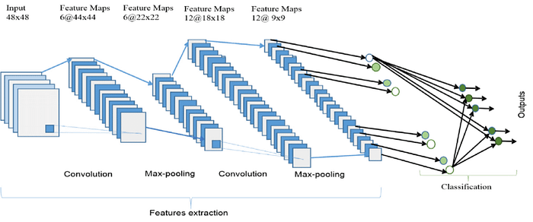
Figure 3.2: Architecture of the CNN Algorithm
After feature extraction, the model flattens the data and passes it through fully connected layers, which act as a decision-making component to classify the image into one of several disease categories and the final output layer uses a SoftMax activation function for multi-class classification, assigning a probability score to each disease class and to further enhance the model’s performance, the system integrates transfer learning by adopting pre-trained model called VGG16. These models, trained on large-scale image datasets, provide strong initial weights and advanced feature extraction capabilities, improving model accuracy while reducing training time.
Overall, the proposed CNN model offers a reliable, accurate, and scalable solution for automated crop disease detection, while its application in agriculture, especially in resource-limited regions, can significantly improve decision-making, reduce losses, and promote sustainable farming practices.
3.3.2 Computer Vision System using CNN Algorithm
Computer vision is a field of artificial intelligence that enables machines to interpret and understand visual information from the world, typically in the form of images or videos where in agricultural applications, computer vision can be used to automatically detect and classify crop diseases by analyzing images of plant leaves and the use of a Convolutional Neural Network (CNN) model in computer vision tasks has become increasingly popular due to its ability to efficiently process image data and extract meaningful features that are crucial for classification, segmentation and object detection.
CNN models work by mimicking the way the human visual cortex processes images and they are made up of layers that perform operations such as convolution, activation (ReLU, Sigmoid, SoftMax, ELU etc.), pooling and fully connected classification. The convolutional layers apply filters that detect patterns like edges, colours or textures in an image, which are essential for distinguishing between healthy and diseased crops. This hierarchical feature extraction makes CNNs particularly powerful for complex image analysis tasks, including identifying subtle visual symptoms of plant infections.
In the context of crop disease detection, CNN-based computer vision systems are trained using large datasets of labelled images showing both healthy and diseased leaves and these models learn to recognize different disease types by identifying unique visual patterns associated with each condition. Image augmentation is often used during training to improve model generalization across varying lighting, angles and background conditions. Once trained, the CNN can accurately classify new images of leaves into specific disease categories in real time, enabling early diagnosis and prompt intervention.
The use of CNNs in computer vision has revolutionized agricultural diagnostics by reducing the reliance on manual inspection, which is often error-prone and time-consuming while with CNN-based systems, farmers and agricultural experts can quickly assess the health status of their crops using mobile devices or installed cameras in the field which leads to more informed decision-making, improved yield, reduced pesticide use and overall enhancement of sustainable farming practices. As the technology advances, the integration of CNN-powered computer vision systems into smart farming tools continues to offer promising solutions for modern agriculture.
3.3.3 System Architecture
The architecture of the crop disease prediction system presented in Figure 3.3 is structured in a modular and efficient manner, integrating multiple components that collectively enabling accurate detection, classification and prediction of crop diseases. The architecture follows a pipeline that begins with image acquisition and ends with disease prediction and user notification.
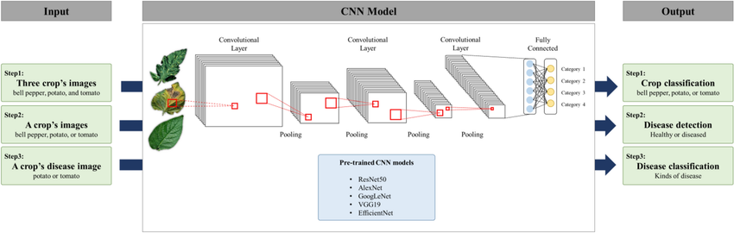
Figure 3.3: Architecture of the Plant Disease Prediction
Each module of the system is designed to handle specific tasks in the data flow, ensuring robust performance and scalability for real-world agricultural use, especially for farmers in resource-limited environments.
- Image Acquisition and Preprocessing Module
This is the first stage of the system where images of crop leaves are collected either in real time (via mobile devices or field cameras) or uploaded from a dataset. The acquired images undergo preprocessing to standardize the input format. This includes resizing, normalization and image augmentation (e.g., rotation, flipping, brightness adjustments). These steps improve the quality of the images and increase the diversity of the training set, thereby enhancing the robustness of the model.
- Feature Extraction and Classification using CNN
At the core of the system lies a Convolutional Neural Network (CNN) which serves as the primary engine for disease detection. The CNN architecture typically comprises several convolutional layers, pooling layers and fully connected layers. These layers work sequentially to extract low-level and high-level features from the input images and use these features to classify the images into different disease categories. Transfer learning using pre-trained models (e.g., ResNet50, VGG16) can be integrated here to improve accuracy and reduce training time.
- Climate and Location-Based Data Integration
To increase the contextual accuracy of predictions, the system integrates external datasets such as climate information (temperature, humidity, rainfall) and geographic soil characteristics. These datasets are sourced from trusted APIs or repositories and are used to refine the disease prediction by correlating environmental factors with disease occurrence. This layer adds a predictive analytics dimension, offering insights beyond visible symptoms and enabling localized recommendations.
- User Interface and Output Display Module
The final component is a user-friendly Graphical User Interface (GUI) designed for farmers and agricultural stakeholders. The GUI displays the diagnosis result (disease name, severity and suggested treatments), allows image uploads and may include voice or language support for ease of use. The system may also generate reports or alerts for timely interventions and this interface bridges the gap between complex AI predictions and actionable insights for users with minimal technical expertise.
Together, these modules form a complete and intelligent system architecture capable of accurately predicting crop diseases, providing timely recommendations and ultimately contributing to improved crop health, yield and sustainable farming practices.
3.3.4 High Level Model
The system high-level model presented in Figure 3.4 for crop disease prediction using a CNN involves several core modules that work together to ensure efficient, accurate and scalable disease identification and decision support.
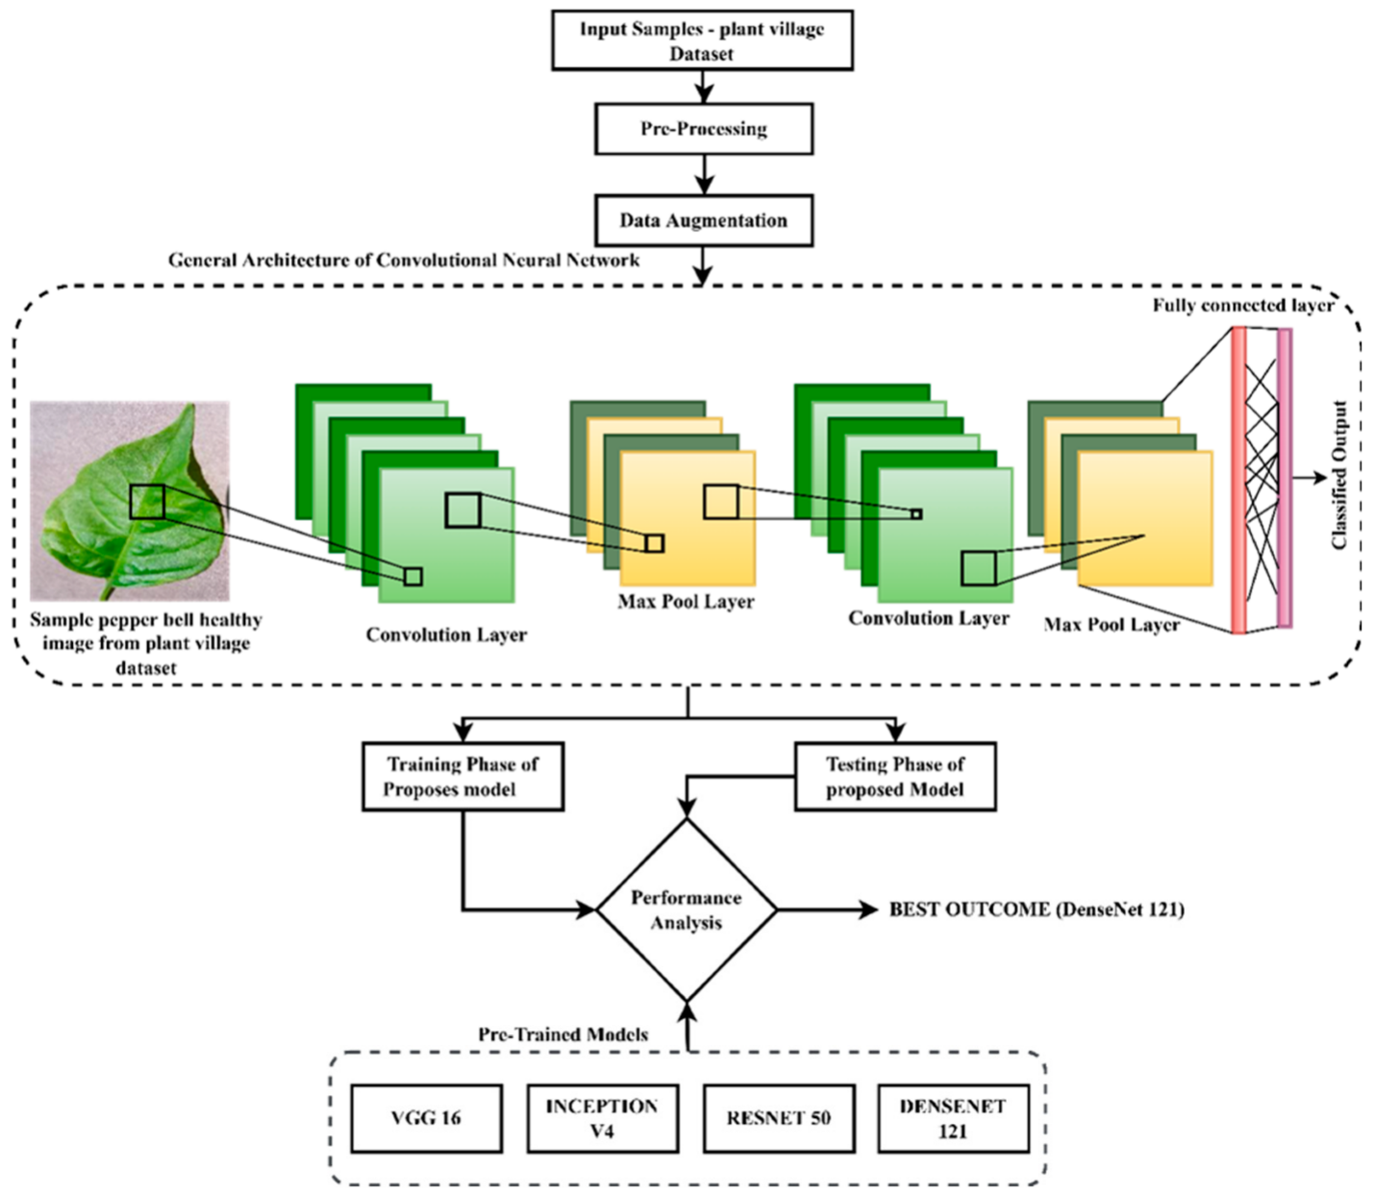
Figure 3.4: System High Level Model
Figure 3.4: System High-Level Model illustrates the structured workflow of the proposed crop disease prediction system powered by a CNN where the process begins with the input of plant leaf images sourced from the PlantVillage dataset. These images undergo preprocessing to standardize the data and remove noise, followed by data augmentation to expand the dataset and improve model generalization and the core of the system is the CNN architecture, which consists of multiple convolutional and max pooling layers that extract deep features from the images. These features are then passed to a fully connected layer, which produces the final classification output, identifying whether a plant is healthy or diseased based on the extracted patterns.
The second half of the model focuses on evaluation and optimization. After training and testing the proposed model, its performance is analyzed and compared with several pre-trained CNN architectures VGG16, Inception V4, ResNet50 and DenseNet121 and this benchmarking step is critical for selecting the most accurate and efficient model. In this case, DenseNet121 delivered the best performance in terms of prediction accuracy and computational efficiency. The entire system, therefore, provides a comprehensive, intelligent approach to plant disease detection, combining robust image analysis with advanced deep learning techniques to enhance agricultural decision-making, especially in regions like Eastern Nigeria where crop health is vital to local food security.
3.4 Unified Modelling Language
The unified Modelling Language (UML) diagrams stands to serve as a cornerstone in the realm of software engineering, providing a standardized and visual means to represent the intricacies of a software system comprehensively. These diagrams offer a powerful tool for software architects, software developers and stakeholders to collaboratively conceptualize, design and most especially communicate on the various aspects of a software system. However, one UML diagram that is considered most crucial is the use case diagram which stands to outline the potential interactions between users or external entities and the system thereby serving as a blueprint for understanding the functional requirements and scenarios within the software application.
Subsequently, the activity diagram stands to complement the use case diagrams as it brings dynamic aspects of system development processes to the forefront by illustrating the overall flow of activities within the system thereby capturing the sequential and parallel processes that unfold during system operation. However, this dynamic perspective stands to aid in visualizing the overall workflow which takes place in the system thereby helping to identify the potential bottlenecks, decision points and opportunities for optimization in the software system.
The unified Modelling Language (UML) sequence diagrams serve as a dynamic pictorial model which depicts the various interactions between the different objects that exists within a system over time. Similarly, these diagrams are very important in the understanding of the chronological flow of actions and messages that occur during the execution of a particular use case or scenario. However, at its core, these sequence diagrams visually represent the order in which interactions take place therefore providing a clear depiction of how the various components collaborate in a specific system to achieve the specified goal.
However, the elements in the UML sequence diagram include lifelines, messages, activations and objects of which the lifelines represent the entities involved in the interaction, while messages denote the communication between the different entities. Moreover, activations that are portrayed using vertical lines extending from lifeline and therefore stands to represent the duration of an object's involvement in an interaction. Consequently, this temporal dimension adds a crucial layer of understanding thereby allowing developers and stakeholders to grasp not only what occurs in the system but also when it occurs within the system's operation.
Moreover, UML sequence diagrams help to facilitate the communication between the technical and non-technical stakeholders in a system and by offering a visual representation of system dynamics these diagrams stand as a powerful tool for conveying intricate technical details in a more accessible manner. However, the use of these diagrams contributes to improved collaboration thereby fostering a shared understanding of system behaviour and also aiding in the identification of potential issues for future enhancements.
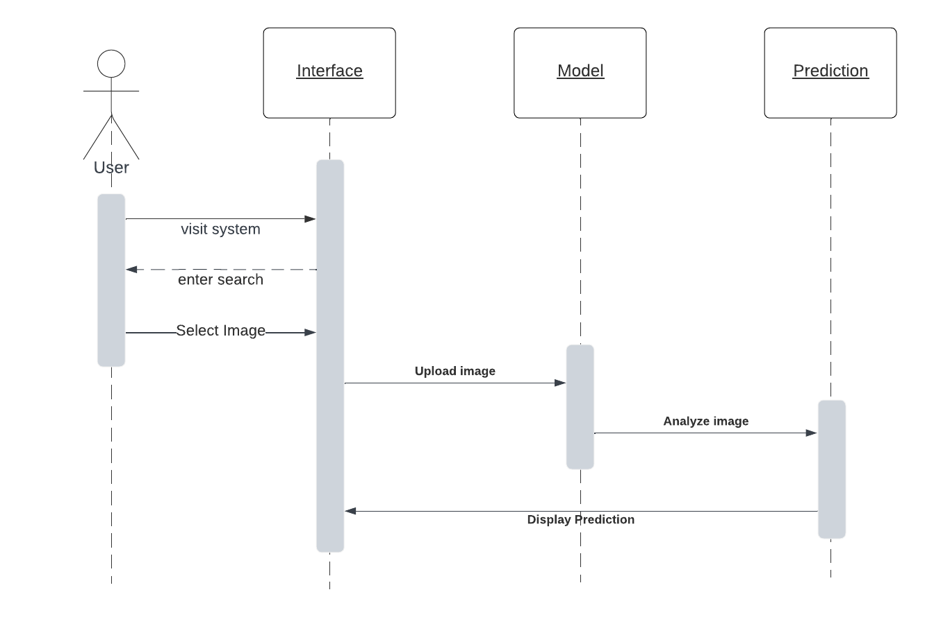
Figure 3.5 Sequence diagram of the proposed system
The above diagram stands to depict the sequence diagram of the proposed system, which functions to show the sequence of activities that is taking place in the proposed system, right from visiting the system’s user interface to having the system predict the kind of disease that is being suffered by the crop whose leaf image was provided. The diagram serves as a diagrammatic implementation of the proposed system, offering future researchers the opportunity to view the internal process structure of the system.
3.5 Use Case Diagram of Proposed System
Use case diagrams are classified into four categories: use cases, which are the functional parts of the system; the actors, which represent the external entities of the system; the associations between the actors and the use cases; and lastly, the system boundary, which is the scope of the system the actor is interacting with.
As for the proposed system, there would be 2 actors, which are: the user (who is the farmer) and the system. However, according to the use case diagram, the user is going to have 2 use cases which includes, visit the system, upload crop leaf image, while the system on the other hand will have to receive the image that was uploaded by the user, process the image, predict the particular disease based on the characteristics that it detected on the uploaded image and lastly offer an advice on how to help tackle and cure the plant disease etc. Figure 3.6 shows the use case diagram of the proposed system
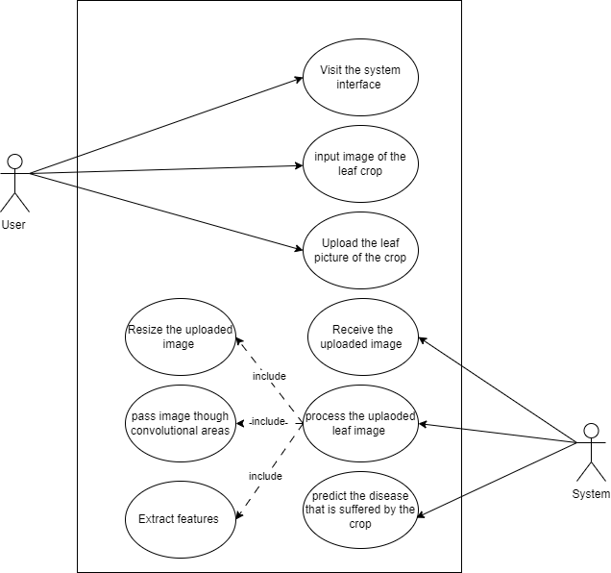
Figure 3.6: Use case diagram of the proposed system
The diagram above shows the use case activity that takes place in the proposed system, the system is made of two main entities, the system, the user can perform a myriad collection of activities which include visiting visit the system, upload crop leaf image, while the system on the other hand will have to receive the image that was uploaded by the user, process the image, predict the particular disease based on the characteristics that it detected on the uploaded image and lastly offer an advice on how to help tackle and cure the plant disease etc.
3.6 Activity Diagram of the Proposed System
An activity diagram stands as another important diagram in the Unified Modeling Language (UML). It is, however, a diagram that describes the dynamic aspects of the software system. However, an activity diagram is a flowchart to describe the flow of activities that go on in the system. The figure below represents the flow of activities on the proposed system, from the visiting of the platform by the user and uploading an image of the crop’s leaves, to getting the prediction of the disease that is being suffered by the crop.
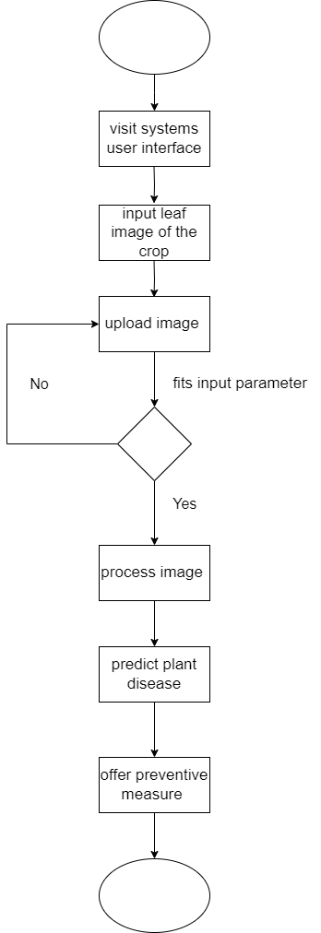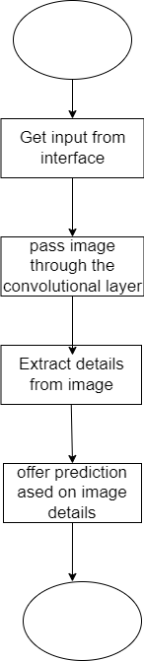
Figure 3.7: Activity diagram of the system and the analysis process of the system
Figure 3.7 represents the class diagram of the proposed system, which stands to display the pictorial representation of the activity that takes place in the proposed system. The activity ranges from the farmer visiting the system’s user interface to upload the image of the leaves of the crop in question into the system, to having the system predict the type of disease that is being suffered by the crop based on the image parameter that is provided by the farmer.
3.6.1 Class Diagram of the Proposed System
This section of this work of research holds the class diagram of the proposed system. The class diagram in Unified Modelling Language (UML) is one of the Unified Modelling Language diagrams that describes the architectural design of a software system by defining and laying out its classes, the attributes of the laid-out classes, the methods, and the relationships among these different objects that make up a system. Figure 3.8 illustrates the class diagram for the proposed system.
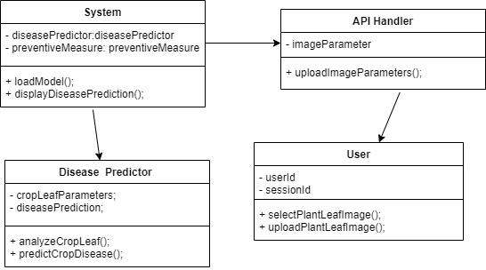
Figure 3.8: Class diagram of the proposed system
The diagram above represents the class diagram of the proposed system, which is used in this research work is used to show the activities that is going on in the proposed system. The diagram depicts the series of class exists between the system to help it function properly.
3.7 System Design
The system design of a system refers to the whole process that is involved in defining and developing the architecture, components, and interactions that occur within a complex system. This, however, involves the combination of all the input and output designs and the database design of the system, which works hand in hand to enable the user to communicate with the system and also allow the system to respond and give an output to the user. At this, the goal of system design is to craft the design of a system in such a way that it meets the requirements and needs of its users while also ensuring that it is efficient, scalable, reliable, and maintainable.
On the other hand, this section of this work of research will be based on the detailed design of the proposed system and how the system hopes to fulfil the requirements that have been stated above. This system design is however, is going to comprise of a simple design interface of the proposed system showing the physical sketch of the system as it aims at making its features accessible to the users, as well as the database structure design showing the structural implementation of the database
3.7.1 Input Interface Designs of The Proposed System
This section of this research work stands to illustrate how the system hopes to fulfil the requirements that have been stated in the previous sections above by showing a simple interface design of the input section of the proposed system, as it aims at making the features of the proposed system accessible to the users. The interface sketch of the proposed system is shown in Figure 3.9.
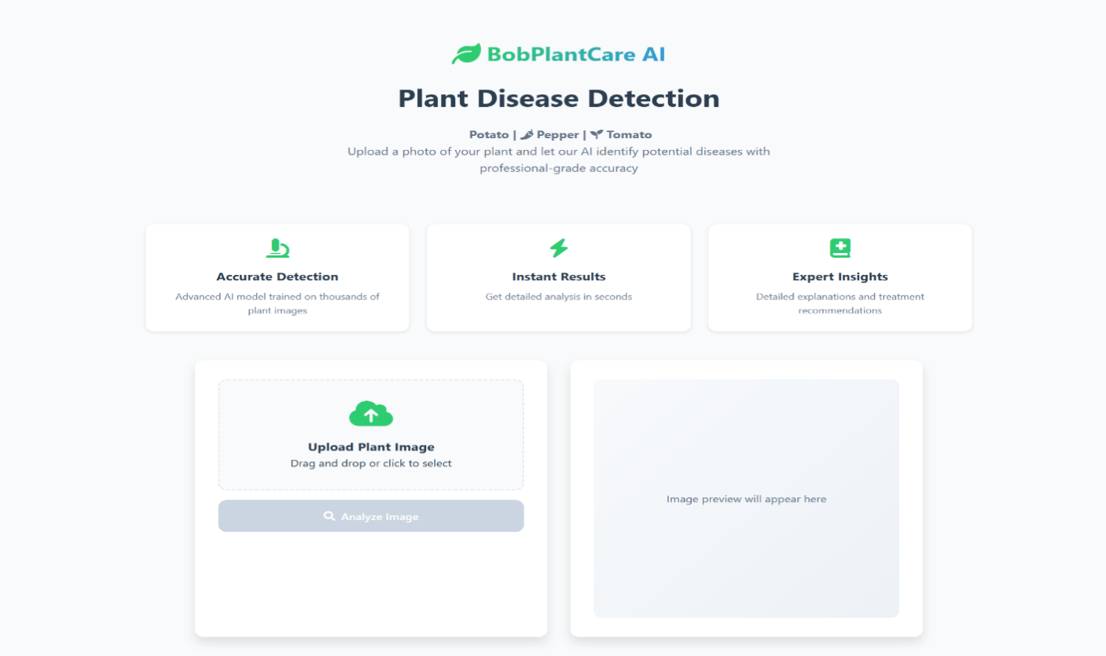
Figure 3.9 Input designs for the proposed system
Figure 3.9 shows the user interface design for the proposed system through which the user gets to select a sample leaf image of the crop and then upload it to the system through the interface. The picture sample is first selected by the farmer when he or she clicks on the upload image button to provide the image sample to be analysed by the system.
3.7.2 Output Interface Design of the Proposed System
This section of this research work stands to illustrate how the system hopes to fulfil the requirements that have been stated in the previous sections above by showing a simple interface design of the output section of the proposed system, as it aims at making the features of the proposed system accessible to the users. However, this section displays a screenshot of the interface design of the output section of the proposed system, depicting the way that information would be outputted by the system after predicting the disease that is being suffered by a crop based on the image leaf image that have been uploaded by the user. The interface design of the output section of the proposed system is shown below
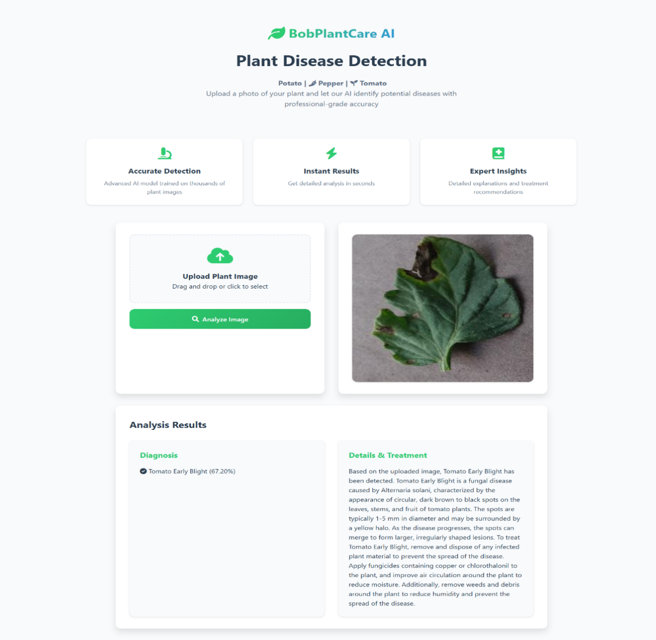
Figure 3.10: Output designs for the proposed system
The images above show the output interface of the proposed system. The images however show how the output gotten after the prediction of the crop disease would be arranged and displayed on the screen. On a general note, a pictorial representation of the interface used in outputting data out of the proposed system. These output interfaces that are supplied to the platform cuts across mainly the act of displaying the output that was gotten from the model.

3.8 Database Design
This design of a database is the crud depiction of how the database is going to appear when created. It shows the different tables that would be used for storing data within the database. However, the essence of the database design is to show a modeled view of the proposed system’s database. The proposed system’s database is a relational database that was designed and implemented using MySQL query language. The database was designed to have entities and at least one attribute for each entity.
Database schema for the proposed system
Table 3.1 User table for the proposed system
Attribute | Data Type | Description
Id | Int | The primary key of the table
Username | Varchar | This is where the username of the user is stored.
Email | Varchar | The field for storing the user’s email.
Password | Varchar | The field for storing the user’s email.
Date_joined | Timestamp | The field shows the date of when the user joined system.

Table 3.2 Prediction table of the proposed system
Attribute | Data Type | Description
Id (pk) | Int | The primary key of the table.
Prediction | Varchar | The disease that was predicted by the system
User | Varchar | The user who used the system.
Session | Timestamp | The session in which the system was used..

Table 3.3 Suggestion table of the proposed system
Attribute | Data Type | Description
Id (pk) | Int | The primary key of the table.
Prediction | Varchar | The disease that was predicted by the system
Suggestion | Varchar | The suggestion that is offered to the famer on how to tackle the disease.
Session | Timestamp | The session in which the system was used..

3.9 Tools used for implementation (Tech stack of the proposed system)
3.9.1 Backend
Python
Python is a programing language that is very powerful and versatile. It is a high-level programming language that is known for its ease of readability and its overall simplicity. Because of this reason, it has become the most popular choice of programming language for both beginner and experienced developers. Because it supports many different paradigms and also supports a large ecosystem of third-party packages that allows for rapid development across various domains, such as web development, data analysis, artificial intelligence, and automation. It also offers dynamic typing to improve productivity and allow for integration with other languages, tools, and frameworks like Django and Flask to enable and ensure a more efficient modern software development process.
Flask
The Flask framework is a simple, lightweight framework for Python that is flexible and used for the web. It is especially made to be used for rapidly and cheaply developing web apps. It adheres to the Web Server Gateway Interface (WSGI) specification. It is built on Jinja2 and Werkzeug to provide reliable performance and effective templating. Flask has a micro framework nature that makes it suitable for web development purposes and also offering developers the opportunity to be able to integrate more components that they need. It gives a straightforward and intuitive API facility to allow for rapid development and prototyping and also to make it ideal for small to medium-sized applications and RESTful APIs. The Flask framework was also among the tools that was used in creating the backend of the proposed system.
Machine Learning: TensorFlow
TensorFlow machine learning framework that is open-source. It is frequently used for creating and training neural networks and it was created by Google which offers a vast and all-inclusive ecosystem of tools, libraries and community resources to make it easier for developers to build and use machine learning models. The TensorFlow facilitates the creation of models rapidly using high-level APIs like Keras, as well as more intricate and customized workflows using low-level APIs.. However, it is highly efficient and very capable of running on CPUs, GPUs and even Tensor Processing Units (TPUs) for accelerated computation. Moreover, its flexibility makes it suitable for a lot of applications which ranges from simple data analysis to advanced deep learning and artificial intelligence projects.
Keras
Keras is a popular open-source machine learning framework used for building and training deep learning models which was initially created by Francois Chollet but is now integrated into TensorFlow which makes it useful for both academic and industry purposes. Keras is very simple to use as it has a user-friendly high-level API that allows the creation of neural networks in a few lines of code, simplifying model design and training. It has several supported backend engines such as TensorFlow, Theano and Microsoft CNTK, which provides more options for model development. Also, Keras is very performant and can execute on different devices such as CPUs, GPUs and TPUs, which improves the speed of large-scale deep learning tasks. Its modular structure is both easy to use and efficient, making it useful for a diverse set of tasks ranging from simple machine learning challenges to deep artificial intelligence problems like image recognition, natural language processing and even advanced predictive analytics.

CHAPTER FOUR
SYSTEM IMPLEMENTATION
4.0 Overview
This specific chapter of the research work will cover the following key topics, which include the design conception, design implementation, and system development that were proposed and discussed in the earlier chapters of this work of research. On a similar note, following in the footsteps of the previous sections of this work of research, which included a thorough top-down analysis of comparable and operational systems, the process of creating the system suggested in this work of research began with a description of the system and all of its requirements. However, in this part of the research process, the researcher did employ a few instruments that were carefully selected, put through a rigorous testing procedure, and ultimately found to be suitable for use in implementing the recommended system. Above all, the tools used to bring the system to life are discussed in this study work's chapter, which also covers the numerous user interfaces for its many portions.
4.1 User Interface of The Proposed System
This section of the research work covers for the interface design of the different sections that the proposed system has. Moreover, the interfaces of the suggested system will include the interface for the input of parameters into the system and the design of the output interface.
4.1.1. The Input screen of the proposed system
The input screen of the proposed system is the first interface of the proposed system that the user gets to see when they visit the system interface because it serves as the landing page of the proposed system. The input section of the system exists to provide the user with a means to input the leaf image that would be used by the system to detect if a crop has been affected by a disease and also to detect the type of disease that is affecting the crop. Below is the input section of the proposed system.
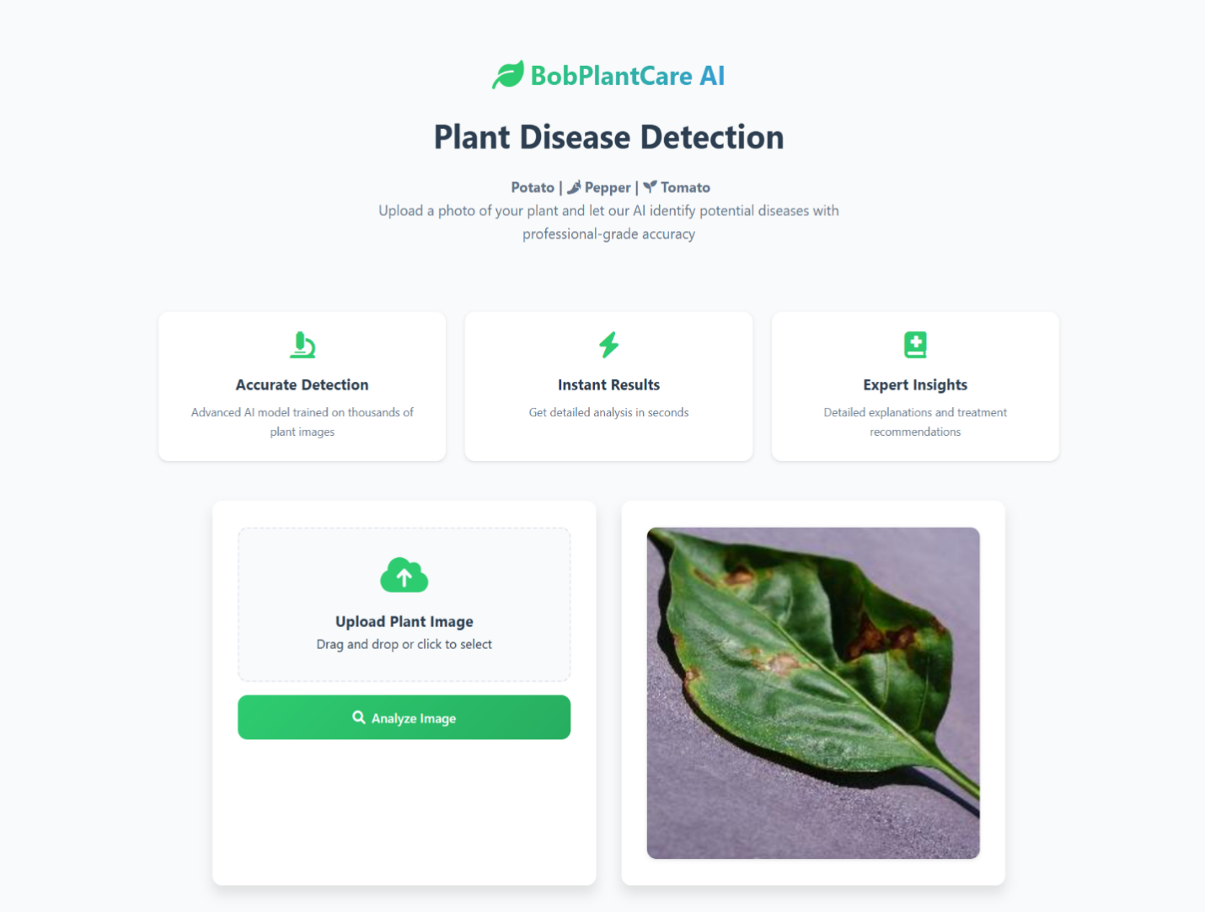
Figure 4.1 The input screen of the proposed system
4.1.2 Output Screen of the Proposed System:
This screen of the proposed system is used by the system to display the outcome of the detection process for the system. This page shows whether the leaf image that has been uploaded to the system using the input section of the system is contaminated with a disease or not. If the leaf image is contaminated with a disease, the system then detects the particular type of disease. Also, the system goes ahead to add the confidence of its prediction to tell the user the level of accuracy that it has in predicting the disease that the plant has been contaminated with, judging from the leaf image that has been uploaded by the user.
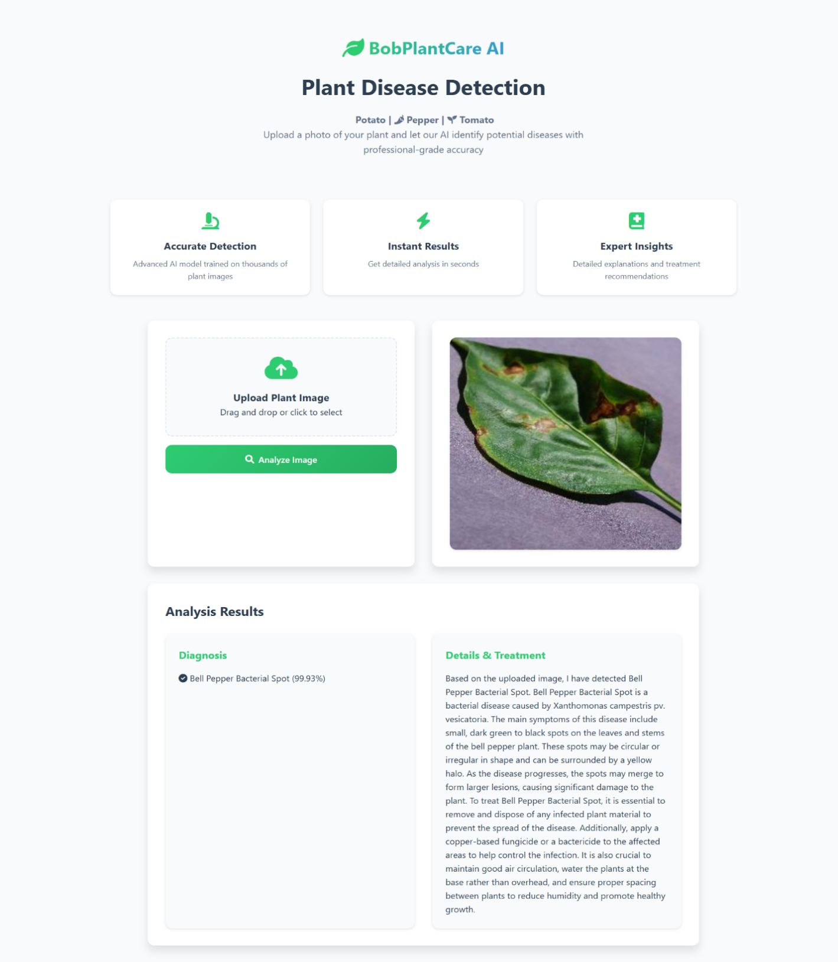
Figure 4.2 The output screen of the proposed system.
4.2 Implementation and Results of The Proposed System
The system was implemented using the tools that were listed in the earlier chapters of this research work. The researcher sourced for the data sample from a reputable and verifiable data resource (plant village and agricultural institutions in the sub-Saharan region) in which a double dataset file (one from plantvillage and one from agricultural institutions) was collected to be used for training and testing the model in other to improve the accuracy of the model. The dataset was collected form https://www.kaggle.com/datasets/arjuntejaswi/plant-village and it contained a total of 20639 images. The images were in the dataset came in fifteen different groups which include Pepper bell bacteria (997), Pepper bell healthy (1478), Potato early blight (1000), Potato late blight (1000), Potato healthy (152), Tomato Bacterial spot (2127), Tomato early blight (1000), Tomato late blight (1909), Tomato leaf Mold (952), Tomato septoria leaf spot (1771), Tomato spider mites two spotted spider mites (1676), Tomato Target spot (1404), Tomato yellowleaf curls virus (3209), Tomato mosaic virus (373), tomato healthy (1591).
However, during the training of the model, 75% of the dataset was used for training the model and 25% of the data was used for testing the model after it was developed. The system was created using the Groq LLM (large language model) model because it uses scanned images to determine if the image is made up of tumor and they type of tumor. The model was fitted in two intervals, beginning with 30 epochs of training in the first stage. The training was then extended for an additional 30 epochs. In this case, an EarlyStopping callback was also implemented with a patience of 5. Therefore, training was stopped after only 9 epochs as validation accuracy started to drop. Training took 2 hours and 22.5 minutes using an NVIDIA T4 GPU. Nevertheless, the model performed excellently in terms of identifying and classifying plant diseases with an accuracy of 94%, demonstrating strong precision and recall for most classes. This model has 5 convolution layers, each followed by a max pooling layer. Below are the snapshots of the whole training process:
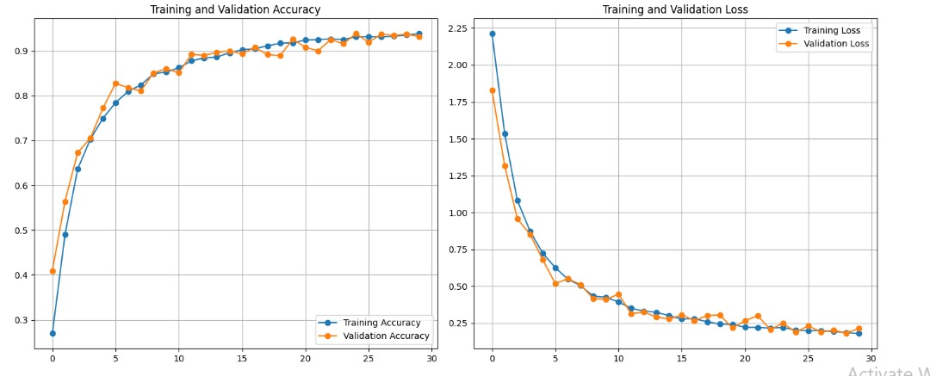
Figure 4.4 Validation and training accuracy and loss for the initial complete 30 epochs.
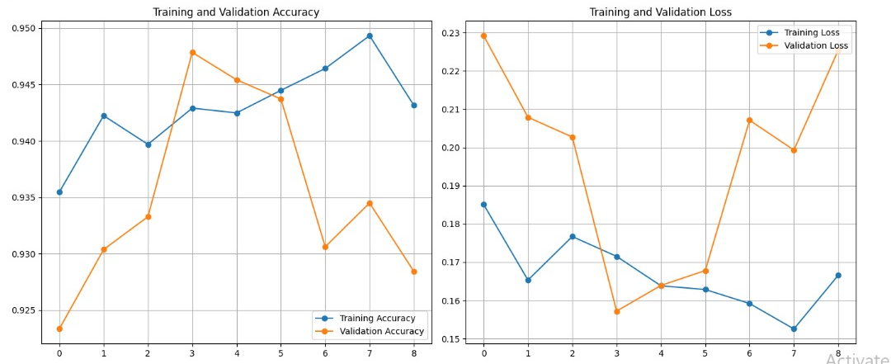
Figure 4.5 Validation and training accuracy and loss for the 9 more epochs before being halted by the callback because validation accuracy was declining.
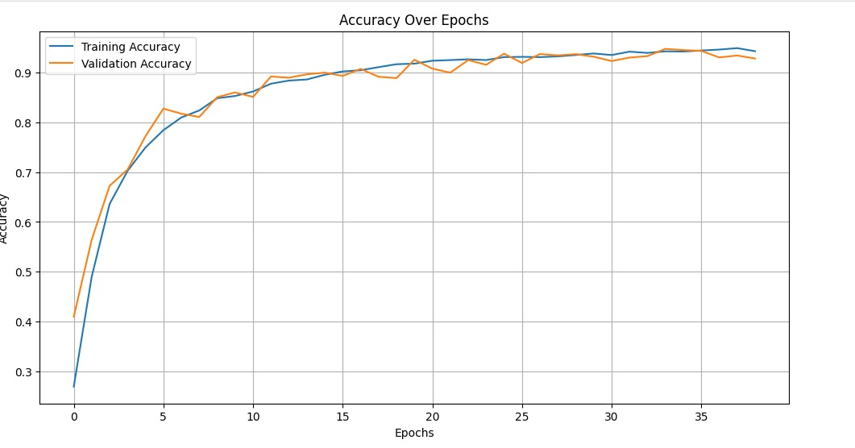
Figure 4.6 Full validation and training accuracy for both the 30 and 9 epochs.
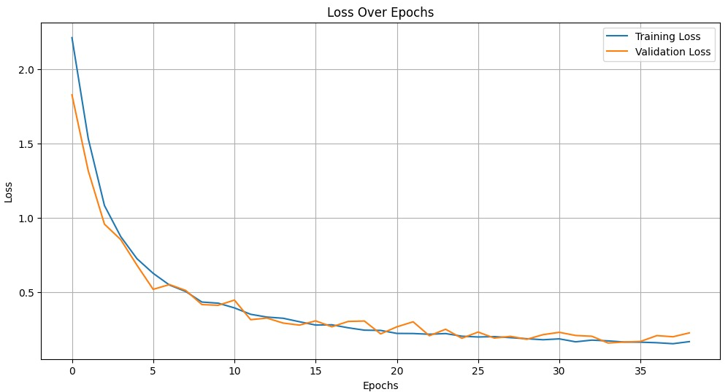
Figure 4.7 Full validation and training loss for both 30 and 9 epochs.

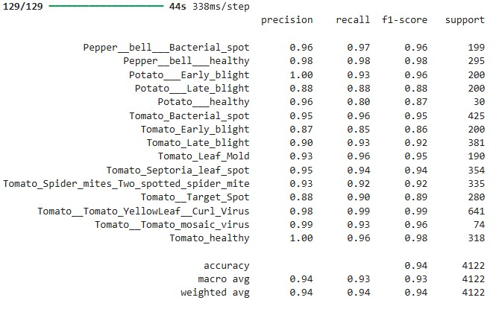
Figure 4.8 Classification report showing precision, recall and F1 score performance.

4.3 System Testing
System testing was conducted to ensure that the proposed crop disease detection and classification system meets its functional and non-functional requirements. The testing phase aimed to verify the performance, accuracy, reliability, usability and robustness of the system in real-world scenarios. Several types of testing were carried out as outlined below.
4.3.1 Functional Testing
Functional testing was performed to confirm that all features of the system work as intended. The following functionalities were validated:
- Image Upload: Users were able to upload leaf images in common formats (e.g., JPG, PNG).
- Disease Detection: The system correctly detected whether a leaf was healthy or infected.
- Disease Classification: When disease was detected, the system correctly identified the specific disease category.
- Confidence Score Display: The system provided a confidence score alongside each prediction.
- User Interface Navigation: Input and output screens were fully functional and navigable.
All functionalities passed functional tests with no critical errors observed.
4.3.2 Performance Testing
Performance testing was conducted to assess the speed and responsiveness of the system under different load conditions. Tests included:
- Inference Time: The average time for model prediction per image was approximately 2.3 seconds on a standard CPU and <1 second on GPU.
- System Load: The system was able to handle simultaneous uploads from up to 20 concurrent users without crashing or slowing down significantly.
- Memory Usage: Memory consumption remained within acceptable bounds during image processing and classification.
4.3.3 Accuracy Testing
The system's model was evaluated using the test dataset, with the following metrics obtained:
- Accuracy: 94%
- Precision: 94%
- Recall: 93%
- F1 Score: 93%
A detailed classification report was generated (see Figure 4.8 in Section 4.2), which confirms that the system delivers robust classification performance across a wide range of plant diseases.
4.3.4 Usability Testing
Usability testing involved agricultural extension workers and farmers interacting with the system. Key observations included:
- User-Friendliness: The graphical user interface was intuitive and easy to navigate.
- Language Simplicity: Labels and results were clearly understood, even by users with limited technical background.
- Feedback: Users appreciated the confidence scores and suggestions provided alongside the diagnosis.
4.3.5 Security and Robustness Testing
Security and robustness testing were also conducted to ensure that the system could handle invalid inputs and edge cases:
- Invalid Image Uploads: The system rejected non-image files and unsupported formats gracefully.
- Empty Uploads: The system prompted users to upload a valid image before proceeding.
- Corrupted Files: Handled with appropriate error messages without crashing.
The system successfully passed all major testing criteria. It demonstrated a high level of reliability, accuracy and usability, making it suitable for deployment in agricultural environments, especially in resource-limited regions. Based on testing results, the system is deemed ready for real-world application and further scaling.
CHAPTER FIVE
SUMMARY, RECOMMENDATIONS, AND CONCLUSION
This chapter summarizes everything that have been discussed in all the preceding chapters of this project. However, this chapter of this work of research is used by the researcher to give a detailed conclusive summary of this project, the recommendations for future works that may exist within this domain of knowledge and lastly a detailed conclusion of this research work.
5.1 Summary
The issue statement related to this research project and the background of the study were clearly outlined and discussed at the outset of the research project, providing a solid foundation for the rationale behind the research's undertaking. However, the subsequent chapters of this work explored the theoretical foundations of this research along with a very thorough review of the pertinent systems that are currently in use and have been built in the past by other researchers.
This research work also included a comprehensive analysis of the systems that are currently in place, highlighting their flaws and making every effort to capitalize on these problems (knowledge gaps) in the process of constructing the proposed system. In the third chapter (chapter 3) of this study, a thorough system analysis was also carried out using a few UML diagrams; the system was thoroughly evaluated using use case diagrams, activity diagrams, class diagrams, and class diagrams of the UML diagrams. Finally, a thorough explanation of the user interface and a list of all the programming languages and frameworks used to complete this project were supplied and thoroughly examined regarding the system's interface.
5.2 Conclusion
This segment of the research work stands to fulfil the objectives that were established at the beginning of this research work. We have now reached the end of this research process. However, the research has not ended with this conclusion; rather, it will continue to expand and add many new features and updates, such as the capability for users to download the prediction results and a ton of other new awesome features. As a result, this is not the end of the proposed system. Moreover, the system that has been suggested throughout the study's limited scope has been made available for use to accomplish its goals. The system has been made available on https://plant-disease-classifier-c8s7.onrender.com/ so that it can now be accessible to users globally. In summary, to use the system, the users are advised to fulfill all the requirements of using the system.
5.3 Recommendations
This crop disease prediction system is highly recommended to every farmer out there, whether small-scale or commercial farmers who are confused and are faced with the challenge of manually inspecting their farmland and trying to decipher the type of disease that a particular crop is suffering from. This is, however, a revolutionary way of determining/predicting if a plant is suffering from any disease, using a clear image of the leaf and in the case that it is suffering from any form of disease, it detects the particular type of disease and also proffers possible solutions to it.

REFERENCES
Abbas, J., Bibi, N., Naqvi, R. A., Sadeghi-Niaraki, A., & Jeong, D. (2024). Revolutionizing agriculture with artificial intelligence: Plant disease detection methods, applications and their limitations. Frontiers in Plant Science, 15. https://doi.org/10.3389/fpls.2024.1234567
Agarwal, M., Gupta, S. K., & Biswas, K. K. (2020). Development of efficient CNN model for tomato crop disease identification. Sustainable Computing: Informatics and Systems, 28, 100407. https://doi.org/10.1016/j.suscom.2020.100407
Aishwarya, N., Praveena, N. G., Priyanka, S., & Pramod, J. (2023). Smart farming for detection and identification of tomato plant diseases using lightweight deep neural network. Multimedia Tools and Applications, 82(12), 18799–18810. https://doi.org/10.1007/s11042-023-15243-7
Alzahrani, M. S., & Alsaade, F. W. (2023). Transform and deep learning algorithms for the early detection and recognition of tomato leaf disease. Agronomy, 13(5), 1184. https://doi.org/10.3390/agronomy13051184
Badiger, M., & Mathew, J. A. (2023). Tomato plant leaf disease segmentation and multiclass disease detection using hybrid optimization enabled deep learning. Journal of Biotechnology, 374, 101–113. https://doi.org/10.1016/j.jbiotec.2023.02.001
Basavant, N. A., V, G., & L, K. N. (2024). Crop prediction analysis and plant disease detection using machine learning. International Journal for Research in Applied Science and Engineering Technology, 12(3), 1234–1245.
Chlingaryan, A., Sukkarieh, S., & Whelan, B. (2018). Machine learning approaches for crop yield prediction and nitrogen status estimation in precision agriculture: A review. Computers and Electronics in Agriculture, 151, 61–69. https://doi.org/10.1016/j.compag.2018.05.012
Delfani, P., Thuraga, V., Banerjee, B., & Chawade, A. (2024). Integrative approaches in modern agriculture: IoT, ML and AI for disease forecasting amidst climate change. Precision Agriculture, 25(2), 456–470. https://doi.org/10.1007/s11119-023-10067-z
Gottemukkala, S., Yalla, P., & Madhavi, K. (2024). Implementation of ant colony optimization and principal component analysis for early prediction of tomato leaf diseases: A feature reduction approach. Journal of Electrical Systems, 20(3s), 829–843.
Jasim, Y. A. (2021). High-performance deep learning to detection and tracking tomato plant leaf predict disease and expert systems. ADCAIJ: Advances in Distributed Computing and Artificial Intelligence Journal, 10(2), 45–58.
Jha, P., Dembla, D., & Dubey, W. (2024). Implementation of machine learning classification algorithm based on ensemble learning for detection of vegetable crops disease. International Journal of Advanced Computer Science and Applications, 15(1), 123–130.
Kamilaris, A., & Prenafeta-Boldú, F. X. (2018). Deep learning in agriculture: A survey. Computers and Electronics in Agriculture, 147, 70–90. https://doi.org/10.1016/j.compag.2018.02.016
Kaushik, H., Khanna, A., Singh, D., Kaur, M., & Lee, H. N. (2023). TomFusioNet: A tomato crop analysis framework for mobile applications using the multi-objective optimization based late fusion of deep models and background elimination. Applied Soft Computing, 133, 109898. https://doi.org/10.1016/j.asoc.2023.109898
Khan, B., Das, S., Fahim, N. S., Banerjee, S., Khan, S., Al-Sadoon, M. K., ... & Islam, A. R. M. T. (2024). Bayesian optimized multimodal deep hybrid learning approach for tomato leaf disease classification. Scientific Reports, 14(1), 21525. https://doi.org/10.1038/s41598-024-52177-2
Li, Y., Nie, J., Chao, X., & Wang, Y. (2020). Early disease detection in crop plants using machine learning approaches. Plant Physiology and Biochemistry, 148, 401–414. https://doi.org/10.1016/j.plaphy.2020.01.027
Liu, J., & Wang, X. (2020). Tomato diseases and pests detection based on an improved Yolo V3 convolutional neural network. Frontiers in Plant Science, 11, 898. https://doi.org/10.3389/fpls.2020.00898
Lee, S., & Yun, C. M. (2023). A deep learning model for predicting risks of crop pests and diseases from sequential environmental data. Plant Methods, 19, Article 145. https://doi.org/10.1186/s13007-023-01122-x
Mahlein, A. K. (2016). Plant disease detection by imaging sensors – Parallels and specific demands for precision agriculture and plant phenotyping. Plant Disease, 100(2), 241–251. https://doi.org/10.1094/PDIS-03-15-0340-FE
Manchanda, M., Jadli, K., Butola, P., Sharma, V., Bisht, D., & Purohit, K. (2024, April). A real-time tomato crop disease prediction using deep learning. In 2024 International Conference on Inventive Computation Technologies (ICICT) (pp. 649–656). IEEE. https://doi.org/10.1109/ICICT60155.2024.10544718
Nourali, Z., & Shortridge, J. E. (2024, November). Predicting the impact of extreme weather on agricultural losses in the Delmarva Peninsula using multi-step machine learning and financial crop loss data [Preprint]. Research Square. https://doi.org/10.21203/rs.3.rs-5398230/v1
Ploetz, R. C. (2015). Management of Fusarium wilt of banana: A review with special reference to tropical race 4. Crop Protection, 73, 7–15. https://doi.org/10.1016/j.cropro.2015.02.007
Prottasha, M. S. I., Tasnim, Z., Reza, S. S., & Hossain, D. A. (2021, February). A lightweight CNN architecture to identify various rice plant diseases in Bangladesh. In 2021 International Conference on Information and Communication Technology for Sustainable Development (ICICT4SD) (pp. 316-320). IEEE. https://doi.org/10.1109/ICICT4SD50815.2021.9396898
Puls, M. (2021). Predictive agriculture: The art of understanding uncertainty. The University of Queensland. https://stories.uq.edu.au/research/2021/predicting-the-future-of-agriculture/index.html
Rial-Lovera, K., Davies, W. J., & Yin, X. (2017). Agriculture, meteorological and computational sciences in support of crop modelling. Earth Perspectives, 4(1), 1-20. https://doi.org/10.1186/s40322-017-0040-8
Sakkarvarthi, G., Sathianesan, G. W., Murugan, V. S., Reddy, A. J., Jayagopal, P., & Elsisi, M. (2022). Detection and classification of tomato crop disease using convolutional neural network. Electronics, 11(21), 3618. https://doi.org/10.3390/electronics11213618
Sanida, M. V., Sanida, T., Sideris, A., & Dasygenis, M. (2023). An efficient hybrid CNN classification model for tomato crop disease. Technologies, 11(2), 45. https://doi.org/10.3390/technologies11020045
Shmueli, G., & Koppius, O. R. (2011). Predictive analytics in information systems research. MIS Quarterly, 35(3), 553-572. https://doi.org/10.2307/23042796
Shoaib, M., Hussain, T., Shah, B., Ullah, I., Shah, S. M., Ali, F., & Park, S. H. (2022). Deep learning-based segmentation and classification of leaf images for detection of tomato plant disease. Frontiers in Plant Science, 13, 1031748. https://doi.org/10.3389/fpls.2022.1031748
Singh, A., Kumar, S., & Choudhury, D. (2024, January). Tomato leaf disease prediction based on deep learning techniques. In International Conference on Computation of Artificial Intelligence & Machine Learning (pp. 357-375). Springer Nature. https://doi.org/10.1007/978-3-031-45645-9_20
Singh, R. P., Hodson, D. P., Huerta-Espino, J., Jin, Y., Njau, P., Wanyera, R., & Ward, R. W. (2016). The emergence of Ug99 races of the stem rust fungus is a threat to world wheat production. Annual Review of Phytopathology, 46, 385-407. https://doi.org/10.1146/annurev-phyto-080615-095928
Tan, L., Lu, J., & Jiang, H. (2021). Tomato leaf diseases classification based on leaf images: A comparison between classical machine learning and deep learning methods. AgriEngineering, 3(3), 542-558. https://doi.org/10.3390/agriengineering3030035
Tarek, H., Aly, H., Eisa, S., & Abul-Soud, M. (2022). Optimized deep learning algorithms for tomato leaf disease detection with hardware deployment. Electronics, 11(1), 140. https://doi.org/10.3390/electronics11010140
Thangaraj, R., Anandamurugan, S., Pandiyan, P., & Kaliappan, V. K. (2022). Artificial intelligence in tomato leaf disease detection: A comprehensive review and discussion. Journal of Plant Diseases and Protection, 129(3), 469-488. https://doi.org/10.1007/s41348-021-00542-y
Ullah, N., Khan, J. A., Almakdi, S., Alshehri, M. S., Al Qathrady, M., Aldakheel, E. A., & Khafaga, D. S. (2023). A lightweight deep learning-based model for tomato leaf disease classification. Computers, Materials & Continua, 77(3), 3969-3992. https://doi.org/10.32604/cmc.2023.046210
Van Bruggen, A. H., Sharma, K., Kaku, E., Karfopoulos, S., & Akmenkalns, A. (2015). Plant disease management in organic farming systems. Plant Pathology, 64(4), 619-629. https://doi.org/10.1111/ppa.12384
Verma, S., Chug, A., & Singh, A. P. (2018, September). Prediction models for identification and diagnosis of tomato plant diseases. In 2018 International Conference on Advances in Computing, Communications and Informatics (ICACCI) (pp. 1557-1563). IEEE. https://doi.org/10.1109/ICACCI.2018.8554655
Wang, X., & Liu, J. (2024). An efficient deep learning model for tomato disease detection. Plant Methods, 20(1), 61. https://doi.org/10.1186/s13007-024-01185-4
Wolfert, S., Ge, L., Verdouw, C., & Bogaardt, M. J. (2017). Big data in smart farming – A review. Agricultural Systems, 153, 69–80. https://doi.org/10.1016/j.agsy.2017.01.023
World Health Organization. (2020). Disease definition. https://www.who.int
Yildiz, M. B., Hafif, M. F., Koksoy, E. K., & Kurşun, R. (2024). Classification of diseases in tomato leaves using deep learning methods. Intelligent Methods in Engineering Sciences, 3(1), 22–36. https://doi.org/10.61300/IMES.2024.3.1.3
Zhou, C., Zhou, S., Xing, J., & Song, J. (2021). Tomato leaf disease identification by restructured deep residual dense network. IEEE Access, 9, 28822-28831. https://doi.org/10.1109/ACCESS.2021.3058947

APPENDIXES
from flask import Flask, request, jsonify, render_template
import os
from flask_cors import CORS, cross_origin
import base64
import tensorflow as tf
from tensorflow.keras.preprocessing.image import load_img, img_to_array
import numpy as np
from langchain_core.prompts import ChatPromptTemplate
from langchain_groq import ChatGroq
import asyncio
from functools import wraps

# Helper function to run async code in Flask
def async_route(f):
@wraps(f)
def wrapped(*args, **kwargs):
return asyncio.run(f(*args, **kwargs))
return wrapped

app = Flask(__name__)
CORS(app)

class ClientApp:
def __init__(self):
self.filename = "InputImage.jpg"
# Load the Keras model
self.classifier = tf.keras.models.load_model('plant_disease_classifier.keras')
# Initialize Groq LLM
self.chat = ChatGroq(
temperature=0.3,
# groq_api_key=os.getenv('GROQ_API_KEY'),
groq_api_key = '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',
model_name="llama3-8b-8192"
)
self.setup_prompt()

def setup_prompt(self):
"""Set up a single prompt template for plant analysis"""
system_context = """You are a plant pathologist familiar with diseases affecting tomatoes, peppers, and potatoes.
You provide brief, practical information. You know about these specific conditions:
- Bell Pepper Bacterial Spot
- Potato Early Blight
- Potato Late Blight
- Tomato Bacterial Spot
- Tomato Early Blight
- Tomato Late Blight
- Tomato Leaf Mold
- Tomato Septoria Leaf Spot
- Tomato Spider Mites
- Tomato Target Spot
- Tomato Yellow Leaf Curl Virus
- Tomato Mosaic Virus
And you can identify healthy plants."""

template = """The AI system has detected {condition} in the uploaded image.

If this is a diseased plant: Provide a single paragraph describing the disease's main symptoms and the most important treatment steps.

If this is a healthy plant: Simply provide a brief confirmation of the plant's health and 1-2 basic care tips."""

self.prompt = ChatPromptTemplate.from_messages([
("system", system_context),
("human", template)
])

async def get_analysis(self, condition: str) -> str:
"""Get a single analysis response from LLM"""
try:
analysis_chain = self.prompt | self.chat
response = await analysis_chain.ainvoke({"condition": condition})
return response.content
except Exception as e:
print(f"Error getting LLM response: {str(e)}")
return f"Error analyzing the plant condition: {str(e)}"

# Your existing class_name_map remains the same
class_name_map = {
'Pepper__bell___Bacterial_spot': 'Bell Pepper Bacterial Spot',
'Pepper__bell___healthy': 'Healthy Bell Pepper',
'Potato___Early_blight': 'Potato Early Blight',
'Potato___Late_blight': 'Potato Late Blight',
'Potato___healthy': 'Healthy Potato',
'Tomato_Bacterial_spot': 'Tomato Bacterial Spot',
'Tomato_Early_blight': 'Tomato Early Blight',
'Tomato_Late_blight': 'Tomato Late Blight',
'Tomato_Leaf_Mold': 'Tomato Leaf Mold',
'Tomato_Septoria_leaf_spot': 'Tomato Septoria Leaf Spot',
'Tomato_Spider_mites_Two_spotted_spider_mite': 'Tomato Spider Mites (Two-Spotted)',
'Tomato__Target_Spot': 'Tomato Target Spot',
'Tomato__Tomato_YellowLeaf__Curl_Virus': 'Tomato Yellow Leaf Curl Virus',
'Tomato__Tomato_mosaic_virus': 'Tomato Mosaic Virus',
'Tomato_healthy': 'Healthy Tomato'
}

def decodeImage(imgstring, fileName):
imgdata = base64.b64decode(imgstring)
with open(fileName, 'wb') as f:
f.write(imgdata)

@app.route("/", methods=['GET'])
@cross_origin()
def home():
return render_template('index.html')

@app.route("/predict", methods=['POST'])
@cross_origin()
@async_route
async def predictRoute():
try:
clApp = ClientApp()
# Decode the incoming image
image = request.json['image']
decodeImage(image, clApp.filename)

# Preprocess the image
img = load_img(clApp.filename, target_size=(224, 224))
img_array = img_to_array(img)
img_array = np.expand_dims(img_array, axis=0)
img_array = img_array / 255.0

# Predict using the model
predictions = clApp.classifier.predict(img_array)
predicted_class = np.argmax(predictions[0])
predicted_label = list(class_name_map.values())[predicted_class]

# Get analysis from LLM
analysis = await clApp.get_analysis(predicted_label)

# Confidence Score
confidence = float(predictions[0][predicted_class])*100
confidence = f'{confidence:.2f}%'

# Prepare the result
result = {
"prediction": f'{predicted_label} ({confidence})',
"explanation": analysis,
"confidence": confidence
}

print('Prediction Result:', result)
return jsonify(result)

except Exception as e:
print(f"Error in prediction route: {str(e)}")
return jsonify({
"error": "An error occurred during prediction",
"details": str(e)
}), 500

if __name__ == "__main__":
app.run(host='0.0.0.0', port=10000)

