STUDENT PERFORMANCE MONITORING MANAGEMENT SYSTEM FOR GODFREY OKOYE UNIVERSITY

BY
OKORONKWO CHINAZA IKECHUKWU
GOU/U21/CSC/727

FACULTY OF NATURAL SCIENCES AND ENVIRONMENTAL STUDIES, GODFREY OKOYE UNIVERSITY, ENUGU

JUNE, 2025.

STUDENT PERFORMANCE MONITORING MANAGEMENT SYSTEM FOR GODFREY OKOYE UNIVERSITY

BY
OKORONKWO CHINAZA IKECHUKWU
GOU/U21/CSC/727

SUBMITTED TO THE DEPARTMENT OF COMPUTER SCIENCE,

FACULTY OF NATURAL SCIENCES AND ENVIRONMENTAL STUDIES, GODFREY OKOYE UNIVERSITY, ENUGU

IN PARTIAL FULFILMENT OF THE AWARD OF BACHELOR OF SCIENCE DEGREE

SUPERVISED BY PROF N.M OZOFOR

JUNE, 2025.

CERTIFICATION
I hereby certify that the work included therein was completed by myself and that it was mainly based only on my own observations and investigation. Consequently I will fully accept the University's decision if I am found to have cheated on the assignment.

________________________
OKORONKWO CHINAZA IKECHUKWU
GOU/U21/CSC/727

APPROVAL PAGE

This is to validate that this research work “STUDENT PERFORMANCE MONITORING MANAGEMENT SYSTEM FOR GODFREY OKOYE UNIVERSITY” was embarked upon by “OKORONKWO CHINAZA IKECHUKWU” with the matriculation number GOU/U21/CSC/727in partial fulfillment of the requirements for the award of Bachelor Science(B.SC) in Computer Science, Facultyof Natural Sciences and Environmental Studies , Godfrey Okoye University, Enugu.

__________________________ ________________________

PROF N.M OZOFOR Date

(Supervisor)

_______________________________ _________________________

Dr. (Mr.) Frank Okebanama Date

Head of Department

________________________________ _________________________

External Examiner Date

DEDICATION

This work “STUDENT PERFORMANCE MONITORING MANAGEMENT SYSTEM FOR GODFREY OKOYE UNIVERSITY” is dedicated to my parents Mr. and Mrs. IKECHUKWU OKORONKWO who all effort has contributed heavily to everything that I have achieved up until this day and I pray that the good lord continue to guide and protect them for the rest of their days.

ACKNOWLEDGMENTS
First of all, I would like to appreciate the almighty God for his abundant mercies, inspiration and grace throughout this project.In a special way, I want to also acknowledge and appreciate my supervisor, prof N.M OZOFOR for the guide he made sure I get to make sure that this project is a success. I would also like to appreciate my parents, Mr. & Mrs. Ikechukwu okoronkwo for their love, support and prayers for me throughout this project. Also want to applaud the HOD of computer science department, Dr. (Mr.) Frank Okebanama for the effort he put to see that students brings out the best of themselves.

TABLE OF CONTENTS
Title page i
Declaration ii Certification iii Approval Page iv
Dedication v Acknowledgement vi Abstract ix
Chapter One: Introduction 1
1.1 Background of the Study 1
1.2 Problem Statement 1
1.3 Aim and Objectives 2
1.4 Scope of the Study 3
1.5 Significance of the Study 4
Chapter Two: Literature Review 6
2.1 Introduction 6
2.2 Theoretical Background 6
2.3 Review of Related Works 8
2.4 Summary of Related Literature 9
2.5 Importance of Monitoring Student Performance 10
2.6 Traditional vs Modern Ways to Monitor Systems Performance 12
2.7 Role of Data in Student Performance 14
2.8 Characteristics of a Good Student Monitoring System 16
2.9 Challenges in Implementing SPMMS 16
2.10 The Future of Student Performance Monitoring System 17
2.11 Summary 18
Chapter Three: System Analysis and Design 19
3.1 Overview 19
3.2 System Analysis 19
3.3 Weaknesses of the Existing System 20
3.4 Analysis of the Proposed System 21
3.5 Benefits of the Proposed System 21
3.6 System Development Methodology 22
3.7 Tools and Technologies Used 22
3.8 System Requirements 23
3.9 System Architecture 23
3.10 System Design 24
3.11 Implementation 30
3.12 Testing 30
3.13 Summary 30
Chapter Four: System Implementation and Testing 31
4.1 Introduction 31
4.2 System Modules and Description 31
4.3 User Interface Screenshots and Description 32
4.4 Implementation Environment 35
4.5 System Testing 35
4.6 Challenges Encountered 36
4.7 Summary 36
Chapter Five: Summary, Conclusion and Recommendations 37
5.1 Summary 37
5.2 Conclusion 37
5.3 Recommendations 38
5.4 Contribution to Knowledge 39
5.5 Future Work 39
5.6 Final Thoughts 39
References 41

Abstract
This project "Student Performance Monitoring Management System" was created in order to solve the problems that have so far been experienced with the manual method of monitoring and handling students' academic performance at universities. The manual method has had a tendency of being slow, keeping wrong records, opaque, and not allowing access to history data for academic assessment.The system is a web-based application that has been developed to automate the inputting, processing, and reporting of students' performance. It allows lecturers to input marks for continuous assessments as well as exams, with the system automatically calculating total marks, grades, and Grade Point Averages (GPA). Students are given secure access to access their performance in real time, where they are able to monitor their progress and receive instant feedback. Administrators are also able to publish reports and performance summary for academic decision-making and planning.The use of this system assists in the reduction of human errors, enhanced efficiency, data security, and enhancement of accountability. The system was developed based on emerging web technologies with emphasis on user interface development, data validation, and role-based access control. Overall, the Student Performance Monitoring Management System is a more efficient and reliable means of monitoring student performance in institutions of higher learning.

List of Figures
Figures
3.1 INPUT DESIGNS OF THE PROPOSED SYSTEM 24
3.2 Use case Diagram 26
3.3 Entity Relationship Diagram (ERD) 27
3.4 Flowchart of the proposed system 28
4.1 Login page 32
4.2 Admin Dashboard 33
4.3 Lecturer Interface 33
4.4 Student Dashboard 34
4.5 Grade upload Interface 34

List of Tables
Tables
2.3 Review of Related Works 8
2.5 Importance of monitoring student performance 10
3.7 Tools and Technologies Used 22
4.5.2 Test cases 35

CHAPTER ONE:
INTRODUCTION
  - Background of the Study
Education plays a deciding role in an individual's future, and the educational performance of a student is a crucial success marker. However, there are lots of schools and institutes still using traditional methods to monitor the performances of students, which can cause inefficiency, loss of data, and a lack of monitoring long-term performance. The Student Performance Monitoring Management System(SPMMS) is superior to these setbacks by providing an automated databased system.
The system allows administrators, educators, and learners to effectively monitor academic achievement, view live reports, and analyze trends in performance through visualized data. The learners can also view their progress, recognize areas of improvement, and strive towards the improved academic results.
1.2Problem Statement
The traditional method of monitoring the performance of students in the majority of institutions is through paper records or spreadsheets, which have some drawbacks, which are:
- Time-Consuming Processes – Data about students' performance is recorded and analyzed through a time-consuming process. It takes administrators and teachers time to key in scores manually, determine averages, and discern patterns.
- Loss and Inaccuracy of Data – Paper-based or spreadsheet manual is vulnerable. Papers get lost, destroyed, or misplaced. Even computer spreadsheets may get
accidentally deleted, overwritten, or contain human errors in data entry. This can lead to inaccurate performance and decision-making.
- Lack of Real-Time Insights – Educators and Administrators cannot easily track student progress in real-time. By the time performance reports are brought together, the information may already be outdated, delaying necessary interventions for struggling students. A real-time system would allow teacher to act quickly when students needs help.
- Limited Student Access – Students may not have direct access to their performance records. In a manual system, they might need to wait for teachers to compile reports or print results. This delay can prevent students from identifying areas where they need improvement early enough to take corrective actions.
- Difficulty in Trend Analysis – Manually tracking long-term student performance trends is challenging. Teachers would have to compare multiple records over time, which is inefficient. Without automated tools, identifying patterns- such as consistent improvement, decline, or areas of difficulty- becomes difficult, making it harder to develop targeted interventions for students.
To address these Issues, the Student Performance Monitoring Management System will provide centralized, automated, and data-driven platform for monitoring academic progress.
  - Aim and Objectives
The aim of this project is to develop a Student Performance Monitoring Management System that enables educational institutions to efficiently track, analyze, and manage student academic performance, also to compare student’s past performance through the use of graphs and chart.
The specific objectives of the project include:
- Developing a Web-based System for Recording and Managing Student Performance Data.
- Implementing a role-based access for administrators, teachers and students.
- Providing real-time performance analysis using graphs and reports.
- Enabling automated grading and feedback to assist lecturers in performance evaluation.
- Allowing students to view their academic records and receive performance insights.
- Ensuring data security and backup to prevent loss of academic records.
  - SCOPE OF THE STUDY
This project focuses on developing a web-based student performance monitoring system for educational institutions. The system will include:
- USER ROLE: Admin, lecturers and students with different levels of access.
- Performance Tracking: Storage and retrieval of student scores for different subjects.
- Attendance Monitoring: Monitoring the student attendance to classand also behavioral analysis.
- Automated Reports: Charts and graphs for academic progress visualization.
- Student Dashboard: A portal for students to check their results.
- Security Measures: Login authentication and data encryption to ensure privacy.
However, this project does not cover:
- Integration with external educational platforms.
- Offline access (the system requires internet connection).

  - SIGNIFICANCE OF THE STUDY
The development of this system will provide multiple benefits to different stakeholders in the education system. Here are detailed breakdown:
1. Education Institutions
Schools and universities can systemically store, retrieve, and analyze student performance data, reducing manual work.Administrators can also use Reports and insights to identify trends, adjust teaching methods, and allocate resources effectively.
2. Lecturers
The system will automatically generate reports when the lecturer input the score of the student instead of manually scoring which is time consuming. Lecturers will be able to provide quick insight on student performance, which will help students increase in their academic performance. Lecturers can also compare class performance across subjects and will be able to know when students need more academic aid.
3. Students
The students will be able to see their scores, grades and performance so far without waiting for manual reports.It will help the student identify with instant feedback the areas they aren’t performing well and make them encourage self-improvement. When the student see progress update it can motivate them and can better their study habits.
By implementing this system, the school can make data-driven decisions, and be able to bring better academic support and improve in general students outcomes.This project will help in easy access of the student performances records by the lecturers, student and parents for the betterment of academic decision-making.

CHAPTER TWO
LITERATURE REVIEW
2.1 INTRODUCTION
This chapter carries out a comprehensive review of available literature on student performance monitoring and management systems. It highlights main concepts, methodologies, and technologies applied to this field. In relation to this review of the theoretical basis and related works, this chapter brings out the strengths and weaknesses of the current existing systems and paves the way toward building something better.
The role that technology can potentially play in improving education outcomes has been highly debated over the past few years, with special attention toward data-driven approaches in monitoring and evaluation of student performance. Combining all these different tools and frameworks enables institutions to give an overall view of student progress, allowing for timely intervention and support. This chapter covers the theoretical background based on established educational theories, a review of ten related works in tabular form, and a summary of key trends and gaps in the literature.

2.2 THEORETICAL BACKGROUND
A Student Performance Monitoring Management System (SPMMS)is based on a multidisciplinary background. It is built up according toeducation, information systems, cognitive science, and performance management theories. All these theories inform their design, operation, and implementation.
1. Behaviorism (B.F. Skinner, 1938)
Behaviorism is concerned with observable behavior and how it is manipulated by stimuli.
In SPMMS context:
- Students' learning habits (e.g., attendance, submission of assignments, grade) are monitored and measured.
- Positive behaviors are rewarded and reinforced through feedback (e.g., praise, grades).
Relevance: The system may utilize behavior-tracking software and analytics to give feedback and modify learning strategies.
2. Constructivist Learning Theory (Jean Piaget, 1950s)
Constructivism is directed at learners building knowledge from experience.
- SPMMS can provide personalized feedback, analytics, and interventions to direct students' learning trajectory.
- It supports data-based reflective learning.
Relevance: Teachers can tailor instruction in accordance with students' zones of proximal development based on performance data.
3. Information Processing Theory (Atkinson &Shiffrin, 1968)
This theory considers learning as encoding information, storing information, and recalling information.
- It holds performance data that can be referred to and analyzed to measure retention of knowledge and long-term performance.
- Dashboards and reports assist in identifying cognitive overload or learning gaps.
Relevance: Allows for planning of content delivery and scheduling of intervention based on how students learn.
2.3 Review of Related Works
The following table summarizes related works on Student Performance Monitoring Management system:
No. | Author(s) |  | Title | Year | Key Findings
1 | Amin, M., & Wahid, K. |  | "A Comprehensive System for Monitoring Student Academic Performance" | 2019 | Highlighted the importance of real-time analytics and visualization tools.
2 | Kumar, S., & Singh, P. |  | "Development of a Student Performance Management System Using ML" | 2021 | Demonstrated the effectiveness of predictive analytics for early intervention.
3 | Ngugi, M., &Mwangi, J. |  | "A Web-Based Tool for Student Performance Analysis" | 2020 | Focused on web-based solutions for scalable performance monitoring.
4 | Li, H., & Zhao, W. |  | "Predictive Analytics in Academic Performance Monitoring Systems" | 2022 | Emphasized the use of machine learning models for performance prediction.
5 | Smith, R., & Brown, T. |  | "Improving Student Success Using Performance Dashboards" | 2018 | Showed how dashboards improve transparency and communication.
6 | Alotaibi, F., &Alshehri, A. |  | "Cloud-Based Solutions for Tracking Student Performance" | 2020 | Explored cloud computing for scalability and accessibility in monitoring.
7 | Gupta, R., & Sharma, A. |  | "AI-Powered Academic Monitoring System for Students in Higher Education" | 2021 | Highlighted the potential of AI in tailoring interventions for students.
8 | Yilmaz, G., & Aydin, O. |  | "Design and Implementation of a Student Performance Tracking System" | 2017 | Discussed the design process and usability of tracking systems.
9 | Mohammed, S., & Ali, K. |  | "Big Data Analytics for Student Performance Prediction and Monitoring" | 2023 | Demonstrated the scalability and accuracy of big data approaches.
10 | Johnson, L., & Patel, D. |  | "Real-Time Student Performance Monitoring Using IoT Devices" | 2022 | Explored IoT for real-time data collection and analysis.

2.4 SUMMARY OF RELATED LITERATURE
From the reviewed literature, a number of trends and gaps are recognised:

1. Trends: • Increased adoption of predictive analytics and machine learning. • Real-time adoption of cloud computing and IoT. • Dashboards for clarity in data visualization.
2. Gaps: • Lesser emphasis on integration of behavioural and emotional bases. • Inability to adapt to a wide variety of educational settings. • High price barriers for small-scale institutes. This paper enhances the strengths of these studies, while addressing their limitations, by integrating academic and behavioural data, real-time analytics, and proposing a cost-effective solution.
2.5 IMPORTANCE OF MONITORING STUDENT PERFORMANCE
It is very important to monitor student's performance because it helps the lecturers and the school to know when a student is doing well and when a student is struggling. Previously, schools regularly used tests and exams to check students' progress, but that doesn't always show the whole picture. For example, a student might understand a course/subject and still fail in the exam because of maybe nervousness or probably they had a bad day and so on. That's why modern systems don't just look at the exam scores; they also check their class attendance, assignments, and classwork. By constantly monitoring the students, the school will be able to help those lacking students that are performing bad in their studies before it gets serious. This is a tabular representation of the importance of this system:
Aspect | Key Elements | Contextual Significance | Implementation Strategies | Outcomes
Early Detection | -Identification of struggling students  - Recognition of performance patterns | Provides opportunity for timely intervention before academic failure | - Regular performance monitoring  - Automated alert systems | - Reduced academic failures  - Improved student retention
Holistic Assessment | - Beyond exam results  - Multiple performance indicators | Creates comprehensive picture of student capabilities and challenges | - Multi-metric monitoring  - Integration of diverse data points | - More accurate student evaluation  - Personalized support mechanisms
Daily Monitoring | - Attendance tracking  - Assignment completion  - Classwork participation | Captures ongoing engagement rather than just milestone achievements | - Digital attendance systems  - Assignment tracking tools  - Participation metrics | - Consistent student engagement  - Early identification of disengagement
External Factor Recognition | - Nervousness in exams  - Personal issues (bad days)  - Contextual challenges | Acknowledges non-academic factors affecting performance | - Behavioral pattern analysis  - Contextual performance evaluation | - More fair assessment  - Support for student wellbeing
Proactive Support | - Early intervention  - Preventative measures | Acts before problems become serious | - Targeted support programs  - Intervention protocols | - Academic success  - Student confidence building
Stakeholder Benefits | - Lecturer awareness  - School administration insights  - Student self-awareness | Provides value across educational ecosystem | - Multi-user dashboards  - Role-specific analytics | - Improved teaching effectiveness  - Enhanced administrative decisions  - Student self-regulation

2.6 TRADITIONAL VS MODERN WAYS TO MONITOR SYSTEMS PERFORMANCE
Before the era of technology, teachers/lecturers used to manually record students grades and behaviour paper-based. However, with the presence of technology schools and educational systems are becoming more dynamic and data-driven approaches. A digital system makes it earlier for a time-to-time tracking of student performance, making real-time insight for teachers/lecturers, parents, and students themselves. Some programs even predict the risk of failing by a student, so that the lecturer/school will do something about it before it becomes too late. The move from traditional/manual to digital/modern monitor makes learning more effective and helps students improve.
- Historical Context:
  - Traditional methods relied on paper records, manual grade books, and in-person observations
  - Limited frequency of assessment (mainly periodic tests and exams)
  - Reactive rather than proactive approach to student challenges
- Technological Transition:
  - Introduction of digital record-keeping systems
  - Evolution from simple digital gradebooks to comprehensive monitoring platforms
  - Integration of multiple data sources into unified dashboards
- Key Differences:
  - Data Collection: Manual vs automated/continuous
  - Analysis Capabilities: Basic statistics vs predictive analytics
  - Intervention Timing: End-of-term vs real-time
  - Accessibility: Physical records vs cloud-based solutions
  - Scope: Academic-focused vs holistic (academic, behavioral, attendance)
- Benefits of Modern Systems:
  - Real-time monitoring and early intervention
  - Data-driven decision making
  - Predictive capabilities for at-risk identification
  - Comprehensive student profiles
  - Increased stakeholder engagement (teachers, parents, students)
- Implementation Challenges:
  - Technology adoption barriers
  - Staff training requirements
  - Data privacy concerns
  - Cost considerations for institutions
  - Integration with existing systems
2.7 ROLE OF DATA IN STUDENT PERFORMANCE
Data is the backbone of student performance monitoring systems. It sucks in a mountain of information: from attendance records and assignment scores to exam results and much more. From this, schools can detect patterns: for example, a student may suddenly stop attending classes; the system would alert teachers, who could do check-ups on why. This extends a helping hand to schools before a student falls behind.
- Direct Impacts:
  - Academic achievement improvements through targeted interventions
  - Increased student engagement through personalized feedback
  - Development of student self-regulation and metacognitive skills
  - Enhanced motivation through goal-setting and progress visualization
- Mediating Factors:
  - Quality and frequency of feedback provided
  - Student access to performance data
  - Integration with learning support services
  - Teacher use of data for instructional adjustments
  - Parental engagement with monitoring systems
- Evidence from Research:
  - Meta-analyses of intervention effectiveness
  - Case studies of successful implementations
  - Longitudinal studies tracking performance improvements
  - Comparative studies across different monitoring approaches
- Outcome Measures:
  - Short-term: Test scores, assignment completion, participation
  - Medium-term: Course completion rates, grade improvements
  - Long-term: Graduation rates, career readiness, lifelong learning skills
- Differential Effects:
  - Variations across student demographics and backgrounds
  - Subject-specific impacts (STEM vs humanities)
  - Effects at different educational levels (primary, secondary, tertiary)

2.8 CHARACTERISTICS OF A GOOD STUDENT MONITORING SYSTEM
A typical Student Performance Monitoring Management System would be characterized by several functionalities designed to enhance the assessment process and the experience of students in their assessment. These are the characteristics:
- Instant Feedback: Students need to get their results early and in a quicker manner, which would help them in ascertaining areas they should improve.
- Dashboard Analytics: Interactive Dashboards showing student progress, trends, and areas that need attention/improvement.
- Personalized Learning Plans: The system should be able to advise the students on how they can improve themselves based on their performance.
- Automated Reports: The system should be able to generate reports more efficiently, instead of the lecturer taking hours writing reports manually.
These functionalities create a more efficient and personal learning environment but also make it easier for both lecturers and students to ensure they stay informed about academic progress.
2.9 CHALLENGES IN IMPLEMENTING SPMMS
While the benefits of SPMMS are clear, the implementation may prove to be a challenge. Here are the challenge faced when implementing the system.
1. Data Privacy: Much information is stored at school, concerning the student's confidentiality. If not well protected, this data can easily be accessed by hackers.
2. High Cost: Maintenance can be expensive in schools with low budget allocations for the system.
3. Technology Learning curve: There will be a need for training on how to use this system because some lecturers will find it hard to try and use the system, especially if they are not familiar with anything software.
4. Over-reliance on Computers: if a student didn't perform well due to some personal problems, the computer won't be able to detect it, it going to be the work of the lecturer to ask the student reason for their poor performance.
Aside the challenges most schools believe the benefits outweigh the challenges, and it'll be advisable to invest in these systems.
2.10 THE FUTURE OF STUDENT PERFORMANCE MONITORING SYSTEM
Among the features that will emerge in the near future as we go deeper into the technology age include: • AI-powered prediction: The systems will be able to tell beforehand those students who will fail and suggest solutions for them. • Gamification: Learning will become more like playing games, fun and interactive.
•More Personalized learning: Students will be able to learn according to their strength and weakness individually.
These developments will help the school provide better education and will make sure that no student is left lacking. These are the future of SPMMS
2.11 Summary
This chapter reviews the main theories and related ten works on student performance monitoring and management systems. The theoretical background gives a base needed to understand the principles of system design, and the literature review indicates the existing trends, gaps, and the relevance of this study.

CHAPTER THREE:
SYSTEM ANALYSIS AND DESIGN
3.1 OVERVIEW
This chapter of this research work discuss in detail the complete analysis and design of the proposed improvement of SPMMS for Gouni, the methodology would be employed during this process, and the approach through which the adopted methodology was incorporated into the development of the proposed system,
3.2 SYSTEM ANALYSIS
System analysis is an important step in developing any information system. It involves looking at the current system, whether it's manual or automated, to understand its processes, find problems, and figure out what is needed for a new system. For a Student Performance Monitoring Management System, system analysis focuses on how student performance data is currently collected, recorded, processed, and reported. The main goals of this analysis are to:
- Understand user needs (students, lecturers, and administrators).
- Identify data flow and communication gaps.
- Highlight inefficiencies or delays in the current process.
- Serve as a basis for designing a better solution.
3.2 ANALYSIS OF THE EXISTING SYSTEM
In many educational institutions, student performance is tracked by hand or with basic spreadsheet tools. Lecturers manually input scores, and results are usually calculated at the end of the semester. Reports are often printed or typed and stored either physically or on local machines. Communication about performance to students is frequently delayed, inconsistent, or filled with errors. Typical features of the current system include:
- Manual entry of continuous assessment (CA) and exam scores.
- Use of physical record books or simple spreadsheets (e.g., Excel).
- Manual calculation of GPAs, grades, and academic standings.
- No real-time updates or centralized tracking system.
- Limited access to performance history for students or guardians.
3.3 WEAKNESSES OF THE EXISTING SYSTEM
The following weaknesses exist in the current system found in many institutions:
- Time-consuming: The manual process of entering, calculating, and reporting student results is slow and labor-intensive.
- High risk of errors: Mistakes during score input or grade calculation can lead to incorrect results.
- Lack of transparency: Students often cannot see their performance until the end of the term, which can hurt motivation.
- Inefficient record-keeping: Data stored in physical files or scattered spreadsheets is hard to access or update.
- Brief data analysis: The system will not support insightful analysis of students' performance trends over time or early detection of failing students.
- Security concerns: Paper records or local files can be lost, altered, or accessed by unauthorized individuals.
- No real-time feedback: Students and guardians do not receive timely updates, which can lead to missed chances for academic help.
3.4 ANALYSIS OF THE PROPOSED SYSTEM
The proposed Student Performance Monitoring Management System is an internet-based system that will address the shortcomings of the current platform by automating processes like important ones and providing real-time access to performance information. The major features of the proposed system are:
- Calculation of GPA and results grading automatically by lecturers.
- Real-time student dashboards displaying CA, exams, cumulative GPA, course performance, and remarks.
- Administrator, lecturer, student, and parents/guardians role-based access.
- Performance records backup and recovery information.
- Data visualization software, including performance graphs and semester-to-semester comparisons.
- Alerts and notifications for low-performing students or upcoming assessments.
- Secure login authentication to protect data privacy.
3.5 BENEFITS OF THE PROPOSED SYSTEM:
Increased efficiency and accuracy in performance tracking.
Timely feedback and intervention for struggling students.
Improved transparency and accountability.
Easier report generation and academic analysis.
Reduced workload for academic staff.
Supports long-term performance analysis and trends.
3.6 System Development Methodology
In this project, i decided to go with the Waterfall Model because of its clear and organized step-by-step approach. Each stage of the software development lifecycle is wrapped up before we dive into the next one. Here’s a quick rundown of the phases in the Waterfall Model:
• Requirement Analysis: This is where we gather and analyze what students, lecturers, and administrators need from the system.
• System Design: Here, we create both high-level and detailed designs.
• Implementation: This phase involves coding the system according to the design we’ve laid out.
• Testing: We check to make sure the system works as it should.
• Deployment: This is when we host the system on either a local or web server.
• Maintenance: Finally, we keep the system updated and fine-tuned based on user feedback.
3.7 TOOLS AND TECHNOLOGIES USED
Category | Tool/Technology
Programming Language | PHP, JavaScript
Frontend | HTML, CSS, Bootstrap
Backend | PHP
Database | MySQL
IDE | VS Code
Server | XAMPP (for local deployment)
Diagram Tools | Draw.io, Lucidchart
3.8 SYSTEM REQUIREMENTS
3.8.1 HARDWARE REQUIREMENTS
- Processor: Intel Core i3 or above
- RAM: 4 GB minimum
- Storage: 50 GB minimum
- Display: 13-inch or larger monitor
3.8.2 SOFTWARE REQUIREMENTS
- Operating System: Windows 10 or higher
- Web Server: XAMPP (Apache, MySQL)
- Browser: Google Chrome, Mozilla Firefox
3.9 SYSTEM ARCHITECTURE
- 3.5.1 High-Level Architecture
- Users (Students, Lecturers, Admins)
- ↓
- Web Browser (UI)
- ↓
- Web Server (PHP)
- ↓
- Application Logic
- ↓
- Database Server (MySQL)
3.10 SYSTEM DESIGN
The system design of this system is going to illustrate how the system is going to fulfil the requirement that have been given above. The system design is to going to comprise of an input/output design of the proposed system as well as other important details of the system.
3.10.1 INPUT DESIGNS OF THE PROPOSED SYSTEM
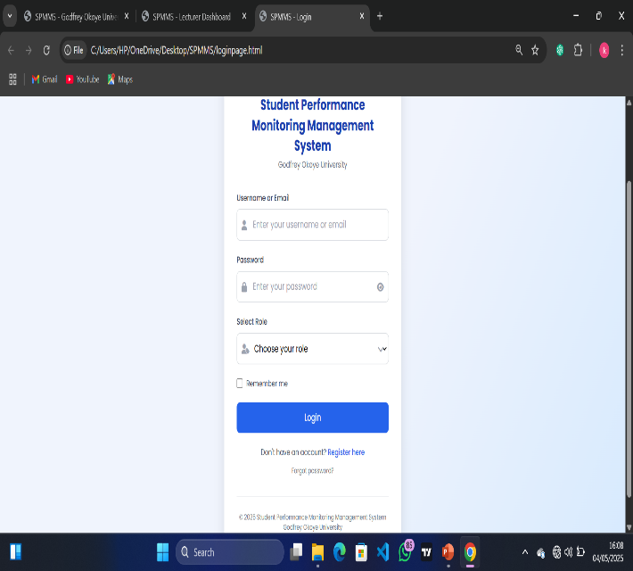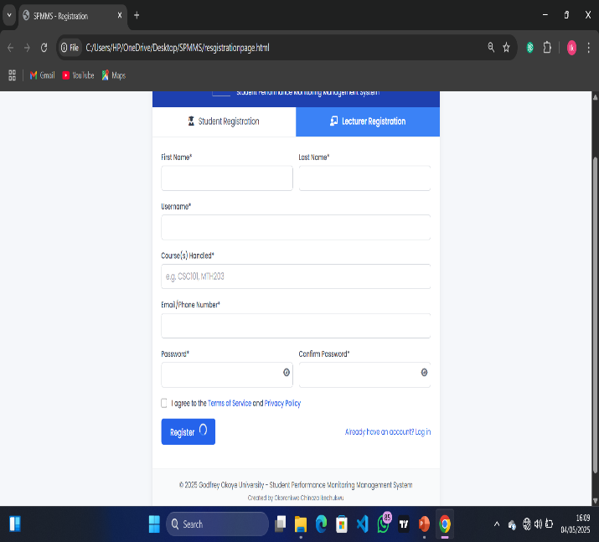
The diagram above shows the user infterface design for both the lgin and sign up page. In this system, input design ensures that data are inputted are entered correctly and efficiently.

3.10.1.1 OBJECTIVES OF INPUT DESIGN:
  - To Ensure Data Accuracy And Completeness
  - To Minize User Errors Through Validation And Structed Forms
  - To Make The Input Process Intuitive And User Friendly

3.10.2 OUTPUT DESIGN OF THE PROPOSED SYSTEM
The image above shows the interface of the proposed system for both the lecturer and student.
3.10.2.1 OBJECTIVES OF OUTPUT DESIGN:
- To provide users with timely and accurate information
- To ensure outputs are clear, actionable and easy to interpret
- To support academic decisions and performance monitoring

3.10.3 Use Case Diagram
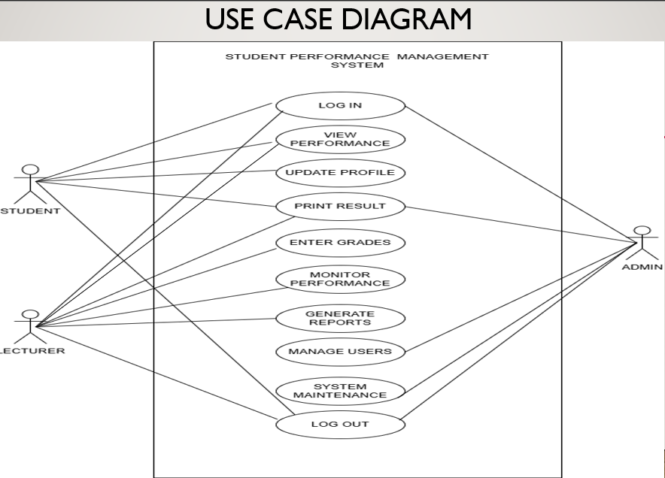
Actors:
- Student
- Lecturer
- Admin
Use Cases:
- Student: log in, View performance, update profile, print result, log out
- Lecturer: Log in, View performance, print result, Upload grades, monitor performance, generate reports, log out
- Admin: Log in, Print result, Manage users, system maintenance, log out
3.10.4 Entity Relationship Diagram (ERD)
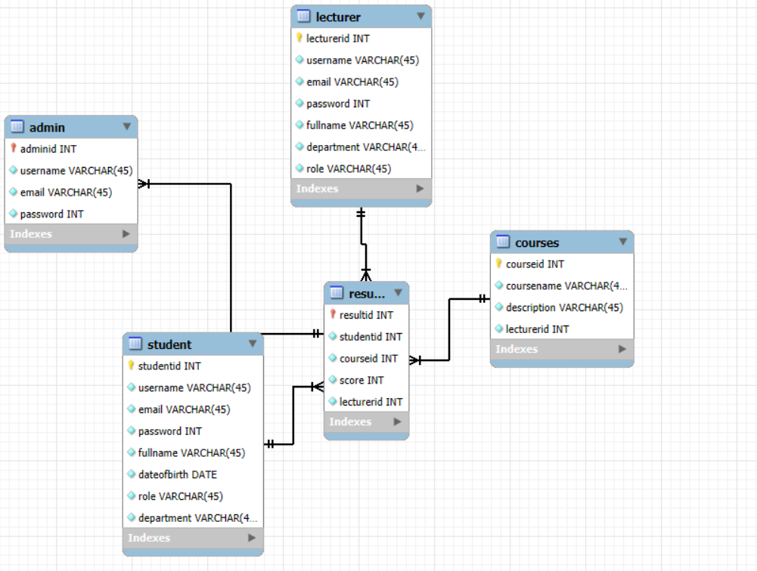
Entities:
- Users (admin, lecturer, student)
- Courses
- Results

3.10.5 Flowchart of the proposed system
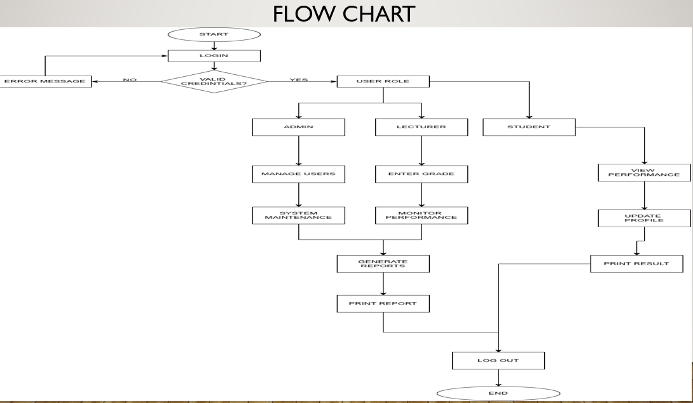

3.7 Database Design (Schema)
TABLE: users
- user_id (PK)
- username
- password
- Email
- full name
- date of birth
- department
- role (student, lecturer, admin)

TABLE: courses
- course_id (PK)
- course_name
- lecturer_id (FK)
- description
- schedule
- subject_id

TABLE: results
- result_id (PK)
- student_id (FK)
- course_id (FK)
- score
- grade

3.11 IMPLEMENTATION
The system was implemented using:
- PHP for backend processing
- HTML/CSS/Bootstrap for user interface
- MySQL for the database
All modules were tested individually before integration.
3.12 TESTING
Testing was carried out through both unit testing and system testing to verify functionality and performance. Additionally, users were invited to test the system and provide feedback for enhancements.
3.13 SUMMARY
In this chapter, we walked through the methodology behind developing the already proposed system, starting with the choice of the Waterfall model, moving on to system design and implementation. We laid out diagrams and technical specifications that served as a solid foundation for both development and testing.

CHAPTER FOUR
SYSTEM IMPLEMENTATION AND TESTING
4.1 INTRODUCTION
This chapter dives into the implementation of the Student Performance Monitoring Management System. It highlights the key modules, the system interface, and the results from testing. The goal here is to show how the system fulfills the specified requirements and to illustrate its features with screenshots and detailed descriptions.
4.2 SYSTEM MODULES AND DESCRIPTION
The system is organized into various modules tailored to user roles and their specific functionalities:
4.2.1 ADMIN MODULE
• Manage users, including both students and lecturers
• Add, edit, or delete courses
• Generate performance reports
4.2.2 LECTURER MODULE
• Upload grades for students
• Monitor student performance
• Create summaries of course performance

4.2.3 STUDENT MODULE
• Check grades and overall performance
• Keep track of academic progress
• Print out performance reports

4.3 User Interface Screenshots and Description
4.3.1 LOGIN PAGE
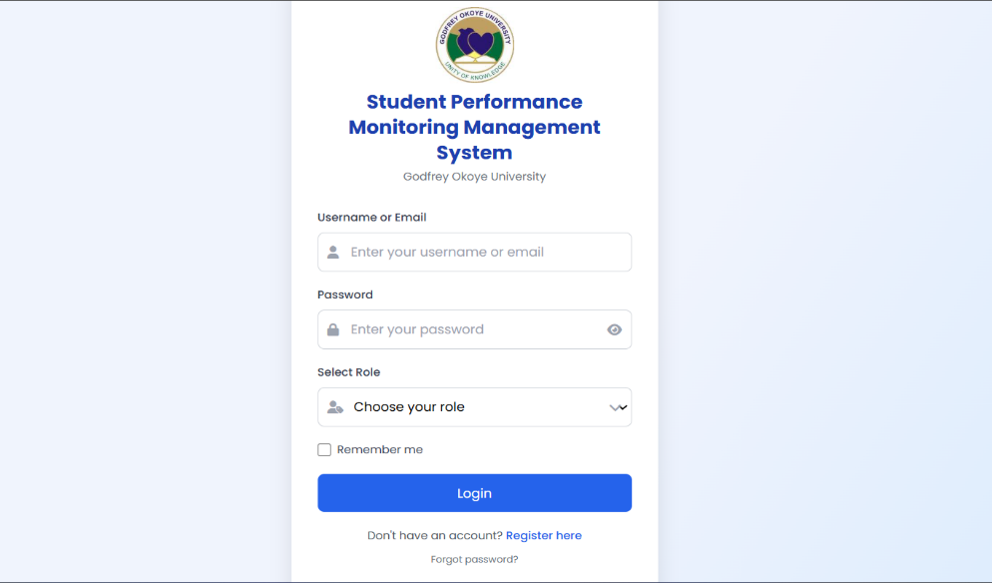
A secure login page where users input their credentials to gain access to the system. Features:
• Fields for username and password
• Selection of role

4.3.2 ADMIN DASHBOARD
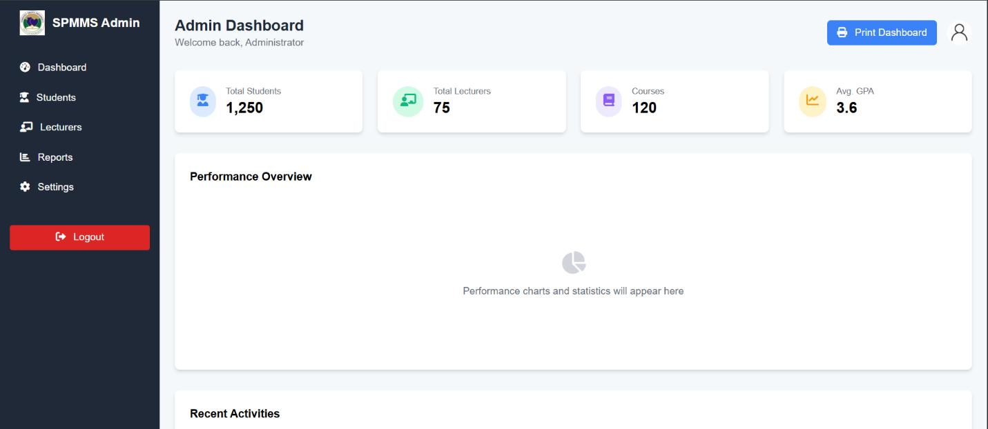
This dashboard showcases statistics like the total number of students, lecturers, and courses, along with navigation links for data management.
4.3.3 LECTURER INTERFACE
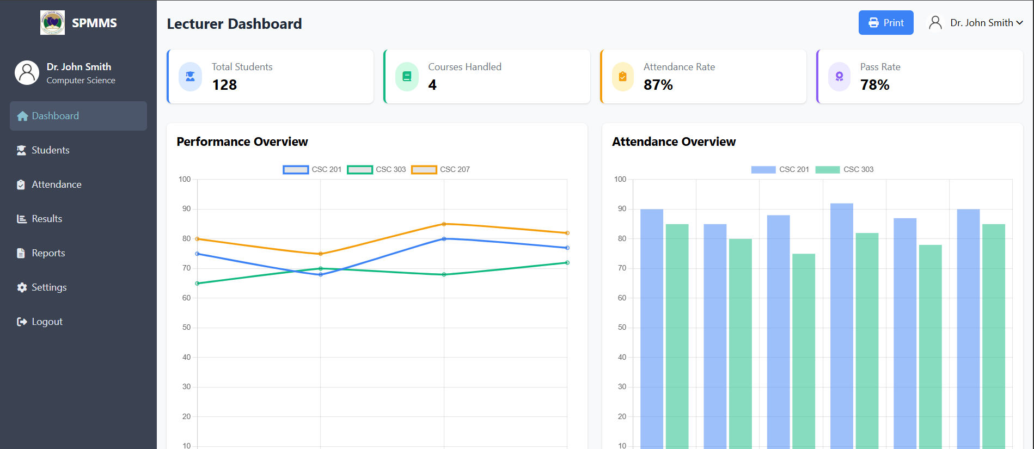This interface enables lecturers to upload student grades and view performance metrics for their assigned courses.

4.3.4 STUDENT DASHBOARD
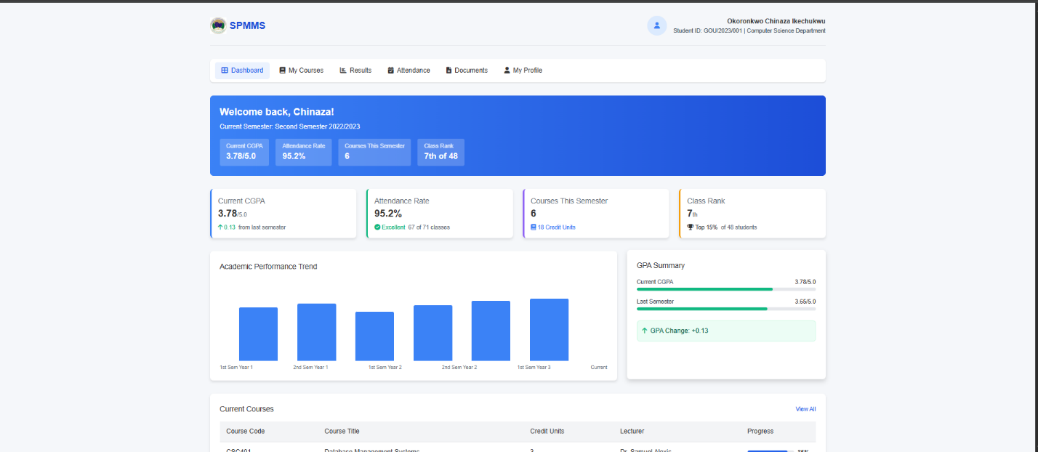
Here, students can see their personalized data, including course lists, grades, and performance graphs.
4.3.5 GRADE UPLOAD INTERFACE
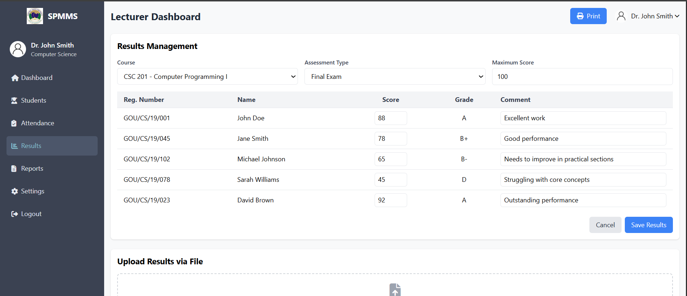
Lecturers can choose a course, enter student scores, and assign grades accordingly.
4.4 IMPLEMENTATION ENVIRONMENT
• Language: PHP
• Frontend: HTML, CSS, Bootstrap
• Database: MySQL
• Server: Apache via XAMPP
• IDE: Visual Studio Code
• Testing Browser: Google Chrome
4.5 SYSTEM TESTING
4.5.1 TESTING APPROACH
• Unit Testing: Each module (like login and grade entry) was tested on its own.
• Integration Testing: Verified that all modules work seamlessly together.
• User Acceptance Testing (UAT): Conducted by students and lecturers to ensure the system is user-friendly.
4.5.2 TEST CASES
Test Case ID | Description | Expected Result | Actual Result | Status
TC001 | Login with valid credentials | User logs in | Success | Pass
TC002 | Upload grades for a course | Grades saved in DB | Success | Pass
TC003 | View student report | Report loads correctly | Success | Pass
TC004 | Invalid login | Show Error Message | Error Shown | Pass
4.5.3 BUGS AND FIXES
There were certain small problems in testing, for example, validation errors and layout misalignments, but we worked out all those issues and had it sorted.
4.6 CHALLENGES ENCOUNTERED
• Struggled at first with role-based access control
• Experienced data validation problems while uploading scores
• Had certain cross-browser inconsistencies that we resolved by employing Bootstrap and keeping the HTML validated correctly
4.7 Summary
In this chapter, we've walked the Student Performance Monitoring Management System through the deployment. We've outlined the most critical modules, along with screenshots and descriptions. It was tested to validate its functionality, and the outcome indicated that it meets all the specifications needed.

CHAPTER FIVE
SUMMARY, CONCLUSION AND RECOMMENDATIONS
5.1 SUMMARY
This project required the creation of a Student Performance Monitoring Management System which would make it easy to track, analyze, and report students' academic performance within an institution.
We took a formal software development process by using the Waterfall Model with phases like requirements gathering, system design, implementation, testing, and result evaluation.
Some of the key features of the system are:
- A login page that is secure for multiple users (Admin, Lecturer, Student)
- A lecturers' page where scores can be entered and performance reports per course created
- A dashboard for students to track progress while studying
- An admin panel for management of users, courses, and printing institution reports
We built the system with PHP, MySQL, HTML, CSS, and Bootstrap, and we carried out strenuous testing to verify that all the functional and non-functional requirements were satisfied adequately.
5.2 Conclusion
The Student Performance Monitoring Management System has fulfilled its purpose of computerizing academic performance management. It addresses the prevalent problems with manual marking of scores, such as loss of data, calculation mistakes, and restricted accessibility.
Some of the most important achievements of the project are:
- Improved access to performance data for students
- Role-based, secure user interactions
- Current, accurate monitoring of performance
- Automatic reports to enable more informed decision-making
Overall, this system improves efficiency, reduces lecturers' workload, and supports greater transparency and accountability in marking.

5.3 RECOMMENDATIONS
Although the system is running very well, we do have some ideas on future upgrades that can be done:
1. Integration with School Portal: Connect the system to the existing university or college portal for easy user authentication and data sharing.
2. Auto-Notification System via SMS/Email: Implement automatic notifications to inform students when new grades are posted or if their performance is below a given level.
3. Mobile Application Version: Develop an Android or iOS app to improve accessibility, with students and teachers being able to access the system while on the move.
4. Visualization of Data: Implement more advanced graphs and analytics to present trends in the performance of students.
5. Transcript Generation: Develop a module that will be able to generate official transcripts for graduating students.
6. Cloud Hosting: Host the system on a cloud server to access it anywhere, anytime.

5.4 CONTRIBUTION TO KNOWLEDGE
The project contributes to the enrichment of the academic community by providing a model that automatically manages student performance using new web technologies. The project is also an educational guide for prospective researchers and developers who would like to develop similar systems.

5.5 FUTURE WORK
Future releases of this system may include:
- Integration with biometric attendance systems
- Use of AI for performance prediction and academic advice
- Real-time collaboration features between students and lecturers

5.6 FINAL THOUGHTS
From this project, I have come to truly appreciate how principles of software engineering operate in practice. I have learned far more about system analysis, design, programming, and the way that individuals utilize technology.

If this system works effectively and is scaled, it can have the power to significantly improve academic administration and student life as a whole.

References

Ajayi, A. (2020). *The Role of ICT in Monitoring Academic Performance*. Nigerian Journal of ICT, 12(3), 45–52.

Oyelami, M. & Adeyemo, A. (2019). *Design and Implementation of Student Academic Record System*. International Journal of Computer Applications

Laudon, K. C., & Laudon, J. P. (2018). *Management Information Systems: Managing the Digital Firm* (15th ed.). Pearson Education.

Pressman, R. S. (2014). *Software Engineering: A Practitioner’s Approach* (8th ed.). McGraw-Hill.

Amin, M., & Wahid, K.(2019) *A Comprehensive System for Monitoring Student Academic Performance*

Kumar, S., & Singh, P. (2021) *Development of a Student Performance Management System Using ML*

Ngugi, M., & Mwangi, J. (2020) *A Web-Based Tool for Student Performance Analysis*

Li, H., & Zhao, W.(2022) *Predictive Analytics in Academic Performance Monitoring Systems*

Smith, R., & Brown, T(2018) *Improving Student Success Using Performance Dashboards*

Alotaibi, F., & Alshehri, A(2020) *Cloud-Based Solutions for Tracking Student Performance*

Gupta, R., & Sharma, A. (2021) *AI-Powered Academic Monitoring System for Students in Higher Education*

Yilmaz, G., & Aydin, O. (2017) *Design and Implementation of a Student Performance Tracking System*

Mohammed, S., & Ali, K. (2023) *Big Data Analytics for Student Performance Prediction and Monitoring*

Johnson, L., & Patel, D (2022) *Real-Time Student Performance Monitoring Using IoT Devices*

