DAYLIGHTING IN PRINTING PRESS BUILDINGS.

IKECHUKWU JOHNATHAN
U18/NAS/ARC/079

ARCHITECTURE
FACULTY OF NATURAL SCIENCES AND ENVIRONMENT STUDIES
GODFREY OKOYE UNIVERSITY, ENUGU
NIGERIA

A PROJECT RESEARCH SUBMITTED TO THE DEPARTMENT OF
ARCHITECTURE IN PARTIAL FULFILMENT OF THE REQUIREMENT FOR
THE AWARD OF BACHELOR OF SCIENCE (B.Sc.) DEGREE IN ARCHITECTURE

SUPERVISOR: ARC. AGU AUGUSTINE

JULY, 2024.

APPROVAL
This research titled DAYLIGHTING IN PRINTING PRESS BUILDINGS has been assessed and approved by the Committees of the Department of Architecture and Faculty of Natural Sciences and Environment Studies, Godfrey Okoye University, Enugu, Nigeria.

Arc. Agu Augustine ……………………… ……………........
Supervisor Signature Date

Arc. ……………………… ……………........
External Examiner Signature Date

Arc. Chukwu Chinecheta ……………………… ……………........
HOD, Department of Architecture Signature Date

Prof. Chidi C. Uhuegbu ……………………… ……………........
Dean, FNSES Signature Date

CERTIFICATION
This is to certify that this research titled “DAYLIGHTING IN PRINTING PRESS BUILDINGS”was carried out by IKECHUKWU JOHNATHAN with Registration Number U18/NAS/ARC/079 under supervision in the Department of Architecture, Godfrey Okoye University, Enugu, Nigeria.

Arc. Agu Augustine ……………………… ……………........
Supervisor Signature Date

Prof. Chidi C. Uhuegbu ……………………… ……………........
Dean, FNSES Signature Date

DEDICATION
This research study is dedicated to my irreplaceable family for their abundant love, care and support thus far.

ACKNOWLEDGEMENT
My humble gratitude to my supervisor for guidance, encouragement and support through the course of my research. Thank you to my HOD (Head of Department, Architecture) and all my lecturers for their input and assistance in the deployment of this work. Thank you to all my departmental level mates that provided me their assistance and support while working on this research report.
My boundless appreciation to my parents, siblings and relatives for their support, love, provision of resources that I used throughout the process of this research. Most importantly a mighty thank you to God Almighty for his love, blessings, guidance, protection, grace and mercy on my life.

TABLE OF CONTENT
Title Page i
Approval Page ii
Certification Page iii
Dedication iv
Acknowledgement v
Table of Content vi
List of Figures vii
Abstract xi

CHAPTER ONE: INTRODUCTION
1.1 Background to the Study 1
1.2 Statement of Problem 1
1.3 Aim of the Study 2
1.4 Objectives of the Study 2
1.5 Research Questions 3
1.6 Significance of the study 4
1.7 Scope and Delimitation 5
1.8 Organization of the Report/Thesis 5
1.9 Definition of Special Terms 5

CHAPTER TWO: LITERATURE REVIEW AND CASE STUDIES
2.1 Conceptual Framework (if applicable) 7
2.2 Theoretical Framework 9
2.3 Review of related literature 10
2.4 Case studies 11
2.4 Summary of literature review and case studies 12

CHAPTER THREE: THE STUDY AREA 13
3.1 Geographical location and setting 13
3.2 Site selection criteria 14
3.3 Brief history of the study area 14
3.4 Physiography, climate and vegetation 16
3.5 Population, culture and economic development 17

CHAPTER FOUR: RESEARCH METHODOLOGY
4.1Research Design – review, survey, case studies, quasi-experimental, experimental research,etc. 19
4.2 Data needs and sources 19
4.3 Population of study and sampling procedure (if applicable) 19
4.4 Methods and instruments for data collection (“) 19
4.5 Methods of data analysis and analysis (“) 19

CHAPTER FIVE: DESIGN SYNTHESIS AND DEVELOPMENT
5.1 The design brief 24
5.2 Design requirements for activities/planning data (Standards, anthropometrics, etc.) 24
5.2 Schedule of accommodation 26
5.3 Special consideration 26
5.4 Site inventory and analysis 26
5.5 Data analysis and presentation 29
5.6 Design concept and design proposal 29
5.7 Presentation Drawings with 3D 30
5.8 Detailed Drawings and Physical Model (as appropriate)

CHAPTER SIX
6.0 Conclusion and Recommendations
6.1 Summary of findings or main issues
6.2 Conclusion
6.3 Recommendations
6.4 Contribution to knowledge

REFERENCES
APPENDICES

LIST OF FIGURES
Figure 5.1 Conceptual design proposal 31
Figure 5.2 Presentation Drawings with 3D 32
Figure 5.3 Detailed Drawings and Physical Model (as appropriate) 34

ABSTRACT
Daylighting is the practice of using natural sunlight to illumine interior spaces. It’s a sustainable and energy efficient approach to lighting that offers numerous benefits including environmental advantages, health and well being benefits, architectural considerations. Talking about daylighting in a printing press it implies that the introduction of natural daylighting will drastically reduce the cost effect of artificial lighting. the design of a printing press is obviously a linear movement, now, the access to the part ways should not be dark as it deals with sophisticated machines which if not properly placed in its position will cause accident to the workers. Incorporating daylighting in this design, I will like to highlight on how to go about it. However, window height, adequate lobby, linear movement and placement of machines is required. Hence trying to achieve daylighting in a printing press the aforementioned consideration is taken into consideration

CHAPTER ONE
INTRODUCTION
1.1 Background to the Study
In architectural design the term “Daylighting” is the art of introducing enough natural light to buildings (Partiquin Architects, 2021). Daylighting, the idea of illuminating building interiors with natural light, has been a fundamental aspect of architectural design for centuries. Its significance extends beyond mere illumination; it deals with a range of benefits from energy efficiency to psychological well-being. In the context of printing press buildings, where precision and color accuracy are the prerequisite, the role of daylighting becomes even more essential
Going on a memory lane, daylight has been the primary source of lighting for all types of buildings, influencing design and construction to maximize light distribution. The hope of artificial lighting changed this focus, but recent trends in sustainable design have renewed interest in the strategic use of daylight (Nyole, 2013). This resurgence is driven by the acknowledgement of daylight’s impact on human health, productivity, and the surrounding.
In printing press buildings, the challenge is to incorporate daylight to enhance visual clarity and color fidelity while reducing glare and thermal gain. The difficult tasks involved in printing demand consistent and high-quality lighting conditions.
1.2 Statement of Problem
Daylight in architecture has long recognized as a vital element in design, the application of daylighting method in printing press buildings presents a uniform set of challenges and opportunities. The accuracy required in the printing process requires consistent, high-quality lighting conditions to ensure color accuracy and reduce mistakes. Still, the integration of natural light into these facilities is often compromised by factors such as glare, heat gain, and the need for privacy and security. Hence, providing adequate daylighting in printing press facilities with these factors in consideration is a challenge that needs to be solved.
1.3 Aim and Objectives of the Study
1.3.1 Aim of the Study
The primary aim of this research is to investigate and enhance the application of daylighting within printing press buildings, the goal is to create a framework that can guide architects and designers in integrating daylighting solutions that enhance both the functionality and the environmental sustainability of printing press facilities.
1.3.2 Objectives of the study
The above aim can be achieved by:
- Evaluating current practices (Research and Case studies) to assess the existing state of daylighting in printing press buildings and identify areas for improvement.
- Addressing unique challenges to explore the specific challenges faced in implementing effective daylighting in printing environments.
- Examining innovative daylighting technologies and strategies suitable for printing press buildings.
- Developing a design framework to propose a design for integrating daylighting solutions that optimize visual comfort, energy efficiency, and operational productivity.
1.4 Research Question
- “How does daylighting impact color accuracy in printing press environments?”
- “What innovative daylighting technologies and strategies can enhance productivity in printing press buildings?”
- “What role does building orientation play in effective daylighting for printing press operations and how can privacy and security requirements be balanced with daylighting design in printing press facilities?”
- “How can daylight-responsive lighting controls be integrated seamlessly into printing press buildings?”
1.5 Significance of the Study
The significance of this research lies in its potential to transform architectural practice and enhance the functionality of these specialized facilities through:
- Energy Efficiency and Sustainability:
Effective daylighting reduces reliance on artificial lighting, leading to energy savings and lower operational costs. Sustainable design aligns with global environmental goals, making printing press buildings more responsible and resource-efficient.
- Health and Well-Being:
Daylight positively impacts occupant health, mood, and productivity. By prioritizing natural light, you create a healthier work environment for printing press staff.
- Quality of Workspaces:
Well-designed daylighting enhances the overall quality of interior spaces, promoting visual comfort and visual clarity. Printing press employees benefit from well-lit areas that support their tasks.
- Architectural Aesthetics and Identity:
Daylighting contributes to the character and identity of a building. Thoughtful integration of natural light can elevate the architectural expression of printing press facilities.

- Innovation and Adaptation:
Investigating innovative daylighting strategies allows architects to stay at the forefront of design trends. Adapting these strategies to printing press buildings demonstrates forward-thinking and responsiveness to industry challenges.
In summary, this study has the potential to revolutionize how printing press buildings are designed, impacting energy consumption, occupant well-being, and architectural aesthetics.
1.7 Scope and Delimitation
1.7.1 Scope of the Study
This study focuses on the application of daylighting strategies within printing press buildings. The scope encompasses the following areas:
- Design Analysis: Examination of architectural design features that contribute to effective daylighting, including window placement, glazing materials, and interior finishes.
- Technological Integration: Evaluation of advanced daylighting technologies such as dynamic glazing, light shelves, and automated shading systems.
- Energy Efficiency: Assessment of the impact of daylighting on energy consumption and the potential for reducing reliance on artificial lighting.
- Occupant Well-being: Investigation into how daylighting influences the health, productivity, and satisfaction of printing press workers.
- Case Studies: Review of existing printing press buildings that have successfully implemented daylighting solutions.
The study will be conducted through a combination of literature review, analysis of architectural plans, and interviews with industry professionals.

1.7.2 Delimitation of the Study
Despite the known benefits of daylighting, including energy savings, enhanced worker productivity, and improved psychological well-being, its implementation in industrial settings, particularly printing presses, has not been extensively explored.
The delimitations of this study are as follows:
- Geographic Focus
- Building Type
- Time Frame
- Scale of Analysis
A clear and manageable framework for the research, will be coined out from this aforementioned delimitations ensuring that the study remains focused and relevant to the field of architectural design for printing press buildings.
1.8 Organization of the Report
This research reportsis organized in such a way that it will help the young and potential architects that wants to know more about building a printing press, the factors to consider and as well not to go beyond scope.
1.9 Definition of Special Terms
1. Daylighting: The inform introduction of natural light into a building to control incessant usage of artificial lighting.
2. Glare Control: methods used to reduce the impact of direct sunlight that can cause visual discomfort for the occupants in building.
3. Fenestration: openings in a building’s envelope.
4. Skylights: A window installed in a roof to allow natural light to enter the space below.
5. Light Shelves: Horizontal overhangs placed above eye-level to allow the deeper reflection of daylight into a building.
6. Solar Shading Devices: it is an elements designed on architectural basis to control the amount of heat gain and light penetration.
7. Reflectance: affecting the distribution of light within a space is the measure of how much light is reflected by a surface,
8. Task Illuminance: The relative amount of light expected on a work surface to perform a specific tasks effectively.
9. Circadian Lighting: considers the impact of light on the human circadian rhythm.
10. Visual Comfort: deals with reducing eye strain and enhancing productivity.

CHAPTER TWO
LITERATURE REVIEW AND CASE STUDIES
In the context of printing press buildings, daylighting plays a crucial role in architectural design, impacting occupant satisfaction, energy gain, and aesthetically pleasing environment. effective daylighting strategies are crucial. The literature review in question aims to go more deeper in the existing research, theories, and case studies relating to daylighting in printing press facilities.
Daylighting Design and Implementation
Modern buildings have seen a resurgence in the use of daylighting to create sustainable living environments. Research has focused on predicting and measuring daylight levels and the range of technologies available for daylighting. Despite the development of various daylighting systems, their application has been limited by high initial costs and a lack of studies on their utilization².
Daylighting Systems and Strategies
A thematic review of daylighting systems over the past five years has identified current research on daylighting strategies in buildings. This includes the examination of new daylighting strategies, calculation methods, and the integration of daylighting with energy and thermal performance considerations³.
Visual Comfort and Glare Studies
The literature on daylighting has extensively covered visual comfort and glare studies. Different definitions and structures associated with daylight and glare have been examined, highlighting the need for designers to rely on simulation software to reimagine spaces and examine potential visual discomfort conditions.

Daylighting Quality in Institutional Libraries
Daylighting is expected to contribute to reducing electric consumption and cooling load while increasing the psychological and physiological comfort of occupants. The luminous efficacy of solar radiation used for evaluating energy savings is indicated, underscoring the technological and technique control of daylight.
This literature review provides a foundation for understanding the complexities and considerations of daylighting in printing press buildings. It highlights the balance required between maximizing natural light benefits while minimizing potential negative effects such as glare and thermal discomfort.
2.1 Conceptual Framework
daylighting in printing press buildings is the conceptual framework for this study and its rooted in the multidisciplinary nature of architectural design, which covers some aspects of engineering, aesthetics, and functionality. This framework is guided by the following key components:
The Vitruvian Triad
- Utilitas (Utility): This considers the functional aspects of daylighting, introducing natural light to harness and improve the operational efficiency of printing press buildings.
- Venustas (Beauty): this aspect examines the aesthetic implications of daylighting,
- Firmitas (Durability): it deals with the structural integrity of daylighting interventions
Contextual Adaptation
It takes into account the specific areas of printing press buildings, Architectural Thinking
  - Concept Formation
  - Spatial Form
  - Intellectual Form
  - Structural Form
Integration of Systems
Ensuring that the solutions are coherent with the overall design philosophy of the building. The architectural concept is driven in the design of daylighting systems.
Sustainability and Innovation
For adequate sustainability in this building Structural Form have to play a vital role which includes windows, skylights, and shading devices, on occupants and the symbolic meaning of light within the space.
2.2 Theoretical Framework
Theoretically this study is constructed upon the interplay between architectural design principles and environmental psychology, emphasizing the role of daylighting in printing press buildings.
Architectural Design Theories
- Form Follows Function: the shape of a building should be primarily based upon its intended function or purpose as a principle guiding the design.
- Biophilic Design: incorporating natural elements into the built environment cannot be over emphasized as it improves human adaptability and comfort.
Environmental Psychology
- response to stimulus: This explains how environmental stimuli, such as light and space, reacts to responses from human beings.
- Attention Restoration Theory (ART): ART has it that natural environments can make to improved concentration from mental disturbances.

Human-Centric Lighting
  - Circadian Lighting Design: a concept on lighting that focuses supports on human circadian rhythms.
The framework above gives an insight with a structured approach to understanding the multifaceted impact of daylighting in printing press buildings. It combines architectural design principles with environmental psychology to com e to the understanding on how natural light can be harnessed effectively within these spaces.
2.3 Review of Related Literature
1. Daylighting Principles and Benefits:
- Author: Boubekri, M.
- Summarizes work as the importance of daylighting in architectural design. Its discussion how natural light positively impacts occupant well-being, productivity, and energy savings.
2. Building Orientation and Fenestration Design:
- Author: Ratti, C.
- gave a summary of research exploring the impact of building orientation on daylight availability. The study discusses fenestration design, emphasizing on the use of high-performance glazing and shading devices.
3. Energy-Efficient Building Design:
- Author: Santamouris, M.
- Summarizes work focuses on energy-efficient building design, including daylighting as passive design strategies, such as well-placed windows, light shelves, and reflective surfaces.
4. Case Studies in Printing Press Buildings:
- Author: **Various
- Summarizes that daylighting provides insight into successful building practices.
5. Human-Centric Design and Circadian Rhythms:
- Author: Veitch, J. A.
- Veitch’s research delves into the impact of daylight on human health. It discusses circadian rhythms, melatonin production, and alertness which enhances occupants well-being and productivity.
6. Simulation Tools and Daylight Analysis:
- Author: Reinhart, C. F.
- Reinhart’s work introduces simulation tools e.g., Radiance for daylight analysis. He lays emphasison evidence-based design decisions using computational models.
2.4 Case studies
Daylighting and User Behavior:
Effects of Daylight in a University Library
Findings: This study examined the psychological impact of daylight on users in a library setting. It found that daylight glare, intensity, and window location can significantly influence users’ moods and behaviors. While some effects were positive, others were negative, indicating the need for careful daylighting design.
Daylighting Design in Institutional Buildings
Findings: in institutional buildings daylighting affects the performance of tasks. It revealed that while average illumination levels might meet standards, individual positions within a space could experience too much or too little light. guidelines on the improvement of indoor light quality.
Technological Solutions for Daylighting:
Daylighting Strategies in Classrooms
Findings: it underscored several technological solutions that can increase daylight levels in classrooms without introducing glare issues. Appropriate design strategies are crucial for implementing these solutions effectively.
Daylighting Analysis in Design:
Findings: The literature and case studies reviewed provide valuable insights into the effects of daylight on user behavior, the importance of balanced daylight distribution, and the use of technology in optimizing daylighting design. These findings can inform the design of daylighting systems in printing press buildings, ensuring that they provide adequate illumination while enhancing user comfort and energy efficiency.
2.4 Summary of literature review and case studies
1. Daylighting Principles and Benefits:
Includes occupant well-being, productivity, and energy savings.
2. Building Orientation and Fenestration Design:
Includes Fenestration design, high-performance glazing and shading devices
3. Energy-Efficient Design Strategies:
By reducing reliance on artificial lighting,
4. Human-Centric Design and Circadian Rhythms:
Designing spaces that align with natural light patterns positively influences occupants’ well-being and alertness.
The aforementioned literature underscores the significance of daylighting in architectural practice. By applying insights from these studies, the printing press building design can achieve an equilibrium between natural light, energy efficiency, and occupant comfort.

CHAPTER THREE
THE STUDY AREA
3.1 Geographical Location and Setting
Site Description:
The chosen site is a portion of land within the Godfrey Okoye University main campus located in Ugwuomu-Nike, Emene, Enugu State, Nigeria. The campus itself is situated in a serene and picturesque area, surrounded by lush greenery and rolling hills. The site is easily accessible from the main entrance of the university.
Climate and Sun Path:
Enugu State experiences a tropical savanna climate characterized by distinct wet and dry seasons. The climate significantly influences daylighting design.
Topography and Natural Features:
Ugwuomu-Nike is found in Enugu north area which features gentle slopes and undulating terrain. The site itself have slight elevation changes, which architects use for strategic building placement. Existing vegetation, such as trees or shrubs, provide shade and act as natural filters for incoming light.
Cultural and Environmental Context:
Enugu State is rich in cultural heritage, and the Godfrey Okoye university campus reflects this blend of tradition and modernity. The design of a printing press building, incorporates elements that resonate with the local culture, adhering to the environmental regulations and sustainability goals of the region. For example, energy efficiency, minimizes the building’s ecological footprint.
Geographical location and setting that influences design considerations as follows:
- Orientation
- Fenestration Design
- Solar Shading
- Interior Layout
The geographical context of Ugwuomu-Nike, provides a unique canvas on thedaylighting while focusing on the intending design project. By integrating the site’s features, climate, and cultural context, this design will create a printing press building that harmonizes with its surroundings while optimizing natural light for productivity and energy efficiency.
3.2 Site selection criteria
The site selection criteria include:
- Solar Exposure and Orientation
- Climate and Weather Conditions
- Topography and Terrain
- Accessibility and Proximity
- Cultural Context and Aesthetics
- Utilities and Infrastructure
- Safety and Security
- Environmental Impact and Sustainability
- Zoning and Legal Considerations
- Future Expansion and Flexibility
3.3 Brief history of the study area
Historical Overview
Enugu state derives its name from its capital and largest city,
Pre-Colonial Period: Enugu State was once part of the medieval Kingdom of Nri and the Aro Confederacy based in Arochukwu. The Aro Confederacy was defeated by British troops in the early 1900s during the Anglo-Aro War.
Colonial Era: After the war, the British incorporated the area into the Southern Nigeria Protectorate, which later merged into British Nigeria in 1914.
Anti-Colonial Resistance: Enugu gained significance as a symbol of anti-colonial resistance after the 1949 massacre of striking coal miners in the Iva Valley.
Post-Independence: After Nigeria gained independence in 1960, the area that is now Enugu State was part of the post-independence Eastern Region. In May 1967, the region split, and the area became part of the East Central State.
Enugu Coal Mines: Enugu was historically known for its coal mines, which played a crucial role in Nigeria’s early industrial development.
Nike Community
Location and Borders:
- The Nike Community is situated in Enugu East, Enugu State, Nigeria. It shares borders with Nsukka, Ebonyi, and Enugu North.
- The community encompasses several villages and features both tourist sites and commercial areas.
Origin and Legend:
- Legend has it that Nike was biologically related to Egede and Affa. They were believed to have come from the same mother, Ugwunye.
- Ugwunye, a beautiful woman, was initially married to the god Awuwa. She gave birth to Anike at Nike and later married Ukwu, giving birth to Egede. She then married Eze Achala Ukwu, leading to the birth of Ikolo (named Affa).
- Anike Nwa Awuwa, the child of Awuwa and Ugwunye, married Aho-Ojoma, a deity in Nokpa. They had 11 children, with Ibagwa being the eldest.
- The Ogui Nike area is another part of the Nike Community, allegedly settled by refugees from one of the Udi plateau villages.
- Notable Figures:
- Senator Gilbert Emeka Nnaji represents Enugu East and the Nike community in the Nigerian Senate.
3.4 Physiography, climate and vegetation
Physiography:
1. Udi-Nsukka Plateau:
- The study area lies within the Udi-Nsukka Plateau, a prominent geological feature. This plateau is characterized by undulating terrain, gentle slopes, and elevated landforms.
- The plateau provides a scenic backdrop and influences the overall landscape of the region.
2. Ekulu River:
- The Ekulu River flows through the city of Enugu, which is part of the study area. Rivers like Ekulu contribute to the drainage network and play a role in shaping the landforms.
Climate:
- Enugu State experiences a Tropical Wet and Dry (Savanna) Climate:
- Temperature: The yearly average temperature in Enugu is approximately 28.27°C (82.89°F), which is slightly lower than Nigeria’s overall averages.
- Precipitation: Enugu typically receives about 158.57 millimeters (6.24 inches) of precipitation annually.
- Rainy Days: There are approximately 192.73 rainy days each year, accounting for 52.8%of the time.
Vegetation:
The vegetation in the study area reflects the transition between different ecological zones:
1. Guinean Forest–Savanna Mosaic: This zone covers most of Enugu State. It consists of a mix of forested areas and savanna grasslands. Forest Pockets: Some parts retain remnants of Guinean forest, characterized by tall trees, dense foliage, and diverse plant species. Savanna Areas: Open grasslands with scattered trees dominate other regions.
2. Niger Delta Swamp Forests: In the far south of Enugu State, near the Niger Delta, swamp forests thrive. These swampy areas are characterized by waterlogged soils, mangroves, and specialized vegetation adapted to wet conditions.
3. Biodiversity: Plant species, including hardwood trees, shrubs, and grasses.
The physiography, climate, and vegetation of the study area enhances the environment, influencing architectural design, and impacting the well-being of its inhabitants.
3.5 Population, culture and economic development
Population:
It is a vibrant community located in Enugu East Local Government Area of Enugu State, Nigeria.
Factors such as urbanization, migration, regulates their natural population increase.
The community life is diverse inn ethnic groups, thereby reflecting Nigeria’s rich cultural tapestry.
Culture:
- Ofala Festival
- Chieftaincy Titles
- National Integration
Economic Development:
- Petroleum Sector
- Tax Implications
- Financial Market Efficiency
In summary, Ugwuomu-Nike’s population growth, cultural celebrations, and economic endeavors contribute to its dynamic development. By fostering unity, embracing cultural heritage, and optimizing financial systems, the community continues to thrive.

CHAPTER FOUR
RESEARCH METHODOLOGY
4.1 Research Design
This research employs a case study approach to examine a specific printing press buildings. By analyzing the facility, itself and its surrounding environment, including any architectural shortcomings, the study aims to develop an improved printing press building plan for the area.
4.2 Data needs and Sources
I conducted a site visit to Ugwuomu Nike, Godfrey Okoye University's permanent location. Interviews with students, staff, and university workers and gather basic information’s. This data will be crucial in identifying shortcomings of the printing press buildings facilities used at the temporary campus. The insights gained will help me to design a more suitable printing press buildings facility for the permanent site.
4.3 Population of the Study
The target population for this study consisted of 1000 individuals, including students and university staff.
4.4 Method and Instrument for Data Collection
Data collection for this study involved semi-structured questionnaires administered by interviewers. The questionnaires, designed to assess awareness, challenges, and utilization of essential printing press among the Ugwuomu Nike community, were divided into four sections:
Socioeconomic factors (Section A)
Utilization of printing press services (Section B)
Challenges faced in accessing printing press (Section C)

Result and Analysis
A high response rate of 90% was achieved, with 180 out of 200 questionnaires successfully retrieved from the participants.
Table 1: Sociodemographic Characteristics of Respondents
Age: The largest age group (20.9%) falls between 25 and 39 years old.
Education: Over half (47.2%) of the respondents have a secondary education.
Gender: The majority of respondents are female (53.3%), with males accounting for 36.7%.
Ethnicity: Yoruba is the most prevalent ethnicity (57.5%) among the respondents.
Occupation: Self-employment is the primary occupation for 38.3% of the respondents.
Table 2: Awareness of printing press
A high number of respondents (164, representing 91.1%) reported awareness of printing press in their communities.
Table 3: Sources of Information about printing press(n=164)
Data presented in this table are categorized by the primary source from which respondents acquired information on printing press within their communities. The "Others" category encompasses information gleaned from sources such as seminars, educational institutions, and religious organizations.
Table 4: Familiarity with Services Offered at printing press (n=180)
Table 5: Utilization of printing press (n=180)
This table shows the utilization rate of printing press among respondents. The majority (136, representing 75.6%) reported using the printing press, while 44 (24.4%) have never availed themselves of these services.

Table 6: Services Utilized at printing press in the Past Six Months (n=136)
This table highlights the range of services accessed by respondents at printing press within the last six months. Vaccinations were the most commonly used service (33.1%). Preventive services like promotion of healthy eating and referrals to other facilities were utilized the least (1.11% each).
Non-Utilization of printing press Services (n=44)
Among respondents who do not utilize printing press (n=44), the primary reason cited by 27.7% (12 respondents) was a preference for attending private medical clinics.
When Ill, Respondents typically have the knowledge of:
Governmental printing press (55%)
Private printing press (28.9%)
Table 9: Referral Rates from printing press (n=136)
This table shows the referral rate from private printing press to commercial printing press among respondents who utilize printing press services (n=136). Only 11.8% of respondents reported ever being referred to a commercial printing press by a private printing press
Figure 2: Satisfaction with Services at printing press
Among the respondents who utilize PHC centers (n=136), slightly more than half (71 or 52.21%) expressed satisfaction with the services received.
Table 14: Gender and Utilization of printing press (n=136)
An examination of gender distribution among users of printing press (n=136) reveals that males make up the majority (98 or 72.1%), with females accounting for 27.9% (38 respondents).
Education Level and printing press Center Utilization
Secondary Education (n=103): 73.7% (76 respondents) reported using printing press centers.
Other Non-Formal Education (n=17): 64.7% (11 respondents) reported using printing press centers.
Table 16: Statistical Test - Education Level and printing press Center Use
This table examines the relationship between respondents' education level and their use of printing press centers. A chi-square test was conducted, yielding the following results:
Chi-Square (X²) = 1.9736
Degrees of freedom (df) = 1
p-value (p) = 0.1600
Since the p-value (0.1600) is greater than the significance level of 0.01, we fail to reject the null hypothesis. In other words, there is no statistically significant association between the level of education and the use of printing press centers. This suggests that education level does not influence a respondent's likelihood of utilizing printing press centers.
Table 17: printing press Center Utilization by Distance
This table explores how distance from a printing press center affects utilization. Among respondents living a further distance from their printing press center (n=37), over half (21 or 56.7%) still reported using printing press services.
Table 18: Statistical Test - Distance and printing press Center Use
A chi-square test was conducted to examine the relationship between distance from home and printing press center utilization (n=180). The results are as follows:
Chi-Square (X²) = 2.0000
Degrees of freedom (df) = 1
p-value (p) = 0.0000014587
While the chi-square statistic itself isn't directly interpretable, the p-value (0.0000014587) is much lower than the significance level of 0.01. This suggests a statistically significant relationship between distance and printing press center use. However, due to the low number of respondents living further away, further analysis may be needed to confirm the direction of this relationship (i.e., does closer proximity lead to higher utilization?).
Table 19: Occupation and printing press Center Utilization
"These findings reveal that the printing press centers serve a diverse population, including those who may be unemployed."
The questionnaires were translated into Igbo, the local language, to ensure clear understanding by participants. Trained research assistants conducted the interviews in Igbo. To account for potential non-responses and lost questionnaires, a total of 200 questionnaires were distributed. Of these, 180 questionnaires were successfully retrieved.

CHAPTER FIVE
DESIGN SYNTHESIS AND DEVELOPMENT
5.1 Design Synthesis and development
This phase I integrated research findings, theoretical insights, and practical considerations to create a cohesive architectural design and equally outlined the process of synthesizing data and developing design solutions for optimal daylighting in printing press buildings.
5.2 The design brief
This is an outstanding project that aims to explore and implement effective daylighting strategies in printing press buildings by enhancing natural light utilization, improve occupant well-being, and reduce energy consumption. The main focus is emphasized on integrating architectural design principles with innovative daylighting solutions to create sustainable and efficient work environments.
Spatial Requirements
1. Printing Area:
Purpose: The Central space for printing operations.
Features: Offset printing presses, digital printers and screen-printing equipment.
2. Pre-Press Area:
Purpose: to prepare the materials before printing.
Features: Design workstations, proofing equipment and plate-making equipment.
3. Post-Press Area:
Purpose: to finish and bind the printed materials.
Features: Binding and laminating machines, cutting and trimming equipment.

4. Storage and Inventory:
Purpose: Storing paper, inks, and other materials.
Features: Shelving units, and climate control.
5. Administrative Offices:
Purpose: Management and coordination of printing operations.
Features: Office desks, meeting rooms.
6. Customer Service Area:
Purpose: Interaction involving clients and order processing.
Features: Reception desk, consultation area.
7. Quality Control Area:
Purpose: Ensures the quality of printed materials.
Features: Inspection tables, quality control tools.
8. Training and Workshop Space:
Purpose: Conducts training sessions and workshops.
Features: Training room, hands-on workstations.
9. Break Room:
Purpose: Provides a space for staff to relax and take breaks.
Features: Seating area, kitchenette.
10. Loading and Unloading Area:
Purpose: Handles deliveries and shipments.
Features: Loading dock, storage area.

5.3 Design requirements for activities/planning data (Standards, anthropometrics, etc.)
1. Standards and Regulations
Purpose: To ensure compliance with industry standards and regulations.
Building Codes:
Adhere to local and international building codes related to daylighting, energy efficiency, and safety.
Ensure compliance with fire safety regulations, accessibility standards, and environmental guidelines.
Daylighting Standards:
Follow standards such as LEED (Leadership in Energy and Environmental Design) and BREEAM (Building Research Establishment Environmental Assessment Method) for sustainable design.
Implement guidelines from the Illuminating Engineering Society (IES) for optimal daylighting levels.
2. Anthropometric Data
Purpose: To design spaces that accommodate human dimensions and movements.
Static Anthropometry: Consider body sizes at rest to determine appropriate dimensions for workstations, seating, and pathways.
Ensure that furniture and equipment are designed to fit the average dimensions of users.
Functional Anthropometry: Measure abilities related to task completion, such as reaching, maneuvering, and motion.
3. Spatial Requirements
Purpose: To define the necessary spaces and their dimensions for various activities.
Printing Area:
Space: Central area for printing operations.
Dimensions: Sufficient space for offset printing presses, digital printers, and screen-printing equipment.
Lighting: Ensure even distribution of natural light to reduce shadows and glare.
Pre-Press Area:
Space: Preparation area for materials before printing.
Dimensions: Workstations for design, proofing equipment, and plate-making equipment.
Lighting: High-quality lighting for detailed work, with adjustable task lighting.
5.4 Accommodation Schedule
1. Printing Area: Central space suitable for printing operations.
Spaces:
Offset Printing Press Room: 150sqm
Digital Printing Room: 100sqm
Screen Printing Room: 80sqm
2. Pre-Press Area: Preparation of materials before printing.
Spaces:
Design Workstations: 50sqm
Proofing Room: 30sqm
Plate-Making Room: 40sqm
3. Post-Press Area: Finish and binding printed materials.
Spaces:
Binding Room: 60sqm
Laminating Room: 40sqm
Cutting and Trimming Room: 50sqm
4. Storage and Inventory: paper Storage, inks, and other materials.
Spaces:
Paper Storage: 70sqm
Ink Storage: 30sqm
General Supplies Storage: 50sqm
5. Administrative Offices: Management and coordination of printing operations.
Spaces:
Manager’s Office: 20sqm
Staff Offices: 60sqm
Meeting Room: 30sqm
6. Customer Service Area: Interaction with clients and order processing.
Spaces:
Reception Area: 25sqm
Consultation Room: 20sqm
7. Quality Control Area: Ensuring the quality of printed materials.
Spaces:
Inspection Room: 30sqm
Quality Control Office: 20sqm
8. Training and Workshop Space: Conducting training sessions and workshops.
Spaces:
Training Room: 40sqm
Hands-On Workstations: 30sqm
9. Break Room: Providing a space for staff to relax and take breaks.
Spaces:
Seating Area: 25sqm
Kitchenette: 15sqm
10. Loading and Unloading Area: Handling deliveries and shipments.
Spaces:
Loading Dock: 50sqm
Temporary Storage Area: 30sqm
5.5 Special consideration
1. Building Orientation and Layout
2. Fenestration Design
3. Interior Layout and Surface Reflectance
5. Thermal Comfort and Ventilation
6. Spatial Flexibility and Adaptability
5.6 Site inventory and analysis
1. Site Location
Address: Godfrey Okoye University, Ugwuomu-Nike, Emene, Enugu State, Nigeria.
2. Site Context
3. Topography
4. Climate
5. Vegetation and Landscaping
6. Soil and Geology
7. Utilities and Infrastructure
8. Zoning and Land Use
9. Environmental Considerations
10. Cultural and Social Factors
5.7 qualitative Data analysis and presentation
1. Qualitative Data Analysis
2. Quantitative Data Analysis
3. Comparative Analysis
4. Spatial Analysis
5. Energy Consumption Analysis
Visual Aids:
  - Charts and Graphs
  - Tables
  - Diagrams and Maps
  - Narrative Summary
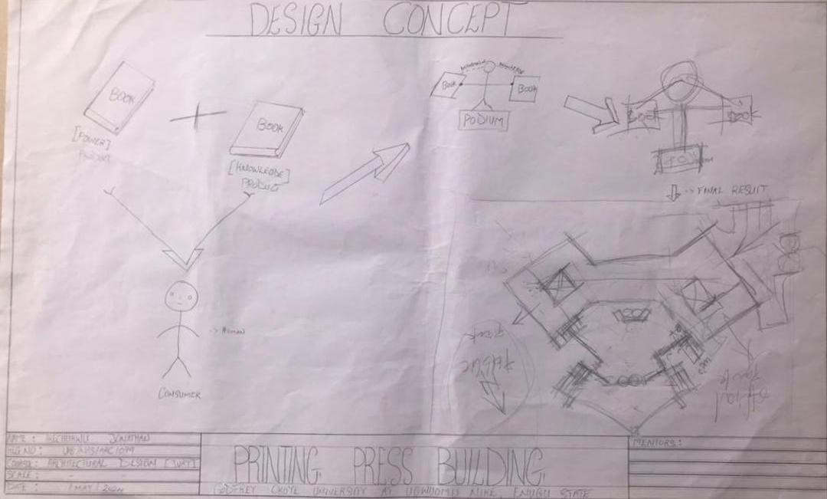
Figure 5.1 Conceptual design proposal

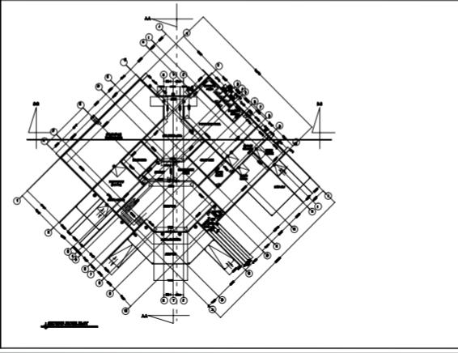
Figure 5.2 Presentation Drawings with 3D
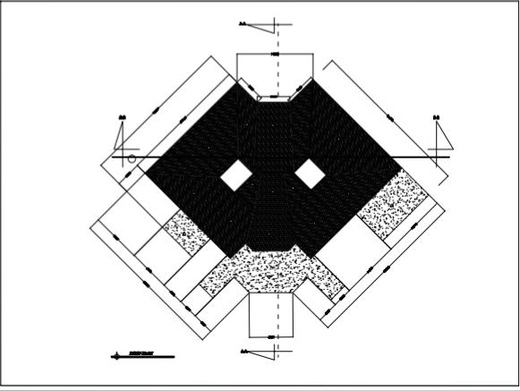
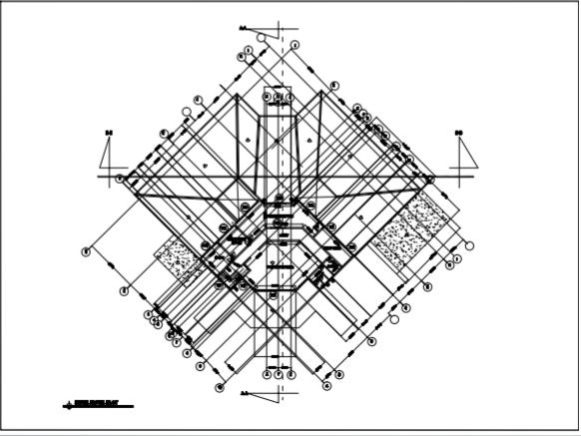

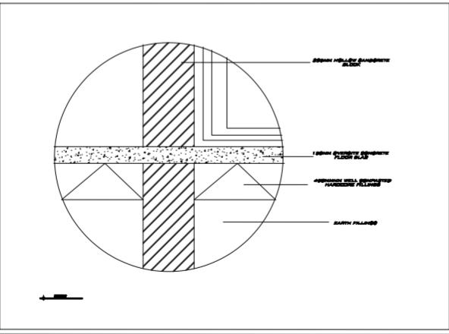
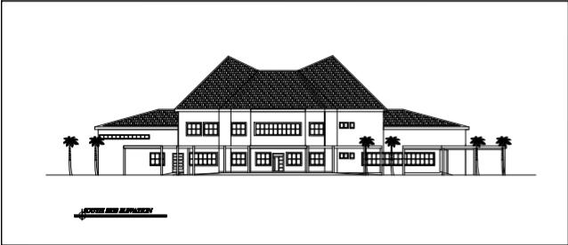
Figure 5.3 Detailed Drawings and Physical Model (as appropriate)


Conclusion and Recommendations
5.8 Summary of findings or main issues
1. Enhanced Natural Light Utilization:
Window Design: Strategic placement and sizing of windows, along with the use of high-transmittance glazing, significantly improve natural light penetration.
Light Distribution: Incorporating light wells, atriums, and reflective interior surfaces enhances light distribution within the building, reducing the need for artificial lighting.
5.8.1 Conclusion
1. Enhanced Natural Light Utilization
2. Occupant Comfort and Productivity
3. Energy Efficiency:
4. Sustainable Design

5.8.2 Recommendations
Recommendations
I recommend the examples below
- Optimize Window Design
- Implement Shading Solutions
- Enhance Interior Reflectance
- Incorporate Passive Solar Design
- Conduct Regular Evaluations
- Promote Sustainable Practices
5.8.3 Contribution to knowledge
1. Advancements in Daylighting Design
2. Enhanced Occupant Well-being
3. Energy Efficiency and Sustainability
4. Practical Applications and Case Studies
5. Methodological Contributions
5.9 Conclusion
This study covers virtually the basic knowledge to potential architectural practices, ultimately contributing to the creation of more sustainable, comfortable, and efficient built environments.
Using the guidelines above will thus, make a wide range of research on the printing press design.

REFERENCES
Nyole, Florence Chepchumba (2013). History of Daylighting Strategies: A Comparative Analysis Across The Periods.

Schoof, Jakob (2022). Rethinking Daylight: The History of the Daylight & Architecture Magazine.

Patriquin Architects (2021). What Is Daylighting and Why Is It Important?

Barrett, Richard (2009). The Case for Daylighting in Architecture.

Farimah Piraei, Barbara Matusiak and Valerio R. M. Lo Verso (2022). Evaluation and Optimization of Daylighting in Heritage Buildings: A Case-Study at High Latitudes.

Arch Daily (2022). How to Factor in Daylighting Design for Healthier Buildings.

Gregg D. Ander, FAIA (2016). Daylighting.

Diego Hernández (2021). Architectural Vocabulary Defined A to Z.

Dalia Hafiz (2015). Daylighting, Space, and Architecture: A Literature Review.

Ing Liang Wong (2017). A review of daylighting design and implementation in buildings.

Fazidah Hanim; Azhan Abdul Aziz; Salahuddin Abdul Hakeem Abas; Mohd Hafiz Mohammad Zin; Ahmad Faisol Yusof; Izzat Anuar (2023). A thematic review on daylighting strategies and its implementation in buildings.

Vitruvius. (1960). The Ten Books on Architecture (M. H. Morgan, Trans.). Dover Publications.

