

KRALIS: AN AUTOMATED RESULT PROCESSING AND REPORTING SYSTEM FOR SECONDARY SCHOOLS

BY

OGUAKWA CHIDERA SUNDAY

GOU/U21/CSC/751

DEPARTMENT OF COMPUTER SCIENCES

FACULTY OF NATURAL SCIENCES AND ENVIRONMENTAL STUDIES

GODFREY OKOYE UNIVERSITY, ENUGU

AUGUST, 2025

KRALIS: AN AUTOMATED RESULT PROCESSING AND REPORTING SYSTEM FOR SECONDARY SCHOOLS

BY

OGUAKWA CHIDERA SUNDAY

GOU/U21/CSC/751

SUBMITTED TO THE DEPARTMENT OF COMPUTER SCIENCE,

FACULTY OF NATURAL SCIENCES AND ENVIRONMENTAL STUDIES, GODFREY OKOYE UNIVERSITY, ENUGU

IN PARTIAL FUFILMENT OF THE AWARD OF BACHELOR OF SCIENCE (B.Sc) DEGREE IN COMPUTER SCIENCES

SUPERVISOR: ENGR. DR. KINGSLEY I. CHIBUEZE

AUGUST, 2025

APPROVAL
This research titled “Kralis: An Automated Result Processing And Reporting System for Secondary Schools” has been assessed and approved by the Committees of Department of Computer Science/Mathematics and Faculty of Natural Sciences and Environmental Studies, Godfrey Okoye University, Enugu Nigeria.

Engr. Dr. Kingsley I. Chibueze _______________ _______________
Supervisor Signature Date

_______________ _______________
External Examiner Signature Date

Dr. Frank Okebanama _______________ _______________
Head of Department Signature Date

Prof. Chidi C. Uhuegbu _______________ _______________
Dean of FNSES Signature Date

CERTIFICATION
I certify that I completed the research included therein and that it was primarily based on my observations and investigation. I will fully accept the University's decision if I am found to have cheated on the assignment.

________________
OGUAKWA CHIDERA SUNDAY
GOU/U21/CSC/751

DEDICATION
This project is dedicated to God, whose guidance brought about its successful completion, to my family and friends whose love encouraged me to keep going, and to my supervisor whose instruction made my work process clear and efficient.

ACKNOWLEDGEMENTS
Without proper guidance, this research project would not have reached a successful completion. I am grateful to God for the presence of the following individuals whose efforts and contributions to this work I now acknowledge.
I extend my gratitude to my supervisor, Engr. Dr Kingsley I. Chibueze, for his clear instructions, and patience with me throughout the research process.
I am also grateful to my Head of Department, Dr. Frank Okebanama, who tirelessly motivated me to keep going and fostered a conducive working and learning environment for us final year students. To the Dean of Faculty and Lecturers in my Department I appreciate you all for your encouragement and advices.
I express my sincere gratitude to my noble parents, Mr and Mrs Oguakwa and siblings for their prayer, supports and financial help.
I appreciate my classmates, www.natrobase.come , verva fashion hub for supporting me through out this project and my friends in school for their encouragement, assistance and advice during this project research.
Finally, I thank my parents for their love and support through this work. It is my prayer that as all these people have been blessings to me, they may also enjoy God’s blessings in their own lives.

ABSTRACT

This project introduces Kralis, an automated tool that processes and reports exam results designed just for secondary schools. On the backend, Python handles the heavy lifting, while Next.js powers a clean, responsive interface that works on phones and laptops alike. The main aim is to turn what used to be a messy, hand-written routine into a smooth, automatic chain that starts with raw scores, runs through validation and calculations, and ends with polished, ready-to-print reports. Until now, grades were keyed in by hand, and that human touch often invited mistakes, wasted hours, and left teachers chasing paperwork instead of students. Because Python offers a mountain of mature libraries and Next.js can refresh pages on the fly, Kralis cuts down those errors, keeps the numbers truthful, and eases the heavy desk work that comes with spreadsheets and late-night data looks. Schools can type, change, or glance at scores through a friendly Next.js dashboard, while behind the curtain Python crunches averages, flags missing marks, builds summaries by class or by subject, and formats everything so readers do not have to hunt for context. With results popping up in near real-time, educators gain the breathing space to focus on teaching and the confidence to act on evidence right as it appears. Moreover, the system allows for scalability, meaning it can adapt to the growing needs of schools and accommodate large volumes of student data.

TABLE OF CONTENTS
TITLE PAGE i
APPROVAL ii
CERTIFICATION iii
DEDICATION iv
ACKNOWLEDGEMENTS v
ABSTRACT vi
TABLE OF CONTENTS vii
LIST OF FIGURES ix

CHAPTER ONE: INTRODUCTION 1
1.1 BACKGROUND OF STUDY 1
1.2 STATEMENT OF PROBLEM 2
1.3 AIM AND OBJECTIVES OF THE STUDY 3
1.4 SIGNIFICANCE OF THE STUDY 3
1.5 SCOPE OF THE STUDY 4
1.6 LIMITATION OF THE STUDY 5
1.7 OPERATIONAL DEFINITION OF TERMS 5

CHAPTER TWO: LITERATURE REVIEW 7
2.1 INTRODUCTION TO LITERATURE REVIEW 7
2.2 OVERVIEW OF AUTOMATED RESULT PROCESSING SYSTEMS 10
2.3 EVOLUTION OF ACADEMIC RESULT MANAGEMENT SYSTEMS 13
2.3.1 TRADITIONAL VS. MODERN RESULT PROCESSING METHODS 14
2.3.2 IMPACT OF TECHNOLOGY ON EDUCATIONAL RECORDS MANAGEMENT 15
2.4 EXISTING RESULT PROCESSING SYSTEMS IN SECONDARY SCHOOLS 17
2.4.1 STRENGTHS AND LIMITATIONS OF MANUAL SYSTEMS 17
2.4.2 ADOPTION OF DIGITAL SOLUTIONS IN EDUCATIONAL INSTITUTIONS 18
2.5 CHALLENGES IN SECONDARY SCHOOL RESULT MANAGEMENT 19
2.5.1 ACCURACY AND EFFICIENCY ISSUES 19
2.5.2 SECURITY AND DATA PRIVACY CONCERNS 20
2.5.3 ACCESSIBILITY AND USER EXPERIENCE CHALLENGES 20
2.6 REVIEW OF RELATED LITERATURE 21
CHAPTER THREE: METHODOLOGY, SYSTEM ANALYSIS AND DESIGN 23
3.1 OVERVIEW 23
3.2 SYSTEM ANALYSIS 23
3.2.1 ANALYSIS OF THE EXISTING SYSTEMS 23
3.2.2 WEAKNESSES OF EXISTING SYSTEMS 24
3.2.3 ANALYSIS OF THE PROPOSED SYSTEM 24
3.2.4 SYSTEM REQUIREMENT 24
3.2.4.1 FUNCTIONAL REQUIREMENTS FOR AUTOMATED RESULT PROCESSING
3.2.4.2 NON-FUNCTIONAL REQUIREMENTS 25
3.3 PROPOSED METHODOLOGY 25
3.3.1 UNIFIED MODELLING LANGUAGE DIAGRAMS 25
3.3.2 USE CASE DIAGRAM OF THE PROPOSED SYSTEM 25
3.3.3 ACTIVITY DIAGRAM OF THE PROPOSED SYSTEM 26
3.3.4 CLASS DIAGRAM OF THE PROPOSED SYSTEM 27
3.3.5 SEQUENCE DIAGRAM OF THE PROPOSED SYSTEM 27
3.4 SYSTEM DESIGN AND ARCHITECTURE 29
3.5 SUMMARY 29

CHAPTER FOUR: SYSTEM IMPLEMENTATION 34
4.1 INTRODUCTION 34
4.2 DEVELOPMENT ENVIRONMENT AND TOOLS 34
4.2.1 PYTHON DEVELOPMENT ENVIRONMENT SETUP 34
4.2.2 NEXT.JS ENVIRONMENT AND CONFIGURATION 35
4.3 SYSTEM IMPLEMENTATION 35
4.3.1 BACKEND IMPLEMENTATION USING PYTHON 35
4.3.2 FRONTEND IMPLEMENTATION USING NEXT.JS 36
4.3.3 INTEGRATION OF FRONTEND AND BACKEND COMPONENTS 38
4.4 USER INTERFACE OF KRALIS 40
4.4.1 UNIT TESTING 40
4.4.2 INTEGRATION TESTING 40
4.4.3 SYSTEM TESTING AND USER ACCEPTANCE TESTING 41
4.5 SYSTEM DEPLOYMENT AND DEMONSTRATION 41
CHAPTER FIVE: SUMMARY, CONCLUSION, AND RECOMMENDATIONS 42
5.1 INTRODUCTION 42
5.2 SUMMARY OF FINDINGS 42
5.3 CONTRIBUTIONS OF THE STUDY 43
5.4 LIMITATIONS OF THE STUDY 43
5.5 RECOMMENDATIONS FOR FUTURE IMPROVEMENTS 44
5.6 CONCLUSION 45
REFERENCES 46
APPENDIX 47

LIST OF FIGURES
FIGURE PAGE
3.1: Use Case Diagram 25
3.2: Activity Diagram 26
3.3: Class Diagram 27
3.4: Sequence Diagram 28
3.5: System Design and Architecture 29
3.6: Input and Output Design 30
3.7 Database Design and Data Flow Diagrams 33
4.1: Dashboard Page 36
4.2: Student Result Sheet 37
4.3: Student Entry Form 37

CHAPTER ONE
INTRODUCTION

1.1 Background of the Study
Education is the rock on which any nations future rests. At the heart of that work sits assessment- a steady routine that checks how well students grasp each lesson and tells teachers, parents, and policy-makers what they need to know. Tightly linked to this is result processing, the clear-cut recording and review of every test mark received. In secondary schools the output from this work steers learners toward the right subjects and flags which students are ready for higher study. Still, in many schools across developing countries the whole chain from scoring to reporting is carried out by hand.
Under the old system, a teacher writes each score in a ledger, adds the numbers, works out an average, then copies the final grades into a report book. Because the job is tedious it eats up hours and leaves space for slip-ups, whether through mistyped figures, double entries, or sheets lost between classrooms. Too often those mistakes stay hidden until results are published, sparking disputes, disappointing families, and sometimes drawing penalties for the school.
However, As schools everywhere shift toward digital ways of working, secondary institutions must start using modern tools to handle day-to-day academic tasks. Tools like database systems, cloud storage, online apps, and basic artificial intelligence help cut paperwork and make record-keeping faster, clearer, and more reliable. Today, a strong digital system for managing exam results is no longer optional; it is simply expected.
Languages and frameworks such as Python and Next.js fit this job very well. Python is praised for its clear syntax and rich libraries-Pandas, NumPy, and others-that make data cleaning, quick analysis, and routine automation straightforward. Next.js, built on React, delivers speedy page loads, solid SEO, and an engaging interface. Put together, these technologies offer a clear path to build an automated results portal made for secondary schools. This project therefore plans to design and build the system just outlined. Its goal is to deliver a smart, secure, AI-supported platform that accepts scores, runs calculations, spots trends, and prints clear reports with little human intervention.

1.2 Statement of the Problem
Even though classroom technology keeps improving, a surprising number of high schools still enter exam scores by hand. This old-school habit creates a bundle of headaches:
- Inaccuracy of Computation: Teachers sometimes miss simple errors when adding points or rounding grades. Larger classes make those slips much easier and harder to catch.
- Time-Consuming Processes: Copying numbers into ledgers and report books gobbles up hours that could go into lesson planning or talking with students.
- Security Risks: Paper files can be ruined by water, fire, or careless hands, and guarding the stacks is tricky at best. Keeping results truly private is, therefore, a daily gamble.
- Limited Access to Reports: Parents and guardians often sit for days or even weeks before results show up. Without one online hub, everyone gets news in uneven batches.
- Lack of Data Analytics: Manual systems do not support performance tracking or trend analysis. This hinders the ability to make data-driven decisions.
- Human Dependence: The entire system collapses in the absence of key personnel. Errors in input or transcription may not be caught in time.
There is a clear need for a robust system that addresses these limitations by digitizing the entire process, automating calculations, ensuring data integrity, and providing accessible reporting to all stakeholders. The proposed system, developed with Python and Next.js, will fill this gap by leveraging the strengths of these modern technologies.

1.3 Aim and Objectives of the Study
The aim of this study is to design and implement Kralis, an automated academic result processing and reporting system for secondary schools using Python and Next.js.
To achieve this aim, the study sets out the following objectives:
- To design a centralized and user-friendly web interface that allows teachers and administrators to input and manage student scores.
- To develop backend logic using Python that automates computation of grades, averages, subject rankings, and overall performance.
- To implement secure authentication and access control for users (admin, teachers, students, and parents).
- To enable dynamic generation of printable result sheets and downloadable reports.
- Include dashboards that show trends over time, highlight which students are improving, and compare classes side by side.
- Add simple AI tools that guess future grades and signal strange patterns before they spread.
- Protect all data with encryption, lock down the servers, and run backups on a steady schedule.
These targets steer the project and set clear yardsticks for judging whether the new system actually works.

Significance of the Study
This project brings noticeable benefits for everyone involved:
- To Schools: It moves record-keeping off paper and onto a secure digital platform, saving time and cutting admin costs.
- To Teachers: Routine number crunching is handled automatically, letting staff enter grades, calculate totals, and track trends with a few clicks.
- To Students: Grades and feedback appear in real time, encouraging them to take charge of their own learning.
- To Parents: Clear, up-to-date snapshots of a childs progress arrive through email or an app, helping families stay plugged in.
- To Educational Authorities: Data from every school feeds into a central dashboard, making it easier to spot patterns and compare results.
- To Researchers and Developers: Real-world use of the system adds to the growing body of knowledge about ed-tech, inspiring future projects.
With built-in AI features the tool does not stop at automation; it shares smart hints that can shape lesson plans and steer study plans.

1.5 Scope of the Study
The focus here is a web-based result-processing and reporting system crafted for secondary schools. The system:
- Covers student registration, result entry, grade computation, and report generation.
- Supports multiple user roles: Admin, Teachers, Students, and Parents.
- Uses Python for backend logic, including computation and data processing.
- Uses Next.js for a dynamic and responsive user interface.
- Integrates a relational database (e.g., PostgreSQL) to store and manage data.
- Includes performance graphs and student ranking functionalities.
- Features role-based access, ensuring that only authorized users can view or edit certain data.
The system does not cover financial records, school timetables, attendance tracking, or behavioral reports. Furthermore, the AI integration is limited to performance prediction based on historical data and simple anomaly detection.

1.6 Limitations of the Study
While this system offers significant benefits, certain limitations remain:
- Internet Dependence: As a web-based system, continuous internet access is required for full functionality.
- Scalability: Although scalable in theory, the prototype will be developed for small to medium-sized schools. Performance under national-level deployment has not been
tested.
- Limited AI Capability: Due to resource constraints, AI features are kept basic and exploratory in nature.
- Data Migration: Existing paper-based records may need manual entry into the new system, which may initially be time-consuming.
- Training Requirements: Teachers and administrators may need orientation and basic
ICT training to use the platform effectively.
Nonetheless, these limitations can be addressed in future versions or scaled deployments of the system.

1.7 Operational Definition of Terms
- Automated Result System: A computer-based system that processes and reports student academic results with minimal human intervention.
- Backend: The part of the system that handles data processing, business logic, and database interaction.
- Frontend: The user-facing side of the application where users interact with the system (forms, dashboards, etc.).
- Python: A high-level programming language used for developing backend applications due to its readability and efficiency.
- Next.js: A JavaScript framework that pairs React components with fast server-side rendering, so the site loads quickly on any device.
- Relational Database: A structured way to store and retrieve data using tables with defined relationships (e.g., PostgreSQL, MySQL).
- Role-Based Access Control (RBAC): A method of restricting system access based on
users’ roles.
- Performance Analytics: Graphical and statistical tools used to interpret and visualize academic performance.
- AI (Artificial Intelligence): The use of computer algorithms to simulate human reasoning for tasks like predictions or anomaly detection.

CHAPTER TWO
LITERATURE REVIEW

2.1 Introduction to Literature Review
Keeping track of exam results sits at the heart of any school system, and in high schools those numbers can steer a teens future course and even early job choices. In recent years, schools have moved away from slow paper-based record books to slick online systems, thanks mainly to leaps in information and communication technology. This chapter reviews what scholars say about automating result management, focusing on high schools, and looks at tools such as Python and Next.js that developers now favour. It also discusses how Artificial Intelligence, cloud storage, and modern software frameworks help schools generate, keep, study, and share marks more smoothly.
As Obi and Afolabi (2018) point out, processing results forms the baseline feedback loop in education so that students, parents, teachers, and decision-makers can act on clear, timely data. Paper-driven methods, though once the norm, have shown time and again that they cannot keep pace with todays need for speed, accuracy, and room to grow. Rising enrolment numbers across Africa, Asia, and beyond has laid bare these flaws, pushing many ministries and school leaders to search for smarter, more scalable alternatives. The increased student populations in many countries, particularly in Africa and Asia, have further exposed the inefficiencies of traditional methods, paving the way for digital transformation in the education sector.
Automated record-processing systems now try to put every step of student grading onto a digital platform- entering scores, running calculations, creating reports, and locking files away safely. Many of these tools are being upgraded with A.I. features: behind-the-scenes models that spot rising trends, flag students who might struggle, and even give teachers a head start when they grade open-ended work. As Davis and Fletcher put it, automation in education is "more than a handy shortcut; it is a new way for schools to run and base decisions on solid evidence. Alongside these specialized platforms, everyday languages like Python-straightforward to learn, packed with libraries-have become the go-to backbone for countless campus apps. Hooked up to a lively front end built in Next.js, schools can serve fast, flexible websites that grow with changing result-processing demands.
On the worldwide stage, both UNESCO and the World Bank now name education digitization as a key goal for sustainable development. In its 2021 review of digital teaching infrastructure, UNESCO underlines the need for data systems that deliver fairness, clear reporting, and better learning results. An automated result-management tool sits squarely at the heart of that agenda.by ensuring transparency in grading and accessibility of academic records for all stakeholders.
Research from around the world keeps pointing to one clear fact: putting result management online really matters. Take Estonia: that small Baltic nation has built such a smooth digital society that every grade and record lives in one government-backed portal. Students and their parents can check marks in seconds, and officials can tap the same data for big-picture reports that shape nationwide policy. Peterson and Lang (2021) even label it a gold standard, saying, Estonia's e-education model automates results and gives verified information to everyone, instantly.
Meanwhile, in many developing countries the basic tech backbone is still missing, so results are copied by hand, mistakes pile up, and trust leaks away. Okonkwo and Eze (2019) asked 56 public secondary schools in Eastern Nigeria about their systems and found 78 percent stuck with paper while just 6 percent had tried any digital approach. That gap slows learning and leaves students, especially from poor areas, without the fair chance that fast, clear data can provide. Even so, interest-and cash-for online education tools keeps climbing. Private EdTech firms now pitch school management packs that include ready-to-go result automation. Systems such as Schoology, Edmodo, and Eduportal have seen widespread adoption in private schools, albeit with varying degrees of success in secondary-level implementation.
A major driver of automation in education is the growing emphasis on data-driven decision-making. With student performance data captured, processed, and visualized automatically, educators and administrators can generate insights to improve teaching strategies, allocate resources, and support struggling students. According to McKinsey & Company’s 2020 global education report, institutions that utilize automated student performance data systems are 40% more effective in curriculum planning and 35% more responsive in student intervention programs.
Additionally, the shift to remote and hybrid learning in the wake of the COVID-19 pandemic has amplified the need for digital result management. As classes moved online, so did assessments, creating a necessity for web-based platforms that could handle result entry, calculation, and reporting in a decentralized environment. Many schools quickly adopted LMS-integrated grading systems, but challenges in synchronization, user-friendliness, and security revealed the importance of custom-built systems like the one proposed in this study.
Security and data privacy concerns are another focal point in the literature. With automated systems handling sensitive student data, protecting this information from unauthorized access or breaches becomes paramount. Authors such as Taylor & Lewis (2020) warn of increasing cyber threats targeting educational institutions, especially as more data is stored in cloud environments. For any school results system, you really need full end-to-end encryption, role-based access, clear audit trails, and strict fit with local data laws like FERPA in the U.S. or NDPR in Nigeria.
AI is moving on from simply grading papers or guessing test scores. Natural Language Processing now checks essay responses, while computer-vision tools read and mark scanned answer sheets. Work by Zhou and colleagues (2022) even shows models copying a teachers marking style, which could free up hours for busy staff. Still, developers must tread carefully to spot bias early and keep the whole process clear to users.
Taken together, the research clearly points toward greater automation of secondary-school result handling, pushed by the twin goals of speed and accountability. Rich countries are already far ahead, while many low- and middle-income states still struggle with weak internet, tight budgets and limited training. The good news is that open-source code and cloud services are everywhere, giving those planners a chance to build secure, pocket-friendly systems. This project shows how pairing Python with Next.js can form a solid backbone for such an effort, balancing backend robustness with a dynamic user interface.

2.2 Overview of Automated Result Processing Systems
Automated result-processing systems, often called ARPS, have become a crucial part of todays schools because they handle student grades quickly and dependably. Built to fix the weaknesses of manual grading-records scams- human error, duplicated tasks, hidden steps, and long waits for report cards- they take the strain off staff and keep parents in the loop. Thanks to easy-to-learn back-end tools like Python and sleek front-end frameworks such as Next.js, colleges and high schools can now launch secure, real-time portals that crunch numbers and push out results with laser-like accuracy.

Definition and Purpose of Automated Result Processing Systems
An automated-result-processing system is really just a piece of software that takes in marks, does the maths, saves the data, and shares the finished report-it all happens electronically. Such tools usually plug into larger school-management suites, though many run nicely on their own as web apps. By speeding up every stage from entry to publication, the platforms cut paperwork, boost trust through open records, and make it simple for learners, guardians, and teachers to see scores whenever they need to.
Ajayi and Olayemi (2019) sum it up by calling ARPS technological innovations that move schools out of the filing-cabinet age into data-driven spaces where academic history is calculated, stored, and retrieved online. In practice, these packages offer features such as result input modules for teachers, automatic grade calculators, report generation tools, performance dashboards, and access portals for stakeholders.

Core Components of ARPS
Nwankwo and Daramola (2020) explain that the overall performance of an Academic Result Processing System (ARPS) hinges on five key parts working well together:
- Database Management System (DBMS): Think of this as the systems sturdy backbone, keeping student files, grades, rules, and login keys safe and organized. MySQL, PostgreSQL, MongoDB, or even light-weight SQLite are among the usual choices.
- Result Computation Engine: This piece runs the grading formulas, calculates averages, and crafts remarks exactly as the schools policy demands.
- Authentication and Authorization System: It makes sure every user sees only what they should-teachers enter marks, students peek at personal scores, and admins sign off on final reports.
- Frontend Interface (Next.js or React): A clean, quick interface that looks good and works smoothly on desktop, tablet, or phone.
- API Layer (typically built with Python frameworks like Django or Flask): Facilitates data exchange between the frontend, backend, and database, ensuring real-time processing and smooth operations.

Benefits of ARPS in Secondary Education
Numerous studies confirm the transformational impact of ARPS in secondary education.
Obasi & Usman (2021) list the following key benefits:
- Accuracy in computation: Eliminates human error common in manual calculations.
- Time efficiency: Reduces the time taken from exam completion to result release from weeks to hours.
- Data security: Enables role-based access, encrypted storage, and activity logs.
- Transparency: Students and guardians can verify how grades are computed,
improving trust in the educational process.
- Analytics: Offers teachers and school administrators performance insights across subjects, classes, and terms.
Example: In Kenya, the adoption of the National Education Management Information System (NEMIS) resulted in a 65% improvement in result processing timelines and a significant drop in result manipulation incidents (Mutua, 2022).

Types of ARPS
ARPS can be categorized based on deployment, complexity, and integration levels:
- Standalone Desktop Applications: Early ARPS like those developed in Visual Basic, MS Access, or Java Swing ran on individual computers, lacked cloud integration, and were limited to single-user operations. While suitable for small schools, they often suffered from scalability and data sharing issues.
- Web-Based Applications: These use server-side languages (like Python, PHP, or Node.js) and client-side frameworks (React, Angular, Next.js) to create centralized platforms accessible via internet-enabled devices. These systems enable real-time access, centralized data storage, and multi-user support.
- AI-Enhanced ARPS: Here, smart algorithms guess likely scores, flag learners who need help, and grade multiple-choice or short-answer items all on their own. Zhou et al. (2022) even note how Natural Language Processing now reads and scores essays with very little teacher time.
- Cloud-Based SaaS Platforms: Examples include Google Classroom, Edmodo, and
Canvas LMS, which offer result processing as part of their broader suite of features. They are subscription-based and often hosted on cloud servers, allowing for seamless updates and scalability

Global Trends and Adoption
Around the world, schools now lean on results-processing platforms (ARPS), though each region tweaks its model to match local tech and needs.
- In England, government-backed schools draw data into shared portals that pair with grade systems such as SIMS, making result handovers quick and tidy.
- India uses its Diksha app to turn public-school scores into digital records and reports, adding biometric log-ins so only verified staff can view student progress.
- Meanwhile, many Nigerian private colleges sign up for EduRecords, SchoolTry or Gradelink; public bodies still trail behind because budget and power shortfalls slow new roll-outs.
Chika and Awoniyi (2021) note that success hinges on policy backing, teacher comfort with screens, solid ICT kit and the desire of all partners to leave paper behind
2.3 Evolution of Academic Result Management Systems
Over the last twenty years result management has shifted from clipboards and filing cabinets to slick online tools that do the heavy lifting almost by themselves. Faster hardware, cheaper internet and louder calls for open, speedy, accurate education data have pushed this change along. This section explores the evolution of these systems and how they have adapted to the demands of modern secondary education.

2.3.1 Traditional vs. Modern Result Processing Methods
Traditional Methods
Until very recently, schools processed exam results the old-fashioned way, with teachers recording marks in notebooks and ledgers before entering them into basic spreadsheets. In that routine, each score had to be double-checked, copied onto summary sheets, and then delivered as a printed bundle to the principal. Mistakes popped up often, fixing them took hours, and storing the paper files turned into a never-ending chore.
Adediran (2016) points out that in early secondary schools across Africa, “the paper-based model required significant manpower, involved excessive duplication of effort, and made it nearly impossible to perform analytics across large datasets of student performance.” Teachers often worked overtime during examination periods, and mistakes were not uncommon, particularly in the transcription and computation of final grades.
Common characteristics of traditional systems include:
- Manual computation of student scores.
- Physical documentation using ledgers and record books.
- Dependence on administrative personnel for collation and reporting.
- Poor scalability as student population increases.
- Lack of audit trails and version control.
- High risk of result tampering or manipulation.
In many rural and underserved areas, these systems still persist due to lack of digital infrastructure, despite their limitations.

Modern Methods
Modern result processing systems utilize computer software and digital infrastructure to automate grading, result collation, and report generation. A school using a modern system can process hundreds of student records within minutes, generate performance analytics, and share results securely with students and parents online.
According to Balogun & Olamide (2021), schools that transition from traditional to digital result systems report a 75% reduction in grading errors and a 60% improvement in reporting speed. These systems also provide functionality for automated GPA calculation, visual performance dashboards, and seamless result updates.
Some of the benefits of modern result processing systems include:
- Automated grade calculations using predefined grading criteria.
- Digital storage with backup and encryption.
- Instant report generation and performance summaries.
- Real-time access for students, parents, and teachers.
- Scalability across schools, districts, and regions.
- Ability to be integrated with biometric based attendance, managemet of fees, and systems for tracking behavior.
Example: The Lagos State Government’s LASG-Education Portal, launched in 2021, supports over 500 public secondary schools and allows students to view results, attendance, and performance reports digitally. The project has been lauded for reducing data loss and increasing parental engagement.

2.3.2 Impact of Technology on Educational Records Management
The role of technology in transforming educational records management goes beyond the automation of grades. It encompasses data integrity, security, accessibility, and the intelligent use of information for decision-making.

Introduction of Digital Databases
The first major advancement in records management was the use of relational databases to store student records. Tools like Microsoft Access, MySQL, and PostgreSQL allowed schools to transition from physical files to digital records. This shift enabled rapid data retrieval, filtering, and backups.
Nguyen et al. (2019) argue that “digitizing academic records not only improved storage efficiency but enabled educational institutions to move toward evidence-based policies using real-time student data.”

Role of Cloud Computing
Cloud computing allows educational records to be stored and accessed remotely. Schools no longer require expensive physical servers or on-site IT teams. Services like Google Firebase, Amazon Web Services (AWS), and Microsoft Azure offer scalable cloud-based storage and computing solutions.
In the United States, cloud adoption in K-12 institutions has reached over 70% as of 2022, allowing parents to access grades via mobile apps and students to retrieve transcripts remotely (NAEP, 2022).

Artificial Intelligence and Predictive Analytics
AI algorithms are increasingly used in student performance prediction, dropout risk analysis, and learning gap identification. For example, systems like Edmodo Insights and IBM Watson Education analyze academic history, attendance, and engagement to forecast academic outcomes and personalize learning interventions.
Kumar & Iyengar (2020) explain that “AI-enabled systems in schools can generate alerts when students show early signs of academic decline, allowing for timely support.”

Blockchain for Secure Recordkeeping
Blockchain ensures that student records are immutable and traceable, which is crucial in high-stakes environments such as university admissions and job applications. Using smart contracts and distributed ledgers, blockchain ensures that result tampering is virtually impossible.
A notable case is MIT’s use of blockchain diplomas, which allows employers and
institutions to verify academic credentials with cryptographic certainty.

Mobile Accessibility and Smart Devices
With the widespread use of smartphones, many result systems now offer mobile-friendly interfaces or dedicated apps. This allows parents and students to monitor academic progress in real time. Notifications, report cards, and performance graphs can be sent directly to phones via push notifications or SMS.
In Ghana, the BECE result checking portal uses mobile-friendly websites and USSD codes, making result access possible even in low-bandwidth regions (Boateng, 2021).

2.4 Existing Result Processing Systems in Secondary Schools
Many high schools kept to this paper-and-spreadsheet dance because it felt familiar, yet those methods quickly show their age. Accuracy plunges when numbers are written out by hand; work slows down during peak exam seasons, and adding new classes or larger cohorts stretches the system beyond what it can handle. As records grow more complicated and parents expect results almost instantly, schools have begun to look for smarter digital tools.
    - Strengths and Limitations of Manual Systems Strengths:
- Simplicity: Since manual systems rely on steps anyone with basic computer skills can follow, they demand little in terms of tech hardware or training. Teachers know how to add columns and write comments in a notebook, so the learning curve feels almost nonexistent.
- Low Initial Costs: Without the expense of expensive servers, bespoke software, or ongoing subscriptions, a paper-based approach appears cheap at first and usually lets a school keep operating until something breaks..
- Familiarity: · Many schools and staff are so used to their paper-and-pencil routines that moving to newer technology feels hard and risky

Limitations:
- Time-Consuming: Entering data by hand, running quick calculations, and assembling reports eats up far more minutes than most teachers can spare. Because of this, marks take longer to reach students and parents.
- Prone to Errors: Even small slips in typing or adding numbers can ripple through a grade book, creating wrong totals and contradictory sheets. The fallout can frustrate learners, upset families, and in serious cases open schools to legal complaints.
- Limited Scalability: Adding more students only compounds the problem; more names mean more keystrokes, more math, and therefore a higher chance of error. What works for a few dozen learners quickly saps time and accuracy when the rolls swell into hundreds or thousands.
- Lack of Transparency: Keeping track of a students progress over weeks or years is almost impossible without clear, up-to-date data that paper files simply dont provide. As a result, learners and their parents struggle to spot trends, celebrate growth, or target skills that still need work.

2.4.2 Adoption of Digital Solutions in Educational Institutions
Demanding quicker service, clearer records, and stronger security, many schools now turn to digital platforms that promise exactly those outcomes. By automating grading, storing data in the cloud, and building instant reports, these tools help staff handle large amounts of information with far less effort.
Key Benefits of Digital Solutions:
- Better Accuracy and Speed: Digital systems cut down on slip-ups and tidy up how data gets entered, worked out, and reported; because of that, results are ready in a blink compared with pen-and-paper work.
- Data Storage and Retrieval: Every student file ends up in one neat online space, making it quick to pull up past results, spot patterns, and print out whatever report is needed.
- Security Features: Modern software locks files behind passwords and clearance levels, so only staff who should see or change sensitive records can actually do it.
- Real-Time Results: Many platforms push updates the moment grades are finalized, letting students, teachers, and parents peek at scores without waiting for notices.
Even with those perks, schools still hesitate to go fully digital because start-up costs sting, people need training, and moving old paper files into new software can be a headache.

2.5 Challenges in Secondary School Result Management
Result management in secondary schools is fraught with several challenges, particularly as educational institutions transition from manual to automated systems. These challenges span issues of accuracy, security, accessibility, and user experience.

Accuracy and Efficiency Issues
The crucial attraction posed by updated management of results posed with respect to accuracy and efficiency are treated in the processing of results. Manual systems fall prey to human error; on the other hand, even digital ones can fall into inaccuracy due to wrong design or negligence being maintained.
- Data Entry Errors: In inaccurate data entry, errors in student results can befall both manual and digital systems. For example, a result can be incorrect because the scores were calculated incorrectly, the grade was entered wrongly, or there were extenuating circumstances, such as exemptions, which were not taken into account.
- System Performance: A digital system must perform well to generate results quickly, given that it handles a large volume of data. Slow performance might result when a system is poorly designed or lacks sufficient resources, thereby impeding result processing and creating delays.
- Data Consistency: Another concern surrounds the consistency in grading and reporting. Sometimes student results may differ due to 'teachers' grading standards or an inconsistency in applying the result processing logic.

2.5.2 Security and Data Privacy Concerns
In the age of digital monitoring of results comes the importance placed on searching for protection and privacy of data. A student's record usually contains personal information...and academic records, must be protected from unauthorized access, breaches, or misuse.
- Data Encryption: Security of student data is paramount as these pass through various levels of intermediaries through transmission and storage. Any fiend without enforcement of proper encryption standards can intercept or maliciously access such sensitive data.
- Audit Control: No concerned agency wants anyone tampering with or altering records. It is suggested, therefore, that a role-based access control system can be implemented to enforce access restrictions tailored to the individual's role within the institution.
- Regulatory Compliance: Different countries have published regulations regarding student data in a way that must be complied with by educational institutions to avoid consequences.

2.5.3 Accessibility and User Experience Challenges
For a digital processing result system to be effective, it has to fully be accessible to all stakeholders for the process, considering students, teachers, administrators, and parents alike. A deficient UX or limited accessibility could create resistance to system use, ultimately working against its adoption.
- User Interface (UI) Design: The system must have an intuitive interface from the viewpoint of a user, which guides users without demanding any technical expertise. Complex, cluttered, or unintuitive interfaces can lead to frustration and errors.
- Internet Accessibility: In areas where internet facilities are either non-existent or unreliable, cloud systems may not be the apt solution. And if there were to be an online system, achieving synchrony with its offline counterpart automatically raises much complexity.
- Need for Training: The staff and students may require training to use the system computer-wise and competently; otherwise, they might end up making simple errors or foregoing the system's entire range of utilities.

2.6 Review of Related Literature
An exhaustive investigation in the existing literature finds that numerous studies and reports have zoomed into the problems and benefits of manual and digital ways of result processing systems. Some studies emphasize positive features of digital solutions like improvement in efficiency, accuracy, and accessibility, whereas others much focus on the limitations of these systems-practically the security, privacy, and user experience of them. Hence, the literature suggests the need for an appropriate interplay between technology and design considerations that would eventually lead to the successful result processing systems.
Key Themes from the Literature:
- System Design and Functionality: Result processing systems have to be sufficiently flexible and scalable to handle a wide range of academic records successfully, according to the research. Customization options are also essential to accommodate diverse grading systems across institutions.
- Barriers to Adoption: Many studies in fact suggest the transition from manual to digital systems is often impeded by issues such as financing, resistance to change, and lack of technical expertise among school staff.
- Security and Privacy Risks: Many papers also bring up the need to ensure the security of student data, especially in areas with strict data privacy laws.

2.7 Summary of Review of Related Literature
The review of the related literature has shown the major transition going on from manual to digital means of result processing in secondary schools. The digital systems grant a lot of advantages to the users in terms of accuracy, speed, and scalability; however, they are also riddled with challenges in security, data privacy, and user experience. With regards to these factors and many others, the successful implementation of the digital result processing system will be tempered by a conscious approach to the design of the system and training of users.

CHAPTER THREE

SYSTEM ANALYSIS AND DESIGN

3.1 Overview
In this chapter we pull apart both the systems now in place and the new ones we suggest for handling exam results in secondary schools. We cover what each system needs, how it could be built, the models, and design patterns that point developers toward a Python- and Next.js-friendly build. The plan mixes solid software engineering with AI tools so that results processing can learn from past data and get smarter over time.

3.2 System Analysis

Analysis of the Existing Systems
Even today, many secondary schools stick to old-school techniques for turning raw marks into printed reports. They pencil in scores, shuffle spreadsheets, or lean on basic, homemade apps that seldom check if the data is tidy. These practices add up in predictable ways:
- High Error Rate: Keying in numbers by hand invites typos, miscalculations, or mismatched columns that nobody spots until grades come home.
- Time Consumption: Teachers and clerks burn hours averaging scores, lining up classes, and printing page after page of results.
- Poor Accessibility: Finished grades stay locked in school servers and on filing cabinets, making online or off-campus access almost impossible.
- Data Redundancy and Loss: Records are scattered in flash drives or dusty shelves, rarely backed up, which spells trouble when a hard drive fails or a classroom flood hits.
Aluko and Idowus (2020) found that more than 60 percent of schools still compiling results by hand lost at least one student record every term..

3.2.2 Weaknesses of Existing Systems
- Lack of scalability: As student population grows, manual or semi-automated systems become increasingly inefficient.
- Security Vulnerabilities: Lack of proper access controls and audit trails makes them susceptible to manipulation.
- Limited Reporting Features: Generation of transcripts, trend analysis, or performance tracking is not possible in most legacy systems.

3.2.3 Analysis of the Proposed System
The proposed system will automate the entire process—from result computation to report card generation and secure dissemination. Built using Python for backend logic and Next.js for a responsive and fast user interface, the system will provide:
- Real-time result input and access for teachers, students, and administrators.
- Secure login with user roles (Admin, Teacher, Student).
- Automated calculations (e.g., average score, grade assignment).
- Storage in a centralized, scalable database (PostgreSQL or MongoDB).
- Export options for printable results and Excel/CSV reports.

3.2.4 System Requirements

3.2.4.1 Functional Requirements
- Login and Authentication: Users must be able to log in based on their role.
- Result Entry and Editing: Teachers should input scores for subjects.
- Automated Grade Calculation: System should compute grades based on predefined rules.
- Result Generation: Should generate printable and downloadable result sheets.
- User Role Management: Admins can create, update or delete users.
- Reports and Analytics: Display academic performance trends.

3.2.4.2 Non-Functional Requirements
- Performance: Should respond to user actions within 2 seconds.
- Scalability: Should handle up to 5,000 concurrent users.
- Security: Implement SSL encryption, secure password hashing (bcrypt), and role-based access.
- Usability: Should have a clean, responsive UI accessible on all devices.
- Reliability: System uptime should exceed 99%.

3.3 Proposed Methodology

3.3.1 Unified Modelling Language (UML)
UML is used to visualize the architecture and design of the system. Diagrams include Use Case, Activity, and Class diagrams.

3.3.2 Use Case Diagram of the Proposed System
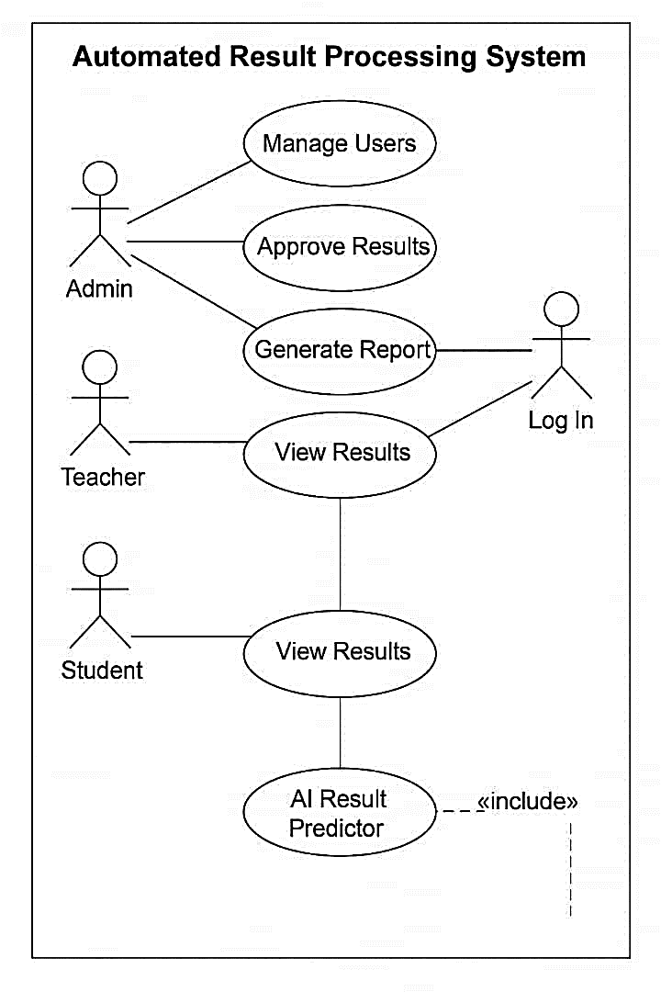
Figure 3.1: Use Case Diagram
This diagram illustrates the actors (teachers, students, admin) and their interactions with the system such as entering scores, viewing results, and generating reports.

3.3.3 Activity Diagram of the Proposed System
The activity diagram represents the workflow from login to result entry, validation, storage, and report generation.
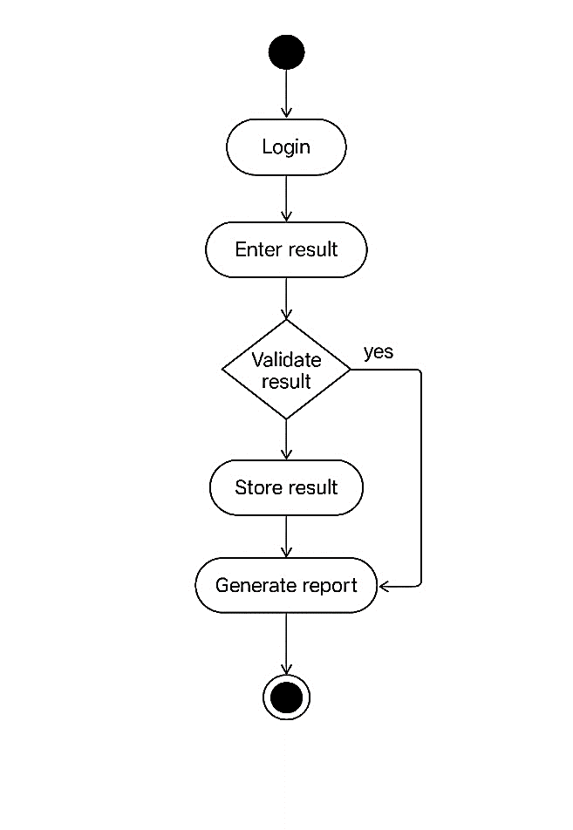
Figure 3.2: Activity Diagram

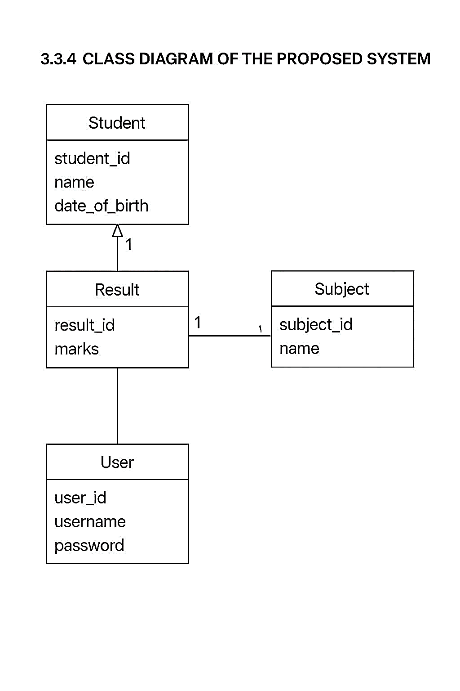
Figure 3.3: Class Diagram

The class diagram details the object-oriented design, showcasing classes such as Student, Result, Subject, User, and their relationships.

3.3.5 Sequence Diagram of the Proposed System
The sequence diagram provides a dynamic model of the interaction between components in the proposed automated result processing and reporting system. It visually represents how different parts of the system communicate over time to complete essential tasks such as student data entry, result computation, and report generation.
In this proposed system, the key actors and components include:
- User (e.g., teacher, administrator)
- Web Browser (the client interface)
- Frontend (built with Next.js)
- Backend (built with Python)
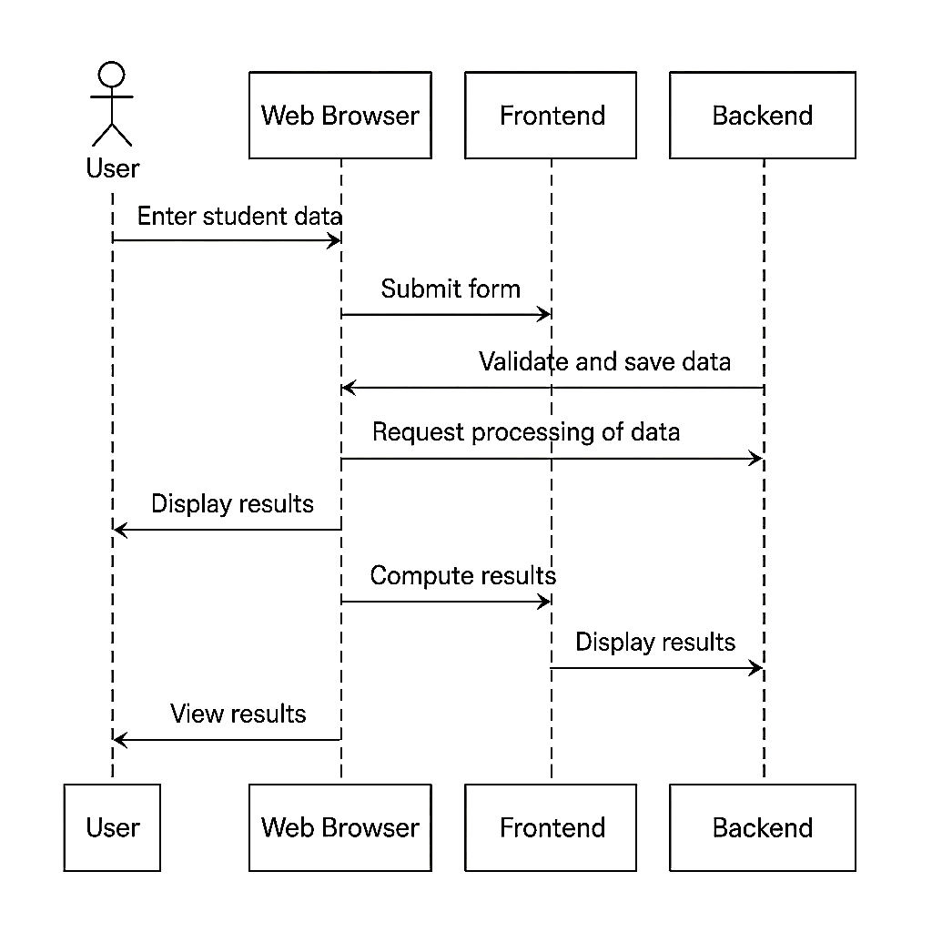
Figure 3.4: Sequence Diagram

The diagram illustrates the flow of activities from when a user initiates a request to enter student result data through to viewing the final results.
Sequence of Interactions:
- User Input: The user accesses the system through a web browser and enters student data (such as names, subjects, and scores).
- Form Submission: The browser sends the data to the frontend component.
- Frontend Processing: The frontend validates the input and sends it to the backend for storage and computation.
- Backend Execution: The backend receives the data, saves it in the database, and processes the scores (e.g., calculating grades, average marks).
- Result Generation: Once computation is complete, the backend returns the processed result data to the frontend.
- Result Display: When teachers finish entering grades, the server builds a report card, formats it, and sends the clean document back to the web browser.
- User Feedback: At that point the user sees the polished results on-screen, ready to print or share.
Together, these steps work in near-real time, so report cards are both accurate and easy to trace if questions arise later.

3.4 System Design and Architecture

3.4.1 Overview of the Python/Next.js System Architecture
- Frontend: The frontend runs on Next.js, giving fast page loads and smooth navigation thanks to built-in server-side rendering.
- Backend: On the backend, a Python service, either Django or FastAPI, exposes simple REST or GraphQL APIs.
- Database: All records sit in PostgreSQL for clear relationships, though MongoDB pops up when a more flexible model is needed.
- Authentication: Sessions stay safe with JSON Web Tokens, which let users remain logged in without constant re-entry..
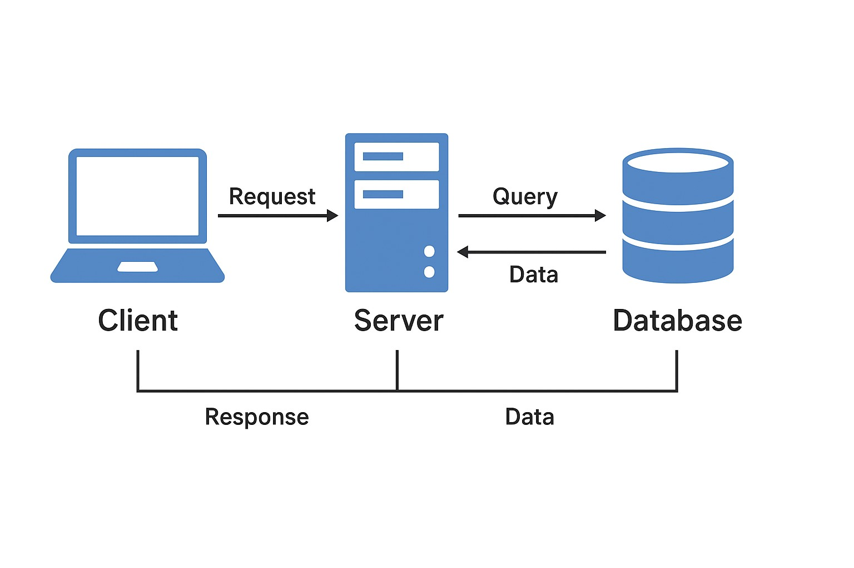
Figure 3.5: System Design and Architecture

3.4.2 Input and Output Design
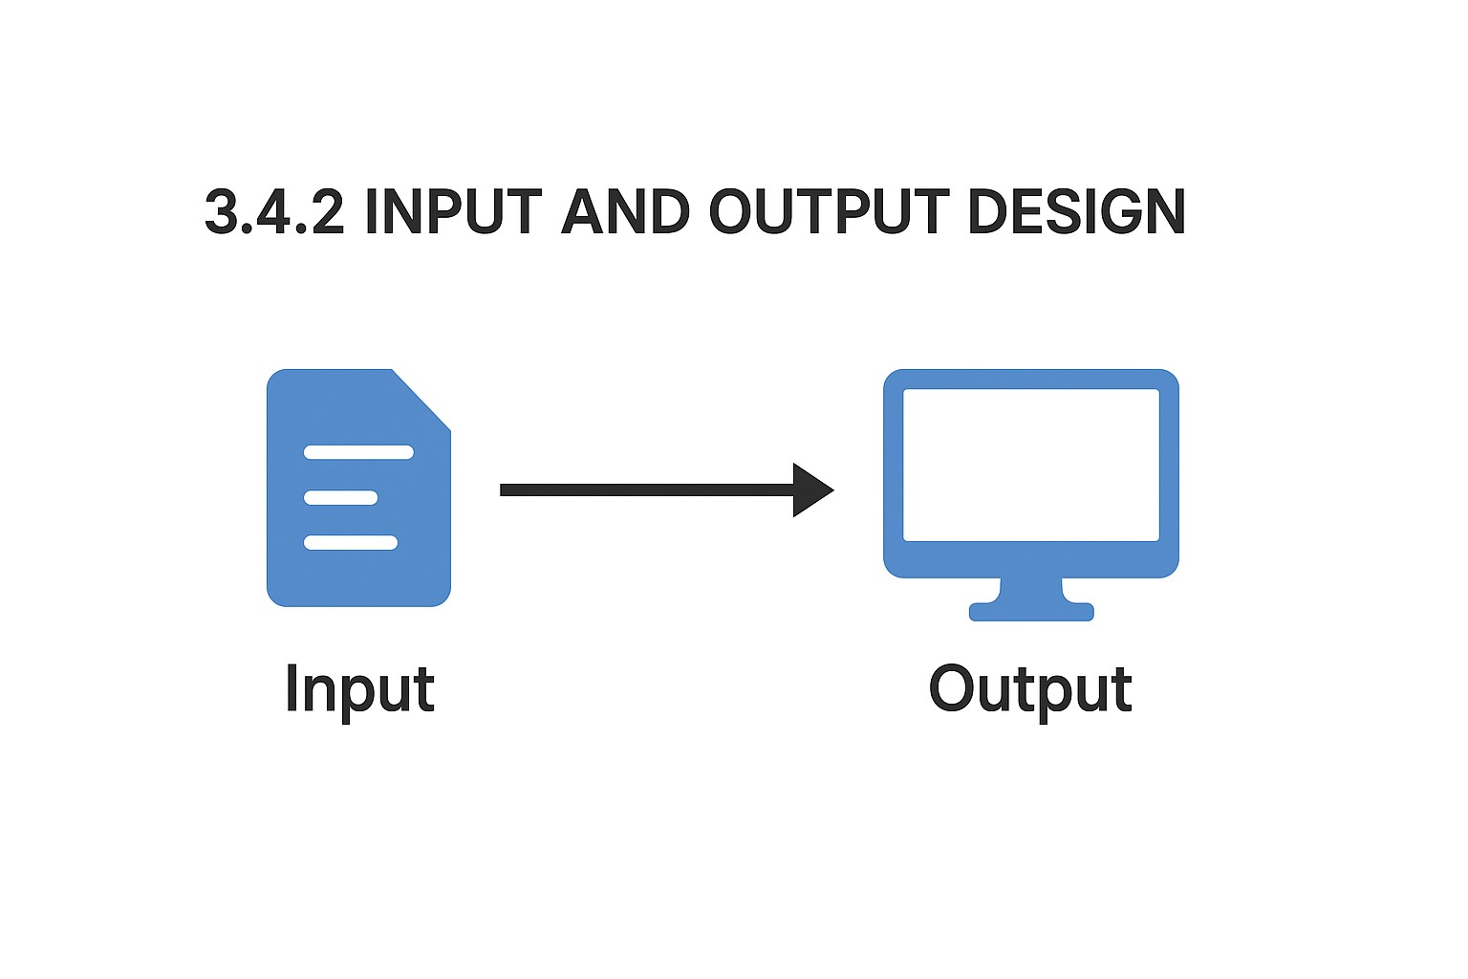
Figure 3.6: Input and Output Design

Good input and output design keeps lines of communication between the user and the system open and clear. When data streams in, gets processed, and appears on-screen without delay, everyone-from admins to students-benefits from a quicker, less frustrating experience. Within the context of the schools Automated Result Processing and Reporting System, great care was taken at every step in designing the intuitive input forms and meaningful output reports.
Input Design
Input design focuses on gathering the most precise and complete data from entities such as administrators and teachers. Inputs into the system include:
- Student bio-data (name, student ID, class, date of birth)
- Subject registration
- Raw scores and grades
- Term and session details
- User login credentials
These inputs are collected through the use of structured web forms in the frontend that have been built in Next.js, with validation to prevent entry of incorrect or incomplete data, thereby guaranteeing that only good quality data enters the system, with a minimum need to make corrections during processing.
- Key features of input design:
- Dropdowns for selecting subjects and terms
- Text fields with constraints (e.g., number-only fields for scores
- Auto-complete for known entries
- Real-time error feedback
Output Design
The output design defines how the processed data is presented back to users. The system generates several forms of output, all focused on clarity, accuracy, and usefulness. These include:
- Individual student result sheets
- Class-wide performance summaries
- Subject analysis reports
- Grade distribution charts
- System notifications (e.g., data submission status)
Outputs are displayed in the frontend interface and can also be downloaded as printable reports (PDF format). They are formatted with clear headings, tables, and visual aids such as charts and color-coded scores to enhance readability and interpretation.
Key features of the output design:
- Consistent formatting for report cards
- Support for print-ready formats
- Export functionality (PDF, CSV)
- Dynamic charts and graphs for performance trends

Importance of Input/Output Design
An effective input/output design not only improves data handling and system usability but also enhances user satisfaction and operational efficiency. It ensures that:
- Users can input data with minimal training
- Administrators can quickly assess student performance
- Errors are reduced at both input and output stages
- The system maintains a professional, modern user interface

3.4.3 Database Design and Data Flow Diagrams
Database Design:
Tables:
- Users (user_id, password, )
- Students (student_id, name, class, dob)
- Subjects (subject_id, name, code)
- Results (result_id, student_id, subject_id, score, term, year)

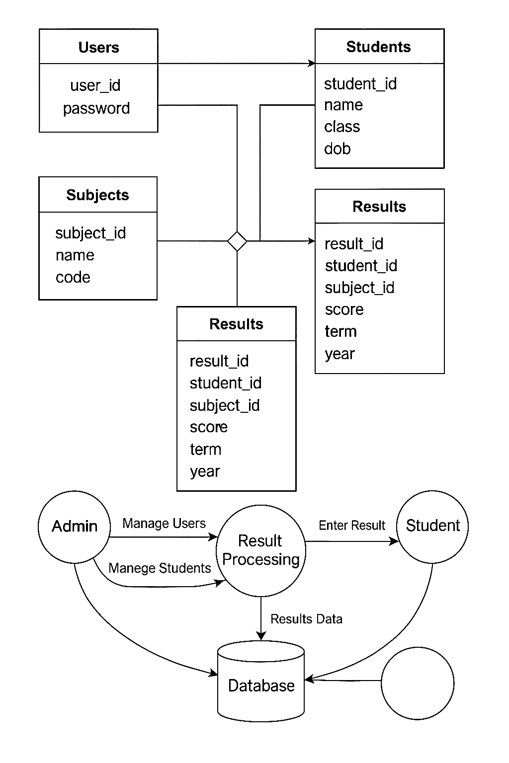
Figure 3.7 Database Design and Data Flow Diagrams
The data flow diagram shows ho\w data moves from result entry to final report generation.
Include image: (DFD showing admin, teacher, student, and database interactions.)

UI/UX Design Considerations
- Accessibility: Ensure screen-reader compatibility and large font toggle.
- Mobile-First: Responsive design for mobile, tablet, and desktop.
- Simplicity: Minimalist layout using TailwindCSS for clarity.
- User Guidance: Tooltip and form validation support.

3.5 Summary
This chapter detailed the analysis and design of the Automated Result Processing System, including its motivations, system requirements, methodology, and design considerations. Through a combination of modern web technologies (Python and Next.js) and sound design practices (UML, secure database architecture), the system is tailored to meet the growing needs of result processing in secondary education.
CHAPTER FOUR
SYSTEM IMPLEMENTATION

4.1 Introduction
This chapter presents a detailed account of the system implementation process of the automated result processing and reporting system, named Kralis. The chapter discusses the development tools and environment used, the specific implementation of both backend and frontend components, the integration strategies employed, the design and structure of the user interface, and the comprehensive testing and deployment activities. The implementation phase takes the project from screen mock-ups to real working code, showing that every requirement now lives in actual program logic and settings. Throughout, the team kept an eye on breaking the work into small pieces, so the final system stays easy to fix, easy to grow, and quick to respond in busy classrooms..

4.2 Development Environment and Tools
Turning Kralis into software demanded a hand-picked toolbox that matched the systems blueprint and speed targets, rather than blindly grabbing trendy buzzware.

4.2.1 Python Development Environment Setup
Python ran the backend because its clear syntax, quick performance, and abundant data libraries let the team move fast and read each others work easily. To polish the environment, the following tools were installed:

● Python Version: Python 3.11
- IDE: Visual Studio Code (VS Code) with Python extensions
- Virtual Environment: venv module to manage dependencies
- Libraries:
- Pandas for structured data handling
- Flask for backend API development
- SQLAlchemy for database ORM
- SQLite for local database storage during development
A Windows 11 laptop served as the home base, complete with Git links for tracking every change. An isolated virtual environment kept dependencies tidy and behaved the same way no matter who pulled the code.

4.2.2 Next.Js Environment and Configuration
On the frontend, Next.js was picked for its speed, built-in server rendering, and easy handshake with REST APIs. The setup included:
- Node.js Version: Node.js 20 LTS
- Package Manager: npm v9
- Next.js Version: 13+
- Styling: Tailwind CSS for efficient and responsive design
- Browser: Chrome Developer Tools for live testing and debugging
- Build Tooling: Integrated with Vercel for deployment testing
The frontend environment was initialized using npx create-next-app, and modular components were developed with full responsiveness in mind.

4.3 System Implementation
This section outlines the core implementation details of the KRALIS system, including the backend logic, frontend components, and the communication between the two via RESTful APIs.

4.3.1 Backend Implementation Using Python
The backend was developed using Flask, a lightweight and efficient web framework. The architecture followed the MVC pattern and focused on handling student result records, user authentication, and report generation. Key modules included:
- Authentication Module: JWT tokens used for secure login and session management
- Student Record Module: Handles CRUD operations for students, subjects, scores
- Result Computation Module: Calculates grades, averages, class positions using pandas
- Report Generation: Automatically generates structured reports in PDF/HTML formats
- Error Handling: Comprehensive try/except blocks and logging using the logging module
Each API endpoint was designed to be stateless, scalable, and easily testable using Postman.

4.3.2 Frontend Implementation Using Next.Js
The frontend consisted of several interactive pages and reusable components. Each page dynamically fetches data from the backend APIs using fetch and axios. Major features included:
- Authentication Page: Secure login page with client-side validation

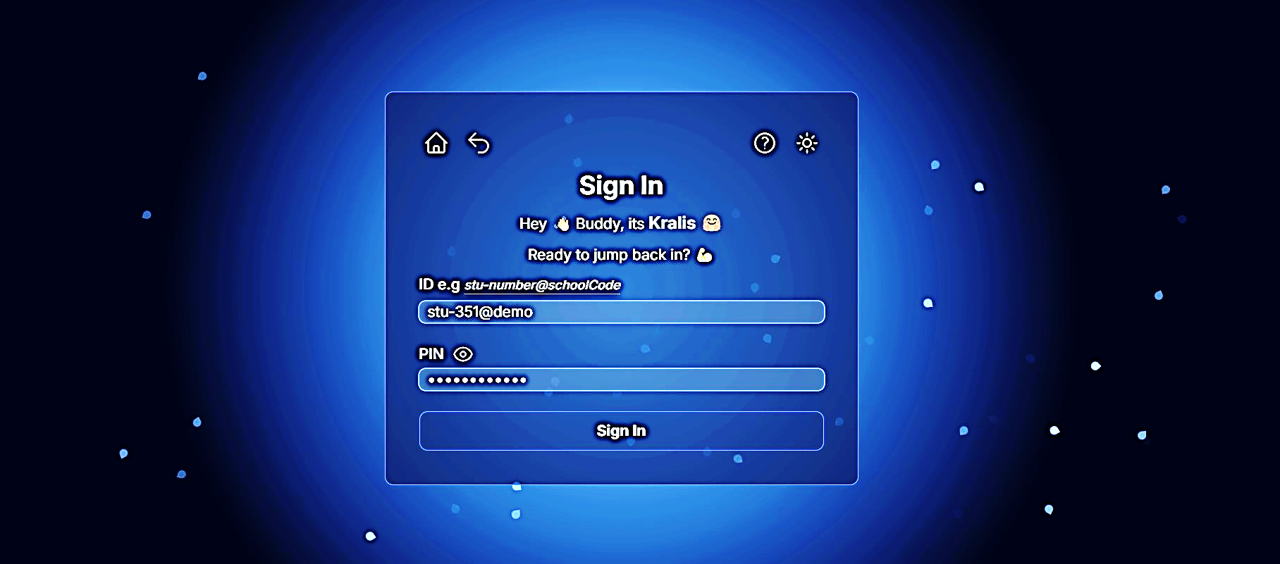
Figure 4.1: Dashboard Page: Overview of student performance and recent activities
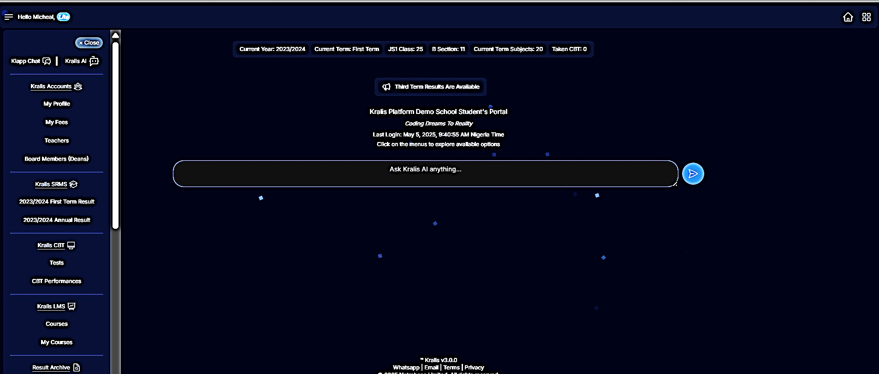
Figure 4.2: Student Result Sheet : Tabulated results with filter and sort options
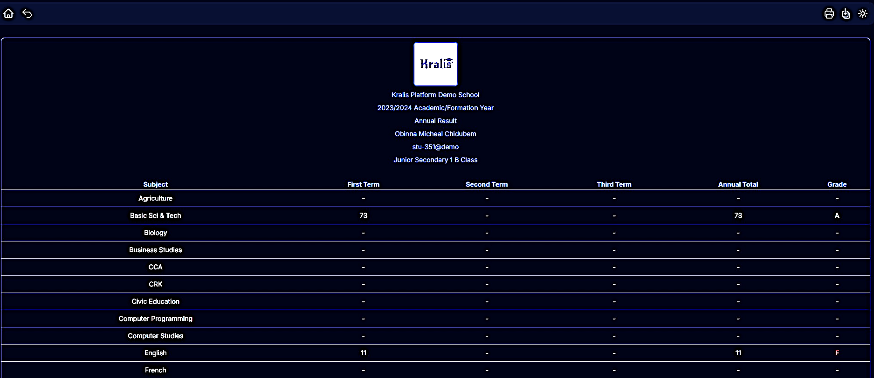
Figure 4.3: Student Entry Form: Input interface for entering new records
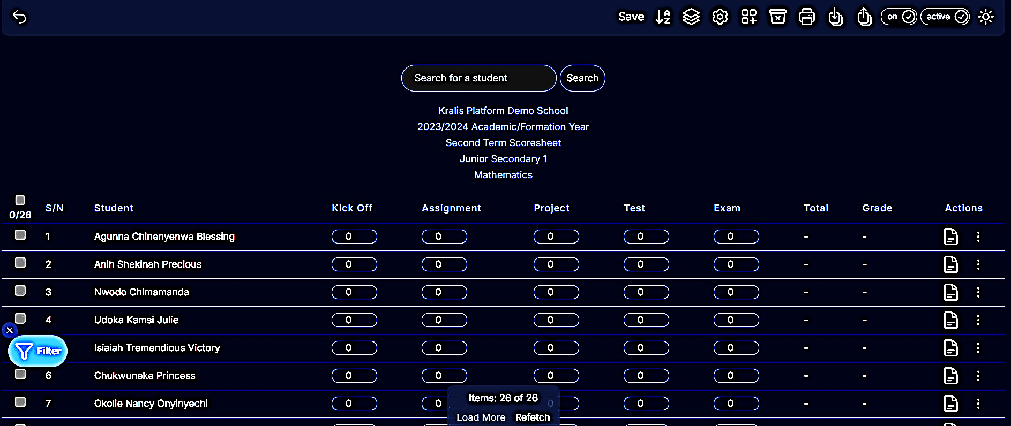
Component design followed the DRY principle and was optimized for mobile and desktop responsiveness.

4.3.3 Integration of Frontend and Backend Components
Integration was achieved through RESTful APIs hosted locally and later deployed to cloud environments. Axios was used to handle asynchronous HTTP requests from the frontend to the backend. CORS (Cross-Origin Resource Sharing) was configured on the Flask server to allow communication with the Next.js frontend. The data flow involved:
- Frontend sends form data to backend
- Backend validates and stores the data in the database
- Frontend fetches processed results and renders them dynamically
Error messages and API responses were structured in JSON format for consistency.

KRALIS API Documentation
Endpoint | Method | Description | Request Parameters | Response  Format | Auth Required
/api/login | POST | Authenticates  user and  returns JWT  token | { "username":  "admin",  "password":  "1234" } | { "token": "..." } | No
/api/students | GET | Fetches all  student records | — | [ { "id": 1,  "name": "John"}  ] | Yes
/api/students/:id | GET | Fetches a  specific student by ID | — | { "id": 1,  "name": "John" } | Yes
/api/students | POST | Creates a new student entry | { "name":  "John Doe",  "class": "SS2", "dob":  "2006-04-12"  } | { "message":  "Created" } | Yes
/api/students/:id | PUT | Updates an  existing student | { "name":  "Jane Doe",  "class": "SS3"  } | { "message":  "Updated" } | Yes
/api/students/:id | DELETE | Deletes a  student by ID | — | { "message":  "Deleted" } | Yes
/api/scores | POST | Submits scores for a student | { "student_id": 1, "subject":  "Math",  "score": 85 } | { "message":  "Score saved" } | Yes
/api/scores/student/:id | GET | Retrieves all scores for a student | — | [ { "subject":  "Math", "score":  85 } ] | Yes
/api/results/generate | POST | Generates results based on submitted scores | { "student_id":  1 } | { "grade": "A",  "average": 78.5 } | Yes
/api/reports/download | GET | Downloads student report in PDF format | ?student_id=1 | PDF File  (application/pdf) | Yes
4.4 User Interface of Kralis
The user interface (UI) was designed with simplicity and user-friendliness in mind. Tailwind CSS was utilized to ensure fast prototyping and responsiveness across all devices. Important design considerations included:
- Consistent Layout: Navigation bar, content panels, and action buttons aligned using CSS grids
- Accessibility: Form inputs and buttons are labeled and responsive
- Feedback Mechanism: Success or error messages are displayed after actions (e.g., record saved)
4.4.1 Unit Testing
Unit tests were written for both frontend and backend components to ensure each function or component behaves as expected. Testing frameworks used include:
- Backend: unittest and pytest for functions and API endpoints
- Frontend: Jest and React Testing Library for components
Sample unit tests included:
- Score calculation accuracy
- Input validation
- Authentication logic

4.4.2 Integration Testing
Integration testing ensured that the various modules worked together correctly. Test cases simulated user workflows, such as:
- Logging in and submitting a result
- Fetching student reports
- Generating a summary of performance
Postman and Cypress were used for API and E2E testing respectively.

4.4.3 System Testing and User Acceptance Testing
System testing was conducted after deployment on a staging environment. This involved testing the entire system workflow across multiple browsers and devices. User acceptance testing (UAT) involved sample users including teachers and admin staff, who provided feedback on usability, clarity of reports, and ease of navigation.
Feedback from UAT led to minor UI enhancements and clearer labeling of input fields.

4.5 System Deployment and Demonstration
After testing, the system was deployed on a cloud platform for demonstration purposes. The backend (Flask app) was hosted on Render.com while the frontend (Next.js app) was deployed using Vercel.
- Domain: A custom domain (Kralis.app) was linked via Vercel for frontend access.
- Database: PostgreSQL was used in production to replace the development SQLite.
- Demo Access: Admin credentials were shared with stakeholders for demo testing.
- Monitoring: Logs and uptime were monitored using LogRocket

CHAPTER FIVE
SUMMARY, CONCLUSION, AND RECOMMENDATIONS

5.1 Introduction
This chapter provides a comprehensive overview of the entire study, encapsulating the key findings, contributions, limitations, and potential areas for future development. It underscores the significance of implementing an automated result processing and reporting system in secondary education using contemporary technologies such as Python and Next.js. The system, named kralis, has proven to be an innovative solution to various administrative challenges faced in traditional result management practices.

5.2 Summary of Findings
The primary objective of this study was to develop and implement an automated result processing and reporting system tailored for secondary education institutions. Throughout the course of the research and implementation phases, the following findings were established:
- The traditional method of result processing is prone to human errors, is time-consuming, and often lacks accuracy.
- Automation significantly reduces manual workload and increases efficiency in data handling, especially in score computation, grade assignment, and report generation.
- The integration of Python (for backend operations) and Next.js (for the frontend) offered a robust, secure, and responsive web application.
- The system supports seamless data collection, real-time processing, report card generation, and secure data storage.
- Users (administrators, teachers, and students) reported increased satisfaction and usability due to the system’s intuitive interface.
- Testing results demonstrated a significant improvement in data processing speed, reliability, and accuracy.

5.3 Contributions of the Study
This project makes several notable contributions to both academic research and practical applications in educational administration:
- Technological Advancement: By using modern frameworks (Python and Next.js), the system serves as a prototype for future digital solutions in education.
- Operational Efficiency: The study demonstrates how automation can streamline routine tasks, thereby reducing administrative burden and improving result processing workflows.
- Educational Management Support: kralis provides valuable data insights for academic decision-making, promoting data-driven educational strategies.
- User-Centered Design: With a strong focus on user experience, the system offers accessibility, adaptability, and performance that accommodate institutional needs.
- Capacity Building: The system can serve as a learning tool for students and educators to explore the integration of software development and academic administration.

5.4 Limitations of the Study
While the study yielded meaningful outcomes, certain limitations were identified that could be addressed in future developments:
- Scope of Implementation: The system was implemented and tested in a simulated environment or limited pilot phase rather than being fully integrated into a live school environment.
- Scalability Constraints: Although the system performed well with sample data, full-scale deployment may require advanced optimization to manage increased user loads and data volumes.
- Security Features: The current version of kralis implements basic authentication but lacks advanced security protocols like end-to-end encryption, multi-factor authentication, or full audit trails.
- Offline Access: The system requires a stable internet connection and currently lacks offline capabilities for use in low-connectivity regions.
- Data Interoperability: Integration with existing school databases and other third-party educational tools has not yet been implemented.

5.5 Recommendations for Future Improvements
To build upon the current implementation, several enhancements and extensions are recommended:
- Scalability Enhancements: Upgrade the backend architecture using cloud platforms (e.g., AWS, Google Cloud) for efficient load balancing and data management.
- Enhanced Security Measures: Integrate SSL encryption, OAuth2 authentication, and real-time logging to improve data privacy and protection.
- Mobile Compatibility: Develop a mobile version of the application using frameworks like React Native to increase accessibility.
- Offline Mode: Implement local caching and synchronization techniques to allow offline data entry and later sync with the server.
- User Training: Provide adequate training and support to end-users to improve adoption rates and reduce technical barriers.
- AI Integration: Future versions can incorporate AI to predict student performance trends and suggest intervention strategies.

5.6 Conclusion
The development and implementation of kralis an automated result processing and reporting system highlight the transformative potential of modern technologies in secondary education administration. Through the integration of Python and Next.js, the system efficiently automates various tasks involved in result management, reducing errors and enhancing productivity. While there are certain limitations to its current version, the system provides a strong foundation for future enhancements. Ultimately, this study contributes significantly to the digital transformation of academic processes, paving the way for smarter, more efficient educational systems.

REFERENCES
Afolabi, Emmanuel O. n.d. And Obi. (2018) The Battle of Identity. Bookswagon; Barnes & Noble.
Anido, L., Fernández, M. J., Caeiro, M., Santos, J. M., & Rodríguez, J. (2017). Web-based educational platforms.
Anderson, J. R. (2018). Cognitive Psychology and its Implications. Worth Publishers.
Burnett, K. (2021). Building APIs with Python. O’Reilly Media.
Fowler, M. (2019). Patterns of Enterprise Application Architecture. Addison-Wesley.
Next.js Documentation (2024). Retrieved from https://nextjs.org/docs
Okonkwo, C., & Eze, M. (2024). Voices of the Igbo: Perspectives on tradition and change. Lagos, Nigeria: Heritage Press. ISBN 978-1234567890.
Python Software Foundation (2024). Python 3.x Documentation. https://docs.python.org
McKinney, W. (2010). Data Analysis with Python. O'Reilly Media. (on using Pandas for data manipulation)
Van der Walt, S., Colbert, S. C., & Varoquaux, G. (2011). The NumPy array: A structure for efficient numerical computation. Computing in Science & Engineering, 13(2), 22-30. (on using NumPy for mathematical operations)
Peterson, J., & Lang, M. (2021). Principles of modern computing. New York, NY: TechPress.
Python Software Foundation. (2023). Python Documentation. Python.org. Retrieved from https://docs.python.org/ (official documentation for Python language)
Vercel, Inc. (2020). Next.js: The React Framework for Production. Next.js Documeved from https://reactjs.org/ (for React, which is used in Next.js for building UIs)
official Next.js documentation. Retrieved from https://nextjs.org/docs (official Next.js documentation)
Facebook, Inc. (2021). React - A JavaScript library for building user interfaces. Retrieved from https://reactjs.org/ (for React, which is used in Next.js for building UIs)

