PREDICTIVE EVALUATION OF HUMAN DISEASE USING LEARNING APPROACH (A CASE STUDY OF CHRONIC KIDNEY DISEASE)

BY

ONOH NNAMDI VICTOR

U18/NAS/CSC/286

A PROJECT SUBMITTED TO DEPARTMENT OF COMPUTER SCIENCE AND MATHEMATICS, FACULTY OF NATURAL SCIENCE AND ENVIRONMENTAL STUDIES
GODFREY OKOYE UNIVERSITY ENUGU STATE, NIGERIA

IN PARTIAL FULFILLMENT OF THE REQUIREMENTS FOR THE AWARD OF THE BACHELOR OF SCIENCE DEGREE (B.Sc.) IN COMPUTER SCIENCE

SUPERVISOR: DR. AMAKU AMAKU

JULY, 2023

APPROVAL
This is to certify that this research work “PREDICTIVE EVALUATION OF HUMAN DISEASE USING LEARNING APPROACH (A CASE STUDY OF CHRONIC KIDNEY DISEASE) carried out by ONOH NNAMDI VICTOR with the registration number U18/NAS/CSC/286 in partial fulfillment of the requirement for the award of Bachelor’s Science (B.Sc.) in Computer Science, Faculty of Natural Sciences and Environmental Studies, Godfrey Okoye University, Enugu Nigeria.

Dr. Amaku Amaku --------------------- -----------------------
(Supervisor) Signature Date

Dr. Agbogun ------------------------ -------------------------
HOD of Computer Science Signature Date

Prof. Chidi Uhuegbu --------------------------- -----------------------
Dean of FNSES Signature Date

(External Examiner) ------------------------ -------------------------
Signature Date

CERTIFICATION
This is certify that this research titled PREDICTIVE EVALUATION OF HUMAN DISEASE USING LEARNING APPROACH (A CASE STUDY OF CHRONIC KIDNEY DISEASE) was carried out by ONOH NNAMDI VICTOR with the registration number of U18/NAS/CSC/286 under the supervision in the department of COMPUTER SCIENCE AND MATHEMATICS, Godfrey Okoye University, Enugu Nigeria.

ONOH NNAMDI VICTOR ------------------------- -----------------------
(Student) Signature Date

DEDICATION
This project is dedicated to God Almighty, my maker for granting me the opportunity to write it and for providing me with good health.

ACKNOWLEDGEMENTS

I would love to thank God Almighty who gave me the strength, wisdom and knowledge throughout this research.
I will not forget my supervisor Dr, Amaku Amaku for his support and encouragement you are a wonderful mentor and my HOD Dr. J.B. Agbogun I appreciate your care. My sincere gratitude goes to all academic and non- academic staff in my department, for their fruitful contribution in one way or the other towards the success of this project work.
I would like to appreciate the efforts of my lecturers for their fruitful contribution towards the success of this project work. I sincerely thank them all for the volume of knowledge they have impacted in me.
Any attempt at any level can't be satisfactorily completed without the support and guidance of my dear family and siblings who in one way or the other contributed to the completion of this work. I also wish to give my sincere thanks to my loving parents Mr and Mrs. Onoh whose constant love and support made this work successful.

ABSTRACT

This research project is to predict a kidney disease using machine learning approach. The discovery of knowledge from medical datasets is important in order to make effective medical diagnosis. In addition, predicting the disease early enables early treatment of patients before it becomes critical. There are increase in rise of this ailment and people are becoming victims on daily basis. Machine learning plays an important role in this research related work to detect this ailment. The study methodology used in this study is predictive modeling with Knowledge Discovery in Databases (KDD). Gaining insight from data is a broad process referred to as "knowledge discovery in databases," and it is extremely beneficial in data mining approaches. The ultimate purpose of the method is to extract information from large amounts of data. This is made possible through the use of algorithms and data mining techniques to extract what is considered knowledge. An accuracy s score o of 94% is obtained in this project work showing that with the variables that were used for the training of this work, there is high chances of the patients having kidney related disease.

TABLE OF CONTENTS

Title Page i
Approval Page ii
Certification iii
Dedication iv
Acknowledgement v
Abstract vi
Table of Contents vii
List of Figures ix
CHAPTER ONE: INTRODUCTION 1
  - Background of the Study 1
1.2 Statement of the Problem 3
1.3 Aim and Objectives of the Study 3
1.4 Objective of the Study 4
1.5 Significance of the Study 4
1.6 Scope of the Study 4
1.7 Limitation of the Study 5

CHAPTER TWO: LITETRATURE REVIEW 6
2.1 Review of related work 6

CHAPTER THREE: METHODS AND SYSTEMS ANALYSIS 11
3.1 System Analysis 11
3.2 Review of the existing System 11
3.2.1 Problems of the Existing System 12
3.3 Review of the Proposed System 13

3.4 Proposed System Analysis 13
3.5 Methods Of Data Collection 14
3.5.1 Objective 15
3.6 Database Design 17
Data Preparation

CHAPTER FOUR: SYSTEM IMPLEMENTATION AND EVALUATION 21
4.1 Program Development 21
4.2 System Requirement 21
4.2.1 Software Requirement 21
4.2.2 Hardware Requirement 22
4.3 System Interface 23
4.3.1 Input Interface 23
4.3.2 Output Interface 26
4.4 System Performance 26
4.5 System Training 27
4.6 Conversion To The Proposed System 27
4.7 System Documentation 27
CHAPTER FIVE:
SUMMARY, CONCLUSION AND RECOMMENDATIONS 28
5.1 Summary 28
5.2 Conclusion 28
5.3 Recommendations 29
References 30
Appendix 31

LIST OF FIGURES

Fig.3.5.1: System Flow Chart Algorithm 15
Fig. 3.5.2: Diagram system model implementation 16
Fig. 3.5.3: Diagram system model implementation 20
Fig, 4.1: Dataset Importation using pandas 24
Fig 4.2 Data pre-processing View in Jupiter Note book of Python 25
Fig 4.3 Classifier (random forest) applied on the dataset in
Jupiter Notebook of Python 25
Fig. 4.4: Accuracy score result output 26

CHAPTER ONE
INTRODUCTION
  - Background of the Study
To double check the condition, the doctor usually performs a physical exam and reviews the patient's medical history. Then run tests and diagnostic procedures to determine the true cause of the symptoms. Chronic kidney disease (CKD) is the leading cause of kidney failure and the leading cause of death, with an increasing incidence and 1.9 million deaths each year. Various diagnostic methods are available. In this study, we test high recognition accuracy using machine learning methods. Chronic kidney disease (CKD) is a global public health problem health problem with variable epidemic risk, seriously affecting the quality of life of patients (Gerodianni, 2019). It is a progressive and irreversible decline in kidney function that completely deprives the body of its ability to maintain metabolic, water and electrolyte balance, resulting in urotoxicity or uraemia (retention of urea in the blood). Blood and other nitrogenous waste (Lung et al, 2018). The kidneys regulate blood composition and volume, remove waste products from urine, and help regulate acidbase balance in the body. It often progresses with impaired renal function (defined as estimated glomerular filtration rate (eGFR) < 60 mL/min /1.73 m2) and/or signs of renal damage, including persistent albuminuria (urine > 30 mg and definition). Albumin per gram of urine creatinine. The early stages are mostly asymptomatic (Levy & Mitchel, 2019). It is not an isolated disease, but is defined by the presence of kidney damage and the degree of renal but is defined by the presence or absence of kidney damage and the degree of renal dysfunction, independent of the type of kidney disease. The score is based on the level of kidney function based on GFR on a scale of 1 to 5, with higher numbers indicating more advanced disease. Structural evidence of kidney damage has also been included in this classification system by the National Kidney Foundation's Dialysis Outcome and Quality Initiative (K/DOQI) (Palhushanetal, 2019). There are many causes, but the damage is often irreversible and can lead to health problems. The main risk factors for chronic kidney disease are diabetes mellitus, hypertension, anemia, osteodystrophy, glomerulonephritis, malnutrition and polycystic kidney disease (Jha, 2019). Risk factors can be identified individually. In some cases, dialysis or a transplant may be needed.
Chronic Kidney Disease (CKD) is currently the leading cause of death with a rapidly increasing incidence, causing 1.7 million deaths each year. There are different diagnostic methods, but this study used a very precise machine learning technology. Today, chronic kidney disease (CKD) is a rapidly growing disease that is claiming millions of lives due to the lack of timely and affordable treatment. Patients with chronic kidney disease live in low- and middle-income countries (jha, 2019). In 2013, about 1 million people died from chronic kidney disease. Chronic kidney disease is prevalent in developing countries, causing a total of 387.5 million chronic kidney disease patients in low- and middle income countries, Jug. An average of 177.4 million men and 210.1 million women (Prothomalo, 2008).These figures show that a large number of people in developing countries suffer from chronic kidney disease and its prevalence is increasing every day. Great efforts have been made to detect chronic kidney disease early so that it can be treated quickly. Classification is a very important task of data mining. The purpose of a classifier is to provide a function or model of a classifier. A classification model can assign data from a database to a specific class. Classification generation methods include Decision Trees, Naive Bayes, ANN, KNN, Support Vector Machines, Approximation Theorems, Logistic Regression, Genetic Algorithms, and Clustering (Ramyaet al, 2019), work on this project will focus on predictive machine learning models for chronic kidney disease, with an emphasis on accuracy.
1.2 Statement of the Problem
Kidney disease is one of the most common ailment in developing countries. The most obvious reason is lack of physical activity. Doctors used a variety of diagnostic procedures and methods, including the latest development – machine learning. Machine learning algorithms allow you to extract objective and invisible patterns from real-world information, especially in the public health field. There is a need to develop models that can predict kidney disease, especially in its early stages, to prevent further infection.
1.3 Aim and Objectives of the study
The aim of this project is to use machine learning technique (random forest algorithm) to predict a kidney disease.
1.4 OBJECTIVE OF THE STUDY
The objectives of the study are:
(i) to develop interactive capacity between humans and machines using an artificial intelligence (AI) approach in medical Sciences.
(ii) to formulate a predictive model(random forest algorithm) based on the identified variables.
(iii) to predict a likely case of kidney disease using machine learning model
1.5 SIGNIFICANCE OF THE STUDY
The advantages and purposes of this study make its implementation necessary. This project's work will help doctors and other health-care professionals forecast kidney illness using factors that have been identified as being mostly related to the disease. This increases the likelihood that kidney illness will be discovered early, allowing for the administration of preventative measures to stop its complex progression.
1.6 SCOPE OF THE STUDY
The scope of this study covers design of a model to predict a kidney disease using the key identifiable variables in its prediction. This is achievable using machine learning technique with an algorithm known as random forest. However further research can be carried upon on using different algorithm for more array enhancement.

1.7 LIMITATION OF THE STUDY
This study is limited to the design of a model to predict a likely case of only kidney disease using machine learning technique. It focuses on the key identifiable variables in its prediction.
Definition of Terms
CKD - Chronic Kidney DiawAWA
REC - Random forest classification
GFR - GlaneralarFultration Role
ML - Machine Learning
GUL - Graphical Use Interface

CHAPTER TWO
LITETRATURE REVIEW
2.1 Review of related work
This research in the literature to diagnose or automatically detect chronic kidney disease (CKD), using machine learning approach but it is not entirely effective in helping healthcare professionals. In chronic kidney disease, the authors use predictive analytics models to predict progression and, at best, attempt to prevent disease. In 2010, a case study was published that predicted his CKD in a rural UK hospital (Aljaaf, 2019). Two conditions were considered in this study: (a) his CKD, moderate to severe; and (b) end-stage renal disease. Algorithms provide the basis for identifying high-risk patients who may benefit from more detailed evaluation, closer follow-up, or risk-reducing interventions. And in 2011, he said, Tangli used demographic, clinical and laboratory data to develop a predictive model. The most accurate models included age, sex, estimated glomerular filtration rate (GFR). In 2014, the use of data mining techniques to predict survival after dialysis was published (neto & kamariotou, 2019). This method uses three of his data mining methods: ANN, decision tree, and logistic regression, and uses the first of his three methods to achieve value accuracy. It was 93.852%, sensitivity 93.87%, specificity 93.87%. A definition and classification of chronic kidney disease was proposed by the National Kidney Foundation Kidney Disease Outcomes Quality Initiative (NKF- Prognosis can be determined based on clinical diagnosis, stage of disease, and other important factors associated with a particular outcome. KDIGO has now established a working group to develop global clinical practice guidelines for the definition, classification and prognosis of chronic kidney disease.
Kidneys play an important role in maintaining the body's blood pressure, acid-base balance, and electrolyte balance, and they do more than just filter toxins from the body. Malfunctions not only cause mild, fatal illnesses, but also lead to malfunctions of other organs in the body. Therefore, researchers around the world are working hard to find accurate methods to diagnose and effectively treat chronic kidney disease. As machine learning classifiers are increasingly used for diagnosis in the medical field, chronic kidney disease (CKD) is now included in the list of diseases that can be predicted by machine learning classifiers. Research using machine learning (ML) algorithms to detect chronic kidney disease (CKD) will incrementally improve the accuracy of procedures and results. The kidney is a very important organ for human health. Mainly responsible for distance and penetration power. Simply put, the kidneys and excretory system collect and remove all harmful and unwanted substances from the body. About one million people in India suffer from chronic kidney disease (CKD) each year. Kidney failure is another name for chronic kidney disease. It is a serious kidney disease in which kidney function gradually declines. CKD is a disease in which kidney function gradually declines over many years, people who suffer from kidney failure and are unable to regain their health. Mainly responsible for distance and penetration power. Simply put, the kidneys and excretory system collect and remove all harmful and unwanted substances from the body. About one million people in India suffer from chronic kidney disease (CKD) each year. Kidney failure is another name for chronic kidney disease. This is a dangerous kidney disease that causes a gradual loss of kidney function. CKD is a disease in which kidney function gradually declines over many years. He developed kidney failure, which is irreversible. Patients may experience the following symptoms: Chronic renal failure is common renal failure that occurs in people who have both kidneys damaged and who have chronic kidney disease for a long time. Kidney injury, as used herein, refers to kidney disease that can lead to kidney failure. This may be due to disruption or deficiency of essential substances, such as decreased glomerular filtration rate (GFR) (Pulmahetal, 2022). The prediction model we propose takes clinical symptoms as input and predicts outcomes using a stacked classifier with random forest algorithm as the base classifier. Machine learning is becoming increasingly important in medical diagnostics as it enables complex analysis, minimizes human error and improves prediction accuracy. Machine learning and classification algorithms are currently considered the most reliable techniques for diagnosing various diseases such as heart disease, diabetes, and tumors, as well as predicting liver disease (Rhaman et al, 2020). Various machine learning algorithms have used Naïve Bayes, SVM, and decision trees for classification purposes, and random forests, logistic regression, and linear regression have been used for prediction for regression purposes in health economics. Effective use of these algorithms minimizes mortality through early diagnosis and allows prompt treatment of patients. In addition to maintaining clinical symptoms, people with chronic kidney disease should incorporate physical activity into their daily routine. Exercise, drink water, and avoid junk food. This study provides a follow- Build and analyze the implementation and evaluation of machine learning classifiers used to diagnose IRC and lead to its downfall. Furthermore, this study discusses the importance of classifiers in machine learning in medicine and attempts to make more accurate predictions.
Gunarathne etal. (2019) compared the results of different models. In summary, we conclude that the multiclass decision forest algorithm offers higher accuracy than other algorithms, providing approximately 99% accuracy on the reduced data set of 14. Radha and Numnonda (2019) attempted to improve diagnosis time and accuracy by using different machine learning classifier algorithms. The proposed study is devoted to classifying the different stages of CRF by severity. By analyzing different algorithms like basic neural network, RBF, RF. The analysis results show that the RBF algorithm is superior to other classifiers with an accuracy of 85.3%.
Scarlet andThirumalaiselvi (2018) investigated missing values in a chronic kidney disease dataset. Missing values in the data set not only reduce the accuracy of the model, but also affect the prediction results. They found a solution to this problem by performing a recalculation at the CKD step and finding the unknown values. I replaced the missing values with the newly calculated values.
Asif and Stankovich (2019) used machine learning algorithms to identify IRCs in a new way. I get results for a dataset with 400 records and 25 attributes, with or without CKD. Get the results using K-Nearest Neighbors, Random Forests and Neural Networks. To reduce the number of functions, the encapsulation method is applied to detect CKD with high accuracy.
Pinar Yildirim (2018) studied the effects of class imbalance in training data using a neural network that developed algorithms for medical decisions for chronic kidney disease. This study shows that the performance of classification algorithms can be improved by using sampling algorithms. We also find that learning rate is an important parameter that has a strong impact on multilayer perception.
Sahiletal (2021) evaluated 12 different classification algorithms using a dataset of 400 records and 24 attributes. Calculate the accuracy of the prediction results by comparing the calculated results with the actual results. They used evaluation parameters such as accuracy, sensitivity, precision, and specificity. They found that the decision tree method gave an accuracy of up to 98.6% with a sensitivity, accuracy and specificity of 0.9720.

CHAPTER THREE
METHODS AND SYSTEMS ANALYSIS
3.1 System Analysis
System analysis is the study of the many functions of a system and their interactions. The focus is on defining the problem, finding the key variables involved, evaluating and synthesizing multiple components, and choosing alternative or at least feasible solutions (Max,2013). During this phase, as issues are discovered and system fixes are further investigated, recommendations are made to allocate used resources to the system. System analysis is affected by how it is designedsystem. It guarantees that the system is constructed in accordance with a set of procedures that the developing team will adhere to for any particular project.
3.2 Review of the Existing System
The issue that emerges when multiple diseases have very similar symptoms to one another is one of the main challenges faced by doctors while diagnosing in medicine. The majority of doctors follow the practice of making general assumptions about a suspected condition first, then progressively adding or deleting details that will aid in an accurate diagnosis. A medical professional must therefore have a vast knowledge base and the special capacity to draw accurate conclusions from the material he has collected in order to make the best diagnosis or detect a kidney disease

3.2.1 Problems of the Existing System
The problems of the existing system are;
i. The degree of acquaintance between the patient and the doctor. It might not be difficult for a patient who is unfamiliar with the doctor to confide in him or her and give some information.
ii. How much background information the doctors possess. The background knowledge of a medical doctor goes long way to determine how effective he / she will be predict or diagnose a disease. For instance a doctor that has a vast knowledge of various diseases and vast knowledge of kidney disease will be in a better place to predict kidney disease . Thepatient state of mind will determine if he / she will reveal the correct information needed for the diagnosis or not.
In in view of the above mentioned indications, there is also a need to introduce a system that will assist medical personnel to predict or diagnosis a kidney disease after patients has been able to tell the system of signs and symptoms that relates to a particular ailment. Furthermore, an objective to ensure that human error in diagnosis or leading to a prediction of a particular disease are reduced such as error as patient’s insincerity which the computer would be able to take care of as the patient will be relating to his computer instead of the medical team .With this, the attitude of shyness, which comes into play when a male patient faces a female health worker, or vice versa, is reduced if not eliminated. The system will also reduce the problems of delay which the patient experience in any health institutions since the computer can diagnose a patient as quickly as possible.The use of this program design involves the specification of the data objects, outputs to be provided, input data to be captured, and storage formats system interface and finally specification of various data manipulation procedures, which should be implemented as codes.
3.3 Review of the Proposed System

The proposed system is a computerized system for predicting kidney disease which will tend to solve the problem of diagnosis relating to kidney disease. This will be made possible as the system is an interactive one; hence it is a patient – computer interactive system instead of the patient – doctor interaction when the system is consulted, it put forward some list of symptoms of all forms of signs indicating kidney disease from which the user is expected to select from. It carries out a diagnosis by going through its knowledge base where some pre – program signs and symptoms associated with some specific diseases are stored. The proposed system should have the following;
- The quick retrieval of the information as the computer can accomplish this task in a matter of seconds
- A large number of patients can be diagnosed within a few minutes thereby reducing time wastage.

3.4 PROPOSED SYSTEM ANALYSIS
The proposed system will have computer software that can solve the problem of the previous system. Highly recommended for future use and provides a high level of security as the data stored is genuine. The proposed system is intended to facilitate the renal disease prediction model. System development problems lie in the design of the system. It requires the in-depth knowledge and procedural details required for the logical and physical steps of the software development process. When developing a new system, the systems analyst should clearly understand the project objectives. The operational phases include the design, implementation, and testing phases of the program. System design can be defined as the process of applying different methods and principles to define a device, process or system in sufficient detail to allow for practical implementation (John, 2019). Therefore, system design is a decision about “how” to approach the creation of a new system. This step helps to understand and detail the process required to implement the system proposed in the feasibility study. The design phase includes data design, arehitectural design, and process design. The proposed system should be able to train the model on a reasonable number of historical data sets to update the model.
3.5 METHODS OF DATA COLLECTION
We conducted a thorough assessment of the current system to obtain sufficient information on the extent of change. Research also includes examining thefunctioal requirements of the existing system and determining whether its needs and goals are being met. The study used a variety of data collection methods, including interviews, observations, and review of historical records. This method gives the most favorable results because it is obtained by physical contact; Therefore, online research can also provide first-

hand information about various processes. These methods are applied to ensure the validity of the collected data and the appropriateness of the results after data processing.
3.5.1 OBJECTIVE OF MODEL DESIGN
An efficient method, represented as a finite list of well-defined instructions, is called an algorithm. Calculation, data processing and autoberformed, begins with an initial state and initial input, and proceeds through a finite number of well-defined consecutive steps to produce an “output” for until terminated by a final state. The defined state transition does not always occur; some algorithms, called stochastic algorithms, accept random input.
System Flow Chart Algorithm
MAIN MENU
STOP
Import dataset

Start
Analyze dataset

Fit model into data

Generate Result

Fig.3.5.1: System Flow Chart Algorithm

3.6 DATABASE DESIGN
A file is a grouping of connected data that is typically kept in auxiliary storage. This is a File’s overall format, with an emphasis on its constituent parts. Additionally, it describes show data is organized in files, which might be serial, sequential, indexed sequential or random files. Supervised learning method involves the collection of dataset followed by the application of the ensemble algorithm to predict possibility of kidney disease. The prediction is based on the historical data of kidney disease which constitute the dataset. The architectural design of the proposed system is given below;The system is implemented using random forest classifier as shown in the below.
Diagram system model implementation
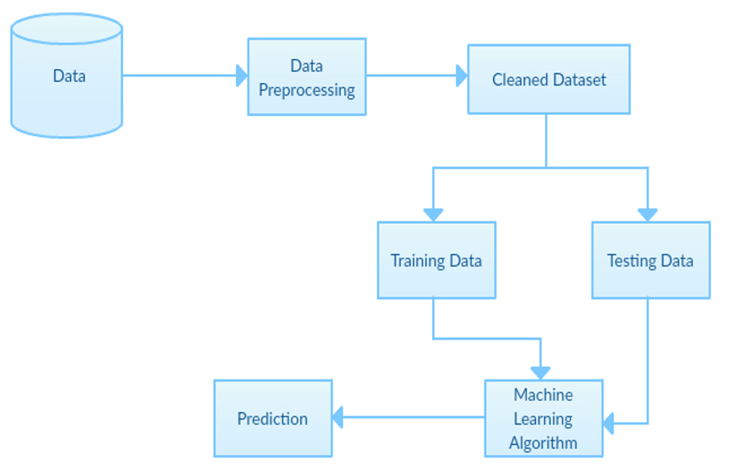
Fig. 3.5.2: Diagram system model implementation

From the architectural design shown above, dataset is required in the process. The dataset obtained is preprocessed using a supervised algorithm. The dataset is spitted into two namely training set and testing set. The training set is used to train a model from the algorithm applied while the testing set is used to predict the model developed.

- Methodology
The study methodology used in this study is predictive modeling with Knowledge Discovery in Databases (KDD). Gaining insight from data is a broad process referred to as "knowledge discovery in databases," and it is extremely beneficial in data mining approaches. The ultimate purpose of the method is to extract information from large amounts of data. This is made possible through the use of algorithms and data mining techniques to extract what is considered knowledge.

    - DataPreparation
The data is collected from different sources available online and through various medical researches done on kidney disease and are pre-processed by applying appropriate filters to make them suitable for the machine learning algorithm. In machine learning algorithm, various machine learning algorithms based on the type of data collected can be used. It can be either supervised learning method or semi supervised learning method. In this project work, supervised learning method is used which is popularly known as Random forest classifier The following is the dataset used in the project. The dataset contains 399 instances (399 rows) and 25 attributes (columns). It contains 24 features variables and 1 target variable. The aim of this supervised learning method is to collect dataset and then apply machine learning algorithm in which an ensemble model is used in this case to predict possibility of kidney disease which involve the following;
The entire process of knowledge discovery involves the following steps:
- Developing an understanding of the application domain: The application domain of this project is model prediction of biotin price
- Creating a target data set: After proper understanding of the domain had been carried out, relevant dataset is collected which is used in the prediction
- Data Cleaning: This step is carried out in order to identify the target variable and the useful feature variables to represent the data depending on the goal of the task.
- Stating the data mining task: The goal of this process is predictive modeling.
- Choosing the data mining algorithm: The algorithm considered is ensemble model(Random Forest classifier)
- Interpreting knowledge discovered.
A supervised machine learning technique was utilized to create the predictive model, and Python was used to implement the predictive model. Python is used in conjunction with the proper libraries and programming language packages to calculate the algorithm's prediction accuracy score. The supervised machine learning algorithm used in this project work is an ensemble algorithm known as Random forest. It creates a set of decision trees from randomly selected subset of training set. It then aggregates the votes from different decision trees to decide the final class of the test object. It can efficiently handle large databases, handles thousands of input variables without variable deletion and gives an estimate of which variables are important in the classification process. This supervised learning method involves the collection of dataset followed by the application of the ensemble algorithm to predict kidney disease. The prediction is based on the historical data of kidney disease. Data preparation is an important phase in the data mining process. The obtained data may contain several out-of-range values, impossible data connections, and multiple missing values.Thus, prior to any analysis, data is preprocessed, and the output of this stage provides a final training set that can be used in machine learning algorithms.

Diagram system model implementation

Fig. 3.5.3: Diagram system model implementation

CHAPTER FOUR
SYSTEM IMPLEMENTATION AND EVALUATION
4.1 PROGRAM DEVELOPMENT
System design is the process of defining a device, a process, or a system in sufficient detail to allow for its physical embodiment. It involves a variety of approaches and ideas. System design provides a "how to" guide for creating new systems as a result. This critical phase provides the information and procedural details necessary for implementing the system indicated in the feasibility study. The design process offers a data design, an architectural design, and a procedural design. This has to do with the actual installation and use of the new system.
4.2 SYSTEM REQUIREMENT
System requirements are the system's physical and non-physical parts. They can be roughly divided into hardware requirements and software requirements.
4.2.1 Software Requirement
The new system requires a number of multi-user operating systems or a suitable networked single user operating system, for instance (thin client), to support, regulate, and oversee the operations of the hardware. Software is the fundamental software that makes it possible for physical components to function properly and offer a wide range of helpful functions.
The suggested system's software needs are as follows:
- Operating system Windows 8, Windows 10 e.t.c.)
- Python Programming Language
- Python(jupyter notebook)
- Prepared dataset
To achieve the intended outcomes or goals, the system should have this software installed. The proposed system's functional requirements depend on the dataset, methodology, and programming language. The random forest technique is used in this study's perdition procedure, which makes use of an adequate dataset with pertinent and appropriate data. Python is the programming language used in this research project. The two modules for dataset manipulation and prediction make up the architectural design of Python when utilized with the necessary libraries and packages. In the Dataset Manipulation module, the dataset is subjected to feature engineering, and after that, predictive modeling is utilized to determine an accuracy score. After dividing the dataset into two half, the model was trained. he remaining 20% of the data were split into a training set and a testing set, respectively. The findings of the study revealed the variables that the algorithm took into account when predicting kidney disease. The suggested system's outputs give a report after processing the identified variable in the prediction operations.
4.2.2 Hardware Requirement
The user requirement, also referred to as the hardware, refers to the tangible parts of a computer that can be seen or handled and that enable successful and efficient use of its application. The necessary hardware to design this project is;
i. CPU (Central Processing Unit).
ii. Random Access Memory (RAM)- at least, 2GB Memory capacity
iii. Hard Disk-at least 90GB of storage spac
vi. Uninterruptible Power Supply (UPS) -1000Volt Amp

4.3 SYSTEM INTERFACE
A user can utilize a package with little to no computer knowledge because to the system interface, which describes how computers can process and retrieve records. What and how the new system does its work depend on the level of system development. The following are the components of the system design.
1. Input Interface
2. Output Interface
4.3.1 Input Interface
User-generated inputs are transformed into a computer-based system format in the input design. Choosing the record medium, input method, capture speed, and screen entry are further considerations. The design of the menu and prompts is the main input strategy. Each choice has predetermined possibilities for the user. Logical data flow, data stores, source, and destination are all shown in the data flow diagram. Once specified input media are chosen for processing, input data are gathered and grouped with related data. The development of the Graphical User Interface (GUI), a crucial component in creating effective and user-friendly software, is prioritized in this program. For inputting user data, attractive forms are designed. The user can also choose their preferred selections from the menu, which offers all available features. Additionally, the crucial input format is created to prevent unintentional mistakes. Only the bare minimum of information is requested from the user, which also helps to reduce the possibility of user error. When creating effective software, accurate input format design is crucial. Input design aims to make entry as simple, logical, and error-free as possible. The design of data gathering includes numerous ways to process the data that is entered into them in the future. In order to collect data from the user and then store it in the system database, the input forms were created in a methodical way. As a result, the input database is created to satisfy the system's requirements. The dataset to be examined is imported as one of the system's inputs. The input interface in this project is shown below
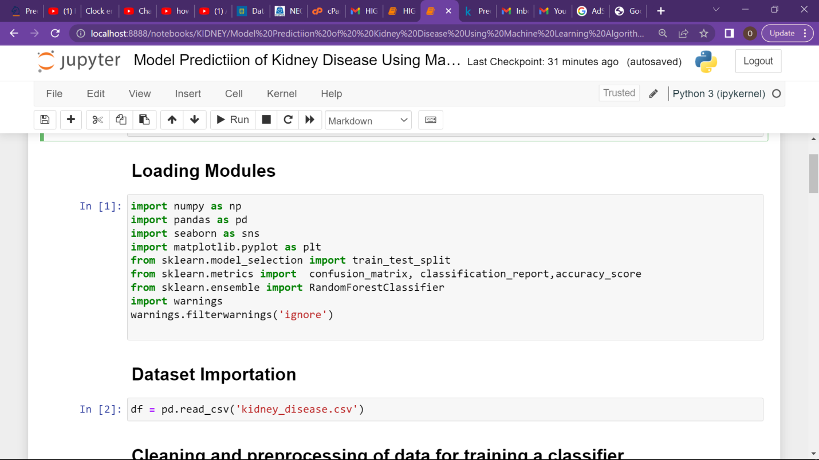
Figure 4.1 Dataset Importation using pandas

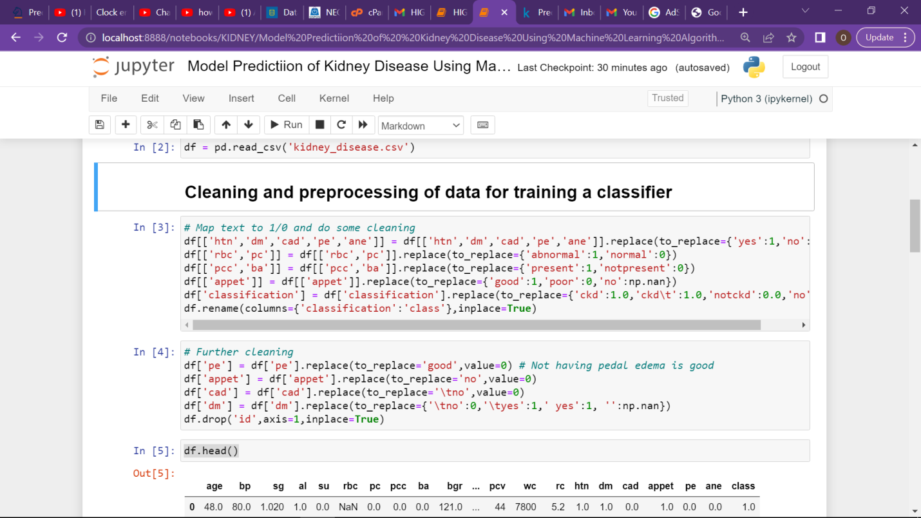
Fig 4.2 Data pre-processing View in Jupiter Note book of Python

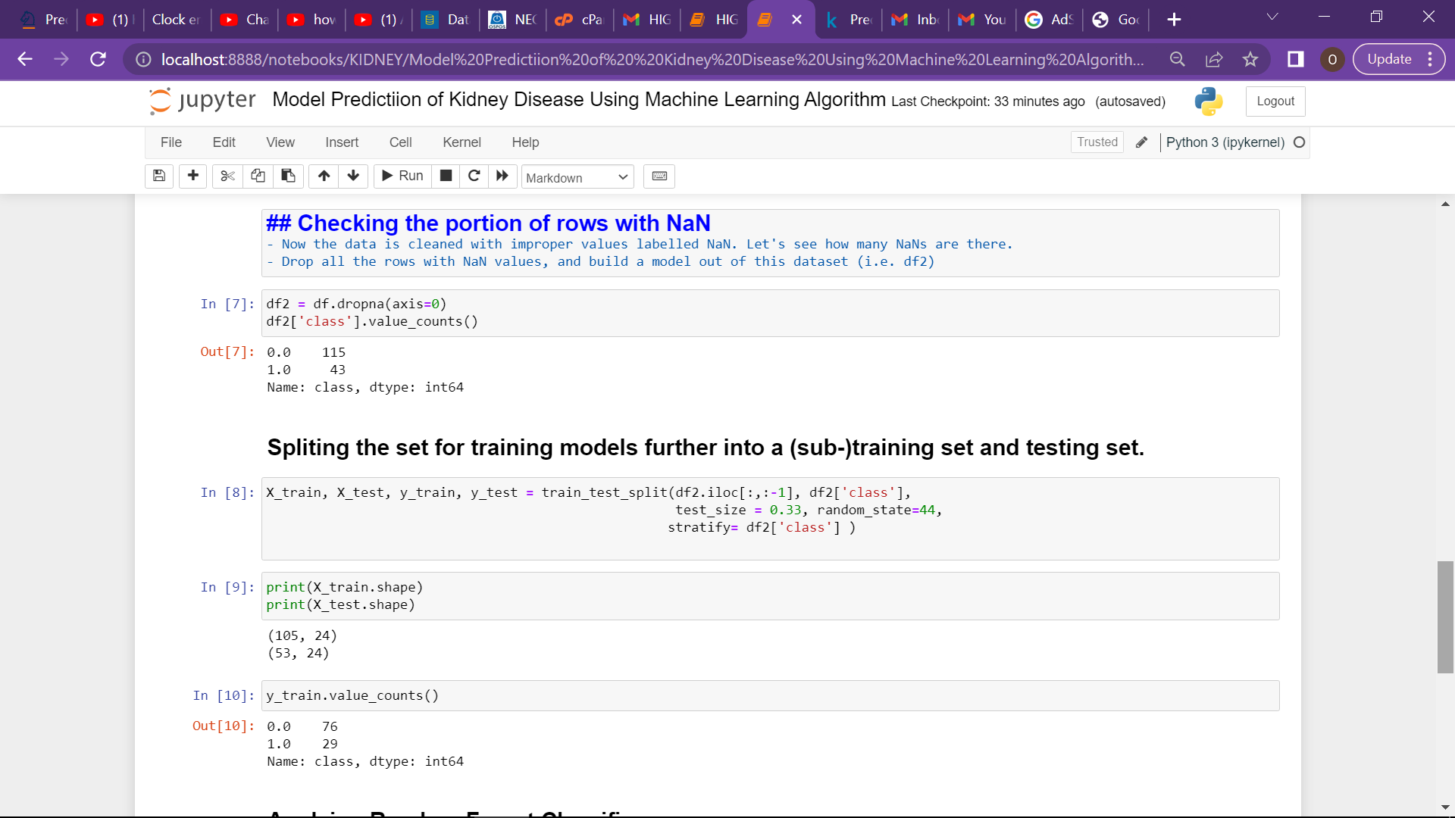
Fig 4.3 Classifier (random forest) applied on the dataset in Jupiter Notebook of Python

4.3.2 OUTPUT INTERFACE
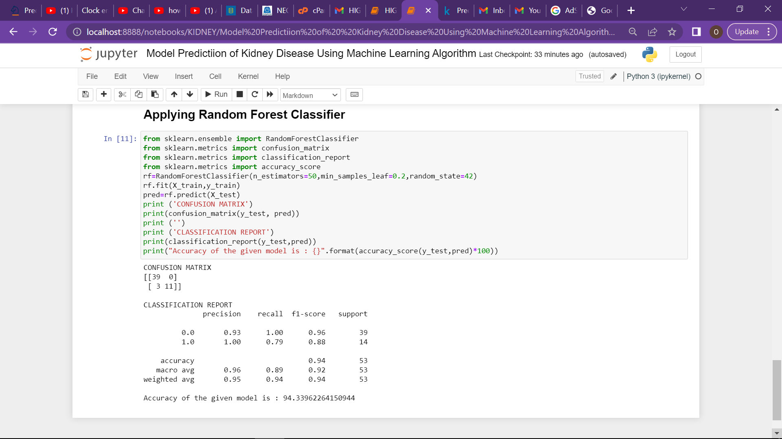
4.4 Accuracy score result output
An accuracy s score o of 94% is obtained in this project work

4.4 SYSTEM PERFORMANCE
The newly suggested system is put into action at this stage. It involves program testing and documentation. The use of a good implementation will be made since it produces the best results because the manual and the computerized systems will be employed together. It is strongly advised to refrain from opening too many application programs on the computer, as this may cause the computer to run slowly and result in inadequate time limitations for the applicants. This is necessary for the system to operate efficiently throughout the time limit.

4.5 SYSTEM TRAINING
The user will go through extensive instruction on how to utilize the computer system and the fundamental procedures for installing and using designed applications.
4.6 CONVERSION TO THE PROPOSED SYSTEM
The type of changeover and level of risk to the company will determine which changeover approach will be most effective for that company. This project effort suggests a comparable changeover. For a predetermined amount of time, the new system and the old system coexist during a parallel switch. This method is typically the most widely used because it poses the least risk of all the methods. The entire system can be returned to its initial condition if something goes wrong at any time. Higher costs are the main drawback of running two systems simultaneously. The parallel switch procedure alone can take a long time.
4.7 SYSTEM DOCUMENTATION
Because it is a systematic collection of all the data needed for a certain project, documentation is the key to developing the system. It is essential and must be stressed since it leads to thorough, durable, and legal record keeping.

CHAPTER FIVE
SUMMARY, CONCLUSION AND RECOMMENDATIONS
5.1SUMMARY
The random forest classifier, which can be further developed to include different other classifiers, is used in the current suggested model of kidney disease prediction. Depending on the type of dataset that is available, a particular classifier will be utilized. The datasets that are readily available online or from other sources are often for a group of communities, but more datasets of individuals with their specific locations and symptoms are required to obtain better forecasts of individuals. The model's ability to forecast the likelihood of a kidney disease will improve with the availability of more datasets. The suggested approach can be utilized to forecast other connected medical problems.
5.2 Conclusion
Most of the present kidney disease using a person's medical history as a starting point, prediction models estimate the likelihood of a kidney disease. In the public health field, there are particular and pressing issues with identifying people as well as determining their true medical histories. Machine learning technologies can assist in achieving this objective. The proposed kidney disease prediction model utilizes identified medical history factors that are included in the dataset to train the classifiers for the improved predictions to forecast the likelihood that an individual will have kidney disease 3990 5679 200

5.3 RECOMMENDATIONS
- The model can also be included into the prenatal care system at private or public hospitals, enhancing the nation's educational system for the early identification of kidney disease.
- It is recommended that further study be done on other relevant factors that have been discovered as possibly contributing to kidney disease. This will improve the advice that medical professionals give to patient in order to prevent further stage of kidney disease spread.

REFERENCES

Asif P. &Stankovich A., (2019).Prediction model in medical science Neural networks. A Survey Analysis: International Journal of Advanced Technology and Engineering Exploration. 7. (Page 425).

Aljaaf H. (2019). A Machine Learning Technique to Determine the Impact Health Sciences. 13th International Conference on Computational sciences (pp. 7- 10). IEEE.

Gerodiana C., (2019). Proceeding with Caution-A Survey on kidney diseases pandemics.

Gumarathene C., Jane P., Van, D., Stanley, G.K. &Zex, P (2019)."C2P2: A survey of medical Prediction Analysis,".IEEE International ), Atlanta, GA, USA, (pp.425-430), doi: 10.1109/

Jha A., Luzx, H, Nandler, C., Saty, U., Baron, B. (2019). "Evolutionary dynamics of in kidney diseases outrage", Society and sciences and Education, vol. 4, no. 11, (pp. 170623)

Lung I., Kris, D., &Kamaniotou, K. (2019). Real Transformation and User Acceptance of Information Technology in the medical Sciences, Proceedings of the 8th International Symposium & 35th National Conference on Operational Research, Paris.

Levy, A. I., & Mitchell, Y. L. (2019).Machine learning: Trends, perspectives, and prospects, Science, vol. 349, no. 6245, pp. 255-260.

Nato Y., Kritsios, H., &Kamarionitou, M. (2019). Transformation and User informatics in the Healthcare Sector, Proceedings of the 8th International Symposium & 30th National Conference on Operational Research, Patras, Greece, (pp. 6-10)

Palhushan, H., Rochlle J., &Catmon, S. (2019). Predicting kidney diseases using machine learning, 26th Medical biology International Conference on Parallel Distributed.

Pulmah, J. L., Najik, M., Bahmouya, N. and Esanaidi, M.(2022). “Multivariate deep l earning approach for health sciences forecasting,” Big Data Mining and Analytics, vol. 4, no. 1, (pp. 56–64), 2022.
Ramya, P., Bonnedu, K., Ferltan, E., Miler, J., Goldfender, S. (2019). Kidney Diagnosis in medical Sciences: A Comprehensive Introduction. Princeton University Press, Princeton

Rhaman E., Livienris I.E., Stavronyiannis S., Kotsilireris T., Pintenlas P. (2020). Investigating the Problem of Kidney Diseases: A Deep Learning Approach. In: Maglogiannis I., Iliadis L., Pimenidis E. (eds) Artificial Intelligence Applications and Innovations. AIAI 2020. IFIP Advances in Information and Communication Technology, vol 584. Springer, Cham.https://doi.org/10.1007/978-3-030-49186- 4_9 8
.
Rhada, T, &Numnonda, T. (2019). Machine learning techniques comparison for Kidney Disease prediction.. In 2018 10th International Conference on Information Technology and Electrical Engineering (ICITEE) (pp. 506-511). IEEE
.
Searrlet, E. and Thirumallaisehi, L. (2018). Chronic Kidney Disease prediction using ensembles of neural networks, 13th International Conference on Natural Computation Fuzzy Systems and Knowledge Discovery (ICNCFSKD), (pp. 666-671), Network- based Processing (PDP)

Sahil, S.; Patell, N.P.; Panell, S.N.; Patel, J.R.; Sharnma, G.; Davideson, I.E.(2021)Deep Learning on Medical Sciences With Inter-Dependent Relations. IEEE Access 2021, 9, 138633– 138646.

APPENDIX
{
"cells": [
{
"cell_type": "markdown",
"metadata": {
"_cell_guid": "ef22745a-3680-441c-952a-7ce07e28ef3a",
"_uuid": "78003d4f6d7b9dc5c6b298422dfe6e0e7601a24f"
},
"source": [
"# ModelPredictiion of Kidney Disease Using Machine Learning Algorithm\n"
]
},
{
"cell_type": "markdown",
"metadata": {
"_cell_guid": "b0692cea-7400-461d-a8af-c29231368f02",
"_uuid": "92c521a749de6c280b92828423b40db416fe1241"
},
"source": [
"## Loading Modules"
]
},
{
"cell_type": "code",
"execution_count": 1,
"metadata": {
"_cell_guid": "1a35d647-79b7-40a8-86aa-adc4e5bb33cf",
"_uuid": "e80657e1dba9c8011e3c89ff215e50b2793bf637"
},
"outputs": [
{
"name": "stderr",
"output_type": "stream",
"text": [
"Matplotlib is building the font cache; this may take a moment.\n"
]
}
],
"source": [
"importnumpy as np\n",
"import pandas as pd\n",
"importseaborn as sns\n",
"importmatplotlib.pyplot as plt\n",
"fromsklearn.model_selection import train_test_split\n",
"fromsklearn.metrics import confusion_matrix, classification_report,accuracy_score\n",
"fromsklearn.ensemble import RandomForestClassifier\n",
"import warnings\n",
"warnings.filterwarnings('ignore')\n"
]
},
{
"cell_type": "markdown",
"metadata": {
"_cell_guid": "68be8886-4e23-4f5d-a35b-e9c4ab3df8de",
"_uuid": "7c0340215ef5df788ab038b09acb0d4a0478ca9e"
},
"source": [
"## Dataset Importation"
]
},
{
"cell_type": "code",
"execution_count": 2,
"metadata": {
"_cell_guid": "2795e5b4-a0e0-4ca6-9374-37b554a6115b",
"_uuid": "7411d96d0f393dd253f6dc6aa8d6a24a220647c4"
},
"outputs": [],
"source": [
"df = pd.read_csv('kidney_disease.csv')"
]
},
{
"cell_type": "markdown",
"metadata": {
"_cell_guid": "7d1d9de5-6b08-4317-ac17-b3d6da8379cf",
"_uuid": "5be7dfb54962791ae37d47cf089cc699b54fbae2"
},
"source": [
"## Cleaning and preprocessing of data for training a classifier"
]
},
{
"cell_type": "code",
"execution_count": 3,
"metadata": {
"_cell_guid": "d26cdb91-8988-455a-9c16-cf98b901a82a",
"_uuid": "d673c87769a249511ff4143f186d74482e201516"
},
"outputs": [],
"source": [
"# Map text to 1/0 and do some cleaning\n",
"df[['htn','dm','cad','pe','ane']] = df[['htn','dm','cad','pe','ane']].replace(to_replace={'yes':1,'no':0})\n",
"df[['rbc','pc']] = df[['rbc','pc']].replace(to_replace={'abnormal':1,'normal':0})\n",
"df[['pcc','ba']] = df[['pcc','ba']].replace(to_replace={'present':1,'notpresent':0})\n",
"df[['appet']] = df[['appet']].replace(to_replace={'good':1,'poor':0,'no':np.nan})\n",
"df['classification'] = df['classification'].replace(to_replace={'ckd':1.0,'ckd\\t':1.0,'notckd':0.0,'no':0.0})\n",
"df.rename(columns={'classification':'class'},inplace=True)"
]
},
{
"cell_type": "code",
"execution_count": 4,
"metadata": {
"_cell_guid": "ad80743d-6471-4871-a817-c6cf96f73f3b",
"_uuid": "c40044cea7ae9b4ab210b54ccc2c3c8f37783287"
},
"outputs": [],
"source": [
"# Further cleaning\n",
"df['pe'] = df['pe'].replace(to_replace='good',value=0) # Not having pedal edema is good\n",
"df['appet'] = df['appet'].replace(to_replace='no',value=0)\n",
"df['cad'] = df['cad'].replace(to_replace='\\tno',value=0)\n",
"df['dm'] = df['dm'].replace(to_replace={'\\tno':0,'\\tyes':1,' yes':1, '':np.nan})\n",
"df.drop('id',axis=1,inplace=True)"
]
},
{
"cell_type": "code",
"execution_count": 5,
"metadata": {
"_cell_guid": "10731633-cd50-41ce-9c95-a60dc8ac8e8f",
"_uuid": "775c0d2c2c49b847ab698964a033e5f124fa42d3"
},
"outputs": [
{
"data": {
"text/html": [
"<div>\n",
"<style scoped>\n",
" .dataframetbodytrth:only-of-type {\n",
" vertical-align: middle;\n",
" }\n",
"\n",
" .dataframetbodytrth {\n",
" vertical-align: top;\n",
" }\n",
"\n",
" .dataframetheadth {\n",
" text-align: right;\n",
" }\n",
"</style>\n",
"<table border=\"1\" class=\"dataframe\">\n",
" <thead>\n",
" <tr style=\"text-align: right;\">\n",
" <th></th>\n",
" <th>age</th>\n",
" <th>bp</th>\n",
" <th>sg</th>\n",
" <th>al</th>\n",
" <th>su</th>\n",
" <th>rbc</th>\n",
" <th>pc</th>\n",
" <th>pcc</th>\n",
" <th>ba</th>\n",
" <th>bgr</th>\n",
" <th>...</th>\n",
" <th>pcv</th>\n",
" <th>wc</th>\n",
" <th>rc</th>\n",
" <th>htn</th>\n",
" <th>dm</th>\n",
" <th>cad</th>\n",
" <th>appet</th>\n",
" <th>pe</th>\n",
" <th>ane</th>\n",
" <th>class</th>\n",
" </tr>\n",
" </thead>\n",
" <tbody>\n",
" <tr>\n",
" <th>0</th>\n",
" <td>48.0</td>\n",
" <td>80.0</td>\n",
" <td>1.020</td>\n",
" <td>1.0</td>\n",
" <td>0.0</td>\n",
" <td>NaN</td>\n",
" <td>0.0</td>\n",
" <td>0.0</td>\n",
" <td>0.0</td>\n",
" <td>121.0</td>\n",
" <td>...</td>\n",
" <td>44</td>\n",
" <td>7800</td>\n",
" <td>5.2</td>\n",
" <td>1.0</td>\n",
" <td>1.0</td>\n",
" <td>0.0</td>\n",
" <td>1.0</td>\n",
" <td>0.0</td>\n",
" <td>0.0</td>\n",
" <td>1.0</td>\n",
" </tr>\n",
" <tr>\n",
" <th>1</th>\n",
" <td>7.0</td>\n",
" <td>50.0</td>\n",
" <td>1.020</td>\n",
" <td>4.0</td>\n",
" <td>0.0</td>\n",
" <td>NaN</td>\n",
" <td>0.0</td>\n",
" <td>0.0</td>\n",
" <td>0.0</td>\n",
" <td>NaN</td>\n",
" <td>...</td>\n",
" <td>38</td>\n",
" <td>6000</td>\n",
" <td>NaN</td>\n",
" <td>0.0</td>\n",
" <td>0.0</td>\n",
" <td>0.0</td>\n",
" <td>1.0</td>\n",
" <td>0.0</td>\n",
" <td>0.0</td>\n",
" <td>1.0</td>\n",
" </tr>\n",
" <tr>\n",
" <th>2</th>\n",
" <td>62.0</td>\n",
" <td>80.0</td>\n",
" <td>1.010</td>\n",
" <td>2.0</td>\n",
" <td>3.0</td>\n",
" <td>0.0</td>\n",
" <td>0.0</td>\n",
" <td>0.0</td>\n",
" <td>0.0</td>\n",
" <td>423.0</td>\n",
" <td>...</td>\n",
" <td>31</td>\n",
" <td>7500</td>\n",
" <td>NaN</td>\n",
" <td>0.0</td>\n",
" <td>1.0</td>\n",
" <td>0.0</td>\n",
" <td>0.0</td>\n",
" <td>0.0</td>\n",
" <td>1.0</td>\n",
" <td>1.0</td>\n",
" </tr>\n",
" <tr>\n",
" <th>3</th>\n",
" <td>48.0</td>\n",
" <td>70.0</td>\n",
" <td>1.005</td>\n",
" <td>4.0</td>\n",
" <td>0.0</td>\n",
" <td>0.0</td>\n",
" <td>1.0</td>\n",
" <td>1.0</td>\n",
" <td>0.0</td>\n",
" <td>117.0</td>\n",
" <td>...</td>\n",
" <td>32</td>\n",
" <td>6700</td>\n",
" <td>3.9</td>\n",
" <td>1.0</td>\n",
" <td>0.0</td>\n",
" <td>0.0</td>\n",
" <td>0.0</td>\n",
" <td>1.0</td>\n",
" <td>1.0</td>\n",
" <td>1.0</td>\n",
" </tr>\n",
" <tr>\n",
" <th>4</th>\n",
" <td>51.0</td>\n",
" <td>80.0</td>\n",
" <td>1.010</td>\n",
" <td>2.0</td>\n",
" <td>0.0</td>\n",
" <td>0.0</td>\n",
" <td>0.0</td>\n",
" <td>0.0</td>\n",
" <td>0.0</td>\n",
" <td>106.0</td>\n",
" <td>...</td>\n",
" <td>35</td>\n",
" <td>7300</td>\n",
" <td>4.6</td>\n",
" <td>0.0</td>\n",
" <td>0.0</td>\n",
" <td>0.0</td>\n",
" <td>1.0</td>\n",
" <td>0.0</td>\n",
" <td>0.0</td>\n",
" <td>1.0</td>\n",
" </tr>\n",
" </tbody>\n",
"</table>\n",
"<p>5 rows × 25 columns</p>\n",
"</div>"
],
"text/plain": [
" agebpsg al surbc pc pccbabgr ... pcvwc \\\n",
"0 48.0 80.0 1.020 1.0 0.0 NaN 0.0 0.0 0.0 121.0 ... 44 7800 \n",
"1 7.0 50.0 1.020 4.0 0.0 NaN 0.0 0.0 0.0 NaN ... 38 6000 \n",
"2 62.0 80.0 1.010 2.0 3.0 0.0 0.0 0.0 0.0 423.0 ... 31 7500 \n",
"3 48.0 70.0 1.005 4.0 0.0 0.0 1.0 1.0 0.0 117.0 ... 32 6700 \n",
"4 51.0 80.0 1.010 2.0 0.0 0.0 0.0 0.0 0.0 106.0 ... 35 7300 \n",
"\n",
" rchtndm cad appetpeane class \n",
"0 5.2 1.0 1.0 0.0 1.0 0.0 0.0 1.0 \n",
"1 NaN 0.0 0.0 0.0 1.0 0.0 0.0 1.0 \n",
"2 NaN 0.0 1.0 0.0 0.0 0.0 1.0 1.0 \n",
"3 3.9 1.0 0.0 0.0 0.0 1.0 1.0 1.0 \n",
"4 4.6 0.0 0.0 0.0 1.0 0.0 0.0 1.0 \n",
"\n",
"[5 rows x 25 columns]"
]
},
"execution_count": 5,
"metadata": {},
"output_type": "execute_result"
}
],
"source": [
"df.head()"
]
},
{
"cell_type": "code",
"execution_count": 6,
"metadata": {},
"outputs": [
{
"name": "stdout",
"output_type": "stream",
"text": [
"<class 'pandas.core.frame.DataFrame'>\n",
"RangeIndex: 400 entries, 0 to 399\n",
"Data columns (total 25 columns):\n",
" # Column Non-Null Count Dtype \n",
"--- ------ -------------- ----- \n",
" 0 age 391 non-null float64\n",
" 1bp 388 non-null float64\n",
" 2sg 353 non-null float64\n",
" 3 al 354 non-null float64\n",
" 4su 351 non-null float64\n",
" 5rbc 248 non-null float64\n",
" 6 pc 335 non-null float64\n",
" 7pcc 396 non-null float64\n",
" 8ba 396 non-null float64\n",
" 9bgr 356 non-null float64\n",
" 10bu 381 non-null float64\n",
" 11sc 383 non-null float64\n",
" 12 sod 313 non-null float64\n",
" 13 pot 312 non-null float64\n",
" 14hemo 348 non-null float64\n",
" 15pcv 330 non-null object \n",
" 16wc 295 non-null object \n",
" 17rc 270 non-null object \n",
" 18htn 398 non-null float64\n",
" 19dm 398 non-null float64\n",
" 20 cad 398 non-null float64\n",
" 21appet 399 non-null float64\n",
" 22pe 399 non-null float64\n",
" 23ane 399 non-null float64\n",
" 24 class 400 non-null float64\n",
"dtypes: float64(22), object(3)\n",
"memory usage: 78.2+ KB\n"
]
}
],
"source": [
"df.info()"
]
},
{
"cell_type": "code",
"execution_count": 7,
"metadata": {},
"outputs": [
{
"data": {
"text/html": [
"<div>\n",
"<style scoped>\n",
" .dataframetbodytrth:only-of-type {\n",
" vertical-align: middle;\n",
" }\n",
"\n",
" .dataframetbodytrth {\n",
" vertical-align: top;\n",
" }\n",
"\n",
" .dataframetheadth {\n",
" text-align: right;\n",
" }\n",
"</style>\n",
"<table border=\"1\" class=\"dataframe\">\n",
" <thead>\n",
" <tr style=\"text-align: right;\">\n",
" <th></th>\n",
" <th>age</th>\n",
" <th>bp</th>\n",
" <th>sg</th>\n",
" <th>al</th>\n",
" <th>su</th>\n",
" <th>rbc</th>\n",
" <th>pc</th>\n",
" <th>pcc</th>\n",
" <th>ba</th>\n",
" <th>bgr</th>\n",
" <th>...</th>\n",
" <th>pcv</th>\n",
" <th>wc</th>\n",
" <th>rc</th>\n",
" <th>htn</th>\n",
" <th>dm</th>\n",
" <th>cad</th>\n",
" <th>appet</th>\n",
" <th>pe</th>\n",
" <th>ane</th>\n",
" <th>class</th>\n",
" </tr>\n",
" </thead>\n",
" <tbody>\n",
" <tr>\n",
" <th>395</th>\n",
" <td>55.0</td>\n",
" <td>80.0</td>\n",
" <td>1.020</td>\n",
" <td>0.0</td>\n",
" <td>0.0</td>\n",
" <td>0.0</td>\n",
" <td>0.0</td>\n",
" <td>0.0</td>\n",
" <td>0.0</td>\n",
" <td>140.0</td>\n",
" <td>...</td>\n",
" <td>47</td>\n",
" <td>6700</td>\n",
" <td>4.9</td>\n",
" <td>0.0</td>\n",
" <td>0.0</td>\n",
" <td>0.0</td>\n",
" <td>1.0</td>\n",
" <td>0.0</td>\n",
" <td>0.0</td>\n",
" <td>0.0</td>\n",
" </tr>\n",
" <tr>\n",
" <th>396</th>\n",
" <td>42.0</td>\n",
" <td>70.0</td>\n",
" <td>1.025</td>\n",
" <td>0.0</td>\n",
" <td>0.0</td>\n",
" <td>0.0</td>\n",
" <td>0.0</td>\n",
" <td>0.0</td>\n",
" <td>0.0</td>\n",
" <td>75.0</td>\n",
" <td>...</td>\n",
" <td>54</td>\n",
" <td>7800</td>\n",
" <td>6.2</td>\n",
" <td>0.0</td>\n",
" <td>0.0</td>\n",
" <td>0.0</td>\n",
" <td>1.0</td>\n",
" <td>0.0</td>\n",
" <td>0.0</td>\n",
" <td>0.0</td>\n",
" </tr>\n",
" <tr>\n",
" <th>397</th>\n",
" <td>12.0</td>\n",
" <td>80.0</td>\n",
" <td>1.020</td>\n",
" <td>0.0</td>\n",
" <td>0.0</td>\n",
" <td>0.0</td>\n",
" <td>0.0</td>\n",
" <td>0.0</td>\n",
" <td>0.0</td>\n",
" <td>100.0</td>\n",
" <td>...</td>\n",
" <td>49</td>\n",
" <td>6600</td>\n",
" <td>5.4</td>\n",
" <td>0.0</td>\n",
" <td>0.0</td>\n",
" <td>0.0</td>\n",
" <td>1.0</td>\n",
" <td>0.0</td>\n",
" <td>0.0</td>\n",
" <td>0.0</td>\n",
" </tr>\n",
" <tr>\n",
" <th>398</th>\n",
" <td>17.0</td>\n",
" <td>60.0</td>\n",
" <td>1.025</td>\n",
" <td>0.0</td>\n",
" <td>0.0</td>\n",
" <td>0.0</td>\n",
" <td>0.0</td>\n",
" <td>0.0</td>\n",
" <td>0.0</td>\n",
" <td>114.0</td>\n",
" <td>...</td>\n",
" <td>51</td>\n",
" <td>7200</td>\n",
" <td>5.9</td>\n",
" <td>0.0</td>\n",
" <td>0.0</td>\n",
" <td>0.0</td>\n",
" <td>1.0</td>\n",
" <td>0.0</td>\n",
" <td>0.0</td>\n",
" <td>0.0</td>\n",
" </tr>\n",
" <tr>\n",
" <th>399</th>\n",
" <td>58.0</td>\n",
" <td>80.0</td>\n",
" <td>1.025</td>\n",
" <td>0.0</td>\n",
" <td>0.0</td>\n",
" <td>0.0</td>\n",
" <td>0.0</td>\n",
" <td>0.0</td>\n",
" <td>0.0</td>\n",
" <td>131.0</td>\n",
" <td>...</td>\n",
" <td>53</td>\n",
" <td>6800</td>\n",
" <td>6.1</td>\n",
" <td>0.0</td>\n",
" <td>0.0</td>\n",
" <td>0.0</td>\n",
" <td>1.0</td>\n",
" <td>0.0</td>\n",
" <td>0.0</td>\n",
" <td>0.0</td>\n",
" </tr>\n",
" </tbody>\n",
"</table>\n",
"<p>5 rows × 25 columns</p>\n",
"</div>"
],
"text/plain": [
" agebpsg al surbc pc pccbabgr ... pcvwc \\\n",
"395 55.0 80.0 1.020 0.0 0.0 0.0 0.0 0.0 0.0 140.0 ... 47 6700 \n",
"396 42.0 70.0 1.025 0.0 0.0 0.0 0.0 0.0 0.0 75.0 ... 54 7800 \n",
"397 12.0 80.0 1.020 0.0 0.0 0.0 0.0 0.0 0.0 100.0 ... 49 6600 \n",
"398 17.0 60.0 1.025 0.0 0.0 0.0 0.0 0.0 0.0 114.0 ... 51 7200 \n",
"399 58.0 80.0 1.025 0.0 0.0 0.0 0.0 0.0 0.0 131.0 ... 53 6800 \n",
"\n",
" rchtndm cad appetpeane class \n",
"395 4.9 0.0 0.0 0.0 1.0 0.0 0.0 0.0 \n",
"396 6.2 0.0 0.0 0.0 1.0 0.0 0.0 0.0 \n",
"397 5.4 0.0 0.0 0.0 1.0 0.0 0.0 0.0 \n",
"398 5.9 0.0 0.0 0.0 1.0 0.0 0.0 0.0 \n",
"399 6.1 0.0 0.0 0.0 1.0 0.0 0.0 0.0 \n",
"\n",
"[5 rows x 25 columns]"
]
},
"execution_count": 7,
"metadata": {},
"output_type": "execute_result"
}
],
"source": [
"df.tail()"
]
},
{
"cell_type": "markdown",
"metadata": {
"_cell_guid": "042af755-5ec1-4e4d-8923-c14e743195c7",
"_uuid": "cd05059199eacedc1d7fdaa950c85189977a8914"
},
"source": [
"## Checking the portion of rows with NaN\n",
"- Now the data is cleaned with improper values labelledNaN. Let's see how many NaNs are there.\n",
"- Drop all the rows with NaN values, and build a model out of this dataset (i.e. df2)"
]
},
{
"cell_type": "code",
"execution_count": 8,
"metadata": {
"_cell_guid": "e4242e89-614a-4a6f-bd45-2f82351b5d04",
"_uuid": "3d98f3adfcf97d96b3bc9ff37b4ab8c4c13d3dbb"
},
"outputs": [
{
"data": {
"text/plain": [
"0.0 115\n",
"1.0 43\n",
"Name: class, dtype: int64"
]
},
"execution_count": 8,
"metadata": {},
"output_type": "execute_result"
}
],
"source": [
"df2 = df.dropna(axis=0)\n",
"df2['class'].value_counts()"
]
},
{
"cell_type": "markdown",
"metadata": {
"_cell_guid": "288204a8-f8d8-4ceb-9a7d-d17d36c484b0",
"_uuid": "de87bc336ca22e901bd0ee2c58d1160a8e7332fa"
},
"source": [
"## Spliting the set for training models further into a (sub-)training set and testing set."
]
},
{
"cell_type": "code",
"execution_count": 9,
"metadata": {
"_cell_guid": "5eb0de02-55b0-447d-9a14-7ec9915d7ffc",
"_uuid": "71f45a3d6c98d57ac8f1592388f5700316de502a"
},
"outputs": [],
"source": [
"X_train, X_test, y_train, y_test = train_test_split(df2.iloc[:,:-1], df2['class'], \n",
" test_size = 0.33, random_state=44,\n",
" stratify= df2['class'] )\n"
]
},
{
"cell_type": "code",
"execution_count": 10,
"metadata": {
"_cell_guid": "a44df0d8-f87e-4f17-b7fc-5dc74aeb9af0",
"_uuid": "fe32d3246677ac2ea2edb679f8bdeb036a12f24f"
},
"outputs": [
{
"name": "stdout",
"output_type": "stream",
"text": [
"(105, 24)\n",
"(53, 24)\n"
]
}
],
"source": [
"print(X_train.shape)\n",
"print(X_test.shape)"
]
},
{
"cell_type": "code",
"execution_count": 11,
"metadata": {
"_cell_guid": "a91caed3-dab3-4151-99c4-5d7d6853f745",
"_uuid": "8c2d9a6eacd3d3f27be1c3c4bc042d839c778b69"
},
"outputs": [
{
"data": {
"text/plain": [
"0.0 76\n",
"1.0 29\n",
"Name: class, dtype: int64"
]
},
"execution_count": 11,
"metadata": {},
"output_type": "execute_result"
}
],
"source": [
"y_train.value_counts()"
]
},
{
"cell_type": "markdown",
"metadata": {
"_cell_guid": "4f9fa8e7-cc41-4776-86ba-654d8f225d0a",
"_uuid": "13430eedffd5ecf5a1d70ab2cc86271d91a00d47"
},
"source": [
"## Applying Random Forest Classifier \n"
]
},
{
"cell_type": "code",
"execution_count": 12,
"metadata": {},
"outputs": [
{
"name": "stdout",
"output_type": "stream",
"text": [
"CONFUSION MATRIX\n",
"[[39 0]\n",
" [ 3 11]]\n",
"\n",
"CLASSIFICATION REPORT\n",
" precision recall f1-score support\n",
"\n",
" 0.0 0.93 1.00 0.96 39\n",
" 1.0 1.00 0.79 0.88 14\n",
"\n",
" accuracy 0.94 53\n",
" macroavg 0.96 0.89 0.92 53\n",
"weightedavg 0.95 0.94 0.94 53\n",
"\n",
"Accuracy of the given model is : 94.33962264150944\n"
]
}
],
"source": [
"fromsklearn.ensemble import RandomForestClassifier\n",
"fromsklearn.metrics import confusion_matrix\n",
"fromsklearn.metrics import classification_report\n",
"fromsklearn.metrics import accuracy_score\n",
"rf=RandomForestClassifier(n_estimators=50,min_samples_leaf=0.2,random_state=42)\n",
"rf.fit(X_train,y_train)\n",
"pred=rf.predict(X_test)\n",
"print ('CONFUSION MATRIX')\n",
"print(confusion_matrix(y_test, pred))\n",
"print ('')\n",
"print ('CLASSIFICATION REPORT')\n",
"print(classification_report(y_test,pred))\n",
"print(\"Accuracy of the given model is : {}\".format(accuracy_score(y_test,pred)*100))"
]
}
],
"metadata": {
"kernelspec": {
"display_name": "Python 3 (ipykernel)",
"language": "python",
"name": "python3"
},
"language_info": {
"codemirror_mode": {
"name": "ipython",
"version": 3
},
"file_extension": ".py",
"mimetype": "text/x-python",
"name": "python",
"nbconvert_exporter": "python",
"pygments_lexer": "ipython3",
"version": "3.9.13"
}
},
"nbformat": 4,
"nbformat_minor": 1
}

