DEVELOPMENT OF STUDENT ACADEMIC PERFORMANCE PREDICTION SYSTEM

BY
OFOMAH CHINONSO CLEMENT

U19/NAS/CSC/170

FACULTY OF NATURAL SCIENCES AND ENVIRONMENTAL STUDIES, GODFREY OKOYE UNIVERSITY, ENUGU

SUPERVISED BY
DR. FRANK OKEBANAMA

JULY, 2025
ABSTRACT

This study was centred around developing a straightforward and smart system to assess a student’s potential academic performance using actual historical academic data. The dataset came from Kaggle and had the records of students from two Portuguese secondary schools. Unlike many other datasets which only indicate whether a student passed or failed, this dataset also included actual final grades which enabled us to use regression as opposed to mere classification. To enhance the dataset for predictions aligned with university standards, we selected the most relevant characteristics including term grades, absences, study time, health, and converted the grades to a 5.0 GPA scale because that’s what most universities use. We then trained a machine learning model we selected called Random Forest Regressor. The model performed remarkably well in predicting student grades with an accuracy score (R²) of 0.819, which improved to 0.8377 after model tuning. Additionally, through analysis, it emerged that the best predictor of student performance for the next term was their previous term grade (G2). While the dataset was valuable in enabling us to build a working system, we believe collecting data directly from universities as well as incorporating other school-related factors would significantly improve the system in future versions. This would improve the system's performance by making it more accurate and useful in real school environments.
CHAPTER ONE
INTRODUCTION

  - INTRODUCTION
The academic performance of a student is an indicator that is critical for detecting and deducing the success rate of the student both on the basis of educational and also on future opportunities. It covers different aspects which includes grades, test scores, involvement in extra-curricular activities and the overall academic achievements of a student within a specific time. It is also important to note that the academic performance of a student can be influenced by a lot of factors which includes the socio-economic status of the student, the involvement of the parents/guardian in the affairs of the student, the quality of teaching and the various individual characteristics of the student. At this, it is important to note that a high academic performance of a student is often associated with better career prospects and higher earning potential, thereby making it a focal point for educators and policymakers alike (Arora and singh, 2017).
However, despite the huge importance that a student’s academic performance holds, so many students still tend to struggle to achieve their full potential when in an academic setting. In the light of this, studies have revealed that the poor academic performance of a student can result from a lot of issues such as the lack of resources to finance their education, teaching methods that are inadequate and other personal challenges like mental health issues and family problems. These challenges can therefore lead to high rates of dropout, increased amount of low self-esteem, and a very limited career opportunities (Arora and singh, 2017). While on the other hand, it is also important to note that addressing these problems requires a multifaceted approach that includes early intervention, personalized learning plans, and a suitable support systems to help students overcome their obstacles.
Moreover, while there are several interpretations, in this case, a student academic prediction system will be explained as a prediction system for students where a student’s historical data and various predictive elements are taken into account to locate a future academic scenario. This includes students’ academic records and such systems use the grade before, student school attendance records, and the student’s social and economic milieu to forecast results such as the proportion of students graduating and achieving certain standardized test scores. However, when teachers are able to determine these students at the outset, there is great potential to support these students by applying targeted strategies. One such approach could help students perform better in academics as well as lower the total number of students who drop out from educational sectors.
Plus, there’s a strong reason to believe that machine learning has had a huge impact in furthering the ease with which integrated student academic prediction systems work as these algorithms helped analyze data in predicting the future academic performance of students for instance through decision trees, neural networks and support vector machines. At the same time, by continuously learning from new data, these systems can be able to provide increasingly accurate predictions over time, therefore making the integration of machine learning in education to allow for more personalized and effective teaching strategies which is believed to ultimately enhancing student learning experiences.
In the same vein, the implementation of student academic prediction systems has been seen to have brought about significant changes to the educational sector as it has enabled educators to identify at-risk students early enough and provide tailored support to improve their academic outcomes (Lone, 2021). However, as a result of this, schools can be able to reduce dropout rates, increase graduation rates, and ensure that more students are able to achieve their full potential. Additionally, the data-driven insights that are provided by these systems help educators to make informed decisions about the development of curriculums and also in the allocation of resource, leading to a more efficient and effective educational environment
  - STATEMENT OF PROBLEM
The manual process of monitoring students’ performance and also predicting the future performance of students have given birth to a lot of problems which includes the following:
- The traditional way of predicting the future performance of a student has proven to be futile and are not backed up by data.
- Late identification of at-risk students, thereby reducing their probability of receiving the adequate support in other to be able to cope again, resulting to a high rate of dropouts.
- Low prediction accuracy of currently existing systems as a result of the being trained with data gotten from adulterated and unverifiable sources.
- Difficulty in the use of these exiting systems as a result of the poor and inaccessible user interface and user experience.

  - AIM AND OBJECTIVES OF THE PROJECT

This research work is solely aimed at the Development of student academic performance prediction system. However, the specific objectives of this study includes; To

- Collect and sourcing out data from a notable and verifiable repository (Kaggle) and performing exploratory data analysis on them to gain meaningful insights on the data.
- Train Deep Neural Network based model using Tensorflow and Keras which will be able to perform regression Tasks.
- Deploy the developed model using an intuitive web application interface that would be both accessible through various devices and user friendly
- Achieve a high accuracy score that would be suitable for ascertaining the future performance of a student.

  - SIGNIFICANCE OF THE PROJECT
This research work holds a paramount significance to the following persons
- The school administrative system
- Researchers and Academicians
This project however beams a light of importance to the above mentioned persons through the following ways:
- To the school administrative system, it offers them a practical solution to the challenges that is posed before them on the matters of student’s participation and performance and the constant quest of parents/guardians who want to know how their children are performing and how they are going to perform over time. However leveraging on comprehensive datasets, which strongly considers the different academic performance ratings of students, their attendance history, and their participation in extracurricular activities among other factors to assist academic personnel in making informed decisions about the future performance of a student.
- To the researchers and academicians, this project work serves as a foundational platform for further investigations in the field as it stands to offer researchers a basis for refining predictive models, exploring new variables, and advancing methodologies.

  - SCOPE OF THE PROJECT

This research work centers on the Development of student academic prediction system with a specific focus on addressing the challenges that is being faced by educational personnel in making predictive decisions on the future performance of a student considering the current and past records of the students’ academic performance and social performance among all other factors. The scope of this work of research however is not only limited to the landscape of the higher educational sector or the educational sector as a it extends its domain to the individual organizations who make use of the present and past performance of students and learners to analyze and predict the future performance prowess of their student both for professional and research purposes.

  - LIMITATION OF THE PROJECT

The researcher experienced some setbacks while embarking on this research. Some of these limitations are as follows:
- Inefficiency in data Quality and availability: The inaccuracies or gaps in the different performance of students may compromise the reliability of the output of this as the accuracy of the performance of students is very highly contingent on the quality and precision of the dataset that is available.
- Applicability Constraints: This study may pose a risk at some students when they are tagged as negatively impacted, especially if they are labeled as at-risk" or "low-performing." This could affect their self-esteem and motivation. It is however important that the predictions are used in a supportive and constructive manner.
- Technical Expertise: The successful deployment of the system required a high level of technical expertise in area like software development which the researcher experienced s shortage of professional skill in this area.

  - OPERATIONAL DEFINITION OF TERMS
There is a lot of terms associated with this research work but for the purpose of this study we will only consider a few which are listed below
Academic Performance: The outcome of a student's learning that is measurable and can be typically reflected in grades and test scores.
Predictive Analytics: The use of data, statistical algorithms, and machine learning techniques in other to identify the likelihood of future outcomes.
Machine Learning: this is a subset of artificial intelligence that involves training algorithms to learn from data and also make predictions based on data.
Algorithm: Set of rules or instructions that is given to a computer to help it solve a problem a particular problem or perform a specific task.
Data Mining: It refers to the activities destined for the discovery of useful information within data resources by looking for relationships and patterns in large data sets.
Neural Networks: A type of machine learning model that loosely resembles the structure and function of the human brain in its efforts to perform the tasks of pattern recognition and prediction.
Decision Trees: A tree-like structure to depict the decisions made by a machine learning model given some input data.
Classification: It attempts to determine the target class from the given dataset.
Training Data: It is the data sets used in fitting a machine learning model.
Test Data: It is a set of data in classification that is used to test previously trained data.
Overfitting: An error in supervised machine learning in which the model identifies noise rather than the signal in the training dataset.
Underfitting: An error in supervised machine learning in which the model is too simplistic to capture the underlying patterns of the data.
Accuracy: The frequency with which a predicted outcome from a machine learning model corresponds to the actual outcome.
Precision: This is defined as the accuracy of positive predictions made by the model during the learning process.
CHAPTER TWO
LITERATURE REVIEW

2.1 INTRODUCTION
The idea of trying to predict the future performance of students have been long existing and have significantly changed over the years. Back in the days, the traditional rudimentary methods relied heavily on the intuition of the educators and some basic statistical techniques to forecast and predict the performance of a student in the future. But as it has been noticed that these methods often involved the analysis of the past grades of students, their attendance records and other straightforward metrics. However, as the educational landscape grew lager and started to grow more complex in analysis, the urgent need for a more prediction system that is more sophisticated emerged. This problem therefore led to the development of student academic prediction systems that would rely on advanced technologies such as machine learning and data mining to make predictions on the future performance of students (Albreiki et al, 2021).
Moreover, the transition from the traditional method of student prediction systems, to the modern prediction systems which are highly driven by modern technologies have brought about a lot of key developments, as early predictions methods were seen to be very limited in their scope and also in accuracy, which most of the time are responsible for certain factors that influence the academic performance of a student. However, with the introduction of machine learning algorithms into the field of student academic prediction systems, researchers now started to explore more complex algorithms that could be able to handle large datasets and also uncover hidden patterns. As a result of this shift, student academic prediction systems have been able to provide more accurate and reliable predictions, therefore paving the way for the advanced systems that we see today (Almalawi et al, 2024).
2.2 THERORITICAL BACKGROUND
The introduction and integration of machine learning algorithms has also played a key role in the move to revolutionize the student academic prediction systems with the most significant advancements in student academic prediction systems being the incorporation of multi-dimensional data (Luo et al, 2024). At this, algorithms such as neural networks, decision trees, and support vector machines have proven to be highly effective in predicting the academic outcome of students, as they can be able to protect a vast amount of data and most importantly identify complex relationships in which traditional methods might overlook. Moreover, as a result of this, the modern prediction systems are not only more accurate at predicting the academic success of a student over time, but are also more adaptable to the different arrays of educational contexts (Sghir et al, 2023).
However, this project work puts forward a modern student academic performance prediction system that uses machine learning techniques to track and measure the academic performance of students and with that tries to predict the future academic performance of students in other to help acidic administrators and parents evaluate the performance of students and however offer them opportunity of making data-driven decisions rather than the traditional emotional based decisions. It is important that all these were achieve by implementing the proposed system using the following tools, Streamlit which is an open source python library was used for creating the interface of the system, python was used for creating the backend, and then sci-kit learn, joblib and pandas which are different machine learning libraries and packages were used in implementing machine learning in the system making the system suitable for the problem statement.
2.1.1 DESCRIPTION OF THE DIFFERENT STUDENT ACADEMIC PERFORMANCE PREDICTION SYSTEMS
There are different categories of student academic prediction systems and this section will be reviewing some of these different categories in detail. Some of these categories include:
- Early Warning Systems (EWS):
These category of student academic prediction systems are designed to be able to identify students who are at the risk of failing academically and most likely dropping out of school in a proactive manner. This type of systems normally make us of different types of different things as indicators such as student attendance records, students grades, students behavioural data, the students engagement metrics in other to be able to provide alerts to educators and administrators on time. This type of systems normally have a primary objective of early interventions, in other to help students who are at risk, to receive the necessary support and improve their outcomes academically and also to stay on track for graduation. Some examples of this type of systems includes: the Early Warning Intervention and Monitoring System (EWIMS), Student Success Collaborative by EAB, Learning Analytics Dashboard (LAD) by the Open University.
- Predictive Analytics Systems:
These category of student academic prediction systems make use of statistical techniques that are advanced and also machine learning algorithms, in other to forecast the future academic performance of a student. These type of systems normally analyse historical data and various predictive factors in other to provide useful suggestions into the potential academic outcome of the students. It however helps educators and administrators to make informed decisions, allocate resources effectively and most importantly implement the targeted interventions to support the students. Some examples of this type of systems include: Student Success Collaborative by EAB, DegreeWorks by Ellucian, Learning Analytics Dashboard by the Open University, etc.
- Learning Analytics Systems:
These category of student academic prediction systems are designed to analyse the data that are related to the learning behaviours and activity of the students’. This type of system provides insights into how the students tend to engage with educational contents and also identify areas where they may need additional support. However, these type of systems aim a enhancing and improving the overall experience of students by monitoring the various aspects of the learning process of the student such as his/her interaction with course materials, participation in discussions and overall performance on assessments. It also helps the educators and administrators to tailor their teaching strategies to better meet the needs of their students, thereby improving their academic outcomes. Some of the examples of this type of system that are already existing are: Learning Analytics Dashboard (LAD) by the Open University, Course Signals by Purdue University, SNAPP (social Networks Adapting Pedagogical Practice), etc.
- Adaptive Learning Systems:
These category of student academic prediction systems are designed in such a way that they provide personalized learning experiences for each student by adjusting the content and pace of instruction, specifically, based on the individual learning needs and performance of the a student. This category of student academic prediction systems however operate by leveraging the different algorithms of data analytics and machine learning in other to be able to continuously assess students’ progress and however tailor educational materials so as to be able to maximize their learning outcomes. However, the goal of this type of systems is to address the unique needs and capabilities of each student by create a learning environment that would be more effective and engaging. Some already existing examples of student academic prediction systems which fall under this category includes: Knewton, Smart Sparrow, DreamBox Learning, etc.
- Academic Advising Systems:
These category of student academic prediction systems are designed in such a way that they help and support academic advisors in guiding the students through their educational journey. This category of student academic prediction systems helps advisors to make informed decisions about course selection, academic planning and interventions by providing insights that are driven and backed up by data into the academic progress of students. Some already existing examples of academic prediction systems that belong to this category includes: DegreeWorks by Ellucian, Integrated Planning and advising for Student Success (iPASS), Expert Systems in Academic Advising, etc.
- Student Retention Systems:
These category of student academic prediction systems are designed in a way that they identify and address the different factors that stand to contribute to the attrition of students in the educational institutions. This particular category of student academic prediction systems are used to analyse data that are related to engagement, satisfaction, academic performance of the student and also other metrics that are relevant in other to predict which student that is at the risk of dropping out. However, this category of systems make use of targeted interventions in other to improve retention rates and ensure the success of students by understanding the different reasons that are behind the dropping out of a student. Some already existing examples of academic prediction systems that belong to this category includes: Civitas Learning’s Student Retention Predictor, EAB’s Student Success Collaborative, DegreeWorks by Ellucian, etc.

2.1.2 BRIEF HISTORY OF STUDENT ACADEMIC PERFORMANCE PREDICTION SYSTEMS
The general idea of trying to predict the academic performance of students have greatly improved over the years. Because back in the days, the traditional methods such as the observations of teachers, the use of standardized tests and grade point averages (GPAs) were used as the key players in identifying the estimate of student’s success. However this method, while being useful then, were most of the time very subjective and on the other hand it also lacked the ability to comprehensively analyze large datasets. But with the advent of the educational data mining (EDM) and learning analytics in the early 2000s, a significant shit took place in this field as researchers now started exploring the potential of incorporating different other approaches so as to be able to predict the student outcomes more accurately. Notably, this change to the modern technologically driven methods was greatly engineered by the availability of digital data from various different sources which includes, the student information systems, online learning platforms and most importantly the administrative records (Albreiki et al, 2021).
However, as technologies continued to advance, so also did the methods that are used for academic prediction keep advancing as well, to the extent that the Machine Learning (ML) and artificial intelligence (AI) techniques started to play a very important role in analyzing educational data. In light of this, the adoption of advanced technologies made different studies to start employing algorithms such as decision trees, neural networks, and regression models in other to help them predict student performance based on factors like attendance, participation and most importantly the previous academic records of the student. This data driven methods have so far proven to have provided a more objective and scalable approach to academic prediction, thereby allowing educators to identify students who are at risk early enough and intervene with targeted support (Wang and Luo, 2024).

2.1.3 THE FUTURE OF STUDENT ACADEMIC PERFORMANCE PREDICTION SYSTEMS
The realm encompassing student academic prediction systems has transformed over the years since its onset. In the initial stages, one could say rudimentary methods such as observation of teachers and simple statistical models were employed in other for administrators to understand student performance. However, this was changed dramatically with the introduction and acceptance of data based systems. Due to the development of machine learning algorithms and data analytics tools, the predictive capability of educators in understanding and improving the performance of students has greatly changed. Also, important improvements such as real-time data processing, multi-dimensional analysis, and the diversity of data sources have significantly increased the effectiveness and efficiency of these systems. These days, these systems can focus on a wide range of parameters including social media activity, socioeconomic history as well as school absenteeism to give a complete picture of a student’s output.
However, another major branch of the evolution of student academic prediction systems surfaced with the creation and integration of AI and deep learning systems into these tools. These technologies will further enhance the forecasting capabilities of these systems by recognizing intricate relationships that were unreachable to earlier generations. Moreover, natural language processing (NLP) can shed more light on students’ written works as well, thus giving a more focused appraisal of the student’s skills in writing. Furthermore, the function of smart devices and IoTs in monitoring students' participation and welfare and providing timely and relevant interventions may be crucial.
Moreover, when combined with the existing technology in the classrooms, the introduction of these anticipated technologies will, in the long run, boost the sophistication of student academic prediction systems even further into the future. They will however be able to adapt and improve as new information is presented, ensuring that they are always effective. A further development of intuitive user interfaces and dashboards will facilitate the educators, students and parents in consuming and understanding the forecasts. On the other hand, it will be important for educational institutions, technology authors, and governments to cooperate and adopt this changes in other to help ensure the systems are implemented in the best manner possible. Focusing on such advanced technologies, the industry of student academic prediction systems will also provide with better educational opportunities alongside students’, tailored individual learning processes and will contribute actively to the students’ demanding and competitive career preparation in the years to come.

2.2 REVIEW OF EXISTING RELATED WORKS
There are a lot of existing systems which are related to this research work in one way or the other, however, in this section some of these systems would be reviewed.
Alboaneen et al (2022), collaborated to develop a system that is based of Educational Data Mining (EDM) which employees machine learning to extract and identify patterns from educational datasets. The system was designed as a web based application to be used to predict the academic performance of students and also identify the students who are at risk using various machine learning algorithms such as Support Vector Machine (SVM), Random Forest (RF), K-Nearest Neighbours (KNN), Artificial Neural Network (ANN), and Linear Regression (LR). The system was tested using the data of female students in the department of computer science at Imam Abdulrahman bin Faisal University and after the study, the system was able to achieve a Mean Absolute Percentage Error (MAPE) of 6.34%. The result however, highlighted that academic factors had a greater impact on performance than demographic factors.
Hussain and Khan (2023), all worked together to develop a system based on the Educational Data Mining (EDM) where they made use of different Machine Learning (ML) techniques to predict students' academic performance. The system made use of supervised ML algorithms which includes regression models for predicting marks of the students and decision tree classifiers for forecasting grade. The researchers made use of the dataset obtained from the Board of Intermediate and Secondary Education (BISE) Peshawar, which covered seven regions, including Peshawar, Charsadda, and Khyber. However, after the pre-processing of the data to enhance its quality, the system was then used to analyse historical academic records of students’ using 30 optimal attributes, and the result showed that ML technology is effective for predicting academic performance, aiding educational institutions in improving administrative and teaching strategies for better learning outcomes.
Khalil et al (2018), worked collaboratively to develop predictive models that will identify students that are at the risk of academic failure and who perform poorly on the USMLE step 1 Examination. The models that they developed integrated behavioural attributes from the Learning and Study Strategies Inventory (LASSI) and also academic performance metrics such as MCAT scores, undergraduate GPA, internal examinations, and National Board of Medical Examiners (NBME) Comprehensive Basic Science Examination (CBSE) progress tests. At the end of their study, the researchers developed three models: pre-matriculation, end of first year (M1), and end of second year (M2), explaining 24%, 62%, and 81% of the variance in USMLE Step 1 performance, respectively. However, Including the LASSI scores improved the prediction accuracy, therefore enabling continuous performance monitoring and targeted academic interventions.
Ahmad et al (2022), collectively conducted a comprehensive review of performance prediction studies which focused on identifying at-risk students and also enhancing the success of the high-achieving learners. The study analysed 1,497 publications from 1990 to 2022, covering psychological studies, data mining discoveries, and data analysis techniques that are related to academic performance prediction. The study however, highlighted the lack of synchronization between these research areas, creating reliance on real-world datasets and delaying the modelling of students' emotional attributes. During the study, it evaluated various prediction approaches, proposed improvements to existing methods, and suggested future research directions, including assumption-based pilot projects, to optimize current performance prediction systems.
Patil et al (2018), collectively embarked on a study in which they proposed a system that makes use of the data mining techniques for to predict the future academic performance of students' based on their prior academic records. The system was built in such a way that it applies classification methods, including ID3, C4.5, and an improved weighted modified ID3 algorithm, to analyse students’ data such as gender, entrance exam scores, and third-year results of previous batches. The system’s classification process however involved a learning phase, where training data is used to generate classification rules, and a testing phase, where new data is categorized based on these rules. This approach was chosen because it enables educational institutions to identify both underperforming and high-achieving students and therefore facilitates timely interventions and support.
Hamsa et al (2016) all worked together to develop a student academic performance prediction model using Educational Data Mining techniques. The study focused on Bachelor’s and Master’s degree students who were studying Computer Science and Electronics and Communication streams. The developed model applied the Decision Tree and Fuzzy Genetic Algorithm classification method and considered the following key parameters, marks, sessional scores, and admission scores, derived from prior academic records and entrance exams. The model was however able to predict students’ performance in individual subjects, enabling early intervention by lecturers to improve outcomes. The system also supported student progress tracking and also facilitated recruitment by allowing companies to search for suitable candidates based on academic performance.
Sweeney et al (2016), all worked collaboratively to develop a system that will predict students' grades in upcoming courses using historical transcript data combined with student, course, and instructor characteristics. The study explored various prediction models which includes Factorization Machines (FM), Random Forests (RF), and Personalized Multi-Linear Regression, achieving the best results with a hybrid FM-RF approach. A novel feature selection method in the system, functioned to enhance prediction accuracy and model interpretability, revealing links between instructor traits and student outcomes, along with the differences between transfer and non-transfer students. The system however, supported personalized advising, instructor interventions, and degree planning, offering a promising solution for improving student retention and academic success.
Miguéis et al (2018), worked on a research where they proposed a two-stage predictive model in which they used data mining techniques to classify university students based on their potential academic performance. The model made use of data from the first year of study to predict their overall performance by considering both average grades and time taken to complete the degree. During the process of their study, a dataset of 2,459 students from a European engineering school was used for validation and at the end of the project an over 95% prediction accuracy was achieved. The result from the study showed that Random Forests outperformed other methods like decision trees, support vector machines, and boosted trees. However, the segmentation framework of the model helps to identify students that are at risk or likely to excel, enabling targeted strategies in other to improve academic outcomes and resource management.
Wang et al (2023) worked on a high-performance prediction framework called ProbSAP. The system was created to be used for forecasting student academic performance (SAP) using massive educational datasets. The framework however addressed imbalanced academic data by incorporating three main components: a collaborative data processing module for enhancing data quality, a scalable metadata clustering module for balancing academic features, and an XGBoost-enhanced SAP prediction module for accurate forecasting. However, comparative evaluations showed that ProbSAP significantly outperformed state-of-the-art methods like Convolutional Neural Networks (CNN), Support Vector Regression (SVR), and Catboost-SHAP, thereby reducing the Mean Absolute Error (MAE) by up to 84.76%. Moreover, at the end of the project, it achieved prediction accuracy within a 1% to 9% error margin for over 98% of actual samples, demonstrating its effectiveness in academic performance prediction.
Hoque et al (2020) all worked cooperatively to develop a University Students Result Analysis and Prediction System so as to forecast students' academic performance and identify areas of improvement. During the study, the researchers collected data from university databases and student surveys. This data that was collected were made up of variables such as gender, extracurricular activities, attendance, programming skills, and previous semester GPA. The researchers however made use of the Weka tools to train the system with decision tree algorithms, focusing on J48, REPTree, and Hoeffding Tree models. At the end of the project, the J48 algorithm demonstrated the highest accuracy in predicting students' CGPA and generating easy-to-understand classification rules. The system also provides personalized suggestions to help students improve their academic outcomes and skill development.
Imran et al (2019), all together proposed an educational data mining (EDM) model for predicting student performance, addressing challenges like high dimensionality, class imbalance, and classification errors. The model that was developed made use of a supervised learning decision tree classifier and applied an ensemble method to enhance accuracy of its prediction. The study however, made use of a dataset from the Alentejo region of Portugal which was obtained from the UCI Machine Learning Repository, and tested three supervised learning algorithms: J48, NNge, and MLP. The results showed that the J48 algorithm achieved the highest accuracy of 95.78%.
Helal et al (2018), all embarked on a research to develop various classification models to predict the performance of students using data from an Australian university, including both enrolment details and activity data from the university's learning management system (LMS). The enrolment data consisted of socio-demographic features, admission basis, and attendance type, while LMS data recorded student engagement in online activities. The study however, highlighted the importance of student heterogeneity, showing that models that are trained on sub-populations of students with similar characteristics outperformed those using all data. It was also found that incorporating both enrolment and course activity data improved the accuracy of identifying at-risk students. The research demonstrated that while no single method performed best in all areas, rule-based and tree-based methods offered higher interpretability, making them more effective for designing student support strategies.
Trakunphutthirak et al (2022), all worked together to develop an enhanced student performance prediction system by integrating Internet usage behaviour logs with Learning Management System (LMS) data, thereby addressing limitations in traditional LMS-based evaluations. The study applied machine learning techniques to educational data mining, by incorporating student demographic data for better interpretability. Also during the study, internet usage data were categorized by browsing types to improve prediction accuracy. This comprehensive approach enabled for a more accurate identification of at-risk students and provided explanations in understandable terms, offering valuable insights for educators to support targeted interventions.
Jokhan et al (2019), all worked together wholeheartedly and developed a home-grown Early Warning System (EWS) plug-in for Moodle to predict student performance in a first-year IT literacy course at the University of the South Pacific. The system was designed in such a way that it tracked student logins, activity completion, and online engagement. The study was created using the regression-based statistical modelling and it found that student performance correlated with average weekly logins and activity completion rates. The prediction model achieved an accuracy of 60.8%, demonstrating that the EWS can effectively monitor student progress and identify underperforming student’s early, enabling timely intervention.
Mengash (2020) worked tirelessly as he explored data mining techniques in other to enhance university admissions decisions by predicting applicants' academic performance before enrolment. He used data from 2,039 students in a Saudi public university's Computer Science and Information College (2016-2019), and at the end of his study he identified high school grade averages, Scholastic Achievement Admission Test scores, and General Aptitude Test scores as key pre-admission criteria. However, the Scholastic Achievement Admission Test score emerged as the most accurate predictor of future performance, suggesting it should be weighted more heavily in admissions decisions. Among various models tested, the Artificial Neural Network achieved the highest prediction accuracy at over 79%.

2.2 SUMMARY OF REVIEW OF RELATED WORKS
Author(s) Name/  Year | Name of research work/Journal Name | Technique | Contribution | Limitation/Gap
Alboaneen, D., Almelihi, M., Alsubaie, R., Alghamdi, R., Alshehri, L., & Alharthi, R. (2022). | Development of a web-based prediction system for students’ academic performance. Data, 7(2), 21. | The study made used of a combination of different techniques which includes, the Support Vector Machine (SVM), the Random Forest model, the K-Nearest Neighbours, The Artificial Neural Network, and the Linear Regression technique. | The study highlighted that academic factors had a greater impact on performance than demographic factors | The system only made use of educational dataset and failed to incorporate data from different other characteristics that are related to a student.
Hussain, S., & Khan, M. Q. (2023). | Student-performulator: Predicting students’ academic performance at secondary and intermediate level using machine learning. Annals of data science, 10(3), 637-655. | The study made use of the educational Data mining technique. | The study showed that showed that ML technology is effective for predicting academic performance, aiding educational institutions in improving administrative and teaching strategies for better learning outcomes. | The system made use of supervised machine learning algorithm instead of artificial neural network.
Khalil, M. K., Hawkins, H. G., Crespo, L. M., & Buggy, J. (2018) | The design and development of prediction models for maximizing students’ academic achievement. Medical Science Educator, 28, 111-117 | The study made use of the Reinforcement learning technique. | The system helped to identify students who that are at the risk of academic failure and who perform poorly on the USMLE step 1 Examination | The system was only focused on behavioral attributes and academic performance without incorporating the parental background of the student.
Ahmad, S., El-Affendi, M. A., Anwar, M. S., & Iqbal, R. (2022 | Potential future directions in optimization of students’ performance prediction system. Computational Intelligence and Neuroscience, 2022(1), 6864955 | The study made use of data mining technique. | The study highlighted the lack of synchronization between these research areas, creating reliance on real-world datasets and delaying the modelling of students' emotional attributes. | The study only analyzed already existing studies and never created any new contribution.
Patil, R., Salunke, S., Kalbhor, M., & Lomte, R. (2018, August) | Prediction system for student performance using data mining classification. In 2018 Fourth International Conference on Computing Communication Control and Automation (ICCUBEA) (pp. 1-4). IEEE | The study made use of data mining technique. | The system was built in such a way that it applies classification methods, including ID3, C4.5, and an improved weighted modified ID3 algorithm, to analyse students’ data such as gender, entrance exam scores, and third-year results of previous batches. | The system identified both underperforming and high performing students making the administrators to now shift their focus to the high performing students instead of the underperforming students who are the main case study.
Hamsa, H., Indiradevi, S., & Kizhakkethottam, J. J. (2016) | Student academic performance prediction model using decision tree and fuzzy genetic algorithm. Procedia Technology, 25, 326-332 | The study made use of educational data mining technique. | The model was able to predict students’ performance in individual subjects, enabling early intervention by lecturers to improve outcomes | The system only favored the high performing students which deviated the whole idea of creating the system.
Sweeney, M., Rangwala, H., Lester, J., & Johri, A. (2016) | Next-term student performance prediction: A recommender systems approach. arXiv preprint arXiv:1604.01840. | The study made use of an array of techniques which includes, the Factorization Machines Technique, the Random Forest technique and the Personalized Multi-linear Regression technique. | The system supported personalized advising, instructor interventions, and degree planning, offering a promising solution for improving student retention and academic success | The system was built using outdated technologies and agreements.
Miguéis, V. L., Freitas, A., Garcia, P. J., & Silva, A. (2018) | Early segmentation of students according to their academic performance: A predictive modelling approach. Decision Support Systems, 115, 36-51 | The study made use of the data mining technique. | The study made use of data from the first year of study to predict their overall performance by considering both average grades and time taken to complete the degree. | The system only considered the first year or studies of the student and that wasn’t enough to determine the performance rate of the student in the future.
Wang, X., Zhao, Y., Li, C., & Ren, P. (2023) | ProbSAP: A comprehensive and high-performance system for student academic performance prediction. Pattern Recognition, 137, 109309. | The system made use of an XGBoost-enhanced SAP prediction technique. | The study addressed imbalanced academic data by incorporating three main components: a collaborative data processing module for enhancing data quality, a scalable metadata clustering module for balancing academic features | The system only focused on the academic performance of the student.
Hoque, M. I., Azad, A. K., Tuhin, M. A. H., & Salehin, Z. U. (2020) | University students result analysis and prediction system by decision tree algorithm. Adv. Sci. Technol. Eng. Syst. J, 5(3), 115-122 | The system used the decision tree algorithm technique. | The study produced a system that provided personalized suggestions to help students improve their academic outcomes and skill development | The system was only centered on the academic performance of the student.
Imran, M., Latif, S., Mehmood, D., & Shah, M. S. (2019) | Student academic performance prediction using supervised learning techniques. International Journal of Emerging Technologies in Learning, 14(14). | The study made use of the Educational Data Mining model. | The study helped in addressing challenges like high dimensionality, class imbalance, and classification errors. | The system was developed with a dataset that is limited to a particular region.
Helal, S., Li, J., Liu, L., Ebrahimie, E., Dawson, S., Murray, D. J., & Long, Q. (2018) | Predicting academic performance by considering student heterogeneity. Knowledge-Based Systems, 161, 134-146 | The study employed the use of a hybrid classification technique. | The study , highlighted the importance of student heterogeneity, showing that models that are trained on sub-populations of students with similar characteristics outperformed those using all data | The study was limited to the Australian university.
Trakunphutthirak, R., & Lee, V. C. (2022) | Application of educational data mining approach for student academic performance prediction using progressive temporal data. Journal of Educational Computing Research, 60(3), 742-776. | The study made use of the educational data mining techniques. | The study enabled for a more accurate identification of at-risk students and provided explanations in understandable terms, offering valuable insights for educators to support targeted interventions | The system predicted the future performance of the students using only their behavioral logs which isn’t enough to judge the future performance of a student.
Jokhan, A., Sharma, B., & Singh, S. (2019). | Early warning system as a predictor for student performance in higher education blended courses. Studies in Higher Education, 44(11), 1900-1911 | The study made use of the regression-based statistical modelling technique. | The study demonstrated that the EWS can effectively monitor student progress and identify underperforming student’s early, enabling timely intervention. | The system wasn’t accurate cause it predicted the future performance of student by only using their performance in a first-year IT literacy course therefore limiting the scope of the work.
Mengash, H. A. (2020) | Using data mining techniques to predict student performance to support decision making in university admission systems. Ieee Access, 8, 55462-55470 | The study made use of the data mining technique. | The study enhanced university admissions decisions by predicting applicants' academic performance before enrolment | The data that was used to train the model was limited to a particular school, therefore making the system inefficient for judgement.

2.4 CONTRIBUTION TO KNOWLEDGE
After a detailed review of some of the existing systems which are in one way or the other related to this work of research, the researcher noticed that most of the systems that are already existing have failed to incorporate a simple and easy to navigate user interface. Also most of these already existing systems have failed to incorporate other factors which are not related to the classroom activity of the student but still plays a key role on the performance of the student. On this note, this work of research have stood to contribute to this domain of knowledge by incorporating extra features that are absent in the other existing systems which includes: a better user interface, more attributes to be considered when predicting the future performance of students in which the presently existing system failed to add and also contributing greatly to the field of research as it now stands as a base for future research.

CHAPTER THREE
SYSTEM ANALYSIS AND DESIGN
3.1 OVERVIEW
This chapter covers the design and analysis of the proposed system by delving into the employed methodology (OOAD) and the specific manner in which this methodology was applied.

3.2 SYSTEM ANALYSIS
System analysis involves the dissection of the proposed system and examining its individual components and their interactions. This section of this research work addresses the comprehensive system analysis of the proposed system encompassing an evaluation of existing systems, identification of the limitations within those systems and the strategies for enhancement. However, the analysis of the proposed system encompasses the detailed modelling activities using use case diagrams, activity diagrams, and class diagrams.

3.2.1 ANALYSIS OF EXISTING SYSTEMS
Hussain and Khan (2023) Educational Data Mining system:
The system made use of supervised ML algorithms which includes regression models for predicting marks of the students and decision tree classifiers for forecasting grade. The researchers made use of the dataset obtained from the Board of Intermediate and Secondary Education (BISE) Peshawar, which covered seven regions, including Peshawar, Charsadda, and Khyber. However, after the pre-processing of the data to enhance its quality, the system was then used to analyse historical academic records of students’ using 30 optimal attributes, and the result showed that ML technology is effective for predicting academic performance, aiding educational institutions in improving administrative and teaching strategies for better learning outcomes.
Hamsa et al student academic performance prediction model:
The system applied the Decision Tree and Fuzzy Genetic Algorithm classification method and considered the following key parameters, marks, sessional scores, and admission scores, derived from prior academic records and entrance exams. The model was however able to predict students’ performance in individual subjects, enabling early intervention by lecturers to improve outcomes. The system also supported student progress tracking and also facilitated recruitment by allowing companies to search for suitable candidates based on academic performance.
ProbSAP:
The system was created to be used for forecasting student academic performance (SAP) using massive educational datasets. The framework however addressed imbalanced academic data by incorporating three main components: a collaborative data processing module for enhancing data quality, a scalable metadata clustering module for balancing academic features, and an XGBoost-enhanced SAP prediction module for accurate forecasting. However, comparative evaluations showed that ProbSAP significantly outperformed state-of-the-art methods like Convolutional Neural Networks (CNN), Support Vector Regression (SVR), and Catboost-SHAP, thereby reducing the Mean Absolute Error (MAE) by up to 84.76%. Moreover, at the end of the project, it achieved prediction accuracy within a 1% to 9% error margin for over 98% of actual samples, demonstrating its effectiveness in academic performance prediction
Hoque et al University Students Result Analysis and Prediction System:
The system made use of data that was collected from university databases and student surveys. This data that was collected were made up of variables such as gender, extracurricular activities, attendance, programming skills, and previous semester GPA. The researchers however made use of the Weka tools to train the system with decision tree algorithms, focusing on J48, REPTree, and Hoeffding Tree models. At the end of the project, the J48 algorithm demonstrated the highest accuracy in predicting students' CGPA and generating easy-to-understand classification rules. The system also provides personalized suggestions to help students improve their academic outcomes and skill development.

3.2.2 WEAKNESSES OF EXISISTING SYSTEMS
Hussain and Khan (2023) Educational Data Mining system: The weakness of this system comes from the system being built using supervised machine learning algorithm instead of artificial neural network.
Hamsa et al student academic performance prediction model: The weakness of this system however comes from the system only favouring the high performing students which deviated the whole idea of creating the system..
ProbSAP: The weakness of this system however comes from the system only focusing on the academic performance of the student.
Hoque et al University Students Result Analysis and Prediction System: The weakness of this system however comes from the system only centring on the academic performance of the student.

3.2.3 BENEFITS OF THE PROPOSED SYSTEM
The benefits of the proposed student academic prediction system is that it is very helpful to schools, teachers, and even the students themselves. First, the system is based on real student data from a credible source, Kaggle, which strengthens the trustworthiness of its predictions. In addition, the system can estimate a student’s future academic performance accurately through the use of a sophisticated machine learning algorithm, Random Forest, which considers their previous grades and other personal and academic factors. This foresight allows schools to provide timely support to struggling students, ensuring they receive help before critical junctures in their education.. The system also addresses serious problems associated with high and low accuracy scores and cluttered interfaces by offering strong accuracy scores alongside a sleek design. In summary, planning for schools is improved, instruction for teachers is targeted, and timely support is ensured for students, all provided seamlessly and effortlessly while maintaining a contemporary system.

3.2.4 ANALYSIS OF THE PROPOSED SYSTEM
This system represents a significant step forward in addressing the existing pitfalls and knowledge gaps within traditional student academic prediction system. The proposed system has come to address the common challenges that is being faced in predicting student academic performance by providing an approach that is more intelligent and data-driven. The system focus on developing an academic prediction model that is very comprehensive using the historical dataset gotten from reputable online repositories and also using the historical data of the students of Godfrey Okoye University, Enugu Nigeria as a case study. The proposed system will integrate the performance data of the students such as previous grades, attendance records and assessment scores ad with it, analyse the academic pattern and however predict the future outcomes of the students’ performance.
However, unlike the usual traditional systems that uses this system incorporates a distinctive feature as it utilizes the deep learning algorithms for training models that can accurately forecast the academic success of students. Moreover, in contrast to the conventional systems that do rely on the assumptions of academic instructors and administrators, the proposed systems’ approach goes beyond basic data analysis by considering multiple factors, including demographic details, learning behaviour and course difficulty levels, which contribute to more precise and personalized predictions.
Furthermore, this system takes a holistic approach by not only considering the academic performance of students but also the learning preference and engagement of students. The system integrates predictive analytics to help educators and academic administrators to identify students who are at risk, early enough in other that they may intervene on time to save the student. However, this forward thinking feature bridges a crucial gaps in the existing systems that is often overlooked by the conventional systems which focuses solely on the past academic record of the individuals. In summary, this system offers a robust solution for predicting student performance by combining advanced machine learning techniques, comprehensive data analysis, and early intervention strategies. It also enhances decision-making processes in educational institutions, fostering better academic planning and improving overall student success.
.
3.3 SYSTEM REQUIREMENTS
System requirements refers to the processes or statements of what a system should be able to do or what quality a system is supposed to have.
3.3.1. Functional requirements and non-functional requirements of this system:
The functional requirements and non-functional requirements of this system refer to the requirements that specify what the system must have, the attributes and the abilities. The requirements of the proposed system include that:
- The system’s user interface should be as simple as possible to use enabling the user to efficiently make use of the system.
- The system should be able to analyse the values of the different characteristics of the student which is provided by the user.
- The system should be able to accurately predict the future academic performance of the student.

3.4 PROPOSED METHODOLOGY: OBJECT ORIENTED ANALYSIS AND DESIGN
Object-Oriented Analysis and Design (OOAD) stands as a software development methodology that employs the object-oriented concepts for the creation and implementation of software system. However, within this approach, the initial step involves determining the system requirements followed by the identification of classes and their respective relationships with each other in the system. Moreover, various techniques and practices are integral to this methodology which encompasses UML diagrams, object-oriented programming, and use cases. Consequently, OOAD employs object-oriented programming for the actual design and implementation of the software system as the UML diagrams play a crucial role in illustrating different facets and interactions among various components within the software system. Lastly, use cases are employed to articulate the diverse manners in which users engage with the software system. The application of OOAD is particularly suited for handling intricate systems, substantiating its selection for such scenarios.

3.4.1 UNIFIED MODELLING LANGUAGE
The unified Modelling Language (UML) diagrams stands to serve as a cornerstone in the realm of software engineering, providing a standardized and visual means to represent the intricacies of a software system comprehensively. These diagrams offer a powerful tool for software architects, software developers, and stakeholders to collaboratively conceptualize, design, and most especially communicate on the various aspects of a software system. However, one UML diagram that is considered most crucial is the use case diagram which stands to outline the potential interactions between users or external entities and the system thereby serving as a blueprint for understanding the functional requirements and scenarios within the software application.
Subsequently, the activity diagram stands to complement the use case diagrams as it brings dynamic aspects of system development processes to the forefront by illustrating the overall flow of activities within the system thereby capturing the sequential and parallel processes that unfold during system operation. However, this dynamic perspective stands to aid in visualizing the overall workflow which takes place in the system thereby helping to identify the potential bottlenecks, decision points, and opportunities for optimization in the software system.

3.4.2 USE CASE DIAGRAM OF PROPOSED SYSTEM
Use case diagrams are classified into four categories; use cases which are the functional parts of the system , the actors which represent the external entities of the system, the associations between the actors and the use cases, and lastly the system boundary which is the scope of the system the actor is interacting with.
As for the proposed system, there would be 2 actors which are; the user (which is the farmer) and the system admin. However, according to the use case diagram, the user is going to have 6 use cases which includes, visit the system, enter the soil data,, process climate data, enter season of the year, etc.
Use case diagram:
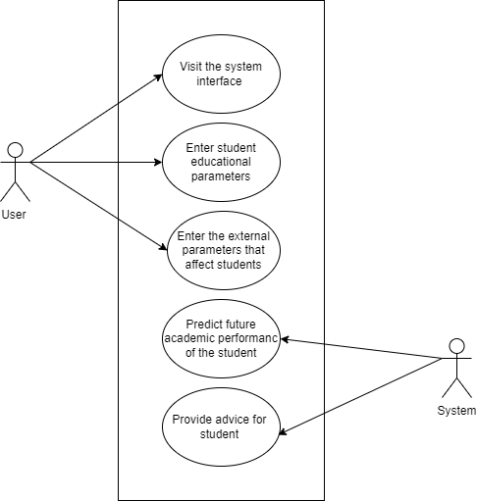
Figure 3.1 Use case diagram of the proposed system
The diagram above shows the use case activity that takes place in the proposed system, the system is made of two main entities, the system and the user. The user can perform a myriad collection of activities which include visiting the system online platform and entering the different parameters that are required for the system to analyse and predict the future performance of the student. While the system stands as a base for the user to operate and therefore functions to analyse the parameters in which the use have supplied through the input fields in the user interface and most importantly predict the future performance of the student based on the supplied parameters. It also offers advice on the best way through which the user may use to recover from their condition.

3.4.3 ACTIVITY DIAGRAM OF THE PROPOSED SYSTEM
An activity diagram stands as another important diagram in Unified Modelling Language (UML). It is however a diagram that describes the dynamic aspects of the software system. However, an activity diagram is basically a flowchart to describe the flow of activities that go on in the system. The figure below represents the flow of activities on the proposed system, from the visiting the platform and entering the parameters that are related to the student’s performance and wellbeing to getting the prediction of the students future performance.
Activity diagram of the proposed system:
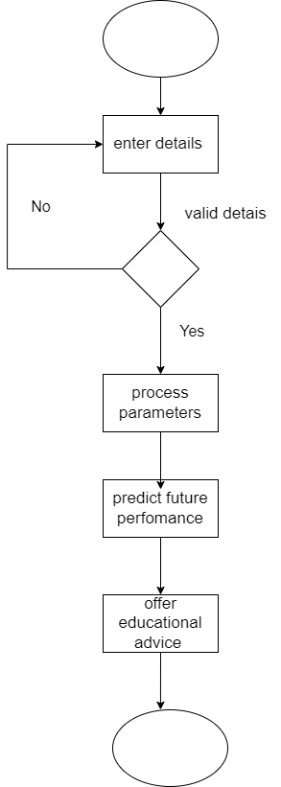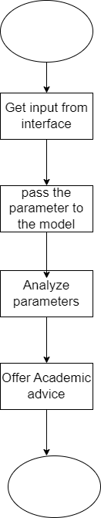
Figure 3.2 Activity diagram of the system and the analysis process of the system

The diagram above represents the activity diagram of the proposed system which stands to display the pictorial representation of the step by step approach to all the activities that takes place in the proposed system. The activity ranges from the academic administrator visiting the system and accessing its interface to enter the required parameters into the system and having the system predict the future academic performance of a student based on the details provided and also provide a solid advice on where next to go or the best way to support the student to avoid the risk of them dropping out of school.

3.4.4 CLASS DIAGRAM OF THE PROPOSED SYSTEM
Class diagrams are Unified Modelling language (UML) diagrams that stands to describe the structure of a software system by mapping out its classes and subclasses, attributes, methods and the relationships among objects. Below is the illustration of the class diagram for the proposed system.
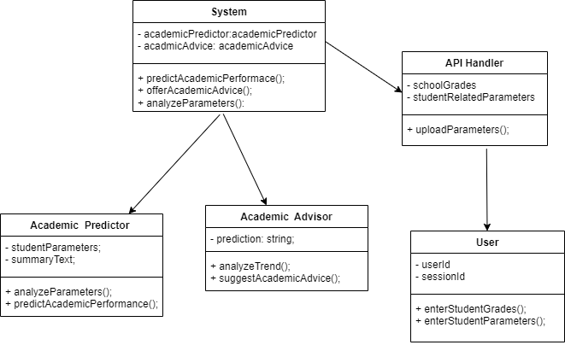
Figure 3.4 Class diagram of the proposed system
The diagram above represents the class diagram of the proposed system, which is used in this research work is used to show the way in which the activities that is going on in the proposed system is being engineered and managed. It shows the interconnection and the relationship between the various sections and components of the system, thereby helping the user to vividly understand the intricacy and contextual makeup of the system.

3.4.5 UML SEQUENCE DIAGRAM
The unified Modelling Language (UML) sequence diagrams serve as a dynamic pictorial model which depicts the various interactions between the different objects that exists within a system over time. Similarly, these diagrams are very important in the understanding of the chronological flow of actions and messages that occur during the execution of a particular use case or scenario. However, at its core, these sequence diagrams visually represent the order in which interactions take place therefore providing a clear depiction of how the various components collaborate in a specific system to achieve the specified goal.
However, the elements in the UML sequence diagram include lifelines, messages, activations, and objects of which the lifelines represent the entities involved in the interaction, while messages denote the communication between the different entities. Moreover, activations that are portrayed using vertical lines extending from lifeline and therefore stands to represent the duration of an object's involvement in an interaction. Consequently, this temporal dimension adds a crucial layer of understanding thereby allowing developers and stakeholders to grasp not only what occurs in the system but also when it occurs within the system's operation.
Moreover, UML sequence diagrams help to facilitate the communication between the technical and non-technical stakeholders in a system and by offering a visual representation of system dynamics these diagrams stand as a powerful tool for conveying intricate technical details in a more accessible manner. However, the use of these diagrams contributes to improved collaboration thereby fostering a shared understanding of system behaviour and also aiding in the identification of potential issues for future enhancements.
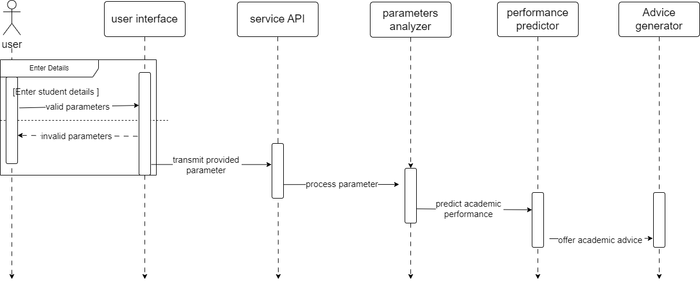
Figure 3.5 Sequence diagram of the proposed system
The above diagram stands to depict the sequence diagram of the proposed system which functions to show the sequence of activities that is taking place in the proposed system, right from the user visiting the system’s platform to the getting a prediction of the future academic performance of the student and the advice on what to do in other to change from being an at-risk student to a high performing student.

3.5.1 INPUT INTERFACE DESIGNS OF THE PROPEOSED SYSTEM:
This section of this research work stands to illustrate how the system hopes to fulfil the requirements that have been stated in the previous sections above by showing a simple interface design of the input section of the proposed system as it aims at making the features of the proposed system accessible to the users. The interface sketch of the proposed system is shown below
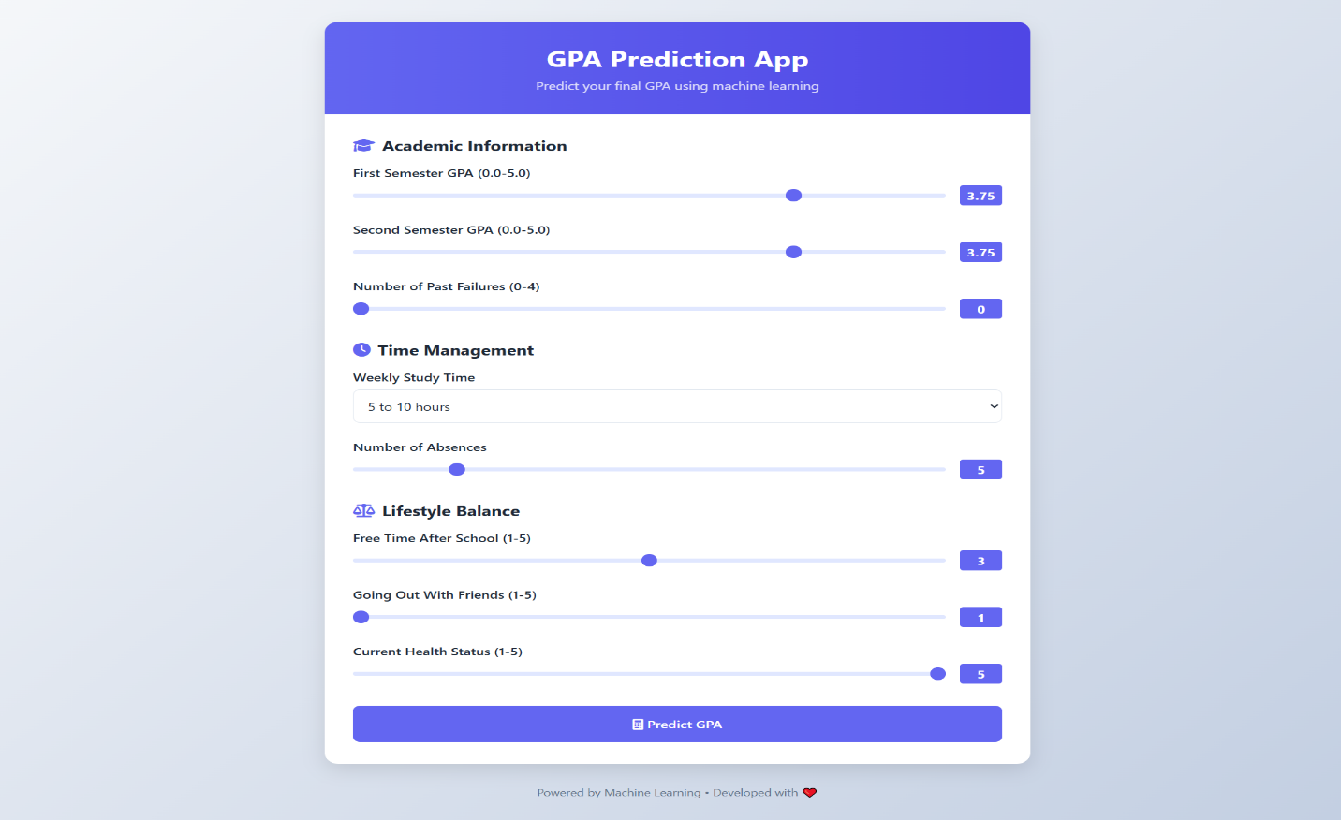
Figure 3.6 Input designs for the proposed system

The diagram above shows the user interface design for the proposed system through which the user gets to select a sample leaf image of the crop and then upload it to the system through the interface. The picture sample is first selected by the famer when he or she clicks on the upload image button to provide the image sample to be analysed by the system.

3.5.2 OUTPUT INTERFACE DESIGN OF THE OF THE PROPOSED SYSTEM:
This section of this research work stands to illustrate how the system hopes to fulfil the requirements that have been stated in the previous sections above by showing a simple interface design of the output section of the proposed system as it aims at making the features of the proposed system accessible to the users. However, this sections displays a screenshot of the interface design of the output section of the proposed system, depicting the way that information would be outputted by the system after predicting the disease that is being suffered by a crop based on the image leaf image that have been uploaded by the user. The interface design of the output section of the proposed system is shown below

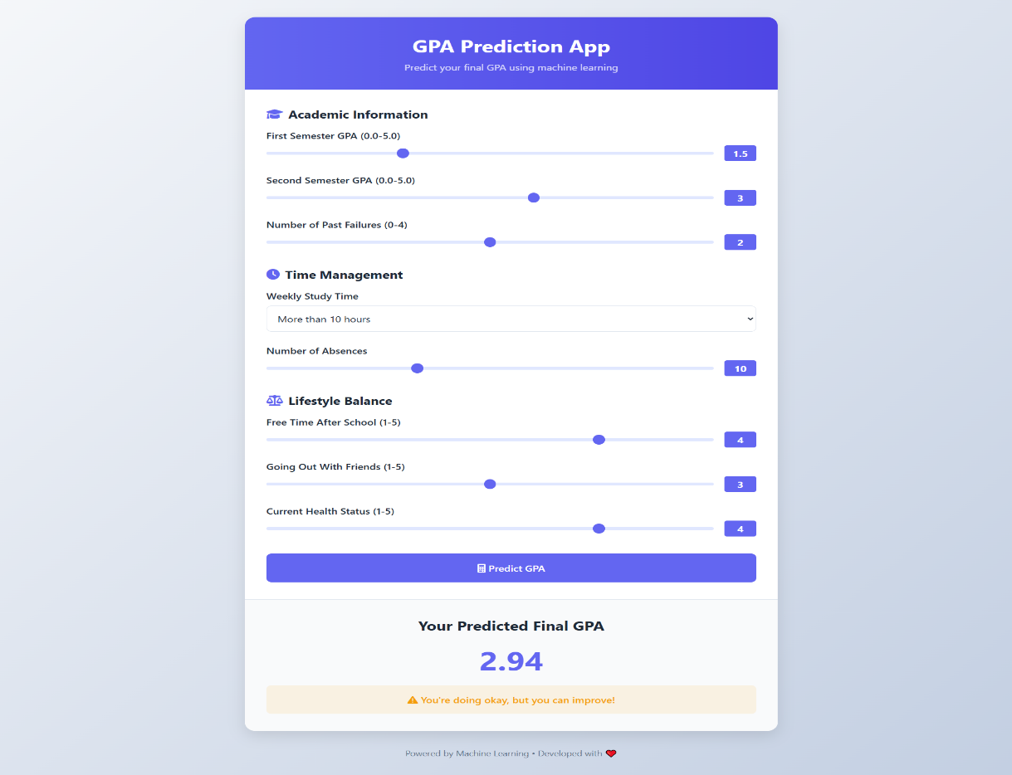
Figure 3.7 Output designs for the proposed system
The images above shows the output interface of the proposed system. The images however shows how the output gotten after the prediction of the crop disease would be arranged and displayed on the screen. On a general note, a pictorial representation of the interface used in outputting data out of the proposed system. These output interfaces that are supplied to the platform cuts across mainly the act of displaying the output that was gotten from the model.

CHAPTER FOUR
SYSTEM IMPLEMENTATION
4.1 introduction
The conception of the design idea, the design implementation, and the development of the system which have been suggested in the prior chapters of this study work are the main things that would be discussed in this chapter of this work of research. On the same vein as the earlier parts of the work of research, incorporated a comprehensive top-down investigation of some of the systems that are comparable which are currently in place. The detailed process that was involved in developing the system that was proposed in this work of research commenced with a description of the system and all of its requirements. However, the researcher made use of some instruments that were carefully chosen, thoroughly tested, and at the end of the day determined to be appropriate to be used to bring the suggested system into practice/life in this section of the research process. Above all, this chapter of this work of research discusses the different user interfaces for the various sections of the system would be outlined, along with the tools that was implemented in bringing it to live.

4.2 Tools used for implementation (Tech stack of the proposed system)
4.2.1 Frontend
4.2.1.1 Streamlit
Streamlit is a Python library that is open source. It makes it easy to create and share beautiful and web applications that is peculiar for machine learning and data science projects. It most importantly allows developers to build dashboards that are very interactive and visually appealing very fast while making use of very few lines of code and not requiring the developer to have a prior extensive experience in web development. It however offers a very intuitive interface which allows the developer to manipulate data in real-time and also providing feedback, making it ideal for prototyping and showcasing results. However, it also allows for the integration with some libraries of python like Pandas, Numpy and Matplotlib therefore ensuring compatibility with a wide range of data science workflows.

4.2.2 Backend
4.2.2.1 Python
Python is a programing language that is very powerful and versatile. It is a high-level programming language that is known for its ease of readability and its overall simplicity. Because of this reason, it has become the most popular choice of programming language for both the beginners and experienced developers. Because it supports many different paradigms and also supports a large ecosystem of third-party packages that allows for a rapid development across various domains such as web development, data analysis, artificial intelligence and automation. It also offers dynamic typing to improve productivity and also allow for integration with other language, tools and frameworks like Django and Flask to enable and ensure a more efficient modern software development process.

4.2.3 Machine Learning
4.2.3.1 Sci-Kit Learn
This is a very powerful and versatile machine learning library that was created specially for python. It is used for data mining and data analysis because it provides simple and efficient tools for preprocessing data, classification of data, regression, clustering and in all reduction in dimensionality. It is built on NumPy, SciPy, and Matplotlib and because of this reason, it integrates very well with other scientific computing libraries to ensure robust performance and ease of use. It has good documentation to serve both the beginners and the experts. It was used in the development of the proposed system because it is an essential tool for developing models that are predictive and also for performing complex data analysis.

4.2.3.2 Joblib
Joblib is a library for Python available as open-source software that facilitates the saving, loading, and handling of machine learning models and associated datasets. It is particularly helpful in data science projects where optimization is crucial. Both complex Python objects like NumPy arrays and trained machine learning models can be handled error-free and efficiently through Joblib. Its compression abilities during storage allow for faster data loading as well as memory savings. Also, Joblib allows for parallel computing, resulting in faster throughput via multiple CPU cores. Its simplicity sets Joblib apart; it allows developers and researchers to seamlessly port their models across various environments and platforms, enabling easy collaboration. In general, Joblib is a versatile and accessible tool that increases productivity and effectiveness in performing machine learning tasks.

4.2.3.3 Pandas
Pandas is a data analysis and manipulation library available on the Python programming language. Its purpose was to facilitate the management of structured data like tables and time series data. It provides an extensive collection of tools for data reading, cleaning, transformation, analyzing, and visualization that are extremely simple and intuitive to use. Developed on top of NumPy, Pandas is especially recognized for its two most common data structures, Series and DataFrames, which provide a more natural interface for complex data manipulations. At the same time, it is very fast and relatively simple to use with large datasets. Its versatility combined with smooth working with other extensions written in Python makes Pandas useful for everything from basic data investigation to sophisticated statistical modeling and machine learning.

4.3 SYSTEM REQUIREMENTS
The proposed system is a system that is very simple and at that, they are just few things that would be needed to use this system. This section therefore shows the things that the user must have before he or she can be able to use the system that have been developed in the cause of this research project. These requirements are as follows:
- A good and functioning internet enabled device.
- A good and up to date web browser
- Good and fast internet speed.

4.4 USER INTERFACE OF THE PROPOSED SYSTEM
This particular section of the research work stands to cover for the design of the different interface sections that the proposed system has. Moreover the interfaces of the suggested system will include the interface for the input of parameters into the system and the design of the output interface.
4.4.1. The Input screen of the proposed system
The input screen of the proposed system is the first interface of the proposed system that the user gets to see when they visit the system interface because it serves as the landing page of the proposed system and it is made up of two sections only, the header section, and the input section The input section of the system exists to aid the user in uploading the PDF file that he or she wants to analyze and also for displaying the questions that have been generated from the PDF that the user have uploaded.
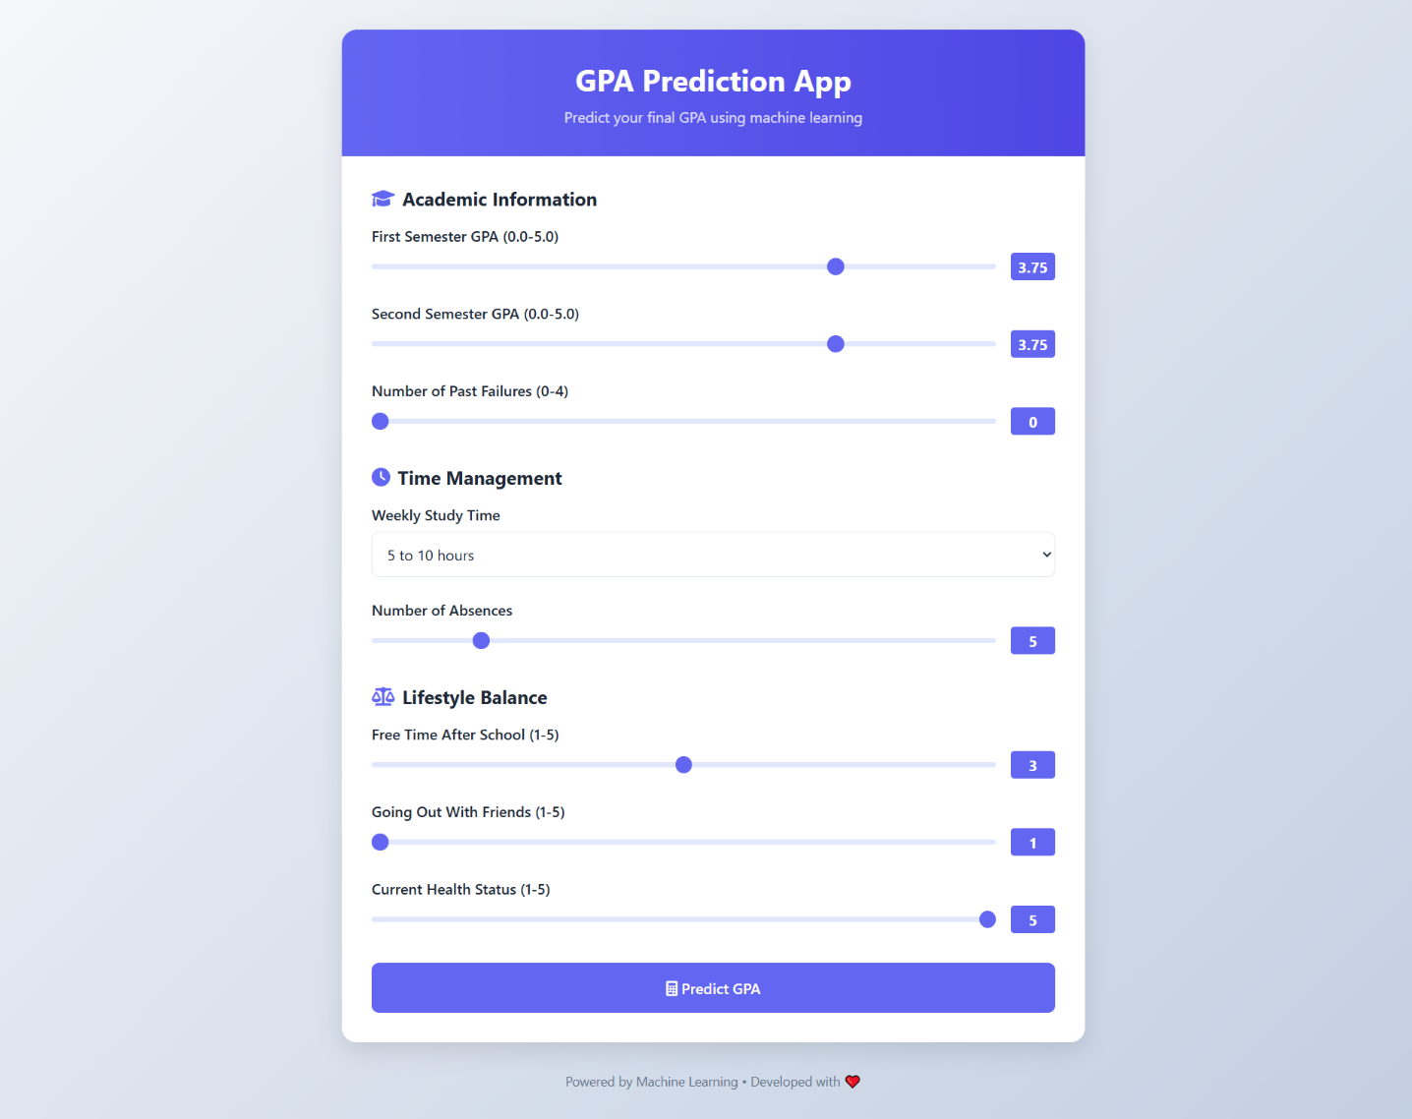
Figure 4.1 The input screen of the proposed system

4.4.2 Output Screen of the proposed system:
This screen of the proposed system is meant to be used to display the output of the analysis that is performed on the pdf file which the user have supplied. The result at the end of each analysis is displayed on the screen on the output interface for the user to be able to see and access it. The result comprises of questions that have been generated from the pdf that the user have uploaded.
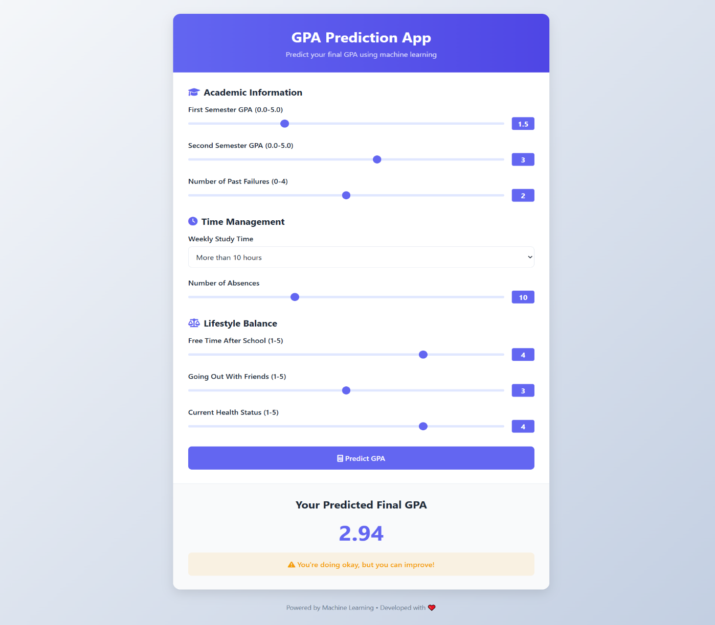
Figure 4.2 The output screen of the proposed system.

4.4 SYSTEM IMPLEMENTATION OF THE PROPOSED SYSTEM
The development of the student academic prediction system was undertaken with a practical blend of reliable and easy to use technologies that guaranteed seamless and responsive experience. Python, a programming language known for its versatility and ease of learning, served as the system’s backbone. Its powerful capabilities were utilized for data pre-processing, model training and prediction tasks. In addition, academic data concerning the students’ performance was sorted using Pandas to ensure it was clean and stored in a structured format so that it was easier to navigate and work with. After structuring the data, the prediction model was trained with appropriate algorithms designed to accurately estimate a student’s academic performance using a reliable machine learning library, Scikit-learn. To enhance the model's data adaptability, methods such as normalization and scaling were implemented prior to the training phase.
After completing the training and testing of the model's accuracy, Joblib was employed to persist both the model and the scaler. This allows the system to leverage them without needing to retrain from scratch. Such an approach proved to be time-saving and efficiency-optimized in practical scenarios. To broaden access to the model and simplify its usability for individuals with no technical background, such as students, academic advisers, or school principals, Streamlit was utilized to develop a functional web interface. This web application permits users to enter students' information and instantly receive predictions as well as suggestions in an intuitive, easy-to-read format. All in all, this system implementation shows how the prudent use of a specific set of tools can provide a sophisticated academic performance and decision-making supporting solution in schools.

4.4.1 Test result of the proposed system
After the system was developed, the system was tested with data samples gotten from the students of Godfrey Okoye university, Enugu. The system was first tested with the students in the department of computer science and later proceeded to other departments. The system was however, able to analyse the current performance of the students and predict their future performance based on their current performance.

CHAPTER FIVE
SUMMARY, RECOMMENDATIONS AND CONCLUSION
5.1 OVERVIEW
This chapter of this work of research is used by the researcher of this work to give a detailed conclusive summary of this project, the recommendations for future works that may exist within this domain of knowledge, and lastly a detailed conclusion of this research work. This chapter however summarizes everything that have been discussed in all the preceding chapters of this project.

5.2 SUMMARY
At the beginning of the research project the problem statement that is connected to this research work and the study's backdrop were explicitly outline and discussed thereby setting a clear ground for the reason why this project research was embarked upon. However, the theoretical underpinnings of this research were covered in the latter chapters of this paper, together with a very descriptive review of the relevant systems that have been developed in the past by previous researchers and are currently in place.
This research work also provided a thorough examination of the current existing systems, pointed out their shortcomings, and did its best to take advantage of these issues (gaps in knowledge) when developing the system that was suggested in this research work. Additionally, a comprehensive system analysis was also conducted using some UML diagrams in the third chapter (chapter 3) of this study; the system was explicitly analyzed utilizing use case diagrams, activity diagrams, class diagrams, and class diagrams of the UML diagrams. Lastly, on the note of the systems interface, a full description of the user interface and a list of all the programming languages and frameworks utilized to carry out this project were also provided and analyzed in detail.

5.3 RECOMMENDATIONS
The proposed system is invaluable for students, teachers, and school administrators who wish to make informed decisions related to study and learning academic assistance. It is more beneficial for students in higher institutions who are exam ready and require guidance on their performance milestones early on. This system enables students to ascertain their strongholds and the areas that require improvement, thus allowing them to take appropriate measures well in advance. It also enables lecturers and academic advisers to track students who are likely to perform poorly, hence help them by giving the support and motivation before it is too late. This interdisciplinary system, built on principles of research and authentic data, is an excellent way of supporting learning, alleviating academic stress, nurturing student’s self-esteem and confidence irrespective of academic standing. This is a reliable, modern tool that transforms education into a journey that is more interactive, engaging, and academically rewarding.

5.4 CONCLUSION
Finally, at this juncture we have come to the end of this research as this particular section of this research work stands to conclude the objectives that were defined at the beginning of this research work. Nevertheless, this is not the conclusion (end) of the proposed system as this research has not come to a halt with this conclusion but would continue to grow and add a lot of new features and updates like the ability for users to be able to download the predictions of the students that was generated by the system after analysing the data of a student. However, for the purpose of this study which has a limited scope, the system which has been proposed all through the process of this study, would be made available to run online through a web interface, to be accessed using https://predictyourgpa.streamlit.app/ by users all over the world. However, in other to use the system, the users are advised to fulfil all the requirements that have stated above in the system requirement section of this work of research to avoid breaks when using the system.

REFERENCES

Ahmad, S., El-Affendi, M. A., Anwar, M. S., & Iqbal, R. (2022). Potential future directions in optimization of students’ performance prediction system. Computational Intelligence and Neuroscience, 2022(1), 6864955.

Alboaneen, D., Almelihi, M., Alsubaie, R., Alghamdi, R., Alshehri, L., & Alharthi, R. (2022). Development of a web-based prediction system for students’ academic performance. Data, 7(2), 21.

Albreiki, B., Zaki, N., & Alashwal, H. (2021). A systematic literature review of student’performance prediction using machine learning techniques. Education Sciences, 11(9), 552.

Albreiki, B., Zaki, N., & Alashwal, H. (2021). A systematic literature review of student’performance prediction using machine learning techniques. Education Sciences, 11(9), 552.

Almalawi, A., Soh, B., Li, A., & Samra, H. (2024). Predictive Models for Educational Purposes: A Systematic Review. Big Data and Cognitive Computing, 8(12), 187.

Arora, N., & Singh, N. (2017). Factors affecting the academic performance of college students. Journal of Educational Technology, 15(2), 45-60.

Hamsa, H., Indiradevi, S., & Kizhakkethottam, J. J. (2016). Student academic performance prediction model using decision tree and fuzzy genetic algorithm. Procedia Technology, 25, 326-332.

Helal, S., Li, J., Liu, L., Ebrahimie, E., Dawson, S., Murray, D. J., & Long, Q. (2018). Predicting academic performance by considering student heterogeneity. Knowledge-Based Systems, 161, 134-146.

Hoque, M. I., Azad, A. K., Tuhin, M. A. H., & Salehin, Z. U. (2020). University students result analysis and prediction system by decision tree algorithm. Adv. Sci. Technol. Eng. Syst. J, 5(3), 115-122

Hussain, S., & Khan, M. Q. (2023). Student-performulator: Predicting students’ academic performance at secondary and intermediate level using machine learning. Annals of data science, 10(3), 637-655.

Imran, M., Latif, S., Mehmood, D., & Shah, M. S. (2019). Student academic performance prediction using supervised learning techniques. International Journal of Emerging Technologies in Learning, 14(14).

Jokhan, A., Sharma, B., & Singh, S. (2019). Early warning system as a predictor for student performance in higher education blended courses. Studies in Higher Education, 44(11), 1900-1911.
Khalil, M. K., Hawkins, H. G., Crespo, L. M., & Buggy, J. (2018). The design and development of prediction models for maximizing students’ academic achievement. Medical Science Educator, 28, 111-117

Li, K. F., Rusk, D., & Song, F. (2013, July). Predicting student academic performance. In 2013 Seventh International Conference on Complex, Intelligent, and Software Intensive Systems (pp. 27-33). IEEE.

Lone, R. A. (2021). Study habits and academic performance among students: A systematic review. Research Review International Journal of Multidisciplinary, 6(5), 132-135.

Luo, Z., Mai, J., Feng, C., Kong, D., Liu, J., Ding, Y., & Zhu, Z. (2024). A Method for Prediction and Analysis of Student Performance That Combines Multi-Dimensional Features of Time and Space. Mathematics, 12(22), 3597. https://doi.org/10.3390/math12223597

Mengash, H. A. (2020). Using data mining techniques to predict student performance to support decision making in university admission systems. Ieee Access, 8, 55462-55470.

Miguéis, V. L., Freitas, A., Garcia, P. J., & Silva, A. (2018). Early segmentation of students according to their academic performance: A predictive modelling approach. Decision Support Systems, 115, 36-51.

Patil, R., Salunke, S., Kalbhor, M., & Lomte, R. (2018, August). Prediction system for student performance using data mining classification. In 2018 Fourth International Conference on Computing Communication Control and Automation (ICCUBEA) (pp. 1-4). IEEE.

Sanz, M., Rodrigo, I. G., Izquierdo, C. G., & Ajenjo, P. (2017). Exploring academic performance: Looking beyond numerical grades. Universal Journal of Educational Research, 5(7), 1105-1112.

Sghir, N., Adadi, A., & Lahmer, M. (2023). Recent advances in Predictive Learning Analytics: A decade systematic review (2012–2022). Education and information technologies, 28(7), 8299-8333.

Sweeney, M., Rangwala, H., Lester, J., & Johri, A. (2016). Next-term student performance prediction: A recommender systems approach. arXiv preprint arXiv:1604.01840.

Trakunphutthirak, R., & Lee, V. C. (2022). Application of educational data mining approach for student academic performance prediction using progressive temporal data. Journal of Educational Computing Research, 60(3), 742-776.
Wang, S., & Luo, B. (2024). Academic achievement prediction in higher education through interpretable modeling. PLOS ONE, 19(9), e0309838. https://doi.org/10.1371/journal.pone.0309838

Wang, X., Zhao, Y., Li, C., & Ren, P. (2023). ProbSAP: A comprehensive and high-performance system for student academic performance prediction. Pattern Recognition, 137, 109309.

APPENDIXES
import streamlit as st
import numpy as np
import pandas as pd
import joblib

# Load your pre-trained Random Forest model and scaler
rf_model = joblib.load('artifacts/rf_model.pkl')
scaler = joblib.load('artifacts/scaler.pkl')

# Function to predict GPA
def predict_gpa(user_input):
# Assuming the model and scaler have been loaded

# Create DataFrame from user input
user_df = pd.DataFrame([user_input])

# Scale the input data using the same scaler
user_scaled = scaler.transform(user_df)

# Predict GPA
predicted_gpa = rf_model.predict(user_scaled)

return predicted_gpa[0]

# Streamlit UI
def app():
st.title("GPA Prediction App")

st.subheader("Enter your details:")

# Define the options for study time as a dictionary
study_time_dict = {
1: '<2h',
2: '2-5h',
3: '5-10h',
4: '>10h'
}

# User input fields
G1 = st.slider("Enter first semester GPA (0.0-5.0)", 0.0, 5.0, 3.75)
G2 = st.slider("Enter second semester GPA (0.0-5.0)", 0.0, 5.0, 3.75)
studytime = st.selectbox("Enter weekly study time", [1, 2, 3, 4], format_func=lambda x: study_time_dict[x])
failures = st.slider("Enter number of past failures (0-4)", 0, 4, 0)
absences = st.slider("Enter number of absences", 0, 100, 5)
freetime = st.slider("How much free time do you have after school?", 1, 5, 3)
goout = st.slider("How often do you go out with friends?", 1, 5, 1)
health = st.slider("Enter current health status (1-5)", 1, 5, 5)

# Prepare input data
user_input = {
'G1': G1,
'G2': G2,
'studytime': studytime,
'failures': failures,
'absences': absences,
'freetime': freetime,
'goout': goout,
'health': health
}

if st.button("Predict GPA"):
# Make the prediction
predicted_gpa = predict_gpa(user_input)

# Display the result
st.subheader(f"Predicted Final GPA: {predicted_gpa:.2f}")
if predicted_gpa >= 3.5:
st.success("Great! You have a high GPA.")
elif predicted_gpa >= 2.5:
st.warning("You're doing okay, but you can improve!")
else:
st.error("It looks like you need to focus on improving your GPA.")

# Run the Streamlit app
if __name__ == "__main__":
app()

