AI-POWERED CHAT BOT FOR MENTAL HEALTH

BY

OBIEFUNA JUDITH UCHECHI
U21/NAS/CSC/736

FACULTY OF NATURAL SCIENCES AND ENVIRONMENTAL STUDIES, GODFREY OKOYE UNIVERSITY, ENUGU

JUNE, 2025

AI-POWERED CHAT BOT FOR MENTAL HEALTH

BY
OBIEFUNA JUDITH UCHECHI
U21/NAS/CSC/736
SUBMITED TO DEPARTMENT OF COMPUTER SCIENCE,
FACULTY OF NATURAL SCIENES AND ENVIRONMENTAL STUDIES, GODFREY OKOYE UNIVERSITY, ENUGU

IN PARTIAL FUFILMENT OF THE AWARD OF BACHELOR OF SCIENCE DEGREE

SUPERVISED BY DR K.M OKORIE

JUNE, 2025

CERTIFICATION
I certify that the work presented here was done by me and is primarily based on my own observations and research. Therefore, I will fully accept the University’s decision if it determines that I have cheated on the assignment.

Obiefuna Judith Uchechi
U21/NAS/CSC/736

APPROVAL PAGE
This is to certify that the research project on the AI-Powered chat bot for mental health designed to help users interact with mental health professionals was completed by OBIEFUNA JUDITH UCHECHI, with matriculation number U21/NAS/CSC/736, in partial fulfillment of the requirements for the Bachelor of Science (B.Sc.) degree in computer Science, under the faculty of Natural Science and Environmental Studies. Godfrey Okoye University, Enugu.

Dr. K.M Okorie Date

Dr. (Mr.). Frank Okebanama Date
Head of Department

External Examiner Date

DEDICATION
This work “AI-POWERED CHATBOT FOR MENTAL HEALTH” is dedicated to my parents, uncle, aunt and siblings who has contributed heavily to everything I have accomplished up till now and I pray that the good lord continues to guide and protect them for the rest of their days.
I also dedicate this project to my very good friend Ogba Anthony Nnamdi who left this world and wasn’t able to see the end of this work. I really appreciate your words of support and encouragement during my research for this work.

ACKNOWLEGMENT
First of all, I would like to appreciate the almighty God for his abundant mercies, inspiration and grace throughout this project. In a special way, I want to also acknowledge and appreciate my supervisor, Dr. K.M Okorie the time he set aside for me during my project to make sure that this project is a success and for guiding me throughout this project. I would like to appreciate my parents, uncle and aunt for their love, support and prayers for me throughout this project, and my Siblings for also being supportive during this project and I pray that the good lord will continue to bless them all. I would like to acknowledge and appreciate my lectures who taught me from my first year till my final year, without their teachings and the knowledge they instilled in me I won’t be able to do this project.

ABSTRACT
This paper outlines the proposal of an AI-based mental encounter examination chatbot that would convey scaleable and time-unbiased psychological assistance that is aware of its circumstance. The system uses the best of Natural Language Processing (NLP) such as intent classification and sentiment analysis to see meaning in what the user type in and use that to come up with a response that is in context. The chatbot is implemented on a hybrid architecture that integrates rule-based logic with machine-learning models allowing the chatbot to recognize cues of emotional distress as well as distinguish between common or relatively high-level information and crisis-level input and respond with evidence-based intervention or escalation procedures.
Its salient characteristics are individual interaction history, adaptive course of conversation, and privacy-focused data management framework that would guarantee observation of ethical standards and data protection laws. In comparison with the current solutions, the proposed chatbot will be more personalized, will recognize crises more accurately, and will be more flexible to vary user situations. The system should be used to supplement the traditional services of mental health by offering continuous/around the clock support, thus filling the gaps in services and offloading healthcare professionals. And this Chabot can locate the nearest clinic or hospital for advance treatment using goggle location map. The proposed chatbot will implement object- oriented analysis and design for both analysis and design of the system. The tools include goggle map API, health care chat bot API, java script, html and CSS.

TABLE OF CONTENT COVER PAGE

TITLE PAGE I
CRETIFICATION II
APPROVAL III
DEDICATION IV
ACKNOWLEGMENT V
ABSTRACT VI
CONTENT VII
FIGURES IX
CHAPTER ONE
1.0 BACKGROUND OF THE STUDY 11
1.1 STATEMENT OF PROBLEM 12
1.2 AIM AND OBJECTIVES 12
1.3 SIGNIFICANCE OF STUDY 13
1.4 SCOPE OF STUDY 13
1.5 DEFINITION OF TERMS 13
CHAPTER TWO
2.0 INTRODUCTION TO LITERATURE REVIEW 15
2.1 OVER VIEW ON ARTIFICIAL INTELIGENCE 15
2.2 OVER VIEW OF CHATBOT 17
2.3 A REVIEW ON CHATBOT INTERFACE 19
2.4 A REVIEW ON NLU ENGINE 20
2.5 A REVIEW ON DECISION OF ML ENGINE 21
2.6 A REVIEW ON NLG ENGINE 22
2.7 REVIEW OF EXISTING SYSTEMS 23
2.8 KNOWLEDGE GAP 28
2.9 SUMMARY OF EXISTING SYSTEMS 29
CHAPTER THREE
3.1 INTRODUCTION 31
3.2 METHODOLOGY 32
3.3 ANALYSIS OF EXISTING SYSTEM 35
3.4 PROBLEMS OF EXISTING SYSTEM 35
3.5 ANALYISIS OF THE PROBLEM 35
3.6 ADVANTAGES OF PROPOSED SYSTEM 36
3.7 ANALYSIS OF PROPOSED SYSTEM 36
3.8 DESIGN OF PROPOSED SYSTEM 37
CHAPTER FOUR
4.0 INTRODUCTION 41
4.1 SOFTWARE REQUIREMENTS USED IN NEW SYSTEM 41
4.2 SYSTEM REQUIREMENTS 43
4.3 HARDWARE REQURMENTS USED IN NEW SYSTEM 44
4.4 SYSTEM IMPLEMENTATION 44
4.5 INTERFACE OF THE SYSTEM 45

CHAPTER 5
5.0 SUMMARY 50
5.1 CONCLUSION 50
5.2 RECOMMENDATION 51
REFERNCES 52

LIST OF FIGURES
1.1 ARCHITECTURE OF CHATBOT SYSTEM 18
3.1 DIAGRAM OF AN OOAD MODEL 32
3.2 USE CASE DIAGRAM 38
3.3 ACTIVITY DIAGRAM 39
4.1 CREATE ACCOUNT/ SIGN UP PAGE 46
4.2 LOGIN IN PAGE 47
4.3 HOME PAGE 47
4.4 INPUT IN THE CHATROOM 48
4.5 OUTPUT OF THE CHATROOM 49
4.6 LOCATION MAP 49

CHAPTER ONE
INTRODUCTION
1.0 BACKGROUND OF THE STUDY
Artificial intelligence systems using natural language processing, working as digital conversation agents, are known as chatbots. According to Dr. Himani Mittal, 2021, the use of chatbot is able to stimulate human interaction. It is possible for chatbot to communicate verbally in writing, whereby through human speech they are able to interact with people. As explained by Arun, 2021, chatbots can be used to enhance the communication between a patient and a clinic or hospital, and also between the patients and the doctors.
According to World Health Organization, mental well-being describes an optimal state when people fully manage life’s challenges alongside acknowledging their abilities so they can achieve both academic and professional excellence plus serve their communities. Mental health services face shortage of clinical professionals, which has impeded quality service delivery, hence the increasing demand for innovative technological solutions in this field. Due to rapid development of artificial intelligence, there are a multitude of different chatbots in service, which screen and diagnose issues like mental health but also give them treatment. More acceptable to patients who often do not want to seek out help within a traditional setting due to stigma, these act not only as adjunct workforce but are also more pleasing to such patients (Vaidyam et al. 2019). Today, chat services like Facebook Messenger, Telegram, and the rest of them, virtual assistants like Google Assistant and Amazon, Alexa, or the app or websites of specific businesses are how most chatbots are reached. According to Anuji pati, 2022, a chatbot technically reflects the logical development of a Question- Answer system that uses Natural Language Processing (NLP). People are so busy working that, due to continuous stress, they fail to pay attention to their mental health. In the design of a mental health chatbot system, an AI assistant will help in diagnosing the problem of mental health and treat it with the help of suitable guidelines and recommendations. With the advancement in the field of artificial intelligence, services can be provided at low cost and according to the convenience of the people. The main aim of the chatbot is to provide all these through the performance of various services. The patient will also be assisted as it will help them to have clearly defined needs with proper question elicitation.
1.1 STATEMENT OF PROBLEM
Mental health issues are very common, with almost a billion people in the world according to World Health Organization (WHO) are suffering from these disorders. Some of the key challenges that need to be recognized include:
- Many individuals with social anxiety face stigma that prevents them from seeking help and connecting with others.
- Lack of awareness and education.
- Longer waiting time for professional assistance from health professionals.
- Limited availability and accessibility of mental health services.
1.2 AIM AND OBJECTIVES
The aim is to build an AI-powered mental health chatbot that is programmed to provide accessible and convenient support to people dealing with mental health challenges, to achieve the following objectives:
- Create a user-friendly interface for mental health assistance.
- Use AI-driven communication leveraging NLP and ML technologies.
- Offer personalized coping strategies.
- Ensure data protection and confidentiality.
1.3 SIGNIFICANT OF STUDY
1. It provides mental health support to individuals who cannot seek conventional therapy due to distance or financial problems.
2. It assists in diagnosing mental health conditions and provides tailored treatment options.
3. The chat-based interface individuals can openly discuss their psychological problems thereby lowering the barriers that keep people from getting medical help.
1.4 SCOPE OF STUDY
Users will be able to log in via a login page of the chatbot and interact with the system. There will be an AI assistant that attends to them over mental health issues and generally guide them on the appropriate medications one should take.
1.5 DEFINITION OF TERMS
1. Artificial Intelligence (AI): Machine learning involves programming computer programs to execute tasks that demand cognitive abilities including trouble-solving and problem identification and decision making. The field of computer science defines AI as both an engine which performs human-intelligence tasks and a system which reenacts computer activities. Illustrations of applications of AI are: expert systems natural language processing speech recognition and machine vision.
2. Chatbot: The software operates through natural language processing elements together with machine learning algorithms to create interactions which resemble human conversations.These Chabot’s usually communicate verbally or in writing, and they are skilled in imitating human speech patterns to communicate with people in a manner that resembles that of a human. The phrase "Chabot" describes software agents that mimic human contact through text or voice messages. Additionally, they are known as "chatter robots." The initial and primary intent of Chabot’s was always to appear intelligent and fool users about their true nature
3. Mental Health: A person’s mental state represents both their psychological fitness and social needs and emotional foundation while shaping their mind and emotional reactions plus life behaviors. AI-driven conversational tools called mental health chatbots is to simplify the communication between patients, insurance companies, and mental health facilities. These bots could be crucial for giving the right stakeholders instant access to important mental health data, the diagnosis, and treatment, especially by trained and licensed experts (in professions like psychology, therapy, and psychiatry).

CHAPTER 2
LITERATURE REVIEW
2.0 INTRODUCTION
The Chabot would act as a virtual doctor and facilitate patient-virtual doctor contact, according to Saurav Kumar Mishra from 2017. A pattern-matching algorithm and natural language processing were used to build this Chabot. It was made using the Python programming language.
Computers give us information, but they also amuse us and help us in many more ways. A Chabot is an artificial intelligent agent specially programmed for carrying out natural speech or text conversation. Even though this essay specifically narrows it down to the analysis of text. The systems are self-learning and can learn new knowledge or restore previous knowledge with the assistance of people or the Internet tools. This system aims to provide users with some of their precious time and hard-earned cash that they can‘t affords to visit the doctors or other specialists when they are in so much need of them. (Mohammed et al.2022).

THEORICAL BACKGROUND
2.1 Overview on Artificial Intelligence
The actual term used to label the field was coined in 1956 at a meeting held at Dartmouth College. At the present time, AI is the most urgent international issue of the 21st century. A subfield of computer science, Artificial intelligence (AI) studies developing intelligent machines for processes such as voice recognition or decision-making and language translation. The ability of natural language processing, machine learning, and planning open up many possibilities for what an intelligent system can do and how it can creatively implement new tasks. Simply put, AI is mainly applied in imitating the human brain and doing things that would be done by a human. Unlike where humans will guide machines to find a solution to a problem, the machines do it based on what they have learned. The main highlights of Sadiku MNO et al.2021 include that AI is not just one technology but rather a group of computer models and algorithms.
- Applications of Artificial Intelligence (AI)
The following are a few types of AI which find their application most frequently:
- Expect systems: It solve problems by making inferences from knowledge about some particular subject stored in a knowledge base mainly in the form of if-then rules, using an inference engine. The oldest, largest, most active, and most productive field is expert systems.
- Fuzzy logic: It allows the establishment of rules on how machines respond to inputs with a continuum of possible conditions, as opposed to simple binary conditions.
- Neural networks: These are special types of machine learning systems that consist of synthetic synapses and which, from an anatomical point of view, would remind one of a brain. They bear some resemblance to the human brain. They consist of artificial neurons, receive multiple inputs, but only give one output. The synapses transfer information amongst each other; data is filtered as it moves through different layers as the network observes and learns new things.
- Machine learning: It is a broad subfield of statistical models and algorithms that grant the ability to systems to recognize patterns, draw conclusions, and pick up new skills without explicit programming. Machine learning is an application of AI for making a particular task to happen automatically without explicitly programming it. Data insights obtained using ML techniques might boost the effectiveness of production. Machine learning is the foundation of artificial intelligence as it exists today (Sadiku MNO et al. 2021).
- Deep learning: It is a type of machine learning that makes use of artificial neural networks, Since it has a hierarchical processing features, increasing abstraction, the architecture of the deep learning methods has come out to be particularly useful in speech, image, and natural language processing. These networks can solve complex nonlinear problems with ease (Sadiku MNO et al.2021).
- There are Natural Language Processors: To be truly useful to a human being, artificial intelligence must also be capable of communicating with people in our own language. The language spoken by the none-computer person may well be translated or interpreted into some computer form.
- The programmable machines with physical manipulators and sensors are computer-based. In some conditions, sensors can record data, make important decisions, and monitor temperature, humidity, pressure, and time. From science fiction to your local hospital, the robots are real. They may even completely replace workers in jobs that require repetitive and monotonous tasks. According to Sadiku MNO et al.2021, robotics and autonomous systems are the fourth industrial revolution.

2.2 OVERVIEW ON CHATBOT
Virtual assistants, or Chatbots, are the latest innovations in the market and are built to enable communication between humans and computers. Ever since Chatbots entered the digital world, the marketers are eager to comprehend how this is going to work as a primary tool for everyday customer interaction. Many web-based applications are employing Chatbots. Today, Chatbots are utilized for placing pizza orders, booking of hotels, flights, and doctor’s appointments. Simply put, these robots are now becoming ubiquitous. Sadiku MNO et al. 2021.
- The figure below shows the architecture of a Chatbot system.
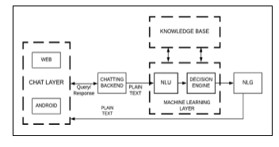
Fig1.1. Architecture of Chabot System
There are two (2) main types of chatbots. Let us look at both of them and see how they work.
- Rule-Based Chatbots: On a question from a particular end, the bot gives something to him for his desired question regarding what follows, provided one after another, either actions and pathways. In other words, most of your simpler applications rely on the rule-based bots that tell inquiries or reactions since teaching for whom necessary rule was made up. Classic Weather, to wit, reacts toward request issuance on your side due to the forecasts gathering incoming either diversified sources. The rule-based chatbot may not be able to carry on complex conversations. If the developer doesn’t make further advancements, it can only complete the tasks programmed into it (SMISHAD THOMAS JUNE 2023).
- Machine Learning-Based Chatbots: The more complicated conversation provided is done by machine learning-based chatbots, while processing the question and understanding its context. It learns from previously answered conversations to answer more challenging ones in the future (SMISHAD THOMAS JUNE 2023).
ADVANTAGES OF CHATBOT
- Among the merits of Chatbot are their ability to understand spoken language and use speech as a user interface (M. L. McNeal, 2013).
- By providing a natural language interface, they enable communication and make it possible to receive direct answers by (M. L .McNeal, 2013).
- They can actually personalize user experience. According to the views of (M. L. McNeal, 2013).
- They are anonymous, which encouraged users who were hesitant to ask inquiries or who believed they were foolish (M. L. McNeal, 2013).
- They become a marketing tool for reference services. M. L. McNeal, 2013 analysis.
A chatbot contains many engines, such as NLU, NLG, and ML engines. Components will involve the following:
2.3 A REVIEW OF CHAT INTERFACE
This module is the first interface between the system and the users or clients. The system, therefore has to obtain questions from the end users in order for it to receive the questions. It is also involved in presenting the solutions of the system to the user. It would thus be further postulated that every interaction is facilitated by the chat interface, thus serving us as the system’s external representation. It is used in the transmission or the receipt of instructions by the user to the system and vice versa. The system between the chat interface and the backend with the machine learning layer consists of messaging. This could be a request by the user to the system and vice versa. In addition, it could also be accessed via a website or through a mobile application. The type of interface will vary depending on how well the system will meet the user’s needs. When accessed from a smartphone, the interface of the system will resemble an app; when viewed from a computer, it will resemble a website. Applications for smartphones need to be made using either Swift for iOS or Android. In this case, it would only build the Android interface platform and the complete backend processing would happen on the server where it was deployed. Creation of websites can be achieved using web frameworks developed over Java or Python. The latest and most featured web frameworks for Java are Spring or Struts. Similarly, it is possible in Python to use frameworks like Django and Flask for the purpose of website development (Nivedita et al. 2019).
2.4 A REVIEW ON NLU
NLU i.e. A component of NLP, also called “Natural Language Understanding” helps to facilitate understanding of the users’ spoken Natural Language or conversational language. People use informal language, not as standard as the language followed in business and official affairs. Grammar and vocabulary are not emphasized much in it. Due to this fact, a system finds it difficult to understand the meaning of a sentence. These twerks, when a user uses them while speaking with the Chatbot, can be recognized by the system through NLU techniques, giving the user an impression of speaking with another human rather than a bot. The NLU systems cannot interpret what a user sentence means directly. There a couple of steps that have to be followed in order to get the sentence’s actual intent. For a NLU system to understand a statement, it has to be understood as an entity. That would suggest the initial task must remain with segmenting the phrases down to their constituent words. Once this is done, in order for the algorithm to know what the word says, the sentence’s syntax has to be comprehended. This will be made easier if you know the different parts of speech for each word in that statement (Nivedita et al. 2019).

2.5 A REVIEW ON THE DECISION OR ML ENGINE
Machine learning is what allows Chatbots to generate responses from scratch. It serves a purpose. Predict the performance of customer inquiry responses for updating in the system based on the past. The databases are updated constantly as new information is found by the user. This engine uses either supervised or unsupervised or both to analyze the requests of the user. It also uses a model to estimate the intent of the users to deliver appropriate results and any form of analysis, predictive or not. Most of the machinery and the application and testing of the mathematical models could be the outcomes. The statistical and probabilistic considerations of the cases are the foundation of learning models. Something is happening, and the calculations lead to a prediction used by the test instance to decide about an outcome which includes predictive models and data acquisition algorithms. Retrievals like classification of various text, extractions of entities, etc. These are the features of the device. A simple and static FAQ system becomes smart and personalized through learning.
It is not only about information sharing but also about shared experiences, as evident in various industry-wide used Chatbot. Adding a machine learning layer increases the variety of services that Chatbot can offer. It aims to extend the application of the system and the degree of accuracy of the answers given by the system to users. The system updates itself during the process of learning its mistakes. Thus the likelihood of inaccurate predictions is reduced by the system. Some algorithms like clustering, Bayesian networks, decision trees, etc, in chatbots of mental health industries are used for the prediction of mental health issues. We will explain here how these could be executed and compare between various algorithms to decide on the appropriate choice. Furthermore, ML enables the system to learn from its past experiences in order to provide better results. The chatbots require an algorithm for the prediction of a mental health issues for the mental health domain.
2.6 NLG ENGINE LITERATURE REVIEW
Its action is quite the opposite of NLU. It is basically a process that involves transforming system output into understandable natural language forms. In other words, NLG, or Natural Language Generation, refers to producing voice or text from patterns generated by systems. The system generates results in a tabular form so that the system can process and understand the results fast. To make the system knowledge base understandable to the users, NLG represents it in conversational or natural language. One sentence can be said using a number of different ways. Sentences can be spoken using two voices, i.e. both active and passive voie. Also, two sentences might be similar even though they would use synonyms. Thus, the NLG group needs to compute all the possible interpretations of the same sentence before selecting the best among them when responding to the user. The engine of the NLG performs a series of activities in generating the sentences. Content determination is the first activity. It consists of selecting the response the user is going to get. They require grammar rules to be added to them for completeness. This section tests the semantic correctness of sentences based on system-defined grammar rules. In the morality check the final stage verifies both the previously generated sentence and its correctness in sentence structure.

2.7 REVIEW OF EXISTING SYSTEMS
The following are existing related projects on Chabot for mental health:
ELIZA: Is commonly recognized as the first mental health Chatbot, created in 1966 by Joseph Weizenbaum, a computer scientist at the Massachusetts Institute of Technology (MIT). The breakthrough advancement integrated artificial intelligence (AI) technology with mental health services to enable computerized human interaction. ELIZA operated under SLIP (Symmetric List Processor) a specially designed language focused on handling text and lists. Machine programmers created this system primarily for the purpose of demonstrating computer capabilities to emulate humanlike interaction patterns instead of providing mental health benefits.
PARRY: Mathematicians recognize PARRY as part two of the major advancements in conversational AI after the launch of ELIZA. Dr. Kenneth Colby developed PARRY during 1972 at Stanford University between his roles as psychiatrist and computer scientist. This model aimed to replicate schizophrenia expressions in conversations alongside the associated thought patterns of paranoid schizophrenia patients. Scientists improved the capabilities of computer-natural communication through PARRY by including emotional processing and rational systems because this development surpassed ELIZA's limited function of pretending to be a therapist. Computing experts selected FORTRAN in the 1970s for their scientific and engineering tasks when creating this system.
REPLIKA: This artificial intelligence system functions as a dedicated emotional support platform which provides both companionship and secure dialogue space for self-expression. The CEO of Luka AI startup Eugenia Kuyda created REPLIKA in 2017 to function as a digitized confidant helping users to safely express themselves and share personal feelings and life events with virtual companionship. Since its introduction, REPLIKA achieved widespread user adoption because it created meaningful discussion pathways while building authentic friendships with its users.
YOUPER: The YOUPER mental health chatbot helps users through their emotional experiences with evidence-based tactics including scientific methods such as cognitive-behavioral therapy (CBT) and mindfulness. More than six years ago in 2016 Dr. Jose Hamilton teamed up with software engineer Diego Varela to develop this program. The developers created YOUPER to satisfy the demand for solution-oriented mental health service delivery that remains reachable and cost-effective as well as expandable on a large scale. Purchase of this program first occurred through mobile devices in application form available to users of both operating systems. The application exists as a mobile app available for both iOS and Android systems that routes users through dialogues for emotional examination and pattern discovery alongside strategy development for healthier mental well-being.
WOEBOT: Dr. Alison Darcy from Stanford University launched this mental health chatbot under the name is in 2017 after completing her training as a clinical research psychologist at Stanford University. This innovative platform achieved its mission of providing basic evidence-based mental health services through artificial intelligence technology that interacts through conversations. Woebot began its operation as a Facebook Messenger app through implementation of proven cognitive-behavioral therapy (CBT) methods used to treat anxiety and depression and manage stress-related conditions. The therapeutic platform received quick validation because of its unique mental health intervention model. As development proceeded the application built its own mobile platform and implemented additional tools such as mood tracking followed by psychoeducational material alongside customized emotional welfare strategies. Woebot uses a conversational interface which mimics human dialogue to both foster empathy and humor during therapeutic sessions and coaching users through their practice. The research including a 2017 JMIR Mental Health publication proves digital intervention techniques successfully decrease symptoms of depression and anxiety.
WYSA: The mental health chatbot WYSA made its debut in 2017 when Jo Aggarwal and Ramakant Vempati established Touchkin as their company platform. The artificial intelligence system Wysa exists to provide emotional support by implementing evidence-based therapeutic models specifically CBT and DBT along with mindfulness and narrative content through conversation interfaces. This digital platform emerged in response to expanding international needs for mental health services among people who cannot access standard therapy because of cost or availability or cultural and societal barriers. Through its anonymous platform the chatbot enables users to freely share their emotions before providing them with self-help tools that address stress together with anxiety and depression. Wysa received global appreciation after launching because it earned recognition for its user-friendly interface and successful delivery of mental health treatment interventions. Through time Wysa has evolved to integrate mood tracking features together with guided meditation content and crisis management solutions. User interactions could get additional support from human therapists who provided professional guidance through the platform.
SANVELLO: Originally launched in 2014 under the name Pacifica the app provides a mental health solution for individuals struggling with stress aggression and depression. Users founded SANVELLO through the work of Dale Beermann who drew inspiration from proven therapy modalities particularly cognitive-behavioral therapy (CBT) alongside mindfulness. Sanvello gained popularity as users appreciated its intuitive design as well as its extensive range of mood tracking along with guided mindfulness sessions and reasoning practice tools for emotional management with additional group support functionality. Through their platform Pacifica worked to give users full control of their mental health development by making therapy approaches accessible through engaging tools. After UnitedHealth Group’s Optum acquired Pacifica the company underwent a change of name to Sanvello in 2019. Sanvello gained new capabilities through acquisition thus generating access to its services for millions of users who have health insurance plans. Through integrated in-app assistance and therapeutic interaction with licensed professionals Sanvello strengthened the bond between virtual and conventional mental healthcare platforms. Sanvello has become a top mental health application that uses psychological practices with technological capabilities to deliver evidence-based tailored support to worldwide users.
Tess by X2AI: X2AI established Tess as a mental health chatbot following the foundation of Michiel Rauws in 2014 at his company X2AI which specializes in emotional artificial intelligence. The system functions as a psychological resource which uses artificial intelligence with scientifically proven therapeutic frameworks including cognitive-behavioral therapy (CBT) and motivational interviewing. The system launched to address growing needs of scalable mental health care systems while providing text-based emotional support via SMS parts and web apps and messaging services. The chatbot uses user input analysis to generate personalized solutions that combine coping approach recommendations while providing educational resources and step-by-step guidance for users. Tess functions across different environments which include school facilities, workspaces and healthcare institutions and disaster relief initiatives. The system proves most efficient when crisis breaks out because it provides counseling services to victims who experience natural disasters along with public health crises. Tess operates through X2AI with multiple language support so the platform provides mental health assistance to users from diverse cultural backgrounds. Through Tess's continued mission the platform delivers 24/7 scalable mental healthcare support to users across the global landscape.
HAPPIFY: The digital mental health platform Happify started operations in 2012 through the partnership of Ofer Leidner and Tomer Ben-Kiki. The platform serves as a hub for evidence-based mental health activities yet includes chatbot elements that drive user retention and support sessions. Happify implements scientifically proven techniques such as cognitive-behavioral therapy (CBT) and positive psychology together with mindfulness to help users build emotional strength and develop healthy lifestyles and reduce their stress levels. The chatbot features integrated within Happify assist users as they move through interactive activities while tracking their moods and following customized emotional guidance pathways. Mental health exercises on the platform engage users through gamified functions that keep the platform accessible. The introduction of Happify has led to an expansion through market partnerships with employers and health plans and organizations for wider mental health resource offerings. In 2021, the company introduced Happify Health, a digital therapeutics division focused on more clinically targeted interventions, further enhancing its impact in mental health care. Today, Happify continues to merge technology and psychology to promote mental well-being, reaching millions of users globally through its interactive and engaging approach.
2.8 KNOWLEDGE GAP
Although mental health chatbots like Woebot, Wysa, Youper, and others gain popularity thanks to their power of AI-backed technology, there is still a substantial gap in their capacity to provide highly personalized, emotionally intelligent, and context-aware assistance. Most of the current systems are built around rule-based or pre-scripted dialogues, and therefore, have limited abilities to respond and embrace the unique needs of a user, their emotional moods, and their changing states of mental health. Moreover, most chatbots today fail to offer effective systems of identifying emergencies in real-time or making on-time referrals to human practitioners. Issues of privacy and lack of clear information on how data is used and used additionally contribute to the gap in the number of users and their trust in the product.
Also, the local languages, cultural context, and offline user support in the under-resourced or developing regions are hardly incorporated. This emphasizes the serious necessity of a more open-minded, situation-aware, and morally inclined chat-bot that provides not only emotional support but also the practical recommendations of mental well-being assistance. The chatbot proposed in this paper will address this gap by integrating the most advanced natural language processing, sentiment analysis, and personalized intervention strategies and opportunities of the crisis response in a secure and user-friendly setting.
2.9 SUMMARY OF EXISTING SYSTEMS

This project delves into multiple technologies. These technologies craft a variety of mental health chatbots. They minimize the separations between patients and top-grade mental health services. This is achieved through utilization of chatbots, they have cutting-edge technology principles. They are coupled with unrestricted natural language input abilities. A Chatbot is a potent tool for conversation. In this concrete case, the application gets constructed to offer detailed answers promptly. It alleviates burden from the source of answers How?. An expert system is utilized, it delivers the response directly to the user. The project had a particular aim, it was made with a focus to save time of users and patients. This is when they seek psychological advice. This advice comes from physicians or psychiatrists. The project was designed with them in mind.
Below is a tabular summary of the review of existing systems.
Chatbot | Launch Year | Founder(s) | Purpose | Key Features | Milestones and History
ELIZA | 1966 | Joseph Weizenbaum | Simulate a Rogerian psychotherapist for basic interaction. | Pattern-matching scripts to respond to user input with reflective questions. | - First chatbot in history, demonstrating the potential for conversational AI in mental health.
PARRY | 1972 | Kenneth Colby | Simulate a person with paranoid schizophrenia for research. | Simulated human-like conversations reflecting paranoia symptoms. | - First chatbot to focus on mimicking specific mental health conditions, used mainly for academic purposes.
Woebot | 2017 | Alison Darcy (Stanford Univ.) | Deliver CBT-based mental health support for stress, anxiety, and depression. | - CBT techniques, mood tracking, psychoeducational content. | - Gained popularity for making evidence-based mental health support accessible and user-friendly.
Wysa | 2017 | Jo Aggarwal and Ramakant Vempati | Provide emotional support through AI-driven conversations. | - CBT, DBT, mindfulness exercises, mood tracking, journaling. | - Known for empathetic interactions and a hybrid model integrating human therapists with AI.
Replika | 2017 | Eugenia Kuyda | Create a digital friend for emotional connection and self-expression. | - Adaptive personality, mood tracking, custom avatars, voice conversations. | - Inspired by the loss of the founder’s friend, Replika grew into a popular tool for companionship and emotional well-being.
Sanvello | 2014 (as Pacifica) | Dale Beermann and Chris Goettel | Offer tools for stress, anxiety, and depression management. | - Guided meditations, CBT-based activities, mood tracking, telehealth therapy sessions. | - Transitioned from Pacifica to Sanvello, expanding features to include professional therapy services.
Youper | 2016 | Dr. Jose Hamilton and Diego Varela | Empower users to manage mental health through AI-driven self-help tools. | - CBT, mindfulness exercises, mood tracking, and telehealth integration. | - Positioned itself as a data-driven, personalized mental health assistant, integrating telehealth services in 2020.
Tess by X2AI | 2016 | Michiel Rauws | Provide scalable mental health support for organizations. | - AI-based text interventions, customizable for organizational needs. | - Used by healthcare providers, nonprofits, and corporations to support large populations.
Happify | 2012 | Tomer Ben-Kiki, Ofer Leidner, and Andy Parsons | Improve emotional well-being through gamified activities. | - Science-based games, mood tracking, and resilience-building exercises. | - Incorporated elements of gamification into mental health, focusing on stress reduction and happiness.

CHAPTER THREE
SYSTEM ANALYSIS AND DESIGN
3.1 Introduction
Developers created this approach to decrease mental health costs and patient waiting times since direct specialist consultations prove difficult during urgent mental health crises. The system shows information based on user input and available knowledge resources. The system extracts fundamental words from users' texts along with their responses before demonstrating the correct answer when suitable matches emerge between these elements. Users can submit their symptoms through the system which retrieves pertinent illness diagnoses from the available dataset. Users can request doctor information such as name and website address and prognosis and location information for the nearest open clinics and hospitals through this system.
3.2 METHODOLOGY
A Mental health ChatBot System uses JavaScript as its programming language alongside Google Dialogue flow and public API's and GUI hyperlink functionality. Object-oriented analysis and design methodology used in the development of this system puts greater emphasis on how the system interacts with itself and its environment. The method follows a systematic process for performing analysis while using Object Oriented principles to design systems and develop multiple graphical models throughout software development life. The application contains every data element as instances from personnel records to digital photos to bank accounts to spacecraft to asteroids to videos and sound files (Omar elgabry, 2017). The object-oriented analysis and design (OOAD) of software engineering incorporates object-oriented principles within its analysis and design technique to build software systems development processes. Use cases together with object-oriented methodologies and design patterns along with Unified Modeling Language diagrams form the core principles of the OOAD discipline. Ideation represents the concept according to (Amarnath Ganguli et al 2023).
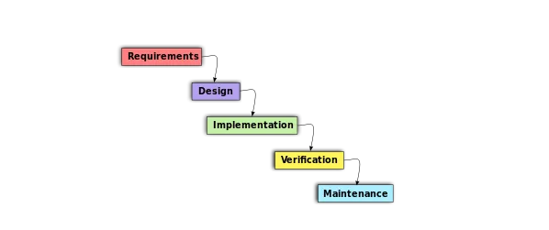

Fig 3.1 Diagram of an OOAD model
Here are some important aspects of OOAD:
1. Object-Oriented Programming: Real life things transform to software objects embracing their attributes through object-oriented programming while maintaining functions equivalent to their originals. The creation and application of software systems within OOAD make use of this technique.
2. Design Patterns: Software design patterns solve common architectural issues which developers encounter during development. Design patterns in OOAD help programmers develop simpler and faster systems through software development.
3. UML diagrams: UML serves as a language for drawing diagrams that show the different parts of specific software applications through standardized procedures. Digital rendering of software system sub-systems employs UML diagrams during OOAD development.
4. Use Cases: Development teams use, Use Cases as a technique for describing how software users experience a program through their actions. The research of Amarnath Ganguli et al. (2023) demonstrates that through use cases OOAD allows developers to understand requirements for building suitable software programs. According to Grady Booch "object-oriented design" functions as both a design methodology and a graphic representation system managing static and dynamic system models along with design elements and physical modules. Tutorials Point (I) Pvt. Limited, the year 2014.
Selecting this methodology has the following advantages:
Programming development occurs through functional elements which involve additional functional elements to generate final programs which reduce project timelines considerably. The OOP language divides total programming issues into smaller solvable problems which follow one object at a time. The new technology requires accountability with regard to benefiting programmers by developing high-quality software while reducing maintenance expenses. Extending OOP-based systems proves more straightforward when developers’ transition from small to large program scales compared to other development methodologies. Several object instances exist without creating any interactions between those entities. Work partition in these projects can possibly be the most convenient through using object-based allocation methods. Objects in the program domain match objects in the problem domain thus generating possibilities. Data hiding principles ensure developers can implement secure applications that resist interferences from programming elements in other program areas. By using inheritance mechanisms programmers can prevent duplicate code while allowing their classes to extend their functionality. The messaging framework for object-to-object communications simplifies external system description interfaces. The demonstrated design approach enables researchers to obtain higher details about models that could lead to implementation-ready specifications form the program, thus cutting down the development period tremendously.
- The OOP language can then separate the overall problems into manageable problems (one object at a time).
- Accountability of the new technology that makes the programmer’s jobs easier, develops high quality software and reduce maintenance cost.
- Compared to other methodologies, OOP systems can be easily extended from a small system to a large one.
- This simply means that it is possible to have many object instances while these do not interact with each other in any way.
- Possibly one of the most convenient ways to partition work in the projects is on the basis of objects.
- In this case possibility exists that objects in problem domain can be mapped to objects in the program.
- The principle of data hiding assist the programmer create programs that are safe from invasion by the code present in other portions of the program.
- In this way, through applying inheritance, it is possible to avoid the duplicate code and expand the usage of the classes.
- Message passing techniques are used for inter-object communications which make the interface descriptions of the external systems simpler.
- The shown design approach allows getting more details of model in a format that could be implemented.

3.3 ANALYSIS OF THE EXISTING SYSTEM
The current system enables user interaction with the chatbot through both text input and the bot processes text and voice input. During conversations with the Chabot the bot detects which illness a user has by analyzing the nature of their queries. Based on diagnosed conditions the bot generates suggestions for the user's medical conditions. The system permits several users at once to join without performance delays.

3.4 PROBLEMS OF EXISTING SYSTEM
Some current platforms contain built-in encrypted handwritten chat functions. The main drawbacks of Chatbots include extended waiting periods for expert responses alongside first-initiating constraints. This data contains limited diagnostic disorders because of which its effectiveness becomes diminished. Any medical system should efficiently guide patients to their nearby hospital but the current setup struggles to deliver technical functions properly.
3.5 ANALYSIS OF THE EXISTING SYSTEM
Using this communication method users can exchange text messages with the Chabot system which responds through text. All users must visit the login page to access the chat room. In its system an AI assistant aids patients who need medical support after experiencing illness or other health challenges. Users will receive appropriate instructions together with relevant recommendations through this system. Users will easily navigate through the user interface of this Chabot. Round-the-clock availability makes this Chabot highly beneficial for patients who need fast disease diagnoses. Through the Google location map integration this Chabot enables users to access directions they need to get to emergency care facilities nearest their current position.

ADVANTAGES OF THE PROPOSED SYSTEM
The interface approaches basic functionality while remaining easy for users to utilize. The connection between users and the Chabot takes place at relatively fast speeds. The method delivers exceptionally reliable outcomes. Once logged into the system by a doctor or nurse the bot reports the patient location to the nearest medical facility. Symptoms can be read out directly from user text conversations. It is a comparatively quick method of interacting with the Chabot.
• Optimum user interface.
• The result is highly reliable.
• Sends the location to the closest medical facility.
• It extracts symptoms from user chat.
• Efficient responds.

ANALYSIS OF THE PROPOSED SYSTEM
Researchers conduct this study with this objective.
1. The available chatbot programs currently demonstrate multiple problems with correctly determining and treating different mental health conditions. Healthcare leverage this modern technique to deliver continuous online mental healthcare which resolves both critical issues and daily inquiries and gives precise therapeutic interventions.
2. A single minor mental issue might stem from experiences of being lonely and having normal overthinking before developing into major problems of depression and anxiety. The new system helps users get online support by recognizing typical mental health symptoms so it provides solutions to their problems. Online users without housebound limitations can access treatment quickly by just logging in to ask their questions.
3. The new system operates throughout every part of society while offering simple usability to assist day-to-day activities by reducing patient stress from waiting rooms or faulty medical treatments. Through remote access from home or office you can obtain immediate responses along with appropriate medical recommendations.

3.8 DESIGN OF THE PROPOSED SYSTEM
• Use-case: A system's operational behavior becomes clear through use-case diagrams so that system requirements become visible. The use-case diagram helps stakeholders view an overview of system boundaries alongside its main operations. Through use-case diagrams system participants can observe the various interactions which take place between them. System operation becomes visible through alternative modeling methods while use case diagrams demonstrate both user interaction models and system targets but lack operational system representations (IMB corporation, 2021). The primary visual presentation to demonstrate incomplete new software development system software requirements uses a UML use case diagram. A use-case contains elaborate decision-making details yet the use-case diagram provides a useful system overview at a higher abstract level. The basis of system structure rests on use case diagrams. Below you will find the depicted user case diagram for the proposed system. The diagram shows AI together with a patient who play the parts.

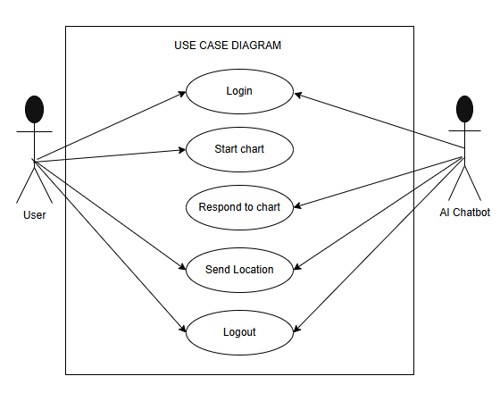

Fig 3.2 Use Case Diagram

USE CASE DIAGRAM DESCRIPTION
The diagram depicts the design of the forthcoming system. It has two basic actors which are: the User and the AI Doctor.
The User: Users can access login through the image above which launches them into the chat room where they can share their problems and symptoms like "I have been feeling down lately."
AI Doctor: The AI helper or doctor will bring you answers regarding your symptoms which will solve your problems. After an insufficient solution from the AI doctor a link through Google Maps will direct you to your nearest clinic or hospital information. All these elements connect to facilitate normal queries.
Activity diagram Descriptions
A service delivery framework is explained through activity diagrams by showing the sequence of required activities at various levels of detail. Through behavioural diagrams in UML models one can find descriptions of the system's dynamic elements. An activity diagram represents the system I introduced in this visual explanation. (Created in 2022; all rights reserved).

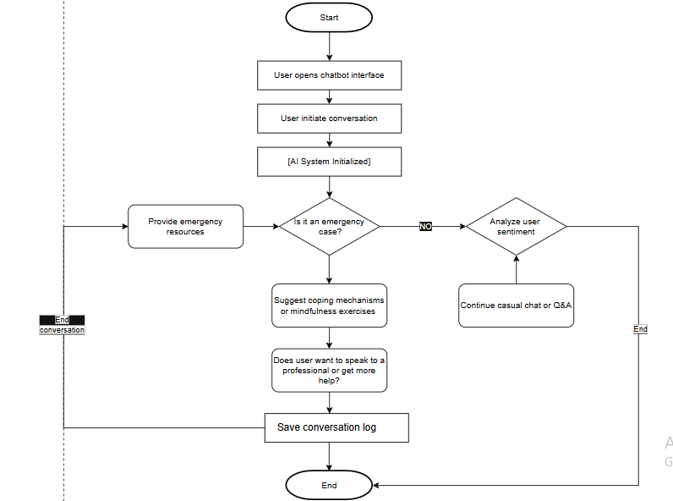
Fig 3.3 Activity Diagram

Database Design
Table 3.1: Conversation table
Name | Type | Null | Default | Extra | Action
Conversation Id | Int | No | None | AUTO_INCREMENT
Intent Id | Int | No | None
Person Id | Int | No | None
Question | Varchar | No | None
Sent Msg | Varchar | No | None
Answer | Varchar | No | None
Incoming Msg | Varchar | No | None
Date created | Date time | yes | NULL

Table 3.2: Health home table
Name | Type | Null | Default | Extra | Action
Health Home Id | Int | No | None | AUTO_INCREMENT
Location Id | Int | No | None
Health place Id | Int | No | None
Name | Varchar | No | None
date added | Date time | yes | NULL

Table 3.3: Location table
Name | Type | Null | Default | Extra | Action
Location id | Int | No | None | AUTO_INCREMENT
Name | Varchar | No | None
Date added | Date time | yes | NULL

Table 3.4: Person table
Name | Type | Null | Default | Extra | Action
Person id | Int | No | None | AUTO_INCREMENT
Location id | Int | No | None
Person type id | Varchar | No | None
Username | Varchar | No | None
Email | Varchar | No | None
Password | Varchar | No | None
Date created | Datetime | yes | NULL

Table 3.5: Hospital table
Name | Type | Null | Default | Extra | Action
Hospital Id | Int | No | None | AUTO_INCREMENT
Location Id | Int | No | None
Health place Id | Int | No | None
Name | Varchar | No
Date added | Datetime | yes | NULL

CHAPTER FOUR
DESIGN AND IMPLEMENTATION

4.0 INTRODUCTION
This chapter explains how the new system will be implemented, including the hardware and software that must be installed for it to work properly.
4.1 SOFTWARE REQUIREMENT USED IN NEW SYSTEM

The required software used in this new system are as follows:
1. The platform used:
I. Dialog flow: Dialog flow is basically an understanding service for natural language which can be employed for designing and integrating dialog UEIs for different solutions such as mobile applications, Web applications, devices, IVR and so on. Such a role is called a ‘dialogue flow agent’ – and this agent is in charge of the conversations your end users have with you. This module talk fluent natural language and is capable of interpreting figurative language and speech. In conversation, dialog flow is when the user’s written text or spoken word is converted into data that affiliated services and applications can comprehend (Peer-Sport, 2023).
II. Node.js: It is an open-source server that works across different operating systems like Windows, Linux, Unix, and macOS. It’s a back-end JavaScript runtime environment that utilizes the V8 JavaScript Engine to execute JavaScript outside of a browser context.
III. XAMMP: This is a comprehensive web server solution that includes all the elements needed for a local web development environment, such as the Apache server, MariaDB database, and interpreters for PHP and Perl scripts. It’s a free product distributed by Apache Friends, Inc.
2. The programming language used:
Frontend
I. JavaScript: JavaScript is a scripting language with which one can develop dynamic content on the page, control multimedia, animation of images and virtually anything else (Mozilla. org 2023).
II. React Native: This UI software framework, developed by Meta Platforms, Inc., is open-source and enables developers to create applications for Android, Android TV, iOS, macOS, tvOS, the web, Windows, and the Universal Windows Platform. It combines the React framework with native interface features for a seamless experience.
3. Backend
I. PHP: Another way of looking at PHP is that it is Hypertext Preprocessor abbreviated as PHP. At first, they interpreted it as the physical home of the page, namely, on a person’s face. The below is a scripting language that may be used to generate dynamic Web pages on the server. PHP is a web development tool mainly designed for webpage programming. It was developed firstly in 1993 by Rasmus Lerdorf who is a Danish-Canadian programmer and was published in 1995 (Wikipedia 2023).
4. Database used.
I. MySQL I: A relational database driver called MySQL Extension (MySQL Improved) is used in PHP scripting to connect to MySQL databases. If you're thinking about connecting to a MySQL database server, you have three primary API choices: MySQL Extension for PHP (Wikipedia 2023).
5. The text editor used is Microsoft Visual Studio Code (VScode): Thanks to the Electron Framework, Microsoft rolled out Visual Studio Code, or simply VS Code, which is compatible with Windows, Linux, and macOS. It comes packed with features like code debugging, syntax highlighting, code completion, code snippets, code refactoring, and built-in Git integration. The web hosting server used are Google cloud, Google Map, MySQLI
6. Application used.
Expo Go: It is an open source and free client which does not require any building on the local development environment for testing the React Native apps on the Android and iOS devices. It helps to execute projects faster while creating them through the opening of the apps that Expo CLI provides.
4.2 SYSTEM REQUIREMENT
To create this chatbot successfully using a laptop or desktop some software is required. This software is.
- VS Code (Visual Studio Code)
- Google map
- Google Cloud
- Node.js
- Xammp
- Mental Health API

4.3 HARDWARE REQUIREMENT USED IN NEW SYSTEM
The hardware required are:
- A computer or server with sufficient processing power and memory to handle the Chabot workload.
- 32 GB RAM.
- Eight-core processor.
- Hard drive space of 500 GB.
- Check that the C: drive has 100 GB or more of free hard disk space.
- A laptop, keyboard, CPU, and monitor.
- A mouse.
- Internet connection.

4.4 SYSTEM IMPLEMENTATION
Thus, for the preprocessing of the text and for constructing the neural network, the Mental Health chatbot system was built fully in Node. js framework and XAMMP server for database. Node. js is suitable for this task because this post is developed with respect to the Node implementation of chatbots. It contains the following features: Besides the set-coded ones such as dates, names, and many others, CEs were the AI ones that were built analogously to the integrated neural networks that are interconnected for categorization. Also, JavaScript, React native, PHP, Google Cloud, etc. are used Teams. The automated physician (chatbot) and the patient are the components of the implementation of the system.
4.5 INTERFACE
The following are the notable features on the interface:
Create Account/ Sign Up page: It is where users or patient click to create a new account to access the chatbot and the chat room.

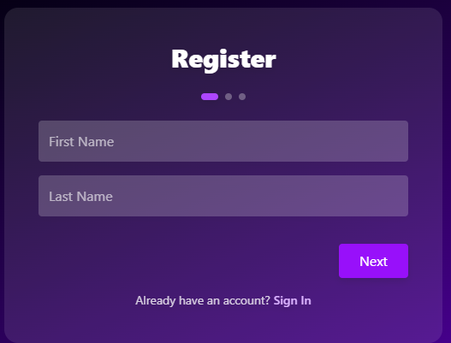
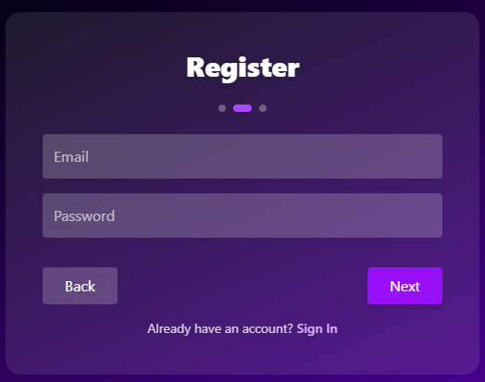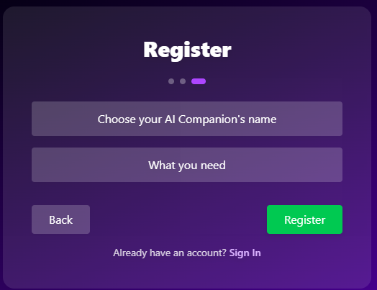
Fig 4.1 Create Account/sign up page

Login: A login page is a form designed to accept a username and password for administrators as a means of authenticating access to the system. It is where the patient or the user login in to access the chatbot.

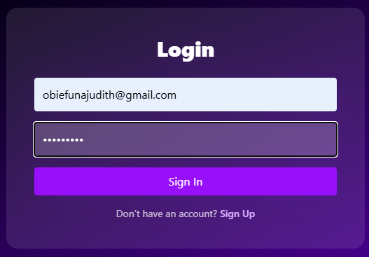
Fig 4.2 Login page
Homepage: The homepage is the first thing we see after the patient login and when the patient can start communicating with the AI bot. From this homepage one can easily access any activity that they want to see. The image below displays the empty state and functioning state.
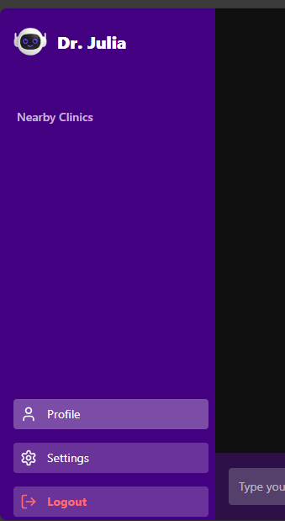
Fig 4.3 Homepage
Input in the chat room for admin: it is where the admin controls the chat bot buy inserting different question and answer for the patient to communicate with the AI doctor.
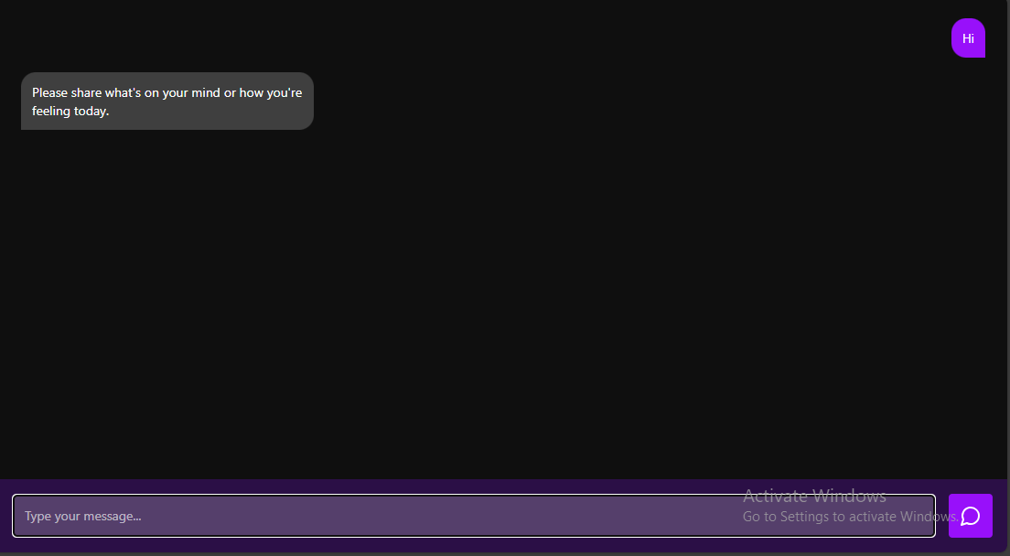
Fig 4.4 Input of the chat room

Output of the Chatroom: This is where the AI and the patient communicate, where the patient can state the problem they have and the bot will give right prescription for the symptoms the patient is face easily and fast without any error.
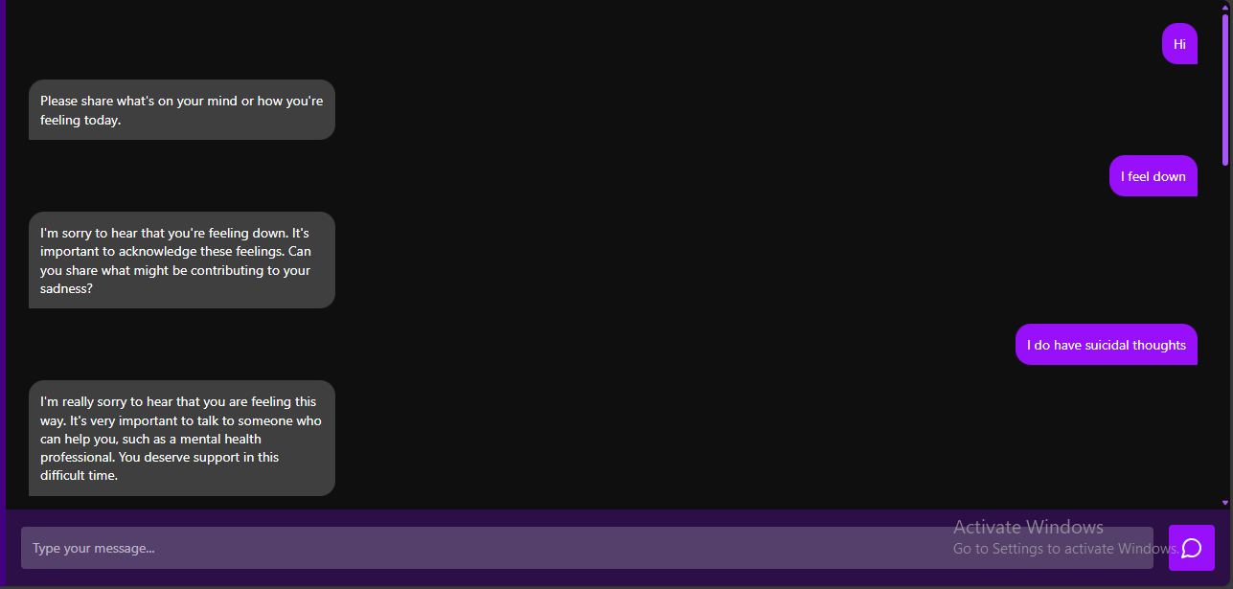
Fig 4.5 Output of the Chat room
Location Map: In this place the chatbot will send a location to the user or patient whose case is more complex that needs the help of a professional and the bot can’t be of help. The chatbot will send nearby location of the nearest clinic or hospital for the patient to visit base on what the patient stated in the chatroom to seek for help.
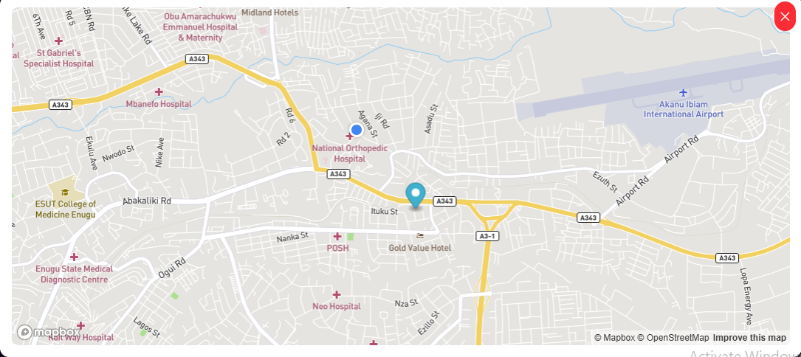
Fig 4.6 Location Map
CHAPTER FIVE
SUMMARY AND conclusion

5.0 SUMMARY

This project consists of list of tables and figures used, certification, acknowledgments, dedication, abstract, and five (5) chapters make up this project. The introduction, problem definition, study goal and objectives, study rationale, and system development methodology were all covered in the first chapter. The second chapter provided a summary of the previous researchers' contributions based on the study and an overview of chatbots, NLP, machine learning, and artificial intelligence. The system model, data modeling, system design, and system performance were introduced in chapter three. The system's analysis, implementation, and documentation are covered in the fourth chapter, and the fifth chapter summarizes, closes, makes recommendations, and adds to the body of knowledge. The project's appendices and references list the sources used to conduct the investigation.

5.1 CONCLUSION

Patients can communicate with professionals through traditional channels like phone calls, video calls, SMS, and emails thanks to Chabot's for mental health. This increases participation and gives medical professionals more time and opportunity to focus on patients who need it most. The influence of AI has spread quickly across industries. The healthcare sector is no exception. AI is being used by healthcare providers to help patients round-the-clock. With the aid of a mental health Chabot, patients are able to acquire the necessary information as and when they need it and have a better mental health experience. Because they automate all of a medical representative's mundane and lower-level tasks, chabots in the healthcare industry save professionals a ton of time. That's not the case, though. They gather and keep track of patient data, ensure that it is secured, allow for patient monitoring, offer a variety of educational help, and offer more comprehensive medical aid. Chabots in general are transforming the healthcare sector. The adoption rate will continue to rise as more companies realize how beneficial it is to automate their operations with Chabot's. By 2032, the healthcare Chabot market is expected to have grown from $230.28 million to $944.65 million. Thus, you can see that healthcare is a global phenomenon that benefits individuals every day by preventing stress caused by standing in line or receiving a bad prescription and allowing people to stay in the comfort of their homes, workplaces, etc. Ask the bot a question, and you'll quickly and accurately receive an answer. This chatbot also create a location for users or patient to visit any local hospital in there for more help in solving their problems.

5.2 RECOMMENDATION

This system has been fully designed and developed to be recommended for the full use of its resources. System maintenance should also be provided to maximize continuous access to the system and updates to software and system functionality required to further meet additional user requirements. We hereby recommend it to any college, school, offices, at home etc.

REFERENCES
Anuji, P. (2022). A chatbot technically reflects the logical development of a question-answer system that uses Natural Language Processing (NLP).
Arun. (2021). Chatbots in healthcare: Enhancing communication between patients and providers.
Elgabry, O. (2017). Object-oriented analysis and design (OOAD) methodology in software engineering.
Ganguli, A., et al. (2023). Ideation in object-oriented software development.
IBM Corporation. (2021). Understanding use-case diagrams in system development.
McNeal, M. L. (2013). Advantages of chatbot systems in user communication.
Mittal, H. (2021). Chatbots and human interaction: An overview.
Mishra, S. K. (2017). Development of a chatbot using Python and NLP.
Mohammed, A., et al. (2022). An analysis of chatbot systems using pattern-matching and NLP.
Mozilla. (2023). JavaScript documentation and uses. https://developer.mozilla.org/
Nivedita, S., et al. (2019). Review of chatbot architecture and components.
Peer-Sport. (2023). Dialogflow documentation.
Sadiku, M. N. O., Eze, T., & Musa, S. M. (2021). Artificial intelligence: An overview. International Journal of Engineering Research and Applications.
Smishad, T. (2023, June). Comparison of rule-based and machine learning-based chatbots.
Tutorials Point (I) Pvt. Limited. (2014). Object-oriented design and UML principles.
Vaidyam, A. N., Wisniewski, H., Halamka, J. D., Kashavan, M. S., & Torous, J. B. (2019). Chatbots and conversational agents in mental health: A review of the psychiatric landscape. JMIR Mental Health, 6(11), e16021. https://doi.org/10.2196/16021
Wikipedia contributors. (2023). MySQL. Wikipedia. https://en.wikipedia.org/wiki/MySQL
Wikipedia contributors. (2023). PHP (programming language). Wikipedia. https://en.wikipedia.org/wiki/PHP
World Health Organization. (n.d.). Mental well-being: WHO definition and perspective. https://www.who.int/

