ISOLATION AND CHARACTERIZATION OF BACTERIA FROM READY _TO_ DRINK BEVERAGES (FURA DE NUNU, TIGERNUT DRINK
AND SOYAMILK)

BY

OKOSHI JUDITH CHISOM
GOU/U21/MCB/505

BIOLOGICAL SCIENCES
MICROBIOLOGY DEPARTMENT
FACULTY OF NATURAL SCIENCES AND ENVIRONMENTAL STUDIES
GODFREY OKOYE UNIVERSITY, ENUGU NIGERIA

A PROJECT SUBMITTED TO THE DEPARTMENT OF BIOLOGICAL SCIENCES IN PARTIAL FULFILMENT TO THE AWARD OF BACHELOR SCIENCE (B.Sc) DEGREE IN MICROBIOLOGY

SUPERVISORS: PROF. I. M. EZEONU AND BELLO-UKWUEZE M. N.

JULY, 2025
APPROVAL
This research work titled “ISOLATION AND CHARACTERIZATION OF BACTERIA FROM READY _TO_ DRINK BEVERAGES (FURA DE NUNU, TIGERNUT DRINK
AND SOYAMILK)” has been assessed and approved by the committees of the Department of Biological Sciences and the Faculty of Natural Sciences and Environmental Studies, Godfrey Okoye University, Enugu, Nigeria.

Prof. I. M. Ezeonu
and Bello-Ukwueze M. N. __________________ _________________
Supervisors Signature Date

Dr. F. N. Olisaka __________________ _________________
Head of Department Signature Date

Prof. Chidi Uhuegbu __________________ _________________
Dean of FNASE Signature Date

External Examiner __________________ _________________
Signature Date

CERTIFICATION
This is to certify that this project report titled: ISOLATION AND CHARACTERIZATION OF BACTERIA FROM READY _TO_ DRINK BEVERAGES (FURA DE NUNU, TIGERNUT DRINK AND SOYAMILK) was carried out by Okoshi Judith Chisom with Registration Number GOU/U21/MCB/505 under the supervision in the department of Biological Sciences, Godfrey Okoye University Enugu Nigeria.

Prof. I. M. Ezeonu
and Bello-Ukwueze M. N. __________________ _________________
Supervisors Signature Date

Dr. F. N. Olisaka __________________ _________________
Head of Department Signature Date

DEDICATION
This project is wholeheartedly dedicated to God for the guidance, strength, power, protection, skills and for giving me a healthy life.

ACKNOWLEDGEMENT
First and foremost, praises and honour to God the almighty for his shower of blessings throughout my research work. I would like to express my deep and sincere gratitude to my supervisors Professor I.M Ezeonu, Bello N. Maria Ukwueze for giving me proper guidance throughout my project work. I would like to experience my gratitude to my uncle, Hon. Dr. Alphonsus Onyeachonam Nwafor for his support, efforts and sacrifices throughout my project work. I am extremely grateful to my family for their love, prayers and care. Also, I express my gratitude to my junior brother Omego Gabriel for his assistance and support. My special thanks also to Mr. Uchenna Solomon and Ms. Adaobi for their support.

TABLE OF CONTENTS
Title Page i
Approval ii
Dedication iii
Acknowledgements iv
Abstract v
List of Tables viii
List of Figures ix
List of appendix x

CHAPTER ONE: INTRODUCTION 1
1.1 Background to the Study 1
1.2 Statement of the Problem 2
1.3 Aim of the Study 3
Specific Objectives 3

CHAPTER TWO: LITERATURE REVIEW 5
2.1 Overview of Fura de Nunu 5
2.2 Overview of Soyamilk 6
2.3 Overview of Tigernut 7
2.4 Microbial contamination of ready-to-drink beverages 8
2.5 Common bacterial isolates in dairy and plant-based beverages 10
2.6 Factors affecting bacterial growth in beverages 11
2.7 Health benefits of Fura de Nunu, Soyamilk, and Tigernut drink consumption 15
2.8 Microbial safety standards and regulatory frameworks 17

CHAPTER THREE: MATERIALS AND METHODS 19
3.1 Sample collection 19
3.2 Serial dilution 19
3.3 Preparation of media for isolation 20
3.4 Isolation of bacteria 20
3.5 Subculture of the isolate by streaking method 21
3.6 Gram staining 21
3.7 Stock culture 22
3.8 Biochemical test 22

CHAPTER FOUR: RESULTS 25
4.1 Total viable counts in CFU/mL 25
4.2 Identification and characterization of isolates 26

CHAPTER FIVE: DISCUSSION, CONCLUSION AND RECOMMENDATIONS
Discussion 29
Conclusion 32
Recommendations 32

REFERENCES 33

LIST OF TABLES

Table 4.1 Total viable counts in CFU/mls 26
Table 4.2 Characteristics of the sample isolate from the Fura de nunu, tigernut drink,
soya milk 28

LIST OF APPENDICES
Appendix 1: Nutrient Agar showing colonies 37
Appendix 2: Subculture on macConkey Agar, Mannitol salt agar and Eosine Methyl Blue 38
Appendix 3: Indole test 39
Appendix 4: Catalase test showing positive result 39
Appendix 5: Picture of me working in the laboratory 40

ABSTRACT
Ready-to-eat (RTE) beverages such as Fura de Nunu, tigernut drink and soyamilk are widely consumed in Nigeria for their nutritional value and accessibility. However, their traditional preparation and informal sale often occur under unhygienic conditions, increasing the risk of microbial contamination and posing public health concerns. A total of 20 beverage samples (Fura de Nunu, soya milk, and tigernut drink) were collected from vendors in New Artisan market,
Abakpa market, Thinkers corner and New Haven market, Enugu. Standard microbiological techniques were used for bacterial isolation and identification, including serial dilution, selective media culturing, Gram staining, and biochemical tests such as catalase, coagulase, indole, citrate, oxidase and sugar fernmentation test. The study revealed varying levels of bacterial contamination across all sample types, with tigernut drink exhibiting the highest microbial load. Pathogens identified included Escherichia coli, Staphylococcus species, Klebsiella species, Citrobacter species and Enterobacter species. Many isolates were catalase-positive and oxidase-negative, consistent with Enterobacteriaceae and Staphylococcus species. The presence of foodborne pathogens in all beverage types highlights serious lapses in hygiene during preparation and handling. These findings underscore the need for improved food safety practices and regulatory oversight to protect consumers from potential health risks.

CHAPTER ONE
INTRODUCTION
1.1 Background to the Study
More people in Nigeria and other areas in West Africa are demanding ready-to-drink beverages like Fura de Nunu, soyamilk and tigernut drink as a result of improvements in living standards and the fast-paced way people live today. Most people enjoy these drinks because of their taste, positive nutritional impact and possible health advantages (Mensah e. 2019). Many people love to buy Fura de Nunu, soyamilk and tigernut drink at street market stalls and vendor stands (Ayoade et al., 2018; Abioye et al., 2020).
Even though RTD beverages are good for you, they do not stay fresh for long and can be contaminated with harmful microbes. Because they are moist and full of nutrients and are made using traditional methods, they help bacteria to thrive (Obadina et al., 2015). Most of the time, these products are produced and sold under unhygienic circumstances which makes them more likely to be contaminated during processing, handling, transportation and storage. Because they are often made in unsuitable places, the healthiness of these snacks is facing serious challenges (Oladipo et al., 2016). Since Fura de Nunu is produced by allowing untreated and unpasteurized milk from cows to ferment and adds ground millet balls, the food is more likely to cause outbreaks than other foods (Oguntoyinbo and Narbad, 2018). Just like soyamilk, tigernut drinks are sometimes processed with dirty tools, untreated water and left unpasteurized which puts them at higher risk of being contaminated by microorganisms (Bello et al., 2017). Studies have found that RTD beverages can contain E. coli, Salmonella, Staphylococcus aureus, Listeria monocytogenes and Bacillus cereus—all regularly linked to illnesses caused by food (Adebayo-Tayo et al., 2012; Odu and Adebayo, 2018). Taking dairy beverages that are not pure can result in everything from mild gastrointestinal issues to dangerous illnesses like septicemia and hemolytic uremic syndrome in certain populations such as children, the older people and people with weak immune systems (WHO, 2015).
These traditional drinks are not safe enough because they are often kept warm, improperly sealed, mixed in dirty utensils and consumed by people who haven’t learned about food safety (Eze et al., 2020). Many times, these drinks are created without following hygiene rules and they are often offered in open cups or used plastic bottles which raises the risk of pollution after production. Nigerian bodies such as National Agency for Food and Drug Administration Control (NAFDAC) and Standard Organization of Nigeria (SON) have created rules for ensuring food safety and hygiene. Nevertheless, finishing these guidelines in informal markets still proves hard due to a lack of resources and rules that do not cover the whole area (Okpalugo et al., 2010). Without regulations, there is no control over the distribution of polluted products that may be dangerous.
Due to the rising consumption of Fura de Nunu, soyamilk and tigernut drink, we must now scientifically examine their safety from microbial contamination. Consequently, the study intends to isolate and characterize the bacteria in these dairy-based products.
1.2 Statement of the Problem
In Nigeria, more people now prefer ready-to-drink drinks such as Fura de Nunu, soyamilk and tigernut drink which indicates evolving food habits and popular trends in large cities. Due to their helpful nutrients, low cost and ease of use such drinks find many fans in Enugu, where they are easily available at local informal markets. Even though they have benefits, they are frequently processed and sold in ways that do not ensure their safety from microbes.
Most of the time, those who sell food in open markets and along roadsides do not have clean water, sterilized accessories or cold storage facilities. Because of these gaps in food handling, these drinks may get contaminated with a variety of harmful and spoilage bacteria. Based on research done so far, Escherichia coli, Salmonella spp., Staphylococcus aureus, Listeria monocytogenes and Bacillus spp. have been found in RTD beverages and may result in severe foodborne diseases (Oladipo et al., 2016; Obadina et al., 2015). These pathogens might get into the products during various production phases such as through tainted raw supplies, polluted utensils, surrounding dust or incorrect storing of the items.
There is not enough research available about the types of bacteria found in Fura de Nunu, soyamilk and tigernut drink in Nigerian open markets. So far, there has been not much microbiological review or thorough studies into the microbial makeup of these RTD products in the Abakpa market. Because of this lack of knowledge, there is a threat to people’s health as well as a problem with effective regulatory measures and food safety campaigns. Since contaminated beverages might have health consequences, learning about their bacterial profiles is very important. Therefore, this study aims to isolate and characterize bacteria found in RTD Fura de Nunu, soyamilk, and tigernut drink sold in Abakpa Market, in order to provide evidence-based insight into food safety risks and support the formulation of practical health and safety guidelines.
1.3 Aim of the Study
The main aim of this study is to isolate and characterize the bacteria present in ready-to-drink Fura de Nunu, soyamilk, and tigernut drink products sold in New Artisan market, Abakpa market, Thinkers corner, New Haven market, Enugu.

Specific Objectives include to;
- Isolate bacteria from RTD Fura de Nunu, soyamilk, and tigernut drink sold in New Artisan market, Abakpa market, Thinkers corner, New Haven market, Enugu.
- Identify and characterize the isolated bacterial species using microbiological and biochemical techniques.
- Determine the prevalence and types of potentially pathogenic bacteria in these beverage samples.

CHAPTER TWO
LITERATURE REVIEW
2.1 Overview of Fura de Nunu
The traditional tea-like drink called Fura de Nunu is popular all over West Africa, especially in northern Nigeria. It is recognized for its culture and nutrition, as it is made by mixing Fura (spiced fermented millet dough balls) and Nunu (fermented cow milk). Because it quenches thirst, fills one up and gives lots of energy, the drink is favored by those working in hot places and by pastoral communities (Adeyeye et al., 2017).
There are four main parts to Fura preparation: soaking millet, grinding it, adding spices and letting it ferment. Ginger, cloves and black pepper are usually added to help food taste better and avoid microbial growth. After fermentation, the dough is formed into small balls and may be sold alone or mixed with Nunu right away. Nunu is usually made by letting unpasteurized cow milk ferment by itself at room temperature, so no starter culture is added. Olasupo et al. (2019) stated that Lactobacillus, Leuconostoc and Streptococcus species found in raw milk and the utensils naturally cause the fermentation.
This food is thought to provide nutrition in balanced amounts. Millet in Fura brings complex carbohydrates, fiber and iron and magnesium, while the Nunu offers nutritious animal protein, a lot of calcium and vitamins such as B12 and riboflavin (Ameh et al., 2020). Although Fura de Nunu is healthy, there are concerns about its bacteria because hygiene care during the milking, fermenting and handling processes is poor. A number of investigations have revealed that pathogens such as Escherichia coli, Staphylococcus aureus, Salmonella sp. and Listeria monocytogenes may be present in food sold at open markets (Onilude et al., 2018). The main reason for this is consuming raw milk, not cleaning kitchen equipment properly and not keeping products in the cold enough. Still, Fura de Nunu is an important means of earning income for many vendors nearby and has been identified as a possible probiotic food as it contains many beneficial microbes. More food scientists and health professionals are now interested in improving food safety by using proper hygiene, standard methods and possibly scaling up how foods are processed (Olasupo et al., 2019).
2.2 Overview of Soyamilk
Soyamilk is created by first soaking, grinding, boiling and filtering soybeans to take out a milk-like liquid. Many people who can’t have animal milk, are lactose-intolerant, allergic to cow proteins or eat only vegetarian or vegan diets prefer it to animal milk (Kwon et al., 2020). People of all backgrounds and ages in Nigeria and similar countries like soyamilk because it is a suitable substitute for cow milk, very affordable and provides important protein and vitamins (Oboh and Rocha, 2017).
The amino acids lysine and leucine which are necessary for health, are found in soyamilk in higher quantities and are especially missing in diets with a lot of cereals. It furthermore has B-complex vitamins, calcium, magnesium (only if fortified), dietary fiber and antioxidants called isoflavones that also serve to lower cholesterol (Liu, 2024). Therefore, soyamilk can help reduce the chance of suffering from cardiovascular disorders, some types of cancer and osteoporosis.
Because it has lots of health perks, soyamilk does not keep for long and is easy for bacteria to infect, mostly when conditions for storage are unclean. In Nigeria, the traditional method of making soymilk is usually not organized and relies on unregulated vendors and smaller producers who do not have proper ways to sterilize and package their milk.
In turn, the safety of the product is threatened by common infectious microorganisms called Escherichia coli, Staphylococcus aureus and Bacillus cereus (Adebayo-Tayo et al., 2009). Also, the soyamilk’s high moisture and important nutrients can cause microbes to grow very fast if not handled correctly. Chances of microbial contamination can be reduced by using pasteurization and aseptic packaging, mainly in crowded urban areas where quality and shelf life are important. Regulatory bodies and health organizations latest efforts involve teaching local producers better hygienic techniques and encouraging them to pasteurize beverages at a small-scale (Adelekan et al., 2018). In addition to being healthy, soymilk plays an important part in reducing food insecurity and malnutrition, mainly among people in low-income areas. It is still necessary to ensure that this beverage is safe from microorganisms so consumers remain healthy and willing to drink it.
2.3 Overview of Tigernut
Traditionally called “Kunun Aya” in Nigeria, tigernut drink is created from the Cyperus esculentus tuber, commonly called tigernut. Many people across West Africa like this drink because it helps them stay cool, gives them extra energy and is considered nutritious (Osagie et al., 2019). Usually, the drink is made by washing and soaking tigernuts, grinding them, filtering the mixture and occasionally mixing in ingredients such as dates, coconut or ginger to make it taste and be better for consumption. Tigernut drink is nutritious since it is rich in fiber, natural sugars, essential acids and minerals including potassium, phosphorus, magnesium, calcium and vitamins E and C. Eating it helps digestion, may keep gut bacteria healthy, reduce extreme changes in blood sugar and keep you satisfied for a long time.
Tigernuts have substances called antioxidants and phytochemicals that help the body fight against damage from oxidative stress. Because of these health-related advantages, people in both rural and city areas enjoy drinking coffee. Even though tigernut drink offers important nutritional value, its traditional processing and storage create a lot of health and safety risks. Many times, tigernut drink in Nigeria is produced in unsanitary environments using untreated water and kitchen ware that has not been cleaned. Such factors increase the risk of microbial contamination by microbes including E. coli, Salmonella spp., Staphylococcus aureus and yeasts and molds, that can cut short the product’s safety and shelf-life (Omemu and Aderoju, 2018).
Also, being served raw, this drink can transmit stomach infections, mainly when it is not stored cold and available at street markets. Investigations show that using pasteurization and safe packaging is necessary for protecting and maintaining tigernut drinks (Obadina et al., 2014). Nevertheless, tigernut drink is considered important both for the economy and nutrition in Nigeria. Due to rising consumer demands, people are becoming more interested in better, efficient ways to produce traditional breads, keeping them safe and ensuring everyone’s health.
2.4 Microbial Contamination of Ready-to-Drink Beverages
Many people in Nigeria like to drink ready-to-drink (RTD) drinks like fura de nunu, soyamilk and tigernut drink since they are nutritious, easy to find and affordable. Nevertheless, their high humidity, rich nutrients and basic methods of handling and storing them increase their chances of being contaminated by microbes. RTD beverages that are contaminated play a role in foodborne diseases and can seriously harm people who consume them (Beuchat, 2022).
The contamination of RTD beverages by microorganisms can come from different places. Contamination is usually caused by the ingredients introduced during the preparation of food. For example, unpasteurized milk, unwashed soybeans or tigernuts that are poorly treated may contain many pathogens such as Escherichia coli, Salmonella and Listeria (Uzeh et al., 2016). Sometimes, these contaminated beverages are caused by using polluted water, dirty machines or untidy places where food and beverages are made and sold (Umar et al., 2017). Also, if containers and hands are not properly cleaned, the microbes in these products can increase. It has been revealed through studies that issues such as dust, flies and exposure to the environment increase the chances of contamination when selling these beverages in open markets (Mensah et al., 2022).
The microbiological quality of RTD beverages depends greatly on good hygiene while preparing, handling and storing them. Sadly, producers and vendors in a lot of cases do not understand the basics of food hygiene and safety. Among the usual problem factors in food are obstacles such as contaminated raw materials, unpasteurized food, bad storage and use of dirty water or utensils, as indicated by Obadina et al. (2024). Besides, some vendors make large batches of these beverages and keep them at normal temperatures which helps bacteria to thrive. The lack of refrigeration and proper preservation can cause food to get spoiled quickly and puts it at greater risk of containing harmful pathogens such as Staphylococcus aureus and Bacillus cereus (Oranusi et al., 2023). The government not enforcing rules and doing health inspections on a regular basis adds to these risks.
If RTD drinks are contaminated, this can be very serious for people’s health, especially when access to healthcare is limited. Many food products are contaminated with pathogens which may lead to light cases of stomach upset or more serious diseases such as cholera, typhoid and listeriosis (WHO, 2015). As a result of exposure to such infections, children, pregnant women and people with weak immune systems have a higher chance of experiencing issues. Not only do foodborne illnesses cause more cases of sickness and death, but also cost households and health services a lot of money. Recurring cases of unclean foods in Nigeria reveal that it is important to enhance food safety measures and educate the public about the issue (Ifeadike et al., 2012).

2.5 Common Bacterial Isolates in Dairy and Plant-Based Beverages
Microorganisms, particularly bacteria, can spread and grow well in beverages such as fura de nunu, soyamilk and tigernut drink because these drinks are moist, nutritious and have a normal pH (Jay et al., 2005). Studies have found different kinds of harmful and spoilage bacteria in these drinks, showing that there are significant risks for those who drink them.
Typically in fura de nunu and similar homemade dairy beverages, the Lactic Acid Bacteria (LAB) group, including Lactobacillus, Leuconostoc and Streptococcus, participate in both fermentation and keeping the beverage safe. Yet, in addition to good microbes, some types of bacteria like Staphylococcus aureus, Escherichia coli, Salmonella spp. and Listeria monocytogenes have been found in different smoked fish (Abdelgadir et al., 2008; Okpalugo et al., 2008; Ezeonu et al., 2018). Bacteria may enter food through unpasteurized milk, incorrect fermentation methods or unsanitary tools.
Soymilk derived from soybeans often gets contaminated with Bacillus cereus, Enterobacter spp., Klebsiella pneumoniae and Pseudomonas aeruginosa (Omemu et al., 2011). Such bacteria are able to survive rough treatment, food that has not been cooked adequately and storage in normal temperatures. Soymilk does not contain preservatives and is rich in nutrients, so it allows bacteria to reproduce quickly if not treated correctly.
Just like raw milk, tigernut drink contains many microbial pollutants because the water and blending tools are not thoroughly sanitized. Through research, E. coli, Salmonella typhi, Shigella spp. and Staphylococcus aureus have been found in locally sold foods (Ameh et al., 2013). In case the brewing is done without proper hygiene, the presence of Saccharomyces cerevisiae is not enough to avoid the spread of harmful bacteria. It is necessary to identify and examine the bacteria in these foods to ensure they are safe and plan the right actions (Cheesbrough, 2006).
2.6 Factors Affecting Bacterial Growth in Beverages
Some intrinsic and extrinsic factors cause bacterial growth in drinks like fura de nunu, soymilk and tigernut drink. Microbial growth is impacted by all these factors, so it’s important to know what they are to find out what supports or stops the spread of microbes. Bacteria in these beverages can make them unsafe for drinking and may cause health problems to many people if not controlled correctly. These factors basically include the physical and chemical features of all drinks, the environment around them, processing techniques and how they are stored and handled.
2.6.1 Temperature
The extent of heat or coldness there is in an environment determines if bacteria will reproduce. Many dangerous and spoilage bacteria are mesophilic and they prefer a temperature range between 20°C and 45°C (Jay et al., 2005). For example, drinks such as fura de nunu and soymilk which are part of RTD products, are stored and sold at ambient temperatures wherever tropical countries such as Nigeria are included. This allows Staphylococcus aureus, Escherichia coli and Salmonella spp. to thrive and multiply very rapidly when perishable food is not properly stored or eaten soon. Additionally, poor cold-chain storage during the food journey creates a nice environment for bacteria, leading to a higher chance of food poisoning (Adesokan et al., 2008).
2.6.2 pH
A beverage’s pH level greatly determines how microorganisms can survive and grow. Most types of bacteria like to live in an environment with a near-neutral pH between 6.5 and 7.5. Besides, some bacteria like lactic acid bacteria (LAB) adapt to low pH and are normally part of beverages such as fura de nunu (Olasupo et al., 2002). Although acidic conditions can block the growth of many harmful microbes, they cannot always completely get rid of them, mainly when the bacteria belong to groups such as Listeria monocytogenes and E. coli O157:H7. Tiger nut drink and soymilk which have a pH level close to neutral, can support a wider variety of bacterial contaminants (Ameh et al., 2013).
2.6.3 Nutrient Content
Fura de nunu, soymilk and tigernut drink contribute to your health and also to your enjoyment when you drink them. It can benefit food production, but it also becomes an excellent space for bacteria to breed. These drinks contain a lot of proteins, carbohydrates, vitamins and minerals that help bacteria function and reproduce (Beuchat, 2002). Soymilk and tigernut drink contain amino acids, sugars and starch, therefore not handling them properly could lead to conditions where bacteria and fungi such as spoilage and pathogenic types, can grow successfully (Omemu et al., 2011).
2.6.4 Water Activity
AW stands for water activity which means the amount of water available in a food that bacteria and fungi can use. Most types of bacteria only grow when there is a water content of above 0.91 (Frazier and Westhoff, 1998). Thanks to the high moisture percentage, beverages like fura de nunu and tigernut drink are friendly to bacteria and their spreading. Since these products are not dried, they can still easily be infected with microbes during storage unless they are stored in the refrigerator or pasteurized.

2.6.5 Oxygen Availability
If there is no oxygen in the environment, bacterial growth will be different. Pseudomonas aeruginosa thrives where there is plenty of oxygen and Clostridium perfringens can live and multiply without oxygen. Anaerobic conditions do not prevent the growth of some bacteria such as Staphylococcus aureus which belongs to the group of facultative anaerobes (Cheesbrough, 2006). Most RTD beverages are made and stored in traditional ways which leaves them open to oxygen, so aerobic and facultative microorganisms can easily develop.
2.6.6 Microbial Interactions
The environmental conditions for microorganisms in a beverage control the development of bacteria. In such drinks, the leading lactic acid bacteria hinder the development of pathogens by lowering the pH, making bacteriocins and competing for available nutrients (Oyedeji et al., 2013). Non-fermented drinks without protective bacteria such as soymilk and tigernut drink, can let other bacteria grow without limits. Also, pathogens may increase due to the rise in immunosuppressive bacteria affecting the microorganism population balance.
2.6.7 Processing Techniques
Methods like fermentation, boiling, blending and filtration play a significant role in controlling the number of bacteria in beverages. Improper soymilk boiling might lead to bacterial or fungal contamination; however, if it is boiled properly, the contamination can be avoided. If beverages are not treated or re-contaminated properly, microbes may grow in greater numbers. Fura de nunu is usually prepared by hand, without sterile conditions and this results in it having a high number of microorganisms when produced (Adebesin et al., 2014). In addition, differences in local production methods make it hard to maintain a similar level of microbial safety in each batch.

2.6.8 Storage Conditions
The growth of microorganisms in beverages mainly depends on the storage temperature and how long they are stored. Because the drinks do not contain preservatives, most are stored close to room temperature and have to be drunk within a short time. But if nuts and seeds are stored too long and if warm conditions are involved, the bacteria present can grow very quickly (FAO, 2020). Spoilage happens faster and there is a higher chance of illness when food is not cooled or kept in the sun for a long time.
2.6.9 Personal Hygiene and Handling Practices
Ensuring good hygiene during the preparation and handling of beverages greatly affects the growth of bacteria. Studies indicate that the main sources of contamination are not washing hands, unhygienic utensils, polluted water and dirty production sites (Ibrahim et al., 2016). Unpasteurized milk, untreated soybeans and water from dirty sources can bring in many microbes that multiply often during production. Various methods are used to distribute food, but poor practices such as not washing hands or using gloves to cook, clean with dirty water or not covering foods to avoid fly invasion may cause dirty hands and bacterial contamination.
2.6.10 Packaging and Distribution
Packaging and methods of transferring the milk to customers are important for preventing the growth of bacteria. Containers that are left open or improperly sealed may let airborne germs into the beverages and also cause recontamination during handling. At these places where fura de nunu, soymilk and tigernut drinks are sold, drinks are stored sometimes in plastic or ceramic containers that have not been properly cleaned. With this, contamination is possible and the bacteria can further multiply during the time the foods are being carried and displayed (Adepoju-Bello et al., 2012).
2.7 Health Benefits of Fura de Nunu, Soymilk, and Tigernut Drink Consumption
Many people in Nigeria and West Africa, as well as others, enjoy Fura de Nunu, soymilk and tigernut drink for both cultural reasons and because they are always healthy to consume. They are all unique because of their plant and dairy ingredients, the fermentation process and the natural activity of some active substances. The rising demand for them is due in part to how healthy, immune and well they can make one feel.
Fura de Nunu has just the right amount of proteins, carbohydrates, essential fatty acids and minerals (calcium, phosphorus and magnesium) along with vitamins. Through fermentation, necessary lactic acid bacteria (LAB) are added to nunu such as Lactobacillus and Streptococcus species which serve as probiotics. They help the gut by increasing the good bacteria in it, reducing inflammation, helping digest lactose and easing symptoms of irritable bowel syndrome (Saulnier et al., 2019). The dietary fiber in fura’s millet helps keep things moving in your digestive system and makes you feel full. Thanks to their high calcium and vitamin D, dairy foods greatly assist in strengthening bones, teeth and warding off osteoporosis (Levy et al., 2015).
Soymilk contains plenty of plant protein, isoflavones and omega-3 fatty acids. Isoflavones in particular have been proven to have antioxidant effects that shield against oxidative stress and decrease the chances of developing cardiovascular disease, diabetes and some forms of cancer, according to Messina (2016). Lactose-intolerant people can use soymilk without any problems. Also, the phytoestrogens found in flaxseed assist in regulating hormones and this is especially beneficial for those going through menopause. Researchers suggest that having soymilk on a regular basis can lower LDL cholesterol and improve how the lipids are balanced in your body, helping your heart health (Kang et al., 2011).
Tigernuts provide you with fiber, natural sugars, healthy fats and minerals such as potassium, magnesium and phosphorus. Drinking this beverage is connected to healthy digestion as its fiber helps maintain normal bowel movements and keeps constipation at bay. It also acts as a stable food for the good bacteria in the gut which in turn supports gut health (Egbuonu et al., 2015). Antioxidants in tigernuts, vitamin E and arginine, have been linked to better care of your heart and blood pressure (Adekanmi et al., 2009).
It has been discovered that including Fura de Nunu, soymilk and tigernut drink in your diet can make you feel fuller and assist with controlling your weight. Higher protein and fiber in diet cause you to feel full longer which helps you consume fewer calories. Probiotics, isoflavones and antioxidants in these drinks join forces to help improve metabolism, lower the body’s cholesterol levels and fight inflammation. These beverages can positively impact our immune system. The GALT is stimulated by Fura de Nunu probiotics which boosts the body’s protective ability. Both soymilk and tigernut drink contain isoflavones and antioxidants which can help lessen oxidative damage and control the body’s defense system (Ciorba, 2022; Bermudez-Brito et al., 2022). In addition, these drinks supply the body with calcium, magnesium, phosphorus and iron which are important for cells, bones and red blood cells.
Research done recently also implies that these drinks may be helpful for brain health. Since both the ingredients in Fura de Nunu are rich in vitamins and antioxidants, they may contribute to the regulation of the gut-brain axis. Because the gut microbiota and central nervous system interact strongly, gut microbes play a role in mood, thoughts and handling stress. Eating probiotics is thought to help reduce anxiety and depression by balancing chemicals in the brain such as serotonin (Dinan and Cryan, 2017).
2.8 Microbial Safety Standards and Regulatory Frameworks for Ready-to-Drink Beverages
Since these beverages are highly nutritious, they easily become contaminated by microbes due to their high moisture content, content of nutrients and low degree of heat treatment. It is very important to keep these drinks safe from microbiological hazards to protect the people who enjoy them in areas where they are usually prepared in rough or low-quality settings. These products’ quality and safety during their journey from being made to being used rely on having proper regulations and microbiological rules.
In Nigeria, two agencies, the National Agency for Food and Drug Administration and Control (NAFDAC) and the Standards Organisation of Nigeria (SON), make sure that quality and safety standards are in place for food and drink products. Those agencies establish guidelines about the allowed microorganisms in ready-to-drink products, mainly coliforms, Escherichia coli, Salmonella spp. and Staphylococcus aureus.
Normally, the total aerobic plate count for such drinks should be below 10510^5 CFU/mL. Additionally, there should be no coliforms in 1 mL sample (SON, 2018; NAFDAC, 2020). On a worldwide scale, the Codex Alimentarius Commission, in collaboration with both the WHO and FAO, gives uniform rules for food which include microbiological standards for many types of foods. They are created to support and protect international food and health interests. FAO/WHO Codex guidelines consider GMP, HACCP and frequent microbial testing to be main elements for ensuring food safety (2020).
Despite what is required by these standards, several developing countries, including Nigeria, are still finding it hard to follow them. Nearly all Fura de Nunu, soymilk and tigernut drinks are produced by small-scale processors or vendors who frequently do not have a strong knowledge of how to keep food clean or get safe water or tools. Frequent testing of soft drinks from local markets has uncovered high numbers of microorganisms in some samples and sometimes shows the existence of pathogens including E. coli, Salmonella and Listeria monocytogenes (Ameh et al., 2021; Eze et al., 2020).
Consequently, there is need to enforce the already established laws, educate the public more about health and give more support to small food producers. If producers are encouraged to register with their area health department and take food safety workshops, chances of compliance improve. Furthermore, carrying out tests on mobile preventing laboratories or regular microbial monitoring with the health authorities helps control foodborne issues. It is also important for these drinks to be labelled with expiry dates, directions on how to store them and how to identify each batch under the rules. If food is properly labelled according to these rules, it becomes easier to trace and the public understands the relevance of food safety (NAFDAC, 2021).

CHAPTER THREE
MATERIALS AND METHODS
3.1 Sample Collection
Twenty(20) Samples were obtained from various local vendors and retail outlets known to sell kunu, fura de nunu, soya milk, and tigernut drink in New Artisan market, Abakpa market, Thinkers corner, New Haven market, Enugu. A total of twenty samples were collected, with five samples allocated to each beverage type, providing enough datasets for comparative analysis.
During the sample collection phase, aseptic techniques were strictly observed to prevent external contamination. The beverages were collected in sterile, screw-capped bottles, and each sample was assigned a unique identification code. Immediately after collection, the samples were stored in a cooler at 4°C and transported to the microbiology laboratory within two hours, thereby preserving the viability of any bacterial flora present.
3.2 Preparation of Media for Isolation
The media was measured accordingly to the manufacturer’s guide. The prepared medium was transferred into a conical flask and loosely covered with aluminum foil. Sterilization was carried out using an autoclave at 121°C for 15 minutes under a pressure of 15 psi. After sterilization, the medium was allowed to cool to a temperature between 45–50°C to minimize condensation during solidification. Approximately 20 mL of the agar medium was poured into each sterile Petri dish under aseptic conditions. The plates were then allowed to solidify at room temperature.
3.3 Isolation of Bacteria
Bacterial isolations were carried out using a variety of different selective media and differential media to determine the specific bacterial groups. Macconkey agar , Eosin Methylene Blue(EMB) and Mannitol salt agar(MSA) was prepared according to manufacturer guide. Plate Count Agar (PCA) was employed to estimate the total viable bacterial load in each sample, offering a general overview of microbial contamination. For the isolation of Gram-negative bacteria, particularly members of the Enterobacteriaceae family, MacConkey Agar was used. On this medium, lactose-fermenting bacteria, such as Escherichia coli, produce pink colonies due to acid production. Mannitol Salt Agar (MSA) was selected for the isolation of staphylococci, taking advantage of its high salt concentration to inhibit the growth of most other bacteria. On MSA, Staphylococcus aureus can be distinguished by its ability to ferment mannitol, which results in a characteristic yellow color change in the medium. Ten-fold serial dilutions of the samples were prepared in nutrient broth. Aliquots of 100 µL from the appropriate serial dilutions were spread evenly on these media, and the inoculated plates were incubated at 37°C for 24 to 48 hours. After incubation, colonies were examined, and those with distinct morphological characteristics were selected for subsequent analyses.
3.4 Subculture of the Isolate by Streaking Method
The agar plate was labeled with the bacterial name, date, and sample source. An inoculating loop was sterilized by holding it in the flame of a Bunsen burner until it became red-hot, then allowed to cool before use. A small portion of an isolated colony was picked from the original culture using the sterile loop. The first quadrant of the agar plate was streaked by gently spreading the bacteria in a zig-zag pattern. The loop was flamed and allowed to cool before streaking from the first quadrant into the second quadrant. This process was repeated for the third and fourth quadrants, with the number of bacteria reduced in each successive section to facilitate the development of isolated colonies. The Petri dish was closed and incubated in an inverted position at 37°C for 24 hours, or under appropriate conditions specific to the bacterial strain. After incubation, the plate was observed for the presence of isolated bacterial colonies.
3.5 Gram Staining
Gram staining is a differential staining technique used to classify bacteria into Gram-positive and Gram-negative based on their cell wall structure. It was developed by Hans Christian Gram in 1884 and is widely used in microbiology. The colony of lactic acid bacteria was smeared on the clean slide and allowed to dry. They were fixed with gentle heat by passing the slide 2 -3 times over a Bunsen flame or placing the slide on a heater at 60'C. They were stained with crystal violet for 1 min. After staining, it was washed away with water. Lugol's iodine was applied and left for 1min. it was washed away with water. The sample was decolorized with acetone or alcohol for some minutes, and was washed away immediately with water and counter-stain with neutral red or safranin or diluted carbol fuchsin for 1 min, then washed away with water and left to dry. After drying, they were examined under microscope using oil immersion lens.
3.6 Stock Culture
A stock culture is a traditional bacterial or fungal culture saved for a long period for research, medical tests and manufacturing. It allows microorganisms to be safe and alive through many cell divisions, making contamination or mutations at a later date rare. The slants were labeled both with the type of bacteria and the date they were cultured. The loop was heated over a flame and turned red-hot before being allowed to cool. The loop was used to pick a small sample of the bacteria growing in their fresh culture. The surface of the slant was made into a zig-zag pattern to spread the organism equally. The slants with the inoculated samples were incubated for 24 hours at 37°C or at the right temperature for the strain of bacteria. When incubation ended, the tubes were sealed using parafilm or plugged with sterile cotton and kept in the refrigerator at 4°C for short-term storage.
3.7 Biochemical Test
These laboratory techniques detect different types of bacteria from the activities they carry out. They make it possible to tell different bacteria apart by looking at their ability to work with special molecules or make certain substances.
3.7.1 Catalase Test
With the help of the catalase enzyme, bacteria can survive where there is much oxygen by eliminating the harm caused by hydrogen peroxide. This test separates strains that produce catalase from those that do not which aids in telling apart Staphylococcus spp. (positive) from Streptococcus spp.(negative).
A slide was set on a smooth surface, labeled and then cleaned.
The infection researcher used a sterile loop to move a bit of the bacterial colony onto the slide.
Approximately one to two drops of 3% hydrogen peroxide were put on the sample.
It was observed that catalase added bubbles in the test tube as a good indication of activity.
3.7.2 Coagulase Test
The coagulase test is used to differentiate Staphylococcus aureus (coagulase-positive) from other coagulase-negative staphylococci (CoNS), such as Staphylococcus epidermidis. Coagulase is an enzyme that converts fibrinogen to fibrin, causing blood plasma to clot. The test determines the ability of the enzyme coagulase produced by certain bacteria to convert fibrinogen directly to fibrin. The colony of the test organism was emulsified on drop of physiological saline on a glass slide. A drop of plasma was then added to the suspension and mixed. Formation of clumps within 10 seconds indicates coagulase positive organism.
3.7.3 Indole Test
The indole test is a biochemical test used to determine whether a bacterium can produce indole from the amino acid tryptophan. This test is commonly used to identify bacteria in the Enterobacteriaceae family. Tryptone broth was inoculated with a loopful of the test organism and incubated at 37°C for 24–48 hours. After incubation, 5 drops of Kovac’s reagent were added to the culture. The formation of a red ring at the top layer indicated a positive indole
3.7.4 Oxidase Test
The oxidase test is a biochemical test used to detect the presence of the enzyme cytochrome c oxidase, which is involved in the electron transport chain of many bacteria. The presence of this enzyme indicates that the bacteria are capable of aerobic respiration. A piece of filter paper was moistened with oxidase reagent (tetramethyl-p-phenylenediamine). A colony of the test organism was picked using a sterile wooden stick and smeared onto the filter paper. The color change was observed within 10–30 seconds. A dark purple coloration indicated a positive oxidase reaction.
3.7.5 Sugar Fermentation Test
The sugar fermentation test is a biochemical test used to determine whether a bacterium can ferment specific sugars (e.g., glucose, sucrose, lactose) to produce acid and/or gas. This test is useful in identifying bacteria based on their metabolic pathways and differentiating between species based on their fermentation abilities. The sugar weighed was 1g with 4.5g of peptone in 300mls of water and mixed. 100mls of the mixture in 3 different conical flasks were measured depending on how many sugars used. After adding the sugars respectively.(Glucose was used), methyl red indicator was added. The mixtures were carefully poured into the test tubes and were autoclaved at 121"C for 15mins. They were allowed to cool at 45°C before inoculating; the positive results were cloudy which do not have the same colour with the control while the negative was clear.

CHAPTER FOUR
RESULTS
This chapter presents the results obtained from the isolation, identification, and characterization of bacterial isolates from fura de nunu, soya milk, and tigernut drink samples sold in New Artisan market, Abakpa market, Thinkers corner, New Haven market, Enugu.
Twenty (20) samples were analyzed: five each from fura de nunu (A1–A5), Tigernut drink (B1–B5), and Soya milk (C1–C5). The total bacteria in the samples ranged from 10⁵ to 10⁶ (Table 4.1)
Gram staining results indicated Gram positive and Gram negative organisms and all the biochemical activities was carried out to achieve the actual and the presumptive isolate identified.
The presumptive isolates included Escherichia Coli, Klebsiella sp., Staphylococcus Aureus, among others (Table 4.2)
The rate of the contaminant on the colony count was high due to improper handling of food and beverages during the preparation. Why there is high/multiple variable count is because there is contaminant which can come from the water environment or the handlers during the preparation.

Table 4.1 Total viable counts in CFU/mls
Sample isolated | Dilution Factor | No. Of colonies | CFU/mls
A1FDN | 10⁵ | 40 | 4.0 x 10⁵ CFU/ml
A5FDN | 10⁵ | 57 | 5.7 x 10⁵ CFU/ml
B1TN | 10⁵ | 33 | 3.3 x 10⁵ CFU/ml
B2TN | 10⁵ | 111 | 1.11 x 10⁶ CFU/ml
C1SM | 10⁵ | 70 | 7.0 x 10⁵ CFU/ml
C2SM | 10⁵ | 155 | 1.55 x 10⁶ CFU/ml
C3SM | 10⁵ | 34 | 3.4 x 10⁵ CFU/ml
C5SM | 10⁵ | 140 | 1.4 x 10⁶ CFU/ml

CODES: A1-A5 = samples of Fura de Nunu; B1-B5 = Samples of Tigernut drinks and C1-C5 = Samples of Soyamilk.

Table 4.2 Identification and Characterization of Isolates
Isolate code | Colonial characteristics | Cellular morph | Coagulase | Indole | Catalase | Citrate | Oxidase | Sugar Fermentation (Glucose) | Presumptive identity
A1 MaC | Creamy, flat, circular, smooth | -short rod | - | + | + | - | - | + | Escherichia coli
A2 MaC | Pink, Irregular, dry, smooth | -short rod | - | + | + | - | - | + | Escherichia coli
A3 MaC | pigmentation(pinkish), irregular, raised, smooth | -medium rod | - | - | + | + | - | + | Klebsiella spp.
A4 MaC | pigmentation(pinkish), irregular, dry and smooth | -rod | - | - | + | + | - | + | Citrobacter spp.
A5 MaC | Pink, irregular, dry and smooth | -medium rod | - | - | + | + | - | + | Enterobacter spp.
B1 MaC | Pink, flat, dry and raised | -medium rod | - | - | + | + | - | + | Enterobacter spp.
B2 MaC | Pink, flat, dry and smooth | -medium rod | - | - | + | + | - | + | Enterobacter spp.
B3 MaC | Off-white, flat, smooth, irregular | -short rod | - | - | + | + | + | - | Escherichia coli.
B4 MaC | Off-white, flat, smooth, irregular | -short rod | - | + | + | + | + | + | Escherichia coli
B5 MaC | Pigmentation(pinkish), flat, dry and raised | -medium rod | - | - | + | + | - | + | Enterobacter spp.
C1 MaC | Creamy, flat, smooth, irregular | -short rod | - | - | + | + | - | + | Escherichia coli
C2 MaC | pigmentation(pinkish),irregular, flat and raised | -medium rod | - | - | + | + | - | + | Klebsiella
C3 MaC | Pink, irregular, flat and raised | -medium rod | - | - | + | + | - | + | Enterobacter spp.
C4 MaC | Yellowish, flat, smooth, irregular | -short rod | - | - | + | + | + | - | Escherichia coli.
C5 MaC | Pigmentation(pinkish), flat, dry, raised | -medium rod | - | - | + | + | - | + | Klebsiella
A3 EMB | Dark purple or shiny, raised, circular | -short rod | - | + | + | - | - | + | Escherichia coli.
A4 EMB | Metallic, shiny, smooth, raised | -short rod | - | + | + | - | - | + | Escherichia coli
A5 EMB | Metallic green sheen, shiny, smooth, irregular | -short rod | - | + | + | - | - | + | Escherichia coli
B3  EMB | Metallic green sheen, shiny, smooth, irregular | -short rod | - | + | + | - | - | + | Escherichia coli
B4 EMB | Metallic green sheen, shiny, smooth, irregular. | -short rod | - | + | + | - | - | + | Escherichia coli
B5 EMB | Greenish black, smooth, dark purple | -short rod | - | + | + | - | - | + | Escherichia coli
C1 EMB | Dark purple, Shiny, smooth. | -short rod | - | + | + | - | - | + | Escherichia coli
C2 EMB | Metallic, Flat, irregular, smooth | -short rod | - | + | + | - | - | + | Escherichia coli
A2 MSA | Pink, circular, shiny, smooth | +cocci in cluster | + | - | + | + | - | + | Staphylococcus spp.
A4 MSA | Yellow and pink, shiny and smooth, circular. | +cocci in cluster | + | - | + | + | - | + | Staphylococcus spp.
A5 MSA | Yellow and pink, circular, shiny, smooth | +cocci in cluster | + | - | + | + | - | + | Staphylococcus spp.
B1 MSA | Pigmentation(pinkish), circular, shiny, smooth. | +cocci in cluster | + | - | + | + | - | + | Staphylococcus spp.
B2 MSA | pigmentation(yellowish), Circular, shiny, smooth. | +cocci in cluster | + | - | + | + | - | + | Staphylococcus spp.
C3 MSA | Pigmentation(Yellowish)Circular, shiny, smooth | +cocci in cluster | + | - | + | + | - | + | Staphylococcus spp.
C4 MSA | Yellow,Circular, shiny, smooth. | +cocci | + | - | + | + | - | + | Staphylococcus spp.

Sample (Fura de nunu) | Organisms Identified
A1 | Escherichia Coli, Staphylococcus Aureus
A2 | Escherichia Coli, Staphylococcus Aureus
A3 | Klebsiella spp., Staphylococcus Aureus
A4 | Klebsiella spp., Staphylococcus Aureus
A5 | Klebsiella spp., Staphylococcus Aureus

Sample (Tigernut drink) | Organisms Identified
B1 | Klebsiella spp., Citrobacter spp., Staphylococcus Aureus
B2 | Klebsiella spp., Citrobacter spp., Staphylococcus Aureus
B3 | Escherichia coli, Citrobacter spp., Staphylococcus Aureus
B4 | Escherichia coli, Citrobacter spp., Staphylococcus Aureus
B5 | Citrobacter spp., Enterobacter spp., Staphylococcus Aureus

Sample (Soya Milk) | Organisms Identified
C1 | Escherichia coli, Staphylococcus Aureus
C2 | Enterobacter spp., Staphylococcus Aureus
C3 | Enterobacter spp., Staphylococcus Aureus
C4 | Escherichia coli, Staphylococcus Aureus
C5 | Enterobacter spp., Staphylococcus Aureus

CHAPTER FIVE
DISCUSSION, CONCLUSION, AND RECOMMENDATIONS
5.1 Discussion
These organisms; Staphylococcus spp., Klebsiella spp., Escherichia coli, Citrobacter spp., Enterobacter spp., that are seen after gram staining and biochemical tests are pathogenic organisms. They are not commensal organisms. These organisms are not good for our body because they are pathogenic. This study investigated the microbial quality of ready-to-drink (RTD) beverages—Fura de Nunu, soya milk, and tigernut drink—sold in New Artisan market, Abakpa market, Thinkers corner, New Haven market, Enugu. The results obtained from Table 4.1 and Table 4.2 provide key insights into the microbial load and diversity of bacteria present in these beverages. Table 4.1 presents the colony counts across the three beverage types. The results show that Soya milk drinks samples (C1–C5) recorded the highest bacterial loads, with sample C2 reaching 1.55 × 10⁶ cfu/mL, followed by C5 (1.4 × 10⁶ cfu/mL). This suggests that Soya milk drinks are more susceptible to bacterial contamination, likely due to the traditional preparation methods involving raw, unsterilized ingredients, the absence of pasteurization, and exposure to environmental contaminants. This is in agreement with Omemu and Aderoju (2018), who highlighted the microbiological risks associated with locally prepared Soya milk drinks. The Fura de Nunu samples (A1–A5) also showed high microbial loads, with sample A5 recording 5.7 × 10⁵ cfu/mL, indicating significant contamination. These results align with reports by Oguntoyinbo and Narbad (2018) and Obadina et al. (2015), which attribute such contamination to the use of raw milk and poor hygiene during fermentation and handling. Interestingly, tigernut drinks samples (B1–B5) showed varied microbial loads, with B2 having an exceptionally high count of 1.11 × 10⁶ cfu/mL, while B1 had a relatively low count of 3.3 × 10⁵ cfu/mL. This variability may reflect inconsistent hygiene practices and differing levels of heat treatment or storage conditions among vendors. Moving to Table 4.2, which details bacterial identification and characteristics, a broad range of pathogenic and opportunistic bacteria were isolated. Prominent among these were:
- Staphylococcus aureus – Identified in numerous samples across all three beverage types. This organism is a known cause of food poisoning and its presence indicates contamination from human handlers, consistent with Omemu and Bankole (2022).
- Escherichia coli – Found in B4 and potentially others based on biochemical characteristics such as indole positivity. This coliform bacteria is a fecal contaminant and a critical indicator of poor water quality or sanitation breaches.
- Klebsiella spp– Isolated in multiple samples, both of which belong to the Enterobacteriaceae family. These bacteria thrive in moist environments and may be introduced via contaminated water or improperly cleaned utensils.
Biochemical tests further support these findings. Most isolates were catalase-positive, consistent with Staphylococcus . A significant number were indole- and citrate-positive, characteristic of E. coli and Klebsiella spp. The coagulase-positive results strongly point to Staphylococcus spp, which poses a serious foodborne risk. The bacterial diversity observed in these samples underscores the inadequate hygiene standards during production, handling, and storage of RTD beverages in informal market settings. The detection of both Gram-positive and Gram-negative pathogens, some with multidrug resistance potential, signals a pressing need for food safety interventions.

5.2 Conclusion
This study investigated the microbiological quality of fura de nunu, soya milk, and tigernut drink sold in New Artisan market, Abakpa market, Thinkers corner, New Haven market, Enugu. The results showed that all samples contained varying levels of bacterial contamination. Tigernut drink had the highest microbial load, and common pathogens such as Escherichia coli, Staphylococcus aureus, and Klebsiella spp. were identified based on biochemical and gram staining characteristics. These findings highlight significant lapses in the hygienic preparation and handling of these beverages. The presence of foodborne pathogens poses a health risk to consumers, particularly in cases of poor storage, cross-contamination, or lack of pasteurization. These traditional drinks, though nutritious and popular, require improved safety practices to protect public health.
5.3 Recommendations
Based on the findings of this study, the following recommendations are made:
- Sellers of fura de nunu, soya milk, and tigernut drink should undergo regular health and hygiene training to reduce contamination during preparation and handling.
- Health authorities and market management should enforce regular microbiological screening of food and drink products sold in local markets.
- Only potable water should be used in the preparation of these beverages. Utensils and containers must be thoroughly cleaned and disinfected.
- Ready-to-drink products should be stored in cool conditions and protected from flies, dust, and open-air exposure to reduce microbial growth.
- Consumers should be educated on the risks of consuming unrefrigerated or improperly stored traditional beverages, especially during hot weather.

References
Abdelgadir, W. S., Ahmed, T. K., and Dirar, H. A. (2008). The traditional fermented milk products of the Sudan. International Journal of Food Microbiology, 44(1–2), 1–13.
Abioye, V. F., Akinbile, O. O., and Ayeni, O. A. (2020). Bacteriological safety of traditional drinks in urban Nigeria. African Journal of Microbiology Research, 14(5), 200–206.
Adebayo-Tayo, B. C., Onilude, A. A., and Ogunjobi, A. A. (2009). Comparative assessment of microbiological quality of locally prepared and packaged soymilk samples sold in Nigeria. African Journal of Food Science, 3(11), 354–358.
Adebayo-Tayo, B. C., Odu, N. N., and Esen, C. U. (2012). Microbiological and physicochemical quality of some commercially available yogurt brands in Nigeria. African Journal of Microbiology Research, 6(21), 4703–4707.
Adejuyitan, J. A. (2011). Tigernut processing: Its food uses and health benefits. American Journal of Food Technology, 6(3), 197–201.
Adekanmi, A. T., Dairo, F. A., and Adebowale, A. A. (2009). Chemical composition and microbial quality of tigernut-based drinks. African Journal of Food Science and Technology, 1(1), 10–12.
Adelekan, A. O., Idowu, A. B., and Awotunde, A. A. (2018). Public health implications of street vended soymilk in Nigeria. International Journal of Food Safety, 10, 31–38.
Adepoju-Bello, A. A., Oguntibeju, O. O., Akinola, F. F., and Adejumo, O. (2012). Microbial contamination of street vended fura-de-nunu. African Journal of Microbiology Research, 6(4), 603–608.
Adesokan, I. A., Odetoyinbo, B. B., and Olubamiwa, A. O. (2008). Biopreservative activity of lactic acid bacteria on suya produced from poultry meat. African Journal of Biotechnology, 7(20), 3799–3803.
Ameh, J. B., Sani, A., and Ajayi, J. A. (2013). Bacteriological assessment of tigernut drink (Kunun Aya). Nigerian Journal of Microbiology, 27(1), 2249–2254.
Ameh, J. B., Eze, V. C., and Ibrahim, A. H. (2021). Microbiological assessment of dairy-based traditional beverages. Journal of Applied Biosciences, 45(3), 145–153.
Ayoade, G. F., Akinyemi, K. O., and Olabode, T. E. (2018). Nutritional and microbial quality of traditional dairy beverages. Food and Nutrition Bulletin, 39(2), 165–171.
Bello, M., Tukur, A., and Haruna, M. (2017). Microbial quality of street-vended soymilk in Nigeria. Bayero Journal of Pure and Applied Sciences, 10(1), 399–403.
Beuchat, L. R. (2002). Ecological factors influencing survival and growth of human pathogens on raw fruits and vegetables. Microbes and Infection, 4(4), 413–423.
Beuchat, L. R. (2022). Microbiological safety of minimally processed foods. Food Microbiology, 8(2), 98–104.
Cheesbrough, M. (2006). District laboratory practice in tropical countries (2nd ed.). Cambridge University Press.
Ciorba, M. A. (2022). Gut microbiota and immunity: The dual relationship. Trends in Immunology, 43(1), 34–48.
Dinan, T. G., and Cryan, J. F. (2017). Gut-brain axis and microbiota: Review of neuroactive bacteria. Nature Reviews Gastroenterology and Hepatology, 14(1), 69–70.
Egbuonu, A. C. C., Opara, C. N., and Orisakwe, O. E. (2015). Nutritive value of tigernut. International Journal of Nutrition and Metabolism, 7(3), 55–60.
Eze, V. C., Eze, J. U., and Okonko, I. O. (2020). Quality assessment of dairy products in Nigeria. Scientific Research Journal, 8(3), 112–122.
Ezeonu, C. S., Chikezie, A. C., and Nwachukwu, N. C. (2018). Assessment of bacterial contamination of fura-de-nunu sold in Nsukka, Nigeria. African Journal of Food Science and Technology, 9(6), 78–85.
FAO. (2020). Food safety and quality: Good practices for the food industry. Food and Agriculture Organization of the United Nations.
FAO/WHO. (2020). Codex Alimentarius: General principles of food hygiene. Rome: FAO/WHO.
Ifeadike, C. O., Ironkwe, O. C., and Ogunleye, A. O. (2012). Foodborne disease surveillance in Nigeria: An overview. Nigerian Journal of Public Health, 46(4), 201–207.
Ibrahim, A. M., Musa, J. A., and Okonkwo, E. M. (2016). Hygiene practices among food handlers in rural Nigeria. Health Promotion Perspectives, 6(3), 150–156.
Iroha, I. R., Adikwu, M. U., Esimone, C. O., and Aibinu, I. E. (2021). Detection of plasmid-borne extended spectrum beta-lactamase enzymes from bacterial isolates obtained from water bodies in South Eastern Nigeria. World Journal of Microbiology and Biotechnology, 27(10), 2343–2346.
Jay, J. M., Loessner, M. J., and Golden, D. A. (2005). Modern food microbiology (7th ed.). Springer.
Kang, H. J., Lee, C. H., and Kim, H. (2011). Effects of soymilk on blood lipid and antioxidant levels. Journal of Nutrition and Health, 44(3), 211–219.
Kwon, D. Y., Daily, J. W., Kim, H. J., and Park, S. (2020). Health benefits of soymilk and its isoflavones. Food Science and Human Wellness, 9(4), 203–210.
Levy, J., and Fischel, K. (2015). Calcium and vitamin D: Role in bone health. Nutrition Reviews, 73(1), 19–31.
Liu, K. (2024). Soymilk and health: A review. CRC Press.
Mensah, P., Yeboah-Manu, D., Owusu-Darko, K., and Ablordey, A. (2019). Street foods in West Africa. International Journal of Food Microbiology, 63(1–2), 91–98.
Mensah, P., Ofori, J. A., and Dapaah, J. K. (2022). Microbial contamination of traditional beverages in Accra, Ghana. African Journal of Food Science, 16(1), 23–32.
Messina, M. (2016). Soy and health update: Evaluation of the clinical and epidemiologic literature. Nutrients, 8(12), 754.
NAFDAC. (2020). Food safety guidelines for ready-to-eat foods. National Agency for Food and Drug Administration and Control.
NAFDAC. (2021). Regulatory framework for food safety in Nigeria. National Agency for Food and Drug Administration and Control.
Obadina, A. O., Oyewole, O. B., and Sanni, L. O. (2014). Safety of traditional beverages in Nigeria. African Journal of Biotechnology, 13(9), 1012–1017.
Obadina, A. O., Oyewole, O. B., Sanni, L. O., and Tomlins, K. (2015). Microbiological safety of traditional fermented foods. Critical Reviews in Food Science and Nutrition, 55(5), 620–632.
Obadina, A. O., Oyewole, O. B., Sanni, L. O., and Tomlins, K. (2024). Traditional beverages and food safety. International Journal of Microbiology, Article ID 9836574.
Oboh, G., and Rocha, J. B. T. (2017). Antioxidant properties of traditional Nigerian plant-based milk. International Journal of Food Sciences and Nutrition, 68(2), 143–152.
Odu, N. N., and Adebayo, R. A. (2018). Pathogenic bacteria in dairy beverages. Nigerian Journal of Microbiology, 32(2), 1359–1365.
Oguntoyinbo, F. A., and Narbad, A. (2018). Microbial safety of traditional fermented foods. Food Research International, 103, 426–432.
Okpalugo, J., Ibrahim, K., Inyang, U. S., and Ukwe, C. V. (2010). Microbiological safety assessment of some ready-to-use herbal medicines marketed in Abuja, Nigeria. Tropical Journal of Pharmaceutical Research, 7(3), 1179–1183.
Olasupo, N. A., Odunfa, S. A., and Schillinger, U. (2002). Antimicrobial properties of traditional fermented foods. International Journal of Food Microbiology, 79(1–2), 149–154.
Olasupo, N. A., Oyewole, O. B., and Odunfa, S. A. (2019). Microbial diversity in Fura de Nunu. African Journal of Biotechnology, 18(5), 123–132.
Oladipo, I. C., Olayemi, A. B., and Omalu, I. C. (2016). Microbial quality of traditionally prepared dairy beverages in Nigeria. Nigerian Journal of Microbiology, 30(1), 3673–3679.
Omemu, A. M., and Aderoju, S. T. (2018). Microbiological safety of street-vended tigernut drinks. African Journal of Microbiology Research, 12(2), 34–42.
Omemu, A. M., and Bankole, M. O. (2022). Ready-to-eat (RTD) food: A potential vehicle for spread of foodborne pathogens. African Journal of Food, Agriculture, Nutrition and Development, 5(1), 1–8.
Onilude, A. A., Oguntoyinbo, F. A., Fadahunsi, I. F., and Obadina, A. O. (2018). Microbiological safety of traditional dairy-based products. African Journal of Food Science, 12(4), 100–108.
Oranusi, S., and Braide, W. (2021). A study of microbial safety of ready-to-eat foods vended on highways: Onitsha-Owerri, South East Nigeria. International Research Journal of Microbiology, 3(2), 66–71.
Oranusi, S., Adebayo, O. A., and Ukwuru, M. U. (2023). Microbial risks of street-vended beverages. Journal of Food and Public Health, 13(2), 45–54.
Osagie, A. U., Uzogara, S. G., and Ukhun, M. E. (2019). Nutritional and health benefits of tigernut-based drinks. African Journal of Food Science, 13(1), 1–9.
Oyedeji, O., Oyetayo, V. O., and Olajuyigbe, F. M. (2013). Antimicrobial properties of LAB from traditional beverages. African Journal of Microbiology Research, 7(25), 3245–3250.
Saulnier, D. M., Spinler, J. K., Gibson, G. R., and Versalovic, J. (2019). Mechanisms of probiotic health effects. Genome Medicine, 1(2), 4–14.
SON. (2018). Standards for microbiological quality of foods. Standards Organisation of Nigeria.
Tambekar, D. H., Jaiswal, V. J., Dhanorkar, D. V., Gulhane, P. B., and Dudhane, M. N. (2019). Microbial quality and safety of street vended fruit juices: A case study of Amravati city. Internet Journal of Food Safety, 10, 72–76.

Umar, S., Shehu, A. A., and Abubakar, M. A. (2017). Microbial contamination of local drinks in Nigeria. Journal of Applied Microbiology Research, 15(1), 81–88.
Uzeh, R. E., Ohenhen, R. E., and Lawal, S. F. (2016). Microbiological quality of non-alcoholic beverages. African Journal of Microbiology Research, 10(5), 145–151.
WHO. (2015). WHO estimates of the global burden of foodborne diseases. World Health Organization. https://www.who.int/publications/i/item/9789241565165

APPENDICES
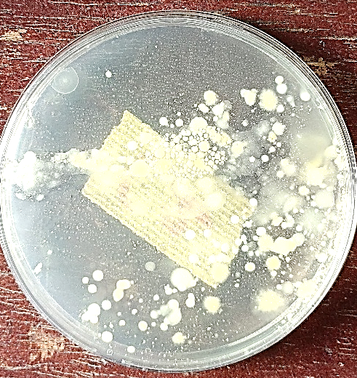
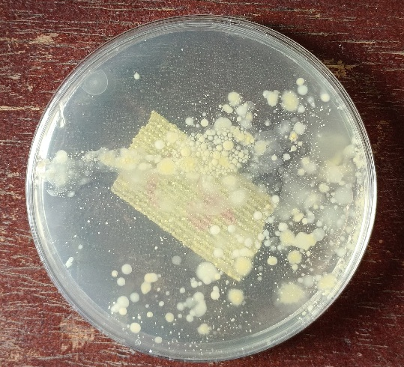
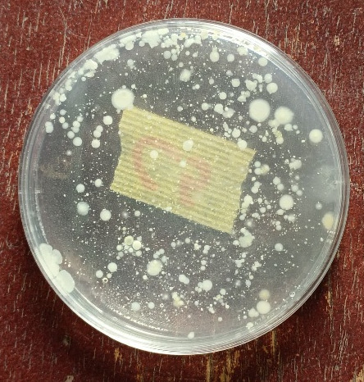
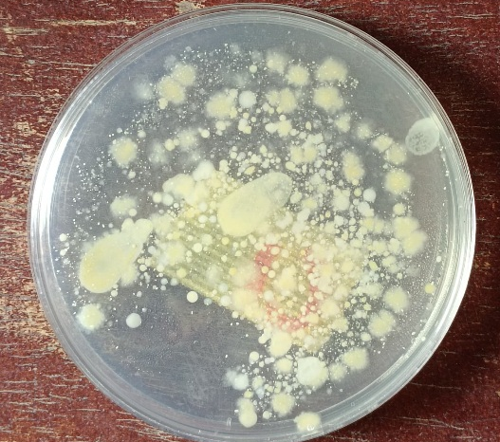

Appendix 1: Nutrient Agar showing colonies

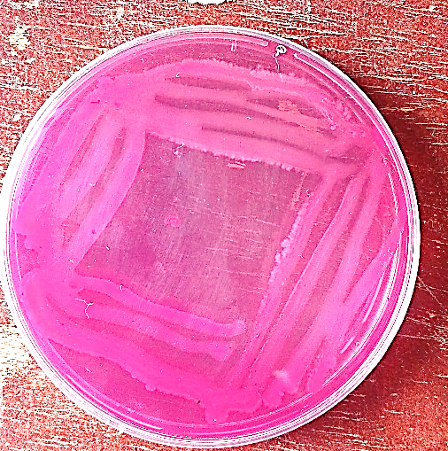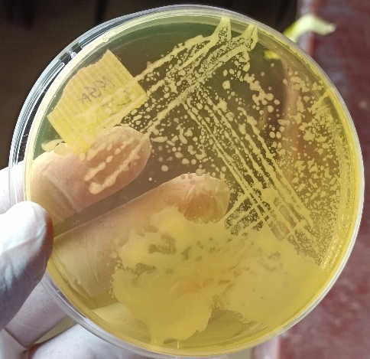
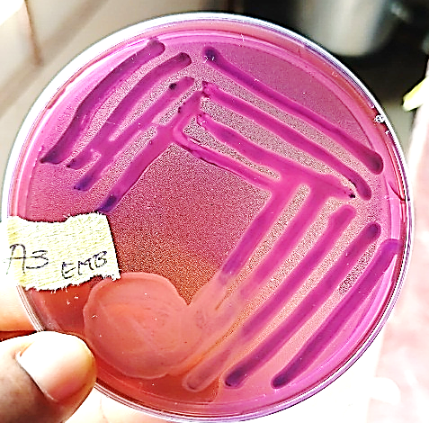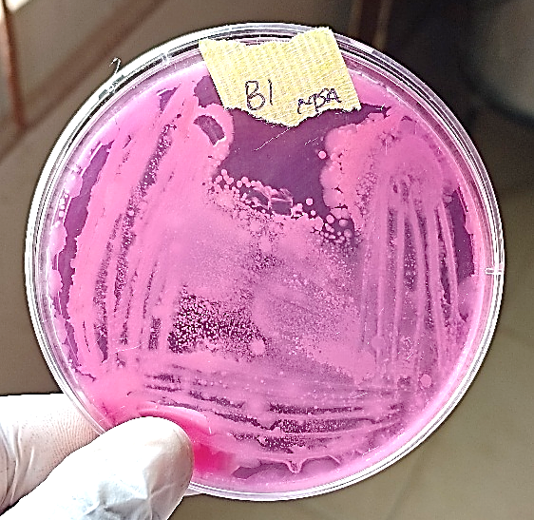
Appendix 2: Subculture on macConkey Agar, Mannitol salt agar and Eosine Methyl Blue.

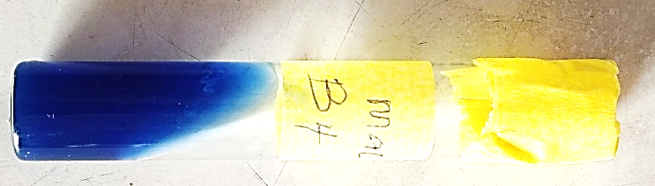
Appendix 3: Indole test

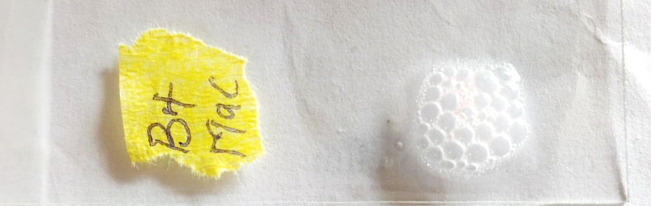
Appendix 4: Catalase test showing positive result


Appendix 5: Pictures of me working in the laboratory

