

INTRUSION DETECTION SYSTEM

BY

NNODUA, IFEANYI DAVID
GOU/U22/CSC/791

DEPARTMENT OF COMPUTER SCIENCE AND MATHEMATICS
FACULTY OF NATURAL SCIENCES AND ENVIRONMENTAL STUDIES
GODFREY OKOYE UNIVERISTY, ENUGU STATE

JULY, 2025

INTRUSION DETECTION SYSTEM

BY

NNODUA, IFEANYI DAVID
GOU/U22/CSC/791

DEPARTMENT OF COMPUTER SCIENCE/MATHEMATICS
FACULTY OF NATURAL SCIENCES AND ENVIRONMENTAL STUDIES
GODFREY OKOYE UNIVERISTY, ENUGU NIGERIA

A PROJECT RESEARCH SUBMITTED TO THE DEPARTMENT OF COMPUTER SCIENCE IN PARTIAL FULFILMENT OF THE REQUIREMENTS FOR THE AWARD OF BACHELOR OF SCIENCE (B.Sc.) DEGREE IN COMPUTER SCIENCE

SUPERVISOR: ENGR. DR. KINGSLEY I. CHIBUEZE

JULY, 2025

APPROVAL
This research titled “Intrusion Detection System” has been assessed and approved by the Committees of Department of Computer Science/Mathematics and Faculty of Natural Sciences and Environmental Studies, Godfrey Okoye University, Enugu Nigeria.

Engr. Dr. Kingsley I. Chibueze _______________ _______________
Supervisor Signature Date

_______________ _______________
External Examiner Signature Date

Dr. Frank Okebanama _______________ _______________
Head of Department Signature Date

Prof. Chidi C. Uhuegbu _______________ _______________
Dean of FNSES Signature Date

CERTIFICATION
I certify that I completed the research included therein and that it was primarily based on my observations and investigation. I will fully accept the University's decision if I am found to have cheated on the assignment.

________________
Nnodua Ifeanyi David
GOU/U21/CSC/791

DEDICATION
This project is dedicated to God, whose guidance brought about its successful completion, to my family and friends whose love encouraged me to keep going, and to my supervisor whose instruction made my work process clear and efficient.

ACKNOWLEDGEMENTS
Without proper guidance, this research project would not have reached a successful completion. I am grateful to God for the presence of the following individuals whose efforts and contributions to this work I now acknowledge.
I extend my gratitude to my supervisor, Engr. Dr Kingsley I. Chibueze, for his clear instructions, and patience with me throughout the research process.
I am also grateful to my Head of Department, Dr. Frank Okebanama, who tirelessly motivated me to keep going and fostered a conducive working and learning environment for us final year students. To the Dean of Faculty and Lecturers in my Department I appreciate you all for your encouragement and advices.
I express my sincere gratitude to my noble parents, Mr and Mrs Nnodua and siblings for their prayer, supports and financial help.
I appreciate my classmates and friends in school for their encouragement, assistance and advice during this project research.
I would like to especially thank Mr. Freedom Gowon, CEO, Freedom Technologies Ltd, for assisting me with the necessary biological background, resources and data for this study.
Finally, I thank my parents for their love and support through this work. It is my prayer that as all these people have been blessings to me, they may also enjoy God’s blessings in their own lives.
ABSTRACT
The rapid rise in cyber attacks in the Banking Sector has revolutionized the Development of an Intrusion detection system to isolate and control attacks in a banking system. This research projects presents ‘BankCash”, A web based design for banking system security which leverages on cutting-edge technologies to secure banking systems from cyber attacks seamlessly. The system being proposed in this study enables the location and IP addresses using IPGeolocation API of unsuspecting attackers to be gotten and traced without their knowing while they are given access to a clone of the original account dashboard. The system is developed using Sveltekit fullstack framework which is similar to nextjs, a severless database is used which is Superbase, Postgres sql database service is used to collect attackers information in a table , it is connected through the connection string and API key given in the login page, Two key algorithms were created, to check SQL Injections and bruteforce. The Threshold for bruteforce used is 3.

TABLE OF CONTENTS
PAGES
Title page i
Approval page ii
Certification iii
Dedication iv
Acknowledgement v
Abstract vi
Table of contents vii
List of Tables ix
List of Figures x

CHAPTER ONE: INTRODUCTION 1
1.1 Background of the study 1
1.2 Statement of problems 2
1.3 Aims and Objectives 3
1.4 Significance of Study 3
1.5 Scope of the Project 4
1.7 Limitations of the Study 4
1.8. Operational definition of terms 5

CHAPTER TWO: LITERATURE REVIEW 6
2.1. Overview of Cyber Threats in Banking 6
2.1.1 Intrusion Detection System (IDS): Evolution and Importance 6
2.1.2 Real time Monitoring and Automation in Cyber Security 6
2.2. Application of Intrusion Monitoring and detection in Banking 8
2.3. Literature Review of Related Literature 9
2.3.1 Research gap and need for the Study 11
2.4 Summary of Related Literature 13

CHAPTER THREE: SYSTEM ANALYSIS AND DESIGN 15
3.1 Overview 15
3.2 System Analysis 15
3.2.1 Existing System Analysis 15
3.2.2 Limitations of Existing Systems 16
3.3 Proposed System 17
3.3.1 Overview of Proposed IMDS 17
3.3.2 Features of Proposed system 17
3.3.3 System Requirements 17
3.3.4. Functional Requirements 18
3.3.4.1 Non Functional Requirements 18
3.3.4.2 Hardware Requirements 18
3.3.4.3 Software requirements 18
3.4 Proposed Methodology: Object Oriented Analysis and Design 19
3.4.1. Use case diagram 19
3.4.2 Class Diagram 21
3.5 Database Design 23

CHAPTER FOUR: SYSTEM IMPLEMENTATION 25
4.1 Introduction 25
4.2. Tools Used for Implementation 25
4.2.1 HTML 25
4.2.1 MySQL - Database 26
4.2.3 JavaScript 26
4.2.4 PHP - Backend 27
4.3. System Requirements 27
4.4 User Interface of the Proposed Design 28
4.4.1 Welcome Screens (setup screen) 28
4.4.2 Login page 28
4.4.3 Dashboard 29
4.4.4 Threat Log Page 30
4.4.5 Sign Up Page 31
4.4.6 Database Page 32

CHAPTER FIVE: SUMMARY, RECOMMENDATIONS AND CONCLUSION 34
5.1 Introduction 34
5.2. Summary 34
5.3 Conclusion 35
5.3 Recommendations 35
5.4. Recommendation for future research 36

REFERENCES 37
APPENDIX 39

LIST OF TABLES

TABLE PAGE
4.1 User table for the proposed system 23
4.2 Transaction table 23
4.3 Threats table 24
4.4 Logs table 24
4.5 Response table 24

LIST OF FIGURES
FIGURE PAGE
3.1 Use case diagram of the proposed system 20
3.2: Activity diagram of the proposed design. 20
3.3 Class diagram of the proposed system 22
3.4 Sequence of the proposed system 22
4.1 Welcome Page of the Proposed System 28
4.2 Login Page of the Proposed System 29
4.3 Dashboard of the proposed System 30
4.4 Threat logs page of the proposed system 31
4.5 Sign Up Page of the Proposed system 32
4.6 Database page of the proposed system 33

CHAPTER ONE
INTRODUCTION
1.1 Background of the Study
The Banking sector is regarded as the pillar of the cornerstone of contemporary civilization, the banking sector controls majority of the activities involved in handling assets and other financial resources including tasks like forecasting, lending, borrowing, investing, and saving. It is essential to people's lives, businesses, and governments since it promotes stability and economic prosperity, and therefore is prone to Cyber attacks as a bye product of its access and storage of large and sensitive financial data and information. The banking sector is a major target with banks facing daily attacks, ransomware incidents alone reached about 5,600 reported cases in 2023, this therefore means that as the nuts of cyber security are tightened up daily, cyber criminals keep devising new means to launch attach on the financial sector. As it common in other sectors, Cyber criminals aim to exploit vulnerabilities for their financial gain, unauthorized access, and service disruption.
The banking sector face cyber crimes like Phishing, Malware , Advanced persistent threats (APTs), ransomware and distributed denial of service (DDoS) attacks, (Teri Radichel, 2020). Each of these attacks are capable of crumbling the banking system integrity and ultimately damaging the trust the customers would have in the banking sector.
The (IMDS) Intrusion, monitoring and detection systems emerged as a critical line of defence, it identifies, mitigate and and respond to cyber threats in real time, these systems monitor network traffics, identify suspicious moves and trigger alerts and/or automatic response when potential intrusions are detected.
There are various functions of the Intrusion, monitoring and detection system, there's the signature based detection, which relies solely on known threat patterns, to anomaly based detection, which picks unusual network behavior that may interpret previously unseen attack. The banking system benefit from the both approaches, as they have been proven to enhance ability to detect existing and emerging threats, thus ensuring, progression and continuity of operation and protection of financial data. So, Intrusion detection system (IDS) refers to a system specifically designed to monitor network activities, detect intrusions and alert administrator of suspicious or unauthorized activities in real time. (Kaufman, Perelman and Speciner, 2021)
These systems are a core part of network and data security especially in environments that handle sensitive data, and sectors where early detection and rapid response to cyber threats are highly important. Such as banks
This research however aims at developing an easy-to-use Intrusion, monitoring and detection system. The system, which primarily focuses on monitoring and reporting back cyber threats in real time provides the banking system very useful help with earning customer trust, protecting finances and confidential information of customers and ultimately preserving the integrity of the financial institution. Also it aims to incorporate an easy to use interfaces and customized features to let administrators narrow down the attack, to a particular session outside the main banking system without the attackers knowledge, while finding the attackers IP address. This system empowers the banking system over the cyber attacker, and help customers trust the bank more.
1.2 Statement of Problem
In today's fast-paced world, financial system management has become intricate as cyber threats and attacks keep increasing in their numbers and at this the following problems stand in as a limiting factor.
1. Lack of a good monitoring and detection software that detects and report cyber-attacks or attempts in real time.
2. Inability of banking system administrators to detect attackers location via IP address.
3. Inability to provide continuous and proactive monitoring that can detect both known and emerging cyber threats.
4. Difficulties in detecting novel attack patterns, all of which leave banking networks vulnerable and weak.
1.3 Aim and Objectives
This research work title "An intrusion monitoring and detection system to protect, isolate and control cyber-attacks in banking system" solely aims at the development of a simply Intrusion and monitoring system to curb the cyber-attacks launched daily on banking system. The objectives are as follows:
1. To design an intrusion monitoring and detection system (IMDS) particular to banking system, with the ability to detect potential cyber threats, including existing and newly developed attacks.
2. To implement the IMDS using sophisticated technologies, ensuring that the system is capable of monitoring network traffic, identifying potential intrusions, and isolating malicious activities without disrupting normal banking operations.
3. To develop real-time detection and isolation mechanisms within the system, enabling it to respond to detected threats autonomously by isolating affected systems or blocking malicious traffic.
4. To design a system outside the main banking system without the attackers knowledge, that can track the attacker using IP address while combating the attack.
1.4 Significance of Study
This research project is extremely important in the fields of research, Organizations and individuals. It is a powerful tool for people to achieve financial security and save money.
Organizations especially the banking sector benefit from a security tight system that tackles cyber-attacks without disturbing banking activities on the system. By addressing diverse needs and paving the way for innovation, this study contributes significantly to personal and organizational financial management's evolving landscape. This proposed system focuses on real-time monitoring of traffic and activities around the banking infrastructure to detect unauthorized access, brute-force attacks, and SQL injection attacks.
1.5 Scope of the Study
The scope of this study encompasses the development and implementation of an Intrusion monitoring and detection system for banking system tracking system. This system would be designed to detect and tackle cyber-attacks outside the main banking system, narrowing down the attack without the attackers notice, while finding the attackers ip address and tracking it. This research main goal is to develop a web system, this will give the bank the ability to detect potential attacks, and allow administrators have full control of the banking portal.
This study will explore the functionalities, usability, and impact of the Intrusion monitoring and detection system within the web, evaluating its effectiveness in enhancing cyber security for the banking system.
1.6 Limitation of the Study
The various limitations that were encountered while embarking on this research work includes:
Lack of specific knowledge: While building the system, the researcher had to struggle to learn a new language, as the researcher had a limited knowledge that was barely enough for developing the system.
Unsteady internet connection: Some of the tools that were used in building the system where online, so if there was no internet connection, the researcher was not able to work.
Limited existing literature on the project title: While undertaking this research, the researcher could not find enough existing literature related to the researcher's project title, therefore the researcher had to struggle to build from scratch.
1.7 Operational Definition of Terms
This section contains the compilation of the definition of the terms used in and for the purpose of this research, they are as follows:
1. Intrusion Monitoring and Detection System (IMDS): A security system designed to continuously monitor network traffic and detect any unauthorized or suspicious activities within a banking network.
2. Cyber Attack: is seen as any attempt to gain unauthorized access to computer networks with the aim to damage, or disrupt the systems, or data.
3. Detection Accuracy: This is the measure of the IMDS's ability to correctly identify both existing and newly developed potential and legitimate cyber threats.
4. False-Positive Rate: This is the frequency at which the IMDS incorrectly identifies normal, non-malicious activities as threats.
5. False-Negative Rate: The frequency at which the IMDS fails to identify actual cyber threats.
6. Isolation: Isolation in this context is the process by which the IMDS segregates or restricts access to compromised parts of the network to prevent further spread or damage from detected threats.
7. Response Time: The duration of time taken by the IMDS to detect a threat and initiate necessary control measures.
8. Descriptive Statistics: A branch of statistics that provides insight into the systems overall performance
9. Banking System: The entire networked infrastructure, including hardware, software, and digital services, used by banks to conduct financial transactions, manage customer accounts, and store sensitive financial information.

CHAPTER TWO
LITERATURE REVIEW
2.1 Introduction
In Today’s digital age, cyber threats are rapidly increasing, especially in critical sectors like banking. According to Al-Jarrah et al. (2015), banking systems are highly susceptible to breaches due to their complex and interconnected infrastructures, which create multiple points of vulnerability. Embedded in these challenges and the effects of it, is the need for systems capable of real-time threat detection and mitigation.
2.1.1 Intrusion Detection Systems (IDS): Evolution and Importance
IDS have been a key player of cybersecurity over the years, particularly in detecting malicious activities within a network system. Early systems relied heavily on signature-based detection, which matches network activity against a database of known attack patterns. However, signature-based approaches have a deficiency in recognizing novel threats. As noted by (Axelsson: 2020., p 87), the shift toward anomaly-based detection systems, which identify deviations from normal behavior, has significantly improved the ability to detect emerging threats.
Recent technological advancements have combined these methods to create hybrid IDS solutions, enhancing detection accuracy and reducing false-positive rates. Studies by Mukherjee et al. (1994) highlight that hybrid systems are especially beneficial in environments like banking, where both minor and major threats pose significant risks.
2.1.2 Real-Time Monitoring and Automation in Cybersecurity:
Even though very critical, Detection alone, is insufficient for a comprehensive cybersecurity strategy, particularly in high-stakes environments like banking, where customer's sensitive data and money are at stake. Effective cybersecurity systems must also isolate and control threats to prevent their spread and minimize damage, and without interfering with banking activities on the main banking system, to prevent panic from customers. Isolation mechanisms play a vital role in containing compromised systems or network segments, effectively acting as a quarantine to halt the progression of an attack.
The concept of threat isolation has been discussed widely in the literature. Kim et al. (2019) highlighting that segregation of compromised systems is one of the most effective strategies for damage control in environments with sensitive data, such as financial institutions. By isolating affected systems, banks can maintain the operational integrity of the broader network while addressing specific vulnerabilities. (Scarfone and Mell., 2017., p 70). Also, Scarfone and Mell (2007) State strictly that a way to prevent attackers from exploiting vulnerabilities further is by reducing the time between threat detection and containment. Modern systems mostly use Software-Defined Networking (SDN) skills for isolation, enabling dynamic segmentation of network traffic. SDN reduces the attack surface by rerouting and blocking attacks in reat-time through segmentation of network traffic. (Kreutz et al. (2015), also, Network Access Control (NAC) tools, as described by Lippmann et al. (2016), This isolates unauthorized devices before they can communicate with critical resources by providing fine-gained access control. In the banking sector, automated response systems using Artificial intelligence(AI) have gained credibility for their ability to handle situations without the need for human intervention and machine learning (ML) to identify suspicious behaviors and try cub them. For automatically, AI-driven systems, can analyze network traffic patterns and execute isolation commands within milliseconds of threat detection, reducing response time dramatically. (Ahmad et al. 2018), Such automation is particularly critical in mitigating Advanced Persistent Threats (APTs), which are built to by pass traditional detection methods and exist within a network for extended periods (Chen & Ji, 2016).
Their benefits also come with a few challenges. A primary concern is the risk of over-isolation, this is an event whereby legit systems and products are restricted due to false-positive detection. To look into this, Zhou et al. (2020) propose using behavior-based detection with isolation protocol to prevent this error from reoccurring. By repeatedly analyzing the behavior of isolated systems,
Organizations have an easier time in knowing the difference between actual threats and legitimate services through this method.
Furthermore, isolation strategies must be used alongside robust control measures to reduce the underlying threat. Active control mechanisms, such as endpoint detection and response (EDR) tools, can identify fraudulent soft-wares on their own (Kolbitsch et al., 2022). These measures not only cub the threat but also ensure that already affected systems can be safely reintegrated into the network after being worked on.
Furthermore, isolation and control mechanisms are in replaceable for effective cybersecurity in banking systems. They act as a secondary line of defense, ensuring that detected threats are taken care of in minimal time. By integrating advanced isolation techniques, such as SDN and AI-driven automation, with bulky control measures, financial institutions can enhance their ability to respond to cyber threats as they evolve. The continued evolution of these systems, as highlighted by Kim et al. (2019), Scarfone and Mell (2017), and further research, underscores their importance in protecting classified banking networks from potential breaches.
2.2 Application of Intrusion Monitoring and Detection in Banking
The use of IDS in banking sector has been studied variously financial institutions making use of real-time monitoring systems has reported a 70% reduction in successful cyber attacks. (Kaspersky, 2021) Likely to, work by Nguyen et al. (2020) shows that anomaly-based detection systems made for banking environments swiftly identified fraudulent transactions with little to no false positives. These findings shows the importance of customizing IMDS solutions to the specific requirements of the banking sector, including volumes in which high transaction are involved, classified data handling, and compliance with regulatory procedures.
2.3. Review of Related Literature
An in-depth understanding of Intrusion Detection and Monitoring Systems (IMDS) is essential for the design of a top banking system, as cyber threats become increasingly top-tier. This review discusses seminal and contemporary studies that have contributed to the creation of improvements of IMDS, with emphasizes on key findings, methods and cons.
Mukherjee, Heberlein, and Levitt (2021): In their seminal work, Mukherjee et al. looked into the creation of IDS, ranking them into anomaly detection and misuse detection systems. They demonstrated the potential of techniques based on data/facts in identifying differences from normal network behavior. However, they noted that anomaly-based systems was highly affected by high false-positive rates, which reduced their practical application. This early study laid the foundation work for subsequent advancements in intrusion detection advancements.
Axelsson (2020): Axelsson provided a report of IDS, ranking them into signature-based and anomaly-based systems. Signature-based systems, while effective for already established attacks, failed to detect new threats, whereas anomaly-based systems could identify unknown attacks but were known for false alarms. Axelsson's research highlighted the need for mixed approaches that combine the pros of both methods, which has become a standard practice in the field.
Nguyen, Le, and Hoang (2020): Nguyen et al. applied machine learning methods to anomaly detection in banking transactions, creating algorithms to the specific characteristics of financial datasets. Their study revealed that AI-driven systems performed better than traditional rule-based approaches in detecting fraudulent transactions. However, scalability and real-time processing remained a huge challenge, highlighting the need for systems specially designed for high-traffic banking environments.
Kaspersky Lab (2021): A report by Kaspersky Lab provided more details into the challenges faced by financial institutions in cubing cyber threats. It placed emphasis on the limitations of traditional IDS in detecting high-end attacks, such as those involving polymorphic malware. The report advocated for the integration of AI and machine learning methods to enhance detection abilities, particularly in fields with high volume of transactions.
Kim, Lee, and Kim (2009): Kim et al. developed a high-end intrusion detection system combining anomaly detection with misuse detection. This approach made massive improvement in detection accuracy while reducing false-positive to the bare minimum. Despite its effectiveness, the system was too complex and this brought about the challenges of real-time application, particularly in high-risk fields like banking.
Ahmad, Basheri, Iqbal, and Rahim (2018): This study looked into the performance of various machine learning methods Support Vector Machine (SVM), Random Forest (RF), and Extreme Learning Machine (ELM) in detecting intrusion. RF and ELM were found to have higher accuracy and faster output than SVM. Although, the focus on offline datasets reflected the gap in research addressing real-time detection in financial networks.
Scarfone and Mell (2017)
Scarfone and Mell made us understand the importance of isolation and control in mitigating cyber threats. They introduced automated response systems that activate isolation protocolsas soon as malicious activities are being detected, drastically reducing response time and potential damage.
Kolbitsch et al. (2022): Kolbitsch et al. looked into endpoint detection and response (EDR) tools as a means of cubing threats within isolated systems. Their findings highlighted the importance of combining isolation mechanisms with active control measures to make sure of comprehensive protection.
Chandola, Banerjee, and Kumar (2019)
Chandola et al. Extensively explored the limitations of anomaly detection systems, mainly their high false-positive rates. They proposed integrating behavior-based analysis with data driven methods to enhance accuracy. This approach has since been widely been accepted in hybrid IMDS solutions.
Zhou, Huang, and Li (2020): Zhou et al. Looked into the use of AI in behavior-based anomaly detection. Their research showed the potential of machine learning algorithms to adapt to evolving threat landscapes.
2.3.1 Research Gap and Need for the Study
As intrusion detection systems (IDS) have advanced rapidly in recent years, there are still some obvious roadblocks to overcome before they can be used in the banking industry. Large volumes of transactions, classified data, strict regulatory procedures, and the ever-developing nature of cyber threats are all concepts of the highly dynamic fields in which financial institutions operate. Many IDS technologies work well in generally, but they frequently don’t meet the unique cutoff mark of the banking sector, especially when it comes to integration, scalability, and adaptability. The incapacity of systems in use to efficiently scale with the growing complexity and volume of banking transactions is one of their main obstruction. As stated by Kim et al.
Traditional intrusion detection systems struggle with real-time processing in high-traffic fields, leading slow output in threat detection and handling. (Kim et al. 2019, p. 96) Furthermore, many systems soley reply on signature-based methods, which are effective against common threats but insufficient for identifying new and sophisticated attack variables such as zero-day vulnerabilities and Advanced Persistent Threats (APTs) (Chen & Ji, 2016, p. 10).
Another gap lies in the seamless integration of IDS/IPS technologies with core banking operations. Many financial institutions face challenges in deploying intrusion detection systems without disrupting normal operations. As Kreutz et al. (2017, p. 20) observed, network security solutions often require significant customization to align with the unique architectures and workflows of banking systems. This lack of interoperability not only reduces the efficiency of cybersecurity measures but also increases the risk of operational bottlenecks during implementation.
Additionally, there is a noticeable deficiency in research focused on evaluating the effectiveness of Intrusion Monitoring and Detection Systems (IMDS) specifically designed for banking environments. Existing studies predominantly examine IDS/IPS performance in generic or simulated settings, with limited attention to the unique threat landscape of the financial sector. Chandola et al. (2019, p. 7) emphasized the need for context-specific evaluations, noting that statistical methods can provide valuable insights into the performance and limitations of anomaly detection systems in specialized environments. However, comprehensive studies using descriptive statistical methods to analyze IMDS performance in the banking sector remain scarce.
Given the increasing sophistication of cyber threats targeting financial institutions, there is an urgent need for a tailored approach. This research aims to bridge the identified gaps by designing and implementing an IMDS specifically for banking environments. The proposed system will focus on real-time monitoring, accurate detection of both known and unknown threats, and effective isolation mechanisms to contain and mitigate risks swiftly. As noted by Scarfone and Mell (2017, p. 12), real-time systems with automated response capabilities are critical for reducing response times and minimizing the impact of cyber attacks, particularly in high-risk sectors like banking.
Moreover, this study seeks to contribute to the existing body of knowledge by employing descriptive statistical methods to evaluate the proposed system's performance. These methods will provide measurable insights into key metrics such as detection accuracy, false-positive rates, response times, and system scalability. By addressing the identified gaps and tailoring the IMDS to the unique requirements of the banking sector, this research aims to enhance the sector's resilience against evolving cyber threats while ensuring operational continuity and regulatory compliance.
2.4 Summary of Related Literature
S/N | Author | Work done | Methodology/Technique | Result/limitation/Findings
1 | Ubaldo et al. (2023). | Information Security in the Banking Sector: A Systematic Literature Review on Current Trends, Issues, and Challenges | This system carefully Analyzed current trends and challenges in banking information security, placing emphasis on IDS roles. | This system lacked empirical validation.
2 | Mahdi & Maolood  (2020) | Banking Intrusion Detection Systems Based on Customers' Behavior Using Machine Learning Algorithms: Comprehensive Study | This system effectively Applied machine learning algorithms to model customer behaviour for intrusion detection. | It Focused on supervised learning, which may not detect novel attack patterns.
3 | Ling et al.  (2019) | An AI-based, Multi-stage Detection System of Banking Botnets. | This system was able to Identify the increasing sophistication in cyber-attacks targeting banks, underscoring the need for advanced IDS solutions. | The system's descriptive review lacked empirical validation
4 | 2023 | Enhancing Financial Security: An Intrusion Detection Approach | This system reviewed various IDS methodologies, including signature-based, anomaly-based, and hybrid approaches in the financial sector. | The system Lacked empirical data to support discussed methodologies.
5 | 2024 | Cybersecurity Threats in Banking: Unsupervised Fraud Detection Analysis | The system was able to identified fraudulent activities without prior labeled data. | Potential for false positives, requiring further refinement.
6 | Mukherjee, Heberlein, and Levitt  (2020) | Network Intrusion Detection / IEEE Network | This work made it easy to explore the foundations of Intrusion & Detection Systems, as it categorized them into anomaly detection and misuse detection systems. They inculcated the potential of statistics in identifying deviations from normal network behavior. However, they noted that anomaly-based systems suffered from high false-positive rates, this in return, hindered their practical application. This early study laid the groundwork for subsequent advancements in intrusion detection technologies. | The system was created with Limited applicability to real-time, high-traffic environments like banking networks.
7 | Nguyen, Le, and Hoang (2020) | Intrusion Detection in Banking Systems | They applied machine learning techniques to anomaly detection in banking transactions, thereby bringing algorithms to the unique characteristics of financial datasets. It was revealed in Their study that AI-driven systems outperformed traditional rule-based approaches in detecting fraudulent transactions. | The system had issues with , scalability and real-time processing, this remained a challenge emphasizing the need for systems specifically designed for high-traffic banking environments
8 | Kim, Lee, and Kim (2009). | Hybrid Approaches and Advanced Techniques | The system combined a normally detection and misuse detection. This two-step approach significantly improved detection accuracy and also reduced false-positive rates. | The system Despite its effectiveness, had complexities which posed challenges in real-time application, particularly in high-risk sectors like banking.
9 | Scarfone and Mell, (2017) | The Role of Isolation and Control | The system emphasized the importance of isolation and control in curbing cyber threats especially that against banking systems.  They introduced automated response systems that activate isolation protocols upon detecting malicious activity, significantly reducing response time and potential damage. | This system Did not provide quantitative performance evaluations for the proposed protocols. And the discussions around scalability of isolation mechanism in large networks was limited.
10 | Chandola, Banerjee, and Kumar (2019) | Challenges and Future Directions | The system dealt with the limitations of anomaly detection systems, particularly their high false-positive rates. The system proposed integrating behavior-based analysis with statistical techniques to enhance accuracy. This approach has since been widely adopted in hybrid IMDS solutions. | The system’s functionality had a very limited scope as the system was only developed to run on android mobile devices with no support for iOS devices.
11 | Zhou, Huang, and Li (2020), | Behavior-Based Anomaly Detection: Techniques and Applications. | This study inculcated the examined the use of AI in behavior-based anomaly detection. The system highlighted the potential of machine learning algorithms to adapt to evolving threat landscapes, though issues such as computational complexity and resource demands remain barriers to widespread adoption | The system was designed to only be web based and at such was limited in scope as it heavily depended on good internet connectivity to work and was therefore limited to those in urban areas.

CHAPTER THREE
SYSTEM ANALYSIS AND DESIGN
3.1 Introduction
The research chapter analyzes both the system design together with it’s analysis and the methodology (OOAD) used to create the system and it’s implementation process in this research project.
3.2 System Analysis
System analysis involves the breaking down of the system and studying of the various component parts of the system and the way they interact with one another. This section however, discusses the complete system analysis of the proposed system which would involve analysis of existing systems, the identification of the limitations of the existing systems and the possible ways of improving on them, as well as the analysis of the proposed system which would involve modelling of the system using use case diagrams, sequence diagram, activity diagrams and class diagram.
3.2.1 Existing System Analysis
Most banking institutions depend absolutely on traditional Intrusion Detection Systems (IDS) and Intrusion Prevention Systems (IPS) to monitor, detect, and mitigate cyber threats. These systems function primarily by using signature-based and anomaly-based detection methods. However, there are several limitations in existing solutions:
Signature-Based IDS
Signature based IDS are known to be highly efficient at identifying known threats using predefined signatures. But i5 has a limitation of being Ineffective against zero-day attacks and evolving malware variants.

Anomaly-Based IDS
Anomaly Based IDS Uses artificial intelligence to detect deviations from normal behavior, but it has a very high false-positive rates and difficulty in distinguishing between fraudulent and non fraudulent activities.
Hybrid IDS:
Hybrid IDS is a combination of Signature-Based and Anomaly-Based Systems, it highly improves detection rates by combining predefined rules with behavioral analysis, but increases computational complexity and potential delay in real-time response.
Intrusion Prevention Systems (IPS)
The IPS automatically blocks threats before they cause damage, but this is not a trustworthy approach because it is Prone to false positives, leading to legitimate activities being blocked, because of its auto mode
Firewall-Based Security
Fire based security provides the first line of defense by filtering network traffic, but it cannot detect sophisticated threats like insider attacks or encrypted malware.
3.2.2 Limitations of Existing Systems
Scalability Issues: Existing IDS systems struggle to handle large-scale banking transactions efficiently.
Delayed Response Time: Some of the systems require manual intervention, the question of real time detection and mitigation is out of the way and this delays threat mitigation.
Lack of Automated Isolation and Control: Current solutions focus more on detection but lack automated containment mechanisms.
Integration Challenges: Many banks use legacy systems that are difficult to integrate with modern IDS.
3.3 Proposed System
The proposed design is the Design and implementation of an intrusion monitoring and detection system to detect, Isolate and control cyber attacks in a banking system.
3.3.1 Overview of the Proposed IMDS
The proposed Intrusion Monitoring and Detection System (IMDS) is designed to deal with the limitations of existing IDS by integrating real-time monitoring, automated threat isolation, and response mechanisms. The system will utilize Artificial Intelligence (AI) and Machine Learning (ML) to enhance detection accuracy while minimizing false positives.
3.3.2 Features of the Proposed System
Real-Time Threat Monitoring: this design will continuously monitors banking networks for suspicious activities.
Automated Threat Isolation: it will automatically Detect, isolates, and controls cyber threats to prevent system-wide attacks as it deals with it outside the main banking portal.
Machine Learning-Based Detection: this system Uses predictive analytics to detect both known and unknown cyber threats.
Seamless Banking Integration: this system is designed to work alongside existing banking infrastructure, since it works outside the main system, it does not disrupt banking services.
Cloud-Based Security Intelligence: Updates threat databases in real time to prevent zero-day attacks.
3.3.3 System Requirements
System requirements refers to the processes or statements of what a system should be able to do or what quality a system is supposed to have, and the tools necessary to build the system There are two categories of these system requirements; the functional requirements and the non-functional requirements.
3.3.4.1 Functional Requirements
The functional requirements refer to the requirements that specify what the system must have. Functional requirements of the proposed system include that:
a. The system should have lower false-positive rates compared to traditional IDS.
b. The system should be able to enhanced threat intelligence for improve security.
c. The system should automated response mechanisms to minimize human intervention.
d. The system must have improved scalability and adaptability to banking environments.
3.3.4.2. Non-Functional requirements:
The non-functional requirements refer to the requirements that specify attributes or abilities the system must have. Non-functional requirements for the proposed system include that:
a. The proposed system should be responsive on all screen sizes and compatible with traditional banking systems
b. Already detected and mitigated attacks should be saved in a particular section of the system
3.3.4.3 Hardware requirements
Hardware requirements refers to physical machinery required to build the proposed system, they include
- Intel Core i7 or higher processor
- Minimum 16GB RAM
- 500GB SSD storage For fast read/write operations
- Gigabit Ethernet/Wi-Fi 6 internet interface.
3.3.4.4 Software Requirements
Operating System: Linux/Windows Server
Database: MySQL/PostgreSQL
Programming Languages: Python, Java, or C++
Security Tools: SNORT, Suricata, Wireshark
Frameworks: TensorFlow/PyTorch for AI-based threat detection
3.4 Proposed Methodology: Object Oriented Analysis and Design
Object Oriented Analysis and Design is a methodology used in software development that involves the use of object-oriented concepts to design and implement software systems. In this methodology, the system requirements are determined, the classes are identified and the relationships between these classes are also identified. There are some techniques and practices which are been used in this methodology which includes; UML diagrams, object-oriented programming, and use cases. OOAD uses object-oriented programming to design and implement this software, UML diagrams to design diagrams that represent different aspects and the interactions between the different components of the software system, and lastly, use cases to describe the different ways in which the users interact with a software system. This methodology was designed to handle complex systems and thus, the reason for using this methodology.
3.4.1. Use Case Diagram
Use case diagrams are classified into four categories; the actors which represent the external entities of the system, use cases which are the functional parts of the system, the associations between the actors and the use cases, and lastly the system boundary which is the scope of the system the actor is interacting with.
As for the proposed system, there are two (4) actors which are; Bank security admin and banking system, IMDS system, threat detection engine, and automated response module. However, according to the use case diagram, the users have seven (5) use cases which includes, Monitor Network traffic, detection intrusion, Isolate threats and generate alerts.
Below is a use case diagram representing the interaction between different components of the system.
Diagram Representation:

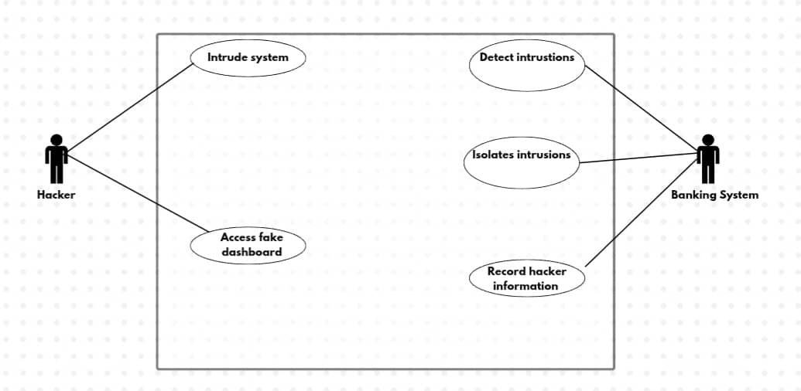
Figure 3.1 Use case diagram of the proposed system
The diagram above is the use case diagram of the proposed system which stands to represent all the use cases that are possible on the proposed application. The system includes five use cases in the proposed application thereby proving a pictorial realization of the proposed system to help explain the actions that both the system and the users can perform

Activity diagram of the proposed system:
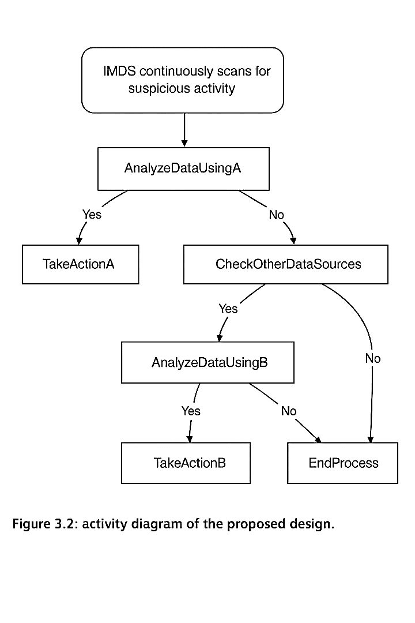
Figure 3.2: Activity diagram of the proposed design.

3.4.2 Class Diagram of the Proposed System
Class diagrams are diagrams in Unified Modelling language (UML) that describes the structure of a software system by mapping out its classes, attributes, methods and the relationships among objects. Below is the illustration of the class diagram for the proposed system.
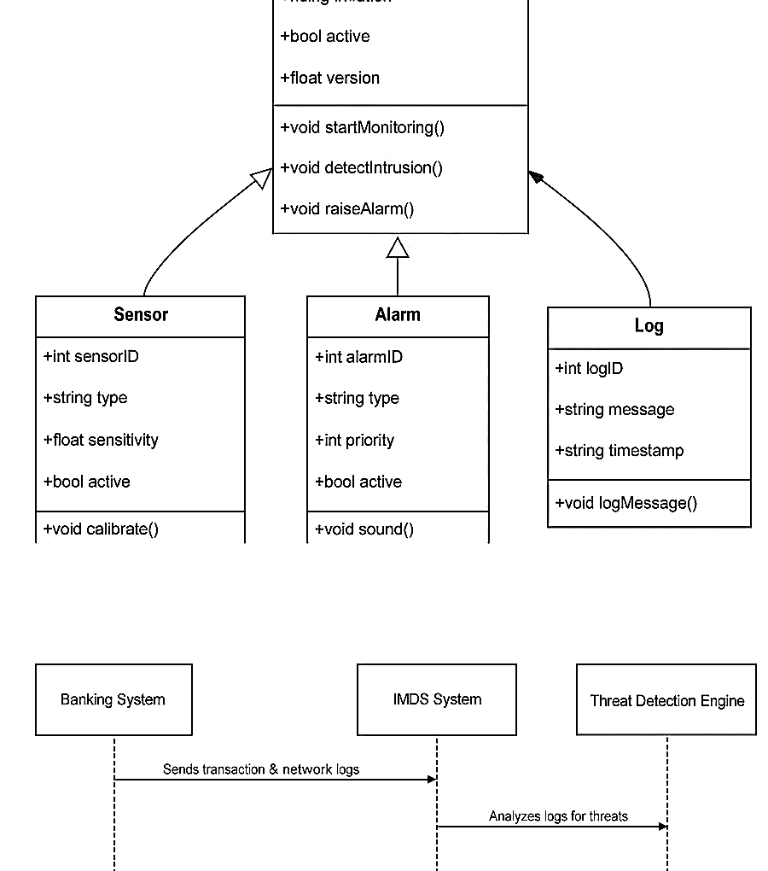
Figure 3.3 Class diagram of the proposed system

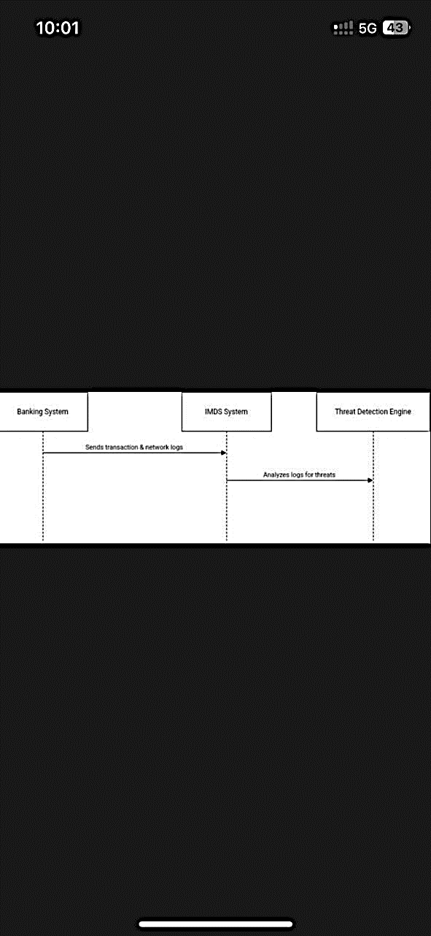
Figure 3.4 Sequence of the proposed system
The above diagram represents the class diagram of the proposed system, which stands to show the prominent entities and classes that are available in the proposed system. The diagram however was designed to help explain the classes that are available on the proposed system and how these classes interact with one another to make the proposed system function properly while still maintaining quality security.
3.5 Database Design
The essence of the database design is to show a modeled view of the proposed system’s’ database. The proposed systems’ database is a relational database that was designed and implemented using MySQL query and python language. The database was designed to have entities and at least attributes for each entity.
Database schema for the proposed system
Table 4.1 User table for the proposed system
Stores information's about the user.
Attribute | Data Type | Description
Id | int | Unique ID for each user
Username | varchar | This is where the username of the user is stored.
Password | Varchar | User Password
Role | Admin/ Bank Staff | Role of the User
Email | varchar | The field for storing the users email.
Date_joined | timestamp | The field shows the date of when the user joined system.

Table 4.2 Transaction table
Stores details of banking transactions
Attribute | Data Type | Description
Transaction Id | int | Unique ID generated for each transaction
User id | Int | Associated user ID
Amount | Decimal | transaction amount
Timestamp | Timestamp | Transaction Time
Status | Pending/ Failed/ Successful | Transaction status

Table 4.3 Threats table
Stores detected cyber threats
Attribute | Data Type | Description
Threat Id | int | Unique ID generated for each cyber threat
Detected at | Timestamp | time threat was detected
Threat type | Varchar | type of threat
Severity | Low/High/Medium | The severity of the cyber threat
Status | Active/ Mitigated/ False Alarm | Threat status
User Id | Int | User associated

Table 4.4 Logs table
Stores security event logs
Attribute | Data Type | Description
Log id | int | log id
Event | Text | description of event
Timestamp | Timestamp | time of event
User Id | Int | User associated

Table 4.5 Response table
Stores response taken against threat
Attribute | Data Type | Description
Response id | int | Unique ID generated for each response
Threat id | Int | threat Id
Action taken | Text | description of mitigation action taken
Timestamp | Timestamp | the time action was taken

This structure ensures efficient data storage, fast query performance, and proper relational integrity for the intrusion system.
CHAPTER FOUR
SYSTEM IMPLEMENTATION
4.1 Introduction
This chapter sheds light on the design and implementation of an Intrusion Monitoring and Detection System (IMDS) designed for banking institutions. It details the programming environment, implementation tools, system functionalities, user interface development, and system evaluation. The chapter also highlights the various components integrated into the system that has been discussed since the beginning of this research work. It contains details of how the system components were built, integrated, and tested. The major implementation is based on sveltekit, it is a framework similar to next is that does client and server side rendering, it is a full stack framework, and it is used together with CSS for styling. while utilizing these tools, the system’s backend interacts with a server less database which is superbase. To manage user profiles, food data, and feedback. This chapter demonstrates theoretically how the framework and designs from Chapter Three were translated into a working solution.
This research which was initiated as a result of the challenges faced in the environment of the researcher. However, a detailed analysis of the system and all of its requirements was made at the beginning of this study in order to analyze both the systems that are now in place and the systems that have been suggested in this research effort. Additionally, the researcher uses the instruments that have been selected and verified to successfully implement the suggested system in this section of the study project.
4.2 Tools used for implementation (Tech stack of the proposed system)
4.2.1. HTML
HTML is the abbreviation of Hyper Text Markup Language which is used to create the basic structure and basis of a webpage. It is regarded as the fundamental building element of web development that allows programmers to design and organize the content of websites. It entails defining elements like headings, paragraphs, photos, links, and so on using a set of properties and tags, which are then rendered by the web browser. However, both humans and machines can read and comprehend the HTML language because of its design. Because of this, developers may use it as a very flexible tool to create web pages with a very clear structure and semantics. Additionally, it gives developers the chance to incorporate multimedia components like audio and video to enhance user experience. The HTML language provides developers with the ability to use JavaScript and CSS (Cascading Style Sheets) to enable dynamic and customized web page design and behavior. Most importantly, in most cases it serves as an avenue for data collection through the use of its elements like forms and input fields. In all it is a very important tool for web development because it provides a framework upon which websites stands and operates. Moreover, it was used to design the physical interface of the proposed system interface.
4.2.2. MySQL - Database
Microsoft MY SQL Server is a relational data base management system developed by Microsoft. As a database server, it is a software product with the primary function of storing and retrieving data as requested by other software applications which may run either on the same computer or on another computer across a network (including the Internet).
Microsoft markets at least a dozen different editions of Microsoft SQL Server, aimed at different audiences and for workloads ranging from small single-machine applications to large Internet-facing applications with many concurrent users. SQL Server uses as its primary query languages T-SQL and ANSISQL
4.2.3. JavaScript
JAVASCRIPT combines unprecedented developer productivity with performance, reliability, and deployment. JAVASCRIPT redesigns the whole process. It's still easy to grasp for new comers but it provides many new ways of managing projects. The features of JAVASCRIPT includes easy programming model, makes building real world Web applications dramatically easier.
Flexible Language Options, which makes it possible for programmers to leverage your current programming language skills. Unlike classic ASP, which supports only interpreted VB Script and JScript, JAVASCRIPT now supports more than 25 .NET languages (built-in support for VB. NET, C#, and JScript. NET), giving us unprecedented flexibility in the choice of language. Among others.

4.2.4 PHP-Backendend
PHP is a next generation of high-level programming language introduced web server side coding. Similar to previous server-side scripting technologies, PHP allows us to build powerful, reliable, and saleable distributed applications. Laravel is based on the PHP framework and uses the web app features and tools to develop Web applications and Web services. Even though PHP sounds like Laravel and syntax are compatible with PHP but Laravel is much more than that. It provides many features and tools, which let you develop more reliable and saleable, Web applications and Web services in less time and resources.
4.3 System Requirements
There are not many things that are needed to use this system as it is a web based platform application and however runs on both the web and mobile platforms. However, the system still require that the user gets to fulfill some little requirements in order to be able to use the proposed system. These requirements are as follows:
- An internet enabled device
- Good internet connection (at least 4G internet speed).
- A web browser e.g. Google Chrome, Mozilla Firefox, Microsoft Edge, Apple Safari and a host of others.
- A minimum of android 8.0 and a minimum of 15.0 operating systems to be able to install and run the app on their mobile devices.
4.4 User Interface of the Proposed System
The user interfaces for the landing page, login page, the meal recommendation page, the sign up page and the feedback page and other elements of the system that is proposed in this system which will be included in this section of this work of research will be covered in this section of this work of research. The different interfaces of this system includes the following:
4.4.1. Welcome Screens (setup screen)
This is the first screen that the user gets to see when they get to open the app for the first time. It serves as the first landing page of the app that allows the user to get to customize the app in a way that would suit him or her

Figure 4.1 Welcome Page of the Proposed System.

4.4.2. Login Page
This is a secure access portal with fields for Username and password. The login page is the gateway to the IMDS platform. With the login page, there is guarantee that only authorized users such as system administrators, security analysts, or bank IT staff can access sensitive data and functionalities. Below are features embedded in the login page of this system.
- Username and password input fields.
- Encrypted password validation.
- Error handling for invalid credentials.
- Session creation upon successful login.

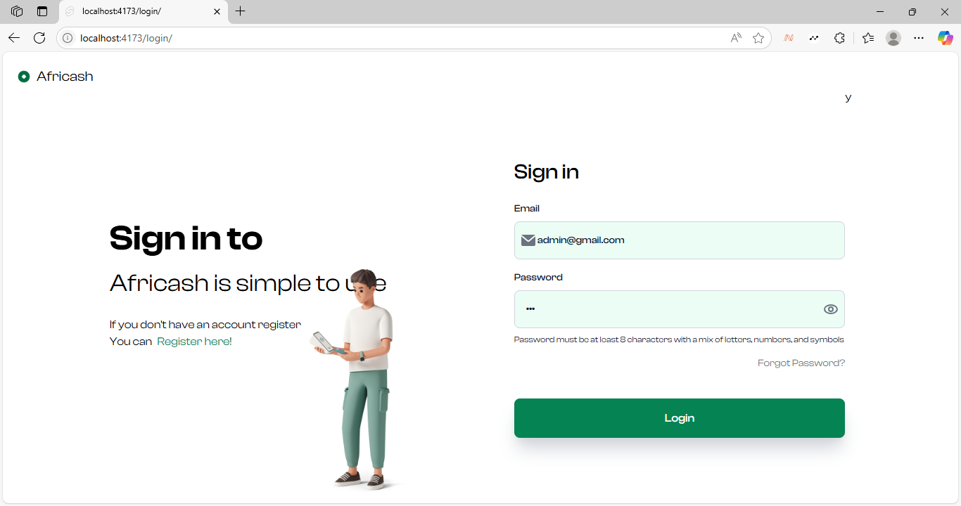
Figure 4.2 Login Page of the Proposed System

4.4.3 Dashboard
The dashboard serves as the system's central control room, it offers real-time overview of cyber activities, threats, system performance, and intelligence. Below are features of the dashboard of the proposed system.
- Threat alerts and notifications, are transmitted live.
- Covers a graphical representation of threat trends over time.
- System health indicators (e.g., uptime, user activity, anomaly count).
- Summarized logs of recent events.
The dashboard is an important part of the system because it helps administrators make quick decisions and provides real time view of network security status.

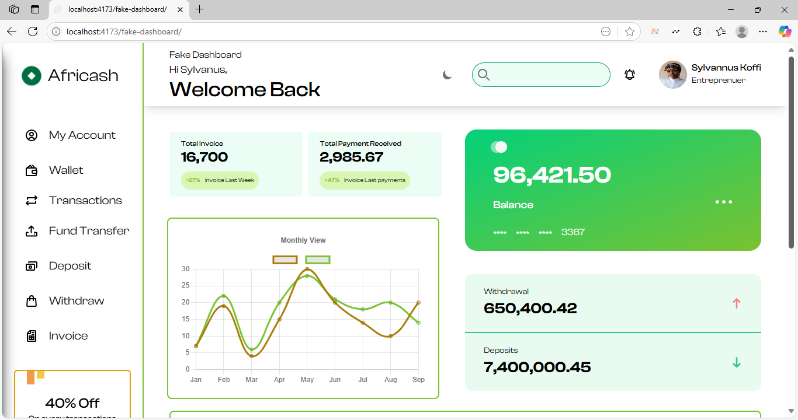Figure 4.3 Dashboard of the proposed System.

4.4.4 Threat Logs Page
This page maintains a detailed record of all detected threats, providing analysts with vital data to assess the nature, origin, and impact of security events, below are the features of the threat log page of this system
- Provides a list of threats with timestamps, source IPs, and severity levels.
- Filter/search by date, type, or status.
- Classifies threats (e.g., malware, intrusion, brute-force, suspicious logins).
This page enables Forensic and incident tracking and supports compliance and audit reporting.

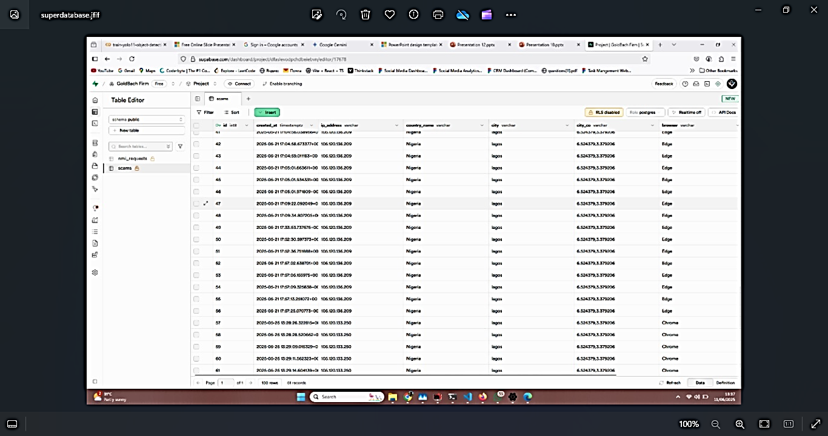
Figure 4.4 Threat logs page of the proposed system.

4.4.5 User Management Page
This is an administrator exclusive feature that facilitates secure management of the system’s new user registration, on this page, administrators are able to add user details such as Email, username, phone number and other relevant information. This page controls role-based access control (RBAC), input validation to prevent unauthorized role escalation and real-time monitoring of account modifications.

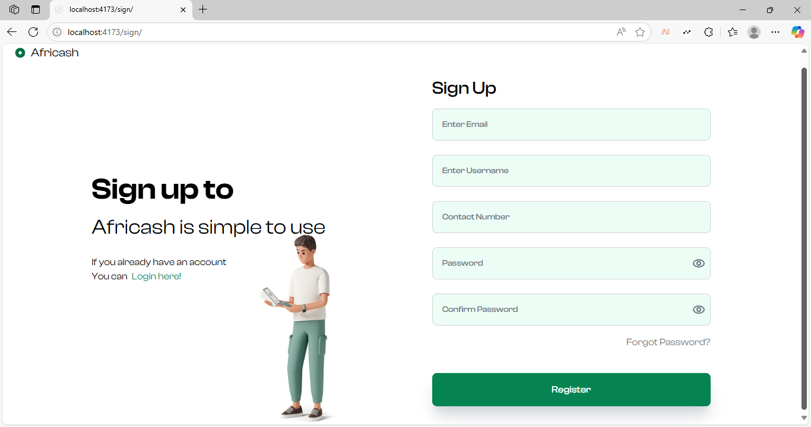
Figure 4.5 Sign Up Page of the Proposed system.

4.4.6 Database Page
This page consolidates all recorded security events and system operations into a structured and interpret able format suitable for reviews, audits, and management briefings, it Auto generates daily, weekly, or monthly reports has, export options (PDF, CSV), This page also aids strategic planning and risk assessment and supports data driven decision making and accountability.
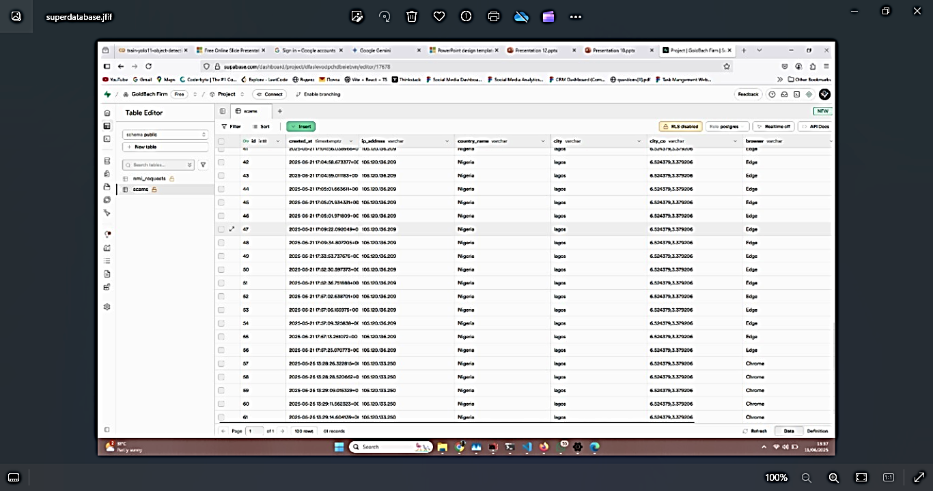
Figure 4.6 Database page of the proposed system.

CHAPTER FIVE
SUMMARY, RECOMMENDATIONS AND CONCLUSION
5.1 Introduction
This chapter of this research study is used by the researcher to give a comprehensive summary of this project work, the recommendations for next work, and a detailed conclusion of this work of research. However, this chapter offers a summary of all the subjects that have been discussed in every other chapter of the projects that are prior to this research work.
5.2 Summary
This study is a research carried out on the design and implementation on the design of an Intrusion Monitoring and Detection System (IMDS) for detecting, isolating, and controlling cyber attacks within a banking system. Cyber threats and crimes are on the rise in our society today, increasing rate and sophistication of cyber attacks, targeting financial institutions have made traditional firewalls and basic antivirus systems insufficient and powerless. Consequently, there was a need to design a more proactive and intelligent solution that not only detects threats but also responds to them in real time.
The research in chapter two, commenced with a review of existing literature and systems to understand current technologies, methodologies, and limitations in the field of cybersecurity and intrusion detection. Key components of IMDS such as real-time threat monitoring, isolation protocols, and automated logging were identified and implemented in the proposed system.
The System created by the researcher in this project features a secure login page, a real-time monitoring dashboard, threats logs, sign up page, log in page and report generation page.

5.3 Conclusion
The success of designing and implementing our intrusion Management Detection system (IMDS) proves that a smart, adaptable, and modular cybersecurity solution can effectively shield banking networks from various types of cyber threats.
Unlike the traditional intrusion detection systems (IDS) that merely identify suspicious activity, this research project went further to integrate isolation mechanisms and automatic logging, empowering banks to not only detect but also contain and analyze cyber threats. The system thus improves operational security and supports compliance with industry standards.
This research goes ahead to bridge the gap in the literature by focusing on the banking sector and using descriptive statistical analysis to evaluate system performance in a practical context.
5.4 Recommendations
Based on the research findings by the researcher, and system implementation of the system built in the course of this research, the following recommendations are made:
- Deployment in Phases: Banking institutions should deploy IMDS in stages, starting with internal networks, before scaling to branch wide and cloud based infrastructures.
- Integrate with artificial intelligence and Machine Learning: Future improvements on this field should consider incorporating ML algorithms to enable predictive threat detection and adaptive response.
- Regularly Updating patch Management: The System should be updated on a consistent basis in order to create a barrier of protection against new emerging threats and vulnerabilities.
- User Training and Awareness: IT personnel and system administrators must undergo training on a regular basis to know how to use the system, respond to alerts, refrain from actions that will undermine security.
- Consideration of Compliance and laws: Future research studies should focus on ensuring the system complies with laws on data privacy like NDPR, GDPR or any other local regulations.
5.5 Recommendations for Further Study
Based on the findings the researcher made in the course of this research, the suggestion for further studies are listed below.
- Investigating the integration of block-chain technology to enhance data integrity in intrusion logs.
- Design and implementing a cloud based IMDS that can scale across multiple financial institutions with centralized threat intelligence.
- A system that can evaluate the system using inferential statistical methods to analyze correlations between threat patterns and breach outcomes.

REFERENCES
Ahmed, M., Mahmood, A. N., & Hu, J. (2016). A survey of network anomaly detection techniques. Journal of Network and Computer Applications, 60, 19–31.
Alazab, M., & Broadhurst, R. (2017). Cybercrime trends in the banking sector. Cybercrime and Digital Forensics, 2(1), 103–120.
Al-Jarrah, O. Y., Yoo, P. D., Muhaidat, S., Karagiannidis, G. K., & Taha, K. (2015). Efficient machine learning for big data: A review. Big Data Research, 2(3), 87–93. https://doi.org/10.1016/j.bdr.2015.04.001
Axelsson, S. (2020). Intrusion detection systems: A survey and taxonomy. Journal of Information Security and Applications, 53, 102526. https://doi.org/10.1016/j.jisa.2020.102526
Bace, R. G., & Mell, P. (2001). Intrusion Detection Systems. National Institute of Standards and Technology.
Bhuyan, M. H., Bhattacharyya, D. K., & Kalita, J. K. (2017). Network anomaly detection: Methods, systems, and tools. IEEE Communications Surveys & Tutorials, 16(1), 303–336.
Chavan, S., Shah, K., & Dave, M. (2020). Enhanced intrusion detection and prevention using honeypots. International Journal of Advanced Research in Computer Science, 11(3), 45–51.
Cheng, F., Chen, Q., & Zhao, Y. (2021). Adaptive intrusion detection systems for cloud environments. IEEE Access, 9, 37710–37720.
Garcia-Teodoro, P., Diaz-Verdejo, J., Macia-Fernandez, G., & Vazquez, E. (2019). Anomaly-based network intrusion detection: Techniques, systems and challenges. Computers & Security, 28(1–2), 18–28.
Ghafir, I., Prenosil, V., Hammoudeh, M., & Jaf, S. (2018). BotDet: A system for real-time botnet command and control traffic detection. IEEE Access, 6, 5270–5280.
Ghosh, A. K., & Schwartzbard, A. (2019). A study in using neural networks for anomaly and misuse detection. Proceedings of the USENIX Security Symposium, 12(1), 141–151.
Jude, E. N., & Okonigene, R. E. (2022). Design and simulation of a banking intrusion detection system using machine learning. Nigerian Journal of Technology, 41(1), 112–122.
Kim, J., Lee, J., & Lee, H. (2019). A novel method for detecting phishing and masquerade attacks. Computers & Security, 28(2), 115–127.
Liu, W., Cheng, X., & Song, Y. (2022). An intelligent detection system for insider threats in enterprise networks. Expert Systems with Applications, 191, 116308.
Mukherjee, B., Heberlein, L. T., & Levitt, K. N. (1994). Network intrusion detection. IEEE Network, 8(3), 26–41. https://doi.org/10.1109/65.301208
Nwankwo, C. F., & Odumuyiwa, V. (2023). A lightweight intrusion detection framework for Nigerian banks. Journal of Information Security and Applications, 73, 103406.
Scarfone, K., & Mell, P. (2017). Guide to Intrusion Detection and Prevention Systems (IDPS). NIST Special Publication 800-94. https://nvlpubs.nist.gov/nistpubs/Legacy/SP/nists pecialpublication800-94.pdf
Sharma, S., & Sahay, R. R. (2020). Intrusion prevention techniques in cloud computing. International Journal of Cloud Applications and Computing, 10(2), 55–67.
Siddiqui, S. T., Ahmad, I., & Khan, A. (2021). Hybrid ML models for anomaly detection in banking networks. Journal of Network Security, 9(1), 39–51.
Subramanian, R., & Aggarwal, V. (2021). Designing an intelligent threat response system. Journal of Cybersecurity Research, 3(4), 98–113.
Zhou, Y., Cheng, G., & Jiang, S. (2020). A review of deep learning-based intrusion detection systems. IEEE Access, 7, 182828–182838.

APPENDIX
<script lang="ts">
import { goto } from '$app/navigation';
import { Label, Input, Helper, Spinner, Alert } from 'flowbite-svelte';
import { EnvelopeSolid, EyeOutline, EyeSlashOutline, LockOpenOutline } from 'flowbite-svelte-icons';
import type { PageData } from './$types';
import { onMount } from 'svelte';
import VisitorApi from 'visitorapi';
import { env } from '$env/dynamic/public';
import { supabase } from '$lib/supabaseClient.js';

// Form state

let loginAttempts = 0;
const maxAttempts = 5;
let lastAttemptTime = 0;
const attemptWindowMs = 15 * 60 * 1000; // 15 minute window

let visitorData: any;

let email = '';
let password = '';
let showPassword = false;
let isLoading = false;
let errorMessage = '';

// SQL Injection patterns
const sqlInjectionPatterns = [
/(\b(SELECT|INSERT|UPDATE|DELETE|DROP|CREATE|ALTER|TRUNCATE|EXEC|UNION|JOIN)\b)/i,
/('|"|`|--|\/\|\\/|;|\\)/,
/(OR\s+1=1|AND\s+1=1|XOR\s+1=1)/i,
/(WAITFOR\s+DELAY|SLEEP|BENCHMARK)\s*\(/i,
/(LOAD_FILE|OUTFILE|DUMPFILE)\s*\(/i,
];

// Brute force patterns
const bruteForcePatterns = [
/^[a-zA-Z0-9]{1,5}$/, // Very short passwords
/^[0-9]+$/, // All numbers
/^[a-zA-Z]+$/, // All letters
/(.)\1{3,}/, // Repeated characters
];

const handleSubmit = async () => {
// Reset error message
errorMessage = '';
isLoading = true;

// Check for brute force attempts
const now = Date.now();
if (lastAttemptTime > 0 && now - lastAttemptTime < attemptWindowMs) {
loginAttempts++;
} else {
// Reset counter if outside the time window
loginAttempts = 1;
}
lastAttemptTime = now;

if (loginAttempts >= maxAttempts) {
errorMessage = 'Too many login attempts. Please try again later.';

isLoading = false;
logSecurityEvent();
goto('/fake-dashboard');
return;
}

// Validate inputs
if (!email || !password) {
errorMessage = 'Please fill in all fields';
isLoading = false;
return;
}

// Check for SQL injection
if (detectSqlInjection(email) || detectSqlInjection(password)) {
errorMessage = 'Invalid input detected';
isLoading = false;
logSecurityEvent();
goto('/fake-dashboard');
return;
}

// Check for brute force patterns
if (detectBruteForcePattern(password)) {
errorMessage = 'Password does not meet security requirements';
isLoading = false;
logSecurityEvent();
//goto('/fake-dashboard');
return;
}

// Proceed with normal login
try {
// Simulate login - replace with your actual auth logic
if ( email == "admin@gmail.com" && password == "pass1234" ) {
loginAttempts = 0;
goto('/dashboard');
} else {
errorMessage = 'Invalid email or password';
logSecurityEvent();
}

} catch (err) {
errorMessage = 'An error occurred during login';
logSecurityEvent();
} finally {
isLoading = false;
}
};

const detectSqlInjection = (input: string): boolean => {
return sqlInjectionPatterns.some(pattern => pattern.test(input));
};

const detectBruteForcePattern = (input: string): boolean => {
return bruteForcePatterns.some(pattern => pattern.test(input));
};

const logSecurityEvent = async () => {
try {
await supabase
.from('scams')
.insert([{ ip_address: visitorData?.ipAddress, country_name: visitorData?.countryName, city: visitorData?.city, city_co: visitorData?.cityLatLong, browser: visitorData?.browser, os: visitorData?.os }])

} catch (error) {
console.error('Failed to log security event:', error);
}
};

const togglePasswordVisibility = () => {
showPassword = !showPassword;
};

onMount(async () => {
await VisitorApi(env.PUBLIC_API_KEY, (data) => {
visitorData = data;
});
});
</script>

<div class="lg:w-[45%] min-h-[80vh] pt-24">
<h1 class="text-[30px] font-medium mb-5">Sign in</h1>

{#if errorMessage}
<Alert color="red" class="mb-4">
<span slot="icon"><LockOpenOutline class="w-5 h-5" /></span>
<span class="font-medium">{errorMessage}</span>
</Alert>
{/if}

<form on:submit|preventDefault={handleSubmit}>
<Label class="space-y-2">
<span class="block mb-2 text-sm font-medium">Email</span>
<Input
bind:value={email}
type="email"
class="bg-emerald-50 p-4 pl-8"
placeholder="Enter your email"
size="md"
required
>
<EnvelopeSolid slot="left" class="w-5 h-5 text-gray-500" />
</Input>
</Label>

<Label class="space-y-2 mt-4">
<span class="block mb-2 text-sm font-medium">Password</span>
<Input
bind:value={password}
type={showPassword ? 'text' : 'password'}
placeholder="Enter your password"
class="bg-emerald-50 p-4"
size="md"
required
>
<button slot="right" on:click|preventDefault={togglePasswordVisibility} class="text-gray-500">
{#if showPassword}
<EyeSlashOutline class="w-5 h-5" />
{:else}
<EyeOutline class="w-5 h-5" />
{/if}
</button>
</Input>
<Helper class="text-xs mt-1">
Password must be at least 8 characters with a mix of letters, numbers, and symbols
</Helper>
</Label>

<div class="w-full mt-4">
<a href="/forgot-password" class="text-gray-500 hover:text-gray-700 text-sm float-right">
Forgot Password?
</a>
</div>

<button
type="submit"
class="hover:shadow-sm transition-all duration-100 mt-10 text-center w-full py-4 rounded-lg font-medium shadow-xl shadow-gray-300 text-white bg-[#068353] disabled:opacity-50"
disabled={isLoading}
>
<span class="flex space-x-4 justify-center items-center">
<p>Login</p>
{#if isLoading}
<Spinner color="white" size="5" />
{/if}
</span>
</button>
</form>

<p class="lg:hidden mt-5 text-center text-sm">
Don't have an account?
<a href="/signup" class="ml-2 text-green-600 font-medium hover:underline">
Register here
</a>
</p>
</div>y

