IDENTIFICATION OF MICROORGANISMS INVOLVED IN YAM PRESERVATION

EZE PHILIP CHIEBUKA

GOU/U21/MCB/485

MICROBIOLOGY

DEPARTMENT OF BIOLOGICAL SCIENCE
FACULTY OF NATURAL SCIENCE AND ENVIRONMENTAL STUDIES
GODFREY OKOYE UNIVERSITY THINKERS CORNER, ENEGU

JUNE, 2025.

IDENTIFICATION OF MICROORGANISMS INVOLVED IN YAM PRESERVATION

EZE PHILIP CHIEBUKA
GOU/U21/MCB/485

MICROBIOLOGY

DEPARTMENT OF BIOLOGICAL SCIENCE

FACULTY OF NATURAL SCIENCE AND ENVIRONMENTAL STUDIES
GODFREY OKOYE UNIVERSITY THINKERS CORNER, ENUGU
A PROJECT RESEARCH SUBMITTED TO THE DEPARTMENT OF BIOLOGICAL SCIENCE IN PARTIAL FULFILLMENT OF THE REQUIREMENTS FOR THE REWARDS OF BACHELOR OF SCIENCE
(B.Sc) DEGREE IN MICROBIOLOGY

SUPERVISOR: EMERITA PROFESSOR J.I OKAFOR

CO- SUPERVISOR: OKOLI CHISOM CYNTHIA

JUNE 2025

APPROVAL
This research titled identification of microorganism involved in yam preservation has been assessed and approved by the Committees of the Department of Biological Science and Faculty of Natural Science and Environmental Studies, Godfrey Okoye University, Enugu, Nigeria.

Emerita Professor J.I Okafor ……………...... ………………
Supervisor Signature Date

Okoli Chisom Cynthia ……………… ………………
Co-supervisor Signature Date

_____________________ ….…………… ……………..…..
External examiner Signature Date

Dr. Frances N. Olisaka ………………… …………………
HOD Department of biological Science Signature Date

Prof. Chidi C. Ughuegbu ………………… ……………..…..
Dean, FNSES Signature Date
CERTIFICATION
This is to certify that this research, titled "Identification of Microorganisms Involved in Yam Preservation" was carried out by Eze Philip Chiebuka. Registration Number GOU/U21/MCB/485, under the supervision of Emerita Professor J.I Okafor in the Department of Biological Sciences, Godfrey Okoye University, Enugu.

Eze Philip Chiebuka. ………………………. ……………………
Student Sig/nature Date

DEDICATION
This work is dedicated to God almighty who by his grace and care, I was able to carry out my research work, also to my lovely parents who by their support and prayer, I was able to reach tertiary level of education. A special thanks to all those who guided and put me through in my academics, also to my supervisors, to department, faculty and the school as a whole, I sincerely appreciate the help, knowledge rendered to me. May God continue to bless you all Amen.

ACKNOWLEDGMENT
I want to express a sincere gratitude to all these people for helping me with this project and for their guidance. My HOD and supervisors for giving me insightful and guidance advice. Thank you, our distinguished vice chancellor, for creating a creative and learning atmosphere at our institution. My success was achieved through my parents' tolerance, understanding and unwavering support, I'm appreciative of my friends' view points and thoughts, which facilitated the work.
Once more, thanks to all who by their help my project work became successful and may God almighty reward you all.

ABSTRACT
Yam is a very popular and important food stock, unfortunately they get spoil easily. The study was designed to discover the microorganisms responsible for preserving yams using a white substance found on the surface of some stored yam which prevented their spoilage for over 5 months and the ones that was not covered by the white substance got spoilt very easily. Methods such as sample collections, sterilization of materials, media preparation, sample preparation, sub-culturing, stock culture, slide culture, and microscopic examination was used to identify the microorganisms. As a result, some species of fungi such as Mucor (10%), Penicillium spp (30%), Fusarium spp (15%), Trichoderma spp (25%), Aureobasidium spp (5), Microspoum spp (5%), Alternaria spp (5%) and Rhizopus spp (5%) was identified as microorganism involved in yam preservation. By understanding the microbes in yam preservation, we can design better ways to preserve them, decrease waste and increase yam safety. The research supports the development of good methods to preserve yams, making food security and sustainability easier to achieve. Understanding which microorganisms help yam preservation may bring about new bio-preservation methods that are both safe and environmentally friendly.

TABLE OF CONTENT
Title page i
Approval ii
Certification iii
Dedication iv
Acknowledgement v
Abstract vi
Table of Contents vii
List of Tables x
List of Figures xi

CHAPTER ONE: INTRODUCTUION 1
  - Background of the study 1
  - Statement of problem 5
  - Aim 5
  - Objective 5
  - Problems associated with microorganisms involved in yam preservation 6
  - Significant of microbes involved in yam preservation 6

CHAPTER TWO:
2.1 Literature review 7
2.2 Most produced species of yam 9
2.2.1 Dioscorea cayennensis and Dioscorea rotundata 9
2.2.2 Dioscorea alata 10
2.2.3 Dioscorea polystachya 10
2.2.4 Dioscorea bulbiera 11
2.2.5 Dioscorea dumetorum 11
2.2.6 Dioscorea triﬁda 12
2.2.7Wild taxa. (Dioscorea hirtiﬂora subsp pedicellata). 12
2.2.8Dioscorea japonica 12
2.3 Harvesting of yam 13
2.4 Determination of yam quality 13
2.5 Microorganisms That attack yam and its microbial preservation 14
2.5.1 Fungi diseases of yam and its microbial preservation 14
2.5.2 Microbial preservation of yam against fungi diseases 17
2.5.3 Viral diseases of yam and its microbial preservation 18
2.5.4 Microbial preservation of yam against viral diseases 20
2.5.5Bacterial diseases of yam and its microbial preservation 22
2.5.6 Microbial preservation of yam against bacterial diseases 23
2.5.7 Nematode diseases of yam and its microbial preservation 23
2.5.8 Microbial preservation of yam against nematode diseases 25
2.6 Importance in identifying microorganism involved in yam preservation 26
2.7 Limitations in identification of microorganism involved in yam preservation 26

CHAPTER THREE: METHODOLOGY 28
3.1 Sample collection 28
3.2 Sterilization of materials 28
3.3 Media preservation 28
3.4 Sample preparation 29
3.5 Sub-culturing and storage of the fungi isolate 29
3.6 Stock culture 29
3.7 Identification of the isolates in tube 29
3.8 Slide culture 30
3.9 Microscopic examination of slide 30

CHAPTER FOUR
4.1 Result 31
4.2Mould spp 32
4.3 Penicillium spp 33
4.4Fusarum spp 34
4.5 Microsporum spp 35
4.6 Alternaria spp 36
4.7 Rhizopus spp 37
4.8 Aureobasidium spp 38
4.9 Trichoderma spp 39

CHAPTER FIVE: CONCUSION 42
5.1 Discussion 42
5.2 Conclusion 44
5.3 Recommendations 45
References 46

LIST OF TABLES
Table 4.1.Shows the color, shape frequency and cultural characteristic of the isolate 40
Table 4.2.The microscopic and macroscopic characteristics 41

LIST OF FIGURES
Figure2.2: Crazy root ryndrome of yam 25
Fig. 4.1 Macroscopic view of different colonies 31
Fig. 4.2Microscopic view of Mucor 32
Fig 4.3Microscopic view of Penicillium spp 33
Fig 4.4 Microscopic view of Fusarium spp 34
Fig 4.5Microscopic view of Microsporum spp 35
Fig. 4.6Microscopic view of Alternaria spp 36
Fig. 4.7Microscopic view of Rhizopus spp 37
Fig. 4.8Microscopic view of Aureobasidium spp 38
Fig. 4.8 Microscopic view of Trichoderma spp 39

CHAPTER ONE
INTRODUCTION
1.1 BACKGROUND OF THE STUDY
Yam (Dioscorea spp.), a staple crop that is widely grown throughout Africa, Asia, Latin America, the Caribbean, and Oceania, is a member of the family Dioscoreaceae and the order Dioscoreales. It is important for food security, medicine, and the economy of developing nations (Obiediegwu et al, 2020). According to Douglas (2017), the term "yam" seems to have originated from Portuguese inhame or Canarian Spanish ñame, which were taken from Fula, one of the West African languages used during commerce. However, rather than Dioscorea, this name is typically used in Portuguese to refer to the taro plant (Colocasia esculenta) from the genus Colocasia. The verbs "to eat" are the source of the primary derivations. There are several common names for true yams in different parts of the world. Other (unrelated) root vegetables are occasionally called "yams" in some contexts. For example, in the US, sweet potatoes (Ipomoea batatas), particularly those with orange flesh, are frequently called "yams." In some parts of Australia, Aboriginal Australians relied heavily on the tubers of the Microseris lanceolata, sometimes known as the yam daisy. The term "yam" is commonly used to refer to oca (Oxalis tuberosa) in New Zealand. Taro (Colocasia esculenta) is known as "yam" in Malaysia and Singapore.The "elephant foot yam" (Amorphophallus paeoniifolius) is cultivated in Africa, South and Southeast Asia, and the tropical Pacific islands (Santosa et al, 2017).

In Asia, yam is frequently used as a tuber vegetable and herb, and it is a significant source of carbohydrates in the sub-Saharan region, particularly in West Africa (Li et al, 2023). Only roughly ten of the 600 species in the Dioscorea are thought to have been domesticated for food. The primary edible organs are the roots, tubers, and rhizomes, which are rich in proteins, lipids, vitamins, minerals, and carbohydrates (fiber, starch, and sugar), as well as bioactive substances (phenols, flavonoids, saponins, tannins, and alkaloids).
One of the contenders for the 2002 Chinese publication on the homology of medicine and food is the yam, popularly known as "Shanyao," which is extensively grown throughout the nation. Since yams are harvested once a year and often stored at ambient temperature using conventional procedures, it can be challenging to manage germination and decay over an extended period of time. A suitable storage environment should have a good ventilation system and the capacity to regulate humidity and temperature (Xie et al, 2022). Storage temperature has a significant impact on the physiochemical properties (firmness, weight loss, etc.) of postharvest fruits and vegetables. Food shelf-life was significantly impacted by temperature; high temperatures typically made diseases more severe, while low temperatures during transportation and storage might also result in severe chilling damage, which could degrade fruit quality and cost money (Fan et al, 2022). Temperature dependence accounted for the majority of the microbiological, physiological, and biochemical mechanisms that led to the decline in crop quality.

Microbial assaults are the cause of yet another significant postharvest loss in yams. The periderm, or outer layer, of yam tubers is normally impervious to germs, but it is readily harmed by human handling, processing, distribution, and transportation. Therefore, the main concerns of its processors and marketers were foodborne illness and degradation loss due to microorganisms (Sun et al, 2019). The surfaces of fruits and vegetables were the most likely to harbor the pathogenic germs Salmonella typhimurium, Escherichia coli, Staphylococcus aureus, and Listeria monocytogenes. Alternaria, Aspergillus, Cladosporium, Colletotrichum, Phomopsis, Fusarium, Penicillium, Phoma, Phytophthora, Pythium and Rhizopus spp., Botrytis cinerea, Ceratocystisfimbriata, Rhizoctoniasolani, Sclerotiniasclerotiorum, and some mildews were among the fungi that frequently caused fresh vegetable rotting. Fusicoccumputrefaciens, Colletotrichumacutatum, Coleophomaempetri, Phomopsisvaccinii, and Phyllostictaelongata were the fungi most commonly linked to storage rot. Pseudomonas aeruginosa, Erwiniacarotovora, Serratiamarcescens, and Klebsiellaoxytoca were all identified as the bacterial pathogen responsible for yam rot at the same time (Shiriki et al, 2015). Although infections frequently harmed yams while they were being stored, chemical pesticides are the primary means of controlling illness. The coating was a novel technique that might improve food products' quality by reducing moisture loss, discolouration, and unpleasant odors. It could successfully increase food safety by postponing spoiling, shielding the product from chemical reactions and mechanical harm, and preventing the growth of food germs. Due to its ability to stop food products from spoiling while being handled, transported, and stored, edible films and coatings have recently drawn a lot of attention (Aniset al, 2021). In China, a traditional method of protecting plant tissues and preventing bacterial invasion was to apply a lime-mud coating.

Postharvest Mandarins' antibacterial stability may be improved using a microbial decontamination approach that combines coating and washing with CaO.China is a significant and remote hub for yam domestication, producing a wide range of resources. The microbial diversity, pathogenicity, and decomposing microorganisms of Chinese yam tubers during long-term storage have not been extensively studied, as far as we are aware (Choi et al 2019). Our knowledge of common pathogenic microorganisms and how they alter over storage was incomplete. We examined the effects of lime-mud coating on browning, weight loss, microbial growth and respiration rate, and other factors in Baoxing yam, as well as typical pathogenic microorganisms and the microbial composition of Chinese yam, in order to meet the long-term supply demand of yam in production, based on different storage temperatures.
Rhizopusoligosporus, Mucorhiemalis, Aspergillusoryzaeetc are fungi that help in preservation of yam by fermentation. Trichodermaharzianum and Microsporum gypseumare some of the main fungi that helps in yam preservation (Wu, et al, 2016).
The best temperature to store yams is between 14 and 16 °C (57 and 61 °F), with high-technology-controlled humidity and climatic conditions, after a process of curing. Most countries that grow yams as a staple food are too poor to afford high-technology storage systems. While storing yams at low temperatures increases respiration rates, temperatures below 12 °C (54 °F) cause damage through chilling, which breaks down internal tissues, increases water loss, and makes the yam more susceptible to decay.
A tuber's respiration rates are quickly increased during sprouting, which also speeds up the rate at which its nutritional value declines. Some yam varieties store better than others. Compared to yam varieties adapted to humid tropical regions, which do not require dormancy,
yams adapted to desert climates are easier to store because they typically remain in a dormant low-respiration state for a longer period of time. Compared to water yam, white yam, or lesser yam, yellow yam and cush-cush yam naturally have substantially shorter dormant periods. (Nora and others, 2019)
In Africa, yam storage losses are extremely significant, and the most frequent storage pests are bacteria, insects, nematodes, and animals.
1.2 STATEMENT OF PROBLEM:
Because of excessive use of chemical in yam preservation and quick yam deterioration, this study is carried out to identify microorganism involved in yam preservation in order to reduce the use of chemicals in preserving yam.
1.3AIM:
To identify microorganisms involved in yam preservation.
1.4 OBJECTIVES
The objectives are to:
- Isolate and characterize fungi associated with yam preservation
- Understand how microorganisms extend yam shelf-life
- Identify the fungus using slide culture techniques
- In order to identify beneficial microbes in yam

1.5 PROBLEM ASSOCIATED WITH MICROORGANISM INVOLVED IN YAM PRESERVATION
When using microbes to preserve yam, numerous challenges are experienced. One of the main challenge is the irregular growth of microorganisms, which can lead to undesirable flavors and changes in texture of the food. Scaling up production for mass consumption is also challenging, and the cost of using microbes can be high. Yam safety concerns must be carefully well-thought-out, Possible risks include the presence of dangerous pathogens, the possibility of allergic responses, the development of contaminants, and the degradation of needed nutrients. There are need to study the environmental effect of development and use of microbes in yam preservation. These application requires beneficial materials like energy and water, and can create waste and possibly harm biodiversity.
1.6 SIGNIFICANT OF MICROBES INVOLVED IN YAM PRESERVATION
- By controlling microbial growth, preservation helps maintain the safety of yam.
- Microbial preservation agents create an unfavorable environment for spoilage microorganisms, slowing down the deterioration process and promoting the shelf life of yam.
- This reduces yam waste and increases the availability of fresh and safe yam.
- In some cases, preservation can enhance the sensory qualities of yam, such as flavor, aroma, and texture.

CHAPTER TWO
2.1 LITERATURE REVIEW
A tuber crop with multiple edible species in the Dioscoreaceae family, yams (Dioscorea spp.) are the most produced tuber crop globally, with an average of 75 million tonnes produced from over 9 million hectares in 2021; West Africa accounts for 95% of global yam production, making them a crucial crop for many farmers' sociocultural and economic well-being. Despite its high production costs, yams are a lucrative crop that is primarily farmed by small-scale farmers and interplanted with vegetables, legumes, and cereals. The Dioscoreaalata the water yam is the most extensively dispersed species worldwide, although Dioscorearotundata is the most major species in the yam creation zone. In West Africa, yams are the most popular main food, but their demand is controlled by inadequate manufacture and storage.
Insect pests, bacteria, fungi, viral diseases, and soil-borne nematodes linked to intensive farming practices are among the stressors that yam crops must contend with (Omohimi et al, 2019). Gram-negative, non-spore-forming bacteria in the genus Pseudomonas, aerobic, are members of the Pseudomonadaceae family. Their vast genetic diversity and low nutritional requirements enable them to thrive in a variety of settings, including soil, water, vegetation, and dust in the atmosphere.
These traits also enable them to live on the tools and machinery utilized in the dairy production chain, including bulk tanks, pipelines, and milking machines. The yam is known to be destroyed by microorganisms, which lowers the crop's quality and quantity for human consumption while raising costs from planting to the post-harvest phase. Reduced germination and plant vigor are caused by microorganisms, particularly pathogenic ones (Akintunde et al, 2023). This study assessed the microbial contamination of various yam varieties in two Ibadan markets in order to ascertain the extent of contamination and to establish a foundation for the development of control strategies from field, to store, and to market. Bacterial and fungal infections are frequently linked to the degeneration of most crops, and their presence in yam products can cross food items during food handling, which can have a negative and long-lasting effect on health.
In several temperate also tropical countries, particularly in South America, West Africa, and the Asia, Caribbean, and Oceania, yams are grown for their starchy tubers. Africa harvests over 95% of the world's yam crops. (Douglas 2017).
At the beginning of the rainy period, complete tuber parts or seed tubers are planted into ridges or mounds to begin a yam crop. How and where the sets are planted, the size of the mounds, the distance between plants, the type of yam, the size of the tubers that are required at harvest, and the availability of stakes for the resulting plants all affect the crop production. Yams are frequently interplanted with vegetables and cereals by small-scale farmers in West and Central Africa. The seed yams are heavy to carry and perishable. Up to 30% of the harvest is typically saved for growing the following year by farmers who do not purchase new seed yams. Nematodes, fungal and viral diseases, and a variety of insect pests put strain on yam harvests. The wet and dry seasons correlate to their development and dormant stages, respectively. The yams need a humid tropical climate with more than 1,500 millimeters of rainfall per year spread evenly throughout the growing season in order to produce their best yield. Each year, white, yellow, and water yams usually yield one giant tuber that weighs between 5 and 10 kilograms (11 and 22 pounds).
There aren't many pests or diseases that affect yams (Nora et al., 2019). Colletotrichum gloeosporioides is widespread in the growing regions of the world and causes anthracnose,

which kills a lot of Dioscorea species (Winch et al., 1984). Regardless of the high labor costs and production costs, there is a high demand for yams in some subregions of Africa, which makes yam cultivation profitable for some farmers.
2.2 MOST PRODUCED SPECIES OF YAM
The humid tropics are home to a wide variety of Dioscorea yam cultivars.
Plectranthus rotundifolius, also known as the P. esculentus and Hausa potato also known as the Livingstone potato, are two non-Dioscorea tubers that were formerly significant in Africa but have since been mostly replaced by cassava production.
2.2.1 D. cayennensis and D. rotundata
D. cayenensis, the yellow yam and D. rotundata, the white yam, are endemic to Africa. They are the utmost significant yams that are grown. The majority of taxonomists now believe them to be the same species, but they were once thought to be two distinct species. Together, they grow more than 200 types.
The white yam tuber has a roughly cylindrical shape, with a brown, smooth skin that is naturally hard and white. Carotenoids are what provide yellow yams their yellow flesh. On the outside, it resembles the white yam; however, the tuber skin is frequently slightly firmer and less intensely grooved. In Comparism to white yam, yellow yam has shorter dormant phase and a longer period of vegetation. When preparing dried yam chips, the Kokoro variety is crucial.
The vines of these huge plants can reach lengths of 10 to 12 meters (33 to 39 feet). Although they can weigh 25 kg (55 lb), the tubers normally weigh between 2.5 and 5 kg (6 and 11 lb)
individually. The tubers grow for 7 to 12 months before being picked. In Africa, the majority are ground into a paste to create Iyan, a traditional "pounded yam" delicacy. (Alison 2016)
2.2.2 D. alata
D. alata, also known as larger yam, water yam winged yam, purple yam (not to be confused with the Okinawan purple "yam" which is a sweet potato), and white yam, was initially grown in Southeast Asia. Although not cultivated in the same amounts as the African yams, it has the biggest supply worldwide of any grown yam, being cultivated throughout Asia, Africa, the Paciﬁc islands, and the West Indies. White yams are more popular than water yams, even in Africa. D. esculenta (lesser yam) and D. alata were significant staple crops for the seafaring Austronesian cultures, and they were transported as canoe plants with the Austronesian migrations from Island Southeast Asia to as far as Polynesia and Madagascar. The tuber's shape is typically cylindrical, though it can vary, and its flesh is white also watery in texture (Lucas 2016).
2.2.3 D. polystachya
The Chinese yam, or D. polystachya, is indigenous to China and is a little lesser than the African yam, with vines that are about 3 meters (10 feet) long. It can withstand frost and can be grown in much colder climates than other yams. It was brought to Europe in the 19th century when the potato crop there was suffering from disease, and it is still cultivated in France for the Asian food market. The tubers are gathered after about 6 months of cultivation, and some are consumed immediately after harvesting, while others are used as ingredients for traditional medicines and other dishes, such as noodles (Thompson 2014).

2.2.4 D. bulbifera
The D. bulbifera is a large vine that grows 6 m (20 ft) or longer in length. It produces tubers, but the more important food yield is the bulbils that grow at the base of its leaves. These are about the size of potatoes (thus the name "air potato"), weighing between 0.5 and 2.0 kg (1 lb 2 oz to 4 lb 7 oz).
While some types can be consumed raw, others must first be boiled or soaked to detoxify them. Since most people prefer the flavor of other yams, it is not farmed very commercially. But because it yields a crop after just four months of development and continues to do so for up to two years, it is a favorite in home vegetable gardens. The bulbils are also simple to collect and prepare.
Since its introduction to Florida in 1905, the air potato has spread throughout much of the state and is now considered an invasive species. Since it can regrow through the new vines and tubers can sprout from the bulbils even after being chopped down or burned, its quick growth displaces native plants and makes removal extremely challenging. (2019 Zulu)
2.2.5D. dumetorum
Because it takes less work to grow than other yams, the bitter yam, D. dumetorum, is a popular vegetable in some parts of West Africa. When combined with bait, the extremely toxic wild forms are occasionally utilized to poison animals. They have allegedly also been employed for illegal activities. (Donald 2019)

2.2.6 D. triﬁda
The most essential grown New World yam is D. trifida, also known as the cush-cush yam, which is innate to the Guyana region of South America. Owing to their tropical rainforest origins, their growth cycle is less influenced by seasonal changes than that of other yams. Due to their good flavor and relative ease of cultivation, they are thought to have a great potential for increased production (Donald 2019).
2.2.7 Wild taxa (D. hirtiﬂora subsp. Pedicellata)
Native to Tropical Africa, D. hirtiflorasubsp, pedicellata, also known as lusala,lwidi or busala is extensively harvested and consumed in Southern Zambia, where it cultivated in open forest regions. It is a significant adding to the March–September diets of nearly all people and the source of income for more than half of rural households in Southern Zambia, and studies on propagating this subspecies to lessen the threat from wild harvest have been successful (Zulu 2020).
2.2.8 D. japonica
D. japonica is a native Japanese yam (Dioscorea) that is also referred to as the Japanese mountain yam, yamaimo, or East Asian mountain yam. Chinese yam, glutinous yam, dang ma, cham ma, rìběn-shƔyù, jinenjo, pinyin, Taiwanese yam, shanyao, and wild yam are some of its other common names. D. japonica Thunb var. pseudojaponica Yamamoto is one of the varieties. D. japonica var. oldhamii, D. japonica var. japonica, Thunb. var. pseudojaponica (Hyata) Yamam, and D. japonica var. pilifera,. It is extensively grown in China, Korea, Japan, and the nearby islands (Thompson 2021).
Jinenjo is a similar kind of Japanese yam which is used as soba noodles ingredient and is grown extensively as a food crop in China, Japan, Korea, and neighboring islands.
2.3 Harvesting of yam
In West Africa, yams are normally harvested using hand with diggers, shovels, or sticks. Because they are less prone to break the important tubers, wood-based instruments are recommended over metallic ones; nonetheless, wood tools require regular repair. Harvesting yams is a physically taxing and labor-intensive task. Depending on the size of the mound, the size of the tuber, and the depth of tuber penetration, harvesting tubers may require bending, standing, kneeling, and sometimes, sitting on ground. Because wounded tubers do not last well and decay quickly, care must be taken to prevent damage. Staking and mixed cropping are practices used by certain farmers that might make harvesting more difficult.
The development and adoption of mechanization could reduce the cost and increase yields of yam yield, especially for small-scale rural farmers, but there are significant obstacles to successful mechanization of yam production, including the need for significant changes to olden cultivation practices, example mixed cropping, and the need to modify current tuber harvesting equipment due to the unique physical properties of yam tubers. In forested region, tubers grow in present of other root trees and harvesting the tuber then comprises the extra step of freeing them in the present of other roots, which frequently causes tuber injury. The bulbils or aerial tubers are harvested by hand pulling from the vine.
2.4Determination of Yam Quality
Weight loss rate, dry matter content, electrical conductivity, color assessment, decay index, firmness, and chilling injury index were among the factors that were noted regarding the quality of yams during storage (Ana et al, 2017). In short, a modified technique created by (Gao et al, 2018) was used to measure the electrical conductivity and determine the weight loss of a whole yam. Flesh firmness and rind hardness of yams were calculated using a texture analyzer (TA.XT Plus texture analyzer, Stable Micro System Corp, UK). A tristimulus colorimeter (Konica Minolta Optics. Inc, CR-400 Chroma Meter J.P) was used to investigate the upper side surfaces of yams using the CIELAB color coordinates A* (green chromaticity) and L* (lightness). Rotating rate was measured using the technique outlined by (Ninget al, 2019), and chilling injury was assessed using the visual yam external browning scale based on Fan's (Zhou et al, 2022) with minor adjustments.
2.5Microorganisms That Attack Yam and Its Microbial Preservation
- Fungi
- Virus
- Bacteria
- Nematode e.t.c.
2.5.1 Fungi Diseases of Yam and Its Microbial Preservation
Anthracnose of Yam
The most destructive diseases in yam-growing regions worldwide is yam anthracnose, which can result in yield losses of 50–90%. Aggressive infectivity brought on by rapid pathogen establishment results in significant yield loss. The ninth most important fungal group in the world, the Colletotrichum genus is a major cause of illnesses in major crops (Jeewon et al, 2021). This demonstrates a range of development traits, including different growth rates, unique conidia, and appressoria morphology, which are present in yams grown in different parts of the world. Colletotrichumgloeosporioides, also called Colletotrichumalatae, is the main cause of yam anthracnose, which can end up to 90% harvest losses (Ekefan et al. 2017). Although it can affect any part of the yam plant, it primarily affects the stems, leaves, and vines. The disease is described by a variety of spots, most of which are brown or black, and when defoliation occurs unchecked, leaving behind naked, scorched vines. The initial symptoms include small, oval or round, brown spots or dark black that appear on leaves, stems and petioles; these spots are usually oval or round, with a minor depression in the middle of the spot.
The spot's core is frequently grey-white or grey-brown as the illness worsens, with a yellow halo surrounding it. The spots combine to create patches, and th e leaf blade edges often become necrotic as a result of the spots' growth. Black dots that first emerge on the stem's surface and grow into pike-shaped spot long stripes which are frequently blackish brown—are typically the first signs of infection. The spots eventually grow into patches, which causes the stems to dry up and turn black. Although there are other ways to disseminate anthracnose, rain splashes of spore-infected soil are the primary way. Since spore germination and viability are moderately delicate to relative humidity, continuous research and farmer training are essential to reducing the impact of yam anthracnose. The infection begins with the pathogen penetrating through natural openings such as the cuticle and stomata. The ideal temperature for triggering the pathogen Colletotrichumgloeosporioides to cause spoilage is 25 ◦C to 30 ◦C (Shen et al, 2023).
Yam Wilt
Fusarium spp, a fungus genus with over 3000 phylogenetic spp spread throughout the world, is responsible for yam wilt, one of the most destructive new diseases (Ward et al, 2015). This specific ascomycete genus is known to cause the most economically devastating plant infections in the world, impacting almost all commercially important crops and causing billions of dollars in annual losses in the worldwide agriculture industry. Fusariumoxysporum was first identified as the causative agent of yam wilt in 1988, and current research continues to show that this pathogen is the predominant cause of the disease (Dongzhenet al, 2020). Fusarium-induced disease losses, which impact both above-ground and below-ground yam portions, ranging from 30 to 70% in China alone. Early infection results in persistent color variations in the infected tissues, which eventually cause rot, wilting, and plant death. Another significant post-harvest hazard to yams is yam wilt. Rainy weather and warm temperatures can hasten the start of pathogen infection because it is a soil-borne illness.
Collar Rot of Yam
The roots of yam tubers are the main target of collar rot, which is brought on by Rhizoctonia spp. and results in subsequent degradation. Brown stains close to the soil level are important signs of collar rot, which is shown by dark patches on the stem. Any leaf symptoms typically only show up on one side, even though the roots are the primary infection locations. Rhizoctoniaspecies are particularly dangerous in the summer because they thrive in low-humidity environments with temperatures between 12°C and 32°C, which encourages the spread of the illness. When there are lesions close to the soil surface, plants become more vulnerable (Reddy 2015).
Tuber Rot of Yam
One important factor impacting the post-harvest life duration of yam tubers is rot, which reduces their market value and makes them unappealing. Numerous bacterial and fungal infections cause post-harvest losses that vary from 25% to 50% of the crop; viruses also nematodes can contribute to further product losses. In order to damage parenchymatous tissues, these infections usually generate extracellular enzymes that break down cell wall polymers (Adeniji 2019). The pathogen attack, host specialization, and yam types all affect how severe tuber rot is. Fusarium tuber rot is particularly devastating, although other fungal infections that have been reported to cause rot include Aspergillus, Rhizopus, Penicillium, Macrophomina, Botrydiplodia, Sclerotiumrolfsii, species, and the bacterium Erwiniacarotovora. Ascomycota members Fusarium spp. cause significant infections in fruits and crops all over the world (Sameza et al, 2016). Fusarium-induced tuber rot is most common in China, Japan, India, and Nigeria. The pathogen prefers to infect plants at high humidity levels and temperatures between 23 and 29 degrees Celsius. Until the tubers are cut transversely and the infected tissues show dark, dry rot, the disease symptoms are frequently invisible. The thorough analysis emphasizes how yam tuber rot significantly reduces post-harvest damages, especially those caused by Fusarium spp., which raises the market value and shelf life of yam tubers.

2.5.2 Microbial Preservation of Yam Against Fungi Diseases
An environmentally benign substitute for chemical approaches is biological control, which makes use of microbial antagonists. Numerous diseases can be suppressed by soil actinomycetes, which are known to produce a variety of secondary metabolites. Particularly efficient against soil-borne fungal infections are Streptomyces species. Streptomyces MJM5763, a new strain, has demonstrated effectiveness in managing yam anthracnose. The use of the crude culture filtrate extract (CCFE) and MJM5763 validated significant effectiveness in reducing anthracnoseseverityby85–88%andincidenceby79–81%in vitro,90dayspost-inoculation. In contrast, field trials showed an 86% and 75% reduction in the severity and incidence of anthracnose, respectively. Biological agents such as Pseudomonas spp, Trichodermaspp, plant extracts (garlic, ginger, neem, turmeric), Penicilliumspp and methods like soil solarization are important and eco-friendly ways to prevent diseases like Sclerotiumrolfsii (Dwivediet al, 2016). Bacillus species isolated in the yam farm soil also microflora of yam tubers, as well as Trichodermaharzianum, have successfully decreased yam rot and tuber rot. Research revealed that when Trichodermaharzianum was used as a treatment, the inhibition rate was 50.61% higher than the control. Alkaloids, glycosides, and flavonoids found in plant extracts also help prevent tuber rot. Because bitter melon (Momordicacharantia L.) extracts have antifungal properties against a variety of diseases, such as Curvulariaeragrostidis, and Alternariaalternata they are used to treat yam leaf spots (Leite et al, 2022). Previous research have confirmed the efficacy of Bacillus subtilis, which is derived from the microflora of cow dung, as a biocontrol agent against yam post-harvest diseases. The water yam (Dioscoreaalata) peel extract shows promise for reducing rot in post-harvest yam tubers, according to an in vivo study that showed Bacillus subtilis strains hinders the growth of Botryodiplodiatheobromaeand Fusariumoxysporum in wound cavities of yam up to 83% (Okigbo et al, 2015).
2.5.3Viral Diseases of Yam and Its Microbial Preservation
Although the geographic spreading of yam viruses differs, the infections induced by viruses have been noticed in all yam farming locations. According to the International Committee for the Taxonomy of Viruses (ICTV), there are twenty-five viruses that contaminate yams. These viruses are divided into twelve genera, which Aureusvirus, Ampelovirus, Badnavirus, Dioscovirus, Potyvirus, Cucumovirus, Carlavirus, Sadwavirus, Macluravirus, Fabavirus, and Velarivirus, and Potexvirus, eight families: Alphaflexiviridae, Bromoviridae, Betaflexiviridae, Closteroviridae, Caulimoviridae, Tombusviridae, Potyviridae, and Secoviridae, (Dioufet al, 2022).
Yam Mosaic Virus (YMV)
Globally, yam production is seriously threatened by viral infections, of which the yam mosaic virus (YMV) is the utmost harmful. Although there is currently a lack of information regarding the variety of these viruses, YMV, which is a member of the potyvirus group, is one of the key issues in yam agriculture. Symptoms of YMV usually include dark green, mottled spots on leaves that are chlorotic. Leaf chlorosis, noticeable green veining, stunting, leaf curling, and general plant distortion are all symptoms of severe infections. Aphids can disseminate YMV through the sap and do so in a non-persistent way. Furthermore, horizontal transmission is facilitated by aphids' mechanical injection. The vegetative proliferation of contaminated plant material is another way that the virus might propagate. Dioscoreacayenensis, Dioscoreaesculenta, Dioscoreaalata, andDioscorearotundata are notable yam species that are susceptible to YMV. According to (Bomeret al, 2019), the decline in tuber yield is greater in the initial stages of infection than at the maturity level. The aforementioned findings demonstrate the significant influence of the yam mosaic virus on yam productivity, and it is imperative for sustainable yam farming to manage its transmission, particularly through vegetative and aphid propagation.
Yam Mild Mosaic Virus (YMMV)
Additional member of the Potyvirus genus that affects yams globally is the Yam mild mosaic virus (YMMV), which was first identified as Dioscoreaalata virus (DAV) or Yam virus 1. YMMV primarily attack Dioscoreaalata spp, mainly in Africa. Its symptoms, which are mosaic patterns, and mild mottling are typically noticed in Dioscoreatrifida, and Dioscoreaalata but surprisingly, Dioscorearotundata exhibits no symptoms. According to the International Committee on Taxonomy of Viruses (ICTV) species classification criteria, YMMV differs from other potyviruses in that it has a 57.1% amino acid sequence similarity with YMV in the CP region and less than 76–77% nucleotide and less than 80% amino acid identity in the CP region. The aphid vector Aphis craccivora is the principal vector of YMMV, which is mostly propagated by vegetative proliferation of infected tubers and vines.
Dioscorea Bacilliform Virus (DBV)
Badnaviruses are important pathogens that cause diseases in practically all major crops worldwide. They are members of the plant pararetrovirus group under the family Caulimoviridae. These viruses have a significant economic impact; in certain situations, losses might range from 10% to 90%. Numerous crops, such as yam, bananas, citrus, sugarcane, pepper, black grapes, cocoa, taro and sweet potatoes, are impacted by badnaviruses. The main viral concern in yams is the Dioscorea bacilliform virus (DBV), which is notably common in these fruits. While DBV-infected plants often do not exhibit any symptoms, some can exhibit mosaic patterns, chlorosis, necrosis, and crickling which are generally mild to moderate in severity. The association of Badnaviruses with yams was first reported in relation to Brown spot disease in D. alata (Luo et al, 2022). DBV generally spreads by vegetative propagation and is also transferred through various mealybug species, particularly Planococcuscitri.
2.5.4 Microbial Preservation of Yam Against Fungi Diseases
Unlike bacterial or fungal infections, plant viruses are intracellular obligatory parasites that can only live inside a living host, making them more challenging to treat. Using infected cuttings or tubers as planting materials is thought to be the main way that viruses spread in yams (Luo et al, 2022). Several studies have shown that insect vectors and mechanical transmission increase the secondary transimission of viruses in vegetatively produced crops. However, the discovery and application of efficient control measures against these pathogens are hampered by the unknown transmission methods of other viruses that infect yams (Dioufet al, 2022). Successful disease management, especially in sanitation initiatives that are essential for clean seed production, depends on accurate virus diagnosis. False negative or positive results from inaccurate diagnoses can range from modest misrepresentations of virus distribution to serious repercussions, including viruses spreading to new locations through the interchange of infected germplasm. One effective strategy for getting rid of viruses is to create virus-free plants using in vitro culture methods. These methods consist of meristem culture, thermotherapy, chemotherapy, micrografting, and shoot-tip cryotherapy (Gong et al, 2019). The development of diagnostic tools to advance and improve yam production requires a comprehensive study of the genetic variety of the yam mosaic virus (YMV). The best way to stop YMV from spreading is to use planting material free of disease, as it can continue from season to season and from generation to generation. Effective YMV management methods also include tissue culture and mini tuber yield in a disease-free area. It has been demonstrated that cryotherapy of shoot tips can help produce Dioscoreaopposita plants devoid of YMV. Axillary bud cryotherapy eliminated the yam mosaic virus and produced a plantlet regeneration rate of roughly 76.33% [110]. To detect YMV, sophisticated detection methods have been developed, including TAS-ELISA, CT-RT-LAMP, ICRT-PCR, and RT-RPA (Saffaet al, 2023). Although quantitative PCR (qPCR) has been shown to be sensitive than traditional RT-PCR in noticing YMV, it is rarely used for the tedious diagnosis of yam viruses. To successfully identify viral sequences, it is imperative to develop sensitive and reliable detection techniques that target tiny viral genes and those with low abundance. In order to identify the entire spectrum of YMMV variety worldwide, stop the spread of yam mild mosaic virus isolates, and stop possible suggestion that could result in the emergence of new virulent strains, sensitive diagnostic methods are crucial. It is essential to use planting material free of disease in order to stop the spread and lessen the effects of YMMV. It has been observed that YMMV can be effectively eliminated at 90% by hot water treatment at 32°C and 36°C, and that potyviruses can be successfully sanitized at roughly 63% by water-dissolved ozone application (Luo et al, 2022). The advance of diagnostic methods for the discovery of badnaviruses is complicated by their great genetic heterogeneity. The detection of yam badnaviruses is made more difficult by the detection of endogenous DBV in the yam genome. Since next-generation sequencing (NGS) has already shown itself to be sufficient for defining unknown viruses, its subsidizing costs suggest that it might soon turn out to be the method of choice for screening prospective yam breeding lines or landraces for viral and eDBV content prior to "seed yam" multiplication. Until then, PCR and ELISA using currently available antisera may be useful methods for combating DBV. However, DBV may also benefit from control measures that are comparable to those for YMV and YMMV.
2.5.5 Bacterial Diseases of Yam and Its Microbial Preservtion
Bacterial Soft Rot
The initial information of bacterial soft rot on yam (Dioscoreaopposita) was made in 2022. (Fan et al., 2022). Panoeaagglomerans is a Gram negative aerobic bacillus which exist in plants inform of mutualist and is the causative agent of several grwon crops, including rice, cotton, sorghum, maize, and ornamental plant called Chinese Taro (Dutkiewiczet al, 2016). The main and characteristic symptoms of bacterial soft rot are water-soaked lesions, which are often observed on the infected tubers. The bacterial colonies are rod-shaped and characterized by peritrichous flagella.
2.5.6 Microbial Preservation of Yam Against Bacterial Diseases.
Several virulence factors make Xanthomonas infections extremely damaging and challenging to treat. The bacterium's flagellum can swiftly penetrate the plant's vascular system after it is introduced (Qi et al, 2020). By using various forms of zinc, magnesium, and copper, the disease's severity can be lessened. A mixture of copper oxychloride and streptocycline at concentrations of 2000 ppm and 500 ppm, successfully prevents the bacterial leaf spot caused by Xanthomonas campestris. On the other hand, Moringa oleifera leaf extracts offer an ordinary solution because of the opposing effects of chemical handlings. A popular tropical plant, Moringa oleifera is especially well-known for its antibacterial qualities and bioactive substances that fight Xanthomonas (Fontana et al, 2021). Ocimum gratissimum, Cymbopogon citratus, Azadirachta indica, and Eucalyptus officinalis leaf extracts demonstrated promising efficacy in reducing bacterial leaf spot brought on by Xanthomonas campestris. Furthermore, copper-based nanoparticles have demonstrated promise in reducing bacterial leaf spots in yams, underscoring the importance of novel materials in the control of plant diseases. Compared to the other nine commercial insecticides, oxolinic acid had superior control efficacy.
2.5.7 Nematode Diseases of Yam and Its Microbial Preservation
Dry rot of yam
Nematodes are important because they reduce tuber quality and tuber yield hasten fungal and bacterial occurrences. The main cause of dry rot in yams is the plant-parasitic nematode Scutellonema bradys, which presents a serious obstacle to yam farming around the world. The production of yams is gravely threatened by this worm, which is common in tropical areas. With infected tubers weighing about 20–30% less than good ones, this disease lowers the number of yams and negatively affects the market value of damaged tubers. The endoparasite Scutellonemabradys is restricted to the outer one to two cm of tubers and mostly affects the roots and tubers. Cavities and necrosis are caused by its capacity to travel across cells and break down cell barriers. Scutellonemabradys is a major problem in yam-growing regions and a high risk factor because of its ability to spread quickly within yam tubers. An important source of nematode inoculum is diseased seed tubers rather than soil. The majority of yam species used for human consumption are impacted by Scutellonemabradys, which also has a wide host range. Storage conditions have a major impact on Scutellonemabradys population dynamics; temperatures between 22°C and 32°C and relative humidity levels between 40 and 80% are critical for population growth (Reddy 2015). The information highlights how seriously Scutellonemabradys threatens yam quality and yield. Maintaining yam output in tropical areas requires addressing its quick spread and effects on tuber weight.
Crazy Root Syndrome of Yam
Crazy root syndrome in yams has been discovered to be caused by root-knot nematodes (RKN). Yam farming is significantly impacted by RKNs. This disease decreases the market value of yams by changing their look and negatively affecting the quality of their tubers. Numerous cultivars have declined as a result of RKNs in China, which cause significant yield losses that range from 24% to 80% (Abdulsalam et al, 2021). Yam illnesses are known to be caused by a variety of Meloidogyne species, most notably Meloidogyneincognita,Meloidogynearenaria and Meloidogynejavanica. Meloidogyne incognita and Meloidogynejavanica are thought to be the most important of them. Stunted and chlorotic plants were the result of root and tuber galling caused by Meloidogyne spp. infestations. In extreme situations, these infections may even cause young seedlings to die. Subterranean tubers and roots are the main targets of RKNs, which develop into bulbous, unequal tumors that first look yellowish-white or white on the exterior of fibrous roots before it turns yellow-brown or brown. Such destruction can cause rotting and significantly hinder the production of tubers. When conditions are right, the number of RKNs in the soil can grow quickly. The ideal temperature range for its growth is between 25°C and 28°C.
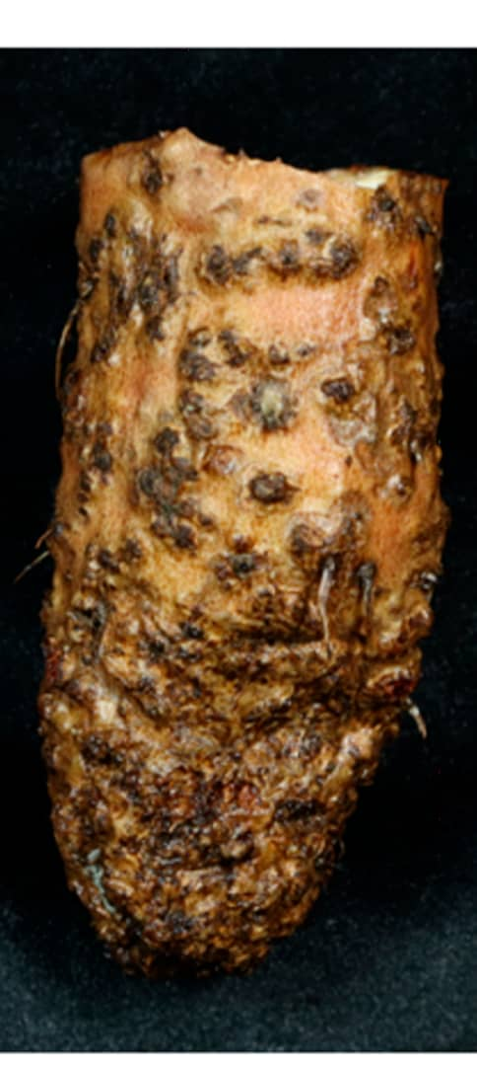
Figure2.2: Crazy Root Syndrome of Yam (Abdulsalam 2021)
2.5.8 Microbial Preservation of Yam Against Nematode Diseases.
As biocontrol agents, filamentous fungi have demonstrated efficacy against plant parasitic nematodes (PPNs). Mycorrhizal and Trichodermafungi can generate plant resistance to PPNs through activation of hormone-mediated defense mechanisms including jasmonic acid and salicylic acid (Povedaet al, 2020). It has also been demonstrated that the antagonistic bacterium Pasteuriapenetrans is efficient against S. bradys. Furthermore, Rhizobium species and Pseudomonas species (PGPR) suppress nematodes in addition to encouraging plant growth. For yam tubers in particular, arbuscularmycorrhizal fungi (AMF) efficiently boost oil fertility and lower worm populations.
The use of nematode antagonists and bio-agents, including nematophagous fungi, to manage root-knot nematodes (RKNs) is becoming more popular as research shows promise. According to reports, these fungi—which include Trichoderma spp, Paecilomyces spp and Pochoniasp can efficiently combat Meloidogyn espp, lowering damage by as much as 45%. Furthermore, it has been discovered that certain species of Arthrobotrysand Acremonium are especially efficient against nematodes that cause knotting in roots (Peiriset al, 2020). The nematode is also managed with spore-forming plant growth-promoting rhizobacteria (PGPR).
According to Xiang (2018), certain Bacillus species have been found to be effective against Meloidogyne incognita. These species include Bacillus altitudinis Bacillus thuringiensis, Bacillus cereus, Bacillus amyloliquefaciens, Bacillus coagulans, Bacillus circulans, Bacillus firmus, Bacillus polyinyxa, Bacillus megaterium, Bacillus mojavensis, Bacillus licheniformis, Bacillus penetrans, Bacillus subtilis, and Bacillus sphaericus
2.6 Importance in Identifying Microorganism Involved in Yam Preservation.
- It enhances good and effective preservation technique. (Babalolaet al, 2019)
- It encourages and promote food safety.
- It help us to understand how to use microbes in extending yam shelf life. (Nwachukwuetal, 2017)
2.7 Limitations in Identification of MicroorganismInvolved in Yam Preservation
- They require diverse microbes, making identification to complex and challenging. (Cocolinet a,l 2015)
- Differences in sampling, identification, isolation technique can lead to varying result.
- Limited reference database for a particular yam microorganism may affect accurate identification. (Babalola, 2019)
- Wrong result may occur due to contamination.

CHAPTER THREE
METHODOLOGY
3.1 Sample Collection
Samples of microorganism was collected in a stored yam of about 5 months containing white substances which might be microorganism. The white substance surrounding the yam enabled the yam to stay long before spoilage, hence those substance was scraped out and sealed inside sterile zip lock bag in order to identify the organism responsible for the extending of the yam shelf life.
3.2 Sterilizationof Materials
Sterilization of all the equipment needed to carry out the experiment was done in the laboratory. The glassware's were sterilized in the oven at 120°C for an hour after washing with soap. While the other equipment and working area was sterilized with 70% ethanol to reduce contamination Inoculating loops and scalpels were sterilized by dipping for 20 seconds in 70% ethanol and heated to red hot. The media PDA Agar was prepared following the manufacturers guide.
3.3 Media Preservation
Potatoes Dextrose Agar
Exactly 4.68 grams of powdered commercially prepared PDA was weighed on analytic meter balance into a clean 1liter conical flask and 120ml of distilled water was poured into it and placed inside a water bath at about 90°C, for the agar to dissolve. The medium was autoclaved at temperature 121°C for 15 minutes, after which it was poured inside sterile petri dishes and allowed to gel.
3.4 Sample Preparation
The work place was cleaned and disinfected in order to prevent contamination. The fungal inoculum was inoculated inside already prepared potatoes dextrose agar media. It was inoculated and streaked using inoculation loop to the different agar plates according to how they were labelled. The inoculated samples were gently tilted and allowed to be absorbed by the media before inverting and incubated at room temperature for 3-4 days with regular inspection for signs of growth and appropriate recording.
3.5Sub-Culturing and Storage of The Fungi Isolate
Distinct colonies were sub-cultured on a freshly prepared potatoes dextrose agar based on their colour, shape and arrangement in order to obtain pure culture. This was incubated under room temperature for 3-4 days.
3.6 Stock Culture
Exactly 4.68gram of potatoes dextrose agar (PDA) was dissolved in 120ml of distilled water and dispersed into bijour bottles and autoclaved at 121C for 15minutes. After autoclaving it was placed slantly to gel before inoculating the organisms. The inoculating bottles were incubated at room temperature for 3-4 days and served as stock culture for the study.
3.7 Identification of The Isolates
Direct Microscopic Examination
A clean slide was used to mount each isolate for identification. A drop of Lacto phenol blue was placed at the centre of the slide. Using sterilized needle, a small quantity of the isolate was mounted on the stains covered with a clean coverslip and observed under the microscope. The identification of each isolate is obtained from the cultural characteristics and morphology under the microscope.
3.8Slide Culture
The petri dish containing the u shaped rod, slide and cover slip was sterilized. With a sterilized forceps, the sterile slide was placed on top of the u shaped rod. A sterile scaple blade was used to cut out the potatoes dextrose agar block about lem square and the agar was placed on top of the sterile slide using a sterile scaple blade. The fungus under study was then inoculated at the four sides of the agar block using a sterile inoculating needle. With the use of a sterile forceps, the sterile coverslip was placed gently on the inoculated agar block. Exactly 2ml of sterile distilled water was poured aseptically into the plate to provide moisture environment for fungi growth. The plate was incubated at normal room temperature for 4-7 days to allow growth and sporulation to occur.
3.9Microscopic Examination of Slide
After four to five days, the coverslip was gently removed with a sterile forceps and the slide with growth was turned to face upward. The Agar block was gently removed with an inoculating sterile needle without disturbing the growth on the slide and discarded into a disinfectant jar to avoid spreading of spores around.
Water bubbles on the slide and coverslip within the area of fungal growth was removed by dropping 70% ethanol and a new clean slide and coverslip was used to mount the growth in the coverslip and slide before staining using lacto phenol cotton blue. The excess stain was removed with the aid of a blotting paper. The growth in the slide as well as the coverslip was observed under the microscope to obtain two conventional slide mounts using x10 and x40 objective lens.
CHAPTER FOUR
4.1 RESULT
During the culturing and identification stage of this practical (project), there was different colonies that was form due to the existence of fungi in PDA. The following organism was identified as some of the microorganism (fungi) that helps in extending yam shelf-life. Some of these fungi include Mucor, Penicillium spp, Alternaria spp, Microsporum spp, Fusarium spp, Trichoderma spp, Aureobasidium spp and Rhizopus spp

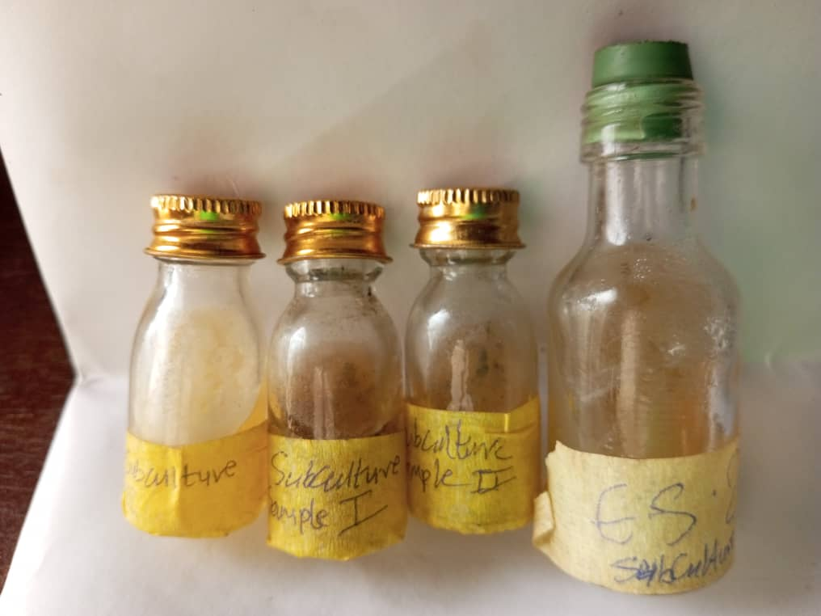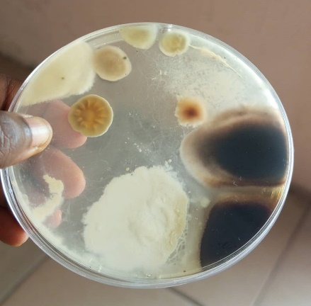
Fig. 4.1 Macroscopic view of different colonies.

4.2Mucorspp
Mucor on Potato Dextrose Agar (PDA), its colonies are woolly, grew rapidly with are whiteto a grayish color. Under the microscope,they are broad, unsegmented hyphae with a branching structure and sporangia that have many sporangiospores inside.
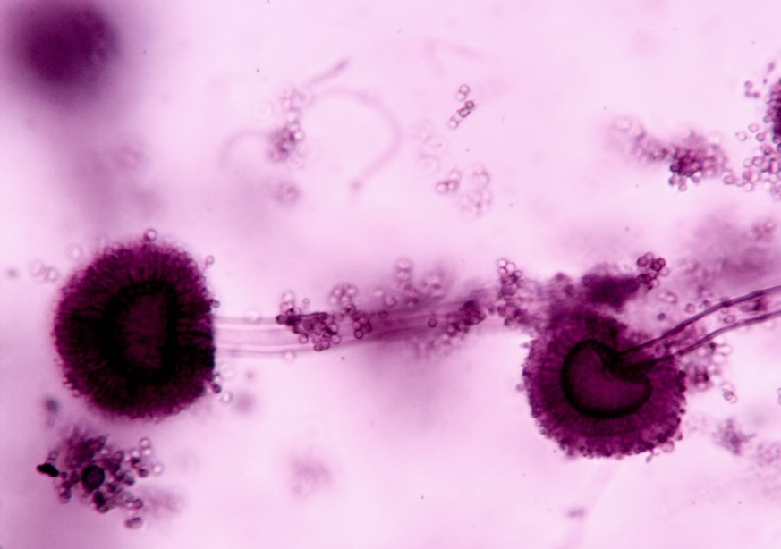
Fig. 4.2 Microscopic view of Mucor

4.3 Penicilliumspp
When grown on PDA, Penicillium species become blue-green and velvety, while microscopically, they show conidiophores with conidia arranged in chains.
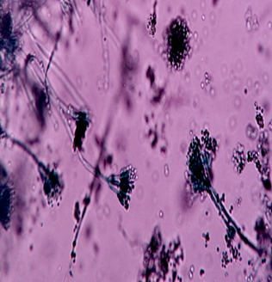
Fig 4.3 Microscopic view of Penicilliumspp

4.4Fusarumspp
Fusarium species grow on Potatoes Dextrose Agar with colonies that have different appearances and consistencies and microscopically, they have sickle-shaped macroconidia with 3-5 septa.
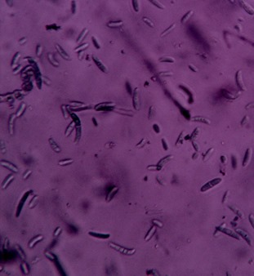
Fig 4.4 Microscopic view of Fusariumspp

4.5 Microsporumspp
PDA reveals that the colonies of Microsporum spp. are flat, powdery and range from buff to brown, with microscopy revealing large, spindle-shaped conidia that contain many partitions. 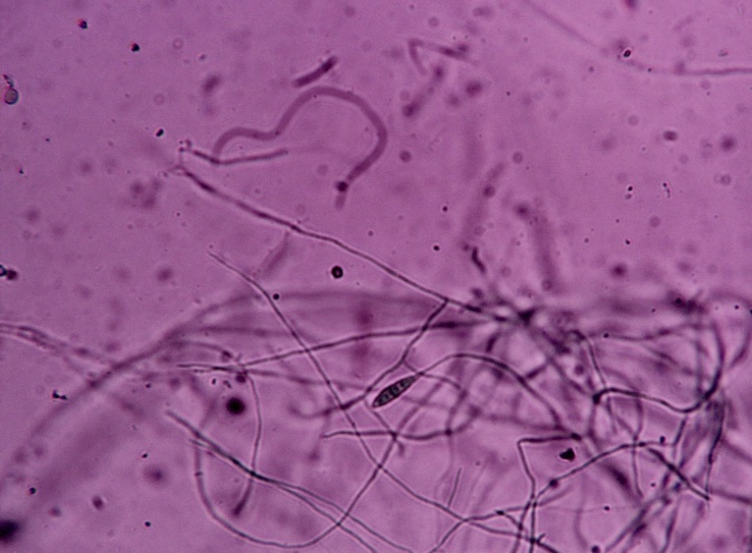
Fig 4.5 Microscopic view of Microsporum spp

4.6 Alternaria spp
Darkly colored, woolly colonies are formed by Alternaria spp. on PDA. On microscopy, they are identified by large, club-like conidia with a long beak sticking out.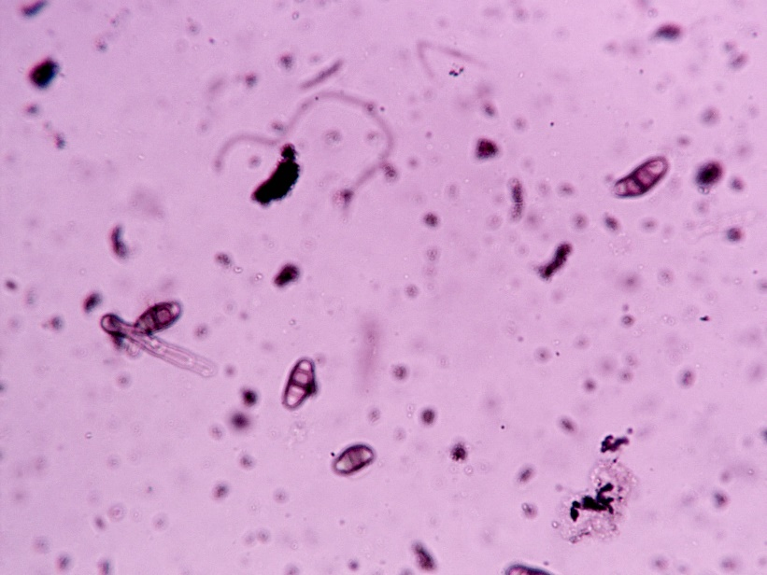
Fig. 4.6 Microscopic view of Alternaria spp

4.7 Rhizopus spp
Rhizopus spp. colonies on PDA are fast growing, soft and white or grayish, while, under the microscope, their sporangia are spherical and include sporangiospores.
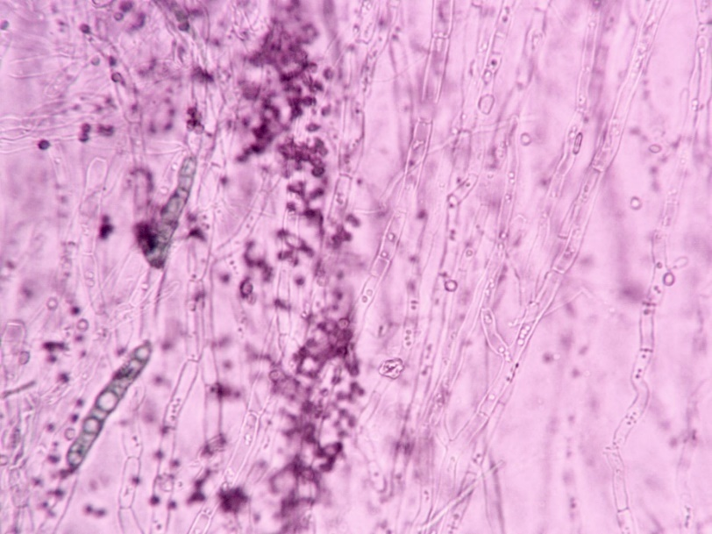
Fig. 4.7 Microscopic view of Rhizopus spp

4.8 Aureobasidium spp
At first, Aureobasidium spp. on PDA are yeast-like, only to later become filaments with dark hues and microscopic examination shows that their hyphae have septa and conidia are formed close to one another along a growing tip. 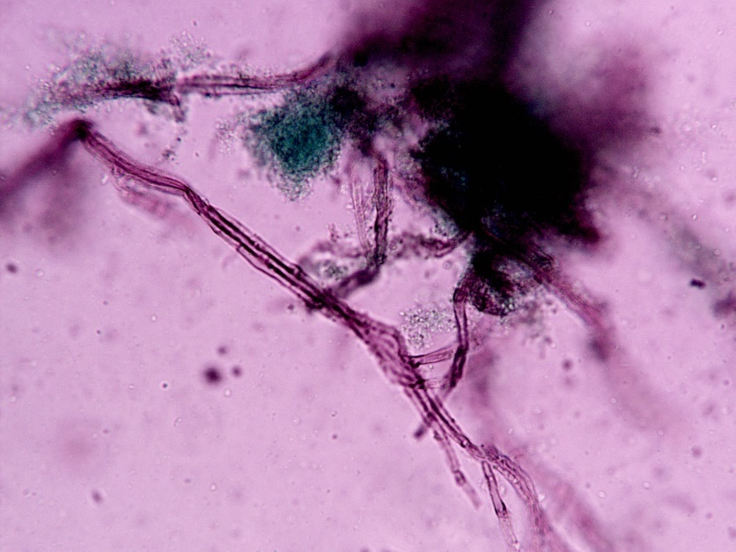
Fig. 4.8 Microscopic view of Aureobasidium spp

4.9 Trichoderma spp
Trichodermaspecieson PDA quickly form large, cottony colonies. When seen under a microscope, they have branches with groups of conidia appearing at their tips.
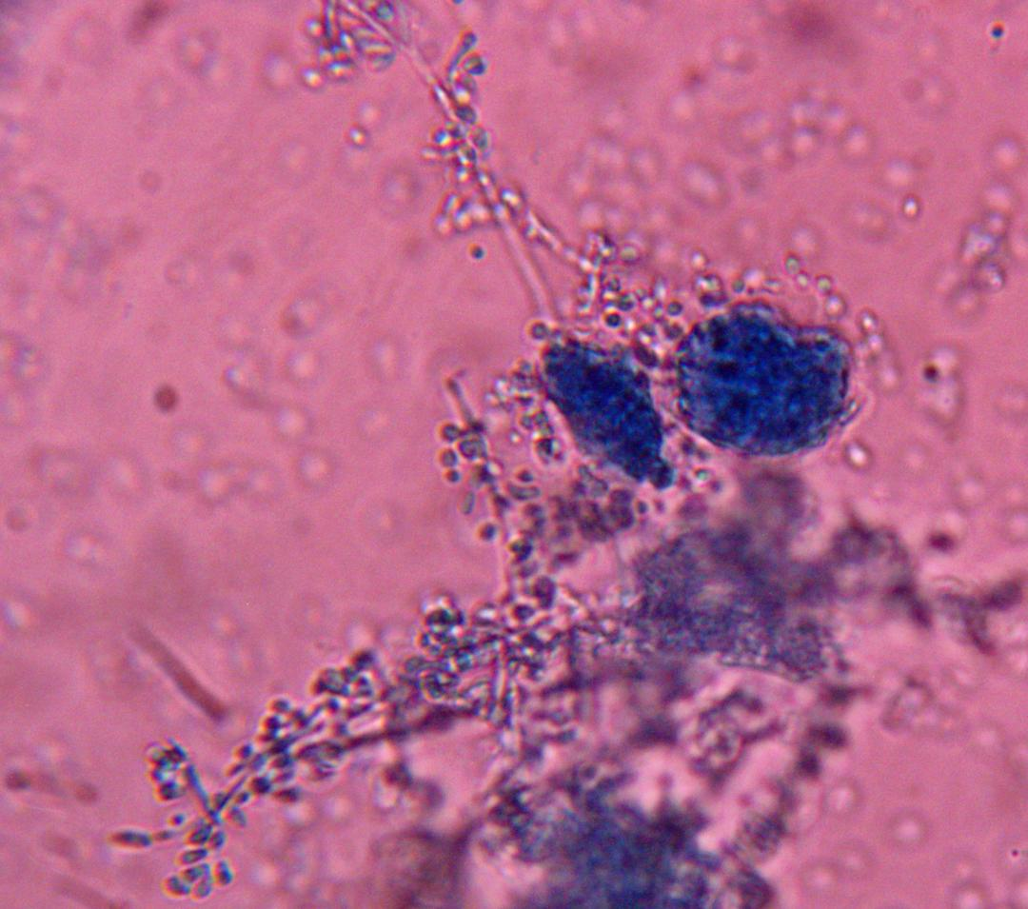
Fig. 4.8 Microscopic view of Trichoderma spp

TABLE OF ISOLATED FUNGI AND ITS FEATURE
S/N | Fungi Isolate | Color | Shape | Frequency of the total isolate in Percentage | Cultural characteristics
1 | Mucorspp | White | Spherical | 10 | Grows rapid on PDA producing white to grayish colony.
2 | Penicilliumspp | Greenish blue | Irregular | 30 | Grows moderately on PDA producing greenish blue mycelium
3 | Fusariumspp | Pinkish white | Filamentous | 15 | Grows slowly on PDA producing pinkish white mycelium
4 | Trichodermaspp | Greenish white | Spherical | 25 | Grows rapid on PDA producing greenish white mycelium
5 | Rhizopusspp | White | Filamentous | 5 | Grows rapid on PDA producing white mycelium
6 | Microsporumspp | Buff to tan | Flat with irregular margin | 5 | Grows rapid on PDA producing powdery colony
7 | Alternariaspp | Lightly pigment or colourless | Spherical or oval | 5 | Grows rapid on PDA producing a dark green, brown or black mycelium
8 | Aureobasidiumspp | Creamy, pink or black | Irregular | 5 | Grows rapid on PDA producing smooth or wrinkled colony

Table 4.1: Shows the color, shape frequency and cultural characteristic of the isolate

Microscopic and macroscopic characteristics of the isolated fungi
S/N | Fungi Isolate | Microscopic Characteristics | Macroscopic Characteristics
1 | Mouldspp | Aseptate hyphae, branched spherical, 5-15um in diameter | Colonies are fluffy and woolly in texture. They grew up to 5-7 cm in diameter.
2 | Penicilliumspp | Hyphae septate, branched, conidia cylindrical,5-7um in in length | Colonies are blue-green, with a velvety texture. They grew up to 5-7 cm in diameter
3 | Fusariumspp | Hyphae septate, branched, conidia spherical, 2-3um in diameter | Colonies are pinkish-white, with a cottony texture. They grew up to 5-7 cm in diameter.
4 | Trichodermaspp | Hyphae septate, branched, conidia spherical, 2-3um in diameter | Colonies are white or light green, with a cottony texture. They grew up to 5-7 cm in diameter.
5 | Rhizopusspp | Hyphae non-septate, branched, sporangia spherical, 10-15um in diameter | Colonies are white or light gray, with a cottony texture. They grew up to 5-10 cm in diameter.
6 | Microsporumspp | Typically 10-15um in size with a rough thick-walled appearance | Colonies are buff to tan, with a powdery texture. They grew up to 3-5 cm in diameter.
7 | Aurobsidiumspp | Typically 5-10um in size with a smooth thin-walled appearance | Colonies are cream, pink, or black, with a smooth or wrinkled texture. They grew up to 3-5 cm in diameter.
8 | Alternariaspp | Typically muriform with a beak-like appendage at the apex | Colonies are dark green, brown, or black, with a velvety or cottony texture. They grew up to 5-10 cm in diameter.
Table 4.2. The microscopic and macroscopic characteristics

CHAPTER FIVE
5.1 DISCUSSION
The project topic identification of microorganism involved in yam preservation was aim to identify beneficialmicrobes that extends yam shelf life in order to reduce the early spoilage and damage of yam using biological means. During the course of the identification, the process of growing, separating and examining under microscope to identify and examine microorganisms living on preserved yams which helped them to last long was adopted. As a result, some species of fungi such as Mucor, Penicillium spp, Fusarium spp, Trichoderma spp, Rhizopus spp, Microsporum spp, Aurobasidium spp. and Alternaria spp are among the fungi that extend yam storage and preservation, (Adebayo et al 2019). In the view of Oguntoyinbo and Narbad (2018), fungi accomplish these tasks by making antifungal or antimicrobial compounds. As an illustration, Mucorsppemits fumaric acid (Abbas et al, 2015), Penicillium spp produces patuin and expansoide (Irobi and Ojimelukwe, 2019), Fusarium spp discharges fusaric acid and dehydrousaric acid (Okigbo and Ikediugwu, 2000), Trichoderma spp gives trichod. These authors believe that the antimicrobial and antifungal products made by the fungi stop spoilage in yam and encourage other microbes to compete.

At the resting phase, fungi grow at different rates which shows in their growth frequency in the lab. As discussed by Omemu and Oluwafemi (2020), species such as Mucor occurred at a frequency of 10%, Penicillium spp occurred 30% and Fusariumspp (15%), Trichoderma spp grew at 25%. Rhizopus spp, Microsporum spp, Aureobasidium species and Alternaria spp each grew at 5%. For proper growth of microorganisms, the suitable factors needed for their health must be supplied. Some of these factors include PH, nutrient, temperature, oxygen and moisture etc. When these factors are not in adequate, it might hinder or slow down the growth of the microbe.

5.2 CONCLUSION
The research discovered which microorganisms are involved in yam preservation, revealing their part in protecting the yam against spoilage and damage by other microbes. The results point out that these microorganisms may be used as biocontrol agents, making chemical preservatives less necessary.
These findings suggest that microorganisms such as Mucor spp, Penicillium spp, Alternaria spp,
Microsporum spp, Fusarium spp, Trichoderma spp, Aureobasidium spp and Rhizopus spp
are crucial for preserving yams. It is ability of these microorganisms to produce antifungals and antibacterials, sharing resources and breaking down complex materials that make them beneficial in preserving yams.
As a result of this research, it becomes easier to find environmentally friendly ways to store food without using many chemicals. More research should explore the best circumstances for the work of these microbes and produce new biocontrol products that help to preserve yams.
As a result, this research improves our knowledge of the role of microorganisms in keeping yams safe which helps create better methods to preserve food and decrease losses after harvest.

5.3 RECOMMENDATIONS
1. Encourage interdisciplinary collaboration among food scientists, microbiologists, and industry stakeholders.
2. Support research and development of biopreservation technologies.
3. Promote consumer education and awareness of biopreservation benefits.
4. Develop regulatory frameworks to facilitate the use of biopreservatives in yam production.

REFERENCES:
Adebayo, A. O., and Aderiye, B. I. (2019). Microbial diversity of fermented yam products in Nigeria. Journal of Food Science and Technology, 56(4), 2226–2235.
Adeyemi, O. S., and Awosanya, O. A. (2022). Microbial analysis of fermented yam products in Nigeria. Journal of Food Science and Technology, 59(2), 638–646.
Adeyeye, S. A. O., and Oyewole, O. B. (2018). Microbial analysis of fermented foods in Nigeria.
Adetunji, C. O., and Anani, O. A. (2020). Microbial analysis of fermented yam products. Journal of Food Science and Technology, 57(4), 1526–1534.
Anjum, M., and Chandra, S. (2015). Efficacy of Bacillus licheniformis: A biocontrol agent against Colletotrichum gloeosporioides Penz. Causing anthracnose in greater yam (Dioscorea alata L.). Egyptian Journal of Biological Pest Control. https://doi.org/ 10.1186/s41938-023-00755-3
Douglas, M. (2017). Yams and their cultural significance: The etymology and history of yam terminology. Journal of Ethnobotanical Research, 12(3), 211–225.
Ezebo, R. O., and Okigbo, R. N. (2024). Biological control of post-harvest rot in water yam (Dioscorea alata L.) using antagonistic fungi. International Journal of Pathogen Research, 13(6), 101–116. https://doi.org/10.9734/ijpr/2024/v13i6325
Fan, Z., Liu, Y., Wang, T., and Zhang, X. (2022). Temperature effects on postharvest physiology and quality of root and tuber crops: A review. Postharvest Biology and Technology, 189, 111914. https://doi.org/10.1016/j.postharvbio.2022.111914

Irobi, E. N., and Ojimelukwe, P. C. (2019). Microbial analysis of fermented yam products in Nigeria. Journal of Food Science and Technology, 56(3), 1388–1396.
Li, Y., Chen, J., and Wang, H. (2023). Nutritional and functional components of yams (Dioscorea spp.): A review of food uses and potential health benefits. Food Research International, 163, 112223. https://doi.org/10.1016/j.foodres.2022.112223
Mbam, P. N., Ebongue, C. O., and Tiku, O. E. (2019). Molecular identification of fungal pathogens associated with post-harvest yam tubers rot in Mbam et Kim Division (Cameroon) with emphasis on Penicillium monomenatosum as a first report. American Journal of Microbiological Research, 8(2), 5–11. https://doi.org/10.12691/ajmr-8-2-2
Obiediegwu, J. E., Akpabio, E. M., and Asiedu, R. (2020). Yam (Dioscorea spp.) improvement: A systematic review of breeding, genomics, and conservation. Plant Genetic Resources, 18(5), 332–345. https://doi.org/10.1017/S1479262120000339
Odetunde, O. A., Odu, N. N., and Okonko, I. O. (2020). Microbiological analysis and molecular characterization of bacterial and fungal isolates present in exposed and packaged cassava, plantain, and yam flour sold in selected markets in Port Harcourt, Rivers State, Nigeria. American Journal of Microbiological Research, 7(2), 5–11. https://doi. org/10. 12691/ajmr-7-2-2
Oguntoyinbo, F. A. (2018). Microbial diversity of fermented foods in Africa.
Oguntoyinbo, F. A., and Narbad, A. (2018). Microbial diversity of fermented foods in Africa. Journal of Food Science, 83(5), S1448–S1456.

Okigbo, R. N., and Ebere, E. (2015). Control of white yam (Dioscorea rotundata) rot pathogen using peel extract of water yam (Dioscorea alata). Advances in Applied Science Research, 6(1), 7–13.
Okigbo, R. N., and Ikediugwu, F. E. O. (2000). Studies on biological control of postharvest rot in yams (Dioscorea spp.) using Trichoderma viride. Journal of Phytopathology, 148(6), 351–355. https://doi.org/10.1046/j.1439-0434.2000.00515.x
Omemu, A. M., and Oluwafemi, F. O. (2020). Microbial diversity of fermented foods in West Africa. Journal of Food Science, 85(5), S1439–S1447.
Sameza, M. L., Tchinda, R. A., Nana, L. R., Tatchago, V., Zambou, N. T., and Mbeumo, A. F. (2016). Evaluation of clove essential oil as a mycobiocide against Rhizopus stolonifer and Fusarium solani, tuber rot causing fungi in yam (Dioscorea rotundata Poir.). Journal of Phytopathology, 164(6), 433–440. https://doi.org/10.1111/jph.12423
Santosa, P., Rahayu, E. S., and Widodo, H. (2017). Elephant foot yam (Amorphophallus paeoniifolius): Biodiversity, cultivation, and its role in food security. Indonesian Journal of Agricultural Research, 14(2), 45–52.
Sanni, A. I., and Oguntoyinbo, F. A. (2017). Microbial diversity of fermented products. Journal of Applied Microbiology, 123(3), 647–658.
Sulaiman, B., Hayatu, M., and Terna, T. P. (2023). Biocontrol potentials of selected plants against some post-harvest fungal pathogens of yam (Dioscorea rotundata P.) in Lafia, Nasarawa State, Nigeria. FUDMA Journal of Sciences, 3(2), 354–363.
Xie, J., Wang, L., Zhang, H., and Zhao, M. (2022). Postharvest storage strategies of yams (Dioscorea spp.): Impacts on quality and germination. Journal of Food Storage and Preservation, 46(1), e16034. https://doi.org/10.1111/jfsp.16034

