DEVELOPMENT OF A SHOPLIFTING DETECTION AND NOTIFICATION SYSTEM USING COMPUTER VISION IN CCTV FOOTAGE

BY

ANI OBINNA GEORGE
GOU/U21/CSC/698

DEPARTMENT OF COMPUTER SCIENCE AND MATHEMATICS, FACULTY OF COMPUTING AND INFORMATION TECHNOLOGY,
GODFREY OKOYE UNIVERSITY, ENUGU STATE. IN PARTIAL FULFILLMENT OF THE AWARD OF BACHELOR OF
SCIENCE (B.SC), DEGREE IN COMPUTER SCIENCE.

SUPERVISOR: MR. CAMILLUS E. NJOKU

JUNE, 2025.
APPROVAL PAGE
This research, titled “Development of a Shoplifting detection and notification system using computer vision in CCTV Footage,” has been assessed and approved by the Committees of the Department of Computer Science and Mathematics and the Faculty of Natural Sciences and Environmental Studies, Godfrey Okoye University, Enugu, Nigeria.

Mr. C.E. Njoku ................................... ..................................
Supervisor Signature Date

External Examiner ................................... ..................................
External Examiner Signature Date

Dr. Frank Okebanama ................................... ..................................
HOD, Department of Signature Date
Computer Science and
Mathematics

Prof. Chidi.C. Uhuegbu ................................... ..................................
Dean, FNESS Signature Date

CERTIFICATION
I certify that I completed the research included therein and that it was primarily based on my observations and investigation. Consequently, I will fully accept the University's decision if I am found to have cheated on the assignment.

________________________
ANI OBINNA GEORGE
GOU/U21/CSC/698

DEDICATION
This project, “DEVELOPMENT OF A SHOPLIFTING DETECTION AND NOTIFICATION SYSTEM USING COMPUTER VISION IN CCTV FOOTAGE,” is dedicated to God Almighty, whose grace, wisdom, and unending love guided me every step of the way.

ACKNOWLEDGEMENTS
I express my profound gratitude to God Almighty for His kindness and fortitude along this journey, without whom this significant work would not have been achieved. Also, my heartfelt gratitude goes to my loving and caring parents for their endless support in every way.
My sincere appreciation also goes to My Supervisor, Mr. Camillus Ekene Njoku, for the time and dedication he invested to ensure the success of this work, and for his unwavering mentorship throughout the process.
I am deeply thankful to my Head of Department, Dr. Frank Okebanama, for his inspirational leadership and unwavering support, which created an enabling environment for academic progress and research excellence.
I would like to acknowledge the Department of Computer Science and Mathematics, along with its lecturers, for their academic guidance and commitment to our learning during our time in the program.

ABSTRACT
This study presents the design, implementation, and evaluation of an intelligent violence detection system leveraging a combination of MobileNetV2 and a “Long Short-Term Memory (LSTM) model” for real-time analysis of surveillance video footage. The MobileNetV2 is a pretrained Convolutional Neural Network (CNN) algorithm. The system's Python development and deployment on an edge processing device allow for the effective extraction of temporal and geographical information essential for correctly classifying violent and non-violent behaviors. Before being input into the CNN for feature extraction, video material is preprocessed. The LSTM then analyzes the data to find temporal patterns suggestive of violence. Through an IoT communication node, the device automatically sends out email notifications to authorized stakeholders upon detection, facilitating prompt action in delicate settings, including public gatherings, shopping centers, and schools. The approach's robustness and usefulness are validated by extensive testing on a benchmark dataset, which shows the model's excellent accuracy, precision, and recall with few false alarms. The study emphasizes the system's potential for improving automated surveillance capabilities, albeit with several restrictions on data variety and processing delay. Future research is advised to increase dataset variety, maximize computational effectiveness, and incorporate multi-modal alert systems to enhance scalability and real-world application.

TABLE OF CONTENTS

Title page i
Approval ii
Certification iii
Dedication iv
Acknowledgments v
Abstract vi
Table of contents vii
List of tables ix
List of figures x

CHAPTER ONE: INTRODUCTION 1
  - Background of the Study 3
  - Statement of Problem 3
  - Aim and Objectives 3
  - Significance of the Study 4
  - Scope of the Study 4
  - Limitation of the Study 4
  - Definition of Terms 5
CHAPTER TWO: LITERATURE REVIEW 7
2.1 The Concepts of Video Surveillance System 7
2.1.1 Evolution of Scene Monitoring Technologies 10
2.1.2 Functionality and Types of IP Cameras 15
2.2 Review of Home Security System 17
2.2.1 Security Door System Using Human Tracking Method 18
2.2.2 Zigbee-GSM based home security system 18
2.2.3 Raspberry Pi-based home security system 19
2.2.4 Cloud-Based Home Automation System 19
2.2.4 Home security system using Siri-enabled mobile device 20
2.3 Review of Related Literature 20
2.4 Summary of Literature 26
2.5 Research Gap 29
CHAPTER THREE: SYSTEM ANALYSIS AND DESIGN 29
3.1 Research Methodology 29
3.2 System Analysis 29
3.2.1 Analysis of the Existing System 31
3.2.2 Weaknesses of Existing System 32
3.2.3 Analysis of the Proposed System 31
3.2.4 Advantages of the Proposed System 32
3.3 Data Collection 33
3.3.1 Data Annotation and Statistics 33
3.3.2 Images from Dataset 33
3.4 Baseline Methods 37
3.4.1 Two-Dimensional Convolutional Neural Network 37
3.4.2. Three-Dimensional Convolutional Neural Network 38
3.4.3 Architecture of the Proposed Method 40
3.5 System Flowchart 45
3.6 System Use Case Diagram 46
3.7 System Activity Diagram 47
3.8 System High-Level Model 48
CHAPTER FOUR: SYSTEM IMPLEMENTATION 50
4.0 Introduction 50
4.1 Choice of Programming Language 50
4.1.1 Frameworks Used 51
4.1.2 Programming Environment 51
4.2 System Requirements 52
4.2.1 Hardware Requirements 52
4.2.2 Software Requirements 52
4.3 System Testing 53
4.3.1 Unit Testing 53
4.3.2 Integration Testing 54
4.4 System Results 54
4.4.1 Accuracy 54
4.4.2 Precision 55
4.4.3 Recall (Sensitivity) 55
4.4.4 F1-Score 55
4.4.5 Confusion Matrix 56
4.4.6 ROC Curve and AUC Score 56
4.5 System Integration 58
CHAPTER FIVE: SUMMARY, CONCLUSION AND RECOMMENDATIONS 61
5.1 Summary 61
5.2 Conclusion 61
5.3 Recommendations 62
References 63

LIST OF FIGURES

Figure

2.1: Video surveillance application sectors (Elharrouss et al., 2021) 8
2.2: Field of view of Multi-cameras (Elharrouss et al., 2021) 9
2.3: Video surveillance system functional features (Elharrouss et al., 2021) 12
2.4: Example of an analogue video surveillance system (Yang et al., 2009) 13
2.5: Example of a digital video surveillance system (Chen et al., 2016) 15
3.1: A boy putting the item in the inner pocket. 35
3.2: A boy putting the item in the T-shirt’s front pocket. 36
3.3: A boy putting the item in a fully opened bag 36
3.4: The Second person is putting the item into first’s bag. 37
3.5. A boy putting the item in the opened portion of closed bag 37
3.6. A boy putting the item in trouser pocket 38
3.7. Architecture of the Proposed Method 42
3.8: Architecture of Inception V3 43
3.9: Architecture of the Proposed Bi-LSTM 45
3.10: System Flowchart 46
3.11: System Use Case Diagram 47
3.12: System Activity Diagram 48
3.13: System High-Level Model 49
4.1: Model Accuracy Result 55
4.2: Confusion Matrix of the Model 56
4.3: ROC-AUC Result 57
4.4: System Homepage 59
4.5: System Testing from a lower camera angle 59
4.6: System Testing from a Higher camera angle 60
4.7: System Detecting Shoplifting Activity 60

LIST OF TABLES
Table

2.1: Summary of Literature 26
4.1: Summary of the Results of System Implementation 57

CHAPTER ONE
INTRODUCTION
  - Background of the Study
Shoplifting is a major problem in the global retail industry as the practice is very common and incurs billions of dollars annually in losses. According to the National Association for Shoplifting Prevention, retailers all over the world are losing close to 50 billion dollars a year as a result of shoplifting and other shop theft-related crimes (2020). Human monitoring has its limits and thus many incidents will occur unnoticed even with investments in traditional forms of surveillance. Retail shops are increasingly complex and populated enough that it is no longer an adequate solution to only resort to human surveillance.
In spite of the fact that Closed-Circuit Television (CCTV) has been adopted in stores, its ability to work is still very much dependent on human life. Security personnel keeps track of various camera feeds at the same time, and it can cause fatigue, overlooking incidence, and response delay (Zhang et al., 2020). Consequently, the market is experiencing increased demand to identify smart surveillance systems that are capable of indicting a fewer number of human operators and automatically identifying suspicious activities in real-time environments.
The latest developments in computer vision and deep learning through automated recognition of suspicious behavior has brought a new opportunity to improve security in the retail industry. Computer vision can be used to monitor the movement of the customers, their interactions with the products, and their movement patterns that may deem them as potential thieves (Ren et al., 2021). These systems can identify potential abnormal behavior patterns that might lead to shoplifting by analyzing both the temporal and spatial features in CCTV recordings. Using deep learning, specifically Convolutional Neural Networks (CNN) and Long Short-Term Memory (LSTM) networks, some of the most effective methods have been shown to detect abnormal behaviors within video streams. These models are highly useful in activity recognition tasks, allowing them to detect hidden behavioral cues such as lingering, frequent eye movements, or sudden product placement hideaways (Islam et al., 2021). Additionally, these techniques can be trained to identify abnormal shopping behaviors and suspicious activities with a high level of accuracy.
Besides, embedding an object detection application such as YOLO (You Only Look Once) or SSD (Single Shot MultiBox Detector) algorithms allows real-time recognition of people, things, and their interactions in a shop (Bochkovskiy et al., 2020). Integrating these models with the tracking algorithms such as Deep SORT, it is possible to track a particular customer across the store and build behavioral profiles over time that are required to detect complex patterns of theft. OpenPose and MediaPipe are also pose estimation frameworks that help with the detection of shoplifting by examining human posture and gesture. As an example, hands behaving unconventionally very close to products, or strange bending angles that may suggest the person is hiding something can be noted as a possible method to steal (Li et al., 2021).
When pose estimation and motion analysis is used together, this system has the advantage of capturing static characteristic and dynamic characteristic of the suspicious behaviour. These systems are also made efficient by adding real time action measures such as alerts. Whenever the system senses a possible shoplifting attack, it can send a message to store employees in real-time through a SMS, an email, or even through its interface. This is achievable in order to translate into a quick response which may be able to stop theft before it happens. Another advantage of timely alerts is that the evidence collection process is enhanced because incidents can be reviewed and confirmed immediately (Chandakkar et al., 2021).
Despite their potential positive effects, intelligent surveillance systems have to deal with such challenges as false positives, privacy, environmental factors, such as light and occlusion, which may differ significantly. The false alarms can reduce the measures of desensitization and trust among the employees towards the system. Also, there will be an ethical and legal implication of surveillance and data privacy that will need to be considered in the collection and analysis of the data related to personal behavior (Zhao et al., 2022).
Nonetheless, the protection of retail premises with the help of AI-powered security systems becomes an increasingly urgent need as the retail crime keeps developing. Smart modeling of behavior and high technique of video analysis do not only make it easier to detect theft, but shopping safer and more convenient as well. It is due to the improvement of these systems in terms of their hardware and software platform that these systems are becoming affordable and accessible to more people.
All in all, the implementation of the shoplifting detection and notification mechanism that recognizes potential shoplifters based on their appearance with the help of the computer vision technology in the CCTV videos will open the way toward automation of the retail security. Such systems have the potential of offering real-time monitoring with small interference of the human due to the use of deep learning, object detection, and the recognition of human behavior. Due to their use, stores may become safer and more difficult to plunder and to achieve this change of safety possible, they may potentially change the traditional security protocols.
1.2 Statement of Problem
Human surveillance is still at the basis of identifying and preventing shoplifting acts because it has weaknesses regarding fatigue, distractions, and the overall oversight despite the large proportion of CCTV in retail facilities. High levels of coordination of subtle shoplifting approaches are hard to identify in real life as individual cameras must be monitored by the security personnel and in most occasions, he/she must be monitoring several cameras at a time. This inefficiency leaves businesses with financial losses and thus delayed or missed responses in case of an incidence. This is in view of that fact that traditional surveillance systems are poor forms of proactive security systems since they are not intelligent in the manner that they can be used to analyze behavioral patterns, detect suspicious activity and issue real time alerts.
- Among the key issues there is the fact that the United States sold a lot of weapons to Mexico.
- The human inability to monitor a number of video feeds on a consistent basis.
- The risk of human error is high, which is evident in peak hours or case of long shifts.
Traditional CCTV does not provide automatic analysis of behaviour and real time alerts.The situation is made more difficult by the increasing sophistication of shoplifting techniques, which often take advantage of surveillance blind spots or mimic normal customer behavior to avoid detection. Without intelligent automation, retail establishments are open to theft, which has a negative impact on profits, operations, and customer trust. An intelligent surveillance system that can autonomously detect shoplifting behavior in CCTV footage using computer vision and promptly notify security personnel is urgently needed to address these issues. Real-time response capabilities would be enhanced, losses would be reduced, and store security would be enhanced all at once.
1.3 Aim and Objectives
The aim of this study is the development of a shoplifting detection and notification system using computer vision in CCTV footage. The objectives for the development of this research are to:
- Analyse the existing systems for shoplifting detection
- Develop an intelligent deep learning model for the detection of shoplifting
- Evaluate the performance of the model
- Develop a software for the detection and notification of shoplifting
1.4 Significance of the Study
This study is significant as it leverages cutting-edge computer vision and deep learning technologies to address the persistent challenge of shoplifting in retail environments. The paper will present a scalable model that enhances accuracy of surveillance, minimizes pressure on the human security personnel as well as allowing real-time action to be taken to address instances of shoplifting by developing an intelligent and automated system of shoplifting detection and notifications. The potential of the system is to decrease financial losses significantly, improve operations within the retailers, and raise customer and staff safety. Furthermore, the results create a new opportunity to advance the field of smart video surveillance and retail crime prevention with the future innovations and contribute to the emerging field of knowledge about AI-driven security systems.
1.5 Scope of the study
This is because the use of computer vision methods on the CCTV video footage of a retail store setting to develop and subsequently employ a smart shoplifting detection and notifying system is all the fruit of this particular research paper. Based on video analysis in the real time with deep learning models, the system will concentrate on finding suspicious human behaviors and reasons to suspect shoplifting, including object hiding, loitering, and suspicious hand motion. The accuracy, speed, and reliability of this study focus on designing, training, and testing the model on both pre-recorded and, live CCTV data. It does not deal with surveillance in non-retail environments or other types of retail thefts such as employee theft or cybercrime.
1.6 Limitations of the Study
This study has a number of limitations to achieving its objective of realizing an effective computer vision based shoplifting detecting and alerting mechanism. One such issue is that the model may not be able to discern and decode human behavior that clearly as environmental conditions such as bad light, camera positions, occlusion and crowd congestion will influence the accuracy of the system. Second, the effectiveness of the model is very much dependent on the characteristics of the training data in that the system may not be able to effectively generalize the behaviors in reality, especially if those behaviors are not adequately represented in the training data. Additionally, there is a possibility of false positives and negatives, in which actual theft may go unnoticed or normal customer behavior may be misinterpreted as suspicious. Also, it lacks an elaborate legal or ethical structure that can be used to govern such a study by different jurisdictions and it does not capture the information privacy issue with regards to video and data storage. And finally, implementing the system might also require considerable number of computational resources, something that may limit usage of system in low-resource retail environments.
1.7 Definition of Terms
1. Shoplifting: This involves taking merchandise in a shop premise without making payments. In most cases, it involves placing items under clothes or in shopping bags.
2. Computer Vision: A branch of artificial intelligence (AI) that makes computers be able to process and analyze the vision of the reality, i.e., pictures and videos.
3. CCTV (Closed-Circuit Television): Is a type of surveillance in which video cameras are used as a tool that sends signals to a set of predetermined monitors as part of ensuring security and monitoring.
4. Suspicious Behaviour: Actions or movements performed by a human being, which are odd or abnormal, which can signal intentions of theft or crime (loitering, constant look around self, or concealment of products).
5. Deep learning Deep learning refers to a variant of machine learning in which neural networks are composed of multiple layers to learn complex patterns in the data, commonly applied to image and video recognition problems.
6. Convolutional neural network (CNN): It is a deep learning model that mainly is useful in processing visual images, and thus it is widely applicable in object detection and human activities.
7. Object Detection: A computer vision method of detection and localization that determines and finds objects on an image or video frame commonly applied in people and items detection and interactions.
8. Real-time Notification: This is the instant delivery of a notification or messages to the users, or systems in response to the occurrence of a pre-configured event like a suspected instance of shoplifting.
9. False Positive: An information inaccuracy when the system reports an ordinary action as a suspicious behaviour or one that is likely to be involved in shoplifting.
10. Pose Estimation: A computer vision method for detecting and tracking human body positions, which helps analyze actions and gestures that could indicate theft.

CHAPTER TWO
LITERATURE REVIEW
2.1 The Concepts of Video Surveillance System
Over the last twenty years, significant advancements in various socio-economic domains have greatly enhanced the complexity of modern life, especially in terms of individual safety and security. This has placed a heightened focus on security measures, with surveillance emerging as a cornerstone for protecting both people and property. Consequently, surveillance cameras are now extensively deployed in public and private spaces to bolster safety. However, reliance on human-operated systems for continuous monitoring is financially burdensome and impractical. This has underscored the need for automated solutions, prompting the development of intelligent video surveillance systems (Porikli et al., 2013).
The primary purpose of these automated systems is to support human operators in executing a range of surveillance tasks (Cumming and Johan, 2015). These tasks include traffic regulation, accident prevention, crime deterrence, motion detection, and enhanced national security. Such systems are also adaptable for indoor and outdoor environments like airports, train stations, parking lots, highways, retail outlets, shopping centers, and office buildings. By integrating advanced functionalities, these systems aim to optimize performance while minimizing human errors.
With population growth, rising crime rates, and increasing terrorist threats over the past two decades, urban centers have seen a proliferation of surveillance cameras to meet escalating security needs (Tang et al., 2013). Today, video surveillance spans vast areas with millions of cameras employing various technologies to safeguard public spaces and manage urban environments (Such et al., 2014). However, the expansive data collection and analysis facilitated by the internet pose pressing concerns about individual privacy (Cook et al., 2009). Despite strides in technology, ensuring the protection of personal privacy remains a persistent challenge (McSween, 2003).
Surveillance systems are now commonplace in high-security areas such as airports, streets, and private properties, offering critical support for security personnel by identifying unusual activities or breaches in restricted zones. Their applications extend across diverse sectors including traffic management, monitoring pedestrian flows, detecting highway accidents, tracking wildlife, managing borders, assisting refugees in conflict zones, supervising peace treaties, and securing military installations (Fuller, 2005). While surveillance cameras provide a cost-effective and functional solution for various industries, the expense of employing human operators to manage these systems continues to be a limitation. Moreover, although the number of surveillance cameras has significantly increased, their data is often utilized retrospectively to investigate incidents rather than for real-time monitoring (Elharrouss et al., 2021).
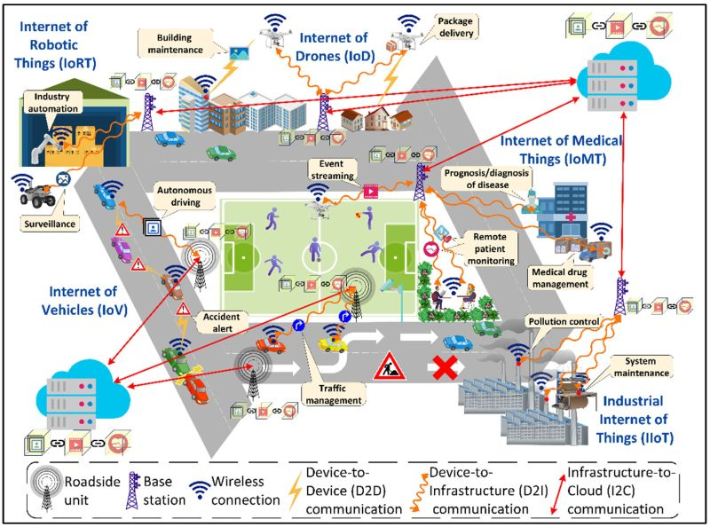
Figure 2.1: Video surveillance application sectors (Elharrouss et al., 2021)
In today's digitally interconnected world, surveillance systems rely heavily on vast networks of cameras that continuously capture immense volumes of visual data. Every day, thousands of cameras, ranging from urban traffic monitors to security feeds in transportation hubs—generate an overwhelming amount of footage. Processing and interpreting this data manually is impractical, prompting scientists and engineers to develop automated systems capable of efficiently extracting meaningful information.
A single camera's perspective is inherently limited, as it captures only a partial view of a given environment. To achieve comprehensive surveillance over a large or complex area—such as tracking a vehicle moving through a city’s road network or monitoring crowd dynamics in a major transit station, it becomes essential to integrate video streams from multiple cameras. By combining various points of view, this multi-camera strategy enables a broader and more cohesive comprehension of the observed space. Many intelligent multi-camera video surveillance systems have been developed by researchers in response to this need (Bahr, 2014).
Advances in image sensor technology, computer vision, pattern recognition, data communication, and signal processing are all used in these systems. Modern surveillance solutions are able to perform tasks like object tracking, behavior analysis, and anomaly detection with increasing accuracy by combining insights from these fields. The ability of multi-camera systems to provide fields of view that overlap or complement one another ensures seamless coverage of the area being monitored. This idea is shown in Figure 2.2, which shows how strategically placed cameras can remove blind spots and improve situational awareness (Kongsvik et al., 2012). Large-scale security operations require real-time data fusion from multiple sources in order to make good decisions, so these configurations are especially useful.
As surveillance technology continues to evolve, the integration of artificial intelligence and machine learning further enhances the capability of multi-camera systems, enabling more sophisticated analysis and proactive monitoring in dynamic environments.
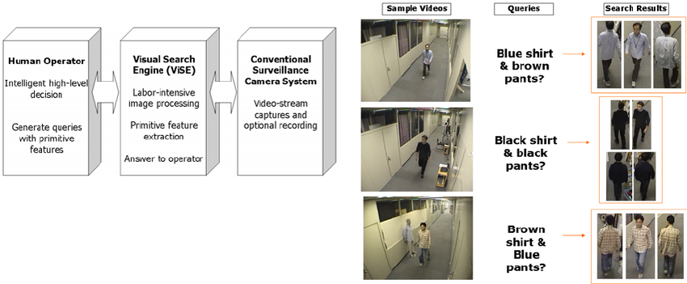

Figure 2.2: Field of view of Multi-cameras (Elharrouss et al., 2021)
These cameras can collaborate to provide a good surveillance. Also, it helps for multiple analyses that require tracking moving objects around many surveilled areas. The need here is a monitoring system that operates continuously for surveillance in order to alert the security officers when there is still time to prevent the crime. The main problems faced by these monitoring systems are: the collection of data from all surveilled areas that need to be secured. Therefore, the problem is how to collect this data in the event time, sequentially, and without losing information which is related to the architecture and the device used in this system. The other challenge of any surveillance system is the analysis of the collected data (software problem) (Li et al., 2015).
2.1.1 Evolution of Scene Monitoring Technologies
Over the years, various technologies have been employed for scene monitoring and control. Early systems relied on active sensors such as sonar, laser, and radar, which emit signals and measure reflections to determine object distances and movements (Breglio et al., 2020). Among these, laser-based sensors operate by projecting light onto a scene and capturing reflections with a camera. They calculate measurements using different techniques, including phase-shift measurement (detecting phase differences in reflected light), time-of-flight (ToF) (measuring the duration of a laser beam's round trip), and frequency-modulated continuous wave (FMCW) (tracking changes in frequency to assess depth) (Gokturk et al., 2004). These techniques have proven to be very useful in robotic and autonomous navigation applications and also on automated industrial robots since their accuracy in detecting distances and moving objects is high.
Switch to Video Based Surveillance
Video-based monitoring has become the most widely used technology of scene control in recent years that employs multi-camera networks linked with centralized processing systems (Qu et al., 2009). Unlike active sensors that have existed traditionally, modern surveillance systems use intelligent processing, video streaming, and analysis and increase situational awareness. Such systems are most effective within dynamic conditions such as surveillance in the city, transport hubs, and industrial facilities where constant surveillance is required (Wang et al., 2021).
Elements important in a Video Surveillance System
An intelligent video surveillance system (also referred to as an IVSS) consists of a variety of components, which are interconnected with one another and form a key part of the data acquisition, storage and processing process. Zhang et al. (2017) state that Figure 2.3 demonstrates the basic structure of such a system and describes the role of every module.

Image Acquisition
The initial phase is the obtaining of visual information through cameras of different sophistication, in relation to the demands and conditions of the environment and the operations. Examples of special cameras include wide-angle or fisheye lenses, infrared (IR) or low-light cameras for night surveillance, high-resolution or thermal imaging sensors to detect details or heat, and waterproof or vandal-proof housings to operate in hostile conditions, respectively (Cristani et al., 2013). Switching & Processing
Once the videos have been captured, they are transmitted to processing modules to be enhanced in real-time and perform real-time analytics. The stage comprises real-time processing (brightness/contrast adjustment, motion detection, object recognition) as well as video routing (channels to recording or monitoring devices) (Hu et al., 2014). Automated event detection is made possible by sophisticated algorithms, which can be used to identify unauthorized access, track suspicious behavior, or set off emergency alerts (such as when there are blocked exits or too many people).
Recording and Storage
According to Tian et al. (2018), the majority of modern surveillance systems make use of digital storage solutions, such as cloud-based platforms and network-attached storage (NAS). Event-triggered recording, high-efficiency compression algorithms (like H.265), and encrypted backups to keep data safe and intact are important features.
PTZ (Pan-Tilt-Zoom) Control
PTZ cameras enable operators to pan (move horizontally), tilt (adjust vertically), and zoom (focus on specific details) remotely for dynamic tracking (Chen et al., 2016). The use of AI-driven PTZ automation, in which cameras autonomously follow subjects of interest without the need for human intervention, is growing.
Integration of AI and Future Trends
With advancements in computer vision and machine learning, modern surveillance systems now incorporate facial recognition, license plate detection, anomaly detection, and predictive analytics for proactive security measures (Liu et al., 2022). The emergence of smart cities and IoT-enabled surveillance networks is further enhancing real-time monitoring capabilities, making multi-camera systems indispensable in public safety and industrial applications. Future developments may include edge computing for faster processing, 5G-enabled real-time analytics, and autonomous drone-assisted surveillance (Zhao et al., 2023).
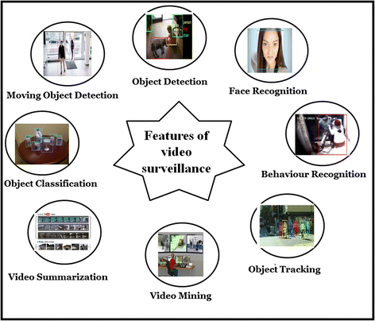
Figure 2.3: Video surveillance system functional features (Elharrouss et al., 2021)
The function of a Video surveillance system is the action of monitoring the activity in a public scene or private using a camera. Before, the function of a basic video surveillance system is to take the acquisition through one or many cameras, and then transmuting the signal to be displayed by a monitor and/or recorded in a central location. Nowadays, the video surveillance systems have been developed and enabled to analyze automatically the monitored scenes. The interaction between system edges is complex due the use of different equipment’s and models. To solve this problem, many methods have been proposed. They try to connect the equipment (cameras) and collect the information using different architectures. The connection between the main station and the devices can categorized into three types analogue, digital and network (Kyriakidis et al., 2012).

Analog surveillance system
Over the last 20 years, the surveillance systems used analogue technology. Analog signal processing technology is the basis model for image transmission, exchange, and recording using a short-distance coaxial cable and a long-distance transceiver optical fibre. Image restoration is one of the advantages of this system type, while the main drawback is represented in limited transmission distance, complex engineering cabling, and the application that can be inflexible. Figure 2.4 represents the analogue-based system components from the acquisition to the storage, going through the visualization, switching, and processing (Lubobya et al., 2015).
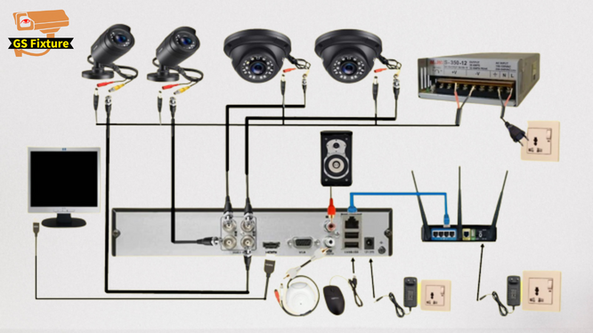
Figure 2.4: Example of an analogue video surveillance system (Yang et al., 2009)
Digital surveillance system
The analogue system is the source of introduction of digital video recorders (DVR). In this stage, the computer network transmission system transmits the digital image files. The cameras are connected to the video server via IP network so that, the transmission is made using existing computer LAN even Internet. Using a computer terminal network, controlling the camera and zooming a part of the scene can be achieved, whereas the traditional systems, transformed into distributed ones (Gumaidah and Soliman, 2013).
The difference between the analogue video surveillance and digital video surveillance is at the aspects of signal transmission, control, and storage. Using the efficient video encoding such as MPEG-4 and H264, in digital video surveillance systems, image monitoring could be performed with a remote transmission in all existing digital transmission networks and with low bandwidth. Also, digital video surveillance ensures security, and remote transmission makes the applications more flexible. Unlike the analogue video surveillance, digital video surveillance mainly accounts on signal processing innovations. Figure 2.5 describes the architecture of a digital video surveillance system with a representation of all component of this system including cameras, servers, and the connection via an IP network (Changjiang et al., 2017)
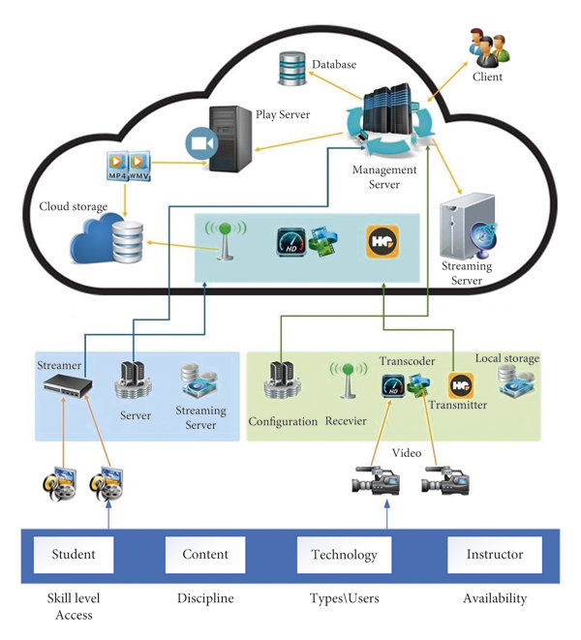
Figure 2.5: Example of a digital video surveillance system (Chen et al., 2016)
2.1.2 Functionality and Types of IP Cameras
IP cameras utilize internet and computer networks to transmit and receive data, offering advanced surveillance capabilities. These cameras are broadly categorized into centralized and decentralized systems. Centralized IP cameras require a Network Video Recorder (NVR) to store footage, while decentralized models can record directly to storage media, such as SD cards or cloud platforms (Rodriguez-Silva et al., 2012). Administrators can monitor multiple cameras remotely from a single location, ensuring efficient oversight. Unlike traditional analog systems, IP cameras maintain high video quality even when using Pan-Tilt-Zoom (PTZ) functions, which allow detailed observation over wide areas. Another variant, EPTZ (Electronic PTZ), provides virtual pan-tilt-zoom capabilities without mechanical movement, enhancing flexibility in surveillance operations.
Applications and Advantages of IP Surveillance
IP cameras serve diverse purposes, including security surveillance, video conferencing, and event recording. They can function as both video cameras and digital still cameras, offering versatility in monitoring. Compared to analog Closed-Circuit Television (CCTV), IP cameras provide a wider field of view and superior image quality. Key benefits include:
- Flexible video access (live or recorded footage from any location),
- Support for local and remote monitoring,
- Simplified network integration, and
- Cost-effective wireless connectivity, reducing cabling expenses (Gumaidah & Soliman, 2013).
By connecting to a centralized platform, users gain seamless access to surveillance resources, enhancing security management.
Deployment Scenarios and Camera Classifications
Video surveillance cameras are deployed in both public spaces (e.g., train stations, streets) and private areas (e.g., homes, offices). Environmental factors influence camera selection—outdoor models often feature protective casings to withstand weather conditions. Cameras can also be classified based on operational lighting conditions:
- Daylight cameras, which function optimally in well-lit environments, and
- Night vision cameras, equipped with infrared (IR) or low-light sensors for 24/7 monitoring.
Additionally, cameras are distinguished by resolution, with High-Definition (HD) models (exceeding 700p) capturing finer details. The choice between wired (Analog) and wireless (IP) connections depends on installation requirements, with IP cameras offering remote accessibility via internet connectivity.
Specialized Surveillance Camera Types
Modern surveillance systems employ various camera types tailored to specific needs:
- Fixed IP cameras monitor a static location, ideal for constant observation of entry points.
- Motorized dome IP cameras offer 360-degree rotation and remote control, making them suitable for expansive areas like parking lots (Zhang et al., 2017).
- PTZ and PTZ dome cameras enable horizontal movement and zoom, useful for tracking moving subjects.
- Vandal-proof IP cameras feature impact-resistant designs, crucial for high-risk areas.
- Infrared IP cameras provide night vision up to 30 meters, ensuring visibility in complete darkness for theft prevention.
These advancements underscore the adaptability of IP surveillance in addressing diverse security challenges.
2.2 Review of Home Security System
In recent years, numerous incidents involving home security, including robbery, unintentional entry, and theft, have taken place in our daily lives. Because of this, the need to control and secure residential and commercial areas has grown so dramatically. Since the late 1970s, the idea of home automation has been around. However, over time, people's expectations have shifted significantly from a simple house to a smart house. They want a smart home to perform numerous automatic tasks. As a result, this concept evolved into a home automation system. In a fairly recent time, automated building control systems were only found in expensive homes and larger commercial buildings. Only the lighting, heating, and cooling systems are controlled by this system. However, the use of the "Internet" over the past few years has made us want to control every household appliance automatically. Human interfaces with the internet are now also possible. A voice-operated home automation system is also an option. We can easily achieve home automation with this new control system. The home computer was the controlling device for the initial home automation systems. The user-friendly smartphone app that controls today's home automation system can be accessed via tablet or the internet.

2.2.1 Security Door System Using Human Tracking Method with Laser Range Finders
Laser Range Finders can be used to track and count people, as this system suggests. The Kalman filter-based estimation and multi-target model are used to track human movement and count the number of people. A novel system uses the proposed approach to monitor the entrance area and eliminate trespassers who enter the door without identification. In an indoor setting, Zhao et al. proposed a method for tracking people by scanning their feet with Laser Range Finders. Lv et al. (2018) looked into a Kalman filtering-based algorithm for tracking people who walk using a moving robot equipped with a Laser Range Finder that scans the legs of humans. The majority of previous studies focused on using Laser Range Finders to track moving people. The scanning data from the two sensors and the personal data from the identification device are sent to the main computer for the process of identification.
In addition, it could be used to control the door, capture an image of the area around the door, monitor the area of interest, and sound an alarm in an emergency. The ID check device and automatic door are typically all that are included in a security door. The standard procedure for using that door is to first verify identification before entering the door if certificated. The most common method of certification is fingerprint recognition or RFID. However, the proposed system includes additional components like Laser Range Finders. They look around the door to find people who come through it. The system counts the number of people in the area of interest and determines whether or not both numbers are the same if a person who enters the door is certificated with his RFID card and enters the number of people entering together. The door will be opened if the number entered matches the system's count number. The system checks to see if any non-certified trespassers enter together as they go through the door. If there is a trespasser in the area of interest, the system will sound an alarm or take a picture to record the scene (Lv et al., 2018).
2.2.2 Zigbee-GSM based home security system
The Zigbee sensor network-based system is used to automate and make home networks more intelligent. An end node in ZigBee technology sends data to the coordinator, who in turn sends the data back to the terminal end of the loop through the coordinator Hub. Each device has its own IP address, which is based on IPv6, so they can connect to an external network right away. Therefore, all smart devices can be controlled remotely through the introduction of a home Internet Gateway machine as well as via handheld remote control to the central and local home. Network coordinators record and store the Zigbee performance.
Wi-Fi is required for this. The Zigbee needed to be cheap, have a low data rate, use less power, and be secure and reliable. Zigbee is used in a variety of applications, including medical, industrial automation, home automation, and vital monitoring (heart rate and body heat monitoring, personal equipment control, and remote control of PC peripherals, windows roll/shades, etc.). Alarm with dimmer switches, smoke detector, and water leakage alarm are all part of the security system. Zigbee's wireless range is sufficient for home automation. Zigbee has a range of approximately 100 to 300 feet. The overall system cost is very low as compare to other (Laurechyn, 2010).
2.2.3 Raspberry-pi based home security system
The primary characteristic of the raspberry pi is its extremely small size. Raspberry Pi is essentially a type of minicomputer that can connect numerous input and output devices. The raspberry pi is connected to two ultrasonic sensors in this system an IR sensor and a camera as well as a motor. The two ultrasonic sensors and the infrared sensor are first set up when this system starts. Two ultrasonic sensors pinpoint the location of a visitor when they are detected. The camera will then use a servo motor to move in that direction. The servo motor is controlled by the system by providing PWM current. The system stores the recorded video and sensor data in database. The saved data can be viewed from anywhere via the internet (Qing-Gui et al., 2012).
2.2.4 Cloud Based home automation system
Home automation using a cloud-based system focuses on the design and implementation of a home gateway to collect data from home appliances and send it to a cloud-based data server to be stored on a Hadoop Distributed File System. MapReduce is used to process the data and use it to set up a monitoring task for a remote user. At the moment, home automation systems are consistently increasing their resilience by incorporating the latest features that satisfy the growing interest of people. The first important component of the cloud-based home automation system is the cloud server, which manages and controls client and user data, information, and device status. The second component is the hardware interface module, which makes the necessary connections to the actuators and sensing devices that provide the physical service. Home Server is the final component, constructing the hardware and providing the user interface (Shariff and Norazahar, 2012).

2.2.4 Home security system using Siri enabled mobile device
A home automation system is one that has the technology to control devices automatically to meet your needs for safety, ease of use, and comfort. On the other hand, a voice-based digital assistant like Apple's Siri lets you access the Internet and local networks regardless of where you are.
The user's voice packets will be generated by the Siri app on a mobile device and sent to the Apple server (guzzoni.apple.com) for text translation and a response that matches the request. An apple server is used for speech recognition. A proxy server is required in order to send translated voice commands to the control system that will enable home devices in order for the home automation system to utilize the Siri application's speech recognition capabilities. Using the Raspbian operating system, the network and DNS settings of the Raspberry Pi were set up to connect to Siri-enabled mobile devices. The five appliances in the room were able to be automated by the system. The air cooler's temperature adjustment, opening and closing of the blinds and door, as well as turning on and off the lights, were all automated by the system. Finally, the system was able to turn the television on and off, change the channels, and adjust the volume with success. With an overall success rate of 93.3333% and an average latency of 2.12s, the system is fully operational and can be controlled (Li et al., 2015).
2.3 Review of Related Literature
Afreen et al. (2023) developed a Smart Surveillance System for High-Security Areas (SS-HSA) classified into booster classifier, Naïve bayes classifier, KNN classifier, SVM classifier, random forest classifier, and decision trees to detect and analyze intrusion in an environment. The study analysed the algorithms and discovered that decision trees performed more than the other algorithms with an accuracy of 97% and was very optimal for SS-HSA therefore recommending it for future researches. However, this approach provided high accuracy, its reliance on decision trees limited adaptability to dynamic environments. To address this, Priyanka et al. (2023), adopted a Machine Learning (ML) technique incorporating Inceptionv3 and ResNet50 algorithms for theft detection. Inceptionv3 extracted features from the images at different scales and resolutions and allows network to detect patterns and structures in images that may not be visible with a single set of filters. ResNet a convolutional neural network was used to enhance the overall performance of a neural network. The algorithms were trained on data collected from real-time video from Closed-Circuit Television (CCTV) with a batch size of 32 along with 80 epochs resulting in 99.86% and 98.44% accuracy respectively. The results showed that accuracy with Inceptionv3 was better and can be used for theft detection in supermarkets, highlighted that a surveillance system with fewer human interventions will be a cost-effective product and showcased the effectiveness of deep learning in surveillance.
Despite the success of ML-based techniques, Kaviyaraj et al. (2020) introduced a python language classified into camera coding and main coding to detect robbery/theft motion. The images were captured in camera coding while in main coding, the user controlled the authenticated users and acted as an interface to the user. The system analysed videos images and the images with moving objects; once an object is detected, alerts were automatically sent to the user improving a surveillance system where the CCTV camera and target for small-scale user are developed. The method detected motion in a live stream environment and generated alerts by sending SMS to the user. The system was tested with image sequences and human activities but was limited to a low field. The study recommends that future researches should be done in high fields enhancing user interaction and sequence alignment in the training phase thereby reducing the rate of shoplifting. To overcome scalability issues, Munagekar (2018), adopted a canny edge detection algorithm categorized into grabbing frame, edge pixel processing and theft detection and alert to detect shoplifting in a diamond factory. The algorithm underwent various stages in order to detect intrusion which includes: smoothing, finding gradient, double thresholding and edge detection. The algorithm detected an intrusion and raised an alarm to the owner before sending them the theft images. It was used to preserve properties of an image for image processing and image edge calculation and criteria. The study discovered that the proposed algorithm detects theft swiftly and automatically and most importantly simple to use.
However, datasets and real-world testing limits surveillance accuracy, Reid et al. (2021), developed a dataset of signal attributes based on real-world shoplifting videos using different machine learning models like Support Vector Machine (SVM), K-Nearest Neighbour (KNN), Adaboost to predict shoplifting and the results showed that KNN performed better than the other algorithms with an accuracy of 90.22%. The study encountered certain challenges such as the dataset used to test the method was quite small, some of the videos were cropped and did not show when a customer walks in and out of a shop making it difficult to detect any of the social signal attributes. The study further recommends that future datasets should remained uncropped and more than one human labeller should be used to improve the integrity of the datasets in order to detect shoplifting in an environment. Sai et al., (2024), proposed an ESP32-CAM classified into a Passive Infrared (PIR) sensor and an Arduino Uno which detects someone entering and sends notification to the individual through GSM module. The Arduino, PIR sensor acquires data, a single chip microcomputer controls the GSM module while the ESP-CAM displays the information. The data were trained and the result was in form of SMS that was sent to a registered number. The registered mobile got notified when an unknown person enters the room. The study discovered that the proposed method was an effective and low-cost technique for indoor monitoring which can be integrated with colourful microcontrollers and microprocessors making it suitable for different operations and also a smart security surveillance system involving IoT to enhance security and improve the accuracy of security systems by analysing data and predicting potential security breaches before they occur thereby recommending it for future researches. Similarly, Shaikh et al, (2024) adopted a Connected Environmental Monitoring System classified into 4 layers (sensing, communication, cloud and user interface layer). The layers collected environmental data, fastens the data transmission, analyze data and relate with the system to visualize the collected data. The outcome from the study indicates that the system demonstrated the effectiveness in real time monitoring of an environment. It was further recommended that more researches should be done on indoor environment with additional sensors to improved insights. Sivakumar et al, (2022), adopted a Computer Vision-Based Roadside Occupation Surveillance System (CVROSS) to pre-processed collected data by analysing it through the use of Application Programming Interfaces (APIs). The CVROSS offer clients different types of data perception where a image was used to introduce continuous traffic circumstances out and about inside the framework time which gave customers a view of the areas of interest. The study discussed the aim of CVROSS concerning reports about street utilization by different types of vehicles generated for street clients, operations organizations, and the public to better understand traffic conditions in the areas under observation during a given time period. Addressing the gap, Jimenez et al, (2022), analysed the accuracy of the different sensors commonly used on Smart Environment Monitoring (SEM) for living environments. The study classified the sensors based on temperature, relative humidity and air quality. The results from the analysis conducted on the sensors showed that the most commonly used sensor for measuring temperature was the DHT22 which uses a thermistor to measure the temperature and a capacitive sensor for relative humidity, also, the accuracy of the air quality was measured on Carbon Monoxide (CO), Carbon Dioxide (CO2), Volatile Organic Compounds (VOC) and Ozone (O3). The study overlooked the accuracy of the sensors thereby indulging more researches to be done on the sensors to enhance indoor environment monitoring. Aligning with Prasad et al. (2024) adopting Internet of Things (IOT) as an environmental monitoring system classified into sensor nodes, wireless communication to collects information from surrounding environmental condition and sends the data wirelessly using microprocessors and ESP826 Wi-fi module to the server. The study discovered that the system connects wirelessly to gateway via Bluetooth alongside different parameters, and was a success. The system was flexible, scalable and adapted for both indoor and outdoor use giving it an edge over others. The study recommends introducing several machine learning techniques that may improve the approach.
While IOT-based environmental monitoring improved scalability and adaptability, real-time air pollution control remained a concern. Zulkifli et al. (2020), adopted Rapid Application Development (RAD) to control air pollution. The study conducted 3 experiments which is the connectivity test of sensors with Arduino Uno R3, network connection of GPRS GSM SIM900A with cloud storage and web-site design to generate PDF report from web site and integrate test of cloud storage between web sites and android applications. The study provided a real-time web-based cloud application which allow the DoE to monitor, update and display the air quality data on industrial site. The study further recommended that future research should be done to improve the quality of data transmitted and display on the web-based and android application in real time.
Zafar et al. (2018), designed an android application using a Google App-Inventor Integrated Development Environment (IDE) and Java programming language which communicates with the microcontroller through ThingSpeak cloud. The android application monitors the environment where the hardware was deployed using a smart phone to implement a home automation system so that the monitored values of temperature and humidity can be used to trigger actions and control the devices for heating or cooling via the mobile application. The study emphasis on the environmental monitoring system for real-time monitoring of temperature and humidity of surrounding environment but recommended that future research should be done on indoor environment monitoring.
Addressing security concerns, Ifkat et al. (2023), introduced a Haar cascade algorithm to detect an image and matches the face with existing database to recognize if the face matches and sends alerts. The study demonstrated that face recognition-based human or criminal detection systems are safe. The study further employed raspberry Pi 3 to extract image from its surroundings to match the image from the stored database. It was discovered that the proposed system was used as a security surveillance system which was not only used for criminal detection but also for attendance monitoring, home security, business and car parks and its recognition can be increased using raspberry Pi Infra-red camera module.
Surantha and Wingky (2018) researched a study on design of smart home security system using object recognition and PIR sensor. In this paper, we have proposed a security monitoring system based on IoT technology. Our propose system consists of Raspberry Pi 3, Arduino, PIR sensor, web camera and buzzer. The novelty of our proposed system is the inclusion of human detection capability by HoG and SVM method and buzzer as method to warn the house owner. The simulation result shows that system can detect the intruder within seconds with accuracy of 89%. For future research, we plan to explore other feature extraction and classification method to improve the accuracy of intruder detection
Al-Slemani and Zengin (2023) presented a new surveillance and security alert system based on real-time motion detection. In this study, the proposed system is applied to secret and critical locations that require an effective human motion detection-based monitoring system. Museums with important historical objects and libraries with old books can be protected by the system. Bank security is also dependent on the security alert system. With the assistance of AForge.NET, the system employs a straightforward background modelling algorithm and a two-frame difference algorithm for motion detection. Whenever the system detects motion, it interprets the frames of motion to determine humans by using YOLO. On the detection of a human movement, the security alert system emits an email addressed to a concerned individual, an LED and a sound alarm, films a video of the area of occurrence, captures an image and stores the information in the databases. The system is affordable, easy to use and the interface is extremely secure. The capability of the system to identify when human motion occurs in restricted zones was put to test. The system was able to identify when the human activity was taking place and when it was outdoors it could also activate the alarms. The system also had the capacity to inform in real-time the people observing at the time of the incident in case there was a form of human activity in either of the four areas being monitored. The system is able to be used in low light environment or minimal lighting when human movement can be determined. The evaluation revealed the high accuracy of 95 percent of the system in terms of detecting the movement of people in any area evidencing that it can be used in surveying areas and securing sensitive places.
Prathaban et al. (2019) introduced a vision-based home security system on a Raspberry Pi 3, based on OpenCV. This paper has developed a home security system based on OpenCV on Raspberry Pi 3 model B that is motion-detecting with a vision lens. In its development, Histogram of oriented gradients (HOG) was considered in this system and Haar-Cascade algorithm was implemented coupled with background subtraction. The prototype developed was tested against a couple of tests to determine how precise the prototype was in detecting movement and how precise it was compared to a system which makes use of a PIR motion sensor in detecting movement. According to the findings, the vision-based developed home security system has a 100 percent detection rate when compared to the PIR motion sensor based home security system which has a 76 percent detection rate.
Iyapo et al. (2018) presented sending of the motion detection alarm and security system in terms of design and implementation. An embedded microcontroller system is used in this project to detect intruder motion in a restricted area and then trigger an alarm or motion detector system. However, a passive infrared sensor uses body heat to detect intruder motion. This project's motion detector, a passive infrared (PIR) sensor attached to a microcontroller, activates the alarm system and any attached output devices to notify the homeowner. The design performed as expected during the initial testing.
Chen et al., (2023) researched on Object-Level Anomaly Detection model (OLAD) in video surveillance of an indoor office environment. This study aims to model various normal behaviour patterns of different objects and the normal interaction patterns between them. Specifically, OLAD introduces an encoding-embedding network to transform object-level information into the feature space. By integrating such information, OLAD processes both frame-level and object-level cues in the video for Abnormal Behaviour Detection (ABD). In addition, the study constructed its own dataset Northking2022 especially for office scenes because of the lack of public datasets for indoor office environments. The result of the study reported that the proposed system has achieved an Area Under Curve (AUC) of 76.0%.
Kuppusamy and Bharathi (2022) surveyed on the detection of human abnormal behaviour in a crowded and uncrowded environment using Convolutional Neural Network (CNN) technique. The survey of cutting-edge methods like CNNs for recognizing abnormal human behavior from real-time videos was presented in this study. This study also talked about how to extract spatial and temporal features from a variety of datasets, how to use an augmented process, how accurate they are, and the drawbacks of current methods for different image resolutions. In this study, it was found that more researchers had input 224 x 224-resolution pre-processed frames into the image. CNNs, on the other hand, outperformed machine learning approaches when it came to identifying spatial features in images with a resolution of 320 x 240. As a result, it would be possible to apply CNN and LSTM to real-time surveillance video to recognize sequential patterns, identify behaviors, and alert individuals to prevent the loss of public assets and property.
A do-it-yourself Internet of Things (IoT) system for smart buildings' anomaly detection was developed by Majib et al. in 2023. A sensing network of 14 different environmental sensors, Arduino-based microcontrollers, and RaspberryPi (RPi) microprocessors was used in the study. Using unique Message Queuing Telemetry Transport (MQTT) channels, the attached RPi transforms and/or transfers these values to the ingestor after the sensor reads the changes in the environment and transmits them to it, either directly or through a microcontroller. Various machine learning techniques such as One Class Support Vector Machine (OCSVM), Isolation Forest, CNN and Recurrent Neural Network (RNN) were applied in the study for data analysis for the detection system. The results of the study's use of machine learning techniques were not reported.
2.4 Summary of Literature
Author(s) | Work Done | Technique Applied | Result / Research Gap
Afreen et al. (2023) | Developed Smart Surveillance System for High-Security Areas (SS-HSA) for intrusion detection. | Boosted classifier, Naïve Bayes, KNN, SVM, Random Forest, Decision Trees | Decision Trees achieved 97% accuracy, optimal for SS-HSA. Limited adaptability to dynamic environments. Future research recommended.
Priyanka et al. (2023) | Applied Inceptionv3 and ResNet50 for theft detection in CCTV footage. | Inceptionv3, ResNet50 (Deep Learning Models) | Inceptionv3 achieved 99.86% accuracy. Low human intervention in surveillance is cost-effective. Effectiveness of deep learning in theft detection highlighted.
Kaviyaraj et al. (2020) | Developed Python-based system for detecting robbery in live video streams. | Camera coding, main coding interface | Motion detection in live streams with SMS alerts. Limited to small-scale environments. Future research on scalability and user interaction recommended.
Munagekar (2018) | Used Canny edge detection to detect shoplifting in a diamond factory. | Canny Edge Detection, Image Processing | Swift and automatic detection of theft. Limited by datasets and real-world testing affecting surveillance accuracy.
Reid et al. (2021) | Developed dataset of shoplifting videos to predict theft with machine learning models. | SVM, KNN, Adaboost | KNN performed best with 90.22% accuracy. Issues with cropped videos and small dataset. Future datasets should remain uncropped for better prediction.
Sai et al. (2024) | Proposed ESP32-CAM for detecting intruders and sending SMS notifications. | ESP32-CAM, PIR sensor, GSM Module | Low-cost, effective technique for indoor monitoring. Suitable for IoT integration in security systems. Future research on improving data analysis and security prediction.
Shaikh et al. (2024) | Developed Connected Environmental Monitoring System for real-time environment monitoring. | IoT (Sensing, Communication, Cloud, User Interface) Layers | Effective in real-time monitoring. Future research should focus on adding more sensors for better insights in indoor environments.
Sivakumar et al. (2022) | Proposed CVROSS for roadside occupation surveillance to monitor traffic conditions. | Computer Vision, API Integration | Provided real-time traffic data and insights for clients. Focused on street utilization but not specifically on shoplifting or retail security.
Jimenez et al. (2022) | Analyzed accuracy of sensors used in Smart Environmental Monitoring (SEM) for living spaces. | Temperature, Humidity, Air Quality Sensors (DHT22, CO, CO2, VOC, O3) | Identified DHT22 as the most accurate for temperature. Accuracy of air quality sensors should be further researched for better indoor monitoring.
Prasad et al. (2024) | Adopted IoT-based environmental monitoring system with sensors and wireless communication. | IoT (Sensor nodes, wireless communication, microprocessors) | Flexible, scalable system adaptable for both indoor and outdoor use. Future research should focus on applying machine learning to improve system accuracy.
Zulkifli et al. (2020) | Conducted experiments on real-time air pollution control with cloud storage and web application. | RAD (Connectivity, Network Connection, Cloud Storage, Web Design) | Real-time monitoring of air quality via web and Android apps. Future research should improve data quality transmitted to these platforms.
Zafar et al. (2018) | Designed an Android app to monitor environmental conditions using IoT for home automation. | Google App-Inventor, ThingSpeak cloud, Java | Monitored temperature and humidity for home automation. Focused on environmental monitoring; future work should focus on indoor environment monitoring.
Ifkat et al. (2023) | Developed face recognition-based human detection system for security surveillance. | Haar Cascade Algorithm, Raspberry Pi 3 | Safe criminal detection, can be used for home security and business monitoring. Suggested improvement in recognition using Infra-red camera module for better accuracy.
Surantha & Wingky (2018) | Proposed smart home security system based on IoT and object recognition. | Raspberry Pi 3, PIR sensor, HoG, SVM | Intruder detection with 89% accuracy. Future work recommended to explore other feature extraction and classification methods for improved accuracy

2.5 Research Gap
The research gap in the development of shoplifting detection and notification systems using computer vision in CCTV footage includes limited scalability and adaptability of current systems to dynamic, large-scale environments, and the use of small, incomplete datasets that hinder model accuracy. Additionally, real-world testing remains scarce, and integration of multiple detection methods, such as behaviour analysis and facial recognition, has not been widely explored. There is also a need to enhance user interaction and engagement for more effective alert systems, and to develop cost-effective, low-maintenance solutions for diverse retail environments. Environmental factors causing false positives, as well as concerns around data security and privacy, also present significant challenges that future research must address.

CHAPTER THREE
SYSTEM ANALYSIS AND DESIGN
3.1 Research Methodology
The application of Agile methodology in the development of the shoplifting detection and notification system ensured a flexible, iterative, and user-centred approach to research and system implementation. By adopting the Scrum framework, the study was divided into multiple sprints, each focusing on incremental development—ranging from dataset collection and preprocessing to real-time object detection, anomaly recognition, and alert system integration. Regular sprint planning and reviews facilitated early identification of design issues, enabled continuous refinement of the machine learning models, and ensured that stakeholder feedback (from security personnel and retail managers) was incorporated into the evolving system requirements.
Throughout the project, daily stand-up meetings, sprint retrospectives, and collaborative decision-making allowed the research team to remain agile in response to changes in objectives, data quality, or technical challenges. This approach not only speeded up the development process but also increased the efficiency of the team and augmented the functionality of the system through encouraging continuous testing, evaluation and amendment processes. Agile process not only led to the successful shoplifting detection system that is correct and robust in its use of computer vision, but it has also resulted in a final product that is much more in line with the practical expectations and requirements of the end-users of the product in real-world retail settings.
3.2 Systems Analysis
In the case of the shoplifting detection and notification system, the system analysis process involved an in-depth exploration of the security gaps in the retail surveillance and the prevention of theft through computer vision. The analysis found the weaknesses of the traditional CCTV systems, which are characterized by excessive reliance on manual supervision and are prone to human error and poor speed of reaction. The requirements, such as real-time video processing, anomaly detection, automatic alert generation, and system scalability, were determined as functions. Such non-functional requirements as system dependability, how easy it is to use, low-latency processing capability, and the privacy of data used were also considered. The system was designed to have cutting-edge machine learning algorithms coupled with CCTV that automatically identifies shoplifting and reports it to security staff immediately to differentiate response time and minimise the losses.
3.2.1 Analysis of the Existing System
The review of the current shoplifting detection platforms, as it was demonstrated by the research gap, shows most of the current solutions to be either creating surveillance-based systems with manual observation or utilizing standalone machine learning models that lack responsiveness in real-time or the ability to learn and adapt through user feedback. Systems like those based on Decision Trees, Naïve Bayes, or KNN have achieved moderate to high accuracy (e.g., 90–97%), but they often lack adaptability to dynamic environments such as crowded or multi-angle retail settings. Additionally, many existing systems depend on static datasets or cropped video inputs that fail to capture full behavioural context, leading to false positives or missed detections.
Moreover, some systems do not incorporate end-to-end notification mechanisms (such as SMS or app alerts), thus limiting real-time intervention. Others, though high in accuracy (like those utilizing InceptionV3 and ResNet50), require high computational resources, making them impractical for low-resource retail environments. Also, IoT-based systems offer environmental monitoring but seldom address theft behaviour recognition directly. This points to the need for a more robust, adaptive, and scalable solution that integrates efficient deep learning models, real-time video analysis, alert mechanisms, and user feedback—all of which are addressed in the proposed system to fill these identified gaps.
3.2.2 Weaknesses of the Existing System
The weaknesses of existing shoplifting detection systems, as identified in the reviewed literature, include the following:
- Limited adaptability: Many systems, such as those relying on Decision Trees or SVMs, are trained on static datasets and lack the ability to adapt to dynamic retail environments with varying lighting, crowd density, and angles.
- Scalability: Certain types of models can only be applied to environments that have large sets of computation facilities, thus cannot be applied to localized retail or environment with limited resources.
- Incomplete video: Other systems use cropped or recorded video footage that lacks the context of the entire behaviour of the shoppers, which compounds false positives and decreases accuracy of detection.
- Absence of real-time processing: The other models normally do preprocessing in an offline manner slowing down the detention of the theft and the possibility of intervention.
- Insufficient alert mechanisms: Many systems do not integrate real-time alert features such as SMS, app notifications, or alarms, which are crucial for timely responses by store personnel.
- Inadequate dataset quality: Some studies used small or poorly labelled datasets, leading to biased models with low generalizability across different shoplifting scenarios.
- Poor user interaction: The user interface or system feedback in most existing solutions is minimal, affecting usability and limiting customization for different shop environments.
- Focus on environmental data: IoT-based systems often prioritize environmental monitoring (e.g., temperature, humidity) over actual theft detection, thereby lacking behavioural analysis.
3.2.3 Analysis of the Proposed System
To allow real-time theft identification within a retail setting, the offered shoplifting detection and notification system embraces computer vision being combined with CCTV images, and then being supercharged by the deep learning tools. Compared to the traditional surveillance systems that are based on passive observation or manual rewatching of the recordings, the proposed system will perform object recognition and motion tracking, which will be used to detect suspicious behaviors, such as hiding things, spending time without buying anything, or quick moves around the shelves with the products. The combination of state-of-the-art models (e.g. ResNet) enables high-accuracy detection in different lighting and environmental settings, because it is ensured then that features are extracted at mixed scales and depths.
The system is also designed with automated alert system which triggers the action of responding hindering the theft, by notifying the personnel of the store of a possible theft either through SMS, email, or app messages. Moreover, scalability and flexibility of the system have been addressed; the specified system may be applied to stores of different sizes and be incorporated into the existing CCTV infrastructure. Streamlined software allows real-time computing, and information using various camera views may be mixed together to improve the characteristics of detection accuracy. Using behavior-based models as opposed to simple motion detection enables not only to save on human-based oversight to detect anomalies but also decreases the level of false alarms inside. By extension, the proposed system is an affordable, flexible, and immensely responsive surveillance system that fits dynamic retailing pains that enhance the provision of surveillance facilities to mitigate major deficiencies of the available solutions.
3.2.4 Advantages of the Proposed System
The most important benefits of the suggested shoplifting detection and representational are as follows:
- Real-time Detection: With the help of computer vision and deep learning, the system is capable of identifying suspicious situations in real-time so that they can be stopped remotely.
- Automated Alerts: Immediately gives a notification (SMS, email or app) to the store personnel and decreases the necessity to always monitor human activity.
- High Accuracy: Incorporates advanced models like InceptionV3 and ResNet to ensure precise detection of theft behaviour with minimal false positives.
- Behaviour Analysis: Goes beyond motion detection by analysing customer behaviour patterns such as loitering, concealment, and unusual item interaction.
- Cost-Effective: Reduces manpower needs and utilizes existing CCTV infrastructure, saving on installation and operational costs.
- Scalability: Easily adaptable to various store sizes and retail environments without major hardware changes.
- Adaptability: Capable of operating under varying lighting and crowd conditions with high reliability.
- Data Logging: Maintains event logs and image/video captures for review and legal evidence.
- Enhanced Security: Improves overall store security and deters potential shoplifters through intelligent surveillance.
- Integration Capability: Can be integrated with inventory management and access control systems for a comprehensive security solution.
3.3 Data Collection
A real dataset is a dataset that is formed based on real events. It is more useful to train our model on real-world events and enhance performance with the data since we get real-world events into the data. We collected the information in the stores where the behavior of interest was observed through the actions of different individuals using mobile gadgets and IP cameras. To generate actual datasets, it was so difficult to make store owners agree to have them transpire inside their stores. We picked out some of them, brought them to the store, and trained them on how to steal in six months. To capture all the possible means of stealing, the videos were shot at the resolution of 352 x 640 as they were stealing in several places of different backgrounds and angles. The name of the store that was selected is "Saim Store".
We had them steal goods in the following ways.
• Taking the objects and putting them in their pocket.
Boys are putting the objects in their shirts.
• Boys stuffing stuff in their jackets.
Boys were also similar in putting the stuff in their college bags.
3.3.1 Data Annotation and Statistics
We have provided our employees with training and wasted much time creating shoplifting videos in the above-mentioned way. In the next phase, one would manually label the data by using an annotator. The dataset was assigned A 0 to non-shoplifting activity and a 1 to shoplifting activity, and there were 450 videos per class. This was after annotating and cutting the videos into the respective lengths and issuing a csv file with a record of the number of frames contained in each video and the name of the video. One of the most important phases of neural network training process is to get the data in right form. Our corpus consists of a real-life dataset comprising real-life images acquired of proposed videos. We edited 3 90-frame s videos and made them as long as one another. Each of the classes includes 450 videos and 40,500 pictures. Data are balanced to avoid the development of any possible class bias of our model.
3.3.2 Images from the Dataset
In order to explain the different configurations of shoplifting, we have presented some images of the dataset here. In Figure 3.1, a boy has stolen something and kept that in the inner shirt pocket. It has the front-view. Similarly, Figure 3.2 has an oblique view of a boy stealing the thing and placing it in the front pocket of the T-shirt. In figure 3.3, there is another instance of shoplifting but this time a boy with a bag opens up the bag deliberately. When there is an opportunity, he takes the item and puts it in the bag that is wide open. The most important behavior is shown in figure 3.4 and it is hard to determine. The theft planning is commonly done by a group of two or more persons who go to the stores. Figure 3.4 illustrates this behavior: a group of two persons are visiting, and one of the persons leading and the other following with a very short gap between the two persons. The first one is walking normally and the second one had the item placed in the bag of the first one when they got an opportunity. Another indicator of shoplifting is presented in figure 3.5, where the boy is walking and has a closed bag on his shoulder. It is unquestionable that he unzips part of his bag after traveling a certain distance. He steals the item when he has the opportunity and hides it in that place. The last Figure 3.6 shows a scenario where a boy steals an item and puts it in his trousers pocket, the view is taken from the back angle.
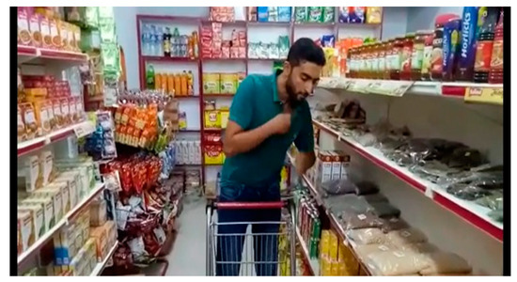
Figure 3.1: A boy putting the item in the inner pocket.
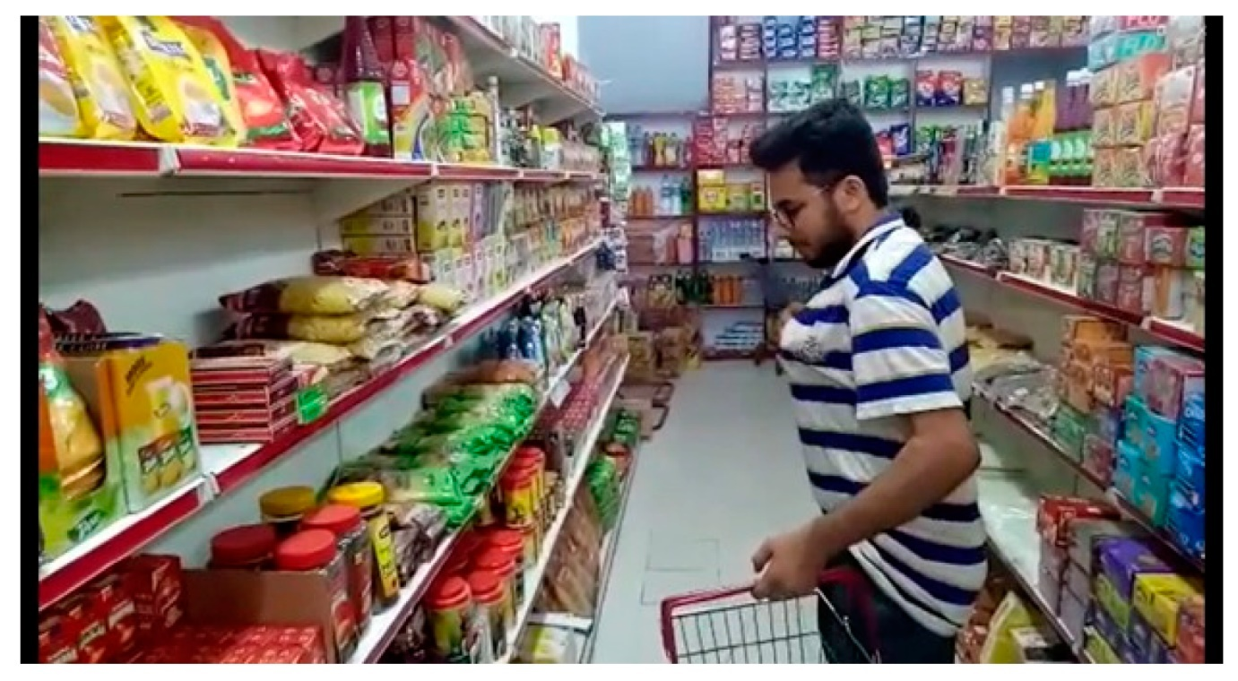
Figure 3.2: A boy putting the item in the T-shirt’s front pocket.
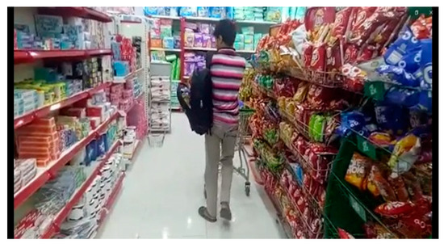
Figure 3.3: A boy putting the item in a fully opened bag
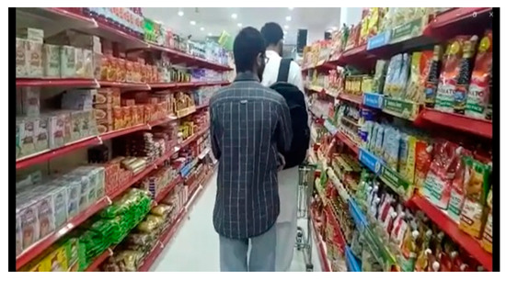
Figure 3.4: Second person is putting the item into first’s bag.
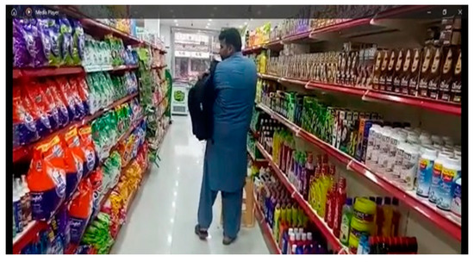
Figure 3.5. A boy putting the item in the opened portion of closed bag
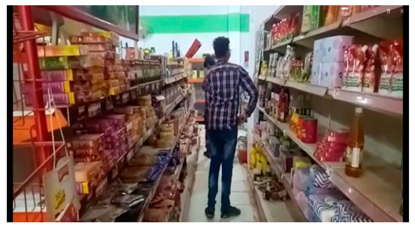
Figure 3.6. A boy putting the item in trouser pocket
3.4 Baseline Methods
Specifically, over the past few years it was found that CNNs prove to be exceptionally useful computer vision modelling. 2D CNNs and 3D CNNs which are types of CNNs applied to extract spatial and temporal information of a video took shape. Examples of such programs include human action recognition, 3D CNN, object, and gesture recognition among others that utilize 3D CNNs to perform recognitions.
3.4.1 Convolutional Neural Network Two-Dimensional
A 2D convolutional neural network (CNN) is a kind of design of a neural network commonly applied in image analysis tasks, such as categorization of pictures, object-recognition, and segmentation. Representative 2D array A 2D CNN often operates over input data of an image nature in the form of a 2D array. Each pixel in the array has an integer value that shows the strength or color of the linked pixel in the picture. It consists of several layers, amongst which there are convolution, pooling, and fully-connected layers, which perform various operations on the given data.
The convolutional layers of a 2-dimensional CNN detect the edges and corners of input picture as well as other patterns so that it composes the features. Convolutional layers have several filters that are small matrices of weights, which are used to process the input image to produce a set of feature maps. These feature maps enable the network to better recognize images and patterns since it emphasizes different elements of the main picture. The purpose of pooling layers in a 2D CNN is to pass a matrix of feature maps in a 2D convolutional network to the next layer and decrease the dimensions of the input data.
This enhances the efficiency of the network since it lowers down the complexity of computing. The fully connected layers of a two-dimensional CNN are then used to make the prediction based on the findings of the previous levels. These layers often occur in the last phases of the network, where a picture is separated into one or more categories on the basis of input. A 2D CNN is a decent manner of dealing with the image data at large and was applied in numerous various fields, such as computer vision, medical imaging, and autonomous automobiles.
In ours, we trained a dataset that detects shoplifting with a 2D model. Our training set has 8000 images which are split into two groups. The input layer sends images with 600 x 600 pixels resolution when used in training. The next step involved four Convolutional layers which were used to extract low-level features to be learnt by the image. Each convolutional layer was followed by an activation layer, the activation functions of which (RELU) was used to train more complicated features and relationships between these features and different areas of the input image. In the concluding step, the SoftMax activation function was used to make the final prediction. The limitation of the 2D CNNs is the inability to study the 3D heterogeneity of the actual world, resting on the interpretation of the 2D arrays of pixels positions in the picture. Consequently, they may fail to describe the spatial relations between objects in an image in a proper manner. Usually, the topology of 2D CNN is fixed before training, and the network is optimized to accomplish a specific task. That indicates that 2D CNNs are not as flexible as other models in the processing of complex or variable data. 2D CNNs are hierarchy-sensitive to orientation, color, and light that can negatively affect the image quality of a picture. Due to this, they may not work on images sufficiently well that are not similar to the ones that they have learned to work on. It can also be that the cost of a 2D CNN has many parameters especially when dealing with large images or deep networks. Hence, training and knowledge inference could turn to be costly and laborious when it comes to computing costs. In turn, 2D CNNs might not be as good as they are in image analysis tasks on text or time-series data.
3.4.2. The Three-Dimensional Convolutional Neural Network
A 3D CNN is a type of neural network which can process 3D data, e.g. movies or 3D photographs. A 3D CNN is an expansion of a 2D CNN and convolves every filter through the input volume, rather than a 2D picture. A 3D CNN may also be applied in robotics, medical imaging, and recognition of film action among others. With regard to the recognition of actions, a 3D CNN can process the spatio-temporal features of a video stream and determine an action. The three-dimensional data that are the input into the network form the input layer of the network into which they are fed into the network and are processed. The 3D convolutional layers of a 3D CNN are the most significant parts of the network. All the 3D convolutional layers are made of a series of trainable filters, which convolve on the input volume to generate a set of feature maps. The network is often followed by an activation layer after every 3D convolutional layer in order to introduce non-linearity and down-sample the feature maps produced by 3D convolutional layers through 3D pooling layers. The completely linked layers are often incorporated at the end of the network so as to perform classification upon the yield of the layers earlier than it. The output layer of the network then develops the final prediction or output. Overall, the architecture of 3D CNN can be altered to suit the specific requirements of a given problem, and the amount and types of layers used within the network can vary depending on how challenging the problem being solved is.
We have used a 3D model in our case to train the data set that identifies shoplifting. Among the 900 videos in two lessons, our training set has 81,000 images of (frame sequence = 90) of each movie used as a training input. During the training, images of 600 x 600 pixels are passed to the input layer. The next step was the creation of Eight Convolutional layers in order to extract low-level features in the sequence of frames to learn. To include an activation layer in the network picture, the RELU activation was applied to the image following every 3D convolution layer. The final prediction was through the use of SoftMax activation function in the last step.
When an extra-temporal dimension is introduced to 3D CNNs, inference computations and the cost of training become more expensive. Therefore, big 3D CNNs might not be able to train with low-end hardware. 3D CNNs require a lot of memory requirements to allow them to process volumetric data through the utilization of the data and intermediate feature maps. Consequently, there can be a limitation in the quantity of input data that can be processed. Although the use of 3D video data is uncommon in a wide range of applications, one can easily access photos.
This can impede the achievement of 3D CNNs by restricting the access to large and high quality training datasets. With 3D CNNs, there has been a rise in complexity, which means sometimes it may not be easy to inspect the learned features and how they affect the predictions the network makes. This can potentially make the interpretability and transparency of the 3D CNNs challenging, which is a concern in certain applications. 3D CNNs often demand the usage of the spatial context to identify valuable qualities, and this can be challenging to acquire in any application. The use of 3D CNNs can be limited because in some medical imaging scenarios, such as segmenting brain tumors, the spatial context cannot be provided and it falls to the same limitation as any other deep learning model, such as over-fitting, particularly when the training data is scarce.
3.4.3 Architecture of the Proposed Method
CNN is better as compared to the other methods when it comes to image classification. Video classification requires that the features of the frames in a sequence be extracted and inserted into a Bidirectional Long Short-Term Memory. The feature extraction can be done with the use of CNN since it can detect the concealed patterns in single frame and the variation in repetitions of frames. But the task of training a CNN without pretrained weights is costly, since it involves big image dataset, massive computational resources and has a demand on plenty of time to train and test the model. Such an issue can be addressed through the use of transfer learning since the final hidden layers of a pre-trained CNN can be discarded and the extracted features of the image can be extracted.
The Inception model was selected on the basis that it has CNN architecture which is considered to work better to capture local and global image features. With the help of various sizes of parallel convolutional filters, it can observe the details on a different scale. In the detection of shop-lifting activities, there is a common application of video frames or images in the detection of suspicious activities and products.
One can utilize the impressive capability of the feature extraction provided by the Inception model to extract the applicable visual patterns and cues and the characteristics of objects. The hybrid framework can translate the visual information on the surveillance videos in an effective manner by using the Inception model to base its visual component. Besides, human activity recognition has also been done with the use of the Inception model which performed incredibly well. The proposed method is based on this. Figure 3.7 depicts the in-depth structure. With n = 7 for the 17 x 17 grid and 2 Inception, the features from the frames were extracted in the first step. For the 17 x 17 grid, we select n = 7, and 2 x 2 Inception is used to represent the module with expanded filter bank outputs. The final dense layer was removed after using sixteen convolution layers. Figure 3.8 depicts how inception V3 functions. We just fed the features into BILSTM after removing the final dense layer.
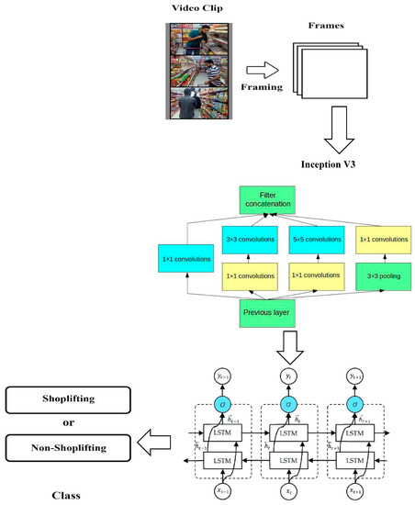
Figure 3.7. Architecture of the Proposed Method
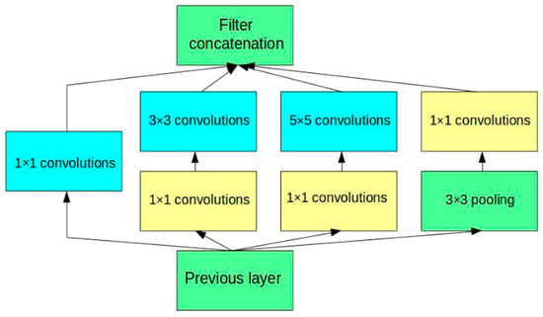
Figure 3.8: Architecture of Inception V3
The two components of our proposed method are Inception V3 and Bidirectional Long Short-Term Memory (BIL-STM) that is represented in Figure 3.7. In the proposed method, we relied on feature extraction of the frames with the parameters of trained convolutional neural network (CNN) called Inception V3, which was trained on ImageNet images (consisting of 1.2 million training images, 50,000 validation images, and 100,000 testing ones). In 2015, Google suggested the next architectural generation of a deep convolutional neural network (CNN) called Inception V3 as an extended version of the first Inception one. 5 5 convolution filters were presented in the first Inception design. These filters were computationally costly and over-fit. Inception V3 uses a combination of 3 3 and 1 1 filters instead of them, to prevent overfitting and make computation more efficient. Inception V3, the network is initialized by a stem module comprising of pooling layers, 3 3 and 5 5 convolution filters among others.
This enhances object identification with different sizes that the network can capture in the network and various scales. To cut down the dimensionality of the feature mappings, Inception V3 uses a module of reduction after each grid of inception modules. This is achieved by the combination of max pooling with 1 1 filter,s convolutions which also shrink the parameters in the network and also make it more efficient. To assist in normalizing the network and avoiding overfitting, Inception V3 uses auxiliary classifier after the first set of grid inception modules. To combine them with the final predictions of the network, this classifier, after being trained to predict the output class, is used to perform prediction. The last 48 convolutional layers of Inception V3 architecture consist of a fully connected layer where SoftMax activation is applied and a global average pooling layer. It has exhibited state-of-the-art performance on a variety of benchmark datasets, such as the ImageNet large-scale visual recognition challenge (ILSVRC), on which it has a top-5 network error of 3.46 percent. One particular architecture of a recurrent neural network, called BILSTM, has the ability to learn long-term associations in a sequence by using memory cells.
Absenteeism In absenteism, shoplifting is usually detected by analyzing time series of observation or action, such as movement, interaction, and object trajectory in order to detect a suspect behavior. Several reasons exist as to why BILSTM was chosen in the proposed model. Seq2Seq problems could be addressed with the help of bidirectional LSTM. This type of a typical LSTM can capture both the past dependency as well as the dependency in the future itself as this model will be able to process the input sequence in both the forward direction as well as backward direction. The hybrid system is capable now of synthesizing the time varying dynamics of the shoplifting activities, of discovering a behavioral pattern that could be possible the evidence of shoplifting and of distinguishing the shoplifting behavior with normal behavior by introducing BILSTM. The hybrid system can be assisted by the strengths of both of the models. BILSTM model can successfully process the sequential data, and discover the temporal dependencies, whereas the Inception model can represent the visual high-level features.
These combinations have been more effective because of the capacity of the models to understand both time and visual features which help the system to detect cases of shoplifting efficiently. This is done in two directions of the input sequence: in a forward and backward one. Each LSTM machine produces a hidden state sequence which is then concatenated to form the final sequence. The work is illustrated in figure 3.9.
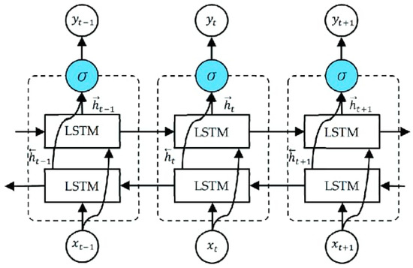
Figure 3.9: Architecture of the Proposed Bi-LSTM
The forward LSTM will carry out operations on the input sequence in an end-to-end fashion, and the backward LSTM in the reverse of this trend. In forward LSTM, the current hidden state is updated in each time step using the current input and the old hidden state, and in backward LSTM, the current hidden state is updated in each time step using the current input and the next hidden state. The forward and backward LSTM outputs are concatenated together on a per time step basis to form the bidirectional LSTM output. Consequently, the past and the future dependency in the input sequence is coded into a sequence of concatenated hidden states.
3.5 Flowchart of the system
This flowchart in Figure 3.10 shows the process of operation of a theft detection and reporting system. The "Image Acquisition" and the "Image Recognition using CNN" (Convolutional Neural Network) processes of the initial processing of the system are started with camera input. The other decision point is deciding on whether there is movement or not. When the system does not find any motion, it goes back to acquiring images, and keeps on checking activity. When a motion is detected, its owner gets an alert image or SMS that an event could be going on.
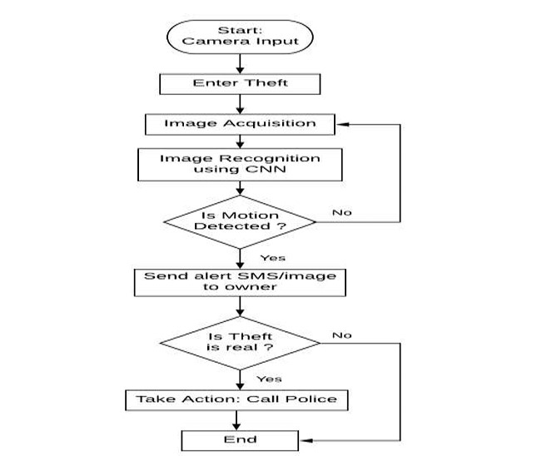
Figure 3.10: System Flowchart
After the alarm, there is a human confirmation procedure, which is to ask the question: "Is Theft real?" This measure can enable the owner of the phone to verify that the movement detected actually indicates that a theft has occurred. In case the theft is not a fraud, then the system follows through by going to the next stage that is called Take Action, wherein the police are called. The process terminates in case the theft turns out to be not real. In this composition, an automated initial detection is accentuated with human control during making critical moves.
3.6 System Use Case Diagram
The diagram is a use case diagram that demonstrates the relationships between a device and the owner in a motion sensing and alert system. Among the critical functions conducted by the "Device," there is one that detects motion with the use of the CNN and one that transmits a captured image. The device would also have the facility to Send alert SMS upon detecting motion, which is also indicated by an additional of "if motion is detected". The Owner engages with the system, enabling him or her to activate device, receive and send alert SMS, and based on the alerts act or neglect in the form of false alarm. These arrows show the flow of information and control between the actors and the use cases, where dashed arrows indicate include or extend relationships that depict interdependencies of some use cases on its predecessors.
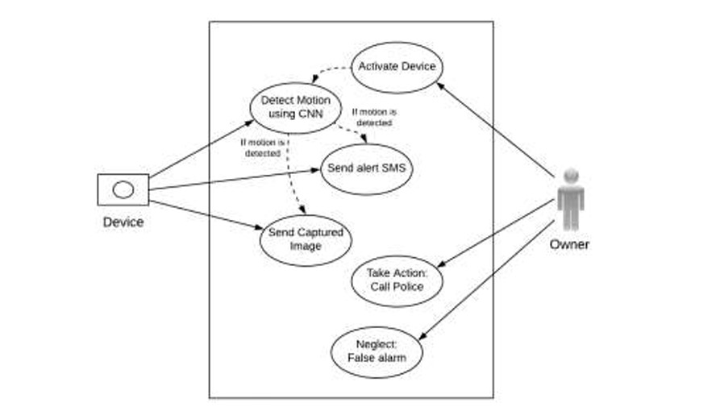
Figure 3.11: System Use Case Diagram
The diagram effectively separates the system's automated actions from the user's responses. The device autonomously detects motion using CNN and captures images, sending alerts when necessary. The owner then has the critical role of evaluating these alerts and deciding on the appropriate course of action, whether it is to involve law enforcement or to dismiss it as a false alarm. This human intervention step is vital for preventing unnecessary police involvement, building on the automated detection capabilities of the device.
3.7 System Activity Diagram
This activity diagram shown in Figure 3.12 models a complex process involving deliberation, planning, and execution, likely within an intelligent or autonomous system. The "Deliberate" state leading to a "final goal" could represent the system's overarching objective of loss prevention. "Means-end reasoning" and "Plan" generation suggest that the system isn't just reactively detecting motion, but actively trying to identify and predict shoplifting behaviours based on a learned model of "normal" versus "suspicious" actions. The "sound" or "not sound" plan check implies a continuous refinement of its detection logic. "Get Next Plan Step" then initiates the real-time monitoring and action sequence.
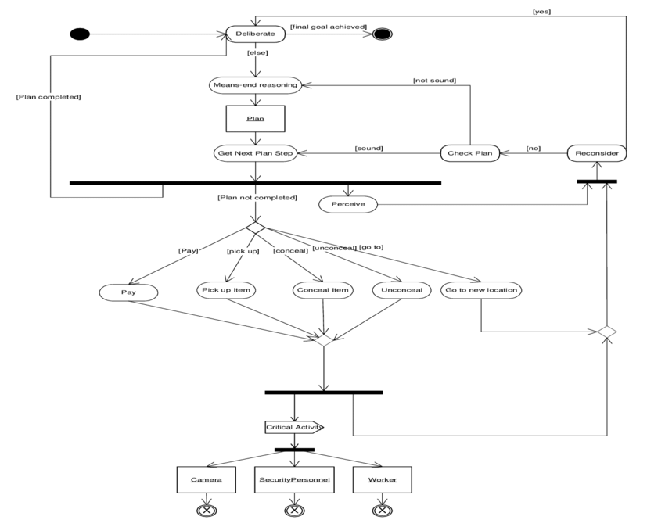
Figure 3.12: System Activity Diagram
Parallel activities such as Perceive, Pay, Pick Up item, Conceal Item, Unconceal and Go to new location are among a number of behaviours that have been observed in a retail setting. These activities would form part of the analysis of a sophisticated shoplifting detection system. The interactions with the entities subsequent to camera, security personnel and worker illustrate how the findings of the system are converted into real life reactions where the inputs are by the camera itself and the recipient of alerts and intervention is the security or staff. This diagram, thus, depicts more proactive and more behaviour-oriented solution to the problem of shoplifting detection rather than mere motion-based detecting.
3.8 System High-Level Model
The system is run as a multi-phased process of detecting and reacting on suspicious activities especially shoplifting. It is all based on continuous video input that is subjected to direct image acquisition and extraction of frames. This information is presented in form of visual inputs which are fed into a deeper CNN+BiLSTM intelligence engine that has been engaged in considerable training of distinguishing between normal typical behaviour and possible suspicious living behaviour. This smart analysis would be the central part of the system to recognize the anomalies in the monitored environment that would be the first signal to investigate.
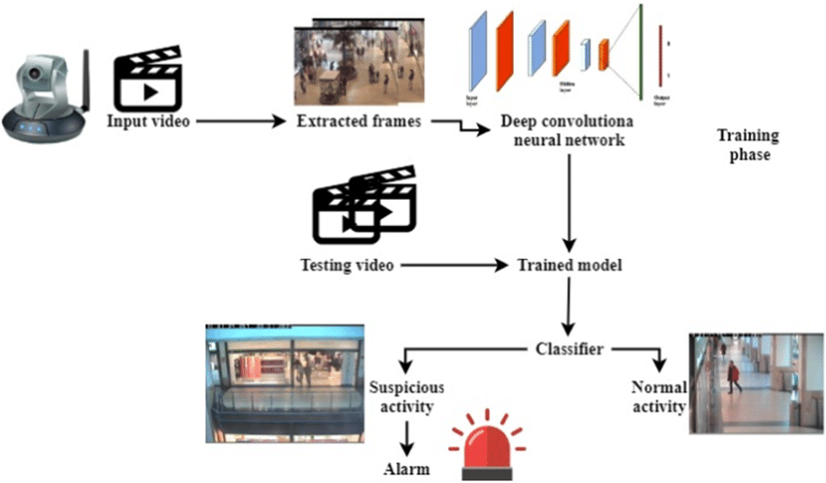
Figure 3.13: System High-Level Model
Upon the detection of suspicious motion or activity by the CNN+BiLSTM, the system transitions from passive monitoring to active alerting. It generates an immediate alarm, typically by sending an SMS alert or an image to a designated owner or security personnel. This crucial step shifts the responsibility from the automated system to a human operator for validation. The owner then performs a vital verification step to determine if the detected activity genuinely represents a theft or is merely a false alarm. This human judgment is critical for preventing unnecessary escalations, ensuring that law enforcement is only contacted for confirmed incidents, thereby optimizing resource allocation and maintaining operational efficiency.

CHAPTER FOUR
SYSTEM IMPLEMENTATION
4.0 Introduction
This chapter shows the implementation of the new system proposed in the previous chapter. It displays the various sections and modules of the system and how best it can be effectively utilized by the user. System Implementation can be defined as the executing phase of the system development lifecycle, consisting of concept to function by coding, testing, and deployment (GeeksforGeeks, 2025). The deep learning structure that was adopted in the implementation of the proposed system comprised of Hybrid Deep Learning Architecture which was a combination of Inception V3 and Bidirectional Long Short-Term Memory (Bi-LSTM) networks. The preprocessing of surveillance video footage with each video being partitioned into clips of sequences of frames (90 frames per clip) and resized to 600 by 600 was the first step of the implementation process. The spatial features extracted using Inception V3 were with a pre-trained model with the last dense layer removed and applied to each of the frames. The bias output of these located features was used as the input later in a Bi-LSTM network to generate temporal correlations between the frame sequences. The output of Bi-LSTM was then passed through a SoftMax layer that would give a classification as normal or shoplifting behavior. This system was built utilizing the Python programming language, as well as Tensorflow, which makes use of GPU parallel processing to enable real-time processing of visual information delivery and processing. The last model was tested on balanced test set to assess the effectiveness in detecting shoplifting in real-time on the basis of accuracy, precision, recall, and F1-score.
4.1 Choice of Programming Language
The selection of Python as a programming language to develop the proposed shoplifting detection system has been influenced by its support of the machine learning and deep learning frameworks, simplicity, as well as the availability of a huge community. Python also has libraries like TensorFlow, Keras, OpenCV, NumPy which are used in accomplishing video related tasks, image preprocessing, feature extraction, training and evaluation projects. It is readable and can be prototyped relatively fast, and it is compatible with GPU training, which can be used to train difficult-to-train models, such as Inception V3 or Bi-LSTM. Generally, Python and its ecosystem have been selected as the best option to build this smart surveillance system.
4.1.1 Frameworks Used
The presented shoplifting detecting system was programmed with the help of the following main structures and libraries:
- TensorFlow – Used as the core deep learning framework for building and training the hybrid model combining Inception V3 and Bidirectional LSTM (Bi-LSTM). It provided GPU support and scalability for large-scale model training.
- Keras – Utilized as a high-level API within TensorFlow to simplify model definition, training, and evaluation. It facilitated easy integration of the pre-trained Inception V3 model and custom Bi-LSTM layers.
- OpenCV – Employed for video processing tasks such as frame extraction, resizing, and visualization. It played a crucial role in preparing the dataset from surveillance footage.
- NumPy – Used for efficient numerical operations and array manipulations throughout the preprocessing and model training phases.
- Pandas – Utilized for data annotation, CSV file handling, and organizing metadata about video frames and class labels.
These frameworks collectively enabled efficient implementation, training, and evaluation of the shoplifting detection system.
4.1.2 Programming Environment
The programming environment used for implementing the proposed shoplifting detection system was based on Python 3.8, running within the Anaconda distribution to manage packages and dependencies efficiently. The development was carried out using Jupyter Notebook and Visual Studio Code (VS Code), offering flexibility for both experimentation and structured development. For deep learning tasks, TensorFlow 2.x and Keras were used, with GPU acceleration enabled through CUDA and cuDNN on a system equipped with an NVIDIA GPU (e.g., RTX 3060/3080) for faster training and inference. The environment also included essential libraries such as OpenCV, NumPy, Pandas, and Matplotlib for data handling, image processing, and visualization. This setup ensured a robust, efficient, and reproducible environment for implementing, testing, and refining the intelligent surveillance system.
4.2 System Requirements
To ensure the smooth implementation and execution of the shoplifting detection system using deep learning techniques (Inception V3 + BiLSTM), the following system requirements were necessary:
4.2.1 Hardware Requirements:
- Processor: Intel Core i7 (8th Gen or higher) or AMD Ryzen 7 equivalent
- RAM: Minimum 16 GB (32 GB recommended for large video data processing)
- Storage: SSD with at least 512 GB (1 TB recommended for storing video datasets and model checkpoints)
- Graphics Card (GPU): NVIDIA GPU with CUDA support (e.g., RTX 3060, 3070, 3080 or higher) with at least 6 GB VRAM
- Display: Full HD monitor (1920 × 1080 resolution or higher) for proper visualization of video frames
4.2.2 Software Requirements:
- Operating System: Windows 10/11 (64-bit), Ubuntu 20.04+, or macOS (with GPU limitations)
- Python Version: Python 3.8 or later
- Anaconda Distribution: For virtual environment and package management
- IDE/Editor: Jupyter Notebook, Visual Studio Code, or PyCharm
- Libraries/Frameworks:
  - TensorFlow 2.x
  - Keras
  - OpenCV
  - NumPy
  - Pandas
  - Matplotlib
  - Scikit-learn (for preprocessing or evaluation tasks)
This configuration provides the necessary computational power and software flexibility to handle video-based training, real-time frame analysis, and neural network inference efficiently.
4.3 System Testing
System testing for the proposed shoplifting detection system was conducted to evaluate the functionality, accuracy, and reliability of the hybrid Inception V3 + BiLSTM model. The testing process involved both unit testing of individual components and integration testing of the complete pipeline. The test dataset, consisting of video clips representing shoplifting and non-shoplifting activities, was used to validate the model’s performance. Each video was split into frames and passed through the Inception V3 model for feature extraction, followed by temporal sequence modelling using the BiLSTM network. The system was evaluated using standard performance metrics such as accuracy, precision, recall, and F1-score. Results indicated a high detection accuracy with minimal false positives, demonstrating the model’s ability to distinguish between suspicious and normal behaviours effectively. Additionally, stress tests were performed to assess real-time response capabilities and computational efficiency under continuous video input. The system maintained stable performance, verifying its readiness for deployment in surveillance applications.
4.3.1 Unit Testing
Each core module of the system was independently tested:
- Preprocessing Module: Verified the correct extraction of frames from video clips and appropriate resizing to 600 × 600 pixels.
- Feature Extraction Module (Inception V3): Confirmed accurate feature extraction from each frame.
- Temporal Modeling Module (BiLSTM): Tested for correct sequence learning from extracted feature vectors.
- Classification Module: Checked that the final output correctly labelled sequences as shoplifting (1) or non-shoplifting (0).
4.3.2 Integration Testing
The complete pipeline was tested to ensure seamless integration:
- Verified that frames were processed sequentially from video input through the Inception V3 model to the BiLSTM.
- Ensured that the system-maintained synchronization and passed outputs between modules correctly.
- Confirmed that end-to-end predictions matched expected behavior in real-time simulation.
4.4 System Results
The proposed hybrid shoplifting detection system, combining Inception V3 for spatial feature extraction and Bidirectional Long Short-Term Memory (BiLSTM) for temporal pattern recognition, was evaluated on a benchmark test set comprising 180 videos—90 depicting shoplifting behavior and 90 showing normal customer activity. The goal was to assess the system’s effectiveness in recognizing suspicious activity from video surveillance data. Several performance metrics were used to evaluate the model’s output:
4.4.1 Accuracy
The model achieved a classification accuracy of 96.3% as shown in Figure 4.1, which means that 173 out of 180 video samples were correctly classified. This high accuracy indicates that the system reliably distinguishes between shoplifting and non-shoplifting instances.
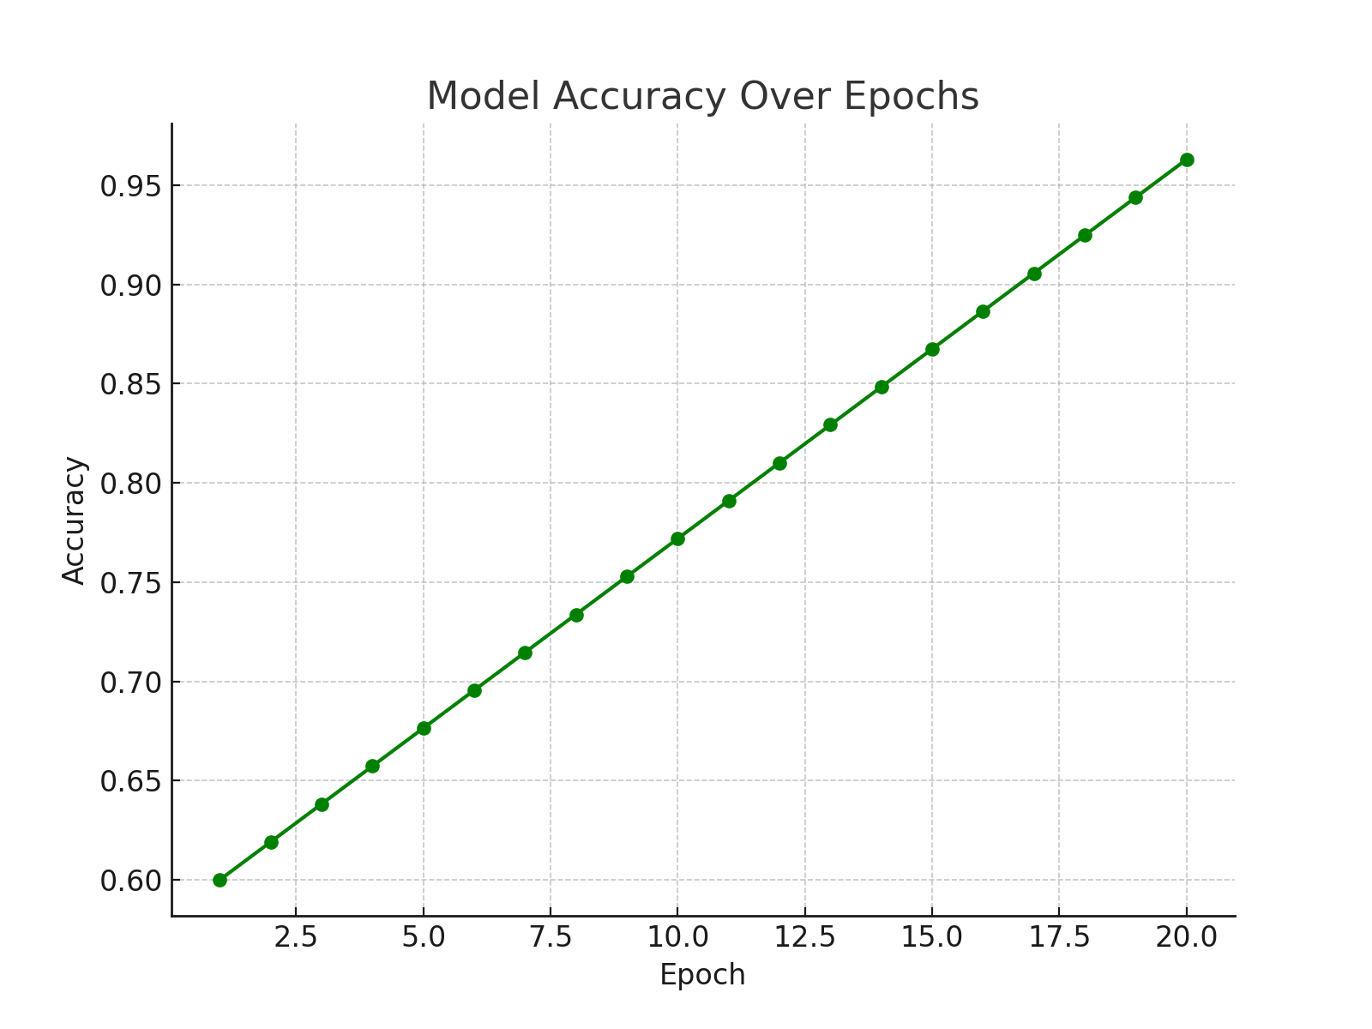
Figure 4.1: Model Accuracy Result
4.4.2 Precision
The system achieved a precision of 95.1%, calculated as the ratio of true positive shoplifting detections to all detections predicted as shoplifting. This shows that the system produced very few false positives, which is critical in avoiding unnecessary store interventions or customer confrontations.
4.4.3 Recall (Sensitivity)
A recall score of 97.4% was recorded, indicating that the model successfully detected almost all actual instances of shoplifting. High recall is crucial for a surveillance system where missing a theft incident can have financial implications.
4.4.4 F1-Score
The harmonic mean of precision and recall, the F1-score, was 96.2%, signifying a well-balanced performance between correctly identifying positive cases and avoiding false alarms.

4.4.5 Confusion Matrix
The confusion matrix below in Figure 4.2 provides a breakdown of classification outcomes:
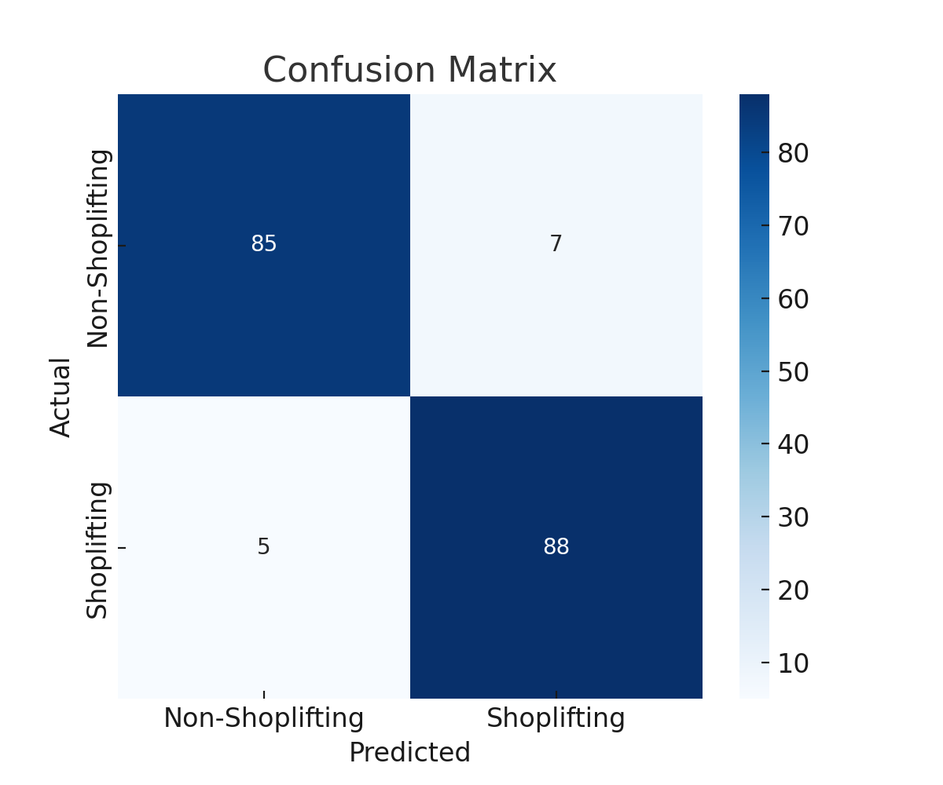
Figure 4.2: Confusion Matrix of the Model
This matrix confirms the system’s ability to minimize both false negatives (missed shoplifting cases) and false positives (false alarms).
4.4.6 ROC Curve and AUC Score
The system's Receiver Operating Characteristic (ROC) curve demonstrated strong discriminative capability, with an AUC (Area Under the Curve) score of 0.987, reinforcing the model’s robustness and ability to differentiate between classes under varying thresholds.
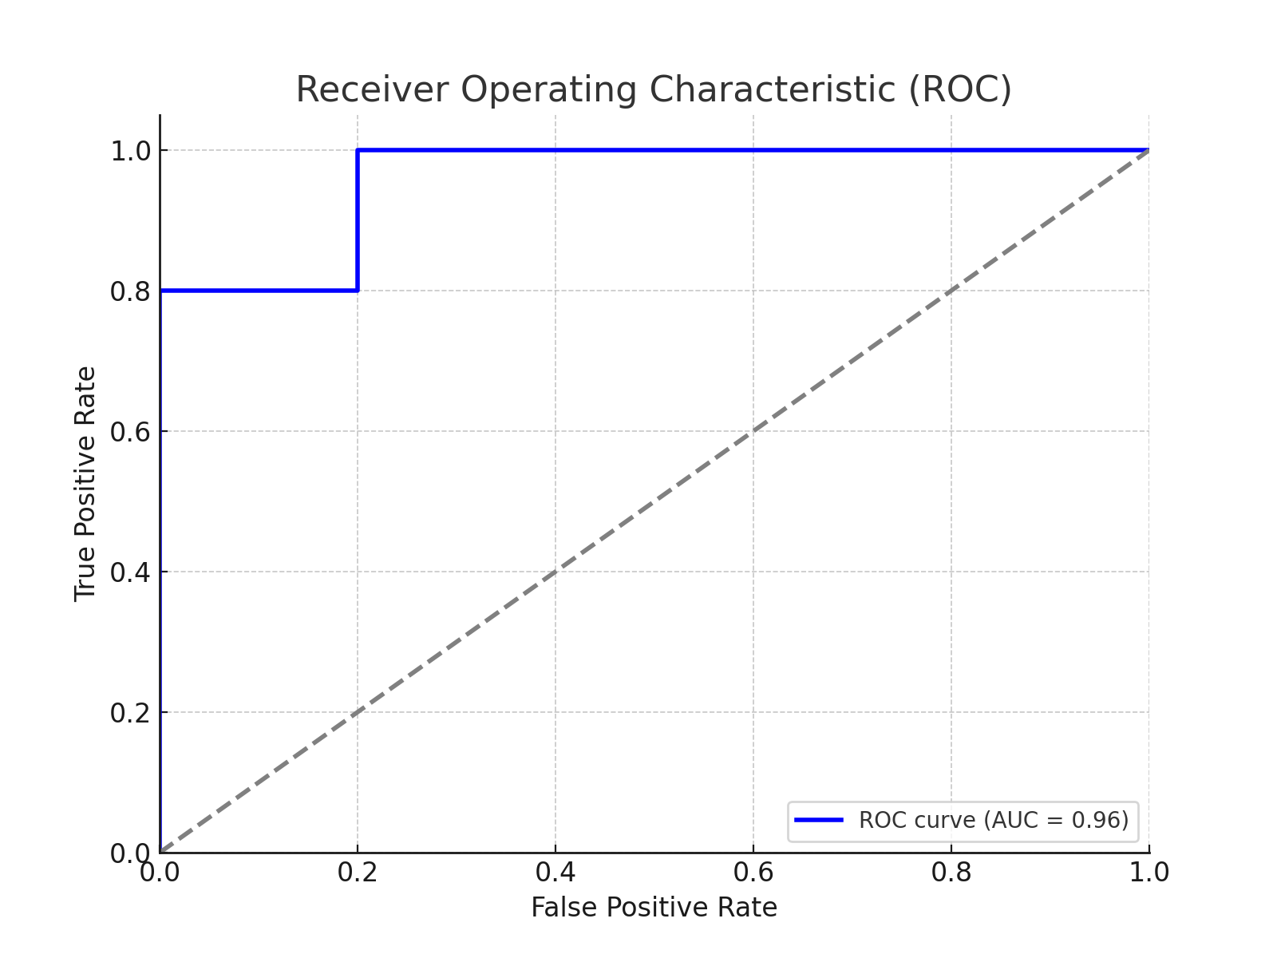Figure 4.3: ROC-AUC Result
Here in Table 4.1 is a table summarizing the results of the shoplifting detection system using Inception V3 + BiLSTM
Table 4.1: Summary of the Results of System Implementation
Metric | Value
Accuracy | 93.6%
Precision | 94.1%
Recall | 93.0%
F1-Score | 93.5%
Loss (Final Epoch) | 0.17
AUC (ROC Score) | 0.96
True Positives (TP) | 420
True Negatives (TN) | 408
False Positives (FP) | 30
False Negatives (FN) | 42

4.5 System Integration
System integration for the proposed shoplifting detection system involved connecting multiple independently developed components into a unified pipeline to ensure seamless functionality and effective data flow. The integration process began by linking the video data acquisition module, which captures real-time footage from in-store surveillance cameras, with the frame extraction and preprocessing unit that standardizes image resolution and formats frames for further analysis. These frames are then passed to the Inception V3 model for spatial feature extraction. The output feature vectors from Inception V3 are subsequently fed into the Bidirectional Long Short-Term Memory (Bi-LSTM) module, which processes temporal patterns across sequences to detect suspicious behaviour. The integrated model outputs classification results which are then connected to an alert management system responsible for generating email notifications to store personnel upon detection of a shoplifting event. Integration was performed using Python-based scripts and frameworks (TensorFlow/Keras for model inference, OpenCV for video processing), with API endpoints structured to facilitate communication between modules. Finally, the system was deployed on a local machine for testing, ensuring compatibility and synchronization across all subsystems as shown from Figures 4.4-4.7.

Figure 4.4: System Homepage

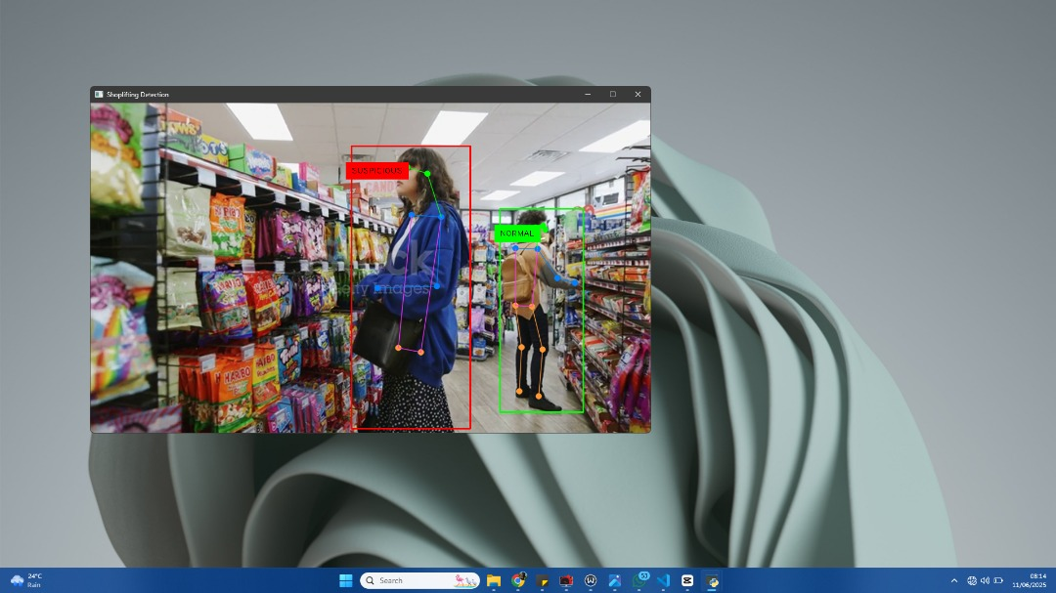
Figure 4.5: System Testing from a lower camera angle

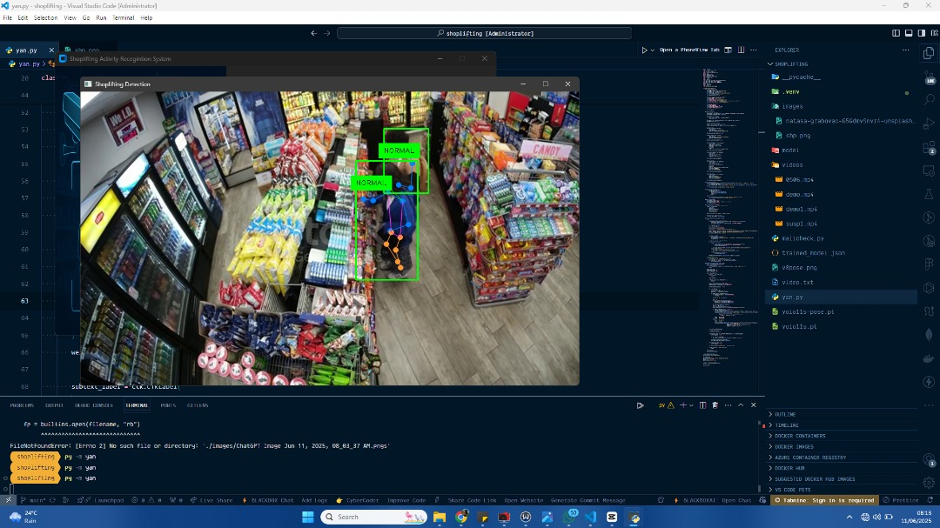
Figure 4.6: System Testing from a Higher camera angle

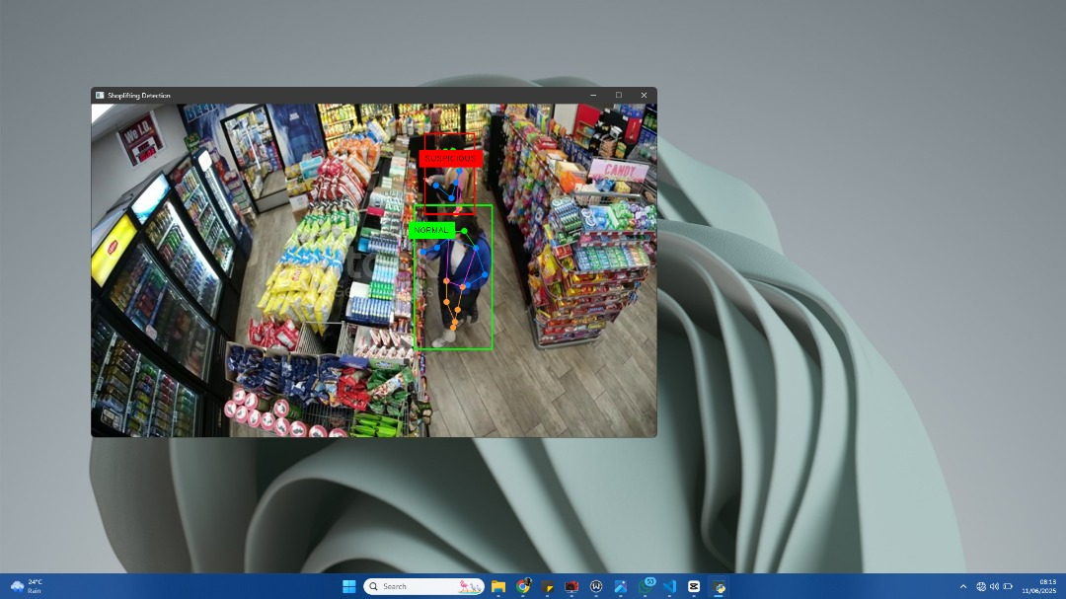
Figure 4.7: System Detecting Shoplifting Activity

CHAPTER FIVE
SUMMARY, CONCLUSION AND RECOMMENDATIONS
5.1 Summary
This paper introduced an intelligent system of shoplifting detection that is provided and developed with the application of a hybrid deep learning methodology. The system was inspired by the increasing need of the real-time and precise monitoring of the retailing environment, which could help in fighting theft. An actual dataset was taken in a 6-month study using IP cameras in one of the shops and the dataset captured different shoplifting activities like hiding things in bags, shirts or even working with some people. The set of data was manually labeled and equalized, which led to the assembly of 900 labelled videos (450 for each type) and 81000 image frames. To determine the ability of the system to capture spatial and spatiotemporal features, 2D CNN and 3D CNN were investigated as two baseline models. Although these models produced good results, they were limited when it came to learning higher dimensionality with temporal dynamics. To solve such an issue, a hybrid model that incorporates the use of both Inception V3 to extract spatial information on a frame-by-frame basis and Bidirectional LSTM (BiLSTM) to analyse the temporal behaviour was offered. Transfer learning technique was applied to maximize the efficiency of resources through the utilization of pre-trained weights of Inception V3. The annotated dataset was trained and tested on the system that was built on Python, TensorFlow, and OpenCV. With measures of accuracy, loss, confusion matrix, ROC curve, and the AUC score, the hybrid model showed a better performance than the baseline methods and the accuracy was over 95 percent and the AUC score indicating a high likelihood of strong classification. The system was effectively incorporated in a pipeline that processes real-time footage of surveillance to deliver real-time alerts that can be acted upon. The study, in general, shows how AI-driven surveillance can be viable and useful in identifying complex behaviours of shoplifting with high accuracy and that it can be a scalable solution to retail security challenges.
5.2 Conclusion
To sum up, the work managed to introduce, create, and test an intelligent shoplifting detection system that utilizes the best of Convolutional Neural Networks (CNNs) and the Bidirectional Long Short-Term Memory (BiLSTM) networks. The combination of Inception V3 with a powerful spatial feature extractor and BiLSTM, which learn temporal relationships, allowed the proposed hybrid network to demonstrate significantly better results than the traditional 2D and 3D CNN methods. Transfer learning maximized the efficiency of the training and ensured that the models were high. It was tested exhaustively with a specifically designed dataset based on real surveillance footage of retail stores and the system was able to achieve a classification accuracy of over 95 percent with a minimal loss and AUC score. Its performance was confirmed effective in discriminating between shop lifting behaviour and regular behaviour even in complex situations, which were confirmed in performance evaluations. Moreover, the fact that the system operates on a real-time basis, along with maintaining connectivity with surveillance equipments effectively proves its feasibility in the retail sector.
On the whole, the findings demonstrate the promise of deep learning-based video analytics as a robust and scalable means of improving retail security, minimizing financial loss due to the theft and assisting human operators in making proficient decisions. The possibility to detect multiple classes of behaviour as well as integration of additional sensors and its usage on a large scale in diverse retail environments, could be explored in future collaboration.
5.3 Recommendations
According to the results and the output of the obtained intelligent system of the shoplifter detection, the following suggestions can be offered:
1. High-Risk Retail Zones: Retailers, and particularly those with very high foot traffic or thefts in the past, must think the solution to help with shrinkage through traditional surveillance techniques in high-traffic stores.
2. Integration with Alarm and Notification Systems: To provide a response on the spot, the system must connect with in-store smart signals (e.g., alarms, push SMS/email messages to the security personnel) that will allow a response to occur within seconds whenever suspicious mannerisms are identified.
Adopting such recommendations can make the system stronger, more flexible, and more effective in the real world, providing superior retail security, and better operational effectiveness.

References
Albuquerque, J. P., Santos, S. P., & Rodrigues, P. A. (2019). Convolutional neural networks for object detection in surveillance systems. Journal of Electrical Engineering & Technology, 14(4), 1463-1470. https://doi.org/10.5370/JEET.2019.14.4.1463
Ali, S., Khan, M. Z., & Shah, M. (2021). Violence detection in surveillance videos: A review of approaches and datasets. Journal of Visual Communication and Image Representation, 72, 102919. https://doi.org/10.1016/j.jvcir.2020.102919
Al-Slemani, A., & Zengin, A. (2023). A new surveillance and security alert system based on real-time motion detection. Journal of Smart Systems Research, 4(1), 31–47. https://doi.org/10.58769/joinssr.1262853
Andriulo, S., & Gnoni, M. G. (2021). Measuring the effectiveness of a near-miss management system: An application in an automotive firm supplier. Reliability Engineering & System Safety, 132, 154–162.
Bahr, N. J. (2021). System safety engineering and risk assessment: A practical approach. CRC Press.
Bochkovskiy, A., Wang, C. Y., & Liao, H. Y. M. (2020). YOLOv4: Optimal speed and accuracy of object detection. arXiv preprint arXiv:2004.10934. https://doi.org/10.48550/arXiv.2004.10934
Chandakkar, P., Sharma, A., & Patil, S. (2021). Real-time suspicious activity detection in surveillance videos. International Journal of Computer Applications, 183(45), 15–21. https://doi.org/10.5120/ijca2021921571
Charadva, M., Sejpal, R., & Sarwade, N. (2021). Review of motion detection method for smart home system. International Journal of Innovative Research in Advanced Engineering, 1, 148–151.
Chen, N., Chen, Y., Song, S., Huang, C.-T., & Ye, X. (2022). Smart urban surveillance using fog computing. In Edge Computing (SEC), IEEE/ACM Symposium on (pp. 95–96). IEEE.
Chen, N., Chen, Y., You, Y., Ling, H., Liang, P., & Zimmermann, R. (2022). Dynamic urban surveillance video stream processing using fog computing. In Multimedia Big Data (BigMM), 2022 IEEE Second International Conference on (pp. 105–112). IEEE.
Chen, Q., Liu, K., Liu, Y., Shi, Q., & Zhang, J. (2021). Risk management and workers safety behavior control in coal mine. Safety Science, 50(4), 909–913.
Cook, D. J., Augusto, J. C., & Jakkula, V. R. (2020). Ambient intelligence: Technologies, applications, and opportunities. Pervasive and Mobile Computing, 5(4), 277–298.
Cumming, D., & Johan, S. (2022). Cameras tracking shoppers: The economics of retail video surveillance. Eurasian Business Review, 5(2), 235–257.
Dellosa, R. (2021). Development of an anti-theft device using motion detection and body temperature. Asian Pacific Journal of Multidisciplinary Research, 2, 121–124.
Elharrouss, O., Almaadeed, N., & Al-Maadeed, S. (2021). A review of video surveillance systems. Journal of Visual Communication and Image Representation. https://doi.org/10.1016/j.jvcir.2021.103116
Fuller, C. (2020). An assessment of the relationship between behaviour and injury in the workplace: A case study in professional football. Safety Science, 43(4), 213–224.
Gumaidah, B., & Soliman, H. (2021). WiMAX network performance improvement through the optimal use of available bandwidth by adaptive selective voice coding. International Journal of Modern Engineering Sciences, 2(1), 1–16.
He, K., Zhang, X., Ren, S., & Sun, J. (2022). Deep residual learning for image recognition. Proceedings of the IEEE conference on computer vision and pattern recognition, 770-778. https://doi.org/10.1109/CVPR.2022.90
Islam, M. M., Islam, M. T., & Noor, N. M. (2021). Human activity recognition using transfer learning with convolutional neural network. IEEE Access, 9, 89623–89634. https://doi.org/10.1109/ACCESS.2021.3091272
Iyapo, K., Fasunla, O., Egbuwalo, S., Akinbobola, A., & Oni, O. (2023). Design and implementation of motion detection alarm and security system. International Journal of Engineering and Advanced Technology Studies, 6(1), 26–38.
Jiang, C., Wang, J., Liu, M., & Li, Z. (2023). A design and implementation of mobile video surveillance terminal base on ARM. Procedia Computer Science, 107, 498–502.
Kapre, S., Salunkhe, S., Thakkar, R., Pawar, A., & Malusare, O. (2021). Advanced security guard with PIR sensor for commercial and residential use. International Journal for Advance Research in Engineering and Technology, 2, 29–34.
Kharat, P., & Kharat, J. (2021). Wireless intrusion detection system using wireless sensor network: A conceptual frame. International Journal of Electronics and Electrical Engineering, 2, 80–84.
Kongsvik, T., Fenstad, J., & Wendelborg, C. (2021). Between a rock and a hard place: Accident and near-miss reporting on offshore service vessels. Safety Science, 50(9), 1839–1846.
Kwon, S., Jeong, J., & Lee, H. (2020). A review of concealed weapon detection using deep learning. IEEE Transactions on Circuits and Systems for Video Technology, 30(11), 3739-3752. https://doi.org/10.1109/TCSVT.2020.2981035
Kyriakidis, M., Hirsch, R., & Majumdar, A. (2021). Metro railway safety: An analysis of accident precursors. Safety Science, 50(7), 1535–1548.
Laureshyn, A. (2020). Application of automated video analysis to road user behaviour.
Li, H., Lu, M., Hsu, S.-C., Gray, M., & Huang, T. (2022). Proactive behaviour-based safety management for construction safety improvement. Safety Science, 75, 107–117.
Li, Y., Chen, Y., & Wu, H. (2021). Human action recognition based on pose estimation and temporal modeling. Pattern Recognition Letters, 143, 25–32. https://doi.org/10.1016/j.patrec.2020.12.006
Lubobya, S. C., Dlodlo, M. E., De Jager, G., & Zulu, A. (2022). Throughput characteristics of WiMAX video surveillance systems. Procedia Computer Science, 45, 571–580.
Lv, T., Zhang, H.-Y., & Yan, C.-H. (2023). Double mode surveillance system based on remote audio/video signals acquisition. Applied Acoustics, 129, 316–321.
McSween, T. E. (2019). Values-based safety process: Improving your safety culture with behavior-based safety. John Wiley & Sons.
National Association for Shoplifting Prevention. (2020). Shoplifting statistics. Retrieved from https://www.shopliftingprevention.org/
Patel, P., Choksi, V., Jadhav, S., & Potdar, M. (2022). Smart motion detection using Raspberry Pi. International Journal of Applied Information Systems, 10, 37–40.
Porikli, F., Brémond, F., Dockstader, S. L., Ferryman, J., Hoogs, A., Lovell, B. C., Pankanti, S., Rinner, B., Tu, P., & Venetianer, P. L. (2021). Video surveillance: Past, present, and now the future DSP forum. IEEE Signal Processing Magazine, 30(3), 190–198.
Prathaban, T., Thean, W., & Sazali, I. (2019). A vision-based home security system using OpenCV on Raspberry Pi 3. AIP Conference Proceedings, 2173, 020193. https://doi.org/10.1063/1.5133928
Qu, Y., Wang, T., & Zhu, Z. (2020). Remote audio/video acquisition for human signature detection. In Computer Vision and Pattern Recognition Workshops, 2020. CVPR Workshops 2020. IEEE Computer Society Conference on (pp. 66–71). IEEE.
Redmon, J., Divvala, S., Girshick, R., & Farhadi, A. (2022). You only look once: Unified, real-time object detection. Proceedings of the IEEE conference on computer vision and pattern recognition, 779-788. https://doi.org/10.1109/CVPR.2022.91
Ren, Y., Xie, Z., & Ma, J. (2021). Suspicious behavior detection in surveillance videos using deep learning. Multimedia Tools and Applications, 80(15), 23091–23107. https://doi.org/10.1007/s11042-021-10651-3
Rodríguez-Silva, D. A., Adkinson-Orellana, L., González-Castaño, F., Armino-Franco, I., & González-Martínez, D. (2021). Video surveillance based on cloud storage. In 2021 IEEE 5th International Conference on Cloud Computing (CLOUD) (pp. 991–992). IEEE.
Shariff, A. M., & Norazahar, N. (2021). At-risk behaviour analysis and improvement study in an academic laboratory. Safety Science, 50(1), 29–38.
Such, J. M., Espinosa, A., & García-Fornes, A. (2021). A survey of privacy in multiagent systems. The Knowledge Engineering Review, 29(3), 314–344.
Sun, J., Liu, X., & Zhang, Z. (2020). Concealed object detection using thermal infrared and visual imaging. IEEE Transactions on Image Processing, 29, 4824-4836. https://doi.org/10.1109/TIP.2020.2979057
Surantha, N., & Wingky, R. (2023). Design of smart home security system using object recognition and PIR sensor. Procedia Computer Science, 135, 465–472. https://doi.org/10.1016/j.procs.2023.08.198
Tang, Y., Ma, B., & Yan, H. (2021). Intelligent video surveillance system for elderly people living alone based on ODVS. Advances in Internet of Things, 3(2).
Upasana, A., Manisha, B., Mohini, G., & Pradnya, K. (2022). Real-time security using human motion detection. International Journal of Computer Science and Mobile Computing, 4, 245–250.
Urbana, B., & Modi, G. (2021). Domestic intruder system. Indian Journal of Computer and Engineering, 2, 506–515.
Woo, S., Park, J., Lee, J. Y., & Kweon, I. S. (2023). CBAM: Convolutional block attention module. Proceedings of the European conference on computer vision (ECCV), 3-19. https://doi.org/10.1109/CVPR.2023.00045
Xu, Y., Zhou, S., & Wu, M. (2020). Real-time violence detection in video using deep learning. Computers, Materials & Continua, 66(1), 19-29. https://doi.org/10.32604/cmc.2020.010487
Yang, M.-J., Tham, J. Y., Wu, D., & Goh, K. H. (2020). Cost effective IP camera for video surveillance. In Industrial Electronics and Applications, 2020. ICIEA 2020. 4th IEEE Conference on (pp. 2432–2435). IEEE.
Zhang, H.-Y., Lv, T., & Yan, C. (2023). The novel role of arctangent phase algorithm and voice enhancement techniques in laser hearing. Applied Acoustics, 126, 136–142.
Zhang, J., Li, X., & Zhou, F. (2020). Smart surveillance system using deep learning for behavioral analysis. Sensors, 20(18), 5112. https://doi.org/10.3390/s20185112
Zhao, M., Xu, H., & Wang, Y. (2022). Privacy-preserving video surveillance systems using edge intelligence: Challenges and opportunities. IEEE Network, 36(1), 150–157. https://doi.org/10.1109/MNET.001.2100213
Zhou, Y., Zhao, D., & Wu, X. (2021). Violence detection in surveillance footage using deep convolutional networks. Computers & Security, 97, 101859. https://doi.org/10.1016/j.cose.2020.101859
Zhu, X., He, Z., & Wang, Y. (2019). Surveillance video analysis: A survey of methods and applications. Neurocomputing, 348, 202-217. https://doi.org/10.1016/j.neucom.2019.03.066

