SPECTROSCOPIC ANALYSIS OF BIOACTIVE COMPOUNDS IN FERMENTED WATER EXTRACT OF UNRIPE Carica papaya

CHUKWUEMEKA, CHISOM PEACE
GOU/U21/BCH/293

BIOCHEMISTRY PROGRAMME
DEPARTMENT OF CHEMICAL SCIENCES
FACULTY OF NATURAL SCIENCES AND ENVIRONMENTAL STUDIES, GODFREY OKOYE UNIVERSITY, ENUGU
NIGERIA

AUGUST, 2025

SPECTROSCOPIC ANALYSIS OF BIOACTIVE COMPOUNDS IN FERMENTED WATER EXTRACT OF UNRIPE Carica papaya

CHUKWUEMEKA, CHISOM PEACE
GOU/U21/BCH/293

BIOCHEMISTRY PROGRAMME
DEPARTMENT OF CHEMICAL SCIENCES
FACULTY OF NATURAL SCIENCES AND ENVIRONMENTAL STUDIES
GODFREY OKOYE UNIVERSITY, ENUGU
NIGERIA

A PROJECT RESEARCH SUBMITTED TO THE DEPARTMENT OF CHEMICAL SCIENCES IN PARTIAL FULFILLMENT OF THE REQUIREMENTS FOR THE AWARD OF BACHELOR OF SCIENCE (B.Sc.) DEGREE IN BIOCHEMISTRY

SUPERVISOR: DR. ANOSIKE JOY .C.

AUGUST, 2025
APPROVAL
This research titled “Spectroscopic Analysis of Bioactive Compounds in Fermented Water Extract of Unripe Carica papaya” has been assessed and approved by the Committees of Department of Chemical Sciences and Faculty of Natural Sciences and Environmental Studies, Godfrey Okoye University, Enugu, Nigeria.

Dr. Anosike Joy .C. ................................... ........................................
Supervisor Signature Date

Dr. Anosike Joy .C. ................................... ......................................
HOD, Signature Date
Department of Chemical Sciences

Prof. Chidi Uhuegbu ................................... .....................................
Dean, FNSES Signature Date

................................... .....................................
External Examiner Signature Date

CERTIFICATION
This is to certify that this research titled “Spectroscopic Analysis of Bioactive Compounds in Fermented Water Extract of Unripe Carica papaya” was carried out by Chukwuemeka Chisom Peace with Registration Number GOU/U21/BCH/293, under the supervision in the Department of Chemical Sciences, Godfrey Okoye University, Enugu, Nigeria.

Dr. Anosike Joy .C. ................................... ........................................
Supervisor Signature Date

Dr. Anosike Joy .C. ................................... ......................................
HOD, Signature Date
Department of Chemical Sciences

DEDICATION
I dedicate this work with all my heart to Almighty God, whose wisdom, grace and infinite favor have provided this work to full completion. All this would not have happened without His input in terms of direction, power, and blessings.
I also dedicate this project to my lovely parents and my lovely siblings. I could not have embarked on this journey without your steady love, prayers and support. With the help of sacrifices, support, and belief you have in me, I have been motivated and never given up along the way.

ACKNOWLEDGEMENTS
My profound appreciation goes to my supervisor and Head of Department, Dr. Anosike Joy, for her exceptional guidance, insightful corrections, and patient encouragement throughout the duration of this research. I am equally grateful to the Dean of the Faculty of Natural Sciences and Environmental Studies, and to the Vice Chancellor of Godfrey Okoye University, Enugu, for his constant advice, unwavering support, and dedication to fostering academic excellence.
I express my deep appreciation to my mentor, Dr. Mrs. Juliana Iwu James, whose words of wisdom, motivation, and guidance have continually inspired me to strive for excellence.
I extend my heartfelt gratitude to all my lecturers in the Department of Chemical Sciences for their invaluable contributions to my academic growth. I deeply appreciate Prof. Agbafor, Prof. Engwa, Prof. Oscar Eze, Dr. Obiudu Kenneth, Dr. Enechi, Dr. Ejikeme, Mrs. Ugwuonah Linda, Mrs. Amara, Mr. Jachike, Dr. Uhio, Dr. Chidimma, and Dr. Agbara. Your commitment to teaching and mentorship has left an indelible mark on me.
To my wonderful parents and siblings, thank you for your unwavering love, sacrifices, and steadfast encouragement. Your prayers and support have been my bedrock.
May God richly bless you all.
I return all glory and honor to Almighty God, whose infinite wisdom, grace, and unfailing love have guided me through every step of this academic journey. His blessings and favor have made the completion of this project a reality.

ABSTRACT
Carica papaya is widely used in traditional and modern medicine due to its high content of papain, carotenoids, flavonoids, phenolic acids, and vitamins. It supports digestion, immunity, wound healing, and cardiovascular health. This study merges indigenous knowledge with modern analytical techniques to evaluate the bioactive compounds and biochemical properties of fermented water extract from unripe Carica papaya. Fresh unripe fruits were obtained from Federal Government College, Independence Layout, Enugu, Nigeria. They were deseeded, sliced, and fermented in distilled water for 12 days. Fermentation was confirmed by a pH decrease from 6.0 to 5.0 and an increase in titratable acidity from 1.33 mL to 6.82 mL NaOH. GC-MS analysis identified a range of compounds across the fermentation period. Detected throughout were ethylbenzene (0.32% to 0.18%), o-xylene (0.28% to 0.21%), benzoic acid (0.71% to 0.46%), squalene (0.37% to 0.13%), and l-(+)-ascorbic acid 2,6-dihexadecanoate (0.63% to ~1.62%, peaking at 6.70% on Day 6). By Day 6, acetic acid (3.35%), butanoic acid (7.88%), and methyltartronic acid (6.22%) increased notably. By Day 12, CLA (0.31%), cis-13-octadecenoic acid (0.19%), octadecanoic acid (0.24%), and eicosanoic acid (0.12%) appeared. FTIR confirmed O–H, C–O, C=C, N=C=S, and S=O groups, supporting antioxidant, antimicrobial, and anti-inflammatory properties. Rare compounds like 2,4,6-decatrienoic acid ester and [1,1′-bicyclopropyl]-2-octanoic acid ester suggest additional therapeutic relevance. These results validate the traditional use of Carica papaya and highlight its potential as a source of functional food and phytotherapeutic agents.

TABLE OF CONTENTS
Title page i
Approval ii
Certification iii
Dedication iv
Acknowledgements v
Abstract vi
List of Tables ix
List of Figures x
List of Appendices xi

CHAPTER ONE: INTRODUCTION 1
  - Background of the Study 1
1.1.1 Brief Overview of Context 2
1.2 Problem Statement 3
1.3 Aim and Objectives of the Study 4
1.3.1 Aim of the Study 4
1.3.2 Objectives of the Study 4
1.4 Significance of the Study 5

CHAPTER TWO: LITERATURE REVIEW 6
2.1 Carica papaya 6
2.1.1 Botany and Taxonomy of Carica papaya 9
2.1.2 Traditional and Medicinal benefits of unripe Carica papaya 11
2.2 Fermentation of Unripe Pawpaw Water 12
2.2.1 Enhanced bioactive compounds production 13
2.3 Pharmacological Properties of Bioactive Compounds in Pawpaw 15
2.3.1 Anti-inflammatory Activity 14
2.3.2 Anti-cancer Activity 16
2.3.3 Antidiabetic Activity 16
2.3.4 Antioxidant Activity 17
2.3.5 Antimicrobial Activity 19
2.4 Clinical Studies on the Pharmacological Properties of Carica papaya 19
2.5 Techniques for Evaluation of Bioactive Compounds in Fermented Water from Unripe
Pawpaw 21
2.5.1 pH and Titratable Acidity 21
2.5.2 Gas chromatography - mass spectroscopy (GCMS) 22
2.5.3 Fourier transform infrared (FTIR) spectroscopy 24

CHAPTER THREE: MATERIALS AND METHODS 26
3.1 Materials 26
3.1.1 Plant Material 26
3.1.2 Chemical and Reagent 26
3.1.3 Equipment and Apparatus 26
3.2 Methods 26
3.2.1 Preparation of Sample Extract 27
3.2.2 pH and Titratable acidity 27
3.2.3 GCMS Analysis of Fermented water Extract from Unripe Carica papaya 28
3.2.4 FTIR Spectroscopy Analysis of Fermented water Extract from Unripe Carica
papaya 28

CHAPTER FOUR: RESULTS 30
4.1 GC-MS Analysis
4.1.1. Biologically Active Chemical Compounds Present in the Day 3 water extract of unripe
Carica papaya 30
4.1.2. Biologically Active Chemical Compounds Present in the Day 6 water extract of unripe
Carica papaya 33
4.1.3. Biologically Active Chemical Compounds Present in the Day 9 water extract of unripe
Carica papaya 36
4.1.4. Biologically Active Chemical Compounds Present in the Day 12 water extract of
unripe Carica papaya 39
4.2 FTIR Analysis 42
4.2.1. FTIR Frequency Range and Functional Groups Present in the Day 3 water extract of
unripe Carica papaya 42
4.2.2. FTIR Frequency Range and Functional Groups Present in the Day 6 water extract of
unripe Carica papaya 44
4.2.3. FTIR Frequency Range and Functional Groups Present in the Day 9 water extract of
unripe Carica papaya 46
4.2.4. FTIR Frequency Range and Functional Groups Present in the Day 12 water extract of
unripe Carica papaya 48
4.3 pH and Titratable Acidity 50

CHAPTER FIVE: DISCUSSION, CONCLUSION AND RECOMMENDATIONS 52
5.1 Discussion 52
5.2 Conclusion 55
5.3 Recommendations 56

REFERENCES 58
APPENDICES 63

LIST OF TABLES
Table 4.1.1: Biologically Active Compounds in Day 3 Water Extract of Unripe Carica
papaya 31
Table 4.1.2: Biologically Active Compounds in Day 6 Water Extract of Unripe Carica
papaya 34
Table 4.1.3: Biologically Active Compounds in Day 9 Water Extract of Unripe Carica
papaya 37
Table 4.1.4: Biologically Active Compounds in Day 12 Water Extract of Unripe Carica
papaya 40
Table 4.2.1: FTIR Frequency and Functional Groups in Day 3 Water Extract 43
Table 4.2.2: FTIR Frequency and Functional Groups in Day 6 Water Extract 45
Table 4.2.3: FTIR Frequency and Functional Groups in Day 9 Water Extract 47
Table 4.2.4: FTIR Frequency and Functional Groups in Day 12 Water Extract 49
Table 4.3.1: pH and Titratable Acidity of Aqueous Carica papaya Extract over Time 50

LIST OF FIGURES
Figure 1: Carica Papaya plant and its processing 7
Figure 2: Botanical characterization of Carica papaya 10
Figure 3: Pharmacology of Carica papaya derived bioactive compounds 14
Figure 4: Anti-diabetic activity of phytochemicals derived from Carica papaya 15
Figure 5: Instrumentation of Gas Chromatography–Mass Spectrometry (GC-MS) 23
Figure 6: Schematic diagram of FTIR spectrometer 25
Figure 7: pH and Titratable Acidity 51

LIST OF APPENDICES
Appendix 1: FTIR Spectra for Day 3 63
Appendix 2: FTIR Spectra for Day 6 63
Appendix 3: FTIR Spectra for Day 9 64
Appendix 4: FTIR Spectra for Day 12 64
Appendix 5: Titratable Acidity (color change from colorless to pink) 65
Appendix 6: Preparation of sample 65
Appendix 7: Chromatogram of GC-MS analysis for Day 3 fermented water extract of unripe
Carica papaya. 66

Appendix 8: Chromatogram of GC-MS analysis for Day 6 fermented water extract of unripe
Carica papaya. 66

Appendix 10: Chromatogram of GC-MS analysis for Day 9 fermented water extract of
unripe Carica papaya. 67

Appendix 11: Chromatogram of GC-MS analysis for Day 12 fermented water extract of
unripe Carica papaya. 67

CHAPTER ONE
INTRODUCTION
1.1 Background of Study
Humans have relied on natural remedies dating back to history because various civilizations employed plant-based and mineral-based medicines for treatment (Agada et al., 2020). Traditional practices such as Ayurveda and Traditional Chinese Medicine (TCM) still affect modern healthcare although pharmaceutical advancements happened (Amin, 2021; Alzate-Yepes et al., 2023). Bodily balance restoration represents their primary objective instead of focusing solely on symptoms treatment (Atanu et al., 2021).
Most people view natural remedies as safer than synthetic drugs since they produce better tolerance levels and generate less adverse effects as well as drug interactions (Cao et al., 2024; Choudhary et al., 2025). Bioactive compounds derived from plants activate natural healing mechanisms in the body thus helping patients control both cardiovascular conditions and diabetes alongside inflammatory diseases (Fasakin et al., 2022). Modern medicine gains strength by integrating traditional remedies which at the same time improves global healthcare services along with promoting sustainable farming practices and biodiversity protection (Gudimella et al., 2022).
Industry practices produce worldwide cultivation of the tropical fruit Carica papaya L. which people know as papaya in its commercial form. The food and therapeutic values of papaya stem from four groups of compounds including protease papain alongside carotenoids (β-carotene and lycopene) and flavonoids (quercetin and kaempferol) and phenolic acids (caffeic and ferulic acids) which demonstrate antimicrobial and anti-inflammatory and antioxidant action. (Memudu & Oluwole 2021; Miraj et al 2023; Mouafo et al 2024).
The nutritional value of papaya includes vital vitamins C A and E as well as potassium magnesium and fiber which support cardiovascular health immunity and digestion (Ranebennur et al., 2023; Rao et al., 2021; Safriani et al., 2022). The worldwide consumption of papaya has steadily increased because its enzyme papain provides essential use in leather processing and food production (Aravind et al., 2013). Research shows that papaya has three main uses which include skin care products, gastrointestinal treatments through traditional medicine and recovery from dengue infections (Patel et al., 2024; Peng et al., 2024).
This research tracks the bioactive compounds along with nutrition benefits and biomedical solutions of C. papaya through new scientific studies that unite ancient indigenous knowledge with present-day academic research to improve complete healthcare solutions.
1.1.1 Brief Overview of Context
The research investigates unripe pawpaw (Carica papaya) that contains various active components including papain (an enzyme with digestive and anti-inflammatory functions), carotenoids (β-carotene, lycopene), flavonoids (quercetin, kaempferol, luteolin), phenolic acids (caffeic, ferulic), alkaloids and vitamins A and C together with proteins. The antioxidant and antimicrobial along with the anti-inflammatory and nutritional capabilities of unripe pawpaw stem from its multiple components. (Oboh et al., 2013; Maduba et al., 2022; Tersoo-Abiem et al., 2024).
The anaerobic biochemical method of fermentation allows microorganisms (including yeast and bacteria) to metabolize glucose into alcohol along with lactic acid through a process known as breaking down glucose. Glycolysis starts the process which enzymes power through their catalytic actions. Louis Pasteur developed advanced knowledge of fermentation during the 19th century by showing that microorganisms use the process to create both ethyl alcohol and carbon dioxide together with multiple additional products. The traditional application of fermentation for food and drink development now serves as an industrial necessity for biofuel production and antibiotics synthesis and biochemical synthesis operations (Encyclopaedia Britannica, 2025).
Bioactive compounds exist as natural substances which reside in various foods particularly plants and they generate additional biological effects apart from basic nourishment. Many substances from plant secondary metabolism serve protective and communication functions for plants while offering humans therapeutic medication properties. (Walia et al., 2019).
Microbial fermentation of unripe Carica papaya generates a fermented extract rich in bioactive compounds. These compounds often become more bioavailable and achieve enhanced activity through conversion into activated forms during fermentation. As a result, the fermented extract exhibits superior antioxidant, antimicrobial, and anti-inflammatory properties, supporting its potential use in nutrition and therapeutic applications.
1.2 Statement of Problem
For many years unripe Carica papaya has received reputation as a medicinal and nutritional plant containing multiple bioactive compounds like alkaloids and flavonoids together with phenolic acids and proteolytic enzymes (Hiraga et al., 2021; Khor & Wong, 2014). Several compounds in unripe Carica papaya provide antioxidant properties along with antimicrobial and anti-inflammatory health benefits. The higher quantity of proteolytic enzymes along with alkaloid and phenolic compound content in unripe Carica papaya makes it a preferred choice compared to ripe papaya because these compounds decrease in concentration as the fruit matures according to Dada (2013). Traditional medical practices employ unripe papaya as a treatment for digestive health issues and for healing wounds along with destroying microorganisms.
Science recognizes fermentation as a bioprocess which transforms plant-based foods while simultaneously improving how bioactive compounds absorb in the human body (El Sheikha & Ray, 2017). Plant-based products such as grape leaves, soybeans and cocoa experience enhanced total phenolic content swelling and greater flavonoid activity as well as antioxidant action following fermentation according to Al Juhaimi et al. (2019). When unripe Carica papaya undergoes fermentation, it may improve its medicinal properties for use as functional food or nutraceuticals.
The documented advantages of fermentation to enhance bioactivity in plant materials need further academic attention because few studies focus on unripe Carica papaya fermentation effects on its bioactive constituents specifically in fermented water. Phytochemical changes observed throughout fermentation produce essential knowledge for developing functional beverages and alternative medicine treatments and nutraceutical formulations. The objective of this research is to evaluate the bioactive elements detected in unripe Carica papaya fermented water along with its possible health advantages based on the growing consumer demand for natural health-promoting fermented products.
1.3 Aim and Objectives
1.3.1 Aim of the study
The study focused on the evaluation and identification of bioactive compounds present in fermented water from unripe Carica papaya.
1.3.2 Objectives of the study:
The specific objectives of this study were to;
- Perform structural analysis of fermented Carica papaya water extracts collected at different fermentation time points using Gas Chromatography–Mass Spectrometry (GC-MS).
- Identify functional groups in the time-dependent fermented Carica papaya water extracts using Fourier Transform Infrared (FTIR) spectroscopy.
- Determine the pH and titratable acidity of Carica papaya water extracts at various stages of fermentation.

1.4 Significance of Study
This research evaluates traditional beliefs about unripe Carica papaya fermentation water which supposedly enhances digestion while boosting both immunity and introducing antioxidant benefits. The essential presence of papain enzyme in the composition is believed to promote protein breakdown to help digestion. The fermented extract demonstrates potential therapeutic effects in two areas by reducing oxidative stress and supporting health and wound healing functions for treating ulcers because of its anti-inflammatory properties. An evaluation of the bioactive compounds extracted from fermented extract through laboratory and spectroscopic analysis follows this study to confirm traditional beliefs about its health benefits. The studies could establish better knowledge about bioactive component transformations during fermentation which leads to potential developments of natural remedies for digestive conditions and immune system enhancement and oxidative damage treatment.

CHAPTER TWO
LITERATURE REVIEW
2.1 Carica papaya
Carica papaya grows within the Caricaceae family where people identify it as Erandakarkati in Sanskrit and Papita in Hindi and they commonly call it papaya in English. Grown every month of the year this plant provides various health advantages because it contains abundant nutrients. The fruit contains essential minerals including potassium and magnesium in addition to antioxidant vitamins C, A and E and nutrients pantothenic acid (B vitamin) and folate and dietary fibre (Alara et al., 2022). India received papayas as an exotic plant from tropical American territories during the 16th century. The papaya plant has become a standard crop in India since its acceptance despite being viewed as foreign in previous times. With a maximum height of 20 meters the papaya plant develops a long soft stem which contains ample white latex. The plant expands at a fast rate until it forms a leaf cluster with elongated substantial leaves (Figure 1) (Ugo et al., 2019).
Traditional medicine used papaya leaves as a remedy for treating dengue and malaria diseases in addition to jaundice along with immune problems and viral infections. The bioactive compounds found in young leaves of Carica papaya include phenolics such as ferulic acid and chlorogenic acid and ferulic acid as well as flavonoids and cyanogenic substances and alkaloids featuring carpaine and dehydrocarpaine I and II and pseudocarpaine. Carica papaya leaves and fruit consisting of mostly immature development contain β-carotene, lycopene, and anthraquinone glycosides among their carotenoid content. Multiple therapeutic properties manifest in papaya because of its chemical constituents which support wound healing and protect the liver while exhibiting anti-inflammatory effects and lowering blood sugar and acting as an anti-fertility agent with abortive behaviour. New research has established two beneficial effects of this substance as an antihypertensive substance and anticancer substance (Sharma et al., 2020).
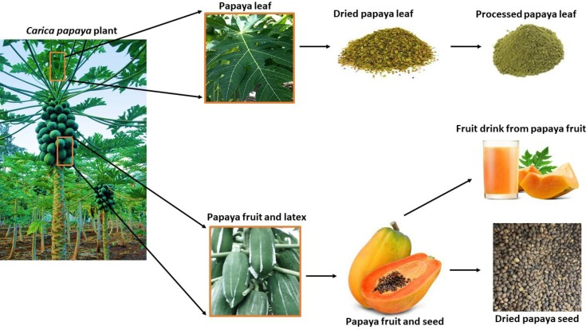
Figure 1: Carica papaya plant and its processing.
Multiple sections of the papaya plant produce raw materials that enable the creation of medical products and industrial goods and nutraceutical products.
(Benjamin et al., 2024)

Ripe Carica papaya contains three fundamental carbohydrates which include sucrose at 48% (w/w), glucose at 30% (w/w) and fructose at 22% (w/w). Kinds of dietary fibre in the fruit help to move stool contents through the intestines while the papain enzyme concentration rises as the fibre total increases. Santana et al. (2019) reported that papaya contains different phytochemical compounds wherein enzymes reside in the latex tissue while alkaloids accumulate in the leaves and phenolic compounds dwell throughout the pulp and leaves. Research shows β-cryptoxanthin exists as the lowest pro-vitamin A component among compounds located in pulp and seed tissues of the fruit.
Red pulp papaya encompasses lycopene as its main pigment which demonstrates powerful antioxidant properties because it excels at neutralizing free radicals even more than β-cryptoxanthin and β-carotene. Seeds contain plenty of β-carotene together with glucosinolates and benzyl isothiocyanate as well as carotenoids and phenolic components. Papaya contains similar amounts of citric acid and malic acid among its organic acids, while ascorbic acid and α-ketoglutaric acid are present in much smaller quantities. Papaya content is affected by two factors: fruit ripeness increases carotenoid and ascorbic acid amounts and summer sunlight duration extends total ascorbic acid together with its precursor glucose concentrations (Singh et al., 2020).
Although traditional medicine uses various papaya plant parts for treating diseases such as diabetes, cancer, cardiovascular issues, and infections. Papaya research focuses on three major components: glucosinolates, carotenoids, and phenolic compounds because these substances interact with multiple cancer-related biological pathways including cell signalling, growth, programmed cell death (apoptosis), migration, invasion, angiogenesis, and carcinogens detoxification.
Consumers typically eat just the pulp of ripe papaya which demonstrates additional therapeutic qualities as a sedative and expectorant and diuretic and also contains a carminative effect. People use papaya as a skin health booster because it helps prevent and treat ringworm and psoriasis together with other dermatological conditions. Traditional medical practice shows that unripe papaya fruit treats impotence and ulcers and controls menstrual flow as well as periodic irregularities. Research shows that diabetes patients along with those following weight-loss diets should consider eating papaya because it offers high nutritional benefits while having only 32 kcal in 100 grams of ripe fruit (Saeed et al., 2014).
2.1.1 Botany and taxonomy of Carica papaya
Carica papaya fruit presents itself as round-shaped objects with broad central openings. As a vegetation type C. papaya reaches heights from 5 to 10 meters (16 to 33 feet) and its dark seeds maintain a rough texture with some appearing inside a clear aril membrane. Its leaves only cluster at the apex of the stem and are arranged in a spiral pattern. There are noticeable leaf scars at the base of the hollow, green, or sometimes dark purple, trunk. The plant has latex vessels all around, thick and hollow leaves that have dark purple and green hues. Milky white latex is secreted in large quantities by the stems and leaves. The tiny, yellowish-white flowers are widely distributed (Figure 2) (Manpreet et al., 2019).
The taxonomy of papaya includes the following:
- Domain: Flowering plant.
- Kingdom: Plantae.
- Sub Kingdom: Tracheobionta.
- Class: Magnoliopsida.
- Subclass: Dilleniidae.
- Super division: Spermatophyta.
- Phylum: Steptophyta.
- Order: Brassicales.
- Family: Caricaceae.
- Genus: Carica.
- Botanical Name: Carica papaya.
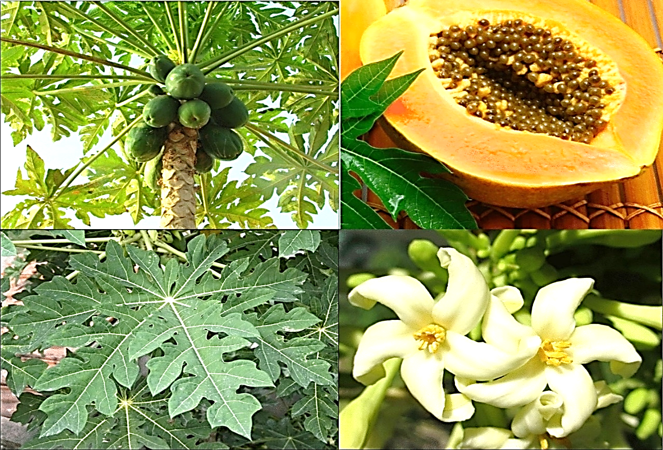
Figure 2: Botanical characterization of Carica papaya. (Kumarasinghe et al., 2024)

2.1.2 Traditional and medicinal benefits of unripe Carica papaya
- Digestive health
Unripe Carica papaya have been utilized for decades to improve digestive health. One of the main bioactive substances found in Carica papaya is papain. This proteolytic enzyme facilitates healthy digestion by catalysing the breakdown of protein. In traditional medicine, unripe papaya is used to alleviate constipation, bloating in the abdomen, and indigestion. Additionally, papain facilitates the digestion of protein, nutritional absorption, and peristaltic movement, all of which assist ease constipation. Unripe papaya treatments both reduce stomach inflammation and heal gastritis and peptic ulcers because it calms stomach tissue while providing anti-inflammatory benefits according to Gautam et al. (2021).
- Anti-inflammatory effects
The phytochemicals papain, flavonoids, and carotenoids are responsible for the health advantages of papaya, including its anti-inflammatory and therapeutic properties against rheumatism and arthritis. Traditionally, unripe papayas are applied topically or taken orally to lessen swelling and inflammation in the afflicted areas. By causing the breakdown of proteins, the papain enzyme is believed to help reduce inflammatory reactions at the joints, thereby alleviating the symptoms of rheumatoid arthritis (Venugopal et al., 2018).
- Antimicrobial and antifungal effects
In traditional medicine, unripe Carica papaya are used to treat infections because they have antibacterial and antifungal properties. Research indicates that unripe papaya latex contains bioactive substances that have been shown to have antibacterial qualities against a range of illnesses. Unripe papaya latex and extracts are commonly used to limit bacterial growth in wounds, cuts, and infections. Unripe papaya seeds and latex, which are used to treat fungal infections such as ringworm and athlete's foot, appear to correlate with the fruit's natural antibacterial properties (Gupta et al., 2017).
2.2 Fermentation of Unripe Pawpaw Water
Fermentation is a fundamental metabolic process wherein organisms, primarily yeasts and certain bacteria, transform sugars and starches into alcohol (alcoholic fermentation) or carboxylic acids (lactic or acetic fermentation) under anaerobic or microaerophilic circumstances. An intermediate product is created during this conversion, such as pyruvate (also known as acetaldehyde), which is generated from the metabolism of glucose (Maicas, 2020).
The aqueous extract made by soaking or processing unripe pawpaw fruit in water is referred to as "unripe pawpaw water". Phytochemicals such as alkaloids, flavonoids, and papain-like enzymes are abundant in this extract. When this water is fermented, either naturally (natural fermentation) or intentionally (by adding microbial cultures), a number of metabolic events start to occur (Leitão et al., 2022).
The microbial community, particularly Lactobacillus, Saccharomyces cerevisiae, and Bacillus subtilis, secretes enzymes during fermentation that interact with the pawpaw extract's phytochemicals. These enzymes aid in the breakdown of complicated molecules, the transformation of inert substances into bioactive forms, and occasionally the creation of newly advantageous metabolites. The extract's stability, pharmacological potency, and bioavailability, or how well the body can absorb and use the compounds, may potentially be enhanced by this change. For example, Lactobacillus species are known to produce lactic acid, which enhances the extract's antibacterial and antioxidant qualities while also preserving it (Somanah et al., 2018). Bacillus species frequently contribute to increased anti-inflammatory and immune-boosting effects, while Saccharomyces cerevisiae, a type of yeast frequently used in baking and brewing, can enhance enzyme activity and flavor (Somanah et al., 2018). Furthermore, researches have demonstrated that fermentation can increase beneficial compounds in plants while decreasing toxic or anti-nutritional ones. This implies that unripe papaya may be able to transform fewer active phytochemicals into substances with better medicinal qualities, such as increased antioxidant activity or better anti-parasitic effects (Leitão et al., 2022).
2.2.1 Enhanced bioactive compound production
Enhancing the medicinal potential of bioactive molecules is one of fermentation's primary advantages. Through a process called biotransformation, fermenting unripe Carica papaya water greatly increases the extract's biological activity in addition to preserving it. The chemical breakdown or microbiological breakdown of complex chemicals into simpler, frequently more potent forms is known as biotransformation. Microbes such Lactobacillus plantarum, Saccharomyces cerevisiae, and Bacillus subtilis create enzymes during fermentation that start to interact with the phytochemicals in the unripe pawpaw extract. These interactions alter these molecules' chemical structures in ways that are advantageous (Maicas, 2020).
For example:
- The body transforms flavonoid glycosides first connected to sugar molecules into aglycones through decomposition while these aglycones demonstrate better absorption properties. The anti-inflammatory along with antioxidant properties of aglycones are stronger than those of flavonoid glycosides (Somanah et al., 2018).
- The extract's proteins and peptides may hydrolyze into free amino acids or shorter peptide chains; some of them have been demonstrated to have immune-modulating, antioxidant, and antibacterial properties (Somanah et al., 2018).
- During fermentation, phenolic chemicals that are occasionally bound or inactive in their unprocessed state can be liberated or undergo structural changes. Their antioxidant activity rises as a result, which could improve cellular defenses against oxidative stress (Somanah et al., 2018).
Furthermore, fermentation can produce new bioactive metabolites that were not initially present in the unfermented extract in addition to changing preexisting components. These new substances, which complement the fermented pawpaw water's medicinal toolkit, could be organic acids, short-chain peptides, or secondary metabolites. Fermentation essentially transforms good phytochemicals into even better ones by acting as a natural "upgrade system" (Somanah et al., 2018).

2.3 Pharmacological Properties of Bioactive Compounds in Pawpaw
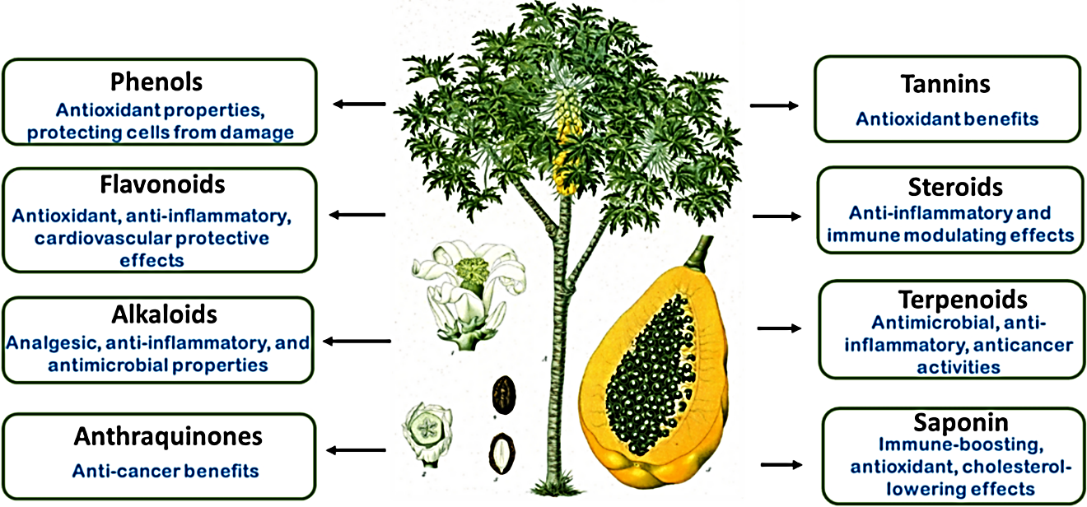
Figure 3: Pharmacology of Carica papaya derived bioactive compounds.
Ref: Kumarasinghe et al., 2024.

2.3.1 Anti-inflammatory activity
Anti-inflammatory properties emerge from C. papaya through its antioxidant activities that spread through the entire fruit. Through fermentation papaya undergoes chemical transformations that elevate its anti-inflammatory properties along with its anti-diabetic benefits because it enhances the quantity of beneficial compounds. Transformation caused by microorganism converts intricate molecules into basic structures that improves both absorption rates and cellular anti-inflammatory response. Through this method fermentation increases the levels of small-molecule antioxidants along with other neutralizing substances which combat reactive oxygen species known as ROS that produce inflammation and cell death (Gupta et al., 2017). Research indicates that fermented papaya enhances its effectiveness in influencing MAPK signalling pathways related to inflammation by improving the potency with which it controls ERK, Akt and p38 regulation of inflammatory responses and oxidative stress. Each fermentation step produces papaya preparations that present better anti-inflammatory features than raw papaya by exhibiting superior protein phosphorylation reduction. The use of papaya fruit aqueous extracts at 2 mg/mL has shown scientific evidence for ROS inhibition and reducing pro-inflammatory cytokines such as IL-6 and TNF-α. Antioxidant enzymes become more active through the use of extracts while the extracts contribute to anti-inflammatory effects. An important component of its antioxidant nature functions through stress reduction as one of the main inflammatory triggers (Gupta et al., 2017).
2.3.2 Anticancer activity
Research shows that C. papaya fibers work as cancer prevention agents by attaching to dangerous chemicals to block these substances from reaching healthy colon cells. A collective defense mechanism operates through fibers which shields colon cell DNA from free radical-induced damage. The scientific literature demonstrates that Carica papaya shows positive results as both a cancer prevention agent and cancer therapy in multiple research tests using laboratory and live subjects. The combination of fermented papaya preparation (FPP) with aqueous fruit and leaf extracts displays an effective potential to halt the growth of MCF-7 human breast cancer cells as doctors have documented. The product activates tumor growth suppression through its mechanisms while activating death-triggering biochemical pathways. Laboratory studies prove three protective cancer functions of papaya flavonoids through radical-free activity and antioxidant benefits and molecule bond capabilities. The main effects of fermented papaya preparation consisted of increasing glutathione levels while reducing MDA and ROS concentrations while simultaneously preventing DNA fragmentation along with enhancing antioxidant enzyme activities GPx, SOD, and CAT (Kong et al., 2021).
2.3.3 Antidiabetic activity
Diabetes is a prolonged medical condition that occurs when insulin synthesis is inadequate or insulin resistance surfaces and blood glucose levels become elevated. Management challenges of uncontrolled diabetes produce widespread microvascular and macrovascular complications that lead to severe deterioration of patient quality of life according to Ogunlakin et al. (2023).
β-cells in the pancreas can receive protection through the anti-diabetic treatment of unripe papaya as this plant is commonly used in traditional medicine. Research has proven that diabetic rat β-cells receive protection through oxidative guards provided by papaya fruit extract which in turn enhances their function to produce insulin. Bioactive phytochemicals like kaempferol along with quercetin and caffeic acid exist within papaya and help defend both the antioxidant abilities of the body and shield β-cells from harmful hyperglycemia outcomes. The β-cell function remains intact through papaya fruit extract supplementation because it assists in maintaining proper blood glucose control according to Kong et al., 2021.
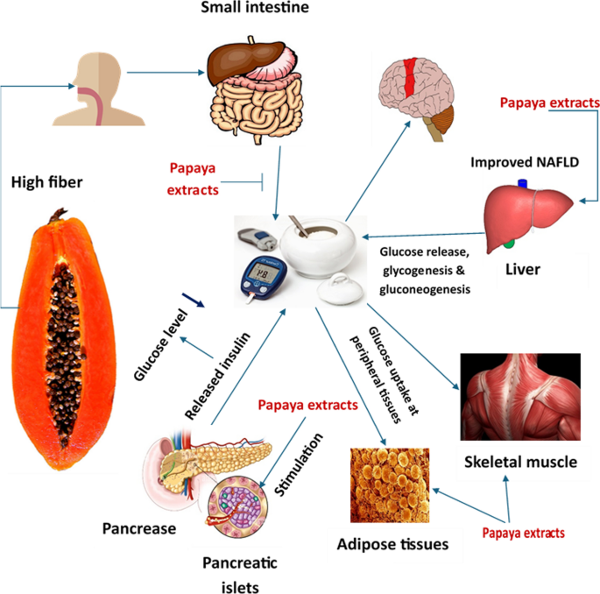
Figure 4: Anti-diabetic activity of phytochemicals derived from Carica papaya.
Ref: Ogunlakin et al., 2023.

2.3.4 Antioxidant activity
The antioxidants that provide the most defense are flavonoids combined with phenolic substances such as quercetin and gallic acid. Free radicals that cause oxidative stress receive elimination from antioxidants contributing to the prevention of heart disease and cancer and other related illnesses. The antioxidants protect cells and postpone aging by taking in dangerous free radicals (Kong et al., 2021).
2.3.5 Antimicrobial activity
Strong antibacterial qualities are exhibited by the alkaloids, saponins, and proteolytic enzymes (such as papain) present in unripe pawpaw water. The fruit may be used as a natural treatment for diseases since it prevents the growth of bacteria, viruses, and fungi. Additionally, these substances complement one another, strengthening the fruit's defenses against infections (Gupta et al., 2017).
2.4 Clinical Studies on the Pharmacological Properties of Carica papaya
The study conducted by Mahfujul et al. (2024) investigated physio-chemical properties and bioactive compounds along with antioxidant activity within three sections of ripe and unripe Carica papaya fruit. The researchers reported important variations existed between the two ripening stages because of differences in moisture content and pH along with ascorbic acid concentrations. Unripe Carica papaya demonstrated higher bulk density together with stronger swelling capacity along with more crude fibre content but ripe papaya displayed increased antioxidant properties. The multipurpose value of Carica papaya produces beneficial benefits for food applications as well as pharmaceuticals and cosmetics and agricultural operations.
A review controlled by Kumarasinghe et al. (2024) evaluated the medicinal elements of Carica papaya and its medical relevance in drug exploration. This study explained environmental influences on papaya medicine then it demonstrated therapeutic effects that apply to cancer treatment and diabetes management and wound care and gastrointestinal health. Research indicates that Carica papaya shows antibacterial and antiviral properties which make it a potential drug development candidate.
Benjamin et al. (2024) analysed papain thoroughly as they studied the pharmaceutical properties of papayas. The paper used several techniques to extract papain while analysing its medical and industrial applications and pharmaceutical usage. Through this study more emphasis was placed on papaya's active compounds which contains alkaloids with phenolics and flavonoids and terpenoids while showcasing its therapeutic capabilities to treat cancer and digestive diseases and anxiety disorders so scientists should continue researching to sustain its therapeutic benefits.
The research by Sharma et al. (2022) examined the medicinal features of papaya leaves including their antioxidant properties and their anticancer effects alongside their antidiabetic properties and their anti-inflammatory effects. Studies based on preclinical and clinical trials have demonstrated papaya leaves as herbal medicine for epidemic diseases yet researchers identified safety risks when using high concentration levels. The medical industry showed interest in the treatment possibilities of papaya leaves as an active therapeutic agent.
The research by Fasoyinu et al. (2019) examined the antibacterial activity of Carica papaya parts against enteric organisms through fermentation whereby, as time passed on, pH decreased whereas titratable acidity increased corresponding with elevated zones of inhibition on the 3rd and 5th days. This vindicates the possibility of fermented unripe Carica papaya water as a promising mechanism to curb some enteric diseases.
The research study by Kong et al. (2021) included a review of scientific investigations regarding papaya usage to control oxidative stress. A comprehensive analysis examined papaya's antioxidant elements including caffeic acid, myricetin and papain since these compounds support stress reduction via multiple pathways signalling. The research showed papaya has potential uses in medication or supplement form for managing oxidative stress-related diseases yet more testing must be done to understand how it can treat chronic diseases.
The contraceptive potentials of Carica papaya seed extract were investigated in the experiment of Memudu and Oluwole (2021) conducted with grown Wistar rats. The study was centred on the determination of effects of the extract on the oestrus cycle, progesterone concentrations and histomorphology of utero-ovarian tissues. The findings indicated that the papaya seed extract had an important effect on changing the oestrus cycle and lowering progesterone levels which implied a possibility of its contraceptive actions. Also, histology demonstrated that the structure of utero-ovarian tissue had been altered. The above results show that Carica papaya seed extract may be an alternative source of contraception in humans, but additional research is required to establish its effectiveness and safety.
2.5 Techniques for Evaluation of Bioactive Compounds in Fermented Water from Unripe Pawpaw
2.5.1 pH and titratable acidity
Measurement of both pH and titratable acidity (TA) is vital in the process of tracking fermentation because they help to either determine the extent of acid formation or general microbial activity. The pH represents the concentration of H + ions, giving an indication of the short-term acidic or alkaline nature of the medium whereas the TA gives a measure of total amount of acid on the basis of titration with standard alkali up to a specific endpoint, measuring both free and bound acids. When sugars are converted to organic acids in the process of fermentation, microorganisms including the lactic acid bacteria produce their characteristic drop in pH and rise in TA levels, which does not only indicate active fermentation but also serves to inhibit spoilage and pathogenic organisms (Abioye et al., 2024). In combination, the level of pH and TA can be used as convenient indicators that will allow you to monitor the course of the process and maintain the quality of the product.
2.5.2 Gas chromatography–Mass spectrometry (GC-MS)
The test sample analysis relies on Gas chromatography–Mass spectrometry (GC–MS) which integrates gas chromatographic capabilities with mass spectrometry for detecting different sample compounds. This analytical method (as described by Unuh et al., 2019) provides the same capability to detect small quantities of substances that liquid chromatography–mass spectrometry does. Experts choose the combination of GC-MS analysis for separating volatile and semi-volatile chemicals such as pesticides and steroids and fatty acids and hormones and alcohols and aromatics and hydrocarbons. The analysis combines GC with MS detectors to separate complex mixtures and perform chemical detections as well as unknown peak identification and trace contaminant level detection (Skarysz, 2018). The GC analytical method requires a sample vaporization step followed by carrier gas transportation of the sample through a glass capillary column which has a surface coating. The stationary phase exists at the inside of the column wall. Each compound in the test sample needs a particular duration known as retention time to pass through the column before the detector detects it for identification purposes. Gas Chromatography transfers the GC column's exiting substances to an MS instrument which applies electronic impact fragmentation to generate charged fragment components. The instrument detects these fragments which leads to identification of the compound through a generated mass spectrum. GC-MS functions as the preferred method to detect both volatile and semi-volatile chemical compounds. Mass spectrometry detects the mass-to--charge ratios of separated compounds in a sample after physical breaking of compounds occurs through the separation method. The analytic method GC-MS operates effectively to evaluate aromatic substances and essential oils found in pawpaw (Skarysz, 2018).
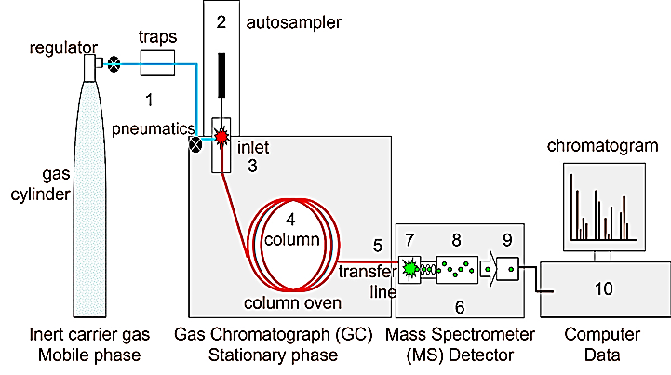
Figure 5: Instrumentation of Gas Chromatography-Mass Spectrometry (GC-MS).
Ref: Hübschmann et al., 2015

2.5.3 Fourier transform infrared (FTIR) spectroscopy
Fourier transform infrared spectroscopy (FTIR) is the process that acquires infrared spectrums of infrared absorption or emission by a solid or liquid or a gaseous substance. Spectra with high resolution are gathered simultaneously over a wide range of spectrum using an FTIR spectrometer. This device has got great advantages over the dispensation spectrometer which needs the intensity determination with wavelength-to-wavelength inspection. Real spectrum emergence from raw data can be achieved through the mathematical procedure which describes Fourier transform infrared spectroscopy. The FTIR technique determines the functional groups of a given sample based on application of infrared radiations in which the radiation absorption levels by resolvable bonds within the molecular bonds are obtained using various wavelengths. The approach will offer a survey of the molecular fingerprints of bioactive compounds allowing the identification of changes in the structures of chemical compounds during fermentation (Tsagkaris et al., 2023).

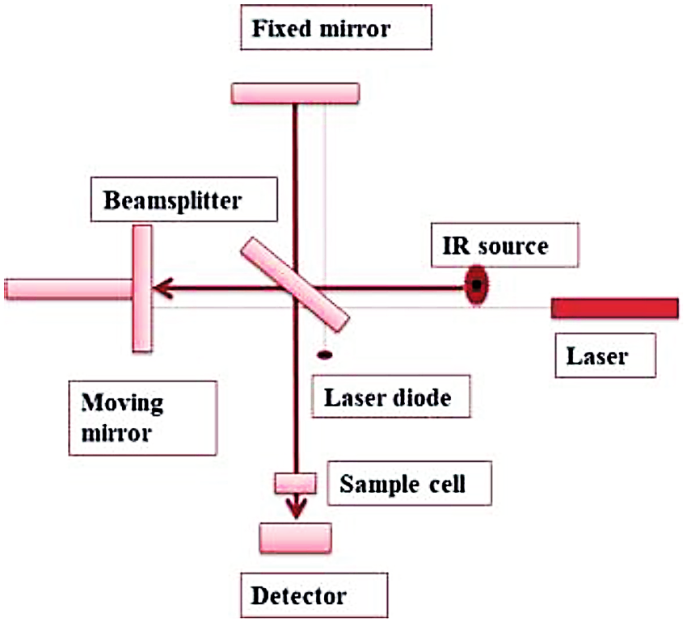
Figure 6: Schematic diagram of FTIR spectrometer.
Ref: Tsagkaris et al., 2023.

CHAPTER THREE
MATERIALS AND METHODS
3.1. Materials
3.1.1 Biological Material
Unripe Carica papaya fruits
3.1.2. Chemical and Reagent
- Distilled water
- Sodium hydroxide
- Phenolphthalein
3.1.3. Equipment and Apparatus
- Weighing balance
- Beakers, Conical flask, filter paper, funnel, burette, Cylinders, PH paper.
- A Bucket
- FTIR-8400S spectrophotometer (Shidmazu model)
- Thermo Scientific™ TRACE™ 1310 Gas Chromatograph coupled to an ISQ™ 7000 Single Quadrupole Mass Spectrometer (Germany)
- B’U’CHI LyovaporTM lyophilizer (L-300, Switzerland)
  - Methods
3.2.1. Collection of Sample
Unripe Carica papaya fruits were sampled from a pawpaw plantation located at Federal Government College, Isiuzo Street, Independence Layout, Enugu state, Nigeria. Although formal taxonomic identification was not carried out, the fruits were morphologically consistent with unripe Carica papaya based on existing literature and visual guides. The fruit was selected based on morphological characteristics such as green skin, firm texture, and absence of any sign of ripening.
3.2.2 Preparation of sample Extract
The Carica papaya fruits (4) were washed thoroughly with clean water sliced into small pieces, the seeds separated from the unpeeled pulp. Approximately 2612.32g of the sliced fruit was placed in a container (a bucket with a lid), 3000ml of distilled water was added. The container was covered tightly - under these factors; nutrient availability, temperature, oxygen levels and microorganisms present – at room temperature (20ºC – 25ºC) for 12 days. Samples of the water extract were collected on days 3, 6, 9 and 12, stored in a labelled beaker – Day 3, Day 6, Day 9, Day 12 (200ml each) - placed in the refrigerator (4ºC).
3.2.3. GC-MS Analysis of Fermented water extract from unripe Carica papaya
Gas Chromatography–Mass Spectrometry (GC-MS) was employed to separate volatile constituents based on their retention times in the gas chromatograph, followed by identification through analysis of their mass-to-charge ratios using a mass spectrometer. About 5.0 mL each of the fermented water samples derived from unripe pawpaw (Carica papaya) at Day 3, Day 6, Day 9, and Day 12 were subjected to freeze-drying with a B’U’CHI Lyovapor™ lyophilizer (L-300, Switzerland), yielding approximately 0.25 mg of dried solid extract. Precisely 0.20 g of this lyophilized extract was weighed and dissolved in 2.0 mL of n-hexane (equivalent to a 1:10 w/v ratio) to prepare it for GC-MS analysis. The resulting solution was vortexed for 2 minutes and then filtered through a 0.22 µm PTFE syringe filter into a 2 mL amber GC vial. The GC-MS analysis was carried out using a Thermo Scientific™ TRACE™ 1310 Gas Chromatograph coupled with an ISQ™ 7000 Single Quadrupole Mass Spectrometer (Germany). A TG-5MS capillary column (30 m × 0.25 mm internal diameter, 0.25 µm film thickness) was utilized, operating at a pressure of 100.00 kPa, with high-purity helium serving as the carrier gas at a steady flow rate of 1.0 mL/min. The injection was performed in split-less mode with an injection volume of 1 µL, and the total run time was 48 minutes. The oven temperature program began at 40°C (maintained for 5 minutes), increased at 10 °C/min to reach 80 °C (held for 3 minutes), and then ramped at 5 °C/min up to 250 °C, where it remained until the run concluded. The injector, mass transfer line, and ion source temperatures were maintained at 150°C, 250°C, and 200°C, respectively. Detection was executed in electron ionization (EI) mode at 70eV, scanning a mass range from m/z 50 to 600. Compound identification was achieved by matching the obtained mass spectra with those in the NIST/EPA/NIH Mass Spectral Library (NIST 2017).
3.2.4. FTIR Spectroscopy Analysis of fermented water extract from unripe Carica papaya
FTIR analysis was performed using a Shidmazu FTIR-8400S spectrophotometer at the Central Science Laboratory, University of Nigeria, Nsukka. Samples were prepared as thin films between two potassium bromide discs by placing a drop of the liquid paste on each disc. Spectra were recorded in the infrared region (1.20 × 10¹³–1.20 × 10¹⁴ Hz) and reported as absorption bands in cm⁻¹.
3.2.5. pH and Titratable acidity
pH measures the concentration of hydrogen ions and gives an indication on whether a solution is acidic or alkaline. Titratable acidity (TA) quantifies the total amount of acids present by neutralizing them with a standard base, usually NaOH. While pH reflects the intensity of acidity, TA provides a more accurate measure of total acid content, making both essential for monitoring fermentation and microbial activity.
The unripe Carica papaya aqueous extract was collected from the container for each day and the following parameters was measured; pH and titration and titratable acidity. Measure the pH value for Day 0,3,6,9 & 12 using a pH paper (model or manufacturer). Titration was carried out using 50ml of 0.25N NaOH as base and 5ml of the sample as acid.
Procedure; Indicator: Phenolphthalein
- The tripod stand and burette containing 50ml of NaOH was set up.
- In a conical flask, 5ml of the sample extract was added followed by 4 drops of phenolphthalein (Day 9 and 12 – 6 drops).
- Sufficient NaOH was added to the conical flask until an end point is observed (change from colorless to pink).
- The amount of the base used in total was registered. This was done and results were noted as titre 1, titre 2 and titre 3 after which the average titre value was obtained. This was repeated for the samples for Day 3, 6, 9 and 12. (Fasoyinu et al., 2019).

CHAPTER FOUR
RESULTS
4.1. Gas Chromatography – Mass Spectrometry(GC-MS) Analysis
4.1.1. Biologically Active Chemical Compounds Present in the Day 3 water extract of unripe Carica papaya
The compounds present in day 3 of fermenting water from unripe Carica papaya were identified by GC-MS analysis. Spectrogram showing the peak identities of the compound is presented in appendix 5. Active principles with their Retention Time (RT), Molecular Formula (MF), Concentration (%) are presented in Table 4.1.1. Two hundred and twenty-one compounds were identified in this sample. However, many compounds were repeatedly identified at different retention times but the bioactive compounds identified are presented in Table 4.1.1.

Table 4.1.1: Biologically active chemical compounds present in the Day 3 water extract of unripe Carica papaya
Name of compounds  (molecular formula) | Chemical  Structure | Retention  time (min) | %
Undecane  (C₁₁H₂₄) | 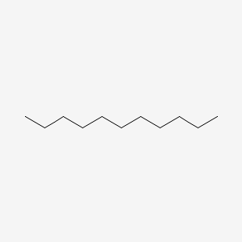 | 2.98 | 0.24
Tridecane  (C₁₃H₂₈) | 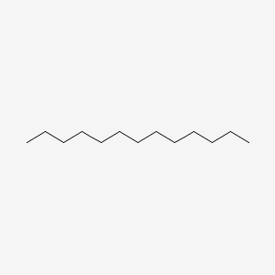 | 3.01 | 0.26
Ethylbenzene (C₈H₁₀) | 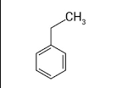 | 3.21 | 2.48
o-Xylene (C₈H₁₀) | 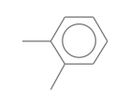 | 3.79 | 5.07
Dodecane  (C₁₂H₂₆) | 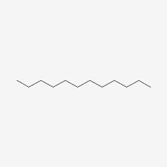 | 5.66 | 0.38
Benzene, 1,2,4-trimethyl- (C₉H₁₂) | 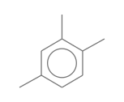 | 6.66 | 3.79
o-Cymene  (C₁₀H₁₄) | 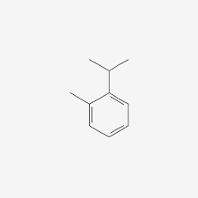 | 7.40 | 0.58
Benzene, 1,2,3-trimethyl- (C₉H₁₂) | 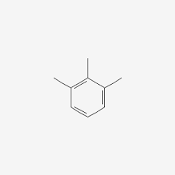 | 7.86 | 3.36
Benzoic acid  (C₇H₆O₂) | 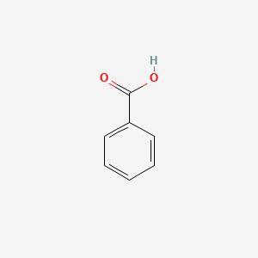 | 30.44 | 0.32
5-Hydroxymethylfurfural (HMF) (C₆H₆O₃) | 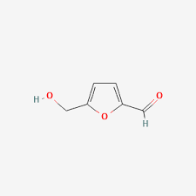 | 31.21 | 0.21
Palmitic acid (n-Hexadecanoic acid) (C₁₆H₃₂O₂) | 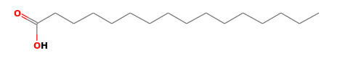 | 34.17 | 0.49
l-(+)-Ascorbic acid 2,6-dihexadecanoate  (C₃₈H₆₈O₈) | 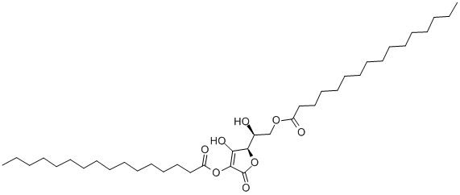 | 34.38 | 3.22
2,4,6-Decatrienoic acid ester  (C₃₅H₄₆O₈) | 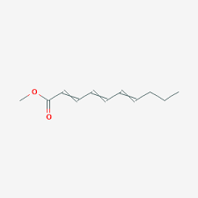 | 35.00 | 0.10
Squalene  (C₃₀H₅₀) | 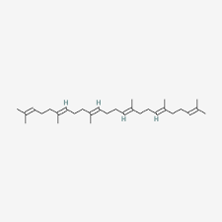 | 35.48 | 0.64
Octadecanoic acid (Stearic acid) (C₁₈H₃₆O₂) | 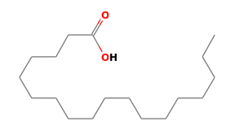 | 35.94 | 2.11
cis-Vaccenic acid (C₁₈H₃₄O₂) | 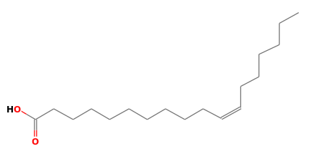 | 36.23 | 6.30
Linoelaidic acid  (C₁₈H₃₂O₂) | 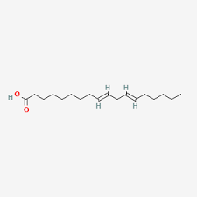 | 36.61 | 1.68
9(E),11(E)-Conjugated linoleic acid (C₁₈H₃₂O₂) | 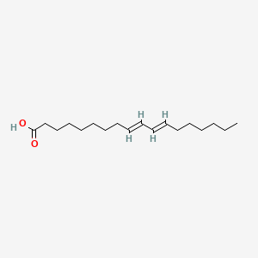 | 36.76 | 4.76
{1,1-Bicyclopropyl}-2-octanoic acid ester  (C₂₁H₃₈O₂) | 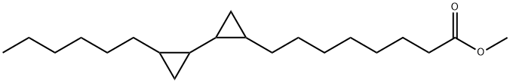 | 36.96 | 0.17
Eicosanoic acid (Arachidic acid) (C₂₀H₄₀O₂) | 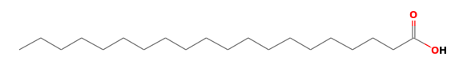 | 38.13 | 1.33
cis-13-Eicosenoic acid (C₂₀H₃₈O₂) | 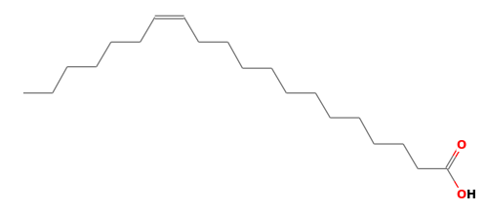 | 38.51 | 1.40

4.1.2. Biologically Active Chemical Compounds Present in the Day 6 water extract of unripe Carica papaya
The compounds present in day 6 of fermenting water from unripe Carica papaya were identified by GC-MS analysis. Spectrogram showing the peak identities of the compound is presented in appendix 6. Active principles with their Retention Time (RT), Molecular Formula (MF), Concentration (%) are presented in Table 4.1.2. Two hundred and thirty-nine compounds were identified in this sample. However, many compounds were repeatedly identified at different retention times but the bioactive compounds identified are presented in Table 4.1.2.

Table 4.1.2: Biologically active chemical compounds present in the Day 6 water extract of unripe Carica papaya
Name of compounds  (molecular formula) | Chemical  Structure | Retention  time (min) | %
O-xylene  (C₈H₁₀) |  | 3.43 | 0.22
- Butanol  (C₄H₁₀O) | 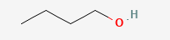 | 4.80 | 1.73
Acetic Acid (C₂H₄O₂) | 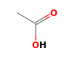 | 14.36 | 3.35
Butanoic acid (C₄H₈O₂) | 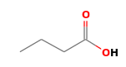 | 20.43 | 7.88
Methyltartronic acid (C₄H₆O₅) | 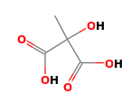 | 28.18 | 6.22
L-Lactic acid (C₃H₆O₃) | 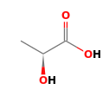 | 28.21 | 2.00
4 H-pyran-4-one  (C₆H₈O₄) | 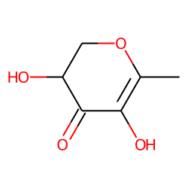 | 29.04 | 1.36
Benzoic acid  (C₇H₆O₂) |  | 30.43 | 1.22
l-(+)-Ascorbic acid 2,6-dihexadecanoate (C₃₈H₆₈O₈) | 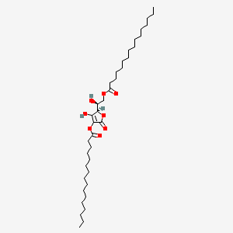 | 34.33 | 6.70
Squalene  (C₃₀H₅₀) |  | 35.48 | 0.64
Octadecanoic acid (C₁₈H₃₆O₂) |  | 35.94 | 5.27
cis-13-Octadecanoic acid (C₁₈H₃₄O₂) | 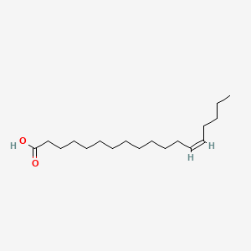 | 36.23 | 11.28
9(E),11(E)-Conjugated linoleic acid (C₁₈H₃₂O₂) |  | 36.76 | 9.25
Eicosanoic acid (C₂₀H₄₀O₂) |  | 38.13 | 2.52
cis-13-Eicosenoic acid (C₂₀H₃₈O₂) |  | 38.53 | 3.93

4.1.3. Biologically Active Chemical Compounds Present in the Day 9 water extract of unripe Carica papaya
The compounds present in day 9 of fermenting water from unripe Carica papaya were identified by GC-MS analysis. Spectrogram showing the peak identities of the compound is presented in appendix 7. Active principles with their Retention Time (RT), Molecular Formula (MF), Concentration (%) are presented in Table 4.1.3. Two hundred and twenty-five compounds were identified in this sample. However, many compounds were repeatedly identified at different retention times but the bioactive compounds identified are presented in Table 4.1.3.

Table 4.1.3: Biologically active chemical compounds present in the Day 9 water extract of unripe Carica papaya
Name of compounds  (molecular formula) | Chemical  Structure |  |  | Retention  time (min) |  | %
Ethylbenzene (C₈H₁₀) |  |  |  | 3.17 |  | 1.77
o-Xylene (C₈H₁₀) |  |  |  | 4.81 |  | 3.62
Benzene, 1-ethyl-2-methyl- (C₉H₁₂) | 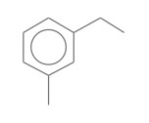 |  |  | 6.10 |  | 4.99
Benzene, 1,2,3- trimethyl-(C₉H₁₂) |  |  |  | 6.71 |  | 3.21
Benzene, 1,2,3- trimethyl-(C₉H₁₂) |  |  |  | 7.91 |  | 4.02
Methyltartronic acid (C₄H₆O₅) |  |  | 28.15 |  | 1.53
Benzoic acid (C₇H₆O₂) |  |  | 30.43 |  | 0.25
l-(+)-Ascorbic acid 2,6-dihexadecanoate (C₃₈H₆₈O₈) |  |  |  | 34.31 |  | 2.07
Squalene (C₃₀H₅₀) |  |  |  | 35.46 |  | 0.19
Octadecanoic acid (C₁₈H₃₆O₂) |  |  |  | 35.94 |  | 5.27
cis-13-Octadecenoic acid (C₁₈H₃₄O₂) | 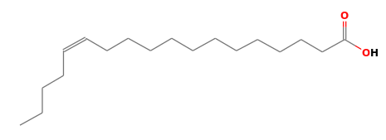 |  |  | 36.22 |  | 3.76
9(E),11(E)-Conjugated linoleic acid (C₁₈H₃₂O₂) |  |  |  | 36.74 |  | 3.32
Eicosanoic acid (C₂₀H₄₀O₂) |  |  |  | 38.11 |  | 0.92
cis-13-Eicosenoic acid (C₂₀H₃₈O₂) |  |  |  | 38.51 |  | 1.51

4.1.4. Biologically Active Chemical Compounds Present in the Day 12 water extract of unripe Carica papaya
The compounds present in day 12 of fermenting water from unripe Carica papaya were identified by GC-MS analysis. Spectrogram showing the peak identities of the compound is presented in appendix 8. Active principles with their Retention Time (RT), Molecular Formula (MF), Concentration (%) are presented in Table 4.1.4. Two hundred and six compounds were identified in this sample. However, many compounds were repeatedly identified at different retention times but the bioactive compounds identified are presented in Table 4.1.4.

Table 4.1.4: Biologically active chemical compounds present in the Day 12 water extract of unripe Carica papaya
Name of compounds  (molecular formula) | Chemical  Structure | Retention  time (min) | %
Ethylbenzene (C₈H₁₀) |  | 3.17 | 1.53
o-Xylene (C₈H₁₀) |  | 3.54 | 5.09
Benzene, 1-ethyl-3-methyl- (C₉H₁₂) |  | 6.12 | 5.23
Benzene, 1,2,3- trimethyl-(C₉H₁₂) |  | 6.73 | 3.18
Benzene, 1,2,3- trimethyl-(C₉H₁₂) |  | 7.93 | 3.95
Methyltartronic acid (C₄H₆O₅) |  | 28.14 | 0.90
Benzoic acid (C₇H₆O₂) |  | 30.43 | 0.18
l-(+)-Ascorbic acid 2,6-dihexadecanoate (C₃₈H₆₈O₈) |  | 34.30 | 1.62
Squalene (C₃₀H₅₀) |  | 35.46 | 0.17
Octadecanoic acid (C₁₈H₃₆O₂) |  | 35.92 | 1.46
cis-13-Octadecenoic acid (C₁₈H₃₄O₂) |  | 36.21 | 3.41
9(E),11(E)-Conjugated linoleic acid (C₁₈H₃₂O₂) |  | 36.73 | 2.80
Eicosanoic acid (C₂₀H₄₀O₂) |  | 38.10 | 0.84
cis-13-Eicosenoic acid (C₂₀H₃₈O₂) |  | 38.50 | 1.44

4.2. Fourier Transform Infrared Spectroscopy (FTIR) Result
4.2.1. FTIR Frequency Range and Functional Groups Present in the Day 3 water extract of unripe Carica papaya
Day 3 spectra (Table 4.2.1 and appendix 1) revealed strong absorption peak at a frequency of 1639.49, 1528.70, 1158.39, 1089.80 and 665.12cm⁻¹ assigned to alkenes, nitrites and alcohols. Other peaks indicate presence of phenols and alcohols.

Table 4.2.1. FTIR frequency range and functional groups present in the Day 3 water extract of unripe Carica papaya
Wave number (cm⁻¹) | Functional groups  (vibration mode) | Possible compounds present
3277.50  1639.49  1528.70  1323.67  1158.39  1089.80  665.12 | O-H str. (br)  C=C str. (s)  N-O str. (s)  O-H bending (m)  C-O str. (s)  C-O str. (s)  C=C bending (s) | Alcohols  Alkenes  Nitro compound  Phenols  Alcohols  Alcohols  Alkene
Key: w: weak, m: medium, s: strong, str.: stretching, br: broad

4.2.2. FTIR Frequency Range and Functional Groups Present in the Day 6 water extract of unripe Carica papaya
Day 6 spectra (Table 4.2.2 and appendix 2) revealed strong absorption peak at a frequency of 2041.30 and 516.89cm⁻¹ assigned to N=C=S of Isothiocyanate and C-Br of halo compounds respectively. Other peaks indicate presence of Carboxylic acid and alkenes.

Table 4.2.2: FTIR frequency range and functional groups present in the Day 6 water extract of unripe Carica papaya
Wave number (cm⁻¹) | Functional groups  (vibration mode) | Possible compounds present
3259.86  2041.30  1633.93  516.89 | O-H str. (br)  N=C=S str. (s)  C=C str. (m)  C-Br str. (s) | Carboxylic acid  Isothiocyanate  alkene  Halo compound
Key: w: weak, m: medium, s: strong, str.: stretching, br: broad

4.2.3. FTIR Frequency Range and Functional Groups Present in the Day 9 water extract of unripe Carica papaya
Day 9 spectra (Table 4.2.3 and appendix 3) revealed strong absorption peak at a frequency of 1639.49cm⁻¹ assigned to O=C=O of Carbon dioxide. Other peaks indicate presence of alcohols and alkenes.

Table 4.2.3: FTIR frequency range and functional groups present in the Day 9 water extract of unripe Carica papaya
Wave number (cm⁻¹) | Functional groups  (vibration mode) | Possible compounds present
3273.63  1639.49  1528.70 | O-H str. (br)  O=C=O str. (s)  C=C str. (m) | Alcohols  Carbon dioxide  Alkene
Key: w: weak, m: medium, s: strong, str.: stretching, br: broad

4.2.4. FTIR Frequency Range and Functional Groups Present in the Day 12 water extract of unripe Carica papaya
Day 12 spectra (Table 4.2.4 and appendix 4) revealed strong absorption peak at a frequency of 2358.37, 1636.63, 1159.54 and 1090.14cm⁻¹ assigned to carbon dioxide, sulfonamide and alcohols.

Table 4.2.4. FTIR frequency range and functional groups present in the Day 12 water extract of unripe Carica papaya
Wave number (cm⁻¹) | Functional groups  (vibration mode) | Possible compounds present
3276.79  2358.37  1636.63  1159.54  1090.14 | O-H str. (br)  O=C=O str. (s)  S=O str. (s)  C-O str. (s)  C-O str. (s) | Alcohols  carbon dioxide  Sulfonamide  Alcohols  Alcohols
Key: w: weak, m: medium, s: strong, str.: stretching, br: broad

4.3. pH and Titratable Acidity
Table 4.3.1. pH and Titratable Acidity of Aqueous Carica papaya Extract over Time
DAYS | pH | Titratable Acidity
Day 0 | 6.0 | 1.33
Day 3 | 6.0 | 5.17
Day 6 | 5.0 | 5.67
Day 9 | 5.0 | 6.73
Day 12 | 5.0 | 6.82

Figure 7: pH and Titratable Acidity
The level of acidity increased with an increase in the numbers of fermenting days. The pH decreases from about 6.0 to 5.0. The titratable acidity of the fermenting water from pawpaw increases with time from 1.33 to 6.82.

CHAPTER FIVE
DISCUSSION AND CONCLUSION
5.1 Discussion
This study investigated the bioactive composition of water extracts from unripe Carica papaya after soaking over a twelve-day period, with the aim of identifying compounds of therapeutic and nutritional importance and elucidating their structural characteristics. By systematically analysing GC-MS profiles, FTIR spectra, and changes in acidity, the research provides compelling evidence that supports both traditional uses and novel prospects for this plant extract in health applications (Khairunnisa et al., 2021; Yong et al., 2022).
GC-MS analysis on Day 3 extract revealed diverse bioactive compounds in the Carica papaya water extract, including nonpolar hydrocarbons (undecane, dodecane, tridecane) and aromatic compounds (ethylbenzene, o-xylene, trimethylbenzenes), which support antimicrobial activity. Benzoic acid reinforces this property, while 5-hydroxymethylfurfural (HMF) indicates carbohydrate degradation. Detected esters like l-(+)-ascorbic acid 2,6-dihexadecanoate and unique long-chain esters may serve antioxidant or novel pharmacological roles. Fatty acids such as palmitic, stearic, cis-vaccenic, and CLA imply anti-inflammatory, lipid-regulating, and wound-healing benefits, aligning with traditional gastrointestinal and skin uses. Day 3 FTIR spectra showed strong absorptions at 3277.50 cm⁻¹ (O–H stretch, alcohols/phenols), 1639.49 cm⁻¹ (C=C, alkenes/aromatics), and 1528.70 cm⁻¹ (N–O, nitro groups), along with C–O stretches at 1158.39 and 1089.80 cm⁻¹, supporting the presence of ascorbic acid esters and fatty acid esters detected in GC-MS.
Day 6 extract showed a notable shift, with high levels of organic acids (acetic, butanoic, methyltartronic, lactic) that promote gut health by lowering intestinal pH and supporting beneficial microbiota. The extract also had the highest content of l-(+)-ascorbic acid 2,6-dihexadecanoate (6.70%), emphasizing antioxidant potential. Elevated levels of octadecanoic, cis-13-octadecenoic acids, and CLA suggest anti-inflammatory and cholesterol-regulating effects. Persistent compounds like o-xylene, squalene, benzoic acid, and methyltartronic acid add therapeutic value, with squalene notably supporting antioxidant and skin healing activities. FTIR spectra on Day 6 revealed peaks at 2041.30 cm⁻¹ (N=C=S of isothiocyanates) and 516.89 cm⁻¹ (C–Br halo compounds), indicating the presence of chemoprotective isothiocyanates known for detoxifying properties.
Day 9 extract consistently contained ethylbenzene, o-xylene, benzene ethyl-methyl derivatives, benzoic acid, methyltartronic acid, l-(+)-ascorbic acid esters, squalene, and key fatty acids. Although ascorbic acid esters slightly declined (~2.07%) from their Day 6 peak, this suggests stabilization of antioxidant levels. The extract at this stage represents a mature blend where phenolic acids, PUFAs, and antioxidants may synergistically deliver antimicrobial, gut-soothing, and antioxidant benefits aligning with traditional uses of Carica papaya water for digestion and immune support. FTIR spectra on Day 9 continued to show prominent O–H (3273.63 cm⁻¹) and C=C (1639.49 cm⁻¹) absorptions, confirming the sustained presence of alcohols, phenols, and aromatics that underpin its bioactivities.
By Day 12, the extract maintained a rich profile of bioactives, including ethylbenzene, o-xylene, benzene derivatives, benzoic acid, squalene, and key fatty acids like octadecanoic acid, CLA, cis-13-octadecenoic, eicosanoic, and cis-13-eicosenoic acids. Although ascorbic acid esters decreased to ~1.62%, their persistence suggests ongoing antioxidant activity. This stable composition of fatty acids, aromatics, and antioxidants after twelve days points to a biochemical equilibrium, supporting the traditional use of prolonged Carica papaya water preparations for gut health, oxidative stress reduction, and systemic resilience. Day 12 FTIR spectra showed absorptions at 2358.37 cm⁻¹ (O=C=O of CO₂ derivatives), 1636.63 cm⁻¹ (S=O of sulfonamides), and strong C–O stretches, indicating sustained alcohols and esters. The presence of sulfonamides also suggests added antibacterial potential.
The increase in titratable acidity from 1.33 to 6.82 mL NaOH and the pH drop from 6.0 to 5.0 over six days indicate the formation of souring agents during soaking. This likely results from the action of natural enzymes like papain, which break down complex compounds into simpler organic acids. Such acidification not only enhances the extraction of bioactive phenolics and fatty acids but also creates conditions unfavorable to pathogens, supporting the traditional use of Carica papaya water for digestive health (Nur & Abdillah, 2022; Louis et al., 2022).
Across all days, FTIR and GC-MS analyses consistently revealed a core suite of bioactive compounds—including ethylbenzene, o-xylene, benzoic acid, squalene, key fatty acids, and l-(+)-ascorbic acid esters—alongside stable functional groups such as O–H, C–O, and C=C stretches, indicating persistent alcohols, phenols, esters, and alkenes. This chemical consistency demonstrates that simple water extraction over time reliably concentrates a balanced mix of antimicrobial, antioxidant, and anti-inflammatory constituents from unripe Carica papaya. The progressive build-up of short-chain organic acids supports traditional digestive and gut microbiota benefits, while sustained phenolic acids, benzenes, PUFAs, and squalene underline roles in wound healing, cardiovascular health, and oxidative stress protection. FTIR detection of N=C=S and S=O stretches further suggests minor isothiocyanate and sulfonamide formations, enhancing the antimicrobial profile. Altogether, these findings scientifically validate the traditional use of prolonged Carica papaya water preparations, confirming that such extracts achieve a stable biochemical composition that preserves their therapeutic potential throughout fermentation.
GC-MS analysis also revealed several unusual compounds likely formed during fermentation, including 2,4,6-decatrienoic acid ester (0.10%) and [1,1′-bicyclopropyl]-2-octanoic acid ester (0.17%) on Day 3, 4H-pyran-4-one derivatives (0.56%) and 1,2-benzenedicarboxylic acid ester (0.21%) on Day 6, and notably high l-(+)-ascorbic acid 2,6-dihexadecanoate (2.76%) on Day 9, with long-chain ascorbic acid esters persisting into Day 12. Their novel profiles suggest potential antioxidant, lipid-regulating, or antimicrobial roles. However, further structural and functional studies are recommended to confirm their health benefits and expand the pharmacological value of fermented unripe Carica papaya extracts (Chen et al., 2023; Yong et al., 2022). The findings of this study align with previous research on Carica papaya by confirming key fatty acids, phenolic acids, and squalene with known antioxidant, anti-inflammatory, and antimicrobial roles, similar to reports by Yong et al. (2022) and Khairunnisa et al. (2021). The rise in short-chain organic acids also matches trends seen by Nur and Abdillah (2022), supporting traditional digestive benefits. However, unlike many studies using alcoholic extracts, this work’s simple prolonged water soaking revealed unusually high levels of long-chain ascorbic acid esters and rare compounds like 2,4,6-decatrienoic acid ester and [1,1′-bicyclopropyl]-2-octanoic acid ester. This suggests that extended aqueous extraction may drive unique biochemical transformations, offering new avenues to explore Carica papaya as a source of potentially unusual therapeutic compounds (Chen et al., 2023).
5.2 Conclusion
This study set out to explore the structure-related bioactive composition of water extracts from unripe Carica papaya soaked over 12 days, aiming to scientifically validate traditional claims of benefits for digestion, immunity, and wound healing. Through careful tracking of physicochemical changes, comprehensive GC-MS profiling, and supportive FTIR analysis, the research demonstrated that simple water extraction effectively mobilizes a wide spectrum of bioactive compounds. The steady drop in pH (6.0 to 5.0) and rise in titratable acidity (1.33 to 6.82 mL NaOH) pointed to significant biochemical activity, likely driven by natural enzymes like papain, enhancing both extraction efficiency and antimicrobial conditions. GC-MS findings showed an evolving yet stabilizing profile: early extracts were rich in aromatic hydrocarbons, benzoic acid, and distinctive long-chain ascorbic acid esters; by Day 6, there was notable accumulation of short-chain organic acids and bioactive fatty acids; by Day 12, these compounds balanced into a stable complex known to support gut health, combat oxidative stress, and aid immune modulation. FTIR spectra consistently confirmed functional groups tied to alcohols, phenols, esters, alkenes, isothiocyanates, and sulfonamides. Notably, the convergence of repeated compound detection in GC-MS, stable FTIR patterns, and plateauing pH and acidity between Days 9 and 12 indicates the extract reached a steady chemical state, underscoring its reliable bioactive profile. These findings not only validate traditional practices but also suggest potential for developing functional foods or phytotherapeutics from unripe papaya. Nonetheless, limitations including uncontrolled natural fermentation, semi-quantitative GC-MS, absence of advanced structural confirmation (like NMR), and lack of direct bioactivity assays highlight the need for deeper investigations to fully establish these promising properties.
5.3 Recommendations
Future research should aim to isolate and fully characterize the unusual compounds detected in this study—such as 2,4,6-decatrienoic acid ester, [1,1′-bicyclopropyl]-2-octanoic acid ester, and long-chain ascorbic acid esters—using advanced techniques like NMR to confirm their structures and explore their specific pharmacological activities. Conducting extractions under controlled sterile conditions is also advised to clearly distinguish the roles of inherent plant enzymes from incidental microbial contributions. Moreover, direct in vitro and in vivo assays, along with toxicity evaluations, are essential to experimentally substantiate the antioxidant, antimicrobial, and anti-inflammatory potentials of both the crude extract and individual compounds, thereby ensuring safety and efficacy. This study significantly advances scientific understanding by demonstrating that simple water soaking over a twelve-day period can effectively extract and even facilitate the transformation of diverse bioactive compounds from unripe Carica papaya, many of which align with traditional claims related to digestive health, microbial control, and oxidative stress protection. Notably, it offers the first documentation of potentially uncommon constituents in such aqueous extracts and reveals how acidity and chemical profiles evolve over time, providing practical insights for optimizing preparation. Collectively, these findings not only validate indigenous practices but also lay a strong foundation for future research into developing functional foods and phytotherapeutic products derived from unripe Carica papaya fermented water extracts.

REFERENCES
Abioye, A. O., Eze, V. C., and Oludairo, O. O. (2024). Fermentation of cereal-based foods: Impacts on pH, titratable acidity and microbial quality. Annals of Microbiology, 74(1), 52–61.
Agada, R., Usman, W. A., Shehu, S., and Thagariki, D. (2020). In vitro and in vivo inhibitory effects of Carica papaya seed on α-amylase and α-glucosidase enzymes. Heliyon, 6(3), e03618.
Alam, M., Hasan, M. M., Debnath, M. K., Alam, A., Zahid, M. A., Alim, M. A., Rahman, M. N., Molla, M. M., Khan, M. R., and Biswas, M. (2024). Characterization and evaluation of flour's physico-chemical, functional, and nutritional quality attributes from edible and non-edible parts of papaya. Journal of Agriculture and Food Research, 15, 100961.
Ali, M., Khan, T., Fatima, S., Ovais, M., and Khalil, A. T. (2020). Phytochemicals and biological activities of Carica papaya: A review. Journal of Traditional and Complementary Medicine, 10(5), 495–507.
Al Juhaimi, F., Uslu, N., Özcan, M. M., Gülcü, M., Ahmed, I. A. M., Alqah, H. A. S., Osman, M. A., and Gassem, M. A. (2019). Effect of fermentation on antioxidant activity and phenolic compounds of the leaves of five grape varieties. Journal of Food Processing and Preservation, 43(7), e13979.
Alara, O. R., Abdurahman, N. H. and Alara, J. A. (2022). Carica papaya: comprehensive overview of the nutritional values, phytochemicals and pharmacological activities. Advances in Traditional Medicine, 22, 17–47.
Alzate-Yepes, T., Pérez-Palacio, L., Martínez, E., and Osorio, M. (2023). Mechanisms of Action of Fruit and Vegetable Phytochemicals in Colorectal Cancer Prevention. Molecules, 28(11), 4322.
Amin, A. H. (2021). Ameliorative effects of Carica papaya extracts against type II diabetes-induced myocardial pathology and dysfunction in albino rats. Environmental Science and Pollution Research, 28(41), 58232-58240.
Aravind G, Debjit B, Duraivel S, Harish G. (2013) Traditional and medicinal uses of Carica papaya. J Med Plants Stud; 1(1): 7-15.
Atanu, F. O., Idih, F. M., Nwonuma, C. O., Hetta, H. F., Alamery, S., and El-Saber Batiha, G. (2021). Evaluation of antimalarial potential of extracts from Alstonia boonei and Carica papaya in Plasmodium berghei-infected mice. Evidence-Based Complementary and Alternative Medicine, 2021, 2599191.
Benjamin, A. B., Amos, I. A., Adebisi, A. O., Gboyega, E. A., Oluwabukunmi, B. and Chekwube, N. (2024). Therapeutic benefits of Carica papaya: A review on its pharmacological activities and characterization of papain. Arabian Journal of Chemistry, 17(1), 105369.
Cao, Y., Lai, K. M., Fu, K. C., Kuo, C. L., Tan, Y. J., Yu, L. L., et al. (2024). Dual functionality of papaya leaf extracts: Anti-coronavirus activity and anti-inflammation mechanism. Foods, 13(20), Article 3274.
Chen, Q., Zhao, Y., Sun, X., Wang, J., and Liu, L. (2023). Biological roles of 5-hydroxymethylfurfural in plant extracts and its health implications. Plant Foods for Human Nutrition, 78(1), 12–19.
Choudhary, R., Kaushik, R., Chawla, P., and Manna, S. (2025). Exploring the extraction, functional properties, and industrial applications of papain from Carica papaya. Journal of the Science of Food and Agriculture, 105(3), 1533–1545.
Dada, F. A. (2013). Phytochemical and antioxidant analysis of aqueous extracts of unripe pawpaw (Carica papaya Linn.) fruit’s peel and seed. International Journal of Medicinal and Aromatic Plants, 3(1), 125-130. (Accessed: 22 March 2025).
Donadio, G., Mensitieri, F., Santoro, V., Parisi, V., Bellone, M. L., De Tommasi, N., Izzo, V., and Dal Piaz, F. (2021). Interactions with Microbial Proteins Driving the Antibacterial Activity of Flavonoids. Pharmaceutics, 13(5), 660.
El Sheikha, A. F., and Ray, R. C. (2017). Fermented food and beverages: General aspects and future prospects. In A. F. El Sheikha, R. C. Ray, and S. A. Y. Youssef (Eds.), Fermented food: Part I: Biochemistry and biotechnology (pp. 1-47). CRC Press.
Encyclopaedia Britannica, Inc. (2025, March 27). Fermentation. Encyclopaedia Britannica.
Fasakin, O. W., Oboh, G., Ademosun, A. O., and Lawal, A. O. (2022). The modulatory effects of alkaloid extracts of Cannabis sativa, Datura stramonium, Nicotiana tabacum and male Carica papaya on neurotransmitter, neurotrophic and neuroinflammatory systems linked to anxiety and depression. Inflammopharmacology, 30(6), 2447–2476.
Fasoyinu, B. T., Oyetayo, O. V., and Ajayi, A. T. (2019). Antibacterial activity of fermenting unripe pawpaw parts (Carica papaya) against some enteric bacteria. International Journal of Pathogen Research, 3(2), 1–10.
Gautam, G., Parveen, B., Umar Khan, M., Sharma, I., Kumar Sharma, A., Parveen, R., and Ahmad, S. (2021). A systematic review on nephron protective AYUSH drugs as constituents of NEERI-KFT (A traditional Indian polyherbal formulation) for the management of chronic kidney disease. Saudi journal of biological sciences, 28(11), 6441–6453
Gudimella, K. K., Gedda, G., Kumar, P. S., Babu, B. K., Yamajala, B., Rao, B. V., Singh, P. P., Kumar, D., and Sharma, A. (2022). Novel synthesis of fluorescent carbon dots from bio-based Carica papaya Leaves: Optical and structural properties with antioxidant and anti-inflammatory activities. Environmental research, 204(Pt A), 111854.
Gupta, A., Patil, S. S. and Pendharkar, N. (2017). Antimicrobial and anti-inflammatory activity of aqueous extract of Carica papaya. Journal of Herbmed Pharmacology, 6, 148–152.
Hassan, S. T. S., Šudomová, M., Berchová, K., and Šmejkal, K. (2023). Squalene and its derivatives: Health-promoting effects and applications. Nutrients, 15(1), 89.
Hiraga, Y., Ara, T., Sato, N., Akimoto, N., Sugiyama, K., Suzuki, H., and Kera, K. (2021). Metabolic analysis of unripe papaya (Carica papaya L.) to promote its utilization as a functional food. Bioscience, Biotechnology, and Biochemistry, 85(5), 1141–1149.
Hübschmann, H. J. (2015). Handbook of GC-MS: Fundamentals and Applications (3 ed.). John Wiley & Sons, Incorporated. p. 735. Retrieved 09 April 2025.
Khor, E.-S., and Wong, N.-K. (2014). Potential antioxidant and cytotoxic properties of secondary metabolite extracts from Carica papaya fruits and seeds. International Journal of Pharmacy and Pharmaceutical Sciences, 6(7), 220–224. (Accessed: 22 March 2025).
Kong, Y. R., Jong, Y. X., Balakrishnan, M., Bok, Z. K., Weng, J. K. K., Tay, K. C., Goh, B. H., Ong, Y. S., Chan, K. G., Lee, L. H., and Khaw, K. Y. (2021). Beneficial Role of Carica papaya Extracts and Phytochemicals on Oxidative Stress and Related Diseases: A Mini Review. Biology, 10(4), 287.
Khairunnisa, S., Othman, F., and Zakaria, Z. (2021). Carica papaya bioactives: Pharmacological potential and underlying mechanisms. Biomedicine & Pharmacotherapy, 137, 111394.
Kumarasinghe, H. S., Kim, J.-H., Kim, S.-L., Kim, K. C., Perera, R. M. T. D., Kim, S.-C., and Lee, D.-S. (2024). Bioactive constituents from Carica papaya fruit: Implications for drug discovery and pharmacological applications. Applied Biological Chemistry, 67, Article 103.
Leitão, M., Ribeiro, T., García, P. A., Barreiros, L. and Correia, P. (2022). Benefits of Fermented Papaya in Human Health. Foods, 11(4), 563.
Louis, P., Flint, H. J., and Duncan, S. H. (2022). Role of short-chain fatty acids in gut health and immunity. Frontiers in Nutrition, 9, 828802.
Maduba, C. C., Nnadozie, U. U., Modekwe, V. I., Maduba, V., Okorie, G. M., and Onyebum, V. O. (2022). Wound bed preparation using unripe pawpaw in a resource-poor environment: A prospective study. World Journal of Plastic Surgery, 11(1), 59–63.
Maicas, S. (2020). The Role of Yeasts in Fermentation Processes. Microorganisms, 8, 1142.
Memudu, A. E., and Oluwole, T. J. (2021). The contraceptive potential of Carica papaya seed on oestrus cycle, progesterone, and histomorphology of the utero-ovarian tissue of adult Wistar rats. JBRA Assisted Reproduction, 25(1), 34–43.
Mendez, E., Pizarro, J., González, S., and Mujica, V. (2021). Health effects of dietary fatty acids on inflammation. Nutrients, 13(11), 4023.
Miraj, S. S., Kurian, S. J., Rodrigues, G. S., Saravu, K., Rao, M., Raychaudhuri, S. P., Downs, B. W., and Bagchi, D. (2023). Phytotherapy in Diabetic Foot Ulcers: A Promising Strategy for Effective Wound Healing. Journal of the American Nutrition Association, 42(3), 295–310.
Mouafo, H. T., Matuekam, A. D., Petagou, I. L., Ngeudjo, M. W., Baomog, A. M. B., Ntsama, P. M., and Medoua, G. N. (2024). Formulation of nutritious and functional meal-based biscuits from mixture of soybean, papaya fruit pulp, and baobab fruit pulp flours. Heliyon, 10(18), e38171.
National Institute of Standards and Technology (NIST). (2017). NIST/EPA/NIH Mass Spectral Library (NIST 17), Version 2.3. Gaithersburg, MD: U.S. Department of Commerce.
Nur, S., and Abdillah, F. (2022). Enzymatic and non-enzymatic transformations during soaking of tropical fruits. Food Chemistry Advances, 2, 100025.
Oboh, G., Olabiyi, A. A., Akinyemi, A. J., and Ademiluyi, A. O. (2013). Inhibitory effect of aqueous extract of different parts of unripe pawpaw (Carica papaya) fruit on Fe²⁺-induced oxidative stress in rat pancreas in vitro. Journal of Basic and Clinical Physiology and Pharmacology, 25(1), 21–34.
Ogunlakin, A. D., Adeyanju, A. A., Ajani, E. O., Nwakokoo, E. O., Ogunbanjo, O. O. and Salami, A. A. (2023). Antidiabetic potential of Carica papaya L. and its constituents: from folkloric uses to products development. Bioactive Compounds in Health and Disease, 6,1108.
Patel, S., Rana, K., Arya, P., Nelson, J., Hernandez, V., and Minakova, V. (2024). Anticancer Activity of Phytochemicals of the Papaya Plant Assessed: A Narrative Review. Journal of cancer prevention, 29(3), 58–68.
Peng, S., Wang, J., Farag, M. A., Salah, M., Liu, L., Fang, Y., and Zhang, W. (2024). Impact of refining on phytochemicals and anti-inflammatory activity of papaya (Carica papaya L.) seed oil in LPS-stimulated THP-1 cells. Food chemistry, 459, 140299.
Ranebennur, H., Rawat, K., and Basavraj, Y. B. (2023). First report of a 'Candidatus Phytoplasma aurantifolia'-related strain associated with faba bean phyllody symptoms in India. Plant disease, 10.1094/PDIS-02-23-0203-PDN. Advance online publication.
Rao, D. G., Havale, R., Sara, S. S., Bemalgi, N., Fatima, B. O., and Kumar, A. Y. (2021). Antibacterial efficacy of Carica papaya leaf extract, probiotics, kidodent, and placebo mouthwashes in reduction of salivary Streptococcus mutans: A double-blinded parallel designed randomized controlled trial. Journal of Indian Society of Pedodontics and Preventive Dentistry, 39(3), 291–298.
Saeed, F., Arshad, M. U., Pasha, I., Naz, R., Batool, R., Khan, A. A., Nasir, M.A., Shafique, B. (2014). Nutritional and Phyto-Therapeutic Potential of Papaya (Carica papaya Linn.): An Overview. International Journal of Food Properties, 17(7), 1637–1653.
Safriani, N., Zakaria, F. R., Prangdimurti, E., Suwarti, Verpoorte, R., and Yuliana, N. D. (2022). Using metabolomics to discover the immunomodulator activity of food plants. Heliyon, 8(5), e09507.
Saltveit, M. E. (2017). Synthesis and Metabolism of Phenolic Compounds. In Fruit and Vegetable Phytochemicals, E. M. Yahia (Ed.).
Santana, L. F., Inada, A. C., Espirito Santo, B. L. S. D., Filiú, W. F. O., Pott, A., Alves, F. M., Guimarães, R. C. A., Freitas, K. C., and Hiane, P. A. (2019). Nutraceutical Potential of Carica papaya in Metabolic Syndrome. Nutrients, 11(7), 1608.
Sharma, A., Bachheti, A., Sharma, P., Bachheti, R. K. and Husen, A. (2020). Phytochemistry, pharmacological activities, nano-particle fabrication, commercial products and waste utilization of Carica papaya L.: a comprehensive review. Current Research in Biotechnology, 2, 145–160.
Sharma, A., Sharma, R., Sharma, M., Kumar, M., Barbhai, M. D., Lorenzo, J. M., Sharma, S., Samota, M. K., Atanassova, M., Caruso, G., Naushad, M., Radha, Chandran, D., Prakash, P., Hasan, M., Rais, N., Dey, A., Mahato, D. K., Dhumal, S., Singh, S., Senapathy, M., Rajalingam, S., Visvanathan, M., Saleena, L. A. K., and Mekhemar, M. (2022). Carica papaya L. leaves: Deciphering its antioxidant bioactives, biological activities, innovative products, and safety aspects. Oxidative Medicine and Cellular Longevity, 2022, 2451733.
Skarysz, A. (2018). Convolutional neural networks for automated targeted analysis of raw gas chromatography-mass spectrometry data. 2018 International Joint Conference on Neural Networks (IJCNN). pp. 1–8.
Somanah, J., Putteeraj, M., Aruoma, O. I. and Bahorun, T. (2018). Discovering the health promoting potential of fermented papaya preparation—its future perspectives for the dietary management of oxidative stress during diabetes. Fermentation, 4, 83
Tersoo-Abiem, E. M., Abel, C. O., and Akpensuen, M. S. (2024). Quality assessment of mature unripe pawpaw (Carica papaya) fruit powder as a stabilizer in thermized yoghurt. European Journal of Applied Sciences, 12(4), 124–137.
Tsagkaris, A. S., Bechynska, K., Ntakoulas, D. D., Pasias, I. N., Weller, P., Proestos, C., and Hajslova, J. (2023). Investigating the impact of spectral data pre-processing to assess honey botanical origin through Fourier transform infrared spectroscopy (FTIR). Journal of Food Composition and Analysis, 119, 105276.
Ugo, N. J., Ade, A. R. and Joy, A. T. (2019). Nutrient composition of Carica papaya leaves extracts. Journal of Food Science and Nutrition Research, 2(3), 11.
Unuh, M. H., Muhamad, P., Waziralilah, N. F. and Amran, M. H. (2019). Characterization of Vehicle Smart Fluid using Gas Chromatography-Mass Spectrometry (GCMS). Journal of Advanced Research in Fluid Mechanics and Thermal Sciences, 55(2), 240–248.
Venugopal, R., Suresh, M. and Halesha, B. R. (2018). Role of Carica papaya leaf extract tablets/capsules on platelet counts in cases of dengue thrombocytopenia. International Journal of Advances in Medicine, 5(4), 845–848.
Walia, A., Gupta, A. K., and Sharma, V. (2019). Role of bioactive compounds in human health. ACTA Scientific Medical Sciences, 3(9), 25-33.
Wang, J., Liu, Y., and Chen, L. (2021). Natural antimicrobial compounds in fruits and their applications. Food Science & Human Wellness, 10(4), 393–400.
Yong, K. L., Chia, W. T., Tan, L. T., and Lee, L. H. (2022). Bioactive compounds and traditional medicinal uses of Carica papaya. Phytotherapy Research, 36(2), 890–907.

APPENDICES

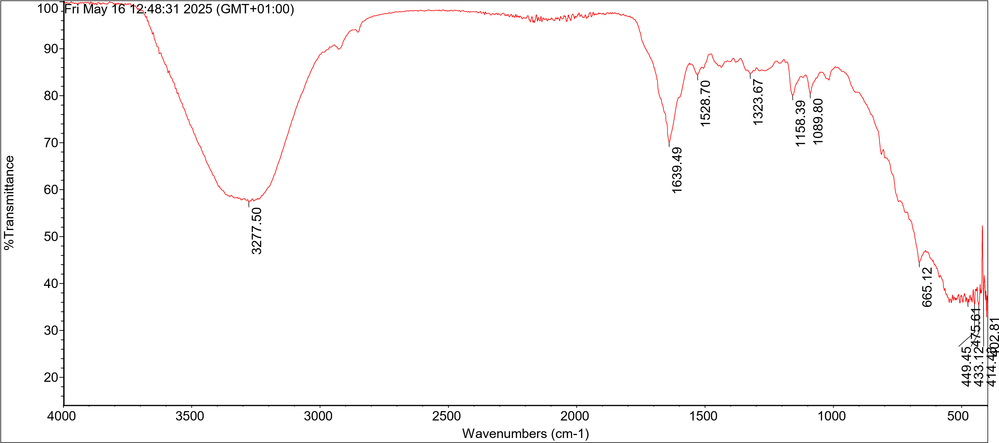
Appendix 1: FTIR Spectra for Day 3
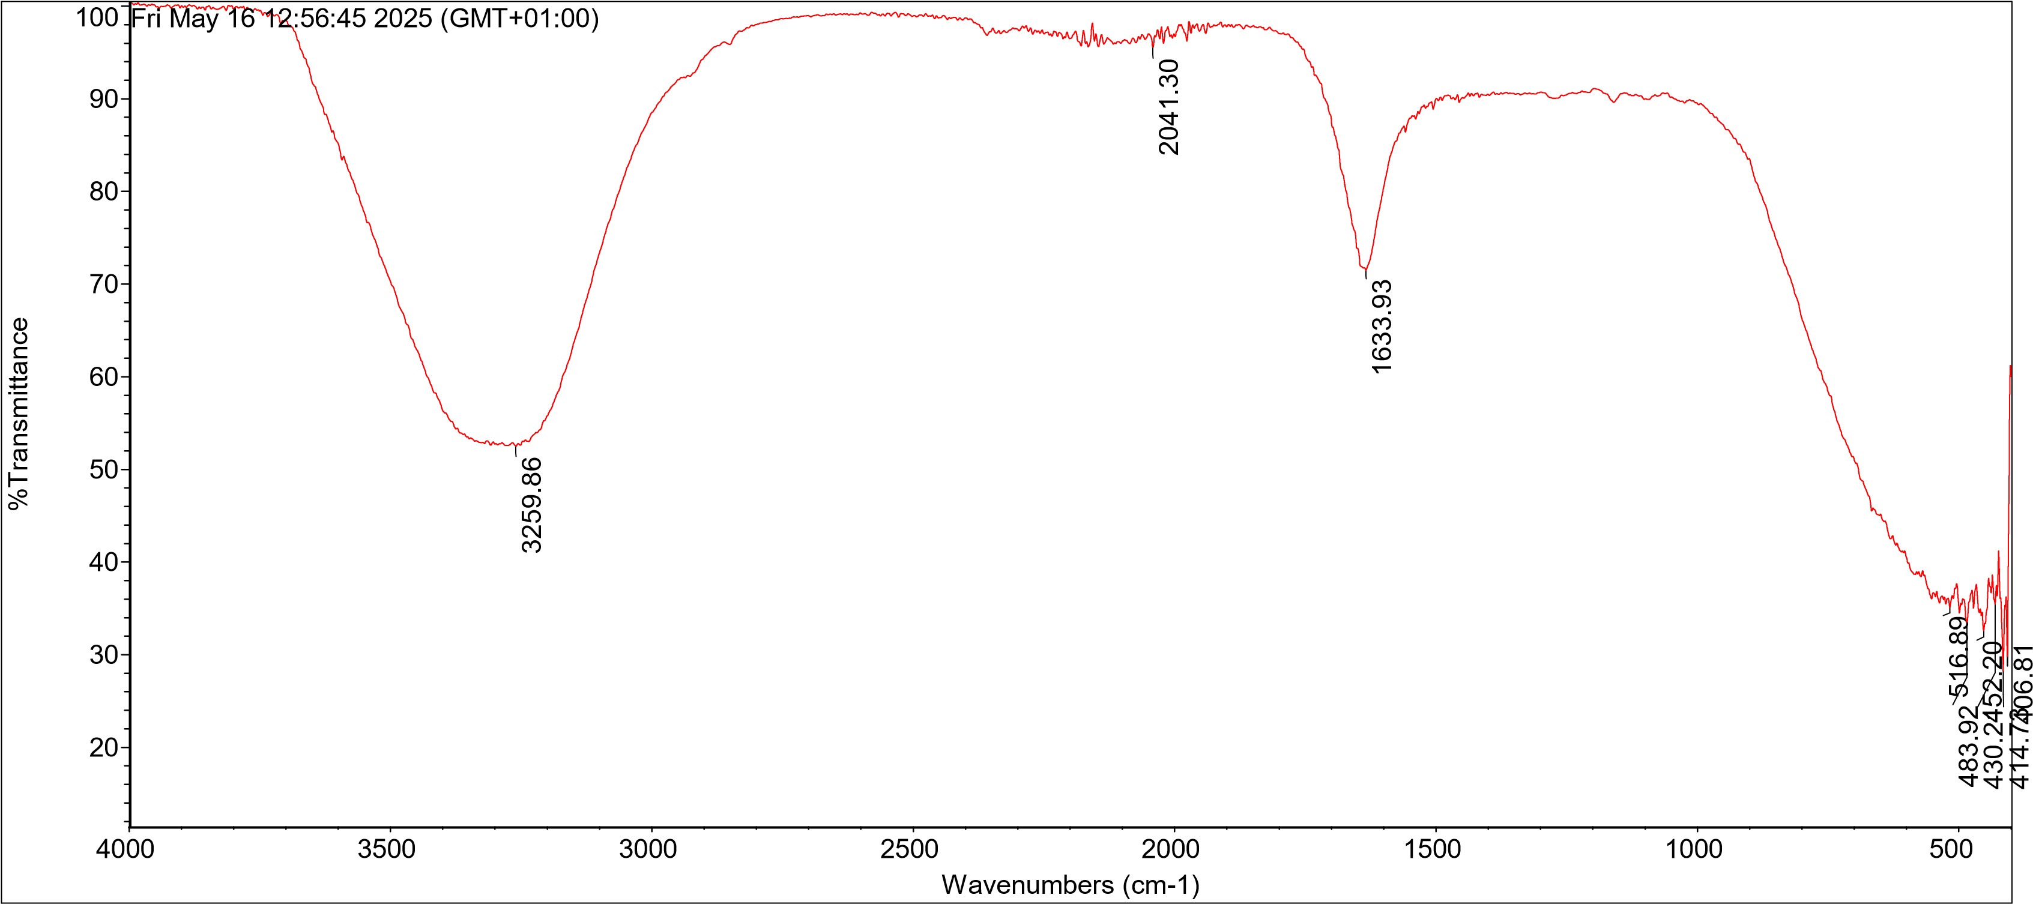
Appendix 2: FTIR Spectra for Day 6
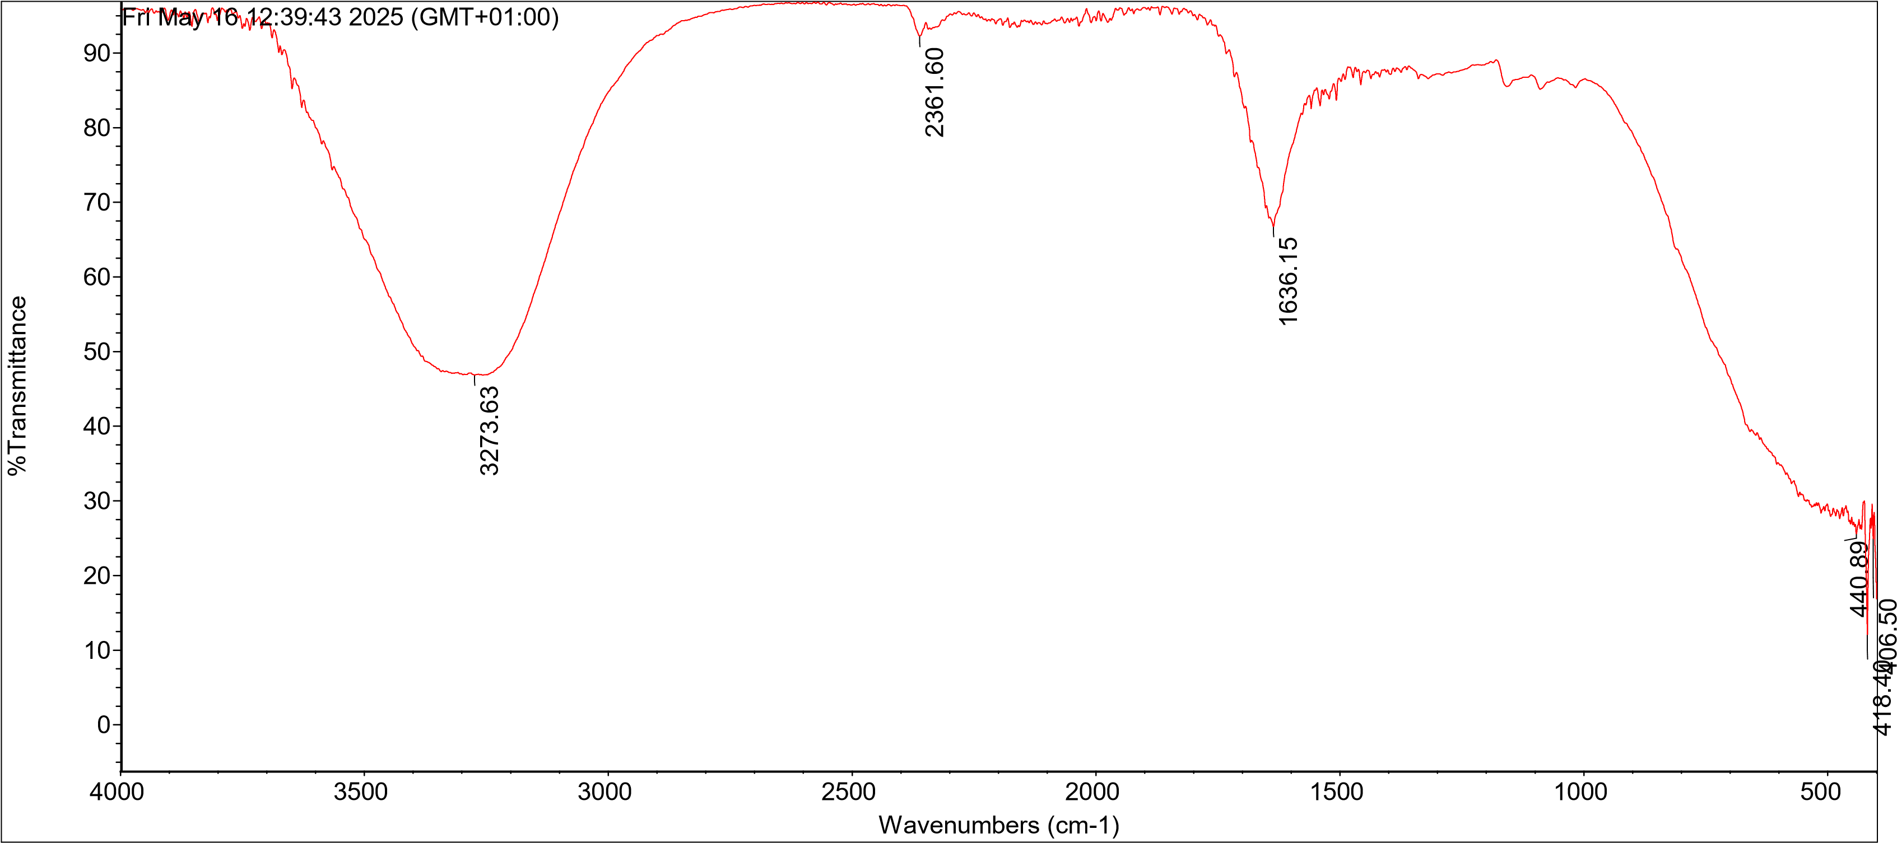
Appendix 3: FTIR Spectra for Day 9

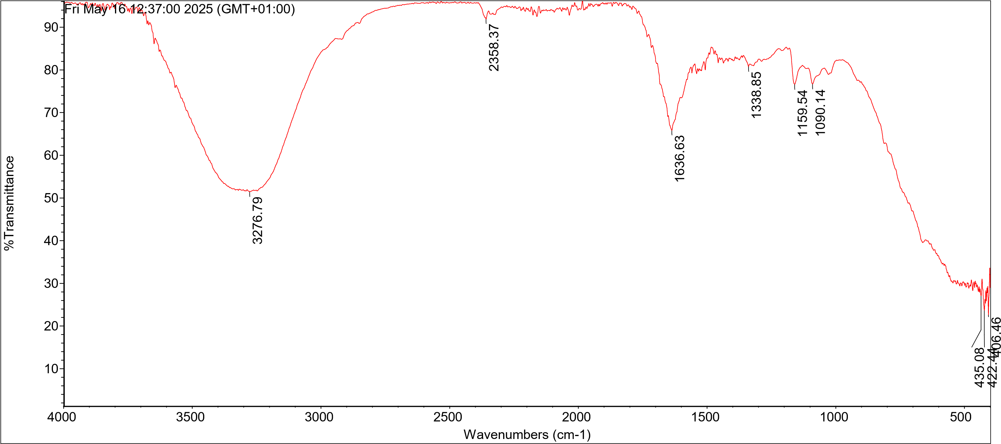
Appendix 4: FTIR Spectra for Day 12

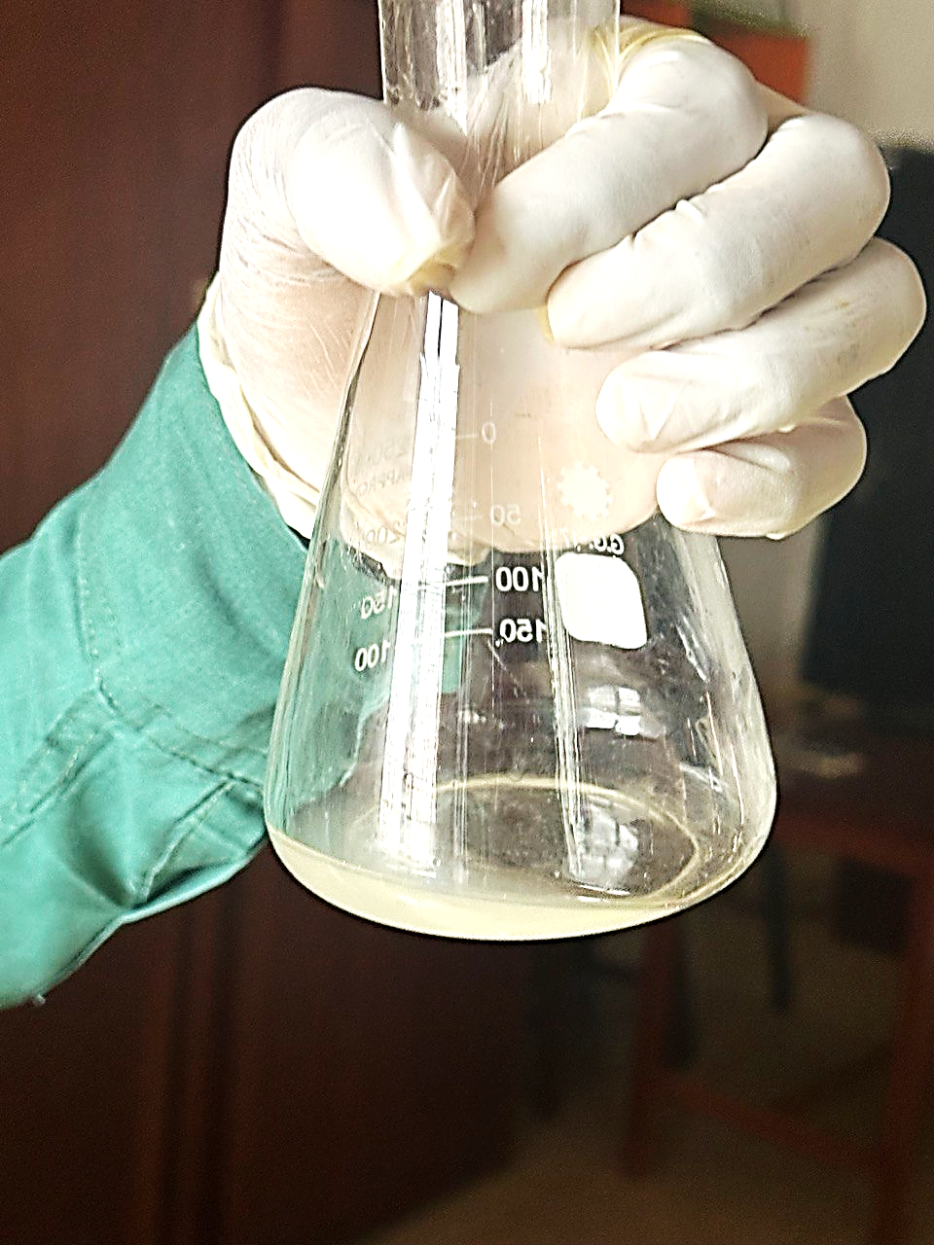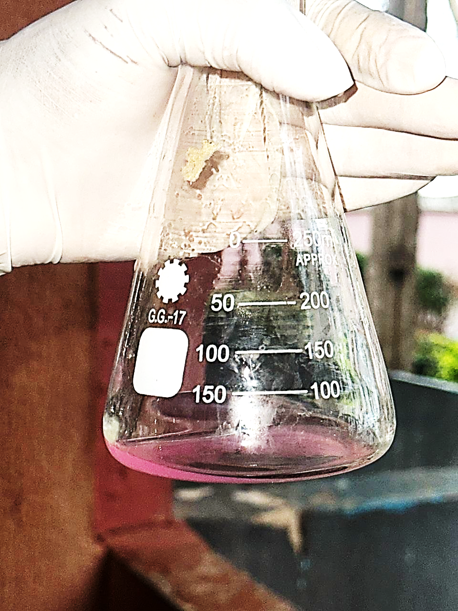
Appendix 5: Titratable Acidity (color change from colorless to pink)

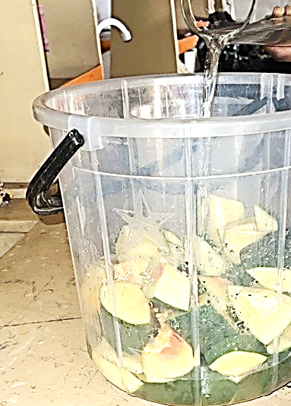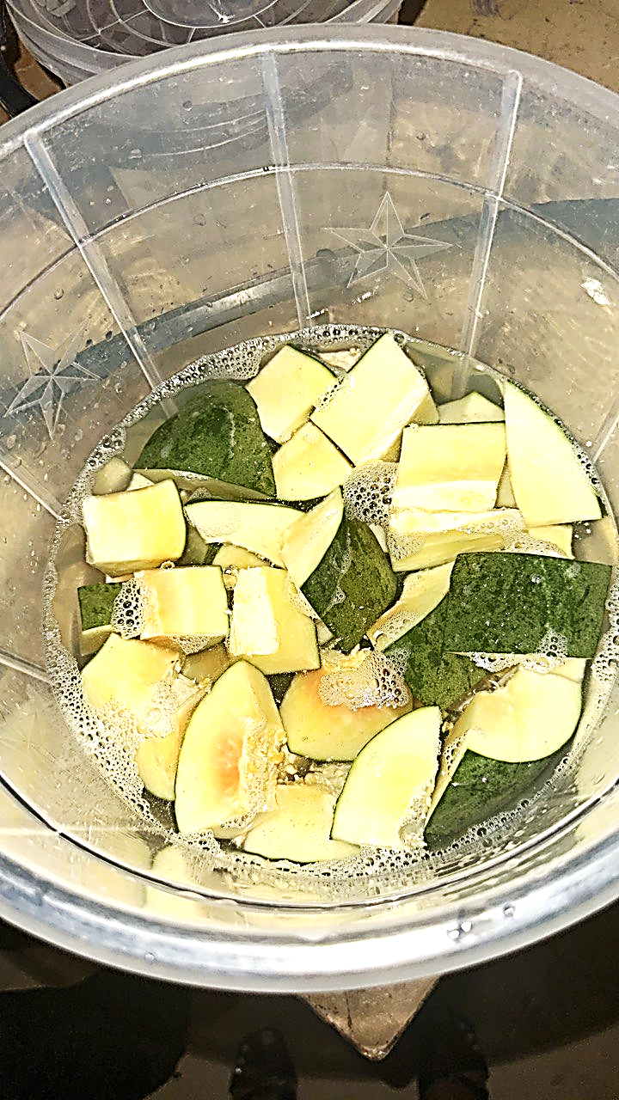
Appendix 6: Preparation of sample
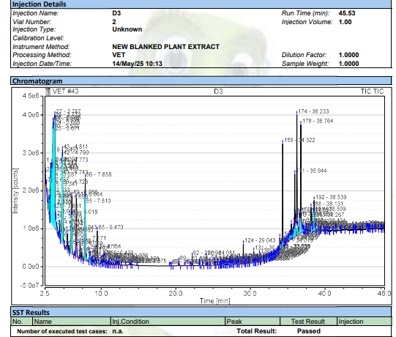
Appendix 7: Chromatogram of GC-MS analysis for Day 3 fermented water extract of unripe Carica papaya.

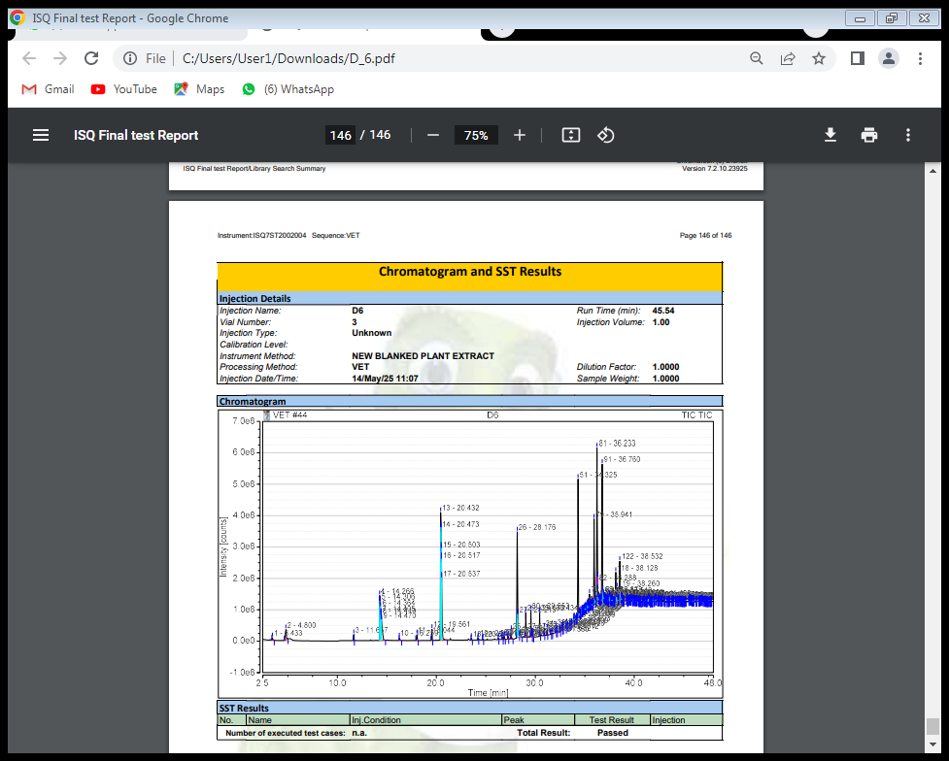
Appendix 8: Chromatogram of GC-MS analysis for Day 6 fermented water extract of unripe Carica papaya.
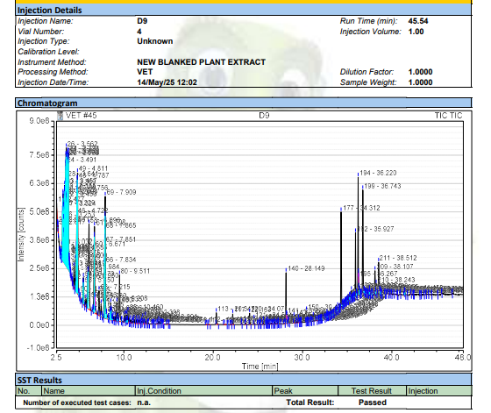
Appendix 10: Chromatogram of GC-MS analysis for Day 9 fermented water extract of unripe Carica papaya.

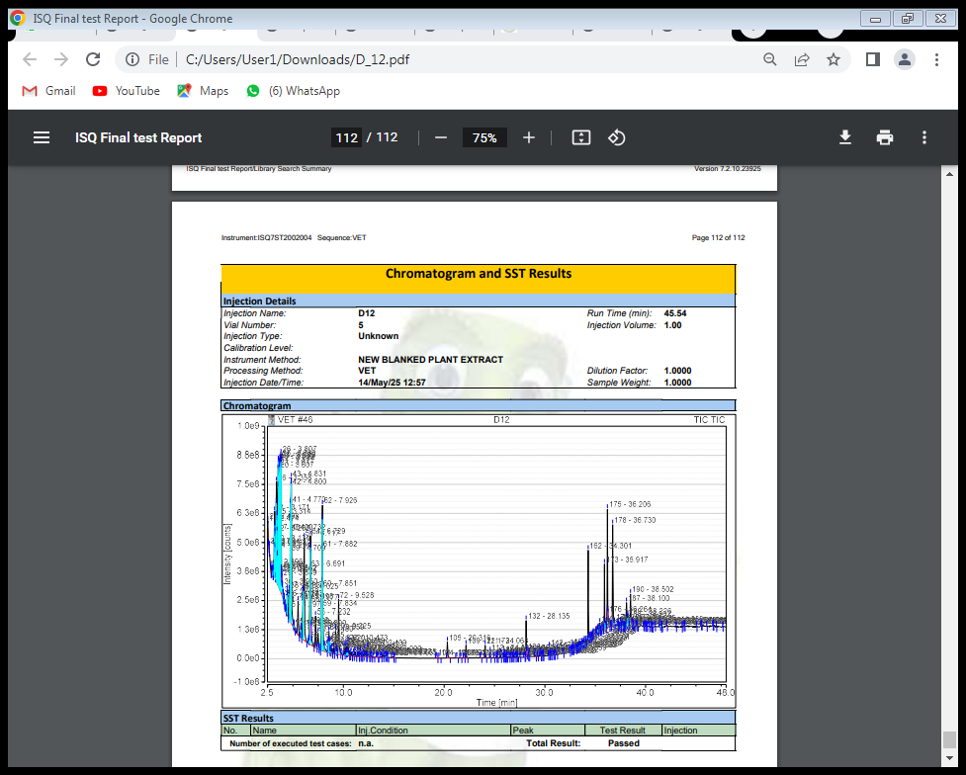
Appendix 11: Chromatogram of GC-MS analysis for Day 12 fermented water extract of unripe Carica papaya.

