INTELIDETECT: DEVELOPMENT OF A BEHAVIOURAL BIOMETRICS-BASED INTRUSION DETECTION SYSTEM

BY

OWOH, FAVOUR CHIDINMA

GOU/U21/CSC/673

SUPERVISED BY
DR. U. F. OKEBANAMA

JULY, 2025

INTELIDETECT: DEVELOPMENT OF A BEHAVIOURAL BIOMETRICS-BASED INTRUSION DETECTION SYSTEM

BY
OWOH, FAVOUR CHIDINMA
GOU/U21/CSC/673

SUBMITTED TO THE DEPARTMENT OF COMPUTER SCIENCE,
FACULTY OF NATURAL SCIENCES AND ENVIRONMENTAL STUDIES, GODFREY OKOYE UNIVERSITY, ENUGU

IN PARTIAL FUFILMENT OF THE AWARD OF BACHELOR OF SCIENCE DEGREE

SUPERVISED BY DR OKEBANAMA U. F

JULY, 2025

CERTIFICATION
I formally declare the whole research work I completed was done by me. The option of assignment cheating by the University will be accepted by me in full if I am proven to have cheated on it.

________________________
Owoh, Favour Chidinma
GOU/U21/CSC/673

APPROVAL PAGE
This is to validate that this research work “INTELIDETECT: DEVELOPMENT OF A BEHAVIOURAL BIOMETRICS-BASED INTRUSION DETECTION SYSTEM” was embarked upon by “OWOH, FAVOUR CHIDINMA” with the matriculation number GOU/U21/CSC/673 in partial fulfilment of the requirements for the award of Bachelor Science (B.SC) in Computer Science, Faculty of Natural Sciences and Environmental Studies, Godfrey Okoye University, Enugu.

__________________________ ________________________
Dr. Frank Okebanama Date
(Supervisor)

_______________________________ _________________________
Dr. Frank Okebanama Date
Head of Department

_______________________________ _________________________
Prof. Chidi Uhuegbu Date
Dean of FNSES

________________________________ _________________________
External Examiner Date

DEDICATION
The research work “INTELIDETECT: DEVELOPMENT OF A BEHAVIOURAL BIOMETRICS-BASED INTRUSION DETECTION SYSTEM” bears a dedication to my parents, Mr Obinna Owoh and Mrs Victoria Owoh, who provided me with all I needed and supported me spiritually, emotionally, and financially. I also dedicate this work to my supervisor, Dr. Frank Okebanama, who worked towards making my project process effortless.

ACKNOWLEDGMENTS
I am grateful to Almighty God, who, by His grace, inspired me throughout this research work. I want to show my gratitude to my Head of Department and Supervisor, Dr. Frank Okebanama, for dedicating his time and effort to making this project a success. May God bless my parents, Mr. Obinna Owoh and Mrs. Victoria Owoh, and my siblings, Precious Owoh, Blessing Owoh and Victor Owoh, for their constant love and support during this project. I genuinely express my appreciation to my lecturers, Mr. Emeka, Mr. Chibueze and Mr. Benjamin for their excellent lecture strategies and an innovative environment. I also express my gratitude to my friends for their advice and kindness towards me.

ABSTRACT
In this current age, cyber threats are becoming more rampant. Intelidetect is an innovative Intrusion Detection System (IDS) that encompasses behavioural biometrics and machine learning to pinpoint and avoid unauthorised access to various software. Its purpose is to identify its users based on the unique patterns in their behaviour, which include typing pace and session rhythms. This system is developed using Next.js and Tailwind for the frontend, TypeScript for the scripting language, Shadcn for the UI library, pnpm and MongoDB for the backend, and Python for the server. Intelidetect emphasises the user's needs by offering constant monitoring to quickly and accurately know when they are acting differently from their usual framework. This project brings a solution to a huge gap in cybersecurity by emphasising behavioural monitoring, it not only gives accurate results in detection but also improves he user experience by reducing intrusive security checks when there is a deviation from the normal user behaviour. By integrating behavioural biometrics, an intelligent intrusion detection system is built, offering threat reduction, thereby safeguarding digital identities.

TABLE OF CONTENTS
COVER PAGE i
TITLE PAGE ii
CERTIFICATION iii
APPROVAL iv
DEDICATION v
ACKNOWLEDGEMENTS vi
ABSTRACT vii
TABLE OF CONTENTS viii
LIST OF FIGURES xii
LIST OF TABLES xiii

CHAPTER 1: INTRODUCTION 1
  - BACKGROUND OF STUDY 1
  - STATEMENT OF PROBLEM 2
  - AIM AND OBJECTIVES OF THE STUDY 3
  - SIGNIFICANCE OF THE STUDY 3
  - SCOPE OF THE STUDY 4
  - LIMITATION OF THE STUDY 5
  - OPERATIONAL DEFINITION OF TERMS 5

CHAPTER 2: LITERATURE REVIEW 6
  - INTRODUCTION TO LITERATURE REVIEW 6
  - THEORETICAL BACKGROUND OF THE STUDY 6
    - DESCRIPTION OF DIFFERENT CATEGORIES OF BEHAVIOURAL
BIOMETRICS-BASED INTRUSION DETECTION SYSTEM 7
    - BRIEF HISTORY OF BEHAVIOURAL BIOMETRICS-BASED
INTRUSION DETECTION SYSTEM 8
    - THE FUTURE OF BEHAVIOURAL BIOMETRICS-BASED INTRUSION
DETECTION SYSTEM 9
  - REVIEW OF RELATED LITERATURE 10
  - SUMMARY OF REVIEW OF RELATED WORK 15

CHAPTER 3: SYSTEM ANALYSIS AND DESIGN 21
  - INTRODUCTION 21
  - SYSTEM ANALYSIS 21
    - ANALYSIS OF THE EXISTING SYSTEMS 21
    - WEAKNESSES OF EXISTING SYSTEMS 22
    - ANALYSIS OF THE PROPOSED SYSTEM 22
    - SYSTEM REQUIREMENTS 23
      - FUNCTIONAL REQUREMENTS 23
      - NON-FUNCTIONAL REQUIREMENTS 24
    - PROPOSED METHODOLOGY 24
      - UNIFIED MODELLING LANGUAGE DIAGRAMS 25
      - USE CASE DIAGRAM OF THE PROPOSED SYSTEM 25
      - ACTIVITY DIAGRAM OF THE PROPOSED SYSTEM 27
      - CLASS DIAGRAM OF THE PROPOSED SYSTEM 28
      - UML SEQUENCE DIAGRAM 29
  - SYSTEM DESIGN 32
    - INPUT/OUTPUT DESIGN 32
    - DATABASE DESIGN 33

CHAPTER FOUR: SYSTEM IMPLEMENTATION 36
  - INTRODUCTION 36
  - TOOLS USED FOR IMPLEMENTATION (TECH STACK OF THE PROPOSED
SYSTEM) 36
    - FRONTEND 36
      - NEXT.JS (JS FRAMEWORK) 36
      - TAILWIND CSS (CSS FRAMEWORK 37
      - TYPESCRIPT (SCRITING LANGUAGE) 37
      - SHADCN (UI LIBARAY) 37
    - BACKEND 38
      - PNPM (PERFORMANT NODE PACKAGE MANAGER) 38
      - PYTHON 38
      - FAST API 39
      - MONGODB (DATABASE) 36
  - SYSTEM REQUIREMENTS 40
  - USER INTERFACE OF INTELIDETECT 40
    - INTELIDETECT’S HOMEPAGE 40
    - USER CORRELATION MATRIX 41
    - USER CONFUSION MATRIX 42
    - USER MANAGEMENT PAGE 43
    - USER BEHAVIOUR GRAPH 44
    - PAGE DWELL TIME PAGE 45
    - PIN VERIFICATION PAGE 46

CHAPTER FIVE 48
  - INTRODUCTION 48
  - SUMMARY 48
  - RECOMMENDATIONS 49
  - CONCLUSION 49
REFERENCES 50
APPENDIX 52

LIST OF FIGURES

FIGURE PAGES
3.1 Use case diagram of the proposed system 26
3.2 Activity diagram of the proposed system 27
3.3 Class diagram of the proposed system 29
3.4 Sequence diagram of the proposed system 31
3.5 Input/output designs for the proposed system 32
4.1 INTELIDETECT’S Home page 41
4.2 User correlation matrix 42
4.3 User confusion matrix 43
4.4 User management page 44
4.5 User behaviour graph 45
4.6 Page Dwell Time page 46
4.7 Pin Verification page 47

LIST OF TABLES
TABLES PAGES
4.1 User table for the proposed system 33
4.2 Habit table for the proposed system 34
4.3 Anomalies table for the proposed system 34
CHAPTER ONE
INTRODUCTION
  - BACKGROUND OF THE STUDY
Cyberthreats have been a problem since the 1960s and have become rampant. Users are constantly exposed to the risks of being scammed by cyber criminals, and there are few systems to alert them before they are vulnerable. Due to the rise in data breaches in recent years, there could be a challenge if the data ends up in the wrong hands (Hadeel & Wathiq, 2024). The vulnerabilities in systems allow intruders to try to steal or destroy the information, damaging the systems themselves (Soulaiman, Khaldoun, & Assef, 2021). With the rising need for more developed security measures, Intrusion Detection Systems have been an effective security measure. Still, they lack some functions, which include insider threats and behavioural biometrics, which are used as solutions to problems.
Intrusion detection systems are powerful mechanisms that are used on the Internet to detect anomalous behaviours of attackers based on malicious activities. With the rapid transition to remote work and digital workspaces, security threats are more sophisticated. Users constantly interact with systems, which makes it more difficult to maintain secure environments. The outstanding growth and usage of the internet raise concerns about how to effectively communicate and protect digital information safely (Tazin, Siddharth, Kiran, Milennium, Ram, & Pawan, 2023). By analysing the characteristics of each user’s behaviour, such as session rhythm, movement of the mouse and typing patterns, behavioural biometrics can provide a digital fingerprint for each user. Differences from these learned behaviours can signify potential unauthorised access, even if the attacker has the correct login credentials.
Machine learning has expanded in the world of cybersecurity, providing a more secure environment for users and institutions (Afnan & Murad, 2023). Machine learning analyses big data and detects complex patterns. Intrusion Detection Techniques rely on the quality of the training datasets (Mahmoud, Nhien-An, Marwan, Anca, 2021). It is essential in enhancing the Intrusion Detection System capabilities. With constant monitoring, machine learning helps detect unusual user behaviours and identify insider threats using behaviour analysis.
In summary, InteliDetect especially combines behavioural biometrics and machine learning to address security limitations. By constantly watching and learning each user's patterns, this system can create a comprehensive profile. InteliDetect is an accurate system that protects its users from cyber threats.

  - STATEMENT OF PROBLEM
With so many flawed Intrusion Detection Systems, cyber threats are increasing which has birthed a lot of problems including:
- The increase in insider threats is caused by inadequate continuous authentication systems.
- Current security solutions can’t detect authorized users acting suspiciously.
- Compromised credentials are constantly compromised without being able to be detected by existing systems.
- The rising need for accurate behavioural analysis in systems.
- Current Intrusion Detection Systems only identify at login leaving gaps for intruders.
- Restricted detection of anomalies leaves organizations exposed.

  - AIM AND OBJECTIVE OF THE STUDY
The aim of this project is to develop a BEHAVIOURAL BIOMETRICS-BASED INTRUSION DETECTION SYSTEM. The specific objectives are to:
- Develop a behavioural biometric-based Intrusion Detection System (IDS) for continuous user authentication.
- Increase user data protection by detecting suspicious activities before sensitive information is compromised.
- Evaluate the impact of constant behavioural monitoring on identifying insider threats.
- Develop a real-time alert system that alerts its users on potential security breaches.
- Estimate the potency of different machine learning for detecting abnormal user behaviour.

  - SIGNIFICANCE OF STUDY
This proposed system is significant as it addresses breaches in cybersecurity operations. Most Intrusion Detection Systems identify their users only at login thereby making them vulnerable to cyber-attacks. This proposed system is significant to;
- Financial institutions
- Health care sector
- Enterprise security
- Online services
- Financial Institutions: Financial institutions and banks can use this system to identify fraudulent actions such as unauthorised transactions.
- Healthcare Sector: This system can improve the security of health records and help to make sure that only authorised individuals can gain access to the data of the patients.
- Enterprise Security: This system can help businesses protect important data and intellectual property by monitoring the activities of employees and preventing insider threats.
- Online Services: Service providers can leverage this system to improve the verification processes of users, decreasing the rate of fraud and enhancing customer trust.
Finally, this project is significant in contributing to the increased knowledge of behavioural biometrics and how to apply it to cybersecurity. Machine learning analyses and detects special behavioural traits.

  - SCOPE OF THE STUDY
This study involves the implementation and design of ‘InteliDetect’: a behavioural biometrics-based Intrusion Detection System that increases security through constant monitoring of the user. It captures the user's behaviour such as typing speed and session rhythms and then evaluates algorithms for the detection of anomalies. This research work is aimed at reducing security threats and promoting a more secure environment for its users.

1.6: LIMITATION OF THE STUDY
Limitations of this research work include:
- User behaviour variability: Due to the vastness of human behaviour which can change because of stress or other physical conditions, the variability can lead to the detection of anomalies which limits the accuracy of the system.
- Resource requirements for computation: The constant monitoring of the user’s behavioural data needs resources for computation and this could limit the scalability for organizations with limited IT infrastructure.
- Privacy concerns: Observing the user’s behaviour includes collecting personal data over a period of time. Evaluating functional security measures with respect for the privacy of the user’s data is difficult and may require more measures to secure data.
- Restricted testing environment: The testing phase of this study is going to be challenging and can go beyond the range from the initial research.

  - OPERATIONAL DEFINITION OF TERMS
Biometrics: It is the physical or behavioural features that will be used to identify an individual’s identity.
Intrusion Detection System: It is a tool in cybersecurity that is used to analyse and monitor activities in a system to identify security threats.
Security: They are practices that are made to protect users from risks.
Anomalies: They are suspicious behaviours that suggest security threats in a system.
CHAPTER TWO
LITERATURE REVIEW

  - INTRODUCTION
In the world of cybersecurity, traditional Intrusion Detection Systems fall short in detecting insider threats. To address these limitations, the coming of behavioural biometrics such as typing speed and session rhythms offers a user-specific way of monitoring the behaviour of users.
InteliDetect is an intelligent Intrusion Detection System designed to leverage the behavioural patterns to identify anomalies in user activities. It continuously analyses the behaviour of users in a session to detect deviations from the user patterns and then alerts to malicious intent.
This section involves the theoretical background, history and future of the proposed system and review of related works. It tends to compare the proposed system with already existing systems. However, this section discusses in detail the literature review of the proposed system.

  - THEORETICAL BACKGROUND OF THE STUDY
Intrusion detection systems have been an important component of cybersecurity for decades, advancing from traditional approaches to machine learning and artificial intelligence models. These systems are used to analyse the network data and detect anomalies in the network activities (Logeswari, Bose & Anitha, 2023). Traditional intrusion detection systems were signature-based and relied on predefined patterns of existing threats to detect malicious activities. With the increase in the complexity of cyber threats, the need for enhanced security solutions has become essential. Intrusion detection systems evolved to integrate machine learning and artificial intelligence to detect previously unknown threats by using the baselines of the users’ behaviour to indicate deviations.
However, behavioural biometrics, which leverages the unique behaviours of users such as typing patterns, movement of the mouse and session rhythms, has surfaced to be a promising approach to improve security and effectively identify unauthorised access. Behavioural biometrics offers new ways to strengthen security, improve the user experience, and analyse the users’ interactions with IT systems (Brice, 2023). This makes it useful for intrusion detection as the criminals are unlikely to replicate the users’ behavioural traits.
Moreover, this system contributes to the field of cybersecurity by offering an innovative solution to the limitations of existing systems. By using insights gained from existing research, InteliDetect plays a crucial role in the future of cybersecurity. Therefore, this literature review helps to investigate the ability of behavioural biometrics as a means to enhance cybersecurity (Jonah, 2024)

2.2.1 DESCRIPTION OF DIFFERENT CATEGORIES OF BEHAVIOURAL BIOMETRICS-BASED INTRUSION DETECTION SYSTEM
- Touchscreen Behaviour: This category centres on how individuals interact with touch-enabled devices, analysing the tap patterns and swipe speed. It is used in mobile banking and authentication applications.
- Gait Analysis: This category studies the walking patterns of individuals using data obtained from the sensors in mobile devices and wearable devices. It is used in healthcare applications to monitor physical conditions and improve security.
- Voice Recognition: This category of systems analyses the tone and speech patterns to identify users. It is mostly used in call centres and voice-activated systems to verify users securely.

2.1.2 BRIEF HISTORY OF A BEHAVIOURAL BIOMETRICS-BASED INTRUSION DETECTION SYSTEM
Behavioural biometric-based intrusion detection systems have evolved over the years. They were born from the need to improve traditional methods of authentication and better measures in cybersecurity. This concept goes far back to the mid-20th century when researchers started to explore human behavioural patterns for identification. The first form of behavioural biometrics was studied in psychology and human-computer interaction, which helped to understand how people interact with computers.
In the 1950s and 1960s, researchers started exploring human behavioural traits like speech patterns, typing rhythms, and handwriting. In the 1970s, it was observed that individuals had unique typing rhythms. The first intrusion detection system was proposed in 1980, and since then, other better intrusion detection systems have come about (Hungyu & Bo, 2019).
However, with the emergence of artificial intelligence and machine learning in the 2000s, behavioural biometrics-based intrusion detection systems greatly transformed. AI algorithms allow the analysis of the behaviour of the users, allowing the systems to identify anomalies accurately with the adoption of big data to enhance the system's performance. Incidents in cybersecurity, such as breaches in data and identity theft, drove the demand for more complex security measures. The intrusion detection models used in 2000 were out of date and depended on local machines more than network traffic during the analysis stage (Mohamed, Ali & Hesham, 2018).
Finally, the evolution of behavioural biometric-based intrusion detection systems shows the need for more secure methods of authentication. From the early studies in individual methods of typing to AI-driven models, systems have been developed to offer protection against threats thereby shaping the future of cybersecurity.

2.2.3 THE FUTURE OF A BEHAVIOURAL BIOMETRICS-BASED INTRUSION DETECTION SYSTEM
Behavioural biometric-based intrusion detection systems are quickly appearing in the cybersecurity world. It has a favourable future. Unlike past methods of authentication, which include the use of credentials like passwords or passcodes, behavioural biometric-based IDS will leverage AI tools that can detect anomalies using the unique behaviours of the users, like typing speed and session rhythms. The future of this kind of intrusion detection system will provide easy and continuous authentication to handle evolving threats in cybersecurity.
This future of behavioural biometric-based intrusion detection system will incooperate an AI driven adaptive learning method which will increase the accuracy of intrusion detection and reduce false positives, thereby continuously learning the user behaviour. Multi modal authentication will also be implemented which will not only involve behavioural patterns but also gait analysis, voice recognition and facial recognition.
Additionally, blockchain technology will be implemented to distribute intelligence in threats among intrusion detection systems that are connected to help organizations jointly defend against cyber threats. Self-healing mechanisms will also be integrated to restore the integrity of systems after an attack without manual intervention.
However, the advancement of behavioural biometrics-based intrusion detection systems will immensely revolutionise cybersecurity. With artificial intelligence and machine learning evolving, systems will be able to offer better security solutions. Also, as technologies evolve, behavioural biometric-based intrusion detection systems will provide exceptional protection against complex cyber threats.

2.3 REVIEW OF RELATED WORKS
There are many intrusion detection systems in the world today. However, this section will review in detail the existing systems that align with this project.
Albara Awajan (2023) developed an Intrusion Detection System for IOT devices employing deep learning. It uses a four-layer deep Fully Connected network architecture to identify suspicious traffic that can cause an invasion on connected devices that use IoT. This system was developed as a communication protocol-independent system to reduce the implementation issue. During the experimental performance analysis, the system displayed dependable performance for security threats. It identifies attacks like Denial of Service, Sinkhole, Opportunistic service, and Blackhole.
Michael, Florian, Elizabeth and Tharam (2022) surveyed a Provenance-based IDS. This survey utilises the provenance of data to better the detection performance of intrusions and lessen the rate of false alarms compared to traditional Intrusion Detection Systems. The survey depicts the potential of PDIS producing a comprehensive evaluation of current research in the field. It will also help understand the origin of an anomaly within the system by presenting an explicit data flow record.
Muhammad Ashfaq Khan (2021) designed a Deep Learning based hybrid Intrusion Detection System that distinguishes and predicts cyberattacks in a network. The signature technique in detection in this system takes advantage of predefined patterns that are used to detect malicious attacks. Its technique in detection depends on heuristic methods to reduce analytical overheads. It addresses the issue of imbalance in classes that are recurrent in Intrusion Detection data and uses traditional machine learning and deep learning algorithms to identify anomalies.
Abdul, Smys and Haoxiang (2020) proposed a hybrid Intrusion Detection system that collects data, processes it and trains the network to detect anomalies in IoT devices. Unlike other Intrusion Detection Systems, this system not only detects single attacks, it also detects multiple attacks. This system was compared to an RNN model after training its network and it attained a 98% better efficiency.
Shema, Saad, & Fekadu (2023) did a study on a computer vision-based intrusion detection system for the Internet of Things. The study aimed to figure out the network attack on Internet of Things devices. It used two approaches to work on the data set, which included reducing the size of the data and solving the problem of data imbalance, training five machine learning algorithms on the dataset. This research work helps to secure IoT networks by discovering attacks against them, with denial of service attacks being the most famous among them.
Robin, Nase, Jose, Daniel and Michel (2020) presented a framework to identify intrusion on smart devices. It involves the combination of different machine-learning algorithms and techniques in tracing the monitored devices. This infrastructure comprises different actuators and sensors and an analysis system that can run Python. This system relies on traces to get information, making it detect anomalies in connected devices. After the traces perform their task, data is processed from sensors, and then the collected trace data is used to detect anomalies.
Junaid, Muhammad, Roohi, Khaled, Mamoun and Razi (2020) performed a study on already existing intrusion detection systems for IoT devices in the aspect of computational overhead, energy consumption and privacy implications. This system provides an attack model for IoT devices. The attack model involves various threats in IoT system that aims to improve classification. The attacks include wormhole attacks, sinkhole attacks, buffer reservation attacks, selective forwarding attacks and denial of service attacks.
Hakan and Zafer (2023) proposed an intrusion detection system based on deep learning to detect anomalies in IoT devices. This study was performed using CNN (Convolutional Neural Network), LSTM (Long Short Term Memory) and CNN+LSTM methods. The end product of this research showed the superiority of deep learning methods in identifying abnormal events in complex datasets. The deep learning models were trained using the latest dataset generated for IDS.
Sharuka, Lasitha, Lasith, Pushpika, and Chaminda (2022) conducted a study on the experiment carried out to make a real-time intrusion detection system using machine learning algorithms. It captures the traffic in the network and detects harmful intrusions. This system is hosted in a web server, making it possible for personal and corporate sector networks to involve it in their networks using a RESTful API. This system has easy implementation and remote accessibility.
Cheolhee, Jonghoon, Youngsoo, Jong-Geun, Hyunjin and Dowon (2023) developed a deep learning-based Network Intrusion Detection System (NIDS) to detect anomalies. In this system, AI models and outliers were detected and eliminated to ensure their effectiveness and efficiency. Data was generated and trained to detect threats utilizing DNN, LSTM and CNN classifiers. This network intrusion detection System solves the problem of data imbalance in the previous system, leveraging a generative data model to improve the detection of anomalies.
Abhishek and Virender (2023) did a study of statistical analysis of a CIDDS-001 dataset using machine learning algorithms evaluating a network intrusion detection system. In this paper, unsupervised and supervised techniques in machine learning are integrated to analyse the elaborateness of the dataset. This system includes a detection model that learns from a dataset involving attacks and packet traces, performing classification of incoming networks.
Ammar and Faisal (2021) proposed a hybrid intrusion detection system to protect data in the cloud using machine learning models based on improved Genetic Algorithms (AG) and Support Vector Machine (SVM) algorithms. This system was trained using two datasets, which include normal and up-to-date attacks. The dataset was folded to change the training and testing dataset to determine the behaviour of the system.
Mohd, Abdul, and Talal (2021) proposed two categories of intrusion detection to handle attacks in EDGE Computing. The hybrid approach in this system integrates binary classifications with high precisions to identify detection methods. The EDGE Computing-based design makes sure the intrusions are defended in Internet of Things devices. This system was aimed at detecting application-specific threats including Denial of Service attacks which is the most common attack.
Muhammad and Yangwoo (2021) proposed a deep learning-based hybrid intrusion detection system split into various datasets and trained to identify malicious traffic in a system. It used the Spark ML library for the machine learning tasks and for executing machine learning algorithms. This HIDS is based on deep learning classifications, and it is a combination of anomaly-based and signature-based approaches, thereby enhancing the accuracy in the detection of intrusions.
Alamgir and Saiful (2023) proposed an intrusion detection system using ensemble-based machine learning capable of detecting various attack types accurately. This system integrates Google Colaboratory and Python programming languages. This system used the Random Forest ensemble method which addresses the limitations of existing IDSs and creates a framework tested with various datasets. It also employs machine learning models for anomaly detection.

2.4 SUMMARY OF REVIEW OF RELATED WORK
Author’s Name/ Year | Journal Name | Contribution | Shortfall | Methodology
Albara Alwajan. (2023) | A Novel Deep Learning-Based Intrusion Detection System for IoT Networks | This system makes use of deep learning to identify attacks on IoT networks. | This system does not study user behaviours. The system has been trained using its dataset. | Deep Neural Network-based detection
Michael, Z., Florian, G., Elizabeth, C., & Tharam, D. (2022) | Provenance-based Intrusion Detection Systems: A Survey | This study helps in depicting the origin of anomalies and reduces the rate of false alarms in a system. | This system does not doesn’t leverage machine learning which is an application of artificial intelligence. | Provenance-based detection
Muhammad Ashfaq Khan. (2021) | HCRNNIDS: Hybrid Convolutional Recurrent Neural Network-Based Network Intrusion Detection System | This system uses heuristic methods to identify to identify anomalies. | The system has its data it has been trained with and doesn’t collect new data from the users. | Hybrid Convolutional Recurrent Neural Network-based detection
Abdul, B., Smys, S., & Haoxiang, W. (2020) | Hybrid Intrusion Detection System for Internet of Things (IoT) | This system detects diverse malicious attacks on IoT devices. | It doesn’t incooperate behavioural biometrics. | Hybrid Convolutional Neural Network detection
Shema, A., Saad, M., & Fekadu, A. (2023) | Computer Vision-Based Intrusion Detection System for Internet of Things | This research integrates machine learning algorithms to detect anomalies in IoT devices. | It has its dataset it was trained with and doesn’t get data from its users. | Computer Vision-based detection
Robin, G., Nase, E., Jose, M., Daniel, A., & Michel, R. (2020) | Multi-level host-based intrusion detection system for the Internet of Things | This system uses a Host-based intrusion detection to detect intrusions in connected devices. | The algorithms used are supervised learning techniques which makes them detect anomalies similar to what they have learned. | Multi-level Host-based detection
Junaid, A., Muhammad, A., Roohi, A., Khaled, S., Mamoun, A., & Razi, I. (2020) | A Review of Performance, Energy and Privacy of Intrusion Detection Systems for IoT | This system uses privacy implications and energy consumption to protect devices from malicious attacks. | Limited experimentation and the unavailability of accurate data. | Review of various methodologies
Hakan, C., & Zafer, A. (2023) | A hybrid CNN+LSTM-based intrusion detection system for industrial IoT networks | This system uses deep learning models to detect anomalies accurately. | They have the dataset they are trained with. | Hybrid CNN+LSTM-based detection
Sharuka, P., Lasitha, J., Lasith, Y., Pushpika, L., & Chaminda, H. (2022) | Deep Neural Network Based Real-Time Intrusion Detection System | This real-time IDS uses machine learning algorithms to detect intrusions. | Unavailability of a rich dataset that contains modern intrusion types. | Deep Neural Network-based detections
Cheolhee, P., Jonghoon, L., Youngsoo, K., Jong-Geun, P., Hyunjin, K., & Dowon, H. (2023) | An Enhanced AI-Based Network Intrusion Detection System Using Generative Adversarial Networks | This system leverages an AI-based NIDS to identify the rate of threats in a network. | This system does not use behavioural biometrics. | AI-based network detection
Abhishek, V., & Virender, R. (2023) | On evaluation of Network Intrusion Detection Systems: Statistical analysis of CIDDS-001 dataset using Machine Learning Techniques | It used a CIDDS-001 dataset for intrusion detection. | Limited dataset. | Signature-based detection
Ammar, A., & Faisal, A. (2021) | Effective Intrusion Detection System to Secure Data in Cloud Using Machine Learning | It uses a genetic algorithm and support vector machine algorithm to identify attacks. | Insufficient dataset to be trained with. | Hybrid anomaly+signature-based detection
Mohd, H., Abdul, R., & Talal, A. (2021) | Development of PCCNN-Based Network Intrusion Detection System for EDGE Computing | It uses a machine learning approach and EDGE Computing-based design to accurately detect anomalies. | Its accuracy is low. | Principal Component-based Convolution Neural Network (PCCNN)
Muhammad, A., & Yangwoo, K. (2021) | Deep Learning-Based Hybrid Intelligent Intrusion Detection System | It uses a HIDS method to detect anomalies. | Anomalies can not be identified with several real-time image data. | Hybrid anomaly+signature-based detection
Alamgir, H., & Saiful, I. (2023) | Ensuring network security with a robust intrusion detection system using ensemble-based machine learning | It used ensemble-based machine learning models for the detection of intrusions. | It has the dataset it was trained with. | Ensemble-based detection

CHAPTER THREE
SYSTEM ANALYSIS AND DESIGN
3.1 INTRODUCTION
This chapter of this research work stands to discuss the design and analysis of the proposed system, the methodology employed in the design of the system (OOAD), and the approach to which this methodology was used. It describes the systems’ requirements, analysis of existing systems and the UML diagrams.

3.2 SYSTEM ANALYSIS
System analysis is the study of a system to recognize the problem, suggest improvements, and build a model for that system. However, this section of this study discusses the system analysis of the proposed system which includes the analysis of already existing systems, limitations of those existing systems and ways to improve them. It also includes the modelling appertaining to the proposed system using use case diagrams, class diagrams, activity diagrams and sequence diagrams.

3.2.1 ANALYSIS OF EXISTING SYSTEMS
IBM QRadar Security Intelligence:
This system was developed involving advanced analytics for the detection of anomalies with the use of Artificial Intelligence. It collects data from the users' activities to provide insights. This system stores risks and then alerts the pressing cases to direct users on where and what to focus on. Its machine-learning abilities improve its ability to detect insider risks and threats. Despite all these features, it still has some pitfalls.
Palo Alto Networks Cortex XDR:
This is an advanced Intrusion Detection System that unifies network and cloud data to identify cyber threats. It leverages machine learning to analyse data, pinpoint anomalies and predict potential attacks. Its agents stop threats with Behavioural Threat Protection. It uses incident management to investigate threats swiftly making users able to view alerts quickly. While this system is successful in threat detection, it has some fallbacks.
3.2.2 WEAKNESS OF EXISTING SYSTEMS
IBM QRadar Security Intelligence: This system’s deployment process is complex and it lacks user-specific behavioural analysis.
Palo Alto Networks Cortex XDR: This system lacks behavioural biometrics and it requires extensive data integration and advanced enterprise.
3.2.3 ANALYSIS OF THE PROPOSED SYSTEM
This proposed system is a behavioural biometrics-based Intrusion Detection System that integrates behavioural biometrics and machine learning to detect anomalies in real time. It will continuously monitor the system's behaviour, including session rhythms and typing speed, to set up individual behavioural profiles. Digression from these profiles prompts the detection of an anomaly, indicating threats like insider threats.
This proposed system's architecture comprises data collection, presentation layers, processing and ensuring scalability with key features like predictive threat analytics, real-time alerts and a dashboard for administrators.
The system will be able to continuously monitor user behaviours and detect insider threats by alerting the users when there is a deviation from their normal behavioural pattern. It is a real-time anomaly detection system which adapts to the user behaviours of individuals over time. It is user-friendly and scalable, that is, it can be integrated into an already existing system, thereby supporting privacy and preserving security.
This proposed system will be available across operating systems like Windows, iOS and Android.
3.2.4 SYSTEM REQUIREMENTS
System requirements are specifications an application or system must have to work efficiently, which when the requirements will result in performance problems. System requirements are fractionalized into two categories and they are; functional requirements which give a detailed specification of tasks that must be performed by the system, and non-functional requirements which describes the characteristics expected from the system.

3.2.4.1 Functional requirements:
The functional requirement is a category of system requirements that indicates what the system must have. The functional requirements expected from this proposed system include;
- The system should have a straightforward user interface.
- The system should alert users if there are suspicious activities.
- Users should have their unique profiles.
- The system should continuously monitor user behaviour.
3.2.4.2 Non-Functional Requirements:
A non-functional requirement is the second category of system requirement that specifies the features or capabilities of the system. The non-functional requirements expected from this proposed system include:
- All screen sizes should be responsive in the proposed system.
- The system should detect anomalies using machine learning algorithms.
- The system should have a secure login mechanism.

3.3.5 PROPOSED METHODOLOGY: OBJECT-ORIENTED ANALYSIS AND DESIGN
Object-Oriented Analysis and Design (OOAD) is an approach in software development that focuses on identifying the object, classes and relationships of the system. It combines the principles in object-oriented programming which enables developers to build maintainable and scalable software. The goal of OOAD is to analyse the needs of the systems and create a model that represents the system to be developed. Objects in OOAD constitute entities in the system while classes describe their behaviour and structure. OOAD involves the use of Unified Modelling Language (UML) diagrams, use cases and object-oriented programming.
However, the Object-Oriented Analysis and Design approach makes use of the use case diagram to make it depict the various approaches the users of InteliDetect can take part in in the system.

3.2.5.1 UNIFIED MODELLING LANGUAGE DIAGRAMS
UML (Unified Modelling Language) is a modernised visual representation of a system that models the software's architecture, design and processes. UML uses elements like actors, classes and objects depending on the type of diagram used. It follows specific rules, which makes it a universal language for modelling systems. Software developers use UML to enhance the system's clarity and identify potential problems early.

3.2.5.2 USE CASE DIAGRAM OF PROPOSED SYSTEM
A use case diagram visually represents the system’s interactions with its users. It involves the actors, use cases and relationships. Use case diagrams helps in the requirement analysis phase and the system’s design.
The use case of this proposed system will consist of two actors which include the administrators and the users. According to the use case diagram, the users have six use cases which include
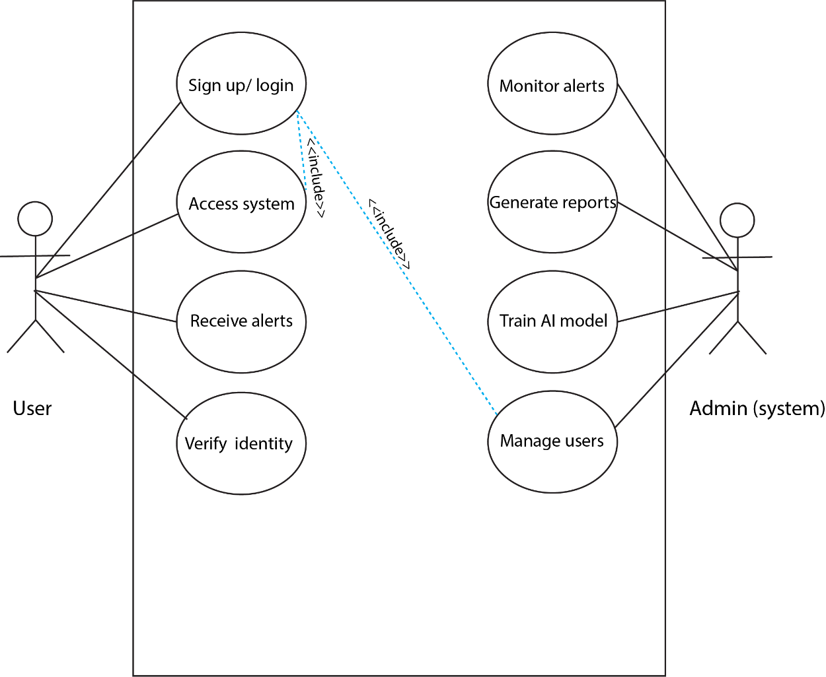
Fig 3.1 Use case diagram of the proposed system
The diagram above depicts the use case diagram of the proposed system. It consists of two actors which are the system and users and shows their use cases and functions. The user can be able to create an account and login to their profile. They can also be able to request support and receive alerts. The admin which is also the system will be able to train the AI models, manage users’ biometric data and also monitor the users’ behaviours which is the base of smooth operation by the users.

3.2.5.3 ACTIVITY DIAGRAM OF THE PROPOSED SYSTEM
An activity diagram is a type of Unified Modelling Language (UML) diagram that shows the dynamic processes of the system. It is used to measure the flow of data in a system making it possible to understand complex functionalities. This diagram is represented using a flowchart which ensures a clearer understanding of the system’s requirements. The figure below shows the flow of different activities going on in the proposed system from signing up to creating a user profile.
Activity diagram of the proposed system:
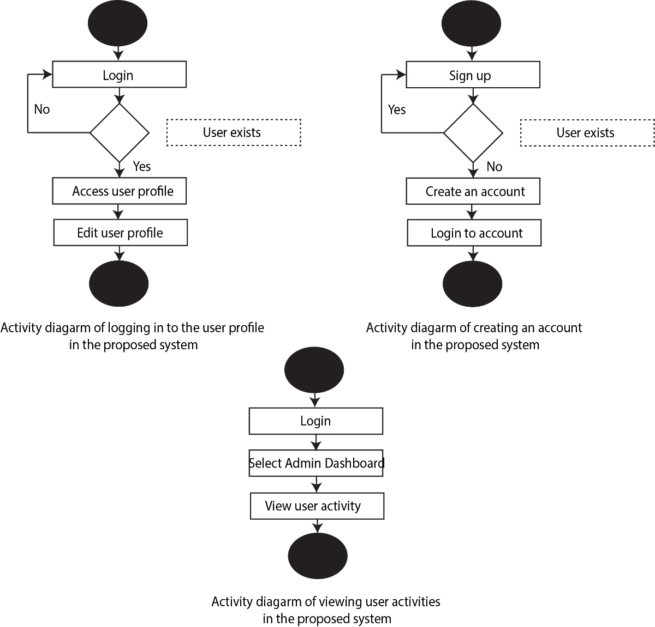
Figure 3.2 Activity diagram
The above diagram represents the activity diagram of the proposed system which depicts the activities that takes place. The activities involve, creating an account, logging in and viewing the user profile which includes the users’ data. It also involves viewing and deleting alerts and notifications on the system.

3.2.5.4 CLASS DIAGRAM OF THE PROPOSED SYSTEM
A class diagram is a type of UML diagram that shows the static structure of the system, showing its classes, methods, attributes and relationships. It is mostly used in object-oriented programming to visualise the system’s architecture before it is implemented. Below is the class diagram for the proposed system.
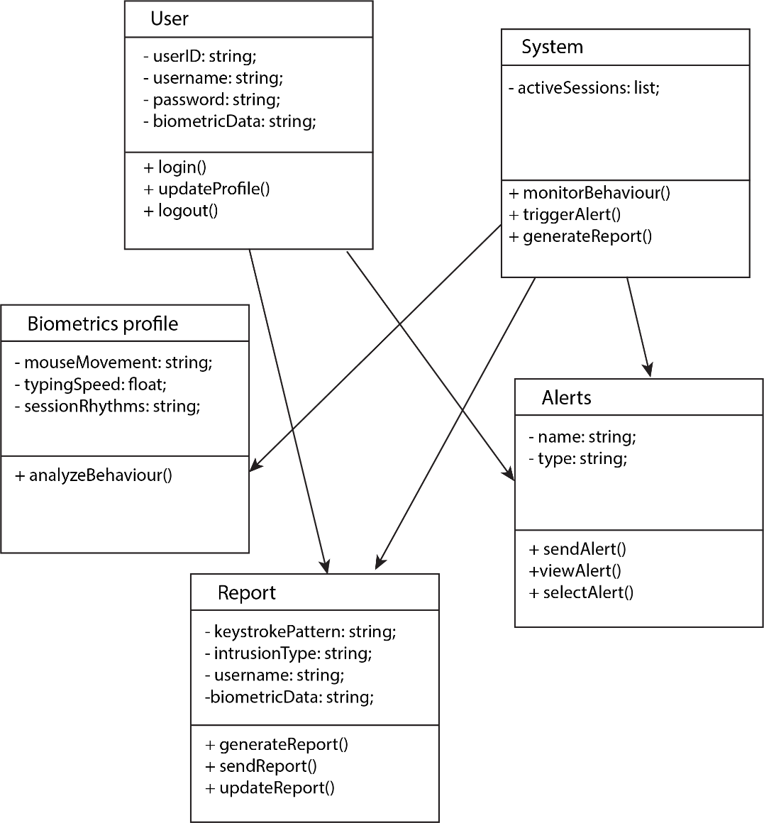
Figure 3.3 Class diagram of the proposed system
The diagram shows the class diagram of the proposed system. It shows the activities that will be taking place in the system using classes. This diagram represents the series of classes in the system to improve its functionality.

3.2.5.5 UML SEQUENCE DIAGRAM
The Universal Modelling Language (UML) sequence diagram is a diagram that shows how objects interact in real-time. It emphasises the format of exchanging messages among objects. This diagram is important in understanding the flow of messages during the execution process. It is also useful for understanding the workflow execution of the behaviour of the system. Its key elements include actors, objects, messages, and conditions, therefore representing how the different components of the system collaborate to achieve its goals. Here, activations are represented using vertical lines that extend from the lifeline and portray the time involved in an interaction.
However, UML sequence diagrams make it possible for software developers to understand the flow of activities, making it easier to design complex systems. These diagrams help in identifying problems early in the process of development and enhancing easy execution. However, capturing the flow of messages between objects provides insights into the system's behaviour.

Sequence diagram of the proposed system:
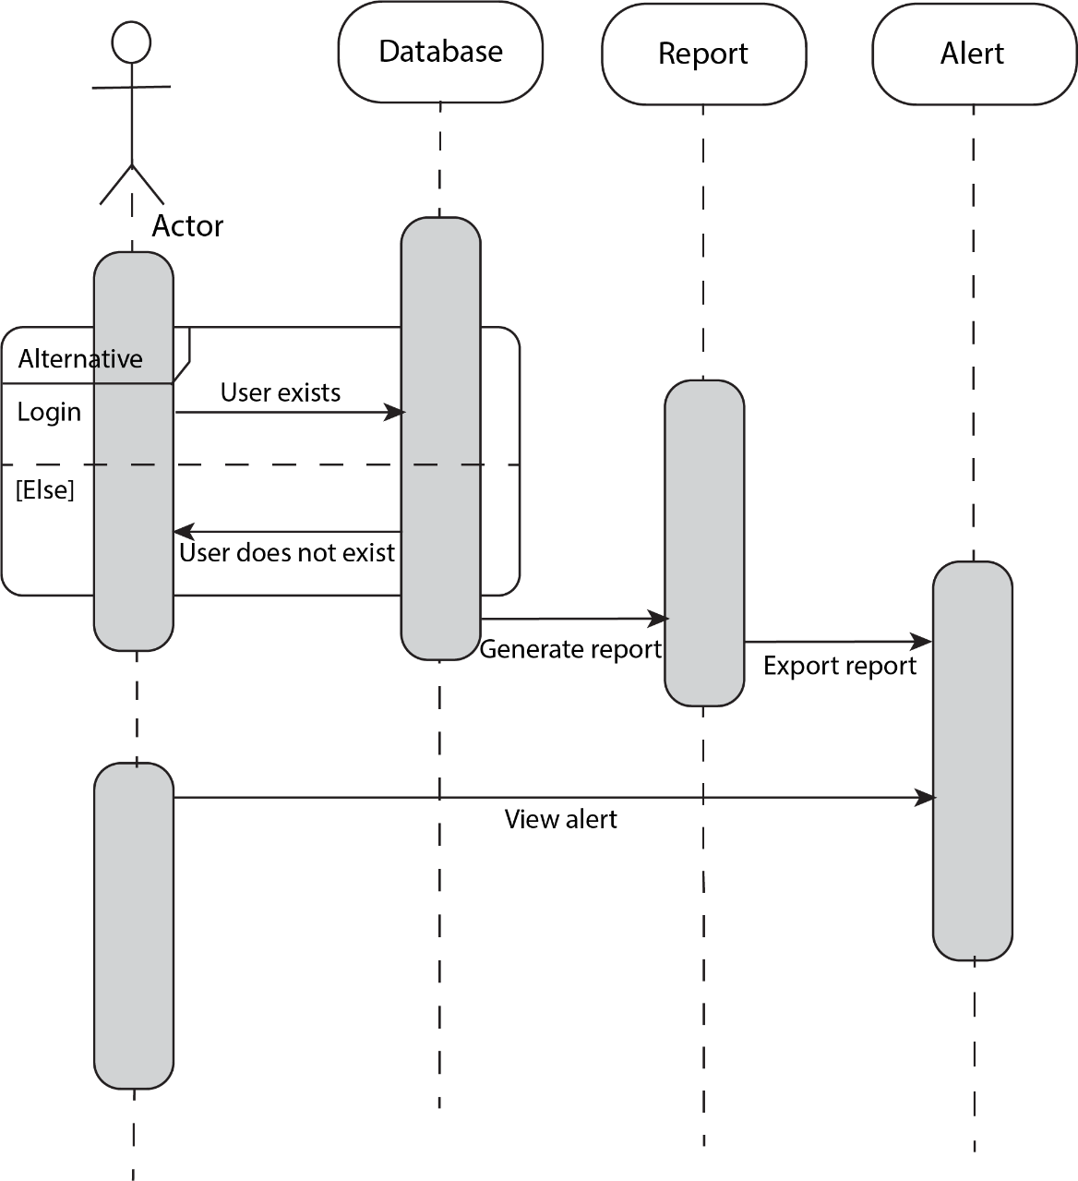
Fig 3.4 Sequence diagram of the proposed system
The diagram above represents the sequence diagram of the proposed system, which shows the sequence of activities that will be carried out from the users creating an account and logging in to viewing reports and notifications on intrusions.

3.3 SYSTEM DESIGN
The system design of the proposed system is going to depict how the system expects to satisfy the needs that have been stated above. This system will include the database design of the proposed system, which drives all the activities that will take place in the system.

3.3.1 INPUT/ OUTPUT DESIGN
This is the representation of the physical design of the input/ output design of the interface of the system, which shows how the system aims to achieve the specified objectives.
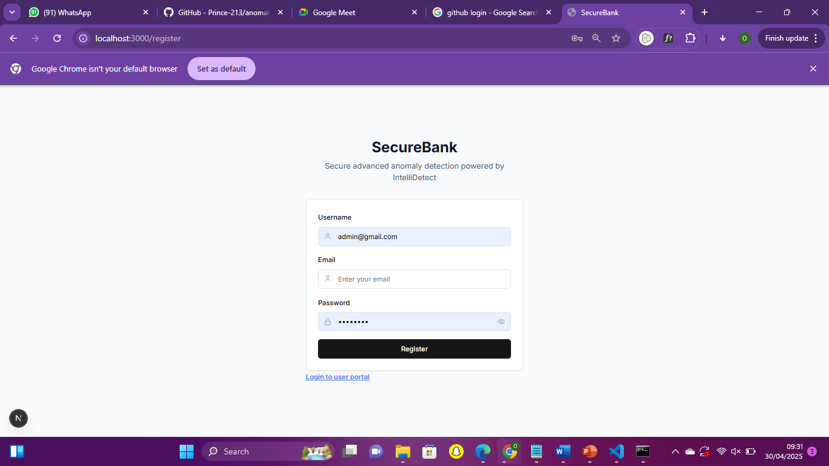
Figure 3.6 Input/ Output diagram of the proposed system

3.3.2 DATABASE DESIGN
The database design aims at displaying a structured view of the database of the proposed system. This database was designed and implemented with MySQL. The database will store the user profiles and behavioural data of the users.
Database schema for the proposed system
USER TABLE
Table 4.1 User table of the proposed system
Attribute | Data Type | Description
Id | String | This field shows the identifier for each user.
Email | String | This field is for storing the users’ email.
Name | String | This field stores the users’ login name.
Password | String | This is the password for authentication.
Habits | Habit | This is the behavioural biometric data.
Anomalies | Anomaly | This shows the timestamp of last successful login.

HABIT TABLE
Table 4.2 Habit table of the proposed system
Attribute | Data Type | Description
HistoryDwell | Int | This field shows the time spent on the transaction history page.
TransferDwell | Int | This shows the time spent on the transfer page.
DashboardDwell | Int | This shows the time spent on the dashboard page.
PinSpeed | Int | This shows the speed of typing the PIN to make the transfer in the bank model.

ANOMALIES TABLE
Table 4.3 Anomalies table of the proposed system
Attribute | Data Type | Description
Type | String | This field shows the type of anomaly detected, either pin speed, page dwell or mouse movements.
Severity | String | It shows high or low the rate of change in pages is.
TimeDetected | DateTime | This field shows the time frame an anomaly was detected.

CHAPTER FOUR
  - INTRODUCTION
This research work in detail describes the system that has been talked about from the beginning of this work and throughout the investigation that was initiated as a result of the challenges faced in the environment of the researcher. However, a detailed examination of the system describing the needs of both the systems that are currently existing systems and the systems that have been suggested in this project was mentioned in the earlier stages of this work. In addition to this, the researcher uses selected instruments to implement the proposed system successfully. Moreover, it is most important to note that this chapter will describe the user interface for the different components of the system that are integrated to make the system function effectively.
  - TOOLS USED FOR IMPLEMENTATION (TECH STACK OF THE PROPOSED SYSTEM)
    - FRONT END
      - NEXT JS (JS FRAMEWORK)
Next.js is an open-source React framework that is used to build fast and reliable web applications. It offers developers options of choosing between service-side rendering and static site generation. It supports API routes, which allow you to build services in the backend within the same project. Its default features include image optimization, performance enhancements, and automatic code splitting. Next.js supports TypeScript, and it integrates easily with databases and external API for external data. Businesses use Next.js to develop high-performance websites like e-commerce stores, dashboards, portfolios, and blogs. It also enables developers to benefit from strong community support and extensive documentation.
      - TAILWIND CSS (CSS FRAMEWORK)
Tailwind CSS is a utility-first framework in CSS that is used to build modern responsive user interfaces quickly. It makes use of predefined utility classes that can be put together to style elements in your HTML or JSX. Developers make use of this framework to build custom designs without having to write traditional CSS. It integrates with frameworks like Next.js and React, making it flexible when styling. Tailwind CSS supports mobile-first responsive design, making it seamless to build layouts and adapt to various screen sizes. Tailwind CSS is highly configurable, allowing its users to define colors, themes, and breakpoints. It is mainly used to build dashboards, blogs, and landing pages.
      - TYPESCRIPT (SCRIPTING LANGUAGE)
TypeScript is a statically typed superset of JavaScript that includes optional type annotations for your block of codes. It is commonly used for large-scale applications and allows developers to identify errors at compile time instead of at run time. Developers use several TypeScript frameworks, like Node.js and React, to build big frontend and backend applications. It can run in any environment where JavaScript runs and can define custom types, integrating an API. Overall, TypeScript enhances readability and documentation, especially in open-source projects.
      - SHADCN UI (UI LIBRARY)
Shadcn UI is a collection of beautifully styled, fully customizable components of the user interface built with Tailwind CSS. It is designed for React applications and helps developers rapidly build modern and accessible interfaces. Developers make use of Shadcn UI to increase the rate of development with components that are pre-built, like buttons, forms, tabs, and dropdowns. Unlike traditional component libraries, Shadcn UI provides its users with the source code for each component, so you can modify it freely. It’s well known in projects built with Next.js and TypeScript because of its simplicity and flexibility, and it is ideal for developers who want the benefits of a component library without sacrificing control or custom design.

    - BACKEND
      - PNPM (PERFORMANT NODE PACKAGE MANAGER)
PNPM (Performant Node Package Manager) is a fast package manager for JavaScript that is compatible with NPM. It installs various libraries and frameworks used in Node.js and other JavaScript environments. PNMP uses a content-addressable store to save disk space instead of duplicating dependencies in each project. Developers use PNMP to run scripts, install, delete, or update packages. It supports workspaces by enabling users to manage multiple related packages in a single repository, thereby improving performance with parallel installation and caching, reducing time in installation time. Overall, PNMP prevents deep dependency hoisting issues, making it easier to track bugs.
      - PYTHON
Python is a high-level, all-purpose programming language that is versatile and easy to use. It is a well-known programming language that supports various programming paradigms. It emphasizes code readability and straight-forward syntax. Python has an extended standard library that minimizes the need to write code from scratch. It has one of the biggest programming communities, which means that there is abundant support in the forum. The simplicity of python makes it more valuable than other programming languages, providing tools, flexibility and support needed.
The python was used in InteliDetect to learn the user behavioural pattern and then flag if there is an anomaly. Its server is where the system is running on.
      - FAST API
Fast API is a fast performance web framework that builds API with Python. It uses the API standard of automatic API documentation, making it efficient and easy to use. It is one of the best framework for building API’s, especially in machine learning. It is fast because of ASGI (Asynchronous Server Gateway Interface), and has built-in data validation. Fast API supports asynchronous programming, which allows users to write non-blocking code. It is easy to learn and promotes reusable and testable code, it is also scalable, making it easy to deploy modern production environments.
      - MONGODB (DATABASE)
MongoDB works well with real time applications and IoT systems. Integrating tools like Mongoose for object modelling in Node.js and MongoDB Compass for visual database management. Its flexibility makes it capable of rapid prototyping and agile development workflow. MongoDB's document-based model makes it easy to illustrate complex data structures without the need for multiple tables. It makes use of CRUD operations: Create, Read, Update, Delete, through a powerful query language. Developers use Mongodb to create applications that require scalability, high availability, and performance, such as e-commerce sites and real-time analytics tools. Overall, MongoDB is a great choice for developers who want a flexible, scalable, and developer-friendly database system.
The database schema that was used for this system is a NoSQL (Not Only SQL) database (a non-relational database that allows ways to store and retrieve data that does not depend on the traditional table-based structures that SQL databases use). I used a Prisma, which is an object-relational mapper, to connect to the database using a connection string. Prisma made it possible to write JavaScript code to manipulate the database in the Next.js server.

  - SYSTEM REQUIREMENTS
Providing that this system is a web-based application, there are not many tools that are needed to use it. Therefore, in order for the user to make use of the system efficiently, some requirements must be met. They include:
- A device that supports the Internet
- Good internet connection (at least 3 G internet speed)
- A web browser, e.g., Google Chrome and Mozilla Firefox

  - USER INTERFACE OF INTELIDETECT
This research will display the user interfaces of the intrusion detection system's login page, homepage, dashboard, and user profile.
    - INTELIDETECT Homepage
This Homepage includes the user’s login and the admin login. Here, the user can log in to their profile or register an account, and the admin can login to their account to view the overview of the user behaviour and anomalies.
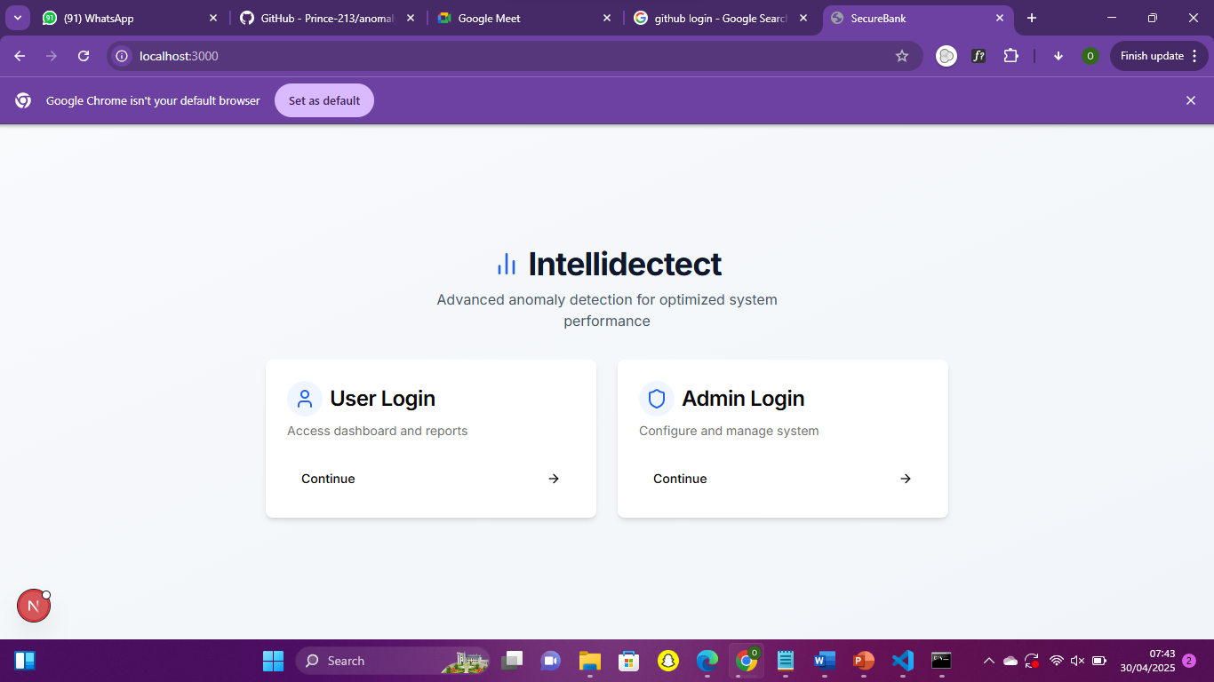
Figure 4.1 The homepage of InteliDetect

4.4.2 User Correlation Matrix
This correlation matrix shows how features like transfer page dwell time, total session time, and transfer-to history ratio moderately correlate with anomalies. Here, no single feature strongly predicts anomalies
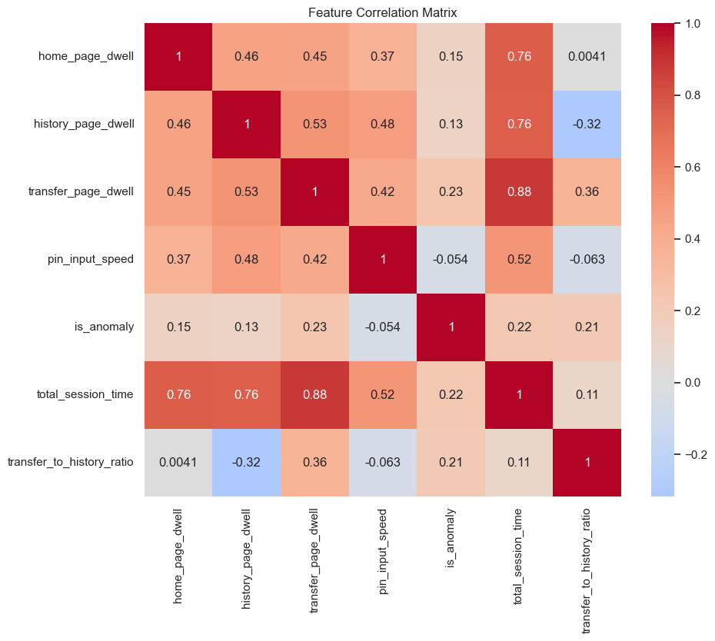
Figure 4.2 User correlation matrix

4.4.3 User Confusion Matrix
This confusion matrix of XGBoost model depicts an excellent anomaly detection performance in the proposed system. Out of 200 normal sessions, only 1 was misclassified and 189 classified, for 10 anomalies, 9 were detected accurately. This shows that the XGBoost model distinguishes between normal and suspicious behaviour with minimal false positives and false negatives.

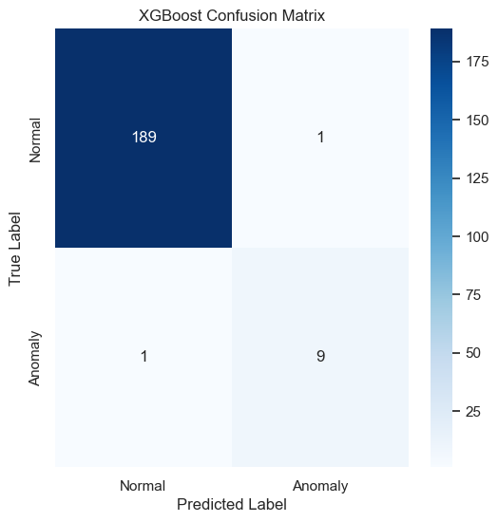
Figure 4.3 User confusion matrix

4.4.4 User Management Page
This page shows the details of the users, their habits, and their status. This page shows the summary of the user behaviour.
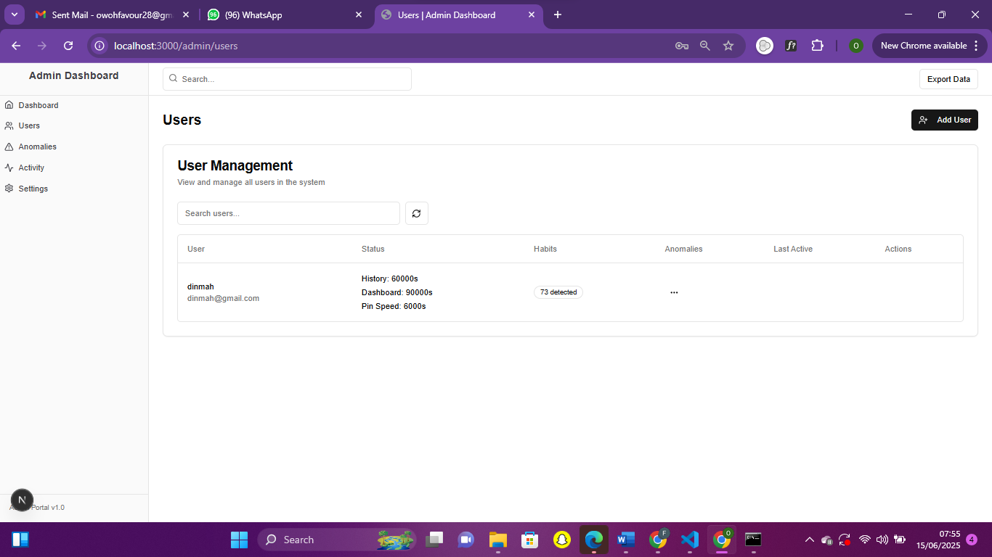
Figure 4.4 User Management page

4.4.5 User Behaviour Graph
This visualisation shows the distribution of features in the proposed system by class (normal vs anomaly). The blue represents normal behaviour and the orange represents anomaly, where the anomalous behaviour stands out from the normal behaviour, validating the effectiveness of the model.
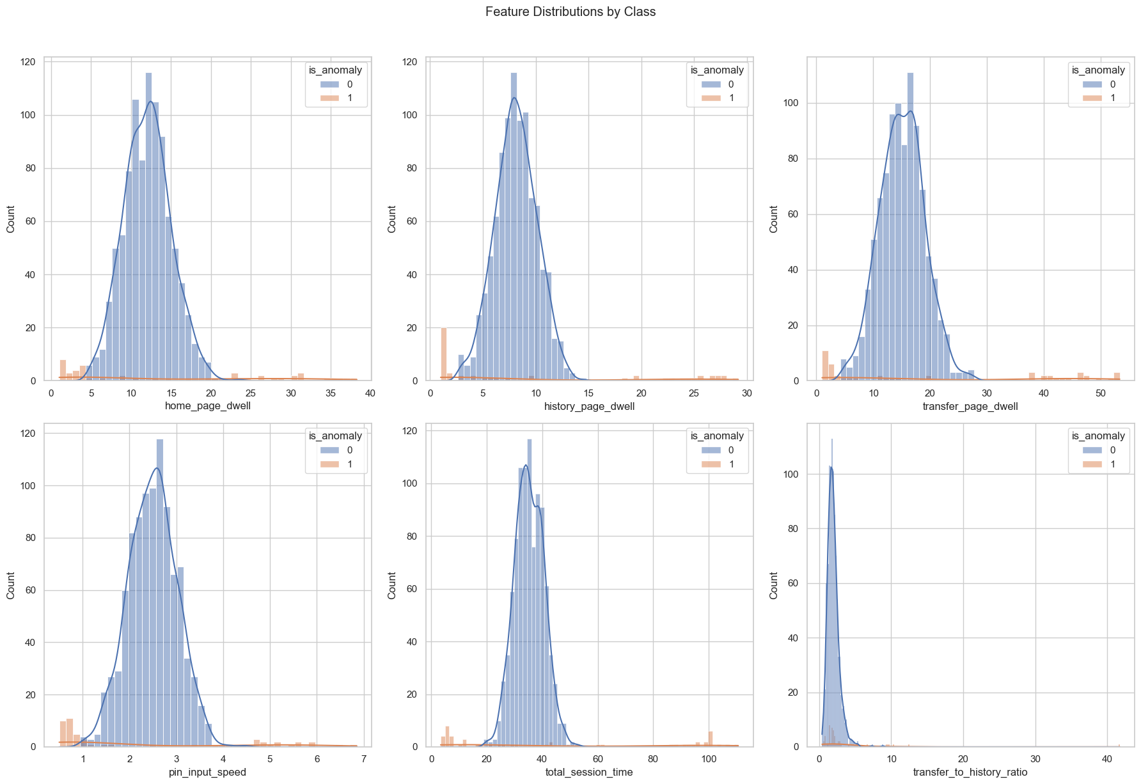
Figure 4.5 User behaviour graph

4.4.6 Page Dwell Time Page
This page shows how the user will be alerted when there is a deviation from the normal user session rhythm. Here, the rate of change in pages was high, which prompted this alert.
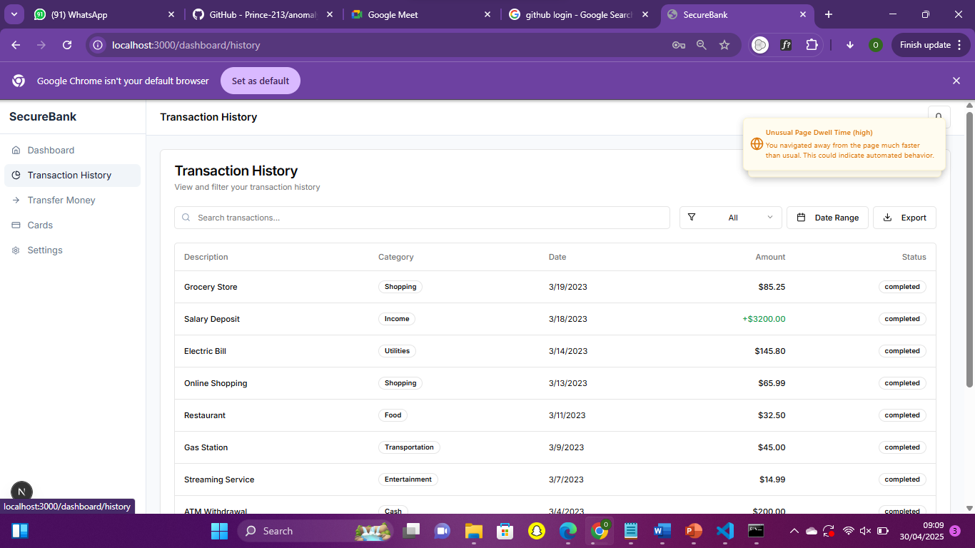
Figure 4.6 Page Dwell Time Page

4.4.7 Pin Verification Page
This page is where the users type their PIN to transfer money. If there is a deviation from the pin speed or you copy and paste the pin, an alert “unusual input pattern” will be flagged, as shown on the page.
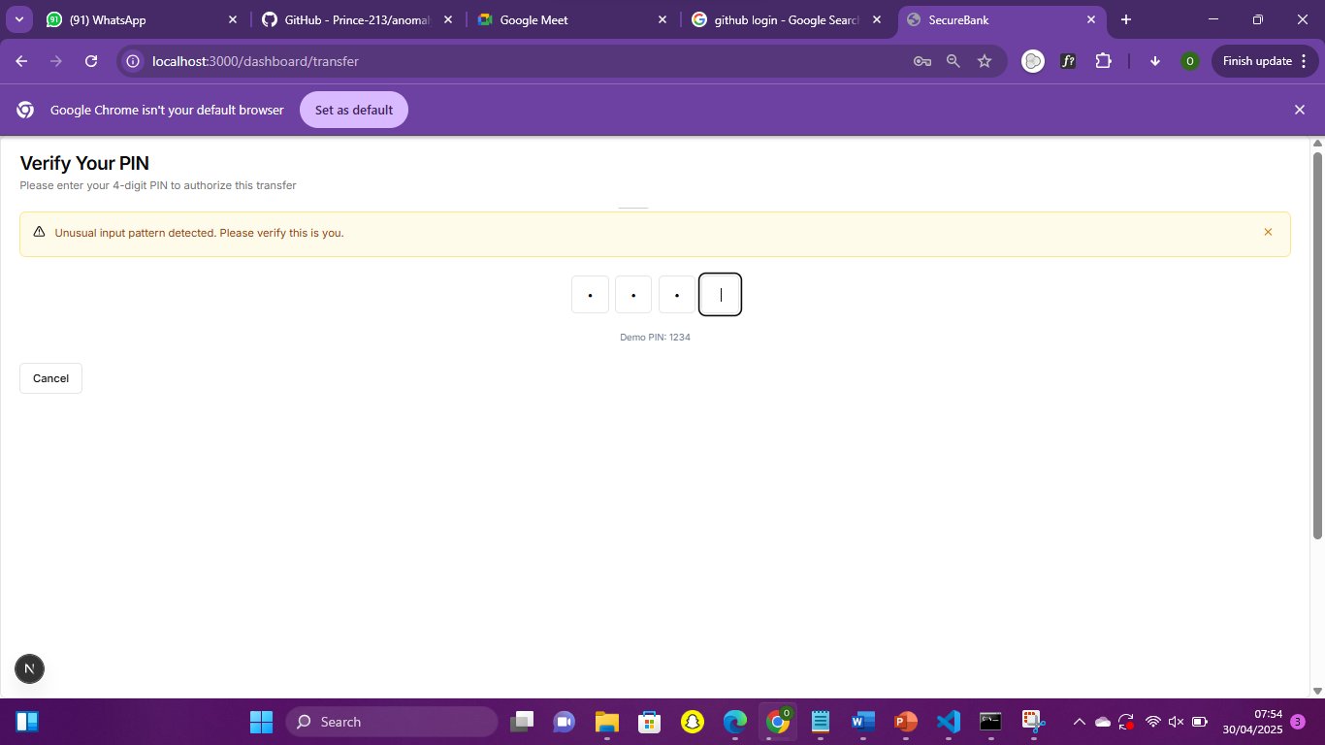
Figure 4.7 Pin Verification Page
CHAPTER FIVE
SUMMARY, RECOMMENDATIONS AND CONCLUSIONS

  - INTRODUCTION
This chapter provides a comprehensive summary of the proposed work, including future work recommendations and a conclusion. This chapter thereby summarises all that has been discussed in the previous chapters of this project.

  - SUMMARY
In the initial part of the research project, the background of the study and the problem statement were discussed. In the latter part of this work, a review of works relating to the system and their theoretical foundations was covered. However, this project presented a comprehensive analysis of already existing systems, pointing out their flaws, thereby using their disadvantages in the creation of the suggested system.
In the third chapter of this work, a thorough analysis of the system was conducted using UML (Unified Modelling Language) diagrams; the system was comprehensively analysed using use case diagrams, class diagrams, activity diagrams, and sequence diagrams of the UML diagrams. Lastly, the description of the programming languages and frameworks used in the completion of this research work and the user interface were provided.

  - RECOMMENDATIONS
This behavioural biometrics-based intrusion detection system is highly recommended for financial institutions to prevent fraud by continuous user verification. It is also recommended for online enterprises like healthcare, tech, and e-commerce to monitor employee and user activities. With this system flagging on various sites visited, it studies the behavioural patterns of its users and alerts to any deviation from the normal user behaviour as an anomaly. It provides data-driven insights into user behaviour to prevent fraud and provide insider threat detection by monitoring user behaviour in real time.

  - CONCLUSION

We have finally reached the concluding part of this research work, as this section wraps up the goals of this proposed work. However, this is not the end of the project, but rather, this research work has not stopped with this finding, and the researcher will continually expand and integrate a lot of additional services, such as voice recognition as a biometric to identify anomalies.

REFERENCES
Hadeel, Q., & Wathiq, L. (2024). Two-step data clustering for improved intrusion detection system using CICIoT2023 dataset. journal homepage: www.elsevier.com/locate/prime
Soulaiman, M., Khaldoun K., & Assef, J. (2021). Improving the Performance of Machine Learning-Based Network Intrusion Detection Systems on the UNSW-NB15 Dataset. Hindawi, Computational Intelligence and Neuroscience Volume 2021, Article ID 5557577, 13 pages https://doi.org/10.1155/2021/5557577
Tazin, S., Siddharth, K., Kiran, D., Milennium, A., Ram, K.S., & Pawan R.B (2023). Intrusion Detection System. International Journal of Aquatic Science ISSN: 2008-8019 Vol 14, Issue 01, 2023
Afnan, A., & Murad, A. (2023). Adversarial Machine Learning Attacks against Intrusion Detection Systems: A Survey on Strategies and Defence. Future Internet 2023, 15, 62. https://doi.org/10.3390/fi15020062
Mahmoud, S.E., Nhien-An, L., Marwan A.A., & Anca, J. (2021). A novel hybrid model for intrusion detection systems in SDNs based on CNN and a new regularisation technique. Journal of Network and Computer Applications 191 (2021) 103160. journal homepage: www.elsevier.com/locate/jnca
Logeswari, G., Bose, S., & Anitha, T., (2023). An Intrusion Detection System for SDN Using Machine Learning. IASC, 2023, vol.35, no.1, DOI: 10.32604/iasc.2023.026769
Yris, B.W.P. (2023). Performance and Security Evaluation of Behavioural Biometric Systems. https://hal.science/tel-04397160v1
Hungyu, L., & Bo, L. (2019) Machine Learning and Deep Learning Methods for Intrusion Detection Systems: A Survey. Licensee MDPI, Basel, Switzerland. Licensee MDPI, Basel, Switzerland. This article is an open access article distributed under the terms and conditions of the Creative Commons Attribution (CC BY) license (http://creativecommons.org/licenses/by/4.0/)
Mohamed, F.E., Ali, I.A., & Hesham, F.A.H. (2018). Intrusion detection systems for Iot-based smart environments: a survey. Journal of Cloud Computing: Advances, Systems and Applications, (2018) 7:21 https://doi.org/10.1186/s13677-018-0123-6
Albara, A. (2023). A Novel Deep Learning-Based Intrusion Detection System for Iot Networks. Computers 2023, 12, 34. https://doi.org/ 10.3390/computers12020034
Michael, Z., Florian, G., Elizabeth, C., & Tharam, D. (2022). Provenance-based Intrusion Detection Systems: A Survey. ACM Comput. Surv. 55, 7, Article 135 (December 2022), https://doi.org/10.1145/3539605
Muhammad, A.K. (2021). HCRNNIDS: Hybrid Convolutional Recurrent Neural Network-Based Network Intrusion Detection System. . Processes 2021, 9, 834. https://doi.org/ 10.3390/pr9050834
Abdul, B., Smys, S., & Haoxiang, W. (2020). Hybrid Intrusion Detection System for Internet of Things (Iot). Journal of ISMAC (2020) Vol. 02/ No.04 http://irojournals.com/iroismac/ DOI: https://doi.org/10.36548/jismac.2020.4.002
Shema, A., Saad, M.A., & Fekadu, A.C. (2023). Computer Vision-Based Intrusion Detection System for Internet of Things. Hindawi Wireless Communications and Mobile Computing Volume 2023, Article ID 5881769, 11 pages. https://doi.org/10.1155/2023/5881769
Robin, G., Nase, E.J., Jose, M.F., Daniel, A., & Michel, R.D. (2020). Multi-level host-based intrusion detection system for the Internet of Things. Gassais et al. Journal of Cloud Computing: Advances, Systems and Applications (2020) 9:62 https://doi.org/10.1186/s13677-020-00206-6
Junaid, A., Muhammad, A.A., Roohi A., Khaled, S., Mamoun, A., & Razi, I. (2020). A Review of Performance, Energy and Privacy of Intrusion Detection Systems for Iot. http://creativecommons.org/licenses/by/4.0/
Hakan, C.A., & Zafer, A. (2023). A hybrid CNN+LSTM-based intrusion detection system for industrial Iot networks. Engineering Science and Technology, an International Journal 38 (2023) 101322, International Journal journal homepage: www.elsevier.com/locate/jestch
Sharuka, P.T., Lasitha, J., Lasith, Y., Pushpika, L., & Chaminda, H. (2022). Deep Neural Network Based Real-Time Intrusion Detection System SN Computer Science (2022) 3:145 https://doi.org/10.1007/s42979-022-01031-1
Cheolhee, P., Jonghoon, L., Youngsoo, K., Jong-Geun, P., Hyunjin, K., & Dowon, H., (2023). An Enhanced AI-Based Network Intrusion Detection System Using Generative Adversarial Networks. IEEE INTERNET OF THINGS JOURNAL, VOL. 10, NO. 3, 1 FEBRUARY 2023
Abhishek, V., & Virender, R. (2023). On evaluation of Network Intrusion Detection Systems: Statistical analysis of CIDDS-001 dataset using Machine Learning Techniques. 1Department of Computer Engineering, NIT Kurukshetra, Haryana, India abhishek_6170034@nitkkr.ac.in 2Department of Computer Engineering, NIT Kurukshetra, Haryana, India virender.ranga@nitkkr.ac.in
Ammar, A., & Faisal, A. (2021). An Effective Intrusion Detection System to Secure Data in Cloud Using Machine Learning. Symmetry 2021, 13, 2306. https://doi.org/10.3390/ sym13122306
Mohd, A.H., Mohd, A.R.K., & Talal, A. (2021). Development of PCCNN-Based Network Intrusion Detection System for EDGE Computing. Computers, Materials & Continua DOI:10.32604/cmc.2022.018708 Article
Muhammad, A.K., & Yangwoo, K. (2021). Deep Learning-Based Hybrid Intelligent Intrusion Detection System. Computers, Materials & Continua DOI:10.32604/cmc.2021.015647 Article
Alamgir, H., & Saiful, I. (2023). Ensuring network security with a robust intrusion detection system using ensemble-based machine learning. journal homepage: www.sciencedirect.com/journal/array

APPENDIX
app/auth/adminlogin/page.tsx
"use client";

import LoginForm from "@/components/login-form";
import { useActionState, useEffect, useState } from "react";
import { motion } from "motion/react";
import {
ArrowRight,
BarChart2,
Loader2,
Lock,
Shield,
User
} from "lucide-react";
import { Button } from "@/components/ui/button";
import {
Card,
CardContent,
CardDescription,
CardFooter,
CardHeader,
CardTitle
} from "@/components/ui/card";
import { Input } from "@/components/ui/input";
import { Label } from "@/components/ui/label";
import { loginAdmin, loginUser } from "@/lib/action";
import { toast } from "sonner";

const initialState = {
message: ""
};

export default function Home() {
// For anonymous users, we can still track but with a generic ID
const anonymousUser = {
id: "anonymous",
name: "Anonymous User"
};

const [state, formAction, pending] = useActionState(loginAdmin, initialState);

useEffect(() => {
if (state.message == "success") {
toast.success("Loggin Successful");
} else if (state.message == "unsuccess") {
toast.error("Unsuccessful Login");
}
}, [state]);

return (
<>
<main className="flex min-h-screen flex-col items-center justify-center p-4 bg-slate-50">
<motion.form
initial={{ opacity: 0, y: 20 }}
animate={{ opacity: 1, y: 0 }}
transition={{ duration: 0.4 }}
className="w-full max-w-md"
action={formAction}
>
<Card className="border-0 shadow-lg">
<CardHeader>
<CardTitle className="flex items-center gap-2">
<Shield className="h-5 w-5 text-blue-600" />

<p>Admin Login</p>
</CardTitle>
<CardDescription>
Enter your credentials to access the admin portal
</CardDescription>
</CardHeader>
<CardContent className="space-y-4">
<div className="space-y-2">
<Label htmlFor="email">Email</Label>
<Input
id="email"
type="email"
name="email"
placeholder="name@company.com"
/>
</div>
<div className="space-y-2">
<div className="flex items-center justify-between">
<Label htmlFor="password">Password</Label>
</div>
<div className="relative">
<Input id="password" type="password" name="password" />
<Lock className="absolute right-3 top-2.5 h-4 w-4 text-slate-400" />
</div>
</div>
</CardContent>
<CardFooter className="flex flex-col space-y-4">
<Button type="submit" className="w-full">
Login
{pending ? (
<Loader2 className=" ml-2 h-4 w-4" />
) : (
<ArrowRight className="ml-2 h-4 w-4" />
)}
</Button>
</CardFooter>
</Card>
</motion.form>
</main>
</>
);
}

app/auth/userlogin/page.tsx
"use client";

import LoginForm from "@/components/login-form";
import { useActionState, useEffect, useState } from "react";
import { motion } from "motion/react";
import {
ArrowRight,
BarChart2,
Loader2,
Lock,
Shield,
User
} from "lucide-react";
import { Button } from "@/components/ui/button";
import {
Card,
CardContent,
CardDescription,
CardFooter,
CardHeader,
CardTitle
} from "@/components/ui/card";
import { Input } from "@/components/ui/input";
import { Label } from "@/components/ui/label";
import { loginUser } from "@/lib/action";
import { toast } from "sonner";
import Link from "next/link";

const initialState = {
message: ""
};

export default function Home() {
// For anonymous users, we can still track but with a generic ID
const anonymousUser = {
id: "anonymous",
name: "Anonymous User"
};

const [state, formAction, pending] = useActionState(loginUser, initialState);

useEffect(() => {
if (state.message == "success") {
toast.success("Loggin Successful");
} else if (state.message == "unsuccess") {
toast.error("Unsuccessful Login");
}
}, [state]);

return (
<>
<main className="flex min-h-screen flex-col items-center justify-center p-4 bg-slate-50">
<motion.form
initial={{ opacity: 0, y: 20 }}
animate={{ opacity: 1, y: 0 }}
transition={{ duration: 0.4 }}
className="w-full max-w-md"
action={formAction}
>
<Card className="border-0 shadow-lg">
<CardHeader>
<CardTitle className="flex items-center gap-2">
<User className="h-5 w-5 text-blue-600" />

<p>User Login</p>
</CardTitle>
<CardDescription>
Enter your credentials to access the user portal
</CardDescription>
</CardHeader>
<CardContent className="space-y-4">
<div className="space-y-2">
<Label htmlFor="email">Email</Label>
<Input
id="email"
type="email"
name="email"
placeholder="name@company.com"
/>
</div>
<div className="space-y-2">
<div className="flex items-center justify-between">
<Label htmlFor="password">Password</Label>
</div>
<div className="relative">
<Input id="password" type="password" name="password" />
<Lock className="absolute right-3 top-2.5 h-4 w-4 text-slate-400" />
</div>
</div>
</CardContent>
<CardFooter className="flex flex-col space-y-4">
<Button type="submit" className="w-full">
Login
{pending ? (
<Loader2 className=" ml-2 h-4 w-4 animate-spin" />
) : (
<ArrowRight className="ml-2 h-4 w-4" />
)}
</Button>
</CardFooter>
</Card>

<Link
href={"/register"}
className=" mt-2 underline text-blue-500 text-sm font-semibold "
>
Register new user
</Link>
</motion.form>
</main>
</>
);
}

##Libraries
import pandas as pd
import numpy as np
import matplotlib.pyplot as plt
import seaborn as sns
from sklearn.model_selection import train_test_split
from sklearn.preprocessing import StandardScaler
from sklearn.ensemble import IsolationForest
from sklearn.metrics import classification_report, confusion_matrix, roc_auc_score
from sklearn.svm import OneClassSVM
from xgboost import XGBClassifier

## 1. Load and Explore the Data
df = pd.read_csv('user_behavior_dataset.csv')
print("\nDataset Overview:")
print(df.head())
print("\nSummary Statistics:")
print(df.describe())
print("\nClass Distribution:")
print(df['is_anomaly'].value_counts())

## 2. Data Visualization
def plot_feature_distributions(df):
fig, axes = plt.subplots(2, 3, figsize=(18, 12))

# Plot distributions for each feature
sns.histplot(data=df, x='home_page_dwell', hue='is_anomaly', kde=True, ax=axes[0, 0])
sns.histplot(data=df, x='history_page_dwell', hue='is_anomaly', kde=True, ax=axes[0, 1])
sns.histplot(data=df, x='transfer_page_dwell', hue='is_anomaly', kde=True, ax=axes[0, 2])
sns.histplot(data=df, x='pin_input_speed', hue='is_anomaly', kde=True, ax=axes[1, 0])
sns.histplot(data=df, x='total_session_time', hue='is_anomaly', kde=True, ax=axes[1, 1])
sns.histplot(data=df, x='transfer_to_history_ratio', hue='is_anomaly', kde=True, ax=axes[1, 2])

plt.suptitle("Feature Distributions by Class", y=1.02)
plt.tight_layout()
plt.show()

def plot_correlation_matrix(df):
plt.figure(figsize=(10, 8))
corr = df.drop(columns=['user_id', 'timestamp']).corr()
sns.heatmap(corr, annot=True, cmap='coolwarm', center=0)
plt.title("Feature Correlation Matrix")
plt.show()

def plot_time_series_analysis(df):
df['timestamp'] = pd.to_datetime(df['timestamp'])
df.set_index('timestamp', inplace=True)

plt.figure(figsize=(15, 8))
df['home_page_dwell'].plot(alpha=0.5, label='Home Page')
df['history_page_dwell'].plot(alpha=0.5, label='History Page')
df['transfer_page_dwell'].plot(alpha=0.5, label='Transfer Page')

# Mark anomalies
anomalies = df[df['is_anomaly'] == 1]
plt.scatter(anomalies.index, anomalies['home_page_dwell'], color='red', label='Anomaly')

plt.title("Page Dwell Times Over Time with Anomalies Highlighted")
plt.ylabel("Dwell Time (seconds)")
plt.legend()
plt.show()
# Execute visualization functions
plot_feature_distributions(df)
plot_correlation_matrix(df)
plot_time_series_analysis(df)

## 3. Data Preprocessing
# Prepare features and target
features = ['home_page_dwell', 'history_page_dwell', 'transfer_page_dwell',
'pin_input_speed', 'total_session_time', 'transfer_to_history_ratio']
X = df[features]
y = df['is_anomaly']

# Split data into train and test sets
X_train, X_test, y_train, y_test = train_test_split(X, y, test_size=0.2, random_state=42, stratify=y)

# Scale the features
scaler = StandardScaler()
X_train_scaled = scaler.fit_transform(X_train)
X_test_scaled = scaler.transform(X_test)

## 4. Model Training and Evaluation
def train_and_evaluate_model(model, model_name, X_train, X_test, y_train, y_test):
print(f"\n=== {model_name} ===")

# Train model
if model_name in ['Isolation Forest', 'One-Class SVM']:
# Unsupervised models (trained only on normal data)
normal_idx = y_train == 0
model.fit(X_train_scaled[normal_idx])

# Predict anomalies (1 = normal, -1 = anomaly)
y_pred_train = model.predict(X_train_scaled)
y_pred_test = model.predict(X_test_scaled)

# Convert predictions to same format as true labels
y_pred_train = np.where(y_pred_train == 1, 0, 1)
y_pred_test = np.where(y_pred_test == 1, 0, 1)
else:
# Supervised models
model.fit(X_train_scaled, y_train)
y_pred_train = model.predict(X_train_scaled)
y_pred_test = model.predict(X_test_scaled)

# Evaluate performance
print("\nTraining Performance:")
print(classification_report(y_train, y_pred_train))
print("Test Performance:")
print(classification_report(y_test, y_pred_test))

# Confusion matrix
cm = confusion_matrix(y_test, y_pred_test)
plt.figure(figsize=(6, 6))
sns.heatmap(cm, annot=True, fmt='d', cmap='Blues',
xticklabels=['Normal', 'Anomaly'],
yticklabels=['Normal', 'Anomaly'])
plt.title(f"{model_name} Confusion Matrix")
plt.ylabel('True Label')
plt.xlabel('Predicted Label')
plt.show()

## 4. Train and Evaluate XGBoost Model
# Initialize and train XGBoost classifier
xgb_model = XGBClassifier(
objective='binary:logistic',
eval_metric='aucpr',
scale_pos_weight=(len(y_train) - sum(y_train)) / sum(y_train), # Handle class imbalance
random_state=42
)
xgb_model.fit(X_train_scaled, y_train)

# Make predictions
y_pred = xgb_model.predict(X_test_scaled)
y_prob = xgb_model.predict_proba(X_test_scaled)[:, 1]

# Evaluate model
print("Classification Report:")
print(classification_report(y_test, y_pred))
print("\nConfusion Matrix:")
print(confusion_matrix(y_test, y_pred))
print(f"\nROC AUC Score: {roc_auc_score(y_test, y_prob):.4f}")

