ANTIBIOTIC RESISTANCE PATTERNS OF BACTERIA ISOLATED FROM HOSPITAL WASTE WATER
ENUKA, OKEIFUNANYA STEPHANIE
GOU/U21/MCB / 501

MICROBIOLOGY
DEPARTMENT OF BIOLOGICAL SCIENCES
FACULTY OF NATURAL SCIENCES AND ENVIRONMENTAL STUDIES

JUNE 2025

ANTIBIOTIC RESISTANCE PATTERNS OF BACTERIA ISOLATED FROM HOSPITAL WASTE WATER
BY
ENUKA, OKEIFUNANYA STEPHANIE

GOU/U21/MCB/501

MICROBIOLOGY
DEPARTMENT OF BIOLOGICAL SCIENCES

FACULTY OF NATURAL SCIENCE AND ENVIRONMENTAL STUDIES

GODFREY OKOYE UNIVERSITY, ENUGU NIGERIA

A PROJECT RESEARCH REPORT SUBMITTED TO THE DEPARTMENT OF BIOLOGICAL SCIENCES IN PARTIAL FULFILMENT OF THE REQUIREMENTS FOR THE AWARD OF THE DEGREE BACHELOR OF SCIENCE (B.SC.) IN MICROBIOLOGY.

SUPERVISOR: PROF. I.M. EZEONU
CO-SUPERVISOR: BELLO-UKWUEZE N.M

JUNE, 2025

APPROVAL
This research titled “Antibiotic resistant pattern of bacteria isolated from hospital waste water” has been assessed and approved by the Committee of Department of Biological Sciences and the Faculty of Natural Sciences and Environmental Studies, Godfrey Okoye University Enugu, Nigeria.

Prof. I.M Ezeonu​​​ …………………. …………………
Supervisor ​​​​Signature ​​​​​Date

Dr. Frances N. Olisaka​ ………………….​ …………………
HOD, Department of​ Signature​​ Date
Biological Sciences

Prof. Chidi C. Uhuegbu​ ………………….​​ …………………
Dean, FNSES​​​ Signature​​​​ Date

​ ………………….​​ …………………
External Examiner Signature​​​​ Date

CERTIFICATION
This is to certify that this research titled Antibiotic resistant pattern of bacteria isolated from hospital waste water was carried out by Enuka, Okeifunanya Stephanie under supervision of Prof. I.M Ezeonu in the Department of Biological Sciences, Godfrey Okoye University, Enugu.

Enuka Okeifunanya .S. …………………. ​.....………………..
Signature ​ Date

DEDICATION
I dedicate this project to God almighty for making it possible from the beginning of this journey. Also dedicate it to my family for their endless support, encouragement and love throughout my academic journey.

ACKNOWLEDGEMENT
I thank God for the grace and strength that made it possible for me to complete this project. Without his grace, none of this would have been possible.
My appreciation and gratitude goes to my supervisor, Prof I.M. Ezeonu for the consistent guidance, patience and valuable input throughout the duration of my research. Your support and constructive feedback and patience made a significant difference to everything and also played an important role in shaping the quality of this research and I’m beyond grateful. I am deeply grateful for the time and effort you put onto supervising this work.
To Co-Supervisor, Mrs. Bello Ukwueze, I extend my heartfelt thanks for your insightful suggestions, encouragements and continuous support. Your contributions both in the lab and into the work helped shape everything. I would also like to thank the head of department, Dr. Frances N. Olisaka for her encouragement and words of advice towards us from the very beginning.
I also want to appreciate the staff of Biological sciences department for their assistance and for making a supportive academic environment. To my friends and colleagues, I thank for their encouragement when it was tough, and their moral support. To my family, thank you for your understanding and love means more to me. To my parents, Mrs. Oluchi Okeke and Chief Andrew Enuka Okeke, I thank you for being the foundation of all this. Your sacrifices and prayers gave me the strength to persevere. I also appreciate my friends and colleagues who helped and walked with me throughout this journey. Your companionship, moral support and words of advice made the difficult days more bearable.

ABSTRACT
This study investigated the antibiotic resistance patterns of bacteria isolated from hospital wastewater. Two water samples were taken from two separate points at the effluent discharge area of a private hospital. The physical and chemical parameters of the wastewater, including pH, electrical conductivity, and total solids were determined. The samples were then subjected to presumptive tests for coliforms as well as determination of total bacterial counts. A series of microbiological and biochemical tests were conducted to identify and characterize bacterial isolates from the samples. The results showed the pH of the samples to be neutral; the total solids were within range and the conductivity was 422 s/m. The total bacterial counts ranged from 1.5 x 10² CFU/ml to 2.12 x 10² CFU/ml. The bacterial isolates included various pathogenic bacteria, notably Bacillus spp, Staphylococcus spp, Escherichia coli, Pseudomonas spp and Salmonella spp. Antibiotic susceptibility testing showed a high level of resistance to commonly used antibiotics such as Ampicillin, Levofloxacin, Ofloxacin, Ciprofloxacin, Gentamicin and Erythromycin. Some isolates showed intermediate sensitivity to gentamicin and ciprofloxacin, while resistance to Levofloxacin, Ofloxacin and Ciprofloxacin was also observed. The Multiple antibiotic resistance index of the isolates ranged from 0.5-1. The presence of multi-drug resistant strains highlights the public health risks associated with improper wastewater management in healthcare environments. This underscores the urgent need for effective treatment of hospital effluents before discharge into the environment.

TABLE OF CONTENTS
Title Page i
Approval ii
Certification iii
Dedication iv
Acknowledgment v
Abstract vi
Table of Contents vii
List of Tables ix
List of Figures x
List of Appendix xi

CHAPTER ONE: INTRODUCTION 1

1.1 Background of the Study 1

1.2 Statement of the Problem 2
1.3 Aim of the Study 3
1.4 Objectives of the Study 4
CHAPTER TWO: LITERATURE REVIEW 5
2.1 Definition and Mechanism of Antibiotic Resistance 5
2.1.1 Antibiotics restraining synthesis of cell wall 5
2.1.2 Antibiotics restraining synthesis of bacterial protein 5
2.2 Examples of Resistant Bacterial Strain 8
2.3 Hospital Wastewater as a Reservoir of Resistance 11
2.4 Factors Influencing Resistance in Wastewater 14
2.5 Methods used to study Resistance Patterns 15
2.6 Overview of Hospital Wastewater Resistance Globally 18
CHAPTER THREE: MATERIALS AND METHODS 19
3.1 Study Area 19
3.2 Sample Collection 19
3.3 Physical Analysis 19
3.4 Chemical Analysis 20
3.4.1 Determination of acidity 21
3.4.2 Determination of alkalinity 21
3.4.3 Determination of total solids 21
3.4.4 Determination of dissolved solids 21
3.4.5 Determination of suspended solids 22
3.5 Testing for the Presence of Coliforms 22
3.5.1 Plate count 23
3.6 Biochemical tests 23
3.7 Gram Staining 25
3.8 Antibiotic Sensitivity Testing 25
3.9 Data Analysis and Interpretation 26
CHAPTER FOUR: RESULTS 27
4.1 Presumptive Screening for Coliform Bacteria in MacConkey Broth 27
4.2 Total Bacterial Counts in Hospital Wastewater Samples 27
4.3 Identification of Isolates 28
4.4 Antibiotic Sensitivity Profiles of Isolates 30
4.5 Physiochemical Properties of the wastewater samples 37

CHAPTER FIVE: DISSCUSSION, CONCLUSIONAND RECOMMENDATION
5.1 Discussion 38
5.2 Conclusion 39
5.3 Recommendation 40

REFERNCES 41
APPENDIX 47

LIST OF TABLES
Table 2.1: Mechanism of drug resistance of common antibiotics 11
Table 4.1 Lactose fermentation in wastewater samples 27
Table 4.2 Total bacterial counts in wastewater sample 28
Table 4.3 Morphological and biochemical characteristics of bacterial isolate 29
Table 4.4: Interpretation of isolate codes
Table 4.5 Antibiotic susceptibility of Bacillus spp 31
Table 4.6 Antibiotic susceptibility of Escherichia coli 32
Table 4.7 Antibiotic susceptibility of Stsphlococcus spp 33
Table 4.8 Antibiotic susceptibility of Salmonella spp 34
Table 4.9 Antibiotic susceptibility of Pseudomonas spp 35
Table 4.10 Multiple antibiotic resistance (MAR) index of bacterial isolates 36
Table 4.11 physiochemical properties of the wastewater sample 37

LIST OF FIGURES
Figure 2.1 Modification of drug target 8
Figure 2.2 Cycle of hospital wastewater resistance 13
Figure 2.3 Hospital wastewater discharge point 14
Figure 2.4 Phenotypic methods 16
Figure 2.5 Disk diffusion test 17

LIST OF APPENDICES
Appendix 1: Cultures of wastewater in SSB and DSB, showing acid production 47
Appendix II: Appearance of different isolates on various culture media 48

CHAPTER ONE
INTRODUCTION
1.1 Background of the Study
The unrestricted use of antibiotics and the irregular dosage to human has led to antibiotic pollution. Enzymes in the body breakdown antibiotic when taken, thus changing it to active substances that stop the growth of an infection. The remaining part of the antibiotic is excreted as urine or feces into the environment through sewage systems. This leads to increase of antibiotic levels in the environment. Pathogens mutate and grow immunity to antibiotic due to extra antibiotics in the ecosystem. (Kollef et al., 2017). Antibiotic-resistant bacteria are referred to as ‘super bugs’. An example is (MRSA) methicillin-resistant S.aureus. (Elshabrawy et al., 2017). In 2019, MRSA gave rise to about 100,000 infections which was one of the biggest hazard to the human health (Murray et al., 2022).
The exposure of antibiotic remnant in the environment is as a result of several design of antibiotic use. It is usually administered towards fighting against bacterial infections (Ben et al, 2019). Antibiotics administered to human and animal treatment are entering into the environment through excreta and urine. For that reason, optimizing and administering the use of antibiotics are the main elements in decreasing environmental contamination.
Waste water treatment plants that collect waste water from different sources are considered the center for the diffusion of ARGs. This is because they are places for potential bacterial growth and genetic exchange (Baquero et al., 2008; Luo et al., 2014). Aerated sludge provides a good environmental conditions for the growth of bacteria, amoeba, protozoa, and other microorganisms. Sewage treatment plans are prospective antibiotic resistance incubators (Lambirth et al., 2018).
After treatment, the concentration of antibiotics increase with significance in contrast to their concentration upstream. Antibiotics tenacity in these waters can grow the potential collection of ARGs and increase transfer among bacterial population (Lambirth et al., 2018).
The increase in ARB is due to the favorable environment that is caused by landfills receiving sewage sludge. This leads to the transfer of ARGs by pairing to other environmental strains. This contributes to the spread of antibiotic resistance and serious public health issues (Anand et al., 2021). Hospital waste waters are known to be the center for antibiotic resistance. The hospital waste water contains a list of toxic substances such as disinfectants, pharmaceuticals and radionuclides for medical purpose.
The inappropriate and unsuitable use of antibiotics which promotes selective pressure in human medicine makes strains of ARB in humans that are pushed out with feces and urine. It leads to contamination of the environment and sides the transfer of genetic determinants of antibiotic resistance to different microorganisms (Romero et al, 2017).

1.2 Statement of the Problem
Antibiotic resistance has been a worldwide health problem that has long be traced to humans and environmental component (Robinson et al., 2016). Many environmental accumulation are part of antibiotic resistance dissemination which includes water, hospital, industry, and several polluted ecological nooks (Marti et al., 2014; Huijbers et al., 2015). Resistance of bacterial pathogens towards antimicrobial therapies and the alarming multidrug resistance are increasing at a terrible rate (Muhlen and Dersch, 2016). Finding preventive measures against the development of antibiotic resistance has been a major worldwide issue for the community and public wellbeing (Chellat et al., 2016). Lots of infections that are caused by resistant microorganisms do not respond to conventional treatment and some last option antibiotic have lost their desirability.
The utilization of huge amounts of antibiotics in animal farming brings about agro-ecosystem contamination between agricultural lands that has been introduced with contaminated manure as fertilizer and the spraying of crops with wastewater. Other worries rise from the inappropriate disposal of new medicinal products by releasing them into sewage systems. Wastewater treatment plants are used in treating antibiotic-contaminated wastewater therefore transfer of antibiotics is not 100% possible (Wang et al, 2017). Antibiotic remnant can have adverse effects in the ecosystem and in the human health as soon as it is in the environment through the ingestion of contaminated food water, through the offer to enlarge the resistant bacterial population and supporting selective pressure that aim for the growth of resistance in several sections in the environment (Jechalke et al, 2017).
Inappropriate discarding of antibiotics is an important part in the antibiotic occurrence into hospital wastewater. Absence of appropriate disposal exercise between physicians and patients demand targeted period of awareness about the side effects of inappropriate disposal in the environment (Kinrys et al, 2018). Sewage from the hospital is another important site of antibiotic remnant pollution (Lien et al, 2016).

1.3 Aim of the Study
The aim of this study is to be able to analyze the antibiotic resistance pattern of bacteria isolated from hospital waste water.
2.4 Objectives of the Study
1. To isolate and identify bacterial species from hospital wastewater.
2. To determine the antibiotic resistance profiles of the isolates
3. To determine multiple antibiotic index (MAR) of resistant isolates.

CHAPTER TWO
LITERATURE REVIEW
2.1 Definition and Mechanisms of Antibiotic Resistance
Antibiotic resistance can be referred to as the ability for microorganism to withstand the reaction of antibiotic which inhibits its ability to grow and proliferate. (WHO, 2023)

Antibiotic action is categorized in 5 mechanisms.
1. Restraint with synthesis of bacterial cell wall
2. Restraint in biosynthesis of bacterial protein
3. Restraint in synthesis of bacterial Nucleic acid
4. Restraint in metabolic pathways
5. Restraint in bacterial membrane function (Garima et al., 2018)
2.1.1Antibiotics restraining synthesis of cell wall
Cell walls of bacteria comprises of cross-linked peptidoglycan b-lactams example penicillin and glycopeptides like vancomycin, they obstruct peptidoglycan biosynthesis contributing to the cells vulnerability to osmotic pressure (Bush and Bradford, 2016). Glycopeptides obstructs synthesis of the cell wall which develops into inhibition of the Trans peptidase thereby stops ensuing expansion and cross linking in the peptidoglycan chain (Wang et al., 2018)

2.1.2 Antibiotics restraining synthesis of bacterial protein
Aminoglycosides, like ‘neomycin and gentamicin’ stops protein synthesis by connecting to the site. Antibiotic expedites mistakes of codons after aminoacy-transfer RNA is sent. It accompanies to inaccurate protein synthesis which allows wrong amino acids to form within a polypeptide which loosed (Grossman, 2016).
There are two main types of antibiotic resistance.
Normal resistance which is normally shown in the organism. Acquired resistance is mostly the outcome of the bacteria obtaining genetic material through translation, transposition or conjugation (N.A. Leeminiaux, 2019)
Antibiotic resistance is into four group,
- Drug uptake limitation
- Drug target modification
- Drug inactivation
- Drug efflux
1 Limiting drug uptake
Gram-positive bacteria are more porous to some antibiotics than gram-negative bacteria. This is because gram negative produces a permeability protection according to the nature of a lipopolysaccharide surface (Blair et al, 2015). Present findings shows that cutting back in porin expression leads to resistance to medications Like Carbapenem in the family of Enterobacterales order, Acinetobacter spp, and Pseudomonas spp. (Iredell et al, 2016). An additional mechanism which helps for the establishment of bacteria is Biofilm formation (Pang et al, 2019). The biofilm structure includes DNA, Protein polysaccharides that makes antimicrobial agents hard to proceed into the bacteria and ensuring protection (Hall and Mash, 2017).

- Drug Efflux
Bacterial effluent pumps transports various antibiotics out of the cell. They are essential a donators to gram negative bacteria inherent efflux resistance. Efflux pumps comes in various ways of several bacteria.
- ATP binding cassette(ABC) family
- Multi drug and toxic compound extrusion (MATE) family
- Small multi drug resistance (SMR).
- Large facilitator superfamily (MFS)
- Family resistance modulation-cell design (RND)
These are the main 5 families of the efflux pumps (Reygart, 2018). Clinically applicable phenotype inspired by efflux mechanism are resistance to macrolides class of antibiotic, they encode the best characterized efflux pumps. (Munita and Arias, 2016)

- Drug inactivation
Bacteria inactivates antibiotics by using two method
- Destroying the drug
- The chemical adjustment to the drug (Blair et al, 2015)
i. Chemical adjustment of the drug
Bacteria produces enzyme that affix to several chemical groups to the drug. It averts the antibiotic from attaching to the prey within the bacterial cell. (Lin et al, 2015)

ii. Destroying the drug
Medicines like penicillin and cephalosporins are the most often working anti-microbial agent. The pursuit of b- lactamases pulls down b-lactase loop which is the main mechanism of b- lactase resistance (Bush and Bradford, 2016)

4 Modification of drug target
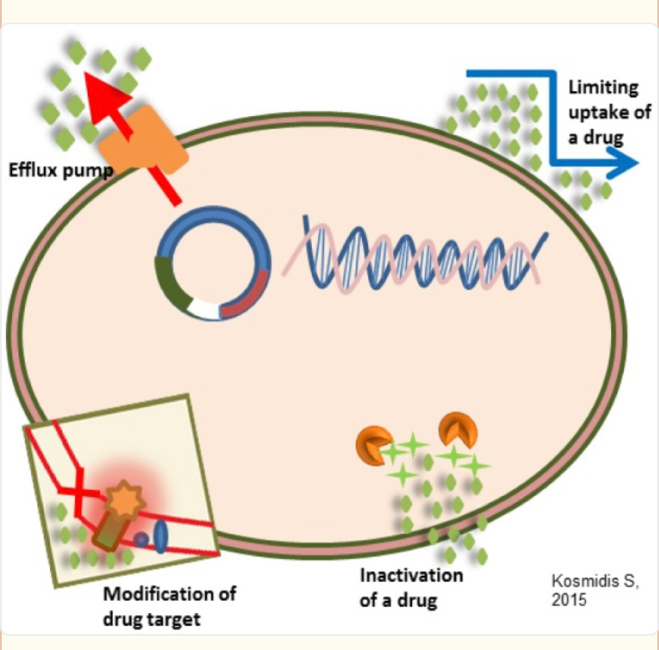
A usual mechanism in which bacteria becomes resistant to antibiotic is the alteration of the antibiotic (Reygart, 2018). The structural adjustment like the growth of the mecA gene inside staphylococcus aureus lessen or totally stops the binding of drug (Foster, 2017). Adjustments in DNA grade are intervene by nucleic acid synthesis that are stopped by the resistance to drugs.(Nainu et al, 2022)

Fig 2.1: Modification of drug target
2.2 Examples of resistance bacterial strain
1. Enterobacteriaceae Carbapenem-resistant
Infections caused by Carbapenem-resistant Enterobacteriaceae (CRE) are of major worry to the public health authorities and clinicians due to its rising frequency, shortage of therapeutic alternatives, bad patient outcomes and fast community spread. CRE transfer is the reason for the occurrence of clinical infection (French et al,. 2017).
The antibiotics Carbapenem in general are known to be the most powerful group of antimicrobial agent. It has a proven success in treating of patients that have serious bacterial infection which include the ones caused by other resistant strains. Carbapenem resistance is expected to the making of four carbapenemases.
Class a: β-lactamases like Klebsiella Pneumonia (KPC)
Class b: β-lactamases like New Delhi metallo-β-lactamase (NDM) and Verona integrin-encoded metallo-β-lactamase (VIM)
Class D: β- lactamase like oxacillinase-48 (OXA) (Mills and Lee, 2019)

2. Staphylococcus aureus, methicillin-resistant
The pathogen Methicillin-resistant Staphylococcus aureus has caused several infections which leads to severe mortality and morbidity globally.
3. Polymyxin-resistance gene
The family of Polymyxin are the second best researched form of antibiotic resistance. This is because of the history of its use in animal making. They are recurrent cation polypeptides that select from outside membrane of Gram-negative bacteria (Sun et al, 2018). Colistin and Polymyxin B are two main polymyxins that is applied in human medicine (Liu et al, 2016).
4. Tetraxycline-resistance genes.
The family of tetracycline which involves doxycycline, tetracycline, tigecycline and oxytetracycline are in the group of the most used antibiotics in the healthcare sectors in treating infections (Peiris et al, 2017; Zhang et al, 2015). Antibiotic resistant gene contains the ones that are in charge of the energy-dependent efflux pumps, ribosomal protection proteins and the ones that are included in enzymatic modification or inactivation (Kim et al, 2016). The too much consumption and appearance within the environment had resulted in increase in tetracycline resistance in several enteric like Enterobacter, Klebsiella, Salmonella and Aeromonas species (Lee and Wendy, 2017).
5. Sulfonamide-resistance genes
Sulfonamides, they are a group of synthetic antibiotics applied in the treatment of bacterial and protozoan infections in humans. Sulfadimethoxine and Sulfadiazine which are under sulfonamide stop dihydrofolic acid biosynthesis in Gram-negative and Gram-positive bacteria through joining plus interfering with dihydropteroate synthase.

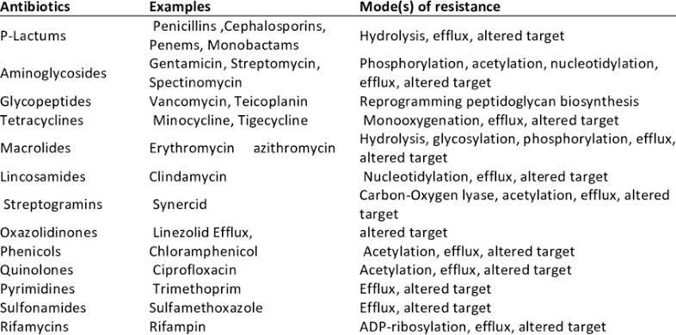
Table 2.1:Mechanism of drug resistance of common antibiotics

2.3 Hospital Wastewater as a reservoir of resistance
Hospital wastewater contains different pathogenic bacteria such as Enterococcus spp, Escherichia coli, Pseudomonas aeruginosa, which comes from patients, doctors, nurses, other healthcare workers and contaminated equipment (Selvarajan et al,. 2021). There are known bacterial pathogens found in the untreated wastewater from hospitals and other healthcare sectors that involves those from the group Acidobacteria, Spirochetes (Mijanur et al, 2021) with genus of Shigella, Klebsiella, Escherichia, Pseudomonas, Vibrio, Clostridium, and Staphylococcus (Tiwari et al., 2019)
Hospital wastewater is an important and an overlooked part in the spread of ABR. It works as an important reservoir for antimicrobial resistance bacteria (Bansal, 2019). The wastewater that comes from healthcare regions covers several places like the laboratories, surgical rooms, patient’s rooms and pharmacy disposal waste (Ajala et al, 2022). If not treated, hospital waste water releases antimicrobial resistant bacteria into municipal sewage systems like rivers and other water parts. This causes the spread of these resistant strains into the environment and populations around (Korzeniewska et al, 2020). Hospital wastewater is a foundation for antibiotic resistant bacteria because of the increase in concentration of antibiotics and other pharmaceuticals. It contributes to the growth of antimicrobial resistant pathogenic bacteria and leads to the spread of infections worldwide (Khawaja et al, 2017).
Antimicrobial resistant bacteria can be increased due to the introduction of harmful compounds of antibiotics. This causes antibiotics to enter the environment through hospital wastewater which contains several biological compounds that includes human waste. The release of untreated hospital wastewater into open water bodies is still an ongoing practice in some countries especially developing ones. Wastewater sewage and specifically hospital wastewater sewage is known to be the main cause for the selection of antibiotic resistant genes between pathogenic and non-pathogenic microbes (Petrovich et al, 2019).

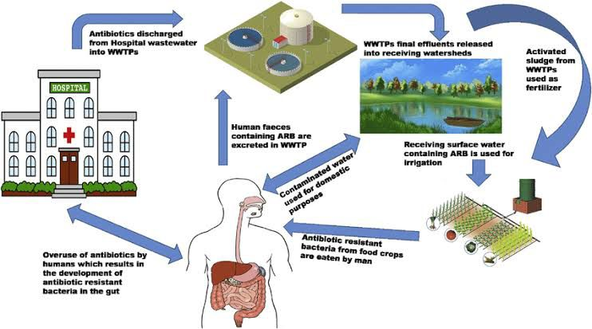
Fig 2.2: cycle of hospital wastewater resistance
Lack of waste water treatment and its role in resistance proliferation
Hospital sewage is an important source of antibiotic due to their usage in the clinical section (Petrovich et al, 2020). The sewage from these hospitals add extremely to the antibiotic load of the wastewater sewage from hospitals. These has made them important places for the spread of Antibiotic resistant gene due to the predicted higher concentration of ARB and antibiotic remnant than that in other wastewater areas (Zilberman et al, 2020). It is important to regulate the discharge of hospital waste water into the environment. This can be done by monitoring the antibiotic resistance in the branch and final outflow of hospital wastewater.

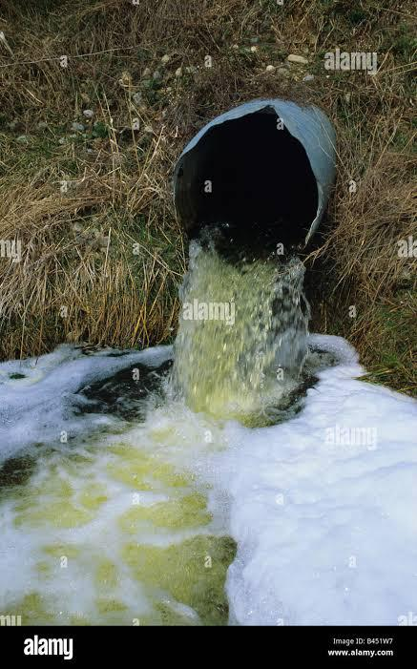
Fig 2.3: Hospital wastewater discharge point

2.4 Factors Influencing Resistance in Wastewater
Alexander Fleming who first found out about antibiotics in the year 1928, has since changed the healthcare sector by reducing mortality and morbidity that comes with infectious disease. They fight against bacterial infections even in places where there are limited resources. The common use has made antibiotics the most prescribed drug worldwide even for small infections. (Muteeb et al., 2023). Factors like knowledge of the diseases, proper dosage and cost effectiveness are needed. Unluckily, the power of pharmaceutical industries has at times led to improper prescriptions, cost increment and risk of bad reactions to the patient (Lahariya et al.,2024).
The main reasons of antibiotic resistance is the misuse and overuse of antibiotics. Over 10 million mass of antibiotics are used globally which some are not given reasons for in the medical sector (Kumawat et al.,2023). The overuse of these medications leads to the mutation of bacteria and formation of resistance mechanism due to the pressure that was put. The reliance on antibiotics for treatment of any disease and preventing it adds to the problem (Baran et al.,2023)
The overuse of antibiotics by humans, which are let out in the form of municipal sewage adds to the problem and therefore municipal wastewater treatment plants (WWTPs) have since become one of the most important place of antibiotic resistance gene (ARGs) (Augeut et al., 2017; Nnadozie et al., 2017). The WWTPs was created to filter nutrient substances like phosphorous, carbon and nitrogen except antibiotics and ARGs. (Rafraf et al., 2016; Su et al., 2017). It is shown that the conditions of the WWTPs are conducive for the growth of antibiotic-resistant bacteria also the gathering of Antibiotic resistance gene.

2.5 Methods used to study resistance patterns
1. Antimicrobial susceptibility testing
Bacteria is the major origin of infectious diseases. Antimicrobial susceptibility testing is a laboratory process used by medical scientists in order to identify the antimicrobial regimen which is effective for a single patient (Sawatzky et al, 2015). In some laboratories, several methods are being used such as the minimum inhibitory concentration (MIC) and disk diffusion (Humphries, 2020). Antimicrobial susceptibility testing are used for gram-positive example Staphylococcus aureus and Gram-negative bacteria example Pseudomonas Aeruginosa (Gajic et al, 2022).
Minimum Inhibitory Concentration
The most used method in laboratories is agar dilution and broth dilution (CLSI, 2018). The usage of both dilution methods determines the minimum Inhibitory concentration (MIC) of antimicrobial agents which is the lowest concentration an agent can stop the development of a microorganism (Golus et al, 2016; Vasilijevic et al, 2019). This test serves as the basis of obtaining the susceptibility section of a pathogen to a particular antibiotic. It also allows for the assessing of percentage of resistance or susceptibility to the antibiotic (Kowalska and Dudek, 2021).
Another name for the macro dilution method is in-tube dilution. This uses serial two fold dilution of antimicrobial substance in correlating media (Balouiri et al, 2015).
Antimicrobial Gradient Method
It is a mixture of both disk-diffusion method and dilution method of AST which has an advantage towards both properties. It makes way for the determination of the MIC making it simple and fast to use. This is gotten off of the diffusion of antibiotic through agar with a continuous activity (CLSI, 2018)

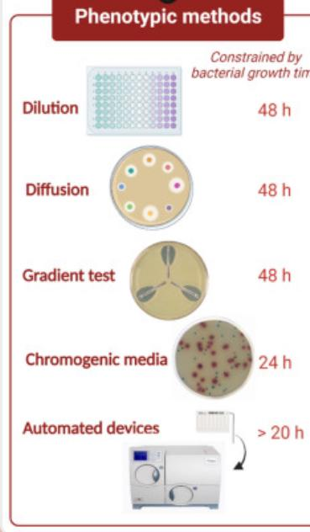
Fig 2.4: Phenotypic methods
Disk diffusion test
The disk diffusion method has since remained the most sort after routine anti susceptibility testing in clinical laboratories. It has been structured for the susceptibility testing of most known relevant bacteria that causes disease to humans. This test is the process of inserting antibiotic impregnated disk on inoculated agar that contains bacterial suspension (Le page et al, 2016).

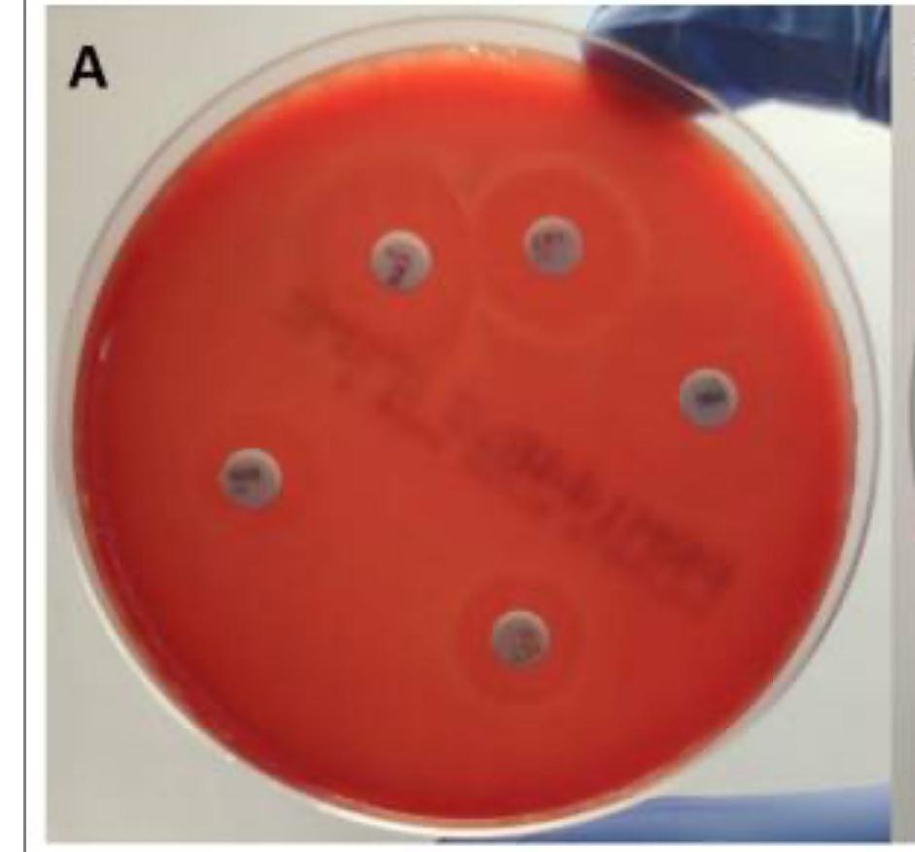
Fig 2.5: Disk diffusion test
2. Polymerase Chain Reaction
It is a sort after nucleic acid amplification-based test used for analyzing specific resistant genes. The conventional PCR and real-time both depend on the amplification of nucleic acid sequences that mix resistance to an antibiotic. The making of advanced PCR based methods are for the observation of genetic determinants of resistance to several antibiotics through list of bacterial species as our comprehension for the genetic foundation of antibiotic resistance grows (Sekyere and Asante, 2018). One lead of this method in contrast to other methods is that it distinguish non-beta-lactam resistant genes.

Overview of Hospital wastewater resistance globally
The overflow concerning antibiotic resistant genes (ARGs) in the surrounding is now a vital worldwide public health issue. This is an outcome of the extensive take of antibiotics within the healthcare sectors (Ju et al, 2016; Ma et al, 2017). There are finding of certain amounts of antibiotics and remnant of bacteria in hospital wastewater. It acts as selective pressure on antibiotic-resistant growth (Rowe et al, 2017). This makes hospital waste water more likely to spread antibiotic resistant genes than most local wastewater organization (Verlicchi et al, 2015; Zheng et al, 2018). The management for wastewater removal has been confirmed all over the world from the 1980’s. This is to avoid problems brought about by post-discharge sewage (Meng et al, 2016). At most, some countries has made the pre-release hospital wastewater treatment lawful (Al Aukidy et al. 2017).

CHAPTER THREE
MATERIALS AND METHODS
3.1 Study Area
Paulsonic hospital is located in GRA, Enugu State. The hospital is a non-profit making organization that prioritizes the health and right of any human which includes the right to respect and confidentiality of the patient. The hospital has an aim of being the best service provider in Enugu, thereby ensuring that their services are accessible and affordable. The hospital has various services like hematology, clinical chemistry, Hormones, medical microbiology, serology and virology. Also offers services in physiotherapy.
Waste water collection points
3.2 Sample Collection
Samples of the hospital effluent were taken from separate points likely to contain antibiotic residue with sterile container in order to avoid contamination. Each sample was labeled according to the point it was collected and the date it was collected. The samples were kept in a cold cooler with ice packs in order to preserve the sample (Rabiu and Falodun, 2017).
Once at the laboratory, the samples were processed for bacteria isolation and identification. Samples that could not be processed immediately were refrigerated (4⁰C)in order to avoid growth of bacteria or contamination of the sample.
3.3 Physical Analysis
The waste water physical properties was examined with the aid of the standard procedures as said by the American Public Health Association (APHA, 2017). Parameters measured:
Determination of pH
pH of the wastewater sample were tested using a digital pH meter that has been calibrated with the standard methods. This was to determine if the water was acidic, alkaline or neutral. Before measuring, the meter was standardized with buffer solutions of pH4.0, 7.0. Fifty milliliters of sample waste water were poured inside a clean and grease free beaker and the electrode of the meter was immersed into the sample. After the values stabilized, the readings was taken. (Zafar et al., 2020)
Electrical conductivity
This was measured with the use of a handy conductivity meter. This is important because it shows how many ions are in the water sample. Before measurement, the calibration was done using the standard potassium chloride solution (KCL). Fifty milliliters of the sample wastewater was poured into a clean beaker and the probe was immersed into the sample. After the values stabilized, the result was recorded. (Apha, 2017).
Odor
The odor was evaluated immediately after collecting the sample. Fifty milliliters of the sample were poured into a clean beaker. The beaker was brought to the nose at the chest level. It was sniffed by waving the hand over the opening in order to direct the air towards the nose. It was observed and written down.
3.4 Chemical Analysis
The chemical analysis of the already collected hospital wastewater sample was focused on obtaining the main water quality parameters which include alkalinity, acidity, total solids, dissolved solids and suspended solids.
3.4.1 Determination of acidity
Acidity in water is due to the presence of free CO2, mineral acids, and salts of strong acids and weak base.
Fifty milliliters of the sample wastewater was measured and poured in a clean conical flask and was added two or three drops of methyl orange indicator. It was titrated using 0.02 N NaOH till change from orange to yellow was observed.
3.4.2 Determination of alkalinity
Alkalinity measures the buffering capacity of water, primarily due to biocarbonates, carbonates and hydroxides. It is determined by titration with a standard acid(H2SO4)
Fifty milliliters of the sample wastewater was poured into a clean conical flask and three drops of phenolphthalein indicator were added. If a pink color showed, it was titrated with 0.02N H2SO4 until the pink disappeared.
3.4.3 Determination of total solids
This total solid content of the wastewater consists of both suspended and dissolved solids. This was gotten by evaporating the sample and weighing the remaining solids. A clean already weighed evaporation dish was used to hold 100 ml of the wastewater sample. The sample was evaporated to dryness in an oven set at 103°C to 105°C until all the water had evaporated. The solids were cooled then weighed.(APHA, 2012)
3.4.4 Determination of dissolved solids
Dissolved solids are the ones that pass through a standard filter. An already weighed filtration apparatus with 0.45 filter was used to filter 50ml of the wastewater sample. The filtrate was evaporated in a clean dish inside an oven at 103°C to 105°C. After it was dried, the dish was cooled and then weighed.
3.4.5 Determination of suspended solids
Suspended solids are the particles that do not pass through a filter and are being trapped in the filter paper. This is gotten by subtracting the mass of the dissolved solids from total solids.
After filtering the wastewater sample, the leftover retained on the filter paper was dried at 103°C to 105°C

3.5 Testing for the presence of coliforms
(a)The presumptive test
(b)The confirmed test
(c)The completed test
(i)The presumptive test
The test is used for observing the existence of coliform bacteria through observation of lactose fermentation and gas production in MacConkey broth. For each of the sample, two test tubes were used with control for each. Nine milliliters of single strength MacConkey broth. Ten milliliters of double strength of MacConkey broth. Double and single strength were used in order to maintain good nutrient concentration when different volume of samples were added. The Durham tubes were arranged inside the tubes to detect gas production. The test tubes were labelled according to the sample. After autoclaving for 15 mins the broth were inoculated with the water sample 1ml and 10ml on each single and double strength and incubated at 37°c for 48 hours.(Cheesbrough, 2006).
(ii)The confirmed test
This test is for verifying the existence of coliform mostly Escherichia coli. After the presumptive test, the bacteria are subcultured into selective media and differential media. A wire loop were used to take a loopful from the presumptive test and was streaked into the following Salmonella-shigella Agar (SSA): a differential and selective media primarily used to isolate and differentiate Salmonella and Shigella. MacConkey agar: is a differential and selective medium used in isolating gram-negative, lactose-fermenting enteric bacteria. Eosin Methylene Blue agar: is for growing of gram-negative enteric bacteria especially Escherichia coli and other coliforms. MSA agar: is for the isolation of Staphylococcus spp. Cetrimide agar: is for selective growth of Pseudomonas aeruginosa.
3.5.1 Plate count
This method is for calculating the sum number of viable bacteria that are present in the hospital waste water. Half a milliliter and one milliliter of sample A and B was inoculated on nutrient media using the pour plate method. (Harrigan and McCance, 2016) by pouring the sample first before introducing the sterile nutrient media. The plates were left in the incubator at 37°c for 24 hours (APHA, 2012). Afterwards, colonies on the plates were counted manually.
3.5 Biochemical tests
After isolation of the bacteria from the waste water sample, several Biochemical tests such as oxidase, catalase, coagulase etc were carried out in order to identify the isolated bacterial species.
Catalase test
In a clean glass slide, a small quantity of bacterial colony was placed and a small amount of hydrogen peroxide (3%) were added. the production of bubbles immediately indicated a positive catalase reaction. This helps differentiate between catalase producing and non-catalase- producing bacteria (Cheesbrough, 2006).
Oxidase test
A small quantity of bacterial culture was placed on an oxidase test strip. Dark purple color within 30 seconds shows a positive result which suggests the presence of cytochrome oxidase enzymes (Forbes et al., 2007)
Indole test
Tryptone broth were prepared and poured into tests tubes. A pure bacterial colony were inoculated into the broth using a sterile wire loop. The test tubes were left in the incubator at 37°c for 24-48 hours. Afterwards, kovacs reagents were added in small drops. A positive indole result is shown by a red layer formed in the top. A yellow or unchanged color showed a negative result. (cheesbrough, 2006)
Coagulase test
Blood were collected and centrifuged in order to separate the plasma from the serum. In a clean slide, a small amount of normal saline were placed. Small bacterial colony were mixed gently ito the saline to get a smooth suspension. A small amount of the plasma were added and gently mixed together. If there are clumps in 5 seconds shows a positive result. (Cheesbrough, 2006)
Citrate test
The agar was prepared and poured inside the test tubes. The test tubes was slanted and left to gel. A pure bacterial colony were streaked on the agar slant using sterile inoculating loop. The test tubes were left in the incubator at 37°c for 24-48 hours. The result is shown through a blue color change with growth which means positive. No growth or a green slant indicates a negative result. (MacFaddin, 2000)
3.6 Gram staining
This was performed in order to know the gram response if negative or positive and morphology of the bacterial isolate. This procedure includes preparing a smear with each isolate on a clean glass slide, which was air-dried and then fixed. This was done by passing the slide past a Bunsen burner. Crystal violet were streamed on the smear and washed off after 1 minute. It was rinsed using distilled water. Lugols Iodine were added and left to sit for 1 minute. This is to stabilize the dyes. It was rinsed gently with water. Acetone was used carefully to wash the smear and was rinsed immediately. Safranin was poured on the slides and was then rinsed after 30 seconds and left to air dry. The slides was viewed under the microscope and observed with oil immersion at 100x objective. Bacteria that appeared purple were known as Gram-positive, while the ones appearing pink or red were classified as Gram-negative.
3.7 Antibiotic Sensitivity Testing
After identifying the bacteria from the collected samples, the standard Agar disk diffusion method were applied in order to observe antibiotic patterns of the isolates using the Muller- hinton agar. (CLSI, 2014). Bacterial inoculations were set by suspending the bacteria in 4-5ml of sterile nutrient broth. The turbidity were regulated to the 0.5 McFarland standard. Antimicrobial sensitivity testing were done using Muller-Hinton medium against available antibiotics which includes amoxicillin, penicillin, vancomycin, gentamicin, clindamycin, ciprofloxacin, tetracycline etc. Selected antibiotic discs were placed using sterile forceps. The plates were left in the incubator at 37⁰C for 24 hrs. After incubation, zone of inhibition were calculated using a ruler while reading was made using susceptibility breakpoints of CLSI (Mir et al, 2022).

3.8 Data analysis and Interpretation
Collection of sample, sample handling, transportation, microbiological analysis and result interpretation were carried out. The data analysis in this study were aimed at the resistance of bacteria to antibiotic that is isolated from waste water in hospital.

CHAPTER FOUR
RESULTS

4.1 Presumptive Screening for Coliform Bacteria in MacConkey Broth
The two samples showed presumptive positive results for coliform bacteria, indicated by the presence of acid and gas after 48-hour incubation in single-strength (SSB) and double-strength (DSB) MacConkey broth (Table 1; Appendix I).
Table 1: Lactose fermentation in wastewater samples
Sample ID | DSB(+ve) | SSB (+ve) | Gas formation
Sample A | 2/2 | 2/2 | Yes
Sample B | 2/2 | 2/2 | Yes

4.2 Total Bacterial Counts in Hospital Wastewater Samples
Four samples of pour plate direct pour were carried out and the colony counts varied through 1.5 x 10² CFU/ml to 2.12 x 10² CFU/ml (Table 2).
Table 2: Total bacterial counts in wastewater samples
Sample Code | Pour plate No | Colonies counted | CFU/ml
A1 | 0.5ML | 172 | 3.44 x 10²
A2 | 1ML | 165 | 1.65 x 10²
B1 | 0.5 Ml | 153 | 3.06 x 10²
B2 | 1 Ml | 212 | 2.12 x 10²

4.3 Identification of isolates
Isolates from the wastewater samples were presumptively identified, based on morphological characteristics on different culture media and results from several biochemical tests, as expressed in Table 3. Organisms discovered included,Staphylococcus aureus, Salmonella spp and Escherichia coli

Table 3: Morphological and biochemical characteristics of bacterial isolates
Isolate  code | Colonial Morphology | Microscopic Appearance | Oxidase | Coagulase | Catalase | Indole | Citrate | Presumptive  organism
Ass SSA | Colorless, flat, smooth and black centered | Short rods | _ | _ | + | _ | + | Salmonella spp
Ads SSA | Colorless, flat,  smooth and black centered | Short rods | _ | _ | + | _ | + | Salmonella spp
Bss SSA | Colorless, flat, smooth and black centered | Short rods | _ | _ | + | _ | + | Salmonella spp
Bds SSA | Colorless, flat, smooth and black centered | Short rods | _ | _ | + | _ | + | Salmonella spp
Ass MSA | Yellow, small, round and raised | Cocci in clusters | _ | + | + | _ | + | Staphylococcus spp
Ads MSA | Yellow, small, round and raised | Cocci in clusters | _ | + | + | _ | + | Staphylococcus spp
Bss MSA | Yellow, small, round and raised | Cocci in clusters | _ | + | + | _ | + | Staphylococcus spp
Bds MSA | Yellow, small, round and raised | Cocci in clusters | _ | + | + | _ | + | Staphylococcus spp
Ass EMB | Purple, large, circular and round | Short rods | _ | _ | + | + | + | Escherichia coli
Ads EMB | Purple, large, circular and round | Short rods | _ | _ | + | + | + | Escherichia coli
Bss EMB | Purple, large, circular and round | Short rods | _ | _ | + | + | + | Escherichia coli
Bds EMB | Purple, large, circular and round | Short rods | _ | _ | + | + | + | Escherichia coli
Ass MAC | Pink, circular and smooth | Short rods | _ | _ | + | + | _ | Escherichia coli
Ads MAC | Pink, circular and smooth | Short rods | _ | _ | + | + | _ | Escherichia coli
Bss MAC | Circular, smooth and off white | Large rods | _ | _ | + | _ | _ | Bacillus spp
Bds MAC | Circular, smooth and off white | Large rods | _ | _ | + | _ | _ | Bacillus spp
Ass Cetrimide | Irregular, yellow, large and slightly raised | Medium rods | + | _ | + | _ | + | Pseudomonas spp
Ads Cetrimide | Irregular, yellow, large and slightly raised | Medium rods | + | _ | + | _ | + | Pseudomonas spp
Bss Cetrimide | Irregular, yellow, large and slightly raised | Medium rods | + | _ | + | _ | + | Pseudomonas spp
Bds Cetrimide | Irregular, yellow, large and slightly raised | Medium rods | + | _ | + | _ | + | Pseudomonas spp

Table 4.4 Interpretation of isolate code
The isolate code used in this study represent the combination of the agar type and the microorganism isolated. The table below provides a key to these codes
Table 4.4: Interpretation of isolate codes
Isolate code | Meaning
Ass SSA | Sample A from single strength broth in Salmonella-shigella agar
Ads SSA | Sample A from double strength broth in Salmonella-shigella agar
Bss SSA | Sample B from single strength broth in Salmonella-shigella agar
Bds SSA | Sample B from double strength broth in Salmonella-shigella agar
Ass MSA | Sample A from single strength broth in Mannitol salt agar
Ads MSA | Sample A from double strength broth in Mannitol salt agar
Bss MSA | Sample B from single strength broth in Mannitol salt agar
Bds MSA | Sample B from double strength broth in Mannitol salt agar
Ass EMB | Sample A from single strength broth in Eosin-methylene blue agar
Ads EMB | Sample A from double strength broth in Eosin-methylene blue agar
Bss EMB | Sample B from single strength broth in Eosin-methylene blue agar
Bds EMB | Sample B from double strength broth in Eosin-methylene blue agar
Ass MAC | Sample A from single strength broth in MacConkey agar
Ads MAC | Sample A from double strength broth in MacConkey agar
Bss MAC | Sample B from single strength broth in MacConkey agar
Bds MAC | Sample B from double strength broth in MacConkey agar
Ass Cetrimide | Sample A from single strength broth in Cetrimide agar
Ads Cetrimide | Sample A from double strength broth in Cetrimide agar
Bss Cetrimide | Sample B from single strength broth in Cetrimide agar
Bds Cetrimide | Sample B from double strength broth in Cetrimide agar

4.5 Antibiotic Sensitivity Profiles of Isolates
The selected antibiotics were used based on their relevance to hospital associated infections and their known effectiveness against some targeted organisms that was isolated from the waste water samples. The antibiotics used included Ampicillin, Ciprofloxacin, Tetracycline, Ceftriaxone, Levofloxacin, Gentamycin, Ofloxacin, and Erythromycin. The zone of inhibition throughout each antibiotic disc was calculated in order to determine the susceptibility. The organism were evaluated into resistant, intermediate and susceptible based on the interpretative standard made available by the clinical and laboratory standard institute (CLSI). The antibiotic sensitivity profiles of these isolates are presented in Tables 4 to 8, while multiple antibiotic resistance (MAR) indexes are presented in Table 9.

Table 4.5Antibiotic susceptibility of Bacillus spp.
Antibiotic | Zone of inhibition | interpretation
Gentamicin | 4 | Resistant
Levofloxacin | 3 | Resistant
Ofloxacin | 14 | Sensitive
Ampicillin | 3 | Resistant
Ciprofloxacin | 2 | Resistant
Erythromycin | 12 | Intermediate

Table 4.6 Antibiotic susceptibility of Escherichia coli
Antibiotic | Zone of inhibition | Interpretation
Gentamicin | 13 | Intermediate
Levofloxacin | 9 | Resistant
Ceftriaxone | 7 | Resistant
Ampicillin | 14 | Intermediate
Ciprofloxacin | 13 | Intermediate
Erythromycin | 8 | Resistant

Table 4.7 Antibiotic susceptibility of Staphylococcus spp
Antibiotic | Zone of inhibition | Interpretation
Gentamicin | 9 | Resistant
Levofloxacin | 8 | Resistant
Ofloxacin | 9 | Resistant
Ampicillin | 7 | Resistant

Table 4.8 Antibiotic susceptibility of Salmonella spp
Antibiotic | Zone of inhibition | Interpretation
Gentamicin | 2 | Resistant
Levofloxacin | 1 | Resistant
Ofloxacin | 3 | Resistant
Ampicillin | 2 | Resistant
Ciprofloxacin | 1 | Resistant
Erythromycin | 3 | Resistant

.

Table 4.9 Antibiotic susceptibility of Pseudomonas spp
Antibiotic | Zone of inhibition | Interpretation
Gentamicin | 0 | Resistant
Levofloxacin | 2 | Resistant
Ofloxacin | 1 | Resistant
Ampicillin | 3 | Resistant
Ciprofloxacin | 0 | Resistant
Erythromycin | 4 | Resistant

Table 4.10 Multiple antibiotic resistance (MAR) index of bacterial isolates
Isolate | Antibiotics tested | Resistance | MAR index
Bacillus spp | 6 | 4 | 0.6
Escherichia coli | 6 | 3 | 0.5
Staphylococcus aureus | 4 | 4 | 1
Salmonella spp | 6 | 6 | 1
Pseudomonas spp | 6 | 6 | 1

4.11 Physicochemical properties of the wastewater samples
Table 4.5 shows some of the chemical and physical properties of the wastewater samples.
Sample code | Acidity | Alkalinity | Total solids | Dissolved solids | Suspended solids | Electrical conductivity
A | _ | + | 360 | 160 | 200 | 422
B | _ | + | 350 | 150 | 200 | 410

CHAPTER FIVE
DISCUSSION, CONCLUSION AND RECOMMENDATION
5.1 Discussion

The analysis that was carried out on hospital waste water in this study showed the presence of bacterial species with different levels of resistance to commonly used antibiotics, despite the wastewater undergoing treatment before being discharged. The isolates that were seen included Staphylococcus aureus, Bacillus spp, Pseudomonas spp. All are commonly associated with hospital environments and are known for carrying antibiotic resistance genes. The use of selective and differential media which included EMB, SSA, MSA, MacConkey and Cetrimide agar with biochemical tests and Gram staining allowed for correct identification of these bacteria. Large, purple/pink colonies observed on EMB suggested lactose fermenting Escherichia coli. The catalase and oxidase test were positive in several isolates and rods that were observed under the microscope confirmed the presence of Gram-positive bacilli.
Antibiotic susceptibility test showed that some of these isolates was resistant to many antibiotics including tetracycline, ampicillin and erythromycin. The persistence of resistant bacteria after wastewater treatment shows that there is a limited efficiency of current hospital treatment systems in completely clearing out microbial contaminants. This supports earlier studies, such as that by (Adeoye et al., 2021), which reported the survival of multidrug-resistant bacteria in treated effluents from medical facilities in Lagos.
Some physiochemical analysis were also carried out. The total solids, dissolved solids and suspended solids were all within ranges suspected for treated hospital wastewater. Total solid values were calculated to around 360 mg, with total dissolved solids at approximately160 mg, and suspended solids at 200 mg. These numbers shows that while treating the water significantly reduces the matter, some residual load remain. The pH of the waste water was within a neutral range which is consistent with partial neutralization. The odor was still detectable but less compared to raw wastewater which indicates incomplete removal of organic material. Alkalinity and acidity levels were also evaluated in order to understand the buffering capacity of the effluent. The values showed that while the treatment drastically reduced the extreme chemical components, some variations still existed. These findings are in correspondence with WHO (2017) and NESREA (2011) guidelines.
Overall, the study shows that while the wastewater treatment plan that is in motion at the hospital was able to lower chemical and physical pollutants to some degree, it didn’t fully eliminate antibiotic-resistant bacteria. This shows that conventional treatment methods may be insufficient in dealing with microbial resistance. This shows that secondary treatment technologies is needed.
5.2 CONCLUSION
This study assessed the microbisal and physiochemical characteristics of treated hospital wastewater with it being focused on identifying antibiotic-resistant bacterial isolates. The results confirmed the presence of some bacteria which included Staphylococcus aureus, Klebsiella spp, Salmonella spp and Bacillus spp some which showed multidrug resistance despite being treated. The chemical analysis of the wastewater showed that total solids, dissolved solids and suspended solids were within normal range for treated wastewater, some other parameters like odor showed that chemical residues remained.
This study shows the fact that treated hospital waste water, if not properly disinfected and treated more regularly can still pose a risk to the environment and public health by serving as a source of antimicrobial resistance. Thus, a broad and comprehensive approach including both regular monitoring and effective treatment systems is necessary.
5.3 RECOMMENDATION
Based on the findings of this study, hospital waste water should be treated regularly with additional disinfection steps like UV treatment to ensure the complete removal of resistant microorganisms. Environmental agencies and hospitals should come together to ensure routine microbiological and chemical monitoring of treated wastewater before discharging it into the environment. Healthcare agencies should tighten their policies on antibiotic prescription and disposal of it to avoid the buildup of antimicrobial residue in wastewater.

REFERENCES
Adeoye, A. O., Akinmoladun, O. F., & Olayemi, A. O. (2021). Antimicrobial resistance bacteria and genes detected in hospital sewage. Science of The Total Environment, 758, 143563.
Ajala, O. J., Tijani, J. O., Salau, R. B., Abdulkareem, A. S., & Aremu, O. S. (2022). A review of emerging micro-pollutants in hospital wastewater: environmental fate and remediation options. Results in engineering, 16, 100671.
Al Aukidy, M., Al Chalabi, S., & Verlicchi, P. (2018). Hospital wastewater treatments adopted in Asia, Africa, and Australia. Hospital wastewaters: characteristics, management, treatment and environmental risks, 171-188.
Aminov, R. (2017). History of antimicrobial drug discovery: Major classes and health impact. Biochemical pharmacology, 133, 4-19.
Anand, U., Reddy, B., Singh, V. K., Singh, A. K., Kesari, K. K., Tripathi, P., ... & Simal-Gandara, J. (2021). Potential environmental and human health risks caused by antibiotic-resistant bacteria (ARB), antibiotic resistance genes (ARGs) and emerging contaminants (ECs) from municipal solid waste (MSW) landfill. Antibiotics, 10(4), 374.
Balouiri, M., Sadiki, M., & Ibnsouda, S. K. (2016). Methods for in vitro evaluating antimicrobial activity: A review. Journal of pharmaceutical analysis, 6(2), 71-79.
Bansal, O. P. (2019). Antibiotics in hospital effluents and their impact on the antibiotics resistant bacteria and remediation of the antibiotics: A review. Network Pharmacology, 4(3-4), 6-30.
Baquero, F., Martínez, J. L., & Cantón, R. (2008). Antibiotics and antibiotic resistance in water environments. Current opinion in biotechnology, 19(3), 260-265.
Baran, A., Kwiatkowska, A. and Potocki, L. (2023) Antibiotics and Bacterial Resistance—A Short Story of an Endless Arms Race. International Journal of Molecular Sciences, 24, Article 5777.
Ben, Y., Fu, C., Hu, M., Liu, L., Wong, M. H., & Zheng, C. (2019). Human health risk assessment of antibiotic resistance associated with antibiotic residues in the environment: A review. Environmental research, 169, 483-493.
Chellat, M. F., Raguž, L., & Riedl, R. (2016). Targeting antibiotic resistance. Angewandte Chemie International Edition, 55(23), 6600-6626.
Elshabrawy, W. O., Zaki, M. E., & Kamel, M. F. (2017). Genetic and phenotypic study of methicillin-resistant Staphylococcus aureus among patients and health care workers in Mansoura University Hospital, Egypt. Iranian journal of microbiology, 9(2), 82.
French, C. E., Coope, C., Conway, L., Higgins, J. P. T., McCulloch, J., Okoli, G., ... & Oliver, I. (2017). Control of carbapenemase-producing Enterobacteriaceae outbreaks in acute settings: an evidence review. Journal of Hospital Infection, 95(1), 3-45.
Gajic, I., Kabic, J., Kekic, D., Jovicevic, M., Milenkovic, M., Mitic Culafic, D., Trudic, A., Ranin, L., & Opavski, N. (2022). Antimicrobial Susceptibility Testing: A Comprehensive Review of Currently Used Methods. Antibiotics (Basel, Switzerland), 11(4), 427. https://doi.org/10.3390/antibiotics11040427
Golus, J., Sawicki, R., Widelski, J., & Ginalska, G. (2016). The agar microdilution method–a new method for antimicrobial susceptibility testing for essential oils and plant extracts. Journal of Applied Microbiology, 121(5), 1291-1299.
https://doi.org/10.3390/ph16111615
Huijbers, P. M., Blaak, H., de Jong, M. C., Graat, E. A., Vandenbroucke-Grauls, C. M., & de Roda Husman, A. M. (2015). Role of the environment in the transmission of antimicrobial resistance to humans: a review. Environmental science & technology, 49(20), 11993-12004.
Humphries R. M. (2020). Update on Susceptibility Testing: Genotypic and Phenotypic Methods. Clinics in laboratory medicine, 40(4), 433–446. https://doi.org/10.1016/j.cll.2020.08.002
Hutchings, M. I., Truman, A. W., & Wilkinson, B. (2019). Antibiotics: past, present and future. Current opinion in microbiology, 51, 72-80
Ju, F., Li, B., Ma, L., Wang, Y., Huang, D., & Zhang, T. (2016). Antibiotic resistance genes and human bacterial pathogens: co-occurrence, removal, and enrichment in municipal sewage sludge digesters. Water research, 91, 1-10.
Khawaja, T., Kirveskari, J., Johansson, S., Väisänen, J., Djupsjöbacka, A., Nevalainen, A., & Kantele, A. (2017). Patients hospitalized abroad as importers of multiresistant bacteria—a cross-sectional study. Clinical Microbiology and Infection, 23(9), 673-e1.
Kim, S. Y., Kuppusamy, S., Kim, J. H., Yoon, Y. E., Kim, K. R., & Lee, Y. B. (2016). Occurrence and diversity of tetracycline resistance genes in the agricultural soils of South Korea. Environmental Science and Pollution Research, 23, 22190-22196.
Kinrys, G., Gold, A. K., Worthington, J. J., & Nierenberg, A. A. (2018). Medication disposal practices: increasing patient and clinician education on safe methods. Journal of International Medical Research, 46(3), 927-939.
Klein, E. Y., Van Boeckel, T. P., Martinez, E. M., Pant, S., Gandra, S., Levin, S. A., ... & Laxminarayan, R. (2018). Global increase and geographic convergence in antibiotic consumption between 2000 and 2015. Proceedings of the National Academy of Sciences, 115(15), E3463-E3470.
Kollef, M. H., Bassetti, M., Francois, B., Burnham, J., Dimopoulos, G., Garnacho-Montero, J., ... & Wunderink, R. G. (2017). The intensive care medicine research agenda on multidrug-resistant bacteria, antibiotics, and stewardship. Intensive care medicine, 43, 1187-1197.
Korzeniewska E, Harnisz M. Sources, occurrence, and environmental risk assessment of antibiotics and antimicrobial-resistant bacteria in aquatic environments of Poland. Pol River Basins Lakes–Part II:Biological Status Water Manage. 2020;179–93.
Kowalska-Krochmal, B., & Dudek-Wicher, R. (2021). The minimum inhibitory concentration of antibiotics: Methods, interpretation, clinical relevance. Pathogens, 10(2), 165.
Kumawat, M., Nabi, B., Daswani, M., Viquar, I., Pal, N., Sharma, P., et al. (2023) Role of Bacterial Efflux Pump Proteins in Antibiotic Resistance across Microbial Species. Microbial Pathogenesis, 181, Article ID: 106182.
Lahariya, A.U., Garg, R. and Singh, S.K. (2024) Antimicrobial Resistance: An Emerging Global Challenge Waiting for Urgent Actions. Preventive Medicine: Research & Reviews, 1, 169-171.
Lambirth, K., Tsilimigras, M., Lulla, A., Johnson, J., Al-Shaer, A., Wynblatt, O., ... & Gibas, C. (2018). Microbial community composition and antibiotic resistance genes within a North Carolina urban water system. Water, 10(11), 1539.
Le Page, S., Dubourg, G., & Rolain, J. M. (2016). Evaluation of the Scan® 1200 as a rapid tool for reading antibiotic susceptibility testing by the disc diffusion technique. Journal of Antimicrobial Chemotherapy, 71(12), 3424-3431.
Lee, S. W., & Wendy, W. (2017). Antibiotic and heavy metal resistance of Aeromonas hydrophila and Edwardsiella tarda isolated from red hybrid tilapia (Oreochromis spp.) coinfected with motile aeromonas septicemia and edwardsiellosis. Veterinary world, 10(7), 803
Lien, L. T. Q., Hoa, N. Q., Chuc, N. T. K., Thoa, N. T. M., Phuc, H. D., Diwan, V., ... & Lundborg, C. S. (2016). Antibiotics in wastewater of a rural and an urban hospital before and after wastewater treatment, and the relationship with antibiotic use—a one year study from Vietnam. International Journal of Environmental Research and Public Health, 13(6), 588
Liu, Y. Y., Wang, Y., Walsh, T. R., Yi, L. X., Zhang, R., Spencer, J., ... & Shen, J. (2016). Emergence of plasmid-mediated colistin resistance mechanism MCR-1 in animals and human beings in China: a microbiological and molecular biological study. The Lancet infectious diseases, 16(2), 161-168.
Luo, Y., Guo, W., Ngo, H. H., Nghiem, L. D., Hai, F. I., Zhang, J., ... & Wang, X. C. (2014). A review on the occurrence of micropollutants in the aquatic environment and their fate and removal during wastewater treatment. Science of the total environment, 473, 619-641.
Ma, L., Li, A. D., Yin, X. L., & Zhang, T. (2017). The prevalence of integrons as the carrier of antibiotic resistance genes in natural and man-made environments. Environmental science & technology, 51(10), 5721-5728.
Maurer, F. P., Christner, M., Hentschke, M., & Rohde, H. (2017). Advances in rapid identification and susceptibility testing of bacteria in the clinical microbiology laboratory: implications for patient care and antimicrobial stewardship programs. Infectious disease reports, 9(1), 6839.
Meng, X. Z., Venkatesan, A. K., Ni, Y. L., Steele, J. C., Wu, L. L., Bignert, A., ... & Halden, R. U. (2016). Organic contaminants in Chinese sewage sludge: a meta-analysis of the literature of the past 30 years. Environmental science & technology, 50(11), 5454-5466.
Mills, M. C., & Lee, J. (2019). The threat of carbapenem-resistant bacteria in the environment: Evidence of widespread contamination of reservoirs at a global scale. Environmental Pollution, 255, 113143.
Mühlen, S., & Dersch, P. (2016). Anti-virulence strategies to target bacterial infections. How to Overcome the Antibiotic Crisis: Facts, Challenges, Technologies and Future Perspectives, 147-183.
Murray, C. J., Ikuta, K. S., Sharara, F., Swetschinski, L., Aguilar, G. R., Gray, A., ... & Tasak, N. (2022). Global burden of bacterial antimicrobial resistance in 2019: a systematic analysis. The lancet, 399(10325), 629-655.
Muteeb, G., Rehman, M.T., Shahwan, M. and Aatif, M. (2023) Origin of Antibiotics and Antibiotic Resistance, and Their Impacts on Drug Development: A Narrative Review. Pharmaceuticals, 16, Article 1615.
National Environmental Standards and Regulations Enforcement Agency. (2011). National environmental (surface and groundwater quality control) regulations.
Peiris, C., Gunatilake, S. R., Mlsna, T. E., Mohan, D., & Vithanage, M. (2017). Biochar based removal of antibiotic sulfonamides and tetracyclines in aquatic environments: a critical review. Bioresource Technology, 246, 150-159.
Rahman, M. M., Devnath, P., Jahan, R., & Talukder, A. (2021). Detection of multiple antibiotic-resistant bacteria from the hospital and non-hospital wastewater sources of a small town in Noakhali, Bangladesh. Journal of Applied Biology and Biotechnology, 9(3), 59-65.
Robinson, T. P., Bu, D. P., Carrique-Mas, J., Fèvre, E. M., Gilbert, M., Grace, D., ... & Woolhouse, M. E. (2016). Antibiotic resistance is the quintessential One Health issue. Transactions of the Royal Society of Tropical Medicine and Hygiene, 110(7), 377-380.
Rowe, W. P., Baker-Austin, C., Verner-Jeffreys, D. W., Ryan, J. J., Micallef, C., Maskell, D. J., & Pearce, G. P. (2017). Overexpression of antibiotic resistance genes in hospital effluents over time. Journal of Antimicrobial Chemotherapy, 72(6), 1617-1623.
Sawatzky, P., Liu, G., Dillon, J. A., Allen, V., Lefebvre, B., Hoang, L., Tyrrell, G., Van Caeseele, P., Levett, P., & Martin, I. (2015). Quality Assurance for Antimicrobial Susceptibility Testing of Neisseria gonorrhoeae in Canada, 2003 to 2012. Journal of clinical microbiology, 53(11), 3646–3649. https://doi.org/10.1128/JCM.02303-15
Sekyere, J. O., & Asante, J. (2018). Emerging mechanisms of antimicrobial resistance in bacteria and fungi: advances in the era of genomics. Future microbiology, 13(2), 241-262.
Selvarajan, R., Sibanda, T., Pandian, J., & Mearns, K. (2021). Taxonomic and functional distribution of bacterial communities in domestic and hospital wastewater system: implications for public and environmental health. Antibiotics, 10(9), 1059.
Singer, A. C., Shaw, H., Rhodes, V., & Hart, A. (2016). Review of antimicrobial resistance in the environment and its relevance to environmental regulators. Frontiers in microbiology, 7, 1728.
Tiwari, B., Sellamuthu, B., Piché-Choquette, S., Drogui, P., Tyagi, R. D., Vaudreuil, M. A., ... & Dubé, R. (2019). The bacterial community structure of submerged membrane bioreactor treating synthetic hospital wastewater. Bioresource technology, 286, 121362.
Vasilijević, B., Mitić-Ćulafić, D., Djekic, I., Marković, T., Knežević-Vukčević, J., Tomasevic, I., ... & Nikolić, B. (2019). Antibacterial effect of Juniperus communis and Satureja montana essential oils against Listeria monocytogenes in vitro and in wine marinated beef. Food control, 100, 247-256.
Verlicchi, P., Al Aukidy, M., & Zambello, E. (2015). What have we learned from worldwide experiences on the management and treatment of hospital effluent?—An overview and a discussion on perspectives. Science of the Total Environment, 514, 467-491.
Wang, M., Shen, W., Yan, L., Wang, X. H., & Xu, H. (2017). Stepwise impact of urban wastewater treatment on the bacterial community structure, antibiotic contents, and prevalence of antimicrobial resistance. Environmental Pollution, 231, 1578-1585.
World Health Organization. (2016). Guidelines for the safe use of wastewater, excreta and greywater: Volume 1 – Policy and regulatory aspects (3rd ed.).
Zhang, Q. Q., Ying, G. G., Pan, C. G., Liu, Y. S., & Zhao, J. L. (2015). Comprehensive evaluation of antibiotics emission and fate in the river basins of China: source analysis, multimedia modeling, and linkage to bacterial resistance. Environmental science & technology, 49(11), 6772-6782.
Zheng, H. S., Guo, W. Q., Wu, Q. L., Ren, N. Q., & Chang, J. S. (2018). Electro-peroxone pretreatment for enhanced simulated hospital wastewater treatment and antibiotic resistance genes reduction. Environment international, 115, 70-78.

APPENDIX I
CULTURES OF WASTE WATER IN SSB AND DSB, SHOWING ACID AND GAS

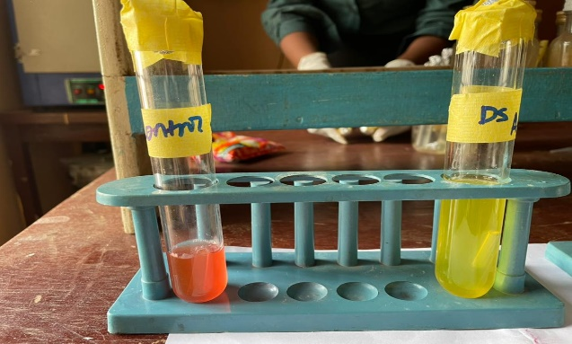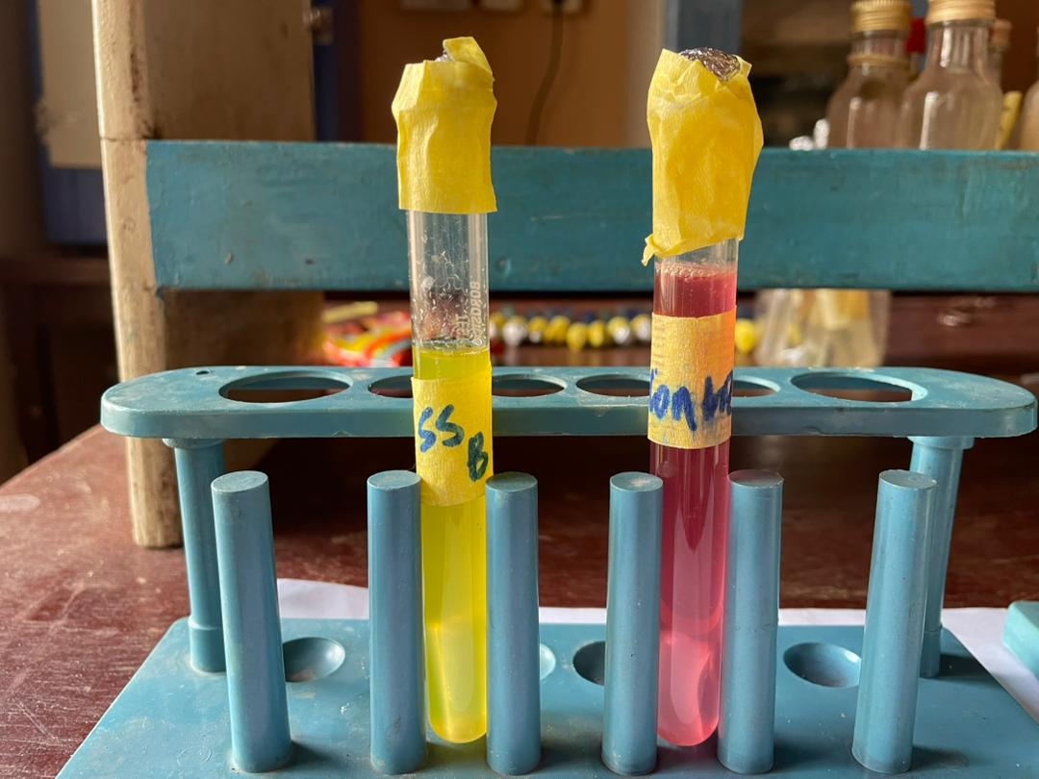

APPENDIX II
APPEARANCE OF DIFFERENT ISOLATES ON VARIOUS CULTURE MEDIA
