

MULTI MODAL VOICE AND CHAT-BASED SHOPPING COMMAND SYSTEM FOR E-COMMERCE

BY

IZUNDU CHUKWUEMIKA IGNATIUS
U21/NAS/CSC/713

DEPARTMENT OF COMPUTER SCIENCES
FACULTY OF NATURAL SCIENCES AND ENVIRONMENTAL STUDIES
GODFREY OKOYE UNIVERSITY, ENUGU

JULY, 2025

MULTI MODAL VOICE AND CHAT-BASED SHOPPING COMMAND SYSTEM FOR E-COMMERCE

BY

IZUNDU CHUKWUEMIKA IGNATIUS
U21/NAS/CSC/713

DEPARTMENT OF COMPUTER SCIENCES
FACULTY OF NATURAL SCIENCES AND ENVIRONMENTAL STUDIES
GODFREY OKOYE UNIVERSITY, ENUGU

A PROJECT TO BE SUMITTED IN THE DEPARTMENT OF COMPUTER SCIENCE, FACULTY OF NATURAL SCIENCE AND ENVIRONMENTAL STUDIES IN PARTIAL FULFILLMENT OF THE REQUIREMENTS FOR THE AWARD OF BACHELOR SCIENCE(B.Sc) IN COMPUTER SCIENCE

SUPERVISOR: DR. FRANK OKEBANAMA

JULY, 2025
i

APPROVAL
This is to validate that this research work “Multi modal voice and chat-based shopping command system for e-commerce was embarked upon by “Izundu Chukwuemika Ignatius” with the matriculation number U21/NAS/CSC/713 in partial fulfilment of the requirements for the award of Bachelor Science(B.SC) in Computer Science, Faculty of Natural Sciences and Environmental Studies, Godfrey Okoye University, Enugu.

__________________________ ________________________

Dr. Frank Okebanama Date

(Supervisor)

_______________________________ _________________________

Dr. Frank Okebanama Date

Head of Department

_______________________________ _________________________

Prof. Chidi C. Uhuegbu Date

Head of Department

________________________________ _________________________

External Examiner Date

CERTIFICATION
I declare that the project work, multi modal voice and chat-based shopping command system for e-commerce was carried out by I, Izundu Chukwuemika Ignatius.

________________________
Izundu Chukwuemika Ignatius
U21/NAS/CSC/713

DEDICATION
This work “multi modal Voice and Chat-Based Shopping Command System for E-Commerce for Godfrey Okoye University e-commerce Platform” is dedicated to my institution, Godfrey Okoye University. I also dedicate this to my loving wonderful family, humanity and finally Zempaa Company.

ACKNOWLEDGMENTS
My humble gratitude goes to almighty God for his blessings, favour and grace throughout my final year. I thank my parents Mr and Mrs Izundu Ogochukwu and Chinyere who always says,“ No cross, no crown”, who taught me about sowing and reaping and supported me throughout my education journey and provided me with all I needed anytime I asked.
I also acknowledge my supervisor Dr. Frank Okebanama who made sure my project turned out successful. I thank you Dr Frank Okebanama for all you have been doing for me and the entire department of computer science, and the upcoming Faculty of computer Science. You always emphasize of being honest with whatever you do and most especially hard work and determination. I express gratitude to my HOD Dr Frank Okebanama, and also to all my lecturers in the Department: Engr K. Chibueze, Mrs. Ekene, Mr Carmelius and Dr. Okorie.
I pray God continues to bless you all.

ABSTRACT
Voice recognition technology including chat has changed the user interaction process with online world platforms. Convenience and speed are vital features of maintaining the e-commerce construction customers happy. In this project, emphasis is made on the design and implementation of a voice shopping and control structure adapted to e-commerce, which consists in ensuring the best experience of the user a part-hands-free interaction system. Through this system, users have an easy time searching products, place them to the cart, make the payment with simple voice commands or chat. It was built with the help of such modern frameworks as Django as the backend and Next.js of the frontend. Speech-to-text and text-to-speech computer interaction is included in the application as well as natural language processing (NLP) that allows it to comprehend correctly respond to instructions given to it by the user. A procedure that is used is Object-Oriented Analysis. Design (OOAD). This voice and chat shopping technology is especially beneficial on the account of the fact that: persons with disabilities or those who want to use internet to do their shopping more efficiently. We would suggest this system as a new step in the direction of easier to access and user-friendly e-commerce experience, which eventually benefits the whole humanity.

TABLE OF CONTENTS
CONTENTS PAGE
Title Page i
Approval ii
Certification iii
Dedication iv
Acknowledgement v
Abstract vi
List of Tables ix
List of Figures x

CHAPTER ONE: INTRODUCTION
1.1 Background of the Study 1
1.2 Statement of the Problem 2
1.3 Aims and Objectives 3
1.4 Significance of the Study 3
1.5 Scope of the Study 4
1.6 Limitations of the Study 4
1.7 Operational Definition of Terms 4

CHAPTER TWO: LITERATURE REVIEW 7
2.1 Introduction 7
2.1.1 Theoretical Background 7
2.1.2 Description of Different Categories of Patient Information Systems 9
2.1.3 Brief History 10
2.1.4 Future of Multi Modal Voice and Chat-Based Shopping Command System for E-
Commerce 12
2.2 Review of Related Works 14
2.3 Summary of Reviewed Literature 17

CHAPTER THREE: SYSTEM ANALYSIS AND DESIGN 18
3.1 Introduction 18
3.2 System Analysis 18
3.2.1 Analysis of Existing System 19
3.2.2 Weakness of Existing System 21
3.2.3 Analysis of Proposed System 22
3.2.4 System Requirements 24
3.2.5 Unified Modelling of the Proposed System (UML) 26
3.3 System Design 23
3.3.1 Input and Output Design 34
3.3.2 Database Design 34

CHAPTER FOUR: IMPLEMENTATION 36
4.1 Introduction 36
4.2 Tools Used For Implementation 36
4.2.1 Frontend 36
4.2.2 Backend 37
4.3 System Requirements 38
4.4 User Interface of the Proposed System 39

CHAPTER FIVE: CONCLUSION 51
5.0 Introduction 51
5.1 Summary 51
5.2 Recommendation 51
5.3 Conclusion 52

REFERENCES 53
APPENDIXES 54

LIST OF TABLE

TABLE PAGE
4.1 User table for Zempaa Voice Shopping and Command System for E-commerce 35

LIST OF FIGURES

FIGURE PAGE
3.1 Use Case Diagram of the Proposed System 27
3.2 Activity diagram for locating stations and also making orders in the proposed system. 30
3.3 Class diagram of the proposed system 31
3.5 Sequence diagram of the proposed Voice Shopping and Command System for
E-Commerce. 33
3.6 Input/output diagram of the proposed system 34
4.1 When user is trying to use the AI (Zai) without being logged in. 40
4.2 The Sign-up page of the proposed system. 40
4.3 The Sign-in page of the proposed system.
4.4a Zai’s interface on dark mode with the previous chats open and also chatting or asking Zai
general questions outside the scope of ecommerce. 40
4.4b Zai’s interface on light mode with the previous chats closed. 41
4.5a when user is trying to search for a product with their voice using Zai. 41
4.5b When Zai is listening and converting the users voice to text. 42
4.6 When Zai is processing the users query. 42
4.7 When Zai takes the user to the /aiProducts page where Zai displays the products it fetched
based on the user's query. 42
4.8 Zai displays the products while speaking or reading it out to the user, the user can choose
to stop listening to Zai and just see it type automatically. 43
4.9 Zai displays more products while speaking or reading it out to the user and the products
images are switching displaying other colours it has. 43
4.10 The user can perform cart operations with Zai (look above at the cart icon above you will
see that the cart is empty. eg. clear their shopping cart 43
4.11 The user can perform cart operations with Zai (look above at the cart icon the user just
added a product to their cart. eg. Adding products to their shopping cart 44
4.12 The user can perform cart operations with Zai (look above at the cart icon the user just
added a product to their cart. eg. Adding products to their shopping cart 44
4.13 The user then goes to the cart page to see the product they added to their, the user can also
use Zai through either chats or their voice. 45
4.14 The user then goes to order confirmation page to see the product they want to order; the
user can also use Zai through either chats or their voice. 45
4.15: The user's information and delivery details. 45
4.16: Final confirmation before payment. 46
4.17: When the user clicks on PAY, behind the scenes kora pay is loading the payment
modal. 46
4.18: When kora pay payment modal opens with three options to choose how you want
to pay. 47
4.19: I choose to pay with debit card, since this is a test account, kora pay provided me with a
fake visa card. 47
4.20: So the payment was successful. 47
4.21: So it redirects the user back to the web app zempaa.com where they choose either to continue shopping which leads to the home page of the web app or to view their latest order.
4.22: The user can also use Zai for navigating pages. 48
4.23: This is the orders page it is still loading above. 49
4.24: This is the orders page where they see their latest orders. 49
4.25: This is the orders page where they can track their order. 49
4.26: This is the orders page the users can also delete an order. 50

CHAPTER ONE
INTRODUCTION

1.1 Background of the Study
Voice recognition technology has rapidly advanced in recent years, thanks to developments in artificial intelligence (AI) and natural language processing (NLP). Popular voice assistants like Amazon’s Alexa, Google’s Assistant, and Apple’s Siri have become commonplace, allowing users to interact with devices through voice commands. Online shopping has not been left behind as this has become another growing trend where consumers can purchase products based on their voices only.
Voice shopping, or voice commerce, enables customers to search or find the item, add to a transaction cart, and make a purchase without typing or clicking in e-commerce. This makes the process of shopping more comfortable, not only to those who have mobile appliances or smart speakers but also to people who have physical challenges when using the normal interfaces.
Voice commerce has displayed explosion in the past years. With increased usage of smart speakers, voice-based purchasing costs billions of dollars to the largest markets such as the U.S. and the U.K. The increasing trend shows that an increasing number of consumers are getting comfortable to use voice commands to buy products.
The advantages of introducing voice command system into e-commerce are also obvious: it will be more convenient to use, checkout will be quicker and custom recommendations will be available, depending on the history of purchases. Nevertheless there are still difficulties. The accuracy is also a question and especially in terms of interpretation of the different accents and ways of speaking. Also, there is the challenge of privacy and security where the voice command is used to manage confidential information e.g. payment details.
The voice recognition technology will probably play a bigger role in the e-commerce process as it evolves to become better. Through early integration of voice shopping systems, companies will be able to take the lead and reach more consumer who are increasingly becoming attracted to simpler and more straightforward shopping experience.
1.2 Statement of the Problem
- Cumbersome Shopping Experience:
Shopping online today require users to get full insight about what they want to order, which takes time, this is the traditional way of shopping.
- Limited Accessibility:
Many e-commerce platforms may not fully cater for people with disabilities which is not good and customer satisfactory.
- Complex Navigation:
There are obviously a lot of products that are online, due to this there will be a lot of navigation's from page to page which not a good way to preserve customers is.
- Limited Adoption of Voice Shopping:
Every product or technology that has ever been built on earth always have disadvantages even if the advantages are high, so users may not be familiar with the voice shopping technology, but with time they will.
- Voice Recognition Accuracy:
Customers speak in different ways, so there might be some cases of wrong user voice search, which cannot make voice shopping seamless.
- User Trust and Adoption:
Many consumers may not feel safe using the voice technology which can hinder them from shopping with their voice.

1.3 Aim and Objectives of the Study
The aim of this study is to develop and implement a multi modal voice and chat-based shopping command system for e-commerce
- Analyse limitations of existing e-commerce systems.
- Design an improved voice and chat-based shopping technology.
- Implement the voice and chat-based shopping technology.
- Test and evaluate the implemented voice and chat-based shopping technology.
- Ensure accurate requests handling.
1.4 Significance of the Study
The present research paper on multi modal voice and chat based hopping command system in the e-commerce is particularly important in many respects. It will enhance access to persons with physical limitations so that they can access even e-commerce systems with ease due to voice commands. Voice shopping makes the shopping process quicker and easier due to streamlining and improves satisfaction and engagement with the processes.
The study will also increase the number of e-commerce outlets that will integrate voice technology thus promoting voice commerce. Business people will decrease cart abandonment and raise the number of sales with enhanced search and checking-out procedures.
Voice transaction security is an aspect that should address any concern of privacy and security of the user data. Also, AI voice systems are capable of providing any individual shopping experience, enhance customer satisfaction, and brand loyalty.
This study will make the e-commerce businesses stay competitive and hold strategic positions as innovators in the market, determining the future of online shopping by looking at the potentials of voice shopping.

1.5 Scope of the Study
The proposed research is dedicated to voice shopping and command systems based on AI in online retailing environment. It will learn the way in which voice recognition can improve user experience, allowing them to search products, add them to cart, and complete purchases using voice instructions. It will research into the success, security and privacy rates of these systems and the adoption of the same by users on different devices such as smart phones and smart speakers. It will also be concerned with the effect of voice technology on universal accessibility and user convenience.
1.6 Limitation of the Study
In this research, a number of limitations are presented in conducting this research and in implementing it. The accuracy of the voice recognition technology is one of the major drawbacks since it can be influenced by different accents, noise in the background or lack of clarity in speech. Also, privacy issues or voice commands may pose a barrier to the user adoption of e-commerce.
By constructing the system, frequent power failure and unstable internet connection may stall the system building and test activities, especially in areas with unstable facilities. Such interference's can slow the process and restrict the comprehensive testing of the voice-shopping system in the actual settings.
1.7 Operational Definition of Terms
- Voice User Interface (VUI):
- The interface that allows users to interact with the e-commerce platform using voice commands instead of traditional inputs like clicks or typing.
- Natural Language Processing (NLP):
Technology that enables the voice searching to understand, interpret, and respond to spoken language, providing very interesting conversational customer shopping experience .
- Using Wake Word or clicking zai icon:
Just saying the word hey zai or zempaa activated the ai
- Voice Commands:
Users can say commands like add to cart, clear cart, go to orders etc
- Voice Shopping:
A process where users use their voice to browse for product and select products.
- Speech Recognition:
Using web speech recognition API to convert users voice to text so that it can understand and responds correctly to the user.
- Cart Management:
This functionality allow users to add products to their cart, delete product from cart with their voice etc
- Personalized Shopping Experience:
An ai feature that can understand customers past search data and display products they buy often.
- Voice-Activated Checkout:
Users can say the word checkout and they proceed to payment quickly
- Device Compatibility:
This technology is available to various devices likes phones, laptops, tablets, desktops etc except button phones.
- Real-Time Feedback:
Quick responses are provided to users in secs, this helps to make shopping faster and smarter.
- Voice Search:
Users can search for any product they want to see with their voice, but if the product is not there it recommends the most related product based on the users search.
- API (Application Programming Interface):
A set of tools that allows software applications to communicate with each other, thereby enabling the integration of voice shopping, payment gateways etc
- Payment Gateway:
A secure and protected service that enables users to pay for services online, payment gateway companies like korapay, stripe, flutterwave and paystack they just provide their api’s so other software companies use it by integrating it on their platforms.

CHAPTER TWO
LIRETATURE REVIEW
2.1 Introduction
However, the convenience and efficiency have become the new guiding factors behind technological development in this digital era, and in this situation, online shopping is exemplary. The most notable innovations in this regard are voice-linked systems that have revolutionized the ways of interacting with e-commerce sites. It is no longer necessary to use the tried and proven method of typing and the subsequent clicking to search and purchase goods as customers can do so, merely by speaking into their devices.
Voice shopping uses natural language processing (NLP) and artificial intelligence (AI) as the means to comprehend and accept verbal instructions. There are devices like smart phones, smart speakers, and even smart home assistants connected to these systems, so shopping has never been easier or more accessible. The customers do not have to browse through the pages filled with products anymore, they can simply request their gadget to search the needed product, compare the prices, and it can offer to buy a product in couple of seconds.
This is one direction in which shopping behaviour is headed, which is a larger push into hands-free technology, in order to develop a smoother, more personalized experience. This is because voice-enabled shopping is gaining ground and various concerns regarding its influence on user experience, user security and user interaction emerge. In this literature review, I will analyse the technological basis, trend and potential of voice shopping and command systems in e-commerce sector, the issues and opportunities with technology adoption.
2.1.1 Theoretical Background
Picture yourself going to a store and rather than looking through a medium or looking at pages of items you need you just say I need a pair of running shoes and you get one. Just as you utter these words, the store comes back with suggestions according to your requirements. The potential of voice shopping in e-commerce is this: it promises an easier and more natural experience of not having to use our hands to shop.
The trend has changed in the past few years concerning online shopping. We changed the way we entered words into the search bars by tapping on the applications, and now we see the rise of voice commands. Voice commerce (or v-commerce) is a fast-growing trend using such devices as Amazon Alexa, Google Assistant, and Apple Siri. Individuals do not have to stick to their keyboards or touch screens anymore; they can just request whatever.
This change could be traced back to the developments in Natural Language Processing (NLP) and Artificial Intelligence (AI), incorporating voice recognition in a more precise and conversant manner. One distinctive characteristic of the early voice systems was that they were rigid and made a lot of mistakes by not understanding the directions or rather giving unrelated answers. However, today, AI is able to understand context and intent more thoroughly and provide a better experience of shopping, and at some conversation points, more human-like.
A real-life situation would be as follows: You are halfway cooking dinner, and you happen to notice that you have run out of one ingredient essential in cooking, namely- olive oil. It would be more convenient because instead of stopping, washing your hands, and getting online, you can just say to your smart speaker, Order olive oil, and it does everything by itself. That is why voice shopping is so attractive.
Why Voice for E-Commerce?
- Convenience: No more typing, clicking, or scrolling. Just speak, and it’s done.
- Speed: It’s quicker to say “Buy coffee beans” than to type it out.
- Semi Hands Free: Great for multitasking whether you're cooking, driving, or simply relaxing.
However, voice shopping is not only convenient or beneficial to the consumer, but it is also a treasure trove to the companies as well. It is more personal as far as companies can personalize recommendations depending on previous orders or interests. It is such as though you had a personal shopper, who just knew what you like and you do not have to tell them every time.
But it is not so easy. There are still limitations of voice systems particularly in interpretation of accents, slang or complex product terms. There are always privacy issues at the back of the mind as these devices are always there to listen and wait to receive instructions.
In conclusion, voice shopping is reshaping the way we interact with e-commerce. It’s fast, convenient, and evolving. As AI continues to improve, the future holds even more potential for a seamless, conversational shopping experience that feels less like a transaction and more like a helpful assistant at your side.
2.1.2 Description of Different Categories of Multi Modal Voice and Chat-Based Shopping Command System for E-Commerce
As voice technology continues to reshape how we engage with e-commerce, it’s helpful to think of voice shopping and command systems in different categories based on the tasks they perform. Here’s a breakdown of these categories, keeping the focus on how they make our everyday shopping experiences more convenient and hands-free:

Voice Search and Product Discovery
Imagine you’re browsing an online store, but instead of typing, you simply ask your device to search for what you want. You might say, “Find black running shoes” or “Show me popular smartphones under 500 naira.” The system interprets your request, finds the right products, and even lets you refine the search with follow-up questions like, “Show only the ones with free shipping.”

Voice-Enabled Shopping Cart and Checkout

Imagine how one-step easier online shopping can be by using your voice to control your shopping cart and complete check out. There is no clicking, no typing: one says, Add those shoes to my cart, or Remove the blue dress. You are also able to request to check out as well as apply a discount code or verify your payments through saved information. The added advantage? Use such secure technology as voice recognition in order to ensure that only you can make an order.
- Personalized Recommendations and Offers

And here is where it becomes even more interesting. Suppose your shopping assistant would learn your preferences with time. You want suggestions and the system will advise you on products that satisfies your taste judging by what you have purchased previously or have been viewed in the recent past. It is also possible to request all the available discounts or promotional deals, including such statements as, “Are there kitchen gadget deals available?”

Semi-Hands-Free Reordering and Subscription Management
For those products you buy regularly—whether it’s groceries, toiletries, or pet food—this category makes it effortless to reorder with a simple command. You can say, “Reorder laundry detergent,” and it’s done. If you’re managing subscriptions, like for monthly deliveries, you can adjust them easily by asking, “Pause my coffee delivery for a week” or “Skip next month’s shipment.”
2.1.3 Brief History of Multi Modal Voice and Chat-Based Shopping Command System for E-Commerce
The journey of voice shopping and command systems in e-commerce is rooted in the broader development of voice recognition technology. What once seemed like science fiction—a world where we could talk to our devices and have them understand us—has become a reality over the past decade, fundamentally changing how we shop online.
Voice shopping first started gaining traction in the early 2010s, driven by advancements in artificial intelligence and natural language processing (NLP).
Voice shopping really got its big moment when smart speakers, specifically, Amazon Echos, fuelled by Alexa were introduced in 2014. Answering questions or playing music were not the only opportunities provided by Alexa, the device allowed people to shop with the device, using their voices. Now, you can suddenly say such things as, Alexa, order another batch of paper towels, and have the product shipped to your door having done nothing at all. This was a great change, because e-commerce stores have started acknowledging the power of voice as a shopping platform.
This was followed soon by other tech giants. In 2016, Google launched a comparable speaker of its own, Google Home, with comparable features running Google Assistant. Voice technology within a short time became more advanced as AI shaped its experience in rejecting user interaction to give more accurate responses and shopping experiences.
As of the late 2010s, voice shopping was becoming more widespread, no longer limited to the simple actions of placing an order to restock the necessities at home to sophisticated purchases. Companies started to create the systems where users could browse, compare their goods and even contact support- only with the voice. This freely shopping process coincided with the rising needs of convenience as individuals wanted faster and more time-saving means of conducting purchases.
Voice shopping has continued to expand in the last few years, including customized suggestions, voice based payment methods, and a multi-channel approach across devices. It is no longer a gimmick but is in fact a facet of the way customers use e-commerce sites, starting with browsing of products to actual sealing on the order.
Through more convenient and customized voice technology, the option of voice shopping seems promising to bring about even more voice shopping in the future. A mere voice command is now a major part of the current shopping experience which changes the way we shop in this digital era.
2.1.4 The Future of Voice Shopping and Command Systems for Ecommerce

With voice technology still on the rise, voice shopping and voice-based command systems in e-commerce are likely to change the future of the e-commerce environment and experience significantly, as they will become more convenient, customized, and integrated into every respective part of shopping an e-commerce environment can offer.

Enhanced Personalization and AI Integration

Voice shopping will become even more popular because of even smarter AI in the future. The individual recommendations, which are already made according to the browsing history and previous purchases, are just the jumping board. Voice assistants will also take a more natural form, the more they will learn about personal preferences and provide extremely customized suggestions. Consider a case where you do a search like, what should I get a friend as a birthday gift and you get recommendations of the type of gifts this guy likes or the kind of gift you have got them before. It will be able to access huge amounts of data to predict needs, and the process of shopping will become more exuberant and delighted.

Seamless Multi-Device and Omnichannel Experiences
Further integration of voice systems into a variety of devices will be possible even more in the future. Nowadays we may initiate a shopping session on a smart speaker and follow it up on a phone or a PC. In the future, this experience will be even more fluid. You might begin your shopping list on your phone, add more items via your smartwatch during a workout, and complete the purchase through your car’s voice assistant while driving home. Voice shopping will also extend into physical stores, where you could ask in-store devices to help locate products or compare prices online.

Frictionless Payments and Voice Authentication
Two of the best areas where voice shopping is going to have a practical impact include security and convenience difference. Voice authentication, in which your identity is verified by use of your special voiceprint, payments will be fast and safe to the users. It is just a matter of imagination to verify that you are not on the same page spends quickly with just a mere affirmative response of Yes, go ahead, with no need of typing passwords and payments details. Voice recognition technology is ready to position itself to become a dependable technology as it keeps undergoing transformation method of providing safety to transactions, reducing cases of fraud, and also quickening check out operations.
• Integration with Augmented Reality (AR) and Virtual Reality (VR):
Voice commands are likely to blend with augmented and virtual reality, creating truly immersive shopping experiences. Picture yourself browsing a virtual store while wearing AR glasses or exploring a virtual marketplace in VR, all controlled by your voice. You could say, “Show me this dress in blue” or “Add this to my cart,” and the system would respond right away. This fusion of voice and visual tech could transform online shopping, making it far more engaging and interactive.

Expansion into New Sectors
While voice shopping is already making a splash in traditional retail, we can expect it to branch out into new areas like healthcare, education, and financial services. Imagine ordering prescriptions, scheduling doctor’s appointments, or even managing your investments just by using your voice. As more industries embrace voice technology, e-commerce will expand beyond retail products to include services, subscriptions, and more complex transactions

Voice Commerce as a Mainstream Channel
As smart speakers, voice assistants, and IoT devices become more common in households, voice shopping is poised to grow into a mainstream e-commerce channel. We could see more brands and retailers optimizing their platforms for voice, offering exclusive deals and personalized promotions to users who shop via voice. Voice technology will become as essential to online shopping as mobile apps are today, with customers expecting to shop via voice in the same way they use websites or apps.

Greater Accessibility and Inclusivity
One of the most exciting prospects for the future of voice shopping is its potential to make e-commerce more accessible. Voice commands eliminate the need for screens, making shopping easier for people with disabilities, the elderly, or those who may find it challenging to navigate traditional online interfaces. This hands-free shopping experience can empower more individuals to engage with e-commerce platforms independently, broadening the reach of online shopping to a wider audience.
2.2 Review of multi modal voice and chat-based shopping command system for e-commerce
As voice technology gains momentum in the e-commerce world, several innovative projects, products, and research initiatives have contributed to the development of voice shopping and command systems. This review highlights the most notable advancements, discussing both commercial applications and academic contributions that have shaped the current landscape.

Amazon Alexa and Voice Shopping Integration
Amazon Alexa is one of the greatest contributors to voice shopping. Introduced in the year 2014, through the ease with which it can be incorporated with Amazon, Alexa has dimmed the voice shopping experience far-reaching e-com facility. By giving a couple of voice commands, the users were able to re-order products learn new products and even place safe purchases. The ease of use enabled by Alexa, backed up by its design, allows connecting two different locations in the same way as two humans can made it one of the most popular voice by integrating it smoothly into Amazon Prime shopping systems out in the market. Voice shopping was more than a fad as Alexa has proven successful something new but a viable solution, making others follow such a move.

Google Assistant and Voice Commerce
Wanting to close to the heels of Amazon, Google launched Google Assistant subscribe to voice-shopping via Google Shopping and its retail affiliates. Thanks to Google Assistant has a flair of picking up and displaying objects based on their natural language with Google having a good background in natural language processing. Being better in interpreting user queries in a conversational manner, which facilitates in the accuracy of the responses product recommendations. The customers are able to easily add items to their shopping cart and also track them, get notifications about their orders, and they can get even recommended shopping in accordance with their last orders searches. One outstanding usage is the use of Google to facilitate voice shopping of a variety of items of products-- including Android phones, Android tablets, and Google Home smart speakers. The voice strategy of Google commerce actually has what it takes to focus on omnichannel shopping, where customers can kick start their shopping on one and complete it on another. This hassles free shopping experience is the giant step on the way to creating voice shopping more flexible and convenient.

Walmart Voice Ordering
Walmart on voice groceries ordering is a good decision to serve a hectic life of its customers to serve reorder and anticipate cleaning every household item quickly. Such a voice shopping system will be capable of managing Malawi has been able to easily navigate multi-step transactions, be it during checkout or when making an appointment of a delivery at least though never lifting a finger. The strategy that Walmart adopts presents us with imagine of what conventional retailers should be doing. Voice technology is a trend that is being accepted by retailers who want to stay afloat in the dynamic retail landscape.

Apple Siri and Voice Commerce
Although the voice assistant Siri by Apple was one of the first hand in the market back in 2011, the experience its journey has taken is quite interesting, adoption of e-commerce has been slightly lagging Amazon Alexa or Google Assistant. However, Siri is crucial in the ability to give voice commands in a range of third-party systems shopping apps. Apple is a bright example of how it perfectly fits into its own ecosystem and enables users to do the browsing, compare the prices and even purchase using Apple pay. Although Siri maybe is not as famous as Alexa or Google Assistant in terms of shopping, but it has a safe connection with Apple Pay is an impressive tool that enables payments in voice form with ease and safety. Siri gradually slips into the e-commerce environment shows that Apple is also interested in the growing possibility of voice shopping as an important constituent of its wider ecosystem.

Alibaba’s Tmall Genie
Tmall Genie Alexa, Tmall Genie can communicate with smart home related devices so that the user uses the device when he or she is shopping. His or her role in managing their home environment. The surging popularity of Tmall Genie indicates the rising number of mobile applications, which can connect with the Internet of Things.
The world is also mesmerized by voice commerce and Alibaba is trying to capitalize on the rising market demand. Chinese AI-based e-commerce. It also shows that voice assistants can personalize to cultural specifics, designing to local tastes and requirements within different markets. Tmall Genie’s its incorporation in the Alibaba ecosystem, which encompassed e-commerce, entertainment, and logistics is more extensive in experience to users in China.

Research in AI and Voice Commerce
Another area of research focuses on accessibility. Voice shopping systems can significantly improve e-commerce accessibility for people with disabilities, particularly those with visual impairments or physical disabilities that make using traditional devices difficult. Ongoing research explores ways to make these systems even more inclusive and efficient for all users
2.3 Summary of Review of Related Works in Multi Modal Voice and Chat-Based Shopping Command System for E-Commerce
Author(s) / Year | Journal / Source | Contribution | Shortfall
Gajula, Y. (2025) | arXiv | Reviewed the application of sentiment-aware NLP systems in e-commerce, showing how user emotions guide recommendations. | Focused mainly on recommendations, not voice command implementation or system integration.
Jayarao, P., & Sharma, A. (2021) | arXiv | Developed a voice shopping assistant by fine-tuning DistilBERT for domain-specific commands. | Lacked user testing and did not address real-time performance in live shopping environments.
 | Forbes | Identified major drivers of voice shopping adoption like speed, convenience, and hands-free access. | Lacked technical analysis or details on system design.
  Forbes Business Development Council (2022)
 | Shopify Blog | Explained how voice shopping improves business-customer interactions, especially in mobile commerce. | Focused on business benefits, not underlying voice recognition or NLP technologies.
  Shopify Nigeria (2024)
 | BusinessDasher | Presented updated voice commerce usage stats, highlighting growth via smart speakers and mobile devices. | Provided quantitative data only, with no technical or system-level insight.
  BusinessDasher (2024)
Mindster (2024) | Mindster Blog | Discussed voice commerce’s role in increasing personalization and customer engagement in mobile shopping. | Did not explore backend architecture or how complex commands are handled.
 | Journal of Internet Services and Applications | Designed a voice-based navigation system for better accessibility, especially for users with disabilities. | Focused on basic navigation commands only; lacked support for advanced features like multitasking or dialogue flow.
  Ahmed, M., & Rana, F. (2022)

CHAPTER THREE
SYSTEM ANALYSIS AND DESIGN
3.1 Introduction
Shopping online can happen without manual effort through the integration of Voice Shopping and Command System. Voice Shopping and Command System provides users with this experience. You only need to talk while the device acts as your ears. The system allows customers to view all available deals and make purchases by just using their voice commands. Just say the word.
Users can transform their voice commands into shopping assistant orders through this system that operates as the core control interface. The system uses intelligent voice recognition with natural language processing technology to transform spoken commands into operational actions through voice activation only.
But the best part? It’s not just about convenience. Online shopping becomes available to everyone because of the system design which benefits customers with disabilities. The system welcomes shoppers from all abilities including multitaskers and disabled users who can experience the convenient voice-commanded shopping experience.
Our system brings user-friendly voice command capability into the world of electronic commerce to generate a shopping routine that requires no extra effort from users. The innovative advancement serves as more than a progression since it guides us toward the progressive direction of Internet shopping.
3.2 System Analysis
The process of system analysis requires detailed investigation into the whole structure by dividing it into smaller components to study their functions and relationships. The analysis focuses on the Voice Shopping and Command System used in E-Commerce platforms. Our evaluation starts by studying existing frameworks to recognize the empty spaces then determines ways to enhance the current models.
We will begin with an assessment of existing systems to determine both positive aspects and negative aspects as well as necessary enhancements. The following section will concentrate on the proposed voice shopping system framework. We will use visual work tools to fully grasp the operating system structure of the voice shopping solution.
The use of use case diagrams enables the representation of system users along with their associated actions.
We will use Activity diagrams to demonstrate the sequence of tasks within the system.
The system's structure together with its different part relationships will be represented through Class diagrams.
Our analysis will provide a comprehensive plan that shows how users can utilize the designed voice shopping system while ensuring practicality and usability.
3.2.1 Analysis of Existing Systems
Most current e-commerce systems maintain basic user input devices that use keyboards and mice on desktops or touchscreens on mobile platforms. Customers perform searches using text before they browse products while using menus to complete their shopping checkout.
The accepted input methods prove functional, but they maintain essential drawbacks. People experience slowness and cumbersome interaction with these methods that stands below the smoothness of regular spoken interactions. The current e-commerce process proves to be extremely difficult for both disabled users and people who have limited mobility. Products and searches become difficult for users to navigate when they have problems with hand-movement control because their dexterity ability is limited.
In essence, while traditional e-commerce works, it leaves room for improvement in terms of both convenience and accessibility. The market presents an obvious opening to upgrade online shopping through speed improvements and increased accessibility for all customers.
Limitations of Existing Systems
At present moment, customers are undergoing the constraint of using their hands to store products through typing using a computer keyboard, and clicking on buttons of navigation in majority of e-commerce websites. This
is a timewaster, more so when a person is keen on making fast purchases- it turns out to be is like a burden. Besides, most platforms have a barrier to disabled individuals people that use wheelchairs or those that have eyesight problems. Although devices, such as screen readers can be used, though other assistive technologies have some aid, they may as well result in frustrating experience. It has an enormous opportunity of enhancing accessibility and inclusivity in the user experience. The existing search/navigation engines oblige the user to be specific, what they are seeking, and this may be difficult when they are presented with ambiguous orders. If someone will not enter the correct keywords; hence they need to sift through thousands of categories of locating the pertinent results which corresponds to the line of thinking. This strict system of shopping can result in frustrating and fruitless ventures. In addition to this, these are platforms that usually do not have on the fly customizable functionality. The consumer often has a problem locating products as a result of the too many products. They cannot adapt systems to their liking, and there is a problem with multitasking. Attempt of looking at It is a challenge to be looking at one product and finding another one, since the systems that are currently available do not give the situation involving the flexibility required to have an easier shopping experience.

The Need for Improvement
A new system that provides interactive ease of use needs development to deal with these challenges. A voice-controlled shopping platform suits these requirements perfectly. Users who engage with natural language can navigate without manual input and enjoy hands-free accessibility especially for persons with disabilities. Users do not need manual input for keyword searches when using this system because they can simply speak their commands to the platform for it to listen and understand. What follows is real-time personalization and combined with those features delivers shopping experiences that become smooth and intuitive for every user.

3.2.2 Weaknesses of Existing Systems
- The standard e-commerce shopping platforms dominate the online marketplace, yet they contain various operational shortcomings resulting in disadvantages for customers during their purchase journey. There are essential shortcomings that traditional E-commerce platforms show during the user experience.
- Most e-commerce platforms demand users to type inquiries into search engines while serving them through multiple menu levels. Users face two significant barriers with this manual technique because it takes too much time, and it becomes challenging for new users or users with difficulties typing.
- Disabled users face numerous obstacles when they try to utilize current e-commerce platforms because of their limited accessibility features for people with physical limitations. Assistive technologies often support users well, but their compatibility fails to cover all scenarios leading to difficulties with disabled users accessing online store features.
The ability to search products successfully is limited because system search tools require exact phrases and specific keywords. Search functions of numerous systems display useless or partial outcomes when users enter incorrect input. The search function presents difficulties for users to discover their targets efficiently.
Users struggle to perform multitasking since most platforms force them to keep always providing manual input. Active hands-free shopping makes things difficult for customers who need help with platform operation because of busy schedules and manual disabilities.
An e-commerce system enabled by voice commands can deliver significant improvements through the resolution of its weakness points. The system allows enhanced accessibility to natural and efficient shopping which allows users to engage effortlessly despite manual input difficulties and restrictive navigation and barriers to accessibility.

3.2.3 Analysis of the Proposed System
Voice Shopping and Command System represents a solution for e-commerce platform restrictions because it embeds voice command functionality during shopping operations. Users will execute shopping activities such as search and purchase via voice commands through NLP which stands alongside voice recognition core functionality. The system considerably minimizes users' need to perform manual tasks because it provides them with a streamlined shopping experience.

Key Improvements:
- The system represents an opportunity to make online shopping available to users at any ability level including disabled people especially those who are visually impaired or unable to move freely. Users now enjoy straightforward online shopping through voice commands because they no longer need to deal with navigation menus or depend on assistive technologies that sometimes fail to function properly. The system produces an experience which includes all users with improved accessibility.
- Users now benefit from semi hands-free shopping convenience through this system that enables them to shop without physical hands engagement. Retailers obtain greater convenience because this feature replaces keyboard usage with voice commands when they drive and cook and when they prefer not to type.
- Voice commands enable customers to browse for products quickly by serving as a fast navigation method. Users benefit from immediate system responses after they speak because this method eliminates both menu navigation and lengthy search queries thereby optimizing the shopping routine.
- The system develops real-time personalization abilities through tracking user preferences and behaviours thus it generates customized product suggestions for each individual client. The customized interface both improves operational speed and strengthens user platform activation which leads to better client satisfaction and better platform usage.

Integration and Future Potential:
- The proposed system combines with present e-commerce platforms through well-structured integration features. Businesses implementing the system can adopt this solution without needing to replace their current setups because it provides high scalability and adaptability.
- Users can access a wide range of customers through the system's capability to deliver services in multiple languages. Lead people from different language groups to your audience because the proposed system provides multilingual support for both local shops and universal retailers.
Security aspect as an improvement towards the future, voice authentication will consider security where the user will be identified by his/her voice pattern to make secure transactions. The supplementary security feature will also give users confidence in its security and make the shopping process easier by not having the need to use the conventional authentication devices and pass codes.

3.2.4 System Requirements

System requirements define the necessary features that a system should serve the user needs. The Voice Shopping and Command System requires two categories of likely requirements comprising of functions needs and non-functional needs.

3.2.4.1 Functional Requirements
The functional requirements consists of the following below:
  - Voice Command Interaction:
  - The system needs to process user voice commands correctly to achieve functions covering product search and cart addition and checkout.
  - Product Search and Recommendation:
  - Users need a capability to conduct product searches through spoken input. Personalization recommendations of products must be featured in the system after considering user preferences and previous purchase behavior patterns.
  - Order Placement:
  - Users need the capability to make orders through spoken commands while getting instant purchase verification to achieve smooth order completion.
  - Repurchasing:
  - Voice command systems need to give users the capability to purchase again previously purchased items through verbal instructions. The commands for automatic purchasing process begin with either "Reorder my last purchase" or "Repurchase item X."
  - Profile Management:
  - Users should be able to regulate their account data through verbal instructions that cover profile enhancements and payment choice modification and address delivery settings modification.

  - Notifications:
  - Users need voice or text-based alerts from the system which provide regular updates about order status during the production and shipping stages.
  - Payment Options:
  - Users should be able to select either voice command payment methods like voice confirmation or use traditional input methods such as manual payment entry. The payment system must provide dual security features which enable users to select from either type of payment while maintaining financial protection and ease of use.

3.2.4.2 Non-Functional Requirements
The non-functional requirements have added performance measurements and security features and quality characteristics to have enhanced user experiences. These are followed by the following requirements that outline what the Voice Shopping and Command System is:
Compatibility:
The system should be compatible with iOS Android Windows operating systems and Chrome Safari Firefox and other desktop computers, tablets and smartphones.
Responsiveness:
The system needs to be highly responsive that enables smooth interaction between various displays and various scales in the screens. System behaviour should be the same to all users irrespective of the operating system preferred.
Performance:
The system must be able to provide immediate recognition of voice without long delays that guarantee smooth usage of voice commands.
Security:
Sensitive data processing and payment details need to have an encryption protocol in place to enable convenient processing of data by the user. The system should also have security practices in line with the data protection acts such as GDPR and PCI-DSS to ensure user privacy and avoid illegal access to information.
Scalability:
It should be able to support the growing number of users and transaction volumes especially around peak periods such holiday seasons and sales when the system must not experience any signs of poor performance.
Privacy:
Data privacy of the user requires that the components involved in running the system have controlled access to the information on their users such as search history and favorite shopping selections.
The voice shopping and command system fulfils the required functional and non-functional requirements to offer an efficient access to shopping and guarantees the security on the different devices and circumstances of shopping.

3.2.5 Unified Modelling of the Proposed System (UML)
  - The blueprint of the system shows how components work together using UML diagrams to explain its overall operational functionality. Multiple diagrams form part of this methodology which specializes in system analysis through various specific viewpoints. The UML diagrams used for the Voice Shopping and Command System consist of the following types:
  - Use Case Diagram:
  - The diagram depicts system-user (actors) relationships through which the system delivers its main functionalities. The diagram shows the user tasks involving product search and cart addition and order placement as well as profile management through voice instruction.

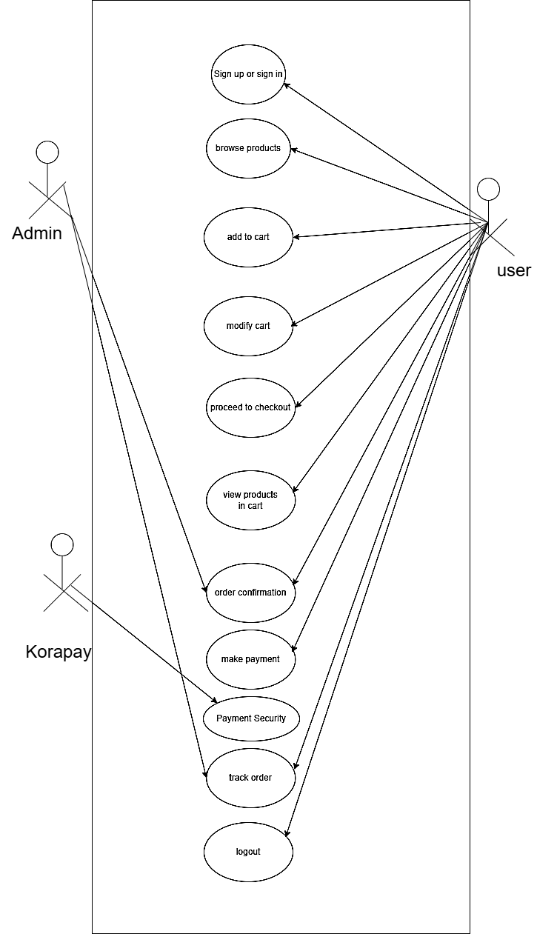
Figure 3.1 Use Case Diagram of the Proposed System
Use case diagrams show the interaction patterns between system users called actors who achieve their goals through system interactions. The proposed Voice Shopping and Command System use case diagram shows how users engage with the system by either using voice commands or standard methods.

Components of the Use Case Diagram:
- Use Cases:
  - These represent the specific actions or functionalities provided by the system that deliver value to the user. For the Voice Shopping and Command System, the following use cases are identified:
    - Sign In: Users can sign into their accounts either through voice command or traditional methods like typing credentials.
    - Update Profile: Users can update their profile details, such as personal information, addresses, and payment methods.
    - Search Products: Users can search for products either by requesting specific items or asking for product recommendations via voice.
    - Add to Cart: Users can add selected products to their shopping cart using voice commands.
    - Place Order: Users can place an order by confirming the items in their cart and completing the purchase process using voice commands.
    - Repurchase Items: Users can easily repurchase previously bought items using a voice command like “Reorder my last purchase.”
    - Make Payment: Users can confirm payment via voice command or opt for traditional manual methods (e.g., entering payment details).
    - Track Order: Users can inquire about the status of their orders, including shipping updates and expected delivery times.
- Actors:
  - Users: External entities (such as customers) who interact with the system to complete tasks like shopping, placing orders, and tracking deliveries.
  - System: The internal system that processes user commands, interacts with databases, and manages tasks like product searching, cart updates, order placement, and payment handling.

- Associations:
  - Users interact with the System through voice commands or traditional methods, performing actions such as logging in, updating profiles, searching products, and placing orders. The use case diagram shows these interactions between users and system functions.
- System Boundary:
  - The system boundary defines the scope of the system’s functionalities, focusing on voice-enabled shopping interactions while still supporting traditional manual input methods for users who prefer or require them.

Visualizing the Diagram:
To illustrate this system, the use case diagram will show:
- Actors (Users and System) on the outside.
- Use cases (sign-in, update profile, etc.) as ovals inside the system boundary.
- Associations (lines) showing the interaction between the actors and the use cases.
This diagram provides a high-level introduction of how users can engage with the Voice Shopping and Command System, either through voice or traditional inputs. It emphasizes the ease of use, accessibility, and the ability to enhance the shopping experience by leveraging voice commands for various tasks.
The following will be the use case diagram for the Voice Shopping and Command System:
- Users can:
  - Sign in
  - Update profile
  - Search products
  - Add products to the cart
  - Place orders
  - Ask general questions outside the scope of e-commerce eg ChatGpt
  - Repurchase items
  - Make payments
  - Track orders
3.2.5.1 Activity Diagram of the Proposed System
The multi modal voice and chat-based shopping command system for e-commerce requires Unified Modelling Language (UML) activity diagrams to depict software system dynamic characteristics. The diagram provides flowchart information about how activities play out in system operations. The figure illustrates the operational sequence of Voice Shopping and Command System for E-Commerce commencing with user authentication followed by product search through voice commands then product selection before check-out and system log-out.

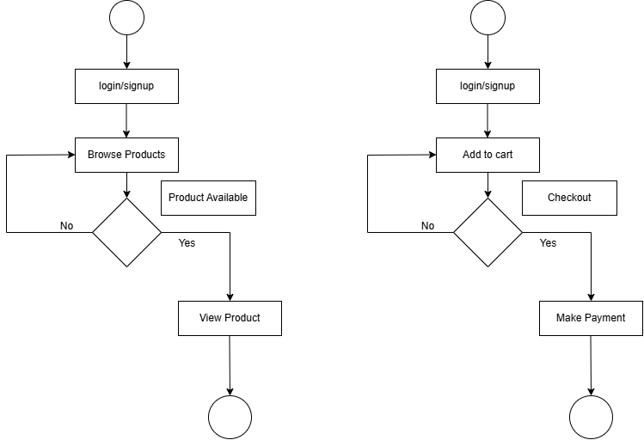
Figure 3.2 Activity diagram for locating stations and also making orders in the proposed system.

Voice Shopping and Command System for E-Commerce displays its system activities through this pictorial representation. The system allows users to experience a complete purchase journey through signing up/logging in to system operations followed by product search via voice commands and cart management then checkout procedures until making a payment.
3.2.5.4 Class Diagram of the Proposed System
Unified Modelling Language (UML) diagrams known as class diagrams explain software system structure through visual representation of objects along with their methods and attributes and relational map of these elements. The illustration of Voice Shopping and Command System for E-Commerce shows its class diagram below.
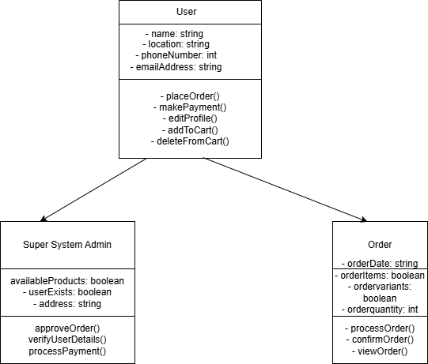
Figure 3.3 Class diagram of the proposed system
This diagram illustrates the class diagram of the proposed Voice Shopping and Command System for E-Commerce by representing its various classes together with their connected properties and executable methods.
3.2.5.5 UML Sequence Diagram
As a dynamic pictorial model, the Unified Modelling Language (UML) sequence diagrams display the chronological order of different objects that exist within the Voice Shopping and Command System for E-Commerce. These diagrams hold essential value to explain the time-based execution of messages that occur when implementing specific use cases or scenarios.
The core functionality of sequence diagrams shows the interaction timeline to display the component collaboration that leads to goal achievement in the Voice Shopping and Command System for E-Commerce.
A sequence diagram in UML consists of four main elements which represent the entities taking part in the interaction through lifelines and demonstrate their communication through messages and activations that show object states.
Researchers indicate that activations get displayed through vertical lines from lifelines to represent how long objects remain active in an interaction. The temporal dimension provides developers and stakeholders with essential information about both system occurrences and their corresponding timelines during program operation.
Sequence Diagrams from UML provide a means for technical teams to interact with non-technical stakeholders in Voice Shopping and Command System for E-Commerce through dynamic visual representations which establish a strong means to present complex technical information to less technical stakeholders.
These diagrams improve team collaboration which helps develop common system behavior understanding but also facilitates future enhancement issue identification.
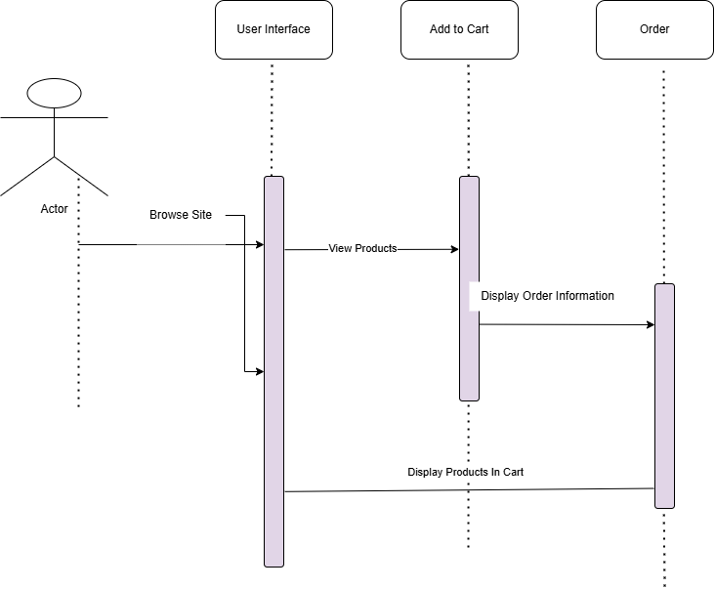
Figure 3.5 Sequence diagram of the proposed Voice Shopping and Command System for E-Commerce.

The above diagram stands to depict the sequence diagram of the proposed Voice Shopping and Command System for E-Commerce, which functions to show the sequence of activities that is taking place in the proposed system, right from the user signing up to the platform to the user searching and selecting products via voice commands, adding products to cart, checking out, and finally making payment for the ordered products when they are delivered.
3.3 System Design
The multi modal voice and chat-based shopping command system for e-commerce design capabilities to fulfil the mentioned requirements. The system design contains a database design that powers all activities visible on the system.

3.3.1 The Input and Output Design
The research work displays the proposed Voice Shopping and Command System for E-Commerce interface through computer-designed diagrams that specify the operational workflow to fulfil system objectives.
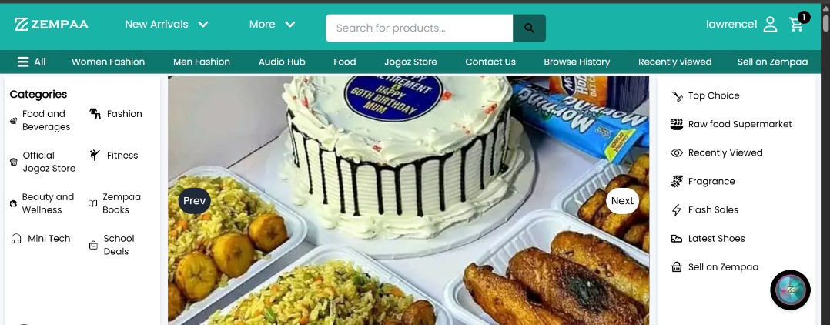

Figure 3.6 Input/output diagram of the proposed system
The essence of the database design is to portray a modelled view of Zempaa database is a relational database that was designed and implemented with PostgreSQL. The database was designed to have more than 6 entities and at least three attributes for each entity.
3.3.2 Database Design
The design of the database presents a structured representation of Voice Shopping and Command System for E-Commerce’s database. A relational database structure of the Voice Shopping and Command System for E-Commerce exists which developers built through Python with Django Rest Framework. The designed database contains various entities and three essential attributes within each entity group.

Database schema for Voice Shopping and Command System for E-Commerce
USER TABLE
Table 4.1 User table for Zempaa Voice Shopping and Command System for E-Commerce
Attribute | Data Type | Description
Id | int | The primary key of the table
Username | varchar | This is where the username of the user is stored
Email | varchar | The field for storing the user's email
Password | varchar | The field for storing the user’s email

CHAPTER FOUR
SYSTEM IMPLEMENTATION
4.1 Introduction
This research work has covered in detail the system that has been long talked about from the beginning of this study and throughout the process of this research and which was initiated because of this challenge faced in the environment of the researcher. However, a detailed analysis of the system and all its requirements was made at the beginning of this study to analyse both the systems that are now in place and the systems that have been suggested in this research effort. Additionally, the researcher uses the instruments that have been selected and verified to successfully implement the suggested system in this section of the study project. Most importantly, this chapter will also address the user interfaces of the various system components as well as the tools that was utilized to make the system function effectively.
4.2 Tools used for implementation (Tech stack of the proposed system)
4.2.1 Frontend
Next.js
Next.js is a powerful React and JavaScript web application framework. That gives one of the most effective and smooth ways for development. It easily handles client-side and server-side rendering in other to allow you to create dynamic and interactive web pages. But one of the main features of Next.js is that it can automatically split code as it can load only the part of the code needed for the specific section of the page thereby increasing performance. However, Next.js also gives support for building static websites where pages are pre-rendered at build time as it was integrated with integrated routing, so that the page navigation will be very smooth. Next.js is highly flexible and offers a bunch of plugins and extensions to make the platform functional. Moreover, there is quite a good community and a lot of documentation backing it, which makes it easy for developers to start off and resolve issues with ease.
4.2.1.2. React JS
React is essential in this system and is popular with developers in terms of creating
The web applications that involve user interfaces. It is efficient and simple to use hence ranking high JavaScript library choice. Using React it is possible to make dynamic, interactive real time updating elements that provide rapid and responsive feelings to the users. Among such pertinent strengths of React.js include the fact that it allows modifying only those sections of the page that require a change. Changed, so there is no necessity of reloading a complete page and performance increases due to a virtual DOM (Document Object Model). Also, React promotes reusable components containers, and this is an extraordinary setting out and continual maintenance of applications.
4.2.1.3. Tailwind CSS:
Tailwind CSS is a CSS styling framework used to style react and next applications and very easy to use.
4.2.2 Backend

Python
Python is highly versatile programming language and is a powerful, programming language that is adequately high-level a great decision in order to work out the backend of this app. In its simple sense, and readable syntax, Python allows a developer to quickly develop maintainable and robust script. server-side logic. It lends itself well to most programming styles, such as procedural, object-oriented programming and functional programming, this allows it to be applied in multiple different ways cases. The ecosystem of libraries and frameworks is rich as well in Python, which allows the creation of a substantial product enhance the development process. The thing is that Python is really good at backend development is very bright particularly when paired with a platform such as Django, which enables a quick execution and good design reality.

4.2.2.1 Django
The level of the web framework Django is a high-level Python web framework which truly encourages quick development a pure utilitarian form. It forms the skeleton of the backend of this application. Django is pre-loaded with a whole load of pre-existing specifications taking you through the Model-View-Template (MVT) architectural pattern the strong ORM (Object-Relational Marching) layer, an integrated administration interface, a user authentication and series of security mechanisms that guard against threats such as CSRF, SQL. SQL injection, and XSS attacks. It is especially comfortable to work with when it comes to developing web applications and APIs that are scalable and safe. Due to its modularity and batteries-included ability, developers can develop entire applications lightning-fast, by performing little setup and boilerplate

4.2.2.2 PostgreSQL
In the case of the database, we decided to use PostgreSQL. This is an open-source and powerful. It is a known fact that object-relational database is reliable, feature-rich and performs. PostgreSQL has first-rate data type support, and it is completely ACID-compliant, as well as capable of managing complex queries, indexing and transactions. It is well incorporated with Django using its ORM, permitting smooth interactions with the database with the use of Python objects but guaranteed to be powerful integrity and stability of data.

4.2.2.3 Kora pay
Korapay is a modern payment API designed for developers to easily integrate secure and efficient payment processing into applications. It was used in this project to enable users to pay seamlessly. It is very easy to integrate.
4.3 Systems Requirements
There are not many things that are needed to use this system as it is a web-based platform application and however runs on both the web and mobile platforms. However, the system still require that the user gets to fulfil some little requirements to be able to use the proposed system. These requirements are as follows:
- A good internet enabled device
- Good internet connection (at least 3G internet speed).
- A web browser e.g. Google Chrome, Apple Safari and a host of others.
4.4 User Interface of the Proposed System
The user interface for the homepage and the products and categories are being displayed then the user clicks on the AI button and starts interacting with the AI through their voice or chat. The user cannot use the AI without being authenticated, there after they can place orders, navigate to different parts of the e-commerce website and ask general questions that is outside the scope of e-commerce and the AI responds.
4.4.1. Homepage of the proposed system
The homepage of the proposed is made up of various sections which includes the header, hero, products section, categories and subcategories of products, flash sales etc. The header section stands to serve as the navigation of the system. This navigation is made up of the logo which is the link to the home page and then, the other links which are present to help the user navigate through the different pages of the proposed system. Secondly on the other hand is the hero section which shows what the system is about.
4.4.2 Sign up Page
This section of the proposed system functions to provide users with the screen to allow users to login to the proposed system. The page comprises of 2 major sections; the first part contains the form to give users the opportunity to login to the proposed system. It contains these fields username, email and password for the sign up and for the login details it needs
just the username and password.
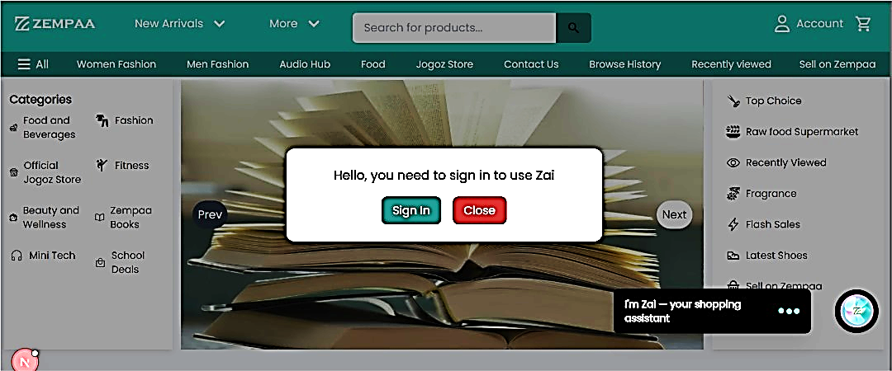
Figure 4.1 When user is trying to use the AI (Zai) without being logged in.

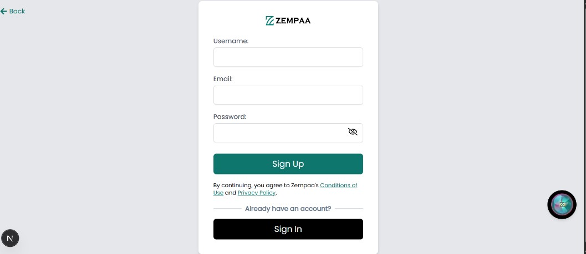
Figure 4.2 The Sign-up page of the proposed system.
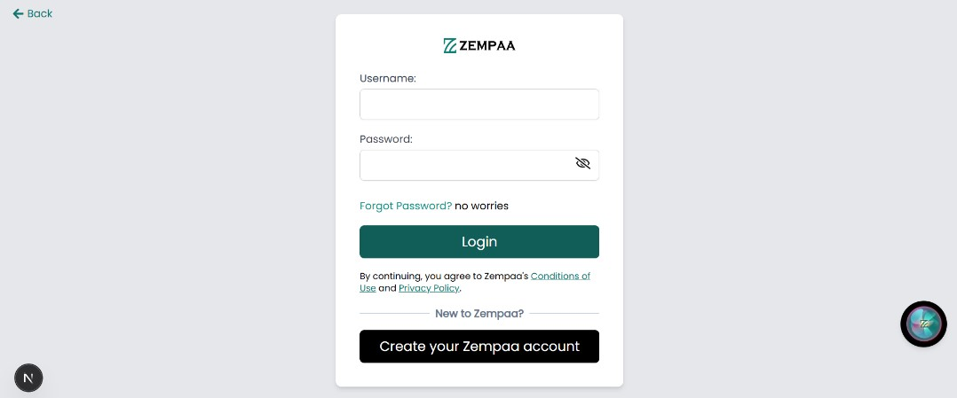
Figure 4.3 The Sign-in page of the proposed system.

4.4.3 Zai interface
This is an interface the user interacts with to place orders, navigate to different pages in the e-commerce platform, searches for products, ask general questions outside the scope of e-commerce e.g. Who is the president of Enugu state. It also has features of creating new chat sessions, going back to previous chats and continue chatting, hide and close chat, perform light and dark mode theme, performing cart operations like adding to cart, removing from cart, updating cart etc
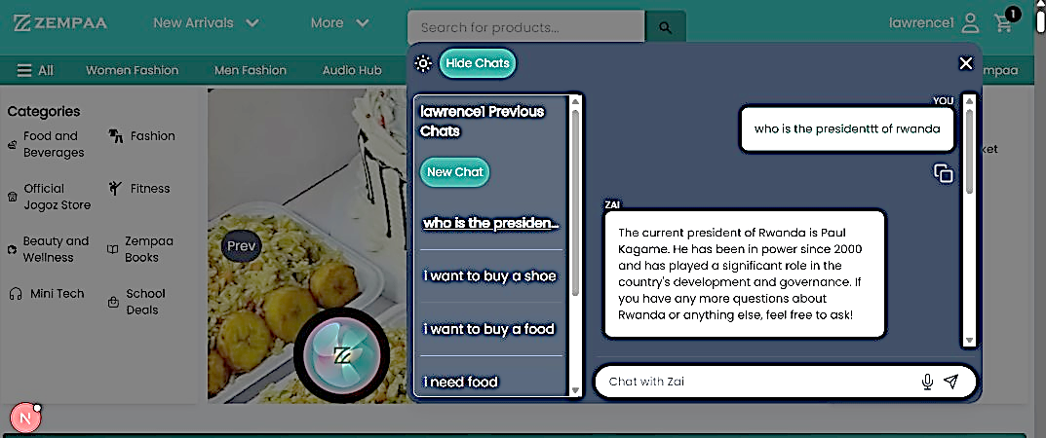
Figure 4.4a Zai’s interface on dark mode with the previous chats open and also chatting or asking Zai general questions outside the scope of ecommerce.
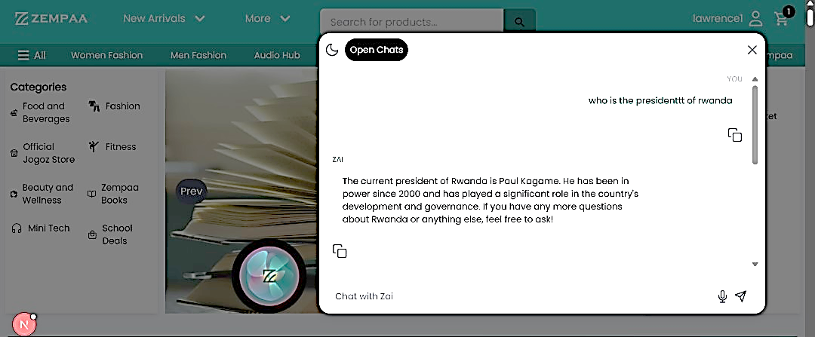Figure 4.4b Zai’s interface on light mode with the previous chats closed.

4.4.3 Search for products
This page navigates here only when the user searches for products through their voice or chat and the ai gives them the most related products based on what they searched for.
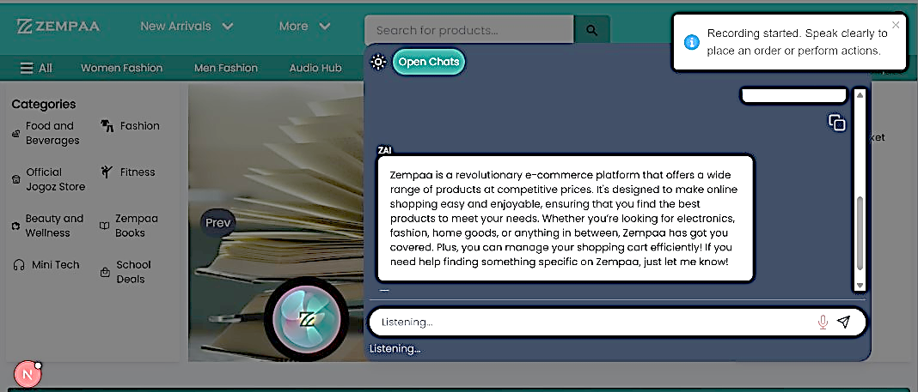
Figure 4.5a when user is trying to search for a product with their voice using Zai.
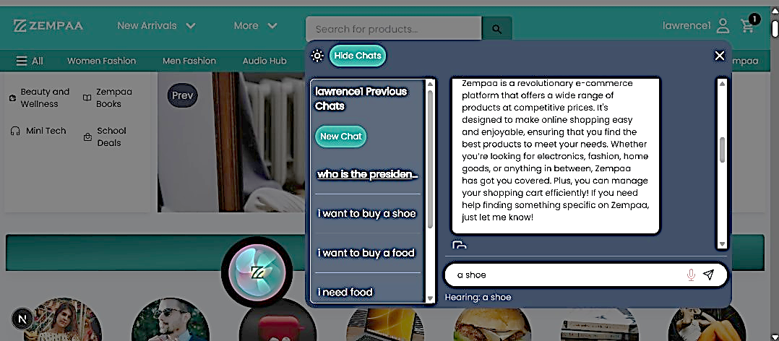
Figure 4.5b When Zai is listening and converting the users voice to text.
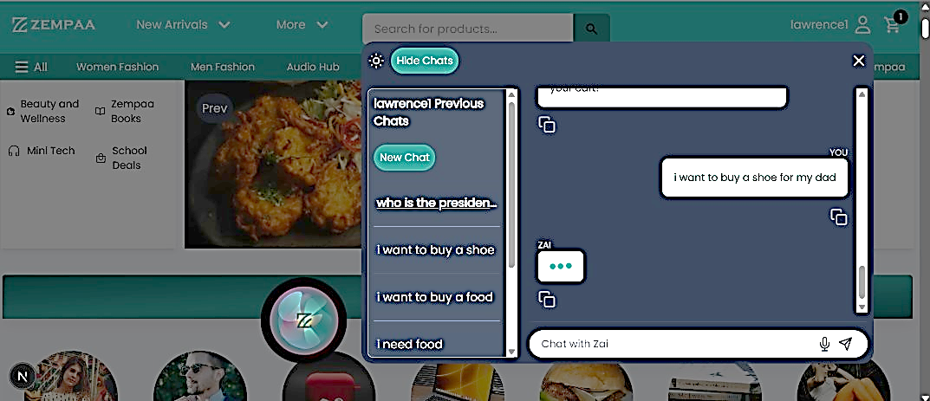
Figure 4.6 When Zai is processing the users query.
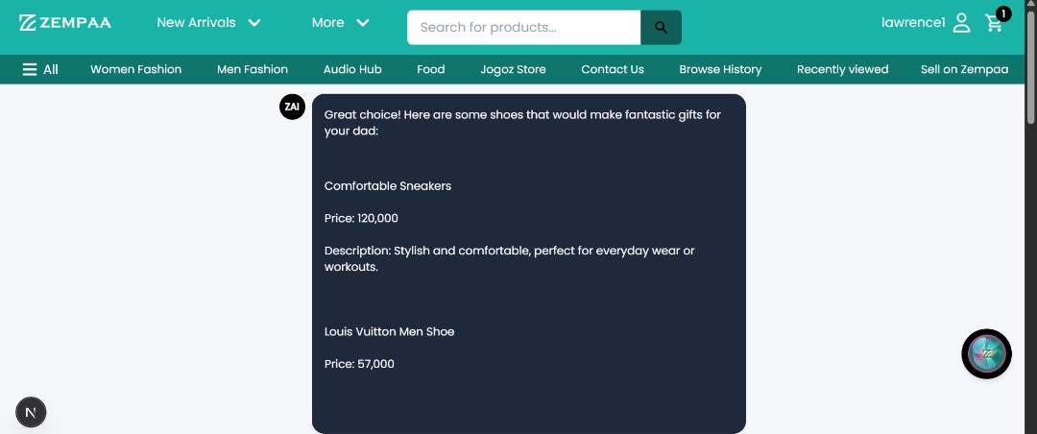
Figure 4.7 When Zai takes the user to the /aiProducts page where Zai displays the products it fetched based on the user's query.

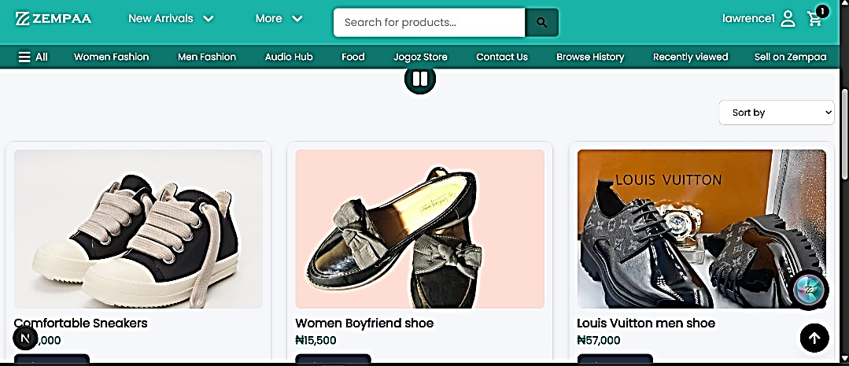
Figure 4.8 Zai displays the products while speaking or reading it out to the user, the user can choose to stop listening to Zai and just see it type automatically.
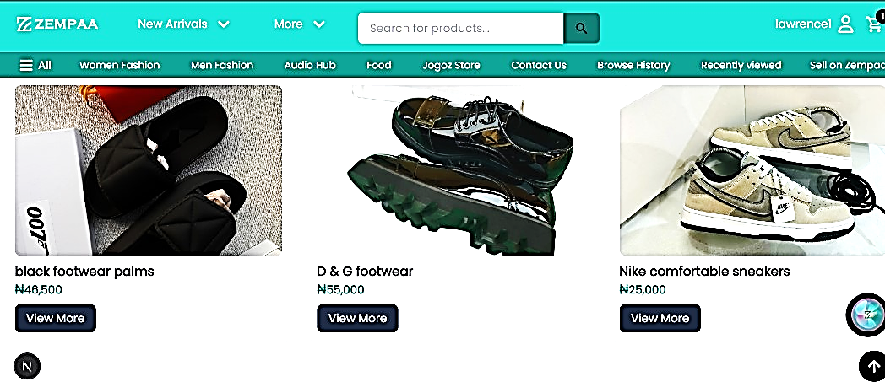
Figure 4.9 Zai displays more products while speaking or reading it out to the user and the products images are switching displaying other colours it has.
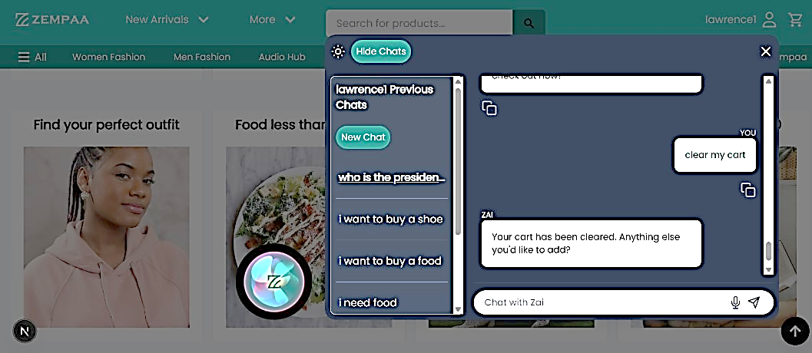
Figure 4.10 The user can perform cart operations with Zai (look above at the cart icon above you will see that the cart is empty. eg. clear their shopping cart
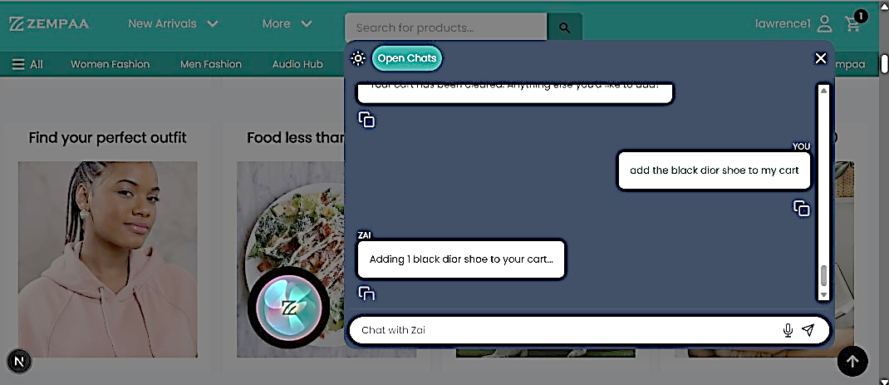
Figure 4.11 The user can perform cart operations with Zai (look above at the cart icon the user just added a product to their cart. eg. Adding products to their shopping cart
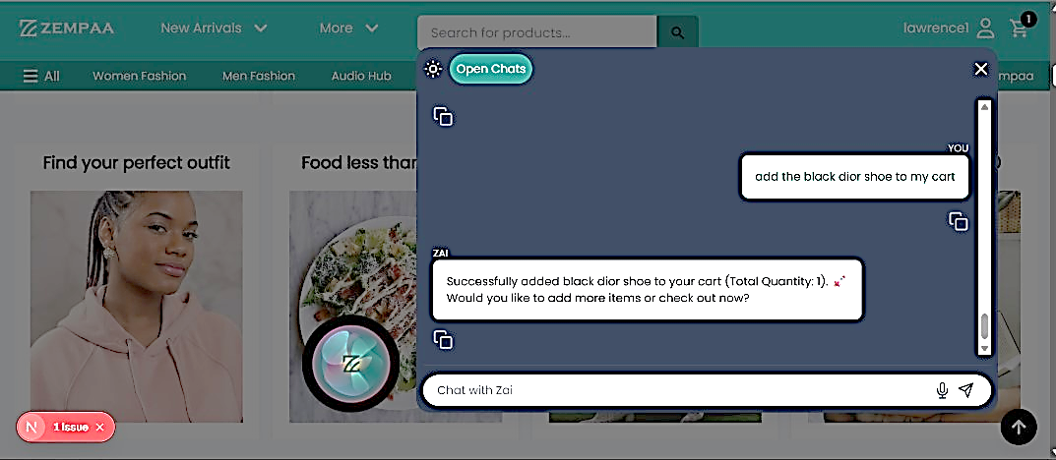
Figure 4.12 The user can perform cart operations with Zai (look above at the cart icon the user just added a product to their cart. eg. Adding products to their shopping cart

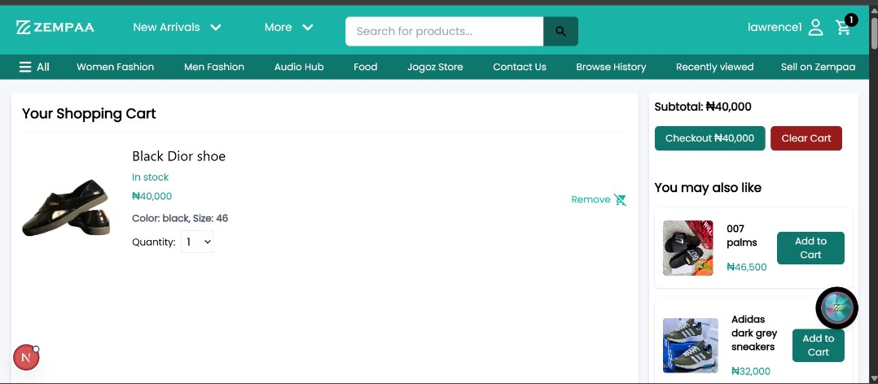
Figure 4.13 The user then goes to the cart page to see the product they added to their, the user can also use Zai through either chats or their voice.

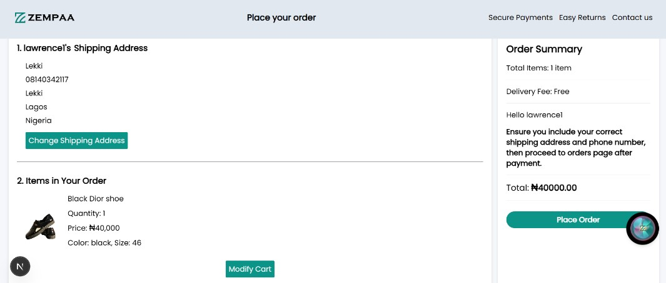
Figure 4.14 The user then goes to order confirmation page to see the product they want to order; the user can also use Zai through either chats or their voice.

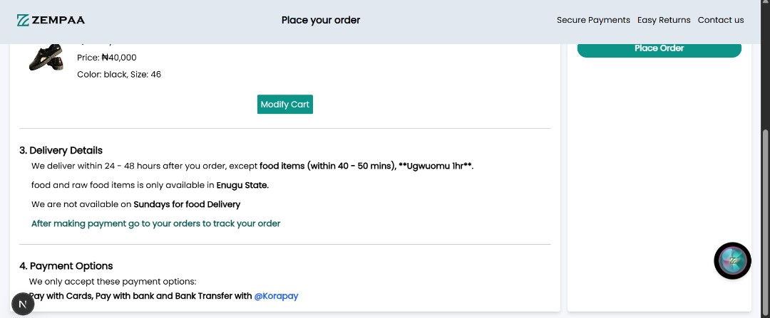
Figure 4.15: The user's information and delivery details.
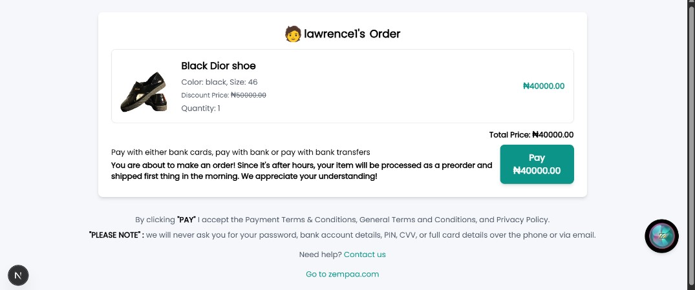
Figure 4.16: Final confirmation before payment.
4.4.4 Payment Checkout page
This page of the proposed system was incorporated in the system to help the user to checkout his or her order when its complete. The page holds various input fields and checkout parameters which was implemented to reduce the hassle of trying to make and process payments on the proposed system. The page incorporates the Kora pay payment API which enables the user to make payment using his or her card, bank transfer and pay with bank. This page is one of the most important pages of the system as it is crucial to the effective operation of the system. In other words, it stands to serve as a means of allowing the users to pay for the products before it gets delivered to them.


Figure 4.17: When the user clicks on PAY, behind the scenes kora pay is loading the payment modal.
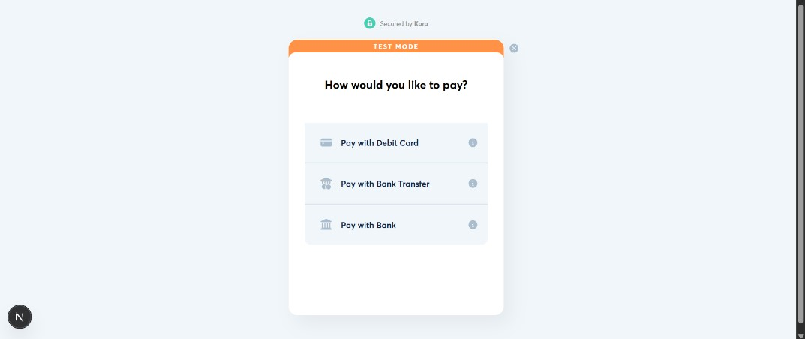
Figure 4.18: When kora pay payment modal opens with three options to choose how you want to pay.
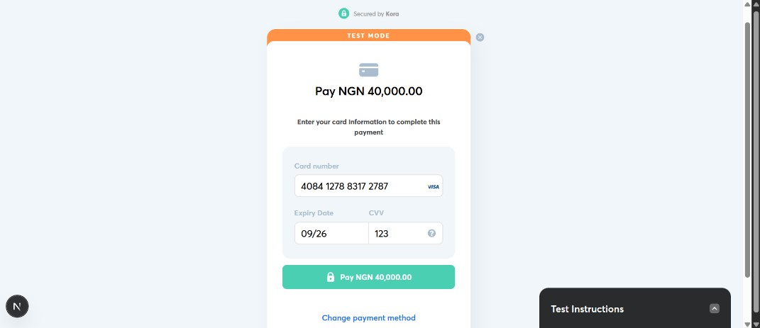
Figure 4.19: I choose to pay with debit card, since this is a test account, kora pay provided me with a fake visa card.
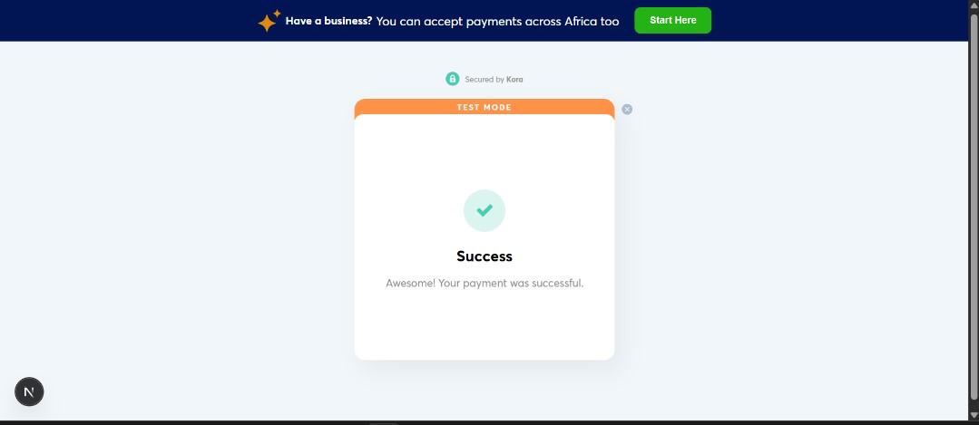
Figure 4.20: So the payment was successful.
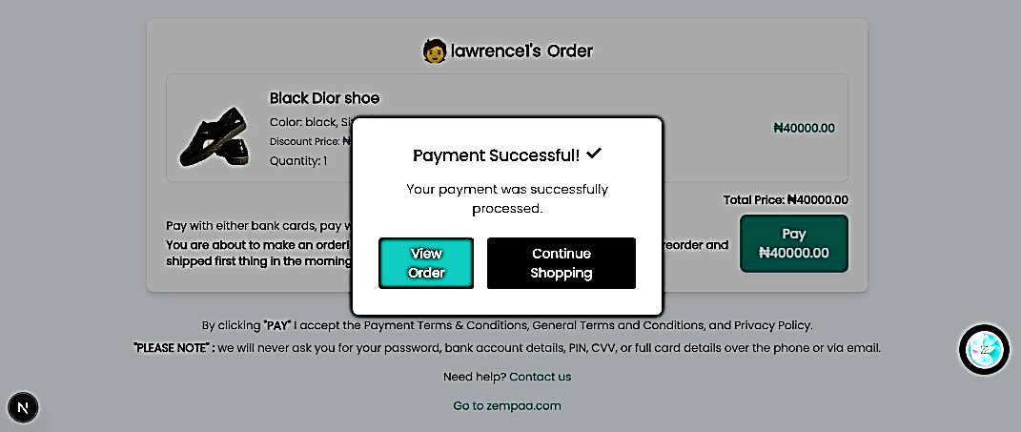
Figure 4.21: So it redirects the user back to the web app zempaa.com where they choose either to continue shopping which leads to the home page of the web app or to view their latest order.

4.4.5 Order page
This screen of the proposed system is the most important page of all the pages in the proposed system as it is the page that handles orders, to track orders and see when it is being delivered or it's on the way, users can also make reviews on the products after they receive it.
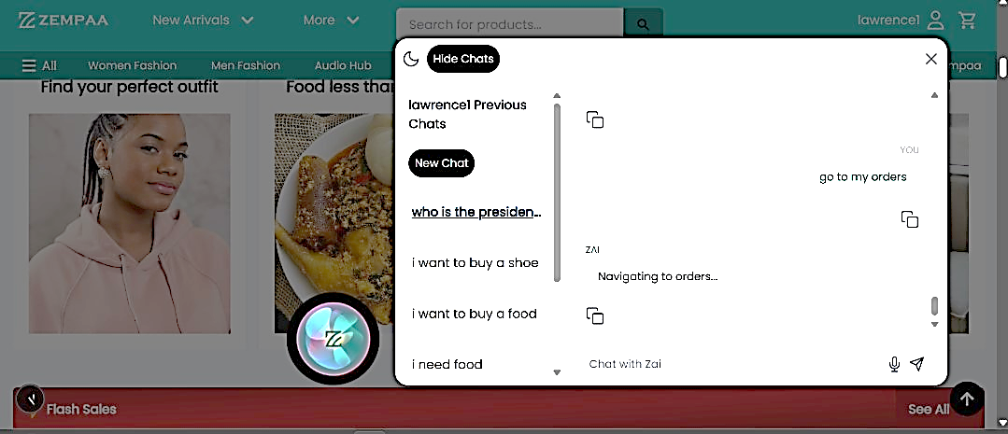
Figure 4.22: The user can also use Zai for navigating pages.
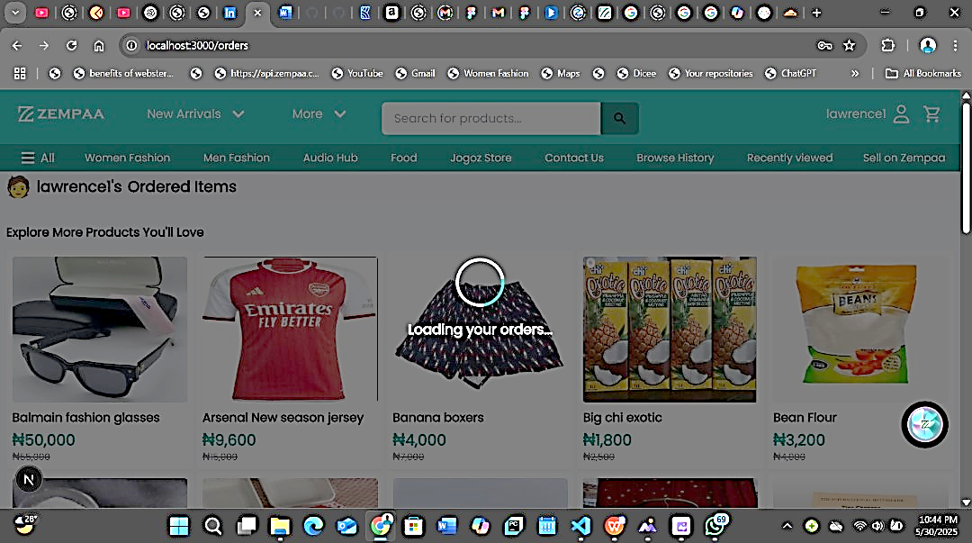
Figure 4.23: This is the orders page it is still loading above.
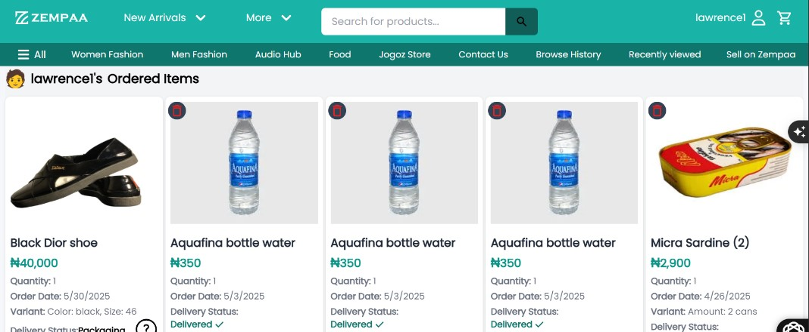
Figure 4.24: This is the orders page where they see their latest orders.
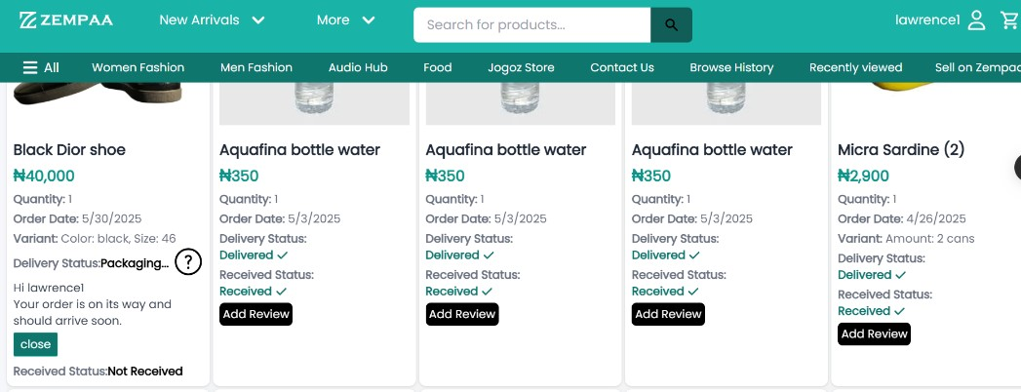
Figure 4.25: This is the orders page where they can track their order.
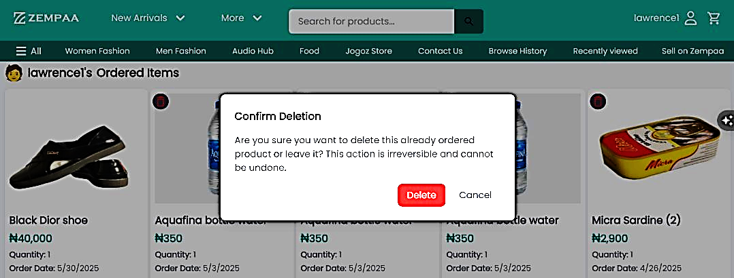
Figure 4.26: This is the orders page the users can also delete an order.

CHAPTER FIVE
SUMMARY, RECOMMENDATIONS AND CONCLUSION
5.0 Introduction
This chapter of this research study is used by the researcher to give a comprehensive summary of this project work, the recommendations for next work, and a detailed conclusion of this work of research. However, this chapter offers a summary of all the subjects that have been discussed in every other chapter of the projects that are prior to this research work.
5.1 Summary
At the beginning of the work of research, the background and the problem statement of that pertains to this research were clearly addressed. However, the later parts of this work of research stood to explore the theoretical underpinnings of the research as well as a review of the relevant systems that are currently in existence. In a similar way, this project also presented a thorough examination of currently existing systems, pointed out their shortcomings, and tried to leverage these drawbacks in the creation of the suggested system.
However, in the third chapter of this work of research, a thorough system analysis was also carried out using UML (Unified Modelling Language) diagrams; the system was thoroughly studied using use case diagrams, activity diagrams, class diagrams, and class diagrams of the UML diagrams. Finally, a list of all the programming languages and frameworks used to complete this project was included, along with a description of the user interface.
5.2 Recommendations
This innovative and fantabulous voice and chat shopping is very beneficial to both the blind and the handicap, and also those who are very descriptive when they want to make an order, users can speak as long as they want and whenever they are done it sends automatically and it provides them with the necessary products they want to buy and if these products are not available it suggest related product by speaking to the user, voice shopping or chat shopping also helps users in navigating the website, so instead of looking for links to click on they can just use their voice to navigate of through chatting, all these helos to make shopping much more easier for online shoppers.
5.3 Conclusion
We have now reached the concluding part of this work of research, as this section stands to wrap up the goals that were established for the project. However, this is not the end for proposed system but rather, the research has not stopped with this finding, and the researcher will continue to expand and include a ton of additional services, such as fully handless shopping functionality to allow the users to shop without touching their phones or screens because at these point it is half way to achieving that.

REFERENCES
Ahmed, M., & Rana, F. (2022). Enhancing accessibility in e-commerce through voice navigation systems. Journal of Internet Services and Applications, 13(1), 11.
https://doi.org/10.1186/s13174-022-00162-0

Business Dasher. (2024). 8+ Voice Commerce Statistics: A Must Know in 2024. https://www.b usinessdasher.com/voice-commerce-statistics/

Forbes Business Development Council. (2022). 6 Reasons Voice Shopping Is the Future of M-Commerce. Forbes. https://www.forbes.com/councils/forbesbusinessdevelopmentcou ncil/2022/12/21/6-reasons-voice-shopping-is-the-future-of-m-commerce/

Gajula, Y. (2025). Sentiment-Aware Recommendation Systems in E-Commerce: A Review from a Natural Language Processing Perspective. arXiv. https://arxiv.org/abs/2505.03828

Jayarao, P., & Sharma, A. (2021). Retraining DistilBERT for a Voice Shopping Assistant by Using Universal Dependencies. arXiv. https://arxiv.org/abs/2103.15737

Mindster. (2024). Can Voice Commerce Revolutionize Online Shopping? https://min dster.com/mindster-blogs/voice-commerce-future-of-shopping/

Shopify Nigeria. (2024). Voice Shopping: Your Business’s New Best Friend. Shopify.
https://www.shopify.com/ng/blog/voice-shopping

APPENDICES
1.0 Authentication
'use client';
import React, { createContext, useContext, useState, useEffect } from 'react';
import { signIn, signOut, getSession } from 'next-auth/react';
import axios from 'axios';
const AuthContext = createContext();
export const AuthProvider = ({ children }) => {
const [session, setSession] = useState(null);
useEffect(() => {
const fetchSession = async () => {
const session = await getSession();
// console.log('Fetched session:', session); // Inspect session data
setSession(session);
};
fetchSession();
}, []);
// Function to refresh the token
const refreshAccessToken = async () => {
try {
const response = await axios.post('https://api.zempaa.com/api/auth/refresh/', {
refresh: session?.user?.refreshToken,
});
const newAccessToken = response.data.access;
// Update the session with the new access token
setSession((prev) => ({
...prev,
user: {
...prev.user,
accessToken: newAccessToken,
},
}));
return newAccessToken;
} catch (error) {
console.error('Error refreshing access token:', error);
logout(); // Log out user if token refresh fails
}
};
const login = async () => {
await signIn();
const session = await getSession();
setSession(session);
};
const logout = async () => {
await signOut();
setSession(null);
};
return (
<AuthContext.Provider value={{ session, login, logout, refreshAccessToken }}>
{children}
</AuthContext.Provider>
);
};
export const useAuth = () => useContext(AuthContext);
2.0 Payment Intent Api
useEffect(() => {
const script = document.createElement("script");
script.src = "https://korablobstorage.blob.core.windows.net/modal-bucket/korapay-collections.min.js";
script.async = true;
document.body.appendChild(script);
return () => {
document.body.removeChild(script);
};
}, []);
function generateTransactionId() {
return txn_${Math.random().toString(36).substr(2, 9)}_${new Date().getTime()}; }
const payKorapay = useCallback(() => {
const timestamp = new Date().getTime();
const uniqueReference = zempaa_checkout_${timestamp};
const newTransactionId = generateTransactionId();
setTransactionId(newTransactionId);
window.Korapay.initialize({
key: process.env.NEXT_PUBLIC_KORA_CHECKOUT_PUBLIC_KEY,
reference: uniqueReference,
amount: totalPrice,
currency: "NGN",
customer: {
name: session?.user?.username || "Guest",
email: session?.user?.email || "guest@example.com",
},
narration: "",
notification_url: "",
onClose: function () {},
onSuccess: async function (response) {
})

