FUNGAL CONTAMINATION AND MYCOTOXIN ANALYSIS OF ROASTED CASHEW NUT SOLD IN ENUGU AND ANAMBRA

BY

IBEAGHA CHIMDALU SHALOM
GOU/U21/BTG/149

BIOTECHNOLOGY B.SC. PROGRAMME
BIOLOGICAL SCIENCES DEPARTMENT
FACULTY OF NATURAL SCIENCES AND ENVIRONMENTAL STUDIES (FNSES)
GODFREY OKOYE UNIVERSITY, UGWUOMU NIKE, ENUGU STATE, NIGERIA.

A RESEARCH PROJECT SUBMITTED TO THE DEPARTMENT OF BIOLOGICAL SCIENCES IN PARTIAL FULFULMENT OF THE REQUIREMENTS FOR THE AWARD OF BACHELOR OF SCIENCE (B.Sc.) DEGREE IN BIOTECHNOLOGY.

SUPERVISOR: DR. U. OYEAGU

AUGUST, 2025.

APPROVAL
This research titled fungal contamination and mycotoxin analysis of roasted cashew nut sold in Nigeria has been assessed and approved by the Committee of Department of Biological Sciences and Faculty of Natural Sciences and Environmental Studies, Godfrey Okoye University Enugu Nigeria.

Name of Supervisor
Dr. Uche Oyeagu ………………. …………….
Supervisor Signature Date

Name of External Examiner
……………… ……………
External Examiner Signature Date

Name of HOD
Dr. Frances Olisaka ……………… ……………
HOD, Department of Signature Date
Biological Sciences

Name of Dean
Prof. Chidi UHUEGBU ……………… ……………
Dean, FNSES Signature Date

CERTIFICATION
This is to certify that this research titled FUNGAL CONTAMINATION AND MYCOTOXIN ANALYSIS OF ROASTED CASHEW NUT SOLD IN NIGERIA was carried out by IBEAGHA CHIMDALU SHALOM with Registration Number GOU/U21/BTG/149 under supervision in the Department of Biological Sciences, Godfrey Okoye University Enugu Nigeria.

Name of Supervisor
Dr. Uche Oyeagu ………………. …………….
Supervisor Signature Date

Name of HOD
Dr. Frances Olisaka ……………… ……………
HOD, Department of Signature Date
Biological Sciences

DEDICATION
This research project is humbly dedicated to God Almighty and my future career as a scientist. It’s by his grace, wisdom and strength I have been able to embark on this journey which has proved quite successful and fruitful.
ACKNOWLEDGEMENT
I would like to begin by thanking my first supervisor, Dr. Uche OYEAGU, who I began my 400 level journey with during the course of my industrial training and seminar presentations respectively. He has been of immense help and guidance to me up to the start of my project. he effortlessly and freely gave me his time, corrections, and laboratory assistance during my entire project at moments I needed the most . I would like to appreciate my HOD, Dr Frances Olisaka, for all her support and time, thank you ma for everything. I also acknowledge Prof. Ezeonu, Mr. Mike, Prof. Marire, Dr. Okafor, Dr. Charles, Dr. Nnamdi, Prof. Onyia and of course, the Dean, Prof. Chidi Uchegbu of the Faculty of Natural Sciences and Environmental Studies, for his seamless efforts. I also would like to appreciate the Biotechnology laboratory technologist, Miss Paschaleen Onyemaechi, for all the support she has given to me before my research project and most especially during my project work, thank you Ma’am for your patience and dedication towards my success.
I also want to appreciate all my friends, course mates and colleagues for their encouragement, cheers and good tidings towards my growth and success.
I would love to appreciate God almighty who made it possible for me to reach this stage in my life, he has been wonderful to me. Finally with all being said, I would love to appreciate my parents and elder siblings for their financial, moral, spiritual, physical, economical and all time support in my academic journey and life from the get go and also my appreciation goes to my noble uncle Dr. Oguchi for all his support. I would not have reached where I am currently without their support.

ABSTRACT
Food safety and public health are seriously threatened by fungus contamination and aflatoxin in nuts, especially in developing nations like Nigeria. Aflatoxin levels and the degree of fungal contamination in roasted cashew nuts sold in a few Nigerian markets were evaluated in this investigation. The study gathered 6 samples from supermarkets and large open marketplaces in various geopolitical zones. The Enzyme-Linked Immunosorbent Assay (ELISA) was used to measure aflatoxin levels, and the serial dilution method on Potato Dextrose Agar (PDA) was used to evaluate the fungal load. (76.7%) of the samples had fungal contamination, with total fungal counts ranging from CFU/g. Aflatoxin-producing Aspergillus species, especially A. flavus, were the most common fungal genera isolated. According to ELISA analysis, 18.3% of the samples had levels of total aflatoxins above the Codex Alimentarius Commission's recommended maximum allowable limit of 4 µg/kg, and 31.7% of the samples had detectable amounts of aflatoxins. Compared to samples from supermarkets, samples from open markets had higher contamination rates. These results drew attention to the possible health hazards that Nigerians may face when consuming roasted cashew nuts, particularly if they are handled and stored improperly. To reduce the risks of aflatoxin exposure from nut intake, the study highlights the necessity of better post-harvest management procedures, regulatory monitoring, and public education.

TABLE OF CONTENTS
Title Page i
Approval ii
Certification iii
Dedication iv
Acknowledgement v
Abstract vi
Table of content vii
List of tables ix
List of Figures x

CHAPTER ONE: INTRODUCTION 1
  - Background of Study 1
1.2 Statement the Problem 1
1.3 Aim and Objective 3

CHAPTER TWO: LITERTURE REVIEW 4
2.1. Botanical Description of the Cashew plant (Anacardium occidental) 4
2.2. Nutrient Composition and Bioactive Compounds of Cashew 5
2.3. Phytochemical Component of the Cashew plant 6
2.3.1. Phenolic Compounds 8
2.3.2. Tannins 9
2.3.3. Flavonoids 9
2.3.4. Anacardic acids 10
2.3.5. Carotenoids, Carotenoid Esters, and Anthocyanins 12
2.4. The Antioxidant and Antimicrobial Activities of Cashew (Anacardium occidentale) as a potential Food Preservative 12
2.5. Description of Mycotoxins and the chemical structure 14
2.6. Clearification of Mycotoxins Toxicity and their Toxic effects 14
2.7 Favourable Condition for Aflatoxin Contamination of Cashew Nut 16
2.7.1. Nutritional Factors 16
2.7.2. Physical Factors 17
2.7.3. Biological Factors 18
2.8. Methods for the Detection and Analysis of Mycotoxins 18

CHAPTER THREE: MATERIALS AND METHODS 20
3.1. Sample Collection and Preparation 20
3.2. Determination of the Total Viable and Fungal Counts in Sample 20
3.3. Sample Preparation for Mycotoxin Extraction and Analysis 20

CHAPTER FOUR: RESULT 22
  - Total Viable and Fungal Counts in Sample 22
  - Mycotoxin And Analysis 22

CHAPTER FIVE: DISCUSSION, CONCLUSION AND RECOMENDATION
5.1 Discussion 25
5.2 Conclusion 26
5.3 Recommendations 27
5.3.1 Regulatory and Policy Recommendations 27
5.3.2 Public Health and Education 27
5.3.3 Industry and Market-Level Interventions 28
5.3.4 Research and Innovation 28
5.3.5 Collaborative Efforts 28

REFRENCEES 30

LIST OF TABLES
Table 1 : Mycotoxin and their toxic effect 15
Table 2 : fungal count 23

LIST OF FIGURES
Figure 1 : The chemical and linear structure of anacardic acid , cardanols , cardols and 2_
methyl cardols 7
Figure 2 :The chemical structure of Anacardium compound with biological activity 10
Figure 3 : The chemical structure of the major Mycotoxins 14
Figure 4.1: Result for the aflatoxin analysis 23

CHAPTER ONE
INTRODUCTION
  - Background of Study
The cashew plant botanically referred to as Anacardium occidentale, is an evergreen tree of the Anacardiaceae family. It's native to tropical South America before being distributed to other parts of the world by early Portuguese explorers who collected seeds, and now serves as the major source of both the cashew apple (accessory fruit) and the cashew nuts worldwide. These Portuguese colonists exported these cashew seeds to Goa which was known as Estado da Índia Portuguese in India from 1560 to 1565.It can grow as tall as 14 meters or 46 feet for the regular or big cultivars whereas dwarf cultivars may only grow up to 6 meters or 20 feet and may be more profitable in terms of maturing earlier than the others and have more yield yearly. The cashew nuts has a lot of uses asides being eaten just as it is like a snack, it can also be processed into cashew cheese and cashew butter by blending into a smooth puree in different recipes. The cashew fruit, which holds the seed or ‘nut,’ dangles from what we call the cashew ‘apple’—the tasty swollen stem of the fruit. This fruit is shaped like a kidney, roughly the size of a large bean, and it has a two-layered shell. The outer layer is coated with a caustic oil that needs to be burned off before anyone can handle the nut. After that, the nuts are either roasted again or boiled to get rid of any remaining toxic substances, and then the second shell is taken off. These nuts can also be pressed for oil. While nuts are a popular snack, improper handling and storage can lead to foodborne infections.
  - Statement the Problem
Even before or after they are harvested, cashew nuts are vulnerable to microbial attack due to their high nutritional profile. When farmers and wholesalers handle them with inadequate marketing and storage procedures, it exacerbates the situation (El-Samawaty, 2013). Understanding the rate of fungal infection on these items and how these fungi release various aflatoxins that are extremely dangerous into the nuts depends on environmental circumstances, which include elements like heat and humidity (Hedawoo and Bijwe, 2018). The Aspergillus species that create aflatoxins, which are known to have carcinogenic, teratogenic, estrogenic, and even immunosuppressive effects on humans, are the fungi strains most likely to attack cashew nuts (Adetunji et al., 2019). About 18 different varieties of aflatoxins have been identified to date, but the AFB1, AFB2, AFG1, and AFG2 are the most common and significant ones that pose a threat to public health (Adetunji et al., 2018). The Food and Agricultural Organization (FAO) estimates that mycotoxins contaminate around 25% of food products globally, with aflatoxins being the most harmful type (Eskola et al., 2020). The prevalence of aflatoxin contamination in cashew nuts has been studied in a number of nations, including Saudi Arabia, Nigeria, South Africa, and Brazil. The findings indicate that some levels of the contamination exceed and others fall below the limits established by the European Union (EU) and the Codex Alimentarius (El-Samawaty et al., 2013; Adetunji et al., 2018; Adetunji et al., 2019). Adetunji et al. (2018) conducted a study in Nigeria that examined the microbiological quality and aflatoxins risk assessment of both groundnuts and cashew nuts that were ready to eat. The study also documented the risk that consumers faced from aflatoxin contamination and foodborne diseases. According to Ashraf (2012), cashew nuts are particularly susceptible to fungal deterioration during extended storage periods, and 92.3% of all cashew nut samples are primarily contaminated with aflatoxin AFB1.
Furthermore, total aflatoxin levels ranged from 0.03 to 0.77 μg/kg and 0.01 to 0.28 μg/kg, respectively, according to a study comparing the fungal metabolite profiles of cashew nuts from South Africa and Nigeria (Adetunji et al., 2019). Numerous research on aflatoxin levels in milk, groundnuts, cereal flours, maize, and cereal-based supplementary flour have been carried out in Anambra. Even though cashew nuts are a major cash crop in the Southeast, nothing is known about aflatoxin contamination at this time. Assessing the aflatoxin levels of cashew nuts marketed in various areas of Anambra State, Nigeria, and determining the extent of contamination based on the recorded results are the main goals of this study. This could have the purpose of raising awareness so that food control and standardization agencies can continue to develop and implement measures for maintaining public safety.
1.3 Aim and Objective
The aim of this study is to examine and analyze the biological contamination and mycotoxin analysis of roasted cashew nuts sold at Anambra state with specific objectives such as ;
1. Investigate the presence of biological contaminants (fungi) and mycotoxins (aflatoxins) in roasted cashew nuts sold in Enugu State.
2. Quantify the levels of biological contaminants and mycotoxins present in roasted cashew nuts to assess potential health risks.

CHAPTER TWO
LITERATURE REVIEW
2.1. Botanical Description of the Cashew plant (Anacardium occidental)
Around the world, cashew nuts, or Anacardium occidentale L., are a popular nut. The cashew is considered one of the "four big nuts," along with walnuts, almonds, and hazelnuts. The genus Anacardium (Anacardiaceae) contains fifteen species, including A. occidentale, a perennial tree that originated in northern Brazil and is now widely grown in tropical places across the world. The Food and Agriculture Organization of the United Nations (FAO) estimates that 4.18 million cashew nuts with shells would be produced by 2020. Were manufactured all around the world. Cote d'Ivoire, India, Tanzania, the Philippines, and Vietnam are the main producers, with 7.10 million hectares producing millions of tons. From an anatomical standpoint, A. occidentale is divided into cashew apple, cashew nutshell, and cashew nut. As the container swells, a pseudocarp known as the cashew apple is formed. It makes up around 90% of the total weight of the cashew fruit (Schweiggert et al., 2016). Ripe cashew apple cultivars come in three different colors: red, orange, and yellow. Cashew apples can be consumed raw due to their soft skin, rich pulp, and absence of seeds (Rodríguez et al., 2017). But when consumed fresh, cashew apples because of the tannins they contain, they always taste astringent and leave your tongue feeling dry (Rodríguez et al., 2017). The cashew apple's utility is further limited by its short shelf life and vulnerability to degradation. Juices, alcoholic beverages, and preserves can be made from this matrix even if the processing rate is less than 20% (Poornakala et al., 2020). Many cashew apples are discarded as leftovers in the fields after cashew nut harvest, which results in a major loss of resources that increases financial and environmental expenses because cashew nuts are the main commercial and exploited product. Thus, to increase their usage rate, innovative cashew apple processing. It is necessary to develop technology. These technologies have the potential to increase the profits of the food sector while also addressing the issue of environmental contamination.
The kernel (cashew nut, CN), the outer shell (cashew nutshell, CNS), the inner shell (testa), and the cashew nutshell liquid (CNSL) comprise the cashew fruit.
2.2. Nutrient Composition and Bioactive Compounds of Cashew
Based on the results of the proximate, mineral, and functional properties of two types of cashew kernel flour, the study by Tamuno and Onyedikachi, (2015) detailed that the defatted (removed fat content) cashew kernel flour had more protein crude fiber and even carbohydrate proximate content at 34, 6.2 and 32.2% respectively as compared to fatted cashew kernel flour [Tamuno and Onyedikachi, 2015]. The dry matter's crude protein (190 g/kg), fiber (103 g/kg), fat (20.1 g/kg), and ash contents (20.2 g/kg) were measured in addition to its metabolizable energy of 7.12 MJ/kg dry matter. It was found that Moisture, ether extracts (crude fat), and total ash were all lower in defatted flour (4.4, 1.6, and 1.8%, respectively). Similarly, all of the mineral elements that were analyzed showed observable changes between the defatted and undefatted flours, with the exception of manganese, which was significantly more prevalent in the undefatted samples than in the defatted ones. However, there were no appreciable differences in bulk density, nitrogen solubility (pH 8), emulsion capacity, or foam capacity/stability between samples of defatted and undefatted flour. Other features, like the two samples' capacity to absorb, also showed notable variations. Nitrogen solubility at pH 8.0, fat and water, and emulsion stability [Tamuno and Onyedikachi, 2015].
A. Amino acids
In order to enhance cereal protein quality by dietary complementation, the amino acid content of A. occidentale was assessed using ion-exchange chromatography [Adeyeye et al., 2007]. With glutamic acid at the maximum concentration, A.occidentale's total amino acid content was 659.17 mg/g protein. The percentage of total essential amino acids in the species was 51.0%, whereas the percentage of total acidic amino acids was 30.4%. All of them can precipitate at acidic pH, according to the computed isoelectric points for A. occidentale, which were 3.9. In A. occidentale, threonine was shown to be the limiting amino acid. Similarly, 50.5% of the total sulfur amino acid content was cystine.
Glutamic acid was the most abundant amino acid (4.60 g/100 g) while tryptophan was the least abundant amino acid (0.32 g/100 g) in the Rico et al., [2016] study, which was based on A. occidentale. Fagbemi's [2009] study found that leucine (34.8-38.2 mg/g crude protein) and tryptophan (3.9-9.2 mg/g crude protein) were the limiting amino acids, whereas glutamic acid (183.5-214.0 mg/g crude protein) was the most prevalent amino acid.
B. Lipids and Fatty Acid Profile
High-yielding cashew cultivars were used to assess the lipid content of the seeds. 96% of the total lipids in the kernel were neutral lipids, with the remaining 4% being glycolipid and phospholipid. Glycolipids mostly included saturated fatty acids like lauric and myristic acid, whereas triglycerides had higher levels of unsaturated fatty acids like oleic and linoleic acid. Neutral and glycolipid compositions were found to differ. High-yielding cultivars did not differ in their phospholipid content, albeit [Nagaraja, 1987]. Samples of A. occidentale nuts underwent germination, fermentation, roasting, boiling, and drying. The fatty acid Nut oil composition was examined. The study discovered that processing methods had a major impact on the proximate composition of nuts.
2.3. Phytochemical Component of the Cashew plant
The chemical makeup of Anacardium species has been investigated, and more than 170 phytochemicals have been found. Cashew nut shells, which contain between 30 and 35 weight percent oil or shell liquid, make up the majority of the agro-waste from cashew nut processing facilities. Four possible substances are present in the liquid: 2-methyl cardol, cardanol, cardol, and anacardic acid. Cashew nut shell liquid is a promising renewable resource for synthesis since its constituents can undergo a variety of reactions to produce industrial compounds (Mubofu and Mgaya, 2018).
Alkaloids were absent from the species' ether extract, although coumarins and quinones were present in the ethanol and aqueous extracts. Likewise, large concentrations of anthocyanidins, triterpenes, steroids, and tannins are found in ethanol extracts. Both aqueous and ethanolic extracts included flavonoids and saponins, according to Martínez Aguilar et al. (2012).
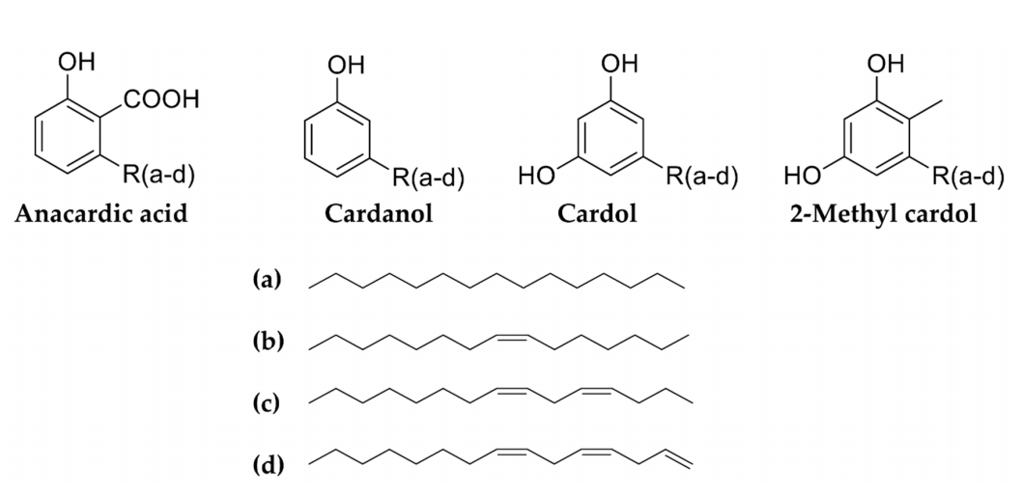
Figure 1: The Chemical and Linear Structure of anacardic acids, cardanols, cardols and 2-methyl cardols.
Source: Biomolecules, 2019.

2.3.1. Phenolic Compounds
Commercial A. occidentale nut shell liquid has three main phenolic components: cardol, cardanol, and anacardic acid. The fifteen-carbon side chain of these phenolic substances contains a variety of molecules, including saturated, monoene, diene, and triene. They have developed a number of methods to extract anacardic acid, cardol, and cardanol for commercial use. Calcium anacardate is used to isolate anacardic acid in a selective manner. After being treated with liquor ammonia, the acid-free cashew nut shell liquid is treated with hexane/ethyl acetate (98:2) to extract cardanol, a monophenolic component. The ammonia solution is extracted using ethyl acetate/hexane (80:20) to produce cardol (Paramashivappa et al., 2001). Similarly, phenolic compounds present in testa and cashew nuts were examined in relation to the effects of roasting. The extract yield, phenolic content, and proanthocyanidin content of cashew testa are higher in both soluble and bound fractions than in whole nuts and kernels. Syringic, gallic, and p-coumaric acids were among the phenolic acids found in both samples. Other flavonoid compounds that have been discovered include (+)-catechin, (-)-epicatechin, and epigallocatechin. However, the concentrations of these substances increase with warmth. Research indicates that short-term high-temperature roasting of testa and cashew nuts improves their chemical makeup (Chandrasekara and Shahidi, 2011). Testa and cashew nut phenolic content was investigated after roasting at low and high temperatures. Roasting increased the total amount of phenolics in both. The cashew apple juice included garlic, protocatechuic, and cinnamic acids (both free and conjugated). After hydrolysing cinnamic acid with cutting, it was stored at 40°C. Damage and higher storage temperatures increased the amount of 5-hydroxymethylfurfural in cashew apple juice, indicating non-enzymatic browning (Queiroz et al., 2011).

2.3.2 Tannins
The pressure autoclaving method employed to extract tannins from A. occidentale was dependent on temperature, duration, particle size, and methanol concentration. Both qualitative and quantitative assessments of tannins were conducted using spectrophotometric assays. It was determined how each extraction condition affected the total tannins. Tannin extraction is significantly impacted by temperature. Although early evaluations indicate that tiny particle sizes may achieve high extraction efficiency, fine grinding is inappropriate due to pressure loss, grinding energy, and product purification costs. Tannin extraction is enhanced by particles that are 5–15 mm in size. At low temperatures (40°C), there was less noticeable reduction or degradation of these compounds. Lokeswari et al. (2010) assert that temperature has a greater impact on chemical extraction than either time or substrate concentration. Tannins from the peel and flesh of four cashew apple cultivars from Brazil and Benin (West Africa) were separated from monomeric phenols using acetone/water (60:40, v/v).
2.3.3. Anacardic Acids
After the cashew shells are removed using the solvent hexane, the natural liquid present in cashew nuts—which are acquired at room temperature—contains a significant amount of anacardic acids. The primary cashew nut liquid is a kind of anacardic and salicylic acid (monoene-15:1, diene-15:2, and triene-15:3), according to Morais et al. (2017). Michodjehoun-Mestres et al. (2009) stated that a full cashew apple contains 6–20 milligrammes of 1-cinnamoyl glucose per 100 grammes. The cashew nut juice was then extracted using supercritical carbon dioxide in a subsequent study to produce very pure anacardic acids. The natural cashew nut liquid's solubility in supercritical carbon dioxide was evaluated at various CO₂ flow rates of 5, 10, and 15 g/min, at temperatures of 40 and 50 °C, and at pressures of 100, 200, and 300 bar. 50°C, 300 pressure, and a CO₂ flow rate of 5 g/min were optimal for supercritical carbon dioxide. A 3 gramme sample of cashew nut shell liquid and supercritical CO₂ were used to extract very pure anacardic acid (82 percent of total anacardic acid) in 150 minutes. Anacardic acid extracted using supercritical carbon dioxide and spectroscopic methods (UV-vis, FT-IR, and (1)H NMR) and HPLC analysis yielded better quality than a conventional process including many chemical conversion stages (Philip et al., 2007). The nut oil extract of A. occidentale was shown to include resorcinolic lipids from bacteria, liposomal structures, and graminaceous sources. Size stability and marker entrapment are higher in vesicular structures (Przeworska et al., 2001).
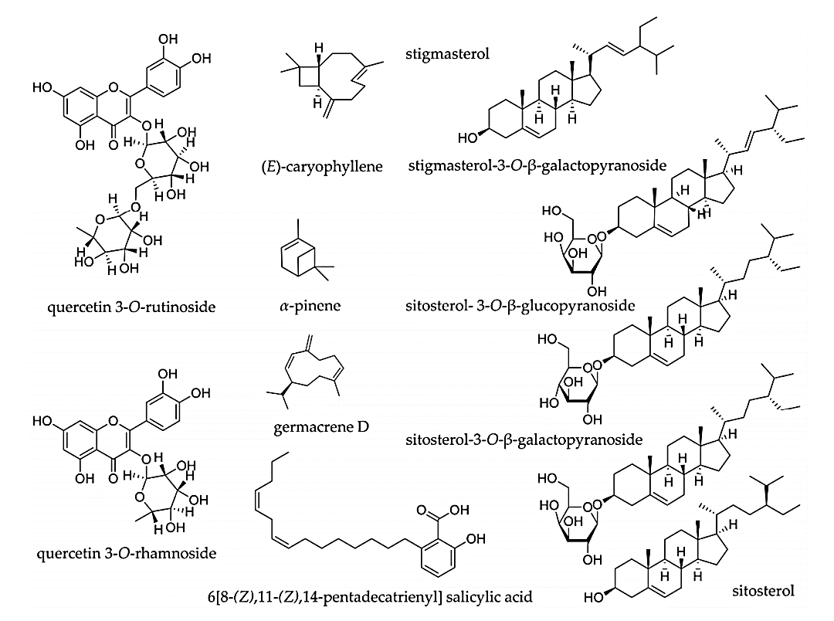
2.4. The Antioxidant and Antimicrobial Activities of Cashew (Anacardium occidentale) as a potential Food Preservative
Figure 2. The chemical structure of Anacardium compounds with biological activity
Source: Biomolecules, (2019).
Seventy precent of the cashew nut shell's chemical makeup is composed of 6[8-(Z),11-(Z),14-pentadecatrienyl] salicylic acid, the species A. occidentale's main bioactive component. The species possesses potent antibacterial qualities due to this type of acid [Narasimhan et al., 2008]. After 28 days of inoculating tomato paste and tomato ketchup with 2 x 10⁴ cfu/g of Gram-positive and Gram-negative bacteria, such as Staphylococcus aureus, Bacillus subtilis, and Escherichia coli, anacardic acid at a concentration of 0.014% resulted in non-viable growth, suggesting that it could be used as a natural food preservative [Narasimhan et al., 2008]. Furthermore, several investigations have shown Anacardium species' antibacterial properties. Himejima and Kubo (1991), for example, discovered that sixteen phenolic compounds from cashew nut shell oil exhibited antimicrobial activity. Most of these compounds were effective against Propionibacterium acnes, Streptococcus mutans, Escherichia coli, Staphylococcus aureus, and Breuibacterium ammoniagenes.
Research has revealed that extracts from cashew nut shell waste, when dissolved in water and ethanol, exhibit significant antibacterial properties, as evidenced by their minimum inhibitory concentrations (MIC) against various pathogens. Specifically, these extracts inhibited the growth of Bacillus cereus at 3.13 µg/mL, Enterococcus fecium at 6.25 µg/mL, and Staphylococcus aureus at 3.13 µg/mL. Furthermore, an evaluation of the antioxidant efficacy of the cashew nut shell extract, at a concentration of 150 µg/mL, demonstrated notable performance when compared to trolox. The extract exhibited 75.5% inhibition of DPPH radicals and 97.1% inhibition of ABTS radicals, corresponding to antioxidant capacity values of 57.1 and 56.2 µmol equivalent, respectively. These findings suggest that cashew nut shell waste could potentially serve dual purposes: diminishing agricultural waste and acting as a natural food preservative (Yuttana et al., 2018). Anacardic acids have recorded very potent antioxidant activity as high as 0.27mM while in combination with another type gave an IC50 of 0.6mM. These anacardic acids have higher antioxidant activity than even cardanols and cardols which had an IC50 >4mM. Phenolic chemicals flavones, triterpenes, xanthones with anacardic and gallic acids have been obtained from ethanol extracts of cashew leaves, stems, bark and even flowers. The ethanol extract from the flower had the most active antibacterial effect as compared to the other three, and also displayed antioxidant qualities in the DPPH experiment. 14 different microrganisms were subjected to the assay for testing, and it was discovered the extract was effective against both Gram-positive and Gram-negative bacteria and fungi alike. The tested microbes include the following species: Staphylococcus aureus, Proteus mirabilis, Escherichia coli, Streptococcus mutans, Helicobacter pylori, Salmonella choleraesuis, Enterococcus faecalis, Pseudomonas aeruginosa, Lactobacillus acidophilus, Methicillin Resistant Staphylococcus aureus (MRSA), Streptococcus pyogenes and Candida albicans, Candida tropicalis [Da Silva et al., 2016].
2.5. Description of Mycotoxins and their chemical structure
Mycotoxins are considered secondary metabolites synthesized by fungi with filament like Aspergillus, Fusarium, and Penicillium and are responsible for serious health complications in both humans and animals (Umereweneza et al., 2018). Contamination of food and feed by fungi that produce mycotoxin can have detrimental health and socioeconomic impacts [Atherstone et al., 2014; Abd-Elghany and Sallam, 2015; Montanari et al., 2016]. [Rodrigues and Naehrer, 2012; Darwish et al., 2014; Pleadin et al., 2019]. Food crops majorly affected by mycotoxins include grains like wheat, corn, barley and rice, legumes peanuts, cashew nuts, almonds, fruits, coffee beans, spices like ginger, garlic, pepper and meat. As stated by Mesterhazy et al. [2020], the amount of food waste due to mycotoxin contamination and food spoilage is over 1.3 billion metric tons yearly, and is about one third of the total global output. Of all the approximately 400 types of mycotoxins discovered in recent times, only about 30 are known to be harmful to both humans and animals (Umereweneza et al., 2018; Vila-Donat et al., 2018). From the list of 30 harmful mycotoxins, the most commonly known are mycotoxin A (OTA), zearalenone (ZEN), fumonisins (FMNs), Alternaria monomethylether (AME), nivalenol (NIV)), citrinin (CIT), patulin (PAT), trichothecenes (T-2/HT-2 toxins, deoxynivalenol (DON), Alternaria toxins (alternariol (AOH), and ergot alkaloids. The most dangerous of these mycotoxins is the Aflatoxins which have been grouped by the International Agency for Research on Cancer (IARC) as Group 1 human carcinogens among the well-known mycotoxins are [Shephard, 2008; Anfossi et al., 2016]. Also, these mycotoxins have been linked to causing cancer, organ toxicity and even allergies in people [Alshannaq and Yu, 2017]. The severity of their effects depends on their mutagenic and teratogenic properties as well as the level of exposure. The consumption of foods contaminated with fungi mycotoxins over a long period of time would result to detrimental health issues like genotoxicity and immune system suppression by AFB1 and OTA, endocrine disruption by ZEN, liver cancer and abdominal pain by DON and even stunted growth by T-2 toxins, and so much more [Amuzie and Pestka, 2010; Song et al., 2014; Rȧsi`c et al., 2019; Liu et al., 2020]. Long-term exposure to many mycotoxins can also have synergistic health effects [Sun et al., 2015; Zhou et al., 2017]. Accurate and effective mycotoxin detection is essential for preventing health issues and guaranteeing food safety.

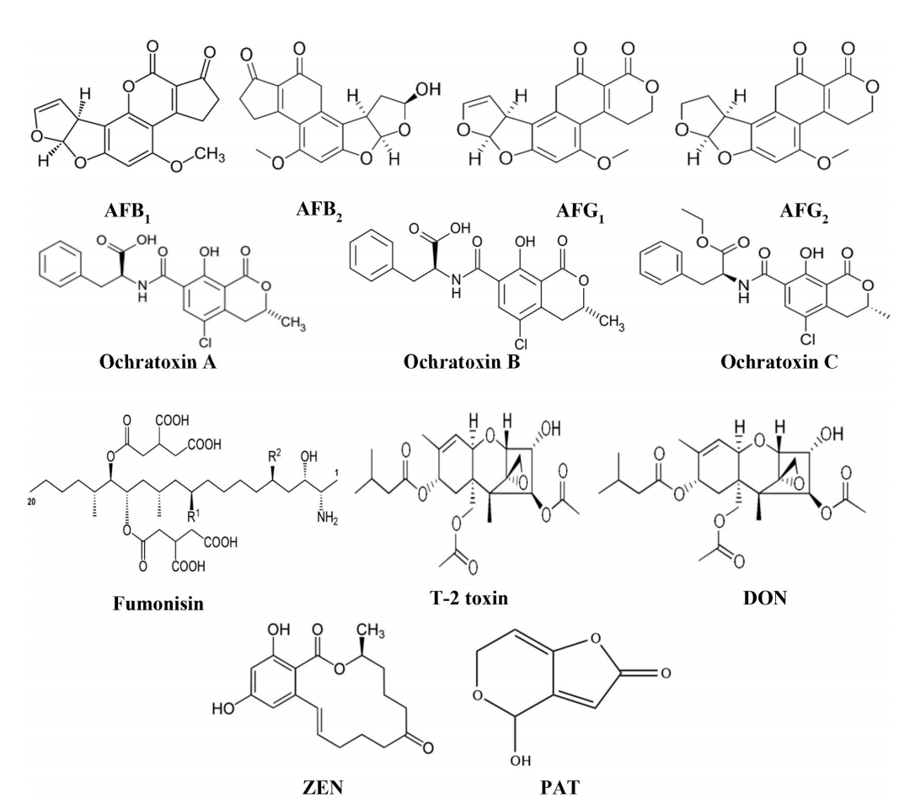
Figure 3. The Chemical structure of the major Mycotoxins.
Source: Khan et al., 2024.

2.6. Classification of Mycotoxins and their Toxic effects
When mycotoxins from pathogenic fungi infiltrate fruits, vegetables, and cereal crops, they can be harmful to human health [Binder, 2007]. Mycotoxin infections affect about 25% of grain products worldwide [Streit et al., 2013]. Table 2 summarizes the toxicity levels for each of the primary mycotoxins, whereas Figure 3 depicts their chemical structures. The mycotoxin types include aflatoxins, ochratoxin A, Patulin, Zearalenone, Trichothecenes and Fumonisins.

Table 2.1. Mycotoxins and their toxic effects
Mycotoxin | Producing Fungi | Common Food Sources | Toxicological Effects | References
Patulin (PAT) | Penicillium expansum, P. patulum, P. urticae, P. crustosum, P. griseofulvum | Apples, apple-derived products, grains, pulses, seeds, fruits, nuts, and vegetables | In humans, PAT is linked to cancer formation, genetic mutations, birth defects, and damage to the nervous system. In animals, it displays both immune system suppression and neurotoxic effects. | Malír et al., 2003; Champdore et al., 2007; Gomes et al., 2013; Frisvad et al., 2018
Aflatoxins (B1, B2, G1, G2, M1, M2) | Aspergillus flavus, A. parasiticus, A. nomius, A. pseudotamarii, A. ochraceoroseus, A. bombycis | Grains, legumes, fruits, vegetables, peanuts | These toxins are strongly associated with liver cancer and have mutagenic and teratogenic effects. AFM1 in particular can contribute to fetal abnormalities during development. | Chu & Ueno, 1977; Richard, 2007; Frisvad et al., 2019; El-Sayed et al., 2022
Ochratoxins (OTA, OTB, OTC) | Aspergillus ochraceus, A. niger, A. carbonarius, Penicillium nordicum, P. viridicatum, P. verrucosum | Cereals, nuts, legumes, fruits, vegetables | OTA is known to be toxic to the liver, kidneys, and nervous system. In pigs, it causes nephropathy. In humans, it has been linked to kidney failure, urinary tract tumors, and Balkan Endemic Nephropathy (BEN). | Bayman et al., 2002; Malír et al., 2003; Ismaiel & Papenbrock, 2015; Pinotti et al., 2016; Tao et al., 2018
Fumonisins (B1, B2, B3) | Fusarium oxysporum, F. nyagamai, F. proliferatum | Maize, beans, soy, sorghum, oats, rice | These toxins inhibit the synthesis of sphingolipids. In humans, they have been associated with cancers of the esophagus and liver. In animals, they can lead to ELEM in monkeys and respiratory inflammation in horses. | Gelderblom & Marasas, 2012; Marin et al., 2013; Adeyeye, 2016; Tao et al., 2018; Kamle et al., 2019; Landoni et al., 2020
Trichothecenes (e.g., DON, T-2, HT-2 toxins) | Fusarium graminearum, F. culmorum, F. poae, F. langsethiae, F. sporotrichoides, Trichoderma, Stachybotrys, Trichothecium | Wheat, corn, barley, and animal-derived products such as milk, kidneys, and eggs | T-2 toxins and DON disrupt protein synthesis by targeting ribosomes. T-2 exposure in humans causes alimentary toxic aleukia (ATA). These toxins interfere with DNA, RNA, and protein synthesis, leading to oxidative stress, programmed cell death, and cellular damage. | Council for Agricultural, 2003; Bhat et al., 2010; Nathanail et al., 2015; Patocka, 2018; Foroud et al., 2019; Klaban, 2021
Zearalenone (ZEN) | Fusarium cerealis, F. graminearum, F. equiseti, F. culmorum, F. verticillioides | Corn, barley, rye, wheat, oats | ZEN is linked to liver tumors, uterine and thyroid gland cancers in rats. It also causes testicular shrinkage, kidney and eye disorders, and disrupts enzyme activity in biosynthetic pathways. | Conková et al., 2003; Ostry et al., 2017; Mazaheri et al., 2021
Source: Khan et al., 2024.

2.7. Favorable Conditions for Aflatoxin Contamination of cashew nut
2.7.1. Nutritional Factors
The synthesis of aflatoxins is notably affected by various substrate components and dietary ingredients, including carbohydrates, amino acids, nitrogen sources, lipids, and trace elements. Substrates that are abundant in carbohydrates serve as a favorable environment for the proliferation of fungi, thereby enhancing aflatoxin production compared to those containing high levels of oil (Ma et al., 2014). Research has identified several effective carbohydrate substrates, such as glucose, ribose, sucrose, xylose, and glycerol, while substances like peptone, lactose, and sorbose demonstrated ineffective results in stimulating aflatoxin synthesis (Liu et al., 2016). Nitrogen, particularly in the form of nitrite and nitrate, also significantly contributes to the aflatoxin production of Aspergillus flavus through various biochemical pathways (Wang et al., 2017). Additionally, lipids are critical to aflatoxin production as they participate in the metabolism of epoxy fatty acids and the oxidation of ergosterol, both of which are essential for fungal development (Reverberi, 2014). Notably, lipid-rich substrates have been shown to encourage greater aflatoxin synthesis compared to low-fat alternatives. For instance, the addition of corn oil to defatted wheat that is infected with Aspergillus flavus resulted in a pronounced increase in aflatoxin levels relative to media devoid of corn oil (Liu et al., 2016). Moreover, the interplay of vitamins, amino acids, and metal ions is integral to the aflatoxin biosynthetic process. Specific bivalent metal ions, including magnesium and zinc, alongside amino acids such as glycine, glutamate, and alanine, have been found to enhance aflatoxin formation (Bolu et al., 2014). Notable findings indicate that the addition of zinc at concentrations of 20, 50, and 100 mg/L escalated aflatoxin production by factors of 4, 5, and 19, respectively (Liu et al., 2016). Furthermore, while amino acids like tyrosine promote aflatoxin synthesis, others, such as tryptophan, exert an inhibitory effect (Chang et al., 2015). As demonstrated, aspartic acid, glutamic acid, arginine, and glycine also significantly contribute to the production of AFB1, particularly at a concentration of 0.5%.
2.7.2. Physical Factors
Physical factors like pH, light, moisture, temperature, water, relative humidity, and airborne gases can all lead to aflatoxin contamination. Aflatoxin-producing molds and fungi can thrive in a wide pH range (1.7–9.3), however 3–7 is the optimal range (Yoshinari et al. 2010). A slightly higher pH 6 > 3 enables the growth of the fungi and the synthesis of their aflatoxins, in opposition to a lower pH 3> 1 prevents any fungal growth (Eshelli et al. 2015). The media composition for culturing fungi also disrupts pH balance, although if the initial pH is 5, this can promote AFB aflatoxin B synthesis and pH at 7 promotes the production of aflatoxin G AFG (Dalié et al. 2010). Aflatoxin synthesis and fungal development are also impacted by light. Darkness increases the production of aflatoxin, while sunlight inhibits it (Rushing and Selim, 2019). A high moisture content always encourages aflatoxin infection because moist conditions are favorable for fungal growth. Although it is greatly enhanced at 95% relative humidity, aflatoxin production is best accomplished at 85% relative humidity (Ding et al., 2015). However, water level has not been found to affect aflatoxin contamination. Aspergillus flavus prefers to grow in temperatures between 28 and 37 degrees Celsius, while it can tolerate a range of temperatures from 12 to 48 degrees (Hawkins et al., 2005). Matumba et al. (2015) state that while both AFB and AFG production are equal at low temperatures, AFB production is frequently greater than AFG production at high temperatures. The availability of O₂ and CO₂ also affects the production of aflatoxins. Higher CO₂ and lower O₂ levels limit the formation of aflatoxins and fungal growth (Mahbobinejhad et al. 2019).

2.7.3. Biological Factors
Biological factors include things like insect damage, weeds, and fungi. Plant stress brought on by weeds, which mostly thrive as competitors, is associated with the generation of aflatoxin. Aflatoxin production is primarily determined by the types of fungi; insects wound in plants cause stress and provide an environment for aflatoxigenic fungi to infect (Kinyungu, 2019). Aflatoxin production is also influenced by strain types. Aspergillus flavus generates fewer aflatoxins than Aspergillus parasiticus (Manjunath & Mohana, 2018). The saprobe characteristic of A. flavus, the most prevalent mold in soil, enables it to grow on a wide range of organic nutrient substrates, including compost piles, waste from plants, cotton, dead insects, stored grains, field crops, animal corpses, and animal feed. In addition to the previously mentioned considerations, this makes it the main species responsible for agricultural contamination and aflatoxin production (Kakde, 2012). Food grains can become contaminated during storage because Aspergillus flavus can ruin them, and field crops are often infected before harvest since Aspergillus flavus is naturally present in the soil. Due to its lack of host specificity, Aspergillus flavus contaminates seeds of both monocots and dicots (Leger et al. 2000).
2.8. Methods for the Detection and Analysis of Mycotoxins
The Association of Official Analytical Chemists (AOAC) offers a number of official methods for determining if crop plants are contaminated with aflatoxin (Kumar et al. 2016). The most popular of them is the Enzyme-Linked Immunosorbent Assay (ELISA), which is followed by a few chromatography methods like Liquid Chromatography-Mass Spectroscopy (LCMS), Thin Layer Chromatography (TLC), and High-Performance Liquid Chromatography (HPLC) (Sulyok et al. 2015).

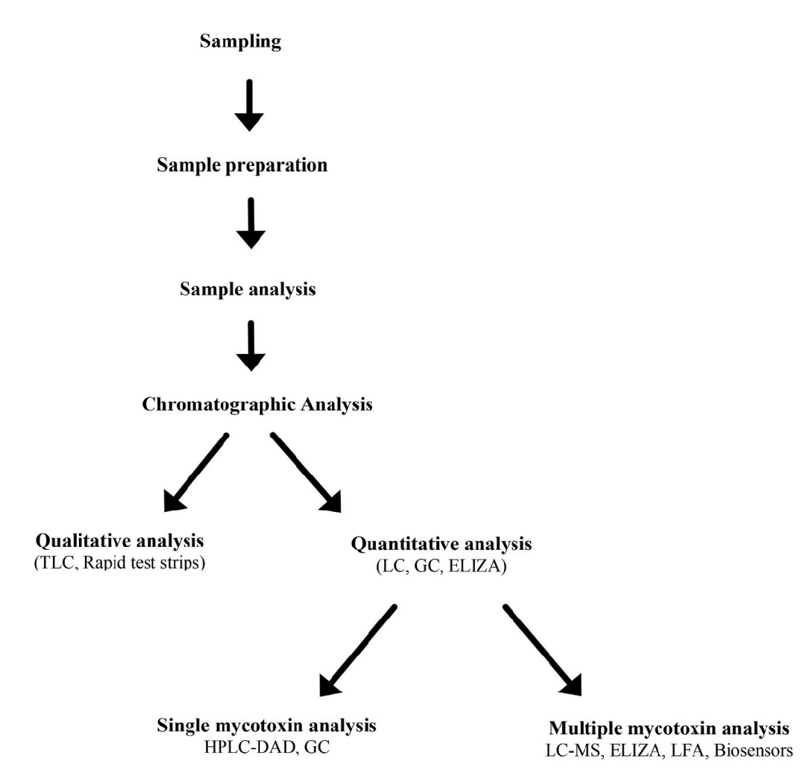
Figure 4. Flow chat description of the steps in Mycotoxin analysis.
Source: Khan et al., 2024.

CHAPTER THREE
MATERIALS AND METHODS
Study Area
3.1. Sample Collection and Preparation
Three markets and different vendors were selected for the purchase of the roasted cashew nuts samples and also from open market vendors who openly roast these nuts, within Enugu and Anambra. About 5 samples of the cashew nuts were aseptically retrieved into sterile nylons and taken back to the laboratory for analysis. They were grounded into a paste, of which 50 grams was transferred into sterile Ziploc bags and stored under refrigerated conditions in the laboratory until needed for analysis.
3.2. Determination of the Total Viable and Fungal Counts in Sample
The total viable count as well as the fungi count was determined using the direct plate count method described by Samson (1995). In this technique, 1 gram of the nut paste was mixed and diluted with 9 milliliters of sterile distilled water and was done serially. An aliquot 1 ml of the diluted samples were plated on sterilized molten nutrient agar and potato dextrose agar enriched with 0.01% chloramphenicol respectively in triplicates. This was spread round using a sterile hockey stick to even out the microbial distribution from the diluent mixture. The nutrient agar platesfor total viable count was incubated at 30°c for 48 hours while the potato dextrose agar plates for fungal count were incubated at 28°c for 48 hours.
The total viable and fungal counts were determined using the following formula:
cfu/g= Number of colonies × reciprocal of the diluting factor ÷ plating volume (1ml).
3.3. Sample Preparation for Mycotoxin Extraction and Analysis
A sample weighing 5 grams was meticulously ground to facilitate the extraction of aflatoxins from 50 grams of the sample using a solvent mixture of methanol and deionized water in a ratio of 80:20 (v/v). This mixture was subjected to thorough agitation for 30 minutes at a rotational speed of 120 RPM utilizing a shaker. Subsequently, the solution was filtered through filter paper, and 20 milliliters of the resulting filtrate was diluted with Phosphate Buffer Solution (PBS) at pH 7.4 in a 4:1 ratio. The diluted solution was then centrifuged at 3400 RPM for 15 minutes and further filtered using a nylon membrane filter with a pore size of 0.45 μm.

Affinity Chromatography

In the subsequent phase of our research, aflatoxins were extracted from the sample using an affinity chromatography column, specifically the Aflaclean (LCTech, Germany). An aliquot of fifty milliliters of the extract was applied to the column, which was maintained at a flow rate of 1 milliliter per minute. After the aflatoxin molecules were adsorbed onto the column matrix, it was washed with distilled water to eliminate any unbound substances. The aflatoxins were subsequently eluted using 2 milliliters of methanol. The eluate underwent incubation at 50 degrees Celsius, followed by solvent evaporation using nitrogen gas. The final sample was then injected into a High-Performance Liquid Chromatography (HPLC) system for the quantitative analysis of Aflatoxin B₁, B₂, G₁ and G₂.

HPLC Analysis of Aflatoxins
The quantification of aflatoxin standards and samples was performed utilizing high-performance liquid chromatography (HPLC) paired with fluorescence detection. The HPLC apparatus comprised a pump and a fluorescence detector, both sourced from Knaur in Germany. In this analysis, aflatoxins were effectively separated using an HPLC column with a mobile phase composed of water, methanol, and acetonitrile in a volume ratio of 60:30:15. The fluorescence detection settings were calibrated to an excitation wavelength of 365 nm and an emission wavelength of 440 nm. Under a flow rate of 1.2 ml/min, the retention times were recorded as follows: AFG2 submitted to 8–9 minutes, AFG1 ranged from 10.5 to 11.5 minutes, AFB1 indicated 13–14 minutes, and AFB2 demonstrated a duration of 16–17 minutes, culminating in a total run time of 25 minutes.
CHAPTER FOUR
RESULT

4.1. Total Viable and Fungal Counts in Sample
The total viable counts of fungal isolates was within the ranges of 5.24×10² to 4.54×10³ indicating low to moderately high concentration of fungi in the roasted cashew nuts samples. The highest fungal count was 286 with a cfu/g of 4.54×10³ while the least count was 33 with a cfu/g of 5.24×10². Two plates had below the colony forming units for acceptable fungal counts at 9.5×10¹ and 1.11×10² CFU/g
4.2 Mycotoxin Analysis
From the mycotoxin analysis, it was discovered the presence of aflatoxins, showing 4 different classes of aflatoxins, the AFG1, AFG2, AFB1 and AFB1 respectively. A standard curve was used to compare the aflatoxins peaks, retention time and area. AFG2 recorded the least retention time at under 1 minute, whereas it had the highest peak height and peak area, meaning it may be the most concerntrated of all 4 aflatoxins detected. On the other hand AFB1 had the highest retention time at 39 minutes (time required for each substance to travel round the column and get identified by the detector), but had the closest peak area and peak height as compared to the standard used. It's counterpart AFG2 had the second highest retention time at 31 minutes but had the lowest peak area and peak height as compared to the others. AFG2 had the second lowest retention time at 8 minutes, but had the second highest peak area and peak height. The total concentration of all aflatoxins present was 1.8760ug/l.

Table 4.1 Fungi count
Plate No | Colony count | Dilution factor | Volume plated (ml) | Sample weight (g) | CFU/g calculated
1 | 286 | 10¹ | 1.0 | 0.6302 | 4.54× 10³
2 | 75 | 10¹ | 1.0 | 0.6302 | 1.19 × 10³
3 | 36 | 10¹ | 1.0 | 0.6302 | 5.71× 10²
4 | 33 | 10¹ | 1.0 | 0.6302 | 5.24× 10²
5 | 7 | 10¹ | 1.0 | 0.6302 | 1.11×10²
6 | 6 | 10¹ | 1.0 | 0.6302 | 9.5×10¹

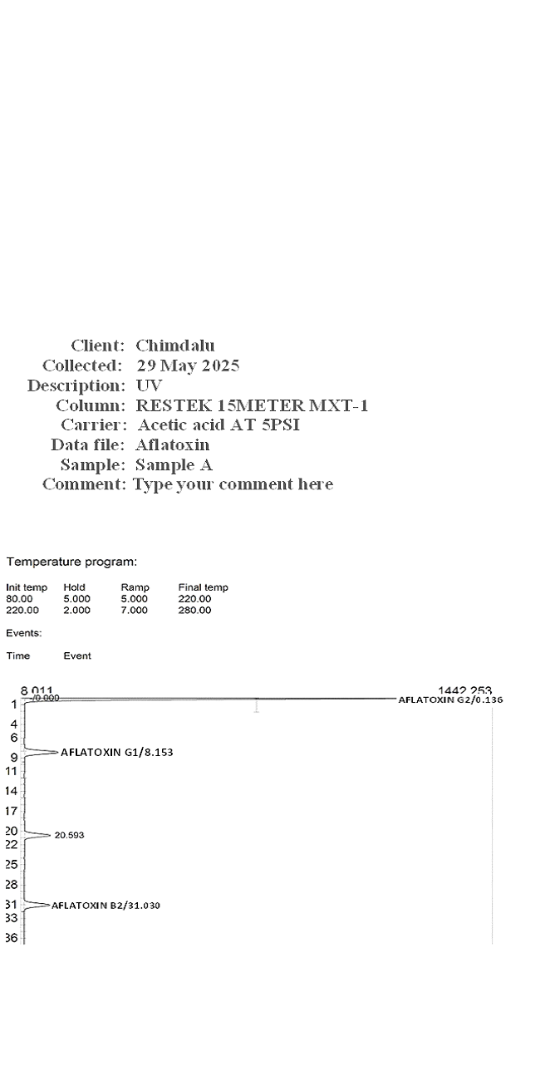

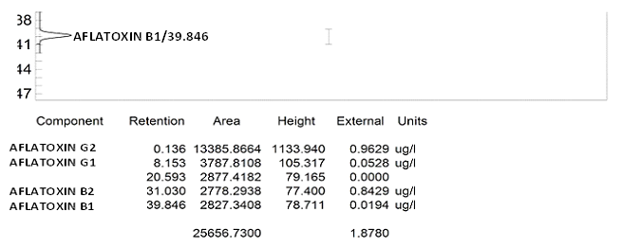
Figure 4.1 Result for the aflatoxin analysis

All four major aflatoxins were detected in the sample of roasted cashew nuts. These include; Aflatoxin G2, Aflatoxin G1, Aflatoxin B2 and Aflatoxin B1. Each of this toxins was positively identified, each with there corresponding retention times and concentration, confirming their presence in the sample. All four aflatoxins were found in the same sample which indicates a multi-aflatoxin contamination suggesting a co-contamination.
This co-contamination is common in improperly stored or processed food, especially in nuts.
Here are the concentration of each aflatoxin;
• Aflatoxin G2: 0.962 µg/L
• Aflatoxin G1: 0.0528 µg/L
• Aflatoxin B2: 0.8429 µg/L
• Aflatoxin B1: 0.0194 µg/L
The result is acceptable and falls within acceptable safety limits in aflatoxins in nuts that’s been set by the international standards (EU, Codex, NAFDAC). This therefore suggests that the sample is safe for consumption.
Mycotoxin analysis is often used to detect, measure, and control presence of toxic and secondary metabolites that are produced by certain fungi. These toxins can contaminate different food products during various stages such as growth, harvest, processing, or storage.

CHAPTER FIVE
DISCUSSION, CONCLUSION AND RECOMMENDATION
5.1 Discussion
The results of this study reveal a significant level of fungal contamination in roasted cashew nuts sold across various locations in Enugu and Anambra. The fact that roasting of cashew nuts is expected to limit microbial load contamination doesn't mean they are not prone to attack, as microbial contamination at their current state could occur during post processing activities as a result of poor handling, storage, packaging and even transportation practices. From the tested samples, different fungal species were isolated, particularly in the Aspergillus species particularly Aspergillus flavors, and Aspergillus niger observed as the most frequently occuring. These findings are consistent with those of a similar study on Aspergillus app. by Bankole & Adebanjo, (2003); Ezekiel et al., (2012), who reported a predominant afoatoxigenic fungi species found commonly in many Nigerian agricultural products. The most common producer of the aflatoxin Aspergillus flavus being present in the samples is of major concern. Based on the results of the mycotoxin analysis, it's been revealed that aflatoxins concentrations of the tested roasted cashew nuts was beyond the acceptable limits for aflatoxin concentration in food products as standardized by NAFDAC (Nigerian Regulatory body for food and drug safeguarding), as well as international organizations like FAO, WHO and the EU Commission. This indicates a potential risk of aflatoxicosis, especially for regular consumers and vulnerable populations such as children, pregnant women, and immunocompromised individuals. This poses a challenge not only for public health but also for Nigeria’s food trade and export industry, as failure to meet international safety standards can result in trade barriers and economic losses.
The survival rate of the fungal spores and their ability to produce these mycotoxins long after roasting of the cashew nuts is a dangerous missing link in typical nut post processing value chain. The act of roasting may as well destroy vegetative fungal cells, but chances are that their spores may survive and regain their toxic activity under conducive storage conditions like in places that are very humid and warm. These aflatoxins are highly heat resistant compounds which may not be disintegrated during and after roasting (Rushing & Selim, 2019).
Variations in contamination levels across different market locations suggest differences in hygiene practices, storage facilities, packaging methods, and supply chain logistics. In open markets, nuts are often exposed to dust, humidity, insect activity, and microbial aerosols, increasing their vulnerability to fungal colonization. Some vendors also reuse old, unclean packaging materials or store nuts in jute sacks that absorb moisture, creating microenvironments conducive to fungal growth. The detection of aflatoxins in products that are often consumed without further processing underscores the urgent need for stronger regulatory surveillance, routine screening, and public education. While some of the detected aflatoxin levels were within regulatory limits, their presence alone is a health hazard due to the cumulative and synergistic effects of chronic exposure. In particular, aflatoxin B₁, the most toxic form, is hepatocarcinogenic, immunosuppressive, and associated with stunting in children. These findings also raise questions about supply chain traceability, suggesting that nuts may become contaminated during storage in warehouses, at transit points, or at the point of sale rather than during harvesting or roasting. This emphasizes the need for an integrated approach to food safety that spans from farm to fork.
5.2 Conclusion
The findings here reveal that roasted cashew nuts sold in various Enugu and Anambra markets are not completely free from fungal contamination and the buildup of aflatoxins. The presence of the producer strains of this aflatoxin, the Aspergillus flavus in these ready to eat food product or snack is of major public health concern. Even though cashew nuts undergo roasting, poor post-roasting handling and storage conditions contribute to re-contamination and toxin production. The study underscores the importance of implementing Good Manufacturing Practices (GMP), Hazard Analysis and Critical Control Points (HACCP), and strict monitoring of the cashew nut value chain, from production to retail. It also highlights the urgent need for regulatory bodies to enforce food safety standards and for stakeholders to prioritize consumer protection.
5.3 Recommendations
Based on the findings and conclusions of this study, the following recommendations are proposed:
5.3.1 Regulatory and Policy Recommendations
Strengthen Regulatory Surveillance: Government agencies such as NAFDAC and SON (Standards Organisation of Nigeria) should intensify routine monitoring of nuts sold in markets for fungal and mycotoxin contamination.
Set and Enforce Permissible Limits: Nigeria must align its permissible mycotoxin limits with international standards, and violators should be sanctioned to serve as deterrents.
Mandatory Mycotoxin Testing for Export: All nuts intended for export must undergo certified aflatoxin testing to meet EU, US, and global food safety standards.
5.3.2 Public Health and Education
Public Awareness Campaigns: Educate vendors, processors, and consumers about the dangers of mycotoxins and safe storage practices through public health campaigns.
Training for Farmers and Processors: Implement training programs on proper harvesting, drying, packaging, and hygienic handling of cashew nuts to prevent fungal growth and toxin formation.
5.3.3 Industry and Market-Level Interventions
Improve Post-Harvest Handling: Introduce low-cost, improved drying and storage technologies (e.g., solar dryers, moisture meters, hermetic bags).
Packaging and Storage: Encourage the use of moisture-proof and airtight packaging materials to prevent fungal contamination after roasting.
Standardize Roasting Processes: Develop and promote roasting protocols that ensure sufficient heat treatment while minimizing recontamination risks.
5.3.4 Research and Innovation
Encourage Further Studies: More research is needed to identify critical points of contamination in the cashew nut supply chain and to explore biocontrol agents or natural antifungal treatments.
Develop Rapid Detection Kits: Invest in the development and local production of affordable rapid testing kits for aflatoxins, especially for small-scale traders.
5.3.5 Collaborative Efforts
Stakeholder Engagement: Collaboration between researchers, public health officials, farmers, exporters, and food vendors is essential to address aflatoxin contamination comprehensively.
International Partnerships: Partner with international food safety organizations to build capacity, access funding, and adopt global best practices.
Finally
Fungal contamination and aflatoxin production in roasted cashew nuts is a silent but deadly threat that affects consumer health, food trade, and national development. Combating it requires multidisciplinary and multi-sectoral collaboration, combining scientific innovation, regulatory enforcement, and community-based awareness. With proper implementation of the outlined recommendations, Nigeria can ensure the safety and quality of its cashew nuts and safeguard both its population and economy.

REFERENCES

Abd-Elghany, S. M. & Sallam, K. I. (2015). Rapid determination of total aflatoxins and ochratoxins A in meat products by immuno-affinity fluorimetry, Food Chemistry. 179, 253–256.
Adeyeye, E. I., Asaolu, S. S. & Aluko, A. O. (2007). Amino acid composition of two masticatory nuts (Cola acuminata and Garcinia kola) and a snack nut (Anacardium occidentale). Int. J. Food Science Nutentr, 58, 241–249.
Adeyeye, S. A. (2016). Fungal mycotoxins in foods: a review. Cogent Food Agriculture. 2 (1), 1213127.
Alshannaq, A. & Yu, J. H. (2017). Occurrence, toxicity, and analysis of major mycotoxins in food, International. Journal Environmental. Recourses. Public. Health 14 (6), 632.
Amaike, S. & Keller, N. P. (2011). Aspergillus flavus, Annu. Rev. Phytopathol. 49, 107–133.
Amuzie, C. J. & Pestka, J. J. (2010). Suppression of insulin-like growth factor acid-labile subunit expression—a novel mechanism for deoxynivalenol-induced growth retardation. Toxicolgy Science. 113 (2), 412–421.
Anderson, P. D. (2012). Bioterrorism: toxins as weapons. J. Pharmaceutical. Practice. 25 (2), 121–129.
Anfossi, L., Giovannoli, C. & Baggiani, C. (2016). Mycotoxin detection. Current. Opinion Biotechnology. 37, 120–126.
Atherstone, C., Grace, D., Waliyar, F., Lindahl, J. & Osiru, M. (2014). Aflatoxin Literature Synthesis and Risk Mapping: Special Emphasis on Sub-saharan Africa.
Bankole, S. A., & Adebanjo, A. (2003). Mycotoxins in Food in West Africa: Current Situation and Possibilities of Controlling it. Review Journal of Biotechnology, 2, 254-263.
Bayman, P., Baker, J. L., Doster, M. A., Michailides, T. J. & Mahoney, N. E. (2002). Ochratoxin production by the Aspergillus ochraceus group and Aspergillus alliaceus. Applied. Environmental Microbiology. 68 (5), 2326–2329.
Bhat, R., Rai, R. V. & Karim, A. A. (2010). Mycotoxins in food and feed: present status and future concerns. Comprehensive. Review Food Science. Food Saf. 9 (1), 57–81.
Binder, E. M. (2007). Managing the risk of mycotoxins in modern feed production. Anim. Feed Sci. Technol. 133 (1–2),149–166.
Bolu, S. A., Elelu, N., Ahmed, R. N., Solaojo, F. E., Daramola, K. F., Omotosho, V. S. & Afeni, M. (2014). Effect of vitamins, amino acids, and Phyto-active biomolecules on Aspergillus flavus in poultry production. Pharmacology and Therapeutics, 21–58.
Chandrasekara, N. & Shahidi, F. (2011). Effect of roasting on phenolic content and antioxidant activities of whole cashew nuts, kernels, and testa. Journal Agriculture Food Chemistry, 59, 5006–5014.
Chang, P. K., Hua, S. S. T., Sarreal, S. B. L. & Li, R. W. (2015). Suppression of aflatoxin biosynthesis in Aspergillus flavus by 2-phenyl ethanol is associated with stimulated growth and decreased degradation of branched-chain amino acids. Toxins, 7(10), 3887–3902.
Chu, F. & Ueno, I. (1977). Production of antibody against aflatoxin B1, Applied Environmental Microbiology 33 (5),1125–1128.
Conková, E., Laciakova, A., Kovàˇc, G. & Seidel, H. (2003). Fusarial toxins and their role in animal diseases. Vet. Journal. 165 (3), 214–220.
Council for Agricultural. (2003). Mycotoxins: Risks in Plant, Animal, and Human Systems: Council for Agricultural Science.
Da Silva, R. A., Liberio, S. A., do Amaral, F. M. M., do Nascimento, F. R. F., Torres, L. M. B., Neto, V. M. & Guerra, R. N. M. (2016). Antimicrobial and antioxidant activity of anacardium occidentale l. Flowers in comparison to bark and leaves extracts. J. Bioscience Med, 4, 87–89.
Dalié, D. K. D., Deschamps, A. M. & Richard-Forget, F. (2010). Lactic acid bacteria–potential for control of mold growth and mycotoxins: A review. Food Control, 21(4), 370–380.
Darwish, W. S., Ikenaka, Y., Nakayama, S. M. & Ishizuka, M. (2014). An overview on mycotoxin contamination of foods in Africa. J. Vet. Medical. Science 76 (6), 789–797.
Das, I., Shah, N. G. & Kumar, G. (2014). Cashew nut quality as influenced by microwave heating used for stored grain insect control. International Journal of Food Science, 2014, 516702.
Ding, N., Xing, F., Liu, X., Selvaraj, J. N., Wang, L., Zhao, Y., Wang, Y., Guo, W., Dai. X. & Liu, Y. (2015). Variation in the fungal microbiome (mycobiome) and aflatoxin in stored in-shell peanuts at four different areas of China. Frontiers in Microbiology, 6, 1055.
El-Sayed, R. A., Jebur, A. B., Kang, W. & El-Demerdash, F. M. (2022). An overview on the major mycotoxins in food products: characteristics, toxicity, and analysis, Journal of Future Foods 2 (2), 91–102.
Ezekiel, C. N., Bandyopadhyay, R., Sulyok, M., Warth, B. & Krska, R. (2012). Fungal and bacterial metabolites in commercial poultry feed from Nigeria. Food Additives & Contaminants: Part A. 29:8, 1288-1299.
Foroud, N. A., Baines, D., Gagkaeva, T. Y., Thakor, N., Badea, A., Steiner, B. & Bürstmayr, H. (2019). Trichothecenes in cereal grains–an update. Toxins 11 (11), 634.
Frisvad, J. C., Hubka, V., Ezekiel, C. N., Hong, S. B., Novßkovß, A., Chen, A. J. & Houbraken, J. (2019). Taxonomy of Aspergillus section Flavi and their production of aflatoxins, ochratoxins, and other mycotoxins, Study Mycology. 93 (1), 1–63.
Fromme, H., Gareis, M., Völkel, W. Gottschalk, C. (2016). Overall internal exposure to mycotoxins and their occurrence in occupational and residential settings–An overview. International Journal Hygenie Environment Health 219 (2), 143–165.
Fung, F. & Clark, R. F. (2004). Health effects of mycotoxins: a toxicological overview, J. Toxicology. Clinic. Toxicologyl. 42 (2), 217–234.
Gelderblom, W. C. A. & Marasas, W. F. O. (2012). Controversies in fumonisin mycotoxicology and risk assessment. Human Experiment Toxicolgy. 31 (3), 215–235.
Gomes, M. A., Priolli, D. G., Tralhao, J. G. & Botelho, M. F. (2013). Hepatocellular carcinoma: epidemiology, biology, diagnosis, and therapies. Revise Association Medical. Bras. 59 (5), 514–524.
Hawkins, L. K., Windham, G. L. & Williams, W. P. (2005). Effect of different postharvest drying temperatures on Aspergillus flavus survival and aflatoxin content in five maize hybrids. Journal of Food Protection, 68(7), 1521–1524.
Himejima, M. & Kubo, I. (1991). Antibacterial agents from the cashew Anacardium occidentale (anacardiaceae) nut shell oil. Journal Agriculture. Food Chemistry, 39, 418–421.
Ismaiel, A. A. &Papenbrock, J. (2015). Mycotoxins: producing fungi and mechanisms of phytotoxicity. Agriculture 5 (3), 492–537.
Kakde, U. B. (2012). Fungal bioaerosols: Global diversity, distribution, and its impact on human beings and crops. Bionano Genmics, 5, 323–329.
Kamle, M., Mahato, D. K., Devi, S., Lee, K. E., Kang, S. G. & Kumar, P. (2019). Fumonisins: impact on agriculture, food, and human health and their management strategies. Toxins 11 (6), 328.
Khan R., Anwar, F. & Ghazali, F. M. (2024). A comprehensive review of mycotoxins: Toxicology, detection, and effective mitigation approaches. Heliyon 10, e28361.
Kinyungu, S. W. (2019). Efficacy of pre-harvest Aspergillus flavus biocontrol treatment on reducing aflatoxin accumulation during drying. Doctoral dissertation, Purdue University Graduate School.
Klaban, V. (2021). Microscopic World and the phenomenon of symbiosis in the natural environment, Micro: The Foundation Stone of the Biosphere. 243–261.
Kubo, I., Masuoka, N., Ha, T. J. & Tsujimoto, K. (2006). Antioxidant activity of anacardic acids. Food Chemistry, 99, 555–562.
Kumar, K. N., Venkataramana, M., Allen, J. A., Chandranayaka, S., Murali, H. S. & Batra, H., (2016). V. Role of Curcuma longa L, Essential oil in controlling the growth and zearalenone production of Fusarium graminearum. LWT–Food Science. Technology. 69, 522–528.
Landoni, M., Puglisi, D., Cassani, E., Borlini, G., Brunoldi, G., Comaschi, C. & Pilu, R. (2020). Phlobaphenes modify pericarp thickness in maize and accumulation of the fumonisin mycotoxins. Science. Represent. 10 (1), 1417.
Leger, R. J. S., Screen, S. E., & Shams-Pirzadeh, B. (2000). Lack of host specialization in Aspergillus flavus. Applied and Environmental Microbiology, 66(1), 320–324.
Liu, D., Ge, L., Wang, Q., Su, J., Chen, X., Wang, C. & Huang, K. (2020). Low-level contamination of deoxynivalenol: a threat from environmental toxins to porcine epidemic diarrhea virus infection. Environmental. 143, 105949.
Liu, J., Sun, L., Zhang, N., Zhang, J., Guo, J., Li, C., & Qi, D. (2016). Effects of nutrients in substrates of different grains on aflatoxin B1 production by Aspergillus flavus. BioMed Research International.
Lokeswari, N., Sriramireddy, D., Sudhakar, P. & Varaprasad, B. (2010). Extraction of tannins from Anacardium occidentale and effect of physical parameters. J. Pharmastical. Res, 13, 906–908.
Mahbobinejhad, Z., Aminian, H., Ebrahimi, L. & Vahdati, K. (2019). Reduction of aflatoxin production by exposing Aspergillus flavus to CO₂. Journal of Crop Protection, 8(4), 441–448.
Malíˇr, F., Ostrý, V., Vl´aknit´e Mikromycety (Plísnˇe). & Mykotoxiny a Zdraví ˇClovˇeka. (2003). [Filamentous Micromycetes (Molds), Mycotoxins and Human Health], vol. 349, Brno. [in Czech].
Manjunath, K. & Mohana, D. C. (2018). Assessment of contamination levels and characterization of Aflatoxin B1 producing Aspergillus flavus strain from food and feed samples from local markets of South India. International Journal of Life Sciences, 6(1), 326–334.
Mari E., & Gregor, K., (2020) Worldwide contamination of food _crops with mycotoxin validity of widely cited FAO estimate. Critical review in food science and nutrition 60 (16) 2773_2789
Marin, S., Ramos, A. J., Cano-Sancho, G. & Sanchis, V. (2013). Mycotoxins: occurrence, toxicology, and exposure assessment, Food Chemistry Toxicolgy. 60, 218–237.
Martínez Aguilar, Y., Rodríguez, F. S., Saavedra, M. A., Hermosilla Espinosa, R. & Yero, O. M. (2012). Secondary metabolites and in vitro antibacterial activity of extracts from Anacardium occidentale l. (cashew tree) leaves. Review. Cuba. De Plantas Medical, 17, 320–329.
Matumba, L., Van Poucke, C., Njumbe Ediage, E., Jacobs, B., & De Saeger, S. (2015). Effectiveness of hand sorting, flotation/washing, dehulling and combinations thereof on the decontamination of mycotoxin-contaminated white maize. Food additives & contaminants. Part A, Chemistry, analysis, control, exposure & risk assessment, 32(6), 960–969.
Mazaheri, M., Maymand, M. M, Gilasgar, A., Akbarzadeh, A. & Manafi, M. H. (2021). Quantification of the zearalenone in maize oil with no clean-up. Food Control 127, 108166.
McCormick, S. P., Stanley, A. M., Stover, N. A. & Alexander, N. J. (2011). Trichothecenes: from simple to complex mycotoxins, Toxins 3 (7), 802–814.
Mesterh´azy, ´A., Ol´ah, J. & Popp, J. (2020).Losses in the grain supply chain: causes and solutions. Sustainability 12 (6), 2342.
Modupeade C., A., & Shamsideen, O., (2019). Fungal metabolism and mycotoxin profile of cashew nut from selected location in two African countries. Food additives contamination part A 36(12) 1847_1859
Montanari, C., Bargossi, E., Gardini, A., Lanciotti, R., Magnani, R., Gardini, F. & Tabanelli, G. (2016). Correlation between volatile profiles of Italian fermented sausages and their size and starter culture. Food Chemistry. 192, 736–744.
Morais, S. M., Silva, K. A., Araujo, H., Vieira, I. G. P., Alves, D. R., Fontenelle, R. O. S. & Silva, A. M. S. (2017). Anacardic acid constituents from cashew nut shell liquid: Nmr characterization and the effect of unsaturation on its biological activities. Pharmaceuticals, 10, 31.
Mubofu, E. B. & Mgaya, J. E. (2018). Chemical valorization of cashew nut shell waste. Top. Current Chemistry, 376, 8.
Nagaraja, K. (1987). Lipids of high-yielding varieties of cashew (Anacardium occidentale l.). Plant Foods Human. Nutrition., 37, 307–311.
Narasimhan, B., Panghal, A., Singh, N. & Dhake, A. S. (2008). Efficiency of anacardic acid as preservative in tomato products. Journal Food Process. Preservation, 32, 600–609.
Nathanail, A. V., Varga, E., Meng-Reiterer, J., Bueschl, C., Michlmayr, H., Malachova, A. & Berthiller, F. (2015). Metabolism of the Fusarium mycotoxins T-2 toxin and HT-2 toxin in wheat. Journal Agricultural Food Chemistry. 63 (35), 7862–7872.
Ostry, V., Malir, F., Toman, J. & Grosse, Y. (2017). Mycotoxins as human carcinogens—the IARC Monographs classification, Mycotoxin Resources. 33 (2017) 65–73.
Paramashivappa, R., Phain, K., Vithay, A. & Rao, A. (2001). Method for isolation of major phenolic consitutents from cashew (Anacardium occidentale l.) nutshell liquid. Journal Agriculture Food Chemistry, 49, 2548–2551.
Patocka, J. & Bolesatine, (2018). a toxic protein from the mushroom Rubroboletus satanas, Military Medical Science Letters 87 (1), 14–20.
Philip, J. Y., Buchweishaija, J., Mkayula, L. L. & Ye, L. (2007). Preparation of molecularly imprinted polymers using anacardic acid monomers derived from cashew nut shell liquid. Jornal Agriculture. Food Chemistry, 55, 8870–8876.
Pinotti, L., M. Ottoboni, M., Giromini, C., Dell’Orto, V. & F. Cheli, F. (2016). Mycotoxin contamination in the EU feed supply chain: a focus on cereal byproducts. Toxins 8 (2), 45.
Pleadin, J. Frece, J. & Markov, K. (2019). Mycotoxins in food and feed. Advance. Food Nutrtion. Resources 89, 297–345.
Poornakala, S. J., Indumathi, V. & Shanthi, K. (2020). Value addition in cashew apple: A review. International Journal of Chemical Studies, 8(6), 819–825.
Przeworska, E., Gubernator, J. & Kozubek, A. (2001). Formation of liposomes by resorcinolic lipids, single-chain phenolic amphiphiles from Anacardium occidentale L. Biochim. Biophys. Acta, 1513, 75–81.
Queiroz, C., da Silva, A. J. R., Lopes, M. L. M., Fialho, E. & Valente-Mesquita, V.L. (2011). Polyphenol oxidase activity, phenolic acid composition and browning in cashew apple (Anacardium occidentale, l.) after processing. Food Chemistry, 125, 128–132.
Raˇsi´c, D., ˇZeljeˇzi´c, D., Kopjar, N., Kifer, D., Klari´c, ˇM. S. & Peraica, M. (2019). DNA damage in rat kidneys and liver upon subchronic exposure to single and combined ochratoxin A and citrinin. World Mycotoxin J. 12 (2), 163–172.
Reverberi, M. (2014). Lipids in Aspergillus flavus-maize interaction. Frontiers in Microbiology, 5, 74.
Richard, J. L. (2007). Some major mycotoxins and their mycotoxicoses—an overview. Int. J. Food Microbiology. 119 (1–2), 3–10.
Rodrigues, I. & Naehrer, K. (2012). A three-year survey on the worldwide occurrence of mycotoxins in feedstuffs and feed. Toxins 4 (9), 663–675.
Rodríguez, Ó., Gomes, W. F., Rodrigues, S. & Fernandes, F. A. N. (2017). Effect of indirect cold plasma treatment on cashew apple juice (Anacardium occidentale L.). LWT, 84, 457–463.
Rushing, B.R. and Selim, M.I. (2019) Aflatoxin B1: A Review on Metabolism, Toxicity, Occurrence in Food, Occupational Exposure, and Detoxification Methods. Food and Chemical Toxicology, 124, 81-100.
Samson. (1995). Introducction to food-borne fungi Calcutta Business School Journal.
Shephard, G. S. (2008). Impact of mycotoxins on human health in developing countries. Food Additional. Contamination 25 (2), 146–151.
Song, E., Xia, X., Su, C., Dong, W., Xian, Y., Wang, W. & Song, Y. (2014). Hepatotoxicity and genotoxicity of patulin in mice, and its modulation by green tea polyphenols administration. Food Chemistry. Toxicolgy. 71, 122–127.
Steinkellner, H., Binaglia, M., Dall’Asta, C., Gutleb, A. C., Metzler, M., Oswald, I. P. & Alexander, J. (2019). Combined hazard assessment of mycotoxins and their modified forms applying relative potency factors: zearalenone and T2/HT2 toxin. Food Chemical. Toxicology. 131, 110599.
Streit, E., Schwab, C., Sulyok, M., Naehrer, K., Krska, R. & Schatzmayr, G. (2013). Multi-mycotoxin screening reveals the occurrence of 139 different secondary metabolites in feed and feed ingredients.Toxins 5 (3), 504–523.
Sulyok, M., Beed, F., Boni, S., Abass, A., Mukunzi, A. & Krska, R. (2015). Quantitation of multiple mycotoxins and cyanogenic glucosides in cassava samples from Tanzania and Rwanda by an LC-MS/MS-based multi-toxin method. Food Additives & Contaminants: Part A, 32(4), 488–502.
Sun, L. H., Lei, M. Y., Zhang, N. Y., Gao, X., Li, C., Krumm, C. S. & Qi, D. S. (2015). Individual and combined cytotoxic effects of aflatoxin B1, zearalenone, deoxynivalenol and fumonisin B1 on BRL 3A rat liver cells. Toxicon 95, 6–12.
Tamuno, E. & Onyedikachi, E. (2015). Proximate, mineral and functional properties of defatted and undefatted cashew (Anacardium occidentale linn.) kernel flour. Europe. Journal Food Science . Technology, 3, 11–19.
Tao, Y., Xie, S., Xu, F., Liu, A., Wang, Y., Chen, D. & Yuan, Z. A. (2018). Ochratoxin, Toxicity, oxidative stress, and metabolism. Food Chemistry. Toxicology. 112, 320–331.
Umereweneza, D., Kamizikunze, T. & Muhizi, T. (2018). Assessment of mycotoxins types in some foodstuff consumed in Rwanda, Food Control 85, 432–436.
Vila-Donat, P., Marín, S., Sanchis, V. & Ramos, A. J. (2018). A review of the mycotoxin adsorbing agents, with an emphasis on their multi-binding capacity, for animal feed decontamination. Food Chemistry. Toxicology. 114, 246–259.
Wang, B., Han, X., Bai, Y., Lin, Z., Qiu, M., Nie, X. & Wang, S. (2017). Effects of nitrogen metabolism on growth and aflatoxin biosynthesis in Aspergillus flavus. Journal of Hazardous Materials, 324(Pt B), 691–700.
Yoshinari, T., Noda, Y., Yoda, K., Sezaki, H., Nagasawa, H. & Sakuda, S. (2010). Inhibitory activity of blasticidin a, a strong aflatoxin production inhibitor, on protein synthesis of yeast: Selective inhibition of aflatoxin production by protein synthesis inhibitors. The Journal of Antibiotics, 63(6), 309–314.
Yuttana, S., Kanittada, T. & Suwannahong, K. (2018). Antioxidant, antibacterial, and cytotoxicity activities of cashew. International Journal Green Pharmaceutical, 229–234.
Zhou, H., George, S., Hay, C., Lee, J., Qian, H. & Sun, X. (2017). Individual and combined effects of aflatoxin B1, deoxynivalenol and zearalenone on HepG2 and RAW 264.7 cell lines. Food Chemistry. Toxicogyl. 103, 18–27.

