TITLE-TAKING IN IGBOLAND: THE LITERARY SIGNIFICANCE OF THE AGBALANZE ONITSHA CULTURAL ASSOCIATION

CHIMDI-OLUOHA, UCHENNA FRANCES
GOU/P22/MA/ELS/007

DEPARTMENT OF ENGLISH AND LITERARY STUDIES
FACULTY OF ARTS
GODFREY OKOYE UNIVERSITY, THINKERS CORNER, ENUGU

SEPTEMBER, 2025

TITLE

TITLE-TAKING IN IGBOLAND: THE LITERARY SIGNIFICANCE OF THE AGBALANZE ONITSHA CULTURAL ASSOCIATION

CHIMDI-OLUOHA, UCHENNA FRANCES
GOU/P22/MA/ELS/007

A THESIS SUBMITTED TO THE DEPARTMENT OF ENGLISH AND LITERARY STUDIES, GODFREY OKOYE UNIVERSITY, THINKERS CORNER, ENUGU

IN PARTIAL FULFILLMENT OF THE REQUIREMENTS FOR THE AWARD OF THE DEGREE OF MASTER OF ARTS (MA) IN ENGLISH AND LITERARY STUDIES

SUPERVISOR: PROF. M. AMADIHE EZUGU, Ph.D

SEPTEMBER, 2025
CERTIFICATION
This is to certify that I, Chimdi-Oluoha, Uchenna Frances, with the registration number GOU/P22/MA/ELS/007, have carried out this research work entitled “Title-Taking In Igboland: The Literary Significance of the Agbalanze Onitsha Cultural Association” submitted for the award of Master of Arts (MA) degree of Godfrey Okoye University, Thinkers Corner, Enugu. It is my independent and original work. I have duly acknowledged all the sources from which the ideas and extracts have been taken. The thesis is free from all forms of plagiarism and has not been submitted elsewhere for award of any Degree or Diploma.

_________________________________ ________________ ____________
Student’s Name Signature Date

APPROVAL PAGE
This topic, “Title-Taking In Igboland: The Literary Significance of the Agbalanze Onitsha Cultural Association”, has been examined and accepted as research done by the student in partial fulfillment of the requirements for the award of Master of Arts (M.A) degree in English and Literary Studies.

________________________ __________________
Prof. M. Amadihe Ezugu, Ph.D. Date
Supervisor

________________________ ___________________
Dr. Chijioke Edward Date
HOD

________________________ ___________________
External Examiner Date

DEDICATION
This work is dedicated to God for His countless graces and blessings upon me, to my parents Chimdi Oluoha and Oby Mbanefo-Oluoha for their support, encouragement and prayers.

ACKNOWLEDGEMENTS
I am eternally grateful to God for His guidance and blessings. My special thanks go to my supervisor, Prof. Amadihe Michael Ezugu for his teachings, constant advice, corrections and ensuring my work is on the right track. I am deeply grateful to all my lecturers; Prof. John Obasikene, Prof. Ifeanyi Ugwu, Dr. Anya Egwu, my amiable Head of Department, Dr. Chijioke Edward and all the lecturers in the department. Thank you.
I thank my parents, Chimdi Oluoha and Oby Mbanefo-Oluoha for aiding me throughout my academic journey. I specially thank my uncle, Mr. Akunnia Ikechukwu Mbanefo for his constant prayers and support and also for making it possible for me to get the adequate research materials and interviews used in this dissertation.
I say a big thank you to Mr. Akunnia Francis Akanya, Dr. Orimmili Clement Okafo, Mr. Chinyelugo Ben Menkiti and Mr. Akunnia Ikechukwu Mbanefo for welcoming me and allowing me to interview them and providing me with materials for this work. I cannot forget to acknowledge the colleagues and friends I made during the course of this program. Thank you and God bless you all.

ABSTRACT
This thesis explores the literary richness of the Agbalanze Onitsha Cultural Association, a distinguished group of men in Onitsha. It examines how their title-taking traditions shape Igbo literature. The study traces the history of title-taking from its pre-colonial roots to modern practices. Using symbolic and interpretive anthropology, the analysis reveals how the Agbalanze’s rituals and ceremonies embody oral literature, such as proverbs, incantations, and praise poetry, which convey deep historical and cultural meaning. This theoretical lens shows how these spoken forms, through communal participation, are transformed into lasting literary works—poems, stories, and dramatic performances. The research captures members’ experiences and interpretations of these rituals through interviews and oral histories. The findings demonstrate that Agbalanze’s title-taking ceremonies create a vibrant body of oral literature that influences Igbo literary traditions, including modern fiction. By examining the rituals’ symbolic language and cultural interpretations, this study highlights the Agbalanze’s essential role in Igbo literary heritage.

TABLE OF CONTENTS
Title i
Approval Page ii
Certification Page iii
Dedication iv
Acknowledgements v
Abstract vi
Table of Contents vii

CHAPTER ONE: INTRODUCTION
1.1 The Background to the Study 1
1.2 Statement of the Problem 3
1.3 Objectives of the Study 3
1.4 Significance of the Study 4
1.5 Limitations of the Study 4
1.5 Scope of the Study 5
1.6 Research Methodology 5
1.7 Brief Survey of Onitsha Community 6

CHAPTER TWO: REVIEW OF RELATED LITERATURE
2.1 Theoretical Framework 11
2.2 Empirical Studies 18

CHAPTER THREE: OZO TITLE TAKING IN ONITSHA
3.0 Ozo Title Taking Institution 25
3.1 The Origin of Ozo Title in Onitsha 26
3.2 Types of Ozo Title in Onitsha 28
3.3 The Initial Preparation for Ozo Title-taking 28
3.4 The Stages of Ozo Title Taking in Onitsha 31
3.5 Disqualification or Removal of an Ozo titled man 61
3.6 Monetary Involvement in Ozo Title Taking 62
3.7 Ozo Title Names 63
3.8 Egwu Ozo 67
3.9 The Paraphernalia and Ancestral Relics/Artefacts of an Ozo titled man 68
3.10 The Death and Burial of an Ozo Title Holder in Onitsha 77

CHAPTER FOUR: THE LITERARY SIGNIFICANCE OF OZO INSTITUTION IN ONITSHA
4.1 Influence of Modernization on the Significance of the Institution 92

CHAPTER FIVE: SUMMARY AND CONCLUSION 94

WORKS CITED 97

CHAPTER ONE
INTRODUCTION
1.1 BACKGROUND TO THE STUDY
Title taking is an inherent element of the Igbo culture. It is valued as it is one of the greatest instruments of social control and authority and as such titled men are greatly respected. In typical Igbo communities, people are not known, called or greeted by their given names but rather by their titles. It is a sign of respect to confer an individual with traditional or chieftaincy title and the title is usually conferred on men of substance who have distinguished themselves in the society (“Title-taking in Igboland”).
In Igboland, titles are more than just names; they reflect a person's character and achievements. Some are purely symbolic, used casually in greetings. However, significant titles are acquired through formal ceremonies involving feasts and fulfilling specific community obligations. Those who simply claim titles without these formalities are not fully respected. This act is considered inappropriate and undermines the value of the title. While formalization isn't always mandatory, it elevates social standing. Title holders who fulfill their obligations to family, other title holders, and the community gain significant respect and honor within the Igbo social hierarchy.
Traditional Igbo society is deeply rooted in a series of life-cycle rituals, from birth ceremonies to funeral rites. These rituals mark significant transitions, integrating individuals into the community and granting them increasing status and responsibilities. Key rituals include puberty rites, marriage, and title-taking. While various titles exist, including Nze na Ozo, Ichie, Onowu, and chieftaincy titles for men and Iyom and Loolo for women, the Ozo society holds particular significance. The Ozo title, achieved through rigorous ceremonies and community contributions, confers the highest status and authority within a village. It signifies leadership and carries with it significant responsibilities towards the community.
The Nze na Ozo society otherwise known as the Agbalanze society, is the highest and most important spiritual, religious and social grouping in the Igbo society of Southeast Nigeria. To become Ozo implies that the title holder is now an Nze, implying a living spirit and an ancestor. One then becomes the moral conscience of the community and is seen to be a fair adjudicator in cases of disputes within the community. In times of crisis, most Igbo communities rely on Ozo members for leadership. Although there is hegemony across Igboland on the notion of Ozo, categorization and grades of Ozo titles are different across Igbo communities. For example, with the exception of the Onitsha and Delta Igbo, if a candidate’s father is still alive, the title cannot be taken; also, certain titles of the Ozo such as Ezeana may not be taken until the candidate is seen to have been a man (“Nze na Ozo”). Another major difference in taking of Ozo title in Igboland relates to the prerequisite for the candidate to have earlier taken Ichi. Ichi is a formal ritual facial scarification worn mainly by men of the Igbo of Southeastern Nigeria which indicates that the wearer has passed through initial initiation into the aristocratic Nze na Ozo society, thus marking the wearer nobility (“Ichi scarification”). While taking Ozo title in most Igbo communities requires the candidate to have taken Ichi title; in Onitsha, Ichi is not a recognized institution and is therefore not undertaken by the Onitsha Igbo and some of the Delta Igbo (“Nze na Ozo”).
Although aspiring candidates for the Ozo title arise regularly, the association requires a highly significant amount of finance for the necessary formalities thereby making the process cumbersome for those who desire it. This has created the notion that the Ozo title is a commercialised institution for flaunting wealth and social status thereby losing its spiritual and traditional relevance. This research, however, seeks to uncover and discuss the concerns of the Agbalanze Cultural Association as well as the myths guiding them and their significance in the society.
1.2 STATEMENT OF THE PROBLEM
- The oral literary forms produced by Agbalanze’s title-taking rituals, such as proverbs, incantations, and praise poetry, remain under-analyzed as texts that shape Igbo literary heritage.
- Scholarship on Igbo literature lacks a comprehensive study of the historical trajectory of title-taking practices within the Agbalanze Onitsha Cultural Association, leaving their literary contributions from pre-colonial origins to modern manifestations underexplored.
- The literary significance of these rituals, particularly their role in generating transmissible narratives and poetic expressions that influence broader Igbo literary traditions, including modern fiction, is often overlooked. This obscures their impact on Igbo orature and written literature.
1.3 OBJECTIVES OF THE STUDY
The objectives of the study are:
- To explore how the Agbalanze institution fosters and sustains oral literary expressions, including proverbs, incantations, and praise poetry, as key components of Igbo literary tradition.
- To assess the literary importance of the Agbalanze’s title-taking rituals, focusing on their role in producing enduring narratives and poetic forms that shape Igbo oral literature and modern written fiction.
- To investigate the historical roots and evolution of title-taking in the Agbalanze Onitsha Cultural Association, emphasizing its influence on the development of Igbo literary forms across pre-colonial and contemporary periods.
1.4 SIGNIFICANCE OF THE STUDY
This study documents the rich oral literary traditions of the Agbalanze Onitsha Cultural Association, contributing to a deeper understanding of Igbo literary heritage. By employing symbolic and interpretive anthropology, it analyzes how the Agbalanze’s title-taking rituals produce and preserve oral literary forms, such as proverbs, incantations, and praise poetry, as texts that shape Igbo literature.
The research examines the entextualization of these forms, highlighting how they are transmitted and transformed into lasting narratives and poetic expressions that influence literature. By exploring the literary functions of these rituals, the study illuminates their role in constructing and reflecting Igbo literary traditions. This work enhances appreciation of the Agbalanze’s contributions to Igbo oral and written literature, fostering greater recognition of its literary significance within academic discourse.
1.5 LIMITATIONS OF THE STUDY
The limitations of the study are:
- Limited Scope: Focusing solely on the Agbalanze Onitsha Association might not fully capture the diverse practices and nuances of title-taking across the entire Igbo region.
- Cultural Sensitivity: Some researchers may misinterpret or misrepresent cultural symbols and practices if they lack a deep understanding of Igbo culture and language.
- Data Collection Challenges: Some participants were reluctant to share sensitive information about traditional practices with outsiders.
1.6 SCOPE OF THE STUDY
The research focuses on the Ozo title institution in Onitsha, Anambra State. This restriction is due to the need for a detailed examination of the subject within the given time limit. The information got from this work can be applied by extension to other places and people.
1.7 RESEARCH METHODOLOGY
This research uses the qualitative research method of data analysis. This is a methodological approach used to explore and understand phenomena in their natural settings. It seeks to understand the meaning and significance of social phenomena from the perspective of the participants involved. Qualitative research emphasises understanding phenomena within their natural contexts, considering the social, cultural and historical factors that shape them.
In this research, the primary and the secondary methods of data collection are used. The primary method of data collection includes oral interviews. The oral interviews dwell much on oral history told amidst personal interactive sessions. Participants are through purposive selection. Purposive selection is a non-probability sampling method used in qualitative research. The participants are deliberately selected by the researcher based on specific criteria that are relevant to the research objectives. Similarly, the secondary method of data collection is based on information obtained from books, journals, internet and websites consulted. This study is grounded in symbolic and interpretive anthropology emphasizing the subjective meanings and interpretations of the institution utilised to explain new facts and form assumptions based on hypotheses. These theories establish the framework for explaining the variables of the Ozo institution and its literary relevance.
The Modern Language Association (MLA) referencing style 9th edition is used for documentation. This research is divided into five chapters: The Introductory Chapter contains: background to the study, statement of the problem, objectives of the study, scope of the study, significance of the study, research methodology and brief history of Onitsha. Chapter Two contains literature review. Chapter Three focuses on Ozo title-taking in Onitsha. Chapter Four deals with the literary significance of the Agbalanze Cultural Association in Onitsha. Chapter Five is the conclusion and summary of the thesis.
1.7 BRIEF SURVEY OF THE ONITSHA COMMUNITY
Onitsha is a metropolitan city known for its river port and as an economic hub for commerce, industry and education with a population of over 3 million. It is one of the largest metropolitan areas in Nigeria with a fast growing population and it hosts the Onitsha Main Market, the largest market in Africa in terms of geographical size and volume of goods (“Onitsha, Wikipedia”).
Many tribes which make up what is today known as Nigeria came from far off countries like Egypt, Sudan and North Africa several centuries ago. One of such settlers are the people of Benin who belong to the Edo tribe. The people of Benin migrated to Nigeria from Egypt about 900 AD. During this period of emigration and for many centuries after, the people of Onitsha who now live on the eastern bank of the River Niger were part and parcel of the Edo tribe. It is for this reason that Onitsha people fondly call their town “Onitsha Ado N’Idu”, meaning Onitsha of Edo origin (Bosah 3).
Onitsha got its name from the ancient Egyptian city of “On” now being called “El Minah” by the modern Egyptian government known for spiritual excellence and as one of the most sacred cities of ancient Egypt. Onicha later corrupted to Onitsha, means those that were sacked or cut off from the city of “On” as the word “cha” in ancient Egypt and Onicha Igbo dialect means to cut off (“About Onitsha”). Onitsha is also described by some as those who despise others as it reflects the manner the emigrants dealt with obstacles placed on their route by adjoining towns and villages and were known for looking down on people other than their tribe (Bosah 3). Onitsha is made up of nine villages also known as Ebo Itenani which are: Umuezechima, Obampka, Ubulu-na-Ikem, Ulutu, Obior, Ugwu, Ubebe, Ogboli Eke and Abgornute. (Bosah 204).
It operates a traditional government headed by the Obi, the titular head of the town who is assisted by Ndi Ichie, titled red cap elders or chiefs. Among these are Ndi Ichie Ume, who are the first class chiefs, Ndi Ichie Okwa who are ranked second and third class, known as Ndi Ichie Okwara Eze. The Ndi Ichie serve as Council of Advisers to the Obi who solicits their advice in major decisions he makes in the Kingdom as well as the Nze na Ozo also known as the Agbalanze institution which helps to maintain order and peace in the community (“Onitsha, Wikipedia”). They are rich in deep rooted culture and tradition ranging from birth to adolescence, religion, festivals, title-taking and coronation ceremonies and burial ceremonies.

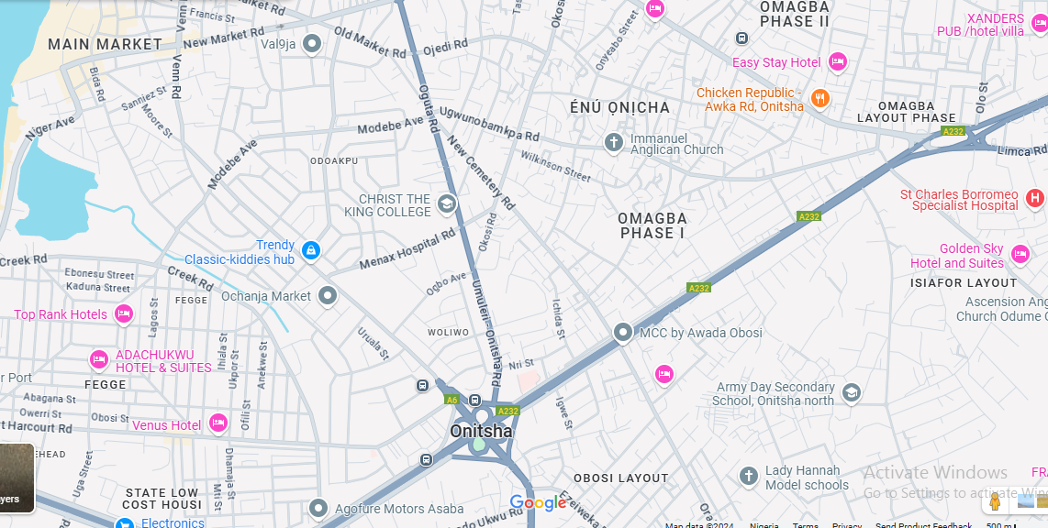

MAP OF ONITSHA


THE OBI’S PALACE


NKISI RIVER

CHAPTER TWO
LITERATURE REVIEW
This literature review examines scholarly works on the Ozo title institution and its title holders. These works have significantly expanded knowledge and understanding of the institution in Igboland. The review provides an overview of various authors' perspectives on the subject, incorporating both theoretical frameworks and empirical studies.
The theoretical framework, grounded in symbolic and interpretive anthropology, applies these theories to enrich the analysis. This approach provides the foundation for theme development and offers deeper meaning to the subject. The theories establish a framework for explaining the literary variables of the Ozo institution and their relevance.
The empirical studies review works that focus on the concept of Ozo title-taking and its literary relevance. While authors have made diligent efforts to address their respective topics, no single work has fully exhausted the issue, leaving a gap for further research. This thesis fills that gap. The authors discussed the Ozo institution without explicitly documenting its literary aspects, including its myths, rituals, and language. This thesis, therefore, delves extensively into the Ozo title institution in Onitsha, highlighting its literary significance and how the Agbalanze adapts and evolves in contemporary society while maintaining its core values.
2.1 THEORETICAL FRAMEWORK
The theoretical framework examines the theories or concepts which provide the foundation for understanding and analysing the research problem. It explains some basic issues about man and his social and cultural activities in the environment where he lives. A theory is a set of interrelated concepts and ideas that are used to explain or describe a phenomenon or set of phenomena. Anaeto, Onabajo and Osifeso (2008) when stating the importance of theory, opined that theory is what gives studies a required footing. Kerlinger and Lee (93) define theory as “a set of interrelated constructs, definitions and propositions that present a systematic view of phenomena by specifying relations among variables with the purpose of explaining or predicting phenomena.” Stam also defines theory as the systematic organisation of knowledge which can be applied for the purpose of problem solving (623).
The theories under study go a long way for easy interpretation of the Ozo institution and its concerns for better understanding of this work. The symbolic anthropological theory is used in this research. This theory falls under cultural anthropology which is one of the areas of study in the field of anthropology best suited for this work.
Meaning of Anthropology
Anthropology is the study of mankind (Anthropos). Etymologically, anthropology comes from the word Anthropos meaning man and logos meaning knowledge. Anthropology looks at humans as something complex in terms of physical, emotional and social complexity. It refers to the science of humans and their culture (Zaenuddin 294). Wikipedia defines anthropology as the scientific study of humanity, concerned with human behaviour, human biology, cultures, societies and linguistics, in both the present and past, including past human species. The study of anthropology is the study of human beings: their culture, their behaviour, their beliefs, their ways of surviving. Anthropology, the study of human-kind everywhere, throughout time, produces knowledge about what makes people different from one another and what they all share in common (Haviland et al 3).
Anthropology is an intellectually challenging, theoretically ambitious subject which tries to achieve an understanding of culture, society and humanity through detailed studies of local life, supplemented by comparison (Eriksen 6). Topinard defines anthropology as the branch of natural history which treats man and of the races of man (2). One can say that it is the study of humans, encompassing their biology, culture, language and societal structures and seeks to understand the diversity of human experiences throughout history and across different societies.
There are four major fields of anthropology which are:
i. Biological Anthropology
ii. Cultural Anthropology
iii. Linguistic Anthropology
iv. Archaeology
Each of these focus on different aspects of human life and experience. For the purpose of this research, cultural anthropology is used for better understanding of the work.
Cultural Anthropology
Cultural anthropology seeks to understand how people in different parts of the world live, what they believe, how they interact and how their social structures function. It aims to explore and document the diversity of human cultures, understand cultural change and contribute to cross-cultural understanding. However, one cannot talk about cultural anthropology without first discussing the concept of culture. Culture encompasses the beliefs, customs, traditions, values, languages, norms, art and practices that characterise a particular group or society. According to Tylor, culture…is that complex whole which includes knowledge, belief, art, morals, law, custom and any other capabilities and habits acquired by man as a member of society (qtd. in Avruch 6).
In the opinion of Kroeber and Kluckhohn,
Culture consists of patterns, explicit and implicit, of and for behaviour acquired and transmitted by symbols, constituting the distinctive achievements of human groups, including their embodiment in artefacts; the essential core of culture consists of traditional (i.e. historically derived and selected) ideas and especially their attached values; culture systems may, on one hand, be considered as products of action, on the other, as conditional elements of future action (qtd. in Adler 14).
Spencer-Oatey defines culture as a fuzzy set of basic assumptions and values, orientations to life, beliefs, policies, procedures and behavioural conventions that are shared by a group of people and that influence (but do not determine) each member’s behaviour and his/her interpretations of the ‘meaning’ of other people’s behaviour (3). Matsumoto says that culture is the set of attitudes, values, beliefs and behaviours shared by a group of people but different for each individual, communicated from one generation to the next (16).
Keesing describes it thus:
A mode of behaviour which is confined to a single person at first, forms an association with a particular object and can be transmitted from individual to individual with the aid of that object. The object along with which particular types of behaviour are thus transmitted may be a material object, a form of social grouping, a mental image which can be recalled with the aid of a particular sound or anything of like nature. Speaking in more general terms, we may describe culture as including such behaviour as is common among a group of men and which is capable of transmission from generation to generation or from one country to another (14).
It is a society’s shared and socially transmitted ideas, values and perceptions, which are used to make sense of experience and which generate behaviour and are reflected in that behaviour (Haviland et al 9). Culture is complex due to its multiple meanings and is attached to various ideologies and interpretations in one form or another. It is the central focus of cultural anthropology and cultural anthropology provides the tools and frameworks to study and understand the complexities of human culture in its many forms.
Handwerker explains that cultural anthropology is one of the areas of study in the broader field of anthropology which specialises in the study of culture and peoples’ beliefs, practices and the cognitive and social organisation of human groups. It studies how people who share a common cultural system organise and shape the physical and social world around them and are in turn shaped by those ideas, behaviours and physical environments. Cultural anthropology, according to Lewis, focuses on cultural systems, beliefs, practices and expressions. It focuses on patterns and systems of belief, social organisation and cultural practice.
In the same vein, Mercier defines cultural anthropology as a major division of anthropology that deals with the study of culture in all of its aspects that uses the methods, concepts and data of archaeology, ethnography and ethnology, folklore and linguistics in its descriptions and analyses of the diverse people of the world. Also called social or sociocultural anthropology, cultural anthropology is the study of customary patterns in human behaviour, thought and feeling. It focuses on humans as culture-producing and culture-reproducing creatures (Haviland et al 9). Cultural anthropology offers various theories to understand human societies and cultures. For the purpose of this research, the symbolic anthropology theory is used for better interpretation of the work.
Symbolic and Interpretive Anthropology Theory
The 1960s witnessed the emergence of symbolic anthropology, a theoretical paradigm that called attention to the importance of symbols, meaning and interpretation in the study of culture. Two major schools of thought dominated in these years. The British School was concerned with how symbols serve as mechanisms for the maintenance of society, as illustrated in the work of Victor Turner and Mary Douglas. The American School was concerned with the study of culture as a symbolic system independent of societal conditions, as exemplified in the work of Clifford Geertz (Sharma and Kumar 2). In this research, Geertz’s School of Thought will be examined for better understanding of the work.
Turner sees symbols as “instrumentalities of various forces – physical, moral, economic, political, and so on – operating in isolable, changing fields of social relationship (Hoskins 861). Turner studied symbols as they are performed in ritual, where he identified forms of drama, fields and metaphors in a series of detailed studies moving from the Ndembu out to a wide range of other societies (Hoskins 861). Geertz described symbols thus:
Sacred symbols function to synthesise a people’s ethos – the tone, character and quality of their life, its moral and aesthetic style and mood – and their world view – the picture they have of the way things in actuality are, their most comprehensive ideas of order (Hoskins 861).
The study of symbols is a way to understand the complex ways in which people communicate with each other and transmit their way of life to future generations (Hoskins 861).
In view of this, Foster opines that “without symbolism there could be no culture. A symbol is an artefact: a ‘thing’ that exists out there somewhere in space and time. As a ‘thing’, a symbol has material reality and is experienced through the senses. It is a ‘thing’ that represents: that is culturally involved in such a way that it can be used in a multiplicity of contexts to convey meaning, not just about itself, but about cultural processes and relationships…Culture is not itself formed of symbols, but of the meaning that lies behind and unites symbols. This meaning only exists in the minds of participants in culture, but it is acted out through the manipulation of symbols, which objectify meaning (366).
According to Hudson et al., symbolic anthropology studies the way people understand their surroundings, as well as the actions and utterances of the other members of their society. Wikipedia explains that symbolic anthropology or, more broadly, symbolic and interpretive anthropology, is the study of cultural symbols and how those symbols can be used to gain a better understanding of a particular society. In theory, symbolic anthropology assumes that culture lies within the basis of the individuals’ interpretation of their surrounding environment, and that it does not in fact exist beyond the individuals’ interpretation of the surrounding environment, and that it does not in fact exist beyond the individuals themselves. Furthermore, the meaning assigned to people’s behaviour is moulded by their culturally established symbols. Symbolic anthropology aims at understanding the way meanings are assigned by individuals to certain things, leading them to a cultural expression. This approach, championed by Clifford Geertz, emphasises the importance of symbols and meanings in understanding human behaviour. It explores how individuals interpret and create meaning through cultural symbols and rituals.
Culture, outlined by Geertz in his famous book The Interpretation of Cultures, is conceived of “a system of inherited conceptions expressed in symbolic forms by means of which people communicate, perpetuate and develop their knowledge about and attitudes towards life.” In line with this, Shamar states that “people give meaning to and interpret their world through cultural symbols, and in doing so, they construct their own cultural reality” (4). Clifford Geertz’s work shifted anthropology’s focus from seeking general laws about human behaviour to interpreting the symbolic meanings within specific cultural contexts.
This theory of symbolic anthropology provides a framework for understanding the literary significance of the Ozo title institution in Igboland. It analyzes the symbols, rituals, and meanings associated with this prestigious social institution as a form of oral literature. The process of acquiring the Ozo title involves elaborate rituals and ceremonies that are rich in symbolism. These rituals convey messages about the individual’s transition in social status and represent the institution's core literary and cultural values. This helps us understand the Ozo title not just as a social position but as an institution rich in symbolic actions and meanings that are integral to Igbo literary culture.
2.2 EMPIRICAL STUDIES
Empirical studies give room for detailed review of various texts related to the topic under discussion. Several works on Igbo tradition and custom are used to give detailed information concerning the Ozo institution in Onitsha and Igboland.
Wikipedia defines title as an “honorific style of address used to convey respect to the recipient in a community or to recognize an attribute such as imperial, royal and noble rank, academic degree, social title prevalent among certain sections of society due to historic or other reasons.” According to Encyclopedia Britannica, the term “title” is “a word or name that is given to someone as a mark of honour, respect or high social rank.” A title is a designation or honorific term that indicates a person’s social status, role, position or level of achievement within a society and serves various functions such as identifying professional roles, indicating respect, denoting accomplishments or establishing social hierarchies.
In Igboland, titles play an essential role in society, indicating a person’s social status, achievements, community service or leadership. These titles are often granted to individuals who have made significant contributions to their communities or have shown leadership and wisdom. The concept involves a system of social stratification and recognition, where individuals earn status and respect within their community through various means. According to Orji, title taking was not so widely spread as it is today in Igboland. It was introduced by the wealthy class for the purpose of stratification of the community into rich and poor segments (45). In line with this, Basden also states that the desire for rank and honour is not confined to the Ibo people, nor is it essential in the transaction peculiar to them; money is always the controlling factor in the business (255).
Titles in Igboland have various grades, one of the most prestigious being the Ozo title. Victor Eyisi in his work Igbo History (with Bible references) explains the history of Ozo title taking in Igboland. He says that in the olden days when there was no insurance scheme or banking system in Igboland for both children to inherit and for the elderly against old age and infirmity, the dire need for these schemes inspired Eri Nri Ifikwanim, (Eze Nri 1), the ruler of Nri Kingdom around 1008 B.C. to institute Ozo title taking in Nri town to serve the above purposes. Just like buying of company shares in modern times, the higher the grade or rank of the Ozo title, the higher the wealth a person has to invest and also the higher the benefit he will expect to get from men who hold the Ozo title and enjoy the benefits from it until death (42).
According to Orji,
Before the introduction of the idea of title taking, the Igbo community was in the doldrums…everybody was presumed equal, however wealthy one might be. In those days, people’s wealth was determined by the number of wives a person married, the number of children one had, the number of slaves one kept, the number of sticks of yams and domestic animals that could be seen in the person's compound. …if any wealthy man wanted to arrogate to himself the superiority of being in a position to lord it over others, such a person would receive the backfire (…if you have money, you have it in your own house. Are you the person feeding my family and me? Or have we come to borrow money from you? Tell me what you have done in this town to show that you are rich?) … It was under this condition that the wealthy class started thinking of what they should do to distinguish them from the generality of the masses…The first title-seeker, then bought a cow, called the whole community together and slaughtered the cow for them. He also brought a giant pot, known as ‘ite-ike’ and filled it with seventy gallons of palm-wine for them to drink. He, in addition gave them seven heads of tobacco together with kola nuts and alligator pepper…He finally addressed them saying (…as from today, I would like you to be calling or greeting me ‘Ogbuefi’…From that day, his status in the town, which was then recognized as the highest was no longer in doubt. He was then able to assert a measure of superiority over other members of his community…The above was the origin of the Ozo title-taking… (46).
In Onitsha, there are two main titles taken by the menfolk, namely: the Ozo title and the Ndichie chieftaincy. … the Ozo is the highest cultural ambition of the average Onitsha man because it confers on the recipient the traditional order of priesthood and the highest degree of social standing in the community (Bosah 153).
During the long years of their migration, spanning about a century and therefore, their first concern after settling down in any locality and adapting the administrative machinery they were used to, was their survival, expressed in security, agriculture and trade.
Ntephe goes further to state that,
“…in order to encourage the production of food, for their independent survival, they founded an exclusive class of honour whereby any man who produced or provided food in abundance and made a certain quantity available to his village community, was recognized, elevated to this class with open ceremonies and respected in a special way (9).
At that time, it was imperative for the candidate to slaughter a cow after which he assumes the name Ogbuefi (cow killer) besides any other nomenclature he may choose to be called. As the majority of people were farmers, agricultural produce formed an essential part of the initiation fees (Bosah 154).
Basden mentions certain general rules controlling the affairs of the order which include the following;
- The Awzaw title can be assumed by no man prior to the death of his father. (This rule has been quite discarded at Onitsha – another sign of the disintegrating forces of the times.)
- On assuming the title, the holder takes four additional names.
- An Awzaw chief committing a theft is liable to be expelled from being an active member of the council.
- It is not permissible for an Awzaw chief to sit upon the bare ground; he must either use a stool or an untanned skin.
- A wife can pay the costs necessary to enable her husband to enter the Awzaw order. She herself receives no actual title but is recognized as the wife of such a chief and wears cords around her ankles and puts other marks to indicate corresponding rank to that of her husband.
- The title is not hereditary (263).
The Ozo title in Igboland carries a mixture of social and spiritual responsibilities. It encompasses priestly duties making Ozo title holders important figures in both the spiritual and social life of their communities.

Ntephe states that,
Henceforth, the honoured man was no longer regarded as an ordinary man but in a way, as a ‘living ancestor’. He was seen to have qualified to be an ancestor to be prayed to and invoked when he would have passed on. This is where the original social and or socio-economic content of Ozo begot the religious feature, for the people reckoned that for someone to produce or provide so much food that he was able and generous enough to feed his community, he must be loved by the all-powerful goddess, Ani. Therefore, he could act as mediator between them and Ani, the great provider-cum-protector goddess and the ancestors abiding in her…This is how priesthood came into Ozo or put inversely, how Ozo acquired priesthood (11).
Basden explains that there is one other point in connection with the Awzaw order which, incidentally, sheds an interesting light upon priesthood. It becomes apparent in the order when deciding the question of precedence amongst members. This is controlled chiefly by the chief who is technically known as the ‘okpala.’ The okpala is the recognized head of the family, who, in virtue of his position, is also the priest of the clan. There are three grades:
- The okpala of the family or household.
- The okpala of the clan. This is confined to the descendants of one family.
- The okpala of the town generally. This is held by the head of each clan in turn.
An okpala by birth, who is also a member of the Awzaw order, always takes precedence over an Awzaw who has not that distinction. A true okpala can only be one by birth, but an Awzaw chief who does not possess that qualification may act either as deputy for a proper (minor) okpala or he may act in his own right in special circumstances (264).

Bosah also says thus:
Nobody can officiate on the family shrine, except an Ozo-titled man. Even the diokpala of a family cannot officiate on the family shrine unless he has taken the Ozo title or the lesser part of it known as Ikpa Muo, otherwise he has to appoint any Ozo man in his family to officiate on his behalf at his pleasure. This rather complicated issue only goes to show the importance of the Ozo title as an order of priesthood. However, by not taking the Ozo title, the okpala does not lose his unique position as the supreme head of the family but such supremacy does not allow him an edge over a person ordained to minister to spiritual needs. When an Ozo man presides at the family shrine as an agent of a non-titled okpala he does so with great caution for he should not by any stretch of imagination treat his principal as a subordinate (153).
Ntephe goes further to explain that Ozo title is therefore essential to the diokpa for full service in his roles of patrilineage priest. The diokpas, in addition to being spiritual heads, were also social, political and judicial heads of their units and held what can be loosely described as courts of first jurisdiction for their clans and families, settling matters of various complexities and varied complexity (12).
The Ozo title is highly significant, representing prestige, honour and authority and is bestowed upon individuals who have demonstrated exceptional moral character, wealth and social status within the community. The titleholder becomes part of a respected council and is entrusted with important traditional responsibilities such as mediating in disputes and preserving cultural norms.
Ogbukagu further explains their responsibilities by saying:
They handled problems threatening the internal and external political, social and economic security of the town; these include settling land and other cases considered inimical to maintenance of peace and order in the town. Their judgement over an issue by them is final and irrevocable…The Nze-na-Ozo men reserve the exclusive right of fixing dates for the celebrations of the annual traditional festivities and also announcing the date of any other event in the town (110).

CHAPTER THREE
OZO TITLE-TAKING IN ONITSHA
The Ozo title institution is a significant and prestigious traditional chieftaincy title among the Igbo people of southeastern Nigeria, particularly in Onitsha. It holds deep cultural, religious, social and political significance, embodying the values, customs and social hierarchies of the Onitsha community. It is one of the oldest traditional institutions in Igboland. It symbolises nobility and is an indication of high social status, moral integrity and wealth. Those who take the Ozo title are seen as intermediaries between the gods and the people, entrusted with maintaining societal norms and traditions. The Ozo title holders are often part of the inner council of the Obi, the traditional ruler of Onitsha and play vital roles in policy-making and governance at the community level.
The Ozo title institution in Onitsha is a testament to the rich cultural heritage and traditional governance structures of the Igbo people. It remains a vital part of Onitsha’s identity, upholding the community’s values and traditions. The Ozo title continues to be a symbol of honour, responsibility and cultural continuity in Onitsha.
3.0 OZO TITLE-TAKING INSTITUTION
The Ozo title taking as an institution is a profound and complex traditional practice among the Igbo people, particularly in Onitsha. It is not merely a title but a structured institution with deep social, cultural, religious and political implications. This institution is deeply embedded in the history and culture of the Igbo people. It predates colonial times and has been integral to maintaining social order, cultural identity and religious practices. The title represents the highest echelon of traditional authority and respect within the community.
The initiation into the Ozo title involves multiple stages, each with its own set of rituals and ceremonies before the candidate becomes a full member. The institution is a cornerstone of Igbo society in Onitsha, embodying the values, traditions and governance structures of the community. It is a symbol of honour, responsibility and cultural continuity which is integral to the social fabric in Onitsha.
3.1 THE ORIGIN OF OZO TITLE IN ONITSHA
The Agbalanze connotation began around 1957. It used to be taken separately by every village until it was decided that all Onitsha people would come together as one to celebrate every Ozo title. Hence the name Agbalanze which means ka agbakota aka onu k’ogbojuo (Mr. Akunnia Francis Akanya personal communication 9th June 2024). Dr. Orimmili Clement Okafo (personal communication 10th June 2024) describes Agbalanze as a member of the nze shrine and so, is a titled spiritual man. Agbala means a female while nze means the altar. This term is peculiar to only the Onitsha people. It is referred to as the Ancient and Prestigious Agbalanze Society of Onitsha also known as Agbalanze Cultural Association Onitsha. According to Anionwu, Ozo, its paraphernalia and its derivative, the Agbalanze Onitsha Cultural Association of Onitsha, are patrimonial gifts from the founding fathers of Onitsha Ado n’Idu. Ozo in Onitsha is intertwined with the traditional religion of its people and is, therefore, as old as Onitsha town (37).
Onuora explains thus:
Ozo had been part of the culture of the Onitsha people before their migration from Ado n’Idu to the east bank of the River Niger…The Iba, Onitsha ancestral house, exhibits striking philosophical parallels with Benin traditional architecture. A most prominent provision in both types is the ancestral altar with its display of sacred and secret emblems, including the osissi (prayer stave). The osissi at Onitsha bears more affinity to those found in Benin and other communities on the west bank of the Niger with whom they share the same ancestry than with any Ozo emblems found among the Igbo on the east bank (37).
In a personal communication with Mr. Chinyelugo Ben Menkiti (9th June 2024), he states that some of the artefacts peculiar to the institution have striking similarities to the ones from Benin and even some parts of Delta which the Onitsha people took down from when they crossed the Niger.
“The historical origin of Ozo title in Onitsha can be traced to five centuries ago but it is very difficult to say who the first sets of initiates were. This is more so as the early rulers of the town were not known to have paraded Ozo title names prior to their installations…Ozo title taking has been unbroken in various families in Onitsha which they and their sons have maintained…This stretches the history of Ozo in such families to great grandparents, grandparents, parents, sons and their sons” (Anionwu 41).
Mr. Akunnia Ikechukwu Mbanefo (personal communication 17th June, 2024) further explains that it is believed that during the migration process from Benin, other communities and people along the way joined the Onitsha people thus leading to an infusion and borrowing of beliefs, ideas and cultures. Benin being a culturally rich entity, Eze Chima the founder of Onitsha town, must have taken some of those cultural values and practices from Benin including the Ozo title. Hence, Ozo is as old as the Onitsha people.
Anionwu goes on to explain that there seems to have been no clear-cut point of introduction of the Ozo title ceremony and its “successor”, Agbalanze Onitsha Cultural Society, in the sociopolitical development of Onitsha. It is maintained that the economy of early Onitsha was agrarian until the advent of the missionaries and European traders with whom they established trade and commercial contacts. The title of di ji which means husband of yams was given to renowned men for bravery, oratory, farming prowess and astonishing agricultural yield. Barns were built in the Iba houses which hosted the farm produce of different family members. This gave a very fair evaluation of the wherewithal of aspirants to the Ozo title in the mediaeval days in Onitsha (43). It began as an exclusive society that is made for distinguished Onitsha people, people of proven character without indentation and was not money oriented but quality and prestigious oriented at a time when cowries and farm produce were used to start the stages of the process of becoming an Agbalanze Onitsha.
3.2 TYPES OF OZO MUO IN ONITSHA
- Ozo Muo.
Other types of Ozo Muo are:
- Ozo nwa
- Ozo transfer
- Ozo nzukwa ozu.
3.3 THE INITIAL PREPARATION FOR OZO TITLE
The kindred group is responsible for initiating individuals into the Agbalanze Onitsha Cultural Association. Mr. Akunnia Francis Akanya explains that the Ozo is a family affair which is referred to by the Onitsha palace as Ozo bu Ozo umunna. The ceremony is one and the same in all the villages. The muo is an in house deity looked upon by the people to protect them and do things for them and they revere it. It is based on this muo that the people stoop before to confer the title on their beneficiary. In order to take the title, the candidate must be an Onitsha man. This is because if it is taken by someone who isn’t, the person doesn’t have any lineage to any muo which leads to the saying kedu muo oji jeko ichi Ozo a. Every family has an muo which must be recognized by people of that lineage. The initiate conceives the idea, shares it with his father if he is alive, the diokpa and umunna at his family setting. They agree on passing through the processes involved and he agrees on the conditions after which the diokpa goes out with him to pick a date from the Agbalanze society and inform other members that will come together at a centre point where he is celebrating the Ozo. He also noted that the picked date should not have any hindrances such as the death of someone or any other event and in the case of death, the people of that household are forbidden from attending the Ozo celebration because it is an occasion of happiness and merriment not of mourning.
This process begins only after the group has fulfilled all the necessary conditions for the candidate’s acceptance. The significant role of the kindred group, led by the diokpa (the eldest male in the lineage), involves conducting and completing the spiritual rites associated with the Ozo title initiation. Historically, only the man who inherited the office of the diokpa could take the Ozo title. This requirement often compelled the entire families to pool resources to cover the initiation expenses within their kindred groups. According to Henderson, “the primary process of purification is attaining [title] Ichi Ozo. The process of attaining Ozo entails continual tests and transformations of a man’s relations with his ancestors and with the spirits of his patrilineage” (252). The rites of passage involve performing numerous religious rituals for both the patrilineal family and the mother’s family of the initiate. In contemporary Onitsha, a male can seek to become an Ozo initiate within his own patrilineage or that of his mother’s for any reason. This attests to the saying that, “Oso chuba onye onaa ikwu nne ya”, which means in the event of confusion or flight, the nwadiani can always have sanctuary in his matrilineal abode (Anionwu 52).
Mr. Akunnia Ikechukwu Mbanefo also explains that from time immemorial, because of what the institution stands for, it is not for the poor or faint-hearted. It is a prestigious association which maintains certain standards. Before a candidate embarks on the various stages required to take the title, there are some traditional requirements he must have fulfilled which are mandatory. They include:
- A man cannot take a title if his father who is still living does not have a title and so, has to give his father a title first before taking his own.
- If his father is alive and is a titled man, he must use his fathers’ paraphernalia as it is believed that it is his father giving him the title irrespective of his wealth.
- If his father is dead, he must accord his father the final funeral rites commonly referred to as the second burial.
It is only after these conditions have been met, then other requirements and stages can follow.
The Screening of Candidates
Any Onitsha man is qualified to take the title. The screening process is done by the umunna, specifically the diokpa. The diokpa of the candidates kindred knows the family or household and can attest to the lineage and integrity of the person and take responsibility for any shortcomings of the candidate and so, avoid making mistakes about it. From that point, it is then confirmed and accepted that the candidate’s lineage is from Onitsha. The diokpa takes responsibility for the initiate, asks important questions and sees to the preparedness of the candidate. The candidate is expected to be responsible with his genealogy established and approval from his kindred group first before going to the Agbalanze society and can be rejected if not up to the standard. The institution is not so rigid on certain criteria because the process of Ozo is a life changing event. It is believed that no one is perfect and human frailty is recognized, hence, the purification process, which is a form of baptism in which the old self is washed away and a new being emerges.
In addition, Ozo title taking is not restricted to only Onitsha indigenes. Nwadiani, that is, those whose mothers are from Onitsha, can also take the title. However, this exception is only for those who have been adopted and assimilated into Onitsha families and are recognized by the kindred. This automatically makes the nwadiani an Onitsha person rather than wherever his father is from. This is a rare occurrence.
3.4 THE STAGES OF OZO TITLE-TAKING IN ONITSHA
Ozo is a spiritual undertaking that can only be perfected with the muo and related paraphernalia of the respective kindred group that have a common ancestry (Anionwu 53). The candidate undergoes several rituals that signify their transition into a higher social and spiritual status. These ceremonies are deeply rooted in Onitsha’s traditions and are designed to honour the ancestors, seek their blessings and ensure the candidate’s commitment to the responsibilities that come with the Ozo title. The initiation ceremonies of the Ozo title include the following:
- Inyedo Muo
- Igba Okonti
- Igo Muo
- Ibu Ego Ozo
- Ikpo Nze Iru
- Ina Obibi
- Mmacha na Ozo (Egwu Efifie)
- Ikpo Ifejioku Iru

INYEDO MUO
This entails the candidate giving his intentions through his ancestors about his interest in taking a title. This requires the presence of all Ozo title men of that kindred group through the diokpa who will preside. Bosah describes this thus: “when a person wishes to take the title he first announces his intentions in a family meeting. This is then followed by the ceremony which is a sort of notification to the ancestors and a plea for their blessings” (154). Anionwu explains further by stating that the prospective initiate, having lost his father (whether titled or not) by death and the second burial rites consummated, has to bring back the “spirit” into the house so that his father might receive his annual share of sacrifice from the hands of his son. However, prior to this ceremony, the candidate who is the eldest son of his father will be obliged to carry out the function of ikpoko muo of his deceased father, grandfather or great grandfather who were titled, in consonance with the death order within the family, village or clan set-up. A candidate whose father is living and is an Ozo titled person begins his own ceremonial activities with Igba Okonti, being initiated as Ozonwa (53). After this ceremony, the candidate is referred to as Eze Muo.
IGBA OKONTI
After Inyedo Muo, the prospective candidate begins a series of consultations (Igba Okonti) with his relatives. This process starts with Nkata Usoekwu – discussions with his maternal brothers, followed by a meeting with his paternal siblings (nkata iba), and finally, with his patrilineage (nkata umunna). During each meeting, the candidate offers kola nuts, hot drinks (preferably gin) and some money to the attendees. He informs them of his intention to pursue the Ozo title and seeks their assistance and support for this challenging journey as well as selecting a date for the ceremony. These steps are intended to ensure a smooth ceremony by addressing and resolving any previous grudges or hard feelings, with the candidate receiving a solemn declaration of support from his relatives (Anionwu 54).
IGO MUO
In the next stage, members of his family accompany him to his mother’s village and his father’s maternal relatives to announce his proposal. Prayers are then offered by the okpala for God’s blessings and ancestral support to ensure the successful acceptance of the proposed title. These prayers may take place at the family shrine but this is not always the case (Bosah, 155). Anionwu describes it as the period when the initiate is led by members of his family to his mother’s village and his father’s maternal kindred to announce his proposal. Prayers which may or may not be said on the family shrine are offered by the okpala for God’s blessing and the support of their ancestors for a successful performance of the noble intentions of the nwadiani (54).
Igo Muo Nwunye, Ada na Okpala
Orakwe (18) thus, “at about 9 o’clock on the morning of the appointed day of the ceremony, all Ozo titled members of the family would then assemble at the family house of the initiate or Iba. Kola nuts, hot drink and palm wine or their equivalents in cash are provided by the person taking Ozo title. This is followed by a similar presentation by his senior wife, each of the other wives if any, his eldest son and his eldest daughter respectively at a lesser amount of money. This over, other ceremonies then commence in full swing (Anionwu 55).
IBU EGO OZO
According to Basden, Ozo is subdivided into Ozo-Uno and Nnukwu Ozo, the idea being that the candidate is recognized as an Ozo chief by those of his own family first (hence the addition of the word “Uno” which means house) and then passes on to the complete title, Nnukwu which means great. He says that this is the most expensive of all titles and it is extremely difficult to state precisely the sum required. The lowest estimate is £120, of which two-thirds must be in cash and the remainder in cows, goats, gin, palm wine, etc. The first £25 must be paid to the members of the candidate’s own umunna, that is, those who can claim any sort of kinship with him. The next payment, perhaps £40 in cash and £20 in kind is handed to the Ozo chiefs of the particular quarter in which the would be chief resides. Other payments to the remaining chiefs of the whole town follow. In addition, there are many expenses in connection with drummers, dancers and all the paraphernalia associated with the conferring of this title (261).
Bosah explains that during this ceremony, an announcement is made of the day in which the initiation fees are paid. The performances on that day are exclusive to Ozo titled men both of the kindred group and those from other villages, although non-titled men, friends and relatives of the candidate could be present as spectators. The programme for the day is usually heavy with numerous items. However, the ceremonies begin with prayer by the presiding okpala who breaks kola nuts and pours libation after which drinks are generally served (155).
When the value of money as a medium of exchange and store of value was not realised, such farm products as yam, maize, okpodudu (locust bean) and other vegetables were used to take the Ozo title. These were evaluated according to the tariff for Ozo title taking. The arbitrariness of the Ozo title members in assessing the value of these farm produce stock requirements as against cash requirements eventually made way for the use of cowries and finally money. In ancient times, there was no fixed quantity of farm produce to be demanded for the ceremonies of the Ozo title. In effect, the fees continued to escalate and could only be mitigated by the ability of the initiate and at times his mother’s matrilineal Ozo kinsmen who stand as witnesses to haggle down the fees to an attainable level. The initial high level of fees was brought about by the non-availability of a pre-agreed limit for the Ego Obubu. Hence, the fees generally continued to increase and vary each time according to the demands of the Ozo titled members and the various families and quarters involved (Anionwu 56).
Anionwu further explains that many years past, the ego obubu was shared into two equal portions. Half of it called money for the house (Ego Uno) was shared equally among the Ozo men of the initiate’s major patrilineage …the other half called Ego Ira (money for all) was shared equally by the Ozo of the entire patrilineage – ideally, the clan (57). Orakwue says that “all the Ozo titled men are equal to one another as far as the sharing of the money and other benefits of the title are concerned. Generally, the money is divided among the concerned Ozo titled members without any regard for one’s personality, age or seniority of rank over the title” (19).
According to Anionwu, in addition, recent developments indicate that the Ibu Ego Ozo has evolved from a strictly Ozo kindred affair to an event encompassing the entire Agbalanze Onitsha Cultural Association. The proceedings for the Ibu Ego of the Onitsha Agbalanze Cultural Association begins precisely at 11:00 am. During the event, members of the Ozo are offered 50 kola nuts, 6 bottles of hot drinks, 4 pots of palm wine and some cash. After accreditation, the President initiates the proceedings by breaking the kola nuts. Subsequently, a member is invited to taste a glass of palm wine to confirm its quality. His approval, usually favourable, permits the distribution of the palm wine to the other members (62).
Furthermore, he explains that members of Ndichie Onitsha who attend the Ibu Ego Ozo ceremony are also entitled to some fee as contained in the Agbalanze tariff. Specifically, for Ndichie Ogbe, that is, Ndichie of the village or who superintend that village, they are entitled to 7 kola nuts, 1 bottle of hot drink and 4,000 naira each. In the same vein, the Iregwu (those males that support and dignify) are given some drinks and cash. They are also served generally from the central pool of entertainment provided by the initiate. It is said that the Iregwu share of the Ibu Ego originated from their role in building the booth of palm fronds and seats of bamboo stems for the sitting arrangements for Ozo title taking in the olden days (63). Nzekwu also states that “the Ibu Ego Ozo ceremony is usually conducted in the ancestral home (iba) of the initiate. In a few other occasions, the venue may be any other iba within the patrilineage that is superior to his own” (123).
Before the ancestral spirits ndi mmuo are brought out to the iru ukpo (throne), the venue is purified with a sanitation instrument of an empty snail shell held up high with a long stick by a virgin girl or post-menstrual woman. It is usually accompanied by some incantations rejecting evil spirits, evil doers and demonic influence in any proceedings to be held at the venue. After use, these cleansing mediums are cast away. On completion of the Ibu Ego, the aspirant becomes known and addressed as Eze Ozo. The initiate launches out holding the goat skin and jubilating while friends and well-wishers shower some amounts of money on him as he dances (Anionwu, 64).
Other ceremonies involved in the Ibu Ego include:
Igbako Mmanya
After completing the “carrying of money to the ghosts”, the candidate participates in the “assessing wine” ceremony, during which they must distribute 160 pots of palm wine to the Ozo men. However, instead of providing all the pots of wine, the candidate may be required to pay two shillings or more for each pot as requested (Anionwu 59).
Isi Mmanya
According to Bosah, a corn soft-drink is generally served during which the presiding okpala holds the candidate by hand and makes him sit on a goat’s skin, thus the intermediate status of mkpalo is conferred on him. This empowers him from thence onward to sit on the ukpo, pour libation before the family shrine and offer drinks to juniors (155).
Anionwu further explains that this involves Igo muo, food, two pots of palm wine, two bottles of gin and the giving of a goat to the Ozo title members or their equivalent in cash, in addition to about one fifth of the first approximate real Ozo title fee. This is shared by all the Ozo title members accordingly in the same manner or proportion as in the case of the first original amount. After the sharing of the items, the diokpa then kills the goat on the shrine of the idols of the initiate and his ancestors. After the killing of the he-goat described as itigbu mkpi, the candidate is made to sit on a goatskin. Usually, a corn drink, mmanya omumu is served, during which the presiding diokpa holds the candidate by hand and makes him sit (idonye ikee na akpukpo) on a goatskin, thus the intermediate status of mkpalo is conferred on him. With this status, he automatically assumes the title of Eze Ozo. In this status, the candidate remains a non-partaker in Ozo taking ceremonies until the final day of initiation when he takes a permanent Ozo name.
A cupful of omumu drink is given to the Eze Ozo to perform for the first time the ceremony of libation. This marks his appropriation of the right to sit on goatskins and to libate wine freely before he drinks at any religious ceremonies or functions. This ceremony of libation known as itu mmanya is a privilege reserved for only those who have taken the Ozo title. The remaining omumu drink is then shared out generally to other Ozo title members and non-members in honour of the occasion. There are also some inherent restrictions according to tradition on itu mmanya or libation. It is forbidden for one whose father is still living to pour libation since the ceremony is performed mainly as the invocation of the blessings of the dead ancestors, particularly one’s father and relatives. Libation is also forbidden for any person on his first son, as it is said that one’s first son is his age mate “nwa izizi onye bu ogbo nya.” The reason is to show some amount of respect and fatherly affection to the son who is often regarded as equal to the father in succession to the responsibilities and affairs of the family.
Any person who cannot or is unable financially to complete the ceremonies of the Ozo title may stop at this principal stage of the title. He, however, becomes entitled and qualified to officiate as priest or okpala of his family when it is his turn to do so or particularly when a full member of the Ozo title is available. This, however, does not confer any benefits to the mkpalo from the Ozo title. As mkpalo he has certain rights and privileges attached to him in honour of his position over the title. He has right to accompany the Ndichie in attending to second burial funerals of deceased persons and is always entitled to the hip ukwu anu part of any goat killed for the funeral hence he is popularly called oli ukwu anu.
The rationale for this novelty of mkpalo was to accommodate the son or okpala of the family in general, whose main duty is to officiate as priest of the family but cannot afford to take the Ozo title. Also, it was instituted such that a younger brother who was not sufficiently buoyant to conclude two Ozo titles simultaneously could bring his elder brother or diokpa thus far to enable the diokpa to preside over their father’s idols as priests and okpala or head of the family. Although this is not a compulsory obligation, it is usually done as a mark of respect and parental regard for one’s own elder brother. It is also necessary that the head of the clan sees that proper seniority relations are followed in Ozo title taking and that younger brothers have not by-passed elders thus upsetting patrilineage ideals (59).
In addition, an aspirant may or may not physically undertake the performance of Ibu Ego. He may be represented by a proxy, who must be a member of the Ozo kindred group and an Ozo title holder. Whether the aspirant acquires the title or by proxy, he is entitled after the initiation to full benefits of members. Proxies may represent Ozo initiates if at the time the consideration is attempted the following extenuating circumstances come into play:
- If an infant is initiated.
- If the initiate is unavoidably absent from home.
- If the initiate is invalid because of old age or a disabling illness
- If after Ibu Ego, the prospective initiate dies and it is deemed necessary and mandatory to complete the ceremonies, in which case, a proxy will take the osissi in what is usually described as Ichi Osissi and bring the process to a logical conclusion (Anionwu 63).
IKPO NZE IRU
Before the Ina Obibi, a mandatory visit to the Obi of Onitsha called Ikpo Nze Iru is undertaken by initiates specifically from the Ezechima clan. This visit is undertaken to the Obi with kola nuts, gin, yam and other prescribed items to seek his clearance and approval before initiation of the candidate. The Ikpo Nze Iru is a prelude to the Ima Nzu of the initiate (Anionwu,71). This is specific to the Umuezechima clan or kindred because they are the direct descendant of Eze Chima, the founding father of Onitsha and so, their Ima Nzu or purification ceremony is done by the Obi of Onitsha who is also a direct descendant and representative of Eze Chima. They are the succession clan due to their lineage. Other clans perform their Ikpo Nze Iru to their various spiritual heads known as Eze Idi who are men appointed by the kindred to perform this ritual.
INA OBIBI
At about 11pm, the procession of the Agbalanze kindred group of the initiate led by the diokpa enters the arena with the initiate accompanied by the prepubertal girl carrying the Okwachi and the drummer. The troupe is normally welcomed to the proceedings of the night while they circle the dance arena three times. Members of the Onitsha Agbalanze who had been sitting and chatting amongst themselves are requested to rise, pick their osissi staves and from a circle for the dance around the diokpa of the initiate’s Ozo kindred group, the initiate, the girl carrying the Okwachi and the members of the okwe-na-maka. They are led by a member of the Executive Committee of Agbalanze Onitsha who will function as the arrowhead of the dance group within the inner circle of the dance arena. The initiate, whose body had been purified by smearing with white chalk from the bare-bodied waist to the face with the head gear/band with two eagle feathers stuck at right angles at both sides of the head, engages in a very delightful and often unrehearsed dance steps holding the two osissi afulu staves tied with egbedegbe leaves (Anionwu 98).
Bosah explains that on the appointed day, the initiation ceremony starts at midnight in the presence of a concourse of Ozo titled men in the precincts of the family shrine, while spectators sit at a distance. The okpala of the candidate proudly occupies the ukpo before the shrine and starts the rite of iwalozo – affirmation of candidature. Other okpalas may sit with him as the occasion warrants. A bowl of kola nuts is presented. After announcing to the assembly the presentation of the bowl, he takes the kola nut out of it and points it towards the sky and calls upon the Almighty God to receive the whole of the kola nuts and allow the assembly to partake of them in parts. He then invokes the blessings of God upon the initiate and prays for the success of the ceremonies without any mishap.
Subsequently he calls out a litany of the family titled ancestors and implores them to participate in the ceremonies and bestow their blessings on the initiate and the assembly, prays for long life and prosperity of all and sundry and for divine protection from all forms of misfortune. He breaks the kola nuts in the bowl and gives one to the initiate and the rest distributed accordingly. A cup of palm wine is next served to the officiating okpala who again prays as he did with the kola. He then pours libation and gives it to the initiate to drink before others. The second stage of the ritual comes when the initiate’s new religious symbols are presented and integrated in the kindred’s shrine and formally dedicated. When this is over, members of the kindred’s titled men are entertained to a meal after which other phases of initiation fees comprising money, kola nuts, wine, liquor are presented. Two goats are slaughtered by umu ilo for entertainment of the Agbalanze in general.
The third and final ceremony for the night is reached when a representative of the Obi of Onitsha arrives on the scene with the symbolic object of Nze. Metaphysically, Nze is a spiritual emblem that symbolises the virtue of goodness and self-restraint. By its grace the order of traditional priesthood is conferred on the aspirant. It imposes self-discipline on the initiate and makes him abstain from any act that may lead to evildoing. It lays emphasis on character-building in order to crystallise the dictum which maintains that “In the development of character is personality. In the development of personality is individuality and in the development of individuality is the existence of the soul and its identity with the Supreme.”
Nze has the power of purification. When an Ozo candidate is finally initiated into the Agbalanze society in the presence of Nze, it is assumed that he has been cleansed of all his bad deeds in the past. He is therefore exhorted to do good henceforth and at all times. Wherefore all Ozo titled men are generally known as agbala – nze, meaning majestic lady of Nze. This nomenclature really connotes an idea of marriage to an ideal. Small wonder the Ozo commands a formidable aura of respectability and is therefore preeminent in society. Because of the spiritual character of Nze, its appearance on the occasion of the Ozo initiation ceremonies is enshrouded in secrecy. It is for this reason that on the arrival of the Nze at midnight all lights are put off and the whole place is enveloped in darkness and utter silence. The initiate then walks up to the bearer of the Nze into an enclosure where his body is smeared with white chalk powder and a strip of cloth tied around his head with a white eagle feather stuck on it.
Subsequently, the new Ozo man is reminded of the fact that having communed with the spirit of his ancestors and past titled men he has become a member of the honourable Agbalanze society and therefore assumed the priestly power of officiating on the family shrine. As a purified person he should refrain from any act that will tarnish his reputation and that of his new society. Henceforth he has become an embodiment of love, honesty, justice and sincere leadership (156).
The whitening of the body has its root principle in the idea of resurrection from the dead. To become a member of the titled society, a man passes through the sacrificial ceremonies whereby he enters into mau, that is, the realm of the spirit world. Thus, he metaphorically dies. After the purifications are completed, he emerges as a resurrected being, hence the white body. From this time, he is respected as a semi-spiritual being and as such, is sacrosanct (Anionwu 87). Basden describes this thus, “the first part of the concluding ceremonies is performed at night, and then ensues a rather protracted series of purifications. The made Awzaw must not venture forth in public for two months. He may not sleep in his own compound; indeed, his feet must not come under the roof of a house. Usually he is accommodated in a friend’s compound, where a small booth is specially erected for his benefit. Should it rain heavily he may sit under the cave of his friend’s house with the stipulation that he keeps his feet outside. During these months, he is smeared with chalk from head to foot (262).”
Chukwura asserts that Ozo title taking in Onitsha encompasses parameters which in the elaborate sequence of activities is climaxed at the Nze (the medium of purification) at the Ikpo Nze Iru. The candidate during this ceremony is dedicated to the nze symbol to signify his purity. The nze symbol comprises the ofo as the insignia of authority of the founding ancestors and some other relics which in some cases include bronze objects. The nze is highly venerated and highly adored. He states that, “history has shown that nze symbols had suffered a crisis of identity. There is really no hard evidence after a span of five centuries about what they might have been in primordial age, objects regarded as being immensely sacred, or perhaps, replicas of those sacred and inviolable original.”
In Onitsha, Ozo title-taking comprises separate Nzes which constitute the legendary nine clans representing the kindred in Umu Eze Chima and those of Eze Idi’s. The eze idi’s in addition to holding the nze’s of their clans are also patrilineal priests. The Obi of Onitsha holds the Umuezechima clan’s sacred nze. The Obi however does not personally perform the Ima Nzu Igwe. Huts are created using native mats called Ute Agini or Ute Mkpala to cordon off where the representative of the Obi performs the Ima Nzu Igwe, followed by the respective Chief Priest who completes the other functions in the ceremonial cycle at various levels of lineage segmentation. Just before midnight, the eze ozo subscribes to an oath at the grove okwu nze to abide by the Agbalanze ethical code which goes as follows:
- You must respect your okpala; you should never over step/override him; you must always sponsor him; you must always support him in the home front on family issues.
- You must always show respect to your father and mother, you must always love them; it is a sacrilege to manhandle your father or mother.
- You must always venerate the Ani, the earth goddess.
- You must not keep late nights, you must, if absolutely, keep late nights in company of an escort.
- An Ozo titled person is always truthful.
- An Ozo titled person abhors stealing and should not be associated with theft.
- An Ozo titled person does not commit murder. More reason why Ozo titled man should not be involved in brawls; neither should he be involved in wizardry to kill; nor send deadly, spiritual arrows to fellow human beings.
- The Ozo titled person does not co-habit his brother’s wife.
- The titled person should not be involved in any conspiracy to kill nor should he be found to be involved in anti-kindred conspiracies that are detrimental to his kindred.
- The titled person is not known for always eating out and does not consume food the purveyor of which is questionable.
The individual has taken an oath from the Obi of Onitsha which entails obeying and paying allegiance to the monarch, saying the truth at all times, observing the rules and regulations guiding Onitsha.
The requirements at Nze during a purification ceremony are kolanut, palm wine, dry gin, a castrated goat to be sacrificed to the Nze (Ewu Awala Ozo) and food (pounded yam/cassava) with palm nut soup. This meal is consumed in communion with the founding fathers (Anionwu 78). After the ritual, the Nze bearer salutes the new Agbalanze by his title name which hitherto had been kept secret. The Nze is then silently taken back to Obi's palace. A little while after the Nze has gone a distance, the new Ozo man bursts out jubilantly in a loud voice: “Oko Mo! Apuanyao! (I have succeeded! I am free!). Immediately, members of the Agbalanze society move up to him and ask him his title name. When he tells them, he is led out to an open space where the traditional Ozo dance is staged. While dancing with other titled men, he holds his two osissi staff in both hands. The okwachi is carried behind him by a virgin. Some women relations take part in the dancing and sing the praise of the new Agbalanze (Bosah 157).
This ceremony is rich in linguistic performances such as the chants and incantations that reinforce the cultural significance of the event and convey deep cultural and spiritual meanings. According to Anionwu, the diokpas retire to the ancestral home of the initiate with one member of their Ozo kindred group to continue their vigil. The drummer had entered the arena with the music – Amalum Afa Ozoyi – Egwu Ego, hence revealing the Ozo name of the initiate to the entire Agbalanze members present. The drummer, using the name of the initiate, eulogises his eventual achievement of his lifetime aspiration in line with his progenitors’ antecedents and legacies (98).
The Ozo name from then supersedes other names of the initiate as it is the title that the entire town will know and refer to him as both in life and in death. It serves as a prefix followed by other official names of the initiate.

Igba Izu Ewu and Ndi Ikenye Iba N’uno
As the vigil progresses and at about 12:10am, the first wealth distribution of cash is made out to members. Thereafter, the President appoints a three or four-man group, including at least one from the initiate’s kindred group, to inspect where the goats to be slaughtered are tethered. Thereafter, the goats are publicly displayed for all members to assess them and the President as a follow-up appoints a committee to deliberate on the size and health or state of well being of the goats and recommend appropriate financial penalty if the goats are considered to be undersized or healthy. This is known as Igba Izu Ewu. If the size and weight of the goats fall short of the minimum standards of the Agbalanze, the initiate would be liable to some fine.
The number of goats slaughtered for the consumption of the members of Agbalanze Onitsha at the ina obibi has progressively moved from one to about ten or twenty in the cases of two or more initiates over a period of eighty years. Where there are more than two initiates, the balance of the goats is commuted cash. This leap is accounted for by the corresponding increase in population of members of the society over the period. The total amount of money collected for distribution is announced, inclusive of fines from all observed shortcomings in the performance of certain duties by the kindred group. As this is done, the slaughtered goats are cooked for breakfast of Agbalanze members. The neck is given to the drummers and chorus singers and sharers and the head delivered to the diokpa of the kindred group. As the dressing, cutting of the meat and cooking progress, two members of the initiate’s Ozo kindred group are appointed by the diokpa as requested by Agbalanze Onitsha to superintend the chores and hygiene around the tasks. They are often given a bottle of gin as incentive for the wake and work.
The elderly Ozo titles men aged eighty years and above are asked to go into the ancestral house where the initiate is temporarily staying to keep him and the diokpa of the kindred company. Meanwhile, the initiate sits up all night on his goatskin among older men of his kindred Ozo group and elderly Agbalanze Onitsha members. They guard and keep him company throughout the vigil and advise the initiate on good moral morals, to avoid stealing, lechery, falsehood and other misdemeanours (Anionwu 100).
Ogbo Mkpoko
This is a very important aspect of the ceremony. It is the first time the candidate will meet the generality of members who will be in attendance. It is a fraternal communion with the initiate. All members pick up their staves and the ceremonial cow skin fans called azuzu, led by a member of the executive, with the drummer and in a dancing procession go to the ancestral house of the initiate kindred. There the visiting members of Agbalanze society perform some streams of Egwu Ozo with the initiate and his Ozo companions from his kindred group. This dance reminds all Agbalanze members that notwithstanding the disparity in their ages, all Agbalanze are equal before nze. Ogbo mkpoko is acclaimed as the induction of the new Nze na Ozo into Agbalanze Onitsha. At about 5 am, the cooked goat meat is distributed for the consumption of the members participating in the obibi vigil (Anionwu 103).
This ceremony signifies the coming together of both the living and the dead members of the institution to celebrate and eat together. The meat is cooked at the venue in the presence of all Ozo men in attendance by males as women are not allowed to participate in the ceremony and the meal is never tasted by those cooking it as it is strictly to be eaten by the Ozo titled men.
Egwu Ili Afa
According to Orakwue, at about 6 am, the final dance of the ina obibi is enacted. This is Egwu Ili Afa. In the olden days, the Ozo members excluding the eze ozo himself proceed to the wives of the new Ozo titled person, so that each of them will take her own Ozo title name accordingly in appropriation of the new dignity of their husband. The first wife of the Ozo titled person presents a large Asa fish, kola nuts and a sum of about the equivalent of five shillings in lieu of gin, whilst the other junior wives respectively present only cash at a lesser, after which they all take their own title names in commemoration of the event of the Ozo title according to Onitsha custom. After this, the Ozo titled men disperse after being entertained with food and drinks, generally corn meal (nni oka) and rice.
In recent times, the initiate’s wife dances to Ozo music of Egwuego. She is led by Agbalanze members of her own kindred group. The Ozo titled men, about two or three in number, one of them carrying the osissi stave are accompanied by women relations of hers, one of them carrying two large azu isi (dried catfish) in a large tray and the other parading the Egwu Ili Afa. Using the Egwu ego (dance of the wealthy and noble) chorus, the drummer plays for the wife, his daughters, sisters and other female relatives who may join the wife in the dance. At the end of this, the wife or wives as the case may be launched out with her troupe, shouting, Ee-Ee-Ee, anyi apua nya o! (At last we have successfully pulled through!) (103).
Igo Mmuo Ututu
At about 6:15am, the diokpa of the kindred group, accompanied by a number of his Ozo kindred group members, arrive and take their seats in the obibi arena to pray with kola nuts and thank God for a successful and hitch-free obibi ceremony. He commits the rest of the program into His hands. A morning meal is served to members. This meal has changed over time from locust beans (Okpodudu) to pork and now cooked goat meat. Members now disperse to reconvene at a later time in the day for Mmacha na Ozo.
Dr. Orimmili Clement Okafo (personal communication, 10th June 2024) notes that at least one she-goat must be present for all the ceremonies involved. Everything done traditionally before the spirits are done with a she-goat from time immemorial as it bears spiritual connotations. It represents fertility and multiplicity and in other words, growth of the institution. Male goats can be used for general feeding and other merriments.
MMACHA NA Ozo (Egwu Efifie)
It is a public dance as it is open to all and sundry. Orakwue explains that the Ozo members would assemble again at the place where the new Ozo person was temporarily staying, all of them dressed in very rich garments and special caps decorated with eagle feathers and holding their osissi while some would carry with them elephant tusks. This refers to the situation some sixty-two years ago, continued with descriptions of the Ozo titled person being more gorgeously dressed just like wives and children. The initiate in addition is dressed in a white skirt according to custom, together with a rolled handkerchief tied around his head to which a white and black eagle feather is stuck on a tuft of hair above his left ear. Furthermore, if he desired, he would wear some necklaces and glass beads tied around his wrists as well as those of his wives, all in honour of the occasion.
A striking difference between what happened then and in the first half of the twentieth century and what is happening now is the selected venue of the dance which was usually at the premises of the new Ozo titled person. These days, Agbalanze members of the kindred group arrive much earlier than the rest of the members of the Onitsha Agbalanze Cultural Association for Egwu Efifie. Prior to this time, the initiate would have secretly relocated to any convenient place to quickly wash off the nzu (chalk) with which the body was substantially smeared with at the ina obibi. After a long waiting game and with the white lace outfit tucked away within the premises of the ancestral house, he changes from the obibi outfit to the regal afternoon dance dress, complete with a pair of immaculate white shoes and stockings. The head is adorned with a coronet of blue and white into which are stuck two vulturine eagle wing feathers above the ear on both sides of the head.
The dress code for members at Egwu Efifie is a lace tunic over a george wrapper or agbada over a tunic and wrapper. In any chosen mode of dressing, the tunic shall extend to about the knee level such as to expose the wrapper. Furthermore, each member must wear an appropriate cap which must have an eagle feather stuck to it vertically. This strict compliance with constitutional requirements by members of the association contrasts sharply with what was obtained some fifty years ago. Then, the Ozo men wore what suited their fancy to the egwu ozo and sometimes wore singlets and trousers with their caps stuck with eagle feathers. Even at obibi and mmacha, a strip of white cloth could be tied round the head to serve as receptacle for two eagle feathers (109).
Bosah explains that the highlight of the social aspect of the ceremony is reached the following day after noon for the traditional debut of the new Ozo man. This time, members of the Agbalanze are gaily dressed with their osissi staff in hand and eagle feathers on their hats. The new member dresses in immaculate white with eagle feathers on his headgear. With his two osissi staff in his hands followed by a virgin bearing the okwachi, he is then led in a singing procession to the family Ani shrine for homage. From there the procession goes to an area prepared for the occasion where the crowd of spectators – men, women and children in their best attires are standing in a circle. Headed by a drummer, the new Ozo man and members of his society enter the arena where a series of dances are staged amidst the ovation of the crowd. The melodious songs rendered on this occasion strongly extol the Ozo title taking and appeal to non-initiates to make haste and become members lest they will forever remain commoners (159).
The novice, led by his diokpa and closely attended by the okwachi handmaid and the drummer, is led in a procession of gorgeously dressed Agbalanze members of his kindred to the village shrine (ani) of the initiate. At the Ani he performs the traditional thanksgiving that portrays protection and appreciation for the enablement the initiate had so far in realising his new status as an Ozo person. From the Ani, the procession dances into the dance arena of the egwu efifie where the initiate is presented to Agbalanze from all Onitsha kindred groups witnessed by the ecstatic general public. The procession was choreographed from the Ani singing, Egwu ego – a dance for wealth and noble rank. On the third dance round the arena by the initiate led by his diokpa, other members of the association join him in the dance arena with their osissi for the egwu efifie.
This is more of a carnival, as gorgeously dressed female relatives dance around the circle made by the stave-thumping Agbalanze members in the dance quadrangle. The initiate, led by a member of his Ozo kindred group, closely attended by the okwachi handmaid dressed in immaculate white outfit, dances in the inner circle assisted by the drummer and the okwe na maka. The afternoon dance of the Ozo music can be grouped into Egwu eji eje na ani (music for the visit to the shrine), Egwu mbata (entry music), Egwu iti obi (for embrace by son, daughter and wife) (Anionwu 112).
Iti Obi
Anionwu states that, “the initiate reunites with his family for the first time since the ina obibi during the afternoon dance. His first wife, first son and first daughter take turns in reverse order to embrace the celebrant in a colourful dance episode. The rounds of three times embrace in the public arena start with the first son (diokpala). Prior to this, a bar of osissi held by two members of the Ozo kindred group of the initiate is created as the son engages himself in some dance steps, feigning to overlook his father, the initiate. As he reaches the bar, it is raised, creating an arc which makes it possible for the son to cross over and embrace the initiate. The embrace is not automatic as the subject may decline the attraction of his father whom he had not seen since the obibi dance in the night. He is wooed with little cash presents until he completes the three rounds of public embrace. This is done amidst applause by onlookers and admirers.
Next is the turn of the first daughter who, well dressed, arrives in the dance inner circle accompanied with an equally gaily dressed friend to assist in collecting her money during iti obi. She dances towards the bar made with the osissi of one of the Ozo kindred members. The process of identification of the father after twelve hours’ absence since the ina obibi is enacted in her dance steps as elegantly as she can. She makes the move to embrace her father either headlong or with some antics feigning rejection in any round of the embrace. Each time she embraces or refrains to embrace her father, she is encouraged to do so with a little gift of money from the cash set aside by the initiate and dispensed by one of the Ozo kindred members. She will eventually complete the three rounds of embrace with the father in the dance arena to great applause.
The first wife of the initiate who has been gearing up for her golden moment is escorted into the dance arena by three relatives from her own Ozo kindred group, the leader with his osissi. She also brings two large fish (azu asa) carried in a big tray by her female relative and a she-goat. These presents are given to the new Ozo man in recognition of his new status as Agbalanze. The first wife of the Ozo titled man, generally known as Anasi die (husband’s true companion) or Nwunye Chie (destined wife), is the only wife authorised by the custom of iti obi to embrace her husband during the iti obi at egwu efifie. No other wife of the initiate has this prerogative. Although this condition subsists for a first wife of an initiate, there are exemptions when the first wife is deceased or divorced. In some cases, the initiate forgoes the public embrace by the wife or a second legal wife does the public embracement where the first wife is dead or formally divorced. During the iti obi session for the deserving wife at egwu efifie, she embraces the husband three times in the full glare of the public and her children. She, like her daughter and the son, also adopts the strategy of identification, rejection, persuasion, recognition and embrace as she goes through the ritual of the three rounds of public embrace and hugging of her husband at the dance arena. She is given some token money usually higher in denomination and total amount than those given to the initiate’s first son and daughter during the iti obi ceremony.
When the dance is over, the initiate launches out with a few of his escorts accompanied by the drummer, the handmaiden and the wife and dances back to his ancestral house. This concluding dance whose lyrics are often thought to be denigrating to the non-Ozo title holders (Akpata elisie ubiam bu onwu) is rather a wake-up call for the non-initiates who are more well-to-do to be more prudent with their resources so that they will eventually be among those that can dance the dance of a wealthy noble rank. The Egwu Ozo (Ozo dance) is a prerogative of the Ozo titled members alone, celebrated occasionally only at the ceremony of Ozo title taking. Immediately after the iti obi (embracing ceremony), the Egwu Efifie comes to an end. The new Ozo titled man is led home amidst cheers and gifts by his admirers. As the new Ozo man changes into a more colourful outfit, with his azuzu in his hand and a befitting hand woven silver or golden embroidered cap with eagle feather stuck to it vertically, he dances to music of his age grade and of other groups, collecting gifts and cash from well-wishers (113).
According to Bosah, headed by a drummer, the new Ozo man and members of his society enter the arena where a series of dances are staged amidst the ovation of the crowd. The melodious songs rendered on this occasion strongly extol the Ozo title taking and appeal to non-initiates to make haste and become members lest they will forever remain commoners. The climax of the outing is reached when the initiate embraces his first son and daughter, and lastly, his wife, three times respectively, presenting them gifts of money. On entering the arena, the wife and her entourage bring along with them a goat and a large calabash of two giant fish for presentation to members of the Agbalanze. Immediately after the embracing ceremony the debut comes to an end, while the newly titled man is led home amidst congratulations and gifts by his admirers (159).
Igba Ugwo Ozo
The following morning, in the ancestral house of the new Ozo man, the Ozo men of his kindred gather not only to review the proceeding at the Ozo initiation but also demand payment of fines for observed shortcoming before and during the initiation. After a total of the whole amount is made, the money is usually paid at once by the new Ozo titled person as a complimentary fee over his Ozo title expenses. At the Igba Ugwo Ozo, the initiate must be prepared for the worst of exigencies in fines. The ceremony begins with breaking of kola nuts and pouring of libation with palm wine by the diokpa. After this opening prayer and preamble, a member of the Ozo kindred group stands up to reel out the infractions and the short payments by the new Ozo man during the ceremony. Some Ozo kindred groups also demand some fraction of fines on ewu iwalu ozo and ewu iti obi. The azu isi and azu asa presented at iti obi are also subject to the scrutiny of the Ozo kindred members and if found insufficiently wholesome, fall into the category of items attracting fines. If the new Ozo man is unable to pay fines immediately, the custom bars him from any entitlement from any prospective entrant after him until he liquidates the debt.
At the close of the ceremony, the goat presented at iti obi is killed and divided among the members together with the azu ili afa and azu iti obi presented by the first wife. The osissi of the members of the Ozo kindred group that assembled for the igba ugwo ozo are thereafter washed in the blood of the goat at iti obi which was killed at the igba ugwo ozo to preserve them from weevils and other insects. The igba ugwo ozo ceremony ends with ibeko osissi whereby the osissi of the new Ozo man are commingled with those of his predecessors hung on a prearranged crossbar hosting the collection of osissi of the living and dead kindred Ozo members that attended the igba ugwo ozo, bodily present or in spirit. This singular act signifies the complete acceptance by the Agbalanze of the induction of the new Ozo man to the priesthood of their ancestral shrine (Anionwu 119).
Ibeko Osissi
Anionwu explains that before this exercise, the venue is sanitised by iju uno purifying/sanitising the house. The diokpa presides at this event, a purely spiritual process of cleansing, acceptance or restoration for a mutual and general spiritual peace and reconciliation. The following are the conditions of ibeko osissi in matter of Ozo:
- A new initiate during igba ugwo ozo ceremony having been put through the process, pays to the kindred Ozo group the prescribed dues for ibenye osissi to qualify for the eventual transformation of ibeko osissi at the village square (ani) at a later ceremony of izu afia ozo. At that point, the initiate’s osissi is joined with those of the kindred group’s Nze na Ozo members having been accepted as a full-fledged member of the kindred’s Ozo group.
- If a schism arose within a kindred Ozo group as a result of which a member or members of the group are forced out by either his/their volition or otherwise, the dissident member or members may opt out join another kindred Ozo group. By doing so, they as joiners in the new kindred are obliged to perform the ceremony of Ibeko Osissi with the group to stabilise their Ozo position. In this case, the new members will provide a she goat with other requirements in order to be accepted as full-fledged members of the new group being connected to their Nze.
- When an Nze na Ozo’s osissi is accidentally broken and needs to be replaced, the ceremony of Ibeko Osissi with other members in the group is consummated with the Ozo man bearing full responsibility for the requirements of the ceremony which included a she goat.
- If an Nze na Ozo member of a kindred group committed abomination, nso ani which is to be cleansed, the okpala of the kindred may require the culprit, as part of the cleansing process, to bring a replacement for his osissi as the existing osissi will be cut up and buried. By doing so, the new osissi will necessarily be required to be admitted by ibeko osissi with those of the other members of the Ozo group. The offending Ozo man will provide a she goat and other requirements.
Other situations which did not come up in the above scenarios are:
- Where either parties decide not to obey any incumbent diokpa of either side by abstaining from all ife muo.
Where an Ozo man decides not to participate in any ife muo and puts his osissi in limbo.
In all cases, the provision of items for ibeko osissi is borne by the diokpa on duty.
Izu Afia Ozo
Orakwue narrates that “four days later or sometimes immediately after the igba ugwo ozo, the new Ozo titled person accompanied by the titled members of his family holds a “mock market” at their village square or before their Ani shrine, attended by his wives and other relatives of his family.” Items offered for the market include ukwa (breadfruit) and okorodudu, both prepared in the form of cake and the same items separately, as pan roasted as well as palm kernels. These fried items which are merchandise in pretence are actually thrown away with some coins for children to scramble for and pick (33).
Bosah states that, in the morning of the following day, the initiate and his immediate relatives assemble before the kindred Ani shrine for the final ceremony of ugwo ozo and afia ozo. During the ceremony, the beginning of which is marked by breaking of kola nuts and libation by the okpala, the remaining initiation fees are demanded by the clan’s Agbalanze society. After payment, a mock market is demonstrated. Token quantities of vegetables, fruits and snacks are hawked and sold. The money collected are then thrown up and on reaching ground, children scramble to pick them, thus coming to a final end the long sanctifying ceremonies redolent of the traditional initiation to the august membership of the aristocratic Agbalanze society of Onitsha (159).
Nzekwu explains that the presentation of these items to humanity represented by the congregation of Agbalanze and daughters, housewives and children of their kindred aims at ilo obi ora (appeasing the souls of men). The items are consumed by the congregation either from the hand offering by the diokpa or when shared out in serving plates by the sharer in the Ozo kindred group. A drummer provisionally springs up from the kindred Agbalanze to paper over the music requirements (egwu ego) for the izu afia ozo ceremony. Later on, the young maid further remains with the new Ozo man for four days rejoicing and feasting, after which she would be led home and honoured with many valuable gifts (138).
Ikwo Aka Ozo
According to Orakwue, the newly appointed Ozo rests for approximately one month, during which he must abstain from all manual labour, including farm work and public engagements. This person is regarded as holy, being a newly ordained priest full of grace and authorised to give blessings. Consequently, it was customary for our ancestors to invite the new Ozo title holder to their homes immediately after he received the title. Friends and relatives, in particular, would do this to receive blessings and grace from him as a new priest and minister of God (35).
At the host’s residence, the new Ozo man, who is the guest of honour along with other invited Agbalanze members and well-wishers are treated to a blend of cultural rituals and social activities. As the Agbalanze guests take their seats, the guest of honour sits among them, though not necessarily according to their dates of induction into the Agbalanze priesthood. The host, or a provisional master of ceremonies from the Ozo titled men, gives an opening remark about the day’s agenda. This introductory statement typically highlights the achievements of the new Ozo person and emphasises the importance of giving him a warm welcome, as was the tradition of their forefathers. The host then presents a kolanut to the gathering, deemed appropriate for the occasion and may also pour a libation with a hot drink.
After these preliminaries, the host drops some coins into a bowl of water for the ikwo aka ritual, performed by the properly dressed members of Agbalanze Onitsha present. The coins, regardless of their denominations or total value, symbolise appreciation for the significance of taking the Ozo title and the importance of the custom. The basin containing the coins is first presented to the doyen of the Agbalanze, who is the longest serving member present at the occasion. This precedence that is accorded to date of initiation is predicated on the saying that, onye bu uzo kpo nze iru, ka nze ma or ka esi kpo nze iru, ka nze ma (Nze knows the precedence of initiation).
The hand washing ceremony begins when the most senior Agbalanze member at the occasion starts by individually recognizing the Agbalanze members present, calling each by his agnomen. He prays in the traditional manner of his ancestors, seeking God’s blessings on the hosts who, from their God-given resources, have chosen to honour the titled man. He invokes the presence and spirit of the ancestors by sprinkling the water on the ground at various points during the supplication. Other prayer points by the doyen of the Agbalanze society at the occasion include the blessings of God on the family of host and the new Ozo member; the golden rule that the veterans would not oppress the novice; neither would the novice outsmart the veterans; a replenishment of the pockets of the new Ozo man and the earliest enrolment of a budding or some budding but overdue and well-to-do members of the new Ozo man’s kindred either present or outside and the entire Onitsha Ado n’Idu to make haste and join the Ancient and Prestigious Agbalanze Cultural Society of Onitsha.
Finally, he picks a few coins from the basin with some allusions to the status of Agbalanze and the self-fulfilling prophecy (onye chie ozo okpoli be ego) literally translated as, “become a member of the Prestigious Agbalanze Society and be a cash cow.” In addition, the doyen of the Agbalanze at the occasion would not hesitate to inform the audience that Onitsha is one town where people of a certain stratum in the society wash hands with money. The bowl of water with its content is circulated among the Agbalanze members present in their order of date of initiation. The prayers, being a rehash of the prayer and admonition of the doyen, is often abridged by saying Ofo solu ofo lee-e, meaning, I concur with the prayer and invocation of others, may our ancestors intercede for us the living and may they continue to ensure that we and our children continue to prosper in good health.
Every member that performs this ritual on this occasion picks some coins from the bowl until it is the turn of the new Ozo man. The new Ozo man, who also is a novice in this exercise, starts by citing precedence and thanking the Almighty for enabling him achieve his ambition of becoming an Agbalanze. He prays for his host, for the Onitsha Monarch, the Agbalanze, members of Otu Odu, the Agbala na Iregwu and other strata of Onitsha society. He invokes the dictum of live and let live, as he prays that those his predecessors in the Agbalanze society present will not by virtue of his late arrival push aside the existing members in his quest to enjoy the perquisites of his title. He then picks the remaining coins in the bowl of water. This done, the host calls on his aide or anyone present to step outdoors and empty the bowl, facing the entrance to his house. This exercise and the manner in which it is conducted are to allow all the blessings and grace therein to pour into the house for the benefit and welfare of the owner of the house and his family in general.
It should be noted that, these days, the host obliges the new Ozo man who is accompanied by his first wife that took a name in commemoration of the Ozo title with two separate envelopes containing some amounts of money in currency notes as a token for “wiping their palms.” The ikwo aka Ozo for the new Ozo man is not a one-off event, as such treats in his honour may continue for upwards of one year, hosted by various relations, groups and well-wishers (Anionwu 121).
IKPO IFEJIOKU IRU
This is a private event which is witnessed by the initiates kindred mostly the non-titled men called the Iregwu. This is a ceremony in which the initiate fully takes possession of his own paraphernalia of office and sets up his own altar. This is done only when the initiates father is no longer living. Due to this rule, many Ozo men do not perform this particular ceremony for many years until the death of their fathers, having performed all the funeral rites. This is because according to tradition, if the father is alive, it is believed that the initiate is still under the fathers’ authority, irrespective of his age.
During this ceremony, one of the two osissi held during the initiation will be adorned with metal rings and it will be used for official purposes depending on the occasion. This osissi outlives the owner and is a representative of the person till the end of time. The other will be left bare and it will be disposed of in the event of the initiate’s death during the burial rites.
OZO NWA
Ozonwa title taking was initially a privilege of the king, the Obi of Onitsha, who alone had the right to bestow the Ozo title upon his first son, signifying noble birth and membership in the royal family. It was recorded that Obi Chimaedia, the 9th Obi of Onitsha was the first to introduce Ozo nwa by giving over his Ozo title to his first son Orezeobi. As Onitsha developed through mercantilism and white-collar jobs, more Onitsha indigenes became wealthier and could afford to bestow the Ozo title on their children during their own lifetimes. This practice became more prevalent in the 1970s.
In an Ozo nwa situation, the young Ozo man is severely encumbered until certain customary embargoes are lifted. Such restrictions include:
- Pouring libation, which is the invocation of the blessing of ancestral spirits, especially beginning with those of his father and his father’s father.
- Using or keeping his osissi, okpulupku and okwachi with him anywhere in his own house or residence.
- Pouring libation or offering any blood sacrifice.
- Taking an osissi with him to any ritual offering or public ceremony where the need may arise to validate decisions reached.
- Kpo Ifejioku iru only after the complete funeral of his father.
Any deviation from or breach of the above condition can only mean;
- Wanting to reverse by force the “mortgage” status of the emblem.
- Desiring the death of his surviving patrilineal progenitor.
At the expiration of the Ozonwa status, that is when the final burial of the initiate’s father would have been concluded, the initiate must perform the inyedo muo and ikpo ifejioku iru. The performance of these ceremonies will entitle him to the use of his ringed osissi and the sitting over the ancestral objects if he is the diokpa. Some families initiate their children under the platform of Ozo with their sons dancing in the arena with the two osissi afulu, while some families insist on proxies dancing with the osissi afulu in the arena during the initiation of their sons as Ozonwa (Anionwu 126).

OZO TRANSFER
The system of Ozo transfer is a social prominence based on the king transferring his Ozo title to his senior son upon taking the throne, making him eligible to play a new set of roles. This custom of “Ozo of the child” (Ozonwa) bestows the right to speak with purity and responsibility upon a man whose father is alive (although the king is symbolically, notionally spiritually transformed). The Onitsha monarch traditionally performs the Ikopu Ozo ceremony on climbing the throne of the Onitsha Kingdom. Its critical importance lies in the considerable competitive advantages thereby conferred upon the son of a king.
The Obi of Onitsha is regarded as “transfigured” and therefore free from requirements of funerary performance. He must renounce his Ozo title (Ikopu Ozo), bestowing it on a son and sacrificing a ram to validate the transfer (Anionwu 128).
OZO NZUKWA OZU
This occurs mainly in the Umuezechima clan. At the death of a king, an mkpalo may for a minimal consideration be dedicated to Nze in the Ime-obi and smeared with powdered white chalk (nzu) procured for use in the funeral of the king. Thereafter, the initiate arranges his mmacha within the extended family. It was recorded that the last Ozo nzukwa ozu was in 1970 (Anionwu 130).
3.5 DISQUALIFICATION OR REMOVAL OF AN OZO MAN
The muo can be very destructive to any Ozo person who comes into it wrongly or misbehaves as the institution is highly spiritual. In the past, there was a saying ebe onye si bute ego ya chielu Onitsha Ozo, however along the line people started involving themselves in funny situations such as selling off land, buildings and doing all sorts of things to take the title. The cleansing of the Ozo initiate with nzu makes the initiate a new being and any misbehaviour or fraudulent activity by him during and after the ceremony going forward will attract heavy consequences. The offenders pay costly prices for their misdeeds which may not be seen or understood by others. Since the Ozo institution is majorly spiritual, punishments for outlaws are believed to be spiritual as well which leads to unexplainable negative events in the person’s life. As long as the titled man is honest and straightforward, the ancestors will guide and protect him from any mishap.
Dr. Orimmili Clement Okafo says that an Ozo man cannot be stripped of his title because he is a priest and is anointed and so, his position is permanent, rather he can be suspended, investigated or punished. Due to the spirituality of the institution, any wrongdoing by an Ozo man is for him and the spirits of his ancestors to deal with.
From the olden days, once the title is taken, it cannot be stripped away from the person again. However, in modern times, if he offends or goes against the rules and regulations guiding the institution, they reserve the right to suspend him for a stipulated period of time as deemed fit by the institution. He is still free to exercise his duties as an Ozo man and is to be referred to by his title.
Mr. Chinyelugo Ben Menkiti further adds that the only time one can be said to no longer be a part of the Ozo institution is when he denounces the institution and all their activities and drops his Ozo name as well. Mr. Akunnia Ikechukwu Mbanefo says that regardless of the situation, Ozo Onitsha is for life as all the ceremonies are irreversible. There is free entry and free exit. However, depending on the offence committed, the town can ostracise the individual and prohibit him from identifying with his kindred with room for repentance and restitution.
3.6 MONETARY INVOLVEMENT IN OZO TITLE-TAKING
In the past, there were no monetary requirements as it is today. A person’s level of wealth was determined through yams and animals as well as cowries. In the present, Mr. Akunnia Francis Akanya says that monetary values are determined by the group. They determine what they want. Every Ozo kindred group has its tariff and inside the tariff, there are stipulations. As the events unfold, every monetary requirement is provided according to their tariff. There is also a general tariff from the Agbalanze Onitsha. These two tariffs are joined together to form the total finances required from the institution. In the olden days, the requirements were in the form of farm produce such as yam and even then titles were also given to elderly men such as diokpas who had no title for no cost mainly because it was strictly an umunna affair. In recent times, the ceremony is for the whole town, the Agbalanze Onitsha now have their own tariff to cover their own requirements.
The items demanded are similar in the entire Onitsha but the money varies as explained by Mr. Chinyelugo Ben Menkiti. Some kindred groups are small mainly as a result of death and so the sizes of kindred groups differ. The tariff required for the kindred groups vary due to the size or number of people there. The higher the number of people, the higher the amount of money collected and vice versa. Tariffs vary from one kindred group to another. The only one that remains constant is the tariff for the Onitsha people as a whole. This means that the candidate will pay both the general tariff for Onitsha people and the tariff for his kindred group as well.
However, with the evolving world and the constant change in the economy, the monetary requirements increase. The price of items then and now has changed drastically and so, have affected the amount spent during the ceremony and initiation process. Also, other monetary expenses made during the ceremony aside the stipulated ones depend on the initiates preference and how lavish or expensive he wants the occasion to be.
3.7 OZO TITLE NAMES
Title-taking in Igboland is not merely a social or economic advancement; it is deeply intertwined with linguistic practices. The Igbo language, with its diverse dialects and rich cultural expressions, plays a pivotal role in shaping the meaning and significance of titles particularly within the context of the Agbalanze Onitsha institution. The names are personal to the individual. Certain things or circumstances could lead to a particular name. Each name connotes something when thought about deeply. It could be part of historical memories or events leading to the ceremony or the life of the candidate.
Anionwu explains that an Ozo initiate assumes a cognomen that will serve as his signature for the rest of his life if for any reason he is not elevated to the rank of red cap chief by the Obi of Onitsha. Except for occasions of Ozo transfer as practised when an Ozo member ascends the throne of Ezechima, the Ozo title dies with its holder. It is said that, ka osi so onye oza afia. This indicates that the Ozo title name of any initiate is the prerogative of the initiate. This is not entirely correct, as there have been occasions in which initiates had to drop names hitherto chosen for alternatives following some disagreements.
The founding fathers of this prestigious institution chose names that reflected their achievements through some visible and invisible hands. Most of the names revolve around parents, children, strength, wealth, character, achievement and nobility. Oftentimes, the Shakespearean dictum of “some are born great, some achieve greatness, some have greatness thrust upon them” is very apt in Ozo names. Such names as Nwakibie, Ezenwa and Nnabuenyi refer to those born great while, Ojinnaka and Ojinnannaka refer to initialization advantages by some children or men.
Later developments brought in the agnomen with the prefix Nwa (the child) who has become the man, indicating the independence of the name bearer through providence in achieving greatness and Ozo title for himself or for his parents or elder relation. Such names include: Nwabunie, Nwawularu, Nwanyelugo, Nwazuluaru, Nwachinemelu and others. Some names reflect very recent sparing incidents. The names in this category can be classified as uncommon and rare. They are; Onwanetilora, Ifechukwukwulu, Mmililienyi, Chinweozo and others may pass for reactions to events that reflect individual trajectories in life.
Initially, many initiates took names with prefixes of Aku and Oku signifying wealth which include Akunne, Akunnia, Akunwata, Akukalia, Akunwanne and Okunwa. Others took names with the prefixes of Nna and Chi ending with Ugo such as Nnanyelugo and Chinyelugo. Others take their bearing and philosophy from Enyi the elephant, the largest of existing land animals hunted for its expensive ivory tusk. They are Nwaenyi, Nnabuenyi, Ononenyi and Dakwasienyi. On the part of the nobility, some initiates take the name of Amalunweze or Ezekwesili.
These are some common Ozo title names and their meanings
Akunnia: I have succeeded through my father.
Akunne: Success through my mother.
Akunwata: A self-made man.
Nwachinemelu: One who is a friend of the gods. Providence has played out in his journey to wealth and nobility.
Chinyelugo: God has picked the eagle feather for me.
Akunetigbuilo: Sufficient wealth undoubtedly suppresses unnecessary anxieties and bickering and makes enemies to bow and tremble.
Ezenwa: The feather was bestowed on an outstanding son.
Nwawuluaru: I am purified and decorated by my child who sponsored my title.
Orimmili, Orimmili atu nnu, Orimmili adiro mma ogugu, Orimmili ata ata: A very wealthy person.
Nwatakwochaka: Humbled by my achievement, I now dine with the wealthy.
Nwakibie: A highly endowed child.
Onwanetilora: A philanthropist or role model whose good deeds affect people far and near.
Akudinobi: Wealth runs in the family.
Ifedioramma: A worthy thing in the eyes of the public.
Ugokwe: My Ozo is deserving.
Ezedinobi: The bearer of this Ozo title has a pedigree of Igwe or Eze Idi in his lineage.
Oranyelugo: An Ozo title achieved through the goodwill of the people.
Chinweozo: My Ozo title belongs to God.
Ozodinobi: Ozo has always existed in your kindred.
Ugonwanne: My relation honored me with the eagle feather.
Each title signifies how wealth or money was obtained to take the Ozo title. Some names represent the life experiences of the initiate, while others reflect the cyclical nature of the initiate’s or family’s fortunes. The Ozo community ensures that each initiate adopts an appropriate and acceptable name at the Ima Nzu ceremony. There have been instances where proceedings were delayed due to initiates choosing inappropriate or unacceptable names. Some prospective Ozo members assume names often taken by their forefathers to retain such cognomen in their family (ancestral legacy) or take names to immortalise the labours of their mothers or fathers as the initiate was plodding to make it in life. Such names often referred to izatalu nne or izatalu nnia afa, feature more prominently in Akunne or Akunnia and in cases where Ozo men simply take the cognomen of their late fathers. It is often said that the present generation use names to bring to life the exploits of their ancestors (afa ka anyi ji azoba ukwu na ife ndi gboo melu), hence some Ozo names take their bearing from circumstances at some material time in one’s life, prayer of the initiate as he struggles to gather the wealth to actualize the Ozo title or as recently displayed outright rebuttal of underdog status by some who one way or the other had had their fair share of reproach because of non-existence of Ozo in their family for unduly long periods (155).
3.8 EGWU OZO
Anionwu explains that one of the key elements of the cultural identity of the Onitsha people is the Ozo. Agbalanze music performance is central to the Ozo initiation. Without the music and the public dancing in the arena by many of its members, the entire event might seem like a mere conversation and, at worst, a pantomime. The music, mostly unwritten, consists of a series of codified, synchronised and sonorous choruses of different stanzas. These choruses symbolise the ideals of the Agbalanze Cultural Association and the various achievements of the initiate in different aspects of life. A flawlessly executed Egwu Ozo is characterised by a symphony of instruments, choruses, staff stomping, choreography, masterful stage arrangement and timely introduction of dramatis personae. The Egwu Ozo showcases the skill of the drummer (Onye Igba), the choruses by the singing associates (Onye na Maka), the dancing and singing crew and the invitees in the dancing quadrangle. The dance coordinator, usually a member or official of the Agbalanze, leads the dancers and singers in the inner circle. The drummer, at any given time, often delves into esoteric realms to reserve and immortalise the musical legacies of past heroes. These heroes’ ideals, talents, exploits, philosophies and values continue to inspire many cultural icons and enthusiasts. Each musical stanza communicates through the parlance derived from everyday observations and the activities of daily life. Skilled orators use language to praise the title-taker, recount historical narratives, and reinforce social values. Their eloquence and mastery of language are highly valued.
The origin of Agbalanze music is as ancient as the Agbalanze society itself. Different drummers draw their inspiration from various sources. Some attribute their inspiration to keen interest and talent, while others credit inheritance, pedigree and tutelage. It is crucial for the Egwu Ozo drummer and vocalist to synchronise their drumming with the choruses and the dancing Agbalanze members in the quadrangle, especially with the percussions of the ringed staves. The rhythmic movements of the staves on the ground must emphasise communication and agreement with the ancestors as the dance progresses. The drummer must also know which music theme to play and for how long at each phase of the Egwu Ozo dance (83).
3.9 THE PARAPHERNALIA AND ANCESTRAL RELICS/ARTEFACTS OF AN OZO TITLED MAN
The regalia of Ozo titled men in Onitsha is a distinctive set of items symbolising their high social and spiritual status. The Ozo title in Onitsha is one of the most prestigious institutions in Igboland, often indicating wealth, influence and deep connection to tradition and spirituality. These items are not just symbols of status but also carry deep cultural and spiritual meanings, reflecting the wearer’s adherence to the customs, traditions and ethical standards of the society
According to Basden, “the insignia of the order are, first an iron spear with a crown like head of twisted iron. In the centre there is a series of six to eight pieces of iron similarly twisted, bellying out on the shank of the spear; at intervals the shaft is bound with brass. Around the ankles of an Awzaw chief are bound cords red with ufie (camwood) stain. A huge ivory horn forms part of the regalia, also a special stool of a pattern jealously restricted to the use of members of the Awzaw order (262).
Things have changed rapidly. In the past, there was a long gestation period between Ibu Ego and Ina Obibi, the night ceremony of Ichi Ozo. During these intervals, the Eze Ozo vigorously pursued his quest to complete the rites of taking the Ozo title. He did this by acquiring ndi mmuo, the major symbols of his anticipated new status. They include the following;
- Osissi
- Okwachi
- Okpulukpu
- Okposi
- Ikenga
- Ofo
- Azuzu
- Okpu
- Ugo
Osissi
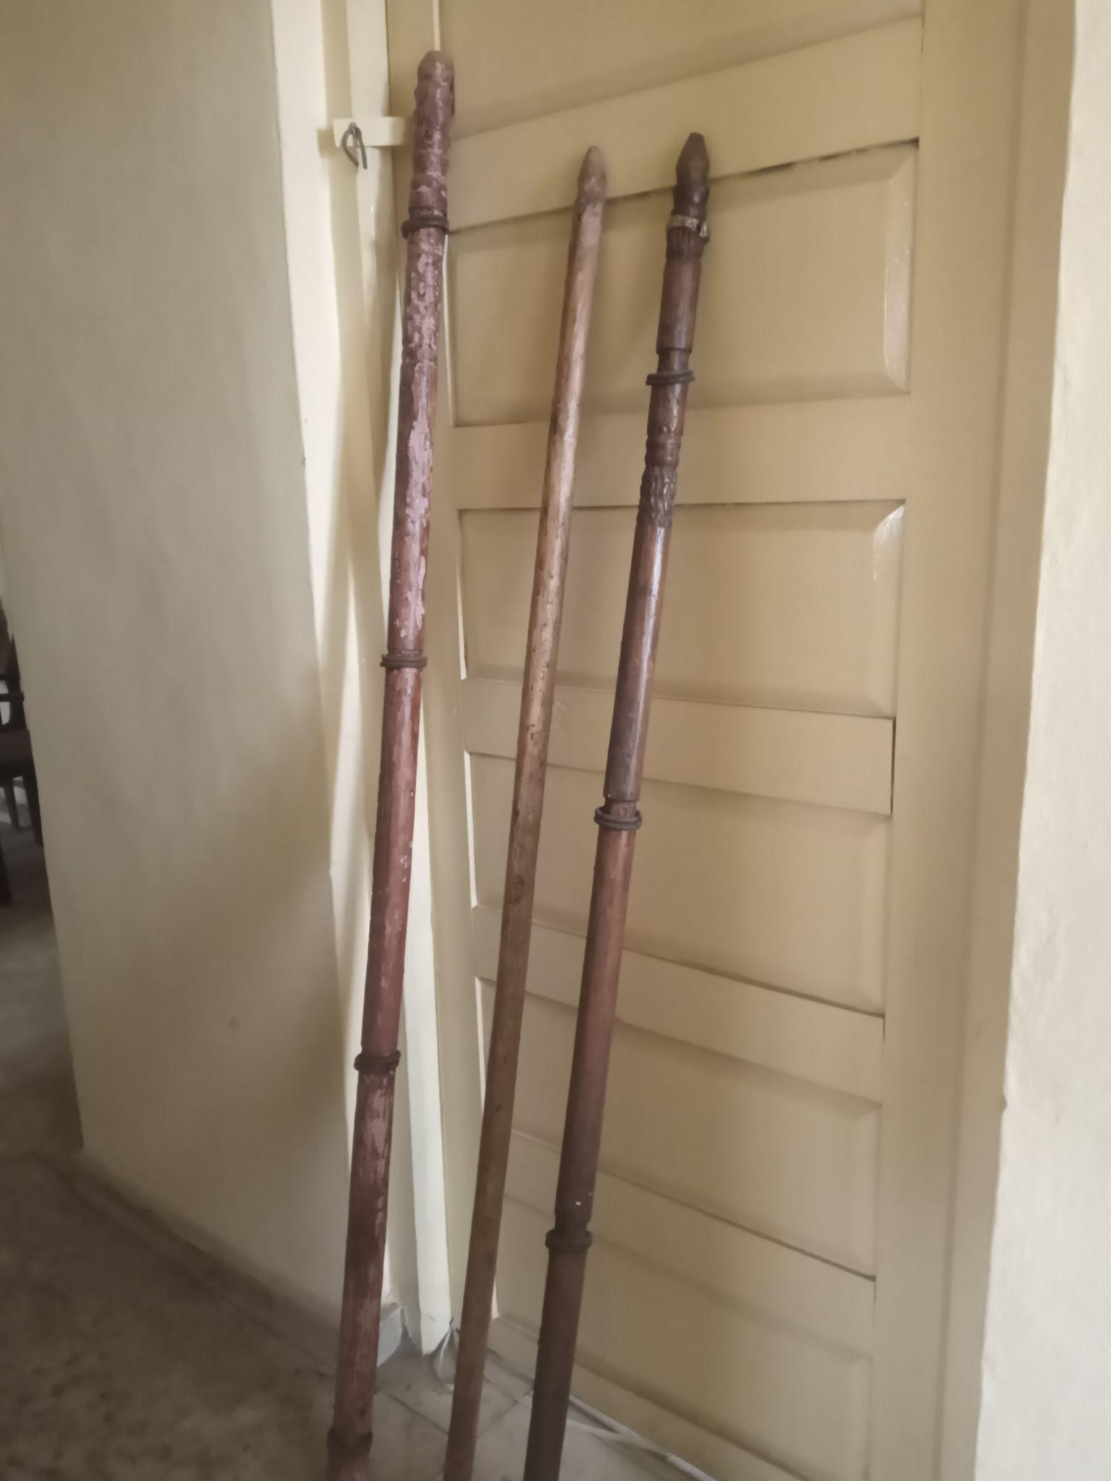
These are Ozo title staves, specially cut from udala (African apple) trees. There are two Osissi, one of which has iron rings fixed at both ends and two in between. After the initiation ceremony, the other remains plain. The plain staff is called Osissi Afulu. It represents the mortal nature of identity purification. The ringed osissi is generally used by the Ozo titled person at other religious ceremonies during his lifetime, if he has performed the ikpo ifejioku iru ceremony after the ceremony of his fathers’ burial. The unringed staff osissi afulu is usually cut into two pieces before his grave during his second burial ceremonies. Aduba and Aduba (38) state that “Ozo members must be pure and clean according to their oath during initiation. The internment is the usual routine of married men but the unringed staff of office osissi afulu is cut into two and thrown into his grave and half of a killed kid (mkpi) sewn in a goatskin bag is also thrown into the grave before it is covered up.”
The Revised Rules and Regulations Guiding Traditional Practices in Onitsha Kingdom direct that this act be performed after a brief ceremony called Itu Ogene by Ndichie around the catafalque or Igbudu. Coming closer after the Itu Ogene is the Itu Ini whereby an Agbalanze member of the deceased’s kindred group in association with the Onye Isi Ofo of the kindred group bids the deceased Ozo titled person a final farewell after some ceremonies and incantations before the catafalque. Thereafter, the catafalque is taken to the grave of the deceased Ozo titled man and buried in situ with the cut osissi afulu. This act signifies the cutting off of the deceased Ozo man from the living members of the Ozo title fold (Anionwu 67).
It is a staff of office where all the powers are inherent. It is referred to as muo m and will remain for eternity for those who are living to call on him after death.

Okwachi
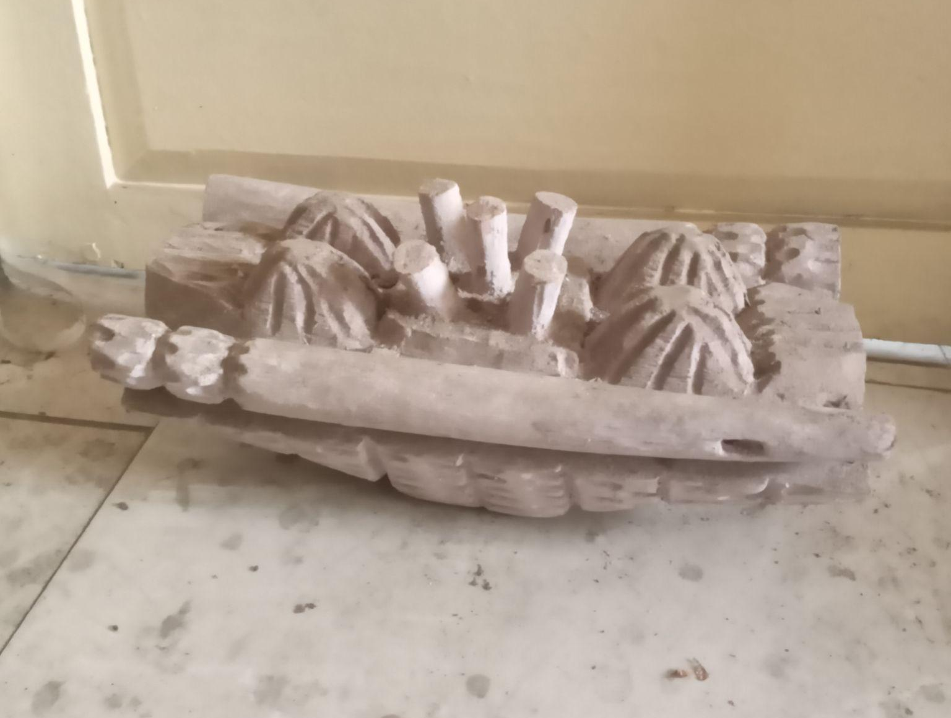
This resembles a sedan chair with two handles on both ends and is very beautifully crafted. In the centre of the ark-like Okwachi are the mkpuluchi which are five pieces of Egbo sticks each about three millimetres in length and one millimetres in diameter. These five sticks are tied together. The Egbo sticks represent the Chi or god of the Ozo titled person which according to Orakwue (29) is similar to the Christian guardian Angel. The Okwachi occupies a very significant place on the ancestral altar of an Agbalanze at every sacrifice he offers. The Okwachi is white washed with the white chalk (nzu), using a brush of ukpa (walnut) leaves during the ceremony of ikpo nze iru as well as at every feast of Ajachi. It is strictly and entirely kept away from animal blood during the lifetime of the Ozo tiled person. This is in consonance with the fact that Okwachi is a representation of the Ozo man’s self which must be pure, clean and as white as snow. Though the Okwachi cannot be touched by sacrificial blood, it is fed with yam food as are the ghosts that lie beside it. It can be carried about only by a virginal, prepubertal girl, for it is an emblem and signature of the man’s socially purified identity.
The Okwachi was often only smeared with blood along with catafalque (igbudu) from the two goats killed by Umu Ilo during the second funeral of the Ozo titled person. The Okpulukpu, the okwachi and the ringed osissi are preserved for posterity as property of inheritance for the children of the deceased and other successive members of the family in general (Anionwu 69).
Okposi
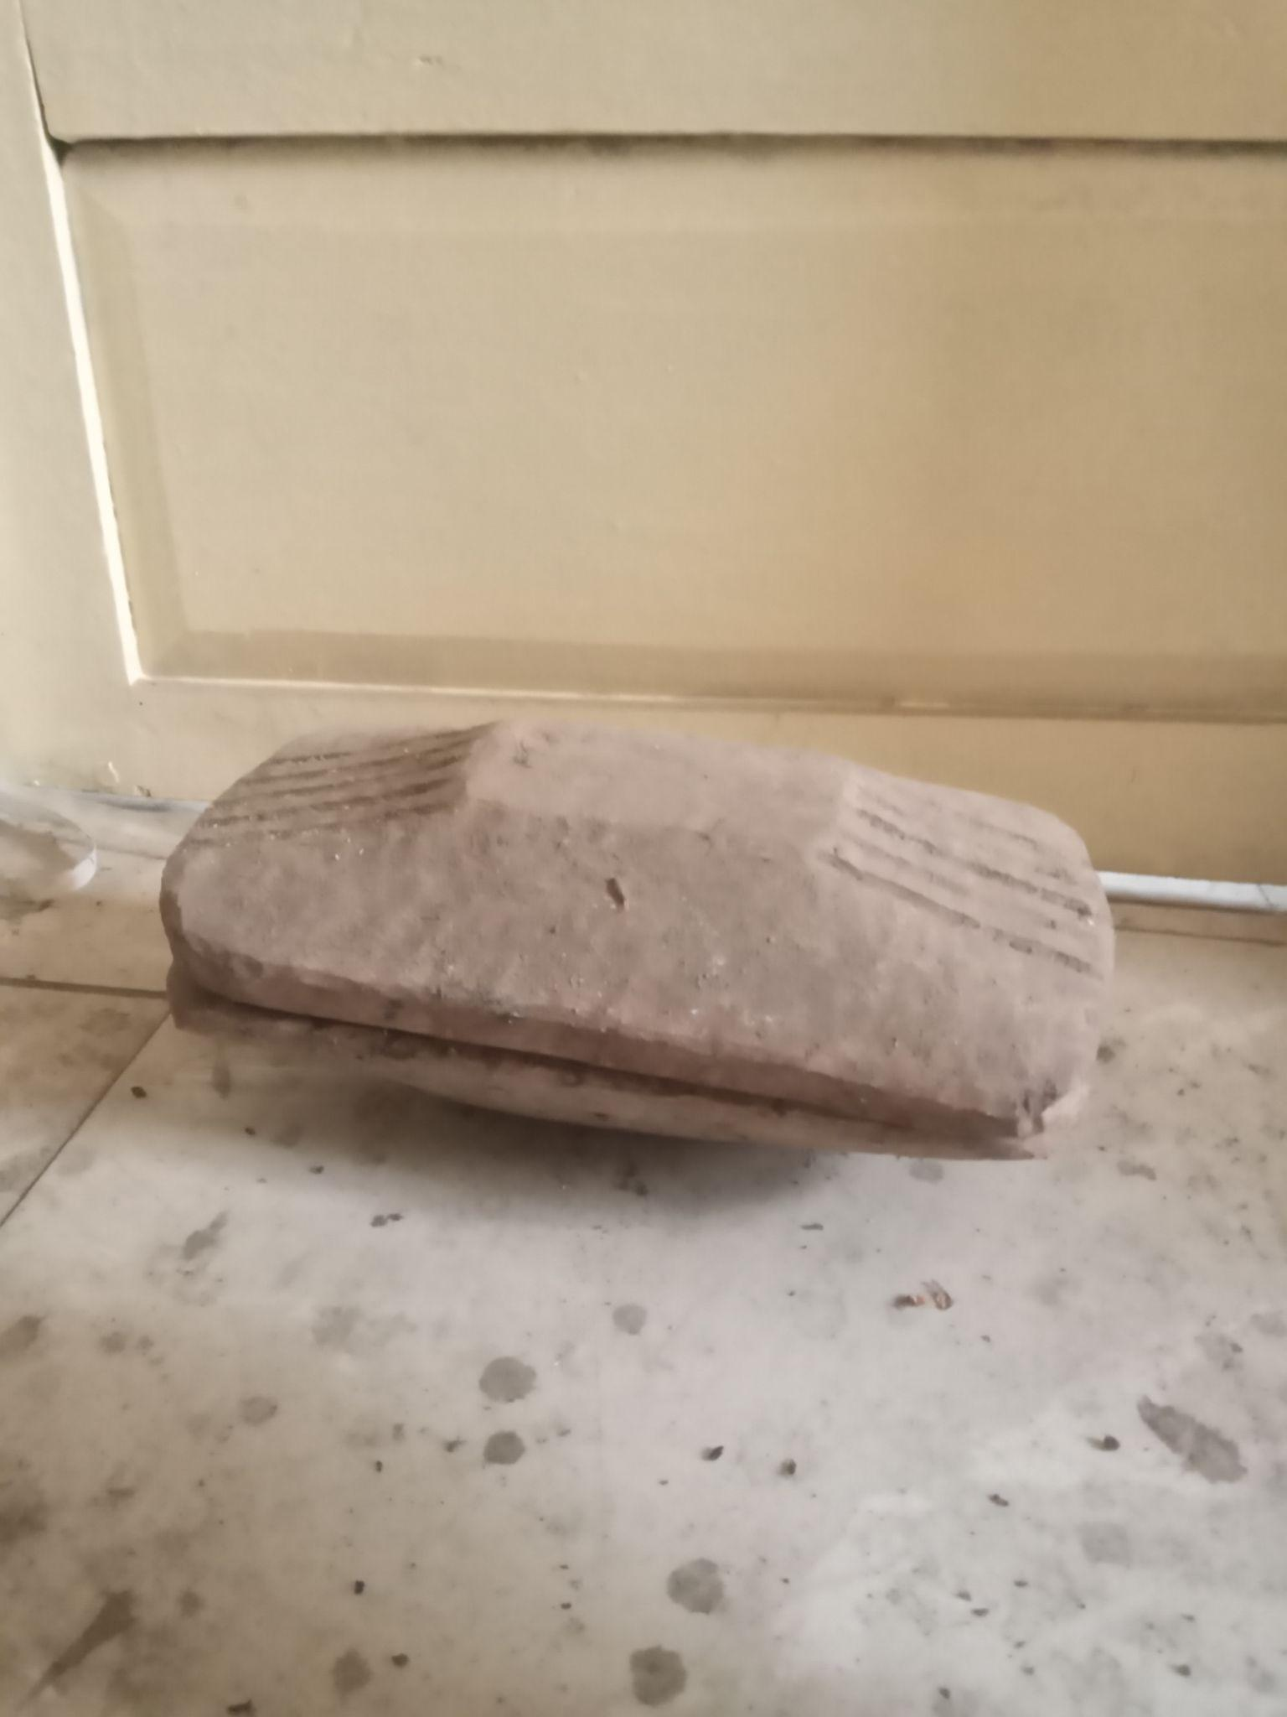
This is an oblong wooden dish with an exquisitely designed cover. It serves as a private and sacred safe for the Ozo titled person generally for keeping petty articles and cash. Such anointed objects hosted by the okposi include white chalk, eagle feather and kola nuts. The use of the okposi is strictly restricted to one’s senior wife, his first son and first daughter (Anionwu 69).

Okpulukpu
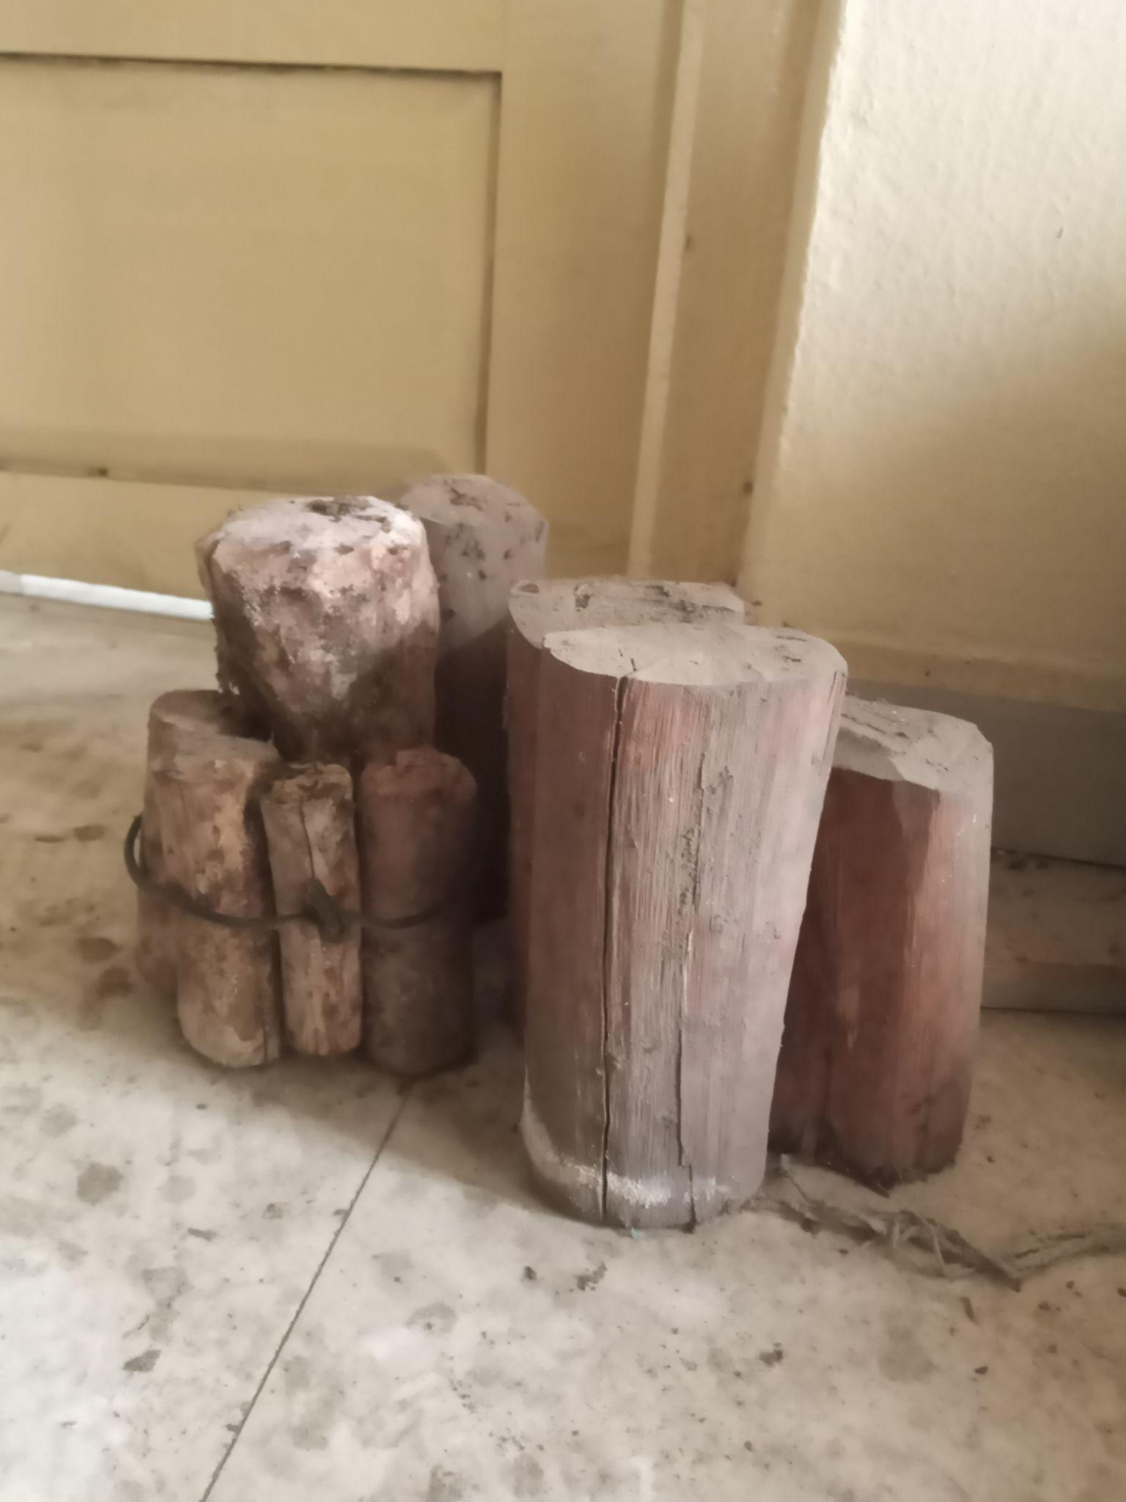
These are the five big pieces of egbo sticks that are tied together. Four of them represent all unidentified ancestors, while the fifth, mkpuluchi, is tied with the ogbo nu uke, often interpreted as “predestination.” It outlives the Ozo man and stays as long as possible.
Ikenga
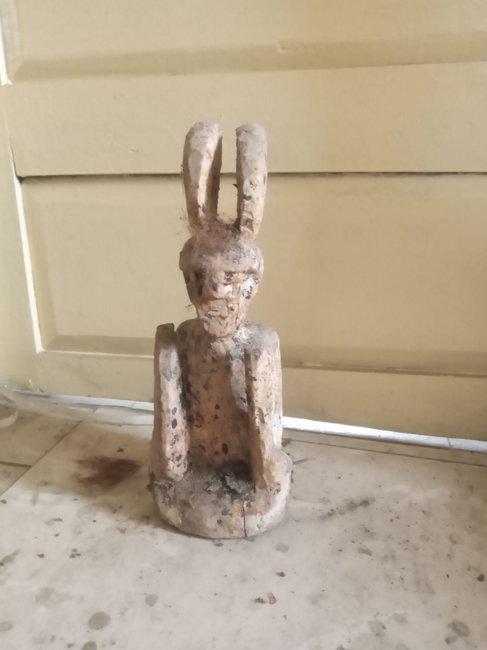
The ikenga represents the Ozo man’s spirit of fortune or his chi. It is the wooden statuette with the semblance of the Benin or Ife bronze work. This is destroyed upon the death of the owner as it is believed that the ikenga is not active any longer to protect the Ozo man.
Azuzu
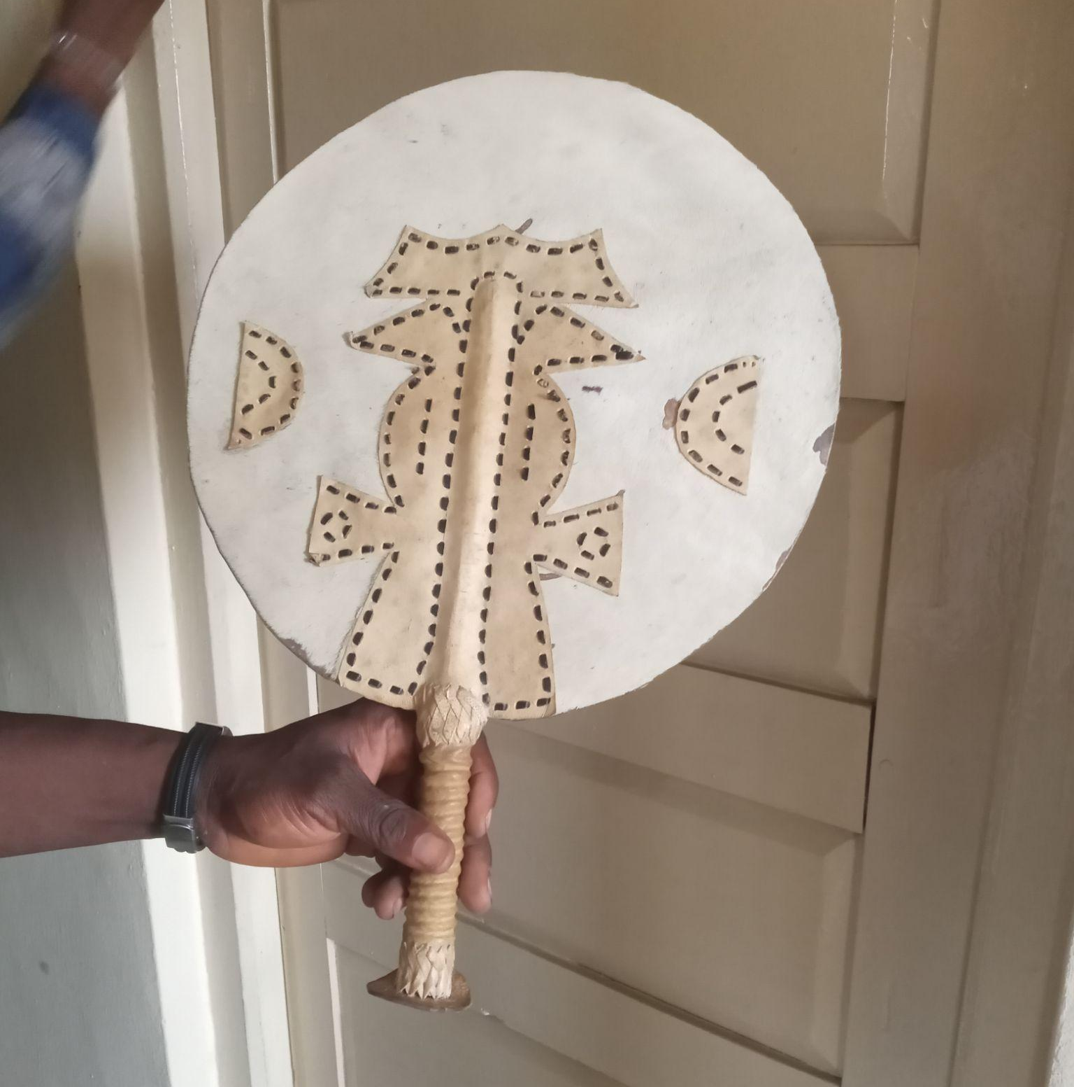
This is used for fanning and cooling situations during peace making. This fan can also be used as an improvised plate while breaking or sharing kola nuts. It is a means of identity used to recognize an Ozo man in Onitsha. It is also used as a means of greeting between Ozo men.

Okpu
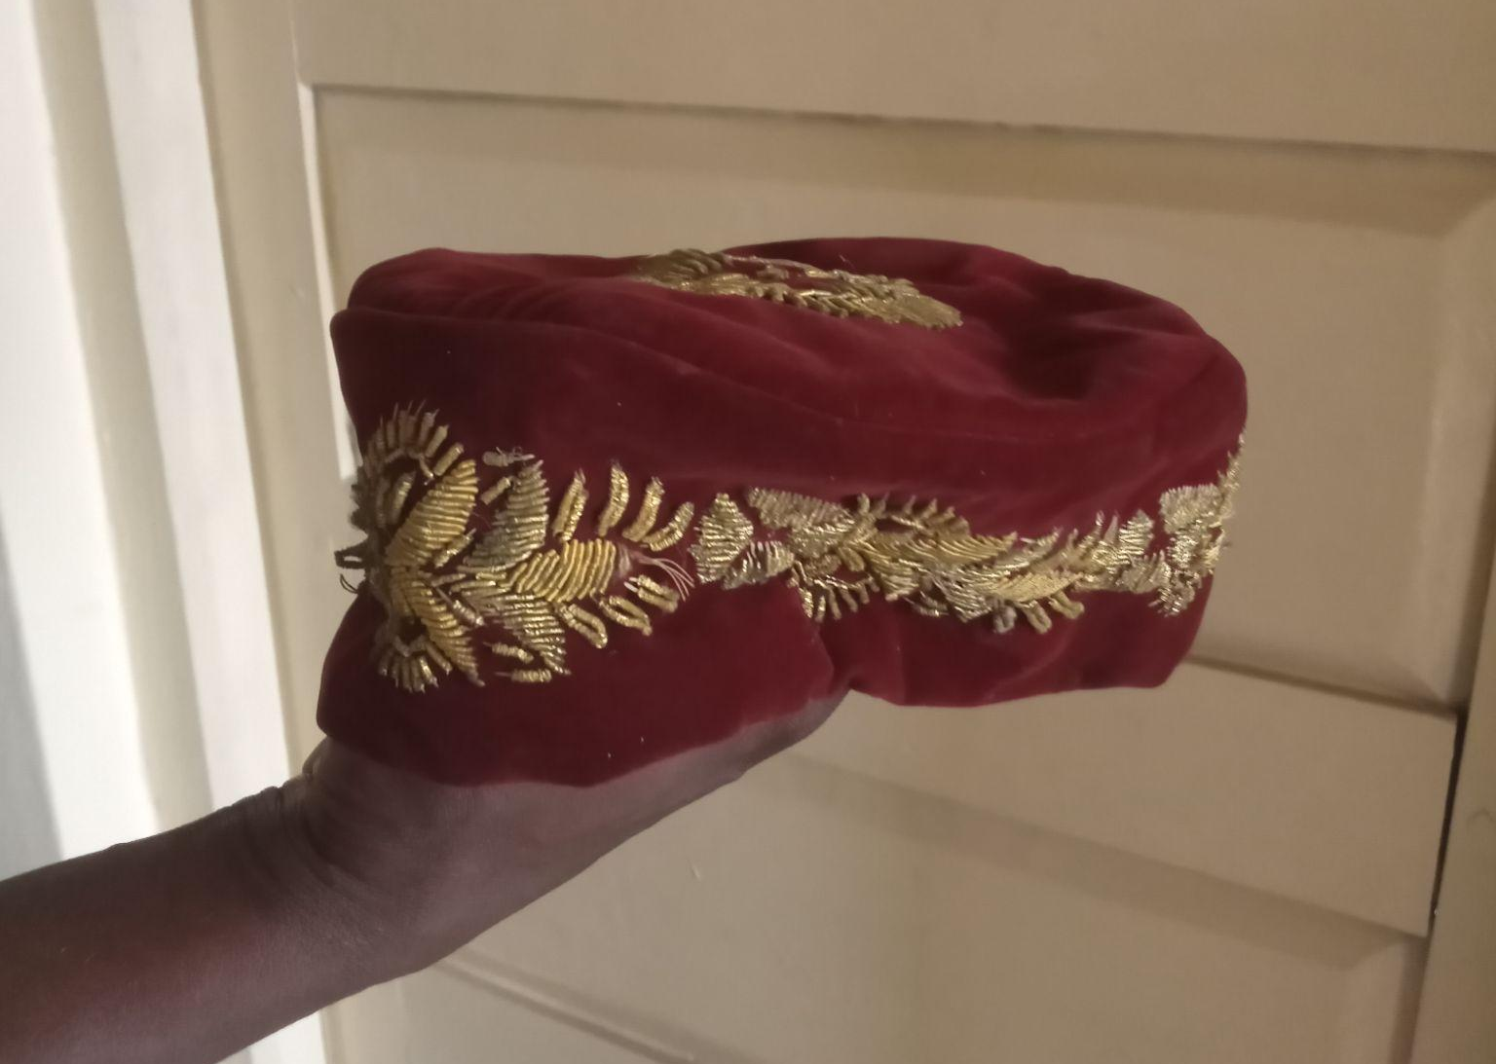
This is an embroidered cap which Ozo men wear as part of their regalia. This cap is used to hold the ugo.
Ugo
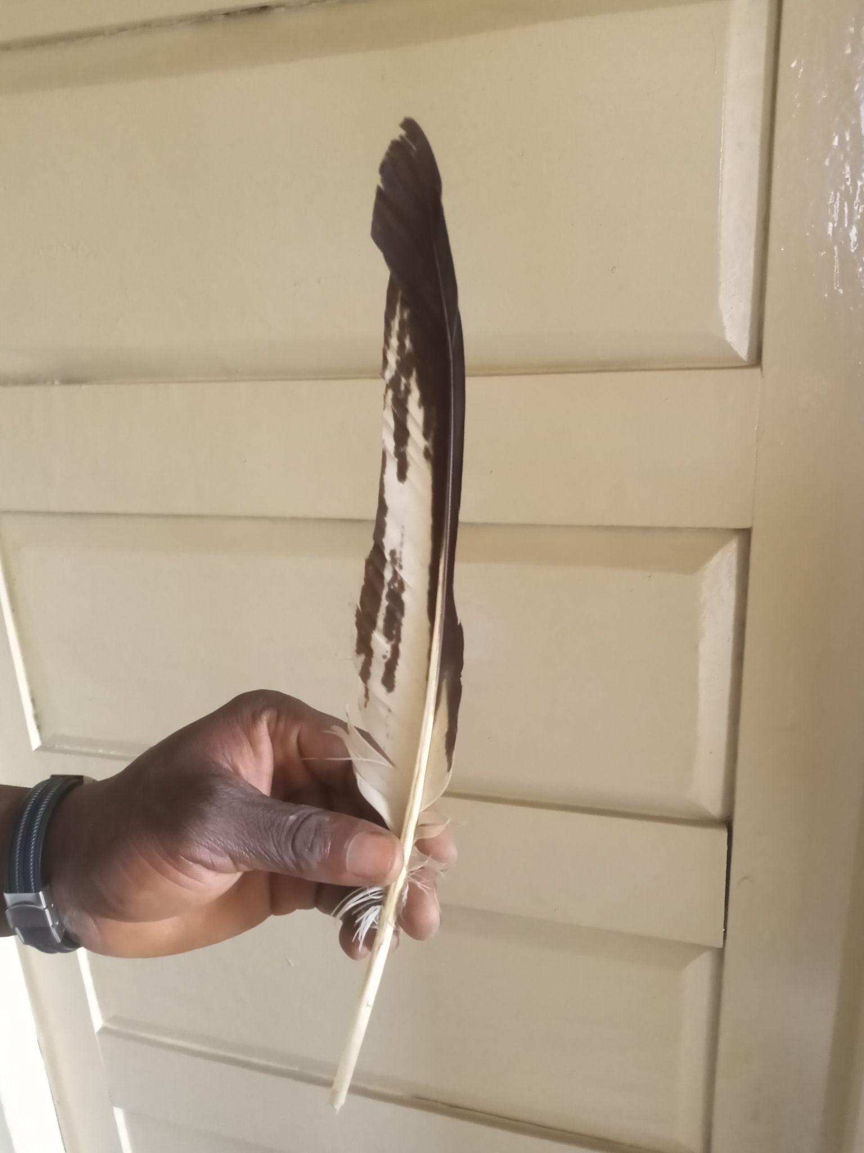
This means eagle feather. This adornment was obtained from the ancient Benin kingdom to signify royalty, wealth and authority. Eagle’s feather is being used because it is known as a prestigious and noble creature which distinguishes itself from other birds just like the Ozo man and it is placed behind the titled man’s okpu (cap).
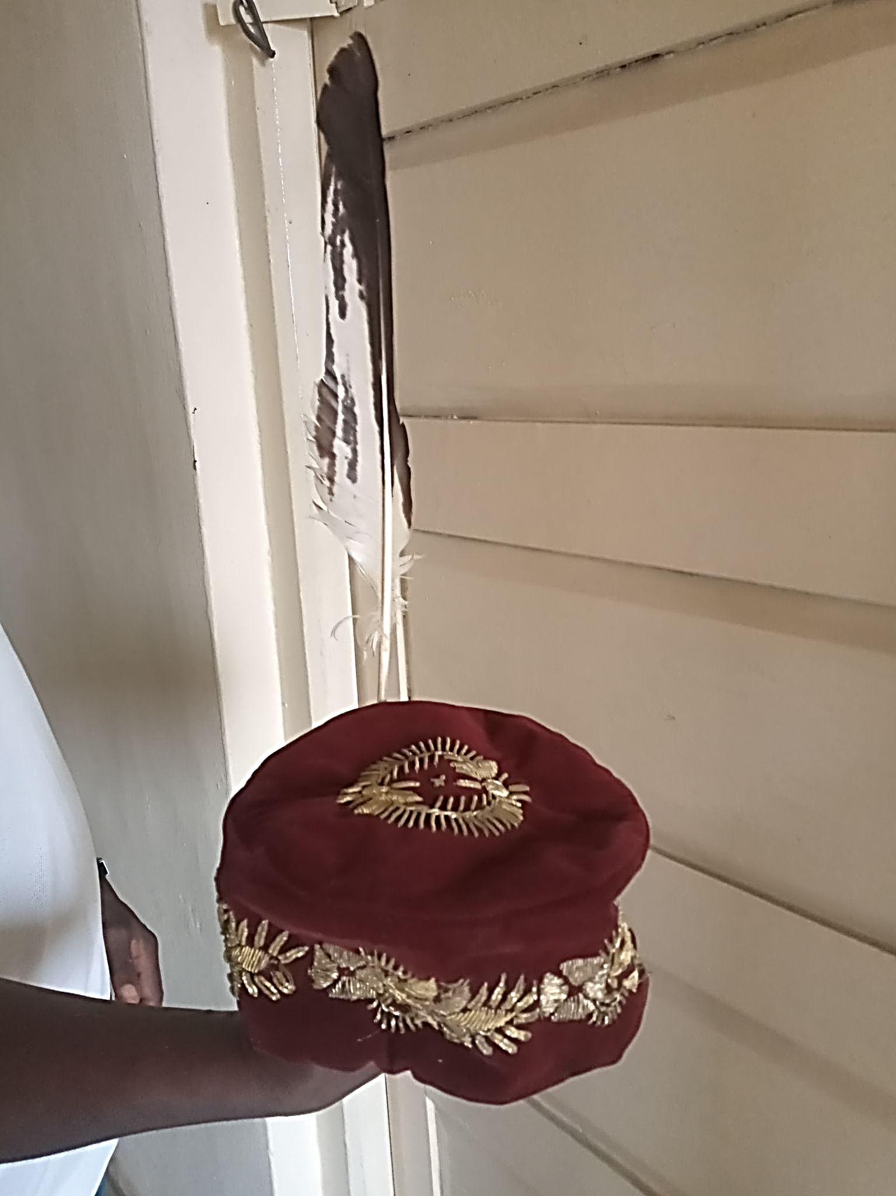

Orakwue says that, “according to history, it was learnt that originally some families do not possess osissi and okpulukpu, but have instead of osissi, a sacred kind of wand known as ofo which they highly respect and use for their own religious ceremonies and their traditional rites. The use of osissi was later introduced in their families on the desire and interest to join other people in various social functions and social ceremonies (25).”
Whenever any of the sacred items for the Ozo man’s ndi muo are lost, burnt, stolen, destroyed or damaged, the custom is that a new one should be substituted at once by the owner. The accompanying ceremony would entail provision of kolanuts, dry fish, food and drinks and the sacrifice of one goat before the family in general (Anionwu 70).
In the past, the dress code for an Ozo was only loin cloth or wrapper as it was believed that an Ozo man should be strong enough to endure any weather. These days the basic traditional dress code for an Ozo Onitsha man is nothing other than wrapper (akwa), a jumper, cap with the ugo and the azuzu.
3.8 THE DEATH AND BURIAL OF AN OZO TITLE HOLDER IN ONITSHA
Emedo and Oguejiofor explain that “unlike Western conception of death as the total annihilation of human life, the Igbo believe there is life after death possibly with the ancestors in the spiritual realm.” Death to the Igbo is not death as such; it is simply a transition, a change of life for a new life. Almost every culture has rituals to honour the dead, which can include burial, cremation and memorial services. Mourning customs vary widely, from wearing specific colours to observing periods of mourning and performing rituals to ensure the deceased’s peace. In Igboland, death is viewed not as an end but as a transition from the physical world to the spiritual world. It is believed that the dead continue to exist as ancestors, watching over and influencing the living. The ancestors are revered and play a crucial role in the spiritual life of the Igbo. They are honoured through rituals, offerings and prayers and it is believed that the well-being of the living is closely connected to the favour of the ancestors.
Funerals are significant social events, often elaborate and involving the entire community. They serve to honour the deceased and ensure their smooth transition to the ancestral world thus maintaining the bond between the living and the spiritual realm. The rites include washing and dressing the body, wake-keeping, music, dancing, feasting and various rituals. The ceremony is deepened in the culture of Onitsha Ado n’Idu. It is the climax of the burial arrangement and must be done according to Onitsha tradition and custom.

Itu Ugo
The Ozo title dies with its holder. The Itu Ugo ceremony, conducted by the Agbalanze association, serves as their equivalent of Ikpu Akwa during the lying-in-state of a deceased member. Upon receiving due notice of a member’s death, the President informs the members about the date of interment. It then becomes obligatory for all members to attend the premises of the deceased in full to pay their final respects on that day. The Itu Ugo ceremony begins precisely at noon with the firing of seven cannon shots. Before this, members of the Agbalanze society, dressed in white jumpers over pure white wrappers, white shoes and caps adorned with an upright eagle feather, assemble and are led in a solemn procession by the President. Previously, Agbalanze members dressed as modestly as they saw fit.
The deceased members of the Ozo kindred group, having gathered at the burial site, play a supportive role by liaising with the deceased’s diokpala to bring the items required by the Agbalanze tariff to the gathering place. They had also performed their own Ikpu Akwa and Itu Ugo ceremonies earlier, before the arrival of the Agbalanze Onitsha members. The route of the procession is closely monitored by some members of the deceased’s Ozo kindred group and members of the Agbalanze Executive Committee. As Agbalanze members solemnly enter the premises where the deceased is laid, the President positions himself at the head of the bed and is approached by the Onyeisi ofo of the deceased’s kindred group. An Agbalanze member beats the Ekwe Dike (the gong of warriors) to announce the arrival of the Agbalanze members, while the Onyeisi ofo performs a ritual of speaking to the dead and hands over the proceedings to the President. A token for odudu is circulated among all Agbalanze members and finally returned to the Onyeisi ofo, who then explains to the deceased why they should not expect the living to join them soon.
The President reads a short eulogy of the deceased in the presence of his first son. Following this, a soloist performs a unique piece of Agbalanze music, Umu Agbalanze, anyanwu esi owele naa-o, to which the Agbalanze members respond with a harmonious chorus. The subsequent songs, typically in three or four movements with varying tempos and moods, are sung by the members. The significance of this sunset music at the Itu Ugo ceremony is to bid farewell to a fallen colleague who, according to the ancient tradition of our forefathers, reached the pinnacle of achievement in his lifetime. While the song at the night of the initiation (ina obibi), anyanwu esi owele waa, heralds the rising of the sun, the music at Itu Ugo signifies the setting of the sun.
At the end of the eulogy, the President places an eagle feather in the coronet worn by the deceased, wishing him a safe journey to the great beyond to join his ancestors. He then declares the assignment concluded, and the Ekwe Dike is beaten once more, this time accompanied by the blowing of “Okike” Odu Enyi (elephant tusk trumpet), also known as Odu n’Akpo Dike (the trumpet that proclaims the warrior). The chief mourner, diokpa na akwa ozu, through the kindred Agbalanze group, entertains the members according to the Agbalanze tariff. Agbalanze Onitsha fulfils its duty to the deceased by giving a cash purse to the late member’s wife, the first son and first daughter. The deceased’s Agbalanze namesakes also pay their respects separately after the main Agbalanze members have offered their condolences (Anionwu 135).
After all these, the highest authority in Onitsha that buries the Ozo man, the masquerade called Muo Ogonogo from both the maternal and paternal side comes to pay respects and bid him farewell as burial rites in Onitsha are done from both sides. After this, the corpse is taken to the grave and buried. It is important that the burial rites are done in the proper way so that when he is being referenced in both in the institution as a whole and in his family’s shrine (iba), they do it with conviction knowing that they have fulfilled their obligation to him and he will respond to them.
The death and burial of an Ozo man in Onitsha are characterised by elaborate and highly respected rituals that reflect the deceased’s status and contributions to the community. These practices ensure that the Ozo man is honoured appropriately and that his spirit transitions smoothly to the ancestral world. The involvement of fellow Ozo title holders, the community and the family underscores the importance of these ceremonies in preserving cultural heritage and upholding social values.
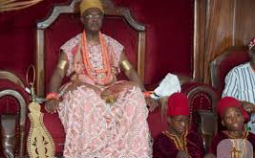
OBI OF ONITSHA

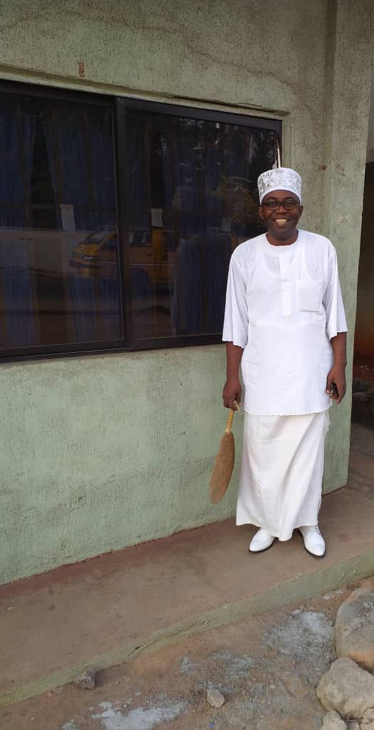
AKUNNIA IKECHUKWU MBANEFO, A MEMBER OF AGBALANZE ONITSHA IN FULL REGALIA

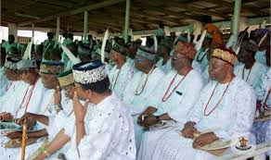
MEMBERS OF AGBALANZE ONITSHA CULTURAL ASSOCIATION

CHAPTER FOUR
THE LITERARY SIGNIFICANCE OF OZO TITLE INSTITUTION IN ONITSHA
The people of Onitsha and the Igbo at large had their own traditional system of title-taking and leadership before the arrival of the colonial masters, which created a significant literary impact on the society. It has helped form and shape the literary character of its members through their moral codes, as well as that of the community's oral traditions. The Ozo institution in Onitsha, a prominent traditional Igbo society, holds a profound literary presence, deeply rooted in the communal narrative. The Ozo title elevates its holders to a higher literary and philosophical order with certain linguistic and poetic privileges.
The Ozo title institution in Onitsha stands as a cornerstone of the community's literary fabric, embodying the values, traditions, and narrative structures that have defined this historic society for centuries. It is a prestigious symbol of literary leadership, honor, and narrative responsibility, deeply intertwined with the identity and heritage of the Onitsha people. This institution not only preserves the literary legacy of the community but also plays a crucial role in maintaining narrative cohesion and a sense of shared heritage.
This research explores the intricate stages of the Ozo title-taking process, highlighting and analyzing the literary forms embedded within its description. The Onitsha Ozo title initiation ceremonies, as detailed in this research, are rich in cultural and symbolic expression, revealing a deep-seated connection with ancestral veneration and communal harmony. These ceremonies are replete with literary forms that serve to convey meaning, solidify social structures, and preserve cultural memory.
One prominent literary form is oral tradition, encompassing both narrative and performative elements. The initial stage, Inyedo Muo, relies heavily on oral pronouncements and ancestral invocation. The candidate's "announcement of intentions" is not a mere statement but a ritualized speech, a form of formal address, delivered in the presence of the kindred group's Ozo title holders. This speech, presided over by the diokpa, functions as a narrative bridge between the living and the dead, seeking ancestral sanction. The act of "bringing back the spirit" through ikpoko muo further underscores the importance of oral transmission, ensuring the continued presence of ancestral wisdom within the community.
The Igba Okonti stage is characterized by dialogic exchange. The consultations with maternal brothers (Nkata Usoekwu), paternal siblings (nkata iba), and the patrilineage (nkata umunna) are structured as formal dialogues, where the candidate presents his case and receives feedback. This process is not merely transactional but performative, involving the exchange of kola nuts, hot drinks, and money, each carrying symbolic weight. These exchanges are embedded with narrative elements, where past grievances are addressed and resolved, ensuring communal harmony. The solemn declaration of support received by the candidate is a form of affirmative discourse, a collective pronouncement that solidifies his social standing.
Igo Muo further exemplifies the use of prayer and invocation. The okpala's prayers, whether delivered at the family shrine or elsewhere, are structured as formal addresses to the divine and ancestral realms. These prayers, seeking blessings and support for the candidate's initiation, embody a form of religious poetry, where language is used to invoke spiritual forces and establish a connection with the unseen.
These ceremonies are not simply procedural but deeply symbolic. The use of material objects like kola nuts and hot drinks, coupled with the formal language and ritualized actions, creates a rich tapestry of meaning. The ceremonies are, in essence, a form of ritual drama, where the candidate undergoes a series of transformative acts, guided by the community and sanctioned by the ancestors. The emphasis on communal participation and ancestral veneration highlights the collective nature of these literary forms, where meaning is created and sustained through shared performance and interpretation.
The process of itu mmanya (libation) involves a verbal act of pouring wine and invoking blessings from ancestors. This is a form of ritualistic chanting or recitation, as the person performing the ceremony addresses the dead ancestors, particularly their father and relatives, to invoke their blessings. This is a common feature in many oral traditions where specific words or phrases are recited during a ceremony to achieve a spiritual or ritualistic outcome.
The process includes a proverb used to explain the restriction on a person pouring libation on their first son: "nwa izizi onye bu ogbo nya," which translates to "one's first son is his age mate." This proverb is a concise, metaphorical saying that embodies a cultural belief or truth. It's used here to explain a social custom and the rationale behind a traditional rule, highlighting the importance of the first son and the respect due to him. Proverbs are a fundamental element of many oral traditions, serving as a repository of cultural wisdom and a tool for moral and social instruction.
The ritualistic calling out of the family's titled ancestors serves as a form of eulogy. The "okpala" recites the names of deceased ancestors to implore their participation and blessings on the ceremony and the initiate. This act honors the dead, acknowledges their legacy, and seeks their continued guidance, which is a classic characteristic of an oral eulogy.
The Ina Obibi explicitly states that the drummer uses the initiate's new Ozo name to "eulogise his eventual achievement of his lifetime aspiration in line with his progenitors’ antecedents and legacies." This is a key example of an oral eulogy, a formal speech or poetic tribute to a person's life and achievements. Here, it is performed rhythmically with a drum to honor the new Agbalanze and connect his success to the legacy of his ancestors.
There are several instances of celebratory exclamations. The new Ozo man "bursts out jubilantly in a loud voice: 'Oko Mo! Apuanyao!' (I have succeeded! I am free!)." Similarly, the wife and her troupe shout, "Ee-Ee-Ee, anyi apua nya o!" (At last we have successfully pulled through!). These are spontaneous, emotional utterances that mark a significant moment of triumph and liberation. They are a form of oral expression that conveys strong feelings and reinforces the communal joy of the occasion.
The "Ozo dance" and the "Egwu ego" (dance of the wealthy and noble) are not just physical movements but are accompanied by vocal performances. Women relations "sing the praise of the new Agbalanze" and a chorus is used for the Egwu ego, both of which are forms of communal chants or songs that celebrate the event and its participants.
The "Mmacha na Ozo" and "Egwu Efifie" are filled with references to songs and music. The procession to the family shrine is led with a singing procession, and the songs strongly extol the Ozo title taking and appeal to non-initiates. This use of melodious songs with specific, persuasive lyrics is a key form of oral tradition used to reinforce cultural values and encourage participation. The text also mentions specific musical categories like Egwu eji eje na ani (music for the visit to the shrine) and Egwu mbata (entry music), indicating a structured use of music and chants for different parts of the ceremony.
It also includes a proverb: Akpata elisie ubiam bu onwu, which is translated to be a "wake-up call for the non-initiates." This proverb, which essentially means "poverty is death to a miser," is used to convey a moral lesson. It encourages the wealthy to use their resources prudently to achieve a higher social and spiritual status, rather than hoarding them and remaining "commoners."
The selection of an Ozo title name is a significant linguistic act, reflecting the initiate's personal narrative, family history, and social aspirations. Anionwu's explanation that "each name connotes something when thought about deeply" highlights the symbolic and narrative weight carried by these names.
The diverse range of Ozo names, categorized by their thematic focus (e.g., parental achievement, personal wealth, divine providence, nobility), reveals the complex interplay of social and cultural values. Names like "Akunnia" (I have succeeded through my father) and "Akunne" (Success through my mother) serve as genealogical narratives, acknowledging the role of family in the initiate's success. Names like "Akunwata" (A self-made man) and "Nwachinemelu" (Providence has played out in his journey to wealth and nobility) are personal narratives of achievement and self-reliance.
The use of prefixes like "Aku" (wealth), "Nna" (father), and "Chi" (God), combined with suffixes like "Ugo" (eagle feather) and "Enyi" (elephant), creates a rich tapestry of symbolic meanings. These names, often rooted in historical events or personal experiences, function as condensed narratives, encapsulating complex stories and values in a single word or phrase.
The practice of adopting ancestral names ("izatalu nne or izatalu nnia afa") is a form of historical preservation, ensuring the continuity of family legacies and connecting the present generation to their ancestors. The deliberation and negotiation surrounding the selection of Ozo names, with the Ozo community ensuring appropriateness and acceptability, highlight the social and cultural significance of this linguistic act.
The Egwu Ozo performance is a multifaceted literary form, combining music, dance, and oratory to create a powerful cultural narrative. Anionwu's description of Egwu Ozo as "central to the Ozo initiation" underscores its role in transforming the ritual into a vibrant and engaging cultural event.
The unwritten music and codified choruses of Egwu Ozo are a form of oral literature, preserving historical narratives, social values, and personal achievements through performance. The drummer's ability to "delve into esoteric realms to preserve and immortalise the musical legacies of past heroes" highlights the role of Egwu Ozo in transmitting cultural memory and reinforcing social identity.
The synchronized movements of the dancers, the rhythmic percussion of the ringed staves, and the oratory of the skilled speakers create a complex performative narrative. The language used to praise the title-taker, recount historical events, and reinforce social values is a form of public discourse, shaping the community's understanding of the Ozo institution and its role in society.
The synchronization of the drummer's music with the choruses and the dancers' movements is a form of intertextual performance, where different artistic elements come together to create a unified and meaningful experience. The rhythmic movements of the staves, signifying communication with the ancestors, add a layer of spiritual significance to the performance.
The Egwu Ozo performance, with its emphasis on skill, eloquence, and cultural knowledge, functions as a form of cultural education. It transmits social values, historical narratives, and artistic traditions to the community, ensuring the continuity of Onitsha cultural identity.
The Agbalanze paraphernalia are not just objects; they are a form of material literature, rich with symbols and narratives that tell the story of the Ozo man's identity, power, and spiritual journey. The literary forms found here are not words, but a system of signs that communicate meaning through their symbolism, use, and cultural context.
The two Osissi staff tell a clear, two-part narrative. The plain Osissi Afulu represents the mortal nature of the Ozo man's purity. Its unadorned state symbolizes the temporary, earthly body. The act of cutting it in two at his second burial is a dramatic, symbolic act that concludes this narrative, signifying the separation of his mortal existence from his perpetual spiritual status.
In contrast, the ringed Osissi represents his eternal, spiritual identity. The rings symbolize a bond to the spiritual world, and this staff is used for "religious ceremonies during his lifetime" and "will remain for eternity." This creates a literary juxtaposition between the finite nature of the Osissi Afulu and the perpetual existence of the ringed Osissi, telling a story of earthly purification and spiritual immortality.
The Okwachi serves as a powerful literary symbol of purity and the Ozo man's chi. Its being "white washed with white chalk" and "strictly and entirely kept away from animal blood" is a visual metaphor for a clean, sinless spirit. This purity is contrasted with the messy reality of life, as the Okwachi is only smeared with blood during the deceased's second burial, signaling a final purification and transition. Its being carried by a "virginal, prepubertal girl" adds a symbolic layer of innocence and a link between the purified spirit and the unblemished future generation.
The destruction of the Ikenga upon the owner's death is a narrative plot point that signifies the end of the Ozo man's individual journey of fortune. It tells a story of a personal spirit that is active in life but becomes inactive in death, contrasting with the eternal nature of the ringed Osissi.
Okposi: This "private and sacred safe" tells a narrative of a guarded, personal sacredness. The "anointed objects" like chalk and kola nuts stored within it act as symbolic characters that speak to the personal piety and private wealth of the individual.
The Okpulukpu sticks tell a narrative of lineage and continuity. The four sticks representing "unidentified ancestors" and the fifth (mkpuluchi) representing the individual's destiny create a literary structure that ties the individual's fate to the collective history of his ancestors. It's a text that says, "You are a part of something larger."
The Okpu (cap) and Ugo (eagle feather) are a pair of visual poetic devices. They are not simply clothes; they are symbols that communicate a man's elevated status. The Ugo is a metaphor for the Ozo man himself: "a prestigious and noble creature which distinguishes itself from other birds." The adornment is a form of visual poetry that instantly communicates the wearer's royalty, wealth, and authority to anyone who sees it.
The Azuzu fan is a powerful literary symbol of wisdom, peace, and social grace. It is used for "fanning and cooling situations during peace making," and this function establishes it as a symbolic tool of conflict resolution. It tells a story about the Ozo man's role as a mediator and a figure of tranquility, serving as a material representation of his moral character.

Also, the death and burial of an Onitsha Ozo title holder are steeped in elaborate rituals and symbolic actions, which function as powerful literary forms. These ceremonies, far from being mere funerary rites, are rich narratives that convey deep cultural beliefs, social structures, and spiritual connections.
The entire process, from the initial announcement of death to the final burial, is a performative narrative, a dramatic enactment of the Ozo title holder's transition from the living world to the ancestral realm. The elaborate rituals, including the washing and dressing of the body, wake-keeping, and feasting, serve to honor the deceased and ensure a smooth transition.
The Itu Ugo ceremony, conducted by the Agbalanze association, is a central piece of this narrative. The firing of seven cannon shots, the solemn procession of Agbalanze members dressed in white, and the ritualistic exchange between the President and the Onyeisi ofo are all elements of ritualistic drama. The use of the Ekwe Dike (gong of warriors) to announce the arrival and departure of the Agbalanze members further emphasizes the performative nature of this ceremony.
The President's reading of a short eulogy and the singing of specific Agbalanze songs, like "Umu Agbalanze, anyanwu esi owele naa-o," are forms of oral literature. These performances, with their carefully chosen words and musical arrangements, serve to commemorate the deceased and reinforce the values of the Agbalanze society. The contrast between the initiation song ("anyanwu esi owele waa") and the burial song ("anyanwu esi owele naa") creates a powerful narrative arc, symbolizing the cycle of life and death.
The eagle feather, placed in the deceased's coronet, is a powerful symbol of nobility and spiritual transition. This act, accompanied by wishes for a safe journey to the great beyond, is a form of symbolic language, conveying deep cultural beliefs about the afterlife.
The use of white clothing by the Agbalanze members signifies purity and mourning, while the elephant tusk trumpet (Odu n’Akpo Dike) proclaims the deceased's status as a warrior and respected member of the community. These material symbols, combined with the ritualistic actions, create a rich tapestry of metaphorical expression.
The involvement of the deceased's Ozo kindred group, the Agbalanze association, and the wider community highlights the communal nature of the burial rites. The sharing of odudu tokens and the entertainment provided by the diokpa na akwa ozu are forms of communal discourse, reinforcing social bonds and expressing collective grief.
The arrival of the masquerade Muo Ogonogo, representing both maternal and paternal lineages, signifies the ancestral connection and the continuation of the deceased's influence in the spiritual realm. This act reinforces the Igbo belief in the ongoing relationship between the living and the dead.
The emphasis on performing the burial rites correctly, ensuring that the deceased is honored and remembered appropriately, is a form of cultural preservation. These rituals serve to maintain the continuity of Onitsha tradition and reinforce the importance of ancestral veneration.
4.1 INFLUENCE OF MODERNIZATION ON THE SIGNIFICANCE OF THE INSTITUTION
The Ozo institution remains a vital cultural pillar in Onitsha, but its profound literary significance is under threat from the pressures of modernization and globalization. While the institution has demonstrated a capacity to adapt, integrating modern economic and political roles, the core of its literary art—the oral and symbolic performances—is being diluted.
The financial burdens of the title and the shift in modern priorities have directly impacted the practice of verbal art as performance. Historically, the ceremonies were a grand public stage for oral literature, where praise poetry, proverbs, and incantations were performed and evaluated by a discerning audience. With a decline in interest among younger generations, there's a risk that the intricate knowledge of these literary forms will be lost. The preference for modern achievements over traditional titles means that fewer people are willing to invest the time and resources to master these highly-skilled forms of verbal expression. Western education and urban migration have also created a disconnect from the cultural context in which this oral literature thrives, leading to a diminished audience and a loss of appreciation for its richness.
The material literature found in the Ozo paraphernalia is also being impacted. Objects like the Osissi and Okwachi serve as symbolic texts, telling narratives of immortality, purity, and lineage. However, as the ceremonies become simplified due to financial constraints and external influences, the intricate rituals that activate and give meaning to these objects are at risk. The reduction in the number of Ozo men means that the stories embedded in these artifacts are told and understood by a smaller number of people, leading to a potential loss of their literary and narrative power. While these symbols are preserved as inheritance, their deeper literary significance—the stories they tell about identity and the afterlife—may be lost on a generation that no longer fully participates in the rituals that give them life.
The broader societal narrative of respect and authority is also changing. In the past, the Ozo title was the ultimate literary achievement, a culmination of a life's story of hard work, lineage, and community service. Now, that narrative is being overshadowed by a new, more modern story of success defined by academic degrees and professional achievements. This shift in values means that the social drama of the Ozo title, once a central plot in the community, is losing its prominence. To remain relevant, the institution's narrative must be rewritten to align with modern societal goals, emphasizing contributions to community development in areas like education and healthcare. This allows the Ozo institution to continue its role as a powerful symbol of identity, but its literary forms must adapt to a changing world or risk becoming a diluted version of their past glory.

CHAPTER FIVE
SUMMARY AND CONCLUSION
SUMMARY
The Ozo title is a prestigious traditional institution among the Igbo people, particularly prominent in Onitsha, Anambra State, which holds significant literary value. Its historical and social significance is not merely a fact but a narrative woven into the fabric of the community. The institution's ancient roots provide a narrative framework, serving as a mechanism for maintaining order, governance, and societal values, and is reflected in the oral histories passed down through generations.
The title-taking process itself is an elaborate socio-dramatic performance, beginning with a period of consultation and divination, which serves as the plot's initial suspense. The initiation rituals, including stages of purification, oaths, and the bestowal of symbolic objects, act as key scenes and performative utterances that transform the candidate's identity. The significant financial commitment is a material expression of the narrative of social ascension, a testament to the character's journey.
Ozo titleholders are viewed as custodians of tradition and moral authority. They are not just leaders but living repositories of oral literature and cultural knowledge. Their role in dispute resolution and governance is a performance of wisdom, with their decisions often seen as the final word in the community's collective story. The title itself is a spiritual narrative, linking the living to the ancestors, and their rituals and sacrifices act as a form of ceremonial literature that ensures communal prosperity. This tradition ensures that the rich cultural history and values are not merely facts but are actively and artistically transmitted through performance.
While the Ozo title faces challenges from modernization and Western influences, its essence as a literary institution remains. The high cost and the shift in societal values threaten the continuity of the oral and symbolic forms of literature embedded in the tradition. The debate over its relevance highlights the clash between traditional and modern narratives of success and leadership. However, the Ozo institution's resilience demonstrates its enduring role as a central symbolic text of Onitsha culture, a continuing testament to identity, continuity, and social cohesion.
CONCLUSION
The Ozo title in Onitsha is a profound cultural institution, but its true significance lies in its powerful role as a form of oral and material literature. This thesis re-frames the institution's contributions to leadership and social order by analyzing how they are articulated through a rich system of literary forms, performances, and symbolic texts.
This research argues that the Ozo institution serves as a living text, embodying the community's values, spirituality, and social structure. The title itself is a central narrative that guides the social and spiritual life of the community, serving as a vital link between the present and the ancestral past. The thesis highlights how this story is preserved and transmitted not just through words, but through the performance of rituals and ceremonies that ensure cultural continuity. The Ozo titleholders, as "custodians of tradition," are the key performers of this ongoing literary work, acting as living repositories of oral history and cultural knowledge.
The study analyzes the Ozo institution's contributions through its distinct literary forms:
- Verbal Art: The maintenance of peace and harmony is achieved through verbal artistry, such as the use of proverbs and oratory in conflict resolution. The propagation of moral virtues and the education of the community are accomplished through speeches and chants that are evaluated for their rhetorical power and wisdom. These forms of spoken literature are crucial to social cohesion.
- Symbolic Literature: The material paraphernalia of the Ozo title serves as a form of symbolic literature, with each object—like the Osissi staff or the Okpu cap—carrying a rich narrative about the titleholder's spiritual status, authority, and journey. This research re-awakens interest in the institution by showing that the change in social status comes with a new identity that is visibly and tangibly written through these items.
- Social Drama: The entire title-taking process is a social drama with a clear plot and characters. The thesis explains the "concept of title taking" by examining the sequence of events as a dramatic narrative that explains the values and beliefs of Onitsha and Igbo society as a whole.
By highlighting these literary elements, this research shifts the focus from the Ozo institution's function to its form, revealing that its enduring power lies in its ability to craft and perform its values. This approach educates not just on the importance of cultural preservation but on the sophisticated literary systems that underpin African traditional institutions.

WORKS CITED
“About Onitsha Ado.” 2024, https://ikporoonitshausa.org.
Adler, N. “International Dimensions of Organizational Behavior.” Ohio: South-Western College Publishing, 1997, 3rd Edition. In. Spencer-Oatey, Helen and Peter Franklin. “What is Culture.” A compilation of quotations. GlobalPAD Core Concepts, vol. 1, no. 22, 2012, pp. 1-21, https://warwick.ac.uk.
Aduba. I and Aduba. C. Aspects of Onitsha History and Culture Up to 2000. Redeemer Links Production, 2014. In. Anionwu, Osita Chinyelugo. Agbalanze Onitsha Cultural Association, Origin and Development. Edited by Zelugo Bel-Molokwu and Nnabuenyi Chiedu Ofodile, Moreways Print Productions, 2019.
Anaeto, Onabajo and Osifeso. “Ten Scholarly Definitions of Theory with Relevant Citations.” Researchcage, 2024, https://researchcage.com.
Anionwu, Osita Chinyelugo. Agbalanze Onitsha Cultural Association, Origin and Development. Edited by Zelugo Bel-Molokwu and Nnabuenyi Chiedu Ofodile, Moreways Print Productions, 2019.
“Anthropology.” Wikipedia, 2024, https://en.m.wikipedia.org.
Avruch, K. “Culture and Conflict Resolution.” Washington DC: United States Institute of Peace Press, 1998. In. Spencer-Oatey, Helen and Peter Franklin. “What is culture.” A compilation of quotations. GlobalPAD Core Concepts, vol. 1, no. 22, 2012, pp. 1-21, https://warwick.ac.uk.
Basden, G.T. Among the Ibos of Nigeria. University Publishing Co, 1983.
Bosah, S.I. Groundwork of the History and Culture of Onitsha.
Chukwurah, R. Ojinnaka. “Nze n’Ozo Agbalanze.” Ado Sentinel, 2006. In. Anionwu, Osita
Chinyelugo. Agbalanze Onitsha Cultural Association, Origin and Development. Edited by Zelugo Bel-Molokwu and Nnabuenyi Chiedu Ofodile, Moreways Print Productions, 2019.
Chukwurah, R. Ojinnaka. “The Nze Factor (Ozo Title-taking in Onitsha).” Ado Sentinel, vol. 12, no. 1, 2015. In. Anionwu, Osita Chinyelugo. Agbalanze Onitsha Cultural Association, Origin and Development. Edited by Zelugo Bel-Molokwu and Nnabuenyi Chiedu Ofodile, Moreways Print Productions, 2019.
“Clifford Geertz.” New World Encyclopedia, 2024, www.newworldencyclopedia.org.
“Cultural Anthropology.” IResearchNet, 2024, https://anthropology.iresearchnet.com.
Dr. Orimmili Clement Okafo (Personal communication, 10th June 2024).
Dwivedi, O.P., Renu, Khator., Jorge, Nef. Global Challenges and Managerial Culture, 2007, pp. 159-178.
Emedo, C. C and Oguejiofor, J.O. Hermeneutics of Death in Igbo Worldview and its Socio-Anthropological Implications. Nnamdi Azikiwe University Awka, www.phd-dissertations.unizik.edu.ng.
Eriksen, Thomas Hylland. What is Anthropology? Pluto Press, 2004.
Eyisi, Victor M.C. Igbo History (with Bible References). Chuvic Int’l Agency Ltd, 2010.
Foster, Mary L. “Symbolism: The Foundation of Culture.” Companion Encyclopedia of Anthropology, 2002, pp. 366-395.
“Fields of Anthropology.” Palomar College, 2024, www.palomar.edu.
Fiveable. "performance theory – Intro to Literary Theory." Edited by Becky Bahr, Fiveable, 2024, https://library.fiveable.me/key-terms/introduction-to-literary-theory/performance-theory. Accessed 16 Aug. 2025.
Handwerker, Penn W. “The Construct Validity of Cultures: Cultural Diversity, Culture Theory and a Method for Ethnography.” American Anthropologist, vol. 104, no. 1, 2002, pp. 106-122. In. “What is Cultural Anthropology?” National Park Service, 2016, www.nps.gov.
Haviland, William A., Prins, H.E., McBride, B., & Walrath, D. Cultural Anthropology: The Human Challenge. Boston: Cengage Learning, 2017.
Henderson, Richard. N. The King in Every Man; Evolution Trends in Onitsha Ibo Society and Culture, Yale University Press, 1972. In. Anionwu, Osita Chinyelugo. Agbalanze Onitsha Cultural Association, Origin and Development. Edited by Zelugo Bel-Molokwu and Nnabuenyi Chiedu Ofodile, Moreways Print Productions, 2019.
Hoskins, Janet. “Symbolism in Anthropology.” International Encyclopedia of the Social & Behavioral Sciences, vol. 2, no. 23, 2015, pp. 860-865.
Hudson. S, Smith. C, Loughlin. M and Hammerstedt. S. “Symbolic and Interpretive Anthropologies.” The University of Alabama, 2024, https://anthropology.ua.edu.
Keesing, Felix Maxwell. Cultural Anthropology. Mittal Publications, 1965.
Kerlinger, F. & Lee, H. B. Foundations of Behavioral Research. Harcourt, 2000. In. “Introduction to Theory.” Sage Publications, 2024, https://us.sagepub.com.
“Ichi (scarification).” Wikipedia, 2024, https://en.m.wikipedia.org.
Landy, Thomas. M. “Initiation, title-taking and the stages of life in Nigeria’s Igboland.” Catholics and Culture, 2024, www.catholicsandcultures.org.
Lewis, Elizabeth. “An Introduction to Cultural Anthropology.” Thoughtco, 2020, www.thoughtco.com.
Matsumoto, D. Culture and Psychology. Brooks/Cole, 1996. In. Spencer-Oatey, Helen and Peter
Franklin. “What is Culture.” A Compilation of Quotations. GlobalPAD Core Concepts, vol. 1, no. 22, 2012, pp. 1-21, https://warwick.ac.uk.
Mercier, Paul. “Cultural Anthropology.” Britannica, 2024, www.britannica.com.
Mr. Akunnia Francis Akanya (Personal communication, 9th June 2024).
Mr. Akunnia Ikechukwu Mbanefo (Personal communication, 17th June 2024).
Mr. Chinyelugo Ben Menkiti (Personal communication, 9th June 2024).
Ntephe, H.N. Onitsha Christians and Ozo Title Taking. Chumez Enterprise Nig, 1999.
Nworah, Uche. “Title Taking in Igboland.” Odogwu Blog, 2024, www.odogwublog.com.
“Nze na Ozo.” Wikipedia, 2024, https://en.m.wikipedia.org.
Obi-in-Council: Regulations on Funeral Rites, Marriages and other Customary Matters in Onitsha: Ime Obi Ezechima Square, Onitsha. Ed. 2009 & 2015. In. Anionwu, Osita Chinyelugo. Agbalanze Onitsha Cultural Association, Origin and Development. Edited by Zelugo Bel-Molokwu and Nnabuenyi Chiedu Ofodile, Moreways Print Productions, 2019.
Ogbukagu, Ik.N. Traditional Igbo Beliefs and Practices. Novelty Industrial Entreprises Ltd, 1997.
“Onitsha.” Wikipedia, 2024, https://en.m.wikipedia.org.
Onuora, Nzekwu. Faith of our Fathers; Okudilinwa Series. Woodsworth Studios, 2002. In. Anionwu, Osita Chinyelugo. Agbalanze Onitsha Cultural Association, Origin and Development. Edited by Zelugo Bel-Molokwu and Nnabuenyi Chiedu Ofodile, Moreways Print Productions, 2019.
Orakwue, I. Jerry. Onitsha Custom of Title-taking. Etukokwu Press Nig. Ltd, 1953. In. Anionwu, Osita Chinyelugo. Agbalanze Onitsha Cultural Association, Origin and Development. Edited by Zelugo Bel-Molokwu and Nnabuenyi Chiedu Ofodile, Moreways Print Productions, 2019.
Oranekwu, George Nnaemeka. The Significant Role of Initiation in the Traditional Igbo Culture and Religion. Snaap Press Nigeria, 2016. In. Anionwu, Osita Chinyelugo. Agbalanze Onitsha Cultural Association, Origin and Development. Edited by Zelugo Bel-Molokwu and Nnabuenyi Chiedu Ofodile, Moreways Print Productions, 2019.
Orji, Matthew O. The History & Culture of the Igbo People Before the Advent of the White Man. Jet Publishers Nig. Ltd, 1999.
Sharma, Kriti and Ratheesh Kumar. “Saying Something of Something.” The Symbolic Anthropology of Clifford Geertz. 2020.
Spencer-Oatey, H. Culturally Speaking. Culture, Communication and Politeness Theory. London: Continuum, 2008, 2nd Edition. In. Spencer-Oatey, Helen and Peter Franklin. “What is Culture.” A Compilation of Quotations. GlobalPAD Core Concepts, vol. 1, no. 22, 2012, pp. 1-21, https://warwick.ac.uk.
Stam, H. Theory. In. Encyclopedia of Research Design. Sage, 2010. In. Jason Earl Thomas. “Scholarly Views on Theory: Its Nature, Practical Application and Relation to World View in Business Research.” International Journal of Business and Management, vol. 12, no. 9, 2017, pp. 232.
“Symbolic anthropology.” Wikipedia, 2024, https://en.m.wikipedia.org.
“Title-taking in Igboland.” 2024, https://umuigbo.com.
“Title Definition & Meaning.” Britannica, 2024, www.britannica.com.
“Title.” Wikipedia, 2024, https://en.m.wikipedia.org.
Topinard, Paul. Anthropology. Chapman and Hall, 1890. Zaenuddin Hudi Prasojo. “Introduction to Anthropology.” Borneo Journal of Religious Studies, vol. 2, no. 2, 2013, pp. 294.

