DESIGN AND IMPLEMENTATION OF NACOS STUDENT PORTAL FOR EVALUATION, VOTING, AND TIMETABLE MANAGEMENT

BY
MGBEMENA KOBIMDI CHINEDU
U21/NAS/CSC/699

COMPUTER SCIENCE AND MATHEMATICS/STATISTICS

FACULTY OF NATURAL AND APPLIED SCIENCE

GODFREY OKOYE UNIVERSITY, ENUGU NIGERIA.

A PROJECT RESEARCH SUBMITTED TO THE DEPARTMENT OF COMPUTER SCIENCE AND MATHEMATICS/STATISTICS.

IN PARTIAL FULFILMENT OF THE REQUIREMENTS FOR THE AWARD OF BACHELOR OF SCIENCE (B.SC) DEGREE IN COMPUTER SCIENCE.

SUPERVISOR:
DR S.C ECHEZONA
JULY, 2025.

CERTIFICATION

I hereby certify that the work included therein was completed by myself and that it was mainly based only on my own observations and investigation. Consequently I will fully accept the University's decision if I am found to have cheated on the assignment.

________________________
MGBEMENA KOBIMDI CHINEDU
U21/NAS/CSC/699

APPROVAL PAGE

This is to validate that this research work “DESIGN AND IMPLEMENTATION OF NACOS STUDENT PORTAL FOR EVALUATION, VOTING, AND TIMETABLE MANAGEMENT” was embarked upon by “MGBEMENA KOBIMDI CHINEDU” with the matriculation number U21/NAS/CSC/699 in partial fulfillment of the requirements for the award of Bachelor Science(B.SC) in Computer Science, Faculty of Natural Sciences and Environmental Studies , Godfrey Okoye University, Enugu.

Dr. S.C Echezona ………………………… ………………………..

(Supervisor) Signature Date

Dr. Frank Okebanama ………………………… .……………………….

(Head of Department) Signature Date

…………………………. ………………………...

(External Examiner) Signature Date

DEDICATION

This project is dedicated first and foremost to the Almighty God, the one whom has made this project a huge success and has been with me all through my stay in school and also to my caring and loving parents, Dr. & Dr. CHARLES, MGBEMENA.

ACKNOWLEDGEMENTS
This work would have not seen the light of the day if not for the help of the Omnipotent, Omniscient and Omnipresent God, father lord, I thank you for been faithful to me.

My sincere gratitude goes to Dr. S.C Echezona, my supervisor for his meaningful suggestions, co-operation, tolerance, patience and untiring efforts in reading through my manuscripts and making corrections that brought this project to the needed academic standard.

My heart felt gratitude also goes to my Head of Department Dr. Frank Okebanama and other lecturers in my department, for their numerous supports.

I also express my profound gratitude to my parents Dr. & Dr. CHARLES, MGBEMENA

ABSTRACT
The NACOS Student Portal is a web-based application developed to enhance and improve the digital experience of computer science students in key areas such as as e-voting for elections, lecturer evaluations, and timetable management. Built using React.js for the frontend and Firebase for backend operations, the system provides real-time interactions, secure authentication, and centralized access to important academic services. The project addresses the absence of an existing digital system for NACOS, offering a more efficient, transparent, and user-friendly platform for both students and administrators. By applying principles of Object-Oriented Analysis and Design (OOAD), the portal ensures a well structured and scalable architecture that can be easily extended in the future.

TABLE OF CONTENTS
COVER PAGE
TITLE PAGE i
CERTIFICATION ii
APPROVAL iii
DEDICATION iv
ACKNOWLEDGEMENTS v
ABSTRACT vi
TABLE OF CONTENTS vii
LIST OF FIGURES ix
LIST OF TABLES x

CHAPTER 1: INTRODUCTION 1
  - BACKGROUND OF STUDY 1
  - STATEMENT OF PROBLEM 2
  - AIM AND OBJECTIVES 3
  - SIGNIFICANCE OF STUDY 4
  - SCOPE OF STUDY 5
  - LIMITATIONS OF STUDY 5

CHAPTER 2: LITERATURE REVIEW
2.1 INTRODUCTION TO PORTAL SYSTEMS 7
2.2 EVOLUTION OF PORTAL SYSTEMS 7
2.3 TECHNOLOGIES BEHIND PORTAL SYSTEMS 8
2.4 REVIEW OF RELATED LITERATURE 9

2.5 SUMMARY OF LITERATUE 13
2.6 COMPARATIVE TABLE BASED ON LITERATURE REVIEW 13

CHAPTER 3: METHODOLOGY AND SYSTEM DESIGN
3.1 DEVELOPING A NACOS PORTAL PLATFORM USING OOAD 15
3.2 ANALYSIS OF EXISTING SYSTEMS 17
3.3 ANALYSIS OF THE PROPOSED SYSTEMS 17
3.5 ADVANTAGES OF THE PROPOSED SYSTEM 18
3.6 DESIGN OF THE PROPOSED MODEL 18

CHAPTER 4: DESIGN AND IMPLEMENTATION
4.1 SOFTWARE REQUIREMENTS 21
4.2 HARDWARE REQUIREMENTS 21
4.3 NETWORK REQUIREMENTS 22
4.4 FUNCTIONAL REQUIREMENTS 22
4.5 NON FUNCTIONAL REQUREMENTS 22
4.4 INTERFACE 22

CHAPTER 5: SUMMARY AND CONCLUSION
5.1 SUMMARY 26
5.2 RECOMMENDATION 26
5.3 CONCLUSION 27

REFERENCES 28

APPENDIX 34

LIST OF FIGURES

FIGURES
FIG 1,0 USE CASE DIAGRAM
FIG 1.1 CLASS DIAGRAM
FIG 1.3 THE LOGIN PAGE
FIG 1.4 CRATE ACCOUNT
FIG 1.5 THE HOME PAGE
FIG 1.6 LECTURER EVALUATION

LIST OF TABLES
TABLE
TABLE 1.0 COMPARATIVE TABLE BASED ON LITERATURE REVIEW

CHAPTER ONE
INTRODUCTION
  - BACKGROUND OF STUDY
NACOS, or the National Association of Computer Science Students, is a professional student organization established to represent and foster collaboration among students in computer science nation-wide. NACOS serves as a platform for talent improvement, networking, and fostering instructional excellence in computing-associated disciplines. It goals to bridge the distance among theoretical know-how and realistic software by using attractive college students in competitions, seminars, workshops, and different instructional sports. In the virtual age, the want for efficient structures to streamline operations has grow to be paramount, specially in academic and professional groups like NACOS. The integration of generation to decorate member engagement and manage core sports consisting of elections, lecturer critiques, and timetable coordination is critical. Developing a centralized platform for these responsibilities no longer most effective improves efficiency however additionally promotes transparency, duty, and accessibility for all participants.
This observe makes a speciality of growing a strong scholar portal tailored to the needs of NACOS participants, ensuring it addresses key functionalities which include lecturer evaluation to provide remarks on teaching fine, a steady vote casting gadget for elections, and an organized timetable management system to optimize scheduling tactics. By leveraging current technologies, this system seeks to decorate the overall operational framework of NACOS and align with its task of fostering innovation and excellence in computer technological know-how education.The proposed system will be developed with a person-centered technique, making sure it is intuitive, reachable, and adaptable to the dynamic wishes of NACOS participants.
This examine holds giant significance for NACOS because it aligns with the association's imaginative and prescient of promoting technological innovation among its members. By automating important capabilities, the system now not best addresses operational inefficiencies but additionally serves as a sensible demonstration of applying laptop technology ideas to resolve real-global issues. Furthermore, it empowers members with a seamless person enjoy, fostering a lifestyle of lively participation and engagement. The gadget supports NACOS's broader mission of getting ready its members for the needs of the unexpectedly evolving tech enterprise. By engaging with the portal, participants gain firsthand revel in in interacting with a technology-driven solution that mirrors real-world structures.
This publicity really helps people get a better grasp of virtual systems, making it easier to connect what they learn in classes with how it’s used in the real world. Plus, the system encourages teamwork among contributors and leadership. With clear communication and efficient processes, everyone can focus more on development instead of getting bogged down by administrative issues. Leaders can also take advantage of the accurate, real-time data from the portal, which helps with decision-making and strategic planning.

  - STATEMENT OF PROBLEM
- There is currently no official NACOS student portal, resulting in disorganized and inefficient handling of student-related activities.
- The vote counting and assessment are done manually hence it has resulted into problems such as lack of transparency, and possible manipulation.
- The current systems of management of students are obsolete and are not customized to suit the specific needs that NACOS needs, does not have modern capabilities.
- The process of the timetable management tends to be inconsistent or not digitalized, which is a challenging task to give students access or to make them track their schedules.
- Real-time updating and availability of data lacks and this affects interaction between the students.
- In general, there is no unified digital platform, which prevents a proper coordination process such as relevance, transparency, and involvement in activities of the NACOS.
  - AIM AND OBJECTIVES OF STUDY
The aim of this project is to design and implement a NACOS student portal for evaluation, voting, and timetable management. This can be attained with the following objectives:
- Creating a safe registration and login process with role-based access for administrators and students.
- Proper design and implementation of a proper digital voting system that ensures accuracy and transparency.
- To create a digital evaluation module where administrators can upload and manage student assessments.
- Integration of a timetable management system that allows students to view and access in real time.
- Development of an admin system that monitors and controls voting process.
- To give admin access to review evaluations make by various users.
- To implement a centralized database using Firebase Firestore to store student records, votes, timetables, and evaluation data securely.

  - SIGNIFICANCE OF STUDY
This study is significant to various stakeholders including NACOS students, executive administrators, academic staff, future developers, and the university at large. Each of these beneficiaries stands to gain uniquely from the development and implementation of this student portal system.
NACOS students will benefit the most as the system provides them with a more interactive, responsive, and digital means of accessing important student services. Instead of relying on outdated, manual processes, students can now vote securely, view their academic timetable in real-time, and deliver prompt evaluations. This will improve participation, convenience, and transparency in student affairs.
Executive administrators and NACOS officials will experience enhanced control and efficiency in managing student activities. The portal allows them to monitor evaluations, oversee elections digitally, and update timetables seamlessly.
Future developers or project contributors will benefit by having a well-documented, modular, and scalable system built using modern technologies like React and Firebase. This makes it easier to maintain, update, or even expand the system into a more comprehensive student management platform.
The university as an institution will benefit from the enhanced digital reputation and smoother coordination of student affairs. A well-implemented portal can serve as a model for other departments or institutions, encouraging digital transformation in academic and administrative operations.

  - SCOPE OF STUDY
This study makes a speciality of growing a centralized student portal for NACOS that addresses key areas: lecturer evaluation, election voting, and timetable control. It will involve designing and enforcing a stable, person-pleasant device to streamline these processes, enhancing efficiency, transparency, and accessibility for NACOS participants. The study is limited to the implementation of this portal within NACOS and does not cover broader student body applications.

  - LIMITATIONS OF STUDY
Despite the promising outcomes of the proposed NACOS student portal, the study is subject to several limitations. A major limitation is the available time to conduct testing and refinement of the system. Testing in a wide range of user scenarios was not able to be comprehensively performed due to academic deadlines. Another issue is technical difficulties, many people do not have proper internet and access to contemporary devices, then they can not easily make use of the system. In regions or for users with limited or no access to a stable internet or smartphone, one cannot experience the full functionality of the portal as envisaged. The absence of real institutional data or actual deployment in a real school environment were also constraints. The system was mainly designed and evaluated in an artificial setup, so its robustness in real life conditions might be subject to (approximative) fine tuning.
Lastly, user feedback during development was minimal due to lack of access to a wide range of end users (e.g., NACOS students and admins) for real-time input. This might affect how well the final product meets user expectations until further iterations and updates are made based on actual usage.

CHAPTER TWO
LITERATURE REVIEW
2.1 INTRODUCTION TO PORTAL SYSTEMS
A portal service is a single web-based destination that offers access to a range of services, information, and resources. It serves as a bridge, allowing users to access various features using one interface without any hiccups. Portal systems are often implemented in schools, companies or organizations to increasethe productivity, optimize a workflow as well as to provide a good user interface.
In the educational domain, student portal system often provides a range of academic specific functionalities and/or features such as access to class timetable, course related information, grades, a communication tool or similar. It might even have advanced capabilities like evaluation systems, voting online and administrative features, turning this it into a many-in-one solution. By integrating various services, portal systems aim to reduce redundancy, promote efficiency, and ensure secure, user-friendly interactions between stakeholders.

2.2 EVOLUTION OF PORTAL SYSTEMS
Early Development (1990s):
Portal systems emerged in the 1990s with the advent of the internet, primarily as simple static websites designed to provide centralized access to information. Early portals like Yahoo! and AOL served as content aggregation hubs for news, email, and basic services.
Customization and Interactivity (2000s):
With technology making strides, portals started to get a makeover, adding interactive and personalized elements. Schools, companies, and even government agencies began using these portal systems to simplify their processes, with login systems in place to ensure each user has a customized experience.
Integration of Advanced Features (2010s):
Portal systems integrated diverse functionalities such as online voting, automated scheduling, and evaluation tools. Cloud computing, mobile responsiveness, and real-time updates became standard, allowing users to access portals on any device.

TECHNOLOGIES BEHIND PORTAL DEVELOPMENT
Frontend Technologies:
- HTML, CSS, JavaScript: For structuring, styling, and interactivity.
- Frameworks: React.js, Angular, Vue.js for dynamic interfaces; Bootstrap for styling.
Backend Technologies:
- Languages: Python (Django), PHP (Laravel), Java (Spring), etc.
- APIs: REST, GraphQL for frontend-backend communication.
- Web Servers: Apache, Nginx.
Databases:
- Relational: MySQL, PostgreSQL.
- NoSQL: MongoDB, Firebase for flexibility.

Security:
- Authentication: OAuth2, JWT.
- Encryption: SSL/TLS for secure data transfer.
Hosting and Cloud:
- AWS, Google Cloud for scalable hosting.
- Docker, Kubernetes for containerized deployments.
Advanced Technologies:
- AI for chatbots and recommendations.
- Blockchain for secure voting.
- Progressive Web Apps (PWAs) for offline access.
2.4 REVIEW OF RELATED LITERATURE
Developing the narcos portal is a major advancement in expanding and increasing students engagement in activities like voting, and streamlining school administration with evaluation and time table management. Recent literature and practical implementation of such components are surveyed below, highlighting their benefits, challenges and evidence-based tactics that have proven successful.
1. Online Voting Systems in Student Governance
Electronic voting systems have been dominating students government election because they expand the accessibility, improve voting transparency and strenghten the integrity of the electoral process. By allowing students to cast votes remotely, these systems foster broader participation and streamline the mechanics of running campus-wide elections. A recent study by Chigada and Mazhawidza (2024) examined the deployment of an e-voting platform in the Student Representative Council at a Western Cape university, revealing critical vulnerabilities associated with the technology. The researchers affirmed that, despite the evident advantages, e-voting introduces novel risks that must be systematically addressed to safeguard electoral fairness. Integrating strong security features was one of the main recommendations. such as biometric authentication which can greatly reduce the likelihood of fraud. illegal entry. to fully utilize electronic devices the study found. Institutions must carefully balance the use of voting as a catalyst for democratic engagement. appeal of easy access versus the necessity of strict security measures. Thiga (2015) conducted complementary research which looked into methods for concurrently. improving security and participation in student elections conducted online discovering that more secure platforms are associated with higher voter turnout and greater trust. the integrity of the electoral process in all universities.
2. Digital Evaluation Platforms
It is more efficient to use digital assessment tools in student portals. obtaining input and tracking academic achievement. by gathering data in real time. Teachers and administrators are able to improve student analyses thanks to these tools. performance as well as to quickly and intelligently modify instruction. Yet. Research on portal-based evaluations in particular is still developing as is their user-friendliness. of use is widely recognized as a crucial tool for raising the caliber of education. Staff and student contributions are made easier by structured input mechanisms which promote. increased accountability and transparency while reducing delays and variances. typical of procedures that rely on paper. Moreover the implementation of digital evaluation. Rich individualized learning analytics are produced by platforms enabling customized academic interventions that meet the needs of each individual student and further institutional goals.
3. Timetable Management Systems
Maintaining a school schedule is essential for students productivity. the general course of school activities. through the implementation of automated scheduling. Schools give students more control and convenience through student portals. throughout their everyday lives. Quick checks reviews and occasionally adjustments are within their capabilities. class times which lowers the possibility of misunderstandings and missed instruction. Yet. Few studies have specifically examined the effects of timetable management in portals. The approachs benefits are widely recognized. automatic schedule. Generation ensures everyone reduces conflicts and eases the administrative burden. gets timely alerts whenever something changes. Finally these instruments.
4. Challenges in Designing Integrated Student Portals
Building a multipurpose student portal presents a number of difficult issues that require careful consideration to ensure the system is reliable and long-lasting. Creating an intuitive user interface ensuring that it can accommodate future additions or users and implementing strong security measures to protect sensitive data are all important components of this. These are not merely technical problems they have a significant impact on users perceptions of and confidence in the system. In their study of e-voting system security issues Chigada and Mazhawidza (2024) demonstrated how security lapses can impact other areas of the portal more broadly. They really emphasize that withouut strong protections, digital platfors can be vulnerable. Plus, for these platforms to really work, they need to focus on user centered design. This means constantly gatherig feedback from students and administrators to keep improving the system. That way, the portal stays useful, meets users’ needs, and ultimately boosts adoption and satisfaction.
5. Godfrey Okoye University Students Portal
The Godfrey Okoye University Students Portal is basically a digital hub that helps students and staff with their academic and administrative tasks. It does a decent job of handling things like paying fees, booking hostels, and signing up for courses. However, it’s missing some of the more interactive and advanced features that today’s academic environments really need. For example, while the portal shares general info and takes care of administrative stuff, things like student evaluations and voting are still done manually. This not only slows things down but can also lead to mistakes. Plus, without real-time digital interaction, it’s not as useful in areas that need student input and quick feedback. So, even though the portal works for basic tasks, it doesn’t really provide a fully digital academic experience. There’s definitely a need for a more integrated system that could offer features like secure online voting, digital evaluation dashboards, and real-time updates on timetables.

2.5 SUMMARY OF LITERATURE
Based on the research, most current systems really just focus on one thing at a time, like online voting, managing schedules, or evaluation tools, without bringing everything together on one platform. For instance, Chigada and Mazhawidza (2024) and Thiga (2015) talk about the advantages of secure online voting, but they don't cover other important areas for students. The same goes for research on timetable management and evaluation; they often end up implementing those separately, overlooking the bigger picture of what students really need.
That's where the NACOS Student Portal comes in. It combines evaluation, voting, and timetable management into one easy-to-use and secure platform.The integrated system offered by this project is specifically tailored for students in contrast to previous solutions that address a single problem at a time. This approach helps promote smooth interaction and cuts down on unnecessary repetition. Plus, its user-friendly design, ability to grow with demand, and real-time access means it's not just about solving today's problems, it can also adjust to what’s needed down the line. Since there isn't much of this kind of functional integration and customization available this project represents a significant advancement in student portals.

2.6 COMPARATIVE TABLE BASED ON LITERATURE REVIEW
TABLE 1.0

S/N | Study / System | Techniques Used | Work Done | Shortfalls
1 | Chigada & Mazhawidza (2024) | Biometric authentication, security-enhanced e-voting | Investigated security risks in student e-voting systems at a university in Western Cape | Focused only on voting; lacks integration with broader student portal functionalities
2 | Thiga (2015) | Secure online voting platforms, digital access control | Proposed online systems to boost participation and trust in student elections | Did not address full system integration or administrative flexibility
3 | Digital Evaluation Platforms (General Insight) | Real-time feedback tools, integrated analytics | Supports efficient performance assessments and decision-making through student evaluation tools | No specific portal-based study; lacks real-case student portal implementation
4 | Timetable Management Systems (General Insight) | Automated scheduling, student-view interfaces | Allows students to view and manage academic schedules flexibly | Lacks direct studies and practical integration examples in student portals
5 | Challenges in Portal Design (Chigada & Mazhawidza) | UI/UX design, scalability, secure architecture | Identified design and security challenges in building student-focused digital systems | General focus; did not propose specific solutions or systems
6 | Godfrey Okoye University Portal | Basic student portal services (e.g., fee payment, room booking) | Provides admin and student services in one system | Evaluation and voting still manual; lacks interactive and real-time digital features

CHAPTER 3
METHODOLOGY AND DESIGN
PLATFORM USING OOAD
In order to guarantee a systematic and effective development process the design of a NACOS student portal for assessment voting and timetable management will make use of Object-Oriented Analysis and Design (OOAD) principles. This methodology focuses on utilizing React js frontend development and firebase to manage the backed activities.
Important Aspects of OOAD in Designing the NACOS Student Portal:
- Object-Oriented Analysis (OOA)
This phase focuses on understanding the functional requirements and identifying the system’s main objects (classes).
- Identifying use cases
- User Registration & Login
- Voting System
- Student Evaluation & Grading
- Timetable Viewing
- Admin Role Management
- Key Actors
- Students
- Admins/Executives
- Main Objects (Entities)
- User (attributes: id, name, email, role)
- Vote (candidateId, userId, position, timestamp)
- Candidate (name, position, voteCount)
- Evaluation (studentId, courseId, score, remarks)
- Timetable (course, day, time, lecturer)
2.Object Oriented design
- Main Classes
1.User: Handles login, role (student/admin)
2.Vote: Stores vote details (user, candidate, position)
3.Candidate: Holds name, position, vote count
4.Evaluation: Links student, course, and score
5.Timetable: Stores class schedules
NB: Key principles include; Encapsulation, Modularity, Reusability and Abstraction.
3. Implementation with React and Firebase
- Frontend (React.js)
Use components for:
i.Login form, voting UI, timetable viewer and evaluation dashboard.
ii. State management: React Context or Redux for global state (e.g., logged-in user, votes)
iii. Routing: React Router for navigation
- Backend (Firebase)
i. Authentication: Firebase Auth for login and user roles
ii. Database: Firebase Firestore for storing: Votes, Timetable data and Evaluations.
4. Diagrams
i. Use Case Diagram: Shows student/admin interactions
ii. Class Diagram: Models User, Vote, Evaluation, etc.

ANALYSIS OF EXISTING SYSTEMS
There is currently no existing official NACOS student portal system in place; however, similar student portals typically include features like user authentication, voting systems, timetable viewing, and basic admin dashboards. These existing systems often suffer from limitations such as outdated or non-responsive user interfaces, lack of real-time updates, limited role-based access, and insecure voting mechanisms. Most are built with older technologies like PHP and MySQL, with little to no integration of modern tools like React or Firebase. This presents an opportunity to build a robust, real-time NACOS portal using React for a dynamic frontend and Firebase for secure, scalable backend services—integrating core features such as evaluation, secure voting, and timetable management in a modular and user-friendly design.

ANALYSIS OF THE PROPOSED SYSTEM
The NACOS student portal is designed to be a modern, efficient, and easy-to-use platform where students can handle important activities like voting, evaluations, and managing their schedules. It uses React.js for the frontend and Firebase on the backend, which means users will get real-time updates and secure logins tailored to their roles. The problems with out-of-date or absent systems have been addressed by this system. The portals responsive design adaptable structure and cloud storage will simplify things for staff and students alike by increasing election transparency providing students with easy access to academic calendars and offering digital tools for assessments.

ADVANTAGES OF THE PROPOSED SYSTEM
1. Real-time Updates: Timetables, votes, and evaluations reflect instantly using Firebase.
- Modern User Interface: Built with React.js for a fast, responsive, and user-friendly experience.
- Secure Voting System: Reduces fraud through authentication and vote tracking.
- Role-Based Access: Ensures only authorized users (e.g., admins, students) access specific features.
- Cloud Storage: Firebase provides scalable and reliable data storage.
- Easy Evaluation Management: Admins can upload and manage student assessments digitally.
- Mobile-Friendly: Optimized for both desktop and mobile use.
- Low Maintenance: Firebase handles backend infrastructure, reducing server management needs.

DESIGN OF THE PROPOSED MODEL
USE CASE MODEL
The use case design for the proposed NACOS student portal outlines the core interactions between users (students and admins) and the system. It helps define what the system should do from the user’s perspective. Each use case describes a specific function, such as voting, viewing timetables, or managing evaluations, ensuring all key features are aligned with user needs. By visualizing these interactions, developers can better understand the required components and workflows, leading to more efficient and user-centered development.
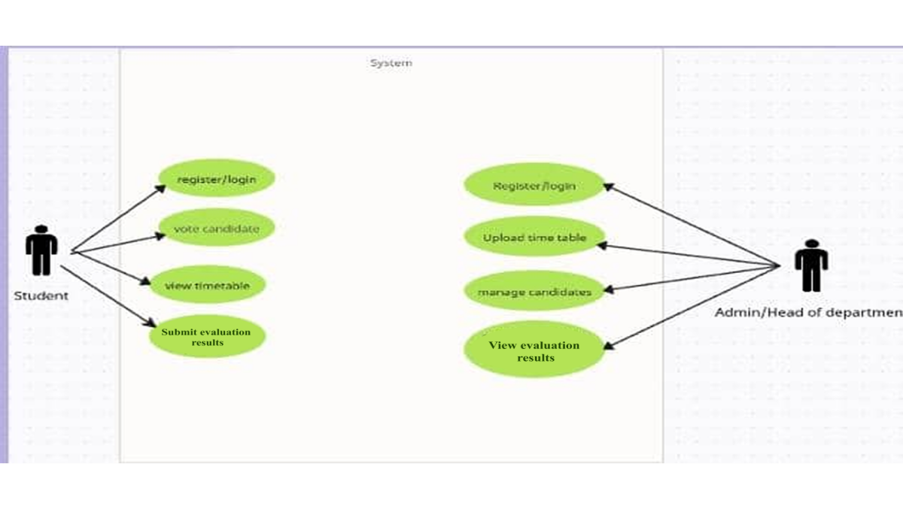
Use case diagram
CLASS DIAGRAM
A class diagram shows the system’s structure by illustrating its classes, their attributes, methods, and the relationships between them. In the NACOS portal, key classes include User, Candidate, Vote, Timetable, and Evaluation. Each class encapsulates relevant data and behavior, enabling modular, maintainable design. The diagram helps developers understand how different parts of the system interact, ensuring clear separation of responsibilities and a solid foundation for implementation.

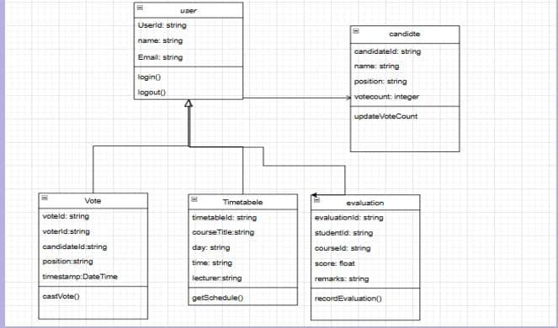
class diagram

CHAPTER 4
DESIGN AND IMPLEMENTATION
SOFTWARE REQUIREMENTS
1. Frontend
i. React.js: For building the user interface.
ii. Node.js: Required to run the React development environment.
iii. React Router: For page navigation.
iv. Tailwind CSS or Bootstrap: For responsive and styled components.
2. Backend / Services
i. Firebase (Google Cloud):
a. Firebase Authentication: For secure user login and role management.
b. Firestore Database: For storing user data, votes, timetables, and evaluations.
3. Development Tools
i. VS Code or any modern code editor.
ii. Git: Version control system.
iii. GitHub: For code repository and collaboration.
- Browser
Google Chrome, Firefox, or any modern web browser (for testing and deployment preview).
HARDWARE REQUIREMENTS
i. Processor: Intel Core i3 or equivalent
ii. RAM: 4 GB (8 GB recommended for smoother performance)
iii. Storage: At least 10 GB of free disk space
iv. Operating System: Windows 10+, macOS, or any modern Linux distro.

NETWORK REQUIREMENTS
Internet Connection: A stable and high-speed internet connection (minimum 10 Mbps) is essential for Firebase services, npm installations, and deployment.

FUNCTIONAL REQUIREMENTS
- The system shall allow students to register and log in securely.
- The system shall allow eligible students to vote in elections.
- The system shall allow administrators to upload and manage evaluation results.
- The system shall display course timetables to students.
- The system shall provide role-based access (students, admins).
- The system shall support mobile responsiveness for user accessibility.

NON-FUNCTIONAL REQUIREMENTS
- Scalability: Must support a growing number of users.
- Usability: Easy to navigate for both students and admins.
- Security: Ensure data protection and secure authentication.
- Performance: Operations should respond within 1-2 seconds.
- Maintainability: Codebase should be modular for easy updates.
- Reliability: System should function correctly 99% of the time.

THE INTERFACE
These are some of the notable features of the interface:
1. Login Page: The login page functions as a gateway into the student portal to access the details and activities of the portal. This contains notable features like an input bar (for username and password), a login button and an option to login with google.
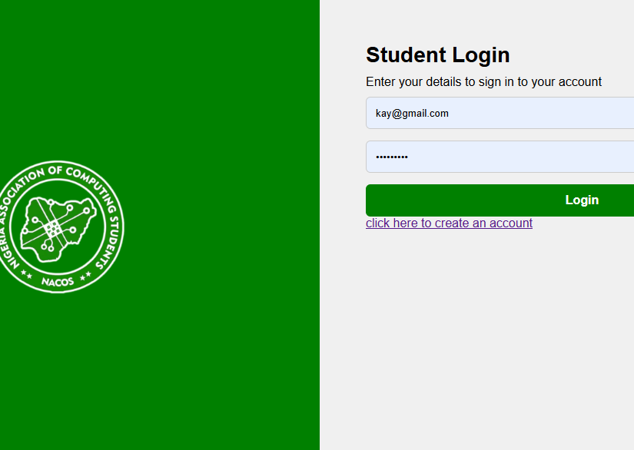
the login page

2. Home Page: The homepage contains A HEADER that boldly identifies the NACOS body. This also contains a NAV BAR for easy navigation across the application. THE BODY section shows the latest update in the NACOS association.

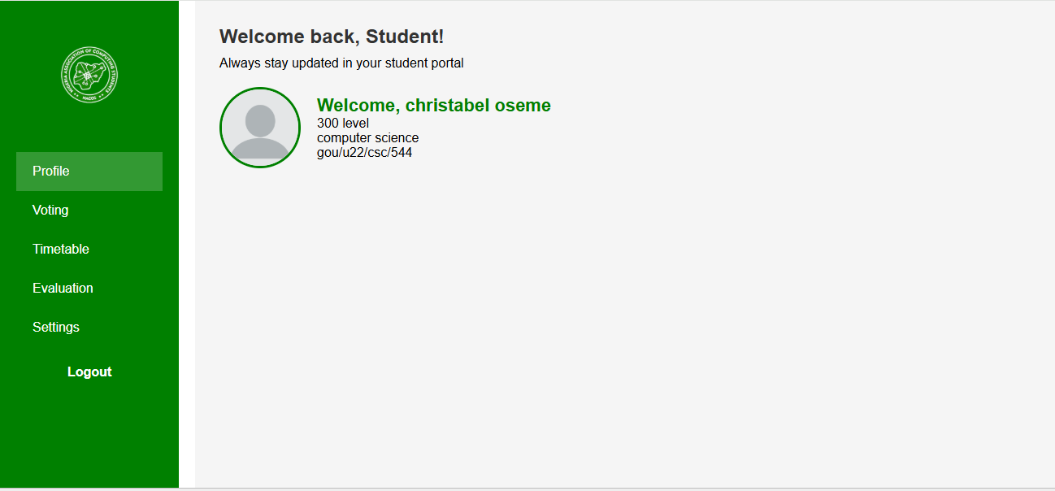
the home page

3. Voting Page: The voting page contains a similar NAVBAR and HEADER as the home page. This also contains a body section with a CONTAINER carrying INPUT BARS for student ID and name which are required for votes.
The names of the contestants are displayed with a RADIO BUTTON for the user to select their preferred contestant. This is then followed by a button to submit the votes.

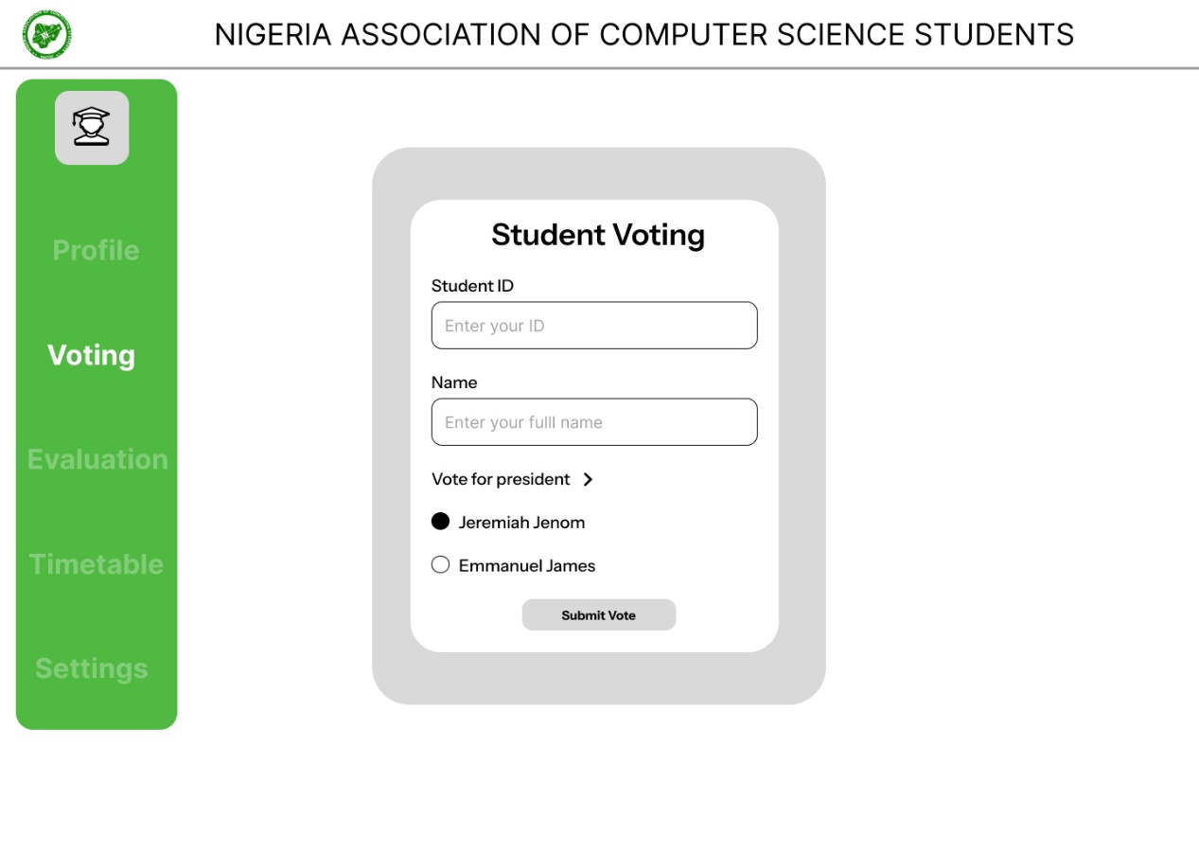
the voting page
Other pages;

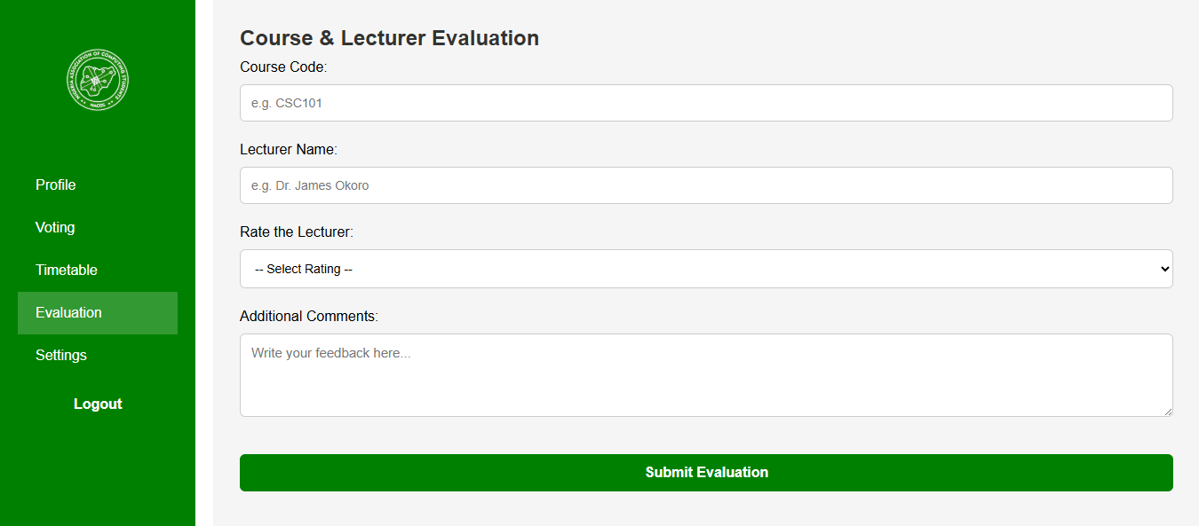Lecturer evaluation
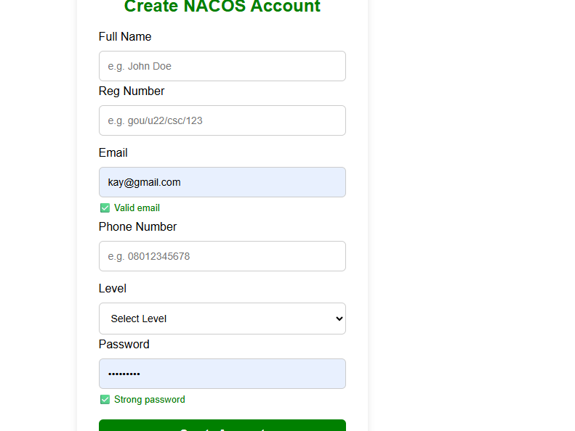

Create an account

CHAPTER 5
SUMMARY AND CONCLUSION
SUMMARY
The NACOS Student Portal is a web-based application designed to streamline key academic and administrative functions for students and executives of the Nigerian Association of Computer Science Students (NACOS). The system focuses on three core modules: student evaluation, e-voting, and timetable management. Built using React.js for a dynamic and responsive frontend and Firebase for secure backend services, the portal provides real-time data handling, role-based access, and mobile-friendly user experiences. It addresses the lack of an existing NACOS digital system and overcomes limitations of outdated student platforms by offering a secure, efficient, and user-centered solution. The portal enhances transparency in elections, simplifies academic data access, and improves communication between students and administrators, thereby fostering a more organized and digitally empowered student body.

RECOMMENDATIONS
Here are some suggestions to improve this projects functionality even more.
- Mobile App Development: Use React Native to develop a cross-platform mobile application that will increase student accessibility and engagement.
2. Link the portal to university databases or portals for integration with school systems (e. g. A. systems for results course registration) to ensure smooth data transfer.
3. Advanced Voting Analytic: For more transparent elections use real-time vote data graphs and fraud detection tools.
4. Notification System: Include push and email alerts to inform users of impending elections schedule modifications and new assessments.
5. Offline Access (PWA): To enable users to access specific features offline convert the portal into a Progressive Web App (PWA).
6. Role Extension: Incorporate additional positions for approving grades or coordinating schedules such as lecturers or course advisers.
7. AI Integration: Apply AI to evaluate trends and make recommendations for enhancements or to optimize schedules.

CONCLUSION
The NACOS Student Portal is an excellent illustration of how contemporary web technologies can address problems related to student administration. A strong and useful area for managing things like voting evaluations and schedules is created by using sophisticated tools like React and Firebase in conjunction with a careful design based on Object-Oriented principles. But the portal promotes accountability openness and student convenience in addition to functionality. In addition to addressing present organizational and academic demands this project opens the door for potential future developments that could improve student organizations operational effectiveness and digital engagement.

REFERENCE

Chigada, J., & Mazhawidza, P. (2024). Security challenges in electronic voting: A case study of student representative council elections. Journal of E-Governance and Digital Innovation, 12(1), 45–59.

Thiga, M. N. (2015). Enhancing participation in student elections through secure online voting systems in Kenyan universities. African Journal of Information Systems, 7(3), 22–35.

Al-Samarraie, H., & Saeed, N. (2018). A systematic review of cloud computing tools for collaborative learning: Opportunities and challenges to the blended-learning environment. Computers & Education, 124, 77–91. (Useful as a source on digital evaluation tools in education)

Adewale, O. S., & Akinyemi, T. A. (2020). Towards effective timetable scheduling in Nigerian universities: A portal-based approach. Nigerian Journal of Technology, 39(2), 425–432.

Nielsen, J. (2012). Usability 101: Introduction to usability. Nielsen Norman Group. Retrieved from https://www.nngroup.com/articles/usability-101-introduction-to-usability/

Godfrey Okoye University. (n.d.). Student Portal Overview. Retrieved from https://www.gouni.edu.ng/student-portal

Sharma, R., & Nigam, D. (2019). Design and development of a web-based student portal using modern web technologies. International Journal of Computer Applications, 177(23), 1-5. https://doi.org/10.5120/ijca2019919665

Omotunde, H. T., & Akintoye, S. O. (2021). Digital voting systems: A case study of e-voting platforms in Nigerian universities. Journal of ICT Development, 9(2), 15–23.

Akinyemi, T. A., & Adewale, O. S. (2020). Adoption of online student portal systems in Nigerian tertiary institutions: Challenges and prospects. Nigerian Journal of Technology, 39(3), 612–619

Ajayi, R. T., & Adebayo, P. O. (2022).
The Impact of Digital Portals on Student Engagement in Nigerian Universities.
Journal of Educational Technology and Development Studies, 7(1), 54–65.

Oluwafemi, T. A. (2021).
Design and Implementation of Online Student Voting Systems in Tertiary Institutions.
International Journal of Computer Applications, 179(6), 12–18.

Nwosu, J. E., & Eze, M. O. (2020).
Improving Student Academic Performance through Feedback and Evaluation Portals.
African Journal of ICT, 14(2), 28–39.

Ibrahim, M. & Yusuf, A. (2019).
Challenges in Developing Multi-functional Educational Platforms in Sub-Saharan Africa.
International Journal of Software Engineering, 11(4), 91–103.

Chigada, J., & Madzinga, R. (2017).
Enhancing Electoral Integrity in Universities through E-voting Solutions.
South African Journal of Information Management, 19(1), a774.

Adeyemi, B. B., & Salawu, A. A. (2018).
Timetable Management Systems and Student Academic Scheduling in Nigerian Institutions.
Journal of Systems and Software Development, 10, 33–41.

Akinyemi, K. O., & Ojo, B. (2023).
An Evaluation of Firebase as a Backend for Real-Time Academic Applications.
International Journal of Cloud Computing and Services Science, 12(3), 20–29.

APPENDIX
Firebase configuration
// firebase-config.js
import { initializeApp } from "https://www.gstatic.com/firebasejs/10.12.2/firebase-app.js";
import { getAuth } from "https://www.gstatic.com/firebasejs/10.12.2/firebase-auth.js";
import { getFirestore } from "https://www.gstatic.com/firebasejs/10.12.2/firebase-firestore.js";

// Firebase config
const firebaseConfig = {
apiKey: "AIzaSyDZ1hwrCzyzNuabWdrNF2J03vSpCcv4Dck",
authDomain: "nacos-portal.firebaseapp.com",
projectId: "nacos-portal",
storageBucket: "nacos-portal.firebasestorage.app",
messagingSenderId: "354805156607",
appId: "1:354805156607:web:c8053b482ebbc06367daca",
};

// Initialize Firebase
const app = initializeApp(firebaseConfig);
const auth = getAuth(app);
const db = getFirestore(app);

export { auth, db };

Admin dashboard
<!DOCTYPE html>
<html lang="en">
<head>
<meta charset="UTF-8" />
<title>Admin Dashboard - NACOS</title>
<link rel="stylesheet" href="style.css" />
</head>
<body>
<div class="sidebar">
<div class="profile-nav">
<img src="./img/nacos-Photoroom (2).png" alt="Admin" class="avatar" />
<p onclick="showSection('profile')" style="cursor: pointer">Admin</p>
</div>
<nav>
<a href="#" onclick="showSection('evaluation')">📊 Evaluation</a>
<a href="#" onclick="showSection('voting')">🗳️ Voting Results</a>
<a href="#" onclick="showSection('timetable')">📅 Manage Timetable</a>
<a href="#" onclick="showSection('settings')">⚙️ Settings</a>
<button id="logoutBtn">Logout</button>
</nav>
</div>

<div class="main-content">
<section id="profile" class="dash-section">
<h2>Admin Profile</h2>
<img
src="./img/blank-profile.webp"
class="avatar-large"
alt="Profile Image"
/>
<p>Name: NACOS Admin</p>
<p>Email: admin@nacos.org</p>
</section>

<section id="evaluation" class="dash-section" style="display: none">
<h2>Lecturer Evaluation Reports</h2>
<p>This section will show detailed feedback from students.</p>
</section>

<section id="voting" class="dash-section" style="display: none">
<h2>Voting Results</h2>
<p>Display vote counts and charts here.</p>
</section>

<section id="timetable" class="dash-section" style="display: none">
<h2>Upload / Update Timetable</h2>
<form>
<label>Select Level:</label>
<select>
<option value="100">100 Level</option>
<option value="200">200 Level</option>
<option value="300">300 Level</option>
<option value="400">400 Level</option></select
><br /><br />
<label>Upload Timetable:</label>
<input type="file" /><br /><br />
<button type="submit">Upload</button>
</form>
</section>

<section id="settings" class="dash-section" style="display: none">
<h2>Admin Settings</h2>
<p>Change password, manage access, etc.</p>
</section>
</div>

<script>
function showSection(id) {
const sections = document.querySelectorAll(".dash-section");
sections.forEach((section) => (section.style.display = "none"));
const active = document.getElementById(id);
if (active) active.style.display = "block";
}

document.getElementById("logoutBtn").addEventListener("click", () => {
sessionStorage.removeItem("user");
window.location.href = "login.html";
});
</script>
</body>
</html>

Styling
* {
box-sizing: border-box;
margin: 0;
padding: 0;
}

body {
margin: 0;
font-family: Arial, sans-serif;
}

.login-container {
display: flex;
height: 100vh;
}

.left-panel {
width: 50%;
background: green;
display: flex;
align-items: center;
justify-content: center;
}

.left-panel img {
width: 200px;
}

.right-panel {
width: 50%;
background: #f0f0f0;
padding: 60px;
}

.right-panel h2 {
font-size: 28px;
margin-bottom: 10px;
}

input {
width: 100%;
padding: 12px;
margin: 10px 0;
border: 1px solid #ccc;
border-radius: 6px;
}

button {
width: 100%;
padding: 12px;
background-color: green;
color: white;
border: none;
border-radius: 6px;
font-size: 16px;
}

.google-login {
margin-top: 20px;
display: flex;
align-items: center;
gap: 10px;
cursor: pointer;
}
/* DASHBOARD STYLE */
.dashboard-container {
display: flex;
height: 100vh;
}

.sidebar {
width: 250px;
background: green;
color: white;
padding: 20px 0;
display: flex;
flex-direction: column;
align-items: center;
}

.sidebar .logo img {
width: 80px;
border-radius: 50%;
margin-bottom: 20px;
}

.sidebar ul {
list-style: none;
padding: 0;
width: 100%;
}

.sidebar ul li {
padding: 15px 20px;
cursor: pointer;
}

.sidebar ul li:hover,
.sidebar ul li.active {
background: rgba(255, 255, 255, 0.2);
}

Importing and collection user data
import { db } from "./firebase-config.js";
import {
collection,
addDoc,
serverTimestamp,
} from "https://www.gstatic.com/firebasejs/10.12.2/firebase-firestore.js";

const form = document.getElementById("evaluationForm");
const statusMsg = document.getElementById("statusMsg");

form.addEventListener("submit", async (e) => {
e.preventDefault();

const user = JSON.parse(sessionStorage.getItem("user"));

const course = document.getElementById("course").value.trim();
const lecturer = document.getElementById("lecturerName").value.trim();
const rating = document.getElementById("rating").value;
const comments = document.getElementById("comments").value.trim();

try {
await addDoc(collection(db, "evaluations"), {
fullName: user.fullName,
regno: user.regno,
email: user.email,
course,
lecturer,
rating,
comments,
submittedAt: serverTimestamp(),
});

statusMsg.textContent = "✅ Evaluation submitted!";
statusMsg.style.color = "green";
form.reset();
} catch (error) {
console.error("Error adding evaluation: ", error);
statusMsg.textContent = "❌ Failed to submit.";
statusMsg.style.color = "red";
}
});

Login and sign up logic
import { auth, db } from "./firebase-config.js";
import { createUserWithEmailAndPassword } from "https://www.gstatic.com/firebasejs/10.12.2/firebase-auth.js";
import {
doc,
setDoc,
} from "https://www.gstatic.com/firebasejs/10.12.2/firebase-firestore.js";

// everything else...

const form = document.getElementById("registerForm");
const nameInput = document.getElementById("name");
const regInput = document.getElementById("regno");
const emailInput = document.getElementById("email");
const phoneInput = document.getElementById("phone");
const levelInput = document.getElementById("level");
const passwordInput = document.getElementById("password");
const status = document.getElementById("status");
// Live validation functions
window.checkEmail = function () {
const email = document.getElementById("email").value.trim();
const feedback = document.getElementById("emailFeedback");
const pattern = /^[^@]+@[^@]+\.[a-z]{2,}$/i;

feedback.textContent = pattern.test(email)
? "✅ Valid email"
: "❌ Invalid email";
feedback.style.color = pattern.test(email) ? "green" : "red";
};

window.checkPhone = function () {
const phone = document.getElementById("phone").value.trim();
const feedback = document.getElementById("phoneFeedback");
const pattern = /^0\d{10}$/;

feedback.textContent = pattern.test(phone)
? "✅ Valid phone"
: "❌ Phone must be 11 digits starting with 0";
feedback.style.color = pattern.test(phone) ? "green" : "red";
};

window.checkRegNumber = function () {
const reg = document.getElementById("regno").value.trim().toLowerCase();
const feedback = document.getElementById("regFeedback");
const pattern = /^gou\/u(2[1-9]|3[0-9])\/csc\/\d{3}$/;

feedback.textContent = pattern.test(reg)
? "✅ Reg number is valid"
: "❌ Format: gou/u22/csc/123";
feedback.style.color = pattern.test(reg) ? "green" : "red";
};

window.checkPassword = function () {
const pass = document.getElementById("password").value;
const feedback = document.getElementById("passFeedback");
const pattern = /^(?=.*[a-z])(?=.*\d).{6,}$/;

feedback.textContent = pattern.test(pass)
? "✅ Strong password"
: "❌ Must be 6+ chars with letters and numbers";
feedback.style.color = pattern.test(pass) ? "green" : "red";
};

form.addEventListener("submit", (e) => {
e.preventDefault(); // prevent form from submitting the traditional way

const fullName = nameInput.value.trim();
const regno = regInput.value.trim().toLowerCase();
const email = emailInput.value.trim();
const phone = phoneInput.value.trim();
const level = levelInput.value;
const password = passwordInput.value.trim();

// Validation patterns
const regPattern = /^gou\/u(2[1-9]|3[0-9])\/csc\/\d{3}$/;
const emailPattern = /^[^@]+@[^@]+\.[a-z]{2,}$/i;
const phonePattern = /^0\d{10}$/;
const passPattern = /^(?=.*[a-z])(?=.*\d).{6,}$/;

// Validate fields
if (!fullName) {
status.textContent = "❌ Full name is required";
status.style.color = "red";
return;
}

if (!regPattern.test(regno)) {
status.textContent = "❌ Invalid Reg Number Format";
status.style.color = "red";
return;
}

if (!emailPattern.test(email)) {
status.textContent = "❌ Invalid Email";
status.style.color = "red";
return;
}

if (!phonePattern.test(phone)) {
status.textContent = "❌ Phone must be 11 digits starting with 0";
status.style.color = "red";
return;
}

if (!level) {
status.textContent = "❌ Please select a level";
status.style.color = "red";
return;
}

if (!passPattern.test(password)) {
status.textContent =
"❌ Password must be at least 6 characters, include a number";
status.style.color = "red";
return;
}

// Create user with Firebase
createUserWithEmailAndPassword(auth, email, password)
.then((userCred) => {
const user = userCred.user;

return setDoc(doc(db, "users", user.uid), {
fullName,
regno,
email,
phone,
level,
role: "student",
createdAt: new Date(),
});
})
.then(() => {
status.textContent = "✅ Account created! Redirecting...";
status.style.color = "green";
setTimeout(() => {
window.location.href = "login.html"; // adjust to your login page
}, 2000);
})
.catch((err) => {
status.textContent = `❌ ${err.message}`;
status.style.color = "red";
});
});

Dashboard structure
<!DOCTYPE html>
<html lang="en">
<head>
<meta charset="UTF-8" />
<title>NACOS Dashboard</title>
<link rel="stylesheet" href="style.css" />
</head>
<body>
<div class="dashboard-container">
<!-- Sidebar -->
<div class="sidebar">
<div class="logo">
<img src="./img/nacos-Photoroom (2).png" alt="Logo" />
</div>
<ul>
<li class="active" onclick="showSection('profile')">Profile</li>
<li onclick="showSection('voting')">Voting</li>
<li onclick="showSection('timetable')">Timetable</li>
<li onclick="showSection('evaluation')">Evaluation</li>
<li onclick="showSection('settings')">Settings</li>
<button id="logoutBtn">Logout</button>
</ul>
</div>

<!-- Main Content -->
<div class="main-content">
<!-- Profile Section -->
<section id="profile" class="section">
<h2>Welcome back, <span id="username">Student</span>!</h2>
<p>Always stay updated in your student portal</p>
<div class="profile-box">
<img
src="./img/blank-profile.webp"
alt="Profile"
class="profile-pic"
/>
<div class="user-info">
<h3 id="studentName">John Student</h3>
<p id="level">100</p>
<p>computer science</p>
<p id="regNo"></p>
</div>
</div>
</section>

<!-- Voting Section -->
<section id="voting" class="section" style="display: none">
<h2>Student Voting Portal</h2>
<form>
<label>Student ID:</label><br />
<input type="text" placeholder="Enter your ID" /><br />
<label>Full Name:</label><br />
<input type="text" placeholder="Enter your full name" /><br />
<label>Vote for President:</label><br />
<input type="radio" name="vote" id="john" /> John Doe<br />
<input type="radio" name="vote" id="jane" /> Jane Smith<br /><br />
<button type="submit">Submit Vote</button>
</form>
</section>

<!-- Timetable Section -->
<section id="timetable" class="section" style="display: none">
<h2>My Timetable</h2>
<table class="timetable">
<tr>
<th>Day</th>
<th>8:00 - 10:00</th>
<th>10:00 - 12:00</th>
<th>12:00 - 2:00</th>
</tr>
<tr>
<td>Monday</td>
<td>CSC101</td>
<td>MAT101</td>
<td>Break</td>
</tr>
<tr>
<td>Tuesday</td>
<td>PHY101</td>
<td>CSC102</td>
<td>Break</td>
</tr>
<!-- Add more days as needed -->
</table>
</section>

<!-- Settings Section -->
<section id="settings" class="section" style="display: none">
<h2>Settings</h2>
<p>Coming soon...</p>
</section>

<!-- Evaluation Section -->
<section id="evaluation" class="section" style="display: none">
<h2>Course & Lecturer Evaluation</h2>
<form id="evaluationForm">
<label>Course Code:</label><br />
<input
id="course"
type="text"
placeholder="e.g. CSC101"
required
/><br /><br />

<label>Lecturer Name:</label><br />
<input
id="lecturerName"
type="text"
placeholder="e.g. Dr. James Okoro"
required
/><br /><br />

<label>Rate the Lecturer:</label><br />
<select id="rating" required>
<option value="">-- Select Rating --</option>
<option>Excellent</option>
<option>Good</option>
<option>Average</option>
<option>Poor</option></select
><br /><br />

<label>Additional Comments:</label><br />
<textarea
id="comments"
rows="4"
placeholder="Write your feedback here..."
></textarea
><br /><br />

<button type="submit">Submit Evaluation</button>
<p id="statusMsg"></p>
</form>
</section>
</div>
</div>
<script>
function showSection(sectionId) {
const sections = document.querySelectorAll(".section");
sections.forEach((section) => (section.style.display = "none"));
document.getElementById(sectionId).style.display = "block";

const items = document.querySelectorAll(".sidebar ul li");
items.forEach((item) => item.classList.remove("active"));
event.target.classList.add("active");
}
const user = JSON.parse(sessionStorage.getItem("user"));

if (user) {
document.getElementById(
"studentName"
).textContent = `Welcome, ${user.fullName}`;
document.getElementById("regNo").textContent = user.regno;
document.getElementById("level").textContent = `${user.level} level`;
} else {
// If no user info, redirect to login
window.location.href = "login.html";
}
document.getElementById("logoutBtn").addEventListener("click", () => {
sessionStorage.clear();
window.location.href = "login.html";
});
</script>
<script type="module" src="dashboardScript.js"></script>
</body>
</html>

