IDENTIFICATION AND CONSERVATION OF INDIGENOUS MEDICINAL PLANTS FOUND IN SELECTED LGA’S IN ENUGU STATE USING DNA BARCODING.

EKEOGBEDE, EBUKA FAVOUR
U19/NAS/BTG/262

BIOTECHNOLOGY
DEPARTMENT OF BIOLOGICAL SCIENCES
FACULTY OF NATURAL AND ENVIRONMENTAL STUDIES
GODFREY OKOYE UNIVERSITY, ENUGU NIGERIA

JULY, 2023

IDENTIFICATION AND CONSERVATION OF INDIGENOUS MEDICINAL PLANTS FOUND IN SELECTED LGA’S IN ENUGU STATE USING DNA BARCODING.

EKEOGBEDE, EBUKA FAVOUR
U19/NAS/BTG/262

BIOTECHNOLOGY
DEPARTMENT OF BIOLOGICAL SCIENCES
FACULTY OF NATURAL AND ENVIRONMENTAL STUDIES
GODFREY OKOYE UNIVERSITY, ENUGU NIGERIA

A PROJECT RESEARCH SUBMITTED TO THE DEPARTMENT OF BIOLOGICAL SCIENCES IN PARTIAL FULFILMENT OF THE REQUIREMENTS FOR THE AWARD OF BACHELOR OF SCIENCE (B.Sc) DEGREE IN BIOTECHNOLOGY

MRS. C. C ENE

JULY, 2023
APPROVAL
This research titled Identification and conservation of indigenous medicinal plants found in some LGA’s in Enugu state using DNA barcoding has been assessed and approved by the Committees of Department of Biological Sciences and Faculty of Natural Sciences and Environmental Studies, Godfrey Okoye University Enugu, Nigeria.

……………………………………. ………………………………
Mrs. Christabel C. Ene Date
Supervisor

…………………………………… ………………………………
Dr. Frances N. Olisaka Date
HOD, Department of Biological Sciences

CERTIFICATION
This is to certify that this research titled Identification and conservation of indigenous medicinal plants found in some LGA’s in Enugu state using DNA barcoding was carried out by Ekeogbede, Ebuka Favour with Registration Number U19/NAS/BTG/262 under supervision in the Department of Biological Sciences, Godfrey Okoye University Enugu, Nigeria.

……………………………………. ………………………………
Ekeogbede, Ebuka Favour Date
Supervisor

DEDICATION
This research work is highly dedicated to the almighty God; Jehovah Jireh, Jehovah Elshadai, the Bishop of my soul, who sustained me throughout the period of this work till this time.
I am also dedicating this piece of research to the foundation Vice Chancellor of Godfrey Okoye University, Enugu, Very Reverend Father Professor, Dr. Christian Anieke. A progenitor, a charismatic, industrious and hardworking leader, whose dogged quest and insatiable thirst for impeccable academic excellence with concrete evidence has inspired this work.

ACKNOWLEDGEMENTS

I am most grateful to the Almighty God for his grace and mercies towards us. He was in control of everything that was involved from the beginning to the final stage of this research work.
I must acknowledge a teacher and a mother– Mrs. Christabel C. Ene, who though is my supervisor, never saw it as that. She essentially took the opportunity to instruct me further on the subject. I hope that her efforts to show her affection will never be in vain.
I also need to acknowledge Mr. Mike Okoro, who, despite being my lecturer, adopted me as a son. He has been a teacher, mentor, friend, and leader. The best teacher, whose effective and practical teaching style served as an inspiration for my work and a major influence on my thinking and inspire me to work hard.
I want to appreciate the following people: The Dean, Natural and Applied Sciences – Professor Chidi Uhuegbu; My Head of Department, Dr. F. Ngozi Olisaka, my wonderful Lecturers – Prof. Ezeonu, Prof. Marire, Asso Prof. Onyia, Dr. Linda, Dr. C. Okafor, Dr. Oyeagu, Mr Mike, Mrs. Christabel, Mrs Maria, Miss Paschaleen, may God bless you all.
Without my great father Chief Emmanuel Obi whose financial capacity has been stretched within my 4 years of rigorous study, this work wouldn’t have been successful. Daddy, I say a very big thank you.
Particular gratitude goes to my mother; Mrs. Lovelyn Obi who generously shared her ideas, time and finances with me to make sure this research work was carried out successfully. God bless you mum.
God bless you to my siblings, Bro Emmy, Bro Ugo, Bro Ossy, West, and Graces. Without the supportive environment you provided at home and the allowance that I received, which promotes and strengthens the intense academic competition, this task would not have been finished.
I also owe an intellectual debt of knowledge to my lecturers who taught me with patience, tolerance and understanding. They supervised, proofread and guided me to the completion of this work.
I must not fail to thank all those who graciously helped me to source, gather and compile information and accurate data at various levels.
I am equally indebted to my friends; Mmesoma, Fortune, Mrs Obih, JP, Edwin, Kosi-Gold and all NIFESIANS who rallied round me during the course of this work, ranging from prayers, gifts and encouragements. I am grateful to God for having in my Life.
Finally, may the good lord bless and protect those who in one way or another saw to the completion of this work.
May God reward and bless you all!

ABSTRACT
This research work DNA Barcoding of Traditionally Used Medicinal Plants in Enugu State, was aimed at cataloguing the various medicinal plant biodiversity available within reach in some LGA of Enugu state. The use of plants as medicine was practiced by our ancestors, a process which must have started by trial and error until now. Twenty-four samples of medicinal plants were gathered from the three prominent towns in Enugu state: Akautara uwenu inNsukka, Ngwo, and Ugwuomu-Nike. A gene region in the chloroplast rbcl gene was amplified through PCR using rbcl primers after DNA from the medicinal plants was extracted using the silica resin technique. A considerable amount of the DNA was successfully recovered from the gel after the agarose gel electrophoresis was complete. Though all the DNA was retrieved, some were more apparent than the others. The PCR amplicons were validated using agarose gel electrophoresis, 66.7% (16) samples had clear DNA bands, 16.7% (4) samples had faint DNA bands, while 16.7% (4) samples had no DNA bands, after gel electrophoresis section, after that, the amplicons were transferred to Genewiz INC. for sequencing.The samples were analyzed using the blue line DNA Barcoding pattern of the DNA Subway and National Center for Biotechnology Information (NCBI). After analysis, 16.67 % (4 samples) had new polymorphisms, 50.00% (12 samples) were existing records and 20.83% (5 samples) needs identification. The preservation of traditional knowledge pertaining to the utilization and preservation of medicinal plants holds great significance, as these groups possess invaluable knowledge that contributes to scientific progress and the application of DNA barcoding approaches for the identification and conservation of these medicinal plants.

TABLE OF CONTENTS
Title page i
Approval ii
Certification iii
Dedication iv
Acknowledgement v
Abstract xi
List of Tables viii
List of Figures ix
List of Appendices x

CHAPTER ONE: INTRODUCTION
1.1 Background Study 1
1.2 Problem Statement 3
1.3 Significance of Study 3
  - Scope of Study 5
1.5 Aim and Objectives 6

CHAPTER TWO: LITERATURE REVIEW
2.1 Introduction to Medicinal Plants 7
2.2 The Economic Advantages of Employing Barcoding
Techniques for Traditionally Utilized Medicinal Plants. 9
2.3 The Value of Medicinal Plants as Antimicrobials 10
2.4 DNA barcoding: An innovative technology for plant authentication 13

CHAPTER THREE: MATERIALS AND METHODS
3.1 Study Area 17
3.2 Sample Collection 17
3.3 Images of Plant Samples Collected 19-24
  - Experimental Methods 25
3.4.1 Test Materials 25
3.4.2 DNA Extraction 25
3.4.3 Amplification by Polymerase Chain Reaction (PCR), Agarose Gel Electrophoresis
and DNA Sequencing 27
3.4.4 Data Analysis Using DNA Subway and MEGA 11 Software 27

CHAPTER FOUR: RESULTS
4.1 Gel Electrophoresis Results 29
4.1.1 Plates of Gel Plates after Electrophoresis 30
4.2 Graphs from DNA Sequence Reads 32
4.3 Sequence Alignment Of DNA Sample Using Clustalw 35
4.4 Phylogenetic Tree Using Maximum Likelihood 37

CHAPTER FIVE: DISCUSSION AND CONCLUSION
5.1 Discussion 38
5.2 Conclusion 40
5.3 Recommendation 41

REFERENCES 42
Appendices 47

LIST OF TABLES
TABLE 3.1: List of Plants Collected 18
TABLE 4.1: Gel Quality Check for Extracted Plant DNA Samples 31
TABLE 4.2: DNA Data Analysis 33
TABLE 4.3: Blast Results OF DNA Sample from NCBI and DNA Subway 36

LIST OF FIGURE
Figure 2.1: DNA barcode identification work flow 16
Figure 4.1: Alignment of DNA sample sequences using ClustalW multiple alignment pattern 35
Figure 4.2: Phylogenetic tree of the Medicinal plants as revealed by rbcl barcoding marker 37

LIST OF APPENDICES
Appendix 1: Sample collection process at sampling site 47
Appendix 2: DNA extraction and polymerase chain reaction amplification process 49

CHAPTER ONE
INTRODUCTION
  - Background Study
It is clear from the history of humanity that medicinal plants have been utilized as part of the treatment plan to treat a wide range of illnesses, including those brought on by insects, fungus, bacteria, and viruses. The compounds found in this plants are what gives them their effects, and they function similarly to traditional medications in this regard (Sharma et al., 2017). As long as humans have existed, people have used medicinal plants to treat illness. Although their chemical components are not always fully understood, popular observations on the usage and performance of medicinal plants considerably contribute to the revelation of their therapeutic characteristics, resulting in their widespread prescription (Silva and Fernandes, 2010), for example before the middle ages bearberry (Arctostaphylos uva-ursi) and cranberry juice (Vaccinium macrocarpon) as reported in various phytotherapy manuals are used to treat urinary tract infection, while the tree (Melaleuca alternifolia), lemon balm (Melissa officinalis) and garlic (Allium sativum) were known to contain broad-spectrum antimicrobial properties (Rios and Recio, 2005) . There have been reports of a variety of biological activity, including antibacterial, anti-inflammatory, and antioxidant properties, in extracts derived from medicinal plants. When implemented to treat resistant microbial strains, the antimicrobial chemicals from medicinal plants may limit the development of bacteria, fungus, viruses, and protozoa through processes other than those employed by currently used antimicrobials (Vaou et al., 2021).
The advancement of DNA barcoding contributed to improved biodiversity identification and classification (Li et al., 2014). Certainly, DNA barcoding doth present itself as a most advanced technique for the discovery of biological specimens, employing concise DNA sequences derived from either the organelle or nuclear genomes. Paul Hebert of the University of Guelph initially suggested the phrase "DNA barcode" as taxon identifiers in 2003. He suggested that the mitochondrial genome's 5ʹ end of cytochrome c oxidase 1 (CO1) was adequate to produce DNA barcodes for animal identification. CO1 was proposed as a region that may produce recognition tags for all creatures in light of this early success with mammals. They emphasized further that DNA barcoding may identify species boundaries, indicate new species, and differentiate between species in addition to assisting in species identification (Techen et al., 2014), as the task of selecting a conventional barcode or barcodes for plants became increasingly challenging, researchers turned their attention to exploring alternative barcode regions. Consequently, two specific regions of plastid DNA were identified as suitable candidates: a 600 base pair segment of the rbcL gene and an 800 base pair segment of the matK gene. It was recommended to augment these geographical areas with the trnH-psbA sequence and the internal transcribed spacers (ITS) of nuclear ribosomal DNA (Coissac et al., 2016).
To distinguish between different species throughout the world, DNA barcoding entails sequencing one or a few standard DNA regions. Since its inception in 2003, DNA barcoding has evolved into a collaborative research endeavour encompassing numerous disciplines, engaging a substantial number of scientists. The collective endeavours of these researchers have yielded a vast repository of barcode sequences, numbering in the millions. (Coissac et al., 2016).
Hebert and his colleagues have consistently praised the merits of barcoding in multiple scholarly publications, beginning with the initial studies on barcoding published in 2003. The identification of individuals down to species level has been achieved with a high degree of success in North American birds, with success rates ranging from 98 to 100%. This accomplishment has been made possible by utilising a single short sequence of the COI gene. Furthermore, similar achievements have been observed in recent studies involving tropical Lepidoptera and Australian fish. (Dasmahapatra and Mallet, 2006).
  - Problem Statement
The large diversity of native medicinal plants in Enugu state Nigeria are under risk as a result of problems including urbanization, deforestation, and habitat loss. However, due to their incomplete documentation and ambiguous identification, these plants are facing challenges of proper protection and utilization in a sustainable manner. The methods of plant identification that have been employed in the past are usually laborious and imprecise. A systematic approach applying DNA barcoding techniques is required to accurately identify and authenticate indigenous medicinal plants in several LGAs of Enugu State and allow their conservation and sustainable usage for the benefit of the local population.
  - Significance of Study
This study employing DNA barcoding to identify and preserve native medicinal plants in Enugu State is of utmost importance. It entails a variety of characteristics that support the preservation of biodiversity, sustainable traditional medicine, health and wellbeing of the population, economic development, the preservation of traditional knowledge, policy and strategy development, scientific advancements, and capacity growth.
Firstly, it is crucial to preserve biodiversity. The state of Enugu is renowned for having a wide variety of indigenous medicinal plants and a great biodiversity. These plants contain chemical compounds that might have medicinal properties and traditional medicine is essential to healthcare systems, especially in rural regions where there may not be as many contemporary medical facilities. The construction of trustworthy plant databases is made possible by the accurate identification of indigenous medicinal plants using DNA barcoding. These databases can educate traditional healers and practitioners about the proper use of plant species, minimizing the danger of misidentification and potential negative consequences.
Secondly, the study acknowledges the connection between ecological services and human welfare. Native medicinal plants provide ecological benefits such pest management, pollination, and soil fertility and it contributes to keeping ecosystems balanced by preserving these plants, which generally improves agricultural output and food security. The economic benefits these native medicinal plants presents are significant as these plants serve as sources of raw materials for pharmaceutical, cosmetic and nutraceutical industries. The accurate identification using DNA barcoding assures the authenticity and quality of plant-based products, promoting the development of regional businesses, the creation of jobs, and the generation of revenue for the local economy.
The preservation of traditional knowledge about the use and conservation of medicinal plants is of utmost importance as these communities possess valuable knowledge that is important for scientific advancement and the use of DNA barcoding techniques to identify and conserve these medicinal plants contributes or advances our understanding of plant taxonomy, genetics and conservational biology. This research also has the potential to uncover novel species, reveal genetic differences within species, and advance our knowledge of the evolutionary connections among medicinal plants.

  - Scope of Study
This project employs DNA barcoding to identify and protect native medicinal plants in a few local government areas (LGAs) in Enugu state, Nigeria. In order to accurately identify and compare the plant species present in these locations, field surveys and DNA barcoding techniques are used. To bridge the gap between conventional practices and scientific breakthroughs, traditional knowledge about medicinal plants is merged. Based on the evaluation of a species' conservation status and the identification of threats, conservation plans are created. These tactics might involve the creation of protected areas, ethical harvesting methods, and neighborhood-based conservation programmes. Policy advice on sustainable use and legal frameworks are given to help policymakers, conservation organizations, and stakeholders. By producing DNA barcoding data and growing the database of recognized medicinal plant species, the project advances science. By facilitating phylogenetic analyses and genetic diversity assessments, it improves understanding of plant taxonomy, genetics, and conservation biology. The importance of cooperation and capacity building is highlighted, incorporating local researchers, students, and community people. The research encourages multidisciplinary cooperation among politicians, traditional healers, ecologists, and botanists.
The overall scope of the study includes capacity building, policy suggestions, scientific breakthroughs, traditional knowledge identification, conservation, and integration. It aims to protect the rich biodiversity of local medicinal plants, ensure sustainable traditional medicine, improve ecosystem services, foster collaboration for the benefit of the environment and local communities, and preserve traditional knowledge. It also aims to create economic opportunities and preserve traditional knowledge.

  - Aim and Objectives
Aim: This study was aimed at identification and conservation of indigenous medicinal plants found in selected L.G.A’s in Enugu state using DNA barcoding.
Specific objectives are:
- To characterize and identify various medicinal plants using DNA barcoding techniques.
- Determining Phylogenetic relationships between collected samples and already documented samples in the international gene database.
- To determine the species of unknown specimens using bioinformatics analysis of plant sequences using the DNA subway platform.

CHAPTER TWO
LITERATURE REVIEW
2.1 Introduction to Medicinal Plants
Since the beginning of time, humans have used plants for a variety of purposes. On a Sumerian clay slab from Nagpur that is considered to be around 5000 years old, the earliest documented written account of employing plants for wellness has been found (Suntar, 2019). Because of their special characteristics as a substantial source of medicinal phytochemicals that may lead to the development of novel pharmaceuticals, medicinal plants are currently seen to be of considerable importance (Azwanids, 2015). Additionally, medicinal plants have a significant impact on people's and communities' health. Initially, these medications were used as straightforward powders, herbal teas, vaporizers, poultices, etc. Since the early nineteenth century, the separation of active ingredients has been a component of the use of medicinal herbs. In 1803, Serturner made a discovery that led to the separation of morphine from opium, marking the beginning of natural product chemistry. Alkaloids, tannins, flavonoids, and phenolic compounds are the most significant of these plant bioactive components, and they are responsible for most of these plants' medicinal efficacy. These chemicals have a definite physiological impact on the human body. (Edeoga et al., 2005 and Suntar, 2019). In the ethnomedical treatment of a wide range of ailments, plants continue to be the most prevalent natural main source of active drugs. Herbal therapy continues to be the main form of treatment for 75–80% of the population, primarily in developing countries, due to its higher cultural acceptance, greater effectiveness with the human body, and lower risk of side effects. The majority of medicinal plants are suppliers of several phytochemicals, some of which are frequently responsible for their biological actions (Ugboko et al., 2020). However, during the past several years, their use in the industrialized world has greatly expanded. (Parekh et al., 2005). Currently, there is a rapid increase of requirement for plants with medicinal properties for the physical separation of natural bioactive chemicals. For instance, Hypericum perforatum is recognized as the top medicinal plant in the world due to its antiviral, antibacterial, antifungal, anti-cancer, anti-inflammatory, and anti-oxidant properties (Mulat et al., 2020).
Over the span of billions of years, nature has evolved to be incredibly varied, but plants in particular retain enormous relevance because of the significance of their metabolites, with over 250.000 plant species now known to exist. These plants are known to generate a large range of phytochemicals (secondary metabolites), which are engaged in interactions between organisms, in addition to the primary metabolites that are essential for a live cell. (Suntar, 2019). Since the 1990s, there has been a growing interest in using plants as potential sources for new pharmaceuticals. Many large pharmaceutical firms are showing interest in medications derived from plants due to the widespread perception that "Green Medicine" is more reliable and effective than more expensive synthetic pharmaceuticals with unfavorable side effects (Pavithra et al., 2010). Some of the traditional ways for identifying medicinal plants include organoleptic techniques (identification by the senses of taste, sight, smell, and touch), macroscopic and microscopic methods (identification by shape, color, and texture), and chemical profiling (e.g. TLC, HPLC-UV, HPLC-MS). But neither method makes it easy to identify related species in processed foods, as the former need for knowledgeable individuals to do macroscopic and microscopic research. (Techen et al, 2014).

2.2 The Economic Advantages of Employing Barcoding Techniques for Traditionally Utilized Medicinal Plants.
Traditional medicine has been practiced in Africa for many centuries and is a significant component of its sociocultural legacy and The utilisation of traditional medicines remains a predominant healthcare approach among populations in developing countries across the globe (Elujoba et al., 2005 and Cunningham, 1993). While a widespread implementation of a micro genomic identification system has not yet been undertaken, sufficient research has been conducted to identify crucial design components. Due to its lack of introns, limited exposure to recombination, and haploid form of transmission, the animal mitochondrial genome is a better research topic than the nuclear genome (Saccone et al. 1999). The mitochondrial genes that encode ribosomal (12S, 16S) DNA have drawn a lot of attention in previous phylogenetic studies, but their use in thorough taxonomic analysis is constrained by the prevalence of insertions and deletions (indels), which make it challenging to match sequences (Doyle & Gaut 2000). The 13 protein-coding genes in the animal mitochondrial genome are great targets since the majority of indels cause a change in the reading frame. Despite the fact that there is no compelling a priori rationale to focus research on the cytochrome c oxidase I gene (COI), there are two important benefits to doing so. First of all, the 59 end of this gene may be retrieved from members of the vast majority, if not all, animal phyla (Folmer et al. 1994; Zhang & Hewitt 1997). This is made feasible by the gene's extremely potent universal primers. Secondly, COI appears to have a greater range of phylogenetic signal than other mitochondrial genes. Similar to other protein-coding genes, it has a high incidence of base substitutions in its third-position nucleotides, which leads to a molecular evolution rate that is around three times quicker than that of 12S or 16S rDNA (Knowlton and Weight 1998). Furthermore, the rapid evolution of this gene allows for the separation of closely related species as well as phylogeographic groups within the same species. (Cox & Hebert 2001; Wares & Cunningham 2001).
2.3 The Value of Medicinal Plants as Antimicrobials
Herbal medicines are a subject that is receiving more and more worldwide attention due to its potential health benefits and economic worth, and it has been consistently shown that infectious diseases are one of the primary risks to global health. According to the World Health Organization (WHO), infectious diseases were to blame for 5.9 million of the 9.6 million fatalities that occurred in sub-Saharan Africa in 2013 or 61.7% of all deaths. Studies have been undertaken all around the world to demonstrate the efficacy of medicinal plants, and some of these bodies of data have given light on the synthesis of plant-based compounds having therapeutic purposes. (Ugboko et al., 2020). In general, the quantity of phytochemicals (secondary metabolites) found in plants is crucial for treating a variety of illnesses affecting people, animals, and plants. In particular, among microorganisms, drug resistance is now rapidly growing. To find new, significant bioactive compounds, scientists are focusing on medicinal plants. In a variety of plant extracts made by decoction, maceration, infusions, and other methods, for instance, the presence of secondary metabolites that contribute to antibacterial action has been shown. (Mulat et al., 2020).
The antimicrobial chemicals found in medicinal plants may inhibit the development of bacteria, fungus, viruses, and protozoa through different processes than those of currently used antimicrobials, and they may have significant clinical benefit in the treatment of microbial strains that are resistant to current antimicrobials (Vaou et al., 2019). Numerous different chemical compounds found in medicinal plants have been discovered in vitro to possess antibacterial properties. Plants create around 100,000 small compounds, and the majority, if not all, of these molecules have antibacterial capabilities. They frequently produce orders of magnitude less than the normal antibiotics produced by bacteria and fungi, and they frequently have lesser action. Although this may not initially appear to be optimistic for drug development, deeper examination reveals cause for a positive outlook (Lewis and Ausubel, 2006).
Nine plants were looked at for possible antibacterial activities in 2005 by Nair et al. A few of the plants looked at included Hibiscus rosasinensis, Sapindus emarginatus, Mirabilis jalapa, Rheo discolor, Nyctanthes arbortristis, Colocasia esculenta, Gracilaria corticata, Dictyota sp., and Pulicaria wightiana. The six bacterial strains examined for antibacterial activity were Pseudomonas testosteroni, Staphylococcus epidermidis, Klebsiella pneumoniae, Bacillus subtilis, Proteus morganii, and Micrococcus flavus. Agar spreading of discs and Agar disc diffusion were the two techniques utilized to examine the antibacterial activity of each plant. The most resilient bacterial strains were Klebsiella pneumoniae and Pseudomonas testosteroni. Strong action against the studied bacteria strains was demonstrated by Sapindus emarginatus. Also Bupesh et al, 2007 investigated the antibacterial efficacy of Mentha piperita leaf extracts against harmful microorganisms as Streptococcus aureus, Bacillus subtilis, Pseudomonas aureus, and Pseudomonas aeruginosa. By using an in vitro diffusion of agar wells method, it was discovered that both the aqueous and organic compounds of the leaves had significant antibacterial properties against a variety of pathogenic bacteria. Mentha piperita leaf extract in ethyl acetate shown more pronounced inhibition than chloroform, petroleum ether, and water, with leaf extracts being more effective against Streptococcus aureus, Pseudomonas aeruginosa, and Serratia marcescens. Research findings by Betoni et al, 2006, on the antimicrobial properties of 70% methanol extracts from the leaves of Mikania glomerata ("guaco"), P. guajava ("guava"), Baccharis trimera ("carqueja"), Mentha piperita ("peppermint"), Cymbopogon citratus ("lemongrass"), A. sativum ("garlic"), Syzygium aromaticum ("clove"), and Zingiber officinale ("ginger") all of the plants tested in nature exhibited some efficacy against S. aureus, although the extracts from clove and guava were the most potent at 0.36 mg/mL and 0.56 mg/mL, respectively.
The pharmacologically relevant compounds (tannins) from the plant species Solanum trilobatum were examined in 2009 by Dos et al using the agar diffusion method against the bacteria Staphylococcus aureus, Streptococcus pyrogens, proteus vulgaris, and Escherichia coli. Tannins showed antibacterial activity against all tested microorganisms. Staphylococcus aureus, Streptococcus pyrogens, Salmonella typhi, Escherichia coli, Proteus vulgaris, and Pseudomonas aeruginosa were the bacteria that were most resistant to the tannins in the plant material. The tannins had a minimum bactericidal concentration of 1.5–2.0 mg/ml and a minimum inhibitory concentration of 1.0–2.0 mg/ml.
The antibacterial effects of a few Indian medicinal plants on different causes of acne vulgaris were examined in a study conducted by Kumar et al. in 2007. Alcohol was used to extract Hemidesmus indicus roots, Eclipta alba fruits, Curcubito pepo seeds, Tephrosia purpurea roots, Mentha piperita leaves, Pongamia pinnata seeds, Symplocos racemosa barks, Euphorbia hirta roots, Tinospora cordyfolia roots, Thespesia populnea roots, and Jasminum officinale roots. According to the results of the disc diffusion method, Propioni bacterium acnes may be prevented from developing by seven medicinal herbs. Strong inhibitory effects were also noted for Hemidesmus indicus, Coscinium fenestratum, Tephrosia purpurea, Euphorbia hirta, Symplocos racemosa, Curcubito pepo, and Eclipta alba among these. The greatest antibacterial effect was demonstrated by the Coscinium fenestratum extract, according to a broth dilution technique.
2.4 DNA barcoding: An innovative technology for plant authentication
The latest advances in the field of molecular genetics have given researchers a variety of novel methods for quickly and accurately identifying different plant species and another strong technology was developed as a result of the expanding advances in taxonomy and biotechnology. DNA barcoding is a new technology added to the taxonomic toolbox. They promoted the use of DNA barcodes, or small sequences of DNA from a specific area of the genome, for identifying living things. It suggests using normal DNA locus sequencing to identify species (Mishra et al., 2016).
DNA barcoding, which has been widely hailed as a groundbreaking taxonomic identification method, may be the most trustworthy framework now available for classifying organisms and specimen-based data necessary for a systematic study. Depending on how much information is available for the barcoded specimens, organizing specimens by barcode genotype early in the study process enables efficient material inspection and helps the organization and maintenance of a plethora of character data and life history information (Goldstein and DeSalle, 2019).
According to Frézal et al. (2008), DNA barcoding is an important prerequisite for numerous advanced biological studies that modern society must adopt to address a number of pressing biological issues, including the requirement to preserve biodiversity, ensure biosecurity, protect species, and prevent pandemics. Then, according to Rusch et al. (2007), automated species identification using DNA barcoding is possible and is particularly helpful in large-scale sampling campaigns due to its efficiency in terms of cost and time.
Furthermore, Frézal and Leblois (2008) noted that DNA barcoding gives access to a public reference library of taxa, enabling the identification of a broad variety of species, which will be useful whenever precise taxonomic identification is necessary. In this approach, the DNA barcode can greatly benefit the bio-industry as well as several scientific fields (such as ecology, biomedicine, epidemiology, evolutionary biology, biogeography, and conservation biology).
The quick collection of molecular data is a clear benefit of DNA barcoding. Contrarily, collecting morphological data might be time-consuming, in some cases completely confused, and in other circumstances, nearly impossible (for example, the taxonomy of dinoflagellates, Litaker et al., 2007; diatoms, Evans et al., 2007; earthworms, Huang et al., 2007).
Additionally, under three crucial circumstances, molecular-based species identification is a must. Identifying the taxonomic identify of harmed creatures or parts of them (such as products, food, and stomach extracts) comes first.
The food business, nutrition analysis, forensic sciences, and the prevention of the illegal trade and poaching of endangered species (such as fisheries, trees, and bush meat) are all possible applications for the DNA barcoding technique.
When there are no obvious ways to match adults with immature specimens (such as fish larvae, Pegg et al., 2006; amphibians, Randrianiaina et al., 2007; coleopterans, Caterino and Tishechkin, 2006; Ahrens et al., 2007; and fungal sexual stage, Shenoy et al., 2007), molecular-based identification becomes necessary.
The third case is when morphological traits do not clearly discriminate species (e.g. red algal species, Saunders, 2005; fungal species, Jaklitsch et al., 2006; and field-collected mosquito specimens, Kumar et al., 2007), especially when size precludes visual identification (i.e. 'unseeable animals', Blaxter et al., 2005; Webb et al., 2006) or if species have polymorphic life cycles and/or exhibit pronounced phenotypic plasticity (e.g. Lamilariales, Lane et al., 2007).
DNA barcoding by Hajibabaei et al. (2007b) is also of interest to experts. Because species must be taxonomically characterized before being deposited in BOLD in order to meet the CBOL goals, researchers must first settle analytical, technological, and basic problems. Additionally, it integrates (and enhances) population genetics, molecular phylogenetics, and taxonomy.
DNA barcoding might be considered a "tremendous tool" to hasten the finding of new species and to begin their descriptions, according to Rubinoff and Holland (2005).
According to Herbert et al. (2003), food fraud and goods derived from conserved species are also caught using DNA barcodes. Students from Trinity High School discovered, in collaboration with experts from Rockefeller University and the American Museum of Natural History, that 25% of 60 seafood items bought in grocers and restaurants in New York City were mistakenly labeled as costlier species. The endangered Acadian redfish was one fish that was mislabeled. The source of the sushi served in California and Korea, according to a different organization, is three endangered whale species. However, the use of DNA barcodes to spot possible biological contraband among items confiscated by customs is still in its infancy.
According to Cunningham (1993), over time, specific flora species that were sources of supply for traditional remedies may substantially reduce as a result of forest clearing for agriculture, reforestation of montane grasslands, uncontrolled burning, and animal grazing. A phylogenetic tree may be used to identify DNA barcoding's relationship to the discovery of new creatures and species, according to Hollingsworth et al. (2009).

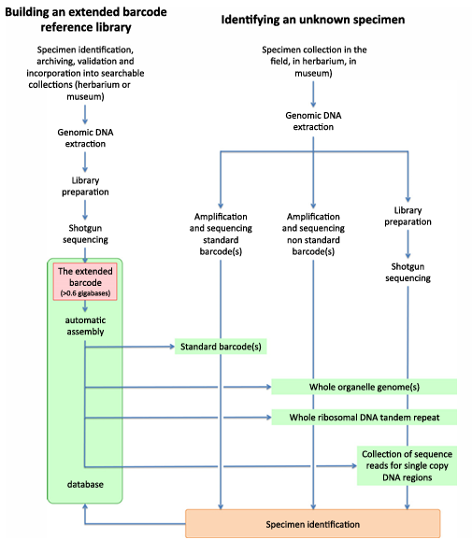
Figure 2.1: DNA barcode identification work flow

CHAPTER THREE
MATERIALS AND METHODS
3.1 Study Area
The primary areas examined in this study include Akautara uwenu in Nsukka, Ngwo, and Ugwuomu-Nike, which represents the permanent location of Godfrey Okoye University in Enugu State. The GPS locations of the selected plants were taken and recorded in Table 3.1.
3.2 Sample Collection
The sampling technique employed in this study is random selection, which is a form of convenience sampling. The utilization of randomization was implemented in order to provide equal opportunities for each plant species or family to represent the therapeutic properties of the plant vegetation found in various geographical locations within the study area.
The research began with a well-coordinated field visit to the designated areas for the purpose of making observations, documenting these observations, and collecting plant samples. In certain cases, The expertise of a well-known herbal product and plant experts as well as their assistance in recognizing some of the therapeutic plants. were employed. A total of 24 plant samples were collected which includes 13 plant samples from Ugwuomu-Nike, 5 plant samples from Ngwo and 6 samples from Akautara uwenu in Nsukka. The geographical coordinates of the plant specimens are provided in the following enumeration.

Table 3.1: LIST OF PLANTS COLLECTED
S/N | Sample I.D | Collector’s Name | Common Name | Local Name(Igbo) | GPS location
1 | EU1 | Ekeogbede, Ebuka. F | Sour sop | Sawansop | 356° N 6° 28’ 12’’ N 7° 31’ 36’’ E
2 | EU2 | Ekeogbede, Ebuka. F | Black Plum | Ucha koro | 209° SW 6° 28’ 12’’ N 7° 31’ 36’’ E
3 | EU3 | Ekeogbede, Ebuka. F | Nturukpa | Uturukpa | 260° W 6° 28’ 12’’ N 7° 31’ 36’’ E
4 | EU4 | Ekeogbede, Ebuka. F | Drumstick | Moringa | 274° W 6° 28’ 12’’ N 7° 31’ 36’’ E
5 | EU5 | Ekeogbede, Ebuka. F | Lemon grass | Achara Ehi | 191° S 6° 28’ 12’’ N 7° 31’ 36’’ E
6 | EU6 | Ekeogbede, Ebuka. F | Sour sop | Shawa Shawa | 160° S 6° 28’ 12’’ N 7° 31’ 36’’ E
7 | EU7 | Ekeogbede, Ebuka. F | Guava | Gova | 88° E 6° 28’ 12’’ N 7° 31’ 36’’ E
8 | EU8 | Ekeogbede, Ebuka. F | Morinda tree | Nfia | 324° NW 6° 28’ 12’’ N 7° 31’ 36’’ E
9 | EU9 | Ekeogbede, Ebuka. F | Neem tree | Akun Shorop | 27° NE 6° 28’ 12’’ N 7° 31’ 36’’ E
10 | EU10 | Ekeogbede, Ebuka. F | Bitter bush | Shigurube | 21° N 6° 28’ 12’’ N 7° 31’ 36’’ E
11 | EU11 | Ekeogbede, Ebuka. F | Male paw paw | Okwuru baeke | 316° NW 6° 28’ 12’’ N 7° 31’ 36’’ E
12 | EU12 | Ekeogbede, Ebuka. F | Forest fever tree | Otu | 277° W 6° 28’ 12’’ N 7° 31’ 36’’ E
13 | EU13 | Ekeogbede, Ebuka. F | Bush Mango | Mangolo | 199° S 6° 28’ 12’’ N 7° 31’ 36’’ E
14 | EN01 | Christable Ene | Fluted Pumpkin | Ugwu cameroon | 6° S 6° 25’ 37’’ N 7° 26’ 31’’ E
15 | EN02 | Christable Ene | Asian mint | Uluogwu Eteka | 20° N 6° 25’ 37’’ N 7° 26’ 31’’ E
16 | EN03 | Christable Ene | Bitter leaf | Onugbu | 52° SW 6° 25’ 37’’ N 7° 26’ 31’’ E
17 | EN04 | Christable Ene | Guava | Gova | 32° E 6° 25’ 37’’ N 7° 26’ 31’’ E
18 | EN05 | Christable Ene | Siam weed | Obiaru Ohuru | 12° W 6° 25’ 37’’ N 7° 26’ 31’’ E
19 | NSK SL | Ekeogbede, Ebuka. F | Scent leaf | Nchanwu | 127° SE 6° 46’ 37’’ N 7° 11’ 1’’ E
20 | NSK SP | Ekeogbede, Ebuka. F | Guinea Henweed | Akwa-Ose | 344° N 6° 46’ 27’’ N 7° 12’ 12’’ E
21 | NSK MAN | Ekeogbede, Ebuka. F | Bush mango | Mangolo | 46° NE 6° 46’ 33’’ N 7° 11’ 2’’ E
22 | NSK BK | Ekeogbede, Ebuka. F | Bitter Kola | Aku ilu | 183° S 6° 46’ 8’’ N 7° 10’ 42’’ E
23 | NSK BL | Ekeogbede, Ebuka. F | Bitter leaf | Onugbo | 46° NE 6° 46’ 33’’ N 7° 11’ 56’’ E
24 | NSK CIK | Ekeogbede, Ebuka. F | Cinnamon | Pawuda | 326° NW 6° 47’ 6’’ N 7° 10’ 43’’ E
3.3 Images of Plant Samples Collected
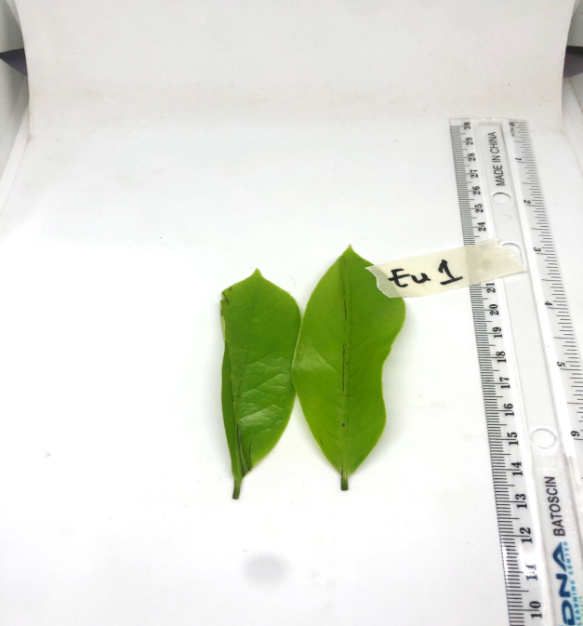
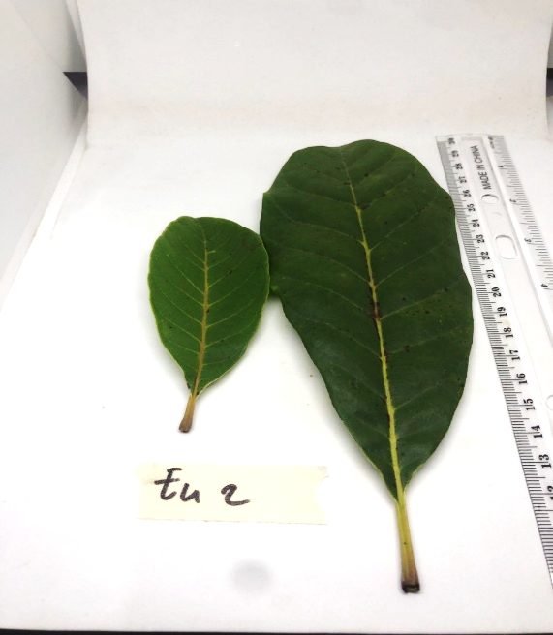
Plate 3.3.1 Plate 3.3.2
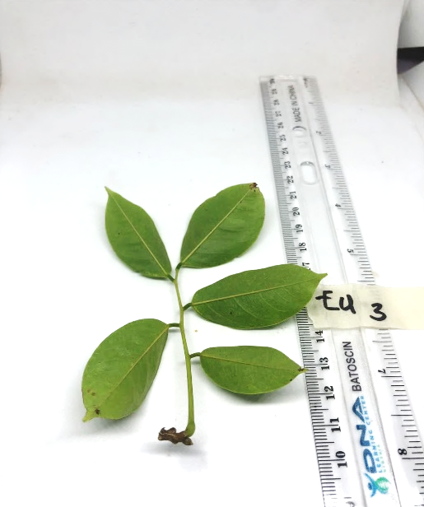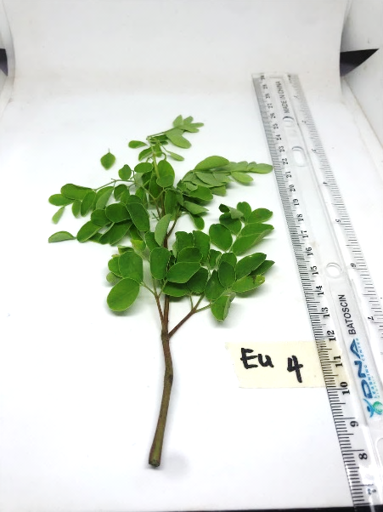
Plate 3.3.3 Plate 3.3.4

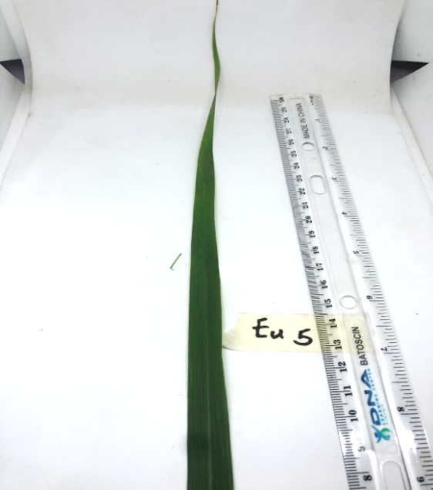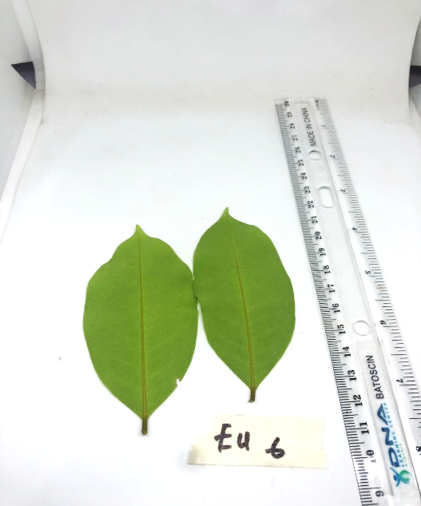
Plate 3.3.5 Plate 3.3.6
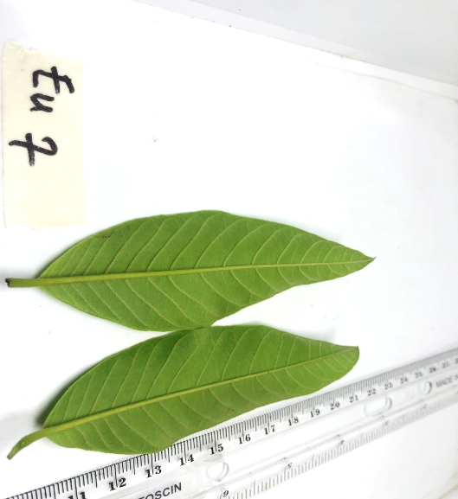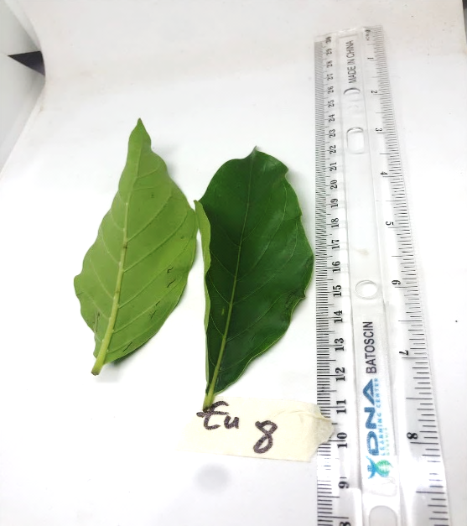
Plate 3.3.7 Plate 3.3.8
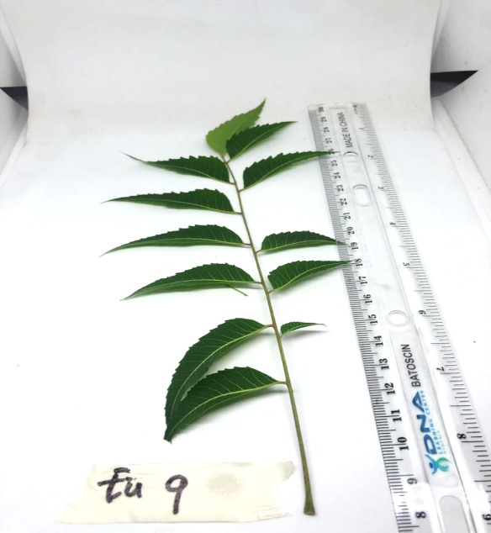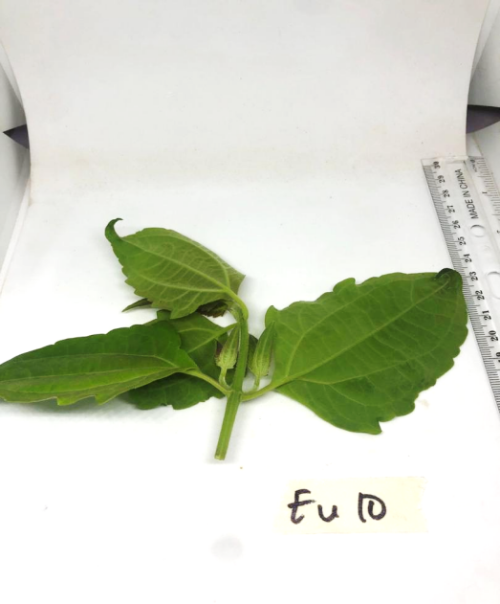
Plate 3.3.9 Plate 3.3.10

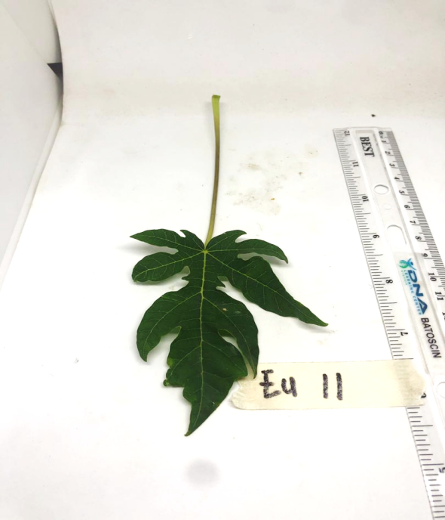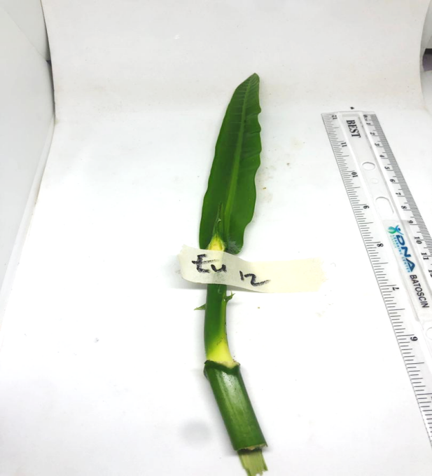
Plate 3.3.11 Plate 3.3.12
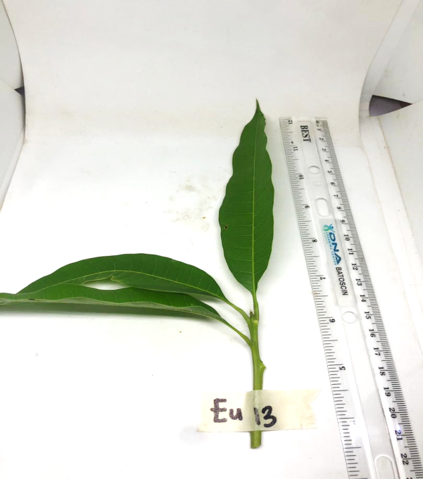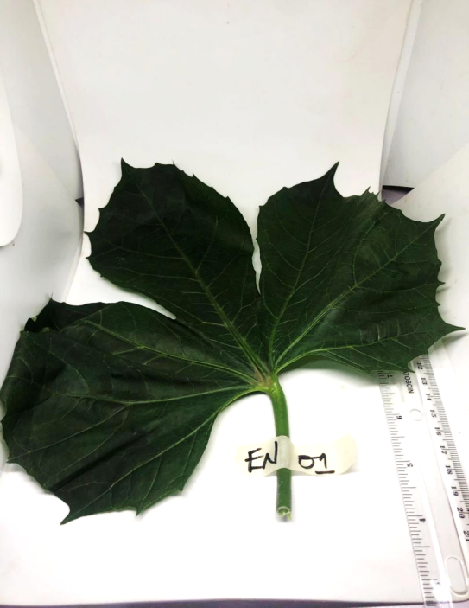
Plate 3.3.13 Plate 3.3.14
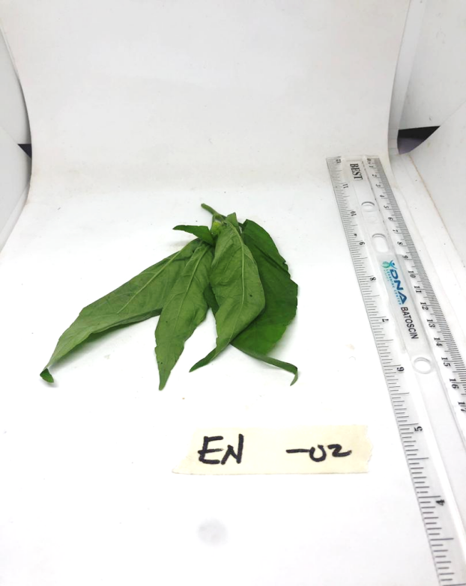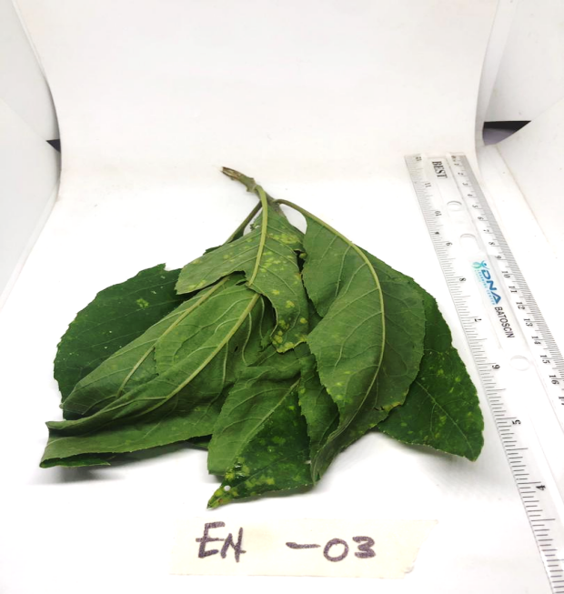
Plate 3.3.15 Plate 3.3.16
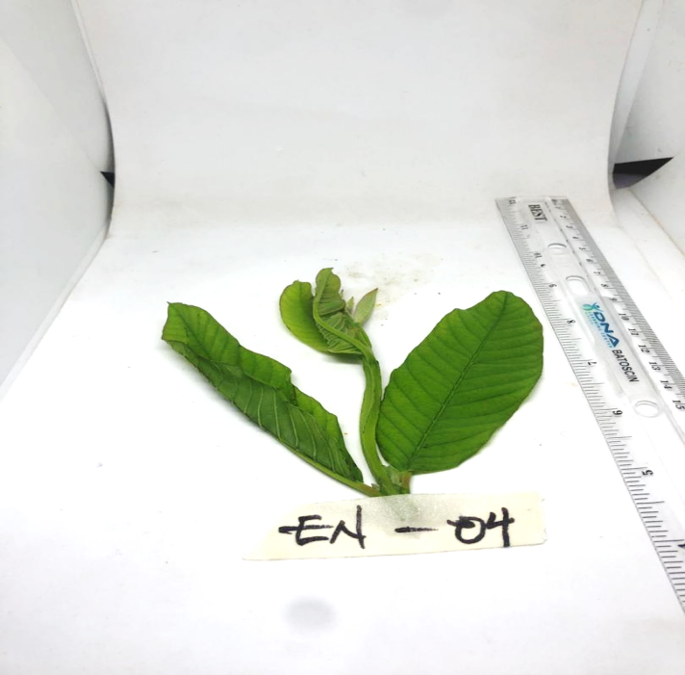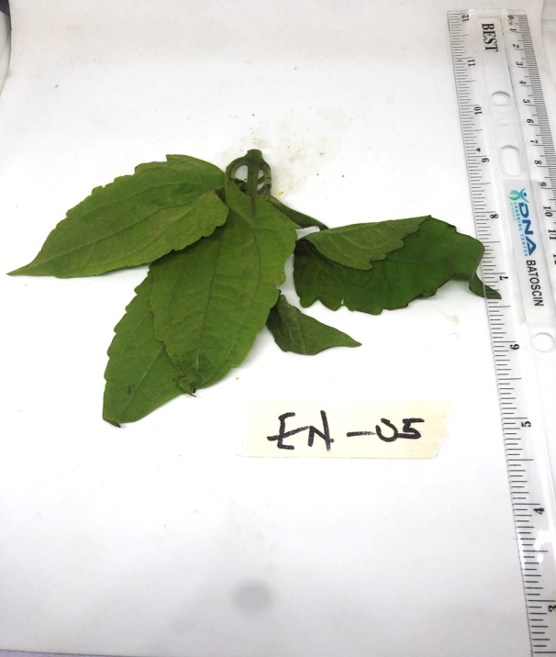
Plate 3.3.17 Plate 3.3.18
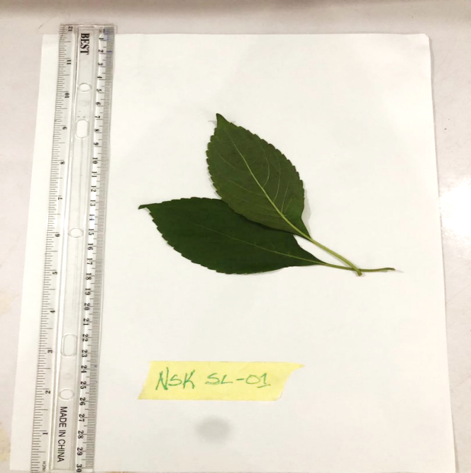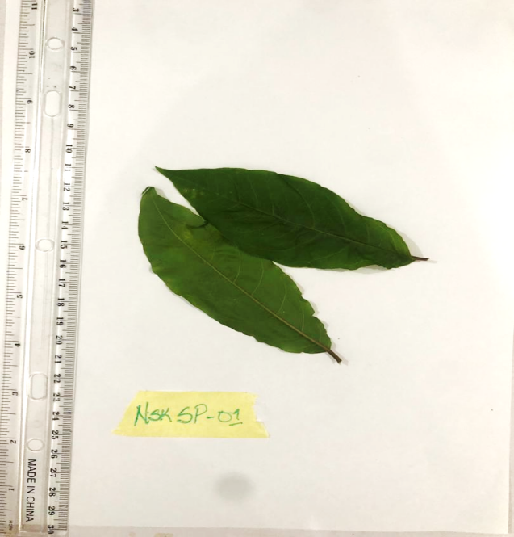
Plate 3.3.19 Plate 3.3.20
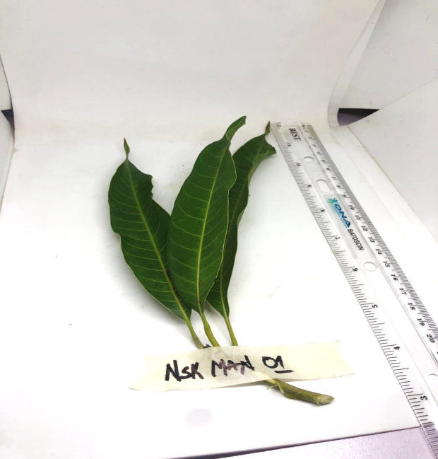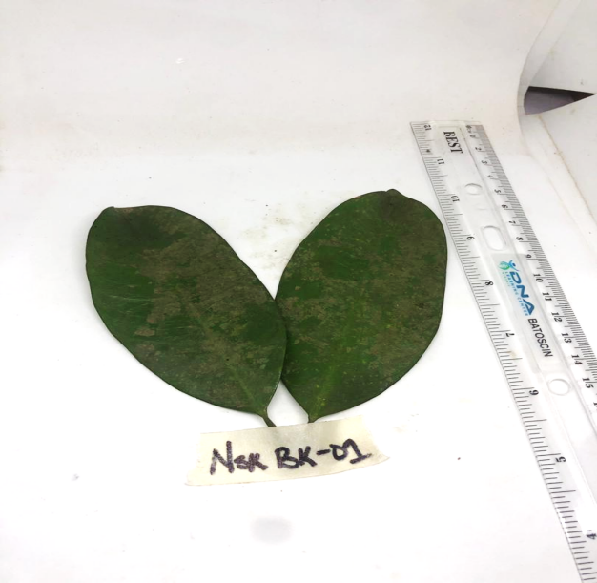
Plate 3.3.21 Plate 3.3.22
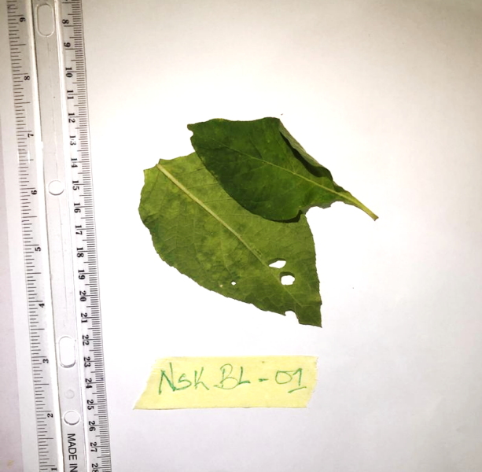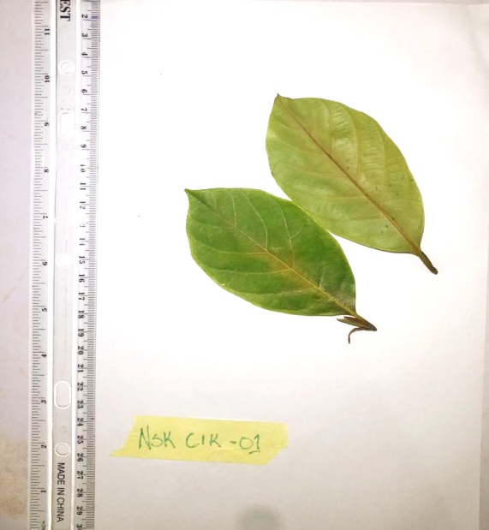
Plate 3.3.23 Plate 3.3.24

3.4 Experimental Methods
3.4.1 Test Materials
- 1.5 ml microcentrifuge tube
- Micropipette and tips (10ul, 100ul, 1000ul)
- Disposable cups
- Racks
- Ice
- Water bath
- Centrifuge
- Thermal cycler
- Vortexer
- Electrophoresis chamber
- Power pack
- Hand gloves
- Agarose
- UV trans-illumunator
    - DNA Extraction
The silica DNA isolation procedure was used for the DNA extraction standardized by the DNA Learning Center. This affordable DNA extraction technique has the benefit of operating reliably with virtually any specimen of a plant, fugus, or animal.
Began by Obtaining the plant tissue using a razor blade that was between 10 mg and 1/8 to 14 inch in diameter. Placed the sample in a clean 1.5 mL microcentrifuge tube that was marked with the appropriate identification number. 300 µl of lysis solution was added in the micro centrifuge tube. A clean plastic micro pestle was twisted against the inner surface of the 1.5-mL tube to forcefully grind the tissue for 2 minutes until the chuck of plant tissue are no longer visible. Incubated the tube in the water bath at 65ºC for 10 minutes. The tubes were placed in a micro-centrifuge, with cap hinges pointing outward and centrifuged for 1 minute at maximum speed to pellet debris. A clean 1.5-mL tube was labelled with the sample number and 150 µl of the supernatant was transferred to a fresh tube and being careful not to disturb the debris pellet during the transfer of the supernatant. Added 3 µl of silica resin to tube and ensured silica resin was mixed and homogenous. Closed the tube and mixed well by flicking and vortexing for the solution to turn cloudy. Closed and incubated the tube for 5 minutes in a water bath at 57ºC. Centrifuged for 30 seconds at maximum speed to pellet the resin. Used a micropipette with fresh tip to remove all supernatant, being careful not to disrupt the white silica resin pellet at the bottom of the tube.Added 500 µl of ice-cold wash buffer to the pellet. Mixed well by pipetting up and down, flicking or vortexing to re-suspend the silica resin. The tube was placed in a micro-centrifuge, with cap hinges pointing outward and Centrifuged for 30 seconds at maximum speed to pellet the resin. Used a micropipette with fresh tip to remove all supernatant. Once again, added 500 µl of ice-cold wash buffer to the pellet. Closed the tube and mixed well by vortexing or by pipetting up and down to re-suspend the silica resin.Placed the tube in a micro-centrifuge, centrifuged for 30 seconds at maximum speed to pellet the silica resin. Used a micropipette with fresh tip to remove the supernatant, Spinned the tube for 15 seconds to collect any drops of supernatant and then remove these with a micropipette.100 µl of TE buffer was added to the silica resin and mixed well by vortexing or by pipetting up and down. Incubated the mixture at 57ºC for 5 minutes. Placed the tube in a micro-centrifuge, with cap hinges pointing outward and centrifuged for 30 seconds at maximum speed to pellet the silica resin. Labelled a clean 1.5- mL tube with the sample number. Transferred 50 µl of the supernatant (clear solution) to the fresh tube, and discarded the old tube containing the silica resin.Stored the sample at -20ºC until ready to begin the Polymerase Chain reaction.
    - Amplification by Polymerase Chain Reaction (PCR), Agarose Gel Electrophoresis and DNA Sequencing
PCR tube containing Ready-To-Go PCR Bead was labelled with the tube with the appropriate identification number. The total volume in the PCR beads was 25 µl : 2 µl of ~100 ng DNA and 23 µl of primer/loading dye mix in each tube and allowed to dissolve for 1 minute. The Plants rbcL primers used were (rbcLaF - ATGTCACCACAAACAGAGACTAAAGC / rbcLa rev - GTAAAATCAAGTCCACCRCG) (Onyia et al., 2022). The PCR tubes were placed in a thermal cycler that has been programmed for 35 cycles of the following profile: Denaturing step: 94°C 30 seconds, annealing step: 54°C 45 seconds, extending step: 72°C 45 seconds. After thermal cycling, the amplified DNA was stored on ice or at -20 °C until I was ready to be electrophoresed. The PCR amplicons were electrophoresed in a 2% agarose gel containing 4µl of ethidium bromide and photographed under a UV light trans-illuminator. The PCR amplicons were sent to Genewiz LLC, located in New Jersey, USA, for DNA sequencing.
3.4.4 Data Analysis Using DNA Subway and MEGA 11 Software
The blue line of DNA Subway was used to upload the sequencing results produced by the Applied Biosystems Genetic automated sequencer (ABI Prism 3130X1, Froster City, CA 94404, USA) at Genewiz LLC. The Blue Line of the DNA Subway was used in the ways described in the instructions below to investigate unique DNA sequences produced by DNA sequencing experiments. The assembled sequences were end-trimmed, coupled in their respective forward and reverse sequences, and then constructed into a consensus sequence by using the Blue Line. Using the BLAST function of the DNA Subway and NCBI web-based sites, sequence alignment and percentage similarity searches were evaluated with GeneBank databases. Using the ClustalW, several alignments were carried out (Ude et al., 2019). The reconstruction of the phylogenetic tree was conducted using the MEGA 11 software. The construction of phylogenies was carried out utilising the Maximum Likelihood method. The assessment of the trees' efficacy was conducted through bootstrapping, with up to 100 replicates (Ude et al., 2019).

CHAPTER FOUR
RESULTS
4.1 GEL ELECTROPHORESIS RESULTS
These results were obtained after the electrophoresis process that separates the DNA fragments based on their sizes in base pairs, and it was viewed under an ultra-violet (UV) trans-illuminator. As shown in Plate 4.1.1.1 – Plate 4.1.1.4, that of the 24 that were used in this research work, 66.7% (16) samples had clear DNA bands, 16.7% (4) samples had faint DNA bands, while 16.7% (4) samples had no DNA bands with Table 4.1 describing the gel quality of the results.

4.1.1 Plates of Gel Plates after Electrophoresis
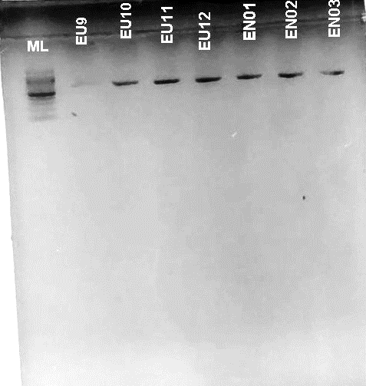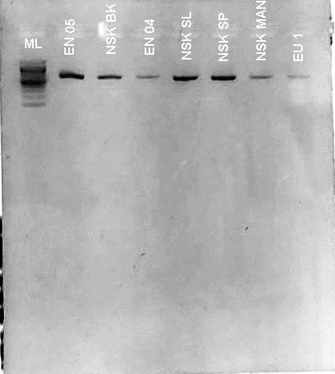
Plate 4.1.1.1 Plate 4.1.1.2
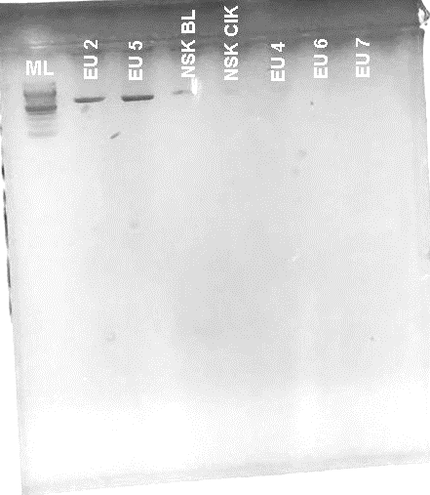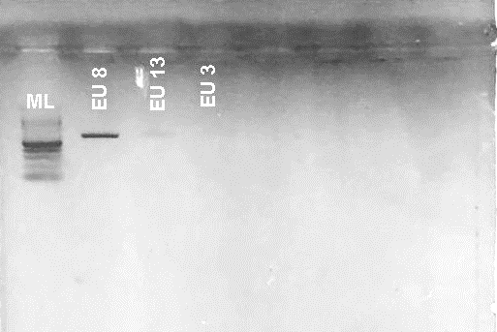
Plate 4.1.1.3 Plate 4.1.1.4

Table 4.1: GEL QUALITY CHECK FOR EXTRACTED PLANT DNA SAMPLES
S/N | Sample I.D | Common Name | Gel Quality
1 | EU1 | Sour sop | Light Band
2 | EU2 | Black Plum | Thick Band
3 | EU3 | Nturukpa | No Band
4 | EU4 | Drumstick | No Band
5 | EU5 | Lemon grass | Thick Band
6 | EU6 | Sour sop | No Band
7 | EU7 | Guava | No Band
8 | EU8 | Morinda tree | Thick Band
9 | EU9 | Neem tree | Light Band
10 | EU10 | Bitter bush | Thick Band
11 | EU11 | Male paw paw | Thick Band
12 | EU12 | Forest fever tree | Thick Band
13 | EU13 | Bush Mango | Light Band
14 | EN01 | Fluted Pumpkin | Thick Band
15 | EN02 | Asian mint | Thick Band
16 | EN03 | Bitter leaf | Thick Band
17 | EN04 | Guava | Light Band
18 | EN05 | Siam weed | Thick Band
19 | NSK SL | Scent leaf | Thick Band
20 | NSK SP | Guinea Henweed | Thick Band
21 | NSK MAN | Bush mango | Thick Band
22 | NSK BK | Bitter Kola | Thick Band
23 | NSK BL | Bitter leaf | Light Band
24 | NSK CIK | Cinnamon | No Band
4.2 DATA ANALYSIS
After performing the sequencing process on the samples, a cumulative count of 48 reads was obtained, encompassing both the forward and backward strands. The distribution of these reads is as follows:
VH - Very High Sequence - 12 reads (25.00%)
H - High Sequence - 8 reads (16.67%)
VL - Very Low Sequence - 8 reads (16.67%)
L - Low Sequence - 15 reads (31.25%)
N - No Sequence - 5 reads (10.41%)

Table 4.2: DNA DATA ANALYSIS
DNA DATA ANALYSIS OF BARCODED SAMPLES FROM DNA SUBWAY
Serial Number | Name of Sample | Sequence Quality |  | NR | NP | ER | Needs ID
Serial Number | Name of Sample | F | R
1 | BD | NS | VL | - | - | -
2 | Black Plum | VH | L |  |  | X
3 | BD | NS | NS | - | - | -
4 | Drumstick | L | L |  | X
5 | Lemon grass | VH | VH |  |  | X
6 | Sour sop | H | H |  |  | X
7 | Guava | NS | NS | - | - | -
8 | Morinda tree | H | H |  |  | X
9 | Neem tree | L | VL |  | X |  | X
10 | BD | VL | VL | - | - | -
11 | Male paw paw | L | L |  |  | X
12 | Forest fever tree | L | H |  |  | X
13 | Bush Mango | L | VL |  |  |  | X
14 | Fluted Pumpkin | VH | VH
15 | Asian mint | L | VL |  | X |  | X
16 | Bitter leaf | VH | VH |  |  | X
17 | Guava | L | L |  |  |  | X
18 | BD | VL | VL | - | - | - | -
19 | Scent Leaf | VH | VH |  |  | X
20 | Snake Plant | VH | VH |  |  | X
21 | Bush mango | H | VH |  |  | X
22 | Bitter kola | H | L |  |  | X
23 | Bitter leaf | L | L |  |  | X
24 | Cinnamon | L | H |  | X |  | X

KEYS TO TABLE

NR - New Record NP - New Polymorphisms ER - Existing Record

VH - Very High Quality VL - Very Low Quality NS - No Sequence

H - High Quality L - Low Quality BD - Bad read

4.3 SEQUENCE ALIGNMENT OF DNA SAMPLE USING CLUSTALW
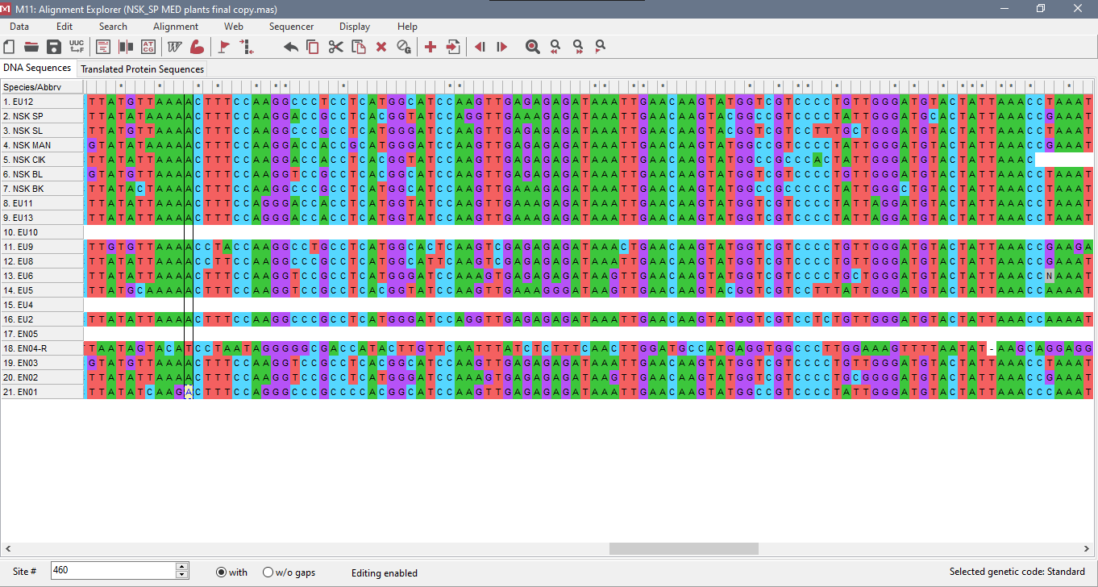
Figure 4.1: Alignment of DNA sample sequences using ClustalW multiple alignment pattern
Table 4.3: BLAST Results of total score, Query length, Query cover, e value and percentage identity of DNA sample from NCBI and DNA Subway
QUERY NAME | SEQUENCE SOURCE ORGANISM(DNA SUBWAY) | SEQUENCE SOURCE ORGANISM (NCBI) | Total Score | Query Length | Query Cover (%) | E-Value | PERCENTAGE IDENTITY(%) | ACCESSION NUMBER (DNA SUBWAY) | ACCESSION NUMBER (NCBI)
EN01 | Annona muricata | Annona muricata | 1007 | 545 | 100 | 0.0 | 100.00 | AY743440.1 | AY743440.1
EN02 | Justicia macrantha | Dicliptera tinctoria | 246 | 172 | 84 | 9e-61 | 97.24 | JQ590063.1 | OR063946.1
EN03 | Gymnanthemum amygdalinum | Gymnanthemum amygdalinum | 1007 | 545 | 100 | 0.0 | 100.00 | MN628016.1 | MN628016.1
EN04-R | Trigonostemon longifolius | Cnidoscolus spinosus | 243 | 159 | 100 | 1e-59 | 94.34 | KJ594921.1 | KU176190.1
EN05 | PS | PS | PS | PS | PS | PS | PS | PS | PS
EU1 | PS | PS | PS | PS | PS | PS | PS | PS | PS
EU2 | Vitex mombassae | Vitex mombassae | 1005 | 544 | 100 | 0.0 | 100.00 | KU568036.1 | KU568036.1
EU3 | PS | PS | PS | PS | PS | PS | PS | PS | PS
EU4 | Moringa oleifera | Moringa oleifera | 252 | 146 | 100 | 2e-62 | 97.28 | LC547436.1 | LC547436.1
EU5 | Cymbopogon giganteus | Cymbopogon giganteus | 1040 | 563 | 100 | 0.0 | 100.00 | OK094432.1 | OK094432.1
EU6 | Dianthera pectoralis | Dicliptera tinctoria | 933 | 509 | 100 | 0.0 | 99.61 | OL536860.1 | OR063946.1
EU7 | PS | PS | PS | PS | PS | PS | PS | PS | PS
EU8 | Morinda pubescens | Morinda pubescens | 1002 | 552 | 100 | 0.0 | 99.28 | KF432025.1 | KF432025.1
EU9 | Morinda royoc | Morinda royoc | 768 | 471 | 100 | 1e-109 | 94.70 | MH549924.1 | MH549924.1
EU11 | Carica papaya | Carica papaya | 996 | 544 | 99 | 0.0 | 100.00 | MK309380.1 | MK309380.1
EU12 | Anthocleista grandiflora | Anthoclesta grandiflora | 989 | 542 | 100 | 0.0 | 99.63 | JF265290.1 | JF265290.1
EU13 | Carica papaya | Carica papaya | 944 | 518 | 100 | 0.0 | 99.42 | MK309380.1 | MK309380.1
NSK_BK | Garcinia sp. | Garcinia pedunculata | 981 | 541 | 100 | 0.0 | 99.45 | MF435438.1 | NC_048983.1
NSK_BL | Gymnanthemum amygdalinum | Gymnanthemum amygdalinum | 992 | 541 | 100 | 0.0 | 99.82 | MN628024.1 | MN628024.1
NSK_CIK | Artocarpus heterophyllus | Artocarpus heterophyllus | 963 | 545 | 96 | 0.0 | 99.43 | MG873185.1 | MK303549.1
NSK_MAN | Mangifera indica | Mangifera indica | 1125 | 615 | 99 | 0.0 | 99.84 | MW164971.1 | MW164971.1
NSK_SL | Ocimum gratissimum | Ocimum gratissimum | 1114 | 628 | 96 | 0.0 | 100.00 | MT385747.1 | MT385747.1
NSK_SP | Petiveria alliacea | Petiveria alliacea | 1085 | 599 | 97 | 0.0 | 100.00 | MF349376.1 | NC_041417.1

4.4 PHYLOGENETIC TREE USING MAXIMUM LIKELIHOOD
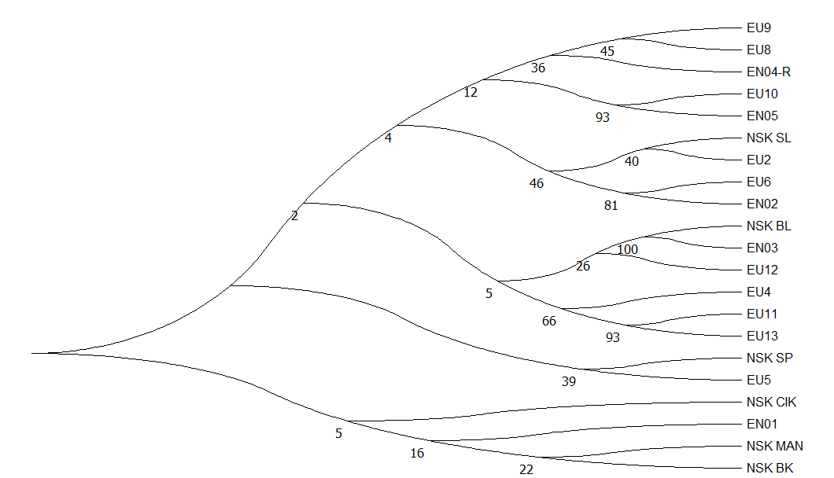
Figure 4.2: Phylogenetic tree of the Medicinal plants as revealed by rbcl barcoding marker.

CHAPTER FIVE
DISCUSSION AND CONCLUSION
5.1 Discussion
DNA barcoding has emerged as a proficient technique for distinguishing between species of flowering plants belonging to the Polygonaceae and Fabaceae families, as well as other terrestrial plant species. Although mitochondrial cytochrome oxidase 1 (CO1) has been established as a standardized DNA barcoding marker for animals, it is not universally applicable for all plant species, as no single barcode sequence can effectively discriminate among them (Ude et al., 2019). The rbcL candidate barcoding marker is found to be suitable for the DNA barcoding process due to its favourable characteristics in terms of amplification and sequencing (Hollingsworth et al., 2011). Nevertheless, the rbcL barcoding marker employed in this study failed to meet the fundamental requirement of distinguishing between various medicinal plant species. The analysis of sequence alignment revealed a limited level of polymorphisms observed among the sequences.
The BLAST computations yielded interesting results, as the grouped sequences generated significant hits. Additionally, a subset of previously unidentified sequences was successfully identified through this process. The analysis has identified two putative species of plants, which were EN01 and NSK_SP. The cumulative bit score acquired in all instances varied from 243 – 1125. The query coverage extended across a range of 84 – 100 and expected values (e-values) were 9e-61 or less. The percentage sequence identity ranged from 94.34% - 100%. The NSK_CIK and NSK_SP query yielded a variable number of sequences in the NCBI database, ranging from two to four. These sequences exhibited synonymous values in terms of total bit score, query coverage, e-value, and percentage identity. However, they were assigned different accession numbers. For instance, EN02, EN04-R, EU6 and NSK_BK had different hits and accession numbers in NCBI database when compared against that on DNA subway database. Accession numbers AY743440.1, MN628016.1, KU568036.1, LC547436.1, OK094432.1, KF432025.1, MH549924.1, MK309380.1, JF265290.1, MN628024.1, MW164971.1, and MT385747.1 had all their percentage hits with similar values in both BLAST indices used.
Maximum likelihood estimation is utilized to access evolutionary distances between species, independent of the actual distance but rather focusing on the nucleotide changes that have occurred. The tree exhibiting the highest overall likelihood score is considered the most reliable approximation of the associations between the sequence and the branch lengths connecting the nodes in the tree. This likelihood score serves as an indicator of the level of confidence we can place in the precision of these associations, as evidenced by the arrangement of the branches. The phylogenetic tree reconstruction analysis involved 21 nucleotide sequences. There were a total of 794 positions in the final dataset. Evolutionary analyses were conducted in MEGA11 (Tamura et al., 2021). From the phylogenetic tree, the phylogenetic diversity(PD) was obtained were NSK_BL and EN03, EU11 and EU13, EU10 and EN05 had PD of 100, 93, and 93 respectively, showed close relatedness. PD value of 81 describes the relatedness between EU6 and EN02. EU9, EU8 are contained in a node and showed close relatedness compared to sample EU10 and EN05 with PD value of 93 on the second node. NSK_SL and EU2 show a PD value of 40, NSK_SP and EU5 had a PD value of 39, NSK_MAN and NSK_BK also had a PD value of 22. NSK_BL, EN03, and EU12 are grouped together in one clade and are closely related to nearest clade containing EU4, EU11 and EU13 compared NSK_SP and EU5 grouped in a separate clade. EN04-R, NSK_CIK and EN01 are considered to be the outgroup.
5.2 Conclusion
During the course of this research, through the gel electrophoresis analysis, the results indicated no DNA bands in about four samples. This may be due to little or no amplification of the rbcl region due to possible mutations in this region, which hindered the rbcl forward and reverse primers from identifying this region for PCR. However, this process could have been repeated using matK to amplify the maturase K region in the chloroplast DNA of the plants, but it wasn’t because of the time limitation. Another reason could be that the DNA sample degraded due to poor storage temperature conditions caused by an insufficient power supply during the course of the experiment.
In conclusion, this research documented the diverse range of medicinal plant species found in notable towns within Enugu State. Additionally, it successfully established the phylogenetic connections between the collected plant samples and those already recorded in the National Centre for Biotechnology Information (NCBI) database.

5.3 Recommendation
I recommend the establishment of a National Barcoding and DNA database center that would be advantageous and beneficial to help preserve our nation’s biodiversity. This center would serve as a platform for conducting various training sessions in the fields of molecular biology and genetic engineering. Additionally, it would facilitate the creation of a comprehensive DNA bank encompassing the diverse fauna and flora present within the ecological habitat of the south east and Nigeria in general.

REFERENCES
Ahrens, D., Monaghan, M.T. and Vogler, A.P., (2007). DNA-based taxonomy for associating adults and larvae in multi-species assemblages of chafers (Coleoptera: Scarabaeidae). Mol. Phylogenet. Evol. 44, 436–449.
Azwanida, N. N. (2015). A review on the extraction methods use in medicinal plants, principle, strength and limitation. Medicinal and Aromatic Plants 2015, 4:3
Betoni, J. E. C., Mantovani, R. P., Barbosa, M. N., Di Stasi, L. C. and Junior, A. F. (2006). Synergism between plant extract and antimicrobial drugs used on Staphylococcus aureus disease. Memorias Do Instituto Oswaldo Cruz 101(4): 387-390
Blaxter, M., Mann, J., Chapman, T., Thomas, F., Whitton, C., Floyd, R. and Abebe, E. (2005) Defining operational taxonomic units using DNA barcode data. Philos. Trans. R. Soc. London. B 360, 1935–1943.
Bupesh, G., Amutha, C., Nandagopal, S., Ganeshkumar, A., Sureshkumar, P. and Murali, K. S. (2007). Antibacterial activity of Mentha piperita L. (peppermint) from leaf extracts-a medicinal plant. Acta Agriculturae Slovenica, 89(1): 73-79
Caterino, M. S. and Tishechkin, A. K. (2006) DNA identification and morphological description of the first confirmed larvae of Hetaeriinae (Coleoptera: Histeridae). Systematic Entomology 31: 405–418.
Coissac, E., Hollingsworth, P. M., Lavergne, S. and Taberlet, P. (2016). From barcodes to genomes: extending the concept of DNA barcoding. Molecular Ecology 25, 1423-1428
Cox, A. J. and Hebert, P. D. N. (2001) Colonization, extinction and phylogeographic patterning in a freshwater crustacean. Mol. Ecol. 10, 371–386
Cunningham A.B. (1993). African medicinal plants: setting priorities at the interface between conservation and primary health care. People and Plants working paper 1. Paris. UNESCO
Cunningham AB (1997). An Africa-wide overview of Medicinal Plant Harvesting, Conservation and Healthcare, Non-Wood Forest Products. Medicinal plants for Forest Conservation and Healthcare. FAO, Italy.
Dasmahapatra, K.K. and Mallet, J. (2006). DNA barcodes: recent successes and future prospects. Heredity 97, 254-255
DNA Learning Center Barcoding 101 (2011). http://www.dnabarcoding101.org/lab/protocol-2.html
Doss, A., Mubarack, H. M. and Dhanabalan, R. (2009). Antibacterial activity of tannins from the leaves of Solanum trilobatum Linn. Indian Journal of Science and Technology 2(2): 41-43
Doyle, J. J., and Gaut, B. S. (2000). Evolution of genes and taxa: a primer. Plant Mol. Biol. 42, 1–6
Edeoga, H. O., Okwu, D. E. and Mbaebie, B. O. (2005). Phytochemical constituents of some Nigerian medicinal plants. African Journal of Biotechnology Vol. 4 (7): 685-688
Elujoba A. A., Odeleye O. M., and Ogunyemi, C.M (2005). Traditional Medical Development for medical and dental primary healthcare: delivery system in Africa. Afr. J. Traditional, Complementary and Alternate Med. 2(1): 46-61.
Evans, K.M., Wortley, A.H. and Mann, D.G. (2007). An assessment of potential diatom ‘‘barcode’’ genes (cox1, rbcl, 18S and ITS rDNA) and their effectiveness in determining relationships in Sellaphora (Bacillariophyta). Protista 158, 349–364.
Folmer, O., Black, M., Hoeh, W., Lutz, R., Vrijenhoek, R., (1994). DNA primers for amplification of mitochondrial cytochrome c oxidase subunit I from diverse metazoan invertebrates. Mol. Mar. Biol. Biotechnology 3, 294–299.
Fre´ zal, L. and Leblois, R. (2008) Four years of DNA barcoding: Current advances and prospects, Infect. Genetic Evolution: doi:10.1016/ j.meegid.05.005
Goldstein, P. Z. and DeSalle, R. (2019). Review and interpretation of trends in DNA barcoding. Frontiers in Ecology and Evolution 7:302
Hajibabaei, M., Janzen, D. H., Burns, J. M., Hallwachs, W. and Hebert, P. D. N. (2006). DNA barcodes distinguish species of tropical Lepidoptera. Proc. Natl. Acad. Sci. USA, 103:968–971.
Hebert P.D., Cywinska A., Ball S.L. and DeWaard J.R. (2003). Biological Identifications through DNA barcodes; Proceedings of the Royal Society B: Biological Sciences 270(1512): 313-21.
Hollingsworth P.M. (2009). A DNA barcode for land plants: Proc. Natl. Acad. Sci. U S A, 106(31): 12794-7.
Hollingsworth, P. M., Graham, S. W. and Little, D. P. (2011). Choosing and Using a Plant DNA Barcode. PLoS ONE 6(5): e19254.
Huang, J., Qin Xu, Q., Sun, Z.J., Tang, G.L. and Su, Z.Y. (2007). Identifying earthworms through DNA barcodes: Pedobiologia 51, 301–309.
Jaklitsch, W.M., Komon, M., Kubicek, C.P. and Druzhinina, I.S. (2006). Hypocrea crystalligena sp nov., a common European species with a white-spored Trichoderma anamorph. Mycologia 98, 499–513.
Knowlton, N. and Weight, L. A. (1998) New dates and new rates for divergence across the Isthmus of Panama. Proc. R. Soc. Lond. B 265, 2257–2263.
Kumar, G. S., Jayaveera, K. N., Kumar, C. K. A., Sanjay, U. P., Swamy, B. M. V. and Kumar, D. V. K. (2007). Antimicrobial effects of Indian medicinal plants against acne-inducing bacteria. Tropical Journal of Pharmaceutical Research 6(2): 717-723
Lane, C.E., Lindstrom, S.C. and Saunders, G.W (2007). A molecular assessment of northeast Pacific Alaria species (Lamiariales, Phaeophyceae) with reference to the utility of DNA barcoding. Mol. Phylogenetics. Evol. 44, 634–648.
Lewis, K. and Ausubel, F. M. (2006). Prospects for plant-derived antibacterials. Nature Biotechnology, 24(12), 1504–1507.
Li, X., Yang, Y., Henry, R. J., Rosetto, M., Wang, Y. and Chen, S. (2014). Plant DNA barcoding: from gene to genome. Biological Reviews 90(1), 157-166
Litaker, R.W., Vandersea, M.W., Kibler, S.R., Reece, K.S., Stokes, N.A., Lutzoni, F.M., Yonish, B.A., West, M.A., Black, M.N.D. and Tester, P.A., (2007). Recognizing Dinoflagellate species using ITS rDNA sequences. J. Phycol. 43, 344–355.
Mishra, P., Kumar, A., Nagireddy, A., Mani, D. N., Shukla, A. K.., Tiwari, R. and Sundaresan, V. (2016). DNA barcoding: an efficient tool to overcome authentication challenges in the herbal market. Plant Biotechnology Journal 14: 8-21
Mulat, M., Khan, F., Muluneh, G. and Pandita, A. (2020). Phytochemical profile and antimicrobial effects of different medicinal plant: current knowledge and future perspectives. Current Traditional medicine 6: 24-42
Nair, R., Kalariya, T. and Chanda, S. (2005). Antibacterial activity of some selected Indian medicinal flora. Turkish Journal of Biology 29(1): 41-47
Onyia, C.O., Ilo, O.P., Obih, C.E., Ugbogu, O., Ojiego, B.O ., Rufai, S.S., Onyemaechi, P.S. and Chuk wuma, E.C. (2022) DNA Barcoding of Nigeria’s Forest Species Listed in CITES and Other Endangered Plant Species of National Interest. American Journal of Plant Sciences, 13, 1335-1346
Parekh, J., Jadeja, D. and Chanda, S. (2005). Efficacy of aqueous and methanol extracts of some medicinal plants for potential antibacterial activity. Turkish Journal of Biology: Vol. 29 (4): 203-210
Pavithra, P. S., Janani, V. S., Charumathi, K. H., Indumathy, R., Potala, S. and Verma, R. S. (2010). Antibacterial activity of plants used in Indian herbal medicine. International Journal of Green Pharmacy vol. 4: 22-28
Pegg CG, Sinclair B, Briskey L, Aspden WJ (2006) MtDNA barcode identification of fish larvae in the southern great barrier reef, Australia. Scientia Marina 70: 7–12.
Randrianiaina, R.D., Glaw, F., Thomas, M., Glos, J., Raminosoa, N., Vences, M., (2007). Descriptions of the tadpoles of two species of Gephyromantis, with a discussion of the phylogenetic origin of direct development in mantellid frogs. Zoo taxa 1401, 53–61.
Rios, J. L. and Recio, M. C. (2005). Medicinal plants and antimicrobial activity. Journal of Ethnopharmacology 100: 80-84
Rubinoff, D. and Holland, B.S. (2005). Between two extremes: mitochondrial DNA is neither the panacea nor the nemesis of phylogenetic and taxonomic inference. Syst. Biol. 54, 92–961
Rusch, D.B., Halpern, A.L., Sutton, G., Heidelberg, K.B., Williamson, S., Yooseph, S., Wu, D., Eisen, J.A., Hoffman, J.M., Remington, K., Beeson, K., Tran, B., Smith, H., Baden-Tillson, H., Stewart, C., Thorpe, J., Freeman, J., Andrews-Pfannkoch, C., Venter, J.E., Li, K., Kravitz, S., Heidelberg, J.F., Utterback, T., Rogers, Y.-H., Falcon, L.I., Souza, V., Bonilla-Rosso, G., Eguiarte, L.E., Karl, D.M., Sathyendranath, S., Platt, T., Bermingham, E., Gallardo, V., Tamayo-Castillo, G., Ferrari, M.R., Strausberg, R.L., Nealson, K., Friedman, R., Frazier, M., and Venter, J.C., (2007). The Sorcerer II Global Ocean Sampling expedition: Northwest Atlantic through eastern tropical Pacific. Plos Biol. 5 (3) e77, 398–431
Saccone, C., De Giogi, C., Gissi, C., Pesole, G., and Reyes A. (1999). Evolutionary Genomics in Metazoa: the mitochondrial DNA as a model system. Gene. 238:195–209.
Saunders, G.W. (2005). Applying DNA barcoding to red macroalgae: a preliminary appraisal holds promise for future applications. Philos. Trans. R. Soc. London. B360, 1879–1888.
Sharma, P., Kumar, P., Sharma, R., Gupta, G. and Chaudhary, A. (2017). Immunomodulators: Role of medicinal plants in immune system. National Journal of Physiology, Pharmacy and Pharmacology 7(6): 552-556
Shenoy, B.D., Jeewon, R. and Hyde, K.A. (2007). Impact of DNA sequence-data on thetaxonomy of anamorphic fungi. Fungal Div. 26, 1–54.
Silva, N. and Fernandes, J. A. (2010). Biological properties of medicinal plants: a review of their antimicrobial activity. Journal of Venomous Animals and Toxins Including Tropical Diseases 16(3): 402-413
Suntar, I. (2019). Importance of ethno pharmacological studies in drug discovery: roe of medicinal plants. Phytochemistry Reviews.
Tamura K., Stecher G., and Kumar S. (2021). MEGA 11: Molecular Evolutionary Genetics Analysis Version 11. Molecular Biology and Evolution.
Techen, N., Parveen, I., Pan, Z. and Khan, I. A. (2014). DNA barcoding of medicinal plant material for identification. Current Opinion in Biotechnology 25:103-110
Ude, G.N., Igwe, D.O., McCormick, J., Ozokonkwo-Alor, O., Harper, J., Ballah, D., Aninweze, C., Chosen, O., Okoro, M., Ene, C., Chieze, V., Unachukwu, M., Onyia, C., Acquaah, G., Ogbonna, J. and Das, A. (2019). Genetic Diversity and DNA Barcoding of Yam Accessions from Southern Nigeria. American Journal of Plant Sciences, 10, 179-207
Ugboko, H. U., Nwinyi, O. C., Oranusi, S. U., Fatoki, T. H. and Omonhinmin, C. A. (2020). Antimicrobial importance of medicinal plants in Nigeria. The Scientific World Journal Vol. 2020, Article ID 7059323, pp 1-10
Vaou, N., Stavropoulou, E., Voidarou, C., Tsigalou, C. and Bezirtzoglou, E. (2021). Towards advances in medicinal plant antimicrobial activity: A review study on challenges and future perspectives. Microorganisms 9, 2041
Wares, J. P., and Cunningham, C. W. (2001) Phylogeography and historical ecology of the North Atlantic intertidal. Evolution12, 2455–2469.
Webb, K.E., Barnes, D.K.A., Clark, M.S. and Bowden, D.A., (2006). DNA barcoding: a Molecular tool to identify Antarctic marine larvae. Deep-Sea Res. Part II 53, 1053–1060.
Zhang, D.X., and Hewitt, G.M., (1997). Insect mitochondrial control region: a review of its structure, evolution and usefulness in evolutionary studies. Biochem. Syst. Ecol. 25:99–120.

APPENDIX
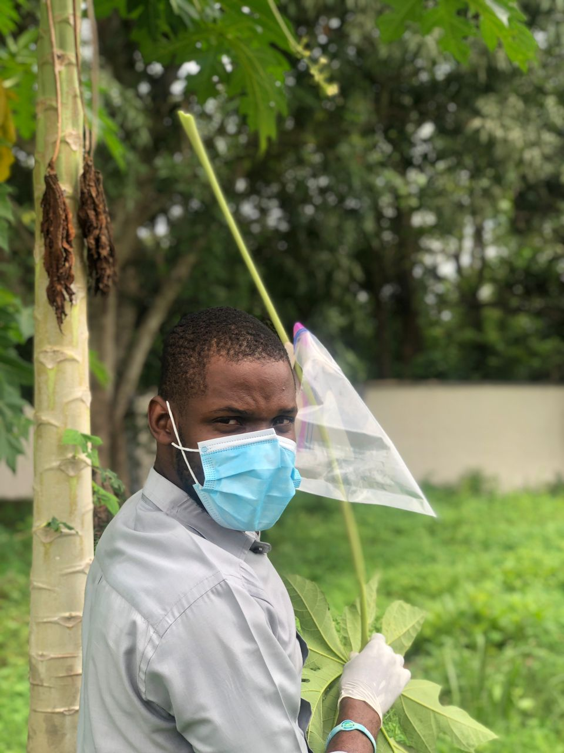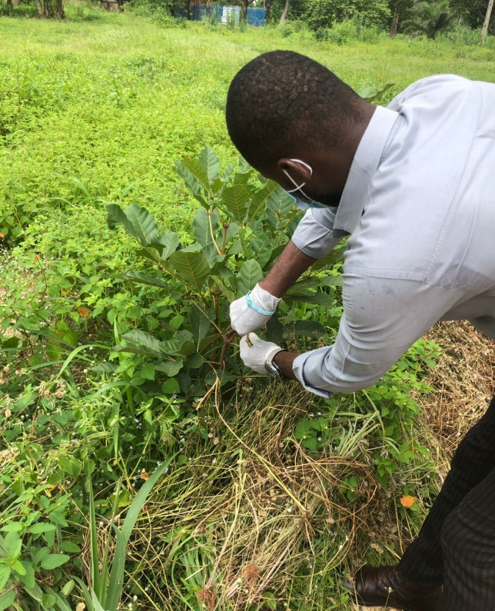
Appendix 1: Sample collection process at sampling site
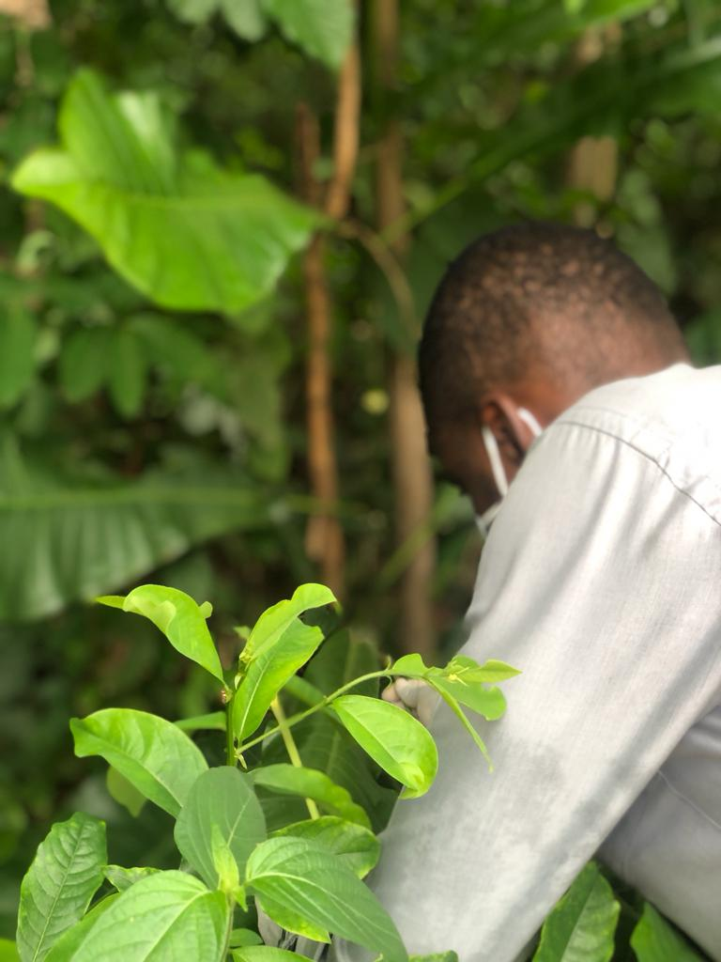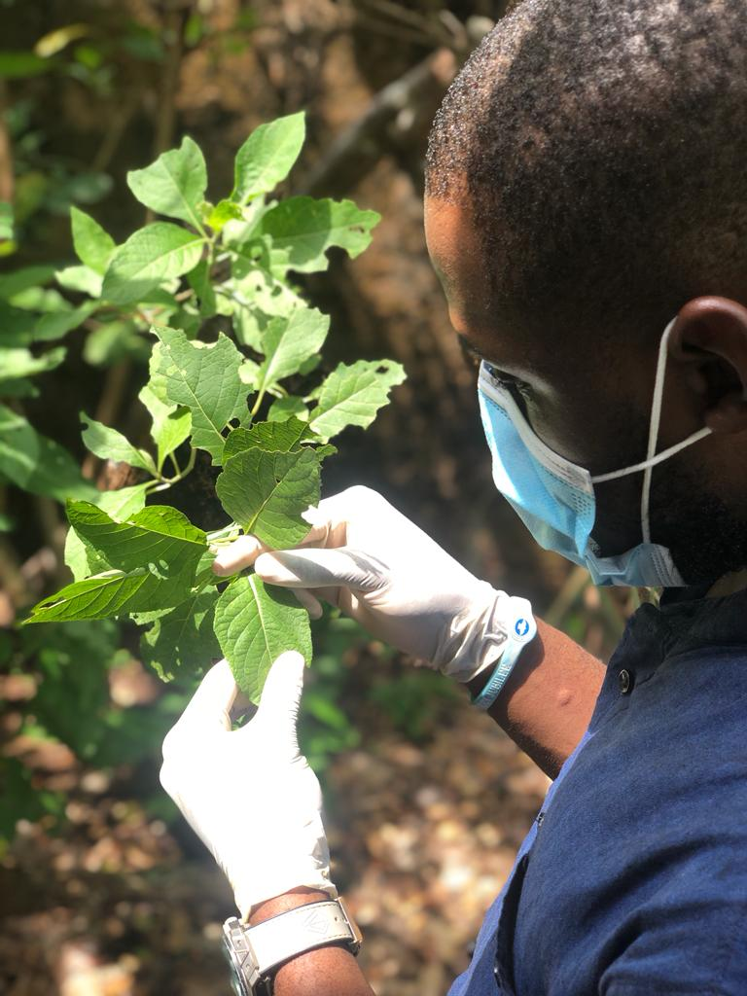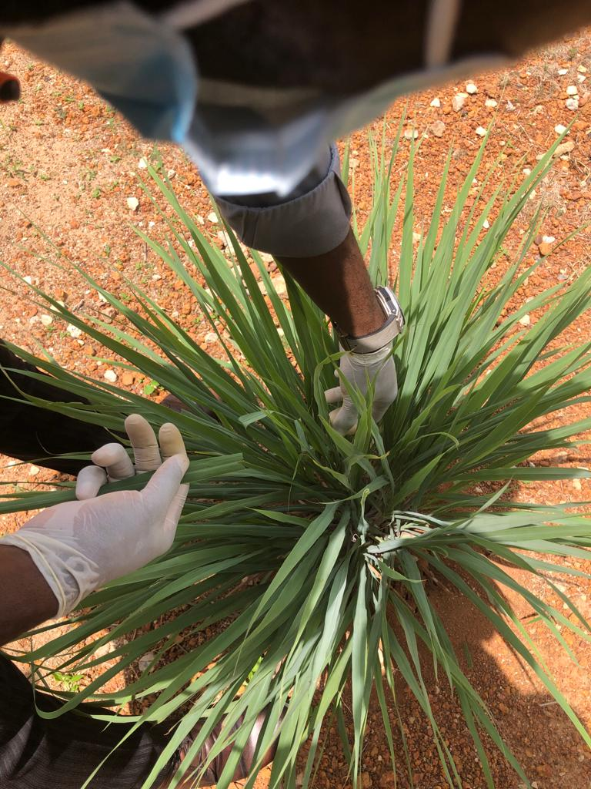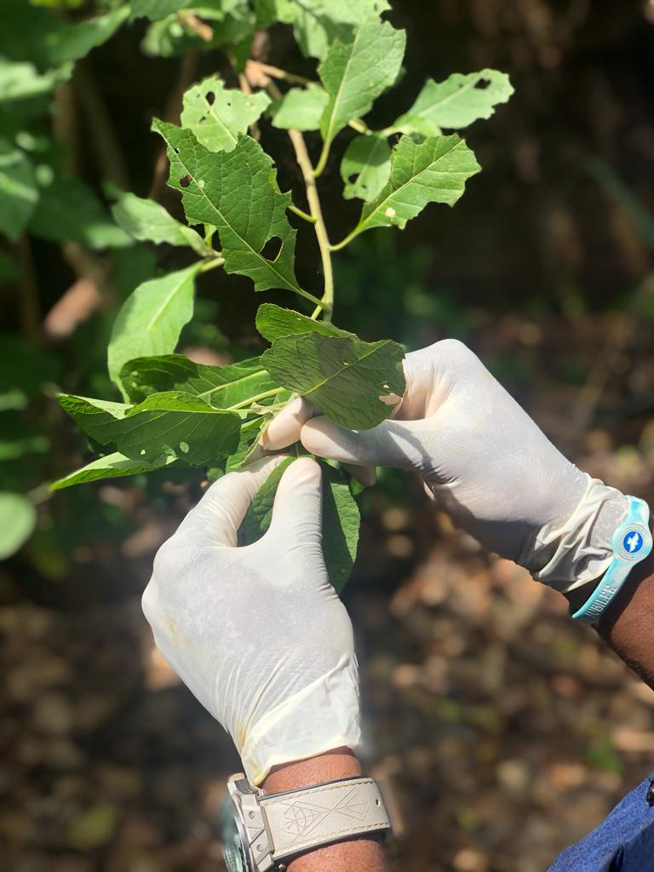

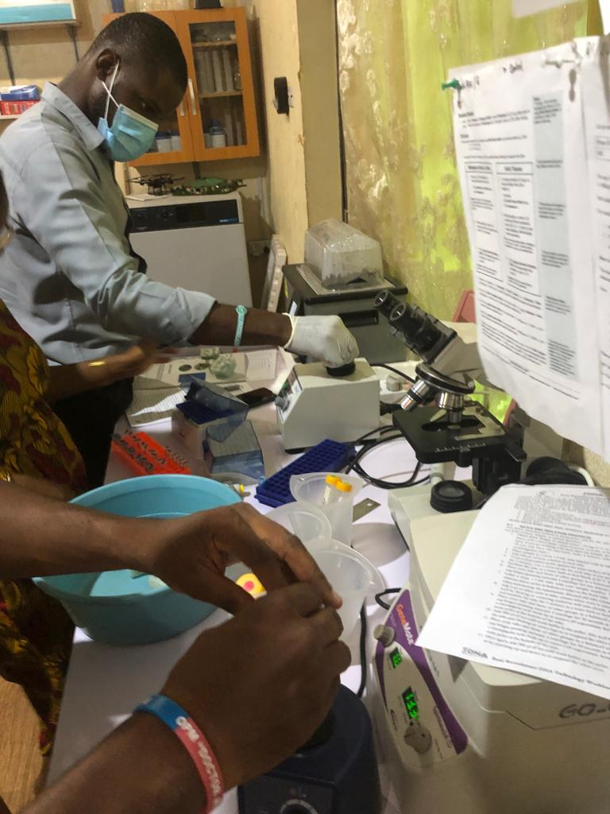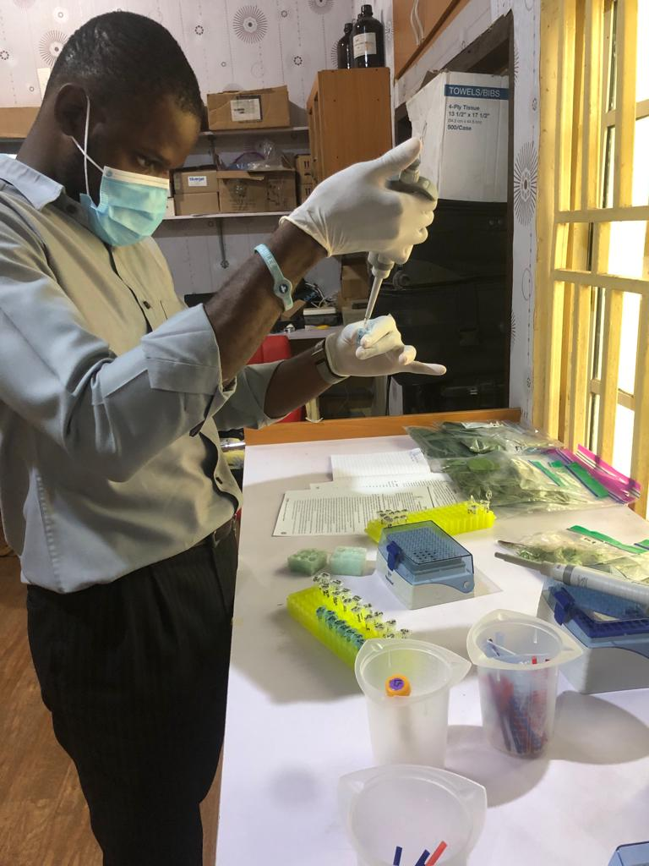

Appendix 2: DNA extraction and polymerase chain reaction amplification process

